# BIBLIOGRAPHY

Agus Suprijono (2011) *Model-Model Pembelajaran*. Jakarta: Gramedia Pustaka Jaya.

Ahmadi, M.R. (2012) “Reciprocal Teaching Strategies and Their Impacts on English Reading Comprehension,” *Theory and Practice in Language Studies*, 2(10), hal. 2053–2060.

Alyousef, H.S. (2005) “Teaching reading comprehension to ESL/EFL learners,” *Language Learning Journal*, 5(1), hal. 143–154.

Berardo, S. (2006) *The Use of Authentic Materials in the Teaching of Reading*. USA : CABI Publishing.

Boud, D. (1999) “Avoiding the Traps: Seeking Good Practice in the Use of Self-Assessment and Reflection in Professional Courses.,” *Social Work Education*, 18, hal. 121–132. Tersedia pada: https://doi.org/http://dx.doi.org/10.1080/02615479911220131.

Brewster, J., Ellis, G. dan Girard, D. (2002) *The primary English teacher’s guide*. 2 ed. Penguin Books.

Brown, H.D. (2001) *Teaching by principles: an Interactive Approach to Language Pedagogy*. New ork: Addison Wesley Longman.

Brown, H.D. (2004) *Teaching by principles: an Interactive Approach to Language Pedagogy*. New York: Longman.

Brown, H.D. (2007) *Principles of Language Learning and Teaching*. USA: Longman.

Brown, H.D. (2017) *Principles of Language Learning and Teaching*. San Francisco: Logman.

Butcher, C., Clara Davies dan Melissa Highton (2006) *Designing Learning: From Module Outline to Effective Teaching*. Routledge. Tersedia pada: https://doi.org/DOI:10.4324/9780203968482.

Christopher M. Gunn dan Alok Johri (2011) “News and knowledge capital,” 14(1), hal. 92–101. Tersedia pada: https://doi.org/https://doi.org/10.1016/j.red.2010.07.003.

Citraningrum, A.W. dan Mivtha, N. (2019) “The Effectiveness of The Cooperative Integrated Reading and Composition (CIRC) and Preview Question Read Reflect Recite Review (PQ4R) on Reading Comphrehension Skill,” *Indonesian Journal on Learning and Advance Education (IJOLAE)*, 1(1), hal. 26–36.

Daniel Muijs dan David Reynolds (2002) “Teachers’ Beliefs and Behaviors: What Really Matters?,” *The Journal of Classroom Interaction*, 3(15), hal. 13.

David Reynolds *et al.* (2014) “Educational effectiveness research (EER): A state-of-the-art review,” *School Effectiveness and School Improvement*, 25(2). Tersedia pada: https://doi.org/DOI:10.1080/09243453.2014.885450.

Depdiknas (2006) *Kurikulum Tingkat satuan Pendidikan (KTSP) untuk Sekolah, Dasar/ MI*. Jakarta: Depdiknas.

Depdiknas (2014) *Kurikulum 2013: Standar Kompetensi Mata Pelajaran Bahasa Inggris Sekolah Menengah Pertama (SMP) dan Madrasah Tsanawiyah (MTs)*. Jakarta: Pusat Kurikulum, Balitbang Depdiknas.

Dunn, K.E. dan Rakes, G.C. (2011) “Teaching teachers: An investigation of beliefs in teacher education students,” *Learning Environments Research*, 14, hal. 39–58. Tersedia pada: https://doi.org/http://dx.doi.org/10.1007/s10984-011-9083-1.

Ference Marton dan Ming Fai Pang (2006) “On Some Necessary Conditions of Learning,” *The Journal of the Learning Sciences*, 15(2), hal. 193–220.

Grabe, W. (1991) “urrent developments in second language reading research,” *TESOL Quarterly* [Preprint]. Tersedia pada: https://doi.org/doi:10.2307/3586977.

Grabe, W. (2002) *Teaching and Researching Reading*. Britain: Pearson Education.

Grabe, W. (2009) *Reading a Second Language: Moving from Theory to Practice*. New York: Cambridge university press.

Hapsari, S., Ekawati, Y.N. dan Molla, N.L. (2019) “Implementing Quick Response ( QR ) Codes in Teaching Reading,” *English Focus*, 2(2), hal. 70–80. Tersedia pada: https://doi.org/10.24905/efj.v2i2.57.

Harmer (2007) *The Practice of English Language Teaching4 th Ed.)*. London: Longman.

Junita, R.T. (2021) “Implementation of real analysis module with PQ4R strategy in facilitating self-regulated learning (SRL),” *Journal of Physics: Conference Series*, 2(1), hal. 1–9.

Kiewra, K.A. (2002) “How Classroom Teachers Can Help Students Learn and Teach Them How to Learn,” *Theory Into Practice*, 41(2), hal. 71–80. Tersedia pada: https://doi.org/DOI:10.1207/s15430421tip4102_3.

L., W.G., Fredericka dan Stoller (2022) *Teaching and Researching Reading*. London: Pearson Education Longman.

Michael Reynolds dan Russ Vince (2004) “Critical Management Education and Action-Based Learning: Synergies and Contradictions,” *Academy of Management Learning & Education*, 3(4), hal. 442–456.

Paweł Sobkowiak (2015) “Developing Students’ Intercultural Competence in Foreign Language Textbooks.” Tersedia pada: https://doi.org/DOI:10.17265/2161-6248/2015.12.003.

Pehofer, J. dan Roy William (2003) *New Media and Teacher Education*. New York: ITE Conference.

Ritzer, G. dan Douglas J Goodman (2010) *Teori Sosiologi Modern*. Jakarta: Kencana.

Ryan, Cooper dan Tauer (2013) *済無No Title No Title No Title*, *Paper Knowledge . Toward a Media History of Documents*.

Slavin, R. (2010) *Cooperative learning: a theory, research and practice*. London: Allya Bacon.

Squire, K. (2003) “Video games in education.,” *International Journal of Intelligent Simulations and Gaming*, 2(1), hal. 49–62.

Sugiyono (2009) *Metode Penelitian Kuantitatif, Kualitatif dan R&D*. Bandung: ALFABETA.

Sugiyono (2010) *Metode Penelitian Pendidikan*. Bandung: Alfabeta.

Thomas, E.L. dan Robinson, H.A. (1972) *Improving Reading In Every Class. Abridged Edition.*

Trianto (2007) *Mendesain Model Pembelajaran Inovatif-Progresif dan Kontekstual*. Jakarta: Kencana Cetakan ke-3.

Wahono, S.S. (2014) “Using PQ4R To Increase The Students’ Reading Comprehension At Al-Bidayah Islamic Boarding School Jember,” *Journal Fenomena*, 13(2). Tersedia pada: https://doi.org/DOI: https://doi.org/10.23887/jpdi.v1i1.2677.

Yuliana (2018) “The Effect of Using PQ4R (Preview, Question, Read, Reflect, Recite, Review) Strategy on EFL Students’ Reading Comprehension Achievement,” *Research in English and Education*, 3 (1), hal. 17–24.

Agus Suprijono (2011) *Model-Model Pembelajaran*. Jakarta: Gramedia Pustaka Jaya.

Ahmadi, M.R. (2012) “Reciprocal Teaching Strategies and Their Impacts on English Reading Comprehension,” *Theory and Practice in Language Studies*, 2(10), hal. 2053–2060.

Alyousef, H.S. (2005) “Teaching reading comprehension to ESL/EFL learners,” *Language Learning Journal*, 5(1), hal. 143–154.

Berardo, S. (2006) *The Use of Authentic Materials in the Teaching of Reading*. USA : CABI Publishing.

Boud, D. (1999) “Avoiding the Traps: Seeking Good Practice in the Use of Self-Assessment and Reflection in Professional Courses.,” *Social Work Education*, 18, hal. 121–132. Tersedia pada: https://doi.org/http://dx.doi.org/10.1080/02615479911220131.

Brewster, J., Ellis, G. dan Girard, D. (2002) *The primary English teacher’s guide*. 2 ed. Penguin Books.

Brown, H.D. (2001) *Teaching by principles: an Interactive Approach to Language Pedagogy*. New ork: Addison Wesley Longman.

Brown, H.D. (2004) *Teaching by principles: an Interactive Approach to Language Pedagogy*. New York: Longman.

Brown, H.D. (2007) *Principles of Language Learning and Teaching*. USA: Longman.

Brown, H.D. (2017) *Principles of Language Learning and Teaching*. San Francisco: Logman.

Butcher, C., Clara Davies dan Melissa Highton (2006) *Designing Learning: From Module Outline to Effective Teaching*. Routledge. Tersedia pada: https://doi.org/DOI:10.4324/9780203968482.

Christopher M. Gunn dan Alok Johri (2011) “News and knowledge capital,” 14(1), hal. 92–101. Tersedia pada: https://doi.org/https://doi.org/10.1016/j.red.2010.07.003.

Citraningrum, A.W. dan Mivtha, N. (2019) “The Effectiveness of The Cooperative Integrated Reading and Composition (CIRC) and Preview Question Read Reflect Recite Review (PQ4R) on Reading Comphrehension Skill,” *Indonesian Journal on Learning and Advance Education (IJOLAE)*, 1(1), hal. 26–36.

Daniel Muijs dan David Reynolds (2002) “Teachers’ Beliefs and Behaviors: What Really Matters?,” *The Journal of Classroom Interaction*, 3(15), hal. 13.

David Reynolds *et al.* (2014) “Educational effectiveness research (EER): A state-of-the-art review,” *School Effectiveness and School Improvement*, 25(2). Tersedia pada: https://doi.org/DOI:10.1080/09243453.2014.885450.

Depdiknas (2006) *Kurikulum Tingkat satuan Pendidikan (KTSP) untuk Sekolah, Dasar/ MI*. Jakarta: Depdiknas.

Depdiknas (2014) *Kurikulum 2013: Standar Kompetensi Mata Pelajaran Bahasa Inggris Sekolah Menengah Pertama (SMP) dan Madrasah Tsanawiyah (MTs)*. Jakarta: Pusat Kurikulum, Balitbang Depdiknas.

Dunn, K.E. dan Rakes, G.C. (2011) “Teaching teachers: An investigation of beliefs in teacher education students,” *Learning Environments Research*, 14, hal. 39–58. Tersedia pada: https://doi.org/http://dx.doi.org/10.1007/s10984-011-9083-1.

Ference Marton dan Ming Fai Pang (2006) “On Some Necessary Conditions of Learning,” *The Journal of the Learning Sciences*, 15(2), hal. 193–220.

Grabe, W. (1991) “urrent developments in second language reading research,” *TESOL Quarterly* [Preprint]. Tersedia pada: https://doi.org/doi:10.2307/3586977.

Grabe, W. (2002) *Teaching and Researching Reading*. Britain: Pearson Education.

Grabe, W. (2009) *Reading a Second Language: Moving from Theory to Practice*. New York: Cambridge university press.

Hapsari, S., Ekawati, Y.N. dan Molla, N.L. (2019) “Implementing Quick Response ( QR ) Codes in Teaching Reading,” *English Focus*, 2(2), hal. 70–80. Tersedia pada: https://doi.org/10.24905/efj.v2i2.57.

Harmer (2007) *The Practice of English Language Teaching4 th Ed.)*. London: Longman.

Junita, R.T. (2021) “Implementation of real analysis module with PQ4R strategy in facilitating self-regulated learning (SRL),” *Journal of Physics: Conference Series*, 2(1), hal. 1–9.

Kiewra, K.A. (2002) “How Classroom Teachers Can Help Students Learn and Teach Them How to Learn,” *Theory Into Practice*, 41(2), hal. 71–80. Tersedia pada: https://doi.org/DOI:10.1207/s15430421tip4102_3.

L., W.G., Fredericka dan Stoller (2022) *Teaching and Researching Reading*. London: Pearson Education Longman.

Michael Reynolds dan Russ Vince (2004) “Critical Management Education and Action-Based Learning: Synergies and Contradictions,” *Academy of Management Learning & Education*, 3(4), hal. 442–456.

Paweł Sobkowiak (2015) “Developing Students’ Intercultural Competence in Foreign Language Textbooks.” Tersedia pada: https://doi.org/DOI:10.17265/2161-6248/2015.12.003.

Pehofer, J. dan Roy William (2003) *New Media and Teacher Education*. New York: ITE Conference.

Ritzer, G. dan Douglas J Goodman (2010) *Teori Sosiologi Modern*. Jakarta: Kencana.

Ryan, Cooper dan Tauer (2013) *済無No Title No Title No Title*, *Paper Knowledge . Toward a Media History of Documents*.

Slavin, R. (2010) *Cooperative learning: a theory, research and practice*. London: Allya Bacon.

Squire, K. (2003) “Video games in education.,” *International Journal of Intelligent Simulations and Gaming*, 2(1), hal. 49–62.

Sugiyono (2009) *Metode Penelitian Kuantitatif, Kualitatif dan R&D*. Bandung: ALFABETA.

Sugiyono (2010) *Metode Penelitian Pendidikan*. Bandung: Alfabeta.

Thomas, E.L. dan Robinson, H.A. (1972) *Improving Reading In Every Class. Abridged Edition.*

Trianto (2007) *Mendesain Model Pembelajaran Inovatif-Progresif dan Kontekstual*. Jakarta: Kencana Cetakan ke-3.

Wahono, S.S. (2014) “Using PQ4R To Increase The Students’ Reading Comprehension At Al-Bidayah Islamic Boarding School Jember,” *Journal Fenomena*, 13(2). Tersedia pada: https://doi.org/DOI: https://doi.org/10.23887/jpdi.v1i1.2677.

Yuliana (2018) “The Effect of Using PQ4R (Preview, Question, Read, Reflect, Recite, Review) Strategy on EFL Students’ Reading Comprehension Achievement,” *Research in English and Education*, 3 (1), hal. 17–24.

# 

# APPENDICES

**Appendices 1 :** Validity of Intstrument Test

|  |  |  |  |
| --- | --- | --- | --- |
| **Items** | **r count (Pearson Correlation)** | **r Tabel** | **conclusion** |
|
| Q1 | 0,434 | 0,361. | Valid |
| Q2 | 0,526 | 0,361. | Valid |
| Q3 | 0,652 | 0,361. | Valid |
| Q4 | 0,652 | 0,361. | Valid |
| Q5 | 0,591 | 0,361. | Valid |
| Q6 | 0,590 | 0,361. | Valid |
| Q7 | 0,615 | 0,361. | Valid |
| Q8 | 0,444 | 0,361. | Valid |
| Q9 | 0,842 | 0,361. | Valid |
| Q10 | 0,469 | 0,361. | Valid |
| Q11 | 0,613 | 0,361. | Valid |
| Q12 | 0,524 | 0,361. | Valid |
| Q13 | 0,596 | 0,361. | Valid |
| Q14 | 0,486 | 0,361. | Valid |
| Q15 | 0,714 | 0,361. | Valid |
| Q16 | 0,483 | 0,361. | Valid |
| Q17 | 0,701 | 0,361. | Valid |
| Q18 | 0,677 | 0,361. | Valid |
| Q19 | 0,714 | 0,361. | Valid |
| Q20 | 0,504 | 0,361. | Valid |
| Q21 | 0,842 | 0,361. | Valid |
| Q22 | 0,842 | 0,361. | Valid |
| Q23 | 0,232 | 0,361. | Invalid |
| Q24 | 0,351 | 0,361. | Invalid |
| Q25 | 0,566 | 0,361. | Valid |
| Q26 | 0,568 | 0,361. | Valid |
| Q27 | 0,344 | 0,361. | Invalid |
| Q28 | 0,842 | 0,361. | Valid |
| Q29 | 0,557 | 0,361. | Valid |
| Q30 | 0,718 | 0,361. | Valid |
| Q31 | 0,286 | 0,361. | Invalid |
| Q32 | 0,034 | 0,361. | Invalid |
| Q33 | 0,718 | 0,361. | Valid |
| Q34 | 0,669 | 0,361. | Valid |
| Q35 | 0,662 | 0,361. | Valid |
| Q36 | 0,577 | 0,361. | Valid |
| Q37 | 0,842 | 0,361. | Valid |
| Q38 | 0,842 | 0,361. | Valid |
| Q39 | 0,577 | 0,361. | Valid |
| Q40 | 0,233 | 0,361. | Invalid |
| Q41 | 0,373 | 0,361. | Valid |
| Q42 | 0,379 | 0,361. | Valid |
| Q43 | 0,427 | 0,361. | Valid |
| Q44 | 0,531 | 0,361. | Valid |
| Q45 | 0,748 | 0,361. | Valid |
| Q46 | 0,383 | 0,361. | Valid |
| Q47 | 0,628 | 0,361. | Valid |
| Q48 | 0,179 | 0,361. | Invalid |
| Q49 | 0,428 | 0,361. | Valid |
| Q50 | 0,638 | 0,361. | Valid |

Appendices 2: Intrument Test (Pre-test)

|  |
| --- |
| **LEMBAR SOAL PRE-TEST** |

**Choose the correct answer by crossing a, b, c, d!**

The following test is for question 1 to 4.

One holiday, Vandra visited his aunt in a village. It was his first experience of traveling by train, but he enjoyed it. He arrived at the railway station at 3 p.m. His uncles house was not far from the railways station, so he decided to go there by horse cart.

Vandra stopped a horse cart. To his surprise, the rider was a woman. She was dark skinned and looked strong. Along the journey, they had a chit-chat. The rider told him about her life. She is a wife with three children. She was simple, but had a great dream. She wanted her children to be successful. As a mother, she was willing to work hard for her children education. She never gave up. She belived that her hard work would be paid off.

Vandra was amazed at the horse cart rider s story. What a great woman.

1. What is the text about?

a. A horse cart riders hard work.

b. Vandras experience on a train.

c. Vandras travelling experience.

d. The life story of a horse cart rider.

2. What was the horse rider like?

a. Honest

b. Generous

c. Kindhearted

d. Hard working

3. Why did Vandra take a great respect to the horse rider?

a. She struggled for the succes

b. She lived with her three children

c. She was simple, but had a great dream

d. She was the only woman who rode a horse card

4. She never gave up.

What is the closest meaning of the bolded phrase?

a. Felt sorry

b. Surrendered

c. Complained

d. Fought against

The following test is for question 5 to 8.

At the frist break, Arin went to the school library. As usual, she walked towrds she fiction section, her favourite one. She took an interesting storybook from the shelf, then sat at the corner. The book was about a handsome and brave prince who tried to free a princess from a giant.

Arin way very sleepy. She didnt realise that she fell asleep while reading. On her dream, she was the princess who was saved by the prince. The giant didnt let Arin go. He held her strongly and she struggled to get loose. Consequently she fell down to the ground. Suddenly, Arin heard people laughing. She opened her eyes and saw several students looking and laughing at her.

Arin was confused, but she finaly realised what had happened. She dreamt about the story in the book she read. For matters wors, she tell down from the chair due to her dream.

5. Why is the text written?

a. To relate Arin’s experience

b. To amuse readers by telling a story

c. To describe Arin’s activity during the break

d. To tell readers the story of a giant and a princess

6. In Arins dream, the giant .... her.

a. pulled

b. pushed

c. captured

d. released

7. What kind of books does Arin like to read?

a. Storybooks

b. Biography books

c. Science books

e. Engineering books

8. What did Arin probably feel when her schoolmates laughed at her?

a. Bored

b. Upsed

c. Jealous

d. Embarrassed

The following test is for question 9 to 12.

On Monday morning Adi woke up late.. Before leaving for school, his mother reminded him of having breakfast, but he refused. He was afraid of being late. Adi arrived at school only one minute before the bell rang. All students walked towards the school yard. They would have a flag hoisting ceremony.

It was very hot and the sun shone very brightly. During the ceremony, Adi felt dizzy and his eyes were blurred. He tried to stand up still, but he could bot hold on. He trembled and fainted.

He didmt know what happened next . When he opened her eyes, he was in the medical room with his class teacher and Riski, his best friend. Riski gave him a glass of hot tea and a piece of bread.

9. What is the main idea of paragraph one?

a. Adi woke up late.

b. Adi skipped breakfast.

c. Adi was afraid of arriving late at school.

d. Adis mother reminded him of having breakfast.

10. Where did Adi tremble and faint?

a. At home

b. In his classroom

c. At the school yard

d. In the medical room

11. What would happen if Adi had breakfast?

a. His mother would be angry with him

b. He could attend the ceremony well

c. He would arrive at school early

d. He missed the hoisting flag ceremony

12. From the text we know that ...

a. nobody cared about Adi

b. Adi arrived late at school

c. Adi felt unwell during the ceremony

d. Riski stood up next to Adi during the ceremony

The following test is for question 13 to 16.

I just returned from my holiday in my uncles house in Malang. During the time, i visited many interesting places, such as Jatim Park 1 and 2, Museum Angkut, Batu Night Spectacular and Mount Bromo. However, the most memorable is my trip to mount Bromo. However, the most memorable is my trip to Mount Bromo. It is the most exotic place ever seen.

At that time i went with my uncle&#39;s family. We went there by car in middle of night and arrived at around 3:30 a.m. There were already many people there. They all wore thick jackets, gloves and beanies, so did we. It was so cold that we were going to freeze. Soon, we could adapt to the weather.

Later on we moved to Penanjakan Peak to see the sunrise. Later on we withnessed such a magnificent sunrise. Luckily, the weather was so fine that we all could see that shinning golden ball very clearly. Then, we walked up to the top of Mount Bromo. It was really hard because we

had to walk through thick sand desert while it was rather cold. Arriving at the top, it was so amazing! Trush me, you should go there one day. What a wonderful place! Overall my last holiday is the best moment of my life. I wash i have another chance to explore Malang City.

13. What is the next mainly about?

a. The writer’s experience in Mount Bromo.

b. The writer’s impression about the sunrise.

c. The writer’s unforgettable holiday in Malang.

d. The writer’s trip to climb a mount for the first time.

14. What is the main idea of the second paragraph?

a. The place was full of visitors.

b. The writer went to bromo by car.

c. The writer arrived at her destination.

d. The weather at the moment awas very cold.

15. From the text we know that...

a. the writer went Bromo with her cousin

b. the sky was cloudy when the morning broke

c. it is quite easy to pass through the sand

d. the writer wore a thick jacket and beanie

16. “They all wore thick jackets, gloves and beanies, so did we.”( Paragraph 2 )

What does the bolded word refer to?

a. The writer’s uncle family

b. The visitors of Mount Bromo

c. The writer and her uncle’s family

d. The people who the writer saw on her arrival.

The following test is for question 17 to 20.

Last week my friend and i were bored after two weeks of holidays, so we rode our bicycles to a beach, which is only five kilometres from where we live. When we arrived at the beach, we were surprised to see only a few visitors there. After having a quick dip in the ocean, which was really cold, we realised why there were not many people here. it was also quite windy.

After we bought several hot chips at the take-away store nearby, we rode our bicycles down the beach for a while , on the hard, damp part of the sand. We had the behind us. Unwittingly, we were many miles down the beach.

Before we made the long trip back we decided to paddle our feet in the water for a while, and then sit down for a rest. While we were sitting on the beach, just chatting, we realised that all the way back we would be riding into the strong wind. When we finally arrived home, we were both totally exhausted!

17. The text mainly tells us about....

a. the situation at the beach

b. the writer and his friend’s reason to a beach

c. the writer and his friend’s long holiday

d. the writer and his friend’s vacation at a beach

18. At that time the beach was ....

a. quiet

b. sunny

c. crowded

d. very clean

19. From the text it can be concluded that ....

a. the water of the beach is quite warm

b. the beach is very close to the writer’s house

c. the writer felt tired because of cycling hard

d. there was no food stall opened at the moment

20. People rarely went to the beach.... the water was very cold.

a. so

b. but

c. and

d. since

The following test is for question 21 to 24.

My elder sister and I are moving into a new house this weekend, so we decided to do shopping to furnish the place.

First, we went to an appliance store not too far from our new house, and we bought a refrigerator for the kitchen. You really cant live without one because you have to keep your food cold or frozen so it doesn spoil. Then, we bought a washing machine to wash and dry our clotes. We dont want to go to a laundromat to do this every week like we used to do when we are in a boarding house. Next, we bought a rice cooker. We certainly need one because it can make life easier. You simply put the rice into the cooker and press the cooking button, then you can do

other chores while the cooker is cooking the rice finally, we picked up a microwave oven. if we are in a hurry and don’t have time to cook, we can place the food in the microwave and heat it up quickly.

We havent purchased everything we need to furnish our new place, but we think we have the basic appliances to make life more comforable for now.

21. The text tells us about the writer and her sisters .....

a. new house

b. household chores

c. shopping experience

d. activities at new house

22. Where did the story take place?

a. At their new house

b. At an appliance store

c. At a furniture store

d. At their boarding house

23. From the text, it can be inferred that the writer and her sister....

a. bought a dishwasher

b. just moved to a new house

c. use to wash their clothes

d. stay at a boarding house at the time

24. so it doesnt spoil&quot; ( Paragraph 2 )

The word refers to ....

a. the rice

b. the food

c. the house

d. the refrigerator

The following test is for question 25 to 27.

One morning I met my father outside the school gate. Prior to this, i received my teachers permission to be temporarily excused from class. i would collect some items from my father.

My father handed me my exmination result slip which he had signed. Also, he handed a consent form for the Track and Field Training Camp which i would take part in. My father scolded me for being irresponsible. i just kept silent and told him that i had to return to my class. My father the quickly left for work.

I rushed back to my class . However, i did not place my wallet, which contained money, in my pocket carefully. I dropped it and I didnt notice it. The money was the fee for the Track and Field Training Camp!

25. The writer father was angry because ....

a. he did not permit the writer to join a training camp

b. he had forgotten to submit the writer’s work to school

c. the writer had forgotten to bring some items to school

d. the writer did not say goodbye to his/her father when leaving

26. What is the writer like?

a. Careless

b. Impatient

c. Moody

d. Offended

27. What happend to the writer at the end?

a. He/She was relieved after receiving the items for his/her father.

b. He/She was disppointed because he/she couldnt join class.

c. He/She didnt know how to tell the accident to his/her father.

d. He/She father took him him/her home to get the items.

The following test is for question 28 to 31.

When i was in 8th grade of junior high school, i participated in a painting contest which took place at the education and culture office in my town. i was competing with other 49 students. The theme of the painting was “Preserving cultural heritages in the global age”. Everyone was provided with canvas but no oil paint, brush or palette. We also had only been given 180 minutes to finish our work.

By the time the contest started, everyone immediately drew sketches on their canvas. I didnt do the same since i was still thinking of what to draw. Then, I finally had an idea and joined the others by drawing a sketch. I decided to paint a street vendor selling traditional crafts while taking a selfie with customers. I think that would be a good representation of the contest theme.

In the middle of my painting, i realised that I didnt bring my orang paint, to paint a realistic brick colour as the background on my painting. For that, I must mix violet and orange colours. I already made the violet colour by mixing red and blue i panicked. Then, i tried to ask other contestants if they had some spares. One contestant gave me one, but it was almost empty. It wouldnt be enough for my brick background. Then, I remembered that i cloud get orange from mixing red and yellow. I was so surprised that i cloud forget such a basic combination.

The time limit is up. I somehow managed to finish my paint at the last minutes. Then, the judge began to observe every work. When they came to my place, one of the judges asked me what colour i used for my background. i said that i mixed violet and orange to get the brick colour and other combinations for other parts of the background. Then, they left to check other paintings.

Finally, the judges announced the winners of the competition. I was surprised that my painting becamethe second place. The judges commended me for my technical skill with colour combinations.

28. The text tells us about....

1. The writers experience in painting using colour combinations.
2. The writers experience in participating on a painting competition.
3. The writers feeling about winning second place in painting competition.
4. The writers difficulties in painting with specific theme and limited time.

29. When did the writer realise that he missed few paints?

a. During the painting.

b. At the end of the painting.

c. During drawing the sketch.

d. At the beginning of the painting.

30. How does the panic effect the writer?

a. He mixed the wrong colour.

b. He forgot to bring few paints.

c. He forgot a simple colour combination.

d. He took a longer time to decide his painting.

31. He writer..... proud of his achievement.

a. felt

b. feel

c. is feeling

d. was feeling

The following test is for question 32 to 34.

I had an unforgettable experience. It happened a week ago. I was going home from my football practice at school. On the way home, i decided to buy shampoo since mine already run out. I practice football three times a week and i always wash my hair after i practice. i decided to buy shampoo from a supermarket. There was a sale at that time. They offered discounts for many items. They also gave discounts for shampoo and jam. Therefore, i decided to buy chocolate jam so i could eat bread with it after shower.

On my arrival at home, i was ready to go shower when my mother suddenly asked me to be quick since we were going to my mothers party. Without thinking, i immerdiately went to the bathroom. The fun began when i started shampooing my hair. i tasted the sweetness from the shampoo and realised that was wrong. Mother laughed at me when i asked her to get me my shampoo bottle and told her about the silly incident.

32. Paragraph two tell us about....

a. the taste of the writers new shampoo.

b. the incident that happened to the writer.

c. the writers mothers reaction to the incident.

d. the reason the writer rushed into the bathroom.

33. From the text we know that the writer ....

a. brought bread to the bathroom

b. used a wrong shampoo bottle

c. brought a wrong bottle to the bathroom

d. drank syrup in the bathroom

34. told her about the silly incident

What is the synonym of the bolded word?

a. Foolish

b. Weird

c. Scary

d. Unusual

The following test is for question 35 to 38.

Last year, my family and i had a vacational to Jakarta, to visit Aunt Marina. We had planned to go there a month before the school holiday. We agreed to go there by train. My father drove us to the train station before noon. It took only an hour and half to reach the station. We stopped to have lunch on the way to the railway station. We had lunch at a Padang Restaurant near the station. My brother requested to have lunch there. After that, we continued to our trip to the station.

The train departed from Gubeng Station at 4 p.m. it was my first time to travel by train. Unfortunately, the train was a night train, so i could not see the scenery. i only saw rice fields, mountains and many other beautiful sunset sceneries before the night came.

We arrived at Gambir Station at 5 in the morning. it took more than two hours by car. Finally, we arrived at his house. Aunt Marina and her daughter, Dayana, had cooked special breakfast for us. After we took at bath, we enjoyed the breakfast together.

35. Who do you think the writer of the text is?

a. Dadangs sister.

b. Marinas daughter.

c. Dayanas sister.

d. Dayanas cousin.

36. What did the writer and his family do after they arrived at Gambir Station?

a. They walked to the exit gate.

b. They went to a costumer service.

c. They looked for a taxi.

d. They bought souvenirs.

37. How did the writer go to the station?

a. By train.

b. By car.

c. By bus.

d. By bicycles.

38. They had their breakfast ... they had a bath.

a. before

b. when

c. because

d. after

The following test is for question 39 to 40.

Last holiday, my family and i decided to spend our time in a village which is famous for their wooden crafts. We had planned this for a month because we just moved to a new house and wanted to look for new home decorations. We left early since we wanted to visit our relatives after the visit.

At the village, we were amazed by the diversity of the crafts we saw. We could discover find small toys, unique boxes and furniture. Several shops also offered a quick lesson on crafting. I had a chance to learn how to make a simple wooden craft in a workshop. In the meantime, my family went to look for several crafts to decorate our house. We spent quite some time in the village.

Satisfied with my lesson in the workshop, I decided to find the others. However, i couldnt find them. Then, i decided to go to the parking lot. To my surprise, I saw my car moving slowly from its place. I yelled and waved while chasing the car. The car stopped and someone I didnt know came out. Then, i heard someone called me behind from the parking lot. That was my family. I felt embarrassed and then apologized to the people in the car that I had chased.

39. What is the main idea of paragraph two?

a. Various crafts are made by the village people.

b. The writers family bought crafts from the village.

c. The writer and his family did different activities in the village.

d. The writer; and his family decided to go to a village.

40. Why did the writer decide to go to parking lot?

a. He wanted to look for his car.

b. He thought he would find his family there.

c. He needed to rest after his crafting lesson.

d. He supposed to wait for the others there.

**Kunci Jawaban**

|  |  |  |  |
| --- | --- | --- | --- |
| 1. C  2. D  3. C  4. B  5. A  6. C  7. A  8. D  9. A  10. C | 11. B  12. C  13. A  14. C  15. D  16. C  17. D  18. A  19. C  20. D | 21. C  22. B  23. D  24. B  25. C  26. A  27. C  28. B  29. A  30. C | 31. A  32. B  33. C  34. A  35. D  36. A  37. B  38. D  39. A  40. B |

Appendices 3: Intrument Test (Post-test)

|  |
| --- |
| **LEMBAR SOAL POST-TEST** |

The following test is for question 1 to 3.

One morning I met my father outside the school gate. Prior to this, i received my teachers permission to be temporarily excused from class. i would collect some items from my father.

My father handed me my exmination result slip which he had signed. Also, he handed a consent form for the Track and Field Training Camp which i would take part in. My father scolded me for being irresponsible. i just kept silent and told him that i had to return to my class. My father the quickly left for work.

I rushed back to my class . However, i did not place my wallet, which contained money, in my pocket carefully. I dropped it and I didnt notice it. The money was the fee for the Track and Field Training Camp!

1. The writer father was angry because ....

a. he did not permit the writer to join a training camp

b. he had forgotten to submit the writer’s work to school

c. the writer had forgotten to bring some items to school

d. the writer did not say goodbye to his/her father when leaving

2. What is the writer like?

a. Careless

b. Impatient

c. Moody

d. Offended

3. What happend to the writer at the end?

a. He/She was relieved after receiving the items for his/her father.

b. He/She was disppointed because he/she couldnt join class.

c. He/She didnt know how to tell the accident to his/her father.

d. He/She father took him him/her home to get the items.

The following test is for question 4 to 7.

Last year, my family and i had a vacational to Jakarta, to visit Aunt Marina. We had planned to go there a month before the school holiday. We agreed to go there by train. My father drove us to the train station before noon. It took only an hour and half to reach the station. We stopped to have lunch on the way to the railway station. We had lunch at a Padang Restaurant near the station. My brother requested to have lunch there. After that, we continued to our trip to the station.

The train departed from Gubeng Station at 4 p.m. it was my first time to travel by train. Unfortunately, the train was a night train, so i could not see the scenery. i only saw rice fields, mountains and many other beautiful sunset sceneries before the night came.

We arrived at Gambir Station at 5 in the morning. it took more than two hours by car. Finally, we arrived at his house. Aunt Marina and her daughter, Dayana, had cooked special breakfast for us. After we took at bath, we enjoyed the breakfast together.

4. Who do you think the writer of the text is?

a. Dadangs sister.

b. Marinas daughter.

c. Dayanas sister.

d. Dayanas cousin.

5. What did the writer and his family do after they arrived at Gambir Station?

a. They walked to the exit gate.

b. They went to a costumer service.

c. They looked for a taxi.

d. They bought souvenirs.

6. How did the writer go to the station?

a. By train.

b. By car.

c. By bus.

d. By bicycles.

7. They had their breakfast ... they had a bath.

a. before

b. when

c. because

d. after

The following test is for question 8 to 10.

I had an unforgettable experience. It happened a week ago. I was going home from my football practice at school. On the way home, i decided to buy shampoo since mine already run out. I practice football three times a week and i always wash my hair after i practice. i decided to buy shampoo from a supermarket. There was a sale at that time. They offered discounts for many items. They also gave discounts for shampoo and jam. Therefore, i decided to buy chocolate jam so i could eat bread with it after shower.

On my arrival at home, i was ready to go shower when my mother suddenly asked me to be quick since we were going to my mothers party. Without thinking, i immerdiately went to the bathroom. The fun began when i started shampooing my hair. i tasted the sweetness from the shampoo and realised that was wrong. Mother laughed at me when i asked her to get me my shampoo bottle and told her about the silly incident.

8. Paragraph two tell us about....

a. the taste of the writers new shampoo.

b. the incident that happened to the writer.

c. the writers mothers reaction to the incident.

d. the reason the writer rushed into the bathroom.

9. From the text we know that the writer ....

a. brought bread to the bathroom

b. used a wrong shampoo bottle

c. brought a wrong bottle to the bathroom

d. drank syrup in the bathroom

10. told her about the silly incident

What is the synonym of the bolded word?

a. Foolish

b. Weird

c. Scary

d. Unusual

The following test is for question 11 to 14.

One holiday, Vandra visited his aunt in a village. It was his first experience of traveling by train, but he enjoyed it. He arrived at the railway station at 3 p.m. His uncles house was not far from the railways station, so he decided to go there by horse cart.

Vandra stopped a horse cart. To his surprise, the rider was a woman. She was dark skinned and looked strong. Along the journey, they had a chit-chat. The rider told him about her life. She is a wife with three children. She was simple, but had a great dream. She wanted her children to be successful. As a mother, she was willing to work hard for her children education. She never gave up. She belived that her hard work would be paid off.

Vandra was amazed at the horse cart rider s story. What a great woman.

11. What is the text about?

a. A horse cart riders hard work.

b. Vandras experience on a train.

c. Vandras travelling experience.

d. The life story of a horse cart rider.

12. What was the horse rider like?

a. Honest

b. Generous

c. Kindhearted

d. Hard working

13. Why did Vandra take a great respect to the horse rider?

a. She struggled for the succes

b. She lived with her three children

c. She was simple, but had a great dream

d. She was the only woman who rode a horse card

14. She never gave up.

What is the closest meaning of the bolded phrase?

a. Felt sorry

b. Surrendered

c. Complained

d. Fought against

The following test is for question 15 to 16.

Last holiday, my family and i decided to spend our time in a village which is famous for their wooden crafts. We had planned this for a month because we just moved to a new house and wanted to look for new home decorations. We left early since we wanted to visit our relatives after the visit.

At the village, we were amazed by the diversity of the crafts we saw. We could discover find small toys, unique boxes and furniture. Several shops also offered a quick lesson on crafting. I had a chance to learn how to make a simple wooden craft in a workshop. In the meantime, my family went to look for several crafts to decorate our house. We spent quite some time in the village.

Satisfied with my lesson in the workshop, I decided to find the others. However, i couldnt find them. Then, i decided to go to the parking lot. To my surprise, I saw my car moving slowly from its place. I yelled and waved while chasing the car. The car stopped and someone I didnt know came out. Then, i heard someone called me behind from the parking lot. That was my family. I felt embarrassed and then apologized to the people in the car that I had chased.

15. What is the main idea of paragraph two?

a. Various crafts are made by the village people.

b. The writers family bought crafts from the village.

c. The writer and his family did different activities in the village.

d. The writer; and his family decided to go to a village.

16. Why did the writer decide to go to parking lot?

a. He wanted to look for his car.

b. He thought he would find his family there.

c. He needed to rest after his crafting lesson.

d. He supposed to wait for the others there.

The following test is for question 17 to 20.

When i was in 8th grade of junior high school, i participated in a painting contest which took place at the education and culture office in my town. i was competing with other 49 students. The theme of the painting was “Preserving cultural heritages in the global age”. Everyone was provided with canvas but no oil paint, brush or palette. We also had only been given 180 minutes to finish our work.

By the time the contest started, everyone immediately drew sketches on their canvas. I didnt do the same since i was still thinking of what to draw. Then, I finally had an idea and joined the others by drawing a sketch. I decided to paint a street vendor selling traditional crafts while taking a selfie with customers. I think that would be a good representation of the contest theme.

In the middle of my painting, i realised that I didnt bring my orang paint, to paint a realistic brick colour as the background on my painting. For that, I must mix violet and orange colours. I already made the violet colour by mixing red and blue i panicked. Then, i tried to ask other contestants if they had some spares. One contestant gave me one, but it was almost empty. It wouldnt be enough for my brick background. Then, I remembered that i cloud get orange from mixing red and yellow. I was so surprised that i cloud forget such a basic combination.

The time limit is up. I somehow managed to finish my paint at the last minutes. Then, the judge began to observe every work. When they came to my place, one of the judges asked me what colour i used for my background. i said that i mixed violet and orange to get the brick colour and other combinations for other parts of the background. Then, they left to check other paintings.

Finally, the judges announced the winners of the competition. I was surprised that my painting becamethe second place. The judges commended me for my technical skill with colour combinations.

17. The text tells us about....

1. The writers experience in painting using colour combinations.
2. The writers experience in participating on a painting competition.
3. The writers feeling about winning second place in painting competition.
4. The writers difficulties in painting with specific theme and limited time.

18. When did the writer realise that he missed few paints?

a. During the painting.

b. At the end of the painting.

c. During drawing the sketch.

d. At the beginning of the painting.

19. How does the panic effect the writer?

a. He mixed the wrong colour.

b. He forgot to bring few paints.

c. He forgot a simple colour combination.

d. He took a longer time to decide his painting.

20. He writer..... proud of his achievement.

a. felt

b. feel

c. is feeling

d. was feeling

The following test is for question 21 to 24.

My elder sister and I are moving into a new house this weekend, so we decided to do shopping to furnish the place.

First, we went to an appliance store not too far from our new house, and we bought a refrigerator for the kitchen. You really cant live without one because you have to keep your food cold or frozen so it doesn spoil. Then, we bought a washing machine to wash and dry our clotes. We dont want to go to a laundromat to do this every week like we used to do when we are in a boarding house. Next, we bought a rice cooker. We certainly need one because it can make life easier. You simply put the rice into the cooker and press the cooking button, then you can do

other chores while the cooker is cooking the rice finally, we picked up a microwave oven. if we are in a hurry and don’t have time to cook, we can place the food in the microwave and heat it up quickly.

We havent purchased everything we need to furnish our new place, but we think we have the basic appliances to make life more comforable for now.

21. The text tells us about the writer and her sisters .....

a. new house

b. household chores

c. shopping experience

d. activities at new house

22. Where did the story take place?

a. At their new house

b. At an appliance store

c. At a furniture store

d. At their boarding house

23. From the text, it can be inferred that the writer and her sister....

a. bought a dishwasher

b. just moved to a new house

c. use to wash their clothes

d. stay at a boarding house at the time

24. so it doesnt spoil&quot; ( Paragraph 2 ) The word refers to ....

a. the rice

b. the food

c. the house

d. the refrigerator

The following test is for question 25 to 28.

At the frist break, Arin went to the school library. As usual, she walked towrds she fiction section, her favourite one. She took an interesting storybook from the shelf, then sat at the corner. The book was about a handsome and brave prince who tried to free a princess from a giant.

Arin way very sleepy. She didnt realise that she fell asleep while reading. On her dream, she was the princess who was saved by the prince. The giant didnt let Arin go. He held her strongly and she struggled to get loose. Consequently she fell down to the ground. Suddenly, Arin heard people laughing. She opened her eyes and saw several students looking and laughing at her.

Arin was confused, but she finaly realised what had happened. She dreamt about the story in the book she read. For matters wors, she tell down from the chair due to her dream.

25. Why is the text written?

a. To relate Arin&#39;s experience

b. To amuse readers by telling a story

c. To describe Arin&#39;s activity during the break

d. To tell readers the story of a giant and a princess

26. In Arins dream, the giant .... her.

a. pulled

b. pushed

c. captured

d. released

27. What kind of books does Arin like to read?

a. Storybooks

b. Biography books

c. Science books

e. Engineering books

28. What did Arin probably feel when her schoolmates laughed at her?

a. Bored

b. Upsed

c. Jealous

d. Embarrassed

The following test is for question 29 to 32.

On Monday morning Adi woke up late.. Before leaving for school, his mother reminded him of having breakfast, but he refused. He was afraid of being late. Adi arrived at school only one minute before the bell rang. All students walked towards the school yard. They would have a flag hoisting ceremony.

It was very hot and the sun shone very brightly. During the ceremony, Adi felt dizzy and his eyes were blurred. He tried to stand up still, but he could bot hold on. He trembled and fainted.

He didmt know what happened next . When he opened her eyes, he was in the medical room with his class teacher and Riski, his best friend. Riski gave him a glass of hot tea and a piece of bread.

29. What is the main idea of paragraph one?

a. Adi woke up late.

b. Adi skipped breakfast.

c. Adi was afraid of arriving late at school.

d. Adis mother reminded him of having breakfast.

30. Where did Adi tremble and faint?

a. At home

b. In his classroom

c. At the school yard

d. In the medical room

31. What would happen if Adi had breakfast?

a. His mother would be angry with him

b. He could attend the ceremony well

c. He would arrive at school early

d. He missed the hoisting flag ceremony

32. From the text we know that ...

a. nobody cared about Adi

b. Adi arrived late at school

c. Adi felt unwell during the ceremony

d. Riski stood up next to Adi during the ceremony

The following test is for question 33 to 36.

Last week my friend and i were bored after two weeks of holidays, so we rode our bicycles to a beach, which is only five kilometres from where we live. When we arrived at the beach, we were surprised to see only a few visitors there. After having a quick dip in the ocean, which was really cold, we realised why there were not many people here. it was also quite windy.

After we bought several hot chips at the take-away store nearby, we rode our bicycles down the beach for a while , on the hard, damp part of the sand. We had the behind us. Unwittingly, we were many miles down the beach.

Before we made the long trip back we decided to paddle our feet in the water for a while, and then sit down for a rest. While we were sitting on the beach, just chatting, we realised that all the way back we would be riding into the strong wind. When we finally arrived home, we were both totally exhausted!

33. The text mainly tells us about....

a. the situation at the beach

b. the writer and his friend’s reason to a beach

c. the writer and his friend’s long holiday

d. the writer and his friend’s vacation at a beach

34. At that time the beach was ....

a. quiet

b. sunny

c. crowded

d. very clean

35. From the text it can be concluded that ....

a. the water of the beach is quite warm

b. the beach is very close to the writer’s house

c. the writer felt tired because of cycling hard

d. there was no food stall opened at the moment

36. People rarely went to the beach.... the water was very cold.

a. so

b. but

c. and

d. since

The following test is for question 37 to 40.

I just returned from my holiday in my uncles house in Malang. During the time, i visited many interesting places, such as Jatim Park 1 and 2, Museum Angkut, Batu Night Spectacular and Mount Bromo. However, the most memorable is my trip to mount Bromo. However, the most memorable is my trip to Mount Bromo. It is the most exotic place ever seen.

At that time i went with my uncle&#39;s family. We went there by car in middle of night and arrived at around 3:30 a.m. There were already many people there. They all wore thick jackets, gloves and beanies, so did we. It was so cold that we were going to freeze. Soon, we could adapt to the weather.

Later on we moved to Penanjakan Peak to see the sunrise. Later on we withnessed such a magnificent sunrise. Luckily, the weather was so fine that we all could see that shinning golden ball very clearly. Then, we walked up to the top of Mount Bromo. It was really hard because we

had to walk through thick sand desert while it was rather cold. Arriving at the top, it was so amazing! Trush me, you should go there one day. What a wonderful place! Overall my last holiday is the best moment of my life. I wash i have another chance to explore Malang City.

37. What is the next mainly about?

a. The writer’s experience in Mount Bromo.

b. The writer’s impression about the sunrise.

c. The writer’s unforgettable holiday in Malang.

d. The writer’s trip to climb a mount for the first time.

38. What is the main idea of the second paragraph?

a. The place was full of visitors.

b. The writer went to bromo by car.

c. The writer arrived at her destination.

d. The weather at the moment awas very cold.

39. From the text we know that...

a. the writer went Bromo with her cousin

b. the sky was cloudy when the morning broke

c. it is quite easy to pass through the sand

d. the writer wore a thick jacket and beanie

40. “They all wore thick jackets, gloves and beanies, so did we”.( Paragraph 2 )

What does the bolded word refer to?

a. The writer’s uncle family

b. The visitors of Mount Bromo

c. The writer and her uncle’s family

d. The people who the writer saw on her arrival.

**KUNCI JAWABAN**

|  |  |  |  |
| --- | --- | --- | --- |
| 1. C  2. A  3. C  4. D  5. A  6. B  7. D  8. B  9. C  10. A | 11. C  12. D  13. C  14. B  15. A  16. B  17. B  18. A  19. C  20. A | 21. C  22. B  23. D  24. B  25. A  26. C  27. A  28. D  29. A  30. C | 31. B  32. C  33. D  34. A  35. C  36. D  37. A  38. C  39. D  40. C |

**Appendices 4:** Pre-test and Post-test Experiment class (VIII A)

|  |  |  |  |
| --- | --- | --- | --- |
| NO. | NAME | PRE-TEST | POST-TEST |
|  | ADE KUSUMA RAMA | 60 | 68 |
|  | ADINDA RAMADHANI | 65 | 70 |
|  | AINUN ISMA YANTI | 65 | 75 |
|  | AISYAH WULANDARI | 80 | 85 |
|  | BANGKIT SANJAYA | 75 | 85 |
|  | BENITA ERLINDA | 75 | 85 |
|  | BILQIS LUTHVIANA A | 75 | 80 |
|  | BIMA SEPTIAN R | 70 | 75 |
|  | DEDE ANNISA | 68 | 75 |
|  | DEDE INAYAH | 68 | 75 |
|  | DIMAS SETIAWAN | 68 | 78 |
|  | DODDY BAEHAQI | 65 | 70 |
|  | ELFA NUR AGUSTIN | 70 | 85 |
|  | ELORA HANA FAUZIAH | 60 | 78 |
|  | ELVINA CARISA PUTRI | 85 | 88 |
|  | FADLI SETIA VANDI | 75 | 85 |
|  | FANNY KHAERUNNISWAH | 68 | 73 |
|  | FEBRIYANI ROHMAWATI | 65 | 75 |
|  | FRIZLLY AL FARISHY | 70 | 88 |
|  | GHAMA ZIZWANTAMA | 75 | 85 |
|  | GILANG RAMADHAN | 78 | 80 |
|  | JUWITA INDAH SARI | 75 | 80 |
|  | KAYLA ANISAH BILQIS | 70 | 80 |
|  | MUHAMMAD ADITYA P | 60 | 75 |
|  | MUHAMMAD FAREL D S | 78 | 80 |

Appendices 5: Pre-test and Post-test Experiment class (VIII B)

|  |  |  |  |
| --- | --- | --- | --- |
| NO. | NAME | PRE-TEST | POST-TEST |
|  | ABDUL MAKMUR | 50 | 53 |
|  | ABU BAKHRI | 70 | 75 |
|  | ALEA RATNA SETYA N | 63 | 65 |
|  | BILQIS VIARKANA A.P | 55 | 60 |
|  | BINTANG KANUGRAHAN | 65 | 70 |
|  | BUNGA DWI PUTRI | 60 | 68 |
|  | CANRA ANDREANSYAH | 60 | 65 |
|  | DAMAR WIDIYANTO | 70 | 78 |
|  | DANU HARJA DIJAYA | 53 | 50 |
|  | DEWI RINDIANI SARI | 53 | 60 |
|  | DIANA SITI MAKFUROH | 68 | 73 |
|  | FRISCA INDRIANINGSIH | 60 | 63 |
|  | GHAITSA ZAHRA H | 63 | 65 |
|  | GRANDY ADITYA K | 50 | 55 |
|  | HANAFI ADITIA P | 63 | 65 |
|  | MUH. ARDA BILI B | 55 | 55 |
|  | MOH. MIFTAKHU R | 50 | 53 |
|  | MOZA NUR AZIZAH | 70 | 73 |
|  | MUHAMAD DANI | 73 | 75 |
|  | MUH. ICHTIAR SABIQ | 53 | 55 |
|  | MUHAMAD IMAM SAFII | 63 | 65 |
|  | MUTIARA ARINA | 60 | 70 |
|  | NAYLA ZAHROTUL J | 73 | 75 |
|  | NEVIANA EVELYN | 55 | 65 |
|  | NUR ALFI ATUN NI'MAH | 50 | 65 |

**Appendices 6**: Students Worksheet

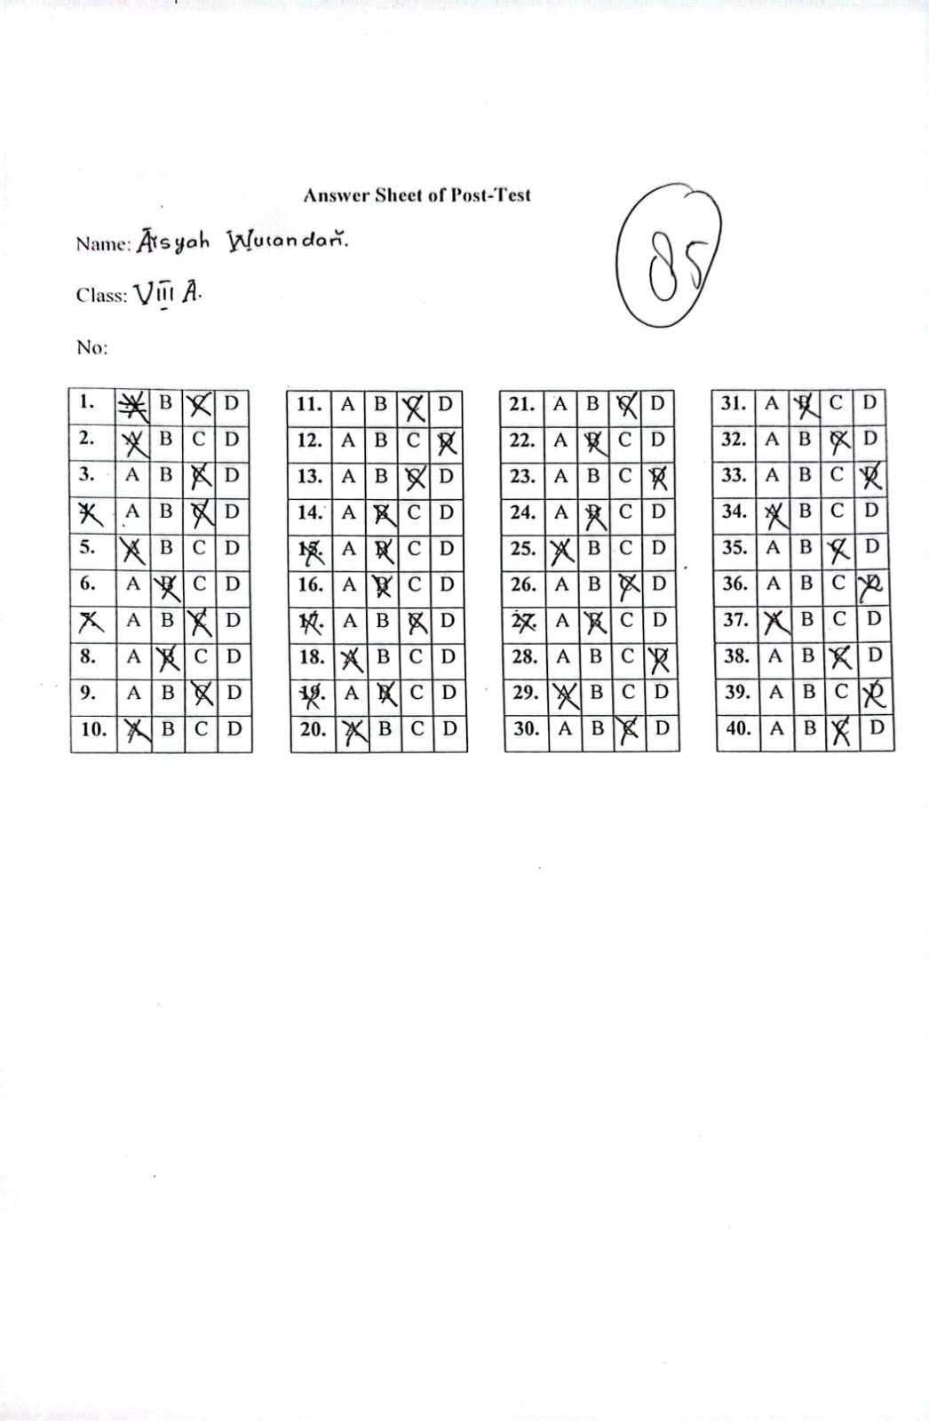

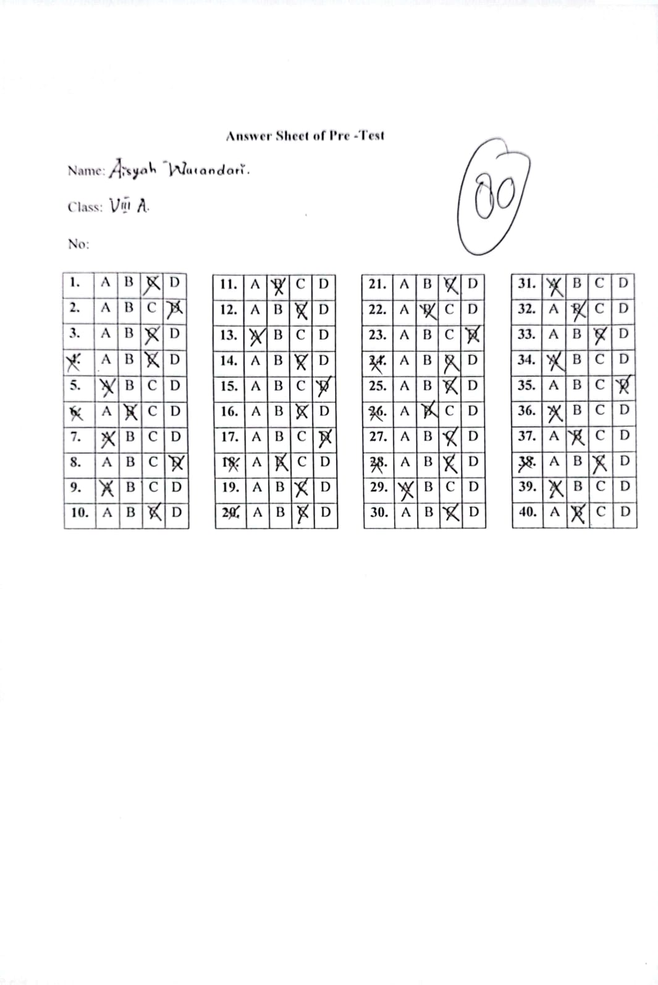

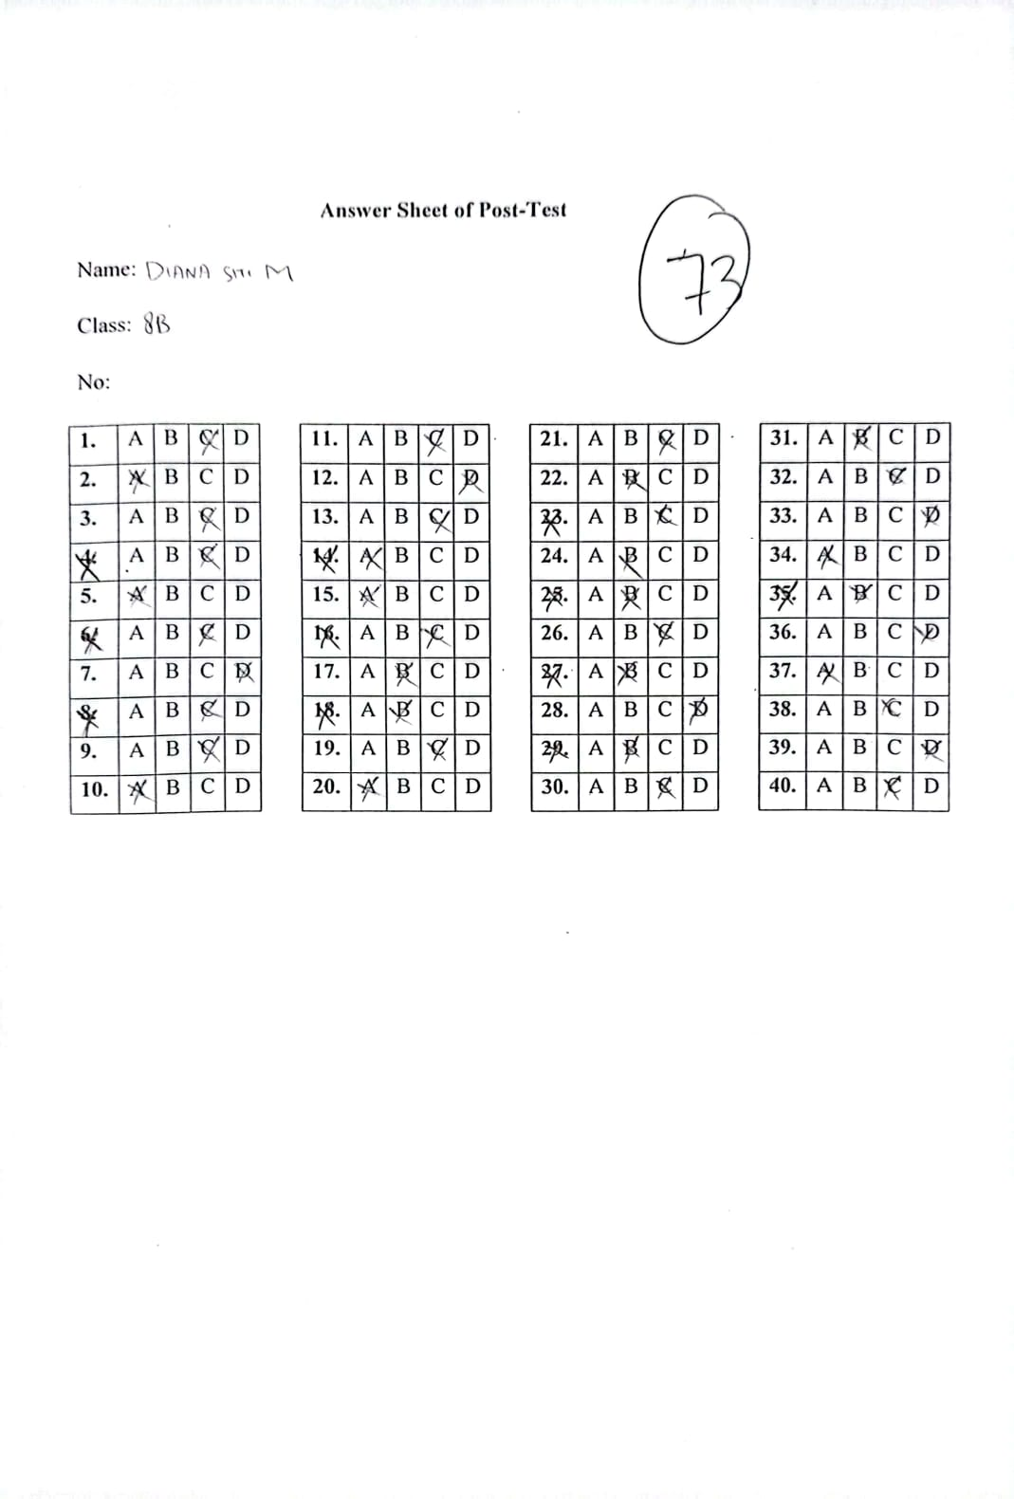

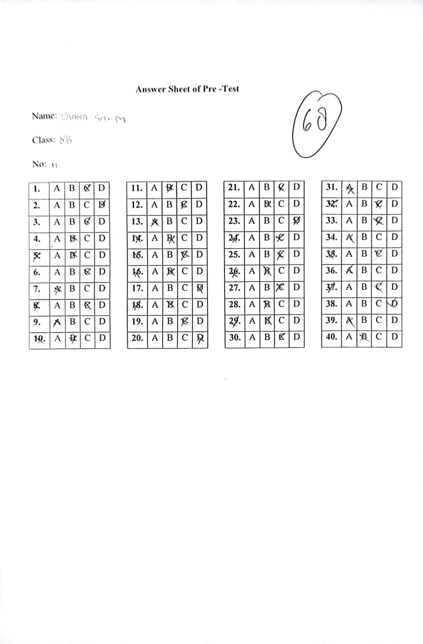

Appendices 7: Syllabus

|  |
| --- |
| **SILABUS** |

|  |  |  |
| --- | --- | --- |
| Satuan Pendidikan | : | SMP N 3 Brebes |
| Mata Pelajaran | : | Bahasa Inggris |
| Kelas/Semester | : | VIII |
| Tahun Pelajaran | : | 2022/2023 |
|  |  |  |

| **Kompetensi Dasar** | **Materi Pemebelajaran** | **Indikator** | **Nilai Karakter** | **Kegiatan Pembelajaran** | **Alokasi Waktu** | **Sumber Belajar** | **Penilaian** |
| --- | --- | --- | --- | --- | --- | --- | --- |
| 3.4 Menerapkan fungsi sosial, struktur teks, dan unsur kebahasaan teks interaksi interpersonal lisan dan tulis yang melibatkan tindakan menyuruh, mengajak, meminta ijin, serta menanggapinya, sesuai dengan konteks penggunaannya | * Fungsi sosial   Menjaga hubungan interpersonal dengan guru dan teman.   * Struktur teks * Memulai * Menanggapi (diharapkan/di luar dugaan) * Unsur Kebahasaan * Ungkapan a.l *let’s ...*, *can you ...*, *would you like ...*, *may I*, *please*. * Nomina singular dan plural dengan atau tanpa *a, the, this, those, my, their*, dsb. * Ucapan, tekanan kata, intonasi, ejaan, tanda baca, dan tulisan tangan * Topik   Interaksi antara guru dan peserta didk di dalam dan di luar kelas yang melibatkan tindakan menyuruh, mengajak, meminta ijin yang dapat menumbuhkan perilaku yang termuat di KI | * Mengidentifikasi ungkapan yang digunakan untuk ungkapan menyuruh dalam bahasa Inggris * Mengidentifikasi ungkapan yang digunakan untuk mengajak * Mengidentifikasi ungkapan yang digunakan untuk meminta ijin dalam bahasa Inggris | * + Religius   + Mandiri   + Gotong royong   + Kejujuran   + Kerja keras   + Percaya diri   + Kerja sama | * Menyimak, menirukan, dan memperagakan beberapa contoh percakapan, dengan ucapan dan tekanan kata yang benar * Mengidentifikasi ungkapan yang sedang dipelajari * Menanyakan hal-hal yang tidak diketahui atau yang berbeda * Menentukan ungkapan yang tepat secara lisan/tulis dari berbagai situasi lain yang serupa * Membiasakan menerapkan yang sedang dipelajari dalam interaksi dengan guru dan teman secara alami di dalam dan di luar kelas * Melakukan refleksi tentang proses dan hasil belajar | 12 JP | * Buku Penunjang Kurikulum 2013 Mata Pelajaran Bahasa Inggris When English Rings The Bell, Kelas VIII, Kemendikbud, Revisi * Kamus Bahasa Inggris * Pengalaman peserta didik dan guru | * + Lisan   + Tertulis   + Penugasan   + Unjukkerja   + Portofolio |
| 4.4 Menyusun teks interaksi interpersonal lisan dan tulis sangat pendek dan sederhana yang melibatkan tindakan menyuruh, mengajak, meminta ijin, dan menanggapinya dengan memperhatikan fungsi sosial, struktur teks, dan unsur kebahasaan yang benar dan sesuai konteks | * Melakukan tindak tutur menyuruh dalam bahasa inggris dengan percaya diri * Melakukan tindak tutur ungkapan mengajak dalam bahasa inggris dengan percaya diri * Melakukan percakapan interpersonal dengan menggunakan ungkapan meminta ijin melalui kegiatan terintegrasi menyimak, membaca, berbicara dan menulis dengan percaya diri | * + Religius   + Mandiri   + Gotong royong   + Kejujuran   + Kerja keras   + Percaya diri   + Kerja sama | * + Lisan   + Tertulis   + Penugasan   + Unjukkerja   + Portofolio |
| 3.5 Membandingkan fungsi sosial, struktur teks, dan unsur kebahasaan beberapa teks khusus dalam bentuk greeting card, dengan memberi dan meminta informasi terkait dengan hari-hari spesial, sesuai dengan konteks penggunaannya | * Fungsi sosial   Menjaga hubungan interpersonal dengan guru dan teman.   * Struktur Teks   Teks *greeting card* dapat mencakup   * Identifikasi (nama peristiwa, hari istimewa) bersifat khusus * Ungkapan khusus yang relevan * Gambar, hiasan, komposisi warna * Unsur Kebahasaan * Ungkapan a.l. *Congratulations. Well done. Good job.*, dll. * Ucapan, tekanan kata, intonasi, ejaan, tanda baca, dan tulisan tangan * Topik   Peristiwa, peringatan ulang tahun, naik kelas, kejuaraan dsb. yang dapat menumbuhkan perilaku yang termuat di KI | * Mengidentifikasi perbedaan dan persamaan dari beberapa greeting card untuk hari spesial tertentu * Mengidentifikasi ucapan selamat yang ada dengan ucapan dan tekanan kata yang benar * Mengidentifikasi perbedaan dan persamaan dari beberapa greeting card untuk event lain | * + Religius   + Mandiri   + Gotong royong   + Kejujuran   + Kerja keras   + Percaya diri   + Kerja sama | * Mencermati dan menemukan perbedaan dan persamaan dari beberapa *greeting card* untuk hari spesial tertentu * Mengidentifikasi dan menyebutkan ucapan selamat yang ada dengan ucapan dan tekanan kata yang benar * Mencermati dan menemukan perbedaan dan persamaan dari beberapa *greeting card* untuk event lain * Mengidentifikasi perbedaan dan persamaan, dan memberikan penilaiannya * Membuat *greeting card* terkait hari istimewa yang relevan dengan peserta didik saat itu. * Melakukan refleksi tentang proses dan hasil belajarnya | 12 JP | * Buku Penunjang Kurikulum 2013 Mata Pelajaran Bahasa Inggris When English Rings The Bell, Kelas VIII, Kemendikbud, Revisi * Kamus Bahasa Inggris * Pengalaman peserta didik dan guru | * + Lisan   + Tertulis   + Penugasan   + Unjukkerja   + Portofolio |
| 4.5 Menyusun teks khusus dalam bentuk greeting card, sangat pendek dan sederhana, terkait hari-hari spesial dengan memperhatikan fungsi sosial, struktur teks, dan unsur kebahasaan, secara benar dan sesuai konteks | * Membuat greeting card terkait hari istimewa yang relevan dengan peserta didik saat itu. * Menyajikan penilaian dari hasil identifikasi perbedaan dan persamaan greeting card | * + Religius   + Mandiri   + Gotong royong   + Kejujuran   + Kerja keras   + Percaya diri   + Kerja sama | * + Lisan   + Tertulis   + Penugasan   + Unjukkerja   + Portofolio |
| 3.11 Membandingkan fungsi sosial, struktur teks, dan unsur kebahasaan beberapa teks personal recount lisan dan tulis dengan memberi dan meminta informasi terkait pengalaman pribadi di waktu lampau, pendek dan sederhana, sesuai dengan konteks penggunaannya | * Fungsi sosial   Melaporkan, mengambil teladan, membanggakan   * Struktur teks   Dapat mencakup   * orientasi * urutan kejadian/kegiatan * orientasi ulang * Unsur kebahasaan * Kalimat deklaratif dan interogatif dalam *Simple Past tense* * Adverbia dan frasa preposisional penujuk waktu: *yesterday*, *last month, an hour ago*, dan sebagainya. * Adverbia penghubung waktu: *first, then, after that, before, at last, finally*, dan sebagainya. * Nomina singular dan plural dengan atau tanpa *a, the, this, those, my, their*, dsb. * Ucapan, tekanan kata, intonasi, ejaan, tanda baca, dan tulisan tangan * Topik   Peristiwa, pengalaman yang terjadi di sekolah, rumah, dan yang dapat menumbuhkan perilaku yang termuat di KI | * Mengidentifikasi teks recount tentang pengalaman pribadi seseorang * Menceritakan kejadian, kegiatan yang dialami secara kronologis * Menggunakan bagan alir untuk mempelajari alur cerita * Melengkapi ringkasan pengalaman dengan kalimat-kalimat yang diambil teks, dengan ejaan dan tanda baca yang benar | * + Religius   + Mandiri   + Gotong royong   + Kejujuran   + Kerja keras   + Percaya diri   + Kerja sama | * Menyimak guru membaca beberapa teks *recount* tentang pengalaman pribadi seseorang * Bertanya jawab tentang kejadian, kegiatan yang dialami secara kronologis * Menggunakan bagan alir untuk mempelajari alur cerita * Didektekan guru, menuliskan teks-teks pendek tersebut dengan tulisan tangan. * Melengkapi ringkasan pengalaman tsb. dengan kalimat-kalimat yang diambil teks, dengan ejaan dan tanda baca yang benar * Mengumpulkan informasi tentang pengalaman pribadi di waktu lampau untuk membuat teks-teks pendek dan sederhana * Saling mempresentasikan, menyimak dan bertanya jawab tentang teks masing-masing dengan teman-temannya, secara lisan, dengan ucapan dan tekanan kata yang benar * Melakukan refleksi tentang proses dan hasil belajarnya | 20 JP | * Buku Penunjang Kurikulum 2013 Mata Pelajaran Bahasa Inggris When English Rings The Bell, Kelas VIII, Kemendikbud, Revisi * Kamus Bahasa Inggris * Pengalaman peserta didik dan guru | * + Lisan   + Tertulis   + Penugasan   + Unjukkerja   + Portofolio |
| 4.11. Teks recount  4.11.1 Menangkap makna secara kontekstual terkait fungsi sosial, struktur teks, dan unsur kebahasaan teks recount lisan dan tulis, sangat pendek dan sederhana, terkait pengalaman pribadi di waktu lampau (*personal recount*)  4.11.2 Menyusun teks recount lisan dan tulis, sangat pendek dan sederhana, terkait pengalaman pribadi di waktu lampau (*personal recount*), dengan memperhatikan fungsi sosial, struktur teks, dan unsur kebahasaan, secara benar dan sesuai konteks | * Menuliskan teks-teks pendek dengan tulisan tangan tentang pengalaman pribadi yang didektekan oleh guru * Membuat teks-teks pendek dan sederhana tentang pengalaman pribadi di waktu lampau * Mempresentasikan teks masing-masing dengan teman-temannya, secara lisan, dengan ucapan dan tekanan kata yang benar | * + Religius   + Mandiri   + Gotong royong   + Kejujuran   + Kerja keras   + Percaya diri   + Kerja sama | * + Lisan   + Tertulis   + Penugasan   + Unjukkerja   + Portofolio |

Appendices 8: Lesson Plan

|  |
| --- |
| **RENCANA PELAKSANAAN PEMBELAJARAN** |

**Sekolah** : SMP Negeri 3 Brebes

**Mata Pelajaran** : Bahasa Inggris

**Kelas/semester** : VIII/Dua

**Materi** : Recount Text

**Alokasi Waktu** : 4 x 2 JP (4x meeting)

**A.Kompetensi Dasar dan Indikator Pencapaian**

|  |  |  |  |  |
| --- | --- | --- | --- | --- |
| No. | Kompetensi Dasar | | Indikator Pencapaian Kompetensi | |
| 1.  2. | 3.11  4.11 | Membandingkan fungsi sosial, struktur teks, dan unsur kebahasaan beberapa teks personal recount lisan dan meminta informasi terkait pengalaman pribadi di waktu lampau, pendek dan sederhana, sesuai dengan konteks penggunaannya  Menangkap makna secara kontekstual terkait fungsi sosial, struktur teks, dan unsur kebahasaan teks personal recount, lisan dan tulis, sangat pendek dan sederhana, sesuai dengan konteks penggunaanya | 3.11.1  3.11.2  3.11.3  4.11.1 | Mendeskripsikan fungsi sosial dari teks personal recount  Menentukan struktur teks dari teks personal recount  Menganalisis unsur kebahasaan dari teks personal recount  Merumuskan makna secara kontektual dari teks personal recount dalam bentuk paragraf sederhana. |
|  | | | | |

**B. Tujuan Pembelajaran**

* Melalui kegiatan mengamati text peserta didik dapat mengidentifikasikan fungsi sosial, struktur, dan unsur kebahasaan pada *Recount Text* secara benar.
* Peserta didik mampu memahami Text Recount secara rinci sesuai bagian setiap paragraf pada Recount Text.
* Peserta didik mampu membuat atau menuliskan contoh *Recount Text* sesuai dengan materi yang telah disampaikan.

**C. Materi**

* Definisi Recount Text

Recount text is a text that tells the reader about one story, action or activity. Its purpose is to entertain or inform the reader. Or a text which retells events or experiences in the past.

(Recount text adalah sebuah teks yang menceritakan kembali peristiwa atau aktivitas yang terjadi di masa lampau yang pernah dialami sebelumnya. Lalu," tujuan dari Recount text itu sendiri adalah untuk menghibur atau memberi informasi kepada pembaca." (the purpose of the Recount text itself is to entertain or provide information to the reader.)

* Ciri-Ciri Recount Text

Memiliki judul yang merangkum teks. Contohnya 'My Vacation to Bali' maka ceritanya hanya akan menceritakan seluruh liburan saat berada di bali

Menceritakan peristiwa yang sudah terjadi di masa lampau. Maka Recount text selalu menggunakan past tense, contohnya 'Last month, I went to Bali with my family.

Semua kejadian yang diceritakan harus secara berurutan. Jadi, harus memakai kata sambung seperti 'when', 'later', 'then', 'after', 'before', dan lain lain.

* Generic Structure dari Recount Text

Generic structure atau struktur kebahasaan dari Recount Text ini terbagi kedalam 3 susunan, yaitu :

* Orientation

Bagian untuk menjelaskan tentang tokoh, tempat, dan waktu

* Events

Bagian untuk menjelaskan rangkaian kejadian yang terjadi di masa lampau atau biasa disebut kronologi

* Re-orientation

Bagian Re-orientation berisi kesimpulan dari isi cerita, atau bisa juga merupakan pendapat pribadi dari si pencerita. Re-orientation ini bisa disebut juga akhir atau penutup dari cerita.

* Unsur kebahasaan
* Menggunakan Simple Past tense karena menceritakan kejadian yang sudah berlalu.
* Menggunakan sequence words untuk menandakan cerita yang berurutan, misalnya first, next, then, finally. Jika tidak menggunakan kata-kata tersebut, bisa juga menggunakan tahun sebagai keterangan waktu.
* Ada proper noun, yaitu kata benda yang ditulis dengan awalan huruf kapital, misalnya Surabaya, Medan dll.
* Example of Recount Text

Unforgettable Memories

My name is Risa, l'am the second grade student of junior high school. My family and I went to my grandmother's house in Cirebon 1 week ago. We went there to visited my Uncle's and Aunty's wedding party. We arrived in Cirebon at night.

The first morning, we were still too tired after the long journey from Brebes to Cirebon. So we decided to stay home to recharge our energy. I walked around the neighborhood with my sister just to experience what it was like to be in Cirebon.

On the second day, we saw a lot of invited guests who came. Then we enjoyed the dishes available at the table, and we all the food there.

On the third day, we all went to the Tirta Indah swimming pool which is not far from Grandma's house. Then after swimming, we decided to go to CSB mall to shoping and dinner together.

We spent our holidays walking around the city of Cirebon. We realized that the city of Cirebon is very famous and there are so many culinary delights there, one of the reasons why we decided to spend a few days after the wedding was over.

**D. Metode Pembelajaran**

* Pendekatan Scientific
* Strategy PQ4R

**E. Media pembelajaran**

* Sumber : Buku Bahasa Inggris for SMP
* Media : Laptop
* Alat : Whiteboard and Marker

**F. Kegiatan Pembelajaran**

**a. Pertemuan Pertama**

|  |  |  |  |
| --- | --- | --- | --- |
| **Kegiatan** | **Guru** | **Siswa** | **Alokasi** |
| **Awal** | * Guru memberi salam * Guru dan siswa berdoa * Guru mengecek kehadiran siswa * Guru memberi apresiasi denga sebuah cerita dan pertanyaan | * Siswa memberi salam * Siswa dan guru berdoa * Siswa mendengarkan dengan baik * Siswa menjawa pertanyaan dari guru | **10 menit** |
| **Inti** | **Observing**   * Guru memberikan materi recount text * Guru membimbing siswa untuk membaca kalimat dalam recount text tersebut   **Quetioning**   * Guru membimbing siswa untuk bertanya mengenai materi   **Collecting information**   * Guru memberikan tugas recount text yang ada di modul * Guru membimbing siwa dalam memahami dan mengerjakan soal   **Associating**   * Guru meminta siswa untuk menganalisis teks recount text yang ada di modul   **Communication**   * Guru meminta siswa untuk memeriksa pekerjaannya Bersama sama * Guru memperhatian analisis yang sudah ditulis oleh siswa | **Observing**   * Siswa mengmati dengan baik * Siswa berlatih membaca dalam teks tersebut   **Questioning**   * Siswa menanyaka hal yang terkait materi   **Collecting information**   * Siswa mengerjakan tugas yang diberikan oleh guru * Siswa memperhatikan dengan baik   **Associating**   * Siswa menganalisis sesuai arahan dari guru   **Communication**   * Siswa memeriksa pekerjaan secara Bersama sama * Siswa memperhatikan dengan baik | **60 menit** |
| **Akhir** | * Guru meminta siswa menyimpulkan apa saja yang telah dipelajari * Guru dana siswa berdoa sebelum meninggalkan kelas * Guru dan siswa mengucapkan salam perpisahan | * Siswa menyimpulkan apa saja yang telah dipelajari pada hari ini * Siswa berdoa sebelum meninggalkan kelas * Siswa mengucapkan salam perpisahan | **10 menit** |

**b. Pertemuan Ke 2**

|  |  |  |  |
| --- | --- | --- | --- |
| **Kegiatan** | **Guru** | **Siswa** | **Alokasi** |
| **Awal** | * Guru memberi salam * Guru dan siswa berdoa * Guru mengecek kehadiran siswa * Guru memberi apresiasi denga sebuah cerita dan pertanyaan | * Siswa memberi salam * Siswa dan guru berdoa * Siswa mendengarkan dengan baik * Siswa menjawa pertanyaan dari guru | **10 menit** |
| **Inti** | **Observing**   * Guru menjelaskan ulang materi recount text * Guru memberikan contoh recount text   **Questening**   * Guru membimbing siswa untuk bertanya mengenai materi   **Collecting Information**   * Guru memberikan uraian lebih tentang materi * guru membimbing siswa dalam memahami materi   **Associating**   * guru memberikan soal materi belajar * guru meminta siswa untuk mengerjakan soal latihan   **Communicating**   * guru meminta siswa untuk menukarkan pekerjaannya dengan siswa yang lain | **Observing**   * Siswa mendengrkan apa yang dojelaskan oleh guru * Siswa mengamati yang dicontohkan   **Questening**   * Siswa menanyakan hal yang terkait materi   **Collecting information**   * Siswa mendengarkan dengan baik * Siswa memperhatikan dengan baik * Siswa memperhatikan dengan baik   **Associating**   * Siswa menulis soal materi * Siswa mendengarkan dengan baik dari arhan guru   **Communicating**   * Siswa menukarkan pekerjaannya dengan teman yang lain * Siswa memeriksa pekerjaan temannya | **60 menit** |
| **Akhir** | * Guru meminta siswa menyimpulkan apa saja yang telah dipelajari * Guru dan siswa berdoa sebelum meninggalkan kelas * Guru dan siswa mengucapkan salam perpisahan | * Siswa menyimpulkan apa saja yang telah dipelajari pada hari ini * Siswa berdoa sebelum meninggalkan kelas * Siswa mengucapkan salam perpisahan | **10 menit** |

**c. Pertemuan Ke 3**

|  |  |  |  |
| --- | --- | --- | --- |
| **Kegiatan** | **Guru** | **Siswa** | **Alokasi** |
| **Awal** | * Guru memberi salam * Guru dan siswa berdoa * Guru mengecek kehadiran siswa * Guru memberi apresiasi denga sebuah cerita dan pertanyaan | * Siswa memberi salam * Siswa dan guru berdoa * Siswa mendengarkan dengan baik * Siswa menjawa pertanyaan dari guru | **10 menit** |
| **Inti** | **Observing**   * Guru menjelaskan strategy PQ4R * Guru memberikan contoh PQ4R * Guru menjelaskan materi recount text   **Questening**   * Guru membimbing siswa untuk bertanya mengenai materi   **Collecting Information**   * Guru memberikan uraian lebih tentang materi * guru membimbing siswa dalam memahami materi   **Associating**   * Guru meminta siswa untuk menganalisis teks recount text yang ada di modul dengan Langkah-langkah PQ4R   **Communicating**   * guru meminta siswa untuk menukarkan pekerjaannya dengan siswa yang lain | **Observing**   * Siswa mendengrkan apa yang dojelaskan oleh guru * Siswa mengamati yang dicontohkan * Siswa mendengarkan dengan baik   **Questening**   * Siswa menanyakan hal yang terkait materi   **Collecting information**   * Siswa mendengarkan dengan baik * Siswa memperhatikan dengan baik * Siswa memperhatikan dengan baik   **Associating**   * Siswa mendengarkan dengan baik dari arhan guru   **Communicating**   * Siswa menukarkan pekerjaannya dengan teman yang lain * Siswa memeriksa pekerjaan temannya | **60 menit** |
| **Akhir** | * Guru meminta siswa menyimpulkan apa saja yang telah dipelajari * Guru dan siswa berdoa sebelum meninggalkan kelas * Guru dan siswa mengucapkan salam perpisahan | * Siswa menyimpulkan apa saja yang telah dipelajari pada hari ini * Siswa berdoa sebelum meninggalkan kelas * Siswa mengucapkan salam perpisahan | **10 menit** |

**d. Pertemuan Ke 4**

|  |  |  |  |
| --- | --- | --- | --- |
| **Kegiatan** | **Guru** | **Siswa** | **Alokasi** |
| **Awal** | * Guru memberi salam * Guru dan siswa berdoa * Guru mengeecek kehadiran siswa * Guru memberi apresiasi denga sebuah cerita dan pertanyaan | * Siswa memberi salam * Siswa dan guru berdoa * Siswa mendengarkan dengan baik * Siswa menjawa pertanyaan dari guru | **10 menit** |
| **Inti** | **Observing**   * Guru membrikan contoh PQ4R dalam recount text di modul * Guru membimbing siswa untuk membaca dan memahami yang ada dimodul * Guru mengulang penjelasan mengenai langkah langkah penerapan PQ4R   **Questening**   * Guru membimbing siswa untuk bertanya mengenai strategy PQ4R   **Collecting Information**   * Guru memberikan uraian lebih tentang strategy PQ4R * guru membimbing siswa dalam memahami langkah langkahnya.   **Associating**   * guru memberikan Kalimat yang akan dijabarkan mengunakan strategy PQ4R * guru meminta siswa untuk mengerjakannya secara mandiri   **Communicating**   * Guru meminta siswa untuk mengumpulkan pekerjaannya | **Observing**   * Siswa mengamati dengan baik * Siswa berlatih membaca dan memahami kata yang ada dimodul * Siswa mendengarkan dengan baik   **Questening**   * Siswa menanyakan hal yang terkait strategy tersebut   **Collecting information**   * Siswa mendengarkan dengan baik * Siswa memperhatikan dengan baik   **Associating**   * Siswa mendengarkan dengan baik dari arahan guru   **Communicating**   * Siswa mengumpuokan pekerjaannya ke pada guru | **60 menit** |
| **Akhir** | * Guru meminta siswa menyimpulkan apa saja yang telah dipelajari * Guru dana siswa berdoa sebelum meninggalkan kelas * Guru dan siswa mengucapkan salam perpisahan | * Siswa menyimpulkan apa saja yang telah dipelajari pada hari ini * Siswa berdoa sebelum meninggalkan kelas * Siswa mengucapkan salam perpisahan | **10 menit** |

Appendices 9: Research Permit

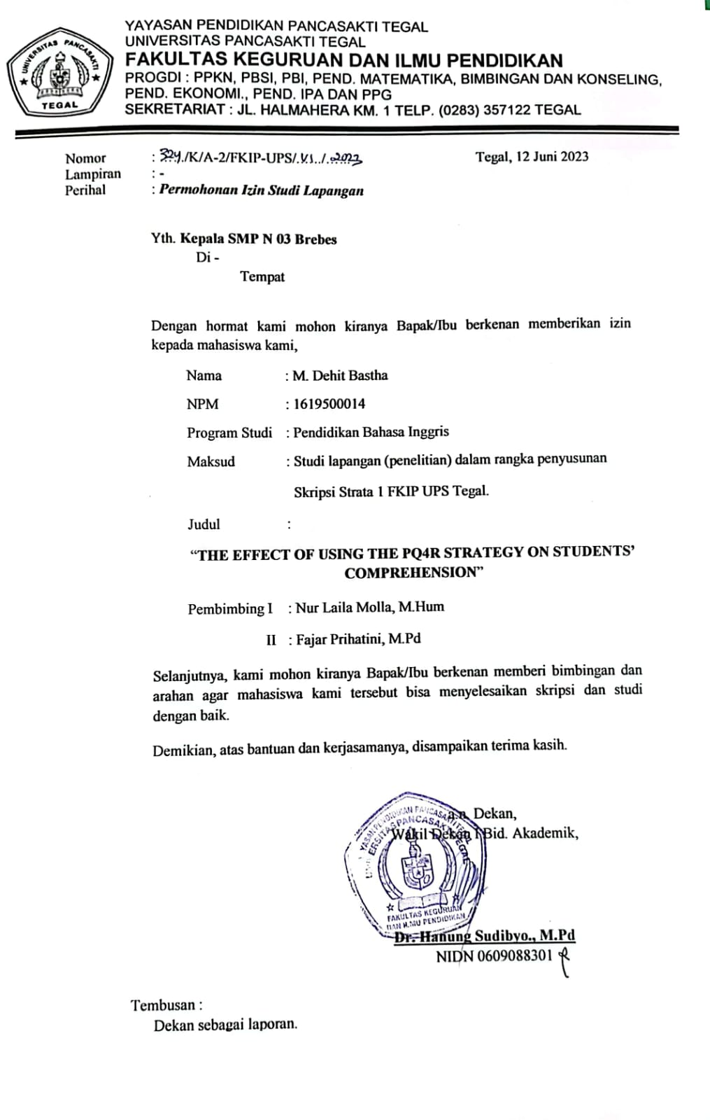

Appendices 10: Observation Permit

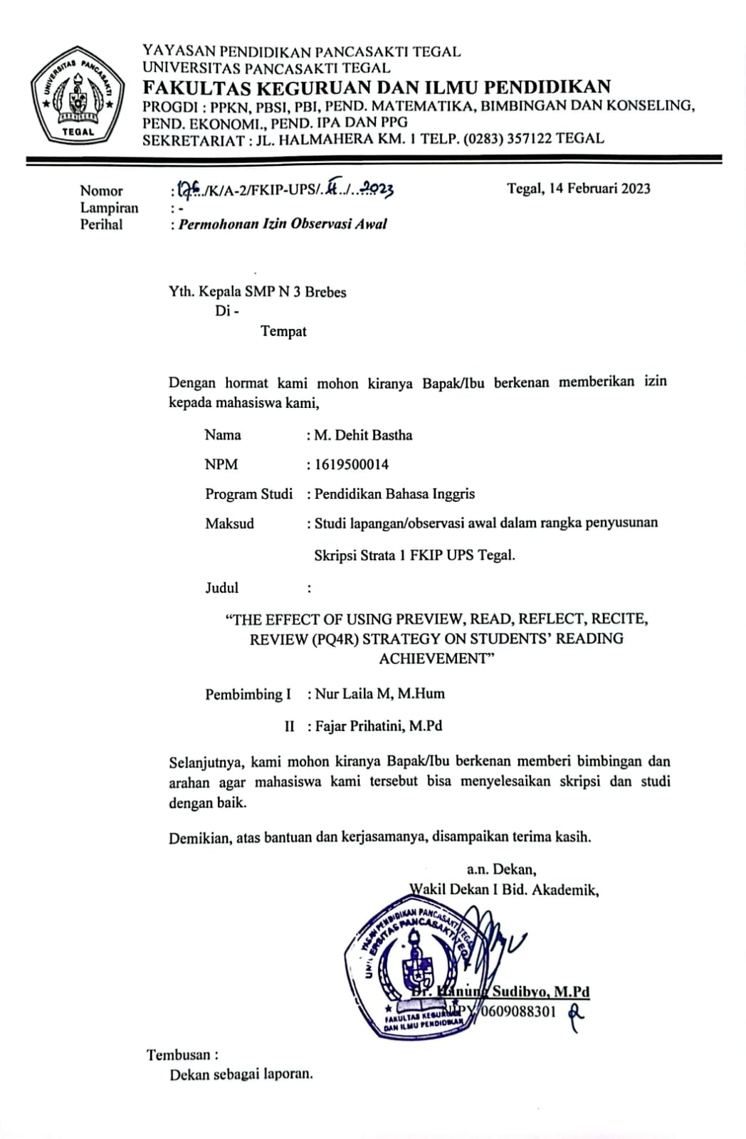

Appendices 11: Request data of the purposes of thesis

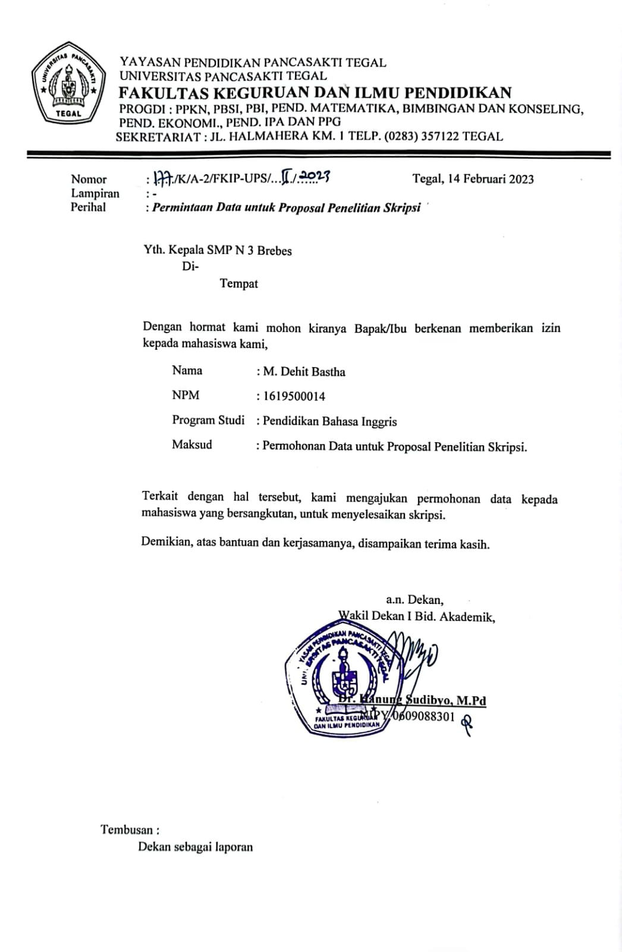

Appendices 12: Research completion information

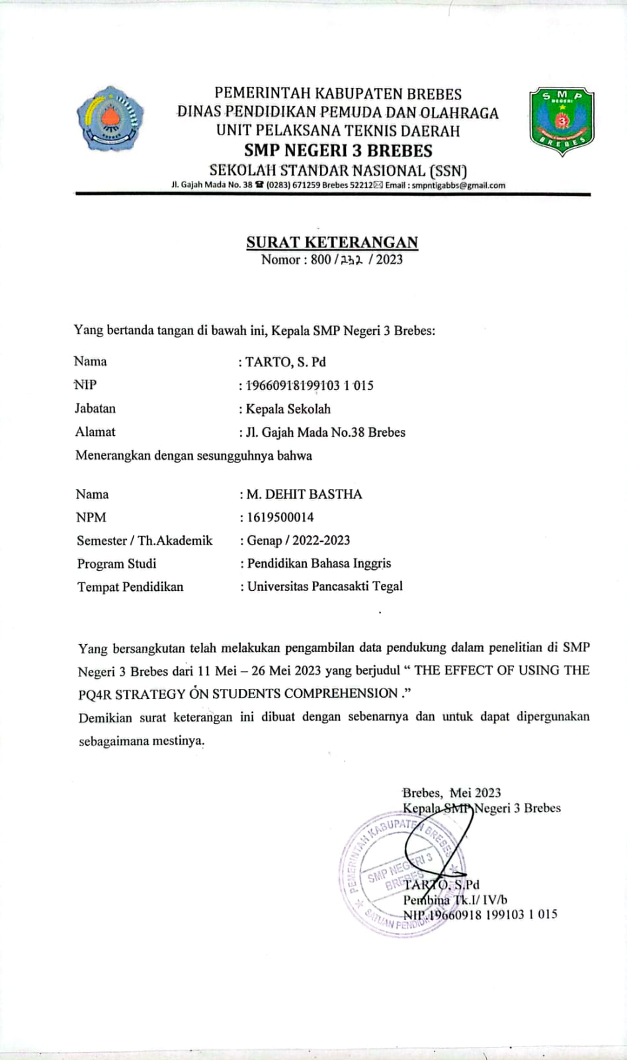

Appendices 13: Minutes of thesis examination

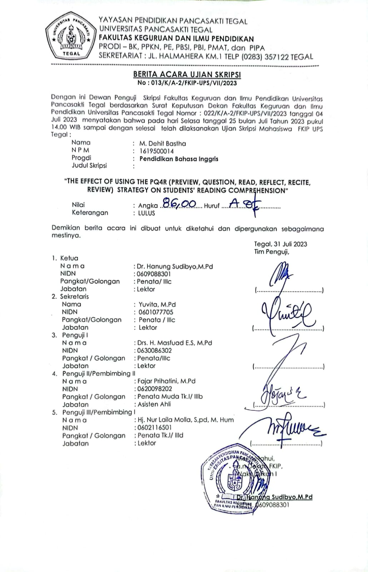

Appendices 14: Minutes of Thesis Guidance

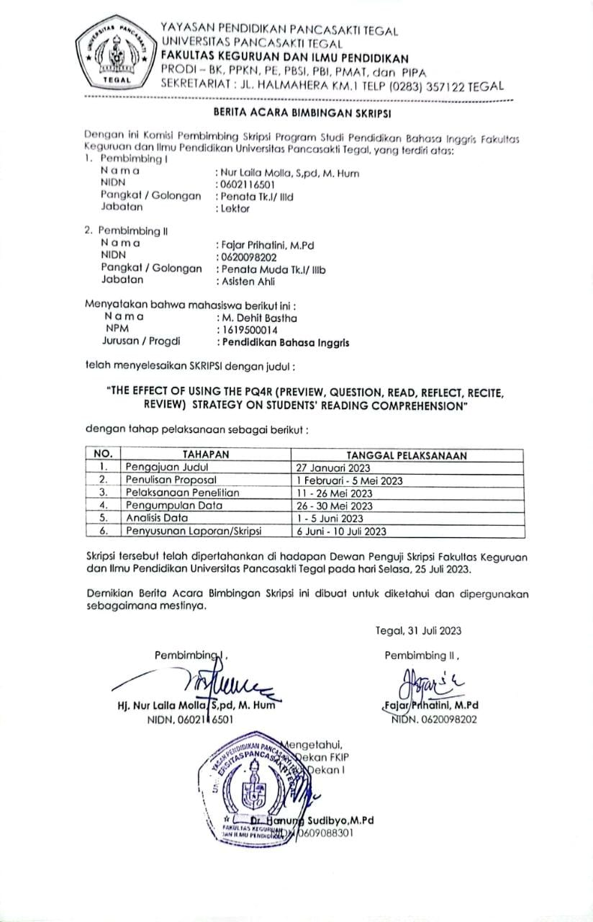

Appendices 15: Similarity

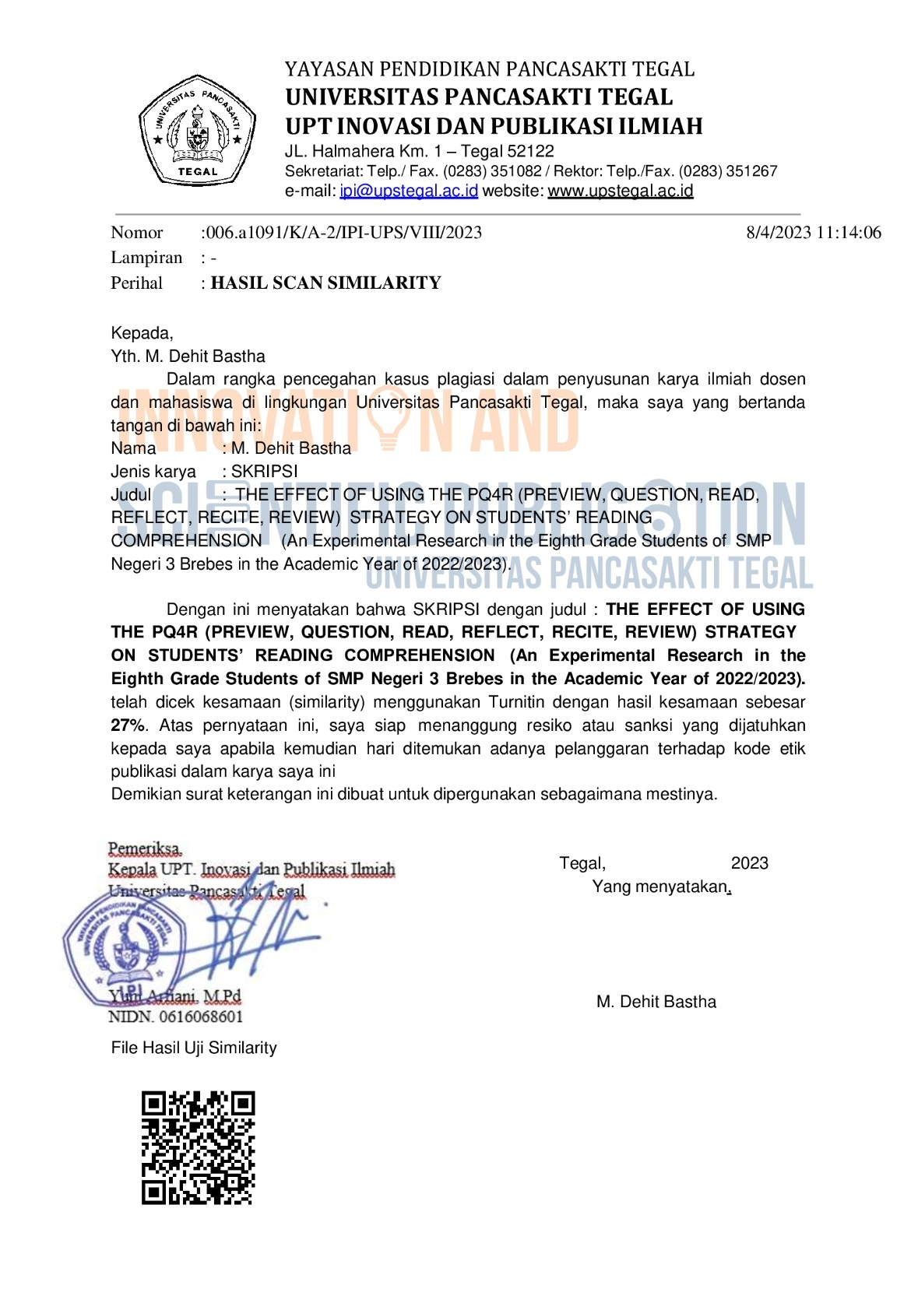

Appendices 16: Documentation

|  |  |
| --- | --- |
|  |  |
|  |  |
|  |  |

|  |  |
| --- | --- |
|  |  |
|  |  |
|  | |
|  |  |