Afyudin, O. A., Rizal, A., Zain, K., & Handriani, F. D. (2015). Pengaruh Phase Change Material Berbahan Dasar Minyak Kelapa dan Minyak Sawit sebagai Pre-Cooling Device terhadap Penurunan Heat Strain ketika Melakukan Aktivitas Fisik di Lingkungan Panas. Seminar Nasional Teknik Industri Universitas Gadjah Mada, 41–46.

Ali, M. A., Fayaz, Viegas, R. F., Shyam Kumar, M. B., Kannapiran, R. K., & Feroskhan, M. (2019). Enhancement of heat transfer in paraffin wax PCM using nano graphene composite for industrial helmets. Journal of Energy Storage, 26. https://doi.org/10.1016/j.est.2019.100982

Dwi Murtyas, S., Cholida, S. N., & Ridwan3, M. K. (n.d.). PEMODELAN PHASE CHANGE MATERIALS PADA DISTRIBUSI TERMAL
SELUBUNG BANGUNAN HOTEL. In Journal of Mechanical Engineering
(Vol. 2, Issue 1).

Grosu, Y., Zhao, Y., Giacomello, A., Meloni, S., Dauvergne, J. L., Nikulin, A., Palomo, E., Ding, Y., & Faik, A. (2020). Hierarchical macro-nanoporous metals for leakage-freeygrosu@cicenergigune.com high-thermal conductivity shape-stabilized phase change materials. Applied Energy, 269. https://doi.org/10.1016/j.apenergy.2020.115088

Hikma, N., Jurusan, S., Fakultas, F., Dan Ilmu, M., Alam, P., & Riau, U. (2020).
Air Conditioning di Kota Pekanbaru. 5(September), 15–17.

Ismail, F. I., Farhan, S. A., Shafiq, N., Husna, N., Sharif, M. T., Affan, S. U., & Veerasenan, A. K. (2021). Nano-porous silica-aerogel-incorporated composite materials for thermal-energy-efficient pitched roof in the tropical region. Applied Sciences (Switzerland), 11(13). https://doi.org/10.3390/app11136081

Kabeel, A. E., & Abdelgaied, M. (2016). Improving the performance of solar still by using PCM as a thermal storage medium under Egyptian conditions. Desalination, 383. https://doi.org/10.1016/j.desal.2016.01.006

Li, J., Liao, Y., Li, S., Yang, X., & Jiao, N. (2022). Thermal properties of the three-dimensional graphene/paraffin nanocomposite phase change materials. E3S Web of Conferences, 341, 01005.
https://doi.org/10.1051/e3sconf/202234101005

77

Prianto, G. O., Amaliyah, A., & ... (2021). Analisis Pemanfaatan Parafin Di Thermal Energy Storage Pada Solar Water Heater. EProceedings …, 8(5), 5605–5612.
https://openlibrarypublications.telkomuniversity.ac.id/index.php/engineering/ article/view/15989%0Ahttps://openlibrarypublications.telkomuniversity.ac.id
/index.php/engineering/article/view/15989/15701

Saha, D., Kim, M. B., Robinson, A. J., Babarao, R., & Thallapally, P. K. (2021). Elucidating the mechanisms of Paraffin-Olefin separations using nanoporous adsorbents: An overview. IScience, 24(9), 103042.
https://doi.org/10.1016/j.isci.2021.103042

Schick, C. (2009). Differential scanning calorimetry (DSC) of semicrystalline polymers. Analytical and Bioanalytical Chemistry, 395(6), 1589–1611. https://doi.org/10.1007/s00216-009-3169-y

Syuhada, A. (2013). Karakteristik Perpindahan Panas Peleburan Parafin-Al 2 O 3 Sebagai Material Penyimpan Panas. Jurnal Fisika, 12(1), 121–126.

TK, G., & Raj, V. (2018). Use of phase change material (PCM) for the improvement of thermal performance of cold storage. MOJ Current Research & Reviews, 1(2), 49–61. https://doi.org/10.15406/mojcrr.2018.01.00010

Umar, H. (2020). Penggunaan material berubah fasa sebagai penyimpan energi termal pada bangunan gedung. Jurnal Polimesin., 18(2), 105–115.

Utari, E. L., Buyung, I., & Utami, H. M. (2017). PERANCANGAN ALAT PARAFFIN BATH DENGAN KONTROL SUHU SECARA OTOMATIS
BERBASIS ARDUINO UNO Evrita. Jurnal Teknologi, Volume 10, 128– 134.

Yu, X. K., & Tao, Y. B. (2022). Preparation and characterization of paraffin/expanded graphite composite phase change materials with high thermal conductivity. International Journal of Heat and Mass Transfer, 198. https://doi.org/10.1016/j.ijheatmasstransfer.2022.123433

A. Proses Pembuatan Bahan PCM

- Siapkan Material sesuai berat perhitungan nya: Paraffin 55.08 gr

Silica/Aerogel 33.20 ml

Ethyl/Alkohol 60.43 ml

- Siapkan Magnetic StirWith Heater

- Campurkan Paraffin dengan Alkohol Panaskan dengan Temperatur 50℃ dengan Rpm 3000 selama 30 menit.
- Setelah 30 menit, Campurkan Silika Aerogel kedalam Campuran (SA+Ethyl)

dengan Temperatur 65℃ selama 90 Menit.

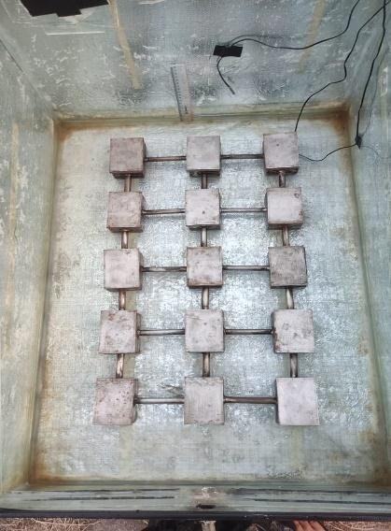
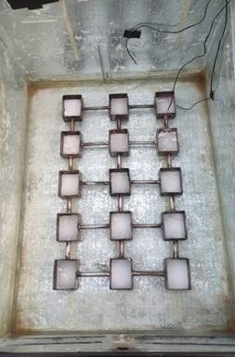
- Setelah 90 menit, Masukan Campuran (SA+Ethyl+Silica Aerogel) kedalam Cetakan.
Gambar PCM pada destilasi air laut Gambar Parafin pada destilasi air laut

79

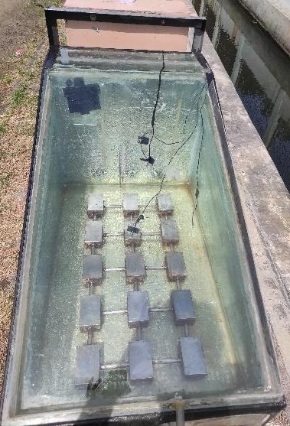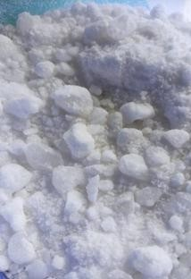

Gambar Destilasi air laut
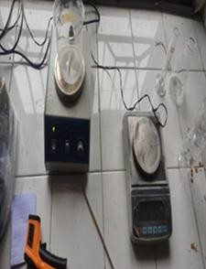

Gambar Timbangan digital
Gambar Material Paraffin
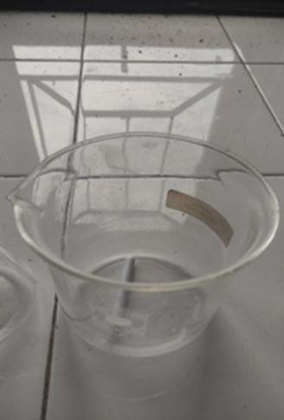

Gambar Gelas Beaker

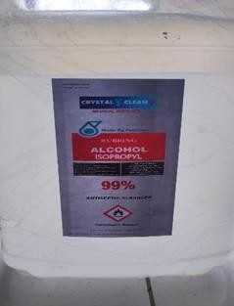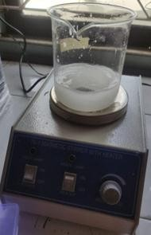

Gambar Alkohol 99 %
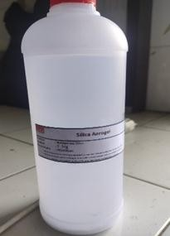

Gambar Silica Aerogel
Gambar Magnetic Sterrer Withheater
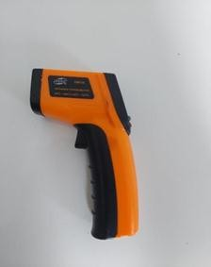

Gambar Termometer Digital Krisbow

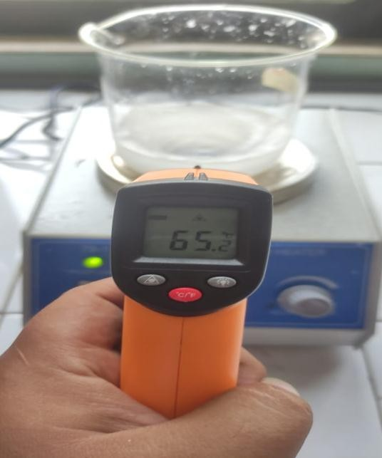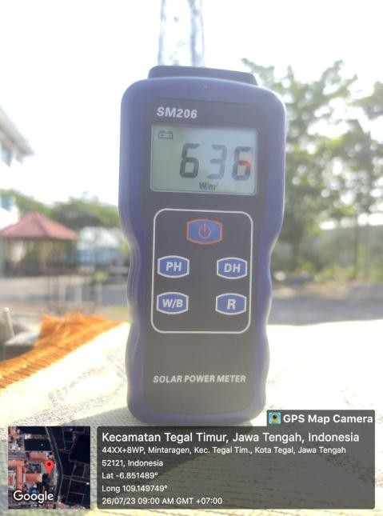

Gambar pengukuran suhu termometer
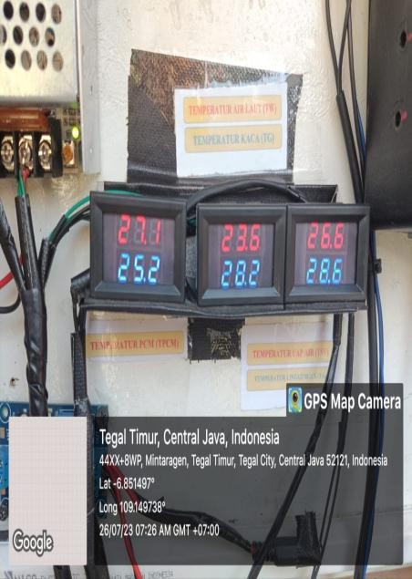

Gambar data temperature suhu
Gambar solar power meter
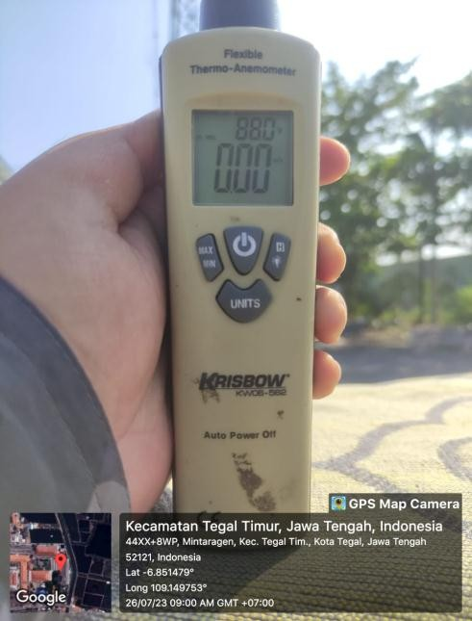

Gambar anometer

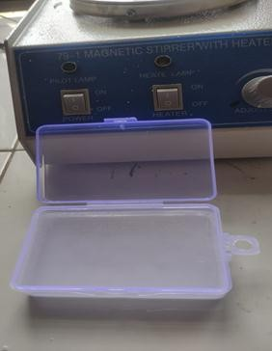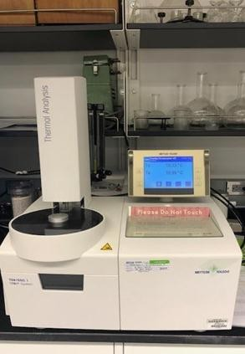

Gambar hasil paraffin campuran
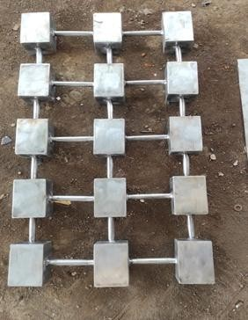

Gambar PCM Storage
Gambar Alat uji SEM
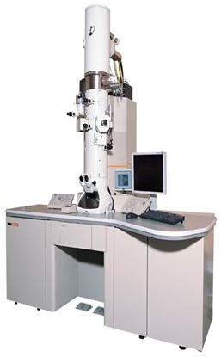

Gambar alat uji tga

