DAFTAR PUSTAKA
Adisaputra, T. F. (2021). Pengaruh Islamic Social Reporting Terhadap Kinerja Keuangan, Zakat Sebagai Intervening Pada Bank Umum Syariah Di Indonesia. Jurnal Masharif Al-Syariah: Jurnal Ekonomi Dan Perbankan Syariah, 6(3), 706.
Andika, & Aldi. (2020, November 25). Kesiapan Perbankan Syariah dalam Menghadapi Resesi. Retrieved from Komite Nasional Ekonomi dan Keuangan Syariah: https://knks.go.id/berita/325/kesiapan-perbankan-syariah-dalam-menghadapi.
Arifin, I. Z., & Marlius, D. (2018). Analisis Kinerja Keuangan Pt . Pegadaian Cabang Ulak Karang. Keuangan Dan Perbankan, 1–10.
Badan Pemeriksa Keuangan. (1998). Undang-Undang Nomor 10 Tahun 1998. Retrieved from https://bpk.go.id/.
Barkhowa, M. K., & Utomo, H. (2019). Pengaruh Identitas Etis Islam Dan Market Share Terhadap Kinerja Keuangan Perbankan Syariah Yang Terdaftar Di Otoritas Jasa Keuangan Indonesia Tahun 2014-2017. Magisma: Jurnal Ilmiah Ekonomi Dan Bisnis, 7(1), 12–18.
Brigham, E. F., & Houston, J. F. (2017). Manajemen Keuangan Edisi 10 (Edisi Indonesia. Jakarta: Salemba Empat.
Cahya, B. T., & Rohman, F. (2019). Evolution of Islamic Social Reporting : Viewed From Islamic Position In The Continuum Social Responsibility. JEBIS : Jurnal Ekonomi dan Bisnis Islam.
Cahya, dkk. (2021). Intellectual Capital, Islamicity Performance Index, dan Kinerja Keuangan Bank Syariah di Indonesia (Studi Pada Tahun 2015-2020). AKTSAR: Jurnal Akuntansi Syariah, 4(2), 155-171.
CNN Indonesia. (2020, Juli 23). Sri Mulyani Taksir Kinerja Bank Syariah Minus karena Corona. Retrieved from CNN Indonesia: https://www.cnnindonesia.com/ekonomi/20200723165152-78-528247/sri-mulyani-taksir-kinerja-bank-syariah-minus-karena-corona
Destiani, N. A., Juliana, & Cakhyaneu, A. (2021). Islamicity Performance Index Dalam Meningkatkan Profitabilitas Bank Syariah Indonesia. Jurnal Ilmiah Manajemen.
Effendi, M. S. (2021). Implikasi Return On Assets (ROA) Perbankan Syariah. Banyumas: CV. Pena Persada.
Fahmi, I. (2018). Analisis Kinerja Keuangan : Panduan Bagi Akademisi, Manajer, dan Investor dan Menganalisis Bisnis dari Aspek Keuangan. Bandung: Alfabeta.
Fanani, B., & Jalil, M. (2013). Pengaruh Pengungkapan Informasi Aktivitas Sosial Perusahaan Terhadap Kinerja Keuangan Perusahaan. Permana : Jurnal Perpajakan, Manajemen, dan Akuntansi, S(1).
Farida, A. (2018). Pengaruh Penerapan Good Corporate Governance dan Pengungkapan Islamic Social Reporting Terhadap Kinerja Keuangan Perbankan Syariah di Indonesia. Malia: Jurnal Ekonomi Islam, 10(1), 31-42.
Fatmala, K., & Wirman, W. (2021). Pengaruh Islamicity Performance Index Dan Islamic Social Reporting Terhadap Kinerja Keuangan Perbankan Syariah Di Indonesia. Invoice : Jurnal Ilmu Akuntansi, 3(1), 30–43.
Fatmasari, R., & Kholmi, M. (2018). analisis kinerja keuangan perbankan syariah dengan pendekatan islamicity performance index pada perbankan syariah di Indonesia. Jurnal Akademi Akuntansi, 1(1).
Ghozali, I. (2018). Aplikasi Analisis Multivariate dengan Program IBM SPSS 25. Semarang: Badan Penerbit Universitas Diponegoro.
Gultom, F., Hernawaty, & Nababan, R. (2021). Metodologi Penelitian Kuantitatif. Malang: CV. Literasi Nusantara Abadi.
Hadinata, S. (2019). Islamic Social Reporting Index Dan Kinerja Keuangan Pada Perbankan Syariah Di Indonesia. EkBis: Jurnal Ekonomi Dan Bisnis, 2(1), 72. https://doi.org/10.14421/ekbis.2018.2.1.1099.
Hameed, dkk. (2004). "Alternatiive Disclosure and Performance Mensure for Islamic Bank". Proceeding of The Second Conference on Administrative Science : Meeting The Challenges of The Globalization Age. Dhahran, Saudi Arabia.
Hamidy, dkk. (2015). Pengaruh Struktur Modal Terhadap Nilai Perusahaan dengan Profitabilitas Sebagai Variabel Intervening pada Perusahaan Properti dan Real Estate di Bursa Efek Indonesia. E-Jurnal Ekonomi dan Bisnis Universitas Udayana, 4.10, 665-682.
Haniffa, R. (2002). Social Reporting Disclosure-An Islamic Perspective. Indonesia Management and Accounting Research, I, pp. 128-146.
Haniffa, R., & Hudaib, M. (2007). Exploring the Ethical Identity of Islamic Banks via Communication in Annual Reports. Journal of Business Ethics, Vol. 76, 97-116.
Harahap, N., Harmain, H., Siregar, S., & Maharani, N. (2017). Pengaruh Islamic Social Reporting (ISR), Umur Perusahaan Dan Kepemilikan Saham Publik Terhadap Profitabilitas (ROA) Pada Perusahaan Yang Terdaftar Di Jakarta Islamic Index (JII) TTahun 2010-2014. Kitabah : Jurnal Akuntansi dan Keuangan Syariah, 1.
Hayati, S. R., & Ramadhani, M. H. (2021). Analisis Kinerja Keuangan Bank Umum Syariah Melalui Pendekatan Islamicity Performance Index. Jurnal ilmiah ekonomi Islam, 7(2), 970-979.
Hery. (2016). Analisi Laporan Keuangan Integrated and Comprehensive Edition. Jakarta: Grasindo.
Hidayat, A. (2021). Studi Kelayakan Bisnis. Sumatera Barat: Penerbit Insan Cendekia Mandiri.
Ibrahim, M., Nuzula, N. F., & Nurlaily, F. (2019). Pengaruh Kecukupan Modal, Fungsi Intermediasi, Pembiayaan Bermasalah, Biaya Operasi, dan Pangsa Pasar Terhadap Profitabilitas Bank Syariah. Jurnal Administrasi Bisnis (JAB).
Ikatan Bankir Indonesia (IBI). (2018). Menguasai Fungsi Kepatuhan Bank. Jakarta Pusat: PT. Gramedia Pustaka Utama.
Indra P., I. M., & Cahyaningrum, I. (2019). Cara Mudah Memahami Metodologi Penelitian. Yogyakarta: Deepublish.
Iqbal, M. (2021, Agustus 12). Perkembangan Perbankan Syariah Saat ini. Retrieved from SEF FEB UGM: https://sef.feb.ugm.ac.id/perkembangan-perbankan-syariah-saat-ini/.
Iqbal, Z., & Mirakhor, A. (2018). Pengantar Keuangan Islam : Teori dan Praktik. Jakarta: Kencana.
Jensen, M. C., & Meckling, W. H. (1976). The Theory of The Firm : Manajerial Behaviour, Agency Cost, and Ownership Structure. Journal of Financial and Economics, 3.
Kasmir. (2014). Manajemen Perbankan Edisi Revisi Cetakan Keduabelas. Jakarta: PT Raja Grafindo Persada.
Kesuma, M., & Irkhami, N. (2021). Analisis Pengaruh Islamicity Performance Index Terhadap Profitabilitas Dengan Intellectual Capital Sebagai Variabel Moderasi. Jurnal Akuntansi dan Keuangan Kontemporer (JAKK), 4(1), 1-12.
Khairany, S. J. (2018). Pengaruh Pengungkapan Tanggung Jawab Sosial Dan Identitas Etika Terhadap Kinerja Keuangan Perbankan Syariah. JEMAS, 14(1), 40–54.
Khasanah, A. N. (2016). Pengaruh Intellectual Capital Dan Islamicity Performance Index Terhadap Kinerja Keuangan Perbankan Syariah Di Indonesia. Jurnal Nominal / Vol. V No. 1 / Tahun 2016.
Kholis, N. (2017). Potret Perkembangan dan Praktik Keuangan Islam di Dunia. Millah : Jurnal Studi Agama, Vol. XVII, No. 1, 1-30.
Kleyn, N., Abratt, R., Chipp, K., & Goldman, M. M. (2012). Building a Strong Corporate Ethical Identity : Key Findings from Suppliers. California Manajement Review, 54, No. 3.
Kotler, P., & Amstrong, G. (2013). Prinsip-prinsip Pemasaran Edisi ke-12. Jakarta: Penerbit Erlangga.
Listiani, Y. U. (2016). Pengaruh Islamicity Performance Index Terhadap Profitabilitas Bank Jabar Banten Syariah Periode 2011-2014. Jurnal Prosiding Keuangan dan Perbankan Syariah, Vol. 5, No. 1.
Kurniawan, H. (2022). Analisis faktor-faktor yang mempengaruhi kinerja keuangan Bank Umum Syariah. Journal of Accounting and Digital Finance, 2(1), 16–30.
Makruflis, M. (2019). Pengukuran Kesehatan Bank Syariah Berdasarkan Islamicity Performance Index. IQTISHADUNA: Jurnal Ilmiah Ekonomi Kita, 8(2), 225-236.
Mardliyyah, Z., Pramono, S. E., & Yasid, M. (2020). Pengaruh Islamic Social Reporting Terhadap Kinerja Bank Syariah di Indonesia. Jurnal Ilmiah MEA (Manajemen, Ekonomi, & Akuntansi), 4(1), 43–51.
Marka, N., & Serly, V. (2020). Pengaruh Pengungkapan Identitas Etika Islam Terhadap Kinerja Keuangan Perbankan Syariah Di Indonesia. Jurnal Eksplorasi Akuntansi, 2(2), 2861–2872.
Meilani, H., & Helliana. (2022). Pengaruh Pengukuran Intellectual Capital dan Islamicity Performance Index terhadap Kinerja Keuangan. Jurnal Riset Akuntansi, 1(2), 126–135.
Mohammed, M. O., & Razak, D. A. (2008). The Performance Measures of Islamic Banking Based on the Maqasid Framework. Departement of Economics, Kulliyah of Economics and Management Sciences, International Islamic University Malaysia.
Mursidah, M., Yunina, Y., & Zahara, M. (2021). Pengaruh Pengungkapan Identitas Etis Islam, Agency Cost Dan Intellectual Capital Terhadap Kinerja Keuangan (Studi Pada Bank Umum Syariah Yang Terdaftar Di Otoritas Jasa Keuangan Periode 2016-2018). Jurnal Akuntansi Dan Keuangan, 9(1), 57.
Musyafah, A. A. (2019). Perkembangan Ekonomi Islam Di Beberapa Negara Di Dunia. Diponegoro Private Law Review, 4 (1).
Muttaqin, C. (2020). Pengaruh Islamic Income Ratio, Profit Sharing Ratio, Dan Zakat Performance Ratio Terhadap Kinerja Keuangan Di Perbankan Syariah. Skripsi.
Nadirah, Pramana, A. D., & Zari, N. (2022). Metodologi Penelitian Kualitatif, Kuantitatif, Mix Method. Sumatera Barat: CV. Azka Pustaka.
Ningsih, S. (2021). Dampak Dana Pihak Ketiga Bank Konvensional Dan Bank Syariah Serta Pertumbuhan Ekonomi di Indonesia. Bandung: Penerbit Widina Bhakti Persada Bandung.
Novita, & Ersyafdi, I. R. (2022). Pengaruh Faktor-faktor Non Keuangan Terhadap Pengungkapan Islamic Social Reporting pada Perusahaan yang Terdaftar di Jakarta Islamic Index 70. Jurnal Ilmiah Ekonomi Islam, 8(03), 3153–3163.
Novitasari, R. (2020). Pengaruh Pembiayaan Jual Beli, Pembiayaan Bagi Hasil, dan Non Performing Financing (NPF) Terhadap Kinerja Keuangan Pada Bank Umum Syariah yang Terdaftar Di OJK Periode 2015-2019. Skripsi.
Nurdin, S., & Suyudi, M. (2019). Pengaruh Intellectual Capital dan Islamicity Performance Index terhadap Kinerja Keuangan Perbankan Syariah di Indonesia. JAMDI (Jurnal Akuntansi Multidimensi) , 2 (1)
Othman, dkk. (2009). Deteriminants of Islamic Social Reporting Among Top Sharia-Approved Companies in Bursa Malaysia. Research Journal of International Studies.
Prastiti, D. W., & Yuwono, S. (2018). Psikologi Eksperimen : Konsep, Teori, dan Aplikasi. Surakarta: Muhammadiyah University Press.
Purwanti, Endang (2010). Pengaruh Pangsa Pasar, Rasio Leverage, Intensitas Modal Terhadap Profitabilitas Koperasi Simpan Pinjam Di Salatiga. Among Makarti, Vol.3 No.5 Juli 2010.
Pudyastuti, L. W. (2018). Pengaruh Islamicity Performance Index Dan Financing To Deposit Ratio ( Fdr ) Terhadap Kinerja Keuangan Perbankan Syariah Di Indonesia. Jurnal Manajemen Bisnis Indonesia Edisi 2, 2(1), 170–181.
Rahayu, D. Y., Kurniati, T., & Wahyuni, S. (2020). Analisa Pengaruh Intellectual Capital, Islamicity Performance Index dan Corporate Social Responsibility Terhadap Profitabilitas Bank Umum Syariah 2014-2018. Kompartemen: Jurnal Ilmiah Akuntansi, 18(2).
Rahma, Y. (2018). The Effect of Intellectual Capital, and Islamic Performance Index On Financial Performance. Accountability : The Science Journal Of Accounting, Vol. 11, Issue I.
Rahmaniar, R. (2020). Analisis Dampak Islamicity Performance Index dan Modal Intelektual terhadap Kinerja Keuangan Bank Umum Syariah di Indonesia. Journal of Applied Islamic Economics and Finance, 1(1), 186-199.
Rahmatullah, N. Z., & Tripuspitorini, F. A. (2020). Analisis Pengaruh Islamicity Performance Index terhadap Profitabilitas Bank Umum Syariah di Indonesia Tahun 2014–2018. Journal of Applied Islamic Economics and Finance, 1(1), 85-96.
Retnaningsih, S., Hariyanti, W., & Astuti, T. P. (2019). Pengaruh Pengungkapan Islamic Social Reporting (ISR) Terhadap Kinerja Keuangan Pada Perbankan Syariah Di Indonesia Tahun 2012-2016. AKTSAR: Jurnal Akuntansi Syariah, 2(2), 169.
Risky, J., & Caesar, A. (2020). Pengaruh Intellectual Capital, Non Performing Financing (Npf), & Financing To Deposit Ratio (Fdr) Terhadap Kinerja Keuangan Bank Syariah Tahun 2014-2018. Jurnal Ilmu Manajemen, 8, 1455–1467.
Rofiatunnisa & Hanafi, R. (2021). Pengaruh Pengungkapan Identitas Etika Islam Dan Dewan Pengawas Syariah Terhadap Kinerja Perbankan Syariah Di Indonesia. Prosiding Konstelasi Ilmiah Mahasiswa Unissula (KIMU) Klaster Ekonomi, 1(1).
Rohman, S. N., & Karsinah. (2016). Analisis Determinan Pangsa Pasar Bank Syariah degan Kinerja Bank Syariah di Indonesia Periode 2011-2016. Economics Development Analysis Journal, 5, 135-142.
Sabir, M. M., Ali, M., & Habbe, A. H. (2013). Pengaruh Rasio Kesehatan Bank Terhadap Kinerja Keuangan Bank Umum Syariiah dan Bank Konvensional di Indonesia. Jurnal Analisis Universitas Hasanuddin Makassar.
Said, R., Daud, M. M., Radjeman, L. A., & Ismail, N. (2014). The Corporate Ethical Identity of Shari'ah Compliant Companies. In Ethics, Governance, and Corporate Crime : Challenges and Consequences. Emerald Group Publishing Limited, 115-127.
Salmia, S., & Prastiwi, I. E. (2022). Pengaruh Faktor-Faktor Internal Dan Faktor Makroekonomi Terhadap Pangsa Pasar (Market Share) Bank Syariah Indonesia. Jurnal Ilmiah Ekonomi Islam, 8(2), 1832-1839.
Santia, T. (2021, Februari 25). OJK Sebut Kinerja Keuangan Perbankan Syariah Lebih Kinclong Dibanding Konvensional. Retrieved from Merdeka: https://www.merdeka.com/uang/ojk-sebut-kinerja-keuangan-perbankan-syariah-lebih-kinclong-dibanding-konvensional.html.
Sari, M. (2021). Pengukuran Kinerja Keuangan Berbasis Good Corporate Governance. Medan: UMSU Press Redaksi.
Seto, A. A., & dkk. (2022). Studi Kelayakan Bisnis. Sumatera Barat: PT. GLOBAL EKSEKUTIF TEKNOLOGI.
Shadeni, E. Al, & NR, Erinos. (2022). Pengaruh Market Share dan Intellectual Capital terhadap Kinerja Keuangan Perbankan Syariah di Indonesia. Jurnal Eksplorasi Akuntansi, 4(2), 363–376.
Sofiatin, D. A. (2020). Pengaruh Profitabilitas, Leverage, Likuditas, Ukuran Perusahaan, Kebijakan Deviden Terhadap Nilai Perusahaan (Studi Empiris Pada Perusahaan Manufaktur Subsektor Industri Dan Kimia Yang Terdaftar Di Bei Periode 2014-2018). Prisma (Platform Riset Mahasiswa Akuntansi), 01, 47-57.
Solihin, K., Ami'in, S. N., & Lestari, P. (2019). Maqashid Shariah Sebagai Alat Ukur Kinerja Bank Syariah Telaah Konsep Maqasid Sharia Index (MSI) Asy-Syatibi. Laa Maisyir : Jurnal Ekonomi Islam 6(2), 148-170.
Spence, M. (1976). Job Market Signaling. The Quarterly Journal of Economics, Vo. 87, No. 3.
Sudarno, dkk. (2022). Teori Penelitian Keuangan. Malang: CV. Literasi Nusantara Abadi.
Sugiyono. (2019). Metode Penelitian Kuantitatif. Bandung: Alfabeta.
Sumartik, & Hariasih, M. (2018). Manajemen Perbankan. Sidoarjo: UMSIDA Press.
Suprapti, Sri Budiwati Wahyu dan Nuraini, Siti Dwi (2009), Pengaruh Pangsa Pasar, Rasio Leverage dan Rasio Intensitas Modal pada Return Saham, Karisma, Vol. 3 No. 2.
Supriadi, I. (2020). Metode Riset Akuntansi. Yogyakarta: Deepublish.
Supriyono, R. A. (2018). Akuntansi Keperilakuan. Yogyakarta: UGM Press.
Suwarno, R. C., & Muthohar, A. M. (2018). Analisis Pengaruh NPF, FDR, BOPO, CAR, dan GCG terhadap Kinerja Keuangan Bank Umum Syariah di Indonesia Periode 2013-2017. BISNIS: Jurnal Bisnis dan Manajemen Islam, 6(1), 94-117.
Utomo, I. P., & Azib, A. (2019). Pengaruh Dimensi Strategi Inovasi dan Islamic Social Reporting terhadap Kinerja Keuangan. Prosiding Manajemen, 1152-1157.
West, D., Ford, J., & Ibrahim, E. (2015). Strategic Marketing-Creating Competitive Advantage. London: Oxford University Press.
Wibisana, D. E., & Saadati, N. (2022). Analisis Islamic corporate governance dan pengungkapan islamic social reporting terhadap kinerja keuangan bank umum syariah dengan pendekatan moderated regression analysis. Journal of Accounting and Digital Finance, 2(1), 31-43.
Wibowo, A. E. (2021). Metodologi Penelitian Pegangan untuk Menulis Karya Ilmiah. Cirebon: Penerbit Insania.
Yulihapsari, W. D., Rahmatika, D. N., & Waskito, J. (2017). Analisis Pengaruh Non Performing Financing (Npf), Capital Adequacy Ratio (Car), Financing To Deposit Ratio (Fdr), Dan Bopo Terhadap Profitabilitas (Studi Kasus Pada Pt. Bank Victoria Syariah Periode 2011-2016). Multiplier: Jurnal Magister Manajemen, 1(2). https://doi.org/10.24905/mlt.v1i2.779.
Yunita, A., & Fitri, M. (2020). Pengaruh Pembiayaan Musyarakah, Market Share Dan Modal Intelektual Terhadap Kinerja Keuangan Pada Bank Umum Syariah Di Indonesia. Jurnal Ilmiah Mahasiswa Ekonomi Akuntansi, 5(3), 344–361.
Yusnita, R. R. (2019). Analisis Kinerja Bank Umum Syariah Dengan Menggunakan Pendekatan Islamicity Performance Index Periode Tahun 2012-2016. Jurnal Tabarru’: Islamic Banking and Finance, 2(1), 12–25.

LAMPIRAN

LAMPIRAN 1
Daftar Sampel Bank Umum Syariah Yang Terdaftar
di OJK Tahun 2018-2022
No | Nama Bank Umum Syariah | Kode Bank
1 | PT. Bank Aceh Syariah | BACS
2 | PT. BPD Nusa Tenggara Barat Syariah | BPD NTB
3 | PT. Bank Muamalat Indonesia, Tbk | BMI
4 | PT. Bank Victoria Syariah | BVIS
5 | PT. Bank Jabar Banten Syariah | BJBS
6 | PT. Bank Mega Syariah | BMS
7 | PT. Bank Panin Dubai Syariah, Tbk | BPDS
8 | PT. Bank Syariah Bukopin | BSB
9 | PT. BCA Syariah | BCAS
10 | PT. Bank Tabungan Pensiunan Nasional Syariah | BTPNS
Sumber : ojk.go.id

LAMPIRAN 2
- Tabel Perhitungan Indeks Maqashid Syariah
No | Tahun | Kode Bank | Total Indikator Kinerja (T1) | Total Indikator Kinerja (T2) | Total Indikator Kinerja (T3) | Hasil
1 | 2018 | BACS | 0,007217011 | 0,431725895 | 0,009886409 | 0,448829314
2 | 2018 | BPD NTB | 0,001585482 | 0,379494489 | 0,018855213 | 0,399935184
3 | 2018 | BMI | 0,015380555 | 0,814918454 | 0,085118185 | 0,915417194
4 | 2018 | BVIS | 0,005304978 | 0,452743115 | 0,000967232 | 0,459015325
5 | 2018 | BJBS | 0,000005363 | 0,675948671 | 0,001946184 | 0,677900217
6 | 2018 | BMS | 0,003486875 | 0,562668190 | 0,002208879 | 0,568363945
7 | 2018 | BPDS | 0,014988125 | 0,505645612 | 0,000782122 | 0,521415860
8 | 2018 | BSB | 0,006047537 | 0,421932588 | 0,000155654 | 0,428135779
9 | 2018 | BCAS | 0,017730247 | 0,715077015 | 0,161775689 | 0,894582952
10 | 2018 | BTPNS | 0,016775483 | 0,390592217 | 0,057954420 | 0,465322120
11 | 2019 | BACS | 0,009164844 | 0,476420551 | 0,010153145 | 0,495738539
12 | 2019 | BPD NTB | 0,007866222 | 0,992093285 | 0,021962871 | 1,021922377
13 | 2019 | BMI | 0,009891309 | 0,805068272 | 0,088316403 | 0,903275984
14 | 2019 | BVIS | 0,003221597 | 0,414731301 | 0,000054708 | 0,418007606
15 | 2019 | BJBS | 0,000482040 | 0,427725302 | 0,003304607 | 0,431511948
16 | 2019 | BMS | 0,004379836 | 0,685121171 | 0,002083818 | 0,691584824
17 | 2019 | BPDS | 0,004748615 | 0,535200943 | 0,000406706 | 0,540356264
18 | 2019 | BSB | 0,009030383 | 0,695605404 | 0,000102774 | 0,704738561
19 | 2019 | BCAS | 0,008211351 | 0,710538967 | 0,139290063 | 0,858040382
20 | 2019 | BTPNS | 0,016959673 | 0,392667166 | 0,063443023 | 0,473069863
21 | 2020 | BACS | 0,005422384 | 0,475231233 | 0,008031782 | 0,488685399
22 | 2020 | BPD NTB | 0,007932153 | 0,904626652 | 0,017442536 | 0,930001341
23 | 2020 | BMI | 0,009678455 | 0,779832824 | 0,097910764 | 0,887422042
24 | 2020 | BVIS | 0,001973531 | 0,384570416 | 0,000521677 | 0,387065624
25 | 2020 | BJBS | 0,000310626 | 0,662918618 | 0,001163960 | 0,664393204
26 | 2020 | BMS | 0,003877187 | 0,390412055 | 0,002728473 | 0,397017715
27 | 2020 | BPDS | 0,005153778 | 0,547467511 | 0,000389243 | 0,553010531
28 | 2020 | BSB | 0,002699093 | 0,774812438 | 0,000401950 | 0,777913481
29 | 2020 | BCAS | 0,004616035 | 0,601255297 | 0,084215150 | 0,690086482
30 | 2020 | BTPNS | 0,006042473 | 0,416449822 | 0,053395287 | 0,475887582
31 | 2021 | BACS | 0,007226276 | 0,503789328 | 0,012706279 | 0,523721883
32 | 2021 | BPD NTB | 0,016873793 | 0,438577069 | 0,008008003 | 0,463458865
33 | 2021 | BMI | 0,009623436 | 0,412109459 | 0,030748588 | 0,452481483
34 | 2021 | BVIS | 0,001062673 | 0,337752666 | 0,002439435 | 0,341254774
35 | 2021 | BJBS | 0,003671882 | 0,622688634 | 0,008546233 | 0,634906749
36 | 2021 | BMS | 0,003846133 | 0,747126119 | 0,012731945 | 0,763704197
37 | 2021 | BPDS | 0,002059241 | 0,420335043 | -0,018711099 | 0,403683184
38 | 2021 | BSB | 0,001869993 | 0,505448302 | 0,020469787 | 0,527788081
39 | 2021 | BCAS | 0,003779262 | 0,722688526 | 0,063799647 | 0,790267435
40 | 2021 | BTPNS | 0,003219894 | 0,415363743 | 0,040963126 | 0,459546762
41 | 2022 | BACS | 0,007243543 | 0,576767752 | 0,017172521 | 0,601183816
42 | 2022 | BPD NTB | 0,017641360 | 0,437149836 | 0,007562525 | 0,462353721
43 | 2022 | BMI | 0,012391476 | 0,363676935 | 0,015185166 | 0,391253576
44 | 2022 | BVIS | 0,001439959 | 0,314012906 | 0,000758326 | 0,316211191
45 | 2022 | BJBS | 0,007574207 | 0,588430309 | 0,008708617 | 0,604713134
46 | 2022 | BMS | 0,004380173 | 0,625603482 | 0,005099504 | 0,635083160
47 | 2022 | BPDS | 0,002441895 | 0,466561398 | 0,005589307 | 0,474592599
48 | 2022 | BSB | 0,003533619 | 0,366170298 | 0,004633303 | 0,374337220
49 | 2022 | BCAS | 0,005701217 | 0,340093082 | 0,010079462 | 0,355873762
50 | 2022 | BTPNS | 0,003308664 | 0,412493362 | 0,060093224 | 0,475895250

- Tabel Perhitungan Islamicity Performance Index yang Diproksikan dengan Profit Sharing Ratio
No | Tahun | Kode Bank | Mudharabah + Musyarakah | Total Pembiayaan | Hasil
1 | 2018 | BACS | 1.270.002.360.978 | 13.236.773.085.482 | 0,095945013
2 | 2018 | BPD NTB | 521.107.250.409 | 4.868.692.414.627 | 0,107032280
3 | 2018 | BMI | 16.288.020.048.000 | 33.566.000.000.000 | 0,485253532
4 | 2018 | BVIS | 974.076.677.018 | 1.234.571.000.000 | 0,789000128
5 | 2018 | BJBS | 1.210.181.998.000 | 4.519.908.919.000 | 0,267744775
6 | 2018 | BMS | 1.248.302.320.000 | 5.178.619.000.000 | 0,241049268
7 | 2018 | BPDS | 5.428.644.600.000 | 6.133.981.000.000 | 0,885011643
8 | 2018 | BSB | 2.621.478.762.968 | 4.243.640.000.000 | 0,617742967
9 | 2018 | BCAS | 2.627.054.922.548 | 4.899.700.000.000 | 0,536166484
10 | 2018 | BTPNS | 0 | 7.300.000.000.000 | 0,000000000
11 | 2019 | BACS | 1.433.862.732.394 | 14.363.251.000.000 | 0,099828565
12 | 2019 | BPD NTB | 2.864.764.621.655 | 582.097.000.000 | 4,921455740
13 | 2019 | BMI | 14.756.796.453.000 | 29.867.000.000.000 | 0,494083653
14 | 2019 | BVIS | 988.760.840.018 | 1.231.614.000.000 | 0,802817149
15 | 2019 | BJBS | 1.661.532.243.000 | 5.415.364.000.000 | 0,306818202
16 | 2019 | BMS | 2.015.213.204.000 | 6.080.453.000.000 | 0,331424847
17 | 2019 | BPDS | 7.733.388.646.000 | 8.335.171.000.000 | 0,927802039
18 | 2019 | BSB | 3.028.462.624.561 | 4.755.589.000.000 | 0,636821774
19 | 2019 | BCAS | 3.389.991.749.419 | 5.645.400.000.000 | 0,600487432
20 | 2019 | BTPNS | 28.838.000.000 | 9.000.000.000.000 | 0,003204222
21 | 2020 | BACS | 1.681.185.020.575 | 15.279.249.000.000 | 0,110030606
22 | 2020 | BPD NTB | 4.228.053.886.290 | 6.410.884.000.000 | 0,659511837
23 | 2020 | BMI | 14.891.132.478.000 | 29.077.000.000.000 | 0,512127540
24 | 2020 | BVIS | 920.498.464.472 | 1.166.972.000.000 | 0,788792246
25 | 2020 | BJBS | 1.788.069.132.000 | 5.774.495.000.000 | 0,309649438
26 | 2020 | BMS | 2.167.448.484.000 | 4.946.543.000.000 | 0,438174395
27 | 2020 | BPDS | 7.989.110.820.000 | 8.845.799.000.000 | 0,903153104
28 | 2020 | BSB | 2.762.630.435.334 | 4.092.839.000.000 | 0,674991231
29 | 2020 | BCAS | 3.578.809.935.043 | 5.569.200.000.000 | 0,642607544
30 | 2020 | BTPNS | 8.232.000.000 | 9.523.000.000.000 | 0,000864433
31 | 2021 | BACS | 2.359.571.254.624 | 16.345.845.000.000 | 0,144352969
32 | 2021 | BPD NTB | 5.543.396.805.088 | 7.406.836.000.000 | 0,748416302
33 | 2021 | BMI | 9.348.698.069.000 | 18.041.000.000.000 | 0,518191789
34 | 2021 | BVIS | 543.217.882.707 | 805.969.000.000 | 0,673993519
35 | 2021 | BJBS | 2.141.270.930.000 | 6.428.792.000.000 | 0,333075161
36 | 2021 | BMS | 4.461.323.017.000 | 7.239.515.000.000 | 0,616246118
37 | 2021 | BPDS | 7.676.397.181.000 | 8.385.993.000.000 | 0,915383209
38 | 2021 | BSB | 3.330.218.167.431 | 4.272.000.000.000 | 0,779545451
39 | 2021 | BCAS | 4.327.132.771.862 | 6.248.500.000.000 | 0,692507445
40 | 2021 | BTPNS | 10.169.000.000 | 10.400.000.000.000 | 0,000977788
41 | 2022 | BACS | 4.477.535.850.214 | 17.334.052.000.000 | 0,258308666
42 | 2022 | BPD NTB | 6.960.580.529.394 | 8.725.028.000.000 | 0,797771713
43 | 2022 | BMI | 10.973.157.841.000 | 18.821.000.000.000 | 0,583027355
44 | 2022 | BVIS | 469.548.081.412 | 622.952.000.000 | 0,753746808
45 | 2022 | BJBS | 2.655.872.191.000 | 7.441.226.000.000 | 0,356913255
46 | 2022 | BMS | 4.957.741.446.000 | 7.227.489.000.000 | 0,685956277
47 | 2022 | BPDS | 9.556.528.326.000 | 10.353.072.000.000 | 0,923062095
48 | 2022 | BSB | 4.328.426.111.000 | 5.168.000.000.000 | 0,837543752
49 | 2022 | BCAS | 5.341.331.630.167 | 7.600.000.000.000 | 0,702806793
50 | 2022 | BTPNS | 59.672.000.000 | 11.500.000.000.000 | 0,005188870

- Tabel Perhitungan Islamicity Performance Index yang Diproksikan dengan Zakat Performance Ratio
No | Tahun | Kode Bank | Zakat | Aset Bersih | Hasil
1 | 2018 | BACS | 9.669.793.459 | 19.641.795.958.880 | 0,000492307
2 | 2018 | BPD NTB | 0 | 6.657.670.610.396 | 0
3 | 2018 | BMI | 10.586.089.000 | 47.772.397.748.000 | 0,000221594
4 | 2018 | BVIS | 14.697.075 | 1.848.969.177.232 | 0,000007949
5 | 2018 | BJBS | 15.796.000 | 5.722.036.471.000 | 0,000002761
6 | 2018 | BMS | 2.772.618.000 | 6.399.272.442.000 | 0,000433271
7 | 2018 | BPDS | 0 | 7.916.554.901.000 | 0
8 | 2018 | BSB | 0 | 5.051.263.626.157 | 0
9 | 2018 | BCAS | 55.892.688 | 6.290.422.230.627 | 0,000008885
10 | 2018 | BTPNS | 0 | 9.989.792.000.000 | 0
11 | 2019 | BACS | 768.577.770 | 21.996.664.827.100 | 0,000034941
12 | 2019 | BPD NTB | 450.953.217 | 8.166.116.648.276 | 0,000055222
13 | 2019 | BMI | 10.868.786.000 | 40.932.635.674.000 | 0,000265529
14 | 2019 | BVIS | 29.763.260 | 2.041.933.856.216 | 0,000014576
15 | 2019 | BJBS | 519.340.000 | 2.150.052.051.000 | 0,000241548
16 | 2019 | BMS | 1.552.198.000 | 7.005.173.212.000 | 0,000221579
17 | 2019 | BPDS | 535.310.000 | 10.552.123.901.000 | 0,000050730
18 | 2019 | BSB | 0 | 5.367.407.461.568 | 0
19 | 2019 | BCAS | 67.825.673 | 7.210.321.633.169 | 0,000009407
20 | 2019 | BTPNS | 0 | 12.943.984.000.000 | 0
21 | 2020 | BACS | 458.023.029 | 23.050.392.532.321 | 0,000019871
22 | 2020 | BPD NTB | 755.913.551 | 8.740.110.750.838 | 0,000086488
23 | 2020 | BMI | 10.293.412.000 | 41.723.214.474.000 | 0,000246707
24 | 2020 | BVIS | 15.000.008 | 1.758.739.353.716 | 0,000008529
25 | 2020 | BJBS | 0 | 7.459.272.784.000 | 0
26 | 2020 | BMS | 1.690.013.000 | 9.515.137.540.000 | 0,000177613
27 | 2020 | BPDS | 583.635.000 | 10.701.150.683.000 | 0,000054539
28 | 2020 | BSB | 0 | 2.736.781.859.588 | 0
29 | 2020 | BCAS | 74.538.259 | 8.272.770.788.112 | 0,000009010
30 | 2020 | BTPNS | 0 | 13.802.115.000.000 | 0
31 | 2021 | BACS | 501.769.269 | 25.441.649.374.738 | 0,000019722
32 | 2021 | BPD NTB | 905.120.870 | 9.540.689.887.327 | 0,000094870
33 | 2021 | BMI | 8.196.858.000 | 47.344.528.223.000 | 0,000173132
34 | 2021 | BVIS | 25.650.000 | 1.591.454.518.931 | 0,000016117
35 | 2021 | BJBS | 542.000.000 | 8.551.648.521.000 | 0,000063380
36 | 2021 | BMS | 4.447.499.000 | 12.751.780.551.000 | 0,000348775
37 | 2021 | BPDS | 168.450.000 | 13.698.807.645.000 | 0,000012297
38 | 2021 | BSB | 0 | 4.966.050.040.000 | 0
39 | 2021 | BCAS | 82.399.023 | 8.734.181.018.205 | 0,000009434
40 | 2021 | BTPNS | 0 | 16.000.803.000.000 | 0
41 | 2022 | BACS | 672.861.659 | 24.590.478.893.679 | 0,000027363
42 | 2022 | BPD NTB | 1.039.078.190 | 11.222.825.392.955 | 0,000092586
43 | 2022 | BMI | 6.942.110.000 | 50.798.913.770.000 | 0,000136659
44 | 2022 | BVIS | 10.551.979 | 1.855.241.634.564 | 0,000005688
45 | 2022 | BJBS | 117.000.000 | 9.705.710.125.000 | 0,000012055
46 | 2022 | BMS | 17.646.421.000 | 15.021.279.377.000 | 0,001174762
47 | 2022 | BPDS | 0 | 12.776.545.945.000 | 0
48 | 2022 | BSB | 0 | 5.304.250.564.000 | 0
49 | 2022 | BCAS | 70.074.287 | 9.548.229.120.480 | 0,000007339
50 | 2022 | BTPNS | 0 | 18.251.256.000.000 | 0

- Tabel Perhitungan Pengungkapan Islamic Social Reporting
No | Tahun | Kode Bank | Jumlah Item Terpenuhi | Jumlah Item Penilaian | Hasil
1 | 2018 | BACS | 21 | 43 | 0,488372093
2 | 2018 | BPD NTB | 15 | 43 | 0,348837209
3 | 2018 | BMI | 22 | 43 | 0,511627907
4 | 2018 | BVIS | 20 | 43 | 0,465116279
5 | 2018 | BJBS | 23 | 43 | 0,534883721
6 | 2018 | BMS | 23 | 43 | 0,534883721
7 | 2018 | BPDS | 19 | 43 | 0,441860465
8 | 2018 | BSB | 23 | 43 | 0,534883721
9 | 2018 | BCAS | 22 | 43 | 0,511627907
10 | 2018 | BTPNS | 24 | 43 | 0,558139535
11 | 2019 | BACS | 22 | 43 | 0,511627907
12 | 2019 | BPD NTB | 16 | 43 | 0,372093023
13 | 2019 | BMI | 20 | 43 | 0,465116279
14 | 2019 | BVIS | 17 | 43 | 0,395348837
15 | 2019 | BJBS | 23 | 43 | 0,534883721
16 | 2019 | BMS | 23 | 43 | 0,534883721
17 | 2019 | BPDS | 19 | 43 | 0,441860465
18 | 2019 | BSB | 24 | 43 | 0,558139535
19 | 2019 | BCAS | 22 | 43 | 0,511627907
20 | 2019 | BTPNS | 24 | 43 | 0,558139535
21 | 2020 | BACS | 22 | 43 | 0,511627907
22 | 2020 | BPD NTB | 16 | 43 | 0,372093023
23 | 2020 | BMI | 20 | 43 | 0,465116279
24 | 2020 | BVIS | 17 | 43 | 0,395348837
25 | 2020 | BJBS | 22 | 43 | 0,511627907
26 | 2020 | BMS | 24 | 43 | 0,558139535
27 | 2020 | BPDS | 19 | 43 | 0,441860465
28 | 2020 | BSB | 25 | 43 | 0,581395349
29 | 2020 | BCAS | 20 | 43 | 0,465116279
30 | 2020 | BTPNS | 22 | 43 | 0,511627907
31 | 2021 | BACS | 22 | 43 | 0,511627907
32 | 2021 | BPD NTB | 16 | 43 | 0,372093023
33 | 2021 | BMI | 20 | 43 | 0,465116279
34 | 2021 | BVIS | 17 | 43 | 0,395348837
35 | 2021 | BJBS | 22 | 43 | 0,511627907
36 | 2021 | BMS | 24 | 43 | 0,558139535
37 | 2021 | BPDS | 19 | 43 | 0,441860465
38 | 2021 | BSB | 25 | 43 | 0,581395349
39 | 2021 | BCAS | 20 | 43 | 0,465116279
40 | 2021 | BTPNS | 22 | 43 | 0,511627907
41 | 2022 | BACS | 22 | 43 | 0,511627907
42 | 2022 | BPD NTB | 16 | 43 | 0,372093023
43 | 2022 | BMI | 20 | 43 | 0,465116279
44 | 2022 | BVIS | 17 | 43 | 0,395348837
45 | 2022 | BJBS | 22 | 43 | 0,511627907
46 | 2022 | BMS | 24 | 43 | 0,558139535
47 | 2022 | BPDS | 19 | 43 | 0,441860465
48 | 2022 | BSB | 25 | 43 | 0,581395349
49 | 2022 | BCAS | 20 | 43 | 0,465116279
50 | 2022 | BTPNS | 22 | 43 | 0,511627907

- Tabel Perhitungan Financing to Deposit Ratio
No | Tahun | Kode Bank | Total Dana yang Diberikan | Total DPK | Hasil
1 | 2018 | BACS | 13.236.773.085.482 | 18.389.948.000.000 | 0,719783062
2 | 2018 | BPD NTB | 4.868.692.414.627 | 4.921.381.000.000 | 0,989293943
3 | 2018 | BMI | 32.546.620.465.000 | 45.305.000.000.000 | 0,718389151
4 | 2018 | BVIS | 1.219.415.731.202 | 1.511.158.000.000 | 0,806941254
5 | 2018 | BJBS | 4.519.908.919.000 | 5.182.150.000.000 | 0,872207273
6 | 2018 | BMS | 5.152.358.960.000 | 5.723.208.000.000 | 0,900257156
7 | 2018 | BPDS | 5.881.921.500.000 | 6.905.806.000.000 | 0,851735699
8 | 2018 | BSB | 4.086.969.681.325 | 4.543.665.000.000 | 0,899487458
9 | 2018 | BCAS | 4.850.968.970.286 | 5.506.100.000.000 | 0,881017230
10 | 2018 | BTPNS | 7.143.353.000.000 | 7.612.144.000.000 | 0,938415379
11 | 2019 | BACS | 14.363.250.793.648 | 20.924.597.000.000 | 0,686429029
12 | 2019 | BPD NTB | 5.582.097.265.612 | 6.816.359.000.000 | 0,818926536
13 | 2019 | BMI | 29.324.292.152.000 | 40.357.000.000.000 | 0,726622201
14 | 2019 | BVIS | 1.209.603.250.762 | 1.529.485.000.000 | 0,790856563
15 | 2019 | BJBS | 5.284.261.782.000 | 5.788.150.000.000 | 0,912944858
16 | 2019 | BMS | 6.044.502.790.000 | 6.578.208.000.000 | 0,91886769
17 | 2019 | BPDS | 8.093.559.047.000 | 8.707.657.000.000 | 0,929476098
18 | 2019 | BSB | 4.601.638.094.997 | 5.087.294.000.000 | 0,904535514
19 | 2019 | BCAS | 5.499.217.602.782 | 6.204.931.000.000 | 0,886265714
20 | 2019 | BTPNS | 8.797.056.000.000 | 9.446.549.000.000 | 0,931245474
21 | 2020 | BACS | 15.279.246.681.425 | 21.574.036.000.000 | 0,708223843
22 | 2020 | BPD NTB | 6.410.883.635.727 | 7.408.917.000.000 | 0,865292948
23 | 2020 | BMI | 28.321.160.081.000 | 41.425.000.000.000 | 0,683673146
24 | 2020 | BVIS | 1.140.573.658.781 | 1.576.027.000.000 | 0,723701852
25 | 2020 | BJBS | 5.617.402.934.000 | 6.664.550.000.000 | 0,842878054
26 | 2020 | BMS | 4.908.733.779.000 | 8.258.189.000.000 | 0,594408021
27 | 2020 | BPDS | 8.605.734.242.000 | 7.918.781.000.000 | 1,086749872
28 | 2020 | BSB | 3.942.409.840.519 | 2.688.040.000.000 | 1,466648502
29 | 2020 | BCAS | 5.408.002.589.311 | 7.419.828.000.000 | 0,728858215
30 | 2020 | BTPNS | 8.761.125.000.000 | 9.780.481.000.000 | 0,895776496
31 | 2021 | BACS | 16.345.844.817.128 | 24.018.009.000.000 | 0,680566188
32 | 2021 | BPD NTB | 7.456.920.892.411 | 8.143.058.000.000 | 0,915739627
33 | 2021 | BMI | 17.501.179.487.000 | 46.871.000.000.000 | 0,373390358
34 | 2021 | BVIS | 755.216.174.107 | 1.234.923.000.000 | 0,611549201
35 | 2021 | BJBS | 6.299.410.086.000 | 7.936.802.000.000 | 0,793696263
36 | 2021 | BMS | 7.211.289.039.000 | 11.715.792.000.000 | 0,615518698
37 | 2021 | BPDS | 8.266.525.119.000 | 7.796.461.000.000 | 1,060291986
38 | 2021 | BSB | 4.039.540.070.135 | 4.595.068.000.000 | 0,879103437
39 | 2021 | BCAS | 5.993.752.378.103 | 7.677.862.000.000 | 0,78065383
40 | 2021 | BTPNS | 9.852.443.000.000 | 10.973.460.000.000 | 0,897842886
41 | 2022 | BACS | 17.162.189.545.928 | 22.976.036.000.000 | 0,746960422
42 | 2022 | BPD NTB | 8.626.093.784.873 | 9.780.184.000.000 | 0,881997086
43 | 2022 | BMI | 18.192.763.952.000 | 46.143.000.000.000 | 0,394269206
44 | 2022 | BVIS | 616.745.801.460 | 816.420.000.000 | 0,75542711
45 | 2022 | BJBS | 7.280.455.239.000 | 9.119.577.000.000 | 0,798332559
46 | 2022 | BMS | 7.164.456.972.000 | 13.551.787.000.000 | 0,52867249
47 | 2022 | BPDS | 11.052.048.714.000 | 10.638.434.000.000 | 1,038879286
48 | 2022 | BSB | 5.052.899.848.254 | 5.589.000.000.000 | 0,904079415
49 | 2022 | BCAS | 7.094.717.558.035 | 9.481.633.000.000 | 0,748259035
50 | 2022 | BTPNS | 10.897.314.000.000 | 12.000.000.000.000 | 0,9081095

- Tabel Perhitungan Identitas Etis Islam
No | Tahun | Kode Bank | Jumlah Item Terpenuhi | Jumlah Item Penilaian | Hasil
1 | 2018 | BACS | 42 | 76 | 0,552631579
2 | 2018 | BPD NTB | 36 | 76 | 0,473684211
3 | 2018 | BMI | 56 | 76 | 0,736842105
4 | 2018 | BVIS | 37 | 76 | 0,486842105
5 | 2018 | BJBS | 49 | 76 | 0,644736842
6 | 2018 | BMS | 41 | 76 | 0,539473684
7 | 2018 | BPDS | 50 | 76 | 0,657894737
8 | 2018 | BSB | 39 | 76 | 0,513157895
9 | 2018 | BCAS | 50 | 76 | 0,657894737
10 | 2018 | BTPNS | 50 | 76 | 0,657894737
11 | 2019 | BACS | 42 | 76 | 0,552631579
12 | 2019 | BPD NTB | 38 | 76 | 0,500000000
13 | 2019 | BMI | 57 | 76 | 0,750000000
14 | 2019 | BVIS | 38 | 76 | 0,500000000
15 | 2019 | BJBS | 50 | 76 | 0,657894737
16 | 2019 | BMS | 42 | 76 | 0,552631579
17 | 2019 | BPDS | 56 | 76 | 0,736842105
18 | 2019 | BSB | 39 | 76 | 0,513157895
19 | 2019 | BCAS | 50 | 76 | 0,657894737
20 | 2019 | BTPNS | 50 | 76 | 0,657894737
21 | 2020 | BACS | 42 | 76 | 0,552631579
22 | 2020 | BPD NTB | 40 | 76 | 0,526315789
23 | 2020 | BMI | 57 | 76 | 0,750000000
24 | 2020 | BVIS | 39 | 76 | 0,513157895
25 | 2020 | BJBS | 49 | 76 | 0,644736842
26 | 2020 | BMS | 42 | 76 | 0,552631579
27 | 2020 | BPDS | 56 | 76 | 0,736842105
28 | 2020 | BSB | 38 | 76 | 0,500000000
29 | 2020 | BCAS | 50 | 76 | 0,657894737
30 | 2020 | BTPNS | 50 | 76 | 0,657894737
31 | 2021 | BACS | 42 | 76 | 0,552631579
32 | 2021 | BPD NTB | 39 | 76 | 0,513157895
33 | 2021 | BMI | 57 | 76 | 0,750000000
34 | 2021 | BVIS | 40 | 76 | 0,526315789
35 | 2021 | BJBS | 50 | 76 | 0,657894737
36 | 2021 | BMS | 42 | 76 | 0,552631579
37 | 2021 | BPDS | 56 | 76 | 0,736842105
38 | 2021 | BSB | 39 | 76 | 0,513157895
39 | 2021 | BCAS | 50 | 76 | 0,657894737
40 | 2021 | BTPNS | 50 | 76 | 0,657894737
41 | 2022 | BACS | 42 | 76 | 0,552631579
42 | 2022 | BPD NTB | 40 | 76 | 0,526315789
43 | 2022 | BMI | 57 | 76 | 0,750000000
44 | 2022 | BVIS | 40 | 76 | 0,526315789
45 | 2022 | BJBS | 50 | 76 | 0,657894737
46 | 2022 | BMS | 42 | 76 | 0,552631579
47 | 2022 | BPDS | 55 | 76 | 0,723684211
48 | 2022 | BSB | 38 | 76 | 0,500000000
49 | 2022 | BCAS | 50 | 76 | 0,657894737
50 | 2022 | BTPNS | 50 | 76 | 0,657894737

- Tabel Perhitungan Market Share
No | Tahun | Kode Bank | Total DPK | Total DPK Seluruh BUS | Hasil
1 | 2018 | BACS | 18.389.948.000.000 | 257.606.000.000.000 | 0,071387887
2 | 2018 | BPD NTB | 4.921.381.000.000 | 257.606.000.000.000 | 0,019104295
3 | 2018 | BMI | 45.305.000.000.000 | 257.606.000.000.000 | 0,175869351
4 | 2018 | BVIS | 1.511.158.000.000 | 257.606.000.000.000 | 0,005866160
5 | 2018 | BJBS | 5.182.150.000.000 | 257.606.000.000.000 | 0,020116573
6 | 2018 | BMS | 5.723.208.000.000 | 257.606.000.000.000 | 0,022216905
7 | 2018 | BPDS | 6.905.806.000.000 | 257.606.000.000.000 | 0,026807629
8 | 2018 | BSB | 4.543.665.000.000 | 257.606.000.000.000 | 0,017638040
9 | 2018 | BCAS | 5.506.100.000.000 | 257.606.000.000.000 | 0,021374114
10 | 2018 | BTPNS | 7.612.144.000.000 | 257.606.000.000.000 | 0,029549560
11 | 2019 | BACS | 20.924.597.000.000 | 288.978.000.000.000 | 0,072408962
12 | 2019 | BPD NTB | 6.816.359.000.000 | 288.978.000.000.000 | 0,023587813
13 | 2019 | BMI | 40.357.000.000.000 | 288.978.000.000.000 | 0,139654230
14 | 2019 | BVIS | 1.529.485.000.000 | 288.978.000.000.000 | 0,005292739
15 | 2019 | BJBS | 5.788.150.000.000 | 288.978.000.000.000 | 0,020029725
16 | 2019 | BMS | 6.578.208.000.000 | 288.978.000.000.000 | 0,022763698
17 | 2019 | BPDS | 8.707.657.000.000 | 288.978.000.000.000 | 0,030132595
18 | 2019 | BSB | 5.087.294.000.000 | 288.978.000.000.000 | 0,017604434
19 | 2019 | BCAS | 6.204.931.000.000 | 288.978.000.000.000 | 0,021471984
20 | 2019 | BTPNS | 9.446.549.000.000 | 288.978.000.000.000 | 0,032689509
21 | 2020 | BACS | 21.574.036.000.000 | 322.853.000.000.000 | 0,066823093
22 | 2020 | BPD NTB | 7.408.917.000.000 | 322.853.000.000.000 | 0,022948267
23 | 2020 | BMI | 41.425.000.000.000 | 322.853.000.000.000 | 0,128309169
24 | 2020 | BVIS | 1.576.027.000.000 | 322.853.000.000.000 | 0,004881562
25 | 2020 | BJBS | 6.664.550.000.000 | 322.853.000.000.000 | 0,020642676
26 | 2020 | BMS | 8.258.189.000.000 | 322.853.000.000.000 | 0,025578790
27 | 2020 | BPDS | 7.918.781.000.000 | 322.853.000.000.000 | 0,024527513
28 | 2020 | BSB | 2.688.040.000.000 | 322.853.000.000.000 | 0,008325894
29 | 2020 | BCAS | 7.419.828.000.000 | 322.853.000.000.000 | 0,022982063
30 | 2020 | BTPNS | 9.780.481.000.000 | 322.853.000.000.000 | 0,030293914
31 | 2021 | BACS | 24.018.009.000.000 | 365.421.000.000.000 | 0,065726953
32 | 2021 | BPD NTB | 8.143.058.000.000 | 365.421.000.000.000 | 0,022284045
33 | 2021 | BMI | 46.871.000.000.000 | 365.421.000.000.000 | 0,128265754
34 | 2021 | BVIS | 1.234.923.000.000 | 365.421.000.000.000 | 0,003379453
35 | 2021 | BJBS | 7.936.802.000.000 | 365.421.000.000.000 | 0,021719611
36 | 2021 | BMS | 11.715.792.000.000 | 365.421.000.000.000 | 0,032061080
37 | 2021 | BPDS | 7.796.461.000.000 | 365.421.000.000.000 | 0,021335558
38 | 2021 | BSB | 4.595.068.000.000 | 365.421.000.000.000 | 0,012574723
39 | 2021 | BCAS | 7.677.862.000.000 | 365.421.000.000.000 | 0,021011004
40 | 2021 | BTPNS | 10.973.460.000.000 | 365.421.000.000.000 | 0,030029637
41 | 2022 | BACS | 22.976.036.000.000 | 429.029.000.000.000 | 0,053553573
42 | 2022 | BPD NTB | 9.780.184.000.000 | 429.029.000.000.000 | 0,022796091
43 | 2022 | BMI | 46.143.000.000.000 | 429.029.000.000.000 | 0,10755217
44 | 2022 | BVIS | 816.420.000.000 | 429.029.000.000.000 | 0,001902948
45 | 2022 | BJBS | 9.119.577.000.000 | 429.029.000.000.000 | 0,021256318
46 | 2022 | BMS | 13.551.787.000.000 | 429.029.000.000.000 | 0,031587112
47 | 2022 | BPDS | 10.638.434.000.000 | 429.029.000.000.000 | 0,024796538
48 | 2022 | BSB | 5.589.000.000.000 | 429.029.000.000.000 | 0,013027091
49 | 2022 | BCAS | 9.481.633.000.000 | 429.029.000.000.000 | 0,022100215
50 | 2022 | BTPNS | 12.000.000.000.000 | 429.029.000.000.000 | 0,027970137

LAMPIRAN 3
- Tabel Hasil Analisis Statistik Deskriptif
Descriptive Statistics
 | N | Minimum | Maximum | Mean | Std. Deviation
X1a_PSR | 50 | 0,00000 | 4,92146 | 0,59033 | 0,68907
X1b_ZPR | 50 | 0,00000 | 0,00117 | 0,00010 | 0,00020
X2_ISR | 50 | 0,34884 | 0,58140 | 0,48512 | 0,06321
X3_FDR | 50 | 0,37339 | 1,46665 | 0,81986 | 0,17456
X4_IEI | 50 | 0,47368 | 0,75000 | 0,60632 | 0,08820
X5_MS | 50 | 0,00190 | 0,17587 | 0,03672 | 0,03757
Y_KK(IMS) | 50 | 0,31621 | 1,02192 | 0,57242 | 0,18175
Valid N (listwise) | 50
Sumber : SPSS 25, Data diolah 2023

Coefficientsª
Model |  | Unstandardized Coefficients |  | Standardized Coefficients | t | Sig.
 |  | B | Std. Error | Beta
1 | (Constant) | 1,441 | 0,272 |  | 5,301 | 0,000
 | X1a_PSR | 0,419 | 0,115 | 0,682 | 3,635 | 0,001
 | X1b_ZPR | -0,046 | 0,051 | -0,158 | -0,915 | 0,368
 | X2_ISR | 1,313 | 0,646 | 0,368 | 2,034 | 0,051
 | X3_FDR | 0,768 | 0,291 | 0,381 | 2,640 | 0,013
 | X4_IEI | -0,911 | 0,575 | -0,290 | -1,584 | 0,124
 | X5_MS | 0,375 | 0,100 | 0,845 | 3,750 | 0,001
a. Dependent Variable: Y_KK(IMS)
- Tabel Hasil Analisis Regresi Linier Berganda
Sumber : SPSS 25, Data diolah 2023

- Uji Normalitas
Hasil Uji Normalitas sebelum Tranformasi Data
One-Sample Kolmogorov-Smirnov Test
 |  | Unstandardized Residual
N |  | 50
Normal Parameters^{a,b} | Mean | 0,0000000
 | Std. Deviation | 0,14643102
Most Extreme Differences | Absolute | 0,165
 | Positive | 0,165
 | Negative | -0,065
Test Statistic |  | 0,165
Asymp. Sig. (2-tailed) |  | ,002^{c}
Test distribution is Normal.
Sumber : SPSS 25, Data diolah 2023
Hasil Uji Normalitas sebelum Tranformasi Data
One-Sample Kolmogorov-Smirnov Test
 |  | Unstandardized Residual
N |  | 36
Normal Parameters^{a,b} | Mean | 0,0000000
 | Std. Deviation | 0,14260610
Most Extreme Differences | Absolute | 0,062
 | Positive | 0,054
 | Negative | -0,062
Test Statistic |  | 0,062
Asymp. Sig. (2-tailed) |  | 0,200
Test distribution is Normal.
Sumber : SPSS 25, Data diolah 2023

- Gambar Histogram Uji Normalitas
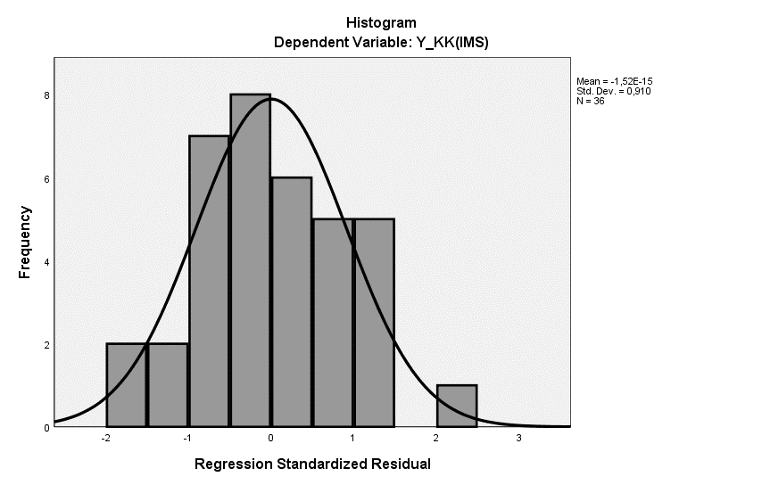

Sumber : SPSS 25, Data diolah 2023

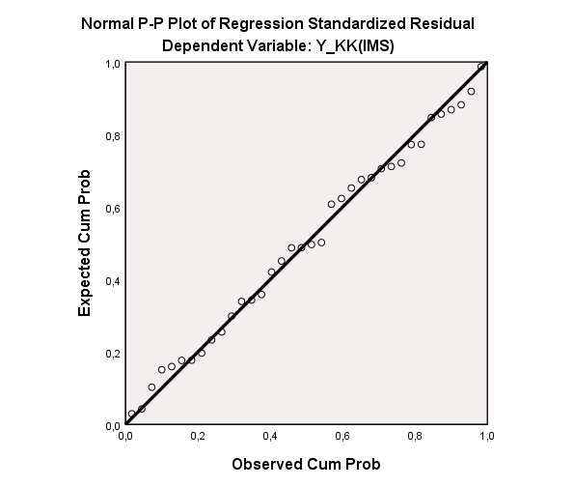
- Gambar Hasil Uji Normalitas P.P Plot of Regression Standardized Residual

Sumber : SPSS 25, Data diolah 2023

- Tabel Hasil Uji Autokolerasi
Model Summary^{b}
Model | R | R Square | Adjusted R Square | Std. Error of the Estimate | Durbin-Watson
1 | ,695ª | 0,483 | 0,376 | 0,15666541 | 1,999
a. Predictors: (Constant), X5_MS, X3_FDR, X1a_PSR, X1b_ZPR, X2_ISR, X4_IEI
b. Dependent Variable: Y_KK(IMS)
Sumber : SPSS 25, Data diolah 2023
Coefficientsª
Model | Collinearity Statistics
 | Tolerance | VIF
X1a_PSR | 0,506 | 1,975
X1b_ZPR | 0,601 | 1,664
X2_ISR | 0,546 | 1,832
X3_FDR | 0,855 | 1,169
X4_IEI | 0,532 | 1,879
X5_MS | 0,351 | 2,849
Dependent Variable: Y_KK(IMS)
- Tabel Hasil Uji Multikolinieritas

Sumber : SPSS 25 Data diolah 2023
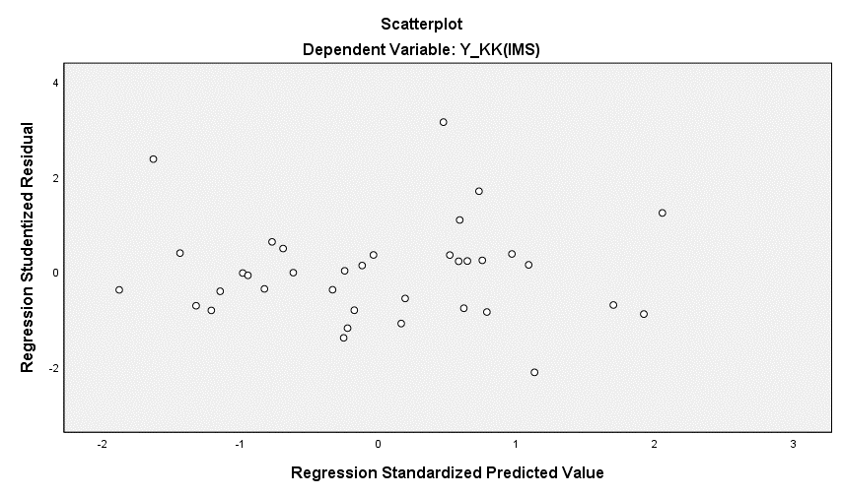
- Gambar Hasil Uji Heterokedastisitas

Sumber : SPSS 25, Data diolah 2023
Coefficientsª
Model |  | Unstandardized Coefficients |  | Standardized Coefficients | t | Sig.
 |  | B | Std. Error | Beta
1 | (Constant) | 1,441 | 0,272 |  | 5,301 | 0,000
 | X1a_PSR | 0,419 | 0,115 | 0,682 | 3,635 | 0,001
 | X1b_ZPR | -0,046 | 0,051 | -0,158 | -0,915 | 0,368
 | X2_ISR | 1,313 | 0,646 | 0,368 | 2,034 | 0,051
 | X3_FDR | 0,768 | 0,291 | 0,381 | 2,640 | 0,013
 | X4_IEI | -0,911 | 0,575 | -0,290 | -1,584 | 0,124
 | X5_MS | 0,375 | 0,100 | 0,845 | 3,750 | 0,001
a. Dependent Variable: Y_KK(IMS)
- Tabel Hasil Uji Statistik T (uji parsial)
Sumber : SPSS 25, Data diolah 2023
ANOVAª
Model |  | Sum of Squares | df | Mean Square | F | Sig.
1 | Regression | 0,665 | 6 | 0,111 | 4,513 | ,002^{b}
 | Residual | 0,712 | 29 | 0,025
 | Total | 1,376 | 35
a. Dependent Variable: Y_KK(IMS)
b. Predictors: (Constant), X5_MS, X3_FDR, X1a_PSR, X1b_ZPR, X2_ISR, X4_IEI
- Tabel Hasil Uji Statistik F (Uji Simultan)
Sumber : SPSS 25, Data diolah 2023
Model Summary^{b}
Model | R | R Square | Adjusted R Square | Std. Error of the Estimate
1 | ,695ª | 0,483 | 0,376 | 0,15666541
a. Predictors: (Constant), X5_MS, X3_FDR, X1a_PSR, X1b_ZPR, X2_ISR, X4_IEI
b. Dependent Variable: Y_IMS
- Tabel Hasil Uji Koefisien Determinasi (R2)
Sumber : SPSS 25, Data diolah 2023
LAMPIRAN 4
Gambar Tabel Durbin Watson (DW)
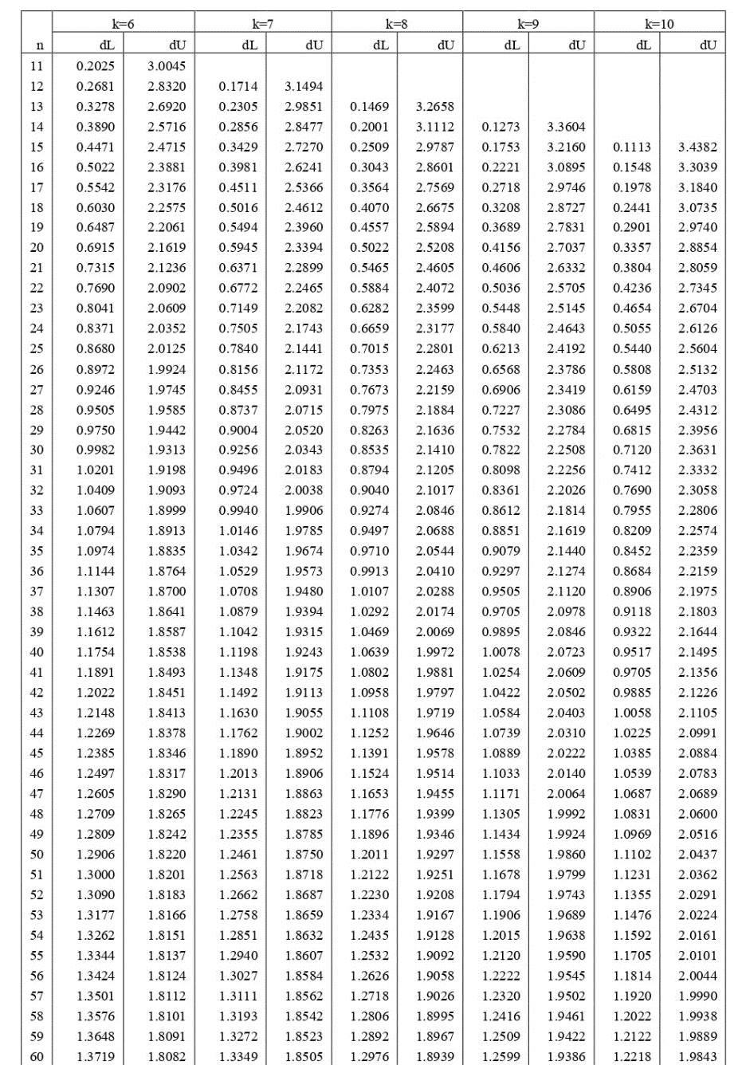
LAMPIRAN 5
Gambar Tabel Uji T

LAMPIRAN 6
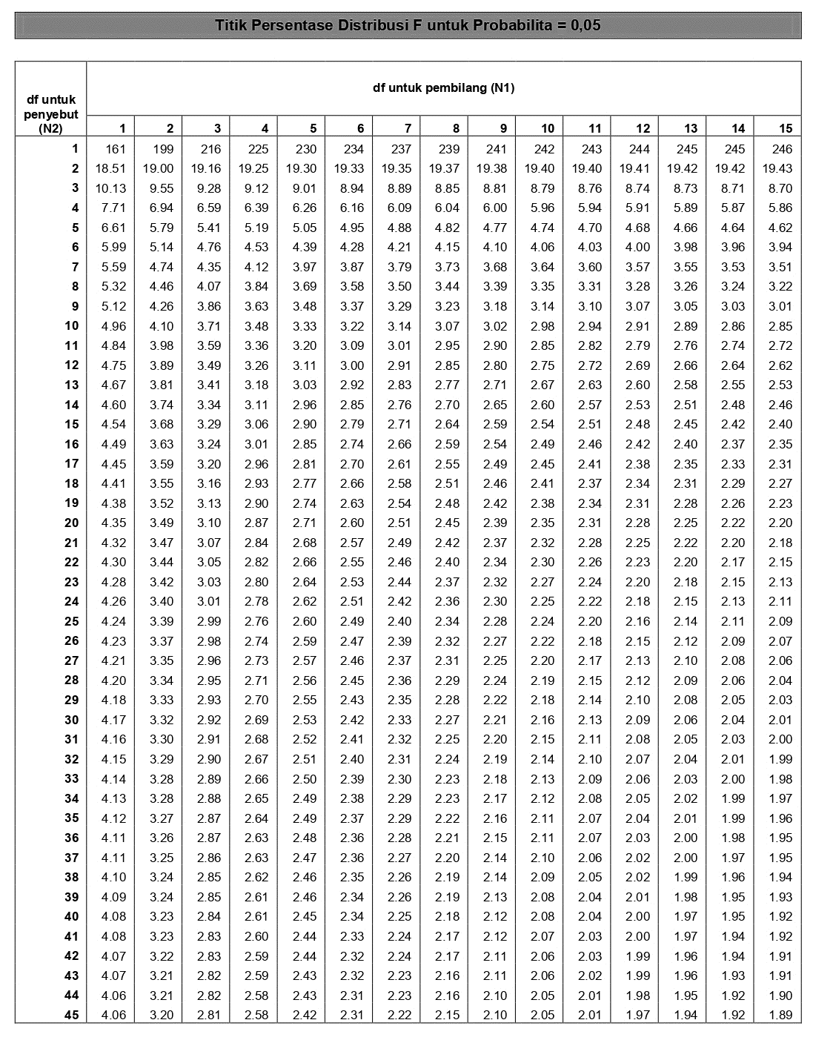
Gambar Tabel Uji F

