DAFTAR PUSTAKA
Agus, Ketut Suweca, Wayan Mitariani Eka, and Gusti Imbayani Ayu. 2020. “Pengaruh Motivasi Kerja Dan Pengalaman Kerja Terhadap Produktivitas Kerja Karyawan Pada CV. Waja Motor Cabang Sukawati.” Jurnal Emas 2(1):51–70. doi: 10.51713/jarma.v2i1.37.
Akila, Akila. 2021. “Pengaruh Fasiltas Lingkungan Kerja Dan Semangat Kerja Terhadap Produktivitas Kerja Karyawan Pada CV. Usaha Mandiri ”Mimi” Palembang.” Jurnal Media Wahana Ekonomika 18(3):290. doi: 10.31851/jmwe.v18i3.6652.
Andriansyah, Mochamat Arif, and Mahfudiyanto Mahfudiyanto. 2020. “Pengaruh Lingkungan Kerja Dan Disiplin Kerja Terhadap Produktivitas Karyawan Pada Pabrik Gula Ngadiredjo Kediri.” BIMA : Journal of Business and Innovation Management 2(1):19–32. doi: 10.33752/bima.v2i1.123.
Bangun Wilsion. 2012. Manajemen Sumber Daya Manusia. Bandung: Erlangga.
Busro Muhammad. 2018. Teori-Teori Manajemen Sumber Daya Manusia. ke-1. Jakarta: Prenadamedia Grroup.
Christian, Kuswibowo. 2020. “Pengaruh Motivasi Dan Disiplin Kerja Terhadap Produktivitas Kerja Karyawan.” E-Jurnal Manajemen Universitas Udayana 2(9):3383. doi: 10.24843/ejmunud.2020.v09.i09.p04.
Dharmawan, MM., Donny. 2017. “Pengaruh Lingkungan Kerja Dan Kompetensi Terhadap Kinerja Karyawan PT. Sinar Mas Land. Tbk Tanggerang.” Jurnal Manajemen Bisnis Krisnadwipayana 5(3). doi: 10.35137/jmbk.v5i3.157.
Enny, Mahmudah. 2019. Manajemen Sumber Daya Manusia. Surabaya, Jawa Timur: UBHARA Manajemen Press.
Fransisca, Vivi. 2022. “Pengaruh Lingkungan Kerja, Motivasi Kerja, Dan Disiplin Kerja Terhadap Produktivitas Kerja Karyawan Produksi PT.Alfa Surya Mandiri.” Ekonomi Dan Manajemen Bisnis 1(1):15–25. doi: 10.55123/mamen.v1i4.1018.
Hendri, Edduar, and Rismansyah. 2016. “Pengaruh Kepuasan Kerja Dan Semangat Kerja Terhadap Produktivitas Kerja Karyawan Pada Pt. Selapan Jaya Ogan Komering Ilir.” Jurnal Wahana Ekonomika 13(1):1–15.
Imam, Ghozali. 2018. Aplikasi Analisis Multivariate Dengan Program IBM SPSS 25. Semarang: Universitas Diponegoro.
Ladjin, Litriani, Kusumaningrum Sahamony, Soeyatno Maulina, Siregar, Hubbansyah, Solikin, Silitonga, Sinaga Asyari, and Amalia. 2022. Manajemen Sumber Daya Manusia.
LIZA, TANRI. 2018. “Pengaruh Kepuasan Kerja Dan Kompensasii Terhadap Produktivitas Kerja Karyawan CV Tiga Permata.” Program Manajemen Bisnis, Program Studi Manajemen, Fakultas Ekonomi, Universitas Kristen Petra 6(2):2–7.
Maydina, Alifia Anisa, and Dudung Abdurrahman. 2020. “Pengaruh Semangat Kerja Dan Disiplin Kerja Terhadap Produktivitas Karyawan PT . Lintas Mediatama Bandung.” Program Studi Manajemen, Fakultas Ekonomi Dan Bisnis Universitas Islam Bandung 6(1):580–85. doi: 10.22441/jimb.v6i1.6955.
Mulyati Sri, Sholikha, and Handaru Wahyu Agung. 2022. “Pengaruh Pelatihan, Pengalaman Kerja, Dan Upah Terhadap Produktivitas Kerja Karyawan UMKM Konveksi Di Kabupaten Tegal.” 3(8.5.2017):2003–5. doi: 10.21009/jbmk.0301.21.
Ningsih, Setia, and Hendra H. Dukalang. 2019. “Penerapan Metode Suksesif Interval Pada Analsis Regresi Linier Berganda.” Jambura Journal of Mathematics 1(1):43–53. doi: 10.34312/jjom.v1i1.1742.
Prawoto, Agung, and Wachid Hasyim. 2022. “Pengaruh Motivasi Kerja, Disiplin Kerja Dan Lingkungan Kerja Terhadap Produktifitas Kerja Pada Pt Manufakturing Cikarang.” Ikraith-Ekonomika 5(3):276–86. doi: 10.37817/ikraith-ekonomika.v5i3.2485.
Rampisela, V. A. J., and G. G. Lumintang. 2020. “Pengaruh Motivasi Kerja, Lingkungan Kerja Dan Upah Terhadap Produktivitas Kerja Karyawan Pt Dayana Cipta.” Jurnal EMBA: Jurnal Riset Ekonomi, Manajemen, Bisnis Dan Akuntansi 8(1):302–11. doi: 10.47709/jebma.v1i2.994.
Sari, Lidya Puspita, Islamuddin Islamuddin, and Meilaty Finthariasari. 2020. “Pengaruh Etos Kerja Dan Lingkungan Kerja Terhadap Produktivitas Kerja Karyawan Pada Industri Kerupuk As-Syifa Kota Bengkulu.” (JEMS) Jurnal Entrepreneur Dan Manajemen Sains 1(2):216–21. doi: 10.36085/jems.v1i2.927.
Sugiyono. 2019. Metode Penelitian Kuantitatif Dan R&D. ke-2. Banddung: Alfabeta Bandung.
Wibowo, Asep Deni, Hari Paradung. 2011. “Pengaruh Lingkungan, Motivasi Dan Disiplin Kerja Terhadap Kinerja Karyawan Pada Cv. Various Stone Indonesia.” Jurnal Ekonomak Vol. VI No(1):hal 33-48.

LAMPIRAN

LAMPIRAN
Lampiran 1 Lembar Kuesioner
Perihal : Permohonan Pengisian Kuesioner
Judul Penelitian : Pengaruh Lingkungan Kerja, Semangat Kerja, dan Motivasi Keja Terhadap Produktivitas Kerja Karyawan Pada Sentra Industri Kacang Asin Bogares Kab Tegal
Kepada Yth
Sdr. Responden
Di Tempat
Dengan Hormat,
Dalam rangka menyelesaikan penelitian, saya Mahasiswa Fakultas Ekonomi dan Bisnis Universitas Pancasakti Tegal, mohon partisipasi dari saudara untuk mengisi kuesioner yang telah kami sediakan.
Adapun data yang kami minta adalah sesuai dengan kondisi yang dirasakan saudara selama ini. Kami akan mengjaga kerahasiaan karena data ini hanya untuk kepentingan penelitian.
Setiap jawaban yang diberikan merupakan bantuan yang tidak ternilai harganya bagi penelitian ini.
Atas perhatian dan bantuannya, kami mengucapkan terima kasih.

Tegal, 6 April 2023
Hormat Saya,
Ivan Azdi Pratama

KARAKTERISTIK RESPONDEN
- Jenis Kelamin
- Laki-laki
- Perempuan
- Usia
- 20-30 tahun
- 31-40 tahun
- > 41 tahun
- Pendidikan
- SD
- SMP
- SMA/SMK
Keterangan
STS : Sangat Tidak Setuju
TS : Tidak Setuju
N : Netral
S : Setuju
SS : Sangat Setuju

Petunjuk Pengisian
Berilah tanda check list (√) pada salah satu jawaban yang paling sesuai dengan pendapat saudara
Variabel Produktivitas Karyawa (Y)
NO | Pertanyaan | Jawaban
 |  | 1 | 2 |  | 3 |  | 4 | 5
 |  | STS | TS |  | N |  | S | SS
Pengetahuan
1 | Saya mempunyai pengetahuan untuk menyelesaikan pekerjaan
2 | Karyawan harus memliki pengetahuan lebih tentang cara bekerja agar bisa lebih baik
Ketrampilan
3 | Saya Memiliki keterampilan yang baik untuk menyelesaikan pekerjaan dengan tepat waktu
4 | Saya memiliki keterampilan sesuai dengan keahlian yang saya miliki
Kemampuan
5 | Saya memiliki Kemampuan dalam memenuhi target kerja yang sudah ditetapkan
6 | Saya memliki kemampuan dalam menyelesaikan pekerjaan sesuai dengan standar kerja
Pendidikan
7 | Pimpinan yang berpendidikan dapat memberikan contoh yang baik bagi para karyawannya
8 | Pendidikan yang baik membuat kualitas hasil kerja yang baik
Pelatihan
9 | Saya bersedia mengikuti pelatihan yang dilakukan ditempat kerja
10 | Perusahaan memberikan pelatihan baik setiap karyawan untuk bertindak dengan aman

Variabel Lingkungan Kerja (X1)
NO | Pertanyaan | Jawaban
 |  | 1 | 2 |  | 3 |  | 4 | 5
 |  | STS | TS |  | N |  | S | SS
Penerangan
1 | Penerangan ditempat kerja saya sudah baik dan cukup memadai
2 | Penerangan ditempat kerja membantu saya dalam menyelesaikan pekerjaan
3 | Penerangan ditempat kerja saya cukup nyaman
4 | Perlengkapan penerangan lampu sudah cukup baik
Temperatur
5 | Temperatur ditempat kerja tidak mempengarahui suhu badan saya
6 | Temperatur ditempat kerja tidak mengganggu aktivitas kerja
Keamanan
7 | Keamanan ditempat kerja saya sudah baik
8 | Perusahaan harus mempunyai tingkat keamanan yang baik
Kebersihan
9 | Lingkungan kerja ditempat kerja saya sudah cukup bersih
10 | Saya ikut menjaga kebersihan tempat kerja

Variabel Semangat Kerja (X2)
NO | Pertanyaan | Jawaban
 |  | 1 | 2 |  | 3 |  | 4 | 5
 |  | STS | TS |  | N |  | S | SS
Absensi
1 | Absensi karyawan penting untuk menegakkan kedisiplinan karyawan
2 | Tingkat abseni karyawan sudah cukup baik
Kerja Sama
3 | Saya mampu bekerja sama dalam menyelesaikan tugas pekerjaan
4 | Para karyawan bekerja sama dalam melakukan pekerjaannya
Kepuasan Kerja
5 | Saya merasa puas dengan pekerjaan dan tempat saya bekerja sekarang
6 | Saya merasa puas karena saat ini saya dapat mengerjakan pekerjaan dengan baik seperti yang saya harapkan
Kedisiplinan
7 | Para karyawan harus menaati peraturan dan siap diberi sanki hukuman jika melanggar peraturan
8 | Karyawan yang disiplin memiliki kesadaran dalam menyelesaikan tugas tepat waktu

Variabel Motivasi Kerja (X3)
NO | Pertanyaan | Jawaban
 |  | 1 | 2 |  | 3 |  | 4 | 5
 |  | STS | TS |  | N |  | S | SS
Target Kerja
1 | Perusahaan menetapkan target penjualan setiap bulan
2 | Target pekerjaan dan tugas dari perusahaan dapat dipenuhi dengan baik
Tanggung jawab
3 | Saya bertanggung jawab penuh atas pekerjaan yang saya kerjakan
4 | Pimpinan harus bertanggung jawab apabila ada masalah di perusahaan
Komunikasi
5 | Saya memiliki kemampuan berkomunikasi sangat baik
6 | Komunikasi antar karyawan sangat baik sehingga dapat menyelesaikan pekerjaannya
7 | Pemimpin dan karyawan saling berkomunikasi dengan baik
Keteladanan
8 | Pimpinan harus mempunyai keteladan yang baik agar bisa ditiru oleh para karyawannya
9 | Karyawan harus mempunyai keteladanan yang baik

Lampiran Pengolahan Data Ordinal
- Lampiran Data Hasil Kuesioner Variabel Produktivitas Kerja (Y)
No | Produktivitas Kerja |  |  |  |  |  |  |  |  |  | Total
 | Y.1 | Y.2 | Y.3 | Y.4 | Y.5 | Y.6 | Y.7 | Y.8 | Y.9 | Y.10
1 | 3 | 4 | 3 | 4 | 4 | 4 | 4 | 4 | 3 | 3 | 36
2 | 5 | 5 | 4 | 5 | 5 | 5 | 5 | 5 | 5 | 5 | 49
3 | 4 | 4 | 4 | 5 | 5 | 4 | 5 | 5 | 4 | 4 | 44
4 | 5 | 5 | 5 | 5 | 4 | 4 | 3 | 5 | 4 | 3 | 43
5 | 5 | 4 | 4 | 4 | 4 | 3 | 4 | 4 | 5 | 5 | 42
6 | 4 | 4 | 4 | 4 | 4 | 4 | 5 | 5 | 5 | 5 | 44
7 | 4 | 5 | 5 | 5 | 4 | 4 | 4 | 4 | 3 | 4 | 42
8 | 5 | 4 | 5 | 5 | 4 | 4 | 4 | 5 | 5 | 5 | 46
9 | 5 | 5 | 5 | 5 | 5 | 5 | 4 | 4 | 4 | 4 | 46
10 | 5 | 4 | 5 | 5 | 4 | 4 | 5 | 5 | 5 | 5 | 47
11 | 4 | 4 | 4 | 5 | 4 | 5 | 3 | 5 | 3 | 5 | 42
12 | 5 | 5 | 5 | 4 | 4 | 4 | 4 | 5 | 5 | 4 | 45
13 | 5 | 4 | 5 | 5 | 4 | 4 | 5 | 4 | 4 | 5 | 45
14 | 5 | 5 | 5 | 5 | 4 | 4 | 4 | 5 | 5 | 5 | 47
15 | 5 | 4 | 5 | 5 | 4 | 5 | 5 | 5 | 3 | 4 | 45
16 | 5 | 5 | 5 | 5 | 4 | 4 | 4 | 4 | 4 | 4 | 44
17 | 5 | 5 | 5 | 5 | 4 | 4 | 5 | 5 | 5 | 3 | 46
18 | 5 | 5 | 5 | 5 | 4 | 3 | 4 | 4 | 4 | 4 | 43
19 | 4 | 5 | 5 | 5 | 4 | 4 | 5 | 5 | 3 | 5 | 45
20 | 5 | 4 | 5 | 5 | 4 | 4 | 5 | 5 | 4 | 4 | 45
21 | 5 | 5 | 5 | 5 | 4 | 4 | 5 | 5 | 4 | 5 | 47
22 | 5 | 4 | 5 | 4 | 4 | 4 | 5 | 4 | 5 | 4 | 44
23 | 4 | 4 | 4 | 4 | 3 | 4 | 4 | 5 | 5 | 5 | 42
24 | 5 | 5 | 5 | 5 | 4 | 5 | 5 | 5 | 3 | 3 | 45
25 | 5 | 5 | 5 | 4 | 4 | 4 | 4 | 4 | 4 | 5 | 44
26 | 5 | 5 | 5 | 4 | 5 | 5 | 5 | 5 | 5 | 4 | 48
27 | 5 | 5 | 5 | 5 | 4 | 4 | 4 | 5 | 4 | 5 | 46
28 | 5 | 5 | 5 | 5 | 4 | 4 | 4 | 5 | 5 | 5 | 47
29 | 3 | 3 | 4 | 4 | 3 | 3 | 3 | 4 | 3 | 4 | 34
30 | 4 | 4 | 4 | 3 | 3 | 1 | 4 | 3 | 4 | 3 | 33
31 | 4 | 4 | 4 | 4 | 4 | 3 | 5 | 4 | 3 | 4 | 39
32 | 4 | 4 | 4 | 4 | 3 | 3 | 3 | 4 | 4 | 4 | 37
33 | 4 | 4 | 4 | 4 | 3 | 3 | 5 | 4 | 5 | 4 | 40
34 | 5 | 5 | 4 | 4 | 4 | 4 | 4 | 5 | 4 | 4 | 43
35 | 4 | 4 | 4 | 3 | 3 | 3 | 5 | 4 | 5 | 4 | 39
36 | 4 | 4 | 4 | 4 | 3 | 3 | 4 | 4 | 3 | 4 | 37
37 | 4 | 4 | 5 | 5 | 4 | 5 | 5 | 5 | 5 | 4 | 46
38 | 4 | 4 | 5 | 5 | 4 | 5 | 5 | 5 | 5 | 5 | 47
39 | 5 | 5 | 5 | 4 | 4 | 4 | 5 | 5 | 4 | 4 | 45
40 | 4 | 4 | 4 | 4 | 3 | 3 | 3 | 5 | 5 | 4 | 39
41 | 5 | 5 | 5 | 5 | 4 | 4 | 5 | 5 | 5 | 4 | 47
42 | 5 | 5 | 5 | 4 | 4 | 4 | 3 | 5 | 4 | 4 | 43
43 | 4 | 4 | 4 | 4 | 3 | 4 | 5 | 5 | 5 | 4 | 42
44 | 5 | 5 | 5 | 5 | 4 | 4 | 4 | 5 | 5 | 5 | 47
45 | 5 | 5 | 5 | 5 | 4 | 4 | 5 | 4 | 4 | 4 | 45
46 | 5 | 4 | 5 | 5 | 4 | 4 | 1 | 5 | 4 | 4 | 41
47 | 5 | 5 | 5 | 5 | 3 | 4 | 1 | 5 | 5 | 5 | 43
48 | 4 | 4 | 5 | 5 | 4 | 5 | 2 | 5 | 5 | 5 | 44
49 | 4 | 5 | 5 | 5 | 5 | 5 | 2 | 5 | 5 | 5 | 46

- Lampiran Data Hasil Kuesioner Variabel Lingkunga Kerja (X1)
No | Lingkungan Kerja |  |  |  |  |  |  |  |  |  | Total
 | X1.1 | X1.2 | X1.3 | X1.4 | X1.5 | X1.6 | X1.7 | X1.8 | X1.9 | X1.10
1 | 4 | 4 | 4 | 4 | 4 | 4 | 4 | 4 | 4 | 5 | 41
2 | 4 | 5 | 4 | 3 | 4 | 3 | 4 | 3 | 4 | 4 | 38
3 | 3 | 3 | 3 | 3 | 3 | 3 | 3 | 3 | 3 | 3 | 30
4 | 4 | 5 | 5 | 5 | 4 | 3 | 3 | 4 | 4 | 3 | 40
5 | 5 | 3 | 4 | 4 | 4 | 4 | 4 | 3 | 4 | 4 | 39
6 | 3 | 3 | 3 | 4 | 5 | 4 | 3 | 3 | 3 | 3 | 34
7 | 4 | 5 | 5 | 5 | 5 | 5 | 5 | 5 | 5 | 5 | 49
8 | 3 | 3 | 5 | 4 | 5 | 3 | 3 | 4 | 4 | 3 | 37
9 | 3 | 3 | 3 | 3 | 3 | 3 | 3 | 3 | 3 | 3 | 30
10 | 5 | 4 | 3 | 4 | 3 | 3 | 3 | 3 | 4 | 3 | 35
11 | 4 | 3 | 3 | 3 | 3 | 4 | 4 | 4 | 3 | 3 | 34
12 | 5 | 5 | 5 | 5 | 5 | 5 | 5 | 5 | 5 | 4 | 49
13 | 5 | 5 | 5 | 5 | 5 | 4 | 5 | 5 | 5 | 5 | 49
14 | 3 | 3 | 3 | 3 | 3 | 3 | 3 | 5 | 3 | 3 | 32
15 | 5 | 4 | 5 | 3 | 3 | 3 | 4 | 4 | 4 | 4 | 39
16 | 4 | 4 | 4 | 4 | 5 | 4 | 4 | 3 | 3 | 3 | 38
17 | 5 | 5 | 5 | 4 | 4 | 4 | 4 | 4 | 4 | 4 | 43
18 | 5 | 4 | 5 | 5 | 5 | 5 | 5 | 5 | 5 | 5 | 49
19 | 4 | 5 | 3 | 3 | 4 | 4 | 3 | 4 | 4 | 4 | 38
20 | 4 | 4 | 4 | 4 | 5 | 5 | 5 | 5 | 5 | 5 | 46
21 | 4 | 5 | 5 | 5 | 5 | 5 | 5 | 4 | 5 | 5 | 48
22 | 5 | 4 | 5 | 5 | 5 | 5 | 5 | 5 | 5 | 5 | 49
23 | 5 | 3 | 3 | 4 | 3 | 4 | 3 | 3 | 3 | 5 | 36
24 | 4 | 5 | 5 | 5 | 5 | 5 | 5 | 5 | 5 | 3 | 47
25 | 3 | 5 | 4 | 4 | 4 | 3 | 4 | 4 | 3 | 5 | 39
26 | 5 | 3 | 3 | 3 | 3 | 3 | 3 | 4 | 4 | 4 | 35
27 | 5 | 4 | 5 | 5 | 5 | 5 | 5 | 5 | 5 | 5 | 49
28 | 4 | 5 | 5 | 5 | 5 | 5 | 5 | 5 | 5 | 5 | 49
29 | 4 | 5 | 5 | 4 | 5 | 3 | 4 | 4 | 4 | 5 | 43
30 | 3 | 4 | 4 | 4 | 5 | 4 | 4 | 4 | 4 | 4 | 40
31 | 5 | 3 | 4 | 4 | 4 | 5 | 4 | 4 | 5 | 4 | 42
32 | 3 | 5 | 5 | 5 | 5 | 4 | 3 | 4 | 3 | 3 | 40
33 | 5 | 4 | 4 | 4 | 4 | 4 | 4 | 4 | 4 | 4 | 41
34 | 5 | 5 | 5 | 5 | 5 | 5 | 5 | 5 | 4 | 5 | 49
35 | 5 | 5 | 4 | 3 | 4 | 3 | 3 | 4 | 4 | 4 | 39
36 | 5 | 5 | 5 | 4 | 5 | 4 | 3 | 4 | 4 | 4 | 43
37 | 4 | 4 | 4 | 4 | 4 | 5 | 5 | 4 | 4 | 4 | 42
38 | 4 | 4 | 4 | 4 | 4 | 4 | 4 | 3 | 5 | 5 | 41
39 | 5 | 4 | 3 | 3 | 3 | 4 | 5 | 4 | 5 | 5 | 41
40 | 3 | 4 | 5 | 5 | 3 | 3 | 3 | 3 | 3 | 3 | 35
41 | 4 | 5 | 5 | 3 | 3 | 4 | 3 | 3 | 3 | 3 | 36
42 | 5 | 4 | 5 | 5 | 5 | 5 | 5 | 5 | 5 | 5 | 49
43 | 5 | 5 | 5 | 5 | 5 | 5 | 5 | 5 | 5 | 4 | 49
44 | 3 | 5 | 3 | 5 | 5 | 3 | 5 | 4 | 3 | 4 | 40
45 | 4 | 5 | 4 | 4 | 3 | 3 | 3 | 3 | 4 | 3 | 36
46 | 4 | 4 | 3 | 4 | 4 | 3 | 3 | 3 | 3 | 3 | 34
47 | 4 | 4 | 4 | 4 | 4 | 3 | 3 | 3 | 3 | 3 | 35
48 | 5 | 4 | 5 | 5 | 5 | 5 | 5 | 5 | 5 | 5 | 49
49 | 4 | 5 | 4 | 3 | 5 | 5 | 5 | 5 | 5 | 5 | 46

- Lampiran Data Hasil Kuesioner Variabel Semangat Kerja (X2)
No | Semangat Kerja |  |  |  |  |  |  |  | Total
 | X2.1 | X2.2 | X2.3 | X2.4 | X2.5 | X2.6 | X2.7 | X2.8
1 | 3 | 3 | 3 | 3 | 4 | 3 | 3 | 3 | 25
2 | 5 | 5 | 5 | 5 | 5 | 5 | 5 | 5 | 40
3 | 3 | 3 | 4 | 3 | 4 | 4 | 4 | 4 | 29
4 | 5 | 3 | 3 | 3 | 5 | 3 | 3 | 5 | 30
5 | 5 | 5 | 5 | 3 | 5 | 3 | 5 | 5 | 36
6 | 5 | 5 | 4 | 5 | 5 | 5 | 5 | 5 | 39
7 | 3 | 5 | 3 | 3 | 4 | 3 | 3 | 3 | 27
8 | 3 | 4 | 5 | 4 | 4 | 3 | 3 | 3 | 29
9 | 5 | 5 | 5 | 5 | 5 | 5 | 5 | 5 | 40
10 | 5 | 5 | 5 | 5 | 5 | 5 | 5 | 5 | 40
11 | 5 | 5 | 5 | 5 | 5 | 5 | 5 | 5 | 40
12 | 4 | 4 | 4 | 5 | 5 | 5 | 5 | 5 | 37
13 | 5 | 5 | 5 | 5 | 5 | 5 | 5 | 5 | 40
14 | 3 | 5 | 5 | 3 | 5 | 4 | 5 | 3 | 33
15 | 4 | 3 | 5 | 4 | 4 | 3 | 4 | 4 | 31
16 | 3 | 4 | 4 | 5 | 5 | 3 | 3 | 5 | 32
17 | 4 | 3 | 3 | 3 | 3 | 4 | 3 | 3 | 26
18 | 5 | 4 | 4 | 5 | 5 | 3 | 5 | 5 | 36
19 | 5 | 5 | 4 | 5 | 5 | 4 | 4 | 4 | 36
20 | 4 | 5 | 4 | 4 | 4 | 4 | 4 | 4 | 33
21 | 5 | 5 | 5 | 5 | 5 | 5 | 5 | 5 | 40
22 | 5 | 5 | 5 | 5 | 5 | 5 | 5 | 5 | 40
23 | 4 | 5 | 5 | 5 | 4 | 3 | 4 | 4 | 34
24 | 5 | 5 | 5 | 5 | 5 | 5 | 5 | 5 | 40
25 | 4 | 4 | 4 | 5 | 5 | 4 | 4 | 4 | 34
26 | 5 | 4 | 5 | 3 | 5 | 5 | 5 | 5 | 37
27 | 5 | 5 | 5 | 5 | 5 | 4 | 5 | 5 | 39
28 | 4 | 5 | 5 | 5 | 5 | 3 | 4 | 4 | 35
29 | 5 | 5 | 5 | 5 | 5 | 5 | 5 | 5 | 40
30 | 5 | 5 | 5 | 5 | 5 | 5 | 5 | 5 | 40
31 | 3 | 3 | 3 | 5 | 5 | 3 | 5 | 5 | 32
32 | 5 | 5 | 3 | 5 | 5 | 4 | 4 | 5 | 36
33 | 3 | 4 | 4 | 4 | 4 | 5 | 4 | 3 | 31
34 | 4 | 5 | 5 | 4 | 5 | 5 | 3 | 5 | 36
35 | 3 | 3 | 5 | 5 | 5 | 3 | 5 | 3 | 32
36 | 4 | 5 | 3 | 4 | 4 | 3 | 4 | 3 | 30
37 | 5 | 5 | 5 | 3 | 5 | 5 | 3 | 5 | 36
38 | 4 | 4 | 5 | 5 | 5 | 5 | 5 | 5 | 38
39 | 3 | 3 | 3 | 5 | 3 | 3 | 5 | 3 | 28
40 | 4 | 5 | 3 | 3 | 4 | 4 | 3 | 4 | 30
41 | 4 | 5 | 3 | 5 | 4 | 4 | 3 | 4 | 32
42 | 5 | 5 | 3 | 5 | 5 | 5 | 3 | 5 | 36
43 | 3 | 5 | 5 | 5 | 5 | 5 | 4 | 5 | 37
44 | 3 | 3 | 3 | 5 | 3 | 3 | 3 | 3 | 26
45 | 3 | 4 | 3 | 3 | 4 | 4 | 5 | 4 | 30
46 | 5 | 5 | 4 | 5 | 3 | 3 | 5 | 4 | 34
47 | 5 | 5 | 4 | 4 | 5 | 5 | 5 | 5 | 38
48 | 5 | 5 | 5 | 5 | 5 | 5 | 5 | 5 | 40
49 | 5 | 5 | 5 | 5 | 5 | 5 | 5 | 5 | 40

- Lampiran Data Hasil Kuesioner Variabel Motivasi Kerja (X3)
No | Motivasi Kerja
 | X3.1 | X3.2 | X3.3 | X3.4 | X3.5 | X3.6 | X3.7 | X3.8 | X3.9 | Total
1 | 5 | 5 | 5 | 5 | 5 | 5 | 5 | 5 | 5 | 45
2 | 3 | 5 | 5 | 5 | 5 | 5 | 5 | 5 | 5 | 43
3 | 4 | 4 | 4 | 4 | 4 | 4 | 4 | 4 | 4 | 36
4 | 5 | 5 | 4 | 3 | 3 | 4 | 4 | 5 | 4 | 37
5 | 4 | 3 | 4 | 4 | 4 | 4 | 5 | 3 | 3 | 34
6 | 4 | 4 | 3 | 3 | 4 | 3 | 4 | 4 | 4 | 33
7 | 4 | 4 | 3 | 4 | 4 | 4 | 3 | 4 | 4 | 34
8 | 3 | 4 | 3 | 4 | 3 | 5 | 4 | 4 | 5 | 35
9 | 5 | 3 | 4 | 3 | 4 | 4 | 5 | 3 | 4 | 35
10 | 4 | 4 | 4 | 3 | 5 | 4 | 4 | 3 | 4 | 35
11 | 3 | 3 | 4 | 4 | 4 | 3 | 3 | 4 | 4 | 32
12 | 4 | 4 | 3 | 4 | 4 | 3 | 4 | 4 | 3 | 33
13 | 3 | 5 | 4 | 4 | 4 | 5 | 3 | 4 | 4 | 36
14 | 5 | 4 | 5 | 3 | 4 | 5 | 5 | 3 | 4 | 38
15 | 3 | 4 | 4 | 3 | 3 | 4 | 3 | 4 | 5 | 33
16 | 5 | 4 | 4 | 4 | 3 | 3 | 3 | 4 | 5 | 35
17 | 5 | 4 | 4 | 5 | 4 | 4 | 5 | 5 | 3 | 39
18 | 4 | 4 | 4 | 4 | 5 | 4 | 4 | 5 | 4 | 38
19 | 4 | 4 | 5 | 4 | 5 | 4 | 4 | 4 | 3 | 37
20 | 5 | 5 | 4 | 4 | 5 | 5 | 5 | 4 | 3 | 40
21 | 3 | 3 | 3 | 3 | 3 | 3 | 3 | 3 | 5 | 29
22 | 4 | 3 | 4 | 3 | 4 | 5 | 3 | 3 | 5 | 34
23 | 4 | 4 | 4 | 3 | 4 | 4 | 4 | 4 | 4 | 35
24 | 5 | 5 | 5 | 5 | 5 | 5 | 5 | 5 | 5 | 45
25 | 4 | 4 | 4 | 4 | 4 | 4 | 4 | 4 | 5 | 37
26 | 3 | 4 | 4 | 4 | 5 | 5 | 3 | 4 | 4 | 36
27 | 4 | 5 | 5 | 5 | 5 | 5 | 5 | 5 | 5 | 44
28 | 4 | 4 | 3 | 4 | 5 | 4 | 4 | 3 | 5 | 36
29 | 3 | 3 | 5 | 4 | 5 | 5 | 3 | 3 | 4 | 35
30 | 4 | 4 | 4 | 3 | 4 | 4 | 4 | 4 | 4 | 35
31 | 5 | 4 | 4 | 4 | 3 | 3 | 4 | 4 | 3 | 34
32 | 5 | 5 | 5 | 4 | 5 | 5 | 5 | 5 | 5 | 44
33 | 3 | 5 | 4 | 5 | 4 | 5 | 5 | 3 | 5 | 39
34 | 3 | 3 | 3 | 3 | 3 | 3 | 3 | 5 | 3 | 29
35 | 3 | 4 | 3 | 3 | 4 | 3 | 3 | 3 | 4 | 30
36 | 5 | 3 | 4 | 3 | 5 | 4 | 3 | 5 | 4 | 36
37 | 4 | 5 | 5 | 3 | 5 | 4 | 4 | 3 | 3 | 36
38 | 4 | 4 | 4 | 4 | 4 | 4 | 4 | 5 | 5 | 38
39 | 4 | 5 | 4 | 3 | 4 | 4 | 5 | 4 | 4 | 37
40 | 5 | 3 | 3 | 4 | 3 | 5 | 4 | 4 | 5 | 36
41 | 4 | 3 | 5 | 5 | 5 | 5 | 3 | 4 | 4 | 38
42 | 5 | 3 | 4 | 4 | 4 | 5 | 3 | 5 | 5 | 38
43 | 3 | 3 | 3 | 3 | 3 | 5 | 3 | 3 | 3 | 29
44 | 3 | 3 | 5 | 4 | 5 | 3 | 3 | 3 | 3 | 32
45 | 3 | 3 | 3 | 3 | 4 | 3 | 5 | 3 | 5 | 32
46 | 3 | 4 | 3 | 3 | 4 | 4 | 3 | 4 | 3 | 31
47 | 4 | 4 | 5 | 4 | 5 | 4 | 5 | 3 | 4 | 38
48 | 5 | 5 | 4 | 4 | 5 | 5 | 5 | 5 | 5 | 43
49 | 5 | 4 | 5 | 5 | 5 | 5 | 5 | 4 | 4 | 42

Lampiran Pengolahan Data Interval (MSI)
- Lampiran data hasil Kuesioner Produktivitas Kerja (Y)
Succesive Interval |  |  |  |  |  |  |  |  |  | Total Y
Y.1 | Y.2 | Y.3 | Y.4 | Y.5 | Y.6 | Y.7 | Y.8 | Y.9 | Y.10
1.000 | 2.700 | 1.000 | 2.328 | 2.540 | 3.413 | 2.822 | 2.434 | 1.000 | 1.000 | 20.237
3.802 | 4.228 | 2.434 | 3.802 | 4.134 | 4.802 | 4.027 | 3.979 | 3.294 | 3.733 | 38.236
2.328 | 2.700 | 2.434 | 3.802 | 4.134 | 3.413 | 4.027 | 3.979 | 2.066 | 2.344 | 31.227
3.802 | 4.228 | 3.979 | 3.802 | 2.540 | 3.413 | 2.065 | 3.979 | 2.066 | 1.000 | 30.875
3.802 | 2.700 | 2.434 | 2.328 | 2.540 | 2.139 | 2.822 | 2.434 | 3.294 | 3.733 | 28.226
2.328 | 2.700 | 2.434 | 2.328 | 2.540 | 3.413 | 4.027 | 3.979 | 3.294 | 3.733 | 30.776
2.328 | 4.228 | 3.979 | 3.802 | 2.540 | 3.413 | 2.822 | 2.434 | 1.000 | 2.344 | 28.890
3.802 | 2.700 | 3.979 | 3.802 | 2.540 | 3.413 | 2.822 | 3.979 | 3.294 | 3.733 | 34.066
3.802 | 4.228 | 3.979 | 3.802 | 4.134 | 4.802 | 2.822 | 2.434 | 2.066 | 2.344 | 34.413
3.802 | 2.700 | 3.979 | 3.802 | 2.540 | 3.413 | 4.027 | 3.979 | 3.294 | 3.733 | 35.271
2.328 | 2.700 | 2.434 | 3.802 | 2.540 | 4.802 | 2.065 | 3.979 | 1.000 | 3.733 | 29.382
3.802 | 4.228 | 3.979 | 2.328 | 2.540 | 3.413 | 2.822 | 3.979 | 3.294 | 2.344 | 32.729
3.802 | 2.700 | 3.979 | 3.802 | 2.540 | 3.413 | 4.027 | 2.434 | 2.066 | 3.733 | 32.498
3.802 | 4.228 | 3.979 | 3.802 | 2.540 | 3.413 | 2.822 | 3.979 | 3.294 | 3.733 | 35.594
3.802 | 2.700 | 3.979 | 3.802 | 2.540 | 4.802 | 4.027 | 3.979 | 1.000 | 2.344 | 32.975
3.802 | 4.228 | 3.979 | 3.802 | 2.540 | 3.413 | 2.822 | 2.434 | 2.066 | 2.344 | 31.431
3.802 | 4.228 | 3.979 | 3.802 | 2.540 | 3.413 | 4.027 | 3.979 | 3.294 | 1.000 | 34.065
3.802 | 4.228 | 3.979 | 3.802 | 2.540 | 2.139 | 2.822 | 2.434 | 2.066 | 2.344 | 30.156
2.328 | 4.228 | 3.979 | 3.802 | 2.540 | 3.413 | 4.027 | 3.979 | 1.000 | 3.733 | 33.030
3.802 | 2.700 | 3.979 | 3.802 | 2.540 | 3.413 | 4.027 | 3.979 | 2.066 | 2.344 | 32.653
3.802 | 4.228 | 3.979 | 3.802 | 2.540 | 3.413 | 4.027 | 3.979 | 2.066 | 3.733 | 35.571
3.802 | 2.700 | 3.979 | 2.328 | 2.540 | 3.413 | 4.027 | 2.434 | 3.294 | 2.344 | 30.861
2.328 | 2.700 | 2.434 | 2.328 | 1.000 | 3.413 | 2.822 | 3.979 | 3.294 | 3.733 | 28.031
3.802 | 4.228 | 3.979 | 3.802 | 2.540 | 4.802 | 4.027 | 3.979 | 1.000 | 1.000 | 33.160
3.802 | 4.228 | 3.979 | 2.328 | 2.540 | 3.413 | 2.822 | 2.434 | 2.066 | 3.733 | 31.346
3.802 | 4.228 | 3.979 | 2.328 | 4.134 | 4.802 | 4.027 | 3.979 | 3.294 | 2.344 | 36.916
3.802 | 4.228 | 3.979 | 3.802 | 2.540 | 3.413 | 2.822 | 3.979 | 2.066 | 3.733 | 34.366
3.802 | 4.228 | 3.979 | 3.802 | 2.540 | 3.413 | 2.822 | 3.979 | 3.294 | 3.733 | 35.594
1.000 | 1.000 | 2.434 | 2.328 | 1.000 | 2.139 | 2.065 | 2.434 | 1.000 | 2.344 | 17.742
2.328 | 2.700 | 2.434 | 1.000 | 1.000 | 1.000 | 2.822 | 1.000 | 2.066 | 1.000 | 17.350
2.328 | 2.700 | 2.434 | 2.328 | 2.540 | 2.139 | 4.027 | 2.434 | 1.000 | 2.344 | 24.272
2.328 | 2.700 | 2.434 | 2.328 | 1.000 | 2.139 | 2.065 | 2.434 | 2.066 | 2.344 | 21.836
2.328 | 2.700 | 2.434 | 2.328 | 1.000 | 2.139 | 4.027 | 2.434 | 3.294 | 2.344 | 25.026
3.802 | 4.228 | 2.434 | 2.328 | 2.540 | 3.413 | 2.822 | 3.979 | 2.066 | 2.344 | 29.956
2.328 | 2.700 | 2.434 | 1.000 | 1.000 | 2.139 | 4.027 | 2.434 | 3.294 | 2.344 | 23.699
2.328 | 2.700 | 2.434 | 2.328 | 1.000 | 2.139 | 2.822 | 2.434 | 1.000 | 2.344 | 21.527
2.328 | 2.700 | 3.979 | 3.802 | 2.540 | 4.802 | 4.027 | 3.979 | 3.294 | 2.344 | 33.795
2.328 | 2.700 | 3.979 | 3.802 | 2.540 | 4.802 | 4.027 | 3.979 | 3.294 | 3.733 | 35.184
3.802 | 4.228 | 3.979 | 2.328 | 2.540 | 3.413 | 4.027 | 3.979 | 2.066 | 2.344 | 32.706
2.328 | 2.700 | 2.434 | 2.328 | 1.000 | 2.139 | 2.065 | 3.979 | 3.294 | 2.344 | 24.609
3.802 | 4.228 | 3.979 | 3.802 | 2.540 | 3.413 | 4.027 | 3.979 | 3.294 | 2.344 | 35.409
3.802 | 4.228 | 3.979 | 2.328 | 2.540 | 3.413 | 2.065 | 3.979 | 2.066 | 2.344 | 30.744
2.328 | 2.700 | 2.434 | 2.328 | 1.000 | 3.413 | 4.027 | 3.979 | 3.294 | 2.344 | 27.846
3.802 | 4.228 | 3.979 | 3.802 | 2.540 | 3.413 | 2.822 | 3.979 | 3.294 | 3.733 | 35.594
3.802 | 4.228 | 3.979 | 3.802 | 2.540 | 3.413 | 4.027 | 2.434 | 2.066 | 2.344 | 32.636
3.802 | 2.700 | 3.979 | 3.802 | 2.540 | 3.413 | 1.000 | 3.979 | 2.066 | 2.344 | 29.626
3.802 | 4.228 | 3.979 | 3.802 | 1.000 | 3.413 | 1.000 | 3.979 | 3.294 | 3.733 | 32.231
2.328 | 2.700 | 3.979 | 3.802 | 2.540 | 4.802 | 1.594 | 3.979 | 3.294 | 3.733 | 32.751
2.328 | 4.228 | 3.979 | 3.802 | 4.134 | 4.802 | 1.594 | 3.979 | 3.294 | 3.733 | 35.873

- Lampiran Data Hasil Kuesioner Lingkungan Kerja (X1)
Succesive Interval |  |  |  |  |  |  |  |  |  | Total X1
X1.1 | X1.2 | X1.3 | X1.4 | X1.5 | X1.6 | X1.7 | X1.8 | X1.9 | X1.10
2.118 | 2.091 | 2.018 | 2.149 | 1.991 | 2.091 | 2.025 | 2.163 | 2.110 | 3.130 | 21.885
2.118 | 3.304 | 2.018 | 1.000 | 1.991 | 1.000 | 2.025 | 1.000 | 2.110 | 2.052 | 18.618
1.000 | 1.000 | 1.000 | 1.000 | 1.000 | 1.000 | 1.000 | 1.000 | 1.000 | 1.000 | 10.000
2.118 | 3.304 | 3.165 | 3.348 | 1.991 | 1.000 | 1.000 | 2.163 | 2.110 | 1.000 | 21.198
3.340 | 1.000 | 2.018 | 2.149 | 1.991 | 2.091 | 2.025 | 1.000 | 2.110 | 2.052 | 19.775
1.000 | 1.000 | 1.000 | 2.149 | 3.131 | 2.091 | 1.000 | 1.000 | 1.000 | 1.000 | 14.370
2.118 | 3.304 | 3.165 | 3.348 | 3.131 | 3.169 | 3.051 | 3.336 | 3.254 | 3.130 | 31.004
1.000 | 1.000 | 3.165 | 2.149 | 3.131 | 1.000 | 1.000 | 2.163 | 2.110 | 1.000 | 17.717
1.000 | 1.000 | 1.000 | 1.000 | 1.000 | 1.000 | 1.000 | 1.000 | 1.000 | 1.000 | 10.000
3.340 | 2.091 | 1.000 | 2.149 | 1.000 | 1.000 | 1.000 | 1.000 | 2.110 | 1.000 | 15.690
2.118 | 1.000 | 1.000 | 1.000 | 1.000 | 2.091 | 2.025 | 2.163 | 1.000 | 1.000 | 14.397
3.340 | 3.304 | 3.165 | 3.348 | 3.131 | 3.169 | 3.051 | 3.336 | 3.254 | 2.052 | 31.148
3.340 | 3.304 | 3.165 | 3.348 | 3.131 | 2.091 | 3.051 | 3.336 | 3.254 | 3.130 | 31.148
1.000 | 1.000 | 1.000 | 1.000 | 1.000 | 1.000 | 1.000 | 3.336 | 1.000 | 1.000 | 12.336
3.340 | 2.091 | 3.165 | 1.000 | 1.000 | 1.000 | 2.025 | 2.163 | 2.110 | 2.052 | 19.946
2.118 | 2.091 | 2.018 | 2.149 | 3.131 | 2.091 | 2.025 | 1.000 | 1.000 | 1.000 | 18.622
3.340 | 3.304 | 3.165 | 2.149 | 1.991 | 2.091 | 2.025 | 2.163 | 2.110 | 2.052 | 24.390
3.340 | 2.091 | 3.165 | 3.348 | 3.131 | 3.169 | 3.051 | 3.336 | 3.254 | 3.130 | 31.013
2.118 | 3.304 | 1.000 | 1.000 | 1.991 | 2.091 | 1.000 | 2.163 | 2.110 | 2.052 | 18.829
2.118 | 2.091 | 2.018 | 2.149 | 3.131 | 3.169 | 3.051 | 3.336 | 3.254 | 3.130 | 27.445
2.118 | 3.304 | 3.165 | 3.348 | 3.131 | 3.169 | 3.051 | 2.163 | 3.254 | 3.130 | 29.831
3.340 | 2.091 | 3.165 | 3.348 | 3.131 | 3.169 | 3.051 | 3.336 | 3.254 | 3.130 | 31.013
3.340 | 1.000 | 1.000 | 2.149 | 1.000 | 2.091 | 1.000 | 1.000 | 1.000 | 3.130 | 16.709
2.118 | 3.304 | 3.165 | 3.348 | 3.131 | 3.169 | 3.051 | 3.336 | 3.254 | 1.000 | 28.874
1.000 | 3.304 | 2.018 | 2.149 | 1.991 | 1.000 | 2.025 | 2.163 | 1.000 | 3.130 | 19.780
3.340 | 1.000 | 1.000 | 1.000 | 1.000 | 1.000 | 1.000 | 2.163 | 2.110 | 2.052 | 15.665
3.340 | 2.091 | 3.165 | 3.348 | 3.131 | 3.169 | 3.051 | 3.336 | 3.254 | 3.130 | 31.013
2.118 | 3.304 | 3.165 | 3.348 | 3.131 | 3.169 | 3.051 | 3.336 | 3.254 | 3.130 | 31.004
2.118 | 3.304 | 3.165 | 2.149 | 3.131 | 1.000 | 2.025 | 2.163 | 2.110 | 3.130 | 24.294
1.000 | 2.091 | 2.018 | 2.149 | 3.131 | 2.091 | 2.025 | 2.163 | 2.110 | 2.052 | 20.829
3.340 | 1.000 | 2.018 | 2.149 | 1.991 | 3.169 | 2.025 | 2.163 | 3.254 | 2.052 | 23.160
1.000 | 3.304 | 3.165 | 3.348 | 3.131 | 2.091 | 1.000 | 2.163 | 1.000 | 1.000 | 21.201
3.340 | 2.091 | 2.018 | 2.149 | 1.991 | 2.091 | 2.025 | 2.163 | 2.110 | 2.052 | 22.029
3.340 | 3.304 | 3.165 | 3.348 | 3.131 | 3.169 | 3.051 | 3.336 | 2.110 | 3.130 | 31.082
3.340 | 3.304 | 2.018 | 1.000 | 1.991 | 1.000 | 1.000 | 2.163 | 2.110 | 2.052 | 19.978
3.340 | 3.304 | 3.165 | 2.149 | 3.131 | 2.091 | 1.000 | 2.163 | 2.110 | 2.052 | 24.504
2.118 | 2.091 | 2.018 | 2.149 | 1.991 | 3.169 | 3.051 | 2.163 | 2.110 | 2.052 | 22.911
2.118 | 2.091 | 2.018 | 2.149 | 1.991 | 2.091 | 2.025 | 1.000 | 3.254 | 3.130 | 21.866
3.340 | 2.091 | 1.000 | 1.000 | 1.000 | 2.091 | 3.051 | 2.163 | 3.254 | 3.130 | 22.119
1.000 | 2.091 | 3.165 | 3.348 | 1.000 | 1.000 | 1.000 | 1.000 | 1.000 | 1.000 | 15.604
2.118 | 3.304 | 3.165 | 1.000 | 1.000 | 2.091 | 1.000 | 1.000 | 1.000 | 1.000 | 16.677
3.340 | 2.091 | 3.165 | 3.348 | 3.131 | 3.169 | 3.051 | 3.336 | 3.254 | 3.130 | 31.013
3.340 | 3.304 | 3.165 | 3.348 | 3.131 | 3.169 | 3.051 | 3.336 | 3.254 | 2.052 | 31.148
1.000 | 3.304 | 1.000 | 3.348 | 3.131 | 1.000 | 3.051 | 2.163 | 1.000 | 2.052 | 21.048
2.118 | 3.304 | 2.018 | 2.149 | 1.000 | 1.000 | 1.000 | 1.000 | 2.110 | 1.000 | 16.698
2.118 | 2.091 | 1.000 | 2.149 | 1.991 | 1.000 | 1.000 | 1.000 | 1.000 | 1.000 | 14.349
2.118 | 2.091 | 2.018 | 2.149 | 1.991 | 1.000 | 1.000 | 1.000 | 1.000 | 1.000 | 15.367
3.340 | 2.091 | 3.165 | 3.348 | 3.131 | 3.169 | 3.051 | 3.336 | 3.254 | 3.130 | 31.013
2.118 | 3.304 | 2.018 | 1.000 | 3.131 | 3.169 | 3.051 | 3.336 | 3.254 | 3.130 | 27.509

- Lampiran Data Kuesioner Variabel Semangat Kerja (X2)
Succesive Interval |  |  |  |  |  |  |  | Total X2
X2.1 | X2.2 | X2.3 | X2.4 | X2.5 | X2.6 | X2.7 | X2.8
1.000 | 1.000 | 1.000 | 1.000 | 1.993 | 1.000 | 1.000 | 1.000 | 8.993
3.050 | 3.042 | 3.017 | 2.930 | 3.385 | 2.986 | 3.033 | 3.075 | 24.517
1.000 | 1.000 | 1.919 | 1.000 | 1.993 | 1.948 | 1.912 | 1.902 | 12.674
3.050 | 1.000 | 1.000 | 1.000 | 3.385 | 1.000 | 1.000 | 3.075 | 14.510
3.050 | 3.042 | 3.017 | 1.000 | 3.385 | 1.000 | 3.033 | 3.075 | 20.602
3.050 | 3.042 | 1.919 | 2.930 | 3.385 | 2.986 | 3.033 | 3.075 | 23.419
1.000 | 3.042 | 1.000 | 1.000 | 1.993 | 1.000 | 1.000 | 1.000 | 11.035
1.000 | 1.843 | 3.017 | 1.794 | 1.993 | 1.000 | 1.000 | 1.000 | 12.647
3.050 | 3.042 | 3.017 | 2.930 | 3.385 | 2.986 | 3.033 | 3.075 | 24.517
3.050 | 3.042 | 3.017 | 2.930 | 3.385 | 2.986 | 3.033 | 3.075 | 24.517
3.050 | 3.042 | 3.017 | 2.930 | 3.385 | 2.986 | 3.033 | 3.075 | 24.517
1.945 | 1.843 | 1.919 | 2.930 | 3.385 | 2.986 | 3.033 | 3.075 | 21.115
3.050 | 3.042 | 3.017 | 2.930 | 3.385 | 2.986 | 3.033 | 3.075 | 24.517
1.000 | 3.042 | 3.017 | 1.000 | 3.385 | 1.948 | 3.033 | 1.000 | 17.425
1.945 | 1.000 | 3.017 | 1.794 | 1.993 | 1.000 | 1.912 | 1.902 | 14.563
1.000 | 1.843 | 1.919 | 2.930 | 3.385 | 1.000 | 1.000 | 3.075 | 16.151
1.945 | 1.000 | 1.000 | 1.000 | 1.000 | 1.948 | 1.000 | 1.000 | 9.893
3.050 | 1.843 | 1.919 | 2.930 | 3.385 | 1.000 | 3.033 | 3.075 | 20.234
3.050 | 3.042 | 1.919 | 2.930 | 3.385 | 1.948 | 1.912 | 1.902 | 20.087
1.945 | 3.042 | 1.919 | 1.794 | 1.993 | 1.948 | 1.912 | 1.902 | 16.455
3.050 | 3.042 | 3.017 | 2.930 | 3.385 | 2.986 | 3.033 | 3.075 | 24.517
3.050 | 3.042 | 3.017 | 2.930 | 3.385 | 2.986 | 3.033 | 3.075 | 24.517
1.945 | 3.042 | 3.017 | 2.930 | 1.993 | 1.000 | 1.912 | 1.902 | 17.741
3.050 | 3.042 | 3.017 | 2.930 | 3.385 | 2.986 | 3.033 | 3.075 | 24.517
1.945 | 1.843 | 1.919 | 2.930 | 3.385 | 1.948 | 1.912 | 1.902 | 17.783
3.050 | 1.843 | 3.017 | 1.000 | 3.385 | 2.986 | 3.033 | 3.075 | 21.388
3.050 | 3.042 | 3.017 | 2.930 | 3.385 | 1.948 | 3.033 | 3.075 | 23.480
1.945 | 3.042 | 3.017 | 2.930 | 3.385 | 1.000 | 1.912 | 1.902 | 19.132
3.050 | 3.042 | 3.017 | 2.930 | 3.385 | 2.986 | 3.033 | 3.075 | 24.517
3.050 | 3.042 | 3.017 | 2.930 | 3.385 | 2.986 | 3.033 | 3.075 | 24.517
1.000 | 1.000 | 1.000 | 2.930 | 3.385 | 1.000 | 3.033 | 3.075 | 16.423
3.050 | 3.042 | 1.000 | 2.930 | 3.385 | 1.948 | 1.912 | 3.075 | 20.341
1.000 | 1.843 | 1.919 | 1.794 | 1.993 | 2.986 | 1.912 | 1.000 | 14.446
1.945 | 3.042 | 3.017 | 1.794 | 3.385 | 2.986 | 1.000 | 3.075 | 20.244
1.000 | 1.000 | 3.017 | 2.930 | 3.385 | 1.000 | 3.033 | 1.000 | 16.364
1.945 | 3.042 | 1.000 | 1.794 | 1.993 | 1.000 | 1.912 | 1.000 | 13.686
3.050 | 3.042 | 3.017 | 1.000 | 3.385 | 2.986 | 1.000 | 3.075 | 20.554
1.945 | 1.843 | 3.017 | 2.930 | 3.385 | 2.986 | 3.033 | 3.075 | 22.213
1.000 | 1.000 | 1.000 | 2.930 | 1.000 | 1.000 | 3.033 | 1.000 | 11.963
1.945 | 3.042 | 1.000 | 1.000 | 1.993 | 1.948 | 1.000 | 1.902 | 13.831
1.945 | 3.042 | 1.000 | 2.930 | 1.993 | 1.948 | 1.000 | 1.902 | 15.760
3.050 | 3.042 | 1.000 | 2.930 | 3.385 | 2.986 | 1.000 | 3.075 | 20.467
1.000 | 3.042 | 3.017 | 2.930 | 3.385 | 2.986 | 1.912 | 3.075 | 21.346
1.000 | 1.000 | 1.000 | 2.930 | 1.000 | 1.000 | 1.000 | 1.000 | 9.930
1.000 | 1.843 | 1.000 | 1.000 | 1.993 | 1.948 | 3.033 | 1.902 | 13.719
3.050 | 3.042 | 1.919 | 2.930 | 1.000 | 1.000 | 3.033 | 1.902 | 17.875
3.050 | 3.042 | 1.919 | 1.794 | 3.385 | 2.986 | 3.033 | 3.075 | 22.283
3.050 | 3.042 | 3.017 | 2.930 | 3.385 | 2.986 | 3.033 | 3.075 | 24.517
3.050 | 3.042 | 3.017 | 2.930 | 3.385 | 2.986 | 3.033 | 3.075 | 24.517

- Lampiran Data Kuesioner Variabel Motivasi Kerja (X3)
Succesive Interval |  |  |  |  |  |  |  |  | Total X3
X3.1 | X3.2 | X3.3 | X3.4 | X3.5 | X3.6 | X3.7 | X3.8 | X3.9
3.292 | 3.473 | 3.519 | 3.535 | 3.435 | 3.376 | 3.169 | 3.381 | 3.360 | 30.540
1.000 | 3.473 | 3.519 | 3.535 | 3.435 | 3.376 | 3.169 | 3.381 | 3.360 | 28.248
2.146 | 2.244 | 2.256 | 2.303 | 2.173 | 2.144 | 2.091 | 2.200 | 2.145 | 19.702
3.292 | 3.473 | 2.256 | 1.000 | 1.000 | 2.144 | 2.091 | 3.381 | 2.145 | 20.783
2.146 | 1.000 | 2.256 | 2.303 | 2.173 | 2.144 | 3.169 | 1.000 | 1.000 | 17.191
2.146 | 2.244 | 1.000 | 1.000 | 2.173 | 1.000 | 2.091 | 2.200 | 2.145 | 15.999
2.146 | 2.244 | 1.000 | 2.303 | 2.173 | 2.144 | 1.000 | 2.200 | 2.145 | 17.356
1.000 | 2.244 | 1.000 | 2.303 | 1.000 | 3.376 | 2.091 | 2.200 | 3.360 | 18.573
3.292 | 1.000 | 2.256 | 1.000 | 2.173 | 2.144 | 3.169 | 1.000 | 2.145 | 18.179
2.146 | 2.244 | 2.256 | 1.000 | 3.435 | 2.144 | 2.091 | 1.000 | 2.145 | 18.461
1.000 | 1.000 | 2.256 | 2.303 | 2.173 | 1.000 | 1.000 | 2.200 | 2.145 | 15.077
2.146 | 2.244 | 1.000 | 2.303 | 2.173 | 1.000 | 2.091 | 2.200 | 1.000 | 16.157
1.000 | 3.473 | 2.256 | 2.303 | 2.173 | 3.376 | 1.000 | 2.200 | 2.145 | 19.926
3.292 | 2.244 | 3.519 | 1.000 | 2.173 | 3.376 | 3.169 | 1.000 | 2.145 | 21.918
1.000 | 2.244 | 2.256 | 1.000 | 1.000 | 2.144 | 1.000 | 2.200 | 3.360 | 16.204
3.292 | 2.244 | 2.256 | 2.303 | 1.000 | 1.000 | 1.000 | 2.200 | 3.360 | 18.655
3.292 | 2.244 | 2.256 | 3.535 | 2.173 | 2.144 | 3.169 | 3.381 | 1.000 | 23.195
2.146 | 2.244 | 2.256 | 2.303 | 3.435 | 2.144 | 2.091 | 3.381 | 2.145 | 22.145
2.146 | 2.244 | 3.519 | 2.303 | 3.435 | 2.144 | 2.091 | 2.200 | 1.000 | 21.081
3.292 | 3.473 | 2.256 | 2.303 | 3.435 | 3.376 | 3.169 | 2.200 | 1.000 | 24.503
1.000 | 1.000 | 1.000 | 1.000 | 1.000 | 1.000 | 1.000 | 1.000 | 3.360 | 11.360
2.146 | 1.000 | 2.256 | 1.000 | 2.173 | 3.376 | 1.000 | 1.000 | 3.360 | 17.311
2.146 | 2.244 | 2.256 | 1.000 | 2.173 | 2.144 | 2.091 | 2.200 | 2.145 | 18.399
3.292 | 3.473 | 3.519 | 3.535 | 3.435 | 3.376 | 3.169 | 3.381 | 3.360 | 30.540
2.146 | 2.244 | 2.256 | 2.303 | 2.173 | 2.144 | 2.091 | 2.200 | 3.360 | 20.917
1.000 | 2.244 | 2.256 | 2.303 | 3.435 | 3.376 | 1.000 | 2.200 | 2.145 | 19.959
2.146 | 3.473 | 3.519 | 3.535 | 3.435 | 3.376 | 3.169 | 3.381 | 3.360 | 29.394
2.146 | 2.244 | 1.000 | 2.303 | 3.435 | 2.144 | 2.091 | 1.000 | 3.360 | 19.722
1.000 | 1.000 | 3.519 | 2.303 | 3.435 | 3.376 | 1.000 | 1.000 | 2.145 | 18.778
2.146 | 2.244 | 2.256 | 1.000 | 2.173 | 2.144 | 2.091 | 2.200 | 2.145 | 18.399
3.292 | 2.244 | 2.256 | 2.303 | 1.000 | 1.000 | 2.091 | 2.200 | 1.000 | 17.386
3.292 | 3.473 | 3.519 | 2.303 | 3.435 | 3.376 | 3.169 | 3.381 | 3.360 | 29.307
1.000 | 3.473 | 2.256 | 3.535 | 2.173 | 3.376 | 3.169 | 1.000 | 3.360 | 23.342
1.000 | 1.000 | 1.000 | 1.000 | 1.000 | 1.000 | 1.000 | 3.381 | 1.000 | 11.381
1.000 | 2.244 | 1.000 | 1.000 | 2.173 | 1.000 | 1.000 | 1.000 | 2.145 | 12.563
3.292 | 1.000 | 2.256 | 1.000 | 3.435 | 2.144 | 1.000 | 3.381 | 2.145 | 19.654
2.146 | 3.473 | 3.519 | 1.000 | 3.435 | 2.144 | 2.091 | 1.000 | 1.000 | 19.807
2.146 | 2.244 | 2.256 | 2.303 | 2.173 | 2.144 | 2.091 | 3.381 | 3.360 | 22.098
2.146 | 3.473 | 2.256 | 1.000 | 2.173 | 2.144 | 3.169 | 2.200 | 2.145 | 20.706
3.292 | 1.000 | 1.000 | 2.303 | 1.000 | 3.376 | 2.091 | 2.200 | 3.360 | 19.621
2.146 | 1.000 | 3.519 | 3.535 | 3.435 | 3.376 | 1.000 | 2.200 | 2.145 | 22.357
3.292 | 1.000 | 2.256 | 2.303 | 2.173 | 3.376 | 1.000 | 3.381 | 3.360 | 22.141
1.000 | 1.000 | 1.000 | 1.000 | 1.000 | 3.376 | 1.000 | 1.000 | 1.000 | 11.376
1.000 | 1.000 | 3.519 | 2.303 | 3.435 | 1.000 | 1.000 | 1.000 | 1.000 | 15.256
1.000 | 1.000 | 1.000 | 1.000 | 2.173 | 1.000 | 3.169 | 1.000 | 3.360 | 14.701
1.000 | 2.244 | 1.000 | 1.000 | 2.173 | 2.144 | 1.000 | 2.200 | 1.000 | 13.762
2.146 | 2.244 | 3.519 | 2.303 | 3.435 | 2.144 | 3.169 | 1.000 | 2.145 | 22.104
3.292 | 3.473 | 2.256 | 2.303 | 3.435 | 3.376 | 3.169 | 3.381 | 3.360 | 28.044
3.292 | 2.244 | 3.519 | 3.535 | 3.435 | 3.376 | 3.169 | 2.200 | 2.145 | 26.915

Lampiran Hasil Output SPSS
- Hasil Uji Analisis Data
- Uji Validitas
- Hasil uji validitas variabel produktivitas kerja (Y)
Correlations
 |  | Y1 | Y2 | Y3 | Y4 | Y5 | Y6 | Y7 | Y8 | Y9 | Y10 | TOTAL
Y1 | Pearson Correlation | 1 | .539** | .752** | .400* | .385* | .285 | .311 | .259 | .484** | .172 | .762**
 | Sig. (2-tailed) |  | .002 | .000 | .029 | .036 | .127 | .094 | .167 | .007 | .363 | .000
 | N | 30 | 30 | 30 | 30 | 30 | 30 | 30 | 30 | 30 | 30 | 30
Y2 | Pearson Correlation | .539** | 1 | .551** | .379* | .430* | .306 | .091 | .214 | .114 | -.040 | .567**
 | Sig. (2-tailed) | .002 |  | .002 | .039 | .018 | .100 | .632 | .256 | .548 | .833 | .001
 | N | 30 | 30 | 30 | 30 | 30 | 30 | 30 | 30 | 30 | 30 | 30
Y3 | Pearson Correlation | .752** | .551** | 1 | .492** | .172 | .240 | .223 | .224 | .133 | .084 | .622**
 | Sig. (2-tailed) | .000 | .002 |  | .006 | .365 | .201 | .237 | .234 | .484 | .658 | .000
 | N | 30 | 30 | 30 | 30 | 30 | 30 | 30 | 30 | 30 | 30 | 30
Y4 | Pearson Correlation | .400* | .379* | .492** | 1 | .426* | .551** | .156 | .506** | -.170 | .190 | .626**
 | Sig. (2-tailed) | .029 | .039 | .006 |  | .019 | .002 | .409 | .004 | .370 | .314 | .000
 | N | 30 | 30 | 30 | 30 | 30 | 30 | 30 | 30 | 30 | 30 | 30
Y5 | Pearson Correlation | .385* | .430* | .172 | .426* | 1 | .625** | .390* | .300 | .163 | .066 | .645**
 | Sig. (2-tailed) | .036 | .018 | .365 | .019 |  | .000 | .033 | .108 | .390 | .730 | .000
 | N | 30 | 30 | 30 | 30 | 30 | 30 | 30 | 30 | 30 | 30 | 30
Y6 | Pearson Correlation | .285 | .306 | .240 | .551** | .625** | 1 | .265 | .622** | -.055 | .175 | .671**
 | Sig. (2-tailed) | .127 | .100 | .201 | .002 | .000 |  | .157 | .000 | .772 | .355 | .000
 | N | 30 | 30 | 30 | 30 | 30 | 30 | 30 | 30 | 30 | 30 | 30
Y7 | Pearson Correlation | .311 | .091 | .223 | .156 | .390* | .265 | 1 | .278 | .220 | .070 | .510**
 | Sig. (2-tailed) | .094 | .632 | .237 | .409 | .033 | .157 |  | .137 | .243 | .715 | .004
 | N | 30 | 30 | 30 | 30 | 30 | 30 | 30 | 30 | 30 | 30 | 30
Y8 | Pearson Correlation | .259 | .214 | .224 | .506** | .300 | .622** | .278 | 1 | .232 | .294 | .665**
 | Sig. (2-tailed) | .167 | .256 | .234 | .004 | .108 | .000 | .137 |  | .217 | .115 | .000
 | N | 30 | 30 | 30 | 30 | 30 | 30 | 30 | 30 | 30 | 30 | 30
Y9 | Pearson Correlation | .484** | .114 | .133 | -.170 | .163 | -.055 | .220 | .232 | 1 | .320 | .453*
 | Sig. (2-tailed) | .007 | .548 | .484 | .370 | .390 | .772 | .243 | .217 |  | .085 | .012
 | N | 30 | 30 | 30 | 30 | 30 | 30 | 30 | 30 | 30 | 30 | 30
Y10 | Pearson Correlation | .172 | -.040 | .084 | .190 | .066 | .175 | .070 | .294 | .320 | 1 | .435*
 | Sig. (2-tailed) | .363 | .833 | .658 | .314 | .730 | .355 | .715 | .115 | .085 |  | .016
 | N | 30 | 30 | 30 | 30 | 30 | 30 | 30 | 30 | 30 | 30 | 30
YTOTAL | Pearson Correlation | .762** | .567** | .622** | .626** | .645** | .671** | .510** | .665** | .453* | .435* | 1
 | Sig. (2-tailed) | .000 | .001 | .000 | .000 | .000 | .000 | .004 | .000 | .012 | .016
 | N | 30 | 30 | 30 | 30 | 30 | 30 | 30 | 30 | 30 | 30 | 30
**. Correlation is significant at the 0.01 level (2-tailed).
*. Correlation is significant at the 0.05 level (2-tailed).

- Hasil uji validitas lingkungan kerja (X1)
Correlations
 |  | X1.1 | X1.2 | X1.3 | X1.4 | X1.5 | X1.6 | X1.7 | X1.8 | X1.9 | X1.10 | TOTAL
X1.1 | Pearson Correlation | 1 | .189 | .322 | .325 | .003 | .336 | .375* | .211 | .494** | .396* | .472**
 | Sig. (2-tailed) |  | .316 | .083 | .080 | .986 | .069 | .041 | .262 | .005 | .030 | .008
 | N | 30 | 30 | 30 | 30 | 30 | 30 | 30 | 30 | 30 | 30 | 30
X1.2 | Pearson Correlation | .189 | 1 | .630** | .510** | .490** | .306 | .541** | .406* | .562** | .414* | .667**
 | Sig. (2-tailed) | .316 |  | .000 | .004 | .006 | .100 | .002 | .026 | .001 | .023 | .000
 | N | 30 | 30 | 30 | 30 | 30 | 30 | 30 | 30 | 30 | 30 | 30
X1.3 | Pearson Correlation | .322 | .630** | 1 | .737** | .682** | .445* | .712** | .586** | .737** | .439* | .829**
 | Sig. (2-tailed) | .083 | .000 |  | .000 | .000 | .014 | .000 | .001 | .000 | .015 | .000
 | N | 30 | 30 | 30 | 30 | 30 | 30 | 30 | 30 | 30 | 30 | 30
X1.4 | Pearson Correlation | .325 | .510** | .737** | 1 | .744** | .697** | .688** | .552** | .720** | .449* | .843**
 | Sig. (2-tailed) | .080 | .004 | .000 |  | .000 | .000 | .000 | .002 | .000 | .013 | .000
 | N | 30 | 30 | 30 | 30 | 30 | 30 | 30 | 30 | 30 | 30 | 30
X1.5 | Pearson Correlation | .003 | .490** | .682** | .744** | 1 | .654** | .677** | .488** | .641** | .395* | .763**
 | Sig. (2-tailed) | .986 | .006 | .000 | .000 |  | .000 | .000 | .006 | .000 | .031 | .000
 | N | 30 | 30 | 30 | 30 | 30 | 30 | 30 | 30 | 30 | 30 | 30
X1.6 | Pearson Correlation | .336 | .306 | .445* | .697** | .654** | 1 | .803** | .591** | .697** | .486** | .788**
 | Sig. (2-tailed) | .069 | .100 | .014 | .000 | .000 |  | .000 | .001 | .000 | .006 | .000
 | N | 30 | 30 | 30 | 30 | 30 | 30 | 30 | 30 | 30 | 30 | 30
X1.7 | Pearson Correlation | .375* | .541** | .712** | .688** | .677** | .803** | 1 | .688** | .794** | .622** | .907**
 | Sig. (2-tailed) | .041 | .002 | .000 | .000 | .000 | .000 |  | .000 | .000 | .000 | .000
 | N | 30 | 30 | 30 | 30 | 30 | 30 | 30 | 30 | 30 | 30 | 30
X1.8 | Pearson Correlation | .211 | .406* | .586** | .552** | .488** | .591** | .688** | 1 | .720** | .449* | .745**
 | Sig. (2-tailed) | .262 | .026 | .001 | .002 | .006 | .001 | .000 |  | .000 | .013 | .000
 | N | 30 | 30 | 30 | 30 | 30 | 30 | 30 | 30 | 30 | 30 | 30
X1.9 | Pearson Correlation | .494** | .562** | .737** | .720** | .641** | .697** | .794** | .720** | 1 | .550** | .906**
 | Sig. (2-tailed) | .005 | .001 | .000 | .000 | .000 | .000 | .000 | .000 |  | .002 | .000
 | N | 30 | 30 | 30 | 30 | 30 | 30 | 30 | 30 | 30 | 30 | 30
X1.10 | Pearson Correlation | .396* | .414* | .439* | .449* | .395* | .486** | .622** | .449* | .550** | 1 | .686**
 | Sig. (2-tailed) | .030 | .023 | .015 | .013 | .031 | .006 | .000 | .013 | .002 |  | .000
 | N | 30 | 30 | 30 | 30 | 30 | 30 | 30 | 30 | 30 | 30 | 30
X.TOTAL | Pearson Correlation | .472** | .667** | .829** | .843** | .763** | .788** | .907** | .745** | .906** | .686** | 1
 | Sig. (2-tailed) | .008 | .000 | .000 | .000 | .000 | .000 | .000 | .000 | .000 | .000
 | N | 30 | 30 | 30 | 30 | 30 | 30 | 30 | 30 | 30 | 30 | 30
*. Correlation is significant at the 0.05 level (2-tailed).
**. Correlation is significant at the 0.01 level (2-tailed).

- Hasil uji validitas variabel semangat kerj (X2)
Correlations
 |  | X2.1 | X2.2 | X2.3 | X2.4 | X2.5 | X2.6 | X2.7 | X2.8 | TOTAL
X2.1 | Pearson Correlation | 1 | .432* | .401* | .478** | .582** | .574** | .684** | .784** | .800**
 | Sig. (2-tailed) |  | .017 | .028 | .008 | .001 | .001 | .000 | .000 | .000
 | N | 30 | 30 | 30 | 30 | 30 | 30 | 30 | 30 | 30
X2.2 | Pearson Correlation | .432* | 1 | .576** | .543** | .515** | .432* | .597** | .341 | .715**
 | Sig. (2-tailed) | .017 |  | .001 | .002 | .004 | .017 | .000 | .065 | .000
 | N | 30 | 30 | 30 | 30 | 30 | 30 | 30 | 30 | 30
X2.3 | Pearson Correlation | .401* | .576** | 1 | .470** | .459* | .406* | .693** | .423* | .711**
 | Sig. (2-tailed) | .028 | .001 |  | .009 | .011 | .026 | .000 | .020 | .000
 | N | 30 | 30 | 30 | 30 | 30 | 30 | 30 | 30 | 30
X2.4 | Pearson Correlation | .478** | .543** | .470** | 1 | .529** | .434* | .478** | .562** | .735**
 | Sig. (2-tailed) | .008 | .002 | .009 |  | .003 | .017 | .008 | .001 | .000
 | N | 30 | 30 | 30 | 30 | 30 | 30 | 30 | 30 | 30
X2.5 | Pearson Correlation | .582** | .515** | .459* | .529** | 1 | .430* | .662** | .741** | .771**
 | Sig. (2-tailed) | .001 | .004 | .011 | .003 |  | .018 | .000 | .000 | .000
 | N | 30 | 30 | 30 | 30 | 30 | 30 | 30 | 30 | 30
X2.6 | Pearson Correlation | .574** | .432* | .406* | .434* | .430* | 1 | .718** | .539** | .749**
 | Sig. (2-tailed) | .001 | .017 | .026 | .017 | .018 |  | .000 | .002 | .000
 | N | 30 | 30 | 30 | 30 | 30 | 30 | 30 | 30 | 30
X2.7 | Pearson Correlation | .684** | .597** | .693** | .478** | .662** | .718** | 1 | .674** | .889**
 | Sig. (2-tailed) | .000 | .000 | .000 | .008 | .000 | .000 |  | .000 | .000
 | N | 30 | 30 | 30 | 30 | 30 | 30 | 30 | 30 | 30
X2.8 | Pearson Correlation | .784** | .341 | .423* | .562** | .741** | .539** | .674** | 1 | .813**
 | Sig. (2-tailed) | .000 | .065 | .020 | .001 | .000 | .002 | .000 |  | .000
 | N | 30 | 30 | 30 | 30 | 30 | 30 | 30 | 30 | 30
X2.TOTAL | Pearson Correlation | .800** | .715** | .711** | .735** | .771** | .749** | .889** | .813** | 1
 | Sig. (2-tailed) | .000 | .000 | .000 | .000 | .000 | .000 | .000 | .000
 | N | 30 | 30 | 30 | 30 | 30 | 30 | 30 | 30 | 30
*. Correlation is significant at the 0.05 level (2-tailed).
**. Correlation is significant at the 0.01 level (2-tailed).

- Hasil uji validitas motivasi kerja (X3)
Correlations
 |  | X3.1 | X3.2 | X3.3 | X3.4 | X3.5 | X3.6 | X3.7 | X3.8 | X3.9 | TOTAL
X3.1 | Pearson Correlation | 1 | .313 | .336 | .338 | .245 | .395* | .439* | .579** | .224 | .687**
 | Sig. (2-tailed) |  | .092 | .069 | .068 | .193 | .031 | .015 | .001 | .233 | .000
 | N | 30 | 30 | 30 | 30 | 30 | 30 | 30 | 30 | 30 | 30
X3.2 | Pearson Correlation | .313 | 1 | .342 | .313 | .395* | .263 | .732** | .251 | .081 | .658**
 | Sig. (2-tailed) | .092 |  | .064 | .093 | .031 | .161 | .000 | .180 | .669 | .000
 | N | 30 | 30 | 30 | 30 | 30 | 30 | 30 | 30 | 30 | 30
X3.3 | Pearson Correlation | .336 | .342 | 1 | .572** | .704** | .387* | .315 | .174 | -.009 | .661**
 | Sig. (2-tailed) | .069 | .064 |  | .001 | .000 | .035 | .090 | .358 | .960 | .000
 | N | 30 | 30 | 30 | 30 | 30 | 30 | 30 | 30 | 30 | 30
X3.4 | Pearson Correlation | .338 | .313 | .572** | 1 | .449* | .535** | .411* | .254 | .249 | .714**
 | Sig. (2-tailed) | .068 | .093 | .001 |  | .013 | .002 | .024 | .176 | .184 | .000
 | N | 30 | 30 | 30 | 30 | 30 | 30 | 30 | 30 | 30 | 30
X3.5 | Pearson Correlation | .245 | .395* | .704** | .449* | 1 | .387* | .297 | .109 | .087 | .635**
 | Sig. (2-tailed) | .193 | .031 | .000 | .013 |  | .035 | .111 | .567 | .647 | .000
 | N | 30 | 30 | 30 | 30 | 30 | 30 | 30 | 30 | 30 | 30
X3.6 | Pearson Correlation | .395* | .263 | .387* | .535** | .387* | 1 | .229 | .263 | .315 | .658**
 | Sig. (2-tailed) | .031 | .161 | .035 | .002 | .035 |  | .223 | .161 | .090 | .000
 | N | 30 | 30 | 30 | 30 | 30 | 30 | 30 | 30 | 30 | 30
X3.7 | Pearson Correlation | .439* | .732** | .315 | .411* | .297 | .229 | 1 | .188 | .318 | .704**
 | Sig. (2-tailed) | .015 | .000 | .090 | .024 | .111 | .223 |  | .320 | .087 | .000
 | N | 30 | 30 | 30 | 30 | 30 | 30 | 30 | 30 | 30 | 30
X3.8 | Pearson Correlation | .579** | .251 | .174 | .254 | .109 | .263 | .188 | 1 | .190 | .533**
 | Sig. (2-tailed) | .001 | .180 | .358 | .176 | .567 | .161 | .320 |  | .315 | .002
 | N | 30 | 30 | 30 | 30 | 30 | 30 | 30 | 30 | 30 | 30
X3.9 | Pearson Correlation | .224 | .081 | -.009 | .249 | .087 | .315 | .318 | .190 | 1 | .436*
 | Sig. (2-tailed) | .233 | .669 | .960 | .184 | .647 | .090 | .087 | .315 |  | .016
 | N | 30 | 30 | 30 | 30 | 30 | 30 | 30 | 30 | 30 | 30
X3.TOTAL | Pearson Correlation | .687** | .658** | .661** | .714** | .635** | .658** | .704** | .533** | .436* | 1
 | Sig. (2-tailed) | .000 | .000 | .000 | .000 | .000 | .000 | .000 | .002 | .016
 | N | 30 | 30 | 30 | 30 | 30 | 30 | 30 | 30 | 30 | 30
*. Correlation is significant at the 0.05 level (2-tailed).
**. Correlation is significant at the 0.01 level (2-tailed).

- Lampiran hasil uji reliabilitas
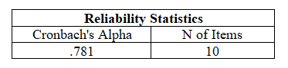
- Uji reliabilitas produktivitas kerja (Y)

- Uji reliabilitas lingkungan kerja (X1)
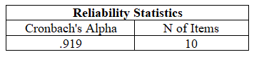

- Uji reliabilitas semangat kerja (X2)
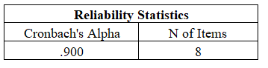

- Uji reliabilitas motivasi kerja (X3)
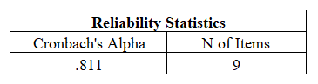

- Lampiran Hasil Statistik Deskriptif
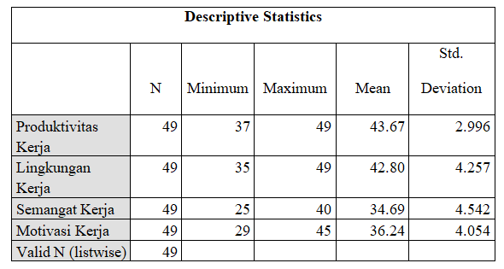
- Lampiran Hasil Uji Asumsi Klasik

Hasil Uji Normalitas

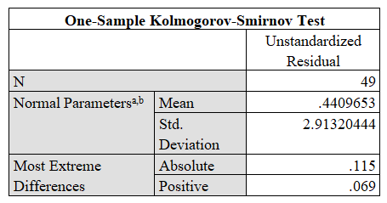
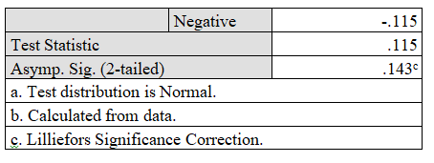
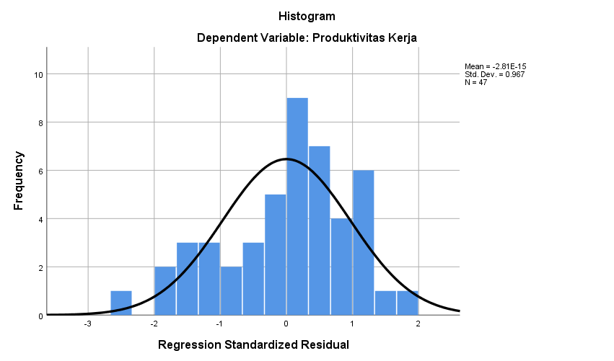
Grafik Histogram Uji Normalitas

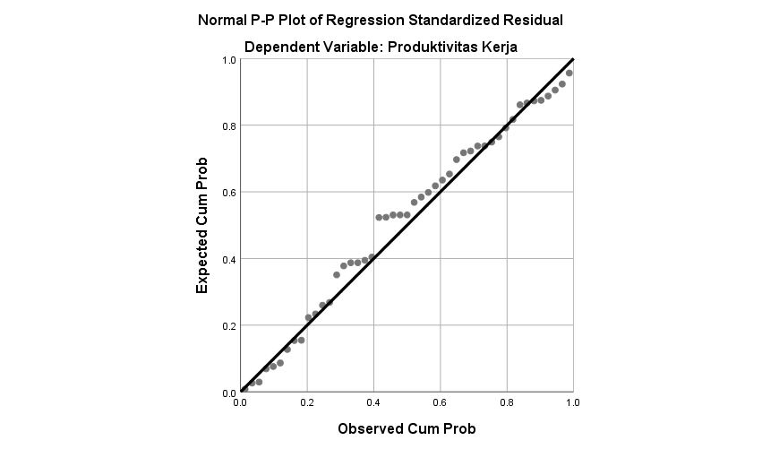
Grafik Normal P-P Plot

Hasil Uji Multikolinearitas

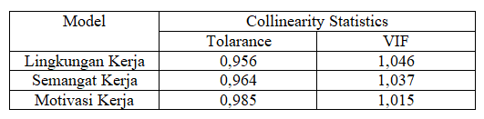

Uji Heteroskadstisitas
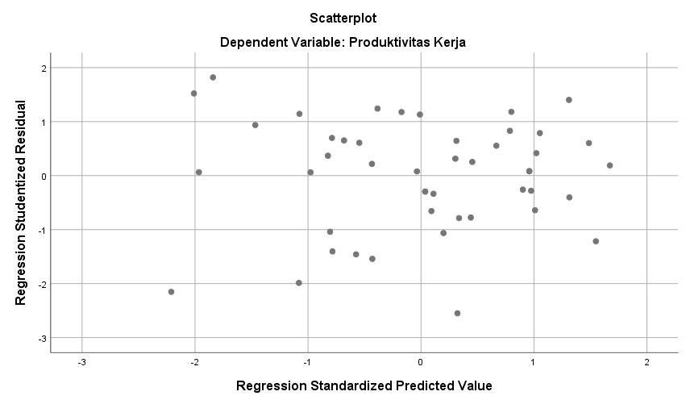

- Lampiran Uji Hipotesis
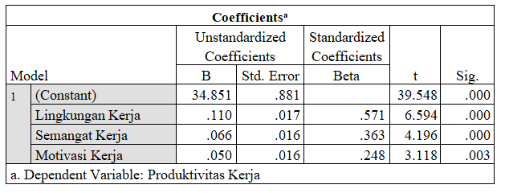
- Hasil Uji t

- Hasil Uji F
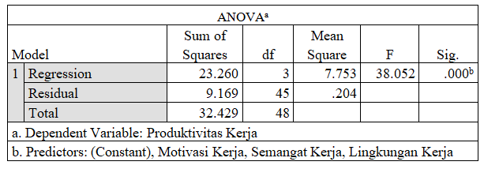

- Lampiran Regresi Linear Berganda

- Lampiran Koefisien Determinasi
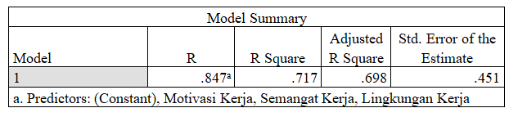

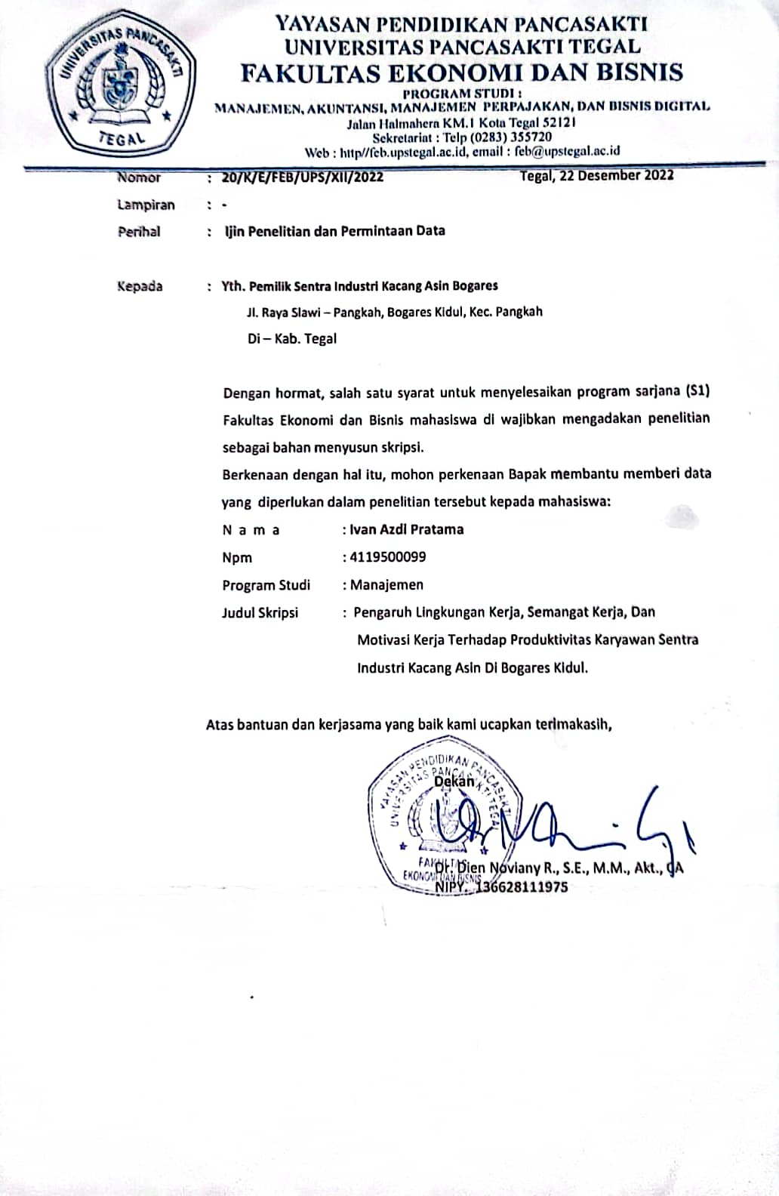
Surat Permohonan izin penelitian
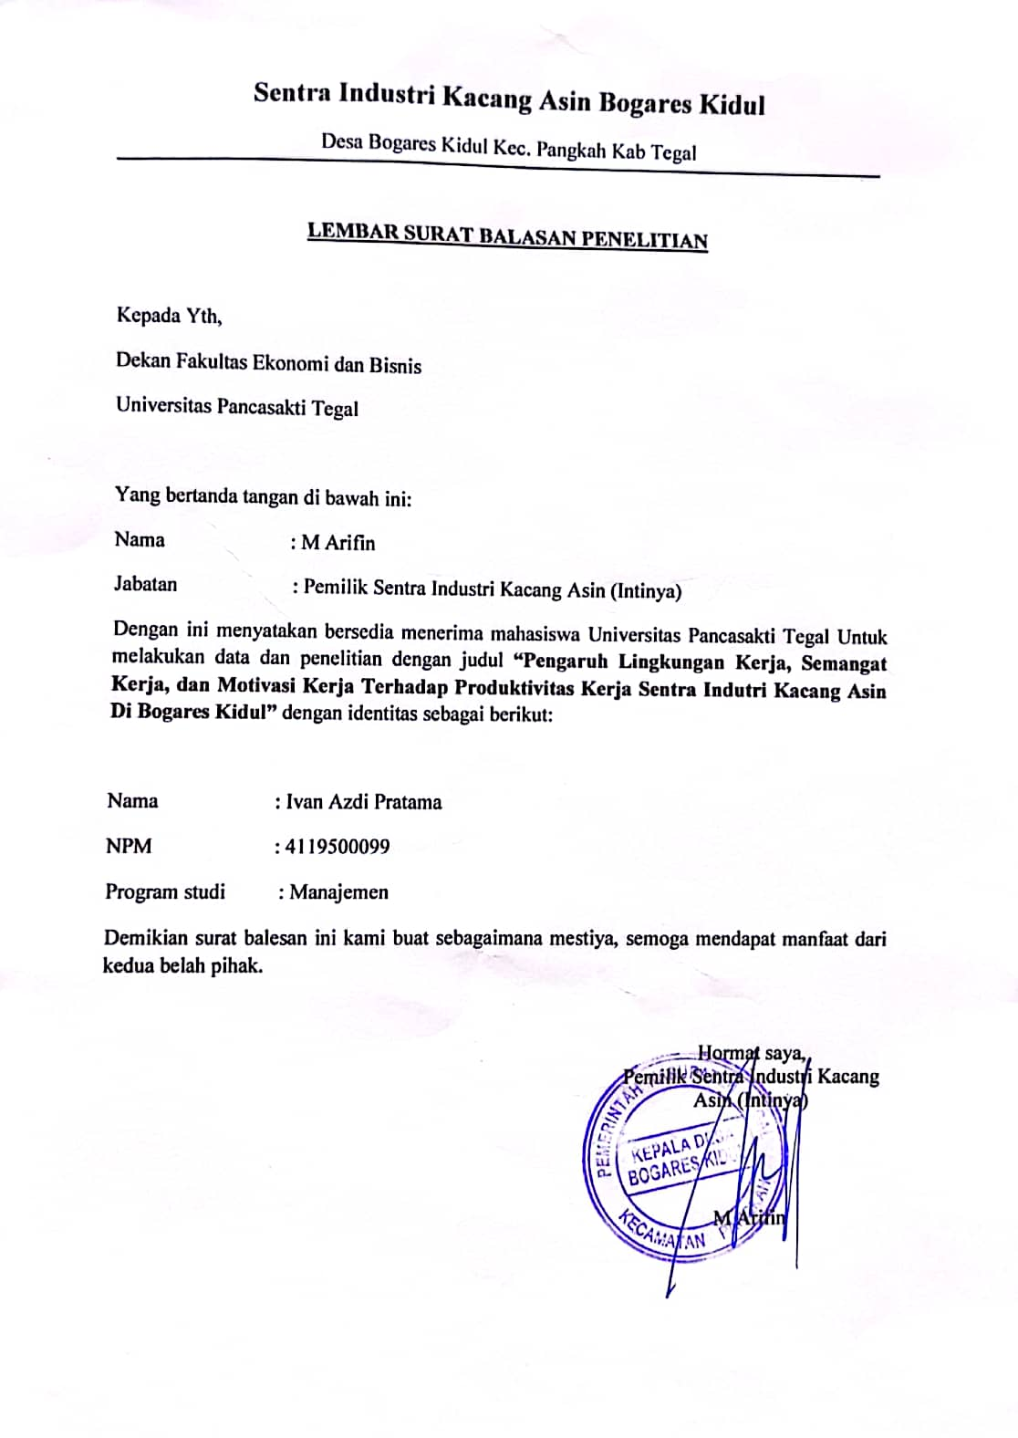
Surat Balasan Penelitian

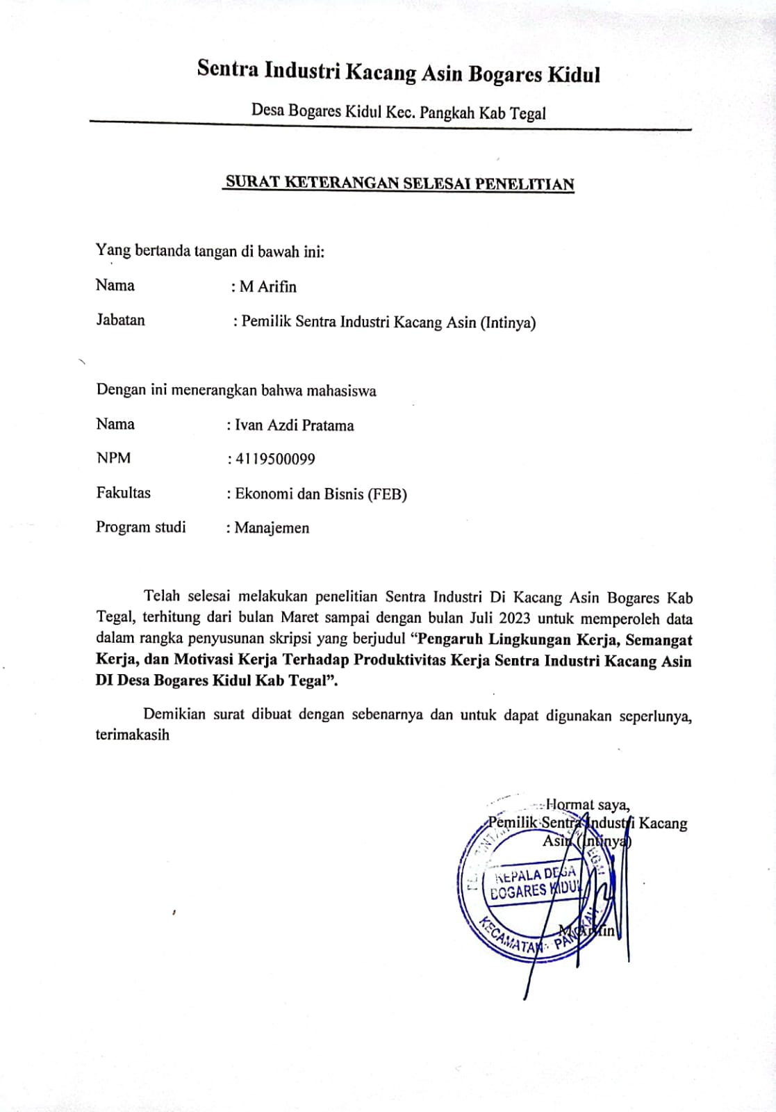
Surat Selesai Penelitian

