# **DAFTAR PUSTAKA**

Aini, Hesti Nur. 2020. “Pengaruh Reward, Keselamatan Dan Kesehatan Kerja, Dan Lingkungan Kerja Terhadap Kepuasan Kerja Pada PT Paragon Technologi And Innovation Kantor Cabang Surabaya.” *Jurnal Ilmu Dan Riset Manajemen* 9(1):1–20.

Akhmal, Akhwanul, Fitriani Laia, Ruri Aditya Sari, Program Studi, Administrasi Bisnis, Program Studi, Teknik Industri, and Pengembangan Karir. 2019. “Kepuasan Kerja Karyawan.” *Jurnal Bisnis Administrasi* 1–6.

Busro Muhammad. 2018. *Teori-Teori Manajemen Sumber Daya Manusia*. jakarta.

Enriko, Febrian, and Tezar Arianto. 2022. “Pengaruh Motivasi Kerja, Disiplin Kerja Dan Insentif Terhadap Kepuasan Kerja Karyawan PT Citra Mitra Sehati Bengkulu.” *Jurnal Entrepreneur Dan Manajemen Sains (JEMS)* 3(1):107–15.

Fadjar, dkk 2018. 2018. *Manajemen Sumber Daya Manusia*.

Farida, Umi, and Sri Hartono. 2016. *Manajemen Sumber Daya Manusia*. Vol. 185.

Faronsyah, Muhammad Iqbal, Universitas Bina Darma, Universitas Bina Darma, and Job Satisfaction. 2020. “Pengaruh Pengembangan Karir Terhadap Kepuasan Kerja Karyawan Pada PT . Jasa Raharja Putera Palembang.” *Jurnal Ilmiah Bina Manajemen*  3(2):113–21.

Fengky, nathalia eunike, Bernhard Tewal, and Bode Lumanauw. 2017. “Pengaruh Motivasi Kerja, Disiplin, Dan Insentif Terhadap Kepuasan Kerja Karyawan Pada RSUP Prof Dr. R. D. Kandou Malalayang.” *Jurnal Ekonomi Bisnis* 5(1):1–10.

Fitri, Klasri Asrika, and Muhammad Yusuf. 2022. “Volume . 24 Issue 3 ( 2022 ) Pages 664-669 Forum Ekonomi : Jurnal Ekonomi , Manajemen Dan Akuntansi ISSN : 1411-1713 ( Print ) 2528-150X ( Online ) Pengaruh Insentif Terhadap Kepuasan Kerja Karyawan The Effect of Incentives on Employee Job Satisfaction.” *Jurnal Ekonomi, Manajemen, Akuntansi* 3(3):664–69.

Foenay, Ephivania Eunike, Rolland E. Fanggidae, and Wehelmina Mariana Ndoen. 2020. “Pengaruh Reward Terhadap Kepuasan Kerja Karyawan Di Pdam Tirta Lontar Kabupaten Kupang.” *Journal of Management : Small and Medium Enterprises (SMEs)* 11(1):83–97.

Hasibuan. 2005. *Manajemen Sunber Daya Manusia*. Edisi Revi. Jakarta: Bumi Aksara.

Iskandar. 2008. *Konseptual Variabel Penelitian*.

Kuncoro. 2009. *Analisi Data*. Indonesia: Alfabeta.

Lasut, Denny Yusak, Bernhard Tewal, and Rosalina A. M. Kolengan. 2018. “Pengaruh Motivasi Kerja, Pengembangan Karir Dan Kepemimpinan Terhadap Kepuasan Kerja Karyawan Pada Pt.Bank Sulut Go.” *Jurnal Ekonomi Manajemen Bisnis* 6(4):2298–2307.

Muqoyyaroh, Lailatul. 2018. “Pengaruh Reward Terhadap Kepuasan Kerja Karyawan PDAM Magetan.” *Jurnal Ilmiah Ekonomi Dan Pembelajarannya* 6(1):95. doi: 10.25273/equilibrium.v6i1.2190.

Onsardi, and Lestari Tamsi Fenni. 2023. “Pengaruh Pengembangan Karir Dan Motivasi Kerja Terhadap Kepuasan Kerja Karyawan.” *Jurnal Ilmiah Manajemen Dan Bisnis* 18(1):109–17.

Rue, Byars &. 2015. *Human Resoure Management*. 8th ed. In The McGraw-Hill Companies.

Rulianti, Erina. 2023. “Pengaruh Motivasi Kerja , Lingkungan Kerja Dan Pengembangan Karier Terhadap Kepuasan Kerja Karyawan.” *Jurnal Ekonomi Dan Ekonomi Syariah* 6(1):849–58.

Sabrina, R. 2021. *Manajemen Sumber Daya Manusia*.

Sangadji, Sopiah &. Etta mamang. 2018. *Manajemen Sumber Daya Manusia Strategik*. Yogyakarta: Andi Yogyakarta.

Siagian. 2015. *Manajemen Sumber Daya Manusia*. jakarta: PT. Bumi Akarsa.

Sugiyono. 2019. *Variabel Dependen Dan Independen Msdm*. 2019th ed. indonesia: alfabetea.

Sugiyono, D. 2013. *Metode Penelitian Kuantitatif, Kualitatif, Dan Tindakan*. 19th ed. indonesia: Alfabeta.

Sujarweni. 2015. *Metodologi Penelitian Bisnis Ekonomi*. Yogyakarta: Pustaka Baru Press.

***LAMPIRAN***

# **LAMPIRAN**

Lembar Kuesioner

Perihal : Permohonan Pengisian Kuesioner

Judul Penelitian : Pengaruh Pengembangan Karir, *Reward*, dan Insentif Terhadap Kepuasan Kerja Karyawan PT. Halt Manufaktur Sentosa Tegal.

Kepada Yth

Sdr. Responden

Di Tempat

Dengan Hormat,

Dalam rangka menyelesaikan penelitian, saya mahasiswa Fakultas Ekonomi dan Bisnis Universitas Pancasakti Tegal, mohon partisipasi dari saudara untuk mengisi kuesioner yang telah kami sediakan.

Adapun data yang kami minta adalah sesuai dengan kondisi yang dirasakan saudara selama ini. Kami akan menjaga kerahasiaan karena data ini hanya untuk kepentingan penelitian.

Setiap jawaban yang diberikan merupakan bantuan yang tidak ternilai harganya bagi penelitian ini.

Atas perhatian dan bantuannya, kami mengucapkan terimakasih.

Tegal, 21 September 2023

Hormat Saya,

Gusnawan Fajrin Ibrahim

A. IDENTITAS RESPONDEN

Nama :

Usia : a. 20-30 Tahun

: b. 31-40 Tahun

: c. 41 > Tahun

Jenis kelamin : a. Laki-laki

: b. Perempuan

Pendidikan Terakhir : a. SD

b. SMP

c. SMA

B. PETUNJUK PENGISIAN KUESIONER

Berilah tanda *check list* (√) pada kolom yang sesuai dengan perasaan dan keadaan saudara, saudara diminta untuk menjawab dengan jujur sesuai dengan penghayatan saudara mengenai situasi dan kondisi yang ada dalam pernyataan tersebut.

Keterangan :

SP : Sangat Puas

P : Puas

N : Netral

TP : Tidak Puas

STP : Sangat Tidak Puas

**KUESIONER PENELITIAN**

**A. KEPUASAN KERJA**

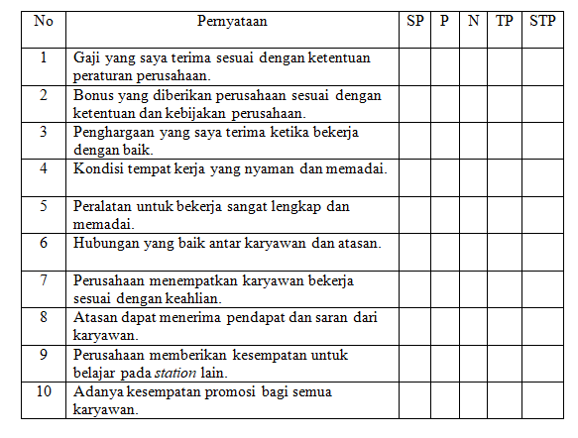

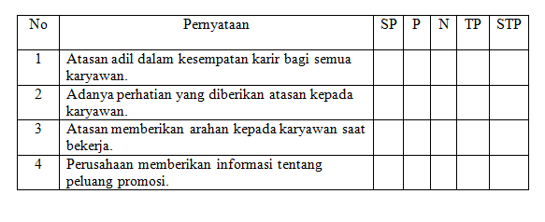**B. PENGEMBANGAN KARIR**

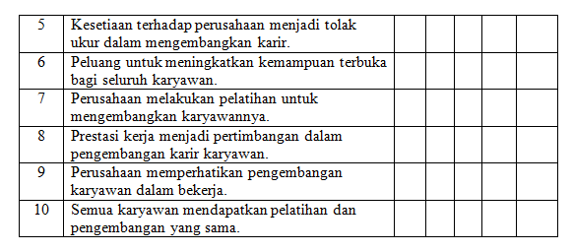

**C. *REWARD***

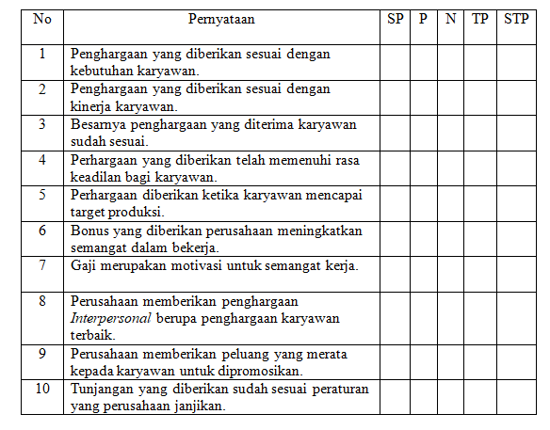

**D. INSENTIF**

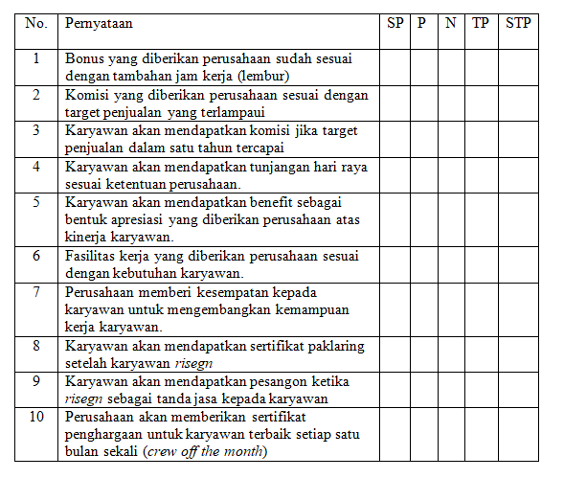

**Lampiran pengolahan data ordinal**

1. **Lampiran data kuesioner variabel kepuasan kerja (Y)**
2. **Lampiran data kuesioner variabel pengembangan karir (X1)**
3. **Lampiran data kuesioner variabel reward (X2)**
4. **Lampiran data kuesioner variabel insentif (X3)**

**Lampiran data pengolahan data interval (MSI)**

1. **Lampiran data hasil kuesioner kepuasan kerja (Y)**
2. **Lampiran data hasil kuesioner pengembangan karir (X1)**
3. **Lampiran data hasil kuesioner reward (X2)**
4. **Lampiran data hasil kuesioner insetif (X3)**

**Lampiran Hasil Output SPSS**

1. **Hasil Uji Analisis Data**
2. **Uji Validitas**
3. **Hasil uji validitas variabel kepuasan kerja (Y)**

|  |  |  |  |  |  |  |  |  |  |  |  |  |
| --- | --- | --- | --- | --- | --- | --- | --- | --- | --- | --- | --- | --- |
| **Correlations** | | | | | | | | | | | | |
|  | | Y1.1 | Y1.2 | Y1.3 | Y1.4 | Y1.5 | Y1.6 | Y1.7 | Y1.8 | Y1.9 | Y1.10 | Y1.TOTAL |
| Y1.1 | Pearson Correlation | 1 | .539** | .752** | .400* | .385* | .285 | .311 | .259 | .484** | .172 | .762** |
| Sig. (2-tailed) |  | .002 | .000 | .029 | .036 | .127 | .094 | .167 | .007 | .363 | .000 |
| N | 30 | 30 | 30 | 30 | 30 | 30 | 30 | 30 | 30 | 30 | 30 |
| Y1.2 | Pearson Correlation | .539** | 1 | .551** | .379* | .430* | .306 | .091 | .214 | .114 | -.040 | .567** |
| Sig. (2-tailed) | .002 |  | .002 | .039 | .018 | .100 | .632 | .256 | .548 | .833 | .001 |
| N | 30 | 30 | 30 | 30 | 30 | 30 | 30 | 30 | 30 | 30 | 30 |
| Y1.3 | Pearson Correlation | .752** | .551** | 1 | .492** | .172 | .240 | .223 | .224 | .133 | .084 | .622** |
| Sig. (2-tailed) | .000 | .002 |  | .006 | .365 | .201 | .237 | .234 | .484 | .658 | .000 |
| N | 30 | 30 | 30 | 30 | 30 | 30 | 30 | 30 | 30 | 30 | 30 |
| Y1.4 | Pearson Correlation | .400* | .379* | .492** | 1 | .426* | .551** | .156 | .506** | -.170 | .190 | .626** |
| Sig. (2-tailed) | .029 | .039 | .006 |  | .019 | .002 | .409 | .004 | .370 | .314 | .000 |
| N | 30 | 30 | 30 | 30 | 30 | 30 | 30 | 30 | 30 | 30 | 30 |
| Y1.5 | Pearson Correlation | .385* | .430* | .172 | .426* | 1 | .625** | .390* | .300 | .163 | .066 | .645** |
| Sig. (2-tailed) | .036 | .018 | .365 | .019 |  | .000 | .033 | .108 | .390 | .730 | .000 |
| N | 30 | 30 | 30 | 30 | 30 | 30 | 30 | 30 | 30 | 30 | 30 |
| Y1.6 | Pearson Correlation | .285 | .306 | .240 | .551** | .625** | 1 | .265 | .622** | -.055 | .175 | .671** |
| Sig. (2-tailed) | .127 | .100 | .201 | .002 | .000 |  | .157 | .000 | .772 | .355 | .000 |
| N | 30 | 30 | 30 | 30 | 30 | 30 | 30 | 30 | 30 | 30 | 30 |
| Y1.7 | Pearson Correlation | .311 | .091 | .223 | .156 | .390* | .265 | 1 | .278 | .220 | .070 | .510** |
| Sig. (2-tailed) | .094 | .632 | .237 | .409 | .033 | .157 |  | .137 | .243 | .715 | .004 |
| N | 30 | 30 | 30 | 30 | 30 | 30 | 30 | 30 | 30 | 30 | 30 |
| Y1.8 | Pearson Correlation | .259 | .214 | .224 | .506** | .300 | .622** | .278 | 1 | .232 | .294 | .665** |
| Sig. (2-tailed) | .167 | .256 | .234 | .004 | .108 | .000 | .137 |  | .217 | .115 | .000 |
| N | 30 | 30 | 30 | 30 | 30 | 30 | 30 | 30 | 30 | 30 | 30 |
| Y1.9 | Pearson Correlation | .484** | .114 | .133 | -.170 | .163 | -.055 | .220 | .232 | 1 | .320 | .453* |
| Sig. (2-tailed) | .007 | .548 | .484 | .370 | .390 | .772 | .243 | .217 |  | .085 | .012 |
| N | 30 | 30 | 30 | 30 | 30 | 30 | 30 | 30 | 30 | 30 | 30 |
| Y1.10 | Pearson Correlation | .172 | -.040 | .084 | .190 | .066 | .175 | .070 | .294 | .320 | 1 | .435* |
| Sig. (2-tailed) | .363 | .833 | .658 | .314 | .730 | .355 | .715 | .115 | .085 |  | .016 |
| N | 30 | 30 | 30 | 30 | 30 | 30 | 30 | 30 | 30 | 30 | 30 |
| Y1.TOTAL | Pearson Correlation | .762** | .567** | .622** | .626** | .645** | .671** | .510** | .665** | .453* | .435* | 1 |
| Sig. (2-tailed) | .000 | .001 | .000 | .000 | .000 | .000 | .004 | .000 | .012 | .016 |  |
| N | 30 | 30 | 30 | 30 | 30 | 30 | 30 | 30 | 30 | 30 | 30 |
| **. Correlation is significant at the 0.01 level (2-tailed). | | | | | | | | | | | | |
| *. Correlation is significant at the 0.05 level (2-tailed). | | | | | | | | | | | | |

1. **Hasil uji validitas variabel pengembangan karir (X1)**

|  |  |  |  |  |  |  |  |  |  |  |  |  |
| --- | --- | --- | --- | --- | --- | --- | --- | --- | --- | --- | --- | --- |
| **Correlations** | | | | | | | | | | | | |
|  | | X1.1 | X1.2 | X1.3 | X1.4 | X1.5 | X1.6 | X1.7 | X1.8 | X1.9 | X1.10 | X1.TOTAL |
| X1.1 | Pearson Correlation | 1 | .189 | .322 | .325 | .003 | .336 | .375* | .211 | .494** | .396* | .472** |
| Sig. (2-tailed) |  | .316 | .083 | .080 | .986 | .069 | .041 | .262 | .005 | .030 | .008 |
| N | 30 | 30 | 30 | 30 | 30 | 30 | 30 | 30 | 30 | 30 | 30 |
| X1.2 | Pearson Correlation | .189 | 1 | .630** | .510** | .490** | .306 | .541** | .406* | .562** | .414* | .667** |
| Sig. (2-tailed) | .316 |  | .000 | .004 | .006 | .100 | .002 | .026 | .001 | .023 | .000 |
| N | 30 | 30 | 30 | 30 | 30 | 30 | 30 | 30 | 30 | 30 | 30 |
| X1.3 | Pearson Correlation | .322 | .630** | 1 | .737** | .682** | .445* | .712** | .586** | .737** | .439* | .829** |
| Sig. (2-tailed) | .083 | .000 |  | .000 | .000 | .014 | .000 | .001 | .000 | .015 | .000 |
| N | 30 | 30 | 30 | 30 | 30 | 30 | 30 | 30 | 30 | 30 | 30 |
| X1.4 | Pearson Correlation | .325 | .510** | .737** | 1 | .744** | .697** | .688** | .552** | .720** | .449* | .843** |
| Sig. (2-tailed) | .080 | .004 | .000 |  | .000 | .000 | .000 | .002 | .000 | .013 | .000 |
| N | 30 | 30 | 30 | 30 | 30 | 30 | 30 | 30 | 30 | 30 | 30 |
| X1.5 | Pearson Correlation | .003 | .490** | .682** | .744** | 1 | .654** | .677** | .488** | .641** | .395* | .763** |
| Sig. (2-tailed) | .986 | .006 | .000 | .000 |  | .000 | .000 | .006 | .000 | .031 | .000 |
| N | 30 | 30 | 30 | 30 | 30 | 30 | 30 | 30 | 30 | 30 | 30 |
| X1.6 | Pearson Correlation | .336 | .306 | .445* | .697** | .654** | 1 | .803** | .591** | .697** | .486** | .788** |
| Sig. (2-tailed) | .069 | .100 | .014 | .000 | .000 |  | .000 | .001 | .000 | .006 | .000 |
| N | 30 | 30 | 30 | 30 | 30 | 30 | 30 | 30 | 30 | 30 | 30 |
| X1.7 | Pearson Correlation | .375* | .541** | .712** | .688** | .677** | .803** | 1 | .688** | .794** | .622** | .907** |
| Sig. (2-tailed) | .041 | .002 | .000 | .000 | .000 | .000 |  | .000 | .000 | .000 | .000 |
| N | 30 | 30 | 30 | 30 | 30 | 30 | 30 | 30 | 30 | 30 | 30 |
| X1.8 | Pearson Correlation | .211 | .406* | .586** | .552** | .488** | .591** | .688** | 1 | .720** | .449* | .745** |
| Sig. (2-tailed) | .262 | .026 | .001 | .002 | .006 | .001 | .000 |  | .000 | .013 | .000 |
| N | 30 | 30 | 30 | 30 | 30 | 30 | 30 | 30 | 30 | 30 | 30 |
| X1.9 | Pearson Correlation | .494** | .562** | .737** | .720** | .641** | .697** | .794** | .720** | 1 | .550** | .906** |
| Sig. (2-tailed) | .005 | .001 | .000 | .000 | .000 | .000 | .000 | .000 |  | .002 | .000 |
| N | 30 | 30 | 30 | 30 | 30 | 30 | 30 | 30 | 30 | 30 | 30 |
| X1.10 | Pearson Correlation | .396* | .414* | .439* | .449* | .395* | .486** | .622** | .449* | .550** | 1 | .686** |
| Sig. (2-tailed) | .030 | .023 | .015 | .013 | .031 | .006 | .000 | .013 | .002 |  | .000 |
| N | 30 | 30 | 30 | 30 | 30 | 30 | 30 | 30 | 30 | 30 | 30 |
| X1.TOTAL | Pearson Correlation | .472** | .667** | .829** | .843** | .763** | .788** | .907** | .745** | .906** | .686** | 1 |
| Sig. (2-tailed) | .008 | .000 | .000 | .000 | .000 | .000 | .000 | .000 | .000 | .000 |  |
| N | 30 | 30 | 30 | 30 | 30 | 30 | 30 | 30 | 30 | 30 | 30 |
| *. Correlation is significant at the 0.05 level (2-tailed). | | | | | | | | | | | | |
| **. Correlation is significant at the 0.01 level (2-tailed). | | | | | | | | | | | | |

1. **Hasil uji validitas variabel reward (X2)**

|  |  |  |  |  |  |  |  |  |  |  |  |  |
| --- | --- | --- | --- | --- | --- | --- | --- | --- | --- | --- | --- | --- |
| **Correlations** | | | | | | | | | | | | |
|  | | X2.1 | X2.2 | X2.3 | X2.4 | X2.5 | X2.6 | X2.7 | X2.8 | X2.9 | X2.10 | X2.TOTAL |
| X2.1 | Pearson Correlation | 1 | .589** | .208 | .408* | .472** | .450* | .567** | .551** | .558** | .670** | .700** |
| Sig. (2-tailed) |  | .001 | .270 | .025 | .008 | .013 | .001 | .002 | .001 | .000 | .000 |
| N | 30 | 30 | 30 | 30 | 30 | 30 | 30 | 30 | 30 | 30 | 30 |
| X2.2 | Pearson Correlation | .589** | 1 | .392* | .722** | .556** | .637** | .687** | .650** | .631** | .356 | .782** |
| Sig. (2-tailed) | .001 |  | .032 | .000 | .001 | .000 | .000 | .000 | .000 | .054 | .000 |
| N | 30 | 30 | 30 | 30 | 30 | 30 | 30 | 30 | 30 | 30 | 30 |
| X2.3 | Pearson Correlation | .208 | .392* | 1 | .339 | .331 | .599** | .357 | .499** | .621** | .316 | .620** |
| Sig. (2-tailed) | .270 | .032 |  | .067 | .074 | .000 | .053 | .005 | .000 | .089 | .000 |
| N | 30 | 30 | 30 | 30 | 30 | 30 | 30 | 30 | 30 | 30 | 30 |
| X2.4 | Pearson Correlation | .408* | .722** | .339 | 1 | .385* | .643** | .595** | .675** | .546** | .411* | .719** |
| Sig. (2-tailed) | .025 | .000 | .067 |  | .035 | .000 | .001 | .000 | .002 | .024 | .000 |
| N | 30 | 30 | 30 | 30 | 30 | 30 | 30 | 30 | 30 | 30 | 30 |
| X2.5 | Pearson Correlation | .472** | .556** | .331 | .385* | 1 | .581** | .734** | .671** | .674** | .454* | .759** |
| Sig. (2-tailed) | .008 | .001 | .074 | .035 |  | .001 | .000 | .000 | .000 | .012 | .000 |
| N | 30 | 30 | 30 | 30 | 30 | 30 | 30 | 30 | 30 | 30 | 30 |
| X2.6 | Pearson Correlation | .450* | .637** | .599** | .643** | .581** | 1 | .759** | .712** | .663** | .498** | .852** |
| Sig. (2-tailed) | .013 | .000 | .000 | .000 | .001 |  | .000 | .000 | .000 | .005 | .000 |
| N | 30 | 30 | 30 | 30 | 30 | 30 | 30 | 30 | 30 | 30 | 30 |
| X2.7 | Pearson Correlation | .567** | .687** | .357 | .595** | .734** | .759** | 1 | .875** | .683** | .472** | .866** |
| Sig. (2-tailed) | .001 | .000 | .053 | .001 | .000 | .000 |  | .000 | .000 | .008 | .000 |
| N | 30 | 30 | 30 | 30 | 30 | 30 | 30 | 30 | 30 | 30 | 30 |
| X2.8 | Pearson Correlation | .551** | .650** | .499** | .675** | .671** | .712** | .875** | 1 | .763** | .542** | .891** |
| Sig. (2-tailed) | .002 | .000 | .005 | .000 | .000 | .000 | .000 |  | .000 | .002 | .000 |
| N | 30 | 30 | 30 | 30 | 30 | 30 | 30 | 30 | 30 | 30 | 30 |
| X2.9 | Pearson Correlation | .558** | .631** | .621** | .546** | .674** | .663** | .683** | .763** | 1 | .695** | .878** |
| Sig. (2-tailed) | .001 | .000 | .000 | .002 | .000 | .000 | .000 | .000 |  | .000 | .000 |
| N | 30 | 30 | 30 | 30 | 30 | 30 | 30 | 30 | 30 | 30 | 30 |
| X2.10 | Pearson Correlation | .670** | .356 | .316 | .411* | .454* | .498** | .472** | .542** | .695** | 1 | .699** |
| Sig. (2-tailed) | .000 | .054 | .089 | .024 | .012 | .005 | .008 | .002 | .000 |  | .000 |
| N | 30 | 30 | 30 | 30 | 30 | 30 | 30 | 30 | 30 | 30 | 30 |
| X2.TOTAL | Pearson Correlation | .700** | .782** | .620** | .719** | .759** | .852** | .866** | .891** | .878** | .699** | 1 |
| Sig. (2-tailed) | .000 | .000 | .000 | .000 | .000 | .000 | .000 | .000 | .000 | .000 |  |
| N | 30 | 30 | 30 | 30 | 30 | 30 | 30 | 30 | 30 | 30 | 30 |
| **. Correlation is significant at the 0.01 level (2-tailed). | | | | | | | | | | | | |
| *. Correlation is significant at the 0.05 level (2-tailed). | | | | | | | | | | | | |

1. **Hasil uji validitas variabel insentif (X3)**

|  |  |  |  |  |  |  |  |  |  |  |  |  |
| --- | --- | --- | --- | --- | --- | --- | --- | --- | --- | --- | --- | --- |
| **Correlations** | | | | | | | | | | | | |
|  | | X3.1 | X3.2 | X3.3 | X3.4 | X3.5 | X3.6 | X3.7 | X3.8 | X3.9 | X3.10 | X3.TOTAL |
| X3.1 | Pearson Correlation | 1 | .452* | .388* | .611** | .326 | .571** | .572** | .537** | .424* | .182 | .701** |
| Sig. (2-tailed) |  | .012 | .034 | .000 | .078 | .001 | .001 | .002 | .019 | .335 | .000 |
| N | 30 | 30 | 30 | 30 | 30 | 30 | 30 | 30 | 30 | 30 | 30 |
| X3.2 | Pearson Correlation | .452* | 1 | .590** | .514** | .366* | .353 | .772** | .603** | .476** | .570** | .813** |
| Sig. (2-tailed) | .012 |  | .001 | .004 | .047 | .056 | .000 | .000 | .008 | .001 | .000 |
| N | 30 | 30 | 30 | 30 | 30 | 30 | 30 | 30 | 30 | 30 | 30 |
| X3.3 | Pearson Correlation | .388* | .590** | 1 | .544** | .217 | .416* | .592** | .536** | .308 | .483** | .734** |
| Sig. (2-tailed) | .034 | .001 |  | .002 | .248 | .022 | .001 | .002 | .098 | .007 | .000 |
| N | 30 | 30 | 30 | 30 | 30 | 30 | 30 | 30 | 30 | 30 | 30 |
| X3.4 | Pearson Correlation | .611** | .514** | .544** | 1 | .308 | .359 | .764** | .568** | .479** | .213 | .764** |
| Sig. (2-tailed) | .000 | .004 | .002 |  | .097 | .051 | .000 | .001 | .007 | .258 | .000 |
| N | 30 | 30 | 30 | 30 | 30 | 30 | 30 | 30 | 30 | 30 | 30 |
| X3.5 | Pearson Correlation | .326 | .366* | .217 | .308 | 1 | .476** | .183 | .311 | .353 | .679** | .593** |
| Sig. (2-tailed) | .078 | .047 | .248 | .097 |  | .008 | .333 | .094 | .056 | .000 | .001 |
| N | 30 | 30 | 30 | 30 | 30 | 30 | 30 | 30 | 30 | 30 | 30 |
| X3.6 | Pearson Correlation | .571** | .353 | .416* | .359 | .476** | 1 | .339 | .346 | .426* | .485** | .662** |
| Sig. (2-tailed) | .001 | .056 | .022 | .051 | .008 |  | .067 | .061 | .019 | .007 | .000 |
| N | 30 | 30 | 30 | 30 | 30 | 30 | 30 | 30 | 30 | 30 | 30 |
| X3.7 | Pearson Correlation | .572** | .772** | .592** | .764** | .183 | .339 | 1 | .682** | .454* | .183 | .790** |
| Sig. (2-tailed) | .001 | .000 | .001 | .000 | .333 | .067 |  | .000 | .012 | .332 | .000 |
| N | 30 | 30 | 30 | 30 | 30 | 30 | 30 | 30 | 30 | 30 | 30 |
| X3.8 | Pearson Correlation | .537** | .603** | .536** | .568** | .311 | .346 | .682** | 1 | .346 | .333 | .732** |
| Sig. (2-tailed) | .002 | .000 | .002 | .001 | .094 | .061 | .000 |  | .061 | .072 | .000 |
| N | 30 | 30 | 30 | 30 | 30 | 30 | 30 | 30 | 30 | 30 | 30 |
| X3.9 | Pearson Correlation | .424* | .476** | .308 | .479** | .353 | .426* | .454* | .346 | 1 | .358 | .644** |
| Sig. (2-tailed) | .019 | .008 | .098 | .007 | .056 | .019 | .012 | .061 |  | .052 | .000 |
| N | 30 | 30 | 30 | 30 | 30 | 30 | 30 | 30 | 30 | 30 | 30 |
| X3.10 | Pearson Correlation | .182 | .570** | .483** | .213 | .679** | .485** | .183 | .333 | .358 | 1 | .638** |
| Sig. (2-tailed) | .335 | .001 | .007 | .258 | .000 | .007 | .332 | .072 | .052 |  | .000 |
| N | 30 | 30 | 30 | 30 | 30 | 30 | 30 | 30 | 30 | 30 | 30 |
| X3.TOTAL | Pearson Correlation | .701** | .813** | .734** | .764** | .593** | .662** | .790** | .732** | .644** | .638** | 1 |
| Sig. (2-tailed) | .000 | .000 | .000 | .000 | .001 | .000 | .000 | .000 | .000 | .000 |  |
| N | 30 | 30 | 30 | 30 | 30 | 30 | 30 | 30 | 30 | 30 | 30 |
| *. Correlation is significant at the 0.05 level (2-tailed). | | | | | | | | | | | | |
| **. Correlation is significant at the 0.01 level (2-tailed). | | | | | | | | | | | | |

1. 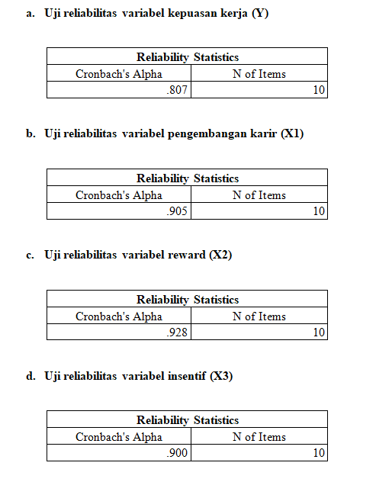**Uji Reliabilitas**
2. **Lampiran Hasil Asumsi Klasik**

**Hasil uji normalitas Kolmogrov-Smirnov**

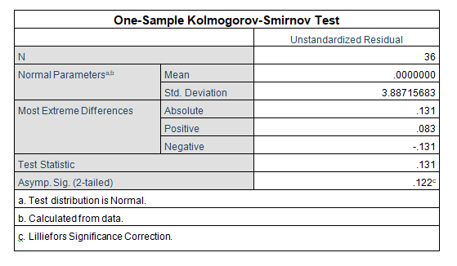

**Histogram**

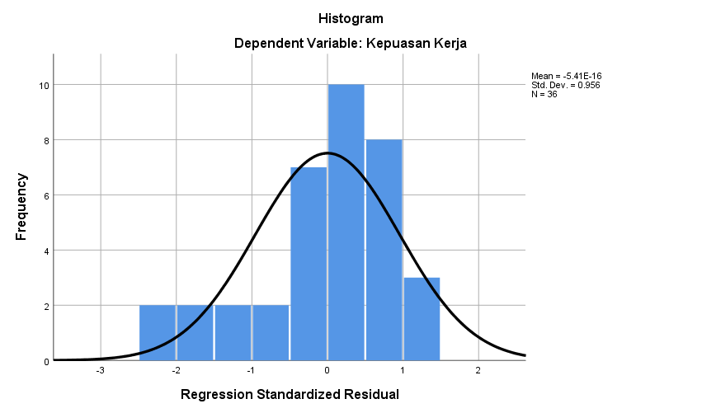

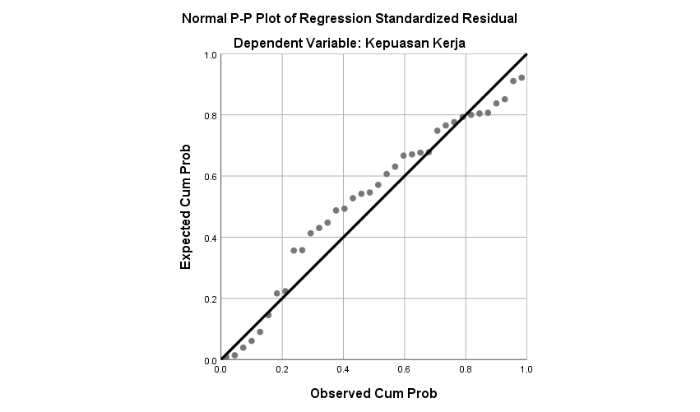**Grafik Normal Plot**

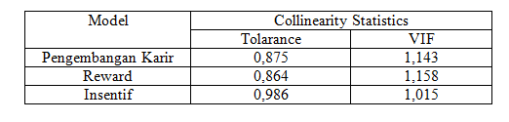**Hasil uji multikolinearitas**

**Hasil uji heteroskedastitas**

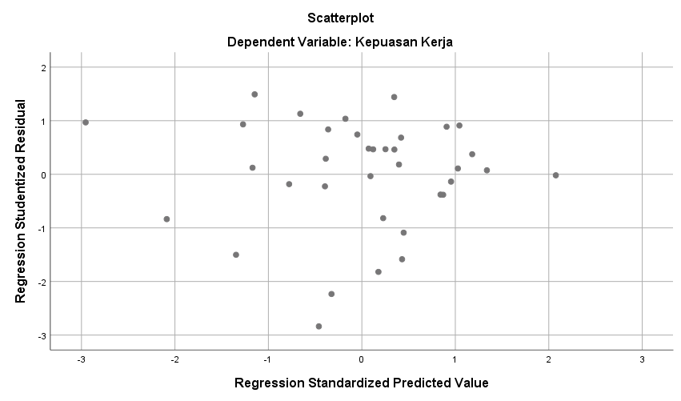

1. **Lampiran uji hipotesis**
2. 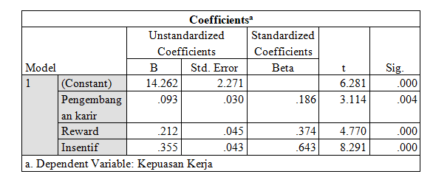**Hasil uji t**
3. 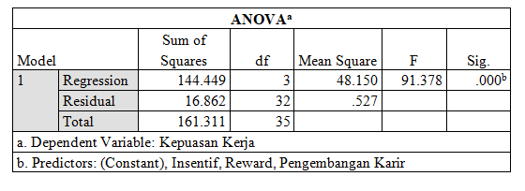**Hasil uji F**
4. **Lampiran hasil analisis regresi linear berganda**



1. **Lampiran hasil koefisien determinasi**

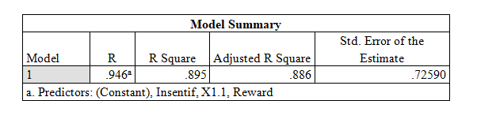

**Surat Permohonan Izin Penelitian**

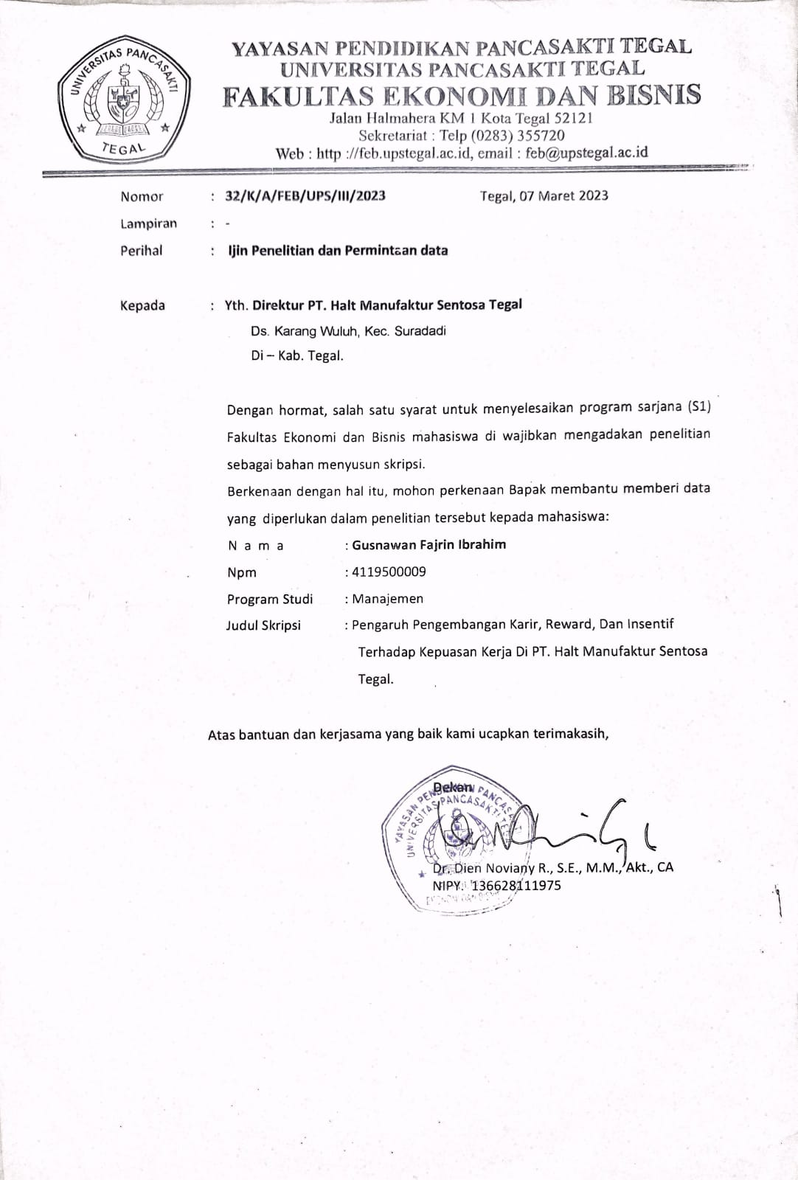

**Surat Balasan Penelitian**

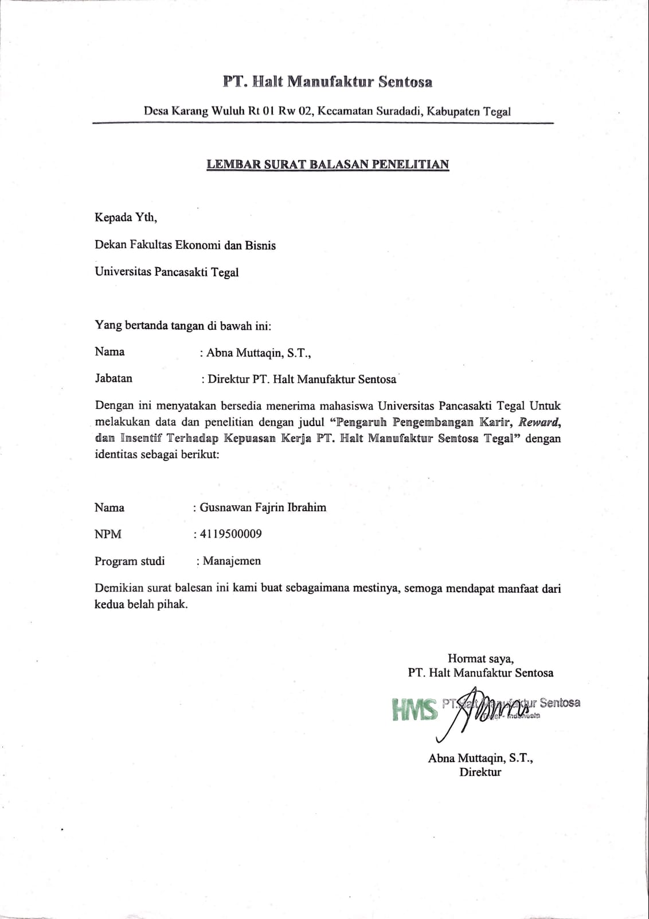

**Surat Selesai Penelitian**

