DAFTAR PUSTAKA

Afandi. (2021). Manajemen Sumber Daya Manusia . Pekan Baru: Zanafa Publishing.
Ghozali, I. (2016). Aplikasi Multivariate dengan Program SPSS . Semarang: UNDIP.
Ghozali, I. (2018). Aplikasi Analisis Multivariate dengan Program SPSS. Semarang: Badan Penerbit UNDIP.
Ginting, D. (2016). Etos Kerja. Jakarta: PT Alex Media Komputindo.
Handoko, H. (2003). Manajemen. Yogyakarta: EdisikeII.
Handoko, T. (2016). Manajemen Sumber Daya Manusia. Jakarta: Bumi Aksara.
Hanggreni, D. (2011). Perilaku Organisasi. Fekon UI : Jakarta.
Hardiansyah , A., & Yanwar, R. (2017). Pengaruh Etos Kerja Terhadap Kinerja Karyawan PT. EA. Jurnal Al-Azhar Indonesia, 1-11.
Hasibuan. (2014). Manajemen Sumber Daya Manusia. Jakarta: Bumi Aksara.
Hasibuan, M. S. (2005). Manajemen Sumber Daya Manusia . PT. Bumi Aksara, Jakarta.
Hasibuan, M. S. (2014). Manejemen Sumber Daya Manusia. Jakarta: PT. Bumi Aksara.
Hutapea, P., & Nirianna. (2008). Kompetensi Plus. Jakarta: Gramedia Pustaka Utama.
Kadarisma. (2016). Manajemen Sumber Daya Manusia. Jakarta: Bumi Aksara.
Kuncoro, R. d. (2008). Cara Menggunakan dan Memakai Analisis Jalur (Part Analysis). Bandung : Alfabeta.
Kusnan, A. (2004). Analisis Sikap Iklim Organisasi, Etos Kerja, dan Disiplin Kerja Dalam Menentukan Efektivitas Kinerja Organisasi di Garnisun Tetap III Surabaya. Universitas Erlangga.
Lasang, G. (2022). Pengaruh Dukungan Organisasi, Latar Belakang Pendidikan dan Pengalaman Kerja Terhadap Etos Kerja Karyawan Di Koperasi Simpan Pinjam Credit Union Dharma Prima Kita Yogyakarta. Jurnal Pendidikan Dasar Dan Sosial Humaniora, I, 50-62.
Nitisemito, A. (2000). Manajemen Personalia. Surabaya: Ghalia Indonesia.
Novliadi, F. (2009). Hubungan Antara Organization Based Self-Estem Dengan Etos Kerja. Universitas Sumatera Utara e-Respository, 1-28.
Priansa, D. J. (2014). Perencanaan dan Pengembangan SDM. Bandung : Alfabeta.
Rivai, V. (2009). Manajemen Sumber Daya Manusia Untuk Perusahaan. Jakarta: Raja Grafindo Persada.
Robbins. (2014). Human Resource Management. Tent Edition Jakarta PT Indeks.
Sagir., S. (2000). Membangun manusia Karya. Jakarta: Pustaka Sinar Harapan.
Salamun, Sumardi, Sadilah, Emiliana, Sumintarsih, Sudijono, & Suhartinah. (1995). Presepsi Tentang Etos Kerja Kaitannya Dengan Nilai Budaya Masyarakat Daerah Istimewa Yogyakarta. Yogyakarta: Departemen Pendidikan Dan Kebudayaan RI.
Saleh, A. R. (2018). Pengaruh Disiplin Kerja, Motivasi kerja, Etos Kerja, dan Lingkungan Kerja Terhadap Produktivitas Kerja Karyawan Bagian Produksi Di PT. Inko Java Semarang. Among Makarti, 28-50.
Saydam, G. (2000). Manajemen Sumber Daya Manusia (Human Resources Management). Jakarta: Djambatan.
Sedarmayanti . (2009). Tata Kerja dan Produktivitas Kerja. Bandung : CV. Mandar Maju.
Simamora, H. (2004). Manajemen Sumber Daya Manusia. Yograkarta: Bagian Penerbitan STIE YKPN.
Soeharsono, S. (2000). Membangun manusia Karya. Jakarta: Pustaka Sinar Harapan.
Sugiyono. (2012). Metode Penelitian Bisnis. Bandung : Alfabeta.
Sugiyono. (2014). Metode Penelitian Bisnis. Bandung: Alfabeta.
Sugiyono. (2017). Metode Penelitian Kuantitatif, Kualitatif, dan R & D. Bandung: CV. Alfabeta.
Sutrisno, E. (2009). Manajemen Sumber Daya Manusia. Jakarta: Prenadamedia Grup.
Tampubolon, B. D. (2007). Analisis Faktor Gaya Kepemimpinan dan Faktor Etos Kerja Terhadap Kinerja Pegawai Pada Organisasi Yang Telah. Jurnal Standarisasi , Vol. 9, No. 3, 106-115.
Wibowo. (2007). Manajemen Kinerja. Jakarta: Raja Grafindo Persada.
Wibowo, B. H., & Susanti, F. (2011). pengaruh Human Relation (Hubungan Antar Manusia), Lingkungan Kerja Terhadap Etos Kerja Karyawan (Studi Kasus Pada PT Pelindo Teknik Bayur Padang. Jurnal Manajemen, 1-14.

.

LAMPIRAN

Lampiran 1 Kuesioner
Kuesioner Penelitian
Perihal : Permohonan Pengisian Kuesioner
Judul Penelitian : Pengaruh Kompetensi Kerja, Pengawasan Kerja, dan Lingkungan Kerja Terhadap Etos Kerja Pegawai Pada Dinas Perumahan Dan Kawasan Permukiman Kabupaten Pemalang
Yth
Bapak/Ibu
Di tempat
Dengan Hormat,
Dalam rangka menyelesaikan penelitian, kami mahasiswa Fakultas Ekonomi dan Bisnis Universitas Pancasakti Tegal, mohon partisipasi dari Bapak/ibu/Sdr untuk mengisi kuesioner yang telah kami sediakan.
Adapun data yang kami minta adalah sesuai dengan kondisi yang dirasakan Bapak/Ibu/Sdr selama ini. Kami akan menjaga kerahasiaanya karena data ini hanya untuk kepentingan penelitian. Setiap jawaban yang diberikan merupakan bantuan yang tidak ternilai harganya bagi penelitian ini. Kami memberikan jangka waktu selama satu minggu setelah kuesioner ini kami sebarkan, agar Bapak/Ibu/Sdr dapat segera mengembalikannya kepada kami.
Atas perhatian dan bantuannya, kami mengucapkan banyak terimakasih.
Tegal, 2023

Elsa Septi Pitasari
KARAKTERISTIK RESPONDEN
PETUNJUK PENGISIAN KUESIONER
- Mohon dengan hormat dan kesediaan Bapak/Ibu/Sdr untuk menanggapi seluruh pertanyaan yang ada
- Beri tanda Checklist () pada kolom yang tersedia
- Mohon menjawab semua pertanyaan yang tertera tanpa ada yang terlewat
- Ada lima alternative jawaban
SS : Sangat Setuju
S : Setuju
N : Netral
TS : Tidak Setuju
STS : Sangat Tidak Setuju

DATA KUESIONER
Nama :
- Jenis Kelamin
Laki-laki Perempuan
- Pendidikan Terakhir
SD/SMP SMA/SMK DIII/S1 S2
- Umur
20-35 tahun 35-40 tahun 41-45 tahun >45 tahun
- Masa Kerja
<1 tahun 1-5 tahun 6-10 tahun >10 tahun

KUESIONER PENELITIAN
- Etos Kerja (Y)

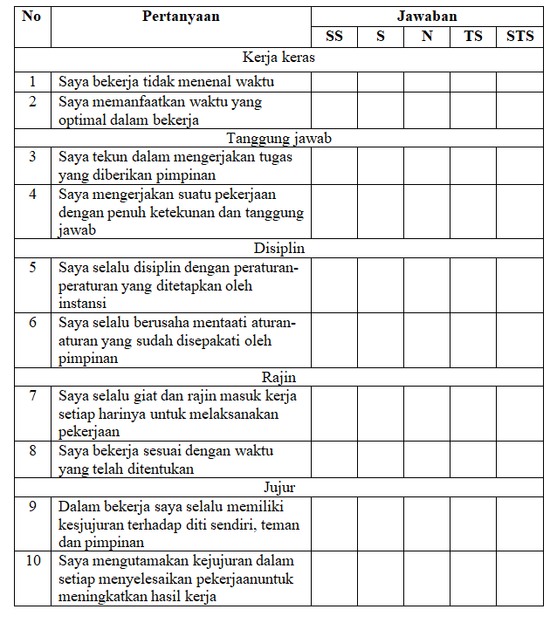

- Kompetensi Kerja (X1)
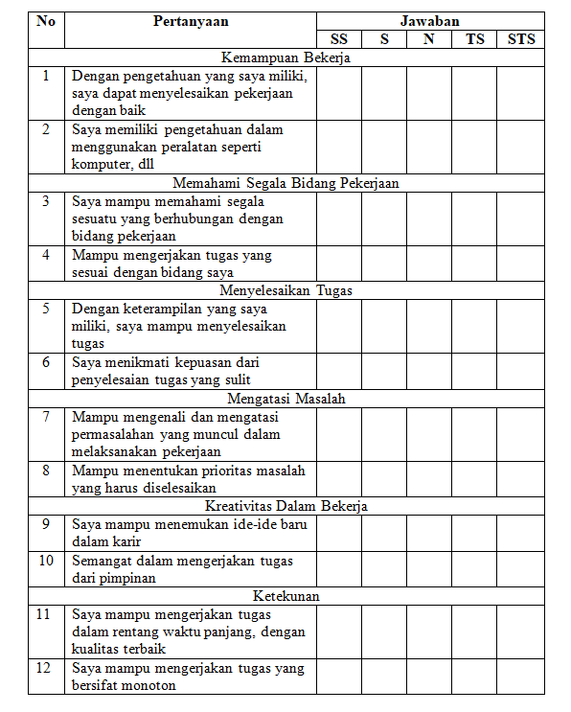

- Pengawasan Kerja (X2)
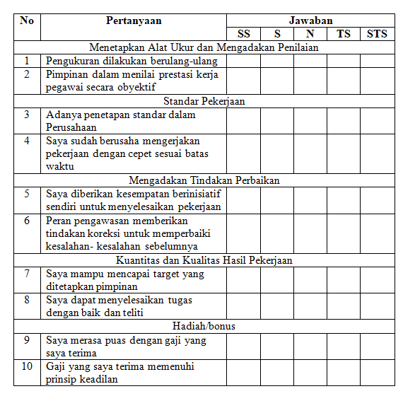

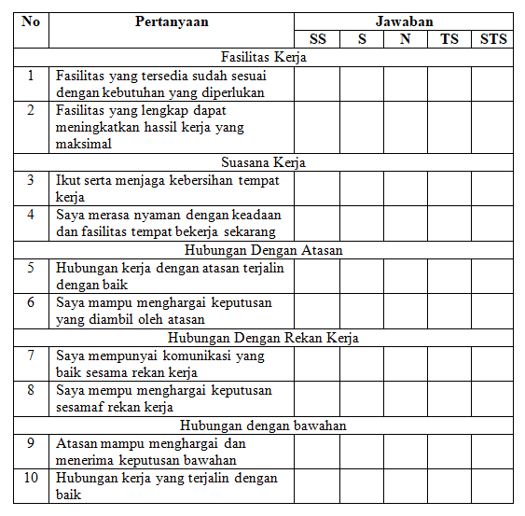
- Lingkungan Kerja (X3)

Lampiran 2 Tabulasi Data Etos Kerja
 | Etos Kerja
No | Y.1 | Y.2 | Y.3 | Y.4 | Y.5 | Y.6 | Y.7 | Y.8 | Y.9 | Y.10 | Total
1 | 4 | 4 | 5 | 4 | 5 | 5 | 4 | 4 | 5 | 5 | 45
2 | 4 | 4 | 4 | 4 | 4 | 4 | 4 | 4 | 4 | 5 | 41
3 | 4 | 4 | 4 | 4 | 5 | 4 | 4 | 4 | 4 | 4 | 41
4 | 4 | 5 | 5 | 4 | 4 | 4 | 4 | 4 | 4 | 5 | 43
5 | 4 | 4 | 4 | 4 | 4 | 4 | 4 | 4 | 4 | 4 | 40
6 | 4 | 5 | 4 | 4 | 4 | 4 | 5 | 5 | 4 | 4 | 43
7 | 5 | 4 | 4 | 4 | 4 | 5 | 4 | 4 | 4 | 4 | 42
8 | 4 | 4 | 4 | 4 | 4 | 4 | 4 | 4 | 4 | 4 | 40
9 | 4 | 4 | 5 | 4 | 4 | 4 | 4 | 4 | 4 | 4 | 41
10 | 4 | 4 | 5 | 4 | 4 | 4 | 4 | 4 | 4 | 4 | 41
11 | 4 | 4 | 4 | 5 | 4 | 4 | 4 | 4 | 4 | 4 | 41
12 | 4 | 4 | 4 | 4 | 4 | 4 | 4 | 4 | 4 | 4 | 40
13 | 4 | 4 | 4 | 4 | 4 | 4 | 4 | 4 | 4 | 4 | 40
14 | 4 | 4 | 4 | 4 | 4 | 4 | 4 | 4 | 4 | 4 | 40
15 | 4 | 4 | 4 | 4 | 4 | 3 | 4 | 4 | 4 | 4 | 39
16 | 4 | 5 | 4 | 4 | 4 | 4 | 5 | 4 | 4 | 4 | 42
17 | 4 | 4 | 5 | 3 | 3 | 4 | 4 | 4 | 3 | 4 | 38
18 | 5 | 5 | 5 | 5 | 5 | 5 | 5 | 4 | 4 | 5 | 48
19 | 5 | 5 | 5 | 5 | 5 | 5 | 5 | 5 | 5 | 5 | 50
20 | 4 | 5 | 5 | 4 | 4 | 4 | 4 | 4 | 5 | 5 | 44
21 | 5 | 4 | 4 | 4 | 5 | 4 | 4 | 4 | 4 | 4 | 42
22 | 4 | 5 | 5 | 5 | 5 | 4 | 5 | 4 | 4 | 5 | 46
23 | 4 | 4 | 3 | 3 | 5 | 4 | 3 | 4 | 4 | 5 | 39
24 | 4 | 3 | 4 | 4 | 4 | 4 | 3 | 4 | 3 | 4 | 37
25 | 5 | 4 | 4 | 5 | 3 | 4 | 5 | 4 | 5 | 3 | 42
26 | 3 | 3 | 3 | 3 | 4 | 4 | 3 | 3 | 4 | 4 | 34
27 | 4 | 4 | 3 | 3 | 4 | 4 | 3 | 3 | 4 | 4 | 36
28 | 4 | 4 | 4 | 4 | 4 | 3 | 4 | 4 | 4 | 4 | 39
29 | 4 | 4 | 4 | 4 | 4 | 4 | 4 | 4 | 4 | 4 | 40
30 | 3 | 3 | 3 | 3 | 3 | 3 | 3 | 3 | 3 | 3 | 30
31 | 4 | 4 | 4 | 4 | 4 | 5 | 4 | 3 | 3 | 5 | 40
32 | 4 | 4 | 5 | 5 | 5 | 4 | 4 | 5 | 5 | 5 | 46
33 | 4 | 4 | 5 | 4 | 5 | 5 | 5 | 5 | 4 | 5 | 46
34 | 4 | 3 | 3 | 4 | 4 | 4 | 4 | 4 | 4 | 4 | 38
35 | 3 | 4 | 3 | 4 | 4 | 4 | 4 | 4 | 4 | 4 | 38
36 | 4 | 4 | 4 | 4 | 4 | 4 | 4 | 4 | 4 | 4 | 40
37 | 4 | 4 | 3 | 4 | 4 | 4 | 4 | 4 | 3 | 4 | 38
38 | 5 | 4 | 5 | 4 | 4 | 5 | 4 | 4 | 4 | 5 | 44
39 | 4 | 4 | 4 | 4 | 4 | 4 | 4 | 4 | 4 | 4 | 40
40 | 4 | 4 | 4 | 5 | 5 | 4 | 4 | 4 | 4 | 4 | 42
41 | 3 | 4 | 3 | 4 | 3 | 4 | 4 | 4 | 3 | 3 | 35
42 | 4 | 4 | 4 | 4 | 4 | 4 | 4 | 4 | 4 | 4 | 40
43 | 4 | 4 | 4 | 4 | 4 | 4 | 4 | 4 | 4 | 4 | 40
44 | 4 | 4 | 4 | 4 | 4 | 4 | 4 | 4 | 4 | 4 | 40
45 | 5 | 4 | 4 | 5 | 5 | 4 | 4 | 5 | 4 | 5 | 45
46 | 4 | 4 | 5 | 4 | 5 | 3 | 5 | 4 | 5 | 5 | 44
47 | 4 | 4 | 4 | 4 | 4 | 4 | 4 | 4 | 4 | 4 | 40

Lampiran 3 Tabulasi Data Kompetensi Kerja
 | Kompetensi Kerja
No | X1.1 | X1.2 | X1.3 | X1.4 | X1.5 | X1.6 | X1.7 | X1.8 | X1.9 | X1.10 | X1.11 | X1.12 | Total
1 | 5 | 5 | 5 | 4 | 5 | 5 | 4 | 5 | 4 | 5 | 4 | 5 | 56
2 | 3 | 4 | 4 | 4 | 4 | 4 | 3 | 4 | 3 | 5 | 3 | 3 | 44
3 | 5 | 5 | 4 | 5 | 5 | 4 | 5 | 5 | 5 | 4 | 5 | 5 | 57
4 | 2 | 4 | 2 | 4 | 4 | 4 | 2 | 4 | 2 | 5 | 2 | 2 | 37
5 | 3 | 3 | 4 | 5 | 3 | 4 | 3 | 4 | 3 | 2 | 3 | 3 | 40
6 | 5 | 5 | 5 | 5 | 5 | 5 | 5 | 4 | 5 | 3 | 5 | 5 | 57
7 | 5 | 4 | 5 | 5 | 4 | 5 | 3 | 5 | 3 | 5 | 3 | 5 | 52
8 | 4 | 4 | 4 | 4 | 4 | 4 | 4 | 3 | 4 | 4 | 4 | 4 | 47
9 | 4 | 2 | 3 | 4 | 2 | 5 | 2 | 4 | 2 | 4 | 2 | 4 | 38
10 | 3 | 4 | 4 | 4 | 4 | 4 | 3 | 5 | 3 | 5 | 3 | 3 | 45
11 | 5 | 4 | 4 | 5 | 4 | 4 | 4 | 5 | 4 | 4 | 4 | 5 | 52
12 | 5 | 5 | 5 | 5 | 5 | 5 | 5 | 5 | 5 | 5 | 5 | 5 | 60
13 | 5 | 5 | 5 | 5 | 5 | 5 | 5 | 5 | 5 | 5 | 5 | 5 | 60
14 | 4 | 4 | 5 | 3 | 4 | 4 | 3 | 5 | 3 | 5 | 3 | 4 | 47
15 | 5 | 5 | 5 | 5 | 5 | 5 | 5 | 5 | 5 | 5 | 5 | 5 | 60
16 | 5 | 5 | 5 | 5 | 5 | 5 | 5 | 5 | 5 | 5 | 5 | 5 | 60
17 | 5 | 5 | 5 | 5 | 5 | 5 | 5 | 5 | 5 | 5 | 5 | 5 | 60
18 | 5 | 5 | 4 | 4 | 5 | 5 | 5 | 5 | 5 | 5 | 5 | 5 | 58
19 | 5 | 3 | 5 | 4 | 3 | 5 | 3 | 5 | 3 | 2 | 3 | 5 | 46
20 | 5 | 5 | 5 | 5 | 5 | 4 | 4 | 5 | 4 | 5 | 4 | 5 | 56
21 | 5 | 5 | 5 | 4 | 5 | 5 | 4 | 5 | 4 | 5 | 4 | 5 | 56
22 | 5 | 5 | 5 | 5 | 5 | 5 | 5 | 5 | 5 | 5 | 5 | 5 | 60
23 | 5 | 5 | 5 | 5 | 5 | 5 | 4 | 5 | 4 | 4 | 4 | 5 | 56
24 | 5 | 4 | 5 | 4 | 4 | 4 | 4 | 5 | 4 | 4 | 4 | 5 | 52
25 | 5 | 4 | 5 | 5 | 4 | 5 | 5 | 5 | 5 | 5 | 5 | 5 | 58
26 | 4 | 4 | 5 | 5 | 4 | 4 | 3 | 4 | 3 | 4 | 3 | 4 | 47
27 | 5 | 4 | 5 | 4 | 4 | 5 | 2 | 5 | 2 | 4 | 2 | 5 | 47
28 | 4 | 4 | 4 | 4 | 4 | 5 | 2 | 5 | 2 | 4 | 2 | 4 | 44
29 | 5 | 5 | 5 | 4 | 5 | 5 | 5 | 5 | 5 | 5 | 5 | 5 | 59
30 | 5 | 5 | 5 | 4 | 5 | 5 | 4 | 5 | 4 | 5 | 4 | 5 | 56
31 | 4 | 5 | 4 | 5 | 4 | 4 | 4 | 5 | 5 | 3 | 4 | 3 | 50
32 | 4 | 5 | 5 | 5 | 4 | 4 | 4 | 3 | 4 | 5 | 4 | 3 | 50
33 | 4 | 5 | 4 | 5 | 4 | 4 | 4 | 5 | 5 | 3 | 4 | 4 | 51
34 | 4 | 5 | 4 | 5 | 4 | 4 | 4 | 5 | 5 | 3 | 4 | 3 | 50
35 | 4 | 5 | 5 | 5 | 4 | 5 | 5 | 4 | 4 | 5 | 4 | 2 | 52
36 | 4 | 5 | 4 | 5 | 4 | 4 | 4 | 5 | 5 | 3 | 4 | 3 | 50
37 | 4 | 5 | 4 | 5 | 4 | 4 | 4 | 5 | 5 | 3 | 3 | 3 | 49
38 | 4 | 5 | 5 | 5 | 3 | 4 | 4 | 4 | 5 | 5 | 3 | 3 | 50
39 | 4 | 5 | 4 | 5 | 4 | 4 | 4 | 5 | 5 | 3 | 3 | 3 | 49
40 | 4 | 5 | 4 | 5 | 4 | 4 | 4 | 5 | 5 | 3 | 3 | 4 | 50
41 | 3 | 2 | 3 | 3 | 4 | 3 | 3 | 4 | 3 | 2 | 3 | 3 | 36
42 | 3 | 3 | 3 | 5 | 3 | 3 | 3 | 3 | 5 | 3 | 3 | 4 | 41
43 | 4 | 3 | 3 | 5 | 5 | 4 | 4 | 4 | 5 | 3 | 3 | 4 | 47
44 | 5 | 4 | 5 | 4 | 5 | 4 | 5 | 4 | 5 | 2 | 3 | 4 | 50
45 | 3 | 3 | 3 | 3 | 3 | 3 | 3 | 3 | 3 | 3 | 3 | 4 | 37
45 | 5 | 3 | 4 | 4 | 4 | 3 | 3 | 5 | 4 | 3 | 4 | 3 | 45
45 | 4 | 5 | 5 | 5 | 4 | 3 | 3 | 2 | 5 | 1 | 4 | 4 | 45

Lampiran 4 Tabulasi Data Pengawasan Kerja
 | Pengawasan Kerja
No | X2.1 | X2.2 | X2.3 | X2.4 | X2.5 | X2.6 | X2.7 | X2.8 | X2.9 | X2.10 | Total
1 | 4 | 4 | 4 | 4 | 4 | 4 | 4 | 4 | 4 | 4 | 40
2 | 4 | 4 | 4 | 4 | 4 | 4 | 4 | 4 | 4 | 4 | 40
3 | 4 | 4 | 4 | 4 | 4 | 4 | 4 | 4 | 4 | 4 | 40
4 | 4 | 3 | 3 | 3 | 4 | 3 | 4 | 4 | 4 | 4 | 36
5 | 4 | 4 | 5 | 4 | 4 | 4 | 4 | 4 | 5 | 5 | 43
6 | 4 | 4 | 4 | 3 | 3 | 3 | 3 | 3 | 4 | 3 | 34
7 | 3 | 4 | 4 | 4 | 4 | 4 | 4 | 4 | 4 | 4 | 39
8 | 5 | 4 | 3 | 4 | 4 | 4 | 4 | 4 | 4 | 4 | 40
9 | 5 | 5 | 4 | 5 | 5 | 5 | 5 | 5 | 5 | 5 | 49
10 | 4 | 4 | 3 | 5 | 3 | 4 | 4 | 4 | 4 | 4 | 39
11 | 4 | 4 | 4 | 4 | 4 | 4 | 4 | 4 | 4 | 4 | 40
12 | 3 | 3 | 4 | 4 | 3 | 3 | 2 | 3 | 4 | 4 | 33
13 | 5 | 5 | 5 | 5 | 5 | 5 | 5 | 5 | 5 | 5 | 50
14 | 5 | 5 | 5 | 5 | 5 | 5 | 5 | 5 | 5 | 4 | 49
15 | 4 | 4 | 4 | 4 | 4 | 4 | 4 | 4 | 4 | 4 | 40
16 | 4 | 4 | 4 | 4 | 4 | 4 | 4 | 4 | 4 | 4 | 40
17 | 4 | 4 | 4 | 4 | 4 | 3 | 4 | 4 | 4 | 3 | 38
18 | 2 | 4 | 4 | 4 | 4 | 4 | 4 | 4 | 4 | 2 | 36
19 | 4 | 4 | 3 | 4 | 4 | 4 | 4 | 3 | 4 | 4 | 38
20 | 4 | 4 | 4 | 4 | 3 | 3 | 3 | 4 | 4 | 4 | 37
21 | 3 | 3 | 3 | 3 | 3 | 3 | 3 | 3 | 3 | 3 | 30
22 | 4 | 4 | 4 | 4 | 2 | 4 | 4 | 4 | 4 | 4 | 38
23 | 4 | 4 | 2 | 4 | 4 | 4 | 4 | 4 | 4 | 4 | 38
24 | 4 | 4 | 3 | 4 | 3 | 3 | 3 | 3 | 3 | 3 | 33
25 | 4 | 4 | 2 | 4 | 4 | 2 | 4 | 4 | 4 | 4 | 36
26 | 5 | 4 | 5 | 4 | 5 | 5 | 5 | 5 | 5 | 5 | 48
27 | 4 | 4 | 4 | 4 | 4 | 4 | 4 | 4 | 4 | 4 | 40
28 | 4 | 4 | 3 | 3 | 4 | 3 | 3 | 3 | 4 | 4 | 35
29 | 4 | 4 | 4 | 4 | 4 | 4 | 4 | 4 | 4 | 4 | 40
30 | 4 | 4 | 4 | 4 | 4 | 4 | 4 | 4 | 4 | 4 | 40
31 | 5 | 5 | 5 | 5 | 5 | 5 | 5 | 5 | 5 | 5 | 50
32 | 5 | 5 | 5 | 5 | 5 | 5 | 5 | 5 | 5 | 4 | 49
33 | 4 | 4 | 4 | 4 | 4 | 4 | 4 | 4 | 4 | 4 | 40
34 | 4 | 4 | 4 | 4 | 4 | 4 | 4 | 4 | 4 | 4 | 40
35 | 4 | 4 | 4 | 4 | 4 | 3 | 4 | 4 | 4 | 3 | 38
36 | 2 | 4 | 4 | 4 | 4 | 4 | 4 | 4 | 4 | 2 | 36
37 | 4 | 4 | 3 | 4 | 4 | 4 | 4 | 3 | 4 | 4 | 38
38 | 4 | 4 | 4 | 4 | 3 | 3 | 3 | 4 | 4 | 4 | 37
39 | 3 | 3 | 3 | 3 | 3 | 3 | 3 | 3 | 3 | 3 | 30
40 | 4 | 4 | 4 | 4 | 2 | 4 | 4 | 4 | 4 | 4 | 38
41 | 4 | 4 | 2 | 4 | 4 | 4 | 4 | 4 | 4 | 4 | 38
42 | 4 | 4 | 3 | 4 | 3 | 3 | 3 | 3 | 3 | 3 | 33
43 | 4 | 4 | 2 | 4 | 4 | 2 | 4 | 4 | 4 | 4 | 36
44 | 5 | 4 | 5 | 4 | 5 | 5 | 5 | 5 | 5 | 5 | 48
45 | 4 | 4 | 4 | 4 | 4 | 4 | 4 | 4 | 4 | 4 | 40
46 | 4 | 4 | 3 | 3 | 4 | 3 | 3 | 3 | 4 | 4 | 35
47 | 4 | 4 | 4 | 4 | 4 | 4 | 4 | 4 | 4 | 4 | 40

Lampiran 5 Tabulasi Data Lingkungan Kerja
 | Lingkungan Kerja
No | X3.1 | X3.2 | X3.3 | X3.4 | X3.5 | X3.6 | X3.7 | X3.8 | X3.9 | X3.10 | Total
1 | 4 | 4 | 4 | 4 | 4 | 4 | 4 | 4 | 4 | 5 | 41
2 | 4 | 5 | 4 | 3 | 4 | 3 | 4 | 3 | 4 | 4 | 38
3 | 3 | 3 | 3 | 3 | 3 | 3 | 3 | 3 | 3 | 3 | 30
4 | 4 | 5 | 5 | 5 | 4 | 3 | 3 | 4 | 4 | 3 | 40
5 | 5 | 3 | 4 | 4 | 4 | 4 | 4 | 3 | 4 | 4 | 39
6 | 3 | 3 | 3 | 4 | 5 | 4 | 3 | 3 | 3 | 3 | 34
7 | 4 | 5 | 5 | 5 | 5 | 5 | 5 | 5 | 5 | 5 | 49
8 | 3 | 3 | 5 | 4 | 5 | 3 | 3 | 4 | 4 | 3 | 37
9 | 3 | 3 | 3 | 3 | 3 | 3 | 3 | 3 | 3 | 3 | 30
10 | 5 | 4 | 3 | 4 | 3 | 3 | 3 | 3 | 4 | 3 | 35
11 | 4 | 3 | 3 | 3 | 3 | 4 | 4 | 4 | 3 | 3 | 34
12 | 5 | 5 | 5 | 5 | 5 | 5 | 5 | 5 | 5 | 4 | 49
13 | 5 | 5 | 5 | 5 | 5 | 4 | 5 | 5 | 5 | 5 | 49
14 | 3 | 3 | 3 | 3 | 3 | 3 | 3 | 5 | 3 | 3 | 32
15 | 5 | 4 | 5 | 3 | 3 | 3 | 4 | 4 | 4 | 4 | 39
16 | 4 | 4 | 4 | 4 | 5 | 4 | 4 | 3 | 3 | 3 | 38
17 | 5 | 5 | 5 | 4 | 4 | 4 | 4 | 4 | 4 | 4 | 43
18 | 5 | 4 | 5 | 5 | 5 | 5 | 5 | 5 | 5 | 5 | 49
19 | 4 | 5 | 3 | 3 | 4 | 4 | 3 | 4 | 4 | 4 | 38
20 | 4 | 4 | 4 | 4 | 5 | 5 | 5 | 5 | 5 | 5 | 46
21 | 4 | 5 | 5 | 5 | 5 | 5 | 5 | 4 | 5 | 5 | 48
22 | 5 | 4 | 5 | 5 | 5 | 5 | 5 | 5 | 5 | 5 | 49
23 | 5 | 3 | 3 | 4 | 3 | 4 | 3 | 3 | 3 | 5 | 36
24 | 4 | 5 | 5 | 5 | 5 | 5 | 5 | 5 | 5 | 3 | 47
25 | 3 | 5 | 4 | 4 | 4 | 3 | 4 | 4 | 3 | 5 | 39
26 | 5 | 3 | 3 | 3 | 3 | 3 | 3 | 4 | 4 | 4 | 35
27 | 5 | 4 | 5 | 5 | 5 | 5 | 5 | 5 | 5 | 5 | 49
28 | 4 | 5 | 5 | 5 | 5 | 5 | 5 | 5 | 5 | 5 | 49
29 | 4 | 5 | 5 | 4 | 5 | 3 | 4 | 4 | 4 | 5 | 43
30 | 3 | 4 | 4 | 4 | 5 | 4 | 4 | 4 | 4 | 4 | 40
31 | 5 | 3 | 4 | 4 | 4 | 5 | 4 | 4 | 5 | 4 | 42
32 | 3 | 5 | 5 | 5 | 5 | 4 | 3 | 4 | 3 | 3 | 40
33 | 5 | 4 | 4 | 4 | 4 | 4 | 4 | 4 | 4 | 4 | 41
34 | 5 | 5 | 5 | 5 | 5 | 5 | 5 | 5 | 4 | 5 | 49
35 | 5 | 5 | 4 | 3 | 4 | 3 | 3 | 4 | 4 | 4 | 39
36 | 5 | 5 | 5 | 4 | 5 | 4 | 3 | 4 | 4 | 4 | 43
37 | 4 | 4 | 4 | 4 | 4 | 5 | 5 | 4 | 4 | 4 | 42
38 | 4 | 4 | 4 | 4 | 4 | 4 | 4 | 3 | 5 | 5 | 41
39 | 5 | 4 | 3 | 3 | 3 | 4 | 5 | 4 | 5 | 5 | 41
40 | 3 | 4 | 5 | 5 | 3 | 3 | 3 | 3 | 3 | 3 | 35
41 | 4 | 5 | 5 | 3 | 3 | 4 | 3 | 3 | 3 | 3 | 36
42 | 5 | 4 | 5 | 5 | 5 | 5 | 5 | 5 | 5 | 5 | 49
43 | 5 | 5 | 5 | 5 | 5 | 5 | 5 | 5 | 5 | 4 | 49
44 | 3 | 5 | 3 | 5 | 5 | 3 | 5 | 4 | 3 | 4 | 40
45 | 4 | 5 | 4 | 4 | 3 | 3 | 3 | 3 | 4 | 3 | 36
46 | 4 | 4 | 3 | 4 | 4 | 3 | 3 | 3 | 3 | 3 | 34
47 | 4 | 4 | 4 | 4 | 4 | 3 | 3 | 3 | 3 | 3 | 35

Lampiran 6 Transformasi Data Etos Kerja
 | Succesive Interval
No | Y.1 | Y.2 | Y.3 | Y.4 | Y.5 | Y.6 | Y.7 | Y.8 | Y.9 | Y.10 | Y.TOTAL
1 | 2,731 | 2,731 | 3,698 | 2,629 | 4,089 | 4,388 | 2,629 | 2,796 | 4,273 | 4,122 | 34,084
2 | 2,731 | 2,731 | 2,341 | 2,629 | 2,579 | 2,731 | 2,629 | 2,796 | 2,636 | 4,122 | 27,924
3 | 2,731 | 2,731 | 2,341 | 2,629 | 4,089 | 2,731 | 2,629 | 2,796 | 2,636 | 2,611 | 27,923
4 | 2,731 | 4,388 | 3,698 | 2,629 | 2,579 | 2,731 | 2,629 | 2,796 | 2,636 | 4,122 | 30,938
5 | 2,731 | 2,731 | 2,341 | 2,629 | 2,579 | 2,731 | 2,629 | 2,796 | 2,636 | 2,611 | 26,413
6 | 2,731 | 4,388 | 2,341 | 2,629 | 2,579 | 2,731 | 4,213 | 4,556 | 2,636 | 2,611 | 31,415
7 | 4,388 | 2,731 | 2,341 | 2,629 | 2,579 | 4,388 | 2,629 | 2,796 | 2,636 | 2,611 | 29,729
8 | 2,731 | 2,731 | 2,341 | 2,629 | 2,579 | 2,731 | 2,629 | 2,796 | 2,636 | 2,611 | 26,413
9 | 2,731 | 2,731 | 3,698 | 2,629 | 2,579 | 2,731 | 2,629 | 2,796 | 2,636 | 2,611 | 27,770
10 | 2,731 | 2,731 | 3,698 | 2,629 | 2,579 | 2,731 | 2,629 | 2,796 | 2,636 | 2,611 | 27,770
11 | 2,731 | 2,731 | 2,341 | 4,213 | 2,579 | 2,731 | 2,629 | 2,796 | 2,636 | 2,611 | 27,998
12 | 2,731 | 2,731 | 2,341 | 2,629 | 2,579 | 2,731 | 2,629 | 2,796 | 2,636 | 2,611 | 26,413
13 | 2,731 | 2,731 | 2,341 | 2,629 | 2,579 | 2,731 | 2,629 | 2,796 | 2,636 | 2,611 | 26,413
14 | 2,731 | 2,731 | 2,341 | 2,629 | 2,579 | 2,731 | 2,629 | 2,796 | 2,636 | 2,611 | 26,413
15 | 2,731 | 2,731 | 2,341 | 2,629 | 2,579 | 1,000 | 2,629 | 2,796 | 2,636 | 2,611 | 24,683
16 | 2,731 | 4,388 | 2,341 | 2,629 | 2,579 | 2,731 | 4,213 | 2,796 | 2,636 | 2,611 | 29,655
17 | 2,731 | 2,731 | 3,698 | 1,000 | 1,000 | 2,731 | 2,629 | 2,796 | 1,000 | 2,611 | 22,926
18 | 4,388 | 4,388 | 3,698 | 4,213 | 4,089 | 4,388 | 4,213 | 2,796 | 2,636 | 4,122 | 38,932
19 | 4,388 | 4,388 | 3,698 | 4,213 | 4,089 | 4,388 | 4,213 | 4,556 | 4,273 | 4,122 | 42,328
20 | 2,731 | 4,388 | 3,698 | 2,629 | 2,579 | 2,731 | 2,629 | 2,796 | 4,273 | 4,122 | 32,575
21 | 4,388 | 2,731 | 2,341 | 2,629 | 4,089 | 2,731 | 2,629 | 2,796 | 2,636 | 2,611 | 29,581
22 | 2,731 | 4,388 | 3,698 | 4,213 | 4,089 | 2,731 | 4,213 | 2,796 | 2,636 | 4,122 | 35,616
23 | 2,731 | 2,731 | 1,000 | 1,000 | 4,089 | 2,731 | 1,000 | 2,796 | 2,636 | 4,122 | 24,834
24 | 2,731 | 1,000 | 2,341 | 2,629 | 2,579 | 2,731 | 1,000 | 2,796 | 1,000 | 2,611 | 21,417
25 | 4,388 | 2,731 | 2,341 | 4,213 | 1,000 | 2,731 | 4,213 | 2,796 | 4,273 | 1,000 | 29,685
26 | 1,000 | 1,000 | 1,000 | 1,000 | 2,579 | 2,731 | 1,000 | 1,000 | 2,636 | 2,611 | 16,557
27 | 2,731 | 2,731 | 1,000 | 1,000 | 2,579 | 2,731 | 1,000 | 1,000 | 2,636 | 2,611 | 20,018
28 | 2,731 | 2,731 | 2,341 | 2,629 | 2,579 | 1,000 | 2,629 | 2,796 | 2,636 | 2,611 | 24,683
29 | 2,731 | 2,731 | 2,341 | 2,629 | 2,579 | 2,731 | 2,629 | 2,796 | 2,636 | 2,611 | 26,413
30 | 1,000 | 1,000 | 1,000 | 1,000 | 1,000 | 1,000 | 1,000 | 1,000 | 1,000 | 1,000 | 10,000
31 | 2,731 | 2,731 | 2,341 | 2,629 | 2,579 | 4,388 | 2,629 | 1,000 | 1,000 | 4,122 | 26,150
32 | 2,731 | 2,731 | 3,698 | 4,213 | 4,089 | 2,731 | 2,629 | 4,556 | 4,273 | 4,122 | 35,771
33 | 2,731 | 2,731 | 3,698 | 2,629 | 4,089 | 4,388 | 4,213 | 4,556 | 2,636 | 4,122 | 35,792
34 | 2,731 | 1,000 | 1,000 | 2,629 | 2,579 | 2,731 | 2,629 | 2,796 | 2,636 | 2,611 | 23,342
35 | 1,000 | 2,731 | 1,000 | 2,629 | 2,579 | 2,731 | 2,629 | 2,796 | 2,636 | 2,611 | 23,342
36 | 2,731 | 2,731 | 2,341 | 2,629 | 2,579 | 2,731 | 2,629 | 2,796 | 2,636 | 2,611 | 26,413
37 | 2,731 | 2,731 | 1,000 | 2,629 | 2,579 | 2,731 | 2,629 | 2,796 | 1,000 | 2,611 | 23,436
38 | 4,388 | 2,731 | 3,698 | 2,629 | 2,579 | 4,388 | 2,629 | 2,796 | 2,636 | 4,122 | 32,596
39 | 2,731 | 2,731 | 2,341 | 2,629 | 2,579 | 2,731 | 2,629 | 2,796 | 2,636 | 2,611 | 26,413
40 | 2,731 | 2,731 | 2,341 | 4,213 | 4,089 | 2,731 | 2,629 | 2,796 | 2,636 | 2,611 | 29,507
41 | 1,000 | 2,731 | 1,000 | 2,629 | 1,000 | 2,731 | 2,629 | 2,796 | 1,000 | 1,000 | 18,515
42 | 2,731 | 2,731 | 2,341 | 2,629 | 2,579 | 2,731 | 2,629 | 2,796 | 2,636 | 2,611 | 26,413
43 | 2,731 | 2,731 | 2,341 | 2,629 | 2,579 | 2,731 | 2,629 | 2,796 | 2,636 | 2,611 | 26,413
44 | 2,731 | 2,731 | 2,341 | 2,629 | 2,579 | 2,731 | 2,629 | 2,796 | 2,636 | 2,611 | 26,413
45 | 4,388 | 2,731 | 2,341 | 4,213 | 4,089 | 2,731 | 2,629 | 4,556 | 2,636 | 4,122 | 34,435
46 | 2,731 | 2,731 | 3,698 | 2,629 | 4,089 | 1,000 | 4,213 | 2,796 | 4,273 | 4,122 | 32,280
47 | 2,731 | 2,731 | 2,341 | 2,629 | 2,579 | 2,731 | 2,629 | 2,796 | 2,636 | 2,611 | 26,413

Lampiran 7 Transformasi Data Kompetensi Kerja
 | Succesive Interval
No | X1.1 | X1.2 | X1.3 | X1.4 | X1.5 | X1.6 | X1.7 | X1.8 | X1.9 | X1.10 | X1.11 | X1.12 | X1.  TOTAL
1 | 4,213 | 3,844 | 4,146 | 2,188 | 4,434 | 3,647 | 2,914 | 3,954 | 2,556 | 4,283 | 3,081 | 4,014 | 43,273
2 | 1,980 | 2,615 | 2,844 | 2,188 | 3,073 | 2,280 | 2,004 | 2,616 | 1,896 | 4,283 | 2,136 | 2,127 | 30,043
3 | 4,213 | 3,844 | 2,844 | 3,609 | 4,434 | 2,280 | 4,040 | 3,954 | 3,645 | 3,290 | 4,140 | 4,014 | 44,307
4 | 1,000 | 2,615 | 1,000 | 2,188 | 3,073 | 2,280 | 1,000 | 2,616 | 1,000 | 4,283 | 1,000 | 1,000 | 23,056
5 | 1,980 | 1,855 | 2,844 | 3,609 | 1,914 | 2,280 | 2,004 | 2,616 | 1,896 | 1,841 | 2,136 | 2,127 | 27,102
6 | 4,213 | 3,844 | 4,146 | 3,609 | 4,434 | 3,647 | 4,040 | 2,616 | 3,645 | 2,649 | 4,140 | 4,014 | 44,997
7 | 4,213 | 2,615 | 4,146 | 3,609 | 3,073 | 3,647 | 2,004 | 3,954 | 1,896 | 4,283 | 2,136 | 4,014 | 39,591
8 | 2,937 | 2,615 | 2,844 | 2,188 | 3,073 | 2,280 | 2,914 | 1,841 | 2,556 | 3,290 | 3,081 | 2,938 | 32,557
9 | 2,937 | 1,000 | 1,914 | 2,188 | 1,000 | 3,647 | 1,000 | 2,616 | 1,000 | 3,290 | 1,000 | 2,938 | 24,530
10 | 1,980 | 2,615 | 2,844 | 2,188 | 3,073 | 2,280 | 2,004 | 3,954 | 1,896 | 4,283 | 2,136 | 2,127 | 31,381
11 | 4,213 | 2,615 | 2,844 | 3,609 | 3,073 | 2,280 | 2,914 | 3,954 | 2,556 | 3,290 | 3,081 | 4,014 | 38,443
12 | 4,213 | 3,844 | 4,146 | 3,609 | 4,434 | 3,647 | 4,040 | 3,954 | 3,645 | 4,283 | 4,140 | 4,014 | 47,969
13 | 4,213 | 3,844 | 4,146 | 3,609 | 4,434 | 3,647 | 4,040 | 3,954 | 3,645 | 4,283 | 4,140 | 4,014 | 47,969
14 | 2,937 | 2,615 | 4,146 | 1,000 | 3,073 | 2,280 | 2,004 | 3,954 | 1,896 | 4,283 | 2,136 | 2,938 | 33,263
15 | 4,213 | 3,844 | 4,146 | 3,609 | 4,434 | 3,647 | 4,040 | 3,954 | 3,645 | 4,283 | 4,140 | 4,014 | 47,969
16 | 4,213 | 3,844 | 4,146 | 3,609 | 4,434 | 3,647 | 4,040 | 3,954 | 3,645 | 4,283 | 4,140 | 4,014 | 47,969
17 | 4,213 | 3,844 | 4,146 | 3,609 | 4,434 | 3,647 | 4,040 | 3,954 | 3,645 | 4,283 | 4,140 | 4,014 | 47,969
18 | 4,213 | 3,844 | 2,844 | 2,188 | 4,434 | 3,647 | 4,040 | 3,954 | 3,645 | 4,283 | 4,140 | 4,014 | 45,245
19 | 4,213 | 1,855 | 4,146 | 2,188 | 1,914 | 3,647 | 2,004 | 3,954 | 1,896 | 1,841 | 2,136 | 4,014 | 33,808
20 | 4,213 | 3,844 | 4,146 | 3,609 | 4,434 | 2,280 | 2,914 | 3,954 | 2,556 | 4,283 | 3,081 | 4,014 | 43,327
21 | 4,213 | 3,844 | 4,146 | 2,188 | 4,434 | 3,647 | 2,914 | 3,954 | 2,556 | 4,283 | 3,081 | 4,014 | 43,273
22 | 4,213 | 3,844 | 4,146 | 3,609 | 4,434 | 3,647 | 4,040 | 3,954 | 3,645 | 4,283 | 4,140 | 4,014 | 47,969
23 | 4,213 | 3,844 | 4,146 | 3,609 | 4,434 | 3,647 | 2,914 | 3,954 | 2,556 | 3,290 | 3,081 | 4,014 | 43,701
24 | 4,213 | 2,615 | 4,146 | 2,188 | 3,073 | 2,280 | 2,914 | 3,954 | 2,556 | 3,290 | 3,081 | 4,014 | 38,324
25 | 4,213 | 2,615 | 4,146 | 3,609 | 3,073 | 3,647 | 4,040 | 3,954 | 3,645 | 4,283 | 4,140 | 4,014 | 45,379
26 | 2,937 | 2,615 | 4,146 | 3,609 | 3,073 | 2,280 | 2,004 | 2,616 | 1,896 | 3,290 | 2,136 | 2,938 | 33,542
27 | 4,213 | 2,615 | 4,146 | 2,188 | 3,073 | 3,647 | 1,000 | 3,954 | 1,000 | 3,290 | 1,000 | 4,014 | 34,140
28 | 2,937 | 2,615 | 2,844 | 2,188 | 3,073 | 3,647 | 1,000 | 3,954 | 1,000 | 3,290 | 1,000 | 2,938 | 30,486
29 | 4,213 | 3,844 | 4,146 | 2,188 | 4,434 | 3,647 | 4,040 | 3,954 | 3,645 | 4,283 | 4,140 | 4,014 | 46,548
30 | 4,213 | 3,844 | 4,146 | 2,188 | 4,434 | 3,647 | 2,914 | 3,954 | 2,556 | 4,283 | 3,081 | 4,014 | 43,273
31 | 2,937 | 3,844 | 2,844 | 3,609 | 3,073 | 2,280 | 2,914 | 3,954 | 3,645 | 2,649 | 3,081 | 2,127 | 36,957
32 | 2,937 | 3,844 | 4,146 | 3,609 | 3,073 | 2,280 | 2,914 | 1,841 | 2,556 | 4,283 | 3,081 | 2,127 | 36,690
33 | 2,937 | 3,844 | 2,844 | 3,609 | 3,073 | 2,280 | 2,914 | 3,954 | 3,645 | 2,649 | 3,081 | 2,938 | 37,768
34 | 2,937 | 3,844 | 2,844 | 3,609 | 3,073 | 2,280 | 2,914 | 3,954 | 3,645 | 2,649 | 3,081 | 2,127 | 36,957
35 | 2,937 | 3,844 | 4,146 | 3,609 | 3,073 | 3,647 | 4,040 | 2,616 | 2,556 | 4,283 | 3,081 | 1,000 | 38,831
36 | 2,937 | 3,844 | 2,844 | 3,609 | 3,073 | 2,280 | 2,914 | 3,954 | 3,645 | 2,649 | 3,081 | 2,127 | 36,957
37 | 2,937 | 3,844 | 2,844 | 3,609 | 3,073 | 2,280 | 2,914 | 3,954 | 3,645 | 2,649 | 2,136 | 2,127 | 36,012
38 | 2,937 | 3,844 | 4,146 | 3,609 | 1,914 | 2,280 | 2,914 | 2,616 | 3,645 | 4,283 | 2,136 | 2,127 | 36,451
39 | 2,937 | 3,844 | 2,844 | 3,609 | 3,073 | 2,280 | 2,914 | 3,954 | 3,645 | 2,649 | 2,136 | 2,127 | 36,012
40 | 2,937 | 3,844 | 2,844 | 3,609 | 3,073 | 2,280 | 2,914 | 3,954 | 3,645 | 2,649 | 2,136 | 2,938 | 36,823
41 | 1,980 | 1,000 | 1,914 | 1,000 | 3,073 | 1,000 | 2,004 | 2,616 | 1,896 | 1,841 | 2,136 | 2,127 | 22,588
42 | 1,980 | 1,855 | 1,914 | 3,609 | 1,914 | 1,000 | 2,004 | 1,841 | 3,645 | 2,649 | 2,136 | 2,938 | 27,486
43 | 2,937 | 1,855 | 1,914 | 3,609 | 4,434 | 2,280 | 2,914 | 2,616 | 3,645 | 2,649 | 2,136 | 2,938 | 33,928
44 | 4,213 | 2,615 | 4,146 | 2,188 | 4,434 | 2,280 | 4,040 | 2,616 | 3,645 | 1,841 | 2,136 | 2,938 | 37,092
45 | 1,980 | 1,855 | 1,914 | 1,000 | 1,914 | 1,000 | 2,004 | 1,841 | 1,896 | 2,649 | 2,136 | 2,938 | 23,128
46 | 4,213 | 1,855 | 2,844 | 2,188 | 3,073 | 1,000 | 2,004 | 3,954 | 2,556 | 2,649 | 3,081 | 2,127 | 31,544
47 | 2,937 | 3,844 | 4,146 | 3,609 | 3,073 | 1,000 | 2,004 | 1,000 | 3,645 | 1,000 | 3,081 | 2,938 | 32,277

Lampiran 8 Transformasi Data Pengawasan Kerja
 | Succesive Interval
No | X2.1 | X2.2 | X2.3 | X2.4 | X2.5 | X2.6 | X2.7 | X2.8 | X2.9 | X2.10 | X2.TOTAL
1 | 3,066 | 2,796 | 3,065 | 2,636 | 3,250 | 3,365 | 3,490 | 2,456 | 2,699 | 3,223 | 30,046
2 | 3,066 | 2,796 | 3,065 | 2,636 | 3,250 | 3,365 | 3,490 | 2,456 | 2,699 | 3,223 | 30,046
3 | 3,066 | 2,796 | 3,065 | 2,636 | 3,250 | 3,365 | 3,490 | 2,456 | 2,699 | 3,223 | 30,046
4 | 3,066 | 1,000 | 1,969 | 1,000 | 3,250 | 2,165 | 3,490 | 2,456 | 2,699 | 3,223 | 24,319
5 | 3,066 | 2,796 | 4,388 | 2,636 | 3,250 | 3,365 | 3,490 | 2,456 | 4,318 | 4,766 | 34,531
6 | 3,066 | 2,796 | 3,065 | 1,000 | 2,001 | 2,165 | 2,148 | 1,000 | 2,699 | 1,907 | 21,848
7 | 1,739 | 2,796 | 3,065 | 2,636 | 3,250 | 3,365 | 3,490 | 2,456 | 2,699 | 3,223 | 28,720
8 | 4,617 | 2,796 | 1,969 | 2,636 | 3,250 | 3,365 | 3,490 | 2,456 | 2,699 | 3,223 | 30,501
9 | 4,617 | 4,556 | 3,065 | 4,273 | 4,687 | 4,687 | 4,956 | 3,923 | 4,318 | 4,766 | 43,848
10 | 3,066 | 2,796 | 1,969 | 4,273 | 2,001 | 3,365 | 3,490 | 2,456 | 2,699 | 3,223 | 29,338
11 | 3,066 | 2,796 | 3,065 | 2,636 | 3,250 | 3,365 | 3,490 | 2,456 | 2,699 | 3,223 | 30,046
12 | 1,739 | 1,000 | 3,065 | 2,636 | 2,001 | 2,165 | 1,000 | 1,000 | 2,699 | 3,223 | 20,530
13 | 4,617 | 4,556 | 4,388 | 4,273 | 4,687 | 4,687 | 4,956 | 3,923 | 4,318 | 4,766 | 45,171
14 | 4,617 | 4,556 | 4,388 | 4,273 | 4,687 | 4,687 | 4,956 | 3,923 | 4,318 | 3,223 | 43,628
15 | 3,066 | 2,796 | 3,065 | 2,636 | 3,250 | 3,365 | 3,490 | 2,456 | 2,699 | 3,223 | 30,046
16 | 3,066 | 2,796 | 3,065 | 2,636 | 3,250 | 3,365 | 3,490 | 2,456 | 2,699 | 3,223 | 30,046
17 | 3,066 | 2,796 | 3,065 | 2,636 | 3,250 | 2,165 | 3,490 | 2,456 | 2,699 | 1,907 | 27,531
18 | 1,000 | 2,796 | 3,065 | 2,636 | 3,250 | 3,365 | 3,490 | 2,456 | 2,699 | 1,000 | 25,757
19 | 3,066 | 2,796 | 1,969 | 2,636 | 3,250 | 3,365 | 3,490 | 1,000 | 2,699 | 3,223 | 27,494
20 | 3,066 | 2,796 | 3,065 | 2,636 | 2,001 | 2,165 | 2,148 | 2,456 | 2,699 | 3,223 | 26,257
21 | 1,739 | 1,000 | 1,969 | 1,000 | 2,001 | 2,165 | 2,148 | 1,000 | 1,000 | 1,907 | 15,930
22 | 3,066 | 2,796 | 3,065 | 2,636 | 1,000 | 3,365 | 3,490 | 2,456 | 2,699 | 3,223 | 27,796
23 | 3,066 | 2,796 | 1,000 | 2,636 | 3,250 | 3,365 | 3,490 | 2,456 | 2,699 | 3,223 | 27,981
24 | 3,066 | 2,796 | 1,969 | 2,636 | 2,001 | 2,165 | 2,148 | 1,000 | 1,000 | 1,907 | 20,689
25 | 3,066 | 2,796 | 1,000 | 2,636 | 3,250 | 1,000 | 3,490 | 2,456 | 2,699 | 3,223 | 25,616
26 | 4,617 | 2,796 | 4,388 | 2,636 | 4,687 | 4,687 | 4,956 | 3,923 | 4,318 | 4,766 | 41,775
27 | 3,066 | 2,796 | 3,065 | 2,636 | 3,250 | 3,365 | 3,490 | 2,456 | 2,699 | 3,223 | 30,046
28 | 3,066 | 2,796 | 1,969 | 1,000 | 3,250 | 2,165 | 2,148 | 1,000 | 2,699 | 3,223 | 23,317
29 | 3,066 | 2,796 | 3,065 | 2,636 | 3,250 | 3,365 | 3,490 | 2,456 | 2,699 | 3,223 | 30,046
30 | 3,066 | 2,796 | 3,065 | 2,636 | 3,250 | 3,365 | 3,490 | 2,456 | 2,699 | 3,223 | 30,046
31 | 4,617 | 4,556 | 4,388 | 4,273 | 4,687 | 4,687 | 4,956 | 3,923 | 4,318 | 4,766 | 45,171
32 | 4,617 | 4,556 | 4,388 | 4,273 | 4,687 | 4,687 | 4,956 | 3,923 | 4,318 | 3,223 | 43,628
33 | 3,066 | 2,796 | 3,065 | 2,636 | 3,250 | 3,365 | 3,490 | 2,456 | 2,699 | 3,223 | 30,046
34 | 3,066 | 2,796 | 3,065 | 2,636 | 3,250 | 3,365 | 3,490 | 2,456 | 2,699 | 3,223 | 30,046
35 | 3,066 | 2,796 | 3,065 | 2,636 | 3,250 | 2,165 | 3,490 | 2,456 | 2,699 | 1,907 | 27,531
36 | 1,000 | 2,796 | 3,065 | 2,636 | 3,250 | 3,365 | 3,490 | 2,456 | 2,699 | 1,000 | 25,757
37 | 3,066 | 2,796 | 1,969 | 2,636 | 3,250 | 3,365 | 3,490 | 1,000 | 2,699 | 3,223 | 27,494
38 | 3,066 | 2,796 | 3,065 | 2,636 | 2,001 | 2,165 | 2,148 | 2,456 | 2,699 | 3,223 | 26,257
39 | 1,739 | 1,000 | 1,969 | 1,000 | 2,001 | 2,165 | 2,148 | 1,000 | 1,000 | 1,907 | 15,930
40 | 3,066 | 2,796 | 3,065 | 2,636 | 1,000 | 3,365 | 3,490 | 2,456 | 2,699 | 3,223 | 27,796
41 | 3,066 | 2,796 | 1,000 | 2,636 | 3,250 | 3,365 | 3,490 | 2,456 | 2,699 | 3,223 | 27,981
42 | 3,066 | 2,796 | 1,969 | 2,636 | 2,001 | 2,165 | 2,148 | 1,000 | 1,000 | 1,907 | 20,689
43 | 3,066 | 2,796 | 1,000 | 2,636 | 3,250 | 1,000 | 3,490 | 2,456 | 2,699 | 3,223 | 25,616
44 | 4,617 | 2,796 | 4,388 | 2,636 | 4,687 | 4,687 | 4,956 | 3,923 | 4,318 | 4,766 | 41,775
45 | 3,066 | 2,796 | 3,065 | 2,636 | 3,250 | 3,365 | 3,490 | 2,456 | 2,699 | 3,223 | 30,046
46 | 3,066 | 2,796 | 1,969 | 1,000 | 3,250 | 2,165 | 2,148 | 1,000 | 2,699 | 3,223 | 23,317
47 | 3,066 | 2,796 | 3,065 | 2,636 | 3,250 | 3,365 | 3,490 | 2,456 | 2,699 | 3,223 | 30,046

Lampiran 9 Transformasi Data Lingkungan Kerja
 | Succesive Interval
No | X3.1 | X3.2 | X3.3 | X3.4 | X3.5 | X3.6 | X3.7 | X3.8 | X3.9 | X3.10 | X3.TOTAL
1 | 2,112 | 2,084 | 2,010 | 2,169 | 2,010 | 2,119 | 2,051 | 2,192 | 2,136 | 3,154 | 22,035
2 | 2,112 | 3,286 | 2,010 | 1,000 | 2,010 | 1,000 | 2,051 | 1,000 | 2,136 | 2,077 | 18,681
3 | 1,000 | 1,000 | 1,000 | 1,000 | 1,000 | 1,000 | 1,000 | 1,000 | 1,000 | 1,000 | 10,000
4 | 2,112 | 3,286 | 3,143 | 3,387 | 2,010 | 1,000 | 1,000 | 2,192 | 2,136 | 1,000 | 21,265
5 | 3,323 | 1,000 | 2,010 | 2,169 | 2,010 | 2,119 | 2,051 | 1,000 | 2,136 | 2,077 | 19,894
6 | 1,000 | 1,000 | 1,000 | 2,169 | 3,143 | 2,119 | 1,000 | 1,000 | 1,000 | 1,000 | 14,431
7 | 2,112 | 3,286 | 3,143 | 3,387 | 3,143 | 3,199 | 3,073 | 3,373 | 3,283 | 3,154 | 31,154
8 | 1,000 | 1,000 | 3,143 | 2,169 | 3,143 | 1,000 | 1,000 | 2,192 | 2,136 | 1,000 | 17,783
9 | 1,000 | 1,000 | 1,000 | 1,000 | 1,000 | 1,000 | 1,000 | 1,000 | 1,000 | 1,000 | 10,000
10 | 3,323 | 2,084 | 1,000 | 2,169 | 1,000 | 1,000 | 1,000 | 1,000 | 2,136 | 1,000 | 15,712
11 | 2,112 | 1,000 | 1,000 | 1,000 | 1,000 | 2,119 | 2,051 | 2,192 | 1,000 | 1,000 | 14,473
12 | 3,323 | 3,286 | 3,143 | 3,387 | 3,143 | 3,199 | 3,073 | 3,373 | 3,283 | 2,077 | 31,289
13 | 3,323 | 3,286 | 3,143 | 3,387 | 3,143 | 2,119 | 3,073 | 3,373 | 3,283 | 3,154 | 31,285
14 | 1,000 | 1,000 | 1,000 | 1,000 | 1,000 | 1,000 | 1,000 | 3,373 | 1,000 | 1,000 | 12,373
15 | 3,323 | 2,084 | 3,143 | 1,000 | 1,000 | 1,000 | 2,051 | 2,192 | 2,136 | 2,077 | 20,006
16 | 2,112 | 2,084 | 2,010 | 2,169 | 3,143 | 2,119 | 2,051 | 1,000 | 1,000 | 1,000 | 18,688
17 | 3,323 | 3,286 | 3,143 | 2,169 | 2,010 | 2,119 | 2,051 | 2,192 | 2,136 | 2,077 | 24,506
18 | 3,323 | 2,084 | 3,143 | 3,387 | 3,143 | 3,199 | 3,073 | 3,373 | 3,283 | 3,154 | 31,164
19 | 2,112 | 3,286 | 1,000 | 1,000 | 2,010 | 2,119 | 1,000 | 2,192 | 2,136 | 2,077 | 18,930
20 | 2,112 | 2,084 | 2,010 | 2,169 | 3,143 | 3,199 | 3,073 | 3,373 | 3,283 | 3,154 | 27,601
21 | 2,112 | 3,286 | 3,143 | 3,387 | 3,143 | 3,199 | 3,073 | 2,192 | 3,283 | 3,154 | 29,972
22 | 3,323 | 2,084 | 3,143 | 3,387 | 3,143 | 3,199 | 3,073 | 3,373 | 3,283 | 3,154 | 31,164
23 | 3,323 | 1,000 | 1,000 | 2,169 | 1,000 | 2,119 | 1,000 | 1,000 | 1,000 | 3,154 | 16,765
24 | 2,112 | 3,286 | 3,143 | 3,387 | 3,143 | 3,199 | 3,073 | 3,373 | 3,283 | 1,000 | 29,000
25 | 1,000 | 3,286 | 2,010 | 2,169 | 2,010 | 1,000 | 2,051 | 2,192 | 1,000 | 3,154 | 19,871
26 | 3,323 | 1,000 | 1,000 | 1,000 | 1,000 | 1,000 | 1,000 | 2,192 | 2,136 | 2,077 | 15,727
27 | 3,323 | 2,084 | 3,143 | 3,387 | 3,143 | 3,199 | 3,073 | 3,373 | 3,283 | 3,154 | 31,164
28 | 2,112 | 3,286 | 3,143 | 3,387 | 3,143 | 3,199 | 3,073 | 3,373 | 3,283 | 3,154 | 31,154
29 | 2,112 | 3,286 | 3,143 | 2,169 | 3,143 | 1,000 | 2,051 | 2,192 | 2,136 | 3,154 | 24,386
30 | 1,000 | 2,084 | 2,010 | 2,169 | 3,143 | 2,119 | 2,051 | 2,192 | 2,136 | 2,077 | 20,980
31 | 3,323 | 1,000 | 2,010 | 2,169 | 2,010 | 3,199 | 2,051 | 2,192 | 3,283 | 2,077 | 23,314
32 | 1,000 | 3,286 | 3,143 | 3,387 | 3,143 | 2,119 | 1,000 | 2,192 | 1,000 | 1,000 | 21,270
33 | 3,323 | 2,084 | 2,010 | 2,169 | 2,010 | 2,119 | 2,051 | 2,192 | 2,136 | 2,077 | 22,170
34 | 3,323 | 3,286 | 3,143 | 3,387 | 3,143 | 3,199 | 3,073 | 3,373 | 2,136 | 3,154 | 31,219
35 | 3,323 | 3,286 | 2,010 | 1,000 | 2,010 | 1,000 | 1,000 | 2,192 | 2,136 | 2,077 | 20,033
36 | 3,323 | 3,286 | 3,143 | 2,169 | 3,143 | 2,119 | 1,000 | 2,192 | 2,136 | 2,077 | 24,588
37 | 2,112 | 2,084 | 2,010 | 2,169 | 2,010 | 3,199 | 3,073 | 2,192 | 2,136 | 2,077 | 23,062
38 | 2,112 | 2,084 | 2,010 | 2,169 | 2,010 | 2,119 | 2,051 | 1,000 | 3,283 | 3,154 | 21,991
39 | 3,323 | 2,084 | 1,000 | 1,000 | 1,000 | 2,119 | 3,073 | 2,192 | 3,283 | 3,154 | 22,228
40 | 1,000 | 2,084 | 3,143 | 3,387 | 1,000 | 1,000 | 1,000 | 1,000 | 1,000 | 1,000 | 15,615
41 | 2,112 | 3,286 | 3,143 | 1,000 | 1,000 | 2,119 | 1,000 | 1,000 | 1,000 | 1,000 | 16,660
42 | 3,323 | 2,084 | 3,143 | 3,387 | 3,143 | 3,199 | 3,073 | 3,373 | 3,283 | 3,154 | 31,164
43 | 3,323 | 3,286 | 3,143 | 3,387 | 3,143 | 3,199 | 3,073 | 3,373 | 3,283 | 2,077 | 31,289
44 | 1,000 | 3,286 | 1,000 | 3,387 | 3,143 | 1,000 | 3,073 | 2,192 | 1,000 | 2,077 | 21,158
45 | 2,112 | 3,286 | 2,010 | 2,169 | 1,000 | 1,000 | 1,000 | 1,000 | 2,136 | 1,000 | 16,712
46 | 2,112 | 2,084 | 1,000 | 2,169 | 2,010 | 1,000 | 1,000 | 1,000 | 1,000 | 1,000 | 14,375
47 | 2,112 | 2,084 | 2,010 | 2,169 | 2,010 | 1,000 | 1,000 | 1,000 | 1,000 | 1,000 | 15,385

Lampiran 10 Uji Validitas Etos Kerja
Correlations
 |  | Y.1 | Y.2 | Y.3 | Y.4 | Y.5 | Y.6 | Y.7 | Y.8 | Y.9 | Y.10 | Y.TOTAL
Y.1 | Pearson Correlation | 1 | .452* | .388* | .611** | .326 | .571** | .572** | .537** | .424* | .182 | .701**
 | Sig. (2-tailed) |  | .012 | .034 | .000 | .078 | .001 | .001 | .002 | .019 | .335 | .000
 | N | 30 | 30 | 30 | 30 | 30 | 30 | 30 | 30 | 30 | 30 | 30
Y.2 | Pearson Correlation | .452* | 1 | .590** | .514** | .366* | .353 | .772** | .603** | .476** | .570** | .813**
 | Sig. (2-tailed) | .012 |  | .001 | .004 | .047 | .056 | .000 | .000 | .008 | .001 | .000
 | N | 30 | 30 | 30 | 30 | 30 | 30 | 30 | 30 | 30 | 30 | 30
Y.3 | Pearson Correlation | .388* | .590** | 1 | .544** | .217 | .416* | .592** | .536** | .308 | .483** | .734**
 | Sig. (2-tailed) | .034 | .001 |  | .002 | .248 | .022 | .001 | .002 | .098 | .007 | .000
 | N | 30 | 30 | 30 | 30 | 30 | 30 | 30 | 30 | 30 | 30 | 30
Y.4 | Pearson Correlation | .611** | .514** | .544** | 1 | .308 | .359 | .764** | .568** | .479** | .213 | .764**
 | Sig. (2-tailed) | .000 | .004 | .002 |  | .097 | .051 | .000 | .001 | .007 | .258 | .000
 | N | 30 | 30 | 30 | 30 | 30 | 30 | 30 | 30 | 30 | 30 | 30
Y.5 | Pearson Correlation | .326 | .366* | .217 | .308 | 1 | .476** | .183 | .311 | .353 | .679** | .593**
 | Sig. (2-tailed) | .078 | .047 | .248 | .097 |  | .008 | .333 | .094 | .056 | .000 | .001
 | N | 30 | 30 | 30 | 30 | 30 | 30 | 30 | 30 | 30 | 30 | 30
Y.6 | Pearson Correlation | .571** | .353 | .416* | .359 | .476** | 1 | .339 | .346 | .426* | .485** | .662**
 | Sig. (2-tailed) | .001 | .056 | .022 | .051 | .008 |  | .067 | .061 | .019 | .007 | .000
 | N | 30 | 30 | 30 | 30 | 30 | 30 | 30 | 30 | 30 | 30 | 30
Y.7 | Pearson Correlation | .572** | .772** | .592** | .764** | .183 | .339 | 1 | .682** | .454* | .183 | .790**
 | Sig. (2-tailed) | .001 | .000 | .001 | .000 | .333 | .067 |  | .000 | .012 | .332 | .000
 | N | 30 | 30 | 30 | 30 | 30 | 30 | 30 | 30 | 30 | 30 | 30
Y.8 | Pearson Correlation | .537** | .603** | .536** | .568** | .311 | .346 | .682** | 1 | .346 | .333 | .732**
 | Sig. (2-tailed) | .002 | .000 | .002 | .001 | .094 | .061 | .000 |  | .061 | .072 | .000
 | N | 30 | 30 | 30 | 30 | 30 | 30 | 30 | 30 | 30 | 30 | 30
Y.9 | Pearson Correlation | .424* | .476** | .308 | .479** | .353 | .426* | .454* | .346 | 1 | .358 | .644**
 | Sig. (2-tailed) | .019 | .008 | .098 | .007 | .056 | .019 | .012 | .061 |  | .052 | .000
 | N | 30 | 30 | 30 | 30 | 30 | 30 | 30 | 30 | 30 | 30 | 30
Y.10 | Pearson Correlation | .182 | .570** | .483** | .213 | .679** | .485** | .183 | .333 | .358 | 1 | .638**
 | Sig. (2-tailed) | .335 | .001 | .007 | .258 | .000 | .007 | .332 | .072 | .052 |  | .000
 | N | 30 | 30 | 30 | 30 | 30 | 30 | 30 | 30 | 30 | 30 | 30
Y.TOTAL | Pearson Correlation | .701** | .813** | .734** | .764** | .593** | .662** | .790** | .732** | .644** | .638** | 1
 | Sig. (2-tailed) | .000 | .000 | .000 | .000 | .001 | .000 | .000 | .000 | .000 | .000
 | N | 30 | 30 | 30 | 30 | 30 | 30 | 30 | 30 | 30 | 30 | 30
*. Correlation is significant at the 0.05 level (2-tailed).
**. Correlation is significant at the 0.01 level (2-tailed).

Lampiran 11 Uji Validitas Kompetensi Kerja
Correlations
 |  | X1.1 | X1.2 | X1.3 | X1.4 | X1.5 | X1.6 | X1.7 | X1.8 | X1.9 | X1.10 | X1.11 | X1.12 | X1.TOTAL
X1.1 | Pearson Correlation | 1 | .503** | .748** | .334 | .503** | .590** | .632** | .587** | .632** | .101 | .632** | 1.000** | .812**
 | Sig. (2-tailed) |  | .005 | .000 | .071 | .005 | .001 | .000 | .001 | .000 | .594 | .000 | .000 | .000
 | N | 30 | 30 | 30 | 30 | 30 | 30 | 30 | 30 | 30 | 30 | 30 | 30 | 30
X1.2 | Pearson Correlation | .503** | 1 | .481** | .305 | 1.000** | .279 | .733** | .427* | .733** | .537** | .733** | .503** | .840**
 | Sig. (2-tailed) | .005 |  | .007 | .101 | .000 | .135 | .000 | .019 | .000 | .002 | .000 | .005 | .000
 | N | 30 | 30 | 30 | 30 | 30 | 30 | 30 | 30 | 30 | 30 | 30 | 30 | 30
X1.3 | Pearson Correlation | .748** | .481** | 1 | .254 | .481** | .409* | .497** | .503** | .497** | .090 | .497** | .748** | .689**
 | Sig. (2-tailed) | .000 | .007 |  | .175 | .007 | .025 | .005 | .005 | .005 | .636 | .005 | .000 | .000
 | N | 30 | 30 | 30 | 30 | 30 | 30 | 30 | 30 | 30 | 30 | 30 | 30 | 30
X1.4 | Pearson Correlation | .334 | .305 | .254 | 1 | .305 | .140 | .498** | .085 | .498** | -.075 | .498** | .334 | .474**
 | Sig. (2-tailed) | .071 | .101 | .175 |  | .101 | .462 | .005 | .655 | .005 | .694 | .005 | .071 | .008
 | N | 30 | 30 | 30 | 30 | 30 | 30 | 30 | 30 | 30 | 30 | 30 | 30 | 30
X1.5 | Pearson Correlation | .503** | 1.000** | .481** | .305 | 1 | .279 | .733** | .427* | .733** | .537** | .733** | .503** | .840**
 | Sig. (2-tailed) | .005 | .000 | .007 | .101 |  | .135 | .000 | .019 | .000 | .002 | .000 | .005 | .000
 | N | 30 | 30 | 30 | 30 | 30 | 30 | 30 | 30 | 30 | 30 | 30 | 30 | 30
X1.6 | Pearson Correlation | .590** | .279 | .409* | .140 | .279 | 1 | .297 | .414* | .297 | .145 | .297 | .590** | .493**
 | Sig. (2-tailed) | .001 | .135 | .025 | .462 | .135 |  | .111 | .023 | .111 | .445 | .111 | .001 | .006
 | N | 30 | 30 | 30 | 30 | 30 | 30 | 30 | 30 | 30 | 30 | 30 | 30 | 30
X1.7 | Pearson Correlation | .632** | .733** | .497** | .498** | .733** | .297 | 1 | .304 | 1.000** | .289 | 1.000** | .632** | .911**
 | Sig. (2-tailed) | .000 | .000 | .005 | .005 | .000 | .111 |  | .102 | .000 | .121 | .000 | .000 | .000
 | N | 30 | 30 | 30 | 30 | 30 | 30 | 30 | 30 | 30 | 30 | 30 | 30 | 30
X1.8 | Pearson Correlation | .587** | .427* | .503** | .085 | .427* | .414* | .304 | 1 | .304 | .345 | .304 | .587** | .558**
 | Sig. (2-tailed) | .001 | .019 | .005 | .655 | .019 | .023 | .102 |  | .102 | .062 | .102 | .001 | .001
 | N | 30 | 30 | 30 | 30 | 30 | 30 | 30 | 30 | 30 | 30 | 30 | 30 | 30
X1.9 | Pearson Correlation | .632** | .733** | .497** | .498** | .733** | .297 | 1.000** | .304 | 1 | .289 | 1.000** | .632** | .911**
 | Sig. (2-tailed) | .000 | .000 | .005 | .005 | .000 | .111 | .000 | .102 |  | .121 | .000 | .000 | .000
 | N | 30 | 30 | 30 | 30 | 30 | 30 | 30 | 30 | 30 | 30 | 30 | 30 | 30
X1.10 | Pearson Correlation | .101 | .537** | .090 | -.075 | .537** | .145 | .289 | .345 | .289 | 1 | .289 | .101 | .423*
 | Sig. (2-tailed) | .594 | .002 | .636 | .694 | .002 | .445 | .121 | .062 | .121 |  | .121 | .594 | .020
 | N | 30 | 30 | 30 | 30 | 30 | 30 | 30 | 30 | 30 | 30 | 30 | 30 | 30
X1.11 | Pearson Correlation | .632** | .733** | .497** | .498** | .733** | .297 | 1.000** | .304 | 1.000** | .289 | 1 | .632** | .911**
 | Sig. (2-tailed) | .000 | .000 | .005 | .005 | .000 | .111 | .000 | .102 | .000 | .121 |  | .000 | .000
 | N | 30 | 30 | 30 | 30 | 30 | 30 | 30 | 30 | 30 | 30 | 30 | 30 | 30
X1.12 | Pearson Correlation | 1.000** | .503** | .748** | .334 | .503** | .590** | .632** | .587** | .632** | .101 | .632** | 1 | .812**
 | Sig. (2-tailed) | .000 | .005 | .000 | .071 | .005 | .001 | .000 | .001 | .000 | .594 | .000 |  | .000
 | N | 30 | 30 | 30 | 30 | 30 | 30 | 30 | 30 | 30 | 30 | 30 | 30 | 30
X1.TOTAL | Pearson Correlation | .812** | .840** | .689** | .474** | .840** | .493** | .911** | .558** | .911** | .423* | .911** | .812** | 1
 | Sig. (2-tailed) | .000 | .000 | .000 | .008 | .000 | .006 | .000 | .001 | .000 | .020 | .000 | .000
 | N | 30 | 30 | 30 | 30 | 30 | 30 | 30 | 30 | 30 | 30 | 30 | 30 | 30
**. Correlation is significant at the 0.01 level (2-tailed).
*. Correlation is significant at the 0.05 level (2-tailed).

Lampiran 12 Uji Validitas Pengawasan Kerja
Correlations
 |  | X2.1 | X2.2 | X2.3 | X2.4 | X2.5 | X2.6 | X2.7 | X2.8 | X2.9 | X2.10 | X2.TOTAL
X2.1 | Pearson Correlation | 1 | .589** | .208 | .408* | .472** | .450* | .567** | .551** | .558** | .670** | .700**
 | Sig. (2-tailed) |  | .001 | .270 | .025 | .008 | .013 | .001 | .002 | .001 | .000 | .000
 | N | 30 | 30 | 30 | 30 | 30 | 30 | 30 | 30 | 30 | 30 | 30
X2.2 | Pearson Correlation | .589** | 1 | .392* | .722** | .556** | .637** | .687** | .650** | .631** | .356 | .782**
 | Sig. (2-tailed) | .001 |  | .032 | .000 | .001 | .000 | .000 | .000 | .000 | .054 | .000
 | N | 30 | 30 | 30 | 30 | 30 | 30 | 30 | 30 | 30 | 30 | 30
X2.3 | Pearson Correlation | .208 | .392* | 1 | .339 | .331 | .599** | .357 | .499** | .621** | .316 | .620**
 | Sig. (2-tailed) | .270 | .032 |  | .067 | .074 | .000 | .053 | .005 | .000 | .089 | .000
 | N | 30 | 30 | 30 | 30 | 30 | 30 | 30 | 30 | 30 | 30 | 30
X2.4 | Pearson Correlation | .408* | .722** | .339 | 1 | .385* | .643** | .595** | .675** | .546** | .411* | .719**
 | Sig. (2-tailed) | .025 | .000 | .067 |  | .035 | .000 | .001 | .000 | .002 | .024 | .000
 | N | 30 | 30 | 30 | 30 | 30 | 30 | 30 | 30 | 30 | 30 | 30
X2.5 | Pearson Correlation | .472** | .556** | .331 | .385* | 1 | .581** | .734** | .671** | .674** | .454* | .759**
 | Sig. (2-tailed) | .008 | .001 | .074 | .035 |  | .001 | .000 | .000 | .000 | .012 | .000
 | N | 30 | 30 | 30 | 30 | 30 | 30 | 30 | 30 | 30 | 30 | 30
X2.6 | Pearson Correlation | .450* | .637** | .599** | .643** | .581** | 1 | .759** | .712** | .663** | .498** | .852**
 | Sig. (2-tailed) | .013 | .000 | .000 | .000 | .001 |  | .000 | .000 | .000 | .005 | .000
 | N | 30 | 30 | 30 | 30 | 30 | 30 | 30 | 30 | 30 | 30 | 30
X2.7 | Pearson Correlation | .567** | .687** | .357 | .595** | .734** | .759** | 1 | .875** | .683** | .472** | .866**
 | Sig. (2-tailed) | .001 | .000 | .053 | .001 | .000 | .000 |  | .000 | .000 | .008 | .000
 | N | 30 | 30 | 30 | 30 | 30 | 30 | 30 | 30 | 30 | 30 | 30
X2.8 | Pearson Correlation | .551** | .650** | .499** | .675** | .671** | .712** | .875** | 1 | .763** | .542** | .891**
 | Sig. (2-tailed) | .002 | .000 | .005 | .000 | .000 | .000 | .000 |  | .000 | .002 | .000
 | N | 30 | 30 | 30 | 30 | 30 | 30 | 30 | 30 | 30 | 30 | 30
X2.9 | Pearson Correlation | .558** | .631** | .621** | .546** | .674** | .663** | .683** | .763** | 1 | .695** | .878**
 | Sig. (2-tailed) | .001 | .000 | .000 | .002 | .000 | .000 | .000 | .000 |  | .000 | .000
 | N | 30 | 30 | 30 | 30 | 30 | 30 | 30 | 30 | 30 | 30 | 30
X2.10 | Pearson Correlation | .670** | .356 | .316 | .411* | .454* | .498** | .472** | .542** | .695** | 1 | .699**
 | Sig. (2-tailed) | .000 | .054 | .089 | .024 | .012 | .005 | .008 | .002 | .000 |  | .000
 | N | 30 | 30 | 30 | 30 | 30 | 30 | 30 | 30 | 30 | 30 | 30
X2.TOTAL | Pearson Correlation | .700** | .782** | .620** | .719** | .759** | .852** | .866** | .891** | .878** | .699** | 1
 | Sig. (2-tailed) | .000 | .000 | .000 | .000 | .000 | .000 | .000 | .000 | .000 | .000
 | N | 30 | 30 | 30 | 30 | 30 | 30 | 30 | 30 | 30 | 30 | 30
**. Correlation is significant at the 0.01 level (2-tailed).
*. Correlation is significant at the 0.05 level (2-tailed).

Lampiran 13 Uji Validitas Lingkungan Kerja
Correlations
 |  | X3.1 | X3.2 | X3.3 | X3.4 | X3.5 | X3.6 | X3.7 | X3.8 | X3.9 | X3.10 | X3.TOTAL
X3.1 | Pearson Correlation | 1 | .189 | .322 | .325 | .003 | .336 | .375* | .211 | .494** | .396* | .472**
 | Sig. (2-tailed) |  | .316 | .083 | .080 | .986 | .069 | .041 | .262 | .005 | .030 | .008
 | N | 30 | 30 | 30 | 30 | 30 | 30 | 30 | 30 | 30 | 30 | 30
X3.2 | Pearson Correlation | .189 | 1 | .630** | .510** | .490** | .306 | .541** | .406* | .562** | .414* | .667**
 | Sig. (2-tailed) | .316 |  | .000 | .004 | .006 | .100 | .002 | .026 | .001 | .023 | .000
 | N | 30 | 30 | 30 | 30 | 30 | 30 | 30 | 30 | 30 | 30 | 30
X3.3 | Pearson Correlation | .322 | .630** | 1 | .737** | .682** | .445* | .712** | .586** | .737** | .439* | .829**
 | Sig. (2-tailed) | .083 | .000 |  | .000 | .000 | .014 | .000 | .001 | .000 | .015 | .000
 | N | 30 | 30 | 30 | 30 | 30 | 30 | 30 | 30 | 30 | 30 | 30
X3.4 | Pearson Correlation | .325 | .510** | .737** | 1 | .744** | .697** | .688** | .552** | .720** | .449* | .843**
 | Sig. (2-tailed) | .080 | .004 | .000 |  | .000 | .000 | .000 | .002 | .000 | .013 | .000
 | N | 30 | 30 | 30 | 30 | 30 | 30 | 30 | 30 | 30 | 30 | 30
X3.5 | Pearson Correlation | .003 | .490** | .682** | .744** | 1 | .654** | .677** | .488** | .641** | .395* | .763**
 | Sig. (2-tailed) | .986 | .006 | .000 | .000 |  | .000 | .000 | .006 | .000 | .031 | .000
 | N | 30 | 30 | 30 | 30 | 30 | 30 | 30 | 30 | 30 | 30 | 30
X3.6 | Pearson Correlation | .336 | .306 | .445* | .697** | .654** | 1 | .803** | .591** | .697** | .486** | .788**
 | Sig. (2-tailed) | .069 | .100 | .014 | .000 | .000 |  | .000 | .001 | .000 | .006 | .000
 | N | 30 | 30 | 30 | 30 | 30 | 30 | 30 | 30 | 30 | 30 | 30
X3.7 | Pearson Correlation | .375* | .541** | .712** | .688** | .677** | .803** | 1 | .688** | .794** | .622** | .907**
 | Sig. (2-tailed) | .041 | .002 | .000 | .000 | .000 | .000 |  | .000 | .000 | .000 | .000
 | N | 30 | 30 | 30 | 30 | 30 | 30 | 30 | 30 | 30 | 30 | 30
X3.8 | Pearson Correlation | .211 | .406* | .586** | .552** | .488** | .591** | .688** | 1 | .720** | .449* | .745**
 | Sig. (2-tailed) | .262 | .026 | .001 | .002 | .006 | .001 | .000 |  | .000 | .013 | .000
 | N | 30 | 30 | 30 | 30 | 30 | 30 | 30 | 30 | 30 | 30 | 30
X3.9 | Pearson Correlation | .494** | .562** | .737** | .720** | .641** | .697** | .794** | .720** | 1 | .550** | .906**
 | Sig. (2-tailed) | .005 | .001 | .000 | .000 | .000 | .000 | .000 | .000 |  | .002 | .000
 | N | 30 | 30 | 30 | 30 | 30 | 30 | 30 | 30 | 30 | 30 | 30
X3.10 | Pearson Correlation | .396* | .414* | .439* | .449* | .395* | .486** | .622** | .449* | .550** | 1 | .686**
 | Sig. (2-tailed) | .030 | .023 | .015 | .013 | .031 | .006 | .000 | .013 | .002 |  | .000
 | N | 30 | 30 | 30 | 30 | 30 | 30 | 30 | 30 | 30 | 30 | 30
X3.TOTAL | Pearson Correlation | .472** | .667** | .829** | .843** | .763** | .788** | .907** | .745** | .906** | .686** | 1
 | Sig. (2-tailed) | .008 | .000 | .000 | .000 | .000 | .000 | .000 | .000 | .000 | .000
 | N | 30 | 30 | 30 | 30 | 30 | 30 | 30 | 30 | 30 | 30 | 30
*. Correlation is significant at the 0.05 level (2-tailed).
**. Correlation is significant at the 0.01 level (2-tailed).

Lampiran 14 Uji Reliabilitas Etos Kerja
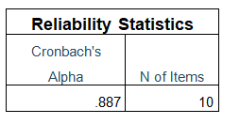
Lampiran 15 Uji Reliabilitas Kompetensi Kerja

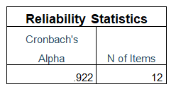
Lampiran 16 Uji Reliabilitas Pengawasan Kerja

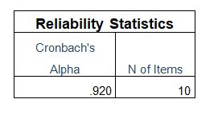
Lampiran 17 Uji Reliabilitas Lingkungan Kerja

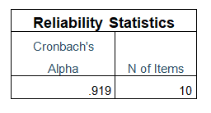
Lampiran 18 Uji Statistik Deskriptive
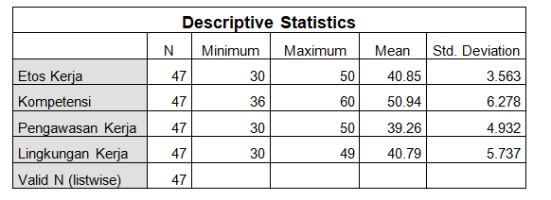

Lampiran 19 Uji Normalitas
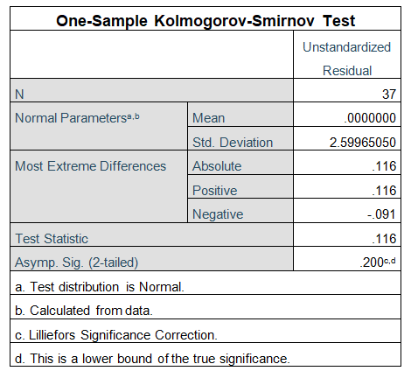

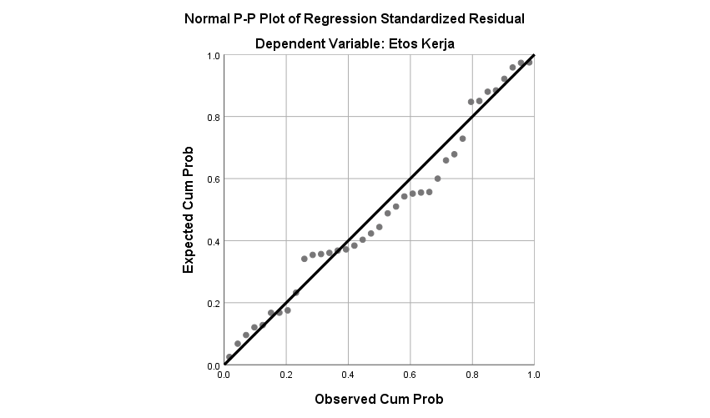

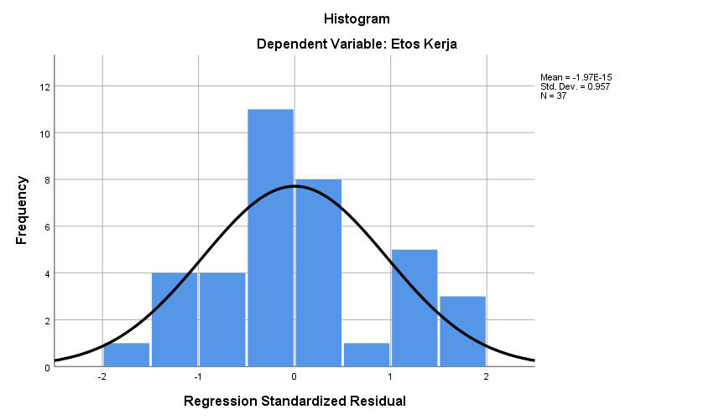

Lampiran 20 Uji Multikolonieritas
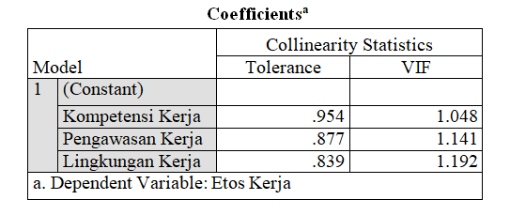
Lampiran 21 Uji Heteroskedasitisitas
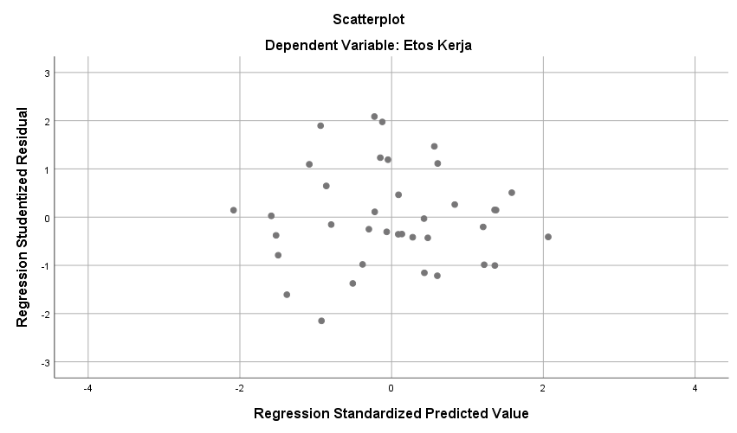
Lampiran 22 Analisis Regresi Linier Berganda
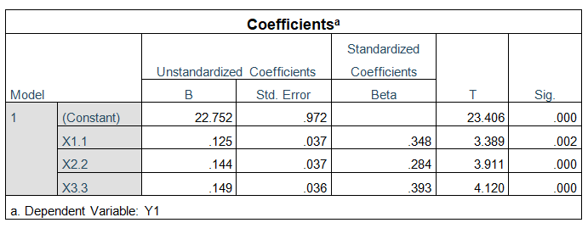
Lampiran 23 Uji t

Lampiran 24 Uji F

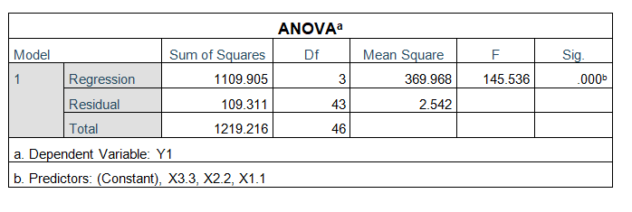
Lampiran 25 Koefisien Determinasi

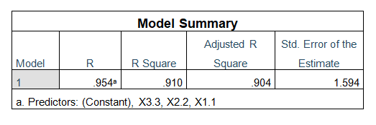

Lampiran 26 Surat Ijin Penelitian

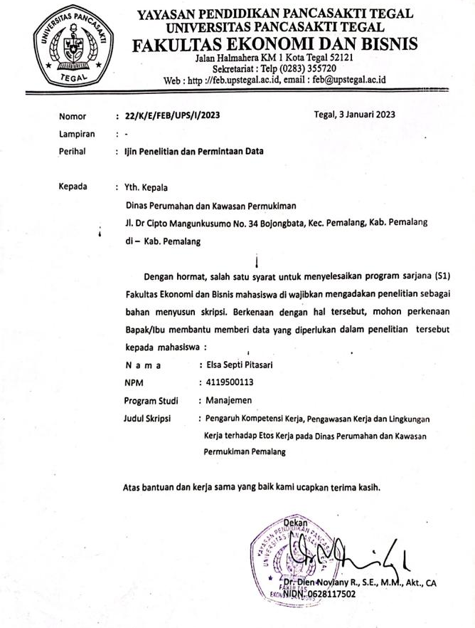

Lampiran 27 Surat Persetujuan Penelitian
