PENGARUH HUMAN RELATIONS, BEBAN KERJA, DAN PENEMPATAN KERJA TERHADAP KINERJA KARYAWAN
TOKO EMAS HIDUP BANJARAN KABUPATEN TEGAL

SKRIPSI
Oleh :
Rahmalia Kurniasari
NPM : 4119500014

Diajukan Kepada :

PROGRAM STUDI MANAJEMEN
FAKULTAS EKONOMI DAN BISNIS
UNIVERSITAS PANCASAKTI TEGAL
2023

DAFTAR PUSTAKA

Afrian, Dwi. (2021). Pengaruh Human Relations dan Lingkungan Kerja Terhadap Kinerja KaryawanPT. Perkebunan Timbang Langsa. Fakultas Ekonomi dan Bisnis. Universitas Medan Area. Medan
http://repository.uma.ac.id
Annisa, P. M. (2022). Pengaruh Beban Kerja, Penempatan Kerja, dan Lingkungan Kerja Fisik Terhadap Kinerja Karyawan PT. ASIA Hakarya Abadi Tegal. Fakultas Ekonomi dan Bisnis Universitas Pancasakti Tegal , Tegal.
http://repository.upstegal.ac.id/

Bangun, W. (2012). Manajemen Sumber Daya Manusia. Jakarta: Erlangga.
Busro, M. (2018). Teori-teori Manajemen Sumber Daya Manusia. Jakarta: Prenadamedia Group.
Effendy, O. U. (2009). Human Relation & Public Relation. Bandung: Mandar Maju.
Beverly, & Lengkong, V. (2017). Pengaruh Pengalam Kerja dan Penempatan Kerja Terhadap Kinerja Karyawan PT. Air Manado. jurnal EMBA , Hal.2761-2770.
https://ejournal.unsrat.ac.id/index.php/emba/article/view/17154

Farida, E., & Kholidah, N. R. (2021). Pengaruh human Relations dan Beban Kerja Terhadap Kinerja Pegawai. Pendidikan Ekonomi , 134-135.
http://ejournal.unp.ac.id/students/index.php/pek/article/view/11039/4551
Ghozali, I. (2018). Aplikasi Analisis Multivariate Dengan Program IBM SPSS 25. Semarang: Badan Penerbit Universitas Diponegoro.
Koesmowidjojo, S. R. (2017). Analisis Beban Kerja. Jakarta: Raih Asa Sukses.
Lubis, N. J. (2022). Pengaruh Human relations, beban keja, dan reward terhadap kinerja karyawan PT.Insan Utama Mandiri Cabang Pemalang. Fakultas Ekonomi dan Bisnis. Universitas Pancasakti Tegal. Tegal.
http://repository.upstegal.ac.id/
Mangkunegara, A. P. (2011). Manajemen Sumber Daya Manusia Perusahaan. Bandung: PT. Remaja Rosda Karya.
Mngkunegara, A. A. (2007). Manajemen Sumber Daya Manusia. Bandung: PT. Remaja Rosdakarya.

Rizki, T. H. (2020). Pengaruh penempatan dan beban kerja terhadap kinerja pegawai Kecamatan Penukal Kabupaten Pali. Fakultas Ekonomi dan Bisnis. Universitas Tridinanti. Palembang.
http://repository.univ-tridinanti.ac.id/id/eprint/2135
Rolos, J. K., A P Sambul, S., & Rumawas, W. (2018). Pengaruh Beban Kerja Terhadap Kinerja Karyawan Pada PT. Asuransi Jiwasraya Cabang Manado Kota. Administrasi Bisnis .
http://repository.umsu.ac.id
Runtuwene, P., Tewal, B., & Mintardjo, C. (2016). Pengaruh Penempatan Kerja, Mutasi, dan Beban Kerja Terhadap Kinerja Karyawan PT. Bank Sulutgo Manado. Jurnal Berkala Ilmiah Efisiensi .
https://ejournal.unsrat.ac.id/v3/index.php/jbie/article/view/10634/10223
S.P Hasibuan, M. (2009). Manajemen Sumber Daya Manusia. Jakarta: PT. Bumi Aksara.
S.P Hasibuan, M. (2011). Manajemen Sumber Daya Manusia. Jakarta: Bumi Aksara.
Siagian, S. P. (2009). Kiat Meningkatkan Produktivitas Kerja. Jakarta: Rineka Cipta.
Siswanto, Sastrohadiwiryo. (2002). Manajemen Tenaga Kerja Indonesia : Pendekatan Administratif dan Operasional. Jakarta: Bumi Aksara.
Sugiharjo, R. J., & Aldata, F. (2018). Pengaruh Beban kerja dan motivasi kerja terhadap kinerja karyawan BPJS Ketenagakerjaan cabang Salemba. Jurnal ilmiah Manajemen Bisnis , 128-137.
http://digilib.mercubuana.ac.id/manager/t!@file_artikel_abstrak/Isi_Artikel_639120199980.pdf
Sugiyono. (2016). Metode Penelitian Kuantitatif, Kualitatif dan R & D. Bandung: Penerbit Alfabeta.
Sugiyono. (2021). Statistika Untuk Penelitian. Bandung: Penerbit Alfabeta.
Suliyanto. (2018). Metode penelitian bisnis. Yogyakarta: Andi Offset.
Suryani, N. K. (2020). Kinerja Sumber Daya Manusia Teori Aplikasi dan Penilaian. Bandung: Nilacakr.
Talumantak, A. (2016). Analisis Pengaruh Human Relations dan Beban Kerja Terhadap Kinerja Pegawai Dinas Koperasi dan UMKM Provinsi Sulawesi Utara. Jurnal Berkala Ilmiah Efisiensi. Manado.
https://ejournal.unsrat.ac.id/v3/index.php/jbie/article/view/12046/11635

LAMPIRAN

Lampiran 1
Surat Permohanan Pengisian Kuesioner
Perihal : Permohonan Pengisian Kuesioner
Judul Penelitian : Pengaruh Human Relations, Beban Kerja, dan Penempatan Kerja Terhadap Kinerja Karyawan Toko Emas Hidup Banjaran Kabupaten Tegal

Kepada :
Sdr. Responden
Karyawan Toko Emas Hidup Banjaran
Di Tempat

Dengan Hormat,
Dalam rangka menyelesaikan penelitian, saya Rahmalia Kurniasari, Mahasiswi S1 prodi Manajemen konsentrasi pemasaran Fakultas Ekonomi dan Bisnis Universitas Pancasakti Tegal, mohon partisipasi dari Sdr. untuk mengisi kuesioner yang telah saya sediakan.

Penelitian ini menggunakan kuisioner sebagai alat untuk pengumpulan data yang utama. Oleh karena itu, saya mohon bantuan Bapak/Ibu untuk berkenan menjadi responden penelitian dengan mengisi kuisioner penelitian ini secara lengkap dan jujur.
Jawaban dari kuisioner ini tidak ada yang salah, sehingga apapun jawaban yang Bapak/Ibu berikan adalah benar. Setiap jawaban yang diberikan merupakan bantuan yang tidak ternilai harganya bagi penelitian ini.
Atas perhatian dan bantuannya, saya ucapkan terimakasih.
Tegal, 12 Juni 2023
Hormat Saya,

Rahmalia Kurniasari
Lampiran 2
Kuesinoer Penelitian
- Petunjuk Pengisian Kuesioner
- Bapak/Ibu/Saudara/i dimohon menjawab setiap pertanyaan dengan memilih satu jawaban pada setiap pernyataan.
- Ketersediaan Bapak/Ibu/Saudara/i untuk mengisi kuesioner ini merupakan suatu kehormatan dan sangat membantu peneliti
- Jawaban Bapak/Ibu/Saudara/i akan terjamin kerahasiaanya.
- Jawablah semua pernyataan dengan jujur, baik dan benar, karena hasil penelitian tidak akan mempengaruhi penilaian pada kinerja.
- Isilah dengan memberikan tanda chescklist / centang (√) pada kotak yang tersedia dijawaban yang anda pilih dan sesuai dengan kondisi yang sebenarnya yang ada di Toko Emas Hidup Banjaran Kabupaten Tegal.
Skala pengukuran untuk variabel kinerja adalah
SL : Selalu
SR : Sering
B : Biasanya
KD : Kadang-kadang
BP : Belum pernah
Skala pengukuran untuk variable human relations, beban kerja , dan penempatan kerja adalah:
SS : Sangat Setuju
S : Setuju
N : Netral
TS : Tidak Setuju
STS : Sangat Tidak Setuju

- Karakteristik Responden
- Nama :
- Jenis Kelamin :
- Laki – laki
- Perempuan
- Usia :
- 20 – 30 tahun
- 31 – 40 tahun
- 41 – 50 tahun
- > 51 tahun
- Pendidikan Terakhir :
- SMA/SMK
- DIII
- S1

- Variabel Kepuasan Kinerja Karyawan (Y)
No |  | Pernyataan | Jawaban
 |  |  | SL |  | SR | B | KD | BP
Keterampilan
1 | Saya dapat menyelesaikan setiap pekerjaan yang diberikan sesuai keterampilan yang saya miliki
Kemampuan
2 | Saya dapat menyelesaikan setiap pekerjaan yang diberikan dengan baik
Pengetahuan
3 | Saya dapat bekerja sesuai dengan pengetahuan yang saya pahami
Target pekerjaan
4 | Saya dapat menyelesaikan pekerjaan sesuai target yang diberikan
5 | Saya dapat menyelesaikan setiap unit pekerjaan dengan ketelitian yang tinggi
Ketepatan waktu
6 | Saya dapat menyelesaikan setiap pekerjaan yang diberikan tepat waktu
7 | Saya dapat menggunakan waktu bekerja dengan efektif & efisien
Kehadiran
8 | Saya hadir tepat waktu sesuai jam kerja
Kemampuan kerja sama
9 | Saya dapat bekerja sama dengan tim dengan baik
10 | Saya dapat menjaga hubungan bsik antara sesama karyawan

- Variabel Human Relations (X1)
No |  | Pernyataan | Jawaban
 |  |  | SS |  | S |  | N | TS |  | STS
Adanya Komunikasi
1 | Komunikasi antar karyawan di Toko Emas Hidup Banjaran baik dan lancar
Pemberian tugas/pekerjaan
2 | Pimpinan memberikan arahan tugas sesuai pekerjaan karyawan
3 | Pimpinan memberikan intruksi kepada karyawan dengan jelas
Kesiapan dalam menghadapi maslah
4 | Karyawan siap menerima sanksi atas kesalahan kerja
5 | Saya dapat menerima setiap perbedaan pendapat antar karyawan
6 | Antar karyawan selalu terbuka dalam menghadapi masalah pekerjaan
Sikap saling menghargai
7 | Antara pimpinan dengan bawahan saling menghormati dan menghargai
8 | Antara karyawan saling menghormati dan menghargai

- Variabel Beban Kerja (X2)
No |  | Pernyataan | Jawaban
 |  |  | SS |  | S |  | N | TS |  | STS
Keadaan Pekerjaan
1 | Pimpinan memberikan pekerjaan terlalu bayak
2 | Pekerjaan yang dibebankan perusahaan melebihi kemampuan karyawan
Waktu dalam bekerja
3 | Perusahaan menetapkan jam kerja tidak sesuai standar
4 | Karyawan menyelesaikan pekerjaan di luar jam kerja
Target yang harus dicapai
5 | Karyawan memiliki deadline kerja setiap hari
6 | Target yang harus dicapai karyawan dalam pekerjaan terlalu tinggi
7 | Pimpinan memberikan target kepada karyawan yang cukup tinggi

- Variabel Penempatan kerja (X3)
No |  | Pernyataan | Jawaban
 |  |  | SS | S |  | N | TS | STS
Kesesuaian latar belakang pendidikan
1 | Menempatkan karyawan sesuai latar belakang pendidikan
Kesesuaian pengetahuan kerja
2 | Penempatan karyawan di Toko Emas karyawan Banjaran sesuai pengetahuan yang dimiliki karyawan
Kemampuan kerja
3 | Penempatan kerja di Toko Emas Hidup Banjaran sesuai dengan kemampuan karyawan
Kesesuaian masa kerja
4 | Penempatan kerja di Toko Emas Hidup Banjaran diterapkan rolling ke cabang Toko Emas Hidup lainnya
5 | Penempatan kerja di Toko Emas Hidup Banjaran sesuai dengan masa kerja

Lampiran 3.
Data Uji Coba Kuesioner Variabel Kinerja Karyawan
Resp | Pernyataan |  |  |  |  |  |  |  |  |  | Total
 | 1 | 2 | 3 | 4 | 5 | 6 | 7 | 8 | 9 | 10
1 | 5 | 5 | 5 | 3 | 5 | 3 | 4 | 4 | 5 | 5 | 44
2 | 5 | 5 | 5 | 5 | 3 | 3 | 3 | 4 | 4 | 4 | 41
3 | 5 | 5 | 5 | 3 | 4 | 4 | 4 | 3 | 5 | 5 | 43
4 | 4 | 3 | 2 | 2 | 2 | 4 | 4 | 4 | 4 | 4 | 33
5 | 4 | 4 | 4 | 4 | 4 | 4 | 4 | 4 | 4 | 4 | 40
6 | 5 | 5 | 5 | 5 | 5 | 4 | 4 | 4 | 4 | 4 | 45
7 | 1 | 1 | 5 | 5 | 5 | 1 | 2 | 5 | 5 | 5 | 35
8 | 5 | 5 | 5 | 5 | 5 | 5 | 5 | 5 | 5 | 5 | 50
9 | 5 | 5 | 5 | 5 | 5 | 5 | 5 | 5 | 5 | 5 | 50
10 | 5 | 5 | 5 | 5 | 5 | 4 | 4 | 4 | 4 | 4 | 45
11 | 5 | 3 | 4 | 3 | 3 | 4 | 4 | 4 | 4 | 4 | 38
12 | 4 | 4 | 5 | 5 | 4 | 5 | 5 | 5 | 5 | 4 | 46
13 | 5 | 5 | 5 | 5 | 5 | 5 | 5 | 5 | 5 | 5 | 50
14 | 5 | 5 | 4 | 5 | 5 | 5 | 5 | 4 | 4 | 5 | 47
15 | 4 | 4 | 5 | 5 | 5 | 5 | 5 | 5 | 5 | 5 | 48
16 | 5 | 5 | 5 | 5 | 5 | 5 | 5 | 5 | 4 | 5 | 49
17 | 5 | 5 | 4 | 5 | 5 | 5 | 5 | 5 | 4 | 5 | 48
18 | 4 | 4 | 5 | 3 | 5 | 5 | 5 | 5 | 5 | 4 | 45
19 | 4 | 4 | 4 | 5 | 5 | 4 | 5 | 5 | 5 | 5 | 46
20 | 4 | 4 | 4 | 4 | 5 | 5 | 5 | 5 | 5 | 4 | 45
21 | 5 | 5 | 5 | 5 | 5 | 5 | 5 | 5 | 5 | 5 | 50
22 | 5 | 4 | 5 | 4 | 4 | 5 | 4 | 4 | 5 | 5 | 45
23 | 5 | 5 | 5 | 5 | 5 | 5 | 5 | 5 | 5 | 5 | 50
24 | 4 | 4 | 4 | 4 | 4 | 4 | 4 | 4 | 4 | 4 | 40
25 | 4 | 4 | 4 | 4 | 4 | 5 | 4 | 4 | 4 | 4 | 41
26 | 4 | 4 | 4 | 4 | 5 | 5 | 5 | 5 | 5 | 5 | 46
27 | 4 | 4 | 4 | 4 | 4 | 4 | 4 | 4 | 4 | 4 | 40
28 | 4 | 4 | 4 | 4 | 4 | 4 | 4 | 4 | 4 | 4 | 40
29 | 4 | 4 | 4 | 4 | 4 | 4 | 4 | 4 | 4 | 4 | 40
30 4 4 5 5 5 5 3 4 4 4 43 | 4 | 5 | 4 | 4 | 3 | 3 | 4 | 3 | 3 | 4 | 37

Lampiran 4
Data Uji Coba Kuesioner Variabel Human Relations
Resp | Pernyataan |  |  |  |  |  |  |  | Total
 | 1 | 2 | 3 | 4 | 5 | 6 | 7 | 8
1 | 4 | 4 | 4 | 4 | 4 | 4 | 4 | 4 | 4
2 | 4 | 4 | 2 | 2 | 5 | 5 | 5 | 5 | 5
3 | 5 | 5 | 5 | 5 | 5 | 5 | 5 | 5 | 5
4 | 4 | 4 | 4 | 4 | 5 | 5 | 4 | 4 | 5
5 | 4 | 4 | 4 | 3 | 4 | 4 | 5 | 4 | 4
6 | 4 | 4 | 4 | 4 | 4 | 4 | 4 | 4 | 4
7 | 4 | 4 | 4 | 4 | 4 | 4 | 4 | 4 | 5
8 | 4 | 5 | 5 | 4 | 3 | 3 | 5 | 5 | 5
9 | 4 | 5 | 5 | 4 | 5 | 5 | 5 | 5 | 4
10 | 4 | 5 | 5 | 5 | 4 | 4 | 5 | 5 | 5
11 | 2 | 4 | 4 | 4 | 4 | 5 | 3 | 4 | 2
12 | 4 | 4 | 5 | 5 | 5 | 5 | 5 | 5 | 5
13 | 4 | 4 | 4 | 4 | 4 | 4 | 5 | 5 | 5
14 | 2 | 2 | 2 | 2 | 2 | 2 | 2 | 2 | 2
15 | 5 | 5 | 5 | 5 | 5 | 5 | 5 | 5 | 5
16 | 5 | 5 | 5 | 5 | 5 | 5 | 5 | 5 | 5
17 | 4 | 3 | 4 | 4 | 4 | 4 | 4 | 4 | 4
18 | 3 | 3 | 3 | 3 | 3 | 3 | 3 | 3 | 3
19 | 3 | 4 | 3 | 4 | 3 | 3 | 3 | 4 | 4
20 | 3 | 5 | 4 | 4 | 4 | 4 | 4 | 3 | 3
21 | 2 | 2 | 2 | 2 | 2 | 2 | 2 | 2 | 2
22 | 3 | 3 | 2 | 3 | 3 | 2 | 3 | 4 | 4
23 | 4 | 3 | 2 | 2 | 4 | 4 | 4 | 5 | 3
24 | 3 | 4 | 1 | 1 | 4 | 4 | 4 | 4 | 3
25 | 3 | 3 | 2 | 2 | 4 | 4 | 4 | 5 | 3
26 | 3 | 3 | 2 | 2 | 4 | 4 | 4 | 5 | 4
27 | 2 | 2 | 2 | 2 | 2 | 2 | 2 | 2 | 2
28 | 4 | 2 | 2 | 2 | 4 | 4 | 5 | 3 | 3
29 | 2 | 3 | 4 | 3 | 3 | 2 | 3 | 4 | 4
30 | 2 | 2 | 2 | 2 | 2 | 2 | 2 | 2 | 2

Lampiran 5
Data Uji Coba Kuesioner Variabel Beban Kerja
Resp | Pernyataan |  |  |  |  |  |  | Total
 | 1 | 2 | 3 | 4 | 5 | 6 | 7
1 | 1 | 1 | 1 | 1 | 1 | 1 | 1 | 7
2 | 1 | 1 | 1 | 1 | 1 | 1 | 1 | 7
3 | 1 | 1 | 1 | 1 | 1 | 1 | 1 | 7
4 | 1 | 1 | 1 | 1 | 1 | 1 | 1 | 7
5 | 2 | 2 | 2 | 2 | 1 | 1 | 1 | 11
6 | 2 | 2 | 2 | 2 | 1 | 1 | 1 | 11
7 | 2 | 2 | 2 | 2 | 1 | 1 | 1 | 11
8 | 2 | 2 | 2 | 2 | 1 | 1 | 1 | 11
9 | 2 | 2 | 2 | 2 | 1 | 1 | 1 | 11
10 | 2 | 2 | 2 | 2 | 1 | 1 | 1 | 11
11 | 2 | 2 | 2 | 2 | 1 | 1 | 1 | 11
12 | 2 | 2 | 2 | 2 | 1 | 1 | 1 | 11
13 | 2 | 2 | 2 | 2 | 1 | 1 | 1 | 11
14 | 2 | 2 | 2 | 2 | 1 | 1 | 1 | 11
15 | 3 | 3 | 3 | 3 | 3 | 3 | 3 | 21
16 | 3 | 3 | 3 | 3 | 3 | 3 | 3 | 21
17 | 3 | 3 | 3 | 3 | 3 | 3 | 3 | 21
18 | 3 | 3 | 3 | 3 | 3 | 3 | 3 | 21
19 | 3 | 3 | 3 | 3 | 3 | 3 | 3 | 21
20 | 2 | 2 | 2 | 2 | 2 | 2 | 2 | 14
21 | 2 | 2 | 2 | 2 | 2 | 2 | 2 | 14
22 | 2 | 2 | 2 | 2 | 2 | 2 | 2 | 14
23 | 1 | 1 | 2 | 2 | 2 | 2 | 2 | 12
24 | 1 | 1 | 2 | 2 | 2 | 2 | 2 | 12
25 | 1 | 1 | 2 | 2 | 2 | 2 | 2 | 12
26 | 1 | 1 | 2 | 2 | 2 | 2 | 2 | 12
27 | 1 | 1 | 2 | 2 | 2 | 2 | 2 | 12
28 | 1 | 1 | 2 | 2 | 2 | 2 | 2 | 12
29 | 1 | 1 | 2 | 2 | 2 | 2 | 2 | 12
30 | 1 | 1 | 2 | 2 | 2 | 2 | 2 | 12

Lampiran 6
Data Uji Coba Kuesioner Variabel Penempatan Kerja
Resp | Pernyataan |  |  |  |  | Total
 | 1 | 2 | 3 | 4 | 5
1 | 5 | 5 | 5 | 5 | 4 | 24
2 | 4 | 2 | 3 | 3 | 3 | 15
3 | 3 | 3 | 3 | 3 | 3 | 15
4 | 3 | 4 | 3 | 3 | 3 | 16
5 | 4 | 4 | 4 | 4 | 4 | 20
6 | 2 | 2 | 2 | 2 | 2 | 10
7 | 2 | 3 | 3 | 2 | 3 | 13
8 | 2 | 2 | 4 | 4 | 4 | 16
9 | 1 | 1 | 4 | 4 | 4 | 14
10 | 2 | 2 | 4 | 4 | 4 | 16
11 | 2 | 2 | 4 | 4 | 4 | 16
12 | 2 | 2 | 2 | 2 | 2 | 10
13 | 2 | 2 | 4 | 4 | 5 | 17
14 | 4 | 3 | 3 | 2 | 3 | 15
15 | 2 | 2 | 2 | 2 | 2 | 10
16 | 2 | 2 | 2 | 3 | 2 | 11
17 | 2 | 2 | 3 | 2 | 3 | 12
18 | 3 | 3 | 3 | 3 | 3 | 15
19 | 2 | 2 | 2 | 3 | 3 | 12
20 | 4 | 3 | 3 | 4 | 4 | 18
21 | 2 | 3 | 3 | 2 | 4 | 14
22 | 4 | 4 | 3 | 5 | 4 | 20
23 | 3 | 3 | 3 | 3 | 3 | 15
24 | 4 | 4 | 4 | 4 | 4 | 20
25 | 5 | 5 | 5 | 5 | 5 | 25
26 | 5 | 5 | 5 | 5 | 5 | 25
27 | 5 | 5 | 5 | 5 | 5 | 25
28 | 2 | 3 | 4 | 4 | 4 | 17
29 | 4 | 4 | 4 | 4 | 4 | 20
30 | 2 | 2 | 4 | 4 | 4 | 16

Lampiran 7.
Data Output SPSS Uji Validitas Variabel Kinerja Karyawan (Y)
Correlations
 |  | Y.1 | Y.2 | Y.3 | Y.4 | Y.5 | Y.6 | Y.7 | Y.8 | Y.9 | Y.10 | Kinerja
Y.1 | Pearson Correlation | 1 | .476** | .411* | .409* | .403* | .389* | .740** | .515** | .519** | .607** | .756**
 | Sig. (2-tailed) |  | .008 | .024 | .025 | .027 | .033 | .000 | .004 | .003 | .000 | .000
 | N | 30 | 30 | 30 | 30 | 30 | 30 | 30 | 30 | 30 | 30 | 30
Y.2 | Pearson Correlation | .476** | 1 | .476** | .728** | .606** | .535** | .520** | .833** | .319 | .631** | .839**
 | Sig. (2-tailed) | .008 |  | .008 | .000 | .000 | .002 | .003 | .000 | .086 | .000 | .000
 | N | 30 | 30 | 30 | 30 | 30 | 30 | 30 | 30 | 30 | 30 | 30
Y.3 | Pearson Correlation | .411* | .476** | 1 | .389* | .177 | .261 | .426* | .290 | .635** | .065 | .581**
 | Sig. (2-tailed) | .024 | .008 |  | .034 | .351 | .163 | .019 | .120 | .000 | .733 | .001
 | N | 30 | 30 | 30 | 30 | 30 | 30 | 30 | 30 | 30 | 30 | 30
Y.4 | Pearson Correlation | .409* | .728** | .389* | 1 | .453* | .232 | .312 | .505** | .125 | .508** | .648**
 | Sig. (2-tailed) | .025 | .000 | .034 |  | .012 | .218 | .093 | .004 | .509 | .004 | .000
 | N | 30 | 30 | 30 | 30 | 30 | 30 | 30 | 30 | 30 | 30 | 30
Y.5 | Pearson Correlation | .403* | .606** | .177 | .453* | 1 | .857** | .486** | .746** | .309 | .521** | .761**
 | Sig. (2-tailed) | .027 | .000 | .351 | .012 |  | .000 | .006 | .000 | .097 | .003 | .000
 | N | 30 | 30 | 30 | 30 | 30 | 30 | 30 | 30 | 30 | 30 | 30
Y.6 | Pearson Correlation | .389* | .535** | .261 | .232 | .857** | 1 | .269 | .641** | .352 | .410* | .674**
 | Sig. (2-tailed) | .033 | .002 | .163 | .218 | .000 |  | .151 | .000 | .057 | .024 | .000
 | N | 30 | 30 | 30 | 30 | 30 | 30 | 30 | 30 | 30 | 30 | 30
Y.7 | Pearson Correlation | .740** | .520** | .426* | .312 | .486** | .269 | 1 | .673** | .605** | .503** | .764**
 | Sig. (2-tailed) | .000 | .003 | .019 | .093 | .006 | .151 |  | .000 | .000 | .005 | .000
 | N | 30 | 30 | 30 | 30 | 30 | 30 | 30 | 30 | 30 | 30 | 30
Y.8 | Pearson Correlation | .515** | .833** | .290 | .505** | .746** | .641** | .673** | 1 | .441* | .700** | .866**
 | Sig. (2-tailed) | .004 | .000 | .120 | .004 | .000 | .000 | .000 |  | .015 | .000 | .000
 | N | 30 | 30 | 30 | 30 | 30 | 30 | 30 | 30 | 30 | 30 | 30
Y.9 | Pearson Correlation | .519** | .319 | .635** | .125 | .309 | .352 | .605** | .441* | 1 | .300 | .641**
 | Sig. (2-tailed) | .003 | .086 | .000 | .509 | .097 | .057 | .000 | .015 |  | .108 | .000
 | N | 30 | 30 | 30 | 30 | 30 | 30 | 30 | 30 | 30 | 30 | 30
Y.10 | Pearson Correlation | .607** | .631** | .065 | .508** | .521** | .410* | .503** | .700** | .300 | 1 | .721**
 | Sig. (2-tailed) | .000 | .000 | .733 | .004 | .003 | .024 | .005 | .000 | .108 |  | .000
 | N | 30 | 30 | 30 | 30 | 30 | 30 | 30 | 30 | 30 | 30 | 30
Kinerja | Pearson Correlation | .756** | .839** | .581** | .648** | .761** | .674** | .764** | .866** | .641** | .721** | 1
 | Sig. (2-tailed) | .000 | .000 | .001 | .000 | .000 | .000 | .000 | .000 | .000 | .000
 | N | 30 | 30 | 30 | 30 | 30 | 30 | 30 | 30 | 30 | 30 | 30
**. Correlation is significant at the 0.01 level (2-tailed).
*. Correlation is significant at the 0.05 level (2-tailed).

Lampiran 8.
Data Output SPSS Uji Validitas Variabel Human Relations (X1)
Correlations
 |  | X1.1 | X1.2 | X1.3 | X1.4 | X1.5 | X1.6 | X1.7 | X1.8 | Human Relations
X1.1 | Pearson Correlation | 1 | .682** | .617** | .537** | .630** | .454* | .857** | .741** | .822**
 | Sig. (2-tailed) |  | .000 | .000 | .002 | .000 | .012 | .000 | .000 | .000
 | N | 30 | 30 | 30 | 30 | 30 | 30 | 30 | 30 | 30
X1.2 | Pearson Correlation | .682** | 1 | .678** | .820** | .923** | .630** | .701** | .872** | .938**
 | Sig. (2-tailed) | .000 |  | .000 | .000 | .000 | .000 | .000 | .000 | .000
 | N | 30 | 30 | 30 | 30 | 30 | 30 | 30 | 30 | 30
X1.3 | Pearson Correlation | .617** | .678** | 1 | .689** | .555** | .407* | .623** | .529** | .763**
 | Sig. (2-tailed) | .000 | .000 |  | .000 | .001 | .026 | .000 | .003 | .000
 | N | 30 | 30 | 30 | 30 | 30 | 30 | 30 | 30 | 30
X1.4 | Pearson Correlation | .537** | .820** | .689** | 1 | .687** | .376* | .543** | .628** | .789**
 | Sig. (2-tailed) | .002 | .000 | .000 |  | .000 | .041 | .002 | .000 | .000
 | N | 30 | 30 | 30 | 30 | 30 | 30 | 30 | 30 | 30
X1.5 | Pearson Correlation | .630** | .923** | .555** | .687** | 1 | .725** | .683** | .841** | .899**
 | Sig. (2-tailed) | .000 | .000 | .001 | .000 |  | .000 | .000 | .000 | .000
 | N | 30 | 30 | 30 | 30 | 30 | 30 | 30 | 30 | 30
X1.6 | Pearson Correlation | .454* | .630** | .407* | .376* | .725** | 1 | .527** | .762** | .727**
 | Sig. (2-tailed) | .012 | .000 | .026 | .041 | .000 |  | .003 | .000 | .000
 | N | 30 | 30 | 30 | 30 | 30 | 30 | 30 | 30 | 30
X1.7 | Pearson Correlation | .857** | .701** | .623** | .543** | .683** | .527** | 1 | .797** | .854**
 | Sig. (2-tailed) | .000 | .000 | .000 | .002 | .000 | .003 |  | .000 | .000
 | N | 30 | 30 | 30 | 30 | 30 | 30 | 30 | 30 | 30
X1.8 | Pearson Correlation | .741** | .872** | .529** | .628** | .841** | .762** | .797** | 1 | .918**
 | Sig. (2-tailed) | .000 | .000 | .003 | .000 | .000 | .000 | .000 |  | .000
 | N | 30 | 30 | 30 | 30 | 30 | 30 | 30 | 30 | 30
Human Relations | Pearson Correlation | .822** | .938** | .763** | .789** | .899** | .727** | .854** | .918** | 1
 | Sig. (2-tailed) | .000 | .000 | .000 | .000 | .000 | .000 | .000 | .000
 | N | 30 | 30 | 30 | 30 | 30 | 30 | 30 | 30 | 30
**. Correlation is significant at the 0.01 level (2-tailed).
*. Correlation is significant at the 0.05 level (2-tailed).

Lampiran 9.
Data Output SPSS Uji Validitas Variabel Beban Kerja (X2)
Correlations
 |  | X2.1 | X2.2 | X2.3 | X2.4 | X2.5 | X2.6 | X2.7 | Beban Kerja
X2.1 | Pearson Correlation | 1 | .471** | .388* | .483** | .761** | .678** | .416* | .745**
 | Sig. (2-tailed) |  | .009 | .034 | .007 | .000 | .000 | .022 | .000
 | N | 30 | 30 | 30 | 30 | 30 | 30 | 30 | 30
X2.2 | Pearson Correlation | .471** | 1 | .607** | .606** | .383* | .498** | .589** | .741**
 | Sig. (2-tailed) | .009 |  | .000 | .000 | .037 | .005 | .001 | .000
 | N | 30 | 30 | 30 | 30 | 30 | 30 | 30 | 30
X2.3 | Pearson Correlation | .388* | .607** | 1 | .871** | .494** | .445* | .388* | .765**
 | Sig. (2-tailed) | .034 | .000 |  | .000 | .006 | .014 | .034 | .000
 | N | 30 | 30 | 30 | 30 | 30 | 30 | 30 | 30
X2.4 | Pearson Correlation | .483** | .606** | .871** | 1 | .713** | .602** | .444* | .858**
 | Sig. (2-tailed) | .007 | .000 | .000 |  | .000 | .000 | .014 | .000
 | N | 30 | 30 | 30 | 30 | 30 | 30 | 30 | 30
X2.5 | Pearson Correlation | .761** | .383* | .494** | .713** | 1 | .886** | .518** | .857**
 | Sig. (2-tailed) | .000 | .037 | .006 | .000 |  | .000 | .003 | .000
 | N | 30 | 30 | 30 | 30 | 30 | 30 | 30 | 30
X2.6 | Pearson Correlation | .678** | .498** | .445* | .602** | .886** | 1 | .648** | .855**
 | Sig. (2-tailed) | .000 | .005 | .014 | .000 | .000 |  | .000 | .000
 | N | 30 | 30 | 30 | 30 | 30 | 30 | 30 | 30
X2.7 | Pearson Correlation | .416* | .589** | .388* | .444* | .518** | .648** | 1 | .725**
 | Sig. (2-tailed) | .022 | .001 | .034 | .014 | .003 | .000 |  | .000
 | N | 30 | 30 | 30 | 30 | 30 | 30 | 30 | 30
Beban Kerja | Pearson Correlation | .745** | .741** | .765** | .858** | .857** | .855** | .725** | 1
 | Sig. (2-tailed) | .000 | .000 | .000 | .000 | .000 | .000 | .000
 | N | 30 | 30 | 30 | 30 | 30 | 30 | 30 | 30
**. Correlation is significant at the 0.01 level (2-tailed).
*. Correlation is significant at the 0.05 level (2-tailed).

Lampiran 10.
Data Output SPSS Uji Validitas Variabel Penempatan Kerja (X3)
Correlations
 |  | X3.1 | X3.2 | X3.3 | X3.4 | X3.5 | Penempatan Kerja
X3.1 | Pearson Correlation | 1 | .541** | .682** | .290 | .481** | .738**
 | Sig. (2-tailed) |  | .002 | .000 | .121 | .007 | .000
 | N | 30 | 30 | 30 | 30 | 30 | 30
X3.2 | Pearson Correlation | .541** | 1 | .628** | .504** | .573** | .805**
 | Sig. (2-tailed) | .002 |  | .000 | .004 | .001 | .000
 | N | 30 | 30 | 30 | 30 | 30 | 30
X3.3 | Pearson Correlation | .682** | .628** | 1 | .554** | .646** | .867**
 | Sig. (2-tailed) | .000 | .000 |  | .002 | .000 | .000
 | N | 30 | 30 | 30 | 30 | 30 | 30
X3.4 | Pearson Correlation | .290 | .504** | .554** | 1 | .739** | .769**
 | Sig. (2-tailed) | .121 | .004 | .002 |  | .000 | .000
 | N | 30 | 30 | 30 | 30 | 30 | 30
X3.5 | Pearson Correlation | .481** | .573** | .646** | .739** | 1 | .856**
 | Sig. (2-tailed) | .007 | .001 | .000 | .000 |  | .000
 | N | 30 | 30 | 30 | 30 | 30 | 30
Penempatan Kerja | Pearson Correlation | .738** | .805** | .867** | .769** | .856** | 1
 | Sig. (2-tailed) | .000 | .000 | .000 | .000 | .000
 | N | 30 | 30 | 30 | 30 | 30 | 30
**. Correlation is significant at the 0.01 level (2-tailed).

Lampiran 11.
Data Output SPSS Uji Reliabilitas Kinerja Karyawan (Y)
Reliability Statistics
Cronbach's Alpha | N of Items
.894 | 10

Item Statistics
 | Mean | Std. Deviation | N
Y.1 | 4.00 | .695 | 30
Y.2 | 4.23 | .626 | 30
Y.3 | 4.10 | .845 | 30
Y.4 | 3.97 | .850 | 30
Y.5 | 4.27 | .740 | 30
Y.6 | 4.37 | .765 | 30
Y.7 | 4.20 | .805 | 30
Y.8 | 4.40 | .675 | 30
Y.9 | 4.37 | .765 | 30
Y.10 | 4.23 | .817 | 30

Item-Total Statistics
 | Scale Mean if Item Deleted | Scale Variance if Item Deleted | Corrected Item-Total Correlation | Cronbach's Alpha if Item Deleted
Y.1 | 38.13 | 24.464 | .692 | .880
Y.2 | 37.90 | 24.369 | .800 | .875
Y.3 | 38.03 | 25.068 | .464 | .897
Y.4 | 38.17 | 24.420 | .543 | .891
Y.5 | 37.87 | 24.120 | .694 | .880
Y.6 | 37.77 | 24.668 | .586 | .887
Y.7 | 37.93 | 23.651 | .690 | .880
Y.8 | 37.73 | 23.789 | .830 | .872
Y.9 | 37.77 | 24.944 | .547 | .890
Y.10 | 37.90 | 23.955 | .635 | .884

Lampiran 12.
Data Output SPSS Uji Reliabilitas Human Relations (X1)
Case Processing Summary
 |  | N | %
Cases | Valid | 30 | 100.0
 | Excludedª | 0 | .0
 | Total | 30 | 100.0
a. Listwise deletion based on all variables in the procedure.

Reliability Statistics
Cronbach's Alpha | N of Items
.938 | 8

Item Statistics
 | Mean | Std. Deviation | N
X1.1 | 3.90 | .960 | 30
X1.2 | 3.97 | .890 | 30
X1.3 | 3.83 | 1.020 | 30
X1.4 | 3.80 | 1.031 | 30
X1.5 | 3.97 | .964 | 30
X1.6 | 4.20 | .997 | 30
X1.7 | 3.83 | .986 | 30
X1.8 | 4.07 | .980 | 30

Item-Total Statistics
 | Scale Mean if Item Deleted | Scale Variance if Item Deleted | Corrected Item-Total Correlation | Cronbach's Alpha if Item Deleted
X1.1 | 27.67 | 33.471 | .764 | .931
X1.2 | 27.60 | 32.731 | .918 | .922
X1.3 | 27.73 | 33.720 | .685 | .937
X1.4 | 27.77 | 33.289 | .717 | .935
X1.5 | 27.60 | 32.455 | .864 | .924
X1.6 | 27.37 | 34.378 | .642 | .940
X1.7 | 27.73 | 32.823 | .804 | .929
X1.8 | 27.50 | 32.052 | .889 | .922

RELIABILITY
/VARIABLES=X2.1 X2.2 X2.3 X2.4 X2.5 X2.6 X2.7
/SCALE('ALL VARIABLES') ALL
/MODEL=ALPHA
/STATISTICS=DESCRIPTIVE
/SUMMARY=TOTAL.

Lampiran 13.
Data Output SPSS Uji Reliabilitas Beban Kerja (X2)
Case Processing Summary
 |  | N | %
Cases | Valid | 30 | 100.0
 | Excludedª | 0 | .0
 | Total | 30 | 100.0
a. Listwise deletion based on all variables in the procedure.

Reliability Statistics
Cronbach's Alpha | N of Items
.900 | 7

Item Statistics
 | Mean | Std. Deviation | N
X2.1 | 3.57 | .935 | 30
X2.2 | 3.10 | .885 | 30
X2.3 | 2.97 | 1.098 | 30
X2.4 | 3.33 | 1.093 | 30
X2.5 | 4.00 | 1.017 | 30
X2.6 | 4.10 | .995 | 30
X2.7 | 3.73 | 1.112 | 30

Item-Total Statistics
 | Scale Mean if Item Deleted | Scale Variance if Item Deleted | Corrected Item-Total Correlation | Cronbach's Alpha if Item Deleted
X2.1 | 21.23 | 25.013 | .656 | .891
X2.2 | 21.70 | 25.390 | .657 | .891
X2.3 | 21.83 | 23.730 | .663 | .891
X2.4 | 21.47 | 22.602 | .792 | .875
X2.5 | 20.80 | 23.200 | .795 | .875
X2.6 | 20.70 | 23.390 | .795 | .875
X2.7 | 21.07 | 24.133 | .609 | .898

RELIABILITY
/VARIABLES=X3.1 X3.2 X3.3 X3.4 X3.5
/SCALE('ALL VARIABLES') ALL
/MODEL=ALPHA
/STATISTICS=DESCRIPTIVE
/SUMMARY=TOTAL.

Lampiran 14.
Data Output SPSS Uji Reliabilitas Penempatan Kerja (X3)
Case Processing Summary
 |  | N | %
Cases | Valid | 30 | 100.0
 | Excludedª | 0 | .0
 | Total | 30 | 100.0
a. Listwise deletion based on all variables in the procedure.

Reliability Statistics
Cronbach's Alpha | N of Items
.866 | 5

Item Statistics
 | Mean | Std. Deviation | N
X3.1 | 3.83 | 1.020 | 30
X3.2 | 3.53 | 1.042 | 30
X3.3 | 3.87 | 1.008 | 30
X3.4 | 4.00 | 1.050 | 30
X3.5 | 4.03 | 1.066 | 30

Item-Total Statistics
 | Scale Mean if Item Deleted | Scale Variance if Item Deleted | Corrected Item-Total Correlation | Cronbach's Alpha if Item Deleted
X3.1 | 15.43 | 12.254 | .591 | .861
X3.2 | 15.73 | 11.582 | .684 | .839
X3.3 | 15.40 | 11.214 | .783 | .814
X3.4 | 15.27 | 11.857 | .629 | .852
X3.5 | 15.23 | 11.013 | .758 | .819

RELIABILITY
/VARIABLES=Y.1 Y.2 Y.3 Y.4 Y.5 Y.6 Y.7 Y.8 Y.9 Y.10
/SCALE('ALL VARIABLES') ALL
/MODEL=ALPHA
/STATISTICS=DESCRIPTIVE
/SUMMARY=TOTAL.

Lampiran 15.
Jawaban Responden Variabel Kinerja Karyawan
Resp | Pernyataan |  |  |  |  |  |  |  |  |  | Total
 | 1 | 2 | 3 | 4 | 5 | 6 | 7 | 8 | 9 | 10
1 | 5 | 5 | 4 | 5 | 5 | 5 | 5 | 5 | 4 | 5 | 48
2 | 4 | 4 | 5 | 3 | 5 | 5 | 5 | 5 | 5 | 4 | 45
3 | 4 | 4 | 4 | 5 | 5 | 4 | 5 | 5 | 5 | 5 | 46
4 | 4 | 4 | 4 | 4 | 5 | 5 | 5 | 5 | 5 | 4 | 45
5 | 5 | 5 | 5 | 5 | 5 | 5 | 5 | 5 | 5 | 5 | 50
6 | 5 | 4 | 5 | 4 | 4 | 5 | 4 | 4 | 5 | 5 | 45
7 | 4 | 4 | 4 | 4 | 4 | 4 | 4 | 4 | 4 | 4 | 40
8 | 3 | 5 | 3 | 5 | 5 | 5 | 3 | 5 | 3 | 5 | 42
9 | 3 | 4 | 5 | 3 | 4 | 5 | 3 | 4 | 5 | 3 | 39
10 | 2 | 2 | 2 | 2 | 2 | 2 | 2 | 2 | 2 | 2 | 20
11 | 4 | 4 | 4 | 4 | 4 | 4 | 4 | 4 | 4 | 4 | 40
12 | 4 | 4 | 4 | 4 | 4 | 4 | 4 | 4 | 4 | 4 | 40
13 | 4 | 4 | 4 | 4 | 4 | 4 | 4 | 4 | 4 | 4 | 40
14 | 3 | 5 | 3 | 5 | 5 | 5 | 3 | 5 | 3 | 5 | 42
15 | 3 | 4 | 5 | 3 | 4 | 5 | 3 | 4 | 5 | 3 | 39
16 | 5 | 4 | 3 | 3 | 4 | 5 | 4 | 5 | 4 | 5 | 42
17 | 4 | 4 | 4 | 4 | 4 | 4 | 4 | 4 | 4 | 4 | 40
18 | 4 | 4 | 4 | 4 | 3 | 3 | 4 | 4 | 5 | 5 | 40
19 | 5 | 5 | 5 | 5 | 5 | 5 | 5 | 5 | 5 | 5 | 50
20 | 4 | 4 | 4 | 4 | 4 | 4 | 4 | 4 | 4 | 4 | 40
21 | 4 | 4 | 4 | 4 | 4 | 4 | 4 | 4 | 4 | 4 | 40
22 | 4 | 4 | 2 | 2 | 5 | 5 | 5 | 5 | 5 | 5 | 42
23 | 5 | 5 | 5 | 5 | 5 | 5 | 5 | 5 | 5 | 5 | 50
24 | 4 | 4 | 4 | 4 | 5 | 5 | 4 | 4 | 5 | 5 | 44
25 | 4 | 4 | 4 | 3 | 4 | 4 | 5 | 4 | 4 | 4 | 40
26 | 4 | 4 | 4 | 4 | 4 | 4 | 4 | 4 | 4 | 3 | 39
27 | 4 | 4 | 4 | 4 | 4 | 4 | 4 | 4 | 5 | 3 | 40
28 | 4 | 5 | 5 | 4 | 3 | 3 | 5 | 5 | 5 | 5 | 44
29 | 4 | 5 | 5 | 4 | 5 | 5 | 5 | 5 | 4 | 4 | 46
30 | 4 | 5 | 5 | 5 | 4 | 4 | 5 | 5 | 5 | 4 | 46
31 | 2 | 4 | 4 | 4 | 4 | 5 | 3 | 4 | 2 | 3 | 35
32 | 4 | 4 | 5 | 5 | 5 | 5 | 5 | 5 | 5 | 4 | 47
33 | 4 | 4 | 4 | 4 | 4 | 4 | 5 | 5 | 5 | 4 | 43
34 | 2 | 2 | 2 | 2 | 2 | 2 | 2 | 2 | 2 | 2 | 20
35 | 5 | 5 | 5 | 5 | 5 | 5 | 5 | 5 | 5 | 5 | 50
36 | 5 | 5 | 5 | 5 | 5 | 5 | 5 | 5 | 5 | 5 | 50
37 | 4 | 3 | 4 | 4 | 4 | 4 | 4 | 4 | 4 | 5 | 40
38 | 3 | 3 | 3 | 3 | 3 | 3 | 3 | 3 | 3 | 3 | 30
39 | 3 | 4 | 3 | 4 | 3 | 3 | 3 | 4 | 4 | 4 | 35
40 | 3 | 5 | 4 | 4 | 4 | 4 | 4 | 3 | 3 | 5 | 39
41 | 2 | 2 | 2 | 2 | 2 | 2 | 2 | 2 | 2 | 2 | 20
42 | 3 | 3 | 2 | 3 | 3 | 2 | 3 | 4 | 4 | 5 | 32
43 | 4 | 3 | 2 | 2 | 4 | 4 | 4 | 5 | 3 | 3 | 34
44 | 3 | 4 | 1 | 1 | 4 | 4 | 4 | 4 | 3 | 3 | 31
45 | 3 | 3 | 2 | 2 | 4 | 4 | 4 | 5 | 3 | 4 | 34
46 | 3 | 3 | 2 | 2 | 4 | 4 | 4 | 5 | 4 | 4 | 35
47 | 2 | 2 | 2 | 2 | 2 | 2 | 2 | 2 | 2 | 2 | 20
48 | 4 | 2 | 2 | 2 | 4 | 4 | 5 | 3 | 3 | 4 | 33
49 | 2 | 3 | 4 | 3 | 3 | 2 | 3 | 4 | 4 | 4 | 32
50 | 2 | 2 | 2 | 2 | 2 | 2 | 2 | 2 | 2 | 2 | 20
51 | 5 | 3 | 2 | 2 | 2 | 3 | 2 | 4 | 2 | 4 | 29
52 | 2 | 2 | 2 | 2 | 3 | 2 | 3 | 5 | 2 | 4 | 27
53 | 2 | 3 | 3 | 3 | 3 | 3 | 3 | 4 | 3 | 4 | 31
54 | 2 | 2 | 2 | 2 | 2 | 3 | 3 | 4 | 4 | 3 | 27
55 | 2 | 2 | 2 | 2 | 2 | 2 | 2 | 2 | 2 | 2 | 20
56 | 4 | 4 | 2 | 3 | 3 | 2 | 4 | 4 | 3 | 4 | 33
57 | 4 | 4 | 4 | 4 | 3 | 5 | 4 | 5 | 4 | 5 | 42
58 | 3 | 3 | 3 | 3 | 3 | 3 | 3 | 3 | 3 | 3 | 30
59 | 4 | 4 | 4 | 4 | 4 | 4 | 4 | 4 | 3 | 4 | 39
60 | 5 | 5 | 5 | 5 | 5 | 5 | 5 | 5 | 5 | 5 | 50
61 | 5 | 5 | 5 | 5 | 5 | 5 | 5 | 5 | 5 | 5 | 50
62 | 5 | 4 | 5 | 5 | 5 | 5 | 5 | 4 | 4 | 4 | 46
63 | 4 | 2 | 2 | 3 | 4 | 4 | 4 | 4 | 3 | 3 | 33
64 | 4 | 4 | 4 | 4 | 4 | 4 | 4 | 4 | 4 | 4 | 40
65 | 3 | 4 | 2 | 2 | 4 | 4 | 4 | 5 | 2 | 3 | 33
66 | 3 | 3 | 2 | 2 | 4 | 4 | 4 | 5 | 3 | 4 | 34
67 | 3 | 3 | 2 | 3 | 4 | 3 | 3 | 5 | 3 | 3 | 32
68 | 4 | 2 | 3 | 2 | 4 | 4 | 3 | 5 | 3 | 4 | 34
69 | 4 | 3 | 3 | 4 | 4 | 3 | 3 | 5 | 4 | 4 | 37
70 | 2 | 2 | 2 | 2 | 2 | 2 | 4 | 2 | 2 | 2 | 22
71 | 4 | 4 | 4 | 4 | 4 | 4 | 4 | 4 | 4 | 4 | 40
72 | 3 | 3 | 2 | 3 | 4 | 5 | 4 | 5 | 2 | 4 | 35
73 | 1 | 1 | 1 | 1 | 4 | 4 | 3 | 4 | 4 | 4 | 27
74 | 3 | 3 | 2 | 3 | 4 | 4 | 4 | 5 | 2 | 4 | 34
75 | 3 | 3 | 2 | 3 | 4 | 4 | 4 | 4 | 3 | 4 | 34

Lampiran 16.
Jawaban Responden Variabel Human Relations
Resp | Pernyataan |  |  |  |  |  |  |  | Total
 | 1 | 2 | 3 | 4 | 5 | 6 | 7 | 8
1 | 3 | 3 | 3 | 3 | 3 | 2 | 2 | 2 | 21
2 | 1 | 1 | 1 | 1 | 1 | 1 | 1 | 1 | 8
3 | 2 | 2 | 2 | 2 | 2 | 5 | 2 | 2 | 19
4 | 3 | 3 | 3 | 4 | 3 | 3 | 3 | 3 | 25
5 | 5 | 5 | 5 | 5 | 5 | 4 | 4 | 4 | 37
6 | 5 | 3 | 4 | 3 | 3 | 4 | 4 | 4 | 30
7 | 4 | 4 | 5 | 5 | 4 | 5 | 5 | 5 | 37
8 | 5 | 5 | 5 | 5 | 5 | 5 | 5 | 5 | 40
9 | 5 | 5 | 5 | 5 | 5 | 5 | 5 | 5 | 40
10 | 4 | 4 | 4 | 4 | 4 | 4 | 4 | 4 | 32
11 | 4 | 4 | 4 | 4 | 4 | 4 | 4 | 4 | 32
12 | 3 | 5 | 3 | 5 | 5 | 5 | 3 | 5 | 34
13 | 3 | 4 | 5 | 3 | 4 | 5 | 3 | 4 | 31
14 | 5 | 4 | 3 | 3 | 4 | 5 | 4 | 5 | 33
15 | 4 | 4 | 4 | 4 | 4 | 4 | 4 | 4 | 32
16 | 4 | 4 | 4 | 4 | 3 | 3 | 4 | 4 | 30
17 | 5 | 5 | 5 | 5 | 5 | 5 | 5 | 5 | 40
18 | 4 | 4 | 4 | 4 | 4 | 4 | 4 | 4 | 32
19 | 4 | 4 | 4 | 4 | 4 | 4 | 4 | 4 | 32
20 | 4 | 4 | 2 | 2 | 5 | 5 | 5 | 5 | 32
21 | 5 | 5 | 5 | 5 | 5 | 5 | 5 | 5 | 40
22 | 4 | 4 | 4 | 4 | 5 | 5 | 4 | 4 | 34
23 | 4 | 4 | 4 | 3 | 4 | 4 | 5 | 4 | 32
24 | 4 | 4 | 4 | 4 | 4 | 4 | 4 | 4 | 32
25 | 3 | 5 | 3 | 5 | 5 | 5 | 3 | 5 | 34
26 | 3 | 4 | 5 | 3 | 4 | 5 | 3 | 4 | 31
27 | 5 | 4 | 3 | 3 | 4 | 5 | 4 | 5 | 33
28 | 4 | 4 | 4 | 4 | 4 | 4 | 4 | 4 | 32
29 | 4 | 4 | 4 | 4 | 3 | 3 | 4 | 4 | 30
30 | 4 | 4 | 4 | 4 | 4 | 4 | 4 | 4 | 32
31 | 3 | 5 | 5 | 5 | 3 | 5 | 3 | 5 | 34
32 | 5 | 3 | 4 | 5 | 3 | 4 | 5 | 3 | 32
33 | 3 | 3 | 4 | 5 | 4 | 5 | 4 | 5 | 33
34 | 2 | 2 | 2 | 2 | 2 | 2 | 2 | 2 | 16
35 | 4 | 4 | 3 | 3 | 4 | 4 | 5 | 5 | 32
36 | 5 | 5 | 5 | 5 | 5 | 5 | 5 | 5 | 40
37 | 4 | 4 | 4 | 4 | 4 | 4 | 4 | 4 | 32
38 | 2 | 2 | 2 | 2 | 2 | 2 | 2 | 2 | 16
39 | 2 | 2 | 2 | 2 | 2 | 1 | 1 | 1 | 13
40 | 3 | 3 | 3 | 3 | 3 | 3 | 3 | 3 | 24
41 | 2 | 2 | 2 | 2 | 2 | 2 | 2 | 2 | 16
42 | 1 | 1 | 1 | 4 | 1 | 1 | 1 | 1 | 11
43 | 3 | 3 | 3 | 3 | 3 | 2 | 2 | 2 | 21
44 | 2 | 2 | 2 | 2 | 4 | 2 | 2 | 2 | 18
45 | 3 | 2 | 3 | 3 | 3 | 3 | 3 | 3 | 23
46 | 2 | 2 | 3 | 2 | 5 | 2 | 2 | 2 | 20
47 | 2 | 2 | 2 | 2 | 2 | 1 | 1 | 1 | 13
48 | 3 | 3 | 3 | 3 | 3 | 3 | 3 | 3 | 24
49 | 1 | 1 | 1 | 5 | 1 | 1 | 1 | 1 | 12
50 | 2 | 2 | 2 | 2 | 2 | 2 | 2 | 2 | 16
51 | 3 | 3 | 3 | 2 | 2 | 2 | 3 | 2 | 20
52 | 4 | 4 | 4 | 3 | 1 | 1 | 1 | 1 | 19
53 | 5 | 3 | 5 | 2 | 3 | 4 | 4 | 2 | 28
54 | 3 | 3 | 3 | 3 | 3 | 3 | 3 | 3 | 24
55 | 3 | 3 | 2 | 2 | 2 | 2 | 4 | 2 | 20
56 | 2 | 2 | 2 | 2 | 1 | 2 | 1 | 1 | 13
57 | 2 | 2 | 2 | 2 | 4 | 2 | 2 | 2 | 18
58 | 1 | 1 | 2 | 1 | 1 | 3 | 1 | 1 | 11
59 | 3 | 3 | 3 | 3 | 3 | 3 | 3 | 3 | 24
60 | 2 | 2 | 2 | 2 | 2 | 2 | 2 | 2 | 16
61 | 2 | 2 | 3 | 2 | 2 | 3 | 3 | 3 | 20
62 | 4 | 4 | 4 | 4 | 4 | 4 | 4 | 4 | 32
63 | 4 | 2 | 2 | 4 | 4 | 4 | 3 | 4 | 27
64 | 2 | 2 | 2 | 2 | 2 | 2 | 4 | 2 | 18
65 | 2 | 2 | 3 | 2 | 2 | 2 | 2 | 2 | 17
66 | 1 | 1 | 1 | 1 | 1 | 1 | 1 | 1 | 8
67 | 2 | 2 | 2 | 2 | 3 | 3 | 3 | 3 | 20
68 | 1 | 1 | 1 | 1 | 2 | 2 | 2 | 2 | 12
69 | 2 | 2 | 2 | 3 | 3 | 3 | 3 | 3 | 21
70 | 1 | 1 | 1 | 1 | 1 | 1 | 1 | 1 | 8
71 | 2 | 2 | 1 | 2 | 2 | 2 | 2 | 2 | 15
72 | 1 | 2 | 2 | 2 | 2 | 2 | 3 | 3 | 17
73 | 2 | 2 | 3 | 2 | 1 | 1 | 1 | 1 | 13
74 | 2 | 2 | 2 | 3 | 2 | 2 | 2 | 2 | 17
75 | 3 | 3 | 1 | 3 | 4 | 3 | 5 | 4 | 26

Lampiran 17.
Jawaban Responden Variabel Beban Kerja
Resp | Pernyataan |  |  |  |  |  |  | Total
 | 1 | 2 | 3 | 4 | 5 | 6 | 7
1 | 1 | 1 | 1 | 1 | 1 | 1 | 1 | 7
2 | 1 | 1 | 1 | 1 | 1 | 1 | 1 | 7
3 | 1 | 1 | 1 | 1 | 1 | 1 | 1 | 7
4 | 1 | 1 | 1 | 1 | 1 | 1 | 1 | 7
5 | 2 | 2 | 2 | 2 | 1 | 1 | 1 | 11
6 | 2 | 2 | 2 | 2 | 1 | 1 | 1 | 11
7 | 2 | 2 | 2 | 2 | 1 | 1 | 1 | 11
8 | 2 | 2 | 2 | 2 | 1 | 1 | 1 | 11
9 | 2 | 2 | 2 | 2 | 1 | 1 | 1 | 11
10 | 2 | 2 | 2 | 2 | 1 | 1 | 1 | 11
11 | 2 | 2 | 2 | 2 | 1 | 1 | 1 | 11
12 | 2 | 2 | 2 | 2 | 1 | 1 | 1 | 11
13 | 2 | 2 | 2 | 2 | 1 | 1 | 1 | 11
14 | 2 | 2 | 2 | 2 | 1 | 1 | 1 | 11
15 | 3 | 3 | 3 | 3 | 3 | 3 | 3 | 21
16 | 3 | 3 | 3 | 3 | 3 | 3 | 3 | 21
17 | 3 | 3 | 3 | 3 | 3 | 3 | 3 | 21
18 | 3 | 3 | 3 | 3 | 3 | 3 | 3 | 21
19 | 3 | 3 | 3 | 3 | 3 | 3 | 3 | 21
20 | 2 | 2 | 2 | 2 | 2 | 2 | 2 | 14
21 | 2 | 2 | 2 | 2 | 2 | 2 | 2 | 14
22 | 2 | 2 | 2 | 2 | 2 | 2 | 2 | 14
23 | 1 | 1 | 2 | 2 | 2 | 2 | 2 | 12
24 | 1 | 1 | 2 | 2 | 2 | 2 | 2 | 12
25 | 1 | 1 | 2 | 2 | 2 | 2 | 2 | 12
26 | 1 | 1 | 2 | 2 | 2 | 2 | 2 | 12
27 | 1 | 1 | 2 | 2 | 2 | 2 | 2 | 12
28 | 1 | 1 | 2 | 2 | 2 | 2 | 2 | 12
29 | 1 | 1 | 2 | 2 | 2 | 2 | 2 | 12
30 | 1 | 1 | 2 | 2 | 2 | 2 | 2 | 12
31 | 1 | 1 | 2 | 2 | 2 | 2 | 2 | 12
32 | 1 | 1 | 2 | 2 | 2 | 2 | 2 | 12
33 | 1 | 1 | 2 | 2 | 2 | 2 | 2 | 12
34 | 2 | 2 | 2 | 2 | 2 | 2 | 2 | 14
35 | 2 | 2 | 2 | 2 | 2 | 2 | 2 | 14
36 | 2 | 2 | 2 | 2 | 2 | 2 | 2 | 14
37 | 2 | 2 | 2 | 2 | 3 | 3 | 3 | 17
38 | 2 | 2 | 2 | 2 | 3 | 3 | 3 | 17
39 | 2 | 2 | 2 | 2 | 3 | 3 | 3 | 17
40 | 1 | 1 | 1 | 1 | 1 | 1 | 1 | 7
41 | 1 | 1 | 1 | 1 | 1 | 1 | 1 | 7
42 | 1 | 1 | 1 | 1 | 1 | 1 | 1 | 7
43 | 2 | 2 | 2 | 2 | 2 | 2 | 2 | 14
44 | 2 | 2 | 2 | 2 | 2 | 2 | 2 | 14
45 | 2 | 2 | 2 | 2 | 2 | 2 | 2 | 14
46 | 2 | 2 | 2 | 2 | 2 | 2 | 2 | 14
47 | 2 | 2 | 2 | 2 | 2 | 2 | 2 | 14
48 | 2 | 2 | 2 | 3 | 3 | 3 | 3 | 18
49 | 2 | 2 | 2 | 3 | 3 | 3 | 3 | 18
50 | 2 | 2 | 2 | 2 | 2 | 2 | 3 | 15
51 | 2 | 2 | 2 | 2 | 2 | 2 | 3 | 15
52 | 2 | 2 | 2 | 3 | 3 | 3 | 3 | 18
53 | 2 | 2 | 2 | 3 | 3 | 3 | 3 | 18
54 | 2 | 2 | 2 | 3 | 3 | 3 | 3 | 18
55 | 1 | 1 | 1 | 1 | 1 | 1 | 1 | 7
56 | 2 | 2 | 2 | 2 | 2 | 2 | 2 | 14
57 | 2 | 2 | 2 | 2 | 2 | 2 | 2 | 14
58 | 1 | 1 | 1 | 1 | 1 | 2 | 2 | 9
59 | 1 | 1 | 1 | 1 | 1 | 2 | 2 | 9
60 | 1 | 1 | 1 | 1 | 1 | 2 | 2 | 9
61 | 1 | 1 | 1 | 1 | 1 | 2 | 2 | 9
62 | 1 | 1 | 1 | 1 | 1 | 2 | 2 | 9
63 | 1 | 1 | 1 | 1 | 1 | 2 | 2 | 9
64 | 1 | 1 | 1 | 1 | 1 | 2 | 2 | 9
65 | 2 | 2 | 2 | 2 | 2 | 2 | 2 | 14
66 | 2 | 2 | 2 | 2 | 2 | 2 | 2 | 14
67 | 2 | 2 | 2 | 2 | 2 | 2 | 2 | 14
68 | 2 | 2 | 2 | 2 | 2 | 1 | 2 | 13
69 | 2 | 2 | 2 | 2 | 2 | 1 | 2 | 13
70 | 2 | 2 | 2 | 2 | 2 | 1 | 2 | 13
71 | 2 | 2 | 2 | 2 | 2 | 1 | 2 | 13
72 | 1 | 1 | 3 | 3 | 1 | 1 | 2 | 12
73 | 1 | 1 | 3 | 3 | 1 | 1 | 2 | 12
74 | 1 | 1 | 1 | 1 | 1 | 1 | 2 | 8
75 | 1 | 1 | 1 | 1 | 1 | 1 | 2 | 8

Lampiran 18.
Jawaban Responden Variabel Penempatan Kerja

Resp | Pernyataan |  |  |  |  | Total
 | 4 | 4 | 4 | 4 | 4 | 20
1 | 3 | 4 | 4 | 5 | 5 | 21
2 | 2 | 2 | 2 | 4 | 2 | 12
3 | 4 | 3 | 4 | 5 | 4 | 20
4 | 3 | 3 | 4 | 5 | 5 | 20
5 | 3 | 4 | 5 | 5 | 4 | 21
6 | 3 | 3 | 4 | 5 | 5 | 20
7 | 3 | 4 | 4 | 5 | 5 | 21
8 | 3 | 3 | 3 | 3 | 3 | 15
9 | 2 | 2 | 2 | 2 | 2 | 10
10 | 4 | 5 | 4 | 3 | 4 | 20
11 | 2 | 2 | 2 | 2 | 2 | 10
12 | 4 | 4 | 3 | 4 | 5 | 20
13 | 4 | 4 | 3 | 3 | 4 | 18
14 | 5 | 4 | 3 | 4 | 4 | 20
15 | 5 | 5 | 5 | 4 | 5 | 24
16 | 5 | 5 | 5 | 5 | 4 | 24
17 | 4 | 5 | 5 | 5 | 5 | 24
18 | 5 | 5 | 5 | 5 | 4 | 24
19 | 5 | 5 | 5 | 5 | 5 | 25
20 | 5 | 4 | 4 | 5 | 5 | 23
21 | 4 | 4 | 4 | 4 | 4 | 20
22 | 5 | 3 | 5 | 3 | 5 | 21
23 | 4 | 4 | 4 | 4 | 4 | 20
24 | 2 | 2 | 2 | 2 | 2 | 10
25 | 5 | 2 | 4 | 2 | 2 | 15
26 | 5 | 3 | 5 | 4 | 4 | 21
27 | 4 | 3 | 5 | 4 | 5 | 21
28 | 4 | 2 | 3 | 5 | 5 | 19
29 | 4 | 3 | 4 | 4 | 4 | 19
30 | 4 | 4 | 5 | 3 | 5 | 21
31 | 2 | 2 | 2 | 2 | 2 | 10
32 | 5 | 3 | 5 | 5 | 4 | 22
33 | 2 | 2 | 2 | 2 | 2 | 10
34 | 4 | 4 | 5 | 3 | 4 | 20
35 | 5 | 5 | 5 | 5 | 4 | 24
36 | 4 | 2 | 3 | 3 | 3 | 15
37 | 3 | 3 | 3 | 3 | 3 | 15
38 | 3 | 4 | 3 | 3 | 3 | 16
39 | 4 | 4 | 4 | 4 | 4 | 20
40 | 2 | 2 | 2 | 2 | 2 | 10
41 | 2 | 3 | 3 | 2 | 3 | 13
42 | 2 | 2 | 4 | 4 | 4 | 16
43 | 1 | 1 | 4 | 4 | 4 | 14
44 | 2 | 2 | 4 | 4 | 4 | 16
45 | 2 | 2 | 4 | 4 | 4 | 16
46 | 2 | 2 | 2 | 2 | 2 | 10
47 | 2 | 2 | 4 | 4 | 5 | 17
48 | 4 | 3 | 3 | 2 | 3 | 15
49 | 2 | 2 | 2 | 2 | 2 | 10
50 | 2 | 2 | 2 | 3 | 2 | 11
51 | 2 | 2 | 3 | 2 | 3 | 12
52 | 3 | 3 | 3 | 3 | 3 | 15
53 | 2 | 2 | 2 | 3 | 3 | 12
54 | 4 | 3 | 3 | 4 | 4 | 18
55 | 2 | 3 | 3 | 2 | 4 | 14
56 | 4 | 4 | 3 | 5 | 4 | 20
57 | 3 | 3 | 3 | 3 | 3 | 15
58 | 4 | 4 | 4 | 4 | 4 | 20
59 | 5 | 5 | 5 | 5 | 5 | 25
60 | 5 | 5 | 5 | 5 | 5 | 25
61 | 5 | 5 | 5 | 5 | 5 | 25
62 | 2 | 3 | 4 | 4 | 4 | 17
63 | 4 | 4 | 4 | 4 | 4 | 20
64 | 2 | 2 | 4 | 4 | 4 | 16
65 | 2 | 2 | 4 | 4 | 4 | 16
66 | 2 | 3 | 4 | 3 | 3 | 15
67 | 3 | 2 | 4 | 4 | 3 | 16
68 | 3 | 4 | 4 | 3 | 3 | 17
69 | 2 | 2 | 2 | 2 | 2 | 10
70 | 4 | 4 | 4 | 4 | 4 | 20
71 | 2 | 3 | 4 | 5 | 4 | 18
72 | 1 | 1 | 4 | 4 | 3 | 13
73 | 2 | 3 | 4 | 4 | 4 | 17
74 | 2 | 3 | 4 | 4 | 4 | 17
75 | 4 | 4 | 4 | 4 | 4 | 20

Lampiran 19.
Data Uji MSI Kinerja Karyawan (Y)

Resp | Succesive Interval |  |  |  |  |  |  |  |  |  | Total
 | 1 | 2 | 3 | 4 | 5 | 6 | 7 | 8 | 9 | 10
1 | 5,087 | 5,004 | 3,647 | 4,751 | 3,962 | 3,684 | 4,020 | 3,707 | 2,634 | 3,990 | 40,484
2 | 3,909 | 3,834 | 4,677 | 2,986 | 3,962 | 3,684 | 4,020 | 3,707 | 3,680 | 2,770 | 37,228
3 | 3,909 | 3,834 | 3,647 | 4,751 | 3,962 | 2,514 | 4,020 | 3,707 | 3,680 | 3,990 | 38,013
4 | 3,909 | 3,834 | 3,647 | 3,703 | 3,962 | 3,684 | 4,020 | 3,707 | 3,680 | 2,770 | 36,915
5 | 5,087 | 5,004 | 4,677 | 4,751 | 3,962 | 3,684 | 4,020 | 3,707 | 3,680 | 3,990 | 42,561
6 | 5,087 | 3,834 | 4,677 | 3,703 | 2,703 | 3,684 | 2,858 | 2,407 | 3,680 | 3,990 | 36,622
7 | 3,909 | 3,834 | 3,647 | 3,703 | 2,703 | 2,514 | 2,858 | 2,407 | 2,634 | 2,770 | 30,977
8 | 3,011 | 5,004 | 3,076 | 4,751 | 3,962 | 3,684 | 1,946 | 3,707 | 1,904 | 3,990 | 35,034
9 | 3,011 | 3,834 | 4,677 | 2,986 | 2,703 | 3,684 | 1,946 | 2,407 | 3,680 | 1,854 | 30,781
10 | 2,179 | 2,179 | 2,353 | 2,201 | 1,000 | 1,000 | 1,000 | 1,000 | 1,000 | 1,000 | 14,911
11 | 3,909 | 3,834 | 3,647 | 3,703 | 2,703 | 2,514 | 2,858 | 2,407 | 2,634 | 2,770 | 30,977
12 | 3,909 | 3,834 | 3,647 | 3,703 | 2,703 | 2,514 | 2,858 | 2,407 | 2,634 | 2,770 | 30,977
13 | 3,909 | 3,834 | 3,647 | 3,703 | 2,703 | 2,514 | 2,858 | 2,407 | 2,634 | 2,770 | 30,977
14 | 3,011 | 5,004 | 3,076 | 4,751 | 3,962 | 3,684 | 1,946 | 3,707 | 1,904 | 3,990 | 35,034
15 | 3,011 | 3,834 | 4,677 | 2,986 | 2,703 | 3,684 | 1,946 | 2,407 | 3,680 | 1,854 | 30,781
16 | 5,087 | 3,834 | 3,076 | 2,986 | 2,703 | 3,684 | 2,858 | 3,707 | 2,634 | 3,990 | 34,557
17 | 3,909 | 3,834 | 3,647 | 3,703 | 2,703 | 2,514 | 2,858 | 2,407 | 2,634 | 2,770 | 30,977
18 | 3,909 | 3,834 | 3,647 | 3,703 | 1,791 | 1,764 | 2,858 | 2,407 | 3,680 | 3,990 | 31,582
19 | 5,087 | 5,004 | 4,677 | 4,751 | 3,962 | 3,684 | 4,020 | 3,707 | 3,680 | 3,990 | 42,561
20 | 3,909 | 3,834 | 3,647 | 3,703 | 2,703 | 2,514 | 2,858 | 2,407 | 2,634 | 2,770 | 30,977
21 | 3,909 | 3,834 | 3,647 | 3,703 | 2,703 | 2,514 | 2,858 | 2,407 | 2,634 | 2,770 | 30,977
22 | 3,909 | 3,834 | 2,353 | 2,201 | 3,962 | 3,684 | 4,020 | 3,707 | 3,680 | 3,990 | 35,339
23 | 5,087 | 5,004 | 4,677 | 4,751 | 3,962 | 3,684 | 4,020 | 3,707 | 3,680 | 3,990 | 42,561
24 | 3,909 | 3,834 | 3,647 | 3,703 | 3,962 | 3,684 | 2,858 | 2,407 | 3,680 | 3,990 | 35,673
25 | 3,909 | 3,834 | 3,647 | 2,986 | 2,703 | 2,514 | 4,020 | 2,407 | 2,634 | 2,770 | 31,421
26 | 3,909 | 3,834 | 3,647 | 3,703 | 2,703 | 2,514 | 2,858 | 2,407 | 2,634 | 1,854 | 30,061
27 | 3,909 | 3,834 | 3,647 | 3,703 | 2,703 | 2,514 | 2,858 | 2,407 | 3,680 | 1,854 | 31,108
28 | 3,909 | 5,004 | 4,677 | 3,703 | 1,791 | 1,764 | 4,020 | 3,707 | 3,680 | 3,990 | 36,244
29 | 3,909 | 5,004 | 4,677 | 3,703 | 3,962 | 3,684 | 4,020 | 3,707 | 2,634 | 2,770 | 38,068
30 | 3,909 | 5,004 | 4,677 | 4,751 | 2,703 | 2,514 | 4,020 | 3,707 | 3,680 | 2,770 | 37,734
31 | 2,179 | 3,834 | 3,647 | 3,703 | 2,703 | 3,684 | 1,946 | 2,407 | 1,000 | 1,854 | 26,956
32 | 3,909 | 3,834 | 4,677 | 4,751 | 3,962 | 3,684 | 4,020 | 3,707 | 3,680 | 2,770 | 38,993
33 | 3,909 | 3,834 | 3,647 | 3,703 | 2,703 | 2,514 | 4,020 | 3,707 | 3,680 | 2,770 | 34,486
34 | 2,179 | 2,179 | 2,353 | 2,201 | 1,000 | 1,000 | 1,000 | 1,000 | 1,000 | 1,000 | 14,911
35 | 5,087 | 5,004 | 4,677 | 4,751 | 3,962 | 3,684 | 4,020 | 3,707 | 3,680 | 3,990 | 42,561
36 | 5,087 | 5,004 | 4,677 | 4,751 | 3,962 | 3,684 | 4,020 | 3,707 | 3,680 | 3,990 | 42,561
37 | 3,909 | 2,973 | 3,647 | 3,703 | 2,703 | 2,514 | 2,858 | 2,407 | 2,634 | 3,990 | 31,336
38 | 3,011 | 2,973 | 3,076 | 2,986 | 1,791 | 1,764 | 1,946 | 1,609 | 1,904 | 1,854 | 22,913
39 | 3,011 | 3,834 | 3,076 | 3,703 | 1,791 | 1,764 | 1,946 | 2,407 | 2,634 | 2,770 | 26,935
40 | 3,011 | 5,004 | 3,647 | 3,703 | 2,703 | 2,514 | 2,858 | 1,609 | 1,904 | 3,990 | 30,942
41 | 2,179 | 2,179 | 2,353 | 2,201 | 1,000 | 1,000 | 1,000 | 1,000 | 1,000 | 1,000 | 14,911
42 | 3,011 | 2,973 | 2,353 | 2,986 | 1,791 | 1,000 | 1,946 | 2,407 | 2,634 | 3,990 | 25,088
43 | 3,909 | 2,973 | 2,353 | 2,201 | 2,703 | 2,514 | 2,858 | 3,707 | 1,904 | 1,854 | 26,975
44 | 3,011 | 3,834 | 1,000 | 1,000 | 2,703 | 2,514 | 2,858 | 2,407 | 1,904 | 1,854 | 23,084
45 | 3,011 | 2,973 | 2,353 | 2,201 | 2,703 | 2,514 | 2,858 | 3,707 | 1,904 | 2,770 | 26,992
46 | 3,011 | 2,973 | 2,353 | 2,201 | 2,703 | 2,514 | 2,858 | 3,707 | 2,634 | 2,770 | 27,722
47 | 2,179 | 2,179 | 2,353 | 2,201 | 1,000 | 1,000 | 1,000 | 1,000 | 1,000 | 1,000 | 14,911
48 | 3,909 | 2,179 | 2,353 | 2,201 | 2,703 | 2,514 | 4,020 | 1,609 | 1,904 | 2,770 | 26,160
49 | 2,179 | 2,973 | 3,647 | 2,986 | 1,791 | 1,000 | 1,946 | 2,407 | 2,634 | 2,770 | 24,330
50 | 2,179 | 2,179 | 2,353 | 2,201 | 1,000 | 1,000 | 1,000 | 1,000 | 1,000 | 1,000 | 14,911
51 | 5,087 | 2,973 | 2,353 | 2,201 | 1,000 | 1,764 | 1,000 | 2,407 | 1,000 | 2,770 | 22,554
52 | 2,179 | 2,179 | 2,353 | 2,201 | 1,791 | 1,000 | 1,946 | 3,707 | 1,000 | 2,770 | 21,124
53 | 2,179 | 2,973 | 3,076 | 2,986 | 1,791 | 1,764 | 1,946 | 2,407 | 1,904 | 2,770 | 23,794
54 | 2,179 | 2,179 | 2,353 | 2,201 | 1,000 | 1,764 | 1,946 | 2,407 | 2,634 | 1,854 | 20,515
55 | 2,179 | 2,179 | 2,353 | 2,201 | 1,000 | 1,000 | 1,000 | 1,000 | 1,000 | 1,000 | 14,911
56 | 3,909 | 3,834 | 2,353 | 2,986 | 1,791 | 1,000 | 2,858 | 2,407 | 1,904 | 2,770 | 25,810
57 | 3,909 | 3,834 | 3,647 | 3,703 | 1,791 | 3,684 | 2,858 | 3,707 | 2,634 | 3,990 | 33,754
58 | 3,011 | 2,973 | 3,076 | 2,986 | 1,791 | 1,764 | 1,946 | 1,609 | 1,904 | 1,854 | 22,913
59 | 3,909 | 3,834 | 3,647 | 3,703 | 2,703 | 2,514 | 2,858 | 2,407 | 1,904 | 2,770 | 30,247
60 | 5,087 | 5,004 | 4,677 | 4,751 | 3,962 | 3,684 | 4,020 | 3,707 | 3,680 | 3,990 | 42,561
61 | 5,087 | 5,004 | 4,677 | 4,751 | 3,962 | 3,684 | 4,020 | 3,707 | 3,680 | 3,990 | 42,561
62 | 5,087 | 3,834 | 4,677 | 4,751 | 3,962 | 3,684 | 4,020 | 2,407 | 2,634 | 2,770 | 37,824
63 | 3,909 | 2,179 | 2,353 | 2,986 | 2,703 | 2,514 | 2,858 | 2,407 | 1,904 | 1,854 | 25,665
64 | 3,909 | 3,834 | 3,647 | 3,703 | 2,703 | 2,514 | 2,858 | 2,407 | 2,634 | 2,770 | 30,977
65 | 3,011 | 3,834 | 2,353 | 2,201 | 2,703 | 2,514 | 2,858 | 3,707 | 1,000 | 1,854 | 26,034
66 | 3,011 | 2,973 | 2,353 | 2,201 | 2,703 | 2,514 | 2,858 | 3,707 | 1,904 | 2,770 | 26,992
67 | 3,011 | 2,973 | 2,353 | 2,986 | 2,703 | 1,764 | 1,946 | 3,707 | 1,904 | 1,854 | 25,200
68 | 3,909 | 2,179 | 3,076 | 2,201 | 2,703 | 2,514 | 1,946 | 3,707 | 1,904 | 2,770 | 26,907
69 | 3,909 | 2,973 | 3,076 | 3,703 | 2,703 | 1,764 | 1,946 | 3,707 | 2,634 | 2,770 | 29,184
70 | 2,179 | 2,179 | 2,353 | 2,201 | 1,000 | 1,000 | 2,858 | 1,000 | 1,000 | 1,000 | 16,769
71 | 3,909 | 3,834 | 3,647 | 3,703 | 2,703 | 2,514 | 2,858 | 2,407 | 2,634 | 2,770 | 30,977
72 | 3,011 | 2,973 | 2,353 | 2,986 | 2,703 | 3,684 | 2,858 | 3,707 | 1,000 | 2,770 | 28,043
73 | 1,000 | 1,000 | 1,000 | 1,000 | 2,703 | 2,514 | 1,946 | 2,407 | 2,634 | 2,770 | 18,972
74 | 3,011 | 2,973 | 2,353 | 2,986 | 2,703 | 2,514 | 2,858 | 3,707 | 1,000 | 2,770 | 26,873
75 | 3,011 | 2,973 | 2,353 | 2,986 | 2,703 | 2,514 | 2,858 | 2,407 | 1,904 | 2,770 | 26,477

Lampiran 20.
Data Uji MSI Human Relations (X1)
Resp | Succesive Interval |  |  |  |  |  |  |  | Total
 | 1 | 2 | 3 | 4 | 5 | 6 | 7 | 8
1 | 2,690 | 2,771 | 2,707 | 2,923 | 2,548 | 1,962 | 1,869 | 1,948 | 19,417
2 | 1,000 | 1,000 | 1,000 | 1,000 | 1,000 | 1,000 | 1,000 | 1,000 | 8,000
3 | 1,994 | 2,072 | 1,994 | 2,126 | 1,921 | 3,996 | 1,869 | 1,948 | 17,919
4 | 2,690 | 2,771 | 2,707 | 3,533 | 2,548 | 2,566 | 2,464 | 2,499 | 21,778
5 | 4,290 | 4,454 | 4,290 | 4,418 | 4,233 | 3,086 | 3,146 | 3,045 | 30,964
6 | 4,290 | 2,771 | 3,362 | 2,923 | 2,548 | 3,086 | 3,146 | 3,045 | 25,172
7 | 3,343 | 3,433 | 4,290 | 4,418 | 3,229 | 3,996 | 4,132 | 4,004 | 30,844
8 | 4,290 | 4,454 | 4,290 | 4,418 | 4,233 | 3,996 | 4,132 | 4,004 | 33,817
9 | 4,290 | 4,454 | 4,290 | 4,418 | 4,233 | 3,996 | 4,132 | 4,004 | 33,817
10 | 3,343 | 3,433 | 3,362 | 3,533 | 3,229 | 3,086 | 3,146 | 3,045 | 26,177
11 | 3,343 | 3,433 | 3,362 | 3,533 | 3,229 | 3,086 | 3,146 | 3,045 | 26,177
12 | 2,690 | 4,454 | 2,707 | 4,418 | 4,233 | 3,996 | 2,464 | 4,004 | 28,967
13 | 2,690 | 3,433 | 4,290 | 2,923 | 3,229 | 3,996 | 2,464 | 3,045 | 26,070
14 | 4,290 | 3,433 | 2,707 | 2,923 | 3,229 | 3,996 | 3,146 | 4,004 | 27,728
15 | 3,343 | 3,433 | 3,362 | 3,533 | 3,229 | 3,086 | 3,146 | 3,045 | 26,177
16 | 3,343 | 3,433 | 3,362 | 3,533 | 2,548 | 2,566 | 3,146 | 3,045 | 24,976
17 | 4,290 | 4,454 | 4,290 | 4,418 | 4,233 | 3,996 | 4,132 | 4,004 | 33,817
18 | 3,343 | 3,433 | 3,362 | 3,533 | 3,229 | 3,086 | 3,146 | 3,045 | 26,177
19 | 3,343 | 3,433 | 3,362 | 3,533 | 3,229 | 3,086 | 3,146 | 3,045 | 26,177
20 | 3,343 | 3,433 | 1,994 | 2,126 | 4,233 | 3,996 | 4,132 | 4,004 | 27,261
21 | 4,290 | 4,454 | 4,290 | 4,418 | 4,233 | 3,996 | 4,132 | 4,004 | 33,817
22 | 3,343 | 3,433 | 3,362 | 3,533 | 4,233 | 3,996 | 3,146 | 3,045 | 28,091
23 | 3,343 | 3,433 | 3,362 | 2,923 | 3,229 | 3,086 | 4,132 | 3,045 | 26,553
24 | 3,343 | 3,433 | 3,362 | 3,533 | 3,229 | 3,086 | 3,146 | 3,045 | 26,177
25 | 2,690 | 4,454 | 2,707 | 4,418 | 4,233 | 3,996 | 2,464 | 4,004 | 28,967
26 | 2,690 | 3,433 | 4,290 | 2,923 | 3,229 | 3,996 | 2,464 | 3,045 | 26,070
27 | 4,290 | 3,433 | 2,707 | 2,923 | 3,229 | 3,996 | 3,146 | 4,004 | 27,728
28 | 3,343 | 3,433 | 3,362 | 3,533 | 3,229 | 3,086 | 3,146 | 3,045 | 26,177
29 | 3,343 | 3,433 | 3,362 | 3,533 | 2,548 | 2,566 | 3,146 | 3,045 | 24,976
30 | 3,343 | 3,433 | 3,362 | 3,533 | 3,229 | 3,086 | 3,146 | 3,045 | 26,177
31 | 2,690 | 4,454 | 4,290 | 4,418 | 2,548 | 3,996 | 2,464 | 4,004 | 28,865
32 | 4,290 | 2,771 | 3,362 | 4,418 | 2,548 | 3,086 | 4,132 | 2,499 | 27,106
33 | 2,690 | 2,771 | 3,362 | 4,418 | 3,229 | 3,996 | 3,146 | 4,004 | 27,615
34 | 1,994 | 2,072 | 1,994 | 2,126 | 1,921 | 1,962 | 1,869 | 1,948 | 15,886
35 | 3,343 | 3,433 | 2,707 | 2,923 | 3,229 | 3,086 | 4,132 | 4,004 | 26,857
36 | 4,290 | 4,454 | 4,290 | 4,418 | 4,233 | 3,996 | 4,132 | 4,004 | 33,817
37 | 3,343 | 3,433 | 3,362 | 3,533 | 3,229 | 3,086 | 3,146 | 3,045 | 26,177
38 | 1,994 | 2,072 | 1,994 | 2,126 | 1,921 | 1,962 | 1,869 | 1,948 | 15,886
39 | 1,994 | 2,072 | 1,994 | 2,126 | 1,921 | 1,000 | 1,000 | 1,000 | 13,107
40 | 2,690 | 2,771 | 2,707 | 2,923 | 2,548 | 2,566 | 2,464 | 2,499 | 21,168
41 | 1,994 | 2,072 | 1,994 | 2,126 | 1,921 | 1,962 | 1,869 | 1,948 | 15,886
42 | 1,000 | 1,000 | 1,000 | 3,533 | 1,000 | 1,000 | 1,000 | 1,000 | 10,533
43 | 2,690 | 2,771 | 2,707 | 2,923 | 2,548 | 1,962 | 1,869 | 1,948 | 19,417
44 | 1,994 | 2,072 | 1,994 | 2,126 | 3,229 | 1,962 | 1,869 | 1,948 | 17,193
45 | 2,690 | 2,072 | 2,707 | 2,923 | 2,548 | 2,566 | 2,464 | 2,499 | 20,469
46 | 1,994 | 2,072 | 2,707 | 2,126 | 4,233 | 1,962 | 1,869 | 1,948 | 18,911
47 | 1,994 | 2,072 | 1,994 | 2,126 | 1,921 | 1,000 | 1,000 | 1,000 | 13,107
48 | 2,690 | 2,771 | 2,707 | 2,923 | 2,548 | 2,566 | 2,464 | 2,499 | 21,168
49 | 1,000 | 1,000 | 1,000 | 4,418 | 1,000 | 1,000 | 1,000 | 1,000 | 11,418
50 | 1,994 | 2,072 | 1,994 | 2,126 | 1,921 | 1,962 | 1,869 | 1,948 | 15,886
51 | 2,690 | 2,771 | 2,707 | 2,126 | 1,921 | 1,962 | 2,464 | 1,948 | 18,589
52 | 3,343 | 3,433 | 3,362 | 2,923 | 1,000 | 1,000 | 1,000 | 1,000 | 17,060
53 | 4,290 | 2,771 | 4,290 | 2,126 | 2,548 | 3,086 | 3,146 | 1,948 | 24,206
54 | 2,690 | 2,771 | 2,707 | 2,923 | 2,548 | 2,566 | 2,464 | 2,499 | 21,168
55 | 2,690 | 2,771 | 1,994 | 2,126 | 1,921 | 1,962 | 3,146 | 1,948 | 18,558
56 | 1,994 | 2,072 | 1,994 | 2,126 | 1,000 | 1,962 | 1,000 | 1,000 | 13,148
57 | 1,994 | 2,072 | 1,994 | 2,126 | 3,229 | 1,962 | 1,869 | 1,948 | 17,193
58 | 1,000 | 1,000 | 1,994 | 1,000 | 1,000 | 2,566 | 1,000 | 1,000 | 10,560
59 | 2,690 | 2,771 | 2,707 | 2,923 | 2,548 | 2,566 | 2,464 | 2,499 | 21,168
60 | 1,994 | 2,072 | 1,994 | 2,126 | 1,921 | 1,962 | 1,869 | 1,948 | 15,886
61 | 1,994 | 2,072 | 2,707 | 2,126 | 1,921 | 2,566 | 2,464 | 2,499 | 18,349
62 | 3,343 | 3,433 | 3,362 | 3,533 | 3,229 | 3,086 | 3,146 | 3,045 | 26,177
63 | 3,343 | 2,072 | 1,994 | 3,533 | 3,229 | 3,086 | 2,464 | 3,045 | 22,765
64 | 1,994 | 2,072 | 1,994 | 2,126 | 1,921 | 1,962 | 3,146 | 1,948 | 17,163
65 | 1,994 | 2,072 | 2,707 | 2,126 | 1,921 | 1,962 | 1,869 | 1,948 | 16,599
66 | 1,000 | 1,000 | 1,000 | 1,000 | 1,000 | 1,000 | 1,000 | 1,000 | 8,000
67 | 1,994 | 2,072 | 1,994 | 2,126 | 2,548 | 2,566 | 2,464 | 2,499 | 18,263
68 | 1,000 | 1,000 | 1,000 | 1,000 | 1,921 | 1,962 | 1,869 | 1,948 | 11,700
69 | 1,994 | 2,072 | 1,994 | 2,923 | 2,548 | 2,566 | 2,464 | 2,499 | 19,059
70 | 1,000 | 1,000 | 1,000 | 1,000 | 1,000 | 1,000 | 1,000 | 1,000 | 8,000
71 | 1,994 | 2,072 | 1,000 | 2,126 | 1,921 | 1,962 | 1,869 | 1,948 | 14,892
72 | 1,000 | 2,072 | 1,994 | 2,126 | 1,921 | 1,962 | 2,464 | 2,499 | 16,038
73 | 1,994 | 2,072 | 2,707 | 2,126 | 1,000 | 1,000 | 1,000 | 1,000 | 12,899
74 | 1,994 | 2,072 | 1,994 | 2,923 | 1,921 | 1,962 | 1,869 | 1,948 | 16,682
75 | 2,690 | 2,771 | 1,000 | 2,923 | 3,229 | 2,566 | 4,132 | 3,045 | 22,355

Lampiran 21.
Data Uji MSI Beban Kerja (X3)
Resp | Succesive Interval |  |  |  |  |  |  | Total
 | 1 | 2 | 3 | 4 | 5 | 6 | 7
1 | 4,821 | 3,137 | 3,700 | 3,630 | 4,677 | 4,642 | 4,751 | 29,358
2 | 3,724 | 4,011 | 2,272 | 3,630 | 4,677 | 4,642 | 4,751 | 27,706
3 | 2,085 | 2,209 | 2,272 | 2,209 | 2,116 | 2,116 | 2,145 | 15,152
4 | 3,724 | 3,137 | 3,700 | 3,630 | 4,677 | 4,642 | 4,751 | 28,261
5 | 3,724 | 2,209 | 3,096 | 2,973 | 4,677 | 4,642 | 2,145 | 23,466
6 | 2,896 | 4,011 | 3,096 | 3,630 | 3,508 | 4,642 | 3,633 | 25,416
7 | 4,821 | 3,137 | 3,096 | 3,630 | 4,677 | 4,642 | 3,633 | 27,637
8 | 3,724 | 4,011 | 3,700 | 3,630 | 3,508 | 3,473 | 3,633 | 25,679
9 | 2,896 | 3,137 | 3,096 | 2,973 | 2,766 | 2,747 | 2,878 | 20,494
10 | 2,085 | 2,209 | 2,272 | 2,209 | 2,116 | 2,116 | 2,145 | 15,152
11 | 4,821 | 4,011 | 3,096 | 3,630 | 4,677 | 3,473 | 3,633 | 27,341
12 | 3,724 | 3,137 | 3,096 | 3,630 | 4,677 | 4,642 | 4,751 | 27,657
13 | 3,724 | 3,137 | 3,700 | 4,664 | 4,677 | 3,473 | 2,145 | 25,520
14 | 3,724 | 3,137 | 3,096 | 3,630 | 4,677 | 4,642 | 2,145 | 25,051
15 | 3,724 | 3,137 | 3,700 | 3,630 | 4,677 | 4,642 | 4,751 | 28,261
16 | 4,821 | 5,094 | 4,646 | 4,664 | 4,677 | 4,642 | 4,751 | 33,295
17 | 3,724 | 4,011 | 1,000 | 1,000 | 2,766 | 3,473 | 3,633 | 19,607
18 | 3,724 | 2,209 | 2,272 | 2,209 | 3,508 | 3,473 | 2,878 | 20,273
19 | 2,085 | 2,209 | 2,272 | 2,209 | 2,116 | 2,116 | 2,145 | 15,152
20 | 3,724 | 3,137 | 2,272 | 2,209 | 2,766 | 3,473 | 3,633 | 21,215
21 | 2,896 | 2,209 | 2,272 | 2,973 | 3,508 | 3,473 | 3,633 | 20,964
22 | 2,896 | 3,137 | 2,272 | 2,209 | 3,508 | 3,473 | 3,633 | 21,129
23 | 2,896 | 2,209 | 1,000 | 2,209 | 3,508 | 3,473 | 3,633 | 18,928
24 | 3,724 | 4,011 | 3,700 | 3,630 | 3,508 | 3,473 | 3,633 | 25,679
25 | 2,085 | 2,209 | 2,272 | 2,209 | 2,116 | 2,116 | 2,145 | 15,152
26 | 2,896 | 2,209 | 2,272 | 2,973 | 3,508 | 3,473 | 3,633 | 20,964
27 | 3,724 | 4,011 | 3,700 | 3,630 | 3,508 | 4,642 | 3,633 | 26,848
28 | 2,085 | 4,011 | 3,700 | 3,630 | 3,508 | 4,642 | 4,751 | 26,327
29 | 2,896 | 4,011 | 4,646 | 4,664 | 3,508 | 3,473 | 4,751 | 27,948
30 | 3,724 | 4,011 | 3,700 | 3,630 | 3,508 | 3,473 | 3,633 | 25,679
31 | 4,821 | 5,094 | 4,646 | 4,664 | 4,677 | 4,642 | 4,751 | 33,295
32 | 2,085 | 2,209 | 2,272 | 2,209 | 2,116 | 2,116 | 2,145 | 15,152
33 | 2,896 | 4,011 | 4,646 | 4,664 | 4,677 | 4,642 | 4,751 | 30,286
34 | 2,085 | 2,209 | 2,272 | 2,209 | 2,116 | 2,116 | 2,145 | 15,152
35 | 3,724 | 4,011 | 3,700 | 3,630 | 3,508 | 3,473 | 3,633 | 25,679
36 | 3,724 | 4,011 | 3,700 | 3,630 | 3,508 | 3,473 | 3,633 | 25,679
37 | 3,724 | 5,094 | 3,700 | 2,209 | 2,766 | 2,747 | 2,878 | 23,119
38 | 2,896 | 3,137 | 3,096 | 2,973 | 2,766 | 2,747 | 2,878 | 20,494
39 | 2,896 | 4,011 | 3,096 | 3,630 | 2,766 | 2,747 | 2,878 | 22,024
40 | 2,896 | 3,137 | 3,096 | 2,973 | 2,116 | 2,116 | 3,633 | 19,968
41 | 2,085 | 2,209 | 2,272 | 2,209 | 2,116 | 2,116 | 2,145 | 15,152
42 | 2,896 | 3,137 | 2,272 | 2,973 | 2,766 | 2,116 | 2,878 | 19,038
43 | 3,724 | 3,137 | 2,272 | 2,209 | 3,508 | 3,473 | 3,633 | 21,957
44 | 2,896 | 4,011 | 1,000 | 1,000 | 3,508 | 3,473 | 3,633 | 19,521
45 | 2,896 | 3,137 | 2,272 | 2,209 | 3,508 | 3,473 | 3,633 | 21,129
46 | 2,896 | 3,137 | 2,272 | 2,209 | 3,508 | 3,473 | 3,633 | 21,129
47 | 2,085 | 2,209 | 2,272 | 2,209 | 2,116 | 2,116 | 2,145 | 15,152
48 | 3,724 | 2,209 | 2,272 | 2,209 | 3,508 | 3,473 | 4,751 | 22,146
49 | 2,085 | 3,137 | 3,700 | 2,973 | 2,766 | 2,116 | 2,878 | 19,655
50 | 2,085 | 2,209 | 2,272 | 2,209 | 3,508 | 2,116 | 2,145 | 16,544
51 | 4,821 | 3,137 | 2,272 | 2,209 | 2,116 | 2,747 | 2,145 | 19,448
52 | 2,085 | 2,209 | 2,272 | 2,209 | 2,766 | 2,116 | 2,878 | 16,535
53 | 2,085 | 3,137 | 3,096 | 2,973 | 2,766 | 2,747 | 2,878 | 19,683
54 | 2,085 | 2,209 | 2,272 | 2,209 | 2,116 | 2,747 | 2,878 | 16,516
55 | 1,000 | 1,000 | 1,000 | 1,000 | 1,000 | 1,000 | 1,000 | 7,000
56 | 2,085 | 2,209 | 2,272 | 2,209 | 2,116 | 2,116 | 2,145 | 15,152
57 | 2,085 | 2,209 | 2,272 | 2,209 | 2,116 | 2,116 | 2,145 | 15,152
58 | 3,724 | 4,011 | 3,700 | 3,630 | 2,116 | 3,473 | 3,633 | 24,286
59 | 3,724 | 4,011 | 3,700 | 3,630 | 3,508 | 3,473 | 3,633 | 25,679
60 | 4,821 | 5,094 | 4,646 | 4,664 | 4,677 | 4,642 | 4,751 | 33,295
61 | 4,821 | 5,094 | 4,646 | 4,664 | 4,677 | 4,642 | 4,751 | 33,295
62 | 4,821 | 4,011 | 4,646 | 4,664 | 4,677 | 4,642 | 4,751 | 32,212
63 | 3,724 | 2,209 | 2,272 | 2,973 | 3,508 | 3,473 | 3,633 | 21,792
64 | 3,724 | 4,011 | 3,700 | 3,630 | 3,508 | 3,473 | 3,633 | 25,679
65 | 2,896 | 4,011 | 2,272 | 2,209 | 3,508 | 3,473 | 3,633 | 22,002
66 | 2,896 | 3,137 | 2,272 | 2,209 | 3,508 | 3,473 | 3,633 | 21,129
67 | 2,896 | 3,137 | 2,272 | 2,973 | 3,508 | 2,747 | 2,878 | 20,411
68 | 3,724 | 2,209 | 3,096 | 2,209 | 3,508 | 3,473 | 2,878 | 21,097
69 | 3,724 | 3,137 | 3,096 | 3,630 | 3,508 | 2,747 | 2,878 | 22,721
70 | 2,085 | 2,209 | 2,272 | 2,209 | 2,116 | 3,473 | 2,145 | 16,508
71 | 3,724 | 4,011 | 3,700 | 3,630 | 3,508 | 3,473 | 3,633 | 25,679
72 | 1,000 | 1,000 | 1,000 | 1,000 | 1,000 | 1,000 | 1,000 | 7,000
73 | 1,000 | 1,000 | 1,000 | 1,000 | 3,508 | 3,473 | 2,878 | 13,859
74 | 2,896 | 3,137 | 2,272 | 2,973 | 3,508 | 3,473 | 3,633 | 21,892
75 | 2,896 | 3,137 | 2,272 | 2,973 | 3,508 | 3,473 | 3,633 | 21,892

Lampiran 22.
Data Uji MSI Penempatan Kerja (X3)
Resp | Succesive Interval |  |  |  |  | Total
 | 1 | 2 | 3 | 4 | 5
1 | 3,774 | 3,974 | 2,733 | 2,612 | 2,680 | 15,774
2 | 3,195 | 3,974 | 2,733 | 3,701 | 3,849 | 17,453
3 | 2,399 | 2,329 | 1,000 | 2,612 | 1,000 | 9,340
4 | 3,774 | 3,245 | 2,733 | 3,701 | 2,680 | 16,134
5 | 3,195 | 3,245 | 2,733 | 3,701 | 3,849 | 16,724
6 | 3,195 | 3,974 | 3,884 | 3,701 | 2,680 | 17,435
7 | 3,195 | 3,245 | 2,733 | 3,701 | 3,849 | 16,724
8 | 3,195 | 3,974 | 2,733 | 3,701 | 3,849 | 17,453
9 | 3,195 | 3,245 | 1,886 | 1,866 | 1,847 | 12,040
10 | 2,399 | 2,329 | 1,000 | 1,000 | 1,000 | 7,728
11 | 3,774 | 4,928 | 2,733 | 1,866 | 2,680 | 15,982
12 | 2,399 | 2,329 | 1,000 | 1,000 | 1,000 | 7,728
13 | 3,774 | 3,974 | 1,886 | 2,612 | 3,849 | 16,097
14 | 3,774 | 3,974 | 1,886 | 1,866 | 2,680 | 14,181
15 | 4,751 | 3,974 | 1,886 | 2,612 | 2,680 | 15,904
16 | 4,751 | 4,928 | 3,884 | 2,612 | 3,849 | 20,025
17 | 4,751 | 4,928 | 3,884 | 3,701 | 2,680 | 19,944
18 | 3,774 | 4,928 | 3,884 | 3,701 | 3,849 | 20,137
19 | 4,751 | 4,928 | 3,884 | 3,701 | 2,680 | 19,944
20 | 4,751 | 4,928 | 3,884 | 3,701 | 3,849 | 21,114
21 | 4,751 | 3,974 | 2,733 | 3,701 | 3,849 | 19,009
22 | 3,774 | 3,974 | 2,733 | 2,612 | 2,680 | 15,774
23 | 4,751 | 3,245 | 3,884 | 1,866 | 3,849 | 17,596
24 | 3,774 | 3,974 | 2,733 | 2,612 | 2,680 | 15,774
25 | 2,399 | 2,329 | 1,000 | 1,000 | 1,000 | 7,728
26 | 4,751 | 2,329 | 2,733 | 1,000 | 1,000 | 11,813
27 | 4,751 | 3,245 | 3,884 | 2,612 | 2,680 | 17,173
28 | 3,774 | 3,245 | 3,884 | 2,612 | 3,849 | 17,365
29 | 3,774 | 2,329 | 1,886 | 3,701 | 3,849 | 15,540
30 | 3,774 | 3,245 | 2,733 | 2,612 | 2,680 | 15,045
31 | 3,774 | 3,974 | 3,884 | 1,866 | 3,849 | 17,349
32 | 2,399 | 2,329 | 1,000 | 1,000 | 1,000 | 7,728
33 | 4,751 | 3,245 | 3,884 | 3,701 | 2,680 | 18,261
34 | 2,399 | 2,329 | 1,000 | 1,000 | 1,000 | 7,728
35 | 3,774 | 3,974 | 3,884 | 1,866 | 2,680 | 16,179
36 | 4,751 | 4,928 | 3,884 | 3,701 | 2,680 | 19,944
37 | 3,774 | 2,329 | 1,886 | 1,866 | 1,847 | 11,703
38 | 3,195 | 3,245 | 1,886 | 1,866 | 1,847 | 12,040
39 | 3,195 | 3,974 | 1,886 | 1,866 | 1,847 | 12,769
40 | 3,774 | 3,974 | 2,733 | 2,612 | 2,680 | 15,774
41 | 2,399 | 2,329 | 1,000 | 1,000 | 1,000 | 7,728
42 | 2,399 | 3,245 | 1,886 | 1,000 | 1,847 | 10,377
43 | 2,399 | 2,329 | 2,733 | 2,612 | 2,680 | 12,753
44 | 1,000 | 1,000 | 2,733 | 2,612 | 2,680 | 10,025
45 | 2,399 | 2,329 | 2,733 | 2,612 | 2,680 | 12,753
46 | 2,399 | 2,329 | 2,733 | 2,612 | 2,680 | 12,753
47 | 2,399 | 2,329 | 1,000 | 1,000 | 1,000 | 7,728
48 | 2,399 | 2,329 | 2,733 | 2,612 | 3,849 | 13,922
49 | 3,774 | 3,245 | 1,886 | 1,000 | 1,847 | 11,753
50 | 2,399 | 2,329 | 1,000 | 1,000 | 1,000 | 7,728
51 | 2,399 | 2,329 | 1,000 | 1,866 | 1,000 | 8,594
52 | 2,399 | 2,329 | 1,886 | 1,000 | 1,847 | 9,461
53 | 3,195 | 3,245 | 1,886 | 1,866 | 1,847 | 12,040
54 | 2,399 | 2,329 | 1,000 | 1,866 | 1,847 | 9,441
55 | 3,774 | 3,245 | 1,886 | 2,612 | 2,680 | 14,198
56 | 2,399 | 3,245 | 1,886 | 1,000 | 2,680 | 11,210
57 | 3,774 | 3,974 | 1,886 | 3,701 | 2,680 | 16,016
58 | 3,195 | 3,245 | 1,886 | 1,866 | 1,847 | 12,040
59 | 3,774 | 3,974 | 2,733 | 2,612 | 2,680 | 15,774
60 | 4,751 | 4,928 | 3,884 | 3,701 | 3,849 | 21,114
61 | 4,751 | 4,928 | 3,884 | 3,701 | 3,849 | 21,114
62 | 4,751 | 4,928 | 3,884 | 3,701 | 3,849 | 21,114
63 | 2,399 | 3,245 | 2,733 | 2,612 | 2,680 | 13,669
64 | 3,774 | 3,974 | 2,733 | 2,612 | 2,680 | 15,774
65 | 2,399 | 2,329 | 2,733 | 2,612 | 2,680 | 12,753
66 | 2,399 | 2,329 | 2,733 | 2,612 | 2,680 | 12,753
67 | 2,399 | 3,245 | 2,733 | 1,866 | 1,847 | 12,090
68 | 3,195 | 2,329 | 2,733 | 2,612 | 1,847 | 12,716
69 | 3,195 | 3,974 | 2,733 | 1,866 | 1,847 | 13,616
70 | 2,399 | 2,329 | 1,000 | 1,000 | 1,000 | 7,728
71 | 3,774 | 3,974 | 2,733 | 2,612 | 2,680 | 15,774
72 | 2,399 | 3,245 | 2,733 | 3,701 | 2,680 | 14,758
73 | 1,000 | 1,000 | 2,733 | 2,612 | 1,847 | 9,192
74 | 2,399 | 3,245 | 2,733 | 2,612 | 2,680 | 13,669
75 | 2,399 | 3,245 | 2,733 | 2,612 | 2,680 | 13,669

Lampiran 23.
Data Output SPSS Uji Asumsi Klasik (Uji Normalitas)

ANOVAª
Model |  | Sum of Squares | df | Mean Square | F | Sig.
1 | Regression | 2856.460 | 3 | 952.153 | 31.427 | .000^{b}
 | Residual | 2151.087 | 71 | 30.297
 | Total | 5007.547 | 74
a. Dependent Variable: Kinerja
b. Predictors: (Constant), Penempatan Kerja, Beban Kerja, Human Relations

Coefficientsª
Model |  | Unstandardized Coefficients |  | Standardized Coefficients | t | Sig.
 |  | B | Std. Error | Beta
1 | (Constant) | 16.510 | 3.408 |  | 4.844 | .000
 | Human Relations | .257 | .079 | .282 | 3.253 | .002
 | Beban Kerja | -.358 | .175 | -.161 | -2.048 | .044
 | Penempatan Kerja | 1.089 | .160 | .584 | 6.798 | .000
a. Dependent Variable: Kinerja

Charts
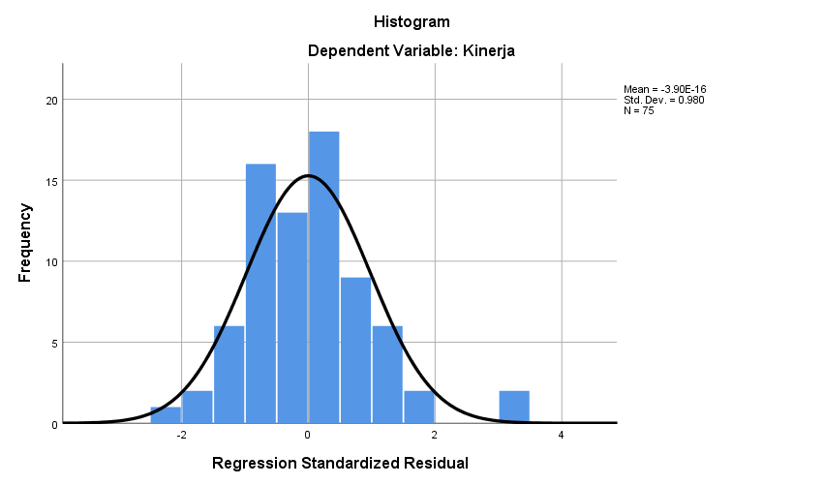

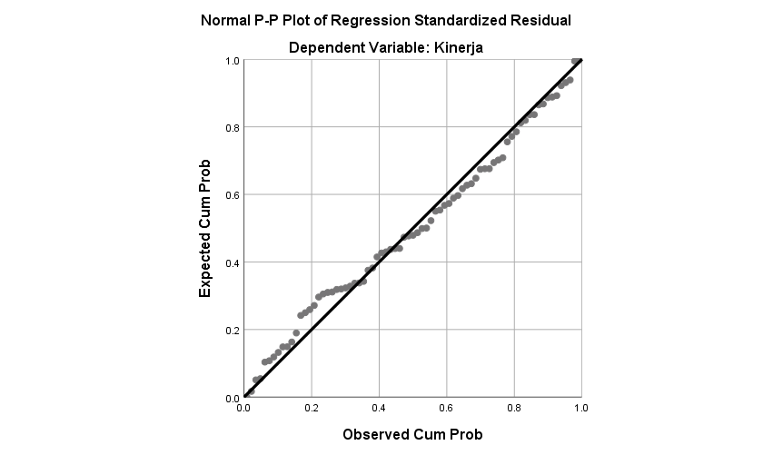

One-Sample Kolmogorov-Smirnov Test
 |  | Unstandardized Residual
N |  | 75
Normal Parameters^{a,b} | Mean | .0000000
 | Std. Deviation | 5.39154383
Most Extreme Differences | Absolute | .079
 | Positive | .061
 | Negative | -.079
Test Statistic |  | .079
Asymp. Sig. (2-tailed) |  | .200^{c,d}
a. Test distribution is Normal.
b. Calculated from data.
c. Lilliefors Significance Correction.
d. This is a lower bound of the true significance.

Lampiran 24.
Data Output SPSS Uji Asumsi Klasik (Uji Multikolinearitas)

Variables Entered/Removedª
Model | Variables Entered | Variables Removed | Method
1 | Penempatan Kerja, Beban Kerja, Human Relations^{b} | . | Enter
a. Dependent Variable: Kinerja
b. All requested variables entered.

ANOVAª
Model |  | Sum of Squares | df | Mean Square | F | Sig.
1 | Regression | 2856.460 | 3 | 952.153 | 31.427 | .000^{b}
 | Residual | 2151.087 | 71 | 30.297
 | Total | 5007.547 | 74
a. Dependent Variable: Kinerja
b. Predictors: (Constant), Penempatan Kerja, Beban Kerja, Human Relations

Coefficient Correlationsª
Model |  |  | Penempatan Kerja | Beban Kerja | Human Relations
1 | Correlations | Penempatan Kerja | 1.000 | .040 | -.425
 |  | Beban Kerja | .040 | 1.000 | -.142
 |  | Human Relations | -.425 | -.142 | 1.000
 | Covariances | Penempatan Kerja | .026 | .001 | -.005
 |  | Beban Kerja | .001 | .031 | -.002
 |  | Human Relations | -.005 | -.002 | .006
a. Dependent Variable: Kinerja

Collinearity Diagnosticsª
Model | Dimension | Eigenvalue | Condition Index | Variance Proportions
 |  |  |  | (Constant) | Human Relations | Beban Kerja | Penempatan Kerja
1 | 1 | 3.834 | 1.000 | .00 | .01 | .00 | .00
 | 2 | .089 | 6.569 | .02 | .49 | .39 | .02
 | 3 | .054 | 8.402 | .06 | .49 | .27 | .38
 | 4 | .023 | 12.902 | .92 | .02 | .34 | .60
a. Dependent Variable: Kinerja

Coefficientsª
Model |  | Unstandardized Coefficients |  | Standardized Coefficients | t | Sig. | Collinearity Statistics
 |  | B | Std. Error | Beta |  |  | Tolerance | VIF
1 | (Constant) | 16.510 | 3.408 |  | 4.844 | .000
 | Human Relations | .257 | .079 | .282 | 3.253 | .002 | .803 | 1.245
 | Beban Kerja | -.358 | .175 | -.161 | -2.048 | .044 | .979 | 1.021
 | Penempatan Kerja | 1.089 | .160 | .584 | 6.798 | .000 | .819 | 1.222
a. Dependent Variable: Kinerja

Residuals Statisticsª
 | Minimum | Maximum | Mean | Std. Deviation | N
Predicted Value | 24.80 | 48.73 | 37.37 | 6.213 | 75
Residual | -18.743 | 15.672 | .000 | 5.392 | 75
Std. Predicted Value | -2.023 | 1.828 | .000 | 1.000 | 75
Std. Residual | -3.405 | 2.847 | .000 | .980 | 75
a. Dependent Variable: Kinerja

Lampiran 25.
Data Output SPSS Uji Asumsi Klasik (Uji Heteroskedastisitas)

Variables Entered/Removedª
Model | Variables Entered | Variables Removed | Method
1 | Penempatan Kerja, Beban Kerja, Human Relations^{b} | . | Enter
a. Dependent Variable: Kinerja
b. All requested variables entered.

Model Summary^{b}
Model | R | R Square | Adjusted R Square | Std. Error of the Estimate | Durbin-Watson
1 | .755ª | .570 | .552 | 5.504 | 1.932
a. Predictors: (Constant), Penempatan Kerja, Beban Kerja, Human Relations
b. Dependent Variable: Kinerja

ANOVAª
Model |  | Sum of Squares | df | Mean Square | F | Sig.
1 | Regression | 2856.460 | 3 | 952.153 | 31.427 | .000^{b}
 | Residual | 2151.087 | 71 | 30.297
 | Total | 5007.547 | 74
a. Dependent Variable: Kinerja
b. Predictors: (Constant), Penempatan Kerja, Beban Kerja, Human Relations

Coefficientsª
Model |  | Unstandardized Coefficients |  | Standardized Coefficients | t | Sig.
 |  | B | Std. Error | Beta
1 | (Constant) | 16.510 | 3.408 |  | 4.844 | .000
 | Human Relations | .257 | .079 | .282 | 3.253 | .002
 | Beban Kerja | -.358 | .175 | -.161 | -2.048 | .044
 | Penempatan Kerja | 1.089 | .160 | .584 | 6.798 | .000
a. Dependent Variable: Kinerja

Residuals Statisticsª
 | Minimum | Maximum | Mean | Std. Deviation | N
Predicted Value | 24.80 | 48.73 | 37.37 | 6.213 | 75
Std. Predicted Value | -2.023 | 1.828 | .000 | 1.000 | 75
Standard Error of Predicted Value | .696 | 1.918 | 1.229 | .326 | 75
Adjusted Predicted Value | 25.03 | 48.93 | 37.35 | 6.234 | 75
Residual | -18.743 | 15.672 | .000 | 5.392 | 75
Std. Residual | -3.405 | 2.847 | .000 | .980 | 75
Stud. Residual | -3.490 | 2.989 | .002 | 1.014 | 75
Deleted Residual | -19.692 | 17.270 | .019 | 5.777 | 75
Stud. Deleted Residual | -3.808 | 3.174 | .001 | 1.045 | 75
Mahal. Distance | .198 | 8.002 | 2.960 | 2.081 | 75
Cook's Distance | .000 | .228 | .018 | .039 | 75
Centered Leverage Value | .003 | .108 | .040 | .028 | 75
a. Dependent Variable: Kinerja

Charts
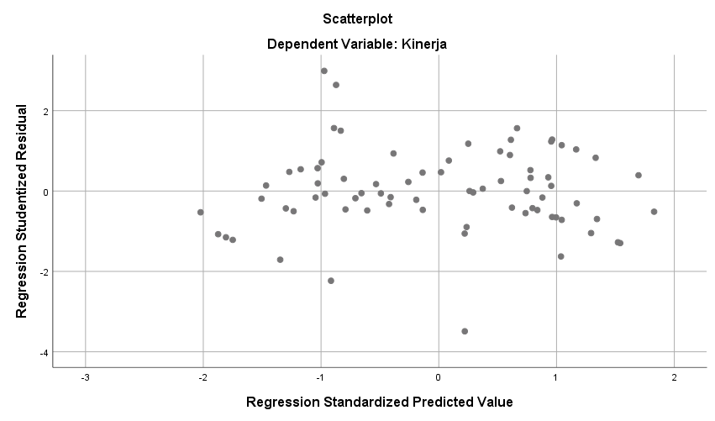

Lampiran 26.
Data Output SPSS Uji Asumsi Klasik (Uji Autokorelasi)

Variables Entered/Removedª
Model | Variables Entered | Variables Removed | Method
1 | Penempatan Kerja, Beban Kerja, Human Relations^{b} | . | Enter
a. Dependent Variable: Kinerja
b. All requested variables entered.

Model Summary^{b}
Model | R | R Square | Adjusted R Square | Std. Error of the Estimate | Durbin-Watson
1 | .755ª | .570 | .552 | 5.504 | 1.932
a. Predictors: (Constant), Penempatan Kerja, Beban Kerja, Human Relations
b. Dependent Variable: Kinerja

ANOVAª
Model |  | Sum of Squares | df | Mean Square | F | Sig.
1 | Regression | 2856.460 | 3 | 952.153 | 31.427 | .000^{b}
 | Residual | 2151.087 | 71 | 30.297
 | Total | 5007.547 | 74
a. Dependent Variable: Kinerja
b. Predictors: (Constant), Penempatan Kerja, Beban Kerja, Human Relations

Coefficientsª
Model |  | Unstandardized Coefficients |  | Standardized Coefficients | t | Sig.
 |  | B | Std. Error | Beta
1 | (Constant) | 16.510 | 3.408 |  | 4.844 | .000
 | Human Relations | .257 | .079 | .282 | 3.253 | .002
 | Beban Kerja | -.358 | .175 | -.161 | -2.048 | .044
 | Penempatan Kerja | 1.089 | .160 | .584 | 6.798 | .000
a. Dependent Variable: Kinerja

Residuals Statisticsª
 | Minimum | Maximum | Mean | Std. Deviation | N
Predicted Value | 24.80 | 48.73 | 37.37 | 6.213 | 75
Std. Predicted Value | -2.023 | 1.828 | .000 | 1.000 | 75
Standard Error of Predicted Value | .696 | 1.918 | 1.229 | .326 | 75
Adjusted Predicted Value | 25.03 | 48.93 | 37.35 | 6.234 | 75
Residual | -18.743 | 15.672 | .000 | 5.392 | 75
Std. Residual | -3.405 | 2.847 | .000 | .980 | 75
Stud. Residual | -3.490 | 2.989 | .002 | 1.014 | 75
Deleted Residual | -19.692 | 17.270 | .019 | 5.777 | 75
Stud. Deleted Residual | -3.808 | 3.174 | .001 | 1.045 | 75
Mahal. Distance | .198 | 8.002 | 2.960 | 2.081 | 75
Cook's Distance | .000 | .228 | .018 | .039 | 75
Centered Leverage Value | .003 | .108 | .040 | .028 | 75
a. Dependent Variable: Kinerja

Lampiran 27.
Data Output SPSS Analisis Regresi Linear Berganda

Variables Entered/Removedª
Model | Variables Entered | Variables Removed | Method
1 | Penempatan Kerja, Beban Kerja, Human Relations^{b} | . | Enter
a. Dependent Variable: Kinerja
b. All requested variables entered.

Model Summary^{b}
Model | R | R Square | Adjusted R Square | Std. Error of the Estimate | Durbin-Watson
1 | .755ª | .570 | .552 | 5.504 | 1.932
a. Predictors: (Constant), Penempatan Kerja, Beban Kerja, Human Relations
b. Dependent Variable: Kinerja

ANOVAª
Model |  | Sum of Squares | df | Mean Square | F | Sig.
1 | Regression | 2856.460 | 3 | 952.153 | 31.427 | .000^{b}
 | Residual | 2151.087 | 71 | 30.297
 | Total | 5007.547 | 74
a. Dependent Variable: Kinerja
b. Predictors: (Constant), Penempatan Kerja, Beban Kerja, Human Relations

Coefficientsª
Model |  | Unstandardized Coefficients |  | Standardized Coefficients | t | Sig.
 |  | B | Std. Error | Beta
1 | (Constant) | 16.510 | 3.408 |  | 4.844 | .000
 | Human Relations | .257 | .079 | .282 | 3.253 | .002
 | Beban Kerja | -.358 | .175 | -.161 | -2.048 | .044
 | Penempatan Kerja | 1.089 | .160 | .584 | 6.798 | .000
a. Dependent Variable: Kinerja

Residuals Statisticsª
 | Minimum | Maximum | Mean | Std. Deviation | N
Predicted Value | 24.80 | 48.73 | 37.37 | 6.213 | 75
Std. Predicted Value | -2.023 | 1.828 | .000 | 1.000 | 75
Standard Error of Predicted Value | .696 | 1.918 | 1.229 | .326 | 75
Adjusted Predicted Value | 25.03 | 48.93 | 37.35 | 6.234 | 75
Residual | -18.743 | 15.672 | .000 | 5.392 | 75
Std. Residual | -3.405 | 2.847 | .000 | .980 | 75
Stud. Residual | -3.490 | 2.989 | .002 | 1.014 | 75
Deleted Residual | -19.692 | 17.270 | .019 | 5.777 | 75
Stud. Deleted Residual | -3.808 | 3.174 | .001 | 1.045 | 75
Mahal. Distance | .198 | 8.002 | 2.960 | 2.081 | 75
Cook's Distance | .000 | .228 | .018 | .039 | 75
Centered Leverage Value | .003 | .108 | .040 | .028 | 75
a. Dependent Variable: Kinerja

Lampiran 28.
Data Output SPSS Uji Hipotesis (Uji t)

Variables Entered/Removedª
Model | Variables Entered | Variables Removed | Method
1 | Penempatan Kerja, Beban Kerja, Human Relations^{b} | . | Enter
a. Dependent Variable: Kinerja
b. All requested variables entered.

Model Summary^{b}
Model | R | R Square | Adjusted R Square | Std. Error of the Estimate | Durbin-Watson
1 | .755ª | .570 | .552 | 5.504 | 1.932
a. Predictors: (Constant), Penempatan Kerja, Beban Kerja, Human Relations
b. Dependent Variable: Kinerja

ANOVAª
Model |  | Sum of Squares | df | Mean Square | F | Sig.
1 | Regression | 2856.460 | 3 | 952.153 | 31.427 | .000^{b}
 | Residual | 2151.087 | 71 | 30.297
 | Total | 5007.547 | 74
a. Dependent Variable: Kinerja
b. Predictors: (Constant), Penempatan Kerja, Beban Kerja, Human Relations

Coefficientsª
Model |  | Unstandardized Coefficients |  | Standardized Coefficients | t | Sig.
 |  | B | Std. Error | Beta
1 | (Constant) | 16.510 | 3.408 |  | 4.844 | .000
 | Human Relations | .257 | .079 | .282 | 3.253 | .002
 | Beban Kerja | -.358 | .175 | -.161 | -2.048 | .044
 | Penempatan Kerja | 1.089 | .160 | .584 | 6.798 | .000
a. Dependent Variable: Kinerja

Residuals Statisticsª
 | Minimum | Maximum | Mean | Std. Deviation | N
Predicted Value | 24.80 | 48.73 | 37.37 | 6.213 | 75
Std. Predicted Value | -2.023 | 1.828 | .000 | 1.000 | 75
Standard Error of Predicted Value | .696 | 1.918 | 1.229 | .326 | 75
Adjusted Predicted Value | 25.03 | 48.93 | 37.35 | 6.234 | 75
Residual | -18.743 | 15.672 | .000 | 5.392 | 75
Std. Residual | -3.405 | 2.847 | .000 | .980 | 75
Stud. Residual | -3.490 | 2.989 | .002 | 1.014 | 75
Deleted Residual | -19.692 | 17.270 | .019 | 5.777 | 75
Stud. Deleted Residual | -3.808 | 3.174 | .001 | 1.045 | 75
Mahal. Distance | .198 | 8.002 | 2.960 | 2.081 | 75
Cook's Distance | .000 | .228 | .018 | .039 | 75
Centered Leverage Value | .003 | .108 | .040 | .028 | 75
a. Dependent Variable: Kinerja

Lampiran 29.
Data Output SPSS Uji Hipotesis (Uji F)

Variables Entered/Removedª
Model | Variables Entered | Variables Removed | Method
1 | Penempatan Kerja, Beban Kerja, Human Relations^{b} | . | Enter
a. Dependent Variable: Kinerja
b. All requested variables entered.

Model Summary^{b}
Model | R | R Square | Adjusted R Square | Std. Error of the Estimate | Durbin-Watson
1 | .755ª | .570 | .552 | 5.504 | 1.932
a. Predictors: (Constant), Penempatan Kerja, Beban Kerja, Human Relations
b. Dependent Variable: Kinerja

ANOVAª
Model |  | Sum of Squares | df | Mean Square | F | Sig.
1 | Regression | 2856.460 | 3 | 952.153 | 31.427 | .000^{b}
 | Residual | 2151.087 | 71 | 30.297
 | Total | 5007.547 | 74
a. Dependent Variable: Kinerja
b. Predictors: (Constant), Penempatan Kerja, Beban Kerja, Human Relations

Coefficientsª
Model |  | Unstandardized Coefficients |  | Standardized Coefficients | t | Sig.
 |  | B | Std. Error | Beta
1 | (Constant) | 16.510 | 3.408 |  | 4.844 | .000
 | Human Relations | .257 | .079 | .282 | 3.253 | .002
 | Beban Kerja | -.358 | .175 | -.161 | -2.048 | .044
 | Penempatan Kerja | 1.089 | .160 | .584 | 6.798 | .000
a. Dependent Variable: Kinerja

Residuals Statisticsª
 | Minimum | Maximum | Mean | Std. Deviation | N
Predicted Value | 24.80 | 48.73 | 37.37 | 6.213 | 75
Std. Predicted Value | -2.023 | 1.828 | .000 | 1.000 | 75
Standard Error of Predicted Value | .696 | 1.918 | 1.229 | .326 | 75
Adjusted Predicted Value | 25.03 | 48.93 | 37.35 | 6.234 | 75
Residual | -18.743 | 15.672 | .000 | 5.392 | 75
Std. Residual | -3.405 | 2.847 | .000 | .980 | 75
Stud. Residual | -3.490 | 2.989 | .002 | 1.014 | 75
Deleted Residual | -19.692 | 17.270 | .019 | 5.777 | 75
Stud. Deleted Residual | -3.808 | 3.174 | .001 | 1.045 | 75
Mahal. Distance | .198 | 8.002 | 2.960 | 2.081 | 75
Cook's Distance | .000 | .228 | .018 | .039 | 75
Centered Leverage Value | .003 | .108 | .040 | .028 | 75
a. Dependent Variable: Kinerja

Lampiran 30.
Data Output SPSS Koefisien Determinasi

Variables Entered/Removedª
Model | Variables Entered | Variables Removed | Method
1 | Penempatan Kerja, Beban Kerja, Human Relations^{b} | . | Enter
a. Dependent Variable: Kinerja
b. All requested variables entered.

Model Summary^{b}
Model | R | R Square | Adjusted R Square | Std. Error of the Estimate | Durbin-Watson
1 | .755ª | .570 | .552 | 5.504 | 1.932
a. Predictors: (Constant), Penempatan Kerja, Beban Kerja, Human Relations
b. Dependent Variable: Kinerja

ANOVAª
Model |  | Sum of Squares | df | Mean Square | F | Sig.
1 | Regression | 2856.460 | 3 | 952.153 | 31.427 | .000^{b}
 | Residual | 2151.087 | 71 | 30.297
 | Total | 5007.547 | 74
a. Dependent Variable: Kinerja
b. Predictors: (Constant), Penempatan Kerja, Beban Kerja, Human Relations

Coefficientsª
Model |  | Unstandardized Coefficients |  | Standardized Coefficients | t | Sig.
 |  | B | Std. Error | Beta
1 | (Constant) | 16.510 | 3.408 |  | 4.844 | .000
 | Human Relations | .257 | .079 | .282 | 3.253 | .002
 | Beban Kerja | -.358 | .175 | -.161 | -2.048 | .044
 | Penempatan Kerja | 1.089 | .160 | .584 | 6.798 | .000
a. Dependent Variable: Kinerja

Residuals Statisticsª
 | Minimum | Maximum | Mean | Std. Deviation | N
Predicted Value | 24.80 | 48.73 | 37.37 | 6.213 | 75
Std. Predicted Value | -2.023 | 1.828 | .000 | 1.000 | 75
Standard Error of Predicted Value | .696 | 1.918 | 1.229 | .326 | 75
Adjusted Predicted Value | 25.03 | 48.93 | 37.35 | 6.234 | 75
Residual | -18.743 | 15.672 | .000 | 5.392 | 75
Std. Residual | -3.405 | 2.847 | .000 | .980 | 75
Stud. Residual | -3.490 | 2.989 | .002 | 1.014 | 75
Deleted Residual | -19.692 | 17.270 | .019 | 5.777 | 75
Stud. Deleted Residual | -3.808 | 3.174 | .001 | 1.045 | 75
Mahal. Distance | .198 | 8.002 | 2.960 | 2.081 | 75
Cook's Distance | .000 | .228 | .018 | .039 | 75
Centered Leverage Value | .003 | .108 | .040 | .028 | 75
a. Dependent Variable: Kinerja

Lampiran 31.
r table
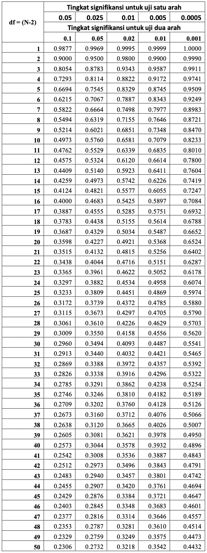
Lampiran 32.
t tabel
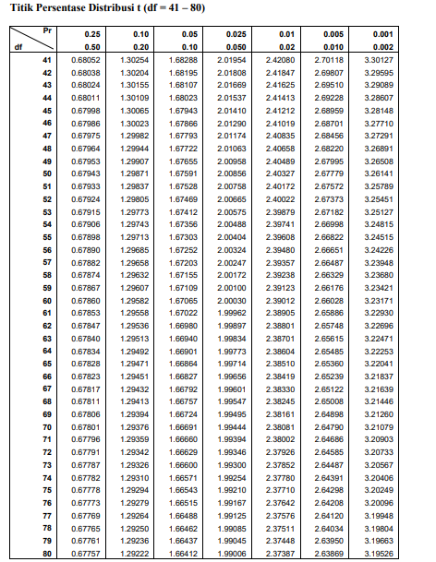

Lampiran 33.
F tabel
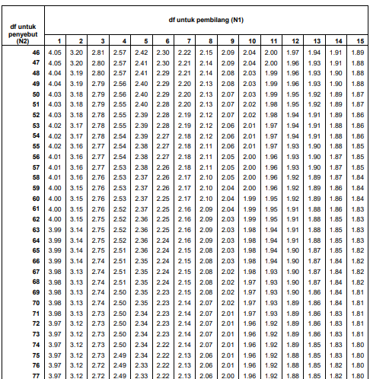

Lampiran 34.
Tabel DW

n | k=1 |  | k=2 |  | k=3 |  | k=4 |  | k=5
 | dL | dU | dL | dU | dL | dU | dL | dU | dL | dU
71 | 1.5865 | 1.6435 | 1.5577 | 1.6733 | 1.5284 | 1.7041 | 1.4987 | 1.7358 | 1.4685 | 1.7685
72 | 1.5895 | 1.6457 | 1.5611 | 1.6751 | 1.5323 | 1.7054 | 1.5029 | 1.7366 | 1.4732 | 1.7688
73 | 1.5924 | 1.6479 | 1.5645 | 1.6768 | 1.5360 | 1.7067 | 1.5071 | 1.7375 | 1.4778 | 1.7691
74 | 1.5953 | 1.6500 | 1.5677 | 1.6785 | 1.5397 | 1.7079 | 1.5112 | 1.7383 | 1.4822 | 1.7694
75 | 1.5981 | 1.6521 | 1.5709 | 1.6802 | 1.5432 | 1.7092 | 1.5151 | 1.7390 | 1.4866 | 1.7698
76 | 1.6009 | 1.6541 | 1.5740 | 1.6819 | 1.5467 | 1.7104 | 1.5190 | 1.7399 | 1.4909 | 1.7701
77 | 1.6036 | 1.6561 | 1.5771 | 1.6835 | 1.5502 | 1.7117 | 1.5228 | 1.7407 | 1.4950 | 1.7704
78 | 1.6063 | 1.6581 | 1.5801 | 1.6851 | 1.5535 | 1.7129 | 1.5265 | 1.7415 | 1.4991 | 1.7708
79 | 1.6089 | 1.6601 | 1.5830 | 1.6867 | 1.5568 | 1.7141 | 1.5302 | 1.7423 | 1.5031 | 1.7712
80 | 1.6114 | 1.6620 | 1.5859 | 1.6882 | 1.5600 | 1.7153 | 1.5337 | 1.7430 | 1.5070 | 1.7716
81 | 1.6139 | 1.6639 | 1.5888 | 1.6898 | 1.5632 | 1.7164 | 1.5372 | 1.7438 | 1.5109 | 1.7720
82 | 1.6164 | 1.6657 | 1.5915 | 1.6913 | 1.5663 | 1.7176 | 1.5406 | 1.7446 | 1.5146 | 1.7724
83 | 1.6188 | 1.6675 | 1.5942 | 1.6928 | 1.5693 | 1.7187 | 1.5440 | 1.7454 | 1.5183 | 1.7728
84 | 1.6212 | 1.6693 | 1.5969 | 1.6942 | 1.5723 | 1.7199 | 1.5472 | 1.7462 | 1.5219 | 1.7732
85 | 1.6235 | 1.6711 | 1.5995 | 1.6957 | 1.5752 | 1.7210 | 1.5505 | 1.7470 | 1.5254 | 1.7736
86 | 1.6258 | 1.6728 | 1.6021 | 1.6971 | 1.5780 | 1.7221 | 1.5536 | 1.7478 | 1.5289 | 1.7740
87 | 1.6280 | 1.6745 | 1.6046 | 1.6985 | 1.5808 | 1.7232 | 1.5567 | 1.7485 | 1.5322 | 1.7745
88 | 1.6302 | 1.6762 | 1.6071 | 1.6999 | 1.5836 | 1.7243 | 1.5597 | 1.7493 | 1.5356 | 1.7749
89 | 1.6324 | 1.6778 | 1.6095 | 1.7013 | 1.5863 | 1.7254 | 1.5627 | 1.7501 | 1.5388 | 1.7754
90 | 1.6345 | 1.6794 | 1.6119 | 1.7026 | 1.5889 | 1.7264 | 1.5656 | 1.7508 | 1.5420 | 1.7758
91 | 1.6366 | 1.6810 | 1.6143 | 1.7040 | 1.5915 | 1.7275 | 1.5685 | 1.7516 | 1.5452 | 1.7763
92 | 1.6387 | 1.6826 | 1.6166 | 1.7053 | 1.5941 | 1.7285 | 1.5713 | 1.7523 | 1.5482 | 1.7767
93 | 1.6407 | 1.6841 | 1.6188 | 1.7066 | 1.5966 | 1.7295 | 1.5741 | 1.7531 | 1.5513 | 1.7772
94 | 1.6427 | 1.6857 | 1.6211 | 1.7078 | 1.5991 | 1.7306 | 1.5768 | 1.7538 | 1.5542 | 1.7776
95 | 1.6447 | 1.6872 | 1.6233 | 1.7091 | 1.6015 | 1.7316 | 1.5795 | 1.7546 | 1.5572 | 1.7781
96 | 1.6466 | 1.6887 | 1.6254 | 1.7103 | 1.6039 | 1.7326 | 1.5821 | 1.7553 | 1.5600 | 1.7785
97 | 1.6485 | 1.6901 | 1.6275 | 1.7116 | 1.6063 | 1.7335 | 1.5847 | 1.7560 | 1.5628 | 1.7790
98 | 1.6504 | 1.6916 | 1.6296 | 1.7128 | 1.6086 | 1.7345 | 1.5872 | 1.7567 | 1.5656 | 1.7795
99 | 1.6522 | 1.6930 | 1.6317 | 1.7140 | 1.6108 | 1.7355 | 1.5897 | 1.7575 | 1.5683 | 1.7799
100 | 1.6540 | 1.6944 | 1.6337 | 1.7152 | 1.6131 | 1.7364 | 1.5922 | 1.7582 | 1.5710 | 1.7804
101 | 1.6558 | 1.6958 | 1.6357 | 1.7163 | 1.6153 | 1.7374 | 1.5946 | 1.7589 | 1.5736 | 1.7809
102 | 1.6576 | 1.6971 | 1.6376 | 1.7175 | 1.6174 | 1.7383 | 1.5969 | 1.7596 | 1.5762 | 1.7813
103 | 1.6593 | 1.6985 | 1.6396 | 1.7186 | 1.6196 | 1.7392 | 1.5993 | 1.7603 | 1.5788 | 1.7818
104 | 1.6610 | 1.6998 | 1.6415 | 1.7198 | 1.6217 | 1.7402 | 1.6016 | 1.7610 | 1.5813 | 1.7823
105 | 1.6627 | 1.7011 | 1.6433 | 1.7209 | 1.6237 | 1.7411 | 1.6038 | 1.7617 | 1.5837 | 1.7827
106 | 1.6644 | 1.7024 | 1.6452 | 1.7220 | 1.6258 | 1.7420 | 1.6061 | 1.7624 | 1.5861 | 1.7832
107 | 1.6660 | 1.7037 | 1.6470 | 1.7231 | 1.6277 | 1.7428 | 1.6083 | 1.7631 | 1.5885 | 1.7837
108 | 1.6676 | 1.7050 | 1.6488 | 1.7241 | 1.6297 | 1.7437 | 1.6104 | 1.7637 | 1.5909 | 1.7841
109 | 1.6692 | 1.7062 | 1.6505 | 1.7252 | 1.6317 | 1.7446 | 1.6125 | 1.7644 | 1.5932 | 1.7846
110 | 1.6708 | 1.7074 | 1.6523 | 1.7262 | 1.6336 | 1.7455 | 1.6146 | 1.7651 | 1.5955 | 1.7851

Lampiran 35.
Foto pembagian kuesioner
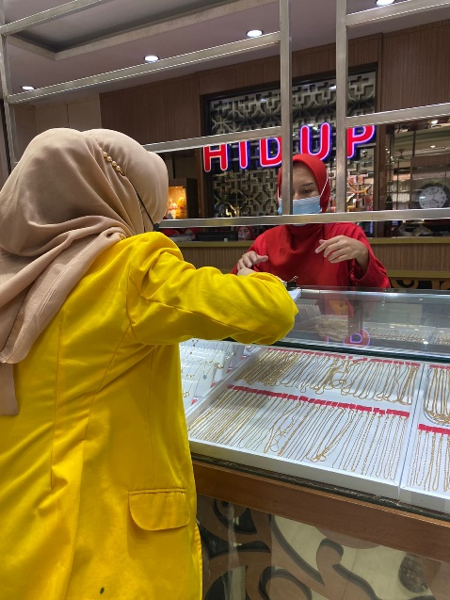
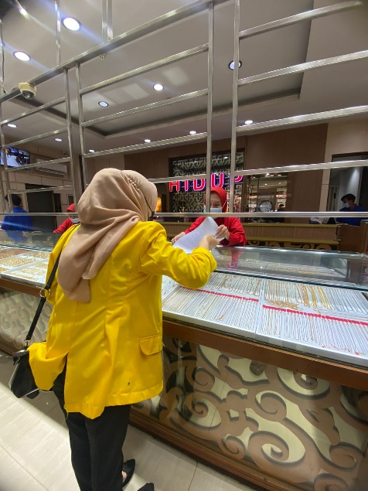
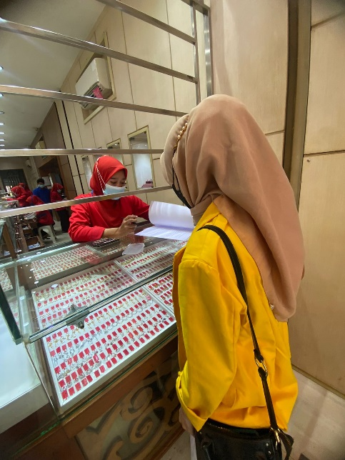
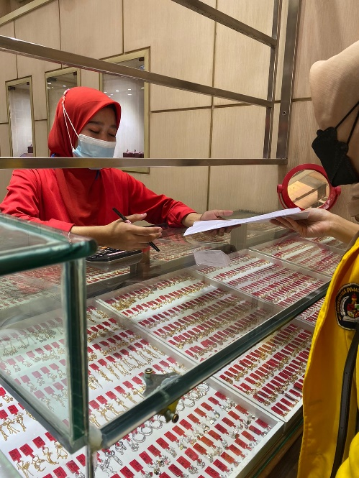
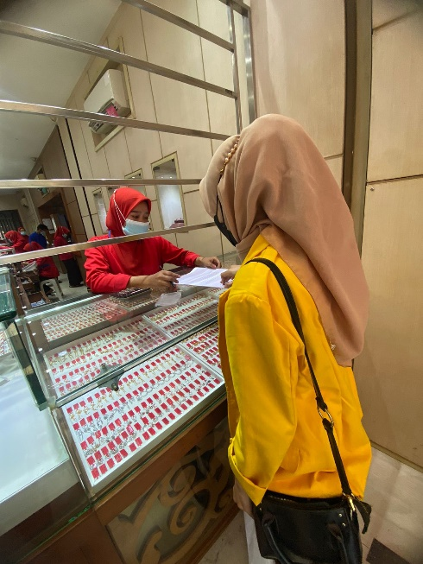
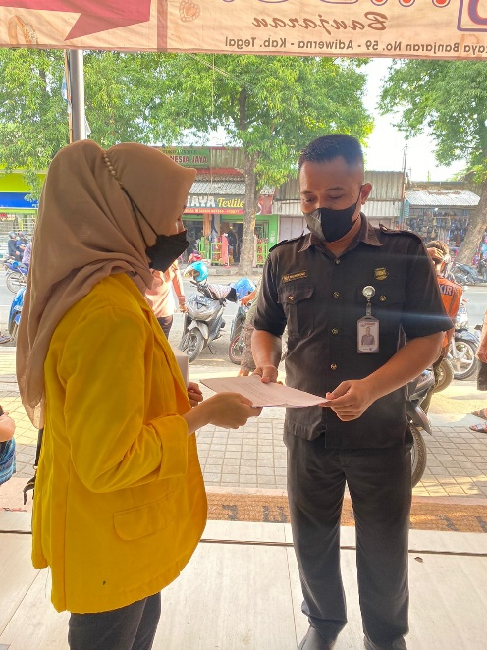

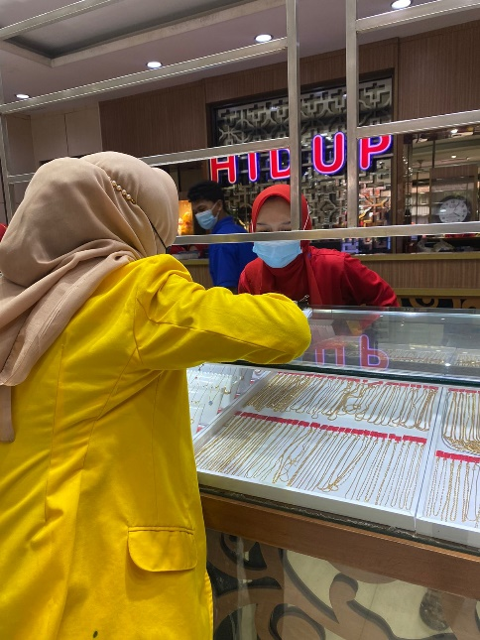
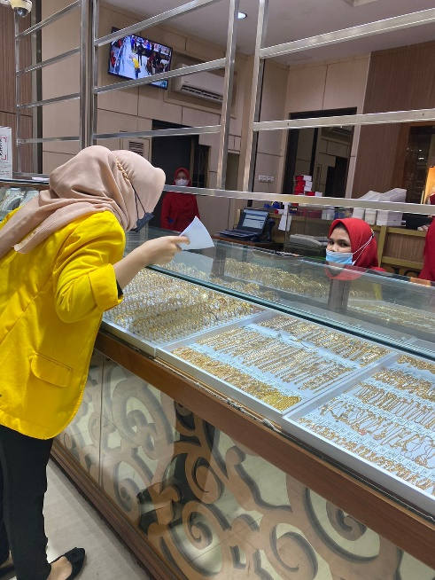
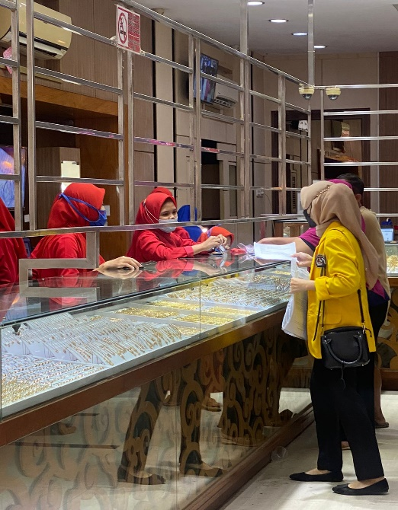
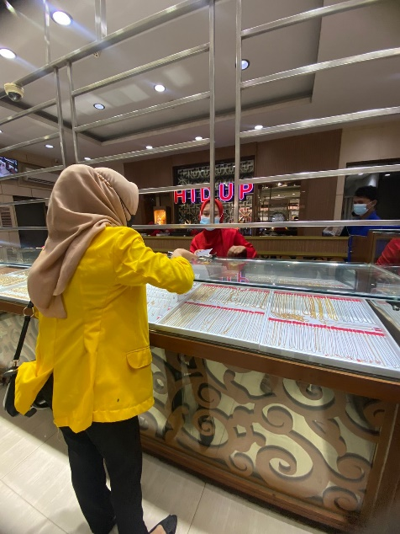
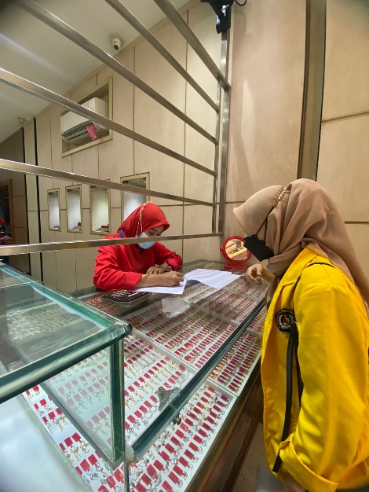
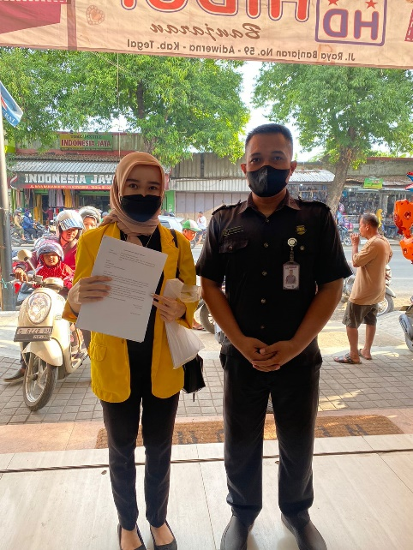

Lampiran 36.
Surat izin penelitian

