DAFTAR PUSTAKA
Alit, I. B., Nurchayati, N., & Pamuji, S. H. (2016). Turbin angin poros vertikal tipe Savonius bertingkat dengan variasi posisi sudut. Dinamika Teknik Mesin, 6(2), 107–112. https://doi.org/10.29303/d.v6i2.13
Bachtiar, A., & Hayyatul, W. (2018). Analisis Potensi Pembangkit Listrik Tenaga Angin PT. Lentera Angin Nusantara (LAN) Ciheras. Jurnal Teknik Elektro ITP, 7(1), 34–45. https://doi.org/10.21063/jte.2018.3133706
Bashir, M. B. A. (2022). Principle Parameters and Environmental Impacts that Affect the Performance of Wind Turbine: An Overview. Arabian Journal for Science and Engineering, 47(7), 7891–7909. https://doi.org/10.1007/s13369-021-06357-1
DEWI, M. L. (2010). ANALISIS KINERJA TURBIN ANGIN POROS VERTIKAL DENGAN MODIFIKASI ROTOR SAVONIUS L UNTUK OPTIMASI KINERJA TURBIN.
Hamdi, S., Alit, I. B., & Mara, I. M. (2015). Pengaruh Variasi Diameter Dan Jumlah Sudu Terhadap Unjuk Kerja Pada Turbin Angin Savonius Poros Vertikal. 4, 1–11.
Hermawan, B. M., Sumarno, F. G., Prasetyo, T., Sahid, S., Roihatin, A., Aulia, N. F., Surindra, M. D., Mulyono, M., Sofiani, G., Putri, T. P., & Ariyanto, W. (2023). Performance Characteristics of Savonius Wind Turbines With Variations Air Gaps in Supporting the Development of Renewable Energy. Eksergi, 19(01), 28. https://doi.org/10.32497/eksergi.v19i01.4252
Idris. (2020). Pembuatan Sudu Type-U Dan Type Heliks Pada Prototype Turbin Angin Savonius Sebagai Pembangkit Listrik Energi Terbaharui. Mekanikal, 1–76.
Ikhya, M., & Ana Mufarida, N. (2021). Pengaruh Sudut Pitch Pada Blade Terhadap Kinerja Turbin Angin Darrieus-H. Jurnal AutoMech, 1(1), 1–4. http://journal.umpo.ac.id/index.php/JTM/index
Irsyad, M. (2012). Penggunaan Bentuk Sudu Setengah Silinder Elliptik Untuk Meningkatkan Efisiensi Turbin Savonius. In MEKANIKA (Vol. 10).
Ismail, & Arrahman, T. (2017). Perancangan Turbin Angin Sumbu Horizontal Tiga Sudu Dengan Kapasitas 3 MW. Presisi, 6(3), 113.
Khairil, A. (2020). Disertasi kinerja turbin angin savonius dengan modifikasi bentuk geometri sudu tipe bach.
Mahendra, B., Soenoko, R., & Sutikno, D. 2010. (n.d.). PENGARUH JUMLAH SUDU TERHADAP UNJUK KERJA TURBIN ANGIN SAVONIUS TYPE L.
Mao, Z., & Tian, W. (2015). Effect of the blade arc angle on the performance of a Savonius wind turbine. Advances in Mechanical Engineering, 7(5), 1–10. https://doi.org/10.1177/1687814015584247
Masykur, M., Kurniadi, A., Saputra, M., & Murhaban, M. (2021). Studi Numerik Pengaruh Sudut Kemiringan Sudu Terhadap Performa Turbin Angin Vertikal Tipe Savonius. Jurnal Mekanova: Mekanikal, Inovasi Dan Teknologi, 7(1), 25. https://doi.org/10.35308/jmkn.v7i1.3634
Muhammad Falah Dias Sunandi. (2016). Numerical Study of Savonius Wind Turbine With Variation of the Number of Blade and Wind Velocity.
Muttaqin, I., & Suprapto, M. (2021). Pembuatan Turbin Angin Savonius Bertingkat Berbahan Alumunium. Journal of Industrial Engineering and Operation Management, 4(1), 2–6. https://doi.org/10.31602/jieom.v4i1.5444
Naitio, I. R., Sanusi, A., & Nurhayati. (2021). Analisis Potensi Angin Sebagai Sumber Penggerak Turbin Angin Savonius Di Kabupaten Timor Tengah Selatan (TTS). LONTAR Jurnal Teknik Mesin Undana, 08(01), 71–75. http://ejurnal.undana.ac.id/index.php/LJTMU
Permadi, M. F. W. (2018). Uji Eksperimental Turbin Angin Sumbu Vertikal Jenis Cross Flow Dengan Variasi Jumlah Blade. 25–31.
Pitriadi, P., Bachmid, R., & Susanto, I. M. (2018). Analisis Performance Kincir Angin Sumbu Vertikal Tiga Sudut Dengan Kelengkungan 90°. Jurnal Poli-Teknologi, 17(2), 137–144. https://doi.org/10.32722/pt.v17i2.1234
Rahmadi Islam. (2018). Analisis Dan Pemodelan Savonius Vertical Axis Wind Turbine Dengan Variasi Blade Terhadap Aliran Udara Dengan Metode Cfd (Computational Fluid Dynamics). العدد الحا(3), 1–13. http://dx.doi.org/10.1186/s13662-017-1121-6%0Ahttps://doi.org/10.1007/s41980-018-0101-2%0Ahttps://doi.org/10.1016/j.cnsns.2018.04.019%0Ahttps://doi.org/10.1016/j.cam.2017.10.014%0Ahttp://dx.doi.org/10.1016/j.apm.2011.07.041%0Ahttp://arxiv.org/abs/1502.020
Rajpar, A. H., Ali, I., Eladwi, A. E., & Bashir, M. B. A. (2021). Recent development in the design of wind deflectors for vertical axis wind turbine: A review. Energies, 14(16). https://doi.org/10.3390/en14165140
Sahin, K., & Prawira, F. (2020). Studi Eksperimental Turbin Darrieus Dengan Sudu Overlap. Jurnal Rekayasa Mesin, 20(1), 7–14. https://doi.org/10.36706/jrm.v20i1.208
Salim, L. L., Sari, S. P., & Setyawan, I. (2020). Analisis Performa Turbin Angin Savonius Tipe U dengan Memvariasikan Jumlah Sudu Turbin. Jurnal Penelitian Enjiniring (JPE) (JPE), 24(2), 148–153. https://doi.org/10.25042/jpe.112020.07
Suanggana, D. (2021). Analisis Jumlah dan Sudut Blade terhadap Kecepatan dan Tekanan Turbin Air Savonius dengan Metode CFD. JTM-ITI (Jurnal Teknik Mesin ITI), 5(3), 119. https://doi.org/10.31543/jtm.v5i3.624
Wibowo, R., Fisika, P. S., Matematika, F., Ilmu, D. A. N., Alam, P., & Jakarta, U. N. (2017). Analisis Performansi Turbin Angin Savonius Tipe-U Dengan Variasi Sudut Kelengkungan Sudu Untuk Pengoptimalan Kinerja Turbin Disusun untuk Melengkapi Syarat-Syarat Guna Memperoleh Gelar Sarjana Sains.

LAMPIRAN
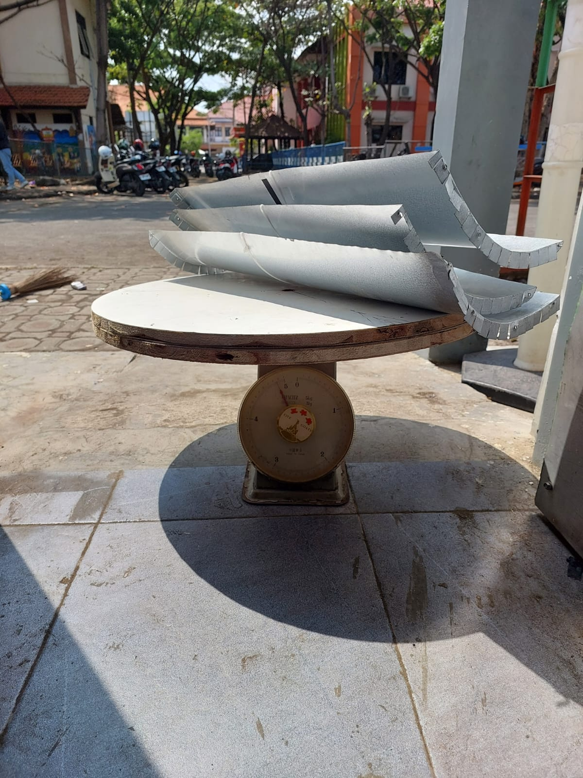
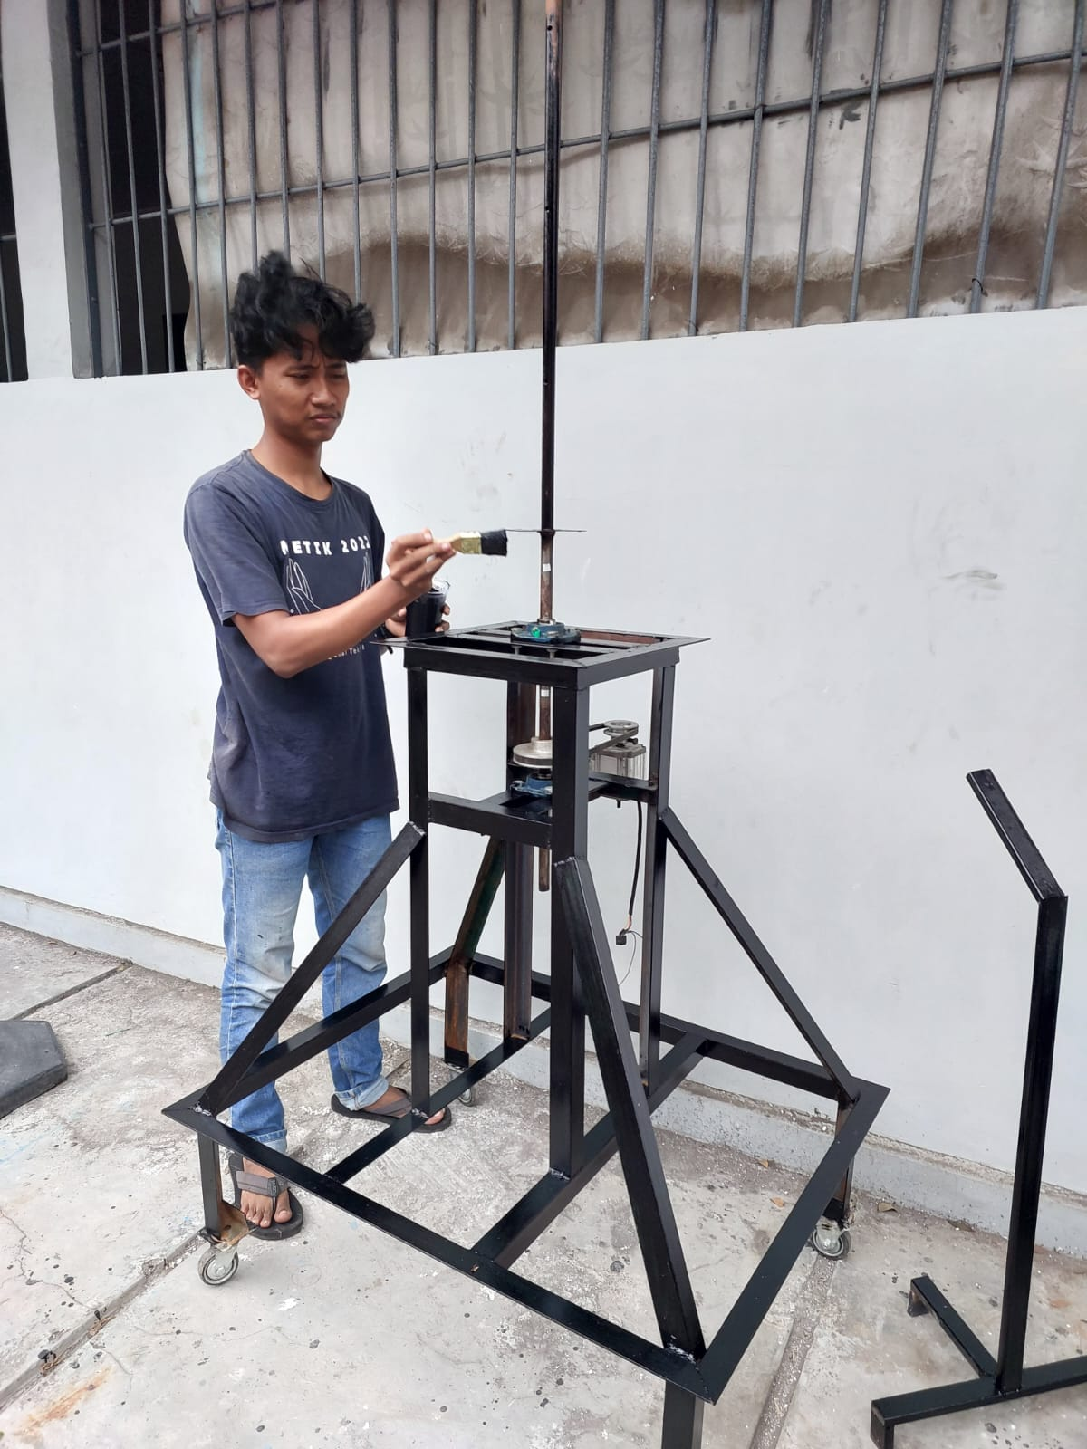

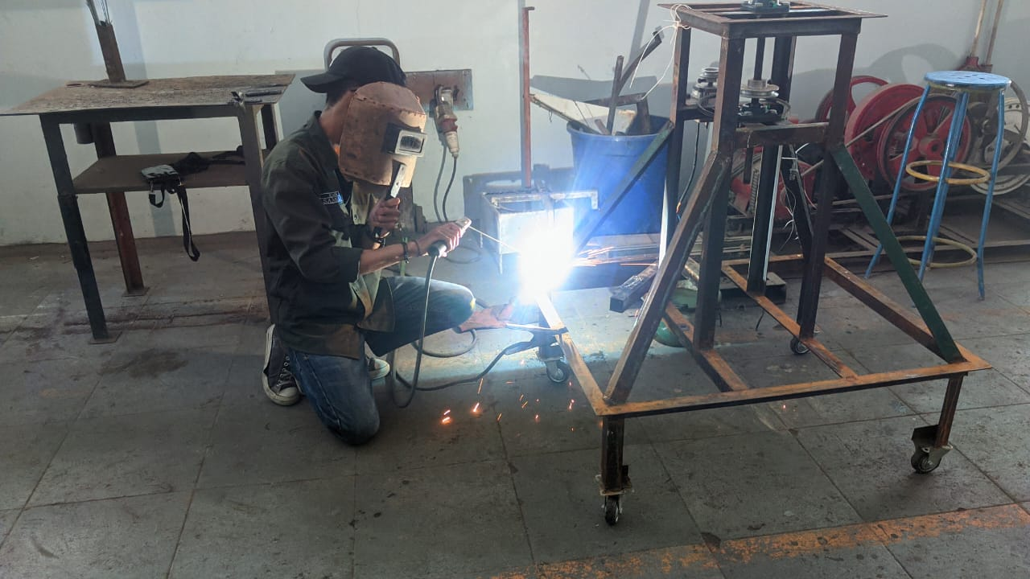
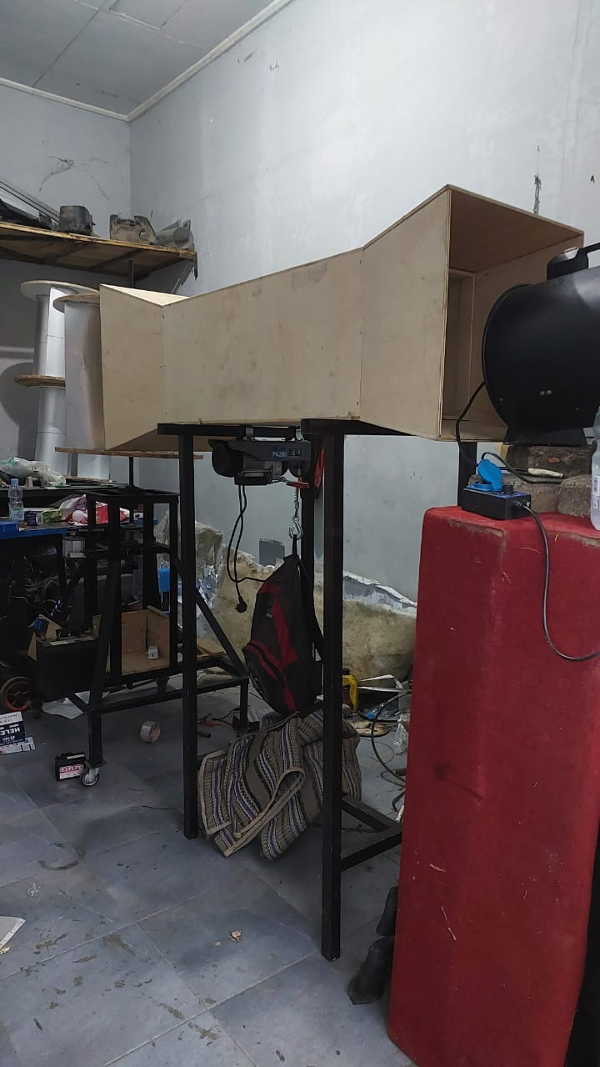
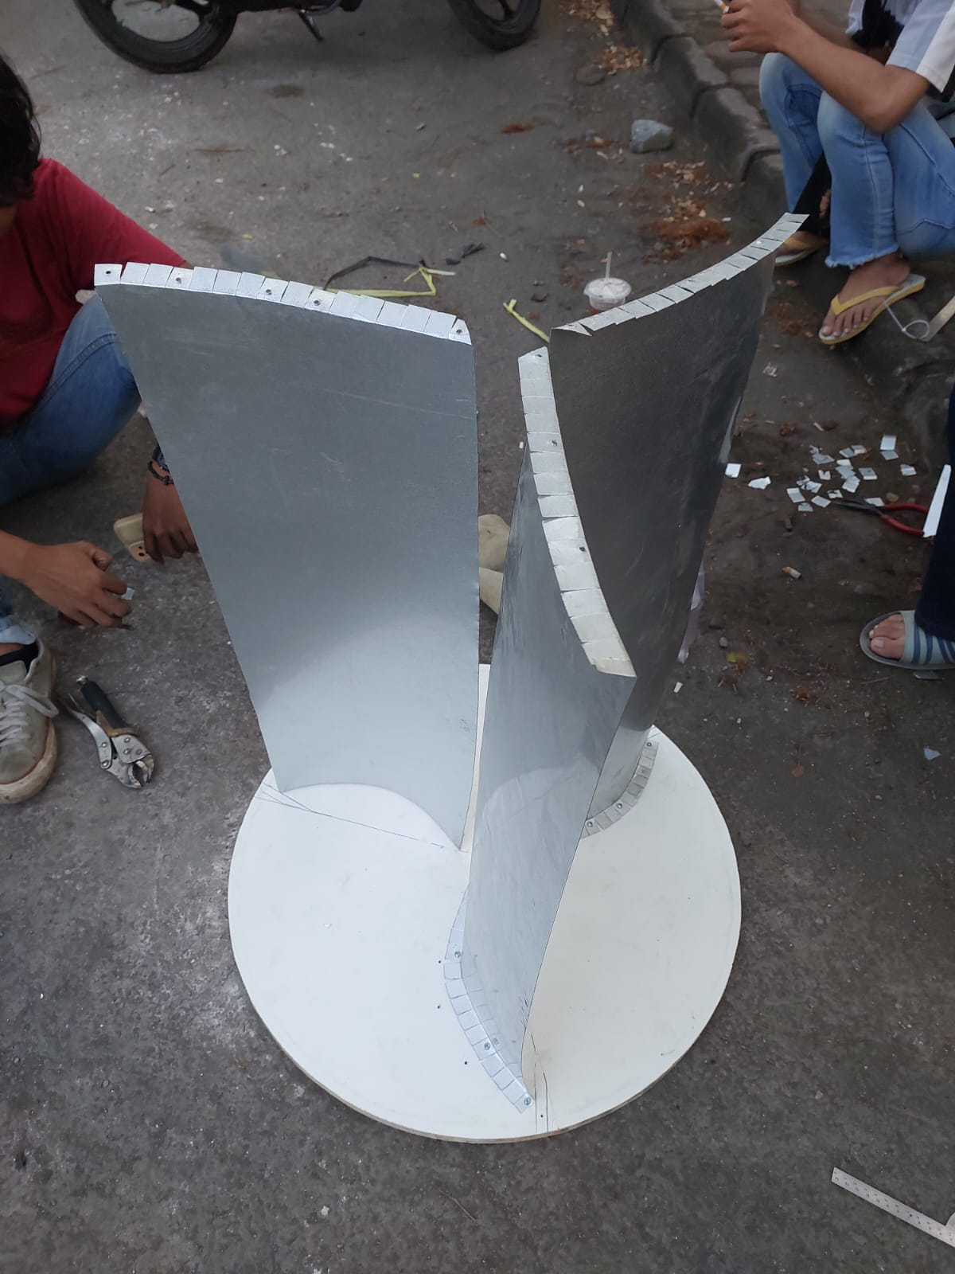
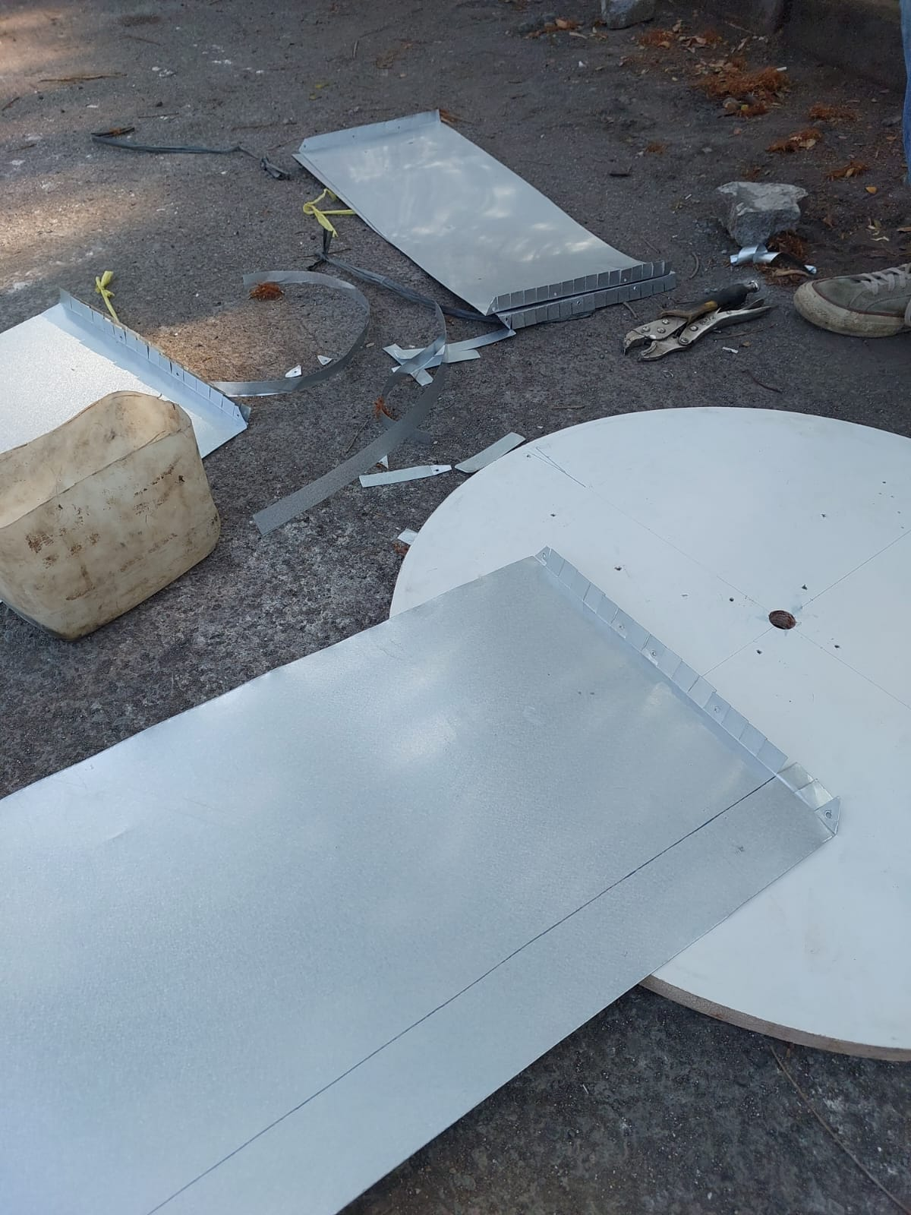
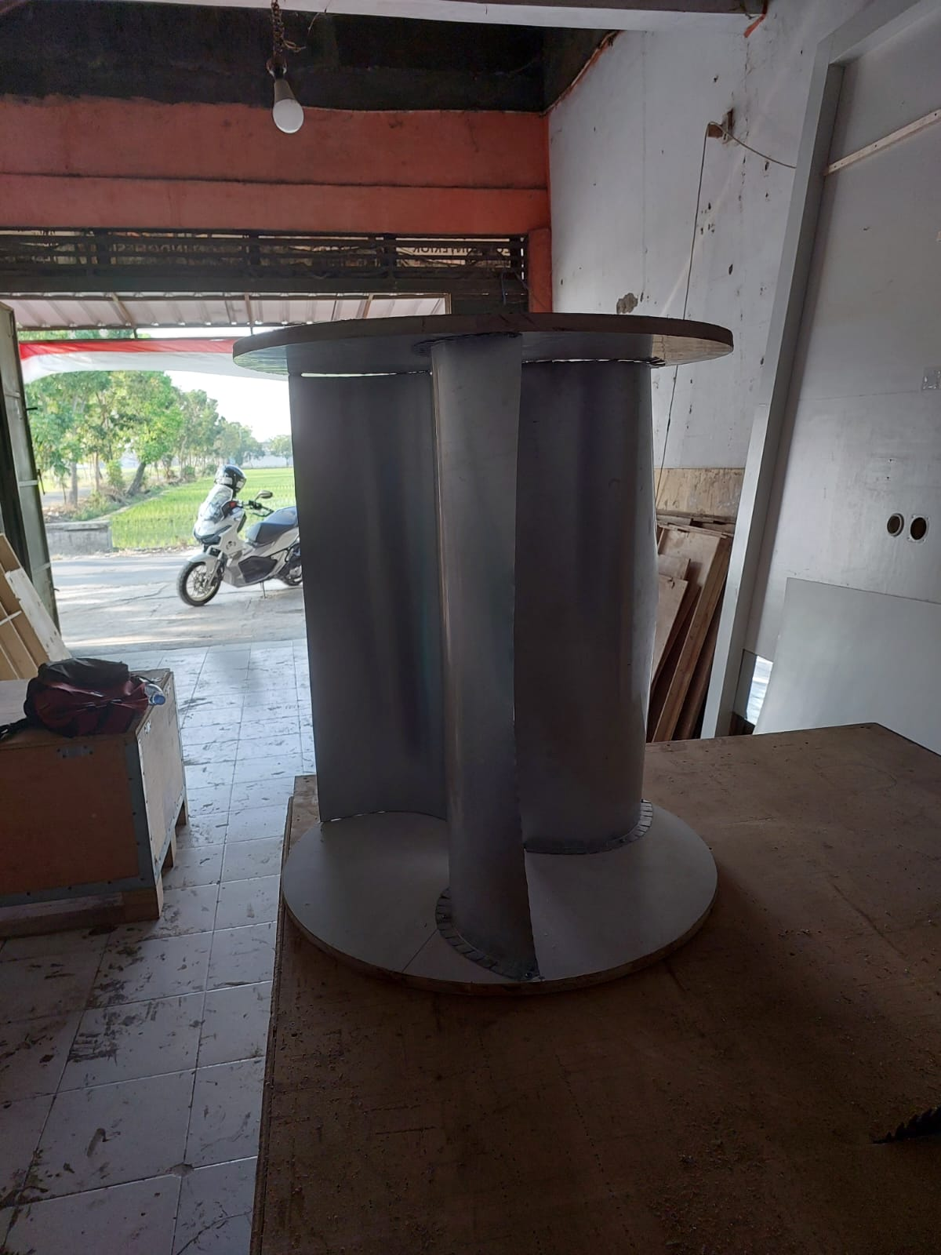
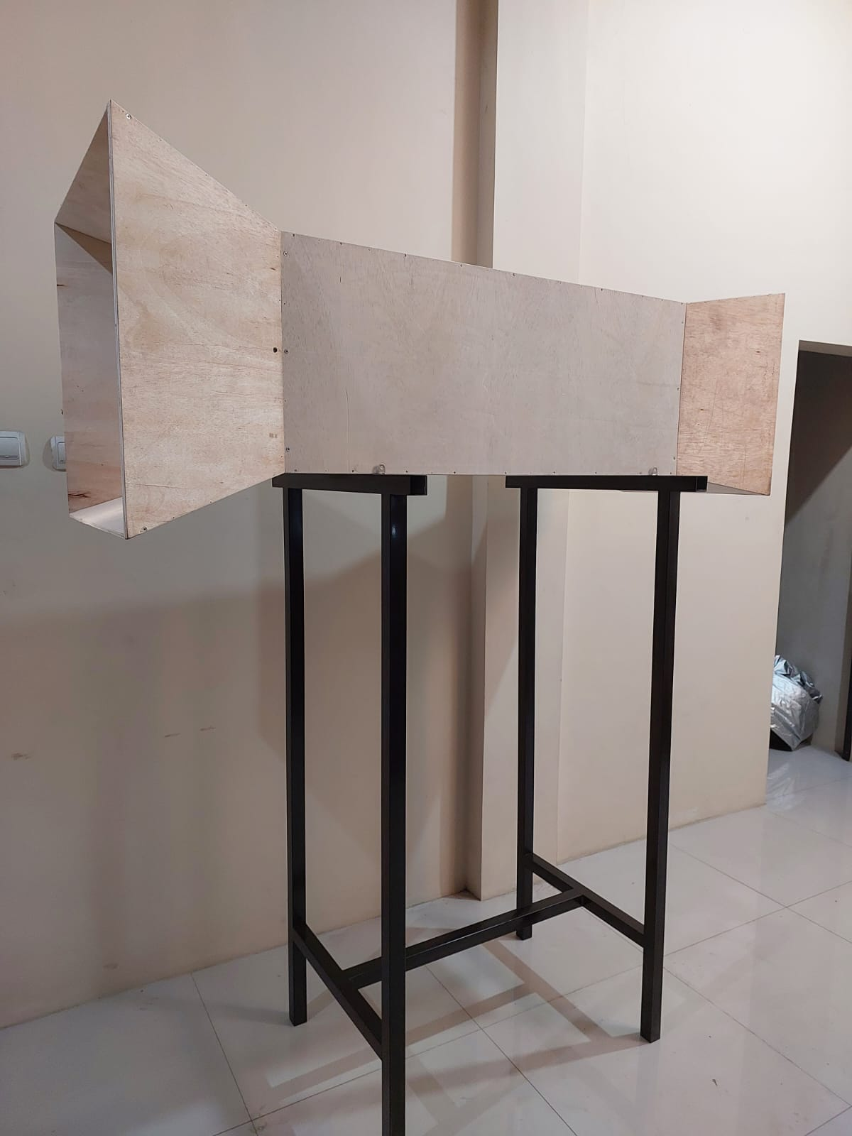
Data Hasil Pengujian
Sudut kelengkungan (θ) | Kecepatan angin | Tegangan (V) | Arus (A) | RPM
155˚ | 4 m/s | 2,75 | 0,4 | 38,3
 |  | 3,06 | 0,3 | 39,6
 |  | 2,89 | 0,5 | 40,8
 |  | 3,35 | 0,4 | 39,4
 |  | 3,25 | 0,3 | 41,5
 |  | 3,2 | 0,4 | 41,9
 |  | 3,09 | 0,4 | 40
 |  | 3,27 | 0,4 | 39,8
 |  | 3,33 | 0,3 | 41,3
 |  | 3,18 | 0,4 | 42,9
 |  | Rata-Rata (V) | Rata-Rata (A) | Rata-Rata RPM
 |  | 3,13 | 0,3 | 40,4

Sudut kelengkungan (θ) | Kecepatan angin | Tegangan (V) | Arus (A) | RPM
155˚ | 4,5 m/s | 4,3 | 0,25 | 49,3
 |  | 4,43 | 0,25 | 53,7
 |  | 4,6 | 0,24 | 54,6
 |  | 4,72 | 0,23 | 56,8
 |  | 4,64 | 0,25 | 53,9
 |  | 4,83 | 0,26 | 57,4
 |  | 5,12 | 0,26 | 56,4
 |  | 5,08 | 0,25 | 57,2
 |  | 5,11 | 0,26 | 62,2
 |  | 4,93 | 0,23 | 60,3
 |  | Rata-Rata (V) | Rata-Rata (A) | Rata-Rata RPM
 |  | 4,77 | 0,24 | 56,1

Sudut kelengkungan (θ) | Kecepatan angin | Tegangan (V) | Arus (A) | RPM
155˚ | 5 m/s | 5,93 | 0,27 | 63,4
 |  | 5,97 | 0,28 | 57,8
 |  | 6,08 | 0,28 | 59,6
 |  | 6,15 | 0,25 | 67,9
 |  | 6,25 | 0,27 | 66,7
 |  | 6,23 | 0,26 | 71,2
 |  | 6,17 | 0,28 | 72,3
 |  | 6,28 | 0,27 | 68,3
 |  | 6,31 | 0,25 | 67,7
 |  | 6,28 | 0,24 | 69,6
 |  | Rata-Rata (V) | Rata-Rata (A) | Rata-Rata RPM
 |  | 6,16 | 0,26 | 66,4

Sudut kelengkungan (θ) | Kecepatan angin | Tegangan (V) | Arus (A) | RPM
155˚ | 5,5 m/s | 6,97 | 0,3 | 83,9
 |  | 7,1 | 0,28 | 86,7
 |  | 7,28 | 0,32 | 87,6
 |  | 7,52 | 0,34 | 88,9
 |  | 7,68 | 0,35 | 85,2
 |  | 7,83 | 0,34 | 87,8
 |  | 7,78 | 0,33 | 86,7
 |  | 7,83 | 0,34 | 89,4
 |  | 7,73 | 0,35 | 90,9
 |  | 7,64 | 0,36 | 87,2
 |  | Rata-Rata (V) | Rata-Rata (A) | Rata-Rata RPM
 |  | 7,53 | 0,33 | 87,43

Sudut kelengkungan (θ) | Kecepatan angin | Tegangan (V) | Arus (A) | RPM
155˚ | 6 m/s | 8,2 | 0,35 | 92,3
 |  | 8,12 | 0,34 | 96,7
 |  | 8,33 | 0,36 | 94,8
 |  | 8,37 | 0,37 | 98,8
 |  | 8,42 | 0,36 | 101,2
 |  | 8,4 | 0,37 | 96
 |  | 8,52 | 0,36 | 97,6
 |  | 8,47 | 0,35 | 0,35
 |  | 8,43 | 0,36 | 100,4
 |  | 8,5 | 0,36 | 95,6
 |  | Rata-Rata (V) | Rata-Rata (A) | Rata-Rata RPM
 |  | 8,37 | 0,35 | 97,2

Sudut kelengkungan (θ) | Kecepatan angin | Tegangan (V) | Arus (A) | RPM
165˚ | 4 m/s | 2,64 | 0,4 | 37,3
 |  | 3,01 | 0,3 | 38,6
 |  | 2,98 | 0,4 | 39,6
 |  | 3,22 | 0,5 | 37,6
 |  | 3,06 | 0,4 | 40,1
 |  | 3,15 | 0,4 | 40,6
 |  | 3,06 | 0,4 | 38,6
 |  | 3,11 | 0,3 | 37,3
 |  | 3,2 | 0,4 | 39,4
 |  | 3,07 | 0,4 | 41,33,
 |  | Rata-Rata (V) | Rata-Rata (A) | Rata-Rata RPM
 |  | 3,05 | 0,3 | 39,0

Sudut kelengkungan (θ) | Kecepatan angin | Tegangan (V) | Arus (A) | RPM
165˚ | 4,5 m/s | 4,0 | 0,25 | 47,5
 |  | 4,17 | 0,24 | 50,6
 |  | 4,29 | 0,25 | 51,4
 |  | 4,47 | 0,26 | 53,4
 |  | 4,37 | 0,25 | 50,6
 |  | 4,51 | 0,25 | 50
 |  | 4,79 | 0,24 | 52,4
 |  | 4,72 | 0,25 | 59,4
 |  | 4,79 | 0,24 | 59,4
 |  | 4,62 | 0,25 | 57,3
 |  | Rata-Rata (V) | Rata-Rata (A) | Rata-Rata RPM
 |  | 4,47 | 0,24 | 52,5

Sudut kelengkungan (θ) | Kecepatan angin | Tegangan (V) | Arus (A) | RPM
165˚ | 5 m/s | 5,79 | 0,26 | 61
 |  | 5,82 | 0,27 | 55,1
 |  | 5,92 | 0,26 | 55,7
 |  | 6,15 | 0,25 | 63,4
 |  | 6,07 | 0,27 | 62,6
 |  | 6,17 | 0,26 | 65,9
 |  | 6,16 | 0,27 | 66
 |  | 6,21 | 0,26 | 64,3
 |  | 6,25 | 0,26 | 65,6
 |  | 6,21 | 0,27 | 67,7
 |  | Rata-Rata (V) | Rata-Rata (A) | Rata-Rata RPM
 |  | 6,07 | 0,26 | 62,7

Sudut kelengkungan (θ) | Kecepatan angin | Tegangan (V) | Arus (A) | RPM
165˚ | 5,5 m/s | 6,82 | 0,29 | 81,7
 |  | 6,97 | 0,32 | 83,8
 |  | 7,2 | 0,32 | 84,2
 |  | 7,33 | 0,33 | 85,1
 |  | 7,32 | 0,32 | 81,8
 |  | 7,51 | 0,34 | 87,7
 |  | 6,87 | 0,33 | 84,2
 |  | 7,47 | 0,35 | 86,4
 |  | 7,19 | 0,33 | 87,7
 |  | 7,06 | 0,32 | 85,5
 |  | Rata-Rata (V) | Rata-Rata (A) | Rata-Rata RPM
 |  | 7,17 | 0,32 | 84,8

Sudut kelengkungan (θ) | Kecepatan angin | Tegangan (V) | Arus (A) | RPM
165˚ | 6 m/s | 7,8 | 0,35 | 90
 |  | 7,99 | 0,34 | 92,5
 |  | 8,05 | 0,36 | 91,8
 |  | 8,08 | 0,35 | 95,6
 |  | 8,03 | 0,35 | 98,5
 |  | 7,81 | 0,34 | 94,2
 |  | 8,09 | 0,36 | 93,7
 |  | 8,17 | 0,34 | 95,3
 |  | 7,82 | 0,34 | 97
 |  | 7,98 | 0,35 | 92
 |  | Rata-Rata (V) | Rata-Rata (A) | Rata-Rata RPM
 |  | 7,98 | 0,34 | 94,06

Sudut kelengkungan (θ) | Kecepatan angin | Tegangan (V) | Arus (A) | RPM
175˚ | 4 m/s | 2,54 | 0,4 | 36,4
 |  | 2,97 | 0,3 | 37,6
 |  | 3,07 | 0,3 | 38,5
 |  | 3,09 | 0,4 | 35,8
 |  | 2,87 | 0,3 | 38,7
 |  | 3,11 | 0,4 | 39,4
 |  | 3,04 | 0,3 | 37,2
 |  | 2,95 | 0,4 | 34,8
 |  | 3,08 | 0,5 | 37,5
 |  | 2,97 | 0,4 | 39,8
 |  | Rata-Rata (V) | Rata-Rata (A) | Rata-Rata RPM
 |  | 2,96 | 0,3 | 37,5

Sudut kelengkungan (θ) | Kecepatan angin | Tegangan (V) | Arus (A) | RPM
175˚ | 4,5 m/s | 3,8 | 0,24 | 45,7
 |  | 3,92 | 0,25 | 47,6
 |  | 3,98 | 0,24 | 48,2
 |  | 4,22 | 0,24 | 51,8
 |  | 4,08 | 0,25 | 47,4
 |  | 4,19 | 0,24 | 42,7
 |  | 4,47 | 0,24 | 40,4
 |  | 4,37 | 0,25 | 48,5
 |  | 4,48 | 0,26 | 56,6
 |  | 4,32 | 0,24 | 54,4
 |  | Rata-Rata (V) | Rata-Rata (A) | Rata-Rata RPM
 |  | 4,18 | 0,24 | 48,3

Sudut kelengkungan (θ) | Kecepatan angin | Tegangan (V) | Arus (A) | RPM
175˚ | 5 m/s | 5,65 | 0,26 | 58,7
 |  | 5,68 | 0,26 | 52,4
 |  | 5,76 | 0,25 | 51,8
 |  | 6,16 | 0,27 | 58,9
 |  | 5,89 | 0,25 | 58,6
 |  | 6,11 | 0,27 | 60,6
 |  | 6,15 | 0,26 | 59,8
 |  | 6,18 | 0,27 | 60,3
 |  | 6,2 | 0,26 | 63,5
 |  | 6,14 | 0,27 | 65,8
 |  | Rata-Rata (V) | Rata-Rata (A) | Rata-Rata RPM
 |  | 5,99 | 0,26 | 59,0

Sudut kelengkungan (θ) | Kecepatan angin | Tegangan (V) | Arus (A) | RPM
175˚ | 5,5 m/s | 6,68 | 0,29 | 79,6
 |  | 6,85 | 0,30 | 80,4
 |  | 6,13 | 0,29 | 80,9
 |  | 7,13 | 0,31 | 81,3
 |  | 6,98 | 0,30 | 78,5
 |  | 7,20 | 0,32 | 81,6
 |  | 5,97 | 0,32 | 81,7
 |  | 7,11 | 0,33 | 83,4
 |  | 6,65 | 0,33 | 84,5
 |  | 6,48 | 0,32 | 83,8
 |  | Rata-Rata (V) | Rata-Rata (A) | Rata-Rata RPM
 |  | 6,71 | 0,31 | 81,5

Sudut kelengkungan (θ) | Kecepatan angin | Tegangan (V) | Arus (A) | RPM
175˚ | 6 m/s | 7,40 | 0,33 | 87,7
 |  | 7,87 | 0,33 | 88,4
 |  | 7,77 | 0,34 | 88,9
 |  | 7,79 | 0,35 | 92,4
 |  | 7,65 | 0,35 | 95,8
 |  | 7,22 | 0,33 | 92,5
 |  | 7,66 | 0,34 | 89,9
 |  | 7,87 | 0,35 | 91,2
 |  | 7,22 | 0,33 | 89,7
 |  | 7,47 | 0,34 | 88,5
 |  | Rata-Rata (V) | Rata-Rata (A) | Rata-Rata RPM
 |  | 7,59 | 0,33 | 90,5

