LAMPIRAN

Lampiran 1. Pertumbuhan Bobot Individu (gram) Benih Ikan Gurame (Osphronemus goramy)

Perlakuan | Ulangan | Wo  (gr) | Sampling Minggu Ke –  (gram)
 |  |  | I | II | III | IV
A | 1 | 1,05 | 1,25 | 1,70 | 2,05 | 3,00
 | 2 | 1,00 | 1,18 | 1,63 | 2,15 | 3,17
 | 3 | 0,98 | 1,10 | 1,58 | 2,08 | 3,10
Rata-Rata |  | 0,99 | 1,18 | 1,67 | 2,09 | 3,09
B | 1 | 0,88 | 1,08 | 1,64 | 2,13 | 3,63
 | 2 | 1,05 | 1,22 | 1,70 | 2,16 | 3,51
 | 3 | 1,07 | 1,20 | 1,68 | 2,21 | 3,72
Rata-Rata |  | 0,97 | 1,17 | 1,67 | 2,17 | 3,62
C | 1 | 0,98 | 1,22 | 1,73 | 2,80 | 4,12
 | 2 | 1,08 | 1,31 | 1,84 | 2,94 | 4,16
 | 3 | 1,05 | 1,36 | 2,25 | 3,10 | 4,20
Rata-Rata |  | 1,03 | 1,30 | 1,94 | 2,95 | 4,16
D | 1 | 0,98 | 1,10 | 1,36 | 2,07 | 2,55
 | 2 | 1,05 | 1,21 | ,152 | 2,10 | 2,60
 | 3 | 1,00 | 1,16 | 1,43 | 2,12 | 2,63
Rata-Rata |  | 1,01 | 1,16 | 1,44 | 2,10 | 2,59

Lampiran 2. Pertumbuhan Bobot Individu Mutlak (gram), Laju Pertumbuhan Harian (%)
Perlakuan | Ulangan | Wo  (gram) | Wt  (gram) | Pertumbuhan Bobot Individu Mutlak (gram) | Laju Pertumbuhan Harian  (gram)
A | 1 | 1,05 | 3,00 | 1,95 | 0,070
 | 2 | 1,00 | 3,17 | 2,17 | 0,077
 | 3 | 0,98 | 3,10 | 2,12 | 0,076
Rata-rata |  | 0,99 | 3,09 | 2,08 | 0,074
B | 1 | 0,88 | 3,63 | 2,75 | 0,098
 | 2 | 1,05 | 3,51 | 2,46 | 0,088
 | 3 | 1,07 | 3,72 | 2,65 | 0,095
Rata-rata |  | 0,97 | 3,62 | 2,62 | 0,094
C | 1 | 0,98 | 4,12 | 3,14 | 0,112
 | 2 | 1,08 | 4,16 | 3,08 | 0,110
 | 3 | 1,05 | 4,20 | 3,15 | 0,112
Rata-rata |  | 1,03 | 4,16 | 3,12 | 0,111
D | 1 | 0,98 | 2,55 | 1,57 | 0,056
 | 2 | 1,05 | 2,60 | 1,55 | 0,055
 | 3 | 1,00 | 2,63 | 1,63 | 0,058
Rata-rata |  | 1,01 | 2,59 | 1,58 | 0,056

Perlakuan | Ulangan | Lo  (Cm) | Sampling Minggu ke –  (Cm)
 |  |  | 1 | 2 | 3 | 4
A | 1 | 3.0 | 3.2 | 3.6 | 3.9 | 4.3
 | 2 | 3.1 | 3.3 | 3.7 | 4.0 | 4.5
 | 3 | 3.2 | 3.5 | 3.9 | 4.2 | 4.6
Rata-rata |  | 3.1 | 3.3 | 3.7 | 4.0 | 4.5
B | 1 | 3.1 | 3.3 | 3.7 | 4.0 | 4.5
 | 2 | 3.2 | 3.4 | 3.8 | 4.2 | 4.7
 | 3 | 3.0 | 3.3 | 3.6 | 4.3 | 4.9
Rata-rata |  | 3.1 | 3.3 | 3.7 | 4.2 | 4.7
C | 1 | 3.2 | 3.4 | 3.8 | 4.5 | 5.3
 | 2 | 3.3 | 3.5 | 3.9 | 4.7 | 5.4
 | 3 | 3.0 | 3.3 | 4.0 | 4.9 | 5.6
Rata-rata |  | 3.2 | 3.4 | 3.9 | 4.7 | 5.4
D | 1 | 3.0 | 3.2 | 3.4 | 3.7 | 4.0
 | 2 | 3.1 | 3.3 | 3.5 | 3.8 | 4.2
 | 3 | 3.2 | 3.4 | 3.6 | 3.7 | 4.1
Rata-rata |  | 3.1 | 3.3 | 3.5 | 3.7 | 4.1
Lampiran 3. Pertumbuhan Panjang (cm) Ikan Gurame (Osphronemus goramy)

Lampiran 4. Pertumbuhan Panjang Mutlak (cm) Benih Ikan Gurame (Osphronemus goramy)
Perlakuan | Ulangan | Lo  (cm) | Lt  (cm) | Pertumbuhan Panjang Mutlak (cm)
A | 1 | 3.0 | 4.3 | 1.3
 | 2 | 3.1 | 4.5 | 1.4
 | 3 | 3.2 | 4.6 | 1.4
Rata-rata |  | 3.1 | 4.5 | 1.4
B | 1 | 3.1 | 4.5 | 1.4
 | 2 | 3.2 | 4.7 | 1.5
 | 3 | 3.0 | 4.9 | 1.9
Rata-rata |  | 3.1 | 4.7 | 1.6
C | 1 | 3.2 | 6.3 | 2.1
 | 2 | 3.3 | 5.4 | 2.1
 | 3 | 3.0 | 5.6 | 2.6
Rata-rata |  | 3.2 | 5.4 | 2.2
D | 1 | 3.0 | 4.0 | 1.0
 | 2 | 3.1 | 4.2 | 1.1
 | 3 | 3.2 | 4.1 | 0.9
Rata-rata |  | 3.1 | 4.1 | 1.0

Lampiran 5. Kelangsungan Hidup Benih Ikan Gurame (Osphronemus goramy)
Perlakuan | Ulangan | No  (ekor) | Minggu ke –  (ekor) |  |  |  | %
 |  |  | 1 | 2 | 3 | 4
A | 1 | 10 | 10 | 10 | 10 | 10 | 100
 | 2 | 10 | 10 | 10 | 10 | 10 | 100
 | 3 | 10 | 10 | 10 | 10 | 10 | 100
Rata-rata |  | 10 | 10 | 10 | 10 | 10 | 100
B | 1 | 10 | 10 | 10 | 10 | 10 | 100
 | 2 | 10 | 10 | 10 | 10 | 10 | 100
 | 3 | 10 | 10 | 10 | 10 | 10 | 100
Rata-rata |  | 10 | 10 | 10 | 10 | 10 | 100
C | 1 | 10 | 10 | 10 | 10 | 10 | 100
 | 2 | 10 | 10 | 10 | 10 | 10 | 100
 | 3 | 10 | 10 | 10 | 10 | 10 | 100
Rata-rata |  | 10 | 10 | 10 | 10 | 10 | 100
D | 1 | 10 | 10 | 10 | 10 | 10 | 100
 | 2 | 10 | 10 | 10 | 10 | 10 | 100
 | 3 | 10 | 10 | 10 | 10 | 10 | 100
Rata-rata |  | 10 | 10 | 10 | 10 | 10 | 100

Lampiran 6. Uji Statistik Bobot Individu Mutlak (gram) Benih Ikan Gurame (Osphronemus goramy)

- Uji Normalitas
Tests of Normality
 | Sampel | Kolmogorov-Smirnovª |  |  | Shapiro-Wilk
 |  | Statistic | df | Sig. | Statistic | df | Sig.
BobotMutlak | A | ,302 | 3 | . | ,910 | 3 | ,417
 | B | ,247 | 3 | . | ,969 | 3 | ,661
 | C | ,337 | 3 | . | ,855 | 3 | ,253
 | D | ,292 | 3 | . | ,923 | 3 | ,463
a. Lilliefors Significance Correction

H0 : Sig > alpha (normal)
H1 : Sig < alpha (tidak normal)
Sig 0.463 > 0.05 pada uji Shapiro-Wilk maka dapat dikatakan pertumbuhan bobot individu mutlak Ikan Gurame (Osphronemus goramy) mempunyai distribusi normal.

- Uji Homogenitas
Test of Homogeneity of Variances
 |  | Levene Statistic | df1 | df2 | Sig.
BobotMutlak | Based on Mean | 2,607 | 3 | 8 | ,124
 | Based on Median | ,832 | 3 | 8 | ,513
 | Based on Median and with adjusted df | ,832 | 3 | 4,897 | ,532
 | Based on trimmed mean | 2,434 | 3 | 8 | ,140

Sig : 0.140 > 0.05
Kesimpulan :
Dapat dikatakan pertumbuhan bobot individu mutlak ikan gurame (Osphronemus goramy) mempunyai ragam data yang sama (homogen).

- Uji Anova

ANOVA
Bobot Mutlak
 | Sum of Squares | df | Mean Square | F | Sig.
Between Groups | 39948,333 | 3 | 13316,111 | 139,557 | ,000
Within Groups | 763,333 | 8 | 95,417
Total | 40711,667 | 11

Sig : 0.000 < 0.05 , H1 Berpengaruh nyata.
Kesimpulan :
Pemberian pakan alami Dapnia sp dengan dosis berbeda berpengaruh sangat nyata terhadap pertumbuhan benih ikan gurame (Osphronemus goramy).

- Uji Duncan
BobotMutlak
 | Sampel | N | Subset
 |  |  | 1 | 2 | 3 | 4
Tukey B^{a,b} | D | 3 | 158,3333
 | A | 3 |  | 208,0000
 | B | 3 |  |  | 262,0000
 | C | 3 |  |  |  | 312,3333
Duncan^{a,b} | D | 3 | 158,3333
 | A | 3 |  | 208,0000
 | B | 3 |  |  | 262,0000
 | C | 3 |  |  |  | 312,3333
 | Sig. |  | 1,000 | 1,000 | 1,000 | 1,000
Means for groups in homogeneous subsets are displayed.
Based on observed means.
a. Uses Harmonic Mean Sample Size = 3,000.
b. Alpha = 0,05.

Keterangan :
(C > B > A > D) Berdasarkan uji duncan mendapatkan hasil terbaik pada perlakuan C dengan nilai 312,33 perlakuan B dengan nilai 262,0 dan disusul oleh perlakuan A dengan 208,0 dan yang terakhir perlakuan K dengan nilai 158,3.
Lampiran 7. Uji Statistik Laju Pertumbuhan Harian (gram) Ikan Gurame (Osphronemus goramy)

- Uji Normalitas
Tests of Normality
 | Sampel | Kolmogorov-Smirnovª |  |  | Shapiro-Wilk
 |  | Statistic | df | Sig. | Statistic | df | Sig.
Laju Pertumbuhan Harian | A | ,337 | 3 | . | ,855 | 3 | ,253
 | B | ,269 | 3 | . | ,949 | 3 | ,567
 | C | ,385 | 3 | . | ,750 | 3 | ,000
 | D | ,253 | 3 | . | ,964 | 3 | ,637
a. Lilliefors Significance Correction

H0 : Sig > alpha (normal)
H1 : Sig < alpha (tidak normal)
Kesimpulan :
Sig 0.253 > 0.05 pada uji Shapiro-Wilk maka dapat dikatakan bahwa data laju pertumbuhan harian ikan gurame (Osphronemus goramy) mempunyai distribusi normal.

- Uji Homogenitas
Test of Homogeneity of Variances
 |  | Levene Statistic | df1 | df2 | Sig.
Laju Pertumbuhan Harian | Based on Mean | 3,183 | 3 | 8 | ,085
 | Based on Median | ,729 | 3 | 8 | ,563
 | Based on Median and with adjusted df | ,729 | 3 | 4,777 | ,579
 | Based on trimmed mean | 2,895 | 3 | 8 | ,102

Sig : 0,085 > 0.05
Kesimpulan :
Data laju pertumbuhan harian ikan gurame (Osphronemus goramy) mempunyai ragam data yang sama (data homogen) dengan signifikasi lebih dari >0,05 .

- Uji Anova

ANOVA
Laju Pertumbuhan Harian
 | Sum of Squares | Df | Mean Square | F | Sig.
Between Groups | ,005 | 3 | ,002 | 153,331 | ,000
Within Groups | ,000 | 8 | ,000
Total | ,005 | 11

Sig : 0.000 < 0.05 , H1 berpengaruh
Kesimpulan :
Pemberian pakan alami keong mas dengan dosis berbeda berpengaruh sangat nyata terhadap pertumbuhan benih ikan gurame (Osphronemus goramy).
- Uji Duncan
Laju Pertumbuhan Harian
 | Sampel | N | Subset
 |  |  | 1 | 2 | 3 | 4
Tukey B^{a,b} | D | 3 | ,0563
 | A | 3 |  | ,0743
 | B | 3 |  |  | ,0937
 | C | 3 |  |  |  | ,1113
Duncan^{a,b} | D | 3 | ,0563
 | A | 3 |  | ,0743
 | B | 3 |  |  | ,0937
 | C | 3 |  |  |  | ,1113
 | Sig. |  | 1,000 | 1,000 | 1,000 | 1,000
Means for groups in homogeneous subsets are displayed.
Based on observed means.
a. Uses Harmonic Mean Sample Size = 3,000.
b. Alpha = 0,05.

Kesimpulan :
C > B > A > D
Berdasarkan Uji Duncan mendapatkan hasil terbaik pada perlakuan C dengan nilai 0,111 perlakuan B dengan nilai 0,094 dan disusul oleh perlakuan A dengan 0,074 dan yang terakhir perlakuan K dengan nilai 0,056.

Lampiran 8. Uji Statistik Pertumbuhan Panjang Mutlak (Cm) ikan gurame (Osphronemus goramy)

- Uji Normalitas

Tests of Normality
 | Sampel | Kolmogorov-Smirnovª |  |  | Shapiro-Wilk
 |  | Statistic | df | Sig. | Statistic | df | Sig.
Pertumbuhan Panjang Mutlak | A | ,385 | 3 | . | ,750 | 3 | 1,000
 | B | ,314 | 3 | . | ,893 | 3 | ,363
 | C | ,385 | 3 | . | ,750 | 3 | ,000
 | D | ,175 | 3 | . | 1,000 | 3 | 1,000
a. Lilliefors Significance Correction

H0 : Sig > alpha (normal)
H1 : Sig < alpha (tidak normal)
Kesimpulan :
Sig = 1.000 > 0.50 pada uji Shapiro-Wilk maka dapat dikatakan bahwa data pertumbuhan panjang mutlak ikan gurame (Osphronemus goramy) Mempunyai distribusi normal.

- Uji Homogenitas
Test of Homogeneity of Variances
 |  | Levene Statistic | df1 | df2 | Sig.
Pertumbuhan Panjang Mutlak | Based on Mean | 4,301 | 3 | 8 | ,044
 | Based on Median | ,425 | 3 | 8 | ,740
 | Based on Median and with adjusted df | ,425 | 3 | 4,020 | ,746
 | Based on trimmed mean | 3,642 | 3 | 8 | ,064

Sig 0.044 > 0.50
Kesimpulan :
Dapat dikatakan pertumbuhan panjang mutlak ikan gurame (Osphronemus goramy) mempunyai ragam data yang sama (homogen).

- Uji Anova

ANOVA
Pertumbuhan panjang mutlak
 | Sum of Squares | df | Mean Square | F | Sig.
Between Groups | 255,583 | 3 | 85,194 | 20,447 | ,000
Within Groups | 33,333 | 8 | 4,167
Total | 288,917 | 11

Sig : 0.000 > 0.05 , H1 Berpengaruh nyata
Kesimpulan :
Pemberian pakan alami Dapnia sp dengan dosis berbeda berpengaruh nyata terhadap pertumbuhan benih ikan gurame (Osphronemus goramy)

- Uji Duncan

Laju Pertumbuhan mutlak
 | Akuarium | N | Subset
 |  |  | 1 | 2 | 3
Tukey B^{a,b} | D | 3 | 10,0000
 | A | 3 | 13,6667 | 13,6667
 | B | 3 |  | 16,0000
 | C | 3 |  |  | 22,6667
Duncan^{a,b} | D | 3 | 10,0000
 | A | 3 | 13,6667 | 13,6667
 | B | 3 |  | 16,0000
 | C | 3 |  |  | 22,6667
 | Sig. |  | ,059 | ,199 | 1,000
Means for groups in homogeneous subsets are displayed.
Based on observed means.
a. Uses Harmonic Mean Sample Size = 3,000.
b. Alpha = 0,05.

Kesimpulan :
Analisis data Duncan C > B > A > K
Berdasarkan uji duncan mendapatkan hasil terbaik pada perlakuan C dengan nilai 22,6667 perlakuan B dengan nilai 16,0000 dan disusul oleh perlakuan A dengan 13,6667 dan yang terakhir perlakuan D dengan nilai 10,0000.

Lampiran 9. Foto Kegiatan Penelitian

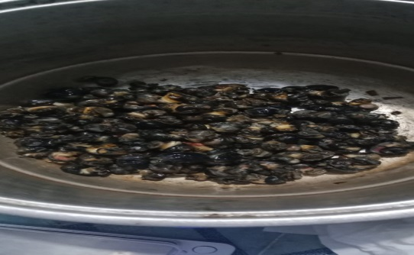
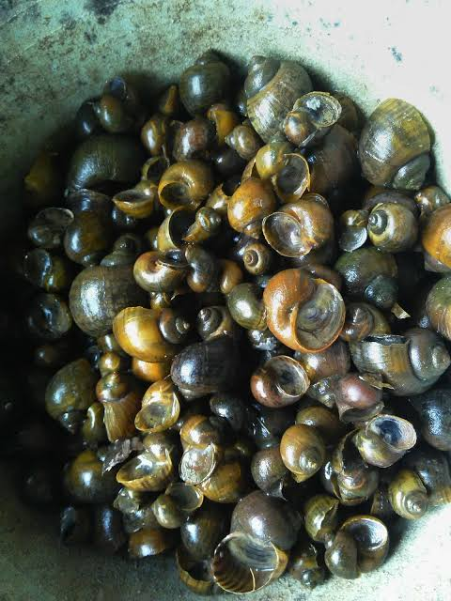

Gambar 1. Keong mas Gambar 2. Fermentasi keong mas
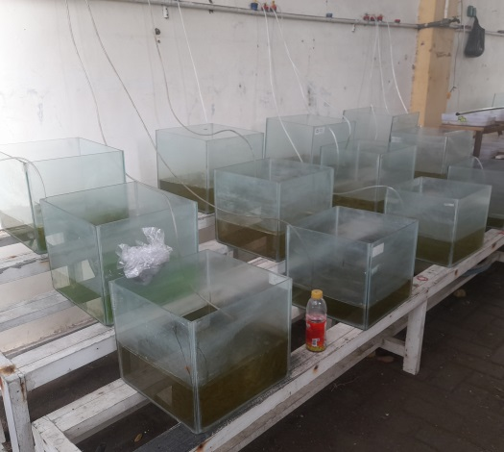
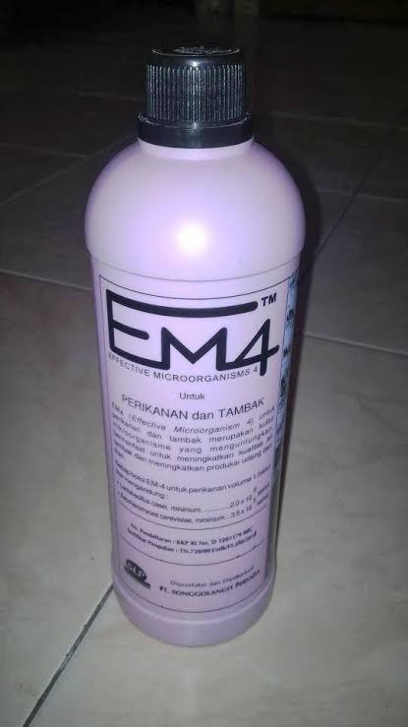

Gambar 3. Probiotik EM 4 Gambar 4. Tata letak wadah penelitian
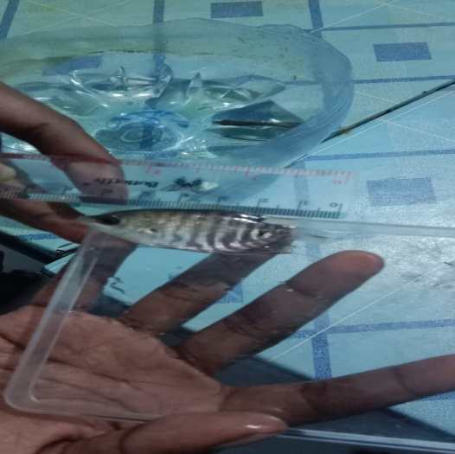

Gambar 5. Pengukuran panjang ikan Gambar 6. pengukuran bobot ikan

Lampiran 10. Hasil Uji Parameter Kualitas Air Budidaya Ikan Gurame (Osphronemus goramy)

Lampiran 11. Hasil Uji Parameter Kualitas Air Budidaya Pakan Alami Keong mas
(Pomacea canaliculata)

RIWAYAT HIDUP

Penulis dilahirkan di Timika pada tanggal 23 Juni 2001, Putra Kedua dari Empat Bersaudara dari Keluarga Bapak Setius Wenda dan Ibu Tibana Tabuni. Pendidikan Sekolah Dasar diselesaikan pada Tahun 2014 di SD Inpres 13 Mimika, Kecamatan Kuala Kencana, Kabupaten, Mimika. Sekolah Lanjutan Tingkat Pertama diselesaikan pada Tahun 2016 di SMP N 06 Mimika, Kecamatan Kuala Kencana, Kabupaten, Mimika.. dan Pendidikan Sekolah Lanjutan Tingkat Atas diselesaikan pada Tahun 2020 di SMK Negeri 01, Kecamatan Kuala Kencana, Kabupaten, Mimika, Provisi Papua Tengah
Pada Tahun 2020 Penulis mendaftarkan diri di Universitas Pancasakti Tegal, pada Fakultas Perikanan dan Ilmu Kelautan dengan Program Studi Budidaya Perairan (BDP). Dan hingga pada saat ini Penulis masih terdaftar sebagai Mahasiswa di Universitas Pancasakti Tegal.

