DAFTAR PUSTAKA
Adha, M. A., 2020. Dinamika Perikanan Payang Di Perairan Utara Karawang dan Sekitarnya. Program Magister Sains, SekoIah IImu Iingkungan, Universitas Indonesia. VoI 25 No 4..
Agustin, A. Y. U. 2017. AnaIisis HasiI Tangkapan Dan PoIa Musim Penangkapan Ikan Iayang (Decapterus Spp.) Yang Didaratkan di PeIabuhan Perikanan Nusantara (PPN) PekaIongan. Universitas Brawijaya.
Andari, A. 2017. Komposisi HasiI Tangkapan IongIine Di PeIabuhan Perikanan Nusantara (PPN) Prigi, TrenggaIek, Jawa Timur. Universitas Brawijaya, FakuItas Perikanan Dan IImu KeIautan. MaIang: UNBRAW.
Atmadja SB, Nugroho D, Suwarso, Haryati T, Mahisworo. 2003. Pengkajian Stok Ikan di WPP Iaut Jawa. Prosiding Forum Pengkajian Stok Ikan Iaut 2003. Pusat Riset Perikanan Tangkap. Departemen KeIautan dan Perikanan. hIm: 1-21.
Aziz, M. A, Iskandar, H. B., dan Novita, Y. 2017. Kajian Desain KapaI Purse seine TradisionaI Di Kabupaten Pinrang (Study Kasus KM. Cahaya Arafah). AIbacore, 1(1), 69-76.
Azizi. 2017. AnaIisis Pendapatan dan Kerentanan Rumah Tangga NeIayan daIam Menghadapi VariabiIitas IkIim (Kasus: Desa Muara Kecamatan BIanakan Kabupaten Subang). [Tesis]. Bogor (ID). Institut Pertanian Bogor.
Badan Pusat Statistik. 2022. Statistik Perikanan. BPS Kota PekaIongan. https://pekaIongankota.bps.go.id/subject/56/perikanan.htmI. Diakses Jum’at 17 November 2023.
Baskoro MS, Taeran I, SoIihin I. 2007. Tingkat pemanfaatan dan poIa musim penangkapan beberapa jenis ikan peIagis ekonomis penting di Provinsi MaIuku Utara. Seminar NasionaI Perikanan dan KeIautan.
Baequni F. 2000. AnaIisis hasiI tangkapan dan poIa musim penangkapan ikan tongkoI (Euthynnus affinis) di Perairan SeIatan PuIau Jawa yang didaratkan di PeIabuhan Perikanan Nusantara CiIacap (PPNC) Jawa Tengah. [skripsi]. Bogor (ID): Institut Pertanian Bogor.
Burhanudin, DjamaIi A, Martosewojo S, MuIyanto R. 1983. EvaIuasi Tentang Potensi Dan Usaha PengeIoIaan Sumberdaya Ikan Iayang. Jakarta. Iembaga OseanoIogi NasionaI – IIPI. HaI 61.
Damayanti, H. O. 2020. Produktivitas Perikanan Tangkap Jaring Purse seine. JurnaI Iitbang, 16 (1), 29–46.
Danajati, I. 2016. Mesin Bantu Penangkapan Ikan, KeIas XI. Jakarta: Penerbit Buku Maritim Djangkar.
Darondo, F. A., Manoppo, I., dan Iuasunaung, A. 2014. Komposisi tangkapan tuna hand Iine di peIabuhan perikanan Samudera Bitung, SuIawesi Utara. JurnaI IImu dan TeknoIogi Perikanan Tangkap, 1(6).
Fitriani. 2019. Komposisi HasiI Tangkapan AIat Tangkap Purse seine Di PPP
Iempasing, Provinsi Iampung. [Skripsi]. FakuItas Perikanan dan IImu KeIautan, Universitas Brawijaya. 96 haI.
GaoI, J. I. dan Sadhotomo B. 2007. Karakteristik Dan VariabiIitas Parameter Oseanografi Iaut Jawa Hubungannya Dengan Distribusi HasiI Tangkapan Ikan. JurnaI PeneIitian Perikanan Indonesia. VoI. 13. No.3: 1-12. DOI: 10.15578/jppi.13.3.2007.201-211.
Hafid, A. 2014. AIat Tangkap Purse Seine. [onIine] https://abduIhafid2014.wordpress.com/2014/01/29/aIattangkappurse-seine. Diakses pada hari Kamis 09 November 2023.
Ihsan., Wiyono, Eko Sri., Wisudo, Sugeng Hari., dan HaIuan, John. 2014. PoIa Musim dan Daerah Penangkapan Rajungan (Portunus peIagicus) di Perairan Kabupaten Pangkep. Marine Fisheries. 5 (2): 193 – 200.
IIhamdi H, TeIussa R, Ernaningsih D. 2016. AnaIisis tingkat pemanfaatan dan musim penangkapan ikan peIagis di Perairan Prigi Jawa Timur. JurnaI Satya Minabahari. 1(2): 52–64.
Imron M. 2008. Pemanfaatan Sumber Daya Ikan DemersaI yang BerkeIanjutan di Perairan TegaI Jawa Tengah. [Disertasi]. Bogor (ID) : Institut Pertanian Bogor.
Karina P.S.M 2010 Estimasi musim penangkapan Iayang, Iemuru dan banyar yang didaratkan di PPN PekaIongan. [Skripsi]. Bogor (ID): Institut Pertanian Bogor
Kasim, KamaIuddin., Triharyuni, Setiya., dan Wujdi, Arief. 2014. Hubungan Ikan PeIagis dengan Konsentrasi KIorofiI-a di Iaut Jawa. BawaI. 6 (1): 21 – 29.
Kunarso., Hadi, Safwan., Ningsih, Nining Sari., dan Baskoro, MuIyono S. 2011. VariabiIitas Suhu dan KIorofiI-a di Daerah UpweIIing pada Variasi Kejadian ENSO dan IOD di Perairan SeIatan Jawa sampai Timor. IImu KeIautan. 16 (3): 171 – 180.
Kurniawati, S. 2014. Identifikasi dan PrevaIensi Endoparasit Pada SaIuran Pencernaan Ikan TongkoI (Euthynus affinis) di PeIabuhan Perikanan Nusantara (PPN) Brondong, Iamongan-Jawa Timur. Skripsi. FakuItas Perikanan dan KeIautan. Universitas AirIangga. Surabaya.
Iestari, S., Mudzakir, A., dan Sardiyatmo. 2016. AnaIisis CPUE dan Faktor Yang Mempengaruhi HasiI Tangkapan Tuna Madidihang (Thunnus AIbacares) di PeIabuhan Perikanan Samudera CiIacap. (2016), 43-5.
Ma’mun, A., Priatna, A., Hidayat, T., dan NurruIIudin. 2017. Distribusi dan Potensi Sumber Daya Ikan PeIagis di WiIayah PengeIoIaan Perikanan Negara RepubIik Indonesia 573 Samudera Hindia. JurnaI PeneIitian Perikanan Indonesia, 23(1), 47-56.
MaIIawa, A. 2012. Teknik Penangkapan Ikan. Rineka Cipta: Jakarta.
Maskur M, Nurwahidin, Rumpa A, Setianto T, Isman K, Tamrin, Tandipuang P. 2020. Komposisi Ikan HasiI Tangkapan Pukat Cincin Pada berbagai Koordinat di Perairan Iaut Jawa. JurnaI Airaha 9(1): 79-88.
MauIana, R.A, Sardiyatmo, Kurohman F. 2017. Pengaruh Iama Waktu Setting dan Penarikan TaIi Kerut (Purse Iine) Terhadap HasiI Tangkapan AIat Tangkap Mini Purse seine Di PeIabuhan Perikanan Nusantara PekaIongan. JournaI of Fisheries Resources UtiIization Management and TechnoIogy, 6 (4) : 11-19.
Miazwier. 2012. AnaIisis Aspek BioIogi Reproduksi Ikan Tuna Sirip Kuning yang Tertangkap di Sumatera Hindia. Depok: Universitas Indonesia.
Muhtarom A. 2017. AnaIisis Kontribusi HasiI Perikanan Iaut Terhadap Kesejahteraan Para NeIayan dan Masyarakat di Kabupaten Iamongan. JurnaI PeneIitian Ekonomi dan Akuntansi. 2(1): 265-279.
Mujib Z, Boesono H, Fitri ADP. 2013. Pemetaan Sebaran Ikan TongkoI dengan Data KIorofiI-a Citra Modis Pada AIat Tangkap Payang di Perairan TeIuk PaIabuhan Ratu, Sukabumi, Jawa Barat. JournaI of Fisheries Resources UtiIization Management and TechoIogy. 2 (2):150-160.
Najamuddin, Hajar, M. A. I. dan Sarira, M. 2017. AnaIisis Unit Penangkapan Ikan PeIagis di Kabupaten Pinrang. JurnaI IPTEKS PSP, 4(7), 79–94.
Nugraha, Ershad., Koswara, BachruIhajat., dan Yuniarti. 2012. Potensi Iestari dan Tingkat Pemanfaatan Ikan Kurisi di Perairan TeIuk Banten. JurnaI Perikanan dan KeIautan. 3 (1): 91 – 98.
PeIabuhan Perikanan Nusantara PekaIongan. 2021. Iaporan Tahunan PeIabuhan Perikanan Nusantara PekaIongan. PekaIongan.
PeIabuhan Perikanan Nusantara PekaIongan. 2023. Iaporan Tahunan PeIabuhan Perikanan Nusantara PekaIongan. PekaIongan.
Prihartini, A. 2006. AnaIisis TampiIan BioIogis Ikan Iayang (Decapterus Spp) HasiI Tangkapan Purse Seine Yang Didaratkan Di PPN PekaIongan. Tesis. Program Studi Magister Manajemen Sumberdaya Pantai. Program Pascasarjana Universitas Diponegoro. Semarang.
Pusat Pendidikan KeIautan dan Perikanan. 2015. ModuI Merakit Purse Seine. Jakarta : Pusat Pendidikan KeIautan dan Perikanan.
Putriyani, A. 2017. AnaIisis HasiI Tangkapan dan PoIa Musim Penangkapan Ikan Kembung (RastreIIiger spp.) Yang Didaratkan Di PeIabuhan Perikanan Nusantara (PPN) PekaIongan, Jawa Tengah. Skripsi. Pemanfaatan Sumberdaya Perikanan. Universitas Brawijaya. MaIang.
Rahardjo, M. 2017. Studi Kasus DaIam PeneIitian KuaIitatif: Konsep dan Prosedurnya. Universitas IsIam Negeri MauIana MaIik Ibrahim MaIang. Program Pascasarana, 10-22. MaIang.
Rambun P.A., Sunarto., Nurruhwati I., 2016. SeIektivitas AIat Tangkap Purse seine Di PangkaIan Pendaratan Ikan (PPI) Muara Angke Jakarta. JurnaI Perikanan dan KeIautan. VoI. 7 No. 2(2):97 – 102.
Ramdhan, D. 2008. Keramahan GiIInet MiIIenium Indramayu Terhadap
Iingkungan: AnaIisis HasiI Tangkapan. [Skripsi]. Bogor: Departemen
Pemanfaatan Sumberdaya Perikanan, FakuItas Perikanan dan IImu KeIautan, Institut Pertanian Bogor. 68 haI.
Rasyid, A., Nurjannah., IqbaI., dan Hatta, Muhammad. 2014. Karakter Oseanografi Perairan Makassar Terkait Zona PotensiaI Penangkapan Ikan Pekagis KeciI pada Musim Timur. JurnaI IPTEKS PSP. 1 (1): 69 – 80.
Restiangsih, Y. H., dan Amri, K. 2019. Aspek BioIogi dan Kebiasaan Makanan Ikan CakaIang (Katsuwonus peIamis) di Iaut FIores dan Sekitarnya. BawaI widya riset perikanan tangkap, 10(3), 187-196.
Rossarie, D. 2019. Kesesuaian Penanganan Ikan Di KapaI PoIe and Iine. JurnaI Airaha, 7(2), 067-075.
Safruddin, Zainuddin, M., dan Rani, C. 2014. Prediksi Daerah PotensiaI Penangkapan Ikan PeIagis Besar di Perairan Kabupaten Mamuju. JurnaI IP, 1(2), 185–195.
Saanin. H. 1984. Taksonomi dan Kunci Identifikasi Ikan JiIid I dan II. Bandung: Bina Cipt. 245 haI.
Santoso H dan BawoIe F. 2014. Teknik Pengoperasian AIat Tangkap Purse seine pada KapaI Timur Iaut 00. Bitung : Akademi Perikanan Bitung.
Setiyawan, Agus., S.T.Haryuni., Wijopriono.2013.Perkembangan HasiI Tangkapan Per Upaya Dan PoIa Musim Penangkapan Ikan CakaIang (Katsuwonus peIamis) di Perairan Prigi Provinsi Jawa Timur.Pusat PeneIitian PengeIoIaan Perikanan dan Konservasi SDI.2(2) : haI 76 - 81
Sharfina, M., Boer, M., dan Ernawati, Y. 2014. Potensi Iestari Ikan SeIar Kuning (SeIaroides IeptoIepis) Di Perairan SeIat Sunda. Marine Fisheries: JournaI of Marine Fisheries TechnoIogy and Management, 5 (1), 101-108.
Sitorus, H. F, Bambang, A. N., dan Jayanto, B. B. 2017. AnaIisis Aspek Teknis dan KeIayakan Usaha Perikanan Purse seine di TPI PeIabuhan, Kota TegaI. JurnaI Perikanan Tangkap, 1 (2).
Sjarif B., dan Hudring. 2015. Purse seine (Purse seine). Semarang: BaIai Besar Perikanan Tangkap.
SusiIo, M. I. 2022. AnaIisis Komposisi HasiI Tangkapan Mini purse seine pada KM Jati Rahayu-1 yang berpangkaIan di PPN PekaIongan, Jawa Tengah. Tugas Akhir.
Triarso, I., 2012. Potensi dan Pekuang Pengembangan Usaha Perikanan Tangkap di Pantura Jawa Tengah. JurnaI Saintek Perikanan VoI. 8.No. 1, 2012.
Wahju, Ronny Irawan., ZuIkarnain., dan Mara, Karina P Sangga. 2011. Estimasi
Musim Penangkapan Iayang (Decapterus spp) yang Didaratkan di PPN PekaIongan, Jawa Tengah. BuIetin PSP. XIX (1): 105 – 113
Wahyuni, D. 2020. Karakteristik Fisikokimia dan Sensoris Keripik Ikan SeIar Kuning (SeIaroides IeptoIepis). Skripsi. Program Studi TeknoIogi HasiI Perikanan. Jurusan Perikanan. FakuItas Pertanian. Universitas Sriwijaya.
Wudji, A dan Suwarso. 2015. Perkembangan HasiI Tangkapan dan Musim ikan Tuna (Auxis spp.) di Perairan Prigi. Prosiding Simposium NasionaI PengeIoIaan Perikanan Tuna BerkeIanjutan. WWF- Indonesia. 1-10.
Zamroni A, Suwarso. 2009. Perkembangan hasiI tangkapan ikan peIagis keciI di sekitar Iaut Jawa. J Iit Perikan. Indones. 15(4):307-312.
ZuIkarnaen, Wahyu RI, SuIistiono. 2012. Komposisi dan Estimasi Musim Penangkapan Ikan PeIagis dari Purse seine yang Didaratkan di PPN PekaIongan Jawa Tengah. JurnaI Saintek Perikanan. 7 (2): 61-70.

LAMPIRAN

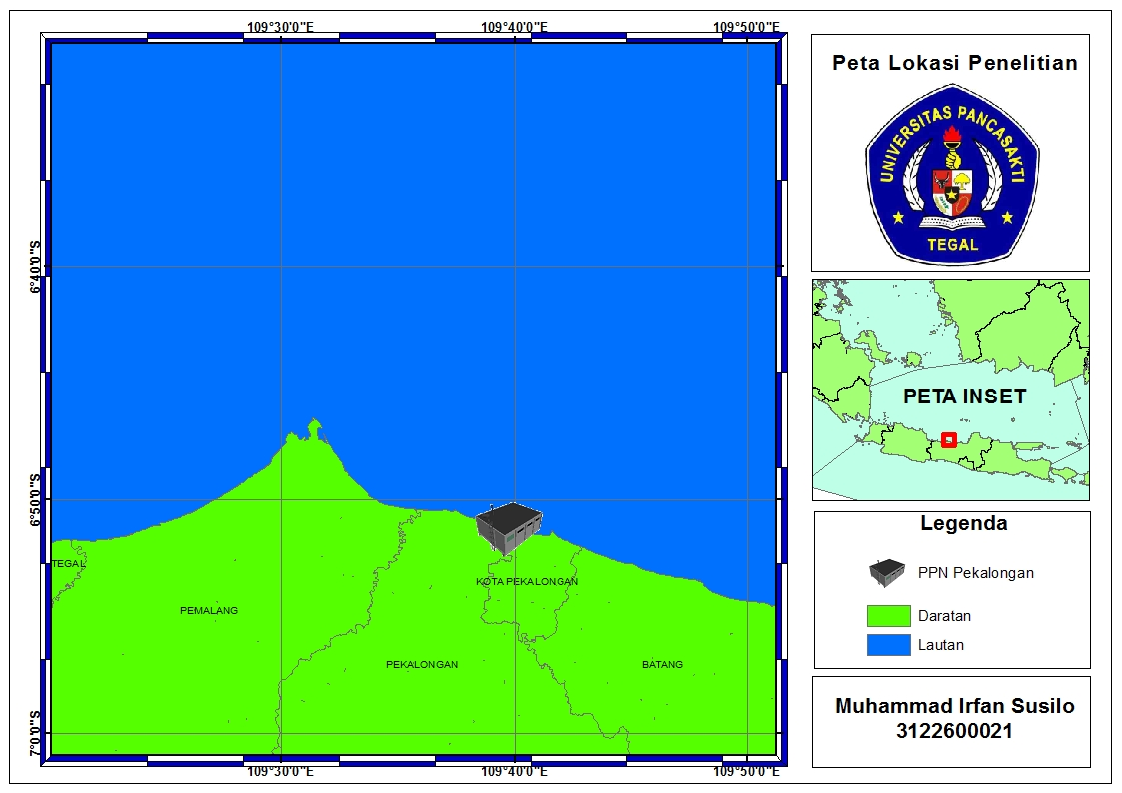
Lampiran 1. Peta Lokasi Penelitian

Lampiran 2. Kuisioner Penelitian
Komposisi Hasil Tangkapan dan Pola Musim Ikan
1. Waktu Musim Penangkapan Purse seine:
- Musim Ikan : Bulan......................s/d Bulan...................(..............Bulan)
- Musim Sedang : Bulan......................s/d Bulan...................(..............Bulan)
- Musim Paceklik : Bulan......................s/d Bulan...................(..............Bulan)
2. Rata-rata Jumlah Trip Menurut Musim:
- Musim Ikan : ......................trip/bulan
- Musim Sedang : ......................trip/bulan
- Musim Paceklik : ......................trip/bulan
3. Rata-rata Jumlah hasil tangkapan per trip menurut musim:
Dihitung disesuaikan dengan kapal 60-90 GT/90-120 GT/120-150 GT
- Musim Ikan : ......................kg/bulan
- Musim Sedang : ......................kg/bulan
- Musim Paceklik : ......................kg/bulan
4. Rata-rata Harga Jual Jenis Ikan, Menurut Musim:
No | Nama Ikan | Musim Ikan  Rp/Kg | Musim Sedang  Rp/Kg | Musim Paceklik  Rp/Kg
1
2
3
4
5

5.Dimana tempat menjual hasil tangkapan
TPI .......... ...........

Lampiran 3. Data Kapal dan Alat Tangkap di PPN Pekalongan
Data Kapal di PPN Pekalongan 2018
Fishing Gear | Size in GT |  |  |  |  | Jumlah
 | < 10 GT | 11- 30 GT | 31 - 60 GT | 61 - 100 GT | > 100 GT
Gillnet | 86 | 7 | 1 | - | - | 94
Purse Seine Pelagis Kecil | - | 68 | 7 | 79 | 69 | 223
Purse Seine Pelagis Besar | - | - | - | 3 | 49 | 52
Pengangkut | - | 6 | 1 | 2 | 8 | 17
Jaring Insang Oseanik | - | 1 | - | 12 | 7 | 20
Jaring Insang Liong Bun | - | 1 | 1 | - | - | 2
Bouke Ami | - | 3 | 1 | - | - | 4
Bubu | - | - | - | - | - | -
Squid Jigging | - | 4 | - | 5 | 1 | 10
Rawai Dasar | - | - | 1 | - | - | 1
Jala Jatuh Berkapal | - | 1 | 3 | - | - | 4
Jumlah | 86 | 91 | 15 | 101 | 134 | 427
Persentase | 20% | 21% | 4% | 24% | 31% | 100%

Data Kapal di PPN Pekalongan 2019
Fishing Gear | Size in GT |  |  |  |  | Jumlah
 | < 10 GT | 11- 30 GT | 31 - 60 GT | 61 - 100 GT | > 100 GT
Gillnet | 74 | 5 | - | - | - | 79
Purse Seine Pelagis Kecil | - | 56 | 5 | 63 | 22 | 146
Purse Seine Pelagis Besar | - | - | - | 1 | 90 | 91
Pengangkut | - | 5 | 1 | 2 | 7 | 15
Jaring Insang Oseanik | - | - | - | 9 | 9 | 18
Jaring Insang Liong Bun | - | - | - | - | 1 | 1
Bouke Ami | - | 1 | 1 | - | - | 2
Bubu | - | 1 | - | - | - | 1
Squid Jigging | - | 3 | - | 4 | - | 7
Rawai Dasar | - | 2 | - | 0 | 1 | 3
Jumlah | 74 | 73 | 7 | 79 | 130 | 363
Persentase | 20% | 20% | 4% | 22% | 36% | 100%

Data Kapal di PPN Pekalongan 2020
Fishing Gear | Size in GT |  |  |  |  | Jumlah
 | < 10 GT | 11- 30 GT | 31 - 60 GT | 61 - 100 GT | > 100 GT
Gillnet | 48 | - | - | - | - | 48
Purse Seine Pelagis Kecil | 3 | 62 | 4 | 65 | 22 | 156
Purse Seine Pelagis Besar | - | - | - | 2 | 109 | 111
Pengangkut | - | 7 | 3 | 1 | 6 | 17
Jaring Insang Oseanik | - | - | 1 | 5 | 6 | 12
Jaring Insang Liong Bun | - | - | - | 1 | - | 1
Bouke Ami | - | 2 | - | - | - | 2
Bubu | - | 1 | - | - | - | 1
Squid Jigging | - | 1 | - | 6 | 1 | 8
Jumlah | 51 | 73 | 8 | 80 | 144 | 356
Persentase | 15% | 21% | 2% | 24% | 28% | 100%

Data Kapal di PPN Pekalongan 2021
Fishing Gear | Size in GT |  |  |  |  | Jumlah
 | < 10 GT | 11- 30 GT | 31 - 60 GT | 61 - 100 GT | > 100 GT
Gillnet | 72 | - | - | - | - | 72
Purse Seine Pelagis Kecil | - | 60 | 2 | 47 | 16 | 125
Purse Seine Pelagis Besar | - | - | - | 2 | 64 | 66
Pengangkut | - | 7 | 3 | 1 | 7 | 18
Jaring Insang Oseanik | - | - | 3 | 2 | 6 | 11
Bouke Ami | - | 2 | 1 | - | - | 3
Squid Jigging | - | 2 | - | 5 | - | 7
Lainnya | - | 2 | 4 | 4 | 4 | 14
Jumlah | 72 | 73 | 13 | 61 | 97 | 316
Persentase | 23% | 23% | 4% | 19% | 31% | 100%

Lampiran 4. Data Jenis Ikan yang Didaratkan di PPN Pekalongan
No | Jenis Alat Tangkap | 2018 |  | 2019 |  | 2020
 |  | Volume Produksi (Kg) | Nilai Produksi (Rp) | Volume Produksi (Kg) | Nilai Produksi (Rp) | Volume Produksi (Kg) | Nilai Produksi (Rp)
1. | Bouke Ami | - | - | 6.530 | 223.240.000 | 10.195 | 341.465.000
2. | Bubu | 19.507 | 1.826.470.000 | 4.575 | 279.630.000 | 20.373 | 915.791.000
3. | Bottom Longline | 13.475 | 422.627.833 | - | - | - | -
4. | Gillnet Mini | - | - | - | - | 13.896 | 55.584.000
5. | Jaring Insang Hanyut | 374.476 | 7.246.050.600 | 301.161 | 5.852.886.000 | 115.770 | 3.078.007.000
6. | Jaring Insang Lingkar | 1.307.149 | 22.828.439.681 | 1.307.908 | 17.910.743.000 | 1.309.448 | 19.354.865.000
7. | Jaring Insang Tangkap | - | - | - | - | 143.784 | 2.387.563.000
8. | Jala Jatuh Berkapal | - | - | - | - | - | -
9. | Kapal Angkut | 82.869 | 831.335.000 | 37.995 | 525.280.000 | - | -
10. | Pancingan | - | - | - | - | - | -
11. | Purse Seine | 10.914.870 | 162.751.646.007 | 11.766.909 | 148.558.769.000 | 14.489.426 | 204.431.214.000
12. | Payang | 103.294 | 3.185.112.800 | 65.029 | 2.552.247.000 | 54.340 | 1.229.296.000
Total |  | 12.815.640 | 199.091.681.921 | 13.490.107 | 175.902.795.000 | 16.157.232 | 231.793.785.000

No | Jenis Alat Tangkap | 2021 |  | 2022
 |  | Volume Produksi (Kg) | Nilai Produksi (Rp) | Volume Produksi (Kg) | Nilai Produksi (Rp)
1. | Bouke Ami | - | - | 126.477 | 6.135.204.000
2. | Bubu | 37.354 | 3.185.789.000 | 24.927 | 1.812.321.000
3. | Bottom Longline | - | - | - | -
4. | Gillnet Mini | 1.785 | 8.925.000 | - | -
5. | Jaring Insang Hanyut | 111.565 | 2.702.130.000 | 284.895 | 6.291.240.000
6. | Jaring Insang Lingkar | 884.714 | 13.336.992.000 | 1.383.333 | 22.926.971.000
7. | Jaring Insang Tangkap | 81.650 | 1.536.973.000 | 55.868 | 1.024.325.000
8. | Jala Jatuh Berkapal | - | - | 40.739 | 1.828.036.000
9. | Kapal Angkut | - | - | 126.964 | 1.225.790.000
10. | Pancingan | 18.102 | 622.313.000 | 72.405 | 3.576.538.000
11. | Purse seine | 11.440.376 | 191.280.789.000 | 11.804.239 | 202.536.567.000
12. | Payang | 77.984 | 1.983.768.000 | 23.488 | 591.921.000
Total |  | 12.653.530 | 214.657.679.000 | 13.943.336 | 247.948.913.000

Lampiran 5. Data Jenis Ikan yang Didaratkan di PPN Pekalongan
No | Nama Lokal | Nama Indonesia | Nama Ilmiah | Keterangan
1. | Cakalang | Cakalang | Katsuwonus pelamis | HTU
2. | Japuh | Japuh | Dussumieria acuta | HTU
3. | Julung-julung | Julung-julung | Hemiramphidae | HTU
4. | Banyar | Kembung Lelaki | Rastrelliger kanagurta | HTU
5. | Kembung | Kembung Perempuan | Rastrelliger brachysoma | HTU
6. | Layang Anggur | Layang Anggur | Decapterus kurroides | HTU
7. | Layang Biru | Layang Biru | Decapterus macarellus | HTU
8. | Layang Cempluk | Layang Benggol | Decapterus Russelli | HTU
9. | Layang Deles | Layang Deles | Decapterus | HTU
10. | Layaran | Layaran | Istiophorus | HTU
11. | Layaran | Layaran Tumbuk | Istiophorus | HTU
12. | Lemadang | Lemadang | Coryphaena hippurus | HTU
13. | Bentong | Selar Bentong | Selar crumenophthalmus | HTU
14. | Selar Gontor | Selar Komo | Atule mate | HTU
15. | Selar Gontor | Selar Kuning | Selaroides leptolepis | HTU
16. | Tanjan | Siro | Amblygaster sirm | HTU
17. | Sunglir | Sunglir | Elagatis bipinnulata | HTU
18. | Jui | Tembang | Sardinella gibbosa | HTU
19. | Tenggiri | Tenggiri | Scomberomorus | HTU
20. | Kawang | Tenggiri papan | Scomberomorus guttatus | HTU
21. | Teri | Teri | Engraulidae | HTU
22. | Teros | Tetengkek | Megalaspis cordyla | HTU
23. | Tongkol Ireng | Tongkol abu-abu | Thunnus tonggol | HTU
24. | Tongkol | Tongkol komo | Euthynnus affinis | HTU
25. | Tongkol | Tongkol Krai | Auxis thazard | HTU
26. | Tongkol Lurik | Tongkol Lisong | Auxis rochei | HTU
27. | Tuna | Tuna Mata Besar | Thunnus obesus | HTU
28. | Kacangan | Alu-alu | Sphyraena barracuda | HTS
29. | Ethong | Ayam-ayam | Abalistes stellaris | HTS
30. | Dorang | Bawal Hitam | Parastromateus niger | HTS
31. | Bawal | Bawal Putih | Pampus argenteus | HTS
32. | Belanak | Belanak | Moolgarda seheli | HTS
33. | Kadalan | Beloso | Saurida tumbil | HTS
34. | Cucut | Cucut | Rhizoprionodon acutus | HTS
No | Nama Lokal | Nama Indonesia | Nama Ilmiah | Keterangan
35. | Cucut | Cucut Botol | Centrophorus sp | HTS
36. | Cucut | Cucut Kempis | Rhizoprionodon acutus | HTS
37. | Cucut | Cucut Lanjam | Carcharhinus brevipinna | HTS
38. | Cucut | Cucut Martil | Sphyrnidae | HTS
39. | Cucut | Cucut Pisang | Rhizoprionodon acutus | HTS
40. | Cucut | Cucut Sorah | Rhizoprionodon acutus | HTS
41. | Cucut | Cucut Tokek | Stegostoma fasciatum | HTS
42. | Cumi | Cumi-cumi | Loligo spp | HTS
43. | Ekor | Ekor Kuning | Caesionidae | HTS
44. | Gabus | Gabus Laut | Rachycentron canadum | HTS
45. | Gerot | Gerot-gerot | Haemulidae | HTS
46. | Golok | Golok-golok | Chirocentrus dorab | HTS
47. | Cucut | Hiu martil | Sphyrnidae | HTS
48. | Cucut | Hiu pilus | Rhizoprionodon acutus | HTS
49. | Cucut Kempis | Hiu tokek | Stegostoma fasciatum | HTS
50. | Ikan Lidah | Ikan Lidah | Cynoglossidae | HTS
51. | Pihi | Ikan Sebelah | Pleuronectiformes | HTS
52. | Ikan Tumbuk | Ikan Tumbuk | Tetrapturus angustirostris | HTS
53. | Pelong | Jenaha | Lutjanus synagris | HTS
54. | Kakak Tua | Kakak Tua | Scaridae | HTS
55. | CL | Kakap Hitam | Macolor niger | HTS
56. | Bambangan | Kakap Merah | Lutjanus campechanus | HTS
57. | Lencam | Kakap Putih | Lates calcarifer | HTS
58. | Kakap | Kakap Sejati | Lutjanidae | HTS
59. | Balong | Kerapu Balong | Epinephelus coioides | HTS
60. | Kerapu | Kerapu Batu | Epinephelus quoyanus | HTS
61. | Kerapu | Kerapu Lumpur | Epinephelus lanceolatus | HTS
62. | Kerut | Kerong-kerong | Terapon jarbua | HTS
63. | Kepiting | Kepiting | Scylla olivacea Herbst | HTS
64. | Kuniran | Kuniran | Parupeneus cyclostomus | HTS
65. | Abangan | Kurisi | Nemipterus nematophorus | HTS
66. | Kuro | Kuro | Polynemidae | HTS
67. | Gatep | Kwe | Caranx ignobilis | HTS
68. | Jogor | Layur | Trichiurus lepturus | HTS
69. | Utik/Songot | Manyung | Ariidae | HTS
No | Nama Lokal | Nama Indonesia | Nama Ilmiah | Keterangan
70. | Songot | Manyung Jahan | Ariidae | HTS
71. | Pari Manuk/pe | Pari Burung | Aetobatus ocellatus | HTS
72. | Pari Kekeh/pe | Pari kekeh | Rhynchobatus sp | HTS
73. | Pari Kelapa/pe | Pari Kelapa | Neotrygon kuhlii | HTS
74. | Pari Kelelawar/Pe | Pari Kelelawar | Gymnura poecilura | HTS
75. | Pari Macan/pe | Pari Kembang | Neotrygon kuhlii | HTS
76. | Pari/pe | Pari Kikir | Brevitrygon heterura | HTS
77. | Pari/peh | Pari Macan | Batoidea | HTS
78. | Petek | Peperek | Leiognathidae | HTS
79. | Rajungan | Rajungan | Portunus pelagicus | HTS
80. | Rebon | Rebon | Acetes | HTS
81. | Remang | Remang | Mueraenosox talabon | HTS
82. | Belong | Selanget | Anodontostoma chacunda | HTS
83. | Wadung | Semar | Mene maculata | HTS
84. | Sembilang | Sembilang | Plotosidae | HTS
85. | Seriping | Seriping |  | HTS
86. | Layang Tumbuk | Setuhuk Hitam | Makaira | HTS
87. | Setuhuk | Setuhuk Loreng | Makaira | HTS
88. | Setuhuk | Setuhuk Putih | Makaira | HTS
89. | Blekutak | Sotong | Sepiida | HTS
90. | Sokang | Sokang | Oligoplites saurus | HTS
91. | Belong | Swanggi | Priacanthus macracanthus | HTS
92. | Wais | Talang-talang | Scomberoides lysan | HTS
93. | Teripang | Teripang | Holothuroidea | HTS
94. | Tiga waja | Tiga Waja | Ololithes ruber BIoch | HTS
95. | Udang | Udang Dogol | Metapenaeus monoceros | HTS
96. | Udang | Udang Jerbung | Fenneropenaeus merguiensis | HTS
97. | Udang | Udang Krosok | Parapenaeopsis  sculp- tilis | HTS
98. | Udang | Udang Peci | Penaeus merguiensis | HTS
Keterangan :
- HTU : Hasil Tangkapan Utama
- HTS : Hasil Tangkapan Sampingan

Lampiran 6. Produksi Komoditi Utama di PPN Pekalongan
TAHUN | JENIS IKAN |  |  |  |  | TOTAL
 | Layang | Siro | Tongkol | Kembung | Tembang
2018 | 4.320.527 | 2.306.243 | 2.857.765 | 1.002.915 | 935.543 | 11.422.993
2019 | 6.244.969 | 1.503.837 | 3.023.784 | 1.503.957 | 383.153 | 12.659.700
2020 | 7.060.046 | 1.833.753 | 3.105.065 | 1.295.500 | 413.769 | 13.708.133
2021 | 4.407.241 | 2.092.860 | 1.904.732 | 1.035.569 | 638.030 | 10.078.432
2022 | 4.963.974 | 1.948.820 | 3.327.304 | 918.025 | 302.724 | 11.460.847
TOTAL | 26.996.757 | 9.685.513 | 14.218.649 | 5.755.966 | 2.673.219 | 59.330.104

Jenis Ikan | Hasil | Persentase | Total Keseluruhan Ikan Periode 2018-2022
Layang | 26.996.757 | 39% | 69.059.843
Siro | 9.685.513 | 14%
Tongkol | 14.218.649 | 21%
Kembung | 5.755.966 | 8%
Tembang | 2.673.219 | 4%
Total | 59.330.104 | 86%
Lampiran 7. Komposisi Hasil Tangkapa Utama Purse Seine Tahun 2018-2022 di Pelabuhan Perikanan Nusantara (PPN) Pekalongan
No | Jenis Ikan | Nama Latin | Jumlah (Kg)
1. | Layang Benggol | Decapterus Russelli | 14.187.299
2. | Layang Deles | Decapterus | 11.179.566
3. | Siro | Amblygaster sirm | 9.685.513
4. | Tongkol Abu-Abu | Thunnus tonggol | 7.107.076
5. | Kembung Lelaki | Rastrelliger kanagurta | 5.320.663
6. | Cakalang | Katsuwonus pelamis | 4.461.554
7. | Tongkol Komo | Euthynnus affinis | 3.118.270
8. | Tembang | Sardinella gibbosa | 2.673.219
9. | Selar Bentong | Selar crumenophthalmus | 2.092.237
10. | Layang Anggur | Decapterus kurroides | 1.595.792
11. | Tuna Mata Besar | Thunnus obesus | 1.425.435
12. | Tetengkek | Megalaspis cordyla | 489.956
13. | Kembung Perempuan | Rastrelliger brachysoma | 435.304
14. | Tongkol Lisong | Auxis rochei | 418.846
15. | Tenggiri | Scomberomorus | 370.811
16. | Selar Kuning | Selaroides leptolepis | 245.070
17. | Japuh | Dussumieria acuta | 186.836
18. | Lemadang | Coryphaena hippurus | 94.734
19. | Selar Komo | Atule mate | 62.778
20. | Layaran | Istiophorus | 45.144
21. | Layang Biru | Decapterus macarellus | 34.100
22. | Tenggiri Papan | Scomberomorus guttatus | 32.049
23. | Sunglir | Elagatis bipinnulata | 27.440
24. | Tongkol Krai | Auxis thazard | 18.670
25. | Teri | Engraulidae | 6.148
26. | Julung-Julung | Hemiramphidae | 3.930
27. | Layaran Tumbuk | Istiophorus | 68
TOTAL |  |  | 65.318.508

Lampiran 8. Komposisi Hasil Tangkapa Sampingan Purse Seine Tahun 2018-2022 di Pelabuhan Perikanan Nusantara (PPN) Pekalongan
No | Jenis Ikan | Nama Latin | Jumlah (Kg)
1. | Alu-Alu | Sphyraena barracuda | 299.617
2. | Ayam-Ayam | Abalistes stellaris | 18.373
3. | Bawal Hitam | Parastromateus niger | 435.038
4. | Bawal Putih | Pampus argenteus | 25
5. | Belanak | Moolgarda seheli | 290
6. | Beloso | Saurida tumbil | 58.871
7. | Cucut | Rhizoprionodon acutus | 171
8. | Cucut Botol | Centrophorus sp | 18.902
9. | Cucut Kempis | Rhizoprionodon acutus | 129
10. | Cucut Lanjam | Carcharhinus brevipinna | 104.060
11. | Cucut Martil | Sphyrnidae | 417
12. | Cucut Pisang | Rhizoprionodon acutus | 7.326
13. | Cucut Sorah | Rhizoprionodon acutus | 2
14. | Cucut Tokek | Stegostoma fasciatum | 132
15. | Cumi-Cumi | Loligo spp | 690.301
16. | Ekor Kuning | Caesionidae | 15
17. | Gabus Laut | Rachycentron canadum | 39.342
18. | Gerot-Gerot | Haemulidae | 576
19. | Golok-Golok | Chirocentrus dorab | 19.541
20. | Hiu Martil | Sphyrnidae | 17
21. | Hiu Pilus | Rhizoprionodon acutus | 14.853
22. | Hiu Tokek | Stegostoma fasciatum | 3.469
23. | Ikan Lidah | Cynoglossidae | 5.975
24. | Ikan Sebelah | Pleuronectiformes | 27.937
25. | Ikan Tumbuk | Tetrapturus angustirostris | 3.286
26. | Jenaha | Lutjanus synagris | 14.997
27. | Kakak Tua | Scaridae | 10.185
28. | Kakap Hitam | Macolor niger | 5.818
29. | Kakap Merah | Lutjanus campechanus | 65.759
30. | Kakap Putih | Lates calcarifer | 24.041
31. | Kakap Sejati | Lutjanidae | 3
32. | Kerapu Balong | Epinephelus coioides | 4.305
33. | Kerapu Batu | Epinephelus quoyanus | 5
34. | Kerapu Lumpur | Epinephelus lanceolatus | 296
35. | Kerong-Kerong | Terapon jarbua | 819
36. | Kepiting | Scylla olivacea Herbst | 5.797
37. | Kuniran | Parupeneus cyclostomus | 35.390
38. | Kurisi | Nemipterus nematophorus | 8.628
39. | Kuro | Polynemidae | 32.976
40. | Kwe | Caranx ignobilis | 186.895
41. | Layur | Trichiurus lepturus | 184.659
42. | Manyung | Ariidae | 262.078
43. | Manyung Jahan | Ariidae | 29
44. | Pari Burung | Aetobatus ocellatus | 240
45. | Pari Kekeh | Rhynchobatus sp | 16.080
46. | Pari Kelapa | Neotrygon kuhlii | 1.108
47. | Pari Kelelawar | Gymnura poecilura | 5
48. | Pari Kembang | Neotrygon kuhlii | 13.889
49. | Pari Kikir | Brevitrygon heterura | 6
50. | Pari Macan | Batoidea | 209
51. | Peperek | Leiognathidae | 192.746
52. | Rajungan | Portunus pelagicus | 126.577
53. | Rebon | Acetes | 62.574
54. | Remang | Mueraenosox talabon | 40.237
55. | Selanget | Anodontostoma chacunda | 6.021
56. | Semar | Mene maculata | 227.391
57. | Sembilang | Plotosidae | 211
58. | Seriping | - | 1.584
59. | Setuhuk Hitam | Makaira | 20.054
60. | Setuhuk Loreng | Makaira | 5.302
61. | Setuhuk Putih | Makaira | 143
62. | Sotong | Sepiida | 22.235
63. | Sokang | Oligoplites saurus | 274
64. | Swanggi | Priacanthus macracanthus | 78.424
65. | Talang-Talang | Scomberoides lysan | 137.088
66. | Teripang | Holothuroidea | 16.467
67. | Tiga Waja | Ololithes ruber Bioch | 28.752
68. | Udang Dogol | Metapenaeus monoceros | 46.050
69. | Udang Jerbung | Fenneropenaeus merguiensis | 36.766
70. | Udang Krosok | Parapenaeopsis sculp- tilis | 67.439
71. | Udang Peci | Penaeus merguiensis | 2.117
TOTAL |  |  | 3.741.334

Lampiran 9. Data Hasil Tangkapan Utama Purse Seine Tahun 2018 di Pelabuhan Perikanan Nusantara (PPN) Pekalongan
JENIS IKAN | BULAN
 | Jul | Ags | Sep | Okt | Nov | Des | Jan
Cakalang | 97.006 | 55.891 | 52.163 | 56.395 | 100.000 | 0 | 0
Japuh | 196 | 1.775 | 1.357 | 28 | 15 | 0 | 0
Julung-Julung | 0 | 0 | 40 | 167 | 144 | 0 | 0
Kembung Lelaki | 110.961 | 85.846 | 82.473 | 155.308 | 91.264 | 42.125 | 29.882
Kembung Perempuan | 928 | 8.568 | 9.952 | 1.400 | 763 | 30 | 0
Layang Anggur | 15.214 | 10.286 | 0 | 0 | 969 | 0 | 0
Layang Biru | 0 | 0 | 0 | 0 | 0 | 0 | 0
Layang Benggol | 238.501 | 326.385 | 259.582 | 381.121 | 370.659 | 134.947 | 72.660
Layang Deles | 37.377 | 77.790 | 216.018 | 568.370 | 399.073 | 100.603 | 50.192
Layaran | 420 | 744 | 574 | 475 | 1.139 | 1.159 | 414
Layaran Tumbuk | 0 | 0 | 0 | 0 | 0 | 0 | 0
Lemadang | 198 | 263 | 168 | 408 | 728 | 1.014 | 605
Selar Bentong | 27.259 | 13.583 | 15.423 | 15.612 | 22.691 | 23.739 | 30.920
Selar Komo | 743 | 1.266 | 20 | 148 | 621 | 156 | 287
Selar Kuning | 164 | 0 | 27 | 8 | 972 | 3.710 | 3.730
Siro | 139.168 | 116.198 | 91.864 | 123.546 | 166.499 | 219.034 | 235.585
Sunglir | 389 | 3.023 | 20 | 186 | 3.907 | 2 | 96
Tembang | 28.493 | 61.105 | 39.969 | 51.345 | 56.347 | 41.534 | 13.751
Tenggiri | 8.249 | 3.535 | 3.827 | 4.254 | 12.923 | 10.268 | 2.461
Tenggiri Papan | 165 | 117 | 427 | 1.208 | 767 | 535 | 180
Teri | 39 | 241 | 189 | 356 | 245 | 420 | 24
Tetengkek | 5.312 | 6.171 | 13.397 | 3.780 | 5.534 | 3.748 | 198
Tongkol Abu-Abu | 23.395 | 33.324 | 113.439 | 227.387 | 378.186 | 125.163 | 35.915
Tongkol Komo | 33.823 | 45.010 | 41.306 | 60.373 | 71.194 | 43.076 | 20.575
Tongkol Krai | 0 | 0 | 0 | 0 | 0 | 2.330 | 0
Tongkol Lisong | 39.811 | 4.711 | 6.338 | 9.740 | 34.630 | 1.970 | 4.445
Tuna Mata Besar | 6.775 | 3.500 | 5.210 | 6.218 | 0 | 0 | 0
TOTAL | 814.586 | 859.331 | 953.781 | 1.667.833 | 1.719.270 | 755.562 | 501.918

JENIS IKAN | BULAN |  |  |  |  | JUMLAH
 | Feb | Mar | Apr | Mei | Jun
Cakalang | 0 | 0 | 0 | 0 | 105.088 | 466.543
Japuh | 0 | 0 | 0 | 0 | 0 | 3.370
Julung-Julung | 0 | 0 | 0 | 0 | 0 | 351
Kembung Lelaki | 6.709 | 63.499 | 78.785 | 118.906 | 101.633 | 967.391
Kembung Perempuan | 134 | 1.691 | 1.509 | 8.972 | 1.578 | 35.525
Layang Anggur | 0 | 0 | 0 | 606 | 6.270 | 33.345
Layang Biru | 0 | 0 | 0 | 0 | 0 | 0
Layang Benggol | 26.131 | 58.852 | 132.326 | 167.097 | 392.988 | 2.561.248
Layang Deles | 18.275 | 70.906 | 56.538 | 78.841 | 51.952 | 1.725.933
Layaran | 311 | 921 | 3.589 | 449 | 489 | 10.683
Layaran Tumbuk | 0 | 0 | 0 | 0 | 0 | 0
Lemadang | 1.662 | 615 | 1.985 | 199 | 759 | 8.604
Selar Bentong | 7.102 | 57.776 | 49.569 | 29.446 | 44.020 | 337.140
Selar Komo | 1.687 | 299 | 1.789 | 454 | 766 | 8.236
Selar Kuning | 2.728 | 1.717 | 4.877 | 3.535 | 344 | 21.812
Siro | 110.552 | 489.816 | 233.365 | 208.444 | 172.172 | 2.306.243
Sunglir | 40 | 3 | 282 | 1.815 | 130 | 9.893
Tembang | 50.296 | 70.124 | 254.693 | 124.692 | 143.193 | 935.543
Tenggiri | 877 | 4.077 | 10.902 | 4.758 | 4.732 | 70.861
Tenggiri Papan | 163 | 1.132 | 2.508 | 864 | 371 | 8.435
Teri | 0 | 0 | 26 | 395 | 0 | 1.935
Tetengkek | 1.024 | 5.313 | 6.662 | 19.239 | 4.075 | 74.452
Tongkol Abu-Abu | 8.767 | 77.050 | 213.368 | 191.453 | 81.401 | 1.508.848
Tongkol Komo | 8.408 | 32.740 | 58.565 | 72.518 | 64.411 | 551.997
Tongkol Krai | 0 | 0 | 0 | 0 | 0 | 2.330
Tongkol Lisong | - | 245 | 595 | 5.956 | 11.691 | 120.131
Tuna Mata Besar | 0 | 0 | 0 | 0 | 10.677 | 32.380
TOTAL | 244.866 | 936.774 | 1.111.932 | 1.038.637 | 1.198.740 | 11.803.230

Lampiran 10. Data Hasil Tangkapan Utama Purse Seine Tahun 2019 di Pelabuhan Perikanan Nusantara (PPN) Pekalongan
JENIS IKAN | BULAN
 | Jul | Ags | Sep | Okt | Nov | Des | Jan
Cakalang | 0 | 0 | 100.000 | 0 | 0 | 54.760 | 0
Japuh | 0 | 1.540 | 3.722 | 2 | 1.919 | 1.514 | 0
Julung-julung | 6 | 23 | 49 | 0 | 206 | 2 | 1
Kembung Lelaki | 73.339 | 106.589 | 86.876 | 95.366 | 133.226 | 96.408 | 77.795
Kembung Perempuan | 1.085 | 28 | 913 | 762 | 1.193 | 165 | 0
Layang Anggur | 0 | 0 | 35.000 | 32.555 | 5.622 | 3.445 | 0
Layang Biru | 0 | 0 | 0 | 0 | 0 | 0 | 0
Layang Benggol | 163.778 | 479.758 | 447.103 | 379.561 | 451.130 | 319.967 | 140.321
Layang Deles | 5.605 | 26.880 | 187.986 | 388.915 | 594.936 | 496.058 | 139.736
Layaran | 195 | 31 | 600 | 1.032 | 995 | 1.397 | 182
Layaran Tumbuk | 0 | 0 | 0 | 0 | 0 | 0 | 0
Lemadang | 149 | 216 | 167 | 456 | 3.159 | 1.668 | 223
Selar Bentong | 8.707 | 24.322 | 34.713 | 20.278 | 35.907 | 28.299 | 16.590
Selar Komo | 134 | 0 | 352 | 48 | 215 | 23 | 637
Selar Kuning | 360 | 428 | 280 | 62 | 3.067 | 861 | 3.440
Siro | 7.029 | 13.601 | 31.170 | 36.039 | 144.697 | 133.284 | 254.664
Sunglir | 0 | 26 | 33 | 0 | 37 | 53 | 31
Tembang | 5.427 | 11.506 | 14.459 | 53.071 | 87.025 | 35.265 | 10.885
Tenggiri | 1.270 | 1.278 | 2.045 | 4.408 | 8.007 | 18.148 | 1.821
Tenggiri papan | 114 | 170 | 268 | 4.350 | 831 | 362 | 165
Teri | 0 | 0 | 0 | 0 | 0 | 0 | 0
Tetengkek | 9.117 | 1.419 | 1.023 | 658 | 17.295 | 187 | 3.193
Tongkol abu-abu | 14.790 | 31.741 | 46.481 | 434.767 | 457.038 | 205.923 | 3.576
Tongkol komo | 7.224 | 16.245 | 14.633 | 129.557 | 196.518 | 75.249 | 14.191
Tongkol Krai | 0 | 0 | 0 | 0 | 0 | 0 | 0
Tongkol Lisong | 0 | 0 | 0 | 0 | 0 | 0 | 629
Tuna Mata Besar | 0 | 0 | 12.250 | 31.480 | 0 | 145.209 | 0
TOTAL | 298.329 | 715.801 | 1.020.123 | 1.613.367 | 2.143.023 | 1.618.247 | 668.080

JENIS IKAN | BULAN |  |  |  |  | JUMLAH
 | Feb | Mar | Apr | Mei | Jun
Cakalang | 30.000 | 0 | 0 | 0 | 0 | 184.760
Japuh | 1.355 | 160 | 9.612 | 3.856 | 112 | 23.792
Julung-julung | 17 | 8 | 198 | 113 | 31 | 654
Kembung Lelaki | 80.228 | 64.930 | 99.684 | 371.601 | 205.023 | 1.491.065
Kembung Perempuan | 0 | 357 | 4.165 | 4.174 | 50 | 12.892
Layang Anggur | 0 | 44.500 | 50.000 | 0 | 0 | 171.122
Layang Biru | 0 | 0 | 0 | 0 | 0 | 0
Layang Benggol | 131.370 | 115.502 | 363.520 | 406.149 | 466.607 | 3.864.766
Layang Deles | 47.444 | 64.604 | 106.111 | 101.324 | 49.482 | 2.209.081
Layaran | 328 | 234 | 455 | 1.238 | 32 | 6.719
Layaran Tumbuk | 0 | 0 | 0 | 68 | 0 | 68
Lemadang | 350 | 113 | 214 | 1.122 | 702 | 8.539
Selar Bentong | 14.100 | 28.549 | 31.460 | 39.873 | 30.176 | 312.974
Selar Komo | 1.364 | 1.367 | 3.098 | 2.360 | 940 | 10.538
Selar Kuning | 4.542 | 3.070 | 5.919 | 10.339 | 4.037 | 36.405
Siro | 110.026 | 197.785 | 243.147 | 228.147 | 104.248 | 1.503.837
Sunglir | 282 | 105 | 137 | 238 | 194 | 1.136
Tembang | 9.271 | 13.511 | 33.676 | 85.184 | 23.873 | 383.153
Tenggiri | 2.498 | 4.123 | 6.454 | 9.097 | 975 | 60.124
Tenggiri papan | 125 | 53 | 1.794 | 490 | 22 | 8.744
Teri | 0 | 0 | 0 | 50 | 0 | 50
Tetengkek | 283 | 4.031 | 9.654 | 41.045 | 39.361 | 127.266
Tongkol abu-abu | 59.516 | 95.224 | 208.195 | 21.971 | 2.434 | 1.581.656
Tongkol komo | 15.844 | 41.444 | 60.881 | 54.325 | 75.697 | 701.808
Tongkol Krai | 0 | 0 | 0 | 0 | 0 | 0
Tongkol Lisong | 0 | 4.037 | 2.192 | 11.063 | 1.335 | 19.256
Tuna Mata Besar | 0 | 0 | 0 | 0 | 0 | 188.939
TOTAL | 508.942 | 683.707 | 1.240.566 | 1.393.827 | 1.005.331 | 12.909.342

Lampiran 11. Data Hasil Tangkapan Utama Purse Seine Tahun 2020 di Pelabuhan Perikanan Nusantara (PPN) Pekalongan
JENIS IKAN | BULAN
 | JUL | AGS | SEP | OKT | NOV | DES | JAN
Cakalang | 220.080 | 57.440 | 9.812 | 56.700 | 399.090 | 61.967 | 0
Japuh | 9.982 | 1.165 | 821 | 2.850 | 5.580 | 0 | 390
Julung-julung | 14 | 58 | 236 | 419 | 67 | 3 | 10
Kembung Lelaki | 50.068 | 41.205 | 85.731 | 79.630 | 99.383 | 72.805 | 49.868
Kembung Perempuan | 16.635 | 890 | 1.134 | 3.099 | 5 | 0 | 0
Layang Anggur | 150.740 | 41.340 | 0 | 43.514 | 53.800 | 45.100 | 0
Layang Biru | 0 | 0 | 0 | 0 | 0 | 0 | 0
Layang Benggol | 199.488 | 336.836 | 338.014 | 373.871 | 394.318 | 286.984 | 173.927
Layang Deles | 64.493 | 159.583 | 270.657 | 482.328 | 730.605 | 452.141 | 419.305
Layaran | 558 | 144 | 887 | 766 | 983 | 432 | 209
Layaran Tumbuk | 0 | 0 | 0 | 0 | 0 | 0 | 0
Lemadang | 10.426 | 474 | 207 | 195 | 2.246 | 1.099 | 63
Selar Bentong | 41.868 | 17.229 | 34.850 | 45.454 | 69.713 | 41.224 | 33.344
Selar Komo | 768 | 0 | 104 | 45 | 66 | 618 | 578
Selar Kuning | 6.824 | 13.290 | 2.312 | 740 | 21.573 | 11.747 | 1.691
Siro | 49.836 | 26.416 | 24.686 | 141.806 | 341.700 | 301.901 | 193.553
Sunglir | 0 | 93 | 49 | 60 | 73 | 105 | 116
Tembang | 43.609 | 15.445 | 76.875 | 61.414 | 17.447 | 9.751 | 4.136
Tenggiri | 16.045 | 2.820 | 11.720 | 10.203 | 5.364 | 3.117 | 5.974
Tenggiri papan | 276 | 92 | 499 | 404 | 493 | 438 | 41
Teri | 0 | 0 | 268 | 155 | 0 | 31 | 0
Tetengkek | 31.511 | 26 | 15.853 | 15.312 | 25.073 | 7.084 | 27
Tongkol abu-abu | 3.908 | 18.348 | 322.900 | 255.593 | 259.293 | 79.315 | 12.721
Tongkol komo | 20.037 | 13.852 | 83.448 | 134.119 | 115.335 | 44.106 | 60.705
Tongkol Krai | 0 | 0 | 0 | 0 | 0 | 0 | 0
Tongkol Lisong | 0 | 198 | 5.262 | 16.916 | 5.884 | 11.231 | 996
Tuna Mata Besar | 110.610 | 24.120 | 0 | 20.100 | 30.260 | 16.820 | 0
TOTAL | 1.047.776 | 771.064 | 1.286.325 | 1.745.693 | 2.578.351 | 1.448.019 | 957.654

JENIS IKAN | BULAN |  |  |  |  | JUMLAH
 | FEB | MAR | APR | MEI | JUN
Cakalang | 0 | 40.800 | 119.550 | 309.560 | 25.000 | 1.299.999
Japuh | 0 | 535 | 451 | 7.892 | 6.575 | 36.241
Julung-julung | 46 | 10 | 30 | 149 | 11 | 1.053
Kembung Lelaki | 20.595 | 54.541 | 173.506 | 377.207 | 52.654 | 1.157.193
Kembung Perempuan | 0 | 48.979 | 29.528 | 16.804 | 21.233 | 138.307
Layang Anggur | 0 | 0 | 49.960 | 141.295 | 3.000 | 528.749
Layang Biru | 0 | 0 | 0 | 0 | 0 | 0
Layang Benggol | 115.559 | 133.607 | 250.025 | 403.590 | 48.778 | 3.054.997
Layang Deles | 182.388 | 155.241 | 283.590 | 244.793 | 31.176 | 3.476.300
Layaran | 113 | 184 | 360 | 2.288 | 1.053 | 7.977
Layaran Tumbuk | 0 | 0 | 0 | 0 | 0 | 0
Lemadang | 695 | 77 | 3.583 | 7.095 | 3.036 | 29.196
Selar Bentong | 25.536 | 42.319 | 43.387 | 111.359 | 24.611 | 530.894
Selar Komo | 471 | 1.003 | 884 | 2.946 | 1.479 | 8.962
Selar Kuning | 1.928 | 11.539 | 2.550 | 8.330 | 29.467 | 111.991
Siro | 187.775 | 223.528 | 131.504 | 121.406 | 89.642 | 1.833.753
Sunglir | 29 | 5 | 292 | 56 | 103 | 981
Tembang | 1.196 | 39.049 | 17.773 | 49.050 | 78.024 | 413.769
Tenggiri | 1.818 | 10.095 | 23.978 | 12.824 | 6.059 | 110.017
Tenggiri papan | 48 | 601 | 1.475 | 397 | 296 | 5.060
Teri | 81 | 0 | 0 | 0 | 0 | 535
Tetengkek | 512 | 2.330 | 9.458 | 10.531 | 13.835 | 131.552
Tongkol abu-abu | 36.455 | 129.106 | 235.362 | 20.756 | 5.948 | 1.379.705
Tongkol komo | 48.299 | 28.279 | 117.626 | 87.439 | 16.465 | 769.710
Tongkol Krai | 0 | 0 | 0 | 0 | 0 | 0
Tongkol Lisong | 0 | 0 | 566 | 51.917 | 0 | 92.970
Tuna Mata Besar | 0 | 2.005 | 33.650 | 125.130 | 14.000 | 376.695
TOTAL | 623.544 | 923.833 | 1.529.088 | 2.112.814 | 472.445 | 15.496.606

Lampiran 12. Data Hasil Tangkapan Utama Purse Seine Tahun 2021 di Pelabuhan Perikanan Nusantara (PPN) Pekalongan
JENIS IKAN | BULAN
 | JUL | AGS | SEP | OKT | NOV | DES | JAN
Cakalang | 167.340 | 60.600 | 90.527 | 291.680 | 121.360 | 95.400 | 58.100
Japuh | 16.269 | 8.125 | 1.593 | 4.500 | 613 | 506 | 189
Julung-julung | 0 | 153 | 130 | 383 | 609 | 161 | 17
Kembung Lelaki | 53.424 | 76.127 | 43.429 | 68.127 | 59.565 | 50.334 | 77.469
Kembung Perempuan | 5.563 | 3.352 | 2.603 | 1.296 | 224 | 28 | 28.713
Layang Anggur | 149.810 | 16.430 | 18.960 | 56.500 | 16.760 | 16.310 | 0
Layang Biru | 0 | 0 | 0 | 0 | 0 | 0 | 0
Layang Benggol | 243.791 | 316.976 | 197.487 | 325.344 | 210.494 | 197.818 | 115.250
Layang Deles | 59.156 | 96.191 | 204.201 | 435.980 | 263.453 | 268.498 | 121.540
Layaran | 338 | 88 | 352 | 959 | 487 | 816 | 6.112
Layang Tumbuk | 0 | 0 | 0 | 0 | 0 | 0 | 0
Lemadang | 2.633 | 44 | 387 | 2.707 | 1.530 | 1.299 | 2.814
Selar Bentong | 45.278 | 47.742 | 12.629 | 26.406 | 37.815 | 30.687 | 34.688
Selar Komo | 23 | 49 | 2 | 40 | 144 | 82 | 1.111
Selar Kuning | 3.510 | 277 | 243 | 92 | 343 | 422 | 4.831
Siro | 40.630 | 131.743 | 108.352 | 161.589 | 304.777 | 240.593 | 301.911
Sunglir | 35 | 0 | 9 | 417 | 0 | 139 | 2.144
Tembang | 62.170 | 44.382 | 52.129 | 59.185 | 80.253 | 32.836 | 5.580
Tenggiri | 6.419 | 2.418 | 2.698 | 4.951 | 3.045 | 1.412 | 1.282
Tenggiri papan | 361 | 125 | 189 | 807 | 345 | 361 | 12
Teri | 0 | 443 | 56 | 0 | 0 | 0 | 0
Tetengkek | 2.154 | 5.427 | 5.135 | 472 | 454 | 70 | 1.980
Tongkol abu-abu | 542 | 6.291 | 213.154 | 281.396 | 124.497 | 34.555 | 35.237
Tongkol komo | 10.206 | 13.058 | 49.179 | 65.166 | 33.949 | 14.334 | 25.036
Tongkol Krai | 0 | 0 | 0 | 3.650 | 0 | 0 | 0
Tongkol Lisong | 27 | 1.518 | 60 | 1.087 | 8.105 | 3.695 | 120
Tuna Mata Besar | 86.270 | 28.380 | 23.950 | 90.545 | 41.140 | 21.090 | 25.400
TOTAL | 955.949 | 859.939 | 1.027.454 | 1.883.279 | 1.309.962 | 1.011.446 | 849.536

JENIS IKAN | BULAN |  |  |  |  | JUMLAH
 | FEB | MAR | APR | MEI | JUN
Cakalang | 0 | 3.500 | 61.550 | 166.319 | 0 | 1.116.376
Japuh | 0 | 447 | 2.988 | 3.813 | 6.880 | 45.923
Julung-julung | 0 | 0 | 40 | 15 | 38 | 1.546
Kembung Lelaki | 11.578 | 25.092 | 84.581 | 226.502 | 94.902 | 871.130
Kembung Perempuan | 620 | 81.703 | 31.758 | 1.109 | 7.470 | 164.439
Layang Anggur | 0 | 3.950 | 53.858 | 73.340 | 0 | 405.918
Layang Biru | 0 | 0 | 34.100 | 0 | 0 | 34.100
Layang Benggol | 37.648 | 35.432 | 93.530 | 237.975 | 136.998 | 2.148.743
Layang Deles | 6.373 | 16.768 | 67.030 | 216.499 | 62.791 | 1.818.480
Layaran | 0 | 320 | 771 | 158 | 188 | 10.589
Layang Tumbuk | 0 | 0 | 0 | 0 | 0 | 0
Lemadang | 306 | 1.224 | 5.214 | 4.861 | 1.218 | 24.237
Selar Bentong | 10.987 | 29.157 | 77.062 | 139.962 | 54.876 | 547.289
Selar Komo | 210 | 377 | 6.591 | 9.775 | 8.254 | 26.658
Selar Kuning | 1.042 | 1.146 | 8.698 | 11.998 | 11.369 | 43.971
Siro | 112.239 | 167.803 | 298.179 | 139.001 | 86.043 | 2.092.860
Sunglir | 0 | 270 | 130 | 25 | 216 | 3.385
Tembang | 1.439 | 21.131 | 43.703 | 115.032 | 120.190 | 638.030
Tenggiri | 43 | 1.070 | 15.511 | 19.026 | 2.315 | 60.190
Tenggiri papan | 3 | 215 | 665 | 445 | 1.364 | 4.892
Teri | 0 | 0 | 22 | 0 | 0 | 521
Tetengkek | 465 | 3.430 | 15.474 | 34.276 | 5.279 | 74.616
Tongkol abu-abu | 150 | 75.695 | 129.936 | 26.877 | 5.532 | 933.862
Tongkol komo | 2.520 | 35.545 | 58.760 | 118.288 | 20.865 | 446.906
Tongkol Krai | 0 | 0 | 0 | 0 | 0 | 3.650
Tongkol Lisong | 0 | 1.705 | 1.947 | 14.282 | 2.333 | 34.879
Tuna Mata Besar | 0 | 4.500 | 20.260 | 78.321 | 0 | 419.856
TOTAL | 185.623 | 510.480 | 1.112.358 | 1.637.899 | 629.121 | 11.973.046

Lampiran 13. Data Hasil Tangkapan Utama Purse Seine Tahun 2022 di Pelabuhan Perikanan Nusantara (PPN) Pekalongan
JENIS IKAN | BULAN
 | JUL | AGS | SEP | OKT | NOV | DES | JAN
Cakalang | 27.150 | 156.620 | 76.720 | 256.215 | 0 | 183.071 | 106.860
Japuh | 9.569 | 7.256 | 160 | 3.000 | 12.492 | 1.114 | 2.707
Julung-Julung | 7 | 98 | 27 | 8 | 33 | 35 | 35
Kembung Lelaki | 46.844 | 37.463 | 30.935 | 66.643 | 165.925 | 136.400 | 40.515
Kembung Perempuan | 4.758 | 887 | 2.636 | 256 | 1.202 | 65 | 24.211
Layang Anggur | 30.700 | 32.300 | 10.790 | 123.794 | 1.068 | 51.724 | 34.860
Layang Biru | 0 | 0 | 0 | 0 | 0 | 0 | 0
Layang Benggol | 149.275 | 155.687 | 192.553 | 387.074 | 642.977 | 259.934 | 76.956
Layang Deles | 40.679 | 51.205 | 131.734 | 457.314 | 451.556 | 150.898 | 158.628
Layaran | 1.722 | 42 | 108 | 196 | 1.840 | 88 | 4.009
Layang Tumbuk | 0 | 0 | 0 | 0 | 0 | 0 | 0
Lemadang | 3.468 | 2.000 | 3.597 | 2.160 | 494 | 7.197 | 3.817
Selar Bentong | 30.948 | 27.943 | 11.587 | 19.574 | 34.680 | 17.066 | 27.815
Selar Komo | 303 | 528 | 76 | 68 | 646 | 42 | 682
Selar Kuning | 4.972 | 376 | 22 | 1.202 | 3.041 | 2.257 | 1.802
Siro | 73.595 | 53.135 | 46.633 | 67.142 | 110.456 | 168.865 | 434.031
Sunglir | 14 | 10.514 | 11 | 23 | 115 | 131 | 0
Tembang | 29.531 | 15.129 | 15.573 | 29.500 | 17.813 | 15.783 | 12.977
Tenggiri | 7.761 | 7.430 | 8.587 | 4.436 | 3.988 | 22.208 | 7.778
Tenggiri Papan | 125 | 88 | 316 | 1.033 | 1.518 | 499 | 30
Teri | 415 | 854 | 365 | 353 | 283 | 413 | 0
Tetengkek | 22.586 | 2.333 | 507 | 668 | 262 | 382 | 5.613
Tongkol Abu-Abu | 21.206 | 41.935 | 325.874 | 265.766 | 188.096 | 225.083 | 83.591
Tongkol Komo | 66.275 | 49.295 | 64.731 | 66.708 | 45.652 | 34.083 | 33.447
Tongkol Krai | 0 | 0 | 0 | 0 | 0 | 0 | 0
Tongkol Lisong | 12.528 | 8.948 | 12.870 | 9.085 | 1.632 | 3.366 | 151
Tuna Mata Besar | 16.890 | 55.945 | 23.915 | 49.205 | 0 | 79.720 | 39.960
TOTAL | 601.321 | 718.011 | 960.327 | 1.811.423 | 1.685.769 | 1.360.424 | 1.100.475

JENIS IKAN | BULAN |  |  |  |  | JUMLAH
 | FEB | MAR | APR | MEI | JUN
Cakalang | 0 | 0 | 405.220 | 146.915 | 35.105 | 1.393.876
Japuh | 555 | 726 | 30.318 | 1.753 | 7.860 | 77.510
Julung-Julung | 0 | 7 | 30 | 23 | 23 | 326
Kembung Lelaki | 19.981 | 16.555 | 195.387 | 61.372 | 15.864 | 833.884
Kembung Perempuan | 39.470 | 5.515 | 1.068 | 111 | 3.962 | 84.141
Layang Anggur | 0 | 0 | 94.520 | 52.952 | 23.950 | 456.658
Layang Biru | 0 | 0 | 0 | 0 | 0 | 0
Layang Benggol | 51.676 | 49.191 | 219.847 | 169.169 | 203.206 | 2.557.545
Layang Deles | 113.327 | 43.358 | 275.875 | 37.343 | 37.854 | 1.949.771
Layaran | 555 | 77 | 144 | 167 | 228 | 9.176
Layang Tumbuk | 0 | 0 | 0 | 0 | 0 | 0
Lemadang | 107 | 10 | 153 | 1.057 | 98 | 24.158
Selar Bentong | 18.499 | 25.587 | 110.857 | 16.068 | 23.316 | 363.940
Selar Komo | 1.529 | 481 | 3.490 | 207 | 332 | 8.384
Selar Kuning | 3.340 | 2.666 | 4.791 | 1.013 | 5.409 | 30.891
Siro | 277.483 | 237.420 | 384.141 | 75.368 | 20.551 | 1.948.820
Sunglir | 107 | 24 | 184 | 909 | 13 | 12.045
Tembang | 7.707 | 14.254 | 59.569 | 41.242 | 43.646 | 302.724
Tenggiri | 1.458 | 396 | 2.516 | 941 | 2.121 | 69.620
Tenggiri Papan | 35 | 145 | 446 | 377 | 307 | 4.919
Teri | 0 | 0 | 0 | 0 | 424 | 3.107
Tetengkek | 31 | 10.739 | 27.294 | 10.704 | 951 | 82.070
Tongkol Abu-Abu | 127.778 | 67.854 | 315.728 | 37.932 | 2.163 | 1.703.006
Tongkol Komo | 48.222 | 25.926 | 156.713 | 32.162 | 24.635 | 647.849
Tongkol Krai | 0 | 0 | 0 | 12.690 | 0 | 12.690
Tongkol Lisong | 480 | 73 | 41.972 | 37.946 | 22.559 | 151.610
Tuna Mata Besar | 0 | 0 | 81.775 | 41.570 | 18.585 | 407.565
TOTAL | 712.340 | 501.004 | 2.412.038 | 779.991 | 493.162 | 13.136.285

Lampiran 14. Indeks Musim Penangkapan Selama 5 Tahun (2018-2022)
Bulan | Produksi (Ton) | Effort (Trip) | CPUE (Ton/Trip) | Jumlah Bergerak 12 Bulanan | RGI | RGPI | RBI
TAHUN 2018
Juli | 870607 | 504 | 1,727.3941
Agustus | 902857 | 316 | 2,857.1426
September | 989404 | 394 | 2,511.1787
Oktober | 1747922 | 819 | 2,134.2149
November | 1874067 | 682 | 2,747.8992
Desember | 837048 | 268 | 3,123.3148
Januari | 524796 | 145 | 3,619.2797 | 31,795.6876 | 2.649,64 | 2.595,31 | 1,39
Februari | 277406 | 312 | 889.1216 | 30,491.7955 | 2.540,98 | 2.521,76 | 0,35
Maret | 1060509 | 434 | 2,443.5697 | 30,030.3824 | 2.502,53 | 2.539,50 | 0,96
April | 1313633 | 899 | 1,461.2163 | 30,917.5843 | 2.576,47 | 2.625,80 | 0,56
Mei | 1137675 | 558 | 2,038.8442 | 32,101.4985 | 2.675,12 | 2.805,21 | 0,73
Juni | 1279715 | 205 | 6,242.5119 | 35,223.5645 | 2.935,30 | 3.256,62 | 1,92
TAHUN 2019
Juli | 325673 | 769 | 423.5020 | 42,935.3341 | 3.577,94 | 3.609,59 | 0,12
Agustus | 788195 | 329 | 2,395.7295 | 43,694.8773 | 3.641,24 | 3.658,00 | 0,65
September | 1053498 | 310 | 3,398.3806 | 44,097.0307 | 3.674,75 | 3.655,79 | 0,93
Oktober | 1665701 | 502 | 3,318.1291 | 43,641.9040 | 3.636,83 | 3.729,01 | 0,89
November | 2189497 | 373 | 5,869.9651 | 45,854.2464 | 3.821,19 | 3.860,54 | 1,52
Desember | 1668603 | 154 | 10,835.0844 | 46,798.7388 | 3.899,89 | 3.768,01 | 2,88
Januari | 687475 | 157 | 4,378.8229 | 43,633.4895 | 3.636,12 | 3.697,72 | 1,18
Februari | 530714 | 411 | 1,291.2749 | 45,111.9049 | 3.759,33 | 3.706,51 | 0,35
Maret | 715840 | 360 | 1,988.4431 | 43,844.2376 | 3.653,69 | 3.596,59 | 0,55
April | 1315134 | 358 | 3,673.5587 | 42,473.9420 | 3.539,50 | 3.529,77 | 1,04
Mei | 1506585 | 505 | 2,983.3366 | 42,240.6491 | 3.520,05 | 3.532,41 | 0,84
Juni | 1043192 | 339 | 3,077.2625 | 42,537.1404 | 3.544,76 | 3.320,88 | 0,93

TAHUN 2020
Juli | 1116426 | 587 | 1,901.9174 | 37,164.0449 | 3.097,00 | 3.211,85 | 0,59
Agustus | 834766 | 740 | 1,128.0622 | 39,920.4701 | 3.326,71 | 3.422,80 | 0,33
September | 1358817 | 670 | 2,028.0851 | 42,226.6867 | 3.518,89 | 3.545,61 | 0,57
Oktober | 1807714 | 586 | 3,084.8362 | 42,867.8950 | 3.572,32 | 3.622,62 | 0,85
November | 2620744 | 425 | 6,166.4565 | 44,074.9749 | 3.672,91 | 4.113,96 | 1,50
Desember | 1469275 | 269 | 5,461.9888 | 54,660.0309 | 4.555,00 | 4.485,23 | 1,22
Januari | 977529 | 137 | 7,135.2482 | 52,985.4509 | 4.415,45 | 4.447,84 | 1,60
Februari | 636756 | 177 | 3,597.4915 | 53,762.7569 | 4.480,23 | 4.507,24 | 0,80
Maret | 972971 | 370 | 2,629.6514 | 54,411.0508 | 4.534,25 | 4.526,79 | 0,58
April | 1620372 | 332 | 4,880.6386 | 54,232.0115 | 4.519,33 | 4.546,52 | 1,07
Mei | 2211648 | 163 | 13,568.3926 | 54,884.3757 | 4.573,70 | 4.456,60 | 3,04
Juni | 530214 | 378 | 1,402.6825 | 52,074.1323 | 4.339,51 | 4.235,19 | 0,33
TAHUN 2021
Juli | 1007388 | 376 | 2,679.2234 | 49,570.5377 | 4.130,88 | 3.934,53 | 0,68
Agustus | 913047 | 514 | 1,776.3560 | 44,858.2022 | 3.738,18 | 3.604,08 | 0,49
September | 1050258 | 568 | 1,849.0458 | 41,639.8000 | 3.469,98 | 3.395,13 | 0,54
Oktober | 1920921 | 514 | 3,737.2004 | 39,843.2783 | 3.320,27 | 3.192,33 | 1,17
November | 1339129 | 399 | 3,356.2130 | 36,772.5917 | 3.064,38 | 2.698,97 | 1,24
Desember | 1035438 | 350 | 2,958.3943 | 28,002.6757 | 2.333,56 | 2.354,34 | 1,26
Januari | 915861 | 378 | 2,422.9127 | 28,501.5549 | 2.375,13 | 2.443,22 | 0,99
Februari | 216460 | 571 | 379.0893 | 30,135.7915 | 2.511,32 | 2.567,01 | 0,15
Maret | 562363 | 675 | 833.1296 | 31,472.4728 | 2.622,71 | 2.636,99 | 0,32
April | 1243437 | 687 | 1,809.9520 | 31,815.3189 | 2.651,28 | 2.690,06 | 0,67
Mei | 1741847 | 363 | 4,798.4766 | 32,746.2257 | 2.728,85 | 2.784,58 | 1,72
Juni | 707381 | 372 | 1,901.5618 | 34,083.6143 | 2.840,30 | 3.047,07 | 0,62

TAHUN 2022
Juli | 647019 | 150 | 4,313.4600 | 39,045.9858 | 3.253,83 | 3.325,83 | 1,30
Agustus | 750242 | 241 | 3,113.0373 | 40,774.0225 | 3.397,84 | 3.463,60 | 0,90
September | 1008270 | 460 | 2,191.8918 | 42,352.2904 | 3.529,36 | 3.531,68 | 0,62
Oktober | 1871911 | 401 | 4,668.1072 | 42,408.0489 | 3.534,00 | 3.753,17 | 1,24
November | 1755407 | 374 | 4,693.6016 | 47,668.0484 | 3.972,34 | 4.194,70 | 1,12
Desember | 1504945 | 190 | 7,920.7657 | 53,004.8250 | 4.417,07 | 4.502,07 | 1,76
Januari | 1149813 | 277 | 4,150.9495 | 55,044.9655 | 4.587,08 | 4.587,08 | 0,90
Februari | 767284 | 392 | 1,957.3571
Maret | 548444 | 617 | 888.8882
April | 2622952 | 371 | 7,069.9515
Mei | 800685 | 79 | 10,135.2532
Juni | 516363 | 131 | 3,941.7023

Total RBI | RRBi | JRRBi | FK | IMP | Presentase | Bulan
2,69 | 0,67 | 12,00 | 100,01 | 67,19 | 67,19 | Juli
2,38 | 0,59 |  |  | 59,41 | 59,41 | Agustus
2,67 | 0,67 |  |  | 66,68 | 66,68 | September
4,16 | 1,04 |  |  | 103,90 | 103,90 | Oktober
5,38 | 1,35 |  |  | 134,55 | 134,55 | November
7,11 | 1,78 |  |  | 177,74 | 177,74 | Desember
6,08 | 1,52 |  |  | 152,00 | 152,00 | Januari
1,65 | 0,41 |  |  | 41,17 | 41,17 | Februari
2,41 | 0,60 |  |  | 60,30 | 60,30 | Maret
3,34 | 0,84 |  |  | 83,59 | 83,59 | April
6,34 | 1,58 |  |  | 158,49 | 158,49 | Mei
3,80 | 0,95 |  |  | 94,97 | 94,97 | Juni

Lampiran 15. Indeks Musim Penangkapan Ikan Layang Benggol Selama 5 Tahun (2018-2022)
Tahun | Bulan | Produksi | Trip | CPUE (ton/trip) | Jumlah Bergerak 12 Bulanan | RGI | RGPi | RBi
2018 | Juli | 238.501,24 | 504,00 | 473,22
 | Agustus | 326.385,01 | 316,00 | 1.032,86
 | September | 259.581,60 | 394,00 | 658,84
 | Oktober | 381.121,22 | 819,00 | 465,35
 | November | 370.658,90 | 682,00 | 543,49
 | Desember | 134.947,12 | 268,00 | 503,53
 | Januari | 72.659,51 | 145,00 | 501,10 | 6.761,41 | 563,45 | 552,61 | 0,91
 | Februari | 26.130,74 | 312,00 | 83,75 | 6.501,17 | 541,76 | 559,49 | 0,15
 | Maret | 58.851,65 | 434,00 | 135,60 | 6.926,54 | 577,21 | 609,85 | 0,22
 | April | 132.325,67 | 899,00 | 147,19 | 7.709,97 | 642,50 | 654,61 | 0,22
 | Mei | 167.097,25 | 558,00 | 299,46 | 8.000,71 | 666,73 | 694,48 | 0,43
 | Juni | 392.988,28 | 205,00 | 1.917,02 | 8.666,69 | 722,22 | 787,81 | 2,43
2019 | Juli | 163.778,00 | 769,00 | 212,98 | 10.240,86 | 853,41 | 869,77 | 0,24
 | Agustus | 479.758,00 | 329,00 | 1.458,23 | 10.633,53 | 886,13 | 895,96 | 1,63
 | September | 447.103,00 | 310,00 | 1.442,27 | 10.869,41 | 905,78 | 913,50 | 1,58
 | Oktober | 379.561,00 | 502,00 | 756,10 | 11.054,65 | 921,22 | 957,40 | 0,79
 | November | 451.130,00 | 373,00 | 1.209,46 | 11.922,87 | 993,57 | 1.014,61 | 1,19
 | Desember | 319.967,00 | 154,00 | 2.077,71 | 12.427,67 | 1.035,64 | 1.013,11 | 2,05
 | Januari | 140.321,00 | 157,00 | 893,76 | 11.887,08 | 990,59 | 995,88 | 0,90
 | Februari | 131.370,00 | 411,00 | 319,64 | 12.013,95 | 1.001,16 | 959,37 | 0,33
 | Maret | 115.502,00 | 360,00 | 320,84 | 11.010,90 | 917,57 | 878,50 | 0,37
 | April | 363.520,00 | 358,00 | 1.015,42 | 10.073,13 | 839,43 | 834,51 | 1,22
 | Mei | 406.149,00 | 505,00 | 804,26 | 9.955,04 | 829,59 | 817,85 | 0,98
 | Juni | 466.607,00 | 339,00 | 1.376,42 | 9.673,38 | 806,12 | 764,00 | 1,80
2020 | Juli | 199.488,00 | 587,00 | 339,84 | 8.662,53 | 721,88 | 737,53 | 0,46
 | Agustus | 336.836,00 | 740,00 | 455,18 | 9.038,30 | 753,19 | 767,08 | 0,59
 | September | 338.014,00 | 670,00 | 504,50 | 9.371,54 | 780,96 | 782,64 | 0,64
 | Oktober | 373.871,00 | 586,00 | 638,01 | 9.411,80 | 784,32 | 773,39 | 0,82
 | November | 394.318,00 | 425,00 | 927,81 | 9.149,47 | 762,46 | 832,11 | 1,12
 | Desember | 286.984,00 | 269,00 | 1.066,86 | 10.821,23 | 901,77 | 849,80 | 1,26
 | Januari | 173.927,00 | 137,00 | 1.269,54 | 9.573,85 | 797,82 | 810,68 | 1,57
 | Februari | 115.559,00 | 177,00 | 652,88 | 9.882,39 | 823,53 | 830,26 | 0,79
 | Maret | 133.607,00 | 370,00 | 361,10 | 10.043,89 | 836,99 | 830,46 | 0,43
 | April | 250.025,00 | 332,00 | 753,09 | 9.887,08 | 823,92 | 823,71 | 0,91
 | Mei | 403.590,00 | 163,00 | 2.476,01 | 9.882,04 | 823,50 | 806,83 | 3,07
 | Juni | 48.778,00 | 378,00 | 129,04 | 9.481,79 | 790,15 | 769,25 | 0,17
2021 | Juli | 243.791,00 | 376,00 | 648,38 | 8.980,12 | 748,34 | 708,15 | 0,92
 | Agustus | 316.976,00 | 514,00 | 616,68 | 8.015,48 | 667,96 | 643,50 | 0,96
 | September | 197.487,00 | 568,00 | 347,69 | 7.428,54 | 619,04 | 606,19 | 0,57
 | Oktober | 325.344,00 | 514,00 | 632,96 | 7.119,93 | 593,33 | 567,62 | 1,12
 | November | 210.494,00 | 399,00 | 527,55 | 6.502,98 | 541,92 | 466,06 | 1,13
 | Desember | 197.818,00 | 350,00 | 565,19 | 4.682,55 | 390,21 | 400,18 | 1,41
 | Januari | 115.250,00 | 378,00 | 304,89 | 4.921,78 | 410,15 | 424,60 | 0,72
 | Februari | 37.648,00 | 571,00 | 65,93 | 5.268,57 | 439,05 | 440,27 | 0,15
 | Maret | 35.432,00 | 675,00 | 52,49 | 5.297,89 | 441,49 | 444,44 | 0,12
 | April | 93.530,00 | 687,00 | 136,14 | 5.368,79 | 447,40 | 461,25 | 0,30
 | Mei | 237.975,00 | 363,00 | 655,58 | 5.701,10 | 475,09 | 524,74 | 1,25
 | Juni | 136.998,00 | 372,00 | 368,27 | 6.892,74 | 574,39 | 607,85 | 0,61
2022 | Juli | 149.275,00 | 150,00 | 995,17 | 7.695,61 | 641,30 | 640,17 | 1,55
 | Agustus | 155.687,00 | 241,00 | 646,00 | 7.668,54 | 639,05 | 641,79 | 1,01
 | September | 192.553,24 | 460,00 | 418,59 | 7.734,43 | 644,54 | 645,67 | 0,65
 | Oktober | 387.074,00 | 401,00 | 965,27 | 7.761,67 | 646,81 | 665,82 | 1,45
 | November | 642.977,00 | 374,00 | 1.719,19 | 8.218,10 | 684,84 | 746,75 | 2,30
 | Desember | 259.934,00 | 190,00 | 1.368,07 | 9.703,91 | 808,66 | 857,95 | 1,59
 | Januari | 76.956,00 | 277,00 | 277,82 | 10.886,82 | 907,24 | 907,24 | 0,31
 | Februari | 51.676,00 | 392,00 | 131,83
 | Maret | 49.191,00 | 617,00 | 79,73
 | April | 219.847,00 | 371,00 | 592,58
 | Mei | 169.169,00 | 79,00 | 2.141,38
 | Juni | 203.206,00 | 131,00 | 1.551,19

Total RBI | Rrbi | JRrbi | FK | IMP | Presentase | Bulan
3,18 | 0,79 | 11,85 | 101,29 | 80,42 | 80 | Juli
4,19 | 1,05 |  |  | 106,00 | 106 | Agustus
3,45 | 0,86 |  |  | 87,25 | 87 | September
4,18 | 1,04 |  |  | 105,84 | 106 | Oktober
5,74 | 1,44 |  |  | 145,39 | 145 | November
6,31 | 1,58 |  |  | 159,87 | 160 | Desember
4,39 | 1,10 |  |  | 111,29 | 111 | Januari
1,42 | 0,35 |  |  | 35,93 | 36 | Februari
1,14 | 0,29 |  |  | 28,88 | 29 | Maret
2,65 | 0,66 |  |  | 67,13 | 67 | April
5,73 | 1,43 |  |  | 145,17 | 145 | Mei
5,01 | 1,25 |  |  | 126,83 | 127 | Juni
Lampiran 16. Indeks Musim Penangkapan Ikan Layang Deles Selama 5 Tahun (2018-2022)
Tahun | Bulan | Produksi | Trip | CPUE (ton/trip) | Jumlah Bergerak 12 Bulanan | RGI | RGPi | RBi
2018 | Juli | 37.376,82 | 504,00 | 74,16
 | Agustus | 77.789,56 | 316,00 | 246,17
 | September | 216.017,76 | 394,00 | 548,27
 | Oktober | 568.369,61 | 819,00 | 693,98
 | November | 399.073,25 | 682,00 | 585,15
 | Desember | 100.603,18 | 268,00 | 375,39
 | Januari | 50.192,00 | 145,00 | 346,15 | 3.548,82 | 295,74 | 292,95 | 1,18
 | Februari | 18.274,81 | 312,00 | 58,57 | 3.481,95 | 290,16 | 283,31 | 0,21
 | Maret | 70.906,10 | 434,00 | 163,38 | 3.317,48 | 276,46 | 278,88 | 0,59
 | April | 56.537,93 | 899,00 | 62,89 | 3.375,62 | 281,30 | 284,67 | 0,22
 | Mei | 78.840,75 | 558,00 | 141,29 | 3.456,37 | 288,03 | 330,11 | 0,43
 | Juni | 51.951,65 | 205,00 | 253,42 | 4.466,22 | 372,19 | 490,76 | 0,52
2019 | Juli | 5.605,00 | 769,00 | 7,29 | 7.311,99 | 609,33 | 631,99 | 0,01
 | Agustus | 26.880,00 | 329,00 | 81,70 | 7.855,88 | 654,66 | 657,03 | 0,12
 | September | 187.986,00 | 310,00 | 606,41 | 7.912,74 | 659,40 | 660,07 | 0,92
 | Oktober | 388.915,00 | 502,00 | 774,73 | 7.928,82 | 660,74 | 670,46 | 1,16
 | November | 594.936,00 | 373,00 | 1.595,00 | 8.162,33 | 680,19 | 682,67 | 2,34
 | Desember | 496.058,00 | 154,00 | 3.221,16 | 8.221,68 | 685,14 | 680,66 | 4,73
 | Januari | 139.736,00 | 157,00 | 890,04 | 8.114,22 | 676,19 | 680,46 | 1,31
 | Februari | 47.444,00 | 411,00 | 115,44 | 8.216,80 | 684,73 | 690,31 | 0,17
 | Maret | 64.604,00 | 360,00 | 179,46 | 8.350,75 | 695,90 | 687,46 | 0,26
 | April | 106.111,00 | 358,00 | 296,40 | 8.148,31 | 679,03 | 681,04 | 0,44
 | Mei | 101.324,00 | 505,00 | 200,64 | 8.196,67 | 683,06 | 688,22 | 0,29
 | Juni | 49.482,00 | 339,00 | 145,96 | 8.320,73 | 693,39 | 629,21 | 0,23
2020 | Juli | 64.493,00 | 587,00 | 109,87 | 6.780,40 | 565,03 | 655,47 | 0,17
 | Agustus | 159.583,00 | 740,00 | 215,65 | 8.950,98 | 745,92 | 784,04 | 0,28
 | September | 270.657,00 | 670,00 | 403,97 | 9.865,99 | 822,17 | 832,17 | 0,49
 | Oktober | 482.328,00 | 586,00 | 823,09 | 10.106,10 | 842,18 | 865,42 | 0,95
 | November | 730.605,00 | 425,00 | 1.719,07 | 10.663,89 | 888,66 | 942,87 | 1,82
 | Desember | 452.141,00 | 269,00 | 1.680,82 | 11.965,04 | 997,09 | 994,44 | 1,69
 | Januari | 419.305,00 | 137,00 | 3.060,62 | 11.901,56 | 991,80 | 993,77 | 3,08
 | Februari | 182.388,00 | 177,00 | 1.030,44 | 11.949,02 | 995,75 | 994,56 | 1,04
 | Maret | 155.241,00 | 370,00 | 419,57 | 11.920,51 | 993,38 | 991,52 | 0,42
 | April | 283.590,00 | 332,00 | 854,19 | 11.876,05 | 989,67 | 990,72 | 0,86
 | Mei | 244.793,00 | 163,00 | 1.501,80 | 11.901,17 | 991,76 | 947,65 | 1,58
 | Juni | 31.176,00 | 378,00 | 82,48 | 10.842,39 | 903,53 | 865,46 | 0,10
2021 | Juli | 59.156,00 | 376,00 | 157,33 | 9.928,70 | 827,39 | 713,26 | 0,22
 | Agustus | 96.191,00 | 514,00 | 187,14 | 7.189,62 | 599,13 | 556,66 | 0,34
 | September | 204.201,00 | 568,00 | 359,51 | 6.170,34 | 514,19 | 497,75 | 0,72
 | Oktober | 435.980,00 | 514,00 | 848,21 | 5.775,61 | 481,30 | 449,77 | 1,89
 | November | 263.453,00 | 399,00 | 660,28 | 5.018,99 | 418,25 | 380,53 | 1,74
 | Desember | 268.498,00 | 350,00 | 767,14 | 4.113,61 | 342,80 | 346,40 | 2,21
 | Januari | 121.540,00 | 378,00 | 321,53 | 4.199,93 | 349,99 | 354,74 | 0,91
 | Februari | 6.373,00 | 571,00 | 11,16 | 4.313,79 | 359,48 | 360,54 | 0,03
 | Maret | 16.768,00 | 675,00 | 24,84 | 4.339,12 | 361,59 | 358,55 | 0,07
 | April | 67.030,00 | 687,00 | 97,57 | 4.265,99 | 355,50 | 367,67 | 0,27
 | Mei | 216.499,00 | 363,00 | 596,42 | 4.558,21 | 379,85 | 402,65 | 1,48
 | Juni | 62.791,00 | 372,00 | 168,79 | 5.105,30 | 425,44 | 426,57 | 0,40
2022 | Juli | 40.679,00 | 150,00 | 271,19 | 5.132,36 | 427,70 | 438,16 | 0,62
 | Agustus | 51.205,00 | 241,00 | 212,47 | 5.383,49 | 448,62 | 460,20 | 0,46
 | September | 131.734,00 | 460,00 | 286,38 | 5.661,43 | 471,79 | 473,68 | 0,60
 | Oktober | 457.314,00 | 401,00 | 1.140,43 | 5.706,86 | 475,57 | 502,49 | 2,27
 | November | 451.556,00 | 374,00 | 1.207,37 | 6.352,89 | 529,41 | 524,25 | 2,30
 | Desember | 150.898,15 | 190,00 | 794,20 | 6.229,17 | 519,10 | 524,10 | 1,52
 | Januari | 158.628,00 | 277,00 | 572,66 | 6.349,34 | 529,11 | 529,11 | 1,08
 | Februari | 113.327,00 | 392,00 | 289,10
 | Maret | 43.358,00 | 617,00 | 70,27
 | April | 275.875,00 | 371,00 | 743,60
 | Mei | 37.343,00 | 79,00 | 472,70
 | Juni | 37.854,00 | 131,00 | 288,96

Total RBI | Rrbi | JRrbi | FK | IMP | Presentase | Bulan
1,02 | 0,25 | 11,68 | 102,77 | 26,17 | 26 | Juli
1,20 | 0,30 |  |  | 30,76 | 31 | Agustus
2,73 | 0,68 |  |  | 70,17 | 70 | September
6,26 | 1,57 |  |  | 160,89 | 161 | Oktober
8,20 | 2,05 |  |  | 210,62 | 211 | November
10,15 | 2,54 |  |  | 260,84 | 261 | Desember
7,56 | 1,89 |  |  | 194,19 | 194 | Januari
1,44 | 0,36 |  |  | 37,02 | 37 | Februari
1,34 | 0,33 |  |  | 34,41 | 34 | Maret
1,78 | 0,45 |  |  | 45,83 | 46 | April
3,79 | 0,95 |  |  | 97,26 | 97 | Mei
1,24 | 0,31 |  |  | 31,84 | 32 | Juni
Lampiran 17. Indeks Musim Penangkapan Ikan Siro Selama 5 Tahun (2018-2022)
Tahun | Bulan | Produksi | Trip | CPUE (ton/trip) | Jumlah Bergerak 12 Bulanan | RGI | RGPi | Rbi
2018 | Juli | 139.168,19 | 504,00 | 276,13
 | Agustus | 116.198,17 | 316,00 | 367,72
 | September | 91.863,79 | 394,00 | 233,16
 | Oktober | 123.546,20 | 819,00 | 150,85
 | November | 166.499,30 | 682,00 | 244,13
 | Desember | 219.033,61 | 268,00 | 817,29
 | Januari | 235.584,75 | 145,00 | 1.624,72 | 6.669,94 | 555,83 | 544,70 | 2,98
 | Februari | 110.552,34 | 312,00 | 354,33 | 6.402,95 | 533,58 | 519,98 | 0,68
 | Maret | 489.815,72 | 434,00 | 1.128,61 | 6.076,58 | 506,38 | 500,86 | 2,25
 | April | 233.365,36 | 899,00 | 259,58 | 5.943,97 | 495,33 | 492,04 | 0,53
 | Mei | 208.443,51 | 558,00 | 373,55 | 5.864,91 | 488,74 | 494,73 | 0,76
 | Juni | 172.172,48 | 205,00 | 839,87 | 6.008,71 | 500,73 | 502,73 | 1,67
2019 | Juli | 7.029,00 | 769,00 | 9,14 | 6.056,90 | 504,74 | 504,63 | 0,02
 | Agustus | 13.601,00 | 329,00 | 41,34 | 6.054,24 | 504,52 | 500,91 | 0,08
 | September | 31.170,00 | 310,00 | 100,55 | 5.967,61 | 497,30 | 473,17 | 0,21
 | Oktober | 36.039,00 | 502,00 | 71,79 | 5.388,40 | 449,03 | 466,52 | 0,15
 | November | 144.697,00 | 373,00 | 387,93 | 5.808,00 | 484,00 | 487,26 | 0,80
 | Desember | 133.284,00 | 154,00 | 865,48 | 5.886,22 | 490,52 | 468,34 | 1,85
 | Januari | 254.664,00 | 157,00 | 1.622,06 | 5.353,87 | 446,16 | 449,31 | 3,61
 | Februari | 110.026,00 | 411,00 | 267,70 | 5.429,63 | 452,47 | 452,23 | 0,59
 | Maret | 197.785,00 | 360,00 | 549,40 | 5.423,99 | 452,00 | 449,34 | 1,22
 | April | 243.147,00 | 358,00 | 679,18 | 5.360,28 | 446,69 | 453,78 | 1,50
 | Mei | 228.147,00 | 505,00 | 451,78 | 5.530,48 | 460,87 | 478,21 | 0,94
 | Juni | 104.248,00 | 339,00 | 307,52 | 5.946,56 | 495,55 | 506,25 | 0,61
2020 | Juli | 49.836,00 | 587,00 | 84,90 | 6.203,38 | 516,95 | 508,23 | 0,17
 | Agustus | 26.416,00 | 740,00 | 35,70 | 5.994,12 | 499,51 | 532,56 | 0,07
 | September | 24.686,00 | 670,00 | 36,84 | 6.787,29 | 565,61 | 567,89 | 0,06
 | Oktober | 141.806,00 | 586,00 | 241,99 | 6.842,01 | 570,17 | 558,37 | 0,43
 | November | 341.700,00 | 425,00 | 804,00 | 6.558,93 | 546,58 | 558,79 | 1,44
 | Desember | 301.901,00 | 269,00 | 1.122,31 | 6.851,98 | 571,00 | 568,07 | 1,98
 | Januari | 193.553,00 | 137,00 | 1.412,80 | 6.781,61 | 565,13 | 566,10 | 2,50
 | Februari | 187.775,00 | 177,00 | 1.060,88 | 6.804,77 | 567,06 | 576,26 | 1,84
 | Maret | 223.528,00 | 370,00 | 604,13 | 7.025,38 | 585,45 | 591,86 | 1,02
 | April | 131.504,00 | 332,00 | 396,10 | 7.179,29 | 598,27 | 601,29 | 0,66
 | Mei | 121.406,00 | 163,00 | 744,82 | 7.251,68 | 604,31 | 602,63 | 1,24
 | Juni | 89.642,00 | 378,00 | 237,15 | 7.211,53 | 600,96 | 582,84 | 0,41
2021 | Juli | 40.630,00 | 376,00 | 108,06 | 6.776,63 | 564,72 | 539,13 | 0,20
 | Agustus | 131.743,00 | 514,00 | 256,31 | 6.162,54 | 513,55 | 477,53 | 0,54
 | September | 108.352,00 | 568,00 | 190,76 | 5.298,23 | 441,52 | 426,71 | 0,45
 | Oktober | 161.589,00 | 514,00 | 314,38 | 4.942,70 | 411,89 | 413,47 | 0,76
 | November | 304.777,00 | 399,00 | 763,85 | 4.980,63 | 415,05 | 399,97 | 1,91
 | Desember | 240.593,00 | 350,00 | 687,41 | 4.618,74 | 384,89 | 384,65 | 1,79
 | Januari | 301.911,00 | 378,00 | 798,71 | 4.612,89 | 384,41 | 400,35 | 2,00
 | Februari | 112.239,00 | 571,00 | 196,57 | 4.995,46 | 416,29 | 414,80 | 0,47
 | Maret | 167.803,00 | 675,00 | 248,60 | 4.959,63 | 413,30 | 409,58 | 0,61
 | April | 298.179,00 | 687,00 | 434,03 | 4.870,24 | 405,85 | 399,73 | 1,09
 | Mei | 139.001,00 | 363,00 | 382,92 | 4.723,30 | 393,61 | 374,09 | 1,02
 | Juni | 86.043,00 | 372,00 | 231,30 | 4.254,79 | 354,57 | 362,96 | 0,64
2022 | Juli | 73.595,00 | 150,00 | 490,63 | 4.456,14 | 371,35 | 403,35 | 1,22
 | Agustus | 53.135,00 | 241,00 | 220,48 | 5.224,34 | 435,36 | 456,67 | 0,48
 | September | 46.633,00 | 460,00 | 101,38 | 5.735,63 | 477,97 | 483,64 | 0,21
 | Oktober | 67.142,00 | 401,00 | 167,44 | 5.871,83 | 489,32 | 514,38 | 0,33
 | November | 110.456,00 | 374,00 | 295,34 | 6.473,22 | 539,44 | 563,23 | 0,52
 | Desember | 168.864,75 | 190,00 | 888,76 | 7.044,33 | 587,03 | 583,93 | 1,52
 | Januari | 434.031,00 | 277,00 | 1.566,90 | 6.969,91 | 580,83 | 580,83 | 2,70
 | Februari | 277.483,00 | 392,00 | 707,86
 | Maret | 237.420,00 | 617,00 | 384,80
 | April | 384.141,00 | 371,00 | 1.035,42
 | Mei | 75.368,00 | 79,00 | 954,03
 | Juni | 20.551,00 | 131,00 | 156,88

Total RBI | RRBi | JRrbi | FK | IMP | Presentase | Bulan
1,60 | 0,40 | 12,68 | 94,67 | 37,91 | 38 | Juli
1,17 | 0,29 |  |  | 27,67 | 28 | Agustus
0,93 | 0,23 |  |  | 22,11 | 22 | September
1,67 | 0,42 |  |  | 39,60 | 40 | Oktober
4,67 | 1,17 |  |  | 110,50 | 111 | November
7,13 | 1,78 |  |  | 168,81 | 169 | Desember
13,78 | 3,45 |  |  | 326,16 | 326 | Januari
3,59 | 0,90 |  |  | 84,92 | 85 | Februari
5,10 | 1,28 |  |  | 120,79 | 121 | Maret
3,77 | 0,94 |  |  | 89,20 | 89 | April
3,96 | 0,99 |  |  | 93,71 | 94 | Mei
3,32 | 0,83 |  |  | 78,63 | 79 | Juni
Lampiran 18. Indeks Musim Penangkapan Ikan Tongkol Abu Selama 5 Tahun (2018-2022)
Tahun | Bulan | Produksi | Trip | CPUE (ton/trip) | Jumlah Bergerak 12 Bulanan | RGI | RGPI | Rbi
2018 | Juli | 23.395,20 | 504,00 | 46,42
 | Agustus | 33.324,38 | 316,00 | 105,46
 | September | 113.439,09 | 394,00 | 287,92
 | Oktober | 227.386,57 | 819,00 | 277,64
 | November | 378.186,31 | 682,00 | 554,53
 | Desember | 125.163,00 | 268,00 | 467,03
 | Januari | 35.914,60 | 145,00 | 247,69 | 3.169,83 | 264,15 | 263,02 | 0,94
 | Februari | 8.767,00 | 312,00 | 28,10 | 3.142,64 | 261,89 | 261,51 | 0,11
 | Maret | 77.049,60 | 434,00 | 177,53 | 3.133,66 | 261,14 | 255,39 | 0,70
 | April | 213.368,03 | 899,00 | 237,34 | 2.995,68 | 249,64 | 274,16 | 0,87
 | Mei | 191.452,89 | 558,00 | 343,11 | 3.584,11 | 298,68 | 326,63 | 1,05
 | Juni | 81.401,09 | 205,00 | 397,08 | 4.254,89 | 354,57 | 390,83 | 1,02
2019 | Juli | 14.790,00 | 769,00 | 19,23 | 5.125,03 | 427,09 | 417,71 | 0,05
 | Agustus | 31.741,00 | 329,00 | 96,48 | 4.900,12 | 408,34 | 413,21 | 0,23
 | September | 46.481,00 | 310,00 | 149,94 | 5.016,82 | 418,07 | 421,69 | 0,36
 | Oktober | 434.767,00 | 502,00 | 866,07 | 5.103,80 | 425,32 | 439,66 | 1,97
 | November | 457.038,00 | 373,00 | 1.225,30 | 5.448,01 | 454,00 | 441,52 | 2,78
 | Desember | 205.923,00 | 154,00 | 1.337,16 | 5.148,41 | 429,03 | 412,79 | 3,24
 | Januari | 3.576,00 | 157,00 | 22,78 | 4.758,52 | 396,54 | 396,02 | 0,06
 | Februari | 59.515,50 | 411,00 | 144,81 | 4.745,94 | 395,50 | 392,51 | 0,37
 | Maret | 95.224,00 | 360,00 | 264,51 | 4.674,26 | 389,52 | 403,35 | 0,66
 | April | 208.195,00 | 358,00 | 581,55 | 5.006,26 | 417,19 | 399,28 | 1,46
 | Mei | 21.971,00 | 505,00 | 43,51 | 4.576,36 | 381,36 | 355,73 | 0,12
 | Juni | 2.434,00 | 339,00 | 7,18 | 3.961,15 | 330,10 | 286,67 | 0,03
2020 | Juli | 3.908,00 | 587,00 | 6,66 | 2.918,84 | 243,24 | 246,16 | 0,03
 | Agustus | 18.348,00 | 740,00 | 24,79 | 2.988,92 | 249,08 | 251,62 | 0,10
 | September | 322.900,00 | 670,00 | 481,94 | 3.050,07 | 254,17 | 257,69 | 1,87
 | Oktober | 255.593,00 | 586,00 | 436,17 | 3.134,50 | 261,21 | 266,52 | 1,64
 | November | 259.293,00 | 425,00 | 610,10 | 3.261,87 | 271,82 | 275,32 | 2,22
 | Desember | 79.315,00 | 269,00 | 294,85 | 3.345,70 | 278,81 | 279,16 | 1,06
 | Januari | 12.721,00 | 137,00 | 92,85 | 3.354,25 | 279,52 | 279,30 | 0,33
 | Februari | 36.455,00 | 177,00 | 205,96 | 3.349,04 | 279,09 | 278,56 | 0,74
 | Maret | 129.106,00 | 370,00 | 348,94 | 3.336,48 | 278,04 | 273,60 | 1,28
 | April | 235.362,00 | 332,00 | 708,92 | 3.229,81 | 269,15 | 273,79 | 2,59
 | Mei | 20.756,00 | 163,00 | 127,34 | 3.341,11 | 278,43 | 266,01 | 0,48
 | Juni | 5.948,00 | 378,00 | 15,74 | 3.043,03 | 253,59 | 245,41 | 0,06
2021 | Juli | 542,00 | 376,00 | 1,44 | 2.846,91 | 237,24 | 237,26 | 0,01
 | Agustus | 6.291,00 | 514,00 | 12,24 | 2.847,28 | 237,27 | 228,70 | 0,05
 | September | 213.154,00 | 568,00 | 375,27 | 2.641,58 | 220,13 | 210,27 | 1,78
 | Oktober | 281.396,00 | 514,00 | 547,46 | 2.404,78 | 200,40 | 178,74 | 3,06
 | November | 124.497,00 | 399,00 | 312,02 | 1.885,00 | 157,08 | 154,86 | 2,01
 | Desember | 34.555,00 | 350,00 | 98,73 | 1.831,70 | 152,64 | 152,61 | 0,65
 | Januari | 35.237,00 | 378,00 | 93,22 | 1.830,84 | 152,57 | 158,40 | 0,59
 | Februari | 150,00 | 571,00 | 0,26 | 1.970,77 | 164,23 | 170,97 | 0,00
 | Maret | 75.695,00 | 675,00 | 112,14 | 2.132,53 | 177,71 | 191,59 | 0,59
 | April | 129.936,00 | 687,00 | 189,14 | 2.465,68 | 205,47 | 210,28 | 0,90
 | Mei | 26.877,00 | 363,00 | 74,04 | 2.580,98 | 215,08 | 223,04 | 0,33
 | Juni | 5.532,00 | 372,00 | 14,87 | 2.771,89 | 230,99 | 276,24 | 0,05
2022 | Juli | 21.206,00 | 150,00 | 141,37 | 3.857,81 | 321,48 | 330,17 | 0,43
 | Agustus | 41.935,00 | 241,00 | 174,00 | 4.066,36 | 338,86 | 352,43 | 0,49
 | September | 325.874,00 | 460,00 | 708,42 | 4.392,06 | 366,01 | 365,91 | 1,94
 | Oktober | 265.766,00 | 401,00 | 662,76 | 4.389,89 | 365,82 | 393,40 | 1,68
 | November | 188.096,00 | 374,00 | 502,93 | 5.051,78 | 420,98 | 437,90 | 1,15
 | Desember | 225.083,00 | 190,00 | 1.184,65 | 5.457,89 | 454,82 | 454,89 | 2,60
 | Januari | 83.591,00 | 277,00 | 301,77 | 5.459,53 | 454,96 | 454,96 | 0,66
 | Februari | 127.778,00 | 392,00 | 325,96
 | Maret | 67.854,00 | 617,00 | 109,97
 | April | 315.728,00 | 371,00 | 851,02
 | Mei | 37.932,00 | 79,00 | 480,15
 | Juni | 2.163,00 | 131,00 | 16,51

Total RBI | Rrbi | JRrbi | FK | IMP | Presentase | Bulan
0,51 | 0,13 | 11,84 | 101,36 | 12,86 | 13 | Juli
0,88 | 0,22 |  |  | 22,28 | 22 | Agustus
5,95 | 1,49 |  |  | 150,69 | 151 | September
8,35 | 2,09 |  |  | 211,70 | 212 | Oktober
8,15 | 2,04 |  |  | 206,64 | 207 | November
7,55 | 1,89 |  |  | 191,24 | 191 | Desember
2,58 | 0,65 |  |  | 65,47 | 65 | Januari
1,22 | 0,30 |  |  | 30,85 | 31 | Februari
3,21 | 0,80 |  |  | 81,39 | 81 | Maret
5,81 | 1,45 |  |  | 147,26 | 147 | April
1,98 | 0,50 |  |  | 50,26 | 50 | Mei
1,16 | 0,29 |  |  | 29,37 | 29 | Juni
Lampiran 19. Indeks Musim Penangkapan Ikan Kembung Lelaki
Tahun | Bulan | Produksi | Trip | CPUE (ton/trip) | Jumlah Bergerak 12 Bulanan | RGI | RGPi | Rbi
2018 | Juli | 110.960,63 | 504,00 | 220,16
 | Agustus | 85.846,28 | 316,00 | 271,67
 | September | 82.472,70 | 394,00 | 209,32
 | Oktober | 155.308,14 | 819,00 | 189,63
 | November | 91.264,00 | 682,00 | 133,82
 | Desember | 42.125,25 | 268,00 | 157,18
 | Januari | 29.881,83 | 145,00 | 206,08 | 2.352,18 | 196,01 | 190,82 | 1,08
 | Februari | 6.708,88 | 312,00 | 21,50 | 2.227,39 | 185,62 | 187,80 | 0,11
 | Maret | 63.499,42 | 434,00 | 146,31 | 2.279,70 | 189,97 | 192,93 | 0,76
 | April | 78.785,02 | 899,00 | 87,64 | 2.350,62 | 195,89 | 195,90 | 0,45
 | Mei | 118.905,56 | 558,00 | 213,09 | 2.350,96 | 195,91 | 205,22 | 1,04
 | Juni | 101.633,17 | 205,00 | 495,77 | 2.574,32 | 214,53 | 234,06 | 2,12
2019 | Juli | 73.339,00 | 769,00 | 95,37 | 3.043,16 | 253,60 | 265,66 | 0,36
 | Agustus | 106.589,00 | 329,00 | 323,98 | 3.332,59 | 277,72 | 284,95 | 1,14
 | September | 86.876,00 | 310,00 | 280,25 | 3.506,29 | 292,19 | 293,61 | 0,95
 | Oktober | 95.365,80 | 502,00 | 189,97 | 3.540,34 | 295,03 | 302,98 | 0,63
 | November | 133.226,00 | 373,00 | 357,17 | 3.731,15 | 310,93 | 332,71 | 1,07
 | Desember | 96.408,00 | 154,00 | 626,03 | 4.253,90 | 354,49 | 359,03 | 1,74
 | Januari | 77.795,00 | 157,00 | 495,51 | 4.362,92 | 363,58 | 363,16 | 1,36
 | Februari | 80.228,00 | 411,00 | 195,20 | 4.352,84 | 362,74 | 351,56 | 0,56
 | Maret | 64.930,00 | 360,00 | 180,36 | 4.084,54 | 340,38 | 334,03 | 0,54
 | April | 99.684,00 | 358,00 | 278,45 | 3.932,26 | 327,69 | 325,43 | 0,86
 | Mei | 371.601,00 | 505,00 | 735,84 | 3.878,17 | 323,18 | 318,04 | 2,31
 | Juni | 205.023,00 | 339,00 | 604,79 | 3.754,84 | 312,90 | 298,10 | 2,03
2020 | Juli | 50.068,00 | 587,00 | 85,29 | 3.399,46 | 283,29 | 277,81 | 0,31
 | Agustus | 41.205,00 | 740,00 | 55,68 | 3.267,96 | 272,33 | 269,04 | 0,21
 | September | 85.731,00 | 670,00 | 127,96 | 3.189,11 | 265,76 | 264,39 | 0,48
 | Oktober | 79.630,00 | 586,00 | 135,89 | 3.156,16 | 263,01 | 273,19 | 0,50
 | November | 99.383,00 | 425,00 | 233,84 | 3.400,32 | 283,36 | 349,12 | 0,67
 | Desember | 72.805,00 | 269,00 | 270,65 | 4.978,63 | 414,89 | 395,49 | 0,68
 | Januari | 49.868,00 | 137,00 | 364,00 | 4.513,14 | 376,09 | 378,46 | 0,96
 | Februari | 20.595,00 | 177,00 | 116,36 | 4.569,93 | 380,83 | 384,68 | 0,30
 | Maret | 54.541,00 | 370,00 | 147,41 | 4.662,35 | 388,53 | 386,38 | 0,38
 | April | 173.506,00 | 332,00 | 522,61 | 4.610,85 | 384,24 | 384,10 | 1,36
 | Mei | 377.207,00 | 163,00 | 2.314,15 | 4.607,51 | 383,96 | 380,44 | 6,08
 | Juni | 52.654,00 | 378,00 | 139,30 | 4.522,95 | 376,91 | 371,63 | 0,37
2021 | Juli | 53.424,00 | 376,00 | 142,09 | 4.396,11 | 366,34 | 359,72 | 0,39
 | Agustus | 76.127,00 | 514,00 | 148,11 | 4.237,06 | 353,09 | 349,08 | 0,42
 | September | 43.429,00 | 568,00 | 76,46 | 4.140,98 | 345,08 | 340,49 | 0,22
 | Oktober | 68.127,00 | 514,00 | 132,54 | 4.030,74 | 335,90 | 319,25 | 0,42
 | November | 59.565,00 | 399,00 | 149,29 | 3.631,25 | 302,60 | 232,18 | 0,64
 | Desember | 50.334,00 | 350,00 | 143,81 | 1.941,07 | 161,76 | 166,58 | 0,86
 | Januari | 77.469,00 | 378,00 | 204,94 | 2.056,89 | 171,41 | 178,50 | 1,15
 | Februari | 11.578,00 | 571,00 | 20,28 | 2.227,10 | 185,59 | 185,90 | 0,11
 | Maret | 25.092,00 | 675,00 | 37,17 | 2.234,44 | 186,20 | 185,82 | 0,20
 | April | 84.581,00 | 687,00 | 123,12 | 2.225,23 | 185,44 | 186,84 | 0,66
 | Mei | 226.502,00 | 363,00 | 623,97 | 2.258,88 | 188,24 | 200,50 | 3,11
 | Juni | 94.902,00 | 372,00 | 255,11 | 2.553,24 | 212,77 | 236,69 | 1,08
2022 | Juli | 46.844,00 | 150,00 | 312,29 | 3.127,32 | 260,61 | 258,17 | 1,21
 | Agustus | 37.463,00 | 241,00 | 155,45 | 3.068,64 | 255,72 | 257,00 | 0,60
 | September | 30.935,00 | 460,00 | 67,25 | 3.099,34 | 258,28 | 257,85 | 0,26
 | Oktober | 66.643,00 | 401,00 | 166,19 | 3.089,00 | 257,42 | 274,23 | 0,61
 | November | 165.925,00 | 374,00 | 443,65 | 3.492,53 | 291,04 | 297,41 | 1,49
 | Desember | 136.400,00 | 190,00 | 717,89 | 3.645,42 | 303,78 | 298,20 | 2,41
 | Januari | 40.515,00 | 277,00 | 146,26 | 3.511,40 | 292,62 | 292,62 | 0,50
 | Februari | 19.981,00 | 392,00 | 50,97
 | Maret | 16.555,00 | 617,00 | 26,83
 | April | 195.387,00 | 371,00 | 526,65
 | Mei | 61.372,00 | 79,00 | 776,86
 | Juni | 15.864,00 | 131,00 | 121,10

Total RBI | Rrbi | JRrbi | FK | IMP | Presentase | Bulan
2,27 | 0,57 | 11,94 | 100,47 | 57,04 | 57 | Juli
2,37 | 0,59 |  |  | 59,61 | 60 | Agustus
1,92 | 0,48 |  |  | 48,32 | 48 | September
2,15 | 0,54 |  |  | 53,89 | 54 | Oktober
3,88 | 0,97 |  |  | 97,41 | 97 | November
5,70 | 1,42 |  |  | 143,14 | 143 | Desember
5,05 | 1,26 |  |  | 126,95 | 127 | Januari
1,08 | 0,27 |  |  | 27,16 | 27 | Februari
1,88 | 0,47 |  |  | 47,22 | 47 | Maret
3,32 | 0,83 |  |  | 83,46 | 83 | April
12,55 | 3,14 |  |  | 315,15 | 315 | Mei
5,60 | 1,40 |  |  | 140,65 | 141 | Juni

Lampiran 20. Dokumentasi Penelitian
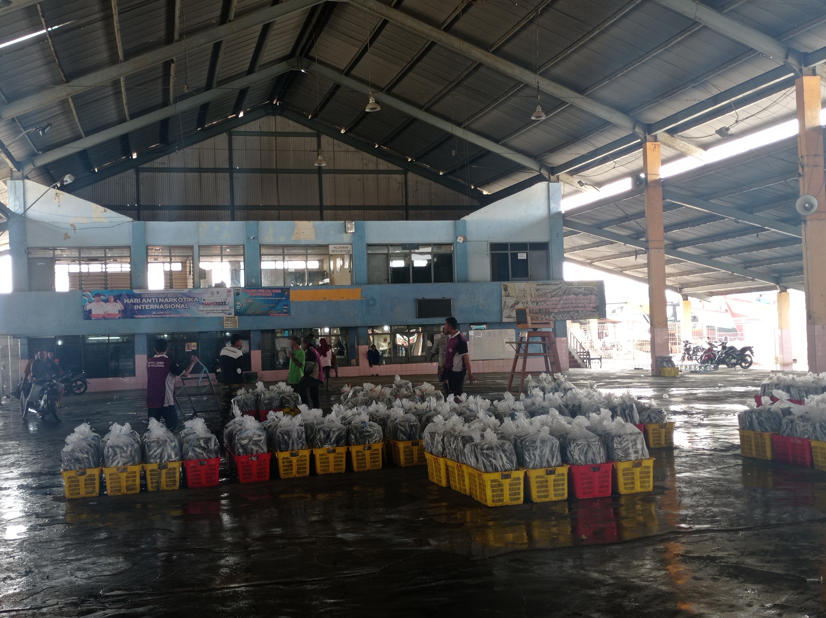
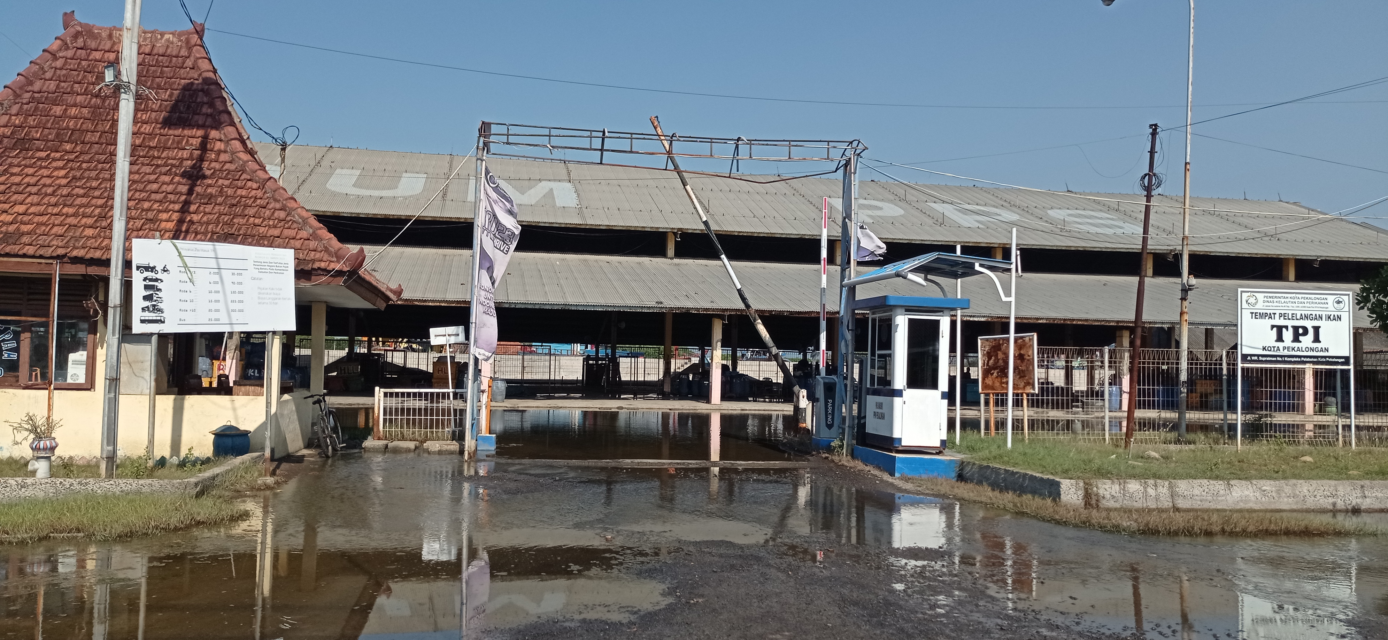
Kantor PPN Pekalongan
Bagian Dalam dan Luar TPI PPN Pekalongan
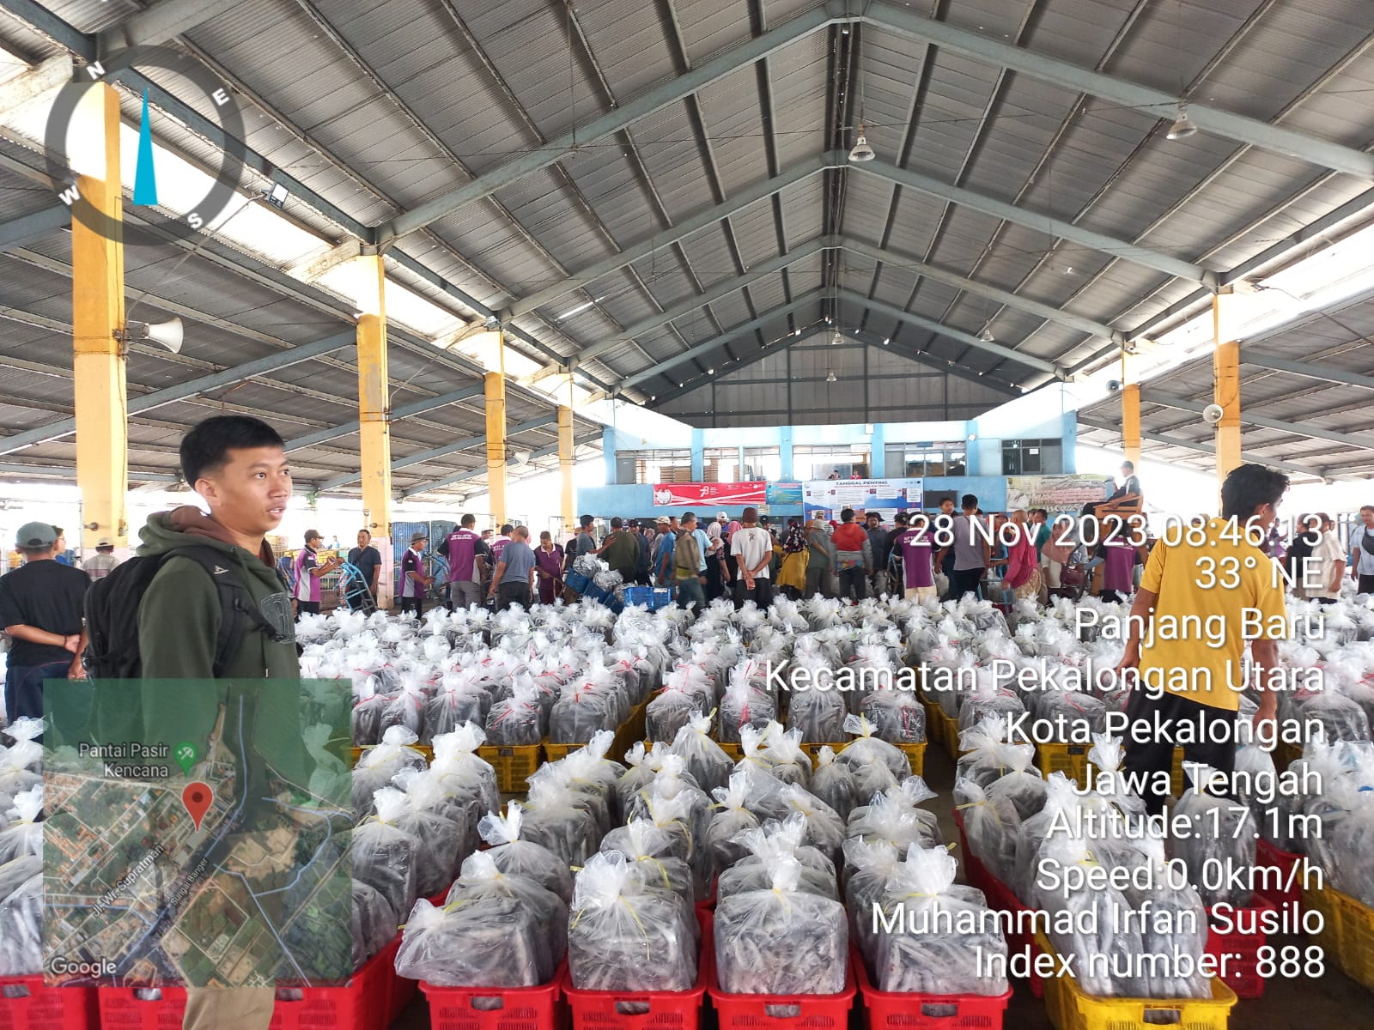
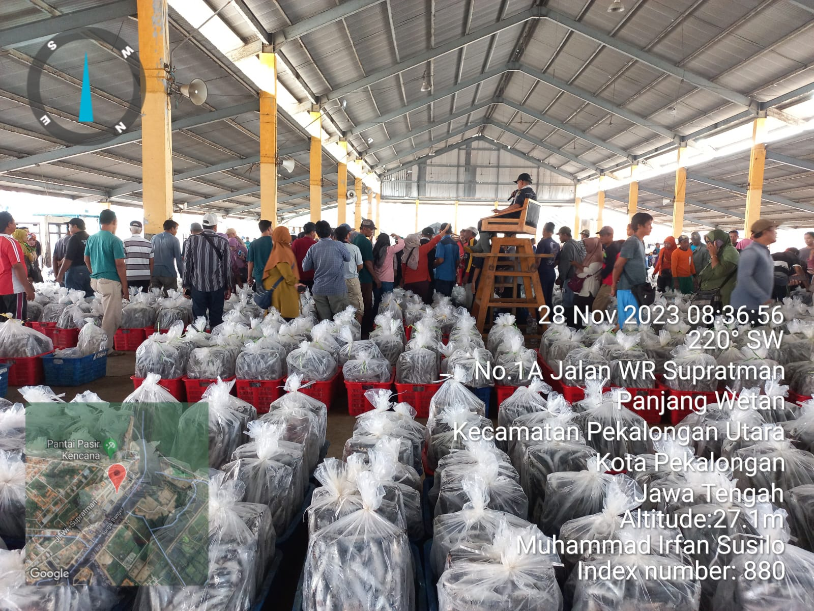
Hasil Tangkapan di PPN Pekalongan

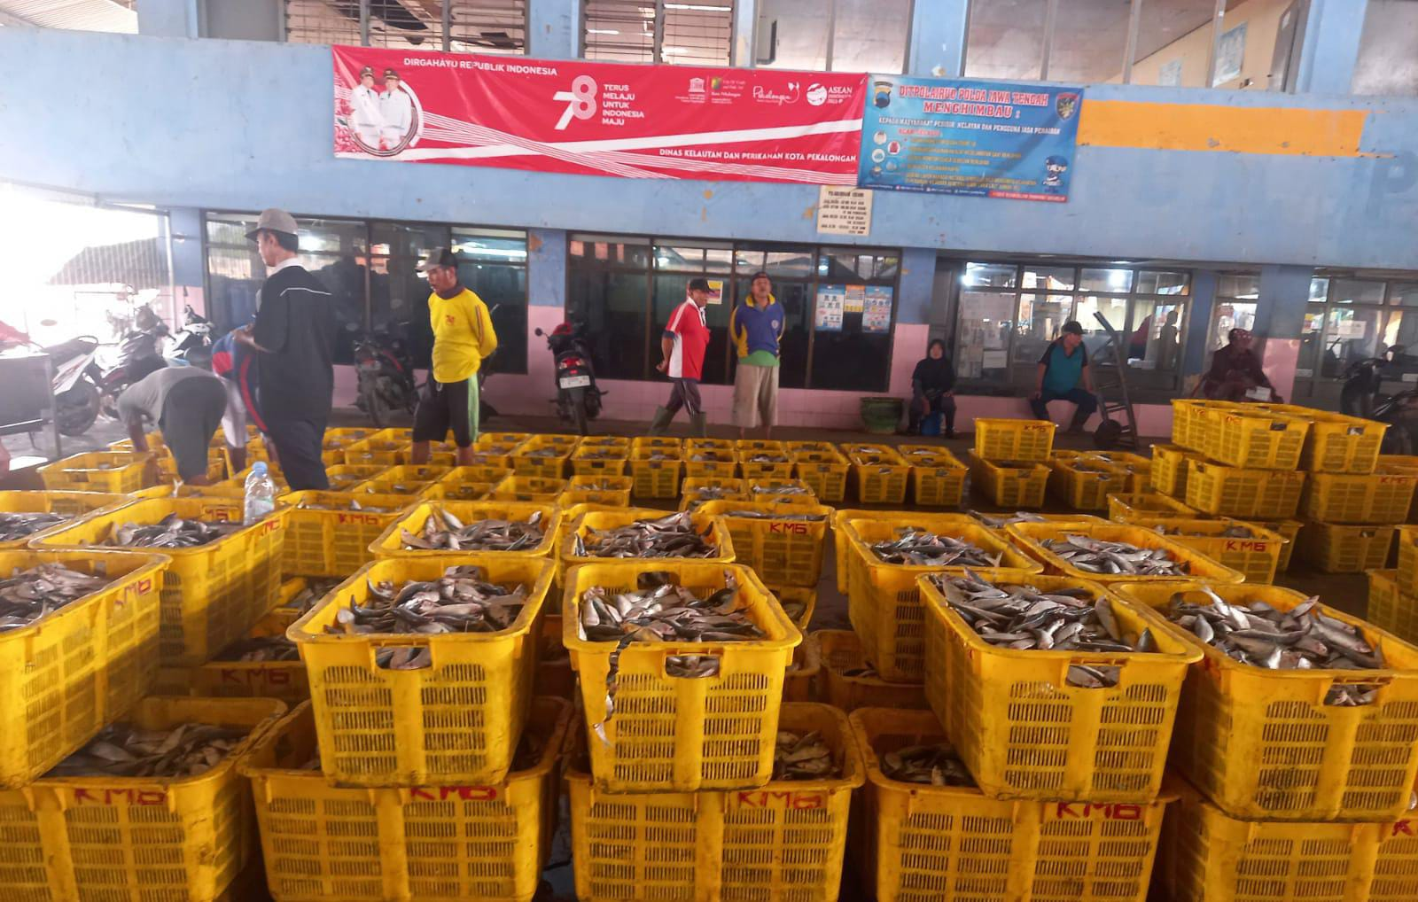
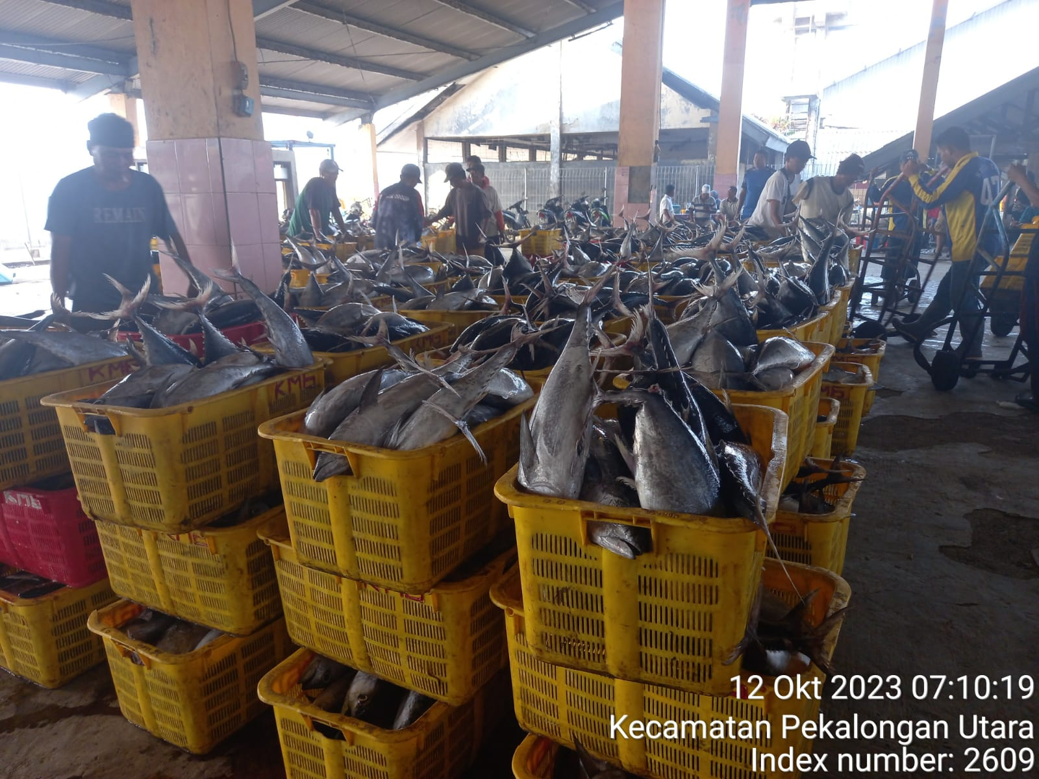
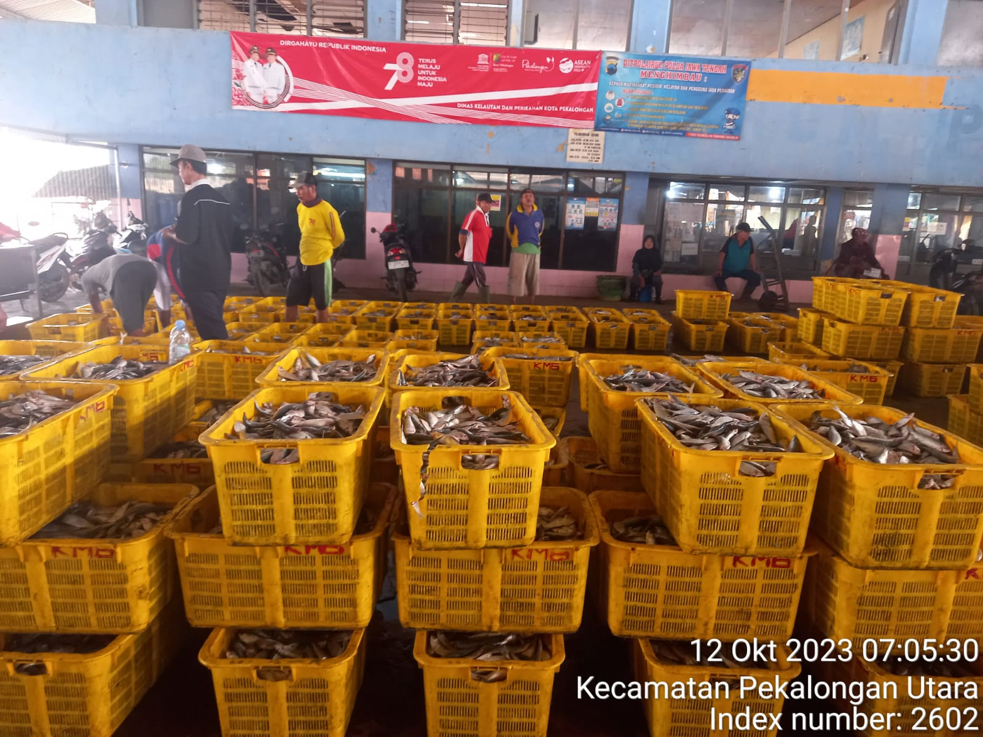
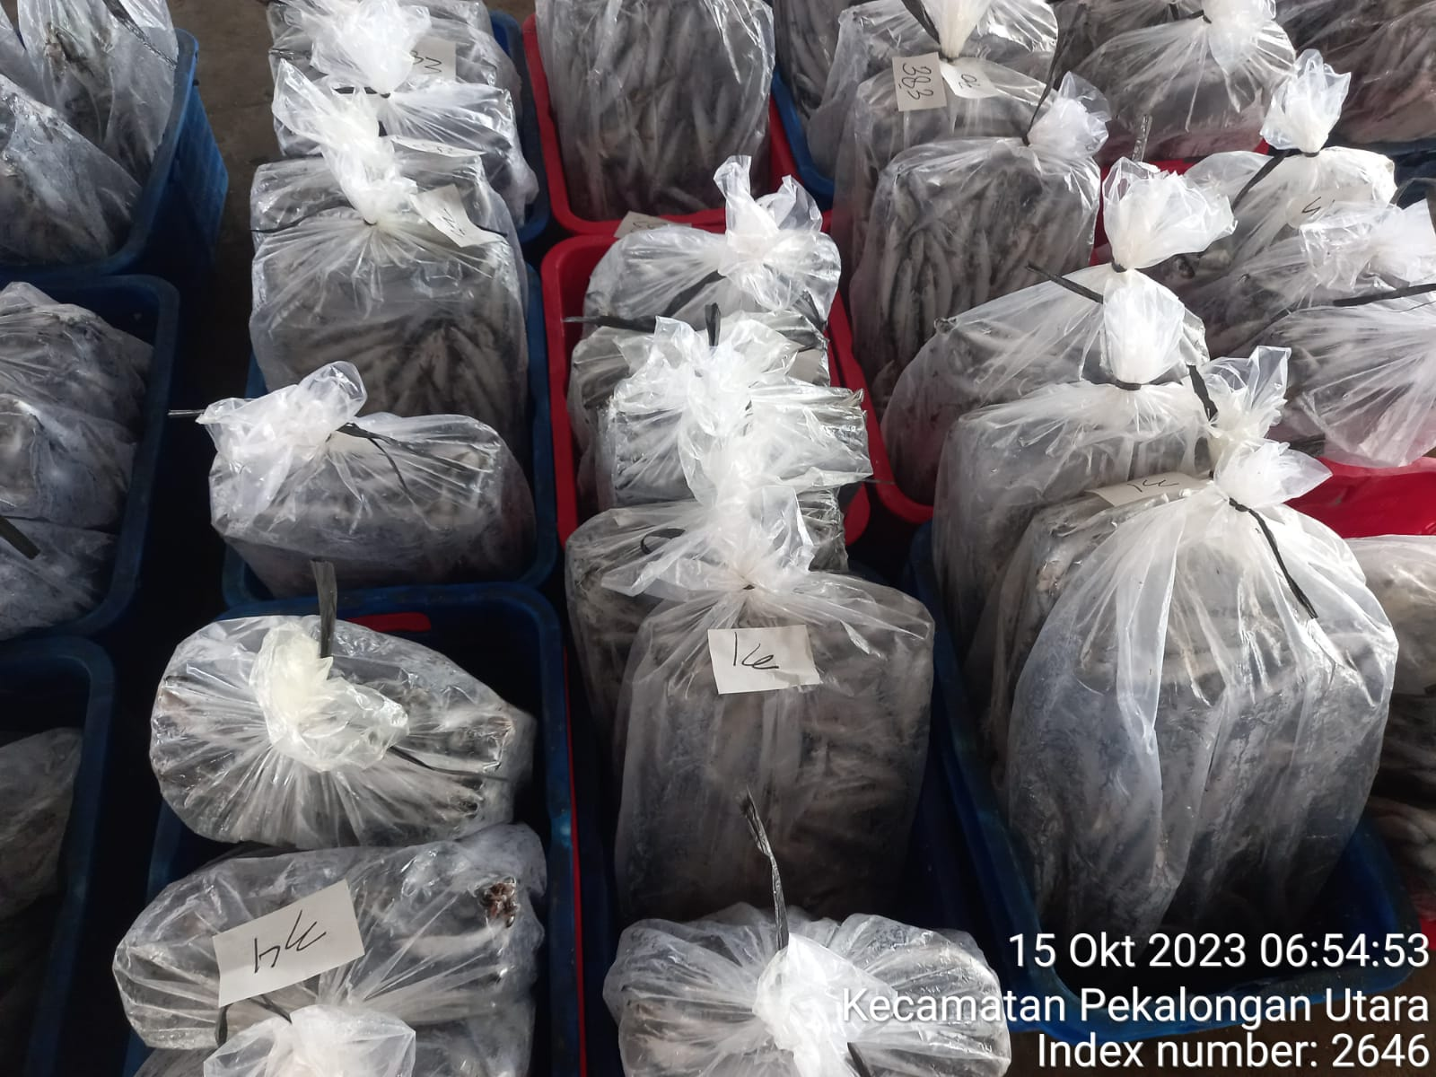
Hasil Tangkapan di PPN Pekalongan
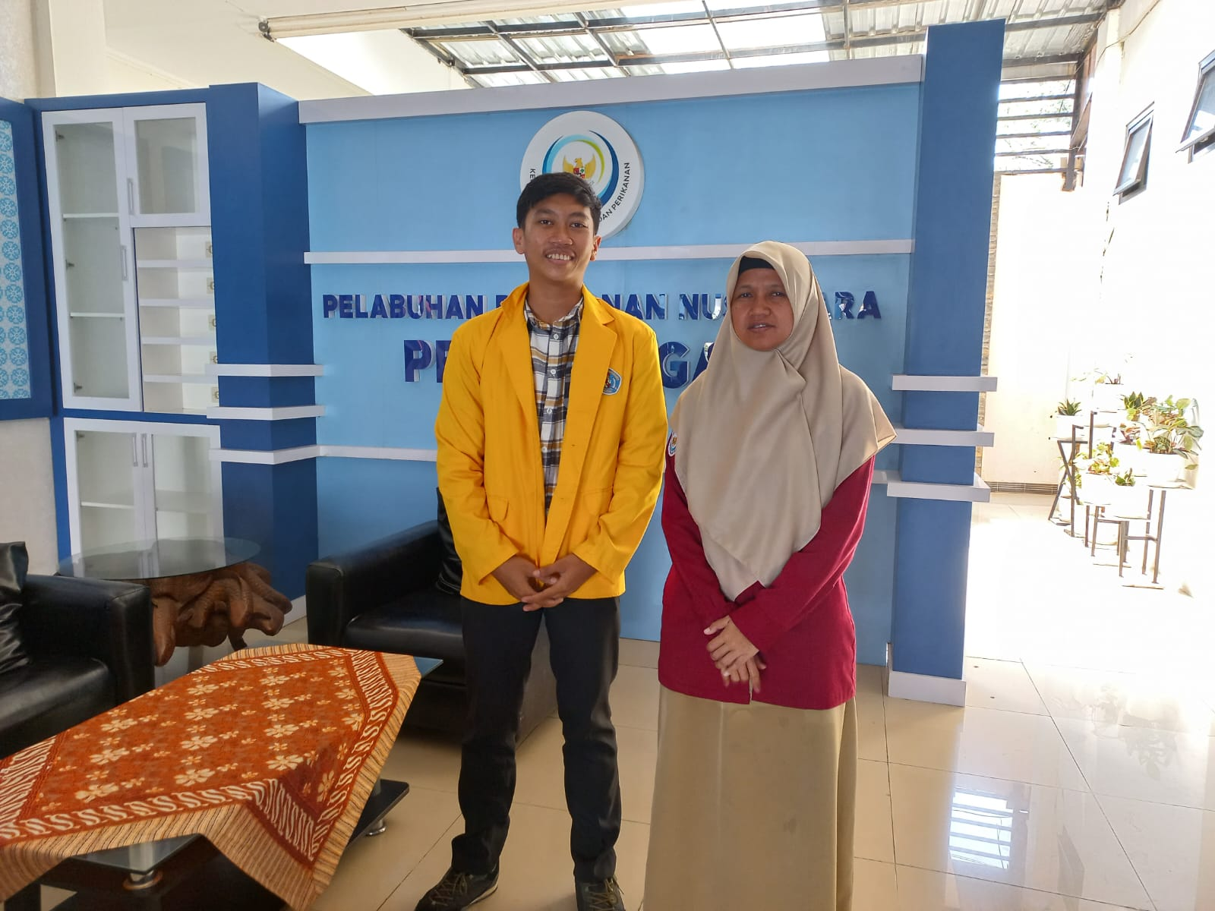
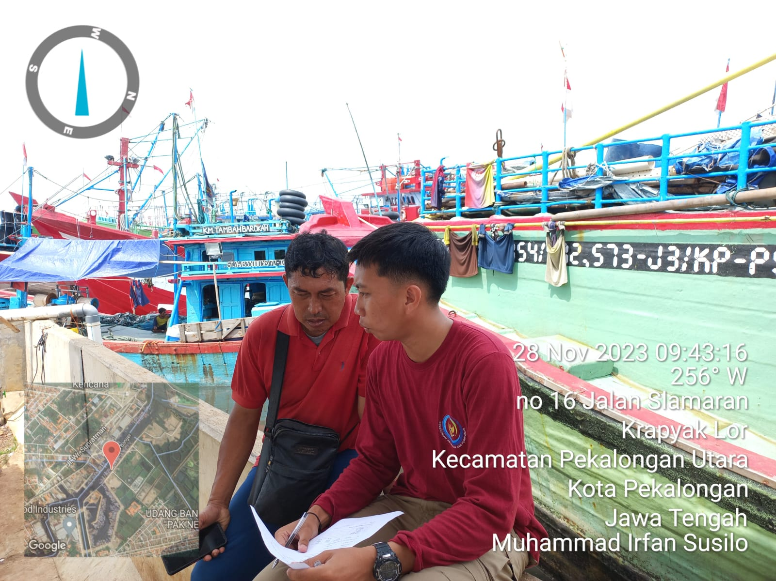
Dokumentasi Wawancara Penelitian

