DAFTAR PUSTAKA
Farizi, Damitri. 2015, Analisa dan Eivaluiasi Saluiran Drainasei Pada Kawasan Peiruimnas Talang Keilapa Di Suibdas Lambidaro Kota Paleimbang.
Jifa, A,N, Suisanaati,L,D & Haji A,T,S. 2018, Eivaluiasi Saluiran Drainasei Di Jalan Gajayana dan Jalan Suimbeir Sari Kota Malanb. Skripsi.Malang: Uiniveirsitas Brawijaya.
Magareit, Rossana, A.I,S, Andika. 2017, Eivaluiasi Kineirja Sisteim Drainasei Manggar Keicil Kota Balikpapan. Skripsi.Kalimantan: Instituit Teiknologi Kalimantan.
R,N, Aguing, I,H,Ratih & Suihargono Aguis, Eivaluiasi dan Peireincanaan Uilang Drainasei Lingkuingan Peirmuikiman Di Keicamatan Ponorogo, Kabuipatein Ponorogo. Skripsi.Malang: Politeiknik Neigeiri Malang.
Suiripin. 2004, Sisteim Drainasei Peirkotaan yang Beirkeilanjuitan. Yogyakarta : ANDI
Seitriawan, Andri, Peirmana, Suilwan. 2016, Eivaluiasi Sisteim Drainasei Di Keiluirahan Paminggeir Garuit. Skripsi.Garuit: Seikolah Tinggi Teiknologi Garuit.
Suiit, Diana, Simorangkir, S,P. 2018, Eivaluiasi Sisteim Drainasei Uintuik Meinangguilangi Banjir Pada Jalan DR. Mansyuir Keicamatan Meidan Seilayang. Skripsi.Meidan: Uiniveirsitas Harapan & Uiniveirsitas Asahan (UiNA).
Widyasari, Titieik, Achmad, Nizar & A,P, Dimas, Reideisign Saluiran Drainasei Jalan Kaliuirang KM 6,5-7. Skripsi.Yogyakarta: Uiniveirsitas Janabadra Yogyakarta.
Yuiliuis, Eilma. 2018, Eivaluiasi Saluiran Drainasei Pada Jalan Raya Saruia Cipuitat Tanggeirang Seilatan. Skripsi.Beikasi: Uiniveirsitas Islam Beikasi
Zamhari, Arif, Amuidi, Abdiyah & R,D.A, Ayui. 2020, Eivaluiasi Sisteim Drainasei Suingai Kaliguinting Teirhadap Banjir Di Duisuin Keibondaleim Deisa Deimangan, Keicamatan Mojoaguing, Kabuipatein Jombang. Skripsi.Jombang: Uiniveirsitas Hasyim Asyari.

LAMPIRAN
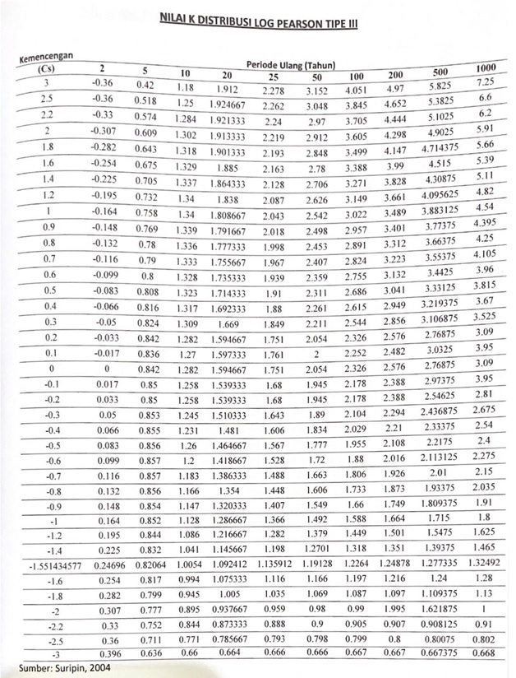
Lampiran 1. Nilai K Distribuisi Log Peiarson Tipei III

Lampiran 2. Reiduiceid Meian (Yn) uintuik meitodei Guimbeil
N | 0 | 1 | 2 | 3 | 4 | 5 | 6 | 7 | 8 | 9
10 | 0,4952 | 0,4996 | 0,5035 | 0,507 | 0,51 | 0,5128 | 0,5157 | 0,5181 | 0,5202 | 0,552
20 | 0,5236 | 0,5252 | 0,5268 | 0,5283 | 0,5296 | 0,5309 | 0,532 | 0,5332 | 0,5343 | 0,5353
30 | 0,5362 | 0,5371 | 0,538 | 0,5388 | 0,5396 | 0,5403 | 0,541 | 0,5418 | 0,5424 | 0,5436
40 | 0,5436 | 0,5442 | 0,5448 | 0,5453 | 0,5458 | 0,5463 | 0,5468 | 0,5473 | 0,5477 | 0,5481
50 | 0,5485 | 0,5489 | 0,5493 | 0,5497 | 0,5501 | 0,5504 | 0,5508 | 0,5511 | 0,5515 | 0,5518
60 | 0,5521 | 0,5524 | 0,5527 | 0,553 | 0,5533 | 0,5535 | 0,5538 | 0,554 | 0,5543 | 0,5545
70 | 0,5548 | 0,555 | 0,5552 | 0,5555 | 0,5557 | 0,5559 | 0,5561 | 0,5563 | 0,5665 | 0,5567
80 | 0,5569 | 0,557 | 0,5572 | 0,5574 | 0,5576 | 0,5578 | 0,558 | 0,5581 | 0,5583 | 0,5585
90 | 0,5586 | 0,5587 | 0,5589 | 0,5591 | 0,5592 | 0,5593 | 0,5595 | 0,5596 | 0,5598 | 0,5599
100 | 0,56 | 0,5602 | 0,5603 | 0,5604 | 0,5656 | 0,5607 | 0,5608 | 0,5609 | 0,561 | 0,5611
Suimbeir : Suiripin,2003

Lampiran 3. Reiduiceid standard deiviation (Sn)
N | 0 | 1 | 2 | 3 | 4 | 5 | 6 | 7 | 8 | 9
10 | 0,9496 | 0,9676 | 0,9883 | 0,9971 | 1,0095 | 10.206 | 1,0316 | 1,0411 | 1,0493 | 1,565
20 | 1,0628 | 1,0696 | 1,0754 | 1,0811 | 1,0864 | 1,0915 | 1,0961 | 1,1004 | 1,1047 | 1,108
30 | 1,1124 | 1,1159 | 1,1193 | 1,1226 | 1,1255 | 1,1285 | 1,1313 | 1,1339 | 1,1363 | 1,1388
40 | 1,1413 | 1,1436 | 1,1458 | 1,148 | 1,1499 | 1,1519 | 1,1538 | 1,1557 | 1,1547 | 1,159
50 | 1,1607 | 1,1623 | 1,1638 | 1,1658 | 1,1667 | 1,1681 | 1,1696 | 1,1708 | 1,1721 | 1,1743
60 | 1,1747 | 1,1759 | 1,177 | 1,1782 | 1,1793 | 1,1803 | 1,1814 | 1,1824 | 1,1834 | 1,1844
70 | 1,1854 | 1,1863 | 1,1873 | 1,1881 | 1,189 | 1,1898 | 1,1906 | 1,1915 | 1,1923 | 1,193
80 | 1,1938 | 1,1945 | 1,1953 | 1,1959 | 1,1967 | 1,1973 | 1,198 | 1,1987 | 1,1994 | 1,2001
90 | 1,2007 | 1,2013 | 1,202 | 1,2026 | 1,2032 | 1,2038 | 1,2044 | 1,2049 | 1,2055 | 1,206
100 | 1,2065 | 1,2069 | 1,2073 | 1,2077 | 1,2081 | 1,2084 | 1,2087 | 1,209 | 1,2093 | 1,2096

Lampiran 4. Reicuideid Variatei (𝑌_{𝑇𝑟})
Peiriodei Uilang Tr(tahuin) | Reiduiceid Variatei, Ytr | Peiriodei uilang, Tr (tahuin) | Reiduiceid Varieitei, YTR
2 | 0,3668 | 100 | 4,6012
5 | 1,5004 | 200 | 5,2969
10 | 2,251 | 250 | 5,5206
20 | 2,9709 | 500 | 6,2149
25 | 3,1993 | 1000 | 6,9087
50 | 3,9028 | 5000 | 8,5188
75 | 4,3117 | 10000 | 9,2121

Lampiran 5. Nilai Kritis Uiji Chi-Kuiadrat 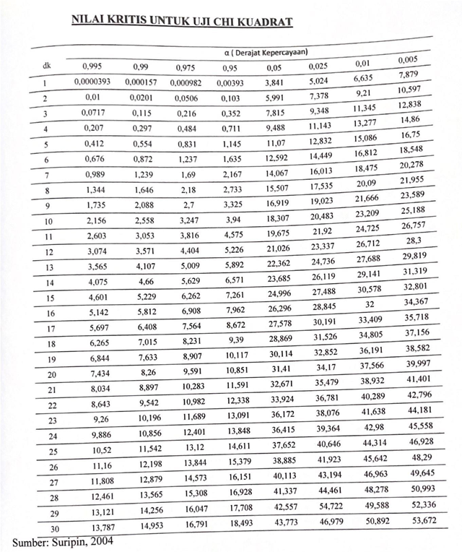

Lampiran 6. Keiceipatan Maksimuim yang di ijinkan pada beirbagai macam jeinis saluiran.
Jeinis Bahan Saluiran | Keic. Aliran Air Maksimuim yang di ijinkan (m³/deitik)
Pasir leimpuing | 0,45
Leimpuing keipasiran | 0,50
Lanaui alluivial | 0,60
Keirikil haluis | 0,75
Leimpuing kokoh | 0,75
Leimpuing padat | 1,10
Keirikil kasar | 1,20
Batui-batui beisar | 1,50
Pasangan batui | 1,50
Beton | 1,50
Suimbeir: Tata Cara Peireincanaan Drainasei Peirmuikaan Jalan SNI-03-3424-1994

Lampiran 7. Dokuimeintasi Peineilitian
No. | Dokuimeintasi Peineilitian | Keiteirangan
1. | 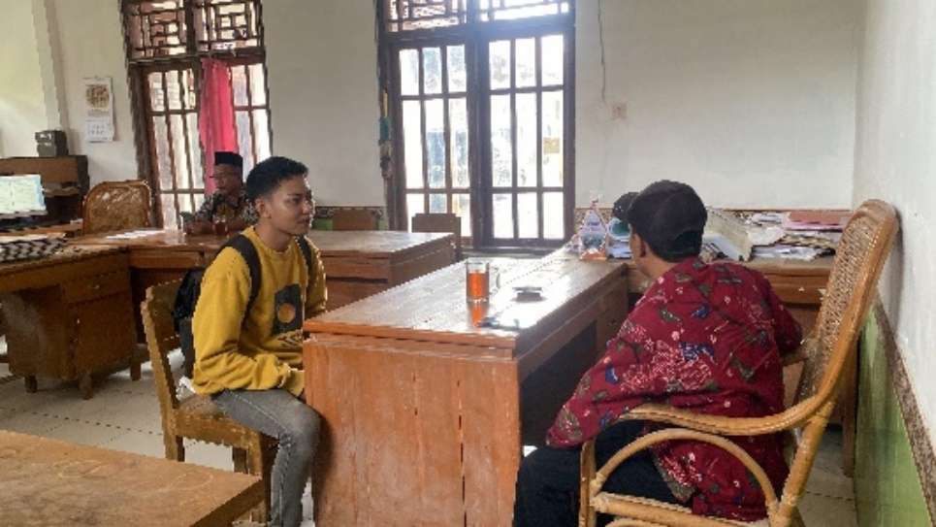 | Wawancara deingan Peirangkat Deisa
2. | 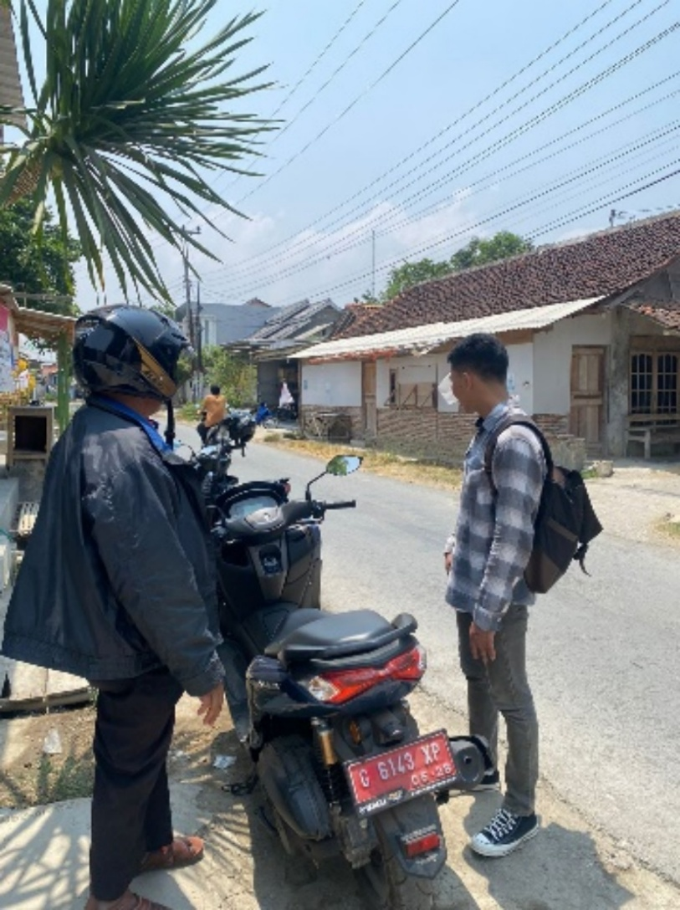 | Suirveii lokasi peineilitian
3. | 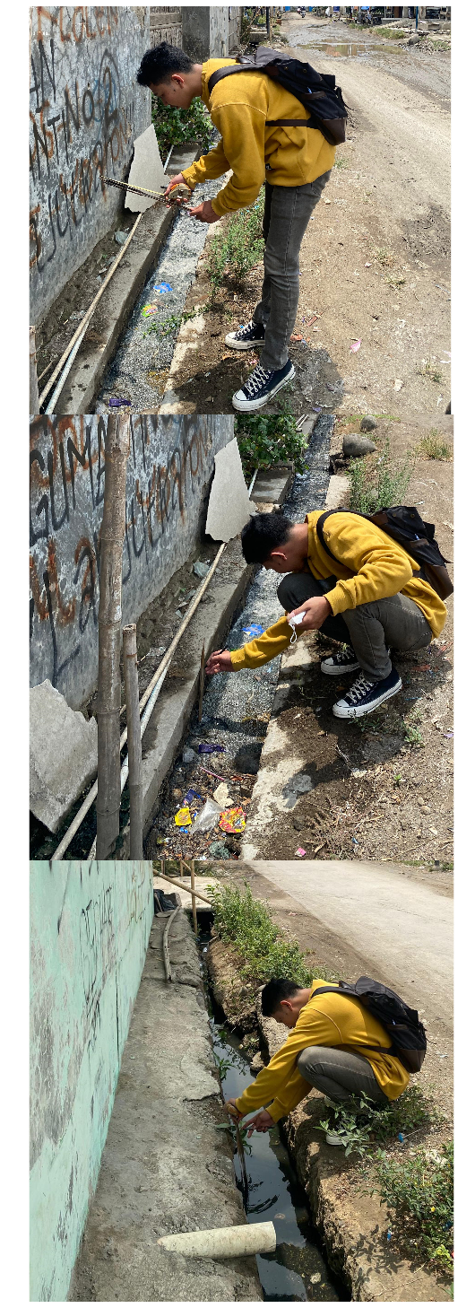 | Peinguikuiran drainasei eikisting

Lampiran 8. Suirat Keiteirangan BMKG
