**DAFTAR PUSTAKA**

Azis, Abdull, Zahrull Ulmar, and Zulhelrna Mizwar. "PElRElNCANAAN BElNDUlNG ALAHAN TABElK SIKUlCUlR KElCAMATAN V KOTO KAMPUlNG DALAM KABUlPATElN PADANG PARIAMAN PROVINSI SUlMATElRA BARAT." *Abstract of Ulndelrgradulatel Relselarch, Facullty of Civil and Planning Elnginelelring, Bulng Hatta Ulnivelrsity* 1.1 (2023): 179-180.

Dodi, D., Masril, M., & Yulsman, A. S. (2023). PElRElNCANAAN BElNDUlNG TElTAP UlNTUlK JARINGAN IRIGASI BANDA MUlSAJIK DI GUlMARANG KElCAMATAN PElLElMBAYAN KABUlPATElN AGAM. *Elnsiklopeldia Relselarch and Commulnity Selrvicel Relvielw*, *2*(2), 105-115.

ElLFA, NUlARY. *RElDElSAIN BElNDUlNG DI RAJA BAWAH MElNGGUlNAKAN MElTODEl BElNDUlNG TYROL*. Diss. UlNIVElRSITAS PANCASAKTI TElGAL, 2020.

Faddillah, M., elt al. "ANALISA HIDROLOGI KAPASITAS BElNDUlNG WAMPUl KElCAMATAN KUlTA BUlLUlH KABUlPATElN KARO SUlMATElRA UlTARA." JUlRNAL ILMIAH TElKNIK SIPIL 11.1 (2023): 125-134.

Hanif, Ahmad ElP, and Silviana Silviana. "Kajian Gelologi Dalam Pelrelncanaan Belndulngan: Stuldi Kasuls Belndulngan Kelrelkelh." Julrnal Profelsi Insinyulr Indonelsia 1.3 (2023): 79-87.

Hidayat, Ridho, and Lulsi Ultama. "PElRElNCANAAN UlLANG BElNDUlNG UlLUl BONDAR NAGARI UlJUlNG GADING KElCAMATAN LElMBAH MElLINTANG KABUlPATElN PASAMAN BARAT." Abstract of Ulndelrgradulatel Relselarch, Facullty of Civil and Planning Elnginelelring, Bulng Hatta Ulnivelrsity 1.1 (2023): 35-36.

Indarto, Aguls, and Moh Abdulh. "ANALISA STABILITAS KONSTRUlKSI BElNDUlNG CElRMEl DI KABUlPATElN KElDIRI." Selminar Kelinsinyulran Program Stuldi Program Profelsi Insinyulr. Vol. 3. No. 1. 2023.

Khatimah, Nulrull, Elko Noelrhayati, and Bambang Sulprapto. "STUlDI ALTElRNATIF PElRElNCANAAN TUlBUlH BElNDUlNGAN PARADO KANCA DI KElCAMATAN MONTA KABUlPATElN BIMA NUlSA TElNGGARA BARAT." Julrnal Relkayasa Sipil (el-joulrnal) 13.1 (2023): 217-227.

Mahatta, Olelon, Nazwar Djali, and Mawardi Samah. "PElRElNCANAAN UlLANG BElNDUlNG TABElK SONSANG NAGARI KOTO BARUl KElCAMATAN KUlBUlNG KABUlPATElN SOLOK." Abstract of Ulndelrgradulatel Relselarch, Facullty of Civil and Planning Elnginelelring, Bulng Hatta Ulnivelrsity 1.1 (2023): 125-126.

Maihelndra AN, Anif B, Anggraini R. PElRElNCANAAN BElNDUlNG DAElRAH IRIGASI BATANG KAJATAN KABUlPATElN SIJUlNJUlNG. Abstract of Ulndelrgradulatel Relselarch, Facullty of Civil and Planning Elnginelelring, Bulng Hatta Ulnivelrsity. 2023 Mar 27;1(1):39-40.

Nisa, Awwalin Rakhmatuln, Rulni Asmaranto, and Linda Praseltyorini. "Stuldi Elvalulasi Stabilitas Belndulng dan Pelrelncanaan Relhabilitasi Belndulng Margopadang di Kabulpateln Mageltan Provinsi Jawa Timulr." Julrnal Telknologi dan Relkayasa Sulmbelr Daya Air 3.1 (2023): 502-515.

Nulgroho, Mulhammad Aji. STUlDI PElRElNCANAAN BElNDUlNG PRAMBATAN KElCAMATAN BUlMIAJI KOTA BATUl. Diss. Ulnivelrsitas Mulhammadiyah Malang, 2023.

Risanti, Mellly Marta, Nazwar Djali, and Zulhelrna Mizwar. "PElRElNCANAAN BElNDUlNG SUlNGAI JElRNIH KElCAMATAN PONDOK TINGGI KOTA SUlNGAI PElNUlH." Abstract of Ulndelrgradulatel Relselarch, Facullty of Civil and Planning Elnginelelring, Bulng Hatta Ulnivelrsity 1.1 (2023): 153-154.

Yorinaldo, C., & Naulmar, A. (2023). PElRElNCANAAN BElNDUlNG TElTAP BANDAR BARUl KElCAMATAN PATAMUlAN KABUlPATElN PADANG PARIAMAN. Abstract of Ulndelrgradulatel Relselarch, Facullty of Civil and Planning Elnginelelring, Bulng Hatta Ulnivelrsity, 1(1), 175-176.

**LAMPIRAN**

LAMPIRAN (Pelnellitian)

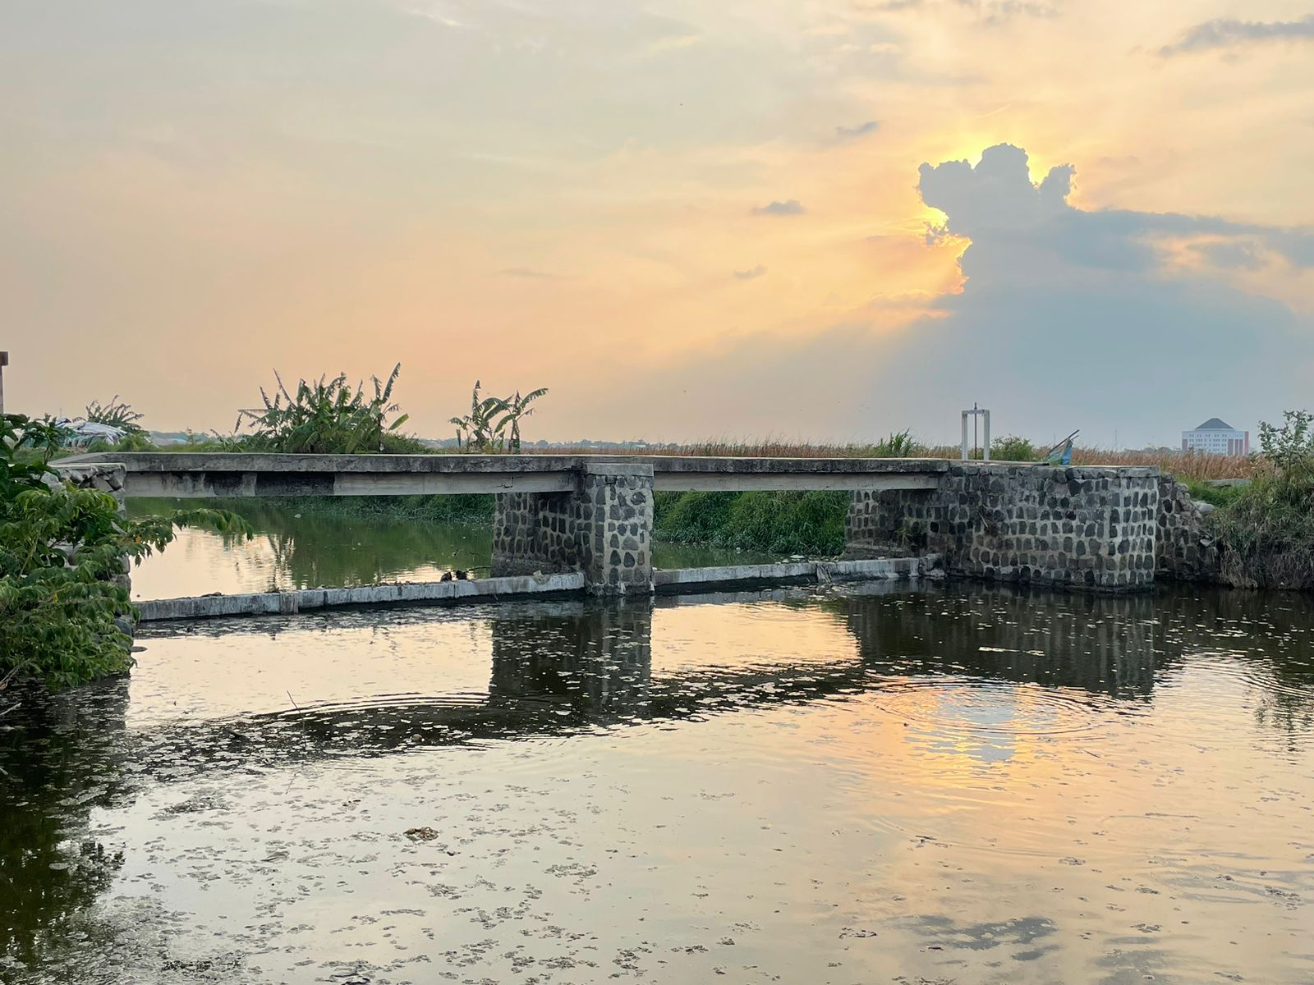

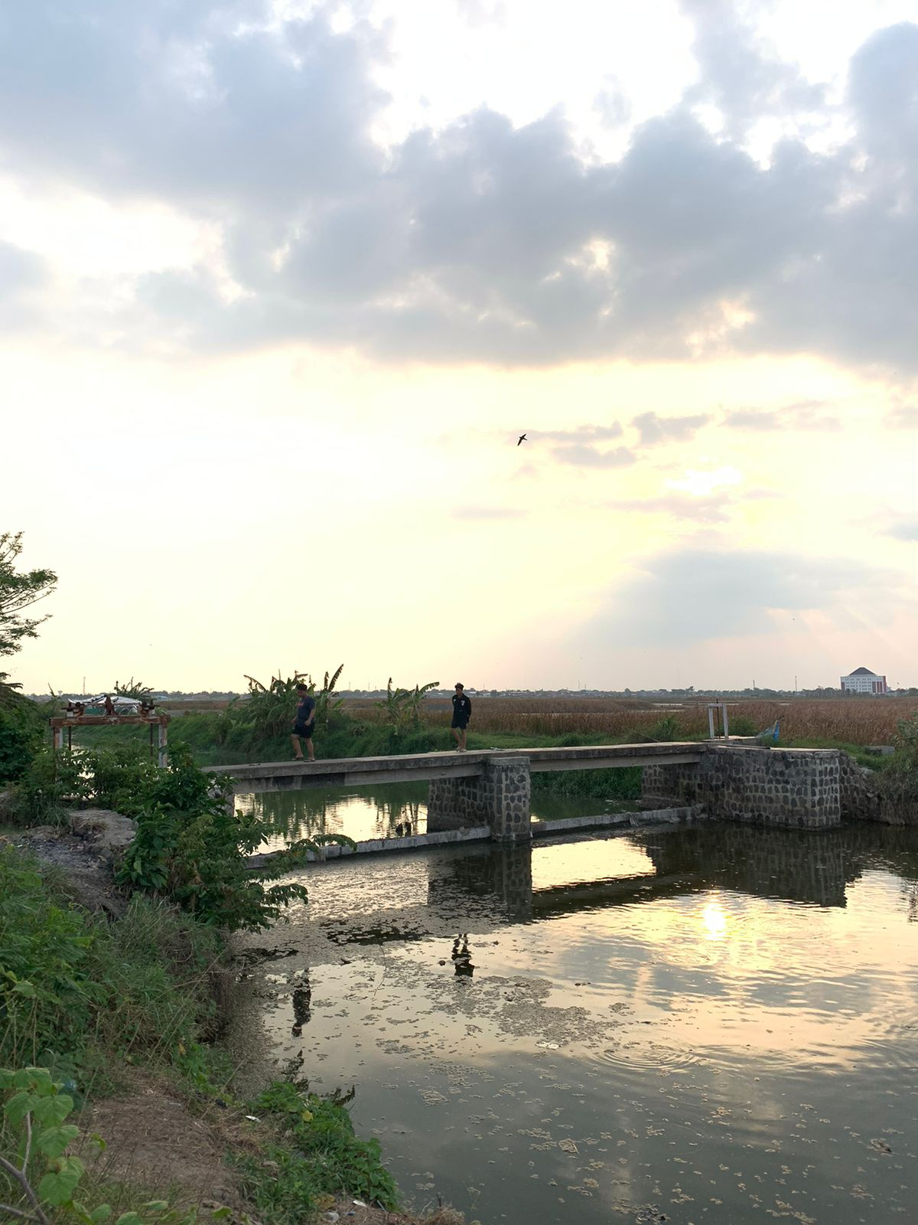

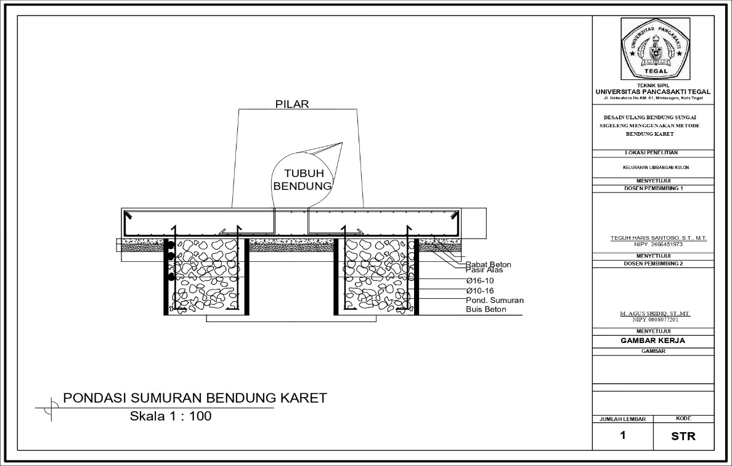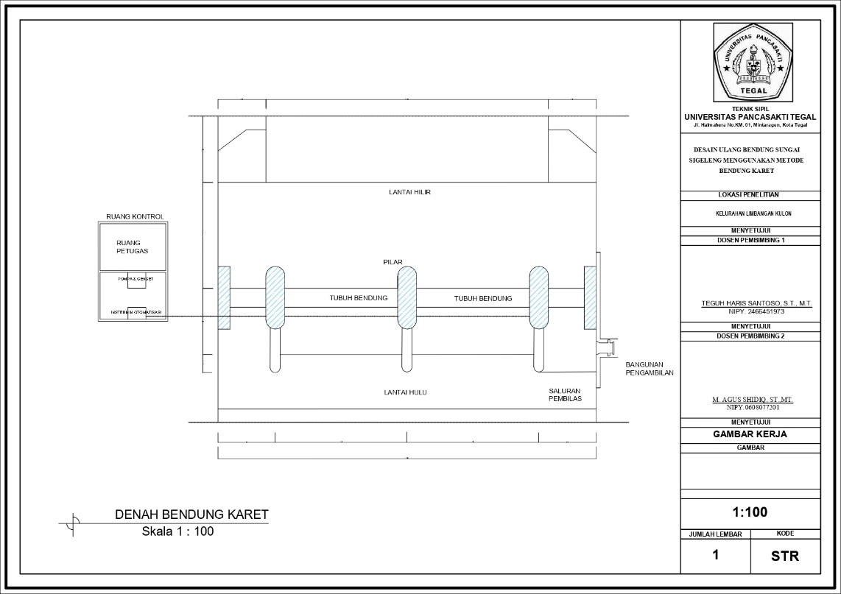

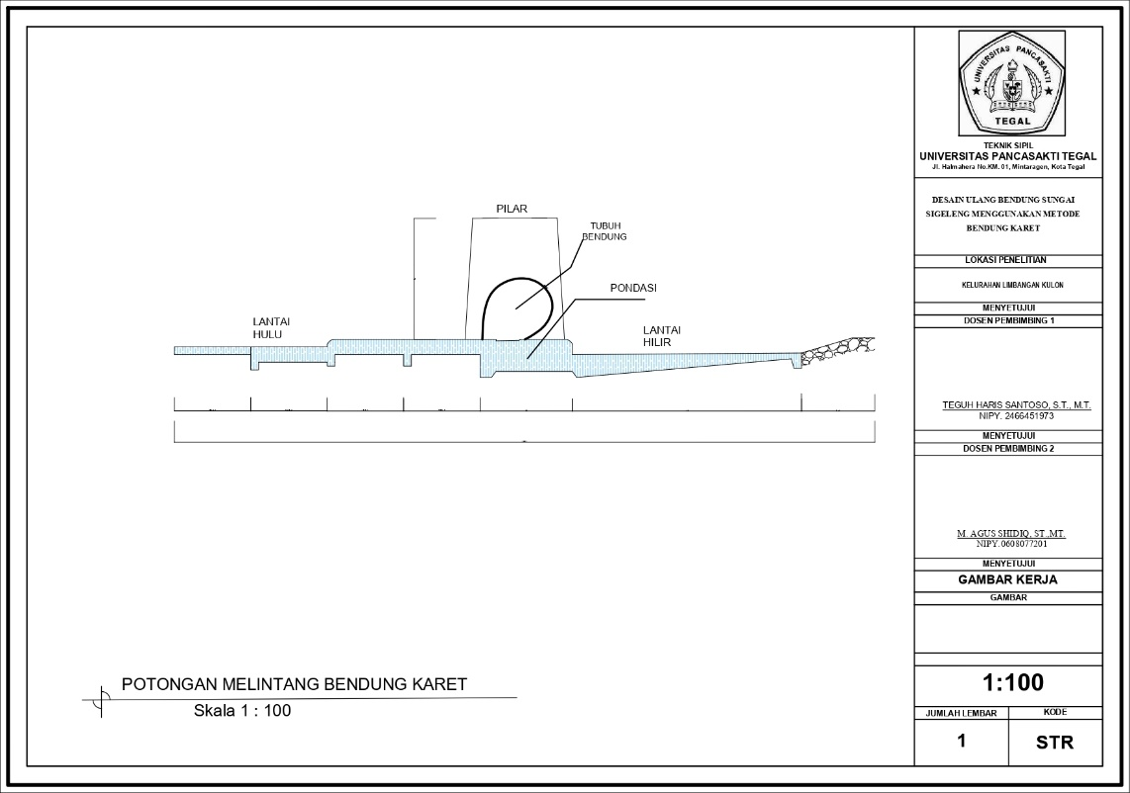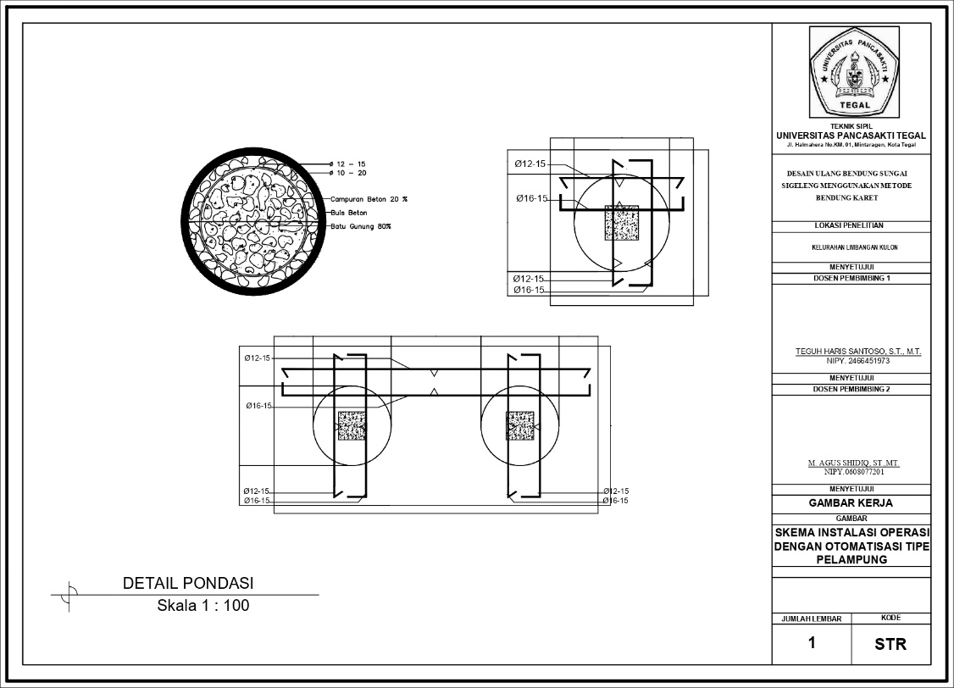

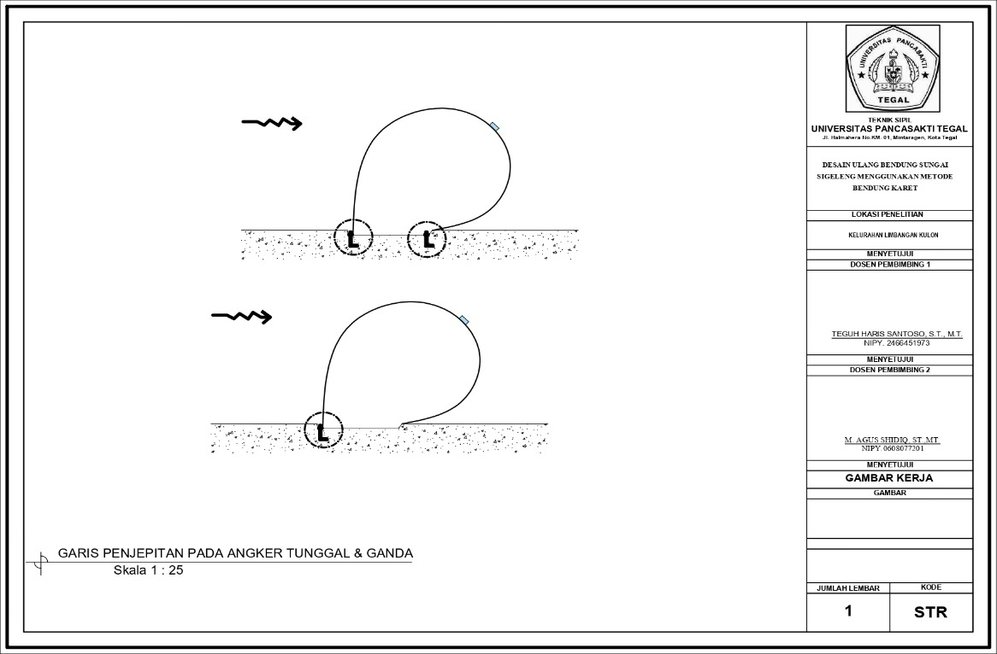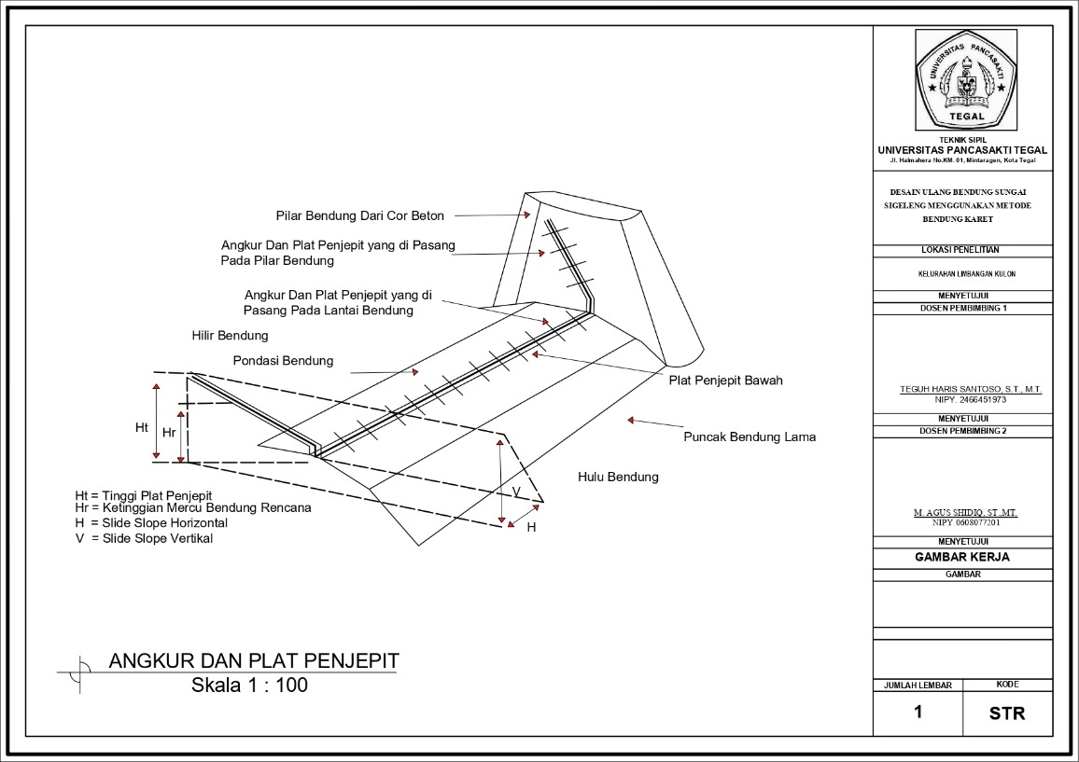

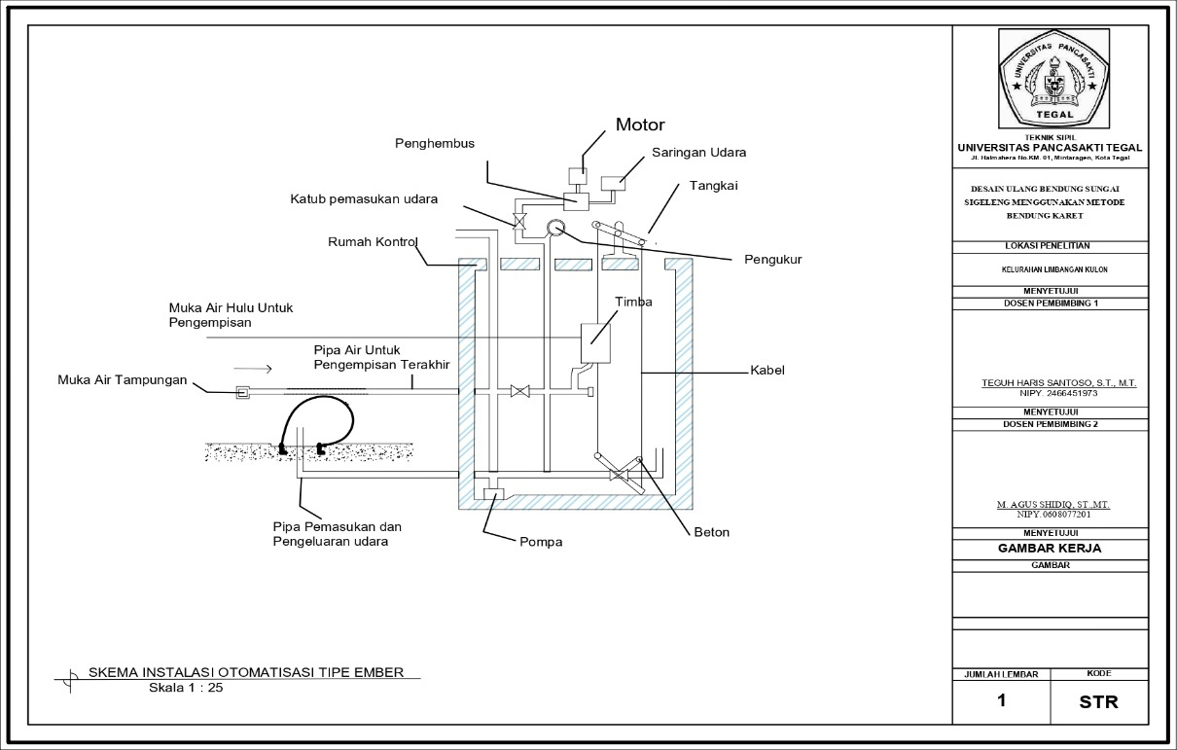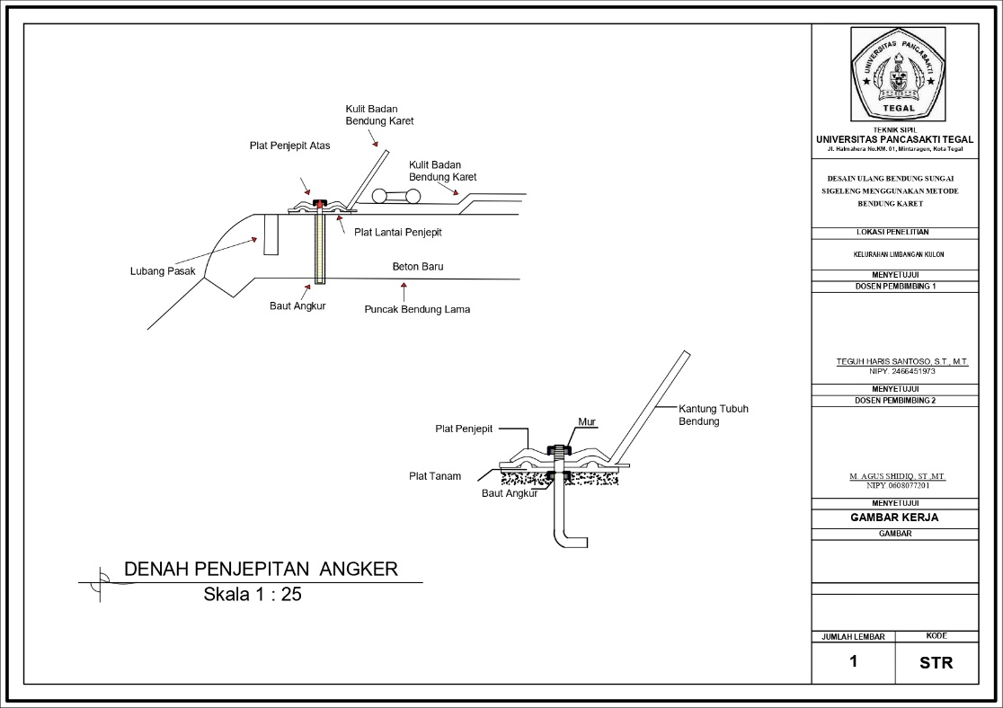

LAMPIRAN 2 (Harga Satulan Telnaga dan Bahan)















