DAFTAR PUSTAKA

Alfarisa, F., & Purnama, D. N. 2019. Analisis Butir Soal Ulangan Akhir Semester Mata Pelajaran Ekonomi SMA Menggunakan RASCH Model. Journal Undiksha. 11(2).
Amalia, N. F., & Susilaningsih, E. 2014. Pengembangan Instrumen Penilaian Keterampilan Berpikir Kritis Siswa SMA pada Materi Asam Basa. Jurnal Inovasi Pendidikan Kimia, 8(2), 1380–1389.
Azwar, Sandhyavitri, A., Maulana, A., Ikhsan, M., Putra, A. I., Husaini, R. R., Restuhadi, F., Misra, I., Hakim, S., Pramana, A., Putera, I. G., Harmayani, K., Putra, I. G., Robert, B., Brown, E. B., Yusa, M., Sandyavitri, A., Sutikno, S., Pertiwi, I. G. A. I. M., … Christie, O. 2021. SIGNIFIKAN ATAU SANGAT SIGNIFIKAN? Procedia Engineering, 6(1), 657–664.
Facione, P. a. 2011. Critical Thinking : What It Is and Why It Counts. Insight Assessment, ISBN 13: 978-1-891557-07-1., 1–28.
Fristadi, R., & Bharata, H. 2015. Meningkatkan Kemampuan Berpikir Kritis Siswa Dengan Problem Based Learning. Seminar Nasional Matematika Dan Pendidikan Matematika UNY 2015, 597–602.
Hatiku, F., Umar, M. K., Supartin, S., Yusuf, M., Odja, A. H., & Payu, C. S. (2022). The Use of PowerPoint and Video as Learning Media in Online Learning and Physics Learning Outcomes in High School. Jurnal Pendidikan Fisika Dan Teknologi, 8(2), 176-183.
Juhji, & Suardi, A. 2018. Profesi Guru dalam Mengembangkan Kemampuan Berpikir Kritis Peserta Didik di Era Globalisasi. Jurnal Genealogi PAI, 5(1), 16–24.
Mulyatiningsih, E. 2015. PENGEMBANGAN MODEL PEMBELAJARAN Endang. Islamic Education Journal, 35,110,114,120,121.
Palimbong, J., Mujasam, M., & Allo, A. Y. T. 2019. Item Analysis Using Rasch Model in Semester Final Exam Evaluation Study Subject in Physics Class X TKJ SMK Negeri 2 Manokwari. Kasuari: Physics Education Journal (KPEJ), 1(1), 43–51.
Patonah, S. 2014. Elemen bernalar tujuan pada pembelajaran ipa melalui pendekatan metakognitif siswa SMP. Jurnal Pendidikan IPA Indonesia, 3(2), 128–133.
Ramdani, A., Jufri, A. W., Jamaluddin, J., & Setiadi, D. 2020. Kemampuan Berpikir Kritis dan Penguasaan Konsep Dasar IPA Peserta Didik. Jurnal Penelitian Pendidikan IPA, 6(1), 119.
Ravand, H., & Firoozi, T. 2016. Examining construct validity of the master’s ueeusing the Rasch model and the six aspects of the Messick’s framework. International Journal of Language Testing, 6(1), 1–23.
Ritdamaya, D., & Suhandi, A. 2016. Konstruksi Instrumen Tes Keterampilan Berpikir Kritis Terkait Materi Suhu dan Kalor. Jurnal Penelitian & Pengembangan Pendidikan Fisika, 02(2), 87–96.
Sadewa, M. A. 2022. Meninjau kurikulum prototipe melalui pendekatan integrasi-interkoneksi Prof M Amin Abdullah. Jurnal Pendidikan Dan Konseling (JPDK), 4(1), 266–280.
Sugiyono, S., Sutarman, S., & Rochmadi, T. 2019. Pengembangan Sistem Computer Based Test (Cbt) Tingkat Sekolah. Indonesian Journal of Business Intelligence (IJUBI), 2(1), 1.
Susongko, P. 2019. Asesmen Kompetensi 4 C ( Communication, Collaboration , Crithical Thinking & Problem Solving , Creative & Innovative ) Terintegrasi Dengan Literasi Sains Bagi Siswa SMA Program MIPA. 1–16.
Susongko, P., & Fatkhurrahman, M. A. 2017. Determinants Factors Analysis of Indonesian Students� Physics Achievement in Timss 2011. Jurnal Pendidikan Fisika Indonesia, 13(1), 49–58.
Susongko, P., Nisa, K., & Budi Utami, W. 2017. PENYUSUNAN SKALA MINAT BELAJAR MATEMATIKA DENGAN PENERAPAN MODEL RASCH (Studi Pengembangan Pada Pembelajaran Matematika Kelas VII di SMP Negeri 1 Tarub Tahun Ajaran 2016/2017). JPMP (Jurnal Pendidikan MIPA Pancasakti), 1(1), 58–64.
Suprayitno, T. (2019). Pendidikan di Indonesia: belajar dari hasil PISA 2018.
Umar Faruq, M. M. H. 2020. Bahasa Arab berbasis Peningkatan Pembelajaran HOTS (Higher Order Thinking Skills)(Kajian Pembelajaran Bahasa Arab di Madrasah Aliyah Unggulan Darul ’Ulum Step 2 Kemenag RI). Al-Hikmah: Jurnal Kependidikan, 8(Maret), 1–20.
Wenning, C. J., & Vierya, R. 2015. Teaching High School Physics: Interacting with Physics Students. AIP Publishing LLC.
Zubaidah, S. 2018. Mengenal 4C: Learning and Innovation Skills untuk Menghadapi Era Revolusi Industri 4.0. 2nd Science Education National Conference, October 2018, 1–18.

LAMPIRAN
Lampiran 1 Surat Ijin Penelitian

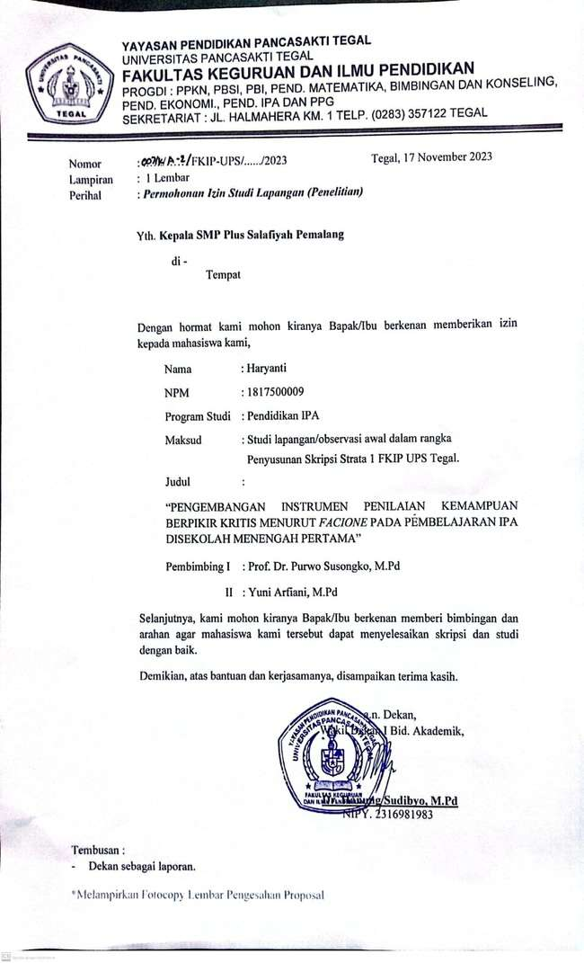
Lampiran 2 Surat Keterangan Selesai Penelitian

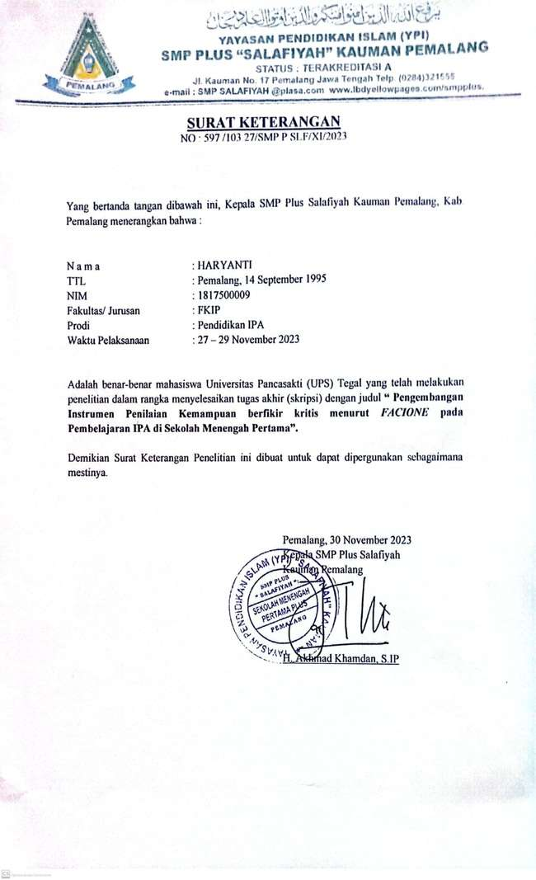

Lampiran 3 Penelitian Lembar Kisi-kisi Pengembangan Instrumen Penilaian Kemampuan Berpikir Kritis Menurut Facione di Sekolah Menengah Pertama

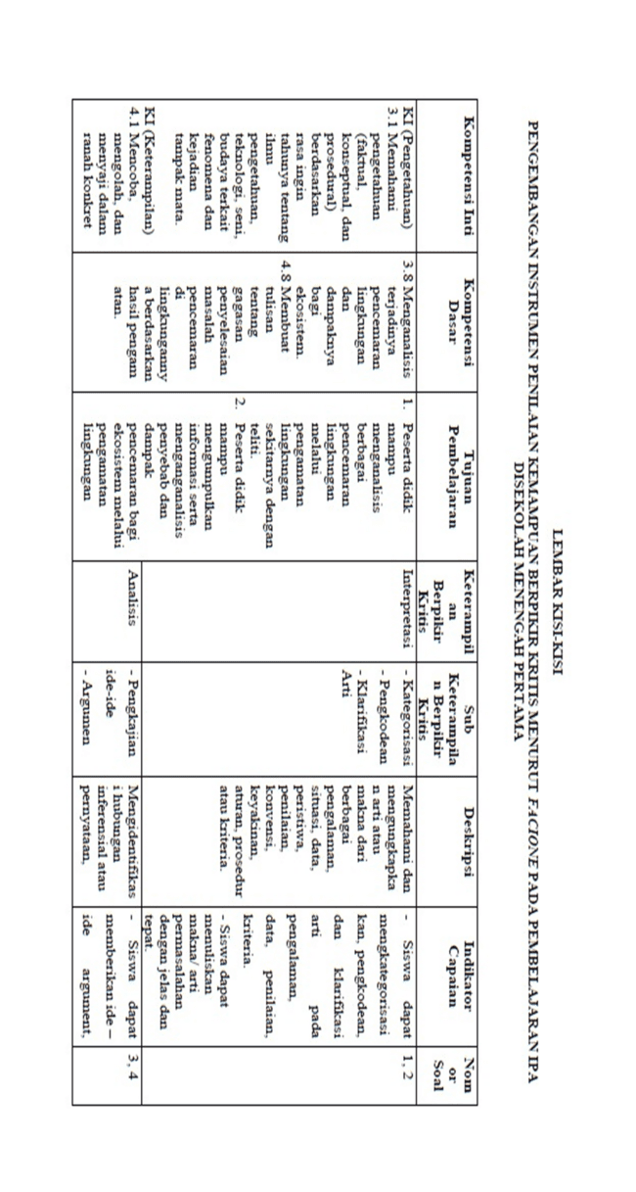
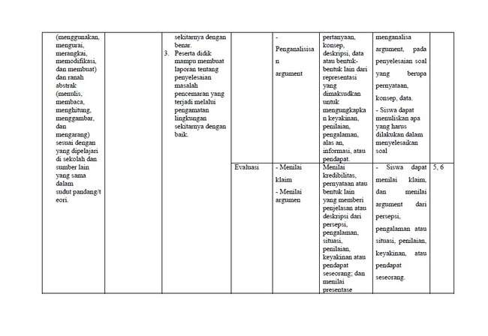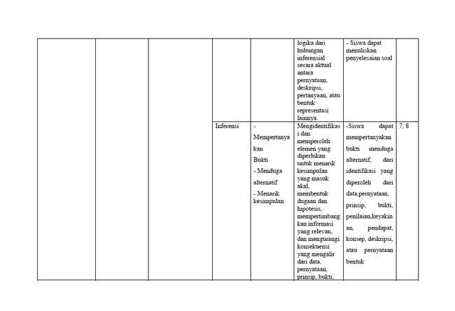

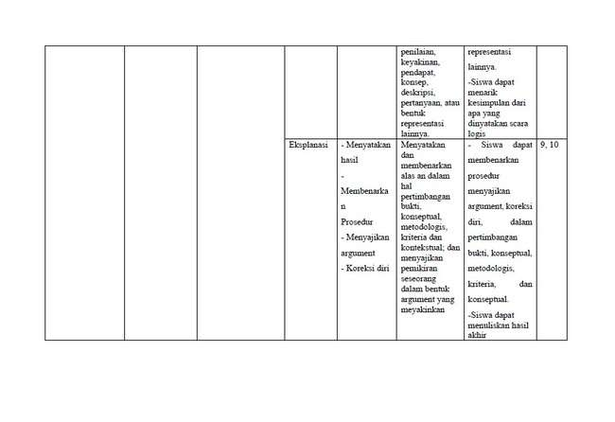
Lampiran 4 Lembar Instrumen Pengembangan Instrumen Penilaian Kemampuan Berpikir Kritis Menurut Facione di Sekolah Menengah Pertama

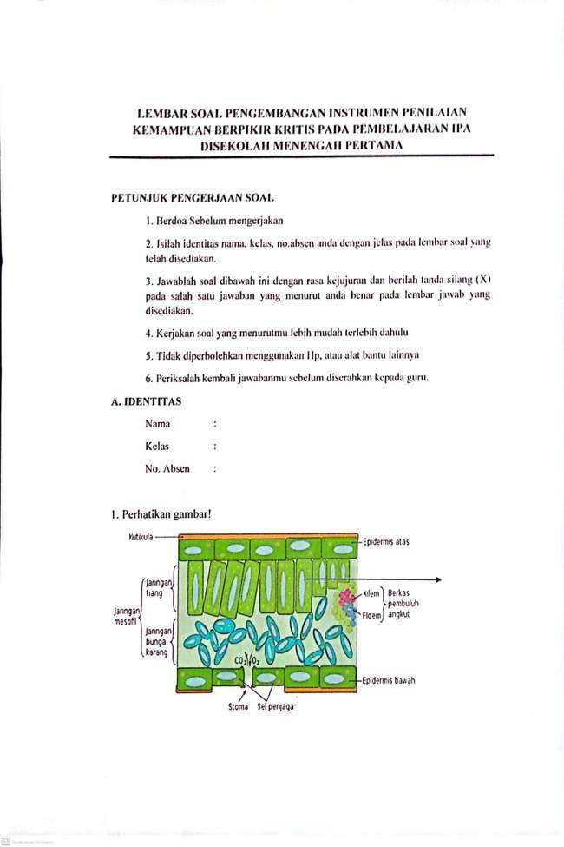
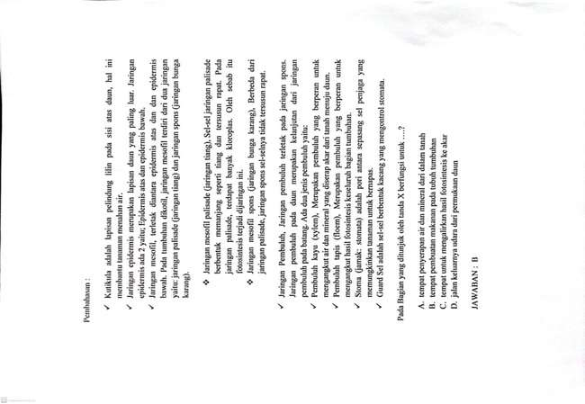
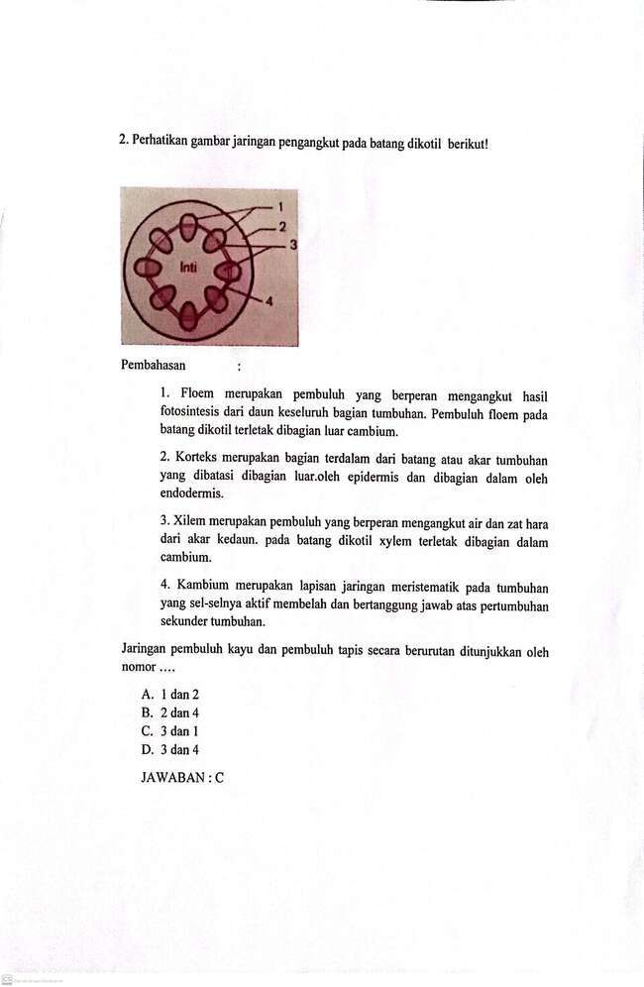
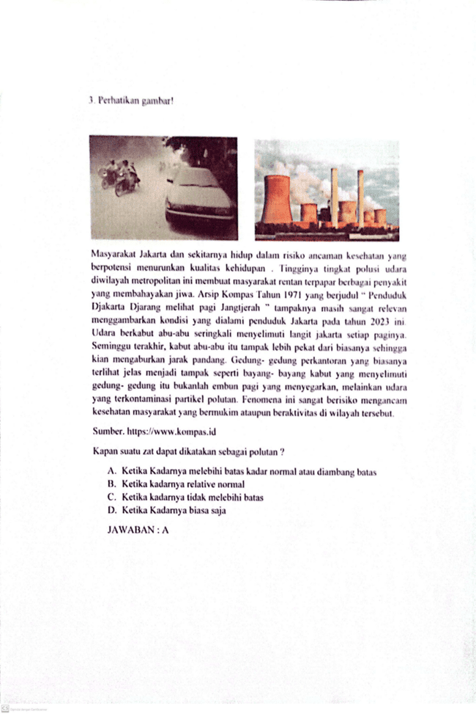
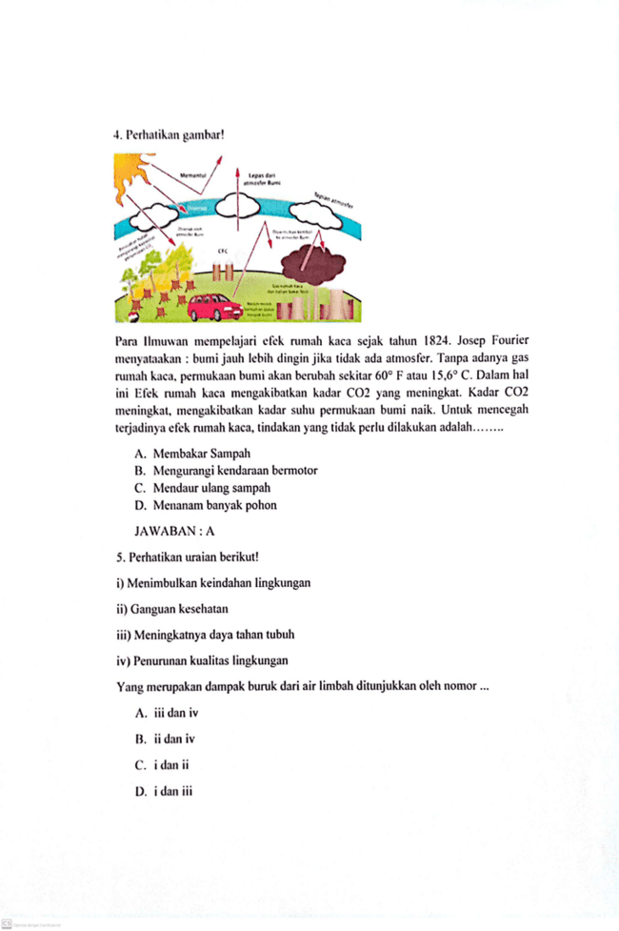
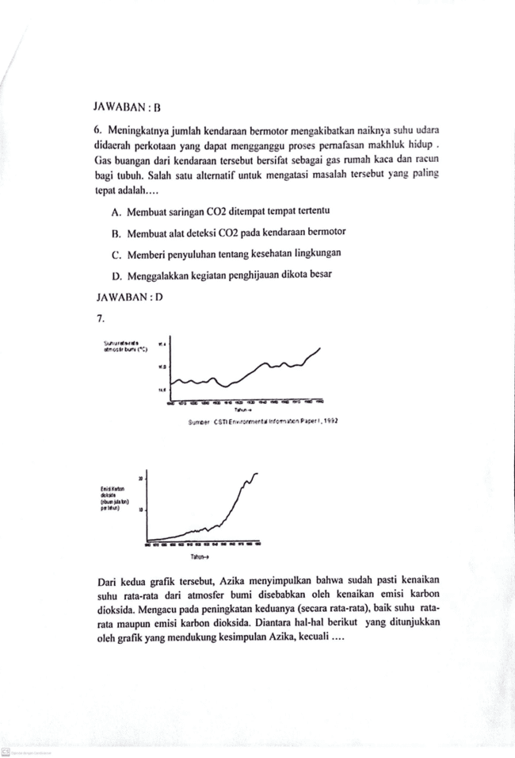
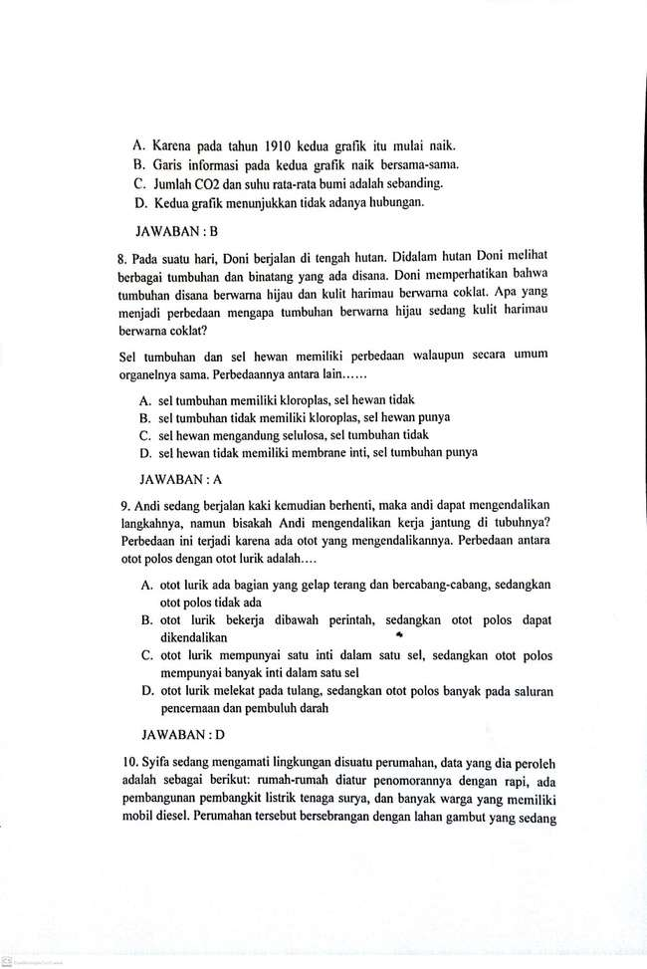

Lampiran 5 Lembar Validasi Aspek Isi 1
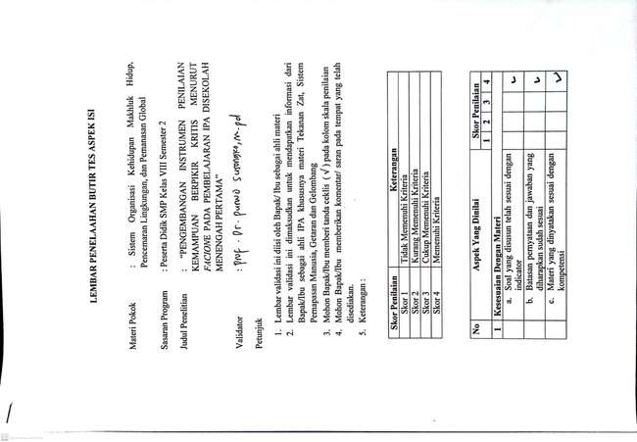
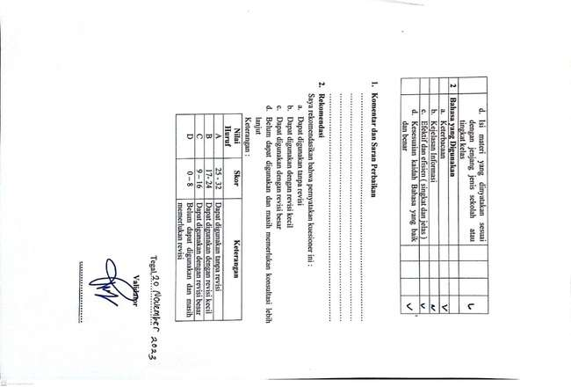

Lampiran 6 Lembar Validasi Aspek Isi 2
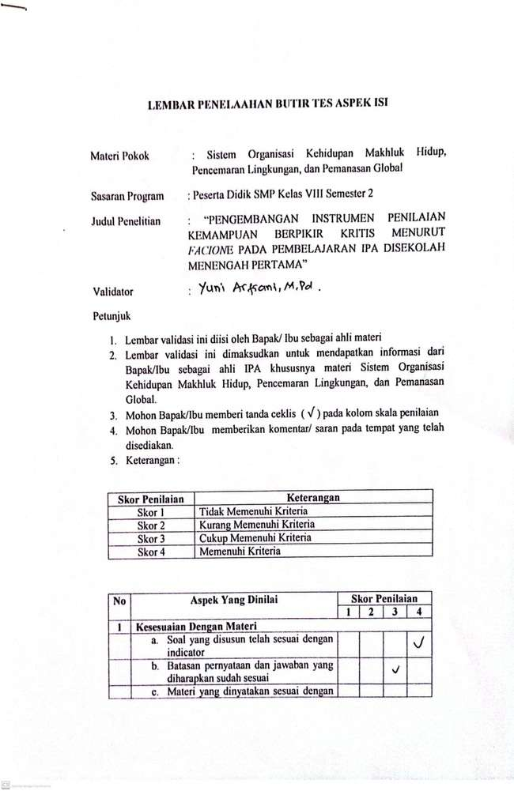
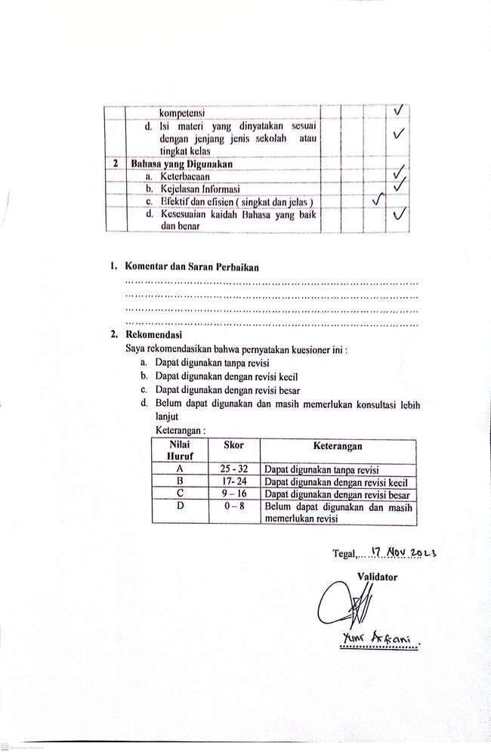

Lampiran 7 Lembar Validasi Aspek Psikometri 1
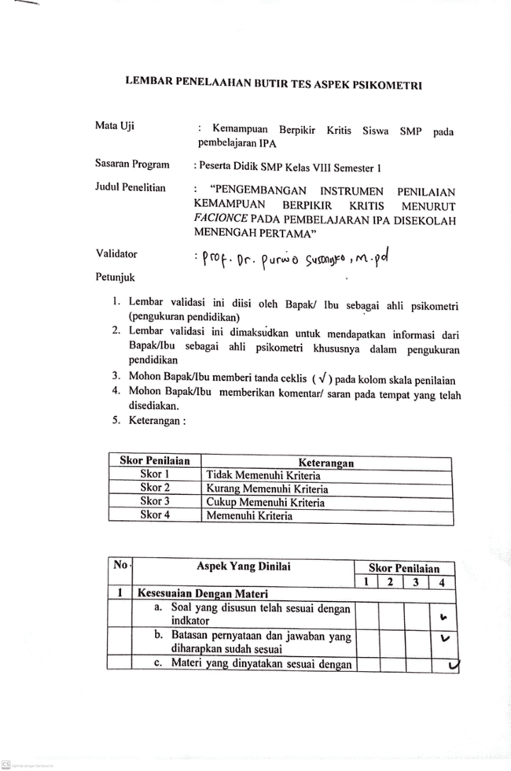
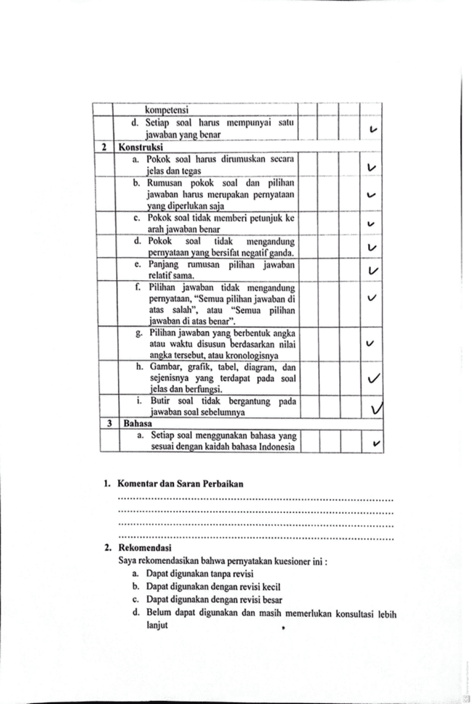
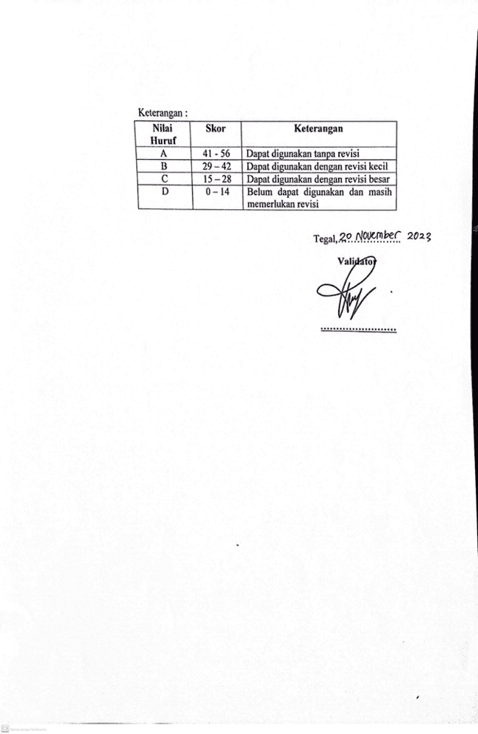

Lampiran 8 Lembar Validasi Aspek Psikometri 2
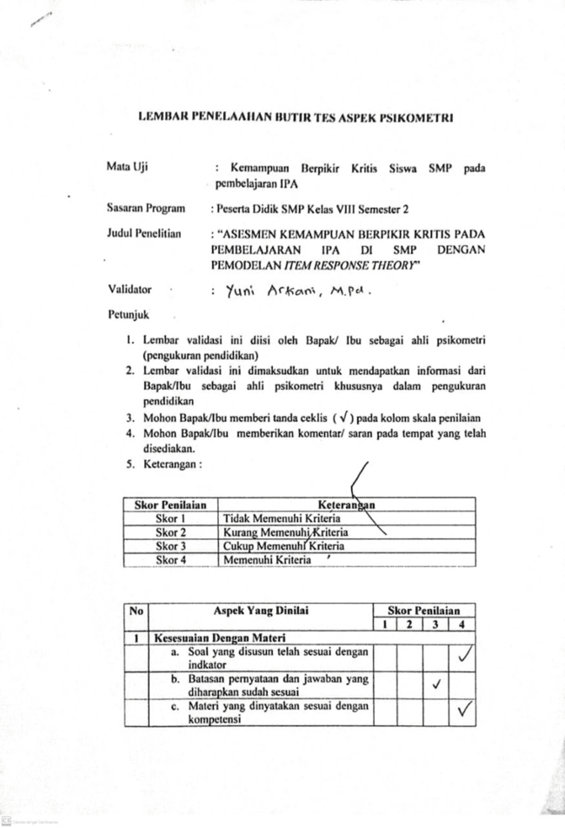
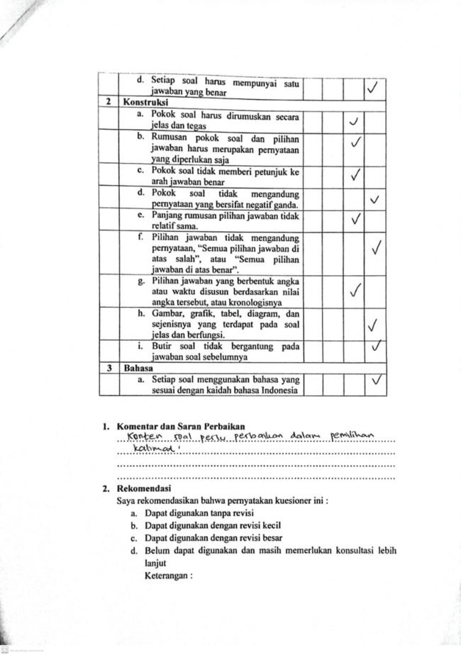
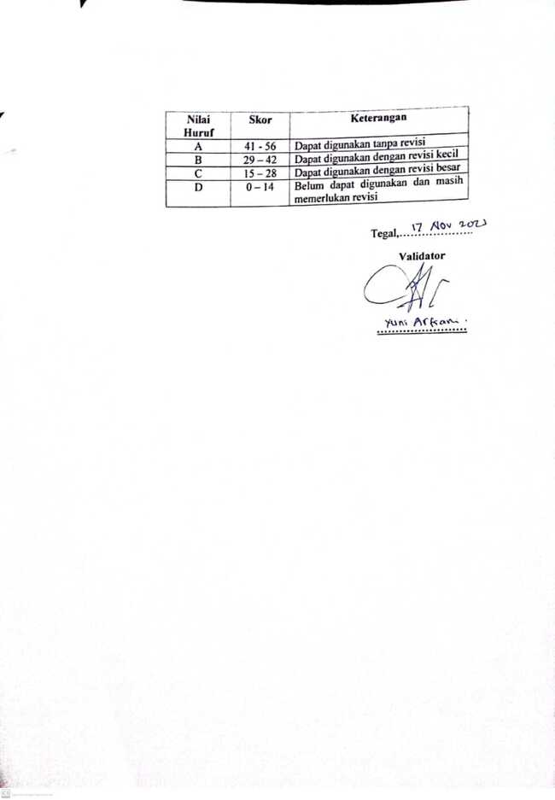

Lampiran 9 Angket Guru
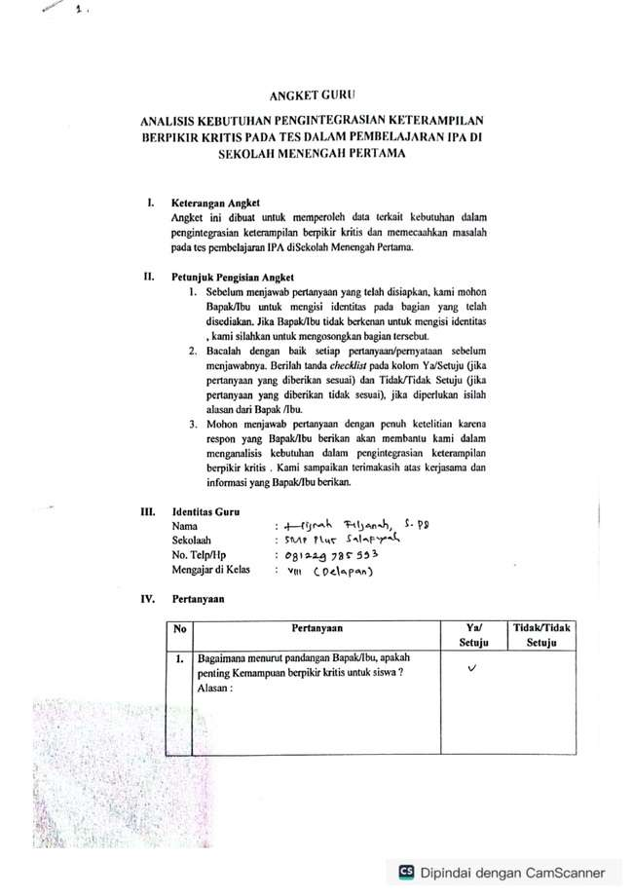
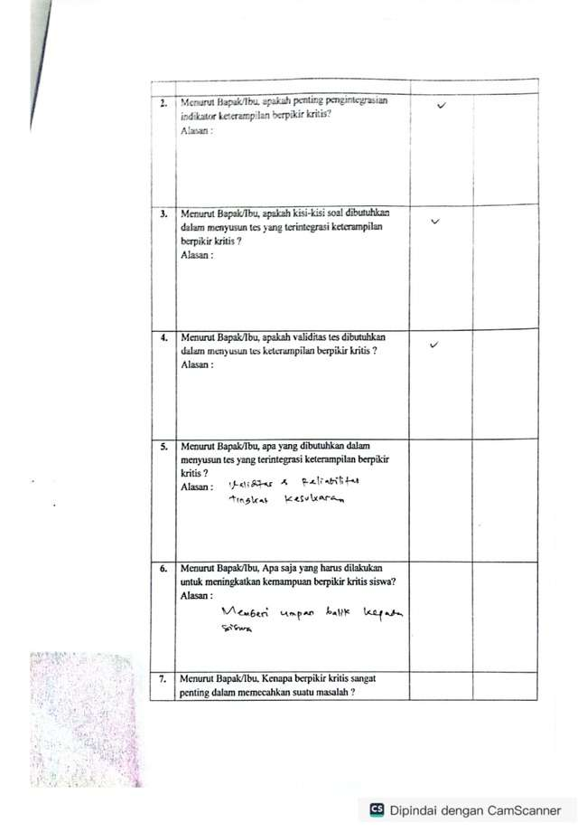
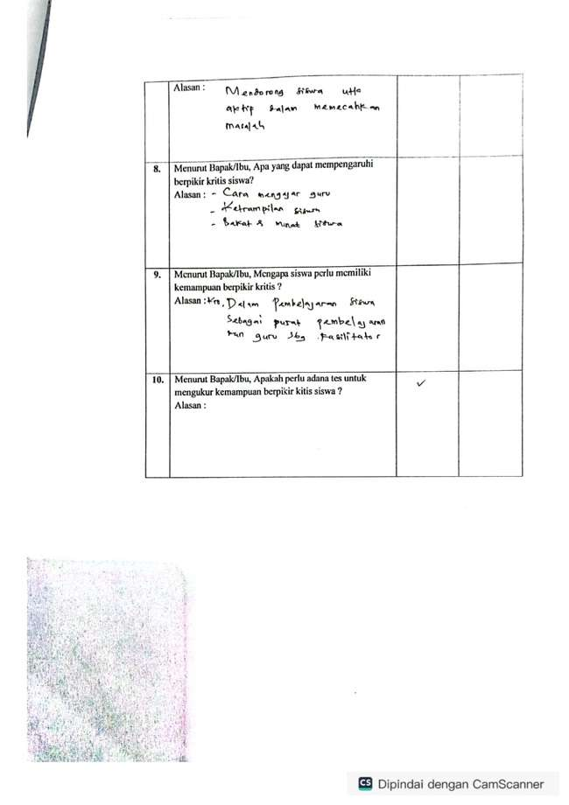

Lampiran 10 Respon Jawaban Peserta Didik

No Peserta | Nomor Butir
 | 1 | 2 | 3 | 4 | 5 | 6 | 7 | 8 | 9 | 10
1 | 0 | 1 | 1 | 0 | 1 | 1 | 1 | 1 | 1 | 1
2 | 0 | 1 | 0 | 1 | 1 | 1 | 0 | 1 | 1 | 0
3 | 1 | 1 | 1 | 0 | 1 | 1 | 0 | 1 | 1 | 0
4 | 0 | 0 | 0 | 0 | 1 | 0 | 0 | 1 | 0 | 0
5 | 0 | 1 | 1 | 1 | 1 | 1 | 1 | 1 | 1 | 0
6 | 0 | 0 | 1 | 0 | 1 | 1 | 0 | 1 | 1 | 0
7 | 1 | 0 | 1 | 1 | 1 | 1 | 0 | 0 | 0 | 0
8 | 0 | 0 | 1 | 0 | 1 | 0 | 0 | 0 | 1 | 0
9 | 1 | 1 | 1 | 1 | 1 | 0 | 0 | 0 | 0 | 0
10 | 0 | 1 | 1 | 1 | 1 | 1 | 1 | 1 | 1 | 0
11 | 0 | 1 | 1 | 0 | 1 | 1 | 0 | 1 | 1 | 0
12 | 1 | 1 | 1 | 0 | 1 | 1 | 0 | 1 | 1 | 0
13 | 0 | 0 | 1 | 1 | 1 | 1 | 0 | 0 | 1 | 0
14 | 0 | 1 | 1 | 0 | 1 | 1 | 0 | 1 | 1 | 0
15 | 1 | 1 | 1 | 1 | 1 | 0 | 0 | 0 | 0 | 0
16 | 0 | 1 | 0 | 1 | 1 | 1 | 0 | 1 | 1 | 0
17 | 0 | 0 | 0 | 0 | 1 | 0 | 0 | 0 | 1 | 0
18 | 0 | 1 | 1 | 1 | 0 | 1 | 1 | 1 | 1 | 0
19 | 1 | 1 | 1 | 0 | 1 | 0 | 0 | 0 | 0 | 0
20 | 0 | 0 | 1 | 0 | 0 | 1 | 0 | 1 | 1 | 0
21 | 0 | 0 | 1 | 0 | 1 | 1 | 0 | 0 | 0 | 1
22 | 0 | 0 | 1 | 0 | 1 | 1 | 0 | 1 | 1 | 0
23 | 0 | 0 | 1 | 1 | 1 | 0 | 0 | 1 | 0 | 1
24 | 0 | 1 | 1 | 1 | 1 | 0 | 0 | 0 | 1 | 1
25 | 0 | 0 | 1 | 1 | 1 | 0 | 1 | 0 | 0 | 0
26 | 0 | 0 | 1 | 0 | 0 | 1 | 0 | 1 | 1 | 0
27 | 0 | 1 | 1 | 1 | 1 | 1 | 1 | 1 | 1 | 0
28 | 0 | 1 | 1 | 0 | 1 | 0 | 1 | 1 | 0 | 1
29 | 1 | 1 | 1 | 0 | 0 | 1 | 0 | 1 | 1 | 0
30 | 0 | 1 | 0 | 0 | 1 | 0 | 0 | 0 | 0 | 0
31 | 0 | 0 | 1 | 0 | 0 | 1 | 0 | 1 | 1 | 0
32 | 1 | 1 | 1 | 0 | 1 | 0 | 0 | 0 | 0 | 0
33 | 0 | 1 | 0 | 0 | 1 | 0 | 0 | 0 | 0 | 0
34 | 0 | 1 | 1 | 0 | 1 | 1 | 1 | 0 | 0 | 0
35 | 0 | 1 | 1 | 1 | 1 | 1 | 1 | 0 | 1 | 0
36 | 0 | 0 | 1 | 1 | 1 | 0 | 0 | 0 | 1 | 0
37 | 0 | 0 | 1 | 1 | 1 | 0 | 0 | 0 | 1 | 0
38 | 1 | 1 | 1 | 0 | 0 | 0 | 0 | 1 | 0 | 0
39 | 1 | 0 | 1 | 1 | 1 | 1 | 1 | 0 | 0 | 0
40 | 1 | 1 | 1 | 1 | 1 | 0 | 0 | 0 | 0 | 0
41 | 1 | 0 | 1 | 1 | 1 | 0 | 0 | 0 | 1 | 0
42 | 0 | 1 | 1 | 1 | 1 | 0 | 1 | 0 | 0 | 0
43 | 0 | 1 | 0 | 0 | 1 | 0 | 1 | 0 | 0 | 1
44 | 0 | 1 | 0 | 0 | 1 | 0 | 1 | 0 | 0 | 1
45 | 0 | 1 | 1 | 1 | 1 | 1 | 1 | 0 | 1 | 0
46 | 0 | 0 | 1 | 0 | 0 | 0 | 0 | 0 | 1 | 0
47 | 1 | 0 | 1 | 1 | 1 | 0 | 0 | 0 | 0 | 0
48 | 1 | 1 | 1 | 0 | 1 | 1 | 0 | 0 | 1 | 1
49 | 0 | 0 | 1 | 0 | 1 | 1 | 1 | 0 | 0 | 0
50 | 0 | 0 | 1 | 1 | 0 | 0 | 0 | 0 | 1 | 0
51 | 1 | 1 | 1 | 0 | 1 | 0 | 0 | 1 | 0 | 1
52 | 1 | 1 | 1 | 0 | 1 | 0 | 0 | 1 | 0 | 0
53 | 1 | 1 | 1 | 1 | 0 | 0 | 1 | 0 | 0 | 0
54 | 1 | 1 | 1 | 0 | 1 | 0 | 0 | 0 | 0 | 0
55 | 0 | 0 | 1 | 0 | 0 | 0 | 0 | 0 | 0 | 0
56 | 0 | 0 | 1 | 0 | 1 | 0 | 0 | 0 | 1 | 0
57 | 1 | 1 | 1 | 1 | 1 | 0 | 0 | 1 | 0 | 1
58 | 1 | 1 | 1 | 1 | 1 | 1 | 0 | 0 | 1 | 0
59 | 0 | 1 | 1 | 1 | 1 | 0 | 0 | 0 | 1 | 0
60 | 1 | 1 | 1 | 0 | 1 | 1 | 0 | 0 | 0 | 0
61 | 1 | 1 | 1 | 1 | 0 | 0 | 1 | 0 | 1 | 0
62 | 0 | 1 | 1 | 1 | 1 | 0 | 0 | 0 | 1 | 0
63 | 1 | 1 | 1 | 0 | 1 | 0 | 0 | 1 | 0 | 1
64 | 1 | 0 | 1 | 1 | 1 | 0 | 0 | 0 | 1 | 0
65 | 0 | 1 | 1 | 0 | 0 | 0 | 0 | 1 | 0 | 0
66 | 0 | 0 | 1 | 0 | 0 | 1 | 0 | 1 | 1 | 0
67 | 0 | 1 | 0 | 0 | 1 | 0 | 0 | 0 | 1 | 1
68 | 0 | 1 | 1 | 1 | 1 | 0 | 1 | 0 | 1 | 1
69 | 0 | 0 | 0 | 1 | 1 | 0 | 0 | 0 | 1 | 0
70 | 0 | 0 | 1 | 0 | 1 | 1 | 0 | 0 | 1 | 0
71 | 0 | 0 | 1 | 1 | 0 | 0 | 1 | 0 | 1 | 0
72 | 0 | 1 | 1 | 0 | 1 | 0 | 0 | 0 | 0 | 1
73 | 0 | 1 | 1 | 1 | 1 | 0 | 0 | 0 | 0 | 1
74 | 0 | 1 | 1 | 0 | 1 | 1 | 1 | 0 | 0 | 1
75 | 1 | 1 | 1 | 0 | 1 | 0 | 0 | 1 | 0 | 1
76 | 0 | 1 | 1 | 0 | 1 | 0 | 0 | 1 | 0 | 0
77 | 1 | 0 | 0 | 1 | 1 | 0 | 1 | 0 | 1 | 0
78 | 0 | 0 | 0 | 0 | 0 | 0 | 0 | 1 | 0 | 1
79 | 0 | 1 | 0 | 0 | 1 | 0 | 0 | 1 | 0 | 0
80 | 0 | 0 | 0 | 0 | 1 | 0 | 0 | 1 | 0 | 1
81 | 0 | 0 | 0 | 1 | 1 | 0 | 0 | 0 | 1 | 0
82 | 0 | 0 | 1 | 1 | 0 | 1 | 1 | 1 | 1 | 1
83 | 0 | 1 | 1 | 0 | 1 | 0 | 0 | 0 | 0 | 1
84 | 0 | 1 | 1 | 0 | 1 | 1 | 1 | 0 | 0 | 1
85 | 0 | 0 | 1 | 1 | 1 | 0 | 0 | 1 | 0 | 1
86 | 0 | 1 | 1 | 0 | 1 | 1 | 1 | 0 | 0 | 1
87 | 0 | 1 | 1 | 0 | 1 | 0 | 0 | 1 | 1 | 0
88 | 0 | 1 | 0 | 1 | 1 | 1 | 0 | 0 | 0 | 0
89 | 0 | 1 | 1 | 1 | 1 | 0 | 0 | 1 | 0 | 1
90 | 0 | 0 | 1 | 0 | 1 | 0 | 0 | 0 | 0 | 0
91 | 0 | 0 | 1 | 1 | 1 | 0 | 1 | 1 | 1 | 0
92 | 0 | 0 | 1 | 1 | 1 | 1 | 0 | 0 | 0 | 0
93 | 1 | 1 | 1 | 1 | 0 | 0 | 0 | 0 | 1 | 0
94 | 0 | 0 | 1 | 0 | 1 | 0 | 1 | 0 | 0 | 0
95 | 0 | 1 | 1 | 1 | 1 | 0 | 0 | 1 | 1 | 1
96 | 0 | 1 | 1 | 0 | 1 | 0 | 0 | 0 | 1 | 0
97 | 0 | 1 | 0 | 0 | 1 | 0 | 0 | 0 | 1 | 0
98 | 0 | 1 | 0 | 1 | 1 | 0 | 0 | 1 | 0 | 0
99 | 0 | 1 | 1 | 0 | 1 | 0 | 1 | 1 | 1 | 0
100 | 0 | 0 | 1 | 0 | 1 | 0 | 0 | 0 | 1 | 0
101 | 0 | 1 | 1 | 0 | 1 | 0 | 1 | 0 | 1 | 0
102 | 0 | 0 | 0 | 0 | 1 | 1 | 0 | 0 | 0 | 0
103 | 0 | 0 | 1 | 0 | 1 | 1 | 0 | 0 | 1 | 0
104 | 0 | 0 | 1 | 1 | 1 | 0 | 0 | 1 | 1 | 1
105 | 0 | 0 | 1 | 0 | 1 | 0 | 0 | 0 | 1 | 0
106 | 0 | 1 | 1 | 1 | 1 | 1 | 0 | 1 | 1 | 1
107 | 0 | 1 | 1 | 1 | 1 | 0 | 0 | 0 | 1 | 0
108 | 0 | 0 | 1 | 1 | 1 | 1 | 0 | 1 | 1 | 0
109 | 0 | 1 | 1 | 1 | 1 | 1 | 0 | 1 | 1 | 1
110 | 0 | 0 | 1 | 0 | 1 | 0 | 0 | 1 | 1 | 0
111 | 0 | 0 | 1 | 1 | 0 | 0 | 0 | 1 | 0 | 0
112 | 0 | 0 | 1 | 1 | 1 | 0 | 0 | 1 | 1 | 0
113 | 0 | 1 | 1 | 1 | 1 | 1 | 0 | 0 | 0 | 0
114 | 0 | 0 | 1 | 0 | 1 | 0 | 0 | 0 | 0 | 1
115 | 0 | 0 | 1 | 1 | 1 | 0 | 0 | 1 | 1 | 0
116 | 0 | 0 | 1 | 0 | 1 | 0 | 0 | 1 | 0 | 1
117 | 0 | 0 | 1 | 1 | 1 | 0 | 0 | 0 | 1 | 0
118 | 0 | 1 | 1 | 0 | 1 | 0 | 0 | 0 | 1 | 0
119 | 0 | 0 | 1 | 1 | 1 | 1 | 0 | 1 | 0 | 0
120 | 0 | 0 | 1 | 1 | 1 | 0 | 0 | 1 | 1 | 0
121 | 0 | 0 | 1 | 1 | 1 | 0 | 0 | 1 | 1 | 0
122 | 0 | 1 | 1 | 1 | 1 | 1 | 0 | 1 | 1 | 1
123 | 0 | 1 | 1 | 1 | 1 | 1 | 0 | 1 | 1 | 1
124 | 0 | 1 | 0 | 0 | 1 | 0 | 0 | 1 | 0 | 0
125 | 0 | 1 | 1 | 0 | 1 | 0 | 0 | 0 | 1 | 0
126 | 0 | 0 | 1 | 1 | 1 | 0 | 0 | 0 | 0 | 0
127 | 0 | 1 | 1 | 0 | 1 | 0 | 0 | 1 | 0 | 0
128 | 0 | 0 | 1 | 0 | 0 | 0 | 0 | 0 | 0 | 0
129 | 0 | 0 | 1 | 1 | 1 | 0 | 0 | 0 | 1 | 0
130 | 0 | 0 | 0 | 0 | 1 | 1 | 0 | 0 | 0 | 0
131 | 0 | 0 | 1 | 1 | 1 | 0 | 0 | 0 | 1 | 1
132 | 0 | 0 | 1 | 1 | 1 | 1 | 0 | 0 | 1 | 0
133 | 0 | 0 | 1 | 0 | 1 | 0 | 0 | 0 | 0 | 0
134 | 0 | 0 | 1 | 1 | 1 | 0 | 0 | 0 | 0 | 0
135 | 0 | 0 | 1 | 1 | 1 | 1 | 0 | 0 | 0 | 1
136 | 0 | 0 | 1 | 0 | 1 | 0 | 0 | 0 | 0 | 0

Lampiran 11 Analisis Kecocokan Item (Item Fit)
No. Butir | Chisq | Df | p-value | Outfit MSQ | Infit MSQ | Outfit t | Infit t | Discrim
1 | 125.161 | 135 | 0.717 | 0.920 | 1.069 | -0.357 | 0.603 | 0.052
2 | 118.619 | 135 | 0.841 | 0.872 | 0.915 | -1.494 | -1.369 | 0.433
3 | 99.619 | 135 | 0.991 | 0.729 | 0.849 | -1.273 | -1090 | 0.281
4 | 128.646 | 135 | 0.638 | 0.946 | 0.978 | -0.596 | -0.329 | 0.235
5 | 148.539 | 135 | 0.201 | 1.092 | 0.937 | 0.454 | -0.379 | -0.018
6 | 121.914 | 135 | 0.783 | 0.896 | 0.897 | -0.906 | -1.394 | 0.336
7 | 113.792 | 135 | 0.907 | 0.837 | 0.926 | -0.856 | -0.622 | 0.232
8 | 135.598 | 135 | 0.469 | 0.997 | 0.991 | 0.002 | -0.108 | 0.171
9 | 133.302 | 135 | 0.525 | 0.980 | 1.024 | -0.197 | 0.402 | 0.161
10 | 134.759 | 135 | 0.490 | 0.991 | 0.972 | -0.007 | -0.243 | 0.189

Lampiran 12 Analisis Tingkat Kesukaran Butir
 | Value | std.err | z.vals
Dffclt.V1 | 3.2988 | 0.9042 | 3.6482
Dffclt.V2 | -0.2807 | 0.4132 | -0.6794
Dffclt.V3 | -4.0115 | 1.0707 | -3.7468
Dffclt.V4 | 0.1400 | 0.4090 | 0.3423
Dffclt.V5 | -4.2839 | 1.1368 | -3.7684
Dffclt.V6 | 1.4391 | 0.5353 | 2.6886
Dffclt.V7 | 3.1920 | 0.8802 | 3.6265
Dffclt.V8 | 0.8470 | 0.4557 | 1.8588
Dffclt.V9 | -0.3502 | 0.4162 | -0.8415
Dffclt.V10 | 2.5105 | 0.7333 | 3.4236
Dscrmn | 0.4402 | 0.1079 | 4.0786

Lampiran 13 Analisis Person Fit

No. Butir | Chisq | Df | p-value | Outfit MSQ | Infit MSQ | Outfit t | Infit t
P1 | 9.298 | 9 | 0.410 | 0.930 | 1.029 | 0.25 | 0.21
P2 | 16.221 | 9 | 0.062 | 1.622 | 0.990 | 1.24 | 0.05
P3 | 7.960 | 9 | 0.538 | 0.796 | 0.941 | -0.11 | -0.10
P4 | 10.139 | 9 | 0.339 | 1.014 | 1.074 | 0.30 | 0.31
P5 | 5.200 | 9 | 0.817 | 0.520 | 0.774 | -0.29 | -0.42
P6 | 7.228 | 9 | 0.613 | 0.723 | 0.843 | -0.64 | -0.52
P7 | 10.593 | 9 | 0.305 | 1.059 | 1.131 | 0.28 | 0.55
P8 | 4.601 | 9 | 0.868 | 0.460 | 0.564 | -1.02 | -1.10
P9 | 9.035 | 9 | 0.434 | 0.903 | 0.942 | -0.12 | -1.10
P10 | 5.200 | 9 | 0.817 | 0.520 | 0.774 | -0.29 | -0.42
P11 | 6.187 | 9 | 0.721 | 0.619 | 0.714 | -0.75 | -1.15
P12 | 7.960 | 9 | 0.538 | 0.796 | 0.941 | -0.11 | -0.10
P13 | 6.601 | 9 | 0.679 | 0.660 | 0.764 | -0.84 | -0.85
P14 | 6.187 | 9 | 0.721 | 0.619 | 0.714 | -0.75 | -1.15
P15 | 9.035 | 9 | 0.434 | 0.903 | 0.942 | -0.12 | -0.12
P16 | 16.221 | 9 | 0.062 | 1.622 | 0.990 | 1.24 | 0.05
P17 | 7.049 | 9 | 0.632 | 0.705 | 0.967 | -0.10 | 0.11
P18 | 26.871 | 9 | 0.001 | 2.687 | 1.150 | 1.98 | 0.57
P19 | 10.524 | 9 | 0.310 | 1.052 | 0.925 | 0.26 | -0.12
P20 | 12.847 | 9 | 0.170 | 1.285 | 1.309 | 0.76 | 0.95
P21 | 10.525 | 9 | 0.310 | 1.052 | 1.059 | 0.26 | 0.28
P22 | 7.228 | 9 | 0.613 | 0.723 | 0.843 | -0.64 | -0.52
P23 | 8.868 | 9 | 0.450 | 0.887 | 1.002 | -0.16 | 0.10
P24 | 6.467 | 9 | 0.692 | 0.647 | 0.758 | -0.67 | -0.94
P25 | 10.628 | 9 | 0.302 | 1.063 | 0.967 | 0.29 | 0.01
P26 | 12.847 | 9 | 0.170 | 1.285 | 1.309 | 0.76 | 0.95
P27 | 5.200 | 9 | 0.817 | 0.520 | 0.774 | -0.29 | -0.42
P28 | 10.614 | 9 | 0.303 | 1.061 | 1.211 | 0.29 | 0.85
P29 | 20.701 | 9 | 0.014 | 2.070 | 1.339 | 1.85 | 1.27
P30 | 7.192 | 9 | 0.617 | 0.719 | 0.975 | -0.08 | 0.12
P31 | 12.847. | 9 | 0.170 | 1.285 | 1.309 | 0.76 | 0.95
P32 | 10.524 | 9 | 0.310 | 1.052 | 0.925 | 0.26 | -0.12
P33 | 7.192 | 9 | 0.617 | 0.719 | 0.975 | -0.08 | 0.12
P34 | 10.036 | 9 | 0.348 | 1.004 | 1.077 | 0.14 | 0.36
P35 | 6.907 | 9 | 0.647 | 0.691 | 0.859 | -0.30 | -0.39
P36 | 5.409 | 9 | 0.797 | 0.541 | 0.640 | -1.18 | -1.13
P37 | 5.409 | 9 | 0.797 | 0.541 | 0.640 | -1.18 | -1.13
P38 | 16.508 | 9 | 0.057 | 1.651 | 1.458 | 1.44 | 1.31
P39 | 12.440 | 9 | 0.190 | 1.244 | 1.400 | 0.63 | 1.46
P40 | 9.035 | 9 | 0.434 | 0.903 | 0.940 | -0.12 | -0.12
P41 | 8.970 | 9 | 0.440 | 0.897 | 0.935 | -0.13 | -0.15
P42 | 8.856 | 9 | 0.451 | 0.886 | 0.934 | -0.16 | -0.15
P43 | 18.155 | 9 | 0.033 | 1.816 | 1.581 | 1.71 | 1.59
P44 | 18.155 | 9 | 0.033 | 1.816 | 1.581 | 1.71 | 1.59
P45 | 6.907 | 9 | 0.647 | 0.691 | 0.859 | -0.30 | -0.39
P46 | 7.293 | 9 | 0.607 | 0.729 | 1.014 | -0.06 | 0.20
P47 | 10.913 | 9 | 0.282 | 1.091 | 0.974 | 0.35 | 0.03
P48 | 9.626 | 9 | 0.382 | 0.963 | 1.135 | 0.16 | 0.53
P49 | 12.082 | 9 | 0.209 | 1.208 | 1.104 | 0.60 | 0.41
P50 | 9.123 | 9 | 0.426 | 0.912 | 1.122 | 0.30 | 0.42
P51 | 10.735 | 9 | 0.294 | 1.074 | 1.222 | 0.31 | 0.89
P52 | 9.662 | 9 | 0.379 | 0.966 | 1.021 | 0.05 | 0.17
P53 | 19.833 | 9 | 0.019 | 1.983 | 1.610 | 2.06 | 1.97
P54 | 10.524 | 9 | 0.310 | 1.052 | 0.925 | 0.26 | -0.12
P55 | 3.187 | 9 | 0.956 | 0.319 | 0.791 | -0.14 | -0.06
P56 | 4.601 | 9 | 0.868 | 0.460 | 0.564 | -1.02 | -1.10
P57 | 9.786 | 9 | 0.368 | 0.979 | 1.112 | 0.19 | 0.46
P58 | 7.003 | 9 | 0.637 | 0.700 | 0.872 | -0.28 | -0.34
P59 | 5.043 | 9 | 0.831 | 0.504 | 0.575 | -1.40 | -1.75
P60 | 10.215 | 9 | 0.333 | 1.021 | 1.085 | 0.19 | 0.39
P61 | 21.688 | 9 | 0.010 | 2.169 | 1.453 | 1.98 | 1.62
P62 | 5.043 | 9 | 0.831 | 0.504 | 0.575 | -1.40 | -1.75
P63 | 10.735 | 9 | 0.294 | 1.074 | 1.222 | 0.31 | 0.89
P64 | 8.970 | 9 | 0.440 | 0.897 | 0.935 | -0.13 | -0.15
P65 | 10.284 | 9 | 0.328 | 1.028 | 1.201 | 0.24 | 0.59
P66 | 12.847 | 9 | 0.170 | 1.285 | 1.309 | 0.76 | 0.95
P67 | 12.937 | 9 | 0.165 | 1.294 | 1.253 | 0.78 | 0.81
P68 | 7.915 | 9 | 0.543 | 0.791 | 0.988 | -0.12 | 0.06
P69 | 8.782 | 9 | 0.458 | 0.878 | 1.092 | -0.04 | 0.35
P70 | 6.864 | 9 | 0.651 | 0.686 | 0.776 | -0.70 | -0.62
P71 | 15.430 | 9 | 0.080 | 1.543 | 1.366 | 1.25 | 1.10
P72 | 8.681 | 9 | 0.467 | 0.868 | 0.874 | -0.19 | -0.28
P73 | 7.863 | 9 | 0.548 | 0.786 | 0.877 | -0.44 | -0.38
P74 | 11.145 | 9 | 0.266 | 1.114 | 1.277 | 0.39 | 1.07
P75 | 10.735 | 9 | 0.294 | 1.074 | 1.222 | 0.31 | 0.89
P76 | 6.202 | 9 | 0.720 | 0.620 | 0.725 | -0.91 | -0.80
P77 | 18.879 | 9 | 0.026 | 1.888 | 1.590 | 1.90 | 1.92
P78 | 25.826 | 9 | 0.002 | 2.583 | 1.871 | 1.59 | 1.53
P79 | 9.942 | 9 | 0.355 | 0.994 | 1.171 | 0.18 | 0.53
P80 | 15.645 | 9 | 0.075 | 1.564 | 1.412 | 1.04 | 1.01
P81 | 8.782 | 9 | 0.458 | 0.878 | 1.092 | -0.04 | 0.35
P82 | 30.185 | 9 | 0.000 | 3.019 | 1.449 | 2.23 | 1.40
P83 | 8.681 | 9 | 0.467 | 0.868 | 0.874 | -0.19 | -0.28
P84 | 11.145 | 9 | 0.266 | 1.114 | 1.277 | 0.39 | 1.07
P85 | 8.868 | 9 | 0.450 | 0.887 | 1.002 | -0.16 | 0.10
P86 | 11.145 | 9 | 0.266 | 1.114 | 1.277 | 0.39 | 1.07
P87 | 5.670 | 9 | 0.772 | 0.567 | 0.654 | -1.16 | -1.35
P88 | 11.634 | 9 | 0.235 | 1.163 | 1.220 | 0.51 | 0.73
P89 | 7.710 | 9 | 0.564 | 0.771 | 0.881 | -0.35 | -0.39
P90 | 2.679 | 9 | 0.976 | 0268 | 0.418 | -0.96 | -1.31
P91 | 8.333 | 9 | 0.501 | 0.833 | 0.945 | -0.20 | -0.13
P92 | 7.316 | 9 | 0.604 | 0.732 | 0.833 | -0.56 | -0.42
P93 | 16.019 | 9 | 0.066 | 1.602 | 1.251 | 1.41 | 0.94
P94 | 13.077 | 9 | 0.159 | 1.308 | 0.847 | 0.69 | -0.25
P95 | 5.646 | 9 | 0.775 | 0.565 | 0.711 | -0.56 | -0.96
P96 | 5.020 | 9 | 0.833 | 0.502 | 0.591 | -1.32 | -1.33
P97 | 8.255 | 9 | 0.509 | 0.825 | 1.045 | -0.14 | 0.24
P98 | 10.909 | 9 | 0.282 | 1.091 | 1.162 | 0.35 | 0.57
P99 | 7.867 | 9 | 0.548 | 0.787 | 0.903 | -0.31 | -0.30
P100 | 4.601 | 9 | 0.868 | 0.460 | 0.564 | -1.02 | -1.10
P101 | 8.414 | 9 | 0.493 | 0.841 | 0.880 | -0.29 | -0.36
P102 | 12.350 | 9 | 0.194 | 1.235 | 1.114 | 0.54 | 0.39
P103 | 6.864 | 9 | 0.651 | 0.686 | 0.776 | -0.70 | -0.62
P104 | 7.627 | 9 | 0.572 | 0.763 | 0.875 | -0.37 | -0.42
P105 | 4.601 | 9 | 0.868 | 0.460 | 0.564 | -1.02 | -1.10
P106 | 4.498 | 9 | 0.876 | 0.450 | 0.677 | -0.41 | -0.70
P107 | 5.043 | 9 | 0.831 | 0.504 | 0.575 | -1.40 | -1.75
P108 | 6.654 | 9 | 0.673 | 0.665 | 0.756 | -0.62 | -0.95
P109 | 4.498 | 9 | 0.876 | 0.450 | 0.677 | -0.41 | -0.70
P110 | 6.138 | 9 | 0.726 | 0.614 | 0.717 | -0.93 | -0.83
P111 | 10.811 | 9 | 0.289 | 1.081 | 1.249 | 0.33 | 0.69
P112 | 6.048 | 9 | 0.735 | 0.605 | 0.700 | -1.03 | -1.14
P113 | 6.666 | 9 | 0.672 | 0.667 | 0.772 | -0.82 | -0.81
P114 | 10.385 | 9 | 0.320 | 1.038 | 0.813 | 0.26 | -0.34
P115 | 6.048 | 9 | 0735 | 0.605 | 0.700 | -1.03 | -1.14
P116 | 9.799 | 9 | 0.367 | 0.980 | 1.000 | 0.09 | 0.11
P117 | 5.409 | 9 | 0.797 | 0.541 | 0.640 | -1.18 | -1.13
P118 | 5.020 | 9 | 0.833 | 0.502 | 0.591 | -1.32 | -1.33
P119 | 7.670 | 9 | 0.568 | 0.767 | 0.896 | -0.50 | -0.30
P120 | 6.048 | 9 | 0.735 | 0.605 | 0.700 | -1.03 | -1.14
P121 | 6.048 | 9 | 0.735 | 0.605 | 0.700 | -1.03 | -1.14
P122 | 4.498 | 9 | 0.876 | 0.450 | 0.677 | -0.41 | -0.70
P123 | 4.498 | 9 | 0.876 | 0.450 | 0.677 | -0.41 | -0.70
P124 | 9.942 | 9 | 0.355 | 0.994 | 1.171 | 0.18 | 0.53
P125 | 5.020 | 9 | 0.833 | 0.520 | 0.591 | -1.32 | -1.33
P126 | 5.210 | 9 | 0.816 | 0.521 | 0.619 | -0.85 | -0.92
P127 | 6.202 | 9 | 0.720 | 0.620 | 0.725 | -0.91 | -0.80
P128 | 3.187 | 9 | 0.956 | 0.319 | 0.791 | -0.14 | -0.06
P129 | 5.409 | 9 | 0.797 | 0.541 | 0.640 | -1.18 | -1.13
P130 | 12.350 | 9 | 0.194 | 1.235 | 1.114 | 0.54 | 0.39
P131 | 7.798 | 9 | 0.555 | 0.780 | 0.870 | -0.46 | -0.41
P132 | 6.601 | 9 | 0.679 | 0.660 | 0.764 | -0.84 | -0.85
P133 | 2.679 | 9 | 0.976 | 0.268 | 0.418 | -0.96 | -1.31
P134 | 5.210 | 9 | 0.816 | 0.521 | 0.619 | -0.85 | -0.92
P135 | 9.421 | 9 | 0.399 | 0.942 | 1.066 | -0.01 | 0.33
P136 | 2.679 | 9 | 0.976 | 0.268 | 0.418 | -0.96 | -1.31

Lampiran 14 Dokumentasi Pengambilan Sampel
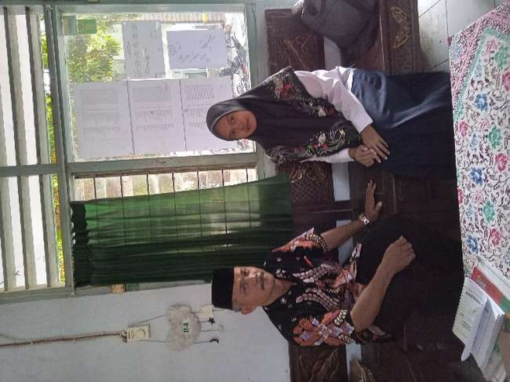 | 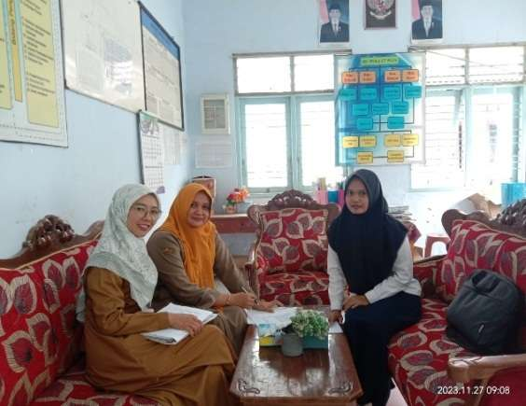
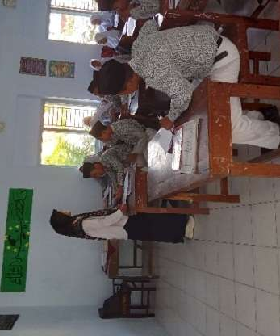
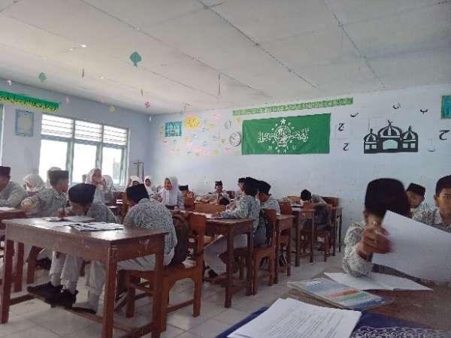 | 