# REFERENCES

Ageng Tirtayasa, Een Helmi Munfidah, Lutfiah, & Slamet Widodo. (2022). The Students’ Responses of English Instagram Account for English Reading Mastery. *Conference on English Language Teaching*, *2*(Celti), 94–108. https://doi.org/10.24090/celti.v2.39

Azmi, A., Yusra, K., & Arifuddin, A. (2020). *The Effect of Skimming and Scanning Strategies on Students’ Reading Comprehension at Computer-Based Text*. *465*(Access 2019), 70–72. https://doi.org/10.2991/assehr.k.200827.019

Banditvilai, C. (2020). The Effectiveness of Reading Strategies on Reading Comprehension. *International Journal of Social Science and Humanity*, *10*(2), 46–50. https://doi.org/10.18178/ijssh.2020.v10.1012

Chrisbianto, A. S., & Aeni, N. (2022). Student difficulties on reading comprehension in explanation text at Eleventh Grade Students of SMAN 1 Makassar. *Journal of Excellence in English Language Education*, *1*(4), 432–433.

Dondi, M., Klier, J., Panier, F., & Schubert, J. (2021). Defining the skills citizens will need in the future world of work. *McKinsey*, *June*, 19. https://mck.co/3b1wULK

Giantika, G. G. (2019). Strategy Pemanfaatan Instagram Sebagai Media Komunikasi Dan Penjualan Fashion Muslim Online (Studi Deskriptif Kualitatif Akun Instagram @zilohijab). *Jurnal Komunikasi*, *10*(2), 169–175. https://doi.org/10.31294/jkom.v10i2.6219

Haryanti, H., & Sari, F. (2019). the Use of Genre-Based Approach To Improve Writing Skill in Narrative Text At the Eleventh Grade Students of Sma Ethika Palembang. *English Community Journal*, *3*(1), 280. https://doi.org/10.32502/ecj.v3i1.1693

Hidayat, D., & Rohati, T. D. (2020). The Effect of Extensive Reading on Students Reading Comprehension. *Wanastra: Jurnal Bahasa Dan Sastra*, *12*(1), 58–64. https://doi.org/10.31294/w.v12i1.7519

Iswar. (2021). *The Effectiveness of Instastory Instagram Media ( IIM ) in Developing Students’ English Skills at the First Grade of SMA Negeri 3 Palopo*. *Iim*, 167. http://repository.iainpalopo.ac.id/id/eprint/3131/1/SKRIPSI ISWAR ACC UT-dikonversi%282%29.pdf

Kartika Sari, D., Etty Pratiwi, Mp., & Ana Theriana, Mp. (2020). *EFFECTIVE READING STRATEGIES FOR READING SKILLS by*. 1–9.

Lestari, D. E., & German, E. (2021). Incorporating Instagram Features in EFL Learning Environment. *Metathesis: Journal of English Language, Literature, and Teaching*, *5*(2), 168. https://doi.org/10.31002/metathesis.v5i2.4192

Ong, C. G., Maramara, E. S., Vacalares, S. T., & Zambas, K. M. D. (2019). *Vocabulary Skills Development Among Students: an Ethnography*. *2008*, 90–96. https://doi.org/10.33965/icedutech2019_201902l011

Pradnyadewi, D. A. M., & Kristiani, P. E. (2021). Use of Quizizz In Improving Students’ Reading Skill. *The Art of Teaching English as a Foreign Language*, *2*(1), 1–6. https://doi.org/10.36663/tatefl.v2i1.93

Putri, E. (2022). an Impact of the Use Instagram Application Towards Students Vocabulary. *Pustakailmu.Id*, *2*(2), 2022.

Putri, R. D. F., Hadi, M. S., & Mutiarani, M. (2021). the Efficacy of Instagram @Gurukumrd As the Media in Improving Students Reading Skills. *Journal of Languages and Language Teaching*, *9*(3), 350. https://doi.org/10.33394/jollt.v9i3.3795

Sitorus, N., & Azir, I. D. A. (2021). Enhancing Students’ Reading and Listening Skills by Using Social Media Language Learning (SMLL) Approach through Features on Instagram Verified Accounts. *Ethical Lingua: Journal of Language Teaching and Literature*, *Vol. 8 No. 2 (2021)*, 346–356. https://doi.org/10.30605/25409190.310

V.A.R.Barao, R.C.Coata, J.A.Shibli, M.Bertolini, & J.G.S.Souza. (2022). No 主観的健康感を中心とした在宅高齢者における 健康関連指標に関する共分散構造分析Title. *Braz Dent J.*, *33*(1), 1–12.

Vantika, A., & Hidayat, E. (2022). Instagram story sebagai media pembelajaran kuis kosa kata bahasa Jerman bagi kelas x SMAN 5 Malang. *Journal DaFIna*, *6*(1), 72–80. http://journal2.um.ac.id/index.php/dafina/article/view/26551

# APPENDICES

**Appendix 1 Observation Permission Letter**

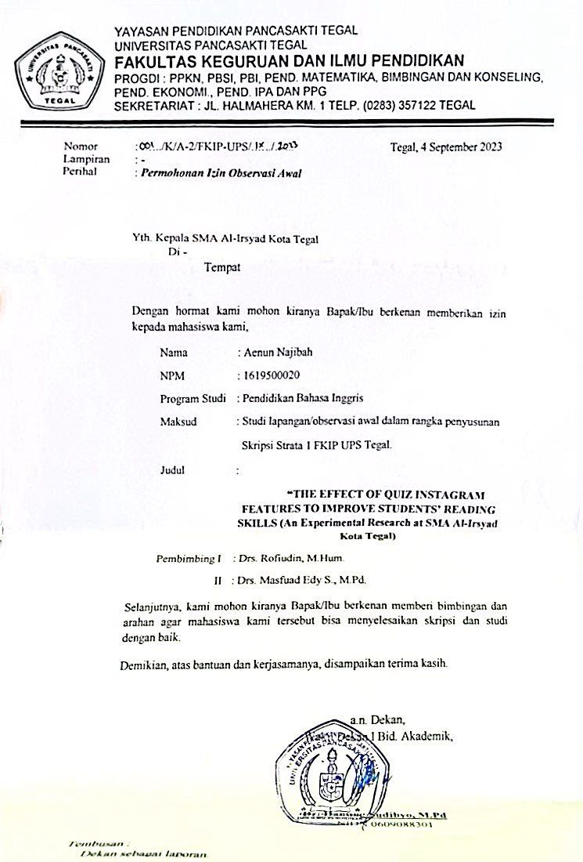

**Appendix 2 Field Study Permission Letter**

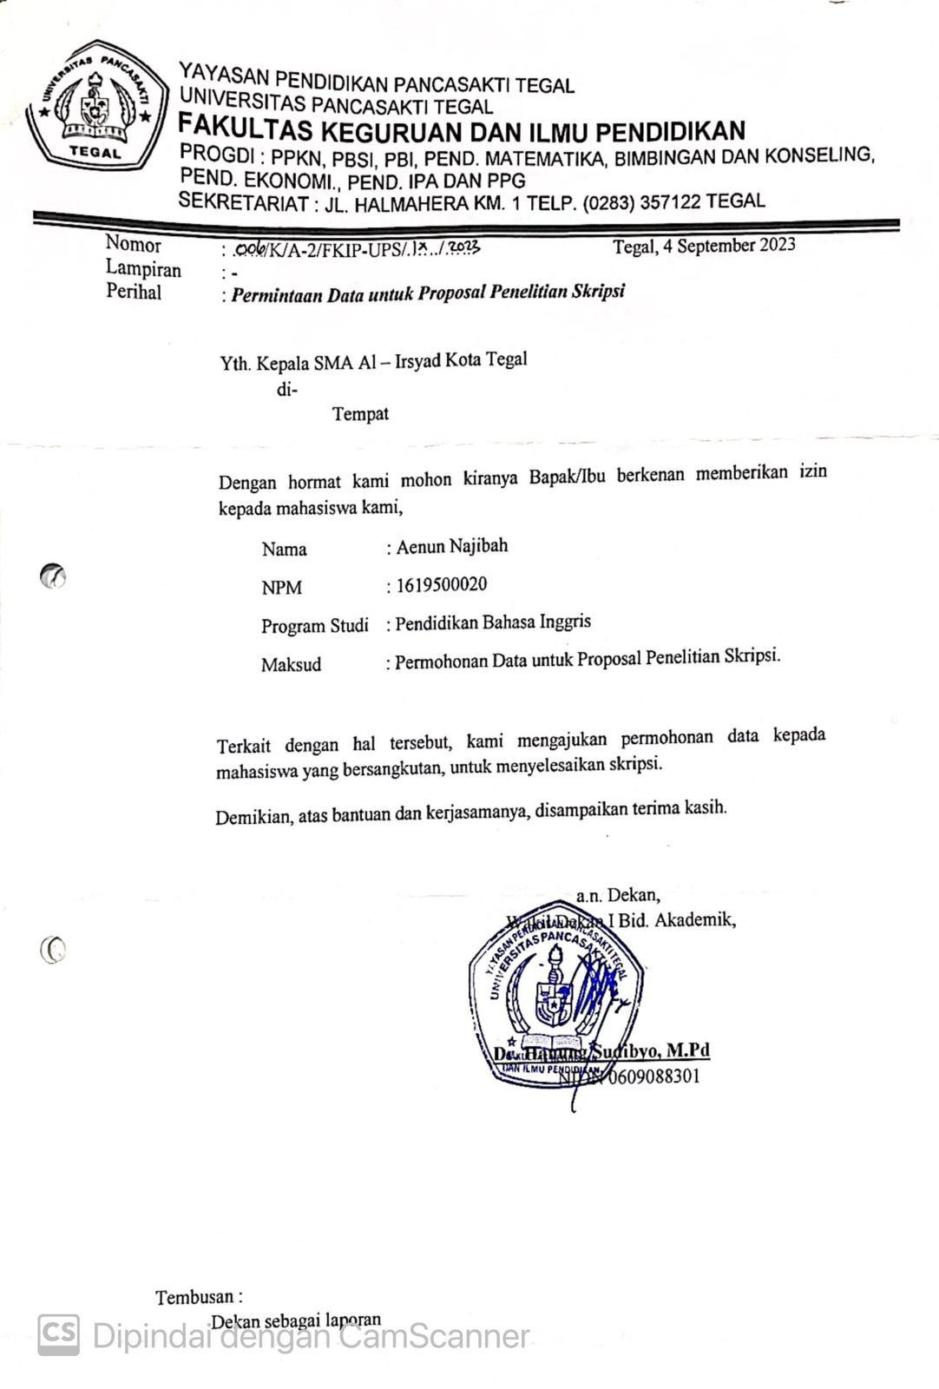

**Appendix 3 Lesson Plan**

**MODUL AJAR**

**MATERI : *Narrative Text***

**INFORMASI UMUM**

Nama Penyusun : Aenun Najibah

Institusi : SMA Al-Irsyad Tegal

Tahun : 2023/2024

Jenjang Sekolah : SMA

Kelas : XI

Alokasi waktu : 1 x 45 Menit (1 kali pertemuan)

Elemen : Menyimak - Berbicara

Membaca – Memirsa

Kompetensi Awal : Peserta didik memiliki pengetahuan awal tentang teks narrative dalam kehidupan sehari - hari, berdasarkan tes diagnostic yang diberikan.

Profil Pelajar Pancasila : Beriman dan Bertaqwa kepada Tuhan YME dan

Berakhlak mulia,

Bergotong royong

Mandiri

Kreatif,

Sarana dan Prasarana : Alat dan Bahan: LCD, Handphone, Laptop, Spidol, Papan tulis

Sumber Bahan Ajar : Buku English in Mind Edisi 2021, Cambridge Diktat Bahasa Inggris Fase E

Target Peserta Didik : Reguler/umum

Model Pembelajaran : Tatap muka

Kegiatan Pembelajaran Utama : Individu

Metode : Discovery Learning

**KOMPONEN INTI**

1. **Tujuan Pembelajaran**
2. Peserta didik mampu mengidentifikasi fungsi social Narrative Text
3. Peserta didik mampu menganalisis struktur Narrative Text dan unsur kebahasaan dengan benar
4. Menyimpulkan isi text Narrative dengan benar
5. Menganalisis pesan moral text Narrative dengan tepat
6. **Pemahaman Bermakna**

Setelah mempelajari modul ini peserta didik mengetahui:

1. Peserta didik dapat mengambil pelajaran dari pesan moral dalam kejadian yang terjadi dalam bacaan narasi.
2. Peserta didik dapat mengadaptasi nilai nilai kemanusiaan yang positif yang didapatkan setelah memahami sebuah cerita narasi ke dalam kehidupan sehari – hari.
3. **Pertanyaan Pemantik**
4. Coba sebutkan Dongeng/Cerita rakyat yang ada dalam Indonesia!
5. Apa yang menarik dalam sebuah dongeng atau cerita rakyat?
6. Hal hal apa yang bisa didapatkan dari mempelajari tokoh tokoh dalam sebuah cerita dongeng/cerita rakyat?
7. **Persiapan Pembelajaran**

Mempersiapkan materi, sumber referensi, merancang presentasi, checking kelas, sarana dan prasaran

1. **Kegiatan Pembelajaran**

Pendahuluan

1. Orientasi
   * + Guru meminta ketua kelas untuk memimpin peserta didik memberi salam dan berdoa menurut agama dan kepercayaannya masing-masing.
     + Guru menanyakan kabar dan kondisi peserta didik.
     + Guru memeriksa kehadiran peserta didik sebagai wujud sikap disiplin.
     + Guru menanyakan kesiapan belajar peserta didik serta mempersiapkan fisik dan psikis peserta didik dalam mengawali kegiatan pembelajaran.
2. Apersepsi
   * + Guru mengajukan pertanyaan mengenai materi sudah dipelajari pada pertemuan sebelumnya.
     + Guru menyampaikan keterkaitan materi sebelumnya dengan materi pembelajaran yang akan dipelajari hari ini.
3. Motivasi
   * Guru memotivasi peserta didik dengan menyampaikan capaian pembelajaran dan tujuan pembelajaran.
   * Guru menyampaikan garis besar cakupan materi yang akan disampaikan.
   * Guru menyampaikan tentang kegiatan yang akan dilakukan peserta didik dalam pembelajaran.
   * Guru memberikan gambaran tentang manfaat atau kegunaan mempelajari materi yang akan dipelajari.
4. Pemberian Acuan
   * Guru menyampaikan kompetensi awal yang harus dimiliki peserta didik untuk mempelajari materi hari ini.
   * Guru melakukan asesmen diagnostik non-kognitif dan kognitif.

Inti (Langkah Langkah Pembelajaran)

**Pertemuan ke 2-3**

* Warm Up: Pertanyaan pemantik, ditunjukkan contoh dengan tebak gambar cerita *Narrative text.*
* Orientasi masalah: Peserta didik mendengarkan pemaparan materi tentang *Narrative text.*
* Organizing student: Guru membagikan contoh *Narrative text* kemudian peserta didik mengidentifikasi *generic structure* dan *language feature.*
* Setiap siswa saling berkolaborasi secara aktif.
* Masing-masing kelompok menyampaikan hasil nya.
* Guru menganalisa dan mengevaluasi hasil kerja peserta didik.

**Pertemuan Ke 4-5**

* Guru memberikan arahan kepada peserta didik untuk membuka akun instragram masing-masing.
* Peserta didik mengerjakan latihan soal yang telah diposting oleh guru kemudian peserta didik mengerjakan soal tersebut menggunakan akun instagram masing-masing.
* Guru mengevaluasi hasil kerja peserta didik.

**Pertemuan 6**

* Warm up: Ice Breaking (If you’re happy and you know it clap your hands)
* Pemantik: Apa pesan dari lagu pada ice breaking tadi? (Sebuah tips)
* Guru menginstruksikan peserta didik untuk mengerjakan soal teks narrative yang sudah disediakan di akun Quiz Instagram masing – masing.
* Guru menganalisa dan mengevaluasi hasil kerja peserta didik

### Penutup

* Guru memberikan apresiasi kepada seluruh peserta didik yang telah mengikuti pembelajaran pada hari ini.
* Guru dan peserta didik melakukan kesimpulan bersama peserta didik dan refleksi mengenai pembelajaran hari ini.

1. **Assessment**

**Assessment :**Bagaimana guru menilai ketercapaian Tujuan Pembelajaran?

* Asesmen individu : Pilihan Ganda

1. **Pedoman Penilaian** 
   1. Untuk tiap nomor, tiap jawaban benar skor 1
   2. Jika salah mendapatkan skor 0
   3. Skor maksimal 40

Nilai Siswa = Skor Perolehan

x100

Skor Maksimal

1. **Rubrik Penilaian**

|  |  |
| --- | --- |
| **Nomor Soal** | **Bobot Soal** |
| 1 – 40 | 1 |
|  |  |
|  |  |
| Jumlah Skor Maksimal | 40 |

1. **Refleksi Peserta Didik dan Guru**

Write down your experience in learning this material

|  |  |
| --- | --- |
| Questions | Answers |
| The words that are new to me |  |
| Can you understand the material given? |  |
| Is the method easy to follow? |  |

Tegal, November 2024

Mengetahui

Guru Pengampu Mahasiswa



Dicky Adhiprabowo, S.Pd Aenun Najibah

NIPY. 290817182 NPM. 1619500020

LAMPIRAN :

**Materi/Bahan Bacaan:**

The narrative text is a text that tells about something that is fictitious and only in the form of essays from the writer. The purpose of narrative text : To entertain the redears, to teach moral velue, and to change social opinion.

Generic Structure of Narrative Text terdiri dari 4 bagian:

* 1. Orientation

Introduction where the characters, setting, and time of the story are established. Usually answers the question who? When? Where? For example: Once upon a time, there was a wolf living in the forest.

* 1. Complication or Problem

Tells the beginning of the problem that caused the crisis (climax). Complications usually involve the main character.

* 1. Resolution

The end of the story is a solution to the problem. There needs to be a resolution of the problem. Problems can be solved for better or worse, happy or sad. Sometimes there are some complications that need to be resolved. This adds and maintains interest and suspense for the reader.

* 1. Reorientation/Coda

Reorientation is the closing statement of the story and is optional. It can contain moral lessons, suggestions or teachings from the author.

Language Feature of Narrative Text :

- Past tense (killed, drunk, etc.)

- Adverb of time (Once upon a time, one day, etc.

- Time conjunction (when, then, suddenly, etc.)

- Specific character. The character of the story is specific, not general. (Cinderella, Snow White, Alibaba, etc.)

- Action verbs. A verb that shows an action. (killed, dug, walked, etc.)

- Direct speech. It is to make the story lively. (Snow White said, "My name is Snow White") The direct speech uses present tense.

Type of Narrative Text :

1. Fairy tale
2. Fable
3. Legends
4. Myth
5. Romance
6. History

Contoh Text :

**Toba Lake**

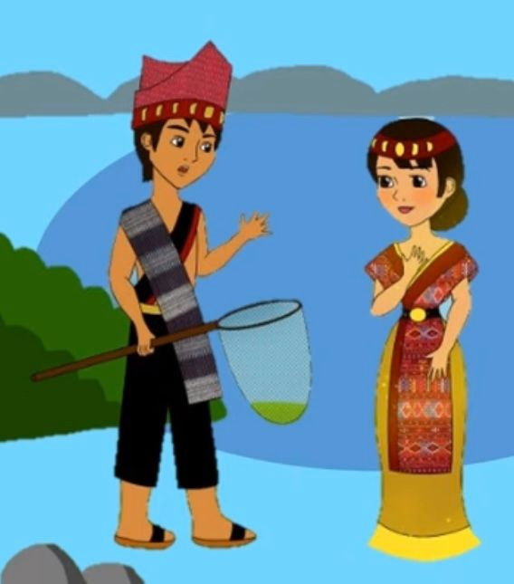

Once a fisherman named Batara Guru Sahala lived in Batakland. One day, he caught a fish. To his surprise, he found that the fish could talk! It begged Sahala to set it free. Sahala did accordingly.

As soon as the fish was free, it changed into a woman. She was so beautiful that the fisherman fell in love with her at once. He asked her to marry him. The woman agreed to marry Sahala. However, she told him that he must never let out the secret that she was once a fish. Sahala promised her that he would not tell anyone about it.

They were happily married, and had two daughters. Every morning, Sahala went out fishing. His daughters would bring him his lunch. One day, however, instead of bringing the food to their father, the girls ate it. When Sahala learnt what they had done with his meal, he got very angry. He shouted at them, saying, "You behaved exactly like the daughters of a fish."

The girls did not understand what their father meant. They went home and asked their mother about it. When they told her what he had said, she was very annoyed. Although Sahala apologized to her later, she would not forgive him for breaking his promise.

Then, the earth began to tremble, and volcanoes started to erupt. The earth cracked to form a big hole. People said that this hole became Lake Toba.

**Appendix 4 Instrument**

**PRE TEST**

**READING NARRATIVE TEXT**

**Research Instrument**

**Subject: English**

**Grade: XI**

1. **Choose the correct answer by crossing A,B,C or D !**

***This text is for questions 1 to 5.***

Once upon a time, there lived a father and his six sons. Their mother had passed away many years ago. The six sons could not get along with one another. They always quarreled with each other. The father tried very hard to unite them, but it always failed.

Then, one day, he came up with an idea. He called all his six sons together and showed them a bundle of sticks. He asked each of them to break the bundle in turn. Each of them tried with all his strength, but none of them could even bend the bundle. Then, the father untied the bundle and separated the sticks. He gave a stick to each of his sons. "Now try breaking it", he said. Each of them broke his stick with ease.

The father then said, "My dear sons, if you remain united, you will be as strong as this bundle of sticks. But if you are divided among yourselves, you will be broken as easily as you have broken the sticks. Remember, always stick together.

1. How many persons were there in the family?
2. Six
3. Five
4. Four
5. Seven
6. Why did the father use the sticks as the illustration?
   1. He wanted his son to realize the importance of unity.
   2. He was sick and tired of the brothers’ quarrelling.
   3. He wanted the brothers to go their separate ways.
   4. He wanted to find out who was the strongest.
7. What can we learn from the story?
8. A bundle of sticks is very useful
9. Playing games together
10. Don’t be greedy
11. Unity is strength
12. “The father united the bundle and separated the sticks”

What is the antonyms of the underlined word?

1. Divided
2. Mixed
3. Broken
4. Split
5. “He came up with an idea”

Who is he ….?

1. Sticks
2. Sons
3. Father
4. Mother

***This text is for questions 6 to 10***.

**The Vixen and the Lioness**

One balmy morning in the forest, the Vixen was taking her babies out for an airing. She came across a Lioness, with her cub in her arms. The Vixen, who had ten kits, was so proud of that number. "Why such airs, haughty dame, over one solitary cub?" sneered the Vixen, (6) ……. the Lioness had only one baby. "Look at my healthy and numerous litter here, and imagine, if you are able, how a proud mother should feel."

The Lioness did not want to get provoked by the Vixen's arrogance. She gave her a squelching look, and lifting up her nose, walked away, saying calmly, "Yes, just look at that beautiful collection. What are they? Foxes! I've only one, but remember, that one is a Lion."

1. The Suitable word to fill in the blank is …
2. As
3. Yet
4. Until
5. Although
6. What is the story about?
7. A mother fox and mother lion.
8. A young fox and a young lion.
9. A father fox and a father lion.
10. Lioness and her baby
11. How many figure are in the story?
12. Two
13. Three
14. Four
15. Five
16. “The lioness did not want to get provoked by the Vixen’s arrogance.”

The underlined word is similar in meaning with …

1. Delighted
2. Irritated
3. Blinded
4. Calmed
5. What is the moral value of the story?
6. Vixens can bear ten kits.
7. Arrogance will never win.
8. Lions are better than foxes.
9. Quality Is better than quantity.

***This text is for questions 11 – 15***.

A long time ago, there lived a powerful Chinese king. He was successful in bringing greatness to his kingdom. He made a lot of military conquests. Then, his success made him worry about his life. He realized that one day he would get older and finally die. So he wanted eternal life. He gave orders to all his people to help him live forever. Those who disobeyed the order would be punished severely. This made everybody in the kingdom afraid of him.

The king had a military advisor, namely Xu Fu. Xu Fu was very concerned with the situation. He wanted to find a way to save the people. One day, Xu Fu came to the palace. He told the king that there was a special grass that could make the king live eternally. The grass could be found on a far to the east. Xu Fu offered himself to find the grass on condition that the king granite he equits immediatelyn de if sia, east neing gave him two big ships.

Two months later, Xu Fu and the 6000 children departed to the east. The king prepared a big party on departure day. Soon, the king stopped killing innocent citizens. He was already dreaming about living eternally. Day by day, he waited for Xu Fu's return.

After five years of hoping for Xu Fu's return, one day the king fell sick and die. Au Fu and the 6000 children never returned to China. They landed on a big island and stayed there. When they grew up, they married each other and became a big nation. The nation was known as Japan.

1. What did Xu Fu request from the emperor?
2. He wanted to live forever.
3. He wanted to save the people.
4. He wanted to take 3000 boys and 3000 girls.
5. He wanted to find the magical grass.
6. What happened to the emperor after 5 years?
7. He died
8. He was sick
9. He got injured
10. He was still healthy
11. “The emperor granted the request immediately.”

What is the synonym of the underlined word?

1. Gave
2. Threw
3. Agreed
4. Offered
5. “He wanted to find a way to save people”

Who is he ….?

1. Xu Fu
2. Militer
3. King
4. Children
5. What is the moral value of the story?
6. Don’t trust other people easily.
7. Responsibility.
8. Be a good person.
9. Become a had person.

***This text is for question 16 – 20.***

**The Legend of Prambanan Temple**

One day, there was a beautiful girl. Her name was Rara Jonggrang. Her beauty was so famous around the country. Every man wanted to marry her. One of them was Bandung Bandawasa. He was a young man with a supernatural power. Rara Jonggrang agreed to marry him with one condition. He had to build one thousand temples during one night.

Helped by the devils, Bandung Bandawasa build the temple. Passing the midnight, his work was nearly finished. Rara Jonggrang woke the girls in the village up and ordered them to grind the rice. The sound made the roosters crow.

They thought that it had been already dawn. Bandung Bandawasa got frustrated because he failed to complete the temple. Because of his anger, he cursed Rara Jonggrang to be a statue. This statue complete the number of temples, that was one thousand temples, like what was requested by Rara Jonggrang.

1. Who wanted to marry Rara

Jonggrang?

* 1. Bathara Guru
  2. Devil
  3. Bandung Bandawasa
  4. The strongest man

1. What was the demand of Rara Jonggrang Bandung Bandawasa?
   1. Making beautiful place.
   2. Making beautiful gold.
   3. Making beautiful dress.
   4. Making one thousand temples in one night.
2. Who helped Bandung Bandawasa to manifest the demand of Rara Jonggrang?
3. People c. Devil
4. His family d. His father
5. What did Rara Jonggrang do to make the work of Bandung Bandawasa failed?
   1. Rara Jonggrang woke the girls in the village up and ordered them to grind the rice.
   2. Rara Jonggrang asked the devil to help her.
   3. Rara Jonggrang killed Bandung Bandawasa.
   4. Rara Jonggrang asked his father to kill devil.
6. “Bandung Bandawasa got frustrated because he failed to complete the temple.”

What is the synonym of the underlined word?

1. Balked
2. Uplifted
3. Encourage
4. Inspirited

***This text is for question 21 – 26.***

**The Two Candles**

Once a wax candle and a tallow candle were having a conversation. The wax candle was very vain and boasted, "I will be placed in a silver candle stand at tonight's party." The tallow candle answered, "It is certainly better to be made of wax than of tallow but I am happy that I burn in the kitchen where food is cooked."

Suddenly, a rich lady came and picked up all the candles. Seeing the tallow candle along with the wax candle, the lady gave it to a poor boy who was passing by.

The poor boy took the tallow candle home.

Seeing the small cottage. the tallow candle thought, "How lucky the wax candle is to be in its rich home." Meanwhile, the mother lit the tallow candle. One of the children said, "Oh, we have light in the house today!" The tallow candle saw the joy in his eyes and was happy to be in the cottage and did not envy the wax candle again.

1. What part of the text is Paragraph 1?
   1. Orientation
   2. Reorientation
   3. Complication
   4. Resolution
2. How was the wax candle characteristic?
   1. Nice c. Wise
   2. Arrogant d. Sly
3. To whom was the tallow candle given?
   1. The lady
   2. The poor boy
   3. The wax candle
   4. The mother
4. How did the tallow candle feel in the end after being in the poor boy’s cottage?
   1. Happy c. Envy
   2. Strange d. Not satisfied
5. What can you learn from the story?
   1. We have to trust each other.
   2. We must compete to win someone else’s heart.
   3. Be confident because you are the best.
   4. Don’t be jealous of other people’s life.
6. What is the synonym of the word ENVY in the sentence “…… and did not envy the wax candle again.”
7. Jealous
8. Trust
9. Suspicious
10. Fear

***This text is for question 27 – 30.***

**Flowers from the Moon**

Once there lived a handsome prince on a high mountain. He wanted to go to the moon because he loved the gentle moonlight. He loved the moon’s gentle white shine.

One day. he fulfilled his dream and really went to the moon. There he met the Moon King’s daughter. She was a lovely young princess. They fell in love with each other and wandered together all over the moon among the flowers and danced together.

But soon, it was time to go back to earth and the prince felt very sad. The princess gave him a beautiful flower that grew on the moon, so that the prince could always look at it and remember her. The prince took the flower, bid the princess goodbye and went all the way back to earth. He planted the flower, and soon it covered all the mountains like a lovely white carpet.

It is believed that this is how the alpine flowers reached the earth from the moon!

1. What is the social function of the story?
   1. To show the way to the moon.
   2. To explain how alpine flowers reach the earth.
   3. To entertain the readers by a story about flowers from moon.
   4. To describe a flower from the moon.
2. Why did the prince want to go to the moon?
   1. Because he loved to fly there
   2. Because he wanted to marry the Moon Princess.
   3. Because he wanted to dance on the moon.
   4. Because he loved the gentle moonlight.
3. Why did the princess give the prince a beautiful flower?
   1. To make the prince could always look at it and remember her.
   2. In order to make the prince remember the moon.
   3. So that the prince could easily go back to the moon.
   4. To make the flower grow on earth.
4. What is the main idea paragraph 3?
   1. The prince planted the flower on earth.
   2. The prince went back to earth.
   3. The prince could finally go to the moon.
   4. The prince and Moon Princess fell in love to each other.

***This text is for questions 31 to 33.***

Once upon a time there was a peacock who was very proud of its beautiful looks. Its only disappointment was that it live next to an ugly owl. Every day, peacock come to the owl house would insult the owl on its looks while the owl stayed quiet.

All the other animals in the forest tried to make the peacock see sense, but it was too swayed by its own good looks.

One night, it rained heavily and flooded the peacock’s nest. Peacocks are homeless and have no food. Peacock came to the owl house to ask for food and the owl gave it. Then the owl told the peacock to stay.

1. What is the story about ….
   1. Two birds in the forest
   2. A beautiful peacock
   3. A beautiful peacock, and the owl.
   4. Animals in the forest.
2. From the story, we know the owl was …
   1. Brave
   2. Wise
   3. Patient
   4. Humble
3. The peacock ignored other animals’ advice to change attitude because …..
   1. Peacock believed it was the prettiest.
   2. Peacock cloud change others to do so.
   3. Peacock thought that is was right.
   4. Peacock didn’t trust other people.

***This text is for questions 34 to***

In a kingdom, there lived 3 corn farmers. All three are smart and diligent farmers. In one season, the land of the three farmers experienced pest problems. Their corn harvest is in danger of failing.

To overcome this, farmers first use pesticides. The second farmer built a cage around his land to prevent pests from entering. The third farmer tried to make a scarecrow. all to no avail.

Then, the king called the three farmers. The king gave a stick to each and told them to break it. The sticks break easily. Then the king gave him a hundred sticks and the three of them had trouble breaking them.

The king said, “When you work alone, you are weak, but together you become strong.” Three farmers worked together, combined strategies, and succeeded.

1. From the text we know that the three farmers earned money by …
   1. Cultivating their fields
   2. Selling crops to a market
   3. Collecting firewood
   4. Working on others fields
2. What is the conflict faced by the farmers in the story?
   1. Three farmers with the king
   2. Three farmers have a good harvest.
   3. The village head gave the three farmers a challenge.
   4. The three farmers' efforts to help their crops failed.
3. The story teaches us ….
   1. Practice makes perfect
   2. There is strength is unity
   3. Hard work is a key of a success.
   4. The king always right.
4. How do three farmers solve their problems?
   1. Work alone
   2. Ask the king for help
   3. Work together
   4. Use the same strategy
5. “Three farmers worked together.”

What is the synonym of the underlined word?

* 1. Treated
  2. Built
  3. Bloomed
  4. Fashioned

1. How many farmers were in the story?
   1. One b. Two
   2. Three d. Four
2. What type of text is the above text? It is …..
   1. A narrative text
   2. A recount text
   3. A description text
   4. An anecdote text

**POST TEST**

**READING NARRATIVE TEXT**

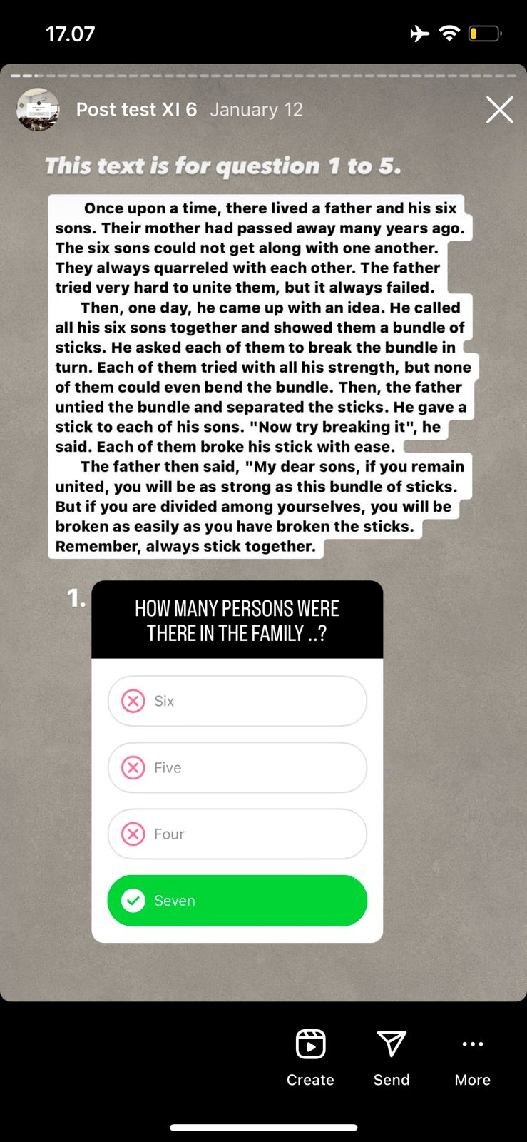 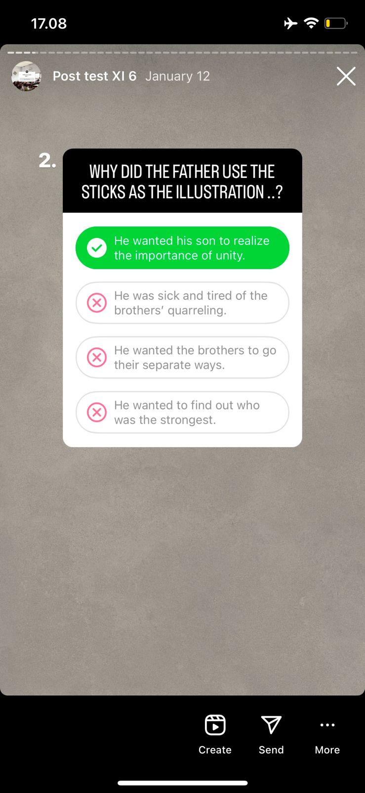

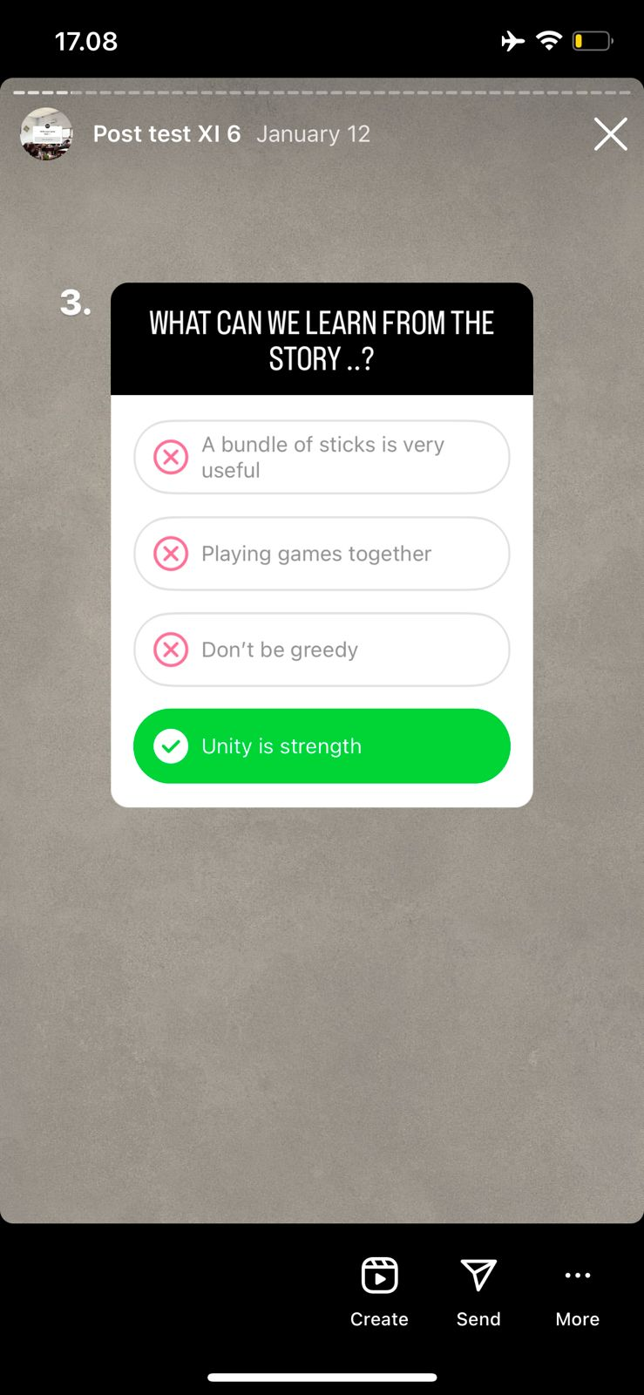 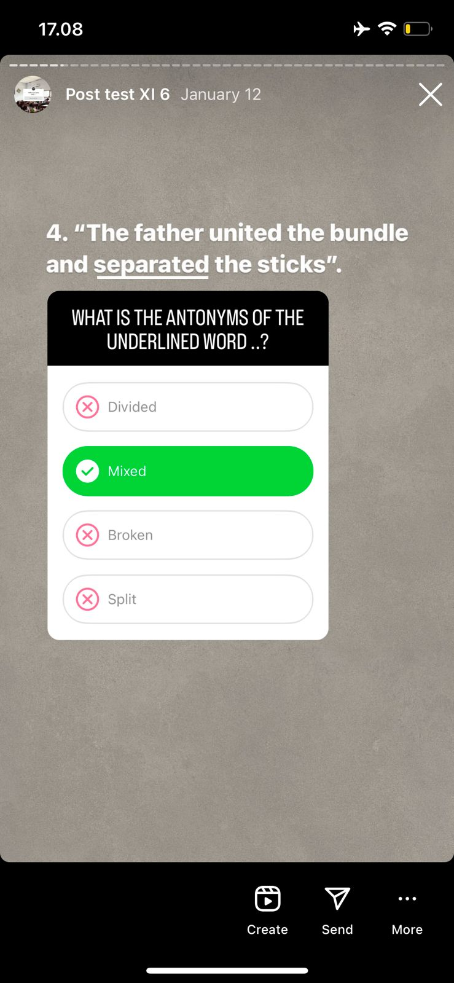

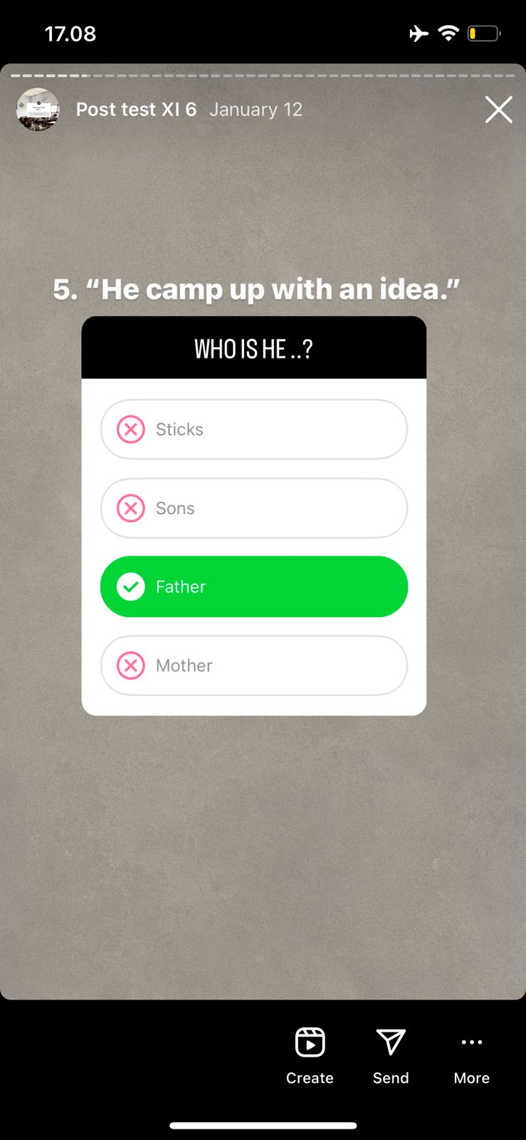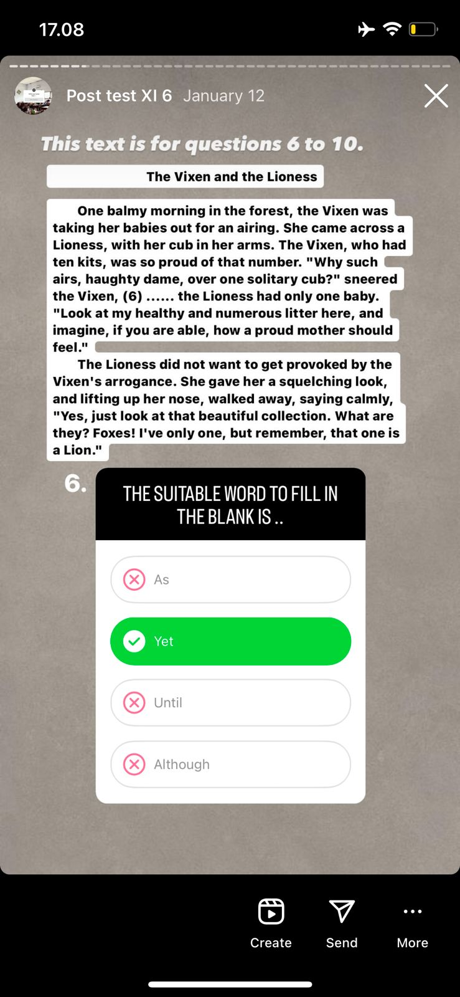

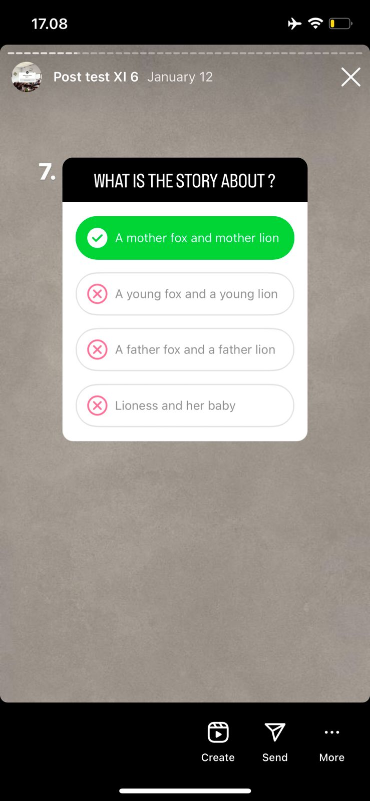 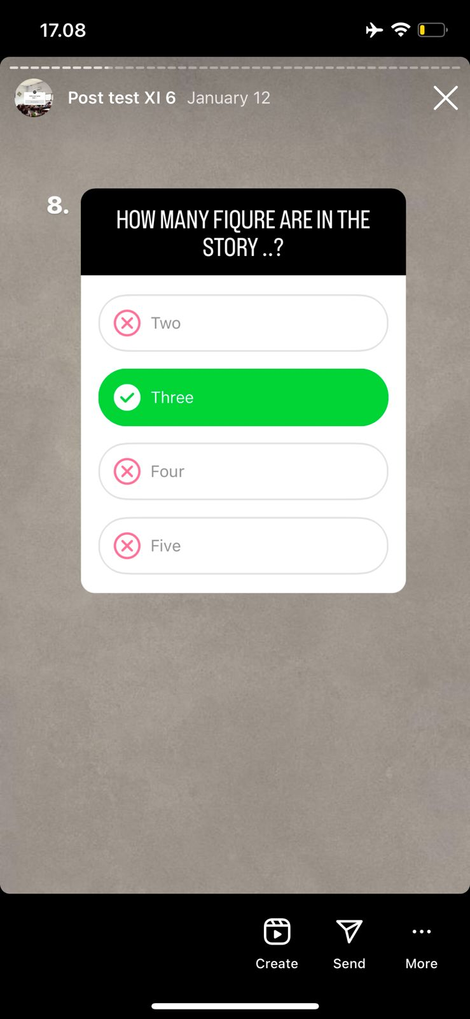

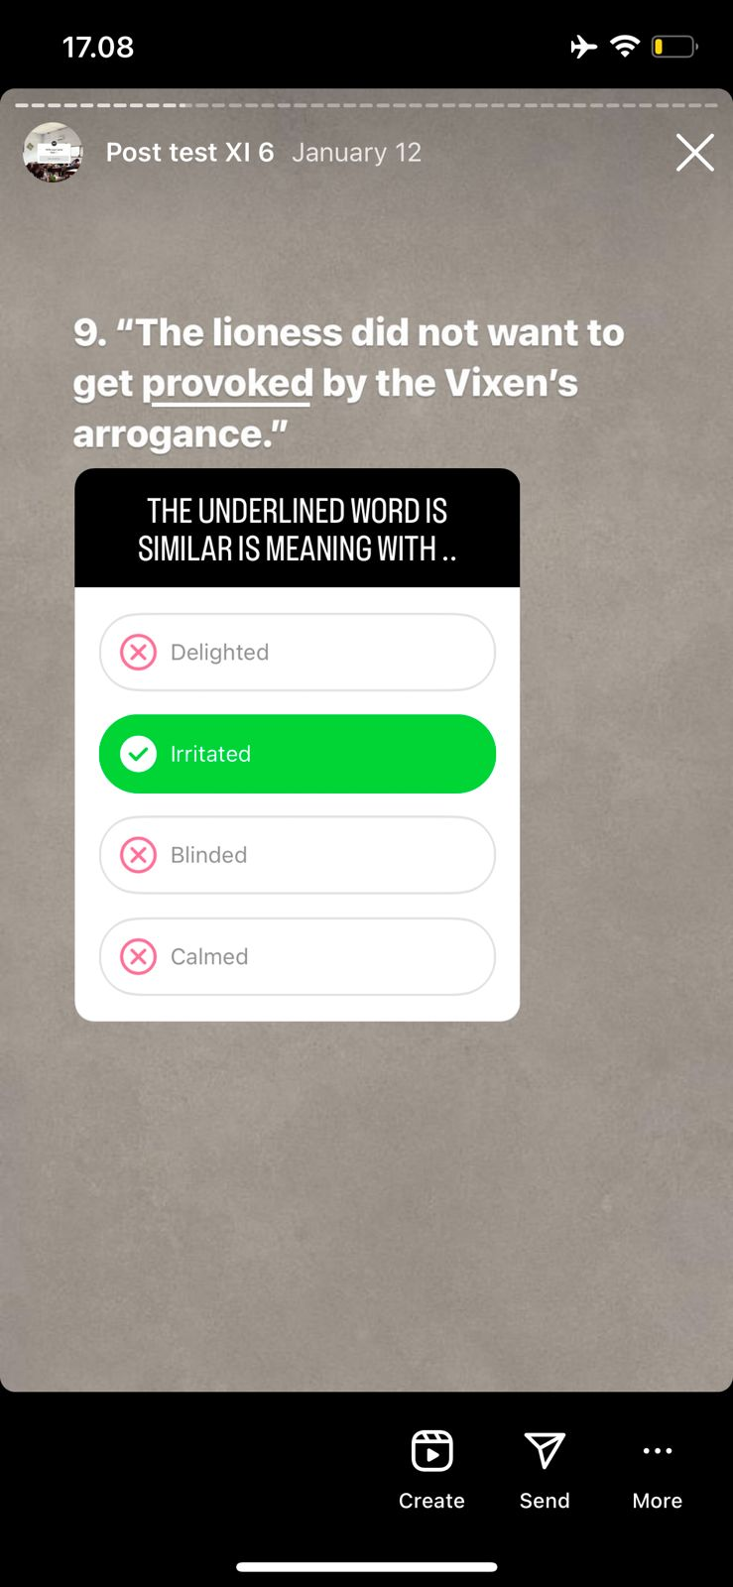 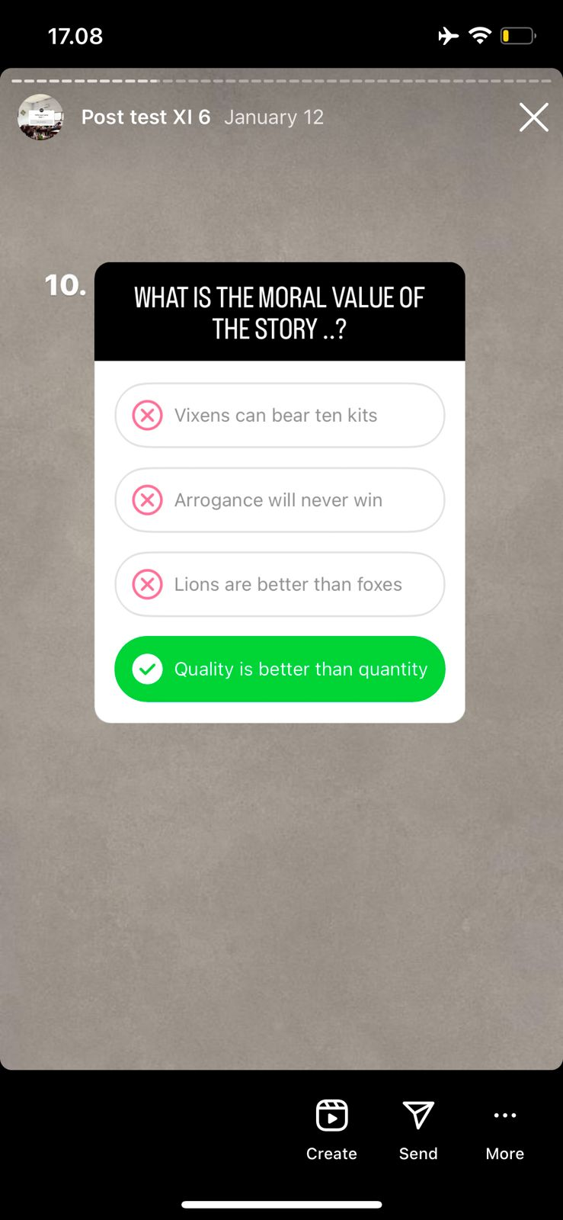

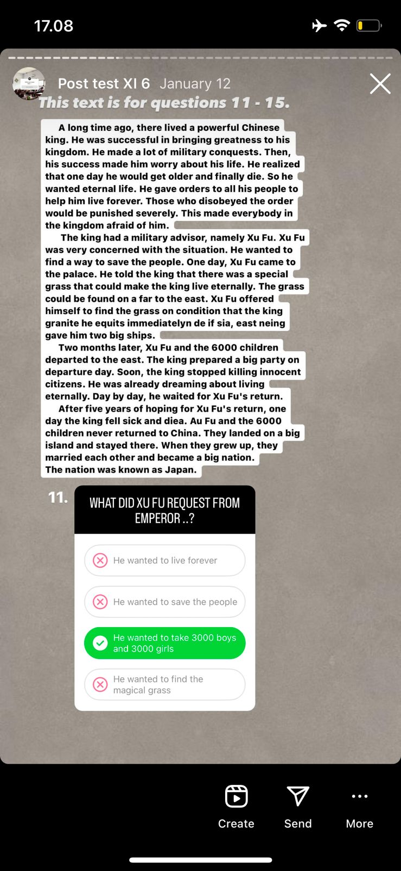 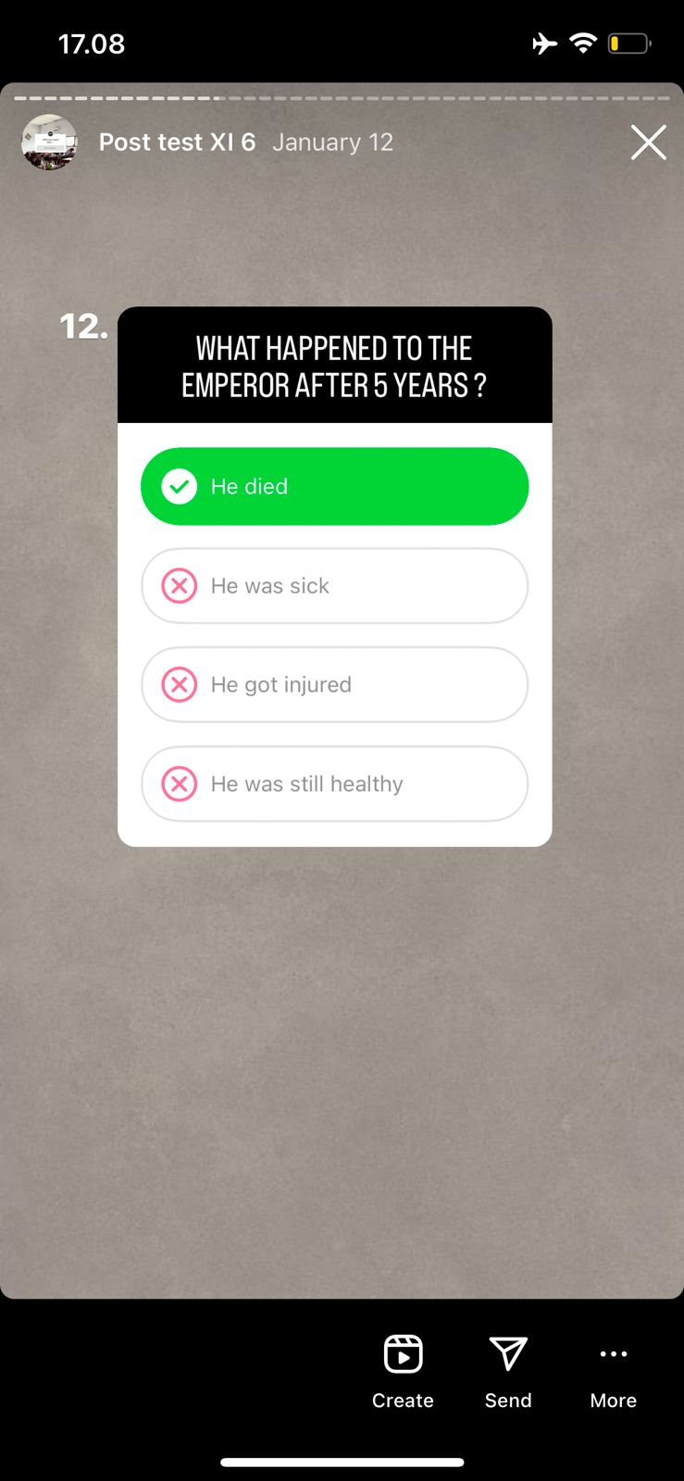

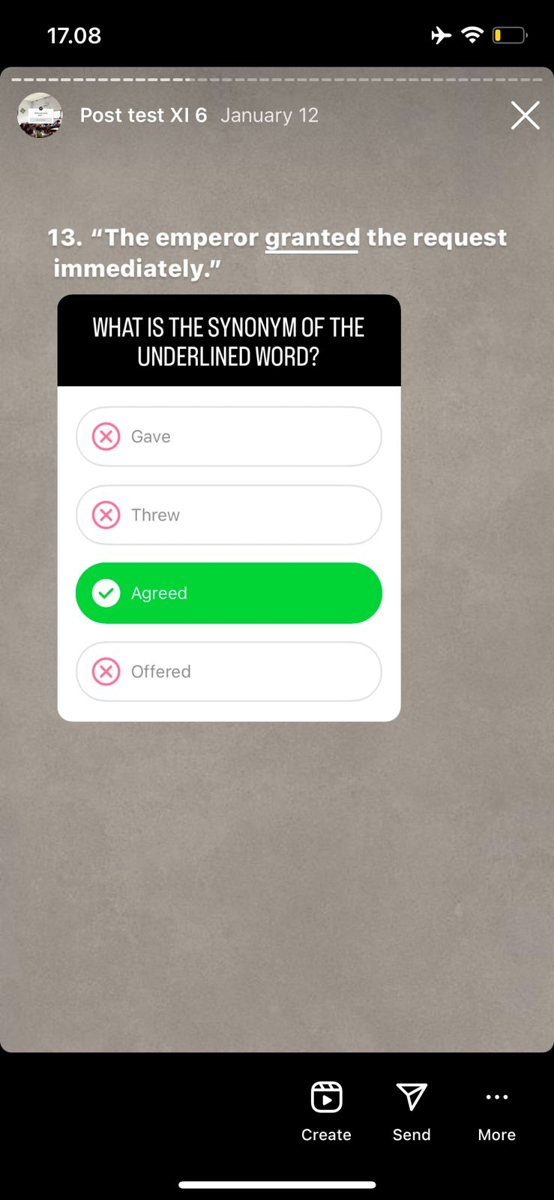 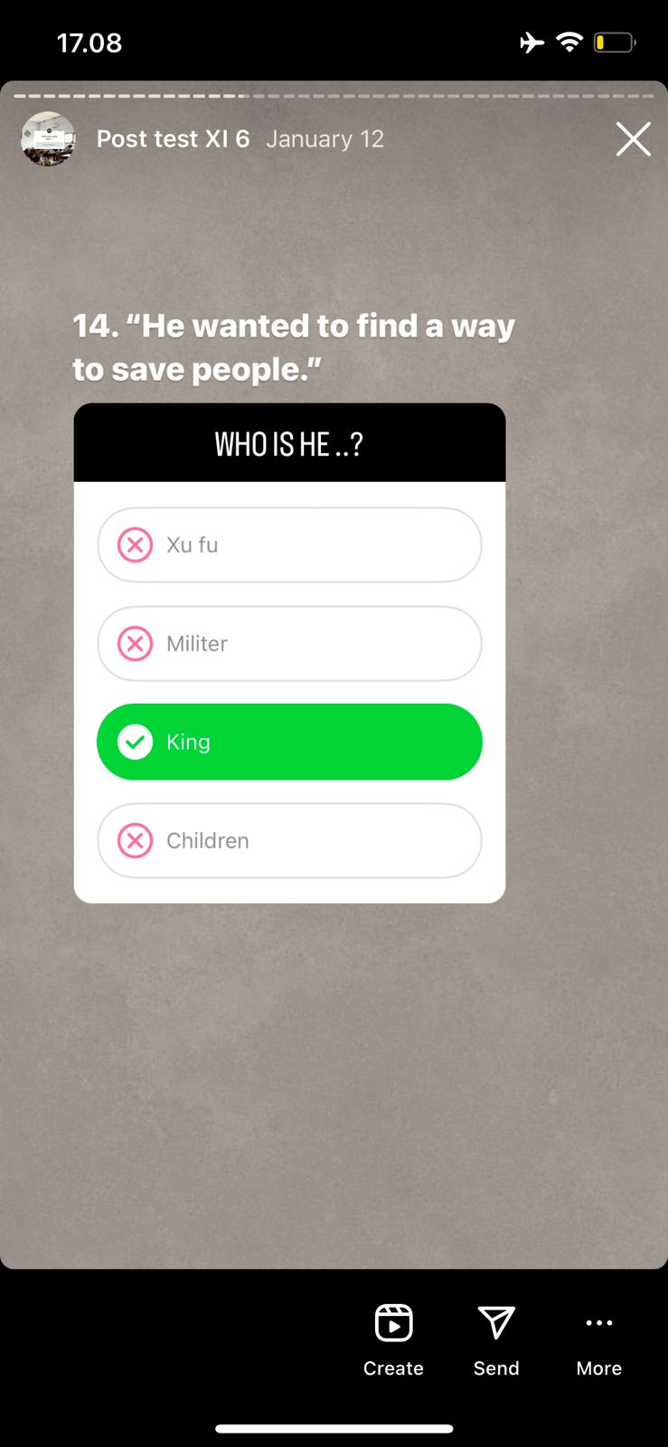

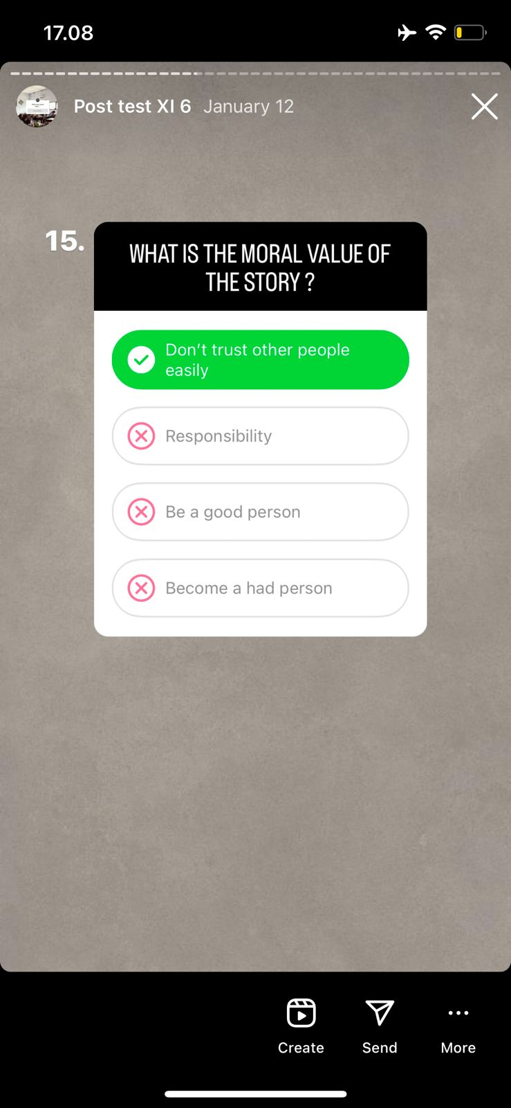 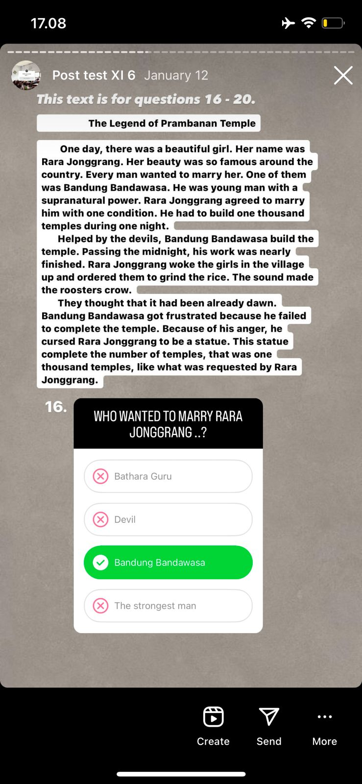

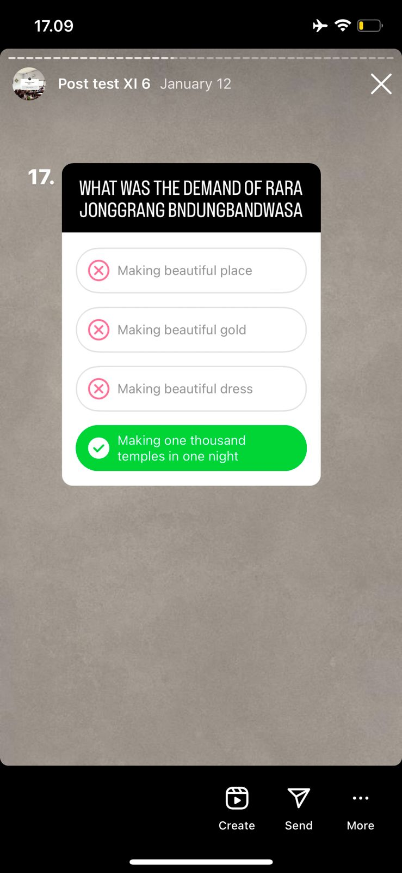 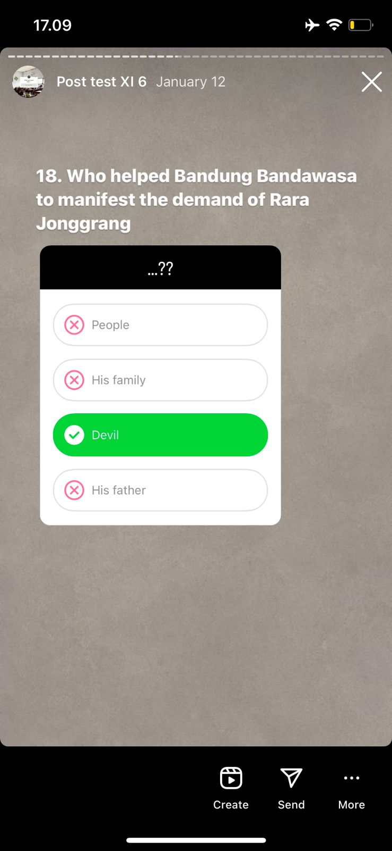

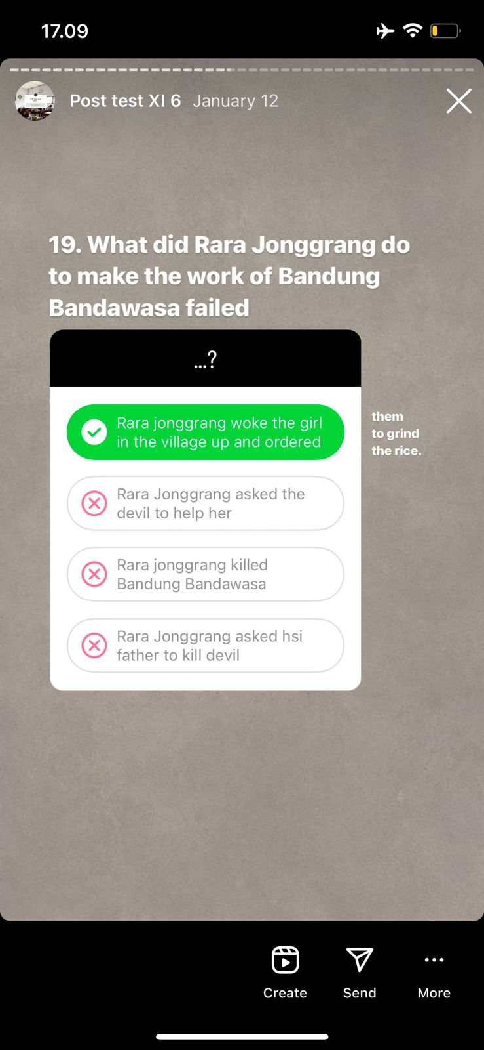 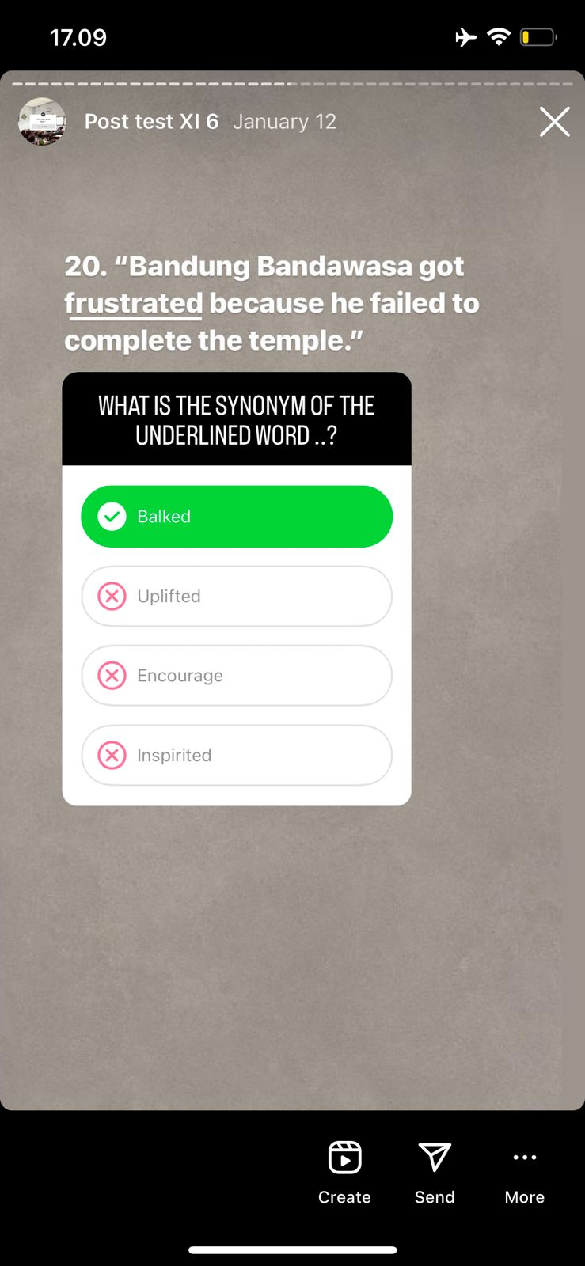

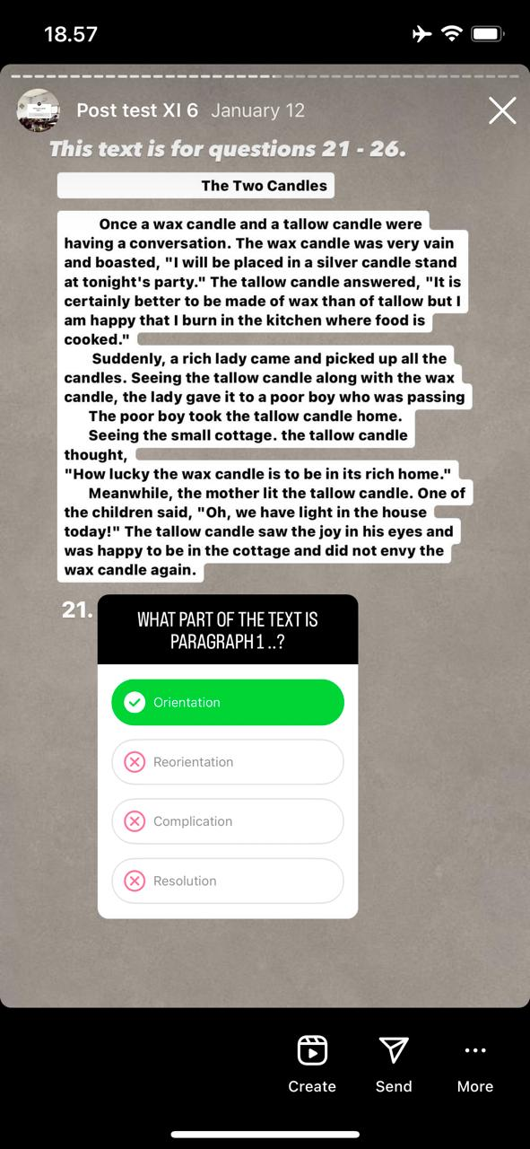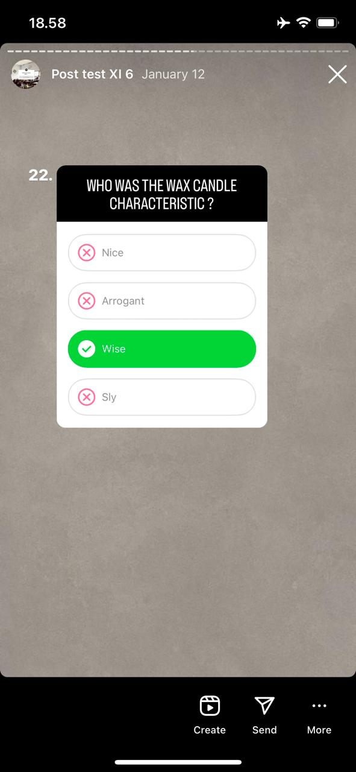

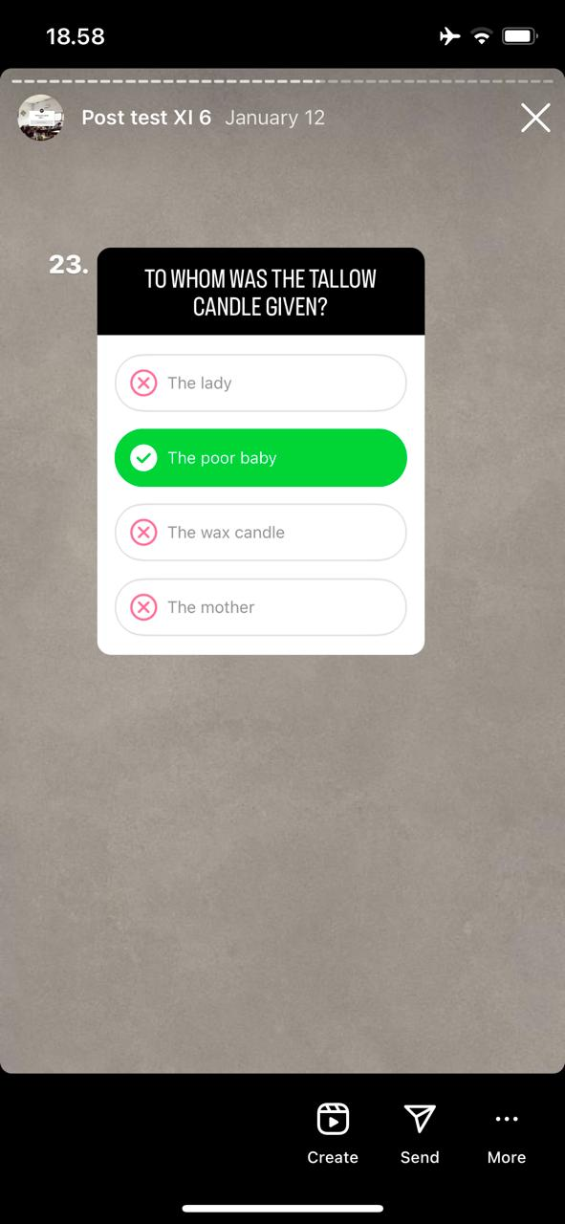 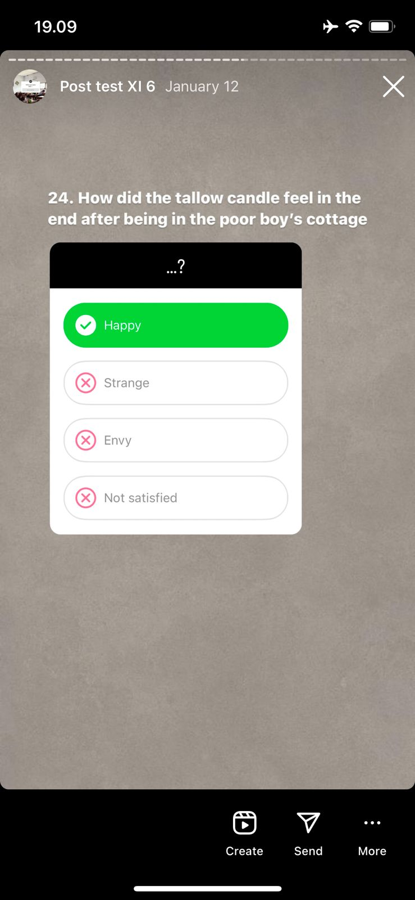

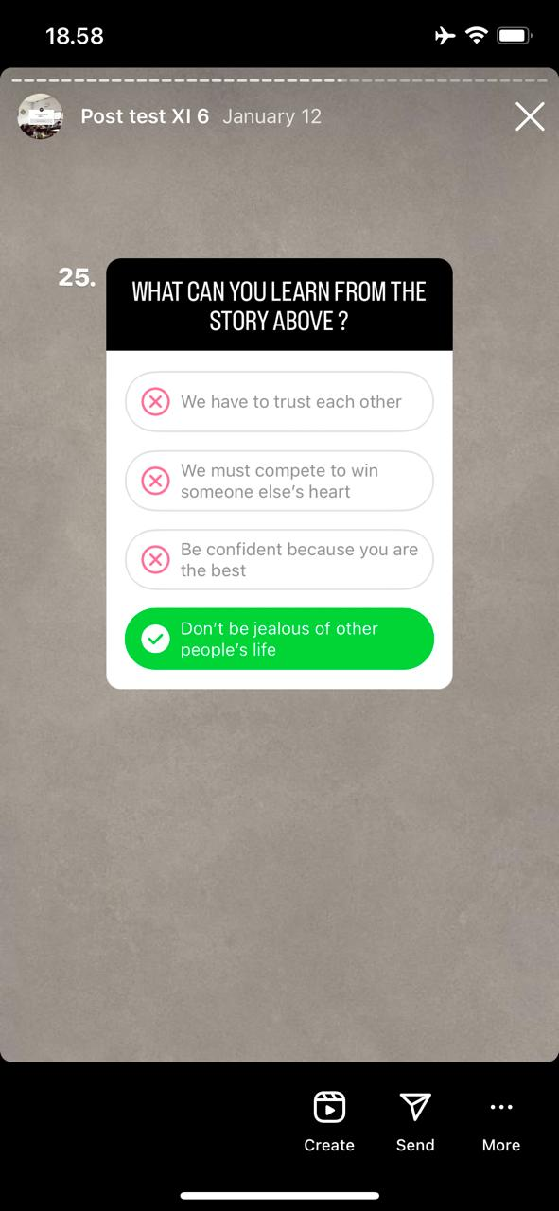 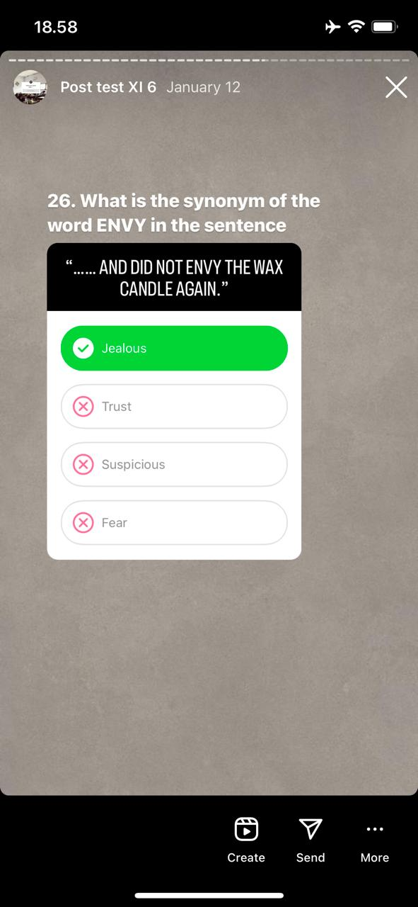

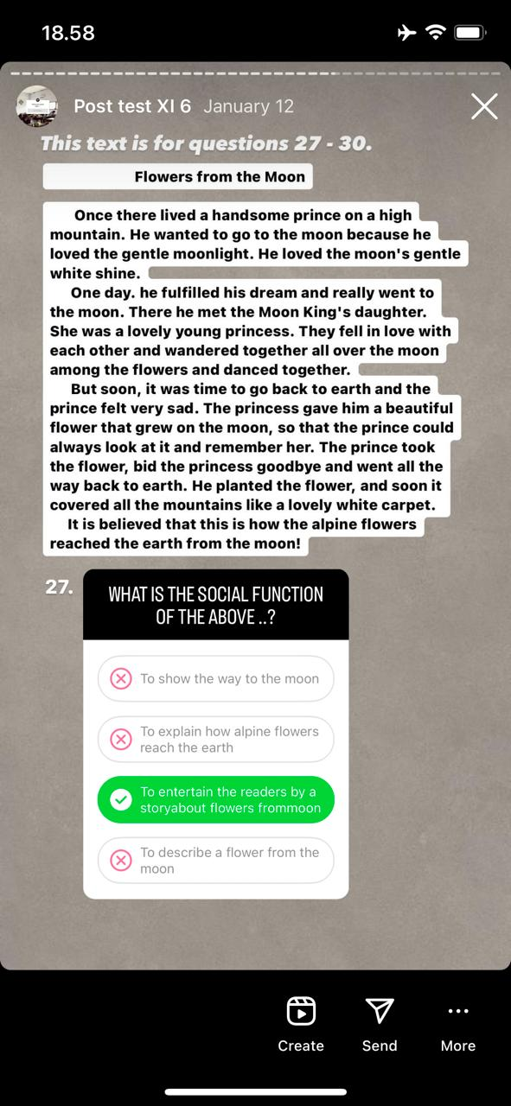 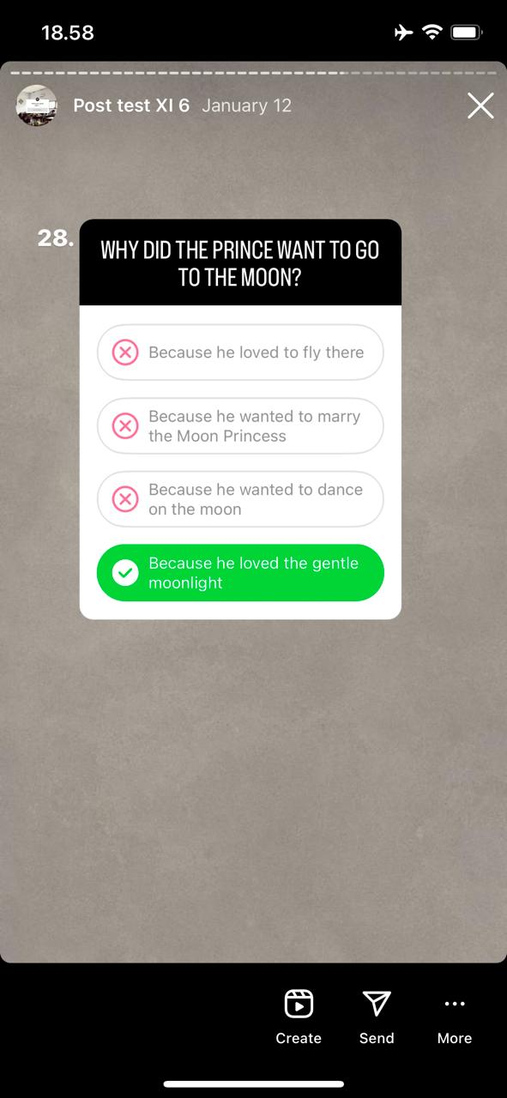

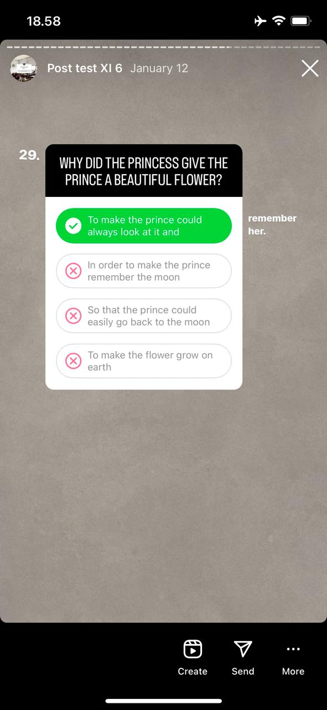 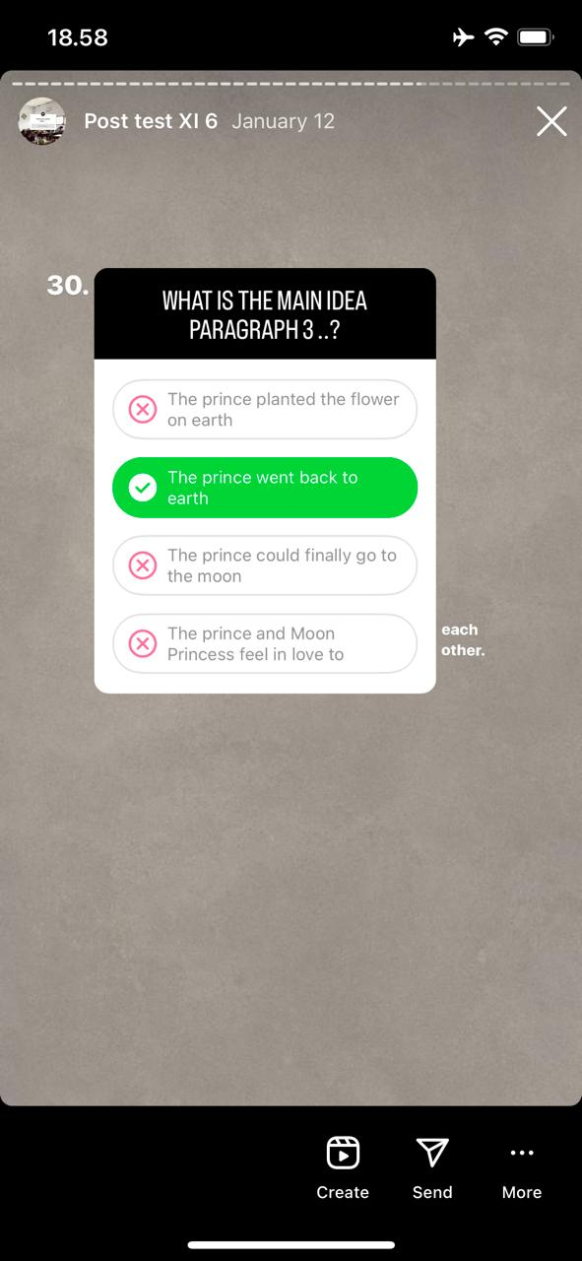

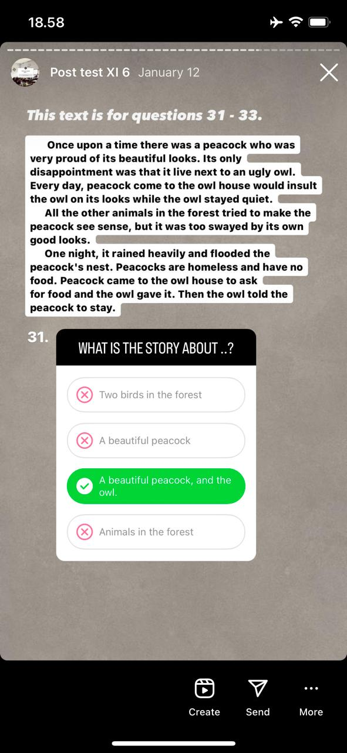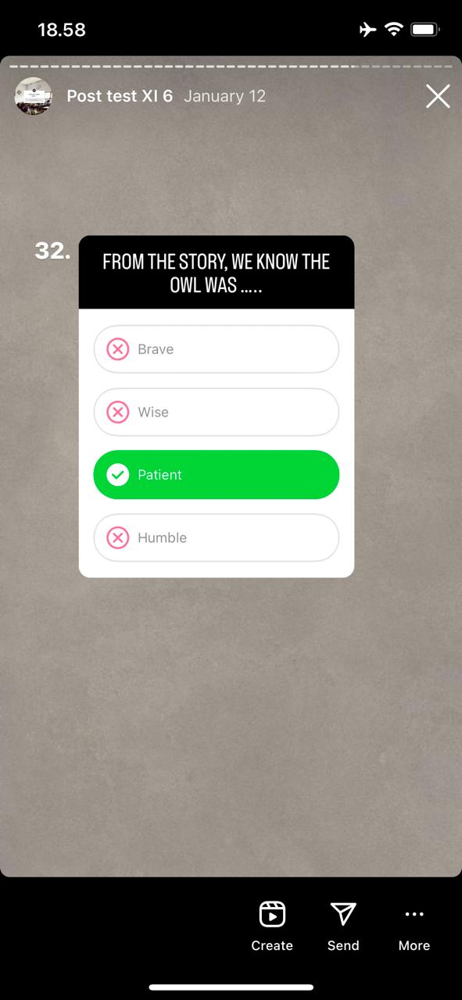

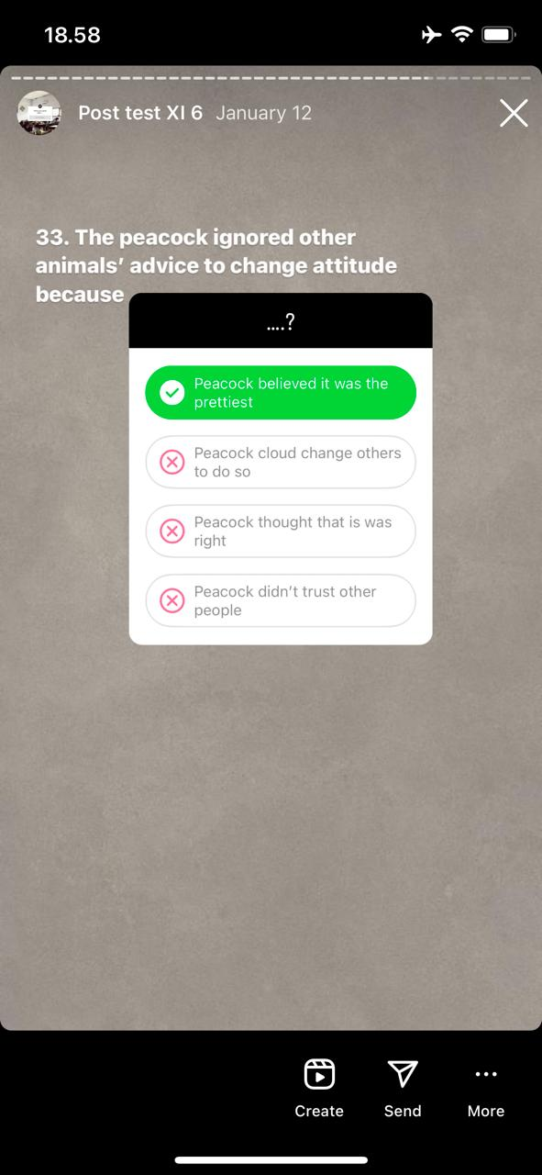 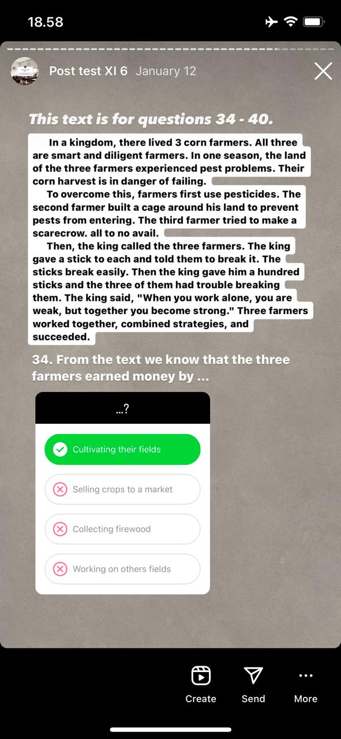

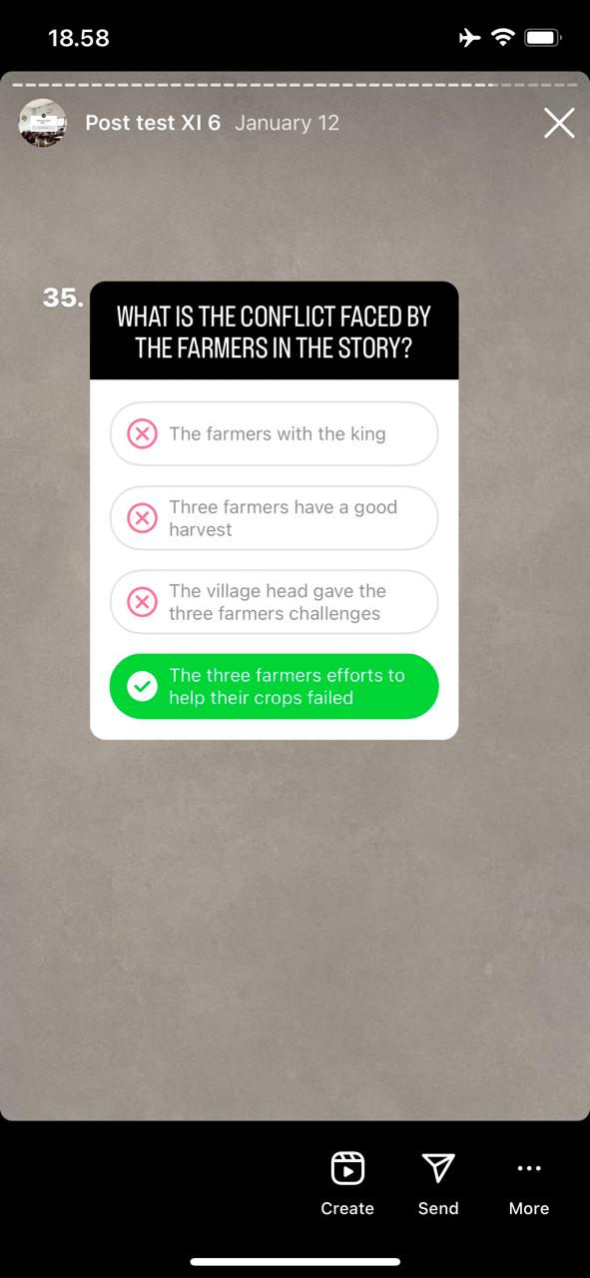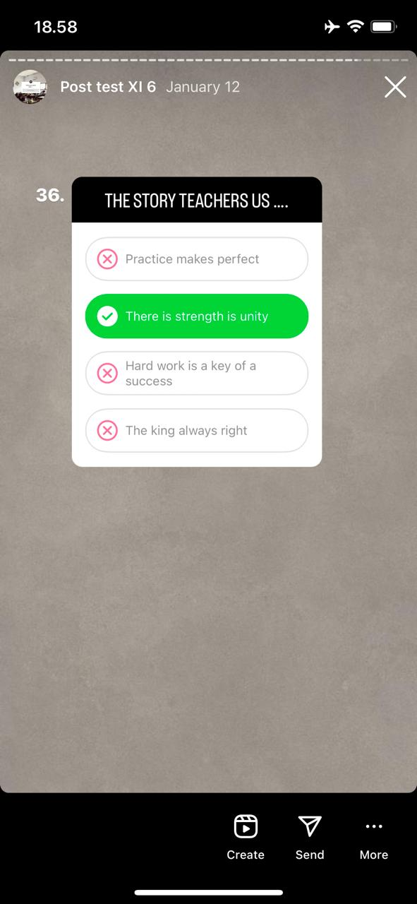

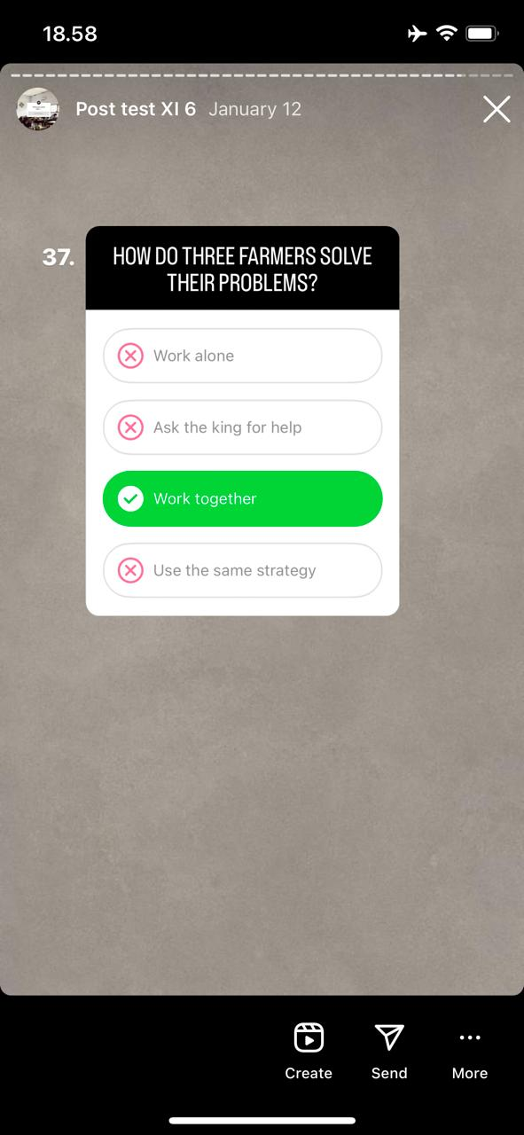 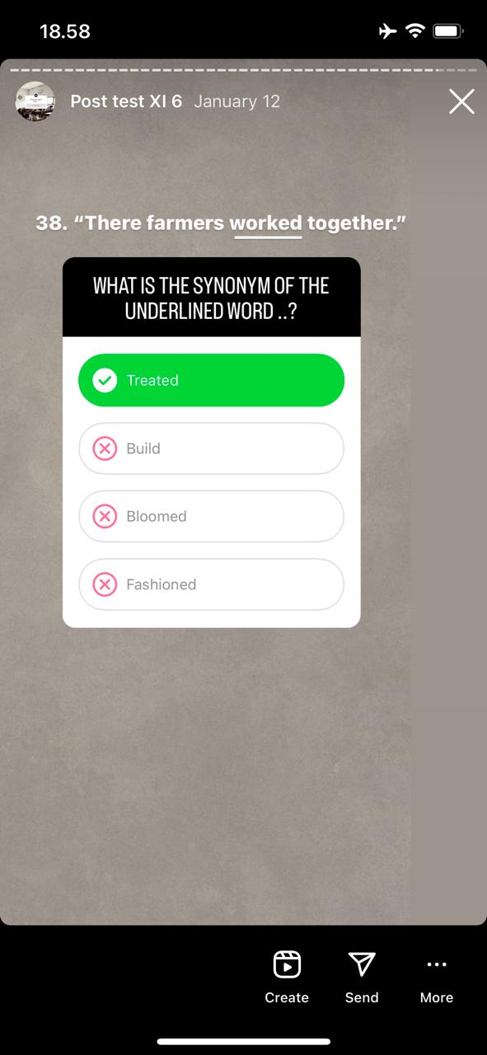

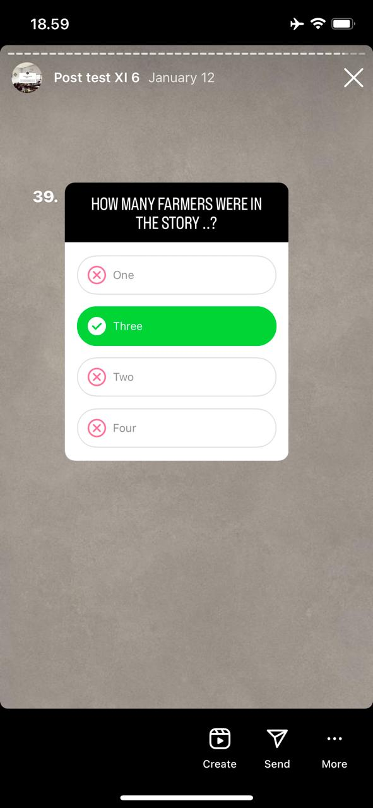 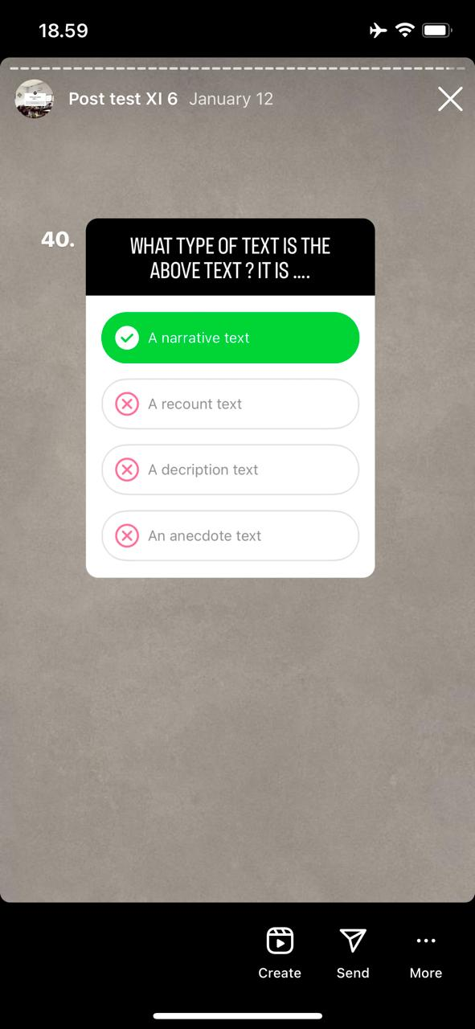

**Appendix 5 Students Works Sheet**

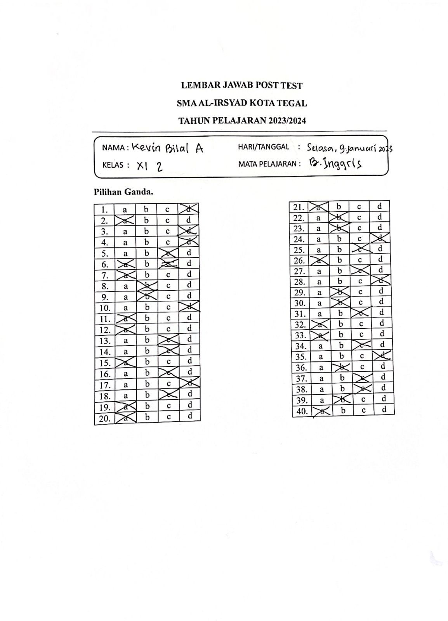

**Appendix 6 Students Reading Scores**

**DAFTAR NILAI PRE TEST SISWA (XI 2)**



**DAFTAR NILAI POST TEST SISWA (XI 2)**



**DAFTAR NILAI PRE TEST SISWA (XI 6)**



**DAFTAR NILAI POST TEST SISWA (XI 6)**



**Appendix 7 Reliability Soal**

|  |  |
| --- | --- |
| **Reliability Statistics** | |
| Cronbach's Alpha | N of Items |
| .948 | 40 |

**Appendix 8 Validity Questionnaire**

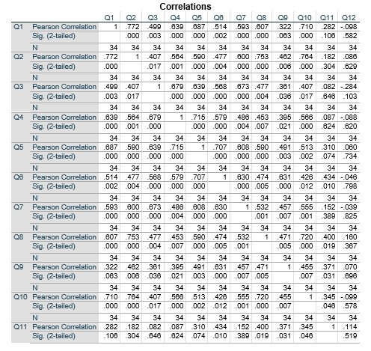

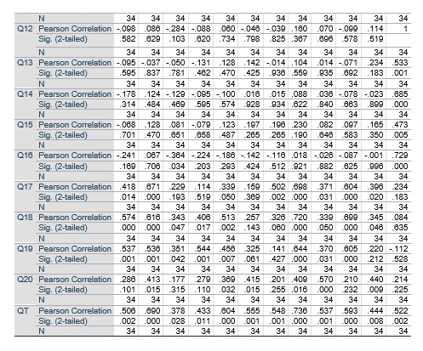

**Appendix 9 Reliability Questionnaire**

|  |  |
| --- | --- |
| **Reliability Statistics** | |
| Cronbach's Alpha | N of Items |
| .856 | 20 |

**Appendix 10 Questionnaire**

**KUESIONER PENELITIAN**

Kuesioner ini bertujuan untuk memperoleh data berkaitan dengan persepsi siswa terhadap penggunaan aplikasi Quiz Instagram Features untuk mengembangkan kemampuan siswa dalam membaca cerita di SMA Al-Irsyad Kota Tegal.

**Jawablah pertanyaan dibawah ini yang sesuai diri anda!**

**Name :**

**Class :**

Ceklislah (✓) salah satu pilihan jawaban soal-soal pertanyaan kuesioner dibawah ini.

**Keterangan pilihan jawaban:**

1. **Sangat Tidak Setuju (STS) 4. Setuju (S)**
2. **Tidak Setuju (TS) 5. Sangat Setuju (SS)**
3. **Netral (N)**

|  |  |  |  |  |  |  |  |  |  |
| --- | --- | --- | --- | --- | --- | --- | --- | --- | --- |
| **No.** | **Pertanyaan** | **Pilihan Jawaban** | | | | | | | |
| **SS** | | **S** | | **TS** | **STS** | | **N** |
| 1. | Saya tertarik untuk belajar materi narrative text. |  | |  | |  |  | |  |
| 2. | Materi narrative text sulit untuk dipahami. |  | |  | |  |  | |  |
| 3. | Guru menggunakan bahan ajar selain buku. |  | |  | |  |  | |  |
| 4. | Bahan ajar yang digunakan guru menarik. |  | |  | |  |  | |  |
| 5. | Guru pernah menggunakan media pembelajaran dengan media sosial. |  | |  | |  |  | |  |
| 6. | Saya tertarik jika pembelajaran menggunakan media pembelajaran Instagram. |  | |  | |  |  | |  |
| 7. | Saya pengguna media sosial Instagram. |  | |  | |  |  | |  |
| 8. | Instagram dapat membantu kegiatan belajar dan mengajar di sekolah. |  | |  | |  |  | |  |
| 9. | Saya mengetahui fitur story pada Instagram. |  | |  | |  |  | |  |
| 10. | Fitur story pada Instagram mudah untuk diakses. |  | |  | |  |  | |  |
| 11. | Saya mengetahui fitur kuis pada story Instagram. |  | |  | |  |  | |  |
| 12. | Ftur kuis sangat menarik menurut saya. |  | |  | |  |  | |  |
| 13. | Saya pernah menggunakan fitur kuis Instagram. |  | |  | |  |  | |  |
| 14. | Saya merasa menggunakan fitur tersebut, mengalami kesulitan selama mengaksesnya. |  | |  | |  |  | |  |
| 15. | Fitur kuis pada Instagram ini cukup nyaman digunakan. |  | |  | |  |  | |  |
| 16. | Saya menyukai jika fitur kuis tersebut dijadikan media pembelajaran materi narrative text. |  | |  | |  |  | |  |
| 17. | Saya merasa dengan menggunakan fitur kuis tersebut akan meningkatkan semangat belajar dalam mempelajari materi narrative text. |  |  | |  | | |  |  |
| 18. | Penggunaan fitur kuis Instagram dalam materi narrative text sangat efektif. |  |  | |  | | |  |  |
| 19. | Bahasa yang digunakan dalam media ini mudah untuk dipahami. |  |  | |  | | |  |  |
| 20. | Penggunakan fitur kuis tersebut dapat membantu untuk bersemangat dalam belajar. |  |  | |  | | |  |  |

*A Reading Rubric Adopted from Sarah (2023)*

**Appendix 11 Dokumentations**

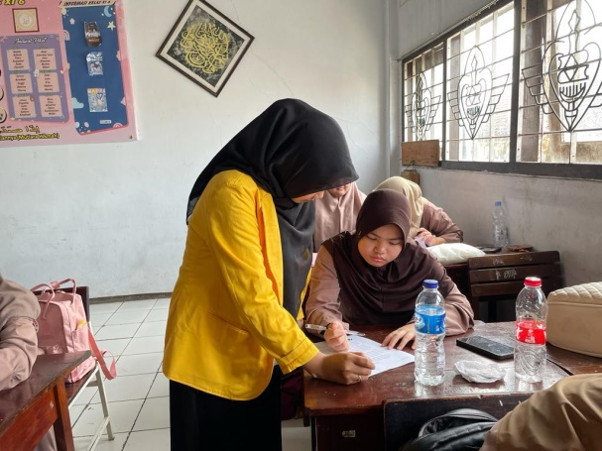 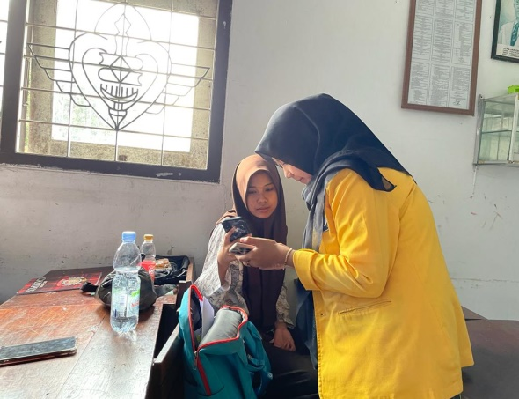

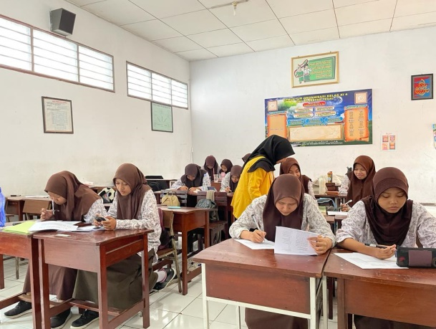 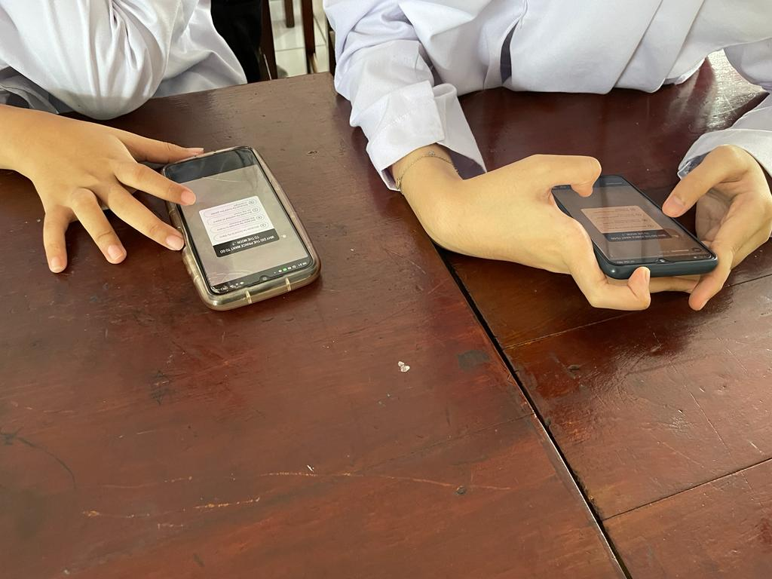

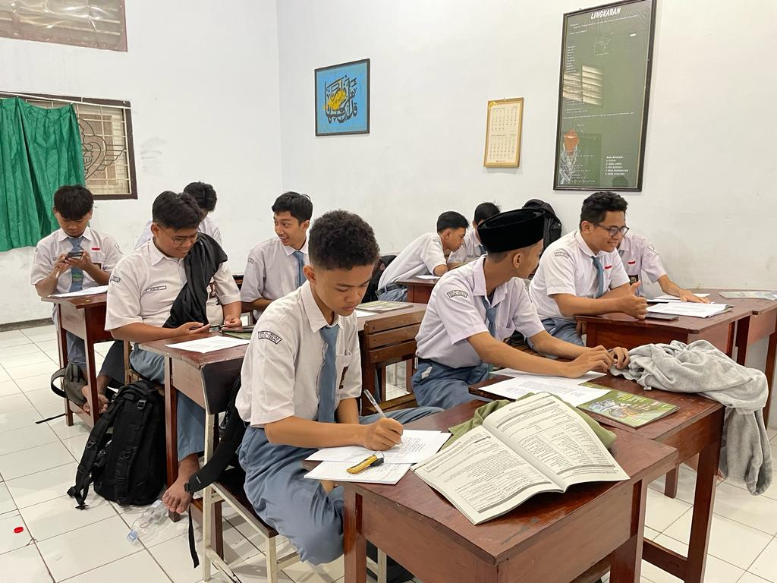

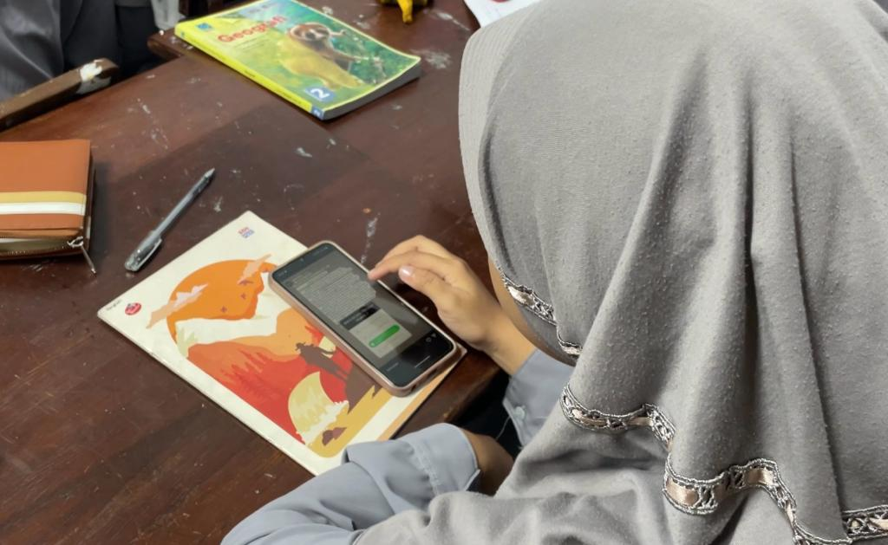 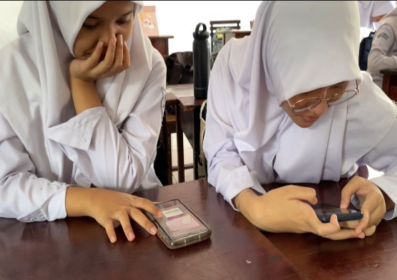

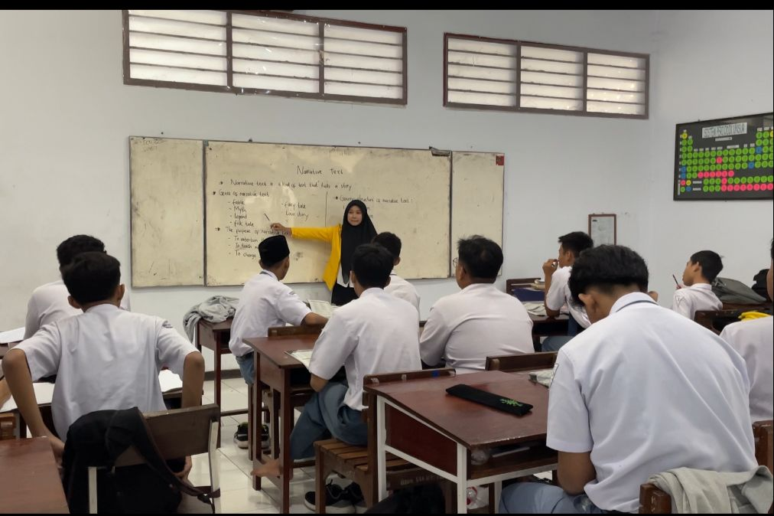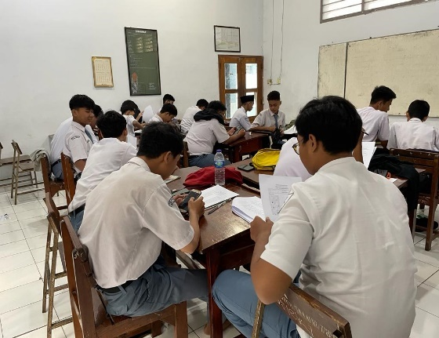

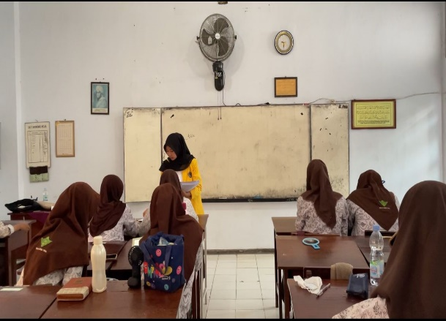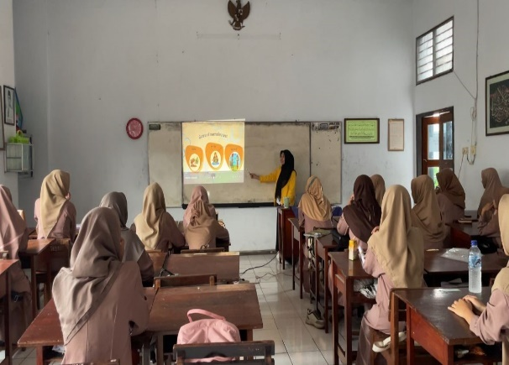

**Appendix 12 Similiarity Check**

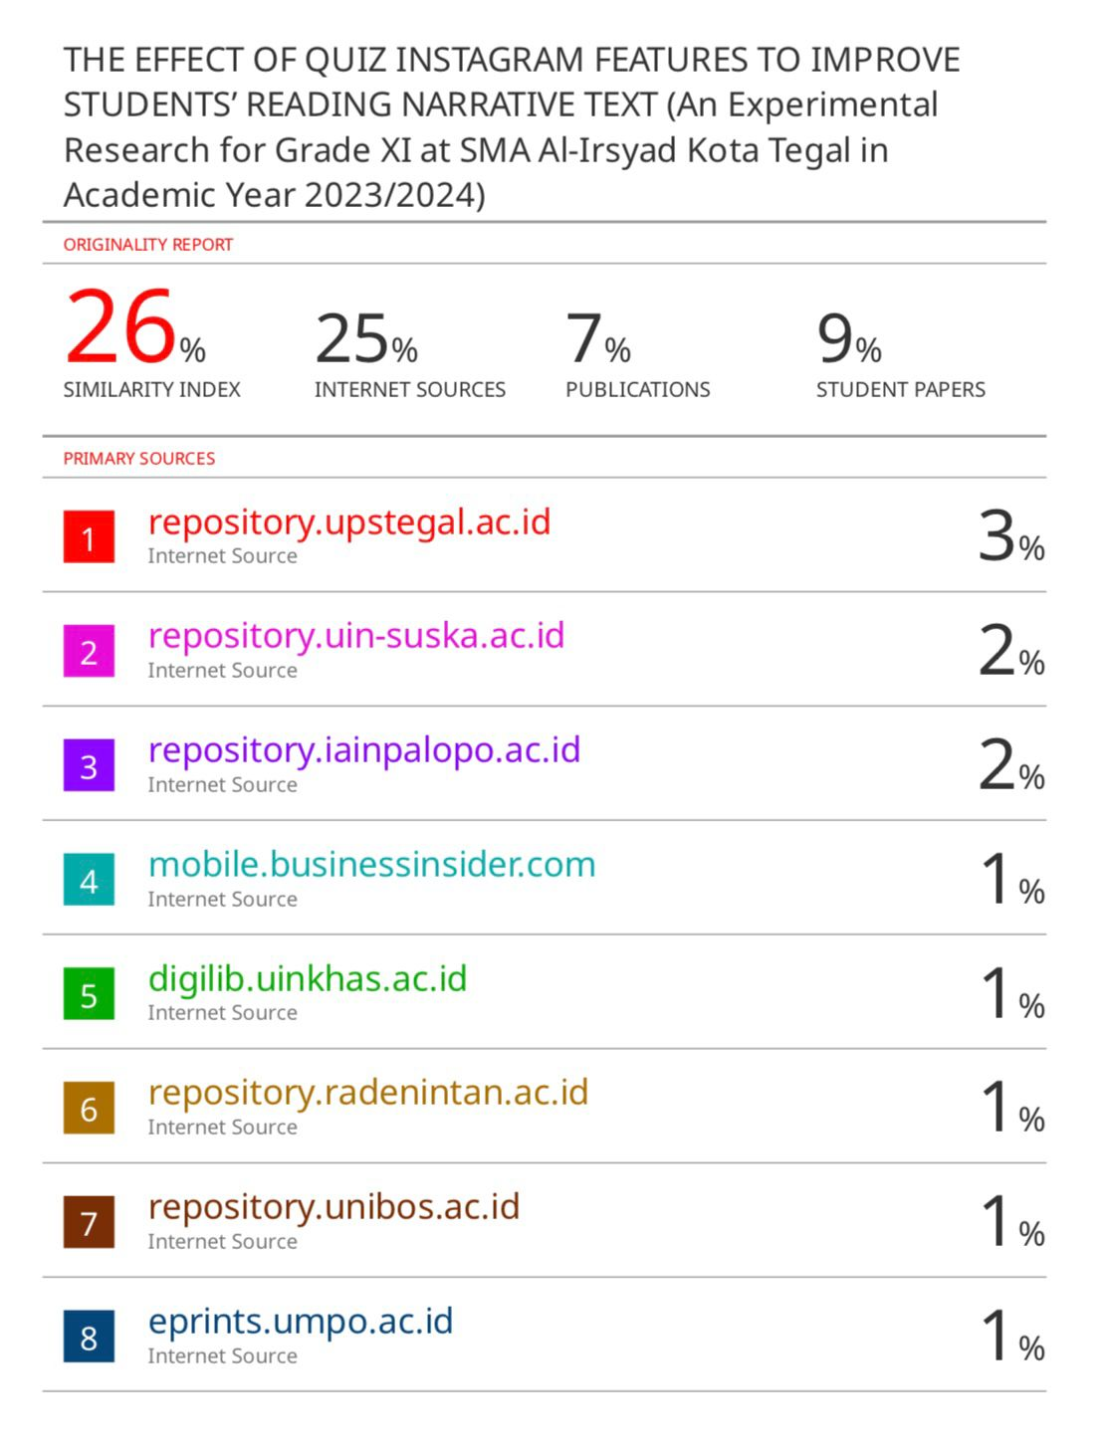

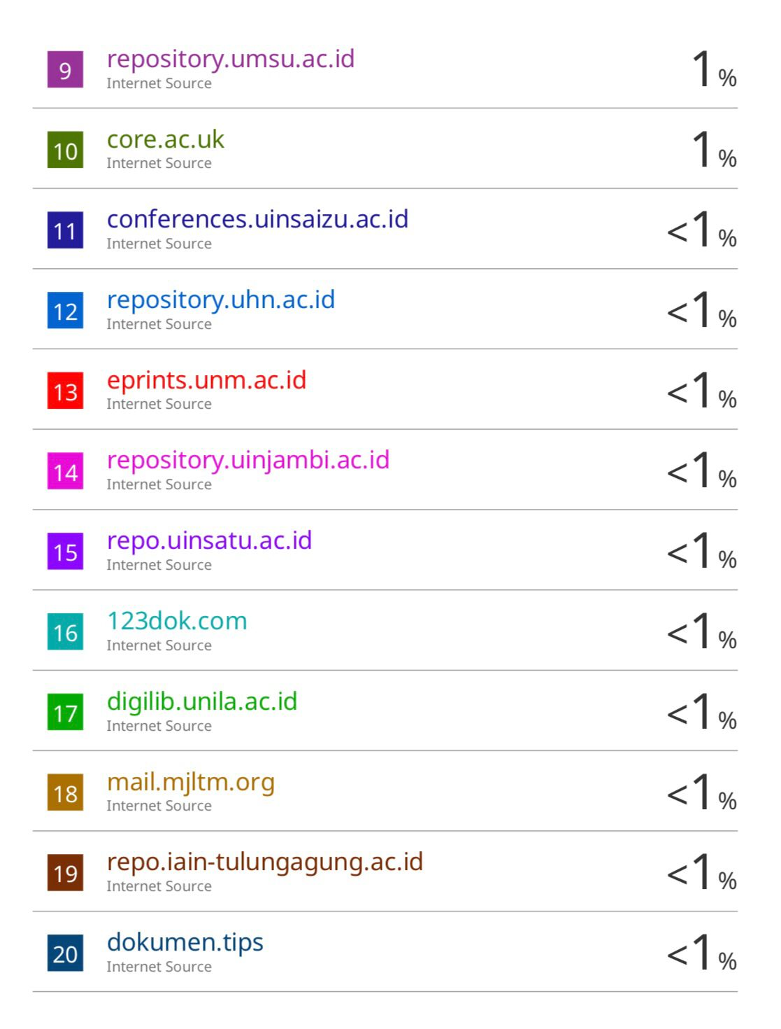

**Appendix 13 Lampiran Berita Acara Bimbingan Skripsi**

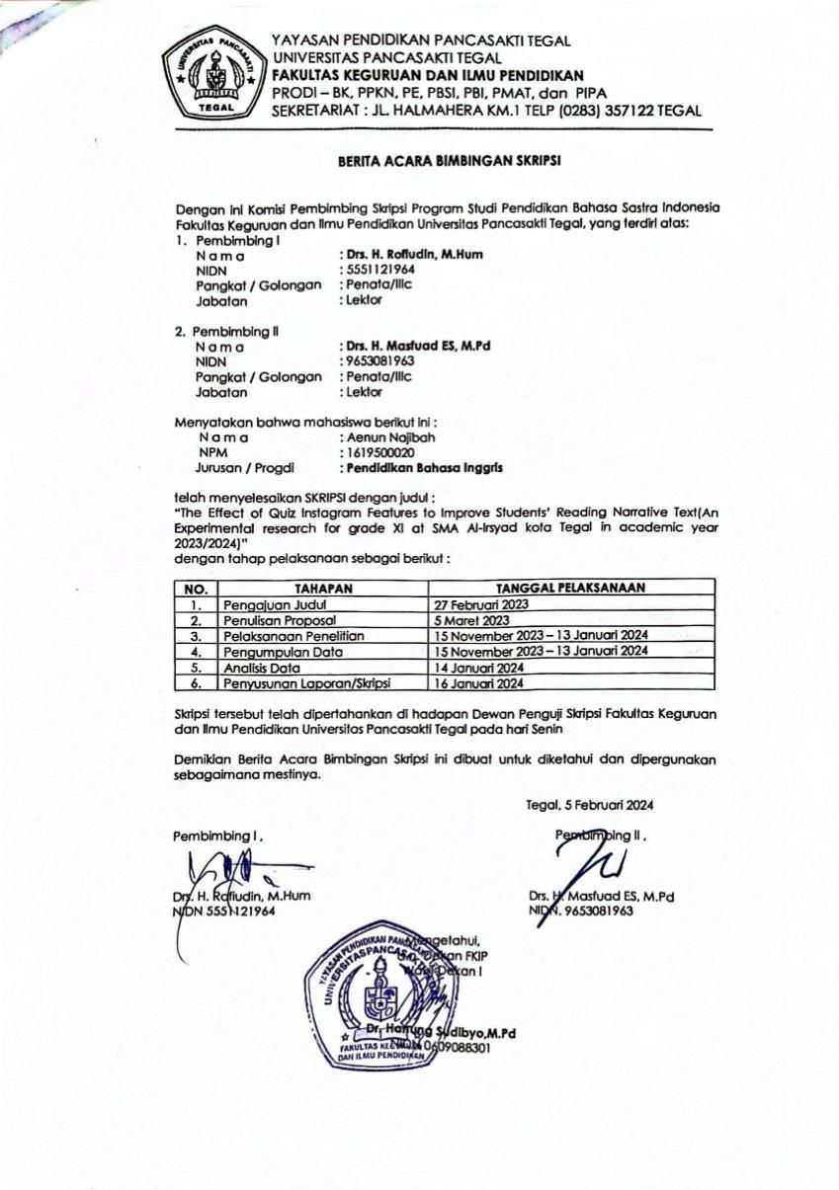

**Appendix 14 Lampiran Berita Acara Ujian Skripsi**

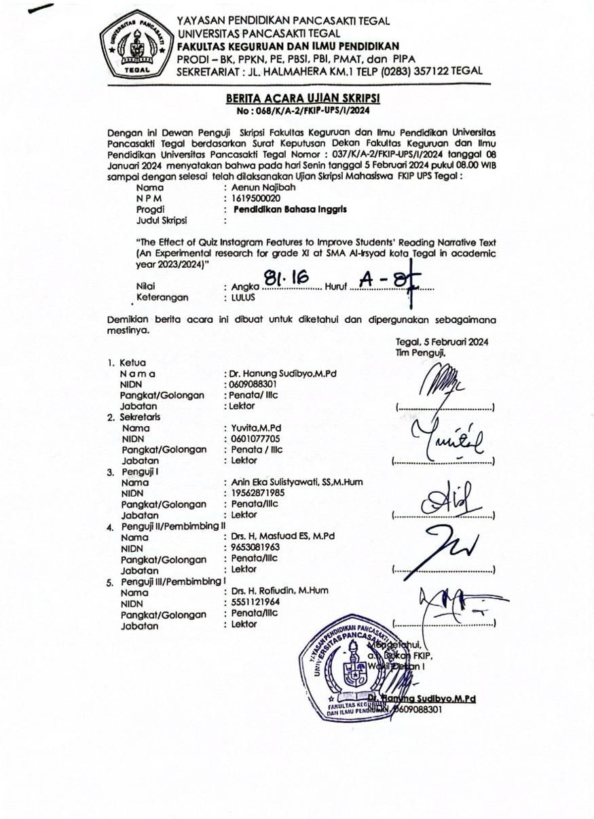

**Appendix 15 Lampiran Surat Keterangan Bebas Plagiasi**

