DAFTAR PUSTAKA

Abdelrady, Abbas Hussein, and Huma Akram. 2022. “An Empirical Study of ClassPoint Tool Application in Enhancing EFL Students’ Online Learning Satisfaction.” Systems 10 (5): 1–14.
Adityaningrum, Amanda. 2021. “Penyuluhan Tentang Dampak Pergaulan Bebas Dan Free Sex Pada Remaja Di Desa Dunggala Kabupaten Gorontalo.” JPKM : Jurnal Pengabdian Kesehatan Masyarakat 2 (2): 111–28.
Arman Suryadi Karim, Melda Agarina, Sutedi, M. Said Hasibuan, and M. Royan Fauzi. 2022. “PELATIHAN PEMBUATAN MEDIA PEMBELAJARAN INTERAKTIF BERBASIS CLASSPOINT BAGI GURU Di PROPINSI
LAMPUNG.” J-ABDI: Jurnal Pengabdian Kepada Masyarakat 2 (3): 4399–.

Azwar, S. (2019). Metode Penelitian Psikologi.Yogyakarta : Pustaka Pelajar. Cresswell, J. W., & Creswell, J. D. (2018). Research Design : Qualitative,
Quantitative, and Mixed Methods Approaches - John W. Creswell, J. David Creswell - Google Books. In SAGE Publications, Inc.
Fitriyani, Aissyah Dwi, and Cici Eka Iswahyuningtyas. 2020. “Online Dating Dalam Relasi Percintaan Friends with Benefit Di Media Sosial Whisper.” Jurnal Ilmu Komunikasi 18 (3): 340. https://doi.org/10.31315/jik.v18i3.3404.
Ghufron, Moh, Hardi Santosa, and Sumiyem Sumiyem. 2022. “Upaya Meningkatkan Motivasi Belajar Dengan Metode Bimbingan Klasikal Berbasis Media Audio Visual Dalam : Literatur Review.” Jurnal Konseling Pendidikan Islam 3 (2): 331–38. https://doi.org/10.32806/jkpi.v3i2.144.
Glading, S. (2015). Konseling Profesi Yang Menyeluruh. In Indeks.
Leandro, G S. 2023. “Studi Kasus: Faktor Mahasiswi Denpasar Melakukan Hubungan Friends With Beneftis.” Jurnal Socia Logica 2 (1): 1–12.
Masha, Jessica, and Abdul Firman Ashaf. 2022. “Konstruksi Sosial Dalam Jalani

87

Hubungan Friends with Benefits (FWB) (Studi Pada Remaja Di Kota Bandarlampung).” Intercode 2 (1): 9.
Moreira, Isabel, Maria Fernandes, Armando Silva, Cristina Veríssimo, Maria Leitão, Luísa Filipe, and Maria Sá. 2021. “Intimate Relationships as Perceived by Adolescents: Concepts and Meanings.” International Journal of Environmental Research and Public Health 18 (5): 1–13.
Nuraini, Vivi Meida, et al. 2023. “59 Parade Riset Mahasiswa 2023 Psychological Security Dalam Dinamika Kehidupan Mahasiswa Fakultas Psikologi Universitas Bhayangkara Jakarta Raya Hubungan Tanpa Komitmen Pada Mahasiswa Yang Menjalankan Friends With Benefit (FWB)” 1 (1): 159–68.
Pramita, et al. 2022. “Education of Sexual Behavior among Adolescent Community To Prevent HIV / AIDS.” Kolabarasi Jurnal: Inspirasi Masyarakat Madani 022: 206–11.
Sugiyono, 2017. Metode Penelitian Pendidikan Pendekatan kuantitatif, kualitatif dan R&D. Bandung: Alfabeta
Suharti, Sri. 2022. “Representasi Perilaku Seks Bebas Dalam Hubungan Friend With Benefit Pada Situs Merdeka . Com” 3: 109–19.
Sumantri, M. Arief, and Yunita Trisna Dewi. 2020. “Komparasi Antara Tingkat Kepuasan Seksual Dan Kepuasan Hubungan (Hubungan Friends with Benefit vs. Hubungan Konvensional).” Gadjah Mada Journal of Psychology (GamaJoP) 6 (1): 29. https://doi.org/10.22146/gamajop.53991.
Sundari, Dian Hadiyani, and Iskandar; Muhlis. 2021. “Penerapan Media Presentasi Classpoint Untuk Meningkatkan Hasil Belajar Siswa Pada Mata Pelajaran Bahasa Inggris MAN 19 Jakarta.” Jurnal Pemikiran Dan Pengembangan Pembelajaran 3 (3): 1–9.
Wahid, Ramdan, Wahyunengsih Wahyunengsih, and Shafina Tunnazah Sholehah. 2022. “Implementasi Bimbingan Klasikal Bagi Siswa Smp.” JURNAL HURRIAH: Jurnal Evaluasi Pendidikan Dan Penelitian 3 (2): 52–58.

LAMPIRAN

Lampiran 1. Informed Consent

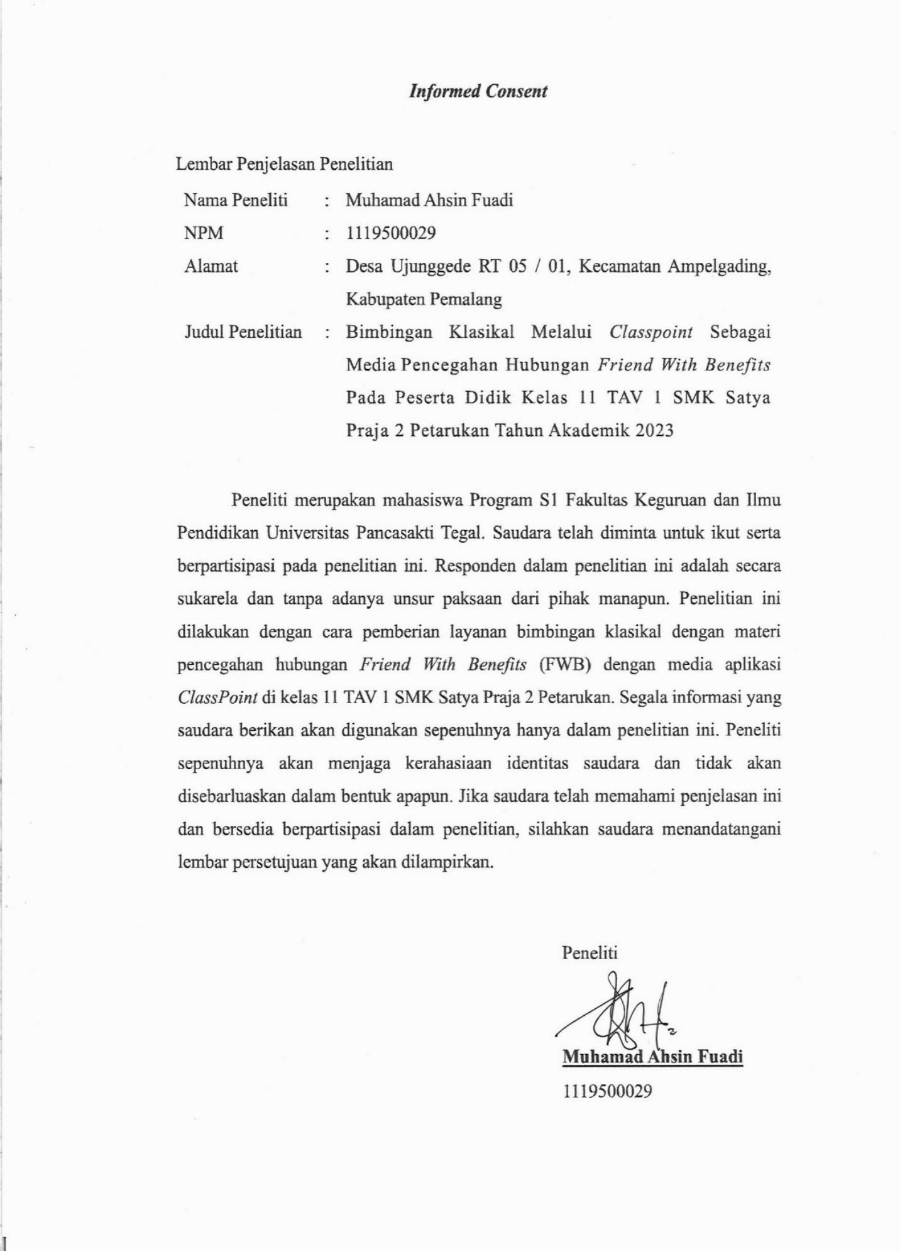

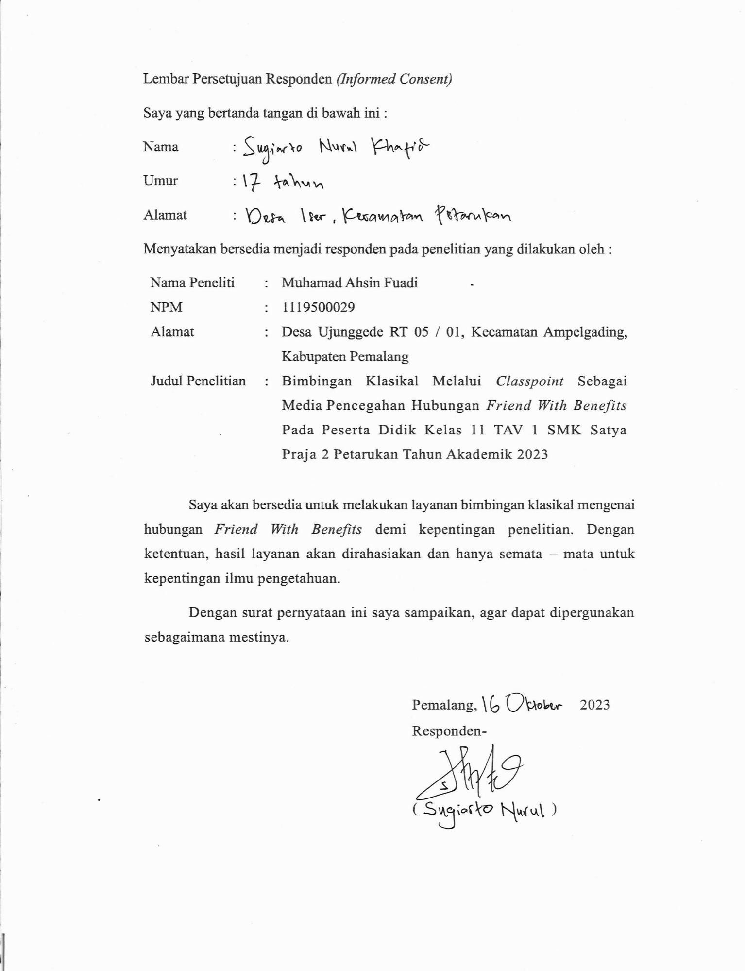

Lampiran 2. RPL Bimbingan Klasikal

YAYASAN PENDIDIKAN SATYA PRAJA PEMALANG SMK SATYA PRAJA 2 PETARUKAN
P E T A R U K A N

BIMBINGAN DAN KONSELING
Jl. Raya Iser Petarukan Pemalang Kode Pos 52362  (0284) 3279529, Fax (0284) 3279558. Email : smksapra2@yahoo.co.id

RENCANA PELAKSANAAN LAYANAN BIMBINGAN KONSELING (RPL BK) TAHUN PELAJARAN 2023 / 2024
Nama Satuan Pendidikan | : | SMK Satya Praja 2 Petarukan
Kelas / Fase / Semester | : | XI / F / Ganjil
Komponen | : | Layanan Responsif
Materi Layanan | : | Pencegahan Hubungan Friend With  Benefits melalui Media ClassPoint
Profil Pelajar Pancasila | : | Berakhlak Mulia
Jenis Layanan | : | Klasikal
Alokasi Waktu | : | 2 x 45 menit

A. | STANDAR KOMPETENSI KEMANDIRIAN (SKK) PESERTA DIDIK | Aspek Perkembangan : Landasan Perilaku Etis | Internalisasi Tujuan : Berperilaku atas dasar keputusan yang meng- integritaskan aspek etis  dalam kehidupan sehari-hari
B. | SASARAN LAYANAN | Peserta Didik XI TAV 1
C. | TUJUAN UMUM | Peserta didik mampu memahami pentingnya pencegahan hubungan Friend With Benefits dan mengetahui faktor – faktor yang menjadi penyebab, serta dampak yang diakibatkan dari  hubungan Friend With Benefits.
D. | TUJUAN KHUSUS | - Peserta didik dapat memahami pencegahan hubungan Friend With Benefits di lingkungan.  - Peserta didik mampu menjaga perilaku dalam menjalin hubungan pertemanan lawan  jenis.
E. | METODE, ALAT, DAN MEDIA | Metode : Problem Based Learning

Alat dan Media : LCD, Laptop, Papan Tulis,
ClassPoint, PowerPoint, Word Search
F. | MATERI LAYANAN | - Pengertian hubungan Friend With Benefits ?  - Faktor – Faktor terjadinya hubungan Friend With Benefits ?  - Bahaya hubungan Friend With Benefits ?  - Mengapa hubungan Friend With Benefits  tidak perlu dilakukan ?  - Media pencegahan hubungan Friend With Benefits dengan aplikasi ClassPoint
G. | PROSES PELAYANAN BIMBINGAN | - Pendahuluan  - Mengucapkan salam, berdoa, dan ucapan terimakasih atas kesempatan dalam
 |  | memberikan layanan.
 |  | b. Menanyakan kabar dan berkenalan
 |  | anatara guru BK dengan peserta didik.
 |  | c. Memberikan daftar presensi untuk
 |  | ditanda tangani oleh peserta didik.
 |  | d. Menjelaskan langkah-langkah mela-
 |  | kukan ice breaking ketika layanan BK
 |  | berlangsung.
 |  | 2. Kegiatan Inti
 |  | a. Guru BK menyampaikan topik layanan
 |  | yang akan diberikan.
 |  | b. Guru BK memaparkan materi yang akan
 |  | disampaikan melalui slide di power point
 |  | yang ditampilkan melalui LCD
 |  | Proyektor.
 |  | c. Peserta didik memperhatikan dan
 |  | menanyakan jika ada materi yang belum
 |  | memberikan kejelasan pada peserta
 |  | didik.
 |  | d. Peserta didik dengan guru BK berdiskusi
 |  | mengenai topik dan materi yang
 |  | tersampaikan.
 |  | 3. Penutup
 |  | a. Menyimpulkan materi yang disampaikan
 |  | oleh guru BK.

- Peserta didik mengikuti permainan aplikasi ClassPoint yang sudah diberikan.
- Peserta didik mengisi setiap kuis yang ditampilkan.
- Guru BK menutup kegiatan layanan BK dengan mengucapkan terimakasih dan memberikan ungkapan manfaat serta
mengajak foto bersama.
H. | ASSESMEN | Assesmen Proses  Assesmen ini dilakukan oleh guru BK melakukan evaluasi layanan BK yang sudah diberikan dengan mencatat hasil yang dicapai setelah proses pemberian layanan selesai, seperti :  - Mengamati keaktifan dan antusias peserta didik saat mengikuti layanan BK.  - Mengamati setiap peserta didik yang menyampaikan ungkapan, pendapat, dan mengajukan pertanyaan.  Assesmen Hasil  Assesmen ini dilakukan setelah peserta didik mengikuti kegiatan layanan klasikal, antara lain:  - Menjelaskan berbagai jenis kenakalan remaja.  - Menyebutkan faktor – faktor yang menyebabkan hubungan Friend With Benefits.  - Menyediakan media pencegahan Friend With Benefits yang berupa aplikasi ClassPoint untuk memastikan peserta didik memahami bahaya dari hubungan Friend  With Benefits.

Lampiran 3. Hasil Uji Validitas

Correlations

X1 |  |  | X2 | X3 | X4 | X5 | X6 | X7 | X8 | TOTA LX1
Y1 | Pearson Correla tion | .044 | -.166 | -.453* | -.237 | -.062 | .008 | -.044 | .012 | -.215
 | Sig. (2-  tailed) | .813 | .373 | .011 | .199 | .741 | .965 | .814 | .951 | .245
 | N | 31 | 31 | 31 | 31 | 31 | 31 | 31 | 31 | 31
Y2 | Pearson Correla tion | -.005 | .089 | -.262 | .134 | .252 | .114 | -.030 | .185 | .079
 | Sig. (2-  tailed) | .977 | .635 | .154 | .473 | .172 | .540 | .874 | .319 | .675
 | N | 31 | 31 | 31 | 31 | 31 | 31 | 31 | 31 | 31
Y3 | Pearson Correla tion | -.226 | .032 | .408* | .018 | -.023 | -.029 | .028 | -.016 | .055
 | Sig. (2-  tailed) | .221 | .866 | .023 | .921 | .901 | .879 | .880 | .932 | .768
 | N | 31 | 31 | 31 | 31 | 31 | 31 | 31 | 31 | 31
Y4 | Pearson Correla tion | .000 | -.399* | -.339 | -.313 | -.086 | -.211 | .059 | -.200 | -.331
 | Sig. (2-  tailed) | 1.000 | .026 | .062 | .087 | .645 | .254 | .752 | .281 | .069
 | N | 31 | 31 | 31 | 31 | 31 | 31 | 31 | 31 | 31
Y5 | Pearson Correla tion | -.056 | .015 | -.168 | .101 | .128 | .157 | -.258 | .165 | .009

 | Sig. (2-  tailed) | .766 | .937 | .365 | .589 | .494 | .400 | .161 | .376 | .962
 | N | 31 | 31 | 31 | 31 | 31 | 31 | 31 | 31 | 31
Y6 | Pearson Correla tion | .009 | -.105 | -.347 | -.025 | .001 | .002 | -.289 | .163 | -.136
 | Sig. (2-  tailed) | .964 | .573 | .056 | .893 | .995 | .993 | .115 | .381 | .466
 | N | 31 | 31 | 31 | 31 | 31 | 31 | 31 | 31 | 31
Y7 | Pearson Correla tion | -.287 | -.122 | .039 | -.071 | .130 | -.141 | .116 | -.176 | -.117
 | Sig. (2-  tailed) | .117 | .514 | .833 | .704 | .484 | .451 | .536 | .345 | .532
 | N | 31 | 31 | 31 | 31 | 31 | 31 | 31 | 31 | 31
Y8 | Pearson Correla tion | .139 | .397* | .308 | .260 | .237 | .132 | .187 | -.089 | .351
 | Sig. (2-  tailed) | .455 | .027 | .092 | .158 | .199 | .481 | .313 | .635 | .053
 | N | 31 | 31 | 31 | 31 | 31 | 31 | 31 | 31 | 31
Y9 | Pearson Correla tion | -.156 | .282 | -.146 | -.127 | .006 | .154 | .021 | .173 | .023
 | Sig. (2-  tailed) | .401 | .125 | .434 | .498 | .973 | .407 | .910 | .352 | .903
 | N | 31 | 31 | 31 | 31 | 31 | 31 | 31 | 31 | 31
Y10 | Pearson Correla tion | -.090 | .267 | -.281 | .187 | .218 | -.111 | -.026 | .081 | .039

 | Sig. (2-  tailed) | .630 | .147 | .126 | .315 | .240 | .552 | .891 | .666 | .836
 | N | 31 | 31 | 31 | 31 | 31 | 31 | 31 | 31 | 31
Y11 | Pearson Correla tion | -.195 | .005 | -.100 | .101 | .042 | .102 | -.242 | -.069 | -.079
 | Sig. (2-  tailed) | .293 | .979 | .591 | .589 | .822 | .586 | .190 | .714 | .673
 | N | 31 | 31 | 31 | 31 | 31 | 31 | 31 | 31 | 31
Y12 | Pearson Correla tion | .071 | -.042 | .277 | -.050 | .120 | .255 | .155 | -.274 | .117
 | Sig. (2-  tailed) | .705 | .823 | .131 | .790 | .519 | .166 | .405 | .136 | .530
 | N | 31 | 31 | 31 | 31 | 31 | 31 | 31 | 31 | 31
Y13 | Pearson Correla tion | .223 | .013 | .491** | .168 | .233 | .334 | .307 | -.080 | .369*
 | Sig. (2-  tailed) | .229 | .944 | .005 | .367 | .208 | .066 | .093 | .667 | .041
 | N | 31 | 31 | 31 | 31 | 31 | 31 | 31 | 31 | 31
Y14 | Pearson Correla tion | .245 | .663** | .221 | .408* | .512** | .394* | .538*  * | .284 | .674**
 | Sig. (2-  tailed) | .184 | .000 | .233 | .023 | .003 | .028 | .002 | .121 | .000
 | N | 31 | 31 | 31 | 31 | 31 | 31 | 31 | 31 | 31
Y15 | Pearson Correla tion | -.280 | -.135 | -.269 | .052 | .252 | -.072 | .014 | .078 | -.107

 | Sig. (2-  tailed) | .127 | .469 | .144 | .782 | .172 | .701 | .942 | .677 | .565
 | N | 31 | 31 | 31 | 31 | 31 | 31 | 31 | 31 | 31
Y16 | Pearson Correla tion | -.280 | -.135 | -.065 | .209 | .248 | .305 | -.157 | -.017 | .001
 | Sig. (2-  tailed) | .127 | .470 | .729 | .260 | .178 | .096 | .398 | .928 | .996
 | N | 31 | 31 | 31 | 31 | 31 | 31 | 31 | 31 | 31
Y17 | Pearson Correla tion | .043 | .088 | .336 | -.028 | -.107 | -.131 | .174 | -.206 | .060
 | Sig. (2-  tailed) | .818 | .636 | .065 | .881 | .568 | .483 | .349 | .267 | .747
 | N | 31 | 31 | 31 | 31 | 31 | 31 | 31 | 31 | 31
Y18 | Pearson Correla tion | .236 | -.044 | .170 | -.235 | -.212 | -.363* | .019 | -.173 | -.089
 | Sig. (2-  tailed) | .201 | .814 | .361 | .203 | .253 | .045 | .921 | .352 | .633
 | N | 31 | 31 | 31 | 31 | 31 | 31 | 31 | 31 | 31
Y19 | Pearson Correla tion | .180 | -.009 | .146 | .335 | .570** | .339 | .153 | -.132 | .333
 | Sig. (2-  tailed) | .333 | .963 | .433 | .065 | .001 | .062 | .411 | .480 | .067
 | N | 31 | 31 | 31 | 31 | 31 | 31 | 31 | 31 | 31
Y20 | Pearson Correla tion | -.337 | -.034 | .094 | .184 | .197 | .191 | -.099 | .008 | .030

 | Sig. (2-  tailed) | .064 | .854 | .614 | .323 | .288 | .303 | .598 | .967 | .871
 | N | 31 | 31 | 31 | 31 | 31 | 31 | 31 | 31 | 31
Y21 | Pearson Correla tion | .188 | -.063 | -.028 | .324 | .436* | .344 | .199 | .008 | .278
 | Sig. (2-  tailed) | .312 | .735 | .883 | .076 | .014 | .058 | .283 | .967 | .130
 | N | 31 | 31 | 31 | 31 | 31 | 31 | 31 | 31 | 31
Y22 | Pearson Correla tion | -.347 | -.306 | .260 | .034 | .088 | -.191 | -.071 | -.243 | -.152
 | Sig. (2-  tailed) | .056 | .094 | .158 | .855 | .637 | .303 | .704 | .189 | .414
 | N | 31 | 31 | 31 | 31 | 31 | 31 | 31 | 31 | 31
TOT ALY 1 | Pearson Correla tion | -.130 | .048 | .015 | .167 | .401* | .188 | .094 | -.069 | .136
 | Sig. (2-  tailed) | .484 | .799 | .936 | .370 | .025 | .312 | .614 | .712 | .465
 | N | 31 | 31 | 31 | 31 | 31 | 31 | 31 | 31 | 31
Y2.1 | Pearson Correla tion | .291 | .382* | -.013 | .093 | .331 | .017 | .187 | .047 | .290
 | Sig. (2-  tailed) | .112 | .034 | .944 | .620 | .069 | .927 | .313 | .800 | .114
 | N | 31 | 31 | 31 | 31 | 31 | 31 | 31 | 31 | 31
Y2.2 | Pearson Correla tion | -.083 | .192 | .364* | .219 | .168 | .016 | .171 | -.096 | .214

 | Sig. (2-  tailed) | .657 | .300 | .044 | .237 | .366 | .931 | .358 | .606 | .247
 | N | 31 | 31 | 31 | 31 | 31 | 31 | 31 | 31 | 31
Y2.3 | Pearson Correla tion | -.101 | .230 | .405* | .019 | .062 | .165 | -.104 | -.208 | .129
 | Sig. (2-  tailed) | .590 | .213 | .024 | .917 | .740 | .374 | .576 | .262 | .490
 | N | 31 | 31 | 31 | 31 | 31 | 31 | 31 | 31 | 31
Y2.4 | Pearson Correla tion | .088 | .174 | -.330 | -.295 | -.156 | -.332 | -.089 | .110 | -.172
 | Sig. (2-  tailed) | .638 | .350 | .070 | .107 | .404 | .068 | .635 | .557 | .354
 | N | 31 | 31 | 31 | 31 | 31 | 31 | 31 | 31 | 31
Y2.5 | Pearson Correla tion | .206 | .561** | .216 | .537** | .403* | .340 | .280 | .409* | .616**
 | Sig. (2-  tailed) | .266 | .001 | .243 | .002 | .024 | .061 | .127 | .022 | .000
 | N | 31 | 31 | 31 | 31 | 31 | 31 | 31 | 31 | 31
Y2.6 | Pearson Correla tion | -.126 | .450* | .355 | .154 | .005 | .063 | .131 | -.074 | .218
 | Sig. (2-  tailed) | .500 | .011 | .050 | .409 | .981 | .736 | .484 | .694 | .238
 | N | 31 | 31 | 31 | 31 | 31 | 31 | 31 | 31 | 31
Y2.7 | Pearson Correla tion | -.098 | -.192 | .008 | -.234 | -.274 | -.215 | -.170 | -.248 | -.284

 | Sig. (2-  tailed) | .599 | .302 | .968 | .204 | .136 | .246 | .359 | .179 | .122
 | N | 31 | 31 | 31 | 31 | 31 | 31 | 31 | 31 | 31
Y2.8 | Pearson Correla tion | -.242 | .037 | .130 | .124 | .031 | .138 | .145 | .029 | .066
 | Sig. (2-  tailed) | .190 | .844 | .484 | .507 | .871 | .458 | .435 | .876 | .724
 | N | 31 | 31 | 31 | 31 | 31 | 31 | 31 | 31 | 31
Y2.9 | Pearson Correla tion | -.071 | .268 | .482** | .457** | .512** | .394* | .277 | .174 | .522**
 | Sig. (2-  tailed) | .703 | .145 | .006 | .010 | .003 | .028 | .131 | .349 | .003
 | N | 31 | 31 | 31 | 31 | 31 | 31 | 31 | 31 | 31
Y2.1 0 | Pearson Correla tion | .264 | .269 | -.259 | .119 | .206 | -.027 | -.114 | .313 | .163
 | Sig. (2-  tailed) | .152 | .143 | .160 | .523 | .267 | .885 | .541 | .086 | .380
 | N | 31 | 31 | 31 | 31 | 31 | 31 | 31 | 31 | 31
Y2.1 1 | Pearson Correla tion | -.121 | .049 | .304 | .488** | .421* | .208 | .249 | .295 | .382*
 | Sig. (2-  tailed) | .516 | .795 | .097 | .005 | .018 | .261 | .176 | .107 | .034
 | N | 31 | 31 | 31 | 31 | 31 | 31 | 31 | 31 | 31
Y2.1 2 | Pearson Correla tion | .167 | .245 | .256 | .346 | .410* | .101 | .397* | .105 | .427*

 | Sig. (2-  tailed) | .368 | .185 | .164 | .056 | .022 | .588 | .027 | .573 | .017
 | N | 31 | 31 | 31 | 31 | 31 | 31 | 31 | 31 | 31
Y2.1 3 | Pearson Correla tion | .271 | .387* | .374* | .175 | .472** | .578** | .536*  * | .191 | .616**
 | Sig. (2-  tailed) | .140 | .032 | .038 | .346 | .007 | .001 | .002 | .304 | .000
 | N | 31 | 31 | 31 | 31 | 31 | 31 | 31 | 31 | 31
Y2.1 4 | Pearson Correla tion | .107 | .286 | .271 | .284 | .350 | .629** | .434* | .450* | .560**
 | Sig. (2-  tailed) | .567 | .119 | .140 | .121 | .054 | .000 | .015 | .011 | .001
 | N | 31 | 31 | 31 | 31 | 31 | 31 | 31 | 31 | 31
Y2.1 5 | Pearson Correla tion | .224 | -.202 | -.124 | .052 | .134 | .048 | -.025 | .123 | .043
 | Sig. (2-  tailed) | .226 | .275 | .505 | .781 | .473 | .796 | .894 | .509 | .816
 | N | 31 | 31 | 31 | 31 | 31 | 31 | 31 | 31 | 31
Y2.1 6 | Pearson Correla tion | .253 | -.160 | -.151 | -.075 | -.003 | -.003 | -.186 | -.052 | -.068
 | Sig. (2-  tailed) | .170 | .391 | .417 | .690 | .989 | .986 | .315 | .783 | .716
 | N | 31 | 31 | 31 | 31 | 31 | 31 | 31 | 31 | 31
Y2.1 7 | Pearson Correla tion | .058 | .332 | .483** | .388* | .387* | .209 | .251 | .234 | .504**

 | Sig. (2-  tailed) | .756 | .068 | .006 | .031 | .032 | .258 | .173 | .205 | .004
 | N | 31 | 31 | 31 | 31 | 31 | 31 | 31 | 31 | 31
Y2.1 8 | Pearson Correla tion | .104 | .264 | .327 | .294 | .565** | .224 | .462*  * | -.088 | .452*
 | Sig. (2-  tailed) | .576 | .151 | .073 | .109 | .001 | .225 | .009 | .637 | .011
 | N | 31 | 31 | 31 | 31 | 31 | 31 | 31 | 31 | 31
Y2.1 9 | Pearson Correla tion | .477*  * | .030 | .196 | -.249 | -.189 | .114 | .042 | -.198 | .081
 | Sig. (2-  tailed) | .007 | .872 | .291 | .177 | .308 | .543 | .821 | .285 | .666
 | N | 31 | 31 | 31 | 31 | 31 | 31 | 31 | 31 | 31
Y2.2 0 | Pearson Correla tion | .410* | .047 | -.132 | -.127 | -.105 | -.272 | -.012 | .158 | .011
 | Sig. (2-  tailed) | .022 | .803 | .479 | .496 | .575 | .138 | .948 | .396 | .952
 | N | 31 | 31 | 31 | 31 | 31 | 31 | 31 | 31 | 31
TOT ALY 2 | Pearson Correla tion | .274 | .470** | .344 | .313 | .430* | .256 | .300 | .213 | .559**
 | Sig. (2-  tailed) | .137 | .008 | .058 | .086 | .016 | .165 | .101 | .250 | .001
 | N | 31 | 31 | 31 | 31 | 31 | 31 | 31 | 31 | 31
X1 | Pearson Correla tion | 1 | .255 | -.144 | -.106 | .162 | .028 | .456*  * | .066 | .377*

 | Sig. (2-  tailed) |  | .166 | .440 | .572 | .385 | .883 | .010 | .724 | .037
 | N | 31 | 31 | 31 | 31 | 31 | 31 | 31 | 31 | 31
X2 | Pearson Correla tion | .255 | 1 | .164 | .369* | .296 | .300 | .394* | .335 | .655**
 | Sig. (2-  tailed) | .166 |  | .379 | .041 | .106 | .101 | .028 | .065 | .000
 | N | 31 | 31 | 31 | 31 | 31 | 31 | 31 | 31 | 31
X3 | Pearson Correla tion | -.144 | .164 | 1 | .323 | .231 | .498** | .085 | -.133 | .463**
 | Sig. (2-  tailed) | .440 | .379 |  | .077 | .212 | .004 | .648 | .476 | .009
 | N | 31 | 31 | 31 | 31 | 31 | 31 | 31 | 31 | 31
X4 | Pearson Correla tion | -.106 | .369* | .323 | 1 | .706** | .582** | .138 | .525*  * | .722**
 | Sig. (2-  tailed) | .572 | .041 | .077 |  | .000 | .001 | .459 | .002 | .000
 | N | 31 | 31 | 31 | 31 | 31 | 31 | 31 | 31 | 31
X5 | Pearson Correla tion | .162 | .296 | .231 | .706** | 1 | .611** | .355 | .381* | .763**
 | Sig. (2-  tailed) | .385 | .106 | .212 | .000 |  | .000 | .050 | .034 | .000
 | N | 31 | 31 | 31 | 31 | 31 | 31 | 31 | 31 | 31
X6 | Pearson Correla tion | .028 | .300 | .498** | .582** | .611** | 1 | .248 | .309 | .731**

 | Sig. (2-  tailed) | .883 | .101 | .004 | .001 | .000 |  | .179 | .091 | .000
 | N | 31 | 31 | 31 | 31 | 31 | 31 | 31 | 31 | 31
X7 | Pearson Correla tion | .456*  * | .394* | .085 | .138 | .355 | .248 | 1 | .263 | .582**
 | Sig. (2-  tailed) | .010 | .028 | .648 | .459 | .050 | .179 |  | .153 | .001
 | N | 31 | 31 | 31 | 31 | 31 | 31 | 31 | 31 | 31
X8 | Pearson Correla tion | .066 | .335 | -.133 | .525** | .381* | .309 | .263 | 1 | .527**
 | Sig. (2-  tailed) | .724 | .065 | .476 | .002 | .034 | .091 | .153 |  | .002
 | N | 31 | 31 | 31 | 31 | 31 | 31 | 31 | 31 | 31
TOT ALX 1 | Pearson Correla tion | .377* | .655** | .463** | .722** | .763** | .731** | .582*  * | .527*  * | 1
 | Sig. (2-  tailed) | .037 | .000 | .009 | .000 | .000 | .000 | .001 | .002
 | N | 31 | 31 | 31 | 31 | 31 | 31 | 31 | 31 | 31

ed).
*. Correlation is significant at the 0.05 level (2-tail
**. Correlation is significant at the 0.01 level (2-ta

iled).

Lampiran 4. Hasil Uji Reliabilitas Scale: ALL VARIABLES

Case Processing Summary

N |  |  | %
Cases | Valid | 31 | 100.0
 | Excludedª | 0 | .0
 | Total | 31 | 100.0

a. Listwise deletion based on all variables in the procedure.

Reliability Statistics

Cronbach's Alpha | N of Items
.772 | 50

Lampiran 5. Hasil Keterangan Per-Item yang Valid Frequency Table

Y1
Frequency |  |  | Percent | Valid Percent | Cumulative Percent
Valid | 1.00 | 14 | 42.4 | 45.2 | 45.2
 | 2.00 | 3 | 9.1 | 9.7 | 54.8
 | 3.00 | 7 | 21.2 | 22.6 | 77.4
 | 4.00 | 7 | 21.2 | 22.6 | 100.0
 | Total | 31 | 93.9 | 100.0
Missing | System | 2 | 6.1
Total |  | 33 | 100.0
Y10
Frequency |  |  | Percent | Valid Percent | Cumulative Percent
Valid | 1.00 | 9 | 27.3 | 29.0 | 29.0
 | 2.00 | 6 | 18.2 | 19.4 | 48.4
 | 3.00 | 5 | 15.2 | 16.1 | 64.5
 | 4.00 | 11 | 33.3 | 35.5 | 100.0
 | Total | 31 | 93.9 | 100.0
Missing | System | 2 | 6.1
Total |  | 33 | 100.0

Y11
Frequency |  |  | Percent | Valid Percent | Cumulative Percent
Valid | 1.00 | 17 | 51.5 | 54.8 | 54.8
 | 2.00 | 3 | 9.1 | 9.7 | 64.5
 | 3.00 | 9 | 27.3 | 29.0 | 93.5
 | 4.00 | 2 | 6.1 | 6.5 | 100.0
 | Total | 31 | 93.9 | 100.0
Missing | System | 2 | 6.1
Total |  | 33 | 100.0

Y15
Frequency |  |  | Percent | Valid Percent | Cumulative Percent
Valid | 1.00 | 3 | 9.1 | 9.7 | 9.7
 | 2.00 | 2 | 6.1 | 6.5 | 16.1
 | 3.00 | 9 | 27.3 | 29.0 | 45.2
 | 4.00 | 17 | 51.5 | 54.8 | 100.0
 | Total | 31 | 93.9 | 100.0
Missing | System | 2 | 6.1
Total |  | 33 | 100.0

Y16
Frequency |  |  | Percent | Valid Percent | Cumulative Percent
Valid | 1.00 | 2 | 6.1 | 6.5 | 6.5
 | 2.00 | 5 | 15.2 | 16.1 | 22.6
 | 3.00 | 9 | 27.3 | 29.0 | 51.6
 | 4.00 | 15 | 45.5 | 48.4 | 100.0
 | Total | 31 | 93.9 | 100.0
Missing | System | 2 | 6.1
Total |  | 33 | 100.0

Y19
Frequency |  |  | Percent | Valid Percent | Cumulative Percent
Valid | 1.00 | 1 | 3.0 | 3.2 | 3.2
 | 2.00 | 3 | 9.1 | 9.7 | 12.9
 | 3.00 | 17 | 51.5 | 54.8 | 67.7
 | 4.00 | 10 | 30.3 | 32.3 | 100.0
 | Total | 31 | 93.9 | 100.0
Missing | System | 2 | 6.1
Total |  | 33 | 100.0

Y20
Frequency |  |  | Percent | Valid Percent | Cumulative Percent
Valid | 1.00 | 5 | 15.2 | 16.1 | 16.1
 | 2.00 | 3 | 9.1 | 9.7 | 25.8
 | 3.00 | 13 | 39.4 | 41.9 | 67.7
 | 4.00 | 10 | 30.3 | 32.3 | 100.0
 | Total | 31 | 93.9 | 100.0
Missing | System | 2 | 6.1
Total |  | 33 | 100.0

Y21
Frequency |  |  | Percent | Valid Percent | Cumulative Percent
Valid | 1.00 | 1 | 3.0 | 3.2 | 3.2
 | 2.00 | 4 | 12.1 | 12.9 | 16.1
 | 3.00 | 10 | 30.3 | 32.3 | 48.4
 | 4.00 | 16 | 48.5 | 51.6 | 100.0
 | Total | 31 | 93.9 | 100.0
Missing | System | 2 | 6.1
Total |  | 33 | 100.0

Y22
Frequency |  |  | Percent | Valid Percent | Cumulative Percent
Valid | 1.00 | 3 | 9.1 | 9.7 | 9.7
 | 2.00 | 7 | 21.2 | 22.6 | 32.3
 | 3.00 | 15 | 45.5 | 48.4 | 80.6
 | 4.00 | 6 | 18.2 | 19.4 | 100.0
 | Total | 31 | 93.9 | 100.0
Missing | System | 2 | 6.1
Total |  | 33 | 100.0

Y2.1
Frequency |  |  | Percent | Valid Percent | Cumulative Percent
Valid | 1.00 | 7 | 21.2 | 22.6 | 22.6
 | 2.00 | 6 | 18.2 | 19.4 | 41.9
 | 3.00 | 11 | 33.3 | 35.5 | 77.4
 | 4.00 | 7 | 21.2 | 22.6 | 100.0
 | Total | 31 | 93.9 | 100.0
Missing | System | 2 | 6.1
Total |  | 33 | 100.0

Y2.2
Frequency |  |  | Percent | Valid Percent | Cumulative Percent
Valid | 1.00 | 3 | 9.1 | 9.7 | 9.7
 | 2.00 | 2 | 6.1 | 6.5 | 16.1
 | 3.00 | 19 | 57.6 | 61.3 | 77.4
 | 4.00 | 7 | 21.2 | 22.6 | 100.0
 | Total | 31 | 93.9 | 100.0
Missing | System | 2 | 6.1
Total |  | 33 | 100.0

Y2.3
Frequency |  |  | Percent | Valid Percent | Cumulative Percent
Valid | 1.00 | 13 | 39.4 | 41.9 | 41.9
 | 2.00 | 6 | 18.2 | 19.4 | 61.3
 | 3.00 | 6 | 18.2 | 19.4 | 80.6
 | 4.00 | 6 | 18.2 | 19.4 | 100.0
 | Total | 31 | 93.9 | 100.0
Missing | System | 2 | 6.1
Total |  | 33 | 100.0

Y2.5
Frequency |  |  | Percent | Valid Percent | Cumulative Percent
Valid | 1.00 | 7 | 21.2 | 22.6 | 22.6
 | 2.00 | 5 | 15.2 | 16.1 | 38.7
 | 3.00 | 14 | 42.4 | 45.2 | 83.9
 | 4.00 | 5 | 15.2 | 16.1 | 100.0
 | Total | 31 | 93.9 | 100.0
Missing | System | 2 | 6.1
Total |  | 33 | 100.0

Y2.8
Frequency |  |  | Percent | Valid Percent | Cumulative Percent
Valid | 1.00 | 4 | 12.1 | 12.9 | 12.9
 | 2.00 | 4 | 12.1 | 12.9 | 25.8
 | 3.00 | 10 | 30.3 | 32.3 | 58.1
 | 4.00 | 13 | 39.4 | 41.9 | 100.0
 | Total | 31 | 93.9 | 100.0
Missing | System | 2 | 6.1
Total |  | 33 | 100.0

Y2.9
Frequency |  |  | Percent | Valid Percent | Cumulative Percent
Valid | 1.00 | 3 | 9.1 | 9.7 | 9.7
 | 2.00 | 5 | 15.2 | 16.1 | 25.8
 | 3.00 | 15 | 45.5 | 48.4 | 74.2
 | 4.00 | 8 | 24.2 | 25.8 | 100.0
 | Total | 31 | 93.9 | 100.0
Missing | System | 2 | 6.1
Total |  | 33 | 100.0

Y2.10
Frequency |  |  | Percent | Valid Percent | Cumulative Percent
Valid | 1.00 | 10 | 30.3 | 32.3 | 32.3
 | 2.00 | 7 | 21.2 | 22.6 | 54.8
 | 3.00 | 8 | 24.2 | 25.8 | 80.6
 | 4.00 | 6 | 18.2 | 19.4 | 100.0
 | Total | 31 | 93.9 | 100.0
Missing | System | 2 | 6.1
Total |  | 33 | 100.0

Y2.12
Frequency |  |  | Percent | Valid Percent | Cumulative Percent
Valid | 1.00 | 1 | 3.0 | 3.2 | 3.2
 | 2.00 | 4 | 12.1 | 12.9 | 16.1
 | 3.00 | 21 | 63.6 | 67.7 | 83.9
 | 4.00 | 5 | 15.2 | 16.1 | 100.0
 | Total | 31 | 93.9 | 100.0
Missing | System | 2 | 6.1
Total |  | 33 | 100.0

Y2.13
Frequency |  |  | Percent | Valid Percent | Cumulative Percent
Valid | 2.00 | 3 | 9.1 | 9.7 | 9.7
 | 3.00 | 11 | 33.3 | 35.5 | 45.2
 | 4.00 | 17 | 51.5 | 54.8 | 100.0
 | Total | 31 | 93.9 | 100.0
Missing | System | 2 | 6.1
Total |  | 33 | 100.0

Y2.17
Frequency |  |  | Percent | Valid Percent | Cumulative Percent
Valid | 1.00 | 2 | 6.1 | 6.5 | 6.5
 | 3.00 | 14 | 42.4 | 45.2 | 51.6
 | 4.00 | 15 | 45.5 | 48.4 | 100.0
 | Total | 31 | 93.9 | 100.0
Missing | System | 2 | 6.1
Total |  | 33 | 100.0

Y2.18
Frequency |  |  | Percent | Valid Percent | Cumulative Percent
Valid | 2.00 | 3 | 9.1 | 9.7 | 9.7
 | 3.00 | 9 | 27.3 | 29.0 | 38.7
 | 4.00 | 19 | 57.6 | 61.3 | 100.0
 | Total | 31 | 93.9 | 100.0
Missing | System | 2 | 6.1
Total |  | 33 | 100.0

Y2.19
Frequency |  |  | Percent | Valid Percent | Cumulative Percent
Valid | 1.00 | 22 | 66.7 | 71.0 | 71.0
 | 2.00 | 6 | 18.2 | 19.4 | 90.3
 | 3.00 | 2 | 6.1 | 6.5 | 96.8
 | 4.00 | 1 | 3.0 | 3.2 | 100.0
 | Total | 31 | 93.9 | 100.0
Missing | System | 2 | 6.1
Total |  | 33 | 100.0

Y2.20
Frequency |  |  | Percent | Valid Percent | Cumulative Percent
Valid | 1.00 | 20 | 60.6 | 64.5 | 64.5
 | 2.00 | 4 | 12.1 | 12.9 | 77.4
 | 3.00 | 3 | 9.1 | 9.7 | 87.1
 | 4.00 | 4 | 12.1 | 12.9 | 100.0
 | Total | 31 | 93.9 | 100.0
Missing | System | 2 | 6.1
Total |  | 33 | 100.0

X1
Frequency |  |  | Percent | Valid Percent | Cumulative Percent
Valid | 1.00 | 10 | 30.3 | 32.3 | 32.3
 | 2.00 | 11 | 33.3 | 35.5 | 67.7
 | 3.00 | 8 | 24.2 | 25.8 | 93.5
 | 4.00 | 2 | 6.1 | 6.5 | 100.0
 | Total | 31 | 93.9 | 100.0
Missing | System | 2 | 6.1
Total |  | 33 | 100.0

X2
Frequency |  |  | Percent | Valid Percent | Cumulative Percent
Valid | 1.00 | 2 | 6.1 | 6.5 | 6.5
 | 2.00 | 4 | 12.1 | 12.9 | 19.4
 | 3.00 | 16 | 48.5 | 51.6 | 71.0
 | 4.00 | 9 | 27.3 | 29.0 | 100.0
 | Total | 31 | 93.9 | 100.0
Missing | System | 2 | 6.1
Total |  | 33 | 100.0

X3
Frequency |  |  | Percent | Valid Percent | Cumulative Percent
Valid | 1.00 | 3 | 9.1 | 9.7 | 9.7
 | 2.00 | 6 | 18.2 | 19.4 | 29.0
 | 3.00 | 11 | 33.3 | 35.5 | 64.5
 | 4.00 | 11 | 33.3 | 35.5 | 100.0
 | Total | 31 | 93.9 | 100.0
Missing | System | 2 | 6.1
Total |  | 33 | 100.0

X4
Frequency |  |  | Percent | Valid Percent | Cumulative Percent
Valid | 1.00 | 1 | 3.0 | 3.2 | 3.2
 | 2.00 | 4 | 12.1 | 12.9 | 16.1
 | 3.00 | 17 | 51.5 | 54.8 | 71.0
 | 4.00 | 9 | 27.3 | 29.0 | 100.0
 | Total | 31 | 93.9 | 100.0
Missing | System | 2 | 6.1
Total |  | 33 | 100.0

X5
Frequency |  |  | Percent | Valid Percent | Cumulative Percent
Valid | 1.00 | 1 | 3.0 | 3.2 | 3.2
 | 2.00 | 3 | 9.1 | 9.7 | 12.9
 | 3.00 | 14 | 42.4 | 45.2 | 58.1
 | 4.00 | 13 | 39.4 | 41.9 | 100.0
 | Total | 31 | 93.9 | 100.0
Missing | System | 2 | 6.1
Total |  | 33 | 100.0

X6
Frequency |  |  | Percent | Valid Percent | Cumulative Percent
Valid | 2.00 | 3 | 9.1 | 9.7 | 9.7
 | 3.00 | 17 | 51.5 | 54.8 | 64.5
 | 4.00 | 11 | 33.3 | 35.5 | 100.0
 | Total | 31 | 93.9 | 100.0
Missing | System | 2 | 6.1
Total |  | 33 | 100.0

X7
Frequency |  |  | Percent | Valid Percent | Cumulative Percent
Valid | 2.00 | 1 | 3.0 | 3.2 | 3.2
 | 3.00 | 16 | 48.5 | 51.6 | 54.8
 | 4.00 | 14 | 42.4 | 45.2 | 100.0
 | Total | 31 | 93.9 | 100.0
Missing | System | 2 | 6.1
Total |  | 33 | 100.0

X8
Frequency |  |  | Percent | Valid Percent | Cumulative Percent
Valid | 1.00 | 1 | 3.0 | 3.2 | 3.2
 | 3.00 | 16 | 48.5 | 51.6 | 54.8
 | 4.00 | 14 | 42.4 | 45.2 | 100.0
 | Total | 31 | 93.9 | 100.0
Missing | System | 2 | 6.1
Total |  | 33 | 100.0

Lampiran 6. Foto Kegiatan Penelitian
- Foto Bersama dengan Para Guru BK
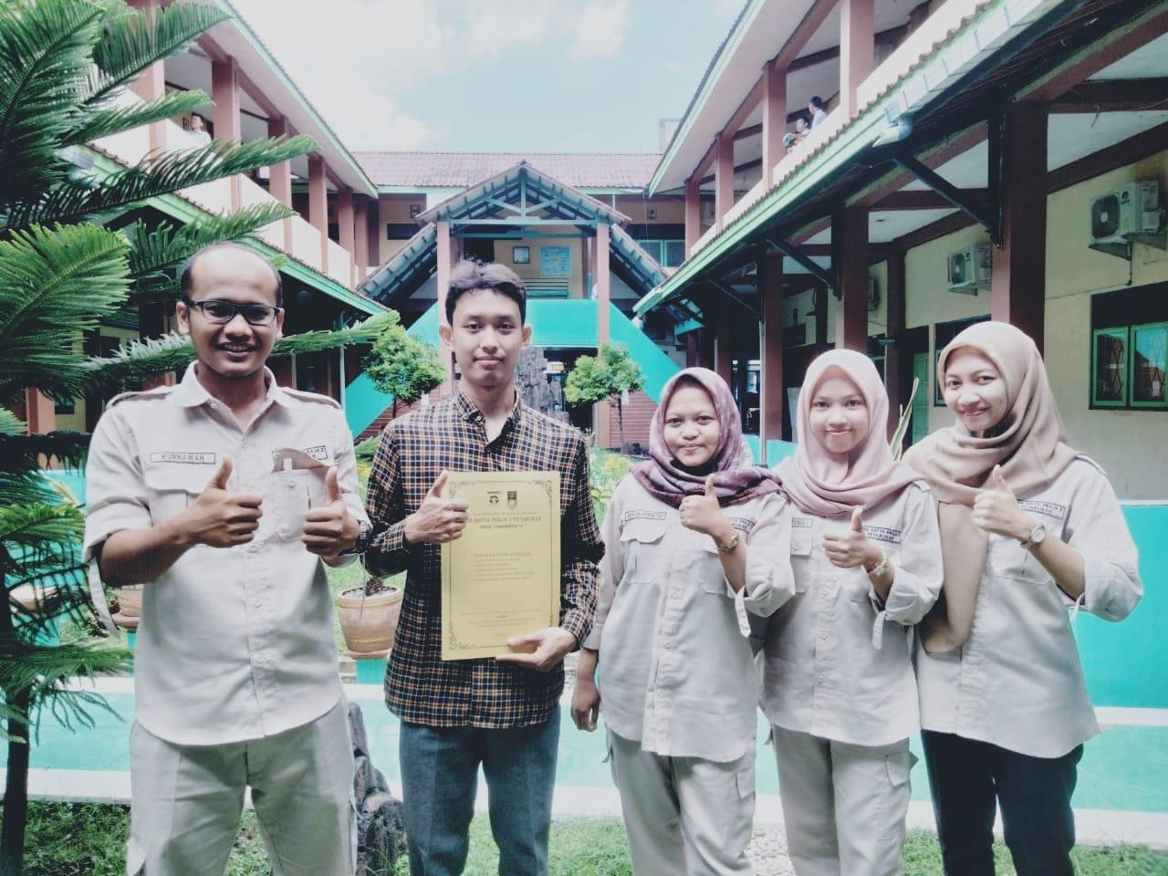
- Foto Perkenalan dan Izin Penelitian kepada Responden
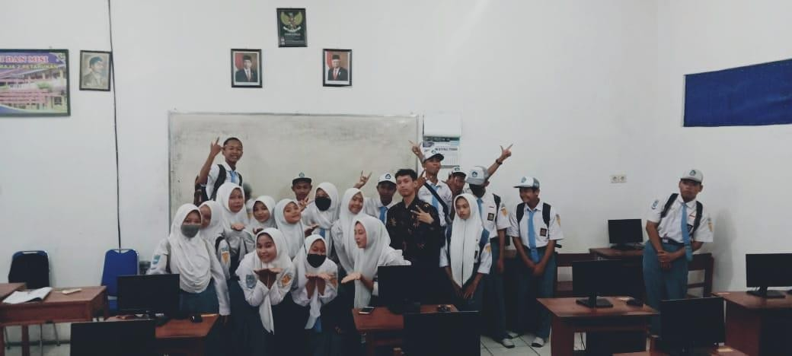

- Foto Acara Penyebaran Kuesioner ke Responden
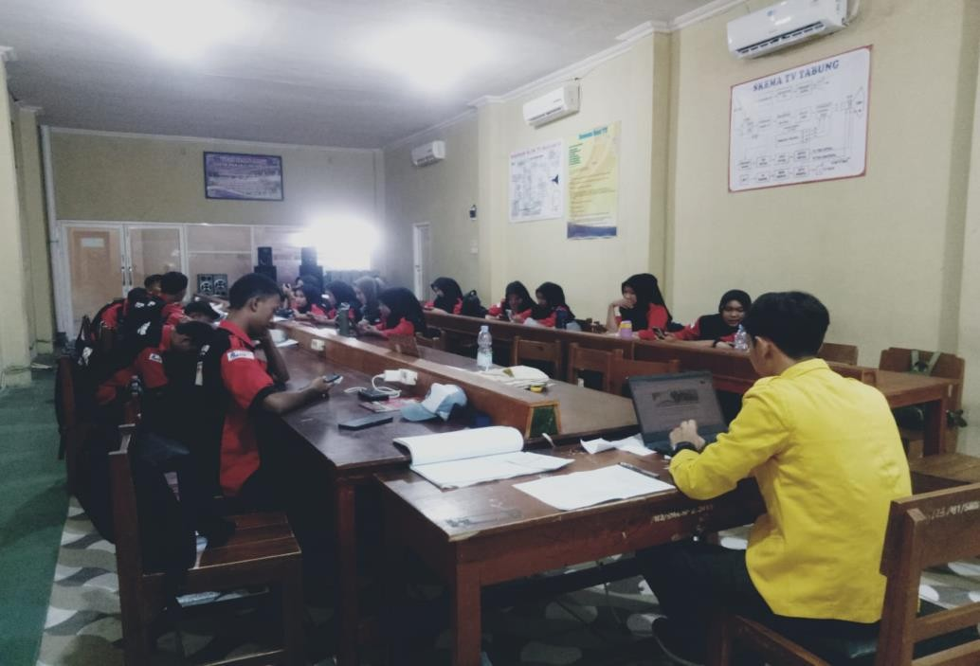

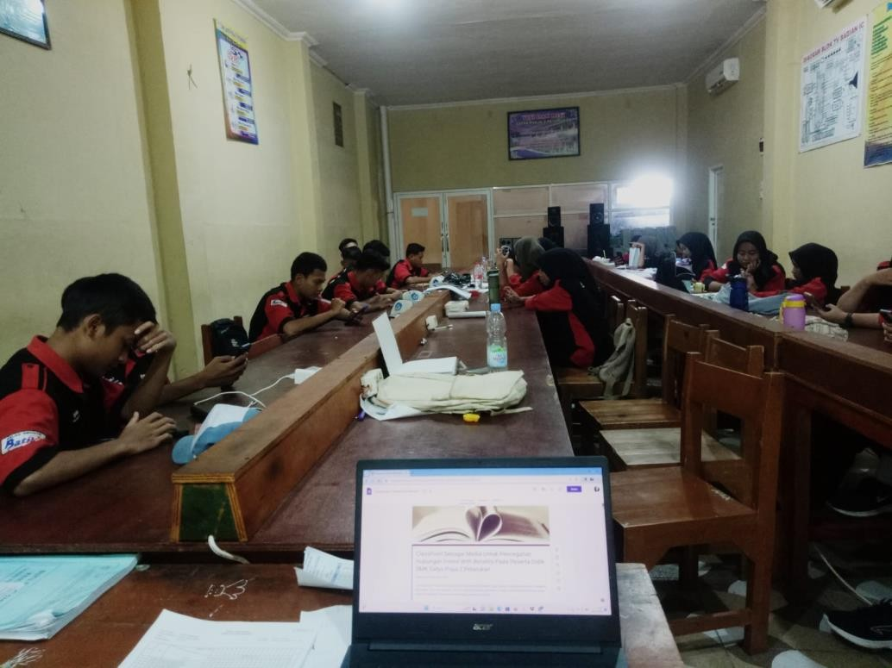

- Foto Acara Pelaksanaan Layanan Bimbingan Klasikal Part 1
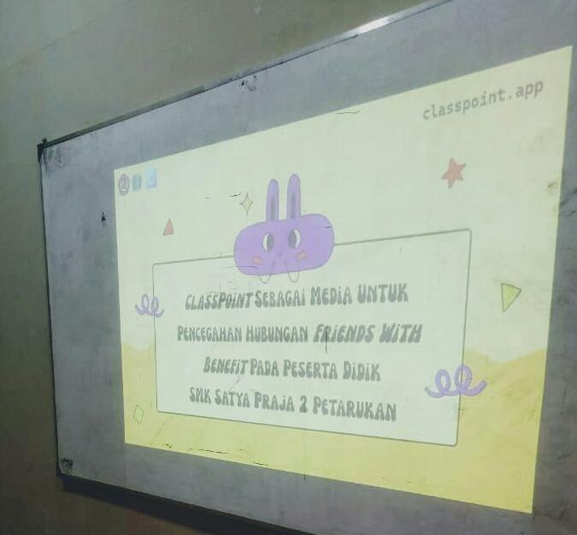

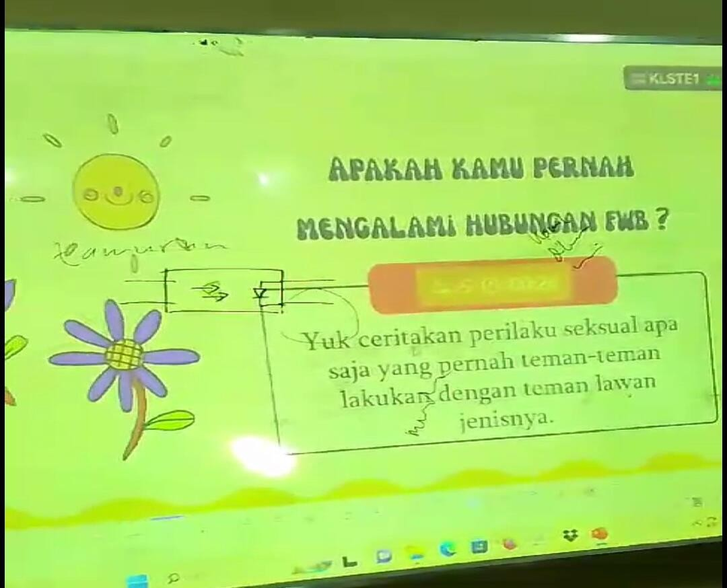

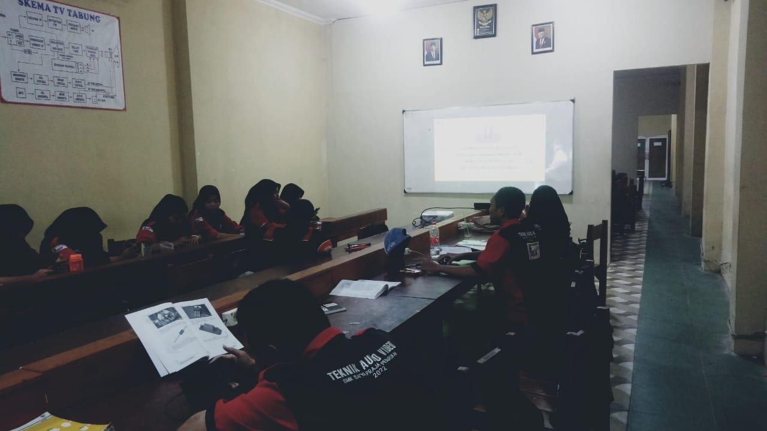

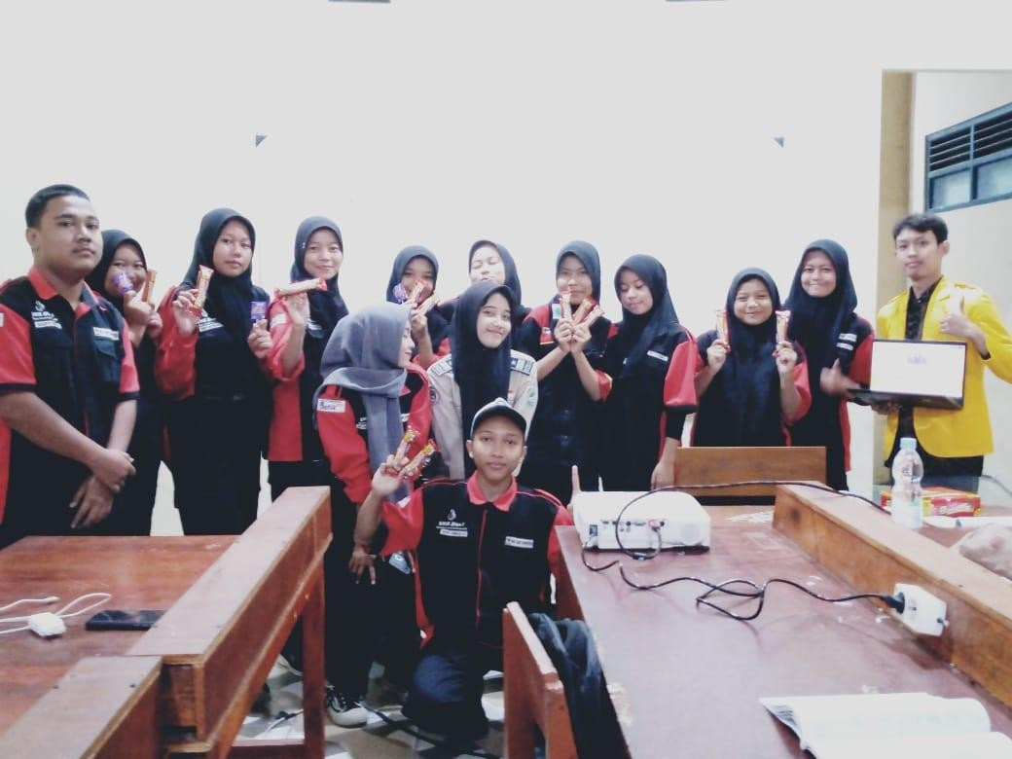

- Foto Acara Pelaksanaan Layanan Bimbingan Klasikal Part 2
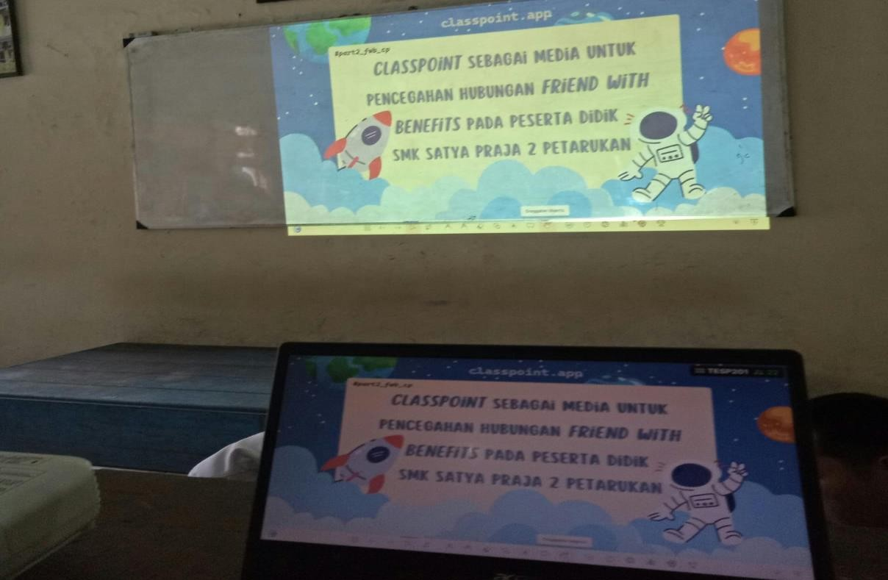

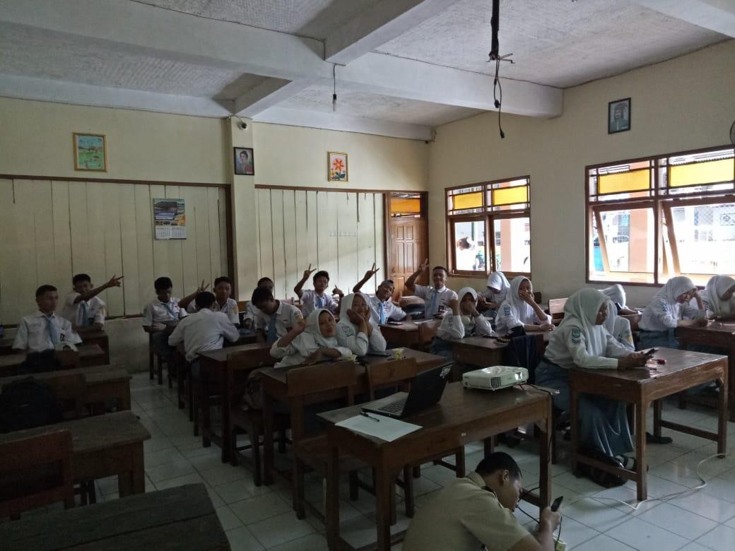

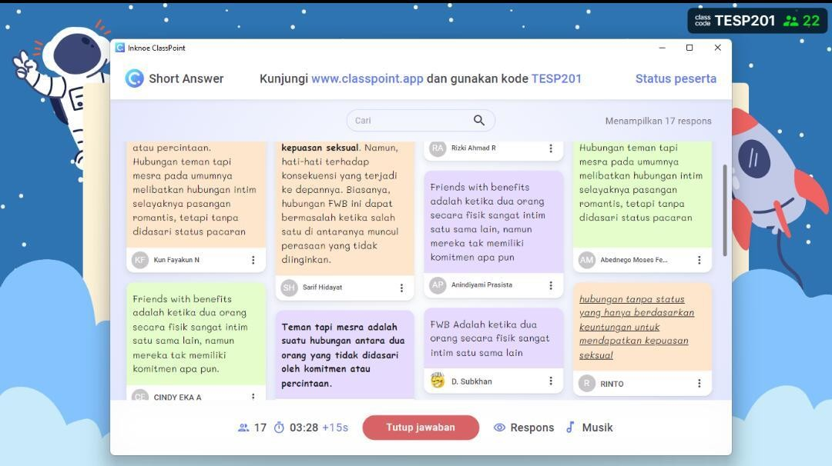

- Screenshot Google Form untuk Responden

- PowerPoint Media ClassPoint

Lampiran 7. Daftar Hadir Acara Bimbingan Klasikal

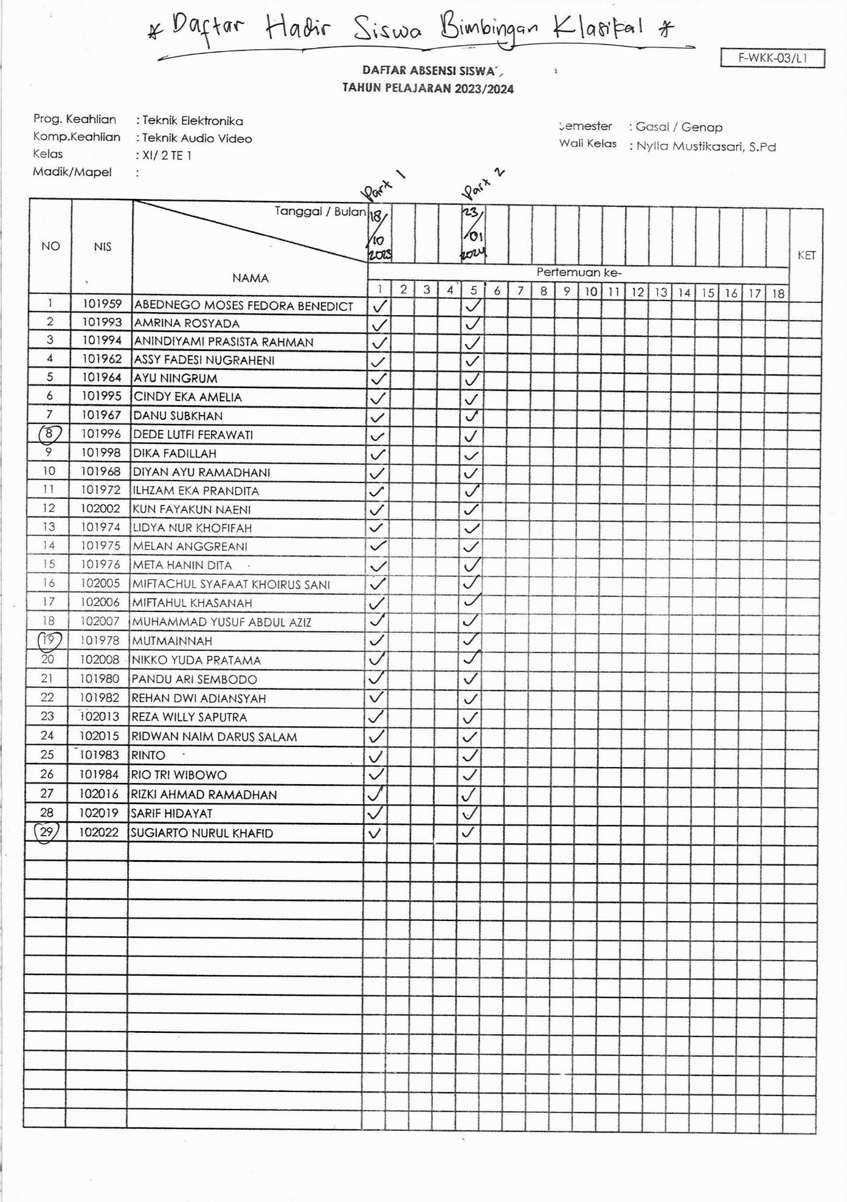

Lampiran 8. Surat Keterangan Telah Selesai Penelitian
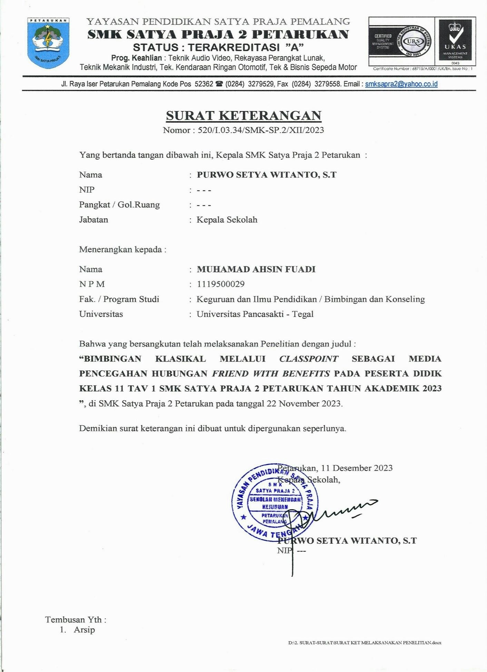

Lampiran 9. Jurnal Bimbingan Skripsi
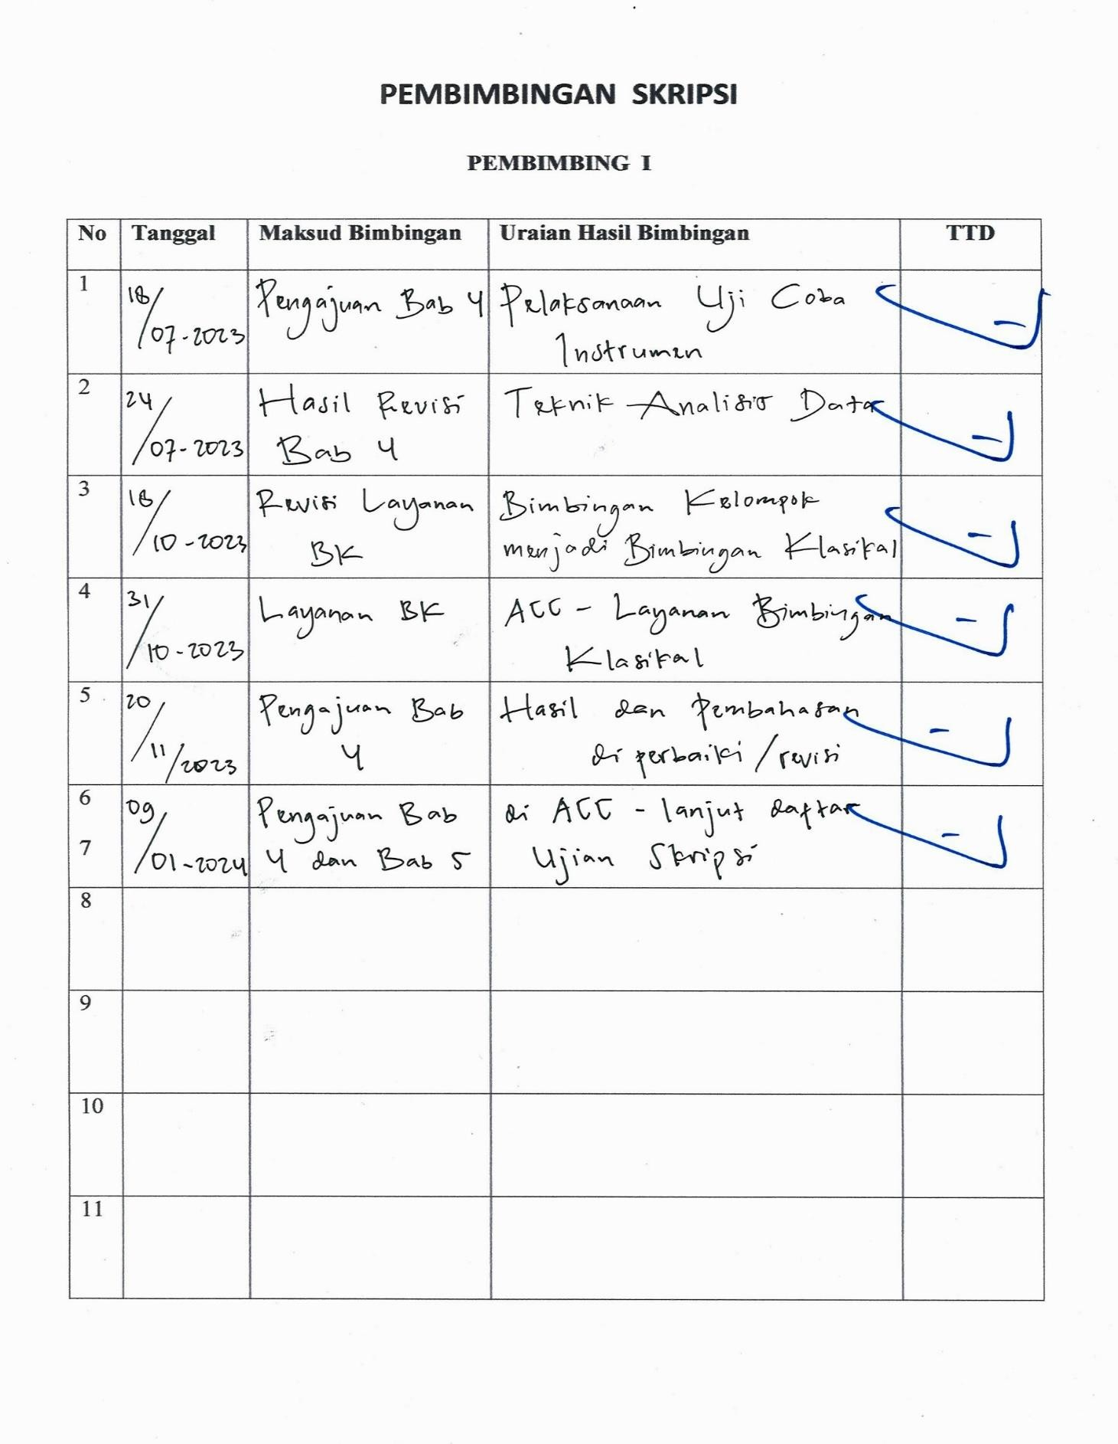

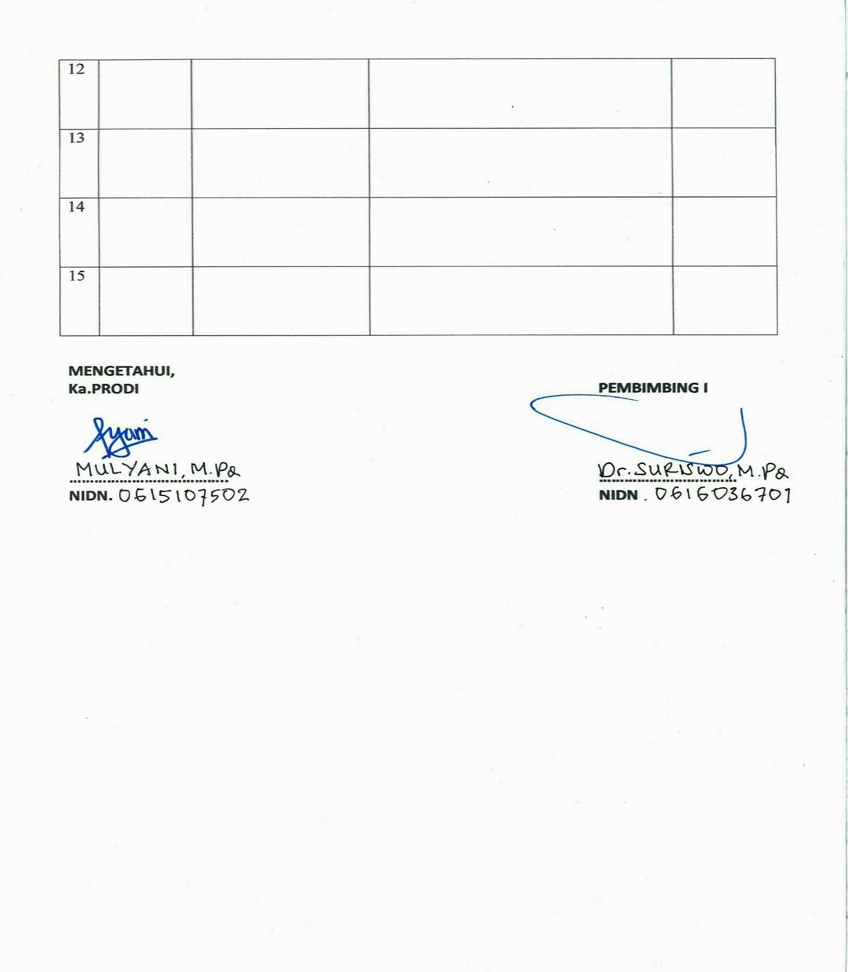

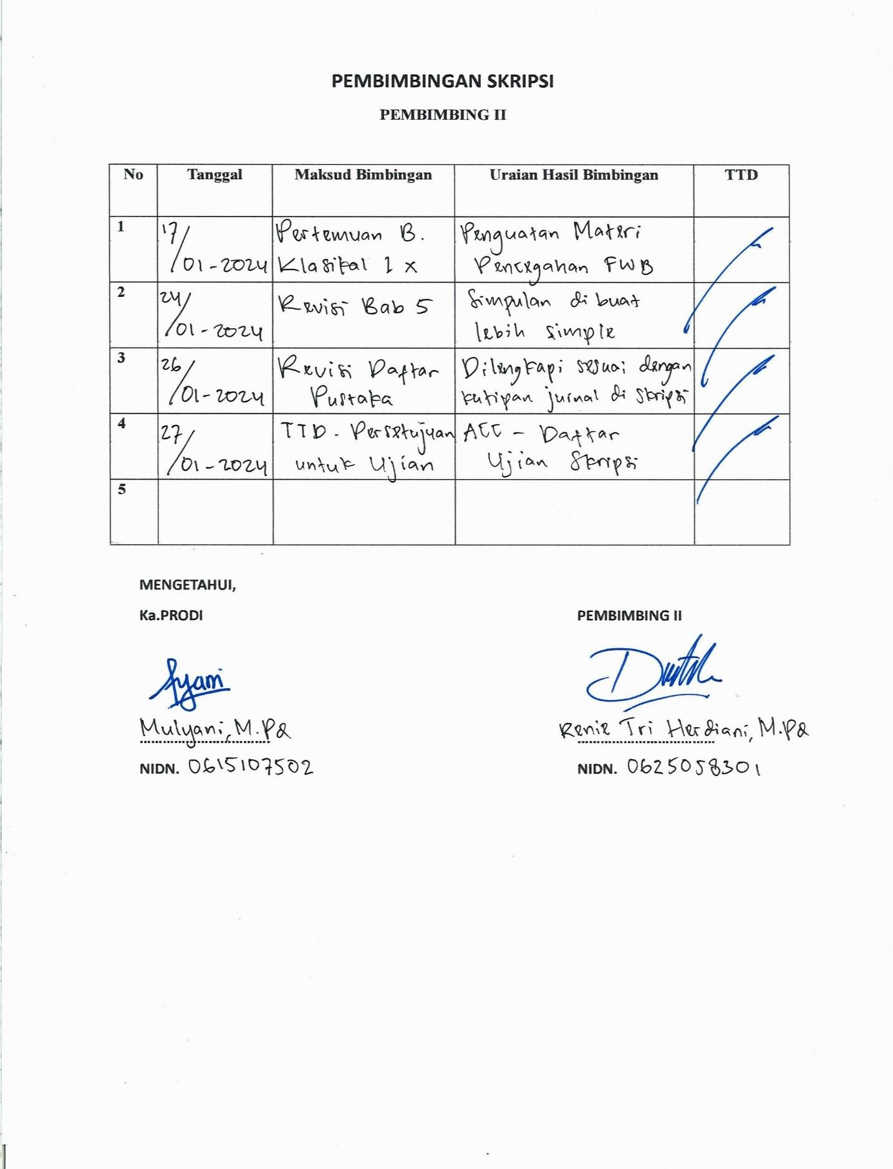

Lampiran 10. Berita Acara Skripsi
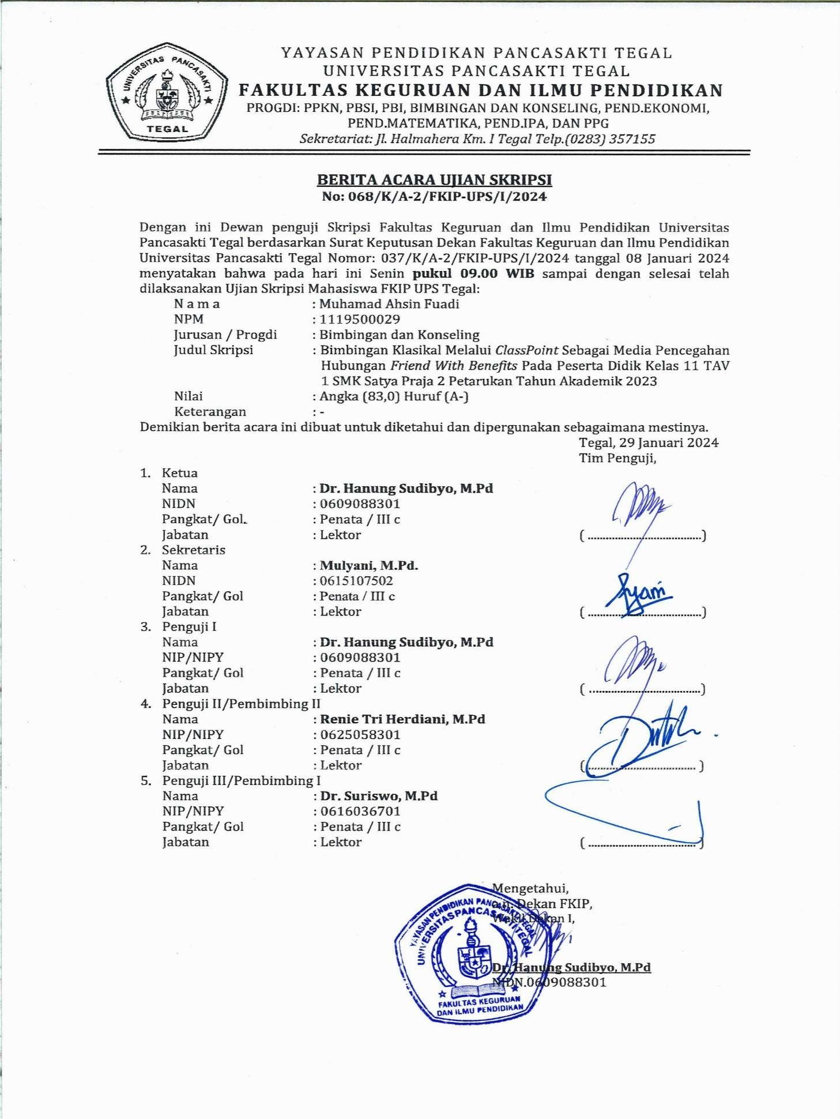

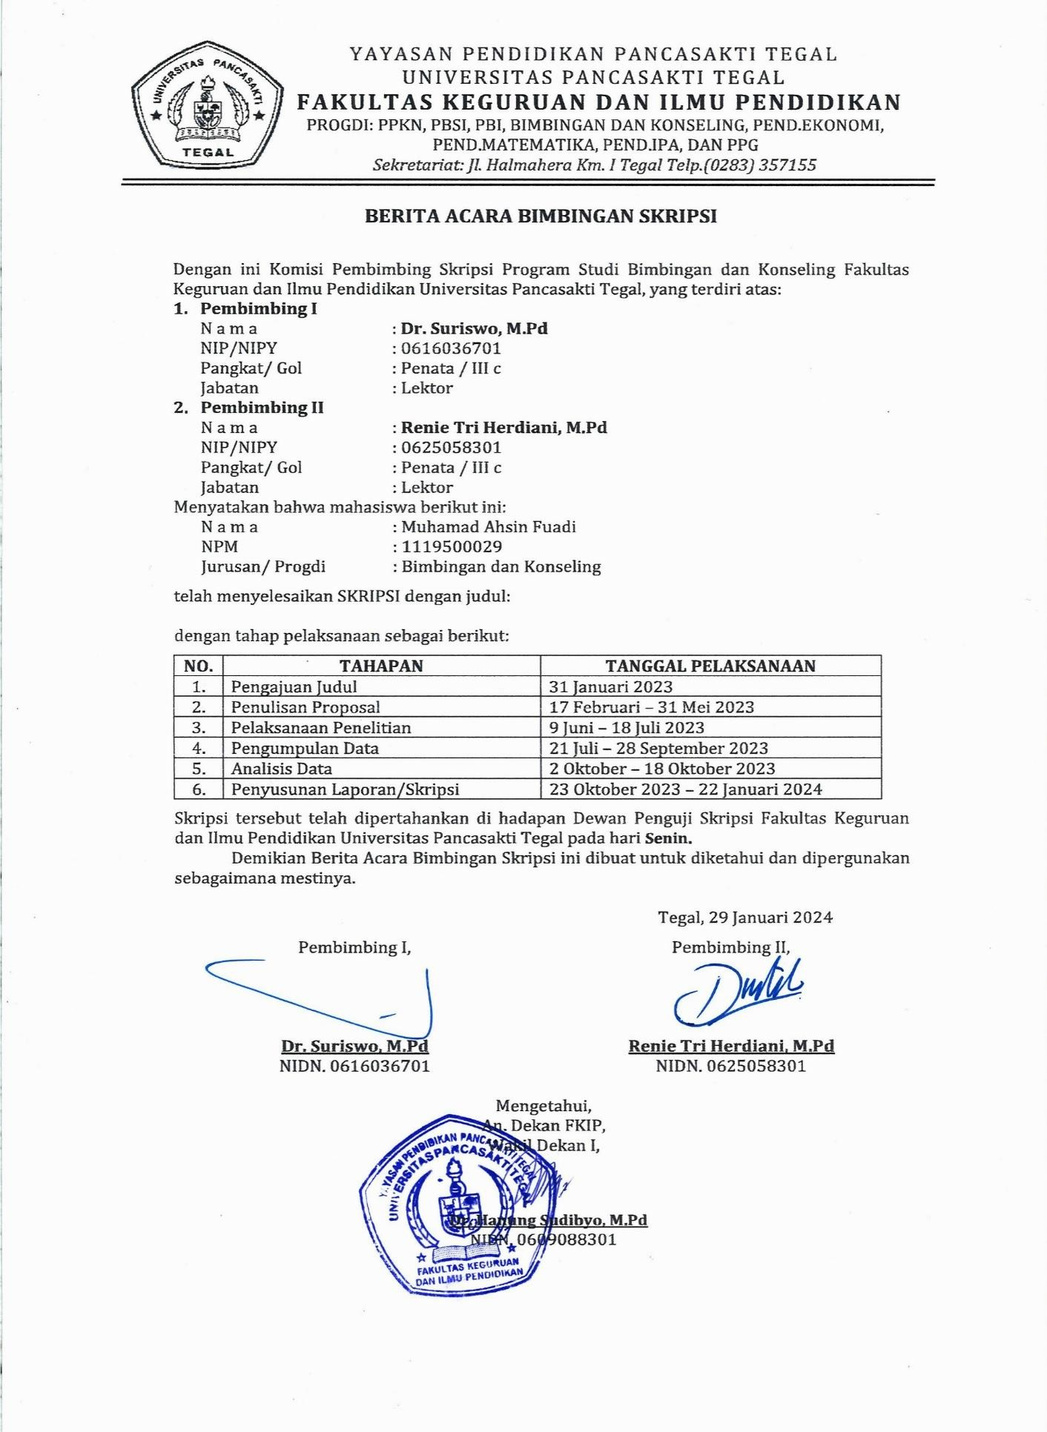

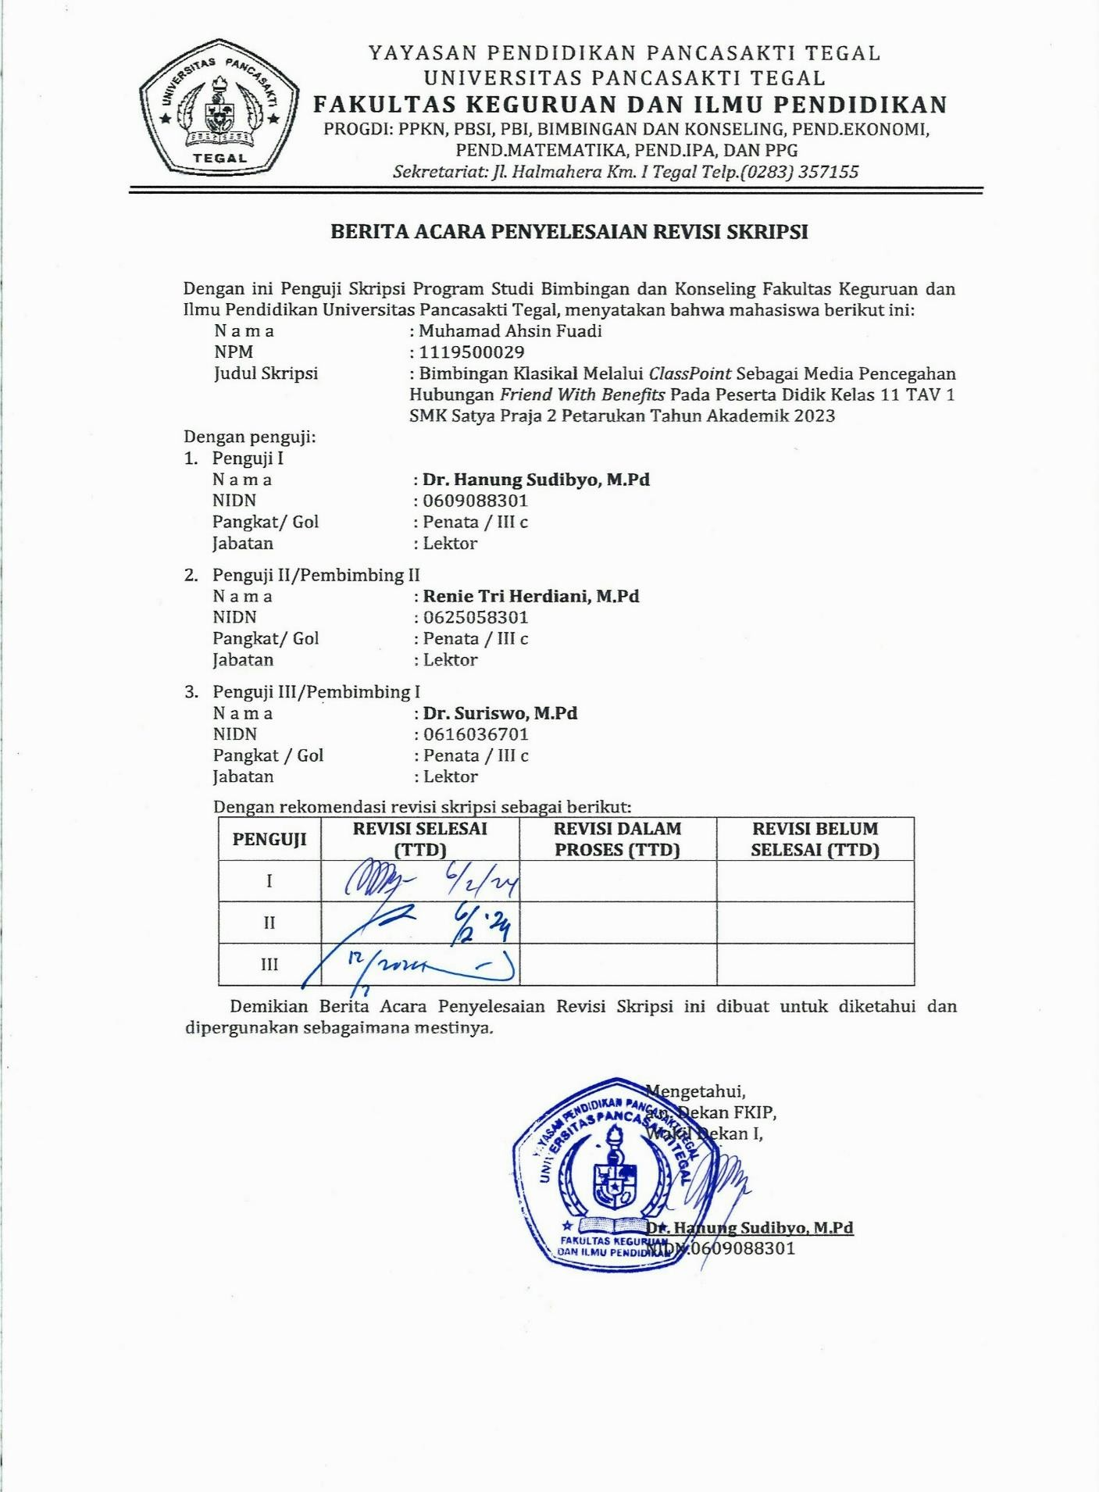

Lampiran 11. Hasil Similarity
