REFERENCES

Alqahtani, M. (2015). The importance of vocabulary in language learning and how to be taught. International Journal of Teaching and Education, III(3), 21–34. https://doi.org/10.20472/te.2015.3.3.002
Alroe, M. J., & Reinders, H. (2015). EJAL The role of translation in vocabulary acquisition : A. Eurasian Journal of Applied Linguistics 1, 1, 39–58. https://doi.org/https://doi.org/10.32601/ejal.460588
B Laufer. (1999). A vocabulary size test of controlled productive ability. Language Testing. https://doi.org/10.1177/026553229901600103
Barbara. (2007). Grammar for everyone : practical tools for learning and teaching grammar. ACER Press. http://thusvienso.bvu.edu.vn/handle/TVDHBRVT/15156
Cameron, L. (2001). Teaching Languages to Young Learners (L Cameroon (ed.)). THE PRESS SYNDICATE OF THE UNIVERSITY OF CAMBRIDGE. http://www.cambridge.org
Clayton, K., & Murphy, A. (2016). Smartphone Apps in Education: Students Create Videos to Teach Samartphone Use as Tool for Learning. Journal of Media Literacy Education, 8, 99–109. https://doi.org/https://doi.org/10.23860/jmle-8-2-5
Fidiyanti, L. (2020). Penggunaan Media Pembelajaran Flashcard Untuk Meningkatkan Penguasaan Vocabulary Dengan Materi Narrrative Text. Journal of Education Action Research, 4(1), 42. https://doi.org/10.23887/jear.v4i1.23437
Halitopo, M. (2020). Implementasi Merdeka Belajar Dalam Buku Teks Bahasa Inggris Untuk SMK. Journal Pendidikan Universitas Sarjawiyata Tamansiswa. Jalan Kusumanegara 157, Yogyakarta 55165, Indonesia Manasehalitopo11@gmail.Com, 54–61. https://jurnal.ustjogja.ac.id/index.php/semnas2020/article/view/7300
Hatch and Brown. (1995). Vocabulary, Semantics, and Language Education. Cambrige University Press. eric.ed.gov/?id=ED396578
Nugraha, G. (2019). EXPLORING LOW AND HIGH STUDENTS ’ PE RCEPTION ON ENGAGING E-DICTIONARY IN MASTERING VOCABULARY : CROSS-SECTIONAL SURVEY. Indonesian EFL Journal, 5(1). https://doi.org/10.25134/ieflj.v5i1.1609
Okpor, M. D. (2014). Machine Translation Approaches : Issues and Challenges. International Journal of Computer Science Issues, 11(5), 159–165. www.IJCSI.org
https://www.proquest.com/scholarly-journals/machine-translation-approaches-issues-challenges/docview/1617937023/se-2
Pratama, A., & Utami, A. R. (2022). THE USE OF GOOGLE TRANSLATE IN ENHANCING THE STUDENTS ’ VOCABULARY. Pustaka Ilmu, 2(1), 1–8. http://pustakailmu.id/index.php/pustakailmu/article/download/77/60/245
Rahmawati, N. D. (2021). Pengaruh Spotify Untuk Mengembangkan Listening Skill Siswa. Pekan Ilmiah Mahasiswa UNIS, 88–89. http://www.ejournal.unis.ac.id/index.php/PKIM/article/view/1969
Richards, J. C. (2001). Curriculum Development in Language Teaching. In Cambrige University Press. THE PRESS SYNDICATE OF THE UNIVERSITY OF CAMBRIDGE. https://doi.org/10.1017/cbo9780511667220
Schmitt, D., & Schmitt, N. (2011). FOCUS ON VOCABULARY 2 M a s t e r i n g t h e A c a d e m i c W o r d L i s t (Focus on V). Pearson Education, Inc. www.irLanguage.com
Sugiyono. (2013). Metode Penelitian Kualitatif dan R and D. In Bandung: Alfabeta (Vol. 3, Issue April).
Sukkhwan, A. (2014). Students’ Attitudes and Behaviors towards the Use of Google Translate. Master's thesis. Prince of Songkla University. http://kb.psu.ac.th/psukb/handle/2010/9459
Sulistiana, E., Nadzifah, W., & Arifin, M. S. (2019). Intensive English Program (IEP) Meningkatkan Penguasaan Vocabulary. Jurnal Studi Guru Dan Pembelajaran, 2(3), 236–240. https://doi.org/10.30605/jsgp.2.3.2019.46
Sutisna, I. (2020). Statistika penelitian. Universitas Negeri Gorontalo, 1, 1–15.
Wangru, C. (2016). Vocabulary Teaching Based on Semantic-Field. Journal of Education and Learning, 5(3), 64. https://doi.org/10.5539/jel.v5n3p64
Wasik, B. A., & Iannone-Campbell, C. (2012). Developing vocabulary through purposeful, strategic conversations. Reading Teacher, 66(4), 321–332. https://doi.org/10.1002/TRTR.01095
Wilson, A., & Sutrisno, S. (2022). Efektifitas Aplikasi Cake Terhadap Kemampuan Penguasaan Kosakata Bahasa Inggris Siswa. Research and Development Journal of Education, 8(1), 263. https://doi.org/10.30998/rdje.v8i1.12093
Wiratman. (2021). THE EFFECTIVENESS OF USING MOBILE DICTIONARY TOWARDS STUDENTS’ VOCABULARY MASTERY. INTERACTION: Jurnal Pendidikan Bahasa, 9(1), 38–50. https://doi.org/10.36232/jurnalpendidikanbahasa.v9i1.1568.
Yusup, F., Studi, P., Biologi, T., Islam, U., & Antasari, N. (2018). UJI VALIDITAS DAN RELIABILITAS. Jurnal Tarbiyah: Jurnal Ilmiah Kependidikan, 7(1), 17–23. https://doi.org/https://doi.org/10.18592/tarbiyah.v7i1.2100

APPENDICES

Appendix 1: Instrument of Research
Petunjuk Umum:
1. Jawaban dikerjakan pada selembar kertas
2. Sebelum mengerjakan soal, tulislah terlebih dahulu pada lembar jawaban: nama lengkap, kelas, dan nomor absen.
3. kerjakan soal dengan hanya menulis jawaban pilihan antara A, B, C, atau D.
4. Tidak diizinkan untuk mencontek, membuka buku, kamus, ataupun HP. Kerjakan dengan kemampuan sendiri.
5. Waktu pengerjaan adalah 60 menit, dimulai saat penyelengggara mempersilahkan.

Kerjakanlah soal-soal pilihan ganda dibawah ini dengan memilih jawaban yang paling tepat diantara pilihan A, B, C, atau D!

Choose the most appropriate answer of the synonym and antonym questions below!

Holiday in Seoul

I spent my last summer holiday in Seoul, South Korea. I went there with my friends.
On the first day, I was landed at Incheon Airport around 7 AM after a 6 hours long flight. Then I went to Seoul by train and checked in to the hotel I already booked. I decided to take a rest for a while. At night, I went to Hongdae, a famous district in South Korea. I went to eat traditional Korean food. On the next day, I went to the Gyeongbokgung Palace and National Museum. I also went to learn how to make Kimchi and see the scenery of Seoul from Seoul Tower. I went back to the hotel at 10 PM and immediately went to sleep.
I spent my last day in Myeongdong and bought some stuffs and souvenirs for my family and friends. I also ate the street food there. I went to the airport at 3 PM because my flight was at 5 PM. I had a fantastic experience in South Korea and made wonderful memory with my friends. It was a great trip.

1. "I was landed at Incheon Airport around 7 AM after a 6 hours long flight."
The word 'landed' is closest in meaning to…
A. went
B. arrived
C. left
D. stayed

2. "At night, I went to Hongdae, a famous district in South Korea."
The underlined word is closest in meaning to….
A. well-known
B. abandoned
C. ruined
D. crowded

3. "I spent my last day in Myeongdong and bought some stuffs and souvenirs…"
The antonym of the word 'bought' is…
A. brought
B. sold
C. got
D. lost

Choose the correct word to complete the sentence into good text!

Holiday in Spain

Last summer I (4) … to a golf and spa resort “Valle del Este” in Almería, Spain.
I went with my wife, Teresa. We went by car and I drove too many hours and we were very tired when we arrived in Almeria. It was very hot but the hotel had a wonderful swimming pool.
We needed to (5) … because we were stressed and tired at work, and we only wanted to swim and sunbathe.
We (6) … a typical villages in Almeria, Mojacar, Carboneras, Vera, etc. And we went sight seeing too. I took photographs all the time and Teresa went preferred to go shopping.
It was a prefect holiday, and we could relax for 10 days.

4. The correct word to complete the sentence (first paragraph) is…
A. bought
B. saw
C. went
D. left

5. The correct word to complete the sentence (third paragraph) is…
A. have a rest
B. drink
C. eat
D. play

6. The correct word to complete the sentence (fourth paragraph) is…
A. avoided
B. wanted
C. saw
D. visited

Choose the most appropriate answer of the synonym and antonym questions below!

Titanic

On April 15, 1912, Titanic, one of the British largest and luxurious liners, sank into the North Atlantic Ocean which about 400 miles south of Newfoundland, Canada.
That giant ship which carried 2,200 passengers and crews had struck an iceberg. Two and a half hour later the ship sank into the deep North Atlantic Ocean at 2:20 a.m. From that tragedy, more than 1,500 people went down in the sinking ship. Some of them froze to death in the icy North Atlantic water and around 700 people (high class woman and children) survived.
Unfortunately that giant luxurious ship was not equipped with much more lifeboats and good emergency procedures so that the victims of that tragedy were more than the half passengers and crews.
That tragedy became popular again some years later after James Cameron directed a movie entitled Titanic in 1997. It was the best movie at that year and still remembered by a lot of people around the world until now.

7. "Titanic, one of the British largest and luxurious liners,.."
The antonym of the word 'largest' is..
A. greatest
B. best
C. biggest
D. smallest

8. "Unfortunately that giant luxurious ship was not equipped …"
The word 'luxurios' is closest in meaning to…
A. cheap
B. advanced
C. cool
D. plush

9. "It was the best movie at that year and still remembered…"
The antonym of the word 'best' is…
A. longest
B. worst
C. greatest
D. cheapest

Thieves

Roy Trenton used to drive a taxi. A short while ago, however, he became a bus driver.
When he was driving along Catford Street recently, he saw two thieves rush out of a shop and run towards a waiting car. One of them was carrying a bag full of money. Roy acted quickly and drove the bus straight at the thieves. The one with the money got such a fright that he dropped the bag.
As the thieves were trying to get away in their car, Roy drove his bus into the back of it. While the damaged car was moving away, Roy stopped his bus and telephoned the police. The thieves’ car was badly damaged and easy to recognize.
Shortly afterwards, the police stopped the car and both men were arrested.

10. "Roy acted quickly and drove the bus straight at the thieves."
The antonym of the word 'quickly' is…
A. carefully
B. suddenly
C. slowly
D. well

Lost Wallet

I lost my wallet yesterday. I realized it when I was about to pay for my lunch. I had kept some cash, my credit cards, and my ID in it. I retraced my steps to where I had been earlier, but I couldn't find it. I asked the restaurant staff, but they hadn't seen it either. It was a stressful day, and I spent hours canceling my credit cards and reporting the loss to the police.

11. "I had kept some cash, my credit cards, and my ID in it."
The word 'it' refers to…
A. credit cards
B. bill
C. restaurant
D. wallet

12. "I retraced my steps to where I had been earlier…"
The word retraced is closest in meaning to…
A. removed
B. thought
C. investigated
D. remembered

Choose the correct time connectives and sequence connective to fill the blank!

Last week was probably the most chaotic week in May this year. I felt like I made a lot of mess that week, both at work and in my circle of friends.
(13) ... , I messed up the division meeting on Monday morning. I accidentally took the wrong document and left the correct one on my desk, which made my division head very angry with me.
(14) …, on a Thursday night, because I was busy towards the end of the month and I had to work late, I did not come to Marcia’s birthday party, which made her furious because I had promised her, and she did not want to talk to me.
Everything that happened to me last week really made me sad and disappointed in myself.

13. The correct word to complete the sentence (paragraph 2) is…
A. First
B. Second
C. Third
D. Finally

14. The correct word to complete the sentence (paragraph 3) is…
A. First
B. Second
C. Finally
D. Third

Choose the most appropriate answer of the synonym and antonym questions below!

Heavy Rain

Two weeks ago, the rain was falling so heavily. I found that there were some leaks on the roof. To fix it, I needed a ladder so that I could climb up to the roof. It was Sunday at 2 in the afternoon, I brought the ladder and set it up to the roof. Water from the leaks made the foothold wet. At that time, I was too confident and not careful. I thought I was strong enough to avoid slipping.
When the ladder became wetter, I already felt the slippery surface. However, I did not pay attention and kept climbing. A disaster came when my brother forgot to hold the ladder. As soon as he turned away, I suddenly lost my balance. Only seconds afterward, I slipped from the ladder and fell to the floor. It happened so fast that I needed several minutes to realize what was really going on.
Then, my two elder brothers checked me out and asked if I was okay. After that, they carried me to a more comfortable place. Later on, they gave me first aid. Finally, I was brought to the nearest doctor so that I got proper medical attention. It was my fault that I was not careful with the hazardous situation.

15. "To fix it, I needed a ladder so that I could climb up to the roof"
The underlined word is closest in meaning to…
A. replace
B. remove
C. repair
D. destroy

16. "At that time, I was too confident and not careful."
The synonym of the word 'not careful' is…
A. thorough
B. wise
C. careless
D. careful

17. "Water from the leaks made the foothold wet."
The antonym of the underlined word is…
A. clean
B. watery
C. dirty
D. dry

18. "I already felt the slippery surface. "
The synonym of the underlined word is…
A. slick
B. dry
C. dirty
D. rough

19. "It was my fault that I was not careful with the hazardous situation."
The underlined word is closest in meaning to…
A. surprising
B. safe
C. dangerous
D. horrible

My Grandpa Hometown

Last week, I and my family were in my grandpa’s hometown. It is our annual agenda every holiday in the end of Semester. Unfortunately, it was rainy season there. It rained almost every day there. We had no enough time to visit some tourism places there because of the rain.
We had no enough sunlight even to dry up our laundries. As a result, we just stayed at home almost all day long. Seeing the condition, we decided to make an interesting activity indoor to spend the holiday together. The activity we choose that day was making funny videos directed by me.

20. "It is our annual agenda every holiday in the end of Semester."
The underlined word is closest in meaning to…
A. daily
B. weekly
C. yearly
D. rarely

The African Elephant

The African Elephant is the largest land mammal on Earth and is distinguished by its long trunk, large ears, and massive tusks. There are two species of African Elephants: the Savannah Elephant and the Forest Elephant. These magnificent creatures are herbivores and consume vast amounts of vegetation daily. African Elephants are highly social animals, living in matriarchal family groups led by the oldest and most experienced female. Unfortunately, they are also facing threats from habitat loss and poaching for their ivory tusks. Conservation efforts are crucial to protect these intelligent and gentle giants.

21. "... and is distinguished by its long trunk, large ears, and massive tusks"
The antonym of the underlined word is…
A. short
B. tiny
C. weak
D. bad

22. "Conservation efforts are crucial to protect these intelligent and gentle giants."
The word 'gentle' is closest in meaning to…
A. wise
B. large
C. majestic
D. friendly

Choose the correct word to complete the sentence into good text!

The Amazon Rainforest

The Amazon Rainforest, (23) … the "Lungs of the Earth," is the largest tropical rainforest on the planet. It spans nine countries in South America, with the majority of the forest located in Brazil. The Amazon Rainforest is home to an incredibly diverse range of plant and animal species, many of which have not yet been discovered by (24) … . It plays a vital role in regulating the Earth's climate, absorbing carbon dioxide and releasing (25) … . However, the Amazon Rainforest is facing severe threats from deforestation, illegal logging, and agricultural expansion. Conservation efforts and sustainable practices are essential to protect this invaluable ecosystem.

23. The correct word to complete the sentence is…
A. also known as
B. with
C. but
D. and

24. The correct word to complete the sentence is…
A. soldier
B. traveler
C. police
D. scientists

25. The correct word to complete the sentence is…
A. hydrogen
B. oxygen
C. fruits
D. soil

Seal

A seal is a mammal that can live both in and out of the water. Seals are (26) … in color and have thin layers of flat flippers and hairy coats for protection from sand and rocks. Seals are six meters long and (27) … about 150 pounds. Most seals eat a variety of fish and shellfish. Seals live in the northern hemisphere and they do not migrate.
Pregnant female seals go up on land every spring to have (28) … pups. It takes almost a full year for a pregnant female seal to have a pup. They have one pup each year. Seals travel in small groups or large herds and often rest together on land.
Seals defend themselves by making loud noises or swimming away fast. Their enemies are sharks, men, and killer whales. For years men hunted seals for their coats, blubber, and meat, and almost made them extinct. The United States passed a law in 1972 to stop the hunting of seals. Now you can see a lot more seals along the beaches.

26. The correct word to complete the sentence (paragraph 1) is…
A. gray
B. blue
C. silver
D. black

27. The correct word to complete the sentence (paragraph 1) is…
A. weight
B. height
C. stength
D. length

28. The correct word to complete the sentence (paragraph 2) is…
A. our
B. her
C. their
D. his

Mobile Phone

A mobile phone (also known as a wireless phone or cell phone) is mini portable radio telephone.
Mobile phones are used to communicate (29) … without wires. It works by communicating with the nearest base station (also called a “cell site”) that connects it to the main telephone (30) ... . When the phone moves, if it gets too far from the cell it’s connected to, it sends a message to the other cell to tell the new cell to take over the call.
These is called a “hand-off,” and the call continues to the new cell the phone is connected to. The hand-off is very well done and, with care so that the user will usually never even know that the call has (31) … to another cell.
As mobile phones became popular, they started. It costs less money, and more people can afford it. Monthly plans are available for as low as US$30 or US$40 per month. Cell phones have become so (32) … to own that they have largely replaced the telephone and telephone booths, except for urban areas with so many people.

29. The correct word to complete the sentence (paragraph 2) is…
A. rarely
B. remotely
C. randomly
D. heavily

30. The correct word to complete the sentence (paragraph 2) is…
A. Wi-Fi
B. bluetooth
C. network
D. google

31. The correct word to complete the sentence (paragraph 3) is…
A. diverted
B. removed
C. rejected
D. accepted

32. The correct word to complete the sentence (paragraph 4) is…
A. popular
B. easy
C. cheap
D. expensive

Bee

Bees are flying insect closely related to wasps and ants, and are known for their role in pollination and for producing honey and beeswax. There are nearly 20,000 known species of bees in nine recognized families.
They are found on every (33) … except Antarctica, in every habitat on the planet that contains insect-pollinated flowering plants.
Bees have a long proboscis that enables them to obtain the nectar from (34) …. They have antennae almost universally made up of 13 segments in males and 12 in females, as is typical for the super family.

33. The correct word to complete the sentence (paragraph 2) is…
A. city
B. continent
C. forest
D. village

34. The correct word to complete the sentence (paragraph 3) is…
A. leaf
B. fruit
C. branches
D. flowers

Choose the most appropriate answer of the synonym and antonym questions below!

Media

Do you know what media is? What are its benefits for human being? Media consists of various constantly updated information which become the most important thing nowadays.
Media creates, modifies, informs, and delivers products to viewers. They can be in form of news, weather reports, TV shows, musics, films, even communication channels such as phone calls and social medias.
The main purpose of the media is to earn some money by creating advertisement of some the goods and services.

35. "What are its benefits for human being?..."
The underlined word is closest in meaning to…
A. income
B. disadvantages
C. advantages
D. impact

36. " … information which become the most important thing nowadays."
The antonym of the underlined word is…
A. useful
B. good
C. trivial
D. practical

37. " … creating advertisement of some the goods and services."
The synonym of the word 'goods' is…
A. investments
B. logos
C. brands
D. products

Choose the correct word to complete the sentence into good text!

Platypus

Many people call the platypus as duckbill because this animal has a bill like a duck’s bill. Platypus is a native in Tasmania and also southern and eastern Australia.
Platypus has a flat tail and webbed feet. (48) … body length is 30 to 45 cm and covered with a thick, and wooly layer of fur. Its bill is used to detect prey and stir up mud. The platypus’ eyes and head (49) … small. It has no ears but has the ability to sense sound and light.
Platypus lives in streams, rivers, and lakes. Female platypus usually dig burrows in the streams or river banks. The burrows are blocked with soil to (50) … it from intruders and flooding. On the other hand, male platypus does need any burrow to stay in.

38. The correct word to complete the sentence (paragraph 2) is…
A. Its
B. Her
C. His
D. Our

39. The correct word to complete the sentence (paragraph 2) is…
A. are
B. is
C. was
D. were

40. The correct word to complete the sentence (paragraph 3) is…
A. disguise
B. protect
C. attack
D. hide

Appendix 2: Instrument Validity and Reliability Result
VALIDITY

No. Soal | Pearson Correlation | Nilai Sig. | Kesimpulan
Soal 1 | 0,681 | 0,000 | VALID
Soal 2 | 0,482 | 0,003 | VALID
Soal 3 | 0,425 | 0,011 | VALID
Soal 4 | 0,428 | 0,010 | VALID
Soal 5 | 0,409 | 0,015 | VALID
Soal 6 | 0,466 | 0,005 | VALID
Soal 7 | 0,437 | 0,009 | VALID
Soal 8 | 0,538 | 0,001 | VALID
Soal 9 | 0,586 | 0,000 | VALID
Soal 10 | 0,501 | 0,002 | VALID
Soal 11 | 0,237 | 0,171 | TIDAK VALID
Soal 12 | 0,459 | 0,005 | VALID
Soal 13 | 0,404 | 0,016 | VALID
Soal 14 | 0,620 | 0,000 | VALID
Soal 15 | 0,448 | 0,007 | VALID
Soal 16 | 0,403 | 0,016 | VALID
Soal 17 | 0,477 | 0,004 | VALID
Soal 18 | 0,637 | 0,000 | VALID
Soal 19 | 0,631 | 0,000 | VALID
Soal 20 | 0,473 | 0,004 | VALID
Soal 21 | 0,437 | 0,009 | VALID
Soal 22 | 0,564 | 0,000 | VALID
Soal 23 | 0,533 | 0,001 | VALID
Soal 24 | 0,581 | 0,000 | VALID
Soal 25 | 0,435 | 0,009 | VALID
Soal 26 | 0,270 | 0,117 | TIDAK VALID
Soal 27 | 0,448 | 0,007 | VALID
Soal 28 | 0,424 | 0,011 | VALID
Soal 29 | 0,417 | 0,013 | VALID
Soal 30 | 0,511 | 0,002 | VALID
Soal 31 | 0,431 | 0,010 | VALID
Soal 32 | 0,417 | 0,013 | VALID
Soal 33 | 0,473 | 0,004 | VALID
Soal 34 | 0,156 | 0,370 | TIDAK VALID
Soal 35 | 0,183 | 0,292 | TIDAK VALID
Soal 36 | 0,473 | 0,004 | VALID
Soal 37 | 0,530 | 0,001 | VALID
Soal 38 | 0,498 | 0,002 | VALID
Soal 39 | 0,417 | 0,013 | VALID
Soal 40 | 0,403 | 0,016 | VALID
Soal 41 | 0,037 | 0,833 | TIDAK VALID
Soal 42 | 0,185 | 0,286 | TIDAK VALID
Soal 43 | 0,416 | 0,013 | VALID
Soal 44 | 0,467 | 0,005 | VALID
Soal 45 | 0,509 | 0,002 | VALID
Soal 46 | 0,473 | 0,004 | VALID
Soal 47 | 0,620 | 0,000 | VALID
Soal 48 | 0,421 | 0,012 | VALID
Soal 49 | 0,443 | 0,008 | VALID
Soal 50 | 0,641 | 0,000 | VALID

RELIABILITY
SCALE: ALL VARIABLES

Case Processing Summary
 |  | N | %
Cases | Valid | 35 | 100,0
 | Excludedª | 0 | ,0
 | Total | 35 | 100,0
a. Listwise deletion based on all variables in the procedure.

Reliability Statistics
Cronbach's Alpha | N of Items
,738 | 51

Appendix 3: Screenshot students’ file and students’ answer
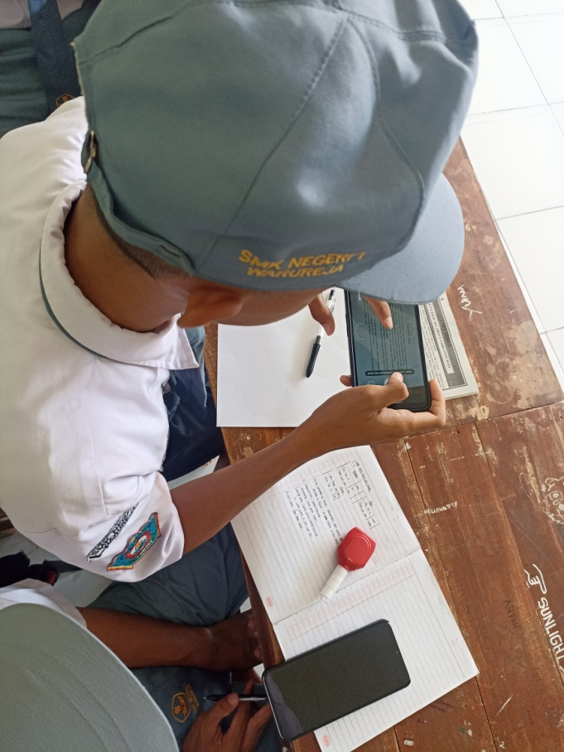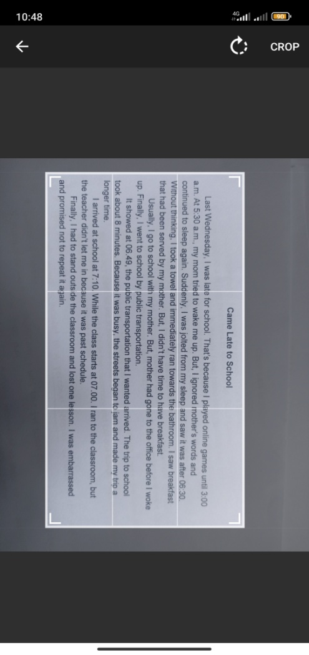

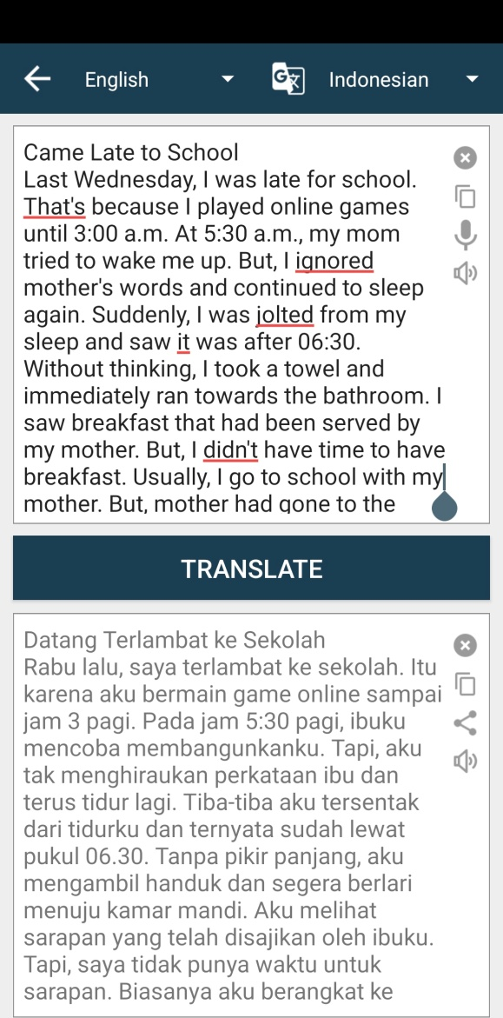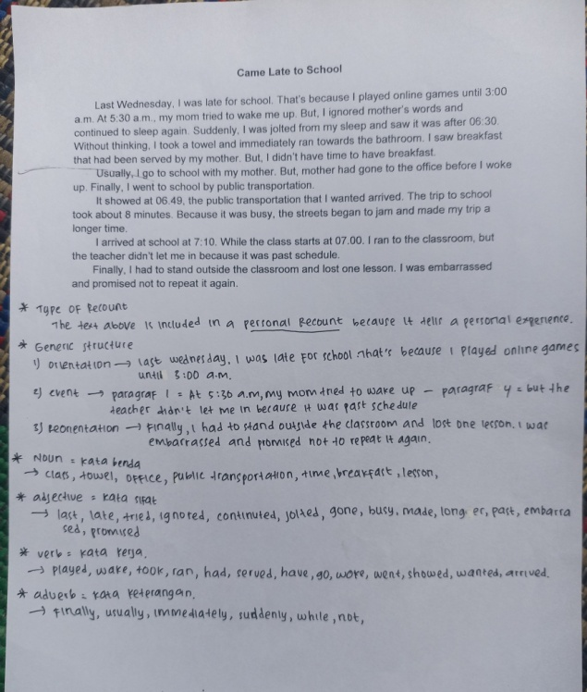
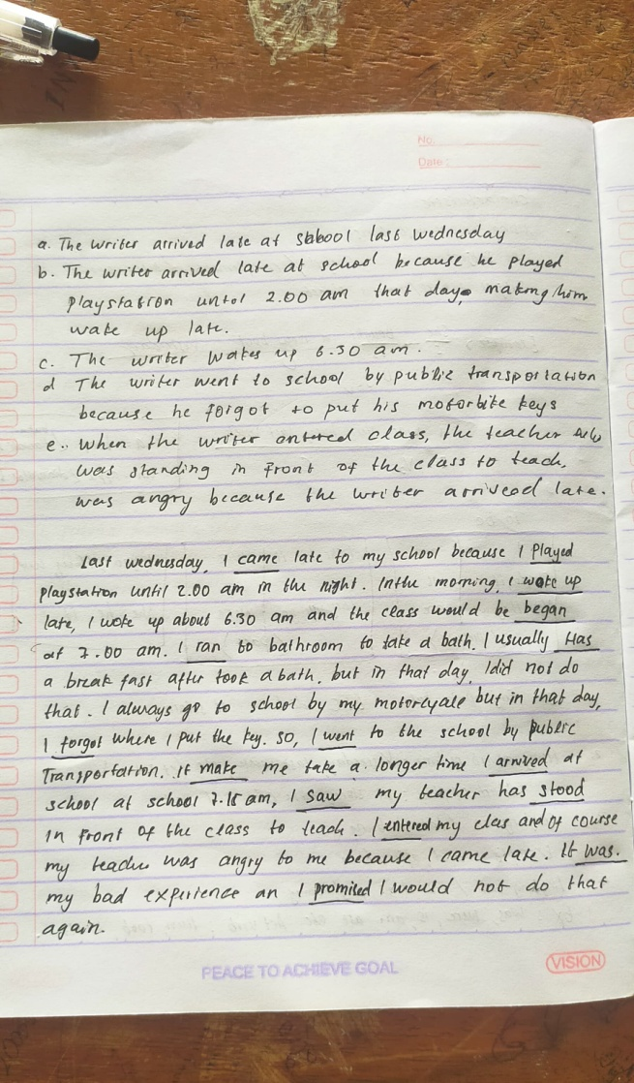

Appendix 4: Documentation of Treatment
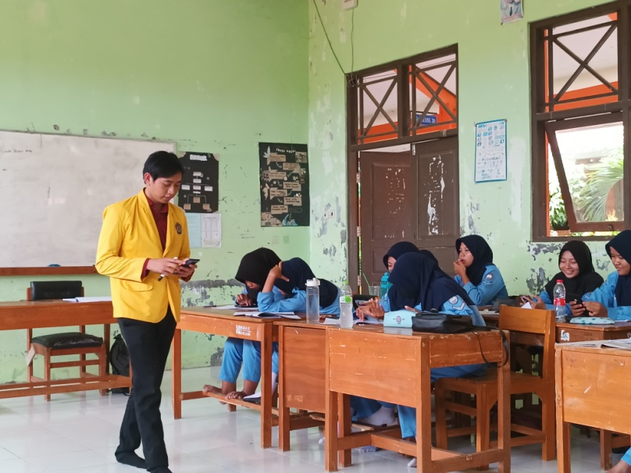
Explaining how to use Camera Translator Application
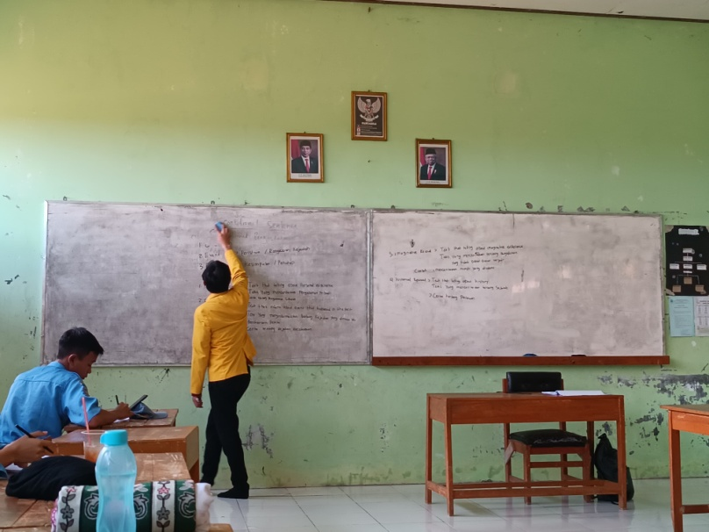
Explaining the material
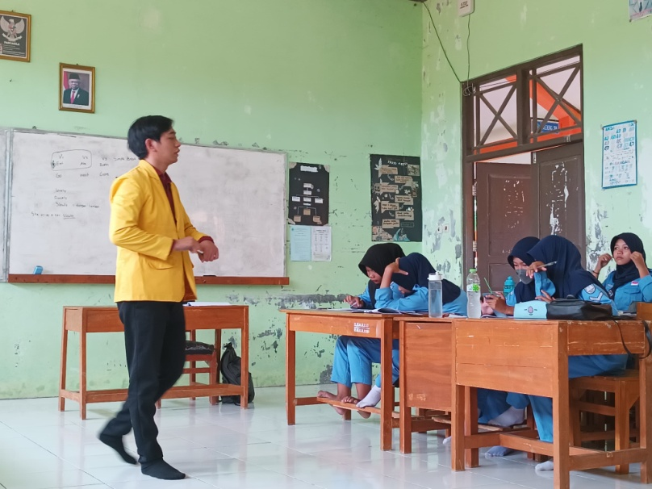
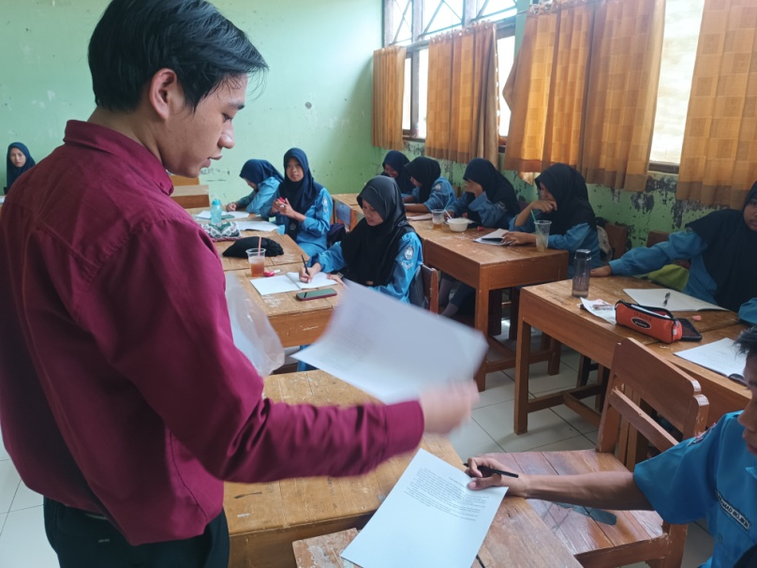
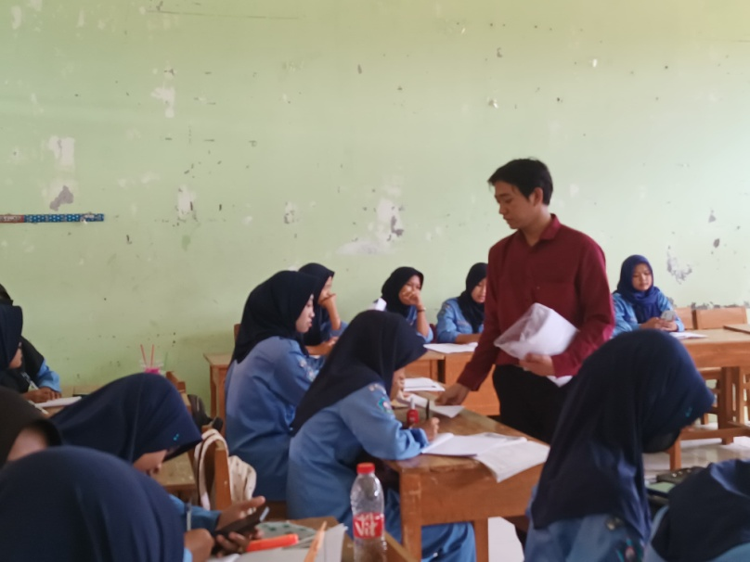
Provided text for students
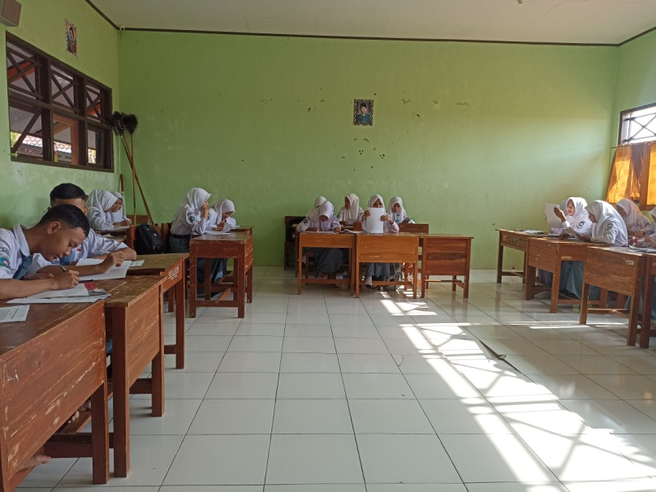
Students analyze the text
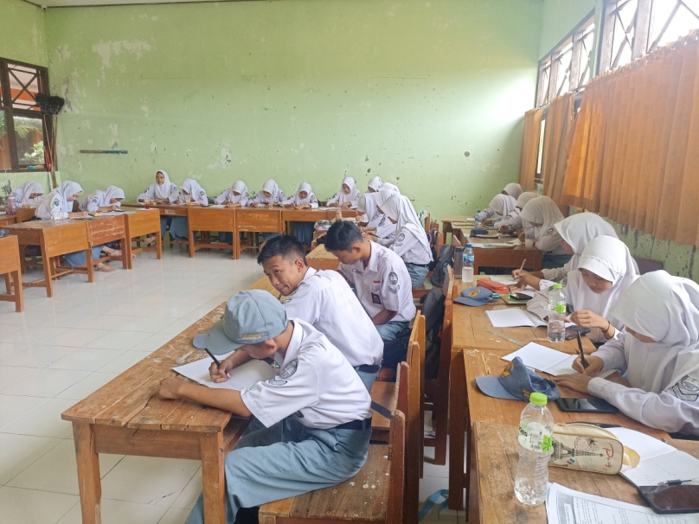
Students write down the new vocbulary
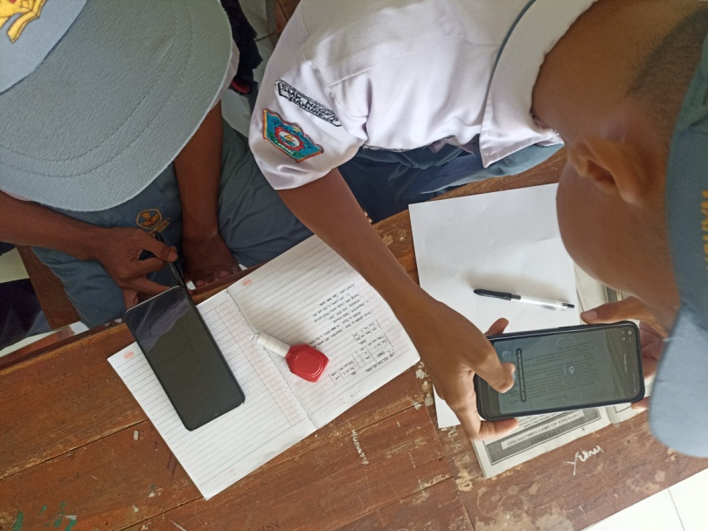
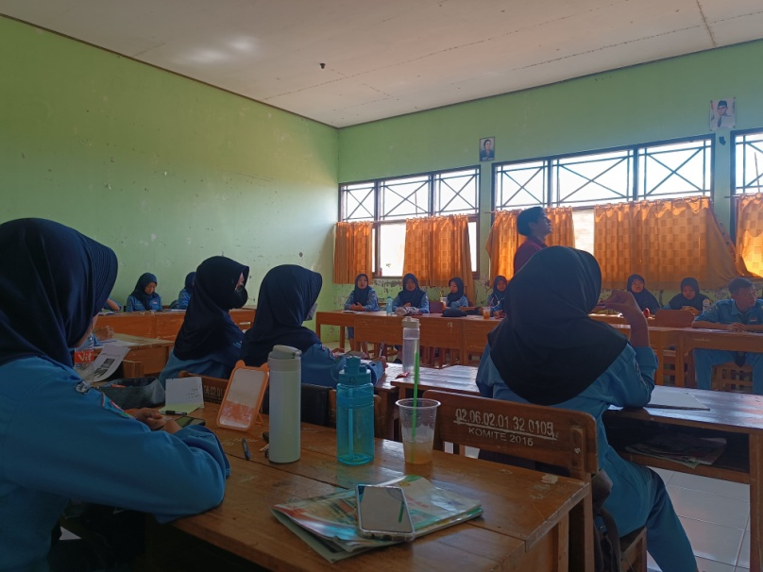
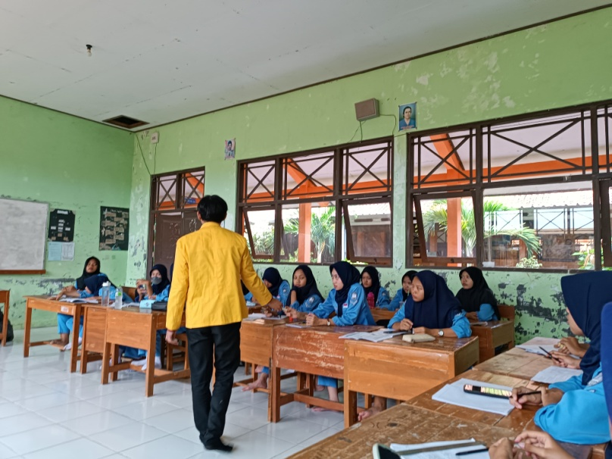
Giving some reflection after treatment

