**DAFTAR PUSTAKA**

Abidin, Yunus, Tita Mulyati dan Hana Yunansah. 2018. *Pembelajaran  
Literasi: Strategi Meningkatkan Kemampuan Literasi Matematika, Sains,  
Membaca, dan Menulis*. Jakarta: Bumi Aksara.

Afrianti, W.E. 2018. *Penerapan Google Classroom dalam Pembelajaran Akuntansi*. Yogyakarta: Universitas Islam Indonesia.

Agus Suprijono. 2011. *Cooperative Learning Teori dan Aplikasi PAIKEM*. Yogyakarta: Pustaka Pelajar.

Amiroh. 2013. *Mari Beralih Ke Flipped Classroom*. [Online] Tersedia Di Http://Amiroh.Web.Id/Mari-Beralih-Ke-Flipped-Classroom/.

Ario, M., & Asra, A. (2018). Pengaruh Pembelajaran Flipped Classroom terhadap Hasil Belajar Kalkulus Integral Mahasiswa Pendidikan Matematika. ANARGYA: *Jurnal Ilmiah Pendidikan Matematika*, 1(2), 82–88.

Asra, Sumiati. 2016. *Metode Pembelajaran*. Bandung: CV Wacana Prima.

Basal, Ahmet. 2015. The Implementation of a Flipped Classroom in Foreign Language Teaching. *Turkish Online Journal of Distance Education-TOJDE* *ISSN* 1302-6488 Volume: 16 Number: 4 Article 3.

Bergmann, J., & Sams, A. 2012. *Flip your classroom: reach every student in every class every day*. Washington, DC: ISTE.

Bishop, Jacob dan Vergeler, Matthew. 2013. *The Flipped Classroom: A Survey of the Research*. Paper presented in the 120th ASEE.

Cormier, C. & Voisard, B. 2018. *Flipped Classroom in Organic Chemistry Has Significant Effect on Students’ Grades*, Frontiers in ICT, 4(JAN), 1–15.

Darmawan, J. 2018. *Menjadi Guru Era Pendidikan 4.0.* Serambinews.Com.

Djalal, F. (2017). Optimalisasi Pembelajaran Melalui Pendekatan, Strategi, dan Model Pembelajaran. *Jurnal Dharmawangsa*, 2(1), 31–52.

Djemari Mardapi. 2008. *Teknik Penyusunan Instrumen Tes Dan Non Tes*, Yogyakarta: Mitra Cendikia Prss.

Dwiyogo Wasis D. 2018. *Pembelajaran Berbasis Blended Learning*. Depok:  
Rajawali Press.

Efendi, A., & Maskar, S. (2020). Studi Pendahuluan: Pengaruh Model Pembelajaran Flipped Classroom Terhadap Hasil Belajar Matematika Siswa Smk Islam Adiluwih. *Jurnal Ilmiah Matematika Realistik* (JI-MR, 3(1), 50–53.

Emilia, E. 2016. *Pendekatan Berbasis Teks dalam Pengajaran Bahasa Inggris*. Bandung: Kiblat Buku Utama.

Fadli, R., Hidayati, S., Cholifah, M., Siroj, R. A., & Afgani, M. W. (2023). Validitas dan Reliabilitas pada Penelitian Motivasi Belajar Pendidikan Agama Islam Menggunakan Product Moment. *JIIP - Jurnal Ilmiah Ilmu Pendidikan*, 6(3), 1734–1739. https://doi.org/10.54371/jiip.v6i3.1419

Gagne, R.M. l974. *The Conditions of Learning and Theory of Instruction*, New York : Holt Renehart and Winston.

Haerudin, dkk. 2020. *Peran Orangtua Dalam Membimbing Anak Selama Pembelajaran Di Rumah Sebagai Upaya Memutus Covid-19*. Universitas Singaperbangsa Karawang.

Hamka, D. & Vilmala, B.K. 2019. Pengembangan Perangkat Pembelajaran Blended Learning Melalui Aplikasi Google Classroom Untuk Peningkatan Kemandirian Belajar Mahasiswa. *Journal of Education Informatic Technology and Science (JeITS)*, 1(2).

Hardjono, Rayner. 2001. *Kamus Istilah Bahasa Asing*. Jakarta: PT Gramedia Pustaka Utama.

Heni Wulandari. 2014. *Pengaruh Metode Pembelajaran Flipped Classroom Dan Diskusi Terhadap Prestasi Belajar Akuntansi Ditinjau Dari Kemandirian Belajar Siswa Kelas X Akuntansi SMA Negeri Di Kabupaten Klaten*. Universitas Negeri Surabaya.

Herreid, Freeman & Nancy A Schiller. 2013. Case Studies and The Flipped Classroom, *Journal of College Science Teaching* Vol. 42, No. 5.

Hosnan. 2014. Pendekatan Saintifik dan Kontekstual dalam Pembelajaran Abad  
21. Jakarta: Ghalia Indonesia.

Huda, Miftahul. 2014. *Model-model Pengajaran dan Pembelajaran*. Yogyakarta: Pustaka Pelajar.

Ibda, H. 2018. Penguatan Literasi Baru Pada Guru Madrasah Ibtidaiyah Dalam Menjawab Tantangan Era Revolusi Industri 4.0. *Journal Of Research And Thought On Islamic Education (JRTIE*), 1(1), 1–21.

Imania, K. A., & Bariah, S. K. 2019. Rancangan Pengembangan Instrumen Penilaian Pembelajaran Berbasis Daring, *Jurnal Petik*, 5(1), 31–47.

Indrawati dan Wawan Setiawan. 2009. *Pembelajaran Aktif, Kreatif, Efektif, dan Menyenangkan Guru SD*. Jakarta: P4TK.

Iru La, La Ode Saifun Arihi. 2012. *Analisi Penerapan Pendekatan Metode, Strategi, dan Model-Model Pembelajaran*. Multi Presindo: DIY.

Isjoni. 2012. *Efektivitas Model Kooperatif dalam Pelajaran Sejarah di Sekolah*.  
Dalam Isjoni dan M. A. Hj. Ismail, Model-Model Pembelajaran Mutakhir: Perpaduan Indonesia-Malaysia (pp. 145--170). Yogyakarta: Pustaka Pelajar.

Jessica, Y.G., Karry, M.A., Katherine, M., Patrick, M. 2014. *Extension of a revew of flipped learning. Flipped Learning*. Network: Pearson*.*

Johnson, Graham, B. 2013*. Student Perceptions Of The Flipped Classroom*. Thesis. The University Of British Coloumbia: Coloumbia.

Kartika, S., Khaeri, M. S., Tinggi, S., Islam, A., Saleh, B., & Belajar, H. (2020). Peningkatan Hasil Belajar Bahasa Inggris Melalui. *Jurnal Pakar Guru*, 03(April), 93–102. <https://ejournal-leader.com/index.php/pakar/article/view/22%0Ahttps://ejournal-leader.com/index.php/pakar/article/download/22/10>

Karwati, Euis. 2014. Pengaruh Pembelajaran Elektronik (E-Learning) Terhadap Mutu Belajar Mahasiswa, *Jurnal Penelitian Komunikasi* Vol. 17 No. 1, Juli 2014, 41-54.

Koehler, M., & Mishra, P. 2009. What is technological pedagogical content knowledge (TPACK)?. *Contemporary issues in technology and teacher education*, 9(1), 60-70.

Lambert, C. 2012. *Twilight of the Lecture*. Havard Magazine. 114.4.23-27.

M, A. (2021). Meningkatkan aktivitas dan hasil belajar siswa menggunakan model flipped classroom melalui aplikasi google classroom. Indonesian Journal of Educational Development, 2(2), 280–289. <https://doi.org/10.5281/zenodo.5681207>

Mahsun. 2014. *Teks dalam Pembelajaran Bahasa Indonesia Kurikulum 2013*. Jakarta: PT Raja Grafindo Persada.

Masganti Sitorus. 2011. Metodologi Penelitian Pendidikan Islam, Medan: IAIN PRESS, hal. 112

Milman B., Natalie. 2012. The Flipped Classroom Strategy What is it and How Can it Best be Used?. *Jurnal Internasional* Volume 9, Issue 3: The George Washington University.

Munir. 2010. *Kurikulum Berbasis Teknologi Informasi dan Komunikasi*. Bandung: Alfabeta.

Nikmah, K. (2023). Penerapan Metode Pembelajaran Observasi Lapangan pada Mata Kuliah Studi Arsip untuk Meningkatkan Kemampuan Berpikir Kritis Mahasiswa. ASANKA : *Journal of Social Science and Education*, 4(1), 26–33. <https://doi.org/10.21154/asanka.v4i1.5912>

Nurhasanah, S., & Sobandi, A. (2016). Minat Belajar Sebagai Determinan Hasil Belajar Siswa. Jurnal Pendidikan Manajemen Perkantoran, 1(1), 128. https://doi.org/10.17509/jpm.v1i1.3264Nurfalah, E. 2019. Optimalisasi E-Learning berbasis Virtual Class dengan Google classroom sebagai Media Pembelajaran Fisika. Physics Education Research Journal, 1 (1).

Paul B. Diedrich dalam Sardiman A.M. 2006. *Interaksi dan Motivasi Belajar Mengajar*. Jakarta: Raja Grafindo Persada.

Putrayasa, I. B. 2013. *Landasan Pembelajaran*. Singaraja: Undiksha Press.

Rusman. 2013. *Belajar dan Pembelajaran Berbasis Komputer*. Jakarta: Alfabet

Rusman, G. 2019. Efektivitas Media Pembelajaran Lectora Inspire dalam  
Meningkatkan Hasil Belajar Siswa pada Mata Pelajaran Biologi.  
Pedagogia. *Jurnal Ilmu Pendidikan, XVII*(1), 80-93.

Rusman. 2010. Model-model Pembelajaran Mengembangkan Profesionalisme  
Guru. Jakarta: RajaGrafindo Persada.

Rusman. 2014. Model-Model Pembelajaran: Mengembangkan Profesionalisme Guru Edisi Kedua. Jakarta: PT RajaGrafindo Perkasa.

S. Iftakhar. 2016. Google classroom: What works and how?, *J. Educ. Soc. Sci.*, vol. 3, no. Feb, pp. 12–18.

Saputra, M. E. A., & Mujib, M. 2018. Efektivitas Model Flipped Classroom Menggunakan Video Pembelajaran Matematika terhadap Pemahaman Konsep Desimal*: Jurnal Matematika*, 1(2), 173.

Sardiman A. M. 2010. *Interaksi dan Motivasi Belajar Mengajar.* Jakarta: Rajawali Pers.

Schwab, K. 2016. The Fourth Industrial Revolution. Cologny/Geneva: World Economic Forum.

Setyorini. U. 2011. Penerapan Model Problem Based Learning untuk Nova, Pengaruh Model Problem Based Learning. 134 Meningkatkan Kemampuan Berfikir Kritis Siswa. *Jurnal Pendidikan Indonesia* 7(2011)52-56.

Subaryana. 2005. *Pengembangan Bahan Ajar*. Yogyakarta : IKIP PGRI Wates.

Sugiyono. 2017. *Metode Penelitian Pendidkan Pendekatan Kuantitatif, Kualitatif, dan R&D*. Bandung:Alfabeta

Suharsimi Arikunto, *Dasar-dasar Evaluasi Pendidikan*, Jakarta: Bumi Aksara, 2015, h.42.

Surbakti, Supartono. 2016. *Jurnal Inovasi Pendidikan Kimia*, Vol 10, No. 2, 2016, halaman 1807 – 1816.

Surya, Mohamad. 2015. *Strategi Kognitif dalam Proses Pembelajaran*. Bandung: Alfabeta.

Sutrisna, Deden. 2018. Meningkatkan Kemampuan Literasi Mahasiswa Menggunakan Google Classroom, FON : *Jurnal Pendidikan Bahasa dan Sastra Indonesia* 13(2):69–78.

Syah, Muhibbin. 2011. *Psikologi Pendidikan*. Bandung: Remaja Rosdakarya.

Toto Syatori Nasehuddin, Nanang Gozali. 2015. *Metode Penelitian Kuantitatif*. Bandung: Pustaka Setia, hal. 68

Trianto. 2011. *Model-model pembelajaran Inovatif Berorientasi Konstruktivistik*. Jakarta: Prestasi Pustaka.

Usmadi, U. 2020. Pengujian Persyaratan Analisis (Uji Homogenitas Dan Uji Normalitas). *Inovasi Pendidikan*, 7(1), 50–62. https://doi.org/10.31869/ ip.v7i1.2281

Widdhiharto, R. 2006. *Model-model Pembelajaran Matematika SMP*. Yogyakarta : PPPG Matematika.

Winingsih, Endang. 2020. Peran Orang Tua Dalam Pembelajaran Jarak Jauh. April 2, 2020. Poskita.co: <https://poskita.co/2020/04/02/peran-orangtua-dalampembelajaran-jarak-jauh/>

Yamin, Martinis. 2007. *Desain Pembelajaran Berbasis Tingkat Satuan Pendidikan.* Jakarta: Gaung Persada Press.

Zuriah, Nurul. 2006. Metodologi Penelitian Sosial dan Pendidikan. Jakarta: Bumi Aksara.

<https://www.greaterkashmir.com/todays-paper/flipped-learning-student-centric-pedagogy>

<https://www.eduspire.org/technology-blog-for-teachers/blended-hybrid-flipped-learning/>

|  |
| --- |
| **LAMPIRAN A**  **PERANGKAT PEMBELAJARAN** |
| 1. Lembar Angket Penelitian Pendahuluan  2. RPP Kelas Eksperimen  3. RPP Kelas Kontrol |

|  |  |  |  |  |
| --- | --- | --- | --- | --- |
| **Lampiran A.1 Angket Penelitian Pendahuluan**  **HASIL ANGKET PENELITIAN PENDAHULUAN BELAJAR SISWA** | | | | |
|  |  |  | |  |
| **No** | **Pertanyaan** | | **Jml Jawaban Ya** | **Hasil (%)** |
| 1 | Pembelajaran bahasa Inggris yang saya peroleh sebelumnya belum dapat menyelesaikan masalah dalam kehidupan sehari-hari | | 17 | 53,13 |
| 2 | Bahasa Inggris adalah pelajaran yang sulit bagi saya | | 23 | 71,88 |
| 3 | Saya mudah lupa dengan materi bahasa Inggris yang sudah dipelajari. | | 24 | 75,00 |
| 4 | Guru bahasa Inggris sering menggunakan model pembelajaran berbantuan komputer seperti power point dll. | | 19 | 59,38 |
| 5 | Saya mengerti materi bahasa Inggris yang disampaikan oleh guru dengan menggunakan model pembelajaran yang sudah ada. | | 20 | 62,50 |
| 6 | Saya seringkali tidak dapat mengikuti pembelajaran secara cepat dengan menggunakan model pembelajaran yang sudah ada. | | 22 | 68,75 |
| 7 | Media pembelajaran yang sudah digunakan guru dapat meningkatkan cara berpikir saya secara mendalam tentang konsep bahasa Inggris. | | 15 | 46,88 |
| 8 | Model pembelajaran yang sudah ada dapat membuat saya tertarik mempelajari bahasa Inggris | | 20 | 62,50 |
| 9 | Model pembelajaran yang digunakan oleh guru dapat membuat saya mengerjakan berbagai variasi soal. | | 14 | 43,75 |
| 10 | Saya menginginkan model pembelajaran berbantuan komputer yang dapat menampilkan gambar, animasi, video penjelasan materi, dan soal-soal evaluasi pada mata pelajaran bahasa Inggris. | | 28 | 87,50 |
| 11 | Saya menginginkan model pembelajaran yang dapat menghubungkan konsep bahasa Inggris dengan kehidupan sehari-hari. | | 24 | 75,00 |
| 12 | Saya memiliki komputer/laptop/handphone di rumah | | 31 | 96,88 |
| 13 | Saya menggunakan komputer/laptop/handphone setiap hari | | 30 | 93,75 |
| 14 | Saya lebih banyak menggunakan komputer/laptop/handphone untuk hiburan (media sosial, menonton film) dibandingkan untuk kepentingan pelajaran | | 28 | 87,50 |
| 15 | Saya memiliki aplikasi di komputer/laptop/handphone saya yang berkaitan dengan pelajaran. | | 13 | 40,63 |
| 16 | Saya tertarik dengan model pembelajaran yang berbantukan media | | 23 | 71,88 |

**Lampiran A.2 RPP Kelas Eksperimen**

**RENCANA PELAKSANAAN PEMBELAJARAN**

(Kelas Eksperimen)

Sekolah : SMP Negeri 1 Pangkah

Mata Pelajaran : Bahasa Inggris

Kelas/Semester : IX/1

Materi Pokok : *Procedure text*

Alokasi Waktu : 6 x pertemuan

1. **Kompetensi Dasar**

|  |  |
| --- | --- |
| 3.2 Membandingkan fungsi sosial, struktur teks, dan unsur kebahasaan beberapa teks prosedur lisan dan tulis dengan memberi dan meminta informasi terkait resep makanan/minuman dan manual, pendek dan sederhana, sesuai dengan konteks penggunaannya | 4.2 Menangkap makna secara kontekstual terkait fungsi sosial, struktur teks, dan unsur kebahasaan teks prosedur lisan dan tulis, sangat pendek dan sederhana, dalam bentuk resep dan manual. |

1. **Tujuan Pembelajaran**
2. Melalui kegiatan menyimak peserta didik dapat melengkapi tabel/bagan bahan untuk membuat makanan/minuman tertentu dengan benar.
3. Melalui kegiatan menyimak peserta didik dapat mengelompokkan jenis makanan sesuai dengan kelompoknya dengan cara melengkapi tabel.
4. Melalui kegiatan membaca teks prosedur (resep masakan), peserta didik dapat mengidentifikasi berbagai informasi yang terdapat dalam teks dengan benar.
5. Melalui kegiatan membaca teks prosedur yang sama, peserta didik dapat menyebutkan fungsi sosial, struktur teks dan unsur kebahasaan dengan benar.
6. Melalui kegiatan membaca dua teks prosedur (resep masakan), peserta didik dapat membandingkan kedua teks terkait berbagai informasi dengan cara melengkapi tabel.
7. Melalui kegiatan mengamati gambar/melihat video, peserta didik dapat menulis teks prosedur dengan kalimat mereka sendiri secara mandiri.
8. **Materi Pembelajaran**

(Terlampir)

1. **Pendekatan Pembelajaran**

Pendekatan saintifik dengan model *Flipped classroom*.

1. **Media Pembelajaran dan Sumber Belajar**

1. Media : Video materi, LKPD, *Google Classroom*

2. Alat Bahan : LCD Projector

3. Sumber :Kemdikbud: 2018. Bahasa Inggris Think Globally Act Locally SMP/MTs

Kelas IX

1. **Penilaian Hasil Belajar**

1. Teknik Instrumen : Tertulis

2. Bentuk Instrumen : Soal Pilihan Ganda

1. **Langkah Pembelajaran**
2. Pendahuluan
3. Guru memberi salam dan mengecek kehadiran siswa.
4. Guru mengajak peserta didik untuk berdoa sebelum melakukan pembelajaran dan mengajaknya untuk selalu bersyukur kepada Tuhan YME.
5. Guru menyampaikan tujuan aktivitas pembelajaran yang akan dilakukan.
6. Menyampaikan rencana penilaian.
7. Kegiatan Inti

* Pertemuan I

1. Peserta didik mengamati cuplikan video/teks dengan harapan siswa mengingat kembali video materi yang mereka lihat dari rumah serta menanyakan hal yang tidak dipahami terkait isi video ataupun hal-hal lain yang berkaitan dengan (literasi) cara membuat makanan/minuman kemudian menuliskan bahan dan alat yang yang dipakai untuk membuat makanan tersebut, kemudian peserta didik mengelompokkan bahan tersebut ke dalam kolom yang sesuai. (visual/auditori)
2. Peserta didik mengamati sebuah teks prosedur (literasi) cara membuat makanan/minuman kemudian menuliskan bahan dan alat yang digunakan kemudian mengelompokkan ke dalam kolom yang sesuai. (kinestetik)
3. Peserta didik mengamati bagan tentang bahan untuk membuat makanan kemudian melengkapinya yang terdapat dalam LKPD Activity 1 dan 2.
4. Peserta didik mendiskusikan hasil kerjanya dalam diskusi kelas. Guru memberikan penguatan.

* Pertemuan II

1. Guru memberikan beberapa alamat tautan/video (visual/auditori)/PPT (kinestetik) cara membuat makanan dan meminta peserta didik untuk memilih salah satu video yang dia suka/tertarik melalui media Google Classroom

* (<https://www.youtube.com/watch?v=-ZnK6OgRqqY>)

* <https://www.youtube.com/watch?v=18xeowmg95g>
* <https://www.youtube.com/watch?v=wpu9G0C4kJk>

1. Peserta didik melengkapi tabel berdasarkan informasi dari video tersebut pada LKPD Activity 3.
2. Peserta didik menulis kembali langkah-langkah pembuatan makanan berdasarkan video tersebut pada LKPD Activity 3.
3. Peserta didik mendiskusikan hasil pekerjaannya dengan temannya setelah itu mengirim tugas tersebut melalui google lassroom.

* Pertemuan III

1. Peserta didik mengamati contoh teks prosedur cara membuat makanan/minuman yang telah dilihat melalui tayangan video dari google classroom
2. Peserta didik menjawab pertanyaan yang berkaitan dengan teks tersebut pada LKPD Activity 4 dan 5.
3. Bersama dengan guru, peserta didik menganalisa fungsi sosial, struktur teks dan unsur kebahasaan yang ada pada teks tersebut. (critical thinking)

(Guru menyiapkan lebih dari satu video/teks untuk dianalisa)

* Pertemuan IV

1. Guru memberikan dua teks prosedur cara membuat makanan/minuman untuk dianalisa oleh peserta didik. Materi dikirim melalui google classroom.
2. Peserta didik membandingkan kedua teks tersebut dengan cara dan menjawab pertanyaan pada LKPD Activity 6.
3. Peserta didik bisa berdiskusi dengan teman melalui chatting google classroom kemudian mengirim hasil pekerjaannya melalui google classroom (gotong royong/collaboration)

* Pertemuan V

1. Peserta didik membaca atau menyimak ketentuan tema proyek pembuatan makanan dari bahan pangan buah segar melalui google classroom
2. Peserta didik membuat kelompok berdasarkan tema (setiap kelompok terdiri dari 4 sampai 5 siswa). (gotong royong/collaboration)
3. Setiap kelompok membentuk pengurus.
4. Setiap kelompok mendiskusikan jenis makanan dari bahan makanan buah segar yang akan dibuatnya dengan difasilitasi guru
5. Setiap kelompok mencari referensi terkait jenis makanan yang akan dibuat.
6. Setiap kelompok menentukan peralatan yang digunakan untuk membuat makanan tersebut.
7. Setiap kelompok menyusun langkah-langkah pembuatannya.
8. Setiap kelompok memutuskan pembagian kerja.

* Pertemuan VI

Penyelesaian proyek dengan fasilitasi dan monitoring guru.

1. Peserta didik bisa berdiskusi melalui google classroom tentang proyek yang dikerjakan.
2. Setiap kelompok menyampaikan draft proyek yang akan dilakukan.
3. Guru memberikan *feedback* terkait dengan *generic structure* dan *language feature.*
4. Penyusunan laporan dan presentasi/publikasi hasil proyek.

Setiap kelompok siswa menyampaikan video/link video.

1. Evaluasi proses dan hasil proyek.

Guru memberi umpan balik terhadap hasil karya kelompok tersebut

Penutup

1. Guru meminta peserta didik untuk melakukan refleksi terhadap pembelajaran yang telah dilakukan.
2. Guru meminta peserta didik untuk tetap semangat melaksanakan pembelajaran dengan tatap muka maupun daring.
3. Guru menginformasikan materi untuk pertemuan berikutnya.
4. **Penilaian**

|  |  |  |  |
| --- | --- | --- | --- |
| **Penilaian** | **Teknik** | **Instrumen** | **Waktu** |
| Sikap | Observasi | Terlampir | Selama pembelajaran |
| Pengetahuan | Tes tertulis | Terlampir di LKPD | Selama pembelajaran |
| Keterampilan | Proyek | Terlampir | Selama dan setelah pembelajaran |

1. Penilaian Sikap

|  |  |  |  |  |  |  |
| --- | --- | --- | --- | --- | --- | --- |
| **No** | **Waktu** | **Nama Siswa** | **Catatan Perilaku** | **Butir Sikap** | **Tanda Tangan** | **Tindak Lanjut** |
| 1 |  |  |  |  |  |  |
| 2 |  |  |  |  |  |  |

1. Penilaian Pengetahuan menggunakan penilaian model *assesement for learning* yang terintegrasi dalam LKPD.
2. Penilaian Keterampilan
3. Kisi-kisi penilaian proyek:

Nama Sekolah : SMP Negeri 1 Pangkah

Kelas/Semester : IX/I

Tahun Ajaran : 2023/2024

Mata Pelajaran : Bahasa Inggris

|  |  |  |  |  |
| --- | --- | --- | --- | --- |
| No | Kompetensi Dasar | Materi | Indikator | Teknik Penilaian |
| 1 | Menangkap makna secara kontekstual terkait fungsi sosial, struktur teks, dan unsur kebahasaan teks prosedur lisan dan tulis, sangat pendek dan sederhana, dalam bentuk resep dan manual. | Teks Prosedur (Resep) | Membuat rekaman video terkait dengan cara membuat suatu makanan/minuman secara singkat dan sederhana dalam bentuk lisan berdasarkan situasi tertentu secara runtut, lancar, akurat, dan berterima. | Proyek |

1. Rubrik Penilaian Proyek

| Aspek | Indikator | Skor | | | |
| --- | --- | --- | --- | --- | --- |
| 0 | 1 | 2 | 3 |
| Perencanaan | * Pemilihan situasi yang menarik atau orisinil. * Perencanaan strategi pelaksanaan proyek yang lengkap dan jelas. * Pelibatan seluruh anggota tim dengan deskripsi tugas yang jelas. |  |  |  |  |
| Pelaksanaan | * Pelaksanaan kegiatan sesuai dengan rencana. * Penggunaan strategi sesuai untuk mengatasi kendala atau mencapai hasil maksimal. * Partisipasi semua anggota kelompok sesuai dengan tugasnya masing-masing. |  |  |  |  |
| Hasil | Bahasa   * Grammar dan Vocabulary (Leksikogramatika) * Manajemen wacana dialog * Ucapan dan intonasi   Isi Video   * Kelengkapan informasi. * Gambar-gambar dalam rekaman (scene) yang mendukung informasi. * Kesesuaian dengan konteks yang dipilih. |  |  |  |  |

Kriteria penskoran:

0 = Tidak satu pun kriteria terpenuhi.

1 = Hanya satu kriteria terpenuhi.

2 = Dua kriteria terpenuhi.

3 = Tiga kriteria terpenuhi.

Pedoman Penskoran

Nilai = (Skor Perolehan/Skor maksimum) x 100

Mengetahui Pangkah, Juli 2023

Kepala SMP Negeri 1 Pangkah Guru Mata Pelajaran

Ali Komsakum, S. Pd., M. Pd. Hery Krisnanto, S. Pd.

NIP 19691008 199003 1 003 NIP. 19700628 200501 1 007

STUDENTS WORKSHEET

**Pertemuan I**

* Activity 1

Video link:

1. <https://www.youtube.com/watch?v=xAGP-IH4xrk> (how to make fried rice)
2. <https://www.youtube.com/watch?v=Q4kXLqUiSWI> (vegetable soup)

After watching the video, fill in the blank with material needed in making the food!

|  |  |
| --- | --- |
| Name of food | Materials/Ingredients |
| Fried Rice |  |
|  |
|  |
|  |
|  |
|  |
| Vegetable soup |  |
|  |
|  |
|  |
|  |

Today’s is holiday so we are all at home. My mother and I want to cook my father’s favourite food. It is porridge.

Indri : Mom, we want to make porridge. What is the first step to do?

Mother : Put 50g porridge oat into saucepan.

Indri : OK mom. Then what is the next step?

Mother : Pour 350ml milk or water and sprinkle in a pinch of salt.

Indri : Alright. Mom, what must we do after that?

Mother : Bring to the boil and simmer for 4-5 minutes, stirring from time to time.

Please watch carefully that it does not stick to the bottom of the pan.

Indri : I will mom.

Mother : To serve it, pour into bowl and you can add yogurt and serve in warm.

(Adapted from: <https://www.bbcgoodfood.com/recipes/perfect-porridge>, downloaded on 16 July 202)

Based on the text, write down the materials you need in making porridge!

**Porridge**

Porridge

**Porridge**

* Activity 2

Classify the food stuff in activity 1 into the headings!

|  |  |  |  |  |
| --- | --- | --- | --- | --- |
| staple food | Fruit | vegetables | spices | dairy product |
|  |  |  |  |  |
|  |  |  |  |  |
|  |  |  |  |  |
|  |  |  |  |  |
|  |  |  |  |  |
|  |  |  |  |  |

**Pertemuan II**

* Activity 3

Video link:

* (<https://www.youtube.com/watch?v=-ZnK6OgRqqY>
* <https://www.youtube.com/watch?v=18xeowmg95g>
* <https://www.youtube.com/watch?v=wpu9G0C4kJk>

1. Watch the video and choose one that you like most.
2. Fill the table based on the video you chose

|  |  |  |
| --- | --- | --- |
| **Ingredient** | **Amount** | **Verb** |
|  |  |  |
|  |  |  |
|  |  |  |
|  |  |  |
|  |  |  |
|  |  |  |
|  |  |  |
|  |  |  |

1. Rewrite the steps how to make the food based on the video you choose.

**Pertemuan III**

* Activity 4

Read the texts below then answer the following questions!

**How to Make Fried Banana**

Ingredients:

* 1 ripe, black-skinned plantain or 4 small finger bananas (make sure that the banana is sweet)
* 1 tsp. sugar
* 1 egg
* 6 tbs. flour
* a pinch of salt
* water
* vegetable oil for deep frying

Steps/ Instructions:

1. Place flour in a deep mixing bowl. Make a well in the middle of the flour, and add egg, sugar and salt. Add water little by little. Whisk vigorously until batter is evenly smooth for coating and not too thin. If it is too thin, add more flour.
2. Peel plantain or banana and cut in half lengthwise and then cut again with 4-inch width. Dip into batter to coat generously.
3. Heat oil in a wok or deep fryer until moderately hot. Place coated plantain or banana in the wok or deep fryer and fry slowly until golden brown and crispy. This usually takes approximately 10-15 minutes. Remove bananas from oil, drain on paper napkins and dry well.
4. Serve while still warm.

Source: <https://www.yuksinau.id/contoh-procedure-text/>

1. How many ingredients do you need in making Fried banana?
2. What is the goal of the text?
3. What is the tool needed in the text?
4. What will happen if we fry banana only in 5 minutes?
5. Why must we do the step number 4?

* Activity 5

**How to Make Sandwich**

Ingredients:

* White bread without the skin
* Onions
* Leaf lettuce
* Sardines fish without the sauce
* Tomatoes
* Boiled eggs
* Mayonnaise
* Cheese

Steps/ Instructions:

1. Toast the bread on the Teflon without put anything on the surface. Let the bread until you find it turn to be brown.
2. Lift and grease by using mayonnaise as your taste on the bread’s surface.
3. Make the content of your sandwich by combining all the materials together. Add the mayonnaise and stir until blended.
4. Take bread that has been baked. Layer it with lettuce and cheese on the top. Also, put the contents of the sandwich’s mixture on the top, then cover with sliced ​​tomatoes and lettuce.
5. Add the mayonnaise over the lettuce before it is covered with the last layer of your sandwich bread.
6. Ready to serve.

Source: <https://www.yuksinau.id/contoh-procedure-text/>

Read the text below then answer the following questions!

1. What is the purpose of writing the text?
2. How many steps are there in making sandwich?
3. Does the sentence use an imperative? Give the example!

**Pertemuan IV**

* Activity 6

|  |  |
| --- | --- |
| Text 1 | Text 2 |
| How to Make Cake  Ingredients:   * 1/4 kg of butter * 1/2 tbs of Ovalet * 3/8 kg of sugar * 3,5 ons of wheat flour * 1 package of chocolate powder. * 2 sachets of vanilla * 5 tbs of milk powder * 12 eggs   Steps:   1. Remove the egg yolk and albumen and place them in different bowl. 2. Mix the butter, sugar, vanilla, and ovalet for 10 minutes. 3. Put the yolk into the dough and blend again at least 10 minutes. 4. Pour the wheat flour little by little into the dough and stir well. 5. Pour the milk powder little by little into the dough and stir well. 6. Pour the chocolate powder little by little into the dough and stir well. 7. Blend the albumen around 5 minutes. 8. Pour the albumen into the dough. Blend them around 10 minutes. 9. Prepare a baking pan lubricated with butter. Pour the dough. Put into the oven and bake around 40 minutes in 25 degrees celsius. 10. Lift the cake and put on the plate. Spread some sugar on it. The bolu cake is ready to serve.   Source: <https://www.yuksinau.id/contoh-procedure-text/> (downloaded on 24 July 2023) | How to Make Pizza  Ingredients:   * 1 – 1/4 Oz Envelopes – active dry yeast (or 2 1/4 tsp) * 1,5 tsp. – Salt * 1,5 cup – warm water (110 ° F – 115 ° F) * 1 tablespoon. – Sugar * 2 tablespoons. – Extra virgin olive oil * 4 Cups – Bread flour * Extra olive oil * Extra flour   Methods:   1. Put the yeast in a bowl, add the sugar and warm water to it. 2. Mix thoroughly. 3. Wait 5-10 minutes, after which the dough will release very few small bubbles. 4. Take the bread flour, add salt, pour the milk into the batter. Now add the yeast mixture into the dough. 5. Knead it vigorously for about 10 minutes. Then a little oil and place the bowl of dough in it. 6. Poke the dough with your fingers about three times. 7. Cover the bowl with a paper wrap with air so tight and then let it rise for about 2 hours. 8. After about 2 hours, check your dough and move it a little to see that the texture. 9. After this you just scoop out the dough and continue kneading until you feel quite soft and not attached to the object that you are kneading on. 10. You’ve finished, your pizza dough to a 14-inch pizza. 11. Pizza is ready to be served.   Source:<https://www.yuksinau.id/contoh-procedure-text/> (downloaded on 24 July 2023) |

Put a thick (V) in the right statements.

|  |  |  |  |
| --- | --- | --- | --- |
| No | Statement | Yes | No |
| 1 | Both texts tell how to make something through sequence of events. |  |  |
| 2 | A bowl is used in both texts. |  |  |
| 3 | Making cake takes longer time than making pizza. |  |  |
| 4 | Making cake needs more ingredients than making pizza. |  |  |
| 5 | We need sugar to make pizza and cake. |  |  |

Answer the following questions based on the text!

Focus on text 1

1. What must we do before we blend the albumen?
2. What must we do in the last step?
3. How long do we bake the dough in baking process?

Focus on text 2

1. How many times we must knead the dough?
2. We must poke the dough with our finger three times. What must we do after that?

**Lampiran A.3 RPP Kelas Kontrol**

RENCANA PELAKSANAAN PEMBELAJARAN

(Kelas Kontrol)

Sekolah : SMP Negeri 1 Pangkah

Mata Pelajaran : Bahasa Inggris

Kelas/Semester : IX/1

Materi Pokok : Procedure text

Alokasi Waktu : 6 x pertemuan

1. **Kompetensi Dasar**

|  |  |
| --- | --- |
| 3.2 Membandingkan fungsi sosial, struktur teks, dan unsur kebahasaan beberapa teks prosedur lisan dan tulis dengan memberi dan meminta informasi terkait resep makanan/minuman dan manual, pendek dan sederhana, sesuai dengan konteks penggunaannya | 4.2 Menangkap makna secara kontekstual terkait fungsi sosial, struktur teks, dan unsur kebahasaan teks prosedur lisan dan tulis, sangat pendek dan sederhana, dalam bentuk resep dan manual. |

1. **Tujuan Pembelajaran**
2. Melalui kegiatan menyimak peserta didik dapat melengkapi tabel/bagan bahan untuk membuat makanan/minuman tertentu dengan benar.
3. Melalui kegiatan menyimak peserta didik dapat mengelompokkan jenis makanan sesuai dengan kelompoknya dengan cara melengkapi tabel.
4. Melalui kegiatan membaca teks prosedur (resep masakan), peserta didik dapat mengidentifikasi berbagai informasi yang terdapat dalam teks dengan benar.
5. Melalui kegiatan membaca teks prosedur yang sama, peserta didik dapat menyebutkan fungsi sosial, struktur teks dan unsur kebahasaan dengan benar.
6. Melalui kegiatan membaca dua teks prosedur (resep masakan), peserta didik dapat membandingkan kedua teks terkait berbagai informasi dengan cara melengkapi tabel.
7. Melalui kegiatan mengamati gambar/melihat video, peserta didik dapat menulis teks prosedur dengan kalimat mereka sendiri secara mandiri.
8. **Materi Pembelajaran**

(Terlampir)

1. **Pendekatan Pembelajaran**

Pendekatan saintifik dengan model *Ceramah*

1. **Media Pembelajaran dan Sumber Belajar**

1. Media : Video materi, LKPD

2. Alat Bahan : LCD Projector

3. Sumber :Kemdikbud: 2018. Bahasa Inggris Think Globally Act Locally SMP/MTs

1. **Penilaian Hasil Belajar**

1. Teknik Instrumen : Tertulis

2. Bentuk Instrumen : Soal Pilihan Ganda

1. **Langkah Pembelajaran**
2. Pendahuluan
3. Guru memberi salam dan mengecek kehadiran siswa.
4. Guru mengajak peserta didik untuk berdoa sebelum melakukan pembelajaran dan mengajaknya untuk selalu bersyukur kepada Tuhan YME.
5. Guru menyampaikan tujuan aktivitas pembelajaran yang akan dilakukan.
6. Menyampaikan rencana penilaian.
7. Kegiatan Inti

* Pertemuan I

1. Peserta didik mengamati video/teks (literasi) cara membuat makanan/minuman kemudian menuliskan bahan dan alat yang yang dipakai untuk membuat makanan tersebut, kemudian peserta didik mengelompokkan bahan tersebut ke dalam kolom yang sesuai. (visual/auditori)
2. Peserta didik mengamati sebuah teks prosedur (literasi) cara membuat makanan/minuman kemudian menuliskan bahan dan alat yang digunakan kemudian mengelompokkan ke dalam kolom yang sesuai. (kinestetik)
3. Peserta didik mengamati bagan tentang bahan untuk membuat makanan kemudian melengkapinya yang terdapat dalam LKPD Activity 1 dan 2.
4. Peserta didik mendiskusikan hasil kerjanya dalam diskusi kelas. Guru memberikan penguatan.

* Pertemuan II

1. Guru memberikan beberapa alamat tautan/video (visual/auditori)/PPT (kinestetik) cara membuat makanan dan meminta peserta didik untuk memilih salah satu video yang dia suka/tertarik.

* (<https://www.youtube.com/watch?v=-ZnK6OgRqqY>)
* <https://www.youtube.com/watch?v=18xeowmg95g>
* <https://www.youtube.com/watch?v=wpu9G0C4kJk>

1. Peserta didik melengkapi tabel berdasarkan informasi dari video tersebut pada LKPD Activity 3.
2. Peserta didik menulis kembali langkah-langkah pembuatan makanan berdasarkan video tersebut pada LKPD Activity 3.
3. Peserta didik mendiskusikan hasil pekerjaannya dengan temannya setelah itu mengirim tugas tersebut melalui laman yang digunakan.

* Pertemuan III

1. Peserta didik mengamati contoh teks prosedur cara membuat makanan/minuman.
2. Peserta didik menjawab pertanyaan yang berkaitan dengan teks tersebut pada LKPD Activity 4 dan 5.
3. Bersama dengan guru, peserta didik menganalisa fungsi sosial, struktur teks dan unsur kebahasaan yang ada pada teks tersebut. (critical thinking)

(Guru menyiapkan lebih dari satu video/teks untuk dianalisa)

* Pertemuan IV

1. Guru memberikan dua teks prosedur cara membuat makanan/minuman untuk dianalisa oleh peserta didik
2. Peserta didik membandingkan kedua teks tersebut dengan cara dan menjawab pertanyaan pada LKPD Activity 6.
3. Peserta didik melaksanakan diskusi dengan teman dalam kelompoknya (gotong royong/collaboration)

* Pertemuan V

1. Peserta didik dengan bimbingan guru menentukan tema proyek pembuatan makanan dari bahan pangan buah segar.
2. Peserta didik membuat kelompok berdasarkan tema (setiap kelompok terdiri dari 4 sampai 5 siswa). (gotong royong/collaboration)
3. Setiap kelompok membentuk pengurus.
4. Setiap kelompok mendiskusikan jenis makanan dari bahan makanan buah segar yang akan dibuatnya.
5. Setiap kelompok mencari referensi terkait jenis makanan yang akan dibuat.
6. Setiap kelompok menentukan peralatan yang digunakan untuk membuat makanan tersebut.
7. Setiap kelompok menyusun langkah-langkah pembuatannya.
8. Setiap kelompok memutuskan pembagian kerja.

* Pertemuan VI

Penyelesaian proyek dengan fasilitasi dan monitoring guru.

1. Setiap kelompok menyampaikan draft proyek yang akan dilakukan.
2. Guru memberikan *feedback* terkait dengan *generic structure* dan *language feature.*
3. Penyusunan laporan dan presentasi/publikasi hasil proyek.

Setiap kelompok siswa menyampaikan video/link video.

1. Evaluasi proses dan hasil proyek.

Guru memberi umpan balik terhadap hasil karya kelompok tersebut

Penutup

1. Guru meminta peserta didik untuk melakukan refleksi terhadap pembelajaran yang telah dilakukan.
2. Guru meminta peserta didik untuk tetap semangat melaksanakan pembelajaran dengan tatap muka maupun daring.
3. Guru menginformasikan materi untuk pertemuan berikutnya.
4. **Penilaian**

|  |  |  |  |
| --- | --- | --- | --- |
| **Penilaian** | **Teknik** | **Instrumen** | **Waktu** |
| Sikap | Observasi | Terlampir | Selama pembelajaran |
| Pengetahuan | Tes tertulis | Terlampir di LKPD | Selama pembelajaran |
| Keterampilan | Proyek | Terlampir | Selama dan setelah pembelajaran |

1. Penilaian Sikap

|  |  |  |  |  |  |  |
| --- | --- | --- | --- | --- | --- | --- |
| **No** | **Waktu** | **Nama Siswa** | **Catatan Perilaku** | **Butir Sikap** | **Tanda Tangan** | **Tindak Lanjut** |
| 1 |  |  |  |  |  |  |
| 2 |  |  |  |  |  |  |

1. Penilaian Pengetahuan menggunakan penilaian model *assesement for learning* yang terintegrasi dalam LKPD.
2. Penilaian Keterampilan
3. Kisi-kisi penilaian proyek:

Nama Sekolah : SMP Negeri 1 Pangkah

Kelas/semester : IX/I

Tahun Ajaran : 2023/2024

Mata Pelajaran : Bahasa Inggris

|  |  |  |  |  |
| --- | --- | --- | --- | --- |
| No | Kompetensi Dasar | Materi | Indikator | Teknik Penilaian |
| 1 | Menangkap makna secara kontekstual terkait fungsi sosial, struktur teks, dan unsur kebahasaan teks prosedur lisan dan tulis, sangat pendek dan sederhana, dalam bentuk resep dan manual. | Teks Prosedur (Resep) | Membuat rekaman video terkait dengan cara membuat suatu makanan/minuman secara singkat dan sederhana dalam bentuk lisan berdasarkan situasi tertentu secara runtut, lancar, akurat, dan berterima. | Proyek |

1. Rubrik Penilaian Proyek

| Aspek | Indikator | Skor | | | |
| --- | --- | --- | --- | --- | --- |
| 0 | 1 | 2 | 3 |
| Perencanaan | * Pemilihan situasi yang menarik atau orisinil. * Perencanaan strategi pelaksanaan proyek yang lengkap dan jelas. * Pelibatan seluruh anggota tim dengan deskripsi tugas yang jelas. |  |  |  |  |
| Pelaksanaan | * Pelaksanaan kegiatan sesuai dengan rencana. * Penggunaan strategi sesuai untuk mengatasi kendala atau mencapai hasil maksimal. * Partisipasi semua anggota kelompok sesuai dengan tugasnya masing-masing. |  |  |  |  |
| Hasil | Bahasa   * Grammar dan Vocabulary (Leksikogramatika) * Manajemen wacana dialog * Ucapan dan intonasi   Isi Video   * Kelengkapan informasi. * Gambar-gambar dalam rekaman (scene) yang mendukung informasi. * Kesesuaian dengan konteks yang dipilih. |  |  |  |  |

Kriteria penskoran:

0 = Tidak satu pun kriteria terpenuhi.

1 = Hanya satu kriteria terpenuhi.

2 = Dua kriteria terpenuhi.

3 = Tiga kriteria terpenuhi.

Pedoman Penskoran

Nilai = (Skor Perolehan/Skor maksimum) x 100

Mengetahui Pangkah, Juli 2023

Kepala SMP Negeri 1 Pangkah Guru Mata Pelajaran

Ali Komsakum, S. Pd., M. Pd. Hery Krisnanto, S. Pd.

NIP 19691008 199003 1 003 NIP 19700628 200501 1 007

STUDENTS WORKSHEET

**Pertemuan I**

* Activity 1

Video link:

1. <https://www.youtube.com/watch?v=xAGP-IH4xrk> (how to make fried rice)
2. <https://www.youtube.com/watch?v=Q4kXLqUiSWI> (vegetable soup)

After watching the video, fill in the blank with material needed in making the food!

|  |  |
| --- | --- |
| Name of food | Materials/Ingredients |
| Fried Rice |  |
|  |
|  |
|  |
|  |
|  |
| Vegetable soup |  |
|  |
|  |
|  |
|  |

Today’s is holiday so we are all at home. My mother and I want to cook my father’s favourite food. It is porridge.

Indri : Mom, we want to make porridge. What is the first step to do?

Mother : Put 50g porridge oat into saucepan.

Indri : OK mom. Then what is the next step?

Mother : Pour 350ml milk or water and sprinkle in a pinch of salt.

Indri : Alright. Mom, what must we do after that?

Mother : Bring to the boil and simmer for 4-5 minutes, stirring from time to time.

Please watch carefully that it does not stick to the bottom of the pan.

Indri : I will mom.

Mother : To serve it, pour into bowl and you can add yogurt and serve in warm.

(Adapted from: <https://www.bbcgoodfood.com/recipes/perfect-porridge>, downloaded on 16 July 202)

Based on the text, write down the materials you need in making porridge!

**Porridge**

Porridge

**Porridge**

* Activity 2

Classify the food stuff in activity 1 into the headings!

|  |  |  |  |  |
| --- | --- | --- | --- | --- |
| staple food | Fruit | vegetables | spices | dairy product |
|  |  |  |  |  |
|  |  |  |  |  |
|  |  |  |  |  |
|  |  |  |  |  |
|  |  |  |  |  |
|  |  |  |  |  |

**Pertemuan II**

* Activity 3

Video link:

* (<https://www.youtube.com/watch?v=-ZnK6OgRqqY>
* <https://www.youtube.com/watch?v=18xeowmg95g>
* <https://www.youtube.com/watch?v=wpu9G0C4kJk>

1. Watch the video and choose one that you like most.
2. Fill the table based on the video you chose

|  |  |  |
| --- | --- | --- |
| **Ingredient** | **Amount** | **Verb** |
|  |  |  |
|  |  |  |
|  |  |  |
|  |  |  |
|  |  |  |
|  |  |  |
|  |  |  |
|  |  |  |

1. Rewrite the steps how to make the food based on the video you choose.

**Pertemuan III**

* Activity 4

Read the texts below then answer the following questions!

**How to Make Fried Banana**

Ingredients:

* 1 ripe, black-skinned plantain or 4 small finger bananas (make sure that the banana is sweet)
* 1 tsp. sugar
* 1 egg
* 6 tbs. flour
* a pinch of salt
* water
* vegetable oil for deep frying

Steps/ Instructions:

1. Place flour in a deep mixing bowl. Make a well in the middle of the flour, and add egg, sugar and salt. Add water little by little. Whisk vigorously until batter is evenly smooth for coating and not too thin. If it is too thin, add more flour.
2. Peel plantain or banana and cut in half lengthwise and then cut again with 4-inch width. Dip into batter to coat generously.
3. Heat oil in a wok or deep fryer until moderately hot. Place coated plantain or banana in the wok or deep fryer and fry slowly until golden brown and crispy. This usually takes approximately 10-15 minutes. Remove bananas from oil, drain on paper napkins and dry well.
4. Serve while still warm.

Source: <https://www.yuksinau.id/contoh-procedure-text/>

1. How many ingredients do you need in making Fried banana?
2. What is the goal of the text?
3. What is the tool needed in the text?
4. What will happen if we fry banana only in 5 minutes?
5. Why must we do the step number 4?

* Activity 5

**How to Make Sandwich**

Ingredients:

* White bread without the skin
* Onions
* Leaf lettuce
* Sardines fish without the sauce
* Tomatoes
* Boiled eggs
* Mayonnaise
* Cheese

Steps/ Instructions:

1. Toast the bread on the Teflon without put anything on the surface. Let the bread until you find it turn to be brown.
2. Lift and grease by using mayonnaise as your taste on the bread’s surface.
3. Make the content of your sandwich by combining all the materials together. Add the mayonnaise and stir until blended.
4. Take bread that has been baked. Layer it with lettuce and cheese on the top. Also, put the contents of the sandwich’s mixture on the top, then cover with sliced ​​tomatoes and lettuce.
5. Add the mayonnaise over the lettuce before it is covered with the last layer of your sandwich bread.
6. Ready to serve.

Source: <https://www.yuksinau.id/contoh-procedure-text/>

Read the text below then answer the following questions!

1. What is the purpose of writing the text?
2. How many steps are there in making sandwich?
3. Does the sentence use an imperative? Give the example!

**Pertemuan IV**

* Activity 6

|  |  |
| --- | --- |
| Text 1 | Text 2 |
| How to Make Cake  Ingredients:   * 1/4 kg of butter * 1/2 tbs of Ovalet * 3/8 kg of sugar * 3,5 ons of wheat flour * 1 package of chocolate powder. * 2 sachets of vanilla * 5 tbs of milk powder * 12 eggs   Steps:   1. Remove the egg yolk and albumen and place them in different bowl. 2. Mix the butter, sugar, vanilla, and ovalet for 10 minutes. 3. Put the yolk into the dough and blend again at least 10 minutes. 4. Pour the wheat flour little by little into the dough and stir well. 5. Pour the milk powder little by little into the dough and stir well. 6. Pour the chocolate powder little by little into the dough and stir well. 7. Blend the albumen around 5 minutes. 8. Pour the albumen into the dough. Blend them around 10 minutes. 9. Prepare a baking pan lubricated with butter. Pour the dough. Put into the oven and bake around 40 minutes in 25 degrees celsius. 10. Lift the cake and put on the plate. Spread some sugar on it. The bolu cake is ready to serve.   Source: <https://www.yuksinau.id/contoh-procedure-text/> (downloaded on 24 July 2021) | How to Make Pizza  Ingredients:   * 1 – 1/4 Oz Envelopes – active dry yeast (or 2 1/4 tsp) * 1,5 tsp. – Salt * 1,5 cup – warm water (110 ° F – 115 ° F) * 1 tablespoon. – Sugar * 2 tablespoons. – Extra virgin olive oil * 4 Cups – Bread flour * Extra olive oil * Extra flour   Methods:   1. Put the yeast in a bowl, add the sugar and warm water to it. 2. Mix thoroughly. 3. Wait 5-10 minutes, after which the dough will release very few small bubbles. 4. Take the bread flour, add salt, pour the milk into the batter. Now add the yeast mixture into the dough. 5. Knead it vigorously for about 10 minutes. Then a little oil and place the bowl of dough in it. 6. Poke the dough with your fingers about three times. 7. Cover the bowl with a paper wrap with air so tight and then let it rise for about 2 hours. 8. After about 2 hours, check your dough and move it a little to see that the texture. 9. After this you just scoop out the dough and continue kneading until you feel quite soft and not attached to the object that you are kneading on. 10. You’ve finished, your pizza dough to a 14-inch pizza. 11. Pizza is ready to be served.   Source: <https://www.yuksinau.id/contoh-procedure-text/> (downloaded on 24 July 2021) |

Put a thick (V) in the right statements.

|  |  |  |  |
| --- | --- | --- | --- |
| No | Statement | Yes | No |
| 1 | Both texts tell how to make something through sequence of events. |  |  |
| 2 | A bowl is used in both texts. |  |  |
| 3 | Making cake takes longer time than making pizza. |  |  |
| 4 | Making cake needs more ingredients than making making pizza. |  |  |
| 5 | We need sugar to make pizza and cake. |  |  |

Answer the following questions based on the text!

Focus on text 1

1. What must we do before we blend the albumen?
2. What must we do in the last step?
3. How long do we bake the dough in baking process?

Focus on text 2

1. How many times we must knead the dough?
2. We must poke the dough with our finger three times. What must we do after that?

|  |
| --- |
| **LAMPIRAN B**  **INSTRUMEN PENELITIAN** |
| 1. Kisi-kisi Soal *Pre-test* dan *Post-test*  2. Instrumen Tes  3. Analisis Hasil Instrumen Tes |

**Lampiran B.1 Kisi-kisi Soal *Pre-test* dan *Post-test***

**KISI-KISI SOAL PRE-TEST DAN POST TEST**

Jenjang Pendidikan : SMP/MTs Kelas / Semester : IX / Gasal

Mata Pelajaran : Bahasa Inggris Tahun Pelajaran : 2023/2024

Kurikulum : 2013 Jenis Soal / Jumlah : PG / 50 butir soal

|  |  |  |  |  |  |  |
| --- | --- | --- | --- | --- | --- | --- |
| **No** | **Kompetensi Dasar** | **Materi Pokok** | **Indikator** | **No. Soal** | **Level Kognitif** | **Kunci Jawaban** |
| 1. | 3.2 Membandingkan fungsi sosial, struktur teks, dan unsur kebahasaan beberapa teks prosedur lisan dan tulis dengan memberi dan meminta informasi terkait resep makanan/minuman dan manual, pendek dan sederhana, sesuai dengan konteks penggunaannya | Procedure text | Disajikan teks procedure tentang resep minuman, siswa dapat:   * Menentukan informasi tertentu   - Menentukan rujukan kata   * Menemukan makna kata (sinonim) | 1, 2  3  4 | C3  C3  C4 | A, C  B  A |
| 2. | Disajikan teks procedure tentang resep makanan, siswa dapat:   * Menentukan informasi rinci   - Menentukan keterkaitan langkah  - Menentukan makna kata | 5  6  7, 8 | C3  C4  C4 | B  D  A, C |
| 3. | Disajikan teks procedure tentang resep makanan, siswa dapat:   * Menentukan topik teks   - Menentukan tujuan komunikatif teks  - Menentukan rujukan kata  - Menentukan langkah terkait teks  - Menentukan informasi tersurat | 9  10  11  12  13 | C4  C3  C4  C4  C3 | D  D  B  C  A |
| 4. | Disajikan teks procedure tentang resep minuman, siswa dapat:   * Menentukan keterkaitan langkah   - Menentukan makna kata  - Menentukan makna rujukan kata | 14  15  16 | C4  C4  C3 | C  C  B |

|  |  |  |  |  |  |  |  |  |  |
| --- | --- | --- | --- | --- | --- | --- | --- | --- | --- |
| **No** | **Kompetensi Dasar** | | **Materi Pokok** | | **Indikator** | **No. Soal** | | **Level Kognitif** | **Kunci Jawaban** |
| 5. | 3.2 Membandingkan fungsi sosial, struktur teks, dan unsur kebahasaan beberapa teks prosedur lisan dan tulis dengan memberi dan meminta informasi terkait resep makanan/minuman dan manual, pendek dan sederhana, sesuai dengan konteks penggunaannya | | Procedure text | | Disajikan teks procedure tentang resep minuman, siswa dapat:   * Menentukan fungsi sosial   - Menentukan informasi tersurat   * Menentukan informasi tersurat * Menentukan informasi tersirat | 17  18  19  20 | | C3  C3  C3  C4 | A  A  B  D |
| 6. | Disajikan teks procedure tentang resep makanan, siswa dapat:   * Menentukan manfaat dari teks * Menentukan informasi tersurat * Menentukan informasi tersurat   - Menentukan keterkaitan langkah | 21  22  23  24 | | C4  C3  C4  C4 | A  A  C  C |
| 7. | Disajikan teks procedure tentang resep minuman, siswa dapat:   * Menentukan fungsi sosial teks * Menentukan kata kerja yang tepat berdasarkan teks * Menentukan makna kata | 25  26  27 | | C3  C4  C4 | B  A  B |
| 8. | Disajikan teks procedure tentang resep minuman, siswa dapat:   * Menentukan topik teks * Menentukan informasi tertentu * Menentukan informasi tersurat * Menentukan informasi tersurat * Menentukan kepanjangan dari suatu kata | 28  29  30  31  32 | | C4  C3  C3  C3  C4 | C  D  C  A  C |
| 9. | Disajikan teks procedure tentang manual, siswa dapat:   * Menentukan kata benda yang tepat berdasarkan teks * Menentukan kata kerja yang benar sesuai teks | 33  34 | | C3  C3 | B  A |
| **No** | **Kompetensi Dasar** | **Materi Pokok** | | **Indikator** | | **No. Soal** | **Level Kognitif** | | **Kunci Jawaban** | |
| 5. | 3.2 Membandingkan fungsi sosial, struktur teks, dan unsur kebahasaan beberapa teks prosedur lisan dan tulis dengan memberi dan meminta informasi terkait resep makanan/minuman dan manual, pendek dan sederhana, sesuai dengan konteks penggunaannya | Procedure text | | Disajikan teks procedure tentang resep minuman, siswa dapat:   * Menentukan fungsi sosial   - Menentukan informasi tersurat   * Menentukan informasi tersurat * Menentukan informasi tersirat | | 17  18  19  20 | C3  C3  C3  C4 | | A  A  B  D | |
| 6. | Disajikan teks procedure tentang resep makanan, siswa dapat:   * Menentukan manfaat dari teks * Menentukan informasi tersurat * Menentukan informasi tersurat   - Menentukan keterkaitan langkah | | 21  22  23  24 | C4  C3  C4  C4 | | A  A  C  C | |
| 7. | Disajikan teks procedure tentang resep minuman, siswa dapat:   * Menentukan fungsi sosial teks * Menentukan kata kerja yang tepat berdasarkan teks * Menentukan makna kata | | 25  26  27 | C3  C4  C4 | | B  A  B | |
| 8. | Disajikan teks procedure tentang resep minuman, siswa dapat:   * Menentukan topik teks * Menentukan informasi tertentu * Menentukan informasi tersurat * Menentukan informasi tersurat * Menentukan kepanjangan dari suatu kata | | 28  29  30  31  32 | C4  C3  C3  C3  C4 | | C  D  C  A  C | |
| 9. | Disajikan teks procedure tentang manual, siswa dapat:   * Menentukan kata benda yang tepat berdasarkan teks * Menentukan kata kerja yang benar sesuai teks | | 33  34 | C3  C3 | | B  A | |

|  |  |  |  |  |  |  |
| --- | --- | --- | --- | --- | --- | --- |
| **No** | **Kompetensi Dasar** | **Materi Pokok** | **Indikator** | **No. Soal** | **Level Kognitif** | **Kunci Jawaban** |
| 10. | 3.2 Membandingkan fungsi sosial, struktur teks, dan unsur kebahasaan beberapa teks prosedur lisan dan tulis dengan memberi dan meminta informasi terkait resep makanan/minuman dan manual, pendek dan sederhana, sesuai dengan konteks penggunaannya | Procedure text | Disajikan teks procedure tentang manual, siswa dapat:   * Menentukan topik teks   - Menentukan informasi tersurat   * Menentukan informasi tersirat | 35  36  37 | C4  C3  C4 | C  B  A |
| 11. | Disajikan teks procedure tentang manual, siswa dapat:   * Menentukan topik teks   - Menentukan informasi tersurat   * Menentukan informasi tersurat * Menentukan kesimpulan teks * Menentukan makna kata | 38  39  40  41  42 | C4  C3  C3  C4  C4 | D  C  A  A  D |
| 12. | Disajikan teks procedure tentang manual, siswa dapat:   * Menentukan informasi tertentu | 43 | C3 | D |
| 13. | Disajikan teks procedure tentang tips, siswa dapat:   * Menentukan informasi tersirat * Menentukan makna kata | 44  45 | C4  C4 | D  A |
| 14. | Disajikan teks procedure tentang manual, siswa dapat:   * Menentukan kata benda yang tepat berdasarkan teks * Menentukan kata kerja yang benar sesuai teks | 33  34 | C3  C3 | B  A |
| 15. | Disajikan teks procedure tentang manual, siswa dapat:   * Menentukan fungsi sosial * Menentukan makna kata | 46  47 | C3  C4 | C  A |

|  |  |  |  |  |  |  |
| --- | --- | --- | --- | --- | --- | --- |
| **No** | **Kompetensi Dasar** | **Materi Pokok** | **Indikator** | **No. Soal** | **Level Kognitif** | **Kunci Jawaban** |
| 16. | 3.2 Membandingkan fungsi sosial, struktur teks, dan unsur kebahasaan beberapa teks prosedur lisan dan tulis dengan memberi dan meminta informasi terkait resep makanan/minuman dan manual, pendek dan sederhana, sesuai dengan konteks penggunaannya | Procedure text | Disajikan teks procedure tentang manual, siswa dapat:   * Menentukan informasi tertentu   - Menentukan rujukan kata   * Menentukan informasi tertentu | 48  49  50 | C3  C3  C3 | D  B  D |

Pangkah, September 2023

HERY KRISNANTO

**Lampiran B.2 Instrumen Tes**

|  |  |  |  |  |  |  |  |  |  |  |  |  |  |  |  |  |  |  |  |  |  |  |  |  |  |  |  |  |  |  |  |  |  |  |  |  |  |  |  |  |  |  |  |  |  |  |  |  |  |  |  |  |  |
| --- | --- | --- | --- | --- | --- | --- | --- | --- | --- | --- | --- | --- | --- | --- | --- | --- | --- | --- | --- | --- | --- | --- | --- | --- | --- | --- | --- | --- | --- | --- | --- | --- | --- | --- | --- | --- | --- | --- | --- | --- | --- | --- | --- | --- | --- | --- | --- | --- | --- | --- | --- | --- | --- |
| |  | | --- | | PEMERINTAH KABUPATEN TEGAL | | | | | | | | | | | | | | | | | | | | | | | | | | | | | | | | | | | | | | | | | | | | | | | | | | | | | |
| DINAS PENDIDIKAN DAN KEBUDAYAAN | | | | | | | | | | | | | | | | | | | | | | | | | | | | | | | | | | | | | | | | | | | | | | | | | | | | |
| **SMP NEGERI 1 PANGKAH** | | | | | | | | | | | | | | | | | | | | | | | | | | | | | | | | | | | | | | | | | | | | | | | | | | | | |
| Alamat : Jl. Kawedanan Pangkah ( 0283 ) 6195706 Pangkah - Tegal 52471 | | | | | | | | | | | | | | | | | | | | | | | | | | | | | | | | | | | | | | | | | | | | | | | | | | | | |
| website: smpn1pangkahtegal.sch.id, E-mail : [smpn1pangkah@yahoo.com](mailto:smpn1pangkah@yahoo.com) | | | | | | | | | | | | | | | | | | | | | | | | | | | | | | | | | | | | | | | | | | | | | | | | | | | | |
|  |  |  |  |  |  |  |  |  |  |  |  |  |  |  |  |  |  |  |  |  |  |  |  |  |  |  |  |  |  |  |  |  |  |  |  |  |  |  |  |  |  |  |  |  |  |  |  |  |  |  |  |  |

**SOAL PRE-TEST DAN POST-TEST**

**Read the text and answer the questions no 1 to 4**

**Crispy Hash Brown Recipe**

**Ingredients** :

3 tbsp olive oil, canola oil or grape seed oil

1 lb russel backing potatoes, peeled and grated, salt and pepper.

**Method:**

1. Heat 3 tbsp of oil in a large friying pan on medium heat.
2. Squeeze out as much moisture as you can from the grated potatoes. It’s easier to do this with potatoes ricer. If you don’t have it, you can use paper towel to squeeze it.
3. Add the grater potatoes on the hot friying pan, spread them out along the bottom of the pan. Sprinkle some salt and pepper on the potatoes. If they have been fried to golden brown, they ready for flip. Continue to cook until they are golden brown on the bottom. Put them on the serving plate. Serve for 4 people.
4. What is the last step to make crispy hash brown?
5. Cook until the grated potatoes are golden brown.
6. Peel and grate the fried potatoes.
7. Sprinkle some salt and pepper.
8. Heat the oil in the frying pan.
9. How many portions can we served based on the recipe above?
   1. Six C. Four
   2. Five D. Three
10. “If **they** have been fried to golden brown ,....”

The word **they** refers to….

1. potatoes ricer C. potatoes
2. grated potatoes D. ingredients
3. **“Heat** 3 tbsp of oil in a large frying pan on medium heat.” (first step).

The word **heat** means ….

1. Cook in high temperature C. Add
2. Prepare D. Boil

**Read the text and answer the questions no 5 to 8**

**How to Make a Summer Fruit Salad**

**Instructions**:

1. Choose the fruit carefully. Select only fruit that is fresh and ripe, but not overripe and soft.

2. Avoid fruits that would overwhelm other ingredients. Grapefruit, for example, will work well in a citrus medley but not with berries or delicate fruits.

3. Steer clear of fruits that might burst and stain the rest, like raspberries and blackberries

4. Be wary of fruits that will oxidize, like apples. These can be used if they are cut and immediately mixed with an acidic fruit to prevent browning.

5. Strive for similar textures but different colors.

6. Peel and seed all fruit as necessary.

7. Cut the fruit in uniform sizes, as close to serving time as you can. If preparing the fruit ahead of time, store it in a colander over a bowl to allow it to drain so it doesn’t become soggy.

8. Dress the salad, if desired, just before serving. Use only enough dressing to lightly coat the fruit.

.

1. Why should we store the fruits cut in a colander?
2. To avoid overwhelm other ingredients.
3. To avoid the fruits become soggy.
4. To make the fruits oxidize.
5. To prevent browning.
6. What should we do before we create the fruits in uniform sizes?
7. Dress the salad. C. Steer clear the fruits.
8. Choose the fruits carefully. D. Peel and seed the fruits.
9. “**Choose** the fruit carefully.” (first step)

The synonym of the underlined word is ….

1. select C. reject
2. classify D. find
3. “ ... but not with berries or **delicate** fruits.”

The word “delicate” means ....

1. delicious C. overripe
2. damaged easily D. very sweet

**Read the text and answer the questions no 9 to 13**

**Pineapple Stew**

Ingredients:

1 pineapple cut into dices

3 glasses of water

1 glass of granulated sugar

Directions:

1. Boil water until boiled.
2. Then add sugar, cinnamon, and clovers.
3. Bring it to boil and add the pineapples.
4. Wait until you can smell the pineapple.
5. Remove from heat and serve cold.
6. The recipe tells you how to make ….
7. Ingredients
8. Dice
9. Granulated sugar
10. Pineapple stew
11. What is the writer’s intention to write the text?
12. To describe the pineapple
13. To amuse the reader
14. To tell his experience
15. To tel how to make pineapples stew
16. "Wait until you can smell the pineapple”

The word **you** here refers to....

1. The writer
2. The readers
3. pineapples
4. sugar
5. When do we have to stop boiling the pineapple?
6. When the water is boiled
7. After sugar, cinnamon, and clovers are needed
8. When we smell the pineapple
9. After we remove the stew from heat
10. How should you serve the pineapple stew?
11. It is served cold
12. It is served hot
13. It is served raw
14. It is served uncooked

**The following text is for questions number 14 to 16**.

**Sekoteng**

Ingredients:  
1 large ginger  
granulated sugar as desired  
1/2 piece of palm sugar  
100 g peanuts, fried and get rid of its inner skin.  
100 g green beans, boiled  
3 slices of bread, slice into dices  
100 g pomegranate seeds, boil until soft

Instructions:

1. Ginger water:
2. Peel and slice the ginger.
3. Boil it in a litre of water.
4. Add some granulated sugar and 6 piece of palm sugar.
5. Strain once it’s boiled.

Serving:

1. Pour some boiled ginger water into a small bowl.
2. Add 1 tbs of pomegranate seed, green bean and peanut.
3. Add some bread on top
4. What should you do after peel and slice the ginger?
5. Add some granulated sugar
6. Pour some boiled ginger water
7. Boil it in a litre of water
8. Add 6 piece of palm sugar
9. “Strain once it’s boiled”

The word **strain** means ....

A. peel C. squeeze

B. drain D. pour

1. “Boil it in a litre of water”

The word **it** here refers to ....

1. Water C. palm sugar
2. Ginger D. bread

**The following text is for questions number 17 to 20.**

Vanilla Drops Cookies

(Makes 4 dozen)

Ingredients:

1 1/2 cups all purpose flour

1/4 teaspoons baking powder

1/4 teaspoons vanilla extract

2 eggs

1 cup sugar

Directions:

1. Combine flour and baking powder! set aside.
2. Beat eggs, sugar, and vanilla extract in a mixing bowl until light-coloured.
3. Stir in the flour and baking powder mixture.
4. Drop the batter by teaspoonfuls about 2 inches apart onto a greased and floured baking sheet. Set aside in a room temperature for 6 hours.
5. Bake at 35oF for 6 minutes.
6. Remove from baking sheet to a wire rack to cool.
7. The text gives us .... how to prepare vanilla drop cookies
8. instructions
9. descriptions
10. stories
11. opinions
12. What ingredients do you need to make vanilla drops cookies?
13. Flour, baking powder, vanilla extract, eggs, and sugar
14. Flour, baking powder, vanilla ice cream, eggs, and sugar
15. Flour, baking powder, vanilla ice cream, eggs, and salt
16. Flour, mixing bowl, vanilla extract, eggs, and sugar
17. How long does it take to bake the cookies?
18. 2 minutes
19. 6 minutes
20. 35 minutes
21. 60 minutes
22. How many cookies will you get with the above recipe?
23. 4
24. 12
25. 16
26. 48

**The following text is for questions number 21 to 24.**

**Homemade Candy**

Ingredients:

1 c. water

1 c. granulated sugar

1 c. light corn syrup

1/2 tsp. peppermint oil or other flavour

Directions:

1. Sprinkle a thick coat of powdered sugar on a cookie sheet.
2. Combine the granulated sugar, light corn syrup and water in a heavy saucepan.
3. Cook over medium-high heat until the hard-crack stage. (When the candy caramel cracks, then dip into cold water).
4. Remove from heat.
5. Add the peppermint oil or other flavour. Stir well.
6. Pour onto the cookie sheet.
7. Sprinkle with more powdered sugar.
8. Cut with a knife as soon as cool enough to handle.
9. What do you learn from the recipe?
10. How to make candies
11. How to sprinkle sugar on a cookie sheet
12. How to stir well
13. How to cut candies with a knife
14. What ingredients do you need to make it?
15. water, granulated sugar, light corn syrup, peppermint oil
16. water, sugar, corn, peppermint
17. cookie sheet, caramel, powdered sugar
18. a knife, cookie sheet, saucepan
19. How many steps are there to make candy?
20. 4
21. 5
22. 8
23. 10
24. When can we cut the candy?
25. Before sprinkle with more powdered sugar
26. After we pour the mixture to the cookie sheet
27. As soon as the candies cool enough to handle
28. As soon as we remove the caramel from heat

**The following text is for questions number 25 to 27.**

**Kunyit Asam**

**Description:**

This traditional beverage has the function of reducing body odour, refreshing,

smoothing, and slimming our body.

**Ingredients:**

1 kg turmeric

1 kg palm sugar

250 g black tamarind

salt as much as needed

3 1 of water

**Instructions:**

1. Peel turmeric and wash it. Then, slice it. Use a grinder or blender to grind the sliced turmeric.
2. Pour the ground turmeric into a deep pan and add the rest of the ingredients.
3. Bring it to boil. Stir it occasionally. Once it is boiled strain the mixture. Let it cool off and serve it with some ice cubes.
4. This recipe tells us how to make “kunyit asam”. It is a kind of ....
5. Cookie
6. Drink
7. Soup
8. Biscuit
9. We have to ... the turmeric before we wash it.
10. Peel
11. Cut
12. Grind
13. Boil
14. Once it is boiled strain the mixture.

The underlined word most nearly means ....

1. Pour the mixture with a sieve to separate the solid part from the liquid part
2. Move substance around, using a spoon in order to mix it thoroughly
3. Combine two or more substances, in a way that they cannot easily be separated
4. Cut something easily with a sharp blade

**The following text is for questions number 28 to 32.**

**Mixed Ice (Es Campur)**

(1 serving)

**Ingredients:**

1/2 of avocado

3 tbs. of condensed milk

1 can of coconut water and coconut shavings

some ice cubes

How to make it:

1. Cut the avocado into small pieces.
2. Put ice cubes into the glass.
3. Fill 1/2 of the glass with some coconut water and coconut shavings.
4. Add the sliced avocado.
5. Add the condensed milk on the top of avocado.
6. MIXED ICE is ready to be served.
7. The text tells you ....
8. About avocado
9. How to mix ice
10. How to make Mixed Ice
11. How to eat Mixed Ice
12. You need the following things to make Mixed Ice, EXCEPT ....
13. Avocado
14. Ice cubes
15. Condensed milk
16. Sugar
17. How much coconut water and coconut shavings do you need?
18. 1 can
19. 1/2 can
20. 1/2 glass
21. 1/4 glass
22. How many servings can you get form the recipe?
23. One
24. Two
25. Three
26. Four
27. You need 3 tbs. of condensed milk.

The underlined word is the abbreviation of ....

1. Spoon C. Tablespoon
2. Teaspoon D. Cup

**The following text is for questions number 33 and 34.**

**How to turn on a computer**

1. Turn the power supply on.
2. Turn the computer on
3. Turn the monitor on.
4. How to turn off a computer
5. Click start menu
6. Click Turn Off.
7. Click Turn Off again.
8. Turn the monitor then the power supply off.
9. To turn on a computer, first we have to turn the ... on.
10. Monitor
11. Power supply
12. Start menu
13. Computer
14. We must ... the “Turn Off” after we click start menu if we want to turn off a computer.
15. Click
16. Turn
17. Press
18. Push

**The following text is for questions number 35 to 37.**

**Printing a File**

* 1. Turn the printer on.
  2. Open the file that you want to print.
  3. Click “File”. And then click “print”.
  4. Check if the printer’s name is the same as the one you are going to use. If it is not the same, then search for the name of the printer that you are going to use by clicking on the small triangle or arrow beside it.
  5. Click “pages” and then type the pages that you want to print.
  6. Select the number of copies that you want to print by clicking on the arrows beside it.
  7. Click “OK” or “Print”.

1. The text is about how to ....
2. Save a file
3. Open a file
4. Print a file
5. Delete a file
6. How do we open the file?
7. Just by turning the printer on.
8. Just by clicking the “File”
9. Just by clicking “Print”
10. Just by typing the pages
11. What do we have to do if the printer's name is not the same as the one we are going to use?
12. Search for the name of the printer that we are going to use by clicking on the small triangle or arrow beside it
13. Select the number of copies that you want to print by clicking on the arrows beside it.
14. Click “pages” and then type the pages that you want to print.
15. Turn the printer off.

**The following text is for questions number 38 to 42.**

**Connecting JetFlash (flash disk) to a Computer**

1. Plug the JetFlash directly into an available USB port on your desktop or notebook computer.
2. When the JetFlash is successfully connected to a computer, the JetFlash ‘s LED will light up.
3. Removable Disk drive® with a newly assigned drive letter indicating the JetFlash will appear in the My Computer window. In addition, a Removable Hardware icon and an icon Quick Menu (provided you setup JetFlash elite) will appear in the Windows System Tray
4. After the JetFlash is connected to the computer, you can start transferring data to the JetFlash Just drag and drop files or folders directly onto the Removable Disk icon that represents the JetFlash002E
5. What does the text tell us about?
6. The steps to install the JetFlash .
7. The steps to uninstall the JetFlash .
8. The steps to install QuickMenu of the JetFlash.
9. The steps to copy files and folders to the JetFlash.
10. Where do we plug the flash disk?
11. Into the IDE port.
12. Into the power slot.
13. Into the USB port.
14. Into the power outlet
15. What indicates that the JetFlash is successfully connected to your computer?
16. The JetFlash ‘s LED will light up.
17. The computer is restarted automatically.
18. The computer is removing the data to the JetFlash .
19. The Auto Log In of the JetFlash is running.
20. “In addition, a Removable Hardware icon and an icon Quick Menu (provided you setup JetFlash elite) will appear in the Windows System Tray.”

The sentence implies ...

1. If the icons do not appear, you must reinstall the JetFlash elite.
2. If the icons do not appear, you must check your hardware configuration.
3. In some computers with different operating systems, the icons may not appear.
4. You must install the icons so that the icons may appear in the Windows System Tray.
5. “In addition, a Removable Hardware icon and an icon QuickMenu (provided you setup JetFlash elite) will appear in the Windows System Tray.”

The word icon’ in the sentence is similar in meaning to ....

1. Port
2. Symbol
3. Cable
4. Drive

**The following text is for question number 43.**

**CD Bowls**

**Materials:**

Old CDs

Hair dryer/oven

Metal bowl

Glue

Small saucer/something to cover the CD hole

**Directions:**

* 1. First, place the CD in a metal bowl and heat it with a hair dryer. Or put it in the oven on low heat. Then, bend the CD softly when it softens.
  2. After that, let it cool off.
  3. Finally, glue a small plastic saucer or anything to cover the hole.

1. What is the hair dryer for?
2. To place the CD
3. To bend the CD
4. To cool off the CD
5. To heat the CD

**The following text is for questions number 44 and 45.**

**Dyeing Old T-shirt**

Things you need:

Old cotton T-shirt

Large thread or rubber band

Cloth dye

Bucket

Steps:

1. Wash the cotton T-shirt.
2. Place the wet shirt flat on the work surface.
3. Tie knots in the T-shirt, or twist it and secure the folds with rubber bands or heavy-duty thread.
4. Mix 1/2 c. liquid dye (or 1 package powdered dye) in 1 qt. hot water. Dissolve 5 tbsp. table salt in the mixture.
5. Let the mixture cool to room temperature.
6. Put the entire shirt in the dye and let it soak for at least 20 minutes.
7. Rinse the shirt in cold water until the water runs clear.
8. Undo the knots and rinse the shirt again.
9. Hang the shirt to dry, under the sun.
10. How must we place the wet T-shirt?
11. inside out
12. upside down
13. folded
14. flat
15. **Dissolve** 5 tbsp. table salt in the mixture.

The underlined word means to make the table salt become ....

1. Part of the mixture
2. More solid
3. Colourful
4. Frozen

**The following text is for questions number 46 and 47.**

**Recycling Paper**

Equipment:

Old paper, magazines, or newspapers

Blender/food processor

Bucket

Insect screens/strainers

Wire

Bleach

White glue

Iron

Water

Directions:

* 1. First, shape wires into a rectangular shape.
  2. Then, cover the wire frame with insect screens and sew it.
  3. After that, rip the paper into small pieces.
  4. And then, put the torn paper in a bucket and fill it with warm water.
  5. Add one table spoon of bleach.
  6. Soak the paper for a half an hour.
  7. Next, put a cup of soaked paper in a blender, add some bleached water and blend it.
  8. And then, pour the blended paper in a large rectangular container. e.g. sink or tray.
  9. After that, repeat step 5 and 6 until all of the soaked paper are blended.
  10. Then, add and mix two table spoon of white glue to the blended paper.
  11. After that, dip the screen frame into the blended paper. Lift and rinse the water for a minute.
  12. Then, dry the paper (with the screen frame still on) in the sun. And then, peel the papers out
  13. of the frame screens when it’s dry.
  14. Finally, iron the paper.

1. What do you learn from the text?
2. How to shapes wires
3. How to rip paper into small pieces
4. How to recycle paper
5. How to bleach paper
6. Soak the paper for a half an hour.

What does the underlined word mean?

1. to make something completely wet
2. to make something completely dry
3. to put something quickly into liquid and take it out again
4. to tear something often suddenly or violently

**The following text is for questions number 48 and 50**

**Snow Globes**

1. Glue a small object to the inside of the lid - a plastic figurine, f, etc.
2. Add glitter, beads, or foil confetti, etc.
3. Fill the jar with equal parts water and corn syrup, add food colouring if desired.
4. Seal the lid onto the jar using a watertight sealant (the kind used for aquariums, or the stuff found in the plumbing section of your hardware store).
5. Put a bead of sealant on the threads of the jar and on the inside threads of the lid.
6. Close it up, leave overnight to dry.
7. Which of the following is not needed to make Snow Globes?
8. Beads
9. Glue
10. Thread
11. Mixer
12. Close **it** up, leave overnight to dry”.

What does the word **it** here refer to?

* + 1. Glue C. Lid
    2. Jar D. Beads

1. Why do you have to leave it over night?[1]
2. To cool off C. To blend
3. To heat D. To dry









|  |
| --- |
| **LAMPIRAN C**  **ANALISIS HASIL PENELITIAN** |
| 1. Hasil *Pre-test* 2. Hasil *Post-test* 3. Uji Normalitas Hasil *Pre-test* dan *Post-test* 4. Uji Homogenitas Hasil *Pre-test* dan *Post-test* 5. Uji Hipotesis Hasil Instrumen *Pre-test* dan *Post-test* |

|  |  |  |  |  |  |  |
| --- | --- | --- | --- | --- | --- | --- |
| **Lampiran C.1 Hasil *Pre Test*** | | | | | | |
|  |  |  |  |  |  |  |
| **Kelas IX B (Eksperimen)** | |  |  | **Kelas IX C (Kontrol)** | |  |
| No | Nama | Nilai |  | No | Nama | Nilai |
| 1 | Ahmad Shidiq Saefudin | 64 |  | 1 | Aissyah Dini Prahesti | 64 |
| 2 | Akhmad Syarof Ni'am | 64 |  | 2 | Akbar Rizqi Murtadho | 64 |
| 3 | Avifah Dwi Aryanto | 72 |  | 3 | Ali Hadi Maulana | 64 |
| 4 | Ayu Wulandari | 64 |  | 4 | Almira Putri Fakhreza | 64 |
| 5 | Byandhra Putra P W. | 72 |  | 5 | Amalia Nurhayati | 72 |
| 6 | Daffa Hanif | 72 |  | 6 | Anndin Dzahabiyyah | 72 |
| 7 | Dicki Adi Setiawan | 84 |  | 7 | Dafa Al Farel | 84 |
| 8 | Dies Luna Tri Pamung | 72 |  | 8 | Danu Bahtiar Rizqi | 72 |
| 9 | Dimas Pratama | 72 |  | 9 | Dennis Aulia Hidayat | 72 |
| 10 | Dina Mulia Farhatun | 84 |  | 10 | Dewi Supriyatin | 84 |
| 11 | Eko Nurwahyono | 64 |  | 11 | Dimas Ananda Irhami | 64 |
| 12 | Farel Ghaffar Febrian | 60 |  | 12 | Dwi Intan Fauziyah | 60 |
| 13 | Faris Abditya | 60 |  | 13 | Dwi Naura Ayu Lestari | 60 |
| 14 | Fatikha Rahma Jingga | 68 |  | 14 | Dyas Aji Saputra | 68 |
| 15 | Intan Maharani | 68 |  | 15 | Eliza Gita Nurcahya | 68 |
| 16 | Moh. Afan Riyadi | 72 |  | 16 | Fadli Rasya Insyani | 72 |
| 17 | Moh. Nur Alim | 80 |  | 17 | Fahri Albar Ramadhani | 80 |
| 18 | Muhammad Faiq F | 80 |  | 18 | Farhan Kusuma Diputra | 80 |
| 19 | Muhammad Ramadhani | 64 |  | 19 | Gadis Anjelina Anazah | 64 |
| 20 | Nisa Azzahra Humaira | 60 |  | 20 | Ikhsan Maulana Hakim | 60 |
| 21 | Novi Widiyanti | 60 |  | 21 | Inayahtul Fauziyah | 60 |
| 22 | Raena Azmi Althafun N | 68 |  | 22 | Jihan Fatimah Az-Zahra | 68 |
| 23 | Shandy Putra Firman S | 76 |  | 23 | Logina Ayu Wandira | 76 |
| 24 | Shely Veronica A | 72 |  | 24 | M. Daffa Al'faqih | 72 |
| 25 | Syfa Micell Handoko | 72 |  | 25 | Markhatus Solikha | 72 |
| 26 | Syiffa Cahyani | 72 |  | 26 | Miftahul Janah | 72 |
| 27 | Tegar Pras Setiyo | 64 |  | 27 | Muhammad Saddam H E. | 64 |
| 28 | Tri Kusmiati Dewi | 68 |  | 28 | Mukhazis Fatur R | 68 |
| 29 | Wulan Maulidia | 68 |  | 29 | Niken Ayu Tri Cahya | 68 |
| 30 | Zahra Aulia Syafari | 72 |  | 30 | Risma Nur'fitri | 72 |
| 31 | Zahra Putri Ramadhani | 76 |  | 31 | Rizky Ramadhan | 76 |
| 32 | Zulfa Syifaudzihni | 76 |  | 32 | Vani Dwi Anjelyvia | 76 |
| **Jumlah** | | **2240** |  | **Jumlah** | | **2232** |
| **Rata-rata** | | **70** |  | **Rata-rata** | | **69,75** |
| **Standar Deviasi** | | **6,662** |  | **Standar Deviasi** | | **6,735** |

|  |  |  |  |  |  |  |
| --- | --- | --- | --- | --- | --- | --- |
| **Lampiran C.2 Hasil *Post Test*** | | | | | | |
|  |  |  |  |  |  |  |
| **Kelas IX B (Eksperimen)** | |  |  | **Kelas IX C (Kontrol)** | |  |
| No | Nama | Nilai |  | No | Nama | Nilai |
| 1 | Ahmad Shidiq Saefudin | 96 |  | 1 | Aissyah Dini Prahesti | 90 |
| 2 | Akhmad Syarof Ni'am | 76 |  | 2 | Akbar Rizqi Murtadho | 76 |
| 3 | Avifah Dwi Aryanto | 88 |  | 3 | Ali Hadi Maulana | 88 |
| 4 | Ayu Wulandari | 84 |  | 4 | Almira Putri Fakhreza | 84 |
| 5 | Byandhra Putra P W. | 88 |  | 5 | Amalia Nurhayati | 84 |
| 6 | Daffa Hanif | 88 |  | 6 | Anndin Dzahabiyyah | 88 |
| 7 | Dicki Adi Setiawan | 84 |  | 7 | Dafa Al Farel | 84 |
| 8 | Dies Luna Tri Pamung | 84 |  | 8 | Danu Bahtiar Rizqi | 84 |
| 9 | Dimas Pratama | 88 |  | 9 | Dennis Aulia Hidayat | 84 |
| 10 | Dina Mulia Farhatun | 88 |  | 10 | Dewi Supriyatin | 84 |
| 11 | Eko Nurwahyono | 72 |  | 11 | Dimas Ananda Irhami | 72 |
| 12 | Farel Ghaffar Febrian | 76 |  | 12 | Dwi Intan Fauziyah | 76 |
| 13 | Faris Abditya | 72 |  | 13 | Dwi Naura Ayu Lestari | 72 |
| 14 | Fatikha Rahma Jingga | 76 |  | 14 | Dyas Aji Saputra | 76 |
| 15 | Intan Maharani | 84 |  | 15 | Eliza Gita Nurcahya | 70 |
| 16 | Moh. Afan Riyadi | 90 |  | 16 | Fadli Rasya Insyani | 70 |
| 17 | Moh. Nur Alim | 100 |  | 17 | Fahri Albar Ramadhani | 70 |
| 18 | Muhammad Faiq F | 76 |  | 18 | Farhan Kusuma Diputra | 76 |
| 19 | Muhammad Ramadhani | 80 |  | 19 | Gadis Anjelina Anazah | 80 |
| 20 | Nisa Azzahra Humaira | 76 |  | 20 | Ikhsan Maulana Hakim | 76 |
| 21 | Novi Widiyanti | 76 |  | 21 | Inayahtul Fauziyah | 76 |
| 22 | Raena Azmi Althafun N | 76 |  | 22 | Jihan Fatimah Az-Zahra | 76 |
| 23 | Shandy Putra FirmanS | 80 |  | 23 | Logina Ayu Wandira | 80 |
| 24 | Shely Veronica A | 92 |  | 24 | M. Daffa Al'faqih | 70 |
| 25 | Syfa Micell Handoko | 88 |  | 25 | Markhatus Solikha | 84 |
| 26 | Syiffa Cahyani | 80 |  | 26 | Miftahul Janah | 80 |
| 27 | Tegar Pras Setiyo | 80 |  | 27 | Muhammad Saddam H E. | 80 |
| 28 | Tri Kusmiati Dewi | 80 |  | 28 | Mukhazis Fatur R | 80 |
| 29 | Wulan Maulidia | 72 |  | 29 | Niken Ayu Tri Cahya | 72 |
| 30 | Zahra Aulia Syafari | 80 |  | 30 | Risma Nur'fitri | 80 |
| 31 | Zahra Putri Ramadhani | 80 |  | 31 | Rizky Ramadhan | 80 |
| 32 | Zulfa Syifaudzihni | 80 |  | 32 | Vani Dwi Anjelyvia | 80 |
| **Jumlah** | | **2630** |  | **Jumlah** | | **2522** |
| **Rata-rata** | | **82,188** |  | **Rata-rata** | | **78,813** |
| **Standar Deviasi** | | **6,953** |  | **Standar Deviasi** | | **5,676** |

**Lampiran C.3 Uji Normalitas Hasil *Pre test* dan *Post test***

**Uji Normalitas Hasil *Pre test* dan *Post test***

**(Kelas Eksperimen dan Kelas Kontrol)**

Langkah-langkah dalam melakukan uji normalitas:

1. Tetapkan hipotesis statistik

𝐻0 = sampel berasal dari populasi terdistribusi normal

1. 𝐻1 = sampel berasal dari populasi terdistribusi tidak normalGunakan tingkat signifikan ∝= 5%
2. Perhatikan significance (sig.) pada ouput setelah pengolahan data
3. Perhatikan kriteria pengambilan keputusan di bawah ini:

* Jika 𝑠𝑖𝑔. > 0,05 (5%) maka 𝐻0 diterima, 𝐻1 ditolak
* Jika 𝑠𝑖𝑔. ≤ 0,05 (5%) maka 𝐻0 ditolak, 𝐻1 diterima

|  |  |  |  |  |  |  |
| --- | --- | --- | --- | --- | --- | --- |
| ***Tests of Normality*** | | | | | | |
|  | *Kolmogorov-Smirnova* | | | *Shapiro-Wilk* | | |
| *Statistic* | *Df* | *Sig.* | *Statistic* | *Df* | *Sig.* |
| Eksperimen *Pre-test* | .163 | 32 | .030 | .936 | 32 | .058 |
| Eksperimen *Post-test* | .186 | 32 | .006 | .937 | 32 | .061 |
| Kontrol *Pre-test* | .156 | 32 | .046 | .938 | 32 | .065 |
| Kontrol *Post-test* | .145 | 32 | .084 | .938 | 32 | .064 |
| *\*. This is a lower bound of the true significance.* | | | | | | |
| *a. Lilliefors Significance Correction* | | | | | | |

Kesimpulan:

Dengan menggunakan uji *Shapiro-Wilk*, data skor *pre-test* pada kedua kelompok baik kelas eksperimen maupun kelas kontrol yaitu *Sig*. sebesar ,058 dan ,065 yang menunjukkan bahwa 𝑠𝑖𝑔. > 0,05 (5%), maka 𝐻0 diterima, 𝐻1 ditolak. Sehingga sampel berasal dari populasi terdistribusi normal.

Nilai signifikansi *post-test* adalah 0,061 untuk kelas eksperimen dan 0,064 untuk kelas kontrol. Dengan nilai signifikansi ini, dapat diambil kesimpulan bahwa baik data pre-test maupun post-test pada 2 kelompok memiliki distribusi yang normal.

**Lampiran C.4 Uji Homogenitas Hasil *Pre test* dan *Post test***

**Uji Homogenitas Hasil *Pre test* dan *Post test***

**(Kelas Eksperimen dan Kelas Kontrol)**

Langkah-langkah dalam melakukan uji normalitas:

1. Tetapkan hipotesis statistik

𝐻0 = sampel berasal dari populasi terdistribusi normal

1. 𝐻1 = sampel berasal dari populasi terdistribusi tidak normalGunakan tingkat signifikan ∝= 5%
2. Perhatikan significance (sig.) pada ouput setelah pengolahan data
3. Perhatikan kriteria pengambilan keputusan di bawah ini:

* Jika 𝑠𝑖𝑔. > 0,05 (5%) maka 𝐻0 diterima, 𝐻1 ditolak
* Jika 𝑠𝑖𝑔. ≤ 0,05 (5%) maka 𝐻0 ditolak, 𝐻1 diterima

|  |  |  |  |  |  |
| --- | --- | --- | --- | --- | --- |
| ***Test of Homogeneity of Variance*** | | | | | |
|  | | *Levene Statistic* | *df1* | *df2* | *Sig.* |
| Hasil Belajar | *Based on Mean* | 1.334 | 1 | 62 | .253 |
| *Based on Median* | .701 | 1 | 62 | .406 |
| *Based on Median and with adjusted df* | .701 | 1 | 56.797 | .406 |
| *Based on trimmed mean* | 1.169 | 1 | 62 | .284 |

Dari hasil nilai signifikansi untuk rata-rata data *pre-test* dan *post-test* dengan nilai 𝑠𝑖𝑔. = 0.253 > 𝛼 = 0,05 (5%), maka 𝐻0 diterima, 𝐻1 ditolak, yaitu varian kedua kelompok sama atau homogen.

**Lampiran C.5 Uji Hipotesis Hasil *Pre test* dan *Post test***

**Uji Hipotesis Hasil *Pre test* dan *Post test***

**Kelas Eksperimen dan Kelas Kontrol**

Langkah-langkah dalam melakukan uji *Independent Sample t test*:

1. Tetapkan hipotesis statistik

𝐻0 = tidak terdapat perbedaan rata-rata Hasil Belajar siswa antara Model *Flipped Classroom* dengan konvensional

𝐻1 = terdapat perbedaan rata-rata Hasil Belajar siswa antara Model *Flipped Classroom* dengan konvensional

1. Persyaratan dalam Uji Independent sample *t test* adalah **data berdistribusi Normal dan homogen (tidak mutlak)**

3. Gunakan tingkat signifikan ∝= 5%

4. Perhatikan significance (sig.) pada ouput setelah pengolahan data

5. Perhatikan kriteria pengambilan keputusan di bawah ini:

* Jika 𝑠𝑖𝑔. > 0,05 (5%) maka 𝐻0 diterima, 𝐻1 ditolak, yaitu tidak terdapat perbedaan rata-rata Hasil Belajar antara Model *Flipped Classroom* dengan konvensional
* Jika 𝑠𝑖𝑔. ≤ 0,05 (5%) maka 𝐻0 ditolak, 𝐻1 diterima, yaitu terdapat perbedaan rata-rata Hasil Belajar siswa antara Model *Flipped Classroom* dengan konvensional.

|  |  |  |  |  |  |  |  |  |  |  |
| --- | --- | --- | --- | --- | --- | --- | --- | --- | --- | --- |
| ***Independent Samples Test*** | | | | | | | | | | |
|  | | *Levene's Test for Equality of Variances* | | *t-test for Equality of Means* | | | | | | |
| F | Sig. | T | Df | Sig. (2-tailed) | *Mean Difference* | *Std. Error Difference* | 95% *Confidence Interval of the Difference* | |
| *Lower* | *Upper* |
| Hasil Belajar | *Equal variances assumed* | 1.334 | .253 | 2.127 | 62 | .037 | 3.375 | 1.587 | .203 | 6.547 |
| *Equal variances not assumed* |  |  | 2.127 | 59.611 | .038 | 3.375 | 1.587 | .201 | 6.549 |

Berdasarkan hasil *output* yang di atas, nilai signifikansi (2-*tailed*) pada *pre test* diperoleh sebesar 0,037 dan *post test* 0,038, yang mana lebih kecil dari tingkat signifikansi 0,05. Dengan demikian, dapat disimpulkan bahwa terdapat perbedaan yang signifikan dalam rata-rata hasil belajar siswa antara penerapan model pembelajaran *Flipped classroom* dengan model pembelajaran konvensional.

|  |
| --- |
| **LAMPIRAN D**  **PELENGKAP PENELITIAN** |
| 1. Surat Ijin Penelitian 2. Daftar Hadir *Pre-test* 3. Daftar Hadir Pembelajaran 4. Daftar Hadir *Post-test* 5. Lembar Observasi Aktivitas Belajar 6. Foto Dokumentasi Pembelajaran |

**Lampiran D.1 Surat Ijin Penelitian**



PEMERINTAH KABUPATEN TEGAL

DINAS PENDIDIKAN DAN KEBUDAYAAN

**SMP NEGERI 1 PANGKAH**

Alamat : Jl. Kawedanan Pangkah 🕿( 0283 ) 6195706 Pangkah - Tegal 52471

website: smpn1pangkah.sch.id, E-mail : smpn1pangkah@yahoo.com

**SURAT IJIN PENELITIAN**

Nomor : 800.2 /333.a/ 2023

Kepala SMP Negeri 1 Pangkah, Kabupaten Tegal memberikan ijin kepada

N a m a : **Hery Krisnanto, S.Pd**

N I P :` 19700628 200501 1 007

Pangkat/Golongan : Pembina Tk.I / IV b

Tugas Mengajar : Mata pelajaran Bahasa Inggris

untuk melakukan kegiatan penelitian sejak tanggal 4 September 2023 sampai dengan 7 Oktober 2023. Kegiatan penelitian dilaksanakan pada siswa kelas IX B dan IX C SMP Negeri 1 Pangkah Semester Gasal Tahun Pelajaran 2023/2024 dalam pembuatan tesis yang berjudul:

**“Pengaruh Model Pembelajaran *Flipped Classroom* terhadap Hasil Belajar Pelajaran Bahasa Inggris Kelas IX di SMP Negeri 1 Pangkah”**

Demikian pemberian ijin kami sampaikan untuk dapat menjadi perhatian dan tanggung jawab sepenuhnya.

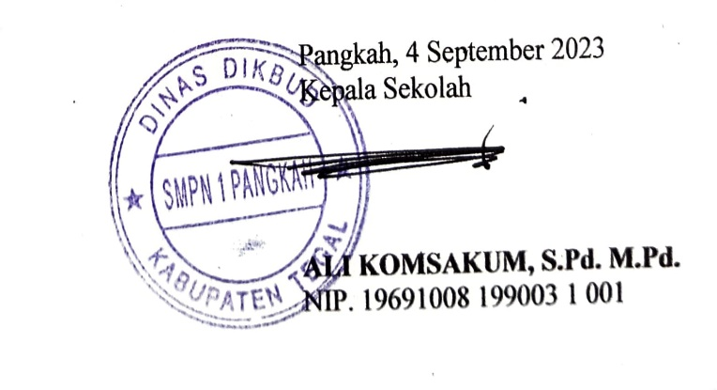

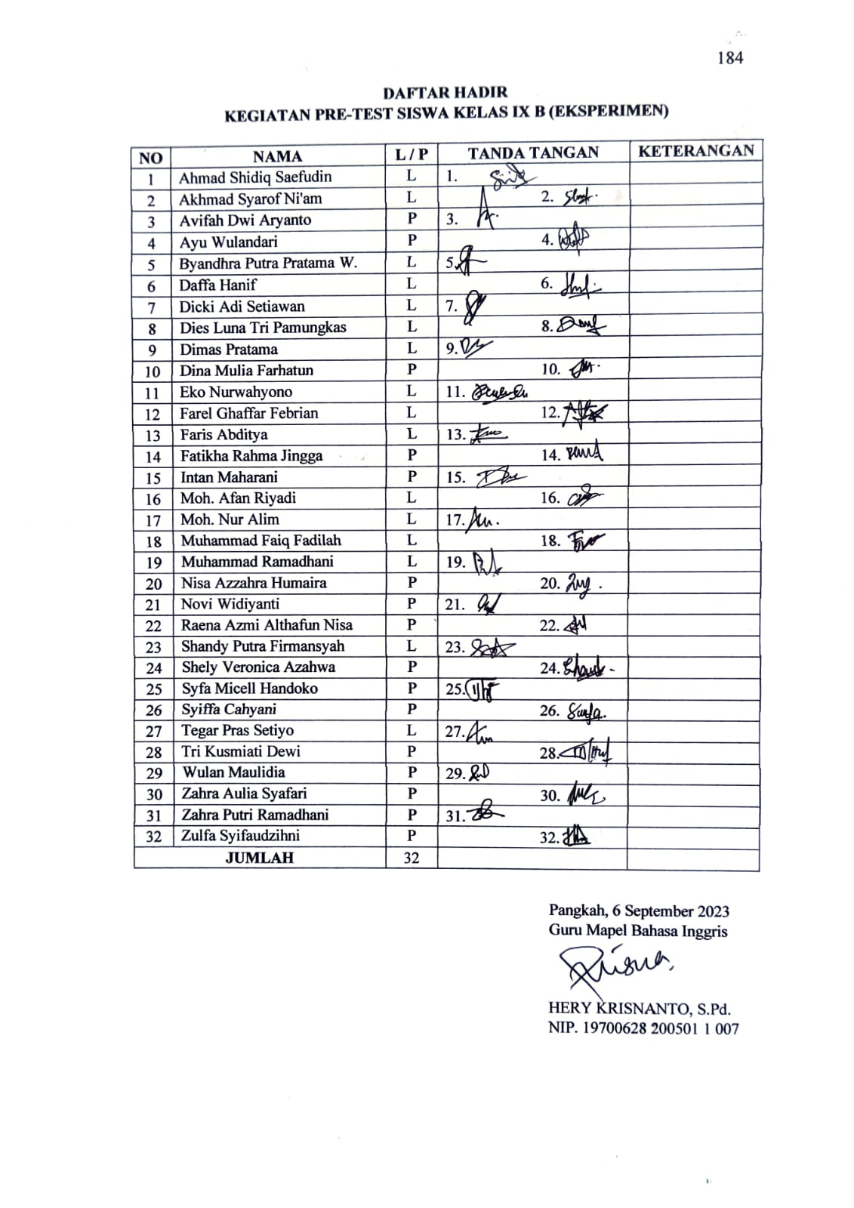

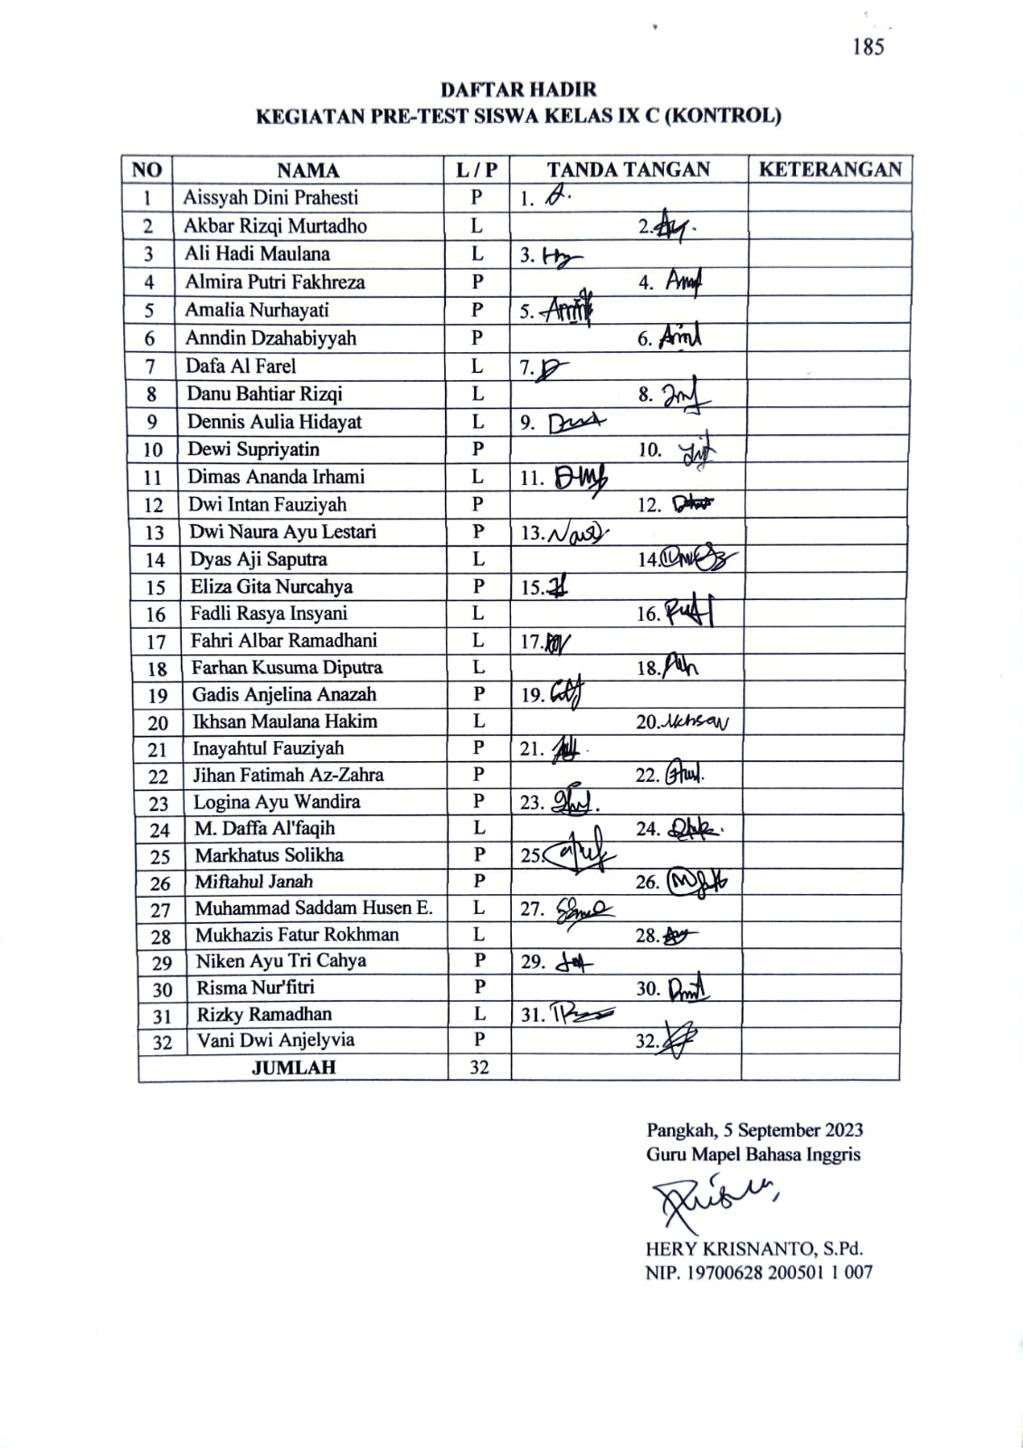

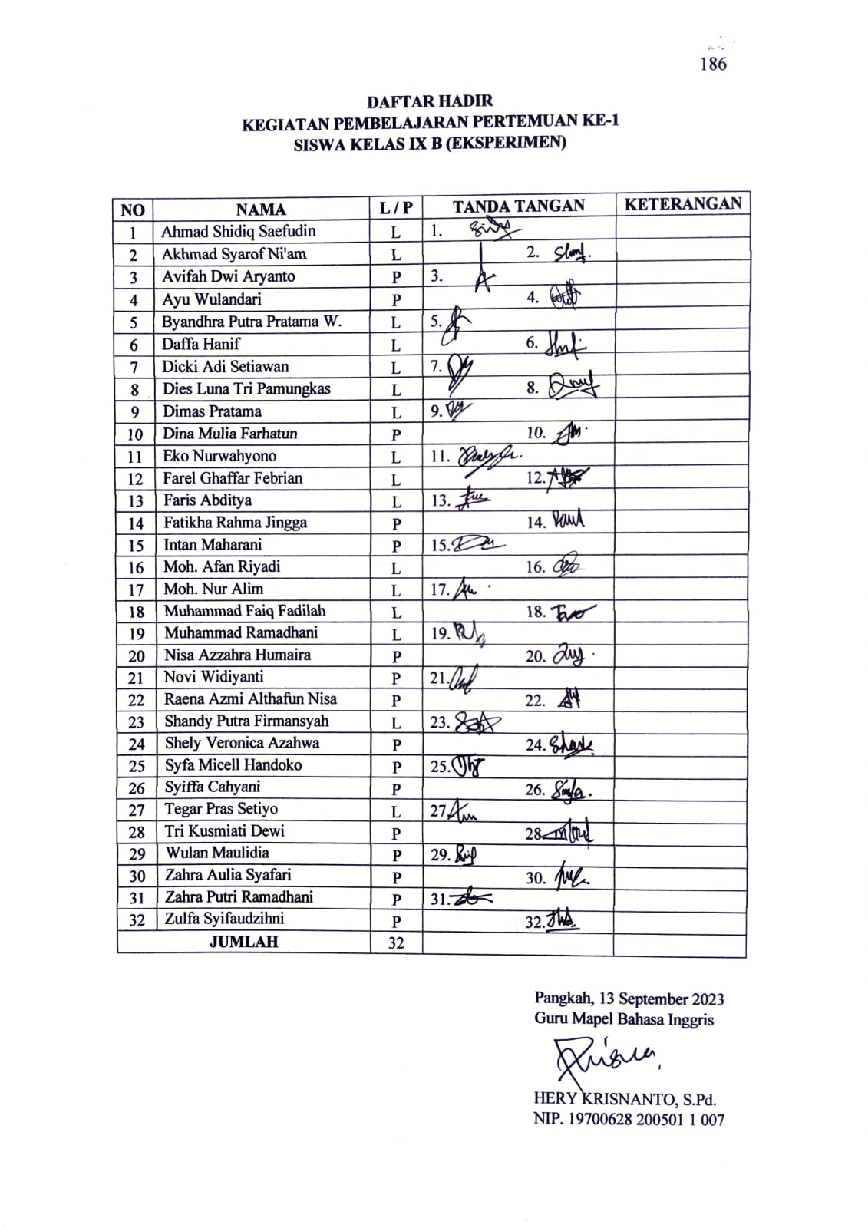

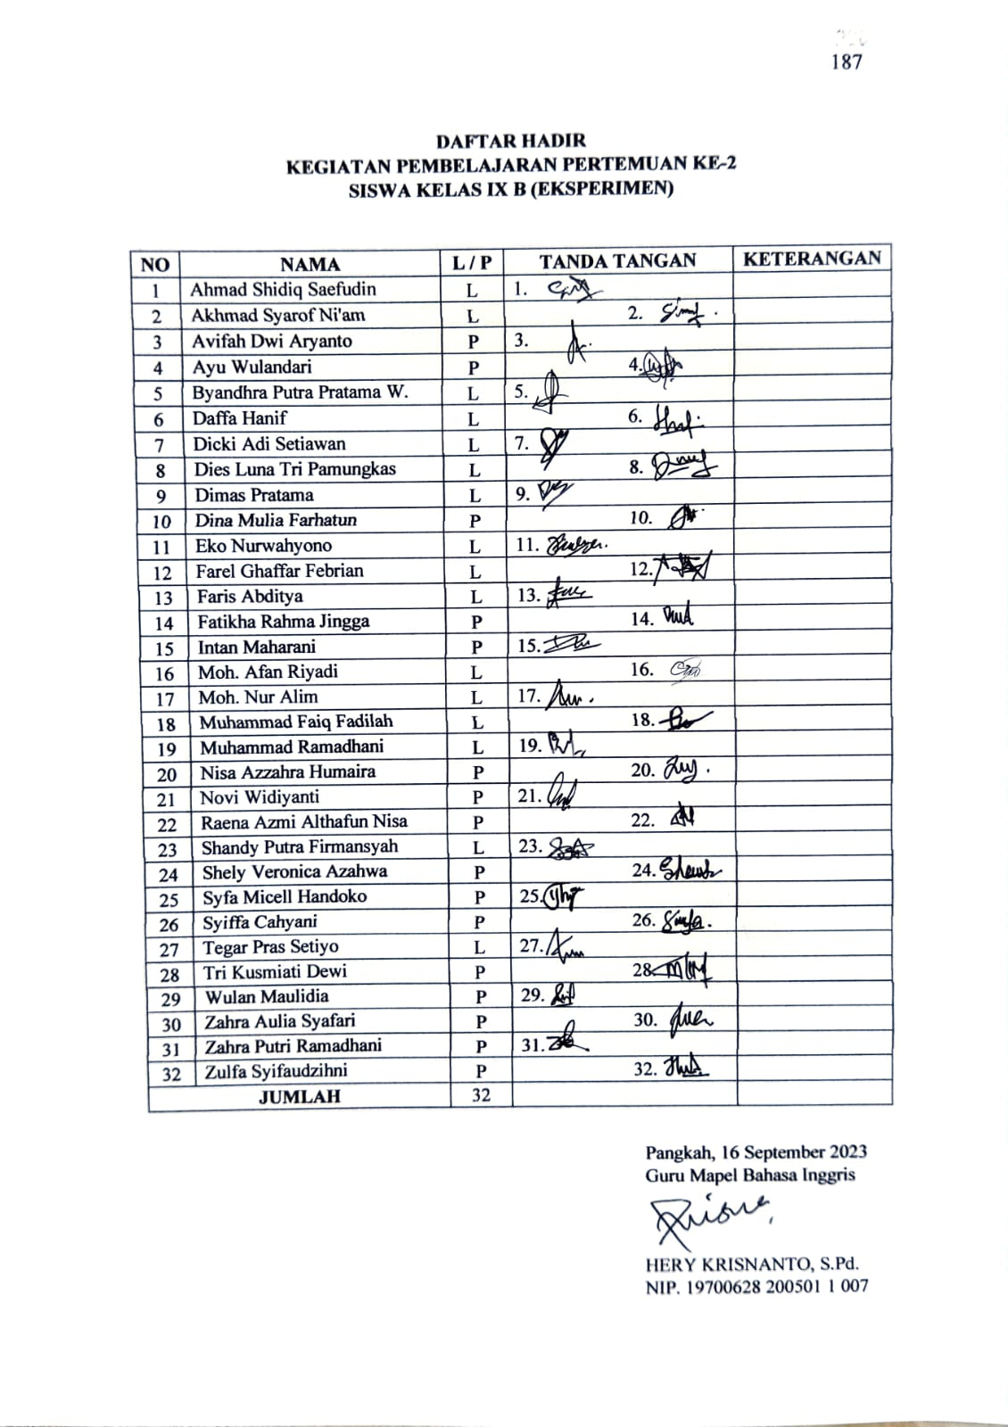

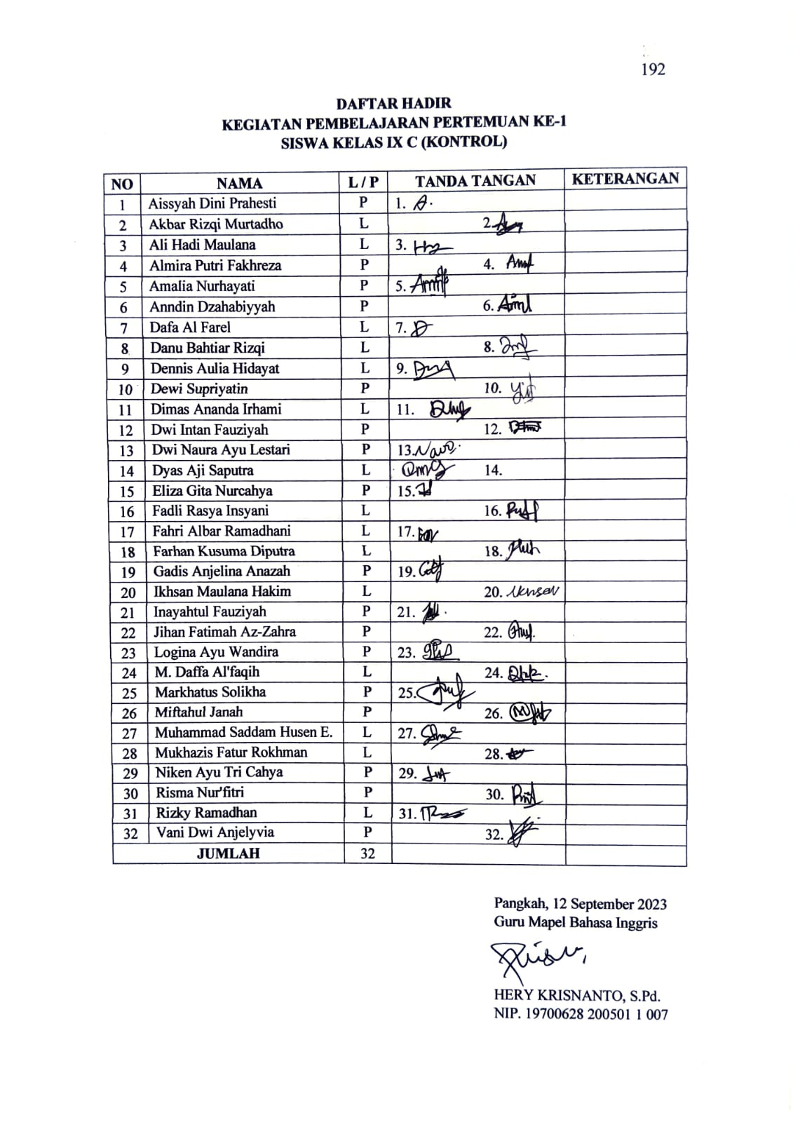

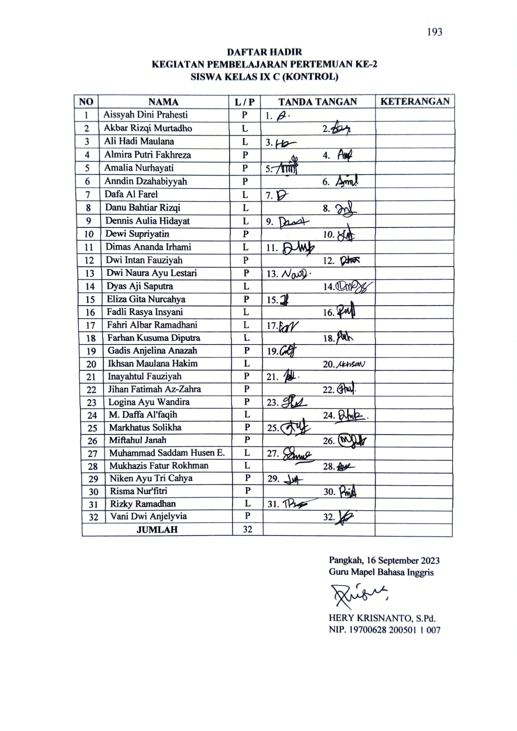

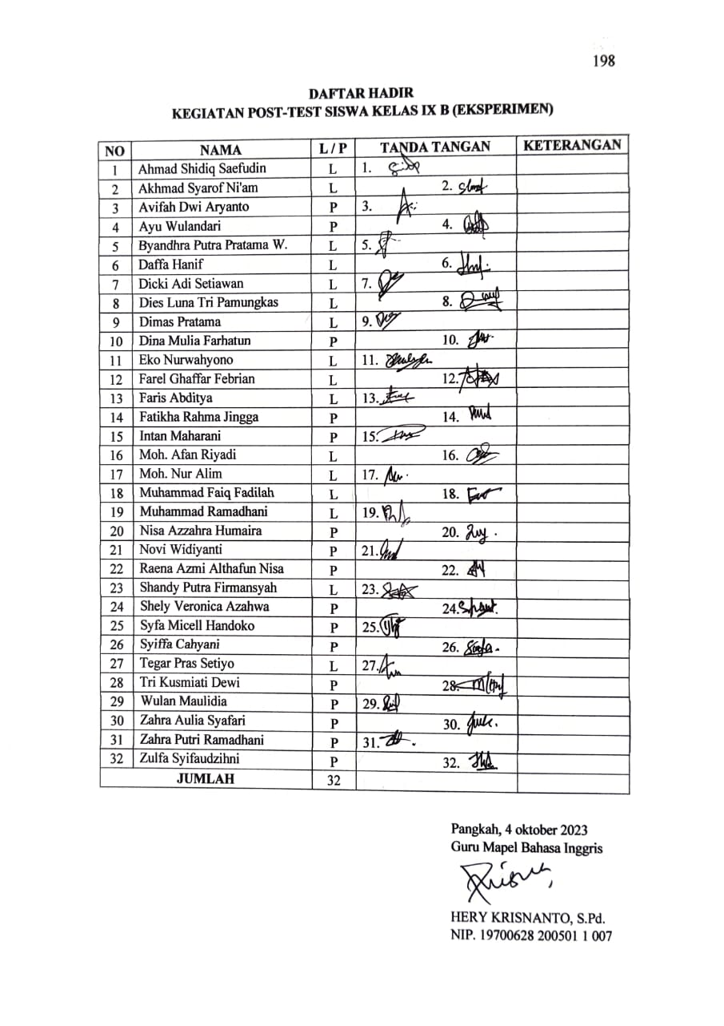

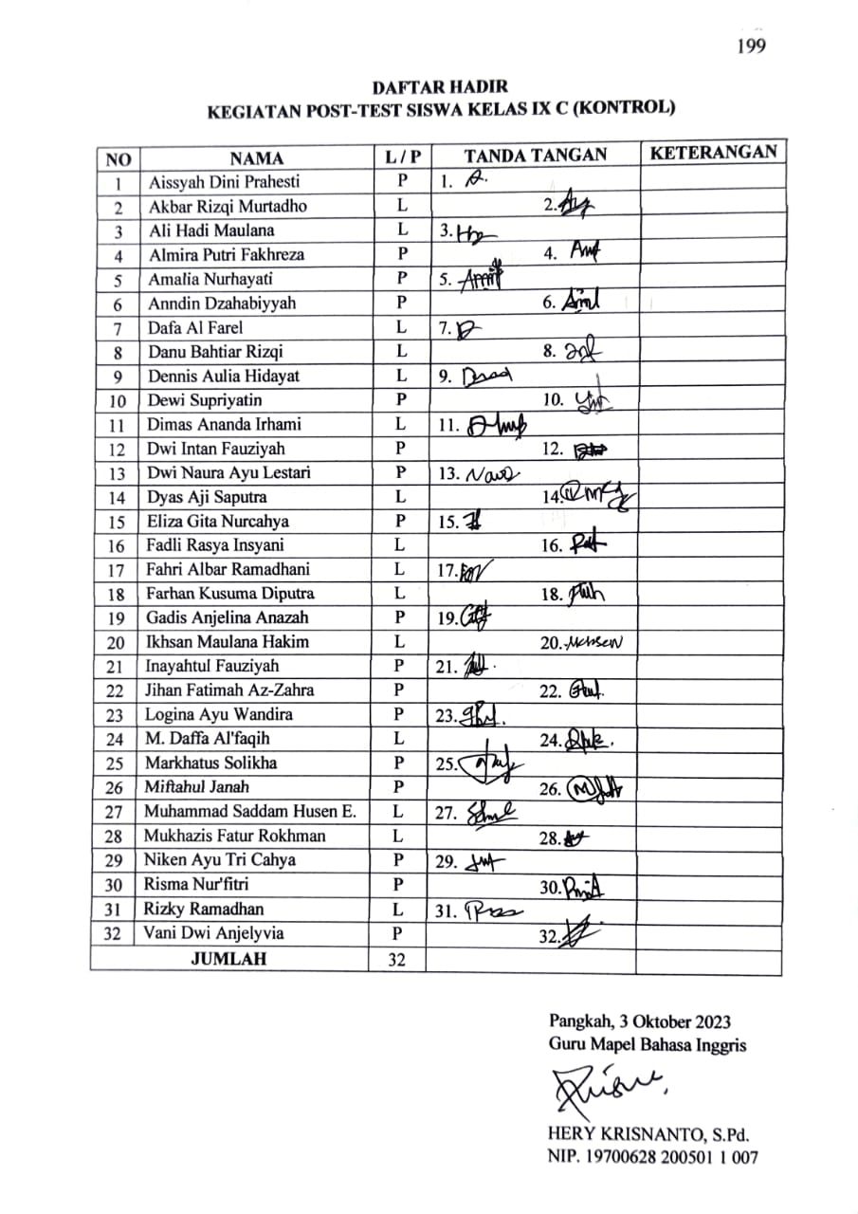

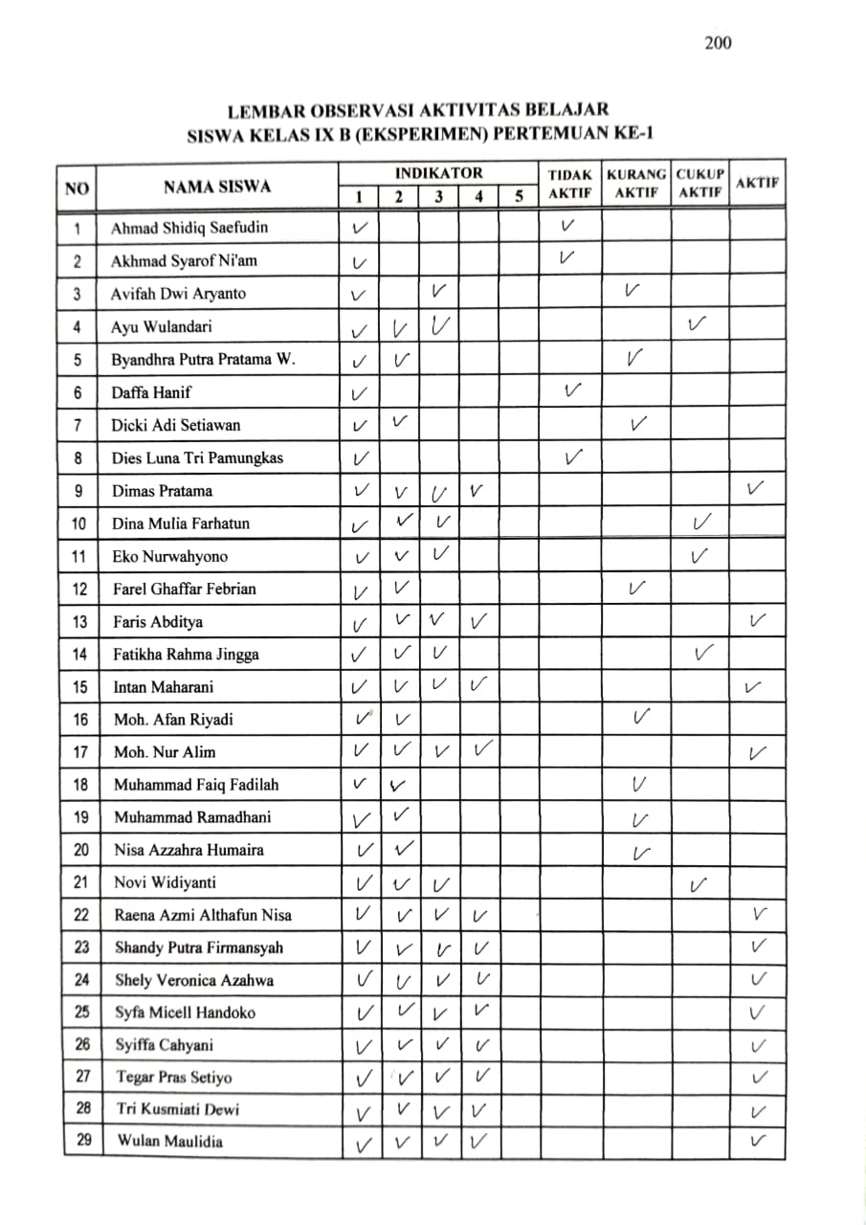

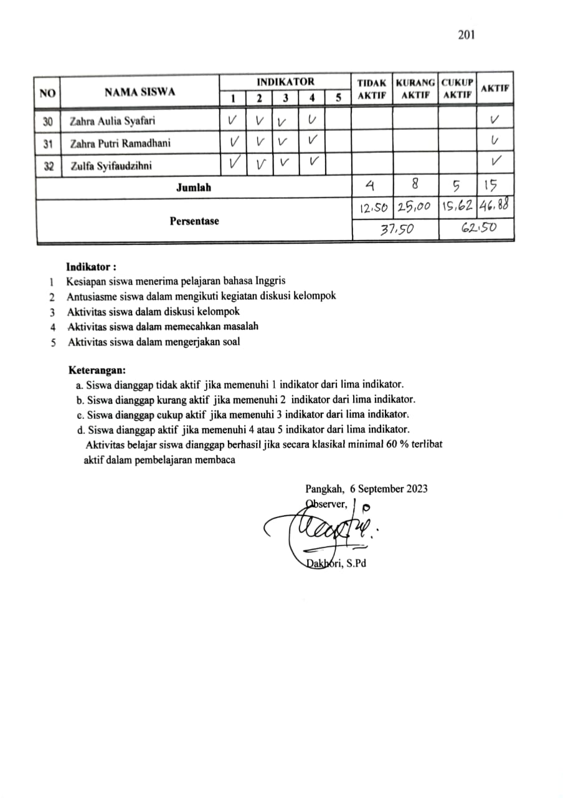

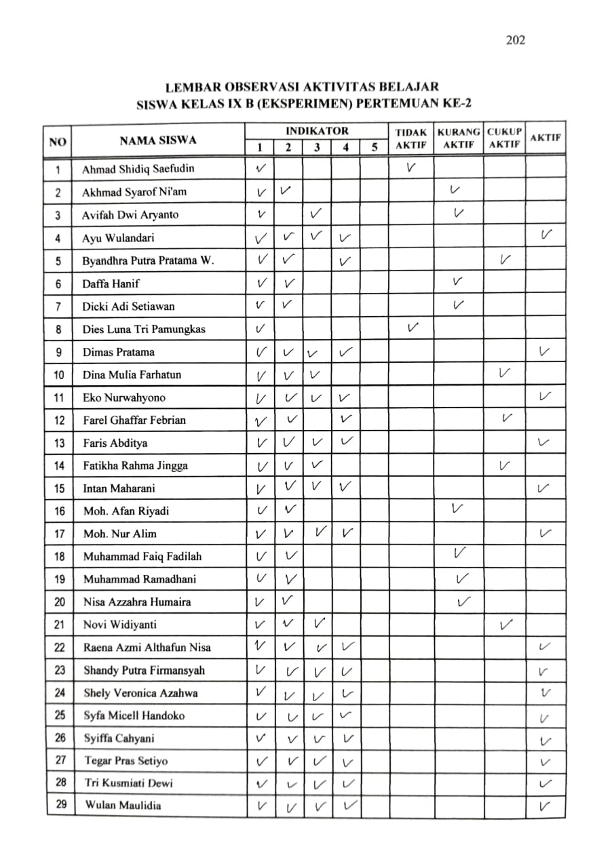

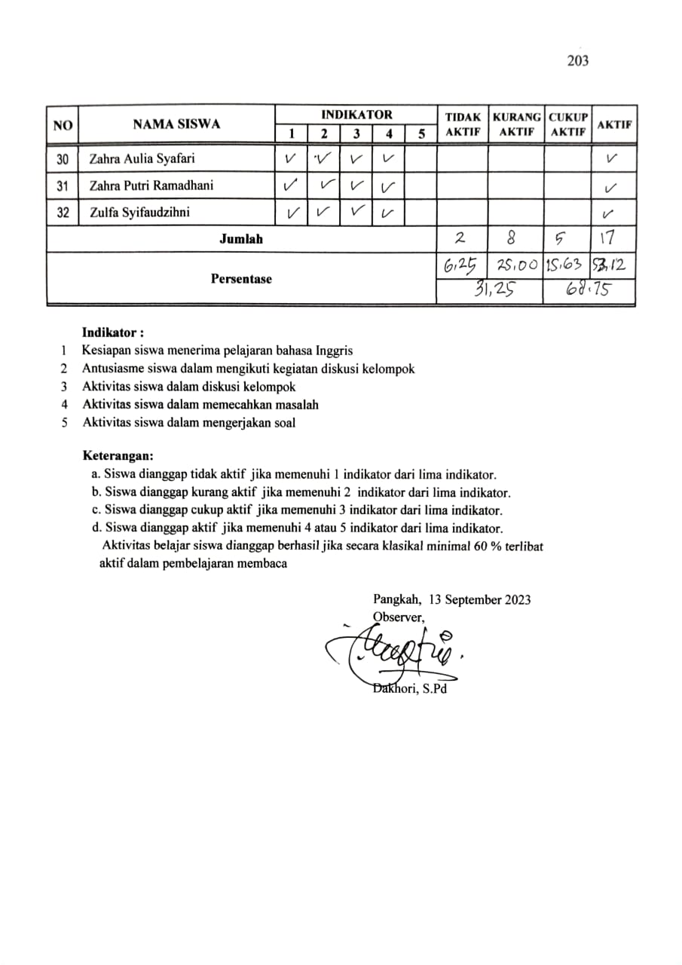

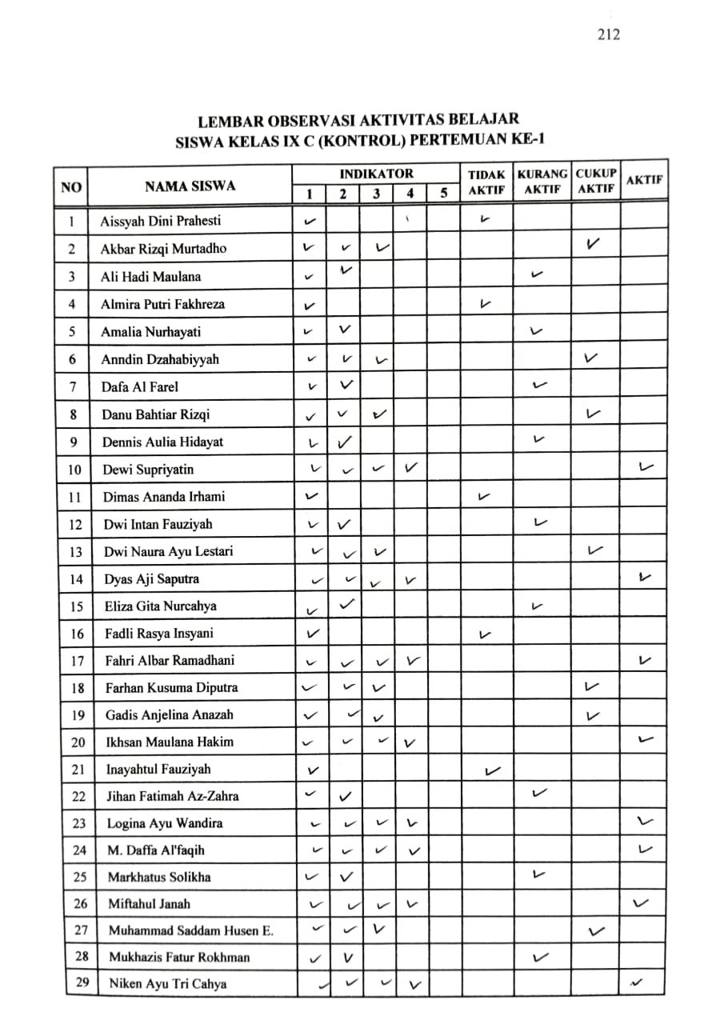

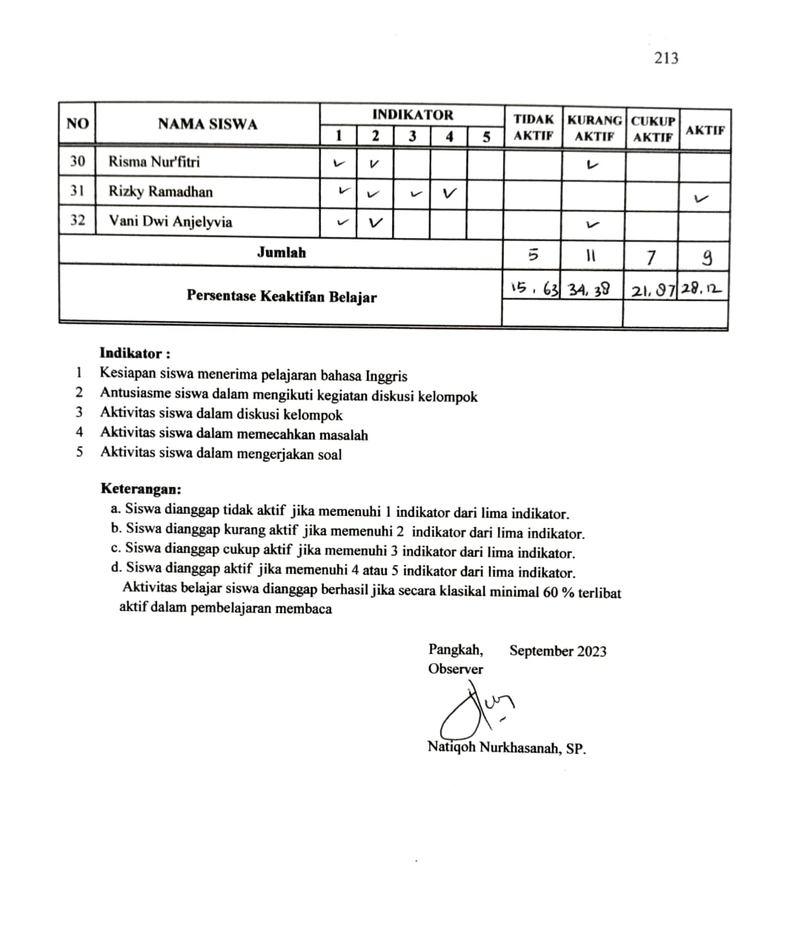

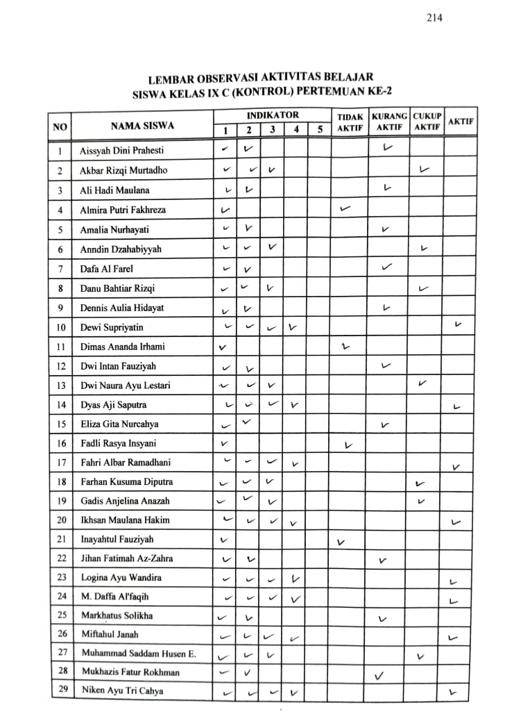

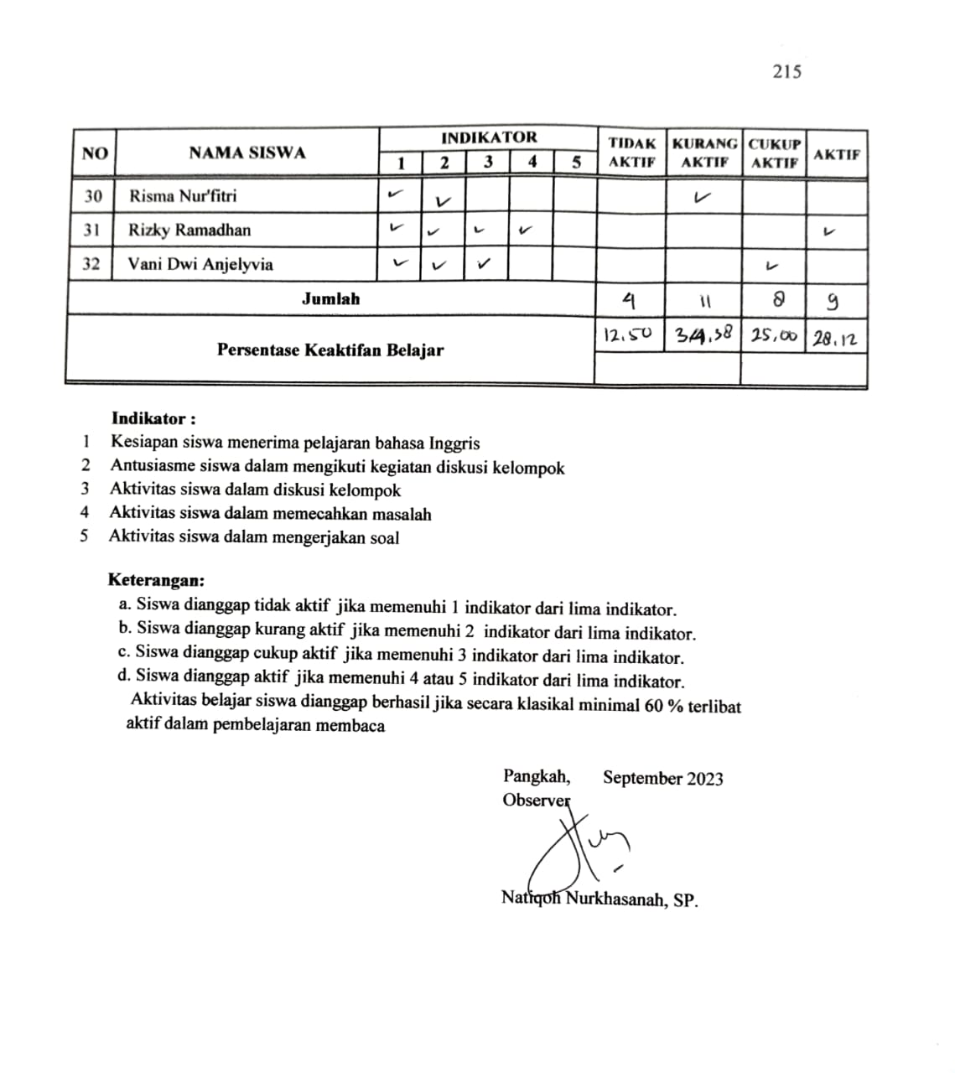

**Dokumentasi Pembelajaran Pre-Test Kelas Eksperimen**

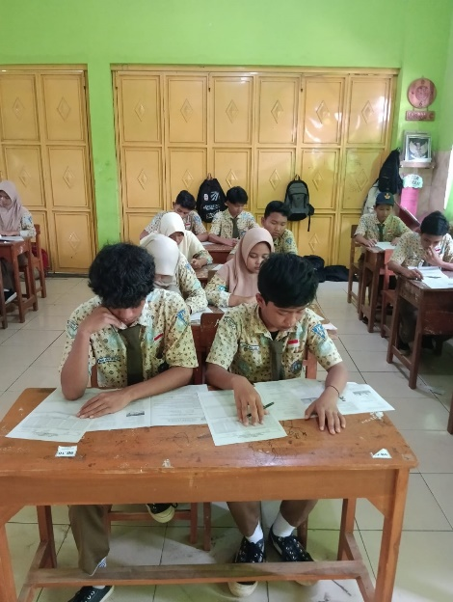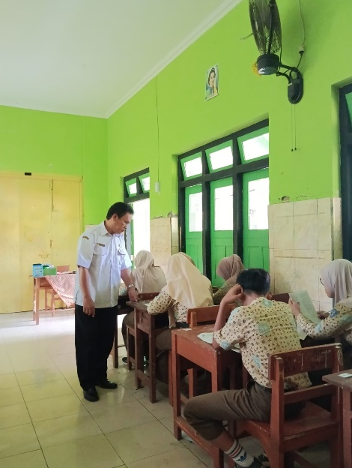

**Dokumentasi Pembelajaran Pertemuan ke 1 Kelas Eksperimen**

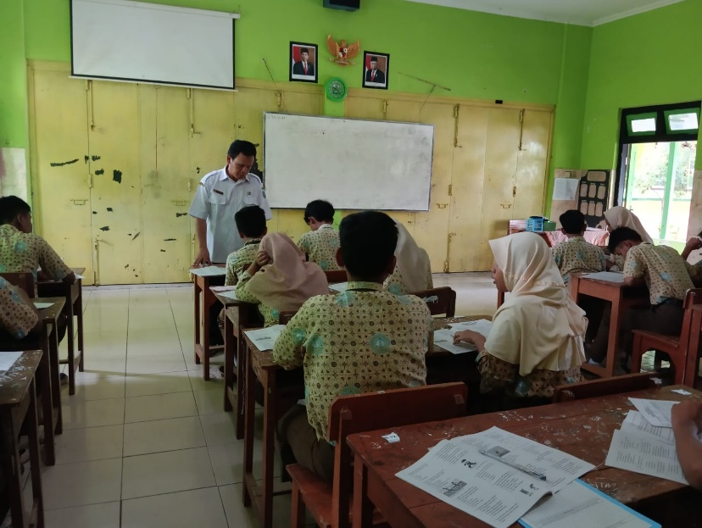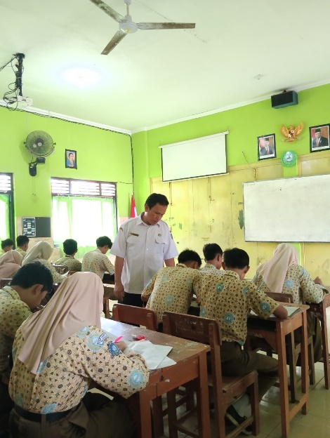

**Dokumentasi Pembelajaran Pertemuan ke 2 Kelas Eksperimen**

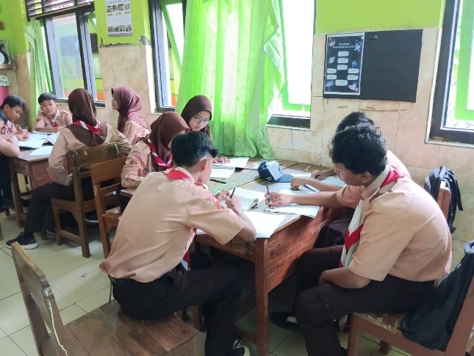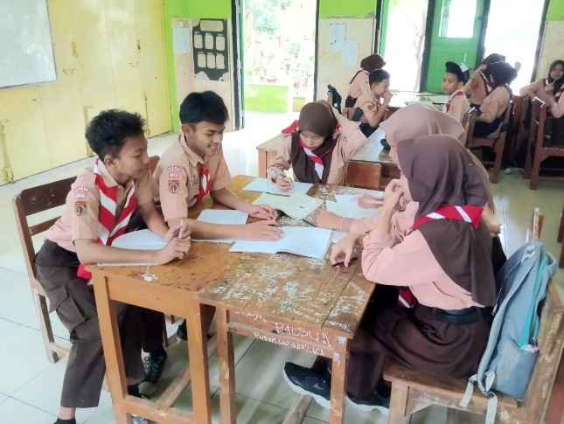

**Dokumentasi Pembelajaran Pertemuan ke 3 Kelas Eksperimen**

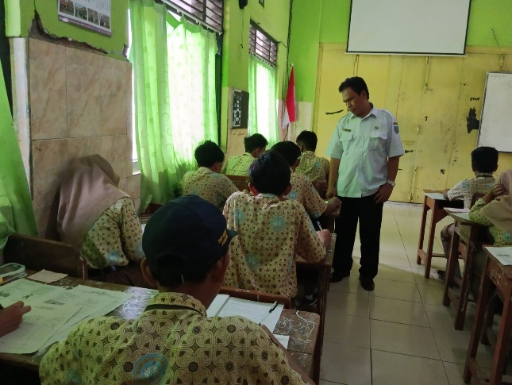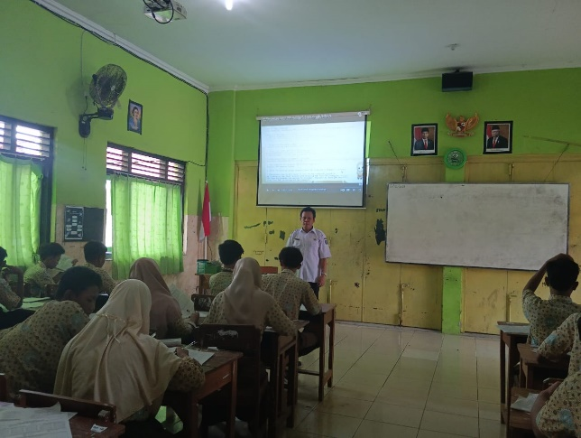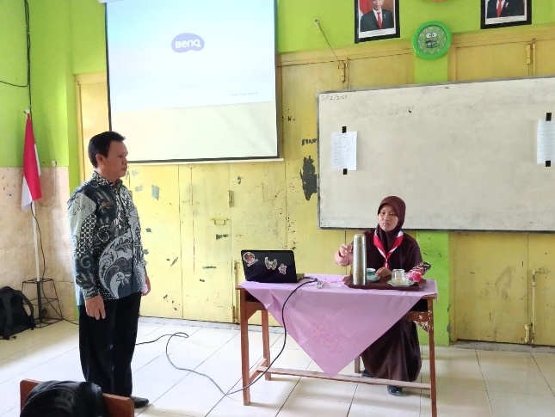

**Dokumentasi Pembelajaran Pertemuan ke 4 Kelas Eksperimen**

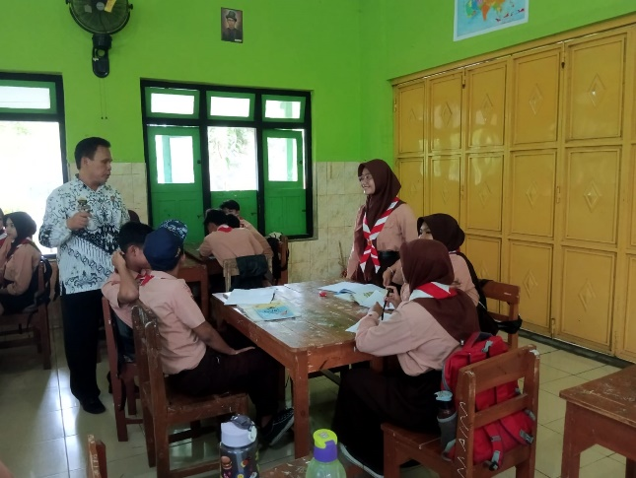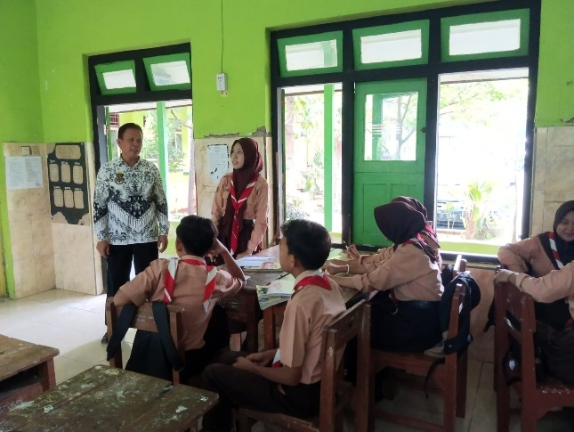

**Dokumentasi Pembelajaran Pertemuan ke 5 Kelas Eksperimen**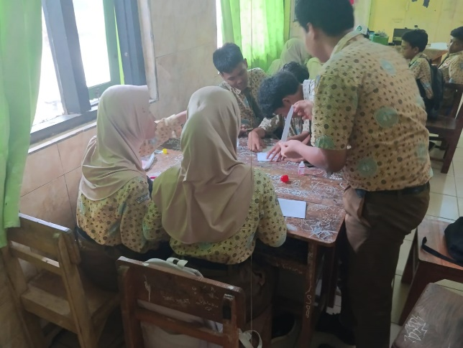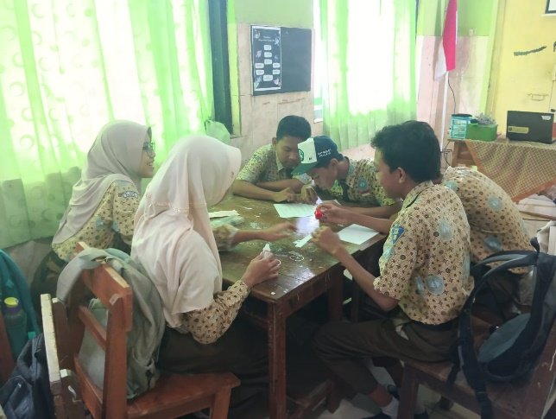

**Dokumentasi Pembelajaran Pertemuan ke 6 Kelas Eksperimen**

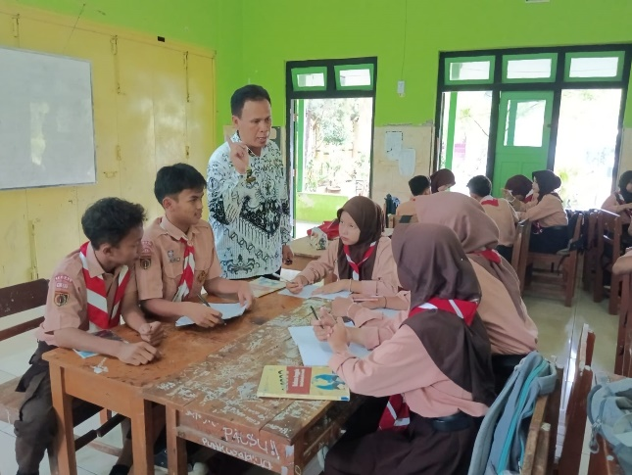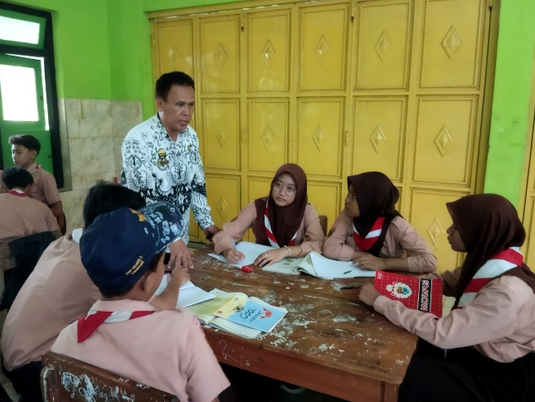

**Dokumentasi Pembelajaran Post-Test Kelas Eksperimen**

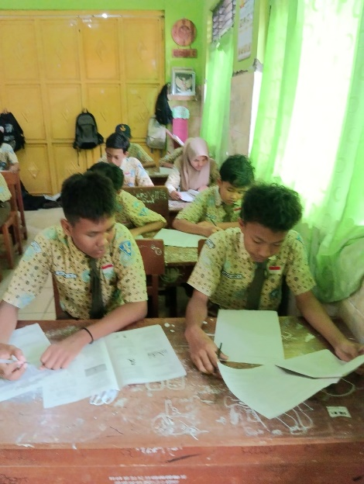

**Dokumentasi Pembelajaran Pre-Test Kelas Kontrol**

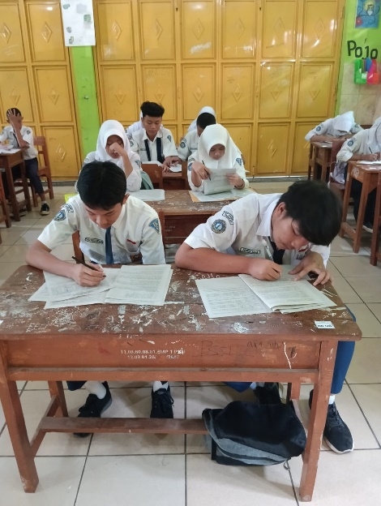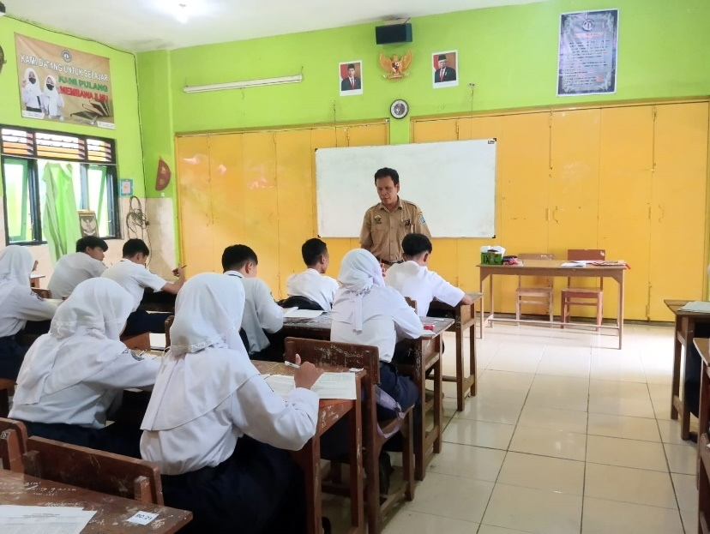

**Dokumentasi Pembelajaran Pertemuan ke 1 Kelas Kontrol**

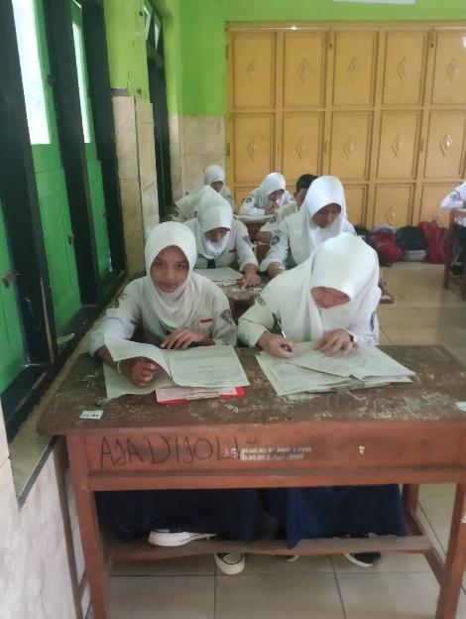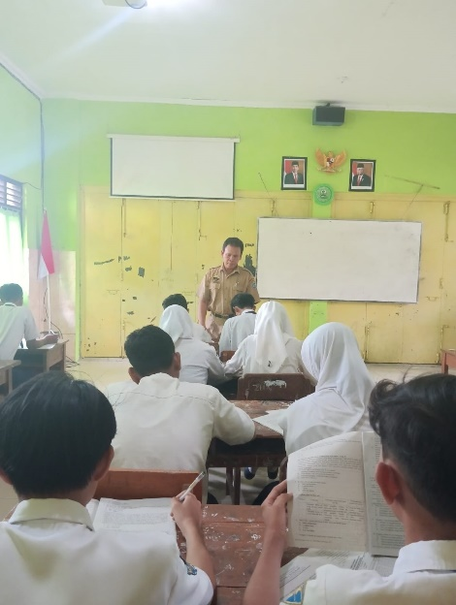

**Dokumentasi Pembelajaran Pertemuan ke 2 Kelas Kontrol**

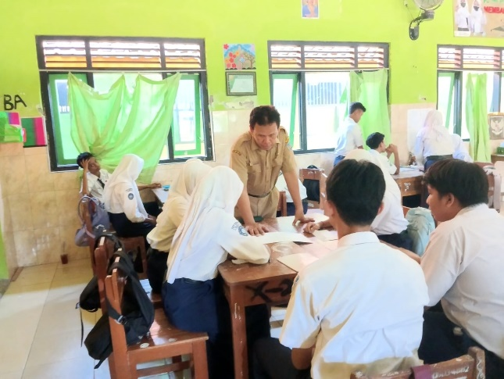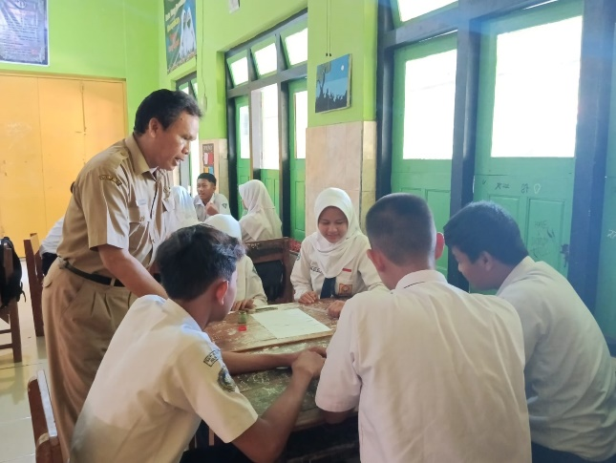

**Dokumentasi Pembelajaran Pertemuan ke 3 Kelas Kontrol**

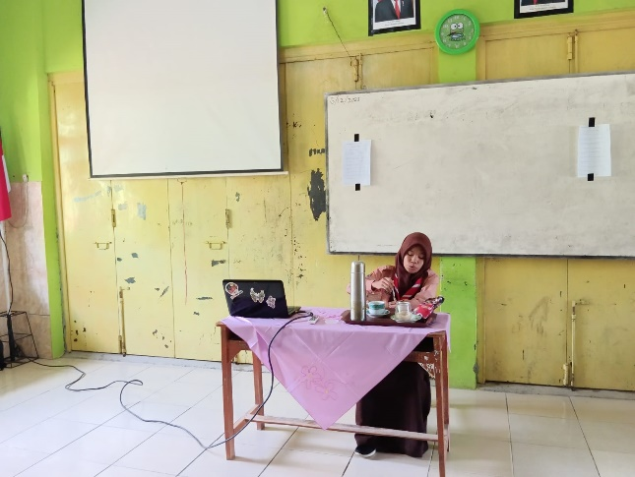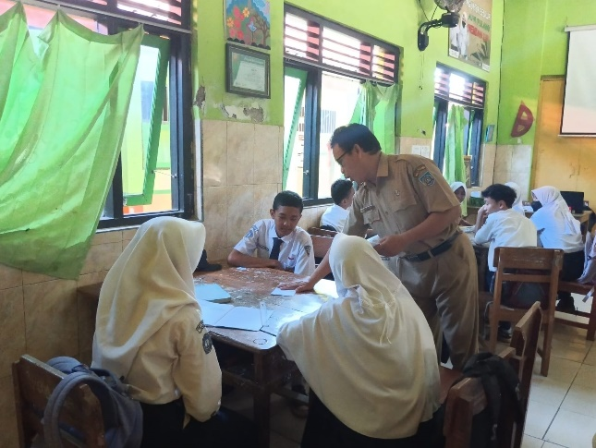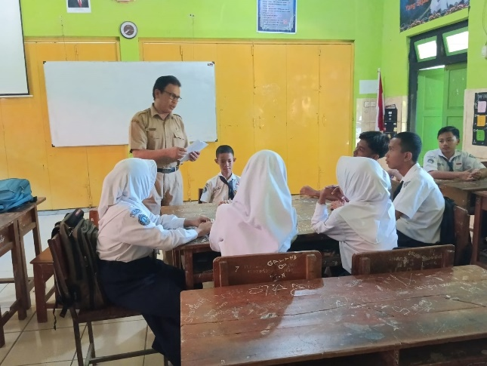

**Dokumentasi Pembelajaran Pertemuan ke 4 Kelas Kontrol**

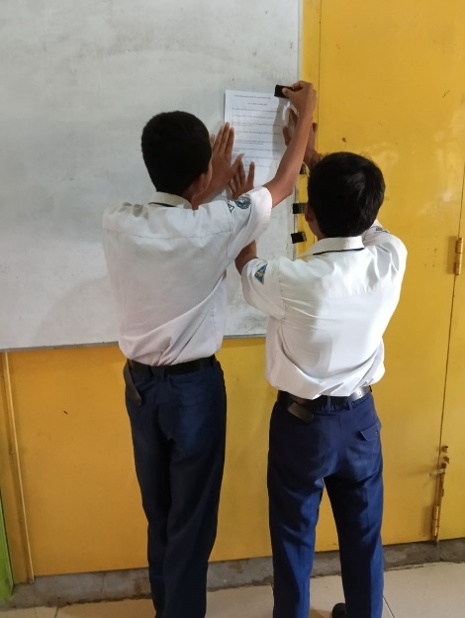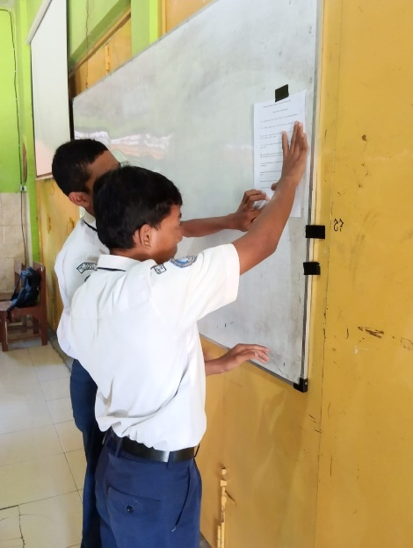

**Dokumentasi Pembelajaran Pertemuan ke 5 Kelas Kontrol**

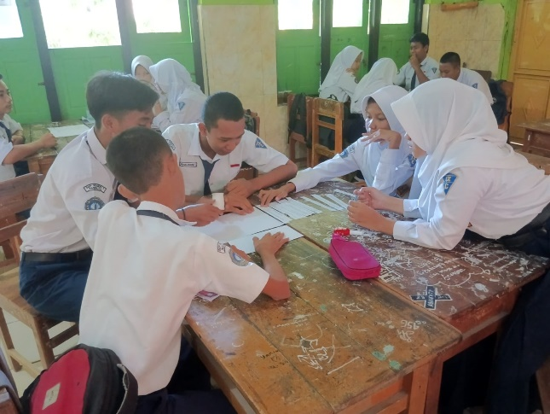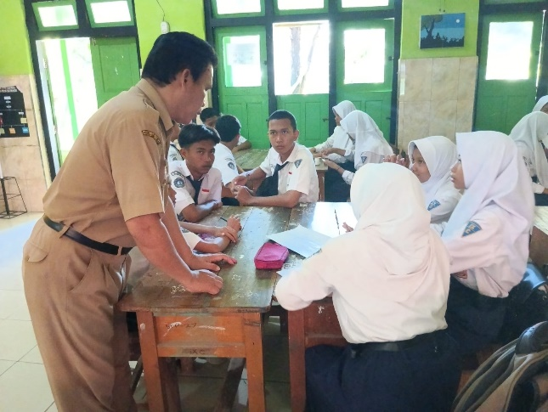

**Dokumentasi Pembelajaran Pertemuan ke 6 Kelas Kontrol**

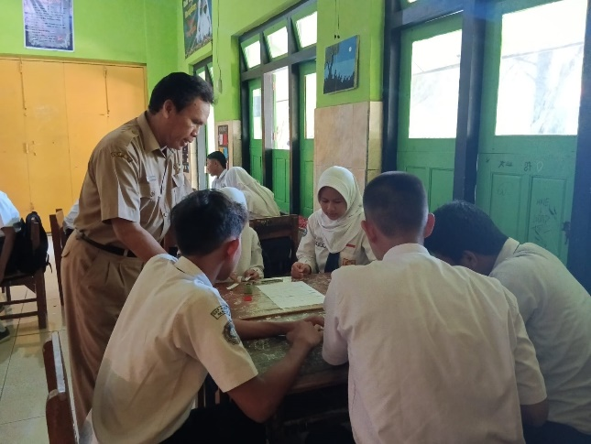

**Dokumentasi Pembelajaran Post-Test Kelas Kontrol**

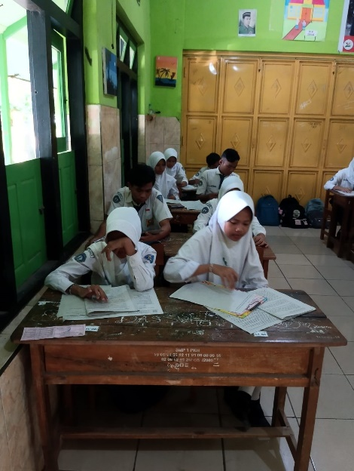

**Google Classroom Kelas Eksperimen**

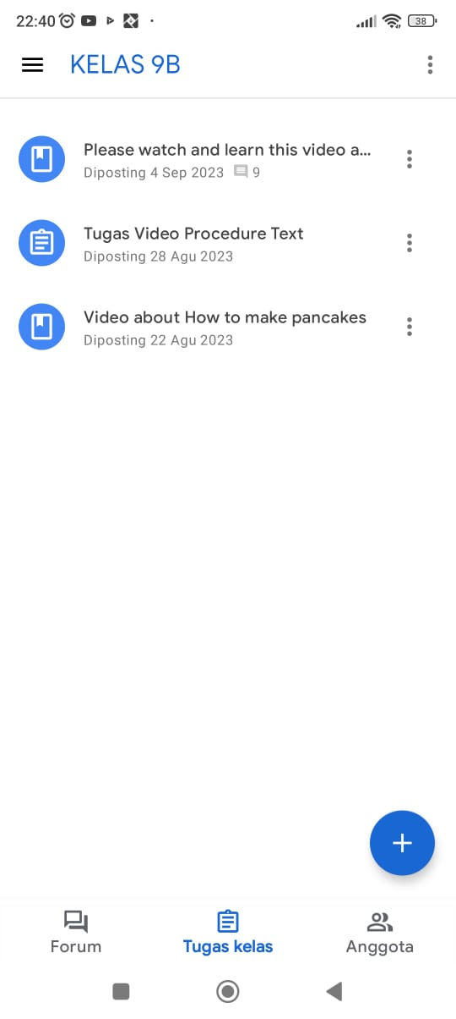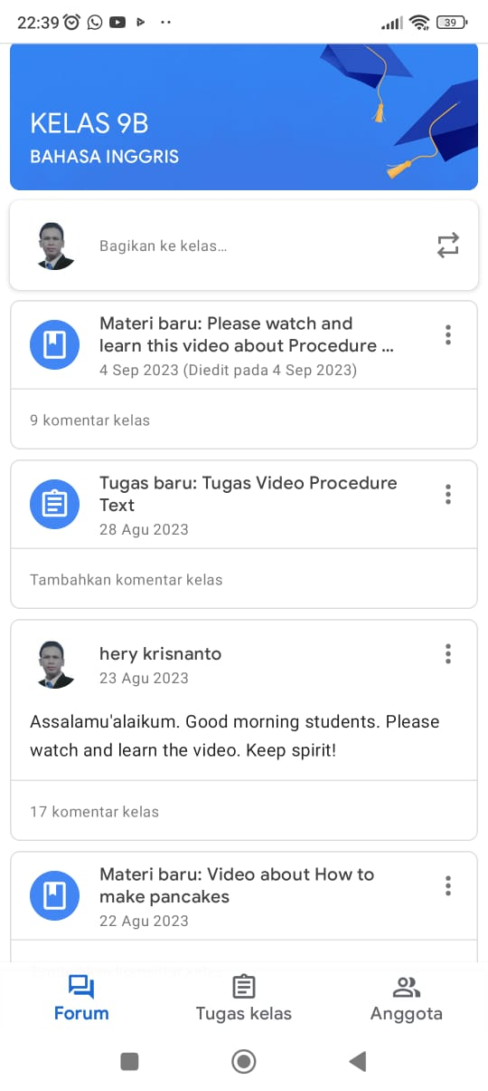

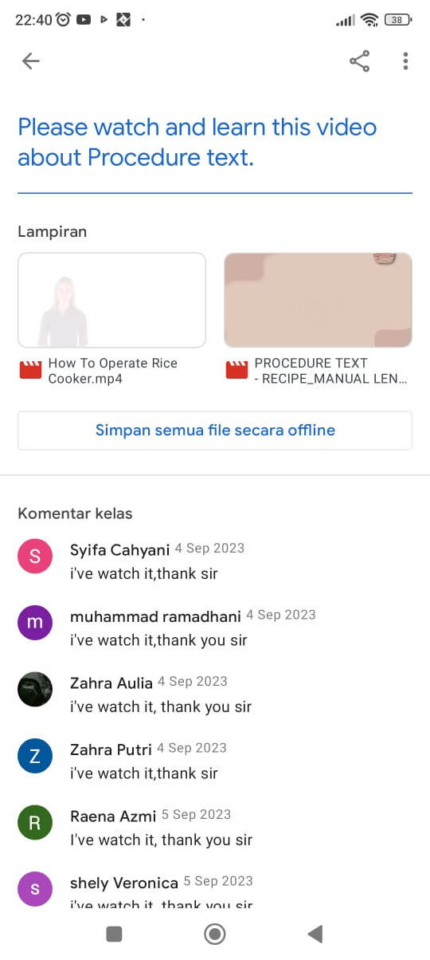

1.