REFERENCES
Aditiara, A., Ngadiso, & Drajati, N. A. 2019. A Correlation Study Between Critical Thinking Skill, Grammatical Mastery, and Critical Reading Skill. English Education Journal, 7(2), 282–291. https://doi.org/10.20961/eed.v7i2.35808
Aksoy, H. 2021. The relationship between grammar and vocabulary levels and their writing skills of those who learn Turkish as a foreign language. Journal of Research in Social Sciences and Language, 1(1), 18–29. https://doi.org/10.20375/0000-000D-FEA9-7
Aliaga, M. & Gunderson, B. 2002. How Do Qualitative and Quantitative Research Differ. St. Gallen: University Of St. Gallen. Switzerland.
Arikunto, S. 2013. Prosedur Penelitian Suatu Pendekatan Praktik. Jakarta: Rineka Cipta.
Betoni, T., & Ulfaika, R. 2020. The correlation between students’ grammatical mastery and students’ writing achievement at XI grade students of SMAN 1 Tarakan academic year. Borneo Journal of English Language Education, 2(1), 42–55.
Cohen, L., Manion, L., & Morrison, K. 2007. Research Methods in Education (Sixth edition). New York: Routledge.
Etfita, F. 2019. The Correlation Between Students’ Grammar Mastery and News Writing Ability. AL-ISHLAH: Jurnal Pendidikan, 11(1), 58-70. https://doi.org/10.35445/alishlah.v11i1.113
Fadhilawati, D. 2019. Basic English Grammar for Foreign Language learners. Sidoarjo: Indomedia Pustaka.
Fraenkel, J. R., Wallen, N. E., & Hyun, Helen H. 2012. How to Design and Evaluate Research in education. New York: McGraw-Hill.
Gerot, L., & Wignell, P. 1994. Making Sense of Functional Grammar. Australia: Gerd Stabler.
Gunawan, Muhammad Ali. 2015. Statistik Penelitian Bidang Pendidikan, Psikologi dan Sosial. Yogyakarta: Parama Publisher.
Halliday, M. A. K., & Matthiessen, C. M. I. M. 2014. Halliday’s introduction to functional grammar: Fourth edition. USA: Routledge.
Harmer, J. 2007. The Practice of English Language Teaching (Fouth edition). England: Longman.
Hartono, R., & Purwanto, B. 2017. English Text Types. Semarang: Fastindo.
Haryono, S. 2012. Metodologi Penelitian Bisnis Dan Manajemen (Teori dan Aplikasi). Bekasi: PT. Intermedia Personalia Utama.
Helmiati, M., Sudarsono, Susilawati, E. 2019. The correlation of grammar mastery with writing ability. JPPK: Journal of Equatorial Education and Learning. 8(9). 1-10. https://dx.doi.org/10.26418/jppk.v8i9.35288
Ilam, V., Widhiasih, L. K. S., & Murtini, N. M. W. 2022. The Correlation Between Grammar Mastery and Writing Ability of the Eighth Grade Students. Academic Journal on English Studies, 2(2), 159–171.
Jamaludin, S., & Nurdiawati, D. 2021. A Study Correlation Between Students’Grammar Mastery, Their Writing and Listening Comprehension Achievement. Indonesian EFL Journal, 7(1), 97–104. https://doi.org/10.25134/ieflj.v7i1.4020
Knapp, P., & Watkins, M. 2005. Genre, text, grammar: Technologies for teaching and assessing writing. Sydney: UNSW Press.
Multazim, A., Dramestika, R., & Hudayah, L. F. 2019. The correlation between students’ grammar mastery and vocabulary mastery toward students’ translation accuracy on recount text. International Journal of Innovation, Creativity and Change, 5(3), 20–38.
Nadeak, V., et al. 2021. The Correlation Between Grammar Mastery and Writing Ability (a Correlation Study) At the Tenth Grade of Smk Negeri 1 Siborongborong. Jurnal Littera: Fakultas Sastra Darma Agung, 1(2), 175-186. https://jurnal.darmaagung.ac.id/index.php/littera/article/view/1314
Nation, I.S.P. 2009. Teaching ESL/EFL Reading and Writing. New York: Routledge.
Patel, M. F., & Jain, P. M. 2008. English Language Teaching (methods, tools & techniques). Jaipur: Sunrise Pulishers & Distributors.
Putra, I. N. J. A., Dharmayanti, P.A.P., Sawitri, N.L.P.D. 2022. The Correlation Between Grammar Mastery and Writing Skill of The Tenth Grade Students of SMK Ratna Wartha Ubud in Academic Year 2021/2022. Academic Journal on English Studies, 2(2), 101-106.
Rajendra, T. D., & Kaur, S. 2022. Print-Based Multimodal Texts: Using Illustrated Poems for Generating Ideas and Writing Narratives. Studies in English Language and Education, 9(1), 278–298. https://doi.org/10.24815/siele.v9i1.21830
Santosa, P. P. P. 2017. Hubungan Antara Penguasaan Tata Bahasa dengan Keterampilan Menulis Narasi Bahasa Inggris Siswa Kelas XI SMK Negeri 2 Depok. Deiksis, 9(2), 182-193.
Shen, Y. 2012. Reconsidering English grammar teaching for improving non-English majors’ English writing ability. English Language Teaching, 5(11), 74–78. https://doi.org/10.5539/elt.v5n11p74
Suastra, I. M., & Menggo, S. 2020. Empowering students’ writing through performance assessment. International Journal of Language Education, 4(3), 432–441. https://doi.org/10.26858/ijole.v4i3.15060
Sugiyono. 2013. Metode Penelitian Kuantitatif Dan Kualitatif Serta R&D. Bandung: Alfabeta.
Weigle, S. C. 2002. Assessing writing. Cambridge: Cambridge University Press.
Widayanti, T., Rustyana, N., & Haryudin, A. 2019. Students’ perception in writing procedure text. Professional Journal of English Education, 2(5), 687–691.
Yusuf, A. M. 2014. Metode Penelitian Kuantitatif, Kualitatif & Penelitian Gabungan. Jakarta: Kencana.

APPENDICES

Appendix 1 Grammar Mastery Test

GRAMMAR TEST INSTRUMENT
Directions:
- This test is for research only.
- This test is multiple choises.
- Write down your name and your class on the provided answer sheet!
- Read all the following sentences carefully and then choose one best answer by crossing a, b, c, or, d!
- The time allocation of the test is 60 minutes.
Choose and cross the correct temporal conjunction by crossing (x) a, b, c, or d!
- ..., cover your seeds with lefover dirt until you can not see them.
- Meanwhile c. After that
- Since d. So that
- ..., wait around 10 to 18 weeks for them to grow.
- Finally c. So
- And d. Since
- ..., you can enjoy yummy carrots.
- And c. Then
- Meanwhile d. Since
- ..., “bloom” the yeast by sprinkling the sugar and yeast in the warm water.
- Just c. As soon as
- Firstly d. Before
- ... grease a clean, large bowl with olive oil and place the dough inside.
- Until c. So
- Since d. Then
- ... make the tomato sauce: Add the salt to the can of tomatoes and puree with an immersion blender.
- Meanwhile c. As
- Just d. And
- ..., go to your laptop/computer and find the “printer setting”.
- Just c. As
- As soon as d. Second
- ..., printer is ready to use.
- Because c. As
- Since d. Finally
- Blend all the ingredients up to a puree ... smooth.
- since c. and
- until d. firstly
- The slime will begin to form, going stringy ... coming away clean from the bowl into a ball.
- just c. at first
- at once d. before
- ... you are ready to take the picture, hold the shutter speed and various other calculations.
- At first c. So
- When d. And
- ..., a light should appear that let you know the camera is set to go.
- After c. Before
- Then d. As
- ..., press shutter all the way down.
- After that c. So that
- So d. After
- ..., pour butter to form pancake of whatever size you like.
- Just c. So
- Next d. When
Choose and cross the correct imperative by crossing (x) a, b, c, or d!
- ... yoghurt and lychee until the lychee is crushed.
- Put c. Add
- Blend d. Cut
- First, ... the tea bag and sugar on a kettle.
- add c. put
- blend d. cut
- Second, ... hot water into it.
- stir c. dip
- mix d. pour
- ... until the color change.
- Open c. Close
- Wait d. Remove
- Last is ... the tea from the kettle to the glass.
- put c. cut
- blend d. pour
- You must ... the eggs first.
- kick c. whisk
- burn d. throw
- After that, ... the margarine and condensed milk.
- cut c. dip
- add d. wait
- ... the dough into flour, mix it until soft.
- Cut c. Dip
- Pour d. Wait
- After the dough is done you must ... the baking pan.
- prepare c. blend
- add d. dip
- When the baking pan is ready, ... margarine on it.
- slice c. put
- hold d. spread
Choose and cross the correct material verb by crossing (x) a, b, c, or d!
- You must ... the tape about 10cm long.
- throw c. cut
- eat d. write
- You ... the flannel from the center.
- write c. eat
- bake d. twist
- You have to ... the rose on the rectangle flannel and glue it.
- put c. drink
- clean d. boil
- The players ... that the marbles are in good condition and are nearly worth the same value.
- must hear
- must listen
- must check
- must write
- First player ... a hole in the ground.
- must see c. must clean
- must buy d. must dig
- First player ... a line distance away from the hole.
- burns c. paints
- draws d. mix
- The first player carefully ... his or her marble towards the hole.
- have c. throws
- eats d. writes
- The winner ... to keep both marbles.
- reads c. chews
- writes d. gets
Choose and cross the correct simple present tense by crossing (x) a, b, c, or d!
- Next, you ... with salt, pepper, and nutmeg.
- seasons c. seasoning
- season d. seasoned
- You ... pan from the stove and cool.
- removes c. removed
- remove d. removing
- ... not boil.
- Does c. Doing
- Did d. Do
- Then garnish with chopped parsley and finally you ... .
- serves c. serve
- serving d. served
- First, ... your hands with soap and water.
- wash c. washes
- washing d. washed
- Then, ... the vegetables into small pieces.
- chopping c. chops
- chopped d. chop
- Next, ... spices and stir well.
- adds c. adding
- add d. added
- There ... three players to play this game.
- am c. are
- is d. were
- The instant noodle ... ready to serve.
- are c. is
- am d. was
- There ... one person in charge of jumping over the rubber rope.
- are c. is
- am d. was
- Meanwhile, two others ... holding each side of the rope.
- are c. were
- is d. am
- The customers ... the tips for the drivers.
- might give
- may give
- may gave
- might gave
- This player ... to flick his or her opponent’s marble into the hole.
- tries c. tried
- try d. trying
- the bowl – First – in – put – the
1 2 3 4 5
Flour
The best arrangement is ...
- 2-3-4-1-5
- 2-4-5-3-1
- 2-3-4-1-5
- 2-4-3-5-1
- and- the butter- Heat- the- put - pan
1 2 3 4 5 6
The best arrangement is ...
- 3-2-4-5-1-6
- 3-4-1-5-2-6
- 3-4-6-1-5-2
- 3-4-5-6-1-2
- into - the potatoes - pieces - small -Cut
1 2 3 4 5
The best arrangement of the jumbled words is...
- 5-4-2-3-1
- 5-1-4-2-3
- 5-2-1-4-3
- 5-4-2-3-1
- The best arrangement of the following sentences is...
- Pour hot water into the cup.
- Instant noodles ready to be served.
- Wait for the instant noodles to cook for 5 minutes.
- Pour the seasoning into the instant noodles cup container.
- 2-4-1-3 c. 1-2-3-4
- 3-4-1-2 d. 4-1-3-2
- The best arrangement of the following sentences is...
- Serve with a cup of rice.
- Wait until broth boil. Blend all the ingredients up to puree until smooth.
- Next, add soft cheese and blend again for creaminess.
- Put the onion, carrots, and broth into a large pan.
- Next, add soft cheese and blend again for creaminess.
- 3-1-2-4 c. 3-4-2-1
- 3-2-4-1 d. 3-2-1-4

Appendix 2 Writing Ability Test
WRITING TEST INSTRUMENT
THE CORRELATION BETWEEN STUDENTS’ GRAMMAR MASTERY AND THEIR ABILITY IN WRITING PROCEDURE TEXT AT NINTH GRADE SMP IHSANIYAH TEGAL
- The test is used for scientific research.
- The result of this test does not influence your grade.
Directions:
- Choose one of the topics below:
- Recipe
- How to make juice
- How to cook rice using rice cooker
- How to make scrambled egg
- How to operate something
- How to operate computer
- How to operate washing machine
- How to operate AC
- Pay attention to the content, organization, vocabulary, language use, and mechanic.
The test is time-based (30 minutes), so make sure you finish it under the alloted time.
Appendix 3 Grammar Mastery Test Score
No | Name | temporal conjunction | material verb | imperative | simple present tense | Score
1 | Amal Muqorrobin | 14 | 10 | 12 | 30 | 66
2 | Atha Ghazali J. | 20 | 14 | 14 | 30 | 78
3 | Cahya Aji N. | 16 | 12 | 12 | 30 | 70
4 | Ilyas Esaramadhan | 24 | 16 | 14 | 30 | 84
5 | Lazuardi Iman | 12 | 4 | 14 | 32 | 62
6 | MF. Duta Santosa | 18 | 12 | 6 | 24 | 60
7 | M. Rasya Harranov | 28 | 16 | 14 | 34 | 92
8 | M. Zaavier A. | 20 | 8 | 8 | 28 | 64
9 | M. Fatan Nawawi | 14 | 2 | 14 | 30 | 60
10 | M. Gilang F.R. | 18 | 8 | 14 | 28 | 68
11 | M. Sabiq Arkaan | 26 | 16 | 12 | 30 | 84
12 | Taruma Negara | 18 | 14 | 8 | 26 | 66
13 | Vaiz Aiman | 20 | 12 | 12 | 30 | 74
14 | Alliya Husnaa V. | 18 | 14 | 8 | 20 | 60
15 | Allea Noor Azmi | 26 | 12 | 14 | 28 | 80
16 | Aninda Dwi N. | 28 | 10 | 12 | 26 | 76
17 | Bunga Nurhikmah | 14 | 14 | 10 | 22 | 60
18 | Farah Filah Hayati | 28 | 18 | 16 | 34 | 96
19 | Keyla Okti Safita | 28 | 8 | 12 | 28 | 76
20 | Ladina Keyza H. | 26 | 16 | 16 | 30 | 88
21 | Nafisa Rahma Dini | 24 | 14 | 14 | 28 | 80
22 | Salsa Ameyla Putri | 28 | 18 | 16 | 34 | 96
Total |  | 468 | 268 | 272 | 632 | 1640

Appendix 4 Writing Ability Test Score
No | Name | content | organiz-ation | vocab-ulary | language-use | mech-anic | score
1 | Amal Muqorrobin | 30 | 6 | 16 | 19 | 3 | 74
2 | Atha Ghazali J. | 30 | 18 | 15 | 18 | 3 | 84
3 | Cahya Aji N. | 30 | 17 | 14 | 17 | 3 | 81
4 | Ilyas Esaramadhan | 30 | 17 | 14 | 17 | 2 | 80
5 | Lazuardi Iman | 18 | 9 | 18 | 21 | 3 | 69
6 | MF. Duta Santosa | 18 | 9 | 17 | 21 | 2 | 67
7 | M. Rasya Harranov | 19 | 9 | 20 | 19 | 3 | 70
8 | M. Zaavier A. | 18 | 9 | 18 | 20 | 3 | 68
9 | M. Fatan Nawawi | 30 | 17 | 16 | 21 | 3 | 87
10 | M. Gilang F.R. | 28 | 17 | 17 | 22 | 3 | 87
11 | M. Sabiq Arkaan | 30 | 17 | 18 | 23 | 4 | 92
12 | Taruma Negara | 18 | 9 | 16 | 22 | 2 | 67
13 | Vaiz Aiman | 30 | 17 | 16 | 20 | 4 | 87
14 | Alliya Husnaa V. | 18 | 9 | 16 | 17 | 3 | 63
15 | Allea Noor Azmi | 30 | 17 | 17 | 20 | 4 | 88
16 | Aninda Dwi N. | 30 | 17 | 19 | 25 | 4 | 95
17 | Bunga Nurhikmah | 18 | 9 | 16 | 20 | 2 | 65
18 | Farah Filah Hayati | 30 | 17 | 17 | 22 | 3 | 89
19 | Keyla Okti Safita | 30 | 17 | 18 | 22 | 3 | 90
20 | Ladina Keyza H. | 30 | 17 | 17 | 21 | 3 | 88
21 | Nafisa Rahma Dini | 30 | 17 | 17 | 22 | 3 | 89
22 | Salsa Ameyla Putri | 30 | 17 | 18 | 22 | 4 | 91
Total |  | 575 | 308 | 370 | 451 | 67 | 1771

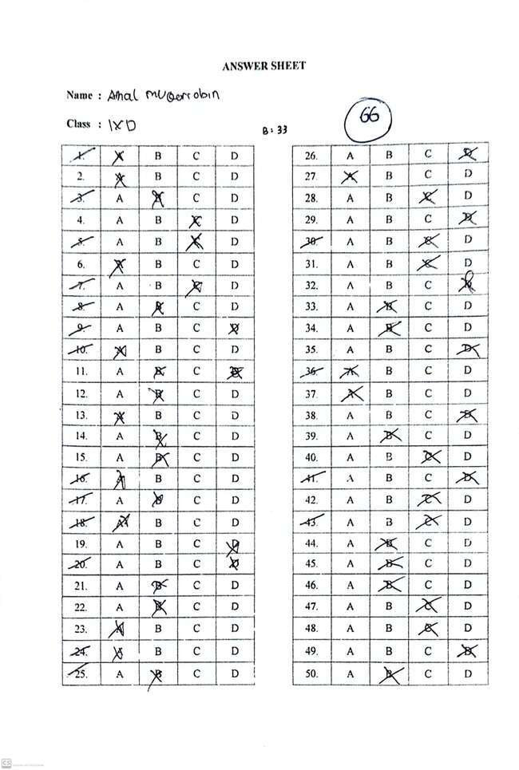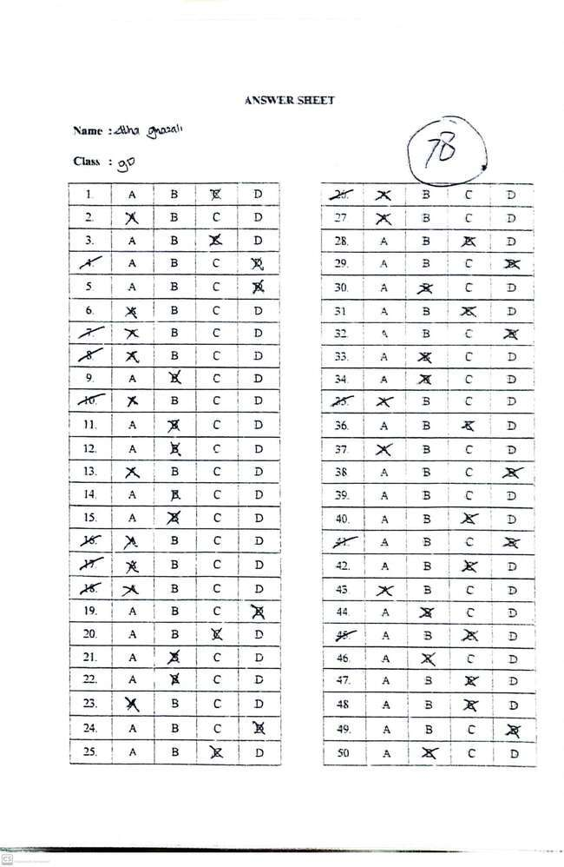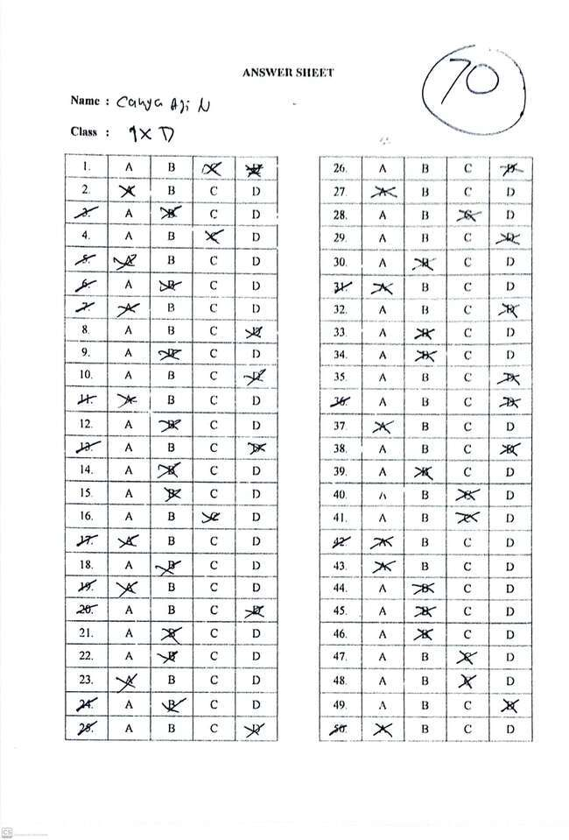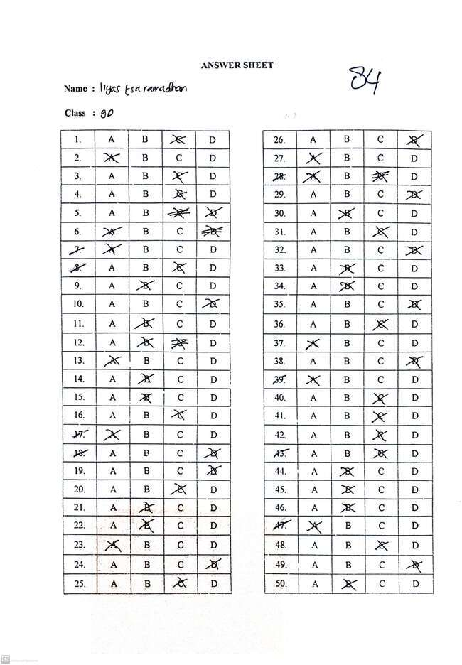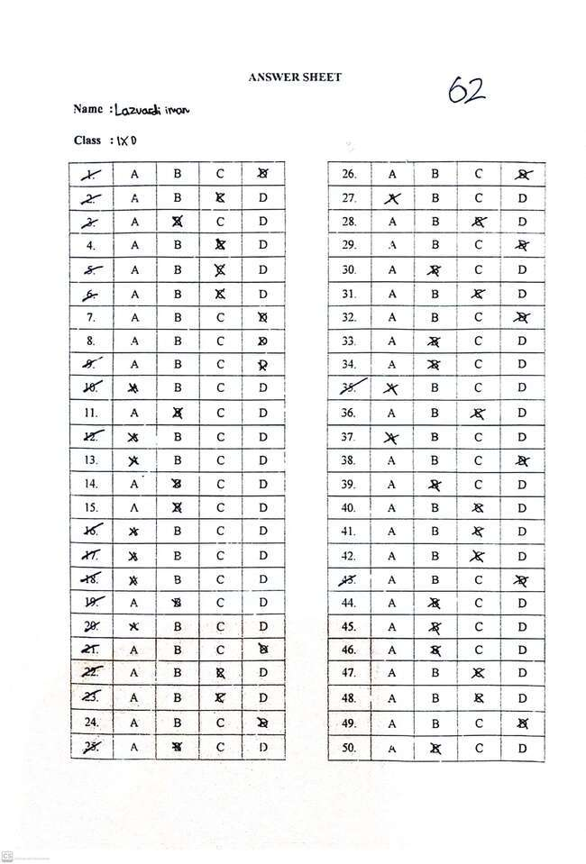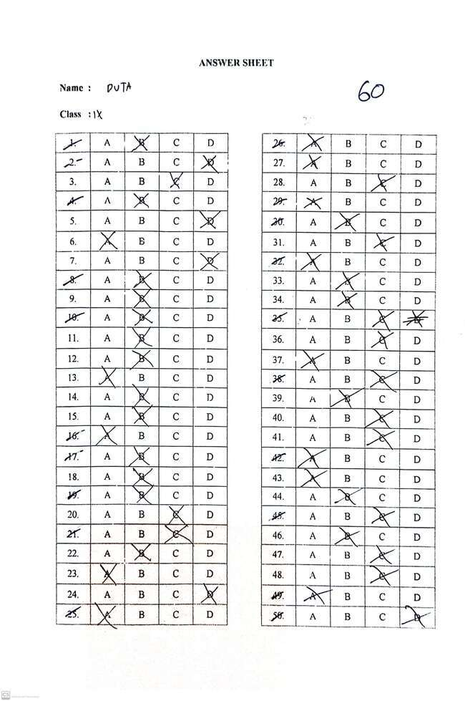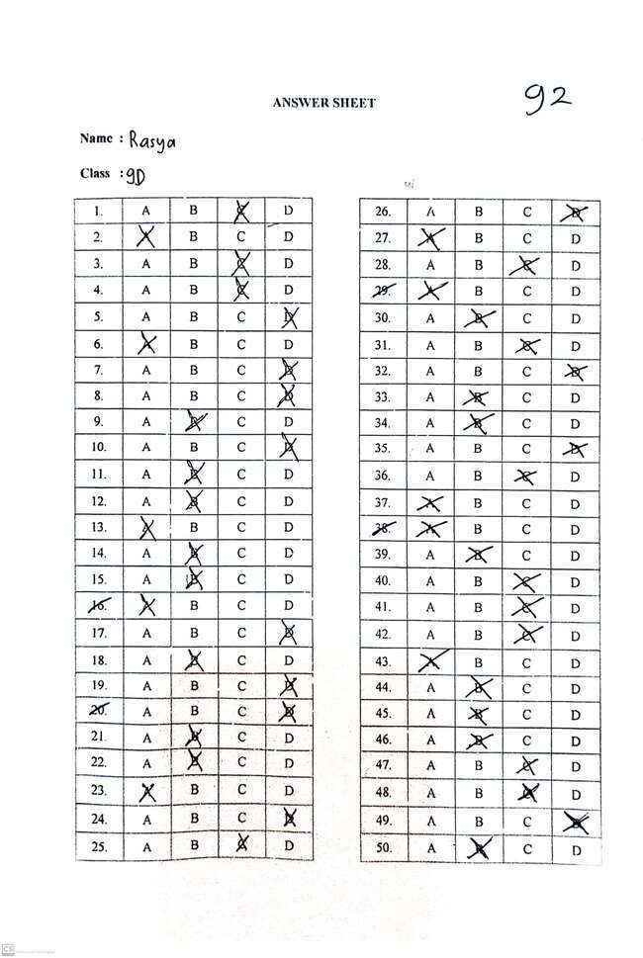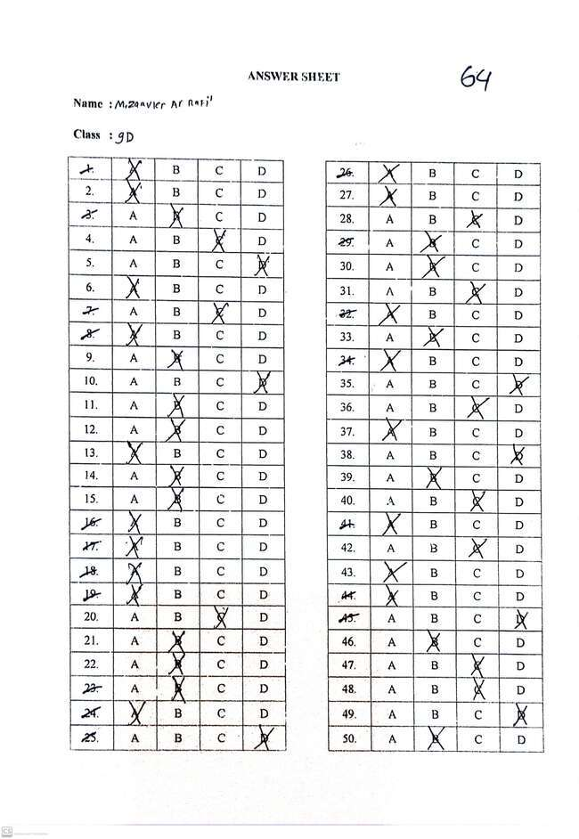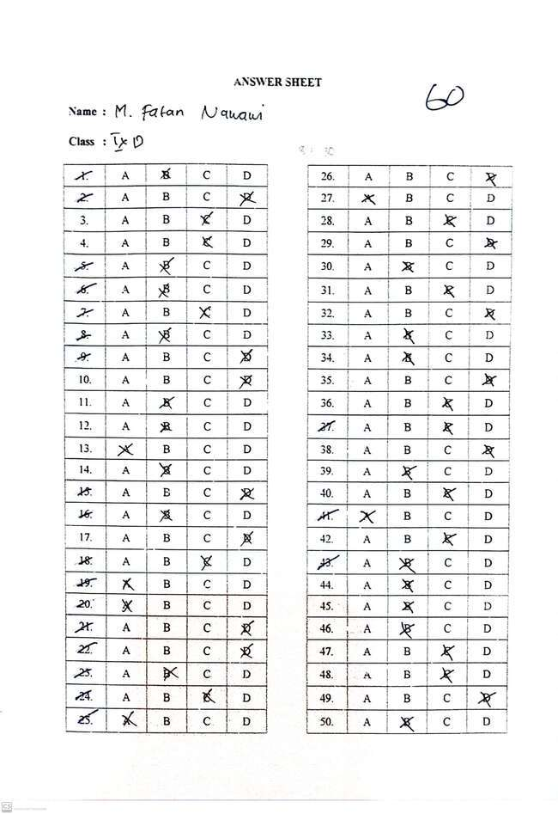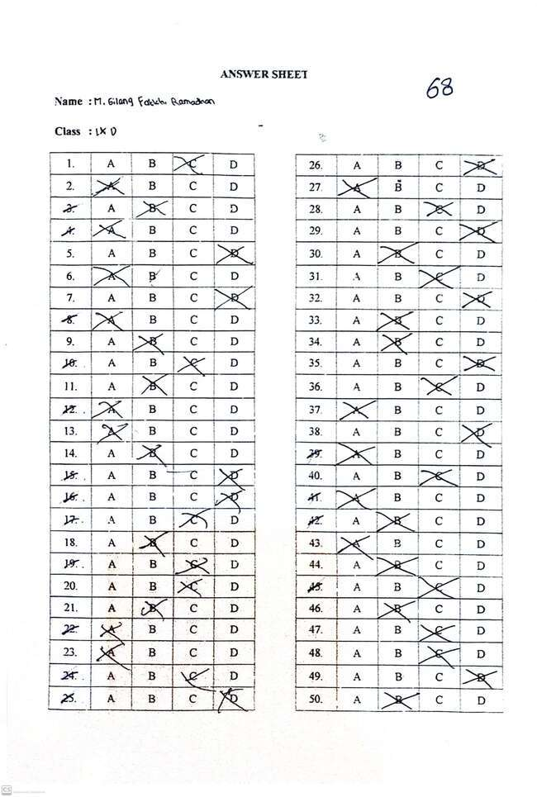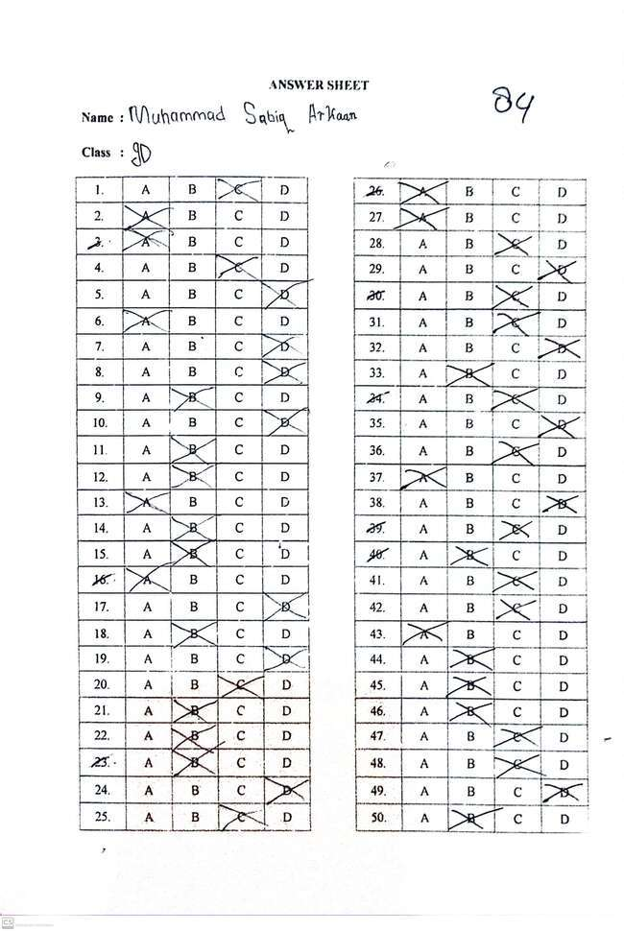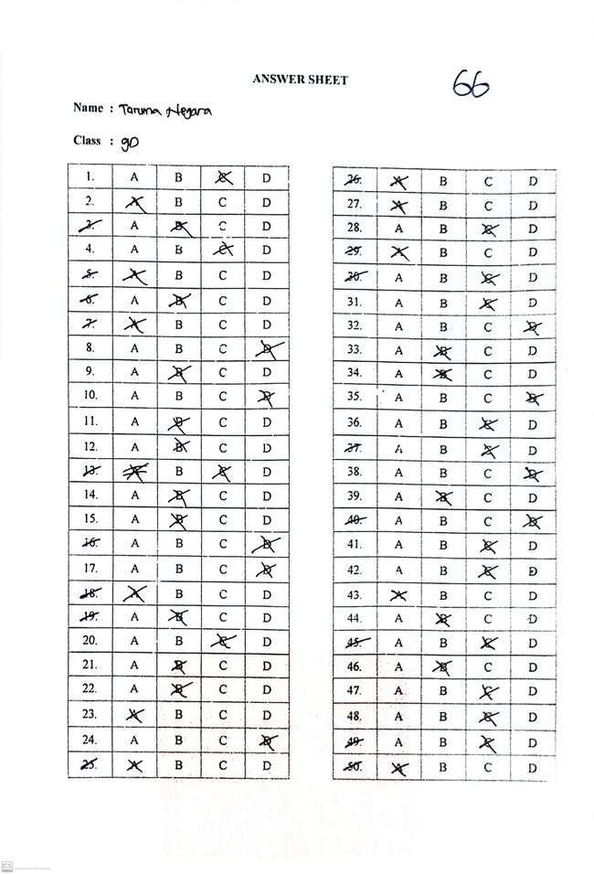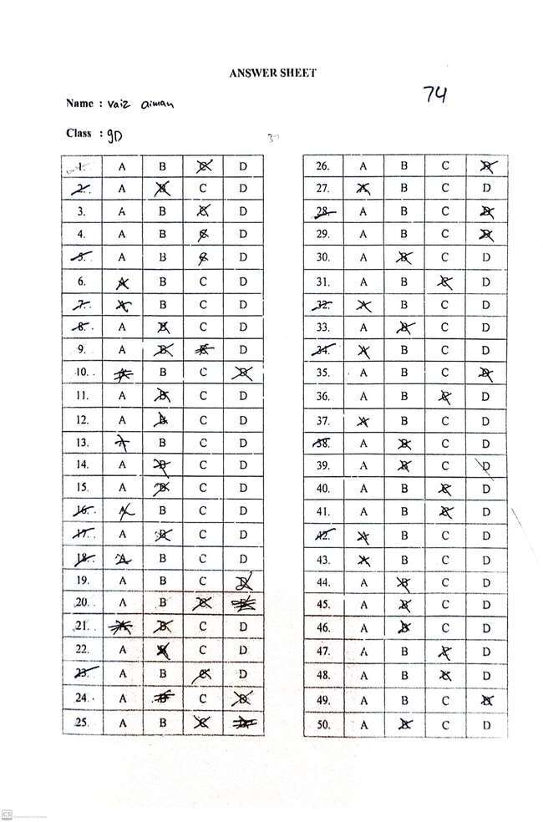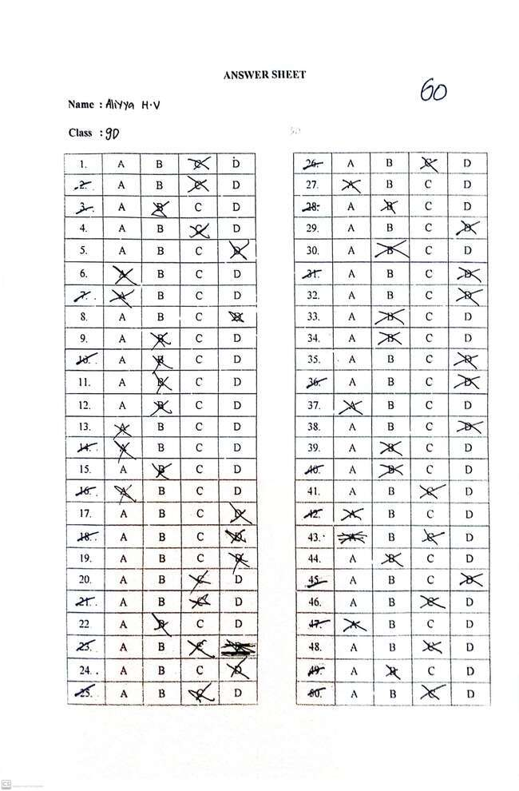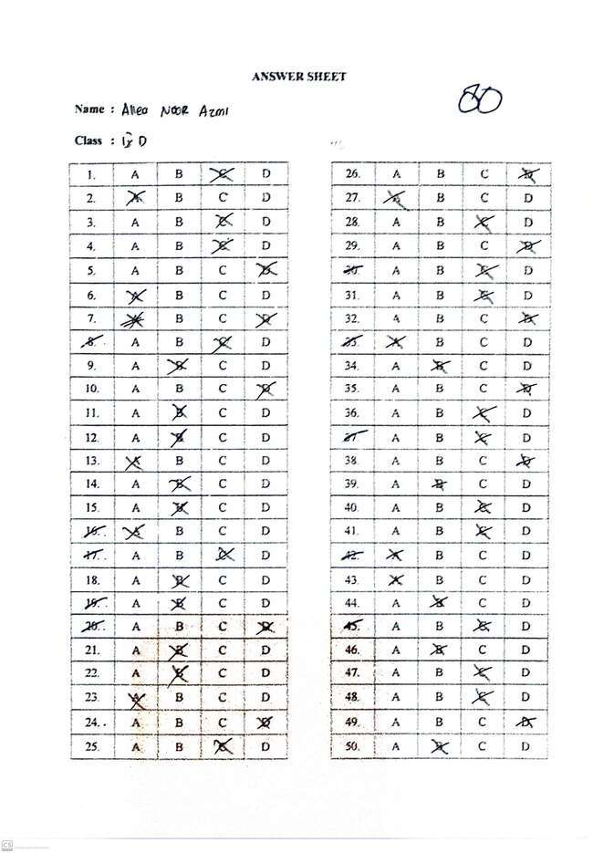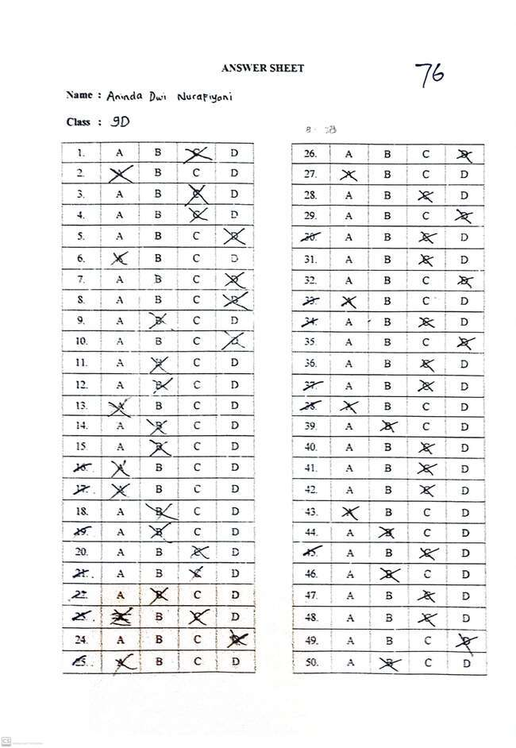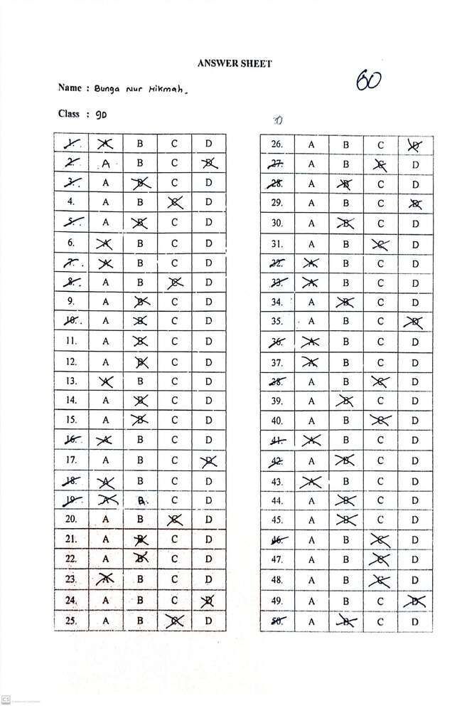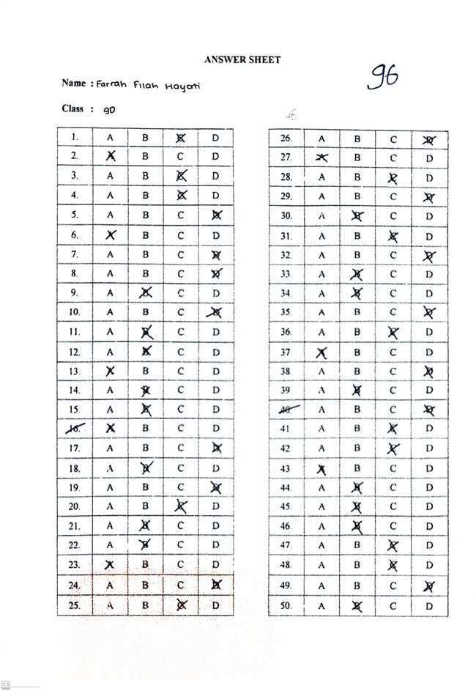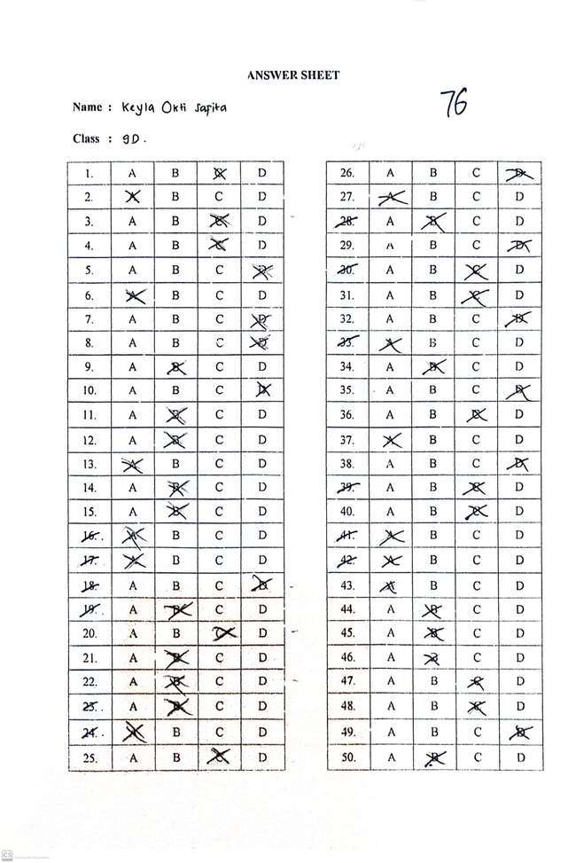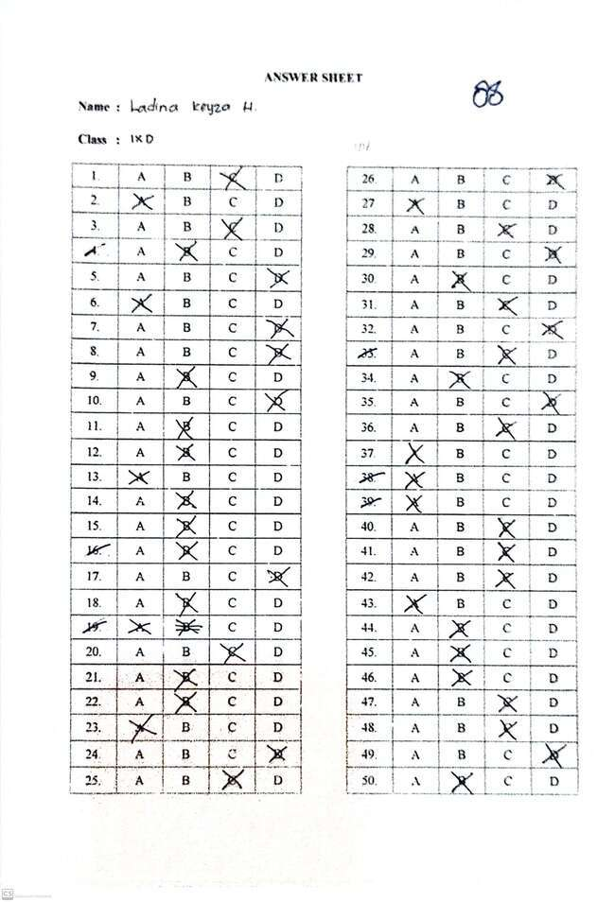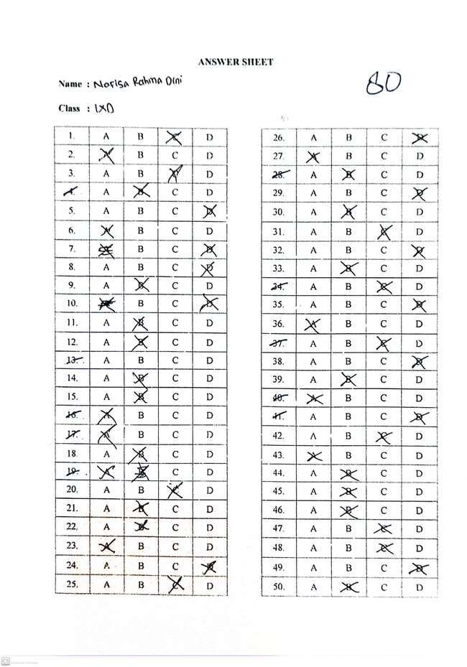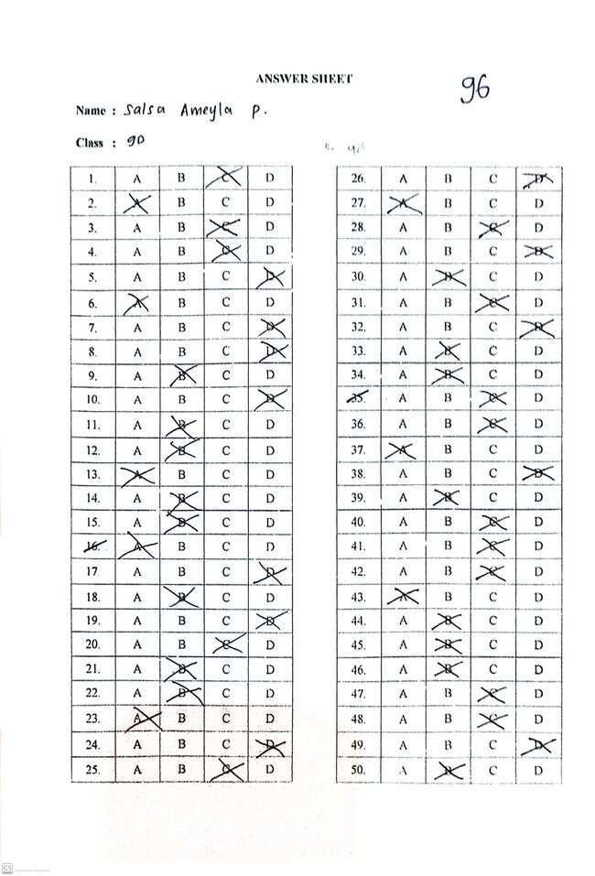
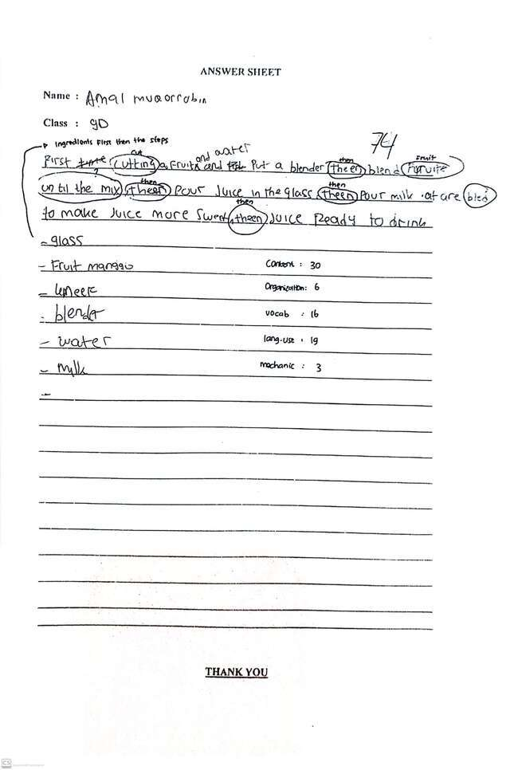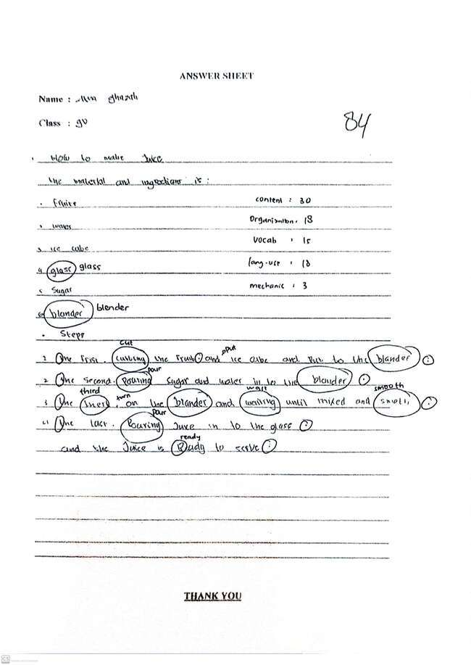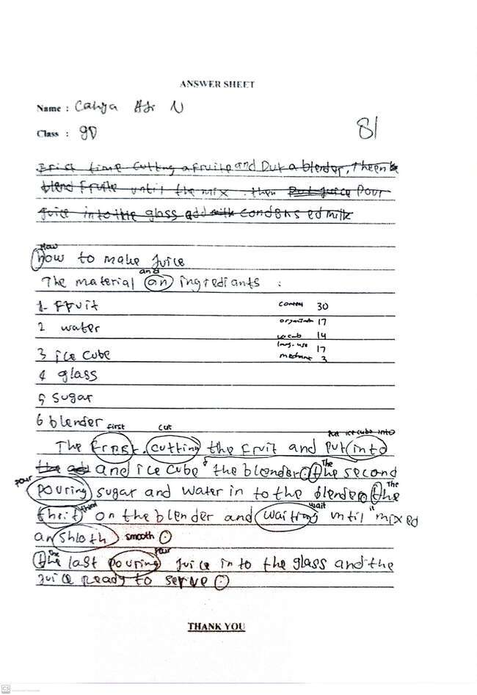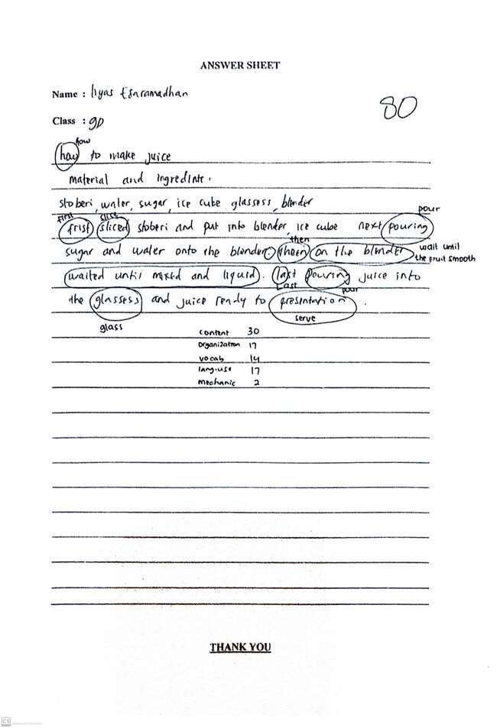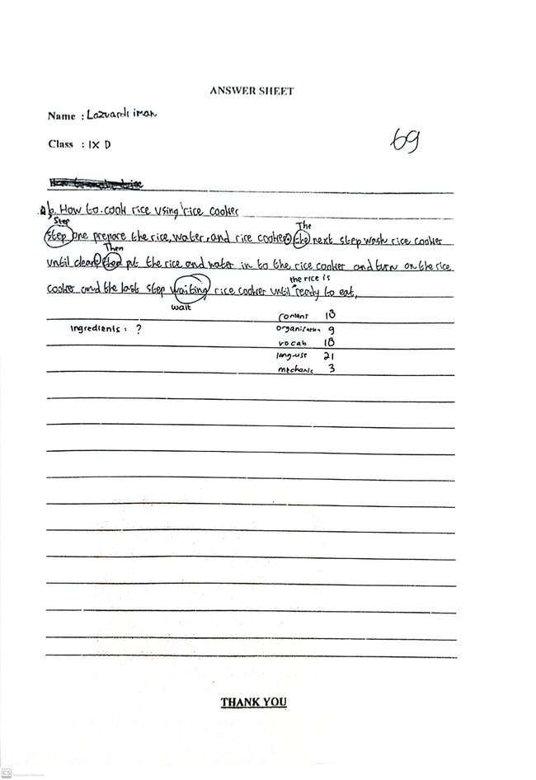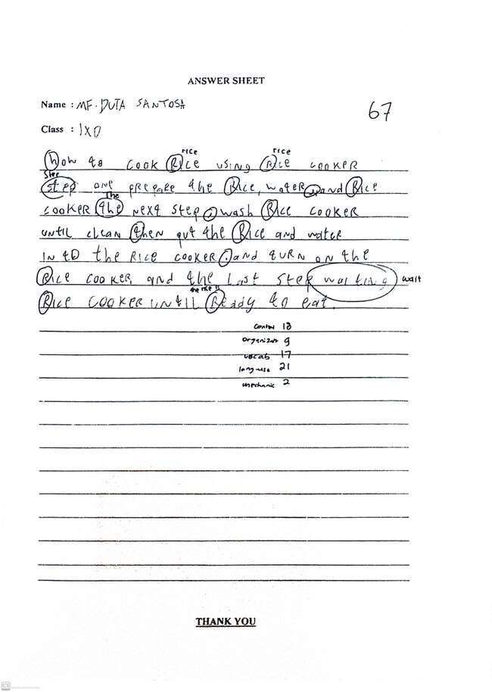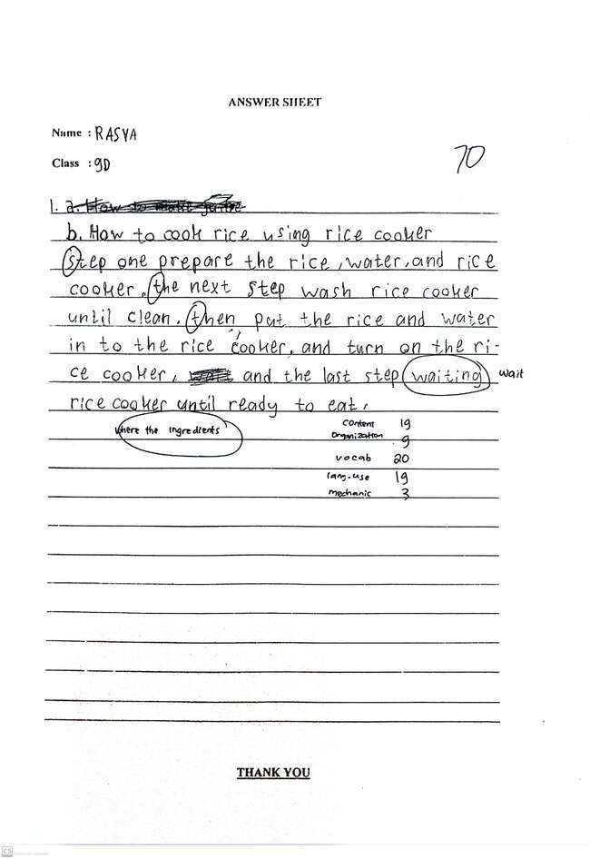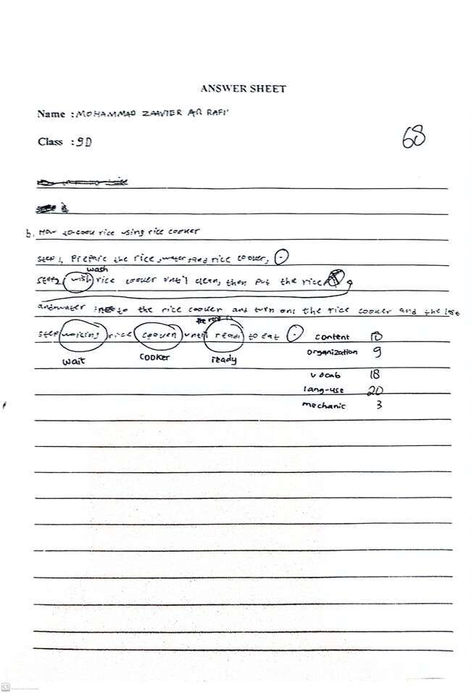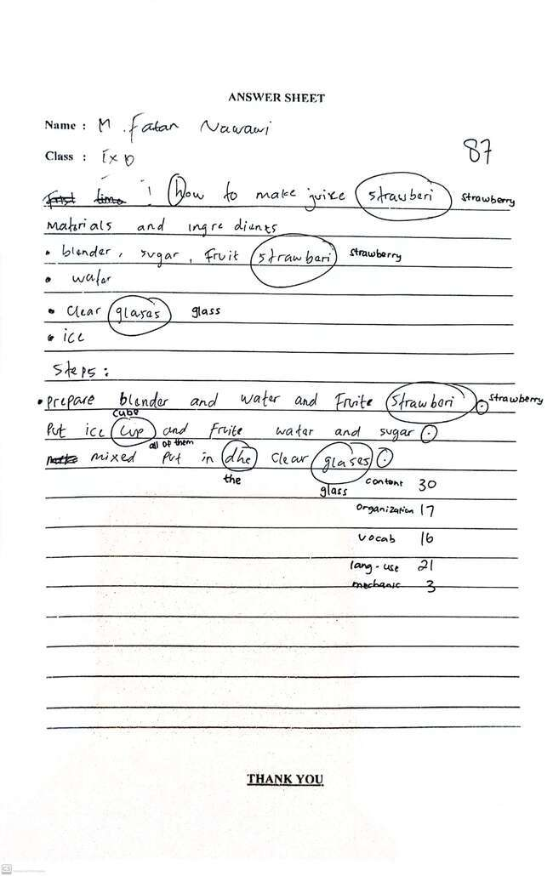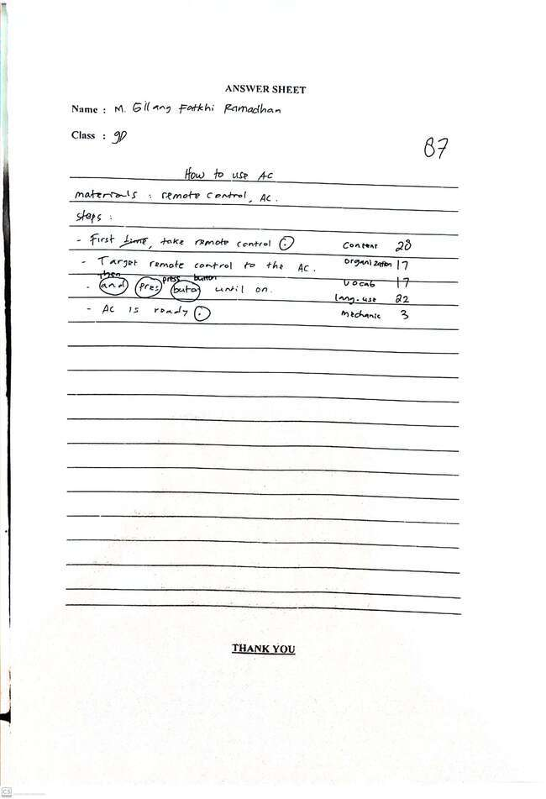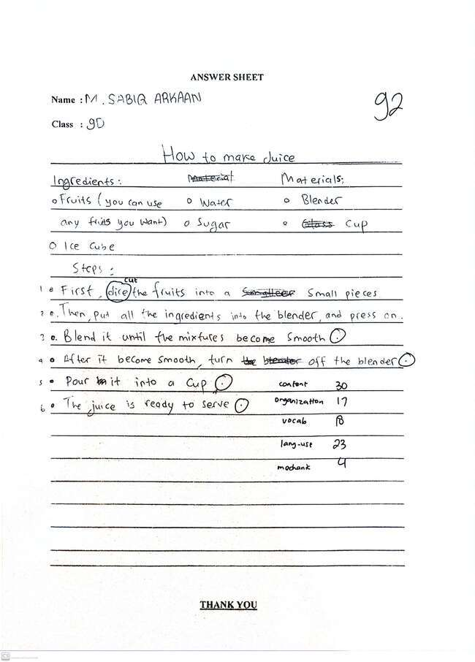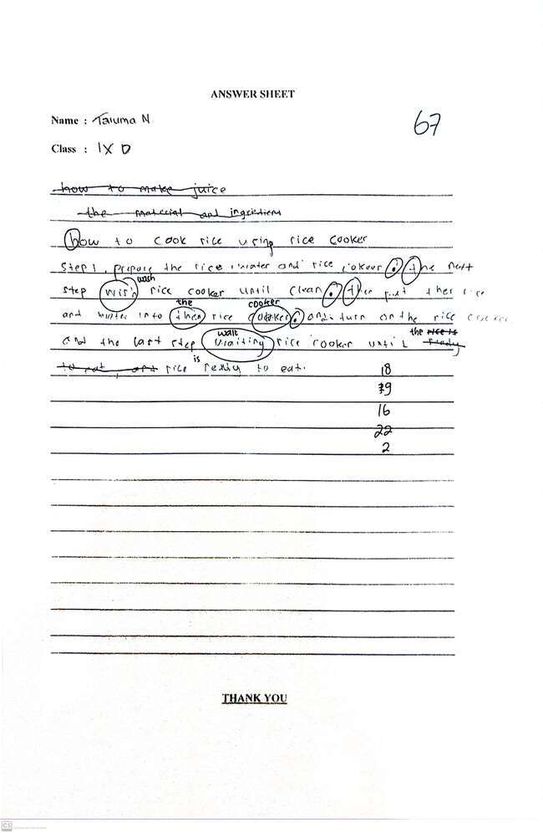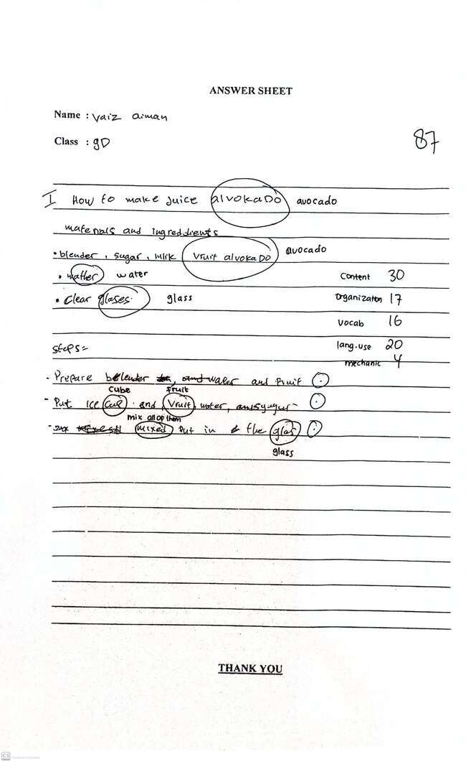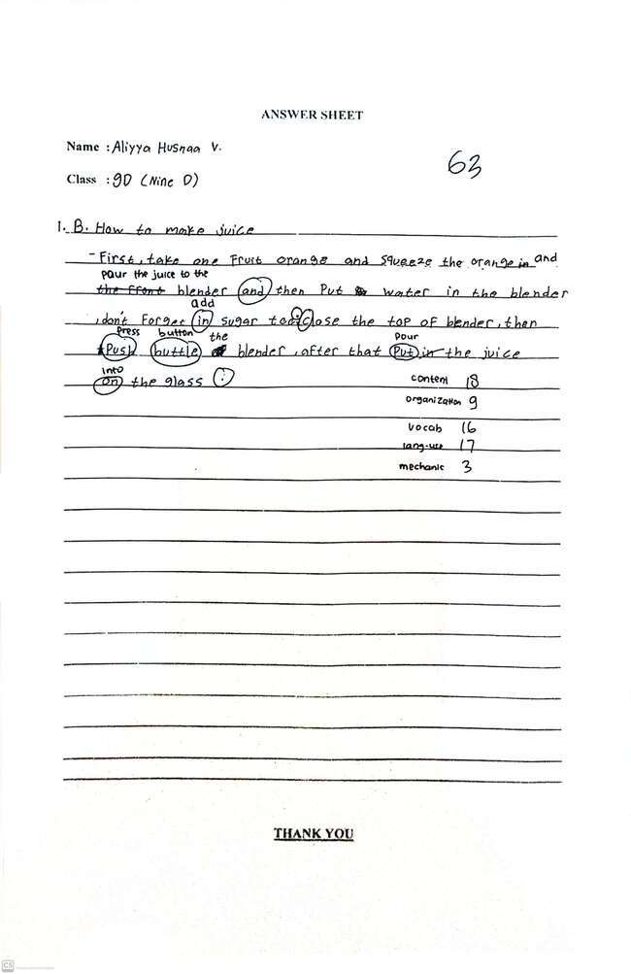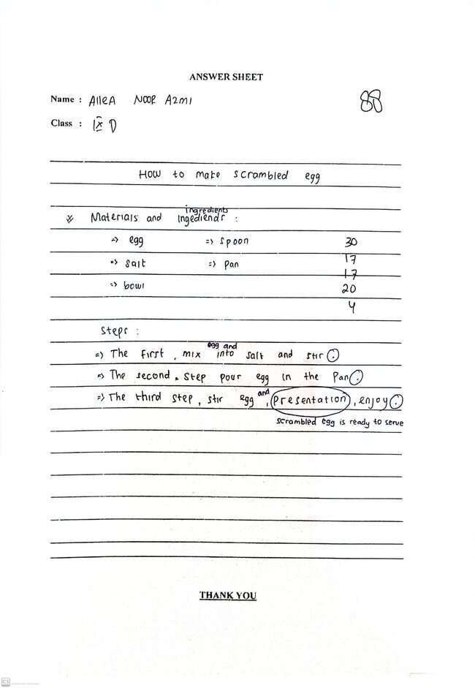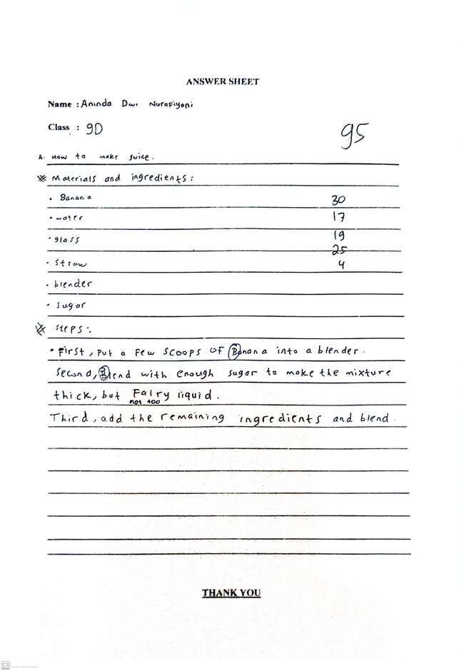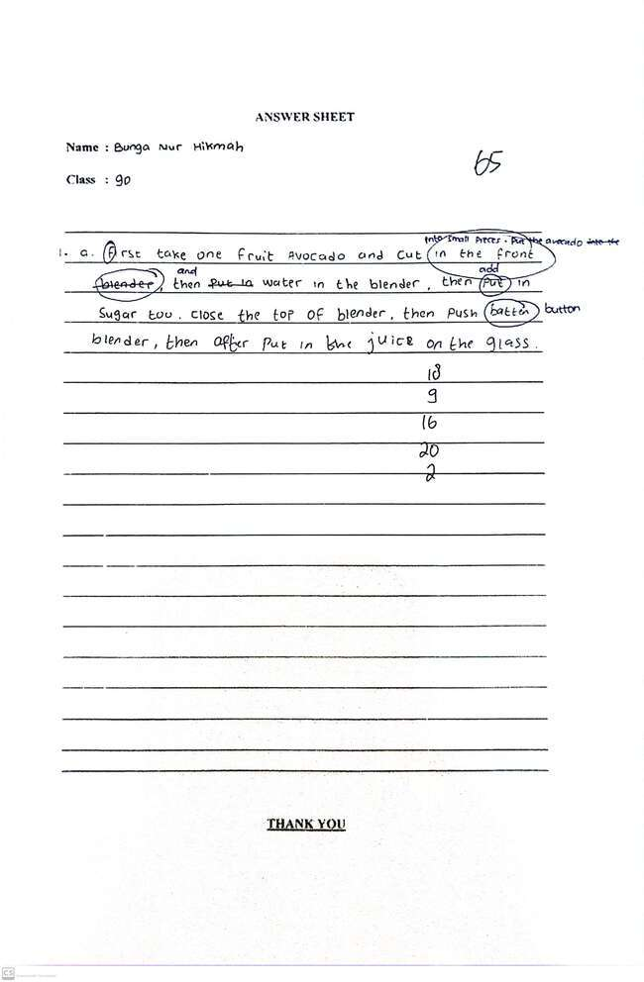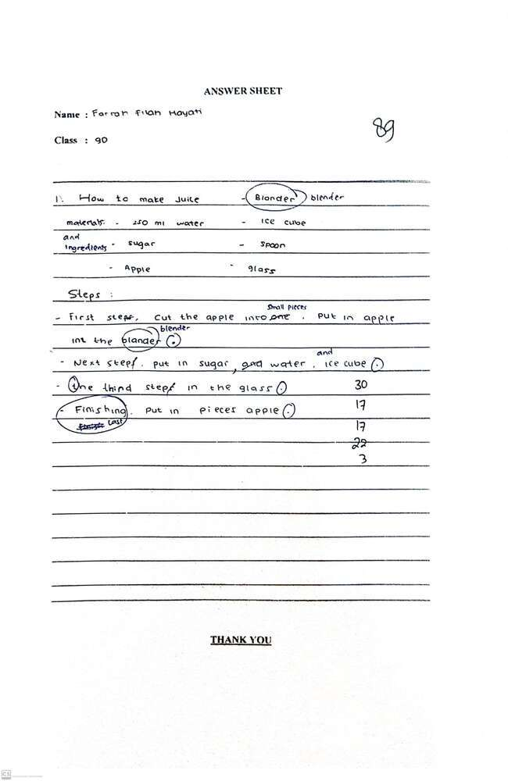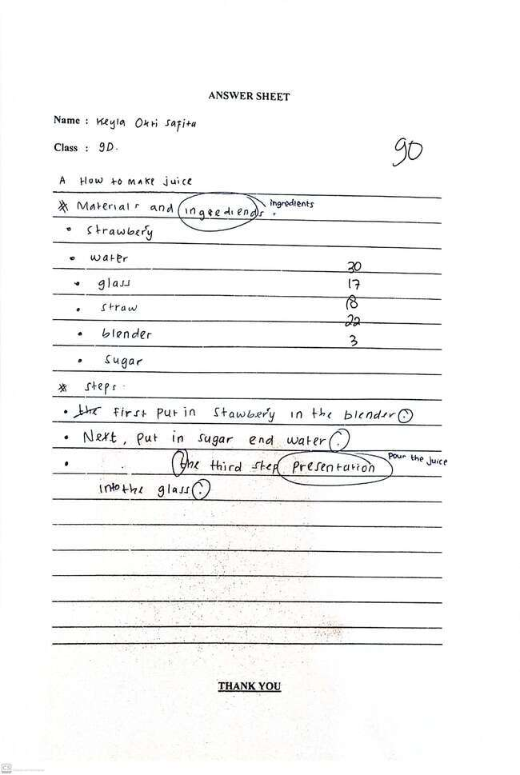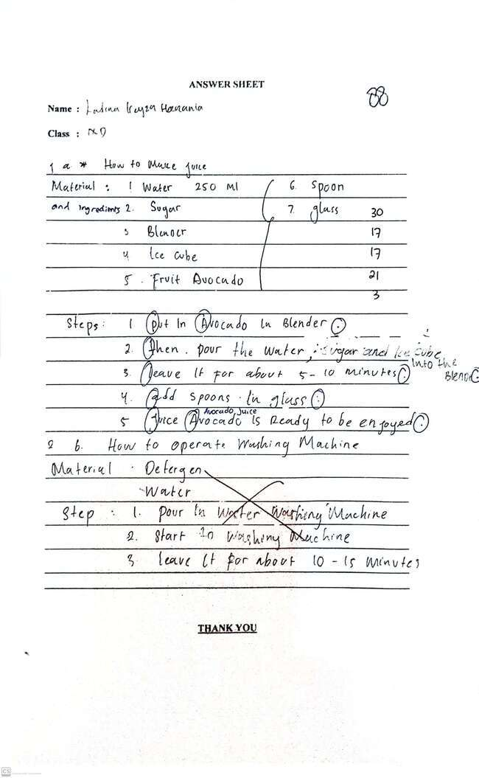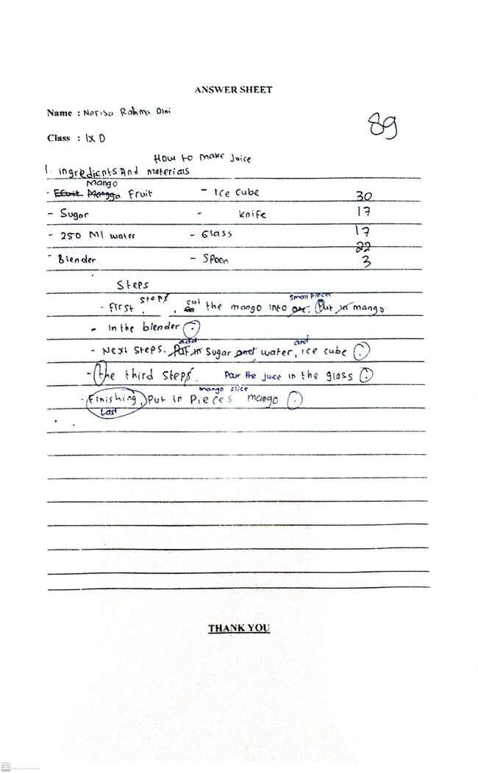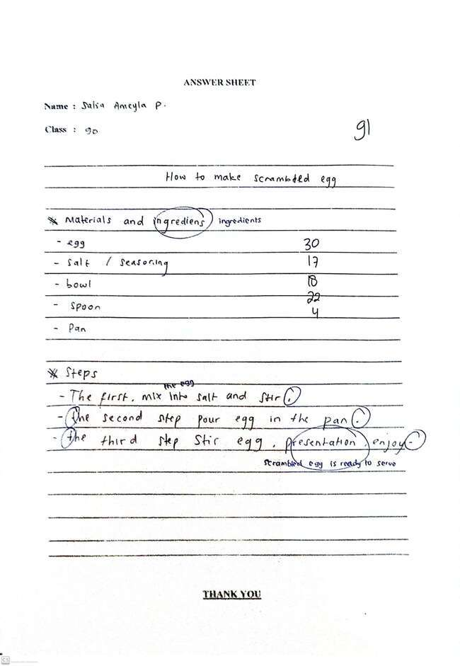
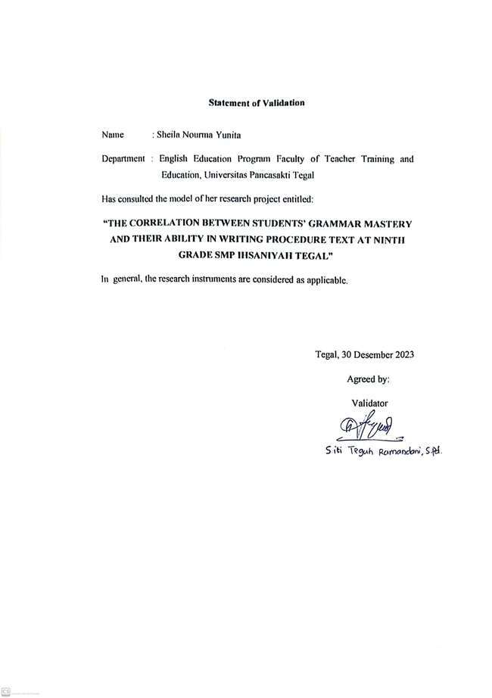
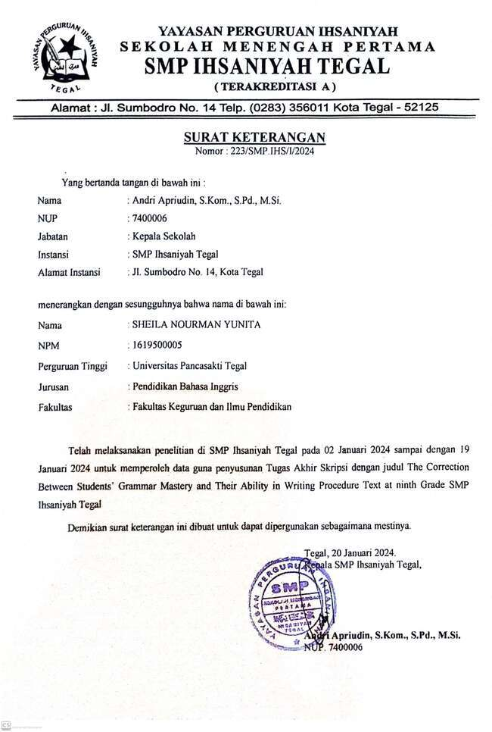
Appendix 9 Documentation
