**REFERENCE**

Afrida. (2022). The use of audiovisual media to improve english listening ability on X class students of SMK Negeri 4 Lahat hospitalization department in academic Year of 2018/2019. *Romeo : Review of Multidisciplinary Education, Culture and Pedagogy*, *1*(2), 93–108. https://doi.org/10.55047/romeo.v1i2.160

Arikunto, S. (2013). Prosedur penelitian: suatu pendekatan praktik (p.413). Yogyakarta: *Rineka Cipta*.

Brown, D. (2004). Language assessment: principles and classroom practice. *The Routledge Handbook of English as a Lingua Franca*, 570–582. https://doi.org/10.4324/9781315717173-46

Christiani, P. (2016). Penerapan model three phase technique dalam meningkatkan aktivitas dan hasil belajar menulis teks monolog berbentuk descriptive/procedure. *Briliant: Jurnal Riset Dan Konseptual*, *1*(1), 102. https://doi.org/10.28926/briliant.v1i1.15

David, C. (2003). *English as a global language* (p.229). New York: Cambridge University Press.

Efrina, Y. (2021). Improving students’ listening ability through audio-visual students at class VIII.3 SMP N 3 Kec. Payakumbuh. *Inovasi Pendidikan*, *8*(2), 157–170. https://doi.org/10.31869/ip.v8i2.3018

Eryawati, M. (2010). *The effectiveness of three phase technique in teaching reading comprehension viewed from intelligence*. https://digilib.uns.ac.id/dokumen/detail/22946

Harmer, J. A. N. (2010). *The practice of English language* (p. 386). https://www.academia.edu/25472823/The_Practice_of_English_Language_Teaching_4th_Edition_Jeremy_Harmer

Laksmi, N. K. ., Yasa, I. K. ., & Mirayani, K. A. M. (2021). The use of animation video as learning media for young learner to improve EFL students’ motivation in learning english. *Universitas Pendidikan Ganesha*, 42–52.

Maylani, A. (2019). *The effect of using animation video in English teaching on students' listening skill at MTSN 2 Kota Jambi*. 01–136. http://repository.uinjambi.ac.id/id/eprint/1790

Nainggolan, E. E., & Hanifah. (2020). University students’ critical thinking ability in listening skill. *Getsempena English Education Journal*, *7*(2), 340–358. https://doi.org/10.46244/geej.v7i2.1022

Nunan, D., Terrell, T. D., & Brown, H. D. (2003). Practical english language teaching. In *Language* (Vol. 57, Issue 3).

Nurdiansa, E. S. (2019). the Effect of Three Phase Technique on Students’ Reading Comprehension. *Journal of Teaching English*, *4*(3), 303. https://doi.org/10.36709/jte.v4i3.13959

Palupi, R. E., & Ayuningtyas. (2018). Be strenght or weaknesses : TLBT three phase technique dalam pembelajaran listening TOEFL preparation. *Jurnal Dimensi Pendidikan Dan Pembelajaran (JDPP)*, *6*(2), 64–73. http://journal.umpo.ac.id/index.php/dimensi/index%0ABE

Promsing, W., Chumpavan, S., & Chaya, W. (2017). *The effect of using english movie clips to enhance the listening ability of Thai University students*. *May*, 181–200. https://doi.org/10.20472/iac.2017.031.040

Puspita, L. bellamari. (2014). *A comparative study of students’ listening comprehension taught through video and audio*. *9*, 1–11.

Rahman, M. H. P., Rani, N., Widya, M. P., & Rasi Yugatiati, M. P. (2019). *Menyimak berbicara teori dan praktik teori dan praktik*. Sumedang: Alqaprint Jatinangor.

Sipayung, R., & Aristianti, A. (2022). Improving students’ listening skill through watching english movie for the eleventh grade students of SMA Dharma Budi Sidamanik. *Bilingual : Jurnal Pendidikan Bahasa Inggris*, *4*(1), 1–12. https://doi.org/10.36985/jbl.v4i1.375

Sopiyah, Y. (2018). Upaya meningkatkan kemampuan siswa dalam mendengarkan bahasa inggris melalui media audi-visual. *Journal of Materials Processing Technology*, *1*(1), 1–8. http://dx.doi.org/10.1016/j.cirp.2016.06.001%

Sugiyono. (2013). Metode penelitian pendidikan (kuantitatif, kulaitatif, dan R&D, dan penelitian pendidikan). *Alfabeta*, 1–908.

Sulistyani, & Susanti, Y. (2017). The strategies of teaching listening applied by the eleventh grade english teacher at SMKN 1 Purwoasri Kediri. *Angewandte Chemie International Edition, 6(11), 951–952.*, *Mi*, 5–24.

Susanti, Affrida, Z., & Fahyuni, E. F. (2017). Jenis jenis media dalam pembelajaran. In *Umsida* (Vol. 1, Issue 1).

Wilson, J. . (2008). *How to teach listening*. Pearson Education Limited.

Wong, J. (2005). English Listening Courses : A Case of Pedagogy Lagging behind Technology. *Language Teaching*, *2*(1), 25–43.

**APPENDICES**

**Appendix 1 Observation Permission Letter**

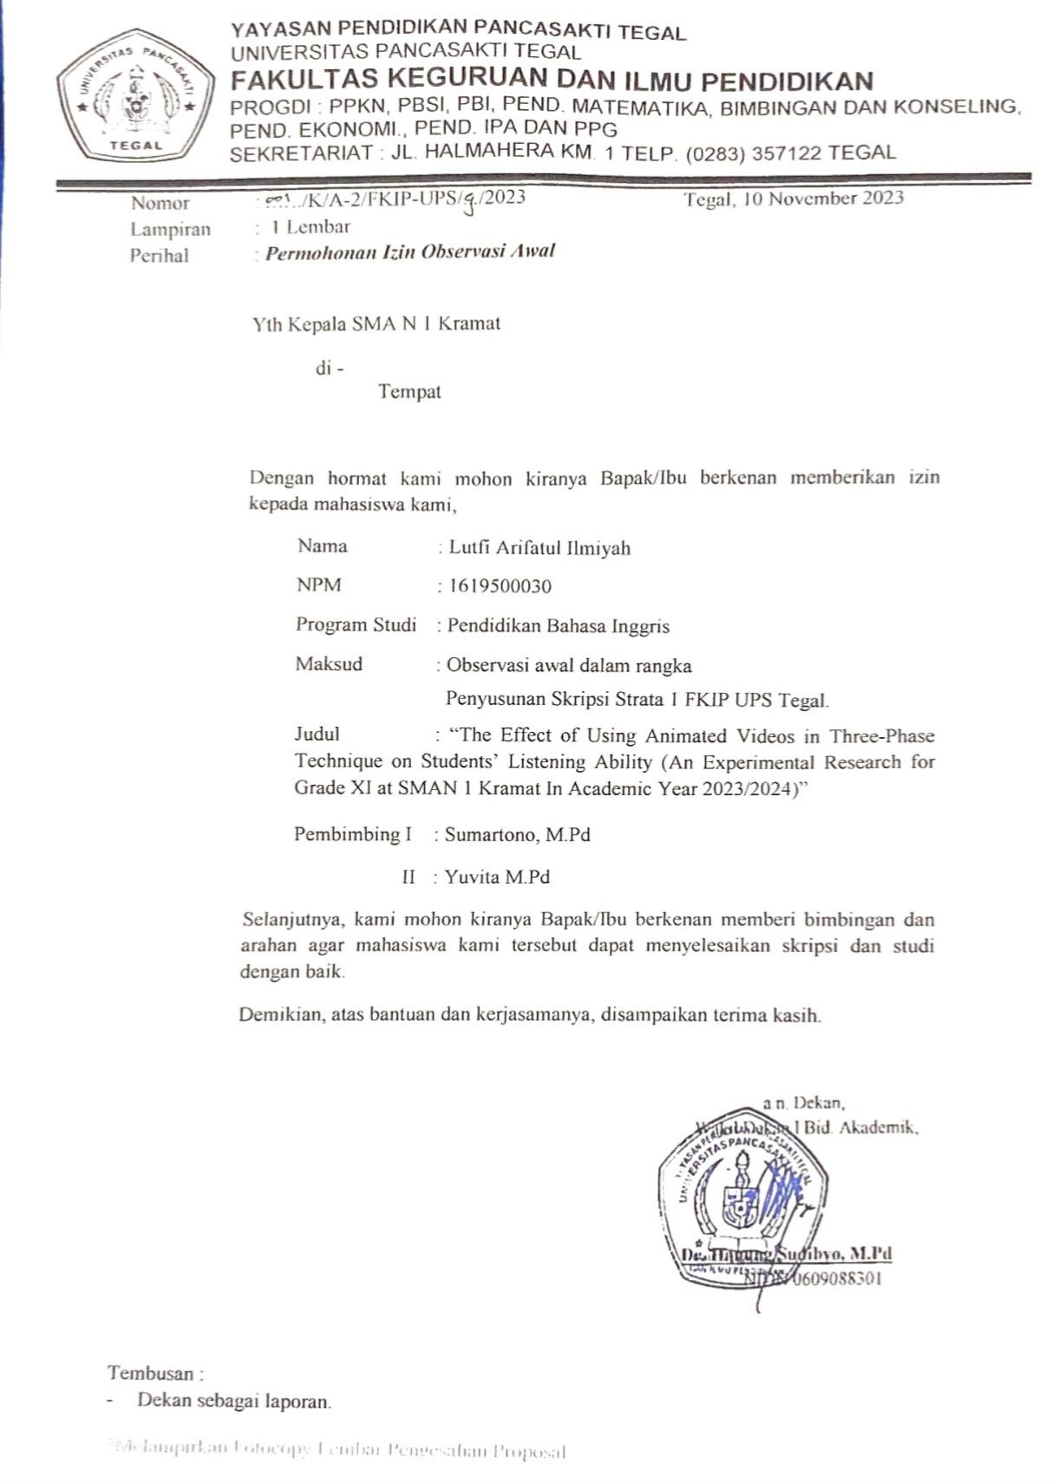

**Appendix 2 Field Study Permission Letter**

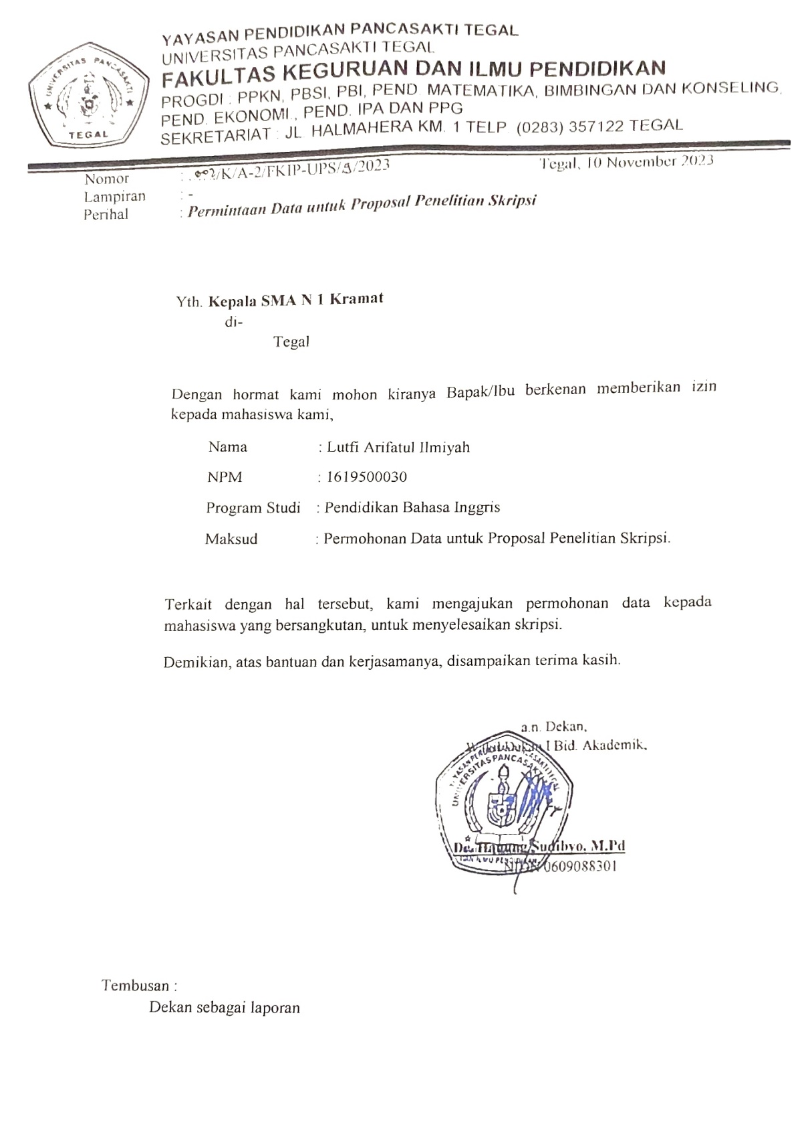

**Appendix 3 Lesson Plan**

**MODUL AJAR**

**MATERI : *Explanation Text***

**INFORMASI UMUM**

Nama Penyusun : Lutfi Arifatul Ilmiyah

Institusi : SMA N 1 Kramat

Tahun : 2023/2024

Jenjang Sekolah : SMA

Kelas : XI

Alokasi waktu : 2 x 45 Menit (1 kali pertemuan)

Elemen : Menyimak - Berbicara

Membaca - Memirsa

Kompetensi Awal : Peserta didik memiliki pengetahuan awal tentang teks eksplanasi dalam kehidupan sehari – hari, berdasarkan tes diagnostic yang diberikan.

Profil Pelajar Pancasila : Beriman dan Bertaqwa kepada Tuhan YME dan Berakhlak mulia, Bergotong royong, Mandiri, Kreatif

Sarana dan Prasarana : Alat dan Bahan: LCD, Handphone, Laptop, Speaker, Spidol, Papan tulis

Sumber Bahan Ajar : Buku English in Mind Edisi 2021, Cambridge Diktat Bahasa Inggris Fase E

Target Peserta Didik : Reguler/umum

Model Pembelajaran : Tatap muka

Kegiatan Pembelajaran Utama : Individu

Metode : Discovery Learning

**KOMPONEN INTI**

1. **Tujuan Pembelajaran**
2. Peserta didik mampu memahami pengertian Explanation Text dengan cermat.
3. Peserta didik mampu menganalisis struktur Explanation Text dan unsur kebahasaan dengan benar
4. Peserta didik mampu menyimpulkan isi Explanation Text dengan benar
5. **Pemahaman Bermakna**

Setelah mempelajari modul ini peserta didik mengetahui:

1. Peserta didik dapat mengambil pelajaran dari kejadian yang terjadi dalam bacaan Explanation Text.
2. Peserta didik dapat mengadaptasi nilai nilai kemanusiaan yang positif yang didapatkan setelah memahami sebuah Explanation Text ke dalam kehidupan sehari – hari.
3. **Pertanyaan Pemantik**
4. What do you see in the video?
5. What do you think after you see the picture?
6. What kind of problems occur in the story?
7. **Persiapan Pembelajaran**

Mempersiapkan materi, sumber referensi, merancang presentasi, checking kelas, sarana dan prasarana.

1. **Kegiatan Pembelajaran**

Pendahuluan

1. Orientasi

* Guru meminta ketua kelas untuk memimpin peserta didik dalam salam dan doa sesuai dengan agama dan kepercayaan masing-masing.
* Guru menanyakan kabar dan kondisi peserta didik, memeriksa kehadiran peserta didik sebagai bentuk disiplin, dan menanyakan kesiapan belajar peserta didik.
* Guru juga mempersiapkan peserta didik secara fisik dan mental sebelum kegiatan pembelajaran dimulai.

1. Apersepsi

* Guru mengajukan pertanyaan tentang materi yang telah dibahas pada pertemuan sebelumnya dan menjelaskan hubungannya dengan materi pembelajaran hari ini.

1. Motivasi

* Guru memotivasi peserta didik dengan menyampaikan pencapaian dan tujuan pembelajaran.
* Guru menyampaikan ringkasan materi yang akan disampaikan dan yang akan dilakukan peserta didik dalam pembelajaran.
* Guru memberikan nilai atau kegunaan mempelajari materi yang akan dipelajari

1. Pemberian Acuan

* Guru menjelaskan kompetensi awal yang diperlukan siswa untuk mempelajari materi hari ini.
* Guru melakukan asesmen.

Inti (Langkah Langkah Pembelajaran)

**Pertemuan ke 2-3**

* Warm Up: Pertanyaan pemantik, ditunjukkan contoh dengan menampilkan sebuah video fenomena alam.
* Orientasi masalah: Peserta didik mendengarkan pemaparan materi tentang Explanation Text.
* Organizing student: Guru membagikan contoh *Explanation Text* kemudian peserta didik mengidentifikasi *generic structure* dan *language feature.*
* Setiap siswa saling berkolaborasi secara aktif.
* Masing-masing kelompok menyampaikan hasil nya.
* Guru menganalisa dan mengevaluasi hasil kerja peserta didik.

**Pertemuan Ke 4-5**

* Guru memberikan informasi kepada peserta didik terkait *Three phase technique* pada animasi video.
* Peserta didik bareng bareng menganalisis latihan soal yang telah diberikan oleh guru kemudian peserta didik mengerjakan soal tersebut menggunakan *Three phase technique* yang sudah diajarkan.
* Guru mengevaluasi hasil kerja peserta didik.

**Pertemuan Ke 6**

* Guru memberikan tugas individu sesuai treatment yang sudah diberikan yaitu animasi video in three-phase technique.
* Guru mengevaluasi dan memberi feedback pada hasil kerja peserta didik.
* Guru memberikan sesi tanya jawab mengenai materi dengan treatment yang diberikan.

Penutup

* Guru memberikan feedback dan mengucapkan terima kasih kepada pesrta didik yang telah mengikuti pelajaran hari ini.
* Guru dan peserta didik melakukan kesimpulan bersama dan berpikir tentang pelajaran hari ini.

1. **Asesmen**Bagaimana guru menilai ketercapaian Tujuan Pembelajaran?

* Asesmen individu :

1. **Pedoman Penilaian** 
   1. Untuk tiap nomor, tiap jawaban benar skor 3
   2. Jumlah skor maksimal x 3 = 15
   3. Nilai maksimal = 10

Nilai Siswa = Skor Perolehan

x10

Skor Maksimal

1. **Rubrik Penilaian**

|  |  |
| --- | --- |
| **Uraian** | **Skor** |
| Isi benar, isi/makna cerita tepat  Isi benar, isi/makna cerita kurang tepat  Isi dan isi/makna cerita kurang tepat  Tidak menjawab | 3  2  1  0 |

1. **Refleksi Peserta Didik dan Guru**

Write down your experience in learning this material

|  |  |
| --- | --- |
| Questions | Answers |
| The words that are new to me |  |
| Can you understand the material given? |  |
| Is the method easy to follow? |  |

Tegal, Novembaer 2023

Mengetahui

Guru Pengampu Mahasiswa

Teguh Nataliyah, S.Pd Lutfi Arifatul Ilmiyah

NIP. - NPM : 1619500030

LAMPIRAN :

**Materi/Bahan Bacaan:**

Explanation text is a text which explains how and why a phenomenon happens. It includes both natural and social phenomena. Jadi, explanation text adalah sebuah teks yang menjelaskan bagaimana dan mengapa sesuatu bisa terjadi, baik berupa fenomena alam maupun sosial.

1. Jenis-Jenis Explanation Text

Ada dua jenis *explanation text*, apa aja?

1. Sequential Explanation Text

Teks ini menjelaskan tentang suatu proses berdasarkan urutan dan waktu.

Contoh: *How seawater becomes salty.*(Bagaimana air laut bisa asin.)

2. Cause and Effect Explanation Text

Teks ini menjelaskan sebab akibat terjadinya fenomena.

Contoh: *Why people feel sleepy after a meal.*(Mengapa seseorang merasa ngantuk setelah makan.)

1. Struktur Explanation Text

*Explanation text*terdiri dari empat bagian, yaitu *title, general statement, explanation,* dan *conclusion*.

1. Title

Struktur yang pertama adalah *title*atau judul. Judul teks memberika gambaran tentang dari isi teks.

2. General Statement

Pada bagian kedua, yaitu *general statement*, akan dijelaskan tentang gambaran umum mengenai hal yang dijelaskan pada teks.

1. Explanation

Selanjutnya, ada bagian *explanation*. Bagian ini memberikan rangkaian proses tentang bagaimana dan mengapa sesuatu terjadi atau sebab akibat yang dijelaskan melalui urutan kejadian.

4. Conclusion

Terakhir, ada bagian *conclusion*, yang berisi kesimpulan dari seluruh proses yang sudah dijelaskan sebelumnya.

1. Kaidah Kebahasaan Explanation Text

1. Simple Present Tense

*Subject + Verb 1 (-s/-es) atau to be + Object*

2. Passive Voice

*Passive voice* digunakan untuk menekankan bahwa seseorang atau suatu objek mengalami sesuatu. Kaidah kebahasaan ini juga digunakan saat pelaku tidak diketahui dan saat pelaku tidak penting untuk diketahui. Sesuai dengan *tense*yang digunakan dalam *explanation text*, *passive voice* yang digunakan juga dalam *simple present tense*. Ini polanya.

|  |  |  |
| --- | --- | --- |
| Subject | Be | Verb 3 |
| I | Am |
| You  They  We  Plural Subject | Are |
| He  She  It  Singular Subject | Is |

3. Connective Words

*Connective words* adalah kata-kata penghubung antar ide.

* *Then*(Kemudian)
* *After that* (Setelah itu)
* *However*(Akan tetapi)
* *Although*(Meskipun)
* *In addition* (Selain itu)
* *Moreover*(Selain itu)
* *Because*(Karena)
* *Since*(Karena)
* *As*(Karena)
* *Because of*(Oleh sebab)
* *So*(Jadi)
* *Therefore*(Oleh karena itu)
* *Caused by*(Disebabkan oleh)
* *Due to* (Disebabkan oleh)

Contoh *Explanation Text*

**Title:**

**How Seawater Becomes Salty**

**General Statement:**

Salty seawater makes up 97% of the water that covers two thirds of the Earth's surface. Freshwater, which is found in lakes, rivers, and streams, makes up only 3% of all water on Earth. This fresh water plays a significant role in explaining how the sea becomes salted. Water on our planet is transported by a cycle that is powered by the sun, which moves it from the sea to the sky, the land, and back again.

**Explanation:**

Through a process known as evaporation, heat from the sun causes seawater to turn into water vapour, which rises into the atmosphere. The water vapor then undergoes a process known as condensation to return to liquid water while still in the atmosphere, creating clouds. Subsequently, this water finally descends from the clouds in the sky as snow, hail, sleet, or rain; this process is known as precipitation. when this eventually finds its way back to the sea and runs into rivers and streams.

**Conclusion:**

Thus, sodium chloride is the primary salt found in seawater. Rainwater runs off the land and into the rivers and streams that flow into the sea, bringing with it the dissolved salts that give seawater its saltiness.

*Explanation Text (Video)*

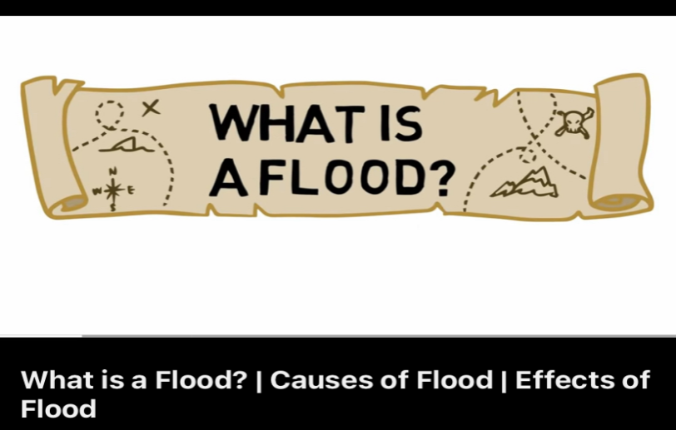

<https://youtu.be/lkY4oj5bll0?feature=shared>

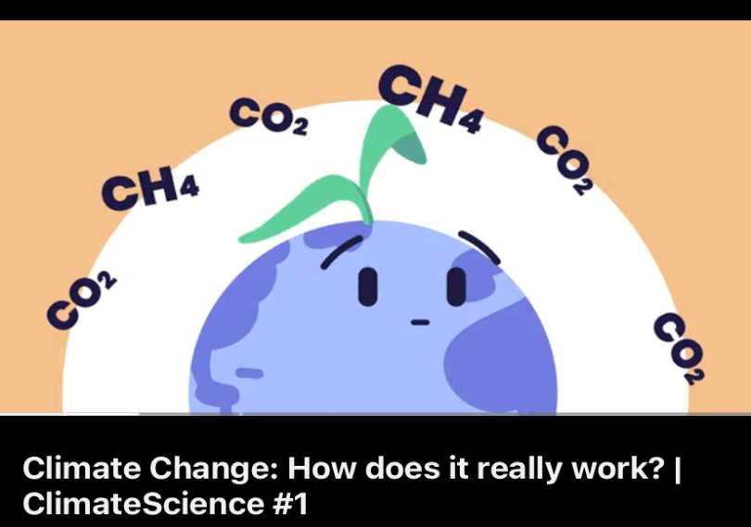https://youtu.be/myZAvqq9jc?si=f8JXXvtq8Jkr8K0s

**LKPD:**

Name :………………………………..

Class :………………………………..

**Essay!**

**After watching the animated video, answer the following questions!**

* + 1. What the suitable tittle for those paragraph?

Answer :………………………………………………………………………………...

…………………………………………………………………………………

* + 1. What causes the floods?

Answer :………………………………………………………………………………...

…………………………………………………………………………………

* + 1. What is the cost of the floods?

Answer :………………………………………………………………………………...

…………………………………………………………………………………

* + 1. How does a flood occur?

Answer :………………………………………………………………………………...

…………………………………………………………………………………

* + 1. Write a solution to reduce flood disaster!

Answer :………………………………………………………………………………...

……………………………………………………………………………………

Good luck!

**GLOSARIUM**

Phenomena : Fenomena

Understand : Paham

Experience : Pengalaman

Methode : Metode

Prular : Jamak

Singular : Tunggal

Sequential : Berurutan

Cause and Effect : Sebab akibat

**DAFTAR PUSTAKA**

Sumber internet:

<https://youtu.be/lkY4oj5bll0?feature=shared>

<https://youtu.be/myZAvqq9jc?si=f8JXXvtq8Jkr8K0s>

[Explanation Text: Pengertian, Struktur, Kebahasaan & Contoh | Bahasa Inggris Kelas 11 (ruangguru.com)](https://www.ruangguru.com/blog/apa-saja-aspects-of-explanation-text)

Sumber buku:

Hart Brian. English in mInd second edition. 2021. Jakarta: Pusat Kurikulum dan Perbukuan

Grace Eudia dan Th. M. Sudarwati. Pathway to English. 2022. Jakarta: Penerbit Erlangga

**Appendix 4 Instrument**

**PRETEST AND POSTTEST**

Name : ……………………

Class : …………………...

I.

**Listen carefully to understand what the speaker is saying. And read the question of 1-6which answer would be the best answer!**

**Transkrip :**

Soil Pollution

Hello friends today we'll learn about soil pollution what do you do with your chocolate wrapper water bottle or cola can when you're finished with it do you throw it on the ground instead of into the bin yes oh then you're contributing to soil pollution soil pollution is when there are changes in soil caused by the adding unwanted and harmful materials or pollutants soil pollution can have dangerous effects on all living organisms such as humans animals and plants let's see some of the causes of soil pollution garbage throwing littering civic waste mainly household waste into places that are not designated to dispose of it causes soil pollution it's normally caused by mismanagement of solid waste when garbage is not lifted from places mining mining weakens the surface of the soil producing large holes in the ground and causing erosion trash from factories throwing harmful trash on land damages the soil and thus causes pollution very bad overuse of pesticides and fertilizers plants absorb the pesticides and fertilizers through the soil and they can enter the food chain thus fertilization leads to soil pollution soil pollution is very harmful for everybody soil pollution not only can hurt animals and humans but also destroys the beauty of nature the harmful chemicals that can get into the soil and water can cause deformities cancers and various skin problems let's see some ways to stop soil pollution try recycling and reusing when you recycle you add less land pollution so always recycle and use the correct bin produce less trash we should produce less trash we should drink water from a glass rather than a plastic bottle and there are many other ways to reduce trash dispose of trash properly we should make sure to properly dispose of all the trash pick up trash don't be a litter bug we should always pick up trash when we see it lying around composting composting is when we collect organic waste and store it this breaks and can be used for fertilizer now you know a lot about soil pollution please drop a like leave a comment share the videos and don't forget to subscribe our app learning junction is available on play store bye bye. (<https://youtu.be/iIHw8gf6LqY?si=nIwrFEGJ7ObFYt9O>)

1. According to the animated video, what phenomenon is being discussed?
2. Tornado
3. Plastic pollution
4. Soil pollution
5. Global warming
6. In the text in the animated video, which is **not** included in the cause of floods is?
7. Mining
8. Heavy rain
9. Garbage throwing
10. Pesticides and fertilizers
11. What are the consequences of the occurrence of such phenomena?
12. The occurrence of floods
13. Destroying the beauty of nature
14. House collapsed house
15. Fish in the river on death
16. Soil pollution can be dangerous to all living organisms, except...
17. Animals
18. Soil
19. Humans
20. Plants
21. According to the animated video, to prevent the occurrence of the phenomenon, we should...
22. No mining
23. Doesn't harm animals
24. Always pick up trash when see it lying around
25. Not cutting down trees

**Listen carefully to understand what the speaker is saying. And read the question 6-10 of which answer would be the best answer!**

**Transkrip :**

Floods

What is a flood? Obviously, you've heard the term "flood" before, but what exactly is a flood? It is well known that one of the most frequent and damaging natural disasters on Earth is flooding. A flood is a natural occurrence in which a section of normally dry ground suddenly becomes submerged in water. However, what triggers flooding? Actually, there are a number of causes. Floods can happen as a result of excessive rain, dam failure, or even a significant volume of ice melting. Have you ever let a faucet run for an extended period of time? When taking a bath, the water gradually overflows the side of the bathtub and onto the bathroom floor. You've just flooded the bathroom when the normally dry floor becomes covered in water, wetting everything. Fortunately, most floods take time to develop, allowing people to avoid them. Nevertheless, in order to prevent being caught in the midst of a major flood, it's critical to stay informed about local weather conditions. Regrettably, floods usually cause so much destruction that the places they occur in lose more than 40 billion dollars in damage every year. They damage pretty about everything—houses, roads, buildings—and it costs a lot of money to put things back to normal. The land is coated in silt and mud even after the floods pass. Hazardous elements including fuel, garbage with sharp edges, pesticides, and raw sewage can contaminate water and the surrounding landscape. It's quite upsetting to read about someone losing their entire home and having to relocate because of a flood. Usually, if a residential area floods, the place is unsafe to occupy anymore owing to potential infections. Floods can be lessened or prevented in several ways. One of the most common methods is to use sandbags or retaining walls. Your city should invest time and resources in preparing if you reside in a flood-prone location.

(<https://youtu.be/lkY4oj5bIl0?si=LlwnheY5yATRUteu>)

1. According to the animated video, what phenomenon is being discussed?
2. The diseases caused by floods
3. The meaning of floods
4. The effects and impacts of floods disasters
5. The an event in which a normally dry piece of land suddenly sinks under water
6. According to the animated video, which is ***not*** included in the cause of floods is?
7. Occurs when there is too much rain
8. When leaving water from a well that runs too long
9. When parts of land that are normally dry suddenly sink under water
10. Because of the disease that may exist now
11. What are the consequences of natural disasters such as floods?
    1. Road house building damage and need a lot of money to repair.
    2. Water and landscape clay and silt can be contaminated with hazardous materials.
    3. The area is not safe to live in.
    4. Unprocessed fuel and wastewater.
12. According to the animated videos, one of the biggest ways to prevent or reduce flooding is by way of?
13. Plant lots of trees
14. People have to move to other place because of the floods
15. Add a retention wall or sandbag if you live in an area prone to flooding
16. The importance of staying up-to-date on weather conditions

**Listen carefully to understand what the speaker is saying. And read the question of which answer would be the best answer!**

1. What is the structure of the text in the animated video?
2. Introduction
3. Interpretation
4. Process of event
5. General statement

**Listen carefully to understand what the speaker is saying. And read the question of which answer would be the best answer!**

1. What is the signal word form in the animated video?
2. Due to c. Since
3. Therefore d. So

**Listen carefully to understand what the speaker is saying. And read the question 12-16 of which answer would be the best answer!**

**Trankrip :**

The greenhouse effect: what is it? Living things have a comfortable home on Earth. The temperature is ideal for the growth of both plants and animals, including people. What makes Earth unique? The greenhouse effect is one of the causes, then! A structure with glass roof and walls is called a greenhouse. In addition to letting light into the greenhouse, the transparent glass retains the heat from the sun. This is how plants are kept warm in a greenhouse, even in the winter and at night. In general, the greenhouse effect maintains Earth's temperature. Earth is encircled by an atmosphere, which is a jacket of gases, rather than glass. During the day, the Earth's surface is warmed by the Sun's light penetrating the atmosphere. The Earth's surface cools when the Sun sets. The air becomes warmer again as a result. However, the gases in the atmosphere trap part of that heat. We refer to these gases that trap heat as greenhouse gases. Methane, carbon dioxide, and water vapor are a few types of greenhouse gases. For life to exist on Earth, a balance of greenhouse gases is necessary to maintain the proper temperature. However, certain human endeavors are altering the inherent greenhouse effect of our planet. Burning fossil fuels, such as coal and oil, increases the amount of carbon dioxide released into the atmosphere. Earth may get warmer as a result of the increased greenhouse gas concentration in the atmosphere. The gases in our atmosphere are continuously being measured from space by NASA satellites. They have seen an increase in greenhouse gas concentrations, including carbon dioxide. Scientists can determine the origin of greenhouse gases and how they enter our atmosphere with the use of data from NASA satellites. We shall be able to comprehend the effects of greenhouse gases on our climate with the use of this information. and aid in our understanding of this unique greenhouse that serves as our home.

(<https://youtu.be/SN5-DnOHQmE?si=vt0WzoLRTwVJswFt>)

1. According to the animated video, what phenomenon is being discussed?
2. Global Warming
3. The Greenhouse Effect
4. The Water Cycle
5. Climate Change
6. Based on the animated video, the greenhouse is constituted by ...
7. The roof is of glass and the walls are of brick.
8. Glass walls and a glass roof.
9. Made of bricks.
10. Made of wood because it is in the forest.
11. According to the animated video, which are greenhouse gases?
12. Oxygen, Nitrogen, Methane
13. Carbondioxcide, Water Vapor, Helium
14. Water Vapor, Oxygen, Methane
15. Carbondioxcide, Water Vapor, Methane
16. Why greenhouses are built with glass roofs and glass walls?
17. Because the wall glass doubles sunlight to keep the plant warm.
18. To protect the plants.
19. Makes the plant look beautiful.
20. Because plants quickly photosynthesize
21. One of the human activities that produces a lot of carbon dioxide so that the atmosphere absorbs a lot of heat and the earth warms up is...
22. Cutting down trees
23. Removing garbage
24. Soil shift
25. Burning fossil fuels

**Listen carefully to understand what the speaker is saying. And read the question 17-22 of which answer would be the best answer!**

**Transkrip :**

Today's subject is the life cycle of a butterfly. A butterfly deposits its eggs on a plant's leaves. When these eggs hatch, tiny creatures known as larvae or caterpillars emerge. The caterpillar begins its life by eating its egg shell. After that, it begins to grow and feed on the leaves. In order to grow, the caterpillar sheds its skin multiple times. The caterpillar stops eating when it grows to a certain size. It then envelops itself in a layer of defense. The name of this stage is chrysalis. The caterpillar is now referred to as a pupa at this point. The pupa in the chrysalis does not move. The pupa changes through a sequence of stages inside the chrysalis. The gorgeous mature butterfly hatches from the cocoon after around 15 days. The butterfly has tiny, damp wings when it emerges. The butterfly expands and strengthens its wings by pumping fluid into them. The butterfly can finally take to the skies after a few hours when its wings grow sufficiently robust. Metamorphosis is the term used to describe these sequence of changes in a butterfly's life cycle. The End.

(<https://youtu.be/WVAEoPC_hUU?si=zw6KHoYxTo2zv8PK>)

1. In the animated video, the cycle change in the first butterfly is…
2. The caterpillar's skin attaches to the plant and releases its skin for the last time to reveal its chrysanthemum.
3. The caterpillar grows and molts from its skin to become larger.
4. A caterpillar hatches out of it, and gets busy eating.
5. A butterfly lays an egg on a plant.
6. In the animated video, the cycle change in the last butterfly is...
7. When its own genes and the climate indicate the time is right, out pops the butterfly.
8. A butterfly lays an egg on a plant.
9. The caterpillar grows and molts from its skin to become larger.
10. A caterpillar hatches out of it, and gets busy eating.
11. After the caterpillar changes to a butterfly, the head, body, ... legs and ... wings are formed …
12. Four legs and six wings c. Six legs and six wings
13. Six legs and four wings d. Four legs and four wings
14. The cycle from the egg to the caterpillar to the chrysalis to the butterfly is known as…
15. Thermotropism
16. Photosynthesis
17. Metamorphosis
18. Metamorphosis
19. What is the structure of the text in the animated video?
20. Introduction
21. General statement
22. The process of the event
23. Interpretation
24. According to the animated video in seconds 0:38 - 0:49, there is a signal word, which is ...
25. Because of c. So
26. Because d. Due to

**Listen carefully to understand what the speaker is saying. And read the question 23-25 of which answer would be the best answer!**

**Transkrip :**

Have you ever had butterflies in your stomach as you stepped on stage for a school performance and wondered to yourself, why do we get anxiety and how do we stop it? Let's find out on today's episode of Colossal Questions. Anxiety can feel a little bit different for each person. But usually the symptoms are more or less the same-- sweaty palms, tense muscles, quick breathing, stomachaches, the shakes, and trouble concentrating just to name a few. All of those feelings are certainly no fun. But there are two bits of good news about anxiety. First, everyone feels anxiety. From toddlers to grownups and everyone in between, we all get anxious sometimes. Sometimes, when you're anxious, it can feel like no one understands. But the truth is we all deal with anxiety all throughout our lives. It's a natural human emotion. Which brings us to the second bit of good news. It actually serves a purpose. It might not feel like it, but all that anxiety is really just your brain trying to help you out. It's true. Think of it like a defense mechanism for your mind. All those uneasy feeling you get when you're anxious happen because your brain thinks you're in danger. It tenses up your muscles and causes you to sweat, which keeps you alert and ready to either fight off danger or run away from it. Sometimes it makes us so tense that we just freeze up entirely-- unable to move or make a sound-- almost like you're stuck in place. These reactions are known as fight, flight, and freeze and are great instincts to have when we're actually in a dangerous situation. They can help us fight, flee, or hide from a threat. But the problem is now and then our brains get a bit confused and perceive relatively basic fears, like flubbing a line in the big school play, as if they're life-or-death scenarios, literally. Something like a high school play might feel scary enough to be life or death even though there's no real danger lurking around the corner. All those anxious feelings are really just your brain overreacting in an attempt to keep you safe. So if you have a big important play at school that everyone's going to see, you might be anxious the night before even though there's no tiger waiting to attack if you flub your lines. So next time you get anxious and feel your palms get sweaty and your stomach churn, just try and keep in mind there's nothing wrong with you. You're just having super normal and, honestly, super annoying feelings that we all get from time to time. So don't fret. It's just your good old brain trying-- and failing-- to help. Better luck next time, buddy.

(<https://youtu.be/Z3t7dUyDFe0?si=qrzNPa1PlQWitebs>)

1. According to the animated video, what phenomenon is being discussed?
2. Anxiety
3. Goosebumps
4. Fever
5. Stress
6. According to the animated video, which one is the correct information?
7. Anxiety can be felt only for those who appear
8. Anxiety can be felt only for toddlers
9. Anxiety can be felt only for adults
10. Anxiety can be felt only for everyone
11. The following are symptoms of anxiety, ***except****…*
12. Sweaty palms c. Drowsy
13. Quickly breathing d. The shakes

**Appendix 5 Students Works Sheet**

**Experimental Class Pre Test**

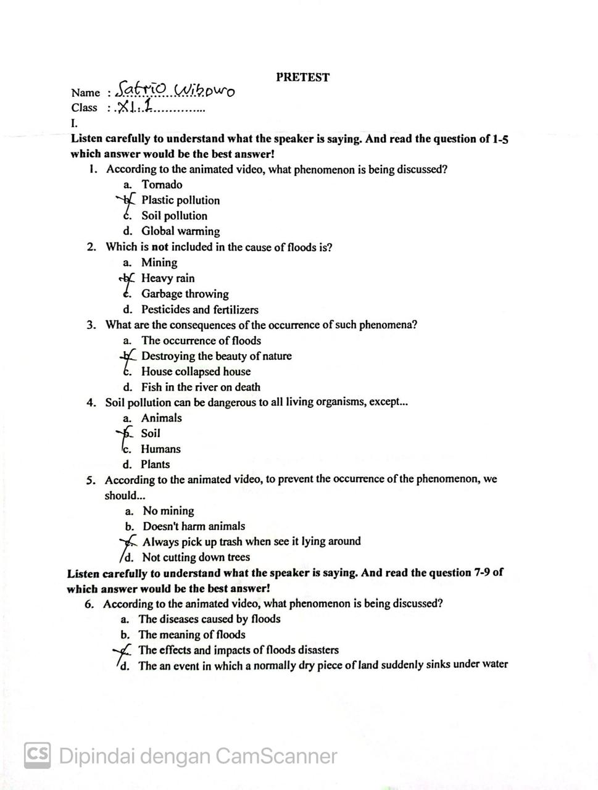

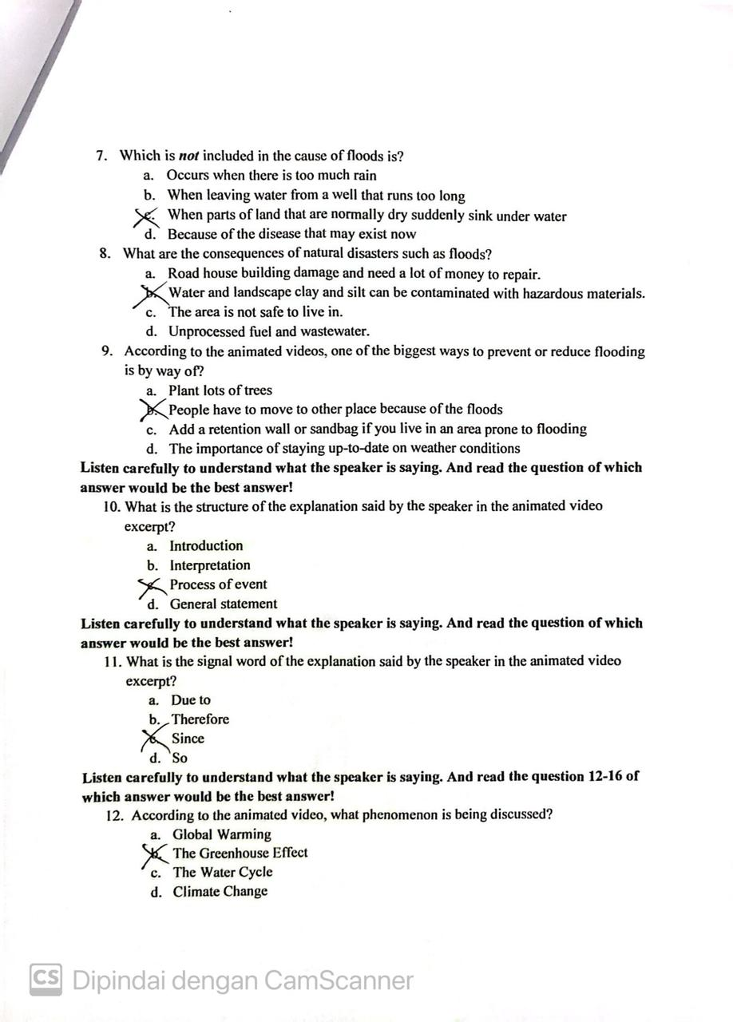

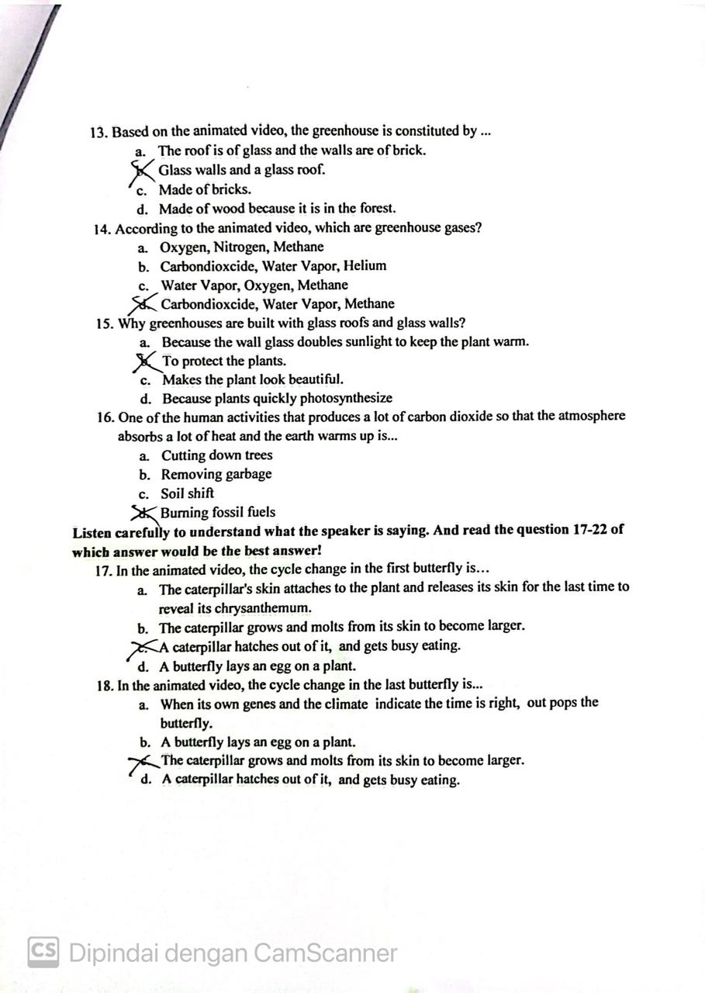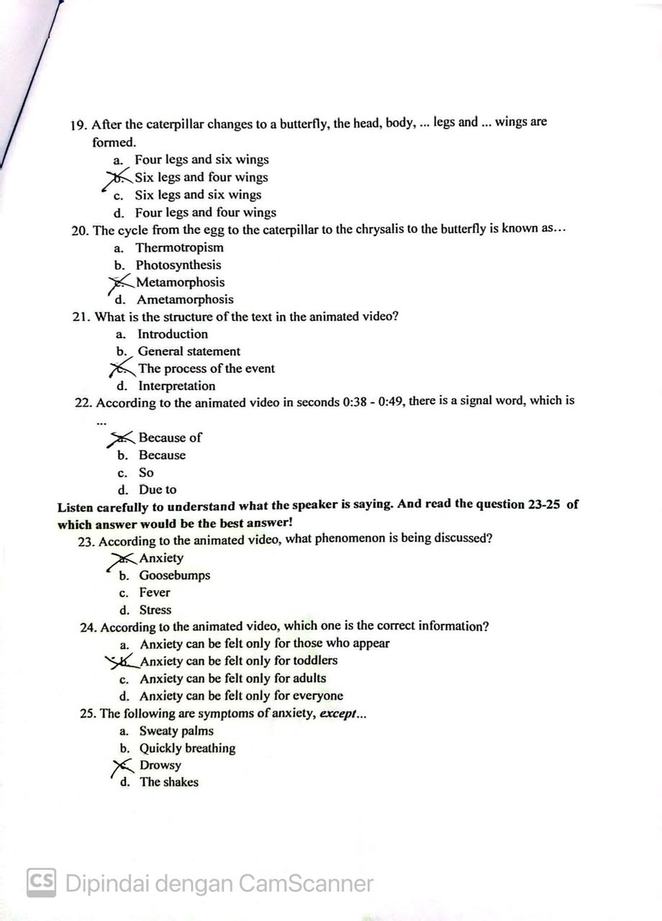

**Experimental Class Post Test**

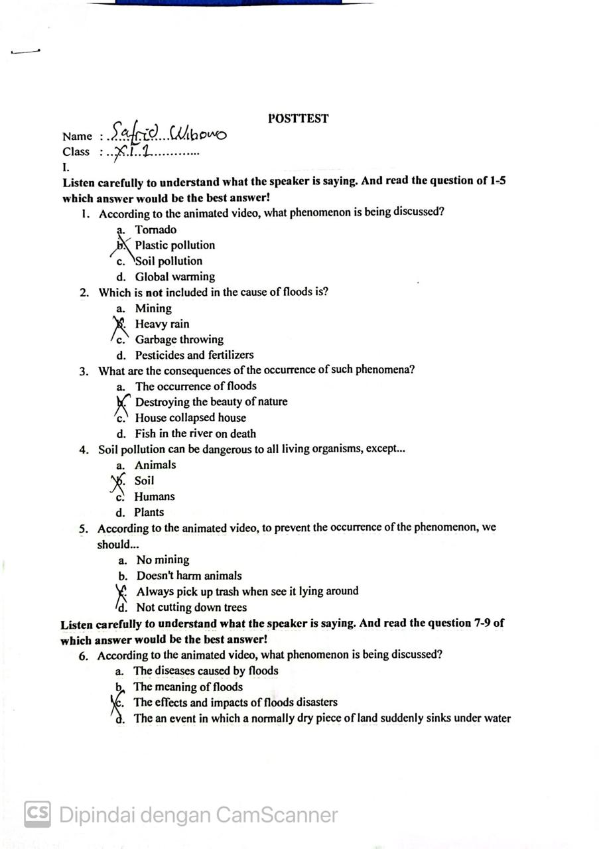

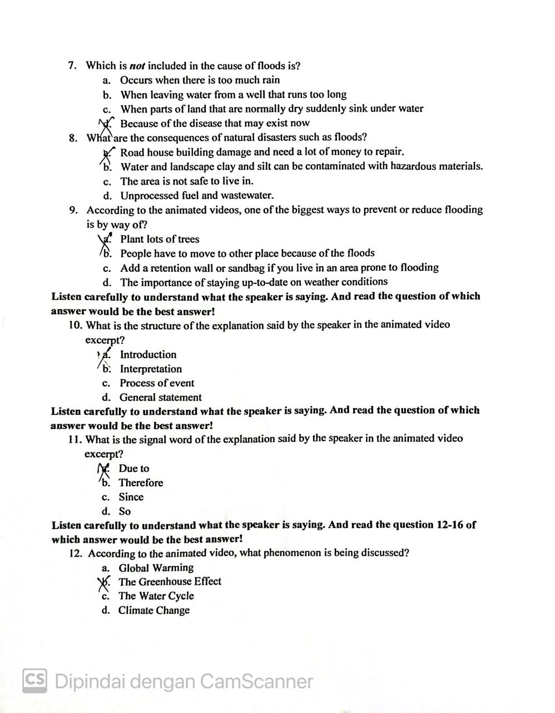

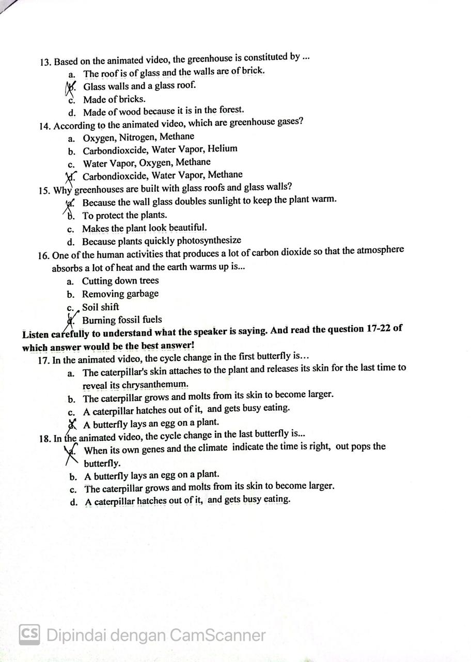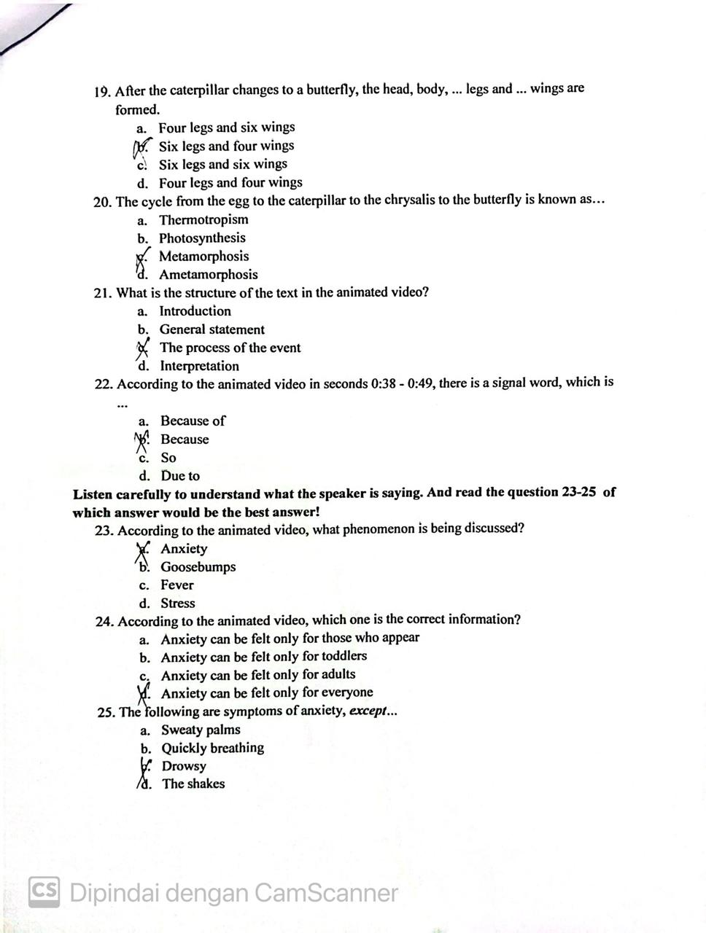

**Control Class Pre Test**

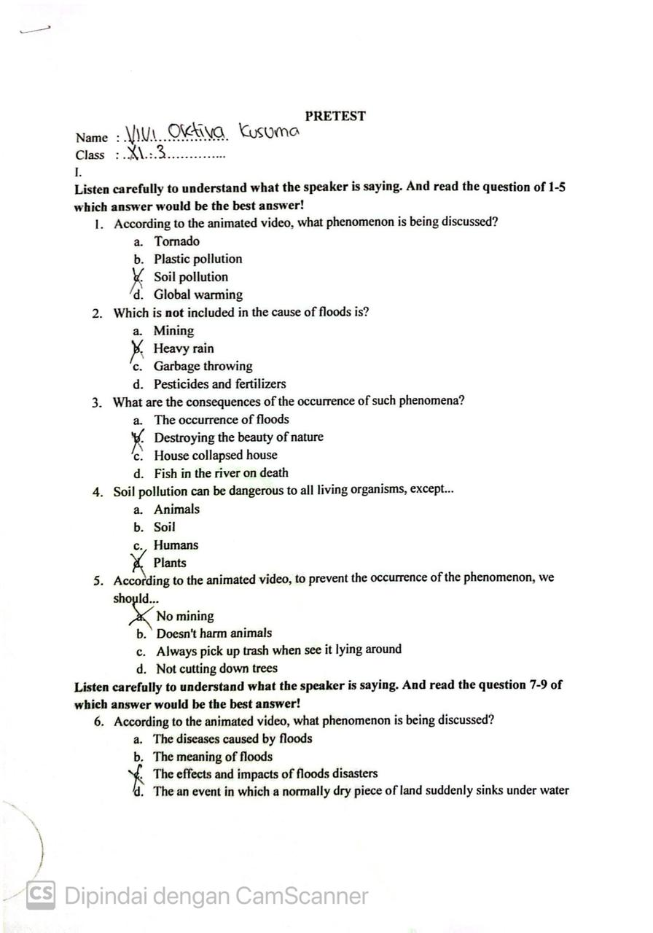

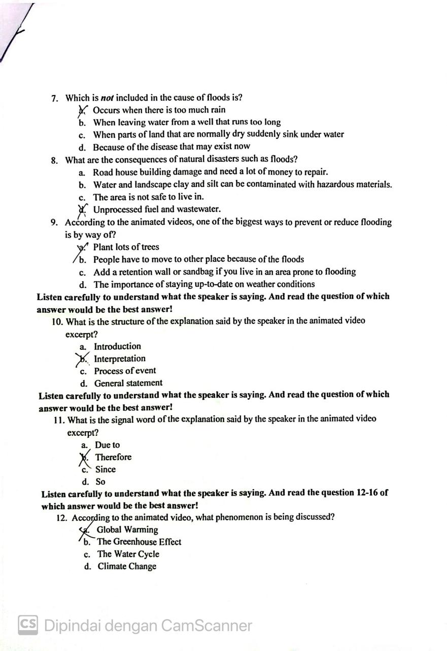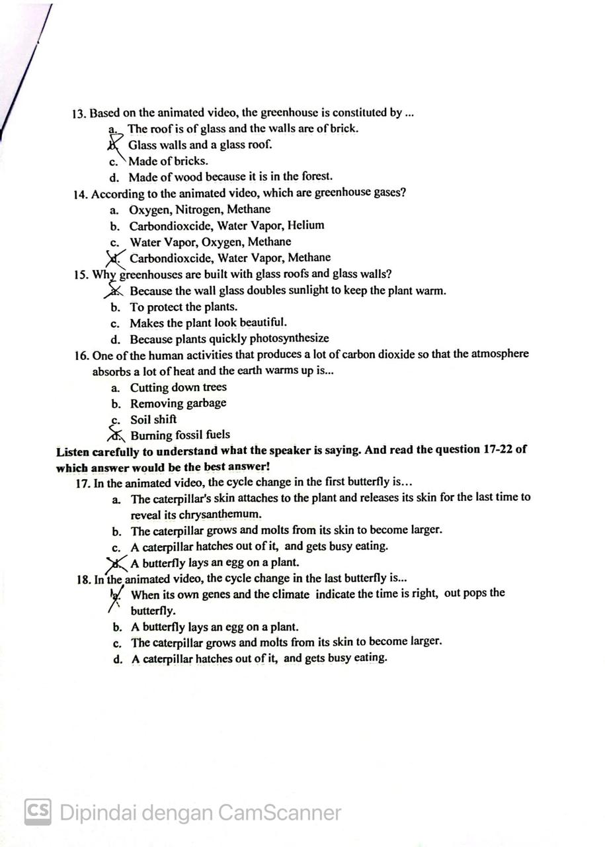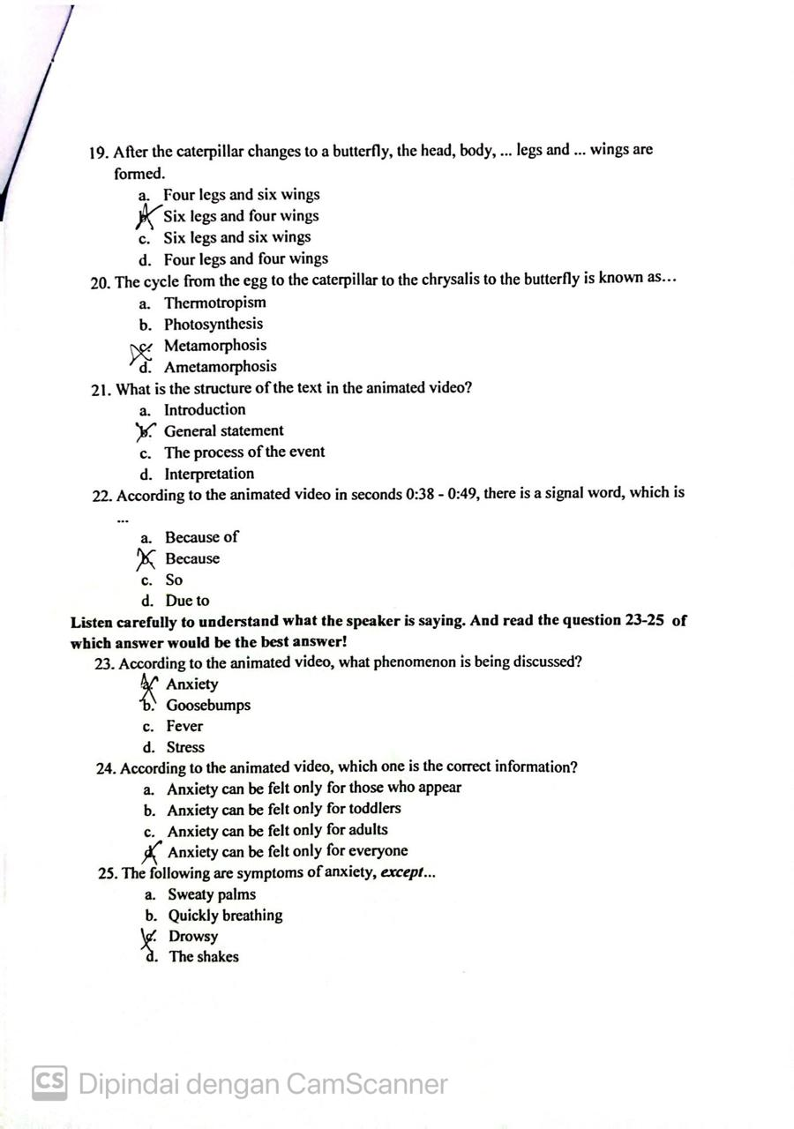

**Control Class Post Test**

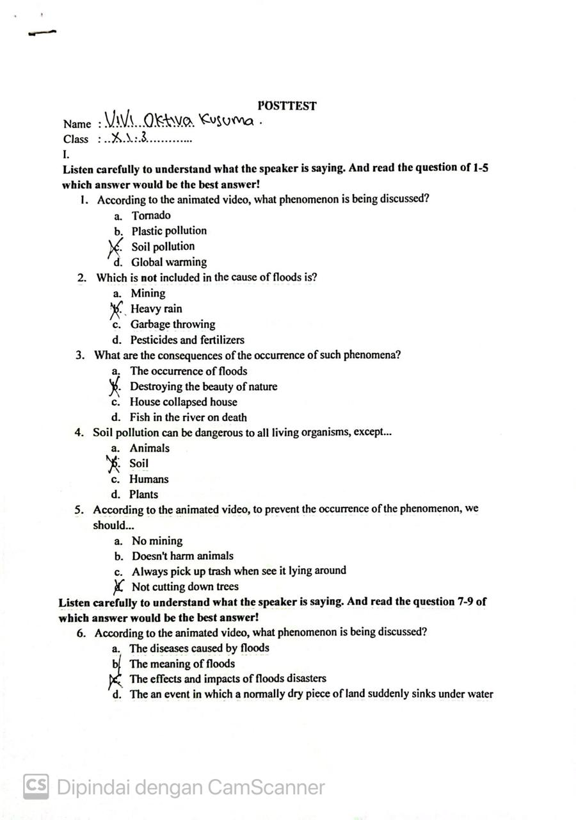

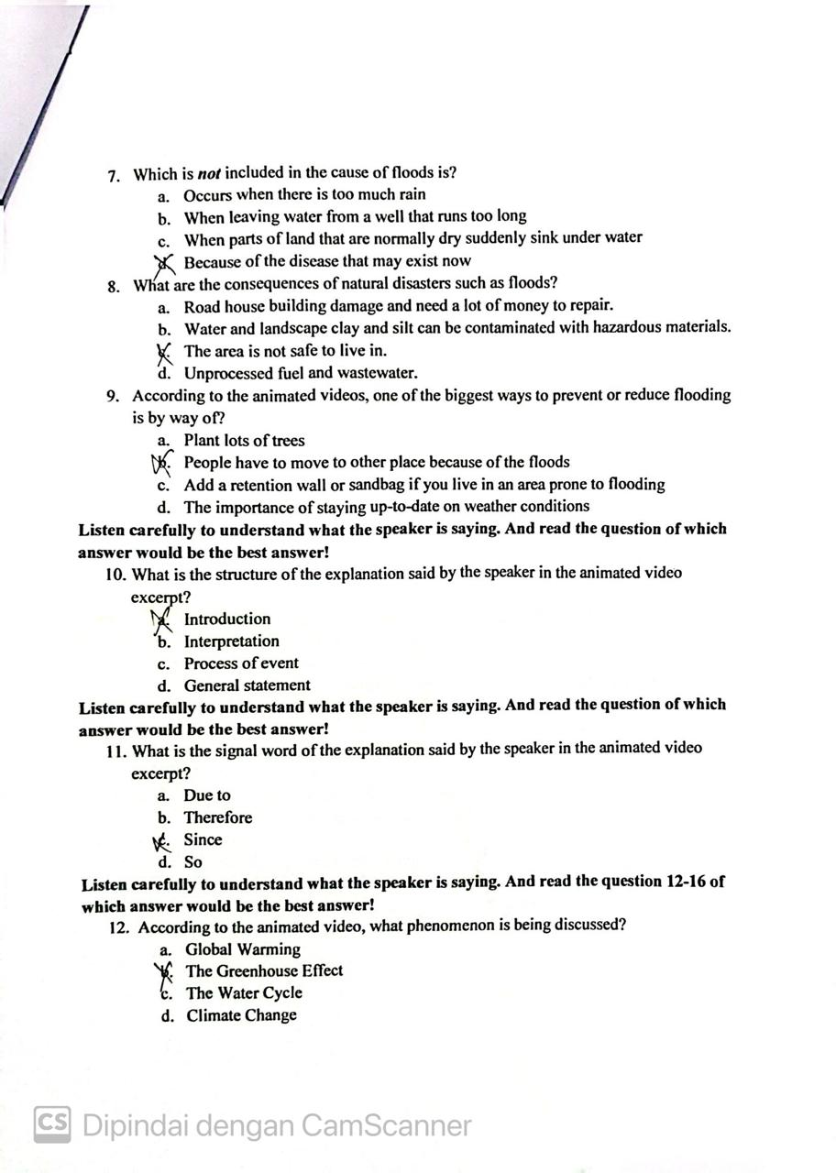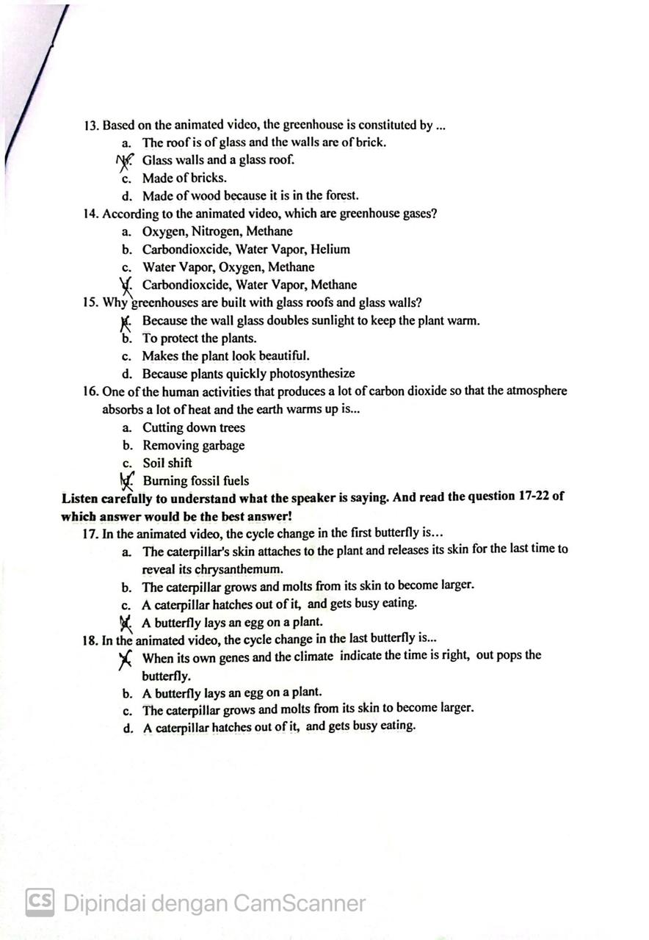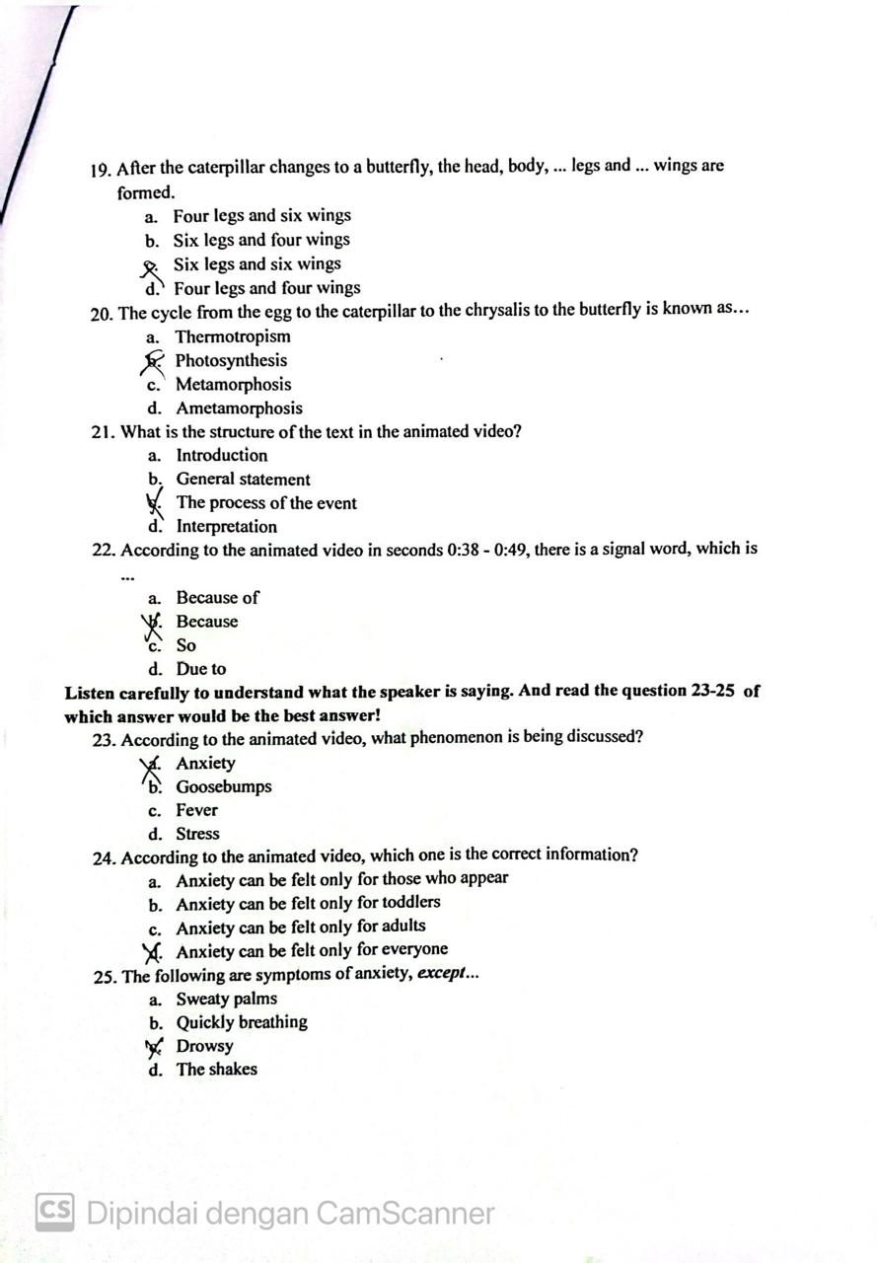

**Appendix 6 Students Listening Score**

**Experimental Class Pre Test Score**



**Experimental Class Post Test Sco**

**Control Class Pre Test Score**



**Control Class Post Test Score**



**Appendix 7 The Result of Gained Score**

**The Result Gained Score of Experimental Class**

|  |  |  |  |
| --- | --- | --- | --- |
| **Student (X)** | **Kelas Experiment** | | **Gained** |
| **Pre Test** | **Post Test** | **Score** |
| 1. | 56 | 92 | 36 |
| 2. | 44 | 84 | 40 |
| 3. | 52 | 80 | 28 |
| 4. | 48 | 76 | 28 |
| 5. | 40 | 88 | 48 |
| 6. | 52 | 96 | 44 |
| 7. | 48 | 72 | 24 |
| 8. | 52 | 96 | 44 |
| 9. | 60 | 80 | 20 |
| 10. | 52 | 84 | 32 |
| 11. | 36 | 88 | 52 |
| 12. | 60 | 92 | 32 |
| 13. | 56 | 96 | 40 |
| 14. | 64 | 84 | 20 |
| 15. | 48 | 88 | 40 |
| 16. | 44 | 84 | 40 |
| 17. | 60 | 76 | 16 |
| 18. | 36 | 84 | 48 |
| 19. | 60 | 80 | 20 |
| 20. | 52 | 84 | 32 |
| 21. | 48 | 72 | 24 |
| 22. | 52 | 92 | 40 |
| 23. | 60 | 80 | 20 |
| 24. | 44 | 84 | 40 |
| 25. | 32 | 80 | 48 |
| 26. | 48 | 72 | 24 |
| 27. | 60 | 80 | 20 |
| 28. | 60 | 84 | 24 |
| 29. | 52 | 88 | 36 |
| 30. | 56 | 76 | 20 |
| 31. | 48 | 84 | 36 |
| 32. | 60 | 76 | 16 |
| 33. | 48 | 96 | 48 |
| 34. | 52 | 92 | 40 |
| 35. | 60 | 80 | 20 |
| 36. | 40 | 88 | 48 |
| **Mean** | **1840** | **3028** | **1188** |

**The Result Gained Score of Control Class**

|  |  |  |  |
| --- | --- | --- | --- |
| **Student (X)** | **Kelas Control** | | **Gained** |
| **Pre Test** | **Post Test** | **Score** |
| 1. | 44 | 72 | 28 |
| 2. | 44 | 76 | 32 |
| 3. | 68 | 80 | 12 |
| 4. | 68 | 76 | 8 |
| 5. | 48 | 84 | 36 |
| 6. | 44 | 80 | 36 |
| 7. | 44 | 88 | 44 |
| 8. | 40 | 84 | 44 |
| 9. | 40 | 80 | 40 |
| 10. | 64 | 76 | 12 |
| 11. | 60 | 72 | 12 |
| 12. | 64 | 84 | 20 |
| 13. | 60 | 72 | 12 |
| 14. | 44 | 80 | 36 |
| 15. | 40 | 76 | 36 |
| 16. | 44 | 84 | 40 |
| 17. | 36 | 80 | 44 |
| 18. | 68 | 88 | 20 |
| 19. | 40 | 76 | 36 |
| 20. | 64 | 80 | 16 |
| 21. | 64 | 84 | 20 |
| 22. | 64 | 76 | 12 |
| 23. | 48 | 72 | 24 |
| 24. | 60 | 80 | 20 |
| 25. | 72 | 72 | 0 |
| 26. | 52 | 84 | 32 |
| 27. | 52 | 76 | 24 |
| 28. | 56 | 80 | 24 |
| 29. | 64 | 72 | 8 |
| 30. | 56 | 84 | 28 |
| 31. | 64 | 84 | 20 |
| 32. | 68 | 72 | 4 |
| 33. | 64 | 80 | 16 |
| 34. | 60 | 76 | 16 |
| 35. | 64 | 80 | 16 |
| 36. | 60 | 76 | 16 |
| **Mean** | **1992** | **2836** | **844** |

**Appendix 8 Validity Soal**

|  |  |  |  |  |  |  |  |  |  |  |  |
| --- | --- | --- | --- | --- | --- | --- | --- | --- | --- | --- | --- |
| **Correlations** | | | | | | | | | | | |
|  | | Soal17 | Soal18 | Soal19 | Soal20 | Soal21 | Soal22 | Soal23 | Soal24 | Soal25 | Skortotal |
| Soal1 | Pearson Correlation | -.067 | .124 | -.163 | -.333 | .124 | -.244 | -.228 | -.383 | .279 | .311 |
| Sig. (2-tailed) | .717 | .499 | .374 | .062 | .499 | .179 | .210 | .031 | .122 | .083 |
| N | 32 | 32 | 32 | 32 | 32 | 32 | 32 | 32 | 32 | 32 |
| Soal2 | Pearson Correlation | -.115 | .255 | -.088 | -.246 | .255 | -.009 | -.425 | .129 | -.166 | .288 |
| Sig. (2-tailed) | .531 | .159 | .631 | .174 | .159 | .963 | .015 | .483 | .364 | .110 |
| N | 32 | 32 | 32 | 32 | 32 | 32 | 32 | 32 | 32 | 32 |
| Soal3 | Pearson Correlation | -.341 | .768 | -.412 | -.341 | .768 | .028 | -.289 | -.272 | -.093 | .440 |
| Sig. (2-tailed) | .056 | .000 | .019 | .056 | .000 | .879 | .109 | .132 | .613 | .012 |
| N | 32 | 32 | 32 | 32 | 32 | 32 | 32 | 32 | 32 | 32 |
| Soal4 | Pearson Correlation | -.258 | .320 | -.126 | -.129 | .160 | .135 | -.126 | -.270 | -.064 | .038 |
| Sig. (2-tailed) | .154 | .074 | .492 | .481 | .381 | .462 | .492 | .136 | .729 | .838 |
| N | 32 | 32 | 32 | 32 | 32 | 32 | 32 | 32 | 32 | 32 |
| Soal5 | Pearson Correlation | .313 | -.324 | .085 | .174 | -.151 | -.164 | .051 | -.018 | -.009 | .000 |
| Sig. (2-tailed) | .081 | .071 | .644 | .341 | .409 | .371 | .782 | .921 | .963 | 1.000 |
| N | 32 | 32 | 32 | 32 | 32 | 32 | 32 | 32 | 32 | 32 |
| Soal6 | Pearson Correlation | -.017 | .158 | .025 | -.153 | .158 | .080 | -.025 | -.204 | .205 | .417 |
| Sig. (2-tailed) | .926 | .388 | .893 | .403 | .388 | .664 | .893 | .263 | .260 | .018 |
| N | 32 | 32 | 32 | 32 | 32 | 32 | 32 | 32 | 32 | 32 |
| Soal7 | Pearson Correlation | -.054 | .056 | -.271 | .090 | .056 | -.122 | -.009 | .028 | -.093 | -.063 |
| Sig. (2-tailed) | .770 | .762 | .133 | .625 | .762 | .507 | .962 | .879 | .613 | .732 |
| N | 32 | 32 | 32 | 32 | 32 | 32 | 32 | 32 | 32 | 32 |
| Soal8 | Pearson Correlation | .119 | -.011 | .025 | -.017 | .158 | .506 | -.025 | -.062 | -.197 | .139 |
| Sig. (2-tailed) | .517 | .954 | .893 | .926 | .388 | .003 | .893 | .736 | .280 | .448 |
| N | 32 | 32 | 32 | 32 | 32 | 32 | 32 | 32 | 32 | 32 |
| Soal9 | Pearson Correlation | -.054 | .234 | -.131 | -.341 | .056 | -.422 | -.289 | -.272 | .190 | .440 |
| Sig. (2-tailed) | .770 | .198 | .474 | .056 | .762 | .016 | .109 | .132 | .297 | .012 |
| N | 32 | 32 | 32 | 32 | 32 | 32 | 32 | 32 | 32 | 32 |
| Soal10 | Pearson Correlation | -.054 | .412 | .009 | -.197 | .234 | .178 | -.289 | -.122 | .049 | .566 |
| Sig. (2-tailed) | .770 | .019 | .962 | .279 | .198 | .330 | .109 | .507 | .791 | .001 |
| N | 32 | 32 | 32 | 32 | 32 | 32 | 32 | 32 | 32 | 32 |
| Soal11 | Pearson Correlation | -.254 | .133 | .143 | .059 | -.061 | -.031 | -.143 | -.194 | .024 | .342 |
| Sig. (2-tailed) | .161 | .468 | .435 | .750 | .742 | .868 | .435 | .288 | .896 | .055 |
| N | 32 | 32 | 32 | 32 | 32 | 32 | 32 | 32 | 32 | 32 |
| Soal12 | Pearson Correlation | -.067 | -.041 | -.033 | -.067 | -.041 | -.383 | -.098 | .035 | .016 | -.039 |
| Sig. (2-tailed) | .717 | .822 | .860 | .717 | .822 | .031 | .595 | .850 | .929 | .832 |
| N | 32 | 32 | 32 | 32 | 32 | 32 | 32 | 32 | 32 | 32 |
| Soal13 | Pearson Correlation | .090 | -.301 | .009 | .233 | -.122 | -.272 | -.009 | .178 | .049 | -.314 |
| Sig. (2-tailed) | .625 | .095 | .962 | .199 | .504 | .132 | .962 | .330 | .791 | .080 |
| N | 32 | 32 | 32 | 32 | 32 | 32 | 32 | 32 | 32 | 32 |
| Soal14 | Pearson Correlation | .233 | -.301 | .009 | -.054 | .056 | .028 | .131 | -.272 | .049 | .105 |
| Sig. (2-tailed) | .199 | .095 | .962 | .770 | .762 | .879 | .474 | .132 | .791 | .568 |
| N | 32 | 32 | 32 | 32 | 32 | 32 | 32 | 32 | 32 | 32 |
| Soal15 | Pearson Correlation | -.017 | .158 | .157 | -.017 | .158 | -.062 | -.025 | -.062 | .071 | .218 |
| Sig. (2-tailed) | .926 | .388 | .389 | .926 | .388 | .736 | .893 | .736 | .699 | .230 |
| N | 32 | 32 | 32 | 32 | 32 | 32 | 32 | 32 | 32 | 32 |
| Soal16 | Pearson Correlation | -.293 | .061 | -.016 | -.033 | -.101 | -.051 | .143 | .085 | .297 | .152 |
| Sig. (2-tailed) | .104 | .742 | .931 | .860 | .583 | .782 | .435 | .644 | .099 | .406 |
| N | 32 | 32 | 32 | 32 | 32 | 32 | 32 | 32 | 32 | 32 |
| Soal17 | Pearson Correlation | 1 | -.207 | .228 | -.067 | -.207 | .174 | .163 | .174 | .016 | .156 |
| Sig. (2-tailed) |  | .256 | .210 | .717 | .256 | .341 | .374 | .341 | .929 | .395 |
| N | 32 | 32 | 32 | 32 | 32 | 32 | 32 | 32 | 32 | 32 |
| Soal18 | Pearson Correlation | -.207 | 1 | -.262 | -.372 | .590 | .022 | -.222 | -.151 | -.234 | .435 |
| Sig. (2-tailed) | .256 |  | .147 | .036 | .000 | .907 | .222 | .409 | .197 | .013 |
| N | 32 | 32 | 32 | 32 | 32 | 32 | 32 | 32 | 32 | 32 |
| Soal19 | Pearson Correlation | .228 | -.262 | 1 | -.293 | -.262 | -.051 | .270 | .221 | .040 | .076 |
| Sig. (2-tailed) | .210 | .147 |  | .104 | .147 | .782 | .135 | .224 | .828 | .679 |
| N | 32 | 32 | 32 | 32 | 32 | 32 | 32 | 32 | 32 | 32 |
| Soal20 | Pearson Correlation | -.067 | -.372 | -.293 | 1 | -.207 | .174 | .033 | .035 | -.115 | -.311 |
| Sig. (2-tailed) | .717 | .036 | .104 |  | .256 | .341 | .860 | .850 | .531 | .083 |
| N | 32 | 32 | 32 | 32 | 32 | 32 | 32 | 32 | 32 | 32 |
| Soal21 | Pearson Correlation | -.207 | .590 | -.262 | -.207 | 1 | .022 | -.545 | -.151 | .092 | .483 |
| Sig. (2-tailed) | .256 | .000 | .147 | .256 |  | .907 | .001 | .409 | .618 | .005 |
| N | 32 | 32 | 32 | 32 | 32 | 32 | 32 | 32 | 32 | 32 |
| Soal22 | Pearson Correlation | .174 | .022 | -.051 | .174 | .022 | 1 | .187 | -.018 | -.420 | .081 |
| Sig. (2-tailed) | .341 | .907 | .782 | .341 | .907 |  | .306 | .921 | .017 | .658 |
| N | 32 | 32 | 32 | 32 | 32 | 32 | 32 | 32 | 32 | 32 |
| Soal23 | Pearson Correlation | .163 | -.222 | .270 | .033 | -.545 | .187 | 1 | -.221 | -.168 | -.266 |
| Sig. (2-tailed) | .374 | .222 | .135 | .860 | .001 | .306 |  | .224 | .357 | .141 |
| N | 32 | 32 | 32 | 32 | 32 | 32 | 32 | 32 | 32 | 32 |
| Soal24 | Pearson Correlation | .174 | -.151 | .221 | .035 | -.151 | -.018 | -.221 | 1 | -.009 | -.203 |
| Sig. (2-tailed) | .341 | .409 | .224 | .850 | .409 | .921 | .224 |  | .963 | .264 |
| N | 32 | 32 | 32 | 32 | 32 | 32 | 32 | 32 | 32 | 32 |
| Soal25 | Pearson Correlation | .016 | -.234 | .040 | -.115 | .092 | -.420 | -.168 | -.009 | 1 | .249 |
| Sig. (2-tailed) | .929 | .197 | .828 | .531 | .618 | .017 | .357 | .963 |  | .169 |
| N | 32 | 32 | 32 | 32 | 32 | 32 | 32 | 32 | 32 | 32 |
| Skortotal | Pearson Correlation | .156 | .435 | .076 | -.311 | .483 | .081 | -.266 | -.203 | .249 | 1 |
| Sig. (2-tailed) | .395 | .013 | .679 | .083 | .005 | .658 | .141 | .264 | .169 |  |
| N | 32 | 32 | 32 | 32 | 32 | 32 | 32 | 32 | 32 | 32 |

**Appendix 9 Reliability Soal**

|  |  |
| --- | --- |
| **Reliability Statistics** | |
| Cronbach's Alpha | N of Items |
| .765 | 25 |

**Appendix 10 Documentation**

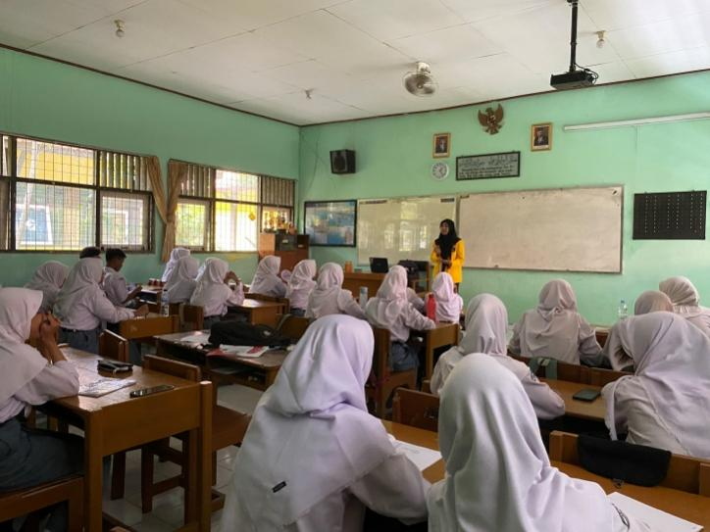 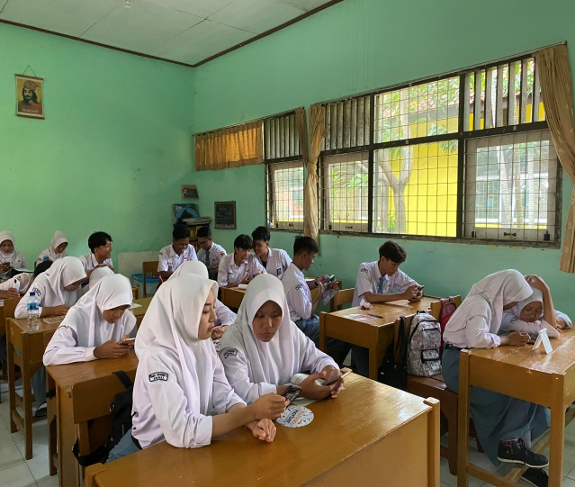

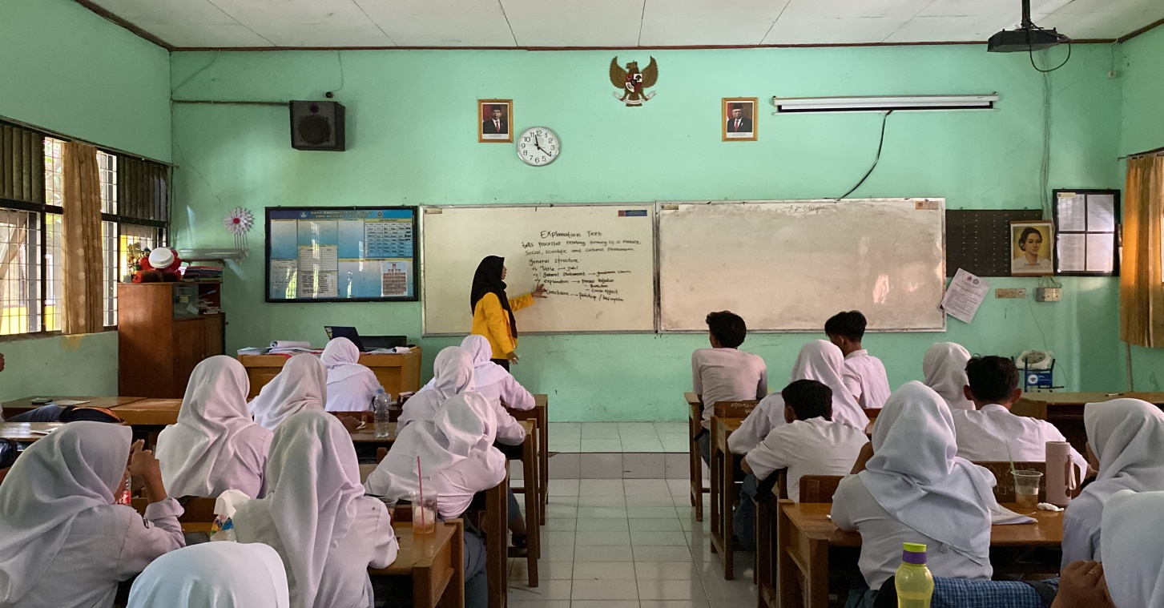

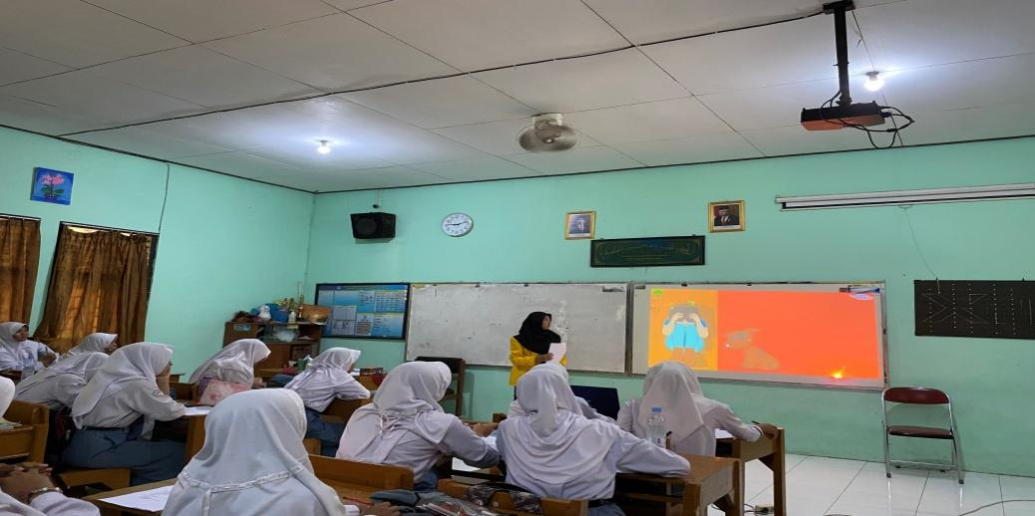

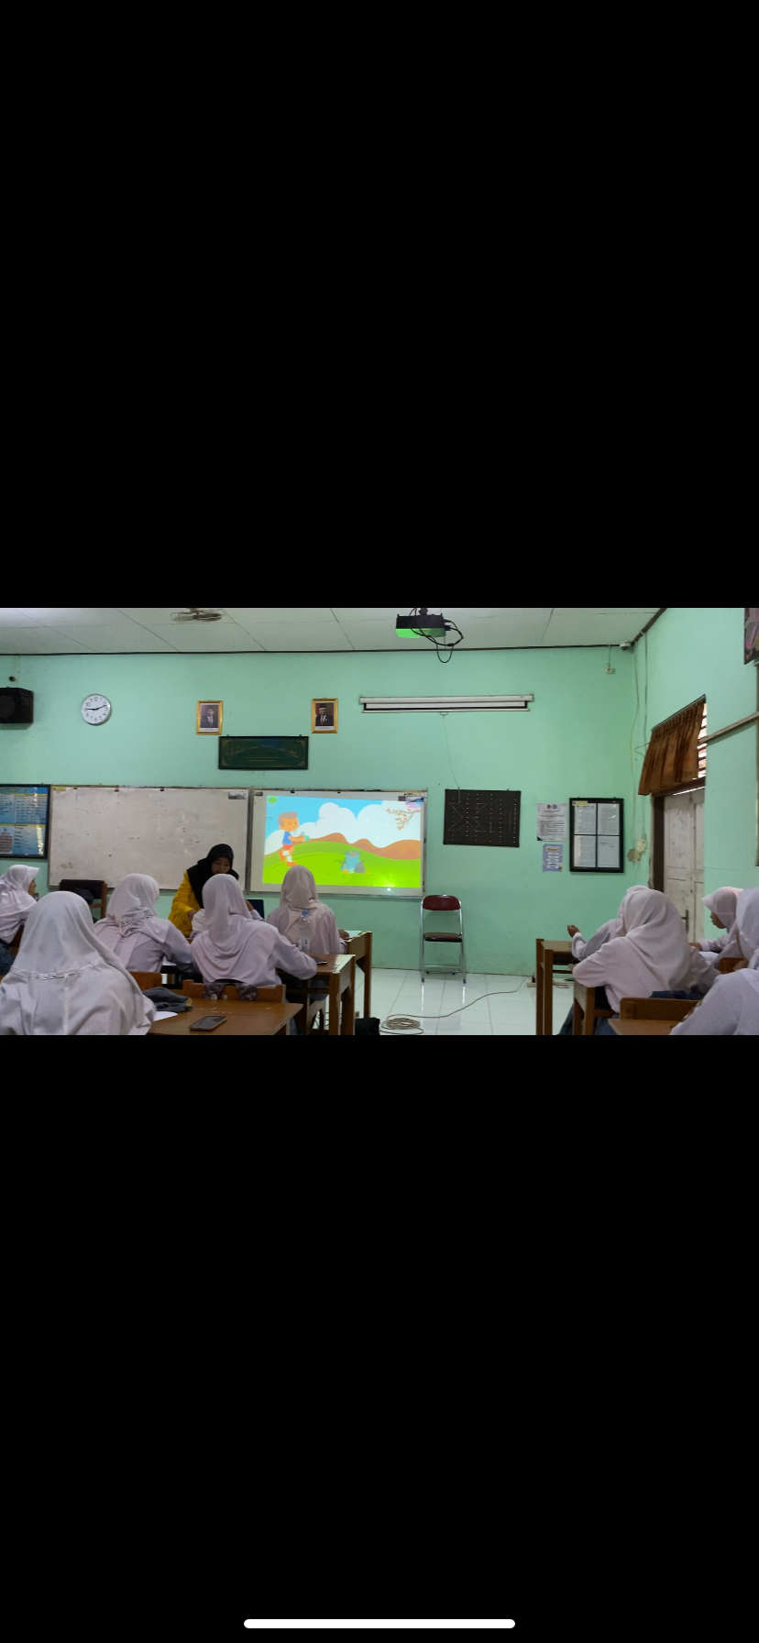

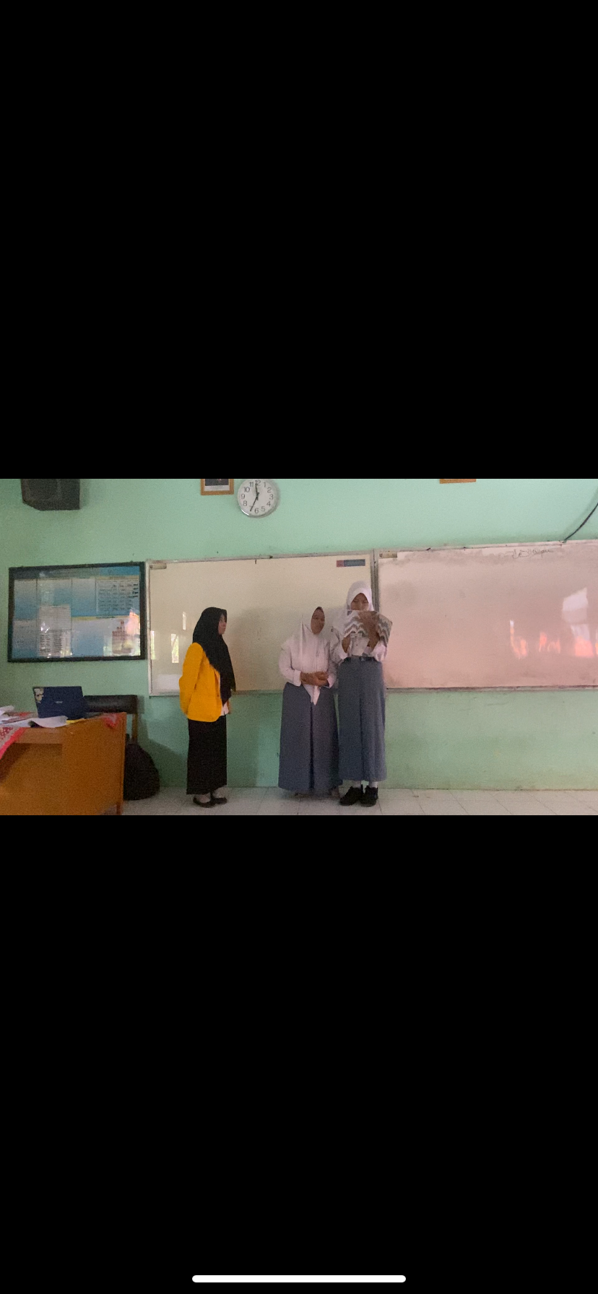

**Appendix 11 Berita Acara Ujian Skripsi**

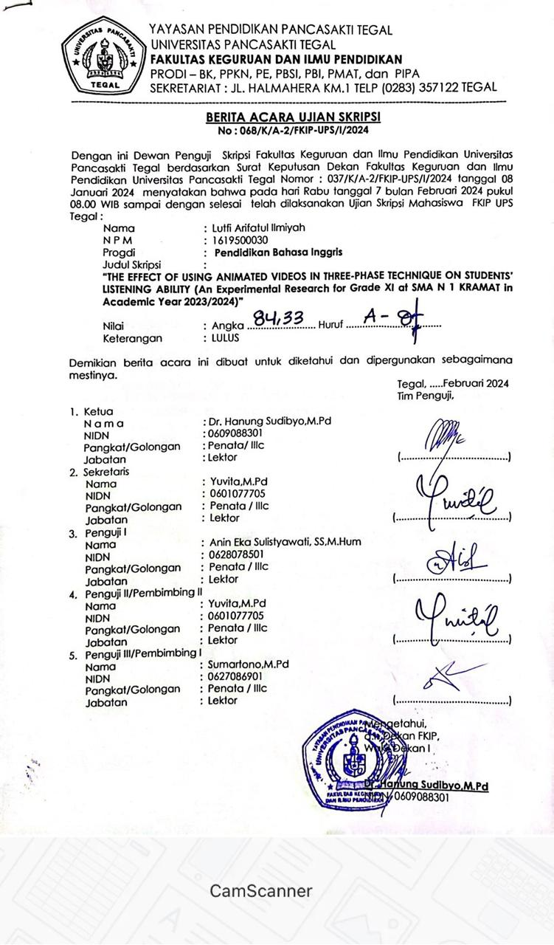

**Appendix 12 Berita Acara Bimbingan Skripsi**

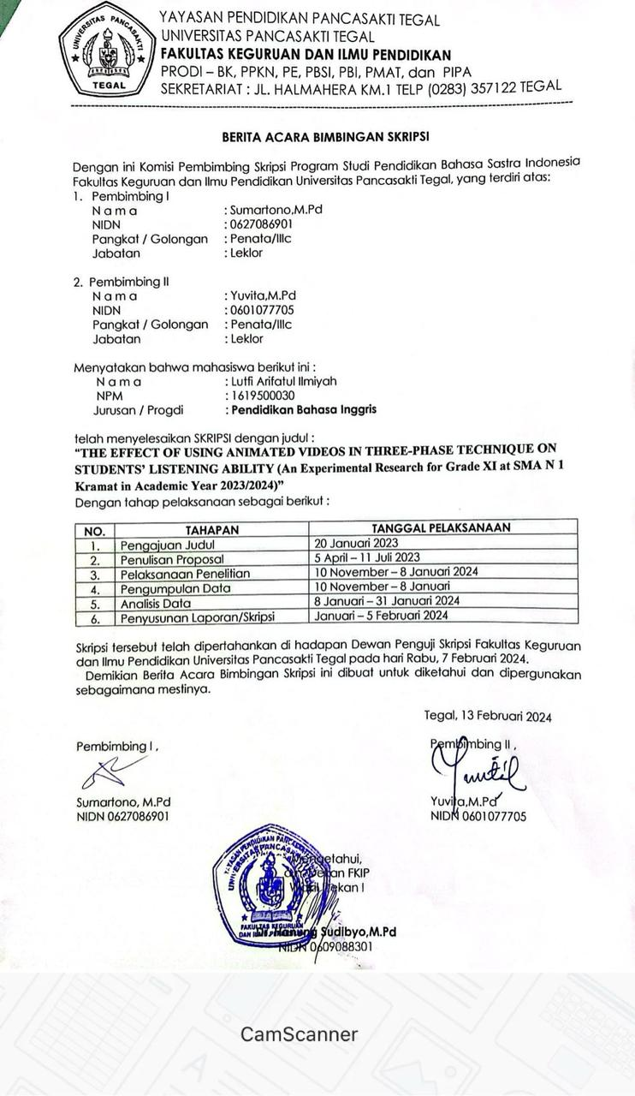

**Appendix 13 Similarity Check**

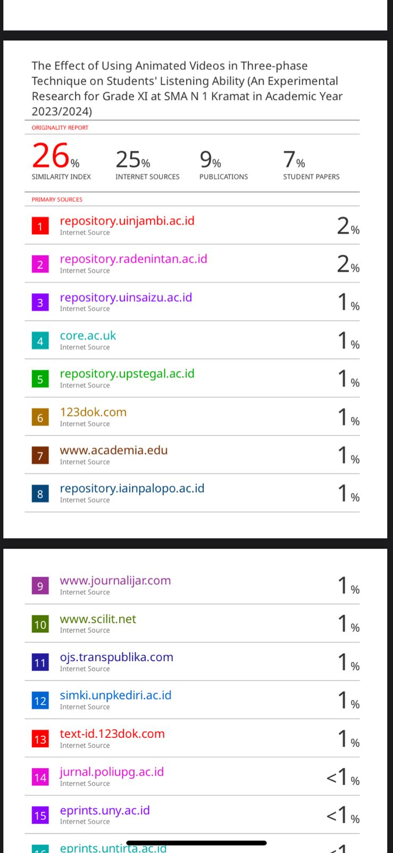

**Appendix 14 Surat Keterangan Bebas Plagiasi**

