BIBLIOGRAPHY

Ali Al-oglah, T. M. (2018). Teaching and Learning English as a Foreign Language. International Journal of English Language Teaching, 5(2), 57. https://doi.org/10.5430/ijelt.v5n2p57
Ammar, M. D., Hartono, R., & Angraini, N. (2022). English pronunciation problems analysis faced by English education students in the second semester at Indo Global Mandiri University. Global Expert: Jurnal Bahasa Dan Sastra, 10(2021), 1–7. http://dx.doi.org/10.36982/jge.v10i1.2166
Anggraini, I., & Bhuana, G. P. (2022). the Use of Song in Learning Pronunciation. PROJECT (Professional Journal of English Education), 5(2), 280. https://doi.org/10.22460/project.v5i2.p280-283
Arimurti, D. (2016). Elements of Pronunciation. Element of Pronunciation, 4.
As Sabiq, A. H. (2020). Localized English for Ngapak Javanese Speakers as Language Instruction. ENGLISH FRANCA : Academic Journal of English Language and Education, 4(2), 85. https://doi.org/10.29240/ef.v4i2.1818
Atmowardoyo, H. (2018). Research Methods in TEFL Studies: Descriptive Research, Case Study, Error Analysis, and R & D. Journal of Language Teaching and Research, 9(1), 197. https://doi.org/10.17507/jltr.0901.25
Dewi, R., Mujiyanto, J., & Sukrisno, A. (2017). The Influence Of Brebes Javanese Dialect Toward Students ‟ Pronunciation Of English Speech Sounds ( A Case Study in Sman 1 Brebes ). 1st English Language and Literature International Conference (ELLiC), 189–199. https://jurnal.unimus.ac.id/index.php/ELLIC/article/view/2468/2492
Denizer, E. N. (2017). Does Mother Tongue Interfere in Second Language Learning? Journal of Foreign Language Education and Technology, 39-54.
Marsono. (2018). Fonetik. Yogyakarta: Gadjah Mada University Press.
Mualimin, M., Marsono, M., & Suhandano, S. (2019). Javanese of Tegal: An Ecological Evidence. E3S Web of Conferences, 125(201 9), 10–13. https://doi.org/10.1051/e3sconf/201912509012
M, L. A. (2021). Interfrensi Bahasa Jawa dan Bahasa Inggris dalam Bahasa Indonesia Pada Video Youtube Arnold Poernomo. Abstrak. 8.
Nurjamin, L. R. (2020). The Priorities of English Pronunciation Elements. 3(1), 16–21.
Purwaningsih, N. (2020). the Influence of Javanese Accent Toward the Students ’ English Consonant Pronunciation At English Education Study Program. Jurnal Pendidikan Bahasa Inggris, 8(1), 55–68. https://journal.peradaban.ac.id/index.php/jdpbi/article/view/540
Setiyadi, B. (2020). Teaching English as a Foreign Language. Graha Ilmu, 3(2). https://doi.org/10.47408/jldhe.v0i1.14
Setiyorini, F. A., Prihatin, Y., & Edi Santoso, M. (2021). A Narrative Inquiry: Students Perception in Increasing Teachers’ Identity By Join Microteaching. South Asian Journal of Social Sciences and Humanities, 02(01), 49–62. https://doi.org/10.48165/sajssh.2021.2105
Subandowo, D. (2017). The Language Interference in English Speaking. Proceedings of the Fifth International Seminar on English Language and Teaching (ISELT-5), 205–210.
Tama, T. A. (2017). Students' Difficulties in Learning English Speaking Skills at SMAN 5 Jambi.
Tambunsaribu, G. (2019). Say It Keunikan Bunyi Bahasa Inggris. 1. https://www.google.co.id/books/edition/Say_It_Keunikan_Bunyi_Bahasa_Inggris/GDTMDwAAQBAJ?hl=id&gbpv=1&dq=kosa+kata+adalah&printsec=frontcover
Trysnawati, I., Mulyani, S., & Syam, A. (2020). Error Analysis on English Consonant Pronunciation Produced By The Fifth Semester Students of the English Education Department. Tamaddun, 19(2), 118–131. https://doi.org/10.33096/tamaddun.v19i2.77
Utomo. (2017). Kamus Bahasa Jawa Tegal - Indonesia.
Wardani, N. A., & Suwartono, T. (2019). Javanese Language Interference in the Pronunciation of English Phonemes. Celtic: A Journal of Culture, English Language Teaching, Literature, and Linguistics, 6(2), 14–25. https://doi.org/10.22219/celtic.v6i2.8589
Yuliati, P., Ferry, R., & Hasyim, Z. (n.d.). An Analysis of Error in Pronouncing Dental Fricative Sounds by The First Year Students of English Education Study Program. In English Language Teaching Society (ELTS) (Vol. 9, Issue 02).
Zaeni, M. O., Prihatin, Y., & Jamaludin, S. (2022). English Education Students ’ Perception of Pronunciation Difficulties at Universitas Pancasakti Tegal. July, 142–152.
Zultiyanti, Z. (2021). Perbandingan Fonetik Bahasa Indonesia dan Bahasa Jawa: Sebuah Amatan Awal. Kode : Jurnal Bahasa, 10(4), 40–51. https://doi.org/10.24114/kjb.v10i4.30731

APPENDICES

Appendix 1: Pronunciation test material adapted from Subandowo (2017), Purwaningsih & Nurdiawati (2020), and Dewi et al. (2017)
No. | Consonant | English Words | No. | Consonants | English Words
 | / p / | happen |  | / s / | Mouse
 | / b / | bathe |  | / z / | Raising
 | / t / | prestige |  | / ∫ / | cash
 | / d / | harder |  | / ʒ / | vision
 | / k / | Cabbage |  | / h / | happen
 | / g / | Got |  | / m / | plum
 | / t∫ / | Church |  | / n / | bin
 | / dʒ / | Judge |  | / ŋ / | coming
 | / f / | Leaf |  | / l / | larger
 | / v / | cover |  | / j / | View
 | / θ / | theater |  | / w / | Sweet
 | / δ / | this |  | / r / | carrot

Appendix 2: Interview guidance adapted from (Dewi et al., 2017)
Number | Questions
 | What semester are you in?
 | What is your mother tongue?
 | What is your foreign language?
 | Which English consonant(s) is/are the most difficult to pronounce?
 | What do you think the factors causing most of the Tegalnese accent “ngapak” of your pronouncing English consonant sounds?

Appendix 3: The questionnaire of factors causing English consonant interference adapted from Subandowo (2017); Wardani et al. (2019)

Read the statement in the following table. Then, give your response to the statement by checklist () in the response column. SA=Strongly Agree, A=Agree, N=Neither Agree nor Disagree, D=Disagree, and SD=Strongly Disagree. Each item and their choices are then equated with a numerical value, where Strongly Agree is weighted 5 points, agree 4 points, Neither Agree nor Disagree 3 points, disagree 2 points, and Strongly Disagree 1 point.
No. | Categories | Questions | Responds
 |  |  | SA  (5) | A  (4) | N  (3) | D  (2) | SD  (1)
 | High accent | My mother tongue affects the accuracy of my emphasis on pronunciation.
 |  | I always produce more air from my lungs when I pronounce English consonants.
 |  | I have difficulty pronouncing the sound /b/.
 |  | I have difficulty pronouncing the sound /d/.
 |  | I have difficulty pronouncing the sound /g/.
 |  | I have difficulty pronouncing the sound / dʒ /.
 |  | I have difficulty pronouncing the sound / δ /.
 |  | I have difficulty pronouncing the sound /p/.
 |  | I have difficulty pronouncing the sound /t/.
 |  | I have difficulty pronouncing the sound /k/.
 | School area | I use my mother tongue language in the classroom.
 |  | I use my mother tongue language when I talk to my classmates.
 |  | I use my mother tongue language when I talk to my teachers.
 |  | I use my mother tongue language outside the class.
 |  | My teachers use the Tegalnesse language when they teach.
 |  | I use Tegalnesse accents when I speak English in the classroom.
 |  | My classmates use Tegalnesse accents when they speak English.
 |  | My teacher uses Tegalnesse accents when they speak English.
 |  | I speak English with the native accent to my teacher at school.
 |  | I speak English with the native accent to my classmate at school.
 | Exposure | I don’t use English in daily communication.
 |  | I Study English only at school.
 |  | I studied English when entering junior high school.
 |  | I start studying pronunciation at university.
 |  | I only practice pronunciation in the classroom.
 |  | I use YouTube for practicing their pronunciation.
 |  | I use music for practicing their pronunciation.
 |  | I use the movie for practicing their pronunciation.
 |  | I use novels for practicing their pronunciation.
 |  | I focus more on other language features such as grammar, vocabulary, and tenses.
 | Motivation | I have personal goals for studying English.
 |  | I have personal goals for studying English pronunciation.
 |  | English is my second option when entering university.
 |  | I want to be as native as I can in English pronunciation.
 |  | I feel satisfied when I speak English with my Tegalnesse accents as long as it’s understandable.
 |  | I study English to get a better job, career, and experience.
 |  | I study English because I follow my friends.
 |  | I like English speaking class.
 |  | I like the English pronunciation class.
 |  | I study English to pass the exam.
 | Environment | Tegalnesse language is my mother tongue.
 |  | I live surrounded by Tegalnesse people.
 |  | People around me speak in the Tegalnesse language.
 |  | People around me speak with Tegalnesse accents.
 |  | English is my second language.
 |  | I live surrounded by English speakers.
 |  | My neighbors speak the English language.
 |  | My parents and family speak the English language.
 |  | My neighbors speak English with a native accent.
 |  | My parents and family speak English with a native accent.
 | High context culture | I often use no verbal communication.
 |  | I often use facial expressions in communication.
 |  | I often use the tone of voice in communication.
 |  | I often use gestures in communication.
 |  | I use indirect communication (known as berbelit-belit).
 |  | I use as few words as possible.
 |  | I often emphasize personal relationships in communication.
 |  | I use emotions in communication.
 |  | I often keep silent to agree.
 |  | I am often silent to keep my own opinions.
 | Low context culture | I mostly use verbal (words) communication.
 |  | I use direct communication.
 |  | I mostly avoid silence between conversations.
 |  | I keep talking whether I have anything to say or not
 |  | I use a logical approach.
 |  | I minimize the personal approach
 |  | I communicate to agree.
 |  | I mostly communicate to express my opinion.
 |  | I look at people's eyes when I talk to them.
 |  | I mention people's names when I talk to them.

Appendix 4: The Result of Validity Test of Students’ Anxiety Questionnaire
No item | r_{xy} | R_{table} 5% (25) | Status
 | 0.416 | 0.444 | Invalid
 | 0.390 | 0.444 | Invalid
 | 0.261 | 0.444 | Invalid
 | 0.304 | 0.444 | Invalid
 | 0.241 | 0.444 | Invalid
 | 0.183 | 0.444 | Invalid
 | 0.456 | 0.444 | Valid
 | 0.230 | 0.444 | Invalid
 | 0.286 | 0.444 | Invalid
 | 0.284 | 0.444 | Invalid
 | 0.374 | 0.444 | Invalid
 | 0.436 | 0.444 | Invalid
 | 0.079 | 0.444 | Invalid
 | 0.246 | 0.444 | Invalid
 | -0.311 | 0.444 | Invalid
 | 0.180 | 0.444 | Invalid
 | 0.160 | 0.444 | Invalid
 | -0.112 | 0.444 | Invalid
 | 0.290 | 0.444 | Invalid
 | 0.102 | 0.444 | Invalid
 | 0.170 | 0.444 | Invalid
 | -0.255 | 0.444 | Invalid
 | -0.087 | 0.444 | Invalid
 | 0.540 | 0.444 | Valid
 | -0.252 | 0.444 | Invalid
 | 0.664 | 0.444 | Valid
 | 0.247 | 0.444 | Invalid
 | 0.357 | 0.444 | Invalid
 | 0.455 | 0.444 | Valid
 | 0.453 | 0.444 | Valid
 | 0.438 | 0.444 | Invalid
 | 0.414 | 0.444 | Invalid
 | 0.596 | 0.444 | Valid
 | 0.573 | 0.444 | Valid
 | 0.170 | 0.444 | Invalid
 | 0.540 | 0.444 | Valid
 | 0.050 | 0.444 | Invalid
 | 0.198 | 0.444 | Invalid
 | 0.342 | 0.444 | Invalid
 | 0.063 | 0.444 | Invalid
 | 0.415 | 0.444 | Invalid
 | 0.348 | 0.444 | Invalid
 | 0.402 | 0.444 | Invalid
 | 0.405 | 0.444 | Invalid
 | 0.355 | 0.444 | Invalid
 | 0.238 | 0.444 | Invalid
 | -0.053 | 0.444 | Invalid
 | 0.400 | 0.444 | Invalid
 | -0.159 | 0.444 | Invalid
 | -0.121 | 0.444 | Invalid
 | 0.536 | 0.444 | Valid
 | 0.409 | 0.444 | Invalid
 | 0.401 | 0.444 | Invalid
 | 0.731 | 0.444 | Valid
 | 0.575 | 0.444 | Valid
 | 0.512 | 0.444 | Valid
 | 0.434 | 0.444 | Invalid
 | 0.460 | 0.444 | Valid
 | 0.167 | 0.444 | Invalid
 | 0.359 | 0.444 | Invalid
 | 0.098 | 0.444 | Invalid
 | 0.515 | 0.444 | Valid
 | 0.127 | 0.444 | Invalid
 | -0.155 | 0.444 | Invalid
 | 0.139 | 0.444 | Invalid
 | 0.476 | 0.444 | Valid
 | 0.497 | 0.444 | Valid
 | 0.097 | 0.444 | Invalid
 | -0.052 | 0.444 | Invalid
 | -0.126 | 0.444 | Invalid

Appendix 5: The Result of Reliability Test of Students’ Anxiety Questionnaire
Case Processing Summary
 |  | N | %
Cases | Valid | 20 | 100.0
 | Excludedª | 0 | .0
 | Total | 20 | 100.0

Reliability Statistics
Cronbach's Alpha | N of Items
.810 | 70

Appendix 6: WhatsApp Voice Note Archive on Google Drive

Appendix 7: Scan Similarity Result
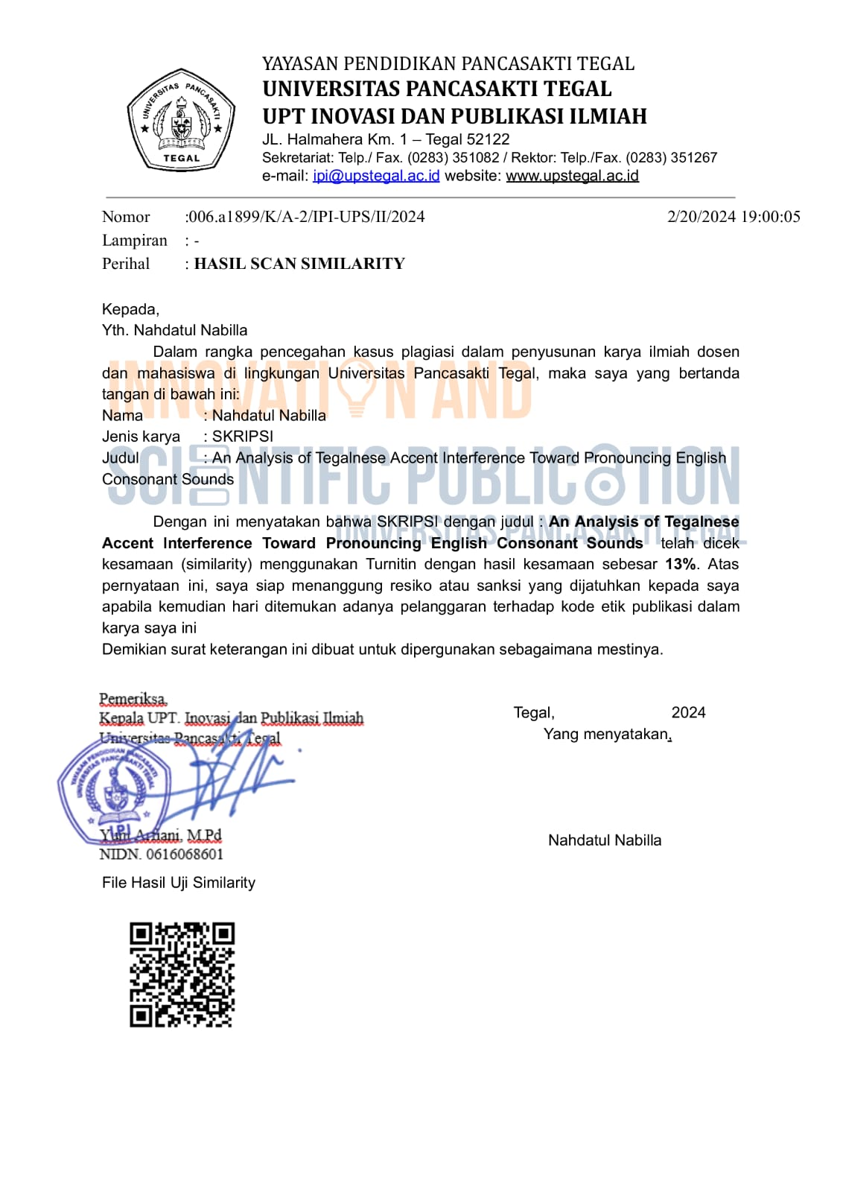
Appendix 8: Official Report

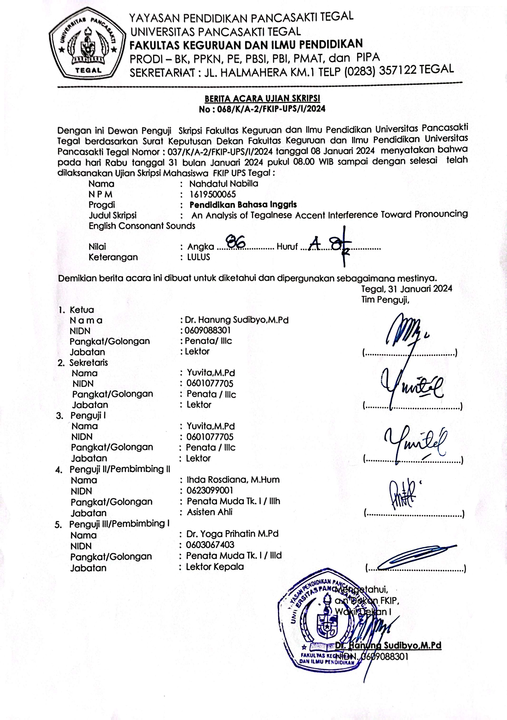
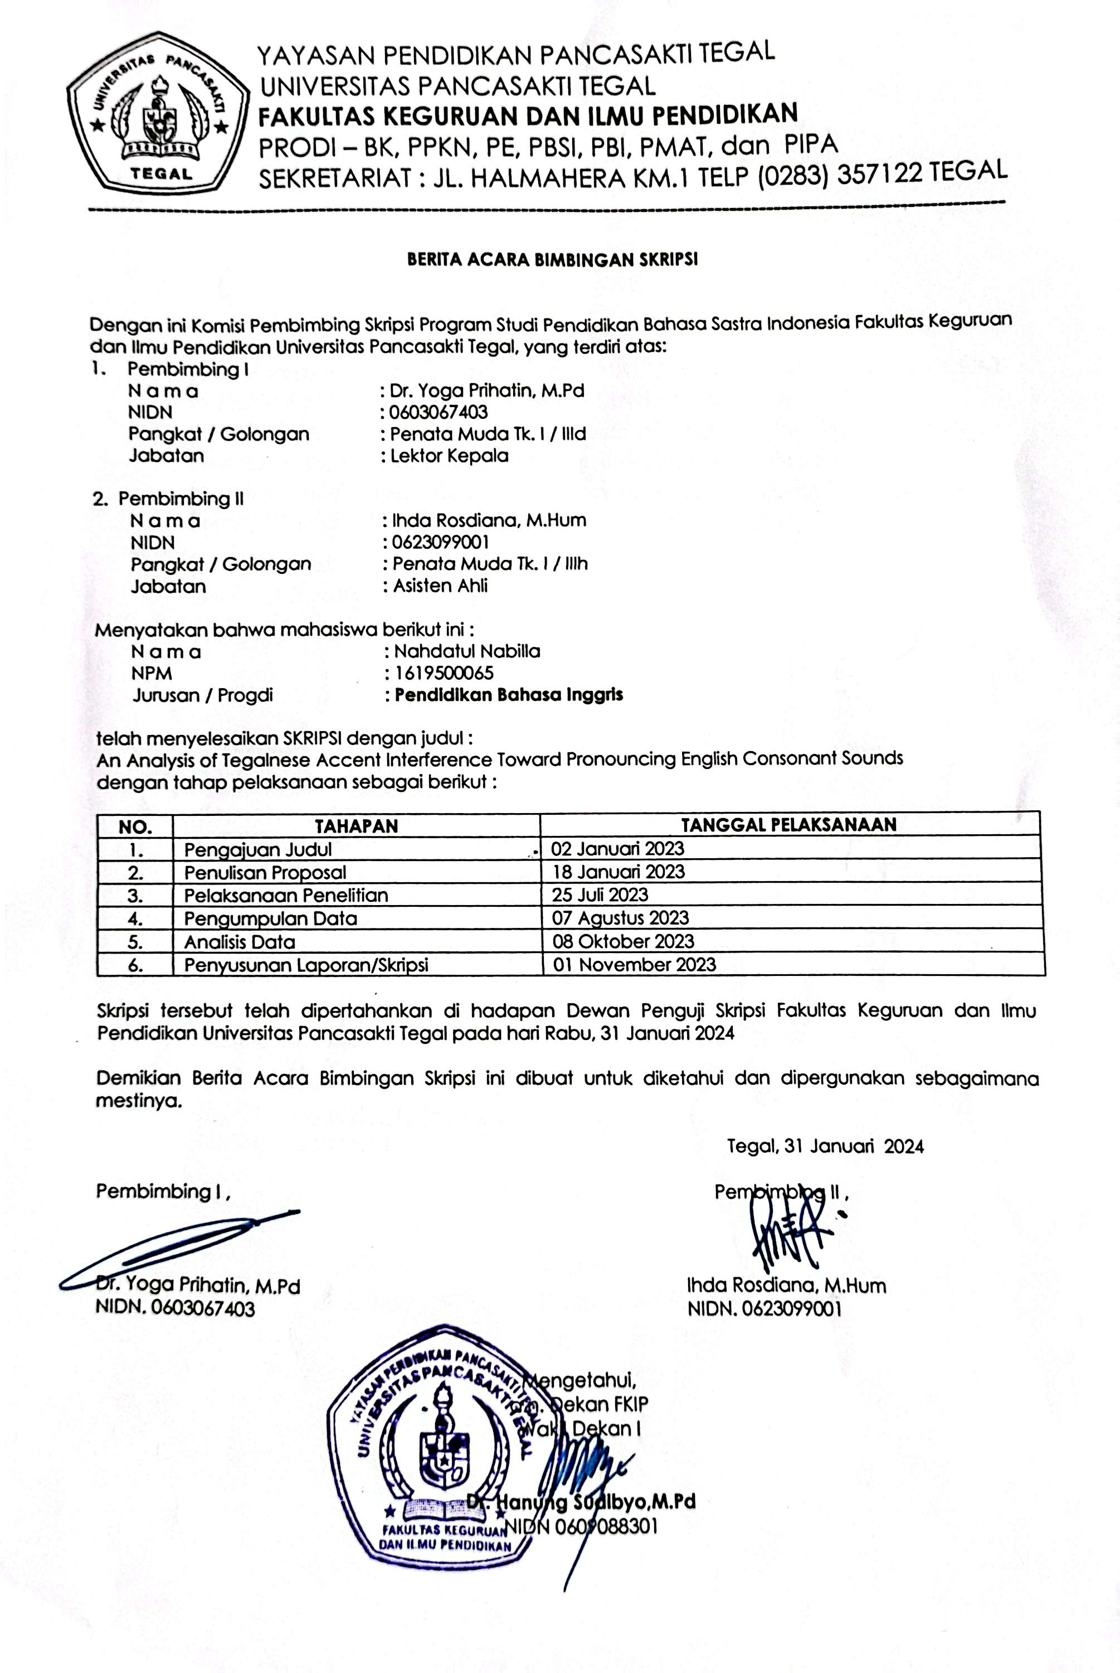
Appendix 8: Recording of respondents
Number | English words | Respondents |  |  |  |  |  |  |  |  |  |  |  |  |  |  |  |  |  |  |  | Number of errors
 |  | 1 | 2 | 3 | 4 | 5 | 6 | 7 | 8 | 9 | 10 | 11 | 12 | 13 | 14 | 15 | 16 | 17 | 18 | 19 | 20
 | happen
 | bathe |  |  |  |  |  |  |  |  |  |  |  |  |  |  |  |  |  |  |  |  | 2
 | prestige
 | harder |  |  |  |  |  |  |  |  |  |  |  |  |  |  |  |  |  |  |  |  | 12
 | Cabbage
 | Got |  |  |  |  |  |  |  |  |  |  |  |  |  |  |  |  |  |  |  |  | 18
 | Church
 | Judge |  |  |  |  |  |  |  |  |  |  |  |  |  |  |  |  |  |  |  |  | 11
 | Leaf
 | cover
 | theater
 | this |  |  |  |  |  |  |  |  |  |  |  |  |  |  |  |  |  |  |  |  | 2
 | Mouse
 | Raising
 | cash
 | vision
 | happen
 | plum
 | bin
 | coming
 | larger
 | View
 | Sweet
 | carrot

Appendix 8: Student’s responses on valid and reliable questionnaires
 |  |  |  |  |  |  |  | Exposure
 | I have difficulty pronouncing the sound / δ /. |  |  |  |  |  |  | I start studying pronunciation at university. |  |  |  | I use YouTube for practicing their pronunciation. |  |  | I use novels for practicing their pronunciation. |  | I focus more on other language features such as grammar, vocabulary, and tenses.
P1 | 4 |  |  |  |  |  |  | 4 |  |  |  | 3 |  |  | 3 |  | 4 |  | 14 |  | 4
P2 | 4 |  |  |  |  |  |  | 4 |  |  |  | 5 |  |  | 5 |  | 5 |  | 19 |  | 5
P3 | 4 |  |  |  |  |  |  | 5 |  |  |  | 5 |  |  | 2 |  | 3 |  | 15 |  | 4
P4 | 3 |  |  |  |  |  |  | 3 |  |  |  | 4 |  |  | 2 |  | 3 |  | 12 |  | 3
P5 | 3 |  |  |  |  |  |  | 1 |  |  |  | 5 |  |  | 5 |  | 4 |  | 15 |  | 4
P6 | 5 |  |  |  |  |  |  | 3 |  |  |  | 4 |  |  | 2 |  | 5 |  | 14 |  | 4
P7 | 1 |  |  |  |  |  |  | 1 |  |  |  | 3 |  |  | 1 |  | 3 |  | 8 |  | 2
P8 | 2 |  |  |  |  |  |  | 4 |  |  |  | 4 |  |  | 2 |  | 4 |  | 14 |  | 4
P9 | 3 |  |  |  |  |  |  | 4 |  |  |  | 4 |  |  | 3 |  | 2 |  | 13 |  | 3
P10 | 2 |  |  |  |  |  |  | 4 |  |  |  | 4 |  |  | 2 |  | 4 |  | 14 |  | 4
P11 | 4 |  |  |  |  |  |  | 3 |  |  |  | 2 |  |  | 2 |  | 2 |  | 9 |  | 2
P12 | 3 |  |  |  |  |  |  | 5 |  |  |  | 4 |  |  | 2 |  | 3 |  | 14 |  | 4
P13 | 3 |  |  |  |  |  |  | 2 |  |  |  | 2 |  |  | 2 |  | 3 |  | 9 |  | 2
P14 | 3 |  |  |  |  |  |  | 4 |  |  |  | 4 |  |  | 3 |  | 3 |  | 14 |  | 4
P15 | 1 |  |  |  |  |  |  | 4 |  |  |  | 4 |  |  | 3 |  | 4 |  | 15 |  | 4
P16 | 3 |  |  |  |  |  |  | 1 |  |  |  | 4 |  |  | 3 |  | 3 |  | 11 |  | 3
P17 | 2 |  |  |  |  |  |  | 4 |  |  |  | 5 |  |  | 2 |  | 3 |  | 14 |  | 4
P18 | 2 |  |  |  |  |  |  | 3 |  |  |  | 3 |  |  | 3 |  | 3 |  | 12 |  | 3
P19 | 3 |  |  |  |  |  |  | 4 |  |  |  | 4 |  |  | 3 |  | 3 |  | 14 |  | 4
P20 | 2 |  |  |  |  |  |  | 1 |  |  |  | 3 |  |  | 2 |  | 4 |  | 10 |  | 3
 |  |  |  |  |  |  |  | 64 |  |  |  | 76 |  |  | 52 |  | 68
 |  |  |  |  |  |  |  | 3,2 |  |  |  | 3,8 |  |  | 2,6 |  | 3,4
Motivation |  |  |  |  |  |  |  |  |  |  | HCC
English is my second option when entering university. | I want to be as native as I can in English pronunciation. |  |  | I study English to get a better job, career, and experience. |  |  |  |  |  |  | I often use no verbal communication. |  |  | I often use gestures in communication. |  | I use indirect communication (known as berbelit-belit). |  | I use as few words as possible. |  | I use emotions in communication.
5 | 4 |  |  | 4 |  | 13 |  |  | 4 |  | 3 |  |  | 4 |  | 2 |  | 4 |  | 4 |  |  | 17 | 3
5 | 5 |  |  | 5 |  | 15 |  |  | 5 |  | 4 |  |  | 4 |  | 4 |  | 4 |  | 4 |  |  | 20 | 4
3 | 5 |  |  | 5 |  | 13 |  |  | 4 |  | 3 |  |  | 5 |  | 5 |  | 5 |  | 3 |  |  | 21 | 4
2 | 5 |  |  | 5 |  | 12 |  |  | 4 |  | 4 |  |  | 4 |  | 3 |  | 3 |  | 4 |  |  | 18 | 4
1 | 5 |  |  | 5 |  | 11 |  |  | 4 |  | 3 |  |  | 5 |  | 1 |  | 2 |  | 5 |  |  | 16 | 3
3 | 5 |  |  | 4 |  | 12 |  |  | 4 |  | 3 |  |  | 5 |  | 5 |  | 3 |  | 5 |  |  | 21 | 4
1 | 5 |  |  | 5 |  | 11 |  |  | 4 |  | 2 |  |  | 2 |  | 3 |  | 3 |  | 4 |  |  | 14 | 3
3 | 4 |  |  | 4 |  | 11 |  |  | 4 |  | 4 |  |  | 4 |  | 2 |  | 3 |  | 2 |  |  | 15 | 3
1 | 5 |  |  | 5 |  | 11 |  |  | 4 |  | 1 |  |  | 3 |  | 2 |  | 3 |  | 4 |  |  | 13 | 3
1 | 2 |  |  | 4 |  | 7 |  |  | 2 |  | 3 |  |  | 4 |  | 3 |  | 4 |  | 2 |  |  | 16 | 3
2 | 2 |  |  | 1 |  | 5 |  |  | 2 |  | 2 |  |  | 2 |  | 2 |  | 2 |  | 3 |  |  | 11 | 2
2 | 5 |  |  | 3 |  | 10 |  |  | 3 |  | 3 |  |  | 3 |  | 3 |  | 3 |  | 3 |  |  | 15 | 3
2 | 4 |  |  | 4 |  | 10 |  |  | 3 |  | 4 |  |  | 4 |  | 3 |  | 4 |  | 2 |  |  | 17 | 3
4 | 4 |  |  | 4 |  | 12 |  |  | 4 |  | 3 |  |  | 4 |  | 3 |  | 4 |  | 4 |  |  | 18 | 4
4 | 4 |  |  | 4 |  | 12 |  |  | 4 |  | 3 |  |  | 3 |  | 4 |  | 5 |  | 4 |  |  | 19 | 4
4 | 3 |  |  | 5 |  | 12 |  |  | 4 |  | 3 |  |  | 3 |  | 3 |  | 3 |  | 3 |  |  | 15 | 3
3 | 5 |  |  | 5 |  | 13 |  |  | 4 |  | 3 |  |  | 4 |  | 3 |  | 3 |  | 4 |  |  | 17 | 3
1 | 5 |  |  | 5 |  | 11 |  |  | 4 |  | 3 |  |  | 4 |  | 1 |  | 4 |  | 3 |  |  | 15 | 3
2 | 4 |  |  | 4 |  | 10 |  |  | 3 |  | 4 |  |  | 4 |  | 4 |  | 4 |  | 4 |  |  | 20 | 4
2 | 1 |  |  | 1 |  | 4 |  |  | 1 |  | 2 |  |  | 2 |  | 1 |  | 2 |  | 2 |  |  | 9 | 2
51 | 82 |  |  | 82 |  |  |  |  |  |  | 60 |  |  | 73 |  | 57 |  | 68 |  | 69
2,55 | 4,1 |  |  | 4,1 |  |  |  |  |  |  | 3 |  |  | 3,65 |  | 2,85 |  | 3,4 |  | 3,45
LCC
I use direct communication. |  | I minimize the personal approach |  | I communicate to agree.
4 |  | 4 |  | 3 |  |  | 11 |  |  | 4
3 |  | 4 |  | 4 |  |  | 11 |  |  | 4
3 |  | 3 |  | 3 |  |  | 9 |  |  | 3
3 |  | 3 |  | 3 |  |  | 9 |  |  | 3
5 |  | 3 |  | 5 |  |  | 13 |  |  | 4
4 |  | 5 |  | 3 |  |  | 12 |  |  | 4
3 |  | 1 |  | 3 |  |  | 7 |  |  | 2
4 |  | 4 |  | 4 |  |  | 12 |  |  | 4
4 |  | 2 |  | 3 |  |  | 9 |  |  | 3
3 |  | 4 |  | 3 |  |  | 10 |  |  | 3
1 |  | 3 |  | 2 |  |  | 6 |  |  | 2
3 |  | 2 |  | 4 |  |  | 9 |  |  | 3
3 |  | 2 |  | 3 |  |  | 8 |  |  | 3
4 |  | 4 |  | 4 |  |  | 12 |  |  | 4
3 |  | 3 |  | 2 |  |  | 8 |  |  | 3
3 |  | 3 |  | 3 |  |  | 9 |  |  | 3
4 |  | 2 |  | 3 |  |  | 9 |  |  | 3
4 |  | 2 |  | 3 |  |  | 9 |  |  | 3
3 |  | 3 |  | 3 |  |  | 9 |  |  | 3
2 |  | 3 |  | 2 |  |  | 7 |  |  | 2
3,3 |  | 3 |  | 3,15

