# DAFTAR PUSTAKA

Adamy, M. (2016). Manajemen Sumber Daya Manusia Teori, Praktik dan Penelitian. In *UNIMAL PRESS*. UNIMAL PRESS.

Asri, C. P. (2022). *Komunikasi Bisnis Untuk Mahasiswa Dan Kalangan Umum*. Pustaka Baru Press.

Borman, R., & Westi. (2021). Pengaruh Kecerdasan Emosional, Budaya Kerja dan Kepribadian Terhadap Kinerja Karyawan pada PT . Palu Mitra Utama ( PMU ) The Influence of Emotional Intelligence , Work Culture and Personality on Employee Performance at PT . Palu Main Partner ( PMU ). *Jurnal Sinar Manajemen*, *08*(01), 138–144.

Firmansyah, D., Rspati, G., & Hidayat, E. R. (2020). Pengaruh Kecerdasan Emosional Dan Komitmen Organisasi Terhadap Kinerja Karyawan Pada PT. Rismawan Pratama Bersinar Sukabumi. *Jurnal Ekonomi Manajemen Prim*, *1*(2), 60–82.

Gani, M. R., Tewal, B., & Trang, I. (2018). Analisis Pengaruh Kecerdasan Emosional, Kepribadian Dan Komitmen Organisasi Terhadap Kinerja Karyawan Pada Pt. Sinar Karya Cahaya (Skc) Gorontalo Analysis Of The Effect Of Emotional Intelligence, Personality And Organizational Commitment On Employee Perfo. *Jurnal EMBA*, *6*(4), 3228–3237.

Ghozali, I. (2018). *Aplikasi Analisis Multivariate Dengan Program IBM SPSS 25 Edisi 9* (Sembilan). UNDIP.

Goleman, D. (2007). *Kecerdasan Emosional*.

Hajati, D. I., A., D. W., & Wahyuni, N. (2018). Pengaruh Karakteristik Individu, Karakteristik Pekerjaan dan Karakteristik Organisasi Terhadap Kinerja Pegawai (Studi pada Politeknik Kotabaru). *Jurnal Bisnis Dan Pembangunan*, *7*(1), 1–10.

Huseno, T. (2019). Kinerja Pegawai. In *Media Nusa Creative* (p. 150). Media Nusa Creative.

Kurniasih. (2021). Pengaruh Komunikasi Internal Dan Komunikasi Eksternal Terhadap Kinerja Pegawai. *Journal of Management Review*, *5*(1), 633–638.

Lia, L., & Mulyadin. (2023). Pengaruh Karakteristik Individu , Kecerdasan Emosional Dan Lingkungan Kerja Terhadap Kinerja Pegawai Pada Kantor Dinas Pekerjaan Umum Dan Penataan Ruang ( PUPR ) Kabupaten Bima. *Jurnal Manajemen Dan Bisnis Ekonomi*, *1*(4), 114–141.

Marbawi. (2021). Pengaruh Karakteristik, Budaya Organisasi Dan Gaya Kepemimpinan Transformasional. In *Sefa Bumi Persada* (Pertama). Sefa Bumi Persada.

Murtiadi, Danarjati, D. P., & Ekawati, A. R. (2015). *Psikologi Komunikasi*. Psikosain.

Nurrachmah, S. (2021). Pengaruh Komunikasi Internal Terhadap Kinerja Pegawai Dengan Partisipasi Sebagai Variabel Intervening. *Jurnal Komunikasi Universal*, *3*(2), 102–119.

Octavia, N., Hayati, K., & Karim, M. (2020). Pengaruh Kepribadian, Kecerdasan Emosional Dan Kecerdasan Spiritual Terhadap Kinerja Karyawan. *Jurnal Bisnis Dan Manajemen*, *16*(2), 130–144.

Pebriana, I. P., & Sanjaya, P. K. A. (2023). Pengaruh Karakteristik Individu , Promosi Jabatan , dan Budaya Organisasi Terhadap Kinerja Karyawan Pada Badan Penyelenggara Jaminan Sosial Ketenagakerjaan Cabang Bali, Gianyar. *Jurnal Manajemen, Kewirausahaan Dan Pariwisatal Manajemen, Kewirausahaan Dan Pariwisata*, *3*(3), 501–509.

Puspita, A., Firdaus, M. A., & Rinda, R. T. (2030). Pengaruh Karakteristik Individu dan Lingkungan Kerja Terhadap Kinerja Karyawan. *Jurnal Ilmu Manajemen*, *3*(1), 1–10.

Putri, N. P. C. S., Sugianingrat, I. A. P. W., & Mahayasa, I. G. A. (2022). Pengaruh Komunikasi Internal Dan Motivasi Kerja Terhadap Kinerja Karyawan. *Jurnal Manajemen, Kewirausahaan Dan Pariwisata*, *2*(4), 1032–1042.

Rauf, R., Dorawati, A., & Hardianti. (2019). Pengaruh Kecerdasan Emosional Terhadap Kinerja Karyawan Pada Pt. Semen Tonasa Kabupaten Pangkep. *SEIKO : Journal of Management & Business*, *2*(2), 225–245.

Robbnis, S. P. (2006). *Perilaku Organisasi*. PT. Indeks Kelompok Gramedia.

Sopiah, & Sangadji, M. E. (2018). *Manajemen Sumber Daya Manusia Strategik* (Pertama). Andi Yogyakarta.

Sugiyono. (2020). *Metode Penelitian Kuantitatif, Kualitatif Dan R&D* (p. 440). Alfabeta.

Sugiyono, & Setiyawami. (2022). *Metode Penelitian Sumber Daya Manusia (Kuantitatif, Kualitatif, dan Studi Kasus)*. Alfabeta.

Sukmawati, P. M., Parwita, G. B. S., & Adhika, I. N. R. (2022). Pengaruh Komunikasi, Karakteristik Individu dan Lingkungan Kerja Terhadap Kinerja Karyawan PT. Astungkara Way “Soogiroll” Bali. *VALUES*, *3*, 335–354.

Sukrispiyanto. (2019). *Manajemen Sumber Daya Manusia* (Pertama). Indomedia Pustaka.

Tannady, H. (2018). *Psikologi Industri Dan Organisasi* (Pertama). Expert.

**LAMPIRAN**

**Lampiran 1**

**Penelitian BPJS Ketenagakerjaan Cabang Kota Tegal**

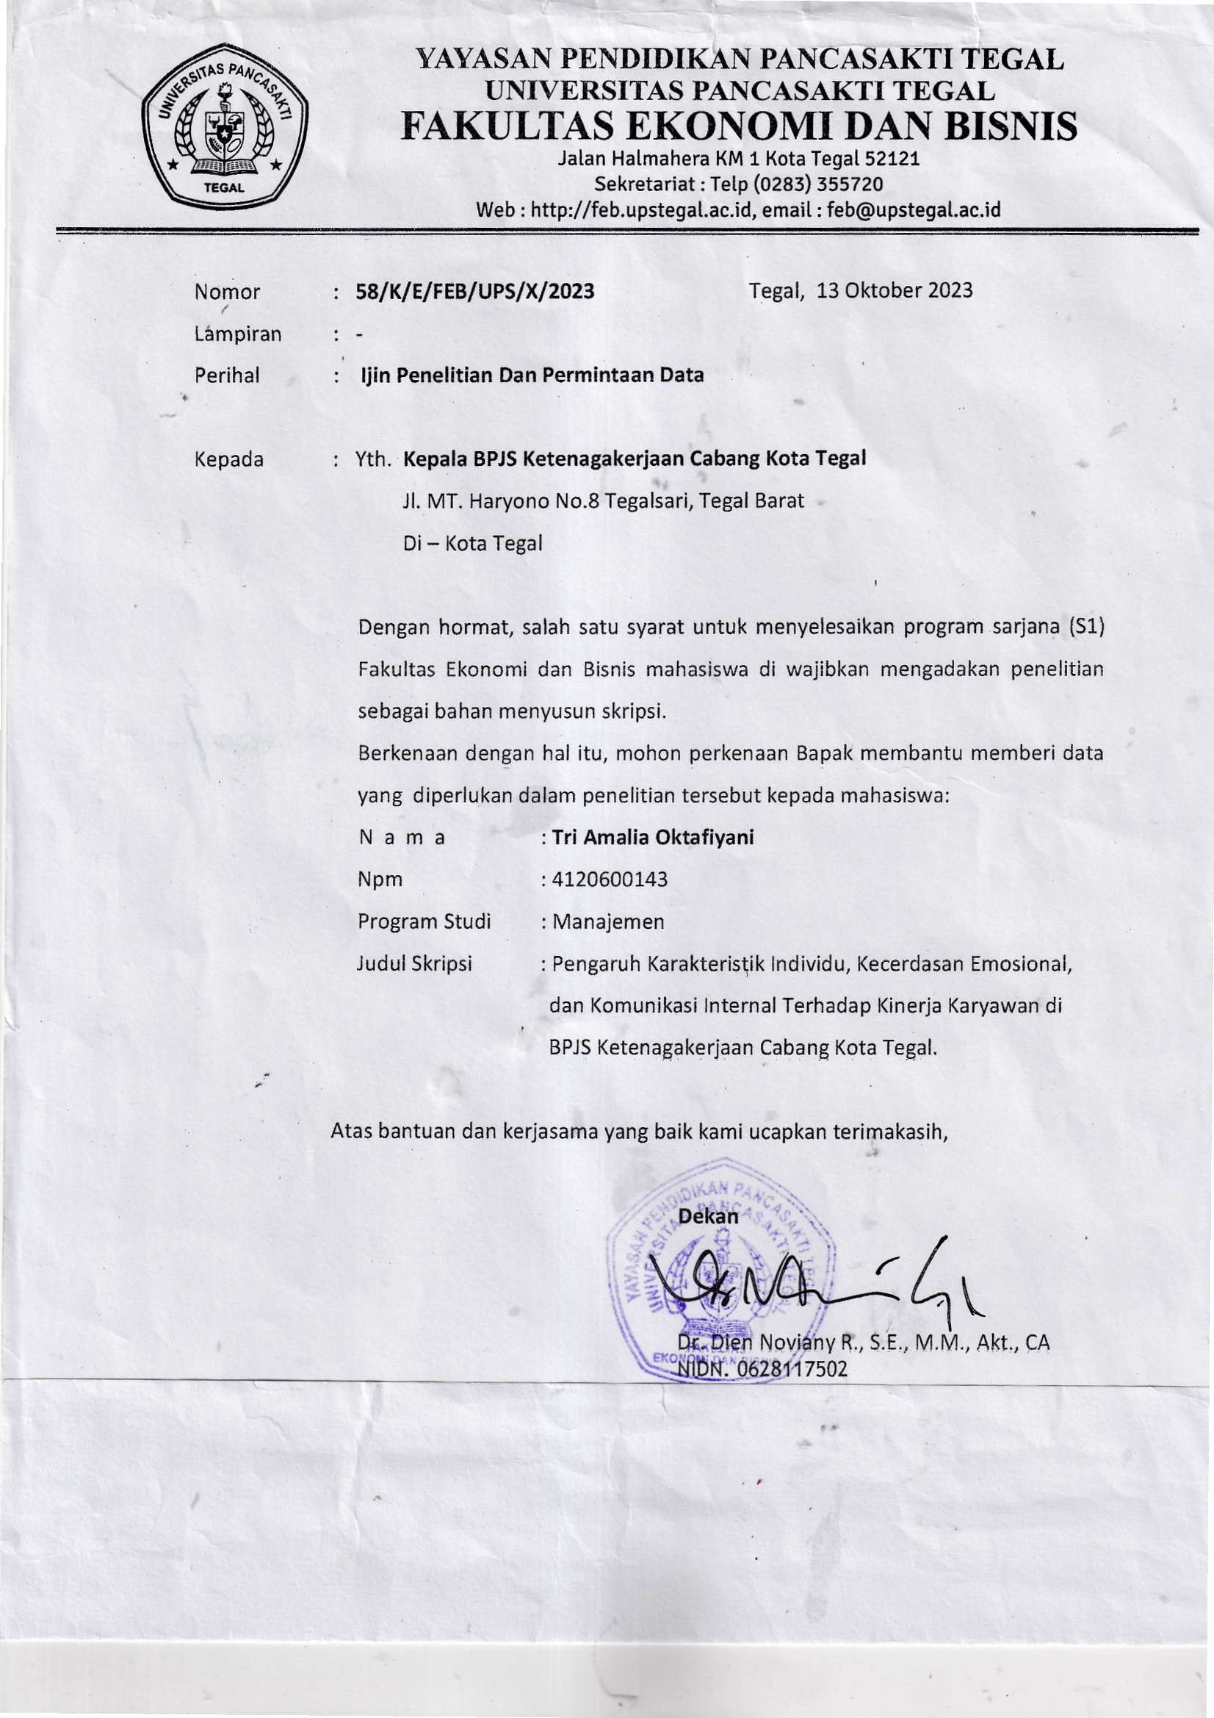

**Lampiran 2**

**Surat Balasan Ijin Penelitian BPJS Ketenagakerjaan Cabang Kota Tegal**

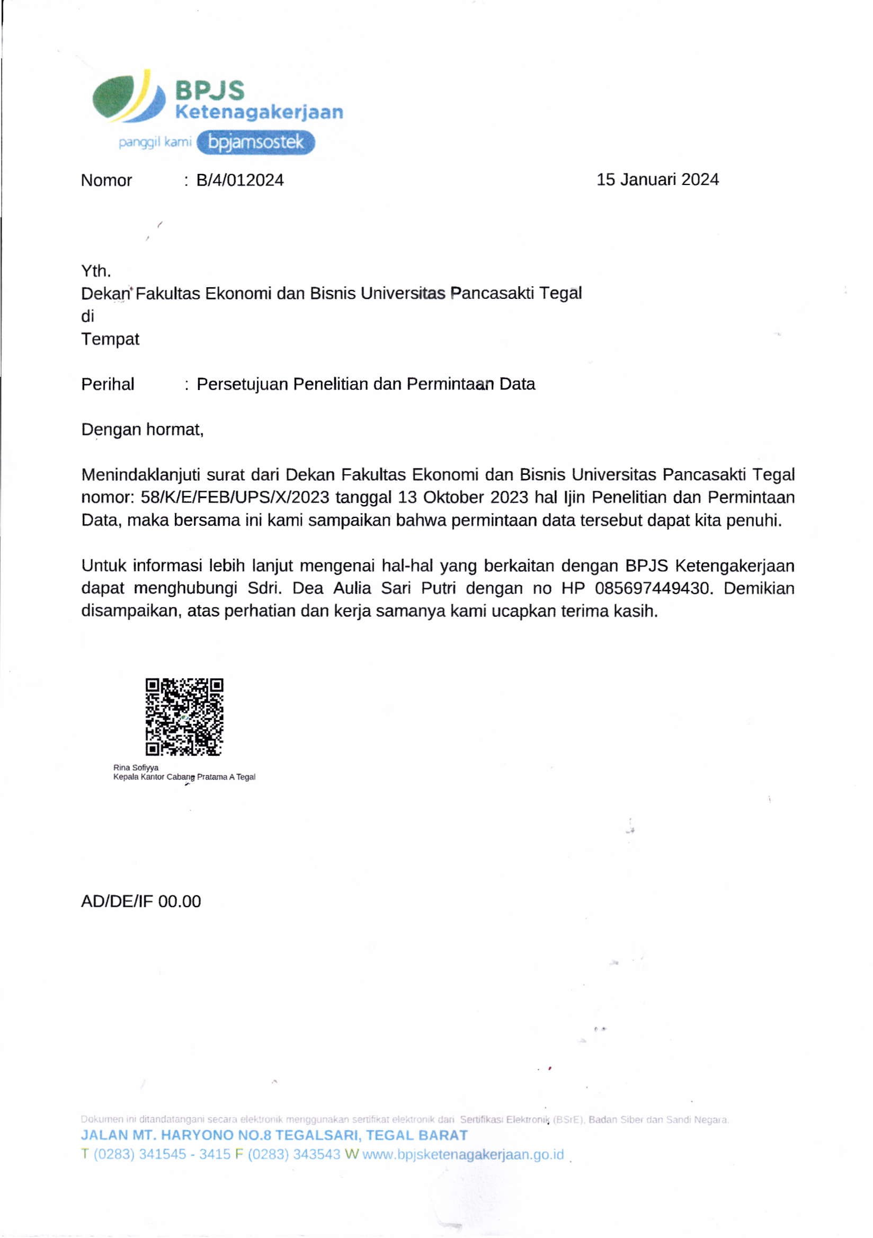

**Lampiran 3**

**Data Penilaian Kinerja Karyawan BPJS Ketenagakerjaan Cabang Kota Tegal Pada Tahun 2021-2022**

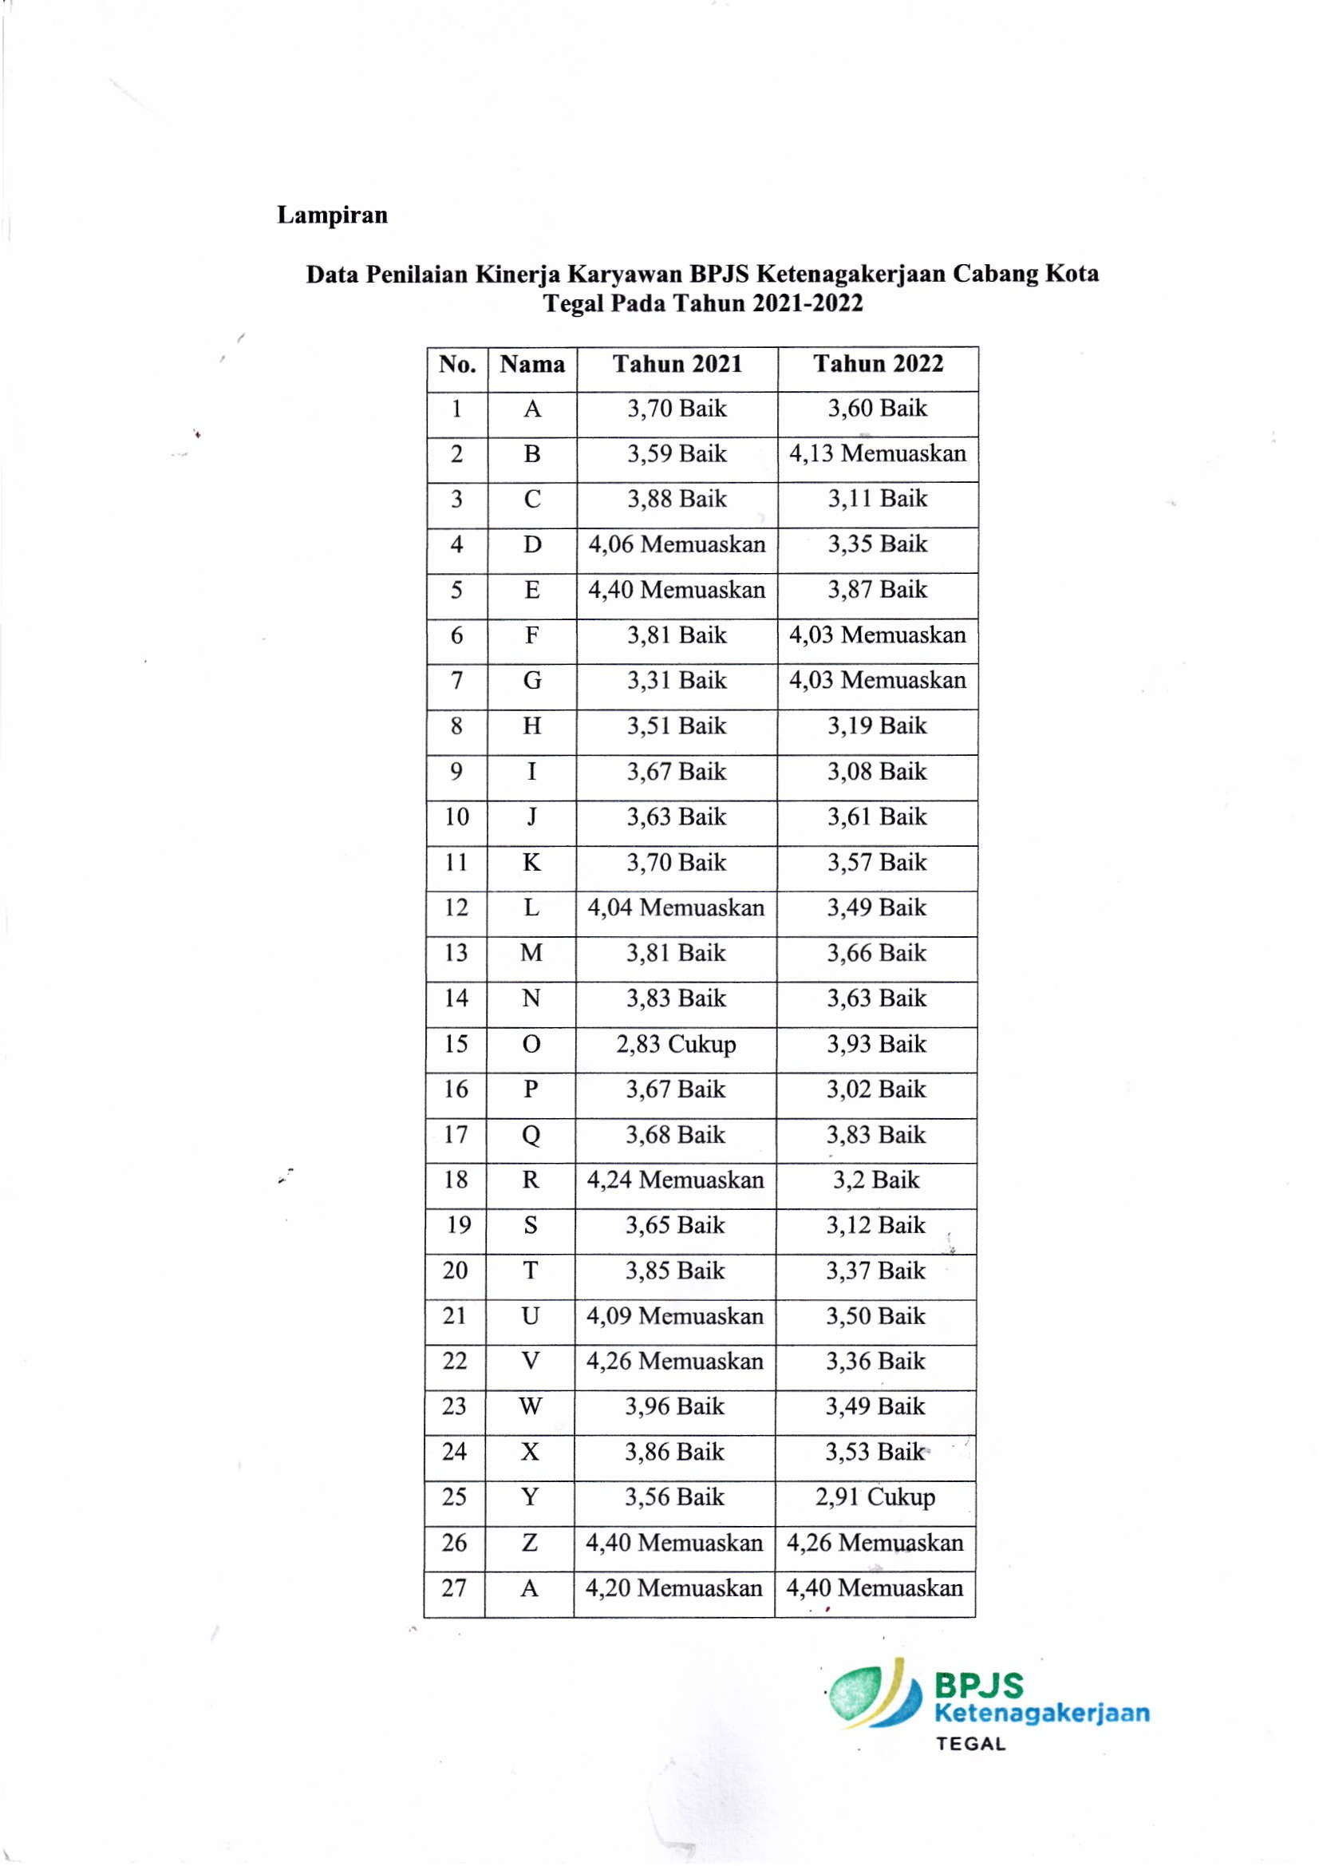

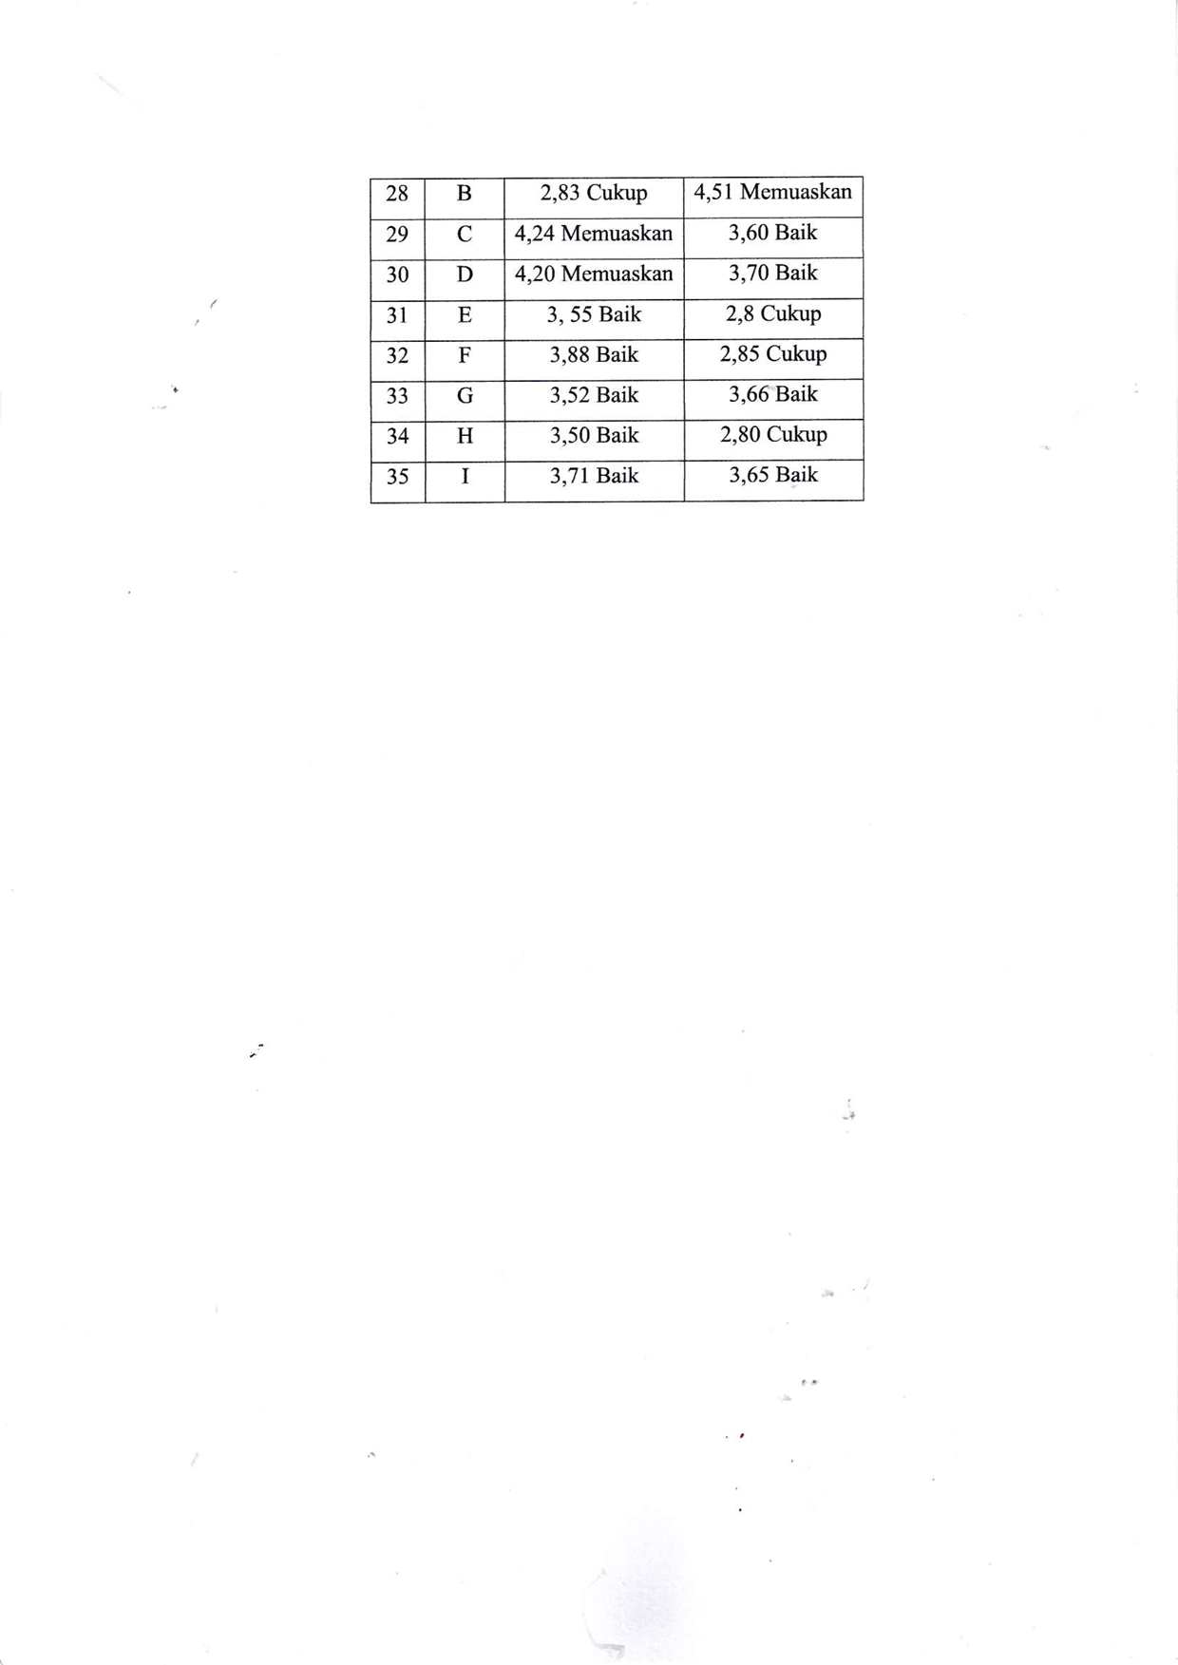

**Lampiran 4**

**Deskripsi Wawancara Kabid. BPJS Ketenagakerjaan Cabang Kota Tegal**

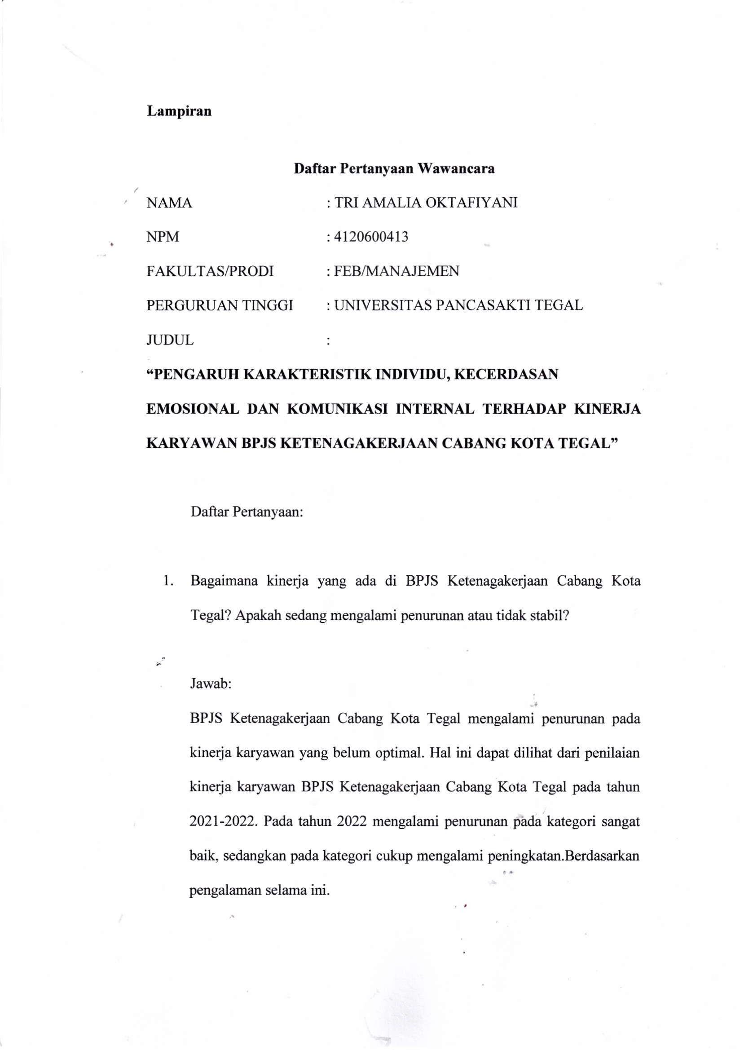

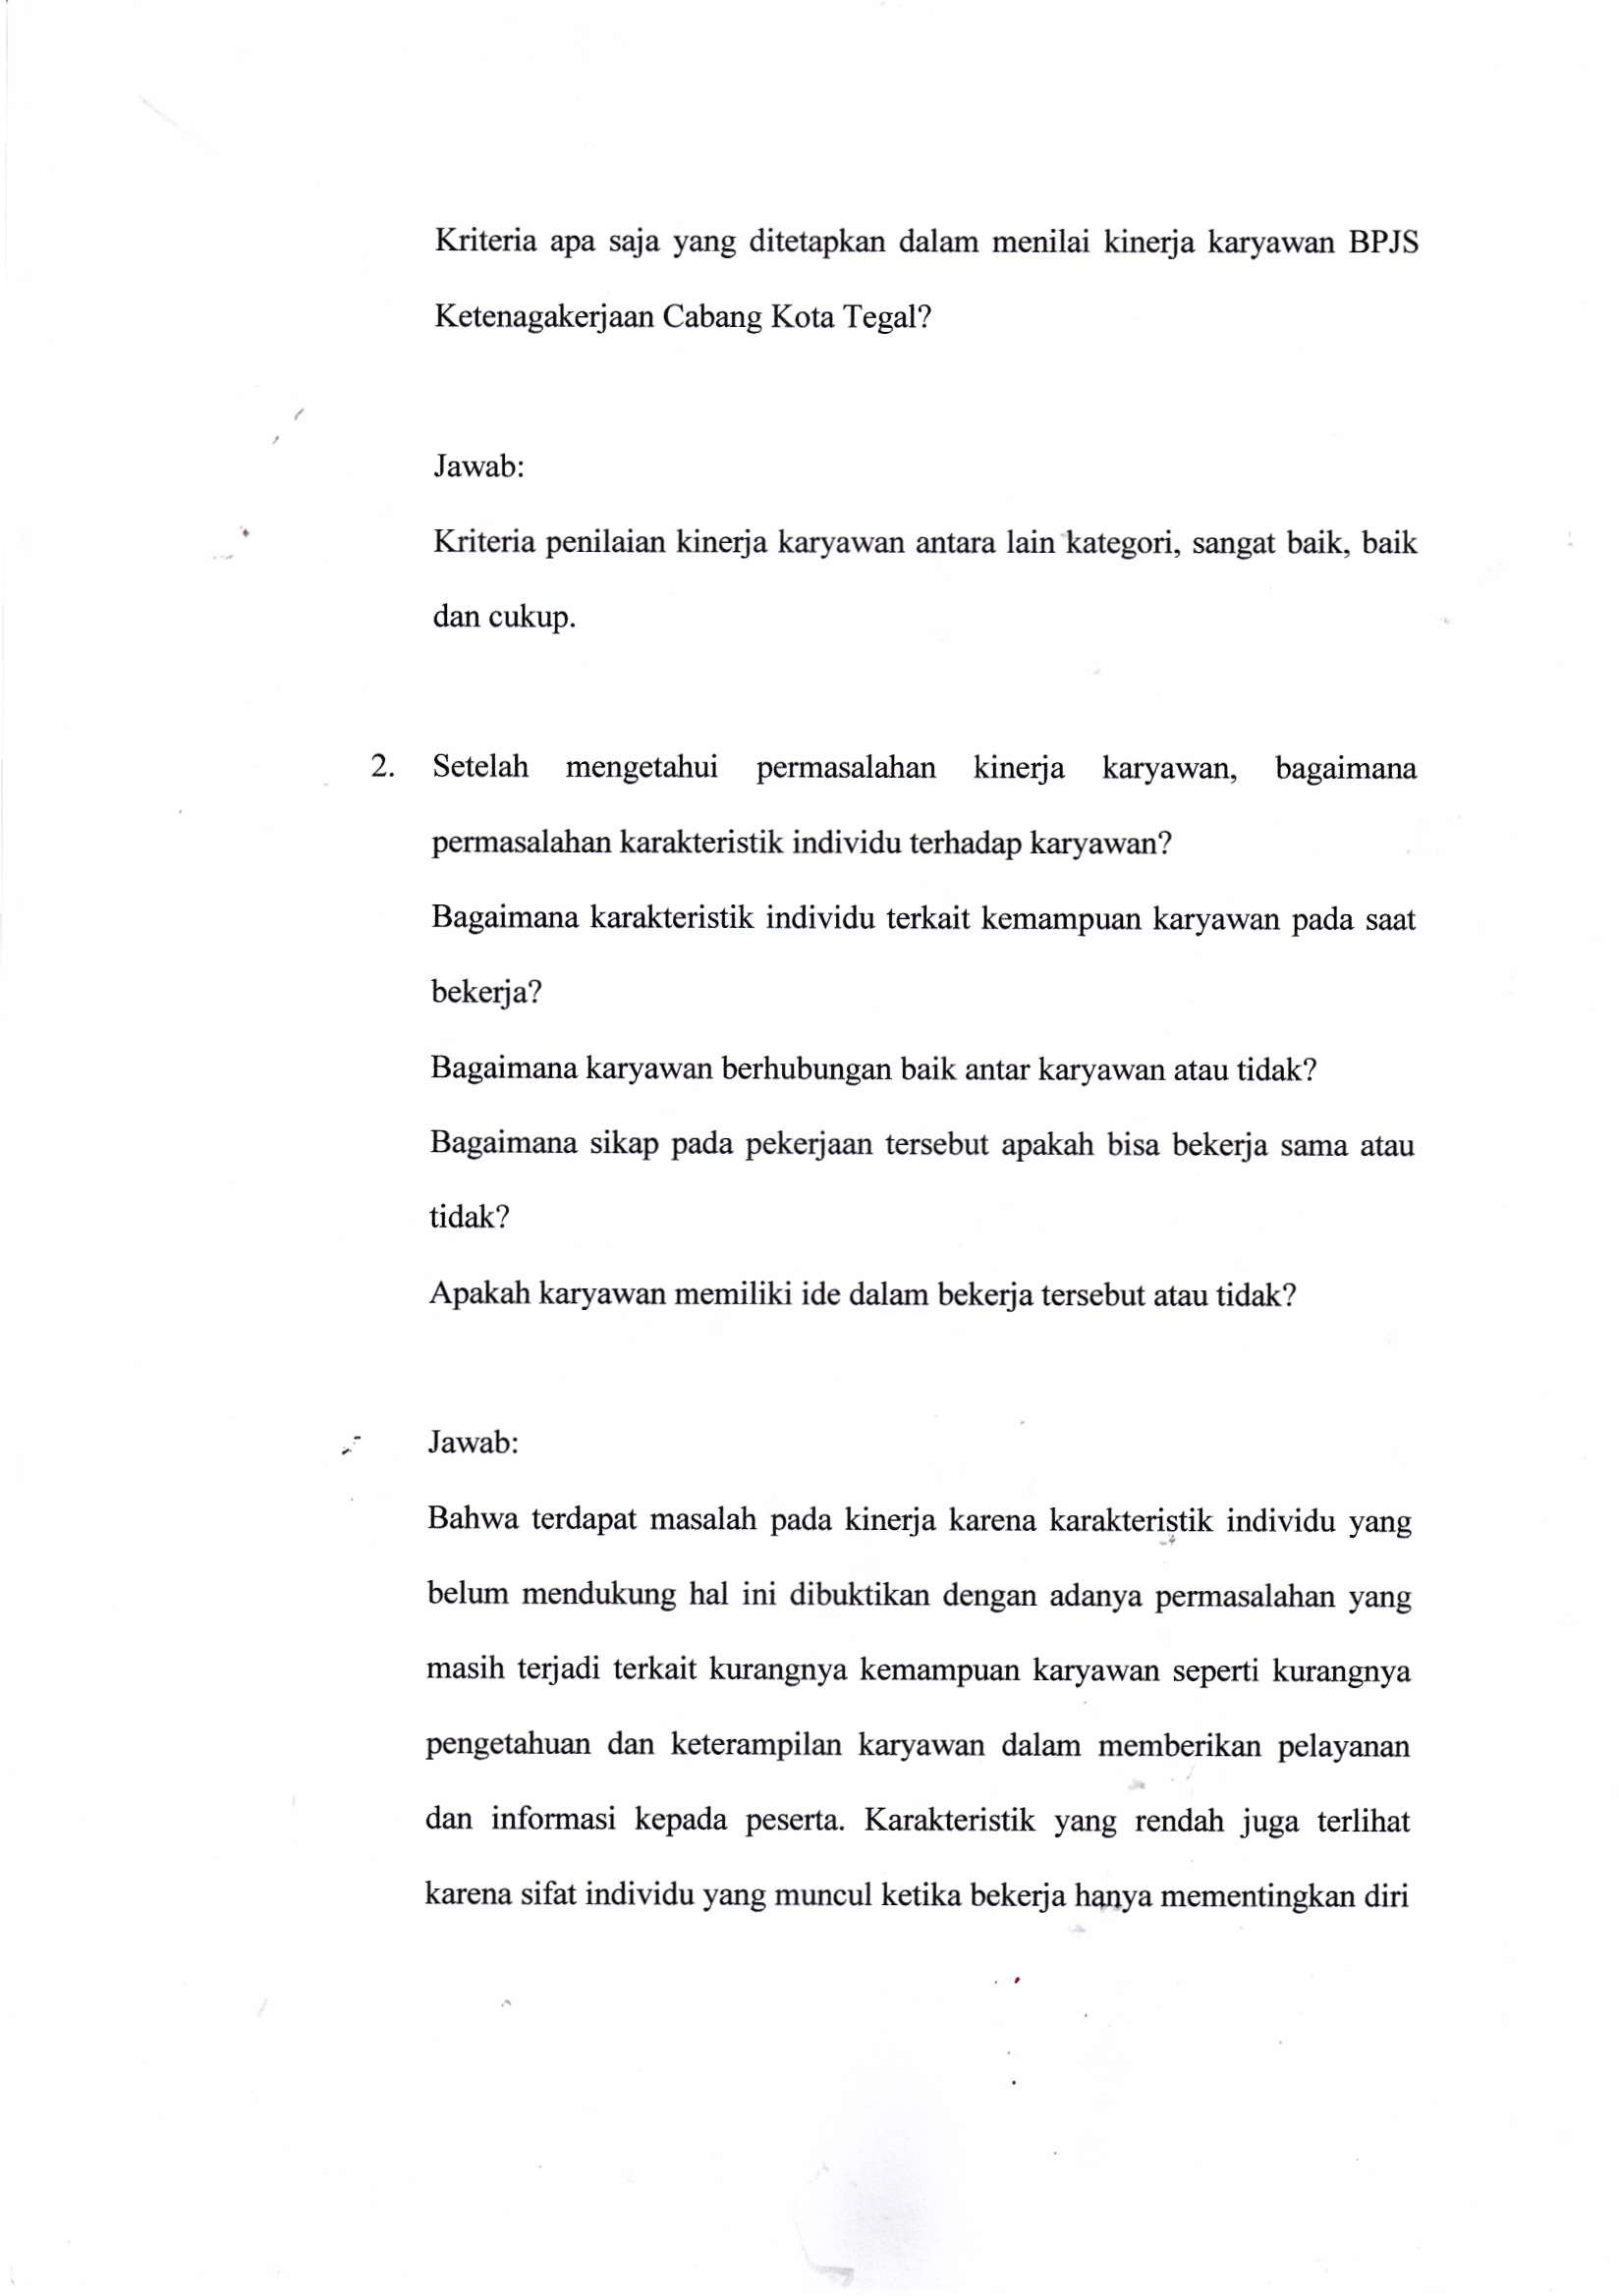

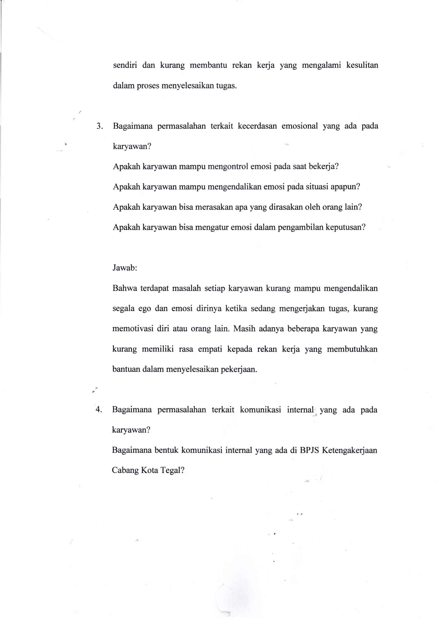

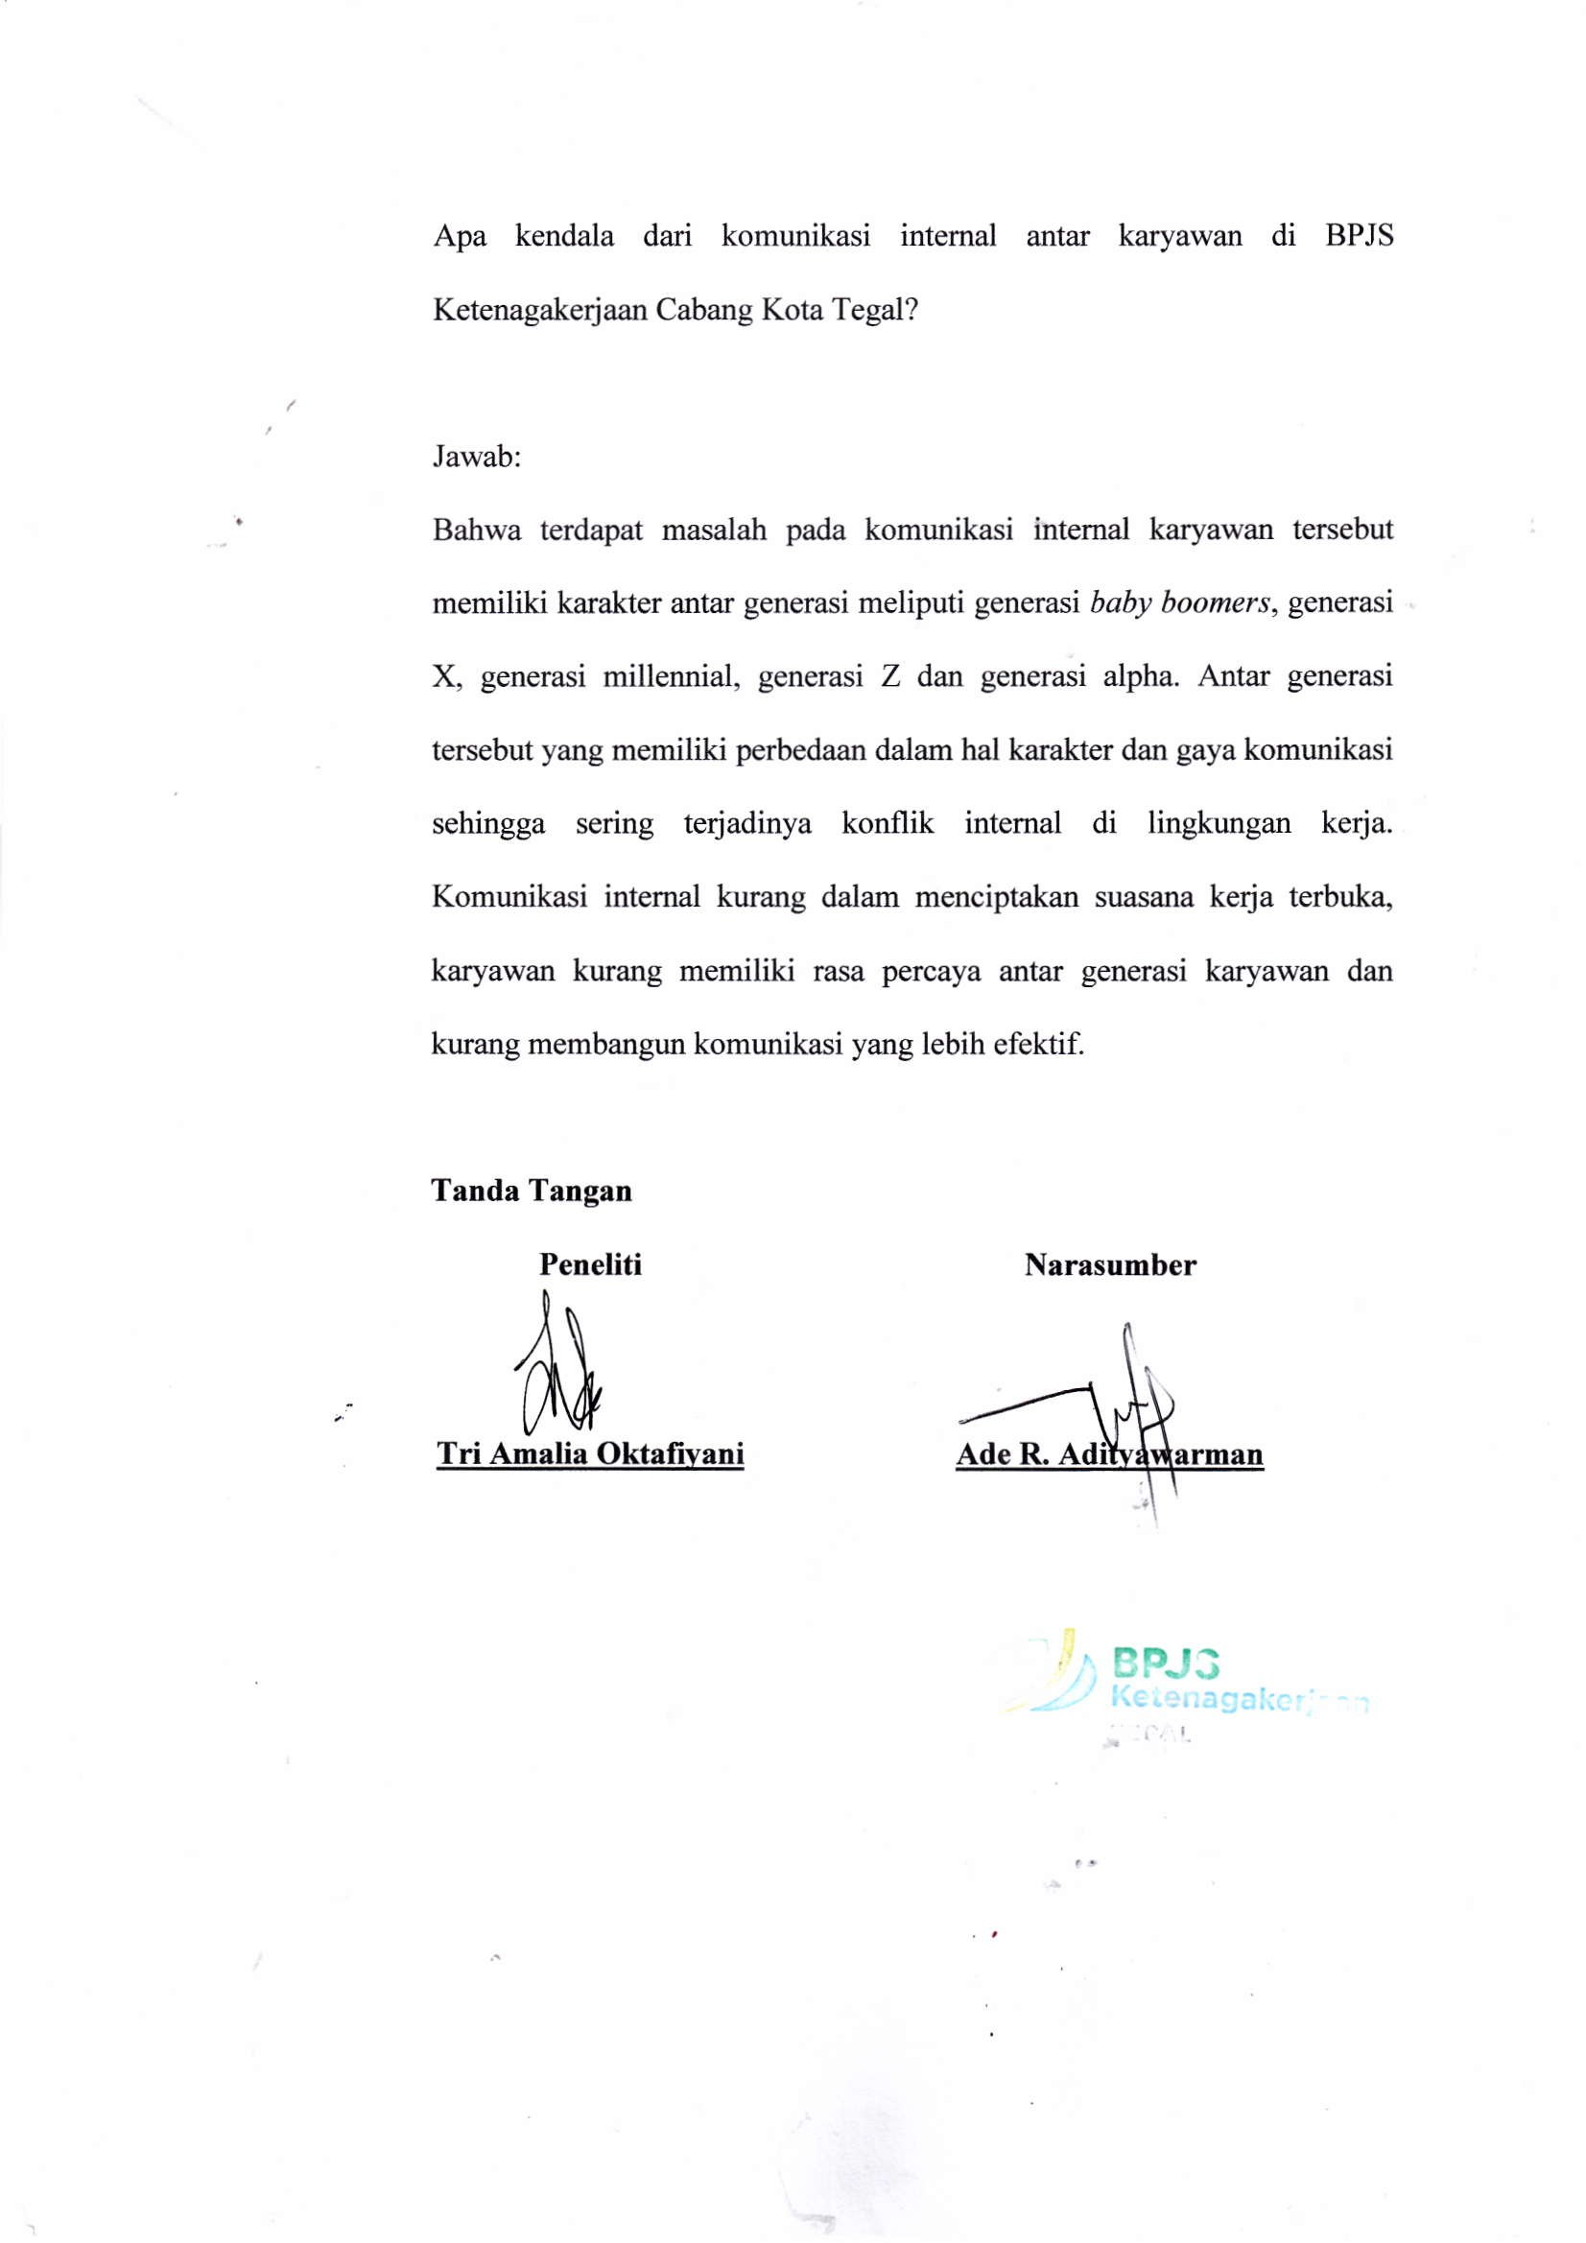

**Lampiran 5**

**Indikator Penilaian Kinerja Karyawan BPJS Ketenagkerjaan Cabang Kota Tegal Tahun 2021-2022**

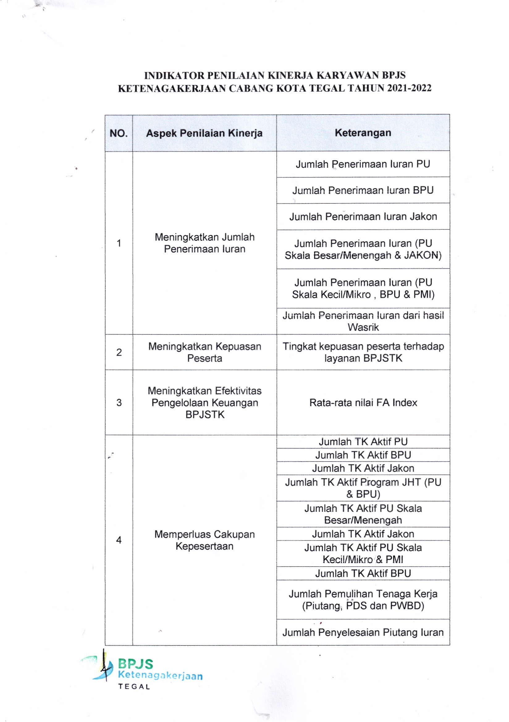

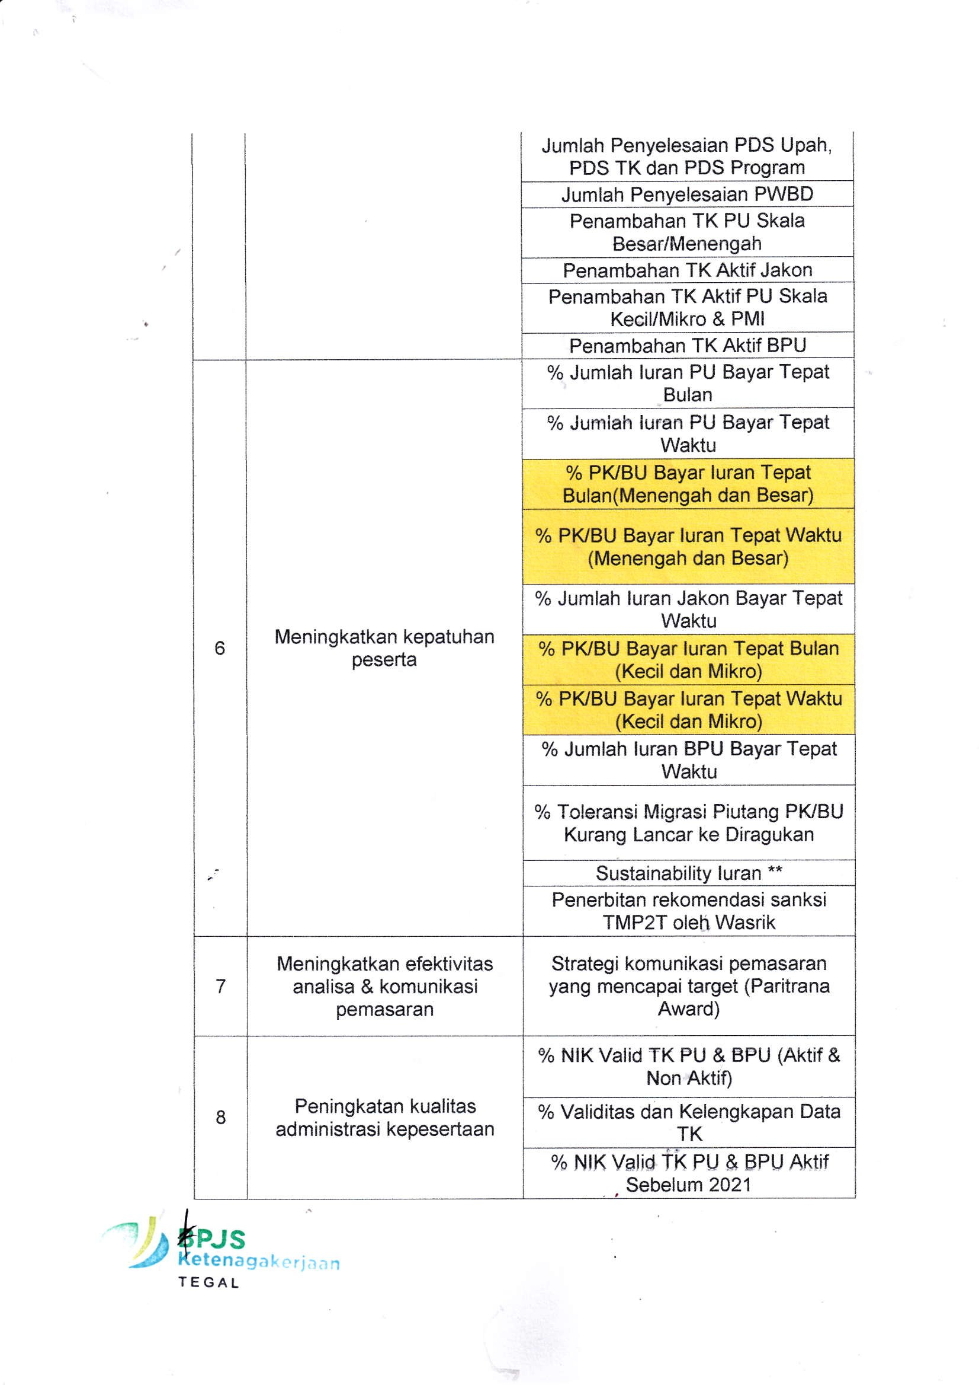

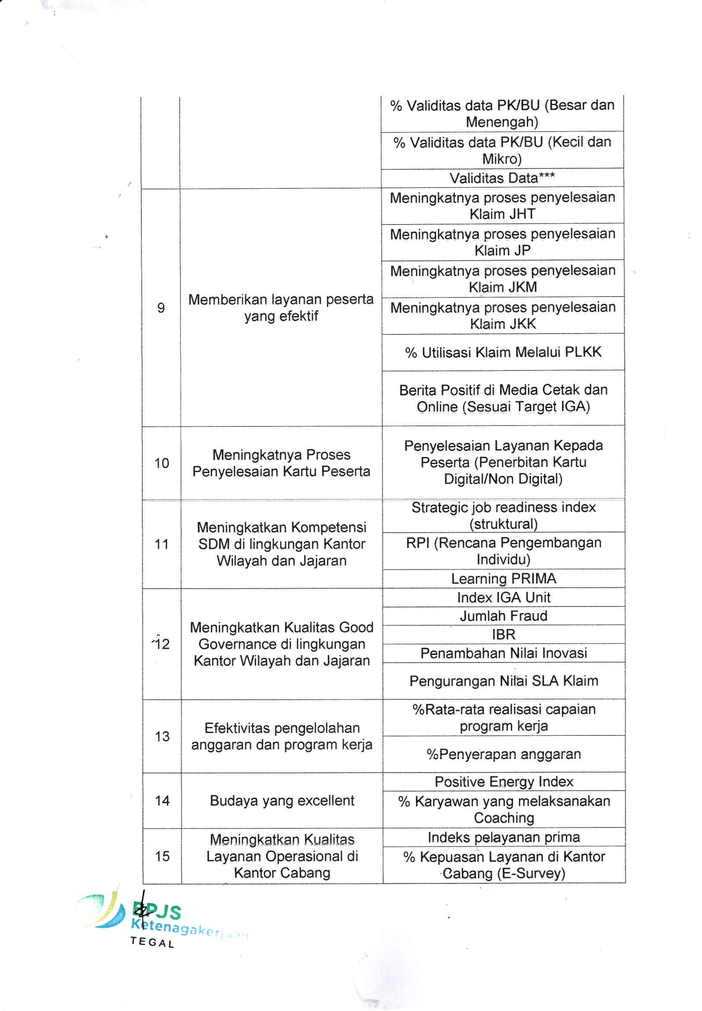

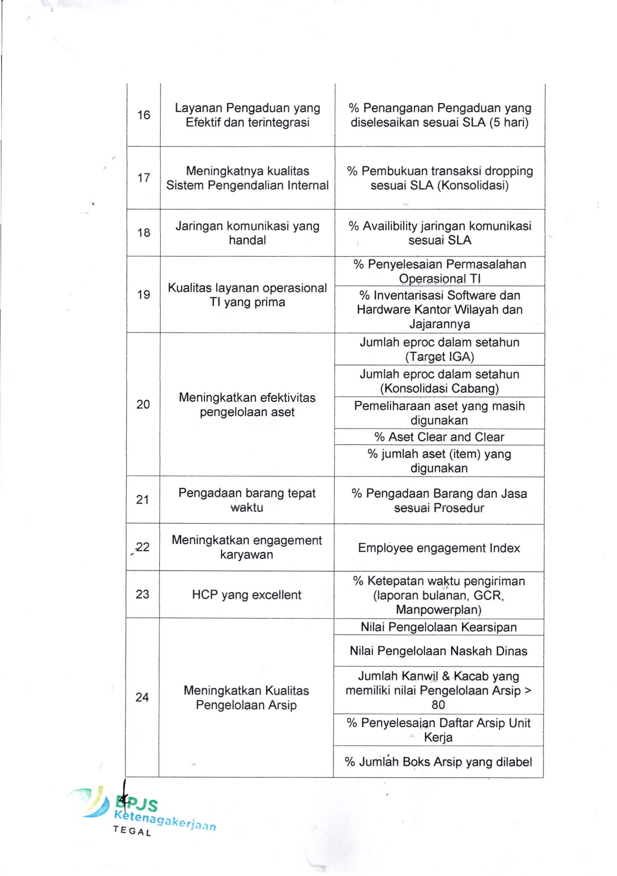

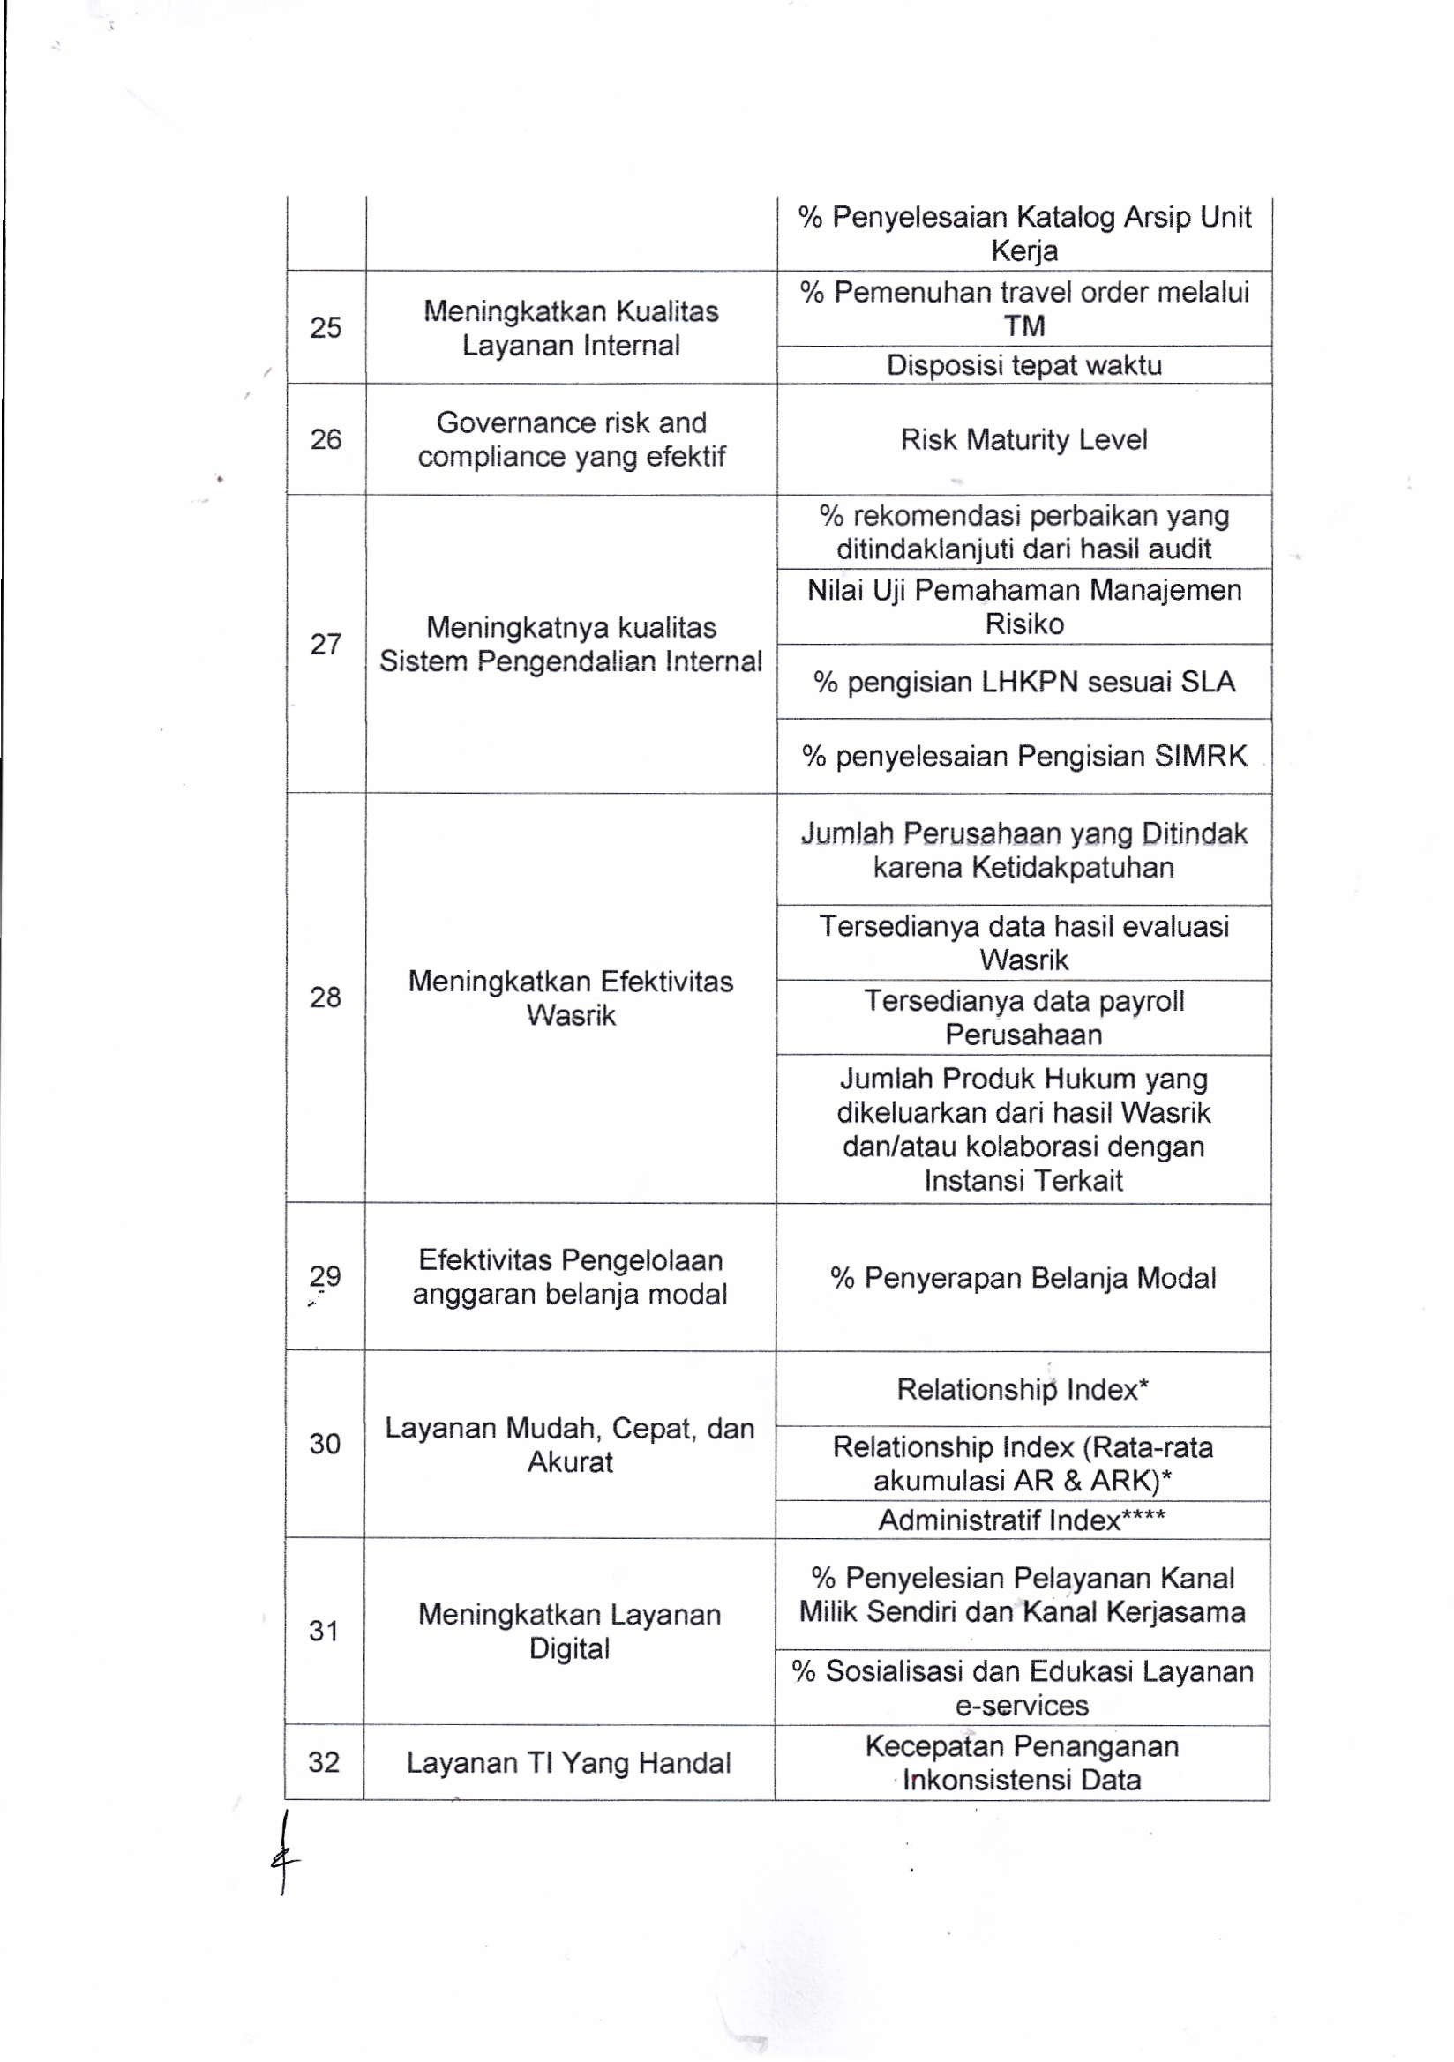

**Lampiran 6**

**Lembar Kuesioner**

**KATA PENGANTAR KUESIONER PENELITIAN**

Kepada

Yth. Bapak/Ibu/Saudara/i

**BPJS Ketenagakerjaan Cabang Kota Tegal**

Dengan hormat,

Dalam rangka penyusunan skripsi untuk menyelesaikan studi jenjang strata 1 (S1) yang berjudul **“Pengaruh Karakteristik Individu, Kecerdasan Emosional dan Komunikasi Internal Terhadap Kinerja Karyawan BPJS Ketenagakerjaan Cabang Kota Tegal”**. Data yang diberikan akan digunakan untuk penelitian skripsi pada Fakultas Ekonomi dan Bisnis Universitas Pancasakti Tegal.

Sehubungan dengan hal tersebut, maka saya mohon bantuan Bapak/Ibu/Saudara/i untuk bersedia mengisi kuesioner ini sesuai dengan keadaan yang dialami dan dirasakan, kami menjamin penuh kerahasiaan informasi yang Bapak/Ibu/Saudara/i berikan.

Atas kerjasamanya dan bersedia untuk meluangkan waktu mengisi kuesioner ini, saya ucapkan banyak terimakasih.

Hormat Saya,

**Tri Amalia Oktafiyani**

**KUESIONER**

**PENGARUH KARAKTERISTIK INDIVIDU, KECERDASAN EMOSIONAL DAN KOMUNIKASI INTERNAL TERHADAP KINERJA KARYAWAN BPJS KETENAGAKERJAAN CABANG KOTA TEGAL**

1. **KARAKTERISTIK RESPONDEN**
2. Jenis Kelamin : a. Laki-laki

b. Perempuan

1. Pendidikan Terakhir : a. SMA/SMK

b. D3

c. S1

d. S2

e. Lainnya

1. Umur : a. 20-30 Tahun

b. 31-41 Tahun

c. 42-52 Tahun

d. > 53 Tahun

1. Lama Bekerja : a. < 1 Tahun

b. 1-5 Tahun

c. 6-10 Tahun

d. >10 Tahun

1. **PETUNJUK PENGISIAN**
2. Mohon dengan hormat dan kesediaan
3. Bapak/Ibu/Sdr untuk menanggapi seluruh pertanyaan yang ada
4. Beri tanda (✓) pada kolom yang tersedia
5. Ada lima alternatif jawaban, yaitu:

|  |  |  |
| --- | --- | --- |
| **No.** | **Jenis Jawaban** | **Bobot** |
| 1 | Sangat Tidak Setuju (STS) | 1 |
| 2 | Tidak Setuju (TS) | 2 |
| 3 | Netral (N) | 3 |
| 4 | Setuju (S) | 4 |
| 5 | Sangat Setuju (SS) | 5 |

1. **Kinerja Karyawan (Y)**

|  |  |  |  |  |  |  |
| --- | --- | --- | --- | --- | --- | --- |
| **NO.** | **PERNYATAAN** | **PENILAIAN** | | | | |
| **SS** | **S** | **N** | **TS** | **STS** |
| **Kualitas** | | | | | | |
| 1. | Saya mempunyai kemampuan yang tinggi dalam bekerja |  |  |  |  |  |
| 2. | Saya mempunyai keterampilan dalam bekerja |  |  |  |  |  |
| 3. | Saya mengerjakan pekerjaan dengan tepat dan sempurna |  |  |  |  |  |
| **Kuantitas** | | | | | | |
| 4. | Saya mampu menghasilkan tugas sesuai dengan harapan organisasi |  |  |  |  |  |
| 5. | Saya menyelesaikan pekerjaan sesuai dengan keinginan atasan |  |  |  |  |  |
| 6. | Saya mengerjakan tugas kerja dengan baik dan teliti |  |  |  |  |  |
| **Ketepatan Waktu** | | | | | | |
| 7. | Saya bekerja sesuai dengan target organisasi |  |  |  |  |  |
| 8. | Saya menyelesaikan tugas sesuai prosedur kerja dengan tepat waktu |  |  |  |  |  |
| **Efektivitas** | | | | | | |
| 9. | Saya memanfaatkan sumber daya yang ada dalam pekerjaan |  |  |  |  |  |
| 10. | Saya mempunyai kemampuan dalam menggunakan teknologi yang ada di organisasi |  |  |  |  |  |

1. **Karakteristik Individu (X1)**

|  |  |  |  |  |  |  |
| --- | --- | --- | --- | --- | --- | --- |
| **NO.** | **PERNYATAAN** | **PENILAIAN** | | | | |
| **SS** | **S** | **N** | **TS** | **STS** |
| **Kemampuan** | | | | | | |
| 1. | Saya memiliki keterampilan yang cukup untuk menyelesaikan pekerjaan |  |  |  |  |  |
| 2. | Saya dapat mengembangkan keterampilan yang berhubungan dengan pekerjaan |  |  |  |  |  |
| **Nilai** | | | | | | |
| 3. | Saya berusaha agar pekerjaan yang dilakukan memuaskan |  |  |  |  |  |
| 4. | Saya mempunyai hubungan baik dengan rekan kerja |  |  |  |  |  |
| 5. | Saya memiliki kapasitas intelektual yang dibutuhkan organisasi |  |  |  |  |  |
| **Sikap** | | | | | | |
| 6. | Saya merasa tertantang untuk menyelesaikan pekerjaan dengan baik |  |  |  |  |  |
| 7. | Saya memiliki kemampuan bekerja dalam kelompok atau tim kerja |  |  |  |  |  |
| 8. | Saya selalu menjaga nama baik organisasi |  |  |  |  |  |
| **Minat** | | | | | | |
| 9. | Saya menyukai pekerjaan yang diberikan oleh organisasi |  |  |  |  |  |
| 10. | Saya memiliki ide dalam menyelesaikan pekerjaan dengan cepat |  |  |  |  |  |

1. **Kecerdasan Emosional (X2)**

|  |  |  |  |  |  |  |
| --- | --- | --- | --- | --- | --- | --- |
| **NO.** | **PERNYATAAN** | **PENILAIAN** | | | | |
| **SS** | **S** | **N** | **TS** | **STS** |
| **Kesadaran Diri** | | | | | | |
| 1. | Saya dapat mengontrol emosi serta mengetahui kelebihan dan kekurangan yang dimiliki |  |  |  |  |  |
| 2. | Saya mempunyai kemampuan untuk mendapatkan apa yang diinginkan |  |  |  |  |  |
| **Penguasaan diri** | | | | | | |
| 3. | Saya memiliki kemampuan mengelola dan mengendalikan emosi dalam situasi apapun |  |  |  |  |  |
| 4. | Saya mampu menanggapi kritik dan saran secara efektif |  |  |  |  |  |
| **Motivasi Diri** | | | | | | |
| 5. | Saya mampu memotivasi diri sendiri untuk meningkatkan kinerja |  |  |  |  |  |
| 6. | Saya dapat mengelola emosi sehingga mendapatkan hasil keputusan |  |  |  |  |  |
| **Empati** | | | | | | |
| 7. | Saya bisa merasakan apa yang dirasakan oleh orang lain |  |  |  |  |  |
| 8. | Saya selalu memberikan informasi terkait pekerjaan yang sudah dilakukan |  |  |  |  |  |
| **Keterampilan sosial** | | | | | | |
| 9. | Saya memiliki kemampuan yang baik dalam hubungan sosial |  |  |  |  |  |
| 10. | Saya selalu menjaga suasana kondusif di tempat kerja |  |  |  |  |  |
| 11. | Saya selalu melihat hal positif didalam segala situasi di tempat kerja |  |  |  |  |  |

1. **Komunikasi Internal (X3)**

|  |  |  |  |  |  |  |
| --- | --- | --- | --- | --- | --- | --- |
| **NO.** | **PERNYATAAN** | **PENILAIAN** | | | | |
| **SS** | **S** | **N** | **TS** | **STS** |
| **Komunikasi ke atas** | | | | | | |
| 1. | Pimpinan memberikan instruksi kepada bawahan dengan jelas |  |  |  |  |  |
| 2. | Pimpinan memberikan informasi kebijakan kepada bawahan dengan jelas |  |  |  |  |  |
| 3. | Pimpinan memberikan penjelasan mengenai tugas yang diberikan kepada bawahan dengan jelas |  |  |  |  |  |
| **Komunikasi ke bawah** | | | | | | |
| 4. | Bawahan rutin memberikan laporan kepada pimpinan |  |  |  |  |  |
| 5. | Bawahan terbuka dalam memberikan saran kepada pimpinan |  |  |  |  |  |
| 6. | Bawahan memberikan pengaduan kepada pimpinan ketika ada permasalahan didalam organisasi |  |  |  |  |  |
| **Komunikasi Horizontal** | | | | | | |
| 7. | Antar karyawan berinteraksi dengan baik dalam bekerja |  |  |  |  |  |
| 8. | Antar karyawan menyampaikan informasi dengan jelas |  |  |  |  |  |
| 9. | Antar karyawan memberikan saran untuk memecahkan permasalahan dalam bekerja |  |  |  |  |  |
| **Komunikasi Diagonal** | | | | | | |
| 10. | Terdapat komunikasi yang baik antar karyawan dan pimpinan pada divisi yang berbeda |  |  |  |  |  |
| 11. | Jika ada kendala dalam pekerjaan, karyawan selalu meminta respon terhadap divisi yang berbeda atau dengan pimpinan |  |  |  |  |  |

**Lampiran 7**

**Data Penelitian Non Responden Variabel Kinerja (Y)**



**Lampiran 8**

**Data Penelitian Non Responden Variabel Karakteristik Individu (X1)**



**Lampiran 9**

**Data Penelitian Non Responden Variabel Kecerdasan Emosional (X2)**



**Lampiran 10**

**Data Penelitian Non Responden Variabel Komunikasi Internal (X3)**



**Lampiran 11**

**Transformasi Data Method of Successive Interval (MSI) Non Responden Variabel Kinerja (Y)**



**Lampiran 12**

**Transformasi Data Method of Successive Interval (MSI) Non Responden Variabel Karakteristik Individu (X1)**



**Lampiran 13**

**Transformasi Data Method of Successive Interval (MSI) Non Responden Variabel Kecerdasan Emosional (X2)**



**Lampiran 14**

**Transformasi Data Method of Successive Interval (MSI) Non Responden Variabel Komunikasi Internal (X3)**



**Lampiran 15**

**Hasil Uji Validitas Variabel Kinerja (Y)**

|  |  |  |  |  |  |  |  |  |  |  |  |  |
| --- | --- | --- | --- | --- | --- | --- | --- | --- | --- | --- | --- | --- |
| **Correlations** | | | | | | | | | | | | |
|  | | Y1 | Y2 | Y3 | Y4 | Y5 | Y6 | Y7 | Y8 | Y9 | Y10 | TOTAL_Y |
| Y1 | Pearson Correlation | 1 | .551** | .714** | .221 | .054 | .485** | .257 | .414* | .479** | .309 | .625** |
| Sig. (2-tailed) |  | .002 | .000 | .240 | .777 | .007 | .170 | .023 | .007 | .096 | .000 |
| N | 30 | 30 | 30 | 30 | 30 | 30 | 30 | 30 | 30 | 30 | 30 |
| Y2 | Pearson Correlation | .551** | 1 | .719** | .482** | .400* | .453* | .391* | .413* | .429* | .195 | .724** |
| Sig. (2-tailed) | .002 |  | .000 | .007 | .028 | .012 | .033 | .023 | .018 | .301 | .000 |
| N | 30 | 30 | 30 | 30 | 30 | 30 | 30 | 30 | 30 | 30 | 30 |
| Y3 | Pearson Correlation | .714** | .719** | 1 | .467** | .292 | .700** | .407* | .507** | .668** | .283 | .814** |
| Sig. (2-tailed) | .000 | .000 |  | .009 | .118 | .000 | .026 | .004 | .000 | .129 | .000 |
| N | 30 | 30 | 30 | 30 | 30 | 30 | 30 | 30 | 30 | 30 | 30 |
| Y4 | Pearson Correlation | .221 | .482** | .467** | 1 | .597** | .424* | .465** | .440* | .475** | .313 | .716** |
| Sig. (2-tailed) | .240 | .007 | .009 |  | .000 | .020 | .010 | .015 | .008 | .092 | .000 |
| N | 30 | 30 | 30 | 30 | 30 | 30 | 30 | 30 | 30 | 30 | 30 |
| Y5 | Pearson Correlation | .054 | .400* | .292 | .597** | 1 | .235 | .348 | .347 | .182 | .422* | .579** |
| Sig. (2-tailed) | .777 | .028 | .118 | .000 |  | .212 | .059 | .060 | .335 | .020 | .001 |
| N | 30 | 30 | 30 | 30 | 30 | 30 | 30 | 30 | 30 | 30 | 30 |
| Y6 | Pearson Correlation | .485** | .453* | .700** | .424* | .235 | 1 | .331 | .503** | .540** | .146 | .667** |
| Sig. (2-tailed) | .007 | .012 | .000 | .020 | .212 |  | .074 | .005 | .002 | .442 | .000 |
| N | 30 | 30 | 30 | 30 | 30 | 30 | 30 | 30 | 30 | 30 | 30 |
| Y7 | Pearson Correlation | .257 | .391* | .407* | .465** | .348 | .331 | 1 | .804** | .553** | .442* | .707** |
| Sig. (2-tailed) | .170 | .033 | .026 | .010 | .059 | .074 |  | .000 | .002 | .014 | .000 |
| N | 30 | 30 | 30 | 30 | 30 | 30 | 30 | 30 | 30 | 30 | 30 |
| Y8 | Pearson Correlation | .414* | .413* | .507** | .440* | .347 | .503** | .804** | 1 | .741** | .517** | .801** |
| Sig. (2-tailed) | .023 | .023 | .004 | .015 | .060 | .005 | .000 |  | .000 | .003 | .000 |
| N | 30 | 30 | 30 | 30 | 30 | 30 | 30 | 30 | 30 | 30 | 30 |
| Y9 | Pearson Correlation | .479** | .429* | .668** | .475** | .182 | .540** | .553** | .741** | 1 | .535** | .788** |
| Sig. (2-tailed) | .007 | .018 | .000 | .008 | .335 | .002 | .002 | .000 |  | .002 | .000 |
| N | 30 | 30 | 30 | 30 | 30 | 30 | 30 | 30 | 30 | 30 | 30 |
| Y10 | Pearson Correlation | .309 | .195 | .283 | .313 | .422* | .146 | .442* | .517** | .535** | 1 | .595** |
| Sig. (2-tailed) | .096 | .301 | .129 | .092 | .020 | .442 | .014 | .003 | .002 |  | .001 |
| N | 30 | 30 | 30 | 30 | 30 | 30 | 30 | 30 | 30 | 30 | 30 |
| TOTAL_Y | Pearson Correlation | .625** | .724** | .814** | .716** | .579** | .667** | .707** | .801** | .788** | .595** | 1 |
| Sig. (2-tailed) | .000 | .000 | .000 | .000 | .001 | .000 | .000 | .000 | .000 | .001 |  |
| N | 30 | 30 | 30 | 30 | 30 | 30 | 30 | 30 | 30 | 30 | 30 |
| **. Correlation is significant at the 0.01 level (2-tailed). | | | | | | | | | | | | |
| *. Correlation is significant at the 0.05 level (2-tailed). | | | | | | | | | | | | |

**Lampiran 16**

**Hasil Uji Validitas Variabel Karakteristik Individu (X1)**

|  |  |  |  |  |  |  |  |  |  |  |  |  |
| --- | --- | --- | --- | --- | --- | --- | --- | --- | --- | --- | --- | --- |
| **Correlations** | | | | | | | | | | | | |
|  | | X1.1 | X1.2 | X1.3 | X1.4 | X1.5 | X1.6 | X1.7 | X1.8 | X1.9 | X1.10 | TOTAL_X1 |
| X1.1 | Pearson Correlation | 1 | .422* | .395* | .121 | .460* | .608** | .289 | .572** | .748** | .614** | .816** |
| Sig. (2-tailed) |  | .020 | .031 | .523 | .011 | .000 | .121 | .001 | .000 | .000 | .000 |
| N | 30 | 30 | 30 | 30 | 30 | 30 | 30 | 30 | 30 | 30 | 30 |
| X1.2 | Pearson Correlation | .422* | 1 | .419* | .012 | .255 | .520** | .134 | .387* | .294 | .063 | .534** |
| Sig. (2-tailed) | .020 |  | .021 | .951 | .173 | .003 | .480 | .035 | .114 | .743 | .002 |
| N | 30 | 30 | 30 | 30 | 30 | 30 | 30 | 30 | 30 | 30 | 30 |
| X1.3 | Pearson Correlation | .395* | .419* | 1 | .401* | .105 | .367* | .440* | .466** | .174 | .133 | .582** |
| Sig. (2-tailed) | .031 | .021 |  | .028 | .581 | .046 | .015 | .009 | .358 | .484 | .001 |
| N | 30 | 30 | 30 | 30 | 30 | 30 | 30 | 30 | 30 | 30 | 30 |
| X1.4 | Pearson Correlation | .121 | .012 | .401* | 1 | .274 | .123 | .183 | -.015 | -.041 | .322 | .395* |
| Sig. (2-tailed) | .523 | .951 | .028 |  | .142 | .517 | .333 | .939 | .829 | .083 | .031 |
| N | 30 | 30 | 30 | 30 | 30 | 30 | 30 | 30 | 30 | 30 | 30 |
| X1.5 | Pearson Correlation | .460* | .255 | .105 | .274 | 1 | .066 | .194 | .047 | .212 | .285 | .477** |
| Sig. (2-tailed) | .011 | .173 | .581 | .142 |  | .727 | .304 | .805 | .261 | .127 | .008 |
| N | 30 | 30 | 30 | 30 | 30 | 30 | 30 | 30 | 30 | 30 | 30 |
| X1.6 | Pearson Correlation | .608** | .520** | .367* | .123 | .066 | 1 | .425* | .716** | .512** | .497** | .762** |
| Sig. (2-tailed) | .000 | .003 | .046 | .517 | .727 |  | .019 | .000 | .004 | .005 | .000 |
| N | 30 | 30 | 30 | 30 | 30 | 30 | 30 | 30 | 30 | 30 | 30 |
| X1.7 | Pearson Correlation | .289 | .134 | .440* | .183 | .194 | .425* | 1 | .500** | .348 | .369* | .631** |
| Sig. (2-tailed) | .121 | .480 | .015 | .333 | .304 | .019 |  | .005 | .060 | .045 | .000 |
| N | 30 | 30 | 30 | 30 | 30 | 30 | 30 | 30 | 30 | 30 | 30 |
| X1.8 | Pearson Correlation | .572** | .387* | .466** | -.015 | .047 | .716** | .500** | 1 | .557** | .283 | .689** |
| Sig. (2-tailed) | .001 | .035 | .009 | .939 | .805 | .000 | .005 |  | .001 | .130 | .000 |
| N | 30 | 30 | 30 | 30 | 30 | 30 | 30 | 30 | 30 | 30 | 30 |
| X1.9 | Pearson Correlation | .748** | .294 | .174 | -.041 | .212 | .512** | .348 | .557** | 1 | .694** | .714** |
| Sig. (2-tailed) | .000 | .114 | .358 | .829 | .261 | .004 | .060 | .001 |  | .000 | .000 |
| N | 30 | 30 | 30 | 30 | 30 | 30 | 30 | 30 | 30 | 30 | 30 |
| X1.10 | Pearson Correlation | .614** | .063 | .133 | .322 | .285 | .497** | .369* | .283 | .694** | 1 | .703** |
| Sig. (2-tailed) | .000 | .743 | .484 | .083 | .127 | .005 | .045 | .130 | .000 |  | .000 |
| N | 30 | 30 | 30 | 30 | 30 | 30 | 30 | 30 | 30 | 30 | 30 |
| TOTAL_X1 | Pearson Correlation | .816** | .534** | .582** | .395* | .477** | .762** | .631** | .689** | .714** | .703** | 1 |
| Sig. (2-tailed) | .000 | .002 | .001 | .031 | .008 | .000 | .000 | .000 | .000 | .000 |  |
| N | 30 | 30 | 30 | 30 | 30 | 30 | 30 | 30 | 30 | 30 | 30 |
| *. Correlation is significant at the 0.05 level (2-tailed). | | | | | | | | | | | | |
| **. Correlation is significant at the 0.01 level (2-tailed). | | | | | | | | | | | | |

**Lampiran 17**

**Hasil Uji Validitas Variabel Kecerdasan Emosional (X2)**

|  |  |  |  |  |  |  |  |  |  |  |  |  |  |
| --- | --- | --- | --- | --- | --- | --- | --- | --- | --- | --- | --- | --- | --- |
| **Correlations** | | | | | | | | | | | | | |
|  | | X2.1 | X2.2 | X2.3 | X2.4 | X2.5 | X2.6 | X2.7 | X2.8 | X2.9 | X2.10 | X2.11 | TOTAL_X2 |
| X2.1 | Pearson Correlation | 1 | .391* | .543** | .492** | .409* | .586** | .293 | .320 | .228 | -.036 | .234 | .593** |
| Sig. (2-tailed) |  | .033 | .002 | .006 | .025 | .001 | .117 | .084 | .225 | .852 | .213 | .001 |
| N | 30 | 30 | 30 | 30 | 30 | 30 | 30 | 30 | 30 | 30 | 30 | 30 |
| X2.2 | Pearson Correlation | .391* | 1 | .498** | .509** | .398* | .402* | .116 | .536** | .449* | .151 | .433* | .640** |
| Sig. (2-tailed) | .033 |  | .005 | .004 | .030 | .028 | .541 | .002 | .013 | .427 | .017 | .000 |
| N | 30 | 30 | 30 | 30 | 30 | 30 | 30 | 30 | 30 | 30 | 30 | 30 |
| X2.3 | Pearson Correlation | .543** | .498** | 1 | .567** | .395* | .787** | .408* | .540** | .448* | .606** | .598** | .862** |
| Sig. (2-tailed) | .002 | .005 |  | .001 | .031 | .000 | .025 | .002 | .013 | .000 | .000 | .000 |
| N | 30 | 30 | 30 | 30 | 30 | 30 | 30 | 30 | 30 | 30 | 30 | 30 |
| X2.4 | Pearson Correlation | .492** | .509** | .567** | 1 | .457* | .556** | .067 | .442* | .409* | .428* | .593** | .722** |
| Sig. (2-tailed) | .006 | .004 | .001 |  | .011 | .001 | .724 | .014 | .025 | .018 | .001 | .000 |
| N | 30 | 30 | 30 | 30 | 30 | 30 | 30 | 30 | 30 | 30 | 30 | 30 |
| X2.5 | Pearson Correlation | .409* | .398* | .395* | .457* | 1 | .653** | .222 | .405* | .337 | .337 | .266 | .630** |
| Sig. (2-tailed) | .025 | .030 | .031 | .011 |  | .000 | .239 | .027 | .069 | .069 | .156 | .000 |
| N | 30 | 30 | 30 | 30 | 30 | 30 | 30 | 30 | 30 | 30 | 30 | 30 |
| X2.6 | Pearson Correlation | .586** | .402* | .787** | .556** | .653** | 1 | .431* | .319 | .358 | .420* | .504** | .812** |
| Sig. (2-tailed) | .001 | .028 | .000 | .001 | .000 |  | .017 | .085 | .052 | .021 | .004 | .000 |
| N | 30 | 30 | 30 | 30 | 30 | 30 | 30 | 30 | 30 | 30 | 30 | 30 |
| X2.7 | Pearson Correlation | .293 | .116 | .408* | .067 | .222 | .431* | 1 | .214 | .406* | .310 | .213 | .535** |
| Sig. (2-tailed) | .117 | .541 | .025 | .724 | .239 | .017 |  | .256 | .026 | .095 | .259 | .002 |
| N | 30 | 30 | 30 | 30 | 30 | 30 | 30 | 30 | 30 | 30 | 30 | 30 |
| X2.8 | Pearson Correlation | .320 | .536** | .540** | .442* | .405* | .319 | .214 | 1 | .668** | .401* | .331 | .676** |
| Sig. (2-tailed) | .084 | .002 | .002 | .014 | .027 | .085 | .256 |  | .000 | .028 | .074 | .000 |
| N | 30 | 30 | 30 | 30 | 30 | 30 | 30 | 30 | 30 | 30 | 30 | 30 |
| X2.9 | Pearson Correlation | .228 | .449* | .448* | .409* | .337 | .358 | .406* | .668** | 1 | .594** | .325 | .696** |
| Sig. (2-tailed) | .225 | .013 | .013 | .025 | .069 | .052 | .026 | .000 |  | .001 | .079 | .000 |
| N | 30 | 30 | 30 | 30 | 30 | 30 | 30 | 30 | 30 | 30 | 30 | 30 |
| X2.10 | Pearson Correlation | -.036 | .151 | .606** | .428* | .337 | .420* | .310 | .401* | .594** | 1 | .522** | .632** |
| Sig. (2-tailed) | .852 | .427 | .000 | .018 | .069 | .021 | .095 | .028 | .001 |  | .003 | .000 |
| N | 30 | 30 | 30 | 30 | 30 | 30 | 30 | 30 | 30 | 30 | 30 | 30 |
| X2.11 | Pearson Correlation | .234 | .433* | .598** | .593** | .266 | .504** | .213 | .331 | .325 | .522** | 1 | .670** |
| Sig. (2-tailed) | .213 | .017 | .000 | .001 | .156 | .004 | .259 | .074 | .079 | .003 |  | .000 |
| N | 30 | 30 | 30 | 30 | 30 | 30 | 30 | 30 | 30 | 30 | 30 | 30 |
| TOTAL_X2 | Pearson Correlation | .593** | .640** | .862** | .722** | .630** | .812** | .535** | .676** | .696** | .632** | .670** | 1 |
| Sig. (2-tailed) | .001 | .000 | .000 | .000 | .000 | .000 | .002 | .000 | .000 | .000 | .000 |  |
| N | 30 | 30 | 30 | 30 | 30 | 30 | 30 | 30 | 30 | 30 | 30 | 30 |
| *. Correlation is significant at the 0.05 level (2-tailed). | | | | | | | | | | | | | |
| **. Correlation is significant at the 0.01 level (2-tailed). | | | | | | | | | | | | | |

**Lampiran 18**

**Hasil Uji Validitas Komunikasi Internal (X3)**

|  |  |  |  |  |  |  |  |  |  |  |  |  |  |
| --- | --- | --- | --- | --- | --- | --- | --- | --- | --- | --- | --- | --- | --- |
| **Correlations** | | | | | | | | | | | | | |
|  | | X3.1 | X3.2 | X3.3 | X3.4 | X3.5 | X3.6 | X3.7 | X3.8 | X3.9 | X3.10 | X3.11 | TOTAL_X3 |
| X3.1 | Pearson Correlation | 1 | .836** | .605** | .736** | .434* | .884** | .438* | .599** | .566** | .493** | .298 | .864** |
| Sig. (2-tailed) |  | .000 | .000 | .000 | .017 | .000 | .015 | .000 | .001 | .006 | .109 | .000 |
| N | 30 | 30 | 30 | 30 | 30 | 30 | 30 | 30 | 30 | 30 | 30 | 30 |
| X3.2 | Pearson Correlation | .836** | 1 | .625** | .600** | .478** | .702** | .385* | .632** | .502** | .484** | .277 | .819** |
| Sig. (2-tailed) | .000 |  | .000 | .000 | .007 | .000 | .036 | .000 | .005 | .007 | .138 | .000 |
| N | 30 | 30 | 30 | 30 | 30 | 30 | 30 | 30 | 30 | 30 | 30 | 30 |
| X3.3 | Pearson Correlation | .605** | .625** | 1 | .426* | .113 | .460* | .553** | .704** | .735** | .753** | .648** | .790** |
| Sig. (2-tailed) | .000 | .000 |  | .019 | .550 | .011 | .002 | .000 | .000 | .000 | .000 | .000 |
| N | 30 | 30 | 30 | 30 | 30 | 30 | 30 | 30 | 30 | 30 | 30 | 30 |
| X3.4 | Pearson Correlation | .736** | .600** | .426* | 1 | .538** | .756** | .303 | .393* | .173 | .423* | .342 | .721** |
| Sig. (2-tailed) | .000 | .000 | .019 |  | .002 | .000 | .103 | .032 | .360 | .020 | .065 | .000 |
| N | 30 | 30 | 30 | 30 | 30 | 30 | 30 | 30 | 30 | 30 | 30 | 30 |
| X3.5 | Pearson Correlation | .434* | .478** | .113 | .538** | 1 | .514** | .267 | .267 | .105 | .279 | .134 | .544** |
| Sig. (2-tailed) | .017 | .007 | .550 | .002 |  | .004 | .154 | .154 | .582 | .136 | .479 | .002 |
| N | 30 | 30 | 30 | 30 | 30 | 30 | 30 | 30 | 30 | 30 | 30 | 30 |
| X3.6 | Pearson Correlation | .884** | .702** | .460* | .756** | .514** | 1 | .464** | .432* | .420* | .422* | .150 | .787** |
| Sig. (2-tailed) | .000 | .000 | .011 | .000 | .004 |  | .010 | .017 | .021 | .020 | .430 | .000 |
| N | 30 | 30 | 30 | 30 | 30 | 30 | 30 | 30 | 30 | 30 | 30 | 30 |
| X3.7 | Pearson Correlation | .438* | .385* | .553** | .303 | .267 | .464** | 1 | .729** | .620** | .737** | .534** | .707** |
| Sig. (2-tailed) | .015 | .036 | .002 | .103 | .154 | .010 |  | .000 | .000 | .000 | .002 | .000 |
| N | 30 | 30 | 30 | 30 | 30 | 30 | 30 | 30 | 30 | 30 | 30 | 30 |
| X3.8 | Pearson Correlation | .599** | .632** | .704** | .393* | .267 | .432* | .729** | 1 | .620** | .737** | .534** | .787** |
| Sig. (2-tailed) | .000 | .000 | .000 | .032 | .154 | .017 | .000 |  | .000 | .000 | .002 | .000 |
| N | 30 | 30 | 30 | 30 | 30 | 30 | 30 | 30 | 30 | 30 | 30 | 30 |
| X3.9 | Pearson Correlation | .566** | .502** | .735** | .173 | .105 | .420* | .620** | .620** | 1 | .641** | .594** | .714** |
| Sig. (2-tailed) | .001 | .005 | .000 | .360 | .582 | .021 | .000 | .000 |  | .000 | .001 | .000 |
| N | 30 | 30 | 30 | 30 | 30 | 30 | 30 | 30 | 30 | 30 | 30 | 30 |
| X3.10 | Pearson Correlation | .493** | .484** | .753** | .423* | .279 | .422* | .737** | .737** | .641** | 1 | .786** | .801** |
| Sig. (2-tailed) | .006 | .007 | .000 | .020 | .136 | .020 | .000 | .000 | .000 |  | .000 | .000 |
| N | 30 | 30 | 30 | 30 | 30 | 30 | 30 | 30 | 30 | 30 | 30 | 30 |
| X3.11 | Pearson Correlation | .298 | .277 | .648** | .342 | .134 | .150 | .534** | .534** | .594** | .786** | 1 | .618** |
| Sig. (2-tailed) | .109 | .138 | .000 | .065 | .479 | .430 | .002 | .002 | .001 | .000 |  | .000 |
| N | 30 | 30 | 30 | 30 | 30 | 30 | 30 | 30 | 30 | 30 | 30 | 30 |
| TOTAL_X3 | Pearson Correlation | .864** | .819** | .790** | .721** | .544** | .787** | .707** | .787** | .714** | .801** | .618** | 1 |
| Sig. (2-tailed) | .000 | .000 | .000 | .000 | .002 | .000 | .000 | .000 | .000 | .000 | .000 |  |
| N | 30 | 30 | 30 | 30 | 30 | 30 | 30 | 30 | 30 | 30 | 30 | 30 |
| **. Correlation is significant at the 0.01 level (2-tailed). | | | | | | | | | | | | | |
| *. Correlation is significant at the 0.05 level (2-tailed). | | | | | | | | | | | | | |

**Lampiran 19**

**Hasil Uji Reliabilitas Variabel Kinerja (Y)**

|  |  |  |  |
| --- | --- | --- | --- |
| **Case Processing Summary** | | | |
|  | | N | % |
| Cases | Valid | 30 | 100.0 |
| Excludeda | 0 | .0 |
| Total | 30 | 100.0 |
| a. Listwise deletion based on all variables in the procedure. | | | |

|  |  |
| --- | --- |
| **Reliability Statistics** | |
| Cronbach's Alpha | N of Items |
| .883 | 10 |

**Lampiran 20**

**Hasil Uji Reliabilitas Variabel Karakteristik Individu (X1)**

|  |  |  |  |
| --- | --- | --- | --- |
| **Case Processing Summary** | | | |
|  | | N | % |
| Cases | Valid | 30 | 100.0 |
| Excludeda | 0 | .0 |
| Total | 30 | 100.0 |
| a. Listwise deletion based on all variables in the procedure. | | | |

|  |  |
| --- | --- |
| **Reliability Statistics** | |
| Cronbach's Alpha | N of Items |
| .821 | 10 |

**Lampiran 21**

**Hasil Uji Reliabilitas Variabel Kecerdasan Emosional (X2)**

|  |  |  |  |
| --- | --- | --- | --- |
| **Case Processing Summary** | | | |
|  | | N | % |
| Cases | Valid | 30 | 100.0 |
| Excludeda | 0 | .0 |
| Total | 30 | 100.0 |
| a. Listwise deletion based on all variables in the procedure. | | | |

|  |  |
| --- | --- |
| **Reliability Statistics** | |
| Cronbach's Alpha | N of Items |
| .878 | 11 |

**Lampiran 22**

**Hasil Uji Reliabilitas Variabel Komunikasi Internal (X3)**

|  |  |  |  |
| --- | --- | --- | --- |
| **Case Processing Summary** | | | |
|  | | N | % |
| Cases | Valid | 30 | 100.0 |
| Excludeda | 0 | .0 |
| Total | 30 | 100.0 |
| a. Listwise deletion based on all variables in the procedure. | | | |

|  |  |
| --- | --- |
| **Reliability Statistics** | |
| Cronbach's Alpha | N of Items |
| .912 | 11 |

**Lampiran 23**

**Data Penelitian Variabel Kinerja (Y)**



**Lampiran 24**

**Data Penelitian Variabel Karakteristik Individu (X1)**



**Lampiran 25**

**Data Penelitian Variabel Kecerdasan Emosional (X2)**



**Lampiran 26**

**Data Penelitian Variabel Komunikasi Internal (X3)**



**Lampiran 27**

**Transformasi Data Method of Successive Interval (MSI) Variabel Kinerja (Y)**



**Lampiran 28**

**Transformasi Data Method of Successive Interval (MSI) Variabel Karakteristik Individu (X1)**



**Lampiran 29**

**Transformasi Data Method of Successive Interval (MSI) Variabel Kecerdasan Emosional (X2)**



**Lampiran 30**

**Transformasi Data Method of Successive Interval (MSI) Variabel Komunikasi Internal (X3)**



**Lampiran 31**

**Uji Asumsi Klasik (Uji Normalitas)**

|  |  |  |
| --- | --- | --- |
| **One-Sample Kolmogorov-Smirnov Test** | | |
|  | | Unstandardized Residual |
| N | | 35 |
| Normal Parametersa,b | Mean | .0000000 |
| Std. Deviation | 2017.75897885 |
| Most Extreme Differences | Absolute | .087 |
| Positive | .087 |
| Negative | -.074 |
| Test Statistic | | .087 |
| Asymp. Sig. (2-tailed) | | .200c,d |
| a. Test distribution is Normal. | | |
| b. Calculated from data. | | |
| c. Lilliefors Significance Correction. | | |
| d. This is a lower bound of the true significance. | | |

**Lampiran 32**

**Uji Asumsi Klasik (Uji Multikolonieritas)**

|  |  |  |  |  |  |  |  |  |
| --- | --- | --- | --- | --- | --- | --- | --- | --- |
| **Coefficientsa** | | | | | | | | |
| Model | | Unstandardized Coefficients | | Standardized Coefficients | t | Sig. | Collinearity Statistics | |
| B | Std. Error | Beta | Tolerance | VIF |
| 1 | (Constant) | -2902.461 | 2784.671 |  | -1.042 | .305 |  |  |
| Karakteristik Individu | .878 | .116 | .775 | 7.547 | .000 | .328 | 3.052 |
| Kecerdasan Emosional | .142 | .121 | .121 | 1.177 | .248 | .325 | 3.077 |
| Komunikasi Internal | .089 | .090 | .092 | .987 | .331 | .401 | 2.494 |
| a. Dependent Variable: Kinerja Karyawan | | | | | | | | |

**Lampiran 33**

**Uji Asumsi Klasik (Uji Heteroskedastisitas)**

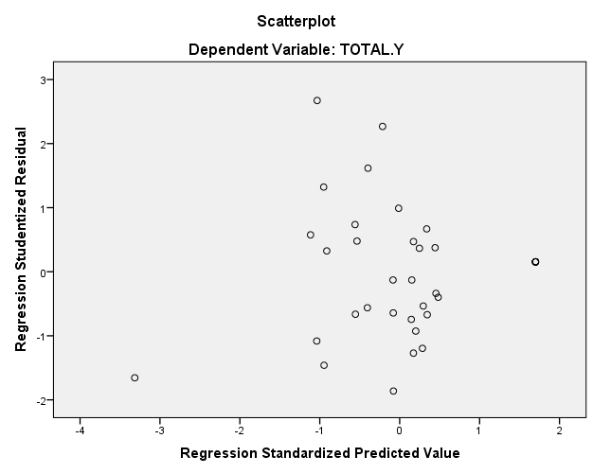

|  |  |  |  |  |  |  |
| --- | --- | --- | --- | --- | --- | --- |
| **Coefficientsa** | | | | | | |
| Model | | Unstandardized Coefficients | | Standardized Coefficients | t | Sig. |
| B | Std. Error | Beta |
| 1 | (Constant) | 5390.709 | 1540.968 |  | 3.498 | .001 |
| Karakteristik Individu | -.072 | .064 | -.313 | -1.119 | .272 |
| Kecerdasan Emosional | -.010 | .067 | -.043 | -.152 | .880 |
| Komunikasi Internal | -.026 | .050 | -.130 | -.515 | .610 |
| a. Dependent Variable: Kinerja Karyawan | | | | | | |

**Lampiran 34**

**Analisis Regresi Berganda**

|  |  |  |  |  |  |  |
| --- | --- | --- | --- | --- | --- | --- |
| **Coefficientsa** | | | | | | |
| Model | | Unstandardized Coefficients | | Standardized Coefficients | t | Sig. |
| B | Std. Error | Beta |
| 1 | (Constant) | -2902.461 | 2784.671 |  | -1.042 | .305 |
| Karakteristik Individu | .878 | .116 | .775 | 7.547 | .000 |
| Kecerdasan Emosional | .142 | .121 | .121 | 1.177 | .248 |
| Komunikasi Internal | .089 | .090 | .092 | .987 | .331 |
| a. Dependent Variable: Kinerja Karyawan | | | | | | |

**Lampiran 35**

**Uji Signifikansi Parsial (Uji t)**

|  |  |  |  |  |  |  |
| --- | --- | --- | --- | --- | --- | --- |
| **Coefficientsa** | | | | | | |
| Model | | Unstandardized Coefficients | | Standardized Coefficients | t | Sig. |
| B | Std. Error | Beta |
| 1 | (Constant) | -2902.461 | 2784.671 |  | -1.042 | .305 |
| Karakteristik Individu | .878 | .116 | .775 | 7.547 | .000 |
| Kecerdasan Emosional | .142 | .121 | .121 | 1.177 | .248 |
| Komunikasi Internal | .089 | .090 | .092 | .987 | .331 |
| a. Dependent Variable: Kinerja Karyawan | | | | | | |

**Lampiran 36**

**Uji Signifikansi Simultan (Uji F)**

|  |  |  |  |  |  |  |
| --- | --- | --- | --- | --- | --- | --- |
| **ANOVAa** | | | | | | |
| Model | | Sum of Squares | df | Mean Square | F | Sig. |
| 1 | Regression | 1153323005.797 | 3 | 384441001.932 | 86.094 | .000b |
| Residual | 138425944.089 | 31 | 4465353.035 |  |  |
| Total | 1291748949.886 | 34 |  |  |  |
| a. Dependent Variable: Kinerja Karyawan | | | | | | |
| b. Predictors: (Constant), Karakteristik Individu, Kecerdasan Emosional, Komunikasi Internal | | | | | | |

**Lampiran 37**

**Analisis Koefisien Determinasi**

|  |  |  |  |  |
| --- | --- | --- | --- | --- |
| Model | R | R Square | Adjusted R Square | Std. Error of the Estimate |
|
| 1 | .945a | .893 | .882 | 2113.138196 |
| a. Predictors: (Constant), Karakteristik Individu, Kecerdasan Emosional, Komunikasi Internal | | | | |
| b. Dependent Variable: Kinerja Karyawan | | | | |