# **DAFTAR PUSTAKA**

**Buku**

Cangara. (2014). *Pengantar Ilmu Komunikasi*. PT. RAJAGRAFINDO PERSADA.

Ginting et al. (2021). *Etika Komunikasi Dalam Media Sosial: Saring sebelum Sharing*. Penerbit Insania.

Irawan. (2003). *Indonesian Customer Satisfaction, Membedah Strategi Kepuasan Pelanggan Merek Pemenang ISCA*. Elex Media Komputindo.

Liliweri. (2010). *Komunikasi Serba Ada Serba Makna*. Kencana Prenada Media Group.

Littlejhon dan Foss. (2014). *Teori Komunikasi Theories Of Human Communication*. Salemba Humanika.

Mulyana. (2016). *Ilmu Komunikasi Suatu Pengantar*. PT. Remaja Rosda Karya.

Pranadita. (2018). *Perumusan Strategi Perusahaan Interaksi Hukum dengan Manajemen Strategis dalam Industri Pertahanan Indonesia*. Deepublish.

Sudaryana dan Agusiady. (2022). *Metodologi Penelitian Kuantitatif*. Deepublish.

Sugiyono. (2018). *Metode Penelitian Kuantitatif, Kualitatif, RnD*. ALFABETA.

Suherman. (2020). *Buku Ajar Teori-Teori Komunikasi*. Deepublish.

Supriadi et al., 2023. (2023). *Statistika Ekonomi dan Bisnis*. Jejak Pustaka

West dan Turner. (2008). *Pengantar Teori Komunikasi: Analisis dan Aplikasi*. Salemba Humanika.

**Jurnal**

B Boestam, A., & Des Derivanti, A. (2022). Komunikasi Digital dan Perubahan Sosial. *Journal Ilmu Sosial Dan Pendidikan (JISIP)*, *6*(4), 2829–2834.

Bakhri, K. (2020). Strategi Radio Dakwah Islam Semarang Dalam Meningkatkan Pendengar. *Sahafa Journal of Islamic Communication*, *3*(1), 51–59. https://doi.org/10.21111/sjic.v3i1.4608

Budhi, K. H., & Pratiwi, A. (2021). Pengaruh Terpaan Konten Akun Instagram @Rintiksedu Terhadap Minat Mendengarkan Podcast Rintik Sedu. *Jurnal Ilmu Komunikasi*, *3*(1), 79–87.

Diniar Puspa, S., & Febriana, P. (2023). Analisis Konten dalam Podcast “Rintik Sedu” untuk Memikat Pendengar. *Komunika: Jurnal Dakwah Dan Komunikasi*, *17*(2), 151–160. https://doi.org/10.24090.komunika.v15i2.7233

Fadilah, E., Yudhapramesti, P., & Aristi, N. (2017). Podcast sebagai Alternatif Distribusi Konten Audio. *Kajian Jurnalisme*, *I* (1), 90–104. http://jurnal.unpad.ac.id/kajian-jurnalisme

Imarshan, I. (2021). Popularitas Podcast Sebagai Pilihan Sumber Informasi Bagi Masyarakat Sejak Pandemi Covid-19. *Perspektif Komunikasi: Jurnal Ilmu Komunikasi Politik Dan Komunikasi Bisnis*, *5*(2), 213–221.

Juli, M., Simbolon, I., Besti, & Simbolon, R. (2021). Podcast Suara Puan Sebagai Sarana Literasi Digital Perempuan Melalui Plarform Spotify. *Jurnal Ilmiah Ilmu Komunikasi*, *6*(2), 66–85.

Mourint, S. (2021). Persepsi Pendengar Terhadap Podcast Rintik Sedu Di Samarinda. *EJournal Ilmu Komunikasi*, *9*(2), 52–61.

Perpati, H. A., & Harnum, R. (2023). Penggunaan Aplikasi Warung Pintar Sebagai Media Bisnis Digital Dalam Upaya Mendukung UMKM. *Jurnal Mutakallimin: Jurnal Ilmu Komunikasi*, *06*(01), 45–54.

Qura, U., Ibrahim, N., Yanti, P. G., & Baadilla, I. (2022). Pengaruh Podcast (Siniar) Youtube terhadap Peningkatan Keterampilan Berbicara. *Ranah: Jurnal Kajian Bahasa*, *11*(2), 351–361. https://doi.org/10.26499/rnh.v11i2.5147

Radika, M. I., & Setiawati, D. (2020). Strategi Komunikasi Podcast Dalam Mempertahankan Pendengar (Studi Kasus Dalam Podcast Do You See What I See). *Medialog:Jurnal Ilmu Komunikasi* , *III*(II), 96–106.

Rizqy, R., Ingratubun, S., Aprianti, A., & Ingratubun, S. (2022). Pengaruh Podcast Rintik Sedu Terhadap Perilaku Celebrity Worship K-Popers (Episode When You Fall In Love With Your Idol). *Mega Aktiva: Jurnal Ekonomi Dan Manajemen*, *11*(2), 46–61. https://doi.org/10.32833/majem.v10i2.268

Syarafina, W. N., Nafis Musyaffa, I., Ramadhana, M. R., & Puspitasari, A. (2021). *Strategi Komunikasi Podcast Dalam Mempertahankan Eksistensi Di Era Digital (Studi Kasus Pada Podcast Manusia Keju)*. *1*(2), 14–24. http://massive.respati.ac.id

Vidi, V., & Daffa, A. (2023). Analisis Podcast Rintik Sedu Dalam Menjaring Penggemarnya. *Jurnal Media Akademik (JMA)*, *1*(1), 83–95.

Yahya, H., & Habibi, M. (2023). Pengaruh Gaya Komunikasi Penyiar Terhadap Minat Dengar Dapur Remaja Radio 107.8 FM. *Jurnal Bincang Komunikasi*, *1*(2), 68–76.

**Internet**

Admin. (2019, Februari 26). *Definisi Pembawa Acara Podcast atau Podcaster*. Retrieved Desember 15, 2023, from Indovoiceover: https://indovoiceover.com/menyelami-podcaster-definition-secara-teori-dan-prakteknya/

Annur, C. M. (2023, September 26). *Daftar Media Sosial Terpopuler di Dunia April 2023, Facebook Masih Juara*. Retrieved Januari 15, 2024, from databoks.katadata: https://databoks.katadata.co.id/datapublish/2023/09/26/daftar-media-sosial-terpopuler-di-dunia-april-2023-facebook-masih-juara

Annur, C. M. (2023, September 20). *Jumlah Pengguna Internet di Indonesia (Januari 2013-Januari 2023)*. Retrieved Januari 15, 2024, from databoks.katadata: https://databoks.katadata.co.id/datapublish/2023/09/20/pengguna-internet-di-indonesia-tembus-213-juta-orang-hingga-awal-2023

Azri, A. H. (2023, Desember 26). *Skill Yang dibutuhkan Podcaster*. Retrieved November 30, 2023, from Medium: https://hilmiazri.medium.com/siniar-495a302279f9

Bayu, D. J. (2021, Maret 10). *Anak Muda Dominasi Jumlah Pendengar Podcast di Indonesia*. Retrieved Januari 8, 2024, from databoks.katadata: https://databoks.katadata.co.id/datapublish/2021/03/10/anak-muda-dominasi-jumlah-pendengar-podcast-di-indonesiapendengar-podcast-di-indonesia-didominasi-anak-muda#:~:text=Hasil%20survei%20Jakpat%20menunjukkan%2C%20jumlah,lainnya%20berusia%2020%2D24%20tahu

Eka, R. (2018, Agustus 27). *Laporan DailySocial: Penggunaan Layanan Podcast 2018*. Retrieved Maret 20, 2024, from dailysocial: https://dailysocial.id/post/laporan-dailysocial-penggunaan-layanan-podcast-2018

Fajrin, Z. (2023, Desember 1). *Spotify Wrapped Live Indonesia 2023, Umumkan Artis, Lagu, Podcast Teratas di Tahun Ini*. Retrieved Desember 1, 2023, from gizmologi: https://gizmologi.id/news/spotify-wrapped-live-indonesia-2023-hadir/

Gianjar, P. A. (2022, Desember 1). *Podcast Rintik Sedu Duduki Posisi Puncak Spotify Wrapped 2022*. Retrieved 26 11, 2023, from hypeabis: https://hypeabis.id/read/19121/podcast-rintik-sedu-duduki-posisi-puncak-spotify-wrapped-2022

N, D. S. (2023, Juni 14). *Begini Ekosistem dan Potensi Podcast di Indonesia*. Retrieved Oktober 26, 2023, from digination: https://www.digination.id/read/019168/begini-ekosistem-dan-

Noice. (2022, November 30). *Mengenal Apa Itu Podcast: Definisi, Asal-usul dan Manfaatnya*. Retrieved November 30, 2023, from noice: https://www.noice.id/info-terbaru/mengenal-apa-itu-podcast-definisi-arti-manfaat/#

Pahlevi, R. (2022, Februari 8). *Pendengar Podcast Indonesia Terbesar ke-2 di Dunia*. Retrieved Oktober 24, 2023, from databoks.katadata: https://databoks.katadata.co.id/datapublish/2022/02/08/pendengar-podcast-indonesia-terbesar-ke-2-di-dunia

Peate, S. (n.d.). *Spotify logo history and the Spotify symbol meaning*. Retrieved Maret 15, 2024, from fabrikbrands: https://fabrikbrands.com/spotify-logo-history-spotify-symbol-meaning/

Rizaty, M. A. (2023, Oktober 10). *Pengguna Spotify di Dunia Capai 551 Juta pada Kuartal II/2023*. Retrieved Desember 6, 2023, from dataindonesia: https://dataindonesia.id/internet/detail/pengguna-spotify-di-dunia-capai-551-juta-pada-kuartal-ii2023

Shewale. (2024, Januari 7). *Podcast Statistics For 2024 (Listeners & Current State)*. Retrieved Januari 8, 2024, from demandsage: https://www.demandsage.com/podcast-statistics

Supadnomo, W. A. (2021, Oktober 24). *Mengenal Lebih Jauh Tentang Spotify, Aplikasi Musik Paling Inovatif di Dunia*. Retrieved November 30, 2023, from medium: https://medium.com/@wisnuariosupadnomo/mengenal-lebih-jauh-tentang-spotify-aplikasi-musik-paling-inovatif-di-dunia-3e58826422b1

Yuniartha, L. (2023, Agustus 14). *Pengguna Spotify di Indonesia Tumbuh 3 Kali Lipat dalam 3 Tahun*. Retrieved Desember 6, 2023, from industri.kontan: https://industri.kontan.co.id/news/pengguna-spotify-di-indonesia-tumbuh-3-kali-lipat-dalam-3-tahun

# **LAMPIRAN – LAMPIRAN**

**Lampiran 1 Kuesioner Penelitian**

**Kuesioner Penelitian "Pengaruh Gaya Komunikasi Podcaster Pada Podcast Rintik Sedu Terhadap Tingkat Kepuasan Pendengar di Aplikasi Spotify"**

Hallo Teman-teman!

Perkenalkan saya Anggun Sinta Dewi, mahasiswa Program Studi Ilmu Komunikasi Fakultas Ilmu Sosial dan Ilmu Politik Universitas Pancasakti Tegal. Saat ini saya sedang mengerjakan penelitian sebagai salah satu syarat dalam rangka memenuhi penyusunan skripsi jenjang S1. Penelitian ini digunakan sebagai syarat kelulusan untuk mendapatkan gelar sarjana Ilmu Komunikasi. Oleh sebab itu, saya mohon bantuan teman-teman untuk mengisi kuesioner di bawah ini dengan baik dan sungguh-sungguh.

Jawablah pertanyaan di bawah ini sesuai pendapat kalian mengenai Gaya Komunikasi Podcaster Pada Podcast Rintik Sedu Terhadap Tingkat Kepuasan Pendengar di Aplikasi Spotify.

Atas ketersediaan teman-teman yang telah meluangkan waktunya untuk mengisi kuesioner ini, saya ucapkan terima kasih.

Salam hormat,

**Anggun Sinta Dewi**

1. **Bagian I : Profil Responden**
2. Nama Responden
3. Jenis Kelamin
4. Laki-laki
5. Perempuan
6. Usia saat ini
7. 15 - 25 Tahun
8. 26 - 35 Tahun
9. 36 - 45 Tahun
10. Status atau pekerjaan saat ini
11. Pelajar/Mahasiswa
12. Pegawai
13. Wiraswasta
14. Alamat Responden (*Kota/Kabupaten)
15. **Bagian II : Pertanyaan**
16. Apakah Anda mengetahui podcast Rintik Sedu?
17. Ya
18. Tidak
19. Apakah Anda pernah mendengarkan podcast Rintik Sedu di Spotify?
20. Ya
21. Tidak
22. Apakah Anda sering mendengarkan podcast Rintik Sedu di Spotify?
23. Ya
24. Tidak
25. Apakah Anda mendengarkan podcast Rintik Sedu di Spotify 5-6 kali dalam satu bulan?
26. Ya
27. Tidak
28. Apakah Anda menggunakan aplikasi Spotify?
29. Ya
30. Tidak
31. Apakah Anda mengikuti Podcast Rintik Sedu di Aplikasi Spotify?
32. Ya
33. Tidak
34. Apakah Anda mengikuti sosial media (Instagram dan Twitter) podcast Rintik Sedu?
35. Ya
36. Tidak

**Petunjuk Pengisian:**

Pilihlah jawaban dari pernyataan di bawah ini sesuai dengan pendapat kalian mengenai “Gaya Komunikasi Podcaster Pada Podcast Rintik Sedu Terhadap Tingkat Kepuasan Pendengar di Aplikasi Spotify”.

Harap pilih salah satu jawaban dengan memberikan tanda centang pada jawaban yang kalian pilih!

Isilah pertanyaan atau pernyataan di bawah ini dengan ketentuan sebagai berikut:

5 = Sangat Setuju (SS)

4 = Setuju (ST)

3 = Kurang Setuju (KS)

2 = Tidak Setuju (TS)

1 = Sangat Tidak Setuju (STS)

1. **Gaya Komunikasi (Variabel X)**

|  |  |  |  |  |  |  |
| --- | --- | --- | --- | --- | --- | --- |
| **No.** | **Pernyataan** | **STS** | **TS** | **KS** | **S** | **SS** |
| 1. | **Gaya Dominan *(Dominant)*** |  |  |  |  |  |
| Podcaster Rintik Sedu banyak berbicara dalam menyampaikan podcastnya. |
| 2. | **Gaya Dramatis *(Dramatic)*** |  |  |  |  |  |
| Dalam menyampaikan isi podcastnya, podcaster Rintik Sedu menggunakan kata-kata kiasan, bercerita, metaphora, fantasi, dan permainan suara. |
| 3. | **Gaya Animasi *(Animated Expresive)*** |  |  |  |  |  |
| Dalam menyampaikan isi podcastnya, podcaster Rintik Sedu melakukan kontak mata, menggunakan ekspresi wajah, dan gerakan badan. |
| 4. | **Gaya Terbuka *(Open)*** |  |  |  |  |  |
| Dalam menyampaikan isi podcastnya, podcaster Rintik Sedu terlihat terbuka dengan pendengarnya. |
| 5. | **Gaya Kontroversial *(Controversial)*** |  |  |  |  |  |
| Dalam menyampaikan isi podcastnya, podcaster Rintik Sedu suka menyampaikan pendapatnya kepada pendengarnya. |
| 6. | **Gaya Santai *(Relaxed)*** |  |  |  |  |  |
| Dalam menyampaikan isi podcastnya, podcaster Rintik Sedu selalu santai, tenang, sabar, dan menyenangkan. |
| 7. | **Gaya Bersahabat *(Friendly)*** |  |  |  |  |  |
| Dalam menyampaikan isi podcastnya, podcaster Rintik Sedu bersahabat dengan memberikan sikap dan energi yang positif terhadap pendengarnya. |
| 8. | **Gaya Atentif *(Attentive)*** |  |  |  |  |  |
| Dalam menyampaikan isi podcastnya, podcaster Rintik Sedu bersikap simpati dan empati serta memberikan perhatian penuh terhadap isi cerita yang dikirimkan oleh pendengar. |
| 9. | **Gaya yang tepat *(Precise)*** |  |  |  |  |  |
| Dalam menyampaikan isi podcastnya, podcaster Rintik Sedu memperhatikan ketelitian pada tempat take podcast maupun materi podcast. |
| 10. | **Gaya Berkesan *(Impression Leaving)*** |  |  |  |  |  |
| Dalam menyampaikan isi podcastnya, podcaster Rintik Sedu bisa menciptakan kesan kepada pendengarnya. |

1. **Tingkat Kepuasan Pendengar (Variabel Y)**

|  |  |  |  |  |  |  |
| --- | --- | --- | --- | --- | --- | --- |
| **No.** | **Pernyataan** | **STS** | **TS** | **KS** | **S** | **SS** |
| **Kualitas Produk** |
| 1. | Saya merasa puas dalam mendapatkan informasi ketika mendengarkan podcast Rintik Sedu. |  |  |  |  |  |
| 2. | Mendengarkan podcast Rintik Sedu dapat memuaskan rasa penasaran Saya akan sesuatu. |  |  |  |  |  |
| 3. | Podcast Rintik Sedu dapat memberikan inspirasi bagi pendengar. |  |  |  |  |  |
| 4. | Setelah mendengarkan podcast Rintik Sedu, Saya mendapatkan banyak hal tentang nilai-nilai kehidupan dan dapat menambah wawasan. |  |  |  |  |  |
| 5. | Mendengarkan podcast Rintik Sedu memberikan dampak yang membuat Saya termotivasi dan semangat lagi dalam menjalani aktivitas. |  |  |  |  |  |
| 6. | Mendengarkan podcast Rintik Sedu membuat Saya merasa santai, terbawa suasana, dan sejenak melupakan aktivitas. |  |  |  |  |  |
| 7. | Mendengarkan podcast Rintik Sedu membuat saya mengikuti dan paham *trend* serta dapat berdiskusi dengan teman maupun sesama pendengar. |  |  |  |  |  |
| 8. | Saya mendapatkan pengetahuan dalam menjalin hubungan (baik dengan pasangan, teman, dan keluarga) setelah mendengarkan podcast Rintik Sedu. |  |  |  |  |  |
| 9. | Mendengarkan podcast Rintik Sedu membuat pendengar berimajinasi dan meningkatkan daya imajinasi. |  |  |  |  |  |
| 10. | Saya merasa puas dengan audio yang baik, jernih, dan tanpa gangguan ketika mendengarkan podcast Rintik Sedu. |  |  |  |  |  |
| 11. | Saya merasa puas dengan segmen dan episode yang ada dalam podcast Rintik Sedu. |  |  |  |  |  |
| 12. | Saya merasa puas dengan fitur Spotify yang lengkap. |  |  |  |  |  |
| **No.** | **Kualitas Pelayanan** | **STS** | **TS** | **KS** | **S** | **SS** |
| 1. | Saya merasa puas ketika konten podcast Rintik Sedu ditayangkan tepat waktu dan sesuai dengan jadwal tayangnya. |  |  |  |  |  |
| 2. | Saya merasa puas ketika cerita-cerita yang dikirimkan oleh pendengar dibacakan untuk diceritakan dalam podcast Rintik Sedu. |  |  |  |  |  |
| 3. | Podcaster Rintik Sedu melakukan interaksi melalui media sosial (Instagram dan Twitter) sehingga pendengar merasa dekat dengan podcaster. |  |  |  |  |  |
| 4. | Saya merasa puas dengan layanan *streaming* podcast di Spotify. |  |  |  |  |  |
| 5. | Saya merasa puas dengan layanan Spotify premium ataupun non premium. |  |  |  |  |  |
| **No.** | **Faktor Emosional** | **STS** | **TS** | **KS** | **S** | **SS** |
| 1. | Saya merasa senang dan terhibur ketika mendengarkan podcast Rintik Sedu. |  |  |  |  |  |
| 2. | Ketika saya sedang senang atau sedih, saya mendengarkan dan memilih konten podcast Rintik Sedu yang sesuai dengan mood yang sedang dirasakan. |  |  |  |  |  |
| 3. | Setelah mendengarkan podcast Rintik Sedu, saya mendapatkan hal yang berkaitan melalui isi konten podcast Rintik Sedu dan kesamaan dengan diri saya atau pengalaman saya. |  |  |  |  |  |
| 4. | Setelah mendengarkan podcast Rintik Sedu, Saya terhindar dan dapat mengatasi rasa kesepian. |  |  |  |  |  |
| 5. | Saya merasa tenang dan damai ketika menggunakan layanan Spotify premium karena tidak gangguan atau ada iklan. |  |  |  |  |  |
| **No.** | **Harga** | **STS** | **TS** | **KS** | **S** | **SS** |
| 1. | Saya merasa puas karena podcast Rintik Sedu dapat didengarkan secara gratis di aplikasi Spotify. |  |  |  |  |  |
| 2. | Saya merasa puas dengan layanan Spotify premium yang harganya terjangkau dan kualitas premium. |  |  |  |  |  |
| **No.** | **Kemudahan** | **STS** | **TS** | **KS** | **S** | **SS** |
| 1. | Bahasa yang digunakan dalam podcast Rintik Sedu mudah dipahami. |  |  |  |  |  |
| 2. | Saya merasa puas karena podcast Rintik Sedu mudah diakses di Spotify. |  |  |  |  |  |
| 3. | Saya merasa puas karena podcast Rintik Sedu dapat didengarkan kapan saja dan dimana saja melalui Spotify. |  |  |  |  |  |

**Pertanyaan Tambahan**

1. Bagaimana pendapat Anda terhadap gaya berbicara podcaster dalam podcast Rintik Sedu?
2. Apakah podcast Rintik Sedu memberikan pengaruh terhadap kehidupan sehari-hari Anda? Bagaimana pengaruhnya?
3. Bagaimana saran dan masukan Anda terhadap podcast Rintik Sedu?

**Lampiran 2 Tabulasi Data Kuesioner**

**TABULASI DATA KUESIONER**

**Variabel Gaya Komunikasi (X)**

|  |  |  |  |  |  |  |  |  |  |  |  |
| --- | --- | --- | --- | --- | --- | --- | --- | --- | --- | --- | --- |
| **No.** | **Gaya Komunikasi (X)** | | | | | | | | | | **Total X** |
|  | **X.1** | **X.2** | **X.3** | **X.4** | **X.5** | **X.6** | **X.7** | **X.8** | **X.9** | **X.10** |
| 1 | 4 | 4 | 4 | 4 | 4 | 4 | 4 | 4 | 4 | 4 | 40 |
| 2 | 5 | 4 | 5 | 4 | 5 | 5 | 5 | 5 | 5 | 5 | 48 |
| 3 | 5 | 4 | 3 | 4 | 4 | 5 | 4 | 4 | 4 | 4 | 41 |
| 4 | 4 | 4 | 4 | 4 | 4 | 5 | 5 | 5 | 3 | 4 | 42 |
| 5 | 5 | 4 | 5 | 5 | 5 | 5 | 5 | 5 | 3 | 5 | 47 |
| 6 | 5 | 5 | 4 | 5 | 5 | 5 | 5 | 5 | 4 | 5 | 48 |
| 7 | 4 | 3 | 4 | 4 | 4 | 5 | 3 | 4 | 4 | 4 | 39 |
| 8 | 4 | 4 | 3 | 3 | 3 | 3 | 3 | 3 | 3 | 3 | 32 |
| 9 | 4 | 4 | 5 | 5 | 5 | 5 | 5 | 5 | 4 | 5 | 47 |
| 10 | 5 | 5 | 5 | 5 | 5 | 5 | 5 | 5 | 5 | 5 | 50 |
| 11 | 5 | 5 | 4 | 5 | 5 | 5 | 5 | 4 | 5 | 5 | 48 |
| 12 | 4 | 4 | 4 | 4 | 4 | 4 | 5 | 4 | 4 | 4 | 41 |
| 13 | 4 | 4 | 3 | 3 | 4 | 4 | 4 | 4 | 3 | 4 | 37 |
| 14 | 5 | 5 | 4 | 4 | 5 | 5 | 5 | 5 | 5 | 5 | 48 |
| 15 | 4 | 3 | 2 | 4 | 4 | 5 | 5 | 5 | 4 | 4 | 40 |
| 16 | 5 | 5 | 3 | 5 | 5 | 5 | 5 | 5 | 4 | 4 | 46 |
| 17 | 4 | 4 | 3 | 4 | 4 | 5 | 5 | 4 | 4 | 5 | 42 |
| 18 | 4 | 4 | 3 | 5 | 5 | 5 | 5 | 5 | 4 | 4 | 44 |
| 19 | 5 | 5 | 5 | 5 | 4 | 5 | 5 | 5 | 4 | 5 | 48 |
| 20 | 4 | 3 | 5 | 5 | 5 | 5 | 5 | 5 | 5 | 5 | 47 |
| 21 | 4 | 5 | 4 | 4 | 4 | 4 | 4 | 4 | 4 | 4 | 41 |
| 22 | 5 | 4 | 4 | 4 | 5 | 5 | 5 | 5 | 4 | 5 | 46 |
| 23 | 5 | 5 | 4 | 4 | 5 | 5 | 5 | 5 | 4 | 4 | 46 |
| 24 | 5 | 4 | 5 | 5 | 5 | 4 | 5 | 5 | 4 | 4 | 46 |
| 25 | 5 | 4 | 2 | 4 | 4 | 4 | 4 | 4 | 4 | 4 | 39 |
| 26 | 4 | 5 | 4 | 4 | 4 | 4 | 4 | 4 | 4 | 4 | 41 |
| 27 | 5 | 5 | 5 | 5 | 4 | 5 | 5 | 5 | 5 | 5 | 49 |
| 28 | 4 | 5 | 3 | 5 | 5 | 5 | 5 | 4 | 4 | 4 | 44 |
| 29 | 5 | 4 | 3 | 4 | 4 | 4 | 4 | 4 | 4 | 4 | 40 |
| 30 | 5 | 4 | 4 | 5 | 5 | 5 | 5 | 5 | 5 | 4 | 47 |
| 31 | 5 | 5 | 3 | 5 | 5 | 5 | 5 | 5 | 5 | 5 | 48 |
| 32 | 4 | 4 | 3 | 4 | 4 | 4 | 4 | 4 | 4 | 5 | 40 |
| 33 | 5 | 5 | 1 | 3 | 5 | 3 | 5 | 5 | 5 | 5 | 42 |
| 34 | 4 | 4 | 3 | 4 | 4 | 3 | 1 | 3 | 3 | 1 | 30 |
| 35 | 5 | 5 | 5 | 5 | 5 | 5 | 5 | 5 | 5 | 5 | 50 |
| 36 | 4 | 3 | 4 | 4 | 4 | 4 | 4 | 4 | 4 | 4 | 39 |
| 37 | 5 | 5 | 4 | 5 | 5 | 4 | 5 | 5 | 4 | 5 | 47 |
| 38 | 5 | 5 | 5 | 5 | 5 | 5 | 5 | 4 | 4 | 4 | 47 |
| 39 | 4 | 4 | 4 | 4 | 4 | 4 | 5 | 4 | 5 | 5 | 43 |
| 40 | 4 | 4 | 4 | 4 | 3 | 5 | 4 | 5 | 3 | 5 | 41 |
| 41 | 4 | 4 | 3 | 5 | 5 | 5 | 5 | 5 | 4 | 5 | 45 |
| 42 | 4 | 5 | 5 | 4 | 5 | 4 | 4 | 5 | 5 | 4 | 45 |
| 43 | 5 | 4 | 5 | 5 | 5 | 4 | 5 | 5 | 4 | 4 | 46 |
| 44 | 4 | 5 | 5 | 3 | 5 | 5 | 4 | 5 | 4 | 5 | 45 |
| 45 | 5 | 5 | 3 | 5 | 4 | 5 | 5 | 5 | 5 | 5 | 47 |
| 46 | 5 | 5 | 5 | 5 | 5 | 5 | 5 | 5 | 5 | 5 | 50 |
| 47 | 5 | 5 | 4 | 5 | 5 | 4 | 5 | 5 | 3 | 5 | 46 |
| 48 | 4 | 4 | 5 | 4 | 5 | 5 | 5 | 4 | 3 | 4 | 43 |
| 49 | 5 | 4 | 4 | 5 | 5 | 5 | 5 | 5 | 4 | 5 | 47 |
| 50 | 4 | 3 | 2 | 5 | 5 | 5 | 5 | 2 | 3 | 4 | 38 |
| 51 | 3 | 4 | 2 | 4 | 3 | 4 | 3 | 4 | 3 | 4 | 34 |
| 52 | 5 | 4 | 3 | 4 | 4 | 4 | 4 | 4 | 4 | 4 | 40 |
| 53 | 5 | 5 | 3 | 4 | 5 | 4 | 4 | 4 | 4 | 5 | 43 |
| 54 | 3 | 4 | 4 | 4 | 4 | 4 | 4 | 4 | 4 | 4 | 39 |
| 55 | 5 | 5 | 5 | 5 | 5 | 5 | 5 | 5 | 5 | 5 | 50 |
| 56 | 4 | 5 | 5 | 5 | 5 | 5 | 5 | 5 | 5 | 5 | 49 |
| 57 | 5 | 4 | 4 | 4 | 3 | 5 | 5 | 5 | 4 | 5 | 44 |
| 58 | 4 | 4 | 3 | 4 | 4 | 4 | 4 | 4 | 4 | 4 | 39 |
| 59 | 4 | 5 | 5 | 5 | 5 | 5 | 5 | 5 | 5 | 5 | 49 |
| 60 | 1 | 4 | 5 | 5 | 5 | 5 | 5 | 4 | 4 | 5 | 43 |
| 61 | 5 | 4 | 3 | 4 | 3 | 5 | 5 | 5 | 4 | 5 | 43 |
| 62 | 4 | 4 | 4 | 5 | 5 | 5 | 5 | 5 | 5 | 5 | 47 |
| 63 | 4 | 4 | 4 | 4 | 4 | 4 | 4 | 4 | 4 | 4 | 40 |
| 64 | 5 | 5 | 3 | 4 | 5 | 5 | 5 | 5 | 4 | 5 | 46 |
| 65 | 2 | 1 | 4 | 1 | 1 | 1 | 1 | 1 | 1 | 1 | 14 |
| 66 | 4 | 5 | 4 | 4 | 5 | 5 | 5 | 5 | 4 | 5 | 46 |
| 67 | 4 | 4 | 3 | 4 | 4 | 5 | 5 | 5 | 5 | 5 | 44 |
| 68 | 5 | 5 | 4 | 5 | 5 | 4 | 5 | 5 | 5 | 5 | 48 |
| 69 | 4 | 5 | 5 | 5 | 5 | 5 | 5 | 5 | 5 | 5 | 49 |
| 70 | 4 | 4 | 3 | 4 | 5 | 5 | 4 | 4 | 4 | 4 | 41 |
| 71 | 4 | 5 | 5 | 5 | 5 | 5 | 4 | 5 | 4 | 5 | 47 |
| 72 | 5 | 5 | 5 | 5 | 5 | 5 | 5 | 5 | 5 | 5 | 50 |
| 73 | 3 | 4 | 4 | 5 | 4 | 3 | 4 | 4 | 3 | 4 | 38 |
| 74 | 3 | 5 | 1 | 3 | 4 | 5 | 5 | 5 | 5 | 5 | 41 |
| 75 | 5 | 5 | 3 | 4 | 4 | 5 | 5 | 5 | 4 | 5 | 45 |
| 76 | 5 | 5 | 4 | 5 | 5 | 5 | 5 | 5 | 4 | 5 | 48 |
| 77 | 5 | 4 | 3 | 5 | 5 | 5 | 5 | 5 | 3 | 5 | 45 |
| 78 | 4 | 5 | 4 | 5 | 3 | 5 | 5 | 5 | 5 | 5 | 46 |
| 79 | 5 | 5 | 5 | 5 | 5 | 5 | 5 | 5 | 5 | 5 | 50 |
| 80 | 4 | 4 | 4 | 4 | 3 | 4 | 4 | 4 | 4 | 4 | 39 |
| 81 | 5 | 4 | 5 | 4 | 4 | 4 | 4 | 4 | 4 | 4 | 42 |
| 82 | 4 | 5 | 5 | 5 | 4 | 5 | 4 | 5 | 4 | 5 | 46 |
| 83 | 5 | 4 | 4 | 5 | 5 | 5 | 5 | 5 | 4 | 5 | 47 |
| 84 | 2 | 5 | 4 | 4 | 4 | 4 | 4 | 4 | 4 | 4 | 39 |
| 85 | 5 | 5 | 3 | 5 | 5 | 5 | 5 | 5 | 5 | 5 | 48 |
| 86 | 5 | 5 | 5 | 5 | 5 | 5 | 5 | 5 | 5 | 5 | 50 |
| 87 | 5 | 5 | 5 | 5 | 5 | 5 | 5 | 5 | 5 | 5 | 50 |
| 88 | 3 | 3 | 3 | 3 | 3 | 3 | 3 | 3 | 3 | 3 | 30 |
| 89 | 4 | 3 | 3 | 5 | 5 | 5 | 5 | 4 | 5 | 5 | 44 |
| 90 | 5 | 5 | 5 | 5 | 5 | 5 | 5 | 5 | 5 | 5 | 50 |
| 91 | 5 | 5 | 3 | 5 | 5 | 5 | 5 | 5 | 5 | 5 | 48 |
| 92 | 5 | 5 | 5 | 5 | 5 | 5 | 5 | 5 | 5 | 5 | 50 |
| 93 | 5 | 5 | 5 | 5 | 5 | 5 | 5 | 5 | 5 | 5 | 50 |
| 94 | 5 | 4 | 5 | 5 | 5 | 5 | 5 | 5 | 3 | 5 | 47 |
| 95 | 5 | 5 | 4 | 5 | 5 | 5 | 5 | 5 | 5 | 5 | 49 |
| 96 | 3 | 5 | 1 | 3 | 4 | 5 | 5 | 4 | 3 | 5 | 38 |
| 97 | 5 | 5 | 5 | 5 | 5 | 2 | 4 | 5 | 4 | 5 | 45 |
| 98 | 5 | 5 | 3 | 5 | 5 | 5 | 5 | 5 | 5 | 5 | 48 |
| 99 | 4 | 5 | 5 | 3 | 4 | 3 | 3 | 4 | 4 | 3 | 38 |
| 100 | 5 | 5 | 5 | 5 | 5 | 5 | 5 | 5 | 5 | 5 | 50 |

**TINGKAT KEPUASAN PENDENGAR (Y)**

|  |  |  |  |  |  |  |  |  |  |  |  |  |  |  |  |  |  |  |  |  |  |  |  |  |  |  |  |  |
| --- | --- | --- | --- | --- | --- | --- | --- | --- | --- | --- | --- | --- | --- | --- | --- | --- | --- | --- | --- | --- | --- | --- | --- | --- | --- | --- | --- | --- |
| **No.** | **Tingkat Kepuasan (Y)** | | | | | | | | | | | | | | | | | | | | | | | | | | | **Total Y** |
|  | **Y.1** | **Y.2** | **Y.3** | **Y.4** | **Y.5** | **Y.6** | **Y.7** | **Y.8** | **Y.9** | **Y.10** | **Y.11** | **Y.12** | **Y.13** | **Y.14** | **Y.15** | **Y.16** | **Y.17** | **Y.18** | **Y.19** | **Y.20** | **Y.21** | **Y.22** | **Y.23** | **Y.24** | **Y.25** | **Y.26** | **Y.27** |
| 1 | 4 | 4 | 4 | 4 | 4 | 4 | 4 | 4 | 4 | 4 | 4 | 4 | 4 | 4 | 4 | 4 | 4 | 4 | 4 | 4 | 4 | 4 | 4 | 4 | 4 | 4 | 4 | 108 |
| 2 | 5 | 4 | 4 | 5 | 4 | 5 | 4 | 4 | 5 | 5 | 5 | 5 | 5 | 5 | 5 | 5 | 5 | 5 | 5 | 5 | 4 | 5 | 5 | 4 | 5 | 5 | 5 | 128 |
| 3 | 5 | 4 | 4 | 5 | 4 | 5 | 4 | 5 | 4 | 5 | 4 | 4 | 5 | 5 | 4 | 4 | 5 | 4 | 5 | 4 | 4 | 5 | 5 | 4 | 5 | 4 | 4 | 120 |
| 4 | 4 | 3 | 4 | 4 | 2 | 3 | 2 | 2 | 2 | 4 | 4 | 3 | 4 | 4 | 4 | 2 | 3 | 3 | 4 | 4 | 2 | 3 | 4 | 3 | 4 | 4 | 4 | 89 |
| 5 | 5 | 4 | 5 | 3 | 3 | 4 | 4 | 5 | 3 | 5 | 5 | 3 | 4 | 5 | 3 | 4 | 3 | 5 | 5 | 5 | 5 | 5 | 5 | 5 | 5 | 5 | 5 | 118 |
| 6 | 5 | 5 | 5 | 5 | 5 | 5 | 5 | 5 | 5 | 5 | 5 | 5 | 5 | 5 | 5 | 5 | 5 | 5 | 5 | 5 | 5 | 5 | 5 | 5 | 5 | 5 | 5 | 135 |
| 7 | 5 | 3 | 4 | 3 | 3 | 4 | 4 | 4 | 3 | 3 | 3 | 3 | 3 | 4 | 3 | 3 | 4 | 4 | 4 | 3 | 4 | 3 | 4 | 4 | 3 | 3 | 4 | 95 |
| 8 | 3 | 3 | 3 | 3 | 3 | 3 | 3 | 3 | 3 | 3 | 3 | 3 | 3 | 4 | 3 | 3 | 3 | 3 | 3 | 3 | 3 | 3 | 3 | 3 | 3 | 3 | 3 | 82 |
| 9 | 5 | 5 | 5 | 5 | 5 | 5 | 5 | 5 | 5 | 5 | 5 | 5 | 5 | 4 | 5 | 5 | 5 | 5 | 5 | 5 | 5 | 5 | 5 | 4 | 5 | 5 | 5 | 133 |
| 10 | 5 | 5 | 5 | 5 | 5 | 4 | 4 | 5 | 5 | 5 | 5 | 4 | 4 | 5 | 5 | 5 | 5 | 5 | 4 | 5 | 4 | 5 | 5 | 3 | 5 | 5 | 5 | 127 |
| 11 | 4 | 5 | 5 | 5 | 4 | 3 | 5 | 5 | 5 | 5 | 3 | 4 | 4 | 3 | 5 | 4 | 5 | 5 | 5 | 5 | 5 | 5 | 5 | 3 | 4 | 5 | 3 | 119 |
| 12 | 5 | 4 | 5 | 4 | 4 | 4 | 3 | 4 | 5 | 4 | 4 | 4 | 4 | 4 | 5 | 4 | 4 | 4 | 4 | 4 | 4 | 3 | 4 | 3 | 4 | 5 | 4 | 110 |
| 13 | 4 | 4 | 4 | 4 | 4 | 4 | 4 | 4 | 4 | 4 | 4 | 3 | 4 | 4 | 4 | 4 | 3 | 4 | 4 | 3 | 3 | 3 | 3 | 4 | 4 | 4 | 3 | 101 |
| 14 | 5 | 5 | 5 | 5 | 5 | 5 | 5 | 5 | 4 | 4 | 5 | 4 | 5 | 5 | 5 | 4 | 5 | 5 | 5 | 5 | 4 | 5 | 5 | 4 | 5 | 5 | 5 | 129 |
| 15 | 4 | 4 | 4 | 4 | 4 | 5 | 4 | 4 | 4 | 5 | 4 | 4 | 4 | 4 | 5 | 4 | 4 | 4 | 4 | 4 | 4 | 4 | 4 | 4 | 4 | 4 | 4 | 111 |
| 16 | 3 | 3 | 4 | 4 | 3 | 4 | 3 | 4 | 5 | 5 | 4 | 5 | 5 | 5 | 5 | 5 | 5 | 4 | 5 | 5 | 4 | 5 | 5 | 4 | 5 | 5 | 5 | 119 |
| 17 | 5 | 4 | 5 | 5 | 5 | 4 | 4 | 5 | 4 | 5 | 4 | 4 | 4 | 4 | 4 | 4 | 4 | 5 | 5 | 4 | 4 | 5 | 5 | 4 | 4 | 5 | 5 | 120 |
| 18 | 4 | 4 | 4 | 5 | 4 | 5 | 5 | 4 | 4 | 5 | 5 | 5 | 5 | 5 | 4 | 5 | 5 | 5 | 5 | 5 | 2 | 4 | 4 | 4 | 5 | 5 | 5 | 122 |
| 19 | 5 | 4 | 4 | 5 | 5 | 5 | 4 | 5 | 4 | 4 | 5 | 4 | 4 | 5 | 5 | 4 | 4 | 5 | 5 | 5 | 5 | 4 | 4 | 4 | 5 | 4 | 5 | 122 |
| 20 | 5 | 4 | 5 | 4 | 4 | 5 | 3 | 5 | 5 | 5 | 5 | 5 | 4 | 4 | 5 | 4 | 4 | 5 | 5 | 5 | 4 | 5 | 5 | 3 | 5 | 5 | 5 | 123 |
| 21 | 3 | 4 | 4 | 4 | 4 | 4 | 4 | 4 | 5 | 4 | 4 | 4 | 4 | 4 | 5 | 4 | 5 | 4 | 4 | 4 | 3 | 5 | 5 | 3 | 5 | 5 | 5 | 113 |
| 22 | 4 | 4 | 4 | 4 | 4 | 4 | 3 | 4 | 4 | 5 | 5 | 4 | 4 | 4 | 5 | 4 | 4 | 5 | 3 | 4 | 4 | 4 | 5 | 4 | 4 | 5 | 5 | 113 |
| 23 | 4 | 4 | 4 | 4 | 4 | 5 | 4 | 4 | 5 | 5 | 4 | 4 | 4 | 4 | 5 | 4 | 4 | 4 | 5 | 5 | 4 | 4 | 5 | 4 | 5 | 5 | 5 | 118 |
| 24 | 4 | 5 | 5 | 4 | 4 | 3 | 5 | 5 | 4 | 5 | 4 | 5 | 5 | 5 | 5 | 4 | 4 | 4 | 5 | 5 | 3 | 4 | 4 | 3 | 5 | 4 | 5 | 118 |
| 25 | 4 | 3 | 4 | 4 | 4 | 4 | 4 | 4 | 3 | 5 | 4 | 4 | 4 | 3 | 4 | 4 | 4 | 4 | 3 | 3 | 4 | 3 | 4 | 3 | 4 | 5 | 5 | 104 |
| 26 | 4 | 4 | 4 | 4 | 3 | 3 | 4 | 3 | 4 | 4 | 3 | 4 | 3 | 3 | 3 | 4 | 3 | 4 | 3 | 4 | 3 | 3 | 4 | 3 | 4 | 4 | 4 | 96 |
| 27 | 5 | 5 | 4 | 5 | 5 | 5 | 5 | 5 | 5 | 5 | 5 | 5 | 5 | 5 | 5 | 5 | 5 | 5 | 5 | 5 | 5 | 5 | 5 | 5 | 5 | 5 | 5 | 134 |
| 28 | 5 | 4 | 5 | 4 | 5 | 5 | 4 | 5 | 4 | 5 | 5 | 4 | 4 | 4 | 4 | 5 | 5 | 4 | 5 | 5 | 4 | 4 | 4 | 4 | 4 | 4 | 4 | 119 |
| 29 | 3 | 3 | 3 | 3 | 3 | 4 | 3 | 4 | 4 | 4 | 4 | 3 | 3 | 4 | 4 | 4 | 2 | 3 | 4 | 4 | 3 | 4 | 5 | 3 | 4 | 5 | 5 | 98 |
| 30 | 4 | 3 | 4 | 4 | 4 | 5 | 3 | 3 | 3 | 5 | 4 | 3 | 4 | 4 | 5 | 3 | 3 | 3 | 4 | 4 | 3 | 3 | 5 | 3 | 5 | 5 | 5 | 104 |
| 31 | 4 | 5 | 5 | 5 | 5 | 5 | 5 | 5 | 5 | 5 | 5 | 5 | 5 | 5 | 5 | 5 | 5 | 5 | 5 | 5 | 5 | 5 | 5 | 5 | 5 | 5 | 5 | 134 |
| 32 | 4 | 4 | 4 | 4 | 4 | 4 | 4 | 4 | 4 | 4 | 4 | 4 | 4 | 4 | 4 | 4 | 3 | 4 | 4 | 4 | 4 | 5 | 4 | 4 | 4 | 4 | 4 | 108 |
| 33 | 5 | 5 | 5 | 5 | 5 | 5 | 3 | 4 | 4 | 5 | 5 | 5 | 5 | 5 | 5 | 5 | 5 | 5 | 5 | 5 | 5 | 5 | 5 | 5 | 5 | 5 | 5 | 131 |
| 34 | 1 | 1 | 1 | 1 | 1 | 1 | 1 | 1 | 1 | 4 | 1 | 4 | 3 | 4 | 4 | 4 | 3 | 1 | 1 | 1 | 1 | 5 | 4 | 3 | 4 | 4 | 4 | 64 |
| 35 | 5 | 5 | 5 | 5 | 5 | 4 | 5 | 5 | 5 | 5 | 5 | 5 | 5 | 5 | 5 | 5 | 5 | 5 | 5 | 5 | 5 | 5 | 5 | 5 | 5 | 5 | 5 | 134 |
| 36 | 4 | 4 | 4 | 4 | 4 | 4 | 3 | 4 | 4 | 4 | 4 | 4 | 4 | 4 | 4 | 4 | 4 | 3 | 3 | 4 | 4 | 4 | 3 | 4 | 4 | 3 | 4 | 103 |
| 37 | 4 | 4 | 4 | 5 | 4 | 5 | 3 | 5 | 5 | 5 | 4 | 4 | 4 | 4 | 5 | 4 | 4 | 5 | 5 | 5 | 3 | 4 | 5 | 4 | 5 | 5 | 5 | 119 |
| 38 | 5 | 5 | 5 | 5 | 5 | 3 | 4 | 5 | 4 | 5 | 5 | 4 | 4 | 4 | 5 | 4 | 3 | 4 | 5 | 5 | 4 | 4 | 5 | 3 | 5 | 5 | 5 | 120 |
| 39 | 4 | 5 | 4 | 4 | 5 | 4 | 4 | 3 | 4 | 4 | 3 | 3 | 4 | 3 | 5 | 4 | 4 | 4 | 5 | 4 | 4 | 4 | 4 | 5 | 4 | 4 | 4 | 109 |
| 40 | 3 | 5 | 5 | 3 | 4 | 4 | 5 | 2 | 2 | 2 | 3 | 4 | 4 | 5 | 4 | 3 | 2 | 5 | 4 | 4 | 5 | 4 | 4 | 4 | 2 | 3 | 5 | 100 |
| 41 | 5 | 5 | 5 | 4 | 4 | 5 | 5 | 4 | 5 | 5 | 4 | 5 | 4 | 5 | 4 | 5 | 4 | 4 | 5 | 5 | 4 | 4 | 5 | 4 | 5 | 5 | 5 | 124 |
| 42 | 5 | 5 | 5 | 5 | 4 | 4 | 4 | 4 | 5 | 5 | 5 | 5 | 4 | 5 | 5 | 5 | 5 | 5 | 5 | 5 | 5 | 3 | 5 | 4 | 5 | 5 | 5 | 127 |
| 43 | 4 | 4 | 5 | 4 | 4 | 4 | 3 | 4 | 3 | 5 | 4 | 5 | 5 | 5 | 5 | 5 | 5 | 4 | 5 | 3 | 4 | 5 | 5 | 4 | 5 | 5 | 5 | 119 |
| 44 | 5 | 5 | 5 | 3 | 3 | 3 | 3 | 4 | 5 | 5 | 5 | 5 | 5 | 5 | 5 | 5 | 2 | 4 | 3 | 4 | 2 | 3 | 5 | 3 | 5 | 5 | 5 | 112 |
| 45 | 4 | 5 | 5 | 5 | 3 | 5 | 5 | 5 | 5 | 5 | 5 | 5 | 3 | 5 | 5 | 5 | 5 | 5 | 5 | 5 | 4 | 2 | 5 | 2 | 5 | 5 | 5 | 123 |
| 46 | 5 | 5 | 5 | 5 | 5 | 5 | 5 | 5 | 5 | 5 | 5 | 5 | 5 | 5 | 5 | 5 | 5 | 5 | 5 | 5 | 5 | 5 | 5 | 5 | 5 | 5 | 5 | 135 |
| 47 | 4 | 5 | 4 | 4 | 3 | 4 | 5 | 4 | 3 | 5 | 4 | 4 | 4 | 4 | 5 | 4 | 4 | 4 | 4 | 5 | 3 | 3 | 4 | 4 | 4 | 5 | 4 | 110 |
| 48 | 5 | 5 | 5 | 4 | 5 | 5 | 3 | 4 | 3 | 4 | 5 | 3 | 4 | 4 | 4 | 3 | 4 | 5 | 5 | 5 | 5 | 5 | 5 | 5 | 5 | 5 | 5 | 120 |
| 49 | 5 | 5 | 5 | 4 | 4 | 5 | 4 | 5 | 5 | 5 | 5 | 4 | 5 | 5 | 5 | 3 | 3 | 5 | 5 | 4 | 5 | 4 | 5 | 3 | 5 | 5 | 5 | 123 |
| 50 | 4 | 3 | 4 | 4 | 5 | 5 | 3 | 3 | 5 | 5 | 4 | 4 | 4 | 4 | 5 | 3 | 2 | 4 | 4 | 4 | 5 | 5 | 5 | 3 | 3 | 4 | 4 | 108 |
| 51 | 3 | 3 | 4 | 5 | 4 | 3 | 3 | 4 | 4 | 4 | 4 | 5 | 4 | 3 | 4 | 5 | 5 | 5 | 5 | 3 | 3 | 3 | 5 | 3 | 4 | 5 | 5 | 108 |
| 52 | 4 | 4 | 4 | 4 | 4 | 4 | 4 | 4 | 3 | 4 | 4 | 3 | 4 | 4 | 4 | 4 | 4 | 4 | 4 | 4 | 4 | 4 | 4 | 4 | 4 | 4 | 4 | 106 |
| 53 | 5 | 5 | 4 | 4 | 4 | 4 | 3 | 4 | 4 | 4 | 4 | 4 | 3 | 4 | 4 | 4 | 4 | 4 | 4 | 4 | 3 | 4 | 4 | 4 | 4 | 4 | 4 | 107 |
| 54 | 4 | 4 | 3 | 3 | 4 | 4 | 4 | 4 | 3 | 4 | 4 | 5 | 3 | 4 | 4 | 5 | 5 | 4 | 4 | 4 | 3 | 5 | 4 | 5 | 4 | 4 | 4 | 108 |
| 55 | 5 | 5 | 5 | 4 | 5 | 5 | 5 | 5 | 4 | 5 | 5 | 5 | 5 | 5 | 5 | 4 | 5 | 4 | 5 | 5 | 5 | 5 | 5 | 5 | 5 | 5 | 5 | 131 |
| 56 | 5 | 5 | 5 | 4 | 4 | 5 | 5 | 5 | 5 | 5 | 5 | 4 | 5 | 5 | 5 | 5 | 4 | 5 | 5 | 5 | 4 | 5 | 5 | 5 | 5 | 5 | 5 | 130 |
| 57 | 5 | 2 | 4 | 4 | 3 | 4 | 4 | 4 | 2 | 4 | 4 | 5 | 4 | 5 | 5 | 4 | 3 | 4 | 4 | 4 | 4 | 4 | 5 | 3 | 4 | 4 | 5 | 107 |
| 58 | 4 | 4 | 4 | 4 | 4 | 4 | 4 | 4 | 3 | 3 | 4 | 3 | 4 | 4 | 4 | 4 | 4 | 4 | 4 | 4 | 4 | 4 | 4 | 3 | 4 | 4 | 4 | 104 |
| 59 | 5 | 5 | 5 | 5 | 5 | 5 | 4 | 5 | 5 | 5 | 5 | 5 | 4 | 5 | 5 | 4 | 5 | 5 | 4 | 5 | 4 | 5 | 5 | 5 | 5 | 5 | 5 | 130 |
| 60 | 5 | 4 | 5 | 5 | 5 | 5 | 4 | 5 | 5 | 5 | 5 | 5 | 4 | 5 | 5 | 5 | 4 | 5 | 4 | 5 | 5 | 4 | 5 | 4 | 5 | 5 | 5 | 128 |
| 61 | 5 | 5 | 5 | 5 | 5 | 5 | 5 | 4 | 3 | 5 | 4 | 5 | 4 | 4 | 4 | 5 | 5 | 5 | 5 | 5 | 5 | 5 | 5 | 5 | 5 | 5 | 5 | 128 |
| 62 | 5 | 4 | 4 | 5 | 5 | 3 | 4 | 4 | 5 | 5 | 5 | 4 | 5 | 5 | 5 | 4 | 4 | 5 | 5 | 5 | 4 | 5 | 5 | 5 | 5 | 5 | 5 | 125 |
| 63 | 4 | 4 | 4 | 4 | 4 | 4 | 4 | 4 | 4 | 4 | 4 | 4 | 4 | 4 | 4 | 4 | 4 | 4 | 4 | 4 | 4 | 4 | 4 | 4 | 4 | 4 | 4 | 108 |
| 64 | 5 | 4 | 5 | 5 | 5 | 4 | 4 | 5 | 4 | 5 | 5 | 5 | 5 | 5 | 5 | 5 | 5 | 5 | 4 | 5 | 4 | 5 | 5 | 5 | 5 | 5 | 5 | 129 |
| 65 | 1 | 1 | 1 | 1 | 1 | 1 | 1 | 1 | 1 | 1 | 1 | 1 | 1 | 1 | 1 | 1 | 1 | 1 | 1 | 1 | 1 | 1 | 1 | 1 | 1 | 1 | 1 | 27 |
| 66 | 5 | 5 | 5 | 5 | 4 | 5 | 4 | 5 | 5 | 5 | 5 | 4 | 5 | 5 | 5 | 4 | 4 | 5 | 5 | 4 | 5 | 5 | 5 | 3 | 5 | 5 | 5 | 127 |
| 67 | 5 | 5 | 5 | 5 | 5 | 5 | 5 | 5 | 5 | 5 | 5 | 5 | 5 | 5 | 5 | 4 | 4 | 5 | 5 | 5 | 5 | 5 | 4 | 5 | 5 | 5 | 5 | 132 |
| 68 | 5 | 5 | 5 | 5 | 5 | 5 | 5 | 5 | 5 | 5 | 5 | 5 | 5 | 5 | 5 | 5 | 5 | 5 | 5 | 5 | 5 | 5 | 5 | 5 | 5 | 5 | 5 | 135 |
| 69 | 5 | 5 | 5 | 5 | 5 | 5 | 5 | 5 | 5 | 5 | 5 | 5 | 5 | 5 | 5 | 5 | 5 | 5 | 5 | 5 | 5 | 5 | 5 | 5 | 5 | 5 | 5 | 135 |
| 70 | 5 | 4 | 4 | 4 | 4 | 4 | 4 | 3 | 4 | 4 | 4 | 4 | 4 | 4 | 4 | 3 | 4 | 4 | 3 | 4 | 4 | 4 | 5 | 4 | 4 | 4 | 4 | 107 |
| 71 | 4 | 5 | 4 | 4 | 4 | 5 | 4 | 4 | 4 | 5 | 4 | 4 | 5 | 5 | 5 | 5 | 4 | 4 | 4 | 4 | 4 | 5 | 5 | 4 | 5 | 5 | 5 | 120 |
| 72 | 5 | 5 | 5 | 5 | 5 | 5 | 5 | 5 | 5 | 5 | 5 | 5 | 5 | 5 | 5 | 5 | 5 | 5 | 5 | 5 | 5 | 5 | 5 | 5 | 5 | 5 | 5 | 135 |
| 73 | 3 | 5 | 3 | 5 | 4 | 5 | 3 | 4 | 5 | 3 | 3 | 3 | 3 | 3 | 3 | 3 | 3 | 4 | 5 | 5 | 5 | 5 | 3 | 3 | 3 | 3 | 3 | 100 |
| 74 | 5 | 5 | 5 | 3 | 4 | 5 | 3 | 4 | 5 | 5 | 5 | 5 | 5 | 5 | 4 | 4 | 4 | 4 | 5 | 4 | 4 | 5 | 5 | 4 | 5 | 5 | 5 | 122 |
| 75 | 4 | 3 | 4 | 5 | 3 | 4 | 3 | 4 | 5 | 5 | 5 | 5 | 3 | 4 | 5 | 5 | 5 | 5 | 5 | 5 | 3 | 5 | 5 | 4 | 4 | 5 | 5 | 118 |
| 76 | 5 | 4 | 4 | 4 | 3 | 4 | 5 | 5 | 5 | 5 | 5 | 5 | 5 | 5 | 5 | 5 | 5 | 5 | 5 | 4 | 4 | 4 | 5 | 5 | 5 | 5 | 5 | 126 |
| 77 | 5 | 4 | 4 | 4 | 5 | 5 | 4 | 4 | 5 | 5 | 5 | 5 | 5 | 5 | 5 | 5 | 5 | 5 | 5 | 5 | 5 | 5 | 5 | 3 | 5 | 5 | 5 | 128 |
| 78 | 5 | 5 | 5 | 4 | 3 | 4 | 3 | 4 | 3 | 4 | 3 | 3 | 4 | 4 | 4 | 4 | 4 | 3 | 2 | 3 | 2 | 3 | 5 | 2 | 5 | 5 | 5 | 101 |
| 79 | 5 | 5 | 5 | 5 | 5 | 5 | 5 | 5 | 5 | 5 | 5 | 5 | 5 | 5 | 5 | 5 | 5 | 5 | 5 | 5 | 5 | 5 | 5 | 5 | 5 | 5 | 5 | 135 |
| 80 | 4 | 4 | 4 | 4 | 4 | 4 | 4 | 4 | 4 | 4 | 4 | 4 | 4 | 4 | 4 | 4 | 4 | 4 | 4 | 4 | 4 | 4 | 4 | 4 | 4 | 4 | 4 | 108 |
| 81 | 4 | 4 | 4 | 4 | 4 | 4 | 4 | 4 | 4 | 4 | 4 | 4 | 4 | 4 | 4 | 4 | 4 | 4 | 4 | 4 | 4 | 4 | 4 | 4 | 4 | 4 | 4 | 108 |
| 82 | 5 | 4 | 5 | 4 | 5 | 4 | 3 | 4 | 5 | 5 | 5 | 5 | 5 | 5 | 5 | 5 | 5 | 5 | 4 | 5 | 4 | 5 | 5 | 5 | 5 | 4 | 4 | 125 |
| 83 | 5 | 3 | 4 | 4 | 5 | 5 | 4 | 4 | 5 | 5 | 5 | 4 | 4 | 4 | 5 | 4 | 4 | 5 | 5 | 5 | 4 | 5 | 5 | 3 | 5 | 5 | 5 | 121 |
| 84 | 4 | 4 | 4 | 4 | 4 | 4 | 2 | 4 | 3 | 2 | 2 | 5 | 4 | 4 | 5 | 4 | 4 | 3 | 3 | 3 | 3 | 3 | 3 | 3 | 4 | 4 | 4 | 96 |
| 85 | 5 | 4 | 5 | 4 | 5 | 4 | 4 | 4 | 5 | 5 | 5 | 5 | 5 | 5 | 5 | 5 | 5 | 5 | 5 | 5 | 5 | 5 | 5 | 5 | 5 | 5 | 5 | 130 |
| 86 | 5 | 4 | 5 | 4 | 5 | 4 | 5 | 5 | 5 | 5 | 5 | 5 | 5 | 5 | 5 | 5 | 5 | 5 | 5 | 5 | 4 | 5 | 5 | 5 | 5 | 5 | 5 | 131 |
| 87 | 5 | 4 | 4 | 4 | 4 | 4 | 3 | 3 | 5 | 5 | 5 | 5 | 5 | 5 | 5 | 5 | 4 | 5 | 4 | 4 | 4 | 4 | 5 | 5 | 5 | 5 | 5 | 121 |
| 88 | 3 | 4 | 4 | 3 | 4 | 4 | 3 | 3 | 4 | 3 | 3 | 3 | 3 | 3 | 4 | 3 | 3 | 3 | 3 | 3 | 3 | 3 | 3 | 3 | 4 | 3 | 3 | 88 |
| 89 | 5 | 4 | 4 | 3 | 4 | 4 | 3 | 4 | 5 | 5 | 5 | 4 | 5 | 5 | 5 | 5 | 5 | 5 | 5 | 5 | 5 | 5 | 5 | 5 | 5 | 5 | 5 | 125 |
| 90 | 4 | 4 | 5 | 4 | 4 | 4 | 4 | 4 | 5 | 4 | 4 | 4 | 4 | 4 | 4 | 4 | 4 | 4 | 4 | 4 | 4 | 4 | 4 | 4 | 5 | 4 | 4 | 111 |
| 91 | 5 | 4 | 5 | 3 | 4 | 4 | 3 | 3 | 5 | 5 | 5 | 5 | 5 | 5 | 5 | 5 | 5 | 5 | 5 | 5 | 3 | 5 | 5 | 5 | 5 | 5 | 5 | 124 |
| 92 | 5 | 4 | 5 | 4 | 5 | 4 | 3 | 4 | 5 | 5 | 5 | 5 | 5 | 5 | 5 | 1 | 3 | 5 | 5 | 5 | 5 | 5 | 5 | 4 | 5 | 5 | 5 | 122 |
| 93 | 5 | 5 | 5 | 4 | 5 | 4 | 4 | 4 | 5 | 5 | 5 | 5 | 5 | 5 | 5 | 5 | 5 | 5 | 5 | 5 | 5 | 5 | 5 | 5 | 5 | 5 | 5 | 131 |
| 94 | 5 | 5 | 5 | 4 | 3 | 5 | 5 | 5 | 5 | 5 | 5 | 3 | 5 | 5 | 5 | 5 | 3 | 5 | 5 | 5 | 5 | 3 | 5 | 3 | 5 | 5 | 5 | 124 |
| 95 | 4 | 5 | 5 | 5 | 4 | 4 | 5 | 5 | 5 | 5 | 5 | 5 | 5 | 5 | 5 | 5 | 4 | 5 | 5 | 5 | 5 | 5 | 5 | 4 | 5 | 5 | 5 | 130 |
| 96 | 4 | 2 | 3 | 5 | 4 | 5 | 5 | 4 | 5 | 5 | 4 | 5 | 5 | 5 | 3 | 5 | 5 | 3 | 2 | 3 | 3 | 5 | 5 | 5 | 5 | 5 | 5 | 115 |
| 97 | 5 | 4 | 4 | 3 | 3 | 5 | 4 | 4 | 5 | 5 | 5 | 4 | 4 | 5 | 5 | 4 | 4 | 4 | 4 | 5 | 4 | 3 | 4 | 3 | 5 | 4 | 5 | 114 |
| 98 | 5 | 4 | 5 | 4 | 5 | 5 | 4 | 4 | 5 | 5 | 5 | 5 | 5 | 5 | 5 | 5 | 5 | 5 | 5 | 5 | 4 | 5 | 5 | 5 | 5 | 5 | 5 | 130 |
| 99 | 4 | 4 | 4 | 3 | 3 | 4 | 3 | 3 | 5 | 4 | 2 | 3 | 3 | 3 | 4 | 5 | 2 | 2 | 2 | 2 | 3 | 5 | 5 | 2 | 5 | 2 | 4 | 91 |
| 100 | 5 | 5 | 5 | 4 | 5 | 5 | 4 | 4 | 5 | 5 | 5 | 5 | 5 | 5 | 5 | 5 | 5 | 5 | 5 | 5 | 4 | 5 | 5 | 5 | 5 | 5 | 5 | 131 |

**Lampiran 3 Uji Validitas dan Uji Reliabilitas Variabel**

**UJI VALIDITAS DAN UJI RELIABILITAS VARIABEL**

Uji Validitas Variabel X

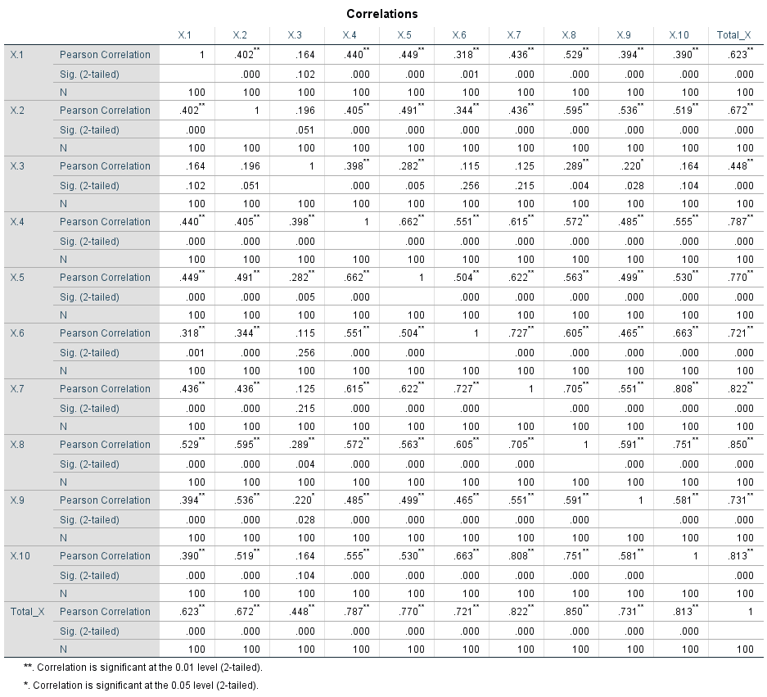

Uji Reliabilitas Variabel X

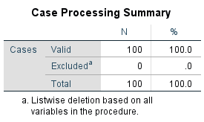

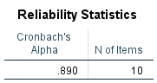

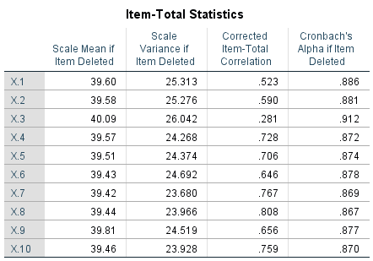

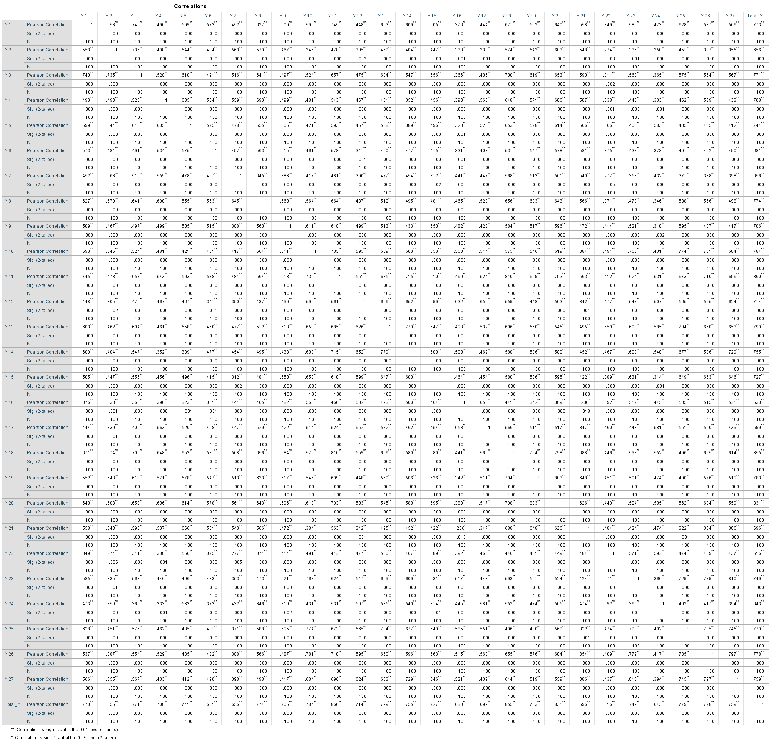Uji Validitas Variabel Y

Uji Reliabilitas Variabel Y



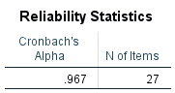

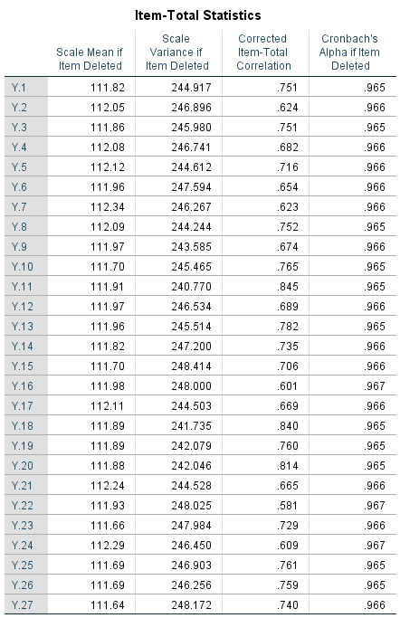

**Lampiran 4 Distribusi Nilai R-tabel**

**Distribusi Nilai rtabel**

**Signifikansi 5% dan 1%**

|  |  |  |  |  |  |
| --- | --- | --- | --- | --- | --- |
| N | The Level of Significance | | N | The Level of Significance | |
| 5% | 1% | 5% | 1% |
| 3 | 0.997 | 0.999 | 38 | 0.320 | 0.413 |
| 4 | 0.950 | 0.990 | 39 | 0.316 | 0.408 |
| 5 | 0.878 | 0.959 | 40 | 0.312 | 0.403 |
| 6 | 0.811 | 0.917 | 41 | 0.308 | 0.398 |
| 7 | 0.754 | 0.874 | 42 | 0.304 | 0.393 |
| 8 | 0.707 | 0.834 | 43 | 0.301 | 0.389 |
| 9 | 0.666 | 0.798 | 44 | 0.297 | 0.384 |
| 10 | 0.632 | 0.765 | 45 | 0.294 | 0.380 |
| 11 | 0.602 | 0.735 | 46 | 0.291 | 0.376 |
| 12 | 0.576 | 0.708 | 47 | 0.288 | 0.372 |
| 13 | 0.553 | 0.684 | 48 | 0.284 | 0.368 |
| 14 | 0.532 | 0.661 | 49 | 0.281 | 0.364 |
| 15 | 0.514 | 0.641 | 50 | 0.279 | 0.361 |
| 16 | 0.497 | 0.623 | 55 | 0.266 | 0.345 |
| 17 | 0.482 | 0.606 | 60 | 0.254 | 0.330 |
| 18 | 0.468 | 0.590 | 65 | 0.244 | 0.317 |
| 19 | 0.456 | 0.575 | 70 | 0.235 | 0.306 |
| 20 | 0.444 | 0.561 | 75 | 0.227 | 0.296 |
| 21 | 0.433 | 0.549 | 80 | 0.220 | 0.286 |
| 22 | 0.432 | 0.537 | 85 | 0.213 | 0.278 |
| 23 | 0.413 | 0.526 | 90 | 0.207 | 0.267 |
| 24 | 0.404 | 0.515 | 95 | 0.202 | 0.263 |
| 25 | 0.396 | 0.505 | 100 | 0.195 | 0.256 |
| 26 | 0.388 | 0.496 | 125 | 0.176 | 0.230 |
| 27 | 0.381 | 0.487 | 150 | 0.159 | 0.210 |
| 28 | 0.374 | 0.478 | 175 | 0.148 | 0.194 |
| 29 | 0.367 | 0.470 | 200 | 0.138 | 0.181 |
| 30 | 0.361 | 0.463 | 300 | 0.113 | 0.148 |
| 31 | 0.355 | 0.456 | 400 | 0.098 | 0.128 |
| 32 | 0.349 | 0.449 | 500 | 0.088 | 0.115 |
| 33 | 0.344 | 0.442 | 600 | 0.080 | 0.105 |
| 34 | 0.339 | 0.436 | 700 | 0.074 | 0.097 |
| 35 | 0.334 | 0.430 | 800 | 0.070 | 0.091 |
| 36 | 0.329 | 0.424 | 900 | 0.065 | 0.086 |
| 37 | 0.325 | 0.418 | 1000 | 0.062 | 0.081 |

**Lampiran 5 Distribusi Nilai T-tabel**

**Distribusi Nilai ttabel**

|  |  |  |  |  |  |  |  |  |  |  |  |  |
| --- | --- | --- | --- | --- | --- | --- | --- | --- | --- | --- | --- | --- |
| d.f | t0.10 | t0.05 | t0.025 | t0.01 | t0.005 |  | d.f | t0.10 | t0.05 | t0.025 | t0.01 | t0.005 |
| 1 | 3.078 | 6.314 | 12.71 | 31.82 | 63.66 |  | 61 | 1.296 | 1.671 | 2.000 | 2.390 | 2.659 |
| 2 | 1.886 | 2.920 | 4.303 | 6.965 | 9.925 |  | 62 | 1.296 | 1.671 | 1.999 | 2.389 | 2.659 |
| 3 | 1.638 | 2.353 | 3.182 | 4.541 | 5.841 |  | 63 | 1.296 | 1.670 | 1.999 | 2.389 | 2.658 |
| 4 | 1.533 | 2.132 | 2.776 | 3.747 | 4.604 |  | 64 | 1.296 | 1.670 | 1.999 | 2.388 | 2.657 |
| 5 | 1.476 | 2.015 | 2.571 | 3.365 | 4.032 |  | 65 | 1.296 | 1.670 | 1.998 | 2.388 | 2.657 |
| 6 | 1.440 | 1.943 | 2.447 | 3.143 | 3.707 |  | 66 | 1.295 | 1.670 | 1.998 | 2.387 | 2.656 |
| 7 | 1.415 | 1.895 | 2.365 | 2.998 | 3.499 |  | 67 | 1.295 | 1.670 | 1.998 | 2.387 | 2.655 |
| 8 | 1.397 | 1.860 | 2.306 | 2.896 | 3.355 |  | 68 | 1.295 | 1.670 | 1.997 | 2.386 | 2.655 |
| 9 | 1.383 | 1.833 | 2.262 | 2.821 | 3.250 |  | 69 | 1.295 | 1.669 | 1.997 | 2.386 | 2.654 |
| 10 | 1.372 | 1.812 | 2.228 | 2.764 | 3.169 |  | 70 | 1.295 | 1.669 | 1.997 | 2.385 | 2.653 |
| 11 | 1.363 | 1.796 | 2.201 | 2.718 | 3.106 |  | 71 | 1.295 | 1.669 | 1.996 | 2.385 | 2.653 |
| 12 | 1.356 | 1.782 | 2.179 | 2.681 | 3.055 |  | 72 | 1.295 | 1.669 | 1.996 | 2.384 | 2.652 |
| 13 | 1.350 | 1.771 | 2.160 | 2.650 | 3.012 |  | 73 | 1.295 | 1.669 | 1.996 | 2.384 | 2.651 |
| 14 | 1.345 | 1.761 | 2.145 | 2.624 | 2.977 |  | 74 | 1.295 | 1.668 | 1.995 | 2.383 | 2.651 |
| 15 | 1.341 | 1.753 | 2.131 | 2.602 | 2.947 |  | 75 | 1.295 | 1.668 | 1.995 | 2.383 | 2.650 |
| 16 | 1.337 | 1.746 | 2.120 | 2.583 | 2.921 |  | 76 | 1.294 | 1.668 | 1.995 | 2.382 | 2.649 |
| 17 | 1.333 | 1.740 | 2.110 | 2.567 | 2.898 |  | 77 | 1.294 | 1.668 | 1.994 | 2.382 | 2.649 |
| 18 | 1.330 | 1.734 | 2.101 | 2.552 | 2.878 |  | 78 | 1.294 | 1.668 | 1.994 | 2.381 | 2.648 |
| 19 | 1.328 | 1.729 | 2.093 | 2.539 | 2.861 |  | 79 | 1.294 | 1.668 | 1.994 | 2.381 | 2.647 |
| 20 | 1.325 | 1.725 | 2.086 | 2.528 | 2.845 |  | 80 | 1.294 | 1.667 | 1.993 | 2.380 | 2.647 |
| 21 | 1.323 | 1.721 | 2.080 | 2.518 | 2.831 |  | 81 | 1.294 | 1.667 | 1.993 | 2.380 | 2.646 |
| 22 | 1.321 | 1.717 | 2.074 | 2.508 | 2.819 |  | 82 | 1.294 | 1.667 | 1.993 | 2.379 | 2.645 |
| 23 | 1.319 | 1.714 | 2.069 | 2.500 | 2.807 |  | 83 | 1.294 | 1.667 | 1.992 | 2.379 | 2.645 |
| 24 | 1.318 | 1.711 | 2.064 | 2.492 | 2.797 |  | 84 | 1.294 | 1.667 | 1.992 | 2.378 | 2.644 |
| 25 | 1.316 | 1.708 | 2.060 | 2.485 | 2.787 |  | 85 | 1.294 | 1.666 | 1.992 | 2.378 | 2.643 |
| 26 | 1.315 | 1.706 | 2.056 | 2.479 | 2.779 |  | 86 | 1.293 | 1.666 | 1.991 | 2.377 | 2.643 |
| 27 | 1.314 | 1.703 | 2.052 | 2.473 | 2.771 |  | 87 | 1.293 | 1.666 | 1.991 | 2.377 | 2.642 |
| 28 | 1.313 | 1.701 | 2.048 | 2.467 | 2.763 |  | 88 | 1.293 | 1.666 | 1.991 | 2.376 | 2.641 |
| 29 | 1.311 | 1.699 | 2.045 | 2.462 | 2.756 |  | 89 | 1.293 | 1.666 | 1.990 | 2.376 | 2.641 |
| 30 | 1.310 | 1.697 | 2.042 | 2.457 | 2.750 |  | 90 | 1.293 | 1.666 | 1.990 | 2.375 | 2.640 |
| 31 | 1.309 | 1.696 | 2.040 | 2.453 | 2.744 |  | 91 | 1.293 | 1.665 | 1.990 | 2.374 | 2.639 |
| 32 | 1.309 | 1.694 | 2.037 | 2.449 | 2.738 |  | 92 | 1.293 | 1.665 | 1.989 | 2.374 | 2.639 |
| 33 | 1.308 | 1.692 | 2.035 | 2.445 | 2.733 |  | 93 | 1.293 | 1.665 | 1.989 | 2.373 | 2.638 |
| 34 | 1.307 | 1.691 | 2.032 | 2.441 | 2.728 |  | 94 | 1.293 | 1.665 | 1.989 | 2.373 | 2.637 |
| 35 | 1.306 | 1.690 | 2.030 | 2.438 | 2.724 |  | 95 | 1.293 | 1.665 | 1.988 | 2.372 | 2.637 |
| 36 | 1.306 | 1.688 | 2.028 | 2.434 | 2.719 |  | 96 | 1.292 | 1.664 | 1.988 | 2.372 | 2.636 |
| 37 | 1.305 | 1.687 | 2.026 | 2.431 | 2.715 |  | 97 | 1.292 | 1.664 | 1.988 | 2.371 | 2.635 |
| 38 | 1.304 | 1.686 | 2.024 | 2.429 | 2.712 |  | 98 | 1.292 | 1.664 | 1.987 | 2.371 | 2.635 |
| 39 | 1.304 | 1.685 | 2.023 | 2.426 | 2.708 |  | 99 | 1.292 | 1.664 | 1.987 | 2.370 | 2.634 |
| 40 | 1.303 | 1.684 | 2.021 | 2.423 | 2.704 |  | 100 | 1.292 | 1.664 | 1.987 | 2.370 | 2.633 |
| 41 | 1.303 | 1.683 | 2.020 | 2.421 | 2.701 |  | 101 | 1.292 | 1.663 | 1.986 | 2.369 | 2.633 |
| 42 | 1.302 | 1.682 | 2.018 | 2.418 | 2.698 |  | 102 | 1.292 | 1.663 | 1.986 | 2.369 | 2.632 |
| 43 | 1.302 | 1.681 | 2.017 | 2.416 | 2.695 |  | 103 | 1.292 | 1.663 | 1.986 | 2.368 | 2.631 |
| 44 | 1.301 | 1.680 | 2.015 | 2.414 | 2.692 |  | 104 | 1.292 | 1.663 | 1.985 | 2.368 | 2.631 |
| 45 | 1.301 | 1.679 | 2.014 | 2.412 | 2.690 |  | 105 | 1.292 | 1.663 | 1.985 | 2.367 | 2.630 |
| 46 | 1.300 | 1.679 | 2.013 | 2.410 | 2.687 |  | 106 | 1.291 | 1.663 | 1.985 | 2.367 | 2.629 |
| 47 | 1.300 | 1.678 | 2.012 | 2.408 | 2.685 |  | 107 | 1.291 | 1.662 | 1.984 | 2.366 | 2.629 |
| 48 | 1.299 | 1.677 | 2.011 | 2.407 | 2.682 |  | 108 | 1.291 | 1.662 | 1.984 | 2.366 | 2.628 |
| 49 | 1.299 | 1.677 | 2.010 | 2.405 | 2.680 |  | 109 | 1.291 | 1.662 | 1.984 | 2.365 | 2.627 |
| 50 | 1.299 | 1.676 | 2.009 | 2.403 | 2.678 |  | 110 | 1.291 | 1.662 | 1.983 | 2.365 | 2.627 |
| 51 | 1.298 | 1.675 | 2.008 | 2.402 | 2.676 |  | 111 | 1.291 | 1.662 | 1.983 | 2.364 | 2.626 |
| 52 | 1.298 | 1.675 | 2.007 | 2.400 | 2.674 |  | 112 | 1.291 | 1.661 | 1.983 | 2.364 | 2.625 |
| 53 | 1.298 | 1.674 | 2.006 | 2.399 | 2.672 |  | 113 | 1.291 | 1.661 | 1.982 | 2.363 | 2.625 |
| 54 | 1.297 | 1.674 | 2.005 | 2.397 | 2.670 |  | 114 | 1.291 | 1.661 | 1.982 | 2.363 | 2.624 |
| 55 | 1.297 | 1.673 | 2.004 | 2.396 | 2.668 |  | 115 | 1.291 | 1.661 | 1.982 | 2.362 | 2.623 |
| 56 | 1.297 | 1.673 | 2.003 | 2.395 | 2.667 |  | 116 | 1.290 | 1.661 | 1.981 | 2.362 | 2.623 |
| 57 | 1.297 | 1.672 | 2.002 | 2.394 | 2.665 |  | 117 | 1.290 | 1.661 | 1.981 | 2.361 | 2.622 |
| 58 | 1.296 | 1.672 | 2.002 | 2.392 | 2.663 |  | 118 | 1.290 | 1.660 | 1.981 | 2.361 | 2.621 |
| 59 | 1.296 | 1.671 | 2.001 | 2.391 | 2.662 |  | 119 | 1.290 | 1.660 | 1.980 | 2.360 | 2.621 |
| 60 | 1.296 | 1.671 | 2.000 | 2.390 | 2.660 |  | 120 | 1.290 | 1.660 | 1.980 | 2.360 | 2.620 |

**Lampiran 6 Interpretasi Koefesien Korelasi**

**Tabel Interpretasi Koefesien Korelasi**

|  |  |
| --- | --- |
| **Interval Koefesien** | **Tingkat Hubungan** |
| 0,00 – 0,199 | Sangat Rendah |
| 0,20 – 0,399 | Rendah |
| 0,40 – 0,599 | Sedang |
| 0,60 – 0,799 | Kuat |
| 0,80 – 1,00 | Sangat Kuat |

Sumber: Sugiyono (2004:214)

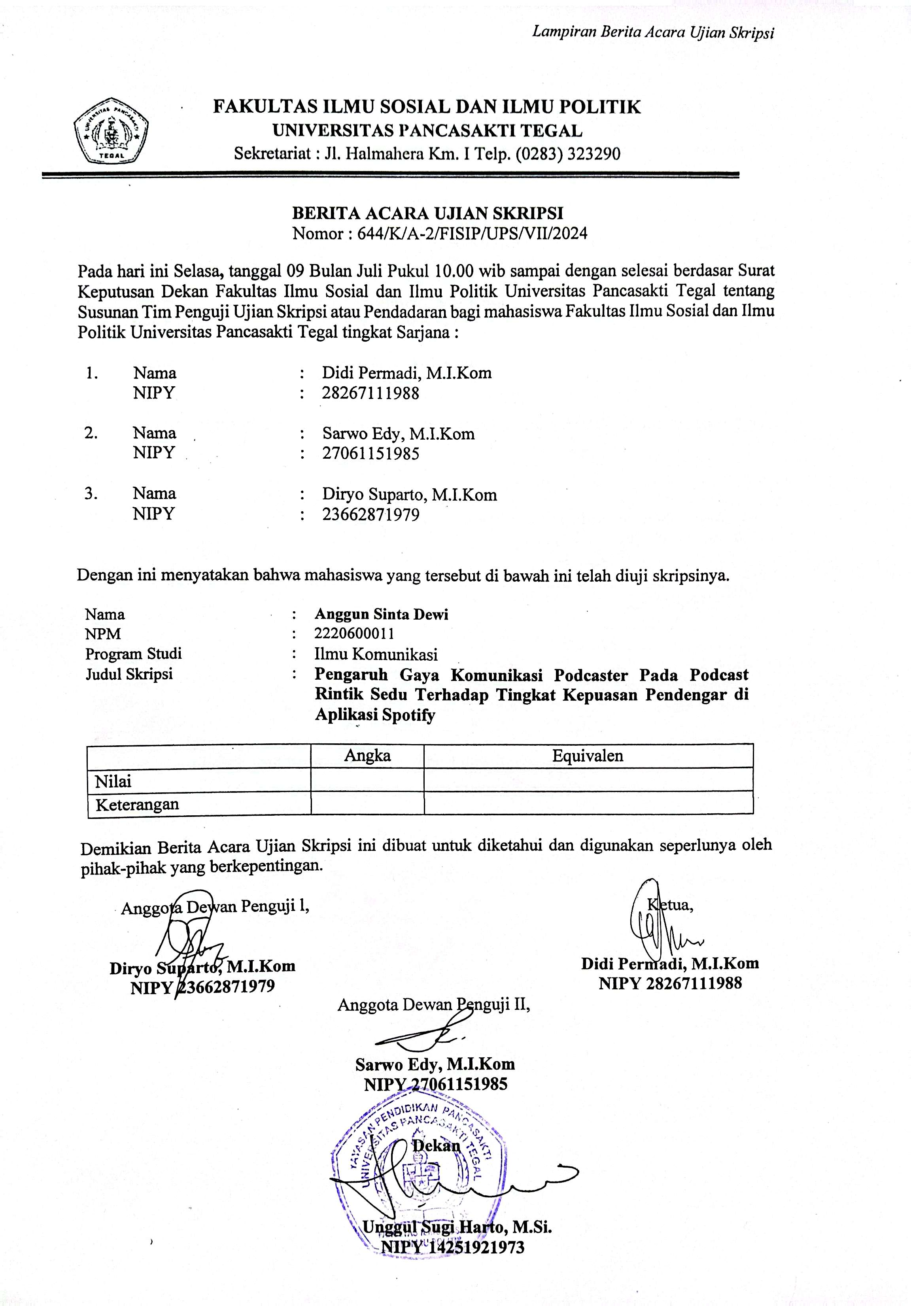**Lampiran 7 Berita Acara Ujian Skripsi**

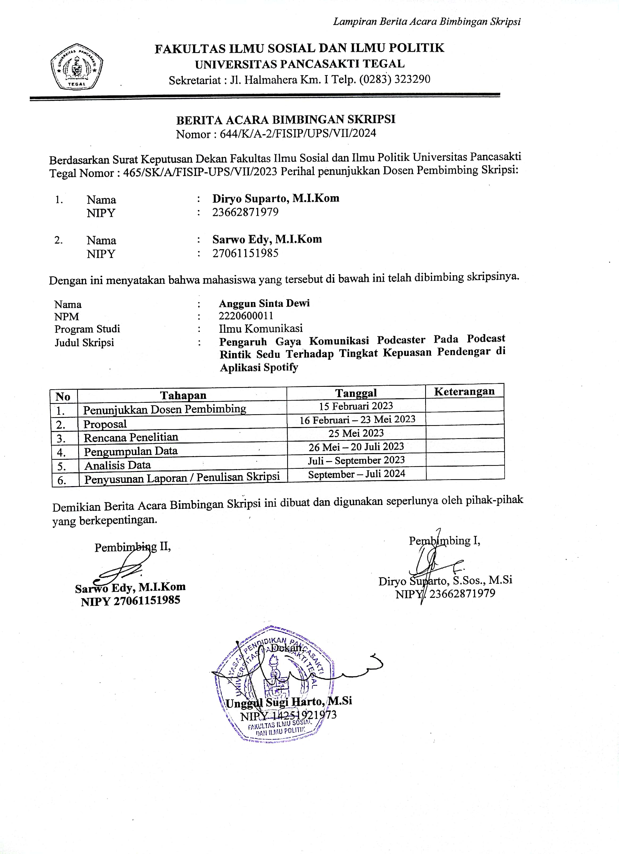**Lampiran 8 Berita Acara Bimbingan Skripsi**

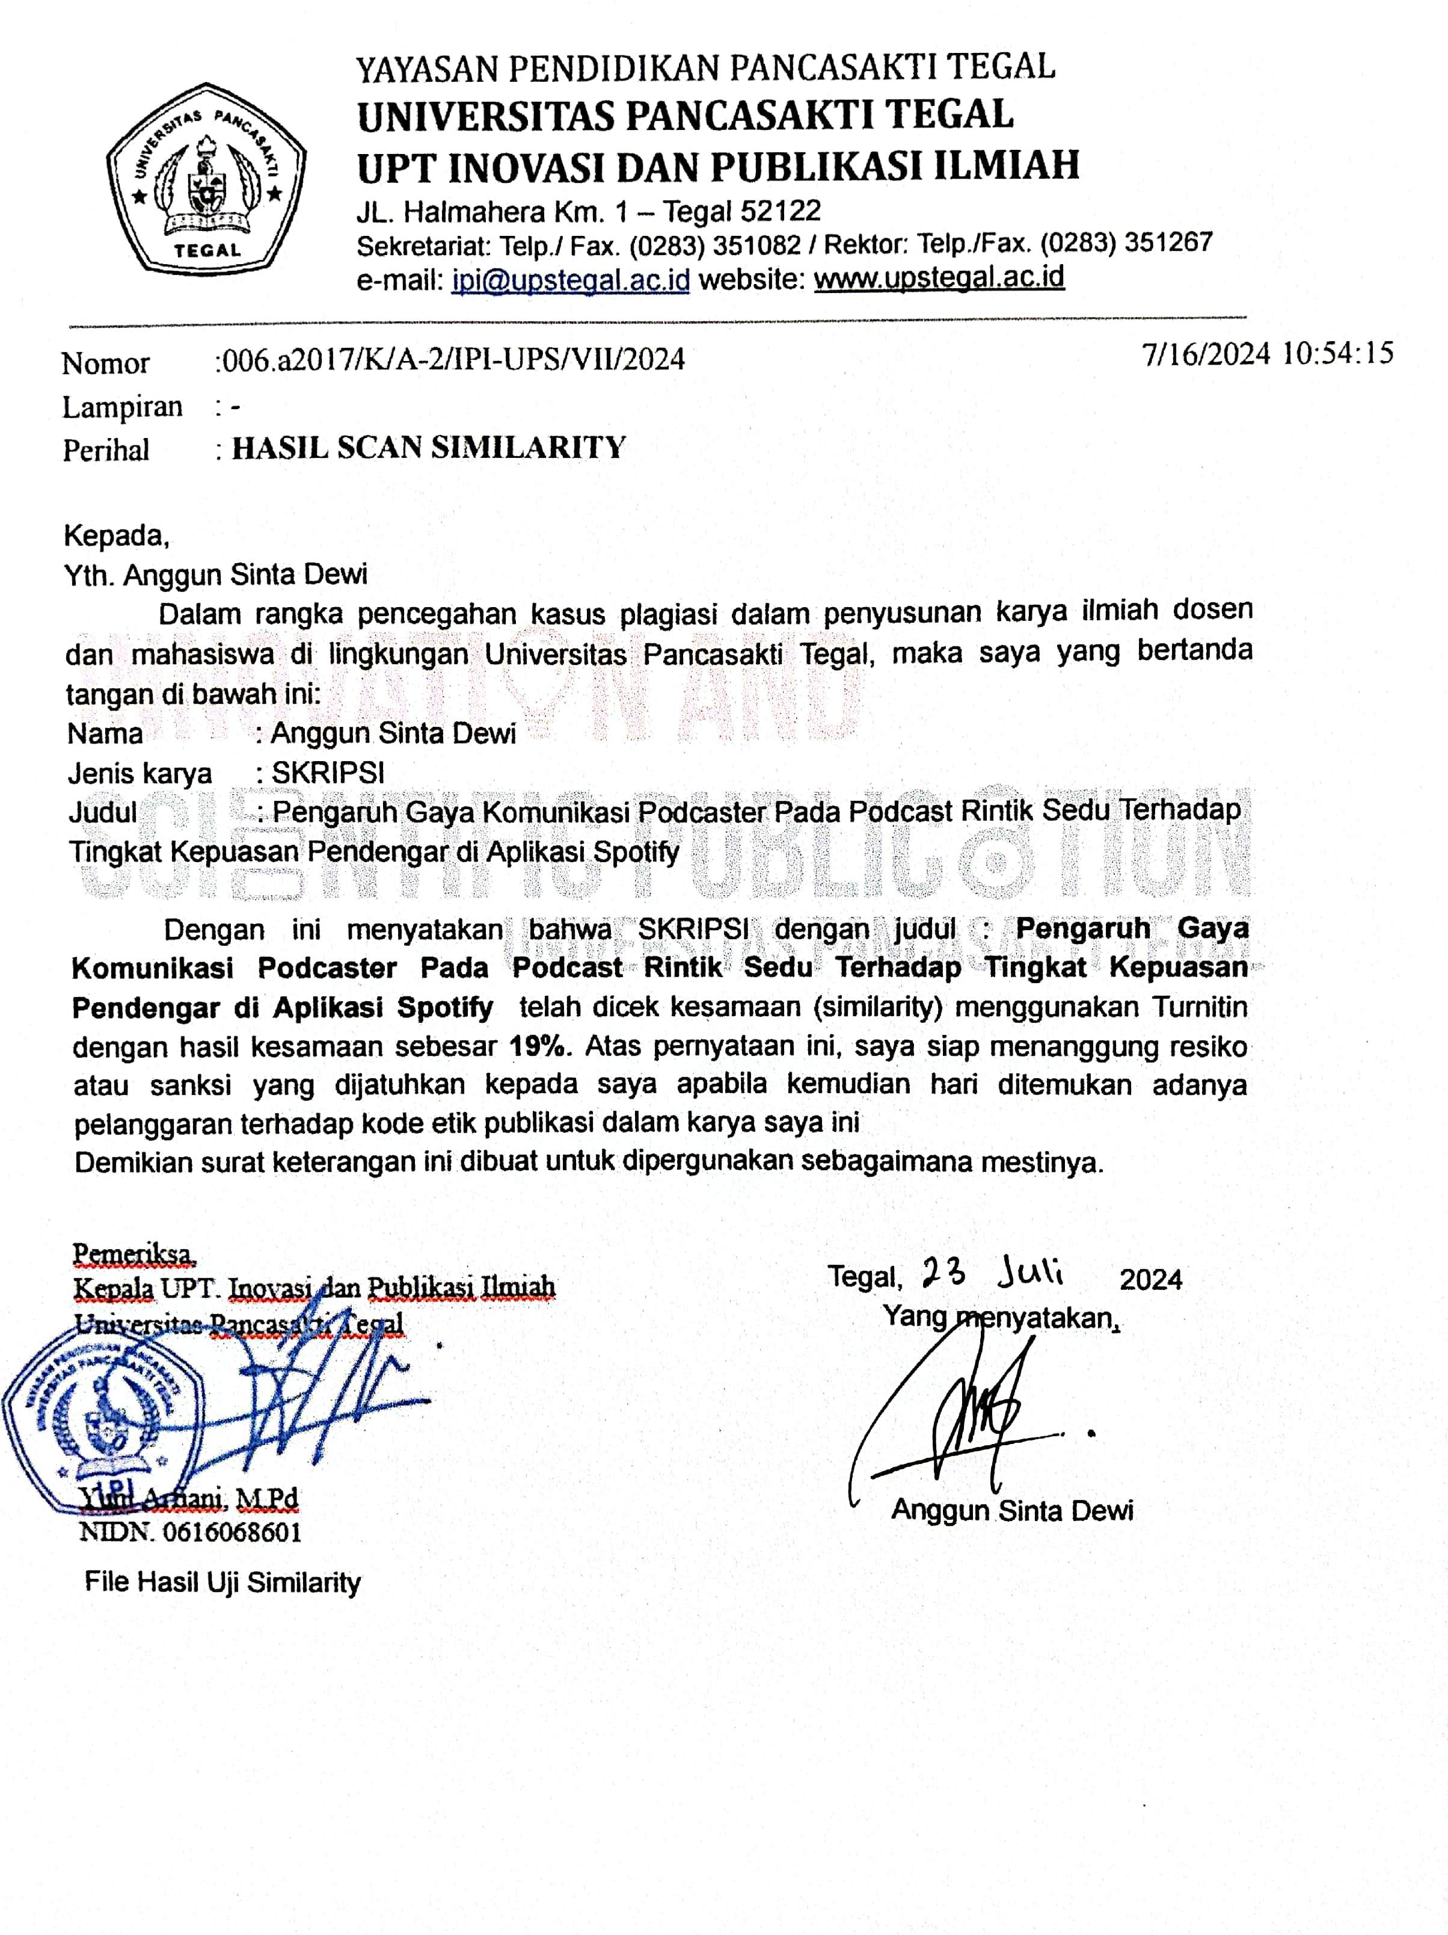**Lampiran 9 Surat Keterangan Plagiasi**