# DAFTAR PUSTAKA

Abdulsalam, N., & Babangida, M. A. (2020). Effect of Sales and Firm Size on Sustainability Reporting Practice of Oil and Gas Companies in Nigeria. *Quest Journals Journal of Research in Business and Management*, *8*(September), 2347–3002. www.questjournals.org

Adhipradana, F., & Daljono. (2013). Pengaruh Kinerja Keuangan, Ukuran Perusahaan dan Corporate Governance Terhadap Pengungkapan Sustainabillitty Report. *Diponegoro Journal of Accounting*, *2*(2011), 1–10. https://ejournal3.undip.ac.id

Afifah, N., Fujianti, L., Rizky, Y., & Mandagie, O. (2022). *( Studi Empiris Pada Perusahaan Peraih Indonesia Sustainability Reporting Award Yang Terdaftar di BEI Pada Tahun 2015- 2019 )*. *2*(1), 19–34. https://journal.univpancasila.ac.id

Aini, N., & Subardjo, A. (2018). Pengaruh Karakteristik Perusahaan Dan Struktur Modal Terhadap Pengungkapan Sustainability Report. *Jurnal Ilmu Dan Riset Akuntansi (JIRA)*, *7*(1), 1–16. http://jurnalmahasiswa.stiesia.ac.id/

Antara, D. made D. J., Putri, G. A. M. A. D., Ratnadi, N. M. D., & Wirawati, N. G. P. (2020). Effect of Firm Size, Leverage, and Environmental Performance on Sustainability Reporting. *American Journal of Humanities and Social Sciences Research*, *4*(1), 40–46. www.ajhssr.com

Apriliyani, F. (2022). *Pengaruh Ukuran Perusahaan,Aktivitas Perusahaan,Produktivitas Dan Leverage Terhadap Pengungkapan Sustainability Report*. *2*(4). Https://Download.Garuda.Kemdikbud.Go.Id

David, A. &. (2023). *Pengaruh Profitabilitas Dan Ukuran Perusahaan Terhadap Pengungkapan Sustainability Report*. Http://Jurnalmahasiswa.Stiesia.Ac.Id

Dewi, I., & Pitriasari, P. (2019). Pengaruh Good Corporate Governance Dan Ukuran Perusahaan Terhadap Pengungkapan Sustainability Report. *Jsma (Jurnal Sains Manajemen Dan Akuntansi)*, *11*(1), 33–53. Https://Doi.Org/10.37151/Jsma.V11i1.13

Diono, H., Jatmiko, T., & Prabowo, W. (2017). *Analisis Pengaruh Mekanisme Corporate Governance , Profitalbilitas , Dan Ukuran Perusahaan Terhadap*. *6*(2013), 1–10. Https://Ejournal3.Undip.Ac.Id

Direksi, P. D., Komisaris, D., Audit, K., & Sofa, F. N. (2020). *Ukuran Perusahaan Terhadap Pengungkapan Sustainability Report ( Studi Pada Perusahaan Manufaktur Yang Terdaftar Di Bursa Efek Indonesia Tahun 2017 )*. *13*(1), 32–49. Https://Www.Stienas-Ypb.Ac.Id

Ekonomi, P. F. (2017). *Analisis Tata Kelola, Jaminan Eksternal, Karakteristik Perusahaan Dan Kebangkrutan Terhadap Laporan Keberlanjutan (Studi Empiris Pada Perusahaan Manufaktur Yang Tercatat Di Bursa Efek Indonesia)*. *2*(2). Http://Repository.Uki.Ac.Id

Erry, S. (2022). *Profitabilitas Ukuran Perusahaan Dan Pertumbuhan Aset Serta Pengaruhnya Terhadap Leverage Pada Perusahaan*. Perkumpulan Rumah Cemerlang Indonesia. Https://Www.Rcipress.Rcipublisher.Org

Fuadah, Luk Luk, Yuliani, & Safitri, R. Henda. (2018). *Pengungkapan Sustainability Reporting Di Indonesia*. Citrabooks Indonesia. Https://Repository.Unsri.Ac.Id

Ghozali. (2018). *Aplikasi Analisis Miltivariate Dengan Program IBM SPSS 25*.

Ghozali. (2020). *25 Grand Theory*. Yoga Pratama.

Gray, R., Kouhy, R., & Lavers, S. (1975). *CSR: A Review Of The Literature 47 Corporate Social And Environmental Reporting A Review Of The Literature And A Longitudinal Study Of UK Disclosure*. *8*(2), 47–76. Https://D1wqtxts1xzle7.Cloudfront.Net

Gunawan, V., & Sjarief, J. (2022). Analisis Pengaruh Profitabilitas, Leverage, Dan Ukuran Perusahaan Terhadap Pengungkapan Sustainability Report. *BALANCE: Jurnal Akuntansi, Auditing Dan Keuangan*, *19*(1), 22–41. Https://Doi.Org/10.25170/Balance.V19i1.3223

Hermawan, T. (2021). *Pengaruh Likuiditas , Leverage , Dan Profitabilitas Terhadap Pengungkapan Sustainability Report*. *9*(3), 597–604. Https://Doi.Org/10.37641/Jiakes.V9i3.1209

Jensen, M. C., & Meckling, W. H. (1976). Also Published In Foundations Of Organizational Strategy. *Journal Of Financial Economics*, *4*, 305–360. Http://Ssrn.Com/Abstract=94043Electroniccopyavailableat:Http://Ssrn.Com/Abstract=94043http://Hupress.Harvard.Edu/Catalog/JENTHF.Html

Kasmir. (2019). *Analisis Laporan Keuangan*. Raja Grafindo Persada.

Kinerja, P., Terhadap, K., Report, S., Di, P., & Efek, B. (2013). *Accounting Analysis Journal*. *2*(4), 480–488.

Liana, S., & Kunci, K. (2019). *Pengaruh Profitabilitas , Leverage , Ukuran Perusahaan , Dan Dewan Komisaris Independen Terhadap Pengungkapan Sustainability Report*. *2*(2), 199–208. Https://Stiealwashliyahsibolga.Ac.Id

Marwati, Y. (2015). *Analisis Pengungkapan Sustainability Report Pada Perusahaan Non-Keuangan Tahun 2009-2013 Candri Puspita Marwati  Yulianti*. *7*(2), 167–181. Https://Journal.Unnes.Ac.Id/

Maya Safira, G., & Rahmawati, N. (2012). Pengaruh Karakteristik Perusahaan Dan Corporate Governance (Cg) Terhadap Pengungkapan Sustainability Report. *Jurnal Kajian Akuntansi Dan Auditing*, *22*, 1–18. Https://Doi.Org/10.37301/Jkaa.V0i0.5127

Mekaniseme, P., Corporate, G., Dan, G., Keuangan, K., & Pengungkapan, T. (2015). *REPORT*. *4*(3), 1–10. Https://Journal.Unnes.Ac.Id

Meutia, F., & Titik, F. (2019). Pengaruh Profitabilitas, Laverage, Ukuran Perusahaan, Dan Kepemilikan Publik Terhadap Pengungkapan Laporan Keberlanjutan [The Effect Of Profitability, Laverage, Company Size, And Public Ownership On Sustainability Report Disclosure]. *Proceeding Of Management :*, *6*(2), 3543–3551.Https://Openlibrarypublications.Telkomuniversity.Ac.Id/Index.Php/Management/Article/View/10352

Mota, L., Sorg, I., Cornelis, G., Parsot, C., Bach, S., Stanford, K., Mcallister, T., Cheng, H., Jiang, N., & Shen, A. (2005). Editorial Board• EDITORIAL BOARD. *FEMS Microbiology Letters*, *252*(1), 1–6. Https://Epe.Lac-Bac.Gc.Ca

Natalia, O., & Wahidahwati. (2016). Faktor-Faktor Yang Mempengaruhi Tingkat Pengungkapan Sustainability Report. *Jurnal Ilmu Dan Riset Akuntansi*, *5*(11), 1–23. Http://Jurnalmahasiswa.Stiesia.Ac.Id

NURDIN, N., & RIYADI, P. (2023). The Effect Of Financial Performance, Leverage, Good Corporate Governance And Company Size On The Sustainability Report (Study Of Companies Listed On The IDX, LQ 45 In Year 2015 – 2019). *Journal Of Entrepreneurial And Business Diversity*, *1*(1), 22–37. Https://Doi.Org/10.38142/Jebd.V1i1.34

Nurrahman, A., Akuntansi, J., Ekonomika, F., & Diponegoro, U. (2013). *Praktik Pengungkapan Sustainability Report*. *2*, 1–13. Https://Journal.Unnes.Ac.Id

Perusahaan, P., & Di, T. (N.D.). *Pengaruh Mekanisme Good Corporate Governace Dan Ukuran Perusahaan Terhadap Kualitas Pengungkapan Sustainability Reporting Pada Perusahaan Terdaftar Di BEI*. *XV*(1), 26–41. Https://Download.Garuda.Kemdikbud.Go.Id

Pratama, A., & Yulianto, A. (2015). Faktor Keuangan Dan Corporate Governance Sebagai Penentu Pengungkapan Sustainability Report. *Accounting Analysisi Journal*, *4*(2), 1–10. Https://Journal.Unnes.Ac.Id/Sju/Aaj/Article/View/7863

Putri & Indrayeni. (2023). *Pengaruh Profitabilitas , Likuiditas , Dan Ukuran Perusahaan Terhadap Pengungkapan Sustainability Reporting Pada Perusahaan Pertambangan*. *01*(03), 281–290. https://jurnal.ittc.web.id

Putri, A. Z., & Pramudiati, N. (2019). Determinan Pengungkapan Tanggung Jawab Sosialperusahaan Dalam Sustainability Report. *Jurnal Akuntansi*, *7*(2), 188–198. https://doi.org/10.26460/ja.v7i2.1013

Rely, G. (2018). The Effect Of Financial Performance, Firm Size And Corporate Governance Towards Sustainability Report Disclosures. *Research Journal of Finance and Accounting Www.Iiste.Org ISSN*, *9*(22), 181–193. www.iiste.org

Rifandi, A. (2017). Pengaruh Ukuran Perusahaan, Profitabilitas, Dan Leverage Terhadap Pengungkapan Sustainability Report. *Jurnal Akuntansi*, *5*(2), 1–24. https://ejournal.unp.ac.id/students/index.php/akt/article/view/2641

Ruhana, A., Hidayah, N., & Buana, U. M. (2020). *The Effect of Liquidity , Firm Size , and Corporate Governance Toward Sustainability Report Disclosures*. *120*(Icmeb 2019), 279–284. https://www.atlantis-press.com

Setiawan, E., Yuliansyah, Y., & Gamayuni, R. R. (2022). *Pengaruh Profitabilitas dan Likuiditas terhadap Pengungkapan Sustainability Report di Perusahaan yang Terdaftar pada Jakarta Islamic Index ( JII ) ( The Effect of Profitability and Liquidity on Disclosure of Sustainability Reports in Companies Listed on t*. *1*(2), 97–111. http://penerbitgoodwood.com

Shamil, M. M., Shaikh, J. M., Ho, P. L., & Krishnan, A. (2014). The influence of board characteristics on sustainability reporting Empirical evidence from Sri Lankan firms. *Asian Review of Accounting*, *22*(2), 78–97. https://doi.org/10.1108/ARA-09-2013-0060

Siswanto Ely. (2021). *Manajemen Keuangan Dasar*. Universitas Negri Malang. http://manajemen.feb.um.ac.id/wp-content/uploads/2021/06/Buku-Ajar-Manajemen-Keuangan-Dasar-E-BOOK.pdf

Sitorus, C. I., Br. Bukit, R., & Bulan, N. (2024). The Influence of Company Size, Board of Directors and Leverage on Sustainability Report Disclosure with Profitability as a Moderation Variable in LQ45 Companies Listed on the Indonesia Stock Exchange. *International Journal of Current Science Research and Review*, *07*(05), 2673–2688. https://doi.org/10.47191/ijcsrr/v7-i5-29

Sonia, D., & Khafid, M. (2020). The Effect of Liquidity, Leverage, and Audit Committee on Sustainability Report Disclosure with Profitability as a Mediating Variable. *Accounting Analysis Journal*, *9*(2), 95–102. https://doi.org/10.15294/aaj.v9i2.31060

Sudana. (2015). *Manajemen keuangan Perusahaan*. Erlangga.

Suganda. (2018). *Event Study Teori dan Pembahasan Reaksi Pasar Modal Indonesia*. CV.Seribu bintang. https://osf.io/preprints/inarxiv/zbqm7

Sugiyono. (2022). *Metode Penelitian Kuantitaif*. ALFABETA.

Suliyanto. (2011). *Ekonometrika Terapan - Teori dan Aplikasi dengan SPSS*. ANDI.

Tobing, R. A. (2019). *Pengaruh Kinerja Keuangan , Ukuran Perusahaan , dan Good Corporate Governance Terhadap Pengungkapan Sustainability Report pada Perusahaan Manufaktur yang Terdaftar dalam Bursa Efek Indonesia*. *3*(1), 102–123. https://journal.umy.ac.id

Ullmann, A. A. (1985). Data in Search of a Theory: A Critical Examination of the Relationships Among Social Performance, Social Disclosure, and Economic Performance of U.S. Firms. *Academy of Management Review*, *10*(3), 540–557. https://doi.org/10.5465/amr.1985.4278989

Winda, D. (2020). *Jurusan Akuntansi, Fakultas Ekonomi, U*. *18*(2), 197–215. http://ecojoin.org

Yohana, S., & Suhendah, R. (2023). *The Effect Of Profitability , Leverage , And Firm Size On Sustainability Report Disclosure*. *27*(03), 525–545. http://ecojoin.org/index.php/EJA/article/view/1481

LAMPIRAN

Lampiran. 1 Daftar Perusahaan dan hasil perhitungan Sampel Penelitian

* 1. Leverage

|  |  |  |  |  |  |  |
| --- | --- | --- | --- | --- | --- | --- |
| **No** | **Kode Saham** | **Leverage** | | | | |
| **2019** | **2020** | **2021** | **2022** | **2023** |
| 1. | BBCA | 4,25 | 4,79 | 5,03 | 4,92 | 4,77 |
| 2. | BBNI | 5,51 | 6,61 | 6,63 | 6,35 | 6,02 |
| 3. | BBRI | 5,67 | 6,36 | 4,75 | 5,15 | 5,21 |
| 4. | BBTN | 11,30 | 16,08 | 15,31 | 13,56 | 12,51 |
| 5. | BMRI | 4,91 | 5,94 | 5,97 | 6,12 | 5,78 |
| 6. | INDF | *Outlier* | | | | |
| 7. | JSMR |
| 8. | KLBF |
| 9. | SMGR |
| 10. | TLKM |
| 11. | UNTR | 0,83 | 0,58 | 0,57 | 1,43 | 0,57 |
| 12. | UNVR | 2,91 | 3,16 | 3,41 | 0,92 | 3,58 |
| 13. | WIKA | 2,23 | 3,09 | 2,98 | 3,29 | 5.89 |

* 1. Likuiditas

| **No** | **Kode Saham** | **Likuiditas** | | | | |
| --- | --- | --- | --- | --- | --- | --- |
| **2019** | **2020** | **2021** | **2022** | **2023** |
| 1. | BBCA | 124,18 | 121,46 | 120,45 | 120,94 | 121,63 |
| 2. | BBNI | 122,82 | 119,44 | 115,09 | 115,76 | 116,60 |
| 3. | BBRI | 119,74 | 118,26 | 121,05 | 119,42 | 119,20 |
| 4. | BBTN | 115,71 | 112,39 | 113,48 | 114,45 | 115,11 |
| 5. | BMRI | 128,52 | 124,15 | 130,08 | 129,04 | 130,94 |
| 6. | INDF | *Outlier* | | | | |
| 7. | JSMR |
| 8. | KLBF |
| 9. | SMGR |
| 10. | TLKM |
| 11. | UNTR | 155,98 | 211,01 | 198,77 | 187,76 | 145,61 |
| 12. | UNVR | 65,29 | 66,09 | 61,41 | 60,82 | 55,17 |
| 13. | WIKA | 139,49 | 108,63 | 129,78 | 109,68 | 79,71 |

* 1. Firm Size

|  |  |  |  |  |  |  |
| --- | --- | --- | --- | --- | --- | --- |
| **No** | **Kode Saham** | **Firm Size** | | | | |
| **2019** | **2020** | **2021** | **2022** | **2023** |
| 1. | BBCA | 20,64 | 20,80 | 20,93 | 21,00 | 21,07 |
| 2. | BBNI | 20,61 | 20,56 | 20,69 | 20,75 | 20,81 |
| 3. | BBRI | 21,07 | 21,14 | 21,24 | 21,35 | 21,40 |
| 4. | BBTN | 19,56 | 19,70 | 19,73 | 19,81 | 19,90 |
| 5. | BMRI | 21,00 | 21,08 | 21,27 | 21,41 | 21,50 |
| 6. | INDF | *Outlier* | | | | |
| 7. | JSMR |
| 8. | KLBF |
| 9. | SMGR |
| 10. | TLKM |
| 11. | UNTR | 18,53 | 18,42 | 18,54 | 18,76 | 18,85 |
| 12. | UNVR | 16,84 | 16,84 | 16,76 | 16,72 | 16,63 |
| 13. | WIKA | 24,85 | 24,94 | 24,96 | 25,04 | 24,91 |

* 1. Sustainability report

| **No** | **Kode Saham** | **Sustainability report** | | | | |
| --- | --- | --- | --- | --- | --- | --- |
| **2019** | **2020** | **2021** | **2022** | **2023** |
| 1. | BBCA | 0,10 | 0,26 | 0,27 | 0,24 | 0,29 |
| 2. | BBNI | 0,07 | 0,15 | 0,22 | 0,31 | 0,64 |
| 3. | BBRI | 0,19 | 0,30 | 0,35 | 0,37 | 0,37 |
| 4. | BBTN | 0,32 | 0,32 | 0,46 | 0,56 | 0,63 |
| 5. | BMRI | 0,27 | 0,26 | 0,44 | 0,47 | 0,35 |
| 6. | INDF | *Outlier* | | | | |
| 7. | JSMR |
| 8. | KLBF |
| 9. | SMGR |
| 10. | TLKM |
| 11. | UNTR | 0,19 | 0,21 | 0,25 | 0,14 | 0,14 |
| 12. | UNVR | 0,21 | 0,29 | 0,27 | 0,41 | 0,58 |
| 13. | WIKA | 0,25 | 0,25 | 0,31 | 0,45 | 0,41 |

* 1. Profitabilitas

|  |  |  |  |  |  |  |
| --- | --- | --- | --- | --- | --- | --- |
| **No** | **Kode Saham** | **Profitabilitas** | | | | |
| **2019** | **2020** | **2021** | **2022** | **2023** |
| 1. | BBCA | 0,03 | 0,03 | 0,03 | 0,03 | 0,03 |
| 2. | BBNI | 0,02 | 0,00 | 0,01 | 0,02 | 0,02 |
| 3. | BBRI | 0,02 | 0,01 | 0,02 | 0,03 | 0,03 |
| 4. | BBTN | 0,00 | 0,00 | 0,01 | 0,01 | 0,01 |
| 5. | BMRI | 0,02 | 0,01 | 0,02 | 0,02 | 0,03 |
| 6. | INDF | *Outlier* | | | | |
| 7. | JSMR |
| 8. | KLBF |
| 9. | SMGR |
| 10. | TLKM |
| 11. | UNTR | 0,10 | 0,06 | 0,09 | 0,16 | 0,14 |
| 12. | UNVR | 0,36 | 0,35 | 0,30 | 0,29 | 0,29 |
| 13. | WIKA | 0,04 | 0,00 | 0,00 | 0,00 | 0,12 |

Lampiran. 2 Uji Statistik Deskriptif

|  |  |  |  |  |  |
| --- | --- | --- | --- | --- | --- |
| **Descriptive Statistics** | | | | | |
|  | N | Minimum | Maximum | Mean | Std. Deviation |
| Leverage | 60 | -.50 | 14.62 | 3.0228 | 3.44617 |
| Likuiditas | 60 | -8.77 | 482.84 | 104.1478 | 94.82213 |
| Firm size | 60 | .00 | 26.76 | 15.4076 | 4.61090 |
| LaporanKeberlanjutan | 60 | -.06 | .57 | .2518 | .13256 |
| Profitabilitas | 60 | -.08 | .34 | .0553 | .08921 |
| Valid N (listwise) | 60 |  |  |  |  |

Sumber data: Data yang diolah SPSS 25

Lampiran. 3 Uji Asumsi Klasik

1. **Hasil Uji Normalitas**

**Grafik Histogram**

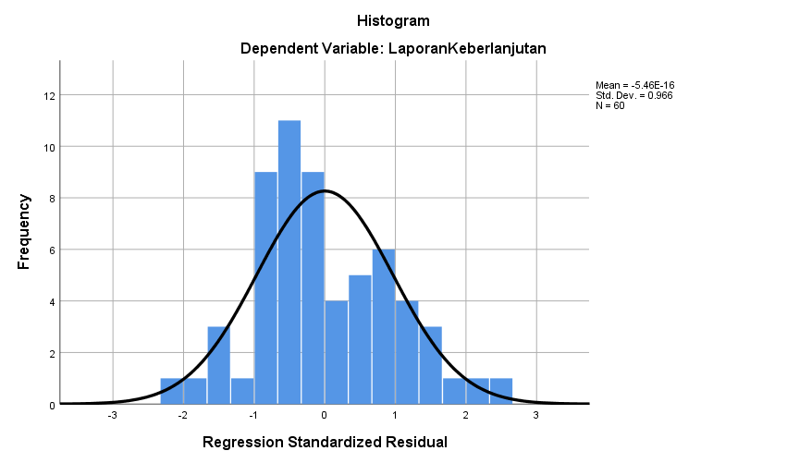

Sumber data: Data yang diolah SPSS 25

**Grafik Normal Probability Plot**

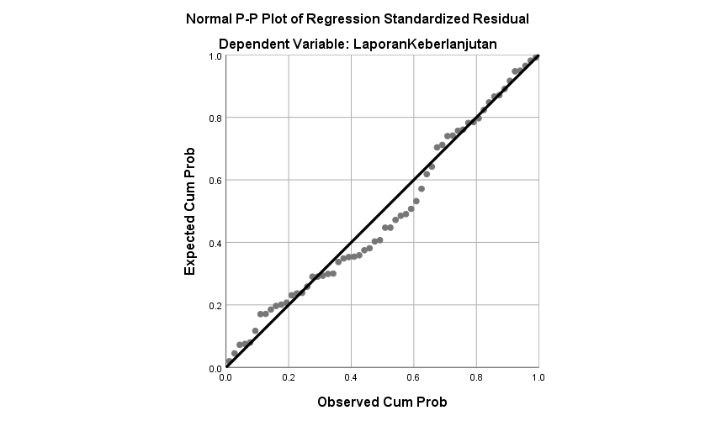

Sumber data: Data yang diolah SPSS 25

**Uji Kolmogorov Smirnov**

|  |  |  |
| --- | --- | --- |
| **One-Sample Kolmogorov-Smirnov Test** | | |
|  | | Unstandardized Residual |
| N | | 60 |
| Normal Parametersa,b | Mean | .0000000 |
| Std. Deviation | .12340012 |
| Most Extreme Differences | Absolute | .096 |
| Positive | .096 |
| Negative | -.062 |
| Test Statistic | | .096 |
| Asymp. Sig. (2-tailed) | | .200c,d |
| a. Test distribution is Normal. | |  |
| b. Calculated from data. | |  |
| c. Lilliefors Significance Correction. | |  |
| d. This is a lower bound of the true significance | |  |

Sumber data: Data yang diolah SPSS 25

|  |  |  |  |  |  |  |  |  |
| --- | --- | --- | --- | --- | --- | --- | --- | --- |
| **Coefficientsa** | | | | | | | | |
| Model | | Unstandardized Coefficients | | Standardized Coefficients | t | Sig. | Collinearity Statistics | |
| B | Std. Error | Beta | Tolerance | VIF |
| 1 | (Constant) | .109 | .073 |  | 1.492 | .142 |  |  |
| Leverage | .012 | .005 | .306 | 2.214 | .031 | .825 | 1.213 |
| Likuiditas | 1.445 | .000 | .010 | .049 | .961 | .357 | 2.800 |
| Firm size | .006 | .006 | .213 | 1.039 | .304 | .375 | 2.664 |
| Profitabilitas | .207 | .194 | .139 | 1.067 | .291 | .925 | 1.081 |
|  | a. Dependent Variable: LaporanKeberlanjutan | | | | | | | |

1. **Hasil Uji Multikolinieritas**

Sumber data: Data yang diolah SPSS 25

1. **Hasil Uji Heteroskedasitas**

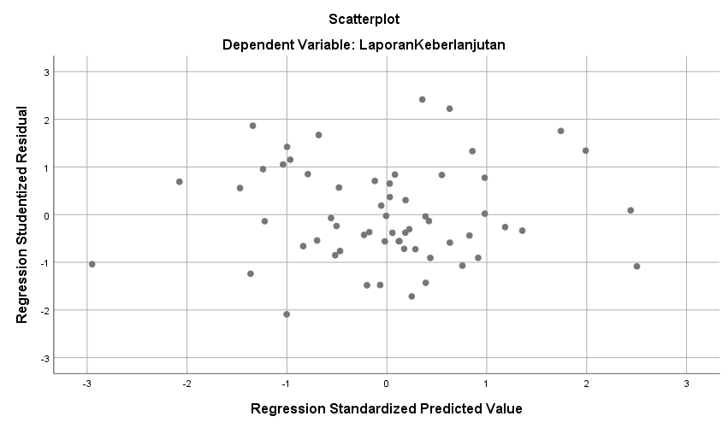

Sumber data: Data yang diolah SPSS 25

1. **Hasil Uji Autokorelasi**

|  |  |  |  |  |  |
| --- | --- | --- | --- | --- | --- |
| **Model Summaryb** | | | | | |
| Model | R | R Square | Adjusted R Square | Std. Error of the Estimate | Durbin-Watson |
| 1 | .365a | .133 | .070 | .12781 | 2.146 |
| a. Predictors: (Constant), Profitabilitas , Likuiditas , Leverage , Firm size | | | | | |
| b. Dependent Variable: LaporanKeberlanjutan | | | | | |

Sumber data: Data yang diolah SPSS 25

Lampiran. 4 Analisis Regresi Linier Berganda

|  |  |  |  |  |  |  |
| --- | --- | --- | --- | --- | --- | --- |
| **Coefficientsa** | | | | | | |
| Model | | Unstandardized Coefficients | | Standardized Coefficients | t | Sig. |
| B | Std. Error | Beta |
| 1 | (Constant) | .136 | .069 |  | 1.980 | .053 |
| Leverage | .011 | .005 | .281 | 2.062 | .044 |
| Likuiditas | 4.511 | .000 | .032 | .154 | .878 |
| Firm size | .005 | .006 | .177 | .875 | .385 |
| a. Dependent Variable: LaporanKeberlanjutan | | | | | | |

Sumber data: Data yang diolah SPSS 25

Lampiran. 5 Analisis Regresi Moderasi

|  |  |  |  |  |  |  |
| --- | --- | --- | --- | --- | --- | --- |
| **Coefficientsa** | | | | | | |
| Model | | Unstandardized Coefficients | | Standardized Coefficients | t | Sig. |
| B | Std. Error | Beta |
| 1 | (Constant) | .117 | .085 |  | 1.384 | .172 |
| Leverage | .011 | .006 | .277 | 1.828 | .073 |
| Likuiditas | .000 | .001 | .231 | .465 | .644 |
| Firm size | .004 | .007 | .145 | .637 | .527 |
| Profitabilitas | .321 | 1.245 | .216 | .258 | .798 |
| Leverage*Profitabilitas | .140 | .241 | .281 | .580 | .564 |
| Likuiditas*Profitabiltas | .000 | .010 | .028 | .031 | .975 |
| FirmSize*Profitabilitas | -.037 | .132 | -.363 | -.277 | .783 |
| a. Dependent Variable: LaporanKeberlanjutan | | | | | | |

Sumber data: Data yang diolah SPSS 25

Lampiran. 6 Koefisien Determinasi

|  |  |  |  |  |
| --- | --- | --- | --- | --- |
| **Model Summary** | | | | |
| Model | R | R Square | Adjusted R Square | Std. Error of the Estimate |
| 1 | .624a | .389 | .320 | .06841 |
| a. Predictors: (Constant), FirmSize_Profitabilitas , FirmSize, Leverage ,Likuiditas , Leverage_Profitabilitas, Likuiditas_Profitabilitas | | | | |

Sumber data: Data yang diolah SPSS 25