**DAFTAR PUSTAKA**

Abdussamad, Z. (2021). Metode Penelitian Kualitatif. In P. Rapanna (Ed.), *Revista Brasileira de Linguística Aplicada* (1st ed., Vol. 5, Issue 1). Syakir Media Press. https://revistas.ufrj.br/index.php/rce/article/download/1659/1508%0Ahttp:

//hipatiapress.com/hpjournals/index.php/qre/article/view/1348%5Cnhttp:// www.tandfonline.com/doi/abs/10.1080/09500799708666915%5Cnhttps:// mckinseyonsociety.com/downloads/reports/Educa

Aderibigbe. (2018). Analisis Kinerja Rumah Sakit Umum Daerah. *Energies*, *6*(1), 1–8.

http://journals.sagepub.com/doi/10.1177/1120700020921110%0Ahttps://d oi.org/10.1016/j.reuma.2018.06.001%0Ahttps://doi.org/10.1016/j.arth.201 8.03.044%0Ahttps://reader.elsevier.com/reader/sd/pii/S106345842030007 8?token=C039B8B13922A2079230DC9AF11A333E295FCD8

Adhan, A. S., & Sembiring, E. E. (2019). Pengukuran Kinerja Instansi Pemerintah Dengan Pendekatan Balanced Scorecard (Studi Kasus Pada Dinas Kesehatan Kota Bandung). *Jurnal Prosiding Industrial Research Workshop and National Seminar*, *10*(1), 1026–1035. https://jurnal.polban.ac.id/proceeding/article/view/1459

Anggraini, Z. T. (2014). Penerapan Balanced Scorecard Sebagai Alat Ukur Kinerja Pada Rumah Sakit Umum Daerah Dr. Harjono Ponorogo. *Pics.Unipma.Ac.Id*, *24*.

<http://pics.unipma.ac.id/content/download/B009_26_09_2018_02_12_44J> urnal ALbadiyah.pdf

Anggraini, Z. T., & Nuraina, E. (2014). PENERAPAN BALANCED SCORECARD SEBAGAI ALAT UKUR KINERJA PADA RUMAH SAKIT UMUM DAERAH Dr.HARJONO PONOROGO. *Assets: Jurnal*

*Akuntansi Dan Pendidikan*, *3*(2), 153.

https://doi.org/10.25273/jap.v3i2.1220

Anisak, L. Y., & Affandy, D. P. (2012). *Analisis Pengukuran Kinerja Rumah Sakit Dengan Penerapan Metode Balanced Scorecard (Studi Kasus Pada Rsud “Kanjuruhan” Kepanjen Kabupaten Malang)*.

Aran, M. G., Tule, P., Djuang, G., & Manafe, H. A. (2023). Analisis Kinerja Rumah Sakit Santo Antonius Jopu DI Ende Nusatenggara Timur dengan Metode Balanced Scorecard dan Swot. *Jurnal Ilmu Manajemen Terapan*, *4*(3), 445–

459. https://creativecommons.org/licenses/by/4.0/

Arifuddin, Anugrah Ilahi, A. A., & Alimuddin, F. (2022). Evaluasi Kinerja Keuangan Berdasarkan Metode Balanced Scorecard Pada PT. Bosowa Asuransi Di Makassar. *Accounting, Accountability, and Organization System (AAOS) Journal*, *4*(1), 35–49. https://doi.org/10.47354/aaos.v4i1.42

144

Bahartiar. (2020). *Analisis Data Penelitian Kualitatif (Konsep, Teknik, & Prosedur Analisis)* (pertama). Badan Penerbit UNM.

Benny. (2022). *Metode Penelitian (Untuk Ekonomi dan Bisnis)* (A. Muhaimin (ed.); Pertama). Media Edu Pustaka.

Besral. (2023). *Tantangan Kesehatan Masyarakat dalam menghadapi Topik Presentasi*.

Bharata, R., Setyorini, D., & Isroah, I. (2019). Penerapan Balance Scorecard Dalam Mengukur Kinerja Rumah Sakit Umum Daerah Wonosari. *Jurnal REP (Riset Ekonomi Pembangunan)*, *4*(2), 174–189. https://doi.org/10.31002/rep.v4i2.1958

Budiyanto. (2020a). *Kinerja Keuangan dan Nilai Perusahaan* (Issue July). Budiyanto, E. (2020b). Kinerja Karyawan Ditinjau dari Aspek Gaya

Kepemimpinan Budaya Organisasi dan Motivasi Kerja. In *Evaluasi Kinerja SDM*.

Burhan. (2023). *Manajemen Strategik* (pertama). Eureka Media Aksara.

Chaebar, H. (2020). *RSUD Kardinah (Kota Tegal)*. TribunNews. https:/[/www.tribunnewswiki.com/2020/04/08/rsu](http://www.tribunnewswiki.com/2020/04/08/rsud-kardinah-kota-tegal)d[-kardinah-kota-tegal](http://www.tribunnewswiki.com/2020/04/08/rsud-kardinah-kota-tegal)

Ciputra, U. (2022). *Bisnis di Bidang Kesehatan: Menjelajahi Peluang dan Tantangan di Industri Kesehatan*. Universitas Ciputra. https:/[/www.uc.a](http://www.uc.ac.id/fk/bisnis-di-bidang-kesehatan-menjelajahi-peluang-)c[.id/fk/bisnis-di-bidang-kesehatan-menjelajahi-peluang-](http://www.uc.ac.id/fk/bisnis-di-bidang-kesehatan-menjelajahi-peluang-) dan-tantangan-di-industri-kesehatan/

Darmiyati, J., & Purwanto, A. (2013). Penerapan Balanced Scorecard Sebagai Metode Pengukuran Kinerja Pada Rs Iphi Pedan Kabupaten Klaten. *Diponegoro Journal of Accounting*, *2*(2), 1–15. [http://ejournal-](http://ejournal-/) s1.undip.ac.id/index.php/accounting

Dewi, L. G. K. (2021). *Buku Ajar Akuntansi Manajeme* (D. N. S. Werastuti (ed.); 1st ed.). UD Surya Grafika.

Dona, E. M., & Lestari, V. A. (2020). Analisis Laporan Realisasi Anggaran Untuk Menilai Kinerja Keuangan Pada Kantor Badan Pendapatan Daerah Kabupaten Oku. *Balance : Jurnal Akuntansi Dan Bisnis*, *5*(2), 135. https://doi.org/10.32502/jab.v5i2.2877

Elyana, A., Erawantini, F., Kesehatan, J., & Jember, P. N. (2020). *J-REMI : Jurnal Rekam Medik dan Informasi Kesehatan J-REMI : Jurnal Rekam Medik dan Informasi Kesehatan*. *2*(1), 28–33.

Evinita, lenny L., Pontoh, J. X., & Gadi, R. I. (2023). Analisis Kinerja Rumah Sakit Umum Daerah Anugerah Tomohon. *Jaim (Jurnal Akuntansi Manado)*, *4*, 1–11.

http://journals.sagepub.com/doi/10.1177/1120700020921110%0Ahttps://d oi.org/10.1016/j.reuma.2018.06.001%0Ahttps://doi.org/10.1016/j.arth.201

8.03.044%0Ahttps://reader.elsevier.com/reader/sd/pii/S106345842030007 8?token=C039B8B13922A2079230DC9AF11A333E295FCD8

Evinita, L. L., Pontoh, J. X., & Gadi, R. I. (2023). *Analisis Kinerja Rumah Sakit Umum Daerah Anugerah Tomohon*. *4*.

Fatimah, S., Kurdi, F. N., & Thamrin, M. H. (2016). Strategi Peningkatan Kinerja dengan Metode Balanced Scorecard di Rumah Sakit Umum Daerah Kabupaten Ogan Ilir Scorecard ( BSC ). Menurut Gasperz ( 2006 ), salah satu instansi pemerintah daerah yang RSUD Kabupaten Ogan Ilir merupakan naungan Pemerintah Prov. *JUrnal Kedokteran Dan Kesehatan*, *3*(1), 351–359.

<http://ejournal.unsri.ac.id/index.php/jkk/article/download/2886/pdf>

Fauzy, A. (2019). Metode Sampling. In *Universitas Terbuka* (Vol. 9, Issue 1). [http://jurnal.globalhealthsciencegroup.com](http://jurnal.globalhealthsciencegroup.com/)

Fentiana, N., & Ginting, D. (2020). Strategi Peningkatan Pendapatan Rumah Sakit Berdasarkan Analisis SWOT. *Jurnal Ilmiah Universitas Batanghari Jambi*, *20*(3), 1008. https://doi.org/10.33087/jiubj.v20i3.1034

Frycillia Widodo, A. S., Puspita, E., & Winarko, S. P. (2022). Analisis Kinerja Keuangan RSUD Simpang Lima Gumul Sebelum dan Sesudah Penerapan PPK-BLUD. *Perspektif Akuntansi*, *5*(3), 259–272. https://doi.org/10.24246/persi.v5i3.p259-272

Garaika. (2019). *Metode Penelitian*. Cv. Hira Tech.

Gub, L. (2023). *Detail Aduan*. Lapor Gub! https://laporgub.jatengprov.go.id/detail/LGMB68050457.html

Hamzah. (2020). Optimalisasi Pelayanan Aparatur Sipil Negara Pasca Gempa Bumi Provinsi Sulawesi Barat. In *Angewandte Chemie International Edition, 6(11), 951–952.*

Hartono. (2021). *Akuntansi Sektor Publik* (S. Bahri (ed.)). Media Sains Indonesia. Hermawan, A. (2021). *Faktor Dominan dalam Pengukuran Kinerja Keuangan*

*Perusahaan*. <http://repository.unpas.ac.id/50973/1/Full>Buku 11 Cetak.pdf

Ikhwan, M. H. (2021). *Analisis Kinerja Rumah Sakit Dengan Pendekatan Balance Scorecard*. *1*(February), 6.

Indiany, D. F., Rahmatika, D. N., & Waskito, J. (2017). Jurnal Analisis Kinerja Keuangan Sebelum Dan Sesudah Penerapan Ppk-Blud Pada Rsud Kardinah. *Multiplier: Jurnal Magister Manajemen*, *1*(1), 43–56. https://doi.org/10.24905/mlt.v1i1.765

Indriasih, D. (2023). *Proceedings of the International Conference on Global Innovation and Trends in Economic and Bussiness* (Sanchita Saha (ed.)). Atlantis Press.

https://books.google.co.id/books?id=x3eiEAAAQBAJ&pg=PA43&dq=De

wi+indriasih+balance+scored&hl=id&newbks=1&newbks_redir=0&sourc e=gb_mobile_search&sa=X&ved=2ahUKEwjM9qa3sOeFAxUpfGwGHSj TCxUQ6wF6BAgLEAU#v=onepage&q=Dewi indriasih balance scored&f=false

Indriasih, D., Prihadi, D., Gunistiyo, Fajri, A., & R, D. N. (2023). *Tingkat kepuasan masyarakat pada pelayanan kepolisian resor pemalang*. *1*, 1–13.

Juang, D. (2022). *Warga Keluhkan Pelayanan RSUD Kardinah, Rosalina: Harus Segera Diperbaiki*. Derap Juang. https://derapjuang.id/featured/warga- keluhkan-pelayanan-rsud-kardinah-rosalina-harus-segera-diperbaiki/

Junaidah. (2022). *Implementasi Manajemen Strategis (Dalam Pendidikan Tinggi Islam)* (Pertama). Anugrah Utama Raharja.

Kardinah, R. (2020). *Visi dan Misi RSUD Kardinah*. RSUD Kardinah. https://rsudkardinah.tegalkota.go.id/homepage/visi_misi/gaJndyx6RIh8M

Kardinah, R. (2021). Sejarah RSUD Kardinah Kota Tegal. *RSUD Kardinah*, *2*, 1–

18. https://panturapost.com/sejarah-rsud-kardinah-tegal-berawal-dari- balai-pengobatan-hingga-jadi-rumah-sakit-umum-daerah/

Kristijono, A. (2021). Statistika Fasyankes. In *Yogyakarta : Poltekkes Kemenkes Yogyakarta*. Kementerian Kesehatan Rupublik Indonesia.

Laleno, E. N., Citraningtyas, G., & Rumondor, E. M. (2020). *Performance Measurement Of Pharmacy Hospital Installation At Datoe Binangkang Bolaang Mongondow District With The Balanced Scorecard Method Binangkang Kabupaten Bolaang Mongondow*. *9*(73).

Lestari, S., & Sumarsih. (2017). Pengukuran Kinerja dengan Pendekatan Balanced ScoreCard Pada Rumah Sakit PKU Muhamadiyah Gombong Tahun 2013 dan 2014. *Article*, *1*(1), 1–16.

Limbu, W. P., & Sisdyani, E. A. (2016). Evaluasi Kinerja Dinas Pendapatan Daerah Kota Denpasar Berbasis Balanced Scorecard. *Jurnal Akuntansi Universitas Udayana*, *15*, 1682–1710.

Malara, J. R., Citraningtyas, G., & Datu, O. S. (2020). Pengukuran Kinerja Instalasi Farmasi Rumah Sakit Advent Manado Dengan Metode Balanced Scorecard Pada Perspektif Keuangan Dan Perspektif Proses Bisnis Internal. *Pharmacon*, *9*(4), 512. https://doi.org/10.35799/pha.9.2020.31357

Mardiasmo. (2019). *Akuntansi Sektor Publik*. Cv. Ondi Offset. https://books.google.co.id/books?id=pBVCEAAAQBAJ&printsec=frontco ver&hl=id&source=gbs_ge_summary_r&cad=0#v=onepage&q&f=false

Mesra Berlyn Hakim, Ali Djamhuri, & Bambang Hariadi. (2021). Aplikasi Pengukuran Kinerja dengan Balanced Scorecard pada Rumah Sakit. *Jurnal Riset Dan Aplikasi: Akuntansi Dan Manajemen*, *5*(2), 229–240. https://doi.org/10.33795/jraam.v5i2.009

Miladi, Y. (2023). *Ini Dia 10 Pengobatan Alternatif yang Diakui Oleh Dunia Kedokteran dan Medis, Apa Saja?* Disway Jateng. https://jateng.disway.id/read/659716/ini-dia-10-pengobatan-alternatif- yang-diakui-oleh-dunia-kedokteran-dan-medis-apa-saja

Muhtar, F. (2023). *Bpkp Beri Predikat Baik pada Kinerja Rsud Maria Walanda Maramis, Ini Empat Indikatornya*. Berita Manado.Com. https://beritamanado.com/bpkp-beri-predikat-baik-pada-kinerja-rsud- maria-walanda-maramis-ini-empat-indikatornya/

Muljono, P., Manampiring, A. E., & Fatimawali, F. (2022). Analisis Citra Rumah Sakit Umum GMIM Bethesda Tomohon pada Unit Rawat Jalan Tahun 2020. *E-CliniC*, *11*(1), 87–94. https://doi.org/10.35790/ecl.v11i1.44320

Murni, Y. (2023). *Akuntansi Sektor Publik* (R. N. Ilham (ed.)). Eureka Media Aksara.

Murwaningsari, E. (2022). *Keunggulan Kompetitif Konsep dan Studi Kasus*. Mutia, N., Assyahri, W., & Putri Oktaviane, D. (2023). Evaluasi Kinerja Rumah

Sakit Islam Ibnu Sina Padang Panjang Menggunakan Perspektif Balance Scorecard. *PUBLICNESS: Journal of Public Administration Studies*, *2*(4), 415–425. https://doi.org/10.24036/publicness.v2i4.141

Ningrum, E. P. (2022). Nilai Perusahaan (Konsep dan Aplikasi). In *Angewandte Chemie International Edition, 6(11), 951–952.* (Vol. 3, Issue 1). [https://medium.com/@arifwicaksanaa/pengertian-use-case-a7e576e1b6bf](https://medium.com/%40arifwicaksanaa/pengertian-use-case-a7e576e1b6bf)

Nisa, G. K., Pangastuti, D. A., & Parawijati, P. (2023). Strategi Peningkatan Kinerja Manajemen Keuangan dan Non Keuangan: Pendekatan Balance Scorecard. *Jurnal Riset Akuntansi & Perpajakan (JRAP)*, *10*(1), 1–9. https://doi.org/10.35838/jrap.2023.010.01.01

Nurmaulidia, A. S., Sidin, I., & Mangilep, A. U. A. (2021). Penilaian Kinerja Berdasarkan Balanced Scorecard Di Rumah Sakit Universitas Hasanuddin Tahun 2020. *Hasanuddin Journal of Public Health*, *2*(1), 88–105. https://doi.org/10.30597/hjph.v2i1.12701

Pahlevi, C. (2023). *Manajamen strategi*. Telektual Karya Nusantara.

Pantih, S. (2021). *Manajemen Sumber Daya Manusia (Pelayanan Publik)* (D. Winarni (ed.); Pertama). Eureka Media Aksara.

Permatasari, N. O. F., & Nurkholis. (2017). ANALISIS PENGUKURAN KINERJA RUMAH SAKIT DENGAN PENDEKATAN BALANCED

SCORECARD (Studi Kasus Pada RSI Hasanah Muhammadiyah Mojokerto). *Jurnal Ilmiah Mahasiswa FEB*, *5*(2).

Pontoh, G. T. (2022). *Spiritualitas Dan Kepuasan Kerja Dalam Meningkatkan Kinerja Rumah Sakit* (F. A. Pratama (ed.); Pertama). K-Media. https://books.google.co.id/books?id=5OFaEAAAQBAJ&pg=PA40&dq=b

alanced+scorecard+rumah+sakit&hl=id&newbks=1&newbks_redir=0&so urce=gb_mobile_search&ovdme=1&sa=X&ved=2ahUKEwiT- LSqlNKGAxVkT2wGHW6KAakQ6wF6BAgMEAU#v=onepage&q=bala nced scorecard rumah sakit&f=fal

Pradana, B. A., Kristanto, R. S., & Hidayat, D. S. (2019). Pengaruh Lingkungan Kerja Dan Beban Kerja Terhadap Burnout Pada Perawat Rsud Kardinah Kota Tegal. *Magisma: Jurnal Ilmiah Ekonomi Dan Bisnis*, *5*(2), 61–69. https://doi.org/10.35829/magisma.v5i2.28

Purwanti, A. (2021). *Akuntansi Manajemen* (Fachrurazi (ed.); pertama). Eureka Media Aksara.

Putri Citradika, D., & Satrio, D. (2021). Implementasi Balanced Scorecard Di Rumah Sakit Umum Daerah Kab. Batang. *RISTEK : Jurnal Riset, Inovasi Dan Teknologi Kabupaten Batang*, *6*(1), 38–46. https://doi.org/10.55686/ristek.v6i1.108

Rahayu. (2020). Kinerja Keuangan Perusahaan. In *Angewandte Chemie International Edition, 6(11), 951–952.*

Rahayu, M., & Usman, S. (2019). *ANALISIS KINERJA FINANSIAL DAN NON FINANSIAL MENGGUNAKAN KONSEP BALANCE SCORECARD ( BSC*

*) PADA RUMAH SAKIT UMUM DAERAH ( RSUD ) MANOKWARI*.

*4*(November), 31–45.

Rahmawati, A. Y. (2020). *Akuntasi Manajemen* (Issue July).

Ramdani, A. D., Sopandi, I., Suharyanto, E., Yustian, R., Wasliman, L., Dianawati, E., & Paramansyah, A. (2023). *Konsep Balanced Scorecard Dalam Strategi Bisnis dan Pendidikan serta Deskripsi Implementasinya pada SMK Negeri 6 Garut Melalui Pendekatan Manajemen Berbasis Sekolah (MBS)*. *5 No 6*.

Rangkuti, F. (2022). *Swot Balanced Scorecard (Teknik Menyusun Strategi Korporat yang Efektif Plus Cara Mengelola Kinerja dan Risiko)* (Pertama). PT. Gramedia Pustaka Utama.

Rombe, Y. (2023). *Kinerja Keuangan Di Masa pandemi Covid-19* (E. Damayanti (ed.); Pertama). Widina Bhakti Persada.

Rumbyarso, Y. P. A. (2021). *Pengukuran Kinerja Perusahaan Pt. Ritra Cargo Indonesia Menggunakan Balanced Scorecard* (M. Fahmi (ed.); pertama). Syntax Computama.

Safarani, S., Raeissi, H. R. P., & Maleki, M. R. (2018). Financial Challenges Of Teaching Hospital and Providing Solutions. *Education and Health Promotion*. https://doi.org/10.4103/jehp.jehp_95_18

Sari, C. F., Akyuni, F. Q., Fresillia, A. Z., & Bawono, I. I. (2021). *Persaingan Industri Rumah Sakit di Indonesia*.

Sari, P. O. (2022). *Manajemen Kinerja (Meningkatkan Keunggulan Bersaing)* (M.

Asmike (ed.); pertama). Unipma Press.

Sholihah, M., & Kosasih, A. (2020). Analisis Penilaian Kinerja Dengan Menggunakan Metode Balanced Scorecard Di Rumah Sakit Dr.Etty Asharto Batu. *Jurnal Akuntansi Dan Perpajakan*, *6*(2), 101–112. <http://jurnal.unmer.ac.id/index.php/ap>

Sipayung, P. K., Elisabeth, D. M., & Sipayung, T. D. (2021). *Analisis Penerapan Balanced Scorecard sebagai Metode Pengukuran Kinerja Pada Rumah Sakit Umum Delia Binjai*. 148–153. https://doi.org/10.46880/siakun.V1N1.H148-153

Sitanggang, F. A., Putri, D. E., & Melina, E. (2019). Analisis Dimensi Balance Scorecard Dari Perspektif Keuangan Perusahaan (Studi Kasus Pada Pt Gudang Garam, Tbk Dan Pt Bentoel International Investama, Tbk ). *Jurnal Manajemen Terapan Dan Keuangan*, *8*(1), 82–91. https://doi.org/10.22437/jmk.v8i1.6937

Soelistya, D. (2022). *Buku Ajar Evaluasi Kinerja* (pertama). Nizamia Learning Center.

Sudaryo, Y. (2021). *keuangan di Era Otonomi Daerah* (B. Belinda (ed.)). Cv. Andi Offset. https://books.google.co.id/books?id=dHI9DwAAQBAJ&hl=id&source=g bs_navlinks_s

Sugiyono. (2019). *Metode Penelitian Kuantitatif, Kualitatif, dan R&D* (Sutopo (ed.); kedua). Alfabeta.

Sulistiadi, W. (2023). *KINERJA RUMAH SAKIT DENGAN PENDEKATAN BALANCED SCORECARD ( BSC ): STUDI KASUS*. *9*(2), 30–35.

Sulistyowati, H., & Sunaningsih, S. N. (2022). Implementasi Pengelolaan Keuangan Puskesmas Setelah Berstatus Menjadi Blud (Studi Kasus Di Puskesmas Magelang Selatan). *Jurnal Bina Akuntansi*, *10*(1), 110–131. https://doi.org/10.52859/jba.v10i1.284

Surbakti, L. P. (2023). *Manajemen Kinerja (Perspektif Balanced Scorecard)*

(Hartini (ed.)). Media Sains Indonesia.

Surya, S. kartika. (2015). Performance Analysis of Financial And Non-Financial General Regional Hospital Dr. Haryato Lumajang Before And After the Implementation of the Public Service Board. *Artikel Ilmiah Mahasiswa*, 1– 9.

Syahmadani, K. A. (2022). *Banyak Keluhan, Pelayanan RSUD Kardinah Harus Diperbaiki*. Disway Jateng. https://jateng.disway.id/read/173339/banyak- keluhan-pelayanan-rsud-kardinah-harus-diperbaiki

Syamsuddin, R. A. (2023). *Balanced Score Card* (I. Satoyo & I. Putranto (eds.); pertama).

Tambuwun, F., Usu, I., Lamuda, I., & Abdullah, J. (2023). Analisis Kinerja Keuangan Pada Rumah Sakit Umum Daerah (RSUD) Dr. Zainal Umar Sidiki Kabupaten Gorontalo Utara. *Wahana*, *75*(1), 97–104. https://doi.org/10.36456/wahana.v75i1.7351

Tria, R. (2014). Perbandingan Kinerja keuangan Rumah Sakit Umum Daerah Polewali dengan Rumah Sakit Umum Daerah Majene. *E-Bussiness Institut Teknologi Dan Bisnis Muhammadiyah Polewali Mandar*, *2*.

Ummah, F., Nuriyatil, R, N. V., & Nurdiana, F. (2021). *Penerapan Balance Scorecard Dalam Analisis Kinerja Rumah Sakit*. *2*(2).

Undang-Undang Nomor 17. (2023). Undang-Undang Republik Indonesia Nomor 17 Tahun 2023 Tentang Kesehatan. *Undang-Undang*, *187315*, 1–300.

Widayati, N., & Khasanah, T. (2019). Evaluasi Metode Balanced Scorecard Dalam Upaya Menilai Kinerja Keuangan Pt. Sumber Alfaria Trijaya, Tbk Tangerang. *Ekonomi Bisnis*, *25*(1), 47–63. https://doi.org/10.33592/jeb.v25i1.287

Widodo, S. (2023). *Manajemen Strategik:Keunggulan Bersaing Berkelanjutan*. Penerbit NEM.

https://books.google.co.id/books?id=pFXEEAAAQBAJ&pg=PA34&hl=id &source=gbs_toc_r&cad=2#v=onepage&q&f=false

Wulandari, R. D. (2023). *Hospitalcare Quality (Kualitas Perawatan Rumah Sakit)* (T. Azhari (ed.); Pertama). Deepublish Digital. https://books.google.co.id/books?id=BE33EAAAQBAJ&pg=PA174&dq= Balanced+scorecard+rumah+sakit&hl=id&newbks=1&newbks_redir=0&s ource=gb_mobile_search&ovdme=1&sa=X&ved=2ahUKEwishamntdKG AxXWcmwGHUzXAmYQ6wF6BAgIEAU#v=onepage&q=Balanced scorecard rumah sakit&f=fa

Zulmita, Wibawa, H. W., & Paryanti, A. B. (2021). Analisis Faktor-Faktor Balanced Scorecard (Bsd) Terhadap Optimalisasi Perspektif Kinerja Keuangan. *Jurnal Ilmiah M-Progress*, *11*(2). https://doi.org/10.35968/m- pu.v11i2.691

**LAMPIRAN**

**Lampiran 1 Kuesioner Penelitian**

Dengan Hormat,

Saya Nabila Nurul Afifah mahasiswa Program Strata Satu (S1) Fakultas Ekonomi dan Bisnis, Jurusan Akuntansi Universitas Pancasakti Tegal yang sedang melakukan penelitian dalam rangka menyusun tugas akhir berupa skripsi.

Dalam rangka melakukan penelitian untuk skripsi saya yang berjudul “Analisis Penilaian Perspektif Keuangan Dengan Model *Balanced Scorecard* Pada RSUD Kardinah Selama Periode 2020-2023”.

Penelitian ini bertujuan untuk mengetahui dan menganalisis kinerja RSUD Kardinah dari berbagai sudut pandang atau perspektif yang meliputi perspektif keuangan, pelanggan, proses bisnis internal, pembelajaran dan pertumbuhan.

Saya memohon bantuan dari saudara/saudari untuk berkenaan mengisi kuesioner yang saya lampirkan bersama surat ini. Data yang diperoleh hanya akan digunakan untuk kepentingan penelitian. Kuesioner ini dirancang sedemikian rupa agar tidak ada seorangpun yang dapat menelusuri sumber informasinya. Oleh karena itu, saudara/i di harapkan dapat memberikan jawaban dengan sejujurnya sesuai dengan kondisi berdasarkan kenyataan.

Atas perhatian dan kesediannya dalam mengisi kuesioner ini, saya mengucapkan terimakasih.

Hormat Saya

Nabila Nurul Afifah

152

**KUESIONER UNTUK MENGETAHUI TINGKAT KEPUASAN PELANGGAN (CUSTOMER)**

1. **Identitas Responden**

Demikian dengan hormat saudara/i untuk mengisi identitas secara lengkap. Setiap pernyataan diharapkan hanya ada satu jawaban untuk menjamin validitas data.

Nama : …………………………………………..

Alamat : …………………………………………..

Jenis Kelamin :

Laki-laki Perempuan Status Pasien :

Umum BPJS

Rawat Jalan Rawat Inap

Petunjuk Pengisian Kuesioner!

* 1. Bacalah setiap pernyataan dengan teliti dan seksama.
  2. Isilah dengan jujur sesuai dengan kenyataan.
  3. Berilah tanda check list (√ ) pada jawaban yang anda anggap benar di kolom yang telah disediakan.
  4. Kuesioner ini dapat digunakan secara optimal bila seluruh pernyataan terjawab, karena itu mohon diteliti kembali apakah semua pernyataan telah terjawab.

Keterangan Skala Pendapat: **STS : Sangat Tidak Setuju TS : Tidak Setuju**

**N : Netral**

**S : Setuju**

**SS : Sangat Setuju**

1. **Kuesioner Penelitian**

|  |  |  |  |  |  |  |
| --- | --- | --- | --- | --- | --- | --- |
| **NO** | **PERNYATAAN** | **STS** | **TS** | **N** | **S** | **SS** |
| 1. | Fasilitas rumah sakit terawat dengan baik. |  |  |  |  |  |
| 2. | Peralatan medis di rumah sakit terlihat  canggih dan modern. |  |  |  |  |  |
| 3. | Fasilitas seperti toilet, kantin, dan tempat  ibadah bersih dan nyaman. |  |  |  |  |  |
| 4. | Ruangan dan tempat layanan rumah sakit  bersih dan rapi. |  |  |  |  |  |
| 5. | Layanan administrasi (pendaftaran) rumah  sakit berjalan cepat dan efisien. |  |  |  |  |  |
| 6. | Pelayanan diberikan dengan ramah. |  |  |  |  |  |
| 7. | Rumah sakit mampu merespons dengan cepat apabila ada keluhan atau masalah dari  pasien. |  |  |  |  |  |
| 8. | Obat-obatan yang diberikan sesuai dengan  resep dan kondisi penyakit. |  |  |  |  |  |
| 9. | Dokter membantu menjelaskan kondisi penyakit dan menjawab pertanyaan pasien  dengan sabar. |  |  |  |  |  |
| 10. | Petugas rumah sakit bersedia membantu  pasien kapanpun dibutuhkan. |  |  |  |  |  |
| 11. | Petugas rumah sakit sigap dalam melayani  setiap pasien yang datang. |  |  |  |  |  |
| 12. | Pengaduan dan keluhan pasien selalu  ditindaklanjuti oleh pihak rumah sakit. |  |  |  |  |  |
| 13. | Dokter dan perawat serta tenaga Kesehatan lainnya terlihat professional dan kompeten di  bidangnya. |  |  |  |  |  |

|  |  |  |  |  |  |  |
| --- | --- | --- | --- | --- | --- | --- |
| **NO** | **PERNYATAAN** | **STS** | **TS** | **N** | **S** | **SS** |
| 14. | Petugas keamanan menimbulkan rasa aman  selama berada di rumah sakit. |  |  |  |  |  |
| 15. | Rumah sakit menjaga privasi dan kerahasiaan data/catatan Kesehatan pasien  dengan baik. |  |  |  |  |  |
| 16. | Petugas rumah sakit dapat memahami apa  yang pasien rasakan selama perawatan. |  |  |  |  |  |
| 17. | Pasien merasa nyaman berkomunikasi  dengan dokter dan petugas rumah sakit. |  |  |  |  |  |

**Lampiran 2 Surat Izin Penelitian**

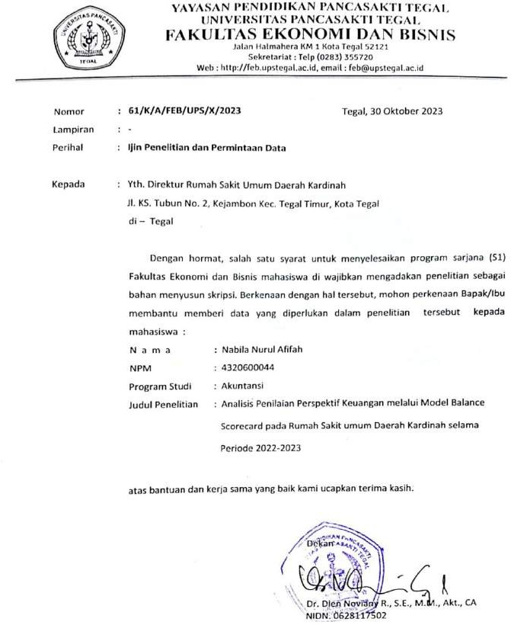

**Lampiran 3 Surat Balasan Penelitian**

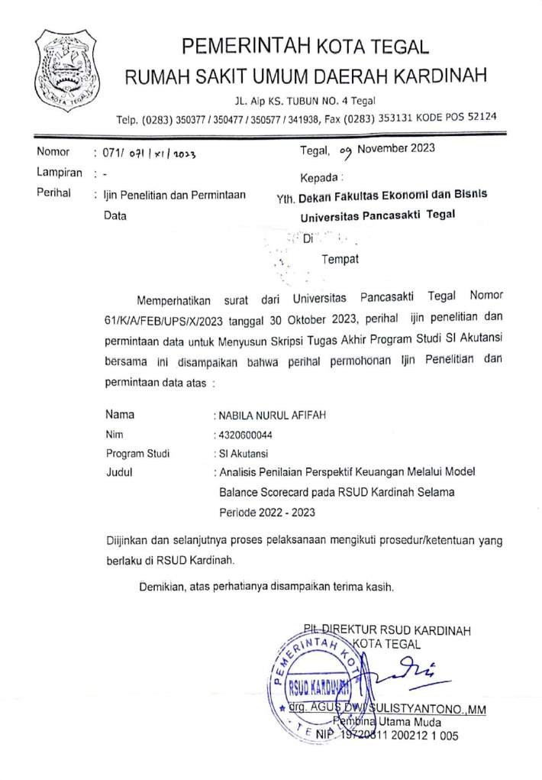

**Lampiran 4 Laporan Keuangan**

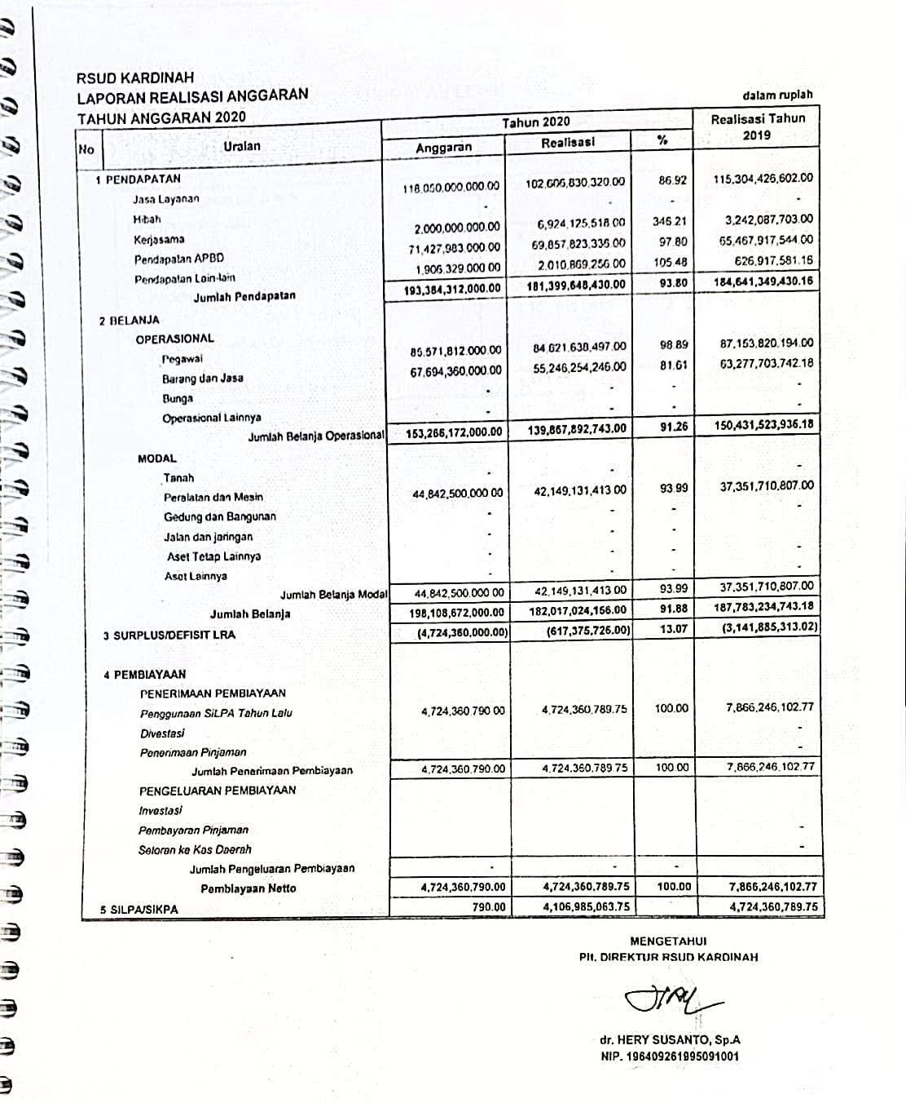

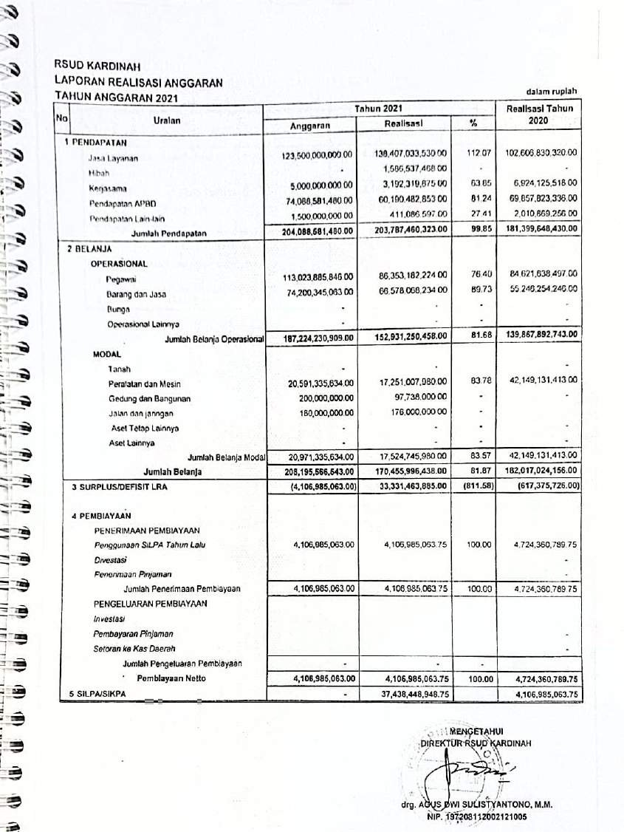

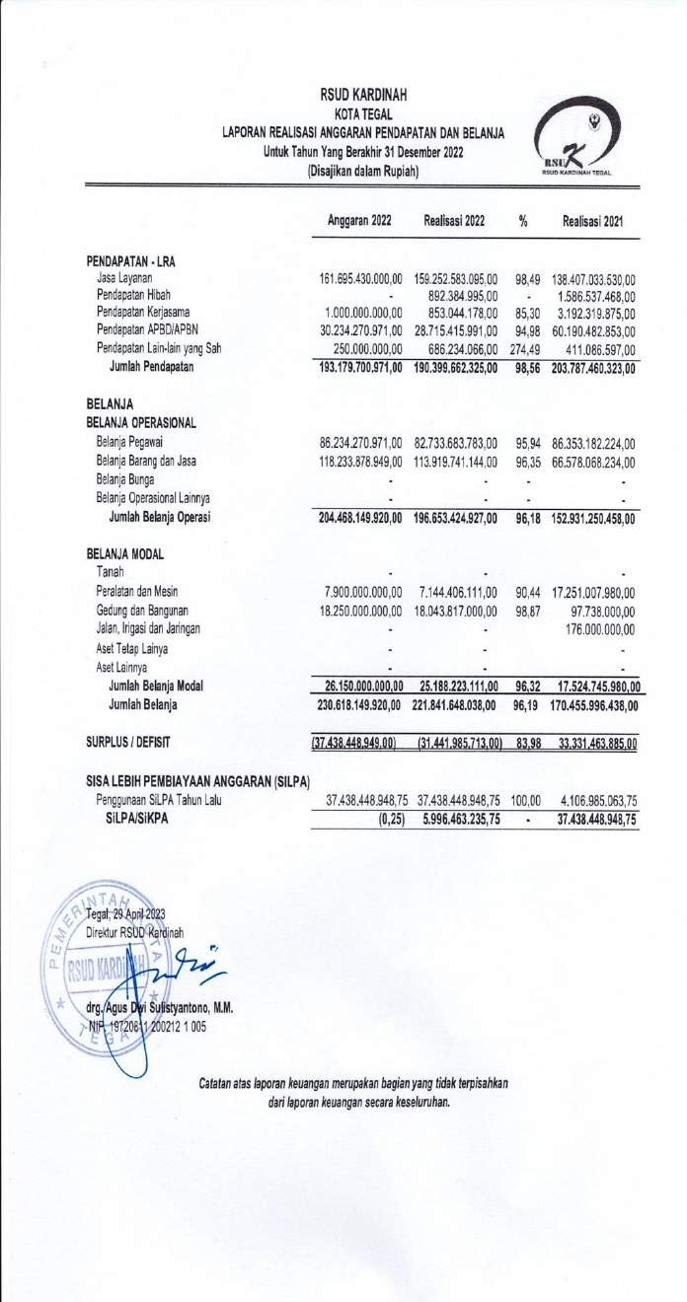

**PEMERINTAH KOTA TEGAL**

**LAPORAN REALISASI ANGGARAN PENDAPATAN DAN BELANJA DAERAH**

**UNTUK TAHUN YANG BERAKHIR SAMPAI DENGAN 31 DESEMBER 2023 DAN 2022**

|  |  |  |  |  |  |
| --- | --- | --- | --- | --- | --- |
| **No** | **Uraian** | **Tahun 2023** | | | **Realisasi Tahun 2022** |
| **Anggaran** | **Realisasi** | **%** |
| **1 PENDAPATAN**  Jasa Layanan Hibah Kerjasama  Pendapatan APBD Pendapatan Lain-lain  **Jumlah Pendapatan** | | 174,300,000,000.00  - 500,000,000.00  37,032,998,537.00  200,000,000.00 | 143,029,897,840.00  - 461,732,400.00  36,903,318,610.00  202,033,717.00 | 82.06  - 92.35  99.65  101.02 | 159,252,583,095.00  892,384,995.00  853,044,178.00  28,715,415,991.00  686,234,066.00 |
| **212,032,998,537.00** | **180,596,982,567.00** | **85.17** | **190,399,662,325.00** |
| **2 BELANJA**  **OPERASIONAL**  Pegawai  Barang dan Jasa Bunga  Operasional Lainnya  Jumlah Belanja Operasional  **MODAL**  Tanah  Peralatan dan Mesin Gedung dan Bangunan Jalan dan jaringan Aset Tetap Lainnya Aset Lainnya  Jumlah Belanja Modal  **Jumlah Belanja** | | 69,532,998,537.00  68,641,263,236.00  -  - | 67,934,613,140.00  98,680,274,300.00  -  - | 97.70  143.76  -  - | 82,733,683,783.00  113,919,741,144.00  -  - |
| **138,174,261,773.00** | **166,614,887,440.00** | **120.58** | **196,653,424,927.00** |
| - 19,594,200,000.00  2,000,000,000.00  -  -  - | - 10,895,768,797.00  297,641,307.00  -  -  - | 55.61  -  -  -  - | - 7,144,406,111.00  18,043,817,000.00  -  -  - |
| 21,594,200,000.00 | 11,193,410,104.00 | 51.84 | 25,188,223,111.00 |
| **159,768,461,773.00** | **177,808,297,544.00** | **111.29** | **221,841,648,038.00** |
| **3 SURPLUS/DEFISIT LRA** | | **52,264,536,764.00** | **2,788,685,023.00** | **5.34** | **(31,441,985,713.00)** |
| **4 PEMBIAYAAN**  PENERIMAAN PEMBIAYAAN | |  |  |  |  |

|  |  |  |  |  |
| --- | --- | --- | --- | --- |
| *Penggunaan SiLPA Tahun Lalu Divestasi*  *Penerimaan Pinjaman*  Jumlah Penerimaan Pembiayaan PENGELUARAN PEMBIAYAAN  *Investasi*  *Pembayaran Pinjaman Setoran ke Kas Daerah*  Jumlah Pengeluaran Pembiayaan  **Pembiayaan Netto**  **5 SiLPA/SiKPA** | 5,996,463,235.75 | 5,996,463,235.75 | 100.00 | 37,438,448,948.75  -  - |
| 5,996,463,235.75 | 5,996,463,235.75 | 100.00 | 37,438,448,948.75 |
|  |  |  | -  - |
| - | - | - |  |
| **5,996,463,235.75** | **5,996,463,235.75** | **100.00** | **37,438,448,948.75** |
| **58,260,999,999.75** | **8,785,148,258.75** |  | **5,996,463,235.75** |

**Lampiran 5 Hasil Perhitungan Ke Empat Perspektif**

HASIL OLAH DATA PERSPEKTIF KEUANGAN

|  |  |  |  |  |
| --- | --- | --- | --- | --- |
| Rasio Ekonomis Tahun 2020-2023 | | | | |
| Tahun | Realisasi Belanja Operasional | Anggaran Belanja Operasional | Hasil | kriteria |
| 2020 | Rp 139.867.892.743 | Rp 153.266.172.000 | 91% | Kurang Ekonomis |
| 2021 | Rp 152.931.250.458 | Rp 187.224.230.909 | 82% | Cukup Ekonomis |
| 2022 | Rp 196.653.424.927 | Rp 204.468.149.920 | 96% | kurang Ekonomis |
| 2023 | Rp 166.614.887.440 | Rp 138.174.261.773 | 121% | Tidak Ekonomis |
| **rata- rata** |  |  | **97%** | **kurang Ekonomis** |

|  |  |  |  |  |
| --- | --- | --- | --- | --- |
| Rasio Efisiensi Tahun 2020-2023 | | | | |
| Tahun | Realisasi Belanja | Realisasi pendapatan | Hasil | Kriteria |
| 2020 | Rp  182.017.024.156 | Rp  181.399.648.430 | 100% | Kurang  Efisien |
| 2021 | Rp 170.455.996.438 | Rp 203.787.460.323 | 84% | Cukup Efisien |
| 2022 | Rp  221.841.648.038 | Rp  190.399.662.325 | 117% | Tidak  Efisien |
| 2023 | Rp 177.808.297.544 | Rp 180.596.982.567 | 98% | Kurang Efisien |
| **rata-rata** | | | **100%** | **Kurang**  **Efisien** |

|  |  |  |  |  |
| --- | --- | --- | --- | --- |
| Rasio Efektivitas Tahun 2020-2023 | | | | |
| Tahun | Realisasi Pendapatan | Anggaran Pendapatan | Hasil | Kriteria |
| 2020 | Rp  181.399.648.430 | Rp  193.384.312.000 | 94% | Efektivitas |
| 2021 | Rp 203.787.460.323 | Rp 204.088.581.480 | 100% | Efektivitas |
| 2022 | Rp  190.399.662.325 | Rp  193.179.700.971 | 99% | Efektivitas |
| 2023 | Rp 180.596.982.567 | Rp 212.032.998.537 | 85% | Cukup Efektivitas |
| **rata-rata** | | | **94%** | **Efektivitas** |

HASIL OLAH DATA REKAPITULASI PERSPEKTIF PELANGGAN

|  |  |  |  |
| --- | --- | --- | --- |
| customer rentention | | | |
| Tahun | jumlah pasien lama | jumlah pasien | total |
| 2020 | 175935 | 250731 | 70% |
| 2021 | 165685 | 235684 | 70% |
| 2022 | 200279 | 299351 | 67% |
| 2023 | 242586 | 317540 | 76% |

|  |  |  |  |
| --- | --- | --- | --- |
| customer acquisition | | | |
| tahun | jumlah pasien baru | jumlah pasien | total |
| 2020 | 74796 | 250731 | 30% |
| 2021 | 69999 | 235684 | 30% |
| 2022 | 99072 | 299351 | 33% |
| 2023 | 74954 | 317540 | 24% |

|  |  |  |  |  |
| --- | --- | --- | --- | --- |
| rata-rata pasien rawat jalan dan darurat | | | | |
| tahun | jumlah pasien Rajal | jumlah pasien IGD | periode dalam setahun | total |
| 2020 | 222991 | 15550 | 365 | 653,537 |
| 2021 | 213679 | 12024 | 365 | 618,3644 |
| 2022 | 266015 | 17863 | 365 | 777,7479 |
| 2023 | 280134 | 20437 | 365 | 823,4822 |

|  |  |  |  |
| --- | --- | --- | --- |
| rata-rata pasien rawat inap | | | |
| tahun | jumlah pasien ranap | periode dalam setahun | total |
| 2020 | 12190 | 365 | 33,39726027 |
| 2021 | 9981 | 365 | 27,34520548 |
| 2022 | 15473 | 365 | 42,39178082 |
| 2023 | 16969 | 365 | 46,49041096 |

HASIL OLAH DATA PERSPEKTIF PROSES BISNIS INTERNAL

|  |  |  |  |  |
| --- | --- | --- | --- | --- |
| jumlah kunjungan rawat jalan | | | | |
| tahun | jumlah kunjungan rajal baru | jumlah kunjungan rajal lama | jumlah hari kerja | Total |
| 2020 | 62782 | 175759 | 295 | 808,6136 |
| 2021 | 60128 | 165575 | 295 | 765,0949 |
| 2022 | 83787 | 200091 | 295 | 962,2983 |
| 2023 | 58199 | 242372 | 295 | 1018,885 |

|  |  |  |  |  |
| --- | --- | --- | --- | --- |
| jumlah kunjungan rawat inap | | | | |
| tahun | jumlah kunjungan ranap lama | jumlah kunjungan ranap baru | jumlah hari kerja | Total |
| 2020 | 176 | 12014 | 295 | 41,32203 |
| 2021 | 110 | 9871 | 295 | 33,8339 |
| 2022 | 188 | 15285 | 295 | 52,45085 |
| 2023 | 214 | 16755 | 295 | 57,52203 |

|  |  |  |  |
| --- | --- | --- | --- |
| Net Death Rate (NDR) | | | |
| tahun | jumlah pasien mati >48 jam | jumlah pasien keluar (hidup+mati) | total |
| 2020 | 392 | 11226 | 34,91893818 |
| 2021 | 300 | 9077 | 33,05056737 |
| 2022 | 330 | 14518 | 22,73040364 |
| 2023 | 397 | 15907 | 24,95756585 |

|  |  |  |  |
| --- | --- | --- | --- |
| bed turn over rate (BTO) | | | |
| tahun | jumlah pasien keluar | jumlah tempat tidur | Total |
| 2020 | 11226 | 341 | 32,92082111 |
| 2021 | 9077 | 362 | 25,07458564 |
| 2022 | 14518 | 378 | 38,40740741 |
| 2023 | 15907 | 373 | 42,6461126 |

|  |  |  |  |
| --- | --- | --- | --- |
| Gross Death Rate (GDR) | | | |
| tahun | jumlah pasien mati seluruhnya | jumlah pasien keluar (hidup+mati) | total |
| 2020 | 741 | 11226 | 66,00748263 |
| 2021 | 581 | 9077 | 64,00793214 |
| 2022 | 649 | 14518 | 44,70312715 |
| 2023 | 688 | 15907 | 43,25139876 |

HASIL OLAH PERSPEKTIF PEMBELAJARAN DAN PERTUMBUHAN

|  |  |  |  |
| --- | --- | --- | --- |
| retensi karyawan | | | |
| tahun | jumlah karyawan keluar | jumlah karyawan | Total |
| 2020 | 43 | 1042 | 4% |
| 2021 | 62 | 1021 | 6% |
| 2022 | 22 | 531 | 4% |
| 2023 | 39 | 977 | 4% |

|  |  |  |  |
| --- | --- | --- | --- |
| tingkat pelatihan karyawan | | | |
| tahun | jumlah karyawan yang dilatih | jumlah karyawan | Total |
| 2020 | 28 | 1042 | 3% |
| 2021 | 55 | 1021 | 5% |
| 2022 | 112 | 531 | 21% |
| 2023 | 100 | 977 | 10% |

177

**Lampiran 6 Rentensi Karyawan dan Jumlah Karyawan**

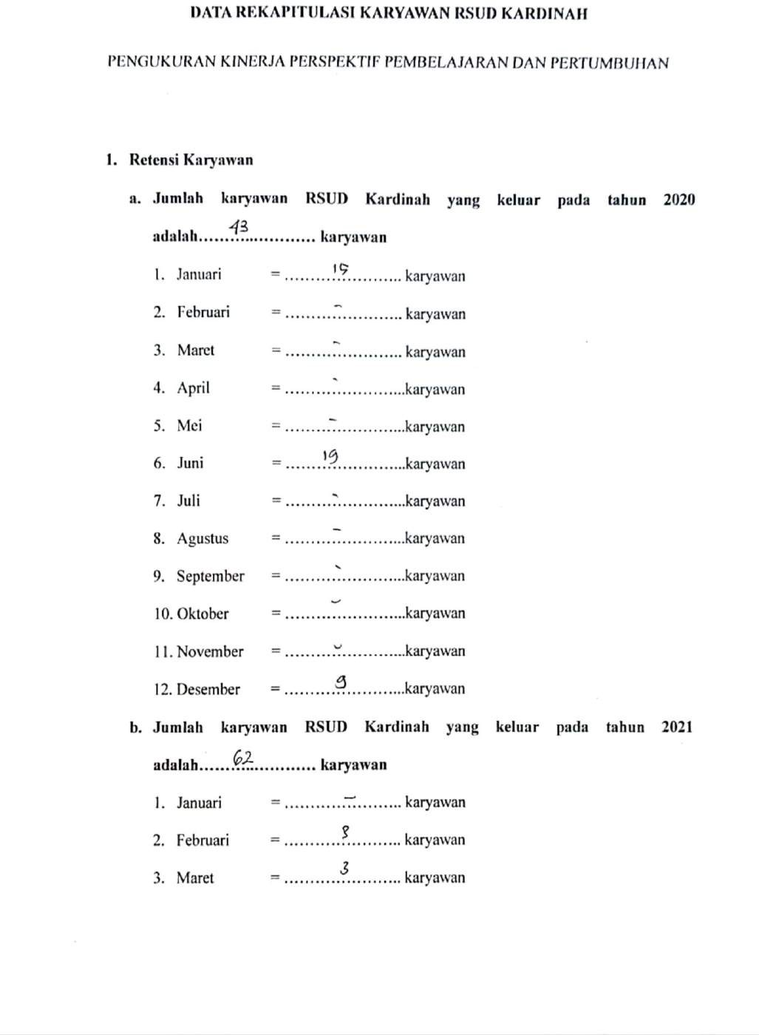

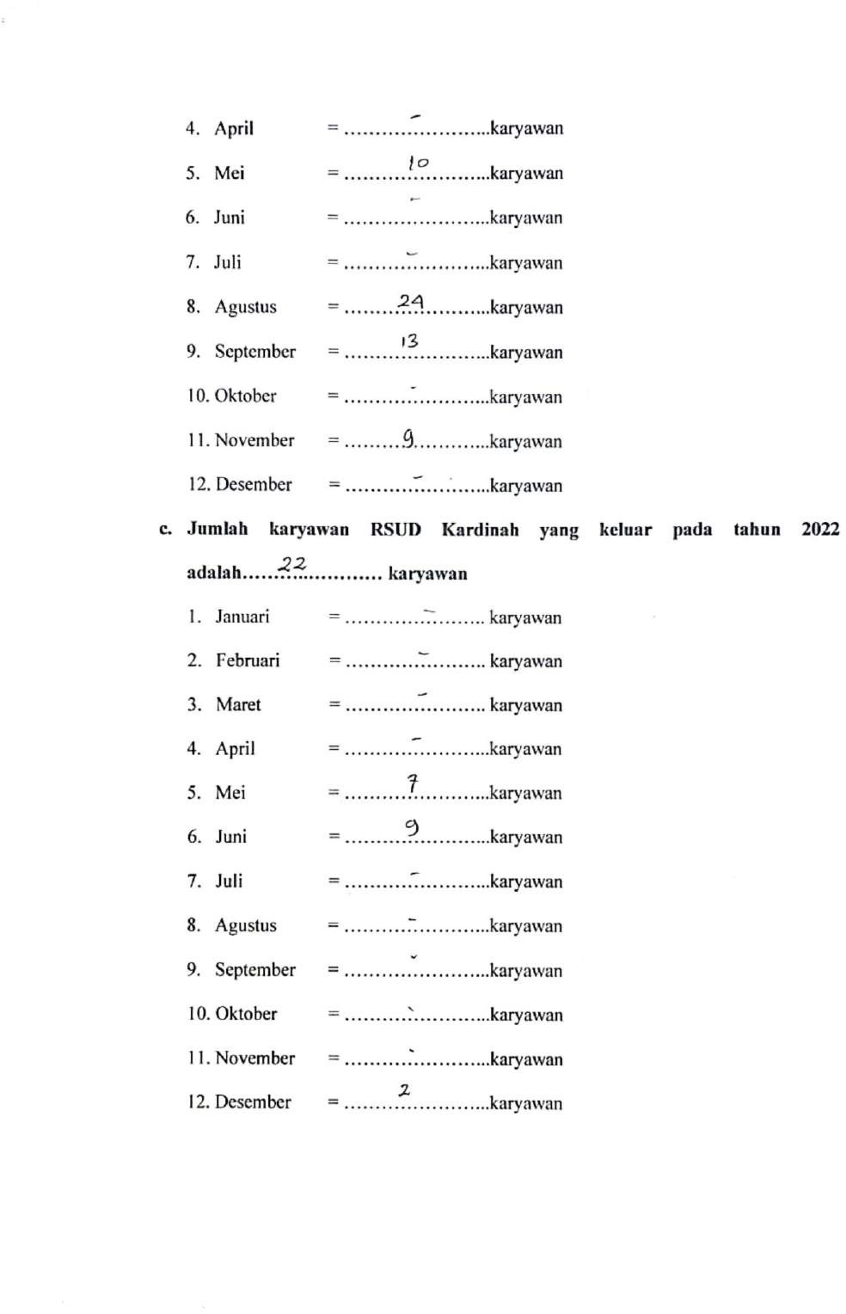

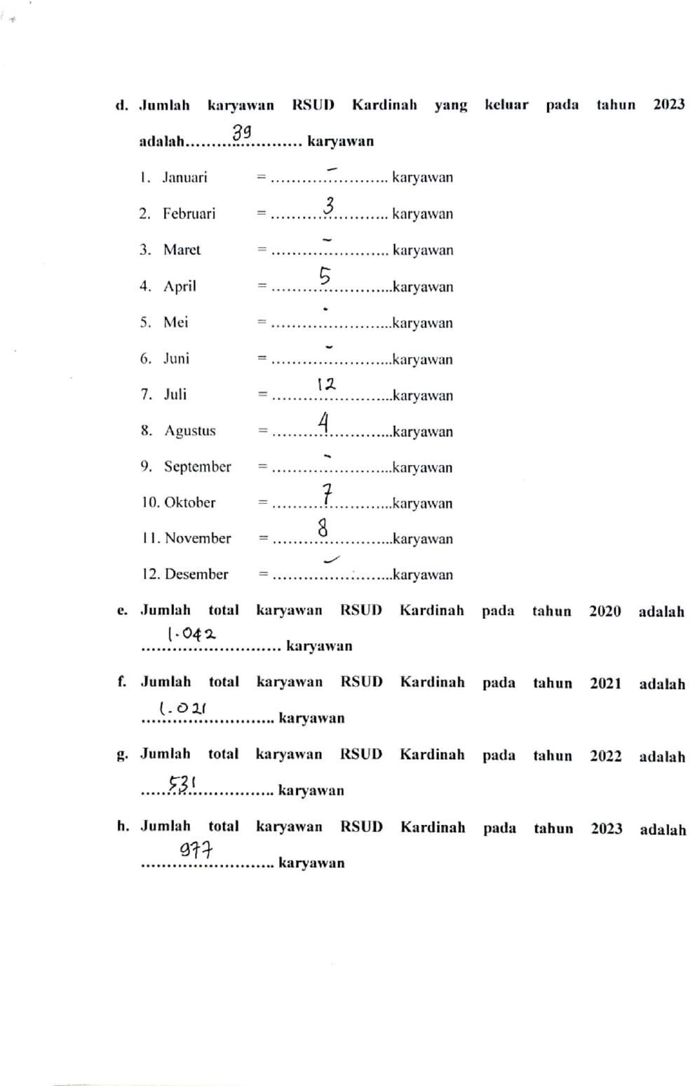

**Lampiran 7 Pelatihan Karyawan**

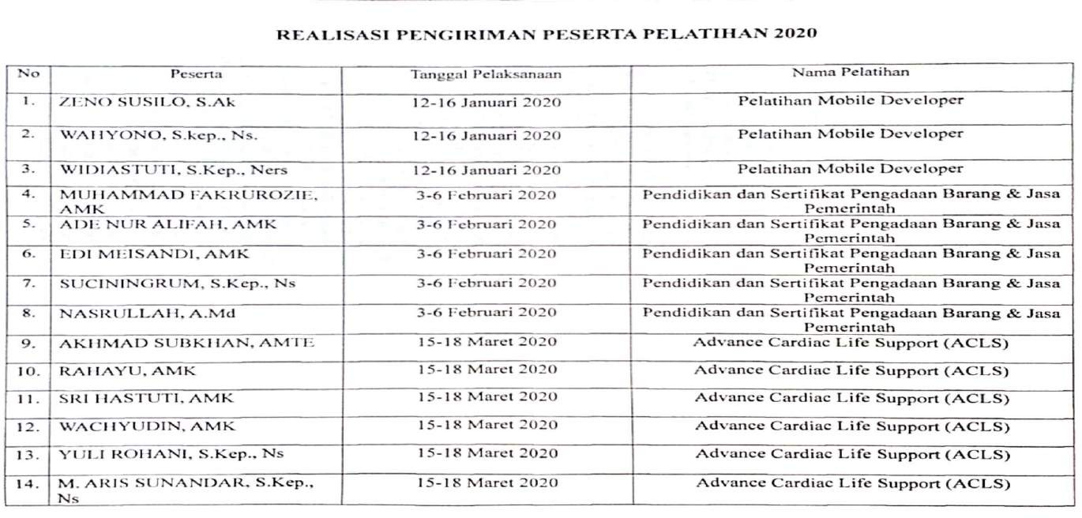

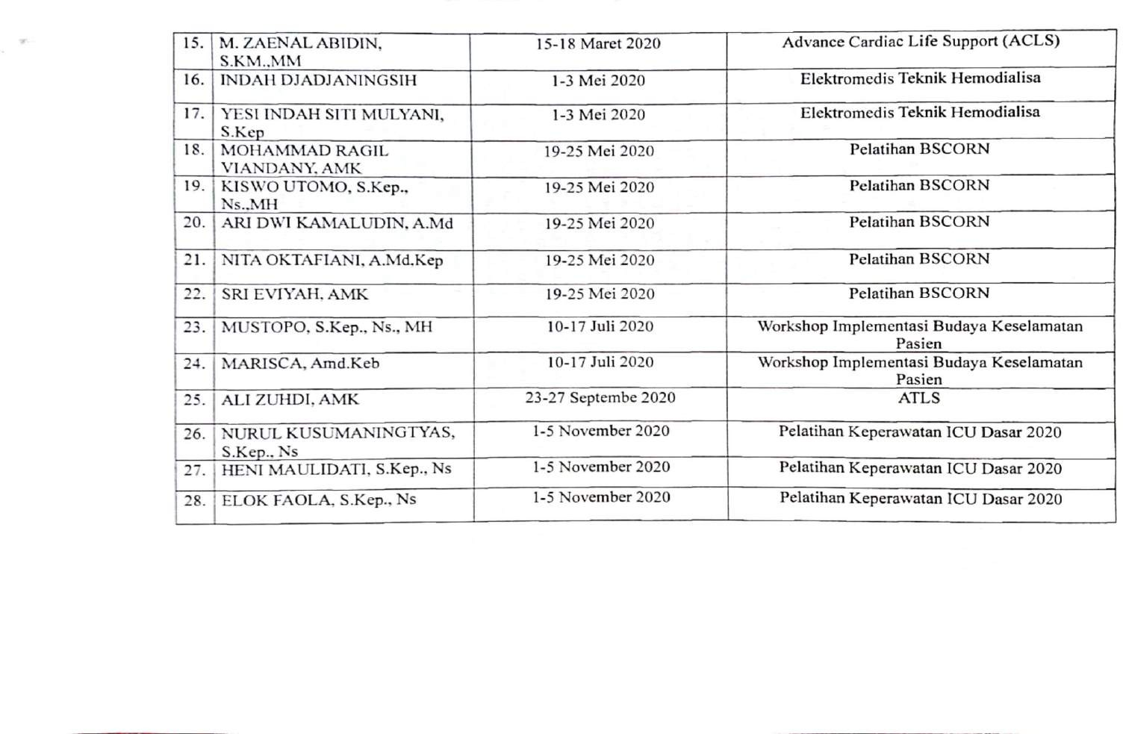

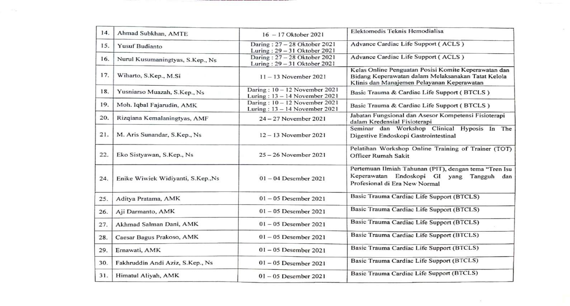

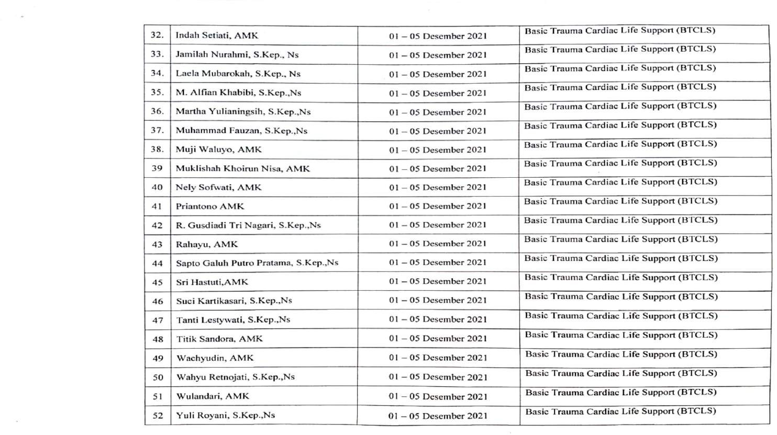

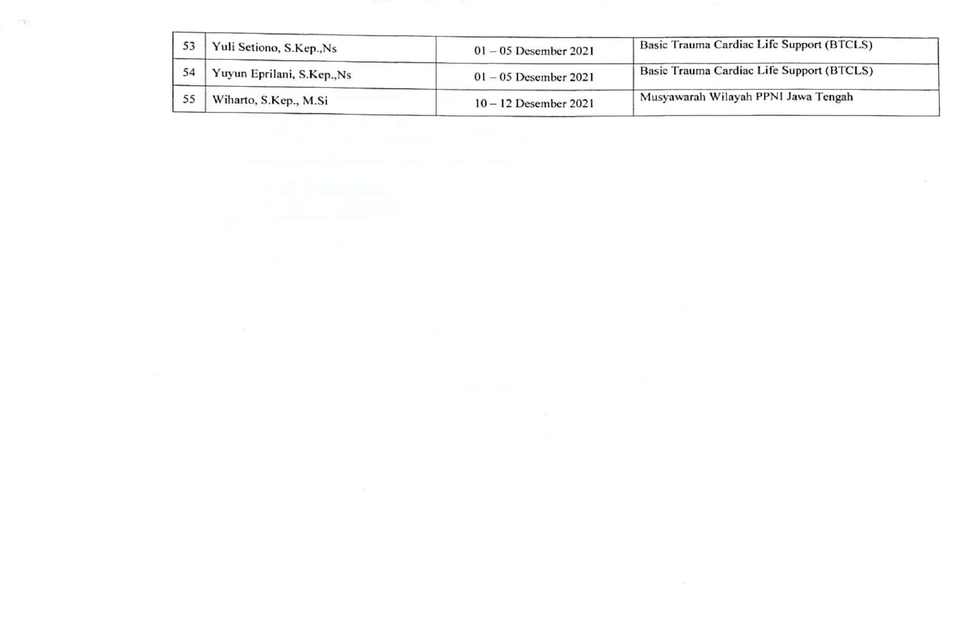

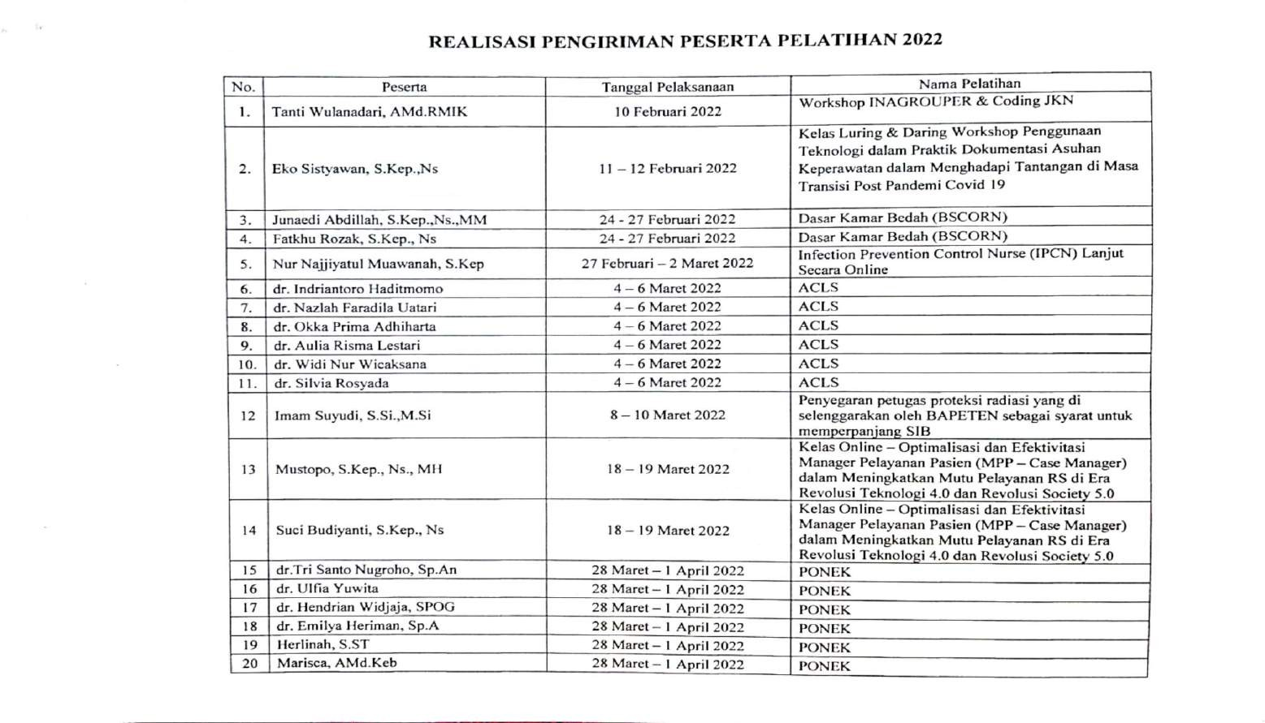

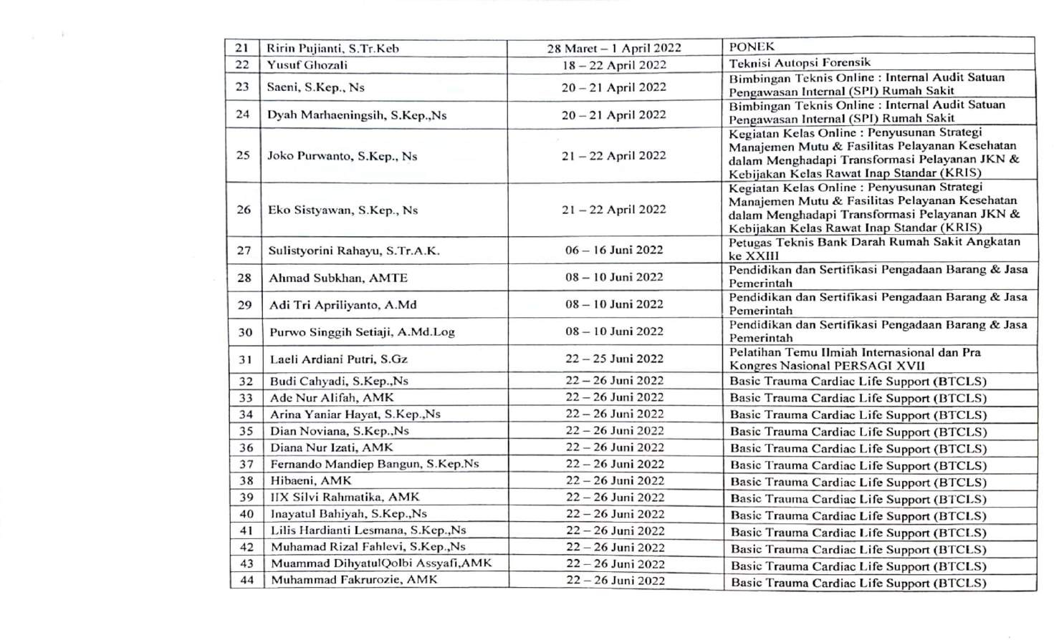

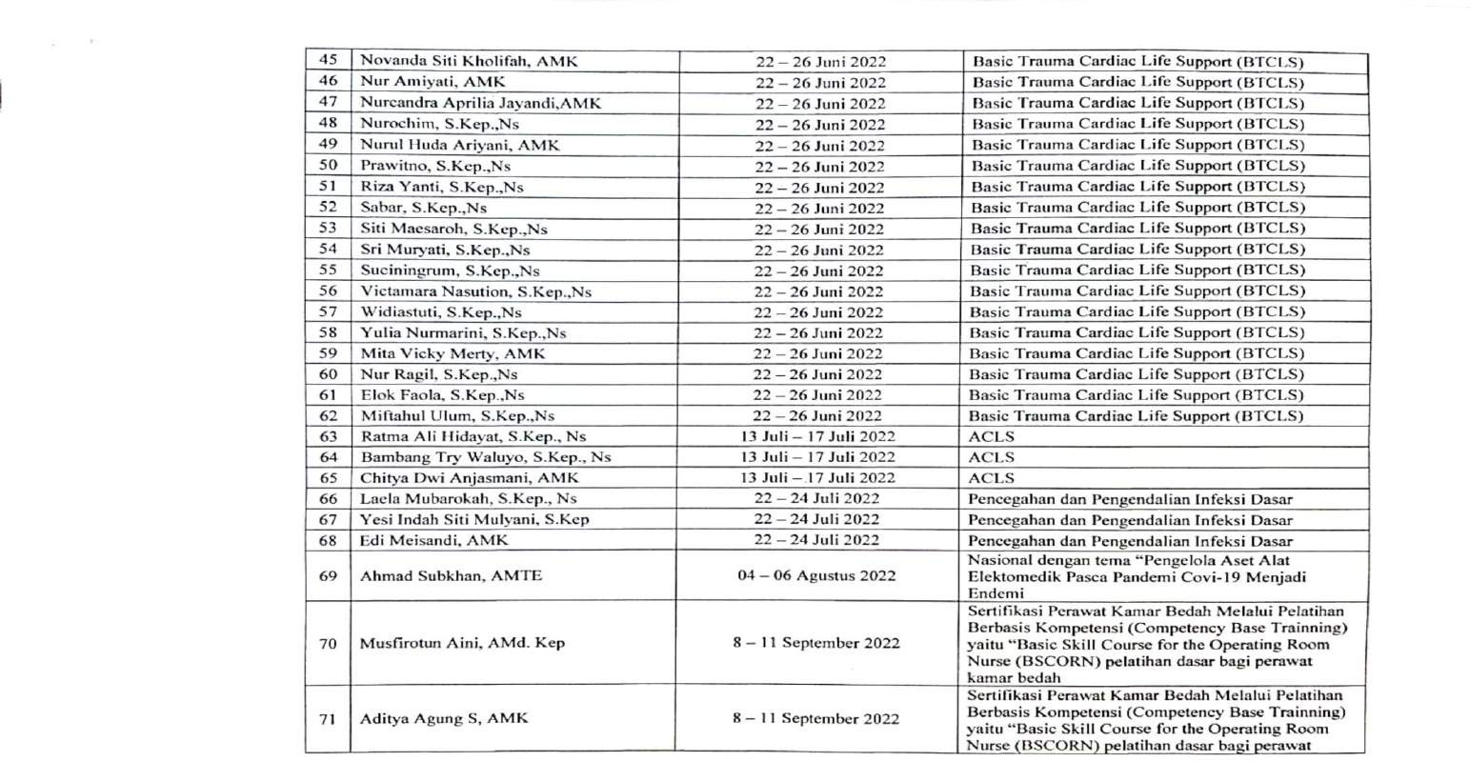

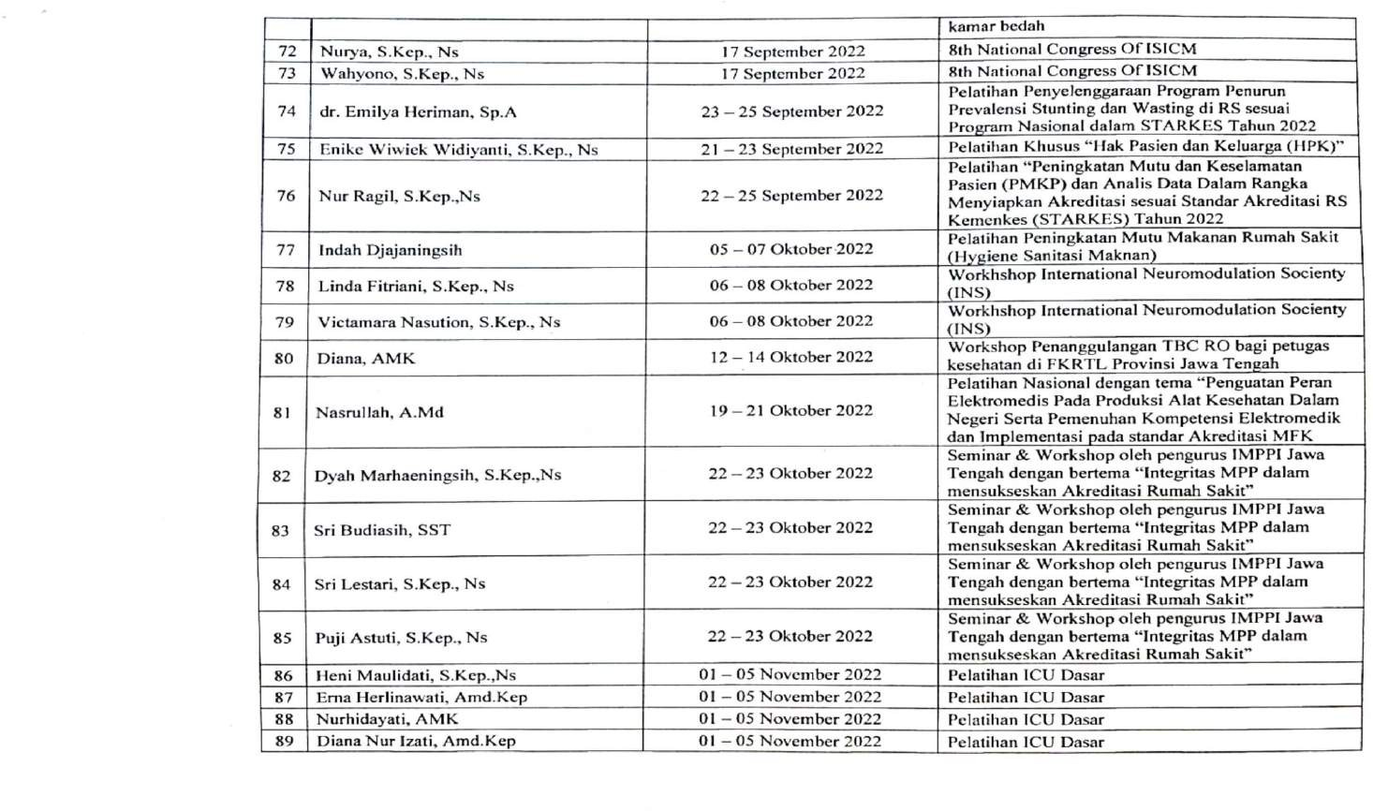

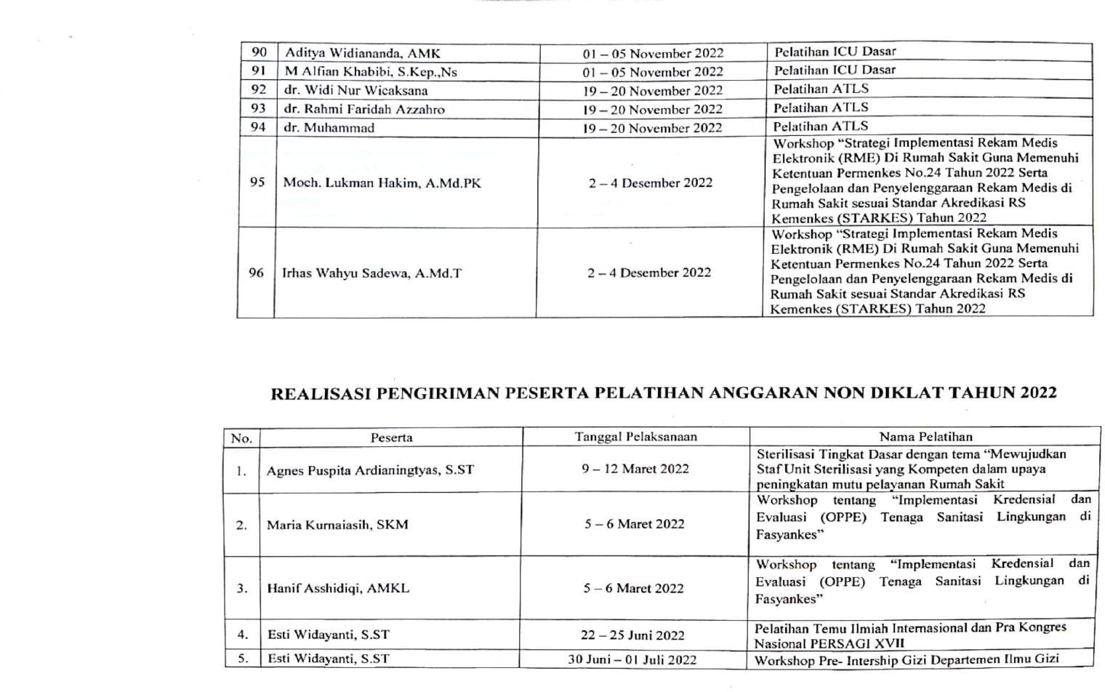

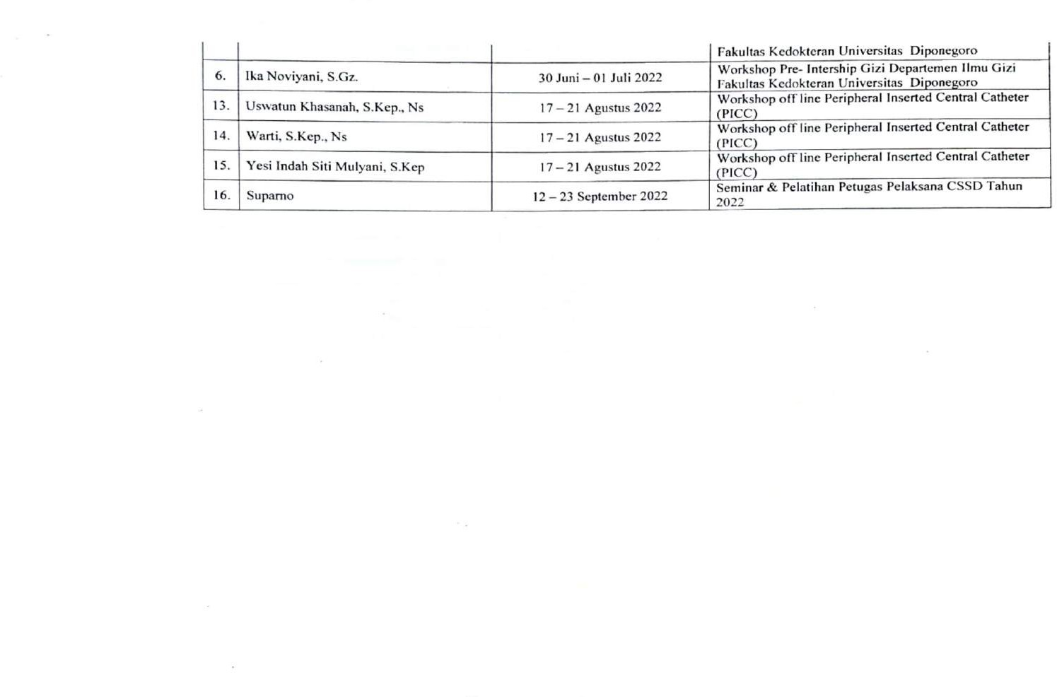

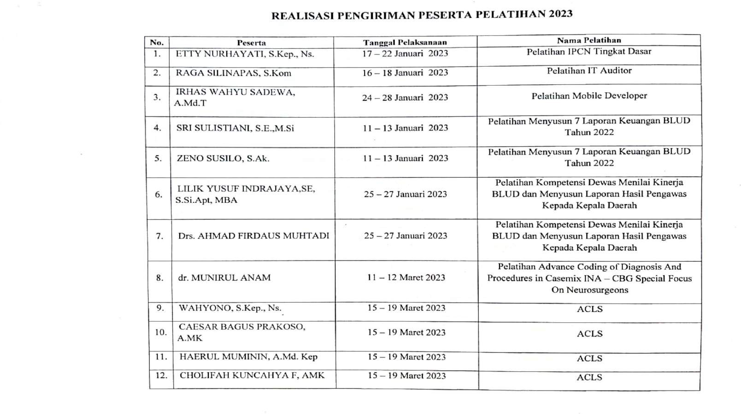

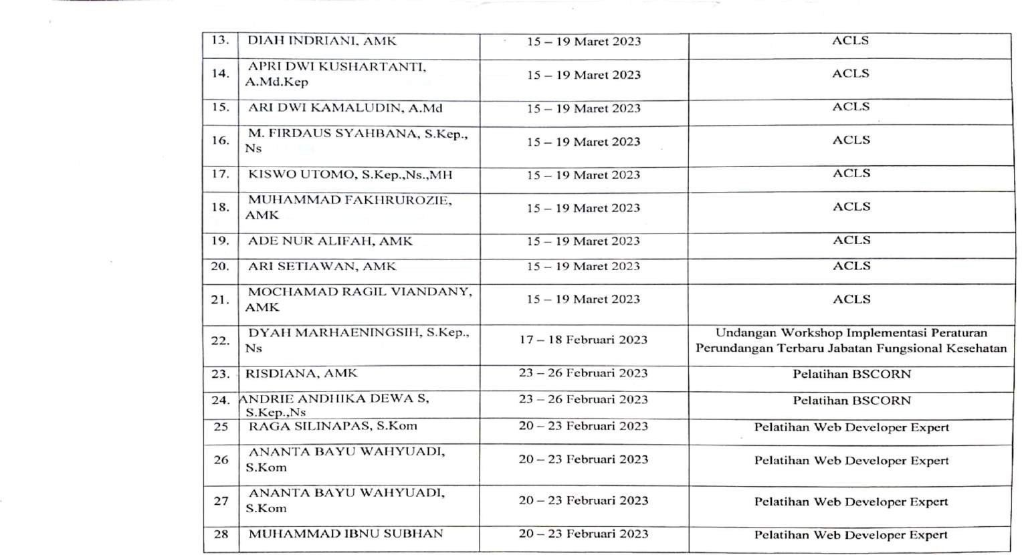

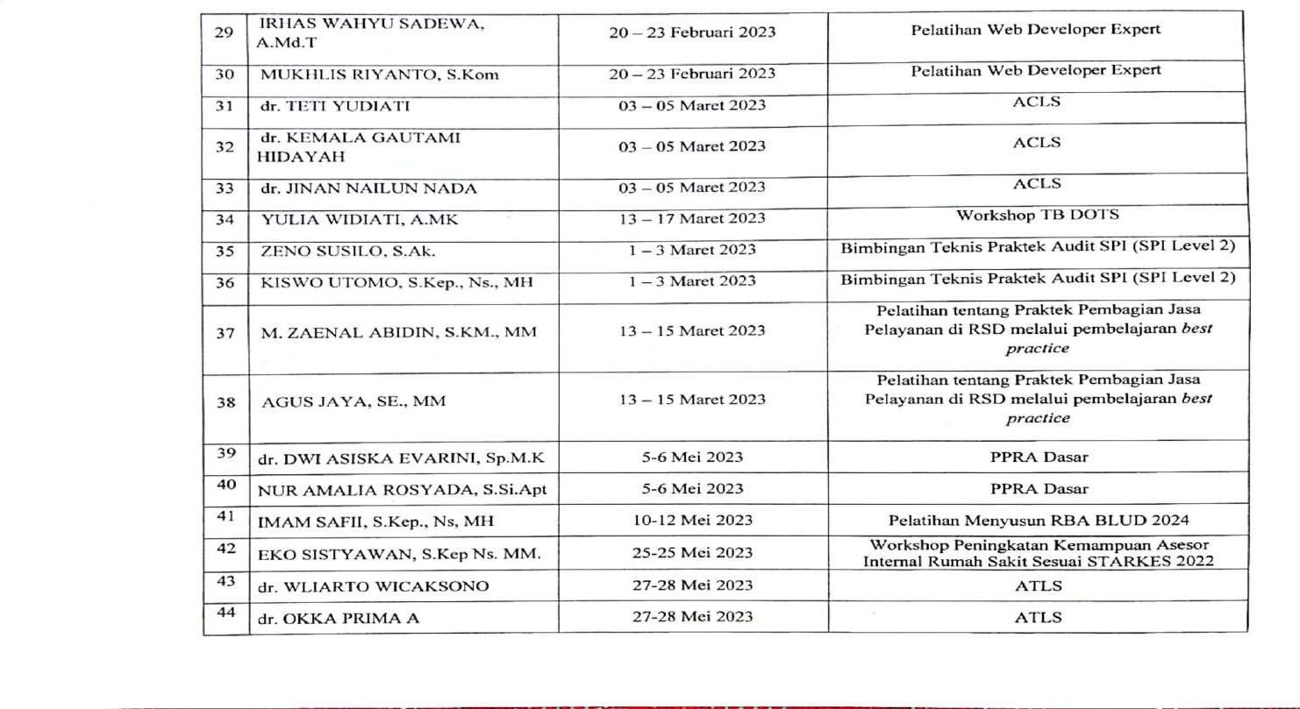

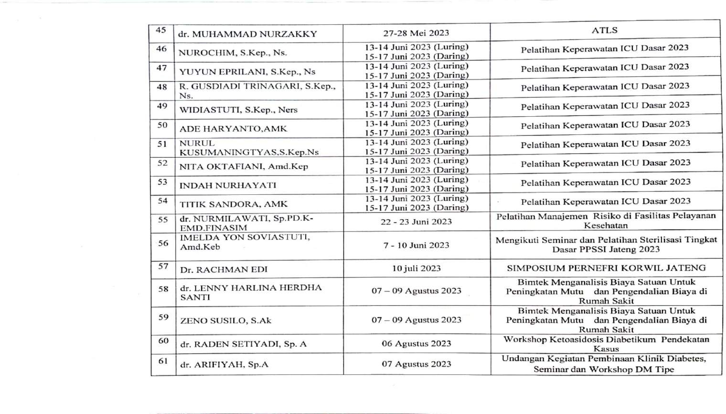

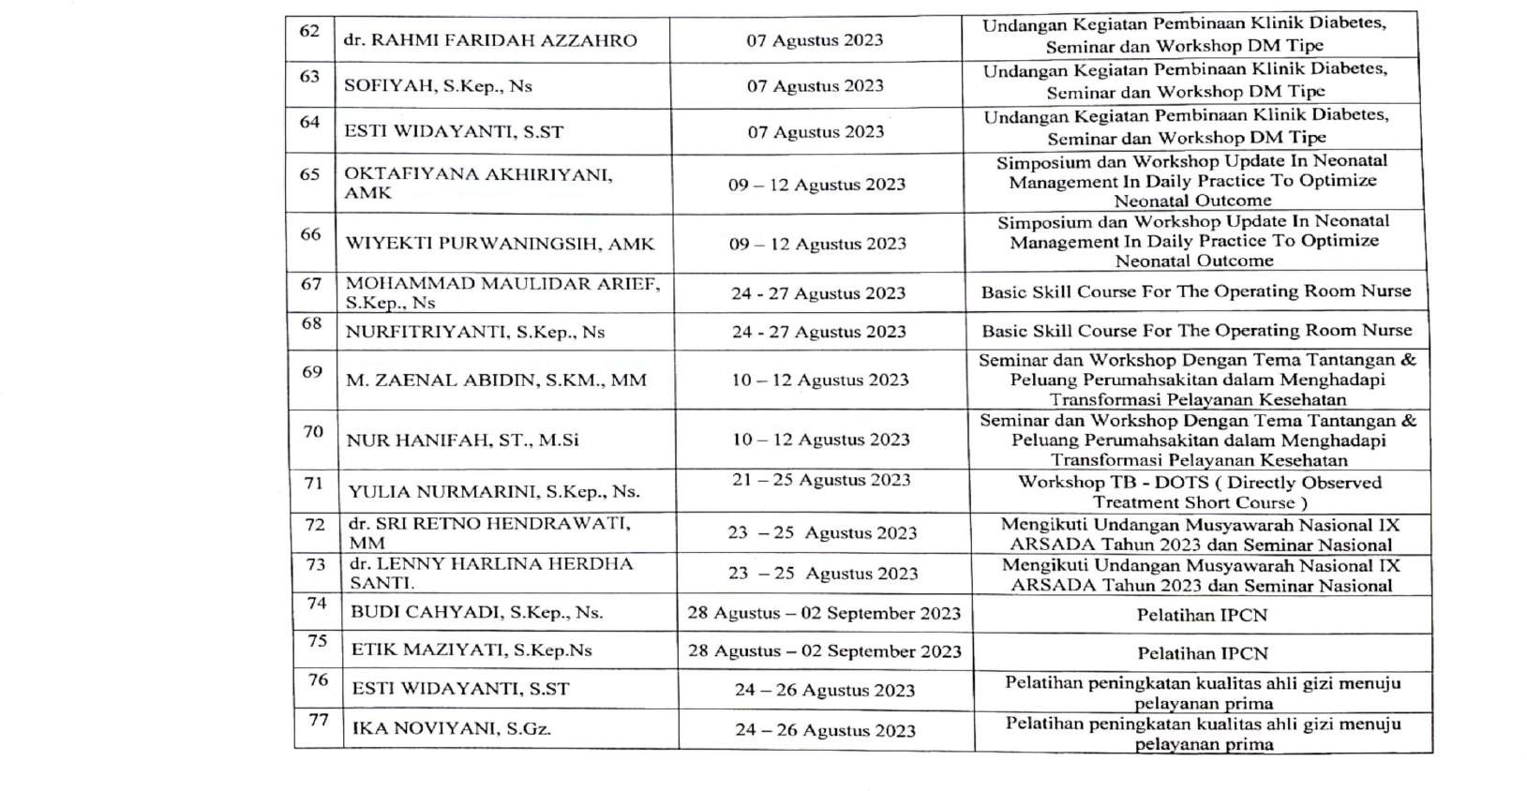

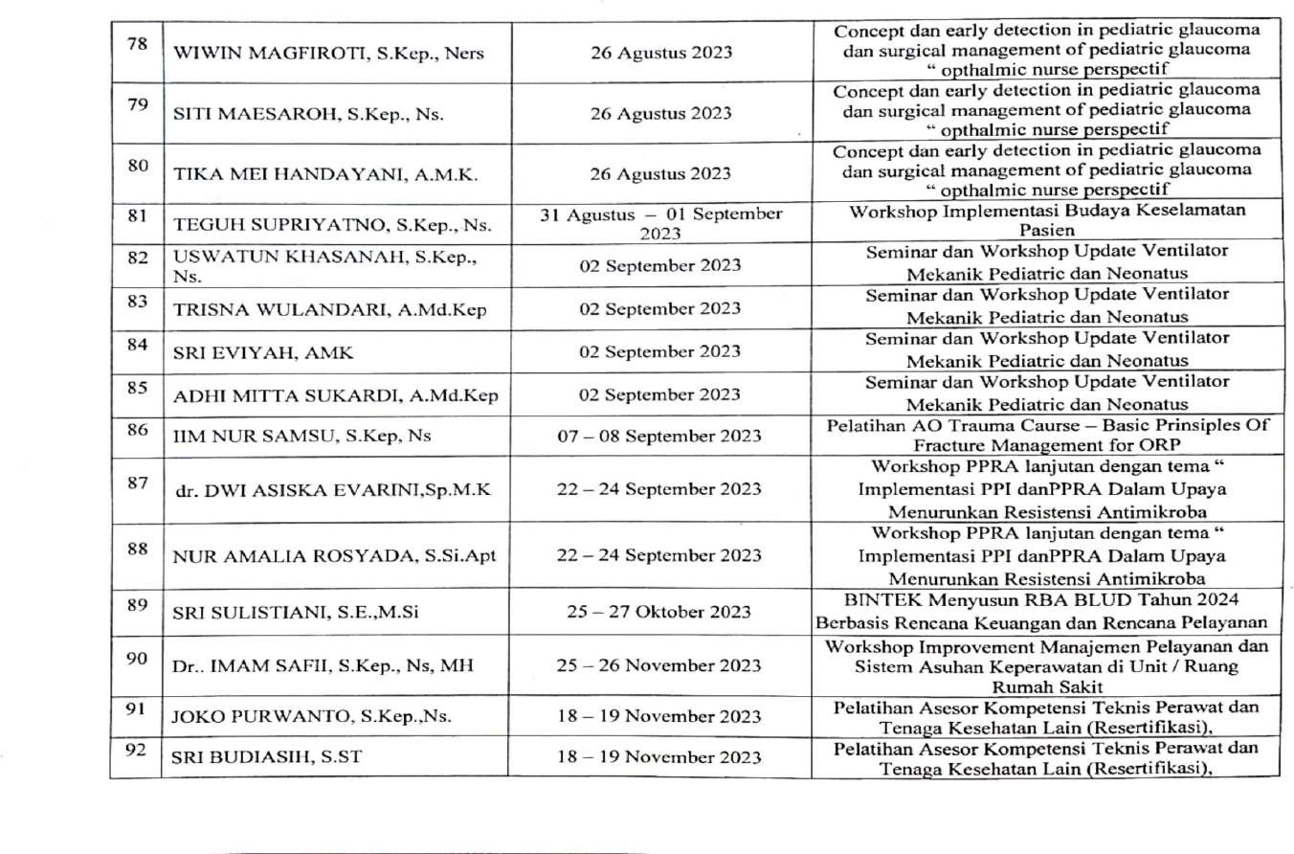

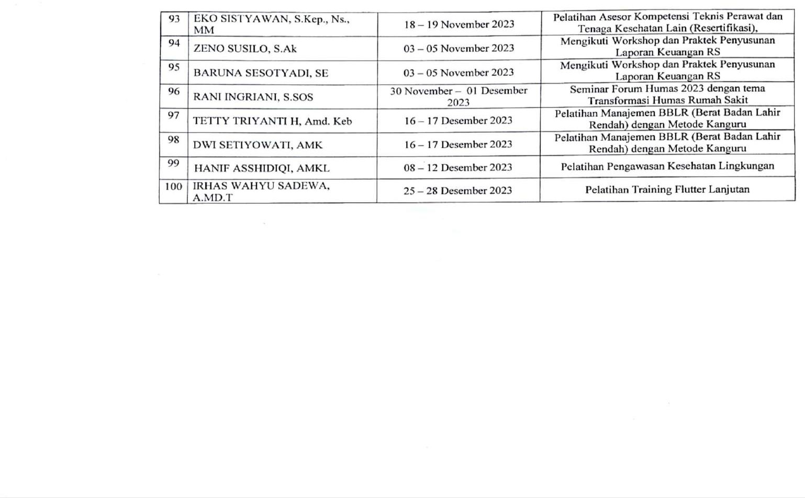

**Lampiran 8 Hasil Tabulasi Data Kuesioner**

DATA HASIL TABULASI KUESIONER

|  |  |  |  |  |  |  |  |  |  |  |  |  |  |  |  |  |  |  |
| --- | --- | --- | --- | --- | --- | --- | --- | --- | --- | --- | --- | --- | --- | --- | --- | --- | --- | --- |
| Nomor Responden | P1 | P2 | P3 | P4 | P5 | P6 | P7 | P8 | P9 | P10 | P11 | P12 | P13 | P14 | P15 | P16 | P17 | Total |
| 1 | 3 | 3 | 2 | 4 | 2 | 2 | 3 | 4 | 4 | 3 | 4 | 4 | 5 | 4 | 4 | 5 | 4 | 60 |
| 2 | 4 | 4 | 4 | 4 | 3 | 3 | 3 | 4 | 4 | 4 | 4 | 4 | 3 | 3 | 3 | 3 | 3 | 60 |
| 3 | 4 | 4 | 3 | 3 | 3 | 3 | 3 | 5 | 3 | 4 | 4 | 3 | 4 | 4 | 4 | 4 | 4 | 62 |
| 4 | 4 | 4 | 4 | 4 | 1 | 2 | 2 | 4 | 4 | 4 | 3 | 3 | 5 | 4 | 4 | 4 | 4 | 60 |
| 5 | 4 | 4 | 5 | 3 | 1 | 4 | 4 | 4 | 3 | 4 | 4 | 4 | 4 | 4 | 4 | 4 | 4 | 64 |
| 6 | 4 | 4 | 3 | 3 | 3 | 4 | 4 | 4 | 4 | 2 | 3 | 3 | 4 | 4 | 4 | 5 | 3 | 61 |
| 7 | 4 | 4 | 3 | 3 | 1 | 3 | 5 | 5 | 4 | 3 | 3 | 4 | 4 | 4 | 4 | 3 | 4 | 61 |
| 8 | 4 | 4 | 4 | 4 | 3 | 4 | 4 | 5 | 4 | 4 | 4 | 4 | 4 | 4 | 4 | 4 | 4 | 68 |
| 9 | 4 | 4 | 4 | 3 | 2 | 4 | 4 | 5 | 3 | 3 | 5 | 3 | 5 | 4 | 4 | 5 | 5 | 67 |
| 10 | 4 | 4 | 5 | 5 | 3 | 3 | 3 | 4 | 4 | 4 | 4 | 3 | 5 | 4 | 4 | 4 | 4 | 67 |
| 11 | 4 | 4 | 3 | 3 | 2 | 2 | 3 | 3 | 5 | 3 | 3 | 3 | 3 | 4 | 4 | 5 | 5 | 59 |
| 12 | 4 | 5 | 5 | 4 | 3 | 3 | 4 | 5 | 4 | 5 | 5 | 4 | 5 | 5 | 5 | 5 | 5 | 76 |
| 13 | 4 | 4 | 4 | 4 | 3 | 3 | 4 | 4 | 4 | 4 | 4 | 4 | 4 | 4 | 4 | 4 | 4 | 66 |
| 14 | 3 | 4 | 4 | 5 | 4 | 3 | 4 | 5 | 3 | 3 | 3 | 3 | 3 | 4 | 4 | 4 | 4 | 63 |
| 15 | 4 | 4 | 4 | 4 | 4 | 4 | 4 | 4 | 4 | 4 | 4 | 4 | 4 | 4 | 4 | 4 | 4 | 68 |
| 16 | 3 | 3 | 3 | 3 | 4 | 4 | 4 | 5 | 5 | 5 | 5 | 5 | 5 | 4 | 4 | 4 | 4 | 70 |
| 17 | 4 | 4 | 4 | 4 | 3 | 3 | 3 | 5 | 4 | 4 | 4 | 3 | 5 | 4 | 5 | 5 | 5 | 69 |
| 18 | 4 | 4 | 4 | 4 | 4 | 4 | 3 | 5 | 5 | 5 | 4 | 4 | 5 | 4 | 5 | 5 | 5 | 74 |
| 19 | 4 | 4 | 3 | 4 | 4 | 4 | 4 | 5 | 4 | 4 | 4 | 4 | 4 | 4 | 4 | 4 | 4 | 68 |
| 20 | 4 | 4 | 4 | 4 | 3 | 3 | 4 | 4 | 5 | 4 | 4 | 3 | 5 | 4 | 5 | 4 | 3 | 67 |

|  |  |  |  |  |  |  |  |  |  |  |  |  |  |  |  |  |  |  |
| --- | --- | --- | --- | --- | --- | --- | --- | --- | --- | --- | --- | --- | --- | --- | --- | --- | --- | --- |
| 21 | 3 | 4 | 3 | 5 | 2 | 3 | 4 | 4 | 5 | 4 | 3 | 3 | 4 | 3 | 4 | 4 | 3 | 61 |
| 22 | 3 | 4 | 3 | 3 | 1 | 2 | 3 | 4 | 4 | 5 | 3 | 4 | 4 | 4 | 4 | 4 | 4 | 59 |
| 23 | 4 | 4 | 5 | 3 | 1 | 3 | 4 | 5 | 3 | 3 | 3 | 4 | 4 | 4 | 4 | 3 | 3 | 60 |
| 24 | 4 | 4 | 1 | 2 | 2 | 3 | 3 | 4 | 2 | 3 | 3 | 3 | 3 | 4 | 4 | 4 | 4 | 53 |
| 25 | 3 | 3 | 4 | 4 | 3 | 3 | 4 | 5 | 2 | 3 | 4 | 3 | 4 | 3 | 4 | 4 | 4 | 60 |
| 26 | 4 | 4 | 3 | 4 | 3 | 3 | 4 | 4 | 4 | 4 | 4 | 4 | 4 | 3 | 5 | 4 | 4 | 65 |
| 27 | 4 | 4 | 4 | 5 | 4 | 4 | 5 | 4 | 4 | 5 | 4 | 4 | 5 | 3 | 4 | 4 | 4 | 71 |
| 28 | 4 | 4 | 4 | 4 | 4 | 4 | 4 | 4 | 4 | 4 | 4 | 4 | 4 | 4 | 4 | 4 | 4 | 68 |
| 29 | 5 | 4 | 3 | 4 | 3 | 3 | 4 | 5 | 5 | 4 | 3 | 4 | 4 | 3 | 4 | 3 | 3 | 64 |
| 30 | 4 | 3 | 3 | 5 | 4 | 5 | 4 | 5 | 4 | 5 | 5 | 4 | 4 | 4 | 5 | 4 | 4 | 72 |
| 31 | 4 | 4 | 4 | 5 | 5 | 5 | 4 | 5 | 4 | 3 | 4 | 3 | 5 | 3 | 4 | 5 | 4 | 71 |
| 32 | 4 | 4 | 3 | 4 | 2 | 2 | 4 | 5 | 5 | 3 | 4 | 3 | 5 | 3 | 4 | 4 | 3 | 62 |
| 33 | 3 | 4 | 4 | 4 | 4 | 4 | 5 | 5 | 3 | 3 | 4 | 3 | 4 | 4 | 5 | 3 | 3 | 65 |
| 34 | 3 | 3 | 4 | 4 | 4 | 5 | 3 | 5 | 5 | 3 | 3 | 3 | 5 | 3 | 3 | 3 | 3 | 62 |
| 35 | 4 | 5 | 5 | 4 | 3 | 3 | 3 | 5 | 5 | 4 | 4 | 4 | 5 | 4 | 4 | 4 | 5 | 71 |
| 36 | 4 | 4 | 3 | 4 | 4 | 4 | 4 | 4 | 3 | 4 | 4 | 3 | 4 | 3 | 3 | 3 | 3 | 61 |
| 37 | 4 | 4 | 5 | 5 | 4 | 4 | 3 | 4 | 3 | 4 | 4 | 5 | 4 | 4 | 5 | 5 | 3 | 70 |
| 38 | 3 | 3 | 4 | 4 | 4 | 4 | 4 | 4 | 4 | 3 | 3 | 3 | 5 | 4 | 4 | 3 | 3 | 62 |
| 39 | 4 | 4 | 4 | 4 | 4 | 4 | 4 | 4 | 3 | 3 | 4 | 4 | 3 | 3 | 3 | 3 | 2 | 60 |
| 40 | 3 | 4 | 4 | 4 | 4 | 4 | 4 | 4 | 4 | 3 | 3 | 4 | 4 | 4 | 4 | 4 | 4 | 65 |
| 41 | 5 | 5 | 5 | 4 | 4 | 5 | 4 | 4 | 4 | 3 | 4 | 4 | 5 | 5 | 4 | 5 | 4 | 74 |
| 42 | 5 | 5 | 5 | 5 | 5 | 5 | 3 | 4 | 4 | 4 | 3 | 4 | 4 | 5 | 5 | 4 | 5 | 75 |
| 43 | 3 | 4 | 2 | 3 | 4 | 3 | 3 | 3 | 4 | 3 | 3 | 3 | 4 | 4 | 3 | 3 | 3 | 55 |
| 44 | 3 | 3 | 3 | 3 | 3 | 4 | 3 | 4 | 3 | 3 | 3 | 3 | 3 | 4 | 4 | 5 | 5 | 59 |
| 45 | 4 | 3 | 4 | 4 | 4 | 3 | 3 | 4 | 4 | 5 | 5 | 4 | 4 | 3 | 5 | 4 | 2 | 65 |

|  |  |  |  |  |  |  |  |  |  |  |  |  |  |  |  |  |  |  |
| --- | --- | --- | --- | --- | --- | --- | --- | --- | --- | --- | --- | --- | --- | --- | --- | --- | --- | --- |
| 46 | 3 | 3 | 4 | 4 | 3 | 3 | 3 | 4 | 4 | 3 | 3 | 3 | 5 | 3 | 5 | 3 | 3 | 59 |
| 47 | 4 | 3 | 2 | 2 | 5 | 5 | 4 | 4 | 2 | 3 | 2 | 2 | 3 | 4 | 5 | 4 | 3 | 57 |
| 48 | 4 | 4 | 4 | 4 | 3 | 3 | 4 | 3 | 3 | 4 | 4 | 5 | 3 | 3 | 5 | 3 | 3 | 62 |
| 49 | 4 | 4 | 3 | 4 | 4 | 3 | 4 | 5 | 4 | 4 | 4 | 4 | 4 | 4 | 5 | 4 | 4 | 68 |
| 50 | 4 | 4 | 4 | 4 | 4 | 4 | 3 | 4 | 4 | 4 | 4 | 4 | 4 | 4 | 4 | 4 | 4 | 67 |
| 51 | 3 | 3 | 4 | 4 | 4 | 4 | 4 | 5 | 4 | 3 | 4 | 4 | 4 | 4 | 4 | 4 | 4 | 66 |
| 52 | 3 | 2 | 3 | 3 | 3 | 3 | 2 | 4 | 4 | 3 | 3 | 3 | 3 | 3 | 4 | 2 | 3 | 51 |
| 53 | 5 | 4 | 4 | 4 | 4 | 4 | 4 | 3 | 5 | 4 | 3 | 3 | 4 | 4 | 4 | 3 | 4 | 66 |
| 54 | 4 | 4 | 4 | 4 | 3 | 4 | 4 | 4 | 4 | 4 | 4 | 3 | 4 | 4 | 4 | 4 | 4 | 66 |
| 55 | 4 | 3 | 4 | 3 | 3 | 5 | 4 | 5 | 3 | 5 | 4 | 3 | 4 | 4 | 3 | 3 | 4 | 64 |
| 56 | 4 | 4 | 4 | 4 | 3 | 3 | 4 | 4 | 4 | 4 | 4 | 4 | 4 | 4 | 3 | 3 | 4 | 64 |
| 57 | 4 | 4 | 4 | 4 | 3 | 3 | 4 | 4 | 4 | 4 | 5 | 4 | 5 | 5 | 5 | 5 | 4 | 71 |
| 58 | 4 | 3 | 4 | 4 | 4 | 4 | 4 | 4 | 4 | 4 | 4 | 4 | 4 | 4 | 4 | 4 | 4 | 67 |
| 59 | 3 | 3 | 3 | 4 | 3 | 3 | 3 | 3 | 3 | 3 | 3 | 3 | 3 | 4 | 3 | 3 | 3 | 53 |
| 60 | 3 | 3 | 3 | 3 | 2 | 3 | 3 | 3 | 3 | 3 | 3 | 3 | 3 | 3 | 3 | 3 | 3 | 50 |
| 61 | 5 | 4 | 3 | 4 | 2 | 3 | 4 | 4 | 5 | 3 | 4 | 3 | 3 | 4 | 5 | 4 | 4 | 64 |
| 62 | 3 | 4 | 3 | 3 | 2 | 2 | 4 | 4 | 4 | 3 | 4 | 3 | 4 | 3 | 4 | 4 | 4 | 58 |
| 63 | 4 | 4 | 5 | 5 | 4 | 4 | 4 | 5 | 5 | 5 | 5 | 4 | 5 | 5 | 5 | 5 | 5 | 79 |
| 64 | 3 | 3 | 3 | 3 | 3 | 3 | 3 | 3 | 3 | 3 | 3 | 3 | 3 | 3 | 3 | 3 | 3 | 51 |
| 65 | 1 | 3 | 2 | 3 | 1 | 4 | 5 | 5 | 5 | 4 | 5 | 3 | 4 | 5 | 5 | 4 | 5 | 64 |
| 66 | 3 | 3 | 3 | 3 | 3 | 3 | 3 | 3 | 3 | 3 | 3 | 3 | 3 | 3 | 3 | 3 | 3 | 51 |
| 67 | 5 | 5 | 4 | 4 | 4 | 4 | 4 | 4 | 4 | 4 | 4 | 3 | 4 | 5 | 5 | 5 | 5 | 73 |
| 68 | 3 | 3 | 3 | 2 | 3 | 2 | 3 | 4 | 4 | 2 | 1 | 3 | 3 | 4 | 4 | 3 | 3 | 50 |
| 69 | 5 | 5 | 5 | 4 | 5 | 4 | 5 | 5 | 4 | 4 | 4 | 5 | 4 | 4 | 5 | 5 | 5 | 78 |
| 70 | 3 | 3 | 3 | 3 | 2 | 3 | 3 | 3 | 3 | 3 | 3 | 3 | 3 | 3 | 3 | 3 | 3 | 50 |

|  |  |  |  |  |  |  |  |  |  |  |  |  |  |  |  |  |  |  |
| --- | --- | --- | --- | --- | --- | --- | --- | --- | --- | --- | --- | --- | --- | --- | --- | --- | --- | --- |
| 71 | 4 | 4 | 4 | 4 | 4 | 4 | 4 | 4 | 4 | 4 | 4 | 4 | 4 | 4 | 4 | 4 | 4 | 68 |
| 72 | 4 | 4 | 4 | 5 | 3 | 4 | 4 | 4 | 4 | 4 | 4 | 4 | 4 | 4 | 5 | 4 | 4 | 69 |
| 73 | 3 | 3 | 3 | 3 | 3 | 3 | 3 | 3 | 3 | 3 | 3 | 3 | 3 | 3 | 3 | 3 | 3 | 51 |
| 74 | 5 | 4 | 4 | 4 | 3 | 4 | 4 | 4 | 4 | 5 | 5 | 4 | 4 | 5 | 5 | 4 | 5 | 73 |
| 75 | 3 | 3 | 3 | 3 | 3 | 3 | 3 | 3 | 4 | 4 | 3 | 3 | 4 | 3 | 3 | 4 | 3 | 55 |
| 76 | 3 | 3 | 3 | 3 | 4 | 3 | 3 | 4 | 4 | 4 | 3 | 4 | 4 | 4 | 4 | 3 | 4 | 60 |
| 77 | 4 | 3 | 3 | 4 | 4 | 4 | 4 | 5 | 4 | 4 | 4 | 5 | 5 | 4 | 5 | 4 | 5 | 71 |
| 78 | 3 | 3 | 3 | 4 | 4 | 3 | 4 | 4 | 3 | 4 | 3 | 3 | 3 | 4 | 4 | 4 | 3 | 59 |
| 79 | 3 | 4 | 4 | 5 | 4 | 3 | 3 | 4 | 4 | 3 | 4 | 2 | 4 | 3 | 4 | 3 | 3 | 60 |
| 80 | 4 | 4 | 4 | 4 | 4 | 3 | 4 | 5 | 5 | 5 | 5 | 3 | 4 | 4 | 4 | 3 | 4 | 69 |
| 81 | 4 | 4 | 3 | 3 | 2 | 2 | 3 | 3 | 3 | 3 | 3 | 2 | 4 | 3 | 5 | 4 | 4 | 55 |
| 82 | 4 | 4 | 3 | 5 | 4 | 3 | 3 | 4 | 4 | 4 | 3 | 3 | 5 | 4 | 5 | 4 | 4 | 66 |
| 83 | 4 | 4 | 4 | 4 | 4 | 4 | 4 | 5 | 5 | 5 | 5 | 3 | 5 | 4 | 5 | 3 | 3 | 71 |
| 84 | 4 | 3 | 5 | 4 | 4 | 4 | 4 | 5 | 5 | 4 | 3 | 3 | 5 | 4 | 5 | 3 | 3 | 68 |
| 85 | 4 | 4 | 5 | 5 | 5 | 5 | 5 | 5 | 5 | 5 | 5 | 4 | 5 | 5 | 5 | 4 | 3 | 79 |
| 86 | 3 | 5 | 5 | 5 | 5 | 5 | 5 | 5 | 4 | 4 | 4 | 4 | 5 | 4 | 5 | 5 | 4 | 77 |
| 87 | 4 | 4 | 3 | 3 | 3 | 3 | 3 | 5 | 4 | 3 | 3 | 3 | 5 | 4 | 5 | 4 | 3 | 62 |
| 88 | 4 | 4 | 4 | 4 | 4 | 3 | 5 | 5 | 5 | 3 | 3 | 3 | 5 | 4 | 5 | 3 | 3 | 67 |
| 89 | 4 | 5 | 3 | 4 | 4 | 4 | 4 | 5 | 5 | 5 | 5 | 5 | 5 | 5 | 5 | 5 | 5 | 78 |
| 90 | 4 | 4 | 4 | 4 | 4 | 4 | 5 | 5 | 5 | 4 | 5 | 3 | 5 | 4 | 5 | 5 | 5 | 75 |
| 91 | 2 | 3 | 4 | 3 | 3 | 3 | 4 | 4 | 4 | 4 | 3 | 3 | 3 | 4 | 5 | 3 | 4 | 59 |
| 92 | 4 | 4 | 3 | 4 | 4 | 4 | 4 | 4 | 3 | 4 | 4 | 4 | 4 | 4 | 4 | 4 | 4 | 66 |
| 93 | 4 | 3 | 3 | 4 | 4 | 3 | 4 | 4 | 3 | 3 | 4 | 4 | 4 | 4 | 4 | 1 | 4 | 60 |
| 94 | 4 | 4 | 4 | 2 | 4 | 4 | 4 | 4 | 2 | 4 | 4 | 3 | 4 | 4 | 3 | 2 | 4 | 60 |
| 95 | 4 | 4 | 4 | 4 | 5 | 4 | 4 | 5 | 4 | 4 | 4 | 4 | 5 | 4 | 4 | 4 | 5 | 72 |

|  |  |  |  |  |  |  |  |  |  |  |  |  |  |  |  |  |  |  |
| --- | --- | --- | --- | --- | --- | --- | --- | --- | --- | --- | --- | --- | --- | --- | --- | --- | --- | --- |
| 96 | 5 | 5 | 3 | 3 | 3 | 3 | 4 | 5 | 5 | 4 | 4 | 3 | 4 | 4 | 4 | 4 | 3 | 66 |
| 97 | 3 | 4 | 3 | 3 | 3 | 3 | 2 | 3 | 4 | 4 | 3 | 2 | 4 | 4 | 4 | 3 | 4 | 56 |
| 98 | 4 | 4 | 4 | 4 | 3 | 4 | 4 | 5 | 5 | 5 | 5 | 4 | 5 | 5 | 5 | 3 | 3 | 72 |
| 99 | 5 | 5 | 5 | 5 | 2 | 4 | 4 | 4 | 4 | 4 | 3 | 4 | 4 | 3 | 5 | 5 | 3 | 69 |
| 100 | 4 | 4 | 3 | 3 | 3 | 3 | 3 | 4 | 4 | 4 | 4 | 3 | 3 | 4 | 5 | 4 | 3 | 61 |
| 101 | 4 | 4 | 3 | 3 | 2 | 2 | 4 | 4 | 3 | 3 | 3 | 2 | 4 | 3 | 5 | 4 | 4 | 57 |
| 102 | 4 | 4 | 4 | 4 | 4 | 3 | 4 | 5 | 5 | 5 | 4 | 3 | 4 | 4 | 4 | 4 | 3 | 68 |
| 103 | 3 | 4 | 4 | 5 | 4 | 3 | 3 | 4 | 4 | 3 | 4 | 2 | 4 | 3 | 5 | 3 | 3 | 61 |
| 104 | 3 | 3 | 3 | 4 | 4 | 3 | 4 | 4 | 3 | 4 | 3 | 3 | 4 | 4 | 4 | 4 | 5 | 62 |
| 105 | 4 | 3 | 3 | 4 | 4 | 4 | 4 | 5 | 4 | 4 | 4 | 5 | 5 | 4 | 5 | 4 | 3 | 69 |
| 106 | 3 | 3 | 3 | 3 | 4 | 3 | 3 | 4 | 4 | 4 | 3 | 4 | 4 | 4 | 4 | 4 | 3 | 60 |
| 107 | 3 | 3 | 3 | 3 | 3 | 3 | 3 | 3 | 4 | 4 | 3 | 3 | 4 | 3 | 3 | 4 | 5 | 57 |
| 108 | 5 | 4 | 4 | 4 | 3 | 4 | 4 | 4 | 4 | 5 | 5 | 4 | 4 | 5 | 5 | 4 | 3 | 71 |
| 109 | 3 | 3 | 3 | 3 | 3 | 3 | 3 | 3 | 3 | 3 | 3 | 3 | 3 | 3 | 3 | 3 | 4 | 52 |
| 110 | 4 | 4 | 4 | 5 | 3 | 4 | 4 | 4 | 4 | 4 | 4 | 4 | 4 | 4 | 5 | 4 | 4 | 69 |
| 111 | 4 | 4 | 4 | 4 | 4 | 4 | 4 | 4 | 4 | 4 | 4 | 4 | 4 | 4 | 4 | 4 | 3 | 67 |
| 112 | 3 | 3 | 3 | 3 | 2 | 3 | 3 | 3 | 3 | 3 | 3 | 3 | 3 | 3 | 3 | 3 | 5 | 52 |
| 113 | 5 | 5 | 5 | 4 | 5 | 4 | 5 | 5 | 4 | 4 | 4 | 5 | 4 | 4 | 3 | 5 | 3 | 74 |
| 114 | 3 | 3 | 3 | 2 | 3 | 2 | 3 | 4 | 4 | 2 | 1 | 3 | 3 | 4 | 5 | 3 | 5 | 53 |
| 115 | 5 | 5 | 4 | 4 | 4 | 4 | 4 | 4 | 4 | 4 | 4 | 3 | 4 | 5 | 4 | 5 | 3 | 70 |
| 116 | 3 | 3 | 3 | 3 | 3 | 3 | 3 | 3 | 3 | 3 | 3 | 3 | 3 | 3 | 5 | 3 | 5 | 55 |
| 117 | 4 | 4 | 5 | 5 | 4 | 4 | 4 | 5 | 5 | 5 | 5 | 4 | 5 | 5 | 3 | 5 | 5 | 77 |
| 118 | 1 | 3 | 2 | 3 | 1 | 4 | 5 | 5 | 5 | 4 | 5 | 3 | 4 | 5 | 5 | 4 | 3 | 62 |
| 119 | 3 | 3 | 3 | 3 | 3 | 3 | 3 | 3 | 3 | 3 | 3 | 3 | 3 | 3 | 5 | 3 | 4 | 54 |
| 120 | 4 | 3 | 4 | 3 | 3 | 5 | 4 | 5 | 3 | 5 | 4 | 3 | 4 | 4 | 3 | 3 | 4 | 64 |

|  |  |  |  |  |  |  |  |  |  |  |  |  |  |  |  |  |  |  |
| --- | --- | --- | --- | --- | --- | --- | --- | --- | --- | --- | --- | --- | --- | --- | --- | --- | --- | --- |
| 121 | 4 | 4 | 4 | 4 | 3 | 4 | 4 | 4 | 4 | 4 | 4 | 3 | 4 | 4 | 3 | 4 | 4 | 65 |
| 122 | 4 | 4 | 4 | 4 | 3 | 3 | 4 | 4 | 4 | 4 | 4 | 4 | 4 | 4 | 4 | 3 | 4 | 65 |
| 123 | 4 | 3 | 4 | 4 | 4 | 4 | 4 | 4 | 4 | 4 | 4 | 4 | 4 | 4 | 3 | 4 | 4 | 66 |
| 124 | 4 | 4 | 4 | 4 | 3 | 3 | 4 | 4 | 4 | 4 | 5 | 4 | 5 | 4 | 4 | 4 | 3 | 67 |
| 125 | 5 | 4 | 4 | 4 | 4 | 4 | 3 | 5 | 4 | 3 | 3 | 4 | 4 | 5 | 5 | 5 | 4 | 70 |
| 126 | 3 | 2 | 3 | 3 | 3 | 3 | 2 | 4 | 4 | 3 | 3 | 3 | 3 | 4 | 4 | 3 | 3 | 53 |
| 127 | 3 | 3 | 4 | 4 | 4 | 4 | 4 | 5 | 4 | 3 | 4 | 4 | 4 | 3 | 4 | 2 | 3 | 62 |
| 128 | 4 | 4 | 4 | 4 | 4 | 4 | 3 | 4 | 4 | 4 | 4 | 4 | 4 | 4 | 4 | 4 | 4 | 67 |
| 129 | 4 | 4 | 4 | 4 | 4 | 3 | 4 | 5 | 4 | 4 | 4 | 4 | 4 | 4 | 4 | 4 | 4 | 68 |
| 130 | 5 | 5 | 4 | 4 | 4 | 5 | 4 | 4 | 4 | 3 | 4 | 4 | 5 | 4 | 5 | 4 | 4 | 72 |
| 131 | 4 | 3 | 4 | 4 | 4 | 3 | 3 | 4 | 4 | 5 | 5 | 3 | 3 | 5 | 4 | 5 | 4 | 67 |
| 132 | 3 | 3 | 3 | 3 | 3 | 4 | 3 | 4 | 3 | 3 | 3 | 3 | 3 | 3 | 5 | 4 | 2 | 55 |
| 133 | 3 | 4 | 3 | 3 | 4 | 3 | 3 | 3 | 4 | 3 | 3 | 3 | 4 | 4 | 4 | 3 | 3 | 57 |
| 134 | 5 | 5 | 5 | 5 | 5 | 5 | 3 | 4 | 4 | 4 | 3 | 4 | 4 | 4 | 3 | 3 | 3 | 69 |
| 135 | 3 | 4 | 4 | 4 | 4 | 4 | 4 | 4 | 4 | 3 | 3 | 3 | 4 | 5 | 5 | 4 | 5 | 67 |
| 136 | 4 | 4 | 4 | 4 | 4 | 4 | 4 | 4 | 4 | 4 | 4 | 4 | 4 | 4 | 4 | 4 | 4 | 68 |
| 137 | 3 | 3 | 4 | 4 | 4 | 4 | 4 | 4 | 4 | 3 | 3 | 3 | 4 | 4 | 4 | 4 | 4 | 63 |
| 138 | 4 | 4 | 5 | 5 | 4 | 4 | 3 | 4 | 3 | 4 | 4 | 5 | 4 | 4 | 4 | 3 | 3 | 67 |
| 139 | 4 | 4 | 4 | 4 | 4 | 4 | 4 | 4 | 3 | 4 | 4 | 3 | 4 | 4 | 5 | 5 | 3 | 67 |
| 140 | 4 | 5 | 4 | 4 | 3 | 3 | 3 | 5 | 5 | 4 | 4 | 4 | 5 | 3 | 3 | 3 | 3 | 65 |
| 141 | 3 | 4 | 4 | 4 | 3 | 4 | 4 | 5 | 5 | 5 | 5 | 5 | 5 | 4 | 4 | 4 | 5 | 73 |
| 142 | 5 | 5 | 5 | 5 | 5 | 5 | 5 | 5 | 5 | 5 | 5 | 5 | 5 | 5 | 5 | 5 | 5 | 85 |
| 143 | 3 | 3 | 4 | 4 | 4 | 4 | 4 | 4 | 4 | 4 | 4 | 4 | 4 | 5 | 5 | 5 | 5 | 70 |
| 144 | 4 | 4 | 4 | 4 | 3 | 4 | 2 | 4 | 4 | 4 | 4 | 2 | 3 | 4 | 4 | 3 | 4 | 61 |
| 145 | 4 | 3 | 3 | 3 | 3 | 2 | 2 | 3 | 3 | 2 | 2 | 3 | 2 | 4 | 4 | 4 | 4 | 51 |

|  |  |  |  |  |  |  |  |  |  |  |  |  |  |  |  |  |  |  |
| --- | --- | --- | --- | --- | --- | --- | --- | --- | --- | --- | --- | --- | --- | --- | --- | --- | --- | --- |
| 146 | 3 | 4 | 4 | 2 | 3 | 1 | 3 | 3 | 3 | 2 | 4 | 3 | 3 | 2 | 3 | 2 | 3 | 48 |
| 147 | 3 | 3 | 3 | 3 | 2 | 2 | 2 | 2 | 3 | 3 | 3 | 5 | 4 | 3 | 4 | 3 | 3 | 51 |
| 148 | 3 | 4 | 4 | 4 | 4 | 3 | 4 | 4 | 3 | 3 | 4 | 4 | 4 | 4 | 4 | 4 | 4 | 64 |
| 149 | 4 | 5 | 5 | 5 | 4 | 3 | 3 | 4 | 4 | 5 | 4 | 4 | 4 | 3 | 3 | 3 | 3 | 66 |
| 150 | 5 | 4 | 4 | 5 | 4 | 4 | 4 | 4 | 4 | 5 | 5 | 5 | 4 | 3 | 4 | 4 | 4 | 72 |
| 151 | 4 | 4 | 3 | 4 | 4 | 4 | 4 | 5 | 5 | 4 | 4 | 3 | 4 | 4 | 5 | 4 | 5 | 70 |
| 152 | 4 | 4 | 4 | 3 | 3 | 3 | 3 | 3 | 4 | 4 | 4 | 3 | 3 | 4 | 3 | 3 | 3 | 58 |
| 153 | 3 | 3 | 4 | 4 | 5 | 4 | 4 | 5 | 5 | 5 | 4 | 5 | 4 | 4 | 4 | 5 | 5 | 73 |
| 154 | 5 | 5 | 5 | 5 | 5 | 5 | 5 | 5 | 5 | 5 | 5 | 5 | 5 | 4 | 5 | 4 | 5 | 83 |
| 155 | 4 | 4 | 5 | 4 | 5 | 4 | 4 | 4 | 5 | 5 | 4 | 4 | 4 | 5 | 4 | 4 | 5 | 74 |
| 156 | 4 | 4 | 4 | 4 | 5 | 5 | 4 | 5 | 5 | 4 | 4 | 4 | 4 | 3 | 3 | 3 | 3 | 68 |
| 157 | 5 | 5 | 5 | 5 | 5 | 5 | 4 | 4 | 5 | 4 | 5 | 4 | 5 | 4 | 4 | 4 | 4 | 77 |
| 158 | 4 | 4 | 4 | 4 | 5 | 5 | 5 | 5 | 4 | 4 | 5 | 5 | 5 | 3 | 3 | 3 | 3 | 71 |
| 159 | 4 | 4 | 4 | 5 | 3 | 4 | 4 | 4 | 4 | 5 | 5 | 4 | 4 | 4 | 4 | 4 | 4 | 70 |
| 160 | 3 | 4 | 4 | 4 | 4 | 4 | 4 | 5 | 4 | 4 | 4 | 5 | 4 | 3 | 3 | 4 | 4 | 67 |
| 161 | 4 | 4 | 4 | 4 | 4 | 3 | 4 | 3 | 5 | 4 | 5 | 5 | 5 | 3 | 3 | 3 | 2 | 65 |
| 162 | 5 | 4 | 3 | 3 | 4 | 4 | 3 | 4 | 3 | 4 | 3 | 5 | 4 | 3 | 3 | 4 | 3 | 62 |
| 163 | 4 | 5 | 4 | 3 | 4 | 5 | 4 | 4 | 5 | 5 | 4 | 4 | 4 | 4 | 4 | 4 | 4 | 71 |
| 164 | 5 | 4 | 5 | 5 | 5 | 4 | 5 | 5 | 5 | 5 | 4 | 4 | 4 | 4 | 4 | 4 | 4 | 76 |
| 165 | 5 | 4 | 4 | 3 | 4 | 3 | 4 | 3 | 3 | 3 | 4 | 4 | 4 | 3 | 4 | 4 | 3 | 62 |
| 166 | 4 | 4 | 4 | 3 | 4 | 3 | 4 | 5 | 5 | 4 | 4 | 4 | 4 | 4 | 5 | 4 | 4 | 69 |
| 167 | 5 | 4 | 4 | 4 | 5 | 3 | 4 | 4 | 3 | 4 | 4 | 5 | 4 | 5 | 5 | 4 | 4 | 71 |
| 168 | 4 | 4 | 4 | 4 | 4 | 4 | 4 | 4 | 4 | 3 | 4 | 4 | 4 | 4 | 4 | 4 | 4 | 67 |
| 169 | 4 | 4 | 4 | 4 | 4 | 4 | 4 | 4 | 4 | 4 | 3 | 4 | 4 | 4 | 4 | 4 | 5 | 68 |
| 170 | 3 | 3 | 3 | 3 | 2 | 2 | 2 | 4 | 4 | 3 | 2 | 3 | 4 | 5 | 4 | 4 | 4 | 55 |

|  |  |  |  |  |  |  |  |  |  |  |  |  |  |  |  |  |  |  |
| --- | --- | --- | --- | --- | --- | --- | --- | --- | --- | --- | --- | --- | --- | --- | --- | --- | --- | --- |
| 171 | 3 | 3 | 3 | 3 | 3 | 3 | 3 | 3 | 3 | 3 | 3 | 3 | 3 | 5 | 4 | 5 | 4 | 57 |
| 172 | 5 | 4 | 4 | 4 | 4 | 4 | 4 | 5 | 5 | 4 | 4 | 3 | 4 | 4 | 4 | 4 | 4 | 70 |
| 173 | 4 | 4 | 4 | 5 | 3 | 4 | 4 | 5 | 3 | 3 | 4 | 4 | 5 | 4 | 4 | 4 | 4 | 68 |
| 174 | 4 | 4 | 4 | 4 | 4 | 4 | 4 | 4 | 4 | 4 | 4 | 4 | 4 | 4 | 4 | 4 | 4 | 68 |
| 175 | 4 | 4 | 4 | 4 | 4 | 5 | 4 | 5 | 5 | 4 | 4 | 4 | 4 | 4 | 4 | 4 | 4 | 71 |
| 176 | 4 | 4 | 4 | 5 | 4 | 5 | 5 | 5 | 4 | 4 | 5 | 4 | 4 | 3 | 3 | 3 | 3 | 69 |
| 177 | 4 | 5 | 4 | 4 | 4 | 5 | 4 | 4 | 5 | 4 | 4 | 5 | 5 | 5 | 4 | 5 | 5 | 76 |
| 178 | 3 | 3 | 2 | 3 | 3 | 3 | 4 | 4 | 3 | 3 | 4 | 3 | 3 | 4 | 5 | 4 | 5 | 59 |
| 179 | 4 | 4 | 4 | 4 | 4 | 4 | 4 | 4 | 4 | 4 | 4 | 4 | 4 | 4 | 4 | 4 | 4 | 68 |
| 180 | 3 | 3 | 3 | 3 | 3 | 3 | 3 | 3 | 3 | 3 | 3 | 3 | 3 | 4 | 4 | 4 | 4 | 55 |
| 181 | 4 | 4 | 3 | 4 | 3 | 4 | 3 | 4 | 4 | 4 | 4 | 4 | 4 | 5 | 5 | 5 | 5 | 69 |
| 182 | 4 | 3 | 4 | 4 | 4 | 5 | 3 | 4 | 4 | 4 | 2 | 3 | 3 | 4 | 3 | 4 | 2 | 60 |
| 183 | 2 | 2 | 2 | 2 | 3 | 1 | 3 | 3 | 3 | 2 | 2 | 4 | 3 | 5 | 4 | 4 | 3 | 48 |
| 184 | 3 | 4 | 3 | 4 | 2 | 3 | 2 | 3 | 4 | 4 | 3 | 3 | 4 | 3 | 3 | 3 | 3 | 54 |
| 185 | 4 | 4 | 4 | 4 | 3 | 3 | 2 | 4 | 3 | 3 | 4 | 2 | 4 | 3 | 4 | 4 | 4 | 59 |
| 186 | 3 | 4 | 3 | 3 | 3 | 4 | 4 | 4 | 4 | 3 | 3 | 3 | 4 | 4 | 4 | 4 | 4 | 61 |
| 187 | 3 | 3 | 3 | 4 | 4 | 3 | 4 | 4 | 4 | 3 | 3 | 4 | 3 | 3 | 4 | 3 | 3 | 58 |
| 188 | 4 | 5 | 3 | 3 | 3 | 4 | 4 | 4 | 5 | 3 | 4 | 4 | 4 | 5 | 4 | 4 | 5 | 68 |
| 189 | 5 | 5 | 5 | 5 | 5 | 5 | 4 | 5 | 5 | 5 | 5 | 3 | 5 | 5 | 4 | 4 | 4 | 79 |
| 190 | 4 | 3 | 4 | 5 | 5 | 4 | 5 | 3 | 3 | 4 | 4 | 4 | 5 | 4 | 4 | 3 | 4 | 68 |
| 191 | 4 | 4 | 4 | 4 | 4 | 3 | 5 | 2 | 4 | 4 | 5 | 5 | 3 | 3 | 3 | 3 | 3 | 63 |
| 192 | 5 | 5 | 5 | 5 | 5 | 4 | 4 | 4 | 5 | 4 | 4 | 5 | 5 | 5 | 4 | 4 | 4 | 77 |
| 193 | 5 | 5 | 5 | 5 | 5 | 5 | 5 | 5 | 5 | 5 | 5 | 5 | 5 | 4 | 4 | 4 | 4 | 81 |
| 194 | 4 | 4 | 4 | 4 | 4 | 4 | 4 | 4 | 4 | 4 | 4 | 4 | 4 | 5 | 5 | 5 | 5 | 72 |
| 195 | 4 | 3 | 4 | 5 | 3 | 5 | 4 | 4 | 3 | 2 | 4 | 4 | 4 | 4 | 3 | 4 | 4 | 64 |

|  |  |  |  |  |  |  |  |  |  |  |  |  |  |  |  |  |  |  |
| --- | --- | --- | --- | --- | --- | --- | --- | --- | --- | --- | --- | --- | --- | --- | --- | --- | --- | --- |
| 196 | 4 | 4 | 2 | 3 | 2 | 3 | 2 | 4 | 4 | 4 | 3 | 4 | 4 | 3 | 3 | 3 | 3 | 55 |
| 197 | 4 | 4 | 4 | 4 | 3 | 4 | 4 | 4 | 5 | 3 | 4 | 3 | 4 | 5 | 5 | 5 | 5 | 70 |
| 198 | 4 | 4 | 4 | 4 | 3 | 3 | 3 | 3 | 4 | 3 | 3 | 3 | 3 | 4 | 4 | 3 | 5 | 60 |
| 199 | 4 | 4 | 4 | 4 | 4 | 4 | 4 | 3 | 4 | 4 | 4 | 5 | 5 | 4 | 5 | 4 | 5 | 71 |
| 200 | 3 | 3 | 4 | 4 | 4 | 4 | 4 | 4 | 5 | 4 | 4 | 4 | 5 | 4 | 4 | 4 | 4 | 68 |
| 201 | 3 | 3 | 3 | 3 | 2 | 2 | 3 | 3 | 2 | 3 | 3 | 3 | 4 | 5 | 5 | 5 | 5 | 57 |
| 202 | 4 | 4 | 4 | 4 | 3 | 3 | 4 | 4 | 4 | 4 | 4 | 3 | 4 | 4 | 5 | 4 | 3 | 65 |
| 203 | 5 | 4 | 5 | 5 | 4 | 4 | 5 | 4 | 5 | 5 | 4 | 5 | 5 | 4 | 4 | 4 | 3 | 75 |
| 204 | 2 | 5 | 2 | 2 | 1 | 1 | 1 | 3 | 4 | 2 | 2 | 3 | 4 | 4 | 4 | 4 | 4 | 48 |
| 205 | 4 | 3 | 4 | 5 | 5 | 5 | 5 | 5 | 4 | 5 | 5 | 5 | 5 | 4 | 4 | 4 | 4 | 76 |
| 206 | 2 | 2 | 3 | 3 | 2 | 3 | 2 | 3 | 4 | 3 | 3 | 3 | 3 | 4 | 5 | 3 | 3 | 51 |
| 207 | 4 | 4 | 4 | 3 | 2 | 3 | 4 | 4 | 3 | 4 | 5 | 4 | 3 | 5 | 4 | 5 | 4 | 65 |
| 208 | 5 | 5 | 5 | 4 | 5 | 4 | 4 | 4 | 4 | 4 | 4 | 4 | 5 | 4 | 4 | 4 | 4 | 73 |
| 209 | 3 | 3 | 3 | 3 | 3 | 3 | 3 | 4 | 4 | 3 | 4 | 4 | 3 | 5 | 4 | 4 | 5 | 61 |
| 210 | 4 | 5 | 5 | 4 | 5 | 4 | 5 | 5 | 5 | 5 | 5 | 5 | 5 | 4 | 4 | 3 | 5 | 78 |
| 211 | 4 | 3 | 3 | 4 | 3 | 3 | 4 | 3 | 4 | 4 | 5 | 4 | 5 | 4 | 4 | 4 | 4 | 65 |
| 212 | 4 | 4 | 4 | 4 | 4 | 4 | 4 | 4 | 4 | 4 | 4 | 4 | 4 | 4 | 4 | 4 | 4 | 68 |
| 213 | 3 | 3 | 3 | 3 | 2 | 2 | 2 | 2 | 3 | 2 | 2 | 3 | 3 | 4 | 4 | 4 | 4 | 49 |
| 214 | 4 | 3 | 4 | 4 | 4 | 5 | 4 | 4 | 5 | 4 | 4 | 5 | 5 | 4 | 5 | 4 | 5 | 73 |
| 215 | 3 | 4 | 3 | 3 | 3 | 3 | 3 | 4 | 4 | 4 | 3 | 4 | 3 | 4 | 5 | 3 | 4 | 60 |
| 216 | 5 | 5 | 5 | 5 | 5 | 5 | 5 | 5 | 5 | 5 | 5 | 5 | 5 | 4 | 4 | 3 | 3 | 79 |
| 217 | 4 | 4 | 3 | 4 | 4 | 4 | 4 | 5 | 4 | 4 | 4 | 4 | 4 | 4 | 4 | 4 | 4 | 68 |
| 218 | 4 | 3 | 3 | 3 | 3 | 3 | 3 | 3 | 3 | 3 | 3 | 3 | 3 | 4 | 4 | 4 | 4 | 56 |
| 219 | 5 | 5 | 5 | 5 | 5 | 5 | 5 | 5 | 5 | 5 | 5 | 5 | 5 | 4 | 4 | 4 | 4 | 81 |
| 220 | 4 | 4 | 3 | 4 | 4 | 4 | 4 | 4 | 4 | 4 | 4 | 4 | 4 | 4 | 5 | 4 | 3 | 67 |

|  |  |  |  |  |  |  |  |  |  |  |  |  |  |  |  |  |  |  |
| --- | --- | --- | --- | --- | --- | --- | --- | --- | --- | --- | --- | --- | --- | --- | --- | --- | --- | --- |
| 221 | 4 | 4 | 5 | 4 | 4 | 5 | 4 | 4 | 5 | 5 | 5 | 5 | 5 | 4 | 4 | 3 | 3 | 73 |
| 222 | 5 | 5 | 4 | 4 | 4 | 5 | 5 | 3 | 5 | 3 | 3 | 4 | 4 | 4 | 5 | 3 | 3 | 69 |
| 223 | 3 | 5 | 4 | 4 | 3 | 4 | 4 | 3 | 4 | 5 | 5 | 3 | 5 | 4 | 5 | 5 | 4 | 70 |
| 224 | 4 | 3 | 3 | 5 | 4 | 5 | 3 | 4 | 4 | 3 | 3 | 2 | 3 | 4 | 4 | 3 | 3 | 60 |
| 225 | 3 | 2 | 4 | 4 | 2 | 4 | 4 | 4 | 3 | 4 | 4 | 4 | 3 | 5 | 5 | 5 | 5 | 65 |
| 226 | 5 | 5 | 4 | 4 | 3 | 4 | 5 | 5 | 3 | 4 | 5 | 4 | 4 | 4 | 4 | 4 | 4 | 71 |
| 227 | 4 | 4 | 4 | 4 | 4 | 4 | 4 | 4 | 4 | 4 | 4 | 4 | 4 | 3 | 4 | 4 | 4 | 67 |
| 228 | 4 | 4 | 4 | 5 | 3 | 3 | 4 | 4 | 4 | 4 | 3 | 4 | 4 | 3 | 3 | 3 | 3 | 62 |
| 229 | 5 | 4 | 2 | 4 | 1 | 3 | 1 | 5 | 4 | 3 | 2 | 3 | 4 | 4 | 4 | 4 | 4 | 57 |
| 230 | 4 | 4 | 4 | 4 | 4 | 4 | 4 | 4 | 4 | 4 | 4 | 4 | 4 | 4 | 4 | 4 | 4 | 68 |
| 231 | 5 | 4 | 4 | 4 | 5 | 5 | 4 | 5 | 5 | 5 | 5 | 4 | 5 | 3 | 4 | 4 | 4 | 75 |
| 232 | 5 | 4 | 4 | 3 | 3 | 3 | 3 | 4 | 5 | 3 | 3 | 4 | 4 | 3 | 3 | 3 | 3 | 60 |
| 233 | 1 | 1 | 1 | 3 | 2 | 2 | 3 | 3 | 3 | 2 | 3 | 4 | 4 | 4 | 4 | 3 | 4 | 47 |
| 234 | 4 | 4 | 4 | 4 | 4 | 4 | 4 | 4 | 4 | 4 | 4 | 4 | 4 | 3 | 4 | 3 | 3 | 65 |
| 235 | 4 | 4 | 4 | 4 | 4 | 4 | 4 | 4 | 4 | 4 | 4 | 4 | 4 | 5 | 5 | 5 | 5 | 72 |
| 236 | 5 | 5 | 5 | 5 | 4 | 4 | 3 | 5 | 5 | 4 | 4 | 4 | 4 | 4 | 3 | 3 | 3 | 70 |
| 237 | 4 | 4 | 4 | 4 | 4 | 4 | 4 | 4 | 4 | 4 | 4 | 4 | 4 | 4 | 4 | 4 | 4 | 68 |
| 238 | 4 | 4 | 4 | 4 | 4 | 4 | 3 | 4 | 3 | 3 | 3 | 4 | 4 | 4 | 4 | 4 | 4 | 64 |
| 239 | 4 | 4 | 5 | 5 | 3 | 5 | 5 | 5 | 5 | 5 | 5 | 4 | 5 | 5 | 5 | 5 | 5 | 80 |
| 240 | 4 | 4 | 4 | 4 | 4 | 4 | 4 | 4 | 4 | 3 | 3 | 4 | 4 | 3 | 3 | 4 | 4 | 64 |
| 241 | 3 | 4 | 4 | 4 | 3 | 4 | 3 | 5 | 4 | 4 | 4 | 4 | 3 | 3 | 4 | 4 | 4 | 64 |
| 242 | 4 | 4 | 4 | 4 | 4 | 4 | 3 | 4 | 5 | 5 | 4 | 3 | 5 | 4 | 3 | 4 | 4 | 68 |
| 243 | 4 | 3 | 4 | 4 | 2 | 3 | 3 | 4 | 4 | 3 | 3 | 3 | 4 | 4 | 4 | 4 | 4 | 60 |
| 244 | 5 | 4 | 5 | 4 | 4 | 1 | 4 | 4 | 5 | 4 | 4 | 3 | 5 | 4 | 4 | 4 | 4 | 68 |
| 245 | 4 | 4 | 3 | 4 | 4 | 3 | 3 | 4 | 4 | 4 | 4 | 4 | 5 | 4 | 4 | 3 | 4 | 65 |

|  |  |  |  |  |  |  |  |  |  |  |  |  |  |  |  |  |  |  |
| --- | --- | --- | --- | --- | --- | --- | --- | --- | --- | --- | --- | --- | --- | --- | --- | --- | --- | --- |
| 246 | 4 | 4 | 4 | 4 | 4 | 4 | 3 | 4 | 3 | 3 | 3 | 3 | 3 | 4 | 4 | 4 | 4 | 62 |
| 247 | 2 | 1 | 3 | 5 | 5 | 5 | 5 | 5 | 5 | 4 | 5 | 4 | 5 | 4 | 3 | 4 | 3 | 68 |
| 248 | 4 | 4 | 4 | 4 | 2 | 4 | 4 | 5 | 5 | 4 | 4 | 4 | 4 | 4 | 3 | 4 | 3 | 66 |
| 249 | 4 | 4 | 4 | 4 | 3 | 4 | 3 | 4 | 4 | 4 | 3 | 4 | 4 | 5 | 5 | 5 | 5 | 69 |
| 250 | 3 | 3 | 3 | 3 | 3 | 3 | 3 | 3 | 3 | 3 | 3 | 3 | 3 | 4 | 4 | 4 | 4 | 55 |
| 251 | 4 | 4 | 4 | 4 | 3 | 4 | 4 | 4 | 4 | 4 | 4 | 4 | 4 | 4 | 4 | 4 | 4 | 67 |
| 252 | 3 | 4 | 4 | 4 | 4 | 4 | 4 | 4 | 4 | 4 | 4 | 4 | 4 | 5 | 5 | 5 | 5 | 71 |
| 253 | 4 | 4 | 4 | 4 | 4 | 4 | 3 | 4 | 4 | 3 | 3 | 3 | 4 | 4 | 4 | 4 | 4 | 64 |
| 254 | 3 | 3 | 3 | 3 | 3 | 3 | 3 | 3 | 3 | 3 | 3 | 3 | 3 | 3 | 4 | 3 | 3 | 52 |
| 255 | 4 | 4 | 3 | 3 | 4 | 4 | 4 | 3 | 4 | 4 | 4 | 4 | 4 | 5 | 5 | 3 | 4 | 66 |
| 256 | 3 | 3 | 3 | 3 | 2 | 2 | 2 | 2 | 3 | 3 | 3 | 3 | 3 | 4 | 4 | 5 | 5 | 53 |
| 257 | 4 | 4 | 3 | 4 | 4 | 5 | 4 | 5 | 5 | 5 | 5 | 5 | 5 | 4 | 4 | 4 | 4 | 74 |
| 258 | 4 | 4 | 3 | 4 | 4 | 4 | 4 | 3 | 3 | 4 | 4 | 4 | 4 | 3 | 4 | 2 | 4 | 62 |
| 259 | 4 | 3 | 4 | 4 | 4 | 4 | 4 | 4 | 4 | 4 | 4 | 4 | 4 | 4 | 4 | 4 | 4 | 67 |
| 260 | 4 | 4 | 4 | 3 | 4 | 4 | 4 | 4 | 4 | 4 | 4 | 4 | 4 | 5 | 5 | 5 | 5 | 71 |
| 261 | 5 | 4 | 5 | 4 | 4 | 5 | 5 | 5 | 5 | 5 | 5 | 5 | 5 | 5 | 5 | 5 | 5 | 82 |
| 262 | 4 | 3 | 4 | 4 | 3 | 4 | 4 | 4 | 4 | 4 | 4 | 4 | 3 | 4 | 5 | 4 | 4 | 66 |
| 263 | 4 | 4 | 4 | 4 | 4 | 4 | 4 | 5 | 3 | 4 | 4 | 4 | 3 | 5 | 4 | 4 | 4 | 68 |
| 264 | 4 | 4 | 4 | 5 | 3 | 3 | 3 | 4 | 4 | 4 | 4 | 4 | 4 | 4 | 4 | 3 | 4 | 65 |
| 265 | 4 | 4 | 4 | 4 | 4 | 4 | 4 | 4 | 4 | 4 | 4 | 4 | 4 | 4 | 4 | 4 | 4 | 68 |
| 266 | 3 | 3 | 3 | 3 | 3 | 4 | 4 | 4 | 4 | 4 | 3 | 3 | 4 | 4 | 4 | 4 | 4 | 61 |
| 267 | 5 | 3 | 4 | 4 | 4 | 4 | 4 | 4 | 4 | 4 | 4 | 4 | 4 | 4 | 5 | 4 | 4 | 69 |
| 268 | 4 | 5 | 5 | 4 | 4 | 5 | 4 | 4 | 5 | 5 | 4 | 4 | 4 | 4 | 3 | 3 | 4 | 71 |
| 269 | 3 | 3 | 4 | 4 | 4 | 3 | 3 | 3 | 5 | 5 | 5 | 5 | 4 | 4 | 4 | 4 | 5 | 68 |
| 270 | 4 | 4 | 4 | 4 | 4 | 4 | 4 | 5 | 4 | 4 | 3 | 3 | 3 | 5 | 5 | 5 | 5 | 70 |

|  |  |  |  |  |  |  |  |  |  |  |  |  |  |  |  |  |  |  |
| --- | --- | --- | --- | --- | --- | --- | --- | --- | --- | --- | --- | --- | --- | --- | --- | --- | --- | --- |
| 271 | 5 | 5 | 5 | 5 | 5 | 5 | 5 | 5 | 4 | 5 | 4 | 4 | 5 | 4 | 4 | 4 | 5 | 79 |
| 272 | 4 | 3 | 3 | 3 | 3 | 4 | 4 | 4 | 4 | 4 | 4 | 4 | 4 | 5 | 4 | 4 | 4 | 65 |
| 273 | 4 | 3 | 4 | 4 | 4 | 4 | 4 | 5 | 5 | 5 | 4 | 4 | 4 | 5 | 5 | 5 | 4 | 73 |
| 274 | 3 | 3 | 4 | 3 | 2 | 4 | 4 | 4 | 4 | 4 | 4 | 4 | 5 | 4 | 5 | 4 | 4 | 65 |
| 275 | 4 | 5 | 5 | 5 | 4 | 3 | 3 | 4 | 3 | 4 | 5 | 5 | 5 | 4 | 4 | 4 | 4 | 71 |
| 276 | 3 | 3 | 3 | 3 | 2 | 2 | 2 | 3 | 3 | 3 | 3 | 3 | 3 | 4 | 4 | 4 | 4 | 52 |
| 277 | 4 | 4 | 4 | 4 | 3 | 4 | 3 | 3 | 4 | 4 | 4 | 4 | 3 | 3 | 5 | 3 | 4 | 63 |
| 278 | 4 | 3 | 4 | 3 | 4 | 4 | 4 | 4 | 4 | 5 | 4 | 4 | 4 | 4 | 4 | 4 | 4 | 67 |
| 279 | 4 | 3 | 5 | 4 | 4 | 5 | 4 | 4 | 4 | 4 | 4 | 4 | 4 | 5 | 5 | 4 | 4 | 71 |
| 280 | 4 | 3 | 4 | 3 | 3 | 3 | 3 | 4 | 4 | 4 | 4 | 4 | 4 | 4 | 4 | 5 | 5 | 65 |
| 281 | 4 | 4 | 4 | 4 | 4 | 4 | 4 | 4 | 4 | 4 | 4 | 4 | 4 | 3 | 3 | 3 | 4 | 65 |
| 282 | 4 | 5 | 5 | 5 | 5 | 4 | 5 | 4 | 4 | 3 | 4 | 4 | 4 | 5 | 4 | 4 | 4 | 73 |
| 283 | 4 | 4 | 4 | 3 | 4 | 4 | 4 | 4 | 3 | 3 | 4 | 4 | 4 | 3 | 3 | 4 | 5 | 64 |
| 284 | 4 | 4 | 5 | 4 | 4 | 4 | 4 | 3 | 3 | 5 | 5 | 5 | 5 | 3 | 4 | 4 | 4 | 70 |
| 285 | 4 | 4 | 4 | 4 | 4 | 3 | 4 | 3 | 5 | 4 | 5 | 5 | 5 | 4 | 5 | 4 | 5 | 72 |
| 286 | 5 | 4 | 3 | 3 | 4 | 4 | 4 | 4 | 3 | 4 | 3 | 5 | 4 | 3 | 5 | 3 | 4 | 65 |
| 287 | 4 | 5 | 4 | 3 | 4 | 5 | 4 | 4 | 5 | 5 | 4 | 4 | 4 | 4 | 4 | 4 | 4 | 71 |
| 288 | 5 | 4 | 5 | 5 | 5 | 4 | 5 | 5 | 5 | 5 | 4 | 4 | 4 | 5 | 5 | 4 | 4 | 78 |
| 289 | 5 | 4 | 4 | 3 | 4 | 3 | 4 | 3 | 3 | 3 | 4 | 4 | 4 | 4 | 4 | 5 | 5 | 66 |
| 290 | 4 | 4 | 4 | 3 | 4 | 3 | 4 | 5 | 5 | 4 | 4 | 4 | 4 | 3 | 3 | 3 | 4 | 65 |
| 291 | 5 | 4 | 4 | 4 | 5 | 3 | 4 | 4 | 3 | 4 | 4 | 5 | 4 | 5 | 4 | 4 | 4 | 70 |
| 292 | 4 | 4 | 4 | 4 | 4 | 4 | 4 | 4 | 4 | 3 | 4 | 4 | 4 | 3 | 3 | 4 | 5 | 66 |
| 293 | 4 | 4 | 4 | 4 | 4 | 4 | 4 | 4 | 4 | 4 | 3 | 4 | 4 | 3 | 4 | 4 | 4 | 66 |
| 294 | 5 | 4 | 4 | 5 | 4 | 4 | 5 | 3 | 5 | 3 | 5 | 5 | 4 | 4 | 5 | 4 | 5 | 74 |
| 295 | 4 | 4 | 4 | 5 | 4 | 5 | 5 | 5 | 5 | 5 | 5 | 4 | 5 | 5 | 5 | 5 | 5 | 80 |

|  |  |  |  |  |  |  |  |  |  |  |  |  |  |  |  |  |  |  |
| --- | --- | --- | --- | --- | --- | --- | --- | --- | --- | --- | --- | --- | --- | --- | --- | --- | --- | --- |
| 296 | 4 | 4 | 3 | 4 | 4 | 4 | 4 | 4 | 4 | 2 | 4 | 3 | 3 | 4 | 4 | 4 | 4 | 63 |
| 297 | 4 | 4 | 4 | 4 | 4 | 4 | 4 | 5 | 4 | 4 | 4 | 5 | 4 | 3 | 4 | 4 | 3 | 68 |
| 298 | 5 | 5 | 4 | 5 | 4 | 4 | 4 | 4 | 4 | 4 | 4 | 4 | 5 | 4 | 5 | 4 | 4 | 73 |
| 299 | 5 | 4 | 4 | 3 | 4 | 4 | 3 | 4 | 3 | 4 | 5 | 4 | 4 | 4 | 4 | 3 | 3 | 65 |
| 300 | 4 | 3 | 5 | 4 | 4 | 3 | 4 | 4 | 5 | 4 | 4 | 4 | 4 | 4 | 3 | 5 | 5 | 69 |
| 301 | 5 | 5 | 3 | 5 | 4 | 5 | 4 | 4 | 4 | 4 | 4 | 4 | 4 | 4 | 4 | 5 | 4 | 72 |
| 302 | 3 | 3 | 5 | 4 | 5 | 4 | 3 | 3 | 3 | 3 | 4 | 4 | 3 | 4 | 4 | 4 | 4 | 63 |
| 303 | 5 | 4 | 3 | 4 | 4 | 4 | 4 | 4 | 4 | 4 | 4 | 5 | 4 | 4 | 3 | 5 | 5 | 70 |
| 304 | 4 | 3 | 5 | 4 | 4 | 4 | 4 | 4 | 4 | 5 | 3 | 4 | 4 | 4 | 4 | 4 | 5 | 69 |
| 305 | 4 | 4 | 4 | 4 | 4 | 3 | 4 | 3 | 4 | 3 | 3 | 4 | 3 | 4 | 4 | 4 | 4 | 63 |
| 306 | 5 | 4 | 5 | 4 | 3 | 4 | 3 | 4 | 4 | 4 | 4 | 4 | 5 | 4 | 5 | 4 | 5 | 71 |
| 307 | 4 | 5 | 5 | 4 | 4 | 4 | 3 | 4 | 4 | 5 | 4 | 4 | 5 | 4 | 4 | 4 | 4 | 71 |
| 308 | 4 | 4 | 4 | 4 | 4 | 4 | 4 | 4 | 4 | 5 | 5 | 5 | 5 | 5 | 5 | 5 | 5 | 76 |
| 309 | 4 | 4 | 3 | 5 | 3 | 4 | 3 | 4 | 2 | 2 | 3 | 3 | 3 | 3 | 3 | 4 | 4 | 57 |
| 310 | 4 | 3 | 4 | 3 | 3 | 4 | 4 | 3 | 4 | 3 | 3 | 4 | 3 | 3 | 4 | 4 | 5 | 61 |
| 311 | 4 | 5 | 4 | 3 | 3 | 4 | 3 | 4 | 3 | 3 | 3 | 4 | 4 | 3 | 3 | 3 | 4 | 60 |
| 312 | 4 | 4 | 4 | 4 | 4 | 3 | 4 | 4 | 5 | 5 | 4 | 4 | 4 | 5 | 5 | 4 | 3 | 70 |
| 313 | 5 | 5 | 5 | 5 | 5 | 5 | 4 | 4 | 5 | 4 | 3 | 4 | 3 | 4 | 4 | 5 | 5 | 75 |
| 314 | 4 | 4 | 5 | 3 | 3 | 4 | 4 | 4 | 4 | 3 | 4 | 4 | 4 | 4 | 4 | 5 | 4 | 67 |
| 315 | 4 | 5 | 3 | 4 | 3 | 3 | 4 | 4 | 3 | 5 | 4 | 5 | 5 | 5 | 5 | 5 | 5 | 72 |
| 316 | 5 | 4 | 4 | 4 | 4 | 3 | 4 | 4 | 5 | 4 | 5 | 4 | 5 | 4 | 4 | 4 | 4 | 71 |
| 317 | 5 | 4 | 4 | 5 | 5 | 4 | 4 | 4 | 5 | 5 | 5 | 4 | 5 | 5 | 5 | 5 | 4 | 78 |
| 318 | 4 | 4 | 5 | 3 | 4 | 4 | 3 | 4 | 5 | 4 | 3 | 4 | 4 | 4 | 4 | 5 | 4 | 68 |
| 319 | 4 | 3 | 4 | 5 | 4 | 4 | 4 | 4 | 4 | 5 | 4 | 4 | 4 | 4 | 4 | 4 | 5 | 70 |
| 320 | 3 | 4 | 4 | 4 | 4 | 4 | 4 | 4 | 4 | 5 | 4 | 3 | 5 | 4 | 4 | 3 | 4 | 67 |

|  |  |  |  |  |  |  |  |  |  |  |  |  |  |  |  |  |  |  |
| --- | --- | --- | --- | --- | --- | --- | --- | --- | --- | --- | --- | --- | --- | --- | --- | --- | --- | --- |
| 321 | 4 | 4 | 4 | 3 | 4 | 5 | 5 | 4 | 4 | 5 | 4 | 4 | 5 | 4 | 4 | 4 | 5 | 72 |
| 322 | 3 | 4 | 4 | 3 | 4 | 3 | 4 | 5 | 4 | 5 | 5 | 4 | 4 | 4 | 4 | 4 | 3 | 67 |
| 323 | 4 | 5 | 4 | 4 | 4 | 4 | 4 | 4 | 3 | 5 | 5 | 4 | 5 | 5 | 5 | 4 | 4 | 73 |
| 324 | 4 | 3 | 3 | 3 | 3 | 2 | 4 | 5 | 5 | 5 | 3 | 2 | 4 | 4 | 4 | 4 | 4 | 62 |
| 325 | 3 | 4 | 3 | 3 | 3 | 4 | 3 | 3 | 4 | 5 | 4 | 4 | 5 | 4 | 4 | 5 | 5 | 66 |
| 326 | 5 | 3 | 5 | 4 | 5 | 3 | 4 | 3 | 3 | 4 | 3 | 3 | 5 | 5 | 5 | 4 | 4 | 68 |
| 327 | 4 | 4 | 4 | 3 | 4 | 3 | 4 | 5 | 4 | 5 | 4 | 5 | 3 | 4 | 4 | 5 | 5 | 70 |
| 328 | 4 | 4 | 3 | 4 | 3 | 2 | 3 | 5 | 5 | 3 | 3 | 3 | 4 | 4 | 4 | 4 | 4 | 62 |
| 329 | 5 | 4 | 4 | 4 | 4 | 4 | 5 | 4 | 3 | 3 | 4 | 3 | 4 | 4 | 4 | 3 | 2 | 64 |
| 330 | 4 | 4 | 5 | 4 | 3 | 5 | 3 | 4 | 4 | 3 | 3 | 3 | 4 | 3 | 4 | 3 | 4 | 63 |
| 331 | 5 | 5 | 3 | 4 | 3 | 3 | 4 | 5 | 4 | 3 | 3 | 5 | 4 | 3 | 3 | 4 | 4 | 65 |
| 332 | 3 | 4 | 5 | 5 | 4 | 2 | 4 | 3 | 4 | 3 | 4 | 4 | 4 | 3 | 3 | 4 | 4 | 63 |
| 333 | 4 | 5 | 4 | 4 | 2 | 3 | 3 | 3 | 4 | 4 | 4 | 3 | 4 | 4 | 3 | 4 | 4 | 62 |
| 334 | 4 | 4 | 4 | 4 | 4 | 4 | 3 | 5 | 4 | 4 | 5 | 5 | 5 | 4 | 4 | 4 | 5 | 72 |
| 335 | 3 | 4 | 4 | 3 | 3 | 4 | 5 | 5 | 4 | 5 | 5 | 4 | 4 | 4 | 4 | 4 | 4 | 69 |
| 336 | 4 | 5 | 4 | 4 | 5 | 4 | 4 | 5 | 4 | 5 | 4 | 4 | 4 | 4 | 4 | 4 | 4 | 72 |
| 337 | 4 | 4 | 5 | 4 | 3 | 4 | 4 | 4 | 4 | 4 | 4 | 4 | 4 | 5 | 5 | 4 | 4 | 70 |
| 338 | 3 | 3 | 5 | 4 | 3 | 3 | 4 | 4 | 4 | 4 | 5 | 4 | 4 | 4 | 3 | 4 | 4 | 65 |
| 339 | 3 | 5 | 5 | 4 | 5 | 4 | 3 | 4 | 5 | 4 | 5 | 5 | 4 | 4 | 4 | 4 | 3 | 71 |
| 340 | 4 | 3 | 4 | 4 | 4 | 5 | 4 | 4 | 4 | 4 | 4 | 4 | 5 | 5 | 5 | 5 | 4 | 72 |
| 341 | 4 | 4 | 3 | 4 | 5 | 4 | 4 | 5 | 4 | 4 | 3 | 4 | 5 | 5 | 4 | 5 | 4 | 71 |
| 342 | 4 | 3 | 4 | 4 | 4 | 5 | 4 | 3 | 3 | 4 | 4 | 4 | 4 | 5 | 5 | 5 | 5 | 70 |
| 343 | 4 | 3 | 3 | 4 | 4 | 3 | 2 | 4 | 3 | 4 | 2 | 4 | 3 | 4 | 3 | 2 | 4 | 56 |
| 344 | 3 | 3 | 4 | 3 | 4 | 4 | 3 | 4 | 3 | 4 | 4 | 3 | 4 | 4 | 4 | 5 | 4 | 63 |
| 345 | 5 | 5 | 4 | 3 | 3 | 4 | 4 | 3 | 4 | 4 | 3 | 5 | 3 | 5 | 5 | 4 | 4 | 68 |

|  |  |  |  |  |  |  |  |  |  |  |  |  |  |  |  |  |  |  |
| --- | --- | --- | --- | --- | --- | --- | --- | --- | --- | --- | --- | --- | --- | --- | --- | --- | --- | --- |
| 346 | 3 | 4 | 4 | 4 | 4 | 4 | 3 | 4 | 4 | 4 | 5 | 4 | 4 | 3 | 4 | 4 | 4 | 66 |
| 347 | 5 | 4 | 3 | 5 | 4 | 5 | 4 | 4 | 4 | 4 | 4 | 4 | 4 | 4 | 5 | 5 | 4 | 72 |
| 348 | 4 | 4 | 3 | 4 | 4 | 4 | 4 | 4 | 4 | 4 | 3 | 4 | 4 | 4 | 4 | 3 | 4 | 65 |
| 349 | 4 | 4 | 4 | 4 | 5 | 4 | 4 | 4 | 4 | 5 | 4 | 4 | 4 | 4 | 4 | 4 | 3 | 69 |
| 350 | 4 | 3 | 4 | 4 | 4 | 5 | 4 | 3 | 4 | 5 | 5 | 4 | 4 | 5 | 5 | 5 | 5 | 73 |
| 351 | 4 | 3 | 4 | 4 | 3 | 3 | 3 | 4 | 4 | 4 | 4 | 4 | 4 | 5 | 4 | 4 | 4 | 65 |
| 352 | 4 | 3 | 4 | 4 | 4 | 4 | 4 | 4 | 5 | 3 | 4 | 3 | 4 | 5 | 4 | 5 | 4 | 68 |
| 353 | 4 | 4 | 5 | 5 | 5 | 5 | 4 | 4 | 4 | 4 | 4 | 5 | 5 | 4 | 4 | 3 | 4 | 73 |
| 354 | 5 | 5 | 5 | 4 | 5 | 4 | 5 | 4 | 4 | 4 | 5 | 4 | 4 | 4 | 4 | 4 | 5 | 75 |
| 355 | 4 | 4 | 4 | 4 | 5 | 4 | 4 | 4 | 4 | 4 | 4 | 4 | 3 | 3 | 4 | 3 | 5 | 67 |
| 356 | 5 | 4 | 5 | 5 | 3 | 4 | 3 | 4 | 3 | 4 | 4 | 4 | 3 | 4 | 4 | 3 | 5 | 67 |
| 357 | 5 | 3 | 5 | 5 | 4 | 4 | 2 | 5 | 5 | 4 | 4 | 3 | 3 | 3 | 4 | 4 | 4 | 67 |
| 358 | 5 | 3 | 5 | 5 | 4 | 4 | 3 | 5 | 5 | 4 | 4 | 3 | 3 | 3 | 4 | 4 | 4 | 68 |
| 359 | 3 | 3 | 4 | 5 | 4 | 4 | 4 | 4 | 5 | 4 | 3 | 4 | 4 | 4 | 4 | 4 | 4 | 67 |
| 360 | 4 | 3 | 4 | 4 | 4 | 4 | 4 | 3 | 4 | 3 | 3 | 4 | 4 | 5 | 4 | 4 | 4 | 65 |
| 361 | 3 | 4 | 4 | 3 | 2 | 5 | 4 | 3 | 3 | 3 | 5 | 3 | 3 | 4 | 4 | 3 | 4 | 60 |
| 362 | 4 | 4 | 3 | 3 | 4 | 4 | 5 | 5 | 5 | 5 | 5 | 5 | 3 | 4 | 3 | 3 | 4 | 69 |
| 363 | 4 | 4 | 3 | 3 | 3 | 5 | 5 | 4 | 4 | 5 | 4 | 5 | 4 | 5 | 4 | 5 | 5 | 72 |
| 364 | 4 | 4 | 4 | 3 | 4 | 4 | 4 | 4 | 4 | 5 | 4 | 4 | 4 | 5 | 4 | 3 | 3 | 67 |
| 365 | 3 | 5 | 5 | 4 | 4 | 4 | 4 | 4 | 4 | 3 | 4 | 4 | 4 | 5 | 4 | 4 | 4 | 69 |
| 366 | 4 | 3 | 3 | 3 | 3 | 3 | 3 | 3 | 4 | 4 | 4 | 4 | 5 | 5 | 3 | 5 | 4 | 63 |
| 367 | 5 | 5 | 4 | 4 | 4 | 4 | 5 | 5 | 5 | 5 | 4 | 4 | 4 | 5 | 4 | 4 | 5 | 76 |
| 368 | 4 | 5 | 5 | 5 | 4 | 4 | 4 | 4 | 4 | 5 | 5 | 4 | 4 | 5 | 4 | 3 | 5 | 74 |
| 369 | 4 | 4 | 3 | 4 | 4 | 4 | 5 | 4 | 5 | 5 | 5 | 4 | 5 | 5 | 4 | 4 | 4 | 73 |
| 370 | 4 | 3 | 3 | 2 | 5 | 5 | 4 | 4 | 4 | 4 | 5 | 4 | 4 | 4 | 4 | 4 | 4 | 67 |

|  |  |  |  |  |  |  |  |  |  |  |  |  |  |  |  |  |  |  |
| --- | --- | --- | --- | --- | --- | --- | --- | --- | --- | --- | --- | --- | --- | --- | --- | --- | --- | --- |
| 371 | 2 | 4 | 3 | 3 | 4 | 4 | 4 | 4 | 4 | 4 | 5 | 5 | 4 | 3 | 4 | 4 | 3 | 64 |
| 372 | 5 | 5 | 5 | 4 | 5 | 4 | 3 | 5 | 4 | 5 | 4 | 5 | 4 | 5 | 3 | 4 | 4 | 74 |
| 373 | 4 | 4 | 3 | 4 | 5 | 4 | 5 | 5 | 5 | 5 | 5 | 3 | 4 | 5 | 5 | 4 | 4 | 74 |
| 374 | 5 | 4 | 3 | 5 | 4 | 4 | 4 | 4 | 4 | 3 | 4 | 4 | 4 | 3 | 5 | 5 | 5 | 70 |
| 375 | 4 | 4 | 3 | 4 | 4 | 4 | 4 | 4 | 3 | 4 | 4 | 5 | 4 | 4 | 5 | 5 | 5 | 70 |
| 376 | 4 | 4 | 3 | 4 | 4 | 4 | 3 | 5 | 5 | 5 | 5 | 4 | 4 | 4 | 5 | 4 | 5 | 72 |
| 377 | 4 | 4 | 4 | 3 | 5 | 5 | 5 | 5 | 5 | 5 | 4 | 5 | 4 | 5 | 4 | 3 | 3 | 73 |
| 378 | 4 | 3 | 4 | 3 | 4 | 5 | 4 | 3 | 4 | 5 | 4 | 3 | 4 | 3 | 4 | 4 | 4 | 65 |
| 379 | 4 | 3 | 4 | 3 | 4 | 3 | 4 | 5 | 4 | 4 | 4 | 3 | 5 | 3 | 4 | 4 | 4 | 65 |
| 380 | 4 | 4 | 5 | 5 | 5 | 4 | 5 | 4 | 3 | 5 | 5 | 5 | 5 | 4 | 4 | 4 | 4 | 75 |
| 381 | 4 | 5 | 4 | 4 | 3 | 5 | 3 | 4 | 4 | 5 | 4 | 5 | 4 | 5 | 4 | 4 | 4 | 71 |
| 382 | 4 | 3 | 3 | 4 | 3 | 3 | 3 | 4 | 4 | 4 | 3 | 3 | 3 | 4 | 4 | 3 | 4 | 59 |
| 383 | 3 | 4 | 4 | 4 | 4 | 4 | 4 | 5 | 4 | 4 | 4 | 4 | 4 | 3 | 4 | 4 | 4 | 67 |
| 384 | 4 | 5 | 5 | 4 | 4 | 5 | 4 | 3 | 4 | 4 | 4 | 3 | 4 | 4 | 3 | 4 | 3 | 67 |
| 385 | 4 | 5 | 5 | 5 | 5 | 4 | 5 | 3 | 4 | 5 | 5 | 4 | 4 | 4 | 5 | 5 | 3 | 75 |
| 386 | 4 | 5 | 4 | 4 | 4 | 5 | 5 | 4 | 5 | 5 | 4 | 3 | 4 | 4 | 3 | 4 | 3 | 70 |
| 387 | 5 | 3 | 4 | 5 | 5 | 4 | 4 | 5 | 5 | 4 | 5 | 5 | 4 | 4 | 4 | 5 | 4 | 75 |
| 388 | 5 | 5 | 5 | 4 | 4 | 5 | 5 | 5 | 4 | 4 | 5 | 5 | 5 | 5 | 4 | 5 | 5 | 80 |
| 389 | 4 | 4 | 4 | 3 | 4 | 4 | 4 | 5 | 5 | 4 | 4 | 5 | 5 | 5 | 5 | 3 | 4 | 72 |
| 390 | 5 | 4 | 3 | 4 | 4 | 4 | 4 | 5 | 5 | 5 | 5 | 4 | 5 | 4 | 5 | 4 | 4 | 74 |
| 391 | 3 | 4 | 3 | 5 | 5 | 5 | 5 | 5 | 4 | 4 | 5 | 5 | 5 | 5 | 4 | 4 | 4 | 75 |
| 392 | 5 | 4 | 4 | 4 | 4 | 3 | 4 | 5 | 3 | 5 | 5 | 4 | 4 | 3 | 4 | 4 | 4 | 69 |
| 393 | 4 | 3 | 4 | 5 | 5 | 4 | 3 | 5 | 4 | 5 | 3 | 5 | 5 | 4 | 5 | 4 | 4 | 72 |

**Lampiran 9 Uji Validitas dan Uji Reabilitas**

1. **Uji Validitas**

**Correlations**

|  |  |  |  |  |  |  |  |  |  |  |  |  |  |  |  |  |  |  |  |
| --- | --- | --- | --- | --- | --- | --- | --- | --- | --- | --- | --- | --- | --- | --- | --- | --- | --- | --- | --- |
|  | | P01 | P02 | P03 | P04 | P05 | P06 | P07 | P08 | P09 | P10 | P11 | P12 | P13 | P14 | P15 | P16 | P17 | TOTAL |
| P01 | Pearson Correlation | 1 | .515** | .425** | .382** | .367** | .321** | .262** | .231** | .206** | .301** | .234** | .285** | .233** | .120* | .078 | .165** | .098 | .561** |
|  | Sig. (2-tailed) |  | .000 | .000 | .000 | .000 | .000 | .000 | .000 | .000 | .000 | .000 | .000 | .000 | .017 | .123 | .001 | .053 | .000 |
|  | N | 393 | 393 | 393 | 393 | 393 | 393 | 393 | 393 | 393 | 393 | 393 | 393 | 393 | 393 | 393 | 393 | 393 | 393 |
| P02 | Pearson Correlation | .515** | 1 | .414** | .297** | .230** | .254** | .266** | .213** | .238** | .276** | .289** | .260** | .301** | .106* | .019 | .128* | .075 | .520** |
|  | Sig. (2-tailed) | .000 |  | .000 | .000 | .000 | .000 | .000 | .000 | .000 | .000 | .000 | .000 | .000 | .037 | .713 | .011 | .138 | .000 |
|  | N | 393 | 393 | 393 | 393 | 393 | 393 | 393 | 393 | 393 | 393 | 393 | 393 | 393 | 393 | 393 | 393 | 393 | 393 |
| P03 | Pearson Correlation | .425** | .414** | 1 | .511** | .435** | .388** | .314** | .200** | .253** | .363** | .370** | .301** | .307** | .128* | .005 | .122* | .092 | .611** |
|  | Sig. (2-tailed) | .000 | .000 |  | .000 | .000 | .000 | .000 | .000 | .000 | .000 | .000 | .000 | .000 | .011 | .919 | .016 | .069 | .000 |
|  | N | 393 | 393 | 393 | 393 | 393 | 393 | 393 | 393 | 393 | 393 | 393 | 393 | 393 | 393 | 393 | 393 | 393 | 393 |
| P04 | Pearson Correlation | .382** | .297** | .511** | 1 | .444** | .389** | .305** | .285** | .289** | .315** | .366** | .273** | .357** | .072 | .102* | .147** | .057 | .603** |
|  | Sig. (2-tailed) | .000 | .000 | .000 |  | .000 | .000 | .000 | .000 | .000 | .000 | .000 | .000 | .000 | .152 | .043 | .003 | .259 | .000 |
|  | N | 393 | 393 | 393 | 393 | 393 | 393 | 393 | 393 | 393 | 393 | 393 | 393 | 393 | 393 | 393 | 393 | 393 | 393 |

|  |  |  |  |  |  |  |  |  |  |  |  |  |  |  |  |  |  |  |  |
| --- | --- | --- | --- | --- | --- | --- | --- | --- | --- | --- | --- | --- | --- | --- | --- | --- | --- | --- | --- |
| P05 | Pearson Correlation | .367** | .230** | .435** | .444** | 1 | .523** | .436** | .263** | .245** | .371** | .329** | .384** | .286** | .127* | .032 | .075 | .039 | .620** |
|  | Sig. (2-tailed) | .000 | .000 | .000 | .000 |  | .000 | .000 | .000 | .000 | .000 | .000 | .000 | .000 | .012 | .531 | .138 | .435 | .000 |
|  | N | 393 | 393 | 393 | 393 | 393 | 393 | 393 | 393 | 393 | 393 | 393 | 393 | 393 | 393 | 393 | 393 | 393 | 393 |
| P06 | Pearson Correlation | .321** | .254** | .388** | .389** | .523** | 1 | .490** | .327** | .240** | .400** | .391** | .329** | .286** | .210** | .074 | .161** | .115* | .646** |
|  | Sig. (2-tailed) | .000 | .000 | .000 | .000 | .000 |  | .000 | .000 | .000 | .000 | .000 | .000 | .000 | .000 | .140 | .001 | .023 | .000 |
|  | N | 393 | 393 | 393 | 393 | 393 | 393 | 393 | 393 | 393 | 393 | 393 | 393 | 393 | 393 | 393 | 393 | 393 | 393 |
| P07 | Pearson Correlation | .262** | .266** | .314** | .305** | .436** | .490** | 1 | .366** | .280** | .378** | .521** | .371** | .359** | .213** | .158** | .165** | .102* | .646** |
|  | Sig. (2-tailed) | .000 | .000 | .000 | .000 | .000 | .000 |  | .000 | .000 | .000 | .000 | .000 | .000 | .000 | .002 | .001 | .044 | .000 |
|  | N | 393 | 393 | 393 | 393 | 393 | 393 | 393 | 393 | 393 | 393 | 393 | 393 | 393 | 393 | 393 | 393 | 393 | 393 |
| P08 | Pearson Correlation | .231** | .213** | .200** | .285** | .263** | .327** | .366** | 1 | .396** | .362** | .322** | .188** | .365** | .136** | .101* | .131** | .060 | .526** |
|  | Sig. (2-tailed) | .000 | .000 | .000 | .000 | .000 | .000 | .000 |  | .000 | .000 | .000 | .000 | .000 | .007 | .045 | .009 | .234 | .000 |
|  | N | 393 | 393 | 393 | 393 | 393 | 393 | 393 | 393 | 393 | 393 | 393 | 393 | 393 | 393 | 393 | 393 | 393 | 393 |
| P09 | Pearson Correlation | .206** | .238** | .253** | .289** | .245** | .240** | .280** | .396** | 1 | .423** | .311** | .201** | .393** | .184** | .095 | .121* | .065 | .525** |
|  | Sig. (2-tailed) | .000 | .000 | .000 | .000 | .000 | .000 | .000 | .000 |  | .000 | .000 | .000 | .000 | .000 | .059 | .017 | .202 | .000 |
|  | N | 393 | 393 | 393 | 393 | 393 | 393 | 393 | 393 | 393 | 393 | 393 | 393 | 393 | 393 | 393 | 393 | 393 | 393 |
| P10 | Pearson Correlation  Sig. (2-tailed) | .301**  .000 | .276**  .000 | .363**  .000 | .315**  .000 | .371**  .000 | .400**  .000 | .378**  .000 | .362**  .000 | .423**  .000 | 1 | .591**  .000 | .410**  .000 | .421**  .000 | .264**  .000 | .126*  .012 | .175**  .001 | .147**  .003 | .681**  .000 |

|  |  |  |  |  |  |  |  |  |  |  |  |  |  |  |  |  |  |  |  |
| --- | --- | --- | --- | --- | --- | --- | --- | --- | --- | --- | --- | --- | --- | --- | --- | --- | --- | --- | --- |
| N | | 393 | 393 | 393 | 393 | 393 | 393 | 393 | 393 | 393 | 393 | 393 | 393 | 393 | 393 | 393 | 393 | 393 | 393 |
| P11 | Pearson Correlation | .234** | .289** | .370** | .366** | .329** | .391** | .521** | .322** | .311** | .591** | 1 | .435** | .457** | .184** | .119* | .208** | .141** | .675** |
|  | Sig. (2-tailed) | .000 | .000 | .000 | .000 | .000 | .000 | .000 | .000 | .000 | .000 |  | .000 | .000 | .000 | .019 | .000 | .005 | .000 |
|  | N | 393 | 393 | 393 | 393 | 393 | 393 | 393 | 393 | 393 | 393 | 393 | 393 | 393 | 393 | 393 | 393 | 393 | 393 |
| P12 | Pearson Correlation | .285** | .260** | .301** | .273** | .384** | .329** | .371** | .188** | .201** | .410** | .435** | 1 | .338** | .154** | .033 | .147** | .170** | .570** |
|  | Sig. (2-tailed) | .000 | .000 | .000 | .000 | .000 | .000 | .000 | .000 | .000 | .000 | .000 |  | .000 | .002 | .518 | .004 | .001 | .000 |
|  | N | 393 | 393 | 393 | 393 | 393 | 393 | 393 | 393 | 393 | 393 | 393 | 393 | 393 | 393 | 393 | 393 | 393 | 393 |
| P13 | Pearson Correlation | .233** | .301** | .307** | .357** | .286** | .286** | .359** | .365** | .393** | .421** | .457** | .338** | 1 | .194** | .174** | .210** | .117* | .613** |
|  | Sig. (2-tailed) | .000 | .000 | .000 | .000 | .000 | .000 | .000 | .000 | .000 | .000 | .000 | .000 |  | .000 | .001 | .000 | .020 | .000 |
|  | N | 393 | 393 | 393 | 393 | 393 | 393 | 393 | 393 | 393 | 393 | 393 | 393 | 393 | 393 | 393 | 393 | 393 | 393 |
| P14 | Pearson Correlation | .120* | .106* | .128* | .072 | .127* | .210** | .213** | .136** | .184** | .264** | .184** | .154** | .194** | 1 | .397** | .440** | .354** | .442** |
|  | Sig. (2-tailed) | .017 | .037 | .011 | .152 | .012 | .000 | .000 | .007 | .000 | .000 | .000 | .002 | .000 |  | .000 | .000 | .000 | .000 |
|  | N | 393 | 393 | 393 | 393 | 393 | 393 | 393 | 393 | 393 | 393 | 393 | 393 | 393 | 393 | 393 | 393 | 393 | 393 |
| P15 | Pearson Correlation | .078 | .019 | .005 | .102* | .032 | .074 | .158** | .101* | .095 | .126* | .119* | .033 | .174** | .397** | 1 | .338** | .258** | .314** |
|  | Sig. (2-tailed) | .123 | .713 | .919 | .043 | .531 | .140 | .002 | .045 | .059 | .012 | .019 | .518 | .001 | .000 |  | .000 | .000 | .000 |
|  | N | 393 | 393 | 393 | 393 | 393 | 393 | 393 | 393 | 393 | 393 | 393 | 393 | 393 | 393 | 393 | 393 | 393 | 393 |
| P16 | Pearson Correlation | .165** | .128* | .122* | .147** | .075 | .161** | .165** | .131** | .121* | .175** | .208** | .147** | .210** | .440** | .338** | 1 | .453** | .434** |

|  |  |  |  |  |  |  |  |  |  |  |  |  |  |  |  |  |  |  |
| --- | --- | --- | --- | --- | --- | --- | --- | --- | --- | --- | --- | --- | --- | --- | --- | --- | --- | --- |
| Sig. (2-tailed) N | .001  393 | .011  393 | .016  393 | .003  393 | .138  393 | .001  393 | .001  393 | .009  393 | .017  393 | .001  393 | .000  393 | .004  393 | .000  393 | .000  393 | .000  393 | 393 | .000  393 | .000  393 |
| P17 Pearson Correlation | .098 | .075 | .092 | .057 | .039 | .115* | .102* | .060 | .065 | .147** | .141** | .170** | .117* | .354** | .258** | .453** | 1 | .347** |
| Sig. (2-tailed) | .053 | .138 | .069 | .259 | .435 | .023 | .044 | .234 | .202 | .003 | .005 | .001 | .020 | .000 | .000 | .000 |  | .000 |
| N | 393 | 393 | 393 | 393 | 393 | 393 | 393 | 393 | 393 | 393 | 393 | 393 | 393 | 393 | 393 | 393 | 393 | 393 |
| TOTAL Pearson  Correlation | .561** | .520** | .611** | .603** | .620** | .646** | .646** | .526** | .525** | .681** | .675** | .570** | .613** | .442** | .314** | .434** | .347** | 1 |
| Sig. (2-tailed) | .000 | .000 | .000 | .000 | .000 | .000 | .000 | .000 | .000 | .000 | .000 | .000 | .000 | .000 | .000 | .000 | .000 |  |
| N | 393 | 393 | 393 | 393 | 393 | 393 | 393 | 393 | 393 | 393 | 393 | 393 | 393 | 393 | 393 | 393 | 393 | 393 |

**. Correlation is significant at the 0.01 level (2-tailed).

*. Correlation is significant at the 0.05 level (2-tailed).

1. **Uji Reliabilitas**

**Reliability Statistics**

|  |  |
| --- | --- |
| Cronbach's Alpha | N of Items |
| .858 | 17 |

**Lampiran 10 SDM RSUD Kardinah**

**DATA SUMBER DAYA MANUSIA RUMAH SAKIT UUMUM DAERAH KARDINAH TAHUN 2020**

|  |  |
| --- | --- |
| PNS | 471 |
| KONTRAK BLUD | 549 |
| DOKTER TAMU/THL | 22 |
| **JUMLAH** | **1.042** |

**DATA SUMBER DAYA MANUSIA RUMAH SAKIT UMUM DAERAH KARDINAH TAHUN 2021**

|  |  |
| --- | --- |
| PNS | 446 |
| CPNS | **13** |
| KONTRAK BLUD | 524 |
| DOKTER TAMU/THL | 37 |
| **JUMLAH** | **1.021** |

**DATA SUMBER DAYA MANUSIA RUMAH SAKIT UMUM DAERAH KARDINAH TAHUN 2022**

|  |  |
| --- | --- |
| PNS | 112 |
| CPNS | **19** |
| KONTRAK BLUD | 397 |
| DOKTER TAMU/THL | 3 |
| **JUMLAH** | **531** |

**DATA SUMBER DAYA MANUSIA RUMAH SAKIT UMUM DAERAH KARDINAH TAHUN 2023**

|  |  |
| --- | --- |
| PNS | 410 |
| PPPK | 201 |
| KONTRAK BLUD | 355 |
| DOKTER TAMU/THL | 11 |
| **JUMLAH** | **977** |

**Lampiran 11 Foto Penyebaran Kuesioner Kepada Pasien RSUD Kardinah**

