DAFTAR PUSTAKA
Aini, S. N., & Sawitri, A. P. (2020). Dampak Sales Growth, Posisi Kas, Investment Opportunity Set, Kepemilikan Institusional Terhadap Kebijakan Dividen pada Indeks Kompas 100. Jurnal Majalah Ekonomi, 25(1), 36–42. https://doi.org/10.36456/majeko.vol25.no1.a2449
BANK Indonesia. (2007). Peraturan Bank Indonesia Nomor: 9/ 9 /PBI/2007 Tentang Perubahan Atas Peraturan Bank Indonesia Nomor 8/21/PBI/2006 Tentang Penilaian Kualitas Aktiva Bank Umum yang Melaksanakan Kegiatan Usaha Berdasarkan Prinsip Syariah. Jakarta. Diakses dari https://peraturan.bpk.go.id/Details/137624/peraturan-bi-no-99pbi2007
Darmawan. (2018). Manajemen Keuangan : Memahami Kebijakan Dividen Teori dan Praktiknya di Indonesia. Yogyakarta: Penerbit Fakultas Ekonomi dan Bisnis Islam Universitas Islam Negeri Sunan Kalijaga. Diakses dari https://digilib.uin-suka.ac.id/id/eprint/37119/2/DARMAWAN_KEBIJAKAN DIVIDEN.pdf
Devi, E., & Mispiyanti. (2020). Pengaruh Profitabilitas, Likuiditas, Pertumbuhan Perusahaan dan Ukuran Perusahaan Terhadap Kebijakan Dividen. Jurnal Ilmiah Mahasiswa Manajemen, Bisnis dan Akuntansi, 2(3), 376–391. https://doi.org/10.32639/jimmba.v3i6
Deviyanti, D. R., & Riyanto, M. D. (2021). Pengaruh free cash flow, collateralizable asset, dan kebijakan utang terhadap kebijakan dividen. JURNAL MANAJEMEN, 13(4), 804–813. https://doi.org/10.29264/jmmn.v13i4.10773
Dina, R., & Musnad, S. (2020). Pengaruh Struktur Kepemilikan Terhadap Kebijakan Dividen pada Perusahaan Non-Keuangan di Bursa Efek Indonesia. Jurnal Ilmiah Mahasiswa Ekonomi Manajemen, 5(4), 662–674. https://doi.org/10.24815/jimen.v5i4.11891
Ghozali, I. (2018). Aplikasi Analisis Multivariate Dengan Program IBM SPSS 25 (9th ed.). Semarang: Badan Penerbit Universitas Diponegoro.
Gumanti, T. A. (2013). Kebijakan Dividen: Teori, Empiris, dan Implikasi (1st ed.). Yogyakarta: UPP STIM YKPN.
Hanafi, M. M. (2013). Manajemen Keuangan (1st ed.). Yogyakarta: BPFE.
Hasan, M. I. (2001). Pokok - Pokok Materi Statistik 1 (Statistik Deskriptif) (2nd ed.). Jakarta: PT Bumi Aksara.
Hermuningsih, S. (2019). Pengantar Pasar Modal Indonesia (2nd ed.). Yogyakarta: UPP STIM YKPN.
Hery. (2013). Rahasia Pembagian DIviden dan Tata Kelola Perusahaan (1st ed.). Yogyakarta: Penerbit Gava Media.
Homer, R. E. (2018). Pengaruh Investment Opportunity Set dan Struktur Modal Terhadap Return Saham Dengan Kinerja Keuangan Sebagai Variabel Intervening pada Perusahaan Manufaktur di Bursa Efek Indonesia. Jurnal Akuntansi dan Manajemen, 29(1), 21–29. Diakses dari https://stieykpn.ac.id/journal/index.php/jam/issue/viewFile/117/400
Irnawati, J. (2021). Nilai Perusahaan dan Kebijakan Dividen pada Perusahaan Contruction and Engineering pada Bursa Efek Singapura. Purwokerto: CV. Pena Persada. Diakses dari https://osf.io/acspn/download?format=pdf
Kasmir. (2019). Pengantar Manajemen Keuangan (2nd ed.). Jakarta: Kencana.
Mubarok, A., Waskita, J., & Rahmatika, D. N. (2019). Manajemen Keuangan (1st ed.). Yogyakarta: Expert.
Myers, S. C. (1977). Determinants of Corporate Borrowing. Journal of Financial Economics, 5(2), 147–175. https://doi.org/10.1016/0304-405X(77)90015-0
Paradita, D. A., Zulaecha, H. E., Hidayat, I., & Rachmania, D. (2022). Pengaruh Leverage, Profitabilitas, Likuiditas, Kepemilikan Manajerial, Dan Kepemilikan Intitusional Terhadap Kebijakan Dividen. OPTIMAL: Jurnal Ekonomi dan Manajemen, 2(4), 101–120. https://doi.org/10.55606/optimal.v2i4.712
Prasetyo, A. H. (2011). Valuasi Perusahaan (1st ed.). Jakarta: PPM.
Putra, A. F., & Bahri, S. (2023). Pengaruh Collateral Assets, Kebijakan Hutang, dan Investment Opportunity Terhadap Kebijakan Dividen. Owner: Riset & Jurnal Akuntansi, 7(2), 1310–1319. https://doi.org/10.33395/owner.v7i2.1445
Putra, I. M. G. R. A., & Devi, S. (2022). Earning Per Share (EPS), Kepemilikan Manajerial, Dan Posisi Kas Terhadap Kebijakan Dividen Pada Perusahaan Yang Terdaftar Di Indeks LQ45 Tahun 2017-2019. JIMAT (Jurnal Ilmiah Mahasiswa Akuntansi), 13(2), 416–425. Diakses dari https://ejournal.undiksha.ac.id/index.php/S1ak/article/view/36251

Rahmawati, K. (2020). Analisis Pengaruh Firm Size, Asset Growth, Cash Position, DER, ROE, EPS, Quick Ratio, Net Profit Margin, dan Past Dividend Terhadap Dividend Payout Ratio (Studi pada Perusahaan Sektor Industri Barang Konsumsi yang Terdaftar di Bursa Efek Indonesia Tahun 2. Fakultas Ekonomi dan Bisnis. Universitas Pancasakti Tegal. Kota Tegal.
Raymond Sihombing, G., & Lindon Siagian, H. (2021). Pengaruh Kepemilikan Institusional, Kebijakan Hutang, Profitabilitas dan Likuiditas Terhadap Kebijakan Dividen pada Perusahaan Sektor Consumer and Good di BEI Periode 2018-2020. Jurnal Ekonomika : Manajemen, Akuntansi, dan Perbankan Syari’ah, 10(2), 357–370. https://doi.org/10.24903/je.v10i2.1236
Riyanto, B. (2016). Dasar-Dasar Pembelanjaan Perusahaan (4th ed.). Yogyakarta: BPFE.
Sejati, F. R., Ponto, S., Prasetianingrum, S., Sumartono, & Sumbari, N. N. (2020). Faktor-Faktor Yang Mempengaruhi Kebijakan Dividen. Berkala Akuntansi dan Keuangan Indonesia, 5(2), 110–131. https://doi.org/10.20473/baki.v5i2.21480
Sidharta, C. A., & Nariman, A. (2021). Pengaruh Free Cash Flow , Collateralizable Assets , Dan Kebijakan Hutang Terhadap Kebijakan Dividen. Jurnal Paradigma Akuntansi, 3(1), 183–190. https://doi.org/10.24912/jpa.v3i1.11500
Subagyo, P., & Djarwanto. (2011). Statistika Induktif (5th ed.). Yogyakarta: BPFE-Yogyakarta.
Sudana, I. M. (2011). Manajemen Keuangan Perusahaan Teori dan Praktik (2nd ed.). Jakarta: Penerbit Erlangga.
Sudjana. (2003). Teknik Analisis Regresi dan Korelasi Bagi Para Peneliti (3rd ed.). Bandung: Tarsito.
Sugiarto. (2009). Struktur Modal, Struktur Kepemilikan Perusahaan, Permasalahan Keagenan dan Informasi Asimetri (1st ed.). Yogyakarta: Graha Ilmu.
Sugiyono. (2022). Metode Penelitian Kuantitatif, Kualitatif, dan R&D (2nd ed.). Bandung: Alfabeta.
Suharyadi. (2016). Statistika Untuk Ekonomi dan Keuangan Modern (3rd ed.). Jakarta: Salemba Empat.

Sukarti, M., Rapel, & Rosel. (2023). Pengaruh Investment Opportunity Set, Kebijakan Utang, Pertumbuhan Perusahaan dan Collateralizable Assets Terhadap Kebijakan Dividen. Jurnal Balance: Media Informasi Akuntansi dan Keuangan, 14(2), 57–67. https://doi.org/10.52300/blnc.v14i2.8567
Wahyuliza, S., & Fahyani, R. (2019). Pengaruh Pertumbuhan Perusahaan, Ukuran Perusahaan, Struktur Modal Dan Return on Equity Terhadap Kebijakan Dividen Pada Perusahaan Manufaktur Yang Terdaftar Di Bursa Efek Indonesia. Jurnal Benefita, 1(1), 78. https://doi.org/10.22216/jbe.v1i1.3388
Wahyuni, E. S. (2021). Pengaruh Leverage, Likuiditas, Profitabilitas Dan Pertumbuhan Perusahaan Terhadap Kebijakan Dividen. Jurnal Ekonomika dan Manajemen, 10(1), 46–55. https://doi.org/10.36080/jem.v10i1.1770
Yani, H. E., & Maharani, N. K. (2022). Pengaruh Profitabilitas, Lagged Dividend, dan Investment Opportunity Set Terhadap Kebijakan Dividen. AKSELERASI: Jurnal Ilmiah Nasional (Vol. 4). https://doi.org/10.54783/jin.v4i2.570

LAMPIRAN
Lampiran 1
Kriteria Sampel Penelitian
No | Kode | Nama Perusahaan | Kriteria 1 | Kriteria 2 | Kriteria 3 | Kriteria 4
1 | ACST | Acset Indonusa Tbk. | ü | ü | - | -
2 | ADHI | Adhi Karya (Persero) Tbk. | ü | ü | - | -
3 | ARKO | Arkora Hydro Tbk. | ü | - | - | -
4 | BALI | Bali Towerindo Sentra Tbk. | ü | ü | - | -
5 | BDKR | Berdikari Pondasi Perkasa Tbk. | ü | - | - | -
6 | BREN | Barito Renewables Energy Tbk. | ü | - | - | -
7 | BTEL | Bakrie Telecom Tbk. | ü | ü | - | -
8 | BUKK | Bukaka Teknik Utama Tbk. | ü | ü | - | -
9 | CASS | Cardig Aero Services Tbk. | ü | ü | - | -
10 | CENT | Centratama Telekomunikasi Indonesia Tbk | ü | ü | - | -
11 | CMNP | Citra Marga Nusaphala Persada Tbk | ü | ü | - | -
12 | DGIK | Nusa Konstruksi Enjiniring Tbk | ü | ü | - | -
13 | EXCL | XL Axiata Tbk. | ü | ü | - | -
14 | FIMP | Fimperkasa Utama Tbk. | ü | - | - | -
15 | FREN | Smartfren Telecom Tbk. | ü | ü | - | -
16 | GHON | Gihon Telekomunikasi Indonesia Tbk | ü | ü | ü | ü
17 | GMFI | Garuda Maintenance Facility Aero Asia Tbk | ü | ü | - | -
18 | GOLD | Visi Telekomunikasi Infrastruktur Tbk | ü | ü | - | -
19 | HADE | Himalaya Energi Perkasa Tbk. | ü | ü | - | -
20 | IBST | Inti Bangun Sejahtera Tbk. | ü | ü | - | -
21 | IDPR | Indonesia Pondasi Raya Tbk. | ü | ü | - | -
22 | INET | Sinergi Inti Andalan Prima Tbk | ü | - | - | -
23 | IPCC | Indonesia Kendaraan Terminal Tbk. | ü | ü | - | -
24 | IPCM | Jasa Armada Indonesia Tbk. | ü | ü | ü | ü
25 | ISAT | Indosat Tbk. | ü | ü | - | -
26 | JAST | Jasnita Telekomindo Tbk. | ü | ü | - | -
27 | JKON | Jaya Konstruksi Manggala Pratama Tbk | ü | ü | - | -
28 | JSMR | Jasa Marga (Persero) Tbk. | ü | ü | - | -
29 | KARW | ICTSI Jasa Prima Tbk. | ü | ü | - | -
30 | KBLV | First Media Tbk. | ü | ü | - | -
31 | KEEN | Kencana Energi Lestari Tbk. | ü | ü | ü | -
32 | KETR | Ketrosden Triasmitra Tbk. | ü | - | - | -
33 | KOKA | Koka Indonesia Tbk. | ü | - | - | -
34 | KRYA | Bangun Karya Perkasa Jaya Tbk. | ü | - | - | -
35 | LAPD | Leyand International Tbk. | ü | ü | - | -
36 | LCKM | LCK Global Kedaton Tbk. | ü | ü | - | -
37 | LINK | Link Net Tbk. | ü | ü | ü | ü
38 | META | Nusantara Infrastructure Tbk. | ü | ü | - | -
39 | MORA | Mora Telematika Indonesia Tbk. | ü | - | - | -
40 | MPOW | Megapower Makmur Tbk. | ü | ü | - | -
41 | MTEL | Dayamitra Telekomunikasi Tbk. | ü | - | - | -
42 | MTPS | Meta Epsi Tbk. | ü | ü | - | -
43 | MTRA | Mitra Pemuda Tbk. | ü | ü | - | -
44 | NRCA | Nusa Raya Cipta Tbk. | ü | ü | ü | ü
45 | OASA | Maharaksa Biru Energi Tbk. | ü | ü
46 | PBSA | Paramita Bangun Sarana Tbk. | ü | ü | ü | ü
47 | PGEO | Pertamina Geothermal Energy Tbk | ü | - | - | -
48 | PORT | Nusantara Pelabuhan Handal Tbk | ü | ü | - | -
49 | POWR | Cikarang Listrindo Tbk. | ü | ü | ü | -
50 | PPRE | PP Presisi Tbk. | ü | ü | - | -
51 | PTDU | Djasa Ubersakti Tbk. | ü | - | - | -
52 | PTPP | PP (Persero) Tbk. | ü | ü | - | -
53 | PTPW | Pratama Widya Tbk. | ü | - | - | -
54 | RONY | Aesler Grup Internasional Tbk. | ü | - | - | -
55 | SMKM | Sumber Mas Konstruksi Tbk. | ü | - | - | -
56 | SSIA | Surya Semesta Internusa Tbk. | ü | ü | - | -
57 | SUPR | Solusi Tunas Pratama Tbk. | ü | ü | - | -
58 | TAMA | Lancartama Sejati Tbk. | ü | - | - | -
59 | TBIG | Tower Bersama Infrastructure Tbk | ü | ü | - | -
60 | TGRA | Terregra Asia Energy Tbk. | ü | ü | - | -
61 | TLKM | Telkom Indonesia (Persero) Tbk | ü | ü | ü | ü
62 | TOPS | Totalindo Eka Persada Tbk. | ü | ü | - | -
63 | TOTL | Total Bangun Persada Tbk. | ü | ü | ü | ü
64 | TOWR | Sarana Menara Nusantara Tbk. | ü | ü | ü | ü
65 | WEGE | Wijaya Karya Bangunan Gedung Tbk. | ü | ü | ü | ü
66 | WIKA | Wijaya Karya (Persero) Tbk. | ü | ü | - | -
67 | WSKT | Waskita Karya (Persero) Tbk. | ü | ü | - | -
Jumlah |  |  | 67 | 51 | 11 | 9

Keterangan:

: Perusahaan yang memenuhi kriteria sampel penelitian

Lampiran 2
Hasil Perhitungan Variabel Kebijakan Dividen (Y) Perusahaan Sektor Infrastruktur Periode 2019-2023
(Dalam Rupiah Penuh)
Kode Saham | Tahun | Dividend | Earning After Tax | DPR (%)
NRCA | 2019 | 73.257.445.320 | 101.155.011.546 | 72,42
 | 2020 | 60.426.958.600 | 55.122.851.471 | 109,62
 | 2021 | 36.256.175.160 | 51.648.101.245 | 70,20
 | 2022 | 36.256.175.160 | 74.670.162.517 | 48,56
 | 2023 | 101.517.290.448 | 99.508.842.135 | 102,02
LINK | 2019 | 673.864.000.000 | 894.531.000.000 | 75,33
 | 2020 | 491.983.000.000 | 941.707.000.000 | 52,24
 | 2021 | 282.587.000.000 | 885.319.000.000 | 31,92
 | 2022 | 531.193.000.000 | 240.718.000.000 | 220,67
 | 2023 | 124.949.000.000 | -532.983.000.000 | -23,44
TLKM | 2019 | 16.229.000.000.000 | 27.592.000.000.000 | 58,82
 | 2020 | 15.262.000.000.000 | 29.563.000.000.000 | 51,63
 | 2021 | 16.643.000.000.000 | 33.948.000.000.000 | 49,02
 | 2022 | 14.856.000.000.000 | 27.680.000.000.000 | 53,67
 | 2023 | 16.603.000.000.000 | 32.208.000.000.000 | 51,55
TOTL | 2019 | 136.400.000.000 | 175.502.010.000 | 77,72
 | 2020 | 34.100.000.000 | 108.580.758.000 | 31,41
 | 2021 | 34.100.000.000 | 101.633.430.000 | 33,55
 | 2022 | 85.250.000.000 | 91.646.670.000 | 93,02
 | 2023 | 341.000.000.000 | 172.704.944.000 | 197,45
TOWR | 2019 | 1.184.695.000.000 | 2.353.089.000.000 | 50,35
 | 2020 | 1.196.476.000.000 | 2.853.617.000.000 | 41,93
 | 2021 | 1.399.002.000.000 | 3.447.875.000.000 | 40,58
 | 2022 | 1.200.154.000.000 | 3.496.535.000.000 | 34,32
 | 2023 | 1.200.155.000.000 | 3.303.642.000.000 | 36,33
PBSA | 2019 | 19.500.000.000 | 13.287.142.235 | 146,76
 | 2020 | 49.500.000.000 | 43.151.541.644 | 114,71
 | 2021 | 40.500.000.000 | 83.315.829.281 | 48,61
 | 2022 | 70.500.000.000 | 133.988.085.819 | 52,62
 | 2023 | 240.000.000.000 | 192.742.530.687 | 124,52

Kode Saham | Tahun | Dividend | Earning After Tax | DPR (%)
WEGE | 2019 | 133.280.528.000 | 456.366.738.475 | 29,20
 | 2020 | 112.949.600.000 | 156.349.499.437 | 72,24
 | 2021 | 30.726.120.000 | 216.387.979.386 | 14,20
 | 2022 | 42.786.840.000 | 230.257.330.260 | 18,58
 | 2023 | 23.164.240.000 | 46.500.150.448 | 49,82
IPCM | 2019 | 51.791.149.000 | 90.047.274.000 | 57,52
 | 2020 | 62.311.459.000 | 80.234.175.000 | 77,66
 | 2021 | 71.816.854.000 | 136.582.720.000 | 52,58
 | 2022 | 110.548.360.000 | 150.654.849.000 | 73,38
 | 2023 | 113.661.654.000 | 157.661.988.000 | 72,09
GHON | 2019 | 7.425.000.000 | 63.509.234.000 | 11,69
 | 2020 | 11.000.000.000 | 77.752.839.000 | 14,15
 | 2021 | 27.500.000.000 | 89.855.831.000 | 30,60
 | 2022 | 55.000.000.000 | 90.728.112.000 | 60,62
 | 2023 | 70.400.000.000 | 100.226.779.000 | 70,24

Lampiran 3
Hasil Perhitungan Variabel Jaminan Aset (X1) Perusahaan Sektor Infrastruktur Periode 2019-2023
(Dalam Rupiah Penuh)
Kode Saham | Tahun | Total Aset Tetap | Total Aset | Jaminan Aset
NRCA | 2019 | 81.983.923.408 | 2.462.813.011.754 | 0,03
 | 2020 | 82.268.923.906 | 2.221.459.173.567 | 0,04
 | 2021 | 72.083.166.950 | 2.142.945.408.364 | 0,03
 | 2022 | 75.328.799.721 | 2.454.852.311.196 | 0,03
 | 2023 | 80.183.732.462 | 2.336.265.865.936 | 0,03
LINK | 2019 | 4.993.913.000.000 | 6.652.974.000.000 | 0,75
 | 2020 | 5.641.224.000.000 | 7.799.803.000.000 | 0,72
 | 2021 | 6.621.243.000.000 | 9.746.894.000.000 | 0,68
 | 2022 | 8.009.003.000.000 | 11.644.794.000.000 | 0,69
 | 2023 | 9.394.810.000.000 | 12.636.281.000.000 | 0,74

Kode Saham | Tahun | Total Aset Tetap | Total Aset | Jaminan Aset
TLKM | 2019 | 156.973.000.000.000 | 221.208.000.000.000 | 0,71
 | 2020 | 160.923.000.000.000 | 246.943.000.000.000 | 0,65
 | 2021 | 165.026.000.000.000 | 277.184.000.000.000 | 0,60
 | 2022 | 173.329.000.000.000 | 275.192.000.000.000 | 0,63
 | 2023 | 180.755.000.000.000 | 287.042.000.000.000 | 0,63
TOTL | 2019 | 163.852.721.000 | 2.962.993.701.000 | 0,06
 | 2020 | 145.403.319.000 | 2.889.059.738.000 | 0,05
 | 2021 | 126.986.259.000 | 2.727.306.841.000 | 0,05
 | 2022 | 120.588.384.000 | 2.990.427.306.000 | 0,04
 | 2023 | 114.193.513.000 | 3.132.571.723.000 | 0,04
TOWR | 2019 | 19.648.004.000.000 | 27.665.695.000.000 | 0,71
 | 2020 | 22.757.823.000.000 | 34.249.550.000.000 | 0,66
 | 2021 | 32.951.482.000.000 | 65.828.670.000.000 | 0,50
 | 2022 | 37.152.092.000.000 | 65.625.136.000.000 | 0,57
 | 2023 | 40.385.074.000.000 | 68.418.946.000.000 | 0,59
PBSA | 2019 | 145.676.335.815 | 722.903.663.896 | 0,20
 | 2020 | 151.323.510.847 | 702.230.672.680 | 0,22
 | 2021 | 92.942.553.783 | 776.987.707.840 | 0,12
 | 2022 | 123.147.749.552 | 857.819.112.060 | 0,14
 | 2023 | 165.029.602.412 | 795.622.503.779 | 0,21
WEGE | 2019 | 148.616.268.053 | 6.197.314.112.122 | 0,02
 | 2020 | 180.651.691.205 | 6.081.882.876.649 | 0,03
 | 2021 | 142.139.595.194 | 5.973.999.226.008 | 0,02
 | 2022 | 93.030.991.532 | 5.424.428.338.683 | 0,02
 | 2023 | 71.317.226.363 | 5.561.533.835.483 | 0,01
IPCM | 2019 | 485.569.453.000 | 1.279.304.590.000 | 0,38
 | 2020 | 511.214.319.000 | 1.408.289.984.000 | 0,36
 | 2021 | 510.624.884.000 | 1.427.875.007.000 | 0,36
 | 2022 | 538.124.122.000 | 1.488.208.066.000 | 0,36
 | 2023 | 581.005.721.000 | 1.522.134.648.000 | 0,38
GHON | 2019 | 658.064.305.000 | 740.433.237.000 | 0,89
 | 2020 | 723.989.944.000 | 827.628.586.000 | 0,87
 | 2021 | 863.949.609.000 | 1.021.478.602.000 | 0,85
 | 2022 | 967.982.005.000 | 1.156.622.811.000 | 0,84
 | 2023 | 1.094.618.790.000 | 1.359.147.579.000 | 0,81

Lampiran 4
Hasil Perhitungan Variabel Kesempatan Investasi (X2) Perusahaan Sektor Infrastruktur Periode 2019-2023
(Dalam Rupiah Penuh)
Kode Saham | Tahun | Market Value per Share | Earning Per Share | PER
NRCA | 2019 | 384 | 41 | 9,37
 | 2020 | 378 | 23 | 16,43
 | 2021 | 290 | 21 | 13,81
 | 2022 | 302 | 31 | 9,74
 | 2023 | 332 | 41 | 8,10
LINK | 2019 | 3960 | 311 | 12,73
 | 2020 | 2410 | 340 | 7,09
 | 2021 | 4000 | 322 | 12,42
 | 2022 | 2620 | 87 | 30,11
 | 2023 | 1325 | -941 | -1,41
TLKM | 2019 | 3970 | 188 | 21,07
 | 2020 | 3310 | 210 | 15,76
 | 2021 | 4040 | 250 | 16,16
 | 2022 | 3750 | 209 | 17,90
 | 2023 | 3950 | 248 | 15,93
TOTL | 2019 | 436 | 52 | 8,46
 | 2020 | 370 | 32 | 11,59
 | 2021 | 316 | 30 | 10,60
 | 2022 | 302 | 27 | 11,23
 | 2023 | 376 | 51 | 7,42
TOWR | 2019 | 805 | 46 | 17,50
 | 2020 | 960 | 57 | 16,84
 | 2021 | 1125 | 69 | 16,30
 | 2022 | 1100 | 69 | 15,94
 | 2023 | 990 | 65 | 15,23
PBSA | 2019 | 700 | 9 | 77,35
 | 2020 | 595 | 29 | 20,70
 | 2021 | 730 | 56 | 13,10
 | 2022 | 304 | 45 | 6,82
 | 2023 | 306 | 64 | 4,76

Kode Saham | Tahun | Market Value per Share | Earning Per Share | PER
WEGE | 2019 | 306 | 47 | 6,48
 | 2020 | 256 | 16 | 15,99
 | 2021 | 190 | 11 | 16,75
 | 2022 | 149 | 24 | 6,20
 | 2023 | 80 | 5 | 16,39
IPCM | 2019 | 175 | 17 | 10,27
 | 2020 | 356 | 15 | 23,44
 | 2021 | 294 | 26 | 11,36
 | 2022 | 274 | 29 | 9,60
 | 2023 | 280 | 30 | 9,37
GHON | 2019 | 1650 | 120 | 13,75
 | 2020 | 1765 | 141 | 12,52
 | 2021 | 2390 | 163 | 14,66
 | 2022 | 1920 | 164 | 11,71
 | 2023 | 1910 | 182 | 10,49

Lampiran 5
Hasil Perhitungan Variabel Kepemilikan Institusional (X3) Perusahaan Sektor Infrastruktur Periode 2019-2023
(Dalam Rupiah Penuh)
Kode Saham | Tahun | Saham Institusional | Saham Beredar | Kepemilikan Institusional (%)
NRCA | 2019 | 1.755.285.800 | 2.496.258.344 | 70,32
 | 2020 | 1.755.285.800 | 2.496.258.344 | 70,32
 | 2021 | 1.755.285.800 | 2.496.258.344 | 70,32
 | 2022 | 1.755.285.800 | 2.496.258.344 | 70,32
 | 2023 | 1.824.783.300 | 2.496.258.344 | 73,10
LINK | 2019 | 1.816.735.484 | 2.863.195.484 | 63,45
 | 2020 | 1.816.735.484 | 2.863.195.484 | 63,45
 | 2021 | 1.996.500.366 | 2.863.195.484 | 69,73
 | 2022 | 2.738.238.913 | 2.863.195.484 | 95,64
 | 2023 | 2.738.238.913 | 2.863.195.484 | 95,64

Kode Saham | Tahun | Saham Institusional | Saham Beredar | Kepemilikan Institusional (%)
TLKM | 2019 | 56.204.190.940 | 99.062.216.600 | 56,74
 | 2020 | 55.441.733.840 | 99.062.216.600 | 55,97
 | 2021 | 56.431.392.640 | 99.062.216.600 | 56,97
 | 2022 | 55.492.022.140 | 99.062.216.600 | 56,02
 | 2023 | 55.575.805.540 | 99.062.216.600 | 56,10
TOTL | 2019 | 1.926.650.000 | 3.410.000.000 | 56,50
 | 2020 | 1.926.650.000 | 3.410.000.000 | 56,50
 | 2021 | 1.926.650.000 | 3.410.000.000 | 56,50
 | 2022 | 1.926.650.000 | 3.410.000.000 | 56,50
 | 2023 | 1.926.650.000 | 3.410.000.000 | 56,50
TOWR | 2019 | 25.532.620.965 | 51.014.625.000 | 50,05
 | 2020 | 26.540.619.965 | 51.014.625.000 | 52,03
 | 2021 | 27.740.905.165 | 51.014.625.000 | 54,38
 | 2022 | 30.315.077.465 | 51.014.625.000 | 59,42
 | 2023 | 30.315.077.465 | 51.014.625.000 | 59,42
PBSA | 2019 | 1.351.860.100 | 1.500.000.000 | 90,12
 | 2020 | 1.355.805.300 | 1.500.000.000 | 90,39
 | 2021 | 1.355.805.300 | 1.500.000.000 | 90,39
 | 2022 | 2.631.610.600 | 3.000.000.000 | 87,72
 | 2023 | 2.773.213.500 | 3.000.000.000 | 92,44
WEGE | 2019 | 6.700.000.000 | 9.572.000.000 | 70,00
 | 2020 | 6.700.000.000 | 9.572.000.000 | 70,00
 | 2021 | 6.700.000.000 | 9.572.000.000 | 70,00
 | 2022 | 6.700.000.000 | 9.572.000.000 | 70,00
 | 2023 | 6.700.000.000 | 9.572.000.000 | 70,00
IPCM | 2019 | 4.653.019.800 | 5.284.811.100 | 88,05
 | 2020 | 4.653.019.800 | 5.284.811.100 | 88,05
 | 2021 | 4.653.019.800 | 5.284.811.100 | 88,05
 | 2022 | 4.653.019.800 | 5.284.811.100 | 88,05
 | 2023 | 4.653.019.800 | 5.284.811.100 | 88,05
GHON | 2019 | 317.049.500 | 550.000.000 | 57,65
 | 2020 | 277.337.700 | 550.000.000 | 50,43
 | 2021 | 277.337.700 | 550.000.000 | 50,43
 | 2022 | 277.337.700 | 550.000.000 | 50,43
 | 2023 | 277.337.700 | 550.000.000 | 50,43

Lampiran 6
Hasil Perhitungan Variabel Pertumbuhan Perusahaan (X4) Perusahaan Sektor Infrastruktur Periode 2019-2023
(Dalam Rupiah Penuh)
Kode Saham | Tahun | Total Assets_{t} | Total Assets_{t-1} | Growth
NRCA | 2019 | 2.462.813.011.754 | 2.254.711.765.640 | 0,09
 | 2020 | 2.221.459.173.567 | 2.462.813.011.754 | -0,10
 | 2021 | 2.142.945.408.364 | 2.221.459.173.567 | -0,04
 | 2022 | 2.454.852.311.196 | 2.142.945.408.364 | 0,15
 | 2023 | 2.336.265.865.936 | 2.454.852.311.196 | -0,05
LINK | 2019 | 6.652.974.000.000 | 6.023.611.000.000 | 0,10
 | 2020 | 7.799.803.000.000 | 6.652.974.000.000 | 0,17
 | 2021 | 9.746.894.000.000 | 7.799.803.000.000 | 0,25
 | 2022 | 11.644.794.000.000 | 9.746.894.000.000 | 0,19
 | 2023 | 12.636.281.000.000 | 11.644.794.000.000 | 0,09
TLKM | 2019 | 221.208.000.000.000 | 206.196.000.000.000 | 0,07
 | 2020 | 246.943.000.000.000 | 221.208.000.000.000 | 0,12
 | 2021 | 277.184.000.000.000 | 246.943.000.000.000 | 0,12
 | 2022 | 275.192.000.000.000 | 277.184.000.000.000 | -0,01
 | 2023 | 287.042.000.000.000 | 275.192.000.000.000 | 0,04
TOTL | 2019 | 2.962.993.701.000 | 3.228.718.157.000 | -0,08
 | 2020 | 2.889.059.738.000 | 2.962.993.701.000 | -0,02
 | 2021 | 2.727.306.841.000 | 2.889.059.738.000 | -0,06
 | 2022 | 2.990.427.306.000 | 2.727.306.841.000 | 0,10
 | 2023 | 3.132.571.723.000 | 2.990.427.306.000 | 0,05
TOWR | 2019 | 27.665.695.000.000 | 22.959.618.000.000 | 0,20
 | 2020 | 34.249.550.000.000 | 27.665.695.000.000 | 0,24
 | 2021 | 65.828.670.000.000 | 34.249.550.000.000 | 0,92
 | 2022 | 65.625.136.000.000 | 65.828.670.000.000 | 0,00
 | 2023 | 68.418.946.000.000 | 65.625.136.000.000 | 0,04
PBSA | 2019 | 722.903.663.896 | 664.737.875.477 | 0,09
 | 2020 | 702.230.672.680 | 722.903.663.896 | -0,03
 | 2021 | 776.987.707.840 | 702.230.672.680 | 0,11
 | 2022 | 857.819.112.060 | 776.987.707.840 | 0,10
 | 2023 | 795.622.503.779 | 857.819.112.060 | -0,07

Kode Saham | Tahun | Total Assets_{t} | Total Assets_{t-1} | Growth
WEGE | 2019 | 6.197.314.112.122 | 5.890.299.960.562 | 0,05
 | 2020 | 6.081.882.876.649 | 6.197.314.112.122 | -0,02
 | 2021 | 5.973.999.226.008 | 6.081.882.876.649 | -0,02
 | 2022 | 5.424.428.338.683 | 5.973.999.226.008 | -0,09
 | 2023 | 5.561.533.835.483 | 5.424.428.338.683 | 0,03
IPCM | 2019 | 1.279.304.590.000 | 1.159.193.789.000 | 0,10
 | 2020 | 1.408.289.984.000 | 1.279.304.590.000 | 0,10
 | 2021 | 1.427.875.007.000 | 1.408.289.984.000 | 0,01
 | 2022 | 1.488.208.066.000 | 1.427.875.007.000 | 0,04
 | 2023 | 1.522.134.648.000 | 1.488.208.066.000 | 0,02
GHON | 2019 | 740.433.237.000 | 485.156.762.000 | 0,53
 | 2020 | 827.628.586.000 | 740.433.237.000 | 0,12
 | 2021 | 1.021.478.602.000 | 827.628.586.000 | 0,23
 | 2022 | 1.156.622.811.000 | 1.021.478.602.000 | 0,13
 | 2023 | 1.359.147.579.000 | 1.156.622.811.000 | 0,18

Lampiran 7
Hasil Analisis Deskriptif Variabel Kebijakan Dividen (Y)
Descriptive Statistics
 | N | Minimum | Maximum | Mean | Std. Deviation
DPR | 45 | -23.44 | 220.67 | 63.3929 | 44.74178
Valid N (listwise) | 45

Lampiran 8
Hasil Analisis Deskriptif Variabel Jaminan Aset (X1)
Descriptive Statistics
 | N | Minimum | Maximum | Mean | Std. Deviation
JA | 45 | .01 | .89 | .3849 | .31408
Valid N (listwise) | 45

Lampiran 9
Hasil Analisis Deskriptif Variabel Kesempatan Investasi (X2)
Descriptive Statistics
 | N | Minimum | Maximum | Mean | Std. Deviation
PER | 45 | -1.41 | 77.35 | 14.4007 | 11.00629
Valid N (listwise) | 45

Lampiran 10
Hasil Analisis Deskriptif Variabel Kepemilikan Institusional (X3)
Descriptive Statistics
 | N | Minimum | Maximum | Mean | Std. Deviation
INST | 45 | 50.05 | 95.64 | 68.5016 | 14.85395
Valid N (listwise) | 45

Lampiran 11
Hasil Analisis Deskriptif Variabel Pertumbuhan Perusahaan (X4)
Descriptive Statistics
 | N | Minimum | Maximum | Mean | Std. Deviation
GROWTH | 45 | -.10 | .92 | .0931 | .17002
Valid N (listwise) | 45
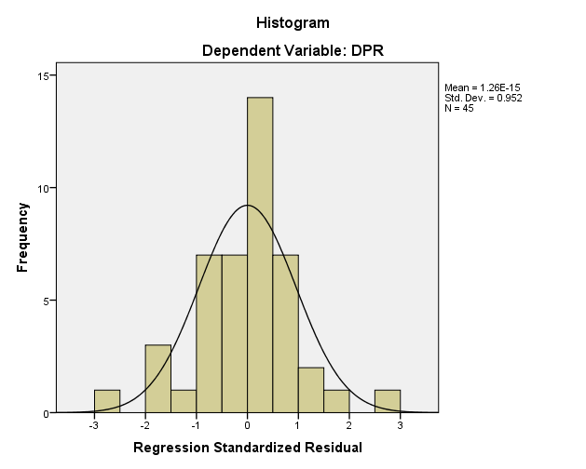
Lampiran 12
Grafik Histogram Uji Normalitas

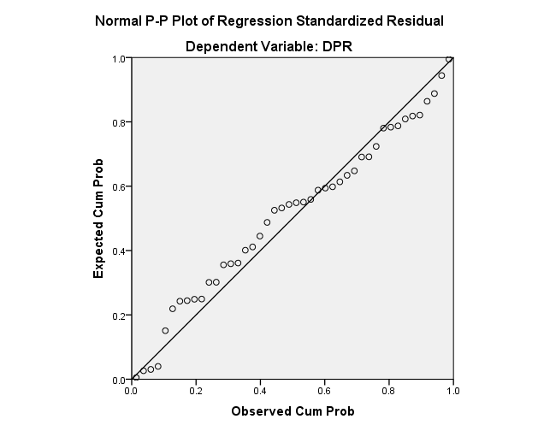
Lampiran 13
Grafik Normal P-P Plot

Lampiran 14
Hasil Uji Normalitas Kolmogorov-Smirnov
One-Sample Kolmogorov-Smirnov Test
 |  | Unstandardized Residual
N |  | 45
Normal Parameters^{a,b} | Mean | .0000000
 | Std. Deviation | .55321811
Most Extreme Differences | Absolute | .095
 | Positive | .076
 | Negative | -.095
Test Statistic |  | .095
Asymp. Sig. (2-tailed) |  | .200^{c,d}
a. Test distribution is Normal.
b. Calculated from data.
c. Lilliefors Significance Correction.

Lampiran 15
Hasil Uji Multikololinieritas
Coefficientsª
Model |  | Collinearity Statistics
 |  | Tolerance | VIF
1 | (Constant)
 | JA | .957 | 1.044
 | PER | .938 | 1.066
 | INST | .925 | 1.081
 | GROWTH | .976 | 1.025
a. Dependent Variable: DPR

Lampiran 16
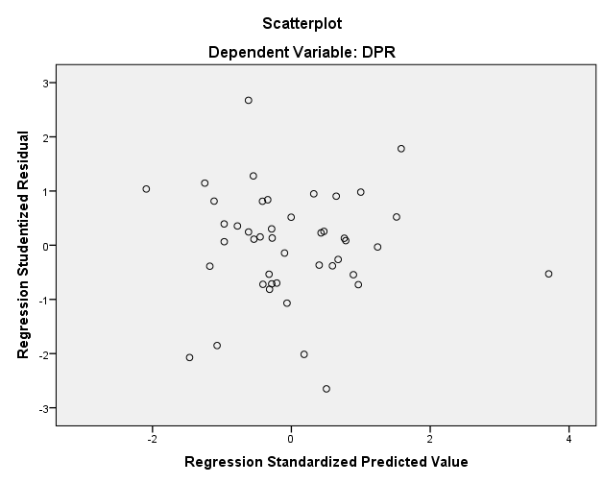
Hasil Scatterplot Uji Heteroskedasdisitas

Lampiran 17
Hasil Uji Heteroskedasdisitas
Coefficientsª
Model |  | Unstandardized Coefficients |  | Standardized Coefficients | t | Sig.
 |  | B | Std. Error | Beta
1 | (Constant) | -.007 | .010 |  | -.752 | .456
 | JA | .035 | .000 | .201 | 1.311 | .197
 | PER | .004 | .016 | .035 | .228 | .820
 | INST | 1.024 | .627 | .255 | 1.632 | .111
 | GROWTH | 9.660E-6 | .000 | .044 | .289 | .774
a. Dependent Variable: ABS_RES

Lampiran 18
Hasil Uji Autokorelasi
Model Summary^{b}
Model | R | R Square | Adjusted R Square | Std. Error of the Estimate | Durbin-Watson
1 | .568ª | .322 | .254 | .01694 | 1.850
a. Predictors: (Constant), GROWTH, PER, JA, INST
b. Dependent Variable: DPR

Lampiran 19
Hasil Analisis Regresi Linier Berganda
Coefficientsª
Model |  | Unstandardized Coefficients |  | Standardized Coefficients | t | Sig.
 |  | B | Std. Error | Beta
1 | (Constant) | -.013 | .013 |  | -.941 | .352
 | JA | .035 | .000 | .119 | .897 | .375
 | PER | .064 | .021 | .405 | 3.014 | .004
 | INST | 1.821 | .856 | .288 | 2.128 | .040
 | GROWTH | -2.609E-5 | .000 | -.076 | -.573 | .570
a. Dependent Variable: DPR

Lampiran 20
Hasil Uji Parsial (Uji t)
Coefficientsª
Model |  | Unstandardized Coefficients |  | Standardized Coefficients | t | Sig.
 |  | B | Std. Error | Beta
1 | (Constant) | -.013 | .013 |  | -.941 | .352
 | JA | .035 | .000 | .119 | .897 | .375
 | PER | .064 | .021 | .405 | 3.014 | .004
 | INST | 1.821 | .856 | .288 | 2.128 | .040
 | GROWTH | -2.609E-5 | .000 | -.076 | -.573 | .570
a. Dependent Variable: DPR

Lampiran 21
Hasil Uji Simultan (Uji F)
ANOVAª
Model |  | Sum of Squares | df | Mean Square | F | Sig.
1 | Regression | .005 | 4 | .001 | 4.753 | .003^{b}
 | Residual | .011 | 40 | .000
 | Total | .017 | 44
a. Dependent Variable: DPR
b. Predictors: (Constant), GROWTH, PER, JA, INST

Lampiran 22
Hasil Uji Koefisien Determinasi
Model Summary
Model | R | R Square | Adjusted R Square | Std. Error of the Estimate
1 | .568ª | .322 | .254 | .01694
a. Predictors: (Constant), GROWTH, PER, JA, INST
b. Dependent Variable: DPR

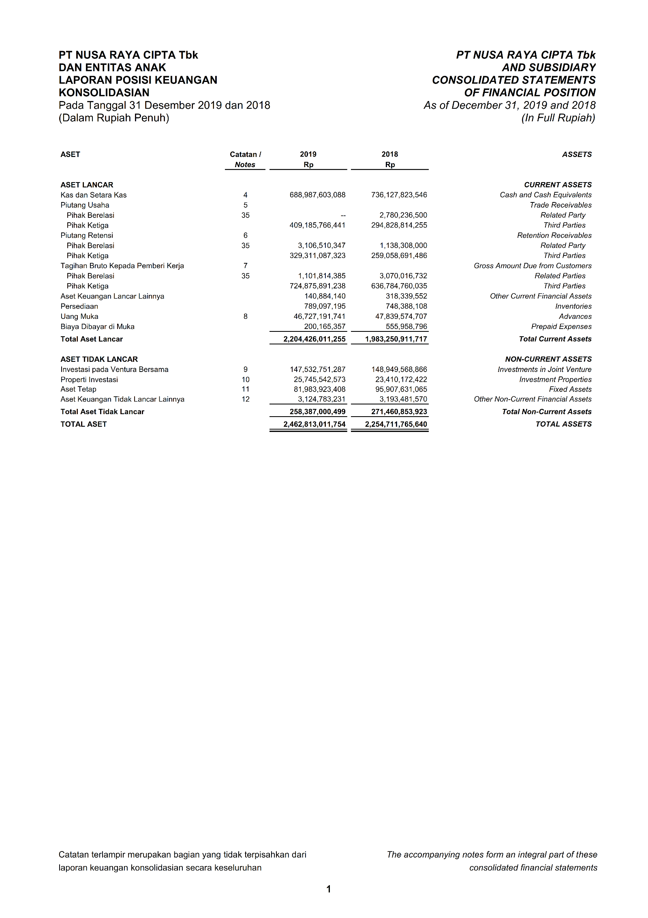
Lampiran 23
Laporan Keuangan
