**DAFTAR PUSTAKA**

Abdussamad, Z. (2022). *Metode Penelitian Kualitatif* (. Patta Rapanna, Ed.; 1st ed.). Jakarta: CV. syakir Media Press.

Adab, P. (2024). *Strategi Edukasi Wakaf untuk Meningkatkan Indeks Literasi Wakaf Uang di Indonesia*. Indramayu: Penerbit Adab. https://books.google.co.id/books?id=VVHyEAAAQBAJ

Adriani Diana, Gst. Bgs. W. (2018). Inklusi Keuangan Dalam Hubungannya Dengan Pertumbuhan Umkm Dan Tingkat Kesejahteraan Masyarakat Di Provinsi Bali. *E-Jurnal Manajemen Unud*, *7*(12), 6420–6444.

Alamsyah, M. F. (2020). Pengaruh literasi keuangan dan kualitas manajemen keuangan terhadap kinerja keuangan pada ukm meubel di kota gorontalo. *Forum Ekonomi*, *22*(2), 245–255. http://journal.feb.unmul.ac.id/index.php/FORUMEKONOMI

Anggriani, I., Armiani, & Wahyullah, M. (2023). Pengaruh Inklusi Keuangan, Literasi Keuangan, dan Pengelolaan Keuangan  terhadap Kinerja UMKM di Kabupaten Dompu. *Kompeten: Jurnal Ilmiah Ekonomi Dan Bisnis*, *2*(3), 598–609.

Ansori, M. A. Z., Wahyudin, M. W., Nurbaet, N. I., Isagozi, M. R., Diva, S. A., Zahra, N. A., Nur, G., Yusuf, M., & Tabroni, M. (2024). Analisis Literasi Keuangan Penggunaan Fintech Payment Bagi Pelaku Usaha UMKM. *Economic Reviews Journal*, *3*(1), 210–225. https://doi.org/10.56709/mrj.v3i1.130

Anwar, Suhadarliyah, Mariana, Rahmawati Christina Heti Tri, Murjana I Made, Faisol, & Sushardi. (2023). *Kewriausahaan Berbasis UMKM* (Barizki Ahmad, Ed.; Cetakan Pertama). Nusa Tenggara Barat: Penerbit SEVAL.

Arifin, S. (2024). Meningkatkan Daya Saing UMKM Melalui Pelatihan Mindset Entrepreneur. *Jurnal Budimas*, *6*(1).

Arsyad, S., Azwandi, & Harahap, A. (2022). Students’ understanding, attitude and experience on dishonesty and plagiarism: How undergraduate and postgraduate students of English Education resemble and/or differ. *JOALL (Journal of Applied Linguistics and Literature)*, *8*(1), 1–18. https://doi.org/10.33369/joall.v8i1.20968

Asisa, W., Aulia, P., Dalianti, N., & Handa, Y. R. (2022). *Pengaruh Pemahaman Literasi Keuangan dan Kemudahan Digital Payment terhadap Kinerja UMKM di Kota Makassar*. Jurnal Ekonomi dan Bisnis. *3*(1).

Astari, A. A. E., Yasa, N. N. K., Giantari, I. G. A. K., & Sukaatmadja, I. P. G. (2023). *Technology Accepted Model, Theory Of Planned Behavior, Dan Fear Of Covid-19: Niat Konsumen Melanjutkan Penggunaan Dompet Digital* (M. A. Wardana, Ed.). Badung: CV Intelektual Manifes Media.

Ayem, S., Chaerunisak, H., Prasetyaningtyas, S. W., Afrianingrum, R. W., & Hanun, N. (2024). *Digitalisasi Bisnis Dan Inklusi Keuangan Sebagai Upaya Mendorong Kinerja Umkm Melalui E-Commerce Di Era Digital* (Vol. 11, Issue 2).

Ayem, S., Kartika Cahyaning, E., Ramadhan, I., Nurlitawati, M., Langkodi, H., & Amelia Trasno, F. (2024). *Faktor-Faktor Yang Mempengaruhi Behavior Intention Terhadap Penggunaan Digital Payment : Systematic Literature Review*. *12*(2). https://doi.org/10.26740/jupe.v12n2.p196

Chusniah, D. N. A., & Adab, P. (2020). *Strategi Inklusi Keuangan Syariah dalam Pemberdayaan UMKM*. Indramayu: Penerbit Adab. https://books.google.co.id/books?id=NnLjEAAAQBAJ

Culebro-Martínez, R., Moreno-García, E., & Hernández-Mejía, S. (2024). Financial Literacy of Entrepreneurs and Companies’ Performance. *Journal of Risk and Financial Management*, *17*(2). https://doi.org/10.3390/jrfm17020063

Dahrani, D., Saragih, F., & Ritonga, P. (2022). Model Pengelolaan Keuangan Berbasis Literasi Keuangan dan Inklusi Keuangan : Studi pada UMKM di Kota Binjai. *Owner*, *6*(2), 1509–1518. https://doi.org/10.33395/owner.v6i2.778

Dasra Viana, E., Febrianti, F., & Ratna Dewi, F. (2021). Literasi Keuangan, Inklusi Keuangan dan Minat Investasi Generasi Z di Jabodetabek Financial Literacy, Financial Inclusion, and Investment Interest Generation Z’s in Jabodetabek. *Jurnal Manajemen Dan Organisasi (JMO)*, *12*(3), 252–264.

Daud, I., Nurjannah, D., Mohyi, A., Ambarwati, T., Cahyono, Y., Haryoko, A. D. E., Handoko, A. L., Putra, R. S., Wijoyo, H., Ari-Yanto, A., & Jihadi, M. (2022). The effect of digital marketing, digital finance and digital payment on finance performance of indonesian smes. *International Journal of Data and Network Science*, *6*(1), 37–44. https://doi.org/10.5267/J.IJDNS.2021.10.006

Defi, A., Prasasti1, E., Triyanto2, 1, Sekolah, 2, Ilmu, T., & Surakarta, E. (2023). The Influence Of Understanding, Application And Utilization Of Accounting Information Systems On The Performance Of Smes In Surakarta City (Case Study on CONVECTION SMEs). In *Kewirausahaan dan Bisnis* (Vol. 51, Issue 1). http://www.ejournal.pelitaindonesia.ac.id/ojs32/index.php/KURS/index

Diana, Hakim, L., & Fahmi, M. (2022). *Analisis Faktor Yang Mempengaruhi Kinerja UMKM Di Tangerang Selatan*. Jurnal Ekonomi & Bisnis

Dina, A. E., & Deniaty, S. D. (2024). Implementasi QRIS (QR Code Indonesian Standard) sebagai Media Pembayaran Elektronik bagi UMKM di Kelurahan Gunung Anyar Tambak. *Journal of Human And Education*, *4*(1), 42–48.

Ekawarna. (2023). *Monograf Intensi (Niat) Berwirausaha Mahasiswa Dan Variabel Yang Mempengaruhinya*. Yogyakarta: CV Budi Utama.

Elsa, C., & Sukmana. (2024). Omzet UMKM Konveksi Turun 90 Persen pada Pemilu 2024. *Artikel Kompas.Com*.

Emely Lisbet Uta, B., Saerang, I. S., & Untu, V. N. (2021). Pengaruh Literasi Keuangan, Pengelolaan Keuangan  Terhadap Keuangan UMKM Di Desa Gemeh  Kabupaten Kepulauan Talaud. *Jurnal EMBA*, *9*(3).

Fajri, A. A., & Indriasih, D. (2021). *Pengaruh Inklusi Keuangan dan Literasi Keuangan terhadap Kinerja UMKM Batik di Kabupaten Tegal* (Vol. 13, Issue 1). http://permana.upstegal.ac.id/index.php/permana

Fatihudin Didin, Wikanta Wiwin, Fauzan Hammadi, & Firmansyah. (2023). *Membangun Kemandirian Petani Garam Melalui Literasi Keuangan & Perencanaan Keuangan Keluarga untuk Produksi, Akses Modal & Informasi Pasar* (Fatihudin Didin, Ed.; Cetakan Januari 2023). Surabaya: UM Surabaya.

Fauziah, R., Husadha, C., Rossa, E., Pangaribuan, D., & Yuniati, T. (2024). Pengaruh Inklusi Keuangan, Literasi Keuangan, Dan  Pengelolaan Keuangan Terhadap Kinerja Umkm Yang  Terdaftar Di Dinas Koperasi Dan Ukm Kota Bekasi. *Jurnal Riset Ilmiah*, *3*(3).

Fitri, F. K., Agus Zul Bay, Fetni, & Perduti Lestari Rulimo. (2024). Implementasi Finansial Literasi Dan Finansial Teknologi Dalam Pengelolaan Keuangan Umkm Di Kabupaten Kolaka. *Journal Publicuho*, *7*(2), 938–953. https://doi.org/10.35817/publicuho.v7i2.449

Ganis Yuliani, R., Norisanti, N., Deni Muhammad Danial, R., Ilmu Sosial, F., & Muhammadiyah Sukabumi, U. (2024). The Influence Of Financial Technology And Access To Capital On The Performance Of Msmes In The City Of Sukabumi Pengaruh Financial Technology Dan Akses Permodalan Terhadap Kinerja Umkm Pada UKM Di Kota Sukabumi. :*:Journal of Economic, Business and Accounting* , *7*(3).

Ghozali. (2018). *Analisis Multivariat dan Ekonometrika* (Java Diponegoro). Semaranag: Badan Penerbit Universitas Diponegoro.

Hanasri, A., Rinofah, R., & Sari, P. P. (2023). Pengaruh Literasi Keuangan, Pengetahuan Keuangan, dan Sikap Keuangan Terhadap Kinerja Keuangan pada Pelaku UMKM Bisnis online di Bantul. *Ekonomis: Journal of Economics and Business*, *7*(1), 443. https://doi.org/10.33087/ekonomis.v7i1.792

Handayani, V. A., Tarsila, H., Hidayati, E., Saputri, R., & Parero, J. (2023). Persepsi Masyarakat Kota Batam Terhadap Transformasi Digital Payment. *Jurnal Institut Teknologi Batam*, *1*(2).

Hartina, Goso, G., & Palatte, M. H. (2023). Analisis Dampak Literasi Keuangan dan Pengelolaan  Keuangan Terhadap Kinerja Keuangan UMKM. *SEIKO : Journal of Management & Business*, *6*(1), 644–651. https://doi.org/10.37531/sejaman.v6i1.3874

Hasanah, N., Muhtar, S., & Muliasari, I. (2020). *Mudah Memahami Usaha Mikro Kecil dan Menengah (UMKM)* (Galih & Haqi, Eds.; Cetakan Pertama, Vol. 26). Jawa Timur: Uwais Inspirasi Indonesia.

Hertadiani, V. W., & Lestari, D. (2021). Pengaruh Inklusi Keuangan dan Pengelolaan Keuangan Terhadap Kinerja UMKM Sektor Kuliner  di Jakarta Timur. *Kalbisocio, Jurnal Bisnis Dan Komunikasi*, *8*(2).

Huston, S. J. (2020). Measuring Financial Literacy. *Journal of Consumer Affairs*, *44*(2), 296–316. https://doi.org/10.1111/j.1745-6606.2010.01170.x

Idawati, I. A. A., & Pratama, , I Gede Surya. (2023). Inklusi Keuangan Dan Literasi Keuangan Terhadap Kinerja Dan Keberlangsungan UMKM Di Kota Denpasar. *Jurnal Bisnis Dan Kajian Strategi Manajemen*, *7*(2), 205–222.

Iltiham, M. F. (2020). Mekanisme Penentuan Margin Pembiayaan Murabahah di Lembaga Keuangan Syariah. *MALIA (TERAKREDITASI)*, *12*(1), 109–124. https://doi.org/10.35891/ml.v12i1.2386

Irawati, S. A. (2023). *Ekonomi Kreatif dan UMKM Kuliner Pendongkrak Ekonomi Rakyat*. Malang: Media Nusa Creative.

Kardini, N. L., Sudomo, A., GS, A. D., Arifin, Z., Sallu, S., Efitra, S. K. M. K., & Juansa, A. (2023). *Manajemen Public Relation*. Jambi: PT. Sonpedia Publishing Indonesia. https://books.google.co.id/books?id=9BTAEAAAQBAJ

Karlin, A. (2024). Development of a Model for Mentoring MSME Actors in the City of Jember Based on a Business Incubator to Increase Competitiveness in the Digital Era Pengembangan Model Pendampingan Pelaku UMKM di kota Jember Berbasis Inkubator Bisnis untuk Meningkatkan Daya Saing di Era Digital. *Jurnal Pengabdian Masyarakat (PENGAMAS)*, *1*(1), 2021–2104. https://journal.ppipbr.com/index.php/pengamas/index

Kesuma, A., Tinggi Ilmu Ekonomi Pariwisata API Yogyakarta, S., & Harper Malioboro Yogyakarta, H. (2023). *Analisis Perilaku Konsumen Menggunakan Model TRA, TPB, SCT dan IMBP Di Hotel Harper Malioboro Yogyakarta* (Vol. 6, Issue 2). http://jurnal.akparda.ac.id/index.php/nusantara1

Khouroh, U., Ratnaningsih, C. S., & Rahayudi, B. (2023). *Inovasi: Membangun Daya Saing Berkelanjutan UMKM* (Galih, Ed.). Jawa Timur: Uwais Inspirasi Indonesia.

Koesrianti, Puspitawati, D., & Andjarwati, T. (2019). *Usaha Mikro Kecil Menengah* (Cetakan Pertama). Sidoarjo: Zifatama Jawara.

Komarudin, M., Fatonah, S., Zahra, S., Widodo, W., & Bina Bangsa, U. (2024). Peranan Penjualan Kredit Terhadap Modal Kerja Dan Perkembangan Penjualan Pada UMKM. *Jurnal Ilmiah Ilmu Manajemen Dan Kewirausahaan* , *4*(1). https://doi.org/10.46306/vls.v4i1

Kuncorosidi, Agustian, R. D., & Sopiwadi, M. (2024). Pengukuran kualitas website dan digital payment e-commerce shopee  menggunakan metode webqual 4.0 dan metode importance and  performance analysis (IPA). *Proceeding of National Conference on Accounting & Finance*, *6*.

Kusuma Melia, D. N. Y. A. N. (2021). Inklusi Keuangan Dan Literasi Keuangan Terhadap Kinerjs Keuangan UMKM. *Jurnal Among Makarti*, *14*(2), 62–76.

Ladya, A., Dewi, S., Masdiantini, P. R., Ekonomi, J., & Akuntansi, D. (2023). Pengaruh Akses Permodalan, E-Payment dan E-Commerce Terhadap Kinerja UMKM di Kecamatan Buleleng. In *Jurnal Ilmiah Mahasiswa Akuntansi ) Universitas Pendidikan Ganesha* (Vol. 14, Issue 03).

Leatemia, S. Y. (2023). Pengaruh Literasi Keuangan dan Inklusi Keuangan Terhadap Kinerja Usaha Mikro, Kecil, dan Menengah (UMKM). *Ekonomi, Keuangan, Investasi Dan Syariah (EKUITAS)*, *4*(4), 1152–1159. https://doi.org/10.47065/ekuitas.v4i4.3221

Lenaini, I. (2021). *Teknik Pengambilan Sampel Purposive Dan Snowball Sampling Info Artikel Abstrak*. Jurnal Akuntansi. *6*(1), 33–39. https://doi.org/10.31764/historis.vXiY.4075

Lestari, Y. P. D., & Hwihanus. (2023). Pengaruh Literasi Keuangan, Inklusi Keuangan Dan Teknologi Informasi Keuangan Terhadap Kinerja Umkm Di Desa Pasinan  Lemah Putih, Kecamatan Wringinanom, Kabupaten Gresik. *Jurnal Riset Ilmu Akuntansi* , *2*(1).

Martono, S., & Febriyanti, R. (2023). Pengaruh Inklusi Keuangan, Literasi Keuangan Dan Pengelolaan Keuangan Terhadap Kinerja Umkm Di Kota Salatiga. *Jurnal Ekonomi Pendidikan Dan Kewirausahaan*, *11*(2), 153–168. https://doi.org/10.26740/jepk.v11n2.p153-168

Mulyanti, D., & Nurhayati, A. (2022). Penerapan Literasi Keuangan Dan Penggunaan Financial Technology Untuk Menilai Kinerja Keuangan Umkm Di Jawa Barat. *Ekono Insentif*, *16*(2), 63–81. https://doi.org/10.36787/jei.v16i2.887

Mulyantini, S., Indriasih, D., & Pustaka, S. M. (2021). *Cerdas Memahami Dan Mengelola Keuangan Bagi Masyarakat Di Era Informasi Digital*. Jawa Barat: Scopindo Media Pustaka. https://books.google.co.id/books?id=q1cmEAAAQBAJ

Mulyasari, E. W., & Srimiati, M. (2020). Macro Nutrition Intake, Physical Activity and Level of Stress with Event of Hypertension for Adults (18-60 Years). *Jurnal Ilmiah Kesehatan (JIKA)*, *2*(2), 83–92. https://doi.org/10.36590/jika.v2i2.2

Munizu, M., Tandiono, R., Pravitasari, E., & Chadra, A. (2023). *UMKM Peran Pemerintah dalam Meningkatkan Daya Saing UMKM di Indonesia* (Efitra & Sepriano, Eds.; Cetakan Pertama). Surabaya: PT. Sonpedia Publishing Indonesia.

Musadad, A., Taufiq, A., Mutiara, A., & Pabulo, A. (2023). *Pengaruh Literasi Keuangan Dan Pembayaran Digital Pada Kinerja UMKM Tahun 2023*. Jurnal Ekonomi Bisns. https://doi.org/10.37817/ikraith-ekonomika.v6i3

Muttaqin, I., Wiyanti, S., Fanani, B., Prasetyo, I., Ekonomi, F., & Bisnis, D. (2022). Pelatihan Digital Marketing dan Akuntansi Biaya Dalam Meningkatkan Kinerja UMKM. Jurnal *Pengabdian Pada Masyarakat Indonesia*, *1*, 84–92.

Nanda Reza, O., Cholid Mawardi, M., Fauzi Kartika Sari, A., Studi Akuntansi, P., Ekonomi dan Bisnis, F., & Islam Malang, U. (2024). Pengaruh Literasi Keuangan, Inklusi Keuangan, Akses Permodalan, dan Penggunaan E-commerce Terhadap Kinerja UMKM (Studi Pada Pelaku UMKM di Kabupaten Blitar). *E_Jurnal Ilmiah Riset Akuntansi*, *13*(01), 531–539. http://jim.unisma.ac.id/index.php/jra,

Nisa, K. (2022). Pengaruh Pinjaman Modal Terhadap Pendapatan Usaha Mikro Kecil Dan Menengah Di Kota Mojokerto. *Jurnal Universitas Negeri Surabaya*.

Nugraha Sugita, I. K. D., & Seri Ekayani, N. N. (2022). Pengaruh Literasi Keuangan, Inklusi Keuangan dan Akses Permodalan Terhadap Keberlanjutan UMKM Pada Bidang Fashion Di Kota Denpasar. *Jurnal Manajemen Dan Bisnis Equilibrium*, *8*(1), 118–126. https://doi.org/10.47329/jurnal_mbe.v8i1.845

Nur Hamida, R., Diana, N., & Studi Akuntansi, P. (2023). Pengaruh Literasi Keuangan, Akses Permodalan, dan Minat Menggunakan E-Commerce Terhadap Kinerja UMKM (Studi Kasus pada Pelaku UMKM di Kota Kediri). In *e_Jurnal Ilmiah Riset Akuntansi* (Vol. 12). http://jim.unisma.ac.id/index.php/jra,

Nuraeni, F., Rachpriliani, A., & Studi Akuntansi Fakultas Ekonomi dan Bisnis Universitas Buana Perjuangan Karawang, P. (2024). Pengaruh Layanan E-Payment dan E-Commerce terhadap Kinerja Supply Chain: Dalam Digitalisasi Usaha Mikro, Kecil, dan Usaha Menengah (UMKM) di Kabupaten Karawang. *Jurnal Kajian Dan Ekonomi Bisnis Islam*, *5*(3).

Ompusunggu, D. P., & Sinurat, D. S. (2023). Pelatihan Manajemen Keuangan Bagi UMKM Kota Palangka Raya dan Pengelolaan Usahanya. *Jurnal Ekonomi Dan Manajemen*, *3*(2).

Onny Siagian, Ade. (2021). Strategi Pemasaran E-Commerce Bagi Umkm Indonesia Untuk Meningkatkan Perekonomian Indonesia. In *Nomor 1 Edisi Februari* (Vol. 6).

Prof. Dr. Sugiyono. (2018). *Metode Penelitian Kuantitatif, Kualitatif Dan R & D*. Bandung: ALFABETA.

Purnamasari, E. D., & Asharie, A. (2024). Digitalisasi UMKM, Literasi Keuangan terhadap Kinerja Keuangan UMKM di Era New Normal Pandemi COVID 19. *Jesya*, *7*(1), 348–361. https://doi.org/10.36778/jesya.v7i1.1416

Puspita, Y. C. (2019). *Kesesuaian Teknologi Digital Payment Aplikasi OVO Analisis Kesesuaian Teknologi Penggunaan Digital Payment Pada Aplikasi Ovo*. Jurnal Akuntansi. 1(2)

Puspitasari, R., & Astrini, D. (2021). Dampak Literasi Dan Inkuisi Keuangan Terhadap Kinerja Pelaku UMKM Di Kota Bogor. *Jurnal Ilmiah Manajemen Kesatuan*, *9*(2), 181–190. https://doi.org/10.37641/jimkes.v9i2.771

Puspitasari, S. D., & Indrarini, R. (2021). Pengaruh Penggunaan Digital Payment Terhadap Perilaku Konsumsi Islam Masyarakat Surabaya Pada Masa Pandemi Covid-19. In *Jurnal Ekonomika dan Bisnis Islam* (Vol. 4, Issue 2). https://journal.unesa.ac.id/index.php/jei

Putri Lestari UPN, R., Timur Fauzatul Laily Nisa UPN, J., Timur Alamat, J., Rungkut Madya No, J., Anyar, G., Gn Anyar, K., & Timur, J. (2024). Pengaruh Implementasi Prinsip Syariah dalam Produk Pembiayaan Murabahah Bank Syariah Terhadap Kinerja Keuangan UMKM: Kajian Literatur. *Jurnal Ekonomi Bisnis Dan Manajemen*, *2*(3), 17–29. https://doi.org/10.59024/jise.v2i3.736

Qothrunnada, N. A., Iswanto, J., Fitrotus, D., Hendrarti, B. G., & Subekan, S. (2023). Transformasi Digital Lembaga Keuangan Syariah: Peluang dan Implementasinya di Era Industri 4.0. *Indonesian Journal of Humanities and Social Sciences*, *4*. https://ejournal.iai-tribakti.ac.id/index.php/IJHSS

Rahyono, Listiyaningsih, E., & Alansori, A. (2022). *Kinerja dan Kerbelangsungan UMKM* (Dewani, Ed.; Cetakan I). Yogyakarta: Penerbit ANDI.

Ratnawati, H., Putranti, D., Al, D., & Mahalalita, A. (2021). Analisis perceived organizational support dan budaya kerja terhadap beban kerja dalam meningkatkan kinerja karyawan bank menuju new normal. *Journal of Business and Banking*, *11*(1). https://doi.org/10.14414/jbb.v11i1.2496

Remmang, H. (2021). *Perencanaan Bisnis UMKM* (M. Idris & H. Abubakar, Eds.; Cetakan I). Jakarta: CV SAH MEDIA.

Ruli, M., Hilmawati, N., & Kusumaningtias, R. (2021). *Nominal: Barometer Riset Akuntansi dan Manajemen Inklusi Keuangan Dan Literasi Keuangan Terhadap Kinerja Dan Keberlangsungan Sektor Usaha Mikro Kecil Menengah*. *10*(1).

Rusnawati, & R, R. (2022). Pengaruh Literasi Keuangan, Perilaku Keuangan dan Sikap  Keuangan Terhadap Kinerja Keuangan Usaha Mikro, Kecil dan  Menengah di Kota Makassa. *SEIKO : Journal of Management & Business*, *5*(2), 253–261.

Samekto, A. (2021). *Penerapan Theory Planed Behaviour pada Penggunaan Payment Gateway oleh UKM di Masa Pandemi Covid 19* (Terbitan pertama). Surabaya: Penerbit NEM.

Saphira, A. D. (2024). *Peran Financial Technology Dalam Memoderasi Literasi Keuangan Dan Inklusi Keuangan Terhadap Kinerja Keuangan UMKM Di Kota Semarang*. Jurnal Akuntansi. 1(2)

Saputri, N. D. M., Malinda, S., Nazaruddin, H. A., & Listya, A. (2023). Pendampingan Pemanfaatan Dompet Digital Guna Meningkatkan Daya Jual Bagi Umkm Di Desa Muara Penimbung Ulu, Ogan Ilir. *JMM (Jurnal Masyarakat Mandiri)*, *7*(1), 73. https://doi.org/10.31764/jmm.v7i1.11788

Saraswati, E., Ghofar, A., & Maghfiroh, I. S. E. (2021). *Akuntansi Manajemen Strategis*. Malang: Universitas Brawijaya Press. https://books.google.co.id/books?id=n31EEAAAQBAJ

Sarwani, Sunarsi. Denok, & Sutoro. Moh. (2022). *Manajemen Budaya Organisasi Pelaku UMKM* (Musliman, Ed.). Jakarta: Cipta Media Nusantara.

Satria, C. (2024). *Systematic Literature Review (Slr): Inklusi Keuangan Terhadap Kinerja UMKM Khoirunnisa Sekolah Tinggi Ekonomi dan Bisnis Syariah (STEBIS) Indo Global Mandiri*. Jurnal Bisnis Syariah. Vol 3(2)

Septiani, R. N., & Wuryani, E. (2020). Pengaruh Literasi Keuangan Dan Inklusi Keuangan Terhadap Kinerja Umkm Di Sidoarjo. *E-Jurnal Manajemen Universitas Udayana*, *9*(8), 3214. https://doi.org/10.24843/ejmunud.2020.v09.i08.p16

Sholihah, E., & Nurhapsari, R. (2023). Percepatan Implementasi Digital Payment Pada UMKM: Intensi Pengguna QRIS Berdasarkan Technology Acceptance Model. *Nominal Barometer Riset Akuntansi Dan Manajemen*, *12*(1), 1–12. https://doi.org/10.21831/nominal.v12i1.52480

Silalahi, P. R., & Chairina. (2023). *Ekonomi Digital* (Cetakan ke-1). Jakarta: CV Merdeka Kreasi Group.

Suardana, K. A., & Musmini, L. S. (2020). Pengaruh Literasi Keuangan, Akses Permodalan  Dan Minat Menggunakan E-Commerce Terhadap Kinerja Umkm Di Kecamatan Buleleng. *JIMAT (Jurnal Ilmiah Mahasiswa Akuntansi) Universitas Pendidikan Ganesha,*.

Sugiharti, H., & Maula, K. A. (2019). Pengaruh Literasi Keuangan Terhadap Perilaku Pengelolaan Keuangan Mahasiswa. In *ACCOUNTHINK : Journal of Accounting and Finance* (Vol. 4, Issue 02).

Sugiyono. (2019). *Metode Penelitian Kuantitatif, Kualitatif, dan R&D*. Bandung: Alfabeta.

Sugiyono. (2021). *Metode Peneltian Kuantitatif, Kualitatif, dan R&D*. Bandung: ALFABETA, cv.

Sumvina, R. A., Muhammad, D., & Fietroh, N. (2024). Dampak Literasi Keuangan, Inklusi Keuangan Dan Teknologi Keuangan Terhadap Kinerja Keuangan  Umkmdi Kabupaten Sumbawa. *Seminar Nasional Manajemen Inovasi*, *2*(1). https://conference.uts.ac.id/index.php/Student

Suryanto, R., Afif Nur Hanan, M., & Saniyatul Ummah, R. (2024). Pengaruh Literasi Keuangan, Inklusi Keuangan, dan Inovasi Terhadap Kinerja UMKM. *Reviu Akuntansi Dan Bisnis Indonesia*, *8*(1), 20–32. https://doi.org/10.18196/rabin.v8i1.21968

Tri, N., Putra, A., Gede, I., Chandra Wijaya, A., Kadek, I., & Saputra, D. (2023). Usabilty Testing Game Pubg Mobile Dengan Metode System Usabilty Scale (Sus). *Jurnal Teknik Informatika,* *2*(2).

Umniyah, & Mulyadi, D. (2023). Pengaruh Digital Payment Gateway (OVO) Terhadap Kinerja Keuangan UMKM Umniyah1, Dedi Mulyadi2. *ETNIK: Jurnal Ekonomi - Teknik*, *2*(7).

Wahyu, E., & Budianto, H. (2023). *Bank Bukopin Syariah dan Konvensional: Studi Pustaka (Library Research) dan Bibliometrik VOSviewer*. https://doi.org/10.5281/zenodo.10049572

Wardani, & Ayu, N. (2022). *Pengaruh Akses Modal terhadap Kinerja UMKM dengan Literasi Keuangan sebagai Variabel Moderasi*. Jurnal Ekonomi & Bisnis. Vol 1. No 2.

Windarti, N. P. (2023). PENgaruh Pemahaman Literasi Keuangan, Penggunaan Digital Payment Dan Kemampuan Menyusun Laporan Keuangan Terhadap Kinerja Umkm Di Kabupaten Bantul. *Universitas PGRI Yogyakarta.*

Yanti, W. I. P. (2019). Pengaruh Inklusi Keuangan Dan Literasi Keuangan  Terhadap Kinerja Umkm Di Kecamatan Moyo Utara. *Jurnal Manajemen Dan Bisnis*, *2*(1).

Yuliyanti, P., & Pramesti, D. A. (2021). Tercapainya Inklusi Keuangan Mampukah Dengan Literasi Keuangan Dan Financial Technology? *Kajian Bisnis Sekolah Tinggi Ilmu Ekonomi Widya Wiwaha*, *29*(2), 57–70. https://doi.org/10.32477/jkb.v29i2.292

Yuniarto, A. Y., Rubiyanto, & Adinata, P. V. (2022). *Manajemen Keuangan* (H. E. Prabowo, Ed.). Yogyakarta: Sanata Dharma University Press.

Zubaidah, F. D., Hidayati, A., & Armi, N. (2023). Pengaruh Literasi Keuangan Dan Fintech Melalui  Inklusi Keuangan Terhadap Perkembangan Umkm  Sektor Pangan Di Kota Bengkulu. *Journal of Applied Management Studies (JAMMS)*, *5*(1), 11–16.

# LAMPIRAN

**Lampiran 1 Kuesioner Penelitian**

Kepada Yth,

Bapak/Ibu/Saudara/i

Di Tempat

Dengan hormat,

Dalam rangka penyelesaian Studi Strata Satu (S1), Studi Akuntansi

Fakultas Ekonomi dan Bisnis, Universitas Pancasakti Tegal, saya Awlia Ghina Sari (4320600164) bermaksud melakukan penelitian skripsi yang berjudul **“Pengaruh Literasi Keuangan, Inklusi Keuangan, Akses Permodalan dan *Digital Payment* terhadap Kinerja Keuangan UMKM Konveksi di Kabupaten Tegal yang Terdaftar di Dinas Koperasi UKM dan Perdagangan Kabupaten Tegal”**. Oleh karena itu diperlukan dukungan dan partisipasi Bapak/Ibu/Sdr/i untuk meluangkan waktunya sejenak dalam mengisi kuesioner ini dengan jujur. Data yang kami peroleh akan dijaga kerahasiaannya dan tidak disebarluaskan karena hanya digunakan untuk kepentingan penelitian dan bukan untuk tujuan lain.

Dengan ini, saya mengucapkan terimakasih atas kesediaan dan kerjasama yang diberikan Bapak/Ibu/Saudara/i.

Hormat saya,

**Awlia Ghina Sari**

**DATA RESPONDEN**

**Identitas Responden**

Petunjuk pengisian jawaban kuesioner. Berilah tanda check list ( √ ) pada kolom isian yang disediakan sesuai dengan data diri anda:

Nama Responden =

Nama UMKM =

Jabatan = Pemilik / Karyawan bagian keuangan

Asal Kecamatan =

Pendapatan UMKM = > Rp. 300 juta - Rp. 2,5 Miliar

> Rp. 2,5 Miliar - Rp. 50 Miliar

Jenis Kelamin = L P

Usia =

Tingkat Pendidikan =

20-35 thn

36-55 thn

SMA S1

Lainnya

> 55 thn

D3

S1

**Data Penelitian**

Bapak/Ibu/Sdr/i memberikan jawaban dengan memberi tanda ( √ ) pada kotak sesuai dengan apa yang anda alami, dengan petunjuk sebagai berikut:

1 = Sangat Tidak Setuju (STS) 4 = Setuju (S)

2 = Tidak Setuju (TS) 5 = Sangat Setuju (SS) 3 = Netral (N)

**Catatan:** Jawaban dari kuesioner ini tidak ada yang salah, semua jawaban yang Bapak/Ibu/Saudara/i berikan adalah benar karena jawaban tersebut semata-mata digunakan untuk penelitian.

**DAFTAR PERTANYAAN**

1. **Variabel Kinerja Keuangan UMKM (Y)**

|  |  |  |  |  |  |  |
| --- | --- | --- | --- | --- | --- | --- |
| No | Pernyataan | Pilihan Jawaban | | | | |
| STS | TS | N | S | SS |
| 1 | Saya merasa puas dengan pendapatan bersih yang dihasilkan oleh usaha saya |  |  |  |  |  |
| 2 | Saya memperoleh peningkatan jumlahkonsumen setiap bulannya |  |  |  |  |  |
| 3 | Saya mengevaluasi dan menyesuaikan harga produk untuk mempengaruhi margin keuntungan usaha |  |  |  |  |  |
| 4 | Pertumbuhan penjualan dalam 6 bulan terakhir usaha saya tidak stabil |  |  |  |  |  |
| 5 | Saya mengetahui pentingnya ekspansi pasar bagi pertumbuhan usaha |  |  |  |  |  |
| 6 | Saya selalu meninjau dan mengatur strategi untuk meningkatkan pertumbuhan asset usaha |  |  |  |  |  |
| 7 | Saya merasa bahwa dengan meningkatnya jumlah pesanan akan membuat usaha lebih mudah berkembang |  |  |  |  |  |
| 8 | Dalam 6 bulan terakhir rata-rata pesanan sangat menurun drastis |  |  |  |  |  |
| 9 | Saya dapat mengatur distribusi pesanan secara merata sesuai dengan produk yang dihasilkan |  |  |  |  |  |

1. **Variabel Literasi Keuangan (X1)**

|  |  |  |  |  |  |  |
| --- | --- | --- | --- | --- | --- | --- |
| No | Pernyataan | Pilihan Jawaban | | | | |
| STS | TS | N | S | SS |
| 1 | Saya mengetahui konsep dasar perencanaan keuangan |  |  |  |  |  |
| 2 | Saya secara konsisten membuat laporan perencanaan keuangan usaha setiap bulannya |  |  |  |  |  |
| 3 | Saya telah memulai investasi sesuai dengan rencana keuangan usaha |  |  |  |  |  |
| 4 | Saya memiliki tujuan keuangan yang jelas dan terstruktur untuk jangka pendek, menengah, dan Panjang |  |  |  |  |  |
| 5 | Saya memiliki pemahaman yang baik tentang jenis-jenis risiko keuangan yang mungkin saya hadapi (misalnya, risiko pasar, risiko kredit, risiko likuiditas) |  |  |  |  |  |
| 6 | Saya cenderung menyisihkan sebagian pendapatan saya untuk melindungi usaha saya dari risiko keuangan yang tidak terduga. |  |  |  |  |  |
| 7 | Saya merasa yakin bahwa saya dapat mengelola utang saya dengan baik dan membayar tepat waktu tanpa kesulitan keuangan |  |  |  |  |  |

1. **Variabel Inklusi Keuangan (X2)**

|  |  |  |  |  |  |  |
| --- | --- | --- | --- | --- | --- | --- |
| No | Pernyataan | Pilihan Jawaban | | | | |
| STS | TS | N | S | SS |
| 1 | Saya merasa percaya diri dalam memahami proses untuk mengakses dan menggunakan layanan jasa keuangan yang sesuai dengan kebutuhan usaha saya |  |  |  |  |  |
| 2 | Saya mengambil langkah-langkah untuk meningkatkan literasi keuangan saya, seperti mengikuti program pelatihan keuangan atau berkonsultasi dengan seorang ahli keuangan |  |  |  |  |  |
| 3 | Saya melihat literasi keuangan sebagai investasi dalam masa depan saya yang dapat membantu saya mengelola risiko keuangan dan mencapai tujuan keuangan saya dengan lebih baik |  |  |  |  |  |
| 4 | Saya menggunakan lembaga keuangan untuk menunjang keberlangsungan usaha saya |  |  |  |  |  |
| 5 | Saya mengambil manfaat dari sumber daya edukasi atau informasi yang disediakan oleh lembaga keuangan, seperti seminar keuangan, brosur, atau platform online |  |  |  |  |  |
| 6 | Saya merasa mudah dalam memperoleh layanan lembaga jasa keuangan |  |  |  |  |  |
| 7 | Saya mengalami hambatan atau kesulitan dalam mencoba mengakses layanan keuangan tertentu |  |  |  |  |  |
| 8 | Saya percaya bahwa lembaga keuangan dapat membantu peningkatan usaha saya |  |  |  |  |  |
| 9 | Saya percaya bahwa lembaga keuangan menyediakan perlindungan yang memadai terhadap risiko keamanan |  |  |  |  |  |

1. **Variabel Akses Permodalan (X3)**

|  |  |  |  |  |  |  |
| --- | --- | --- | --- | --- | --- | --- |
| No | Pernyataan | Pilihan Jawaban | | | | |
| STS | TS | N | S | SS |
| 1 | Saya memperoleh informasi mengenai kredit dalam Lembaga keuangan |  |  |  |  |  |
| 2 | Saya merasakan kesulitan dalam mengakses lembaga jasa keuangan |  |  |  |  |  |
| 3 | Saya merasa bahwa lembaga keuangan menetapkan tingkat bunga yang terlalu tinggi untuk pinjaman usaha |  |  |  |  |  |
| 4 | Saya merasa bahwa lembaga keuangan yang saya gunakan menyediakan informasi yang jelas dan transparan mengenai persyaratan dan prosedur yang terkait dengan produk dan layanan mereka |  |  |  |  |  |
| 5 | Saya mudah menemukan informasi seperti syarat dan ketentuan, suku bunga, atau biaya dalam lembaga keuangan |  |  |  |  |  |
| 6 | Sebagai pelaku UMKM, saya merasa dimudahkan dengan adanya pinjaman KUR dalam lembaga keuangan |  |  |  |  |  |
| 7 | Saya mengetahui risiko atas pengajuan kredit usaha dalam lembaga keuangan |  |  |  |  |  |
| 8 | Saya mengetahui berbagai jenis pinjaman dalam lembaga keuangan |  |  |  |  |  |
| 9 | Saya merasa bahwa lembaga jasa keuangan telah memperhitungkan kebutuhan dan kondisi bisnis secara cermat dalam menawarkan solusi pembiayaan |  |  |  |  |  |

1. **Variabel *Digital Payment* (X4)**

|  |  |  |  |  |  |  |
| --- | --- | --- | --- | --- | --- | --- |
| No | Pernyataan | Pilihan Jawaban | | | | |
| STS | TS | N | S | SS |
| 1 | Saya merasakan kemudahan dalam melakukan transaksi digital |  |  |  |  |  |
| 2 | Saya merasa sulit dalam melakukan transaksi digital |  |  |  |  |  |
| 3 | Dalam keberlangsungan usaha, saya tidak terbantu dengan adanya transaksi digital |  |  |  |  |  |
| 4 | Biaya transaksi yang dikenakan lembaga keuangan sangat mahal |  |  |  |  |  |
| 5 | Saya merasa kesulitan dalam melakukan transaksi digital karena masalah dengan sinyal |  |  |  |  |  |
| 6 | Saya merasa pembayaran digital sangat menghabiskan kuota yang cukup banyak |  |  |  |  |  |
| 7 | Saya menyadari bahwa pembayaran digital dapat mengurangi kecurangan |  |  |  |  |  |
| 8 | Saya merasa lebih aman menggunakan layanan keuangan yang menggunakan teknologi enkripsi data |  |  |  |  |  |
| 9 | Saya percaya pembayaran digital aman dilakukan dimanapun dan kapanpun |  |  |  |  |  |
| 10 | Sertifikasi keamanan seperti ISO 27001 atau PCI DSS membuktikan bahwa lembaga keuangan menjaga standar keamanan yang tinggi |  |  |  |  |  |
| 11 | Lembaga keuangan merespon dengan baik dan cepat apabila terdapat kendala saat melakukan pembayaran digital |  |  |  |  |  |
| 12 | Tingkat proteksi terhadap penipuan yang diberikan oleh lembaga keuangan sangat penting bagi saya |  |  |  |  |  |

Lampiran 2: Hasil Jawaban Responden

1. Kinerja Keuangan UMKM (Y)

| No.  Responden | Kinerja Keuangan UMKM (Y) | | | | | | | | | Total Y |
| --- | --- | --- | --- | --- | --- | --- | --- | --- | --- | --- |
| P1 | P2 | P3 | P4 | P5 | P6 | P7 | P8 | P9 |
| 1 | 4 | 4 | 4 | 3 | 3 | 4 | 5 | 3 | 4 | 34 |
| 2 | 4 | 4 | 4 | 3 | 4 | 4 | 5 | 2 | 4 | 34 |
| 3 | 4 | 4 | 4 | 2 | 5 | 4 | 5 | 2 | 4 | 34 |
| 4 | 4 | 4 | 4 | 3 | 4 | 4 | 4 | 2 | 4 | 33 |
| 5 | 5 | 3 | 4 | 3 | 4 | 4 | 4 | 2 | 4 | 33 |
| 6 | 4 | 4 | 4 | 3 | 4 | 4 | 4 | 2 | 4 | 33 |
| 7 | 5 | 5 | 4 | 3 | 4 | 4 | 4 | 2 | 4 | 35 |
| 8 | 5 | 4 | 4 | 2 | 4 | 4 | 4 | 2 | 4 | 33 |
| 9 | 4 | 4 | 4 | 3 | 4 | 4 | 4 | 2 | 4 | 33 |
| 10 | 4 | 4 | 4 | 3 | 4 | 4 | 4 | 2 | 4 | 33 |
| 11 | 4 | 4 | 4 | 4 | 4 | 5 | 5 | 2 | 4 | 36 |
| 12 | 4 | 4 | 4 | 4 | 4 | 5 | 5 | 3 | 4 | 37 |
| 13 | 4 | 4 | 4 | 4 | 4 | 3 | 5 | 4 | 4 | 36 |
| 14 | 4 | 4 | 4 | 4 | 4 | 4 | 4 | 3 | 4 | 35 |
| 15 | 4 | 4 | 2 | 3 | 4 | 4 | 4 | 3 | 4 | 32 |
| 16 | 4 | 4 | 4 | 1 | 3 | 3 | 4 | 2 | 3 | 28 |
| 17 | 4 | 4 | 4 | 3 | 4 | 2 | 3 | 3 | 2 | 29 |
| 18 | 4 | 3 | 4 | 2 | 2 | 3 | 4 | 4 | 4 | 30 |
| 19 | 4 | 4 | 4 | 4 | 4 | 4 | 4 | 4 | 4 | 36 |
| 20 | 3 | 3 | 3 | 3 | 3 | 4 | 4 | 5 | 4 | 32 |
| 21 | 4 | 4 | 3 | 4 | 4 | 3 | 4 | 3 | 4 | 33 |
| 22 | 5 | 4 | 3 | 4 | 4 | 3 | 3 | 4 | 4 | 34 |
| 23 | 2 | 3 | 3 | 4 | 4 | 4 | 4 | 3 | 4 | 31 |
| 24 | 4 | 4 | 4 | 3 | 4 | 4 | 4 | 2 | 4 | 33 |
| 25 | 3 | 4 | 4 | 3 | 3 | 2 | 2 | 3 | 3 | 27 |
| 26 | 3 | 4 | 4 | 3 | 4 | 4 | 4 | 2 | 3 | 31 |
| 27 | 4 | 4 | 4 | 3 | 4 | 4 | 4 | 2 | 4 | 33 |
| 28 | 4 | 4 | 3 | 3 | 4 | 4 | 4 | 3 | 3 | 32 |
| 29 | 4 | 4 | 4 | 3 | 4 | 4 | 4 | 2 | 4 | 33 |
| 30 | 3 | 4 | 4 | 4 | 3 | 4 | 4 | 2 | 4 | 32 |
| 31 | 5 | 5 | 5 | 3 | 5 | 5 | 5 | 2 | 5 | 40 |
| 32 | 4 | 4 | 3 | 4 | 2 | 3 | 4 | 2 | 3 | 29 |
| 33 | 4 | 4 | 4 | 3 | 4 | 4 | 4 | 2 | 4 | 33 |
| 34 | 5 | 5 | 5 | 3 | 4 | 4 | 4 | 2 | 4 | 36 |
| 35 | 4 | 4 | 4 | 4 | 3 | 4 | 4 | 2 | 4 | 33 |
| 36 | 4 | 4 | 3 | 2 | 3 | 4 | 3 | 3 | 4 | 30 |
| 37 | 4 | 3 | 4 | 3 | 3 | 3 | 3 | 3 | 4 | 30 |
| 38 | 4 | 4 | 3 | 3 | 4 | 4 | 4 | 3 | 2 | 31 |
| 39 | 5 | 5 | 5 | 4 | 3 | 3 | 5 | 5 | 5 | 40 |
| 40 | 4 | 4 | 3 | 5 | 4 | 4 | 4 | 4 | 5 | 37 |
| 41 | 4 | 5 | 5 | 5 | 5 | 5 | 4 | 4 | 4 | 41 |
| 42 | 5 | 5 | 5 | 4 | 4 | 4 | 4 | 4 | 5 | 40 |
| 43 | 5 | 4 | 4 | 3 | 4 | 4 | 4 | 2 | 4 | 34 |
| 44 | 5 | 4 | 4 | 3 | 4 | 4 | 4 | 2 | 4 | 34 |
| 45 | 5 | 4 | 4 | 3 | 4 | 4 | 4 | 2 | 4 | 34 |
| 46 | 5 | 5 | 5 | 3 | 4 | 4 | 4 | 2 | 4 | 36 |
| 47 | 5 | 4 | 4 | 3 | 4 | 4 | 4 | 2 | 4 | 34 |
| 48 | 5 | 5 | 5 | 3 | 4 | 4 | 4 | 2 | 4 | 36 |
| 49 | 5 | 5 | 5 | 3 | 4 | 4 | 4 | 2 | 4 | 36 |
| 50 | 4 | 4 | 4 | 3 | 4 | 4 | 4 | 2 | 4 | 33 |
| 51 | 4 | 4 | 4 | 3 | 4 | 4 | 4 | 2 | 4 | 33 |
| 52 | 4 | 4 | 4 | 3 | 4 | 4 | 4 | 2 | 4 | 33 |
| 53 | 4 | 4 | 4 | 3 | 4 | 4 | 4 | 2 | 4 | 33 |
| 54 | 4 | 4 | 4 | 3 | 4 | 4 | 4 | 2 | 4 | 33 |
| 55 | 5 | 5 | 4 | 3 | 4 | 4 | 4 | 2 | 4 | 35 |
| 56 | 5 | 5 | 5 | 3 | 4 | 4 | 4 | 2 | 4 | 36 |
| 57 | 5 | 5 | 5 | 5 | 5 | 4 | 4 | 3 | 4 | 40 |
| 58 | 4 | 4 | 4 | 3 | 4 | 4 | 4 | 3 | 4 | 34 |
| 59 | 4 | 5 | 3 | 4 | 5 | 5 | 5 | 5 | 4 | 40 |
| 60 | 3 | 4 | 4 | 4 | 4 | 4 | 4 | 3 | 3 | 33 |
| 61 | 3 | 4 | 4 | 3 | 4 | 4 | 3 | 3 | 2 | 30 |
| 62 | 5 | 5 | 4 | 4 | 4 | 4 | 5 | 3 | 5 | 39 |
| 63 | 3 | 3 | 4 | 4 | 3 | 4 | 3 | 2 | 3 | 29 |
| 64 | 4 | 5 | 5 | 3 | 5 | 3 | 5 | 5 | 3 | 38 |
| 65 | 4 | 3 | 4 | 3 | 4 | 4 | 3 | 4 | 3 | 32 |
| 66 | 4 | 4 | 3 | 4 | 4 | 3 | 4 | 4 | 3 | 33 |
| 67 | 4 | 4 | 4 | 3 | 4 | 4 | 4 | 2 | 4 | 33 |
| 68 | 4 | 4 | 4 | 3 | 4 | 4 | 4 | 2 | 4 | 33 |
| 69 | 4 | 3 | 4 | 3 | 4 | 4 | 4 | 3 | 3 | 32 |
| 70 | 3 | 4 | 3 | 4 | 4 | 4 | 4 | 4 | 3 | 33 |
| 71 | 5 | 5 | 4 | 3 | 4 | 4 | 4 | 2 | 4 | 35 |
| 72 | 4 | 4 | 4 | 3 | 4 | 4 | 5 | 3 | 4 | 35 |
| 73 | 4 | 4 | 4 | 3 | 4 | 4 | 4 | 2 | 4 | 33 |
| 74 | 4 | 4 | 4 | 4 | 5 | 4 | 3 | 3 | 3 | 34 |
| 75 | 4 | 4 | 4 | 4 | 3 | 3 | 5 | 3 | 4 | 34 |
| 76 | 4 | 4 | 4 | 4 | 4 | 4 | 4 | 3 | 4 | 35 |
| 77 | 3 | 4 | 4 | 3 | 4 | 3 | 2 | 3 | 4 | 30 |
| 78 | 4 | 4 | 4 | 4 | 4 | 4 | 4 | 3 | 4 | 35 |
| 79 | 4 | 3 | 4 | 4 | 4 | 4 | 3 | 2 | 4 | 32 |
| 80 | 4 | 4 | 4 | 3 | 4 | 4 | 4 | 3 | 4 | 34 |
| 81 | 4 | 4 | 4 | 4 | 4 | 4 | 4 | 3 | 4 | 35 |
| 82 | 4 | 4 | 4 | 4 | 4 | 3 | 3 | 2 | 4 | 32 |
| 83 | 4 | 4 | 3 | 2 | 4 | 4 | 3 | 2 | 3 | 29 |
| 84 | 4 | 3 | 3 | 2 | 4 | 4 | 3 | 2 | 4 | 29 |
| 85 | 4 | 3 | 4 | 3 | 4 | 4 | 3 | 2 | 3 | 30 |
| 86 | 3 | 4 | 4 | 3 | 4 | 4 | 3 | 4 | 4 | 33 |
| 87 | 4 | 4 | 3 | 3 | 4 | 4 | 4 | 4 | 4 | 34 |
| 88 | 4 | 5 | 4 | 4 | 5 | 5 | 4 | 5 | 4 | 40 |
| 89 | 4 | 4 | 4 | 3 | 4 | 4 | 4 | 3 | 4 | 34 |
| 90 | 4 | 5 | 4 | 5 | 3 | 5 | 4 | 5 | 5 | 40 |
| 91 | 4 | 3 | 4 | 2 | 4 | 4 | 4 | 4 | 3 | 32 |
| 92 | 3 | 3 | 4 | 5 | 3 | 5 | 5 | 4 | 5 | 37 |
| 93 | 4 | 3 | 5 | 4 | 5 | 4 | 5 | 4 | 5 | 39 |
| 94 | 3 | 4 | 4 | 4 | 4 | 3 | 4 | 3 | 4 | 33 |
| 95 | 4 | 2 | 4 | 4 | 4 | 4 | 5 | 5 | 4 | 36 |
| 96 | 4 | 4 | 3 | 2 | 4 | 4 | 4 | 3 | 4 | 32 |
| 97 | 2 | 4 | 4 | 5 | 5 | 4 | 5 | 4 | 5 | 38 |
| 98 | 4 | 3 | 5 | 5 | 3 | 5 | 5 | 4 | 4 | 38 |
| 99 | 3 | 4 | 4 | 3 | 4 | 4 | 3 | 3 | 3 | 31 |
| 100 | 4 | 4 | 3 | 4 | 5 | 4 | 5 | 4 | 4 | 37 |
| 101 | 4 | 3 | 4 | 4 | 3 | 3 | 3 | 4 | 4 | 32 |
| 102 | 4 | 4 | 3 | 2 | 3 | 4 | 4 | 3 | 2 | 29 |
| 103 | 4 | 4 | 4 | 4 | 4 | 3 | 4 | 4 | 4 | 35 |
| 104 | 4 | 4 | 3 | 4 | 4 | 4 | 4 | 3 | 4 | 34 |
| 105 | 4 | 5 | 4 | 4 | 4 | 4 | 3 | 5 | 4 | 37 |
| 106 | 4 | 3 | 4 | 3 | 4 | 4 | 4 | 3 | 4 | 33 |
| 107 | 5 | 5 | 5 | 4 | 4 | 4 | 4 | 4 | 5 | 40 |
| 108 | 4 | 3 | 4 | 3 | 4 | 4 | 3 | 4 | 3 | 32 |
| 109 | 3 | 4 | 3 | 4 | 3 | 4 | 4 | 4 | 4 | 33 |
| 110 | 4 | 3 | 4 | 2 | 3 | 3 | 4 | 3 | 3 | 29 |
| 111 | 3 | 4 | 4 | 3 | 3 | 4 | 4 | 3 | 4 | 32 |
| 112 | 3 | 4 | 3 | 4 | 3 | 4 | 3 | 3 | 4 | 31 |
| 113 | 4 | 4 | 5 | 5 | 5 | 4 | 4 | 4 | 4 | 39 |
| 114 | 4 | 4 | 4 | 4 | 5 | 4 | 4 | 4 | 5 | 38 |
| 115 | 4 | 4 | 4 | 4 | 4 | 4 | 4 | 4 | 4 | 36 |
| 116 | 4 | 4 | 4 | 4 | 4 | 4 | 4 | 4 | 4 | 36 |
| 117 | 3 | 2 | 4 | 4 | 4 | 4 | 3 | 3 | 3 | 30 |
| 118 | 3 | 2 | 4 | 4 | 4 | 4 | 3 | 3 | 3 | 30 |
| 119 | 1 | 3 | 5 | 3 | 5 | 4 | 4 | 3 | 4 | 32 |
| 120 | 4 | 4 | 3 | 5 | 3 | 4 | 4 | 3 | 4 | 34 |
| 121 | 5 | 5 | 4 | 5 | 4 | 4 | 2 | 2 | 5 | 36 |
| 122 | 4 | 4 | 4 | 3 | 4 | 4 | 4 | 3 | 4 | 34 |
| 123 | 4 | 4 | 4 | 2 | 4 | 4 | 4 | 2 | 4 | 32 |
| 124 | 5 | 5 | 5 | 4 | 4 | 4 | 5 | 4 | 5 | 41 |
| 125 | 4 | 4 | 3 | 4 | 3 | 5 | 3 | 4 | 3 | 33 |
| 126 | 3 | 4 | 3 | 4 | 5 | 4 | 5 | 3 | 4 | 35 |
| 127 | 3 | 3 | 4 | 3 | 4 | 3 | 4 | 3 | 4 | 31 |
| 128 | 3 | 3 | 2 | 4 | 4 | 2 | 4 | 3 | 3 | 28 |
| 129 | 3 | 3 | 4 | 2 | 3 | 4 | 4 | 3 | 4 | 30 |
| 130 | 3 | 4 | 4 | 2 | 3 | 4 | 4 | 3 | 4 | 31 |
| 131 | 4 | 4 | 4 | 3 | 4 | 4 | 4 | 3 | 3 | 33 |
| 132 | 4 | 4 | 4 | 3 | 4 | 4 | 4 | 3 | 4 | 34 |
| 133 | 3 | 4 | 4 | 2 | 3 | 4 | 4 | 2 | 2 | 28 |
| 134 | 4 | 4 | 4 | 2 | 3 | 4 | 5 | 2 | 3 | 31 |
| 135 | 3 | 2 | 4 | 4 | 4 | 4 | 3 | 3 | 3 | 30 |
| 136 | 3 | 2 | 4 | 4 | 4 | 4 | 3 | 3 | 3 | 30 |
| 137 | 4 | 4 | 4 | 5 | 5 | 4 | 4 | 5 | 5 | 40 |
| 138 | 4 | 4 | 4 | 5 | 4 | 4 | 5 | 4 | 4 | 38 |
| 139 | 4 | 3 | 2 | 2 | 3 | 4 | 4 | 2 | 3 | 27 |
| 140 | 3 | 4 | 3 | 2 | 3 | 4 | 3 | 2 | 4 | 28 |
| 141 | 4 | 4 | 5 | 4 | 5 | 4 | 5 | 5 | 5 | 41 |
| 142 | 5 | 4 | 4 | 2 | 5 | 4 | 4 | 2 | 4 | 34 |
| 143 | 4 | 4 | 5 | 4 | 4 | 5 | 4 | 5 | 5 | 40 |
| 144 | 4 | 4 | 4 | 4 | 4 | 4 | 4 | 2 | 4 | 34 |
| 145 | 3 | 2 | 2 | 4 | 3 | 2 | 4 | 3 | 3 | 26 |
| 146 | 4 | 3 | 4 | 2 | 3 | 3 | 4 | 2 | 2 | 27 |
| 147 | 4 | 4 | 4 | 2 | 3 | 2 | 3 | 2 | 2 | 26 |
| 148 | 4 | 4 | 4 | 4 | 3 | 4 | 3 | 2 | 4 | 32 |
| 149 | 3 | 2 | 4 | 4 | 4 | 4 | 3 | 3 | 3 | 30 |
| 150 | 3 | 2 | 4 | 4 | 4 | 4 | 3 | 3 | 3 | 30 |
| 151 | 2 | 2 | 3 | 3 | 4 | 3 | 2 | 4 | 3 | 26 |
| 152 | 3 | 2 | 4 | 4 | 4 | 4 | 3 | 3 | 3 | 30 |

1. Literasi Keuangan (X1)

| No.  Responden | Literasi Keuangan (Y) | | | | | | | Total (X1_ |
| --- | --- | --- | --- | --- | --- | --- | --- | --- |
| P1 | P2 | P3 | P4 | P5 | P6 | P7 |
| 1 | 3 | 4 | 3 | 4 | 3 | 4 | 4 | 25 |
| 2 | 3 | 4 | 4 | 4 | 4 | 4 | 4 | 27 |
| 3 | 4 | 4 | 3 | 4 | 4 | 3 | 4 | 26 |
| 4 | 4 | 5 | 2 | 4 | 2 | 4 | 4 | 25 |
| 5 | 4 | 4 | 4 | 5 | 3 | 4 | 4 | 28 |
| 6 | 4 | 4 | 4 | 4 | 3 | 4 | 4 | 27 |
| 7 | 4 | 4 | 4 | 4 | 5 | 4 | 4 | 29 |
| 8 | 4 | 4 | 4 | 4 | 4 | 4 | 4 | 28 |
| 9 | 4 | 4 | 4 | 4 | 4 | 4 | 4 | 28 |
| 10 | 4 | 4 | 4 | 4 | 4 | 5 | 4 | 29 |
| 11 | 4 | 4 | 4 | 4 | 3 | 4 | 4 | 27 |
| 12 | 4 | 4 | 4 | 5 | 3 | 4 | 4 | 28 |
| 13 | 3 | 3 | 3 | 4 | 3 | 4 | 4 | 24 |
| 14 | 3 | 4 | 4 | 4 | 4 | 4 | 4 | 27 |
| 15 | 4 | 4 | 3 | 2 | 3 | 4 | 4 | 24 |
| 16 | 4 | 4 | 4 | 3 | 4 | 4 | 3 | 26 |
| 17 | 2 | 3 | 4 | 3 | 4 | 4 | 3 | 23 |
| 18 | 3 | 4 | 4 | 4 | 4 | 4 | 4 | 27 |
| 19 | 4 | 4 | 4 | 3 | 3 | 3 | 3 | 24 |
| 20 | 4 | 4 | 4 | 4 | 4 | 4 | 4 | 28 |
| 21 | 3 | 3 | 4 | 4 | 4 | 4 | 4 | 26 |
| 22 | 4 | 3 | 4 | 4 | 4 | 3 | 4 | 26 |
| 23 | 4 | 4 | 4 | 4 | 4 | 3 | 3 | 26 |
| 24 | 4 | 5 | 5 | 4 | 5 | 4 | 4 | 31 |
| 25 | 4 | 4 | 2 | 3 | 3 | 4 | 3 | 23 |
| 26 | 4 | 4 | 3 | 4 | 4 | 3 | 3 | 25 |
| 27 | 4 | 5 | 4 | 5 | 5 | 5 | 4 | 32 |
| 28 | 4 | 3 | 4 | 4 | 2 | 3 | 2 | 22 |
| 29 | 4 | 4 | 4 | 5 | 5 | 4 | 4 | 30 |
| 30 | 3 | 4 | 4 | 4 | 3 | 4 | 4 | 26 |
| 31 | 5 | 5 | 5 | 5 | 5 | 5 | 5 | 35 |
| 32 | 4 | 4 | 4 | 4 | 4 | 3 | 4 | 27 |
| 33 | 4 | 4 | 4 | 5 | 5 | 4 | 4 | 30 |
| 34 | 4 | 4 | 4 | 4 | 5 | 4 | 4 | 29 |
| 35 | 4 | 4 | 4 | 4 | 3 | 3 | 3 | 25 |
| 36 | 3 | 3 | 4 | 4 | 4 | 4 | 4 | 26 |
| 37 | 3 | 4 | 4 | 3 | 2 | 3 | 4 | 23 |
| 38 | 4 | 2 | 4 | 4 | 4 | 4 | 3 | 25 |
| 39 | 4 | 4 | 3 | 4 | 4 | 4 | 4 | 27 |
| 40 | 5 | 4 | 4 | 3 | 5 | 5 | 5 | 31 |
| 41 | 4 | 3 | 5 | 5 | 5 | 3 | 4 | 29 |
| 42 | 3 | 4 | 4 | 5 | 5 | 4 | 4 | 29 |
| 43 | 4 | 5 | 4 | 4 | 4 | 4 | 4 | 29 |
| 44 | 4 | 4 | 4 | 5 | 5 | 4 | 4 | 30 |
| 45 | 4 | 4 | 5 | 5 | 5 | 5 | 4 | 32 |
| 46 | 4 | 4 | 4 | 5 | 5 | 4 | 4 | 30 |
| 47 | 4 | 4 | 4 | 5 | 5 | 4 | 4 | 30 |
| 48 | 4 | 4 | 4 | 4 | 4 | 4 | 4 | 28 |
| 49 | 4 | 4 | 4 | 4 | 4 | 4 | 4 | 28 |
| 50 | 4 | 4 | 4 | 4 | 4 | 4 | 4 | 28 |
| 51 | 4 | 4 | 4 | 4 | 4 | 4 | 4 | 28 |
| 52 | 4 | 4 | 4 | 4 | 4 | 4 | 4 | 28 |
| 53 | 4 | 4 | 5 | 5 | 4 | 4 | 4 | 30 |
| 54 | 4 | 4 | 4 | 5 | 5 | 4 | 4 | 30 |
| 55 | 4 | 4 | 4 | 4 | 4 | 4 | 4 | 28 |
| 56 | 4 | 4 | 4 | 4 | 4 | 4 | 4 | 28 |
| 57 | 5 | 4 | 3 | 4 | 5 | 5 | 4 | 30 |
| 58 | 4 | 4 | 4 | 4 | 3 | 4 | 4 | 27 |
| 59 | 4 | 4 | 4 | 5 | 5 | 4 | 5 | 31 |
| 60 | 4 | 4 | 4 | 4 | 4 | 4 | 4 | 28 |
| 61 | 4 | 4 | 4 | 4 | 4 | 2 | 4 | 26 |
| 62 | 5 | 4 | 4 | 5 | 4 | 4 | 5 | 31 |
| 63 | 4 | 4 | 4 | 4 | 3 | 4 | 4 | 27 |
| 64 | 4 | 4 | 4 | 5 | 5 | 4 | 3 | 29 |
| 65 | 4 | 4 | 3 | 4 | 4 | 3 | 4 | 26 |
| 66 | 3 | 4 | 4 | 4 | 4 | 3 | 3 | 25 |
| 67 | 4 | 4 | 4 | 4 | 4 | 4 | 4 | 28 |
| 68 | 4 | 4 | 4 | 4 | 4 | 4 | 4 | 28 |
| 69 | 4 | 4 | 3 | 4 | 4 | 4 | 4 | 27 |
| 70 | 3 | 3 | 4 | 4 | 4 | 4 | 3 | 25 |
| 71 | 4 | 4 | 4 | 4 | 4 | 4 | 4 | 28 |
| 72 | 4 | 4 | 4 | 4 | 3 | 4 | 4 | 27 |
| 73 | 4 | 4 | 4 | 4 | 4 | 4 | 4 | 28 |
| 74 | 4 | 5 | 5 | 4 | 3 | 4 | 5 | 30 |
| 75 | 3 | 3 | 3 | 4 | 3 | 4 | 4 | 24 |
| 76 | 3 | 4 | 4 | 4 | 4 | 4 | 4 | 27 |
| 77 | 3 | 4 | 3 | 4 | 3 | 4 | 4 | 25 |
| 78 | 4 | 4 | 4 | 4 | 4 | 4 | 4 | 28 |
| 79 | 2 | 4 | 3 | 4 | 4 | 3 | 3 | 23 |
| 80 | 4 | 4 | 4 | 4 | 4 | 4 | 4 | 28 |
| 81 | 4 | 4 | 4 | 4 | 4 | 4 | 4 | 28 |
| 82 | 4 | 4 | 4 | 4 | 3 | 4 | 2 | 25 |
| 83 | 4 | 4 | 4 | 3 | 4 | 4 | 4 | 27 |
| 84 | 3 | 4 | 4 | 4 | 4 | 4 | 4 | 27 |
| 85 | 4 | 4 | 4 | 3 | 4 | 3 | 3 | 25 |
| 86 | 4 | 3 | 3 | 4 | 4 | 3 | 2 | 23 |
| 87 | 4 | 4 | 4 | 3 | 2 | 3 | 4 | 24 |
| 88 | 5 | 3 | 4 | 4 | 5 | 4 | 5 | 30 |
| 89 | 3 | 4 | 3 | 3 | 3 | 3 | 3 | 22 |
| 90 | 3 | 5 | 5 | 4 | 4 | 5 | 5 | 31 |
| 91 | 4 | 4 | 4 | 3 | 4 | 4 | 3 | 26 |
| 92 | 4 | 4 | 5 | 5 | 4 | 5 | 5 | 32 |
| 93 | 4 | 4 | 5 | 5 | 5 | 5 | 3 | 31 |
| 94 | 4 | 3 | 2 | 3 | 4 | 4 | 4 | 24 |
| 95 | 5 | 5 | 4 | 5 | 5 | 4 | 4 | 32 |
| 96 | 4 | 3 | 4 | 4 | 3 | 4 | 4 | 26 |
| 97 | 5 | 3 | 4 | 4 | 5 | 5 | 5 | 31 |
| 98 | 3 | 5 | 4 | 5 | 4 | 4 | 5 | 30 |
| 99 | 4 | 4 | 4 | 3 | 4 | 4 | 4 | 27 |
| 100 | 5 | 4 | 4 | 3 | 5 | 4 | 5 | 30 |
| 101 | 4 | 3 | 4 | 3 | 3 | 4 | 4 | 25 |
| 102 | 4 | 4 | 4 | 3 | 2 | 4 | 4 | 25 |
| 103 | 4 | 4 | 4 | 3 | 3 | 4 | 4 | 26 |
| 104 | 4 | 3 | 3 | 4 | 4 | 3 | 3 | 24 |
| 105 | 5 | 5 | 4 | 5 | 4 | 3 | 4 | 30 |
| 106 | 4 | 4 | 4 | 4 | 4 | 4 | 3 | 27 |
| 107 | 5 | 4 | 4 | 4 | 4 | 4 | 5 | 30 |
| 108 | 4 | 5 | 3 | 4 | 2 | 3 | 4 | 25 |
| 109 | 3 | 3 | 4 | 4 | 4 | 4 | 4 | 26 |
| 110 | 3 | 2 | 3 | 4 | 3 | 3 | 4 | 22 |
| 111 | 3 | 4 | 4 | 3 | 4 | 3 | 3 | 24 |
| 112 | 4 | 3 | 4 | 3 | 3 | 3 | 4 | 24 |
| 113 | 5 | 5 | 4 | 4 | 5 | 4 | 4 | 31 |
| 114 | 5 | 4 | 5 | 4 | 5 | 5 | 5 | 33 |
| 115 | 4 | 4 | 4 | 4 | 4 | 3 | 4 | 27 |
| 116 | 4 | 5 | 5 | 5 | 5 | 5 | 5 | 34 |
| 117 | 2 | 3 | 2 | 3 | 4 | 3 | 3 | 20 |
| 118 | 4 | 4 | 2 | 3 | 4 | 3 | 5 | 25 |
| 119 | 4 | 3 | 4 | 4 | 5 | 4 | 4 | 28 |
| 120 | 2 | 3 | 4 | 4 | 3 | 3 | 3 | 22 |
| 121 | 4 | 5 | 5 | 5 | 4 | 5 | 5 | 33 |
| 122 | 4 | 4 | 5 | 5 | 4 | 5 | 5 | 32 |
| 123 | 4 | 4 | 5 | 4 | 5 | 5 | 4 | 31 |
| 124 | 5 | 4 | 4 | 4 | 4 | 4 | 5 | 30 |
| 125 | 2 | 3 | 2 | 4 | 3 | 4 | 5 | 23 |
| 126 | 3 | 4 | 2 | 3 | 2 | 3 | 3 | 20 |
| 127 | 2 | 3 | 3 | 4 | 4 | 2 | 4 | 22 |
| 128 | 2 | 1 | 2 | 2 | 4 | 2 | 3 | 16 |
| 129 | 4 | 4 | 4 | 3 | 3 | 4 | 3 | 25 |
| 130 | 3 | 4 | 3 | 3 | 4 | 4 | 4 | 25 |
| 131 | 4 | 4 | 4 | 4 | 4 | 4 | 4 | 28 |
| 132 | 4 | 3 | 4 | 4 | 4 | 4 | 4 | 27 |
| 133 | 4 | 4 | 4 | 4 | 4 | 4 | 4 | 28 |
| 134 | 3 | 4 | 4 | 4 | 4 | 4 | 4 | 27 |
| 135 | 2 | 3 | 2 | 3 | 4 | 3 | 3 | 20 |
| 136 | 2 | 3 | 2 | 3 | 4 | 3 | 3 | 20 |
| 137 | 4 | 5 | 4 | 5 | 4 | 5 | 5 | 32 |
| 138 | 4 | 5 | 4 | 4 | 4 | 4 | 4 | 29 |
| 139 | 4 | 3 | 4 | 3 | 3 | 3 | 3 | 23 |
| 140 | 4 | 4 | 3 | 3 | 4 | 4 | 4 | 26 |
| 141 | 4 | 3 | 4 | 4 | 4 | 3 | 4 | 26 |
| 142 | 4 | 5 | 4 | 4 | 5 | 4 | 4 | 30 |
| 143 | 4 | 4 | 4 | 5 | 3 | 3 | 5 | 28 |
| 144 | 4 | 4 | 4 | 4 | 5 | 5 | 5 | 31 |
| 145 | 3 | 2 | 3 | 4 | 3 | 3 | 2 | 20 |
| 146 | 4 | 4 | 3 | 4 | 4 | 5 | 4 | 28 |
| 147 | 4 | 3 | 4 | 4 | 5 | 4 | 4 | 28 |
| 148 | 4 | 4 | 4 | 4 | 4 | 4 | 4 | 28 |
| 149 | 2 | 3 | 2 | 3 | 4 | 3 | 3 | 20 |
| 150 | 2 | 3 | 2 | 3 | 4 | 3 | 3 | 20 |
| 151 | 2 | 1 | 2 | 3 | 4 | 3 | 3 | 18 |
| 152 | 2 | 3 | 2 | 3 | 4 | 3 | 3 | 20 |

1. Inklusi Keuangan (X2)

| No.  Responden | Inklusi Keuangan (X2) | | | | | | | | | Total (X2) |
| --- | --- | --- | --- | --- | --- | --- | --- | --- | --- | --- |
| P1 | P2 | P3 | P4 | P5 | P6 | P7 | P8 | P9 |
| 1 | 4 | 4 | 4 | 3 | 4 | 4 | 3 | 4 | 4 | 34 |
| 2 | 4 | 4 | 4 | 4 | 5 | 3 | 3 | 5 | 5 | 37 |
| 3 | 4 | 4 | 5 | 4 | 4 | 4 | 3 | 4 | 4 | 36 |
| 4 | 4 | 4 | 4 | 5 | 5 | 4 | 4 | 4 | 5 | 39 |
| 5 | 4 | 4 | 4 | 4 | 5 | 4 | 3 | 4 | 4 | 36 |
| 6 | 4 | 4 | 4 | 4 | 5 | 4 | 3 | 5 | 4 | 37 |
| 7 | 4 | 4 | 4 | 5 | 4 | 4 | 2 | 5 | 4 | 36 |
| 8 | 4 | 4 | 5 | 4 | 5 | 4 | 2 | 4 | 4 | 36 |
| 9 | 4 | 4 | 4 | 4 | 5 | 4 | 2 | 4 | 4 | 35 |
| 10 | 4 | 4 | 4 | 4 | 5 | 4 | 2 | 4 | 4 | 35 |
| 11 | 4 | 4 | 5 | 4 | 4 | 4 | 4 | 4 | 4 | 37 |
| 12 | 4 | 4 | 4 | 5 | 5 | 5 | 4 | 4 | 5 | 40 |
| 13 | 4 | 4 | 4 | 5 | 5 | 4 | 4 | 4 | 4 | 38 |
| 14 | 3 | 4 | 4 | 4 | 5 | 3 | 4 | 4 | 4 | 35 |
| 15 | 4 | 2 | 3 | 4 | 4 | 4 | 4 | 4 | 3 | 32 |
| 16 | 4 | 3 | 4 | 4 | 4 | 4 | 4 | 4 | 4 | 35 |
| 17 | 4 | 4 | 4 | 4 | 4 | 4 | 3 | 2 | 2 | 31 |
| 18 | 4 | 4 | 3 | 3 | 2 | 3 | 4 | 3 | 4 | 30 |
| 19 | 4 | 4 | 4 | 4 | 4 | 4 | 4 | 3 | 4 | 35 |
| 20 | 4 | 4 | 4 | 4 | 4 | 4 | 4 | 4 | 4 | 36 |
| 21 | 3 | 4 | 3 | 4 | 4 | 3 | 4 | 3 | 3 | 31 |
| 22 | 3 | 4 | 4 | 4 | 3 | 4 | 5 | 4 | 4 | 35 |
| 23 | 3 | 4 | 4 | 4 | 4 | 4 | 3 | 3 | 3 | 32 |
| 24 | 4 | 4 | 5 | 4 | 4 | 4 | 4 | 5 | 5 | 39 |
| 25 | 3 | 3 | 3 | 3 | 3 | 3 | 3 | 4 | 4 | 29 |
| 26 | 4 | 4 | 3 | 4 | 3 | 4 | 4 | 3 | 4 | 33 |
| 27 | 4 | 4 | 4 | 4 | 5 | 4 | 3 | 4 | 4 | 36 |
| 28 | 2 | 3 | 3 | 4 | 3 | 4 | 3 | 4 | 4 | 30 |
| 29 | 4 | 4 | 4 | 5 | 4 | 4 | 3 | 4 | 4 | 36 |
| 30 | 4 | 3 | 2 | 2 | 2 | 2 | 3 | 3 | 3 | 24 |
| 31 | 5 | 5 | 5 | 5 | 5 | 4 | 2 | 5 | 5 | 41 |
| 32 | 4 | 4 | 4 | 3 | 4 | 4 | 4 | 4 | 3 | 34 |
| 33 | 4 | 4 | 4 | 4 | 4 | 4 | 4 | 4 | 4 | 36 |
| 34 | 4 | 4 | 4 | 4 | 4 | 4 | 4 | 4 | 4 | 36 |
| 35 | 4 | 3 | 4 | 3 | 4 | 4 | 4 | 4 | 3 | 33 |
| 36 | 4 | 3 | 3 | 3 | 3 | 3 | 3 | 4 | 3 | 29 |
| 37 | 4 | 4 | 4 | 4 | 4 | 3 | 4 | 4 | 4 | 35 |
| 38 | 4 | 2 | 3 | 4 | 4 | 4 | 4 | 3 | 3 | 31 |
| 39 | 4 | 4 | 4 | 5 | 5 | 5 | 5 | 5 | 4 | 41 |
| 40 | 5 | 4 | 4 | 4 | 5 | 5 | 5 | 4 | 4 | 40 |
| 41 | 4 | 4 | 3 | 4 | 5 | 4 | 5 | 5 | 4 | 38 |
| 42 | 4 | 3 | 5 | 5 | 5 | 5 | 4 | 4 | 4 | 39 |
| 43 | 4 | 4 | 4 | 4 | 4 | 4 | 2 | 4 | 4 | 34 |
| 44 | 4 | 4 | 5 | 5 | 5 | 4 | 2 | 5 | 5 | 39 |
| 45 | 4 | 4 | 5 | 5 | 5 | 5 | 2 | 5 | 5 | 40 |
| 46 | 4 | 4 | 4 | 4 | 4 | 4 | 2 | 5 | 4 | 35 |
| 47 | 4 | 4 | 4 | 4 | 4 | 4 | 2 | 4 | 4 | 34 |
| 48 | 4 | 4 | 4 | 4 | 4 | 4 | 2 | 4 | 4 | 34 |
| 49 | 4 | 4 | 4 | 4 | 4 | 5 | 2 | 4 | 4 | 35 |
| 50 | 4 | 4 | 4 | 4 | 4 | 4 | 2 | 4 | 4 | 34 |
| 51 | 4 | 4 | 4 | 4 | 4 | 4 | 2 | 4 | 4 | 34 |
| 52 | 4 | 4 | 4 | 4 | 4 | 4 | 2 | 4 | 4 | 34 |
| 53 | 4 | 4 | 5 | 4 | 5 | 4 | 2 | 4 | 4 | 36 |
| 54 | 4 | 4 | 4 | 5 | 5 | 4 | 2 | 4 | 4 | 36 |
| 55 | 4 | 4 | 4 | 4 | 4 | 4 | 2 | 4 | 4 | 34 |
| 56 | 4 | 5 | 4 | 4 | 4 | 4 | 2 | 4 | 4 | 35 |
| 57 | 5 | 5 | 5 | 4 | 5 | 5 | 5 | 5 | 4 | 43 |
| 58 | 4 | 4 | 4 | 4 | 2 | 2 | 4 | 4 | 4 | 32 |
| 59 | 4 | 4 | 5 | 3 | 5 | 4 | 5 | 5 | 4 | 39 |
| 60 | 4 | 3 | 2 | 4 | 4 | 4 | 4 | 3 | 4 | 32 |
| 61 | 4 | 3 | 2 | 4 | 4 | 4 | 4 | 4 | 4 | 33 |
| 62 | 5 | 4 | 5 | 3 | 5 | 5 | 5 | 4 | 4 | 40 |
| 63 | 3 | 4 | 4 | 3 | 4 | 4 | 3 | 4 | 4 | 33 |
| 64 | 4 | 5 | 5 | 4 | 5 | 4 | 5 | 5 | 4 | 41 |
| 65 | 4 | 3 | 4 | 3 | 3 | 4 | 4 | 3 | 4 | 32 |
| 66 | 2 | 4 | 3 | 4 | 4 | 4 | 4 | 4 | 2 | 31 |
| 67 | 4 | 4 | 4 | 4 | 4 | 4 | 2 | 4 | 4 | 34 |
| 68 | 4 | 4 | 4 | 4 | 4 | 4 | 2 | 4 | 4 | 34 |
| 69 | 4 | 3 | 4 | 4 | 3 | 4 | 3 | 4 | 4 | 33 |
| 70 | 4 | 4 | 3 | 4 | 4 | 2 | 2 | 4 | 4 | 31 |
| 71 | 4 | 4 | 4 | 4 | 4 | 4 | 2 | 4 | 4 | 34 |
| 72 | 4 | 4 | 4 | 4 | 4 | 3 | 3 | 4 | 4 | 34 |
| 73 | 4 | 4 | 4 | 4 | 4 | 4 | 2 | 4 | 4 | 34 |
| 74 | 4 | 4 | 4 | 4 | 4 | 4 | 5 | 4 | 4 | 37 |
| 75 | 4 | 4 | 4 | 4 | 4 | 4 | 4 | 4 | 4 | 36 |
| 76 | 4 | 4 | 4 | 4 | 4 | 4 | 3 | 4 | 4 | 35 |
| 77 | 3 | 4 | 3 | 3 | 4 | 4 | 3 | 4 | 4 | 32 |
| 78 | 4 | 4 | 4 | 4 | 4 | 4 | 3 | 4 | 4 | 35 |
| 79 | 4 | 4 | 4 | 4 | 4 | 4 | 3 | 4 | 3 | 34 |
| 80 | 4 | 4 | 4 | 4 | 4 | 4 | 4 | 4 | 4 | 36 |
| 81 | 5 | 4 | 4 | 4 | 4 | 4 | 4 | 4 | 4 | 37 |
| 82 | 4 | 4 | 4 | 4 | 4 | 4 | 4 | 3 | 4 | 35 |
| 83 | 4 | 4 | 3 | 4 | 3 | 4 | 4 | 4 | 3 | 33 |
| 84 | 4 | 4 | 3 | 4 | 4 | 4 | 3 | 4 | 3 | 33 |
| 85 | 3 | 4 | 4 | 3 | 4 | 4 | 3 | 4 | 4 | 33 |
| 86 | 4 | 3 | 4 | 4 | 3 | 3 | 3 | 4 | 4 | 32 |
| 87 | 4 | 4 | 4 | 4 | 3 | 4 | 4 | 3 | 4 | 34 |
| 88 | 4 | 4 | 5 | 4 | 4 | 5 | 4 | 4 | 5 | 39 |
| 89 | 4 | 4 | 4 | 4 | 4 | 4 | 3 | 3 | 4 | 34 |
| 90 | 4 | 4 | 5 | 4 | 3 | 5 | 3 | 4 | 4 | 36 |
| 91 | 4 | 5 | 3 | 3 | 4 | 4 | 4 | 3 | 4 | 34 |
| 92 | 4 | 5 | 4 | 5 | 4 | 4 | 5 | 5 | 4 | 40 |
| 93 | 4 | 5 | 4 | 3 | 4 | 4 | 5 | 4 | 3 | 36 |
| 94 | 4 | 4 | 4 | 4 | 4 | 4 | 4 | 4 | 3 | 35 |
| 95 | 3 | 4 | 5 | 5 | 5 | 4 | 4 | 3 | 4 | 37 |
| 96 | 4 | 4 | 3 | 4 | 4 | 4 | 3 | 4 | 4 | 34 |
| 97 | 4 | 3 | 5 | 5 | 5 | 4 | 3 | 5 | 4 | 38 |
| 98 | 5 | 5 | 5 | 3 | 4 | 4 | 4 | 5 | 5 | 40 |
| 99 | 3 | 4 | 4 | 3 | 4 | 4 | 2 | 4 | 4 | 32 |
| 100 | 4 | 5 | 5 | 4 | 5 | 4 | 5 | 4 | 5 | 41 |
| 101 | 4 | 4 | 3 | 3 | 3 | 3 | 4 | 4 | 4 | 32 |
| 102 | 3 | 4 | 4 | 4 | 4 | 4 | 4 | 4 | 4 | 35 |
| 103 | 4 | 4 | 3 | 4 | 4 | 4 | 4 | 3 | 3 | 33 |
| 104 | 4 | 4 | 4 | 3 | 4 | 3 | 4 | 4 | 3 | 33 |
| 105 | 5 | 4 | 4 | 4 | 4 | 4 | 4 | 4 | 4 | 37 |
| 106 | 4 | 4 | 4 | 4 | 4 | 4 | 4 | 3 | 4 | 35 |
| 107 | 5 | 5 | 4 | 4 | 4 | 3 | 4 | 5 | 4 | 38 |
| 108 | 3 | 4 | 3 | 4 | 3 | 3 | 4 | 4 | 3 | 31 |
| 109 | 5 | 3 | 4 | 4 | 4 | 3 | 4 | 3 | 3 | 33 |
| 110 | 4 | 3 | 4 | 3 | 4 | 4 | 3 | 4 | 3 | 32 |
| 111 | 4 | 4 | 3 | 3 | 4 | 4 | 3 | 3 | 3 | 31 |
| 112 | 3 | 4 | 3 | 4 | 3 | 4 | 4 | 3 | 4 | 32 |
| 113 | 5 | 5 | 4 | 4 | 4 | 4 | 4 | 4 | 4 | 38 |
| 114 | 4 | 4 | 4 | 4 | 4 | 4 | 4 | 4 | 4 | 36 |
| 115 | 3 | 3 | 3 | 4 | 4 | 5 | 4 | 5 | 4 | 35 |
| 116 | 4 | 4 | 5 | 5 | 4 | 5 | 5 | 4 | 5 | 41 |
| 117 | 4 | 3 | 4 | 2 | 2 | 2 | 5 | 2 | 2 | 26 |
| 118 | 4 | 4 | 4 | 2 | 2 | 4 | 5 | 2 | 2 | 29 |
| 119 | 3 | 5 | 4 | 3 | 4 | 4 | 3 | 5 | 3 | 34 |
| 120 | 4 | 3 | 2 | 3 | 3 | 4 | 3 | 4 | 4 | 30 |
| 121 | 4 | 4 | 5 | 4 | 4 | 4 | 4 | 5 | 4 | 38 |
| 122 | 4 | 4 | 5 | 4 | 4 | 5 | 4 | 4 | 5 | 39 |
| 123 | 4 | 3 | 4 | 4 | 4 | 4 | 5 | 3 | 5 | 36 |
| 124 | 3 | 4 | 4 | 5 | 4 | 4 | 4 | 4 | 5 | 37 |
| 125 | 3 | 3 | 4 | 3 | 3 | 4 | 3 | 2 | 3 | 28 |
| 126 | 4 | 4 | 4 | 4 | 3 | 4 | 3 | 5 | 3 | 34 |
| 127 | 3 | 2 | 1 | 3 | 1 | 1 | 3 | 2 | 4 | 20 |
| 128 | 3 | 2 | 4 | 2 | 2 | 3 | 5 | 2 | 3 | 26 |
| 129 | 3 | 4 | 5 | 4 | 3 | 4 | 3 | 3 | 3 | 32 |
| 130 | 3 | 4 | 4 | 3 | 3 | 4 | 2 | 3 | 3 | 29 |
| 131 | 4 | 4 | 4 | 4 | 4 | 4 | 2 | 3 | 3 | 32 |
| 132 | 4 | 3 | 4 | 4 | 3 | 4 | 4 | 3 | 3 | 32 |
| 133 | 4 | 4 | 4 | 3 | 3 | 2 | 5 | 4 | 3 | 32 |
| 134 | 4 | 4 | 4 | 4 | 4 | 2 | 4 | 4 | 4 | 34 |
| 135 | 4 | 3 | 4 | 2 | 2 | 2 | 5 | 2 | 2 | 26 |
| 136 | 4 | 3 | 4 | 2 | 2 | 2 | 5 | 2 | 2 | 26 |
| 137 | 4 | 5 | 4 | 4 | 4 | 5 | 3 | 4 | 4 | 37 |
| 138 | 4 | 5 | 5 | 4 | 4 | 5 | 4 | 4 | 4 | 39 |
| 139 | 3 | 3 | 3 | 3 | 4 | 3 | 2 | 3 | 3 | 27 |
| 140 | 4 | 4 | 4 | 3 | 3 | 4 | 3 | 4 | 4 | 33 |
| 141 | 5 | 4 | 4 | 5 | 5 | 5 | 1 | 5 | 4 | 38 |
| 142 | 4 | 4 | 4 | 5 | 5 | 5 | 2 | 5 | 5 | 39 |
| 143 | 4 | 4 | 4 | 4 | 5 | 4 | 5 | 4 | 4 | 38 |
| 144 | 4 | 5 | 5 | 4 | 4 | 4 | 4 | 4 | 4 | 38 |
| 145 | 2 | 4 | 4 | 4 | 4 | 4 | 4 | 5 | 4 | 35 |
| 146 | 4 | 5 | 4 | 4 | 4 | 4 | 2 | 3 | 3 | 33 |
| 147 | 3 | 4 | 4 | 4 | 3 | 3 | 4 | 4 | 4 | 33 |
| 148 | 4 | 4 | 4 | 3 | 4 | 3 | 2 | 3 | 3 | 30 |
| 149 | 4 | 3 | 4 | 2 | 2 | 2 | 5 | 2 | 2 | 26 |
| 150 | 4 | 3 | 4 | 2 | 2 | 2 | 5 | 2 | 2 | 26 |
| 151 | 3 | 2 | 2 | 2 | 3 | 2 | 5 | 2 | 2 | 23 |
| 152 | 4 | 3 | 4 | 2 | 2 | 2 | 5 | 2 | 2 | 26 |

1. Akses Permodalan (X3)

| No.  Responden | Akses Permodalan (X3) | | | | | | | | | Total (X3) |
| --- | --- | --- | --- | --- | --- | --- | --- | --- | --- | --- |
| P1 | P2 | P3 | P4 | P5 | P6 | P7 | P8 | P9 |
| 1 | 4 | 3 | 4 | 3 | 4 | 4 | 3 | 3 | 4 | 32 |
| 2 | 4 | 3 | 3 | 5 | 4 | 5 | 4 | 4 | 4 | 36 |
| 3 | 4 | 2 | 4 | 3 | 4 | 3 | 4 | 4 | 4 | 32 |
| 4 | 4 | 2 | 2 | 4 | 4 | 4 | 4 | 4 | 4 | 32 |
| 5 | 4 | 3 | 3 | 4 | 4 | 4 | 4 | 4 | 4 | 34 |
| 6 | 4 | 2 | 3 | 4 | 4 | 4 | 4 | 4 | 4 | 33 |
| 7 | 4 | 3 | 2 | 4 | 4 | 5 | 4 | 4 | 4 | 34 |
| 8 | 4 | 2 | 2 | 4 | 4 | 4 | 4 | 4 | 4 | 32 |
| 9 | 4 | 4 | 2 | 4 | 4 | 4 | 4 | 4 | 4 | 34 |
| 10 | 4 | 2 | 2 | 4 | 4 | 5 | 4 | 4 | 4 | 33 |
| 11 | 4 | 4 | 4 | 4 | 3 | 4 | 4 | 4 | 4 | 35 |
| 12 | 4 | 4 | 4 | 4 | 3 | 3 | 4 | 3 | 4 | 33 |
| 13 | 4 | 4 | 4 | 4 | 4 | 3 | 3 | 3 | 4 | 33 |
| 14 | 4 | 4 | 4 | 4 | 4 | 4 | 4 | 4 | 4 | 36 |
| 15 | 4 | 3 | 3 | 2 | 3 | 4 | 3 | 4 | 4 | 30 |
| 16 | 4 | 4 | 4 | 3 | 2 | 3 | 2 | 3 | 4 | 29 |
| 17 | 3 | 4 | 4 | 3 | 1 | 3 | 4 | 4 | 2 | 28 |
| 18 | 2 | 3 | 4 | 3 | 4 | 4 | 3 | 2 | 3 | 28 |
| 19 | 4 | 4 | 4 | 3 | 4 | 3 | 4 | 4 | 4 | 34 |
| 20 | 4 | 4 | 4 | 4 | 4 | 3 | 3 | 3 | 3 | 32 |
| 21 | 3 | 4 | 4 | 4 | 4 | 4 | 4 | 4 | 3 | 34 |
| 22 | 4 | 5 | 5 | 4 | 5 | 5 | 4 | 4 | 4 | 40 |
| 23 | 3 | 4 | 3 | 3 | 2 | 3 | 3 | 4 | 4 | 29 |
| 24 | 4 | 2 | 2 | 4 | 4 | 5 | 4 | 4 | 4 | 33 |
| 25 | 4 | 3 | 3 | 2 | 2 | 3 | 4 | 4 | 3 | 28 |
| 26 | 4 | 4 | 3 | 2 | 1 | 1 | 2 | 3 | 3 | 23 |
| 27 | 4 | 4 | 2 | 4 | 4 | 5 | 4 | 4 | 4 | 35 |
| 28 | 4 | 3 | 3 | 3 | 4 | 3 | 4 | 3 | 4 | 31 |
| 29 | 4 | 4 | 3 | 4 | 4 | 5 | 5 | 4 | 4 | 37 |
| 30 | 4 | 3 | 4 | 4 | 4 | 4 | 2 | 4 | 4 | 33 |
| 31 | 5 | 2 | 2 | 4 | 5 | 5 | 5 | 5 | 5 | 38 |
| 32 | 4 | 3 | 4 | 3 | 2 | 2 | 3 | 3 | 4 | 28 |
| 33 | 4 | 4 | 2 | 5 | 5 | 5 | 4 | 4 | 5 | 38 |
| 34 | 4 | 2 | 2 | 5 | 5 | 5 | 5 | 4 | 4 | 36 |
| 35 | 4 | 3 | 4 | 4 | 2 | 2 | 3 | 3 | 2 | 27 |
| 36 | 2 | 4 | 2 | 2 | 3 | 2 | 3 | 4 | 4 | 26 |
| 37 | 4 | 3 | 4 | 4 | 4 | 3 | 4 | 3 | 4 | 33 |
| 38 | 3 | 4 | 3 | 2 | 4 | 4 | 4 | 3 | 3 | 30 |
| 39 | 5 | 5 | 4 | 5 | 5 | 4 | 4 | 4 | 4 | 40 |
| 40 | 4 | 4 | 4 | 4 | 5 | 5 | 4 | 5 | 4 | 39 |
| 41 | 4 | 4 | 3 | 3 | 4 | 5 | 5 | 4 | 3 | 35 |
| 42 | 4 | 4 | 4 | 5 | 4 | 4 | 5 | 4 | 3 | 37 |
| 43 | 4 | 2 | 2 | 4 | 4 | 5 | 4 | 4 | 4 | 33 |
| 44 | 5 | 2 | 2 | 4 | 4 | 5 | 4 | 4 | 4 | 34 |
| 45 | 4 | 2 | 2 | 4 | 4 | 5 | 4 | 4 | 4 | 33 |
| 46 | 4 | 2 | 2 | 4 | 4 | 5 | 4 | 4 | 4 | 33 |
| 47 | 5 | 2 | 2 | 5 | 5 | 5 | 4 | 4 | 4 | 36 |
| 48 | 4 | 2 | 2 | 4 | 4 | 4 | 4 | 4 | 4 | 32 |
| 49 | 5 | 2 | 2 | 4 | 4 | 4 | 4 | 4 | 4 | 33 |
| 50 | 4 | 2 | 2 | 4 | 4 | 4 | 4 | 4 | 4 | 32 |
| 51 | 4 | 2 | 4 | 4 | 4 | 5 | 5 | 4 | 4 | 36 |
| 52 | 4 | 2 | 4 | 4 | 4 | 4 | 4 | 4 | 4 | 34 |
| 53 | 4 | 2 | 2 | 4 | 4 | 5 | 4 | 4 | 4 | 33 |
| 54 | 4 | 4 | 4 | 4 | 4 | 5 | 4 | 4 | 4 | 37 |
| 55 | 5 | 2 | 2 | 4 | 4 | 4 | 5 | 5 | 5 | 36 |
| 56 | 4 | 2 | 2 | 4 | 4 | 4 | 4 | 4 | 4 | 32 |
| 57 | 5 | 5 | 5 | 4 | 5 | 5 | 5 | 4 | 5 | 43 |
| 58 | 4 | 4 | 4 | 4 | 4 | 3 | 4 | 2 | 4 | 33 |
| 59 | 5 | 4 | 4 | 5 | 4 | 4 | 4 | 5 | 4 | 39 |
| 60 | 4 | 4 | 3 | 4 | 4 | 4 | 4 | 3 | 4 | 34 |
| 61 | 4 | 3 | 4 | 4 | 4 | 4 | 3 | 4 | 4 | 34 |
| 62 | 5 | 4 | 4 | 5 | 3 | 5 | 5 | 5 | 5 | 41 |
| 63 | 4 | 4 | 4 | 4 | 4 | 3 | 4 | 4 | 3 | 34 |
| 64 | 5 | 5 | 5 | 3 | 5 | 4 | 5 | 4 | 4 | 40 |
| 65 | 4 | 4 | 2 | 4 | 4 | 4 | 4 | 3 | 4 | 33 |
| 66 | 4 | 4 | 4 | 4 | 4 | 4 | 3 | 4 | 3 | 34 |
| 67 | 4 | 2 | 2 | 4 | 4 | 4 | 4 | 4 | 4 | 32 |
| 68 | 4 | 2 | 2 | 4 | 4 | 4 | 4 | 4 | 4 | 32 |
| 69 | 4 | 4 | 3 | 4 | 4 | 3 | 4 | 4 | 4 | 34 |
| 70 | 4 | 4 | 4 | 3 | 4 | 4 | 2 | 4 | 4 | 33 |
| 71 | 4 | 4 | 2 | 4 | 4 | 4 | 4 | 4 | 4 | 34 |
| 72 | 4 | 3 | 4 | 4 | 3 | 4 | 4 | 3 | 4 | 33 |
| 73 | 4 | 2 | 4 | 4 | 4 | 5 | 4 | 5 | 4 | 36 |
| 74 | 4 | 4 | 3 | 3 | 4 | 4 | 4 | 4 | 4 | 34 |
| 75 | 4 | 3 | 4 | 4 | 5 | 3 | 4 | 3 | 4 | 34 |
| 76 | 4 | 2 | 4 | 4 | 4 | 4 | 3 | 3 | 4 | 32 |
| 77 | 3 | 3 | 4 | 4 | 3 | 4 | 4 | 4 | 3 | 32 |
| 78 | 4 | 3 | 3 | 5 | 4 | 4 | 4 | 3 | 4 | 34 |
| 79 | 4 | 4 | 4 | 3 | 4 | 2 | 4 | 4 | 4 | 33 |
| 80 | 4 | 3 | 4 | 4 | 4 | 4 | 4 | 4 | 4 | 35 |
| 81 | 4 | 3 | 4 | 4 | 4 | 4 | 4 | 3 | 3 | 33 |
| 82 | 4 | 4 | 4 | 4 | 4 | 4 | 3 | 3 | 4 | 34 |
| 83 | 4 | 4 | 4 | 4 | 3 | 2 | 4 | 4 | 4 | 33 |
| 84 | 4 | 3 | 4 | 3 | 4 | 3 | 3 | 4 | 4 | 32 |
| 85 | 3 | 4 | 3 | 4 | 3 | 4 | 4 | 4 | 3 | 32 |
| 86 | 4 | 3 | 4 | 4 | 4 | 3 | 4 | 3 | 4 | 33 |
| 87 | 4 | 3 | 4 | 4 | 4 | 3 | 4 | 4 | 4 | 34 |
| 88 | 4 | 3 | 5 | 5 | 4 | 4 | 5 | 4 | 4 | 38 |
| 89 | 2 | 4 | 4 | 4 | 4 | 3 | 4 | 3 | 4 | 32 |
| 90 | 5 | 5 | 4 | 5 | 3 | 4 | 5 | 4 | 4 | 39 |
| 91 | 3 | 4 | 4 | 3 | 4 | 3 | 3 | 4 | 4 | 32 |
| 92 | 5 | 5 | 3 | 4 | 4 | 4 | 5 | 5 | 5 | 40 |
| 93 | 4 | 5 | 4 | 5 | 4 | 4 | 4 | 5 | 5 | 40 |
| 94 | 4 | 4 | 4 | 3 | 4 | 3 | 3 | 2 | 4 | 31 |
| 95 | 4 | 5 | 4 | 5 | 5 | 4 | 5 | 5 | 5 | 42 |
| 96 | 3 | 2 | 3 | 2 | 1 | 3 | 3 | 3 | 4 | 24 |
| 97 | 4 | 3 | 5 | 4 | 5 | 4 | 5 | 4 | 4 | 38 |
| 98 | 4 | 5 | 4 | 3 | 5 | 5 | 3 | 4 | 5 | 38 |
| 99 | 4 | 4 | 4 | 4 | 3 | 4 | 4 | 4 | 3 | 34 |
| 100 | 5 | 4 | 5 | 4 | 5 | 4 | 5 | 5 | 4 | 41 |
| 101 | 4 | 4 | 4 | 4 | 4 | 3 | 4 | 4 | 4 | 35 |
| 102 | 4 | 4 | 3 | 4 | 4 | 4 | 3 | 4 | 2 | 32 |
| 103 | 4 | 4 | 4 | 4 | 4 | 3 | 2 | 4 | 4 | 33 |
| 104 | 2 | 4 | 4 | 3 | 4 | 3 | 4 | 4 | 4 | 32 |
| 105 | 4 | 3 | 3 | 4 | 4 | 4 | 3 | 4 | 4 | 33 |
| 106 | 3 | 4 | 4 | 4 | 4 | 3 | 4 | 4 | 4 | 34 |
| 107 | 4 | 5 | 4 | 4 | 4 | 4 | 4 | 4 | 4 | 37 |
| 108 | 2 | 3 | 2 | 2 | 4 | 4 | 3 | 4 | 4 | 28 |
| 109 | 4 | 3 | 4 | 3 | 3 | 3 | 3 | 4 | 3 | 30 |
| 110 | 3 | 3 | 4 | 4 | 4 | 3 | 3 | 4 | 3 | 31 |
| 111 | 4 | 3 | 4 | 3 | 3 | 4 | 4 | 3 | 4 | 32 |
| 112 | 3 | 3 | 4 | 3 | 4 | 3 | 4 | 3 | 4 | 31 |
| 113 | 5 | 4 | 5 | 5 | 4 | 4 | 4 | 4 | 4 | 39 |
| 114 | 4 | 5 | 4 | 4 | 4 | 4 | 5 | 3 | 3 | 36 |
| 115 | 4 | 4 | 4 | 4 | 4 | 4 | 3 | 4 | 3 | 34 |
| 116 | 5 | 5 | 4 | 5 | 5 | 5 | 4 | 4 | 4 | 41 |
| 117 | 2 | 4 | 5 | 2 | 2 | 1 | 4 | 4 | 2 | 26 |
| 118 | 2 | 4 | 5 | 2 | 2 | 1 | 4 | 4 | 2 | 26 |
| 119 | 4 | 3 | 4 | 5 | 4 | 3 | 3 | 3 | 4 | 33 |
| 120 | 3 | 4 | 3 | 2 | 2 | 2 | 3 | 2 | 3 | 24 |
| 121 | 4 | 3 | 4 | 2 | 2 | 2 | 3 | 4 | 2 | 26 |
| 122 | 4 | 3 | 2 | 4 | 4 | 4 | 4 | 4 | 5 | 34 |
| 123 | 5 | 2 | 2 | 4 | 4 | 4 | 5 | 5 | 5 | 36 |
| 124 | 5 | 4 | 5 | 5 | 4 | 4 | 4 | 4 | 4 | 39 |
| 125 | 4 | 3 | 2 | 2 | 3 | 3 | 3 | 3 | 4 | 27 |
| 126 | 3 | 4 | 3 | 4 | 4 | 4 | 3 | 4 | 3 | 32 |
| 127 | 3 | 4 | 2 | 5 | 4 | 4 | 2 | 2 | 4 | 30 |
| 128 | 2 | 4 | 5 | 1 | 1 | 2 | 4 | 2 | 4 | 25 |
| 129 | 4 | 2 | 3 | 3 | 4 | 3 | 3 | 4 | 3 | 29 |
| 130 | 4 | 2 | 4 | 3 | 3 | 4 | 3 | 3 | 4 | 30 |
| 131 | 3 | 2 | 4 | 3 | 3 | 3 | 3 | 4 | 3 | 28 |
| 132 | 4 | 4 | 3 | 3 | 4 | 3 | 3 | 3 | 3 | 30 |
| 133 | 3 | 4 | 3 | 4 | 4 | 2 | 4 | 4 | 4 | 32 |
| 134 | 3 | 2 | 3 | 4 | 4 | 2 | 3 | 2 | 3 | 26 |
| 135 | 2 | 4 | 5 | 2 | 2 | 1 | 4 | 4 | 2 | 26 |
| 136 | 2 | 4 | 5 | 3 | 3 | 1 | 4 | 4 | 2 | 28 |
| 137 | 4 | 5 | 4 | 4 | 5 | 4 | 4 | 5 | 4 | 39 |
| 138 | 4 | 4 | 4 | 5 | 4 | 5 | 3 | 4 | 3 | 36 |
| 139 | 3 | 3 | 4 | 3 | 3 | 3 | 3 | 3 | 3 | 28 |
| 140 | 4 | 2 | 3 | 4 | 4 | 3 | 3 | 3 | 4 | 30 |
| 141 | 4 | 5 | 4 | 5 | 4 | 5 | 4 | 5 | 5 | 41 |
| 142 | 4 | 1 | 1 | 4 | 4 | 5 | 5 | 4 | 5 | 33 |
| 143 | 4 | 2 | 2 | 4 | 4 | 4 | 4 | 2 | 2 | 28 |
| 144 | 5 | 4 | 5 | 4 | 4 | 5 | 4 | 4 | 4 | 39 |
| 145 | 3 | 2 | 3 | 4 | 4 | 3 | 3 | 3 | 3 | 28 |
| 146 | 4 | 4 | 3 | 3 | 4 | 2 | 3 | 2 | 4 | 29 |
| 147 | 4 | 3 | 3 | 3 | 3 | 4 | 3 | 4 | 3 | 30 |
| 148 | 4 | 3 | 3 | 4 | 4 | 4 | 3 | 4 | 4 | 33 |
| 149 | 2 | 4 | 5 | 2 | 2 | 1 | 4 | 4 | 2 | 26 |
| 150 | 2 | 4 | 5 | 2 | 2 | 1 | 4 | 4 | 2 | 26 |
| 151 | 2 | 5 | 5 | 3 | 2 | 2 | 4 | 3 | 2 | 28 |
| 152 | 2 | 4 | 5 | 2 | 2 | 1 | 4 | 4 | 2 | 26 |

1. Digital Payment (X4)

| No. Responden | *Digital Payment (X4)* | | | | | | | | | | | | Total (X4) |
| --- | --- | --- | --- | --- | --- | --- | --- | --- | --- | --- | --- | --- | --- |
| P1 | P2 | P3 | P4 | P5 | P6 | P7 | P8 | P9 | P10 | P11 | P12 |
| 1 | 4 | 2 | 2 | 2 | 3 | 2 | 3 | 4 | 4 | 4 | 4 | 4 | 38 |
| 2 | 5 | 2 | 2 | 3 | 3 | 2 | 3 | 4 | 5 | 5 | 4 | 4 | 42 |
| 3 | 5 | 2 | 2 | 2 | 3 | 2 | 4 | 4 | 4 | 5 | 5 | 5 | 43 |
| 4 | 5 | 2 | 2 | 2 | 2 | 2 | 4 | 5 | 5 | 5 | 4 | 4 | 42 |
| 5 | 5 | 2 | 1 | 2 | 2 | 1 | 4 | 4 | 4 | 5 | 5 | 4 | 39 |
| 6 | 5 | 2 | 2 | 2 | 2 | 2 | 4 | 4 | 4 | 4 | 5 | 5 | 41 |
| 7 | 5 | 2 | 2 | 3 | 2 | 2 | 4 | 4 | 4 | 4 | 4 | 5 | 41 |
| 8 | 5 | 2 | 2 | 2 | 2 | 2 | 4 | 4 | 4 | 4 | 4 | 4 | 39 |
| 9 | 5 | 2 | 2 | 2 | 2 | 2 | 3 | 4 | 4 | 4 | 4 | 4 | 38 |
| 10 | 4 | 2 | 2 | 2 | 2 | 2 | 4 | 4 | 4 | 4 | 4 | 4 | 38 |
| 11 | 4 | 2 | 2 | 3 | 2 | 4 | 4 | 4 | 4 | 4 | 4 | 4 | 41 |
| 12 | 5 | 2 | 4 | 4 | 4 | 4 | 4 | 5 | 5 | 5 | 4 | 4 | 50 |
| 13 | 4 | 4 | 2 | 4 | 4 | 3 | 4 | 4 | 4 | 4 | 4 | 4 | 45 |
| 14 | 4 | 3 | 2 | 4 | 4 | 4 | 4 | 4 | 4 | 4 | 4 | 4 | 45 |
| 15 | 4 | 4 | 4 | 4 | 4 | 3 | 4 | 3 | 3 | 4 | 4 | 4 | 45 |
| 16 | 4 | 2 | 2 | 3 | 3 | 3 | 2 | 4 | 4 | 4 | 4 | 4 | 39 |
| 17 | 2 | 3 | 3 | 3 | 3 | 3 | 4 | 4 | 4 | 3 | 3 | 4 | 39 |
| 18 | 5 | 1 | 1 | 3 | 2 | 3 | 4 | 4 | 4 | 4 | 4 | 4 | 39 |
| 19 | 4 | 4 | 4 | 4 | 4 | 4 | 4 | 4 | 4 | 4 | 4 | 4 | 48 |
| 20 | 3 | 3 | 3 | 3 | 4 | 4 | 4 | 3 | 3 | 4 | 3 | 3 | 40 |
| 21 | 4 | 4 | 4 | 4 | 4 | 5 | 4 | 4 | 4 | 5 | 4 | 4 | 50 |
| 22 | 4 | 4 | 4 | 4 | 4 | 4 | 5 | 5 | 4 | 5 | 4 | 5 | 52 |
| 23 | 4 | 1 | 3 | 4 | 3 | 4 | 4 | 3 | 4 | 3 | 4 | 4 | 41 |
| 24 | 5 | 2 | 2 | 2 | 2 | 2 | 4 | 4 | 4 | 4 | 4 | 4 | 39 |
| 25 | 4 | 3 | 3 | 3 | 3 | 3 | 4 | 4 | 4 | 4 | 4 | 4 | 43 |
| 26 | 4 | 3 | 4 | 4 | 4 | 4 | 4 | 3 | 4 | 4 | 4 | 4 | 46 |
| 27 | 5 | 2 | 2 | 2 | 2 | 2 | 4 | 4 | 4 | 4 | 4 | 5 | 40 |
| 28 | 3 | 4 | 4 | 4 | 3 | 3 | 3 | 3 | 4 | 4 | 4 | 4 | 43 |
| 29 | 5 | 2 | 2 | 2 | 2 | 2 | 4 | 4 | 4 | 4 | 4 | 4 | 39 |
| 30 | 4 | 4 | 4 | 3 | 4 | 4 | 4 | 4 | 4 | 4 | 4 | 4 | 47 |
| 31 | 5 | 2 | 2 | 2 | 2 | 2 | 4 | 4 | 4 | 4 | 4 | 4 | 39 |
| 32 | 4 | 3 | 3 | 3 | 3 | 3 | 3 | 4 | 4 | 4 | 4 | 4 | 42 |
| 33 | 5 | 2 | 2 | 2 | 2 | 2 | 4 | 4 | 4 | 4 | 4 | 4 | 39 |
| 34 | 5 | 2 | 2 | 2 | 2 | 2 | 4 | 4 | 4 | 4 | 4 | 4 | 39 |
| 35 | 3 | 3 | 3 | 3 | 4 | 3 | 3 | 3 | 3 | 4 | 3 | 4 | 39 |
| 36 | 2 | 2 | 3 | 3 | 3 | 2 | 2 | 2 | 3 | 3 | 2 | 3 | 30 |
| 37 | 3 | 4 | 3 | 4 | 4 | 4 | 3 | 3 | 3 | 4 | 4 | 3 | 42 |
| 38 | 3 | 3 | 4 | 4 | 3 | 4 | 4 | 3 | 3 | 4 | 3 | 4 | 42 |
| 39 | 5 | 5 | 5 | 5 | 5 | 5 | 5 | 4 | 3 | 4 | 4 | 4 | 54 |
| 40 | 5 | 4 | 5 | 5 | 4 | 4 | 4 | 4 | 4 | 4 | 4 | 5 | 52 |
| 41 | 4 | 4 | 4 | 4 | 5 | 3 | 5 | 4 | 4 | 5 | 4 | 4 | 50 |
| 42 | 4 | 4 | 4 | 4 | 4 | 5 | 4 | 4 | 3 | 4 | 4 | 4 | 48 |
| 43 | 4 | 2 | 2 | 2 | 2 | 2 | 4 | 4 | 4 | 4 | 4 | 4 | 38 |
| 44 | 5 | 2 | 2 | 2 | 2 | 2 | 4 | 4 | 4 | 4 | 4 | 4 | 39 |
| 45 | 5 | 2 | 2 | 2 | 2 | 2 | 4 | 5 | 5 | 5 | 5 | 5 | 44 |
| 46 | 5 | 2 | 2 | 2 | 2 | 2 | 4 | 4 | 4 | 4 | 4 | 4 | 39 |
| 47 | 4 | 2 | 2 | 2 | 2 | 2 | 4 | 4 | 4 | 4 | 4 | 4 | 38 |
| 48 | 4 | 2 | 2 | 2 | 2 | 2 | 4 | 4 | 5 | 5 | 5 | 5 | 42 |
| 49 | 4 | 2 | 2 | 2 | 2 | 2 | 2 | 4 | 4 | 4 | 4 | 4 | 36 |
| 50 | 4 | 2 | 2 | 2 | 2 | 2 | 2 | 4 | 4 | 4 | 4 | 4 | 36 |
| 51 | 5 | 2 | 2 | 2 | 2 | 2 | 4 | 4 | 4 | 4 | 4 | 4 | 39 |
| 52 | 4 | 2 | 2 | 2 | 2 | 2 | 4 | 4 | 4 | 4 | 4 | 4 | 38 |
| 53 | 5 | 2 | 2 | 2 | 2 | 2 | 4 | 4 | 4 | 4 | 4 | 4 | 39 |
| 54 | 4 | 2 | 2 | 2 | 2 | 2 | 4 | 4 | 4 | 4 | 4 | 4 | 38 |
| 55 | 5 | 2 | 2 | 2 | 2 | 2 | 4 | 4 | 4 | 4 | 4 | 4 | 39 |
| 56 | 4 | 1 | 2 | 2 | 3 | 2 | 4 | 4 | 4 | 4 | 4 | 4 | 38 |
| 57 | 5 | 3 | 4 | 4 | 5 | 5 | 5 | 5 | 5 | 4 | 5 | 5 | 55 |
| 58 | 4 | 4 | 3 | 3 | 3 | 4 | 3 | 4 | 4 | 4 | 4 | 4 | 44 |
| 59 | 3 | 5 | 5 | 5 | 4 | 3 | 5 | 5 | 5 | 4 | 4 | 5 | 53 |
| 60 | 4 | 4 | 3 | 3 | 3 | 4 | 3 | 3 | 4 | 4 | 4 | 4 | 43 |
| 61 | 3 | 2 | 3 | 4 | 4 | 4 | 3 | 3 | 3 | 3 | 2 | 3 | 37 |
| 62 | 5 | 4 | 4 | 4 | 5 | 4 | 4 | 3 | 5 | 4 | 5 | 5 | 52 |
| 63 | 4 | 4 | 3 | 4 | 4 | 3 | 4 | 4 | 4 | 4 | 4 | 4 | 46 |
| 64 | 4 | 4 | 5 | 5 | 4 | 4 | 5 | 4 | 5 | 4 | 4 | 3 | 51 |
| 65 | 4 | 4 | 3 | 4 | 4 | 4 | 3 | 4 | 4 | 3 | 4 | 4 | 45 |
| 66 | 4 | 4 | 3 | 4 | 4 | 4 | 4 | 3 | 3 | 4 | 4 | 4 | 45 |
| 67 | 4 | 2 | 2 | 2 | 2 | 2 | 4 | 4 | 4 | 4 | 4 | 4 | 38 |
| 68 | 4 | 2 | 2 | 2 | 2 | 2 | 4 | 4 | 4 | 4 | 4 | 4 | 38 |
| 69 | 2 | 4 | 4 | 4 | 4 | 4 | 3 | 4 | 4 | 4 | 4 | 4 | 45 |
| 70 | 4 | 4 | 4 | 2 | 3 | 2 | 4 | 3 | 3 | 4 | 4 | 4 | 41 |
| 71 | 5 | 2 | 2 | 2 | 2 | 2 | 4 | 4 | 4 | 4 | 4 | 4 | 39 |
| 72 | 4 | 3 | 4 | 4 | 4 | 5 | 4 | 4 | 4 | 4 | 4 | 4 | 48 |
| 73 | 5 | 2 | 2 | 2 | 2 | 2 | 4 | 4 | 4 | 4 | 4 | 4 | 39 |
| 74 | 4 | 4 | 4 | 4 | 4 | 4 | 4 | 4 | 4 | 4 | 4 | 4 | 48 |
| 75 | 4 | 2 | 2 | 4 | 3 | 4 | 3 | 4 | 4 | 4 | 4 | 4 | 42 |
| 76 | 4 | 2 | 2 | 3 | 3 | 4 | 4 | 4 | 4 | 4 | 4 | 4 | 42 |
| 77 | 4 | 4 | 3 | 4 | 3 | 3 | 3 | 4 | 4 | 3 | 4 | 4 | 43 |
| 78 | 4 | 2 | 4 | 3 | 3 | 3 | 4 | 4 | 4 | 4 | 4 | 4 | 43 |
| 79 | 4 | 3 | 4 | 4 | 4 | 4 | 4 | 4 | 4 | 4 | 3 | 4 | 46 |
| 80 | 4 | 2 | 4 | 3 | 4 | 4 | 4 | 4 | 5 | 5 | 3 | 5 | 47 |
| 81 | 4 | 3 | 2 | 4 | 3 | 3 | 4 | 4 | 4 | 4 | 4 | 4 | 43 |
| 82 | 4 | 4 | 3 | 2 | 2 | 2 | 3 | 3 | 3 | 3 | 3 | 4 | 36 |
| 83 | 4 | 4 | 4 | 3 | 4 | 3 | 3 | 2 | 4 | 4 | 4 | 4 | 43 |
| 84 | 4 | 2 | 2 | 2 | 2 | 3 | 2 | 4 | 4 | 4 | 4 | 4 | 37 |
| 85 | 4 | 3 | 4 | 4 | 3 | 4 | 2 | 3 | 4 | 3 | 3 | 4 | 41 |
| 86 | 3 | 2 | 4 | 3 | 4 | 4 | 3 | 4 | 4 | 4 | 4 | 4 | 43 |
| 87 | 3 | 4 | 3 | 4 | 4 | 3 | 3 | 4 | 4 | 4 | 4 | 4 | 44 |
| 88 | 5 | 4 | 3 | 5 | 5 | 3 | 5 | 4 | 4 | 4 | 4 | 5 | 51 |
| 89 | 4 | 3 | 4 | 2 | 2 | 3 | 4 | 4 | 4 | 4 | 4 | 4 | 42 |
| 90 | 3 | 5 | 5 | 3 | 5 | 5 | 5 | 5 | 4 | 4 | 3 | 4 | 51 |
| 91 | 4 | 4 | 4 | 3 | 4 | 4 | 4 | 3 | 4 | 4 | 4 | 4 | 46 |
| 92 | 4 | 4 | 5 | 4 | 3 | 5 | 4 | 5 | 4 | 4 | 5 | 3 | 50 |
| 93 | 4 | 4 | 5 | 4 | 4 | 4 | 4 | 3 | 5 | 4 | 5 | 5 | 51 |
| 94 | 4 | 4 | 4 | 3 | 3 | 4 | 4 | 3 | 4 | 4 | 4 | 4 | 45 |
| 95 | 4 | 4 | 5 | 5 | 4 | 3 | 5 | 4 | 4 | 5 | 4 | 5 | 52 |
| 96 | 4 | 2 | 4 | 2 | 3 | 3 | 4 | 4 | 4 | 4 | 4 | 4 | 42 |
| 97 | 4 | 4 | 4 | 4 | 4 | 5 | 4 | 4 | 3 | 4 | 4 | 5 | 49 |
| 98 | 4 | 5 | 5 | 4 | 5 | 4 | 4 | 5 | 4 | 5 | 4 | 5 | 54 |
| 99 | 4 | 4 | 4 | 3 | 4 | 4 | 4 | 3 | 4 | 4 | 3 | 4 | 45 |
| 100 | 5 | 3 | 5 | 4 | 5 | 4 | 5 | 5 | 4 | 4 | 3 | 5 | 52 |
| 101 | 3 | 4 | 4 | 4 | 4 | 4 | 4 | 4 | 4 | 4 | 4 | 4 | 47 |
| 102 | 3 | 3 | 4 | 4 | 4 | 4 | 3 | 4 | 4 | 3 | 3 | 4 | 43 |
| 103 | 4 | 2 | 2 | 4 | 3 | 3 | 3 | 3 | 3 | 4 | 4 | 4 | 39 |
| 104 | 4 | 3 | 4 | 3 | 4 | 4 | 4 | 4 | 3 | 4 | 4 | 4 | 45 |
| 105 | 4 | 4 | 3 | 4 | 4 | 3 | 4 | 4 | 3 | 4 | 4 | 4 | 45 |
| 106 | 3 | 4 | 4 | 4 | 2 | 3 | 4 | 3 | 3 | 4 | 4 | 4 | 42 |
| 107 | 4 | 4 | 4 | 4 | 4 | 4 | 4 | 4 | 4 | 3 | 3 | 4 | 46 |
| 108 | 3 | 4 | 4 | 3 | 4 | 3 | 4 | 4 | 3 | 4 | 4 | 3 | 43 |
| 109 | 5 | 4 | 4 | 4 | 4 | 5 | 4 | 4 | 3 | 3 | 4 | 4 | 48 |
| 110 | 4 | 3 | 4 | 4 | 3 | 4 | 3 | 4 | 4 | 4 | 4 | 3 | 44 |
| 111 | 3 | 4 | 4 | 4 | 4 | 3 | 3 | 3 | 4 | 3 | 4 | 3 | 42 |
| 112 | 3 | 4 | 3 | 3 | 4 | 3 | 4 | 3 | 4 | 3 | 3 | 3 | 40 |
| 113 | 4 | 2 | 1 | 2 | 2 | 5 | 5 | 4 | 5 | 5 | 5 | 5 | 45 |
| 114 | 4 | 2 | 2 | 4 | 3 | 5 | 5 | 5 | 5 | 4 | 4 | 4 | 47 |
| 115 | 3 | 3 | 3 | 4 | 4 | 5 | 4 | 4 | 4 | 4 | 4 | 3 | 45 |
| 116 | 4 | 4 | 4 | 4 | 5 | 4 | 5 | 5 | 5 | 5 | 4 | 4 | 53 |
| 117 | 2 | 5 | 4 | 4 | 4 | 4 | 2 | 4 | 3 | 3 | 3 | 3 | 41 |
| 118 | 2 | 5 | 4 | 4 | 4 | 4 | 2 | 4 | 3 | 3 | 3 | 3 | 41 |
| 119 | 3 | 5 | 4 | 3 | 3 | 4 | 4 | 3 | 3 | 4 | 2 | 3 | 41 |
| 120 | 2 | 3 | 4 | 3 | 3 | 3 | 4 | 3 | 4 | 3 | 2 | 3 | 37 |
| 121 | 2 | 4 | 4 | 3 | 3 | 4 | 4 | 3 | 4 | 4 | 4 | 5 | 44 |
| 122 | 4 | 3 | 1 | 1 | 2 | 2 | 5 | 5 | 4 | 4 | 4 | 5 | 40 |
| 123 | 5 | 4 | 5 | 4 | 5 | 5 | 5 | 4 | 5 | 4 | 5 | 5 | 56 |
| 124 | 5 | 5 | 1 | 3 | 4 | 2 | 4 | 4 | 4 | 3 | 3 | 3 | 41 |
| 125 | 3 | 4 | 4 | 2 | 3 | 3 | 2 | 3 | 3 | 4 | 1 | 5 | 37 |
| 126 | 3 | 2 | 3 | 2 | 3 | 2 | 3 | 3 | 4 | 3 | 2 | 3 | 33 |
| 127 | 3 | 4 | 5 | 5 | 5 | 5 | 5 | 4 | 3 | 4 | 3 | 4 | 50 |
| 128 | 1 | 5 | 5 | 4 | 4 | 5 | 3 | 2 | 3 | 3 | 3 | 4 | 42 |
| 129 | 4 | 2 | 3 | 4 | 3 | 3 | 3 | 4 | 4 | 4 | 3 | 3 | 40 |
| 130 | 5 | 2 | 3 | 4 | 3 | 3 | 3 | 4 | 5 | 4 | 3 | 3 | 42 |
| 131 | 4 | 4 | 3 | 3 | 3 | 2 | 4 | 3 | 3 | 3 | 3 | 4 | 39 |
| 132 | 4 | 2 | 3 | 3 | 4 | 3 | 3 | 4 | 3 | 3 | 3 | 4 | 39 |
| 133 | 5 | 2 | 3 | 4 | 2 | 3 | 3 | 4 | 3 | 4 | 4 | 4 | 41 |
| 134 | 4 | 2 | 3 | 4 | 4 | 3 | 3 | 3 | 4 | 4 | 4 | 4 | 42 |
| 135 | 2 | 5 | 4 | 4 | 4 | 4 | 1 | 4 | 3 | 3 | 3 | 3 | 40 |
| 136 | 2 | 5 | 4 | 4 | 4 | 4 | 2 | 4 | 3 | 3 | 3 | 3 | 41 |
| 137 | 5 | 2 | 1 | 2 | 3 | 2 | 4 | 5 | 5 | 4 | 4 | 5 | 42 |
| 138 | 4 | 3 | 4 | 5 | 4 | 4 | 5 | 5 | 4 | 4 | 5 | 4 | 51 |
| 139 | 3 | 4 | 4 | 3 | 3 | 3 | 4 | 3 | 3 | 4 | 4 | 4 | 42 |
| 140 | 4 | 2 | 3 | 3 | 4 | 2 | 3 | 4 | 3 | 4 | 4 | 4 | 40 |
| 141 | 4 | 4 | 2 | 2 | 2 | 2 | 5 | 5 | 5 | 5 | 4 | 5 | 45 |
| 142 | 4 | 1 | 2 | 2 | 2 | 1 | 5 | 5 | 5 | 4 | 5 | 5 | 41 |
| 143 | 4 | 4 | 2 | 2 | 2 | 2 | 4 | 4 | 4 | 5 | 4 | 4 | 41 |
| 144 | 4 | 2 | 2 | 2 | 2 | 2 | 4 | 4 | 4 | 4 | 4 | 4 | 38 |
| 145 | 4 | 3 | 3 | 2 | 4 | 3 | 4 | 4 | 4 | 5 | 3 | 4 | 43 |
| 146 | 4 | 2 | 3 | 4 | 2 | 3 | 3 | 3 | 3 | 4 | 4 | 4 | 39 |
| 147 | 4 | 1 | 3 | 4 | 2 | 3 | 2 | 3 | 3 | 4 | 3 | 4 | 36 |
| 148 | 4 | 2 | 3 | 2 | 3 | 4 | 3 | 3 | 4 | 4 | 4 | 4 | 40 |
| 149 | 2 | 5 | 4 | 4 | 4 | 4 | 2 | 4 | 3 | 3 | 3 | 3 | 41 |
| 150 | 2 | 5 | 4 | 4 | 4 | 4 | 2 | 4 | 3 | 3 | 3 | 3 | 41 |
| 151 | 2 | 5 | 4 | 4 | 4 | 4 | 3 | 4 | 3 | 4 | 3 | 3 | 43 |
| 152 | 2 | 5 | 4 | 4 | 4 | 4 | 2 | 4 | 3 | 3 | 3 | 3 | 41 |

Lampiran 3: Output Uji Validitas

Kinerja Keuangan

|  |  |  |  |  |  |  |  |  |  |  |  |
| --- | --- | --- | --- | --- | --- | --- | --- | --- | --- | --- | --- |
| **Correlations** | | | | | | | | | | | |
|  | | P.Y1 | P.Y2 | P.Y3 | P.Y4 | P.Y5 | P.Y6 | P.Y7 | P.Y8 | P.Y9 | TOTAL_Y |
| P.Y1 | Pearson Correlation | 1 | .530** | .580** | .238 | .353 | .251 | .229 | .336 | .521** | .658** |
| Sig. (2-tailed) |  | .003 | .001 | .206 | .056 | .181 | .224 | .069 | .003 | .000 |
| N | 30 | 30 | 30 | 30 | 30 | 30 | 30 | 30 | 30 | 30 |
| P.Y2 | Pearson Correlation | .530** | 1 | .626** | .322 | .434* | .400* | .181 | .547** | .499** | .785** |
| Sig. (2-tailed) | .003 |  | .000 | .082 | .017 | .028 | .340 | .002 | .005 | .000 |
| N | 30 | 30 | 30 | 30 | 30 | 30 | 30 | 30 | 30 | 30 |
| P.Y3 | Pearson Correlation | .580** | .626** | 1 | .223 | .469** | .193 | .182 | .346 | .398* | .654** |
| Sig. (2-tailed) | .001 | .000 |  | .237 | .009 | .306 | .335 | .061 | .029 | .000 |
| N | 30 | 30 | 30 | 30 | 30 | 30 | 30 | 30 | 30 | 30 |
| P.Y4 | Pearson Correlation | .238 | .322 | .223 | 1 | .355 | .152 | -.120 | .744** | .251 | .644** |
| Sig. (2-tailed) | .206 | .082 | .237 |  | .054 | .422 | .529 | .000 | .181 | .000 |
| N | 30 | 30 | 30 | 30 | 30 | 30 | 30 | 30 | 30 | 30 |
| P.Y5 | Pearson Correlation | .353 | .434* | .469** | .355 | 1 | .450* | .372* | .196 | .220 | .613** |
| Sig. (2-tailed) | .056 | .017 | .009 | .054 |  | .012 | .043 | .299 | .242 | .000 |
| N | 30 | 30 | 30 | 30 | 30 | 30 | 30 | 30 | 30 | 30 |
| P.Y6 | Pearson Correlation | .251 | .400* | .193 | .152 | .450* | 1 | .184 | .331 | .273 | .512** |
| Sig. (2-tailed) | .181 | .028 | .306 | .422 | .012 |  | .330 | .074 | .144 | .004 |
| N | 30 | 30 | 30 | 30 | 30 | 30 | 30 | 30 | 30 | 30 |
| P.Y7 | Pearson Correlation | .229 | .181 | .182 | -.120 | .372* | .184 | 1 | .119 | .466** | .367* |
| Sig. (2-tailed) | .224 | .340 | .335 | .529 | .043 | .330 |  | .532 | .009 | .046 |
| N | 30 | 30 | 30 | 30 | 30 | 30 | 30 | 30 | 30 | 30 |
| P.Y8 | Pearson Correlation | .336 | .547** | .346 | .744** | .196 | .331 | .119 | 1 | .613** | .806** |
| Sig. (2-tailed) | .069 | .002 | .061 | .000 | .299 | .074 | .532 |  | .000 | .000 |
| N | 30 | 30 | 30 | 30 | 30 | 30 | 30 | 30 | 30 | 30 |
| P.Y9 | Pearson Correlation | .521** | .499** | .398* | .251 | .220 | .273 | .466** | .613** | 1 | .721** |
| Sig. (2-tailed) | .003 | .005 | .029 | .181 | .242 | .144 | .009 | .000 |  | .000 |
| N | 30 | 30 | 30 | 30 | 30 | 30 | 30 | 30 | 30 | 30 |
| TOTAL_Y | Pearson Correlation | .658** | .785** | .654** | .644** | .613** | .512** | .367* | .806** | .721** | 1 |
| Sig. (2-tailed) | .000 | .000 | .000 | .000 | .000 | .004 | .046 | .000 | .000 |  |
| N | 30 | 30 | 30 | 30 | 30 | 30 | 30 | 30 | 30 | 30 |
| **. Correlation is significant at the 0.01 level (2-tailed). | | | | | | | | | | | |
| *. Correlation is significant at the 0.05 level (2-tailed). | | | | | | | | | | | |

Literasi Keuangan

|  |  |  |  |  |  |  |  |  |  |  |
| --- | --- | --- | --- | --- | --- | --- | --- | --- | --- | --- |
| **Correlations** | | | | | | | | | | |
|  | | PX1.1 | PX1.2 | PX1.3 | PX1.4 | PX1.5 | PX1.6 | PX1.7 | PX1.8 | TOTAL_X2 |
| PX1.1 | Pearson Correlation | 1 | .532** | .281 | .386* | .176 | .243 | .181 | .294 | .640** |
| Sig. (2-tailed) |  | .002 | .133 | .035 | .353 | .195 | .340 | .115 | .000 |
| N | 30 | 30 | 30 | 30 | 30 | 30 | 30 | 30 | 30 |
| PX1.2 | Pearson Correlation | .532** | 1 | .277 | .276 | .156 | .407* | -.092 | .689** | .622** |
| Sig. (2-tailed) | .002 |  | .138 | .141 | .410 | .025 | .630 | .000 | .000 |
| N | 30 | 30 | 30 | 30 | 30 | 30 | 30 | 30 | 30 |
| PX1.3 | Pearson Correlation | .281 | .277 | 1 | .563** | .667** | .340 | -.186 | .248 | .645** |
| Sig. (2-tailed) | .133 | .138 |  | .001 | .000 | .066 | .326 | .186 | .000 |
| N | 30 | 30 | 30 | 30 | 30 | 30 | 30 | 30 | 30 |
| PX1.4 | Pearson Correlation | .386* | .276 | .563** | 1 | .540** | .370* | .060 | .421* | .702** |
| Sig. (2-tailed) | .035 | .141 | .001 |  | .002 | .044 | .752 | .021 | .000 |
| N | 30 | 30 | 30 | 30 | 30 | 30 | 30 | 30 | 30 |
| PX1.5 | Pearson Correlation | .176 | .156 | .667** | .540** | 1 | .329 | .191 | .178 | .690** |
| Sig. (2-tailed) | .353 | .410 | .000 | .002 |  | .076 | .313 | .347 | .000 |
| N | 30 | 30 | 30 | 30 | 30 | 30 | 30 | 30 | 30 |
| PX1.6 | Pearson Correlation | .243 | .407* | .340 | .370* | .329 | 1 | -.020 | .497** | .591** |
| Sig. (2-tailed) | .195 | .025 | .066 | .044 | .076 |  | .917 | .005 | .001 |
| N | 30 | 30 | 30 | 30 | 30 | 30 | 30 | 30 | 30 |
| PX1.7 | Pearson Correlation | .181 | -.092 | -.186 | .060 | .191 | -.020 | 1 | .089 | .342 |
| Sig. (2-tailed) | .340 | .630 | .326 | .752 | .313 | .917 |  | .640 | .064 |
| N | 30 | 30 | 30 | 30 | 30 | 30 | 30 | 30 | 30 |
| PX1.8 | Pearson Correlation | .294 | .689** | .248 | .421* | .178 | .497** | .089 | 1 | .646** |
| Sig. (2-tailed) | .115 | .000 | .186 | .021 | .347 | .005 | .640 |  | .000 |
| N | 30 | 30 | 30 | 30 | 30 | 30 | 30 | 30 | 30 |
| TOTAL_X2 | Pearson Correlation | .640** | .622** | .645** | .702** | .690** | .591** | .342 | .646** | 1 |
| Sig. (2-tailed) | .000 | .000 | .000 | .000 | .000 | .001 | .064 | .000 |  |
| N | 30 | 30 | 30 | 30 | 30 | 30 | 30 | 30 | 30 |
| **. Correlation is significant at the 0.01 level (2-tailed). | | | | | | | | | | |
| *. Correlation is significant at the 0.05 level (2-tailed). | | | | | | | | | | |

Inklusi Keungan

|  |  |  |  |  |  |  |  |  |  |  |  |  |
| --- | --- | --- | --- | --- | --- | --- | --- | --- | --- | --- | --- | --- |
| **Correlations** | | | | | | | | | | | | |
|  | | PX2.1 | PX2.2 | PX2.3 | PX2.4 | PX2.5 | PX2.6 | PX2.7 | PX2.8 | PX2.9 | PX2.10 | TOTAL_X2 |
| PX2.1 | Pearson Correlation | 1 | .335 | .360 | .301 | .272 | .587** | .186 | .262 | .402* | .459* | .631** |
| Sig. (2-tailed) |  | .070 | .051 | .107 | .146 | .001 | .324 | .162 | .028 | .011 | .000 |
| N | 30 | 30 | 30 | 30 | 30 | 30 | 30 | 30 | 30 | 30 | 30 |
| PX2.2 | Pearson Correlation | .335 | 1 | .251 | -.131 | .034 | .168 | .047 | .057 | .107 | .202 | .314 |
| Sig. (2-tailed) | .070 |  | .181 | .489 | .857 | .374 | .806 | .763 | .574 | .284 | .092 |
| N | 30 | 30 | 30 | 30 | 30 | 30 | 30 | 30 | 30 | 30 | 30 |
| PX2.3 | Pearson Correlation | .360 | .251 | 1 | .098 | .220 | .329 | .274 | .379* | .342 | .220 | .540** |
| Sig. (2-tailed) | .051 | .181 |  | .607 | .242 | .076 | .143 | .039 | .065 | .242 | .002 |
| N | 30 | 30 | 30 | 30 | 30 | 30 | 30 | 30 | 30 | 30 | 30 |
| PX2.4 | Pearson Correlation | .301 | -.131 | .098 | 1 | .426* | .618** | .424* | .099 | .598** | .547** | .622** |
| Sig. (2-tailed) | .107 | .489 | .607 |  | .019 | .000 | .019 | .601 | .000 | .002 | .000 |
| N | 30 | 30 | 30 | 30 | 30 | 30 | 30 | 30 | 30 | 30 | 30 |
| PX2.5 | Pearson Correlation | .272 | .034 | .220 | .426* | 1 | .694** | .685** | -.048 | .383* | .096 | .604** |
| Sig. (2-tailed) | .146 | .857 | .242 | .019 |  | .000 | .000 | .803 | .037 | .613 | .000 |
| N | 30 | 30 | 30 | 30 | 30 | 30 | 30 | 30 | 30 | 30 | 30 |
| PX2.6 | Pearson Correlation | .587** | .168 | .329 | .618** | .694** | 1 | .687** | .303 | .648** | .558** | .890** |
| Sig. (2-tailed) | .001 | .374 | .076 | .000 | .000 |  | .000 | .104 | .000 | .001 | .000 |
| N | 30 | 30 | 30 | 30 | 30 | 30 | 30 | 30 | 30 | 30 | 30 |
| PX2.7 | Pearson Correlation | .186 | .047 | .274 | .424* | .685** | .687** | 1 | .130 | .400* | .405* | .693** |
| Sig. (2-tailed) | .324 | .806 | .143 | .019 | .000 | .000 |  | .493 | .029 | .026 | .000 |
| N | 30 | 30 | 30 | 30 | 30 | 30 | 30 | 30 | 30 | 30 | 30 |
| PX2.8 | Pearson Correlation | .262 | .057 | .379* | .099 | -.048 | .303 | .130 | 1 | .378* | .336 | .501** |
| Sig. (2-tailed) | .162 | .763 | .039 | .601 | .803 | .104 | .493 |  | .039 | .069 | .005 |
| N | 30 | 30 | 30 | 30 | 30 | 30 | 30 | 30 | 30 | 30 | 30 |
| PX2.9 | Pearson Correlation | .402* | .107 | .342 | .598** | .383* | .648** | .400* | .378* | 1 | .598** | .769** |
| Sig. (2-tailed) | .028 | .574 | .065 | .000 | .037 | .000 | .029 | .039 |  | .000 | .000 |
| N | 30 | 30 | 30 | 30 | 30 | 30 | 30 | 30 | 30 | 30 | 30 |
| PX2.10 | Pearson Correlation | .459* | .202 | .220 | .547** | .096 | .558** | .405* | .336 | .598** | 1 | .704** |
| Sig. (2-tailed) | .011 | .284 | .242 | .002 | .613 | .001 | .026 | .069 | .000 |  | .000 |
| N | 30 | 30 | 30 | 30 | 30 | 30 | 30 | 30 | 30 | 30 | 30 |
| TOTAL_X2 | Pearson Correlation | .631** | .314 | .540** | .622** | .604** | .890** | .693** | .501** | .769** | .704** | 1 |
| Sig. (2-tailed) | .000 | .092 | .002 | .000 | .000 | .000 | .000 | .005 | .000 | .000 |  |
| N | 30 | 30 | 30 | 30 | 30 | 30 | 30 | 30 | 30 | 30 | 30 |
| **. Correlation is significant at the 0.01 level (2-tailed). | | | | | | | | | | | | |
| *. Correlation is significant at the 0.05 level (2-tailed). | | | | | | | | | | | | |

Akses Permodalan

|  |  |  |  |  |  |  |  |  |  |  |  |
| --- | --- | --- | --- | --- | --- | --- | --- | --- | --- | --- | --- |
| **Correlations** | | | | | | | | | | | |
|  | | PX3.1 | PX3.2 | PX3.3 | PX3.4 | PX3.5 | PX3.6 | PX3.7 | PX3.8 | PX3.9 | TOTAL_X3 |
| PX3.1 | Pearson Correlation | 1 | .365* | .147 | .264 | .599** | .275 | .300 | .336 | .089 | .596** |
| Sig. (2-tailed) |  | .047 | .437 | .159 | .000 | .141 | .107 | .070 | .638 | .001 |
| N | 30 | 30 | 30 | 30 | 30 | 30 | 30 | 30 | 30 | 30 |
| PX3.2 | Pearson Correlation | .365* | 1 | .283 | .018 | .305 | -.016 | .225 | .051 | .022 | .462* |
| Sig. (2-tailed) | .047 |  | .130 | .925 | .102 | .933 | .231 | .787 | .906 | .010 |
| N | 30 | 30 | 30 | 30 | 30 | 30 | 30 | 30 | 30 | 30 |
| PX3.3 | Pearson Correlation | .147 | .283 | 1 | .401* | .321 | .301 | .428* | .466** | .399* | .623** |
| Sig. (2-tailed) | .437 | .130 |  | .028 | .084 | .106 | .018 | .009 | .029 | .000 |
| N | 30 | 30 | 30 | 30 | 30 | 30 | 30 | 30 | 30 | 30 |
| PX3.4 | Pearson Correlation | .264 | .018 | .401* | 1 | .519** | .509** | .424* | .216 | .676** | .621** |
| Sig. (2-tailed) | .159 | .925 | .028 |  | .003 | .004 | .019 | .252 | .000 | .000 |
| N | 30 | 30 | 30 | 30 | 30 | 30 | 30 | 30 | 30 | 30 |
| PX3.5 | Pearson Correlation | .599** | .305 | .321 | .519** | 1 | .286 | .668** | .546** | .413* | .780** |
| Sig. (2-tailed) | .000 | .102 | .084 | .003 |  | .125 | .000 | .002 | .023 | .000 |
| N | 30 | 30 | 30 | 30 | 30 | 30 | 30 | 30 | 30 | 30 |
| PX3.6 | Pearson Correlation | .275 | -.016 | .301 | .509** | .286 | 1 | .558** | .402* | .597** | .621** |
| Sig. (2-tailed) | .141 | .933 | .106 | .004 | .125 |  | .001 | .028 | .000 | .000 |
| N | 30 | 30 | 30 | 30 | 30 | 30 | 30 | 30 | 30 | 30 |
| PX3.7 | Pearson Correlation | .300 | .225 | .428* | .424* | .668** | .558** | 1 | .653** | .619** | .813** |
| Sig. (2-tailed) | .107 | .231 | .018 | .019 | .000 | .001 |  | .000 | .000 | .000 |
| N | 30 | 30 | 30 | 30 | 30 | 30 | 30 | 30 | 30 | 30 |
| PX3.8 | Pearson Correlation | .336 | .051 | .466** | .216 | .546** | .402* | .653** | 1 | .544** | .707** |
| Sig. (2-tailed) | .070 | .787 | .009 | .252 | .002 | .028 | .000 |  | .002 | .000 |
| N | 30 | 30 | 30 | 30 | 30 | 30 | 30 | 30 | 30 | 30 |
| PX3.9 | Pearson Correlation | .089 | .022 | .399* | .676** | .413* | .597** | .619** | .544** | 1 | .696** |
| Sig. (2-tailed) | .638 | .906 | .029 | .000 | .023 | .000 | .000 | .002 |  | .000 |
| N | 30 | 30 | 30 | 30 | 30 | 30 | 30 | 30 | 30 | 30 |
| TOTAL_X3 | Pearson Correlation | .596** | .462* | .623** | .621** | .780** | .621** | .813** | .707** | .696** | 1 |
| Sig. (2-tailed) | .001 | .010 | .000 | .000 | .000 | .000 | .000 | .000 | .000 |  |
| N | 30 | 30 | 30 | 30 | 30 | 30 | 30 | 30 | 30 | 30 |
| *. Correlation is significant at the 0.05 level (2-tailed). | | | | | | | | | | | |
| **. Correlation is significant at the 0.01 level (2-tailed). | | | | | | | | | | | |

*Digital Payment*

|  |  |  |  |  |  |  |  |  |  |  |  |  |  |  |
| --- | --- | --- | --- | --- | --- | --- | --- | --- | --- | --- | --- | --- | --- | --- |
| **Correlations** | | | | | | | | | | | | | | |
|  | | PX4.1 | PX4.2 | PX4.3 | PX4.4 | PX4.5 | PX4.6 | PX4.7 | PX4.8 | PX4.9 | PX4.10 | PX4.11 | PX4.12 | TOTAL_X4 |
| PX4.1 | Pearson Correlation | 1 | .118 | .045 | .240 | .141 | .116 | .512** | .150 | .196 | .550** | .326 | .517** | .429* |
| Sig. (2-tailed) |  | .535 | .813 | .202 | .458 | .540 | .004 | .429 | .298 | .002 | .079 | .003 | .018 |
| N | 30 | 30 | 30 | 30 | 30 | 30 | 30 | 30 | 30 | 30 | 30 | 30 | 30 |
| PX4.2 | Pearson Correlation | .118 | 1 | .927** | .746** | .539** | .643** | .164 | .290 | .434* | .206 | .217 | .230 | .782** |
| Sig. (2-tailed) | .535 |  | .000 | .000 | .002 | .000 | .385 | .121 | .017 | .276 | .250 | .222 | .000 |
| N | 30 | 30 | 30 | 30 | 30 | 30 | 30 | 30 | 30 | 30 | 30 | 30 | 30 |
| PX4.3 | Pearson Correlation | .045 | .927** | 1 | .767** | .490** | .619** | .185 | .349 | .336 | .235 | .256 | .127 | .761** |
| Sig. (2-tailed) | .813 | .000 |  | .000 | .006 | .000 | .327 | .059 | .070 | .211 | .172 | .502 | .000 |
| N | 30 | 30 | 30 | 30 | 30 | 30 | 30 | 30 | 30 | 30 | 30 | 30 | 30 |
| PX4.4 | Pearson Correlation | .240 | .746** | .767** | 1 | .410* | .394* | .164 | .308 | .260 | .482** | .301 | .218 | .720** |
| Sig. (2-tailed) | .202 | .000 | .000 |  | .025 | .031 | .386 | .097 | .166 | .007 | .106 | .246 | .000 |
| N | 30 | 30 | 30 | 30 | 30 | 30 | 30 | 30 | 30 | 30 | 30 | 30 | 30 |
| PX4.5 | Pearson Correlation | .141 | .539** | .490** | .410* | 1 | .842** | .490** | .223 | .475** | .386* | .401* | .380* | .776** |
| Sig. (2-tailed) | .458 | .002 | .006 | .025 |  | .000 | .006 | .236 | .008 | .035 | .028 | .038 | .000 |
| N | 30 | 30 | 30 | 30 | 30 | 30 | 30 | 30 | 30 | 30 | 30 | 30 | 30 |
| PX4.6 | Pearson Correlation | .116 | .643** | .619** | .394* | .842** | 1 | .403* | .225 | .395* | .208 | .448* | .271 | .771** |
| Sig. (2-tailed) | .540 | .000 | .000 | .031 | .000 |  | .027 | .231 | .031 | .271 | .013 | .148 | .000 |
| N | 30 | 30 | 30 | 30 | 30 | 30 | 30 | 30 | 30 | 30 | 30 | 30 | 30 |
| PX4.7 | Pearson Correlation | .512** | .164 | .185 | .164 | .490** | .403* | 1 | .319 | .308 | .627** | .295 | .543** | .586** |
| Sig. (2-tailed) | .004 | .385 | .327 | .386 | .006 | .027 |  | .086 | .098 | .000 | .114 | .002 | .001 |
| N | 30 | 30 | 30 | 30 | 30 | 30 | 30 | 30 | 30 | 30 | 30 | 30 | 30 |
| PX4.8 | Pearson Correlation | .150 | .290 | .349 | .308 | .223 | .225 | .319 | 1 | .452* | .418* | .386* | .187 | .503** |
| Sig. (2-tailed) | .429 | .121 | .059 | .097 | .236 | .231 | .086 |  | .012 | .022 | .035 | .322 | .005 |
| N | 30 | 30 | 30 | 30 | 30 | 30 | 30 | 30 | 30 | 30 | 30 | 30 | 30 |
| PX4.9 | Pearson Correlation | .196 | .434* | .336 | .260 | .475** | .395* | .308 | .452* | 1 | .353 | .530** | .514** | .635** |
| Sig. (2-tailed) | .298 | .017 | .070 | .166 | .008 | .031 | .098 | .012 |  | .056 | .003 | .004 | .000 |
| N | 30 | 30 | 30 | 30 | 30 | 30 | 30 | 30 | 30 | 30 | 30 | 30 | 30 |
| PX4.10 | Pearson Correlation | .550** | .206 | .235 | .482** | .386* | .208 | .627** | .418* | .353 | 1 | .563** | .477** | .635** |
| Sig. (2-tailed) | .002 | .276 | .211 | .007 | .035 | .271 | .000 | .022 | .056 |  | .001 | .008 | .000 |
| N | 30 | 30 | 30 | 30 | 30 | 30 | 30 | 30 | 30 | 30 | 30 | 30 | 30 |
| PX4.11 | Pearson Correlation | .326 | .217 | .256 | .301 | .401* | .448* | .295 | .386* | .530** | .563** | 1 | .253 | .597** |
| Sig. (2-tailed) | .079 | .250 | .172 | .106 | .028 | .013 | .114 | .035 | .003 | .001 |  | .178 | .000 |
| N | 30 | 30 | 30 | 30 | 30 | 30 | 30 | 30 | 30 | 30 | 30 | 30 | 30 |
| PX4.12 | Pearson Correlation | .517** | .230 | .127 | .218 | .380* | .271 | .543** | .187 | .514** | .477** | .253 | 1 | .542** |
| Sig. (2-tailed) | .003 | .222 | .502 | .246 | .038 | .148 | .002 | .322 | .004 | .008 | .178 |  | .002 |
| N | 30 | 30 | 30 | 30 | 30 | 30 | 30 | 30 | 30 | 30 | 30 | 30 | 30 |
| TOTAL_X4 | Pearson Correlation | .429* | .782** | .761** | .720** | .776** | .771** | .586** | .503** | .635** | .635** | .597** | .542** | 1 |
| Sig. (2-tailed) | .018 | .000 | .000 | .000 | .000 | .000 | .001 | .005 | .000 | .000 | .000 | .002 |  |
| N | 30 | 30 | 30 | 30 | 30 | 30 | 30 | 30 | 30 | 30 | 30 | 30 | 30 |
| **. Correlation is significant at the 0.01 level (2-tailed). | | | | | | | | | | | | | | |
| *. Correlation is significant at the 0.05 level (2-tailed). | | | | | | | | | | | | | | |

Lampiran 4: Uji Realibilitas

Kinerja Keuangan Literasi Keuangan

|  |  |
| --- | --- |
| **Reliability Statistics** | |
| Cronbach's Alpha | N of Items |
| .820 | 9 |

|  |  |
| --- | --- |
| **Reliability Statistics** | |
| Cronbach's Alpha | N of Items |
| .716 | 8 |

Inklusi Keuangan Akses Permodalam

|  |  |
| --- | --- |
| **Reliability Statistics** | |
| Cronbach's Alpha | N of Items |
| .816 | 10 |

|  |  |
| --- | --- |
| **Reliability Statistics** | |
| Cronbach's Alpha | N of Items |
| .814 | 9 |

Digital Payment

|  |  |
| --- | --- |
| **Reliability Statistics** | |
| Cronbach's Alpha | N of Items |
| .875 | 12 |

Lampiran 5: Uji Normalitas

|  |  |  |
| --- | --- | --- |
| **One-Sample Kolmogorov-Smirnov Test** | | |
|  | | Unstandardized Residual |
| N | | 152 |
| Normal Parametersa,b | Mean | .0000000 |
| Std. Deviation | 2.25636386 |
| Most Extreme Differences | Absolute | .037 |
| Positive | .037 |
| Negative | -.034 |
| Test Statistic | | .037 |
| Asymp. Sig. (2-tailed) | | .200c,d |
| a. Test distribution is Normal. | | |
| b. Calculated from data. | | |
| c. Lilliefors Significance Correction. | | |
| d. This is a lower bound of the true significance. | | |

Lampiran 6: Uji Multikolonieritas

|  |  |  |  |  |  |  |  |  |
| --- | --- | --- | --- | --- | --- | --- | --- | --- |
| **Coefficientsa** | | | | | | | | |
| Model | | Unstandardized Coefficients | | Standardized Coefficients | t | Sig. | Collinearity Statistics | |
| B | Std. Error | Beta | Tolerance | VIF |
| 1 | (Constant) | 7.367 | 2.085 |  | 3.533 | .001 |  |  |
| Literasi Keuangan | .109 | .088 | .106 | 1.241 | .216 | .404 | 2.472 |
| Inklusi Keuangan | .305 | .077 | .349 | 3.964 | .000 | .381 | 2.627 |
| Akses Permodalan | .248 | .071 | .297 | 3.477 | .001 | .406 | 2.463 |
| Digital Payment | .107 | .045 | .149 | 2.354 | .020 | .738 | 1.355 |
| a. Dependent Variable: Kinerja Keuangan | | | | | | | | |

Lampiran 7: Uji Heteroskesdasitas

|  |  |  |  |  |  |  |
| --- | --- | --- | --- | --- | --- | --- |
| **Coefficientsa** | | | | | | |
| Model | | Unstandardized Coefficients | | Standardized Coefficients | t | Sig. |
| B | Std. Error | Beta |
| 1 | (Constant) | 1.628 | 1.268 |  | 1.284 | .201 |
| Literasi Keuangan | .013 | .053 | .033 | .252 | .801 |
| Inklusi Keuangan | .040 | .047 | .115 | .862 | .390 |
| Akses Permodalan | -.035 | .043 | -.105 | -.814 | .417 |
| Digital Payment | -.010 | .028 | -.034 | -.361 | .719 |
| a. Dependent Variable: ABS_RES | | | | | | |

Lampiran 8: Uji Analisis Regresi Liniear Berganda

|  |  |  |  |  |  |  |
| --- | --- | --- | --- | --- | --- | --- |
| **Coefficientsa** | | | | | | |
| Model | | Unstandardized Coefficients | | Standardized Coefficients | t | Sig. |
| B | Std. Error | Beta |
| 1 | (Constant) | 7.367 | 2.085 |  | 3.533 | .001 |
| Literasi keuangan | .109 | .088 | .106 | 1.241 | .216 |
| Inklusi keuangan | .305 | .077 | .349 | 3.964 | .000 |
| Akses permodalan | .248 | .071 | .297 | 3.477 | .001 |
| Digital payment | .107 | .045 | .149 | 2.354 | .020 |
| a. Dependent Variable: Kinerja keuangan | | | | | | |

Lampiran 9: Uji Simultan (Uji F)

|  |  |  |  |  |  |  |
| --- | --- | --- | --- | --- | --- | --- |
| **ANOVAa** | | | | | | |
| Model | | Sum of Squares | df | Mean Square | F | Sig. |
| 1 | Regression | 1001.127 | 4 | 250.282 | 47.858 | .000b |
| Residual | 768.768 | 147 | 5.230 |  |  |
| Total | 1769.895 | 151 |  |  |  |
| a. Dependent Variable: Kinerja keuangan | | | | | | |
| b. Predictors: (Constant), Digital payment, Literasi keuangan, Akses permodalan, Inklusi keuangan | | | | | | |

Lampiran 10: Uji Parsial (Uji T)

|  |  |  |  |  |  |  |
| --- | --- | --- | --- | --- | --- | --- |
| **Coefficientsa** | | | | | | |
| Model | | Unstandardized Coefficients | | Standardized Coefficients | t | Sig. |
| B | Std. Error | Beta |
| 1 | (Constant) | 7.367 | 2.085 |  | 3.533 | .001 |
| Literasi keuangan | .109 | .088 | .106 | 1.241 | .216 |
| Inklusi keuangan | .305 | .077 | .349 | 3.964 | .000 |
| Akses permodalan | .248 | .071 | .297 | 3.477 | .001 |
| Digital payment | .107 | .045 | .149 | 2.354 | .020 |
| a. Dependent Variable: Kinerja keuangan | | | | | | |

Lampiran 11: Uji Koefisien Determinasi

|  |  |  |  |  |
| --- | --- | --- | --- | --- |
| **Model Summary** | | | | |
| Model | R | R Square | Adjusted R Square | Std. Error of the Estimate |
| 1 | .752a | .566 | .554 | 2.287 |
| a. Predictors: (Constant), Digital payment, Literasi keuangan, Akses permodalan, Inklusi keuangan | | | | |

Lampiran 12: Foto Responden

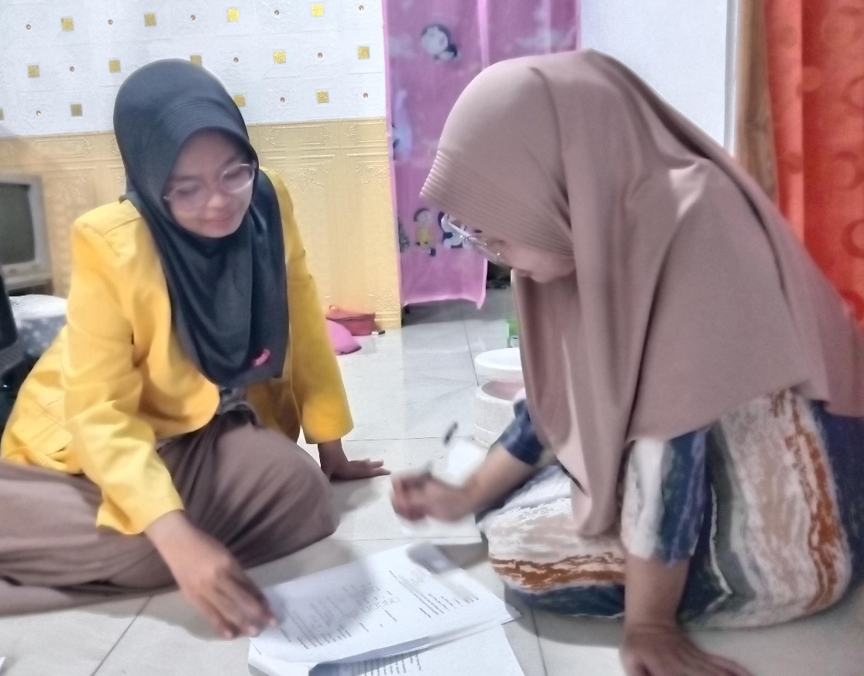

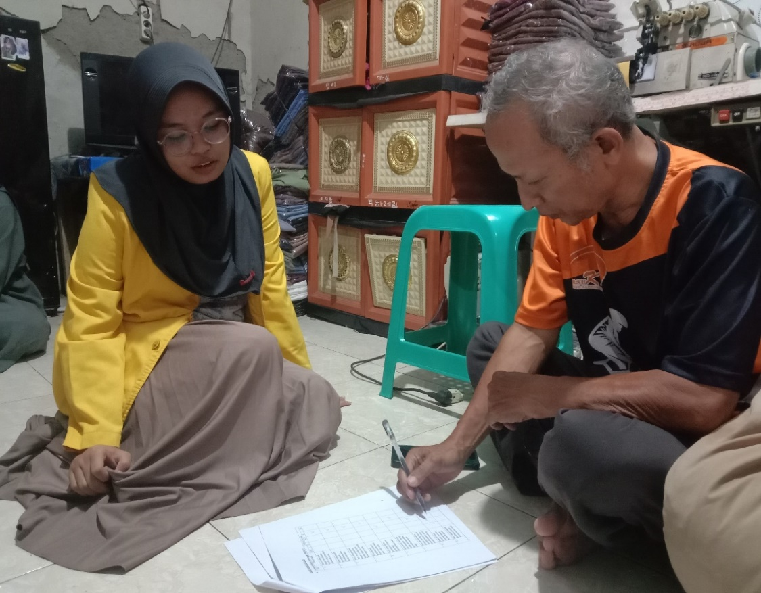

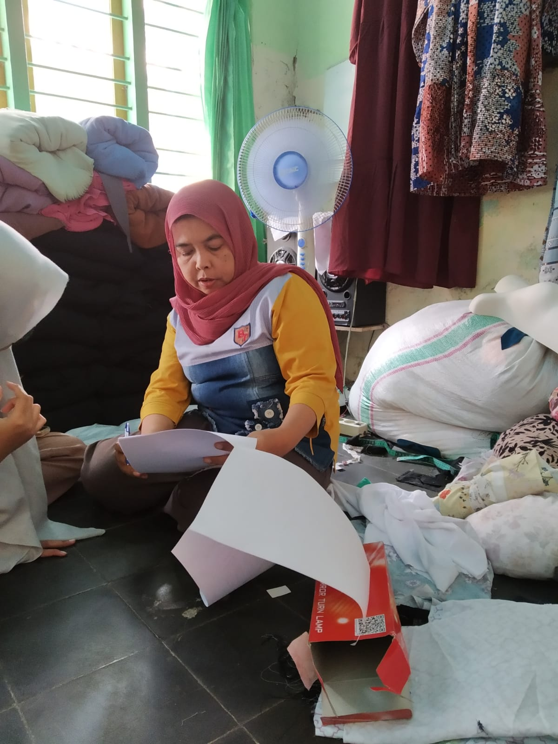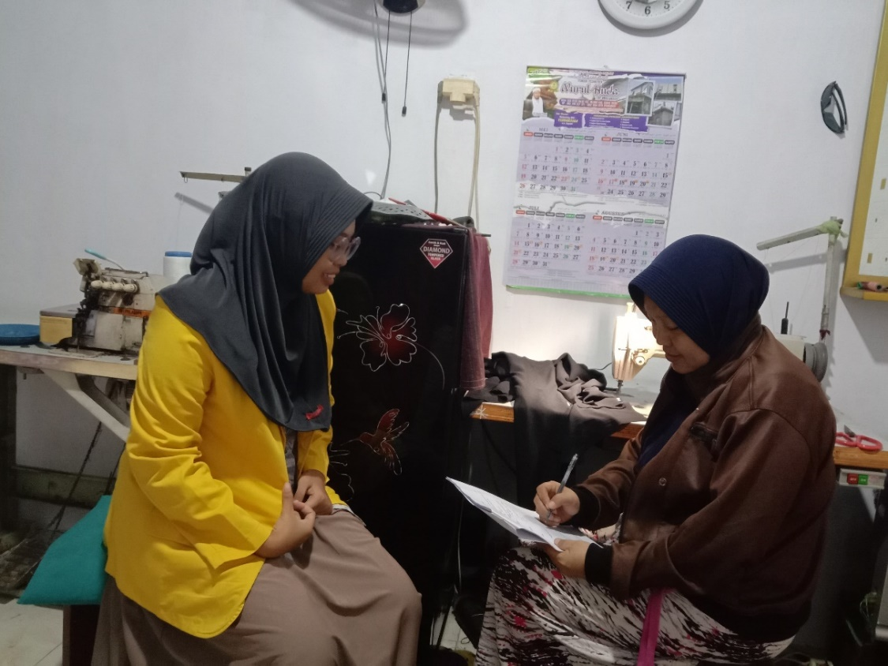

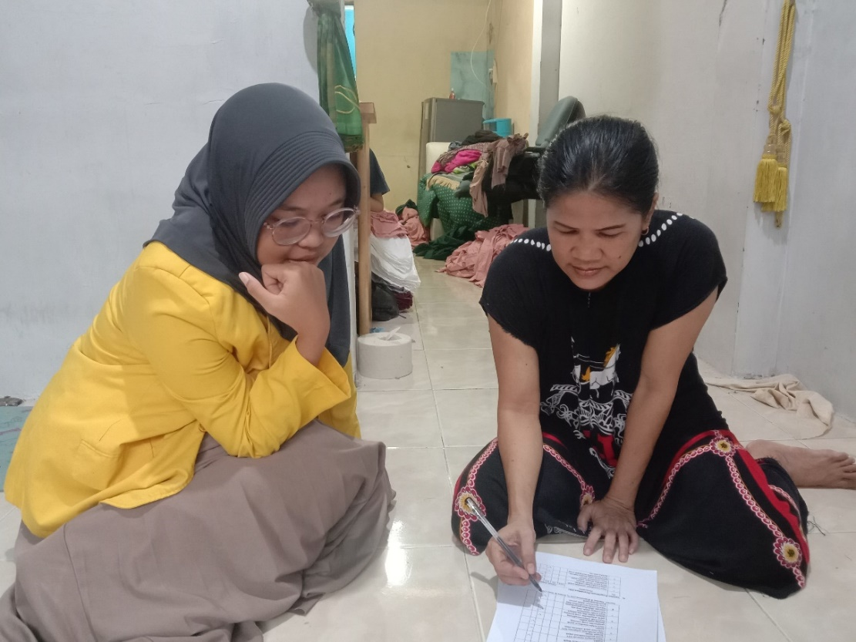

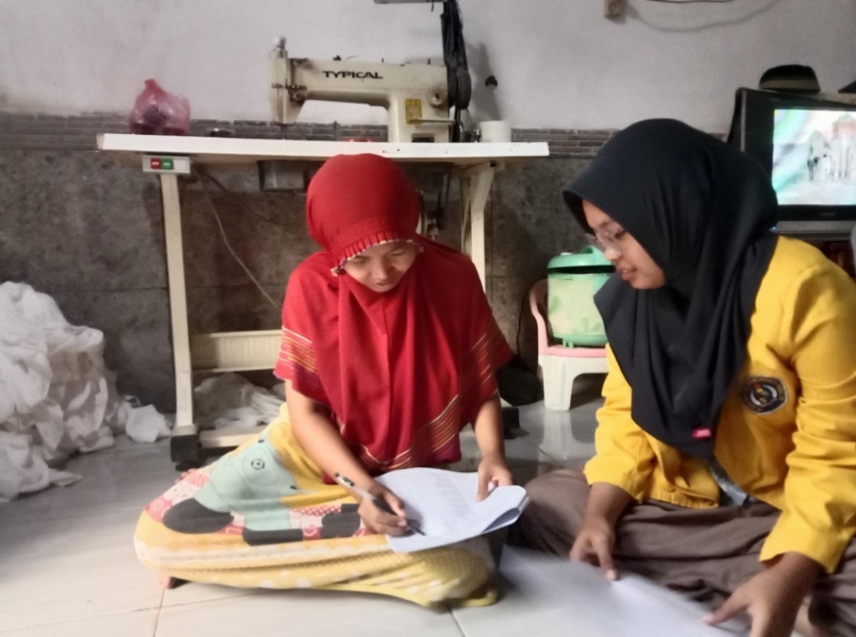

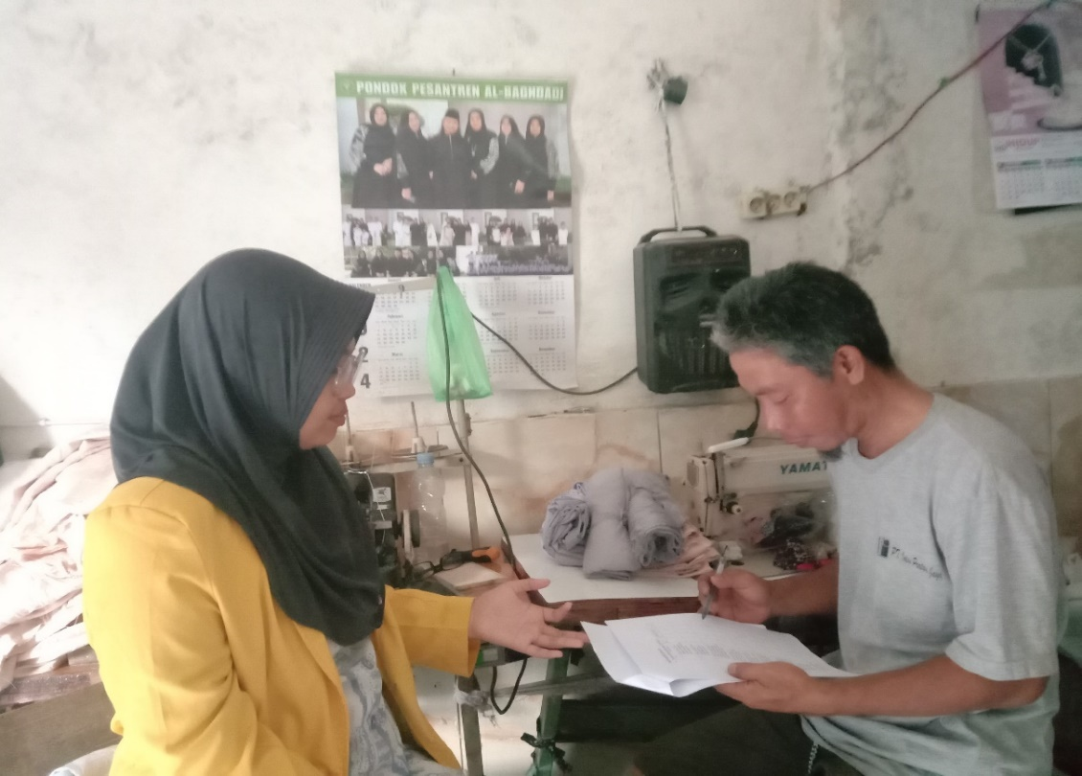

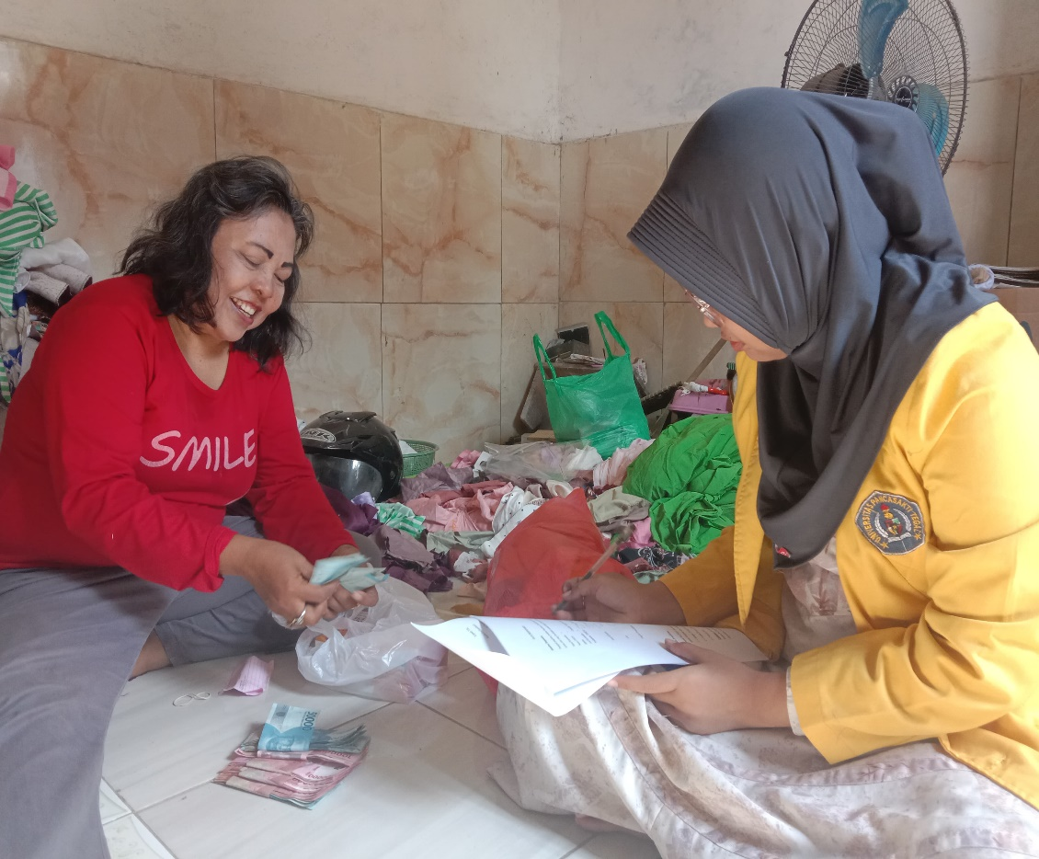

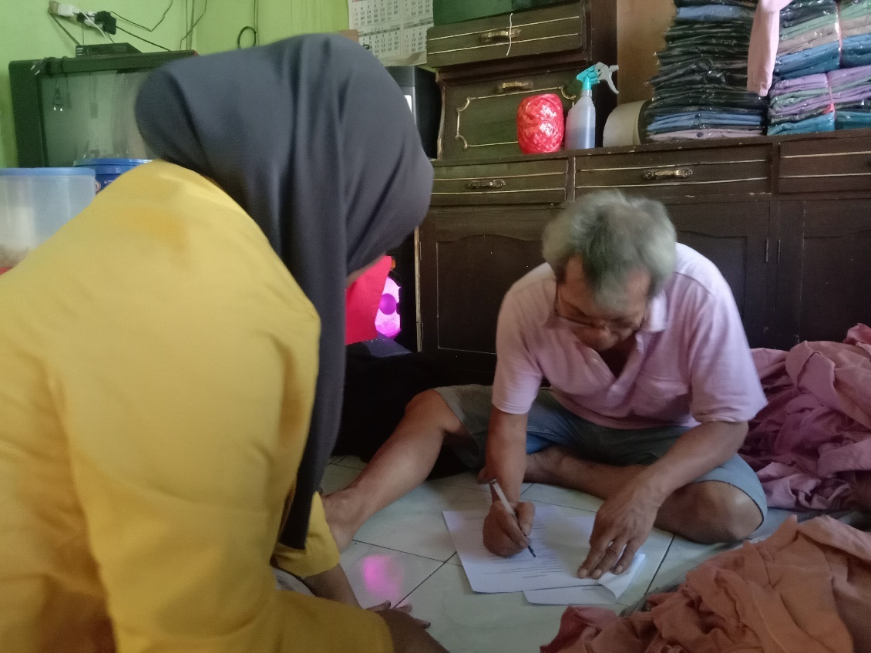

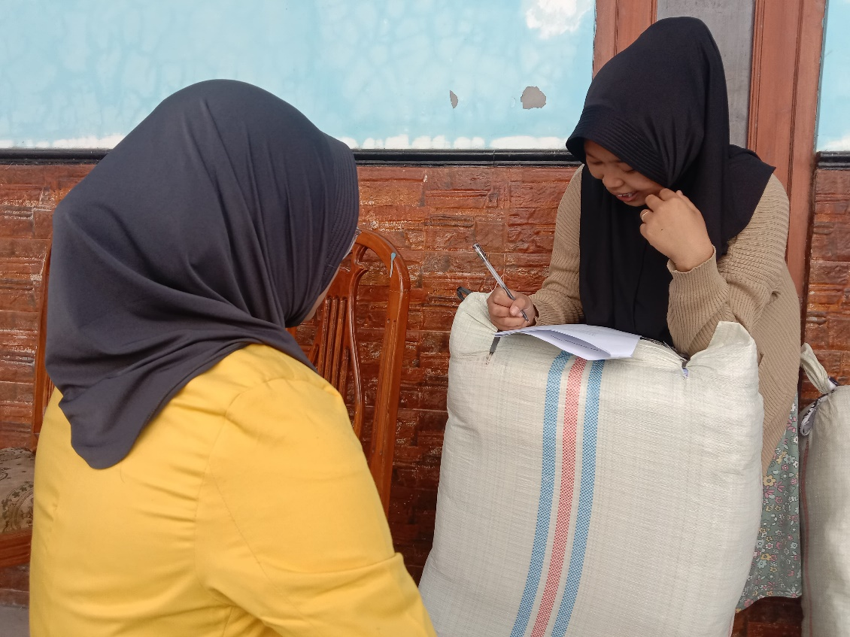

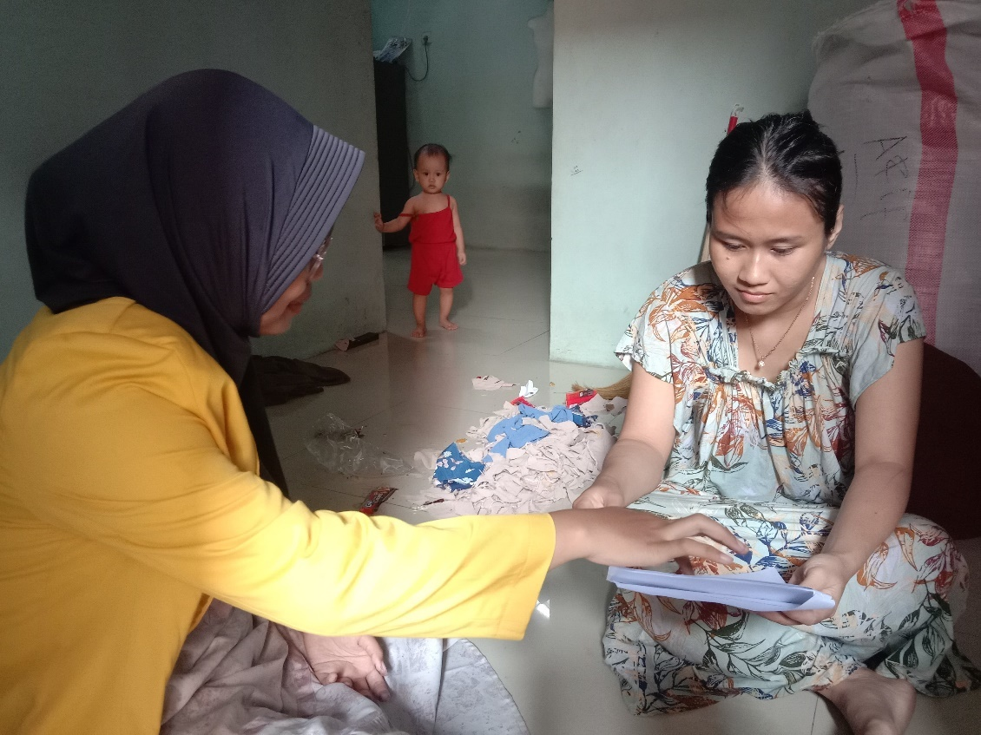

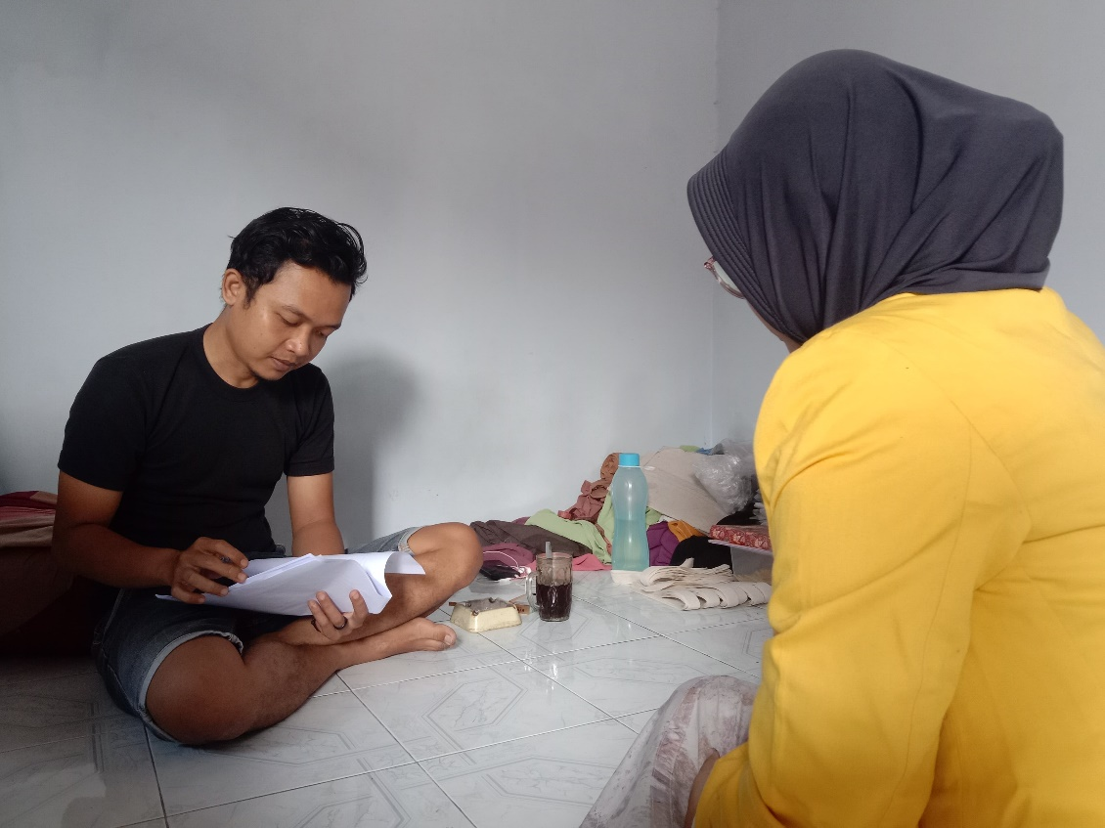

Lampiran 13. Surat Izin Penelitian

