# **DAFTAR PUSTAKA**

Aditya, A. T., & Haryono, N. A. (2019). Pengaruh Leverage, Likuiditas, Market To Book Value, Financial Distress, Dan Firm Size Terhadap Keputusan Hedging (Studi Perusahaan Sektor Consumer Goods Industri Periode 2011-2016). *Jurnal Ilmu Manajemen (JIM)*, *7*(2), 334–343. https://ejournal.unesa.ac.id/index.php/jim/article/view/26116

Afrida, A. (2021). Pengaruh Financial Distress, Firm Size Dan Growth Opportunity Terhadap Keputusan Hedging Pada. *Eko Dan Bisnis (Riau Economics and Business Review)*, *12*(2), 105–116. https://doi.org/https://doi.org/10.36975/jeb.v12i2.320

Aretz, K., Bartram, S. M., & Dufey, G. (2007). Why hedge? Rationales for corporate hedging and value implications. *Journal of Risk Finance*, *8*(5), 434–449. https://doi.org/10.1108/15265940710834735

Ayuningtyas, V., Warsini, S., & Mirati, E. (2019). Analisis Faktor Yang Mempengaruhi Pengambilan Keputusan Hedging Menggunakan Instrumen Derivatif Valuta Asing. *Account*, *6*(1), 980–992. https://doi.org/10.32722/acc.v6i1.1381

Bodroastuti, T., Paranita, E. S., & Ratnasari, L. (2019). Faktor-faktor yang Berpengaruh Terhadap Kebijakan Hedging Perusahaan Di Indonesia. *Valid Jurnal Ilmiah*, *16*(1), 71–84. https://journal.stieamm.ac.id/valid/article/view/83

Bonita, I. (2019). Analisis Faktor yang Mempengaruhi Penggunaan Instrumen Derivatif Valuta Asing sebagai Pengambilan Keputusan Hedging (Studi pada Perusahaan Manufaktur Sub Sektor Automotive and Allied Products yang terdaftar di BEI Periode 2011-2017). *Jurnal Akuntansi Maranatha*, *11*(2), 262–275. https://doi.org/10.28932/jam.v11i2.1905

Br, P. F., & Dillak, V. J. (2022). Pengaruh Growth Opportunity, Firm Size, Dan Financial Distress Terhadap Keputusan Hedging Pada Perusahaan Yang Terdaftar Di Bursa Efek Indonesia (BEI) Periode 2017-2020. *E-Proceeding of Management*, *9*(5), 3054–3062. https://openlibrarypublications.telkomuniversity.ac.id/index.php/management/article/download/18728/18114

Ghozali, I. (2018). *Aplikasi Analisis Multivariate Dengan Program IBM SPSS 25* (Edisi 9). Badan Penerbit Universitas Diponegoro.

Hanafi, D. M. M. (2016). *Manajemen Risiko* (Edisi 3). UPP STIM YKPN.

Hery. (2016). *Analisis Laporan Keuangan*. PT. Grasindo.

Husna, A., Hermanto, H., & Hidayati, S. A. (2019). Pengaruh Firm Size, Financial Distress, Debt Level, Dan Managerial Ownership Terhadap Keputusan Hedging Pada Perusahaan Manufaktur Yang Terdaftar Di Bursa Efek Indonesia. *Jmm Unram - Master of Management Journal*, *9*(1), 28–41. https://doi.org/10.29303/jmm.v9i1.484

Jogiyanto, H. (2017). *Teori Portofolio dan Analisis Investasi* (Edisi 11). BPFE Yogyakarta.

Karlinda, M. P. B., & Manunggal, S. A. M. (2023). Pengaruh leverage, firm size, profitabilitas, dan likuiditas terhadap pengambilan keputusan hedging perusahaan manufaktur di BEI. In *Jurnal Manajemen Bisnis dan Kewirausahaan* (Vol. 7, Issue 2, pp. 467–480). https://doi.org/10.24912/jmbk.v7i2.23104

Kasmir. (2013). *Analisa Laporan Keuangan* (Edisi Pert). Raja Grafindo Persada.

Kasmir, D. (2019). *Pengantar Manajemen Keuangan* (Edisi 2). Kencana.

Kinasih, R., & Mahardika, D. P. K. (2019). Pengaruh Likuiditas, Leverage, Dan Nilai Tukar Rupiah Terhadap Penggunaan Instrumen Derivatif Sebagai Keputusan Hedging. *Jurnal Ilmiah MEA (Manajemen, Ekonomi, & Akuntansi)*, *Vol. 3 No.*(c), 63–80. https://doi.org/10.31955/mea.vol3.iss1.pp63-80

Marhaenis, L. G., & Artini, L. G. S. (2020). Pengaruh Financial Distress, Growth Opportunities Dan Liquidity Terhadap Keputusan Hedging Pada Perusahaan Pertambangan Bei. *E-Jurnal Manajemen Universitas Udayana*, *9*(5), 1778. https://doi.org/10.24843/ejmunud.2020.v09.i05.p07

Maulid, R. R., & Mahardika, D. P. K. (2023). *| Page 1256 Pengaruh Leverage, Profitabilitas, Dan Firm Size Terhadap Keputusan Hedging (Studi Kasus pada Perusahaan Sektor Perbankan yang Terdaftar di Bursa Efek Indonesia Tahun 2017-2020) Effect Of Leverage, Profitability, And Firm Size On Hedging Decis*. *10*(2), 1256–1263. https://openlibrarypublications.telkomuniversity.ac.id/index.php/management/article/download/19908/19274

Nabiilah, I. A. (2021). Determinasi Keputusan Hedging Perusahaan Publik Sektor Pertanian 2013-2019. *Jurnal Ilmu Manajemen*, *9*(2), 386. https://doi.org/10.26740/jim.v9n2.p386-398

Purba, R. B. (2023). *Teori Akuntasi* (1st ed.). Merdeka Kreasi.

Rahmadina, R., Mahardika, D. P. K., & Murti, G. tresna. (2023). Pengaruh Leverage, Liquidity, Dan Growth Opportunity Terhadap Keputusan Hedging (Studi Kasus pada Perusahaan Pertambangan Subsektor Batubara yang Terdaftar di Bursa Efek Indonesia Periode 2016-2021). *E-Proceeding of Management*, *10*(4), 2006–2017. https://scholar.google.com/scholar?hl=id&as_sdt=0%2C5&q=Pengaruh+Leverage%2C+Liquidity%2C+Dan+Growth+Opportunity+Terhadap+Keputusan+Hedging+%28Studi+Kasus+pada+Perusahaan+Pertambangan+Subsektor+Batubara+yang+Terdaftar+di+Bursa+Efek+Indonesia+Periode+2016-

Ramadhana Asfrianto, F., Saleh, S., TAkdir Syaifuddin, D., Sujono, S., & Hamid, W. (2023). *Jurnal Manajemen , Bisnis dan Organisasi ( JUMBO )*. *5*(2), 194–208. http://ojs.uho.ac.id/index.php/JUMBO

Ratnaningsih, R., Tamara, D. A. D., & Mayasari, I. (2021). Pengaruh Likuiditas, Leverage, Profitabilitas, Firm Size dan Growth Opportunity terhadap Hedging Sektor Farmasi, Industri Dasar dan Bahan Kimia pada Perusahaan ISSI. *Journal of Applied Islamic Economics and Finance*, *2*(1), 227–237. https://doi.org/10.35313/jaief.v2i1.3049

Reza Rahmadina, Dewa Putra Krisnha Mahardika, & Galuh tresna Murti. (2023). Pengaruh Leverage, Liquidity, Dan Growth Opportunity Terhadap Keputusan Hedging (Studi Kasus pada Perusahaan Pertambangan Subsektor Batubara yang Terdaftar di Bursa Efek Indonesia Periode 2016-2021). *E-Proceeding of Management*, *10*(4), 2006–2015. https://openlibrarypublications.telkomuniversity.ac.id/index.php/management/article/download/20800/20089

Sasmita, I. E., & Hartono, U. (2019). Karakteristik Perusahaan, Financial Distress, dan Keputusan Hedging: Studi pada Perusahaan Manufaktur di Indonesia. *Jurnal Ilmu Manajemen (JIM)*, *7*(3), 655–667. https://ejournal.unesa.ac.id/index.php/jim/article/view/28770/26341

Sofia, R., & Yuneline, M. H. (2019). Determinasi Pengambilan Keputusan Lindung Nilai pada Instrumen Derivatif Valuta Asing Hedging Decision‐Making Determination on Exchange Rate as Derivative Instrument. *ISEI Business and Management*, *3*(1), 16–25.

Sudana, I. M. (2015). *Manajemen Keuangan Perusahaan Teori dan Praktik* (edisi 2). ERLANGGA.

Sugiyono. (2013). *Metode Penelitian Kuantitatif, Kualitatif Dan R&D*. Alfabeta.

Suliyanto. (2018). *Metode Penelitian Bisnis*. Andi Offset.

Urip Wardoyo, D., Alfani, Z., Siandini, D., Ditya Mei Yanti, S., & Tegar Segara, M. (2022). Faktor-Faktor yang Memengaruhi Perusahaan dalam Mengambil Keputusan Hedging Menggunakan Instrumen Derivatif: Literature Review. *Jurnal Ilmiah Multidisiplin*, *1*(7), 1925–1936. https://journal-nusantara.com/index.php/JIM/article/view/481

Utomo, L. P., & Hartanti, B. (2020). Determinan pengambilan keputusan hedging menggunakan instrumen derivatif valas. *Management and Business Review*, *4*(1), 22–31. https://doi.org/10.21067/mbr.v4i1.4611

Verawaty, V., Jaya, A. K., & Megawati, M. (2019). Determinan Pengambilan Keputusan Lindung Nilai (Hedging) Dengan Instrumen Derivatif Valuta Asing Pada Perusahaan Manufaktur. *Akuisisi: Jurnal Akuntansi*, *15*(1), 9–26. https://doi.org/10.24127/akuisisi.v15i1.281

[www.bi.go.id](http://www.bi.go.id)

[www.idx.co.id](http://www.idx.co.id)

[www.liputan6.com](http://www.liputan6.com)

[www.bps.go.id](http://www.bps.go.id)

# LAMPIRAN

**Lampiran 1: Tabel Melakukan Keputusan *Hedging***

Kode 0 = Tidak melakukan

Kode 1 = Melakukan

|  |  |  |  |  |  |  |  |
| --- | --- | --- | --- | --- | --- | --- | --- |
| No | Kode | Nama Perusahaan | 2019 | 2020 | 2021 | 2022 | 2023 |
| 1 | ABMM | ABM Investama Tbk. | 0 | 0 | 0 | 0 | 0 |
| 2 | ADRO | Adaro Energy Indonesia Tbk. | 1 | 1 | 1 | 1 | 1 |
| 4 | BSSR | Baramulti Suksessarana Tbk. | 0 | 0 | 0 | 0 | 0 |
| 7 | BYAN | Bayan Resources Tbk. | 1 | 1 | 1 | 1 | 1 |
| 9 | DOID | Delta Dunia Makmur Tbk. | 0 | 0 | 0 | 0 | 0 |
| 10 | DSSA | Dian Swastatika Sentosa Tbk | 1 | 1 | 1 | 1 | 1 |
| 11 | GEMS | Golden Energy Mines Tbk. | 0 | 0 | 0 | 0 | 0 |
| 13 | IATA | MNC Energy Investments Tbk. | 0 | 0 | 0 | 0 | 0 |
| 14 | INDY | Indika Energy Tbk. | 1 | 1 | 1 | 1 | 1 |
| 15 | ITMA | Sumber Energi Andalan Tbk. | 0 | 0 | 0 | 0 | 0 |
| 16 | ITMG | Indo Tambangraya Megah Tbk. | 1 | 1 | 1 | 1 | 1 |
| 17 | KKGI | Resource Alam Indonesia Tbk. | 0 | 0 | 0 | 0 | 0 |
| 19 | MBAP | Mitrabara Adiperdana Tbk. | 0 | 0 | 0 | 0 | 0 |
| 20 | MBSS | Mitrabahtera Segara Sejati Tbk | 0 | 0 | 0 | 0 | 0 |
| 21 | MEDC | Medco Energi Internasional Tbk | 1 | 1 | 1 | 1 | 1 |
| 22 | PTRO | Petrosea Tbk. | 1 | 1 | 1 | 1 | 1 |
| 23 | SHIP | Sillo Maritime Perdana Tbk. | 0 | 0 | 0 | 0 | 0 |
| 24 | SOCI | Soechi Lines Tbk. | 0 | 0 | 0 | 0 | 0 |
| 26 | TOBA | TBS Energi Utama Tbk. | 1 | 1 | 1 | 1 | 1 |
| 27 | TPMA | Trans Power Marine Tbk. | 0 | 0 | 0 | 0 | 0 |
| 28 | WINS | Wintermar Offshore Marine Tbk. | 0 | 0 | 0 | 0 | 0 |

**Lampiran 2: Tabel Perhitungan *Profitability***

$$ROA= \frac{Laba Setelah Pajak}{Total Aktiva}$$

|  |  |  |  |  |  |
| --- | --- | --- | --- | --- | --- |
| Tahun | No | Kode | Eat | Total Aktiva | ROA |
| 2019 | 1 | ABMM | 3.893.964 | 854.228.765 | 0,00456 |
|  | 2 | ADRO | 435.002 | 7.217.105 | 0,06027 |
|  | 3 | BSSR | 30.467.457 | 250.680.316 | 0,12154 |
|  | 4 | BYAN | 234.211.277 | 1.278.040.123 | 0,18326 |
|  | 5 | DOID | 20.480.591 | 1.181.911.191 | 0,01733 |
|  | 6 | DSSA | 71.654.412 | 3.718.973.064 | 0,01927 |
|  | 7 | GEMS | 66.765.857 | 780.646.167 | 0,08553 |
|  | 8 | IATA | -4.972.950 | 61.101.287 | -0,08139 |
|  | 9 | INDY | 4.992.434 | 3.616.163.065 | 0,00138 |
|  | 10 | ITMA | 8.995.548 | 145.108.029 | 0,06199 |
|  | 11 | ITMG | 126.502.000 | 1.209.041.000 | 0,10463 |
|  | 12 | KKGI | 5.414.352 | 126.354.537 | 0,04285 |
|  | 13 | MBAP | 35.287.557 | 192.527.289 | 0,18329 |
|  | 14 | MBSS | 1.808.168 | 218.135.430 | 0,00829 |
|  | 15 | MEDC | -13.533.049 | 6.006.538.390 | -0,00225 |
|  | 16 | PTRO | 31.324.000 | 551.044.000 | 0,05684 |
|  | 17 | SHIP | 19.527.023 | 239.823.999 | 0,08142 |
|  | 18 | SOCI | 9.348.634 | 688.215.790 | 0,01358 |
|  | 19 | TOBA | 43.745.700 | 634.640.456 | 0,06893 |
|  | 20 | TPMA | 8.239.249 | 111.635.784 | 0,07380 |
|  | 21 | WINS | -16.842.417 | 247.743.725 | -0,06798 |
| 2020 | 22 | ABMM | -37.740.064 | 827.237.179 | -0,04562 |
|  | 23 | ADRO | 158.505 | 6.381.566 | 0,02484 |
|  | 24 | BSSR | 30.075.927 | 263.343.768 | 0,11421 |
|  | 25 | BYAN | 344.459.870 | 1.619.725.022 | 0,21267 |
|  | 26 | DOID | -23.436.370 | 974.449.753 | -0,02405 |
|  | 27 | DSSA | -57.897.543 | 2.900.230.622 | -0,01996 |
|  | 28 | GEMS | 95.856.553 | 813.717.765 | 0,11780 |
|  | 29 | IATA | -6.411.619 | 53.890.353 | -0,11898 |
|  | 30 | INDY | -103.447.774 | 3.493.702.857 | -0,02961 |
|  | 31 | ITMA | 12.400.825 | 160.216.987 | 0,07740 |
|  | 32 | ITMG | 37.828 | 1.158.629.000 | 0,00003 |
|  | 33 | KKGI | -8.668.015 | 108.688.283 | -0,07975 |
|  | 34 | MBAP | 27.467.486 | 181.973.102 | 0,15094 |
|  | 35 | MBSS | -14.975.954 | 194.859.060 | -0,07686 |
|  | 36 | MEDC | -170.637.031 | 5.900.822.955 | -0,02892 |
|  | 37 | PTRO | 32.498 | 529.688.000 | 0,00006 |
|  | 38 | SHIP | 22.845.562 | 294.563.892 | 0,07756 |
|  | 39 | SOCI | 27.278.762 | 659.557.286 | 0,04136 |
|  | 40 | TOBA | 35.803.866 | 771.871.787 | 0,04639 |
|  | 41 | TPMA | 2.085.091 | 103.761.267 | 0,02010 |
|  | 42 | WINS | -14.243.923 | 220.313.390 | -0,06465 |
| 2021 | 43 | ABMM | 186.183.903 | 541.510.968 | 0,34382 |
|  | 44 | ADRO | 1.028.593 | 7.586.936 | 0,13557 |
|  | 45 | BSSR | 205.164.329 | 435.317.386 | 0,47130 |
|  | 46 | BYAN | 1.265.957.342 | 2.433.712.191 | 0,52018 |
|  | 47 | DOID | 280.546 | 1.635.958.307 | 0,00017 |
|  | 48 | DSSA | 265.337.533 | 3.010.072.696 | 0,08815 |
|  | 49 | GEMS | 354.024.370 | 829.026.937 | 0,42704 |
|  | 50 | IATA | -260.117 | 99.945.119 | -0,00260 |
|  | 51 | INDY | 63.316.596 | 3.691.477.101 | 0,01715 |
|  | 52 | ITMA | 12.256.008 | 182.973.654 | 0,06698 |
|  | 53 | ITMG | 475.390 | 1.666.239.000 | 0,00029 |
|  | 54 | KKGI | 23.003.525 | 132.182.307 | 0,17403 |
|  | 55 | MBAP | 100.566.379 | 257.720.439 | 0,39021 |
|  | 56 | MBSS | 12.142.010 | 177.639.085 | 0,06835 |
|  | 57 | MEDC | 62.600.751 | 5.683.884.139 | 0,01101 |
|  | 58 | PTRO | 33.953 | 532.736.000 | 0,00006 |
|  | 59 | SHIP | 20.702.575 | 325.466.330 | 0,06361 |
|  | 60 | SOCI | 5.432.377 | 629.210.009 | 0,00863 |
|  | 61 | TOBA | 65.607.407 | 858.101.884 | 0,07646 |
|  | 62 | TPMA | 3.959.320 | 99.256.380 | 0,03989 |
|  | 63 | WINS | 33.953 | 196.081.516 | 0,00017 |
| 2022 | 64 | ABMM | 341.903.507 | 1.982.578.564 | 0,17245 |
|  | 65 | ADRO | 2.831.123 | 10.782.307 | 0,26257 |
|  | 66 | BSSR | 239.896.019 | 404.831.175 | 0,59258 |
|  | 67 | BYAN | 2.301.605.547 | 3.945.458.865 | 0,58336 |
|  | 68 | DOID | 28.638.710 | 1.571.087.407 | 0,01823 |
|  | 69 | DSSA | 1.303.531.094 | 6.431.179.918 | 0,20269 |
|  | 70 | GEMS | 695.908.034 | 1.129.086.804 | 0,61635 |
|  | 71 | IATA | 33.742.139 | 180.289.993 | 0,18715 |
|  | 72 | INDY | 510.776.097 | 3.593.872.042 | 0,14212 |
|  | 73 | ITMA | 30.549.794 | 264.017.700 | 0,11571 |
|  | 74 | ITMG | 1.199.345 | 1.701.846.900 | 0,00070 |
|  | 75 | KKGI | 39.055.906 | 133.760.666 | 0,29198 |
|  | 76 | MBAP | 179.391.667 | 306.547.771 | 0,58520 |
|  | 77 | MBSS | 25.585.539 | 210.993.872 | 0,12126 |
|  | 78 | MEDC | 551.410.338 | 6.931.905.826 | 0,07955 |
|  | 79 | PTRO | 41.166 | 596.420.000 | 0,00007 |
|  | 80 | SHIP | 26.119.280 | 379.305.467 | 0,06886 |
|  | 81 | SOCI | 6.479.445 | 633.959.947 | 0,01022 |
|  | 82 | TOBA | 93.885.354 | 899.329.557 | 0,10439 |
|  | 83 | TPMA | 14.296.163 | 107.381.644 | 0,13313 |
|  | 84 | WINS | 861.095 | 189.445.736 | 0,00455 |
| 2023 | 85 | ABMM | 315.623.893 | 2.156.687.895 | 0,14635 |
|  | 86 | ADRO | 1.854.878 | 1.047.271.100 | 0,00177 |
|  | 87 | BSSR | 162.269.459 | 408.454.573 | 0,39728 |
|  | 88 | BYAN | 1.279.580.842 | 3.444.319.816 | 0,37150 |
|  | 89 | DOID | 36.010.191 | 1.874.599.404 | 0,01921 |
|  | 90 | DSSA | 865.313.519 | 3.063.273.017 | 0,28248 |
|  | 91 | GEMS | 528.748.412 | 1.312.042.245 | 0,40300 |
|  | 92 | IATA | 26.392.992 | 245.446.279 | 0,10753 |
|  | 93 | INDY | 151.043.091 | 3.113.102.390 | 0,04852 |
|  | 94 | ITMA | 2.087.099 | 226.695.921 | 0,00921 |
|  | 95 | ITMG | 499.620 | 2.187.847.000 | 0,00023 |
|  | 96 | KKGI | 26.802.561 | 200.536.560 | 0,13365 |
|  | 97 | MBAP | 21.686.927 | 229.500.650 | 0,09450 |
|  | 98 | MBSS | 24.638.813 | 247.068.111 | 0,09972 |
|  | 99 | MEDC | 345.768.603 | 7.468.316.269 | 0,04630 |
|  | 100 | PTRO | 12.438 | 727.945.000 | 0,00002 |
|  | 101 | SHIP | 25.763.464 | 432.180.554 | 0,05961 |
|  | 102 | SOCI | 8.931.190 | 604.303.565 | 0,01478 |
|  | 103 | TOBA | 20.846.270 | 8.931.190 | 2,33410 |
|  | 104 | TPMA | 19.695.773 | 117.406.903 | 0,16776 |
|  | 105 | WINS | 6.630.627 | 194.795.420 | 0,03404 |

**Lampiran 3: Tabel Perhitungan *Leverage***

$$DER= \frac{Total Debt}{Total Equity}$$

|  |  |  |  |  |  |
| --- | --- | --- | --- | --- | --- |
| Tahun | No | Kode | total debt | totalequity | DER |
| 2019 | 1 | ABMM | 609.035.054 | 245.193.711 | 2,48389 |
|  | 2 | ADRO | 3.233.710 | 3.983.395 | 0,81180 |
|  | 3 | BSSR | 80.362.658 | 170.317.658 | 0,47184 |
|  | 4 | BYAN | 658.959.960 | 619.080.163 | 1,06442 |
|  | 5 | DOID | 901.340.212 | 280.570.979 | 3,21252 |
|  | 6 | DSSA | 2.080.864.382 | 1.638.208.682 | 1,27021 |
|  | 7 | GEMS | 422.379.157 | 358.267.010 | 1,17895 |
|  | 8 | IATA | 25.299.740 | 35.801.547 | 0,70667 |
|  | 9 | INDY | 2.570.388.847 | 1.045.774.218 | 2,45788 |
|  | 10 | ITMA | 295.534.000 | 144.812.495 | 2,04080 |
|  | 11 | ITMG | 324.576.000 | 884.465.000 | 0,36697 |
|  | 12 | KKGI | 32.971.463 | 93.383.074 | 0,35308 |
|  | 13 | MBAP | 46.886.899 | 145.640.390 | 0,32194 |
|  | 14 | MBSS | 26.254.611 | 171.880.819 | 0,15275 |
|  | 15 | MEDC | 4.650.292.093 | 1.356.246.297 | 3,42880 |
|  | 16 | PTRO | 338.481.000 | 212.563.000 | 1,59238 |
|  | 17 | SHIP | 125.501.305 | 114.322.694 | 1,09778 |
|  | 18 | SOCI | 352.710.184 | 335.505.606 | 1,05128 |
|  | 19 | TOBA | 370.500.569 | 264.139.887 | 1,40267 |
|  | 20 | TPMA | 32.576.951 | 79.058.833 | 0,41206 |
|  | 21 | WINS | 92.505.045 | 155.238.680 | 0,59589 |
| 2020 | 22 | ABMM | 665.488.035 | 161.749.144 | 4,11432 |
|  | 23 | ADRO | 2.429.852 | 3.951.714 | 0,61489 |
|  | 24 | BSSR | 72.967.723 | 190.376.045 | 0,38328 |
|  | 25 | BYAN | 758.171.248 | 861.553.774 | 0,88000 |
|  | 26 | DOID | 710.718.334 | 263.731.419 | 2,69486 |
|  | 27 | DSSA | 1.311.320.300 | 1.588.910.322 | 0,82530 |
|  | 28 | GEMS | 464.283.221 | 349.434.544 | 1,32867 |
|  | 29 | IATA | 38.911.901 | 14.978.452 | 2,59786 |
|  | 30 | INDY | 2.626.405.463 | 867.297.394 | 3,02826 |
|  | 31 | ITMA | 252.805.000 | 159.964.182 | 1,58039 |
|  | 32 | ITMG | 312.339 | 846.290 | 0,36907 |
|  | 33 | KKGI | 24.437.727 | 84.250.556 | 0,29006 |
|  | 34 | MBAP | 43.752.926 | 138.220.176 | 0,31655 |
|  | 35 | MBSS | 38.053.795 | 156.805.265 | 0,24268 |
|  | 36 | MEDC | 4.687.437.992 | 1.213.384.963 | 3,86311 |
|  | 37 | PTRO | 298.248 | 231.440 | 1,28866 |
|  | 38 | SHIP | 159.651.191 | 134.912.701 | 1,18337 |
|  | 39 | SOCI | 298.634.397 | 360.922.889 | 0,82742 |
|  | 40 | TOBA | 480.957.627 | 290.914.160 | 1,65326 |
|  | 41 | TPMA | 26.757.516 | 77.003.751 | 0,34748 |
|  | 42 | WINS | 79.899.032 | 140.414.358 | 0,56902 |
| 2021 | 43 | ABMM | 679.815.042 | 356.889.117 | 1,90484 |
|  | 44 | ADRO | 3.128.621 | 4.458.315 | 0,70175 |
|  | 45 | BSSR | 182.704.693 | 252.612.693 | 0,72326 |
|  | 46 | BYAN | 570.805.817 | 1.862.906.374 | 0,30641 |
|  | 47 | DOID | 1.370.302.118 | 265.656.189 | 5,15818 |
|  | 48 | DSSA | 1.259.863.437 | 1.750.209.259 | 0,71984 |
|  | 49 | GEMS | 512.702.894 | 316.324.043 | 1,62082 |
|  | 50 | IATA | 73.359.565 | 26.585.554 | 2,75938 |
|  | 51 | INDY | 2.807.763.436 | 883.713.665 | 3,17723 |
|  | 52 | ITMA | 10.725.200 | 172.248.454 | 0,06227 |
|  | 53 | ITMG | 464.680 | 1.201.559 | 0,38673 |
|  | 54 | KKGI | 33.261.651 | 98.920.656 | 0,33625 |
|  | 55 | MBAP | 57.736.778 | 199.983.661 | 0,28871 |
|  | 56 | MBSS | 8.532.100 | 169.106.985 | 0,05045 |
|  | 57 | MEDC | 4.454.547.678 | 1.229.336.461 | 3,62354 |
|  | 58 | PTRO | 272.513 | 260.223 | 1,04723 |
|  | 59 | SHIP | 174.609.148 | 150.857.182 | 1,15745 |
|  | 60 | SOCI | 261.762.446 | 367.447.563 | 0,71238 |
|  | 61 | TOBA | 503.876.557 | 354.225.327 | 1,42247 |
|  | 62 | TPMA | 22.190.861 | 77.065.519 | 0,28795 |
|  | 63 | WINS | 42.115.895 | 153.965.621 | 0,27354 |
| 2022 | 64 | ABMM | 1.365.057.289 | 617.521.275 | 2,21054 |
|  | 65 | ADRO | 4.254.969 | 6.527.338 | 0,65187 |
|  | 66 | BSSR | 184.353.401 | 220.477.774 | 0,83615 |
|  | 67 | BYAN | 1.950.168.318 | 1.995.290.547 | 0,97739 |
|  | 68 | DOID | 1.314.859.176 | 256.228.231 | 5,13159 |
|  | 69 | DSSA | 3.439.195.930 | 2.991.983.988 | 1,14947 |
|  | 70 | GEMS | 570.842.165 | 558.244.639 | 1,02257 |
|  | 71 | IATA | 104.932.829 | 75.357.165 | 1,39247 |
|  | 72 | INDY | 2.253.698.079 | 1.340.173.963 | 1,68165 |
|  | 73 | ITMA | 9.655.696 | 209.524.281 | 0,04608 |
|  | 74 | ITMG | 689.897 | 1.950.280 | 0,35374 |
|  | 75 | KKGI | 47.245.546 | 122.939.144 | 0,38430 |
|  | 76 | MBAP | 56.282.011 | 250.265.760 | 0,22489 |
|  | 77 | MBSS | 24.885.243 | 186.108.629 | 0,13371 |
|  | 78 | MEDC | 5.184.386.501 | 1.747.519.325 | 2,96671 |
|  | 79 | PTRO | 298.429 | 297.991 | 1,00147 |
|  | 80 | SHIP | 207.105.862 | 172.199.605 | 1,20271 |
|  | 81 | SOCI | 259.890.374 | 374.069.573 | 0,69476 |
|  | 82 | TOBA | 475.619.264 | 423.710.293 | 1,12251 |
|  | 83 | TPMA | 18.550.940 | 88.830.704 | 0,20883 |
|  | 84 | WINS | 33.837.309 | 155.608.427 | 0,21745 |
| 2023 | 85 | ABMM | 1.397.760.928 | 758.926.967 | 1,84176 |
|  | 86 | ADRO | 3.063.961 | 7.408.750 | 0,41356 |
|  | 87 | BSSR | 165.971.113 | 242.483.460 | 0,68446 |
|  | 88 | BYAN | 1.465.501.614 | 1.978.818.202 | 0,74059 |
|  | 89 | DOID | 1.601.994.468 | 272.604.936 | 5,87662 |
|  | 90 | DSSA | 1.342.457.831 | 1.720.815.186 | 0,78013 |
|  | 91 | GEMS | 648.930.158 | 663.112.087 | 0,97861 |
|  | 92 | IATA | 142.305.447 | 103.140.832 | 1,37972 |
|  | 93 | INDY | 1.735.964.940 | 1.377.137.450 | 1,26056 |
|  | 94 | ITMA | 15.091.389 | 211.604.532 | 0,07132 |
|  | 95 | ITMG | 399.307 | 1.788.540 | 0,22326 |
|  | 96 | KKGI | 61.195.903 | 139.340.657 | 0,43918 |
|  | 97 | MBAP | 56.712.853 | 172.787.797 | 0,32822 |
|  | 98 | MBSS | 36.253.325 | 210.814.786 | 0,17197 |
|  | 99 | MEDC | 5.440.720.277 | 2.027.595.992 | 2,68334 |
|  | 100 | PTRO | 492.315 | 235.630 | 2,08936 |
|  | 101 | SHIP | 236.710.174 | 195.470.380 | 1,21098 |
|  | 102 | SOCI | 221.780.720 | 382.522.845 | 0,57978 |
|  | 103 | TOBA | 524.150.083 | 423.687.545 | 1,23711 |
|  | 104 | TPMA | 24.882.851 | 92.524.052 | 0,26893 |
|  | 105 | WINS | 32.875.918 | 161.919.502 | 0,20304 |

**Lampiran 4: Tabel Perhitungan *Firm Size***

$$Firm Size=Ln Total Asset$$

|  |  |  |  |  |
| --- | --- | --- | --- | --- |
| Tahun | No | Kode | total aktiva | Firm Size |
| 2019 | 1 | ABMM | 854.228.765 | 20,57 |
|  | 2 | ADRO | 7.217.105.000 | 22,70 |
|  | 3 | BSSR | 250.680.316 | 19,34 |
|  | 4 | BYAN | 1.278.040.123 | 20,97 |
|  | 5 | DOID | 1.181.911.191 | 20,89 |
|  | 6 | DSSA | 3.718.973.064 | 22,04 |
|  | 7 | GEMS | 780.646.167 | 20,48 |
|  | 8 | IATA | 61.101.287 | 17,93 |
|  | 9 | INDY | 3.616.163.065 | 22,01 |
|  | 10 | ITMA | 145.108.029 | 18,79 |
|  | 11 | ITMG | 1.209.041.000 | 20,91 |
|  | 12 | KKGI | 126.354.537 | 18,65 |
|  | 13 | MBAP | 192.527.289 | 19,08 |
|  | 14 | MBSS | 218.135.430 | 19,20 |
|  | 15 | MEDC | 6.006.538.390 | 22,52 |
|  | 16 | PTRO | 551.044.000 | 20,13 |
|  | 17 | SHIP | 239.823.999 | 19,30 |
|  | 18 | SOCI | 688.215.790 | 20,35 |
|  | 19 | TOBA | 634.640.456 | 20,27 |
|  | 20 | TPMA | 111.635.784 | 18,53 |
|  | 21 | WINS | 247.743.725 | 19,33 |
| 2020 | 22 | ABMM | 827.237.179 | 20,53 |
|  | 23 | ADRO | 6.381.566.000 | 22,58 |
|  | 24 | BSSR | 263.343.768 | 19,39 |
|  | 25 | BYAN | 1.619.725.022 | 21,21 |
|  | 26 | DOID | 974.449.753 | 20,70 |
|  | 27 | DSSA | 2.900.230.622 | 21,79 |
|  | 28 | GEMS | 813.717.765 | 20,52 |
|  | 29 | IATA | 53.890.353 | 17,80 |
|  | 30 | INDY | 3.493.702.857 | 21,97 |
|  | 31 | ITMA | 160.216.987 | 18,89 |
|  | 32 | ITMG | 1.158.629.000 | 20,87 |
|  | 33 | KKGI | 108.688.283 | 18,50 |
|  | 34 | MBAP | 181.973.102 | 19,02 |
|  | 35 | MBSS | 194.859.060 | 19,09 |
|  | 36 | MEDC | 5.900.822.955 | 22,50 |
|  | 37 | PTRO | 529.688.000 | 20,09 |
|  | 38 | SHIP | 294.563.892 | 19,50 |
|  | 39 | SOCI | 659.557.286 | 20,31 |
|  | 40 | TOBA | 771.871.787 | 20,46 |
|  | 41 | TPMA | 103.761.267 | 18,46 |
|  | 42 | WINS | 220.313.390 | 19,21 |
| 2021 | 43 | ABMM | 541.510.968 | 20,11 |
|  | 44 | ADRO | 7.586.936.000 | 22,75 |
|  | 45 | BSSR | 435.317.386 | 19,89 |
|  | 46 | BYAN | 2.433.712.191 | 21,61 |
|  | 47 | DOID | 1.635.958.307 | 21,22 |
|  | 48 | DSSA | 3.010.072.696 | 21,83 |
|  | 49 | GEMS | 829.026.937 | 20,54 |
|  | 50 | IATA | 99.945.119 | 18,42 |
|  | 51 | INDY | 3.691.477.101 | 22,03 |
|  | 52 | ITMA | 182.973.654 | 19,02 |
|  | 53 | ITMG | 1.666.239.000 | 21,23 |
|  | 54 | KKGI | 132.182.307 | 18,70 |
|  | 55 | MBAP | 257.720.439 | 19,37 |
|  | 56 | MBSS | 177.639.085 | 19,00 |
|  | 57 | MEDC | 5.683.884.139 | 22,46 |
|  | 58 | PTRO | 532.736.000 | 20,09 |
|  | 59 | SHIP | 325.466.330 | 19,60 |
|  | 60 | SOCI | 629.210.009 | 20,26 |
|  | 61 | TOBA | 858.101.884 | 20,57 |
|  | 62 | TPMA | 99.256.380 | 18,41 |
|  | 63 | WINS | 196.081.516 | 19,09 |
| 2022 | 64 | ABMM | 1.982.578.564 | 21,41 |
|  | 65 | ADRO | 10.782.307.000 | 23,10 |
|  | 66 | BSSR | 404.831.175 | 19,82 |
|  | 67 | BYAN | 3.945.458.865 | 22,10 |
|  | 68 | DOID | 1.571.087.407 | 21,18 |
|  | 69 | DSSA | 6.431.179.918 | 22,58 |
|  | 70 | GEMS | 1.129.086.804 | 20,84 |
|  | 71 | IATA | 180.289.993 | 19,01 |
|  | 72 | INDY | 3.593.872.042 | 22,00 |
|  | 73 | ITMA | 264.017.700 | 19,39 |
|  | 74 | ITMG | 1.701.846.900 | 21,25 |
|  | 75 | KKGI | 133.760.666 | 18,71 |
|  | 76 | MBAP | 306.547.771 | 19,54 |
|  | 77 | MBSS | 210.993.872 | 19,17 |
|  | 78 | MEDC | 6.931.905.826 | 22,66 |
|  | 79 | PTRO | 596.420.000 | 20,21 |
|  | 80 | SHIP | 379.305.467 | 19,75 |
|  | 81 | SOCI | 633.959.947 | 20,27 |
|  | 82 | TOBA | 899.329.557 | 20,62 |
|  | 83 | TPMA | 107.381.644 | 18,49 |
|  | 84 | WINS | 189.445.736 | 19,06 |
| 2023 | 85 | ABMM | 2.156.687.895 | 21,49 |
|  | 86 | ADRO | 1.047.271.100 | 20,77 |
|  | 87 | BSSR | 408.454.573 | 19,83 |
|  | 88 | BYAN | 3.444.319.816 | 21,96 |
|  | 89 | DOID | 1.874.599.404 | 21,35 |
|  | 90 | DSSA | 3.063.273.017 | 21,84 |
|  | 91 | GEMS | 1.312.042.245 | 20,99 |
|  | 92 | IATA | 245.446.279 | 19,32 |
|  | 93 | INDY | 3.113.102.390 | 21,86 |
|  | 94 | ITMA | 226.695.921 | 19,24 |
|  | 95 | ITMG | 2.187.847.000 | 21,51 |
|  | 96 | KKGI | 200.536.560 | 19,12 |
|  | 97 | MBAP | 229.500.650 | 19,25 |
|  | 98 | MBSS | 247.068.111 | 19,33 |
|  | 99 | MEDC | 7.468.316.269 | 22,73 |
|  | 100 | PTRO | 727.945.000 | 20,41 |
|  | 101 | SHIP | 432.180.554 | 19,88 |
|  | 102 | SOCI | 604.303.565 | 20,22 |
|  | 103 | TOBA | 8.931.190 | 16,01 |
|  | 104 | TPMA | 117.406.903 | 18,58 |
|  | 105 | WINS | 194.795.420 | 19,09 |

**Lampiran 5: Tabel Perhitungan *Growth Opportunity***

$$Growth Opportunity= \frac{MVE}{BVE}$$

|  |  |  |  |  |  |
| --- | --- | --- | --- | --- | --- |
| Tahun | No | Kode | MVE | BVE | GO |
| 2019 | 1 | ABMM | 1.964.689.781 | 854.228.765 | 2,29996 |
|  | 2 | ADRO | 256.724.684 | 7.217.105 | 0,03557 |
|  | 3 | BSSR | 612.379.310 | 250.680.316 | 2,44287 |
|  | 4 | BYAN | 3.179.642.857 | 1.278.040.123 | 2,48791 |
|  | 5 | DOID | 42.457.806 | 1.181.911.191 | 0,03592 |
|  | 6 | DSSA | 68.560.714.286 | 3.718.973.064 | 18,43539 |
|  | 7 | GEMS | 1.582.284.173 | 780.646.167 | 2,02689 |
|  | 8 | IATA | -3.200.000 | 61.101.287 | -0,05237 |
|  | 9 | INDY | -257.892.857 | 3.616.163.065 | -0,07132 |
|  | 10 | ITMA | 39.242.718 | 145.108.029 | 0,27044 |
|  | 11 | ITMG | 2.083.072.917 | 1.209.041.000 | 1,72291 |
|  | 12 | KKGI | 88.108.333 | 126.354.537 | 0,69731 |
|  | 13 | MBAP | 149.968.966 | 192.527.289 | 0,77895 |
|  | 14 | MBSS | 412.300.000 | 218.135.430 | 1,89011 |
|  | 15 | MEDC | -248.882.704 | 6.006.538.390 | -0,04144 |
|  | 16 | PTRO | 247.119.741 | 551.044.000 | 0,44846 |
|  | 17 | SHIP | 122.176.471 | 239.823.999 | 0,50944 |
|  | 18 | SOCI | 14.849.231 | 688.215.790 | 0,02158 |
|  | 19 | TOBA | 24.741.818 | 634.640.456 | 0,03899 |
|  | 20 | TPMA | 62.483.871 | 111.635.784 | 0,55971 |
|  | 21 | WINS | -147.247 | 247.743.725 | -0,00059 |
| 2020 | 22 | ABMM | -192.173.745 | 827.237.179 | -0,23231 |
|  | 23 | ADRO | 832.788.671 | 6.381.566 | 0,13050 |
|  | 24 | BSSR | 593.025.641 | 263.343.768 | 2,25191 |
|  | 25 | BYAN | 2.379.250.000 | 1.619.725.022 | 1,46892 |
|  | 26 | DOID | -87.740.741 | 974.449.753 | -0,09004 |
|  | 27 | DSSA | -36.008.181.818 | 2.900.230.622 | -12,41563 |
|  | 28 | GEMS | 1.101.753.287 | 813.717.765 | 1,35397 |
|  | 29 | IATA | -2.666.667 | 53.890.353 | -0,04948 |
|  | 30 | INDY | -86.512.795 | 3.493.702.857 | -0,02476 |
|  | 31 | ITMA | 33.098.592 | 160.216.987 | 0,20659 |
|  | 32 | ITMG | 8.193.750.000 | 1.158.629.000 | 7,07194 |
|  | 33 | KKGI | -83.112.500 | 108.688.283 | -0,76469 |
|  | 34 | MBAP | 332.500.000 | 181.973.102 | 1,82719 |
|  | 35 | MBSS | -56.773.256 | 194.859.060 | -0,29136 |
|  | 36 | MEDC | -77.615.124 | 5.900.822.955 | -0,01315 |
|  | 37 | PTRO | 544.767.802 | 529.688.000 | 1,02847 |
|  | 38 | SHIP | 87.000.000 | 294.563.892 | 0,29535 |
|  | 39 | SOCI | 5.640.000 | 659.557.286 | 0,00855 |
|  | 40 | TOBA | 40.412.903 | 771.871.787 | 0,05236 |
|  | 41 | TPMA | 260.000.000 | 103.761.267 | 2,50575 |
|  | 42 | WINS | -158.282 | 220.313.390 | -0,00072 |
| 2021 | 43 | ABMM | 95.866.815 | 541.510.968 | 0,17704 |
|  | 44 | ADRO | 164.887.257 | 7.586.936 | 0,02173 |
|  | 45 | BSSR | 164.883.929 | 435.317.386 | 0,37877 |
|  | 46 | BYAN | 1.178.965.278 | 2.433.712.191 | 0,48443 |
|  | 47 | DOID | 5.021.666.667 | 1.635.958.307 | 3,06956 |
|  | 48 | DSSA | 75.178.125.000 | 3.010.072.696 | 24,97552 |
|  | 49 | GEMS | 495.689.655 | 829.026.937 | 0,59792 |
|  | 50 | IATA | 0 | 99.945.119 | 0,00000 |
|  | 51 | INDY | 65.981.073 | 3.691.477.101 | 0,01787 |
|  | 52 | ITMA | 34.000.000 | 182.973.654 | 0,18582 |
|  | 53 | ITMG | 1.154.360.465 | 1.666.239.000 | 0,69279 |
|  | 54 | KKGI | 31.587.755 | 132.182.307 | 0,23897 |
|  | 55 | MBAP | 115.158.537 | 257.720.439 | 0,44684 |
|  | 56 | MBSS | 138.912.879 | 177.639.085 | 0,78200 |
|  | 57 | MEDC | 333.834.667 | 5.683.884.139 | 0,05873 |
|  | 58 | PTRO | 559.029.412 | 532.736.000 | 1,04936 |
|  | 59 | SHIP | 156.409.091 | 325.466.330 | 0,48057 |
|  | 60 | SOCI | 37.240.000 | 629.210.009 | 0,05919 |
|  | 61 | TOBA | 31.320.000 | 858.101.884 | 0,03650 |
|  | 62 | TPMA | 156.000.000 | 99.256.380 | 1,57169 |
|  | 63 | WINS | 18.095.000 | 196.081.516 | 0,09228 |
| 2022 | 64 | ABMM | 137.181.763 | 1.982.578.564 | 0,06919 |
|  | 65 | ADRO | 133.528.386 | 10.782.307 | 0,01238 |
|  | 66 | BSSR | 206.725.191 | 404.831.175 | 0,51065 |
|  | 67 | BYAN | 20.722.500.000 | 3.945.458.865 | 5,25224 |
|  | 68 | DOID | 56.112.601 | 1.571.087.407 | 0,03572 |
|  | 69 | DSSA | 12.560.259.740 | 6.431.179.918 | 1,95303 |
|  | 70 | GEMS | 425.301.724 | 1.129.086.804 | 0,37668 |
|  | 71 | IATA | 1.898.305 | 180.289.993 | 0,01053 |
|  | 72 | INDY | 41.547.756 | 3.593.872.042 | 0,01156 |
|  | 73 | ITMA | 22.466.276 | 264.017.700 | 0,08509 |
|  | 74 | ITMG | 932.242.991 | 1.701.846.900 | 0,54778 |
|  | 75 | KKGI | 33.487.952 | 133.760.666 | 0,25036 |
|  | 76 | MBAP | 141.654.110 | 306.547.771 | 0,46209 |
|  | 77 | MBSS | 96.067.708 | 210.993.872 | 0,45531 |
|  | 78 | MEDC | 71.467.391 | 6.931.905.826 | 0,01031 |
|  | 79 | PTRO | 769.709.443 | 596.420.000 | 1,29055 |
|  | 80 | SHIP | 111.869.565 | 379.305.467 | 0,29493 |
|  | 81 | SOCI | 32.426.667 | 633.959.947 | 0,05115 |
|  | 82 | TOBA | 21.000.000 | 899.329.557 | 0,02335 |
|  | 83 | TPMA | 59.703.704 | 107.381.644 | 0,55600 |
|  | 84 | WINS | 6.354.400 | 189.445.736 | 0,03354 |
| 2023 | 85 | ABMM | 114.001.143 | 2.156.687.895 | 0,05286 |
|  | 86 | ADRO | 132.605.010 | 1.047.271.100 | 0,12662 |
|  | 87 | BSSR | 252.462.903 | 408.454.573 | 0,61809 |
|  | 88 | BYAN | 9.734.458.333 | 3.444.319.816 | 2,82624 |
|  | 89 | DOID | 43.546.025 | 1.874.599.404 | 0,02323 |
|  | 90 | DSSA | 21.211.016.949 | 3.063.273.017 | 6,92430 |
|  | 91 | GEMS | 5.218.125.000 | 1.312.042.245 | 3,97710 |
|  | 92 | IATA | 1.523.810 | 245.446.279 | 0,00621 |
|  | 93 | INDY | 80.383.696 | 3.113.102.390 | 0,02582 |
|  | 94 | ITMA | 166.636.364 | 226.695.921 | 0,73507 |
|  | 95 | ITMG | 1.325.142.045 | 2.187.847.000 | 0,60568 |
|  | 96 | KKGI | 36.270.690 | 200.536.560 | 0,18087 |
|  | 97 | MBAP | 626.577.778 | 229.500.650 | 2,73018 |
|  | 98 | MBSS | 92.340.426 | 247.068.111 | 0,37374 |
|  | 99 | MEDC | 111.989.023 | 7.468.316.269 | 0,01500 |
|  | 100 | PTRO | 2.800.406.504 | 727.945.000 | 3,84700 |
|  | 101 | SHIP | 137.448.529 | 432.180.554 | 0,31803 |
|  | 102 | SOCI | 21.630.769 | 604.303.565 | 0,03579 |
|  | 103 | TOBA | 54.432.000 | 8.931.190 | 6,09460 |
|  | 104 | TPMA | 58.066.667 | 117.406.903 | 0,49458 |
|  | 105 | WINS | 1.259.477 | 194.795.420 | 0,00647 |

**Lampiran 6: Hasil Uji Statistik Deskriptif**

Statistik Deskripsi Keputusan *Hedging*

|  |  |  |  |  |  |
| --- | --- | --- | --- | --- | --- |
| **Descriptive Statistics** | | | | | |
|  | N | Minimum | Maximum | Mean | Std. Deviation |
| Keputusan Hedging | 105 | 0 | 1 | ,38 | ,488 |
| Valid N (listwise) | 105 |  |  |  |  |

Statistik Deskriptif *Profitability*

|  |  |  |  |  |  |
| --- | --- | --- | --- | --- | --- |
| **Descriptive Statistics** | | | | | |
|  | N | Minimum | Maximum | Mean | Std. Deviation |
| Profitability | 105 | -,119 | 2,334 | ,14151 | ,272274 |
| Valid N (listwise) | 105 |  |  |  |  |

Statistik Deskriptif *Leverage*

|  |  |  |  |  |  |
| --- | --- | --- | --- | --- | --- |
| **Descriptive Statistics** | | | | | |
|  | N | Minimum | Maximum | Mean | Std. Deviation |
| Leverage | 105 | ,046 | 5,877 | 1,23112 | 1,182278 |
| Valid N (listwise) | 105 |  |  |  |  |

Statistik Deskriptif *Firm Size*

|  |  |  |  |  |  |
| --- | --- | --- | --- | --- | --- |
| **Descriptive Statistics** | | | | | |
|  | N | Minimum | Maximum | Mean | Std. Deviation |
| Firm Size | 105 | 16,010 | 23,100 | 20,28114 | 1,376937 |
| Valid N (listwise) | 105 |  |  |  |  |

Statistik Deskriptif *Growth Opportunity*

|  |  |  |  |  |  |
| --- | --- | --- | --- | --- | --- |
| **Descriptive Statistics** | | | | | |
|  | N | Minimum | Maximum | Mean | Std. Deviation |
| Growth Opportunity | 105 | -12,416 | 24,976 | 1,11032 | 3,497339 |
| Keputusan Hedging | 105 | 0 | 1 | ,38 | ,488 |
| Valid N (listwise) | 105 |  |  |  |  |

**Lampiran 7: Hasil Uji Asumsi Klasik**

* + - * 1. Uji Normalitas

1. Grafik Normal *Probability Plot*

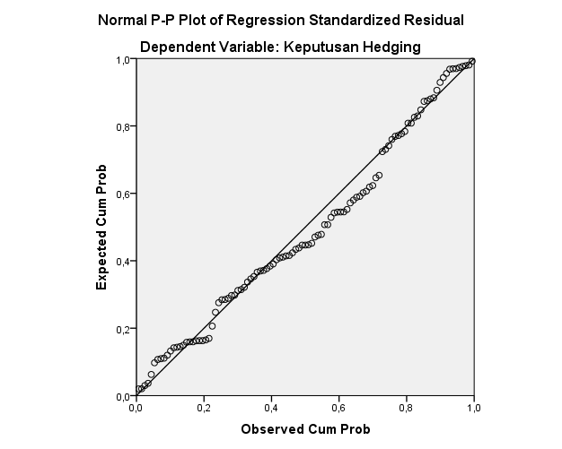

Sumber: data yang diolah SPSS 22, 2024

1. Grafik Histogram

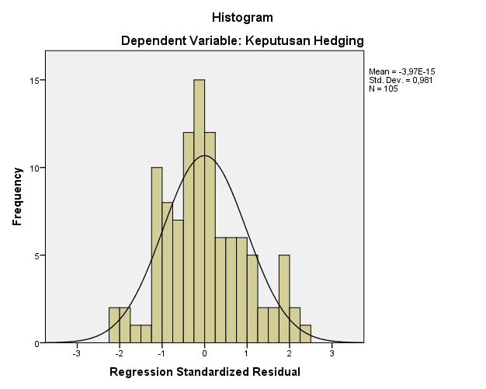

Sumber: data yang diolah SPSS 22, 2024

1. Hasil Uji Normalitas

|  |  |  |
| --- | --- | --- |
| 1. **One-Sample Kolmogorov-Smirnov Test** | | |
|  | | Unstandardized Residual |
| N | | 105 |
| Normal Parametersa,b | Mean | ,0000000 |
| Std. Deviation | ,34057997 |
| Most Extreme Differences | Absolute | ,079 |
| Positive | ,079 |
| Negative | -,047 |
| Test Statistic | | ,079 |
| Asymp. Sig. (2-tailed) | | ,100c |
| a. Test distribution is Normal. | | |
| b. Calculated from data. | | |
| c. Lilliefors Significance Correction. | | |

Sumber: data yang diolah SPSS 22, 2024

1. Hasil Uji Multikolinearitas

|  |  |  |  |
| --- | --- | --- | --- |
| 1. **Coefficientsa** | | | |
| Model | | Collinearity Statistics | |
| Tolerance | VIF |
| 1 | (Constant) |  |  |
| Profitability | ,937 | 1,068 |
| Leverage | ,836 | 1,196 |
| Firm Size | ,826 | 1,210 |
| Growth Opportunity | ,954 | 1,048 |
| a. Dependent Variable: Keputusan Hedging | | | |

Sumber: data yang diolah SPSS 22, 2024

1. 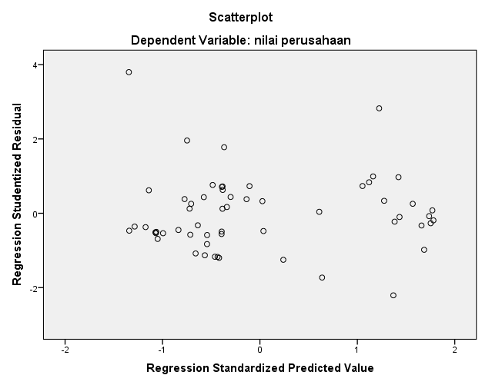Hasil Uji Heteroskedastisitas

Sumber: data yang diolah SPSS 22, 2024

1. Hasil Uji Autokorelasi

|  |  |  |  |  |  |
| --- | --- | --- | --- | --- | --- |
| 1. **Model Summaryb** | | | | | |
| Model | R | R Square | Adjusted R Square | Std. Error of the Estimate | Durbin-Watson |
| 1 | ,716a | ,513 | ,493 | ,347 | 2,215 |
| a. Predictors: (Constant), Growth Opportunity, Leverage, Profitability, Firm Size | | | | | |
| b. Dependent Variable: Keputusan Hedging | | | | | |

Sumber: data yang diolah SPSS 22, 2024

Sumber: data yang diolah SPSS 22, 2024

**Lampiran 8: Hasil Uji Regresi Linear Berganda**

|  |  |  |  |  |  |  |
| --- | --- | --- | --- | --- | --- | --- |
| **Coefficientsa** | | | | | | |
| Model | | Unstandardized Coefficients | | Standardized Coefficients | t | Sig. | |
| B | Std. Error | Beta |
| 1 | (Constant) | -4,917 | ,541 |  | -9,088 | ,000 | |
| Profitability | ,387 | ,129 | ,216 | 2,990 | ,004 | |
| Leverage | -,056 | ,032 | -,136 | -1,779 | ,043 | |
| Firm Size | ,261 | ,027 | ,737 | 9,603 | ,000 | |
| Growth Opportunity | ,011 | ,010 | ,076 | 1,064 | ,290 | |
| a. Dependent Variable: Keputusan Hedging | | | | | | |

Sumber: data yang diolah SPSS 22, 2024

**Lampiran 9: Hasil Uji Analisis Regresi Logistik**

1. Hasil Uji Menilai Keseluruhan Model (Block 0: Beginning Block)

|  |  |  |  |
| --- | --- | --- | --- |
| **Iteration Historya,b,c** | | | |
| Iteration | | -2 Log likelihood | Coefficients |
| Constant |
| Step 0 | 1 | 139,553 | -,476 |
| 2 | 139,551 | -,485 |
| 3 | 139,551 | -,486 |
| a. Constant is included in the model. | | | |
| b. Initial -2 Log Likelihood: 139,551 | | | |
| c. Estimation terminated at iteration number 3 because parameter estimates changed by less than ,001. | | | |

1. Hasil Uji Menilai Keseluruhan Model (Block 1: Method Enter)

|  |  |  |  |  |  |  |  |
| --- | --- | --- | --- | --- | --- | --- | --- |
| **Iteration Historya,b,c,d** | | | | | | | |
| Iteration | | -2 Log likelihood | Coefficients | | | | |
| Constant | X1 | X2 | X3 | X4 |
| Step 1 | 1 | 82,631 | -22,120 | 1,307 | -,257 | 1,072 | ,044 |
| 2 | 74,055 | -34,139 | 2,095 | -,448 | 1,659 | ,083 |
| 3 | 72,814 | -40,456 | 2,489 | -,542 | 1,968 | ,131 |
| 4 | 72,762 | -41,990 | 2,577 | -,566 | 2,043 | ,148 |
| 5 | 72,762 | -42,065 | 2,582 | -,567 | 2,047 | ,149 |
| 6 | 72,762 | -42,065 | 2,582 | -,567 | 2,047 | ,149 |
| a. Method: Enter | | | | | | | |
| b. Constant is included in the model. | | | | | | | |
| c. Initial -2 Log Likelihood: 139,551 | | | | | | | |
| d. Estimation terminated at iteration number 6 because parameter estimates changed by less than ,001. | | | | | | | |

1. Hasil Uji kelayakan Model Regresi

|  |  |  |  |
| --- | --- | --- | --- |
| **Hosmer and Lemeshow Test** | | | |
| Step | Chi-square | df | Sig. |
| 1 | 3,322 | 8 | ,913 |

1. Hasil Uji Koefisien Determinasi

|  |  |  |  |
| --- | --- | --- | --- |
| **Model Summary** | | | |
| Step | -2 Log likelihood | Cox & Snell R Square | Nagelkerke R Square |
| 1 | 72,762a | ,471 | ,640 |
| a. Estimation terminated at iteration number 6 because parameter estimates changed by less than ,001. | | | |

1. Hasil Matriks Klasifikasi 2X2

|  |  |  |  |  |  |
| --- | --- | --- | --- | --- | --- |
| **Classification Tablea** | | | | | |
|  | Observed | | Predicted | | |
|  | Keputusan Hedging | | Percentage Correct |
|  | tidak melakukan hedging | melakukan hedging |
| Step 1 | Keputusan Hedging | tidak melakukan hedging | 60 | 5 | 92,3 |
| melakukan hedging | 10 | 30 | 75,0 |
| Overall Percentage | |  |  | 85,7 |
| a. The cut value is ,500 | | | | | |

**Lampiran 10 Hasil Uji Hipotesis**

1. Hasil Uji Parsial (Uji t)

|  |  |  |  |  |  |  |  |
| --- | --- | --- | --- | --- | --- | --- | --- |
| **Variables in the Equation** | | | | | | | |
|  | | B | S.E. | Wald | df | Sig. | Exp(B) |
| Step 1a | X1 | 2,163 | ,936 | 5,345 | 1 | ,021 | 8,701 |
| X2 | -,567 | ,286 | 3,939 | 1 | ,047 | ,567 |
| X3 | 2,047 | ,392 | 27,277 | 1 | ,000 | 7,744 |
| X4 | ,149 | ,130 | 1,309 | 1 | ,253 | 1,160 |
| Constant | -42,065 | 7,923 | 28,188 | 1 | ,000 | ,000 |
| a. Variable(s) entered on step 1: X1, X2, X3, X4. | | | | | | | |

1. Hasil Uji Simultan (Uji f)

|  |  |  |  |  |
| --- | --- | --- | --- | --- |
| **Omnibus Tests of Model Coefficients** | | | | |
|  | | Chi-square | df | Sig. |
| Step 1 | Step | 66,789 | 4 | ,000 |
| Block | 66,789 | 4 | ,000 |
| Model | 66,789 | 4 | ,000 |

**Lampiran 11 Data Laporan Keuangan Perusahaan Sektor Energi**

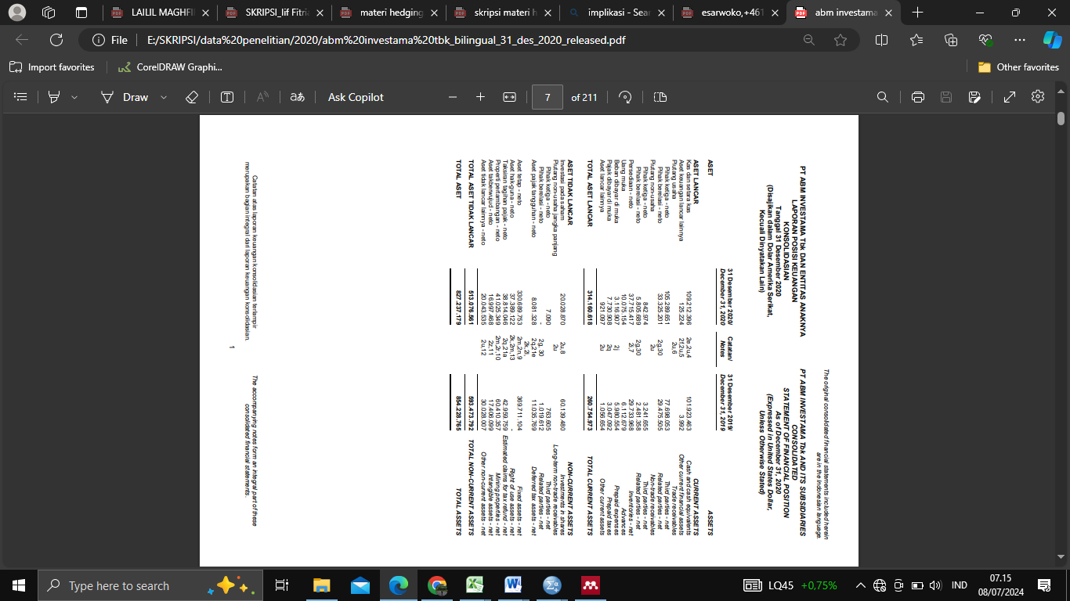

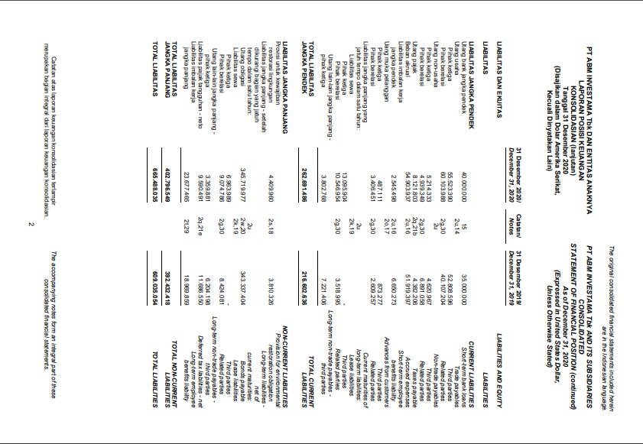

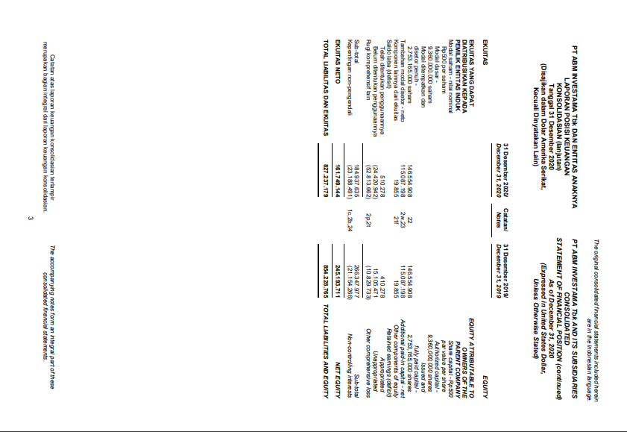

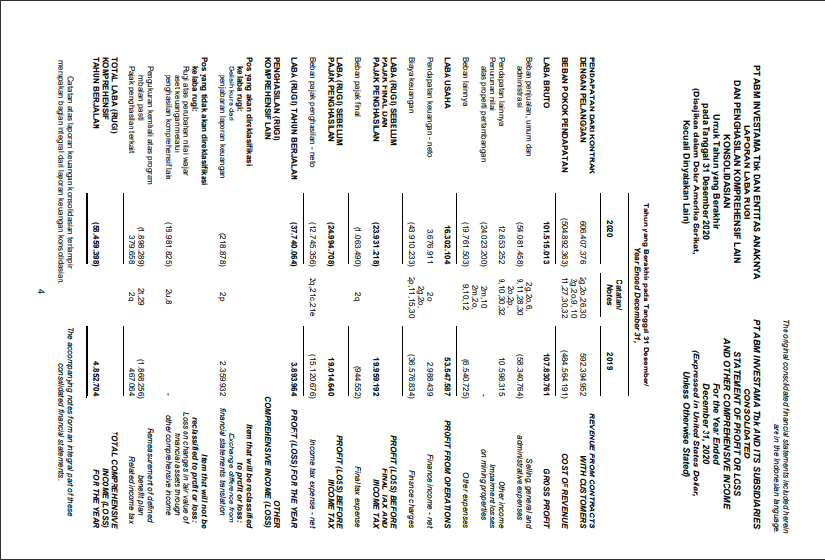

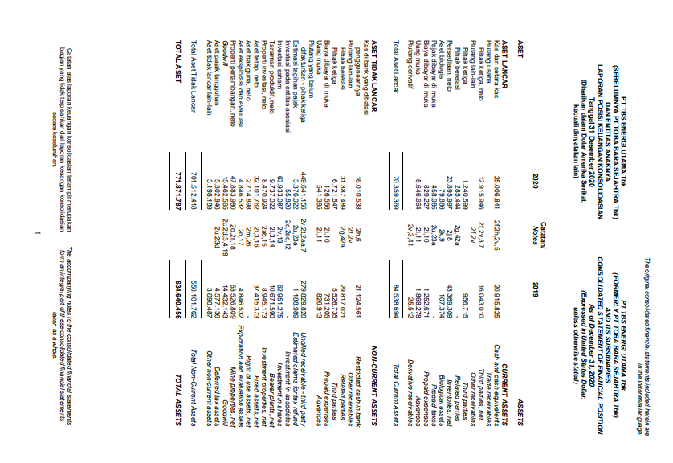

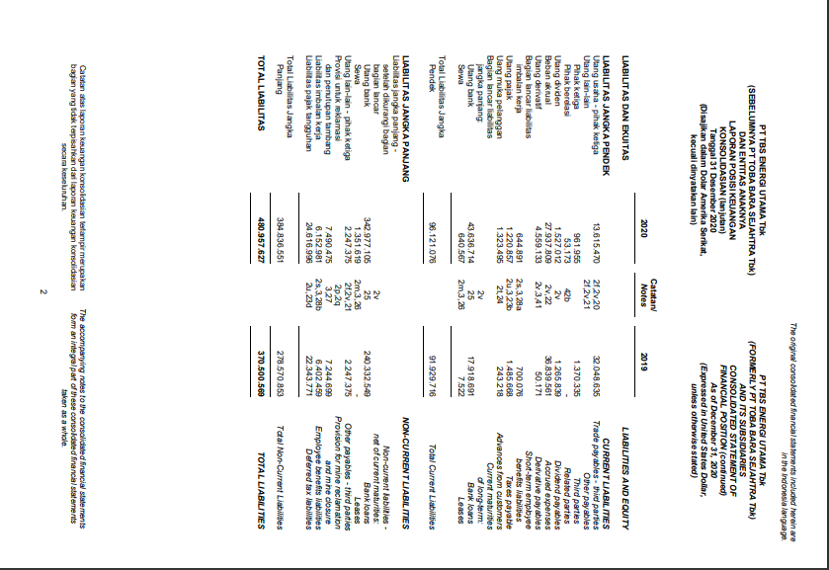

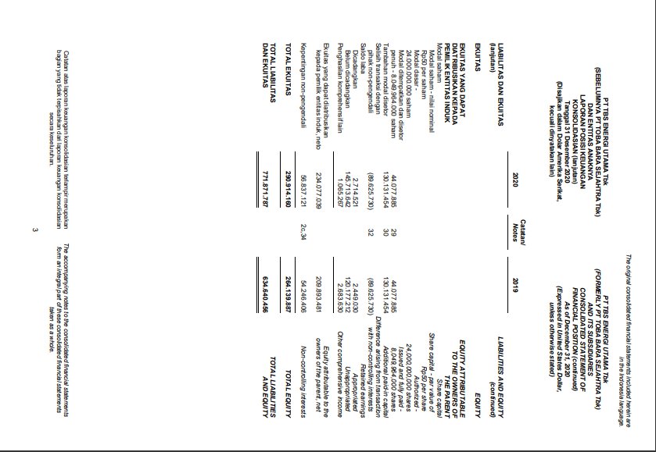

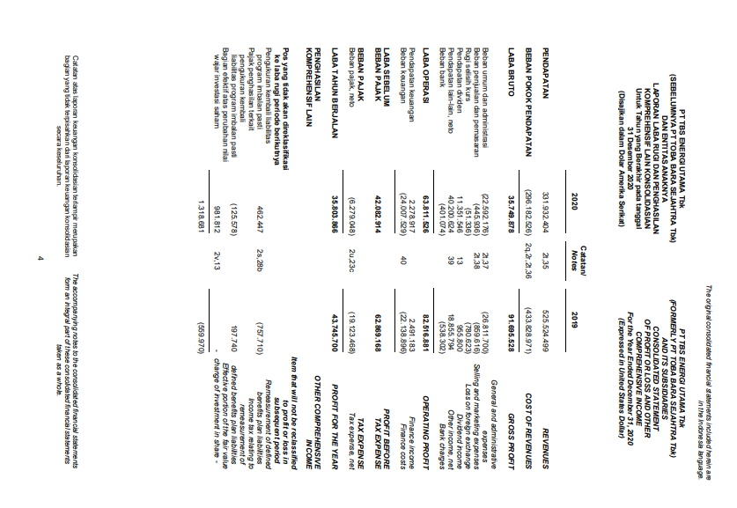

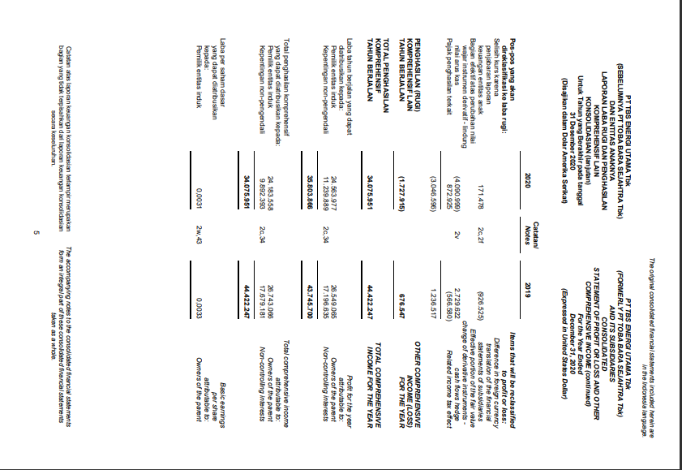

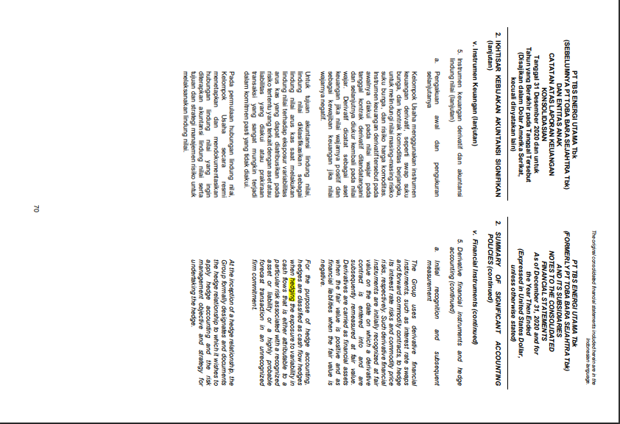

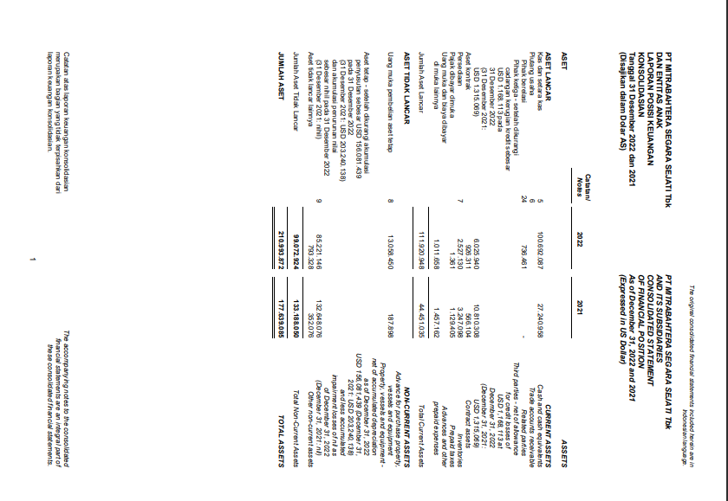

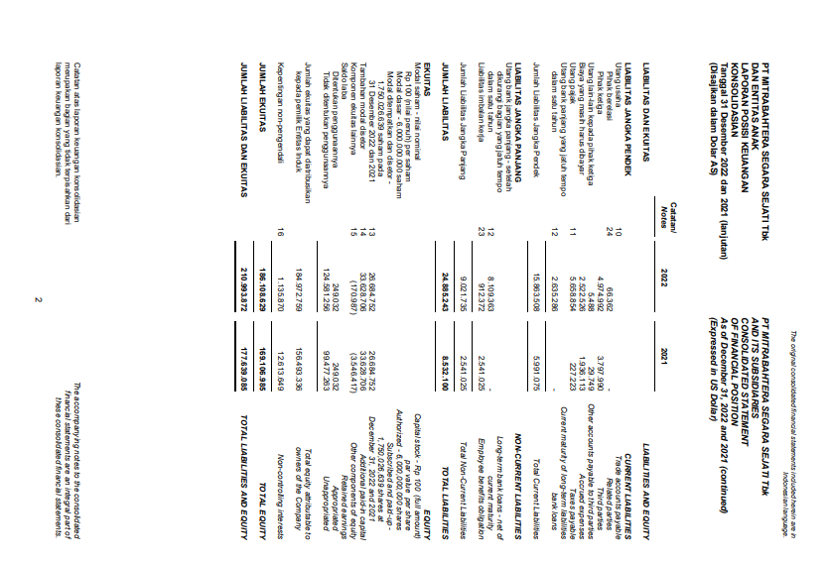

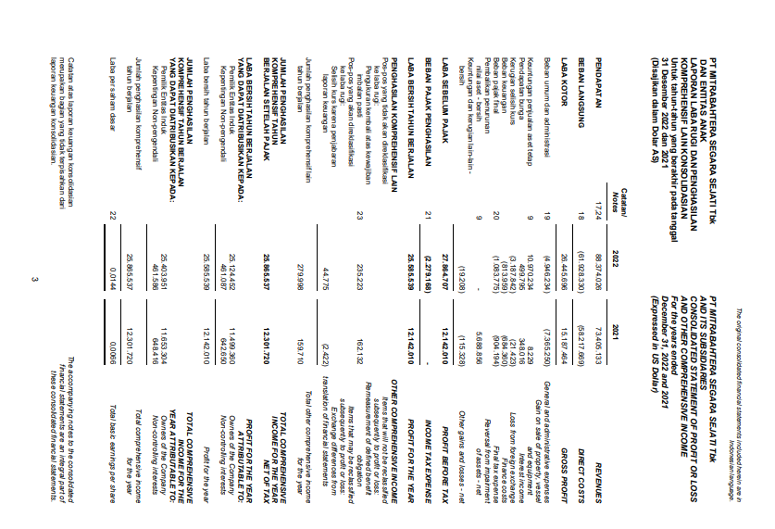

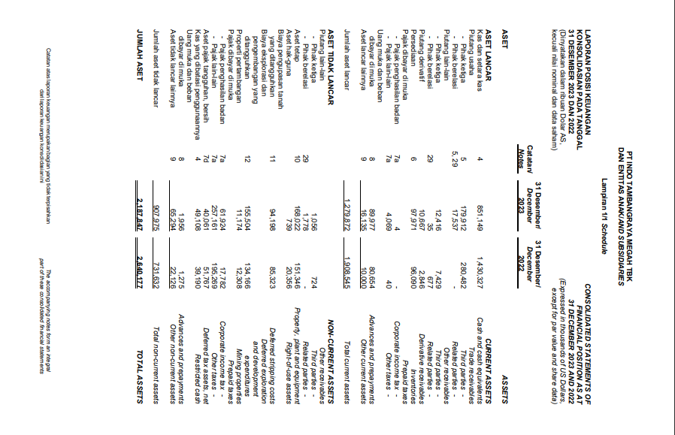

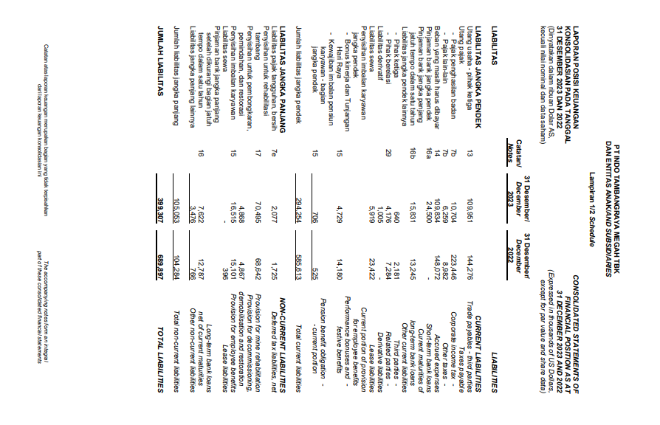

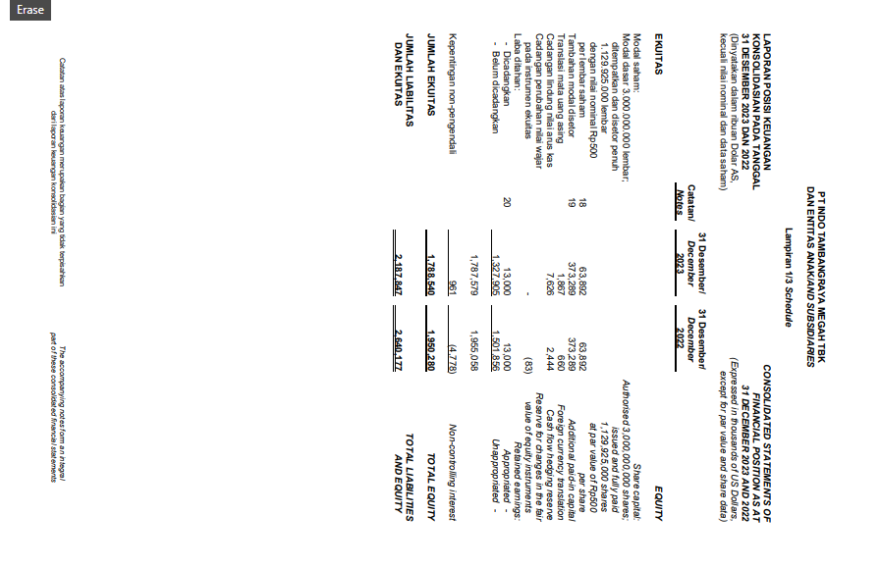

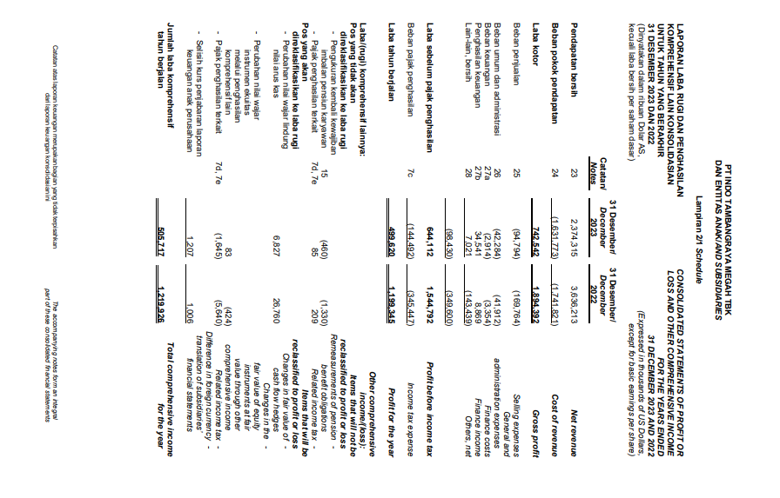

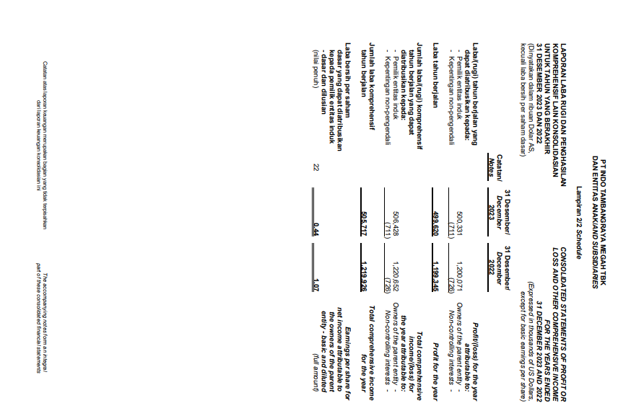

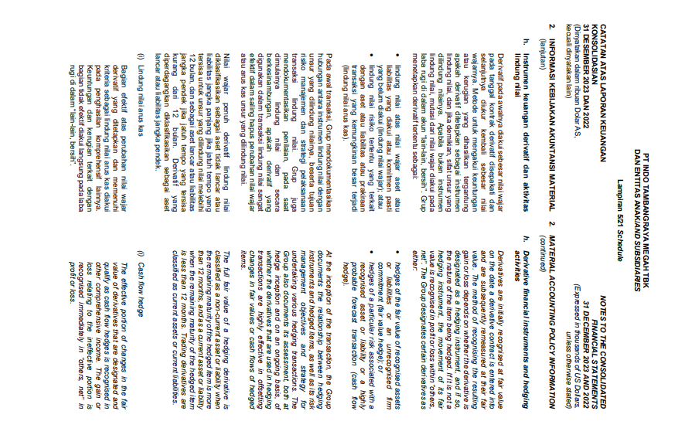

**Lampiran 12 Tabel Durbin-Watson**

