# DAFTAR PUSTAKA

Abdillah, F. (2012). Hubungan Kohesivitas Kelompok dengan Intensi Turnover pada Karyawan*.* *Journal of Social and Industrial Psychology. 1*(2), 52-58.

Achyana, M. (2016). Faktor-Faktor Yang Mempengaruhi Beban Kerja Room Attendant di Grand Jakarta Hotel Pekanbaru*.* *JOM FISIP. 3* (2), 1-12.

Ali, N., & Baloch, Q, B. (2010). Predictors of Organizational Commitment and Turnover Intention of Medical Representative (An Empirical Evidence of Pakistani Companies). *Journal of Management Sciences. 3*(2), 262-273.

Andriani, R., Disman, Ahman, E., & Santoso, B. (2020). *Conditional Process pada Manajemen SDM: Perspektif Polychronicity, Kepuasan Kerja, Engagement Karyawan, Lingkungan Kerja, dan Turnover Intention*. Jakarta: Gracias Logis Kreatif.

Ardan, M., & Jaelani, A. (2021). *Manajemen Sumber Daya Manusia: Turnover Intention Dapat Mempengaruhi Kualitas Kinerja Perusahaan* (H. Aulia (ed.)). Banyumas: CV. Pena Persada.

Aruna, A. (2018). *Pengaruh Gaya Kepemimpinan dan Beban Kerja terhadap Turonover Intention Karyawan pada CV. Daeng Kuliner Makassar.* Skripsi. Universitas Islam Negeri Alaudin, Makassar.

Ashford, S.J., Lee, C. dan Bobko, P. (1989) Content, Cause, and Consequences of Job Insecurity: A Theory-Based Measure and Substantive Test. *Academy of Management Journal. 3*(2), 803-829.

Asih, G. Y., Widhiastuti, H., & Dewi, R. (2018). *Stress Kerja* (Gabriel (ed.)). Semarang: Semarang University Press.

Azizaturrahma, N., Yunita, N., Prastika, R., Sanjaya, V. F. (2020). Pengaruh *Job Insecurity,* Stres Kerja, dan Beban Kerja Terhadap *Turnover Intention* di PT. Agro Prima Sejahtera Lampung. *JEMA: Jurnal Ekonomi, Manajemen, dan Akuntansi. 1*(1), 69-77.

Buchori. (2021). *Modul Analisis Beban Kerja*. Jakarta: Kementrian Agama RI Badan Litbang dan Diklat.

Budiasa, I. K. (2021). *Beban Kerja dan Kinerja Sumber Daya Manusia* (E. Safitry (ed.)). Banyumas: CV. Pena Persada.

Desvarani, R., & Tamami, S. (2019). Pengaruh *Job Imsecurity*, Kepuasan Kerja, dan Stres Kerja Terhadap *Turnover Intention* Pada PT. BPR Artha Prima Perkasa Pulau Batam. *Jurnal Gentiatas manajemen dan Akuntansi. 11*(1), 1-9

Diana, Yana. (2019). Pengaruh Beban Kerja Terhadap Kinerja Karyawan Di Housekeeping Departement Pada Hotel Bintan Lagoon Resort. *Jurnal Manajemen Tools. 11*(2), 193-206

Efendi, I. D. (2018). Analisis Pengaruh Stres Kerja Dan Konflik Pekerjaan- Keluarga (Work Family Conflict) Terhadap Kinerja Melalui Kepuasan Kerja Sebagai Variabel Intervening (Studi Pada Jajaran Satuan Reserse Kriminal Polresta Yogyakarta). *Prosiding National Conference on Applied Business*. 1–10.

Efitriana, I., & Liana, L. (2022). Pengaruh Kompensasi, Lingkungan Kerja, dan Gaya Kepemimpinan Terhadap Turnover Intention (Studi Pada Yamaha Mataram Sakti Semarang). *SEIKO: Journal of Management and Business. 5*(2), 182– 188.

Fauji, H. (2013). *Pengaruh Stres Kerja dan Konflik Kerja terhadap Semangat Kerja Karyawan.* Skripsi. Bandung: Universitas Pasundan.

Ghozali, I. (2012). *Aplikasi Analisis MUltivariate dengan Program IBM SPSS*. Semarang: Badan Penerbit Universitas Diponegoro

Ghozali, I. (2018). *Aplikasi Analisis Multivariate dengan Program IBM SPSS* 25. Semarang: Badan Penerbit Universitas Diponegoro.

Gitosudarmo, Indriyo. (2014). *Manajemen Operasi*. Yogyakarta: BPFE Yogyakarta.

Halimah, T, N., Fathoni, A., Minarsih, M, M. (2016). Lingkungan Kerja Terhadap Turnover Intention Pramuniaga di Gelael Supermarket (Studi Kasus Pada Gelael Superindo Kota Semarang). *Journal of Management. 2*(2).

Hallo, G, S., & Dewi, Y. E. P. (2022). Pengaruh Job Insecurity dan Stres kerja Terhadap Turnover Intention Pada Driver Gojek. *Journal Ilmiah Manajemen. 13*(2), 335-344.

Hasibuan, M. (2011). *Manajemen SDM*. Edisi Revisi, Cetakan Ke Tigabelas. Jakarta: Bumi Aksara.

Hermawati & Syofian. (2021). *Pengaruh Stres Kerja dan Beban Kerja Terhadap Kinerja Karyawan di PT. Sentra Adi Purna Bengkulu*. *Creative Research Management Journal. 4*(1), 77–91.

Hussain. (2013). The Influence of Intention to Leave Towards Employee Engagement Among Young Bankers in Malaysia. *International Journal of Business and Management. 8*(14), 89-97.

Hvinden, B. (2019). *Negotiating Early Job Insecurity*. USA: Edward Elgar Publishing.

Iskandar, & Yuhansyah. (2018). *Pengaruh Motivasi dan Ketidakamanan Kerja terhadap Penilaian Kerja yang Berdampak Kepada Kepuasan Kerja* (Lutfiah (ed.)). Surabaya: Media Sahabat Cendekia.

Joo, B., & Park, S. (2010). Career Satisfaction, Organizational Commitment and Turnover Intention. *Leadership & Organization Development Journal. 31*(6), 482– 500.

Kabito, G. G., Wami, S. D., Chercos, D. H., & Mekonnen, T. H. (2020). Work-related Stress and Associated Factors among Academic Staffs at the University of Gondar, Northwest Ethiopia: An Institution-based Cross-sectional Study. *Ethiopian Journal of Health Sciences*. *30*(2), 223– 232.

Karina, D., Rakhmawati, R., & Abidin. (2018).Pengaruh Job Insecurity Terhadap Turnover Intention Pada Karyawan Hotel Amaris. *JTAM Jurusan Manajemen FEB ULM: JIMI.* *1*(1), 62–72.

Khasanah, F. N. (2021). Pengaruh *Job Insecurity* dan Beban Kerja Terhadap *Turnover Intention* dengan Stres Kerja Sebagai Variabel Intervening (Studi Empiris Pada PT Juara Bike Tangerang). *Prosiding Seminar Fakultas Ekonomi UNTIDAR.* Magelang: 22 September, 1-13.

Kartono. (2017). *Personality, Employee Engagement, Emotional, Intellegence, Job Burnout Pendekatan dalam Melihat Turnover Intention*. Yogyakarta: CV Budi Utama.

Lompoliu, W. T., Nelwan, O. S., Lengkong, V. P. K. J. (2020). Pengaruh Job Insecurity, Job Stress, dan Iklim Organisasi Terhadap Turnover Intention Karyawan Pada PT. Golden Mitra Inti Perkasa Manado. *Jurnal EMBA.* *8*(1), 554–564.

Mahawati, E., Yuniwati, I., Firinia, R., & Rahayu, P. P. (2021). *Analisis Beban Kerja dan Produktivitas Kerja* (R. Watrianthos (ed.)). Medan: Yayasan Kita Menulis.

Mangkunegara, A.A. Anwar Prabu. (2017). *Manajemen Sumber Daya Manusia Perusahaan*. Bandung: Remaja Rosdakarya.

Manuaba. (2000). *Hubungan Beban Kerja dan Kapasitas Kerja*. Jakarta: Rineka Cipta.

Mukhyi., Abdul, M., & Hudiyanto, H. (1996). *Pengantar Manajemen Sumber Daya Manusia*. Jakarta: Gunadarma.

Nuzulia, S. (2021). *Dinamika Stres Kerja* (R. Abimanyu (ed.)). Sematrang: UNNES Press.

Paramitadewi, K. (2017). Pengaruh Beban Kerja Dan Kompensasi Terhadap Kinerja Pegawai Sekretariat Pemerintah Daerah Kabupaten Tabanan. *E-Jurnal Manajemen UNUD. 6*(6), 3370-3397.

Parvaiz, F.L., Saba Batool, Ambar Khalid, Y.A. (2015). Impact of Stressors (Role Conflict , Role Overload , Leadership Support and Organizational Politics) on Job Stress and its Subsequent Impact on Turnover Intention. *International Journal of Business and Management Invention,* 4(10), 52–63.

Pramesti, H. (2020). Pengaruh Komitmen Organisasi dan Job Insecurity Terhadap Kinerja Karyawan di PAM Tirta Moedal Kota. *SENABISMA. 6*(1), 47-59.

Putranti, H. R. D. (2022). *Turnover Intention* (D. E. Wiyoto (ed.)). Purbalingga: Eureka Media Aksara.

Rivai, Veithzal & Mulyadi, D. (2009). *Kepemimpinan dan Perilaku Organisasi*. Jakarta: Raja Grafindo Persada.

Robbins, J. (2015). *Organizational Behavior 16th Edition*. England: Pearson Education Limited

Saleh, L. M., Russeng, S., & Tadjuddun, I. (2020). *Manajemen Stres Kerja*. Yogyakarta: Deepublish Publisher.

Sani, M. P., & Suhana. (2022). Pengaruh Beban Kerja, Burnout, dan Komitmen Organisasi terhadap Perilaku Cyberloafing (Studi pada PT. ABC di Kabupaten Kendal. *Jurnal Management*, 7(2), 286-305.

Saputri, P., Hidayati, t., Lestari, D. (2020). Pengaruh *Job Insecurity* Terhadap Stres Kerja, Kinerja, dan *Turnover Intention* Karyawan PT. Bank Mandiri (Persero) Tbk. *Jurnal Bisnis dan Manajemen. 16*(3), 235-259.

Septiari, N., & Ardana, I. (2016). Pengaruh Job Insecurity dan Stres Kerja Terhadap Turnover Intention Karyawan Pada Hotel Asana Agung Putra Bali. *E-Journal Manajemen UNUD. 5*(10), 6429-6456.

Setiawan, I. N. A., & Putra, M. S. (2016). Turnover Intention Pada Karyawan Legian Village Hotel. *E-Journal Manajemen UNUD. 5*(8), 4983–5012.

Siagian. (2014). *Manajemen Sumber Daya Manusia*. Jakarta: Bumi Aksara

Siddiqui, L., Sandeep, Paarcha, A., Siddiqui, M, A. (2015). Word Participation of Elderly in Haryana – A Case Study of District Rohtak. *International Research Journal of Social Sciences. 4*(12), 55-62.

Solehah, S., & Ratnasari, S. L. (2019). Pengaruh Gaya Kepemimpinan, Beban Kerja, Job Insecurity Terhadap Turnover Intention Karyawan PT. Federal Internasional Finance Cab Batam Effect of Leadership Style, Workload, Job Insecurity on Turnover Intention Employee of PT. FIF Federal Internasi. *Jurnal Dimensi Universitas Riau Kepulauan. 8*(2), 210–239.

Suartana, I. W. (2000). *Anteseden dan Konsekuensi Job Insecurity dan Keinginan Berpindah pada Internal Auditor*. Tesis. Yogyakarta: Universitas Gadjah Mada.

Suciati, H., Andi, T., & Magdalena, M. (2014). Job Insecurity and Job Stress effect of Turnover Intention on PT. Berkat Abadi Surya Cemerlang Semarang (HO). *E-Jurnal Manajemen UNUD.* 11-35.

Sugiyono. (2013). *Metode Penelitian Kuantitatif, Kualitatif, dan R&D.* Bandung: Alfabeta.

Sugiyono. (2014). *Metode Penelitian Pendidikan Pendekatan Kuantitatif, Kualitatif, dan R&D*. Bandung: Alfabeta

Sugiyono. (2017). *Metode Penelitian Kuantitatif, Kualitatif dan R&D*. Bandung: CV. Alfabeta.

Suhana, S. (2022). Pengaruh Beban Kerja, Burnout, dan Komitmen Organisasi Terhadap Perilaku Cyberloafing (Studi Pada PT. ABC di Kabupaten Kendal). *Jurnal Mirai Manajemen. 7*(2), 286– 305.

Suliyanto. (2018). *Metode Penelitian Bisnis*. Yogyakarta: Andi.

Sunyoto, D., & Yulia, I. F. (2023). *Stres Kerja* (M. A. Kalijaga (ed.)). Purbalingga: Eureka Media Aksara.

Sverke, M. (2004). *Job insecurity and Union Membership European Unions in the Wake of Flexible Production*. Brusel: P.I.E, Peter Lang S.A.

Syamsul, Pakaya, S., Musafir, Karim, S. T. (2012). Pengaruh Job Insecurity dan Beban Kerja Terhadap Turnover Intention Pada PT. Telkom Akses Gorontalo. *Journal of Technopreneurship. 4*(1), 1–33.

Tarwaka. (2015). *Ergonomi Industri Dasar-Dasar Pengetahuan Ergonomi dan Aplikasi di Tempat Kerja*. Surakarta: Harapan Press.

Tsani, Rakhma, R. (2016). Pengaruh Lingkungan Kerja dan Kepuasan Kerja terhadap Turnover Intention. *Jurnal Manajemen Bisnis Indonesia (JMBI)* *5*(5), 504- 515.

Umama, H. azza. (2019). *Psikologi Industri dan Organisasi*. Semarang: Semarang University Press.

Wicaksono, W. (2012). Pengaruh Job Insecurity, Job Stress dan Work-Family Conflict Terhadap Turnover Intention. *UMY Repository.* 1–33.

Wulandari, F. R. & Rizana, D. (2020). Pengaruh *Job Insecurity*, dan Stres Kerja Terhadap *Turnover Intention* Dengan Kepuasan Kerja Sebagai Variabel Intervening (Studi Pada Karyawan PT. MNC Sky Vision Tbk Kebumen). *JIMMBA*: *Jurnal Ilmiah Mahasiswa Manajemen Bisnis dan Akuntansi. 2*(3), 323-330.

Yusiana, F. &. (2020). Analisis Pengaruh Kompensasi dan Beban Kerja terhadap Kepuasan Kerja dan Turnover Intention pada Karyawan Inti Pangan, Kuningan. *Indonesian Journal of Strategic Management. 3*(2), 1-14.

**LAMPIRAN**

Lampiran 1 Lembar Kuesioner

Perihal : Permohonan pengisian kuesioner

Judul Penelitian : Pengaruh Job Insecurity, Stres Kerja, dan Beban Kerja Terhadap Turnover Intention Karyawan PT. Merdeka Peken Raya Suradadi Tegal

Kepada Yth. Bapak/ Ibu/ Saudara Responden

Di Tempat

Dengan Hormat,

Dalam rangka menyelesaikan penelitian, saya Anjani Putri Melati (4120600067) mahasiswa Fakultas Ekonomi dan Bisnis Universitas Pancasakti Tegal, memohon partisipasi dari saudara untuk mengisi kuesioner yang kami sediakan.

Adapun data yang kami minta adalah sesuai dengan kondisi yang dirasakan saudara selama ini. Kami akan menjaga kerahasiaan karena data ini hanya untuk kepentingan penelitian. Setiap jawaban yang diberikan merupakan bantuan yang tidak ternilai harganya bagi penelitian ini. Atas perhatian dan bantuannya, saya mengucapkan terimakasih.

Tegal, 26 April 2024

Anjani Putri Melati

1. **Identitas Responden**
2. Jenis Kelamin : Laki-laki Perempuan
3. Pendidikan Terakhir :SMA/SMK DI/DII/DIII

SI S2

1. Umur tahun :20-30 Tahun 31-40 Tahun

>40 Tahun

1. **Petunjuk Pengisian Kuesioner**

Berikan tanda *checklist*/centang pada kotak yang tersedia dijawaban yang anda pilih dan yang sesuai dengan kondisi sebenarnya yang ada pada PT. Merdeka Peken Raya Suradadi Tegal.

Keterangan pilihan jawaban:

SS : Sangat Setuju

S : Setuju

N : Netral

TS : Tidak Setuju

STS : Sangat Tidak Setuju

**Variabel Turnover Intention**

|  |  |  |  |  |  |  |
| --- | --- | --- | --- | --- | --- | --- |
| **No** | **Pernyataan** | **Jawaban** | | | | |
| **SS** | **S** | **N** | **TS** | **STS** |
| 1. | Saya sering absen atau tidak masuk kerja |  |  |  |  |  |
| 2. | Saya pernah tidak masuk kerja lebih dari 3 hari |  |  |  |  |  |
| 3. | Saya merasa tidak menyelesaikan pekerjaan tepat waktu |  |  |  |  |  |
| 4. | Saya merasa sudah melakukan protes saat pekerjaan dirasa terlalu berat atau membebankan |  |  |  |  |  |
| 5. | Saya berfikir untuk berpindah kerja, dan mencari pekerjaan lain |  |  |  |  |  |
| 6. | Saya merasa mulai melanggar tata tertib, seperti terlambat masuk kerja dan bekerja tidak sesuai shift |  |  |  |  |  |
| 7. | Saya merasa tidak puas dalam bekerja, dan mulai mencari alternatif pekerjaan lain |  |  |  |  |  |
| 8. | Gaji yang diberikan perusahaan tidak sesuai dengan pekerjaan yang saya lakukan |  |  |  |  |  |
| 9. | Gaji yang diberikan tidak cukup untuk memenuhi kebutuhan saya |  |  |  |  |  |
| 10. | Adanya kepantasan penghasilan yang diterima setiap bulannya memotivasi saya untuk bekerja lebih baik lagi |  |  |  |  |  |

**Variabel Job Insecurity**

|  |  |  |  |  |  |  |
| --- | --- | --- | --- | --- | --- | --- |
| **No** | **Pernyataan** | **Jawaban** | | | | |
| **SS** | **S** | **N** | **TS** | **STS** |
| 1. | Saya merasa senang karena perusahaan menepati janji untuk menaikkan gaji sesuai dengan besaran yang dijanjikan |  |  |  |  |  |
| 2. | Saya merasa masa kerja dijadikan pertimbangan dalam melakukan promosi jabatan di perusahaan |  |  |  |  |  |
| 3. | Saya merasa adanya ketidaknyamanan dalam bekerja yang berdampak pada keberlangsungan karir saya |  |  |  |  |  |
| 4. | Saya merasa tidak mampu saat mengerjakan pekerjaan yang bukan kompetensi saya |  |  |  |  |  |
| 5. | Saya merasa tidak mampu mempertahankan pekerjaan karena perusahaan kurang memberikan fasilitas yang memadai dan lingkungan yang kurang bagus |  |  |  |  |  |
| 6. | Saya merasa lingkungan kerja tidak sehat dan selalu tidak kondusif |  |  |  |  |  |
| 7. | Saya merasa komunikasi yang terjadi saat ini mampu menciptakan hubungan yang baik antar sesama karyawan di perusahaan |  |  |  |  |  |
| 8. | Saya merasa adanya perubahan organisasi dalam perusahaan |  |  |  |  |  |
| 9. | Saya merasa usia mempengaruhi pekerjaan karyawan |  |  |  |  |  |
| 10. | Saya merasa *gender* mempengaruhi dalam mengerjakan pekerjaan dan cara mengatasi permasalahan di perusahaan |  |  |  |  |  |
| 11. | Saya merasa keefisien dalam proses pekerjaan karyawan dilihat dari tingkat pendidikannya |  |  |  |  |  |
| 12. | Saya merasa karyawan dengan masa kerja yang lama memberikan dampak positif dan arahan serta bimbingan yang baik |  |  |  |  |  |
| 13. | Saya merasa sosial ekonomi yang berbeda membuat gaya hidup dilingkungan kerja tidak sehat |  |  |  |  |  |
| 14. | Saya merasa pengalaman kerja membuat pekerjaan dan wewenang yang diberikan ke saya lebih mudah |  |  |  |  |  |
| 15. | Saya merasa mampu mengendalikan situasi didalam diri saya saat dilingkungan kerja |  |  |  |  |  |
| 16. | Saya merasa motivasi dan dukungan dari atasan sangat berpengaruh untuk kinerja yang maksimal |  |  |  |  |  |
| 17. | Rasa percaya diri akan kemampuannya dalam menyelesaikan pekerjaan adalah kunci keberhasilan |  |  |  |  |  |
| 18. | Atasan yang tidak percaya dengan kinerja karyawannya akan membuat ketidaknyamanan dalam lingkungan kerja |  |  |  |  |  |

**Variabel Stres Kerja**

|  |  |  |  |  |  |  |
| --- | --- | --- | --- | --- | --- | --- |
| **No** | **Pernyataan** | **Jawaban** | | | | |
| **SS** | **S** | **N** | **TS** | **STS** |
| 1. | Tempat kerja yang tidak kondusif dengan kebisingan dan kotor membuat stres dan gangguan fokus dalam bekerja |  |  |  |  |  |
| 2. | Saya merasa pencahayaan didalam ruang kerja kurang memadai yang membuat karyawan mengantuk saat bekerja |  |  |  |  |  |
| 3. | Tuntutan tugas yang tidak wajar akan membuat karyawan tidak nyaman dengan pekerjannya |  |  |  |  |  |
| 4. | Beban kerja yang menumpuk dan jam kerja yang tidak sesuai SOP akan membuat karyawan stres yang berlebihan |  |  |  |  |  |
| 5. | Saya merasa karyawan yang mempunyai konflik pribadi sangat mempengaruhi pekerjaannya |  |  |  |  |  |
| 6. | Saya merasa sering telat masuk kerja karena harus mengurus anak dirumah |  |  |  |  |  |
| 7 | Saya merasa terbebani apabila ditugaskan atasan untuk keluar kantor saat jam kerja dan kerjaan saya belum selesai |  |  |  |  |  |
| 8 | Saya merasa tidak mampu menyelesaikan pekerjaan apabila bukan divisi dari saya |  |  |  |  |  |
| 9. | Saya merasa tidak nyaman apabila pekerjaan saya tidak diapresiasi oleh atasan dan patner kerja |  |  |  |  |  |
| 10. | Saya merasa terbebani apabila diberi tanggung jawab pekerjaan dan wewenang yang berlebihan |  |  |  |  |  |

**Variabel Beban Kerja**

|  |  |  |  |  |  |  |
| --- | --- | --- | --- | --- | --- | --- |
| **No** | **Pernyataan** | **Jawaban** | | | | |
| **SS** | **S** | **N** | **TS** | **STS** |
| 1. | Saya merasa kondisi kerja yang kondusif membuat karyawan merasa nyaman dalam bekerja |  |  |  |  |  |
| 2. | Saya merasa memiliki organisasi kerja yang saling peduli sesama karyawan |  |  |  |  |  |
| 3. | Lingkungan kerja yang sehat dan persaingan antar karyawan ysng sehat membuat kondisi kantor selalu kondusif |  |  |  |  |  |
| 4. | Tuntutan sikap dalam bekerja di lingkungan kerja membuat kesehatan mental saya terganggu |  |  |  |  |  |
| 5. | Gaji dan tunjangan yang diberikan perusahaan membuat saya lebih rajin dalam bekerja |  |  |  |  |  |
| 6. | Setiap ada persepsi yang berbeda antar karyawan dan pekerjaannya harus saling menghargai satu sama lain |  |  |  |  |  |
| 7. | Kepercayaan atasan kepada karyawannya menjadi salah satu motivasi untuk karyawannya |  |  |  |  |  |
| 8. | Saya merasa karyawan yang sudah bekerja lama di perusahaan ini wajar memiliki keinginan untuk naik jabatan yang lebih baik |  |  |  |  |  |
| 9. | Saya merasa puas apabila hasil pekerjaan saya diberikan penghargaan dari perusahaan |  |  |  |  |  |

Lampiran 2 Jawaban Responden Pernyataan *Turnover Intention*

|  |  |  |  |  |  |  |  |  |  |  |  |
| --- | --- | --- | --- | --- | --- | --- | --- | --- | --- | --- | --- |
| **Responden** | **Y1** | **Y2** | **Y3** | **Y4** | **Y5** | **Y6** | **Y7** | **Y8** | **Y9** | **Y10** | **Total** |
| 1 | 4 | 4 | 4 | 3 | 4 | 3 | 4 | 4 | 3 | 4 | 37 |
| 2 | 1 | 1 | 1 | 1 | 5 | 5 | 5 | 1 | 1 | 1 | 22 |
| 3 | 1 | 1 | 1 | 3 | 2 | 1 | 2 | 3 | 2 | 5 | 21 |
| 4 | 2 | 2 | 2 | 2 | 2 | 2 | 2 | 2 | 2 | 2 | 20 |
| 5 | 1 | 4 | 2 | 3 | 4 | 1 | 2 | 2 | 3 | 4 | 26 |
| 6 | 1 | 1 | 1 | 4 | 3 | 1 | 3 | 3 | 3 | 4 | 24 |
| 7 | 1 | 3 | 1 | 4 | 2 | 1 | 1 | 4 | 2 | 2 | 21 |
| 8 | 3 | 3 | 3 | 3 | 3 | 3 | 3 | 4 | 4 | 5 | 34 |
| 9 | 3 | 4 | 3 | 4 | 3 | 3 | 4 | 3 | 4 | 3 | 34 |
| 10 | 2 | 2 | 1 | 3 | 4 | 1 | 3 | 2 | 3 | 3 | 24 |
| 11 | 4 | 5 | 5 | 2 | 3 | 5 | 4 | 4 | 3 | 2 | 37 |
| 12 | 2 | 2 | 2 | 4 | 4 | 2 | 4 | 2 | 2 | 4 | 28 |
| 13 | 1 | 1 | 1 | 3 | 4 | 2 | 4 | 2 | 2 | 5 | 25 |
| 14 | 5 | 5 | 4 | 4 | 5 | 4 | 3 | 3 | 4 | 4 | 41 |
| 15 | 4 | 4 | 4 | 3 | 2 | 4 | 4 | 2 | 3 | 1 | 31 |
| 16 | 1 | 1 | 1 | 4 | 2 | 1 | 2 | 3 | 3 | 4 | 22 |
| 17 | 1 | 1 | 1 | 5 | 1 | 1 | 1 | 1 | 1 | 1 | 14 |
| 18 | 4 | 4 | 4 | 4 | 4 | 4 | 4 | 5 | 5 | 4 | 42 |
| 19 | 3 | 3 | 3 | 4 | 3 | 4 | 3 | 5 | 5 | 5 | 38 |
| 20 | 1 | 1 | 3 | 3 | 2 | 4 | 4 | 2 | 4 | 4 | 28 |
| 21 | 2 | 1 | 2 | 4 | 1 | 2 | 3 | 3 | 3 | 3 | 24 |
| 22 | 3 | 3 | 3 | 3 | 3 | 3 | 3 | 3 | 3 | 3 | 30 |
| 23 | 3 | 3 | 4 | 3 | 4 | 3 | 4 | 4 | 3 | 4 | 35 |
| 24 | 1 | 1 | 2 | 3 | 4 | 3 | 4 | 3 | 3 | 3 | 27 |
| 25 | 1 | 2 | 5 | 3 | 1 | 1 | 1 | 1 | 1 | 1 | 17 |
| 26 | 4 | 5 | 3 | 4 | 4 | 5 | 4 | 4 | 5 | 5 | 43 |
| 27 | 1 | 1 | 3 | 2 | 2 | 2 | 3 | 3 | 3 | 4 | 24 |
| 28 | 3 | 3 | 4 | 4 | 4 | 3 | 3 | 5 | 5 | 5 | 39 |
| 29 | 1 | 2 | 1 | 2 | 3 | 2 | 2 | 2 | 2 | 3 | 20 |
| 30 | 1 | 1 | 2 | 2 | 5 | 2 | 1 | 5 | 5 | 5 | 29 |
| 31 | 4 | 4 | 4 | 4 | 4 | 4 | 4 | 4 | 4 | 4 | 40 |
| 32 | 4 | 4 | 4 | 4 | 4 | 4 | 4 | 4 | 4 | 4 | 40 |
| 33 | 1 | 1 | 1 | 1 | 1 | 1 | 1 | 1 | 1 | 1 | 10 |

Lampiran 3 Jawaban Responden Pernyataan *Job Insecurity*

|  |  |  |  |  |  |  |  |  |  |  |  |  |  |  |  |  |  |  |  |
| --- | --- | --- | --- | --- | --- | --- | --- | --- | --- | --- | --- | --- | --- | --- | --- | --- | --- | --- | --- |
| **Responden** | **X1.1** | **X1.2** | **X1.3** | **X1.4** | **X1.5** | **X1.6** | **X1.7** | **X1.8** | **X1.9** | **X1.10** | **X1.11** | **X1.12** | **X1.13** | **X1.14** | **X1.15** | **X1.16** | **X1.17** | **X1.18** | **Total** |
| 1 | 4 | 3 | 4 | 5 | 5 | 5 | 5 | 5 | 5 | 5 | 4 | 3 | 5 | 4 | 5 | 5 | 4 | 4 | 76 |
| 2 | 5 | 5 | 1 | 1 | 1 | 1 | 5 | 5 | 5 | 5 | 5 | 5 | 5 | 5 | 5 | 5 | 5 | 5 | 69 |
| 3 | 5 | 5 | 4 | 4 | 4 | 3 | 5 | 3 | 3 | 4 | 3 | 5 | 4 | 5 | 5 | 5 | 5 | 5 | 72 |
| 4 | 5 | 4 | 5 | 3 | 3 | 2 | 5 | 5 | 5 | 4 | 5 | 5 | 5 | 5 | 5 | 5 | 5 | 5 | 76 |
| 5 | 4 | 3 | 2 | 2 | 2 | 2 | 3 | 4 | 4 | 3 | 2 | 5 | 4 | 4 | 4 | 5 | 5 | 5 | 59 |
| 6 | 3 | 4 | 3 | 3 | 3 | 3 | 3 | 4 | 3 | 4 | 3 | 3 | 3 | 4 | 4 | 4 | 4 | 4 | 59 |
| 7 | 4 | 2 | 2 | 2 | 2 | 2 | 5 | 1 | 4 | 1 | 1 | 3 | 1 | 3 | 3 | 4 | 5 | 1 | 42 |
| 8 | 4 | 4 | 3 | 3 | 3 | 3 | 4 | 3 | 3 | 3 | 3 | 4 | 3 | 3 | 3 | 3 | 3 | 3 | 54 |
| 9 | 5 | 2 | 5 | 3 | 1 | 1 | 3 | 3 | 3 | 3 | 3 | 3 | 3 | 3 | 3 | 5 | 4 | 4 | 52 |
| 10 | 4 | 4 | 2 | 2 | 3 | 4 | 4 | 3 | 4 | 2 | 3 | 3 | 4 | 4 | 4 | 4 | 4 | 4 | 58 |
| 11 | 4 | 3 | 4 | 4 | 4 | 2 | 5 | 3 | 5 | 3 | 5 | 5 | 4 | 4 | 5 | 5 | 5 | 5 | 71 |
| 12 | 2 | 4 | 4 | 4 | 4 | 4 | 4 | 4 | 2 | 2 | 4 | 4 | 4 | 4 | 4 | 5 | 4 | 5 | 66 |
| 13 | 2 | 4 | 5 | 3 | 2 | 2 | 2 | 2 | 4 | 4 | 4 | 4 | 2 | 4 | 4 | 5 | 5 | 5 | 61 |
| 14 | 3 | 4 | 5 | 3 | 4 | 3 | 3 | 4 | 4 | 4 | 5 | 4 | 4 | 2 | 3 | 4 | 3 | 3 | 62 |
| 15 | 2 | 1 | 2 | 3 | 2 | 2 | 2 | 2 | 1 | 4 | 4 | 1 | 3 | 2 | 1 | 2 | 1 | 1 | 34 |
| 16 | 2 | 3 | 2 | 4 | 3 | 2 | 3 | 3 | 3 | 3 | 3 | 4 | 3 | 4 | 4 | 4 | 4 | 4 | 56 |
| 17 | 5 | 5 | 1 | 5 | 1 | 1 | 5 | 1 | 1 | 1 | 1 | 5 | 1 | 1 | 5 | 5 | 5 | 5 | 49 |
| 18 | 5 | 5 | 4 | 4 | 4 | 4 | 4 | 5 | 4 | 4 | 4 | 5 | 4 | 4 | 4 | 5 | 4 | 4 | 72 |
| 19 | 5 | 5 | 4 | 4 | 4 | 5 | 5 | 5 | 3 | 3 | 3 | 5 | 5 | 5 | 3 | 5 | 4 | 4 | 72 |
| 20 | 4 | 4 | 4 | 3 | 4 | 4 | 5 | 5 | 4 | 5 | 4 | 4 | 3 | 5 | 4 | 4 | 3 | 3 | 68 |
| 21 | 2 | 2 | 4 | 4 | 3 | 4 | 3 | 3 | 4 | 3 | 1 | 4 | 2 | 3 | 2 | 2 | 4 | 2 | 50 |
| 22 | 3 | 3 | 3 | 3 | 3 | 3 | 3 | 3 | 3 | 3 | 3 | 3 | 3 | 3 | 3 | 3 | 3 | 3 | 51 |
| 23 | 4 | 4 | 3 | 3 | 3 | 3 | 3 | 3 | 3 | 4 | 4 | 4 | 4 | 3 | 3 | 4 | 4 | 3 | 58 |
| 24 | 4 | 4 | 4 | 3 | 4 | 2 | 4 | 4 | 3 | 2 | 3 | 4 | 3 | 4 | 4 | 4 | 4 | 4 | 60 |
| 25 | 3 | 5 | 5 | 3 | 4 | 4 | 4 | 4 | 1 | 1 | 1 | 1 | 1 | 1 | 5 | 5 | 5 | 5 | 55 |
| 26 | 3 | 4 | 4 | 5 | 4 | 4 | 5 | 5 | 5 | 4 | 5 | 4 | 5 | 4 | 4 | 4 | 4 | 5 | 75 |
| 27 | 4 | 4 | 2 | 3 | 3 | 2 | 4 | 3 | 4 | 2 | 3 | 4 | 3 | 4 | 4 | 4 | 4 | 4 | 57 |
| 28 | 5 | 4 | 4 | 3 | 3 | 3 | 5 | 3 | 4 | 3 | 5 | 5 | 4 | 4 | 4 | 4 | 5 | 4 | 67 |
| 29 | 4 | 4 | 2 | 4 | 2 | 2 | 4 | 2 | 4 | 4 | 3 | 3 | 2 | 4 | 3 | 3 | 4 | 4 | 54 |
| 30 | 5 | 5 | 4 | 2 | 4 | 5 | 5 | 5 | 5 | 4 | 4 | 5 | 4 | 4 | 4 | 4 | 4 | 3 | 71 |
| 31 | 4 | 4 | 4 | 4 | 4 | 4 | 4 | 4 | 4 | 4 | 4 | 4 | 4 | 4 | 4 | 4 | 4 | 4 | 68 |
| 32 | 4 | 4 | 4 | 4 | 4 | 4 | 4 | 4 | 4 | 4 | 4 | 4 | 4 | 4 | 4 | 4 | 4 | 4 | 68 |
| 33 | 5 | 5 | 1 | 1 | 1 | 1 | 5 | 1 | 1 | 1 | 5 | 5 | 1 | 5 | 5 | 5 | 5 | 5 | 53 |

Lampiran 4 Jawaban Responden Pernyataan Stres Kerja

|  |  |  |  |  |  |  |  |  |  |  |  |
| --- | --- | --- | --- | --- | --- | --- | --- | --- | --- | --- | --- |
| **Responden** | **X2.1** | **X2.2** | **X2.3** | **X2.4** | **X2.5** | **X2.6** | **X2.7** | **X2.8** | **X2.9** | **X2.10** | **Total** |
| 1 | 5 | 4 | 4 | 3 | 3 | 4 | 3 | 4 | 4 | 3 | 37 |
| 2 | 1 | 5 | 5 | 5 | 1 | 1 | 1 | 1 | 1 | 1 | 22 |
| 3 | 5 | 5 | 5 | 5 | 4 | 3 | 4 | 4 | 5 | 4 | 44 |
| 4 | 5 | 5 | 5 | 5 | 5 | 3 | 5 | 5 | 5 | 5 | 48 |
| 5 | 5 | 5 | 5 | 5 | 5 | 1 | 3 | 3 | 5 | 3 | 40 |
| 6 | 4 | 3 | 4 | 4 | 4 | 1 | 3 | 3 | 3 | 3 | 32 |
| 7 | 5 | 5 | 5 | 5 | 5 | 2 | 4 | 3 | 3 | 5 | 42 |
| 8 | 4 | 4 | 4 | 4 | 4 | 3 | 3 | 3 | 3 | 3 | 35 |
| 9 | 5 | 5 | 5 | 5 | 3 | 1 | 3 | 5 | 4 | 2 | 38 |
| 10 | 4 | 3 | 4 | 4 | 3 | 1 | 3 | 3 | 4 | 3 | 32 |
| 11 | 5 | 5 | 5 | 5 | 3 | 1 | 3 | 4 | 4 | 4 | 39 |
| 12 | 5 | 4 | 4 | 5 | 5 | 2 | 4 | 4 | 4 | 4 | 41 |
| 13 | 5 | 4 | 5 | 4 | 4 | 1 | 4 | 4 | 2 | 2 | 35 |
| 14 | 4 | 3 | 2 | 3 | 3 | 2 | 4 | 5 | 5 | 4 | 35 |
| 15 | 1 | 2 | 1 | 1 | 1 | 2 | 2 | 2 | 3 | 1 | 16 |
| 16 | 4 | 3 | 4 | 4 | 3 | 1 | 3 | 3 | 2 | 2 | 29 |
| 17 | 5 | 1 | 5 | 5 | 5 | 1 | 5 | 5 | 5 | 5 | 42 |
| 18 | 5 | 5 | 4 | 4 | 5 | 4 | 4 | 5 | 5 | 5 | 46 |
| 19 | 5 | 4 | 3 | 4 | 4 | 4 | 4 | 4 | 5 | 4 | 41 |
| 20 | 5 | 4 | 4 | 4 | 5 | 5 | 3 | 3 | 4 | 5 | 42 |
| 21 | 4 | 4 | 4 | 4 | 4 | 4 | 4 | 4 | 4 | 4 | 40 |
| 22 | 3 | 3 | 3 | 3 | 3 | 3 | 3 | 3 | 3 | 3 | 30 |
| 23 | 3 | 4 | 4 | 4 | 4 | 4 | 3 | 4 | 3 | 4 | 37 |
| 24 | 4 | 4 | 5 | 5 | 5 | 2 | 3 | 4 | 4 | 4 | 40 |
| 25 | 5 | 5 | 5 | 5 | 5 | 5 | 5 | 5 | 3 | 3 | 46 |
| 26 | 5 | 5 | 4 | 4 | 4 | 4 | 5 | 4 | 5 | 4 | 44 |
| 27 | 3 | 2 | 3 | 2 | 3 | 2 | 3 | 3 | 2 | 3 | 26 |
| 28 | 5 | 4 | 4 | 5 | 4 | 3 | 4 | 3 | 4 | 4 | 40 |
| 29 | 5 | 4 | 2 | 4 | 4 | 1 | 4 | 4 | 4 | 4 | 36 |
| 30 | 4 | 3 | 4 | 4 | 4 | 4 | 3 | 2 | 4 | 4 | 36 |
| 31 | 4 | 4 | 4 | 4 | 4 | 4 | 4 | 4 | 3 | 4 | 39 |
| 32 | 4 | 4 | 4 | 4 | 4 | 4 | 4 | 4 | 4 | 4 | 40 |
| 33 | 1 | 2 | 2 | 2 | 2 | 2 | 2 | 2 | 2 | 2 | 19 |

Lampiran 5 Jawaban Responden Pernyataan Beban Kerja

|  |  |  |  |  |  |  |  |  |  |  |
| --- | --- | --- | --- | --- | --- | --- | --- | --- | --- | --- |
| **Responden** | **X3.1** | **X3.2** | **X3.3** | **X3.4** | **X3.5** | **X3.6** | **X3.7** | **X3.8** | **X3.9** | **Total** |
| 1 | 3 | 4 | 4 | 5 | 5 | 4 | 4 | 4 | 4 | 37 |
| 2 | 5 | 5 | 5 | 5 | 5 | 5 | 5 | 5 | 5 | 45 |
| 3 | 5 | 5 | 5 | 3 | 5 | 5 | 5 | 5 | 5 | 43 |
| 4 | 5 | 5 | 5 | 3 | 5 | 5 | 5 | 5 | 5 | 43 |
| 5 | 5 | 4 | 4 | 3 | 5 | 5 | 5 | 5 | 5 | 41 |
| 6 | 4 | 3 | 4 | 3 | 3 | 5 | 4 | 4 | 4 | 34 |
| 7 | 5 | 4 | 5 | 3 | 5 | 4 | 4 | 3 | 5 | 38 |
| 8 | 4 | 4 | 5 | 2 | 4 | 4 | 4 | 4 | 4 | 35 |
| 9 | 1 | 5 | 1 | 1 | 3 | 3 | 4 | 5 | 5 | 28 |
| 10 | 4 | 4 | 4 | 3 | 4 | 3 | 4 | 3 | 4 | 33 |
| 11 | 5 | 4 | 5 | 3 | 4 | 4 | 4 | 4 | 5 | 38 |
| 12 | 4 | 4 | 4 | 4 | 5 | 4 | 4 | 4 | 4 | 37 |
| 13 | 5 | 4 | 5 | 4 | 5 | 4 | 4 | 4 | 4 | 39 |
| 14 | 4 | 3 | 3 | 2 | 2 | 3 | 4 | 3 | 4 | 28 |
| 15 | 1 | 2 | 1 | 2 | 1 | 1 | 1 | 1 | 1 | 11 |
| 16 | 4 | 3 | 4 | 3 | 4 | 4 | 4 | 4 | 4 | 34 |
| 17 | 5 | 5 | 5 | 1 | 5 | 5 | 5 | 5 | 5 | 41 |
| 18 | 4 | 4 | 5 | 4 | 4 | 5 | 5 | 4 | 4 | 39 |
| 19 | 5 | 5 | 5 | 3 | 4 | 3 | 4 | 5 | 5 | 39 |
| 20 | 4 | 4 | 4 | 4 | 4 | 4 | 4 | 4 | 5 | 37 |
| 21 | 4 | 4 | 4 | 4 | 3 | 3 | 4 | 4 | 4 | 34 |
| 22 | 3 | 3 | 3 | 3 | 3 | 3 | 3 | 3 | 3 | 27 |
| 23 | 4 | 4 | 4 | 4 | 4 | 3 | 4 | 4 | 4 | 35 |
| 24 | 4 | 5 | 5 | 4 | 3 | 4 | 4 | 5 | 5 | 39 |
| 25 | 5 | 5 | 5 | 5 | 5 | 5 | 5 | 5 | 5 | 45 |
| 26 | 4 | 4 | 4 | 4 | 4 | 5 | 4 | 5 | 5 | 39 |
| 27 | 4 | 4 | 4 | 3 | 4 | 4 | 5 | 5 | 4 | 37 |
| 28 | 5 | 4 | 4 | 3 | 5 | 5 | 4 | 5 | 5 | 40 |
| 29 | 4 | 4 | 5 | 4 | 4 | 4 | 4 | 4 | 4 | 37 |
| 30 | 4 | 4 | 2 | 4 | 4 | 5 | 5 | 5 | 5 | 38 |
| 31 | 4 | 4 | 4 | 4 | 4 | 4 | 4 | 4 | 4 | 36 |
| 32 | 4 | 4 | 4 | 4 | 4 | 4 | 4 | 4 | 4 | 36 |
| 33 | 4 | 4 | 4 | 4 | 4 | 4 | 4 | 4 | 4 | 36 |

**Lampiran 6 Uji Validitas *Turnover Intention***

|  |  |  |  |  |  |  |  |  |  |  |  |  |
| --- | --- | --- | --- | --- | --- | --- | --- | --- | --- | --- | --- | --- |
| **Correlations** | | | | | | | | | | | | |
|  | | Y1 | Y2 | Y3 | Y4 | Y5 | Y6 | Y7 | Y8 | Y9 | Y10 | Total |
| Y1 | Pearson Correlation | 1 | .590** | -.037 | .044 | .101 | .287 | .020 | .267 | -.097 | -.013 | .441* |
| Sig. (2-tailed) |  | .001 | .848 | .817 | .596 | .125 | .915 | .154 | .609 | .947 | .015 |
| N | 30 | 30 | 30 | 30 | 30 | 30 | 30 | 30 | 30 | 30 | 30 |
| Y2 | Pearson Correlation | .590** | 1 | .075 | -.117 | .096 | .387* | -.014 | .096 | .113 | .016 | .473** |
| Sig. (2-tailed) | .001 |  | .696 | .537 | .613 | .035 | .941 | .613 | .552 | .933 | .008 |
| N | 30 | 30 | 30 | 30 | 30 | 30 | 30 | 30 | 30 | 30 | 30 |
| Y3 | Pearson Correlation | -.037 | .075 | 1 | .144 | .051 | .431* | .318 | .427* | .111 | .237 | .537** |
| Sig. (2-tailed) | .848 | .696 |  | .449 | .789 | .017 | .087 | .019 | .558 | .208 | .002 |
| N | 30 | 30 | 30 | 30 | 30 | 30 | 30 | 30 | 30 | 30 | 30 |
| Y4 | Pearson Correlation | .044 | -.117 | .144 | 1 | .096 | .380* | .133 | .317 | .129 | .104 | .370* |
| Sig. (2-tailed) | .817 | .537 | .449 |  | .614 | .038 | .483 | .088 | .497 | .585 | .044 |
| N | 30 | 30 | 30 | 30 | 30 | 30 | 30 | 30 | 30 | 30 | 30 |
| Y5 | Pearson Correlation | .101 | .096 | .051 | .096 | 1 | .224 | .385* | .129 | .279 | -.126 | .418* |
| Sig. (2-tailed) | .596 | .613 | .789 | .614 |  | .234 | .036 | .495 | .136 | .508 | .021 |
| N | 30 | 30 | 30 | 30 | 30 | 30 | 30 | 30 | 30 | 30 | 30 |
| Y6 | Pearson Correlation | .287 | .387* | .431* | .380* | .224 | 1 | .368* | .388* | .216 | .179 | .728** |
| Sig. (2-tailed) | .125 | .035 | .017 | .038 | .234 |  | .046 | .034 | .252 | .343 | .000 |
| N | 30 | 30 | 30 | 30 | 30 | 30 | 30 | 30 | 30 | 30 | 30 |
| Y7 | Pearson Correlation | .020 | -.014 | .318 | .133 | .385* | .368* | 1 | .586** | .439* | .098 | .614** |
| Sig. (2-tailed) | .915 | .941 | .087 | .483 | .036 | .046 |  | .001 | .015 | .605 | .000 |
| N | 30 | 30 | 30 | 30 | 30 | 30 | 30 | 30 | 30 | 30 | 30 |
| Y8 | Pearson Correlation | .267 | .096 | .427* | .317 | .129 | .388* | .586** | 1 | .263 | .288 | .694** |
| Sig. (2-tailed) | .154 | .613 | .019 | .088 | .495 | .034 | .001 |  | .160 | .123 | .000 |
| N | 30 | 30 | 30 | 30 | 30 | 30 | 30 | 30 | 30 | 30 | 30 |
| Y9 | Pearson Correlation | -.097 | .113 | .111 | .129 | .279 | .216 | .439* | .263 | 1 | .284 | .526** |
| Sig. (2-tailed) | .609 | .552 | .558 | .497 | .136 | .252 | .015 | .160 |  | .128 | .003 |
| N | 30 | 30 | 30 | 30 | 30 | 30 | 30 | 30 | 30 | 30 | 30 |
| Y10 | Pearson Correlation | -.013 | .016 | .237 | .104 | -.126 | .179 | .098 | .288 | .284 | 1 | .415* |
| Sig. (2-tailed) | .947 | .933 | .208 | .585 | .508 | .343 | .605 | .123 | .128 |  | .023 |
| N | 30 | 30 | 30 | 30 | 30 | 30 | 30 | 30 | 30 | 30 | 30 |
| Total | Pearson Correlation | .441* | .473** | .537** | .370* | .418* | .728** | .614** | .694** | .526** | .415* | 1 |
| Sig. (2-tailed) | .015 | .008 | .002 | .044 | .021 | .000 | .000 | .000 | .003 | .023 |  |
| N | 30 | 30 | 30 | 30 | 30 | 30 | 30 | 30 | 30 | 30 | 30 |
| **. Correlation is significant at the 0.01 level (2-tailed). | | | | | | | | | | | | |
| *. Correlation is significant at the 0.05 level (2-tailed). | | | | | | | | | | | | |

Lampiran 7 Uji Validitas *Job Insecurity*

|  |  |  |  |  |  |  |  |  |  |  |  |  |  |  |  |  |  |  |  |  |
| --- | --- | --- | --- | --- | --- | --- | --- | --- | --- | --- | --- | --- | --- | --- | --- | --- | --- | --- | --- | --- |
| **Correlations** | | | | | | | | | | | | | | | | | | | | |
|  | | X1.1 | X1.2 | X1.3 | X1.4 | X1.5 | X1.6 | X1.7 | X1.8 | X1.9 | X1.10 | X1.11 | X1.12 | X1.13 | X1.14 | X1.15 | X1.16 | X1.17 | X1.18 | Total |
| X1.1 | Pearson Correlation | 1 | .503** | .107 | .334 | -.190 | -.053 | .123 | .059 | -.227 | -.026 | .320 | .154 | .440* | .208 | .060 | .011 | -.023 | .104 | .362* |
| Sig. (2-tailed) |  | .005 | .572 | .071 | .315 | .782 | .517 | .756 | .227 | .891 | .085 | .417 | .015 | .271 | .751 | .953 | .904 | .584 | .050 |
| N | 30 | 30 | 30 | 30 | 30 | 30 | 30 | 30 | 30 | 30 | 30 | 30 | 30 | 30 | 30 | 30 | 30 | 30 | 30 |
| X1.2 | Pearson Correlation | .503** | 1 | -.032 | .619** | -.082 | .087 | .239 | .339 | -.315 | -.112 | .222 | .090 | .256 | .046 | .081 | .316 | -.012 | .334 | .460* |
| Sig. (2-tailed) | .005 |  | .867 | .000 | .665 | .646 | .203 | .067 | .090 | .555 | .239 | .635 | .173 | .807 | .670 | .089 | .951 | .072 | .010 |
| N | 30 | 30 | 30 | 30 | 30 | 30 | 30 | 30 | 30 | 30 | 30 | 30 | 30 | 30 | 30 | 30 | 30 | 30 | 30 |
| X1.3 | Pearson Correlation | .107 | -.032 | 1 | .199 | .250 | .363* | .188 | .229 | .202 | .165 | .367* | -.266 | .253 | -.013 | .019 | -.155 | .429* | .276 | .431* |
| Sig. (2-tailed) | .572 | .867 |  | .292 | .183 | .049 | .321 | .223 | .285 | .384 | .046 | .155 | .177 | .947 | .919 | .414 | .018 | .140 | .017 |
| N | 30 | 30 | 30 | 30 | 30 | 30 | 30 | 30 | 30 | 30 | 30 | 30 | 30 | 30 | 30 | 30 | 30 | 30 | 30 |
| X1.4 | Pearson Correlation | .334 | .619** | .199 | 1 | .229 | .342 | .362* | .409* | -.012 | .137 | .170 | .145 | .262 | .108 | .090 | .131 | .284 | .310 | .629** |
| Sig. (2-tailed) | .071 | .000 | .292 |  | .224 | .065 | .049 | .025 | .948 | .470 | .370 | .444 | .161 | .570 | .637 | .492 | .128 | .095 | .000 |
| N | 30 | 30 | 30 | 30 | 30 | 30 | 30 | 30 | 30 | 30 | 30 | 30 | 30 | 30 | 30 | 30 | 30 | 30 | 30 |
| X1.5 | Pearson Correlation | -.190 | -.082 | .250 | .229 | 1 | .473** | .288 | .496** | .353 | .473** | -.059 | .348 | -.037 | .212 | .325 | .071 | .536** | -.157 | .483** |
| Sig. (2-tailed) | .315 | .665 | .183 | .224 |  | .008 | .122 | .005 | .056 | .008 | .758 | .059 | .845 | .262 | .080 | .708 | .002 | .406 | .007 |
| N | 30 | 30 | 30 | 30 | 30 | 30 | 30 | 30 | 30 | 30 | 30 | 30 | 30 | 30 | 30 | 30 | 30 | 30 | 30 |
| X1.6 | Pearson Correlation | -.053 | .087 | .363* | .342 | .473** | 1 | -.123 | .451* | .240 | .382* | .088 | .141 | .226 | -.005 | .215 | -.211 | .275 | .006 | .460* |
| Sig. (2-tailed) | .782 | .646 | .049 | .065 | .008 |  | .519 | .012 | .202 | .037 | .644 | .458 | .230 | .980 | .254 | .264 | .141 | .974 | .011 |
| N | 30 | 30 | 30 | 30 | 30 | 30 | 30 | 30 | 30 | 30 | 30 | 30 | 30 | 30 | 30 | 30 | 30 | 30 | 30 |
| X1.7 | Pearson Correlation | .123 | .239 | .188 | .362* | .288 | -.123 | 1 | .013 | -.028 | .077 | .236 | .227 | .027 | .153 | -.030 | .215 | .239 | .132 | .400* |
| Sig. (2-tailed) | .517 | .203 | .321 | .049 | .122 | .519 |  | .948 | .883 | .684 | .209 | .228 | .889 | .418 | .876 | .254 | .204 | .487 | .029 |
| N | 30 | 30 | 30 | 30 | 30 | 30 | 30 | 30 | 30 | 30 | 30 | 30 | 30 | 30 | 30 | 30 | 30 | 30 | 30 |
| X1.8 | Pearson Correlation | .059 | .339 | .229 | .409* | .496** | .451* | .013 | 1 | .108 | .099 | -.145 | -.073 | .013 | .033 | .057 | -.096 | .197 | -.042 | .369* |
| Sig. (2-tailed) | .756 | .067 | .223 | .025 | .005 | .012 | .948 |  | .571 | .601 | .445 | .702 | .947 | .863 | .764 | .615 | .297 | .824 | .045 |
| N | 30 | 30 | 30 | 30 | 30 | 30 | 30 | 30 | 30 | 30 | 30 | 30 | 30 | 30 | 30 | 30 | 30 | 30 | 30 |
| X1.9 | Pearson Correlation | -.227 | -.315 | .202 | -.012 | .353 | .240 | -.028 | .108 | 1 | .333 | -.170 | -.130 | -.172 | .441* | .320 | .196 | .367* | .130 | .370* |
| Sig. (2-tailed) | .227 | .090 | .285 | .948 | .056 | .202 | .883 | .571 |  | .072 | .371 | .492 | .365 | .015 | .084 | .299 | .046 | .493 | .044 |
| N | 30 | 30 | 30 | 30 | 30 | 30 | 30 | 30 | 30 | 30 | 30 | 30 | 30 | 30 | 30 | 30 | 30 | 30 | 30 |
| X1.10 | Pearson Correlation | -.026 | -.112 | .165 | .137 | .473** | .382* | .077 | .099 | .333 | 1 | .064 | .338 | -.020 | .119 | .613** | .189 | .542** | -.262 | .428* |
| Sig. (2-tailed) | .891 | .555 | .384 | .470 | .008 | .037 | .684 | .601 | .072 |  | .737 | .067 | .917 | .533 | .000 | .317 | .002 | .162 | .018 |
| N | 30 | 30 | 30 | 30 | 30 | 30 | 30 | 30 | 30 | 30 | 30 | 30 | 30 | 30 | 30 | 30 | 30 | 30 | 30 |
| X1.11 | Pearson Correlation | .320 | .222 | .367* | .170 | -.059 | .088 | .236 | -.145 | -.170 | .064 | 1 | .389* | .436* | .276 | .030 | .391* | .119 | .175 | .404* |
| Sig. (2-tailed) | .085 | .239 | .046 | .370 | .758 | .644 | .209 | .445 | .371 | .737 |  | .034 | .016 | .140 | .875 | .033 | .531 | .356 | .027 |
| N | 30 | 30 | 30 | 30 | 30 | 30 | 30 | 30 | 30 | 30 | 30 | 30 | 30 | 30 | 30 | 30 | 30 | 30 | 30 |
| X1.12 | Pearson Correlation | .154 | .090 | -.266 | .145 | .348 | .141 | .227 | -.073 | -.130 | .338 | .389* | 1 | .219 | .414* | .376* | .354 | .282 | -.182 | .393* |
| Sig. (2-tailed) | .417 | .635 | .155 | .444 | .059 | .458 | .228 | .702 | .492 | .067 | .034 |  | .244 | .023 | .041 | .055 | .132 | .337 | .032 |
| N | 30 | 30 | 30 | 30 | 30 | 30 | 30 | 30 | 30 | 30 | 30 | 30 | 30 | 30 | 30 | 30 | 30 | 30 | 30 |
| X1.13 | Pearson Correlation | .440* | .256 | .253 | .262 | -.037 | .226 | .027 | .013 | -.172 | -.020 | .436* | .219 | 1 | .302 | -.081 | -.062 | .099 | .144 | .369* |
| Sig. (2-tailed) | .015 | .173 | .177 | .161 | .845 | .230 | .889 | .947 | .365 | .917 | .016 | .244 |  | .105 | .670 | .745 | .604 | .447 | .045 |
| N | 30 | 30 | 30 | 30 | 30 | 30 | 30 | 30 | 30 | 30 | 30 | 30 | 30 | 30 | 30 | 30 | 30 | 30 | 30 |
| X1.14 | Pearson Correlation | .208 | .046 | -.013 | .108 | .212 | -.005 | .153 | .033 | .441* | .119 | .276 | .414* | .302 | 1 | .329 | .547** | .366* | -.063 | .488** |
| Sig. (2-tailed) | .271 | .807 | .947 | .570 | .262 | .980 | .418 | .863 | .015 | .533 | .140 | .023 | .105 |  | .076 | .002 | .047 | .743 | .006 |
| N | 30 | 30 | 30 | 30 | 30 | 30 | 30 | 30 | 30 | 30 | 30 | 30 | 30 | 30 | 30 | 30 | 30 | 30 | 30 |
| X1.15 | Pearson Correlation | .060 | .081 | .019 | .090 | .325 | .215 | -.030 | .057 | .320 | .613** | .030 | .376* | -.081 | .329 | 1 | .386* | .638** | -.015 | .500** |
| Sig. (2-tailed) | .751 | .670 | .919 | .637 | .080 | .254 | .876 | .764 | .084 | .000 | .875 | .041 | .670 | .076 |  | .035 | .000 | .939 | .005 |
| N | 30 | 30 | 30 | 30 | 30 | 30 | 30 | 30 | 30 | 30 | 30 | 30 | 30 | 30 | 30 | 30 | 30 | 30 | 30 |
| X1.16 | Pearson Correlation | .011 | .316 | -.155 | .131 | .071 | -.211 | .215 | -.096 | .196 | .189 | .391* | .354 | -.062 | .547** | .386* | 1 | .366* | .188 | .418* |
| Sig. (2-tailed) | .953 | .089 | .414 | .492 | .708 | .264 | .254 | .615 | .299 | .317 | .033 | .055 | .745 | .002 | .035 |  | .047 | .320 | .021 |
| N | 30 | 30 | 30 | 30 | 30 | 30 | 30 | 30 | 30 | 30 | 30 | 30 | 30 | 30 | 30 | 30 | 30 | 30 | 30 |
| X1.17 | Pearson Correlation | -.023 | -.012 | .429* | .284 | .536** | .275 | .239 | .197 | .367* | .542** | .119 | .282 | .099 | .366* | .638** | .366* | 1 | .178 | .699** |
| Sig. (2-tailed) | .904 | .951 | .018 | .128 | .002 | .141 | .204 | .297 | .046 | .002 | .531 | .132 | .604 | .047 | .000 | .047 |  | .347 | .000 |
| N | 30 | 30 | 30 | 30 | 30 | 30 | 30 | 30 | 30 | 30 | 30 | 30 | 30 | 30 | 30 | 30 | 30 | 30 | 30 |
| X1.18 | Pearson Correlation | .104 | .334 | .276 | .310 | -.157 | .006 | .132 | -.042 | .130 | -.262 | .175 | -.182 | .144 | -.063 | -.015 | .188 | .178 | 1 | .380* |
| Sig. (2-tailed) | .584 | .072 | .140 | .095 | .406 | .974 | .487 | .824 | .493 | .162 | .356 | .337 | .447 | .743 | .939 | .320 | .347 |  | .038 |
| N | 30 | 30 | 30 | 30 | 30 | 30 | 30 | 30 | 30 | 30 | 30 | 30 | 30 | 30 | 30 | 30 | 30 | 30 | 30 |
| Total | Pearson Correlation | .362* | .460* | .431* | .629** | .483** | .460* | .400* | .369* | .370* | .428* | .404* | .393* | .369* | .488** | .500** | .418* | .699** | .380* | 1 |
| Sig. (2-tailed) | .050 | .010 | .017 | .000 | .007 | .011 | .029 | .045 | .044 | .018 | .027 | .032 | .045 | .006 | .005 | .021 | .000 | .038 |  |
| N | 30 | 30 | 30 | 30 | 30 | 30 | 30 | 30 | 30 | 30 | 30 | 30 | 30 | 30 | 30 | 30 | 30 | 30 | 30 |
| **. Correlation is significant at the 0.01 level (2-tailed). | | | | | | | | | | | | | | | | | | | | |
| *. Correlation is significant at the 0.05 level (2-tailed). | | | | | | | | | | | | | | | | | | | | |

Lampiran 8 Uji Validitas Stres Kerja

|  |  |  |  |  |  |  |  |  |  |  |  |  |
| --- | --- | --- | --- | --- | --- | --- | --- | --- | --- | --- | --- | --- |
| **Correlations** | | | | | | | | | | | | |
|  | | X2.1 | X2.2 | X2.3 | X2.4 | X2.5 | X2.6 | X2.7 | X2.8 | X2.9 | X2.10 | Total |
| X2.1 | Pearson Correlation | 1 | .328 | .321 | .196 | .509** | .101 | .292 | .483** | .594** | -.038 | .666** |
| Sig. (2-tailed) |  | .076 | .083 | .299 | .004 | .594 | .117 | .007 | .001 | .841 | .000 |
| N | 30 | 30 | 30 | 30 | 30 | 30 | 30 | 30 | 30 | 30 | 30 |
| X2.2 | Pearson Correlation | .328 | 1 | .406* | .308 | -.034 | .160 | .466** | .154 | .325 | .006 | .571** |
| Sig. (2-tailed) | .076 |  | .026 | .098 | .860 | .397 | .009 | .415 | .080 | .973 | .001 |
| N | 30 | 30 | 30 | 30 | 30 | 30 | 30 | 30 | 30 | 30 | 30 |
| X2.3 | Pearson Correlation | .321 | .406* | 1 | .749** | .249 | .375* | .068 | .513** | .356 | .451* | .726** |
| Sig. (2-tailed) | .083 | .026 |  | .000 | .184 | .041 | .721 | .004 | .054 | .012 | .000 |
| N | 30 | 30 | 30 | 30 | 30 | 30 | 30 | 30 | 30 | 30 | 30 |
| X2.4 | Pearson Correlation | .196 | .308 | .749** | 1 | .430* | .251 | -.107 | .434* | .247 | .243 | .578** |
| Sig. (2-tailed) | .299 | .098 | .000 |  | .018 | .180 | .574 | .017 | .188 | .195 | .001 |
| N | 30 | 30 | 30 | 30 | 30 | 30 | 30 | 30 | 30 | 30 | 30 |
| X2.5 | Pearson Correlation | .509** | -.034 | .249 | .430* | 1 | -.122 | -.112 | .335 | .549** | -.029 | .398* |
| Sig. (2-tailed) | .004 | .860 | .184 | .018 |  | .521 | .554 | .070 | .002 | .877 | .029 |
| N | 30 | 30 | 30 | 30 | 30 | 30 | 30 | 30 | 30 | 30 | 30 |
| X2.6 | Pearson Correlation | .101 | .160 | .375* | .251 | -.122 | 1 | .269 | .321 | -.039 | .352 | .448* |
| Sig. (2-tailed) | .594 | .397 | .041 | .180 | .521 |  | .151 | .084 | .836 | .056 | .013 |
| N | 30 | 30 | 30 | 30 | 30 | 30 | 30 | 30 | 30 | 30 | 30 |
| X2.7 | Pearson Correlation | .292 | .466** | .068 | -.107 | -.112 | .269 | 1 | .296 | .158 | .235 | .546** |
| Sig. (2-tailed) | .117 | .009 | .721 | .574 | .554 | .151 |  | .113 | .403 | .211 | .002 |
| N | 30 | 30 | 30 | 30 | 30 | 30 | 30 | 30 | 30 | 30 | 30 |
| X2.8 | Pearson Correlation | .483** | .154 | .513** | .434* | .335 | .321 | .296 | 1 | .325 | .588** | .758** |
| Sig. (2-tailed) | .007 | .415 | .004 | .017 | .070 | .084 | .113 |  | .080 | .001 | .000 |
| N | 30 | 30 | 30 | 30 | 30 | 30 | 30 | 30 | 30 | 30 | 30 |
| X2.9 | Pearson Correlation | .594** | .325 | .356 | .247 | .549** | -.039 | .158 | .325 | 1 | .000 | .582** |
| Sig. (2-tailed) | .001 | .080 | .054 | .188 | .002 | .836 | .403 | .080 |  | 1.000 | .001 |
| N | 30 | 30 | 30 | 30 | 30 | 30 | 30 | 30 | 30 | 30 | 30 |
| X2.10 | Pearson Correlation | -.038 | .006 | .451* | .243 | -.029 | .352 | .235 | .588** | .000 | 1 | .458* |
| Sig. (2-tailed) | .841 | .973 | .012 | .195 | .877 | .056 | .211 | .001 | 1.000 |  | .011 |
| N | 30 | 30 | 30 | 30 | 30 | 30 | 30 | 30 | 30 | 30 | 30 |
| Total | Pearson Correlation | .666** | .571** | .726** | .578** | .398* | .448* | .546** | .758** | .582** | .458* | 1 |
| Sig. (2-tailed) | .000 | .001 | .000 | .001 | .029 | .013 | .002 | .000 | .001 | .011 |  |
| N | 30 | 30 | 30 | 30 | 30 | 30 | 30 | 30 | 30 | 30 | 30 |
| **. Correlation is significant at the 0.01 level (2-tailed). | | | | | | | | | | | | |
| *. Correlation is significant at the 0.05 level (2-tailed). | | | | | | | | | | | | |

**Lampiran 9 Uji Validitas Beban Kerja**

|  |  |  |  |  |  |  |  |  |  |  |  |
| --- | --- | --- | --- | --- | --- | --- | --- | --- | --- | --- | --- |
| **Correlations** | | | | | | | | | | | |
|  | | X3.1 | X3.2 | X3.3 | X3.4 | X3.5 | X3.6 | X3.7 | X3.8 | X3.9 | Total |
| X3.1 | Pearson Correlation | 1 | .570** | .689** | .407* | .272 | .249 | .703** | .529** | .692** | .809** |
| Sig. (2-tailed) |  | .001 | .000 | .026 | .146 | .184 | .000 | .003 | .000 | .000 |
| N | 30 | 30 | 30 | 30 | 30 | 30 | 30 | 30 | 30 | 30 |
| X3.2 | Pearson Correlation | .570** | 1 | .509** | .158 | .141 | .121 | .378* | .171 | .397* | .560** |
| Sig. (2-tailed) | .001 |  | .004 | .405 | .458 | .525 | .040 | .365 | .030 | .001 |
| N | 30 | 30 | 30 | 30 | 30 | 30 | 30 | 30 | 30 | 30 |
| X3.3 | Pearson Correlation | .689** | .509** | 1 | .622** | .583** | .427* | .524** | .374* | .454* | .800** |
| Sig. (2-tailed) | .000 | .004 |  | .000 | .001 | .019 | .003 | .041 | .012 | .000 |
| N | 30 | 30 | 30 | 30 | 30 | 30 | 30 | 30 | 30 | 30 |
| X3.4 | Pearson Correlation | .407* | .158 | .622** | 1 | .489** | .385* | .421* | .323 | .256 | .616** |
| Sig. (2-tailed) | .026 | .405 | .000 |  | .006 | .036 | .021 | .082 | .173 | .000 |
| N | 30 | 30 | 30 | 30 | 30 | 30 | 30 | 30 | 30 | 30 |
| X3.5 | Pearson Correlation | .272 | .141 | .583** | .489** | 1 | .475** | .408* | .535** | .270 | .624** |
| Sig. (2-tailed) | .146 | .458 | .001 | .006 |  | .008 | .025 | .002 | .148 | .000 |
| N | 30 | 30 | 30 | 30 | 30 | 30 | 30 | 30 | 30 | 30 |
| X3.6 | Pearson Correlation | .249 | .121 | .427* | .385* | .475** | 1 | .527** | .662** | .295 | .627** |
| Sig. (2-tailed) | .184 | .525 | .019 | .036 | .008 |  | .003 | .000 | .114 | .000 |
| N | 30 | 30 | 30 | 30 | 30 | 30 | 30 | 30 | 30 | 30 |
| X3.7 | Pearson Correlation | .703** | .378* | .524** | .421* | .408* | .527** | 1 | .722** | .850** | .866** |
| Sig. (2-tailed) | .000 | .040 | .003 | .021 | .025 | .003 |  | .000 | .000 | .000 |
| N | 30 | 30 | 30 | 30 | 30 | 30 | 30 | 30 | 30 | 30 |
| X3.8 | Pearson Correlation | .529** | .171 | .374* | .323 | .535** | .662** | .722** | 1 | .655** | .762** |
| Sig. (2-tailed) | .003 | .365 | .041 | .082 | .002 | .000 | .000 |  | .000 | .000 |
| N | 30 | 30 | 30 | 30 | 30 | 30 | 30 | 30 | 30 | 30 |
| X3.9 | Pearson Correlation | .692** | .397* | .454* | .256 | .270 | .295 | .850** | .655** | 1 | .771** |
| Sig. (2-tailed) | .000 | .030 | .012 | .173 | .148 | .114 | .000 | .000 |  | .000 |
| N | 30 | 30 | 30 | 30 | 30 | 30 | 30 | 30 | 30 | 30 |
| Total | Pearson Correlation | .809** | .560** | .800** | .616** | .624** | .627** | .866** | .762** | .771** | 1 |
| Sig. (2-tailed) | .000 | .001 | .000 | .000 | .000 | .000 | .000 | .000 | .000 |  |
| N | 30 | 30 | 30 | 30 | 30 | 30 | 30 | 30 | 30 | 30 |
| **. Correlation is significant at the 0.01 level (2-tailed). | | | | | | | | | | | |
| *. Correlation is significant at the 0.05 level (2-tailed). | | | | | | | | | | | |

Lampiran 10 Data Uji MSI *Turnover Intention*

|  |  |  |  |  |  |  |  |  |  |  |
| --- | --- | --- | --- | --- | --- | --- | --- | --- | --- | --- |
| **Succesive Interval** | | | | | | | | | | |
| **Y1** | **Y2** | **Y3** | **Y4** | **Y5** | **Y6** | **Y7** | **Y8** | **Y9** | **Y10** | **Total** |
| 3,022 | 2,908 | 3,098 | 2,701 | 3,302 | 2,451 | 3,369 | 3,380 | 2,623 | 2,829 | 29,683 |
| 1,000 | 1,000 | 1,000 | 1,000 | 4,462 | 4,018 | 4,813 | 1,000 | 1,000 | 1,000 | 20,293 |
| 1,000 | 1,000 | 1,000 | 2,701 | 1,898 | 1,000 | 1,793 | 2,662 | 1,849 | 3,916 | 18,819 |
| 1,910 | 1,879 | 1,881 | 1,860 | 1,898 | 1,906 | 1,793 | 1,945 | 1,849 | 1,693 | 18,613 |
| 1,000 | 2,908 | 1,881 | 2,701 | 3,302 | 1,000 | 1,793 | 1,945 | 2,623 | 2,829 | 21,981 |
| 1,000 | 1,000 | 1,000 | 3,801 | 2,508 | 1,000 | 2,393 | 2,662 | 2,623 | 2,829 | 20,816 |
| 1,000 | 2,304 | 1,000 | 3,801 | 1,898 | 1,000 | 1,000 | 3,380 | 1,849 | 1,693 | 18,924 |
| 2,307 | 2,304 | 2,385 | 2,701 | 2,508 | 2,451 | 2,393 | 3,380 | 3,371 | 3,916 | 27,716 |
| 2,307 | 2,908 | 2,385 | 3,801 | 2,508 | 2,451 | 3,369 | 2,662 | 3,371 | 2,114 | 27,877 |
| 1,910 | 1,879 | 1,000 | 2,701 | 3,302 | 1,000 | 2,393 | 1,945 | 2,623 | 2,114 | 20,867 |
| 3,022 | 3,832 | 4,134 | 1,860 | 2,508 | 4,018 | 3,369 | 3,380 | 2,623 | 1,693 | 30,438 |
| 1,910 | 1,879 | 1,881 | 3,801 | 3,302 | 1,906 | 3,369 | 1,945 | 1,849 | 2,829 | 24,671 |
| 1,000 | 1,000 | 1,000 | 2,701 | 3,302 | 1,906 | 3,369 | 1,945 | 1,849 | 3,916 | 21,988 |
| 4,136 | 3,832 | 3,098 | 3,801 | 4,462 | 3,094 | 2,393 | 2,662 | 3,371 | 2,829 | 33,679 |
| 3,022 | 2,908 | 3,098 | 2,701 | 1,898 | 3,094 | 3,369 | 1,945 | 2,623 | 1,000 | 25,657 |
| 1,000 | 1,000 | 1,000 | 3,801 | 1,898 | 1,000 | 1,793 | 2,662 | 2,623 | 2,829 | 19,606 |
| 1,000 | 1,000 | 1,000 | 5,245 | 1,000 | 1,000 | 1,000 | 1,000 | 1,000 | 1,000 | 14,245 |
| 3,022 | 2,908 | 3,098 | 3,801 | 3,302 | 3,094 | 3,369 | 4,324 | 4,211 | 2,829 | 33,959 |
| 2,307 | 2,304 | 2,385 | 3,801 | 2,508 | 3,094 | 2,393 | 4,324 | 4,211 | 3,916 | 31,244 |
| 1,000 | 1,000 | 2,385 | 2,701 | 1,898 | 3,094 | 3,369 | 1,945 | 3,371 | 2,829 | 23,592 |
| 1,910 | 1,000 | 1,881 | 3,801 | 1,000 | 1,906 | 2,393 | 2,662 | 2,623 | 2,114 | 21,290 |
| 2,307 | 2,304 | 2,385 | 2,701 | 2,508 | 2,451 | 2,393 | 2,662 | 2,623 | 2,114 | 24,449 |
| 2,307 | 2,304 | 3,098 | 2,701 | 3,302 | 2,451 | 3,369 | 3,380 | 2,623 | 2,829 | 28,365 |
| 1,000 | 1,000 | 1,881 | 2,701 | 3,302 | 2,451 | 3,369 | 2,662 | 2,623 | 2,114 | 23,103 |
| 1,000 | 1,879 | 4,134 | 2,701 | 1,000 | 1,000 | 1,000 | 1,000 | 1,000 | 1,000 | 15,714 |
| 3,022 | 3,832 | 2,385 | 3,801 | 3,302 | 4,018 | 3,369 | 3,380 | 4,211 | 3,916 | 35,237 |
| 1,000 | 1,000 | 2,385 | 1,860 | 1,898 | 1,906 | 2,393 | 2,662 | 2,623 | 2,829 | 20,556 |
| 2,307 | 2,304 | 3,098 | 3,801 | 3,302 | 2,451 | 2,393 | 4,324 | 4,211 | 3,916 | 32,109 |
| 1,000 | 1,879 | 1,000 | 1,860 | 2,508 | 1,906 | 1,793 | 1,945 | 1,849 | 2,114 | 17,853 |
| 1,000 | 1,000 | 1,881 | 1,860 | 4,462 | 1,906 | 1,000 | 4,324 | 4,211 | 3,916 | 25,560 |
| 3,022 | 2,908 | 3,098 | 3,801 | 3,302 | 3,094 | 3,369 | 3,380 | 3,371 | 2,829 | 32,174 |
| 3,022 | 2,908 | 3,098 | 3,801 | 3,302 | 3,094 | 3,369 | 3,380 | 3,371 | 2,829 | 32,174 |
| 1,000 | 1,000 | 1,000 | 1,000 | 1,000 | 1,000 | 1,000 | 1,000 | 1,000 | 1,000 | 10,000 |

Lampiran 11 Data Uji MSI *Job Insecurity*

|  |  |  |  |  |  |  |  |  |  |  |  |  |  |  |  |  |  |  |
| --- | --- | --- | --- | --- | --- | --- | --- | --- | --- | --- | --- | --- | --- | --- | --- | --- | --- | --- |
| **Succesive Interval** | | | | | | | | | | | | | | | | | | |
| **X1.1** | **X1.2** | **X1.3** | **X1.4** | **X1.5** | **X1.6** | **X1.7** | **X1.8** | **X1.9** | **X1.10** | **X1.11** | **X1.12** | **X1.13** | **X1.14** | **X1.15** | **X1.16** | **X1.17** | **X1.18** | **Total** |
| 2,549 | 2,401 | 3,170 | 4,781 | 4,926 | 4,462 | 3,958 | 4,089 | 4,114 | 4,462 | 3,021 | 1,980 | 4,211 | 3,146 | 4,554 | 3,904 | 3,014 | 2,902 | 65,644 |
| 3,702 | 4,554 | 1,000 | 1,000 | 1,000 | 1,000 | 3,958 | 4,089 | 4,114 | 4,462 | 4,029 | 4,072 | 4,211 | 4,433 | 4,554 | 3,904 | 4,355 | 4,072 | 62,508 |
| 3,702 | 4,554 | 3,170 | 3,711 | 3,482 | 2,739 | 3,958 | 2,396 | 2,086 | 3,259 | 2,170 | 4,072 | 3,113 | 4,433 | 4,554 | 3,904 | 4,355 | 4,072 | 63,729 |
| 3,702 | 3,305 | 4,349 | 2,697 | 2,466 | 2,034 | 3,958 | 4,089 | 4,114 | 3,259 | 4,029 | 4,072 | 4,211 | 4,433 | 4,554 | 3,904 | 4,355 | 4,072 | 67,602 |
| 2,549 | 2,401 | 1,924 | 1,793 | 1,798 | 2,034 | 2,036 | 3,155 | 2,986 | 2,346 | 1,564 | 4,072 | 3,113 | 3,146 | 3,345 | 3,904 | 4,355 | 4,072 | 50,595 |
| 1,793 | 3,305 | 2,449 | 2,697 | 2,466 | 2,739 | 2,036 | 3,155 | 2,086 | 3,259 | 2,170 | 1,980 | 2,263 | 3,146 | 3,345 | 2,611 | 3,014 | 2,902 | 47,416 |
| 2,549 | 1,803 | 1,924 | 1,793 | 1,798 | 2,034 | 3,958 | 1,000 | 2,986 | 1,000 | 1,000 | 1,980 | 1,000 | 2,168 | 2,319 | 2,611 | 4,355 | 1,000 | 37,279 |
| 2,549 | 3,305 | 2,449 | 2,697 | 2,466 | 2,739 | 2,864 | 2,396 | 2,086 | 2,346 | 2,170 | 2,902 | 2,263 | 2,168 | 2,319 | 1,720 | 1,894 | 2,053 | 43,386 |
| 3,702 | 1,803 | 4,349 | 2,697 | 1,000 | 1,000 | 2,036 | 2,396 | 2,086 | 2,346 | 2,170 | 1,980 | 2,263 | 2,168 | 2,319 | 3,904 | 3,014 | 2,902 | 44,135 |
| 2,549 | 3,305 | 1,924 | 1,793 | 2,466 | 3,439 | 2,864 | 2,396 | 2,986 | 1,745 | 2,170 | 1,980 | 3,113 | 3,146 | 3,345 | 2,611 | 3,014 | 2,902 | 47,749 |
| 2,549 | 2,401 | 3,170 | 3,711 | 3,482 | 2,034 | 3,958 | 2,396 | 4,114 | 2,346 | 4,029 | 4,072 | 3,113 | 3,146 | 4,554 | 3,904 | 4,355 | 4,072 | 61,406 |
| 1,000 | 3,305 | 3,170 | 3,711 | 3,482 | 3,439 | 2,864 | 3,155 | 1,564 | 1,745 | 3,021 | 2,902 | 3,113 | 3,146 | 3,345 | 3,904 | 3,014 | 4,072 | 53,952 |
| 1,000 | 3,305 | 4,349 | 2,697 | 1,798 | 2,034 | 1,000 | 1,695 | 2,986 | 3,259 | 3,021 | 2,902 | 1,689 | 3,146 | 3,345 | 3,904 | 4,355 | 4,072 | 50,557 |
| 1,793 | 3,305 | 4,349 | 2,697 | 3,482 | 2,739 | 2,036 | 3,155 | 2,986 | 3,259 | 4,029 | 2,902 | 3,113 | 1,638 | 2,319 | 2,611 | 1,894 | 2,053 | 50,358 |
| 1,000 | 1,000 | 1,924 | 2,697 | 1,798 | 2,034 | 1,000 | 1,695 | 1,000 | 3,259 | 3,021 | 1,000 | 2,263 | 1,638 | 1,000 | 1,000 | 1,000 | 1,000 | 29,329 |
| 1,000 | 2,401 | 1,924 | 3,711 | 2,466 | 2,034 | 2,036 | 2,396 | 2,086 | 2,346 | 2,170 | 2,902 | 2,263 | 3,146 | 3,345 | 2,611 | 3,014 | 2,902 | 44,753 |
| 3,702 | 4,554 | 1,000 | 4,781 | 1,000 | 1,000 | 3,958 | 1,000 | 1,000 | 1,000 | 1,000 | 4,072 | 1,000 | 1,000 | 4,554 | 3,904 | 4,355 | 4,072 | 46,950 |
| 3,702 | 4,554 | 3,170 | 3,711 | 3,482 | 3,439 | 2,864 | 4,089 | 2,986 | 3,259 | 3,021 | 4,072 | 3,113 | 3,146 | 3,345 | 3,904 | 3,014 | 2,902 | 61,772 |
| 3,702 | 4,554 | 3,170 | 3,711 | 3,482 | 4,462 | 3,958 | 4,089 | 2,086 | 2,346 | 2,170 | 4,072 | 4,211 | 4,433 | 2,319 | 3,904 | 3,014 | 2,902 | 62,585 |
| 2,549 | 3,305 | 3,170 | 2,697 | 3,482 | 3,439 | 3,958 | 4,089 | 2,986 | 4,462 | 3,021 | 2,902 | 2,263 | 4,433 | 3,345 | 2,611 | 1,894 | 2,053 | 56,658 |
| 1,000 | 1,803 | 3,170 | 3,711 | 2,466 | 3,439 | 2,036 | 2,396 | 2,986 | 2,346 | 1,000 | 2,902 | 1,689 | 2,168 | 1,566 | 1,000 | 3,014 | 1,544 | 40,235 |
| 1,793 | 2,401 | 2,449 | 2,697 | 2,466 | 2,739 | 2,036 | 2,396 | 2,086 | 2,346 | 2,170 | 1,980 | 2,263 | 2,168 | 2,319 | 1,720 | 1,894 | 2,053 | 39,977 |
| 2,549 | 3,305 | 2,449 | 2,697 | 2,466 | 2,739 | 2,036 | 2,396 | 2,086 | 3,259 | 3,021 | 2,902 | 3,113 | 2,168 | 2,319 | 2,611 | 3,014 | 2,053 | 47,182 |
| 2,549 | 3,305 | 3,170 | 2,697 | 3,482 | 2,034 | 2,864 | 3,155 | 2,086 | 1,745 | 2,170 | 2,902 | 2,263 | 3,146 | 3,345 | 2,611 | 3,014 | 2,902 | 49,440 |
| 1,793 | 4,554 | 4,349 | 2,697 | 3,482 | 3,439 | 2,864 | 3,155 | 1,000 | 1,000 | 1,000 | 1,000 | 1,000 | 1,000 | 4,554 | 3,904 | 4,355 | 4,072 | 49,216 |
| 1,793 | 3,305 | 3,170 | 4,781 | 3,482 | 3,439 | 3,958 | 4,089 | 4,114 | 3,259 | 4,029 | 2,902 | 4,211 | 3,146 | 3,345 | 2,611 | 3,014 | 4,072 | 62,719 |
| 2,549 | 3,305 | 1,924 | 2,697 | 2,466 | 2,034 | 2,864 | 2,396 | 2,986 | 1,745 | 2,170 | 2,902 | 2,263 | 3,146 | 3,345 | 2,611 | 3,014 | 2,902 | 47,320 |
| 3,702 | 3,305 | 3,170 | 2,697 | 2,466 | 2,739 | 3,958 | 2,396 | 2,986 | 2,346 | 4,029 | 4,072 | 3,113 | 3,146 | 3,345 | 2,611 | 4,355 | 2,902 | 57,336 |
| 2,549 | 3,305 | 1,924 | 3,711 | 1,798 | 2,034 | 2,864 | 1,695 | 2,986 | 3,259 | 2,170 | 1,980 | 1,689 | 3,146 | 2,319 | 1,720 | 3,014 | 2,902 | 45,066 |
| 3,702 | 4,554 | 3,170 | 1,793 | 3,482 | 4,462 | 3,958 | 4,089 | 4,114 | 3,259 | 3,021 | 4,072 | 3,113 | 3,146 | 3,345 | 2,611 | 3,014 | 2,053 | 60,957 |
| 2,549 | 3,305 | 3,170 | 3,711 | 3,482 | 3,439 | 2,864 | 3,155 | 2,986 | 3,259 | 3,021 | 2,902 | 3,113 | 3,146 | 3,345 | 2,611 | 3,014 | 2,902 | 55,972 |
| 2,549 | 3,305 | 3,170 | 3,711 | 3,482 | 3,439 | 2,864 | 3,155 | 2,986 | 3,259 | 3,021 | 2,902 | 3,113 | 3,146 | 3,345 | 2,611 | 3,014 | 2,902 | 55,972 |
| 3,702 | 4,554 | 1,000 | 1,000 | 1,000 | 1,000 | 3,958 | 1,000 | 1,000 | 1,000 | 4,029 | 4,072 | 1,000 | 4,433 | 4,554 | 3,904 | 4,355 | 4,072 | 49,632 |

**Lampiran 12 Data Uji MSI Stres Kerja**

|  |  |  |  |  |  |  |  |  |  |  |
| --- | --- | --- | --- | --- | --- | --- | --- | --- | --- | --- |
| **Succesive Interval** | | | | | | | | | | |
| **X2.1** | **X2.2** | **X2.3** | **X2.4** | **X2.5** | **X2.6** | **X2.7** | **X2.8** | **X2.9** | **X2.10** | **Total** |
| 3,574 | 3,264 | 3,102 | 2,159 | 2,156 | 3,046 | 2,710 | 3,588 | 3,463 | 2,454 | 29,516 |
| 1,000 | 4,417 | 4,355 | 4,297 | 1,000 | 1,000 | 1,000 | 1,000 | 1,000 | 1,000 | 20,068 |
| 3,574 | 4,417 | 4,355 | 4,297 | 3,060 | 2,384 | 3,806 | 3,588 | 4,554 | 3,351 | 37,386 |
| 3,574 | 4,417 | 4,355 | 4,297 | 4,200 | 2,384 | 4,926 | 4,716 | 4,554 | 4,530 | 41,952 |
| 3,574 | 4,417 | 4,355 | 4,297 | 4,200 | 1,000 | 2,710 | 2,636 | 4,554 | 2,454 | 34,196 |
| 2,356 | 2,451 | 3,102 | 3,019 | 3,060 | 1,000 | 2,710 | 2,636 | 2,645 | 2,454 | 25,435 |
| 3,574 | 4,417 | 4,355 | 4,297 | 4,200 | 1,920 | 3,806 | 2,636 | 2,645 | 4,530 | 36,379 |
| 2,356 | 3,264 | 3,102 | 3,019 | 3,060 | 2,384 | 2,710 | 2,636 | 2,645 | 2,454 | 27,631 |
| 3,574 | 4,417 | 4,355 | 4,297 | 2,156 | 1,000 | 2,710 | 4,716 | 3,463 | 1,793 | 32,480 |
| 2,356 | 2,451 | 3,102 | 3,019 | 2,156 | 1,000 | 2,710 | 2,636 | 3,463 | 2,454 | 25,348 |
| 3,574 | 4,417 | 4,355 | 4,297 | 2,156 | 1,000 | 2,710 | 3,588 | 3,463 | 3,351 | 32,910 |
| 3,574 | 3,264 | 3,102 | 4,297 | 4,200 | 1,920 | 3,806 | 3,588 | 3,463 | 3,351 | 34,564 |
| 3,574 | 3,264 | 4,355 | 3,019 | 3,060 | 1,000 | 3,806 | 3,588 | 1,894 | 1,793 | 29,354 |
| 2,356 | 2,451 | 1,803 | 2,159 | 2,156 | 1,920 | 3,806 | 4,716 | 4,554 | 3,351 | 29,272 |
| 1,000 | 1,803 | 1,000 | 1,000 | 1,000 | 1,920 | 1,697 | 1,803 | 2,645 | 1,000 | 14,867 |
| 2,356 | 2,451 | 3,102 | 3,019 | 2,156 | 1,000 | 2,710 | 2,636 | 1,894 | 1,793 | 23,117 |
| 3,574 | 1,000 | 4,355 | 4,297 | 4,200 | 1,000 | 4,926 | 4,716 | 4,554 | 4,530 | 37,151 |
| 3,574 | 4,417 | 3,102 | 3,019 | 4,200 | 3,046 | 3,806 | 4,716 | 4,554 | 4,530 | 38,963 |
| 3,574 | 3,264 | 2,291 | 3,019 | 3,060 | 3,046 | 3,806 | 3,588 | 4,554 | 3,351 | 33,554 |
| 3,574 | 3,264 | 3,102 | 3,019 | 4,200 | 4,134 | 2,710 | 2,636 | 3,463 | 4,530 | 34,631 |
| 2,356 | 3,264 | 3,102 | 3,019 | 3,060 | 3,046 | 3,806 | 3,588 | 3,463 | 3,351 | 32,055 |
| 1,695 | 2,451 | 2,291 | 2,159 | 2,156 | 2,384 | 2,710 | 2,636 | 2,645 | 2,454 | 23,583 |
| 1,695 | 3,264 | 3,102 | 3,019 | 3,060 | 3,046 | 2,710 | 3,588 | 2,645 | 3,351 | 29,481 |
| 2,356 | 3,264 | 4,355 | 4,297 | 4,200 | 1,920 | 2,710 | 3,588 | 3,463 | 3,351 | 33,503 |
| 3,574 | 4,417 | 4,355 | 4,297 | 4,200 | 4,134 | 4,926 | 4,716 | 2,645 | 2,454 | 39,717 |
| 3,574 | 4,417 | 3,102 | 3,019 | 3,060 | 3,046 | 4,926 | 3,588 | 4,554 | 3,351 | 36,637 |
| 1,695 | 1,803 | 2,291 | 1,697 | 2,156 | 1,920 | 2,710 | 2,636 | 1,894 | 2,454 | 21,256 |
| 3,574 | 3,264 | 3,102 | 4,297 | 3,060 | 2,384 | 3,806 | 2,636 | 3,463 | 3,351 | 32,937 |
| 3,574 | 3,264 | 1,803 | 3,019 | 3,060 | 1,000 | 3,806 | 3,588 | 3,463 | 3,351 | 29,929 |
| 2,356 | 2,451 | 3,102 | 3,019 | 3,060 | 3,046 | 2,710 | 1,803 | 3,463 | 3,351 | 28,361 |
| 2,356 | 3,264 | 3,102 | 3,019 | 3,060 | 3,046 | 3,806 | 3,588 | 2,645 | 3,351 | 31,238 |
| 2,356 | 3,264 | 3,102 | 3,019 | 3,060 | 3,046 | 3,806 | 3,588 | 3,463 | 3,351 | 32,055 |
| 1,000 | 1,803 | 1,803 | 1,697 | 1,544 | 1,920 | 1,697 | 1,803 | 1,894 | 1,793 | 16,953 |

Lampiran 13 Data Uji MSI Beban Kerja

|  |  |  |  |  |  |  |  |  |  |
| --- | --- | --- | --- | --- | --- | --- | --- | --- | --- |
| **Succesive Interval** | | | | | | | | | |
| **X3.1** | **X3.2** | **X3.3** | **X3.4** | **X3.5** | **X3.6** | **X3.7** | **X3.8** | **X3.9** | **Total** |
| 1,638 | 3,136 | 2,651 | 4,781 | 4,355 | 3,144 | 2,946 | 2,934 | 2,694 | 28,279 |
| 4,072 | 4,554 | 3,958 | 4,781 | 4,355 | 4,355 | 4,483 | 4,241 | 4,136 | 38,933 |
| 4,072 | 4,554 | 3,958 | 2,530 | 4,355 | 4,355 | 4,483 | 4,241 | 4,136 | 36,683 |
| 4,072 | 4,554 | 3,958 | 2,530 | 4,355 | 4,355 | 4,483 | 4,241 | 4,136 | 36,683 |
| 4,072 | 3,136 | 2,651 | 2,530 | 4,355 | 4,355 | 4,483 | 4,241 | 4,136 | 33,958 |
| 2,684 | 1,894 | 2,651 | 2,530 | 2,143 | 4,355 | 2,946 | 2,934 | 2,694 | 24,831 |
| 4,072 | 3,136 | 3,958 | 2,530 | 4,355 | 3,144 | 2,946 | 1,894 | 4,136 | 30,170 |
| 2,684 | 3,136 | 3,958 | 1,720 | 3,102 | 3,144 | 2,946 | 2,934 | 2,694 | 26,317 |
| 1,000 | 4,554 | 1,000 | 1,000 | 2,143 | 2,114 | 2,946 | 4,241 | 4,136 | 23,134 |
| 2,684 | 3,136 | 2,651 | 2,530 | 3,102 | 2,114 | 2,946 | 1,894 | 2,694 | 23,751 |
| 4,072 | 3,136 | 3,958 | 2,530 | 3,102 | 3,144 | 2,946 | 2,934 | 4,136 | 29,958 |
| 2,684 | 3,136 | 2,651 | 3,578 | 4,355 | 3,144 | 2,946 | 2,934 | 2,694 | 28,121 |
| 4,072 | 3,136 | 3,958 | 3,578 | 4,355 | 3,144 | 2,946 | 2,934 | 2,694 | 30,816 |
| 2,684 | 1,894 | 1,808 | 1,720 | 1,566 | 2,114 | 2,946 | 1,894 | 2,694 | 19,319 |
| 1,000 | 1,000 | 1,000 | 1,720 | 1,000 | 1,000 | 1,000 | 1,000 | 1,000 | 9,720 |
| 2,684 | 1,894 | 2,651 | 2,530 | 3,102 | 3,144 | 2,946 | 2,934 | 2,694 | 24,579 |
| 4,072 | 4,554 | 3,958 | 1,000 | 4,355 | 4,355 | 4,483 | 4,241 | 4,136 | 35,153 |
| 2,684 | 3,136 | 3,958 | 3,578 | 3,102 | 4,355 | 4,483 | 2,934 | 2,694 | 30,923 |
| 4,072 | 4,554 | 3,958 | 2,530 | 3,102 | 2,114 | 2,946 | 4,241 | 4,136 | 31,652 |
| 2,684 | 3,136 | 2,651 | 3,578 | 3,102 | 3,144 | 2,946 | 2,934 | 4,136 | 28,310 |
| 2,684 | 3,136 | 2,651 | 3,578 | 2,143 | 2,114 | 2,946 | 2,934 | 2,694 | 24,880 |
| 1,638 | 1,894 | 1,808 | 2,530 | 2,143 | 2,114 | 1,566 | 1,894 | 1,566 | 17,153 |
| 2,684 | 3,136 | 2,651 | 3,578 | 3,102 | 2,114 | 2,946 | 2,934 | 2,694 | 25,839 |
| 2,684 | 4,554 | 3,958 | 3,578 | 2,143 | 3,144 | 2,946 | 4,241 | 4,136 | 31,383 |
| 4,072 | 4,554 | 3,958 | 4,781 | 4,355 | 4,355 | 4,483 | 4,241 | 4,136 | 38,933 |
| 2,684 | 3,136 | 2,651 | 3,578 | 3,102 | 4,355 | 2,946 | 4,241 | 4,136 | 30,828 |
| 2,684 | 3,136 | 2,651 | 2,530 | 3,102 | 3,144 | 4,483 | 4,241 | 2,694 | 28,664 |
| 4,072 | 3,136 | 2,651 | 2,530 | 4,355 | 4,355 | 2,946 | 4,241 | 4,136 | 32,422 |
| 2,684 | 3,136 | 3,958 | 3,578 | 3,102 | 3,144 | 2,946 | 2,934 | 2,694 | 28,175 |
| 2,684 | 3,136 | 1,544 | 3,578 | 3,102 | 4,355 | 4,483 | 4,241 | 4,136 | 31,258 |
| 2,684 | 3,136 | 2,651 | 3,578 | 3,102 | 3,144 | 2,946 | 2,934 | 2,694 | 26,868 |
| 2,684 | 3,136 | 2,651 | 3,578 | 3,102 | 3,144 | 2,946 | 2,934 | 2,694 | 26,868 |
| 2,684 | 3,136 | 2,651 | 3,578 | 3,102 | 3,144 | 2,946 | 2,934 | 2,694 | 26,868 |

Lampiran 14 Uji Normalitas

|  |  |  |
| --- | --- | --- |
| **One-Sample Kolmogorov-Smirnov Test** | | |
|  | | Unstandardized Residual |
| N | | 33 |
| Normal Parametersa,b | Mean | .0000000 |
| Std. Deviation | 4246.18138011 |
| Most Extreme Differences | Absolute | .109 |
| Positive | .051 |
| Negative | -.109 |
| Test Statistic | | .109 |
| Asymp. Sig. (2-tailed) | | .200c,d |
| a. Test distribution is Normal. | | |
| b. Calculated from data. | | |
| c. Lilliefors Significance Correction. | | |
| d. This is a lower bound of the true significance. | | |

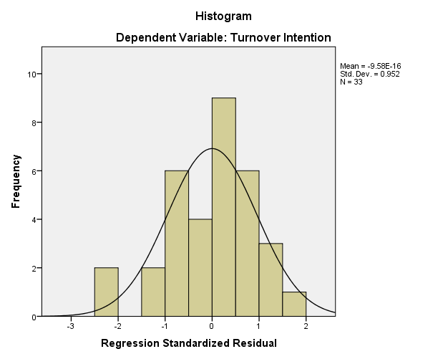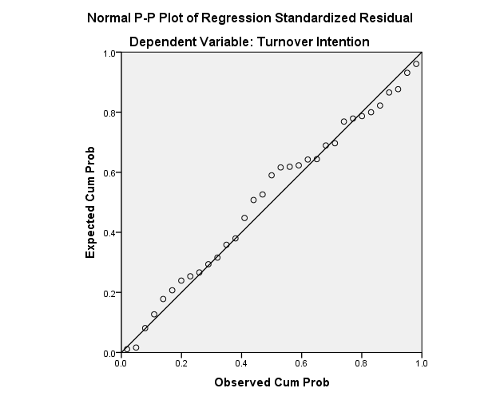

Lampiran 15 Uji Multikolinieritas

|  |  |  |  |  |  |  |  |  |
| --- | --- | --- | --- | --- | --- | --- | --- | --- |
| **Coefficientsa** | | | | | | | | |
| Model | | Unstandardized Coefficients | | Standardized Coefficients | t | Sig. | Collinearity Statistics | |
| B | Std. Error | Beta | Tolerance | VIF |
| 1 | (Constant) | 14134.780 | 4968.878 |  | 2.845 | .008 |  |  |
| Job Insecurity | .513 | .113 | .744 | 4.532 | .000 | .589 | 1.698 |
| Stres Kerja | .395 | .152 | .407 | 2.600 | .015 | .648 | 1.543 |
| Beban Kerja | -.995 | .189 | -.960 | -5.276 | .000 | .479 | 2.088 |
| a. Dependent Variable: Turnover Intention | | | | | | | | |

Lampiran 16 Uji Heteroskedastisitas

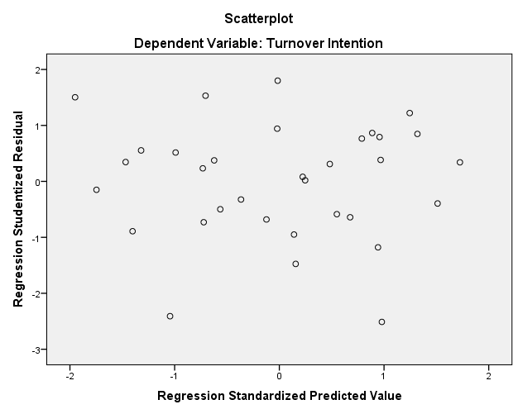

Lampiran 17 Uji Regresi Linier Berganda

|  |  |  |  |  |
| --- | --- | --- | --- | --- |
| **Coefficientsa** | | | | |
| Model | | Unstandardized Coefficients | | Standardized Coefficients | t | Sig. |
| B | Std. Error | Beta |
| 1 | (Constant) | 14134.780 | 4968.878 |  | 2.845 | .008 |
| X1 | .513 | .113 | .744 | 4.532 | .000 |
| X2 | .395 | .152 | .407 | 2.600 | .015 |
| X3 | -.995 | .189 | -.960 | -5.276 | .000 |
|  | | | | |

Lampiran 18 Uji Hipotesis

1. Uji t

|  |  |  |  |  |
| --- | --- | --- | --- | --- |
| **Coefficientsa** | | | | |
| Model | | Unstandardized Coefficients | | Standardized Coefficients | t | Sig. |
| B | Std. Error | Beta |
| 1 | (Constant) | 14134.780 | 4968.878 |  | 2.845 | .008 |
| X1 | .513 | .113 | .744 | 4.532 | .000 |
| X2 | .395 | .152 | .407 | 2.600 | .015 |
| X3 | -.995 | .189 | -.960 | -5.276 | .000 |
|  | | | | |

1. Uji F

|  |  |  |  |  |  |  |
| --- | --- | --- | --- | --- | --- | --- |
| **ANOVAa** | | | | | | |
| Model | | Sum of Squares | df | Mean Square | F | Sig. |
| 1 | Regression | 678200080.961 | 3 | 226066693.654 | 11.363 | .000b |
| Residual | 576961802.009 | 29 | 19895234.552 |  |  |
| Total | 1255161882.970 | 32 |  |  |  |
| a. Dependent Variable: Turnover Intention | | | | | | |
| b. Predictors: (Constant), Job Insecurity, Stres Kerja, dan Beban Kerja | | | | | | |

Lampiran 19 r-tabel

|  |  |  |  |  |  |
| --- | --- | --- | --- | --- | --- |
| **df = (N-2)** | **Tingkat signifikansi untuk uji satu arah** | | | | |
| **0.05** | **0.025** | **0.01** | **0.005** | **0.0005** |
| **Tingkat signifikansi untuk uji dua arah** | | | | |
| **0.1** | **0.05** | **0.02** | **0.01** | **0.001** |
| **1** | 0.9877 | 0.9969 | 0.9995 | 0.9999 | 1.0000 |
| **2** | 0.9000 | 0.9500 | 0.9800 | 0.9900 | 0.9990 |
| **3** | 0.8054 | 0.8783 | 0.9343 | 0.9587 | 0.9911 |
| **4** | 0.7293 | 0.8114 | 0.8822 | 0.9172 | 0.9741 |
| **5** | 0.6694 | 0.7545 | 0.8329 | 0.8745 | 0.9509 |
| **6** | 0.6215 | 0.7067 | 0.7887 | 0.8343 | 0.9249 |
| **7** | 0.5822 | 0.6664 | 0.7498 | 0.7977 | 0.8983 |
| **8** | 0.5494 | 0.6319 | 0.7155 | 0.7646 | 0.8721 |
| **9** | 0.5214 | 0.6021 | 0.6851 | 0.7348 | 0.8470 |
| **10** | 0.4973 | 0.5760 | 0.6581 | 0.7079 | 0.8233 |
| **11** | 0.4762 | 0.5529 | 0.6339 | 0.6835 | 0.8010 |
| **12** | 0.4575 | 0.5324 | 0.6120 | 0.6614 | 0.7800 |
| **13** | 0.4409 | 0.5140 | 0.5923 | 0.6411 | 0.7604 |
| **14** | 0.4259 | 0.4973 | 0.5742 | 0.6226 | 0.7419 |
| **15** | 0.4124 | 0.4821 | 0.5577 | 0.6055 | 0.7247 |
| **16** | 0.4000 | 0.4683 | 0.5425 | 0.5897 | 0.7084 |
| **17** | 0.3887 | 0.4555 | 0.5285 | 0.5751 | 0.6932 |
| **18** | 0.3783 | 0.4438 | 0.5155 | 0.5614 | 0.6788 |
| **19** | 0.3687 | 0.4329 | 0.5034 | 0.5487 | 0.6652 |
| **20** | 0.3598 | 0.4227 | 0.4921 | 0.5368 | 0.6524 |
| **21** | 0.3515 | 0.4132 | 0.4815 | 0.5256 | 0.6402 |
| **22** | 0.3438 | 0.4044 | 0.4716 | 0.5151 | 0.6287 |
| **23** | 0.3365 | 0.3961 | 0.4622 | 0.5052 | 0.6178 |
| **24** | 0.3297 | 0.3882 | 0.4534 | 0.4958 | 0.6074 |
| **25** | 0.3233 | 0.3809 | 0.4451 | 0.4869 | 0.5974 |
| **26** | 0.3172 | 0.3739 | 0.4372 | 0.4785 | 0.5880 |
| **27** | 0.3115 | 0.3673 | 0.4297 | 0.4705 | 0.5790 |
| **28** | 0.3061 | 0.3610 | 0.4226 | 0.4629 | 0.5703 |
| **29** | 0.3009 | 0.3550 | 0.4158 | 0.4556 | 0.5620 |
| **30** | 0.2960 | 0.3494 | 0.4093 | 0.4487 | 0.5541 |
| **31** | 0.2913 | 0.3440 | 0.4032 | 0.4421 | 0.5465 |
| **32** | 0.2869 | 0.3388 | 0.3972 | 0.4357 | 0.5392 |
| **33** | 0.2826 | 0.3338 | 0.3916 | 0.4296 | 0.5322 |
| **34** | 0.2785 | 0.3291 | 0.3862 | 0.4238 | 0.5254 |
| **35** | 0.2746 | 0.3246 | 0.3810 | 0.4182 | 0.5189 |

Lampiran 20 Data Total MSI

|  |  |  |  |
| --- | --- | --- | --- |
| **Y** | **X1** | **X2** | **X3** |
| **29683.00** | **65644.00** | **29516.00** | **28279.00** |
| **20293.00** | **62508.00** | **20068.00** | **38933.00** |
| **18819.00** | **63729.00** | **37386.00** | **36683.00** |
| **18613.00** | **67602.00** | **41952.00** | **36683.00** |
| **21981.00** | **50595.00** | **34196.00** | **33958.00** |
| **20816.00** | **47416.00** | **25435.00** | **24831.00** |
| **18924.00** | **37279.00** | **36379.00** | **30170.00** |
| **27716.00** | **43386.00** | **27631.00** | **26317.00** |
| **27877.00** | **44135.00** | **32480.00** | **23134.00** |
| **20867.00** | **47749.00** | **25348.00** | **23751.00** |
| **30438.00** | **61406.00** | **32910.00** | **29958.00** |
| **24671.00** | **53952.00** | **34564.00** | **28121.00** |
| **21988.00** | **50557.00** | **29354.00** | **30816.00** |
| **33679.00** | **50358.00** | **29272.00** | **19319.00** |
| **25657.00** | **29329.00** | **14867.00** | **9720.00** |
| **19606.00** | **44753.00** | **23117.00** | **24579.00** |
| **14245.00** | **46950.00** | **37151.00** | **35153.00** |
| **33959.00** | **61772.00** | **38963.00** | **30923.00** |
| **31244.00** | **62585.00** | **33554.00** | **31652.00** |
| **23592.00** | **56658.00** | **34631.00** | **28310.00** |
| **21290.00** | **40235.00** | **32055.00** | **24880.00** |
| **24449.00** | **39977.00** | **23583.00** | **17153.00** |
| **28365.00** | **47182.00** | **29481.00** | **25839.00** |
| **23103.00** | **49440.00** | **33503.00** | **31383.00** |
| **15714.00** | **49216.00** | **39717.00** | **38933.00** |
| **35237.00** | **62719.00** | **36637.00** | **30828.00** |
| **20556.00** | **47320.00** | **21256.00** | **28664.00** |
| **32109.00** | **57336.00** | **32937.00** | **32422.00** |
| **17853.00** | **45066.00** | **29929.00** | **28175.00** |
| **25560.00** | **60957.00** | **28361.00** | **31258.00** |
| **32174.00** | **55972.00** | **31238.00** | **26868.00** |
| **32174.00** | **55972.00** | **32055.00** | **26868.00** |
| **10000.00** | **49632.00** | **16953.00** | **26868.00** |

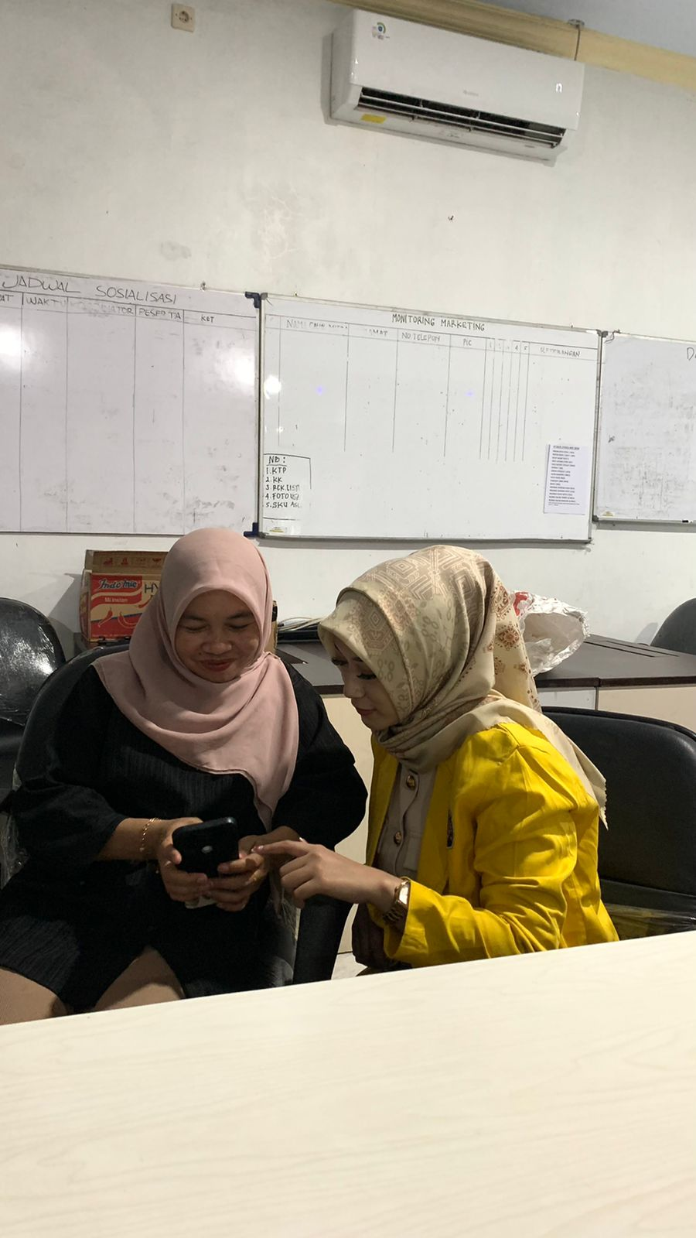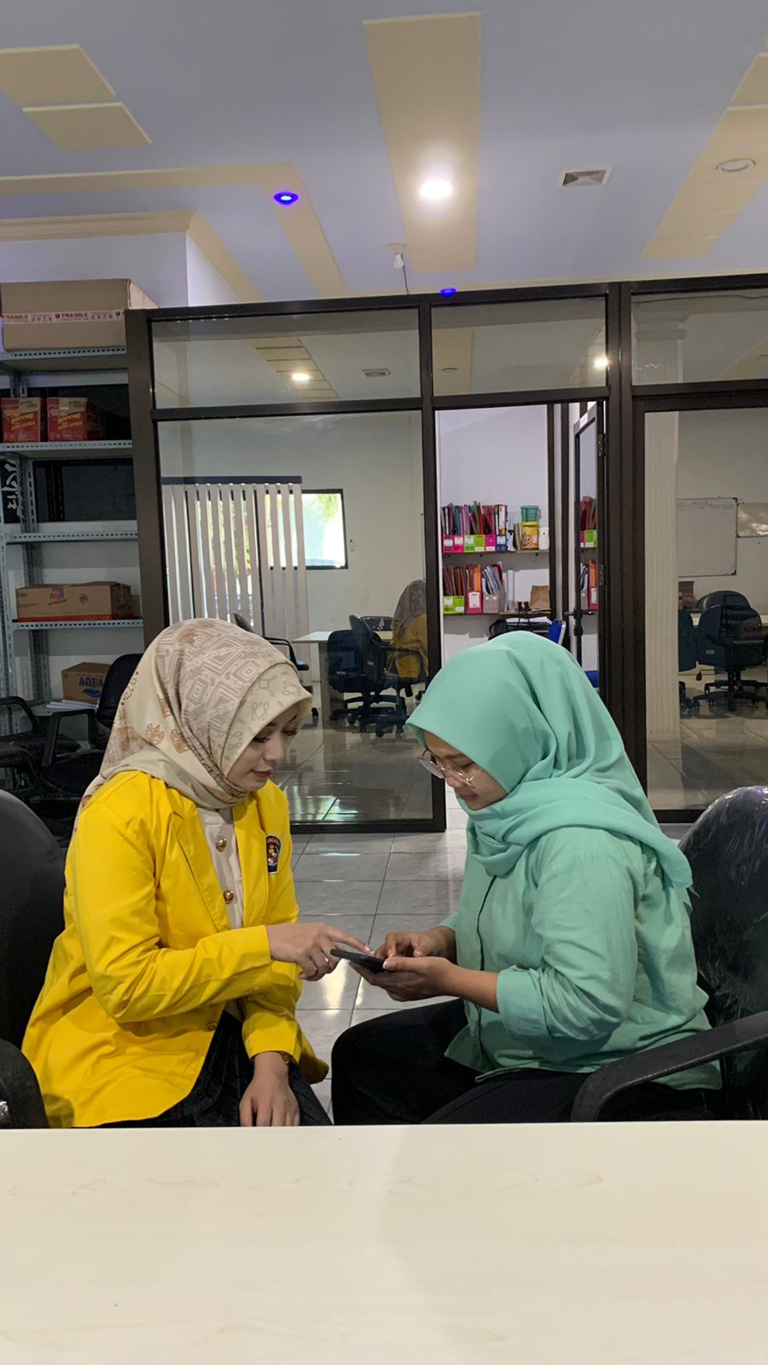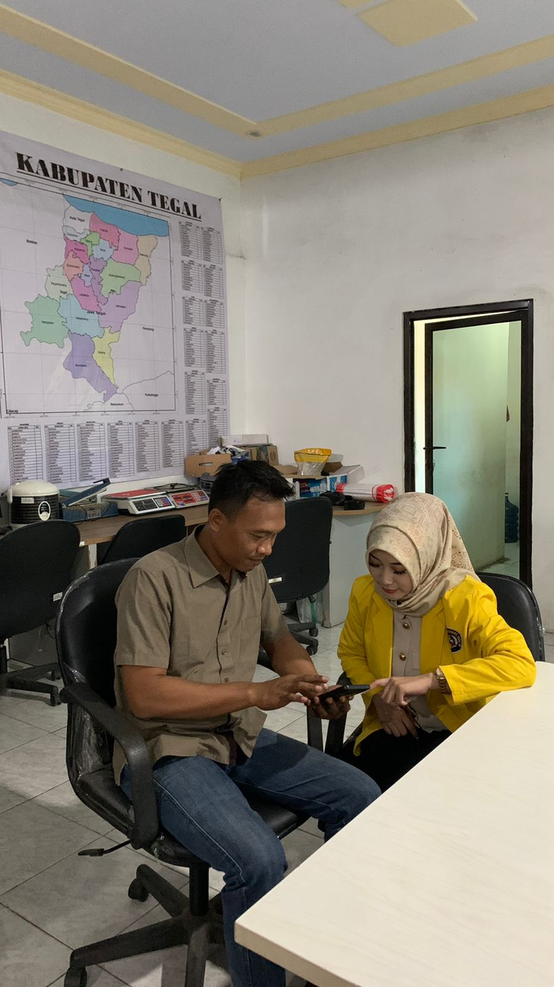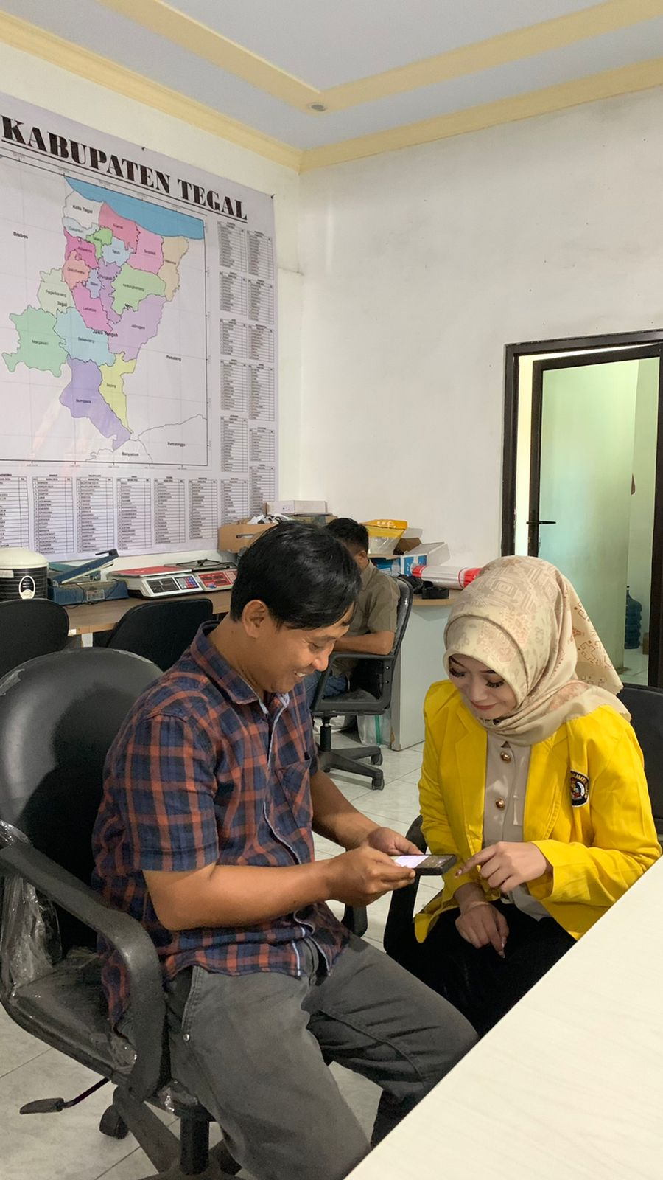Lampiran 21 Dokumentasi Penelitian

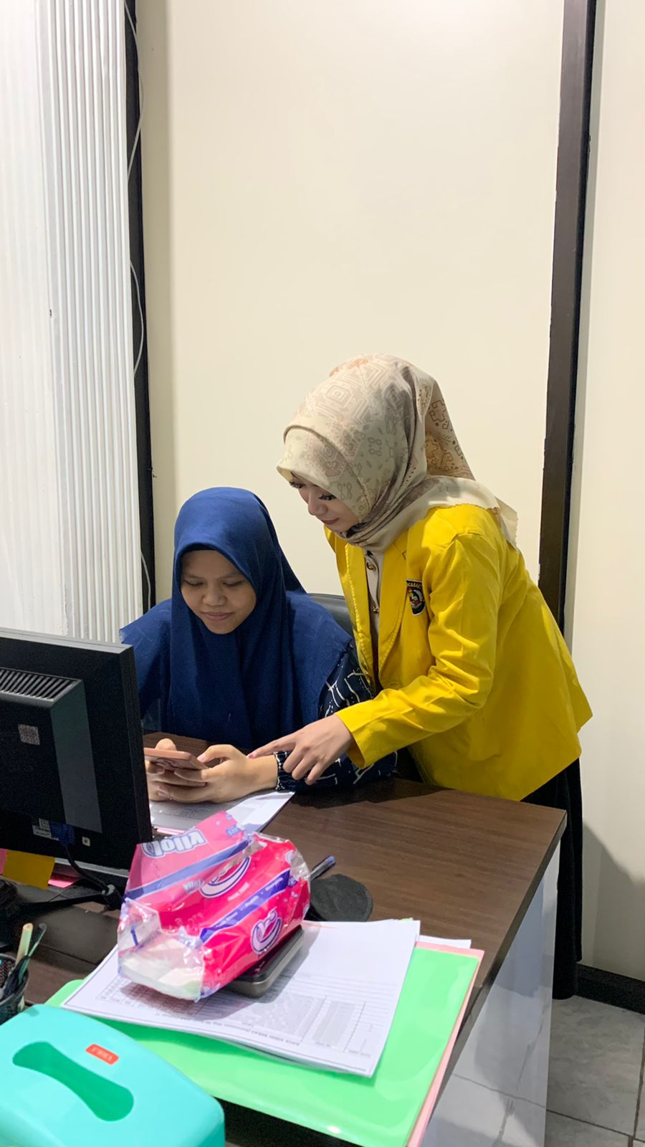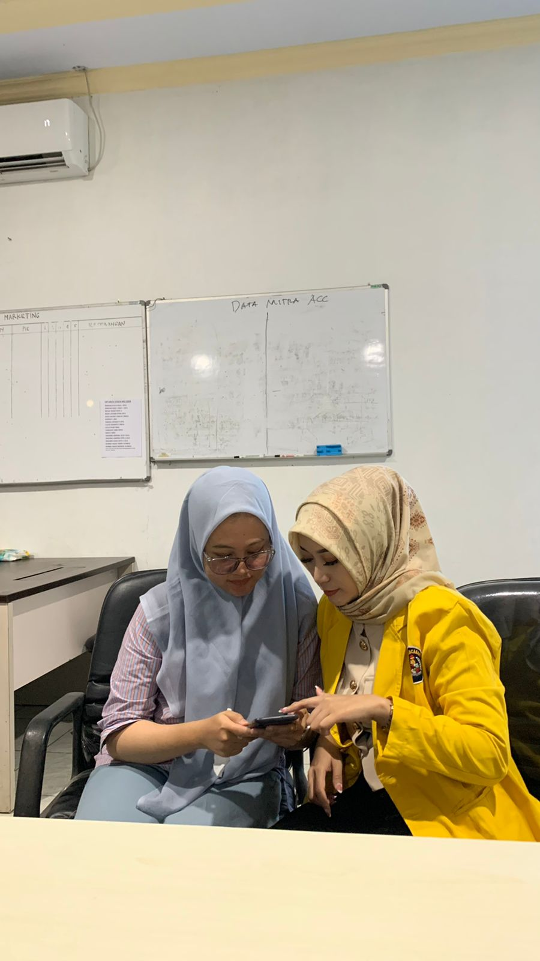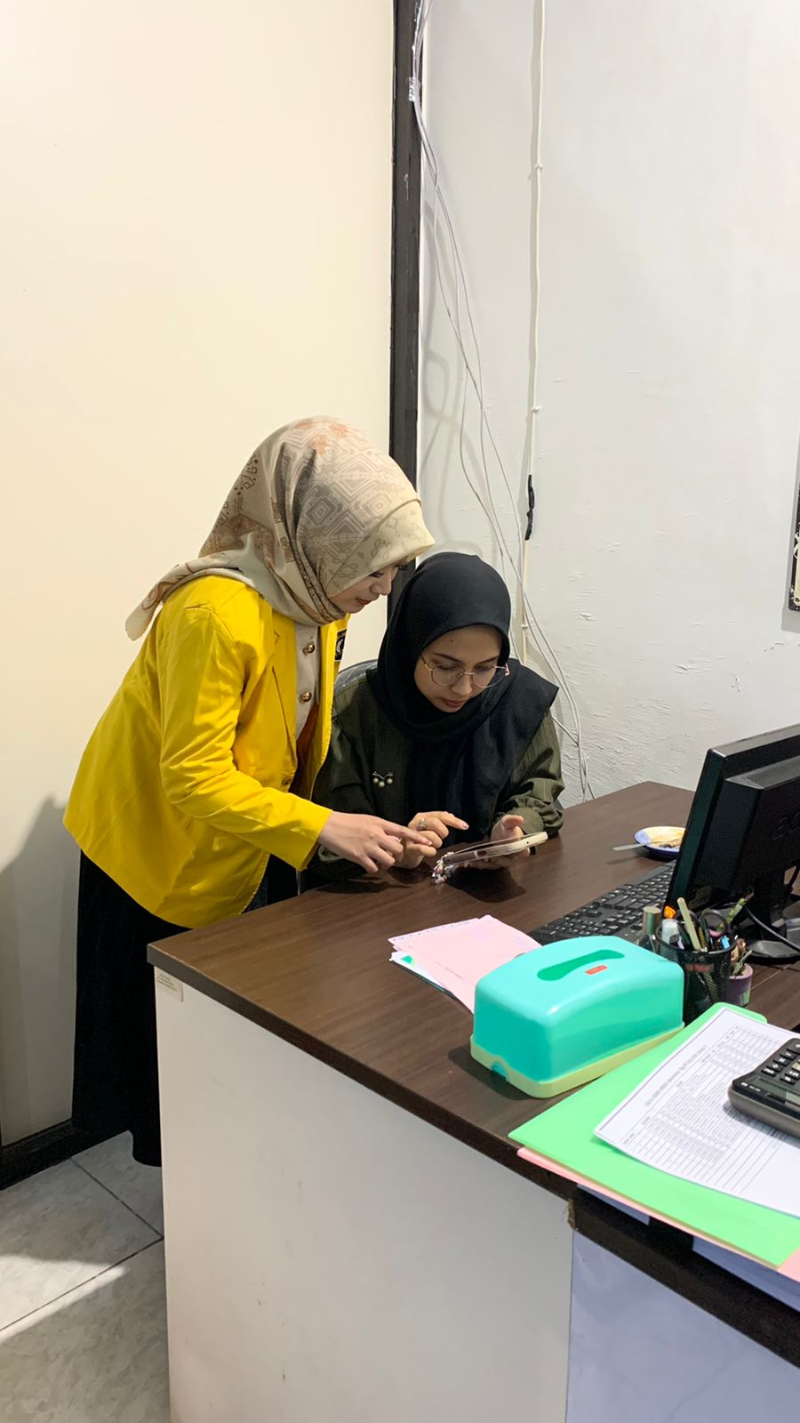

144

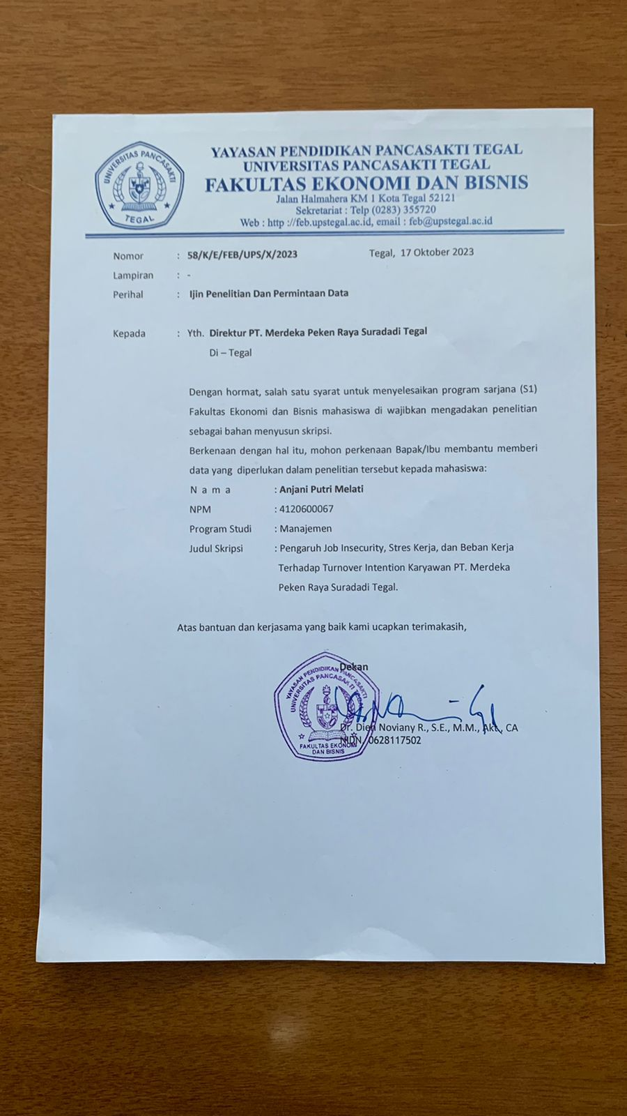Lampiran 22 Surat Izin Penelitian

Lampiran 23 Surat Balasan Izin Penelitian

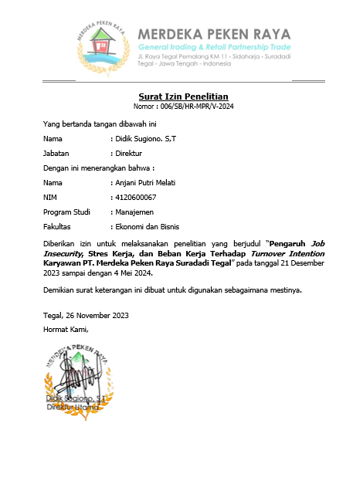

Lampiran 24 Terkait PT. Merdeka Peken Raya

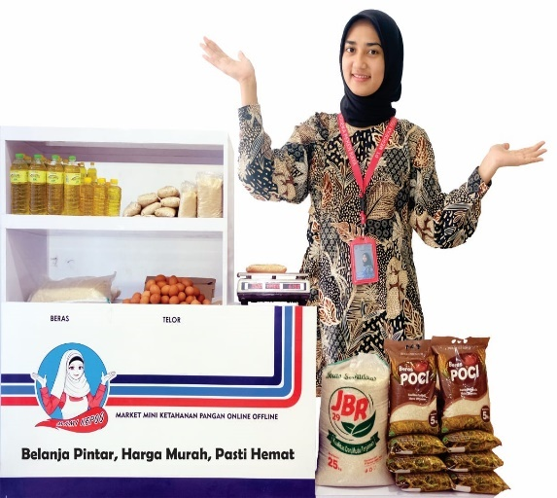



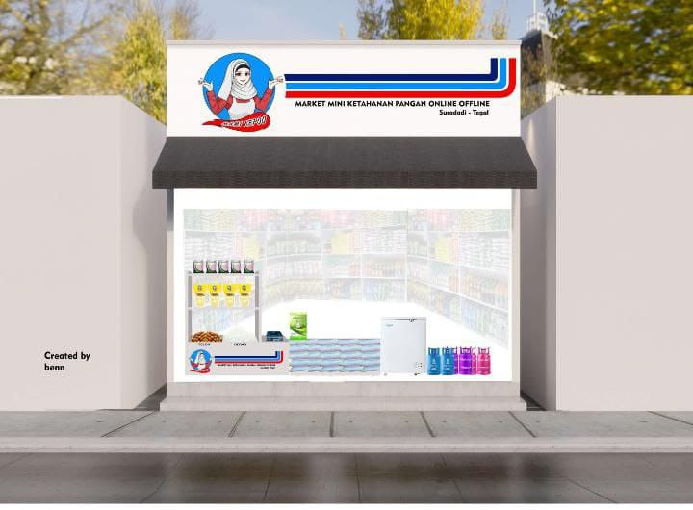

**Jenis Produk dari Franchise Mami Kepo (Market Mini Ketahanan Pangan Online/Offline)**

**Logo Mami Kepo ( Market Mini Ketahanan Pangan Online/Offline)**

**Franchise Mami Kepo (Market Mini Ketahanan Pangan Online/Offline)**