**DAFTAR PUSTAKA**

Abdul Majid. 2016. *Strategi Pembelajaran*. Bandung: PT Remaja Rosda Karya.

Adinugraha, A. Hamdan. 2016. Evaluasi Pertumbuhan Sambungan Eucalyptus Pellita F.Muell Dengan Teknik Venner Grafting. *jurnal sylva lestari* Vol 4 no.3.

Adzroo, N, &D Suryaningrum. 2023. Good Corporate Governance Dan Corporate Social Responsibility Terhadap Financial Distress Pada Perusahaan Manufaktur Yang Terdaftar Di Bursa Efek Indonesia Periode. *Jurnal Ilmiah Wahana Akuntani* 18(1): 128–50. http://journal.unj/unj/index.php/wahana-akuntansi.

Amalina, Nabilah Nur, & Sri Trisnaningsih. 2023. Pengaruh Leverage, Likuiditas, Dan Ukuran Perusahaan Terhadap Financial Distress. *Jambura Economic Education Journal* 5(2): 88–99.

Anggun Prihati. 2023. Pengaruh Sales Growth, Firm Size, Dan Good Crporate Governance Terhadap Kondisi Financial Distress. 4(1): 88–100.

Brigham. Eugene F &Houston. Joel F. 2010. *Dasar-Dasar Manajemen Keuangan*. Jakarta: Salemba Empat.

Brigham, Eugene F & Joel F. Houston. 2013. *Dasar-Dasar Manajemen Keuangan*. Jakarta: Salemba Empat.

Buchori, Ahmad. 2022. BSI Salurkan Dana CSR Senilai Rp84,1 Miliar Sampai Juni 2022. https://m.antaranews.com/amp/berita/3080121/bsi-salurkan-dana-csr-senilai-rp841-miliar-sampai-juni-2022.

Dr. Lela Nurlaela Wati. 2019. *Model Corporate Social Responsibility (CSR)*. ed. Momon. Jawa Timur: Myria Publisher.

Effendi, Muh. Arief. 2020. *The Power Of Good Corporate Governance :Teori Dan Implementasi*. ed. Dedy A. Halim. Jakarta: Salemba Empat.

Fachrudin, Khaira Amalia. 2008. USU Press *Kesulitan Keuangan Perusahaan Dan Personal*.

Fernando, Aldo. 2021. “Right Issue Pada 9 Bank.” *https://www.cnbcindonesia.com/market/20210317195801-17-230946/hai-investor-ada-9-bank-bakal-rights-issue-serap-gak-nih/2*. https://www.cnbcindonesia.com/market/20210317195801-17-230946/hai-investor-ada-9-bank-bakal-rights-issue-serap-gak-nih/2.

Ghozali, Prof. H. Imam. 2018. *Aplikasi Analisis Multivariate Dengan Program IBM SPSS 25*. Semarang: Badan Penerbit Universitas Diponegoro.

Goh, Thomas Sumarsan. 2023. Indomedia Pustaka *Monograf : Financial Distress*. https://admin.methodist.ac.id/cdn/File/thomastambahan/Monograf Financial Distress (1).pdf.

Hendrianto. 2012. Ingkat Kesulitan Keuangan Perusahaan Dan Konservatisme Akuntansi Di Indonesia. *Jurnal Ilmiah Mahasiswa Akuntansi* 1(3): 63.

Ir. Syofian Siregar, M.M. 2017. *Metode Penelitian Kuantitatif : Dilengkapi Dengan Perbandingan Perhitungan Manual & SPSS*. edisi keem. Jakarta: KENCANA Jl. Tambra Raya No 23 Rawamangun jakarta 13220.

Jogiyanto. Hartono. 2013. *Teori Portofolio Dan Analisis Investasi*. Edisi ke-8. Yogyakarta: BPFE.

Kasmir. 2013. *Bank Dan Lembaga Keuangan Lainnya*. Jakarta: PT Raja Grafindo Persada.

Kasmir. 2016. *Analisis Laporan Keuangan*. Jakarta: PT Raja Grafindo Persada.

Malla Avila & Diana Esperanza. 2022. *Pengaruh Corporate Social Responsibility Dan Operating Capitaly Terhadap Financial Distress Dengan Corporate Governance Sebagai Variabel Moderasi Pada Perushaaan Manufaktur Yang Terdaftar Di BEI Tahun 2016-2020*.

Moeljadi. 2010. *Manajemen Keuangan Pendekatan Kuantitatif Dan Kualitatif*. Malang: Bayu Media Publishing.

Mulansari, Retno, & Wahyu Setiyorini. 2019. Pengaruh Good Corporate Governance Dan Financial Indicators Terhadap Financial Distress Pada Perusahaan Property Dan Real Estate. *Jurnal Akuntansi dan Perpajakan* 5(2): 115–26.

Nurviani, Devi Indah, & Hening Widi Oetomo. 2019. Pengaruh Financial Leverage, Ukuran Perusahaan, Dan Arus Kas Terhadap Financial Distress Pada Perusahaan Property dan Real Estate. *Jurnal Ilmu dan Riset Manajemen*: 2–17.

Rahman, Reza. 2009. *Corporate Social Responsibility*. Yogyakarta: Media Pressindo.

Ratih Ayu Kusumaningrum. 2022. Pengaruh Leverage, Likuiditas Dan Kepemilikan Manajerial Terhadap Financial Distress. *Jurnal Ilmu dan Riset Akuntansi (JIRA)* 11(7): 2–17. http://jurnalmahasiswa.stiesia.ac.id/index.php/jira/article/view/4708/4704.

Rizati, Monavia Ayu. 2022. Total Aset Bank Umum Syariah Dan Unit Usaha Syariah Naik 12,8% Pada Januari 2022. https://databoks.katadata.co.id/datapublish/2022/05/20/total-aset-bank-umum-syariah-dan-unit-usaha-syariah-naik-128-pada-januari-2022.

Rizqi, Anis Fathul, & Sunarsih Sunarsih. 2022. Faktor-Faktor Yang Mempengaruhi Financial Distress Bank Syariah Yang Terdaftar Di OJK Tahun 2016-2020 SERAMBI. *Jurnal Ekonomi Manajemen dan Bisnis Islam* 4(3): 223–38. https://doi.org/10.36407/serambi.v4i3.738.

Rudianto. 2013. *Akuntansi Manajemen Informasi Untuk Pengambilan Keputusan Strategis*. Jakarta: Erlangga.

Sartono, Agus. 2010. *Manajemen Keuangan Teori Dan Aplikasi*. edisi keempat. Yogyakarta: BPFE.

Subagyo P & Djarwanto. 2011. *Statistika Induktif*. (Edisi Kelima Yogyakarta: BPFE.

Sugiyono, Dr. 2001. *Metode Penelitian Bisnis*. Cetakan ke. ed. S.Pd Apri Nuryanto. Bandung: ALFABETA.

Sugiyono, Prof. DR. 2020. *Metode Penelitian Kuantitatif, Kualitatif, Dan R&D*. edisi kedu. ed. MT Dr. Ir. Sutopo. S.Pd. Bandung: ALFABETA, cv Jl. gegerkalong Hilir No. 84 Bandung.

Suharto, Edi. 2007. *Memperkuat Tanggung Jawab Sosial Perusahaan (Corporate Social Responsibility) Pekerjaan Sosial Didunia Industri*. Bandung: Refika aditama.

Sumilat, Hillary & Destriana, Nicken. 2017. Faktor-Faktor Yang Mempengaruhi Pengungkapan Corporate Social Responsibility. *Jurnal Bisnis dan Akuntansi STIE Trisakti* Vol 19 No.: hal 129-140.

Wijaya, Jennifen, & Rousilita Suhendah. 2023. Pengaruh Likuiditas, Leverage, Dan Arus Kas Terhadap Financial Distress. *Jurnal Ekonomi* 28(2): 177–96.

Yanti, Rizky Dwi Melli, & Agus Purwanto. 2023. Pengaruh Corporate Governance Dan Corporate Social Responsibility Terhadap Financial Distress. *Diponegoro Journal of Accounting2* 12(2): 169–80.

Yoda, Tilawatil Ciseta, Rida Rahim, Yefri Reswita, & Febrina Permata Sari. 2021. Pengaruh Kepemilikan Manajerial, Likuiditas Dan Ukuran Perusahaan Terhadap Financial Distress Studi Kasus Pada Perusahaan Perhotelan, Restoran Dan Pariwisata Yang Terdaftar Di Bursa Efek Indonesia Periode 2015-2019. *Jurnal Ilmiah Mahasiswa Ekonomi Manajemen* 6(3): 632–45.

Zatira, Dhea, Dede Sunaryo, & Ni Made Dewi Dwicandra. 2023. Pengaruh Likuiditas Dan Implementasi Good Corporate Governance (Gcg) Terhadap Financial Distress. *Balance Vocation Accounting Journal* 6(2): 160.

# LAMPIRAN

Lampiran 1

Data *Financial Distress* Perusahaan Perbankan Syariah Periode 2019-2023 (%)



Lampiran 2

DataKepemilikan Manajerial Perbankan Syariah Periode2019-2023 (%)



Lampiran 3

Data *Corporate Social Responsibility* Perbankan Syariah Periode 2019-2023 (%)



#







Lampiran 4

Data *Firm Size* Perbankan Syariah Periode 2019-2023 (%)

Lampiran 5

Data Likuiditas Perbankan Syariah Periode 2019-2023 (%)



Lampiran 6

Data semua variabel penelitian perusahaan perbankan syariah periode 2019-2023 (%)





Lampiran 7

Hasil Analisis Statistik Deskriptif

|  |  |  |  |  |  |
| --- | --- | --- | --- | --- | --- |
| **Descriptive Statistics** | | | | | |
|  | N | Minimum | Maximum | Mean | Std. Deviation |
| kepemilikan manajerial | 45 | ,428 | 1,000 | ,86824 | ,191451 |
| corporate social responsibility | 45 | ,353 | 1,000 | ,74109 | ,179551 |
| firm size | 45 | 21,550 | 31,050 | 27,05333 | 3,266194 |
| likuiditas | 45 | 2,530 | 49,300 | 12,92622 | 11,268928 |
| financial distress | 45 | 4,110 | 11,680 | 6,99844 | 1,646522 |
| Valid N (listwise) | 45 |  |  |  |  |

Lampiran 8

Hasil Uji Normalitas

|  |  |  |
| --- | --- | --- |
| **One-Sample Kolmogorov-Smirnov Test** | | |
|  | | Unstandardized Residual |
| N | | 45 |
| Normal Parametersa,b | Mean | ,0000000 |
| Std. Deviation | 1,30514992 |
| Most Extreme Differences | Absolute | ,091 |
| Positive | ,091 |
| Negative | -,061 |
| Test Statistic | | ,091 |
| Asymp. Sig. (2-tailed) | | ,200c,d |
| a. Test distribution is Normal. | | |
| b. Calculated from data. | | |
| c. Lilliefors Significance Correction. | | |
| d. This is a lower bound of the true significance. | | |

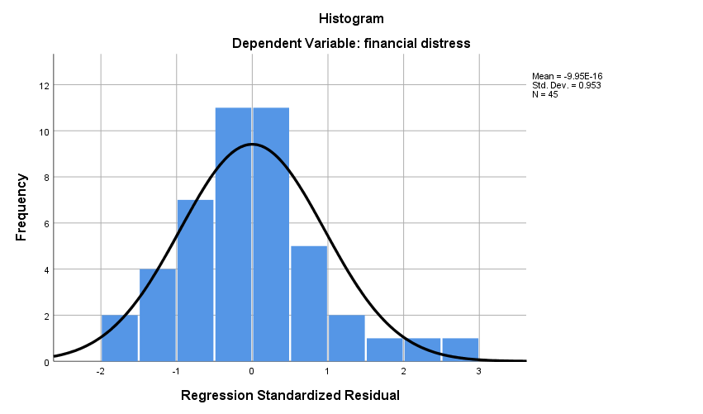

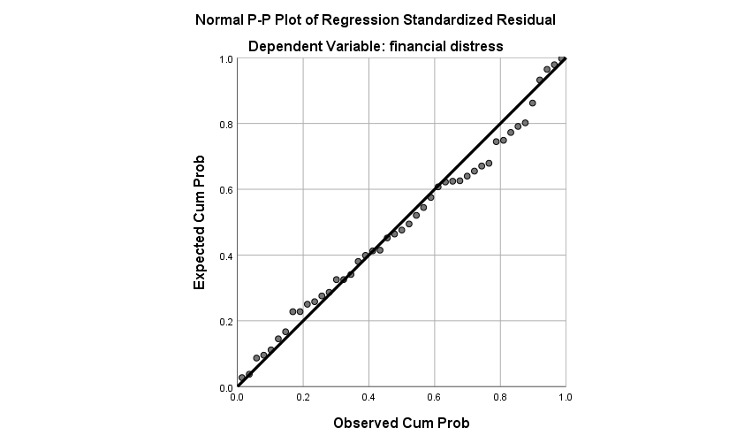

Lampiran 9

Hasil Uji Multikolinieritas

|  |  |  |  |
| --- | --- | --- | --- |
| **Coefficientsa** | | | |
| Model | | Collinearity Statistics | |
| Tolerance | VIF |
| 1 | (Constant) |  |  |
| kepemilikan manajerial | ,280 | 3,571 |
| corporate social responsibility | ,945 | 1,058 |
| firm size | ,705 | 1,418 |
| likuiditas | ,358 | 2,796 |
| a. Dependent Variable: financial distress | | | |

Lampiran 10

Hasil Uji *Scatterplot*

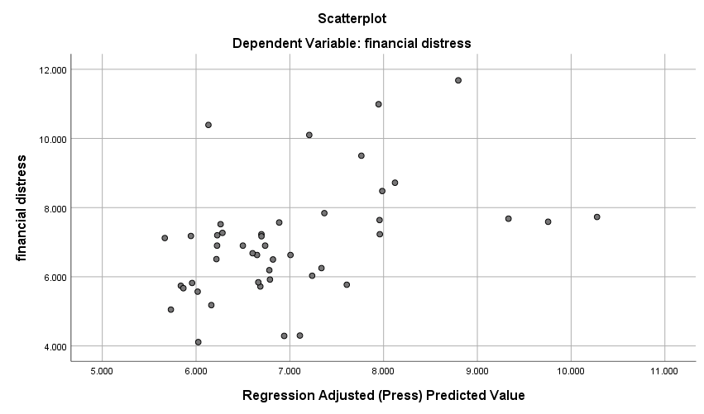

Lampiran 11

Hasil Uji Heteroskedastisitas

|  |  |  |  |  |  |  |
| --- | --- | --- | --- | --- | --- | --- |
| **Coefficientsa** | | | | | | |
| Model | | Unstandardized Coefficients | | Standardized Coefficients | t | Sig. |
| B | Std. Error | Beta |  |  |
| 1 | (Constant) | 3,396 | 2,215 |  | 1,534 | ,133 |
| kepemilikan manajerial | -,279 | 1,201 | -,063 | -,232 | ,817 |
| corporate social responsibility | -1,295 | ,697 | -,276 | -1,858 | ,071 |
| firm size | -,055 | ,044 | -,212 | -1,233 | ,225 |
| likuiditas | ,021 | ,018 | ,279 | 1,156 | ,255 |
| a. Dependent Variable: ABS_RES | | | | | | |

Lampiran 12

Hasil Uji Autokorelasi

|  |  |  |  |  |  |
| --- | --- | --- | --- | --- | --- |
| **Model Summaryb** | | | | | |
| Model | R | R Square | Adjusted R Square | Std. Error of the Estimate | Durbin-Watson |
| 1 | ,628a | ,395 | ,341 | 1,29894 | 1,469 |
| a. Predictors: (Constant), likuiditas, corporate social responsibility, firm size, kepemilikan manajerial | | | | | |
| b. Dependent Variable: financial distress | | | | | |

Lampiran 13

Hasil Analisis Regresi Linier Berganda

|  |  |  |  |  |  |  |
| --- | --- | --- | --- | --- | --- | --- |
| **Coefficientsa** | | | | | | |
| Model | | Unstandardized Coefficients | | Standardized Coefficients | t | Sig. |
| B | Std. Error | Beta |
| 1 | (Constant) | 3,999 | 3,755 |  | 1,065 | ,293 |
| kepemilikan manajerial | 3,669 | 2,037 | ,427 | 2,025 | ,049 |
| corporate social responsibility | -1,932 | 1,182 | -,211 | -1,635 | ,110 |
| firm size | -,013 | ,075 | -,025 | -,171 | ,865 |
| likuiditas | ,123 | ,031 | ,844 | 4,026 | ,000 |
| a. Dependent Variable: financial distress | | | | | | |

Lampiran 14

Hasil Uji Signifikansi Parsial (Uji-t)

|  |  |  |  |  |  |  |  |
| --- | --- | --- | --- | --- | --- | --- | --- |
| **Coefficientsa** | | | | | | | |
| Model | | Unstandardized Coefficients | | Standardized Coefficients | t | Sig. |
| B | Std. Error | Beta |  |  |
| 1 | (Constant) | 3,999 | 3,755 |  | 1.065 | .293 |
| kepemilikan manajerial | 3,669 | 2,037 | ,427 | 2,025 | ,049 |
| corporate social responsibility | -1,932 | 1,182 | -,211 | -1,635 | ,110 |
| firm size | -,013 | ,075 | -,025 | -,171 | ,865 |
| likuiditas | ,123 | ,031 | ,844 | 4,026 | ,000 |
| a. Dependent Variable: financial distress | | | | | | | |

Lampiran 15

Hasil Uji Signifikansi Simultan (Uji F-test)

|  |  |  |  |  |  |  |
| --- | --- | --- | --- | --- | --- | --- |
| **ANOVAa** | | | | | | |
| Model | | Sum of Squares | df | Mean Square | F | Sig. |
| 1 | Regression | 44,335 | 4 | 11,084 | 5,915 | ,001b |
| Residual | 74,950 | 40 | 1,874 |  |  |
| Total | 119,286 | 44 |  |  |  |
| a. Dependent Variable: financial distress | | | | | | |
| b. Predictors: (Constant), likuiditas, corporate social responsibility, firm size, kepemilikan manajerial | | | | | | |

Lampiran 16

Hasil Analisis Koefisien Determinasi

|  |  |  |  |  |
| --- | --- | --- | --- | --- |
| **Model Summaryb** | | | | |
| Model | R | R Square | Adjusted R Square | Std. Error of the Estimate |
| 1 | ,610a | ,372 | ,309 | 1,368853 |
| a. Predictors: (Constant), likuiditas, corporate social responsibility, firm size, kepemilikan manajerial | | | | |
| b. Dependent Variable: financial distress | | | | |