# DAFTAR PUSTAKA

A.A. Anwar Prabu Mangkunegara, 2013, Manajemen Sumber Daya Manusia Perusahaan. Bandung: PT. Remaja Rosda Karya.

Budiasa, I Komang (2021). *Beban Kerja dan Kinerja Sumber Daya Manusia*. (S. Sik. M. Dr. Ni Kadek Suryani, Ed.) (pertama). Purwokerto Selatan: CV. Pena Persada.

Budiyati et al. (2023). Pengaruh Disiplin Kerja dan Komunikasi Terhadap Kinerja Karyawan Bagian Operasional Pada PT. Permata Barito Shipyard & Engineering. *Jurnal Ekonomi Dan Bisnis*, *16*(1), 135–152.

Daryanto, 2011. Manajemen Pemasaran. Cetekan 1. Bandung : Satu Nusa Yogyakarta.

Ghozali, I. (2018b). *Aplikasi Analisis Multivariate Dengan Program IBM SPSS 25 Edisi ke-9.* Universitas Diponegoro.

Harras, H. (2020). *KAJIAN MANAJEMEN SUMBER DAYA MANUSIA* (Wahyudi (ed.); Cetakan pe). UNPAM PRESS.

Hasibuan, H. Melayu S.P., (2003). Manajemen Sumber Daya Manusia, PT. Bumi Aksara, Jakarta

Hendrix, Jerry A and Darrel C.Hayes. 2007. Public Relations Cases 8th. United States: Wadsworth Cencage Learning.

Khaeruman, ST., MM., CHRA., dkk. (2021). *Meningkatkan Kinerja Manajemen Sumber Daya Manusia Konsep & Studi Kasus* (1 ed.). Serang: CV. AA. Rizky

Kurniati, D. P. Y. (2016). *Modul Komunikasi Verbal dan Nonverbal*. https://simdos.unud.ac.id

Indrayana, D. S., & Putra, F. I. F. S. (2024). Pengaruh Beban Kerja, Stres Kerja dan Lingkungan Kerja Terhadap Kinerja Karyawan. *Jurnal Ilmu Ekonomi, Manajemen Dan Bisnis*, *2*(1), 9–18. https://doi.org/10.30787/jiembi.v2i1.1407

Jodie Firjatullah, Christian Wiradendi Wolor, & Marsofiyati Marsofiyati. (2023). Pengaruh Lingkungan Kerja, Budaya Kerja, Dan Beban Kerja Terhadap Kinerja Karyawan. *Jurnal Manuhara : Pusat Penelitian Ilmu Manajemen Dan Bisnis*, *2*(1), 01–10. https://doi.org/10.61132/manuhara.v2i1.426

Jufrizen, J. (2021). Pengaruh Fasilitas Kerja Dan Disiplin Kerja Terhadap Kinerja Karyawan Melalui Motivasi Kerja. *Sains Manajemen*, *7*(1), 35–54. https://doi.org/10.30656/sm.v7i1.2277

Neksen, A., Wadud, M., & Handayani, S. (2021). *Pengaruh Beban Kerja dan Jam Kerja terhadap Kinerja Karyawan pada PT Grup Global Sumatera*. *2*(2), 105–112.

Putra, B. P., & Haryadi, R. N. (2022). Pengaruh Komunikasi dan Disiplin Kerja Terhadap Kinerja Karyawan pada PT. Mackessen Indonesia. *Jurnal Ekonomi Utama*, *1*(3), 154–159. https://doi.org/10.55903/juria.v1i3.32

Ramadhani, Z. I., Haroen, Z. A., & Wijayaningsih, R. (2023). Pengaruh Disiplin Kerja Dan Komunikasi Terhadap Kinerja Karyawan Pada Kantor Sekretariat Pengelola Gedung Aneka Bhakti Ii Bekasi. *Jurnal Economina*, *2*(10), 2884–2897. https://doi.org/10.55681/economina.v2i10.911

Raymond, Siregar, D. L., Putr, A. D., Indrawan, M. G., & Simanjuntak, J. (2023). Pengaruh Disiplin Kerja Dan Beban Kerja Terhadap Kinerja Karyawan Pada PT. Tanjung Mutiara Perkasa. *Jurnal Administrasi Bisnis*, 1–92.

Sari, R., Agustino, M. R., & Zulkurniawati, Z. (2021). Pengaruh Komunikasi dan Motivasi Terhadap Kinerja Karyawan di Boom Futsal Palembang. *Jurnal Ilmiah Mahasiswa Manajemen, Bisnis Dan Akuntansi (JIMMBA)*, *3*(2), 290–301. https://doi.org/10.32639/jimmba.v3i2.802

Sinaga. (2023). Peran Kepemimpinan dan Komunikasi Terhadap Kinerja Karyawan. *Komunikasi Dan Ilmu Sosial (JKIS)*, *1*(4), 160.Sugiyono. (2019). *Metode Penelitian Kuantitatif, Kualitatif dan R&D (Sutopo(Ed))*. Bandung: Alfabeta.

Simon, M. K., & Alouini, M. (2004). Types of Communication. *Digital Communication over Fading Channels*, *2*, 45–79.https://doi.org/10.1002/0471715220.ch3

Sugiyono. (2019). *Metode Penelitian Kuantitatif, Kualitatif dan R&D (Sutopo(Ed))*. Bandung: Alfabeta.

Suliyanto. (2018). *Metode Penelitian Bisnia: untuk Skripsi, Thesis & Disertasi*. Yogyakarta: Andi.

Sutrisno, Edy. 2009. Manajemen Sumber Daya Manusia.Jakarta: Kencana Prenada Media Group.

Tanjung, A. A., & Rasyid, M. A. (2023). Pengaruh Disiplin Kerja Dan Kepuasan Kerja Terhadap Kinerja Karyawan Efarina Tv. *Jurnal Manajemen Ekonomi Dan Bisnis*, *2*(1), 49–59. https://doi.org/10.61715/jmeb.v2i1.78

Wandi, D. (2022). *Pengaruh komunikasi dan motivasi terhadap kinerja pegawai*. *1*(September), 21–30. https://doi.org/10.56721/jisdm.v1i1.35

# LAMPIRAN

**Lampiran 1.**

**Kuesioner Penelitian**

**Permohonan Pengisian Kuesioner**

Yth. Bapak/Ibu/Saudara/I

Di Tempat

Dengan Hormat,

Saya adalah mahasiswa Program Strata Satu (S1) Fakultas Ekonomi, Jurusan Manajemen, Universitas Pancasakti Tegal, yang sedang mengadakan penelitian dalam rangka menyusun tugas akhir berupa Skripsi.

Nama : Bagas Mahardika

NPM : 4120600047

Dalam rangka penelitian untuk skripsi saya yang berjudul “Pengaruh Beban Kerja, Komunikasi Interpersonal Dan Disiplin terhadap Kinerja Karyawan PT. Wahana Semesta Kota Tegal” Maka saya memohon bantuan dari Bapak/Ibu/Saudara/I untuk berkenan mengisi kuesioner yang saya lampirkan bersama surat ini.

Peneliti menjamin sepenuhnya kerahasiaan identitas seluruh jawaban Bapak/Ibu/Saudara/I sesuai dengan etika penelitian. Peneliti mohon maaf apabila ada yang tidak berkenan atas hadirnya kuesioner ini. Atas kesediaan dan perhatiaan serta kerjasamanya peneliti ucapkan terima kasih.

Hormat Saya,

Bagas Mahardika

1. **Identitas Responden**

Jenis Kelamin : ⇨ Laki-laki ⇨ Perempuan

Usia : ⇨ 20 th – 30 th ⇨ 31 th - 40 th

⇨ 41 th – 50 th ⇨ > 50 th

Pendidikan Terakhir : SMP ⇨ SMA/SMK ⇨ DIII ⇨ S1 ⇨

1. **Petunjuk Pengisian**

Jawablah pertanyaan ini dengan jujur dan benar

Bacalah terlebih dahulu pertanyaan dengan cermat sebelum anda memulai untuk menjawabnya.

Pilihlah salah satu jawaban yang tersedia dengan memberikan tanda checlist ( √ ) pada salah satu jawaban yang anda anggap paling benar. Keterangan :

SS : Sangat setuju

S : Setuju

KS : Kurang Setuju

TS : Tidak Setuju

STS : Sangat Tidak Setuju

**Pernyataan Variabel Kinerja**

|  |  |  |  |  |  |  |
| --- | --- | --- | --- | --- | --- | --- |
| **No** | **Pernyataan** | **STS** | **TS** | **KS** | **S** | **SS** |
| **1** | **2** | **3** | **4** | **5** |
| **Kemampuan** | | | | | | |
| **1.** | Saya mempunyai kemampuan menyelesaikan pekerjaan. |  |  |  |  |  |
| **2.** | Saya mampu bekerja cepat dalam menyelesaikan tugas rutin. |  |  |  |  |  |
| **Keahlian** | | | | | | |
| **3.** | Saya menyelesaikan pekerjaan sesuai dengan keahlian saya. |  |  |  |  |  |
| **Latar belakang** | | | | | | |
| **4.** | Latar belakang pendidikan saya membuat saya mampu menganalisis pekerjaan. |  |  |  |  |  |
| **Persepsi** | | | | | | |
| **5.** | Saya mempunyai persepsi bahwa saya bisa meyelesaikan pekerjaan saya. |  |  |  |  |  |
| **Attitude** | | | | | | |
| **6.** | Saya mendengarkan teman menyampaikan pendapatnya dengan seksama dan tidak memotong. |  |  |  |  |  |
| **Motivasi** | | | | | | |
| **7.** | Saya termotivasi untuk meningkatkan kinerja saya. |  |  |  |  |  |
| **Sumber daya** | | | | | | |
| **8.** | Saya memahami setiap pekerjaan yang diberikan dan siap melakukan pengembangan dengan kemampuan yang saya miliki. |  |  |  |  |  |
| **Kepemimpinan** | | | | | | |
| **9.** | Saya memiliki kepercayaan kepada pimpinan saya, bahwa pimpinan saya bias melakukan perubahan yang lebih baik untuk instansi. |  |  |  |  |  |
| **Penghargaan** | | | | | | |
| **10.** | Saya diberi penghargaan atas prestasi yang diraih. |  |  |  |  |  |
| **Struktur** | | | | | | |
| **11.** | Dengan struktur yang jelas bisa meningkatkan kinerja saya. |  |  |  |  |  |
| **Job design** | | | | | | |
| **12.** | Rancangan kerja kelompok mempermudah kerja *team* dalam menyelesaikan tugas-tugas besar. |  |  |  |  |  |

**Pernyataan Variabel Beban Kerja**

|  |  |  |  |  |  |  |
| --- | --- | --- | --- | --- | --- | --- |
| **No** | **Pernyataan** | **STS** | **TS** | **KS** | **S** | **SS** |
| **1** | **2** | **3** | **4** | **5** |
| **Menyelesaikan pekerjaan sesuai target** | | | | | | |
| **1.** | Target yang harus di capai di PT. Wahana Semesta terlalu tinggi sehingga membebani saya. |  |  |  |  |  |
| **2.** | Beban kerja yang tinggi mengganggu konsentrasi dan fokus saya dalam menyelesaikan target pekerjaan. |  |  |  |  |  |
| **Menyelesaikan pekerjaan sesuai jangka waktu**  **yang diberikan** | | | | | | |
| **3.** | Banyaknya pekerjaan yang harus diselesaikan terlalu banyak sehingga membebani saya. |  |  |  |  |  |
| **4.** | Saya tidak mampu menyelesaikan pekerjaan sesuai dengan jangka waktu yang diberikan karena beban kerja yang tinggi. |  |  |  |  |  |
| **Mengambil keputusan dengan cepat** | | | | | | |
| **5.** | Beban kerja yang tinggi menghambat saya dalam mengambil keputusan secara tepat. |  |  |  |  |  |
| **6.** | Kondisi pekerjaan membebani saya dalam mengambil keputusan. |  |  |  |  |  |
| **Mengatasi kejadian tak terduga** | | | | | | |
| **7.** | Saya mempunyai keahlian dalam menghadapi kejadian tak terduga karena adanya beban kerja yang tinggi. |  |  |  |  |  |
| **8.** | Beban kerja yang tinggi dan jadwal yang ketat dapat menyulitkan saya dalam mengatasi kejadian tak terduga dengan efektif. |  |  |  |  |  |
| **Waktu kerja** | | | | | | |
| **9.** | Saya terbebani karena waktu yang diberikan untuk menyelesaikan pekerjaan terlalu cepat. |  |  |  |  |  |
| **10.** | Saya Kesulitan mengatur waktu kerja dengan baik saat menghadapi beban kerja yang tinggi. |  |  |  |  |  |
| **Penyelesaian kerja sesuai standar/target** | | | | | | |
| **11.** | Beban kerja yang tinggi membuat saya sulit untuk menyelesaikan standar/target yang ditetapkan. |  |  |  |  |  |
| **12.** | Saya tidak mampu menyelesaikan pekerjaan sesuai dengan standar atau target yang ditetapkan. |  |  |  |  |  |

**Pernyataan Variabel Komunikasi Interpersonal**

|  |  |  |  |  |  |  |
| --- | --- | --- | --- | --- | --- | --- |
| **No** | **Pernyataan** | **STS** | **TS** | **KS** | **S** | **SS** |
| **1** | **2** | **3** | **4** | **5** |
| **Kredibilitas Sumber** | | | | | | |
| **1.** | Pimpinan memberikan petunjuk kerja dengan jelas. |  |  |  |  |  |
| **2.** | Pimpinan mempunyai kemampuan dalam menyampaikan informasi. |  |  |  |  |  |
| **3.** | Pimpinan mempunyai keahlian dalam menyampaikan informasi. |  |  |  |  |  |
| **4.** | Pimpinan memberikan pemahaman yang jelas kepada saya tentang pekerjaan. |  |  |  |  |  |
| **Pesan** | | | | | | |
| **5.** | Saya dapat memahami pesan dan melakukan Tindakan sesuai denga nisi pesan yang dikomunikasikan oleh Pimpinan/atasan. |  |  |  |  |  |
| **6.** | Cara penyampaian pesan yang dilakukan oleh pimpinan sangat jelas. |  |  |  |  |  |
| **7.** | Jika ada kendala dalam pekerjaan, saya selalu meminta respon terhadap pegawai lainya/atasan. |  |  |  |  |  |
| **8.** | Proses komunikasi saya, yang terjadi sehari-hari berlangsung dalam suasana yang menyenangkan. |  |  |  |  |  |
| **9.** | Komunikasi yang terjadi saat ini mampu menciptakan hubungan yang baik antar sesama pegawai kantor. |  |  |  |  |  |
| **Penerima** | | | | | | |
| **10.** | Saya selalu menerima informasi yang aktual antar sesama pegawai. |  |  |  |  |  |
| **11.** | Saya mempunyai kesalahpahaman yang sama tentang informasi yang disampaikan |  |  |  |  |  |
| **12.** | Pimpinan bertanggung jawab atas informasi yang disampaikan kepada saya. |  |  |  |  |  |
| **Partisipasi audiens** | | | | | | |
| **13.** | Ada kebebasan bagi audiens dalam mengekspresikan pendapat dalam rapat/evaluasi. |  |  |  |  |  |
| **14.** | Ada partisipasi aktif dari audiens untuk bergabung pada konten-konten yang disajikan melalui media cetak koran. |  |  |  |  |  |

**Pernyataan Variabel Disiplin Kerja**

|  |  |  |  |  |  |  |
| --- | --- | --- | --- | --- | --- | --- |
| **No** | **Pernyataan** | **STS** | **TS** | **KS** | **S** | **SS** |
| **1** | **2** | **3** | **4** | **5** |
| **Menghargai waktu** | | | | | | |
| **1.** | Saya selalu masuk kerja lebih awal. |  |  |  |  |  |
| **2.** | Saya selalu hadir tepat waktu pada jam kerja. |  |  |  |  |  |
| **3.** | Saya mengerjakan pekerjaan tanpa harus diperintah terlebih dahulu. |  |  |  |  |  |
| **4.** | Saya memahami dan mematuhi peraturan kerja yang ditentukan oleh perusahaan. |  |  |  |  |  |
| **5.** | Saya selalu mengikuti rapat sebelum pimpinan datang. |  |  |  |  |  |
| **6.** | Saya selalu disiplin mengikuti rapat tanpa harus menunggu pimpinan datang. |  |  |  |  |  |
| **Taat pada perintah** | | | | | | |
| **7.** | Saya menghormati putusan yang diberikan pimpinan. |  |  |  |  |  |
| **8.** | Saya selalu menghormati pimpinan dalam bekerja. |  |  |  |  |  |
| **9.** | Saya selalu sigap ketika menerima perintah yang diberikan oleh pimpinan. |  |  |  |  |  |
| **10.** | Saya sigap menerima perintah dalam mengerjakan tugas. |  |  |  |  |  |
| **11.** | Saya selalu menaati perintah yang diberikan oleh pimpinan |  |  |  |  |  |
| **12.** | Saya selalu melaporkan pekerjaan yang saya selesaikan secepat mungkin. |  |  |  |  |  |
| **Taat pada SOP** | | | | | | |
| **13.** | Saya selalu melakukan kordinasi dengan pimpinan sebelum kerja. |  |  |  |  |  |
| **14.** | Saya selalu berhati-hati dalam mengambil tindakan. |  |  |  |  |  |

**Hasil Wawancara Pada Karyawan PT. Wahana Semesta Kota Tegal**

Hasil wawancara ini sebagai bukti pernyataan variabel Beban kerja, Komunikasi dan Disiplin kerja untuk materi pada BAB 1 latar belakang masalah, adapun pertanyaan-pertanyaan yang di tujukan, yaitu:

1. Apakah karyawan mampu menyelesaikan pekerjaan yang lebih banyak dari standar pekerjaan?
2. Apakah penargetan artikel terlalu tinggi sehingga membebani karyawan?
3. Target artikel wartawan
4. Target Pracetak
5. Target Pemasaran dan Iklan
6. Apakah karyawan selalu menerima informasi yang aktual antar sesama karyawan?
7. Apakah karyawan datang secara tepat waktu saat bekerja?

|  |  |  |  |  |  |
| --- | --- | --- | --- | --- | --- |
| Responden | Timestamp | Jawaban Pertanyaan 1 | Jawaban Pertanyaan 2 | Jawaban Pertanyaan 3 | Jawaban Pertanyaan 4 |
|
| 1 | 28/05/2024 13:20 | Tidak, karena pekerjaan banyak dapat mempengaruhi kinerja karyawan selanjutnya | Iya, penargetan yang tinggi dapat menggangu mental/konsentrasi karyawan saat bekerja | Kadang-kadang, karena tidak semua karyawan menyampaikan informasi ke satu sama lain | Iya, saya datang tepat waktu dalam bekerja |
| 2 | 28/05/2024 13:30 | Tidak | Cukup, dengan alasan tidak setiap bulan memberikan target yang terlalu tinggi kepada karyawan | Iya, saya menerima informasi dari rekan kerja | iya |
| 3 | 28/05/2024 13:50 | Sedikit susah, karena susahnya menyesuaikan jam kerja dan istirahat | Iya | Kadang kadang, terkadang saya menerima informasi dari rekan kerja mengenai penargetan artikel | Kadang kadang, terkadang saya datang tidak tepat waktu dikarenakan ada urusan yang saya harus selesaikan terlebih dahulu |
| 4 | 28/05/2024 14:20 | Iya, saya mampu mengerjakan tugas yang lebih banyak dalam artian sudah menyelesaikan pekerjaan sebelumnya | Iya, target yang terlalu tinggi berdampak pada kesehatan dan mental karyawan | Kadang-kadang | Kadang-kadang saya dating tidak tepat waktu |
| 5 | 29/05/2024 10:20 | Tidak | Iya, target yang terlalu tinggi sangat membebani karyawan | Iya, saya menerima informasi dari rekan saya ketika dalam bekerja | Kadang-kadang |
| 6 | 29/05/2024 10:45 | Sedikit susah, pekerjaan yang banyak harus sesuai dengan apa yang disampaikan pimpinan | Tidak | Iya, saya selalu menerima informasi dari rekan kerja saya | Kadang-kadang, saya terkadang dating tidak tepat waktu karena ada kepentingan perusahaan |
| 7 | 29/05/2024 11:00 | Tidak | Iya, penargetan artikel yang tinggi dapat menggangu konsentrasi saya | Kadang-kadang | Kadang-kadang |
| 8 | 29/05/2024 13:20 | Tidak, saya tidak dapat menyelesaikan pekerjaan lebih banyak karena pekerjaan sebelumnya belum terselesaikan | Iya | Iya, saya selalu menerima informasi dari rekan kerja | Iya, saya selalu dating tepat waktu saat bekerja |
| 9 | 29/05/2024 13:40 | Iya, saya mampu mengerjakan lebih banyak ketika sudah menyelesaikan pekerjaan sebelumnya | Iya, penargetan terlalu tinggi sangat membebani karyawan | Kadang-kadang | Iya, saya selalu dating tepat waktu setiap harinya |
| 10 | 29/05/2024 14:00 | Tidak | Iya | Kadang-kadang, terkadang saya menerima informasi melalui rekan kerja saat membuat artikel | Kadang-kadang |
| 11 | 29/05/2024 14:20 | Tidak, saya tidak dapat menyelesaikan pekerjaan lebih banyak | Iya, penargetan yang tinggi dapat membebani karyawan | Iya | Iya, saya datang tepat waktu saat bekerja |
| 12 | 30/05/2024 13:10 | Sedikit susah, ketika pekerjaan sebelumnya belum terselesaikan | Iya | Kadang-kadang | Kadang-kadang, saya datang terlambat |
| 13 | 30/05/2024 13:25 | Tidak | Cukup | Iya, saya selalu mendapatkan informasi melalui rekan kerja saya setiap waktu | Iya |
| 14 | 30/05/2024 14:00 | Iya, dalam catatan sudah menyelesaikan sebelumnya | Cukup, dengan alasan tidak setiap bulan memberikan target yang terlalu tinggi kepada karyawan | Iya | Iya, saya selalu datang tepat waktu terkecuali beberapa alasan tertentu |
| 15 | 30/05/2024 14:23 | Iya | Tidak | Kadang-kadang, terkadang saya tidak menerima informasi dari rekan kerja saya | Iya |

**Presentase Jawaban Responden**

**KINERJA**

|  |  |  |
| --- | --- | --- |
| **Jawaban Responden** | | |
| **Pertanyaan 1** | **Jumlah** | **Presentase** |
| Tidak | 8 | **53,33%** |
| Iya | 4 | **26,67%** |
| Sedikit Susah | 3 | **20,00%** |

**BEBAN KERJA**

|  |  |  |
| --- | --- | --- |
| **Jawaban Responden** | | |
| **Pertanyaan 2** | **Jumlah** | **Presentase** |
| Tidak | 3 | **20,00%** |
| Iya | 8 | **53,33%** |
| Cukup | 4 | **26,67%** |

**KOMUNIKASI** **INTERPERSONAL**

|  |  |  |
| --- | --- | --- |
| **Jawaban Responden** | | |
| **Pertanyaan 3** | **Jumlah** | **Presentase** |
| Tidak | 1 | **6,67%** |
| Iya | 7 | **46,67%** |
| Kadang-Kadang | 7 | **46,67%** |

**DISIPLIN KERJA**

|  |  |  |
| --- | --- | --- |
| **Jawaban Responden** | | |
| **Pertanyaan 4** | **Jumlah** | **Presentase** |
| Iya | 8 | **53,33%** |
| Kadang-Kadang | 7 | **46,67%** |

**Lampiran 2**

**Data Uji Validitas Dan Reliabilitas Variabel Kinerja**

|  |  |  |  |  |  |  |  |  |  |  |  |  |  |
| --- | --- | --- | --- | --- | --- | --- | --- | --- | --- | --- | --- | --- | --- |
| Responden | Y1.1 | Y1.2 | Y1.3 | Y1.4 | Y1.5 | Y1.6 | Y1.7 | Y1.8 | Y1.9 | Y1.10 | Y1.11 | Y1.12 | Total |
| 1 | 5 | 5 | 4 | 5 | 4 | 4 | 5 | 4 | 5 | 4 | 5 | 4 | 54 |
| 2 | 3 | 4 | 4 | 4 | 3 | 4 | 4 | 3 | 4 | 2 | 3 | 3 | 41 |
| 3 | 5 | 5 | 5 | 5 | 5 | 4 | 3 | 4 | 4 | 4 | 5 | 5 | 54 |
| 4 | 3 | 2 | 3 | 2 | 3 | 3 | 2 | 3 | 2 | 2 | 4 | 3 | 32 |
| 5 | 3 | 5 | 5 | 5 | 4 | 5 | 5 | 5 | 4 | 4 | 3 | 3 | 51 |
| 6 | 4 | 3 | 3 | 3 | 3 | 3 | 3 | 4 | 4 | 4 | 4 | 4 | 42 |
| 7 | 4 | 4 | 3 | 4 | 3 | 3 | 3 | 4 | 4 | 3 | 4 | 4 | 43 |
| 8 | 4 | 5 | 4 | 5 | 5 | 5 | 5 | 4 | 5 | 5 | 5 | 5 | 57 |
| 9 | 3 | 3 | 3 | 3 | 4 | 4 | 4 | 3 | 3 | 3 | 3 | 3 | 39 |
| 10 | 3 | 4 | 4 | 4 | 4 | 4 | 4 | 4 | 4 | 4 | 4 | 4 | 47 |
| 11 | 4 | 5 | 4 | 5 | 4 | 4 | 5 | 3 | 4 | 2 | 5 | 4 | 49 |
| 12 | 5 | 4 | 4 | 4 | 5 | 5 | 5 | 4 | 5 | 5 | 5 | 4 | 55 |
| 13 | 3 | 4 | 4 | 4 | 3 | 3 | 4 | 4 | 4 | 3 | 3 | 4 | 43 |
| 14 | 4 | 4 | 4 | 4 | 4 | 4 | 4 | 4 | 4 | 4 | 4 | 4 | 48 |
| 15 | 4 | 5 | 5 | 5 | 5 | 5 | 5 | 5 | 4 | 4 | 5 | 4 | 56 |
| 16 | 4 | 4 | 4 | 4 | 4 | 3 | 4 | 5 | 4 | 4 | 4 | 4 | 48 |
| 17 | 4 | 3 | 4 | 3 | 3 | 3 | 2 | 3 | 4 | 4 | 4 | 4 | 41 |
| 18 | 4 | 3 | 3 | 3 | 4 | 4 | 4 | 4 | 4 | 4 | 4 | 4 | 45 |
| 19 | 3 | 4 | 4 | 4 | 5 | 4 | 4 | 4 | 4 | 4 | 4 | 4 | 48 |
| 20 | 1 | 3 | 3 | 3 | 4 | 5 | 4 | 4 | 4 | 5 | 5 | 5 | 46 |
| 21 | 4 | 4 | 3 | 4 | 4 | 4 | 3 | 3 | 4 | 4 | 4 | 3 | 44 |
| 22 | 4 | 4 | 4 | 4 | 1 | 4 | 3 | 4 | 4 | 4 | 4 | 4 | 44 |
| 23 | 4 | 2 | 2 | 2 | 2 | 2 | 2 | 2 | 2 | 2 | 3 | 2 | 27 |
| 24 | 5 | 5 | 5 | 5 | 4 | 5 | 4 | 5 | 5 | 5 | 5 | 5 | 58 |
| 25 | 5 | 4 | 3 | 4 | 4 | 5 | 3 | 4 | 5 | 5 | 4 | 5 | 51 |
| 26 | 5 | 5 | 4 | 5 | 4 | 5 | 4 | 5 | 4 | 5 | 4 | 5 | 55 |
| 27 | 4 | 4 | 4 | 4 | 4 | 4 | 4 | 4 | 4 | 4 | 4 | 4 | 48 |
| 28 | 4 | 5 | 5 | 5 | 5 | 5 | 5 | 5 | 5 | 5 | 5 | 5 | 59 |
| 29 | 1 | 4 | 1 | 4 | 4 | 4 | 4 | 1 | 4 | 1 | 1 | 4 | 33 |
| 30 | 1 | 1 | 5 | 4 | 3 | 4 | 4 | 4 | 4 | 1 | 4 | 5 | 40 |

**Lampiran 3**

**Data Uji Validitas Dan Reliabilitas Variabel Beban Kerja**

|  |  |  |  |  |  |  |  |  |  |  |  |  |  |
| --- | --- | --- | --- | --- | --- | --- | --- | --- | --- | --- | --- | --- | --- |
| Responden | X1.1 | X1.2 | X1.3 | X1.4 | X1.5 | X1.6 | X1.7 | X1.8 | X1.9 | X1.10 | X1.11 | X1.12 | Total |
| 1 | 4 | 4 | 3 | 5 | 4 | 4 | 5 | 5 | 5 | 4 | 4 | 4 | 51 |
| 2 | 3 | 4 | 2 | 3 | 4 | 5 | 3 | 4 | 3 | 4 | 2 | 4 | 41 |
| 3 | 5 | 4 | 4 | 2 | 4 | 4 | 3 | 4 | 4 | 4 | 4 | 4 | 46 |
| 4 | 4 | 4 | 3 | 2 | 3 | 3 | 3 | 4 | 4 | 3 | 4 | 3 | 40 |
| 5 | 4 | 4 | 4 | 4 | 4 | 4 | 4 | 5 | 5 | 4 | 4 | 4 | 50 |
| 6 | 4 | 4 | 4 | 4 | 3 | 3 | 4 | 4 | 4 | 4 | 4 | 3 | 45 |
| 7 | 4 | 4 | 5 | 4 | 4 | 4 | 5 | 4 | 4 | 4 | 4 | 4 | 50 |
| 8 | 4 | 4 | 5 | 5 | 4 | 4 | 4 | 3 | 4 | 5 | 5 | 5 | 52 |
| 9 | 5 | 5 | 4 | 3 | 4 | 4 | 4 | 5 | 5 | 4 | 4 | 4 | 51 |
| 10 | 4 | 4 | 5 | 4 | 4 | 4 | 4 | 4 | 5 | 4 | 4 | 4 | 50 |
| 11 | 4 | 5 | 5 | 4 | 4 | 4 | 4 | 4 | 4 | 4 | 4 | 4 | 50 |
| 12 | 4 | 4 | 5 | 4 | 4 | 4 | 5 | 5 | 5 | 4 | 4 | 4 | 52 |
| 13 | 4 | 4 | 3 | 3 | 3 | 3 | 3 | 4 | 4 | 3 | 4 | 3 | 41 |
| 14 | 4 | 4 | 4 | 3 | 4 | 4 | 4 | 4 | 3 | 4 | 4 | 4 | 46 |
| 15 | 4 | 4 | 4 | 4 | 4 | 4 | 5 | 4 | 4 | 4 | 4 | 4 | 49 |
| 16 | 3 | 4 | 3 | 4 | 4 | 3 | 4 | 4 | 4 | 4 | 4 | 4 | 45 |
| 17 | 3 | 3 | 3 | 4 | 4 | 4 | 4 | 4 | 3 | 4 | 4 | 4 | 44 |
| 18 | 5 | 4 | 4 | 5 | 4 | 4 | 4 | 4 | 5 | 4 | 4 | 4 | 51 |
| 19 | 4 | 5 | 4 | 5 | 5 | 4 | 4 | 4 | 4 | 4 | 5 | 5 | 53 |
| 20 | 5 | 5 | 4 | 4 | 4 | 4 | 4 | 4 | 4 | 4 | 4 | 4 | 50 |
| 21 | 5 | 4 | 4 | 4 | 4 | 4 | 4 | 4 | 4 | 4 | 5 | 4 | 50 |
| 22 | 5 | 4 | 4 | 5 | 4 | 4 | 5 | 5 | 4 | 5 | 4 | 4 | 53 |
| 23 | 5 | 5 | 4 | 4 | 4 | 5 | 5 | 5 | 5 | 4 | 5 | 4 | 55 |
| 24 | 5 | 4 | 5 | 5 | 4 | 5 | 5 | 4 | 5 | 4 | 4 | 4 | 54 |
| 25 | 5 | 5 | 4 | 5 | 5 | 5 | 4 | 4 | 5 | 4 | 4 | 5 | 55 |
| 26 | 5 | 4 | 5 | 5 | 4 | 5 | 4 | 5 | 5 | 4 | 4 | 4 | 54 |
| 27 | 4 | 5 | 4 | 4 | 4 | 4 | 5 | 5 | 4 | 4 | 4 | 4 | 51 |
| 28 | 4 | 5 | 5 | 5 | 5 | 4 | 4 | 4 | 5 | 4 | 5 | 5 | 55 |
| 29 | 5 | 4 | 5 | 5 | 4 | 5 | 4 | 4 | 4 | 4 | 4 | 4 | 52 |
| 30 | 4 | 4 | 5 | 5 | 5 | 4 | 5 | 4 | 5 | 4 | 4 | 5 | 54 |

**Lampiran 4**

**Data Uji Validitas Dan Reliabilitas Variabel Komuniakasi Interpersonal**

|  |  |  |  |  |  |  |  |  |  |  |  |  |  |  |  |
| --- | --- | --- | --- | --- | --- | --- | --- | --- | --- | --- | --- | --- | --- | --- | --- |
| Responden | X2.1 | X2.2 | X2.3 | X2.4 | X2.5 | X2.6 | X2.7 | X2.8 | X2.9 | X2.10 | X2.11 | X2.12 | X2.13 | X2.14 | Total |
| 1 | 5 | 5 | 5 | 3 | 4 | 4 | 3 | 3 | 4 | 5 | 5 | 4 | 4 | 4 | 58 |
| 2 | 4 | 5 | 4 | 5 | 4 | 5 | 4 | 4 | 5 | 4 | 5 | 5 | 4 | 4 | 62 |
| 3 | 5 | 4 | 4 | 4 | 3 | 4 | 5 | 5 | 5 | 5 | 5 | 5 | 5 | 5 | 64 |
| 4 | 4 | 3 | 4 | 4 | 3 | 3 | 4 | 4 | 5 | 5 | 5 | 5 | 4 | 4 | 57 |
| 5 | 4 | 4 | 4 | 5 | 3 | 4 | 5 | 4 | 4 | 5 | 5 | 4 | 4 | 5 | 60 |
| 6 | 4 | 4 | 4 | 4 | 4 | 4 | 4 | 4 | 4 | 4 | 4 | 4 | 4 | 4 | 56 |
| 7 | 5 | 5 | 4 | 5 | 5 | 5 | 5 | 5 | 5 | 5 | 5 | 5 | 5 | 5 | 69 |
| 8 | 3 | 4 | 5 | 4 | 3 | 4 | 3 | 4 | 4 | 2 | 3 | 5 | 3 | 2 | 49 |
| 9 | 3 | 4 | 4 | 3 | 2 | 3 | 3 | 4 | 4 | 4 | 4 | 4 | 4 | 3 | 49 |
| 10 | 1 | 2 | 2 | 2 | 2 | 2 | 3 | 3 | 3 | 3 | 3 | 3 | 3 | 3 | 35 |
| 11 | 4 | 5 | 4 | 4 | 5 | 5 | 4 | 4 | 4 | 4 | 5 | 5 | 4 | 4 | 61 |
| 12 | 5 | 4 | 4 | 2 | 3 | 3 | 3 | 2 | 2 | 3 | 2 | 3 | 4 | 4 | 44 |
| 13 | 5 | 5 | 5 | 5 | 5 | 5 | 5 | 5 | 5 | 5 | 5 | 5 | 5 | 5 | 70 |
| 14 | 4 | 4 | 5 | 5 | 5 | 5 | 5 | 5 | 4 | 5 | 5 | 4 | 5 | 5 | 66 |
| 15 | 4 | 4 | 5 | 5 | 4 | 4 | 5 | 5 | 5 | 4 | 5 | 4 | 3 | 2 | 59 |
| 16 | 4 | 4 | 4 | 5 | 3 | 4 | 5 | 5 | 5 | 5 | 5 | 5 | 5 | 4 | 63 |
| 17 | 3 | 4 | 5 | 3 | 5 | 4 | 5 | 4 | 3 | 5 | 4 | 4 | 3 | 5 | 57 |
| 18 | 3 | 3 | 3 | 3 | 3 | 4 | 3 | 3 | 3 | 3 | 4 | 3 | 3 | 3 | 44 |
| 19 | 3 | 3 | 4 | 4 | 3 | 3 | 5 | 4 | 5 | 5 | 5 | 4 | 5 | 4 | 57 |
| 20 | 4 | 3 | 4 | 3 | 3 | 3 | 4 | 4 | 5 | 4 | 5 | 4 | 5 | 4 | 55 |
| 21 | 4 | 3 | 3 | 2 | 3 | 2 | 4 | 4 | 3 | 3 | 3 | 3 | 3 | 3 | 43 |
| 22 | 4 | 4 | 4 | 4 | 3 | 4 | 4 | 4 | 4 | 4 | 4 | 4 | 4 | 4 | 55 |
| 23 | 5 | 3 | 5 | 4 | 5 | 5 | 5 | 5 | 5 | 5 | 5 | 5 | 5 | 5 | 67 |
| 24 | 4 | 4 | 4 | 4 | 4 | 4 | 4 | 4 | 4 | 4 | 4 | 4 | 4 | 4 | 56 |
| 25 | 3 | 3 | 4 | 4 | 3 | 3 | 4 | 4 | 4 | 4 | 3 | 4 | 3 | 3 | 49 |
| 26 | 5 | 4 | 4 | 4 | 4 | 4 | 4 | 4 | 4 | 3 | 4 | 3 | 3 | 3 | 53 |
| 27 | 3 | 3 | 3 | 4 | 3 | 3 | 4 | 4 | 5 | 5 | 5 | 5 | 5 | 3 | 55 |
| 28 | 5 | 5 | 5 | 2 | 5 | 5 | 5 | 5 | 5 | 5 | 5 | 4 | 3 | 3 | 62 |
| 29 | 4 | 4 | 3 | 1 | 1 | 1 | 1 | 1 | 5 | 5 | 5 | 1 | 5 | 5 | 42 |
| 30 | 4 | 4 | 4 | 3 | 4 | 3 | 4 | 5 | 5 | 4 | 5 | 2 | 3 | 4 | 54 |

**Lampiran 5**

**Data Uji Validitas Dan Reliabilitas Variabel Disiplin Kerja**

|  |  |  |  |  |  |  |  |  |  |  |  |  |  |  |  |
| --- | --- | --- | --- | --- | --- | --- | --- | --- | --- | --- | --- | --- | --- | --- | --- |
| Responden | X3.1 | X3.2 | X3.3 | X3.4 | X3.5 | X3.6 | X3.7 | X3.8 | X3.9 | X3.10 | X3.11 | X3.12 | X3.13 | X3.14 | Total |
| 1 | 5 | 4 | 5 | 3 | 5 | 5 | 5 | 4 | 5 | 3 | 4 | 5 | 5 | 5 | 63 |
| 2 | 5 | 3 | 4 | 4 | 4 | 4 | 5 | 5 | 4 | 5 | 5 | 4 | 3 | 3 | 58 |
| 3 | 3 | 5 | 3 | 3 | 3 | 3 | 3 | 3 | 3 | 3 | 3 | 3 | 3 | 3 | 44 |
| 4 | 5 | 4 | 4 | 4 | 4 | 5 | 4 | 5 | 5 | 4 | 4 | 4 | 4 | 4 | 60 |
| 5 | 3 | 4 | 4 | 4 | 3 | 1 | 5 | 4 | 5 | 5 | 4 | 3 | 2 | 2 | 49 |
| 6 | 5 | 4 | 4 | 5 | 4 | 5 | 4 | 4 | 5 | 5 | 5 | 4 | 5 | 5 | 64 |
| 7 | 3 | 3 | 3 | 4 | 3 | 5 | 5 | 4 | 4 | 4 | 4 | 4 | 4 | 4 | 54 |
| 8 | 5 | 5 | 4 | 4 | 4 | 3 | 4 | 4 | 4 | 4 | 4 | 4 | 4 | 4 | 57 |
| 9 | 5 | 4 | 5 | 4 | 5 | 4 | 5 | 4 | 5 | 5 | 4 | 5 | 5 | 5 | 65 |
| 10 | 5 | 5 | 5 | 5 | 5 | 5 | 5 | 5 | 5 | 5 | 5 | 5 | 5 | 5 | 70 |
| 11 | 4 | 3 | 4 | 4 | 3 | 4 | 3 | 4 | 4 | 3 | 4 | 4 | 3 | 4 | 51 |
| 12 | 4 | 5 | 4 | 5 | 4 | 5 | 4 | 5 | 4 | 5 | 4 | 5 | 4 | 5 | 63 |
| 13 | 4 | 5 | 5 | 5 | 5 | 5 | 5 | 5 | 5 | 5 | 5 | 5 | 5 | 5 | 69 |
| 14 | 5 | 4 | 4 | 3 | 3 | 4 | 5 | 4 | 5 | 5 | 4 | 5 | 5 | 5 | 61 |
| 15 | 3 | 3 | 3 | 3 | 3 | 3 | 3 | 3 | 3 | 3 | 3 | 3 | 3 | 3 | 42 |
| 16 | 5 | 4 | 5 | 5 | 5 | 5 | 5 | 5 | 5 | 5 | 5 | 5 | 5 | 5 | 69 |
| 17 | 4 | 4 | 5 | 5 | 5 | 5 | 5 | 4 | 4 | 5 | 5 | 5 | 4 | 4 | 64 |
| 18 | 4 | 4 | 4 | 5 | 5 | 4 | 4 | 4 | 4 | 4 | 5 | 5 | 4 | 4 | 60 |
| 19 | 4 | 4 | 3 | 3 | 3 | 4 | 4 | 4 | 3 | 3 | 3 | 3 | 3 | 3 | 47 |
| 20 | 5 | 5 | 5 | 4 | 4 | 4 | 4 | 3 | 3 | 4 | 2 | 2 | 4 | 5 | 54 |
| 21 | 5 | 4 | 4 | 4 | 4 | 4 | 4 | 4 | 4 | 4 | 5 | 4 | 4 | 4 | 58 |
| 22 | 4 | 4 | 5 | 5 | 5 | 5 | 5 | 5 | 5 | 5 | 5 | 5 | 5 | 5 | 68 |
| 23 | 4 | 4 | 4 | 4 | 5 | 5 | 5 | 4 | 4 | 5 | 4 | 4 | 5 | 5 | 62 |
| 24 | 4 | 4 | 5 | 5 | 4 | 4 | 4 | 4 | 3 | 2 | 4 | 4 | 4 | 4 | 55 |
| 25 | 4 | 4 | 5 | 5 | 5 | 5 | 5 | 5 | 5 | 5 | 5 | 5 | 4 | 5 | 67 |
| 26 | 5 | 5 | 5 | 4 | 5 | 4 | 5 | 5 | 4 | 4 | 5 | 5 | 4 | 4 | 64 |
| 27 | 3 | 3 | 4 | 4 | 4 | 4 | 4 | 3 | 3 | 3 | 2 | 3 | 3 | 3 | 46 |
| 28 | 4 | 4 | 4 | 4 | 4 | 4 | 4 | 4 | 4 | 4 | 4 | 4 | 4 | 4 | 56 |
| 29 | 4 | 4 | 4 | 4 | 3 | 3 | 4 | 3 | 4 | 3 | 3 | 4 | 4 | 4 | 51 |
| 30 | 5 | 2 | 3 | 3 | 4 | 3 | 3 | 3 | 4 | 4 | 3 | 3 | 4 | 3 | 47 |

**Lampiran 6**

**Output SPSS 22 Uji Validitas Variabel Kinerja**

|  |  |  |  |  |  |  |  |  |  |  |  |  |  |  |
| --- | --- | --- | --- | --- | --- | --- | --- | --- | --- | --- | --- | --- | --- | --- |
| **Correlations** | | | | | | | | | | | | | | |
|  | | Y1.1 | Y1.2 | Y1.3 | Y1.4 | Y1.5 | Y1.6 | Y1.7 | Y1.8 | Y1.9 | Y1.10 | Y1.11 | Y1.12 | TOTAL |
| Y1.1 | Pearson Correlation | 1 | .507** | .284 | .317 | .166 | .088 | -.022 | .381* | .313 | .561** | .494** | .094 | .526** |
| Sig. (2-tailed) |  | .004 | .128 | .088 | .381 | .642 | .906 | .038 | .092 | .001 | .006 | .623 | .003 |
| N | 30 | 30 | 30 | 30 | 30 | 30 | 30 | 30 | 30 | 30 | 30 | 30 | 30 |
| Y1.2 | Pearson Correlation | .507** | 1 | .405* | .847** | .522** | .543** | .569** | .422* | .611** | .509** | .305 | .311 | .775** |
| Sig. (2-tailed) | .004 |  | .026 | .000 | .003 | .002 | .001 | .020 | .000 | .004 | .101 | .094 | .000 |
| N | 30 | 30 | 30 | 30 | 30 | 30 | 30 | 30 | 30 | 30 | 30 | 30 | 30 |
| Y1.3 | Pearson Correlation | .284 | .405* | 1 | .635** | .303 | .421* | .438* | .761** | .423* | .363* | .590** | .397* | .700** |
| Sig. (2-tailed) | .128 | .026 |  | .000 | .104 | .021 | .016 | .000 | .020 | .048 | .001 | .030 | .000 |
| N | 30 | 30 | 30 | 30 | 30 | 30 | 30 | 30 | 30 | 30 | 30 | 30 | 30 |
| Y1.4 | Pearson Correlation | .317 | .847** | .635** | 1 | .514** | .636** | .694** | .520** | .716** | .334 | .356 | .518** | .816** |
| Sig. (2-tailed) | .088 | .000 | .000 |  | .004 | .000 | .000 | .003 | .000 | .071 | .054 | .003 | .000 |
| N | 30 | 30 | 30 | 30 | 30 | 30 | 30 | 30 | 30 | 30 | 30 | 30 | 30 |
| Y1.5 | Pearson Correlation | .166 | .522** | .303 | .514** | 1 | .609** | .613** | .327 | .478** | .441* | .385* | .400* | .667** |
| Sig. (2-tailed) | .381 | .003 | .104 | .004 |  | .000 | .000 | .078 | .008 | .015 | .035 | .029 | .000 |
| N | 30 | 30 | 30 | 30 | 30 | 30 | 30 | 30 | 30 | 30 | 30 | 30 | 30 |
| Y1.6 | Pearson Correlation | .088 | .543** | .421* | .636** | .609** | 1 | .662** | .475** | .651** | .552** | .382* | .556** | .750** |
| Sig. (2-tailed) | .642 | .002 | .021 | .000 | .000 |  | .000 | .008 | .000 | .002 | .037 | .001 | .000 |
| N | 30 | 30 | 30 | 30 | 30 | 30 | 30 | 30 | 30 | 30 | 30 | 30 | 30 |
| Y1.7 | Pearson Correlation | -.022 | .569** | .438* | .694** | .613** | .662** | 1 | .421* | .587** | .234 | .262 | .305 | .653** |
| Sig. (2-tailed) | .906 | .001 | .016 | .000 | .000 | .000 |  | .021 | .001 | .213 | .162 | .102 | .000 |
| N | 30 | 30 | 30 | 30 | 30 | 30 | 30 | 30 | 30 | 30 | 30 | 30 | 30 |
| Y1.8 | Pearson Correlation | .381* | .422* | .761** | .520** | .327 | .475** | .421* | 1 | .482** | .681** | .601** | .502** | .773** |
| Sig. (2-tailed) | .038 | .020 | .000 | .003 | .078 | .008 | .021 |  | .007 | .000 | .000 | .005 | .000 |
| N | 30 | 30 | 30 | 30 | 30 | 30 | 30 | 30 | 30 | 30 | 30 | 30 | 30 |
| Y1.9 | Pearson Correlation | .313 | .611** | .423* | .716** | .478** | .651** | .587** | .482** | 1 | .581** | .430* | .688** | .796** |
| Sig. (2-tailed) | .092 | .000 | .020 | .000 | .008 | .000 | .001 | .007 |  | .001 | .018 | .000 | .000 |
| N | 30 | 30 | 30 | 30 | 30 | 30 | 30 | 30 | 30 | 30 | 30 | 30 | 30 |
| Y1.10 | Pearson Correlation | .561** | .509** | .363* | .334 | .441* | .552** | .234 | .681** | .581** | 1 | .600** | .470** | .759** |
| Sig. (2-tailed) | .001 | .004 | .048 | .071 | .015 | .002 | .213 | .000 | .001 |  | .000 | .009 | .000 |
| N | 30 | 30 | 30 | 30 | 30 | 30 | 30 | 30 | 30 | 30 | 30 | 30 | 30 |
| Y1.11 | Pearson Correlation | .494** | .305 | .590** | .356 | .385* | .382* | .262 | .601** | .430* | .600** | 1 | .505** | .697** |
| Sig. (2-tailed) | .006 | .101 | .001 | .054 | .035 | .037 | .162 | .000 | .018 | .000 |  | .004 | .000 |
| N | 30 | 30 | 30 | 30 | 30 | 30 | 30 | 30 | 30 | 30 | 30 | 30 | 30 |
| Y1.12 | Pearson Correlation | .094 | .311 | .397* | .518** | .400* | .556** | .305 | .502** | .688** | .470** | .505** | 1 | .644** |
| Sig. (2-tailed) | .623 | .094 | .030 | .003 | .029 | .001 | .102 | .005 | .000 | .009 | .004 |  | .000 |
| N | 30 | 30 | 30 | 30 | 30 | 30 | 30 | 30 | 30 | 30 | 30 | 30 | 30 |
| TOTAL | Pearson Correlation | .526** | .775** | .700** | .816** | .667** | .750** | .653** | .773** | .796** | .759** | .697** | .644** | 1 |
| Sig. (2-tailed) | .003 | .000 | .000 | .000 | .000 | .000 | .000 | .000 | .000 | .000 | .000 | .000 |  |
| N | 30 | 30 | 30 | 30 | 30 | 30 | 30 | 30 | 30 | 30 | 30 | 30 | 30 |
| **. Correlation is significant at the 0.01 level (2-tailed). | | | | | | | | | | | | | | |
| *. Correlation is significant at the 0.05 level (2-tailed). | | | | | | | | | | | | | | |

**Lampiran 7**

**Output SPSS 22 Uji Validitas Variabel Beban Kerja**

|  |  |  |  |  |  |  |  |  |  |  |  |  |  |  |
| --- | --- | --- | --- | --- | --- | --- | --- | --- | --- | --- | --- | --- | --- | --- |
| **Correlations** | | | | | | | | | | | | | | |
|  | | X1.1 | X1.2 | X1.3 | X1.4 | X1.5 | X1.6 | X1.7 | X1.8 | X1.9 | X1.10 | X1.11 | X1.12 | TOTAL |
| X1.1 | Pearson Correlation | 1 | .335 | .416* | .195 | .081 | .413* | .139 | .224 | .464** | .213 | .359 | .081 | .558** |
| Sig. (2-tailed) |  | .070 | .022 | .302 | .672 | .023 | .465 | .235 | .010 | .257 | .052 | .672 | .001 |
| N | 30 | 30 | 30 | 30 | 30 | 30 | 30 | 30 | 30 | 30 | 30 | 30 | 30 |
| X1.2 | Pearson Correlation | .335 | 1 | .196 | .101 | .386* | .180 | .088 | .172 | .305 | .050 | .333 | .386* | .461* |
| Sig. (2-tailed) | .070 |  | .299 | .597 | .035 | .342 | .644 | .362 | .102 | .793 | .072 | .035 | .010 |
| N | 30 | 30 | 30 | 30 | 30 | 30 | 30 | 30 | 30 | 30 | 30 | 30 | 30 |
| X1.3 | Pearson Correlation | .416* | .196 | 1 | .471** | .342 | .280 | .431* | .019 | .468** | .282 | .396* | .342 | .696** |
| Sig. (2-tailed) | .022 | .299 |  | .009 | .065 | .134 | .017 | .920 | .009 | .131 | .030 | .065 | .000 |
| N | 30 | 30 | 30 | 30 | 30 | 30 | 30 | 30 | 30 | 30 | 30 | 30 | 30 |
| X1.4 | Pearson Correlation | .195 | .101 | .471** | 1 | .549** | .388* | .572** | .104 | .425* | .500** | .284 | .549** | .750** |
| Sig. (2-tailed) | .302 | .597 | .009 |  | .002 | .034 | .001 | .584 | .019 | .005 | .128 | .002 | .000 |
| N | 30 | 30 | 30 | 30 | 30 | 30 | 30 | 30 | 30 | 30 | 30 | 30 | 30 |
| X1.5 | Pearson Correlation | .081 | .386* | .342 | .549** | 1 | .474** | .308 | -.042 | .292 | .447* | .261 | 1.000** | .682** |
| Sig. (2-tailed) | .672 | .035 | .065 | .002 |  | .008 | .098 | .827 | .118 | .013 | .163 | .000 | .000 |
| N | 30 | 30 | 30 | 30 | 30 | 30 | 30 | 30 | 30 | 30 | 30 | 30 | 30 |
| X1.6 | Pearson Correlation | .413* | .180 | .280 | .388* | .474** | 1 | .243 | .193 | .218 | .382* | -.129 | .474** | .565** |
| Sig. (2-tailed) | .023 | .342 | .134 | .034 | .008 |  | .195 | .307 | .247 | .037 | .498 | .008 | .001 |
| N | 30 | 30 | 30 | 30 | 30 | 30 | 30 | 30 | 30 | 30 | 30 | 30 | 30 |
| X1.7 | Pearson Correlation | .139 | .088 | .431* | .572** | .308 | .243 | 1 | .434* | .368* | .527** | .273 | .308 | .661** |
| Sig. (2-tailed) | .465 | .644 | .017 | .001 | .098 | .195 |  | .017 | .046 | .003 | .145 | .098 | .000 |
| N | 30 | 30 | 30 | 30 | 30 | 30 | 30 | 30 | 30 | 30 | 30 | 30 | 30 |
| X1.8 | Pearson Correlation | .224 | .172 | .019 | .104 | -.042 | .193 | .434* | 1 | .424* | .304 | .069 | -.042 | .363* |
| Sig. (2-tailed) | .235 | .362 | .920 | .584 | .827 | .307 | .017 |  | .020 | .103 | .718 | .827 | .049 |
| N | 30 | 30 | 30 | 30 | 30 | 30 | 30 | 30 | 30 | 30 | 30 | 30 | 30 |
| X1.9 | Pearson Correlation | .464** | .305 | .468** | .425* | .292 | .218 | .368* | .424* | 1 | .050 | .346 | .292 | .677** |
| Sig. (2-tailed) | .010 | .102 | .009 | .019 | .118 | .247 | .046 | .020 |  | .794 | .061 | .118 | .000 |
| N | 30 | 30 | 30 | 30 | 30 | 30 | 30 | 30 | 30 | 30 | 30 | 30 | 30 |
| X1.10 | Pearson Correlation | .213 | .050 | .282 | .500** | .447* | .382* | .527** | .304 | .050 | 1 | .014 | .447* | .545** |
| Sig. (2-tailed) | .257 | .793 | .131 | .005 | .013 | .037 | .003 | .103 | .794 |  | .942 | .013 | .002 |
| N | 30 | 30 | 30 | 30 | 30 | 30 | 30 | 30 | 30 | 30 | 30 | 30 | 30 |
| X1.11 | Pearson Correlation | .359 | .333 | .396* | .284 | .261 | -.129 | .273 | .069 | .346 | .014 | 1 | .261 | .493** |
| Sig. (2-tailed) | .052 | .072 | .030 | .128 | .163 | .498 | .145 | .718 | .061 | .942 |  | .163 | .006 |
| N | 30 | 30 | 30 | 30 | 30 | 30 | 30 | 30 | 30 | 30 | 30 | 30 | 30 |
| X1.12 | Pearson Correlation | .081 | .386* | .342 | .549** | 1.000** | .474** | .308 | -.042 | .292 | .447* | .261 | 1 | .682** |
| Sig. (2-tailed) | .672 | .035 | .065 | .002 | .000 | .008 | .098 | .827 | .118 | .013 | .163 |  | .000 |
| N | 30 | 30 | 30 | 30 | 30 | 30 | 30 | 30 | 30 | 30 | 30 | 30 | 30 |
| TOTAL | Pearson Correlation | .558** | .461* | .696** | .750** | .682** | .565** | .661** | .363* | .677** | .545** | .493** | .682** | 1 |
| Sig. (2-tailed) | .001 | .010 | .000 | .000 | .000 | .001 | .000 | .049 | .000 | .002 | .006 | .000 |  |
| N | 30 | 30 | 30 | 30 | 30 | 30 | 30 | 30 | 30 | 30 | 30 | 30 | 30 |
| *. Correlation is significant at the 0.05 level (2-tailed). | | | | | | | | | | | | | | |
| **. Correlation is significant at the 0.01 level (2-tailed). | | | | | | | | | | | | | | |

**Lampiran 8**

**Output SPSS 22 Uji Validitas Variabel Komunikasi Interpersonal**

|  |  |  |  |  |  |  |  |  |  |  |  |  |  |  |  |  |
| --- | --- | --- | --- | --- | --- | --- | --- | --- | --- | --- | --- | --- | --- | --- | --- | --- |
| **Correlations** | | | | | | | | | | | | | | | | |
|  | | X2.1 | X2.2 | X2.3 | X2.4 | X2.5 | X2.6 | X2.7 | X2.8 | X2.9 | X2.10 | X2.11 | X2.12 | X2.13 | X2.14 | TOTAL |
| X2.1 | Pearson Correlation | 1 | .624** | .521** | .185 | .480** | .467** | .287 | .249 | .300 | .331 | .347 | .155 | .320 | .411* | .598** |
| Sig. (2-tailed) |  | .000 | .003 | .327 | .007 | .009 | .124 | .185 | .107 | .074 | .060 | .414 | .084 | .024 | .000 |
| N | 30 | 30 | 30 | 30 | 30 | 30 | 30 | 30 | 30 | 30 | 30 | 30 | 30 | 30 | 30 |
| X2.2 | Pearson Correlation | .624** | 1 | .557** | .271 | .524** | .610** | .154 | .198 | .218 | .255 | .343 | .226 | .107 | .270 | .565** |
| Sig. (2-tailed) | .000 |  | .001 | .148 | .003 | .000 | .417 | .294 | .246 | .173 | .064 | .230 | .574 | .149 | .001 |
| N | 30 | 30 | 30 | 30 | 30 | 30 | 30 | 30 | 30 | 30 | 30 | 30 | 30 | 30 | 30 |
| X2.3 | Pearson Correlation | .521** | .557** | 1 | .412* | .666** | .668** | .487** | .499** | .252 | .301 | .284 | .427* | .056 | .169 | .674** |
| Sig. (2-tailed) | .003 | .001 |  | .024 | .000 | .000 | .006 | .005 | .180 | .107 | .129 | .019 | .768 | .371 | .000 |
| N | 30 | 30 | 30 | 30 | 30 | 30 | 30 | 30 | 30 | 30 | 30 | 30 | 30 | 30 | 30 |
| X2.4 | Pearson Correlation | .185 | .271 | .412* | 1 | .445* | .663** | .657** | .657** | .406* | .269 | .406* | .706** | .304 | .164 | .726** |
| Sig. (2-tailed) | .327 | .148 | .024 |  | .014 | .000 | .000 | .000 | .026 | .150 | .026 | .000 | .103 | .388 | .000 |
| N | 30 | 30 | 30 | 30 | 30 | 30 | 30 | 30 | 30 | 30 | 30 | 30 | 30 | 30 | 30 |
| X2.5 | Pearson Correlation | .480** | .524** | .666** | .445* | 1 | .834** | .662** | .623** | .139 | .272 | .318 | .439* | .000 | .268 | .732** |
| Sig. (2-tailed) | .007 | .003 | .000 | .014 |  | .000 | .000 | .000 | .464 | .146 | .087 | .015 | 1.000 | .152 | .000 |
| N | 30 | 30 | 30 | 30 | 30 | 30 | 30 | 30 | 30 | 30 | 30 | 30 | 30 | 30 | 30 |
| X2.6 | Pearson Correlation | .467** | .610** | .668** | .663** | .834** | 1 | .631** | .632** | .211 | .232 | .366* | .657** | .123 | .224 | .804** |
| Sig. (2-tailed) | .009 | .000 | .000 | .000 | .000 |  | .000 | .000 | .264 | .217 | .047 | .000 | .518 | .234 | .000 |
| N | 30 | 30 | 30 | 30 | 30 | 30 | 30 | 30 | 30 | 30 | 30 | 30 | 30 | 30 | 30 |
| X2.7 | Pearson Correlation | .287 | .154 | .487** | .657** | .662** | .631** | 1 | .863** | .329 | .448* | .393* | .595** | .176 | .254 | .765** |
| Sig. (2-tailed) | .124 | .417 | .006 | .000 | .000 | .000 |  | .000 | .076 | .013 | .032 | .001 | .353 | .175 | .000 |
| N | 30 | 30 | 30 | 30 | 30 | 30 | 30 | 30 | 30 | 30 | 30 | 30 | 30 | 30 | 30 |
| X2.8 | Pearson Correlation | .249 | .198 | .499** | .657** | .623** | .632** | .863** | 1 | .482** | .293 | .417* | .605** | .090 | .047 | .734** |
| Sig. (2-tailed) | .185 | .294 | .005 | .000 | .000 | .000 | .000 |  | .007 | .116 | .022 | .000 | .638 | .806 | .000 |
| N | 30 | 30 | 30 | 30 | 30 | 30 | 30 | 30 | 30 | 30 | 30 | 30 | 30 | 30 | 30 |
| X2.9 | Pearson Correlation | .300 | .218 | .252 | .406* | .139 | .211 | .329 | .482** | 1 | .589** | .819** | .339 | .502** | .188 | .607** |
| Sig. (2-tailed) | .107 | .246 | .180 | .026 | .464 | .264 | .076 | .007 |  | .001 | .000 | .067 | .005 | .319 | .000 |
| N | 30 | 30 | 30 | 30 | 30 | 30 | 30 | 30 | 30 | 30 | 30 | 30 | 30 | 30 | 30 |
| X2.10 | Pearson Correlation | .331 | .255 | .301 | .269 | .272 | .232 | .448* | .293 | .589** | 1 | .761** | .286 | .629** | .667** | .664** |
| Sig. (2-tailed) | .074 | .173 | .107 | .150 | .146 | .217 | .013 | .116 | .001 |  | .000 | .125 | .000 | .000 | .000 |
| N | 30 | 30 | 30 | 30 | 30 | 30 | 30 | 30 | 30 | 30 | 30 | 30 | 30 | 30 | 30 |
| X2.11 | Pearson Correlation | .347 | .343 | .284 | .406* | .318 | .366* | .393* | .417* | .819** | .761** | 1 | .287 | .534** | .430* | .707** |
| Sig. (2-tailed) | .060 | .064 | .129 | .026 | .087 | .047 | .032 | .022 | .000 | .000 |  | .124 | .002 | .018 | .000 |
| N | 30 | 30 | 30 | 30 | 30 | 30 | 30 | 30 | 30 | 30 | 30 | 30 | 30 | 30 | 30 |
| X2.12 | Pearson Correlation | .155 | .226 | .427* | .706** | .439* | .657** | .595** | .605** | .339 | .286 | .287 | 1 | .338 | .078 | .679** |
| Sig. (2-tailed) | .414 | .230 | .019 | .000 | .015 | .000 | .001 | .000 | .067 | .125 | .124 |  | .068 | .682 | .000 |
| N | 30 | 30 | 30 | 30 | 30 | 30 | 30 | 30 | 30 | 30 | 30 | 30 | 30 | 30 | 30 |
| X2.13 | Pearson Correlation | .320 | .107 | .056 | .304 | .000 | .123 | .176 | .090 | .502** | .629** | .534** | .338 | 1 | .646** | .505** |
| Sig. (2-tailed) | .084 | .574 | .768 | .103 | 1.000 | .518 | .353 | .638 | .005 | .000 | .002 | .068 |  | .000 | .004 |
| N | 30 | 30 | 30 | 30 | 30 | 30 | 30 | 30 | 30 | 30 | 30 | 30 | 30 | 30 | 30 |
| X2.14 | Pearson Correlation | .411* | .270 | .169 | .164 | .268 | .224 | .254 | .047 | .188 | .667** | .430* | .078 | .646** | 1 | .506** |
| Sig. (2-tailed) | .024 | .149 | .371 | .388 | .152 | .234 | .175 | .806 | .319 | .000 | .018 | .682 | .000 |  | .004 |
| N | 30 | 30 | 30 | 30 | 30 | 30 | 30 | 30 | 30 | 30 | 30 | 30 | 30 | 30 | 30 |
| TOTAL | Pearson Correlation | .598** | .565** | .674** | .726** | .732** | .804** | .765** | .734** | .607** | .664** | .707** | .679** | .505** | .506** | 1 |
| Sig. (2-tailed) | .000 | .001 | .000 | .000 | .000 | .000 | .000 | .000 | .000 | .000 | .000 | .000 | .004 | .004 |  |
| N | 30 | 30 | 30 | 30 | 30 | 30 | 30 | 30 | 30 | 30 | 30 | 30 | 30 | 30 | 30 |
| **. Correlation is significant at the 0.01 level (2-tailed). | | | | | | | | | | | | | | | | |
| *. Correlation is significant at the 0.05 level (2-tailed). | | | | | | | | | | | | | | | | |

**Lampiran 9**

**Output SPSS 22 Uji Validitas Variabel Disiplin Kerja**

|  |  |  |  |  |  |  |  |  |  |  |  |  |  |  |  |  |
| --- | --- | --- | --- | --- | --- | --- | --- | --- | --- | --- | --- | --- | --- | --- | --- | --- |
| **Correlations** | | | | | | | | | | | | | | | | |
|  | | X3.1 | X3.2 | X3.3 | X3.4 | X3.5 | X3.6 | X3.7 | X3.8 | X3.9 | X3.10 | X3.11 | X3.12 | X3.13 | X3.14 | TOTAL |
| X3.1 | Pearson Correlation | 1 | .188 | .418* | .060 | .418* | .295 | .219 | .340 | .416* | .307 | .332 | .321 | .561** | .484** | .531** |
| Sig. (2-tailed) |  | .319 | .022 | .754 | .022 | .113 | .246 | .066 | .022 | .098 | .073 | .083 | .001 | .007 | .003 |
| N | 30 | 30 | 30 | 30 | 30 | 30 | 30 | 30 | 30 | 30 | 30 | 30 | 30 | 30 | 30 |
| X3.2 | Pearson Correlation | .188 | 1 | .455* | .318 | .289 | .149 | .261 | .326 | .124 | .206 | .205 | .270 | .287 | .432* | .439* |
| Sig. (2-tailed) | .319 |  | .012 | .087 | .121 | .433 | .163 | .079 | .513 | .274 | .278 | .149 | .124 | .017 | .015 |
| N | 30 | 30 | 30 | 30 | 30 | 30 | 30 | 30 | 30 | 30 | 30 | 30 | 30 | 30 | 30 |
| X3.3 | Pearson Correlation | .418* | .455* | 1 | .608** | .745** | .422* | .611** | .502** | .453* | .333 | .458* | .572** | .525** | .628** | .760** |
| Sig. (2-tailed) | .022 | .012 |  | .000 | .000 | .020 | .000 | .005 | .012 | .072 | .011 | .001 | .003 | .000 | .000 |
| N | 30 | 30 | 30 | 30 | 30 | 30 | 30 | 30 | 30 | 30 | 30 | 30 | 30 | 30 | 30 |
| X3.4 | Pearson Correlation | .060 | .318 | .608** | 1 | .564** | .477** | .376* | .570** | .337 | .444* | .611** | .520** | .343 | .465** | .666** |
| Sig. (2-tailed) | .754 | .087 | .000 |  | .001 | .008 | .040 | .001 | .068 | .014 | .000 | .003 | .064 | .010 | .000 |
| N | 30 | 30 | 30 | 30 | 30 | 30 | 30 | 30 | 30 | 30 | 30 | 30 | 30 | 30 | 30 |
| X3.5 | Pearson Correlation | .418* | .289 | .745** | .564** | 1 | .577** | .543** | .525** | .431* | .458* | .559** | .629** | .632** | .579** | .793** |
| Sig. (2-tailed) | .022 | .121 | .000 | .001 |  | .001 | .002 | .003 | .017 | .011 | .001 | .000 | .000 | .001 | .000 |
| N | 30 | 30 | 30 | 30 | 30 | 30 | 30 | 30 | 30 | 30 | 30 | 30 | 30 | 30 | 30 |
| X3.6 | Pearson Correlation | .295 | .149 | .422* | .477** | .577** | 1 | .397* | .548** | .312 | .305 | .435* | .576** | .676** | .747** | .702** |
| Sig. (2-tailed) | .113 | .433 | .020 | .008 | .001 |  | .030 | .002 | .093 | .101 | .016 | .001 | .000 | .000 | .000 |
| N | 30 | 30 | 30 | 30 | 30 | 30 | 30 | 30 | 30 | 30 | 30 | 30 | 30 | 30 | 30 |
| X3.7 | Pearson Correlation | .219 | .261 | .611** | .376* | .543** | .397* | 1 | .613** | .606** | .629** | .552** | .601** | .460* | .432* | .723** |
| Sig. (2-tailed) | .246 | .163 | .000 | .040 | .002 | .030 |  | .000 | .000 | .000 | .002 | .000 | .011 | .017 | .000 |
| N | 30 | 30 | 30 | 30 | 30 | 30 | 30 | 30 | 30 | 30 | 30 | 30 | 30 | 30 | 30 |
| X3.8 | Pearson Correlation | .340 | .326 | .502** | .570** | .525** | .548** | .613** | 1 | .616** | .571** | .790** | .709** | .353 | .428* | .785** |
| Sig. (2-tailed) | .066 | .079 | .005 | .001 | .003 | .002 | .000 |  | .000 | .001 | .000 | .000 | .055 | .018 | .000 |
| N | 30 | 30 | 30 | 30 | 30 | 30 | 30 | 30 | 30 | 30 | 30 | 30 | 30 | 30 | 30 |
| X3.9 | Pearson Correlation | .416* | .124 | .453* | .337 | .431* | .312 | .606** | .616** | 1 | .685** | .645** | .662** | .562** | .501** | .732** |
| Sig. (2-tailed) | .022 | .513 | .012 | .068 | .017 | .093 | .000 | .000 |  | .000 | .000 | .000 | .001 | .005 | .000 |
| N | 30 | 30 | 30 | 30 | 30 | 30 | 30 | 30 | 30 | 30 | 30 | 30 | 30 | 30 | 30 |
| X3.10 | Pearson Correlation | .307 | .206 | .333 | .444* | .458* | .305 | .629** | .571** | .685** | 1 | .580** | .466** | .420* | .422* | .684** |
| Sig. (2-tailed) | .098 | .274 | .072 | .014 | .011 | .101 | .000 | .001 | .000 |  | .001 | .009 | .021 | .020 | .000 |
| N | 30 | 30 | 30 | 30 | 30 | 30 | 30 | 30 | 30 | 30 | 30 | 30 | 30 | 30 | 30 |
| X3.11 | Pearson Correlation | .332 | .205 | .458* | .611** | .559** | .435* | .552** | .790** | .645** | .580** | 1 | .783** | .420* | .386* | .777** |
| Sig. (2-tailed) | .073 | .278 | .011 | .000 | .001 | .016 | .002 | .000 | .000 | .001 |  | .000 | .021 | .035 | .000 |
| N | 30 | 30 | 30 | 30 | 30 | 30 | 30 | 30 | 30 | 30 | 30 | 30 | 30 | 30 | 30 |
| X3.12 | Pearson Correlation | .321 | .270 | .572** | .520** | .629** | .576** | .601** | .709** | .662** | .466** | .783** | 1 | .638** | .627** | .840** |
| Sig. (2-tailed) | .083 | .149 | .001 | .003 | .000 | .001 | .000 | .000 | .000 | .009 | .000 |  | .000 | .000 | .000 |
| N | 30 | 30 | 30 | 30 | 30 | 30 | 30 | 30 | 30 | 30 | 30 | 30 | 30 | 30 | 30 |
| X3.13 | Pearson Correlation | .561** | .287 | .525** | .343 | .632** | .676** | .460* | .353 | .562** | .420* | .420* | .638** | 1 | .885** | .781** |
| Sig. (2-tailed) | .001 | .124 | .003 | .064 | .000 | .000 | .011 | .055 | .001 | .021 | .021 | .000 |  | .000 | .000 |
| N | 30 | 30 | 30 | 30 | 30 | 30 | 30 | 30 | 30 | 30 | 30 | 30 | 30 | 30 | 30 |
| X3.14 | Pearson Correlation | .484** | .432* | .628** | .465** | .579** | .747** | .432* | .428* | .501** | .422* | .386* | .627** | .885** | 1 | .805** |
| Sig. (2-tailed) | .007 | .017 | .000 | .010 | .001 | .000 | .017 | .018 | .005 | .020 | .035 | .000 | .000 |  | .000 |
| N | 30 | 30 | 30 | 30 | 30 | 30 | 30 | 30 | 30 | 30 | 30 | 30 | 30 | 30 | 30 |
| TOTAL | Pearson Correlation | .531** | .439* | .760** | .666** | .793** | .702** | .723** | .785** | .732** | .684** | .777** | .840** | .781** | .805** | 1 |
| Sig. (2-tailed) | .003 | .015 | .000 | .000 | .000 | .000 | .000 | .000 | .000 | .000 | .000 | .000 | .000 | .000 |  |
| N | 30 | 30 | 30 | 30 | 30 | 30 | 30 | 30 | 30 | 30 | 30 | 30 | 30 | 30 | 30 |
| *. Correlation is significant at the 0.05 level (2-tailed). | | | | | | | | | | | | | | | | |
| **. Correlation is significant at the 0.01 level (2-tailed). | | | | | | | | | | | | | | | | |

**Lampiran 10**

**Output SPSS 22 Uji Reliabilitas Variabel Kinerja**

|  |  |  |  |
| --- | --- | --- | --- |
| **Case Processing Summary** | | | |
|  | | N | % |
| Cases | Valid | 30 | 100.0 |
| Excludeda | 0 | .0 |
| Total | 30 | 100.0 |
| a. Listwise deletion based on all variables in the procedure. | | | |

|  |  |
| --- | --- |
| **Reliability Statistics** | |
| Cronbach's Alpha | N of Items |
| .907 | 12 |

**Lampiran 11**

**Output SPSS 22 Uji Reliabilitas Variabel Beban Kerja**

|  |  |  |  |
| --- | --- | --- | --- |
| **Case Processing Summary** | | | |
|  | | N | % |
| Cases | Valid | 30 | 100.0 |
| Excludeda | 0 | .0 |
| Total | 30 | 100.0 |
| a. Listwise deletion based on all variables in the procedure. | | | |

|  |  |
| --- | --- |
| **Reliability Statistics** | |
| Cronbach's Alpha | N of Items |
| .832 | 12 |

**Lampiran 12**

**Output SPSS 22 Uji Reliabilitas Variabel Komunikasi Interpersonal**

|  |  |  |  |
| --- | --- | --- | --- |
| **Case Processing Summary** | | | |
|  | | N | % |
| Cases | Valid | 30 | 100.0 |
| Excludeda | 0 | .0 |
| Total | 30 | 100.0 |
| a. Listwise deletion based on all variables in the procedure. | | | |

|  |  |
| --- | --- |
| **Reliability Statistics** | |
| Cronbach's Alpha | N of Items |
| .902 | 14 |

**Lampiran 13**

**Output SPSS 22 Uji Reliabilitas Variabel Disiplin Kerja**

|  |  |  |  |
| --- | --- | --- | --- |
| **Case Processing Summary** | | | |
|  | | N | % |
| Cases | Valid | 30 | 100.0 |
| Excludeda | 0 | .0 |
| Total | 30 | 100.0 |
| a. Listwise deletion based on all variables in the procedure. | | | |

|  |  |
| --- | --- |
| **Reliability Statistics** | |
| Cronbach's Alpha | N of Items |
| .927 | 14 |

**Lampiran 14**

**Perhitungan MSI Variabel Kinerja**

**Succesive Interval**

|  |  |  |  |  |  |  |  |  |  |  |  |  |  |
| --- | --- | --- | --- | --- | --- | --- | --- | --- | --- | --- | --- | --- | --- |
| Responden | **Y1.1** | **Y1.2** | **Y1.3** | **Y1.4** | **Y1.5** | **Y1.6** | **Y1.7** | **Y1.8** | **Y1.9** | **Y1.10** | **Y1.11** | **Y1.12** | **Total** |
| 1 | 2,228 | 3,522 | 3,309 | 3,006 | 2,196 | 2,145 | 3,399 | 2,726 | 2,003 | 1,924 | 2,830 | 2,021 | 31,309 |
| 2 | 3,526 | 2,204 | 3,309 | 3,006 | 2,196 | 2,145 | 3,399 | 4,025 | 3,198 | 1,000 | 4,025 | 3,309 | 35,340 |
| 3 | 2,228 | 3,522 | 3,309 | 3,006 | 2,196 | 3,323 | 3,399 | 4,025 | 3,198 | 2,615 | 4,025 | 3,309 | 38,154 |
| 4 | 1,000 | 2,204 | 2,021 | 1,875 | 2,196 | 2,145 | 3,399 | 2,726 | 3,198 | 2,615 | 2,830 | 2,021 | 28,230 |
| 5 | 2,228 | 2,204 | 2,021 | 1,000 | 2,196 | 2,145 | 2,052 | 2,726 | 1,000 | 1,924 | 1,993 | 1,000 | 22,488 |
| 6 | 2,228 | 2,204 | 3,309 | 3,006 | 3,553 | 2,145 | 3,399 | 4,025 | 2,003 | 1,924 | 4,025 | 3,309 | 35,128 |
| 7 | 2,228 | 1,000 | 2,021 | 1,000 | 2,196 | 1,000 | 1,000 | 1,817 | 1,000 | 1,000 | 1,993 | 1,000 | 17,254 |
| 8 | 1,000 | 2,204 | 1,000 | 1,875 | 2,196 | 1,000 | 2,052 | 1,817 | 1,000 | 1,924 | 1,993 | 1,000 | 19,061 |
| 9 | 2,228 | 3,522 | 3,309 | 1,000 | 2,196 | 1,000 | 3,399 | 1,000 | 1,000 | 1,000 | 1,000 | 1,000 | 21,654 |
| 10 | 3,526 | 3,522 | 3,309 | 3,006 | 3,553 | 3,323 | 3,399 | 4,025 | 3,198 | 3,641 | 4,025 | 3,309 | 41,835 |
| 11 | 2,228 | 1,000 | 1,000 | 1,000 | 2,196 | 2,145 | 2,052 | 4,025 | 2,003 | 2,615 | 2,830 | 2,021 | 25,115 |
| 12 | 1,000 | 2,204 | 2,021 | 1,875 | 2,196 | 1,000 | 2,052 | 2,726 | 2,003 | 1,924 | 1,993 | 2,021 | 23,015 |
| 13 | 3,526 | 3,522 | 3,309 | 3,006 | 3,553 | 3,323 | 3,399 | 4,025 | 3,198 | 3,641 | 4,025 | 3,309 | 41,835 |
| 14 | 1,000 | 1,000 | 2,021 | 1,000 | 1,000 | 1,000 | 1,000 | 2,726 | 1,000 | 1,000 | 1,993 | 2,021 | 16,760 |
| 15 | 1,000 | 1,000 | 1,000 | 1,000 | 1,000 | 1,000 | 1,000 | 1,817 | 1,000 | 1,924 | 2,830 | 2,021 | 16,592 |
| 16 | 3,526 | 3,522 | 3,309 | 3,006 | 3,553 | 3,323 | 3,399 | 4,025 | 3,198 | 3,641 | 4,025 | 3,309 | 41,835 |
| 17 | 2,228 | 2,204 | 2,021 | 3,006 | 3,553 | 2,145 | 2,052 | 2,726 | 2,003 | 2,615 | 2,830 | 3,309 | 30,691 |
| 18 | 2,228 | 2,204 | 3,309 | 3,006 | 3,553 | 2,145 | 2,052 | 4,025 | 3,198 | 3,641 | 4,025 | 3,309 | 36,693 |
| 19 | 2,228 | 2,204 | 1,000 | 1,000 | 2,196 | 1,000 | 2,052 | 2,726 | 2,003 | 3,641 | 2,830 | 2,021 | 24,902 |
| 20 | 2,228 | 2,204 | 2,021 | 1,875 | 1,000 | 1,000 | 2,052 | 2,726 | 2,003 | 2,615 | 2,830 | 2,021 | 24,575 |
| 21 | 3,526 | 3,522 | 3,309 | 3,006 | 3,553 | 2,145 | 3,399 | 4,025 | 3,198 | 3,641 | 4,025 | 3,309 | 40,657 |
| 22 | 3,526 | 3,522 | 3,309 | 3,006 | 3,553 | 3,323 | 3,399 | 4,025 | 3,198 | 3,641 | 4,025 | 3,309 | 41,835 |
| 23 | 3,526 | 3,522 | 2,021 | 1,875 | 3,553 | 3,323 | 3,399 | 4,025 | 3,198 | 3,641 | 4,025 | 3,309 | 39,417 |
| 24 | 3,526 | 3,522 | 3,309 | 3,006 | 3,553 | 3,323 | 3,399 | 4,025 | 3,198 | 3,641 | 4,025 | 3,309 | 41,835 |
| 25 | 3,526 | 3,522 | 3,309 | 3,006 | 3,553 | 3,323 | 3,399 | 4,025 | 3,198 | 3,641 | 4,025 | 3,309 | 41,835 |
| 26 | 3,526 | 3,522 | 3,309 | 3,006 | 3,553 | 3,323 | 3,399 | 4,025 | 3,198 | 3,641 | 4,025 | 3,309 | 41,835 |
| 27 | 2,228 | 2,204 | 3,309 | 3,006 | 3,553 | 2,145 | 3,399 | 2,726 | 2,003 | 1,924 | 4,025 | 3,309 | 33,829 |
| 28 | 3,526 | 2,204 | 3,309 | 3,006 | 3,553 | 3,323 | 3,399 | 4,025 | 3,198 | 2,615 | 4,025 | 3,309 | 39,489 |
| 29 | 2,228 | 3,522 | 3,309 | 3,006 | 3,553 | 2,145 | 3,399 | 2,726 | 3,198 | 2,615 | 2,830 | 3,309 | 35,839 |
| 30 | 2,228 | 2,204 | 2,021 | 1,875 | 2,196 | 2,145 | 2,052 | 2,726 | 2,003 | 2,615 | 2,830 | 2,021 | 26,916 |

**Lampiran 15**

**Perhitungan MSI Variabel Beban Kerja**

**Succesive Interval**

|  |  |  |  |  |  |  |  |  |  |  |  |  |  |
| --- | --- | --- | --- | --- | --- | --- | --- | --- | --- | --- | --- | --- | --- |
| Responden | **X1.1** | **X1.2** | **X1.3** | **X1.4** | **X1.5** | **X1.6** | **X1.7** | **X1.8** | **X1.9** | **X1.10** | **X1.11** | **X1.12** | **Total** |
| 1 | 4,318 | 2,549 | 1,000 | 4,079 | 3,791 | 2,652 | 2,625 | 3,847 | 3,485 | 2,726 | 3,227 | 2,902 | 37,201 |
| 2 | 4,318 | 2,549 | 1,000 | 4,079 | 2,365 | 2,652 | 3,905 | 2,411 | 2,061 | 2,726 | 3,227 | 1,820 | 33,114 |
| 3 | 2,770 | 2,549 | 2,597 | 1,575 | 2,365 | 2,652 | 3,905 | 2,411 | 3,485 | 4,025 | 3,227 | 2,902 | 34,463 |
| 4 | 2,770 | 4,030 | 2,597 | 4,079 | 3,791 | 4,079 | 2,625 | 3,847 | 3,485 | 4,025 | 3,227 | 2,902 | 41,457 |
| 5 | 2,770 | 2,549 | 1,000 | 4,079 | 3,791 | 2,652 | 3,905 | 2,411 | 1,000 | 4,025 | 3,227 | 2,902 | 34,312 |
| 6 | 4,318 | 4,030 | 1,000 | 2,652 | 3,791 | 4,079 | 2,625 | 3,847 | 3,485 | 2,726 | 1,993 | 2,902 | 37,448 |
| 7 | 2,770 | 4,030 | 2,597 | 4,079 | 3,791 | 4,079 | 3,905 | 3,847 | 3,485 | 4,025 | 3,227 | 2,902 | 42,738 |
| 8 | 2,770 | 2,549 | 2,597 | 2,652 | 2,365 | 4,079 | 2,625 | 2,411 | 3,485 | 2,726 | 4,627 | 2,902 | 35,788 |
| 9 | 2,770 | 2,549 | 1,000 | 2,652 | 2,365 | 2,652 | 2,625 | 3,847 | 3,485 | 4,025 | 4,627 | 2,902 | 35,498 |
| 10 | 2,770 | 1,000 | 1,000 | 2,652 | 2,365 | 2,652 | 2,625 | 1,000 | 2,061 | 1,575 | 3,227 | 1,820 | 24,747 |
| 11 | 2,770 | 4,030 | 2,597 | 2,652 | 1,000 | 4,079 | 2,625 | 2,411 | 2,061 | 1,937 | 4,627 | 2,902 | 33,692 |
| 12 | 4,318 | 4,030 | 2,597 | 4,079 | 3,791 | 4,079 | 3,905 | 3,847 | 3,485 | 4,025 | 4,627 | 4,370 | 47,154 |
| 13 | 1,000 | 2,549 | 1,000 | 1,000 | 1,000 | 1,000 | 3,905 | 1,000 | 1,000 | 1,937 | 3,227 | 1,000 | 19,619 |
| 14 | 4,318 | 2,549 | 1,000 | 2,652 | 2,365 | 2,652 | 2,625 | 2,411 | 3,485 | 4,025 | 3,227 | 2,902 | 34,210 |
| 15 | 2,770 | 2,549 | 2,597 | 4,079 | 3,791 | 4,079 | 2,625 | 3,847 | 3,485 | 4,025 | 3,227 | 2,902 | 39,976 |
| 16 | 2,770 | 2,549 | 1,000 | 2,652 | 2,365 | 2,652 | 2,625 | 2,411 | 2,061 | 2,726 | 1,993 | 1,820 | 27,624 |
| 17 | 2,770 | 2,549 | 1,000 | 2,652 | 2,365 | 1,575 | 2,625 | 2,411 | 2,061 | 2,726 | 4,627 | 1,000 | 28,361 |
| 18 | 4,318 | 4,030 | 1,000 | 4,079 | 2,365 | 2,652 | 3,905 | 3,847 | 3,485 | 4,025 | 1,993 | 1,820 | 37,519 |
| 19 | 4,318 | 2,549 | 2,597 | 2,652 | 2,365 | 4,079 | 3,905 | 3,847 | 3,485 | 4,025 | 4,627 | 4,370 | 42,819 |
| 20 | 2,770 | 2,549 | 2,597 | 4,079 | 3,791 | 4,079 | 3,905 | 2,411 | 3,485 | 1,000 | 3,227 | 1,000 | 34,895 |
| 21 | 2,770 | 2,549 | 1,000 | 2,652 | 3,791 | 2,652 | 2,625 | 2,411 | 3,485 | 4,025 | 3,227 | 1,820 | 33,008 |
| 22 | 4,318 | 2,549 | 1,000 | 4,079 | 3,791 | 2,652 | 3,905 | 3,847 | 3,485 | 2,726 | 3,227 | 2,902 | 38,482 |
| 23 | 4,318 | 2,549 | 1,000 | 4,079 | 2,365 | 4,079 | 3,905 | 3,847 | 3,485 | 2,726 | 1,000 | 2,902 | 36,255 |
| 24 | 2,770 | 2,549 | 2,597 | 2,652 | 2,365 | 4,079 | 1,000 | 2,411 | 3,485 | 4,025 | 3,227 | 2,902 | 34,062 |
| 25 | 2,770 | 4,030 | 2,597 | 4,079 | 3,791 | 2,652 | 2,625 | 2,411 | 3,485 | 4,025 | 3,227 | 2,902 | 38,595 |
| 26 | 2,770 | 4,030 | 2,597 | 4,079 | 3,791 | 2,652 | 3,905 | 2,411 | 2,061 | 4,025 | 3,227 | 2,902 | 38,452 |
| 27 | 4,318 | 4,030 | 1,000 | 2,652 | 3,791 | 4,079 | 1,734 | 3,847 | 2,061 | 2,726 | 3,227 | 4,370 | 37,836 |
| 28 | 2,770 | 4,030 | 2,597 | 4,079 | 3,791 | 4,079 | 1,734 | 3,847 | 3,485 | 4,025 | 3,227 | 1,000 | 38,665 |
| 29 | 2,770 | 2,549 | 2,597 | 2,652 | 2,365 | 4,079 | 1,000 | 2,411 | 3,485 | 2,726 | 1,993 | 2,902 | 31,529 |
| 30 | 2,770 | 1,000 | 1,000 | 2,652 | 2,365 | 2,652 | 1,734 | 2,411 | 2,061 | 2,726 | 1,993 | 2,902 | 26,266 |

**Lampiran 16**

**Perhitungan MSI Variabel Komunikasi Interpersonal**

**Succesive Interval**

|  |  |  |  |  |  |  |  |  |  |  |  |  |  |  |  |
| --- | --- | --- | --- | --- | --- | --- | --- | --- | --- | --- | --- | --- | --- | --- | --- |
| Responden | **X2.1** | **X2.2** | **X2.3** | **X2.4** | **X2.5** | **X2.6** | **X2.7** | **X2.8** | **X2.9** | **X2.10** | **X2.11** | **X2.12** | **X2.13** | **X2.14** | **Total** |
| 1 | 2,595 | 2,706 | 2,112 | 1,820 | 4,172 | 3,029 | 1,993 | 3,142 | 2,756 | 3,407 | 2,136 | 2,454 | 3,316 | 2,068 | 37,704 |
| 2 | 1,000 | 2,706 | 3,044 | 1,820 | 4,172 | 3,029 | 3,314 | 2,421 | 2,756 | 2,190 | 2,136 | 2,454 | 3,316 | 4,539 | 38,896 |
| 3 | 4,099 | 2,706 | 3,044 | 2,704 | 2,940 | 3,029 | 3,314 | 3,142 | 2,756 | 2,190 | 3,218 | 1,810 | 4,539 | 4,539 | 44,028 |
| 4 | 2,595 | 2,706 | 1,000 | 3,926 | 4,172 | 1,734 | 1,993 | 4,193 | 1,734 | 3,407 | 2,136 | 2,454 | 3,316 | 3,575 | 38,940 |
| 5 | 2,595 | 2,706 | 3,044 | 1,000 | 2,152 | 3,029 | 2,600 | 2,421 | 2,756 | 1,000 | 1,000 | 3,538 | 1,993 | 1,000 | 30,832 |
| 6 | 2,595 | 2,706 | 3,044 | 2,704 | 2,940 | 2,206 | 3,314 | 3,142 | 2,756 | 2,190 | 2,136 | 2,454 | 3,316 | 3,575 | 39,076 |
| 7 | 2,595 | 1,000 | 3,044 | 3,926 | 2,940 | 3,029 | 1,000 | 1,708 | 1,734 | 1,000 | 1,000 | 1,000 | 1,000 | 4,539 | 29,514 |
| 8 | 2,595 | 1,000 | 1,708 | 1,000 | 1,734 | 1,000 | 4,459 | 4,193 | 4,099 | 3,407 | 3,218 | 2,454 | 2,550 | 2,068 | 35,484 |
| 9 | 2,595 | 2,706 | 4,386 | 3,926 | 1,734 | 2,206 | 2,600 | 4,193 | 2,756 | 1,000 | 1,000 | 3,538 | 3,316 | 2,879 | 38,834 |
| 10 | 2,595 | 2,706 | 3,044 | 3,926 | 4,172 | 3,029 | 3,314 | 3,142 | 4,099 | 2,190 | 3,218 | 5,167 | 2,550 | 2,879 | 46,029 |
| 11 | 4,099 | 2,706 | 4,386 | 3,926 | 4,172 | 3,029 | 4,459 | 4,193 | 4,099 | 3,407 | 3,218 | 3,538 | 4,539 | 4,539 | 54,309 |
| 12 | 4,099 | 2,706 | 3,044 | 3,926 | 4,172 | 4,251 | 3,314 | 4,193 | 4,099 | 2,190 | 1,000 | 3,538 | 1,993 | 2,879 | 45,403 |
| 13 | 2,595 | 2,706 | 4,386 | 2,704 | 2,940 | 3,029 | 4,459 | 3,142 | 4,099 | 3,407 | 3,218 | 3,538 | 4,539 | 4,539 | 49,299 |
| 14 | 2,595 | 4,099 | 3,044 | 1,820 | 2,152 | 1,734 | 3,314 | 2,421 | 1,000 | 1,000 | 1,000 | 1,000 | 1,993 | 2,879 | 30,050 |
| 15 | 1,000 | 2,706 | 1,708 | 1,000 | 1,000 | 1,000 | 1,993 | 1,708 | 2,756 | 3,407 | 1,000 | 3,538 | 3,316 | 2,879 | 29,010 |
| 16 | 4,099 | 4,099 | 3,044 | 2,704 | 4,172 | 4,251 | 4,459 | 4,193 | 2,756 | 2,190 | 3,218 | 3,538 | 4,539 | 4,539 | 51,800 |
| 17 | 4,099 | 4,099 | 4,386 | 2,704 | 2,940 | 4,251 | 1,993 | 2,421 | 1,000 | 1,000 | 3,218 | 1,810 | 3,316 | 2,068 | 39,303 |
| 18 | 2,595 | 2,706 | 4,386 | 2,704 | 2,940 | 4,251 | 3,314 | 3,142 | 4,099 | 2,190 | 2,136 | 3,538 | 1,993 | 2,879 | 42,871 |
| 19 | 2,595 | 1,650 | 3,044 | 2,704 | 2,940 | 3,029 | 3,314 | 3,142 | 2,756 | 1,596 | 1,000 | 3,538 | 2,550 | 2,068 | 35,924 |
| 20 | 2,595 | 1,650 | 2,112 | 1,820 | 2,152 | 1,734 | 1,993 | 2,421 | 2,756 | 2,190 | 2,136 | 1,810 | 3,316 | 3,575 | 32,259 |
| 21 | 4,099 | 4,099 | 4,386 | 2,704 | 4,172 | 4,251 | 3,314 | 4,193 | 2,756 | 3,407 | 2,136 | 3,538 | 3,316 | 3,575 | 49,945 |
| 22 | 4,099 | 4,099 | 3,044 | 2,704 | 2,940 | 3,029 | 4,459 | 4,193 | 4,099 | 3,407 | 2,136 | 1,810 | 3,316 | 3,575 | 46,907 |
| 23 | 4,099 | 4,099 | 3,044 | 2,704 | 2,940 | 4,251 | 3,314 | 4,193 | 2,756 | 3,407 | 3,218 | 3,538 | 4,539 | 4,539 | 50,640 |
| 24 | 2,595 | 4,099 | 3,044 | 2,704 | 2,940 | 3,029 | 3,314 | 3,142 | 2,756 | 2,190 | 2,136 | 3,538 | 3,316 | 3,575 | 42,376 |
| 25 | 4,099 | 2,706 | 3,044 | 2,704 | 2,940 | 3,029 | 4,459 | 4,193 | 4,099 | 3,407 | 2,136 | 3,538 | 3,316 | 2,879 | 46,546 |
| 26 | 2,595 | 4,099 | 3,044 | 2,704 | 2,940 | 3,029 | 3,314 | 4,193 | 2,756 | 3,407 | 4,539 | 3,538 | 4,539 | 3,575 | 48,270 |
| 27 | 2,595 | 2,706 | 4,386 | 1,820 | 2,940 | 3,029 | 4,459 | 1,000 | 2,756 | 2,190 | 2,136 | 3,538 | 3,316 | 2,068 | 38,938 |
| 28 | 2,595 | 2,706 | 4,386 | 1,000 | 1,734 | 4,251 | 4,459 | 4,193 | 2,756 | 3,407 | 3,218 | 3,538 | 3,316 | 3,575 | 45,135 |
| 29 | 2,595 | 2,706 | 4,386 | 3,926 | 2,940 | 2,206 | 2,600 | 2,421 | 4,099 | 3,407 | 3,218 | 2,454 | 1,993 | 2,068 | 41,017 |
| 30 | 2,595 | 4,099 | 3,044 | 2,704 | 1,000 | 2,206 | 2,600 | 2,421 | 1,734 | 2,190 | 2,136 | 2,454 | 4,539 | 2,879 | 36,598 |

**Lampiran 17**

**Perhitungan MSI Variabel Disiplin Kerja**

**Succesive Interval**

|  |  |  |  |  |  |  |  |  |  |  |  |  |  |  |  |
| --- | --- | --- | --- | --- | --- | --- | --- | --- | --- | --- | --- | --- | --- | --- | --- |
| Responden | **X3.1** | **X3.2** | **X3.3** | **X3.4** | **X3.5** | **X3.6** | **X3.7** | **X3.8** | **X3.9** | **X3.10** | **X3.11** | **X3.12** | **X3.13** | **X3.14** | **Total** |
| 1 | 1,937 | 2,137 | 1,910 | 2,112 | 1,993 | 2,949 | 2,068 | 3,004 | 2,668 | 2,668 | 2,473 | 1,910 | 3,466 | 4,193 | 35,488 |
| 2 | 4,079 | 3,183 | 2,999 | 2,780 | 3,004 | 2,949 | 3,008 | 3,004 | 2,668 | 2,668 | 2,473 | 2,780 | 2,159 | 4,193 | 41,947 |
| 3 | 2,771 | 3,183 | 2,999 | 4,025 | 3,004 | 2,949 | 3,008 | 4,254 | 4,025 | 2,668 | 2,473 | 2,780 | 3,466 | 4,193 | 45,798 |
| 4 | 2,771 | 2,137 | 2,999 | 4,025 | 1,993 | 2,949 | 4,193 | 2,097 | 4,025 | 3,966 | 2,473 | 2,780 | 3,466 | 4,193 | 44,067 |
| 5 | 2,771 | 3,183 | 2,999 | 2,780 | 3,004 | 2,949 | 2,068 | 2,097 | 2,668 | 1,824 | 2,473 | 2,780 | 1,000 | 1,000 | 33,596 |
| 6 | 4,079 | 4,386 | 4,318 | 4,025 | 4,254 | 4,318 | 4,193 | 4,254 | 4,025 | 3,966 | 3,847 | 1,910 | 3,466 | 4,193 | 55,233 |
| 7 | 2,771 | 3,183 | 4,318 | 4,025 | 3,004 | 2,949 | 3,008 | 3,004 | 2,668 | 2,668 | 2,473 | 2,780 | 2,159 | 2,912 | 41,922 |
| 8 | 2,771 | 3,183 | 2,999 | 2,780 | 3,004 | 2,949 | 3,008 | 3,004 | 2,668 | 2,668 | 2,473 | 2,780 | 3,466 | 4,193 | 41,947 |
| 9 | 4,079 | 3,183 | 2,999 | 4,025 | 3,004 | 2,949 | 4,193 | 4,254 | 2,668 | 3,966 | 2,473 | 4,025 | 3,466 | 1,910 | 47,194 |
| 10 | 2,771 | 4,386 | 2,999 | 2,780 | 4,254 | 4,318 | 4,193 | 3,004 | 4,025 | 3,966 | 3,847 | 4,025 | 2,159 | 2,912 | 49,639 |
| 11 | 1,000 | 1,000 | 1,000 | 1,000 | 1,000 | 1,000 | 1,000 | 1,000 | 1,000 | 1,000 | 1,000 | 1,000 | 1,000 | 2,912 | 15,912 |
| 12 | 4,079 | 3,183 | 4,318 | 2,780 | 4,254 | 2,949 | 4,193 | 3,004 | 4,025 | 2,668 | 3,847 | 2,780 | 3,466 | 2,912 | 48,457 |
| 13 | 1,937 | 2,137 | 1,910 | 2,112 | 1,993 | 1,937 | 2,068 | 2,097 | 1,841 | 1,824 | 1,554 | 1,910 | 1,000 | 1,910 | 26,230 |
| 14 | 4,079 | 2,137 | 4,318 | 2,780 | 4,254 | 4,318 | 4,193 | 4,254 | 4,025 | 3,966 | 2,473 | 4,025 | 2,159 | 4,193 | 51,171 |
| 15 | 2,771 | 4,386 | 2,999 | 2,780 | 1,993 | 2,949 | 2,068 | 3,004 | 2,668 | 2,668 | 3,847 | 4,025 | 3,466 | 4,193 | 43,818 |
| 16 | 2,771 | 3,183 | 2,999 | 2,780 | 3,004 | 2,949 | 3,008 | 3,004 | 2,668 | 2,668 | 2,473 | 2,780 | 2,159 | 2,912 | 39,359 |
| 17 | 4,079 | 3,183 | 4,318 | 4,025 | 3,004 | 2,949 | 2,068 | 2,097 | 2,668 | 3,966 | 3,847 | 4,025 | 3,466 | 4,193 | 47,888 |
| 18 | 4,079 | 2,137 | 1,910 | 1,708 | 4,254 | 1,937 | 3,008 | 4,254 | 4,025 | 1,554 | 3,847 | 4,025 | 3,466 | 4,193 | 44,396 |
| 19 | 4,079 | 3,183 | 4,318 | 4,025 | 4,254 | 4,318 | 4,193 | 4,254 | 4,025 | 2,668 | 3,847 | 4,025 | 2,159 | 4,193 | 53,539 |
| 20 | 1,575 | 2,137 | 1,910 | 1,708 | 1,993 | 1,575 | 2,068 | 1,575 | 1,575 | 1,000 | 1,000 | 1,910 | 3,466 | 2,912 | 26,402 |
| 21 | 4,079 | 4,386 | 4,318 | 4,025 | 4,254 | 4,318 | 4,193 | 4,254 | 4,025 | 3,966 | 3,847 | 4,025 | 2,159 | 2,912 | 54,759 |
| 22 | 2,771 | 3,183 | 4,318 | 4,025 | 3,004 | 2,949 | 3,008 | 3,004 | 4,025 | 2,668 | 3,847 | 2,780 | 3,466 | 2,912 | 45,961 |
| 23 | 4,079 | 4,386 | 2,999 | 4,025 | 4,254 | 2,949 | 4,193 | 3,004 | 4,025 | 3,966 | 3,847 | 4,025 | 1,000 | 1,910 | 48,662 |
| 24 | 4,079 | 2,137 | 2,999 | 4,025 | 4,254 | 4,318 | 3,008 | 3,004 | 4,025 | 2,668 | 2,473 | 4,025 | 3,466 | 2,912 | 47,393 |
| 25 | 2,771 | 3,183 | 4,318 | 4,025 | 3,004 | 2,949 | 4,193 | 3,004 | 4,025 | 2,668 | 3,847 | 4,025 | 2,159 | 2,912 | 47,083 |
| 26 | 2,771 | 4,386 | 2,999 | 4,025 | 3,004 | 4,318 | 3,008 | 4,254 | 2,668 | 3,966 | 2,473 | 4,025 | 2,159 | 1,910 | 45,966 |
| 27 | 4,079 | 4,386 | 2,999 | 2,780 | 3,004 | 4,318 | 4,193 | 4,254 | 2,668 | 2,668 | 2,473 | 2,780 | 2,159 | 2,912 | 45,672 |
| 28 | 4,079 | 3,183 | 2,999 | 2,780 | 3,004 | 4,318 | 3,008 | 4,254 | 4,025 | 2,668 | 2,473 | 4,025 | 3,466 | 4,193 | 48,475 |
| 29 | 4,079 | 4,386 | 4,318 | 4,025 | 4,254 | 4,318 | 4,193 | 4,254 | 4,025 | 3,966 | 3,847 | 4,025 | 2,159 | 2,912 | 54,759 |
| 30 | 2,771 | 4,386 | 2,999 | 4,025 | 4,254 | 2,949 | 3,008 | 3,004 | 2,668 | 3,966 | 3,847 | 4,025 | 2,159 | 2,912 | 46,974 |

**Lampiran 18**

**Data Penelitian Variabel Kinerja**

|  |  |  |  |  |  |  |  |  |  |  |  |  |  |
| --- | --- | --- | --- | --- | --- | --- | --- | --- | --- | --- | --- | --- | --- |
| Responden | Y1.1 | Y1.2 | Y1.3 | Y1.4 | Y1.5 | Y1.6 | Y1.7 | Y1.8 | Y1.9 | Y1.10 | Y1.11 | Y1.12 | Total |
| 1 | 4 | 5 | 5 | 5 | 4 | 4 | 5 | 4 | 4 | 3 | 4 | 4 | 51 |
| 2 | 5 | 4 | 5 | 5 | 4 | 4 | 5 | 5 | 5 | 2 | 5 | 5 | 54 |
| 3 | 4 | 5 | 5 | 5 | 4 | 5 | 5 | 5 | 5 | 4 | 5 | 5 | 57 |
| 4 | 3 | 4 | 4 | 4 | 4 | 4 | 5 | 4 | 5 | 4 | 4 | 4 | 49 |
| 5 | 4 | 4 | 4 | 3 | 4 | 4 | 4 | 4 | 3 | 3 | 3 | 3 | 43 |
| 6 | 4 | 4 | 5 | 5 | 5 | 4 | 5 | 5 | 4 | 3 | 5 | 5 | 54 |
| 7 | 4 | 3 | 4 | 3 | 4 | 3 | 3 | 3 | 3 | 2 | 3 | 3 | 38 |
| 8 | 3 | 4 | 3 | 4 | 4 | 3 | 4 | 3 | 3 | 3 | 3 | 3 | 40 |
| 9 | 4 | 5 | 5 | 3 | 4 | 3 | 5 | 2 | 3 | 2 | 2 | 3 | 41 |
| 10 | 5 | 5 | 5 | 5 | 5 | 5 | 5 | 5 | 5 | 5 | 5 | 5 | 60 |
| 11 | 4 | 3 | 3 | 3 | 4 | 4 | 4 | 5 | 4 | 4 | 4 | 4 | 46 |
| 12 | 3 | 4 | 4 | 4 | 4 | 3 | 4 | 4 | 4 | 3 | 3 | 4 | 44 |
| 13 | 5 | 5 | 5 | 5 | 5 | 5 | 5 | 5 | 5 | 5 | 5 | 5 | 60 |
| 14 | 3 | 3 | 4 | 3 | 3 | 3 | 3 | 4 | 3 | 2 | 3 | 4 | 38 |
| 15 | 3 | 3 | 3 | 3 | 3 | 3 | 3 | 3 | 3 | 3 | 4 | 4 | 38 |
| 16 | 5 | 5 | 5 | 5 | 5 | 5 | 5 | 5 | 5 | 5 | 5 | 5 | 60 |
| 17 | 4 | 4 | 4 | 5 | 5 | 4 | 4 | 4 | 4 | 4 | 4 | 5 | 51 |
| 18 | 4 | 4 | 5 | 5 | 5 | 4 | 4 | 5 | 5 | 5 | 5 | 5 | 56 |
| 19 | 4 | 4 | 3 | 3 | 4 | 3 | 4 | 4 | 4 | 5 | 4 | 4 | 46 |
| 20 | 4 | 4 | 4 | 4 | 3 | 3 | 4 | 4 | 4 | 4 | 4 | 4 | 46 |
| 21 | 5 | 5 | 5 | 5 | 5 | 4 | 5 | 5 | 5 | 5 | 5 | 5 | 59 |
| 22 | 5 | 5 | 5 | 5 | 5 | 5 | 5 | 5 | 5 | 5 | 5 | 5 | 60 |
| 23 | 5 | 5 | 4 | 4 | 5 | 5 | 5 | 5 | 5 | 5 | 5 | 5 | 58 |
| 24 | 5 | 5 | 5 | 5 | 5 | 5 | 5 | 5 | 5 | 5 | 5 | 5 | 60 |
| 25 | 5 | 5 | 5 | 5 | 5 | 5 | 5 | 5 | 5 | 5 | 5 | 5 | 60 |
| 26 | 5 | 5 | 5 | 5 | 5 | 5 | 5 | 5 | 5 | 5 | 5 | 5 | 60 |
| 27 | 4 | 4 | 5 | 5 | 5 | 4 | 5 | 4 | 4 | 3 | 5 | 5 | 53 |
| 28 | 5 | 4 | 5 | 5 | 5 | 5 | 5 | 5 | 5 | 4 | 5 | 5 | 58 |
| 29 | 4 | 5 | 5 | 5 | 5 | 4 | 5 | 4 | 5 | 4 | 4 | 5 | 55 |
| 30 | 4 | 4 | 4 | 4 | 4 | 4 | 4 | 4 | 4 | 4 | 4 | 4 | 48 |

**Lampiran 19**

**Data Penelitian Variabel Beban Kerja**

|  |  |  |  |  |  |  |  |  |  |  |  |  |  |
| --- | --- | --- | --- | --- | --- | --- | --- | --- | --- | --- | --- | --- | --- |
| Responden | X1.1 | X1.2 | X1.3 | X1.4 | X1.5 | X1.6 | X1.7 | X1.8 | X1.9 | X1.10 | X1.11 | X1.12 | Total |
| 1 | 5 | 4 | 4 | 5 | 5 | 4 | 4 | 5 | 5 | 4 | 4 | 4 | 53 |
| 2 | 5 | 4 | 4 | 5 | 4 | 4 | 5 | 4 | 4 | 4 | 4 | 3 | 50 |
| 3 | 4 | 4 | 5 | 3 | 4 | 4 | 5 | 4 | 5 | 5 | 4 | 4 | 51 |
| 4 | 4 | 5 | 5 | 5 | 5 | 5 | 4 | 5 | 5 | 5 | 4 | 4 | 56 |
| 5 | 4 | 4 | 4 | 5 | 5 | 4 | 5 | 4 | 3 | 5 | 4 | 4 | 51 |
| 6 | 5 | 5 | 4 | 4 | 5 | 5 | 4 | 5 | 5 | 4 | 3 | 4 | 53 |
| 7 | 4 | 5 | 5 | 5 | 5 | 5 | 5 | 5 | 5 | 5 | 4 | 4 | 57 |
| 8 | 4 | 4 | 5 | 4 | 4 | 5 | 4 | 4 | 5 | 4 | 5 | 4 | 52 |
| 9 | 4 | 4 | 4 | 4 | 4 | 4 | 4 | 5 | 5 | 5 | 5 | 4 | 52 |
| 10 | 4 | 3 | 4 | 4 | 4 | 4 | 4 | 3 | 4 | 2 | 4 | 3 | 43 |
| 11 | 4 | 5 | 5 | 4 | 3 | 5 | 4 | 4 | 4 | 3 | 5 | 4 | 50 |
| 12 | 5 | 5 | 5 | 5 | 5 | 5 | 5 | 5 | 5 | 5 | 5 | 5 | 60 |
| 13 | 3 | 4 | 4 | 1 | 3 | 2 | 5 | 3 | 3 | 3 | 4 | 2 | 37 |
| 14 | 5 | 4 | 4 | 4 | 4 | 4 | 4 | 4 | 5 | 5 | 4 | 4 | 51 |
| 15 | 4 | 4 | 5 | 5 | 5 | 5 | 4 | 5 | 5 | 5 | 4 | 4 | 55 |
| 16 | 4 | 4 | 4 | 4 | 4 | 4 | 4 | 4 | 4 | 4 | 3 | 3 | 46 |
| 17 | 4 | 4 | 4 | 4 | 4 | 3 | 4 | 4 | 4 | 4 | 5 | 2 | 46 |
| 18 | 5 | 5 | 4 | 5 | 4 | 4 | 5 | 5 | 5 | 5 | 3 | 3 | 53 |
| 19 | 5 | 4 | 5 | 4 | 4 | 5 | 5 | 5 | 5 | 5 | 5 | 5 | 57 |
| 20 | 4 | 4 | 5 | 5 | 5 | 5 | 5 | 4 | 5 | 1 | 4 | 2 | 49 |
| 21 | 4 | 4 | 4 | 4 | 5 | 4 | 4 | 4 | 5 | 5 | 4 | 3 | 50 |
| 22 | 5 | 4 | 4 | 5 | 5 | 4 | 5 | 5 | 5 | 4 | 4 | 4 | 54 |
| 23 | 5 | 4 | 4 | 5 | 4 | 5 | 5 | 5 | 5 | 4 | 2 | 4 | 52 |
| 24 | 4 | 4 | 5 | 4 | 4 | 5 | 2 | 4 | 5 | 5 | 4 | 4 | 50 |
| 25 | 4 | 5 | 5 | 5 | 5 | 4 | 4 | 4 | 5 | 5 | 4 | 4 | 54 |
| 26 | 4 | 5 | 5 | 5 | 5 | 4 | 5 | 4 | 4 | 5 | 4 | 4 | 54 |
| 27 | 5 | 5 | 4 | 4 | 5 | 5 | 3 | 5 | 4 | 4 | 4 | 5 | 53 |
| 28 | 4 | 5 | 5 | 5 | 5 | 5 | 3 | 5 | 5 | 5 | 4 | 2 | 53 |
| 29 | 4 | 4 | 5 | 4 | 4 | 5 | 2 | 4 | 5 | 4 | 3 | 4 | 48 |
| 30 | 4 | 3 | 4 | 4 | 4 | 4 | 3 | 4 | 4 | 4 | 3 | 4 | 45 |

**Lampiran 20**

**Data Penelitian Variabel Komunikasi Interpersonal**

|  |  |  |  |  |  |  |  |  |  |  |  |  |  |  |  |
| --- | --- | --- | --- | --- | --- | --- | --- | --- | --- | --- | --- | --- | --- | --- | --- |
| Responden | X2.1 | X2.2 | X2.3 | X2.4 | X2.5 | X2.6 | X2.7 | X2.8 | X2.9 | X2.10 | X2.11 | X2.12 | X2.13 | X2.14 | Total |
| 1 | 4 | 4 | 3 | 3 | 5 | 4 | 2 | 4 | 4 | 5 | 3 | 3 | 4 | 2 | 50 |
| 2 | 3 | 4 | 4 | 3 | 5 | 4 | 4 | 3 | 4 | 4 | 3 | 3 | 4 | 5 | 53 |
| 3 | 5 | 4 | 4 | 4 | 4 | 4 | 4 | 4 | 4 | 4 | 4 | 2 | 5 | 5 | 57 |
| 4 | 4 | 4 | 1 | 5 | 5 | 2 | 2 | 5 | 3 | 5 | 3 | 3 | 4 | 4 | 50 |
| 5 | 4 | 4 | 4 | 2 | 3 | 4 | 3 | 3 | 4 | 2 | 2 | 4 | 2 | 1 | 42 |
| 6 | 4 | 4 | 4 | 4 | 4 | 3 | 4 | 4 | 4 | 4 | 3 | 3 | 4 | 4 | 53 |
| 7 | 4 | 2 | 4 | 5 | 4 | 4 | 1 | 2 | 3 | 2 | 2 | 1 | 1 | 5 | 40 |
| 8 | 4 | 2 | 2 | 2 | 2 | 1 | 5 | 5 | 5 | 5 | 4 | 3 | 3 | 2 | 45 |
| 9 | 4 | 4 | 5 | 5 | 2 | 3 | 3 | 5 | 4 | 2 | 2 | 4 | 4 | 3 | 50 |
| 10 | 4 | 4 | 4 | 5 | 5 | 4 | 4 | 4 | 5 | 4 | 4 | 5 | 3 | 3 | 58 |
| 11 | 5 | 4 | 5 | 5 | 5 | 4 | 5 | 5 | 5 | 5 | 4 | 4 | 5 | 5 | 66 |
| 12 | 5 | 4 | 4 | 5 | 5 | 5 | 4 | 5 | 5 | 4 | 2 | 4 | 2 | 3 | 57 |
| 13 | 4 | 4 | 5 | 4 | 4 | 4 | 5 | 4 | 5 | 5 | 4 | 4 | 5 | 5 | 62 |
| 14 | 4 | 5 | 4 | 3 | 3 | 2 | 4 | 3 | 2 | 2 | 2 | 1 | 2 | 3 | 40 |
| 15 | 3 | 4 | 2 | 2 | 1 | 1 | 2 | 2 | 4 | 5 | 2 | 4 | 4 | 3 | 39 |
| 16 | 5 | 5 | 4 | 4 | 5 | 5 | 5 | 5 | 4 | 4 | 4 | 4 | 5 | 5 | 64 |
| 17 | 5 | 5 | 5 | 4 | 4 | 5 | 2 | 3 | 2 | 2 | 4 | 2 | 4 | 2 | 49 |
| 18 | 4 | 4 | 5 | 4 | 4 | 5 | 4 | 4 | 5 | 4 | 3 | 4 | 2 | 3 | 55 |
| 19 | 4 | 3 | 4 | 4 | 4 | 4 | 4 | 4 | 4 | 3 | 2 | 4 | 3 | 2 | 49 |
| 20 | 4 | 3 | 3 | 3 | 3 | 2 | 2 | 3 | 4 | 4 | 3 | 2 | 4 | 4 | 44 |
| 21 | 5 | 5 | 5 | 4 | 5 | 5 | 4 | 5 | 4 | 5 | 3 | 4 | 4 | 4 | 62 |
| 22 | 5 | 5 | 4 | 4 | 4 | 4 | 5 | 5 | 5 | 5 | 3 | 2 | 4 | 4 | 59 |
| 23 | 5 | 5 | 4 | 4 | 4 | 5 | 4 | 5 | 4 | 5 | 4 | 4 | 5 | 5 | 63 |
| 24 | 4 | 5 | 4 | 4 | 4 | 4 | 4 | 4 | 4 | 4 | 3 | 4 | 4 | 4 | 56 |
| 25 | 5 | 4 | 4 | 4 | 4 | 4 | 5 | 5 | 5 | 5 | 3 | 4 | 4 | 3 | 59 |
| 26 | 4 | 5 | 4 | 4 | 4 | 4 | 4 | 5 | 4 | 5 | 5 | 4 | 5 | 4 | 61 |
| 27 | 4 | 4 | 5 | 3 | 4 | 4 | 5 | 1 | 4 | 4 | 3 | 4 | 4 | 2 | 51 |
| 28 | 4 | 4 | 5 | 2 | 2 | 5 | 5 | 5 | 4 | 5 | 4 | 4 | 4 | 4 | 57 |
| 29 | 4 | 4 | 5 | 5 | 4 | 3 | 3 | 3 | 5 | 5 | 4 | 3 | 2 | 2 | 52 |
| 30 | 4 | 5 | 4 | 4 | 1 | 3 | 3 | 3 | 3 | 4 | 3 | 3 | 5 | 3 | 48 |

**Lampiran 21**

**Data Penelitian Variabel Disiplin Kerja**

|  |  |  |  |  |  |  |  |  |  |  |  |  |  |  |  |
| --- | --- | --- | --- | --- | --- | --- | --- | --- | --- | --- | --- | --- | --- | --- | --- |
| Responden | X3.1 | X3.2 | X3.3 | X3.4 | X3.5 | X3.6 | X3.7 | X3.8 | X3.9 | X3.10 | X3.11 | X3.12 | X3.13 | X3.14 | Total |
| 1 | 3 | 3 | 3 | 3 | 3 | 4 | 3 | 4 | 4 | 4 | 4 | 3 | 5 | 5 | 51 |
| 2 | 5 | 4 | 4 | 4 | 4 | 4 | 4 | 4 | 4 | 4 | 4 | 4 | 4 | 5 | 58 |
| 3 | 4 | 4 | 4 | 5 | 4 | 4 | 4 | 5 | 5 | 4 | 4 | 4 | 5 | 5 | 61 |
| 4 | 4 | 3 | 4 | 5 | 3 | 4 | 5 | 3 | 5 | 5 | 4 | 4 | 5 | 5 | 59 |
| 5 | 4 | 4 | 4 | 4 | 4 | 4 | 3 | 3 | 4 | 3 | 4 | 4 | 3 | 2 | 50 |
| 6 | 5 | 5 | 5 | 5 | 5 | 5 | 5 | 5 | 5 | 5 | 5 | 3 | 5 | 5 | 68 |
| 7 | 4 | 4 | 5 | 5 | 4 | 4 | 4 | 4 | 4 | 4 | 4 | 4 | 4 | 4 | 58 |
| 8 | 4 | 4 | 4 | 4 | 4 | 4 | 4 | 4 | 4 | 4 | 4 | 4 | 5 | 5 | 58 |
| 9 | 5 | 4 | 4 | 5 | 4 | 4 | 5 | 5 | 4 | 5 | 4 | 5 | 5 | 3 | 62 |
| 10 | 4 | 5 | 4 | 4 | 5 | 5 | 5 | 4 | 5 | 5 | 5 | 5 | 4 | 4 | 64 |
| 11 | 1 | 1 | 1 | 1 | 1 | 1 | 1 | 1 | 1 | 1 | 1 | 1 | 3 | 4 | 19 |
| 12 | 5 | 4 | 5 | 4 | 5 | 4 | 5 | 4 | 5 | 4 | 5 | 4 | 5 | 4 | 63 |
| 13 | 3 | 3 | 3 | 3 | 3 | 3 | 3 | 3 | 3 | 3 | 3 | 3 | 3 | 3 | 42 |
| 14 | 5 | 3 | 5 | 4 | 5 | 5 | 5 | 5 | 5 | 5 | 4 | 5 | 4 | 5 | 65 |
| 15 | 4 | 5 | 4 | 4 | 3 | 4 | 3 | 4 | 4 | 4 | 5 | 5 | 5 | 5 | 59 |
| 16 | 4 | 4 | 4 | 4 | 4 | 4 | 4 | 4 | 4 | 4 | 4 | 4 | 4 | 4 | 56 |
| 17 | 5 | 4 | 5 | 5 | 4 | 4 | 3 | 3 | 4 | 5 | 5 | 5 | 5 | 5 | 62 |
| 18 | 5 | 3 | 3 | 2 | 5 | 3 | 4 | 5 | 5 | 2 | 5 | 5 | 5 | 5 | 57 |
| 19 | 5 | 4 | 5 | 5 | 5 | 5 | 5 | 5 | 5 | 4 | 5 | 5 | 4 | 5 | 67 |
| 20 | 2 | 3 | 3 | 2 | 3 | 2 | 3 | 2 | 2 | 1 | 1 | 3 | 5 | 4 | 36 |
| 21 | 5 | 5 | 5 | 5 | 5 | 5 | 5 | 5 | 5 | 5 | 5 | 5 | 4 | 4 | 68 |
| 22 | 4 | 4 | 5 | 5 | 4 | 4 | 4 | 4 | 5 | 4 | 5 | 4 | 5 | 4 | 61 |
| 23 | 5 | 5 | 4 | 5 | 5 | 4 | 5 | 4 | 5 | 5 | 5 | 5 | 3 | 3 | 63 |
| 24 | 5 | 3 | 4 | 5 | 5 | 5 | 4 | 4 | 5 | 4 | 4 | 5 | 5 | 4 | 62 |
| 25 | 4 | 4 | 5 | 5 | 4 | 4 | 5 | 4 | 5 | 4 | 5 | 5 | 4 | 4 | 62 |
| 26 | 4 | 5 | 4 | 5 | 4 | 5 | 4 | 5 | 4 | 5 | 4 | 5 | 4 | 3 | 61 |
| 27 | 5 | 5 | 4 | 4 | 4 | 5 | 5 | 5 | 4 | 4 | 4 | 4 | 4 | 4 | 61 |
| 28 | 5 | 4 | 4 | 4 | 4 | 5 | 4 | 5 | 5 | 4 | 4 | 5 | 5 | 5 | 63 |
| 29 | 5 | 5 | 5 | 5 | 5 | 5 | 5 | 5 | 5 | 5 | 5 | 5 | 4 | 4 | 68 |
| 30 | 4 | 5 | 4 | 5 | 5 | 4 | 4 | 4 | 4 | 5 | 5 | 5 | 4 | 4 | 62 |

**Lampiran 22**

**Hasil Uji Asumsi Klasik**

**Uji Normalitas**

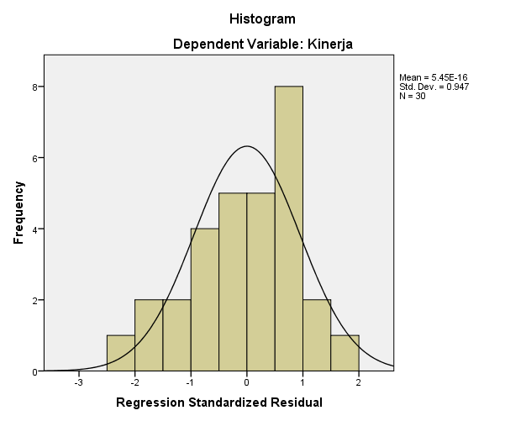

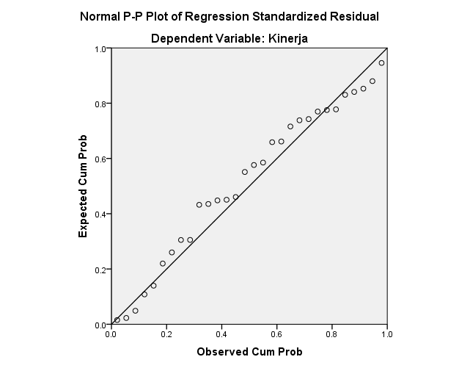

|  |  |  |
| --- | --- | --- |
| **One-Sample Kolmogorov-Smirnov Test** | | |
|  | | Unstandardized Residual |
| N | | 30 |
| Normal Parametersa,b | Mean | .0000000 |
| Std. Deviation | 3.78493717 |
| Most Extreme Differences | Absolute | .128 |
| Positive | .074 |
| Negative | -.128 |
| Test Statistic | | .128 |
| Asymp. Sig. (2-tailed) | | .200c,d |
| a. Test distribution is Normal. | | |
| b. Calculated from data. | | |
| c. Lilliefors Significance Correction. | | |
| d. This is a lower bound of the true significance. | | |

**Lampiran 23**

**Hasil Uji Multikolinieritas**

|  |  |  |  |  |  |  |  |  |
| --- | --- | --- | --- | --- | --- | --- | --- | --- |
| **Coefficientsa** | | | | | | | | |
| Model | | Unstandardized Coefficients | | Standardized Coefficients | t | Sig. | Collinearity Statistics | |
| B | Std. Error | Beta | Tolerance | VIF |
| 1 | (Constant) | 15.241 | 11.414 |  | 1.335 | .193 |  |  |
| Beban Kerja | -.415 | .167 | -.252 | -2.477 | .020 | .883 | 1.133 |
| Komunikasi Interpersonal | .806 | .103 | .774 | 7.813 | .000 | .930 | 1.075 |
| Disiplin Kerja | .253 | .075 | .333 | 3.357 | .002 | .929 | 1.076 |
| a. Dependent Variable: Kinerja | | | | | | | | |

**Lampiran 24**

**Hasil Uji Heteroskedastisitas**

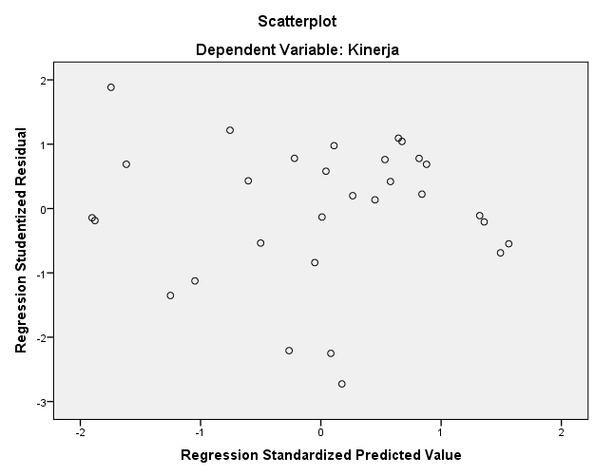

**Lampiran 25**

**Hasil Analisis Regresi Linier Berganda**

|  |  |  |  |  |  |  |  |  |
| --- | --- | --- | --- | --- | --- | --- | --- | --- |
| **Coefficientsa** | | | | | | | | |
| Model | | Unstandardized Coefficients | | Standardized Coefficients | t | Sig. | Collinearity Statistics | |
| B | Std. Error | Beta | Tolerance | VIF |
| 1 | (Constant) | 15.241 | 11.414 |  | 1.335 | .193 |  |  |
| Beban Kerja | -.415 | .167 | -.252 | -2.477 | .020 | .883 | 1.133 |
| Komunikasi Interpersonal | .806 | .103 | .774 | 7.813 | .000 | .930 | 1.075 |
| Disiplin Kerja | .253 | .075 | .333 | 3.357 | .002 | .929 | 1.076 |
| a. Dependent Variable: Kinerja | | | | | | | | |

|  |  |  |  |  |  |  |  |
| --- | --- | --- | --- | --- | --- | --- | --- |
| **Variables Entered/Removeda** | | | | | | | |
| Model | | Variables Entered | | Variables Removed | | Method | |
| 1 | | Disiplin Kerja, Komunikasi Interpersonal, Beban Kerjab | | . | | Enter | |
| a. Dependent Variable: Kinerja | | | | | | | |
| b. All requested variables entered. | | | | | | | |
| **ANOVAa** | | | | | | | | | | |
| Model | | | Sum of Squares | | df | | Mean Square | | F | Sig. |
| 1 | Regression | | 1335.920 | | 3 | | 445.307 | | 27.869 | .000b |
| Residual | | 415.447 | | 26 | | 15.979 | |  |  |
| Total | | 1751.367 | | 29 | |  | |  |  |
| a. Dependent Variable: Kinerja | | | | | | | | | | |
| b. Predictors: (Constant), Disiplin Kerja, Komunikasi Interpersonal, Beban Kerja | | | | | | | | | | |

|  |  |  |  |  |  |
| --- | --- | --- | --- | --- | --- |
| **Model Summaryb** | | | | | |
| Model | R | R Square | Adjusted R Square | Std. Error of the Estimate | Durbin-Watson |
| 1 | .873a | .763 | .735 | 3.997 | 1.292 |
| a. Predictors: (Constant), Disiplin Kerja, Komunikasi Interpersonal, Beban Kerja | | | | | |
| b. Dependent Variable: Kinerja | | | | | |

**Lampiran 26**

**Hasil Uji Hipotesis Uji t**

|  |  |  |  |  |  |  |
| --- | --- | --- | --- | --- | --- | --- |
| **Coefficientsa** | | | | | | |
| Model | | Unstandardized Coefficients | | Standardized Coefficients | t | Sig. |
| B | Std. Error | Beta |
| 1 | (Constant) | 15.241 | 11.414 |  | 1.335 | .193 |
| Beban Kerja | -.415 | .167 | -.252 | -2.477 | .020 |
| Komunikasi Interpersonal | .806 | .103 | .774 | 7.813 | .000 |
| Disiplin Kerja | .253 | .075 | .333 | 3.357 | .002 |
| a. Dependent Variable: Kinerja | | | | | | |

**Hasil Uji Simultan Uji F**

|  |  |  |  |  |  |  |
| --- | --- | --- | --- | --- | --- | --- |
| **ANOVAa** | | | | | | |
| Model | | Sum of Squares | df | Mean Square | F | Sig. |
| 1 | Regression | 1335.920 | 3 | 445.307 | 27.869 | .000b |
| Residual | 415.447 | 26 | 15.979 |  |  |
| Total | 1751.367 | 29 |  |  |  |
| a. Dependent Variable: Kinerja | | | | | | |
| b. Predictors: (Constant), Disiplin Kerja, Komunikasi Interpersonal, Beban Kerja | | | | | | |

**Lampiran 27**

**Hasil Uji Koefisien Determinasi**

|  |  |  |  |  |  |
| --- | --- | --- | --- | --- | --- |
| **Model Summaryb** | | | | | |
| Model | R | R Square | Adjusted R Square | Std. Error of the Estimate |
| 1 | .873a | .763 | .735 | 3.997 |
| a. Predictors: (Constant), Disiplin Kerja, Komunikasi Interpersonal, Beban Kerja | | | | | |
| b. Dependent Variable: Kinerja | | | | | |

**Lampiran 28**

**Surat ijin penelitian**

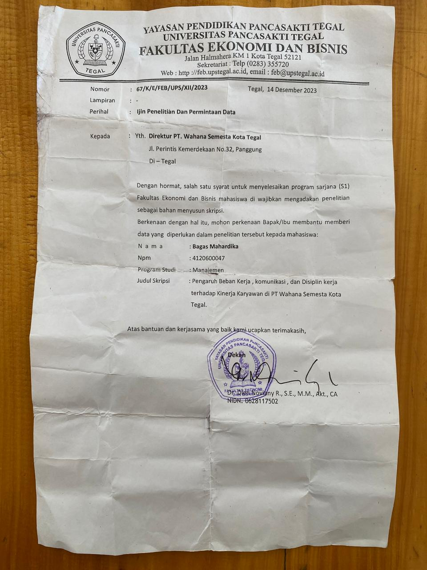

**Lampiran 29**

**Surat balasan ijin penelitian**

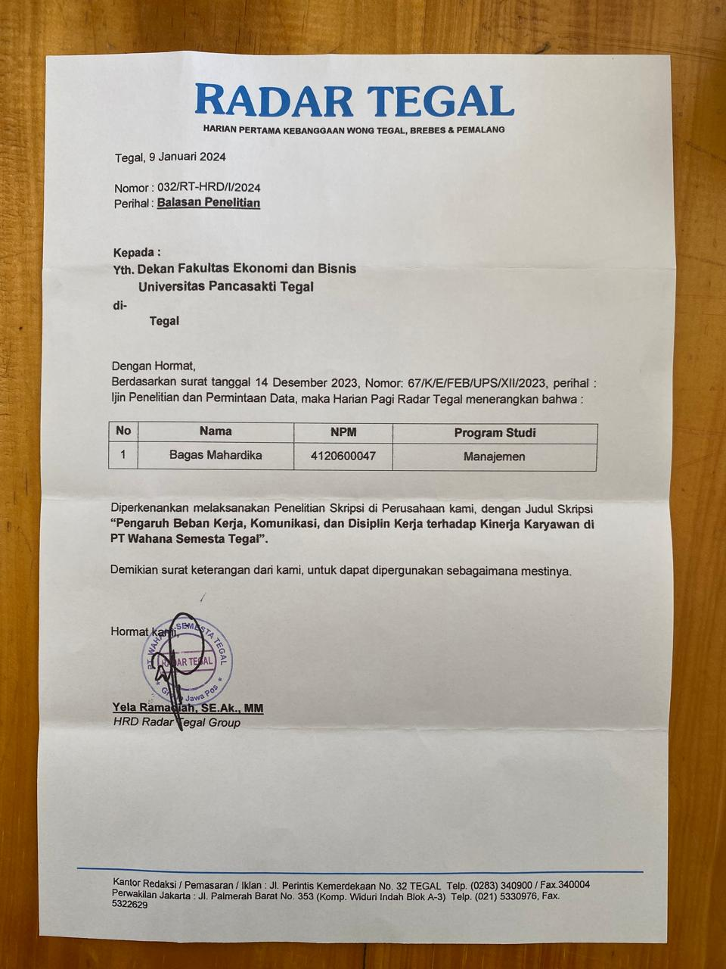

**Lampiran 30**

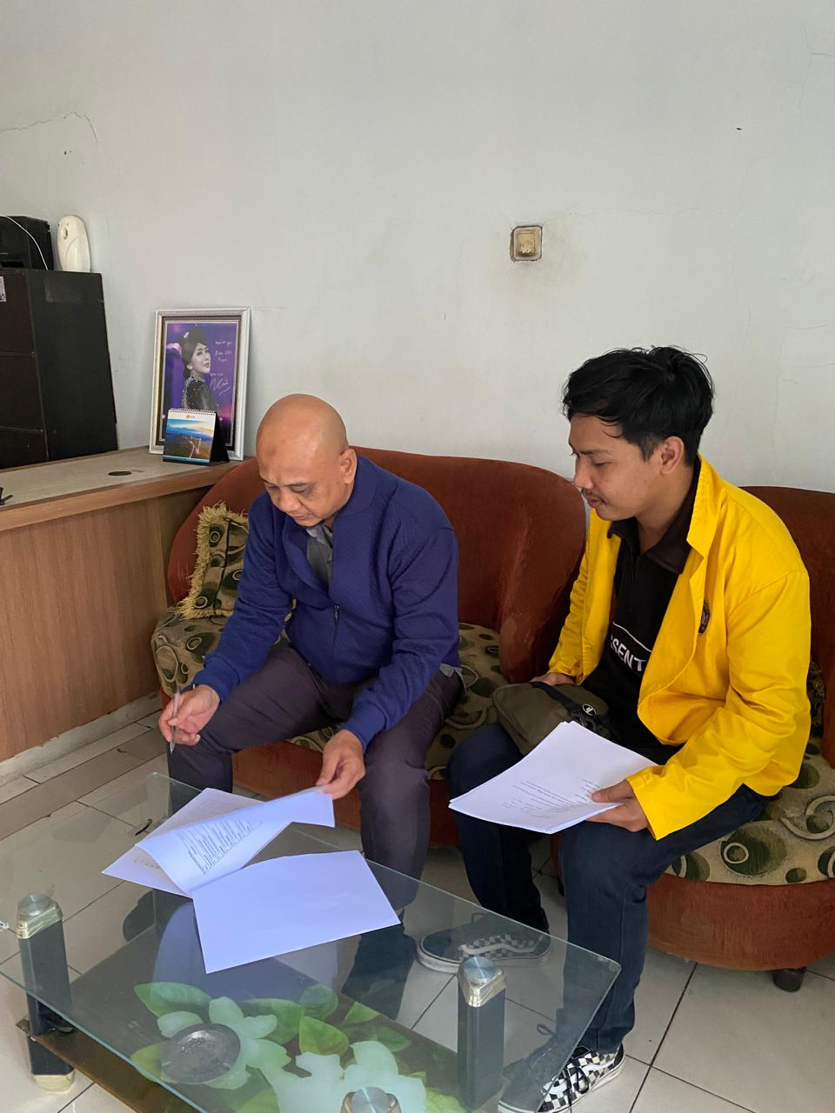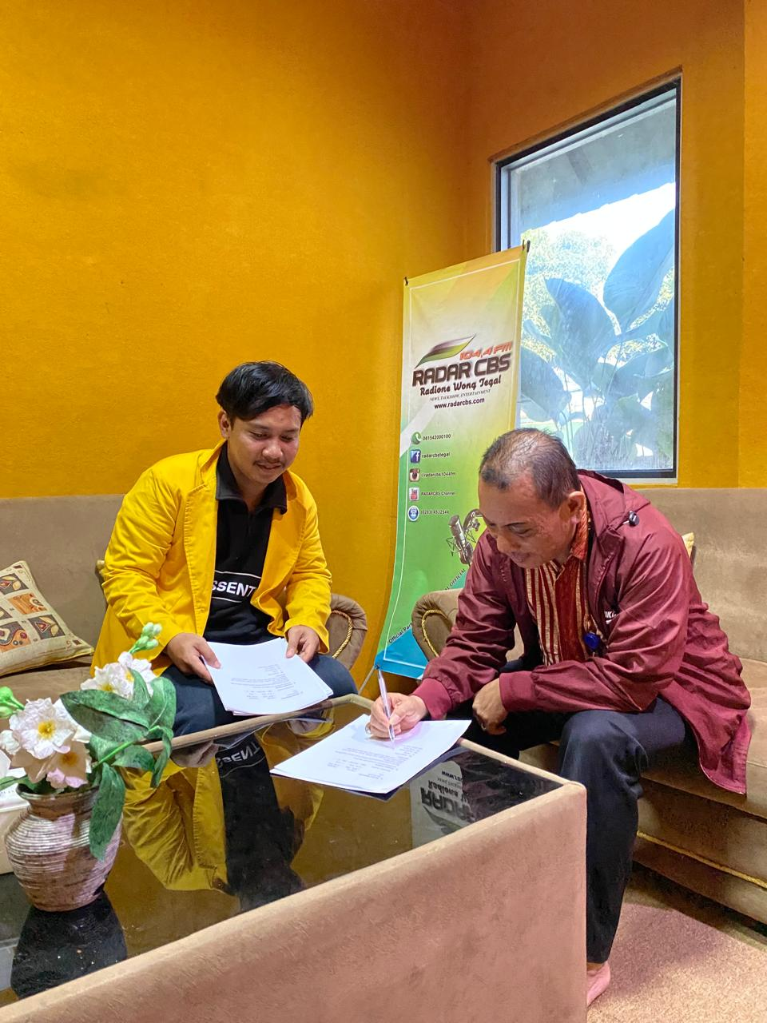**Dokumentasi Penyebaran Kuesioner**

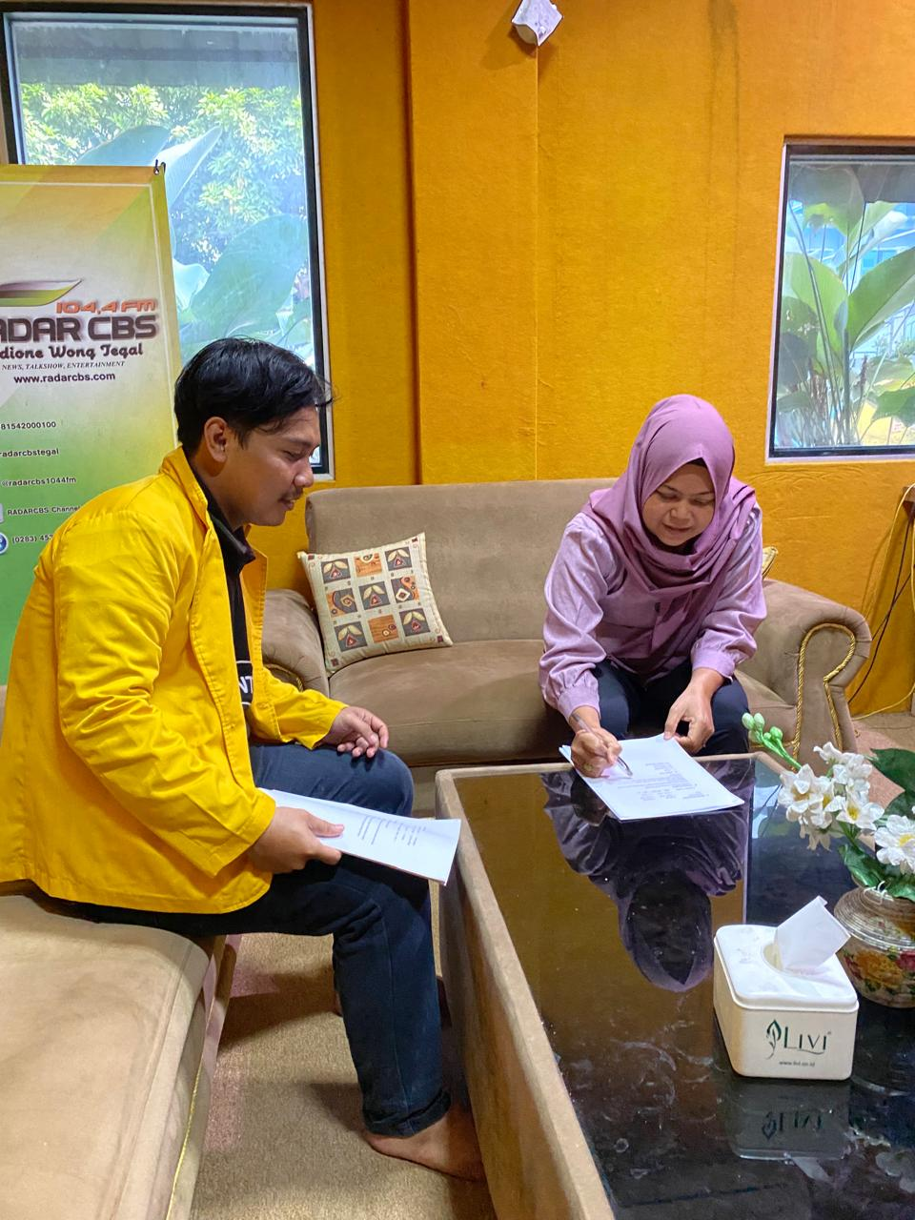

**Lampiran 31**

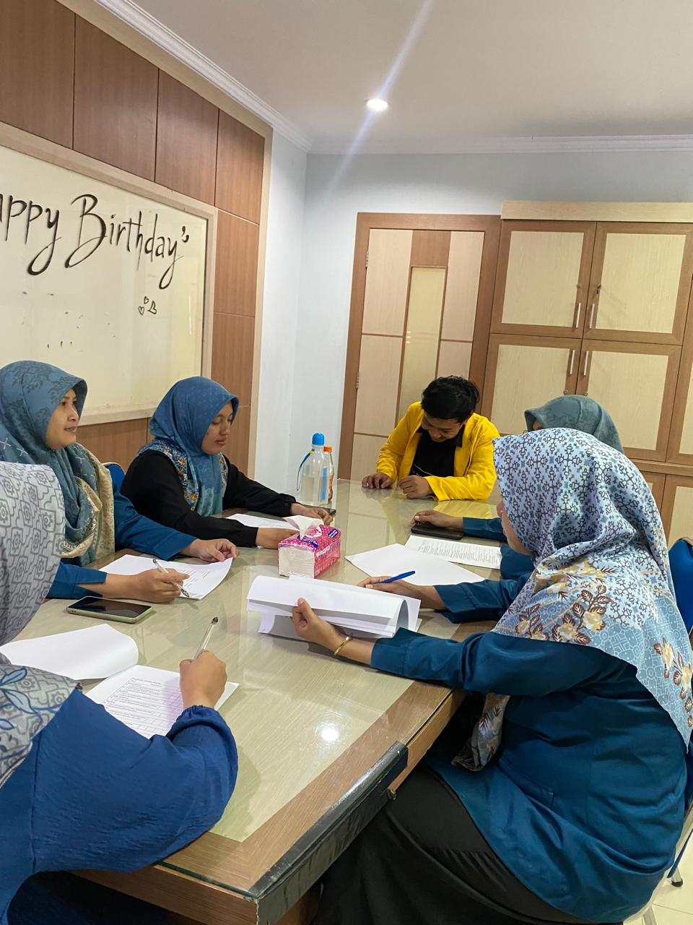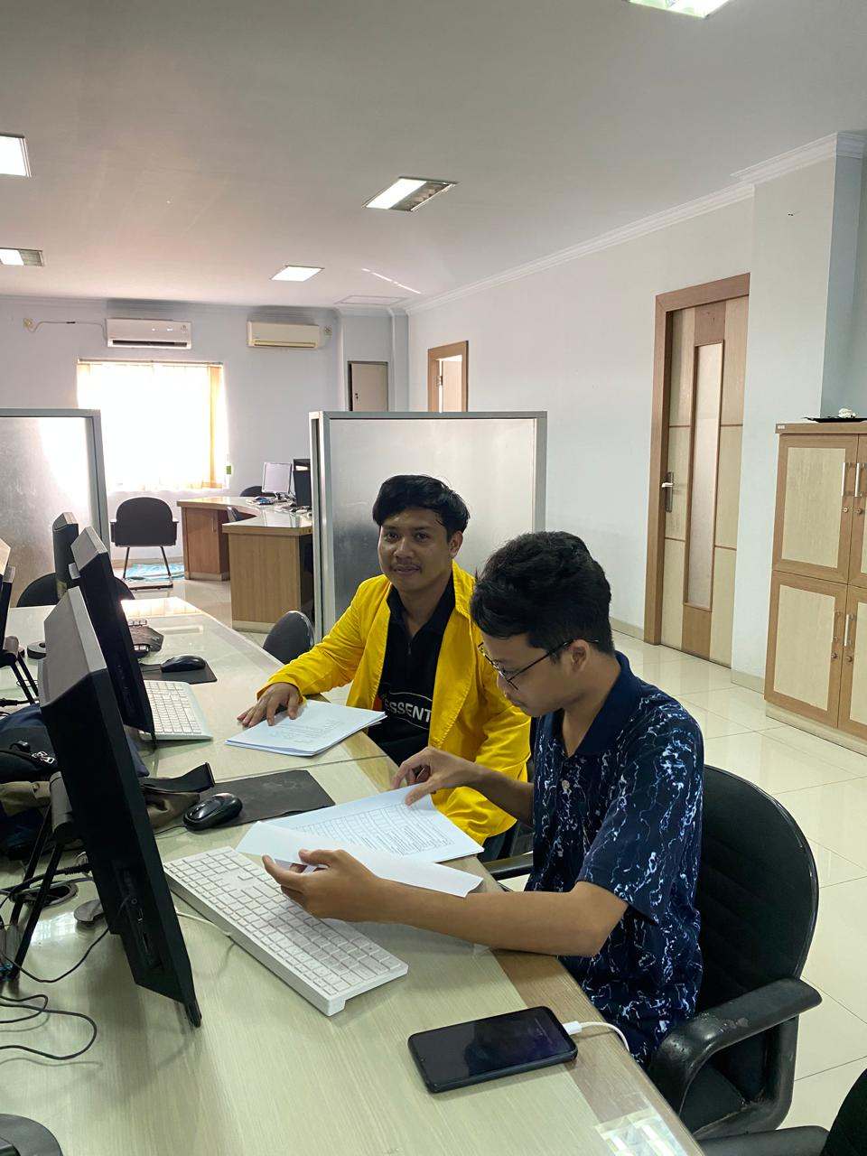**Dokumentasi Penyebaran Kuesioner**

