# DAFTAR PUSTAKA

Alma, B., 2019. *Manajemen Pemasaran dan Pemasaran Jasa.* Bandung: s.n.

Aryatiningrum, S. W. & Insyirah, A. I., 2020. Pengaruh Pemberian Price Discount Terhadap Loyalitas Konsumen Pada Pengguna Online Marketplace. *Jurnal Ilmu Management,* 8(3), pp. 946-953.

Aulia M & Wahyuningsih, 2021. Pengaruh Pengalaman Konsumen Terhadap Loyalitas Mahasiswa Universitas Tadulako Menggunakan Kosmetik Bedak Marcks. *Jurnal Ilmu Manajemen Universitas Tadulako,* Volume 7 (1), pp. 12-20.

Bobby Hartono, S. M. & Indriyani, L., 2022. In: *Minat Beli di Marketplace Shopee.* s.l.:PT Inovasi Pratama Internasional.

Cahya, A. D., Hajati, N. & Basalama, M. R., 2020. Pengaruh Diskon, Promosi, dan Kualitas Pelayanan Terhadap Keputusan Pembelian.. *E - Jurnal Riset Manajemen Prodi Manajemen,* 09(02).

Chen, C. Y., Wang, C. C. & Wang, Y. C., 2021. The Effect Of Price Discount on Customer Loyality: The Mediating Role of Perceived Value. *Journal Of Retailing and Customer Service,* Volume 59.

Ghozali, I., 2018. *Aplikasi Analisis Multivariate Dengan Program IBM SPSS 25.* 9 ed. Semarang: Badan Penerbit Universitas Diponegoro.

Handayani, N. U. & Zalika, A., 2015. Pengaruh Customer Experience Terhadap Purchase Intention Pada KFC Semarang. pp. 557-563.

Hardiansyah, L., Iskandar, K. & Harliana, H., 2019. Perancangan User Experience Website Profil Dengan Metode The Five Planes. *Jurnal Ilmu Intech Informasi Technologi,* 1(1), p. 11–21.

Hidayatuloh, S., Kusumaningtyas, R. H. & Aziati, Y., 2021. Analisis Pengaruh User Experience Terhadap Kepuasan Pengguna Mobile Application E-Commerce Shopee Menggunakan Model Delone & Mclean. *Appl. Inf. System Manage,* 2(2).

Keller, K. L., 2020. *Strategic Brand Management: Building, Measuring, and Managing Brand Equity.* s.l.:Pearson.

Khoo, K. L., 2022. A Study of Service Quality, Corporate Image, Customer Satisfaction, Revisit Intention, and Word-of-Mouth: Evidence from the KTV Industry. 6(2), pp. 105-119.

Kotler, P. & Keller, K. L., 2016. *Marketing Management, 15th Edition.* London: Pearson Education Limited.

Lacap, J. P. G., Plaza, M. N., Caballero, J. & de la Cruz, M., 2023. Factors Affecting Customer Attitude and Loyalty: Evidence from Philipphine Chain of Fast Food Restaurants Smart Retailling Technology. *Journal of Science and Technology Policy Management.*

Lestari, N. & Zen, F. N., 2023. Pengaruh Country Of Origin dan Reputasi Merek Terhadap Loyalitas Konsumen Natasha Skin Care di Kabupaten dan Kota Bekasi. *Jurnal Ekonomi dan Bisnis,* 3(1).

Lie, D., Sudirman, A., Efendi & Butarbutar, M., 2019. Analysis of mediation effect of consumer satisfaction on the effect of service quality, price and consumer trust on consumer loyalty. *International Journal of Scientific and Technology Research,* Volume 8 (8), pp. 421-428.

Mikasari, D. A. & Wibowo, A. E., 2021. Reputasi Merek, Kompetensi Merek, Kesukaan Merek dan Kepercayaan Pada Perusahaan Terhadap Loyalitas Merek Apotek Vitka Farma. *Jurnal Postgraduate Management,* 1(1), pp. 14-25.

Mowen, J. C. & Minor, M., 2002. *Perilaku Konsumen.* Jakarta: PT. Erlangga.

Mu'ah, 2014. *Loyalitas Pelanggan: Tinjauan Aspek Pelayanan dan Biaya Peralihan.* Sidoarjo: Zifatama Publisher.

Oktavian, S., Suhut, U. & Febrilia, I., 2023. Pengaruh Service Quality, Brand Trust, dan Customer Satisfaction Terhadap Loyalty Pada Pengguna Jasa Pembayaran Online. *Jurnal Bisnis, Manajemen dan Keuangan ,* 4(2).

Parhusip, A. A. & Lubis, N. I., 2020. Pengaruh Orientasi Belanja, Kepercayaan Online, Dan Pengalaman Pembelian Terhadap Minat Beli Secara Online (Studi Kasus Pada Toko Online tokopedia.com). *EKOMBIS Sains Jurnal Ekonomi, Keuangan dan Bisnis,* Volume 2, pp. 17 - 28.

Permatasari, A. S., Listyorini, S. & Prihatini, A. E., 2022. Pengaruh Reputasi Merek dan Persepsi Kualitas Jasa Terhadap Loyalitas Merek (Studi pada Pengunjung MG Setos Hotel Semarang). *Jurnal Ilmu Administrasi Bisnis,* Volume 11 No. 2.

Prakash, A. & Kumar, U., 2019. User Interface Design Issues For Easy And Efficient Human Computer Interaction: An Explanatory Approach Debasmita. *Int. J. Comput. Sci. Eng.,* Volume 3, p. 127–135.

Ridwan, M. & Noviyanti, S., 2021. Pengaruh Kualitas Pelayanan dan Kepuasan Pelanggan Terhadap Loyalitas Pelanggan Go-Jek (Studi Kasus Pada Mahasiswa Fakultas Ekonomi dan Bisnis Universitas Islam As-Syafi'iyah). *KINERJA Jurnal Ekonomi dan Bisnis,* 4(1), pp. 53-66.

Satria, R., Ahmad , I. & Gunawan, R. D., 2023. Rancang Bangun E-Marketplace Berbasis Mobile Untuk Meningkatkan Pelayanan Penjualan. *Jurnal Informatika dan Rekayasa Perangkat Lunak (JATIKA),* Volume 4, pp. 89-95.

Smilansky, S., 2018. *Experimental Marketing A Practical guide to interactive brand experiences (2nd ed).* s.l.:Kogan Page.

Sola, K. I., 2017. Pengaruh Harga, Kualitas Produk dan Kualitas Pelayanan Terhadap Loyalitas Pelanggan (Studi Kasus Pada Sakola Factory Outlet Jogja).

Sugiyono, 2016. *Metode Penelitian Manajemen, Pendekatan Kuantitatif, Kualitatif, Kombinasi, Penelitian Tindakan, dan Penelitian Evaluasi.* Bandung: Alfabeta.

Sugiyono, 2018. *Metode Penelitian Kuantitatif.* Bandung: Alfabeta.

Sugiyono, 2020. *Metode Penelitian Kualitatif.* Bandung : Alfabeta.

Suliyanto, 2018. *Metode Penlitian Bisnis untuk Skirpsi, Tesis & Disertasi.* Yogyakarta: Andi Offset.

Syuhada , K. N., Norshahrizan, N., Suraiya, I. & Izwaan, S. M. S., 2023. An Internal and External Factors Affecting Customer Loyalty: A Case Study of Fast Food Industry in Kulim, Kedah. *AIP Conference Proceedings,* Volume 2544 (1).

Tjiptono, F., 2020. *Strategi Pemasaran, Prinsip dan Penerapan.* Yogyakarta: Andi Offset.

Tjiptono, F. & Chandra, G., 2016. *Service, Quality, dan Satisfaction.* Yogyakarta: Penerbit ANDI.

Tjiptono, F. & Diana, 2016. *Pemasaran Esensi dan Aplikasi.* Yogyakarta: Andi Offset.

Wibowo, A. E. & Silitonga, F., 2020. Pengaruh Promosi dan Kualitas Pelayanan Terhadap Intention To Use Jasa Transportasi PT. Batam Fast Ferry di Kota Batam. *Cafetaria,* 1(2), pp. 23-32.

Yuniarti, V. S., 2015. *Perilaku Konsumen Teori dan Praktik.* Bandung: CV. Pustaka Setia.

Zare, M. & Mahmoudi, R., 2020. The Effects of the Online Customer Experience on Customer Loyalty in E-Retailers. *International Journal of Advanced Engineering,* Volume 6.

Zebua, R. S. Y. et al., 2023. *Bisnis Digital.* 1 ed. Jambi: SONPEDIA.

**LAMPIRAN**

**Lampiran 1**

**KUESIONER PENELITIAN**

**PENGARUH PERSEPSI *PRICE DISCOUNT*, PERSEPSI REPUTASI MEREK, DAN PENGALAMAN PENGGUNA TERHADAP LOYALITAS KONSUMEN DI NAY PRODUCTION TEGAL MELALUI *E-COMMERCE SHOPEE***

Lampiran :

Perihal : Permohonan Pengisian

Kuesioner

Kepada Yth:

Bapak/Ibu Responden

Nay Production

Di Tempat

Dengan hormat,

Dalam rangka menyelesaikan tugas penelitian, kami mahasiswa dari Fakultas Ekonomi dan Bisnis Universitas Pancasakti Tegal memohon bantuan dan kesediaan Bapak/Ibu untuk menjadi responden dan berkenan memberikan jawaban yang sesuai dengan persepsi Bapak/Ibu atas pernyataan kuesioner yang sudah kami siapkan.

Jawaban Bapak/Ibu terhadap kuesioner ini tidak akan dipublikasikan dan dijamin kerahasiaannya, karena data ini hanya digunakan untuk kepentingan akademis dan dalam rangka pengembangan ilmu pengetahuan.

Demikian disampaikan atas bantuan dan kerjasamanya diucapkan terimakasih.

Tegal, Mei 2024

Salsabila Sulistyawati

**KUESIONER**

1. **Identitas Responden**
2. Jenis Kelamin : Laki-laki Perempuan
3. Apakah Bapak/Ibu/Saudara/i pernah membeli produk di Nay Production Tegal?

Ya Jika Ya, lanjutkan ke pertanyaan selanjutnya

Tidak Jika Tidak, anda tidak perlu menjawab pertanyaan

1. Usia : 15-20 Tahun 21-30 Tahun

31-40 Tahun > 40 Tahun

1. **Petunjuk Pengisian**
2. Jawablah pertanyaan ini dengan jujur dan benar.
3. Bacalah terlebih dahulu pertanyaan dengan cermat sebelum anda memulai untuk menjawabnya.
4. Pilihlah salah satu jawaban yang tersedia dengan memberikan tanda checklist/centang (√) pada salah satu jawaban yang anda anggap paling benar.

Keterangan:

SS : Sangat Setuju N : Netral

S : Setuju TS : Tidak Setuju

STS : Sangat Tidak Setuju

1. **Daftar Pertanyaan**

* **Loyalitas Konsumen**

|  |  |  |  |  |  |  |
| --- | --- | --- | --- | --- | --- | --- |
| **No.** | **Pertanyaan** | **Jawaban** | | | | |
| **SS** | **S** | **N** | **TS** | **STS** |
| 1. | Produk yang ditawarkan memiliki kualitas yang baik (sesuai deskripsi dan tidak mudah cacat) |  |  |  |  |  |
| 2. | Harga Produk yang saya beli sebanding dengan kualitasnya. |  |  |  |  |  |
| 3. | Saya merasa harga produk ini lebih murah dibandingkan produk sejenis dari toko lain |  |  |  |  |  |
| 4. | Saya sering membicarakan Nay Production dengan teman dan keluarga |  |  |  |  |  |
| 5. | Saya berencana untuk membeli produk ini lagi di masa depan |  |  |  |  |  |
| 6. | Saya sering melakukan pembelian produk Nay Production dalam satu bulan terakhir |  |  |  |  |  |
| 7. | Saya merasa bahwa Nay Production memberikan kesan yang bagus bagi saya. |  |  |  |  |  |
| 8. | Saya cenderung memilih Nay Production setiap kali melakukan dengan kategori produk yang sama |  |  |  |  |  |
| 9. | Saya sudah berkali-kali membeli dan menggunakan produk dari Nay Production secara berulang |  |  |  |  |  |
| 10. | Saya akan merekomendasikan Nay Production kepada teman maupun keluarga |  |  |  |  |  |

* **Persepsi *Price Discount***

|  |  |  |  |  |  |  |
| --- | --- | --- | --- | --- | --- | --- |
| **No.** | **Pertanyaan** | **Jawaban** | | | | |
| **SS** | **S** | **N** | **TS** | **STS** |
| 1. | Saya telah memperhatikan peningkatan penjualan produk di Nay Production ketika memberikan penawaran diskon harga |  |  |  |  |  |
| 2. | Saya merasa bahwa diskon harga sangat mempengaruhi keputusan saya untuk melakukan pembelian dalam jumlah besar |  |  |  |  |  |
| 3. | Saya memilih untuk memanfaatkan penawaran diskon berdasarkan durasi penawaran yang diberikan |  |  |  |  |  |
| 4. | Saya merasa durasi diskon memiliki pengaruh yang signifikan terhadap keputusan pembelian |  |  |  |  |  |
| 5. | Saya cenderung membeli produk yang memiliki variasi atau piihan harga diskon dibandingkan dengan produk yang hanya memiliki satu versi dengan harga reguler |  |  |  |  |  |

* **Reputasi Merek**

|  |  |  |  |  |  |  |
| --- | --- | --- | --- | --- | --- | --- |
| **No.** | **Pertanyaan** | **Jawaban** | | | | |
| **SS** | **S** | **N** | **TS** | **STS** |
| 1. | Tingkat efektivitas iklan merek Nay Production mempengaruhi persepsi saya terhadap reputasi merek |  |  |  |  |  |
| 2. | Nay Production dikenal memiliki kualias produk yang bagus |  |  |  |  |  |
| 3. | Nay Production konsisten terhadap kualitasnya |  |  |  |  |  |
| 4. | Nay Production memiliki kualitas produk yang patut diandalkan |  |  |  |  |  |
| 5. | Nay Production memiliki nama merek yang mudah diingat |  |  |  |  |  |
| 6. | Nay Production memiliki reputasi yang baik |  |  |  |  |  |
| 7. | Nay Production lebih menonjol dibanding pesaing lainnya |  |  |  |  |  |
| 8. | Nay Production dapat mengingatkan pada nilai-nilai atau pengalaman positif |  |  |  |  |  |
| 9. | Produk yang dipesan di Nay Production dapat dipercaya dan sesuai harapan |  |  |  |  |  |
| 10. | Nay Production memberikan deskripsi yang akurat pada setiap produk |  |  |  |  |  |

|  |  |  |  |  |  |  |
| --- | --- | --- | --- | --- | --- | --- |
| **No** | **Pertanyaan** | **Jawaban** | | | | |
| **SS** | **S** | **N** | **TS** | **STS** |
| 1. | Nay Production memiliki keunikan produk yang disebutkan dalam ulasan positif konsumen |  |  |  |  |  |
| 2. | Mudah menemukan produk yang diinginkan di Nay Production karena banyaknya variasi produk |  |  |  |  |  |
| 3. | Produk dari Nay Production memenuhi ekspetasi dan kepuasan terhadap produk-produknya |  |  |  |  |  |
| 4. | Pengalaman menggunakan produk membuat puas selama menggunakannya. |  |  |  |  |  |
| 5. | Ulasan positif konsumen memberikan informasi yang berguna untuk memahami produk-produk dari Nay Production dengan lebih baik lagi |  |  |  |  |  |
| 6. | Membeli produk di toko ini karena ulasan positif dari konsumen |  |  |  |  |  |
| 7. | Membeli produk di Nay Production dalam rentang waktu beberapa bulan ini |  |  |  |  |  |
| 8. | Membeli produk Nay Production di *marketplace* Shopee karena lebih murah |  |  |  |  |  |
| 9. | Membeli produk Nay Production di Shopee karena metode pembayaran yang mudah |  |  |  |  |  |
| 10. | Membeli produk Nay Production di Shopee karena lebih banyak voucher |  |  |  |  |  |

* **Pengalaman Pengguna**

**Lampiran 2**

**Identitas Responden**

|  |  |  |
| --- | --- | --- |
| No Responden | Jenis Kelamin | Umur |
| 1 | Laki-Laki | 21-30 Tahun |
| 2 | Laki-Laki | 21-30 Tahun |
| 3 | Laki-Laki | 21-30 Tahun |
| 4 | Laki-Laki | 15-20 Tahun |
| 5 | Laki-Laki | 21-30 Tahun |
| 6 | Perempuan | 15-20 Tahun |
| 7 | Laki-Laki | 21-30 Tahun |
| 8 | Laki-Laki | 21-30 Tahun |
| 9 | Laki-Laki | >40 Tahun |
| 10 | Laki-Laki | 21-30 Tahun |
| 11 | Laki-Laki | >40 Tahun |
| 12 | Laki-Laki | 21-30 Tahun |
| 13 | Laki-Laki | 21-30 Tahun |
| 14 | Laki-Laki | 21-30 Tahun |
| 15 | Laki-Laki | 21-30 Tahun |
| 16 | Laki-Laki | 15-20 Tahun |
| 17 | Laki-Laki | >40 Tahun |
| 18 | Laki-Laki | 21-30 Tahun |
| 19 | Laki-Laki | 21-30 Tahun |
| 20 | Laki-Laki | 15-20 Tahun |
| 21 | Laki-Laki | >40 Tahun |
| 22 | Laki-Laki | >40 Tahun |
| 23 | Laki-Laki | 15-20 Tahun |
| 24 | Laki-Laki | 21-30 Tahun |
| 25 | Laki-Laki | 21-30 Tahun |
| 26 | Laki-Laki | 21-30 Tahun |
| 27 | Laki-Laki | 21-30 Tahun |
| 28 | Laki-Laki | 21-30 Tahun |
| 29 | Laki-Laki | 21-30 Tahun |
| 30 | Laki-Laki | 15-20 Tahun |
| 31 | Laki-Laki | 21-30 Tahun |
| 32 | Laki-Laki | 21-30 Tahun |
| 33 | Laki-Laki | 21-30 Tahun |
| 34 | Laki-Laki | 21-30 Tahun |
| 35 | Laki-Laki | 15-20 Tahun |
| 36 | Laki-Laki | 15-20 Tahun |
| 37 | Laki-Laki | 15-20 Tahun |
| 38 | Laki-Laki | 21-30 Tahun |
| 39 | Laki-Laki | 21-30 Tahun |
| 40 | Laki-Laki | 15-20 Tahun |
| 41 | Laki-Laki | 21-30 Tahun |
| 42 | Laki-Laki | >40 Tahun |
| 43 | Laki-Laki | 21-30 Tahun |
| 44 | Laki-Laki | 15-20 Tahun |
| 45 | Laki-Laki | >40 Tahun |
| 46 | Laki-Laki | 21-30 Tahun |
| 47 | Laki-Laki | 15-20 Tahun |
| 48 | Laki-Laki | 31-40 Tahun |
| 49 | Laki-Laki | 21-30 Tahun |
| 50 | Laki-Laki | 31-40 Tahun |
| 51 | Laki-Laki | >40 Tahun |
| 52 | Laki-Laki | 21-30 Tahun |
| 53 | Laki-Laki | 31-40 Tahun |
| 54 | Laki-Laki | 31-40 Tahun |
| 55 | Perempuan | 21-30 Tahun |
| 56 | Laki-Laki | 31-40 Tahun |
| 57 | Laki-Laki | >40 Tahun |
| 58 | Laki-Laki | 21-30 Tahun |
| 59 | Laki-Laki | 31-40 Tahun |
| 60 | Laki-Laki | 21-30 Tahun |
| 61 | Laki-Laki | 21-30 Tahun |
| 62 | Laki-Laki | >40 Tahun |
| 63 | Laki-Laki | 15-20 Tahun |
| 64 | Laki-Laki | 31-40 Tahun |
| 65 | Laki-Laki | 31-40 Tahun |
| 66 | Laki-Laki | 31-40 Tahun |
| 67 | Laki-Laki | >40 Tahun |
| 68 | Laki-Laki | 21-30 Tahun |
| 69 | Laki-Laki | 31-40 Tahun |
| 70 | Laki-Laki | 31-40 Tahun |
| 71 | Laki-Laki | 21-30 Tahun |
| 72 | Laki-Laki | 21-30 Tahun |
| 73 | Laki-Laki | >40 Tahun |
| 74 | Laki-Laki | 15-20 Tahun |
| 75 | Laki-Laki | 31-40 Tahun |
| 76 | Laki-Laki | >40 Tahun |
| 77 | Laki-Laki | >40 Tahun |
| 78 | Laki-Laki | 21-30 Tahun |
| 79 | Laki-Laki | >40 Tahun |
| 80 | Laki-Laki | 31-40 Tahun |
| 81 | Laki-Laki | 21-30 Tahun |
| 82 | Laki-Laki | >40 Tahun |
| 83 | Laki-Laki | >40 Tahun |
| 84 | Perempuan | 21-30 Tahun |
| 85 | Laki-Laki | 31-40 Tahun |
| 86 | Laki-Laki | 31-40 Tahun |
| 87 | Laki-Laki | 21-30 Tahun |
| 88 | Laki-Laki | 31-40 Tahun |
| 89 | Laki-Laki | >40 Tahun |
| 90 | Laki-Laki | 21-30 Tahun |
| 91 | Laki-Laki | 31-40 Tahun |
| 92 | Laki-Laki | 21-30 Tahun |
| 93 | Laki-Laki | >40 Tahun |
| 94 | Laki-Laki | 21-30 Tahun |
| 95 | Laki-Laki | 21-30 Tahun |
| 96 | Laki-Laki | >40 Tahun |
| 97 | Laki-Laki | 21-30 Tahun |
| 98 | Laki-Laki | 21-30 Tahun |
| 99 | Laki-Laki | 21-30 Tahun |
| 100 | Laki-Laki | 21-30 Tahun |

**Lampiran 3**

**Tabulasi Hasil Penelitian Kuesioner (Ordinal)**

* **Variabel Loyalitas Konsumen (Y)**

|  |  |  |  |  |  |  |  |  |  |  |  |
| --- | --- | --- | --- | --- | --- | --- | --- | --- | --- | --- | --- |
| Responden | Loyalitas Konsumen | | | | | | | | | | Total |
| 1 | 2 | 3 | 4 | 5 | 6 | 7 | 8 | 9 | 10 |
| 1 | 4 | 4 | 3 | 4 | 3 | 4 | 5 | 4 | 2 | 5 | 38 |
| 2 | 3 | 3 | 5 | 3 | 4 | 4 | 3 | 5 | 5 | 4 | 39 |
| 3 | 4 | 5 | 4 | 4 | 4 | 4 | 4 | 4 | 4 | 4 | 41 |
| 4 | 4 | 4 | 3 | 3 | 3 | 3 | 3 | 3 | 3 | 4 | 33 |
| 5 | 4 | 4 | 4 | 4 | 4 | 4 | 4 | 4 | 3 | 4 | 39 |
| 6 | 3 | 4 | 3 | 4 | 4 | 4 | 4 | 4 | 3 | 4 | 37 |
| 7 | 4 | 4 | 3 | 4 | 4 | 4 | 4 | 4 | 4 | 4 | 39 |
| 8 | 4 | 4 | 4 | 4 | 5 | 5 | 4 | 4 | 4 | 4 | 42 |
| 9 | 4 | 4 | 4 | 3 | 4 | 4 | 4 | 3 | 4 | 4 | 38 |
| 10 | 4 | 4 | 3 | 4 | 3 | 4 | 5 | 4 | 2 | 5 | 38 |
| 11 | 4 | 4 | 4 | 3 | 3 | 3 | 3 | 3 | 2 | 2 | 31 |
| 12 | 4 | 5 | 4 | 4 | 4 | 4 | 4 | 4 | 4 | 4 | 41 |
| 13 | 4 | 4 | 3 | 3 | 3 | 3 | 3 | 3 | 3 | 4 | 33 |
| 14 | 4 | 5 | 4 | 4 | 4 | 4 | 4 | 4 | 4 | 4 | 41 |
| 15 | 4 | 4 | 3 | 3 | 3 | 3 | 3 | 3 | 3 | 4 | 33 |
| 16 | 4 | 4 | 3 | 4 | 3 | 4 | 5 | 4 | 2 | 5 | 38 |
| 17 | 5 | 3 | 5 | 3 | 4 | 4 | 3 | 5 | 3 | 4 | 39 |
| 18 | 4 | 5 | 4 | 4 | 4 | 4 | 4 | 4 | 4 | 4 | 41 |
| 19 | 3 | 4 | 4 | 5 | 3 | 3 | 4 | 4 | 3 | 3 | 36 |
| 20 | 4 | 3 | 4 | 2 | 5 | 4 | 4 | 5 | 4 | 3 | 38 |
| 21 | 4 | 3 | 4 | 4 | 3 | 5 | 4 | 4 | 4 | 3 | 38 |
| 22 | 4 | 3 | 3 | 3 | 4 | 4 | 3 | 3 | 3 | 4 | 34 |
| 23 | 4 | 4 | 3 | 4 | 4 | 4 | 4 | 4 | 4 | 4 | 39 |
| 24 | 3 | 3 | 4 | 4 | 4 | 4 | 5 | 5 | 4 | 4 | 40 |
| 25 | 5 | 5 | 5 | 5 | 5 | 5 | 5 | 5 | 5 | 5 | 50 |
| 26 | 4 | 4 | 5 | 4 | 5 | 4 | 5 | 4 | 2 | 5 | 42 |
| 27 | 5 | 5 | 5 | 5 | 4 | 4 | 5 | 5 | 5 | 4 | 47 |
| 28 | 4 | 5 | 4 | 4 | 4 | 4 | 4 | 4 | 4 | 4 | 41 |
| 29 | 4 | 4 | 5 | 5 | 5 | 5 | 5 | 5 | 5 | 4 | 47 |
| 30 | 4 | 4 | 5 | 4 | 4 | 4 | 4 | 4 | 5 | 4 | 42 |
| 31 | 4 | 5 | 4 | 4 | 4 | 4 | 4 | 4 | 4 | 4 | 41 |
| 32 | 4 | 4 | 4 | 4 | 4 | 4 | 5 | 5 | 5 | 5 | 44 |
| 33 | 4 | 5 | 5 | 5 | 4 | 4 | 4 | 5 | 5 | 4 | 45 |
| 34 | 4 | 5 | 4 | 4 | 5 | 4 | 4 | 4 | 4 | 4 | 42 |
| 35 | 4 | 4 | 5 | 4 | 5 | 4 | 4 | 4 | 4 | 4 | 42 |
| 36 | 4 | 4 | 5 | 5 | 5 | 5 | 5 | 5 | 5 | 4 | 47 |
| 37 | 4 | 4 | 4 | 4 | 4 | 4 | 4 | 4 | 5 | 4 | 41 |
| 38 | 5 | 4 | 5 | 4 | 4 | 4 | 4 | 4 | 5 | 4 | 43 |
| 39 | 4 | 5 | 4 | 5 | 4 | 5 | 4 | 5 | 5 | 5 | 46 |
| 40 | 4 | 5 | 4 | 4 | 5 | 4 | 4 | 4 | 4 | 4 | 42 |
| 41 | 3 | 5 | 5 | 3 | 4 | 4 | 4 | 4 | 3 | 4 | 39 |
| 42 | 4 | 4 | 3 | 4 | 3 | 4 | 5 | 4 | 2 | 5 | 38 |
| 43 | 3 | 3 | 5 | 3 | 4 | 4 | 3 | 5 | 5 | 4 | 39 |
| 44 | 4 | 5 | 4 | 4 | 4 | 4 | 4 | 4 | 4 | 4 | 41 |
| 45 | 4 | 4 | 3 | 3 | 3 | 3 | 3 | 3 | 3 | 4 | 33 |
| 46 | 4 | 4 | 4 | 4 | 4 | 4 | 4 | 4 | 3 | 4 | 39 |
| 47 | 3 | 4 | 3 | 4 | 4 | 4 | 4 | 4 | 3 | 4 | 37 |
| 48 | 4 | 4 | 3 | 4 | 4 | 4 | 4 | 4 | 4 | 4 | 39 |
| 49 | 4 | 4 | 4 | 4 | 5 | 5 | 4 | 4 | 4 | 4 | 42 |
| 50 | 4 | 4 | 4 | 3 | 4 | 4 | 4 | 3 | 4 | 4 | 38 |
| 51 | 3 | 3 | 3 | 2 | 3 | 3 | 3 | 3 | 3 | 2 | 28 |
| 52 | 4 | 5 | 3 | 3 | 4 | 4 | 3 | 4 | 3 | 4 | 37 |
| 53 | 5 | 5 | 4 | 4 | 3 | 3 | 3 | 5 | 4 | 4 | 40 |
| 54 | 3 | 3 | 3 | 3 | 3 | 3 | 3 | 5 | 3 | 3 | 32 |
| 55 | 3 | 3 | 4 | 3 | 4 | 4 | 3 | 5 | 4 | 3 | 36 |
| 56 | 5 | 5 | 5 | 5 | 5 | 5 | 5 | 2 | 3 | 4 | 44 |
| 57 | 4 | 4 | 3 | 3 | 4 | 4 | 3 | 4 | 3 | 4 | 36 |
| 58 | 4 | 4 | 4 | 3 | 4 | 3 | 3 | 5 | 3 | 4 | 37 |
| 59 | 4 | 4 | 4 | 3 | 4 | 3 | 3 | 5 | 4 | 5 | 39 |
| 60 | 3 | 3 | 3 | 2 | 3 | 3 | 3 | 5 | 3 | 2 | 30 |
| 61 | 5 | 4 | 4 | 4 | 4 | 4 | 4 | 4 | 4 | 4 | 41 |
| 62 | 5 | 5 | 4 | 4 | 3 | 3 | 3 | 3 | 4 | 4 | 38 |
| 63 | 3 | 3 | 3 | 3 | 3 | 3 | 3 | 5 | 3 | 3 | 32 |
| 64 | 5 | 5 | 4 | 4 | 3 | 3 | 3 | 5 | 4 | 4 | 40 |
| 65 | 3 | 3 | 3 | 3 | 3 | 3 | 3 | 5 | 3 | 3 | 32 |
| 66 | 4 | 4 | 4 | 2 | 4 | 4 | 4 | 4 | 4 | 2 | 36 |
| 67 | 4 | 5 | 4 | 4 | 4 | 4 | 4 | 4 | 4 | 4 | 41 |
| 68 | 5 | 5 | 4 | 4 | 4 | 4 | 4 | 4 | 4 | 4 | 42 |
| 69 | 4 | 4 | 4 | 4 | 4 | 4 | 4 | 4 | 4 | 4 | 40 |
| 70 | 4 | 4 | 4 | 4 | 4 | 4 | 4 | 4 | 4 | 4 | 40 |
| 71 | 4 | 4 | 4 | 2 | 2 | 2 | 5 | 5 | 2 | 2 | 32 |
| 72 | 2 | 2 | 5 | 5 | 2 | 5 | 5 | 4 | 4 | 2 | 36 |
| 73 | 4 | 4 | 4 | 4 | 4 | 4 | 4 | 4 | 4 | 4 | 40 |
| 74 | 5 | 4 | 4 | 4 | 4 | 2 | 5 | 4 | 4 | 4 | 40 |
| 75 | 4 | 4 | 4 | 4 | 4 | 4 | 4 | 4 | 4 | 4 | 40 |
| 76 | 4 | 4 | 4 | 2 | 4 | 4 | 4 | 4 | 4 | 2 | 36 |
| 77 | 4 | 5 | 4 | 4 | 4 | 4 | 4 | 4 | 4 | 4 | 41 |
| 78 | 5 | 5 | 4 | 4 | 4 | 4 | 4 | 4 | 4 | 4 | 42 |
| 79 | 4 | 4 | 4 | 4 | 4 | 4 | 4 | 2 | 4 | 4 | 38 |
| 80 | 4 | 4 | 4 | 4 | 4 | 4 | 4 | 4 | 4 | 4 | 40 |
| 81 | 4 | 4 | 4 | 4 | 4 | 4 | 4 | 2 | 4 | 4 | 38 |
| 82 | 4 | 4 | 4 | 4 | 4 | 5 | 4 | 5 | 4 | 4 | 42 |
| 83 | 4 | 4 | 4 | 4 | 4 | 4 | 4 | 4 | 4 | 4 | 40 |
| 84 | 4 | 4 | 4 | 4 | 4 | 4 | 5 | 2 | 4 | 4 | 39 |
| 85 | 4 | 4 | 4 | 4 | 2 | 2 | 5 | 2 | 4 | 4 | 35 |
| 86 | 4 | 4 | 4 | 4 | 4 | 4 | 4 | 4 | 4 | 4 | 40 |
| 87 | 4 | 4 | 4 | 4 | 4 | 4 | 4 | 4 | 4 | 4 | 40 |
| 88 | 5 | 5 | 5 | 5 | 5 | 5 | 5 | 2 | 4 | 4 | 45 |
| 89 | 4 | 2 | 4 | 4 | 2 | 4 | 5 | 4 | 4 | 4 | 37 |
| 90 | 4 | 4 | 4 | 4 | 4 | 4 | 5 | 2 | 4 | 4 | 39 |
| 91 | 3 | 3 | 3 | 3 | 3 | 3 | 5 | 3 | 3 | 3 | 32 |
| 92 | 3 | 3 | 3 | 2 | 3 | 3 | 5 | 3 | 3 | 2 | 30 |
| 93 | 4 | 5 | 3 | 3 | 4 | 4 | 5 | 4 | 3 | 4 | 39 |
| 94 | 5 | 5 | 4 | 4 | 3 | 3 | 5 | 3 | 4 | 4 | 40 |
| 95 | 3 | 3 | 3 | 3 | 3 | 3 | 3 | 3 | 3 | 3 | 30 |
| 96 | 3 | 3 | 4 | 3 | 4 | 4 | 5 | 3 | 4 | 3 | 36 |
| 97 | 5 | 5 | 5 | 5 | 5 | 5 | 5 | 2 | 3 | 4 | 44 |
| 98 | 4 | 4 | 3 | 3 | 4 | 4 | 5 | 4 | 3 | 4 | 38 |
| 99 | 4 | 4 | 4 | 3 | 4 | 3 | 5 | 3 | 3 | 4 | 37 |
| 100 | 4 | 4 | 4 | 3 | 4 | 3 | 5 | 4 | 4 | 5 | 40 |

* **Variabel Persepsi *Price Discount* (X1)**

|  |  |  |  |  |  |  |
| --- | --- | --- | --- | --- | --- | --- |
| Responden | Price Discount | | | | | Total |
| 1 | 2 | 3 | 4 | 5 |
| 1 | 5 | 5 | 4 | 4 | 4 | 22 |
| 2 | 5 | 4 | 4 | 4 | 3 | 20 |
| 3 | 5 | 4 | 4 | 4 | 4 | 21 |
| 4 | 5 | 4 | 4 | 4 | 4 | 21 |
| 5 | 5 | 5 | 4 | 4 | 4 | 22 |
| 6 | 5 | 4 | 4 | 5 | 5 | 23 |
| 7 | 4 | 5 | 4 | 4 | 4 | 21 |
| 8 | 5 | 5 | 5 | 5 | 4 | 24 |
| 9 | 5 | 5 | 4 | 4 | 3 | 21 |
| 10 | 5 | 5 | 4 | 5 | 2 | 21 |
| 11 | 5 | 4 | 5 | 5 | 4 | 23 |
| 12 | 5 | 5 | 4 | 5 | 4 | 23 |
| 13 | 4 | 5 | 4 | 5 | 4 | 22 |
| 14 | 5 | 5 | 5 | 5 | 3 | 23 |
| 15 | 5 | 5 | 5 | 5 | 4 | 24 |
| 16 | 5 | 5 | 5 | 4 | 4 | 23 |
| 17 | 5 | 5 | 5 | 4 | 4 | 23 |
| 18 | 5 | 5 | 4 | 5 | 3 | 22 |
| 19 | 5 | 5 | 5 | 5 | 4 | 24 |
| 20 | 5 | 5 | 4 | 5 | 4 | 23 |
| 21 | 5 | 4 | 5 | 5 | 4 | 23 |
| 22 | 5 | 4 | 5 | 5 | 5 | 24 |
| 23 | 5 | 5 | 5 | 5 | 5 | 25 |
| 24 | 5 | 5 | 5 | 5 | 5 | 25 |
| 25 | 5 | 5 | 5 | 4 | 5 | 24 |
| 26 | 5 | 5 | 5 | 4 | 5 | 24 |
| 27 | 5 | 5 | 5 | 4 | 5 | 24 |
| 28 | 5 | 5 | 5 | 4 | 5 | 24 |
| 29 | 5 | 5 | 5 | 4 | 5 | 24 |
| 30 | 5 | 5 | 5 | 4 | 5 | 24 |
| 31 | 5 | 5 | 5 | 4 | 5 | 24 |
| 32 | 5 | 5 | 5 | 4 | 5 | 24 |
| 33 | 5 | 5 | 5 | 4 | 5 | 24 |
| 34 | 5 | 5 | 5 | 4 | 5 | 24 |
| 35 | 5 | 5 | 5 | 4 | 5 | 24 |
| 36 | 5 | 5 | 5 | 4 | 5 | 24 |
| 37 | 5 | 5 | 5 | 4 | 5 | 24 |
| 38 | 5 | 5 | 5 | 4 | 5 | 24 |
| 39 | 5 | 5 | 5 | 4 | 5 | 24 |
| 40 | 5 | 5 | 5 | 4 | 5 | 24 |
| 41 | 5 | 5 | 5 | 4 | 5 | 24 |
| 42 | 5 | 5 | 5 | 4 | 5 | 24 |
| 43 | 5 | 5 | 5 | 4 | 5 | 24 |
| 44 | 5 | 5 | 5 | 4 | 5 | 24 |
| 45 | 5 | 5 | 5 | 4 | 5 | 24 |
| 46 | 5 | 5 | 5 | 4 | 5 | 24 |
| 47 | 5 | 5 | 5 | 4 | 5 | 24 |
| 48 | 5 | 5 | 5 | 4 | 5 | 24 |
| 49 | 5 | 5 | 5 | 4 | 5 | 24 |
| 50 | 5 | 5 | 5 | 3 | 3 | 21 |
| 51 | 4 | 4 | 4 | 4 | 4 | 20 |
| 52 | 5 | 4 | 4 | 5 | 3 | 21 |
| 53 | 4 | 4 | 4 | 5 | 4 | 21 |
| 54 | 4 | 4 | 5 | 5 | 3 | 21 |
| 55 | 5 | 4 | 5 | 5 | 3 | 22 |
| 56 | 4 | 5 | 4 | 5 | 3 | 21 |
| 57 | 4 | 5 | 4 | 4 | 4 | 21 |
| 58 | 4 | 5 | 4 | 5 | 3 | 21 |
| 59 | 4 | 4 | 5 | 5 | 5 | 23 |
| 60 | 5 | 4 | 5 | 5 | 5 | 24 |
| 61 | 5 | 3 | 5 | 5 | 4 | 22 |
| 62 | 5 | 4 | 5 | 5 | 5 | 24 |
| 63 | 5 | 4 | 5 | 5 | 4 | 23 |
| 64 | 4 | 4 | 5 | 5 | 5 | 23 |
| 65 | 5 | 4 | 5 | 5 | 5 | 24 |
| 66 | 5 | 4 | 5 | 5 | 4 | 23 |
| 67 | 5 | 4 | 5 | 4 | 4 | 22 |
| 68 | 5 | 5 | 4 | 5 | 5 | 24 |
| 69 | 5 | 5 | 5 | 5 | 5 | 25 |
| 70 | 4 | 4 | 5 | 5 | 5 | 23 |
| 71 | 4 | 4 | 5 | 5 | 4 | 22 |
| 72 | 5 | 3 | 5 | 5 | 5 | 23 |
| 73 | 5 | 3 | 5 | 5 | 5 | 23 |
| 74 | 4 | 4 | 5 | 5 | 5 | 23 |
| 75 | 4 | 4 | 5 | 5 | 5 | 23 |
| 76 | 5 | 5 | 4 | 5 | 4 | 23 |
| 77 | 5 | 5 | 4 | 5 | 5 | 24 |
| 78 | 5 | 5 | 4 | 5 | 5 | 24 |
| 79 | 4 | 5 | 4 | 4 | 5 | 22 |
| 80 | 4 | 5 | 4 | 5 | 4 | 22 |
| 81 | 4 | 5 | 4 | 5 | 4 | 22 |
| 82 | 4 | 3 | 4 | 5 | 5 | 21 |
| 83 | 5 | 5 | 5 | 5 | 5 | 25 |
| 84 | 5 | 3 | 4 | 5 | 5 | 22 |
| 85 | 5 | 4 | 3 | 5 | 3 | 20 |
| 86 | 5 | 4 | 5 | 3 | 4 | 21 |
| 87 | 5 | 4 | 5 | 5 | 4 | 23 |
| 88 | 5 | 4 | 5 | 5 | 4 | 23 |
| 89 | 5 | 4 | 5 | 4 | 4 | 22 |
| 90 | 5 | 4 | 5 | 4 | 5 | 23 |
| 91 | 5 | 4 | 5 | 4 | 5 | 23 |
| 92 | 5 | 4 | 5 | 4 | 5 | 23 |
| 93 | 5 | 4 | 5 | 4 | 5 | 23 |
| 94 | 5 | 4 | 5 | 5 | 4 | 23 |
| 95 | 5 | 5 | 5 | 5 | 4 | 24 |
| 96 | 5 | 5 | 4 | 5 | 5 | 24 |
| 97 | 5 | 4 | 5 | 5 | 5 | 24 |
| 98 | 5 | 4 | 5 | 5 | 5 | 24 |
| 99 | 5 | 4 | 5 | 5 | 3 | 22 |
| 100 | 5 | 4 | 5 | 5 | 3 | 22 |

* **Variabel Persepsi Reputasi Merek (X2)**

|  |  |  |  |  |  |  |  |  |  |  |  |
| --- | --- | --- | --- | --- | --- | --- | --- | --- | --- | --- | --- |
| Responden | Persepsi Reputasi Merek | | | | | | | | | | Total |
| 1 | 2 | 3 | 4 | 5 | 6 | 7 | 8 | 9 | 10 |
| 1 | 4 | 5 | 5 | 4 | 3 | 4 | 3 | 4 | 3 | 3 | 38 |
| 2 | 5 | 4 | 4 | 4 | 4 | 1 | 5 | 4 | 3 | 4 | 38 |
| 3 | 4 | 4 | 4 | 4 | 4 | 3 | 3 | 4 | 4 | 4 | 38 |
| 4 | 4 | 4 | 4 | 4 | 3 | 4 | 3 | 4 | 3 | 3 | 36 |
| 5 | 3 | 4 | 4 | 4 | 4 | 4 | 3 | 4 | 5 | 4 | 39 |
| 6 | 4 | 4 | 4 | 3 | 5 | 3 | 4 | 3 | 5 | 4 | 39 |
| 7 | 4 | 4 | 4 | 3 | 4 | 3 | 4 | 4 | 5 | 4 | 39 |
| 8 | 5 | 3 | 5 | 5 | 1 | 3 | 4 | 5 | 3 | 4 | 38 |
| 9 | 4 | 4 | 4 | 3 | 4 | 4 | 3 | 4 | 5 | 4 | 39 |
| 10 | 4 | 4 | 4 | 4 | 3 | 4 | 4 | 4 | 4 | 4 | 39 |
| 11 | 5 | 5 | 4 | 4 | 3 | 1 | 5 | 4 | 3 | 4 | 38 |
| 12 | 4 | 4 | 4 | 4 | 4 | 4 | 3 | 4 | 4 | 4 | 39 |
| 13 | 4 | 4 | 4 | 4 | 5 | 3 | 4 | 3 | 4 | 4 | 39 |
| 14 | 4 | 5 | 4 | 4 | 3 | 1 | 5 | 4 | 5 | 4 | 39 |
| 15 | 3 | 4 | 3 | 4 | 3 | 3 | 3 | 4 | 3 | 4 | 34 |
| 16 | 5 | 5 | 3 | 4 | 3 | 1 | 5 | 4 | 3 | 4 | 37 |
| 17 | 4 | 4 | 4 | 4 | 4 | 1 | 5 | 4 | 3 | 4 | 37 |
| 18 | 5 | 4 | 4 | 4 | 3 | 1 | 5 | 4 | 3 | 4 | 37 |
| 19 | 5 | 5 | 3 | 4 | 3 | 1 | 5 | 4 | 3 | 4 | 37 |
| 20 | 4 | 4 | 4 | 4 | 4 | 1 | 5 | 4 | 3 | 4 | 37 |
| 21 | 3 | 4 | 4 | 4 | 3 | 4 | 5 | 4 | 3 | 5 | 39 |
| 22 | 5 | 3 | 5 | 5 | 1 | 3 | 5 | 5 | 3 | 3 | 38 |
| 23 | 5 | 2 | 5 | 5 | 5 | 5 | 5 | 5 | 3 | 4 | 44 |
| 24 | 5 | 5 | 5 | 5 | 3 | 5 | 4 | 4 | 5 | 4 | 45 |
| 25 | 3 | 5 | 5 | 5 | 1 | 4 | 4 | 4 | 3 | 4 | 38 |
| 26 | 5 | 3 | 5 | 5 | 1 | 3 | 3 | 5 | 4 | 4 | 38 |
| 27 | 5 | 4 | 4 | 5 | 4 | 5 | 5 | 5 | 5 | 5 | 47 |
| 28 | 5 | 4 | 5 | 5 | 4 | 4 | 4 | 5 | 5 | 4 | 45 |
| 29 | 3 | 5 | 5 | 5 | 3 | 5 | 4 | 5 | 4 | 4 | 43 |
| 30 | 3 | 5 | 5 | 5 | 1 | 3 | 3 | 5 | 4 | 4 | 38 |
| 31 | 3 | 4 | 5 | 4 | 3 | 3 | 5 | 5 | 3 | 3 | 38 |
| 32 | 5 | 4 | 4 | 4 | 5 | 4 | 4 | 4 | 4 | 4 | 42 |
| 33 | 4 | 5 | 5 | 5 | 1 | 4 | 4 | 4 | 5 | 5 | 42 |
| 34 | 3 | 5 | 4 | 5 | 4 | 4 | 5 | 4 | 4 | 4 | 42 |
| 35 | 3 | 5 | 5 | 5 | 3 | 3 | 5 | 4 | 5 | 4 | 42 |
| 36 | 5 | 5 | 5 | 4 | 5 | 4 | 4 | 5 | 4 | 4 | 45 |
| 37 | 4 | 5 | 4 | 4 | 5 | 4 | 4 | 4 | 4 | 4 | 42 |
| 38 | 4 | 5 | 4 | 4 | 4 | 4 | 4 | 4 | 4 | 4 | 41 |
| 39 | 4 | 5 | 4 | 4 | 5 | 3 | 5 | 4 | 4 | 4 | 42 |
| 40 | 4 | 5 | 4 | 4 | 4 | 4 | 4 | 4 | 4 | 4 | 41 |
| 41 | 5 | 5 | 5 | 4 | 5 | 4 | 4 | 4 | 5 | 4 | 45 |
| 42 | 5 | 5 | 4 | 5 | 4 | 5 | 5 | 5 | 3 | 5 | 46 |
| 43 | 4 | 3 | 5 | 5 | 4 | 4 | 4 | 5 | 4 | 4 | 42 |
| 44 | 4 | 3 | 4 | 5 | 5 | 4 | 5 | 5 | 3 | 3 | 41 |
| 45 | 4 | 3 | 5 | 5 | 4 | 4 | 4 | 4 | 5 | 5 | 43 |
| 46 | 4 | 5 | 4 | 5 | 4 | 4 | 5 | 4 | 4 | 4 | 43 |
| 47 | 4 | 5 | 5 | 5 | 3 | 3 | 5 | 4 | 5 | 4 | 43 |
| 48 | 5 | 5 | 5 | 4 | 5 | 4 | 4 | 5 | 4 | 4 | 45 |
| 49 | 4 | 5 | 4 | 4 | 5 | 4 | 4 | 4 | 4 | 4 | 42 |
| 50 | 4 | 5 | 4 | 4 | 4 | 4 | 4 | 4 | 4 | 4 | 41 |
| 51 | 4 | 4 | 3 | 4 | 4 | 4 | 4 | 3 | 4 | 3 | 37 |
| 52 | 5 | 4 | 4 | 3 | 5 | 5 | 5 | 5 | 5 | 5 | 46 |
| 53 | 3 | 4 | 4 | 3 | 3 | 3 | 5 | 3 | 5 | 3 | 36 |
| 54 | 4 | 4 | 3 | 4 | 4 | 4 | 5 | 5 | 5 | 5 | 43 |
| 55 | 4 | 3 | 3 | 5 | 3 | 3 | 5 | 4 | 5 | 4 | 39 |
| 56 | 4 | 3 | 4 | 5 | 5 | 3 | 5 | 4 | 5 | 4 | 42 |
| 57 | 3 | 4 | 3 | 4 | 4 | 3 | 5 | 4 | 5 | 4 | 39 |
| 58 | 4 | 4 | 4 | 3 | 5 | 5 | 5 | 5 | 5 | 5 | 45 |
| 59 | 4 | 3 | 3 | 4 | 4 | 3 | 5 | 3 | 5 | 3 | 37 |
| 60 | 4 | 4 | 3 | 4 | 3 | 4 | 3 | 5 | 3 | 5 | 38 |
| 61 | 4 | 4 | 4 | 3 | 5 | 5 | 5 | 5 | 5 | 5 | 45 |
| 62 | 4 | 4 | 5 | 4 | 4 | 4 | 5 | 3 | 5 | 3 | 41 |
| 63 | 4 | 4 | 3 | 5 | 3 | 3 | 5 | 3 | 5 | 3 | 38 |
| 64 | 4 | 4 | 4 | 3 | 5 | 5 | 5 | 5 | 5 | 5 | 45 |
| 65 | 3 | 4 | 5 | 4 | 4 | 4 | 3 | 3 | 3 | 3 | 36 |
| 66 | 4 | 4 | 4 | 4 | 4 | 4 | 5 | 3 | 5 | 3 | 40 |
| 67 | 4 | 4 | 4 | 4 | 4 | 4 | 3 | 3 | 3 | 3 | 36 |
| 68 | 4 | 4 | 4 | 3 | 5 | 4 | 5 | 3 | 5 | 3 | 40 |
| 69 | 4 | 4 | 4 | 3 | 5 | 4 | 5 | 3 | 5 | 3 | 40 |
| 70 | 4 | 4 | 4 | 3 | 5 | 5 | 5 | 5 | 5 | 5 | 45 |
| 71 | 4 | 4 | 3 | 4 | 4 | 5 | 3 | 3 | 3 | 3 | 36 |
| 72 | 4 | 4 | 4 | 3 | 5 | 5 | 5 | 5 | 5 | 5 | 45 |
| 73 | 4 | 5 | 4 | 4 | 4 | 5 | 5 | 4 | 5 | 4 | 44 |
| 74 | 5 | 4 | 5 | 5 | 4 | 5 | 5 | 3 | 5 | 3 | 44 |
| 75 | 4 | 5 | 3 | 3 | 5 | 5 | 5 | 3 | 5 | 3 | 41 |
| 76 | 4 | 4 | 4 | 4 | 4 | 5 | 3 | 3 | 3 | 3 | 37 |
| 77 | 5 | 4 | 5 | 5 | 4 | 5 | 5 | 5 | 5 | 5 | 48 |
| 78 | 5 | 5 | 5 | 4 | 5 | 5 | 4 | 5 | 4 | 5 | 47 |
| 79 | 5 | 5 | 4 | 5 | 5 | 5 | 5 | 5 | 5 | 5 | 49 |
| 80 | 4 | 4 | 4 | 4 | 5 | 4 | 4 | 3 | 4 | 3 | 39 |
| 81 | 4 | 4 | 4 | 4 | 5 | 4 | 4 | 3 | 4 | 3 | 39 |
| 82 | 4 | 4 | 4 | 4 | 5 | 5 | 5 | 5 | 5 | 5 | 46 |
| 83 | 4 | 4 | 4 | 4 | 4 | 5 | 3 | 5 | 3 | 5 | 41 |
| 84 | 4 | 5 | 4 | 4 | 5 | 5 | 5 | 3 | 5 | 3 | 43 |
| 85 | 5 | 4 | 4 | 4 | 5 | 5 | 5 | 3 | 5 | 3 | 43 |
| 86 | 3 | 4 | 3 | 5 | 4 | 4 | 3 | 3 | 3 | 3 | 35 |
| 87 | 4 | 4 | 5 | 5 | 4 | 4 | 4 | 4 | 4 | 4 | 42 |
| 88 | 5 | 4 | 4 | 4 | 4 | 4 | 4 | 4 | 4 | 4 | 41 |
| 89 | 4 | 4 | 4 | 5 | 5 | 5 | 5 | 3 | 5 | 3 | 43 |
| 90 | 3 | 5 | 4 | 5 | 5 | 5 | 3 | 3 | 3 | 3 | 39 |
| 91 | 4 | 5 | 4 | 5 | 5 | 4 | 4 | 4 | 4 | 4 | 43 |
| 92 | 4 | 5 | 5 | 4 | 5 | 5 | 5 | 5 | 5 | 5 | 48 |
| 93 | 4 | 5 | 4 | 5 | 5 | 5 | 4 | 5 | 4 | 5 | 46 |
| 94 | 4 | 5 | 4 | 4 | 5 | 5 | 4 | 3 | 4 | 3 | 41 |
| 95 | 4 | 4 | 4 | 4 | 4 | 5 | 3 | 5 | 3 | 5 | 41 |
| 96 | 4 | 5 | 4 | 4 | 5 | 5 | 5 | 3 | 5 | 3 | 43 |
| 97 | 5 | 4 | 4 | 4 | 5 | 5 | 5 | 5 | 5 | 5 | 47 |
| 98 | 3 | 4 | 3 | 5 | 4 | 4 | 3 | 5 | 3 | 5 | 39 |
| 99 | 4 | 4 | 5 | 5 | 4 | 4 | 4 | 4 | 4 | 4 | 42 |
| 100 | 5 | 4 | 4 | 4 | 4 | 4 | 4 | 4 | 4 | 4 | 41 |

* **Variabel Pengalaman Pengguna (X3)**

|  |  |  |  |  |  |  |  |  |  |  |  |
| --- | --- | --- | --- | --- | --- | --- | --- | --- | --- | --- | --- |
| Responden | Pengalaman Pengguna | | | | | | | | | | Total |
| 1 | 2 | 3 | 4 | 5 | 6 | 7 | 8 | 9 | 10 |
| 1 | 4 | 4 | 3 | 3 | 5 | 5 | 5 | 3 | 4 | 4 | 40 |
| 2 | 4 | 4 | 4 | 4 | 4 | 4 | 4 | 4 | 4 | 4 | 40 |
| 3 | 4 | 4 | 4 | 4 | 4 | 4 | 4 | 4 | 4 | 4 | 40 |
| 4 | 4 | 5 | 5 | 4 | 4 | 5 | 4 | 4 | 4 | 4 | 43 |
| 5 | 4 | 4 | 5 | 4 | 5 | 5 | 4 | 3 | 4 | 5 | 43 |
| 6 | 4 | 4 | 5 | 5 | 5 | 4 | 4 | 4 | 4 | 5 | 44 |
| 7 | 5 | 4 | 4 | 4 | 4 | 4 | 4 | 4 | 4 | 4 | 41 |
| 8 | 4 | 4 | 3 | 3 | 4 | 4 | 4 | 5 | 5 | 5 | 41 |
| 9 | 5 | 4 | 4 | 4 | 4 | 4 | 4 | 4 | 4 | 4 | 41 |
| 10 | 4 | 4 | 4 | 4 | 4 | 5 | 5 | 3 | 5 | 4 | 42 |
| 11 | 4 | 5 | 4 | 4 | 4 | 4 | 4 | 4 | 5 | 5 | 43 |
| 12 | 5 | 5 | 4 | 4 | 4 | 4 | 4 | 4 | 5 | 5 | 44 |
| 13 | 5 | 4 | 4 | 4 | 4 | 5 | 4 | 4 | 5 | 5 | 44 |
| 14 | 3 | 3 | 4 | 5 | 5 | 5 | 4 | 4 | 5 | 5 | 43 |
| 15 | 5 | 4 | 3 | 5 | 5 | 4 | 4 | 4 | 5 | 4 | 43 |
| 16 | 4 | 4 | 3 | 4 | 4 | 4 | 4 | 4 | 5 | 5 | 41 |
| 17 | 4 | 3 | 4 | 4 | 4 | 4 | 4 | 4 | 5 | 5 | 41 |
| 18 | 4 | 3 | 4 | 5 | 5 | 4 | 4 | 4 | 4 | 4 | 41 |
| 19 | 5 | 3 | 3 | 4 | 4 | 4 | 4 | 4 | 5 | 5 | 41 |
| 20 | 4 | 4 | 3 | 4 | 4 | 5 | 4 | 4 | 5 | 5 | 42 |
| 21 | 4 | 4 | 3 | 4 | 5 | 5 | 4 | 4 | 5 | 5 | 43 |
| 22 | 4 | 5 | 4 | 5 | 4 | 5 | 4 | 4 | 5 | 5 | 45 |
| 23 | 4 | 5 | 4 | 4 | 4 | 5 | 4 | 5 | 5 | 5 | 45 |
| 24 | 3 | 5 | 3 | 4 | 4 | 5 | 4 | 5 | 4 | 5 | 42 |
| 25 | 3 | 3 | 5 | 4 | 5 | 3 | 5 | 5 | 5 | 4 | 42 |
| 26 | 4 | 3 | 5 | 4 | 5 | 4 | 3 | 3 | 5 | 4 | 40 |
| 27 | 4 | 5 | 3 | 3 | 5 | 3 | 3 | 5 | 5 | 4 | 40 |
| 28 | 5 | 5 | 4 | 5 | 3 | 5 | 4 | 5 | 5 | 4 | 45 |
| 29 | 5 | 5 | 4 | 3 | 5 | 5 | 4 | 5 | 5 | 4 | 45 |
| 30 | 5 | 5 | 4 | 5 | 5 | 5 | 4 | 5 | 5 | 4 | 47 |
| 31 | 5 | 5 | 4 | 5 | 5 | 5 | 4 | 5 | 5 | 4 | 47 |
| 32 | 5 | 5 | 4 | 5 | 5 | 5 | 4 | 5 | 5 | 4 | 47 |
| 33 | 5 | 5 | 4 | 5 | 5 | 5 | 4 | 5 | 5 | 4 | 47 |
| 34 | 5 | 5 | 4 | 5 | 5 | 5 | 4 | 5 | 5 | 4 | 47 |
| 35 | 5 | 5 | 4 | 5 | 5 | 4 | 5 | 4 | 5 | 5 | 47 |
| 36 | 5 | 5 | 4 | 5 | 5 | 5 | 4 | 5 | 5 | 4 | 47 |
| 37 | 5 | 5 | 4 | 5 | 5 | 4 | 5 | 5 | 4 | 5 | 47 |
| 38 | 5 | 5 | 4 | 5 | 5 | 4 | 5 | 5 | 4 | 5 | 47 |
| 39 | 5 | 5 | 4 | 5 | 5 | 4 | 5 | 5 | 4 | 3 | 45 |
| 40 | 5 | 5 | 4 | 5 | 5 | 4 | 5 | 5 | 4 | 3 | 45 |
| 41 | 5 | 5 | 4 | 5 | 5 | 4 | 5 | 5 | 4 | 3 | 45 |
| 42 | 5 | 5 | 4 | 5 | 5 | 4 | 5 | 3 | 3 | 5 | 44 |
| 43 | 5 | 5 | 4 | 5 | 5 | 4 | 5 | 5 | 4 | 5 | 47 |
| 44 | 5 | 5 | 4 | 5 | 5 | 4 | 5 | 5 | 4 | 5 | 47 |
| 45 | 5 | 5 | 4 | 5 | 5 | 5 | 4 | 3 | 5 | 4 | 45 |
| 46 | 5 | 5 | 4 | 5 | 5 | 5 | 4 | 5 | 5 | 4 | 47 |
| 47 | 5 | 5 | 4 | 5 | 5 | 4 | 5 | 4 | 5 | 5 | 47 |
| 48 | 5 | 5 | 4 | 5 | 5 | 5 | 4 | 5 | 5 | 4 | 47 |
| 49 | 5 | 5 | 4 | 5 | 5 | 4 | 5 | 5 | 4 | 5 | 47 |
| 50 | 5 | 5 | 4 | 5 | 5 | 4 | 5 | 5 | 4 | 5 | 47 |
| 51 | 4 | 4 | 4 | 4 | 4 | 4 | 4 | 4 | 4 | 4 | 40 |
| 52 | 3 | 4 | 4 | 4 | 5 | 4 | 4 | 4 | 4 | 4 | 40 |
| 53 | 4 | 4 | 4 | 5 | 4 | 4 | 4 | 4 | 4 | 4 | 41 |
| 54 | 4 | 4 | 5 | 5 | 4 | 4 | 4 | 4 | 4 | 4 | 42 |
| 55 | 4 | 4 | 5 | 5 | 4 | 4 | 4 | 4 | 4 | 4 | 42 |
| 56 | 4 | 4 | 4 | 4 | 5 | 4 | 4 | 4 | 4 | 4 | 41 |
| 57 | 4 | 5 | 3 | 4 | 5 | 5 | 4 | 4 | 5 | 4 | 43 |
| 58 | 4 | 5 | 4 | 4 | 5 | 4 | 4 | 4 | 4 | 4 | 42 |
| 59 | 5 | 5 | 4 | 5 | 5 | 4 | 4 | 4 | 4 | 4 | 44 |
| 60 | 5 | 5 | 4 | 5 | 4 | 5 | 4 | 4 | 4 | 4 | 44 |
| 61 | 5 | 5 | 4 | 5 | 4 | 5 | 4 | 4 | 4 | 4 | 44 |
| 62 | 5 | 5 | 4 | 5 | 4 | 5 | 4 | 4 | 4 | 4 | 44 |
| 63 | 5 | 5 | 4 | 5 | 4 | 4 | 5 | 4 | 4 | 3 | 43 |
| 64 | 5 | 5 | 4 | 5 | 4 | 3 | 5 | 3 | 4 | 4 | 42 |
| 65 | 5 | 5 | 4 | 5 | 4 | 3 | 3 | 3 | 3 | 4 | 39 |
| 66 | 5 | 5 | 4 | 5 | 4 | 3 | 3 | 3 | 3 | 3 | 38 |
| 67 | 4 | 5 | 5 | 4 | 4 | 3 | 4 | 3 | 5 | 4 | 41 |
| 68 | 4 | 4 | 4 | 4 | 5 | 5 | 4 | 4 | 5 | 4 | 43 |
| 69 | 4 | 4 | 4 | 4 | 5 | 5 | 4 | 4 | 5 | 4 | 43 |
| 70 | 5 | 5 | 4 | 4 | 5 | 5 | 4 | 4 | 3 | 3 | 42 |
| 71 | 4 | 5 | 4 | 5 | 4 | 5 | 4 | 4 | 5 | 5 | 45 |
| 72 | 4 | 4 | 5 | 5 | 5 | 5 | 4 | 4 | 4 | 5 | 45 |
| 73 | 4 | 4 | 4 | 4 | 5 | 5 | 5 | 4 | 5 | 5 | 45 |
| 74 | 5 | 5 | 4 | 5 | 5 | 4 | 5 | 4 | 5 | 4 | 46 |
| 75 | 5 | 5 | 4 | 5 | 5 | 4 | 5 | 4 | 3 | 5 | 45 |
| 76 | 5 | 5 | 5 | 4 | 5 | 4 | 5 | 3 | 4 | 5 | 45 |
| 77 | 5 | 4 | 5 | 5 | 4 | 5 | 3 | 3 | 3 | 4 | 41 |
| 78 | 5 | 5 | 4 | 5 | 5 | 4 | 3 | 4 | 4 | 3 | 42 |
| 79 | 5 | 5 | 4 | 5 | 4 | 4 | 5 | 4 | 5 | 5 | 46 |
| 80 | 5 | 5 | 4 | 5 | 5 | 4 | 5 | 4 | 4 | 5 | 46 |
| 81 | 5 | 5 | 4 | 5 | 4 | 4 | 5 | 4 | 4 | 5 | 45 |
| 82 | 5 | 5 | 4 | 5 | 4 | 4 | 5 | 4 | 4 | 5 | 45 |
| 83 | 5 | 5 | 4 | 5 | 4 | 4 | 5 | 4 | 5 | 5 | 46 |
| 84 | 5 | 5 | 4 | 4 | 5 | 4 | 5 | 4 | 5 | 5 | 46 |
| 85 | 5 | 5 | 4 | 4 | 5 | 4 | 5 | 4 | 4 | 5 | 45 |
| 86 | 5 | 5 | 4 | 4 | 5 | 4 | 5 | 4 | 5 | 4 | 45 |
| 87 | 5 | 5 | 4 | 4 | 5 | 4 | 5 | 4 | 5 | 4 | 45 |
| 88 | 5 | 5 | 4 | 4 | 5 | 4 | 5 | 4 | 5 | 4 | 45 |
| 89 | 5 | 5 | 4 | 4 | 5 | 4 | 5 | 4 | 4 | 4 | 44 |
| 90 | 3 | 5 | 4 | 4 | 5 | 4 | 5 | 4 | 4 | 5 | 43 |
| 91 | 3 | 5 | 4 | 5 | 4 | 4 | 5 | 4 | 4 | 5 | 43 |
| 92 | 5 | 3 | 3 | 4 | 4 | 3 | 5 | 4 | 4 | 5 | 40 |
| 93 | 5 | 3 | 4 | 4 | 3 | 4 | 5 | 4 | 4 | 5 | 41 |
| 94 | 5 | 5 | 3 | 4 | 5 | 4 | 5 | 4 | 5 | 5 | 45 |
| 95 | 5 | 5 | 4 | 5 | 5 | 4 | 5 | 4 | 5 | 5 | 47 |
| 96 | 5 | 5 | 4 | 5 | 5 | 4 | 5 | 4 | 5 | 5 | 47 |
| 97 | 5 | 5 | 4 | 5 | 5 | 4 | 5 | 4 | 5 | 5 | 47 |
| 98 | 5 | 5 | 4 | 5 | 5 | 4 | 5 | 4 | 5 | 5 | 47 |
| 99 | 5 | 5 | 4 | 5 | 5 | 4 | 5 | 4 | 5 | 5 | 47 |
| 100 | 5 | 4 | 4 | 5 | 5 | 4 | 5 | 4 | 5 | 4 | 45 |

**Lampiran 4**

**Hasil MSI (*Methode Succesive Interval*****)**

|  |  |  |  |  |  |  |  |  |  |  |  |
| --- | --- | --- | --- | --- | --- | --- | --- | --- | --- | --- | --- |
| **Succesive Interval** | | | | | | | | | | | |
| **No** | **4** | **4** | **3** | **4** | **3** | **4** | **5** | **4** | **2** | **5** | Total |
| 1 | 3,709 | 3,311 | 1,000 | 3,242 | 2,091 | 3,455 | 3,501 | 2,872 | 1,000 | 4,613 | 28,795 |
| 2 | 2,278 | 2,109 | 3,736 | 2,058 | 3,353 | 3,455 | 1,000 | 4,179 | 4,585 | 2,979 | 29,733 |
| 3 | 3,709 | 4,646 | 2,373 | 3,242 | 3,353 | 3,455 | 2,240 | 2,872 | 3,240 | 2,979 | 32,107 |
| 4 | 3,709 | 3,311 | 1,000 | 2,058 | 2,091 | 2,133 | 1,000 | 1,845 | 2,075 | 2,979 | 22,201 |
| 5 | 3,709 | 3,311 | 2,373 | 3,242 | 3,353 | 3,455 | 2,240 | 2,872 | 2,075 | 2,979 | 29,608 |
| 6 | 2,278 | 3,311 | 1,000 | 3,242 | 3,353 | 3,455 | 2,240 | 2,872 | 2,075 | 2,979 | 26,805 |
| 7 | 3,709 | 3,311 | 1,000 | 3,242 | 3,353 | 3,455 | 2,240 | 2,872 | 3,240 | 2,979 | 29,400 |
| 8 | 3,709 | 3,311 | 2,373 | 3,242 | 4,782 | 4,935 | 2,240 | 2,872 | 3,240 | 2,979 | 33,682 |
| 9 | 3,709 | 3,311 | 2,373 | 2,058 | 3,353 | 3,455 | 2,240 | 1,845 | 3,240 | 2,979 | 28,562 |
| 10 | 3,709 | 3,311 | 1,000 | 3,242 | 2,091 | 3,455 | 3,501 | 2,872 | 1,000 | 4,613 | 28,795 |
| 11 | 3,709 | 3,311 | 2,373 | 2,058 | 2,091 | 2,133 | 1,000 | 1,845 | 1,000 | 1,000 | 20,520 |
| 12 | 3,709 | 4,646 | 2,373 | 3,242 | 3,353 | 3,455 | 2,240 | 2,872 | 3,240 | 2,979 | 32,107 |
| 13 | 3,709 | 3,311 | 1,000 | 2,058 | 2,091 | 2,133 | 1,000 | 1,845 | 2,075 | 2,979 | 22,201 |
| 14 | 3,709 | 4,646 | 2,373 | 3,242 | 3,353 | 3,455 | 2,240 | 2,872 | 3,240 | 2,979 | 32,107 |
| 15 | 3,709 | 3,311 | 1,000 | 2,058 | 2,091 | 2,133 | 1,000 | 1,845 | 2,075 | 2,979 | 22,201 |
| 16 | 3,709 | 3,311 | 1,000 | 3,242 | 2,091 | 3,455 | 3,501 | 2,872 | 1,000 | 4,613 | 28,795 |
| 17 | 5,220 | 2,109 | 3,736 | 2,058 | 3,353 | 3,455 | 1,000 | 4,179 | 2,075 | 2,979 | 30,164 |
| 18 | 3,709 | 4,646 | 2,373 | 3,242 | 3,353 | 3,455 | 2,240 | 2,872 | 3,240 | 2,979 | 32,107 |
| 19 | 2,278 | 3,311 | 2,373 | 4,628 | 2,091 | 2,133 | 2,240 | 2,872 | 2,075 | 1,721 | 25,722 |
| 20 | 3,709 | 2,109 | 2,373 | 1,000 | 4,782 | 3,455 | 2,240 | 4,179 | 3,240 | 1,721 | 28,806 |
| 21 | 3,709 | 2,109 | 2,373 | 3,242 | 2,091 | 4,935 | 2,240 | 2,872 | 3,240 | 1,721 | 28,532 |
| 22 | 3,709 | 2,109 | 1,000 | 2,058 | 3,353 | 3,455 | 1,000 | 1,845 | 2,075 | 2,979 | 23,583 |
| 23 | 3,709 | 3,311 | 1,000 | 3,242 | 3,353 | 3,455 | 2,240 | 2,872 | 3,240 | 2,979 | 29,400 |
| 24 | 2,278 | 2,109 | 2,373 | 3,242 | 3,353 | 3,455 | 3,501 | 4,179 | 3,240 | 2,979 | 30,708 |
| 25 | 5,220 | 4,646 | 3,736 | 4,628 | 4,782 | 4,935 | 3,501 | 4,179 | 4,585 | 4,613 | 44,823 |
| 26 | 3,709 | 3,311 | 3,736 | 3,242 | 4,782 | 3,455 | 3,501 | 2,872 | 1,000 | 4,613 | 34,221 |
| 27 | 5,220 | 4,646 | 3,736 | 4,628 | 3,353 | 3,455 | 3,501 | 4,179 | 4,585 | 2,979 | 40,280 |
| 28 | 3,709 | 4,646 | 2,373 | 3,242 | 3,353 | 3,455 | 2,240 | 2,872 | 3,240 | 2,979 | 32,107 |
| 29 | 3,709 | 3,311 | 3,736 | 4,628 | 4,782 | 4,935 | 3,501 | 4,179 | 4,585 | 2,979 | 40,344 |
| 30 | 3,709 | 3,311 | 3,736 | 3,242 | 3,353 | 3,455 | 2,240 | 2,872 | 4,585 | 2,979 | 33,482 |
| 31 | 3,709 | 4,646 | 2,373 | 3,242 | 3,353 | 3,455 | 2,240 | 2,872 | 3,240 | 2,979 | 32,107 |
| 32 | 3,709 | 3,311 | 2,373 | 3,242 | 3,353 | 3,455 | 3,501 | 4,179 | 4,585 | 4,613 | 36,320 |
| 33 | 3,709 | 4,646 | 3,736 | 4,628 | 3,353 | 3,455 | 2,240 | 4,179 | 4,585 | 2,979 | 37,508 |
| 34 | 3,709 | 4,646 | 2,373 | 3,242 | 4,782 | 3,455 | 2,240 | 2,872 | 3,240 | 2,979 | 33,536 |
| 35 | 3,709 | 3,311 | 3,736 | 3,242 | 4,782 | 3,455 | 2,240 | 2,872 | 3,240 | 2,979 | 33,565 |
| 36 | 3,709 | 3,311 | 3,736 | 4,628 | 4,782 | 4,935 | 3,501 | 4,179 | 4,585 | 2,979 | 40,344 |
| 37 | 3,709 | 3,311 | 2,373 | 3,242 | 3,353 | 3,455 | 2,240 | 2,872 | 4,585 | 2,979 | 32,119 |
| 38 | 5,220 | 3,311 | 3,736 | 3,242 | 3,353 | 3,455 | 2,240 | 2,872 | 4,585 | 2,979 | 34,993 |
| 39 | 3,709 | 4,646 | 2,373 | 4,628 | 3,353 | 4,935 | 2,240 | 4,179 | 4,585 | 4,613 | 39,259 |
| 40 | 3,709 | 4,646 | 2,373 | 3,242 | 4,782 | 3,455 | 2,240 | 2,872 | 3,240 | 2,979 | 33,536 |
| 41 | 2,278 | 4,646 | 3,736 | 2,058 | 3,353 | 3,455 | 2,240 | 2,872 | 2,075 | 2,979 | 29,692 |
| 42 | 3,709 | 3,311 | 1,000 | 3,242 | 2,091 | 3,455 | 3,501 | 2,872 | 1,000 | 4,613 | 28,795 |
| 43 | 2,278 | 2,109 | 3,736 | 2,058 | 3,353 | 3,455 | 1,000 | 4,179 | 4,585 | 2,979 | 29,733 |
| 44 | 3,709 | 4,646 | 2,373 | 3,242 | 3,353 | 3,455 | 2,240 | 2,872 | 3,240 | 2,979 | 32,107 |
| 45 | 3,709 | 3,311 | 1,000 | 2,058 | 2,091 | 2,133 | 1,000 | 1,845 | 2,075 | 2,979 | 22,201 |
| 46 | 3,709 | 3,311 | 2,373 | 3,242 | 3,353 | 3,455 | 2,240 | 2,872 | 2,075 | 2,979 | 29,608 |
| 47 | 2,278 | 3,311 | 1,000 | 3,242 | 3,353 | 3,455 | 2,240 | 2,872 | 2,075 | 2,979 | 26,805 |
| 48 | 3,709 | 3,311 | 1,000 | 3,242 | 3,353 | 3,455 | 2,240 | 2,872 | 3,240 | 2,979 | 29,400 |
| 49 | 3,709 | 3,311 | 2,373 | 3,242 | 4,782 | 4,935 | 2,240 | 2,872 | 3,240 | 2,979 | 33,682 |
| 50 | 3,709 | 3,311 | 2,373 | 2,058 | 3,353 | 3,455 | 2,240 | 1,845 | 3,240 | 2,979 | 28,562 |
| 51 | 2,278 | 2,109 | 1,000 | 1,000 | 2,091 | 2,133 | 1,000 | 1,845 | 2,075 | 1,000 | 16,532 |
| 52 | 3,709 | 4,646 | 1,000 | 2,058 | 3,353 | 3,455 | 1,000 | 2,872 | 2,075 | 2,979 | 27,146 |
| 53 | 5,220 | 4,646 | 2,373 | 3,242 | 2,091 | 2,133 | 1,000 | 4,179 | 3,240 | 2,979 | 31,102 |
| 54 | 2,278 | 2,109 | 1,000 | 2,058 | 2,091 | 2,133 | 1,000 | 4,179 | 2,075 | 1,721 | 20,645 |
| 55 | 2,278 | 2,109 | 2,373 | 2,058 | 3,353 | 3,455 | 1,000 | 4,179 | 3,240 | 1,721 | 25,766 |
| 56 | 5,220 | 4,646 | 3,736 | 4,628 | 4,782 | 4,935 | 3,501 | 1,000 | 2,075 | 2,979 | 37,500 |
| 57 | 3,709 | 3,311 | 1,000 | 2,058 | 3,353 | 3,455 | 1,000 | 2,872 | 2,075 | 2,979 | 25,812 |
| 58 | 3,709 | 3,311 | 2,373 | 2,058 | 3,353 | 2,133 | 1,000 | 4,179 | 2,075 | 2,979 | 27,169 |
| 59 | 3,709 | 3,311 | 2,373 | 2,058 | 3,353 | 2,133 | 1,000 | 4,179 | 3,240 | 4,613 | 29,968 |
| 60 | 2,278 | 2,109 | 1,000 | 1,000 | 2,091 | 2,133 | 1,000 | 4,179 | 2,075 | 1,000 | 18,866 |
| 61 | 5,220 | 3,311 | 2,373 | 3,242 | 3,353 | 3,455 | 2,240 | 2,872 | 3,240 | 2,979 | 32,284 |
| 62 | 5,220 | 4,646 | 2,373 | 3,242 | 2,091 | 2,133 | 1,000 | 1,845 | 3,240 | 2,979 | 28,768 |
| 63 | 2,278 | 2,109 | 1,000 | 2,058 | 2,091 | 2,133 | 1,000 | 4,179 | 2,075 | 1,721 | 20,645 |
| 64 | 5,220 | 4,646 | 2,373 | 3,242 | 2,091 | 2,133 | 1,000 | 4,179 | 3,240 | 2,979 | 31,102 |
| 65 | 2,278 | 2,109 | 1,000 | 2,058 | 2,091 | 2,133 | 1,000 | 4,179 | 2,075 | 1,721 | 20,645 |
| 66 | 3,709 | 3,311 | 2,373 | 1,000 | 3,353 | 3,455 | 2,240 | 2,872 | 3,240 | 1,000 | 26,552 |
| 67 | 3,709 | 4,646 | 2,373 | 3,242 | 3,353 | 3,455 | 2,240 | 2,872 | 3,240 | 2,979 | 32,107 |
| 68 | 5,220 | 4,646 | 2,373 | 3,242 | 3,353 | 3,455 | 2,240 | 2,872 | 3,240 | 2,979 | 33,618 |
| 69 | 3,709 | 3,311 | 2,373 | 3,242 | 3,353 | 3,455 | 2,240 | 2,872 | 3,240 | 2,979 | 30,773 |
| 70 | 3,709 | 3,311 | 2,373 | 3,242 | 3,353 | 3,455 | 2,240 | 2,872 | 3,240 | 2,979 | 30,773 |
| 71 | 3,709 | 3,311 | 2,373 | 1,000 | 1,000 | 1,000 | 3,501 | 4,179 | 1,000 | 1,000 | 22,072 |
| 72 | 1,000 | 1,000 | 3,736 | 4,628 | 1,000 | 4,935 | 3,501 | 2,872 | 3,240 | 1,000 | 26,911 |
| 73 | 3,709 | 3,311 | 2,373 | 3,242 | 3,353 | 3,455 | 2,240 | 2,872 | 3,240 | 2,979 | 30,773 |
| 74 | 5,220 | 3,311 | 2,373 | 3,242 | 3,353 | 1,000 | 3,501 | 2,872 | 3,240 | 2,979 | 31,090 |
| 75 | 3,709 | 3,311 | 2,373 | 3,242 | 3,353 | 3,455 | 2,240 | 2,872 | 3,240 | 2,979 | 30,773 |
| 76 | 3,709 | 3,311 | 2,373 | 1,000 | 3,353 | 3,455 | 2,240 | 2,872 | 3,240 | 1,000 | 26,552 |
| 77 | 3,709 | 4,646 | 2,373 | 3,242 | 3,353 | 3,455 | 2,240 | 2,872 | 3,240 | 2,979 | 32,107 |
| 78 | 5,220 | 4,646 | 2,373 | 3,242 | 3,353 | 3,455 | 2,240 | 2,872 | 3,240 | 2,979 | 33,618 |
| 79 | 3,709 | 3,311 | 2,373 | 3,242 | 3,353 | 3,455 | 2,240 | 1,000 | 3,240 | 2,979 | 28,901 |
| 80 | 3,709 | 3,311 | 2,373 | 3,242 | 3,353 | 3,455 | 2,240 | 2,872 | 3,240 | 2,979 | 30,773 |
| 81 | 3,709 | 3,311 | 2,373 | 3,242 | 3,353 | 3,455 | 2,240 | 1,000 | 3,240 | 2,979 | 28,901 |
| 82 | 3,709 | 3,311 | 2,373 | 3,242 | 3,353 | 4,935 | 2,240 | 4,179 | 3,240 | 2,979 | 33,560 |
| 83 | 3,709 | 3,311 | 2,373 | 3,242 | 3,353 | 3,455 | 2,240 | 2,872 | 3,240 | 2,979 | 30,773 |
| 84 | 3,709 | 3,311 | 2,373 | 3,242 | 3,353 | 3,455 | 3,501 | 1,000 | 3,240 | 2,979 | 30,162 |
| 85 | 3,709 | 3,311 | 2,373 | 3,242 | 1,000 | 1,000 | 3,501 | 1,000 | 3,240 | 2,979 | 25,354 |
| 86 | 3,709 | 3,311 | 2,373 | 3,242 | 3,353 | 3,455 | 2,240 | 2,872 | 3,240 | 2,979 | 30,773 |
| 87 | 3,709 | 3,311 | 2,373 | 3,242 | 3,353 | 3,455 | 2,240 | 2,872 | 3,240 | 2,979 | 30,773 |
| 88 | 5,220 | 4,646 | 3,736 | 4,628 | 4,782 | 4,935 | 3,501 | 1,000 | 3,240 | 2,979 | 38,665 |
| 89 | 3,709 | 1,000 | 2,373 | 3,242 | 1,000 | 3,455 | 3,501 | 2,872 | 3,240 | 2,979 | 27,370 |
| 90 | 3,709 | 3,311 | 2,373 | 3,242 | 3,353 | 3,455 | 3,501 | 1,000 | 3,240 | 2,979 | 30,162 |
| 91 | 2,278 | 2,109 | 1,000 | 2,058 | 2,091 | 2,133 | 3,501 | 1,845 | 2,075 | 1,721 | 20,811 |
| 92 | 2,278 | 2,109 | 1,000 | 1,000 | 2,091 | 2,133 | 3,501 | 1,845 | 2,075 | 1,000 | 19,032 |
| 93 | 3,709 | 4,646 | 1,000 | 2,058 | 3,353 | 3,455 | 3,501 | 2,872 | 2,075 | 2,979 | 29,647 |
| 94 | 5,220 | 4,646 | 2,373 | 3,242 | 2,091 | 2,133 | 3,501 | 1,845 | 3,240 | 2,979 | 31,268 |
| 95 | 2,278 | 2,109 | 1,000 | 2,058 | 2,091 | 2,133 | 1,000 | 1,845 | 2,075 | 1,721 | 18,311 |
| 96 | 2,278 | 2,109 | 2,373 | 2,058 | 3,353 | 3,455 | 3,501 | 1,845 | 3,240 | 1,721 | 25,932 |
| 97 | 5,220 | 4,646 | 3,736 | 4,628 | 4,782 | 4,935 | 3,501 | 1,000 | 2,075 | 2,979 | 37,500 |
| 98 | 3,709 | 3,311 | 1,000 | 2,058 | 3,353 | 3,455 | 3,501 | 2,872 | 2,075 | 2,979 | 28,312 |
| 99 | 3,709 | 3,311 | 2,373 | 2,058 | 3,353 | 2,133 | 3,501 | 1,845 | 2,075 | 2,979 | 27,336 |
| 100 | 3,709 | 3,311 | 2,373 | 2,058 | 3,353 | 2,133 | 3,501 | 2,872 | 3,240 | 4,613 | 31,162 |

* **Loyalitas Konsumen (Y)**
* **Persepsi *Price Discount***

|  |  |  |  |  |  |  |
| --- | --- | --- | --- | --- | --- | --- |
| **Succesive Interval** | | | | | | |
| **No** | **5** | **5** | **4** | **4** | **4** | Total |
| 1 | 2,778 | 3,752 | 2,558 | 2,613 | 3,120 | 14,821 |
| 2 | 2,778 | 2,300 | 2,558 | 2,613 | 2,158 | 12,408 |
| 3 | 2,778 | 2,300 | 2,558 | 2,613 | 3,120 | 13,370 |
| 4 | 2,778 | 2,300 | 2,558 | 2,613 | 3,120 | 13,370 |
| 5 | 2,778 | 3,752 | 2,558 | 2,613 | 3,120 | 14,821 |
| 6 | 2,778 | 2,300 | 2,558 | 4,141 | 4,400 | 16,177 |
| 7 | 1,000 | 3,752 | 2,558 | 2,613 | 3,120 | 13,043 |
| 8 | 2,778 | 3,752 | 4,162 | 4,141 | 3,120 | 17,952 |
| 9 | 2,778 | 3,752 | 2,558 | 2,613 | 2,158 | 13,859 |
| 10 | 2,778 | 3,752 | 2,558 | 4,141 | 1,000 | 14,228 |
| 11 | 2,778 | 2,300 | 4,162 | 4,141 | 3,120 | 16,501 |
| 12 | 2,778 | 3,752 | 2,558 | 4,141 | 3,120 | 16,349 |
| 13 | 1,000 | 3,752 | 2,558 | 4,141 | 3,120 | 14,571 |
| 14 | 2,778 | 3,752 | 4,162 | 4,141 | 2,158 | 16,990 |
| 15 | 2,778 | 3,752 | 4,162 | 4,141 | 3,120 | 17,952 |
| 16 | 2,778 | 3,752 | 4,162 | 2,613 | 3,120 | 16,425 |
| 17 | 2,778 | 3,752 | 4,162 | 2,613 | 3,120 | 16,425 |
| 18 | 2,778 | 3,752 | 2,558 | 4,141 | 2,158 | 15,386 |
| 19 | 2,778 | 3,752 | 4,162 | 4,141 | 3,120 | 17,952 |
| 20 | 2,778 | 3,752 | 2,558 | 4,141 | 3,120 | 16,349 |
| 21 | 2,778 | 2,300 | 4,162 | 4,141 | 3,120 | 16,501 |
| 22 | 2,778 | 2,300 | 4,162 | 4,141 | 4,400 | 17,781 |
| 23 | 2,778 | 3,752 | 4,162 | 4,141 | 4,400 | 19,232 |
| 24 | 2,778 | 3,752 | 4,162 | 4,141 | 4,400 | 19,232 |
| 25 | 2,778 | 3,752 | 4,162 | 2,613 | 4,400 | 17,705 |
| 26 | 2,778 | 3,752 | 4,162 | 2,613 | 4,400 | 17,705 |
| 27 | 2,778 | 3,752 | 4,162 | 2,613 | 4,400 | 17,705 |
| 28 | 2,778 | 3,752 | 4,162 | 2,613 | 4,400 | 17,705 |
| 29 | 2,778 | 3,752 | 4,162 | 2,613 | 4,400 | 17,705 |
| 30 | 2,778 | 3,752 | 4,162 | 2,613 | 4,400 | 17,705 |
| 31 | 2,778 | 3,752 | 4,162 | 2,613 | 4,400 | 17,705 |
| 32 | 2,778 | 3,752 | 4,162 | 2,613 | 4,400 | 17,705 |
| 33 | 2,778 | 3,752 | 4,162 | 2,613 | 4,400 | 17,705 |
| 34 | 2,778 | 3,752 | 4,162 | 2,613 | 4,400 | 17,705 |
| 35 | 2,778 | 3,752 | 4,162 | 2,613 | 4,400 | 17,705 |
| 36 | 2,778 | 3,752 | 4,162 | 2,613 | 4,400 | 17,705 |
| 37 | 2,778 | 3,752 | 4,162 | 2,613 | 4,400 | 17,705 |
| 38 | 2,778 | 3,752 | 4,162 | 2,613 | 4,400 | 17,705 |
| 39 | 2,778 | 3,752 | 4,162 | 2,613 | 4,400 | 17,705 |
| 40 | 2,778 | 3,752 | 4,162 | 2,613 | 4,400 | 17,705 |
| 41 | 2,778 | 3,752 | 4,162 | 2,613 | 4,400 | 17,705 |
| 42 | 2,778 | 3,752 | 4,162 | 2,613 | 4,400 | 17,705 |
| 43 | 2,778 | 3,752 | 4,162 | 2,613 | 4,400 | 17,705 |
| 44 | 2,778 | 3,752 | 4,162 | 2,613 | 4,400 | 17,705 |
| 45 | 2,778 | 3,752 | 4,162 | 2,613 | 4,400 | 17,705 |
| 46 | 2,778 | 3,752 | 4,162 | 2,613 | 4,400 | 17,705 |
| 47 | 2,778 | 3,752 | 4,162 | 2,613 | 4,400 | 17,705 |
| 48 | 2,778 | 3,752 | 4,162 | 2,613 | 4,400 | 17,705 |
| 49 | 2,778 | 3,752 | 4,162 | 2,613 | 4,400 | 17,705 |
| 50 | 2,778 | 3,752 | 4,162 | 1,000 | 2,158 | 13,850 |
| 51 | 1,000 | 2,300 | 2,558 | 2,613 | 3,120 | 11,592 |
| 52 | 2,778 | 2,300 | 2,558 | 4,141 | 2,158 | 13,935 |
| 53 | 1,000 | 2,300 | 2,558 | 4,141 | 3,120 | 13,120 |
| 54 | 1,000 | 2,300 | 4,162 | 4,141 | 2,158 | 13,761 |
| 55 | 2,778 | 2,300 | 4,162 | 4,141 | 2,158 | 15,539 |
| 56 | 1,000 | 3,752 | 2,558 | 4,141 | 2,158 | 13,609 |
| 57 | 1,000 | 3,752 | 2,558 | 2,613 | 3,120 | 13,043 |
| 58 | 1,000 | 3,752 | 2,558 | 4,141 | 2,158 | 13,609 |
| 59 | 1,000 | 2,300 | 4,162 | 4,141 | 4,400 | 16,003 |
| 60 | 2,778 | 2,300 | 4,162 | 4,141 | 4,400 | 17,781 |
| 61 | 2,778 | 1,000 | 4,162 | 4,141 | 3,120 | 15,201 |
| 62 | 2,778 | 2,300 | 4,162 | 4,141 | 4,400 | 17,781 |
| 63 | 2,778 | 2,300 | 4,162 | 4,141 | 3,120 | 16,501 |
| 64 | 1,000 | 2,300 | 4,162 | 4,141 | 4,400 | 16,003 |
| 65 | 2,778 | 2,300 | 4,162 | 4,141 | 4,400 | 17,781 |
| 66 | 2,778 | 2,300 | 4,162 | 4,141 | 3,120 | 16,501 |
| 67 | 2,778 | 2,300 | 4,162 | 2,613 | 3,120 | 14,974 |
| 68 | 2,778 | 3,752 | 2,558 | 4,141 | 4,400 | 17,629 |
| 69 | 2,778 | 3,752 | 4,162 | 4,141 | 4,400 | 19,232 |
| 70 | 1,000 | 2,300 | 4,162 | 4,141 | 4,400 | 16,003 |
| 71 | 1,000 | 2,300 | 4,162 | 4,141 | 3,120 | 14,723 |
| 72 | 2,778 | 1,000 | 4,162 | 4,141 | 4,400 | 16,481 |
| 73 | 2,778 | 1,000 | 4,162 | 4,141 | 4,400 | 16,481 |
| 74 | 1,000 | 2,300 | 4,162 | 4,141 | 4,400 | 16,003 |
| 75 | 1,000 | 2,300 | 4,162 | 4,141 | 4,400 | 16,003 |
| 76 | 2,778 | 3,752 | 2,558 | 4,141 | 3,120 | 16,349 |
| 77 | 2,778 | 3,752 | 2,558 | 4,141 | 4,400 | 17,629 |
| 78 | 2,778 | 3,752 | 2,558 | 4,141 | 4,400 | 17,629 |
| 79 | 1,000 | 3,752 | 2,558 | 2,613 | 4,400 | 14,323 |
| 80 | 1,000 | 3,752 | 2,558 | 4,141 | 3,120 | 14,571 |
| 81 | 1,000 | 3,752 | 2,558 | 4,141 | 3,120 | 14,571 |
| 82 | 1,000 | 1,000 | 2,558 | 4,141 | 4,400 | 13,099 |
| 83 | 2,778 | 3,752 | 4,162 | 4,141 | 4,400 | 19,232 |
| 84 | 2,778 | 1,000 | 2,558 | 4,141 | 4,400 | 14,877 |
| 85 | 2,778 | 2,300 | 1,000 | 4,141 | 2,158 | 12,377 |
| 86 | 2,778 | 2,300 | 4,162 | 1,000 | 3,120 | 13,361 |
| 87 | 2,778 | 2,300 | 4,162 | 4,141 | 3,120 | 16,501 |
| 88 | 2,778 | 2,300 | 4,162 | 4,141 | 3,120 | 16,501 |
| 89 | 2,778 | 2,300 | 4,162 | 2,613 | 3,120 | 14,974 |
| 90 | 2,778 | 2,300 | 4,162 | 2,613 | 4,400 | 16,253 |
| 91 | 2,778 | 2,300 | 4,162 | 2,613 | 4,400 | 16,253 |
| 92 | 2,778 | 2,300 | 4,162 | 2,613 | 4,400 | 16,253 |
| 93 | 2,778 | 2,300 | 4,162 | 2,613 | 4,400 | 16,253 |
| 94 | 2,778 | 2,300 | 4,162 | 4,141 | 3,120 | 16,501 |
| 95 | 2,778 | 3,752 | 4,162 | 4,141 | 3,120 | 17,952 |
| 96 | 2,778 | 3,752 | 2,558 | 4,141 | 4,400 | 17,629 |
| 97 | 2,778 | 2,300 | 4,162 | 4,141 | 4,400 | 17,781 |
| 98 | 2,778 | 2,300 | 4,162 | 4,141 | 4,400 | 17,781 |
| 99 | 2,778 | 2,300 | 4,162 | 4,141 | 2,158 | 15,539 |
| 100 | 2,778 | 2,300 | 4,162 | 4,141 | 2,158 | 15,539 |

* **Persepsi Reputasi Merek (X2)**

|  |  |  |  |  |  |  |  |  |  |  |  |
| --- | --- | --- | --- | --- | --- | --- | --- | --- | --- | --- | --- |
| **Succesive Interval** | | | | | | | | | | | |
| **No** | **4** | **5** | **5** | **4** | **3** | **4** | **3** | **4** | **3** | **3** | Total |
| 1 | 2,400 | 4,723 | 3,814 | 2,348 | 1,940 | 2,806 | 1,000 | 2,178 | 1,000 | 1,000 | 23,210 |
| 2 | 3,802 | 3,311 | 2,407 | 2,348 | 2,841 | 1,000 | 3,242 | 2,178 | 1,000 | 2,270 | 24,399 |
| 3 | 2,400 | 3,311 | 2,407 | 2,348 | 2,841 | 1,901 | 1,000 | 2,178 | 2,021 | 2,270 | 22,676 |
| 4 | 2,400 | 3,311 | 2,407 | 2,348 | 1,940 | 2,806 | 1,000 | 2,178 | 1,000 | 1,000 | 20,390 |
| 5 | 1,000 | 3,311 | 2,407 | 2,348 | 2,841 | 2,806 | 1,000 | 2,178 | 3,133 | 2,270 | 23,293 |
| 6 | 2,400 | 3,311 | 2,407 | 1,000 | 4,025 | 1,901 | 2,030 | 1,000 | 3,133 | 2,270 | 23,475 |
| 7 | 2,400 | 3,311 | 2,407 | 1,000 | 2,841 | 1,901 | 2,030 | 2,178 | 3,133 | 2,270 | 23,470 |
| 8 | 3,802 | 2,011 | 3,814 | 3,725 | 1,000 | 1,901 | 2,030 | 3,389 | 1,000 | 2,270 | 24,941 |
| 9 | 2,400 | 3,311 | 2,407 | 1,000 | 2,841 | 2,806 | 1,000 | 2,178 | 3,133 | 2,270 | 23,345 |
| 10 | 2,400 | 3,311 | 2,407 | 2,348 | 1,940 | 2,806 | 2,030 | 2,178 | 2,021 | 2,270 | 23,710 |
| 11 | 3,802 | 4,723 | 2,407 | 2,348 | 1,940 | 1,000 | 3,242 | 2,178 | 1,000 | 2,270 | 24,910 |
| 12 | 2,400 | 3,311 | 2,407 | 2,348 | 2,841 | 2,806 | 1,000 | 2,178 | 2,021 | 2,270 | 23,582 |
| 13 | 2,400 | 3,311 | 2,407 | 2,348 | 4,025 | 1,901 | 2,030 | 1,000 | 2,021 | 2,270 | 23,712 |
| 14 | 2,400 | 4,723 | 2,407 | 2,348 | 1,940 | 1,000 | 3,242 | 2,178 | 3,133 | 2,270 | 25,641 |
| 15 | 1,000 | 3,311 | 1,000 | 2,348 | 1,940 | 1,901 | 1,000 | 2,178 | 1,000 | 2,270 | 17,948 |
| 16 | 3,802 | 4,723 | 1,000 | 2,348 | 1,940 | 1,000 | 3,242 | 2,178 | 1,000 | 2,270 | 23,504 |
| 17 | 2,400 | 3,311 | 2,407 | 2,348 | 2,841 | 1,000 | 3,242 | 2,178 | 1,000 | 2,270 | 22,997 |
| 18 | 3,802 | 3,311 | 2,407 | 2,348 | 1,940 | 1,000 | 3,242 | 2,178 | 1,000 | 2,270 | 23,498 |
| 19 | 3,802 | 4,723 | 1,000 | 2,348 | 1,940 | 1,000 | 3,242 | 2,178 | 1,000 | 2,270 | 23,504 |
| 20 | 2,400 | 3,311 | 2,407 | 2,348 | 2,841 | 1,000 | 3,242 | 2,178 | 1,000 | 2,270 | 22,997 |
| 21 | 1,000 | 3,311 | 2,407 | 2,348 | 1,940 | 2,806 | 3,242 | 2,178 | 1,000 | 3,522 | 23,754 |
| 22 | 3,802 | 2,011 | 3,814 | 3,725 | 1,000 | 1,901 | 3,242 | 3,389 | 1,000 | 1,000 | 24,884 |
| 23 | 3,802 | 1,000 | 3,814 | 3,725 | 4,025 | 3,996 | 3,242 | 3,389 | 1,000 | 2,270 | 30,262 |
| 24 | 3,802 | 4,723 | 3,814 | 3,725 | 1,940 | 3,996 | 2,030 | 2,178 | 3,133 | 2,270 | 31,612 |
| 25 | 1,000 | 4,723 | 3,814 | 3,725 | 1,000 | 2,806 | 2,030 | 2,178 | 1,000 | 2,270 | 24,546 |
| 26 | 3,802 | 2,011 | 3,814 | 3,725 | 1,000 | 1,901 | 1,000 | 3,389 | 2,021 | 2,270 | 24,932 |
| 27 | 3,802 | 3,311 | 2,407 | 3,725 | 2,841 | 3,996 | 3,242 | 3,389 | 3,133 | 3,522 | 33,368 |
| 28 | 3,802 | 3,311 | 3,814 | 3,725 | 2,841 | 2,806 | 2,030 | 3,389 | 3,133 | 2,270 | 31,119 |
| 29 | 1,000 | 4,723 | 3,814 | 3,725 | 1,940 | 3,996 | 2,030 | 3,389 | 2,021 | 2,270 | 28,908 |
| 30 | 1,000 | 4,723 | 3,814 | 3,725 | 1,000 | 1,901 | 1,000 | 3,389 | 2,021 | 2,270 | 24,843 |
| 31 | 1,000 | 3,311 | 3,814 | 2,348 | 1,940 | 1,901 | 3,242 | 3,389 | 1,000 | 1,000 | 22,945 |
| 32 | 3,802 | 3,311 | 2,407 | 2,348 | 4,025 | 2,806 | 2,030 | 2,178 | 2,021 | 2,270 | 27,197 |
| 33 | 2,400 | 4,723 | 3,814 | 3,725 | 1,000 | 2,806 | 2,030 | 2,178 | 3,133 | 3,522 | 29,332 |
| 34 | 1,000 | 4,723 | 2,407 | 3,725 | 2,841 | 2,806 | 3,242 | 2,178 | 2,021 | 2,270 | 27,213 |
| 35 | 1,000 | 4,723 | 3,814 | 3,725 | 1,940 | 1,901 | 3,242 | 2,178 | 3,133 | 2,270 | 27,926 |
| 36 | 3,802 | 4,723 | 3,814 | 2,348 | 4,025 | 2,806 | 2,030 | 3,389 | 2,021 | 2,270 | 31,228 |
| 37 | 2,400 | 4,723 | 2,407 | 2,348 | 4,025 | 2,806 | 2,030 | 2,178 | 2,021 | 2,270 | 27,208 |
| 38 | 2,400 | 4,723 | 2,407 | 2,348 | 2,841 | 2,806 | 2,030 | 2,178 | 2,021 | 2,270 | 26,024 |
| 39 | 2,400 | 4,723 | 2,407 | 2,348 | 4,025 | 1,901 | 3,242 | 2,178 | 2,021 | 2,270 | 27,515 |
| 40 | 2,400 | 4,723 | 2,407 | 2,348 | 2,841 | 2,806 | 2,030 | 2,178 | 2,021 | 2,270 | 26,024 |
| 41 | 3,802 | 4,723 | 3,814 | 2,348 | 4,025 | 2,806 | 2,030 | 2,178 | 3,133 | 2,270 | 31,129 |
| 42 | 3,802 | 4,723 | 2,407 | 3,725 | 2,841 | 3,996 | 3,242 | 3,389 | 1,000 | 3,522 | 32,647 |
| 43 | 2,400 | 2,011 | 3,814 | 3,725 | 2,841 | 2,806 | 2,030 | 3,389 | 2,021 | 2,270 | 27,306 |
| 44 | 2,400 | 2,011 | 2,407 | 3,725 | 4,025 | 2,806 | 3,242 | 3,389 | 1,000 | 1,000 | 26,004 |
| 45 | 2,400 | 2,011 | 3,814 | 3,725 | 2,841 | 2,806 | 2,030 | 2,178 | 3,133 | 3,522 | 28,461 |
| 46 | 2,400 | 4,723 | 2,407 | 3,725 | 2,841 | 2,806 | 3,242 | 2,178 | 2,021 | 2,270 | 28,613 |
| 47 | 2,400 | 4,723 | 3,814 | 3,725 | 1,940 | 1,901 | 3,242 | 2,178 | 3,133 | 2,270 | 29,326 |
| 48 | 3,802 | 4,723 | 3,814 | 2,348 | 4,025 | 2,806 | 2,030 | 3,389 | 2,021 | 2,270 | 31,228 |
| 49 | 2,400 | 4,723 | 2,407 | 2,348 | 4,025 | 2,806 | 2,030 | 2,178 | 2,021 | 2,270 | 27,208 |
| 50 | 2,400 | 4,723 | 2,407 | 2,348 | 2,841 | 2,806 | 2,030 | 2,178 | 2,021 | 2,270 | 26,024 |
| 51 | 2,400 | 3,311 | 1,000 | 2,348 | 2,841 | 2,806 | 2,030 | 1,000 | 2,021 | 1,000 | 20,757 |
| 52 | 3,802 | 3,311 | 2,407 | 1,000 | 4,025 | 3,996 | 3,242 | 3,389 | 3,133 | 3,522 | 31,827 |
| 53 | 1,000 | 3,311 | 2,407 | 1,000 | 1,940 | 1,901 | 3,242 | 1,000 | 3,133 | 1,000 | 19,933 |
| 54 | 2,400 | 3,311 | 1,000 | 2,348 | 2,841 | 2,806 | 3,242 | 3,389 | 3,133 | 3,522 | 27,992 |
| 55 | 2,400 | 2,011 | 1,000 | 3,725 | 1,940 | 1,901 | 3,242 | 2,178 | 3,133 | 2,270 | 23,799 |
| 56 | 2,400 | 2,011 | 2,407 | 3,725 | 4,025 | 1,901 | 3,242 | 2,178 | 3,133 | 2,270 | 27,291 |
| 57 | 1,000 | 3,311 | 1,000 | 2,348 | 2,841 | 1,901 | 3,242 | 2,178 | 3,133 | 2,270 | 23,224 |
| 58 | 2,400 | 3,311 | 2,407 | 1,000 | 4,025 | 3,996 | 3,242 | 3,389 | 3,133 | 3,522 | 30,424 |
| 59 | 2,400 | 2,011 | 1,000 | 2,348 | 2,841 | 1,901 | 3,242 | 1,000 | 3,133 | 1,000 | 20,876 |
| 60 | 2,400 | 3,311 | 1,000 | 2,348 | 1,940 | 2,806 | 1,000 | 3,389 | 1,000 | 3,522 | 22,716 |
| 61 | 2,400 | 3,311 | 2,407 | 1,000 | 4,025 | 3,996 | 3,242 | 3,389 | 3,133 | 3,522 | 30,424 |
| 62 | 2,400 | 3,311 | 3,814 | 2,348 | 2,841 | 2,806 | 3,242 | 1,000 | 3,133 | 1,000 | 25,895 |
| 63 | 2,400 | 3,311 | 1,000 | 3,725 | 1,940 | 1,901 | 3,242 | 1,000 | 3,133 | 1,000 | 22,651 |
| 64 | 2,400 | 3,311 | 2,407 | 1,000 | 4,025 | 3,996 | 3,242 | 3,389 | 3,133 | 3,522 | 30,424 |
| 65 | 1,000 | 3,311 | 3,814 | 2,348 | 2,841 | 2,806 | 1,000 | 1,000 | 1,000 | 1,000 | 20,120 |
| 66 | 2,400 | 3,311 | 2,407 | 2,348 | 2,841 | 2,806 | 3,242 | 1,000 | 3,133 | 1,000 | 24,487 |
| 67 | 2,400 | 3,311 | 2,407 | 2,348 | 2,841 | 2,806 | 1,000 | 1,000 | 1,000 | 1,000 | 20,112 |
| 68 | 2,400 | 3,311 | 2,407 | 1,000 | 4,025 | 2,806 | 3,242 | 1,000 | 3,133 | 1,000 | 24,323 |
| 69 | 2,400 | 3,311 | 2,407 | 1,000 | 4,025 | 2,806 | 3,242 | 1,000 | 3,133 | 1,000 | 24,323 |
| 70 | 2,400 | 3,311 | 2,407 | 1,000 | 4,025 | 3,996 | 3,242 | 3,389 | 3,133 | 3,522 | 30,424 |
| 71 | 2,400 | 3,311 | 1,000 | 2,348 | 2,841 | 3,996 | 1,000 | 1,000 | 1,000 | 1,000 | 19,896 |
| 72 | 2,400 | 3,311 | 2,407 | 1,000 | 4,025 | 3,996 | 3,242 | 3,389 | 3,133 | 3,522 | 30,424 |
| 73 | 2,400 | 4,723 | 2,407 | 2,348 | 2,841 | 3,996 | 3,242 | 2,178 | 3,133 | 2,270 | 29,539 |
| 74 | 3,802 | 3,311 | 3,814 | 3,725 | 2,841 | 3,996 | 3,242 | 1,000 | 3,133 | 1,000 | 29,864 |
| 75 | 2,400 | 4,723 | 1,000 | 1,000 | 4,025 | 3,996 | 3,242 | 1,000 | 3,133 | 1,000 | 25,519 |
| 76 | 2,400 | 3,311 | 2,407 | 2,348 | 2,841 | 3,996 | 1,000 | 1,000 | 1,000 | 1,000 | 21,303 |
| 77 | 3,802 | 3,311 | 3,814 | 3,725 | 2,841 | 3,996 | 3,242 | 3,389 | 3,133 | 3,522 | 34,775 |
| 78 | 3,802 | 4,723 | 3,814 | 2,348 | 4,025 | 3,996 | 2,030 | 3,389 | 2,021 | 3,522 | 33,672 |
| 79 | 3,802 | 4,723 | 2,407 | 3,725 | 4,025 | 3,996 | 3,242 | 3,389 | 3,133 | 3,522 | 35,964 |
| 80 | 2,400 | 3,311 | 2,407 | 2,348 | 4,025 | 2,806 | 2,030 | 1,000 | 2,021 | 1,000 | 23,347 |
| 81 | 2,400 | 3,311 | 2,407 | 2,348 | 4,025 | 2,806 | 2,030 | 1,000 | 2,021 | 1,000 | 23,347 |
| 82 | 2,400 | 3,311 | 2,407 | 2,348 | 4,025 | 3,996 | 3,242 | 3,389 | 3,133 | 3,522 | 31,773 |
| 83 | 2,400 | 3,311 | 2,407 | 2,348 | 2,841 | 3,996 | 1,000 | 3,389 | 1,000 | 3,522 | 26,214 |
| 84 | 2,400 | 4,723 | 2,407 | 2,348 | 4,025 | 3,996 | 3,242 | 1,000 | 3,133 | 1,000 | 28,274 |
| 85 | 3,802 | 3,311 | 2,407 | 2,348 | 4,025 | 3,996 | 3,242 | 1,000 | 3,133 | 1,000 | 28,264 |
| 86 | 1,000 | 3,311 | 1,000 | 3,725 | 2,841 | 2,806 | 1,000 | 1,000 | 1,000 | 1,000 | 18,682 |
| 87 | 2,400 | 3,311 | 3,814 | 3,725 | 2,841 | 2,806 | 2,030 | 2,178 | 2,021 | 2,270 | 27,396 |
| 88 | 3,802 | 3,311 | 2,407 | 2,348 | 2,841 | 2,806 | 2,030 | 2,178 | 2,021 | 2,270 | 26,014 |
| 89 | 2,400 | 3,311 | 2,407 | 3,725 | 4,025 | 3,996 | 3,242 | 1,000 | 3,133 | 1,000 | 28,238 |
| 90 | 1,000 | 4,723 | 2,407 | 3,725 | 4,025 | 3,996 | 1,000 | 1,000 | 1,000 | 1,000 | 23,876 |
| 91 | 2,400 | 4,723 | 2,407 | 3,725 | 4,025 | 2,806 | 2,030 | 2,178 | 2,021 | 2,270 | 28,584 |
| 92 | 2,400 | 4,723 | 3,814 | 2,348 | 4,025 | 3,996 | 3,242 | 3,389 | 3,133 | 3,522 | 34,593 |
| 93 | 2,400 | 4,723 | 2,407 | 3,725 | 4,025 | 3,996 | 2,030 | 3,389 | 2,021 | 3,522 | 32,238 |
| 94 | 2,400 | 4,723 | 2,407 | 2,348 | 4,025 | 3,996 | 2,030 | 1,000 | 2,021 | 1,000 | 25,951 |
| 95 | 2,400 | 3,311 | 2,407 | 2,348 | 2,841 | 3,996 | 1,000 | 3,389 | 1,000 | 3,522 | 26,214 |
| 96 | 2,400 | 4,723 | 2,407 | 2,348 | 4,025 | 3,996 | 3,242 | 1,000 | 3,133 | 1,000 | 28,274 |
| 97 | 3,802 | 3,311 | 2,407 | 2,348 | 4,025 | 3,996 | 3,242 | 3,389 | 3,133 | 3,522 | 33,175 |
| 98 | 1,000 | 3,311 | 1,000 | 3,725 | 2,841 | 2,806 | 1,000 | 3,389 | 1,000 | 3,522 | 23,593 |
| 99 | 2,400 | 3,311 | 3,814 | 3,725 | 2,841 | 2,806 | 2,030 | 2,178 | 2,021 | 2,270 | 27,396 |
| 100 | 3,802 | 3,311 | 2,407 | 2,348 | 2,841 | 2,806 | 2,030 | 2,178 | 2,021 | 2,270 | 26,014 |

* **Variabel Pengalaman Pengguna (X3)**

|  |  |  |  |  |  |  |  |  |  |  |  |
| --- | --- | --- | --- | --- | --- | --- | --- | --- | --- | --- | --- |
| **Succesive Interval** | | | | | | | | | | | |
| **No** | **4** | **4** | **3** | **3** | **5** | **5** | **5** | **3** | **4** | **4** | Total |
| 1 | 2,152 | 2,021 | 1,000 | 1,000 | 4,050 | 4,016 | 3,899 | 1,000 | 2,349 | 2,359 | 23,845 |
| 2 | 2,152 | 2,021 | 2,683 | 2,384 | 2,515 | 2,538 | 2,449 | 2,494 | 2,349 | 2,359 | 23,943 |
| 3 | 2,152 | 2,021 | 2,683 | 2,384 | 2,515 | 2,538 | 2,449 | 2,494 | 2,349 | 2,359 | 23,943 |
| 4 | 2,152 | 3,413 | 4,376 | 2,384 | 2,515 | 4,016 | 2,449 | 2,494 | 2,349 | 2,359 | 28,507 |
| 5 | 2,152 | 2,021 | 4,376 | 2,384 | 4,050 | 4,016 | 2,449 | 1,000 | 2,349 | 3,781 | 28,577 |
| 6 | 2,152 | 2,021 | 4,376 | 3,859 | 4,050 | 2,538 | 2,449 | 2,494 | 2,349 | 3,781 | 30,069 |
| 7 | 3,585 | 2,021 | 2,683 | 2,384 | 2,515 | 2,538 | 2,449 | 2,494 | 2,349 | 2,359 | 25,376 |
| 8 | 2,152 | 2,021 | 1,000 | 1,000 | 2,515 | 2,538 | 2,449 | 3,962 | 3,783 | 3,781 | 25,201 |
| 9 | 3,585 | 2,021 | 2,683 | 2,384 | 2,515 | 2,538 | 2,449 | 2,494 | 2,349 | 2,359 | 25,376 |
| 10 | 2,152 | 2,021 | 2,683 | 2,384 | 2,515 | 4,016 | 3,899 | 1,000 | 3,783 | 2,359 | 26,811 |
| 11 | 2,152 | 3,413 | 2,683 | 2,384 | 2,515 | 2,538 | 2,449 | 2,494 | 3,783 | 3,781 | 28,192 |
| 12 | 3,585 | 3,413 | 2,683 | 2,384 | 2,515 | 2,538 | 2,449 | 2,494 | 3,783 | 3,781 | 29,625 |
| 13 | 3,585 | 2,021 | 2,683 | 2,384 | 2,515 | 4,016 | 2,449 | 2,494 | 3,783 | 3,781 | 29,709 |
| 14 | 1,000 | 1,000 | 2,683 | 3,859 | 4,050 | 4,016 | 2,449 | 2,494 | 3,783 | 3,781 | 29,114 |
| 15 | 3,585 | 2,021 | 1,000 | 3,859 | 4,050 | 2,538 | 2,449 | 2,494 | 3,783 | 2,359 | 28,138 |
| 16 | 2,152 | 2,021 | 1,000 | 2,384 | 2,515 | 2,538 | 2,449 | 2,494 | 3,783 | 3,781 | 25,116 |
| 17 | 2,152 | 1,000 | 2,683 | 2,384 | 2,515 | 2,538 | 2,449 | 2,494 | 3,783 | 3,781 | 25,778 |
| 18 | 2,152 | 1,000 | 2,683 | 3,859 | 4,050 | 2,538 | 2,449 | 2,494 | 2,349 | 2,359 | 25,932 |
| 19 | 3,585 | 1,000 | 1,000 | 2,384 | 2,515 | 2,538 | 2,449 | 2,494 | 3,783 | 3,781 | 25,528 |
| 20 | 2,152 | 2,021 | 1,000 | 2,384 | 2,515 | 4,016 | 2,449 | 2,494 | 3,783 | 3,781 | 26,593 |
| 21 | 2,152 | 2,021 | 1,000 | 2,384 | 4,050 | 4,016 | 2,449 | 2,494 | 3,783 | 3,781 | 28,129 |
| 22 | 2,152 | 3,413 | 2,683 | 3,859 | 2,515 | 4,016 | 2,449 | 2,494 | 3,783 | 3,781 | 31,144 |
| 23 | 2,152 | 3,413 | 2,683 | 2,384 | 2,515 | 4,016 | 2,449 | 3,962 | 3,783 | 3,781 | 31,137 |
| 24 | 1,000 | 3,413 | 1,000 | 2,384 | 2,515 | 4,016 | 2,449 | 3,962 | 2,349 | 3,781 | 26,869 |
| 25 | 1,000 | 1,000 | 4,376 | 2,384 | 4,050 | 1,000 | 3,899 | 3,962 | 3,783 | 2,359 | 27,814 |
| 26 | 2,152 | 1,000 | 4,376 | 2,384 | 4,050 | 2,538 | 1,000 | 1,000 | 3,783 | 2,359 | 24,643 |
| 27 | 2,152 | 3,413 | 1,000 | 1,000 | 4,050 | 1,000 | 1,000 | 3,962 | 3,783 | 2,359 | 23,720 |
| 28 | 3,585 | 3,413 | 2,683 | 3,859 | 1,000 | 4,016 | 2,449 | 3,962 | 3,783 | 2,359 | 31,109 |
| 29 | 3,585 | 3,413 | 2,683 | 1,000 | 4,050 | 4,016 | 2,449 | 3,962 | 3,783 | 2,359 | 31,300 |
| 30 | 3,585 | 3,413 | 2,683 | 3,859 | 4,050 | 4,016 | 2,449 | 3,962 | 3,783 | 2,359 | 34,158 |
| 31 | 3,585 | 3,413 | 2,683 | 3,859 | 4,050 | 4,016 | 2,449 | 3,962 | 3,783 | 2,359 | 34,158 |
| 32 | 3,585 | 3,413 | 2,683 | 3,859 | 4,050 | 4,016 | 2,449 | 3,962 | 3,783 | 2,359 | 34,158 |
| 33 | 3,585 | 3,413 | 2,683 | 3,859 | 4,050 | 4,016 | 2,449 | 3,962 | 3,783 | 2,359 | 34,158 |
| 34 | 3,585 | 3,413 | 2,683 | 3,859 | 4,050 | 4,016 | 2,449 | 3,962 | 3,783 | 2,359 | 34,158 |
| 35 | 3,585 | 3,413 | 2,683 | 3,859 | 4,050 | 2,538 | 3,899 | 2,494 | 3,783 | 3,781 | 34,085 |
| 36 | 3,585 | 3,413 | 2,683 | 3,859 | 4,050 | 4,016 | 2,449 | 3,962 | 3,783 | 2,359 | 34,158 |
| 37 | 3,585 | 3,413 | 2,683 | 3,859 | 4,050 | 2,538 | 3,899 | 3,962 | 2,349 | 3,781 | 34,119 |
| 38 | 3,585 | 3,413 | 2,683 | 3,859 | 4,050 | 2,538 | 3,899 | 3,962 | 2,349 | 3,781 | 34,119 |
| 39 | 3,585 | 3,413 | 2,683 | 3,859 | 4,050 | 2,538 | 3,899 | 3,962 | 2,349 | 1,000 | 31,338 |
| 40 | 3,585 | 3,413 | 2,683 | 3,859 | 4,050 | 2,538 | 3,899 | 3,962 | 2,349 | 1,000 | 31,338 |
| 41 | 3,585 | 3,413 | 2,683 | 3,859 | 4,050 | 2,538 | 3,899 | 3,962 | 2,349 | 1,000 | 31,338 |
| 42 | 3,585 | 3,413 | 2,683 | 3,859 | 4,050 | 2,538 | 3,899 | 1,000 | 1,000 | 3,781 | 29,808 |
| 43 | 3,585 | 3,413 | 2,683 | 3,859 | 4,050 | 2,538 | 3,899 | 3,962 | 2,349 | 3,781 | 34,119 |
| 44 | 3,585 | 3,413 | 2,683 | 3,859 | 4,050 | 2,538 | 3,899 | 3,962 | 2,349 | 3,781 | 34,119 |
| 45 | 3,585 | 3,413 | 2,683 | 3,859 | 4,050 | 4,016 | 2,449 | 1,000 | 3,783 | 2,359 | 31,196 |
| 46 | 3,585 | 3,413 | 2,683 | 3,859 | 4,050 | 4,016 | 2,449 | 3,962 | 3,783 | 2,359 | 34,158 |
| 47 | 3,585 | 3,413 | 2,683 | 3,859 | 4,050 | 2,538 | 3,899 | 2,494 | 3,783 | 3,781 | 34,085 |
| 48 | 3,585 | 3,413 | 2,683 | 3,859 | 4,050 | 4,016 | 2,449 | 3,962 | 3,783 | 2,359 | 34,158 |
| 49 | 3,585 | 3,413 | 2,683 | 3,859 | 4,050 | 2,538 | 3,899 | 3,962 | 2,349 | 3,781 | 34,119 |
| 50 | 3,585 | 3,413 | 2,683 | 3,859 | 4,050 | 2,538 | 3,899 | 3,962 | 2,349 | 3,781 | 34,119 |
| 51 | 2,152 | 2,021 | 2,683 | 2,384 | 2,515 | 2,538 | 2,449 | 2,494 | 2,349 | 2,359 | 23,943 |
| 52 | 1,000 | 2,021 | 2,683 | 2,384 | 4,050 | 2,538 | 2,449 | 2,494 | 2,349 | 2,359 | 24,327 |
| 53 | 2,152 | 2,021 | 2,683 | 3,859 | 2,515 | 2,538 | 2,449 | 2,494 | 2,349 | 2,359 | 25,418 |
| 54 | 2,152 | 2,021 | 4,376 | 3,859 | 2,515 | 2,538 | 2,449 | 2,494 | 2,349 | 2,359 | 27,112 |
| 55 | 2,152 | 2,021 | 4,376 | 3,859 | 2,515 | 2,538 | 2,449 | 2,494 | 2,349 | 2,359 | 27,112 |
| 56 | 2,152 | 2,021 | 2,683 | 2,384 | 4,050 | 2,538 | 2,449 | 2,494 | 2,349 | 2,359 | 25,478 |
| 57 | 2,152 | 3,413 | 1,000 | 2,384 | 4,050 | 4,016 | 2,449 | 2,494 | 3,783 | 2,359 | 28,099 |
| 58 | 2,152 | 3,413 | 2,683 | 2,384 | 4,050 | 2,538 | 2,449 | 2,494 | 2,349 | 2,359 | 26,871 |
| 59 | 3,585 | 3,413 | 2,683 | 3,859 | 4,050 | 2,538 | 2,449 | 2,494 | 2,349 | 2,359 | 29,779 |
| 60 | 3,585 | 3,413 | 2,683 | 3,859 | 2,515 | 4,016 | 2,449 | 2,494 | 2,349 | 2,359 | 29,721 |
| 61 | 3,585 | 3,413 | 2,683 | 3,859 | 2,515 | 4,016 | 2,449 | 2,494 | 2,349 | 2,359 | 29,721 |
| 62 | 3,585 | 3,413 | 2,683 | 3,859 | 2,515 | 4,016 | 2,449 | 2,494 | 2,349 | 2,359 | 29,721 |
| 63 | 3,585 | 3,413 | 2,683 | 3,859 | 2,515 | 2,538 | 3,899 | 2,494 | 2,349 | 1,000 | 28,335 |
| 64 | 3,585 | 3,413 | 2,683 | 3,859 | 2,515 | 1,000 | 3,899 | 1,000 | 2,349 | 2,359 | 26,662 |
| 65 | 3,585 | 3,413 | 2,683 | 3,859 | 2,515 | 1,000 | 1,000 | 1,000 | 1,000 | 2,359 | 22,413 |
| 66 | 3,585 | 3,413 | 2,683 | 3,859 | 2,515 | 1,000 | 1,000 | 1,000 | 1,000 | 1,000 | 21,054 |
| 67 | 2,152 | 3,413 | 4,376 | 2,384 | 2,515 | 1,000 | 2,449 | 1,000 | 3,783 | 2,359 | 25,431 |
| 68 | 2,152 | 2,021 | 2,683 | 2,384 | 4,050 | 4,016 | 2,449 | 2,494 | 3,783 | 2,359 | 28,389 |
| 69 | 2,152 | 2,021 | 2,683 | 2,384 | 4,050 | 4,016 | 2,449 | 2,494 | 3,783 | 2,359 | 28,389 |
| 70 | 3,585 | 3,413 | 2,683 | 2,384 | 4,050 | 4,016 | 2,449 | 2,494 | 1,000 | 1,000 | 27,073 |
| 71 | 2,152 | 3,413 | 2,683 | 3,859 | 2,515 | 4,016 | 2,449 | 2,494 | 3,783 | 3,781 | 31,144 |
| 72 | 2,152 | 2,021 | 4,376 | 3,859 | 4,050 | 4,016 | 2,449 | 2,494 | 2,349 | 3,781 | 31,546 |
| 73 | 2,152 | 2,021 | 2,683 | 2,384 | 4,050 | 4,016 | 3,899 | 2,494 | 3,783 | 3,781 | 31,261 |
| 74 | 3,585 | 3,413 | 2,683 | 3,859 | 4,050 | 2,538 | 3,899 | 2,494 | 3,783 | 2,359 | 32,663 |
| 75 | 3,585 | 3,413 | 2,683 | 3,859 | 4,050 | 2,538 | 3,899 | 2,494 | 1,000 | 3,781 | 31,301 |
| 76 | 3,585 | 3,413 | 4,376 | 2,384 | 4,050 | 2,538 | 3,899 | 1,000 | 2,349 | 3,781 | 31,376 |
| 77 | 3,585 | 2,021 | 4,376 | 3,859 | 2,515 | 4,016 | 1,000 | 1,000 | 1,000 | 2,359 | 25,730 |
| 78 | 3,585 | 3,413 | 2,683 | 3,859 | 4,050 | 2,538 | 1,000 | 2,494 | 2,349 | 1,000 | 26,971 |
| 79 | 3,585 | 3,413 | 2,683 | 3,859 | 2,515 | 2,538 | 3,899 | 2,494 | 3,783 | 3,781 | 32,550 |
| 80 | 3,585 | 3,413 | 2,683 | 3,859 | 4,050 | 2,538 | 3,899 | 2,494 | 2,349 | 3,781 | 32,651 |
| 81 | 3,585 | 3,413 | 2,683 | 3,859 | 2,515 | 2,538 | 3,899 | 2,494 | 2,349 | 3,781 | 31,116 |
| 82 | 3,585 | 3,413 | 2,683 | 3,859 | 2,515 | 2,538 | 3,899 | 2,494 | 2,349 | 3,781 | 31,116 |
| 83 | 3,585 | 3,413 | 2,683 | 3,859 | 2,515 | 2,538 | 3,899 | 2,494 | 3,783 | 3,781 | 32,550 |
| 84 | 3,585 | 3,413 | 2,683 | 2,384 | 4,050 | 2,538 | 3,899 | 2,494 | 3,783 | 3,781 | 32,610 |
| 85 | 3,585 | 3,413 | 2,683 | 2,384 | 4,050 | 2,538 | 3,899 | 2,494 | 2,349 | 3,781 | 31,176 |
| 86 | 3,585 | 3,413 | 2,683 | 2,384 | 4,050 | 2,538 | 3,899 | 2,494 | 3,783 | 2,359 | 31,188 |
| 87 | 3,585 | 3,413 | 2,683 | 2,384 | 4,050 | 2,538 | 3,899 | 2,494 | 3,783 | 2,359 | 31,188 |
| 88 | 3,585 | 3,413 | 2,683 | 2,384 | 4,050 | 2,538 | 3,899 | 2,494 | 3,783 | 2,359 | 31,188 |
| 89 | 3,585 | 3,413 | 2,683 | 2,384 | 4,050 | 2,538 | 3,899 | 2,494 | 2,349 | 2,359 | 29,754 |
| 90 | 1,000 | 3,413 | 2,683 | 2,384 | 4,050 | 2,538 | 3,899 | 2,494 | 2,349 | 3,781 | 28,591 |
| 91 | 1,000 | 3,413 | 2,683 | 3,859 | 2,515 | 2,538 | 3,899 | 2,494 | 2,349 | 3,781 | 28,531 |
| 92 | 3,585 | 1,000 | 1,000 | 2,384 | 2,515 | 1,000 | 3,899 | 2,494 | 2,349 | 3,781 | 24,006 |
| 93 | 3,585 | 1,000 | 2,683 | 2,384 | 1,000 | 2,538 | 3,899 | 2,494 | 2,349 | 3,781 | 25,712 |
| 94 | 3,585 | 3,413 | 1,000 | 2,384 | 4,050 | 2,538 | 3,899 | 2,494 | 3,783 | 3,781 | 30,927 |
| 95 | 3,585 | 3,413 | 2,683 | 3,859 | 4,050 | 2,538 | 3,899 | 2,494 | 3,783 | 3,781 | 34,085 |
| 96 | 3,585 | 3,413 | 2,683 | 3,859 | 4,050 | 2,538 | 3,899 | 2,494 | 3,783 | 3,781 | 34,085 |
| 97 | 3,585 | 3,413 | 2,683 | 3,859 | 4,050 | 2,538 | 3,899 | 2,494 | 3,783 | 3,781 | 34,085 |
| 98 | 3,585 | 3,413 | 2,683 | 3,859 | 4,050 | 2,538 | 3,899 | 2,494 | 3,783 | 3,781 | 34,085 |
| 99 | 3,585 | 3,413 | 2,683 | 3,859 | 4,050 | 2,538 | 3,899 | 2,494 | 3,783 | 3,781 | 34,085 |
| 100 | 3,585 | 2,021 | 2,683 | 3,859 | 4,050 | 2,538 | 3,899 | 2,494 | 3,783 | 2,359 | 31,270 |

**Lampiran 5**

**Hasil Uji Validitas**

* **Variabel Loyalitas Konsumen (Y)**

|  |  |  |  |  |  |  |  |  |  |  |  |  |
| --- | --- | --- | --- | --- | --- | --- | --- | --- | --- | --- | --- | --- |
| **Correlations** | | | | | | | | | | | | |
|  | | Y.1 | Y.2 | Y.3 | Y.4 | Y.5 | Y.6 | Y.7 | Y.8 | Y.9 | Y.10 | Y.Total |
| Y.1 | Pearson Correlation | 1 | ,205 | ,519** | ,208 | ,203 | ,203 | -,080 | ,205 | ,047 | ,047 | ,473** |
| Sig. (2-tailed) |  | ,278 | ,003 | ,270 | ,282 | ,282 | ,673 | ,278 | ,806 | ,806 | ,008 |
| N | 30 | 30 | 30 | 30 | 30 | 30 | 30 | 30 | 30 | 30 | 30 |
| Y.2 | Pearson Correlation | ,205 | 1 | -,082 | ,000 | ,919** | ,919** | ,341 | 1,000** | ,279 | ,279 | ,785** |
| Sig. (2-tailed) | ,278 |  | ,666 | 1,000 | ,000 | ,000 | ,065 | ,000 | ,136 | ,136 | ,000 |
| N | 30 | 30 | 30 | 30 | 30 | 30 | 30 | 30 | 30 | 30 | 30 |
| Y.3 | Pearson Correlation | ,519** | -,082 | 1 | ,587** | -,044 | -,044 | -,104 | -,082 | ,141 | ,141 | ,400* |
| Sig. (2-tailed) | ,003 | ,666 |  | ,001 | ,819 | ,819 | ,585 | ,666 | ,457 | ,457 | ,029 |
| N | 30 | 30 | 30 | 30 | 30 | 30 | 30 | 30 | 30 | 30 | 30 |
| Y.4 | Pearson Correlation | ,208 | ,000 | ,587** | 1 | ,033 | ,033 | ,052 | ,000 | ,071 | ,071 | ,382* |
| Sig. (2-tailed) | ,270 | 1,000 | ,001 |  | ,863 | ,863 | ,785 | 1,000 | ,710 | ,710 | ,037 |
| N | 30 | 30 | 30 | 30 | 30 | 30 | 30 | 30 | 30 | 30 | 30 |
| Y.5 | Pearson Correlation | ,203 | ,919** | -,044 | ,033 | 1 | 1,000** | ,522** | ,919** | ,316 | ,316 | ,843** |
| Sig. (2-tailed) | ,282 | ,000 | ,819 | ,863 |  | ,000 | ,003 | ,000 | ,089 | ,089 | ,000 |
| N | 30 | 30 | 30 | 30 | 30 | 30 | 30 | 30 | 30 | 30 | 30 |
| Y.6 | Pearson Correlation | ,203 | ,919** | -,044 | ,033 | 1,000** | 1 | ,522** | ,919** | ,316 | ,316 | ,843** |
| Sig. (2-tailed) | ,282 | ,000 | ,819 | ,863 | ,000 |  | ,003 | ,000 | ,089 | ,089 | ,000 |
| N | 30 | 30 | 30 | 30 | 30 | 30 | 30 | 30 | 30 | 30 | 30 |
| Y.7 | Pearson Correlation | -,080 | ,341 | -,104 | ,052 | ,522** | ,522** | 1 | ,341 | -,047 | -,047 | ,428* |
| Sig. (2-tailed) | ,673 | ,065 | ,585 | ,785 | ,003 | ,003 |  | ,065 | ,806 | ,806 | ,018 |
| N | 30 | 30 | 30 | 30 | 30 | 30 | 30 | 30 | 30 | 30 | 30 |
| Y.8 | Pearson Correlation | ,205 | 1,000** | -,082 | ,000 | ,919** | ,919** | ,341 | 1 | ,279 | ,279 | ,785** |
| Sig. (2-tailed) | ,278 | ,000 | ,666 | 1,000 | ,000 | ,000 | ,065 |  | ,136 | ,136 | ,000 |
| N | 30 | 30 | 30 | 30 | 30 | 30 | 30 | 30 | 30 | 30 | 30 |
| Y.9 | Pearson Correlation | ,047 | ,279 | ,141 | ,071 | ,316 | ,316 | -,047 | ,279 | 1 | 1,000** | ,521** |
| Sig. (2-tailed) | ,806 | ,136 | ,457 | ,710 | ,089 | ,089 | ,806 | ,136 |  | ,000 | ,003 |
| N | 30 | 30 | 30 | 30 | 30 | 30 | 30 | 30 | 30 | 30 | 30 |
| Y.10 | Pearson Correlation | ,047 | ,279 | ,141 | ,071 | ,316 | ,316 | -,047 | ,279 | 1,000** | 1 | ,521** |
| Sig. (2-tailed) | ,806 | ,136 | ,457 | ,710 | ,089 | ,089 | ,806 | ,136 | ,000 |  | ,003 |
| N | 30 | 30 | 30 | 30 | 30 | 30 | 30 | 30 | 30 | 30 | 30 |
| Y.Total | Pearson Correlation | ,473** | ,785** | ,400* | ,382* | ,843** | ,843** | ,428* | ,785** | ,521** | ,521** | 1 |
| Sig. (2-tailed) | ,008 | ,000 | ,029 | ,037 | ,000 | ,000 | ,018 | ,000 | ,003 | ,003 |  |
| N | 30 | 30 | 30 | 30 | 30 | 30 | 30 | 30 | 30 | 30 | 30 |
| **. Correlation is significant at the 0.01 level (2-tailed). | | | | | | | | | | | | |
| *. Correlation is significant at the 0.05 level (2-tailed). | | | | | | | | | | | | |

* **Variabel Persepsi *Price Discount***

|  |  |  |  |  |  |  |  |
| --- | --- | --- | --- | --- | --- | --- | --- |
| **Correlations** | | | | | | | |
|  | | X1.1 | X1.2 | X1.3 | X1.4 | X1.5 | X1.Total |
| X1.1 | Pearson Correlation | 1 | ,438* | ,316 | ,584** | ,124 | ,679** |
| Sig. (2-tailed) |  | ,016 | ,089 | ,001 | ,513 | ,000 |
| N | 30 | 30 | 30 | 30 | 30 | 30 |
| X1.2 | Pearson Correlation | ,438* | 1 | ,729** | ,720** | ,342 | ,869** |
| Sig. (2-tailed) | ,016 |  | ,000 | ,000 | ,065 | ,000 |
| N | 30 | 30 | 30 | 30 | 30 | 30 |
| X1.3 | Pearson Correlation | ,316 | ,729** | 1 | ,672** | ,286 | ,803** |
| Sig. (2-tailed) | ,089 | ,000 |  | ,000 | ,125 | ,000 |
| N | 30 | 30 | 30 | 30 | 30 | 30 |
| X1.4 | Pearson Correlation | ,584** | ,720** | ,672** | 1 | ,509** | ,912** |
| Sig. (2-tailed) | ,001 | ,000 | ,000 |  | ,004 | ,000 |
| N | 30 | 30 | 30 | 30 | 30 | 30 |
| X1.5 | Pearson Correlation | ,124 | ,342 | ,286 | ,509** | 1 | ,521** |
| Sig. (2-tailed) | ,513 | ,065 | ,125 | ,004 |  | ,003 |
| N | 30 | 30 | 30 | 30 | 30 | 30 |
| X1.Total | Pearson Correlation | ,679** | ,869** | ,803** | ,912** | ,521** | 1 |
| Sig. (2-tailed) | ,000 | ,000 | ,000 | ,000 | ,003 |  |
| N | 30 | 30 | 30 | 30 | 30 | 30 |
| *. Correlation is significant at the 0.05 level (2-tailed). | | | | | | | |
| **. Correlation is significant at the 0.01 level (2-tailed). | | | | | | | |

* **Variabel Persepsi Reputasi Merek**

|  |  |  |  |  |  |  |  |  |  |  |  |  |
| --- | --- | --- | --- | --- | --- | --- | --- | --- | --- | --- | --- | --- |
| **Correlations** | | | | | | | | | | | | |
|  | | X2.1 | X2.2 | X2.3 | X2.4 | X2.5 | X2.6 | X2.7 | X2.8 | X2.9 | X2.10 | X2.Total |
| X2.1 | Pearson Correlation | 1 | ,716** | ,340 | -,071 | ,187 | -,209 | -,018 | ,088 | ,058 | ,000 | ,473** |
| Sig. (2-tailed) |  | ,000 | ,066 | ,711 | ,323 | ,268 | ,924 | ,643 | ,762 | 1,000 | ,008 |
| N | 30 | 30 | 30 | 30 | 30 | 30 | 30 | 30 | 30 | 30 | 30 |
| X2.2 | Pearson Correlation | ,716** | 1 | ,126 | ,058 | -,044 | ,098 | -,070 | ,031 | -,112 | -,092 | ,382* |
| Sig. (2-tailed) | ,000 |  | ,508 | ,760 | ,818 | ,607 | ,712 | ,870 | ,555 | ,630 | ,037 |
| N | 30 | 30 | 30 | 30 | 30 | 30 | 30 | 30 | 30 | 30 | 30 |
| X2.3 | Pearson Correlation | ,340 | ,126 | 1 | ,078 | ,360 | ,000 | ,329 | ,219 | ,315 | ,364* | ,649** |
| Sig. (2-tailed) | ,066 | ,508 |  | ,683 | ,051 | 1,000 | ,076 | ,246 | ,090 | ,048 | ,000 |
| N | 30 | 30 | 30 | 30 | 30 | 30 | 30 | 30 | 30 | 30 | 30 |
| X2.4 | Pearson Correlation | -,071 | ,058 | ,078 | 1 | ,347 | ,320 | ,210 | ,357 | ,139 | ,113 | ,460* |
| Sig. (2-tailed) | ,711 | ,760 | ,683 |  | ,061 | ,085 | ,265 | ,053 | ,464 | ,551 | ,011 |
| N | 30 | 30 | 30 | 30 | 30 | 30 | 30 | 30 | 30 | 30 | 30 |
| X2.5 | Pearson Correlation | ,187 | -,044 | ,360 | ,347 | 1 | ,069 | ,019 | ,331 | ,184 | ,075 | ,498** |
| Sig. (2-tailed) | ,323 | ,818 | ,051 | ,061 |  | ,719 | ,920 | ,074 | ,332 | ,694 | ,005 |
| N | 30 | 30 | 30 | 30 | 30 | 30 | 30 | 30 | 30 | 30 | 30 |
| X2.6 | Pearson Correlation | -,209 | ,098 | ,000 | ,320 | ,069 | 1 | ,414* | ,357 | ,234 | ,095 | ,405* |
| Sig. (2-tailed) | ,268 | ,607 | 1,000 | ,085 | ,719 |  | ,023 | ,053 | ,214 | ,616 | ,026 |
| N | 30 | 30 | 30 | 30 | 30 | 30 | 30 | 30 | 30 | 30 | 30 |
| X2.7 | Pearson Correlation | -,018 | -,070 | ,329 | ,210 | ,019 | ,414* | 1 | ,371* | ,326 | ,479** | ,560** |
| Sig. (2-tailed) | ,924 | ,712 | ,076 | ,265 | ,920 | ,023 |  | ,043 | ,079 | ,007 | ,001 |
| N | 30 | 30 | 30 | 30 | 30 | 30 | 30 | 30 | 30 | 30 | 30 |
| X2.8 | Pearson Correlation | ,088 | ,031 | ,219 | ,357 | ,331 | ,357 | ,371* | 1 | ,434* | ,319 | ,626** |
| Sig. (2-tailed) | ,643 | ,870 | ,246 | ,053 | ,074 | ,053 | ,043 |  | ,017 | ,086 | ,000 |
| N | 30 | 30 | 30 | 30 | 30 | 30 | 30 | 30 | 30 | 30 | 30 |
| X2.9 | Pearson Correlation | ,058 | -,112 | ,315 | ,139 | ,184 | ,234 | ,326 | ,434* | 1 | ,536** | ,580** |
| Sig. (2-tailed) | ,762 | ,555 | ,090 | ,464 | ,332 | ,214 | ,079 | ,017 |  | ,002 | ,001 |
| N | 30 | 30 | 30 | 30 | 30 | 30 | 30 | 30 | 30 | 30 | 30 |
| X2.10 | Pearson Correlation | ,000 | -,092 | ,364* | ,113 | ,075 | ,095 | ,479** | ,319 | ,536** | 1 | ,530** |
| Sig. (2-tailed) | 1,000 | ,630 | ,048 | ,551 | ,694 | ,616 | ,007 | ,086 | ,002 |  | ,003 |
| N | 30 | 30 | 30 | 30 | 30 | 30 | 30 | 30 | 30 | 30 | 30 |
| X2.Total | Pearson Correlation | ,473** | ,382* | ,649** | ,460* | ,498** | ,405* | ,560** | ,626** | ,580** | ,530** | 1 |
| Sig. (2-tailed) | ,008 | ,037 | ,000 | ,011 | ,005 | ,026 | ,001 | ,000 | ,001 | ,003 |  |
| N | 30 | 30 | 30 | 30 | 30 | 30 | 30 | 30 | 30 | 30 | 30 |
| **. Correlation is significant at the 0.01 level (2-tailed). | | | | | | | | | | | | |
| *. Correlation is significant at the 0.05 level (2-tailed). | | | | | | | | | | | | |

* **Variabel Pengalaman Pengguna**

|  |  |  |  |  |  |  |  |  |  |  |  |  |
| --- | --- | --- | --- | --- | --- | --- | --- | --- | --- | --- | --- | --- |
| **Correlations** | | | | | | | | | | | | |
|  | | X3.1 | X3.2 | X3.3 | X3.4 | X3.5 | X3.6 | X3.7 | X3.8 | X3.9 | X3.10 | X3.Total |
| X3.1 | Pearson Correlation | 1 | ,249 | ,257 | ,293 | ,164 | ,258 | ,200 | -,073 | ,222 | ,232 | ,546** |
| Sig. (2-tailed) |  | ,184 | ,171 | ,116 | ,385 | ,169 | ,289 | ,700 | ,239 | ,216 | ,002 |
| N | 30 | 30 | 30 | 30 | 30 | 30 | 30 | 30 | 30 | 30 | 30 |
| X3.2 | Pearson Correlation | ,249 | 1 | ,209 | ,262 | ,342 | ,201 | -,057 | ,116 | ,177 | ,208 | ,491** |
| Sig. (2-tailed) | ,184 |  | ,268 | ,163 | ,064 | ,288 | ,763 | ,541 | ,348 | ,271 | ,006 |
| N | 30 | 30 | 30 | 30 | 30 | 30 | 30 | 30 | 30 | 30 | 30 |
| X3.3 | Pearson Correlation | ,257 | ,209 | 1 | ,049 | ,205 | ,258 | ,441* | ,171 | ,361 | ,039 | ,580** |
| Sig. (2-tailed) | ,171 | ,268 |  | ,798 | ,276 | ,169 | ,015 | ,366 | ,050 | ,839 | ,001 |
| N | 30 | 30 | 30 | 30 | 30 | 30 | 30 | 30 | 30 | 30 | 30 |
| X3.4 | Pearson Correlation | ,293 | ,262 | ,049 | 1 | ,000 | ,143 | ,025 | ,265 | ,200 | ,327 | ,468** |
| Sig. (2-tailed) | ,116 | ,163 | ,798 |  | 1,000 | ,450 | ,896 | ,157 | ,288 | ,078 | ,009 |
| N | 30 | 30 | 30 | 30 | 30 | 30 | 30 | 30 | 30 | 30 | 30 |
| X3.5 | Pearson Correlation | ,164 | ,342 | ,205 | ,000 | 1 | ,121 | ,084 | -,149 | ,211 | ,236 | ,407* |
| Sig. (2-tailed) | ,385 | ,064 | ,276 | 1,000 |  | ,525 | ,659 | ,433 | ,263 | ,210 | ,026 |
| N | 30 | 30 | 30 | 30 | 30 | 30 | 30 | 30 | 30 | 30 | 30 |
| X3.6 | Pearson Correlation | ,258 | ,201 | ,258 | ,143 | ,121 | 1 | ,284 | ,263 | ,397* | ,114 | ,591** |
| Sig. (2-tailed) | ,169 | ,288 | ,169 | ,450 | ,525 |  | ,129 | ,160 | ,030 | ,549 | ,001 |
| N | 30 | 30 | 30 | 30 | 30 | 30 | 30 | 30 | 30 | 30 | 30 |
| X3.7 | Pearson Correlation | ,200 | -,057 | ,441* | ,025 | ,084 | ,284 | 1 | ,399* | ,219 | -,079 | ,487** |
| Sig. (2-tailed) | ,289 | ,763 | ,015 | ,896 | ,659 | ,129 |  | ,029 | ,244 | ,678 | ,006 |
| N | 30 | 30 | 30 | 30 | 30 | 30 | 30 | 30 | 30 | 30 | 30 |
| X3.8 | Pearson Correlation | -,073 | ,116 | ,171 | ,265 | -,149 | ,263 | ,399* | 1 | ,200 | ,210 | ,444* |
| Sig. (2-tailed) | ,700 | ,541 | ,366 | ,157 | ,433 | ,160 | ,029 |  | ,288 | ,265 | ,014 |
| N | 30 | 30 | 30 | 30 | 30 | 30 | 30 | 30 | 30 | 30 | 30 |
| X3.9 | Pearson Correlation | ,222 | ,177 | ,361 | ,200 | ,211 | ,397* | ,219 | ,200 | 1 | ,557** | ,689** |
| Sig. (2-tailed) | ,239 | ,348 | ,050 | ,288 | ,263 | ,030 | ,244 | ,288 |  | ,001 | ,000 |
| N | 30 | 30 | 30 | 30 | 30 | 30 | 30 | 30 | 30 | 30 | 30 |
| X3.10 | Pearson Correlation | ,232 | ,208 | ,039 | ,327 | ,236 | ,114 | -,079 | ,210 | ,557** | 1 | ,548** |
| Sig. (2-tailed) | ,216 | ,271 | ,839 | ,078 | ,210 | ,549 | ,678 | ,265 | ,001 |  | ,002 |
| N | 30 | 30 | 30 | 30 | 30 | 30 | 30 | 30 | 30 | 30 | 30 |
| X3.Total | Pearson Correlation | ,546** | ,491** | ,580** | ,468** | ,407* | ,591** | ,487** | ,444* | ,689** | ,548** | 1 |
| Sig. (2-tailed) | ,002 | ,006 | ,001 | ,009 | ,026 | ,001 | ,006 | ,014 | ,000 | ,002 |  |
| N | 30 | 30 | 30 | 30 | 30 | 30 | 30 | 30 | 30 | 30 | 30 |
| **. Correlation is significant at the 0.01 level (2-tailed). | | | | | | | | | | | | |
| *. Correlation is significant at the 0.05 level (2-tailed). | | | | | | | | | | | | |

**Lampiran 6**

**Hasil Uji Reliabilitas**

* **Uji Reliabilitas Variabel Loyalitas Konsumen (Y)**

|  |  |  |  |
| --- | --- | --- | --- |
| **Case Processing Summary** | | | |
|  | | N | % |
| Cases | Valid | 30 | 100,0 |
| Excludeda | 0 | ,0 |
| Total | 30 | 100,0 |
| a. Listwise deletion based on all variables in the procedure. | | | |

|  |  |
| --- | --- |
| **Reliability Statistics** | |
| Cronbach's Alpha | N of Items |
| ,780 | 10 |

* **Uji Reliabilitas Variabel Persepsi *Price Discount* (X1)**

|  |  |  |  |
| --- | --- | --- | --- |
| **Case Processing Summary** | | | |
|  | | N | % |
| Cases | Valid | 30 | 100,0 |
| Excludeda | 0 | ,0 |
| Total | 30 | 100,0 |
| a. Listwise deletion based on all variables in the procedure. | | | |

|  |  |
| --- | --- |
| **Reliability Statistics** | |
| Cronbach's Alpha | N of Items |
| ,820 | 5 |

* **Uji Reliabilitas Variabel Persepsi Reputasi Merek(X2)**

|  |  |  |  |
| --- | --- | --- | --- |
| **Case Processing Summary** | | | |
|  | | N | % |
| Cases | Valid | 30 | 100,0 |
| Excludeda | 0 | ,0 |
| Total | 30 | 100,0 |
| a. Listwise deletion based on all variables in the procedure. | | | |

|  |  |
| --- | --- |
| **Reliability Statistics** | |
| Cronbach's Alpha | N of Items |
| ,685 | 10 |

* **Uji Reliabilitas Variabel Pengalaman Pengguna (X3)**

|  |  |  |  |
| --- | --- | --- | --- |
| **Case Processing Summary** | | | |
|  | | N | % |
| Cases | Valid | 30 | 100,0 |
| Excludeda | 0 | ,0 |
| Total | 30 | 100,0 |
| a. Listwise deletion based on all variables in the procedure. | | | |

|  |  |
| --- | --- |
| **Reliability Statistics** | |
| Cronbach's Alpha | N of Items |
| ,712 | 10 |

**Lampiran 7**

**Hasil Uji Asumsi Klasik**

* **Uji Normalitas**

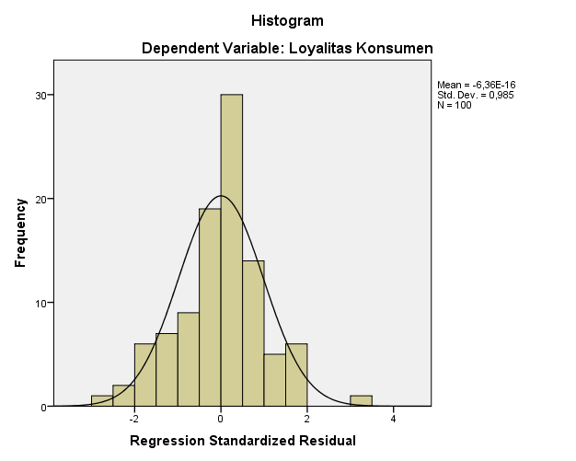

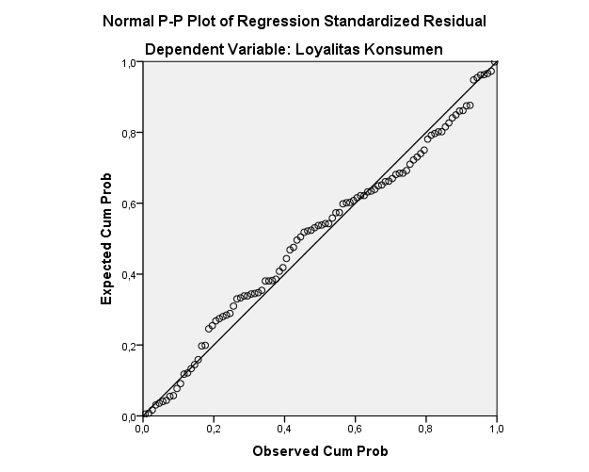

|  |  |  |
| --- | --- | --- |
| **One-Sample Kolmogorov-Smirnov Test** | | |
|  | | Studentized Deleted Residual |
| N | | 100 |
| Normal Parametersa,b | Mean | -,0020309 |
| Std. Deviation | 1,02102096 |
| Most Extreme Differences | Absolute | ,073 |
| Positive | ,059 |
| Negative | -,073 |
| Kolmogorov-Smirnov Z | | ,726 |
| Asymp. Sig. (2-tailed) | | ,668 |
| a. Test distribution is Normal. | | |
| b. Calculated from data. | | |

* **Uji Multikolonieritas**

|  |  |  |  |  |  |  |  |  |
| --- | --- | --- | --- | --- | --- | --- | --- | --- |
| **Coefficientsa** | | | | | | | | |
| Model | | Unstandardized Coefficients | | Standardized Coefficients | t | Sig. | Collinearity Statistics | |
| B | Std. Error | Beta | Tolerance | VIF |
| 1 | (Constant) | 10,311 | 5,783 |  | 1,783 | ,078 |  |  |
| Persepsi Price Discount | ,499 | ,306 | ,170 | 1,629 | ,107 | ,851 | 1,174 |
| Persepsi Reputasi Merek | ,270 | ,134 | ,202 | 2,020 | ,046 | ,924 | 1,082 |
| Pengalaman Pengguna | ,138 | ,154 | ,092 | ,896 | ,373 | ,870 | 1,150 |
| a. Dependent Variable: Loyalitas Konsumen | | | | | | | | |

* **Uji Heteroskedastisitas**

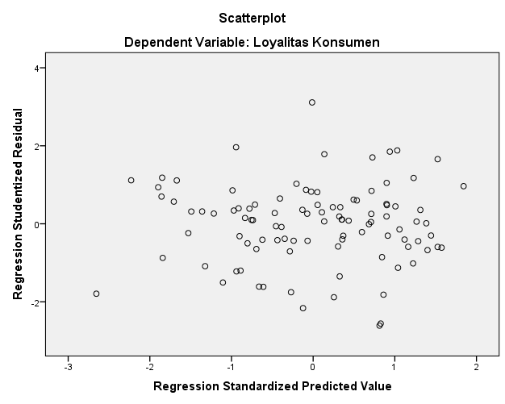

**Lampiran 8**

**Statistik Deskriptif, Hasil Analisis Regresi Linear Berganda**

**Statistik Deskriptif**

|  |  |  |  |  |  |
| --- | --- | --- | --- | --- | --- |
| **Descriptive Statistics** | | | | | |
|  | N | Minimum | Maximum | Mean | Std. Deviation |
| Persepsi Price Discount | 100 | 20 | 25 | 22,95 | 1,242 |
| Persepsi Reputasi Merek | 100 | 34 | 49 | 41,01 | 3,359 |
| Pengalaman Pengguna | 100 | 38 | 47 | 43,83 | 2,412 |
| Loyalitas Konsumen | 100 | 28 | 50 | 38,80 | 4,053 |
| Valid N (listwise) | 100 |  |  |  |  |

**Analisis Regresi Linear Berganda**

|  |  |  |  |  |  |  |
| --- | --- | --- | --- | --- | --- | --- |
| **Coefficientsa** | | | | | | |
| Model | | Unstandardized Coefficients | | Standardized Coefficients | t | Sig. |
| B | Std. Error | Beta |
| 1 | (Constant) | 14,889 | 1,528 |  | 9,742 | ,000 |
| Persepsi Price Discount | ,661 | ,083 | ,523 | 7,986 | ,000 |
| Persepsi Reputasi Merek | ,300 | ,037 | ,522 | 8,164 | ,000 |
| Pengalaman Pengguna | -,133 | ,032 | -,264 | -4,108 | ,000 |
| a. Dependent Variable: Loyalitas Konsumen | | | | | | |

**Lampiran 9**

**Hasil Uji Hipotesis**

**Uji t (Parsial)**

|  |  |  |  |  |  |  |
| --- | --- | --- | --- | --- | --- | --- |
| **Coefficientsa** | | | | | | |
| Model | | Unstandardized Coefficients | | Standardized Coefficients | t | Sig. |
| B | Std. Error | Beta |
| 1 | (Constant) | 14,889 | 1,528 |  | 9,742 | ,000 |
| Persepsi Price Discount | ,661 | ,083 | ,523 | 7,986 | ,000 |
| Persepsi Reputasi Merek | ,300 | ,037 | ,522 | 8,164 | ,000 |
| Pengalaman Pengguna | -,133 | ,032 | -,264 | -4,108 | ,000 |
| a. Dependent Variable: Loyalitas Konsumen | | | | | | |

**Uji F (Simultan)**

|  |  |  |  |  |  |  |
| --- | --- | --- | --- | --- | --- | --- |
| **ANOVAa** | | | | | | |
| Model | | Sum of Squares | df | Mean Square | F | Sig. |
| 1 | Regression | 311,610 | 3 | 103,870 | 55,509 | ,000b |
| Residual | 179,638 | 96 | 1,871 |  |  |
| Total | 491,248 | 99 |  |  |  |
| a. Dependent Variable: Loyalitas Konsumen | | | | | | |
| b. Predictors: (Constant), Pengalaman Pengguna, Persepsi Reputasi Merek, Persepsi Price Discount | | | | | | |

**Lampiran 10**

**Koefisien Determinasi**

|  |  |  |  |  |
| --- | --- | --- | --- | --- |
| **Model Summary** | | | | |
| Model | R | R Square | Adjusted R Square | Std. Error of the Estimate |
| 1 | ,796a | ,634 | ,623 | 1,36793 |
| a. Predictors: (Constant), Pengalaman Pengguna, Persepsi Reputasi Merek, Persepsi Price Discount | | | | |

|  |  |  |  |  |  |  |  |
| --- | --- | --- | --- | --- | --- | --- | --- |
| Indikator | Bulan 6 | Bulan 7 | Bulan 8 | Bulan 9 | Bulan 10 | Bulan 11 | Bulan 12 |
| Jumlah Total Chat | 127 | 151 | 141 | 168 | 189 | 227 | 230 |
| Jumlah Chat yang Dijawab | 80 | 129 | 96 | 132 | 122 | 89 | 85 |
| Kecepatan Chat Dibalas | 03:02:21 | 03:20:01 | 02:33:43 | 03:26:24 | 04:09:55 | 04:39:18 | 04:08:00 |
| Persentase Chat yang Dijawab | 63% | 85% | 68% | 79% | 65% | 39% | 37% |
| Jumlah chat yang Tidak Dijawab | 47 | 22 | 45 | 36 | 67 | 138 | 145 |

**Lampiran 11**

**Tabel Performa Chat Respon Selama 6 Bulan**

**Lampiran 12**

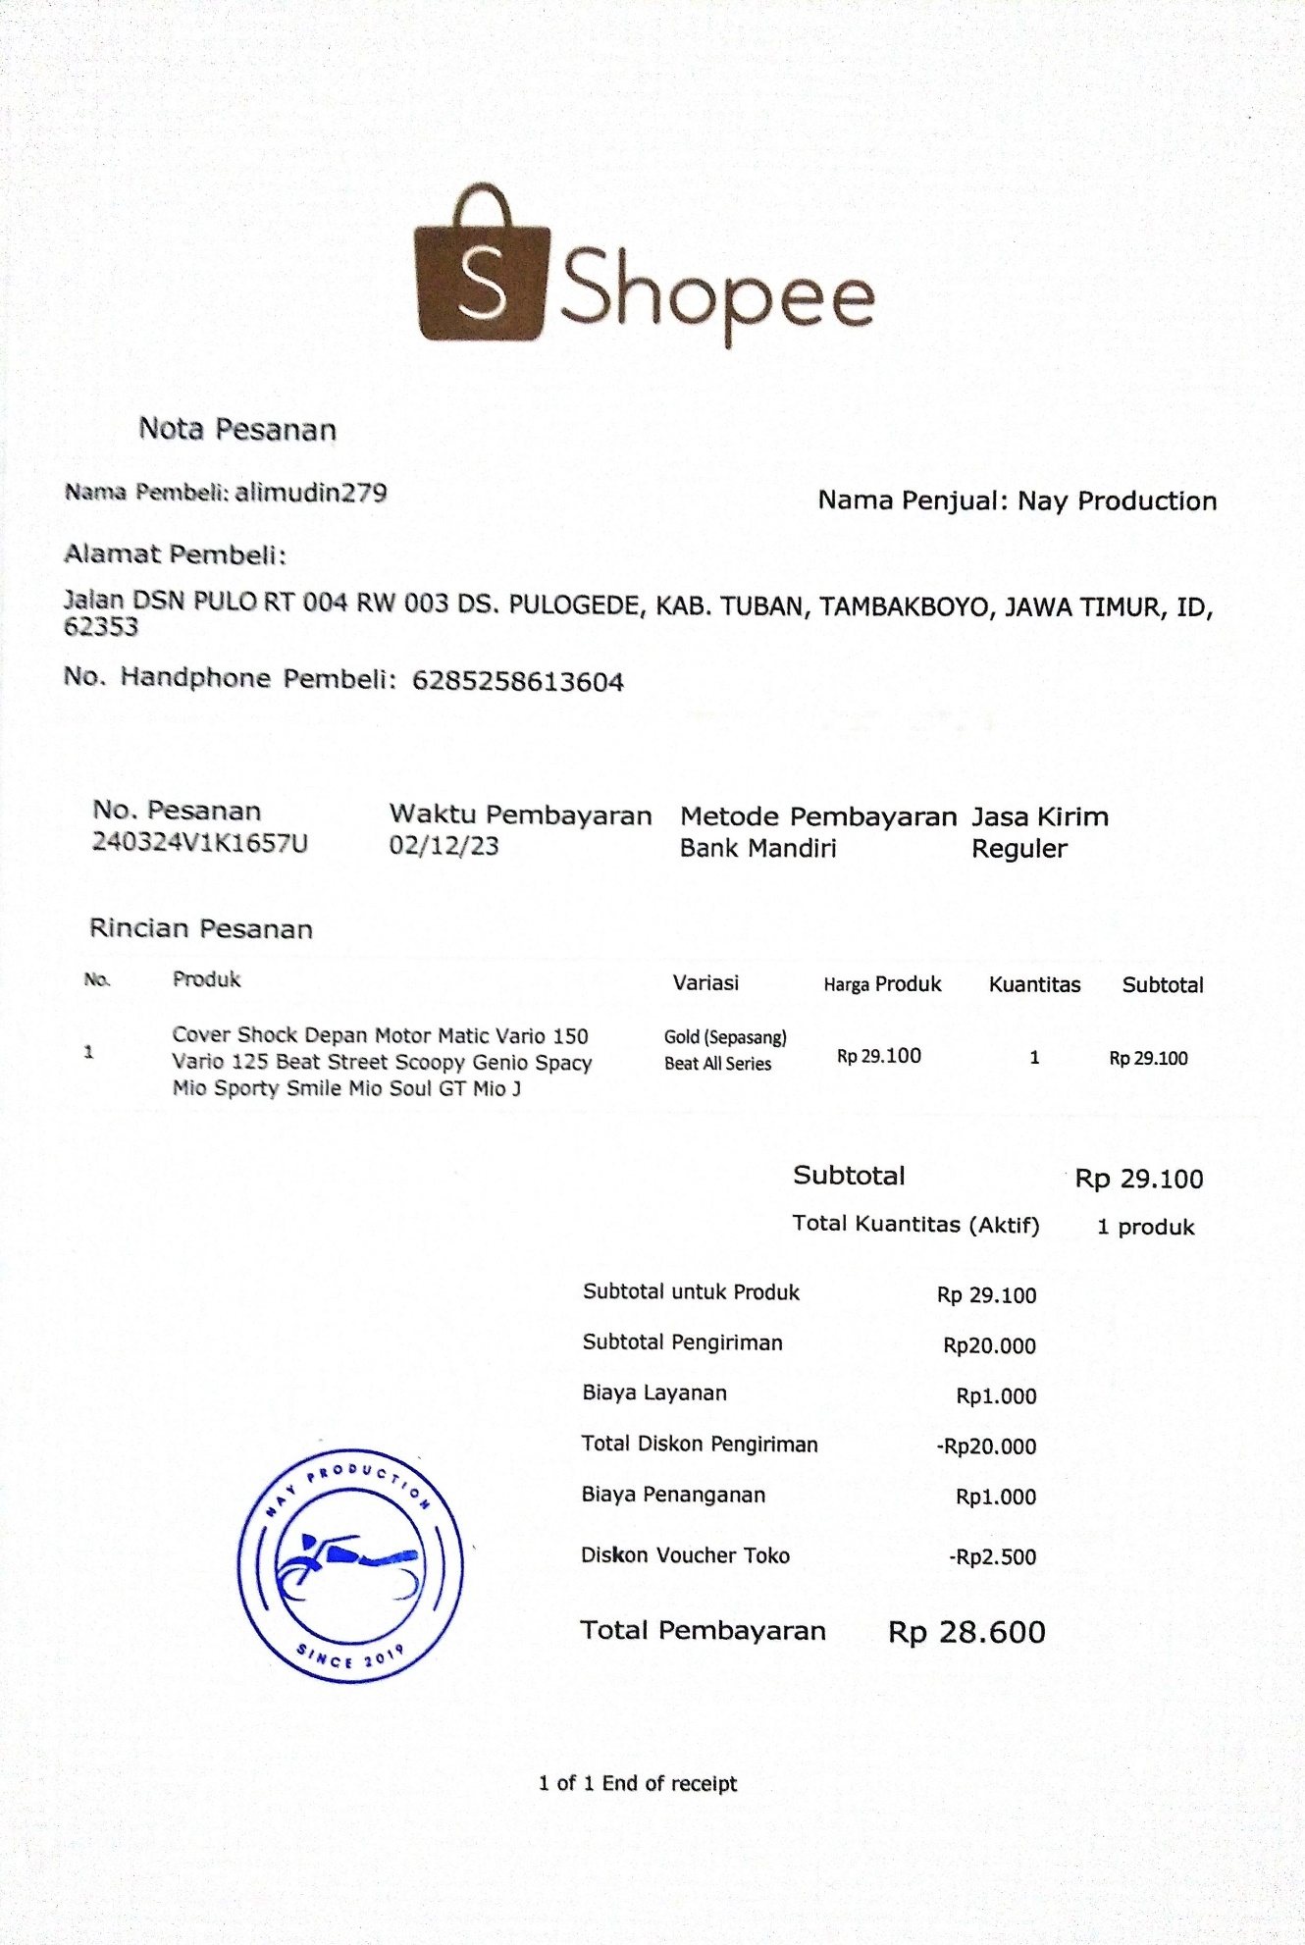

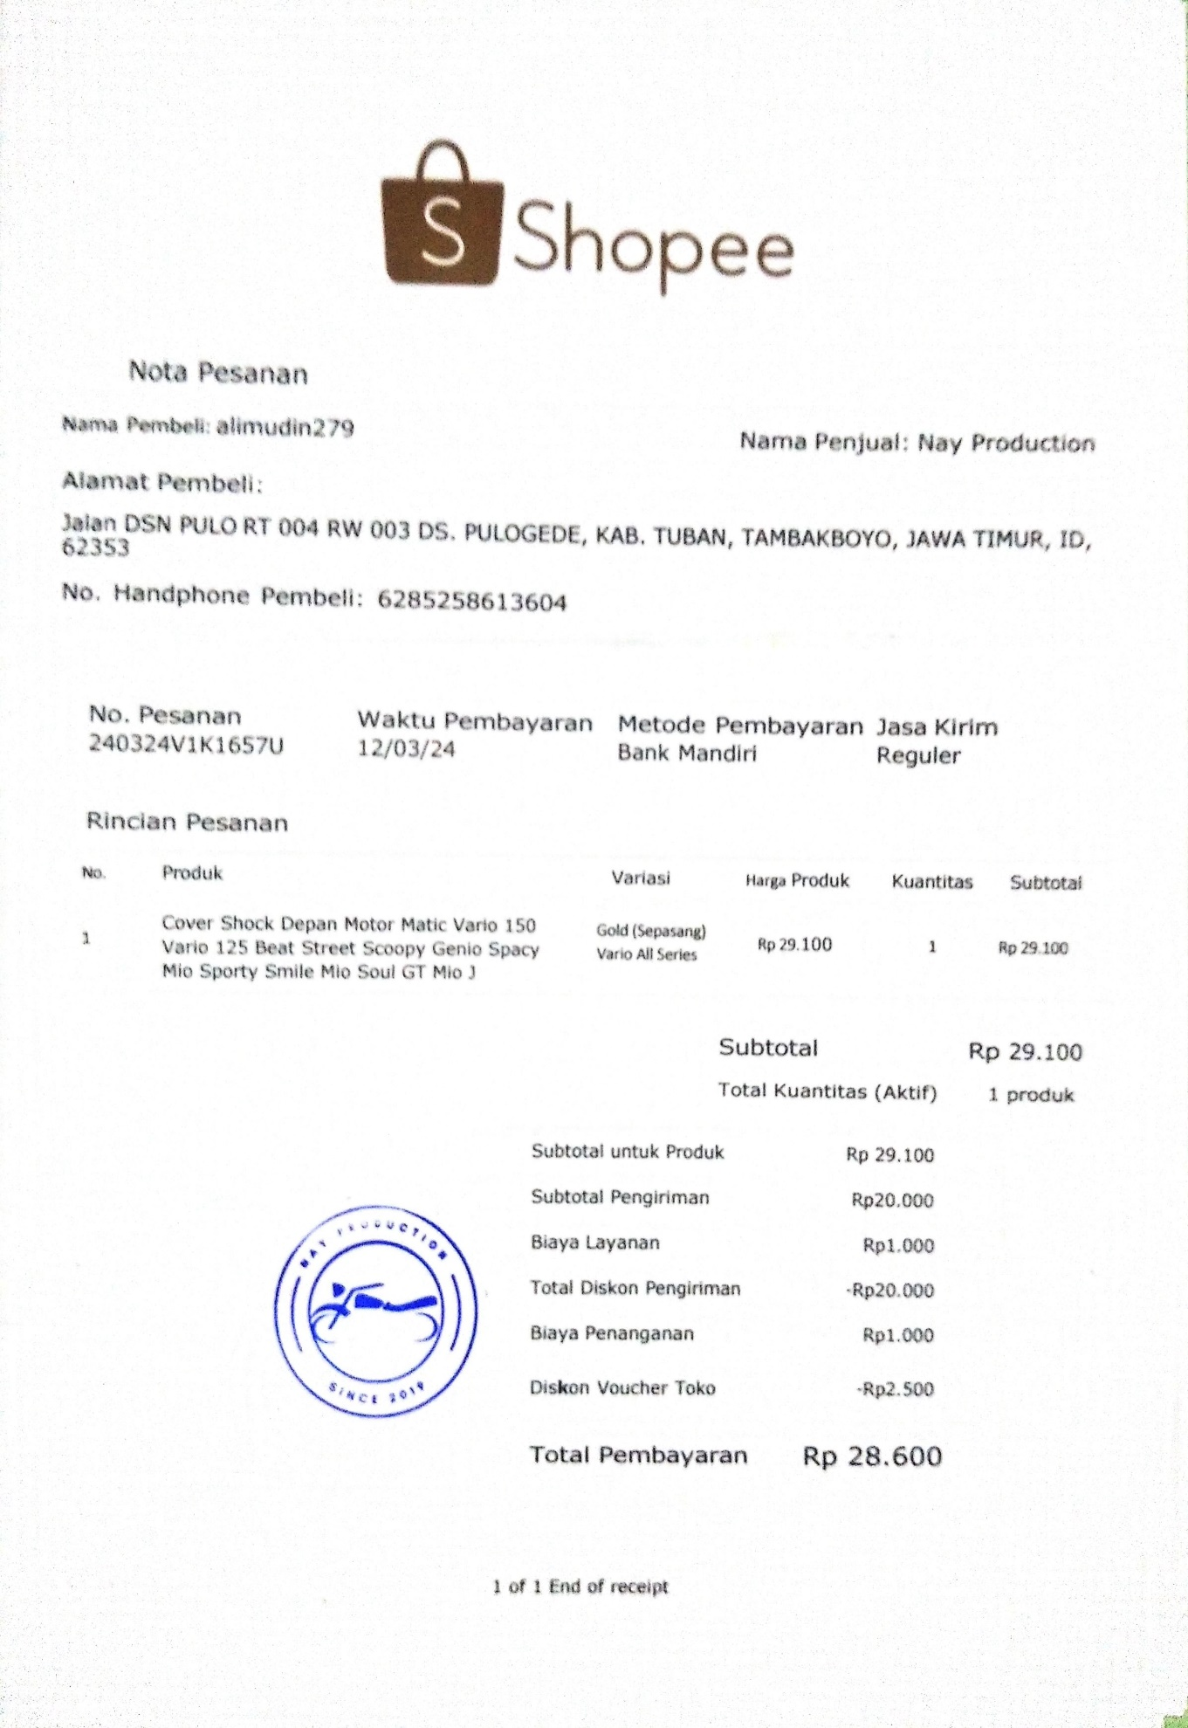

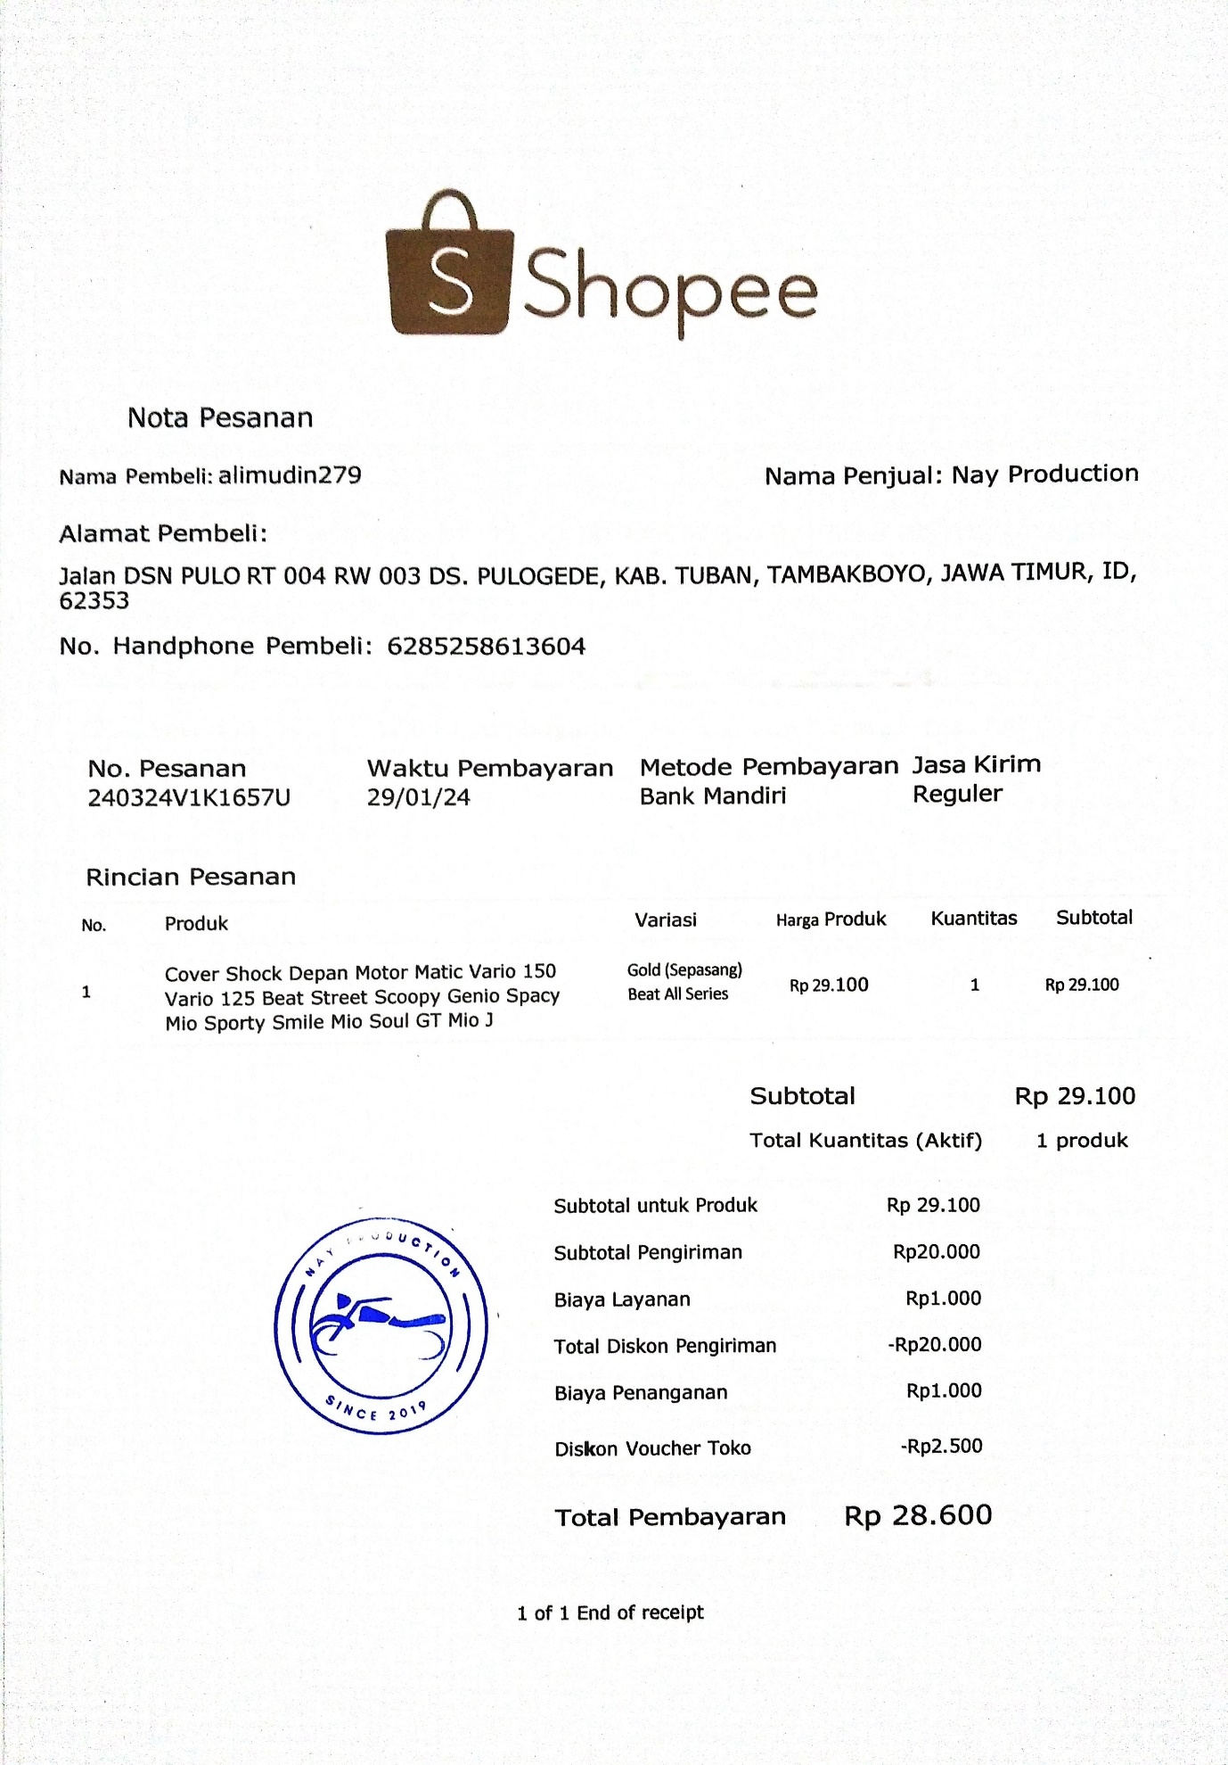

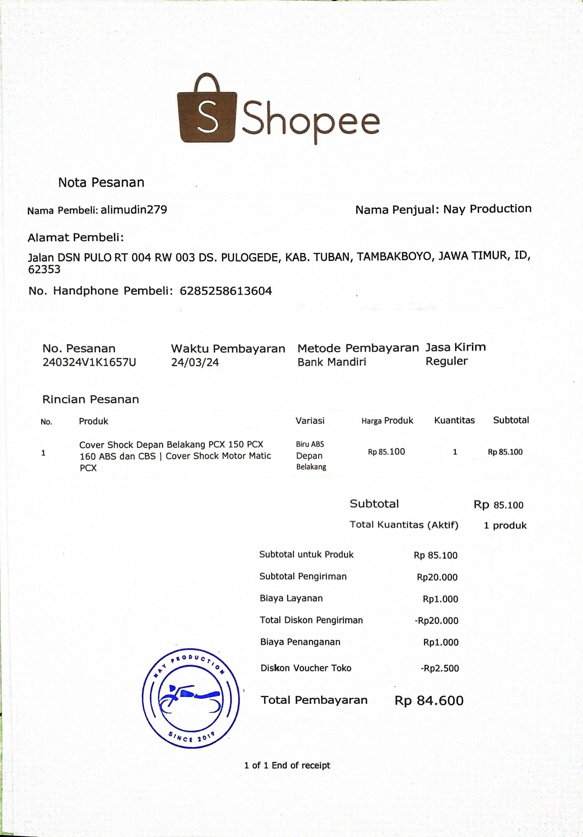

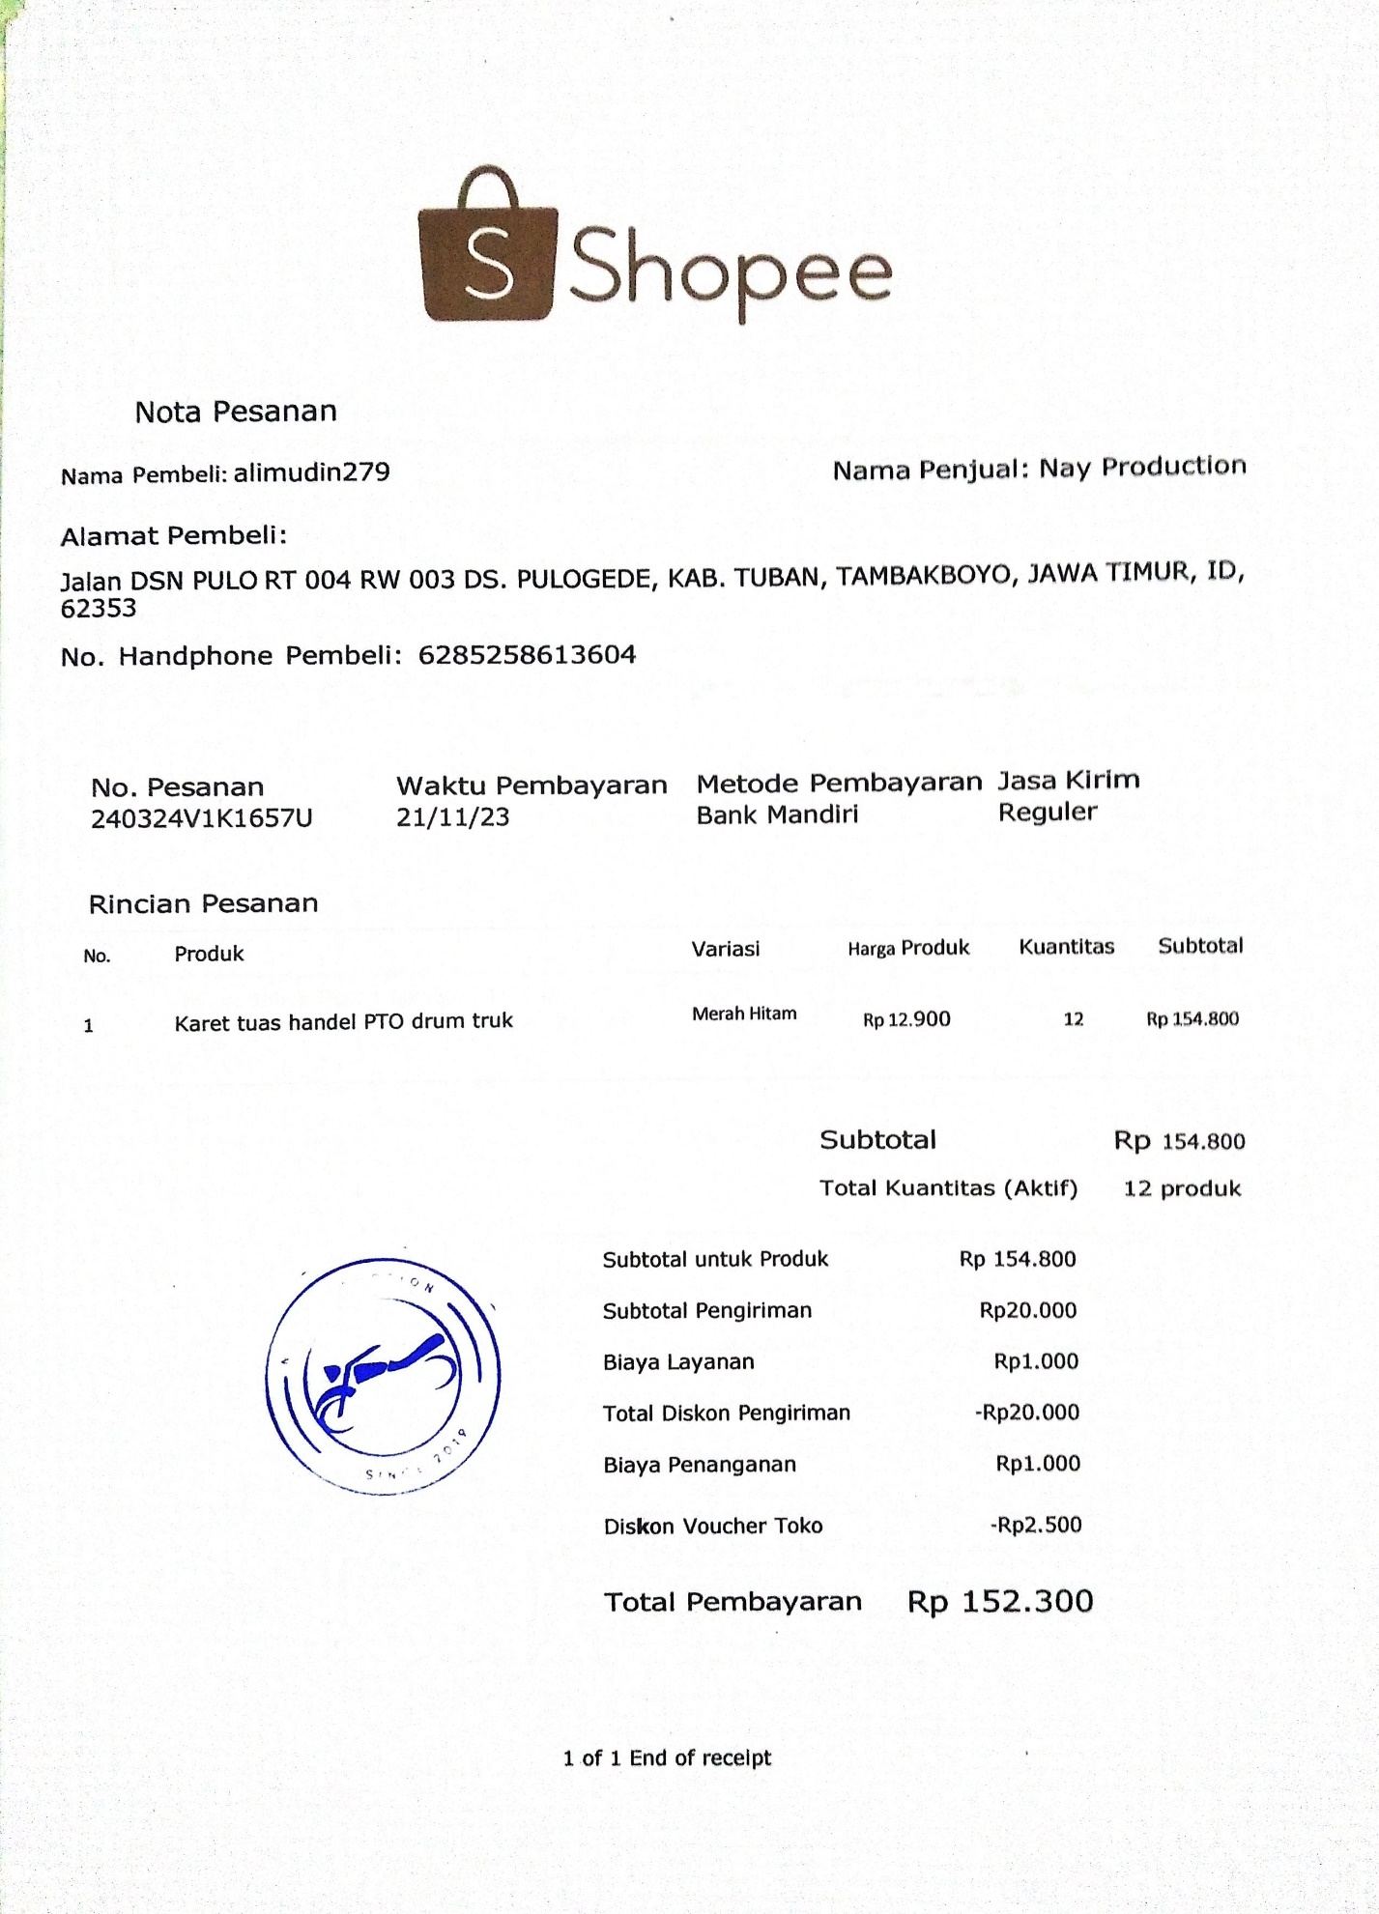

**Lampiran 13**

|  |  |  |  |  |  |
| --- | --- | --- | --- | --- | --- |
| Data Konsumen Nay Production Melalui e-Commerce Shopee Selama Tahun 2022 – 2023 | | | | | |
| Bulan (2022) | Jumlah Konsumen | Bulan (2023) | Jumlah Konsumen |  |  |
| Januari | 97 | Januari | 127 |  |  |
| Februari | 105 | Februari | 82 |  |  |
| Maret | 93 | Maret | 120 |  |  |
| April | 114 | April | 116 |  |  |
| Mei | 101 | Mei | 98 |  |  |
| Juni | 110 | Juni | 124 |  |  |
| Juli | 89 | Juli | 90 |  |  |
| Agustus | 118 | Agustus | 111 |  |  |
| September | 109 | September | 102 |  |  |
| Oktober | 97 | Oktober | 134 |  |  |
| November | 122 | November | 78 |  |  |
| Desember | 104 | Desember | 119 |  |  |
| Total | 1259 | Total | 1303 |  |  |
| Total 2562 | | | |  |  |

*(Sumber : Nay Production, 2024)*

Peningkatan = 1303 – 1259 = 42

Kenaikan dalam persentase = $\frac{peningkatan}{nilai awal}$ $×$ 100 %

= $\frac{42}{1259}$ $×$ 100

= 3,34 %

**Lampiran 14**

**Profil Nay Production Tegal**

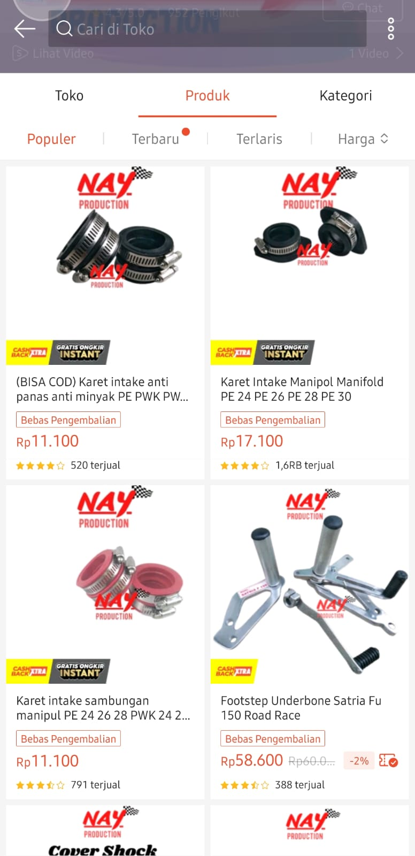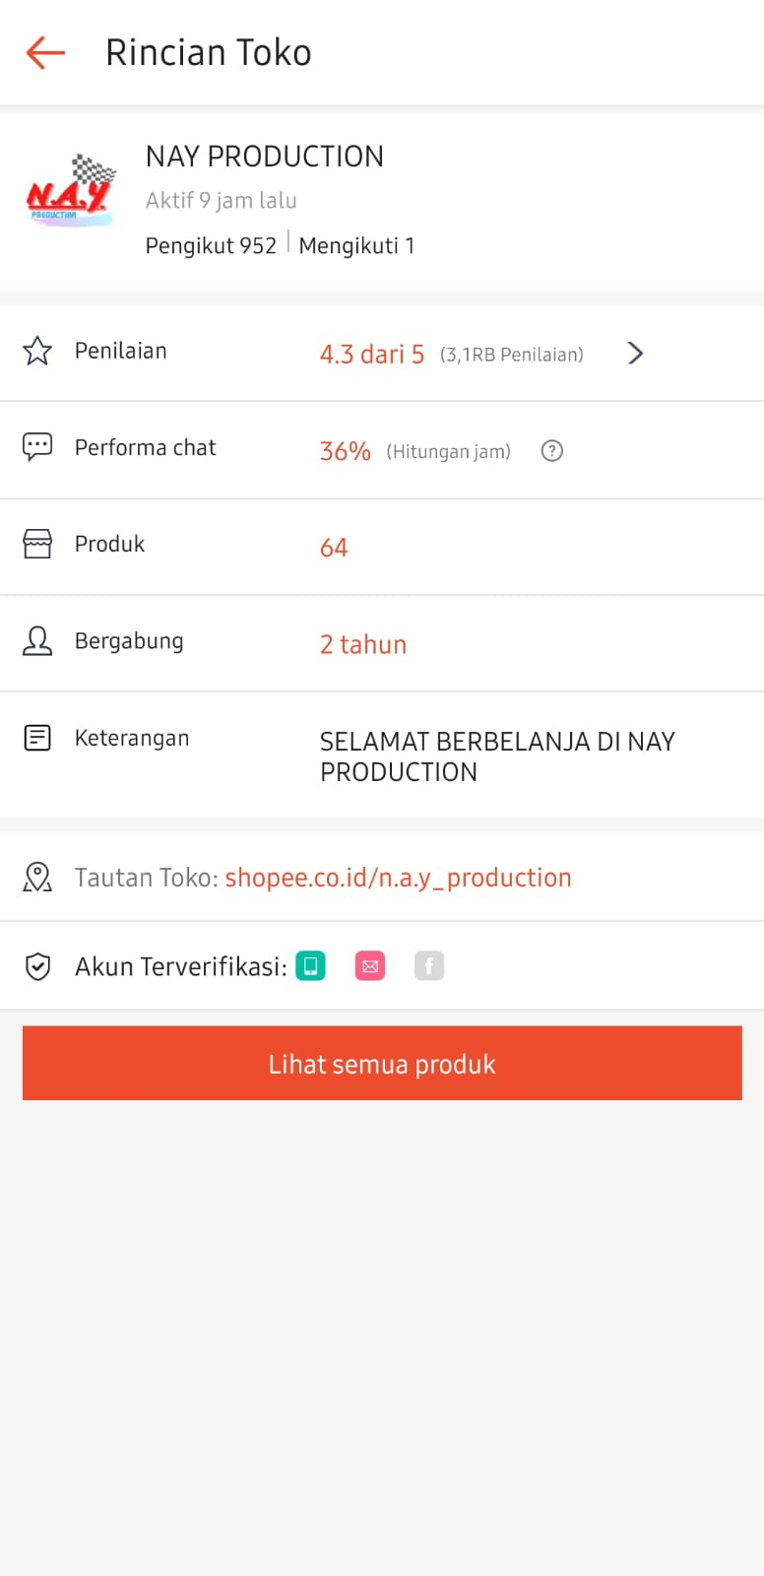

**Lampiran 15**

**Surat Izin Penelitian**

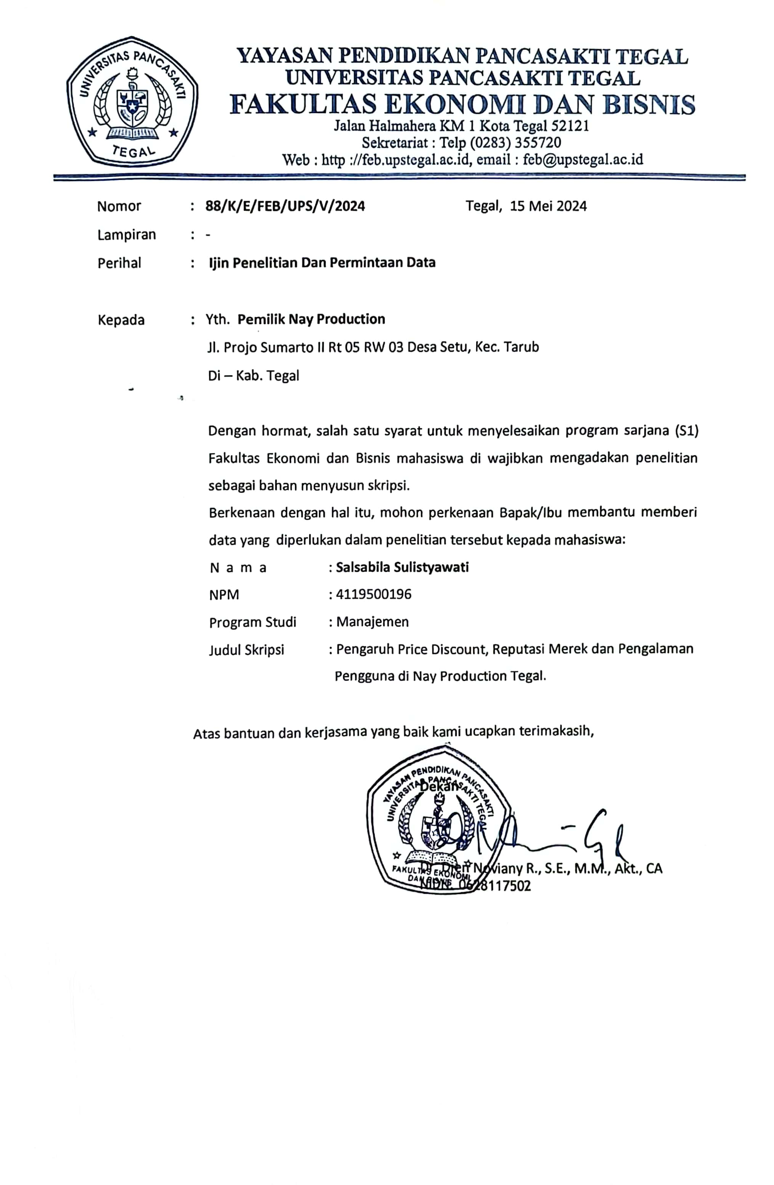

**Lampiran 16**

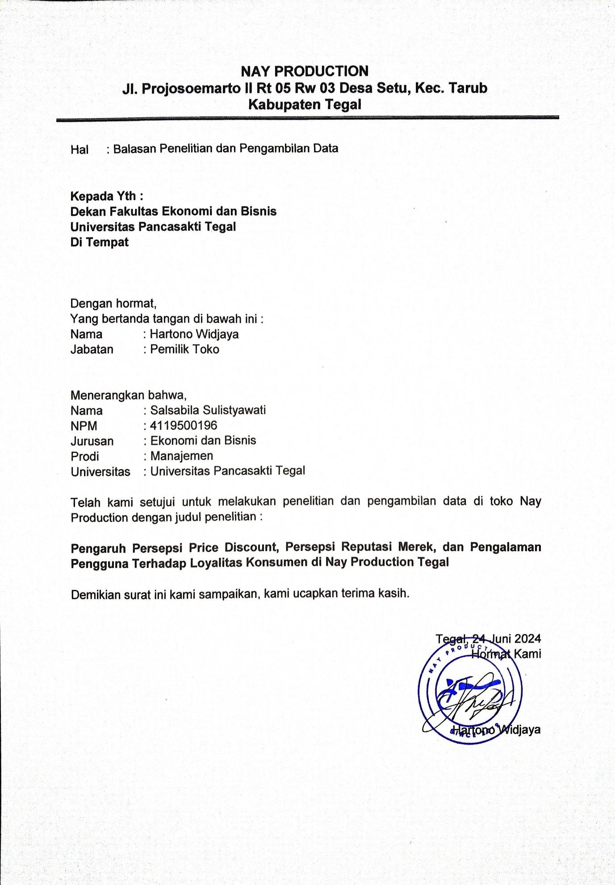**Surat Balasan Penelitian**

**Lampiran 17**

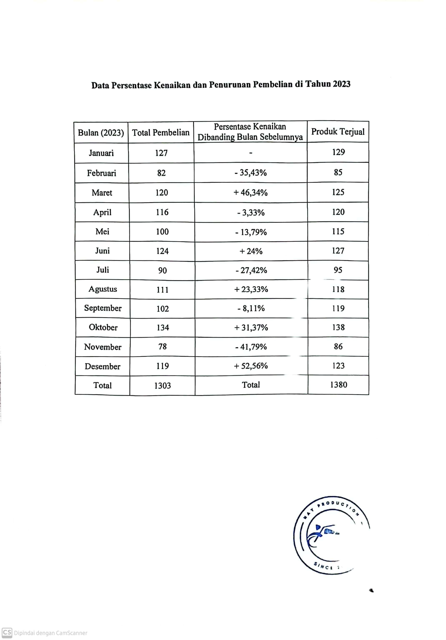**Data Persentase Kenaikan dan Penurunan Loyalitas**