# **DAFTAR PUSTAKA**

Afrizal, A., & Daulay, R. A. D. (2022). Pengaruh Literasi Keuangan Dan Modal Sosial Terhadap Inklusi Keuangan Pegawai Polres Rokan Hulu. *Jurnal Ilmiah Cano Ekonomos*, *11*(1), 54 64.https://doi.org/10.30606/cano.v11i1.1598

Ainiyah, F., & Yuliana, I. (2022). Pengaruh Penggunaan Fintech dan Literasi Keuangan terhadap Inklusi Keuangan. *Jurnal Masharif Al-Syariah: Jurnal Ekonomi Dan Perbankan Syariah*, *7*(3), 1005–1018. http://journal.um-surabaya.ac.id/index.php/Mas/index

Akyuwen, R., & Waskito, J. (2018). Memahami Inklusi Keuangan(Edisi Pertama). In *:* Sekolah Pascasarjana Universitas Gadjah Mada Anggota *IKAPI 077/DIY/2012*.Yogyakarta.

Andyni, N., & Kurniasari, F. (2021). Pengaruh literasi dan efikasi diri terhadap inklusi keuangan pada penggunaan layanan pembayaran digital shopee pay di jabodetabek. *Jurnal ojs.uph.edukation16*(1).

Bank Indonesia. (2020). Menganal Financial Teknologi. *Bank Central Republik Indonesia.* Diakses tanggal 23 Desember 2023 dari *https://www.bi.go.id/id/edukasi/Pages/mengenal-Financial Teknologi.aspx*

Dewi, R. K. (2022). Pengaruh Literasi Keuangan Dan Financial Technology (Fintech) Terhadap Inklusi Keuangan Masyarakat Di Kota Banda Aceh.*Repository.ar-raniry*.Universitas Islam Negeri Ar-Raniry.Banda Aceh.

Fanani, B. (2014). Pengaruh Kualitas Pelayanan Teller Terhadap Kepuasan Nasabah Pada Perusahaan Daerah Bpr Bkk Kota Tegal. *ejournal.poltekharber.ac.id*.*09*, 06.

Fitria, A., Munawar, A., & Pratama, P. P. (2021). Pengaruh Penggunaan Internet Banking, Mobile Banking Dan SMS Banking Terhadap Kepuasan Nasabah Bank BNI. *Jurnal Informatika Kesatuan*, *1*(1), 43–52. https://doi.org/10.37641/jikes.v1i1.406

Geriadi, M. A. D., Sawitri, N. P. Y. R., Wijaya, B. A., & Putri, I. G. A. P. T. (2023). Pengaruh Literasi Keuangan Terhadap Inklusi Keuangan Melalui Financial Technology. *Jurnal Studi Manajemen Dan Bisnis*, *10*(2), 178–187. https://doi.org/10.21107/jsmb.v10i2.23401

Ghozali, I. (2018). Aplikasi Analisis Multivariate Dengan Program IBM SPSS 25 Edisi 9.Universitas Diponegoro.Semarang (Vol. 1, Issue 1, pp. 1–99).

Hamid, M., Sufi, I., Konadi, W., & Yusrizal, A. (2019). Analisis Jalur Dan Aplikasi Spss Versi 25 Edisi Pertama. In Aceh. Kopelma Darussalam.

Herdinata, C., Aepp, & Pranatasari, F. D. (2020). Literasi Keuangan berbasis Fintech Edisi Pertama. Deepublish.Yogyakarta

Indrasih, D. (2023). Pengaruh Inklusi Keuangan dan Literasi Keuangan Terhadap Kinerja UMKM di Kabupaten Sleman. *Jurnal* *Action Research Literate*, *7*(11), 135–144. https://doi.org/10.46799/arl.v7i11.201

Kusuma, I. N. P. (2019). Pengaruh Literasi Keuangan Terhadap Inklusi Keuangan Melalui Financial Technology Pada Umkm Di Bandar Lampung.*Jurnal Manajemen Bisnis dan kewirausahaan*, *11*(1), 1–14.

Liska, R., Machpudin, A., Khaza, M. A. M. H., Ratnawati, R., & Wediawati, B. (2022). Pengaruh Literasi Keuangan Dan Financial Technology Terhadap Inklusi Keuangan (Studi Empiris Pada Mahasiswa Fakultas Ekonomi Dan Bisnis Universitas Jambi). *Jurnal Manajemen Terapan Dan Keuangan*, *11*(04), 1034–1043. https://doi.org/10.22437/jmk.v11i04.21796

Mahdian, winda anis. (2022). Pengaruh Literasi Keuangan Dan Fintech Terhadap Inklusi Keuangan.*Repository.Unja*.Universitas Jambi.Jambi

Muliati. (2016). Penjelasan Atas Peraturan Otoritas Jasa Keuangan Nomor 76 /POJK.07/2016. *Jurnal Revista CENIC. Ciencias*

Mutia, A. (2022). Survei: Mayoritas Publik Indonesia Belum Pernah Akses Internet atau Mobile-Banking. *Sumber databoks* https://databoks.katadata.co.id/datapublish/2022/08/06/survei-mayoritas-publik-indonesia-belum-pernah-akses-internet-atau-mobile-banking

Otoritas Jasa Keuangan. (2022). Literasi keuangan. OJK. https://www.ojk.go.id/id/kanal/edukasi-dan-perlindungan-konsumen/Pages/Literasi-Keuangan.aspx

Otoritas Jasa Keuangan.. (2022). Siaran Pers Survei Nasional Literasi Dan Inklusi Keuangan Tahun 2022. *Otoritas Jasa Keuangan*, *November*, 10–12.

Otoritas Jasa Keuangan. (2023). Transformasi Layanan Keuangan Dengan Fintech. OJK. http://sikapiuangmu.ojk.go.id/FrontEnd/CMS/Article/10378

Otoritas Jasa Keuangan. (2024). Aturan Penyelenggaraan Inovasi Teknologi Sektor Keuangan. *Studies in Systems, Decision and Control*, *487*(021), 525–536. https://doi.org/10.1007/978-3-031-35828-9_45

Peraturan Presiden. (2016). Tentang Strategi Nasional Keuangan Inklusi. Nomor 82. *Peraturan BPK.Com.* Jakarta.

Pradana, G. B. A. (2021). Pengaruh Literasi Keuangan Dan Modal Sosial Terhadap Inklusi Keuangan Pada Buruh Angkut Barang Di Pasar Banyuasri. *Jurnal Manajemen Dan Bisnis*, *8*(2), 273–281.

Praptitorini, M. D., & Shobandiyah, S. (2022). Pengaruh Literasi Keuangan Dan Layanan Keuangan Berbasis Teknologi Terhadap Inklusi Keuangan ( Studi Kasus pada UMKM di Kabupaten Demak ). *Journal The Academy of Management and Business*.*01*(2), 69–79.

Pulungan, D. R., & Ndururu, A. (2019). Pengaruh Literasi Keuangan Dan Modal Sosial Terhadap Inklusi Keuangan Mahasiswa. *Jurnal* *Seminar Nasional & Call Paper Seminar Bisnis Magister Manajemen 2019*, *2685*–*1474*, 132–142.

Rohmah, R. M., & Gunarsih, T. (2021). Pengaruh Literasi Keuangan Dan Fintechterhadap Inklusi Keuangan Pada Masyarakat D.I.Yogyakarta. *Jurnal* *Seminar Nasional Unriyo*, *3*(1), 2019–2226.

Sari, A. N., & Kautsar, A. (2020). Analisis Pengaruh Literasi Keuangan, Financial Technology, dan Demografi terhadap Inklusi Keuangan pada Masyarakat di Kota Surabaya. *Jurnal Ilmu Manajemen*, *8*(4), 1233. https://doi.org/10.26740/jim.v8n4.p1233-1246

Septiani, R. N., & Wuryani, E. (2020). Pengaruh Literasi Keuangan Dan Inklusi Keuangan Terhadap Kinerja Umkm Di Sidoarjo. *E-Jurnal Manajemen Universitas Udayana*, *9*(8), 3214. https://doi.org/10.24843/ejmunud.2020.v09.i08.p16

Sugiyono. (2019). Merode Penelitian Kuantitatif, Kualitatif, dan R&D. In Sutopo (Ed.), (2nd ed., Vol. 4, Issue 1). ALFABETA Bandung. Yogyakarta.

Tamboto, H. J. ., & Manongko, A. A. C. (2019). Model Pengentasan Kemiskinan Masyarakat Pesisir Berbasis Literasi Ekonomi dan Modal Sosial (Edisi Pertama).Seribu Bintang.MakariaWaya.Malang.Jawa Timur

Tobuhu, M. A., Machmud, R., & Rahman, E. (2022). Pengaruh Kemudahan dan Kepercayaan terhadap Sikap Penggunaan Layanan M-Banking (Studi pada Bank BNI Cabang Gorontalo). *Jurnal Ilmiah Manajemen Dan Bisnis*, *5*(2), 686–693.

Wiku, F., & Ayuningtyas, F. J. (2021). Determinan Stabilitas Sistem Keuangan Di Indonesia Melalui Pendekatan Makroekonomi. *Jurnal Tirtayasa Ekonomika*, *16*(2), 214. https://doi.org/10.35448/jte.v16i2.12409

**LAMPIRAN**

1. Lembar Pengisian Kuesioner

**KUESIONER**

Perihal : Permohonan Pengisian Kuesioner Penelitian

Yth. Bapak/Ibu/Sdr/I

Di Kabupaten Tegal

Dengan Hormat,

Dalam rangka penyusunan skripsi yang berjudul “Pengaruh Literasi Keuangan, *Financial Technologhy,* dan Modal Sosial Terhadap Inklusi Keuangan.pada Masyarakat Usia Produktif (25-59) tahun di Kabupaten Tegal”. Maka diperlukan data penelitian sesuai dengan judul tersebut.

Identitas Peneliti :

Nama : Bella Apri Lia

NPM : 4320600014

Program Studi/Fakultas : Akuntansi/Ekonomi dan Bisnis

Peneliti menyadari sepenuhnya, kuesioner ini akan meminta waktu aktivitas Bapak/Ibu yang sangat padat. Namun demikian peneliti berharap kesediaan dan bantuan dari Bapak/Ibu sepenuhnya akan terjaga dan jawaban tersebut semata-mata hanya digunakan untuk kepentingan penelitian dalam rangka penyusunan skripsi ini. Atas perhatian Bapak/Ibu, Peneliti mengucapkan terima kasih.

Peneliti

Bella Apri Lia

NPM : 4320600014

**Petunjuk Pengisian Kuesioner**

1. Pengisian kuesioner dilakukan oleh Masyarakat yang berdomisili di Kabupaten Tegal.
2. Sebelum mengisi kuesioner, mohon lengkapi identitas responden dengan mengisi nama, jenis kelamin, usia, pendidikan dan pendapatan.
3. Jawaban atas pertanyaan dilakukan dengan memberikan tanda checklist atau centang pada salah satu jawaban yang dianggap paling sesuai dengan kondisi yang sebenarnya.
4. Responden dimohon untuk dapat menjawab setiap pertanyaan dengan keyakinan tinggi serta tidak mengosongkan satu jawaban pun dan setiap pertanyaan hanya boleh satu jawaban.

Skala yang digunakan dalam menjawab pertanyaan adalah sebagai berikut :

STS : Sangat Tidak Setuju

TS : Tidak Setuju

KS : Kurang setuju

S : Setuju

SS : Sangat Setuju

**Data Responden**

1. Nama :
2. Alamat :
3. Jenis Kelamin : Laki-laki/Perempuan
4. Usia :
5. Pendidikan : SD/SMP/SMA/S1/S2/S3
6. Pendapatan (Bulanan) : < Rp.1.000.000

Rp. 1.000.000 – Rp. 2.000.000

Rp. 2.500.000 – Rp. 4.000.000

Rp. 4.000.000 – Rp. 5.500.000

Rp. 5.500.000 – Rp. 7.000.000

> Rp.7.000.000

|  |  |  |  |  |  |  |
| --- | --- | --- | --- | --- | --- | --- |
| **No.** | **Literasi Keuangan (X1)** | **SS** | **S** | **KS** | **TS** | **STS** |
|  | **Pengetahuan keuangan** |  |  |  |  |  |
|  | Saya sadar keuangan perlu direncanakan dengan baik |  |  |  |  |  |
|  | Saya rutin menyisihkan sebagian uang  untuk menabung. |  |  |  |  |  |
|  | Saya memahami apa itu investasi dan  Resikonya |  |  |  |  |  |
|  | Pengetahuan keuangan sangat penting  untuk kesejahteraan dan kesuksesan  seseorang baik pada masa sekarang  maupun pada masa yang akan datang |  |  |  |  |  |
|  | **Sikap dan perilaku keuangan** |  |  |  |  |  |
|  | Saya merasa lebih berhati-hati dalam  menggunakan uang |  |  |  |  |  |
|  | Saya lebih puas menghabiskan uang dari  pada menyimpannya |  |  |  |  |  |
|  | Uang yang saya miliki saya habiskan  untuk di belanjakan |  |  |  |  |  |
|  | Sebelum membeli sesuatu, saya memper-  timbangkan dahulu apakah barang  tersebut benar-benar dibutuhkan |  |  |  |  |  |

|  |  |  |  |  |  |  |
| --- | --- | --- | --- | --- | --- | --- |
| **No.** | ***Financial Technology* (X2)** | **SS** | **S** | **KS** | **TS** | **STS** |
|  | **Kemudahan** |  |  |  |  |  |
|  | Sistem pembayaran non tunai atau  digital dinilai lebih efisien  (waktu, tenaga, biaya) |  |  |  |  |  |
|  | Kecenderungan perilaku Masyarakat  Sebagai pengguna internet berpotensi meningkatkan pemanfaatan *financial*  *Technology* (teknologi keuangan). |  |  |  |  |  |
|  | **Efektifitas** |  |  |  |  |  |
|  | Fintech mempermudah akses dalam  menggunakan layanan keuangan |  |  |  |  |  |
|  | Kegiatan transfer, pembayaran, pinja-  man, dan pengelolaan investasi dapat  dilakukan dengan mudah dan praktis  menggunakan teknologi |  |  |  |  |  |
|  | *Financial Technology* seperti Dana,  Shopee Pay, Gopay, dan OVO  merupakan salah satu implementasi  penggunaan teknologi informasi yang  berhubungan dengan keuangan |  |  |  |  |  |
|  | **Minat** |  |  |  |  |  |
|  | Saya lebih memilih menggunakan  Produk *Financial Technology* seperti Dana,  Shopee Pay, Gopay, dan OVO dari  Pada harus pergi ke bank atau ATM |  |  |  |  |  |
|  | Aplikasi produk pembayaran digital  (Dana,Shopee Pay, Gopay, dan OVO)  mudah dipelajari dan dioperasikan |  |  |  |  |  |
|  | Aplikasi produk pembayaran digital  (Dana,Shopee Pay, Gopay, dan OVO)  memberikan pengalaman yang lebih  modern |  |  |  |  |  |

|  |  |  |  |  |  |  |
| --- | --- | --- | --- | --- | --- | --- |
| **No.** | **Modal Sosial (X3)** | **SS** | **S** | **KS** | **TS** | **STS** |
|  | **Kepercayaan** |  |  |  |  |  |
|  | Pentingnya kepercayaan masyarakat  untuk meningkatkan minat meng-  akses instrumen keuangan |  |  |  |  |  |
|  | Kebanyakan penyedia produk jasa  Keuangan seperti Bank, Perusahaan  dan Asuransi lebih terjamin dan  terpercaya |  |  |  |  |  |
|  | Saya lebih percaya produk jasa  keuangan seperti Bank daripada  pinjaman online dalam melakukan  peminjaman |  |  |  |  |  |
|  | **Network** |  |  |  |  |  |
|  | Jaringan (Network) dapat mempeng-  aruhi kebiasaan pengelolaan keuang-  an individu |  |  |  |  |  |
|  | Jaringan yang luas memberikan  Lebih banyak informasi, salah satu-  nya perkembangan produk dan  layanan jasa keuangan |  |  |  |  |  |
|  | Dengan jaringan internet yang lancar  memudahkan pengguna dalam  mengakses produk-produk layanan  jasa keuangan digital |  |  |  |  |  |
|  | **Norma** |  |  |  |  |  |
|  | Saya menilai, penting memiliki dan mengelola instrumen keuangan |  |  |  |  |  |
|  | Saya seringkali bertukar informasi  dengan kerabat atau teman ketika  menentukkan produk layanan  keuangan apa yang akan dipakai |  |  |  |  |  |

|  |  |  |  |  |  |  |
| --- | --- | --- | --- | --- | --- | --- |
| **No.** | **Inklusi Keuangan (Y)** | **SS** | **S** | **KS** | **TS** | **STS** |
|  | **Ketersediaan** |  |  |  |  |  |
|  | Keberadaan Bank di suatu wilayah  mempengaruhi akses pada instrumen  keuangan |  |  |  |  |  |
|  | Saya mempercayakan uang saya  untuk disimpan di Bank atau layanan  jasa keuangan lainnya. |  |  |  |  |  |
|  | **Penggunaan** |  |  |  |  |  |
|  | Frekuensi penggunaan produk dan  layanan jasa keuangan dapat mem-  Pengaruhi inklusi keuangan |  |  |  |  |  |
|  | Kesadaran dan edukasi yang men-  dukung era digitalisasi layanan  keuangan mempengaruhi peningkat-  an penggunaan produk dan layanan  jasa keuangan digital. |  |  |  |  |  |
|  | Saya menggunakan layanan jasa  Keuangan seperti m-banking, Dana,  Shopee Pay, Gopay, dan lain-lain  sesuai kebutuhan saya |  |  |  |  |  |
|  | **Kualitas** |  |  |  |  |  |
|  | Kenyamanan dalam bertransaksi  merupakan suatu kualitas yang baik  dalam layanan keuangan |  |  |  |  |  |
|  | Perlu adanya pengawasan pada  Produk layanan jasa keuangan  sebelum akan menggunakan |  |  |  |  |  |
|  | Saya memiliki akun pembayaran  digital (Dana, Shopee Pay, Gopay,  dan lain-lain) atau rekening di Bank |  |  |  |  |  |

2. Lampiran Screenshoot pengisian kuesioner online

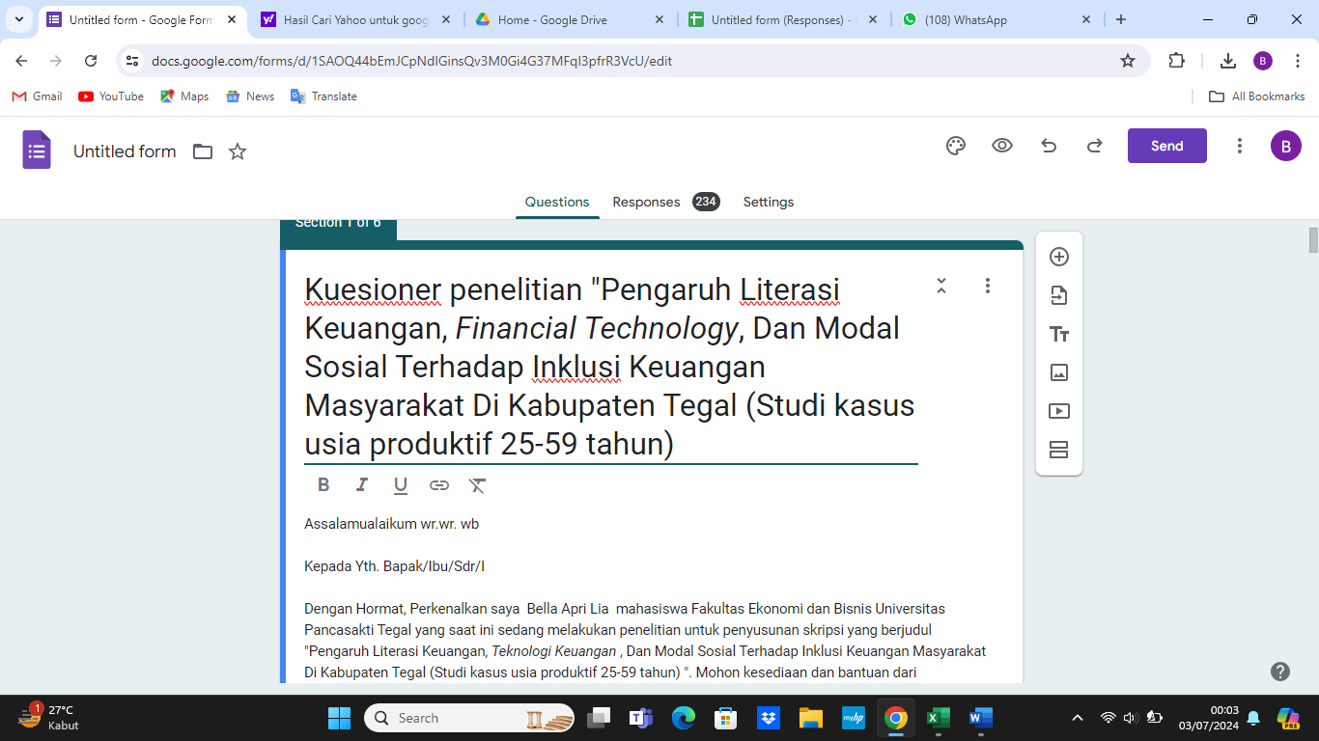

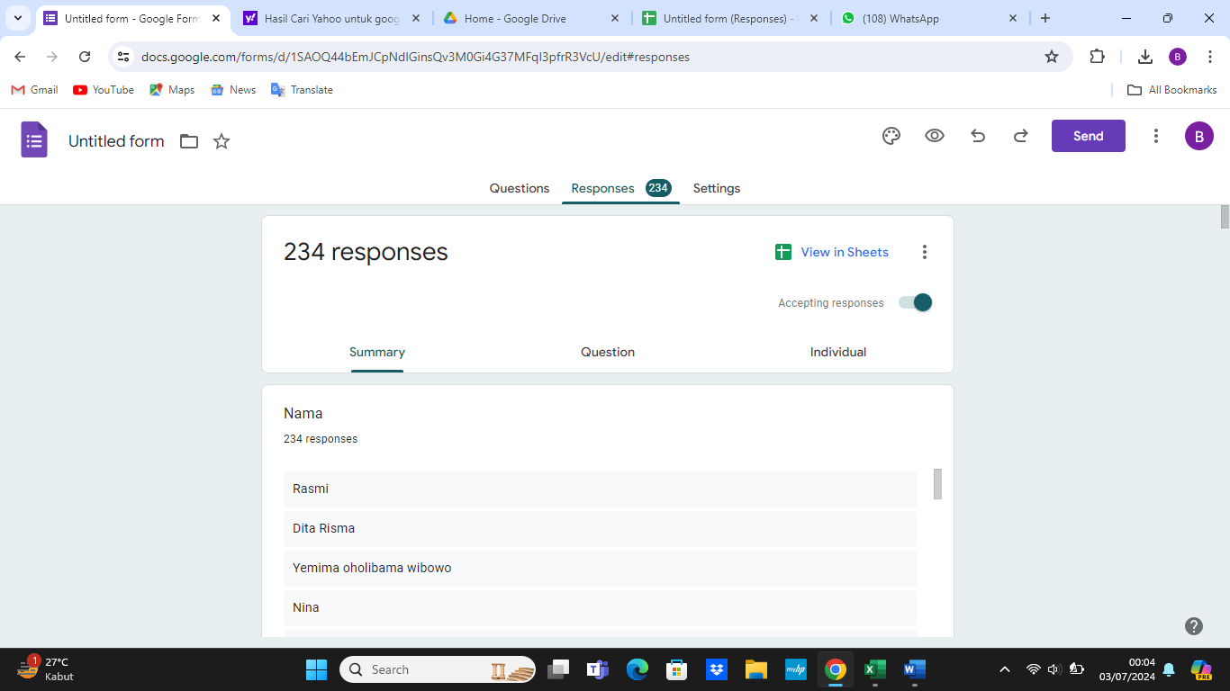

3.Data kuesioner

1. Inklusi Keuangan (Y)

| **Responden** | **Y.1** | **Y.2** | **Y.3** | **Y.4** | **Y.5** | **Y.6** | **Y.7** | **Y.8** | **Total Y** |
| --- | --- | --- | --- | --- | --- | --- | --- | --- | --- |
| 1 | 4 | 4 | 4 | 4 | 4 | 5 | 4 | 4 | 33 |
| 2 | 4 | 5 | 5 | 5 | 5 | 5 | 5 | 5 | 39 |
| 3 | 4 | 4 | 4 | 4 | 4 | 4 | 4 | 5 | 33 |
| 4 | 5 | 5 | 5 | 5 | 5 | 4 | 4 | 4 | 37 |
| 5 | 4 | 3 | 4 | 3 | 4 | 4 | 4 | 5 | 31 |
| 6 | 5 | 5 | 4 | 4 | 4 | 4 | 5 | 4 | 35 |
| 7 | 4 | 4 | 4 | 4 | 4 | 5 | 5 | 4 | 34 |
| 8 | 4 | 4 | 4 | 4 | 4 | 4 | 4 | 4 | 32 |
| 9 | 4 | 5 | 4 | 4 | 5 | 5 | 5 | 5 | 37 |
| 10 | 5 | 5 | 4 | 4 | 5 | 4 | 4 | 4 | 35 |
| 11 | 4 | 4 | 4 | 4 | 4 | 4 | 4 | 4 | 32 |
| 12 | 5 | 4 | 4 | 4 | 4 | 4 | 4 | 4 | 33 |
| 13 | 4 | 4 | 4 | 4 | 4 | 4 | 4 | 4 | 32 |
| 14 | 5 | 5 | 5 | 4 | 5 | 5 | 4 | 5 | 38 |
| 15 | 4 | 3 | 4 | 4 | 4 | 4 | 4 | 4 | 31 |
| 16 | 5 | 4 | 4 | 4 | 5 | 4 | 4 | 5 | 35 |
| 17 | 4 | 5 | 4 | 5 | 5 | 5 | 5 | 4 | 37 |
| 18 | 4 | 3 | 4 | 4 | 5 | 4 | 4 | 5 | 33 |
| 19 | 5 | 5 | 5 | 5 | 5 | 5 | 5 | 5 | 40 |
| 20 | 4 | 3 | 4 | 4 | 4 | 5 | 5 | 4 | 33 |
| 21 | 4 | 4 | 5 | 5 | 5 | 5 | 5 | 5 | 38 |
| 22 | 5 | 5 | 5 | 5 | 5 | 5 | 5 | 5 | 40 |
| 23 | 4 | 4 | 4 | 4 | 4 | 4 | 4 | 4 | 32 |
| 24 | 4 | 4 | 4 | 4 | 5 | 5 | 5 | 5 | 36 |
| 25 | 4 | 4 | 4 | 4 | 5 | 5 | 5 | 5 | 36 |
| 26 | 4 | 4 | 4 | 5 | 5 | 5 | 5 | 4 | 36 |
| 27 | 4 | 4 | 5 | 4 | 4 | 4 | 5 | 4 | 34 |
| 28 | 4 | 4 | 4 | 4 | 4 | 5 | 5 | 5 | 35 |
| 29 | 5 | 5 | 5 | 4 | 4 | 4 | 4 | 4 | 35 |
| 30 | 5 | 5 | 4 | 5 | 4 | 5 | 5 | 5 | 38 |
| 31 | 5 | 5 | 5 | 5 | 4 | 5 | 4 | 4 | 37 |
| 32 | 5 | 5 | 5 | 5 | 5 | 5 | 5 | 5 | 40 |
| 33 | 4 | 4 | 5 | 5 | 5 | 5 | 5 | 5 | 38 |
| 34 | 4 | 4 | 5 | 5 | 5 | 5 | 5 | 5 | 38 |
| 35 | 4 | 5 | 4 | 4 | 4 | 5 | 4 | 4 | 34 |
| 36 | 4 | 4 | 5 | 4 | 4 | 5 | 5 | 5 | 36 |
| 37 | 4 | 4 | 5 | 4 | 5 | 4 | 4 | 5 | 35 |
| 38 | 3 | 3 | 4 | 4 | 4 | 5 | 5 | 5 | 33 |
| 39 | 4 | 3 | 4 | 4 | 5 | 4 | 4 | 4 | 32 |
| 40 | 4 | 4 | 4 | 4 | 5 | 4 | 4 | 4 | 33 |
| 41 | 4 | 4 | 4 | 4 | 5 | 4 | 5 | 5 | 35 |
| 42 | 3 | 4 | 5 | 4 | 3 | 5 | 4 | 4 | 32 |
| 43 | 3 | 3 | 4 | 5 | 4 | 4 | 5 | 4 | 32 |
| 44 | 5 | 4 | 5 | 4 | 4 | 5 | 5 | 4 | 36 |
| 45 | 5 | 4 | 4 | 4 | 5 | 5 | 5 | 5 | 37 |
| 46 | 4 | 4 | 5 | 4 | 4 | 5 | 4 | 4 | 34 |
| 47 | 3 | 3 | 4 | 4 | 4 | 4 | 4 | 4 | 30 |
| 48 | 4 | 4 | 5 | 5 | 4 | 5 | 5 | 5 | 37 |
| 49 | 3 | 4 | 4 | 4 | 5 | 4 | 4 | 5 | 33 |
| 50 | 4 | 4 | 4 | 5 | 5 | 4 | 3 | 4 | 33 |
| 51 | 3 | 3 | 4 | 4 | 5 | 4 | 4 | 4 | 31 |
| 52 | 4 | 3 | 4 | 4 | 5 | 4 | 4 | 4 | 32 |
| 53 | 4 | 4 | 5 | 5 | 5 | 4 | 4 | 4 | 35 |
| 54 | 5 | 5 | 5 | 4 | 5 | 5 | 5 | 4 | 38 |
| 55 | 4 | 5 | 4 | 5 | 5 | 5 | 5 | 5 | 38 |
| 56 | 4 | 3 | 3 | 4 | 5 | 4 | 4 | 4 | 31 |
| 57 | 4 | 5 | 4 | 5 | 4 | 4 | 4 | 4 | 34 |
| 58 | 4 | 5 | 4 | 5 | 4 | 5 | 5 | 5 | 37 |
| 59 | 4 | 3 | 4 | 4 | 4 | 5 | 5 | 4 | 33 |
| 60 | 4 | 3 | 4 | 4 | 4 | 4 | 4 | 3 | 30 |
| 61 | 5 | 5 | 4 | 5 | 5 | 4 | 4 | 4 | 36 |
| 62 | 4 | 4 | 5 | 4 | 5 | 5 | 4 | 5 | 36 |
| 63 | 4 | 5 | 4 | 5 | 4 | 4 | 4 | 4 | 34 |
| 64 | 3 | 3 | 4 | 4 | 4 | 4 | 4 | 4 | 30 |
| 65 | 4 | 4 | 4 | 5 | 5 | 5 | 4 | 4 | 35 |
| 66 | 4 | 5 | 4 | 4 | 4 | 5 | 5 | 5 | 36 |
| 67 | 4 | 5 | 4 | 4 | 5 | 4 | 4 | 4 | 34 |
| 68 | 4 | 4 | 4 | 5 | 5 | 4 | 5 | 5 | 36 |
| 69 | 4 | 5 | 4 | 5 | 5 | 4 | 4 | 4 | 35 |
| 70 | 5 | 5 | 5 | 4 | 5 | 4 | 5 | 4 | 37 |
| 71 | 5 | 5 | 5 | 4 | 4 | 4 | 4 | 4 | 35 |
| 72 | 5 | 5 | 4 | 4 | 5 | 5 | 5 | 4 | 37 |
| 73 | 5 | 4 | 4 | 5 | 4 | 5 | 5 | 5 | 37 |
| 74 | 5 | 5 | 5 | 5 | 4 | 4 | 4 | 4 | 36 |
| 75 | 5 | 5 | 4 | 4 | 4 | 5 | 5 | 5 | 37 |
| 76 | 5 | 4 | 4 | 4 | 4 | 4 | 4 | 4 | 33 |
| 77 | 4 | 4 | 5 | 4 | 3 | 4 | 5 | 2 | 31 |
| 78 | 4 | 3 | 5 | 4 | 4 | 4 | 5 | 4 | 33 |
| 79 | 3 | 3 | 3 | 3 | 5 | 4 | 5 | 4 | 30 |
| 80 | 4 | 4 | 4 | 4 | 4 | 4 | 4 | 4 | 32 |
| 81 | 4 | 3 | 3 | 4 | 3 | 5 | 5 | 3 | 30 |
| 82 | 4 | 4 | 4 | 4 | 4 | 4 | 5 | 4 | 33 |
| 83 | 4 | 5 | 4 | 3 | 5 | 4 | 5 | 4 | 34 |
| 84 | 5 | 4 | 5 | 5 | 5 | 4 | 4 | 4 | 36 |
| 85 | 4 | 5 | 4 | 5 | 4 | 4 | 5 | 5 | 36 |
| 86 | 5 | 5 | 5 | 4 | 4 | 4 | 5 | 5 | 37 |
| 87 | 4 | 4 | 4 | 5 | 5 | 4 | 4 | 4 | 34 |
| 88 | 4 | 4 | 4 | 5 | 5 | 5 | 5 | 5 | 37 |
| 89 | 4 | 4 | 4 | 5 | 4 | 5 | 5 | 5 | 36 |
| 90 | 4 | 4 | 4 | 5 | 4 | 5 | 5 | 5 | 36 |
| 91 | 5 | 4 | 5 | 5 | 5 | 5 | 5 | 5 | 39 |
| 92 | 4 | 5 | 5 | 4 | 5 | 4 | 5 | 5 | 37 |
| 93 | 4 | 5 | 4 | 5 | 4 | 5 | 5 | 5 | 37 |
| 94 | 5 | 4 | 5 | 4 | 5 | 4 | 4 | 4 | 35 |
| 95 | 5 | 5 | 5 | 5 | 5 | 4 | 5 | 4 | 38 |
| 96 | 4 | 5 | 4 | 5 | 4 | 4 | 4 | 4 | 34 |
| 97 | 5 | 5 | 4 | 4 | 5 | 5 | 5 | 5 | 38 |
| 98 | 5 | 5 | 4 | 4 | 5 | 4 | 4 | 4 | 35 |
| 99 | 5 | 4 | 4 | 5 | 4 | 5 | 4 | 4 | 35 |
| 100 | 4 | 4 | 4 | 4 | 4 | 4 | 4 | 4 | 32 |
| 101 | 4 | 4 | 4 | 4 | 5 | 5 | 5 | 5 | 36 |
| 102 | 5 | 5 | 5 | 4 | 4 | 4 | 4 | 4 | 35 |
| 103 | 5 | 5 | 4 | 4 | 4 | 5 | 4 | 4 | 35 |
| 104 | 5 | 4 | 5 | 4 | 4 | 4 | 4 | 4 | 34 |
| 105 | 5 | 4 | 5 | 5 | 5 | 4 | 4 | 4 | 36 |
| 106 | 4 | 4 | 5 | 5 | 5 | 5 | 5 | 5 | 38 |
| 107 | 4 | 4 | 5 | 5 | 5 | 4 | 4 | 4 | 35 |
| 108 | 5 | 5 | 4 | 4 | 5 | 5 | 5 | 5 | 38 |
| 109 | 5 | 5 | 4 | 4 | 4 | 5 | 4 | 4 | 35 |
| 110 | 4 | 4 | 5 | 5 | 5 | 5 | 5 | 5 | 38 |
| 111 | 5 | 5 | 5 | 5 | 5 | 4 | 4 | 4 | 37 |
| 112 | 4 | 4 | 4 | 4 | 5 | 5 | 5 | 4 | 35 |
| 113 | 4 | 4 | 4 | 4 | 4 | 5 | 5 | 5 | 35 |
| 114 | 4 | 4 | 4 | 5 | 4 | 5 | 4 | 5 | 35 |
| 115 | 5 | 4 | 5 | 5 | 5 | 4 | 4 | 4 | 36 |
| 116 | 4 | 4 | 4 | 5 | 4 | 5 | 4 | 4 | 34 |
| 117 | 2 | 3 | 4 | 4 | 5 | 5 | 4 | 4 | 31 |
| 118 | 4 | 5 | 4 | 4 | 4 | 5 | 5 | 5 | 36 |
| 119 | 4 | 5 | 4 | 5 | 4 | 4 | 5 | 5 | 36 |
| 120 | 4 | 5 | 4 | 4 | 4 | 5 | 5 | 5 | 36 |
| 121 | 4 | 4 | 4 | 5 | 4 | 4 | 5 | 4 | 34 |
| 122 | 3 | 3 | 4 | 4 | 4 | 4 | 4 | 4 | 30 |
| 123 | 4 | 5 | 5 | 5 | 4 | 4 | 4 | 4 | 35 |
| 124 | 4 | 5 | 4 | 5 | 4 | 4 | 4 | 4 | 34 |
| 125 | 4 | 5 | 4 | 5 | 4 | 4 | 4 | 4 | 34 |
| 126 | 4 | 4 | 5 | 4 | 5 | 4 | 4 | 4 | 34 |
| 127 | 4 | 4 | 5 | 5 | 5 | 4 | 4 | 4 | 35 |
| 128 | 4 | 5 | 4 | 4 | 4 | 5 | 5 | 5 | 36 |
| 129 | 4 | 4 | 5 | 4 | 5 | 4 | 4 | 4 | 34 |
| 130 | 4 | 4 | 3 | 4 | 5 | 4 | 4 | 5 | 33 |
| 131 | 4 | 5 | 4 | 4 | 4 | 5 | 4 | 5 | 35 |
| 132 | 4 | 4 | 4 | 4 | 5 | 4 | 4 | 4 | 33 |
| 133 | 4 | 4 | 4 | 4 | 5 | 4 | 5 | 4 | 34 |
| 134 | 4 | 4 | 4 | 4 | 4 | 4 | 4 | 4 | 32 |
| 135 | 4 | 4 | 4 | 4 | 4 | 4 | 5 | 4 | 33 |
| 136 | 4 | 4 | 4 | 4 | 3 | 4 | 5 | 3 | 31 |
| 137 | 5 | 5 | 4 | 4 | 4 | 4 | 4 | 4 | 34 |
| 138 | 4 | 4 | 4 | 4 | 4 | 4 | 5 | 4 | 33 |
| 139 | 4 | 4 | 5 | 4 | 4 | 4 | 4 | 5 | 34 |
| 140 | 4 | 4 | 4 | 4 | 4 | 4 | 4 | 4 | 32 |
| 141 | 5 | 5 | 5 | 5 | 5 | 4 | 4 | 4 | 37 |
| 142 | 4 | 4 | 3 | 3 | 4 | 4 | 4 | 4 | 30 |
| 143 | 4 | 5 | 5 | 4 | 5 | 5 | 5 | 5 | 38 |
| 144 | 5 | 5 | 4 | 5 | 4 | 4 | 4 | 4 | 35 |
| 145 | 5 | 5 | 4 | 4 | 4 | 4 | 4 | 4 | 34 |
| 146 | 5 | 5 | 5 | 4 | 4 | 4 | 4 | 4 | 35 |
| 147 | 5 | 4 | 5 | 4 | 5 | 4 | 4 | 4 | 35 |
| 148 | 5 | 5 | 5 | 5 | 5 | 5 | 5 | 5 | 40 |
| 149 | 5 | 5 | 5 | 5 | 5 | 5 | 5 | 5 | 40 |
| 150 | 5 | 5 | 5 | 5 | 5 | 5 | 5 | 5 | 40 |
| 151 | 4 | 4 | 5 | 4 | 5 | 5 | 4 | 5 | 36 |
| 152 | 4 | 5 | 5 | 5 | 4 | 3 | 5 | 4 | 35 |
| 153 | 5 | 4 | 4 | 5 | 5 | 4 | 5 | 5 | 37 |
| 154 | 4 | 4 | 4 | 4 | 4 | 4 | 4 | 4 | 32 |
| 155 | 5 | 5 | 5 | 5 | 5 | 5 | 5 | 5 | 40 |
| 156 | 4 | 5 | 4 | 4 | 5 | 4 | 4 | 5 | 35 |
| 157 | 5 | 5 | 5 | 5 | 5 | 5 | 5 | 5 | 40 |
| 158 | 5 | 4 | 4 | 4 | 5 | 5 | 5 | 5 | 37 |
| 159 | 3 | 5 | 4 | 3 | 4 | 4 | 3 | 5 | 31 |
| 160 | 4 | 4 | 4 | 5 | 5 | 5 | 5 | 5 | 37 |
| 161 | 4 | 4 | 4 | 4 | 4 | 4 | 5 | 3 | 32 |
| 162 | 4 | 4 | 4 | 5 | 5 | 5 | 5 | 5 | 37 |
| 163 | 3 | 5 | 2 | 4 | 5 | 5 | 4 | 4 | 32 |
| 164 | 4 | 4 | 4 | 4 | 5 | 5 | 5 | 5 | 36 |
| 165 | 4 | 4 | 4 | 4 | 4 | 4 | 5 | 5 | 34 |
| 166 | 4 | 5 | 3 | 4 | 5 | 5 | 4 | 5 | 35 |
| 167 | 4 | 5 | 4 | 4 | 5 | 3 | 5 | 5 | 35 |
| 168 | 3 | 2 | 3 | 3 | 2 | 4 | 5 | 2 | 24 |
| 169 | 5 | 4 | 4 | 5 | 5 | 5 | 5 | 5 | 38 |
| 170 | 4 | 4 | 4 | 5 | 4 | 4 | 5 | 5 | 35 |
| 171 | 5 | 3 | 3 | 5 | 5 | 5 | 3 | 5 | 34 |
| 172 | 4 | 4 | 4 | 3 | 5 | 4 | 4 | 3 | 31 |
| 173 | 5 | 3 | 3 | 4 | 5 | 3 | 4 | 5 | 32 |
| 174 | 3 | 4 | 4 | 5 | 4 | 4 | 3 | 5 | 32 |
| 175 | 4 | 4 | 3 | 3 | 4 | 4 | 4 | 5 | 31 |
| 176 | 3 | 4 | 3 | 4 | 4 | 4 | 4 | 5 | 31 |
| 177 | 5 | 5 | 4 | 4 | 5 | 5 | 4 | 5 | 37 |
| 178 | 4 | 4 | 4 | 4 | 4 | 4 | 3 | 3 | 30 |
| 179 | 4 | 4 | 3 | 4 | 4 | 5 | 5 | 4 | 33 |
| 180 | 4 | 4 | 4 | 4 | 4 | 4 | 4 | 4 | 32 |
| 181 | 4 | 4 | 4 | 4 | 4 | 4 | 4 | 4 | 32 |
| 182 | 5 | 4 | 4 | 5 | 5 | 5 | 4 | 5 | 37 |
| 183 | 4 | 4 | 3 | 3 | 5 | 4 | 4 | 5 | 32 |
| 184 | 4 | 5 | 5 | 5 | 5 | 5 | 5 | 5 | 39 |
| 185 | 5 | 5 | 4 | 5 | 5 | 5 | 5 | 5 | 39 |
| 186 | 5 | 5 | 5 | 5 | 5 | 5 | 5 | 5 | 40 |
| 187 | 3 | 4 | 5 | 5 | 5 | 5 | 4 | 5 | 36 |
| 188 | 4 | 4 | 4 | 4 | 4 | 4 | 5 | 4 | 33 |
| 189 | 4 | 5 | 4 | 4 | 4 | 4 | 5 | 4 | 34 |
| 190 | 3 | 5 | 4 | 4 | 5 | 4 | 4 | 4 | 33 |
| 191 | 5 | 5 | 5 | 5 | 5 | 5 | 5 | 5 | 40 |
| 192 | 5 | 4 | 3 | 3 | 4 | 4 | 5 | 4 | 32 |
| 193 | 5 | 3 | 5 | 5 | 5 | 5 | 5 | 5 | 38 |
| 194 | 4 | 4 | 4 | 5 | 4 | 4 | 4 | 5 | 34 |
| 195 | 5 | 5 | 5 | 5 | 5 | 5 | 5 | 5 | 40 |
| 196 | 5 | 4 | 4 | 4 | 5 | 5 | 5 | 5 | 37 |
| 197 | 4 | 4 | 4 | 4 | 4 | 4 | 4 | 4 | 32 |
| 198 | 5 | 4 | 3 | 3 | 5 | 5 | 4 | 4 | 33 |
| 199 | 4 | 5 | 4 | 5 | 5 | 5 | 5 | 5 | 38 |
| 200 | 4 | 5 | 4 | 4 | 5 | 5 | 4 | 5 | 36 |
| 201 | 4 | 4 | 4 | 4 | 4 | 4 | 4 | 4 | 32 |
| 202 | 4 | 4 | 4 | 3 | 3 | 4 | 4 | 3 | 29 |
| 203 | 4 | 4 | 4 | 4 | 4 | 4 | 4 | 4 | 32 |
| 204 | 5 | 5 | 5 | 5 | 5 | 5 | 5 | 5 | 40 |
| 205 | 4 | 4 | 4 | 4 | 4 | 4 | 4 | 4 | 32 |
| 206 | 5 | 5 | 4 | 4 | 4 | 4 | 4 | 4 | 34 |
| 207 | 5 | 5 | 5 | 5 | 5 | 5 | 4 | 3 | 37 |
| 208 | 4 | 4 | 4 | 4 | 4 | 4 | 4 | 4 | 32 |
| 209 | 4 | 4 | 4 | 4 | 4 | 4 | 4 | 4 | 32 |
| 210 | 5 | 4 | 4 | 4 | 5 | 5 | 5 | 5 | 37 |
| 211 | 4 | 4 | 5 | 5 | 4 | 5 | 4 | 4 | 35 |
| 212 | 5 | 5 | 3 | 3 | 5 | 5 | 5 | 5 | 36 |
| 213 | 4 | 4 | 4 | 4 | 3 | 4 | 4 | 4 | 31 |
| 214 | 4 | 4 | 4 | 4 | 4 | 4 | 4 | 5 | 33 |
| 215 | 4 | 4 | 4 | 4 | 3 | 4 | 4 | 4 | 31 |
| 216 | 5 | 5 | 4 | 5 | 5 | 5 | 5 | 5 | 39 |
| 217 | 5 | 5 | 5 | 5 | 3 | 4 | 5 | 3 | 35 |
| 218 | 4 | 4 | 4 | 4 | 4 | 4 | 5 | 4 | 33 |
| 219 | 5 | 5 | 5 | 5 | 5 | 5 | 5 | 5 | 40 |
| 220 | 5 | 5 | 4 | 5 | 5 | 5 | 5 | 5 | 39 |
| 221 | 5 | 5 | 5 | 5 | 5 | 5 | 5 | 5 | 40 |
| 222 | 5 | 4 | 3 | 4 | 4 | 4 | 4 | 4 | 32 |
| 223 | 4 | 4 | 4 | 4 | 4 | 4 | 4 | 4 | 32 |
| 224 | 4 | 4 | 3 | 4 | 4 | 5 | 5 | 4 | 33 |
| 225 | 4 | 4 | 4 | 4 | 4 | 4 | 5 | 4 | 33 |
| 226 | 4 | 4 | 5 | 5 | 4 | 5 | 5 | 4 | 36 |
| 227 | 4 | 4 | 4 | 4 | 4 | 4 | 4 | 4 | 32 |
| 228 | 4 | 5 | 4 | 4 | 4 | 4 | 3 | 3 | 31 |
| 229 | 5 | 4 | 4 | 3 | 4 | 4 | 3 | 5 | 32 |
| 230 | 5 | 5 | 5 | 5 | 5 | 5 | 5 | 5 | 40 |
| 231 | 4 | 4 | 4 | 5 | 5 | 5 | 5 | 4 | 36 |
| 232 | 4 | 4 | 4 | 4 | 4 | 4 | 4 | 4 | 32 |
| 233 | 4 | 4 | 3 | 4 | 4 | 4 | 3 | 4 | 30 |
| 234 | 3 | 4 | 4 | 5 | 5 | 5 | 5 | 5 | 36 |
| 235 | 5 | 4 | 4 | 4 | 5 | 5 | 5 | 5 | 37 |
| 236 | 4 | 4 | 3 | 4 | 5 | 5 | 5 | 4 | 34 |
| 237 | 4 | 2 | 4 | 4 | 5 | 4 | 4 | 4 | 31 |
| 238 | 4 | 3 | 4 | 4 | 4 | 5 | 5 | 5 | 34 |
| 239 | 5 | 5 | 4 | 5 | 5 | 5 | 5 | 5 | 39 |
| 240 | 4 | 4 | 3 | 4 | 4 | 5 | 5 | 4 | 33 |
| 241 | 5 | 4 | 4 | 4 | 5 | 5 | 5 | 5 | 37 |
| 242 | 5 | 5 | 4 | 5 | 5 | 5 | 5 | 5 | 39 |
| 243 | 4 | 4 | 4 | 4 | 4 | 4 | 4 | 4 | 32 |
| 244 | 5 | 4 | 4 | 3 | 4 | 4 | 4 | 4 | 32 |
| 245 | 4 | 4 | 4 | 5 | 5 | 5 | 4 | 4 | 35 |
| 246 | 5 | 4 | 3 | 3 | 5 | 3 | 5 | 5 | 33 |
| 247 | 5 | 5 | 5 | 4 | 5 | 5 | 5 | 5 | 39 |
| 248 | 3 | 3 | 3 | 3 | 4 | 4 | 5 | 5 | 30 |
| 249 | 4 | 5 | 4 | 4 | 3 | 5 | 4 | 4 | 33 |
| 250 | 4 | 3 | 4 | 5 | 5 | 5 | 5 | 5 | 36 |
| 251 | 4 | 4 | 4 | 4 | 5 | 5 | 5 | 5 | 36 |
| 252 | 5 | 4 | 5 | 5 | 5 | 5 | 5 | 5 | 39 |
| 253 | 5 | 5 | 5 | 5 | 5 | 5 | 5 | 5 | 40 |
| 254 | 4 | 5 | 3 | 4 | 5 | 5 | 4 | 4 | 34 |
| 255 | 4 | 5 | 4 | 5 | 5 | 5 | 4 | 5 | 37 |
| 256 | 5 | 5 | 5 | 5 | 5 | 5 | 5 | 5 | 40 |
| 257 | 5 | 5 | 5 | 5 | 5 | 5 | 5 | 4 | 39 |
| 258 | 5 | 5 | 5 | 5 | 5 | 5 | 5 | 5 | 40 |
| 259 | 5 | 5 | 4 | 5 | 5 | 4 | 4 | 4 | 36 |
| 260 | 4 | 4 | 4 | 4 | 4 | 4 | 4 | 4 | 32 |
| 261 | 5 | 4 | 5 | 5 | 5 | 5 | 5 | 5 | 39 |
| 262 | 5 | 5 | 5 | 5 | 5 | 5 | 5 | 5 | 40 |
| 263 | 5 | 5 | 5 | 5 | 5 | 5 | 4 | 5 | 39 |
| 264 | 4 | 4 | 4 | 4 | 4 | 4 | 4 | 4 | 32 |
| 265 | 5 | 5 | 4 | 4 | 5 | 5 | 5 | 5 | 38 |
| 266 | 4 | 4 | 4 | 4 | 5 | 5 | 5 | 4 | 35 |
| 267 | 4 | 4 | 4 | 4 | 4 | 4 | 4 | 4 | 32 |
| 268 | 5 | 5 | 5 | 5 | 5 | 5 | 5 | 5 | 40 |
| 269 | 4 | 4 | 3 | 4 | 4 | 5 | 3 | 4 | 31 |
| 270 | 4 | 4 | 4 | 4 | 4 | 4 | 4 | 4 | 32 |
| 271 | 5 | 4 | 5 | 5 | 5 | 5 | 4 | 5 | 38 |
| 272 | 4 | 3 | 4 | 4 | 4 | 3 | 4 | 4 | 30 |
| 273 | 4 | 4 | 4 | 4 | 4 | 4 | 4 | 4 | 32 |
| 274 | 5 | 5 | 5 | 5 | 5 | 5 | 5 | 5 | 40 |
| 275 | 4 | 5 | 5 | 4 | 4 | 5 | 5 | 5 | 37 |
| 276 | 5 | 5 | 5 | 5 | 4 | 5 | 5 | 5 | 39 |
| 277 | 4 | 5 | 2 | 4 | 3 | 4 | 4 | 5 | 31 |
| 278 | 5 | 5 | 4 | 4 | 5 | 5 | 5 | 5 | 38 |
| 279 | 5 | 5 | 5 | 5 | 5 | 5 | 5 | 5 | 40 |
| 280 | 4 | 4 | 5 | 5 | 5 | 4 | 4 | 5 | 36 |
| 281 | 4 | 5 | 3 | 4 | 5 | 4 | 4 | 5 | 34 |
| 282 | 4 | 5 | 5 | 5 | 4 | 5 | 4 | 4 | 36 |
| 283 | 4 | 5 | 4 | 5 | 5 | 5 | 5 | 5 | 38 |
| 284 | 4 | 5 | 5 | 4 | 4 | 4 | 4 | 5 | 35 |
| 285 | 5 | 4 | 5 | 4 | 5 | 5 | 5 | 5 | 38 |
| 286 | 5 | 5 | 5 | 4 | 5 | 5 | 5 | 5 | 39 |
| 287 | 5 | 5 | 4 | 5 | 4 | 5 | 4 | 5 | 37 |
| 288 | 4 | 5 | 5 | 5 | 4 | 5 | 5 | 5 | 38 |
| 289 | 5 | 5 | 5 | 3 | 5 | 4 | 4 | 5 | 36 |
| 290 | 4 | 5 | 4 | 4 | 5 | 4 | 5 | 4 | 35 |
| 291 | 4 | 5 | 4 | 4 | 4 | 4 | 4 | 4 | 33 |
| 292 | 5 | 4 | 5 | 5 | 5 | 5 | 5 | 5 | 39 |
| 293 | 5 | 4 | 4 | 4 | 5 | 4 | 5 | 5 | 36 |
| 294 | 4 | 5 | 4 | 4 | 5 | 5 | 5 | 4 | 36 |
| 295 | 5 | 5 | 4 | 4 | 5 | 4 | 5 | 5 | 37 |
| 296 | 4 | 4 | 5 | 5 | 4 | 4 | 5 | 4 | 35 |
| 297 | 5 | 5 | 5 | 4 | 5 | 4 | 5 | 5 | 38 |
| 298 | 4 | 5 | 5 | 5 | 5 | 5 | 4 | 5 | 38 |
| 299 | 5 | 5 | 5 | 4 | 4 | 5 | 5 | 5 | 38 |
| 300 | 5 | 5 | 5 | 5 | 5 | 5 | 4 | 5 | 39 |
| 301 | 3 | 4 | 5 | 4 | 5 | 4 | 4 | 5 | 34 |
| 302 | 4 | 5 | 5 | 5 | 5 | 5 | 5 | 5 | 39 |
| 303 | 4 | 5 | 5 | 5 | 5 | 5 | 5 | 5 | 39 |
| 304 | 4 | 4 | 4 | 4 | 5 | 4 | 4 | 5 | 34 |
| 305 | 4 | 4 | 3 | 4 | 5 | 5 | 4 | 4 | 33 |
| 306 | 4 | 4 | 4 | 5 | 4 | 4 | 4 | 5 | 34 |
| 307 | 5 | 4 | 5 | 5 | 4 | 4 | 5 | 5 | 37 |
| 308 | 4 | 5 | 4 | 5 | 4 | 4 | 4 | 4 | 34 |
| 309 | 4 | 5 | 4 | 5 | 4 | 5 | 5 | 5 | 37 |
| 310 | 5 | 5 | 5 | 4 | 5 | 5 | 5 | 5 | 39 |
| 311 | 4 | 5 | 4 | 5 | 5 | 5 | 4 | 5 | 37 |
| 312 | 4 | 4 | 5 | 5 | 5 | 4 | 4 | 5 | 36 |
| 313 | 4 | 5 | 4 | 4 | 5 | 5 | 5 | 5 | 37 |
| 314 | 5 | 5 | 5 | 5 | 5 | 5 | 5 | 5 | 40 |
| 315 | 5 | 4 | 4 | 4 | 5 | 5 | 5 | 5 | 37 |
| 316 | 5 | 5 | 5 | 5 | 5 | 4 | 4 | 4 | 37 |
| 317 | 4 | 5 | 5 | 5 | 4 | 4 | 4 | 5 | 36 |
| 318 | 4 | 4 | 4 | 5 | 5 | 5 | 4 | 4 | 35 |
| 319 | 4 | 5 | 4 | 5 | 5 | 5 | 5 | 5 | 38 |
| 320 | 4 | 5 | 5 | 4 | 4 | 5 | 4 | 5 | 36 |
| 321 | 5 | 5 | 5 | 4 | 4 | 4 | 5 | 5 | 37 |
| 322 | 5 | 5 | 5 | 5 | 5 | 5 | 5 | 5 | 40 |
| 323 | 5 | 4 | 4 | 4 | 5 | 5 | 4 | 5 | 36 |
| 324 | 4 | 5 | 4 | 4 | 4 | 4 | 4 | 3 | 32 |
| 325 | 5 | 5 | 5 | 5 | 5 | 5 | 4 | 4 | 38 |
| 326 | 5 | 5 | 4 | 4 | 4 | 5 | 5 | 5 | 37 |
| 327 | 5 | 5 | 5 | 4 | 5 | 5 | 4 | 4 | 37 |
| 328 | 5 | 5 | 5 | 5 | 5 | 5 | 5 | 5 | 40 |
| 329 | 4 | 4 | 4 | 5 | 4 | 4 | 4 | 5 | 34 |
| 330 | 4 | 4 | 5 | 5 | 5 | 5 | 5 | 5 | 38 |
| 331 | 5 | 4 | 5 | 4 | 4 | 5 | 4 | 5 | 36 |
| 332 | 4 | 5 | 5 | 5 | 5 | 5 | 4 | 5 | 38 |
| 333 | 4 | 4 | 5 | 5 | 4 | 4 | 4 | 5 | 35 |
| 334 | 5 | 5 | 5 | 4 | 4 | 5 | 5 | 5 | 38 |
| 335 | 4 | 4 | 5 | 5 | 5 | 5 | 4 | 4 | 36 |
| 336 | 4 | 4 | 5 | 5 | 4 | 5 | 5 | 5 | 37 |
| 337 | 4 | 5 | 5 | 5 | 5 | 5 | 4 | 4 | 37 |
| 338 | 5 | 4 | 5 | 5 | 5 | 4 | 5 | 5 | 38 |
| 339 | 5 | 5 | 5 | 4 | 5 | 5 | 5 | 5 | 39 |
| 340 | 4 | 5 | 5 | 5 | 5 | 5 | 5 | 5 | 39 |
| 341 | 4 | 5 | 4 | 5 | 5 | 4 | 5 | 4 | 36 |
| 342 | 4 | 5 | 4 | 5 | 5 | 4 | 5 | 5 | 37 |
| 343 | 4 | 4 | 4 | 4 | 4 | 5 | 5 | 5 | 35 |
| 344 | 5 | 4 | 5 | 4 | 5 | 5 | 5 | 5 | 38 |
| 345 | 5 | 5 | 4 | 4 | 5 | 5 | 4 | 5 | 37 |
| 346 | 4 | 5 | 4 | 5 | 4 | 5 | 4 | 4 | 35 |
| 347 | 4 | 5 | 5 | 4 | 5 | 5 | 5 | 5 | 38 |
| 348 | 5 | 5 | 4 | 4 | 4 | 4 | 4 | 5 | 35 |
| 349 | 4 | 5 | 5 | 4 | 4 | 5 | 5 | 4 | 36 |
| 350 | 5 | 5 | 5 | 5 | 5 | 5 | 5 | 5 | 40 |
| 351 | 4 | 5 | 5 | 5 | 4 | 4 | 4 | 4 | 35 |
| 352 | 3 | 5 | 4 | 4 | 4 | 4 | 4 | 5 | 33 |
| 353 | 5 | 4 | 5 | 5 | 5 | 4 | 5 | 4 | 37 |
| 354 | 4 | 5 | 4 | 5 | 4 | 4 | 4 | 4 | 34 |
| 355 | 4 | 4 | 4 | 5 | 5 | 5 | 4 | 4 | 35 |
| 356 | 4 | 5 | 4 | 5 | 5 | 5 | 4 | 5 | 37 |
| 357 | 4 | 4 | 4 | 4 | 4 | 4 | 4 | 4 | 32 |
| 358 | 5 | 4 | 5 | 4 | 4 | 4 | 4 | 4 | 34 |
| 359 | 5 | 5 | 4 | 4 | 5 | 4 | 5 | 4 | 36 |
| 360 | 5 | 4 | 5 | 4 | 5 | 5 | 4 | 5 | 37 |
| 361 | 4 | 4 | 5 | 5 | 5 | 5 | 5 | 5 | 38 |
| 362 | 5 | 4 | 4 | 4 | 5 | 4 | 5 | 5 | 36 |
| 363 | 4 | 4 | 4 | 4 | 4 | 4 | 4 | 5 | 33 |
| 364 | 5 | 4 | 4 | 5 | 4 | 5 | 4 | 5 | 36 |
| 365 | 5 | 4 | 4 | 5 | 5 | 4 | 4 | 4 | 35 |
| 366 | 4 | 5 | 5 | 5 | 4 | 4 | 4 | 4 | 35 |
| 367 | 4 | 4 | 5 | 4 | 5 | 4 | 5 | 5 | 36 |
| 368 | 5 | 5 | 5 | 5 | 5 | 5 | 5 | 5 | 40 |
| 369 | 4 | 4 | 4 | 4 | 4 | 4 | 4 | 4 | 32 |
| 370 | 4 | 4 | 4 | 4 | 5 | 4 | 4 | 4 | 33 |
| 371 | 5 | 5 | 5 | 5 | 5 | 5 | 5 | 5 | 40 |
| 372 | 4 | 5 | 5 | 5 | 4 | 4 | 4 | 4 | 35 |
| 373 | 5 | 4 | 4 | 4 | 4 | 5 | 4 | 4 | 34 |
| 374 | 4 | 4 | 5 | 5 | 5 | 4 | 4 | 5 | 36 |
| 375 | 5 | 5 | 4 | 5 | 5 | 5 | 4 | 4 | 37 |
| 376 | 5 | 5 | 5 | 5 | 5 | 5 | 5 | 5 | 40 |
| 377 | 5 | 4 | 5 | 5 | 5 | 5 | 5 | 5 | 39 |
| 378 | 5 | 4 | 4 | 4 | 5 | 5 | 5 | 4 | 36 |
| 379 | 5 | 5 | 5 | 5 | 5 | 5 | 5 | 5 | 40 |
| 380 | 5 | 5 | 4 | 5 | 4 | 5 | 5 | 5 | 38 |
| 381 | 5 | 5 | 5 | 5 | 5 | 5 | 5 | 5 | 40 |
| 382 | 4 | 4 | 4 | 4 | 4 | 4 | 5 | 4 | 33 |
| 383 | 4 | 5 | 4 | 4 | 4 | 5 | 4 | 4 | 34 |
| 384 | 4 | 4 | 4 | 3 | 4 | 4 | 4 | 4 | 31 |

1. Literasi Keuangan (X1)

| **Responden** | **X1.1** | **X1.2** | **X1.3** | **X1.4** | **X1.5** | **X1.6** | **X1.7** | **X1.8** | **Total X1** |
| --- | --- | --- | --- | --- | --- | --- | --- | --- | --- |
| 1 | 5 | 4 | 4 | 4 | 4 | 3 | 3 | 4 | 31 |
| 2 | 5 | 5 | 5 | 5 | 4 | 4 | 4 | 4 | 36 |
| 3 | 5 | 4 | 4 | 5 | 4 | 3 | 3 | 3 | 31 |
| 4 | 5 | 4 | 5 | 5 | 4 | 3 | 4 | 5 | 35 |
| 5 | 4 | 4 | 3 | 4 | 4 | 3 | 3 | 4 | 29 |
| 6 | 5 | 3 | 3 | 5 | 5 | 4 | 4 | 5 | 34 |
| 7 | 5 | 4 | 4 | 5 | 4 | 3 | 3 | 4 | 32 |
| 8 | 4 | 4 | 4 | 4 | 4 | 3 | 3 | 4 | 30 |
| 9 | 5 | 4 | 4 | 5 | 4 | 3 | 3 | 4 | 32 |
| 10 | 5 | 4 | 4 | 4 | 4 | 3 | 4 | 4 | 32 |
| 11 | 4 | 4 | 4 | 4 | 4 | 3 | 4 | 4 | 31 |
| 12 | 4 | 5 | 4 | 5 | 5 | 4 | 4 | 5 | 36 |
| 13 | 4 | 4 | 4 | 4 | 4 | 4 | 4 | 4 | 32 |
| 14 | 5 | 4 | 5 | 4 | 4 | 3 | 5 | 5 | 35 |
| 15 | 5 | 4 | 4 | 4 | 4 | 5 | 3 | 4 | 33 |
| 16 | 5 | 5 | 3 | 5 | 5 | 4 | 5 | 4 | 36 |
| 17 | 5 | 5 | 5 | 5 | 4 | 3 | 4 | 5 | 36 |
| 18 | 5 | 4 | 4 | 5 | 4 | 3 | 3 | 4 | 32 |
| 19 | 5 | 4 | 5 | 5 | 5 | 3 | 3 | 5 | 35 |
| 20 | 5 | 4 | 3 | 4 | 5 | 4 | 4 | 5 | 34 |
| 21 | 5 | 5 | 5 | 5 | 5 | 4 | 4 | 5 | 38 |
| 22 | 5 | 5 | 5 | 5 | 3 | 3 | 5 | 5 | 36 |
| 23 | 5 | 5 | 5 | 5 | 4 | 5 | 5 | 3 | 37 |
| 24 | 5 | 5 | 5 | 5 | 5 | 4 | 4 | 3 | 36 |
| 25 | 5 | 5 | 5 | 5 | 4 | 4 | 4 | 4 | 36 |
| 26 | 5 | 4 | 5 | 5 | 5 | 4 | 4 | 5 | 37 |
| 27 | 5 | 5 | 5 | 4 | 4 | 5 | 5 | 5 | 38 |
| 28 | 5 | 5 | 5 | 5 | 4 | 5 | 4 | 4 | 37 |
| 29 | 4 | 4 | 5 | 5 | 5 | 5 | 5 | 5 | 38 |
| 30 | 5 | 4 | 5 | 5 | 5 | 4 | 4 | 4 | 36 |
| 31 | 5 | 5 | 4 | 5 | 4 | 3 | 3 | 5 | 34 |
| 32 | 5 | 5 | 5 | 5 | 5 | 3 | 3 | 4 | 35 |
| 33 | 5 | 5 | 4 | 5 | 4 | 3 | 3 | 4 | 33 |
| 34 | 5 | 5 | 4 | 5 | 4 | 3 | 3 | 4 | 33 |
| 35 | 5 | 4 | 4 | 5 | 4 | 3 | 3 | 5 | 33 |
| 36 | 5 | 4 | 4 | 5 | 4 | 5 | 5 | 4 | 36 |
| 37 | 4 | 5 | 5 | 5 | 4 | 3 | 3 | 5 | 34 |
| 38 | 5 | 4 | 3 | 4 | 5 | 5 | 5 | 4 | 35 |
| 39 | 4 | 4 | 3 | 4 | 4 | 3 | 3 | 4 | 29 |
| 40 | 4 | 4 | 4 | 4 | 5 | 4 | 3 | 4 | 32 |
| 41 | 4 | 5 | 4 | 5 | 4 | 4 | 4 | 4 | 34 |
| 42 | 4 | 4 | 5 | 5 | 4 | 5 | 4 | 4 | 35 |
| 43 | 4 | 5 | 4 | 5 | 4 | 4 | 3 | 3 | 32 |
| 44 | 5 | 4 | 5 | 5 | 4 | 3 | 4 | 4 | 34 |
| 45 | 4 | 4 | 3 | 3 | 5 | 5 | 5 | 4 | 33 |
| 46 | 5 | 5 | 4 | 4 | 5 | 3 | 3 | 4 | 33 |
| 47 | 4 | 3 | 3 | 4 | 4 | 4 | 3 | 4 | 29 |
| 48 | 4 | 4 | 4 | 4 | 5 | 3 | 4 | 4 | 32 |
| 49 | 4 | 4 | 4 | 5 | 4 | 3 | 3 | 4 | 31 |
| 50 | 4 | 3 | 3 | 4 | 4 | 4 | 4 | 3 | 29 |
| 51 | 4 | 4 | 3 | 4 | 4 | 3 | 4 | 4 | 30 |
| 52 | 4 | 4 | 4 | 5 | 5 | 5 | 4 | 4 | 35 |
| 53 | 4 | 4 | 3 | 4 | 5 | 4 | 3 | 5 | 32 |
| 54 | 5 | 5 | 4 | 5 | 5 | 3 | 5 | 5 | 37 |
| 55 | 4 | 4 | 5 | 5 | 4 | 5 | 4 | 4 | 35 |
| 56 | 4 | 4 | 4 | 4 | 5 | 3 | 3 | 5 | 32 |
| 57 | 4 | 4 | 3 | 4 | 4 | 3 | 3 | 4 | 29 |
| 58 | 4 | 5 | 4 | 5 | 4 | 4 | 3 | 5 | 34 |
| 59 | 4 | 4 | 4 | 4 | 4 | 4 | 4 | 4 | 32 |
| 60 | 4 | 4 | 3 | 4 | 4 | 4 | 4 | 4 | 31 |
| 61 | 5 | 4 | 4 | 5 | 5 | 4 | 4 | 4 | 35 |
| 62 | 4 | 3 | 4 | 3 | 4 | 4 | 4 | 4 | 30 |
| 63 | 4 | 3 | 3 | 4 | 5 | 3 | 4 | 4 | 30 |
| 64 | 4 | 4 | 5 | 5 | 4 | 4 | 5 | 4 | 35 |
| 65 | 4 | 4 | 5 | 5 | 4 | 5 | 5 | 4 | 36 |
| 66 | 4 | 4 | 4 | 5 | 4 | 3 | 3 | 4 | 31 |
| 67 | 5 | 5 | 5 | 5 | 4 | 4 | 4 | 5 | 37 |
| 68 | 4 | 4 | 4 | 4 | 5 | 3 | 4 | 3 | 31 |
| 69 | 4 | 5 | 5 | 4 | 5 | 5 | 5 | 5 | 38 |
| 70 | 4 | 4 | 4 | 5 | 5 | 4 | 4 | 4 | 34 |
| 71 | 5 | 5 | 4 | 4 | 3 | 4 | 5 | 5 | 35 |
| 72 | 5 | 5 | 5 | 4 | 4 | 4 | 4 | 4 | 35 |
| 73 | 5 | 5 | 5 | 4 | 4 | 4 | 4 | 4 | 35 |
| 74 | 5 | 5 | 5 | 5 | 5 | 4 | 4 | 5 | 38 |
| 75 | 4 | 4 | 5 | 5 | 5 | 4 | 4 | 5 | 36 |
| 76 | 5 | 5 | 5 | 5 | 4 | 5 | 5 | 4 | 38 |
| 77 | 5 | 4 | 3 | 4 | 4 | 4 | 4 | 5 | 33 |
| 78 | 5 | 5 | 5 | 5 | 4 | 5 | 5 | 5 | 39 |
| 79 | 5 | 5 | 4 | 5 | 5 | 4 | 4 | 5 | 37 |
| 80 | 5 | 5 | 4 | 5 | 4 | 4 | 5 | 5 | 37 |
| 81 | 5 | 5 | 3 | 4 | 5 | 5 | 4 | 4 | 35 |
| 82 | 5 | 4 | 4 | 5 | 4 | 4 | 4 | 5 | 35 |
| 83 | 5 | 4 | 4 | 4 | 5 | 4 | 3 | 4 | 33 |
| 84 | 5 | 5 | 5 | 4 | 5 | 5 | 5 | 5 | 39 |
| 85 | 4 | 4 | 5 | 4 | 5 | 4 | 4 | 4 | 34 |
| 86 | 4 | 5 | 4 | 5 | 3 | 4 | 4 | 5 | 34 |
| 87 | 4 | 5 | 5 | 5 | 4 | 5 | 4 | 4 | 36 |
| 88 | 4 | 5 | 4 | 5 | 4 | 4 | 4 | 4 | 34 |
| 89 | 4 | 5 | 4 | 4 | 4 | 4 | 4 | 4 | 33 |
| 90 | 5 | 4 | 5 | 4 | 3 | 5 | 5 | 5 | 36 |
| 91 | 4 | 5 | 5 | 5 | 4 | 5 | 5 | 5 | 38 |
| 92 | 4 | 5 | 5 | 4 | 5 | 5 | 5 | 5 | 38 |
| 93 | 4 | 5 | 5 | 5 | 4 | 4 | 4 | 4 | 35 |
| 94 | 5 | 5 | 5 | 4 | 4 | 5 | 5 | 4 | 37 |
| 95 | 5 | 5 | 4 | 4 | 4 | 5 | 5 | 5 | 37 |
| 96 | 5 | 5 | 5 | 5 | 4 | 5 | 5 | 5 | 39 |
| 97 | 5 | 5 | 5 | 4 | 4 | 5 | 5 | 5 | 38 |
| 98 | 5 | 5 | 4 | 4 | 4 | 5 | 5 | 4 | 36 |
| 99 | 5 | 4 | 4 | 4 | 4 | 5 | 5 | 4 | 35 |
| 100 | 5 | 5 | 4 | 4 | 4 | 5 | 5 | 4 | 36 |
| 101 | 5 | 4 | 4 | 4 | 4 | 5 | 5 | 4 | 35 |
| 102 | 5 | 4 | 4 | 4 | 4 | 5 | 5 | 3 | 34 |
| 103 | 5 | 4 | 4 | 4 | 4 | 5 | 5 | 5 | 36 |
| 104 | 5 | 4 | 4 | 5 | 5 | 5 | 5 | 4 | 37 |
| 105 | 5 | 4 | 5 | 5 | 4 | 5 | 5 | 4 | 37 |
| 106 | 5 | 5 | 4 | 4 | 4 | 5 | 5 | 4 | 36 |
| 107 | 5 | 5 | 4 | 4 | 5 | 5 | 5 | 3 | 36 |
| 108 | 5 | 5 | 5 | 5 | 5 | 5 | 5 | 4 | 39 |
| 109 | 5 | 4 | 4 | 5 | 4 | 5 | 5 | 5 | 37 |
| 110 | 5 | 5 | 4 | 4 | 4 | 5 | 5 | 3 | 35 |
| 111 | 5 | 5 | 5 | 5 | 4 | 4 | 4 | 5 | 37 |
| 112 | 5 | 5 | 5 | 5 | 5 | 5 | 5 | 5 | 40 |
| 113 | 4 | 4 | 4 | 4 | 4 | 4 | 4 | 4 | 32 |
| 114 | 5 | 4 | 4 | 4 | 4 | 4 | 4 | 4 | 33 |
| 115 | 5 | 5 | 5 | 5 | 4 | 4 | 4 | 4 | 36 |
| 116 | 4 | 4 | 4 | 4 | 5 | 4 | 3 | 3 | 31 |
| 117 | 4 | 5 | 4 | 5 | 5 | 3 | 3 | 4 | 33 |
| 118 | 4 | 3 | 3 | 5 | 4 | 4 | 3 | 4 | 30 |
| 119 | 4 | 3 | 3 | 3 | 4 | 4 | 4 | 4 | 29 |
| 120 | 4 | 4 | 5 | 5 | 4 | 4 | 4 | 4 | 34 |
| 121 | 4 | 4 | 4 | 4 | 5 | 3 | 3 | 4 | 31 |
| 122 | 4 | 4 | 4 | 4 | 3 | 4 | 4 | 3 | 30 |
| 123 | 4 | 3 | 3 | 4 | 4 | 4 | 4 | 3 | 29 |
| 124 | 4 | 3 | 3 | 4 | 5 | 4 | 4 | 5 | 32 |
| 125 | 4 | 4 | 5 | 5 | 4 | 3 | 3 | 4 | 32 |
| 126 | 4 | 4 | 5 | 5 | 4 | 4 | 4 | 4 | 34 |
| 127 | 4 | 3 | 3 | 4 | 4 | 4 | 4 | 5 | 31 |
| 128 | 4 | 4 | 3 | 3 | 3 | 5 | 5 | 4 | 31 |
| 129 | 4 | 4 | 4 | 4 | 5 | 5 | 5 | 4 | 35 |
| 130 | 5 | 3 | 4 | 5 | 4 | 4 | 5 | 5 | 35 |
| 131 | 4 | 5 | 4 | 5 | 4 | 4 | 3 | 4 | 33 |
| 132 | 5 | 5 | 4 | 4 | 4 | 5 | 5 | 5 | 37 |
| 133 | 5 | 5 | 4 | 5 | 5 | 5 | 5 | 4 | 38 |
| 134 | 5 | 5 | 5 | 5 | 5 | 5 | 5 | 4 | 39 |
| 135 | 5 | 5 | 5 | 5 | 5 | 5 | 5 | 4 | 39 |
| 136 | 4 | 5 | 4 | 5 | 5 | 5 | 5 | 5 | 38 |
| 137 | 5 | 5 | 5 | 5 | 5 | 5 | 5 | 4 | 39 |
| 138 | 5 | 5 | 4 | 4 | 5 | 5 | 4 | 4 | 36 |
| 139 | 4 | 4 | 4 | 5 | 4 | 4 | 4 | 5 | 34 |
| 140 | 5 | 4 | 4 | 5 | 5 | 4 | 4 | 5 | 36 |
| 141 | 5 | 5 | 5 | 5 | 4 | 5 | 5 | 4 | 38 |
| 142 | 5 | 5 | 5 | 4 | 5 | 5 | 5 | 4 | 38 |
| 143 | 5 | 4 | 4 | 4 | 5 | 5 | 5 | 4 | 36 |
| 144 | 5 | 5 | 5 | 4 | 4 | 5 | 5 | 4 | 37 |
| 145 | 5 | 5 | 4 | 4 | 5 | 5 | 5 | 5 | 38 |
| 146 | 5 | 4 | 4 | 5 | 5 | 4 | 5 | 5 | 37 |
| 147 | 5 | 4 | 4 | 5 | 5 | 5 | 5 | 5 | 38 |
| 148 | 4 | 4 | 4 | 4 | 4 | 4 | 4 | 4 | 32 |
| 149 | 4 | 4 | 5 | 4 | 4 | 4 | 4 | 3 | 32 |
| 150 | 4 | 4 | 3 | 5 | 4 | 4 | 4 | 4 | 32 |
| 151 | 4 | 4 | 4 | 5 | 4 | 3 | 3 | 5 | 32 |
| 152 | 4 | 5 | 5 | 5 | 4 | 5 | 5 | 4 | 37 |
| 153 | 5 | 4 | 3 | 5 | 5 | 2 | 2 | 4 | 30 |
| 154 | 5 | 4 | 4 | 4 | 3 | 3 | 3 | 3 | 29 |
| 155 | 5 | 5 | 5 | 5 | 5 | 4 | 3 | 5 | 37 |
| 156 | 5 | 4 | 5 | 4 | 3 | 5 | 5 | 5 | 36 |
| 157 | 5 | 5 | 5 | 5 | 5 | 3 | 3 | 5 | 36 |
| 158 | 5 | 4 | 4 | 5 | 5 | 4 | 4 | 5 | 36 |
| 159 | 5 | 4 | 4 | 4 | 4 | 4 | 5 | 4 | 34 |
| 160 | 4 | 4 | 4 | 5 | 4 | 3 | 3 | 4 | 31 |
| 161 | 5 | 5 | 4 | 5 | 5 | 3 | 3 | 5 | 35 |
| 162 | 4 | 4 | 4 | 5 | 5 | 4 | 4 | 5 | 35 |
| 163 | 5 | 5 | 4 | 5 | 5 | 5 | 4 | 5 | 38 |
| 164 | 5 | 4 | 4 | 5 | 4 | 4 | 5 | 4 | 35 |
| 165 | 5 | 4 | 4 | 5 | 4 | 4 | 4 | 4 | 34 |
| 166 | 5 | 5 | 4 | 5 | 5 | 3 | 3 | 5 | 35 |
| 167 | 5 | 5 | 4 | 5 | 5 | 4 | 3 | 5 | 36 |
| 168 | 5 | 3 | 5 | 4 | 4 | 3 | 3 | 5 | 32 |
| 169 | 5 | 4 | 3 | 5 | 5 | 4 | 4 | 5 | 35 |
| 170 | 4 | 5 | 5 | 5 | 4 | 5 | 3 | 4 | 35 |
| 171 | 5 | 5 | 5 | 5 | 5 | 5 | 4 | 5 | 39 |
| 172 | 4 | 4 | 4 | 4 | 4 | 3 | 3 | 4 | 30 |
| 173 | 5 | 4 | 3 | 3 | 4 | 3 | 3 | 4 | 29 |
| 174 | 4 | 4 | 3 | 3 | 4 | 3 | 3 | 4 | 28 |
| 175 | 4 | 4 | 3 | 3 | 3 | 5 | 5 | 3 | 30 |
| 176 | 5 | 4 | 4 | 4 | 4 | 5 | 5 | 4 | 35 |
| 177 | 5 | 4 | 4 | 4 | 5 | 5 | 4 | 4 | 35 |
| 178 | 5 | 5 | 4 | 4 | 4 | 3 | 3 | 3 | 31 |
| 179 | 5 | 4 | 4 | 4 | 4 | 5 | 4 | 5 | 35 |
| 180 | 4 | 4 | 4 | 4 | 4 | 3 | 3 | 4 | 30 |
| 181 | 5 | 5 | 4 | 5 | 5 | 5 | 5 | 5 | 39 |
| 182 | 5 | 4 | 5 | 5 | 4 | 4 | 4 | 5 | 36 |
| 183 | 5 | 4 | 4 | 4 | 4 | 3 | 3 | 4 | 31 |
| 184 | 5 | 5 | 5 | 5 | 5 | 5 | 5 | 5 | 40 |
| 185 | 5 | 5 | 4 | 5 | 5 | 3 | 3 | 5 | 35 |
| 186 | 5 | 5 | 5 | 5 | 5 | 3 | 3 | 5 | 36 |
| 187 | 5 | 5 | 3 | 5 | 5 | 3 | 3 | 5 | 34 |
| 188 | 5 | 4 | 4 | 4 | 5 | 5 | 3 | 5 | 35 |
| 189 | 5 | 5 | 5 | 5 | 5 | 3 | 3 | 4 | 35 |
| 190 | 5 | 5 | 4 | 5 | 4 | 4 | 5 | 4 | 36 |
| 191 | 5 | 5 | 5 | 5 | 5 | 5 | 5 | 5 | 40 |
| 192 | 5 | 3 | 4 | 4 | 4 | 3 | 3 | 4 | 30 |
| 193 | 5 | 5 | 5 | 5 | 5 | 3 | 3 | 5 | 36 |
| 194 | 4 | 4 | 4 | 3 | 4 | 4 | 4 | 5 | 32 |
| 195 | 5 | 5 | 5 | 5 | 5 | 5 | 5 | 5 | 40 |
| 196 | 5 | 4 | 5 | 5 | 5 | 5 | 5 | 5 | 39 |
| 197 | 5 | 5 | 4 | 4 | 4 | 3 | 3 | 4 | 32 |
| 198 | 5 | 4 | 5 | 5 | 5 | 4 | 5 | 5 | 38 |
| 199 | 5 | 5 | 5 | 5 | 4 | 5 | 5 | 5 | 39 |
| 200 | 5 | 5 | 4 | 5 | 5 | 3 | 3 | 4 | 34 |
| 201 | 4 | 4 | 4 | 4 | 4 | 4 | 4 | 4 | 32 |
| 202 | 5 | 3 | 4 | 5 | 5 | 5 | 5 | 5 | 37 |
| 203 | 4 | 4 | 4 | 4 | 4 | 5 | 5 | 4 | 34 |
| 204 | 5 | 5 | 5 | 5 | 5 | 5 | 5 | 5 | 40 |
| 205 | 4 | 4 | 4 | 4 | 4 | 4 | 3 | 4 | 31 |
| 206 | 4 | 4 | 4 | 4 | 5 | 5 | 5 | 4 | 35 |
| 207 | 5 | 5 | 5 | 5 | 5 | 3 | 3 | 5 | 36 |
| 208 | 4 | 5 | 4 | 5 | 5 | 4 | 4 | 5 | 36 |
| 209 | 4 | 4 | 4 | 4 | 4 | 4 | 5 | 4 | 33 |
| 210 | 5 | 5 | 3 | 5 | 5 | 3 | 4 | 5 | 35 |
| 211 | 4 | 4 | 4 | 4 | 4 | 5 | 3 | 4 | 32 |
| 212 | 5 | 5 | 5 | 5 | 5 | 4 | 5 | 5 | 39 |
| 213 | 5 | 5 | 3 | 5 | 5 | 5 | 5 | 5 | 38 |
| 214 | 5 | 5 | 4 | 4 | 4 | 5 | 5 | 4 | 36 |
| 215 | 5 | 5 | 3 | 4 | 4 | 5 | 5 | 4 | 35 |
| 216 | 5 | 4 | 5 | 5 | 5 | 5 | 5 | 4 | 38 |
| 217 | 4 | 4 | 4 | 4 | 5 | 5 | 5 | 5 | 36 |
| 218 | 5 | 4 | 3 | 5 | 5 | 3 | 3 | 4 | 32 |
| 219 | 5 | 5 | 5 | 5 | 4 | 5 | 5 | 5 | 39 |
| 220 | 5 | 4 | 4 | 5 | 5 | 5 | 5 | 5 | 38 |
| 221 | 5 | 5 | 5 | 5 | 5 | 5 | 5 | 5 | 40 |
| 222 | 4 | 4 | 4 | 4 | 4 | 5 | 5 | 5 | 35 |
| 223 | 4 | 4 | 4 | 4 | 4 | 3 | 3 | 4 | 30 |
| 224 | 5 | 5 | 4 | 5 | 5 | 5 | 5 | 5 | 39 |
| 225 | 5 | 4 | 4 | 4 | 4 | 5 | 5 | 4 | 35 |
| 226 | 5 | 5 | 5 | 5 | 5 | 5 | 5 | 5 | 40 |
| 227 | 4 | 5 | 4 | 5 | 5 | 4 | 5 | 4 | 36 |
| 228 | 4 | 4 | 4 | 4 | 3 | 4 | 3 | 3 | 29 |
| 229 | 4 | 5 | 3 | 5 | 5 | 3 | 4 | 5 | 34 |
| 230 | 5 | 5 | 5 | 5 | 5 | 3 | 3 | 5 | 36 |
| 231 | 5 | 5 | 4 | 5 | 5 | 5 | 4 | 5 | 38 |
| 232 | 4 | 4 | 4 | 4 | 4 | 3 | 3 | 4 | 30 |
| 233 | 5 | 4 | 4 | 4 | 4 | 3 | 3 | 4 | 31 |
| 234 | 5 | 4 | 4 | 5 | 5 | 5 | 5 | 4 | 37 |
| 235 | 5 | 3 | 5 | 5 | 5 | 3 | 3 | 5 | 34 |
| 236 | 5 | 5 | 4 | 4 | 4 | 4 | 4 | 3 | 33 |
| 237 | 5 | 5 | 4 | 4 | 4 | 3 | 3 | 5 | 33 |
| 238 | 4 | 3 | 3 | 5 | 3 | 5 | 4 | 3 | 30 |
| 239 | 5 | 5 | 3 | 5 | 5 | 5 | 5 | 5 | 38 |
| 240 | 4 | 4 | 3 | 3 | 4 | 5 | 4 | 5 | 32 |
| 241 | 5 | 5 | 4 | 4 | 5 | 3 | 4 | 4 | 34 |
| 242 | 5 | 5 | 5 | 5 | 5 | 5 | 3 | 4 | 37 |
| 243 | 5 | 5 | 5 | 5 | 4 | 4 | 4 | 4 | 36 |
| 244 | 3 | 3 | 3 | 5 | 5 | 4 | 4 | 5 | 32 |
| 245 | 4 | 3 | 3 | 3 | 4 | 4 | 3 | 5 | 29 |
| 246 | 5 | 4 | 3 | 4 | 4 | 3 | 3 | 4 | 30 |
| 247 | 5 | 5 | 5 | 5 | 5 | 2 | 2 | 5 | 34 |
| 248 | 4 | 3 | 3 | 4 | 4 | 4 | 5 | 4 | 31 |
| 249 | 4 | 4 | 3 | 4 | 3 | 3 | 5 | 4 | 30 |
| 250 | 5 | 5 | 4 | 4 | 5 | 5 | 5 | 5 | 38 |
| 251 | 5 | 5 | 5 | 5 | 5 | 3 | 3 | 5 | 36 |
| 252 | 5 | 5 | 5 | 5 | 5 | 5 | 5 | 5 | 40 |
| 253 | 5 | 5 | 5 | 5 | 5 | 5 | 5 | 5 | 40 |
| 254 | 5 | 5 | 5 | 5 | 5 | 4 | 4 | 5 | 38 |
| 255 | 5 | 4 | 5 | 5 | 5 | 5 | 5 | 5 | 39 |
| 256 | 5 | 5 | 5 | 5 | 5 | 3 | 3 | 4 | 35 |
| 257 | 5 | 5 | 5 | 5 | 5 | 3 | 3 | 5 | 36 |
| 258 | 5 | 5 | 5 | 5 | 5 | 5 | 5 | 5 | 40 |
| 259 | 4 | 4 | 4 | 4 | 4 | 3 | 3 | 4 | 30 |
| 260 | 5 | 4 | 4 | 4 | 4 | 4 | 4 | 4 | 33 |
| 261 | 5 | 4 | 4 | 4 | 5 | 3 | 3 | 5 | 33 |
| 262 | 5 | 5 | 5 | 5 | 5 | 3 | 4 | 5 | 37 |
| 263 | 4 | 5 | 5 | 5 | 4 | 3 | 3 | 4 | 33 |
| 264 | 4 | 4 | 4 | 4 | 4 | 4 | 4 | 4 | 32 |
| 265 | 5 | 5 | 5 | 5 | 5 | 5 | 5 | 5 | 40 |
| 266 | 4 | 4 | 4 | 4 | 5 | 3 | 3 | 5 | 32 |
| 267 | 5 | 4 | 4 | 4 | 4 | 2 | 4 | 4 | 31 |
| 268 | 5 | 5 | 5 | 5 | 5 | 5 | 5 | 5 | 40 |
| 269 | 5 | 4 | 4 | 5 | 5 | 3 | 3 | 5 | 34 |
| 270 | 5 | 4 | 4 | 4 | 5 | 5 | 5 | 5 | 37 |
| 271 | 5 | 5 | 4 | 4 | 4 | 5 | 4 | 4 | 35 |
| 272 | 4 | 4 | 4 | 4 | 5 | 5 | 5 | 5 | 36 |
| 273 | 5 | 3 | 5 | 5 | 5 | 3 | 3 | 5 | 34 |
| 274 | 5 | 5 | 5 | 5 | 5 | 4 | 4 | 5 | 38 |
| 275 | 5 | 4 | 5 | 5 | 5 | 5 | 5 | 5 | 39 |
| 276 | 5 | 5 | 5 | 5 | 5 | 4 | 4 | 5 | 38 |
| 277 | 4 | 5 | 2 | 5 | 3 | 5 | 3 | 4 | 31 |
| 278 | 4 | 5 | 5 | 5 | 5 | 5 | 4 | 5 | 38 |
| 279 | 4 | 5 | 4 | 5 | 5 | 4 | 5 | 5 | 37 |
| 280 | 4 | 5 | 4 | 4 | 4 | 4 | 4 | 5 | 34 |
| 281 | 5 | 4 | 3 | 4 | 3 | 5 | 4 | 3 | 31 |
| 282 | 4 | 4 | 4 | 4 | 5 | 5 | 4 | 4 | 34 |
| 283 | 4 | 5 | 4 | 4 | 5 | 4 | 5 | 5 | 36 |
| 284 | 4 | 4 | 5 | 5 | 5 | 5 | 5 | 4 | 37 |
| 285 | 4 | 5 | 5 | 4 | 4 | 5 | 5 | 5 | 37 |
| 286 | 5 | 4 | 5 | 5 | 4 | 5 | 5 | 5 | 38 |
| 287 | 5 | 5 | 4 | 5 | 5 | 5 | 5 | 4 | 38 |
| 288 | 4 | 5 | 4 | 5 | 5 | 4 | 5 | 4 | 36 |
| 289 | 4 | 5 | 4 | 5 | 4 | 4 | 5 | 5 | 36 |
| 290 | 5 | 4 | 5 | 4 | 4 | 5 | 5 | 5 | 37 |
| 291 | 5 | 4 | 5 | 4 | 4 | 5 | 4 | 4 | 35 |
| 292 | 4 | 5 | 5 | 4 | 4 | 5 | 4 | 4 | 35 |
| 293 | 4 | 5 | 4 | 5 | 4 | 5 | 5 | 5 | 37 |
| 294 | 4 | 5 | 4 | 5 | 4 | 5 | 5 | 5 | 37 |
| 295 | 4 | 5 | 5 | 5 | 5 | 4 | 5 | 4 | 37 |
| 296 | 5 | 5 | 4 | 4 | 5 | 4 | 4 | 4 | 35 |
| 297 | 4 | 5 | 5 | 4 | 5 | 5 | 5 | 4 | 37 |
| 298 | 4 | 5 | 4 | 5 | 5 | 4 | 5 | 5 | 37 |
| 299 | 5 | 5 | 4 | 5 | 5 | 5 | 5 | 5 | 39 |
| 300 | 5 | 4 | 4 | 4 | 5 | 4 | 5 | 5 | 36 |
| 301 | 4 | 5 | 5 | 5 | 4 | 5 | 5 | 4 | 37 |
| 302 | 5 | 4 | 5 | 5 | 5 | 5 | 5 | 4 | 38 |
| 303 | 5 | 4 | 5 | 5 | 4 | 5 | 4 | 5 | 37 |
| 304 | 5 | 5 | 4 | 4 | 4 | 5 | 5 | 5 | 37 |
| 305 | 4 | 4 | 5 | 4 | 5 | 5 | 5 | 4 | 36 |
| 306 | 5 | 5 | 5 | 4 | 5 | 4 | 4 | 4 | 36 |
| 307 | 5 | 4 | 5 | 5 | 4 | 5 | 5 | 5 | 38 |
| 308 | 4 | 4 | 5 | 5 | 4 | 4 | 5 | 4 | 35 |
| 309 | 4 | 4 | 4 | 4 | 5 | 4 | 5 | 5 | 35 |
| 310 | 4 | 5 | 5 | 5 | 5 | 4 | 4 | 5 | 37 |
| 311 | 5 | 5 | 5 | 5 | 4 | 5 | 4 | 4 | 37 |
| 312 | 5 | 4 | 4 | 4 | 5 | 4 | 4 | 4 | 34 |
| 313 | 5 | 4 | 5 | 4 | 5 | 5 | 5 | 5 | 38 |
| 314 | 5 | 4 | 5 | 4 | 5 | 5 | 5 | 5 | 38 |
| 315 | 5 | 4 | 4 | 5 | 5 | 5 | 5 | 5 | 38 |
| 316 | 5 | 5 | 5 | 5 | 4 | 5 | 5 | 5 | 39 |
| 317 | 5 | 4 | 4 | 5 | 4 | 5 | 5 | 4 | 36 |
| 318 | 4 | 4 | 4 | 5 | 5 | 5 | 4 | 4 | 35 |
| 319 | 5 | 4 | 5 | 4 | 5 | 5 | 5 | 4 | 37 |
| 320 | 4 | 5 | 4 | 4 | 5 | 5 | 5 | 5 | 37 |
| 321 | 5 | 4 | 4 | 5 | 5 | 5 | 5 | 4 | 37 |
| 322 | 5 | 5 | 5 | 4 | 5 | 5 | 5 | 5 | 39 |
| 323 | 5 | 4 | 4 | 4 | 5 | 4 | 5 | 5 | 36 |
| 324 | 5 | 5 | 4 | 4 | 4 | 5 | 4 | 4 | 35 |
| 325 | 5 | 5 | 5 | 5 | 5 | 5 | 4 | 5 | 39 |
| 326 | 5 | 5 | 5 | 5 | 5 | 5 | 5 | 4 | 39 |
| 327 | 5 | 5 | 5 | 4 | 5 | 5 | 5 | 4 | 38 |
| 328 | 5 | 5 | 5 | 5 | 5 | 5 | 5 | 5 | 40 |
| 329 | 5 | 5 | 5 | 4 | 4 | 4 | 4 | 4 | 35 |
| 330 | 4 | 4 | 4 | 5 | 5 | 5 | 5 | 5 | 37 |
| 331 | 5 | 5 | 5 | 5 | 4 | 5 | 5 | 5 | 39 |
| 332 | 5 | 5 | 5 | 4 | 5 | 5 | 5 | 5 | 39 |
| 333 | 5 | 5 | 5 | 4 | 4 | 5 | 4 | 4 | 36 |
| 334 | 5 | 4 | 5 | 5 | 4 | 5 | 4 | 4 | 36 |
| 335 | 5 | 4 | 5 | 5 | 5 | 5 | 5 | 5 | 39 |
| 336 | 5 | 5 | 4 | 4 | 5 | 5 | 5 | 4 | 37 |
| 337 | 5 | 5 | 4 | 4 | 5 | 5 | 5 | 4 | 37 |
| 338 | 5 | 4 | 5 | 5 | 5 | 5 | 5 | 5 | 39 |
| 339 | 5 | 5 | 5 | 5 | 4 | 5 | 5 | 5 | 39 |
| 340 | 5 | 5 | 4 | 4 | 4 | 5 | 5 | 4 | 36 |
| 341 | 5 | 5 | 5 | 5 | 5 | 5 | 5 | 5 | 40 |
| 342 | 5 | 5 | 4 | 4 | 5 | 5 | 5 | 5 | 38 |
| 343 | 5 | 5 | 4 | 4 | 4 | 5 | 4 | 4 | 35 |
| 344 | 5 | 4 | 4 | 4 | 4 | 4 | 5 | 4 | 34 |
| 345 | 5 | 5 | 4 | 4 | 4 | 4 | 4 | 5 | 35 |
| 346 | 5 | 4 | 4 | 3 | 4 | 5 | 4 | 4 | 33 |
| 347 | 5 | 4 | 4 | 5 | 5 | 5 | 4 | 5 | 37 |
| 348 | 4 | 4 | 4 | 5 | 5 | 4 | 4 | 4 | 34 |
| 349 | 5 | 4 | 5 | 4 | 5 | 5 | 5 | 4 | 37 |
| 350 | 5 | 5 | 5 | 5 | 5 | 5 | 5 | 5 | 40 |
| 351 | 5 | 4 | 5 | 5 | 4 | 5 | 5 | 5 | 38 |
| 352 | 5 | 4 | 5 | 4 | 4 | 5 | 4 | 5 | 36 |
| 353 | 5 | 4 | 5 | 4 | 5 | 5 | 5 | 5 | 38 |
| 354 | 5 | 4 | 4 | 4 | 4 | 5 | 4 | 4 | 34 |
| 355 | 5 | 5 | 4 | 4 | 4 | 5 | 5 | 4 | 36 |
| 356 | 5 | 4 | 5 | 4 | 5 | 5 | 4 | 4 | 36 |
| 357 | 5 | 4 | 3 | 4 | 4 | 5 | 4 | 4 | 33 |
| 358 | 5 | 5 | 4 | 4 | 4 | 5 | 4 | 4 | 35 |
| 359 | 5 | 5 | 4 | 4 | 4 | 4 | 4 | 5 | 35 |
| 360 | 5 | 4 | 5 | 4 | 4 | 5 | 4 | 4 | 35 |
| 361 | 5 | 5 | 4 | 4 | 4 | 5 | 4 | 5 | 36 |
| 362 | 5 | 5 | 5 | 5 | 4 | 4 | 5 | 4 | 37 |
| 363 | 4 | 3 | 5 | 4 | 4 | 4 | 4 | 4 | 32 |
| 364 | 4 | 4 | 4 | 4 | 4 | 4 | 4 | 4 | 32 |
| 365 | 5 | 5 | 4 | 5 | 5 | 5 | 4 | 5 | 38 |
| 366 | 4 | 4 | 4 | 4 | 4 | 4 | 4 | 4 | 32 |
| 367 | 5 | 4 | 4 | 4 | 5 | 4 | 4 | 5 | 35 |
| 368 | 5 | 5 | 5 | 5 | 5 | 5 | 5 | 5 | 40 |
| 369 | 5 | 4 | 5 | 5 | 5 | 5 | 4 | 4 | 37 |
| 370 | 5 | 4 | 5 | 5 | 5 | 5 | 5 | 4 | 38 |
| 371 | 5 | 5 | 5 | 5 | 5 | 4 | 4 | 5 | 38 |
| 372 | 5 | 4 | 4 | 4 | 5 | 4 | 5 | 5 | 36 |
| 373 | 5 | 4 | 4 | 5 | 4 | 5 | 5 | 4 | 36 |
| 374 | 5 | 5 | 4 | 4 | 5 | 5 | 4 | 5 | 37 |
| 375 | 5 | 5 | 5 | 4 | 4 | 5 | 4 | 5 | 37 |
| 376 | 5 | 5 | 4 | 4 | 5 | 5 | 4 | 5 | 37 |
| 377 | 5 | 5 | 5 | 5 | 5 | 5 | 5 | 5 | 40 |
| 378 | 5 | 5 | 5 | 5 | 5 | 4 | 5 | 5 | 39 |
| 379 | 5 | 5 | 5 | 5 | 5 | 5 | 5 | 5 | 40 |
| 380 | 5 | 5 | 5 | 5 | 5 | 5 | 5 | 5 | 40 |
| 381 | 5 | 5 | 5 | 5 | 5 | 5 | 5 | 5 | 40 |
| 382 | 4 | 3 | 4 | 4 | 3 | 4 | 4 | 4 | 30 |
| 383 | 4 | 3 | 4 | 5 | 5 | 4 | 4 | 4 | 33 |
| 384 | 4 | 4 | 3 | 4 | 4 | 3 | 4 | 4 | 30 |

1. *Financial Technology* (X2)

| **Responden** | **X2.1** | **X2.2** | **X2.3** | **X2.4** | **X2.5** | **X2.6** | **X2.7** | **X2.8** | **Total X2** |
| --- | --- | --- | --- | --- | --- | --- | --- | --- | --- |
| 1 | 5 | 4 | 4 | 5 | 4 | 4 | 4 | 4 | 34 |
| 2 | 5 | 5 | 5 | 5 | 5 | 5 | 5 | 5 | 40 |
| 3 | 4 | 4 | 5 | 4 | 4 | 5 | 5 | 5 | 36 |
| 4 | 5 | 5 | 5 | 5 | 5 | 4 | 4 | 4 | 37 |
| 5 | 4 | 3 | 4 | 4 | 4 | 4 | 4 | 4 | 31 |
| 6 | 4 | 5 | 4 | 4 | 4 | 5 | 5 | 5 | 36 |
| 7 | 4 | 4 | 5 | 4 | 4 | 4 | 4 | 4 | 33 |
| 8 | 4 | 4 | 4 | 4 | 4 | 4 | 4 | 4 | 32 |
| 9 | 5 | 5 | 4 | 4 | 5 | 5 | 5 | 4 | 37 |
| 10 | 4 | 4 | 4 | 4 | 4 | 4 | 4 | 4 | 32 |
| 11 | 4 | 4 | 4 | 4 | 4 | 4 | 4 | 4 | 32 |
| 12 | 5 | 4 | 4 | 5 | 4 | 4 | 5 | 3 | 34 |
| 13 | 4 | 4 | 4 | 4 | 4 | 4 | 4 | 4 | 32 |
| 14 | 5 | 5 | 5 | 5 | 5 | 5 | 4 | 5 | 39 |
| 15 | 4 | 4 | 3 | 4 | 4 | 4 | 4 | 4 | 31 |
| 16 | 4 | 4 | 4 | 5 | 3 | 3 | 4 | 4 | 31 |
| 17 | 5 | 5 | 5 | 5 | 5 | 5 | 5 | 5 | 40 |
| 18 | 5 | 5 | 5 | 5 | 5 | 4 | 4 | 4 | 37 |
| 19 | 3 | 4 | 3 | 5 | 5 | 3 | 5 | 5 | 33 |
| 20 | 4 | 3 | 4 | 4 | 4 | 2 | 4 | 4 | 29 |
| 21 | 5 | 5 | 5 | 5 | 5 | 4 | 4 | 4 | 37 |
| 22 | 5 | 5 | 5 | 5 | 5 | 5 | 5 | 5 | 40 |
| 23 | 4 | 4 | 5 | 5 | 5 | 5 | 5 | 5 | 38 |
| 24 | 4 | 4 | 4 | 4 | 4 | 5 | 5 | 5 | 35 |
| 25 | 4 | 4 | 5 | 5 | 5 | 5 | 5 | 5 | 38 |
| 26 | 5 | 5 | 5 | 5 | 4 | 5 | 5 | 5 | 39 |
| 27 | 5 | 5 | 5 | 5 | 5 | 5 | 5 | 5 | 40 |
| 28 | 4 | 4 | 4 | 5 | 5 | 5 | 5 | 5 | 37 |
| 29 | 5 | 5 | 4 | 4 | 4 | 5 | 5 | 5 | 37 |
| 30 | 5 | 4 | 5 | 4 | 5 | 5 | 5 | 5 | 38 |
| 31 | 4 | 4 | 4 | 4 | 4 | 4 | 4 | 4 | 32 |
| 32 | 5 | 5 | 5 | 5 | 5 | 5 | 5 | 5 | 40 |
| 33 | 5 | 5 | 5 | 5 | 5 | 5 | 5 | 5 | 40 |
| 34 | 5 | 5 | 5 | 5 | 5 | 5 | 5 | 5 | 40 |
| 35 | 4 | 4 | 4 | 4 | 5 | 4 | 4 | 4 | 33 |
| 36 | 4 | 4 | 5 | 5 | 5 | 4 | 4 | 4 | 35 |
| 37 | 4 | 4 | 5 | 5 | 5 | 5 | 4 | 5 | 37 |
| 38 | 5 | 5 | 5 | 4 | 4 | 3 | 4 | 4 | 34 |
| 39 | 4 | 4 | 4 | 4 | 5 | 4 | 4 | 5 | 34 |
| 40 | 4 | 4 | 5 | 4 | 4 | 4 | 5 | 4 | 34 |
| 41 | 5 | 4 | 5 | 4 | 4 | 4 | 4 | 4 | 34 |
| 42 | 4 | 5 | 4 | 5 | 5 | 4 | 5 | 4 | 36 |
| 43 | 4 | 4 | 5 | 5 | 5 | 4 | 4 | 5 | 36 |
| 44 | 5 | 4 | 5 | 4 | 4 | 5 | 4 | 5 | 36 |
| 45 | 5 | 5 | 4 | 4 | 4 | 4 | 4 | 4 | 34 |
| 46 | 5 | 4 | 5 | 5 | 5 | 4 | 4 | 4 | 36 |
| 47 | 4 | 4 | 4 | 4 | 5 | 3 | 3 | 4 | 31 |
| 48 | 4 | 5 | 4 | 5 | 4 | 5 | 5 | 5 | 37 |
| 49 | 4 | 4 | 4 | 4 | 5 | 4 | 4 | 5 | 34 |
| 50 | 4 | 4 | 4 | 4 | 4 | 4 | 4 | 4 | 32 |
| 51 | 4 | 4 | 4 | 5 | 4 | 4 | 5 | 5 | 35 |
| 52 | 4 | 4 | 5 | 5 | 4 | 4 | 4 | 4 | 34 |
| 53 | 4 | 4 | 5 | 5 | 5 | 4 | 4 | 4 | 35 |
| 54 | 4 | 4 | 5 | 5 | 5 | 4 | 5 | 5 | 37 |
| 55 | 4 | 4 | 5 | 4 | 5 | 4 | 4 | 4 | 34 |
| 56 | 5 | 4 | 5 | 4 | 4 | 4 | 4 | 4 | 34 |
| 57 | 4 | 4 | 5 | 4 | 5 | 4 | 4 | 4 | 34 |
| 58 | 5 | 5 | 5 | 4 | 4 | 4 | 4 | 4 | 35 |
| 59 | 4 | 5 | 5 | 4 | 4 | 3 | 4 | 4 | 33 |
| 60 | 4 | 4 | 4 | 4 | 5 | 3 | 4 | 4 | 32 |
| 61 | 4 | 4 | 4 | 4 | 4 | 4 | 4 | 4 | 32 |
| 62 | 4 | 4 | 5 | 5 | 5 | 4 | 5 | 4 | 36 |
| 63 | 4 | 4 | 4 | 4 | 4 | 5 | 4 | 5 | 34 |
| 64 | 4 | 4 | 4 | 5 | 5 | 5 | 5 | 5 | 37 |
| 65 | 4 | 4 | 4 | 4 | 4 | 4 | 5 | 4 | 33 |
| 66 | 4 | 5 | 4 | 5 | 4 | 5 | 5 | 5 | 37 |
| 67 | 4 | 5 | 5 | 5 | 4 | 4 | 4 | 4 | 35 |
| 68 | 4 | 4 | 5 | 5 | 5 | 4 | 5 | 4 | 36 |
| 69 | 5 | 5 | 4 | 5 | 5 | 4 | 5 | 4 | 37 |
| 70 | 5 | 5 | 5 | 5 | 5 | 4 | 5 | 4 | 38 |
| 71 | 4 | 4 | 4 | 5 | 5 | 4 | 5 | 4 | 35 |
| 72 | 5 | 5 | 5 | 5 | 4 | 5 | 4 | 5 | 38 |
| 73 | 5 | 5 | 5 | 4 | 4 | 5 | 5 | 5 | 38 |
| 74 | 5 | 5 | 4 | 4 | 4 | 5 | 5 | 5 | 37 |
| 75 | 5 | 5 | 5 | 4 | 5 | 4 | 4 | 4 | 36 |
| 76 | 4 | 4 | 4 | 4 | 4 | 4 | 4 | 4 | 32 |
| 77 | 4 | 4 | 4 | 4 | 4 | 4 | 4 | 4 | 32 |
| 78 | 3 | 3 | 4 | 4 | 4 | 4 | 3 | 4 | 29 |
| 79 | 4 | 3 | 4 | 4 | 5 | 4 | 4 | 5 | 33 |
| 80 | 4 | 3 | 3 | 4 | 4 | 3 | 3 | 4 | 28 |
| 81 | 4 | 3 | 5 | 4 | 3 | 4 | 4 | 4 | 31 |
| 82 | 5 | 4 | 4 | 4 | 4 | 5 | 4 | 4 | 34 |
| 83 | 3 | 3 | 3 | 5 | 4 | 4 | 4 | 4 | 30 |
| 84 | 5 | 5 | 5 | 4 | 5 | 5 | 5 | 4 | 38 |
| 85 | 5 | 4 | 4 | 4 | 4 | 5 | 5 | 4 | 35 |
| 86 | 5 | 4 | 5 | 4 | 5 | 5 | 5 | 4 | 37 |
| 87 | 4 | 5 | 5 | 5 | 4 | 5 | 5 | 5 | 38 |
| 88 | 4 | 5 | 5 | 5 | 5 | 4 | 5 | 4 | 37 |
| 89 | 4 | 5 | 4 | 5 | 4 | 4 | 5 | 5 | 36 |
| 90 | 5 | 5 | 5 | 4 | 5 | 5 | 5 | 5 | 39 |
| 91 | 4 | 4 | 4 | 5 | 4 | 5 | 5 | 5 | 36 |
| 92 | 4 | 5 | 4 | 5 | 5 | 5 | 5 | 5 | 38 |
| 93 | 4 | 5 | 4 | 5 | 5 | 4 | 5 | 5 | 37 |
| 94 | 5 | 5 | 5 | 4 | 4 | 4 | 5 | 4 | 36 |
| 95 | 5 | 5 | 4 | 4 | 5 | 5 | 5 | 4 | 37 |
| 96 | 4 | 4 | 4 | 5 | 5 | 5 | 5 | 5 | 37 |
| 97 | 5 | 5 | 4 | 5 | 4 | 5 | 5 | 5 | 38 |
| 98 | 5 | 5 | 4 | 4 | 5 | 5 | 5 | 4 | 37 |
| 99 | 4 | 4 | 5 | 5 | 5 | 5 | 5 | 5 | 38 |
| 100 | 5 | 5 | 5 | 4 | 4 | 5 | 5 | 5 | 38 |
| 101 | 5 | 5 | 5 | 4 | 4 | 5 | 5 | 5 | 38 |
| 102 | 5 | 5 | 5 | 4 | 4 | 5 | 5 | 5 | 38 |
| 103 | 5 | 5 | 4 | 4 | 4 | 5 | 5 | 5 | 37 |
| 104 | 5 | 5 | 4 | 4 | 4 | 5 | 5 | 5 | 37 |
| 105 | 5 | 5 | 5 | 5 | 5 | 5 | 5 | 5 | 40 |
| 106 | 5 | 4 | 4 | 4 | 4 | 5 | 5 | 5 | 36 |
| 107 | 5 | 5 | 5 | 4 | 4 | 5 | 5 | 5 | 38 |
| 108 | 5 | 5 | 4 | 4 | 4 | 5 | 5 | 5 | 37 |
| 109 | 4 | 4 | 5 | 5 | 5 | 5 | 5 | 5 | 38 |
| 110 | 5 | 4 | 5 | 4 | 5 | 5 | 5 | 5 | 38 |
| 111 | 5 | 5 | 5 | 5 | 5 | 5 | 5 | 5 | 40 |
| 112 | 5 | 5 | 4 | 4 | 4 | 5 | 5 | 5 | 37 |
| 113 | 5 | 5 | 4 | 4 | 4 | 4 | 4 | 4 | 34 |
| 114 | 5 | 5 | 5 | 5 | 4 | 4 | 4 | 4 | 36 |
| 115 | 5 | 5 | 5 | 4 | 4 | 5 | 5 | 5 | 38 |
| 116 | 4 | 4 | 5 | 4 | 5 | 4 | 4 | 4 | 34 |
| 117 | 4 | 4 | 4 | 4 | 4 | 4 | 5 | 4 | 33 |
| 118 | 4 | 3 | 3 | 4 | 4 | 4 | 5 | 4 | 31 |
| 119 | 4 | 5 | 4 | 5 | 4 | 4 | 4 | 4 | 34 |
| 120 | 4 | 4 | 4 | 3 | 4 | 4 | 5 | 4 | 32 |
| 121 | 4 | 4 | 5 | 5 | 5 | 4 | 5 | 4 | 36 |
| 122 | 5 | 4 | 5 | 5 | 4 | 4 | 5 | 4 | 36 |
| 123 | 3 | 4 | 3 | 4 | 4 | 4 | 4 | 5 | 31 |
| 124 | 4 | 4 | 5 | 4 | 5 | 4 | 4 | 5 | 35 |
| 125 | 3 | 3 | 4 | 4 | 4 | 5 | 4 | 5 | 32 |
| 126 | 4 | 4 | 3 | 5 | 5 | 4 | 5 | 4 | 34 |
| 127 | 4 | 5 | 4 | 5 | 4 | 4 | 4 | 4 | 34 |
| 128 | 4 | 3 | 4 | 4 | 5 | 4 | 5 | 4 | 33 |
| 129 | 4 | 3 | 3 | 4 | 4 | 4 | 5 | 4 | 31 |
| 130 | 4 | 4 | 4 | 5 | 4 | 4 | 5 | 5 | 35 |
| 131 | 4 | 4 | 5 | 4 | 5 | 4 | 4 | 4 | 34 |
| 132 | 4 | 4 | 4 | 4 | 4 | 5 | 5 | 5 | 35 |
| 133 | 4 | 4 | 4 | 4 | 4 | 4 | 4 | 4 | 32 |
| 134 | 4 | 4 | 4 | 4 | 4 | 3 | 4 | 4 | 31 |
| 135 | 5 | 5 | 5 | 5 | 5 | 4 | 4 | 4 | 37 |
| 136 | 4 | 5 | 4 | 5 | 5 | 5 | 5 | 5 | 38 |
| 137 | 4 | 4 | 4 | 4 | 4 | 4 | 4 | 4 | 32 |
| 138 | 4 | 4 | 4 | 4 | 4 | 3 | 4 | 4 | 31 |
| 139 | 4 | 5 | 5 | 5 | 5 | 5 | 4 | 4 | 37 |
| 140 | 4 | 4 | 4 | 4 | 4 | 4 | 4 | 4 | 32 |
| 141 | 4 | 4 | 4 | 5 | 5 | 5 | 5 | 5 | 37 |
| 142 | 4 | 4 | 5 | 4 | 4 | 4 | 4 | 4 | 33 |
| 143 | 4 | 4 | 4 | 4 | 4 | 4 | 5 | 4 | 33 |
| 144 | 4 | 5 | 5 | 5 | 5 | 5 | 5 | 5 | 39 |
| 145 | 5 | 5 | 5 | 5 | 5 | 5 | 5 | 5 | 40 |
| 146 | 5 | 5 | 5 | 4 | 4 | 5 | 4 | 5 | 37 |
| 147 | 5 | 5 | 4 | 4 | 5 | 5 | 5 | 5 | 38 |
| 148 | 4 | 4 | 4 | 4 | 4 | 4 | 4 | 4 | 32 |
| 149 | 4 | 4 | 5 | 5 | 5 | 4 | 4 | 4 | 35 |
| 150 | 5 | 5 | 5 | 5 | 5 | 4 | 4 | 4 | 37 |
| 151 | 5 | 4 | 5 | 5 | 5 | 4 | 4 | 4 | 36 |
| 152 | 5 | 5 | 4 | 4 | 3 | 4 | 4 | 4 | 33 |
| 153 | 4 | 5 | 4 | 4 | 4 | 5 | 5 | 4 | 35 |
| 154 | 5 | 4 | 4 | 4 | 5 | 5 | 4 | 4 | 35 |
| 155 | 5 | 5 | 5 | 5 | 4 | 3 | 5 | 4 | 36 |
| 156 | 4 | 3 | 2 | 3 | 4 | 4 | 3 | 5 | 28 |
| 157 | 4 | 4 | 4 | 5 | 5 | 4 | 4 | 4 | 34 |
| 158 | 5 | 5 | 5 | 5 | 5 | 4 | 4 | 4 | 37 |
| 159 | 4 | 4 | 3 | 3 | 4 | 4 | 4 | 4 | 30 |
| 160 | 5 | 4 | 4 | 4 | 4 | 4 | 5 | 5 | 35 |
| 161 | 4 | 4 | 4 | 4 | 4 | 3 | 3 | 5 | 31 |
| 162 | 4 | 4 | 4 | 4 | 4 | 4 | 4 | 4 | 32 |
| 163 | 4 | 4 | 4 | 4 | 4 | 5 | 5 | 5 | 35 |
| 164 | 5 | 4 | 4 | 4 | 4 | 4 | 4 | 4 | 33 |
| 165 | 4 | 4 | 4 | 5 | 5 | 4 | 4 | 4 | 34 |
| 166 | 4 | 4 | 4 | 4 | 4 | 4 | 4 | 4 | 32 |
| 167 | 5 | 4 | 4 | 4 | 4 | 5 | 5 | 5 | 36 |
| 168 | 4 | 4 | 5 | 4 | 4 | 4 | 4 | 3 | 32 |
| 169 | 4 | 5 | 4 | 4 | 5 | 5 | 4 | 4 | 35 |
| 170 | 5 | 5 | 5 | 5 | 4 | 3 | 4 | 3 | 34 |
| 171 | 5 | 5 | 5 | 5 | 5 | 5 | 5 | 5 | 40 |
| 172 | 4 | 4 | 4 | 4 | 4 | 4 | 4 | 4 | 32 |
| 173 | 4 | 4 | 4 | 4 | 4 | 3 | 3 | 4 | 30 |
| 174 | 4 | 4 | 5 | 4 | 3 | 3 | 3 | 3 | 29 |
| 175 | 4 | 4 | 4 | 4 | 3 | 4 | 3 | 5 | 31 |
| 176 | 4 | 4 | 4 | 4 | 4 | 4 | 4 | 4 | 32 |
| 177 | 3 | 4 | 5 | 4 | 5 | 5 | 5 | 5 | 36 |
| 178 | 4 | 4 | 4 | 4 | 3 | 3 | 3 | 5 | 30 |
| 179 | 4 | 4 | 4 | 4 | 4 | 3 | 4 | 4 | 31 |
| 180 | 4 | 4 | 4 | 4 | 4 | 4 | 4 | 4 | 32 |
| 181 | 3 | 4 | 4 | 5 | 5 | 5 | 5 | 5 | 36 |
| 182 | 3 | 3 | 4 | 4 | 5 | 5 | 4 | 4 | 32 |
| 183 | 5 | 4 | 4 | 4 | 4 | 4 | 4 | 4 | 33 |
| 184 | 3 | 5 | 3 | 5 | 5 | 5 | 5 | 5 | 36 |
| 185 | 5 | 4 | 5 | 5 | 5 | 5 | 4 | 5 | 38 |
| 186 | 5 | 5 | 5 | 5 | 5 | 5 | 5 | 5 | 40 |
| 187 | 4 | 5 | 4 | 5 | 5 | 4 | 4 | 5 | 36 |
| 188 | 5 | 5 | 4 | 4 | 4 | 4 | 4 | 4 | 34 |
| 189 | 3 | 4 | 3 | 5 | 5 | 3 | 4 | 4 | 31 |
| 190 | 5 | 4 | 4 | 4 | 4 | 4 | 4 | 4 | 33 |
| 191 | 5 | 5 | 5 | 5 | 5 | 5 | 5 | 5 | 40 |
| 192 | 4 | 3 | 4 | 4 | 4 | 4 | 3 | 4 | 30 |
| 193 | 5 | 5 | 4 | 5 | 5 | 5 | 4 | 5 | 38 |
| 194 | 5 | 4 | 4 | 4 | 4 | 4 | 4 | 4 | 33 |
| 195 | 5 | 5 | 5 | 5 | 5 | 5 | 5 | 5 | 40 |
| 196 | 5 | 4 | 4 | 5 | 5 | 4 | 4 | 5 | 36 |
| 197 | 4 | 3 | 4 | 4 | 4 | 4 | 4 | 4 | 31 |
| 198 | 5 | 4 | 4 | 4 | 4 | 4 | 4 | 4 | 33 |
| 199 | 4 | 5 | 5 | 5 | 5 | 4 | 4 | 5 | 37 |
| 200 | 4 | 4 | 4 | 5 | 5 | 4 | 4 | 4 | 34 |
| 201 | 4 | 4 | 4 | 4 | 4 | 4 | 4 | 4 | 32 |
| 202 | 4 | 3 | 4 | 4 | 4 | 3 | 5 | 4 | 31 |
| 203 | 3 | 3 | 4 | 4 | 4 | 4 | 4 | 4 | 30 |
| 204 | 5 | 5 | 5 | 5 | 5 | 5 | 5 | 5 | 40 |
| 205 | 4 | 4 | 4 | 4 | 4 | 4 | 4 | 4 | 32 |
| 206 | 4 | 4 | 4 | 4 | 4 | 3 | 3 | 4 | 30 |
| 207 | 5 | 5 | 5 | 5 | 5 | 5 | 5 | 5 | 40 |
| 208 | 5 | 4 | 4 | 3 | 4 | 4 | 4 | 5 | 33 |
| 209 | 4 | 4 | 4 | 4 | 4 | 4 | 4 | 4 | 32 |
| 210 | 5 | 5 | 3 | 4 | 2 | 4 | 5 | 5 | 33 |
| 211 | 3 | 5 | 5 | 4 | 4 | 4 | 4 | 4 | 33 |
| 212 | 5 | 4 | 5 | 5 | 5 | 5 | 4 | 5 | 38 |
| 213 | 4 | 4 | 4 | 4 | 4 | 3 | 4 | 4 | 31 |
| 214 | 4 | 4 | 4 | 4 | 4 | 4 | 4 | 4 | 32 |
| 215 | 5 | 4 | 4 | 3 | 3 | 3 | 4 | 4 | 30 |
| 216 | 5 | 4 | 5 | 5 | 5 | 4 | 4 | 5 | 37 |
| 217 | 4 | 5 | 5 | 5 | 5 | 3 | 3 | 3 | 33 |
| 218 | 4 | 4 | 4 | 4 | 4 | 5 | 4 | 4 | 33 |
| 219 | 5 | 4 | 5 | 5 | 5 | 5 | 5 | 5 | 39 |
| 220 | 4 | 4 | 4 | 5 | 5 | 4 | 5 | 5 | 36 |
| 221 | 5 | 5 | 5 | 5 | 5 | 5 | 5 | 5 | 40 |
| 222 | 4 | 4 | 3 | 4 | 4 | 3 | 4 | 4 | 30 |
| 223 | 3 | 4 | 4 | 3 | 4 | 3 | 4 | 5 | 30 |
| 224 | 3 | 4 | 4 | 4 | 4 | 3 | 3 | 5 | 30 |
| 225 | 4 | 4 | 4 | 4 | 4 | 4 | 4 | 4 | 32 |
| 226 | 4 | 4 | 4 | 4 | 4 | 4 | 4 | 5 | 33 |
| 227 | 4 | 4 | 4 | 5 | 5 | 4 | 5 | 4 | 35 |
| 228 | 4 | 4 | 4 | 4 | 4 | 3 | 4 | 4 | 31 |
| 229 | 4 | 4 | 3 | 5 | 3 | 4 | 4 | 5 | 32 |
| 230 | 4 | 4 | 4 | 5 | 5 | 3 | 4 | 4 | 33 |
| 231 | 4 | 4 | 4 | 4 | 4 | 4 | 4 | 4 | 32 |
| 232 | 4 | 4 | 4 | 4 | 4 | 3 | 4 | 4 | 31 |
| 233 | 4 | 4 | 4 | 4 | 4 | 4 | 4 | 4 | 32 |
| 234 | 5 | 5 | 5 | 5 | 5 | 5 | 5 | 5 | 40 |
| 235 | 4 | 5 | 5 | 5 | 5 | 5 | 5 | 5 | 39 |
| 236 | 5 | 4 | 4 | 5 | 5 | 3 | 4 | 4 | 34 |
| 237 | 4 | 5 | 3 | 4 | 5 | 5 | 4 | 4 | 34 |
| 238 | 5 | 4 | 4 | 4 | 3 | 4 | 3 | 3 | 30 |
| 239 | 5 | 4 | 4 | 5 | 5 | 4 | 5 | 5 | 37 |
| 240 | 5 | 3 | 3 | 5 | 4 | 4 | 4 | 5 | 33 |
| 241 | 3 | 5 | 4 | 4 | 5 | 4 | 5 | 4 | 34 |
| 242 | 5 | 5 | 5 | 5 | 5 | 4 | 5 | 5 | 39 |
| 243 | 4 | 4 | 4 | 4 | 4 | 4 | 4 | 4 | 32 |
| 244 | 4 | 3 | 4 | 4 | 4 | 4 | 4 | 4 | 31 |
| 245 | 4 | 3 | 3 | 4 | 4 | 4 | 3 | 5 | 30 |
| 246 | 5 | 5 | 4 | 5 | 4 | 5 | 5 | 5 | 38 |
| 247 | 5 | 5 | 5 | 5 | 5 | 5 | 5 | 5 | 40 |
| 248 | 4 | 4 | 4 | 4 | 4 | 4 | 4 | 5 | 33 |
| 249 | 4 | 4 | 3 | 3 | 4 | 4 | 5 | 4 | 31 |
| 250 | 4 | 4 | 4 | 4 | 4 | 5 | 4 | 3 | 32 |
| 251 | 5 | 5 | 5 | 5 | 5 | 5 | 5 | 5 | 40 |
| 252 | 5 | 5 | 5 | 5 | 5 | 5 | 5 | 5 | 40 |
| 253 | 5 | 5 | 5 | 5 | 5 | 3 | 5 | 5 | 38 |
| 254 | 5 | 4 | 4 | 4 | 4 | 5 | 5 | 4 | 35 |
| 255 | 5 | 5 | 5 | 5 | 5 | 5 | 5 | 5 | 40 |
| 256 | 5 | 5 | 4 | 5 | 5 | 3 | 4 | 4 | 35 |
| 257 | 5 | 5 | 5 | 5 | 5 | 5 | 5 | 5 | 40 |
| 258 | 4 | 4 | 4 | 4 | 4 | 3 | 3 | 4 | 30 |
| 259 | 5 | 5 | 4 | 4 | 4 | 4 | 4 | 4 | 34 |
| 260 | 4 | 4 | 4 | 4 | 4 | 4 | 4 | 4 | 32 |
| 261 | 4 | 4 | 4 | 4 | 4 | 4 | 4 | 4 | 32 |
| 262 | 5 | 5 | 5 | 5 | 5 | 3 | 4 | 4 | 36 |
| 263 | 5 | 5 | 4 | 5 | 5 | 5 | 5 | 5 | 39 |
| 264 | 4 | 4 | 4 | 4 | 4 | 4 | 4 | 4 | 32 |
| 265 | 5 | 5 | 5 | 5 | 5 | 5 | 5 | 5 | 40 |
| 266 | 4 | 4 | 4 | 4 | 4 | 3 | 4 | 4 | 31 |
| 267 | 3 | 3 | 4 | 5 | 4 | 3 | 4 | 4 | 30 |
| 268 | 5 | 5 | 5 | 5 | 5 | 5 | 5 | 5 | 40 |
| 269 | 4 | 4 | 4 | 4 | 4 | 4 | 4 | 4 | 32 |
| 270 | 4 | 4 | 4 | 4 | 4 | 4 | 4 | 4 | 32 |
| 271 | 4 | 4 | 4 | 4 | 4 | 4 | 4 | 4 | 32 |
| 272 | 4 | 5 | 4 | 4 | 4 | 3 | 3 | 4 | 31 |
| 273 | 5 | 5 | 5 | 5 | 5 | 5 | 5 | 5 | 40 |
| 274 | 5 | 5 | 5 | 5 | 5 | 5 | 5 | 5 | 40 |
| 275 | 5 | 4 | 5 | 5 | 5 | 5 | 5 | 5 | 39 |
| 276 | 5 | 5 | 5 | 5 | 5 | 5 | 5 | 5 | 40 |
| 277 | 4 | 4 | 4 | 4 | 4 | 3 | 3 | 4 | 30 |
| 278 | 5 | 5 | 5 | 5 | 5 | 5 | 5 | 5 | 40 |
| 279 | 5 | 5 | 5 | 5 | 5 | 5 | 5 | 5 | 40 |
| 280 | 3 | 4 | 4 | 4 | 5 | 3 | 5 | 4 | 32 |
| 281 | 5 | 4 | 4 | 4 | 5 | 5 | 5 | 4 | 36 |
| 282 | 4 | 4 | 5 | 4 | 5 | 5 | 4 | 5 | 36 |
| 283 | 5 | 5 | 4 | 5 | 4 | 5 | 5 | 5 | 38 |
| 284 | 4 | 5 | 5 | 4 | 5 | 5 | 4 | 4 | 36 |
| 285 | 4 | 5 | 5 | 4 | 5 | 5 | 5 | 5 | 38 |
| 286 | 4 | 5 | 4 | 5 | 4 | 4 | 4 | 4 | 34 |
| 287 | 4 | 4 | 5 | 4 | 5 | 5 | 4 | 5 | 36 |
| 288 | 4 | 4 | 5 | 5 | 4 | 4 | 4 | 4 | 34 |
| 289 | 4 | 5 | 5 | 4 | 5 | 5 | 5 | 4 | 37 |
| 290 | 4 | 5 | 4 | 4 | 5 | 4 | 4 | 4 | 34 |
| 291 | 4 | 5 | 4 | 5 | 4 | 4 | 4 | 5 | 35 |
| 292 | 5 | 4 | 4 | 5 | 5 | 5 | 4 | 5 | 37 |
| 293 | 4 | 5 | 5 | 5 | 4 | 5 | 5 | 4 | 37 |
| 294 | 5 | 4 | 4 | 5 | 4 | 3 | 5 | 4 | 34 |
| 295 | 5 | 4 | 4 | 5 | 4 | 5 | 4 | 4 | 35 |
| 296 | 5 | 5 | 4 | 5 | 5 | 4 | 5 | 5 | 38 |
| 297 | 5 | 4 | 5 | 4 | 5 | 4 | 5 | 5 | 37 |
| 298 | 5 | 4 | 5 | 5 | 4 | 4 | 4 | 4 | 35 |
| 299 | 4 | 5 | 5 | 4 | 5 | 4 | 4 | 5 | 36 |
| 300 | 5 | 5 | 4 | 4 | 4 | 5 | 5 | 4 | 36 |
| 301 | 5 | 4 | 5 | 4 | 4 | 4 | 4 | 4 | 34 |
| 302 | 5 | 4 | 5 | 4 | 4 | 4 | 5 | 5 | 36 |
| 303 | 5 | 5 | 4 | 5 | 4 | 5 | 5 | 5 | 38 |
| 304 | 4 | 5 | 5 | 5 | 4 | 4 | 4 | 5 | 36 |
| 305 | 5 | 4 | 5 | 4 | 5 | 5 | 5 | 5 | 38 |
| 306 | 4 | 4 | 4 | 4 | 5 | 5 | 4 | 4 | 34 |
| 307 | 5 | 4 | 4 | 5 | 5 | 5 | 5 | 5 | 38 |
| 308 | 5 | 5 | 5 | 5 | 4 | 5 | 4 | 5 | 38 |
| 309 | 5 | 4 | 4 | 5 | 5 | 4 | 5 | 5 | 37 |
| 310 | 5 | 5 | 5 | 5 | 5 | 5 | 5 | 5 | 40 |
| 311 | 5 | 4 | 5 | 4 | 5 | 5 | 5 | 5 | 38 |
| 312 | 5 | 5 | 4 | 4 | 4 | 5 | 4 | 5 | 36 |
| 313 | 5 | 4 | 5 | 5 | 5 | 5 | 4 | 4 | 37 |
| 314 | 5 | 5 | 5 | 5 | 5 | 4 | 5 | 4 | 38 |
| 315 | 5 | 5 | 4 | 4 | 5 | 5 | 5 | 5 | 38 |
| 316 | 4 | 4 | 4 | 4 | 4 | 5 | 5 | 5 | 35 |
| 317 | 5 | 4 | 4 | 5 | 4 | 5 | 5 | 5 | 37 |
| 318 | 5 | 5 | 4 | 4 | 5 | 4 | 5 | 4 | 36 |
| 319 | 5 | 4 | 5 | 4 | 5 | 4 | 5 | 5 | 37 |
| 320 | 4 | 4 | 5 | 5 | 5 | 4 | 4 | 4 | 35 |
| 321 | 5 | 5 | 5 | 5 | 5 | 4 | 4 | 5 | 38 |
| 322 | 5 | 5 | 5 | 4 | 5 | 5 | 5 | 5 | 39 |
| 323 | 4 | 5 | 5 | 5 | 4 | 3 | 5 | 5 | 36 |
| 324 | 4 | 4 | 4 | 5 | 5 | 4 | 4 | 4 | 34 |
| 325 | 5 | 5 | 5 | 5 | 5 | 5 | 5 | 4 | 39 |
| 326 | 4 | 5 | 5 | 5 | 4 | 4 | 5 | 5 | 37 |
| 327 | 4 | 5 | 5 | 5 | 5 | 5 | 5 | 4 | 38 |
| 328 | 5 | 5 | 5 | 5 | 5 | 5 | 5 | 5 | 40 |
| 329 | 5 | 5 | 5 | 4 | 4 | 5 | 5 | 4 | 37 |
| 330 | 4 | 5 | 5 | 4 | 5 | 4 | 5 | 5 | 37 |
| 331 | 5 | 5 | 4 | 5 | 5 | 5 | 4 | 5 | 38 |
| 332 | 5 | 4 | 5 | 5 | 5 | 5 | 5 | 4 | 38 |
| 333 | 4 | 4 | 5 | 5 | 5 | 5 | 5 | 5 | 38 |
| 334 | 5 | 4 | 5 | 4 | 5 | 5 | 5 | 5 | 38 |
| 335 | 5 | 4 | 4 | 4 | 4 | 5 | 4 | 5 | 35 |
| 336 | 5 | 4 | 5 | 5 | 4 | 5 | 4 | 5 | 37 |
| 337 | 5 | 4 | 5 | 5 | 5 | 5 | 5 | 5 | 39 |
| 338 | 5 | 4 | 5 | 5 | 4 | 4 | 5 | 5 | 37 |
| 339 | 5 | 5 | 4 | 5 | 4 | 4 | 4 | 4 | 35 |
| 340 | 5 | 5 | 4 | 4 | 5 | 5 | 4 | 5 | 37 |
| 341 | 5 | 4 | 5 | 5 | 5 | 5 | 5 | 5 | 39 |
| 342 | 5 | 4 | 5 | 5 | 4 | 5 | 5 | 5 | 38 |
| 343 | 4 | 4 | 5 | 5 | 5 | 5 | 5 | 4 | 37 |
| 344 | 5 | 4 | 5 | 4 | 4 | 5 | 4 | 4 | 35 |
| 345 | 5 | 5 | 5 | 5 | 4 | 4 | 5 | 4 | 37 |
| 346 | 5 | 4 | 4 | 5 | 5 | 4 | 5 | 5 | 37 |
| 347 | 5 | 4 | 5 | 4 | 4 | 4 | 4 | 4 | 34 |
| 348 | 5 | 5 | 5 | 5 | 5 | 5 | 5 | 5 | 40 |
| 349 | 5 | 4 | 5 | 4 | 4 | 5 | 5 | 5 | 37 |
| 350 | 4 | 4 | 4 | 4 | 4 | 5 | 5 | 5 | 35 |
| 351 | 5 | 4 | 3 | 4 | 5 | 5 | 4 | 4 | 34 |
| 352 | 4 | 4 | 5 | 5 | 5 | 4 | 4 | 5 | 36 |
| 353 | 5 | 4 | 3 | 4 | 5 | 5 | 4 | 4 | 34 |
| 354 | 5 | 4 | 4 | 4 | 4 | 4 | 5 | 5 | 35 |
| 355 | 5 | 4 | 4 | 5 | 4 | 4 | 5 | 5 | 36 |
| 356 | 5 | 4 | 5 | 5 | 5 | 5 | 5 | 5 | 39 |
| 357 | 5 | 4 | 4 | 4 | 4 | 4 | 4 | 5 | 34 |
| 358 | 5 | 4 | 5 | 5 | 5 | 5 | 5 | 5 | 39 |
| 359 | 4 | 4 | 5 | 5 | 5 | 5 | 4 | 5 | 37 |
| 360 | 4 | 4 | 3 | 4 | 5 | 4 | 4 | 4 | 32 |
| 361 | 5 | 4 | 4 | 4 | 4 | 4 | 4 | 4 | 33 |
| 362 | 5 | 5 | 4 | 4 | 5 | 5 | 5 | 5 | 38 |
| 363 | 5 | 5 | 4 | 4 | 4 | 5 | 5 | 5 | 37 |
| 364 | 5 | 4 | 5 | 4 | 4 | 4 | 4 | 5 | 35 |
| 365 | 5 | 5 | 4 | 4 | 5 | 5 | 4 | 4 | 36 |
| 366 | 5 | 4 | 5 | 4 | 5 | 4 | 5 | 4 | 36 |
| 367 | 5 | 4 | 5 | 5 | 5 | 4 | 5 | 4 | 37 |
| 368 | 5 | 5 | 5 | 5 | 5 | 5 | 5 | 4 | 39 |
| 369 | 4 | 4 | 5 | 5 | 4 | 4 | 5 | 4 | 35 |
| 370 | 5 | 4 | 5 | 5 | 5 | 5 | 5 | 5 | 39 |
| 371 | 4 | 5 | 4 | 4 | 5 | 5 | 4 | 5 | 36 |
| 372 | 5 | 5 | 5 | 4 | 4 | 5 | 5 | 5 | 38 |
| 373 | 5 | 5 | 4 | 4 | 5 | 4 | 5 | 5 | 37 |
| 374 | 5 | 5 | 5 | 5 | 5 | 5 | 5 | 4 | 39 |
| 375 | 5 | 5 | 5 | 5 | 5 | 5 | 4 | 5 | 39 |
| 376 | 4 | 5 | 5 | 5 | 5 | 5 | 5 | 5 | 39 |
| 377 | 5 | 5 | 5 | 5 | 5 | 4 | 4 | 5 | 38 |
| 378 | 5 | 5 | 5 | 5 | 5 | 5 | 5 | 5 | 40 |
| 379 | 5 | 5 | 5 | 5 | 5 | 5 | 5 | 5 | 40 |
| 380 | 5 | 5 | 5 | 5 | 5 | 5 | 5 | 5 | 40 |
| 381 | 5 | 5 | 5 | 5 | 5 | 5 | 5 | 5 | 40 |
| 382 | 4 | 4 | 4 | 4 | 4 | 4 | 4 | 4 | 32 |
| 383 | 4 | 4 | 4 | 5 | 4 | 4 | 4 | 4 | 33 |
| 384 | 4 | 4 | 4 | 4 | 4 | 5 | 4 | 4 | 33 |

1. Modal Sosial (X3)

| **Responden** | **X3.1** | **X3.2** | **X3.3** | **X3.4** | **X3.5** | **X3.6** | **X3.7** | **X3.8** | **Total X3** |
| --- | --- | --- | --- | --- | --- | --- | --- | --- | --- |
| 1 | 4 | 4 | 5 | 4 | 4 | 4 | 4 | 4 | 33 |
| 2 | 5 | 4 | 5 | 5 | 5 | 5 | 4 | 4 | 37 |
| 3 | 4 | 4 | 4 | 4 | 4 | 4 | 4 | 4 | 32 |
| 4 | 5 | 4 | 5 | 5 | 5 | 4 | 4 | 4 | 36 |
| 5 | 4 | 3 | 4 | 3 | 3 | 4 | 4 | 5 | 30 |
| 6 | 4 | 4 | 4 | 4 | 4 | 4 | 5 | 3 | 32 |
| 7 | 4 | 5 | 4 | 4 | 4 | 4 | 4 | 4 | 33 |
| 8 | 4 | 4 | 4 | 4 | 4 | 4 | 4 | 4 | 32 |
| 9 | 4 | 4 | 5 | 4 | 5 | 5 | 4 | 4 | 35 |
| 10 | 5 | 5 | 5 | 4 | 4 | 4 | 4 | 4 | 35 |
| 11 | 4 | 4 | 4 | 4 | 4 | 4 | 4 | 4 | 32 |
| 12 | 4 | 5 | 3 | 5 | 4 | 5 | 5 | 4 | 35 |
| 13 | 4 | 4 | 4 | 4 | 4 | 4 | 4 | 3 | 31 |
| 14 | 5 | 5 | 5 | 4 | 5 | 5 | 5 | 4 | 38 |
| 15 | 4 | 3 | 3 | 4 | 4 | 4 | 4 | 4 | 30 |
| 16 | 4 | 4 | 5 | 4 | 5 | 5 | 4 | 5 | 36 |
| 17 | 5 | 4 | 5 | 5 | 5 | 5 | 5 | 4 | 38 |
| 18 | 4 | 3 | 4 | 4 | 5 | 5 | 4 | 4 | 33 |
| 19 | 4 | 4 | 4 | 4 | 5 | 5 | 5 | 4 | 35 |
| 20 | 4 | 3 | 4 | 3 | 4 | 4 | 4 | 4 | 30 |
| 21 | 5 | 5 | 5 | 5 | 5 | 5 | 4 | 5 | 39 |
| 22 | 4 | 5 | 5 | 5 | 5 | 5 | 5 | 5 | 39 |
| 23 | 4 | 4 | 4 | 4 | 4 | 4 | 4 | 4 | 32 |
| 24 | 4 | 4 | 5 | 5 | 5 | 5 | 5 | 5 | 38 |
| 25 | 4 | 4 | 4 | 4 | 4 | 4 | 4 | 4 | 32 |
| 26 | 5 | 5 | 4 | 4 | 4 | 4 | 4 | 4 | 34 |
| 27 | 5 | 4 | 4 | 4 | 4 | 5 | 4 | 5 | 35 |
| 28 | 5 | 5 | 5 | 4 | 4 | 4 | 4 | 4 | 35 |
| 29 | 5 | 4 | 4 | 4 | 4 | 4 | 4 | 4 | 33 |
| 30 | 5 | 5 | 5 | 5 | 5 | 4 | 4 | 4 | 37 |
| 31 | 4 | 5 | 5 | 5 | 5 | 5 | 4 | 5 | 38 |
| 32 | 5 | 5 | 5 | 5 | 5 | 5 | 4 | 4 | 38 |
| 33 | 4 | 4 | 4 | 5 | 5 | 5 | 5 | 5 | 37 |
| 34 | 4 | 4 | 4 | 5 | 5 | 5 | 5 | 5 | 37 |
| 35 | 4 | 4 | 5 | 5 | 5 | 5 | 4 | 4 | 36 |
| 36 | 4 | 4 | 4 | 5 | 4 | 5 | 5 | 3 | 34 |
| 37 | 4 | 3 | 4 | 4 | 4 | 5 | 4 | 4 | 32 |
| 38 | 4 | 4 | 4 | 3 | 4 | 5 | 5 | 5 | 34 |
| 39 | 5 | 3 | 4 | 4 | 4 | 5 | 4 | 4 | 33 |
| 40 | 4 | 4 | 4 | 5 | 5 | 4 | 5 | 5 | 36 |
| 41 | 5 | 5 | 5 | 3 | 4 | 5 | 5 | 4 | 36 |
| 42 | 4 | 4 | 5 | 5 | 4 | 4 | 4 | 5 | 35 |
| 43 | 5 | 5 | 4 | 4 | 5 | 4 | 4 | 4 | 35 |
| 44 | 4 | 4 | 5 | 5 | 4 | 4 | 4 | 4 | 34 |
| 45 | 5 | 4 | 5 | 4 | 4 | 5 | 5 | 4 | 36 |
| 46 | 5 | 4 | 5 | 5 | 5 | 4 | 4 | 4 | 36 |
| 47 | 4 | 3 | 4 | 3 | 4 | 4 | 4 | 4 | 30 |
| 48 | 4 | 5 | 4 | 4 | 5 | 4 | 5 | 5 | 36 |
| 49 | 4 | 4 | 5 | 5 | 5 | 5 | 4 | 4 | 36 |
| 50 | 4 | 3 | 3 | 4 | 4 | 5 | 4 | 5 | 32 |
| 51 | 3 | 4 | 3 | 4 | 4 | 4 | 4 | 4 | 30 |
| 52 | 4 | 3 | 3 | 4 | 4 | 4 | 3 | 4 | 29 |
| 53 | 4 | 4 | 5 | 5 | 5 | 5 | 4 | 4 | 36 |
| 54 | 5 | 5 | 5 | 4 | 5 | 5 | 5 | 4 | 38 |
| 55 | 4 | 5 | 4 | 3 | 3 | 4 | 4 | 4 | 31 |
| 56 | 5 | 5 | 4 | 4 | 4 | 4 | 4 | 5 | 35 |
| 57 | 5 | 4 | 5 | 4 | 4 | 5 | 4 | 5 | 36 |
| 58 | 4 | 5 | 5 | 5 | 4 | 4 | 4 | 4 | 35 |
| 59 | 3 | 3 | 4 | 4 | 4 | 4 | 4 | 4 | 30 |
| 60 | 4 | 4 | 4 | 4 | 5 | 4 | 4 | 4 | 33 |
| 61 | 4 | 4 | 4 | 4 | 4 | 4 | 4 | 4 | 32 |
| 62 | 4 | 4 | 4 | 4 | 5 | 5 | 4 | 4 | 34 |
| 63 | 5 | 5 | 4 | 4 | 5 | 5 | 4 | 4 | 36 |
| 64 | 4 | 5 | 5 | 4 | 4 | 4 | 4 | 4 | 34 |
| 65 | 4 | 4 | 5 | 5 | 4 | 4 | 4 | 5 | 35 |
| 66 | 4 | 4 | 4 | 4 | 5 | 4 | 4 | 5 | 34 |
| 67 | 4 | 4 | 5 | 4 | 4 | 4 | 4 | 4 | 33 |
| 68 | 4 | 4 | 4 | 5 | 4 | 5 | 4 | 4 | 34 |
| 69 | 4 | 4 | 5 | 5 | 5 | 5 | 5 | 5 | 38 |
| 70 | 4 | 5 | 4 | 4 | 5 | 5 | 4 | 5 | 36 |
| 71 | 4 | 4 | 5 | 4 | 5 | 4 | 4 | 5 | 35 |
| 72 | 4 | 5 | 4 | 4 | 5 | 5 | 5 | 5 | 37 |
| 73 | 4 | 5 | 5 | 4 | 5 | 4 | 4 | 4 | 35 |
| 74 | 4 | 5 | 5 | 5 | 5 | 5 | 5 | 5 | 39 |
| 75 | 5 | 5 | 5 | 4 | 5 | 4 | 5 | 4 | 37 |
| 76 | 5 | 5 | 4 | 5 | 4 | 5 | 4 | 4 | 36 |
| 77 | 4 | 4 | 4 | 3 | 4 | 4 | 4 | 4 | 31 |
| 78 | 5 | 5 | 4 | 4 | 5 | 4 | 3 | 3 | 33 |
| 79 | 4 | 4 | 4 | 3 | 4 | 4 | 5 | 3 | 31 |
| 80 | 4 | 5 | 5 | 3 | 4 | 4 | 4 | 3 | 32 |
| 81 | 4 | 4 | 4 | 4 | 4 | 3 | 4 | 4 | 31 |
| 82 | 4 | 4 | 4 | 4 | 4 | 4 | 4 | 4 | 32 |
| 83 | 4 | 5 | 5 | 4 | 5 | 5 | 4 | 5 | 37 |
| 84 | 4 | 5 | 4 | 5 | 4 | 5 | 5 | 4 | 36 |
| 85 | 5 | 4 | 5 | 4 | 5 | 4 | 5 | 5 | 37 |
| 86 | 5 | 4 | 4 | 5 | 4 | 5 | 5 | 5 | 37 |
| 87 | 4 | 5 | 5 | 4 | 5 | 4 | 5 | 5 | 37 |
| 88 | 4 | 4 | 5 | 4 | 5 | 5 | 5 | 5 | 37 |
| 89 | 5 | 5 | 4 | 4 | 5 | 4 | 5 | 4 | 36 |
| 90 | 4 | 5 | 5 | 4 | 4 | 5 | 5 | 5 | 37 |
| 91 | 4 | 5 | 5 | 4 | 5 | 4 | 5 | 5 | 37 |
| 92 | 4 | 5 | 5 | 5 | 5 | 5 | 4 | 4 | 37 |
| 93 | 4 | 5 | 5 | 5 | 5 | 4 | 4 | 5 | 37 |
| 94 | 5 | 5 | 5 | 4 | 4 | 5 | 4 | 5 | 37 |
| 95 | 5 | 5 | 5 | 4 | 5 | 5 | 5 | 5 | 39 |
| 96 | 4 | 5 | 4 | 5 | 4 | 5 | 5 | 5 | 37 |
| 97 | 4 | 4 | 4 | 5 | 4 | 4 | 4 | 5 | 34 |
| 98 | 4 | 5 | 4 | 4 | 5 | 5 | 5 | 5 | 37 |
| 99 | 4 | 4 | 5 | 5 | 5 | 5 | 5 | 5 | 38 |
| 100 | 4 | 4 | 4 | 5 | 5 | 5 | 5 | 5 | 37 |
| 101 | 4 | 4 | 4 | 5 | 4 | 5 | 4 | 4 | 34 |
| 102 | 4 | 4 | 4 | 5 | 5 | 5 | 4 | 4 | 35 |
| 103 | 5 | 4 | 4 | 4 | 4 | 4 | 5 | 4 | 34 |
| 104 | 5 | 4 | 5 | 5 | 4 | 5 | 5 | 4 | 37 |
| 105 | 4 | 4 | 4 | 4 | 4 | 4 | 4 | 4 | 32 |
| 106 | 4 | 4 | 4 | 5 | 5 | 4 | 4 | 4 | 34 |
| 107 | 4 | 5 | 4 | 5 | 5 | 5 | 5 | 5 | 38 |
| 108 | 4 | 4 | 4 | 4 | 4 | 4 | 5 | 5 | 34 |
| 109 | 4 | 4 | 4 | 4 | 4 | 4 | 5 | 4 | 33 |
| 110 | 4 | 4 | 4 | 4 | 4 | 4 | 5 | 5 | 34 |
| 111 | 4 | 4 | 4 | 4 | 4 | 4 | 4 | 4 | 32 |
| 112 | 5 | 5 | 5 | 4 | 4 | 5 | 4 | 4 | 36 |
| 113 | 4 | 4 | 4 | 5 | 5 | 5 | 5 | 5 | 37 |
| 114 | 4 | 4 | 4 | 5 | 5 | 4 | 5 | 4 | 35 |
| 115 | 5 | 5 | 5 | 5 | 4 | 4 | 4 | 4 | 36 |
| 116 | 5 | 4 | 4 | 5 | 4 | 4 | 4 | 3 | 33 |
| 117 | 4 | 5 | 4 | 4 | 4 | 4 | 5 | 5 | 35 |
| 118 | 4 | 5 | 4 | 4 | 4 | 5 | 4 | 4 | 34 |
| 119 | 4 | 5 | 4 | 4 | 4 | 4 | 5 | 5 | 35 |
| 120 | 4 | 4 | 5 | 5 | 4 | 5 | 4 | 5 | 36 |
| 121 | 4 | 4 | 4 | 5 | 4 | 5 | 4 | 4 | 34 |
| 122 | 4 | 4 | 5 | 4 | 4 | 5 | 5 | 4 | 35 |
| 123 | 4 | 5 | 4 | 5 | 4 | 4 | 4 | 4 | 34 |
| 124 | 4 | 4 | 4 | 5 | 5 | 5 | 4 | 4 | 35 |
| 125 | 4 | 4 | 5 | 5 | 4 | 5 | 4 | 4 | 35 |
| 126 | 4 | 5 | 5 | 4 | 4 | 4 | 4 | 4 | 34 |
| 127 | 4 | 5 | 4 | 4 | 5 | 5 | 4 | 4 | 35 |
| 128 | 4 | 4 | 5 | 4 | 4 | 4 | 5 | 5 | 35 |
| 129 | 4 | 4 | 4 | 4 | 4 | 4 | 3 | 4 | 31 |
| 130 | 5 | 5 | 4 | 3 | 4 | 5 | 5 | 3 | 34 |
| 131 | 5 | 4 | 5 | 4 | 4 | 4 | 5 | 5 | 36 |
| 132 | 5 | 5 | 5 | 4 | 4 | 4 | 4 | 4 | 35 |
| 133 | 5 | 5 | 5 | 4 | 4 | 4 | 4 | 4 | 35 |
| 134 | 4 | 4 | 4 | 4 | 4 | 4 | 4 | 4 | 32 |
| 135 | 4 | 4 | 5 | 4 | 4 | 4 | 5 | 4 | 34 |
| 136 | 4 | 4 | 4 | 4 | 4 | 4 | 4 | 4 | 32 |
| 137 | 4 | 5 | 5 | 4 | 4 | 5 | 4 | 4 | 35 |
| 138 | 4 | 4 | 4 | 4 | 4 | 4 | 4 | 4 | 32 |
| 139 | 5 | 5 | 5 | 5 | 5 | 5 | 4 | 4 | 38 |
| 140 | 4 | 4 | 4 | 4 | 4 | 4 | 4 | 4 | 32 |
| 141 | 4 | 4 | 4 | 4 | 4 | 4 | 4 | 4 | 32 |
| 142 | 5 | 5 | 5 | 4 | 4 | 5 | 5 | 5 | 38 |
| 143 | 4 | 5 | 4 | 4 | 5 | 4 | 4 | 4 | 34 |
| 144 | 4 | 4 | 5 | 5 | 5 | 5 | 5 | 5 | 38 |
| 145 | 4 | 4 | 4 | 4 | 4 | 4 | 4 | 4 | 32 |
| 146 | 4 | 4 | 4 | 4 | 4 | 4 | 4 | 4 | 32 |
| 147 | 4 | 4 | 4 | 5 | 5 | 4 | 5 | 4 | 35 |
| 148 | 5 | 5 | 5 | 5 | 5 | 5 | 5 | 5 | 40 |
| 149 | 5 | 5 | 5 | 5 | 5 | 5 | 5 | 5 | 40 |
| 150 | 5 | 5 | 5 | 5 | 5 | 5 | 4 | 4 | 38 |
| 151 | 4 | 5 | 4 | 5 | 5 | 5 | 4 | 4 | 36 |
| 152 | 4 | 4 | 4 | 4 | 5 | 5 | 5 | 4 | 35 |
| 153 | 3 | 3 | 3 | 4 | 4 | 4 | 4 | 5 | 30 |
| 154 | 4 | 4 | 4 | 5 | 5 | 5 | 4 | 4 | 35 |
| 155 | 4 | 4 | 4 | 5 | 5 | 5 | 5 | 5 | 37 |
| 156 | 3 | 4 | 4 | 3 | 5 | 5 | 5 | 4 | 33 |
| 157 | 4 | 3 | 4 | 5 | 4 | 5 | 5 | 4 | 34 |
| 158 | 4 | 4 | 4 | 4 | 4 | 5 | 5 | 4 | 34 |
| 159 | 4 | 4 | 4 | 3 | 4 | 4 | 4 | 5 | 32 |
| 160 | 4 | 4 | 4 | 4 | 4 | 5 | 4 | 4 | 33 |
| 161 | 4 | 4 | 4 | 4 | 4 | 4 | 4 | 4 | 32 |
| 162 | 4 | 4 | 4 | 4 | 4 | 4 | 4 | 4 | 32 |
| 163 | 5 | 5 | 5 | 3 | 4 | 4 | 4 | 4 | 34 |
| 164 | 4 | 4 | 4 | 4 | 4 | 4 | 4 | 4 | 32 |
| 165 | 4 | 4 | 4 | 4 | 4 | 4 | 5 | 4 | 33 |
| 166 | 4 | 4 | 4 | 4 | 4 | 4 | 5 | 4 | 33 |
| 167 | 4 | 4 | 4 | 4 | 4 | 4 | 5 | 4 | 33 |
| 168 | 4 | 4 | 4 | 3 | 4 | 4 | 4 | 4 | 31 |
| 169 | 5 | 5 | 5 | 4 | 4 | 4 | 4 | 4 | 35 |
| 170 | 4 | 4 | 4 | 4 | 4 | 4 | 4 | 4 | 32 |
| 171 | 4 | 4 | 4 | 3 | 4 | 3 | 4 | 4 | 30 |
| 172 | 4 | 4 | 5 | 4 | 4 | 3 | 4 | 3 | 31 |
| 173 | 4 | 4 | 4 | 4 | 3 | 3 | 3 | 5 | 30 |
| 174 | 4 | 4 | 4 | 4 | 4 | 3 | 5 | 4 | 32 |
| 175 | 4 | 4 | 4 | 3 | 3 | 4 | 4 | 5 | 31 |
| 176 | 4 | 4 | 4 | 4 | 4 | 4 | 4 | 4 | 32 |
| 177 | 4 | 4 | 4 | 4 | 5 | 5 | 4 | 4 | 34 |
| 178 | 4 | 4 | 5 | 4 | 4 | 3 | 3 | 4 | 31 |
| 179 | 4 | 4 | 4 | 4 | 4 | 4 | 4 | 4 | 32 |
| 180 | 4 | 4 | 4 | 4 | 4 | 4 | 4 | 4 | 32 |
| 181 | 4 | 4 | 4 | 5 | 4 | 5 | 4 | 4 | 34 |
| 182 | 4 | 4 | 4 | 4 | 4 | 4 | 4 | 5 | 33 |
| 183 | 4 | 4 | 4 | 4 | 4 | 4 | 4 | 4 | 32 |
| 184 | 5 | 5 | 5 | 3 | 5 | 5 | 5 | 5 | 38 |
| 185 | 4 | 4 | 4 | 4 | 5 | 5 | 4 | 5 | 35 |
| 186 | 5 | 5 | 5 | 5 | 5 | 5 | 5 | 5 | 40 |
| 187 | 5 | 5 | 5 | 5 | 5 | 5 | 5 | 4 | 39 |
| 188 | 4 | 4 | 4 | 4 | 4 | 4 | 4 | 4 | 32 |
| 189 | 4 | 4 | 4 | 5 | 5 | 5 | 5 | 4 | 36 |
| 190 | 5 | 5 | 5 | 4 | 4 | 4 | 4 | 4 | 35 |
| 191 | 5 | 5 | 5 | 5 | 5 | 5 | 5 | 5 | 40 |
| 192 | 4 | 4 | 4 | 4 | 4 | 4 | 4 | 4 | 32 |
| 193 | 5 | 5 | 5 | 5 | 5 | 5 | 5 | 4 | 39 |
| 194 | 5 | 5 | 5 | 3 | 4 | 5 | 4 | 4 | 35 |
| 195 | 5 | 5 | 5 | 5 | 5 | 5 | 5 | 5 | 40 |
| 196 | 5 | 5 | 5 | 5 | 5 | 5 | 5 | 5 | 40 |
| 197 | 4 | 4 | 4 | 4 | 4 | 4 | 4 | 4 | 32 |
| 198 | 4 | 4 | 4 | 4 | 4 | 4 | 4 | 4 | 32 |
| 199 | 4 | 4 | 4 | 4 | 4 | 5 | 5 | 4 | 34 |
| 200 | 4 | 4 | 4 | 4 | 5 | 4 | 5 | 4 | 34 |
| 201 | 4 | 4 | 4 | 4 | 4 | 4 | 4 | 4 | 32 |
| 202 | 3 | 3 | 3 | 4 | 4 | 4 | 4 | 4 | 29 |
| 203 | 4 | 4 | 4 | 3 | 4 | 4 | 4 | 4 | 31 |
| 204 | 5 | 5 | 5 | 5 | 5 | 5 | 5 | 5 | 40 |
| 205 | 4 | 4 | 4 | 4 | 4 | 4 | 4 | 4 | 32 |
| 206 | 4 | 4 | 4 | 4 | 4 | 4 | 4 | 4 | 32 |
| 207 | 5 | 5 | 5 | 4 | 4 | 4 | 4 | 4 | 35 |
| 208 | 4 | 4 | 4 | 4 | 4 | 4 | 4 | 4 | 32 |
| 209 | 4 | 4 | 4 | 4 | 4 | 4 | 4 | 4 | 32 |
| 210 | 4 | 4 | 4 | 4 | 4 | 4 | 5 | 4 | 33 |
| 211 | 4 | 4 | 4 | 4 | 4 | 4 | 4 | 4 | 32 |
| 212 | 5 | 5 | 5 | 5 | 5 | 5 | 5 | 5 | 40 |
| 213 | 4 | 4 | 4 | 4 | 4 | 4 | 4 | 4 | 32 |
| 214 | 4 | 4 | 4 | 4 | 4 | 4 | 4 | 4 | 32 |
| 215 | 4 | 4 | 4 | 3 | 4 | 3 | 3 | 5 | 30 |
| 216 | 5 | 5 | 5 | 3 | 5 | 5 | 5 | 5 | 38 |
| 217 | 5 | 5 | 5 | 5 | 5 | 4 | 4 | 4 | 37 |
| 218 | 4 | 4 | 4 | 4 | 4 | 5 | 5 | 4 | 34 |
| 219 | 4 | 4 | 4 | 4 | 5 | 5 | 5 | 5 | 36 |
| 220 | 5 | 5 | 5 | 5 | 5 | 5 | 5 | 4 | 39 |
| 221 | 5 | 5 | 5 | 5 | 5 | 5 | 5 | 5 | 40 |
| 222 | 4 | 4 | 4 | 3 | 4 | 4 | 4 | 4 | 31 |
| 223 | 4 | 4 | 4 | 4 | 4 | 4 | 4 | 4 | 32 |
| 224 | 5 | 5 | 5 | 4 | 4 | 5 | 5 | 3 | 36 |
| 225 | 4 | 4 | 4 | 4 | 4 | 4 | 4 | 4 | 32 |
| 226 | 5 | 5 | 5 | 4 | 4 | 5 | 5 | 5 | 38 |
| 227 | 4 | 4 | 4 | 4 | 5 | 4 | 4 | 4 | 33 |
| 228 | 4 | 4 | 4 | 4 | 4 | 4 | 3 | 3 | 30 |
| 229 | 3 | 3 | 3 | 4 | 5 | 4 | 5 | 3 | 30 |
| 230 | 5 | 5 | 5 | 4 | 5 | 5 | 5 | 4 | 38 |
| 231 | 5 | 5 | 5 | 3 | 4 | 4 | 4 | 4 | 34 |
| 232 | 4 | 4 | 4 | 4 | 4 | 4 | 4 | 4 | 32 |
| 233 | 4 | 4 | 4 | 4 | 4 | 4 | 4 | 4 | 32 |
| 234 | 5 | 5 | 5 | 4 | 5 | 5 | 4 | 5 | 38 |
| 235 | 4 | 4 | 4 | 5 | 4 | 5 | 5 | 4 | 35 |
| 236 | 4 | 4 | 4 | 3 | 4 | 4 | 4 | 3 | 30 |
| 237 | 4 | 4 | 4 | 4 | 4 | 4 | 4 | 4 | 32 |
| 238 | 4 | 4 | 4 | 4 | 4 | 4 | 4 | 3 | 31 |
| 239 | 5 | 5 | 5 | 5 | 5 | 5 | 5 | 5 | 40 |
| 240 | 4 | 3 | 4 | 4 | 3 | 4 | 4 | 5 | 31 |
| 241 | 5 | 5 | 5 | 4 | 4 | 5 | 5 | 3 | 36 |
| 242 | 5 | 5 | 5 | 5 | 5 | 5 | 5 | 5 | 40 |
| 243 | 4 | 4 | 4 | 4 | 4 | 4 | 4 | 4 | 32 |
| 244 | 4 | 4 | 4 | 4 | 5 | 5 | 5 | 5 | 36 |
| 245 | 3 | 3 | 3 | 5 | 4 | 4 | 4 | 5 | 31 |
| 246 | 4 | 4 | 4 | 3 | 3 | 3 | 4 | 5 | 30 |
| 247 | 5 | 5 | 5 | 5 | 5 | 5 | 5 | 5 | 40 |
| 248 | 4 | 4 | 4 | 3 | 4 | 4 | 4 | 5 | 32 |
| 249 | 3 | 3 | 3 | 5 | 5 | 4 | 3 | 5 | 31 |
| 250 | 3 | 3 | 3 | 5 | 4 | 4 | 4 | 4 | 30 |
| 251 | 5 | 5 | 5 | 5 | 5 | 5 | 5 | 5 | 40 |
| 252 | 5 | 5 | 5 | 5 | 5 | 5 | 5 | 5 | 40 |
| 253 | 5 | 5 | 5 | 5 | 5 | 5 | 5 | 5 | 40 |
| 254 | 4 | 4 | 4 | 4 | 5 | 4 | 4 | 4 | 33 |
| 255 | 5 | 5 | 5 | 4 | 4 | 5 | 5 | 5 | 38 |
| 256 | 4 | 4 | 4 | 4 | 5 | 5 | 5 | 4 | 35 |
| 257 | 5 | 5 | 5 | 5 | 5 | 5 | 5 | 5 | 40 |
| 258 | 4 | 4 | 4 | 4 | 4 | 4 | 4 | 4 | 32 |
| 259 | 4 | 4 | 4 | 4 | 4 | 4 | 4 | 4 | 32 |
| 260 | 4 | 4 | 4 | 4 | 4 | 4 | 4 | 4 | 32 |
| 261 | 4 | 4 | 4 | 4 | 4 | 4 | 4 | 4 | 32 |
| 262 | 5 | 5 | 5 | 5 | 5 | 5 | 5 | 5 | 40 |
| 263 | 4 | 4 | 4 | 5 | 5 | 5 | 5 | 4 | 36 |
| 264 | 4 | 4 | 4 | 4 | 4 | 4 | 4 | 4 | 32 |
| 265 | 5 | 5 | 5 | 5 | 4 | 5 | 5 | 5 | 39 |
| 266 | 4 | 4 | 4 | 4 | 5 | 5 | 4 | 4 | 34 |
| 267 | 4 | 4 | 4 | 4 | 4 | 4 | 4 | 4 | 32 |
| 268 | 5 | 5 | 5 | 5 | 5 | 5 | 5 | 5 | 40 |
| 269 | 4 | 4 | 4 | 4 | 4 | 4 | 4 | 4 | 32 |
| 270 | 4 | 4 | 4 | 3 | 4 | 4 | 4 | 4 | 31 |
| 271 | 4 | 4 | 4 | 4 | 4 | 4 | 4 | 4 | 32 |
| 272 | 3 | 3 | 3 | 4 | 4 | 4 | 4 | 4 | 29 |
| 273 | 5 | 5 | 5 | 5 | 5 | 5 | 5 | 5 | 40 |
| 274 | 5 | 5 | 5 | 4 | 4 | 4 | 5 | 5 | 37 |
| 275 | 5 | 5 | 5 | 5 | 5 | 5 | 5 | 4 | 39 |
| 276 | 4 | 4 | 4 | 5 | 5 | 5 | 5 | 5 | 37 |
| 277 | 4 | 4 | 3 | 4 | 4 | 3 | 4 | 5 | 31 |
| 278 | 5 | 5 | 5 | 4 | 4 | 4 | 5 | 4 | 36 |
| 279 | 4 | 4 | 4 | 5 | 5 | 5 | 5 | 5 | 37 |
| 280 | 4 | 4 | 4 | 4 | 3 | 5 | 5 | 4 | 33 |
| 281 | 4 | 4 | 4 | 3 | 4 | 4 | 4 | 4 | 31 |
| 282 | 5 | 5 | 5 | 4 | 4 | 4 | 5 | 5 | 37 |
| 283 | 5 | 5 | 5 | 4 | 5 | 5 | 5 | 5 | 39 |
| 284 | 5 | 5 | 5 | 4 | 4 | 4 | 5 | 4 | 36 |
| 285 | 5 | 5 | 5 | 4 | 5 | 5 | 5 | 5 | 39 |
| 286 | 4 | 4 | 4 | 5 | 4 | 5 | 4 | 5 | 35 |
| 287 | 5 | 5 | 5 | 5 | 4 | 5 | 5 | 5 | 39 |
| 288 | 5 | 5 | 5 | 4 | 5 | 4 | 4 | 4 | 36 |
| 289 | 4 | 4 | 4 | 5 | 4 | 5 | 5 | 4 | 35 |
| 290 | 4 | 4 | 4 | 4 | 5 | 4 | 5 | 5 | 35 |
| 291 | 5 | 5 | 5 | 5 | 5 | 5 | 5 | 4 | 39 |
| 292 | 5 | 5 | 5 | 4 | 5 | 5 | 5 | 5 | 39 |
| 293 | 5 | 5 | 5 | 4 | 4 | 4 | 5 | 5 | 37 |
| 294 | 4 | 4 | 4 | 5 | 5 | 4 | 4 | 4 | 34 |
| 295 | 5 | 5 | 5 | 5 | 5 | 4 | 5 | 5 | 39 |
| 296 | 5 | 5 | 5 | 4 | 5 | 5 | 5 | 4 | 38 |
| 297 | 5 | 5 | 5 | 4 | 5 | 5 | 5 | 5 | 39 |
| 298 | 4 | 4 | 4 | 4 | 5 | 5 | 5 | 5 | 36 |
| 299 | 5 | 5 | 5 | 4 | 4 | 5 | 5 | 5 | 38 |
| 300 | 4 | 4 | 4 | 5 | 4 | 4 | 4 | 5 | 34 |
| 301 | 5 | 5 | 5 | 4 | 5 | 4 | 4 | 4 | 36 |
| 302 | 5 | 5 | 5 | 5 | 5 | 4 | 5 | 5 | 39 |
| 303 | 5 | 5 | 5 | 4 | 5 | 5 | 4 | 5 | 38 |
| 304 | 5 | 5 | 5 | 5 | 4 | 4 | 5 | 5 | 38 |
| 305 | 5 | 5 | 5 | 5 | 5 | 5 | 4 | 5 | 39 |
| 306 | 4 | 4 | 4 | 4 | 4 | 4 | 5 | 5 | 34 |
| 307 | 5 | 5 | 5 | 5 | 5 | 5 | 5 | 5 | 40 |
| 308 | 5 | 5 | 5 | 5 | 4 | 5 | 5 | 5 | 39 |
| 309 | 5 | 5 | 5 | 4 | 5 | 4 | 5 | 5 | 38 |
| 310 | 4 | 4 | 4 | 5 | 5 | 5 | 4 | 5 | 36 |
| 311 | 4 | 4 | 4 | 5 | 4 | 5 | 5 | 5 | 36 |
| 312 | 5 | 5 | 5 | 4 | 5 | 5 | 5 | 5 | 39 |
| 313 | 5 | 5 | 5 | 5 | 5 | 5 | 5 | 4 | 39 |
| 314 | 4 | 4 | 4 | 5 | 4 | 5 | 5 | 5 | 36 |
| 315 | 4 | 4 | 4 | 5 | 5 | 5 | 5 | 5 | 37 |
| 316 | 5 | 5 | 5 | 4 | 4 | 4 | 5 | 5 | 37 |
| 317 | 5 | 5 | 5 | 4 | 5 | 5 | 5 | 5 | 39 |
| 318 | 5 | 5 | 5 | 5 | 5 | 5 | 5 | 4 | 39 |
| 319 | 5 | 5 | 5 | 5 | 5 | 5 | 5 | 4 | 39 |
| 320 | 5 | 5 | 5 | 4 | 5 | 5 | 4 | 4 | 37 |
| 321 | 4 | 4 | 4 | 5 | 4 | 5 | 5 | 5 | 36 |
| 322 | 5 | 5 | 5 | 5 | 5 | 5 | 5 | 5 | 40 |
| 323 | 4 | 4 | 4 | 5 | 4 | 4 | 4 | 5 | 34 |
| 324 | 5 | 5 | 5 | 4 | 4 | 4 | 5 | 5 | 37 |
| 325 | 5 | 5 | 5 | 5 | 5 | 5 | 5 | 4 | 39 |
| 326 | 5 | 5 | 5 | 4 | 4 | 5 | 5 | 5 | 38 |
| 327 | 4 | 4 | 4 | 5 | 5 | 5 | 5 | 5 | 37 |
| 328 | 5 | 5 | 5 | 5 | 5 | 4 | 5 | 5 | 39 |
| 329 | 5 | 5 | 5 | 4 | 4 | 5 | 5 | 5 | 38 |
| 330 | 5 | 5 | 5 | 5 | 5 | 5 | 5 | 5 | 40 |
| 331 | 5 | 5 | 5 | 5 | 5 | 5 | 5 | 5 | 40 |
| 332 | 5 | 5 | 5 | 4 | 5 | 5 | 5 | 5 | 39 |
| 333 | 5 | 5 | 5 | 5 | 5 | 5 | 4 | 4 | 38 |
| 334 | 5 | 5 | 5 | 5 | 5 | 5 | 5 | 5 | 40 |
| 335 | 5 | 5 | 5 | 4 | 5 | 5 | 5 | 5 | 39 |
| 336 | 5 | 5 | 5 | 5 | 5 | 5 | 4 | 5 | 39 |
| 337 | 5 | 5 | 5 | 5 | 4 | 5 | 5 | 4 | 38 |
| 338 | 5 | 5 | 5 | 5 | 5 | 4 | 5 | 5 | 39 |
| 339 | 5 | 5 | 5 | 4 | 5 | 4 | 5 | 5 | 38 |
| 340 | 5 | 5 | 5 | 4 | 5 | 4 | 4 | 4 | 36 |
| 341 | 5 | 5 | 5 | 5 | 5 | 5 | 5 | 5 | 40 |
| 342 | 5 | 5 | 5 | 5 | 5 | 5 | 5 | 5 | 40 |
| 343 | 5 | 5 | 5 | 3 | 4 | 4 | 4 | 4 | 34 |
| 344 | 5 | 5 | 5 | 4 | 4 | 4 | 4 | 4 | 35 |
| 345 | 5 | 5 | 5 | 4 | 5 | 5 | 5 | 5 | 39 |
| 346 | 5 | 5 | 5 | 4 | 5 | 5 | 4 | 4 | 37 |
| 347 | 4 | 4 | 4 | 4 | 5 | 4 | 5 | 4 | 34 |
| 348 | 5 | 5 | 5 | 5 | 5 | 4 | 5 | 5 | 39 |
| 349 | 5 | 5 | 5 | 4 | 4 | 4 | 5 | 5 | 37 |
| 350 | 5 | 5 | 5 | 4 | 4 | 5 | 4 | 4 | 36 |
| 351 | 4 | 4 | 4 | 4 | 4 | 5 | 4 | 5 | 34 |
| 352 | 5 | 5 | 5 | 4 | 4 | 4 | 4 | 4 | 35 |
| 353 | 5 | 5 | 5 | 5 | 5 | 4 | 4 | 4 | 37 |
| 354 | 5 | 5 | 5 | 5 | 4 | 4 | 4 | 4 | 36 |
| 355 | 4 | 4 | 4 | 5 | 5 | 5 | 5 | 5 | 37 |
| 356 | 5 | 5 | 5 | 4 | 4 | 4 | 4 | 5 | 36 |
| 357 | 5 | 5 | 5 | 4 | 5 | 5 | 5 | 5 | 39 |
| 358 | 4 | 4 | 4 | 4 | 5 | 4 | 4 | 4 | 33 |
| 359 | 5 | 5 | 5 | 5 | 5 | 5 | 4 | 5 | 39 |
| 360 | 5 | 5 | 5 | 4 | 5 | 5 | 4 | 4 | 37 |
| 361 | 5 | 5 | 5 | 4 | 4 | 4 | 5 | 4 | 36 |
| 362 | 4 | 4 | 4 | 5 | 4 | 5 | 4 | 4 | 34 |
| 363 | 4 | 4 | 4 | 5 | 5 | 5 | 5 | 4 | 36 |
| 364 | 5 | 5 | 5 | 5 | 4 | 4 | 5 | 4 | 37 |
| 365 | 4 | 4 | 4 | 5 | 4 | 5 | 5 | 5 | 36 |
| 366 | 5 | 5 | 5 | 4 | 4 | 4 | 4 | 5 | 36 |
| 367 | 5 | 5 | 5 | 4 | 4 | 5 | 5 | 4 | 37 |
| 368 | 4 | 4 | 4 | 5 | 4 | 5 | 5 | 5 | 36 |
| 369 | 5 | 5 | 5 | 4 | 4 | 5 | 5 | 5 | 38 |
| 370 | 5 | 5 | 5 | 5 | 5 | 4 | 5 | 4 | 38 |
| 371 | 5 | 5 | 5 | 5 | 5 | 5 | 5 | 5 | 40 |
| 372 | 5 | 5 | 5 | 4 | 4 | 5 | 5 | 5 | 38 |
| 373 | 5 | 5 | 5 | 5 | 5 | 4 | 5 | 5 | 39 |
| 374 | 5 | 5 | 5 | 5 | 4 | 5 | 5 | 5 | 39 |
| 375 | 5 | 5 | 5 | 5 | 5 | 5 | 5 | 5 | 40 |
| 376 | 4 | 4 | 4 | 5 | 4 | 5 | 5 | 4 | 35 |
| 377 | 5 | 5 | 5 | 5 | 5 | 5 | 5 | 5 | 40 |
| 378 | 5 | 5 | 5 | 5 | 5 | 5 | 5 | 5 | 40 |
| 379 | 5 | 5 | 5 | 5 | 5 | 5 | 5 | 5 | 40 |
| 380 | 5 | 5 | 5 | 5 | 5 | 5 | 5 | 5 | 40 |
| 381 | 5 | 5 | 5 | 5 | 5 | 5 | 5 | 5 | 40 |
| 382 | 4 | 4 | 4 | 5 | 4 | 4 | 4 | 4 | 33 |
| 383 | 4 | 4 | 4 | 3 | 4 | 4 | 4 | 3 | 30 |
| 384 | 3 | 3 | 3 | 4 | 4 | 5 | 4 | 4 | 30 |

1. 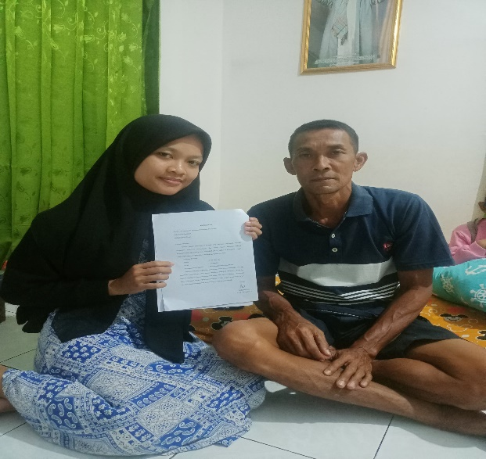Dokumentasi

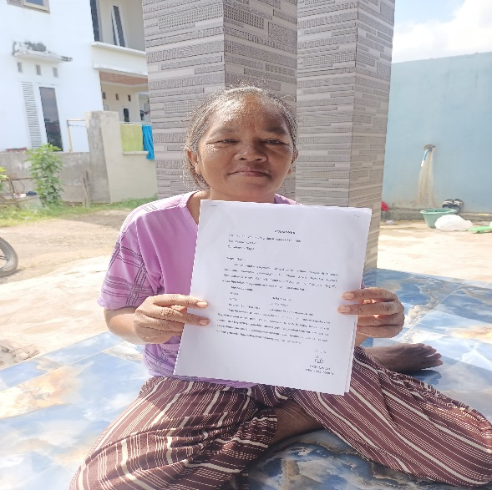 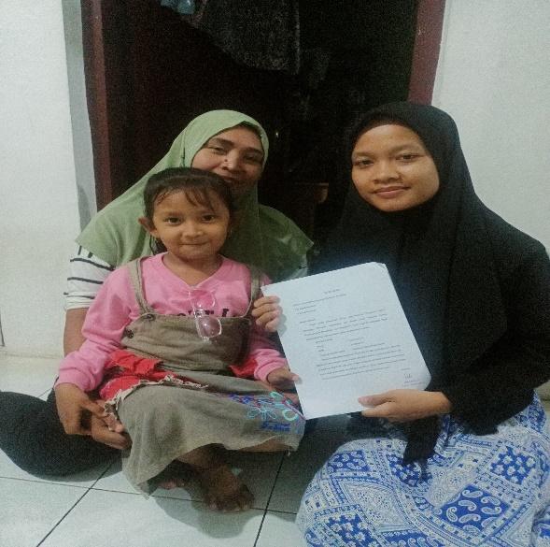 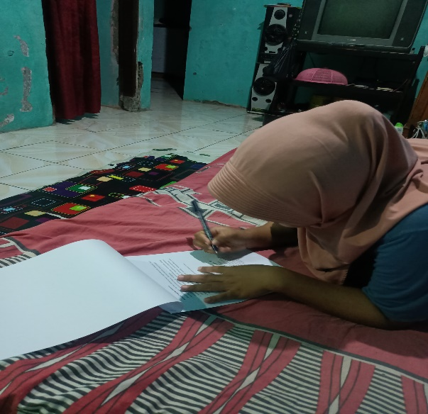

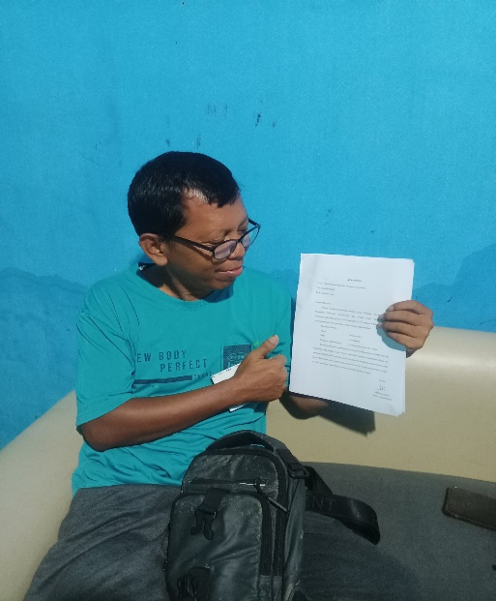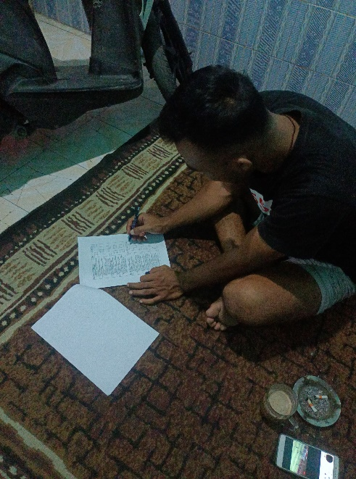 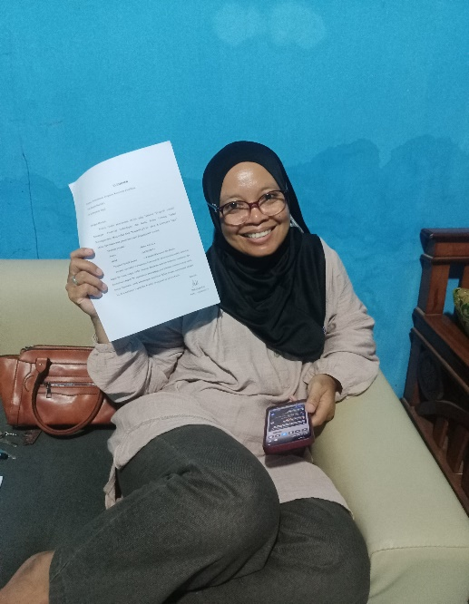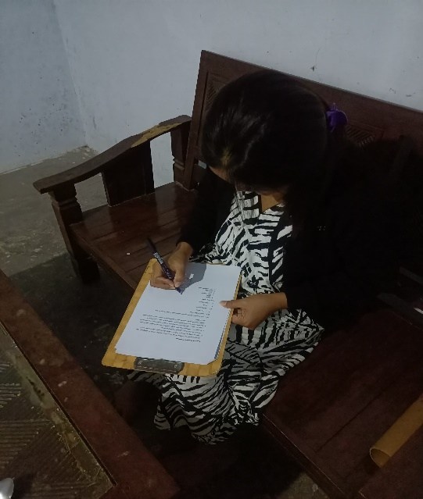  
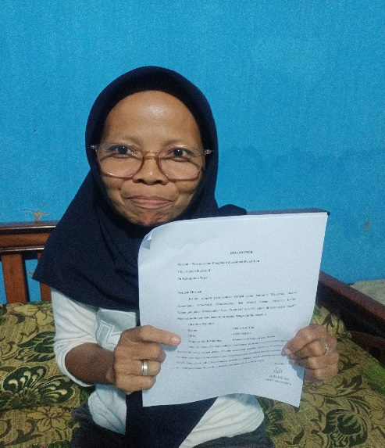 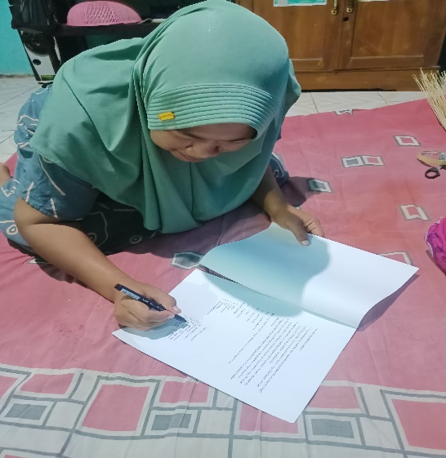

3.Lampiran Hasil Uji

Uji Validitas

Literasi Keuangan

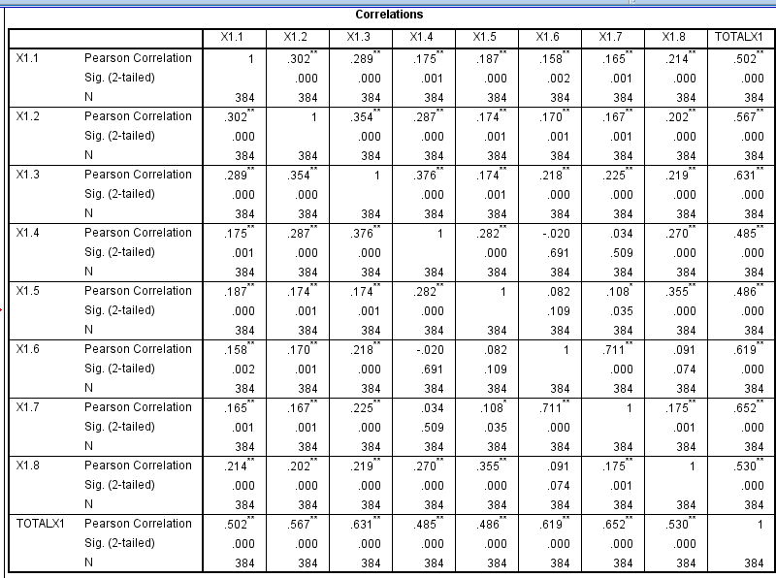

*Financial Technology*

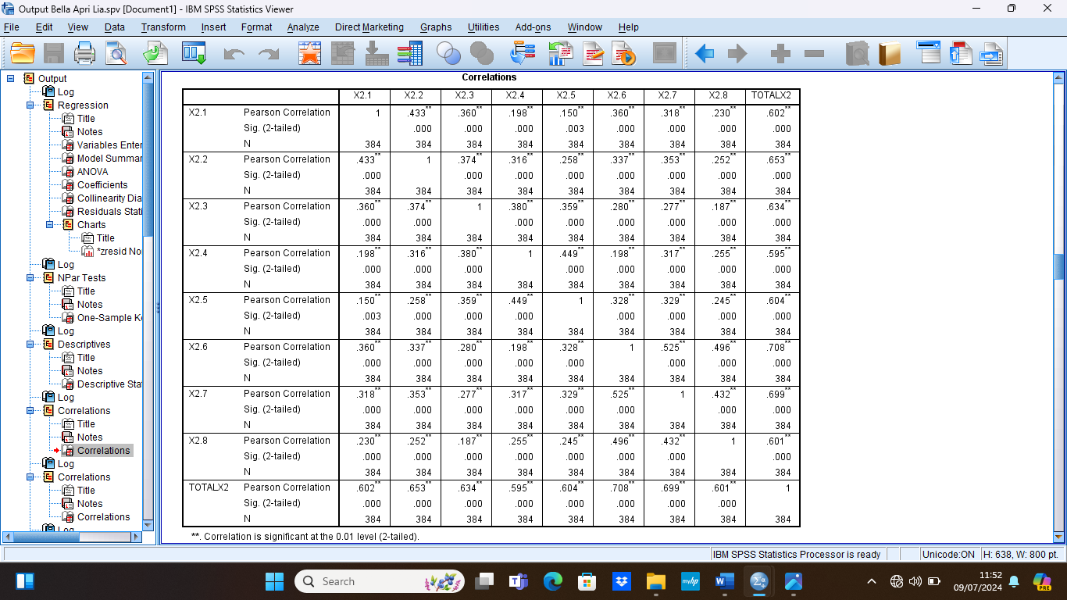

Modal Sosial

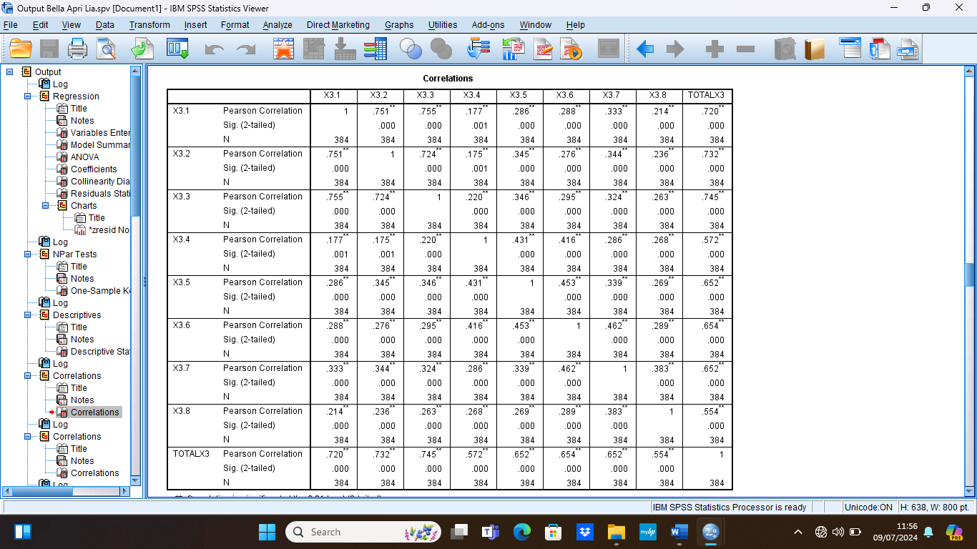

Inklusi Keuangan

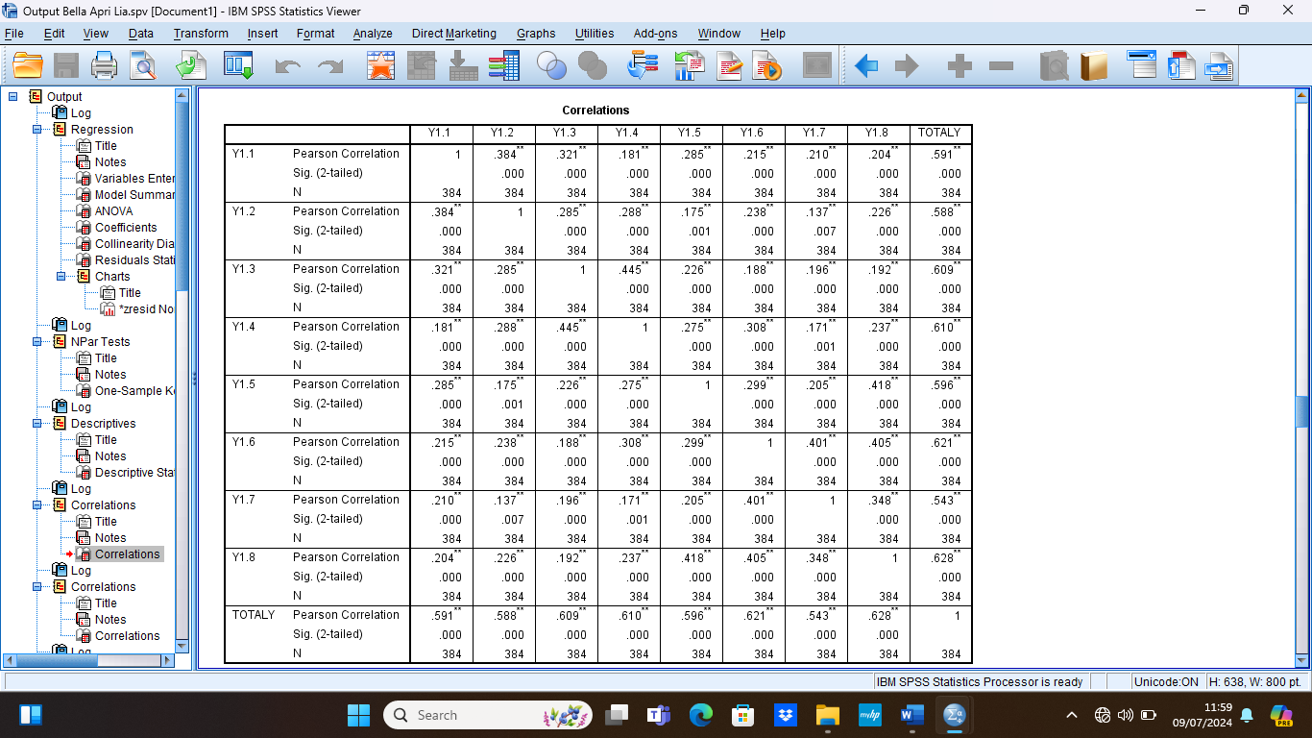

4.Uji Reabilitas

Literasi Keuangan Financial Technology

|  |  |
| --- | --- |
|  | |
| Cronbach's Alpha | N of Items |
| .688 | 8 |

|  |  |
| --- | --- |
|  | |
| Cronbach's Alpha | N of Items |
| .792 | 8 |

Modal Sosial Inklusi Keuangan

|  |  |
| --- | --- |
|  | |
| Cronbach's Alpha | N of Items |
| .814 | 8 |

|  |  |
| --- | --- |
|  | |
| Cronbach's Alpha | N of Items |
| .742 | 8 |

5.Uji Normalitas

Analisis Grafik

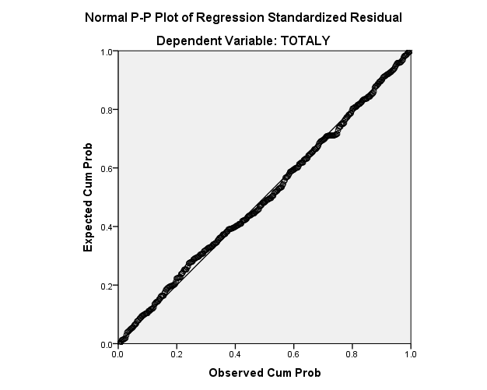

Analisis Statistik

|  |  |  |
| --- | --- | --- |
| **One-Sample Kolmogorov-Smirnov Test** | | |
|  | | Unstandardized Residual |
| N | | 384 |
| Normal Parametersa,b | Mean | .0000000 |
| Std. Deviation | 2.06637875 |
| Most Extreme Differences | Absolute | .034 |
| Positive | .033 |
| Negative | -.034 |
| Test Statistic | | .034 |
| Asymp. Sig. (2-tailed) | | .200c,d |
| a. Test distribution is Normal. | | |
| b. Calculated from data. | | |
| c. Lilliefors Significance Correction. | | |
| d. This is a lower bound of the true significance. | | |

6.Uji Statistik Deskripstif

|  |  |  |  |  |  |
| --- | --- | --- | --- | --- | --- |
| **Descriptive Statistics** | | | | | |
|  | N | Minimum | Maximum | Mean | Std. Deviation |
| TOTALX1 | 384 | 28 | 40 | 35.19 | 2.881 |
| TOTALX2 | 384 | 28 | 40 | 35.32 | 2.967 |
| TOTALX3 | 384 | 29 | 40 | 35.25 | 2.956 |
| TOTALY | 384 | 24 | 40 | 35.32 | 2.770 |
| Valid N (listwise) | 384 |  |  |  |  |

7.Uji Multikolinearitas

|  |  |  |  |
| --- | --- | --- | --- |
| Model | | Collinearity Statistics | |
| Tolerance | VIF |
| 1 | (Constant) |  |  |
| Literasi Keuangan (X1) | .728 | 1.374 |
| Financial Technology (X2) | .569 | 1.756 |
| Modal Sosial (X3) | .566 | 1.766 |

|  |  |  |  |  |  |  |
| --- | --- | --- | --- | --- | --- | --- |
| Model | | Unstandardized Coefficients | | Standardized Coefficients | t | Sig. |
| B | Std. Error | Beta |
| 1 | (Constant) | 1.503 | .971 |  | 1.548 | .122 |
| TOTALX1 | .038 | .027 | .085 | 1.410 | .159 |
| TOTALX2 | -.022 | .030 | -.051 | -.757 | .450 |
| TOTALX3 | -.013 | .030 | -.029 | -.421 | .674 |

8.Uji Heteroskedastisitas

|  |  |  |  |  |  |  |  |
| --- | --- | --- | --- | --- | --- | --- | --- |
| Model | | | Unstandardized Coefficients | | Standardized Coefficients | t | Sig. |
| B | Std. Error | Beta |
| 1 | (Constant) | 9.089 | | 1.552 |  | 5.855 | .000 |
| TOTALX1 | .165 | | .043 | .172 | 3.833 | .000 |
| TOTALX2 | .235 | | .047 | .252 | 4.962 | .000 |
| TOTALX3 | .344 | | .048 | .367 | 7.214 | .000 |

9.Uji Analisis Regresi Linear Berganda

10.Uji Hipotesis

Uji Kelayakan Model (Uji F)

|  |  |  |  |  |  |  |
| --- | --- | --- | --- | --- | --- | --- |
| **ANOVAa** | | | | | | |
| Model | | Sum of Squares | df | Mean Square | F | Sig. |
|  | Regression | 1302.579 | 3 | 434.193 | 100.890 | .000b |
| Residual | 1635.380 | 380 | 4.304 |  |  |
| Total | 2937.958 | 383 |  |  |  |
| a. Dependent Variable: TOTALY | | | | | | |
| b. Predictors: (Constant), TOTALX3, TOTALX1, TOTALX2 | | | | | | |

Uji Parsial (Uji t)

|  |  |  |  |  |  |  |
| --- | --- | --- | --- | --- | --- | --- |
| Model | | Unstandardized Coefficients | | Standardized Coefficients | t | Sig. |
| B | Std. Error | Beta |
| 1 | (Constant) | 9.089 | 1.552 |  | 5.855 | .000 |
| TOTALX1 | .165 | .043 | .172 | 3.833 | .000 |
| TOTALX2 | .235 | .047 | .252 | 4.962 | .000 |
| TOTALX3 | .344 | .048 | .367 | 7.214 | .000 |

11.Uji Koefisien Determinasi

|  |  |  |  |  |
| --- | --- | --- | --- | --- |
| **Model Summaryb** | | | | |
| Model | R | R Square | Adjusted R Square | Std. Error of the Estimate |
| 1 | .666a | .443 | .439 | 2.075 |
| a. Predictors: (Constant), TOTALX3, TOTALX1, TOTALX2 | | | | |
| b. Dependent Variable: TOTALY | | | | |