# DAFTAR PUSTAKA

Abdi, Annisa Surya, and Imam Agus Faisol. 2023. “Pengaruh Pemutihan Pajak, Samsat Keliling, E-Samsat, Sanksi Pajak, Dan Kualitas Pelayanan Terhadap Kepatuhan Wajib Pajak Kendaraan Bermotor Di Kabupaten Bangkalan.” *Neo-Bis* 12(1):91–108.

Afifah Nur Insanny, Diamonalisa Sofianty, and Riyang Mardini. 2023. “Pengaruh Pengetahuan Perpajakan Dan Penerapan Program E-Samsat Terhadap Kepatuhan Wajib Pajak Kendaraan Bermotor.” *Jurnal Riset Akuntansi* 11–16. doi: 10.29313/jra.v3i1.1761.

Alfiah, Irma. 2019. “Tahun 2014.” *Kesadaran Perpajakan, Sanksi Perpajakan, Sikap Fiskus, Lingkungan Pajak, Pengetahuan Peraturan Pajak, Persepsi Efektifitas Sistem Perpajakan, Kemauan Membayar Pajak Terhadap Kepatuhan Wajib Pajak Orang Pribadi Di Dppkad Grobogan- Purwodadi* 3511351(24):2008–10.

Akbar, Dzaki, Ramadhan Khamel, and Ingra Sovita. 2024. “Pengaruh Kesadaran Wajib Pajak , Pengetahuan Pajak , Dan Sanksi Pajak Terhadap Kepatuhan Wajib Pajak Kendaraan Bermotor Roda Dua Di Daerah Terluar , Tertinggal , Terdepan ( 3T ) ( Studi Kasus Kecamatan Sikakap Kab . Kepualaun Mentawai ).” 01(04):593–609.

Arifin, Zaenal, and Muhamad Rizaldy. 2023. “Reslaj : Religion Education Social Laa Roiba Journal Sarjanawiyata Tamansiswa Reslaj : Religion Education Social Laa Roiba Journal.” *Reslaj : Religion Education Social Laa Roiba Journal* 5(1):168–84. doi: 10.47476/reslaj.v6i3.6202.

As’ari, Nur Ghailina. 2018. “PENGARUH PEMAHAMAN PERATURAN PERPAJAKAN, KUALITAS PELAYANAN, KESADARAN WAJIB PAJAK DAN SANKSI PAJAK TERHADAP KEPATUHAN WAJIB PAJAK ORANG PRIBADI.” *Jurnal Ekobis Dewantara* 1. doi: 10.1002/j.1460-2075.1995.tb00098.x.

Ayuni, Henny A., Manafe, and Perseveranda. 2023. “Pengaruh Kasadaran Wajib Pajak, Pengetahuan Wajib Pajak, Sanksi Pajak, Dan Tax Amnesty Terhadap Kepatuhan Wajib Pajak Kendaraan Bermotor (Kajian Studi Literatur Manajemen Keuangan Daerah).” *Jurnal Ilmu Manajemen Terapan (JIMT)* 5(1):1–8.

Barlian, Achmad, Noermina Rossya, and Novianita Rulandari. 2021. “Analisis Strategi Sosialisasi Pajak Atas Transaksi Perdagangan Melalui Sistem Elektronik (Pmse) Sebagai Upaya Optimalisasi Penerimaan Pajak.” *Jurnal Pajak Vokasi (JUPASI)* 3(1):11–15. doi: 10.31334/jupasi.v3i1.1924.

Dewi, Adinda Pristiawati, and Barkah Susanto. 2021. “Faktor–Faktor Yang Mempengaruhi Tingkat Kepatuhan Wajib Pajak UMKM Pada Masa Pandemi Covid-19 (Studi Pada KPP Pratama Temanggung).” Pp. 376–90 in *UMMagelang Conference Series*.

Ermawati, Nanik. 2018. “Pengaruh Religiusitas, Kesadaran Wajib Pajak Dan Pengetahuan Perpajakan Terhadap Kepatuhan Wajib Pajak.” *Jurnal Stie Semarang (Edisi Elektronik)* 10(1):106–22.

Ferry, William. 2020. “Pengaruh Pemutihan Pajak Dan Kesadaran Wajib Pajak Terhadap Kepatuhan Wajib Pajak Dalam Membayar Pajak Kendaraan Bermotor Di Kota Palembang.” *Jurnal Keuangan Dan Bisnis* 1(5):68–88. doi: 10.32524/jkb.v18i1.626.

Ghozali, I. 2018. *Aplikasi Analisis Multivariate Dengan Program IBM SPSS 25*. 9th ed. undip.

Girindratama, Muhammad Wisnu, and Aulia Nur Firdaus Rahmatullah. 2023. “Peran Mediasi Kesadaran Pajak Dalam Hubungan Pemutihan Pajak Dan Kepatuhan Wajib Pajak Kendaraan Bermotor.” *Jurnal Aplikasi Akuntansi* 8(1):91–103. doi: 10.29303/jaa.v8i1.241.

Hadi, Nor, and Umi Mahmudah. 2018. “Pengaruh Kualitas Pelayanan Perpajakan Terhadap Kepatuhan Wajib Pajak.” *AKTSAR: Jurnal Akuntansi Syariah* 1(2):257. doi: 10.21043/aktsar.v1i2.5222.

Hanny Fachrunnissa Icha Fajriana. 2022. “Analisis Pelaksanaan Dan Efektivitas Pemutihan Pajak Kendaraan Bermotor Pada Masa Pandemi Covid 19 Di Palembang (Studi Pada Kantor Badan Pendapatan Daerah Kota Palembang).” *Forum Bisnis Dan Kewirausahaan* 12(1):h.121.

Hartanti, Hartanti, Ratiyah Ratiyah, Eka Dyah Setyaningsih, and Dilla Rizky Amelia. 2022. “Pengaruh Sosialisasi Perpajakan Dan Kesadaran Wajib Pajak Terhadap Kepatuhan Wajib Pajak Kendaraan Bermotor Kabupaten Bandung Barat.” *Moneter - Jurnal Akuntansi Dan Keuangan* 9(1):23–28. doi: 10.31294/moneter.v9i1.12596.

Hidayat, Imam, and Lusiana Maulana. 2022. “Pengaruh Kesadaran Wajib Pajak, Sanksi Pajak, Dan Kualitas Pelayanan Pajak Terhadap Kepatuhan Wajib Pajak Kendaraan Bermotor Di Kota Tangerang.” *Bongaya Journal for Research in Accounting (BJRA)* 5(1):11–35. doi: 10.37888/bjra.v5i1.322.

I Made Hermawan. n.d. “Pengaruh Pemutihan Sanksi Pajak, Modernisasi Sistem Administrasi Perpajakan, Dan Niat Membayar Pajak Terhadap Kepatuhan Wajib Pajak Kendaraan Bermotor (Studi Empiris Pada Wajib Pajak Kendaraan Bermotor Di Kabupaten Bangli).”

Ichlas, Fachrel, Lili Indrawati, and Yanti Rufaedah. 2022. “Pengaruh Pemutihan Pajak Kendaraan Bermotor Terhadap Penerimaan Pajak Pajak Kendaraan Bermotor Di Provinsi Jawa Barat Periode 2019-2020.” *Indonesian Accounting Research Journal* 3(1):93–99. doi: 10.35313/iarj.v3i1.4129.

Jaeng, Theresa Yuliana, and I. Ketut Yadnyana. 2024. “Pengaruh Kesadaran Wajib Pajak, Pengetahuan Perpajakan Dan Kualitas Pelayanan, Terhadap Kepatuhan Wajib Pajak Hotel (Studi Kasus Di Kabupaten Sikka, NTT).” *Owner* 8(1):509–21.

Kartikasari, NLGS, and I. Ketut Yadnyana. 2020. “Pengetahuan Perpajakan, Sanksi Pajak Kesadaran Wajib Pajak Dan Kepatuhan WPOP Sektor UMKM.” *E-Jurnal Akuntansi* 31(4):925–36.

Kesehatan, Pengaruh, and D. A. N. Keselamatan. 2023. “KERJA KARYAWAN PT . KBU BAYUNG LENCIR KABUPATEN.” 4(2):84–93.

Maulana, Muhammad Dian, and Dwi Septiani. 2022. “Pengaruh Layanan Samsat Keliling, E-Samsat Dan Sanksi Perpajakan Terhadap Kepatuhan Wajib Pajak Kendaraan Bermotor.” *Jurnal Akuntansi* 14(2):231–46.

Motivasi, Pengaruh, and Pengetahuan Perpajakan Dan. 2024. “Pengaruh Motivasi, Pengetahuan Perpajakan Dan Kesadaran Pajak Terhadap Kepatuhan Pajak Pada Kpp Pratama Depok Sawangan.” 7(1):138–47.

Natasya, Erika, and Erry Andhaniwati. 2023. “Pengaruh Kepuasan Wajib Pajak Terhadap Kepatuhan Wajib Pajak Kendaraan Bermotor.” *Al-Kharaj : Jurnal Ekonomi, Keuangan & Bisnis Syariah* 6(2):1128–39. doi: 10.47467/alkharaj.v6i2.4202.

Nelly, Nelly, and Ronald Wangdra. 2024. “Pengaruh Sosialisasi Perpajakan, Kualitas Pelayanan Fiskus Dan Sanksi Perpajakan Terhadap Kepatuhan WPOP.” *Owner* 8(1):200–211.

Ni Komang Ayu Juliantari, I Made Sudiartana, Ni Luh Gde Mahayu Dicriyani. 2021. “Pengaruh Kesadaran Wajib Pajak, Kualitas Pelayanan, Kewajiban Moral, Sanksi Pajak, Dan Sosialisasi Pajak Terhadap Kepatuhan Wajib Pajak Dalam Membayar Pajak Kendaraan Bermotor Di Kantor Samsat Gianyar.” *Jurnal Kharisma* 3(1):128–39.

Nilla, Viola Septia, and Dini Widyawati. 2021. “Pengaruh Penerapan E-Billing, Pengetahuan Perpajakan, Dan Kesadaran Membayar Pajak Terhadap Kepatuhan Wajib Pajak.” *Jurnal Ilmu Dan Riset Akuntansi (JIRA)* 10(4).

Ningsih, Ni Luh Ayu Ratna, Putu Kepramareni, and Sagung Oka Pradnyawati. 2022. “Pengaruh Kesadaran Wajib Pajak, Sosialisasi Perpajakan, Kewajiban Normal, Kualitas Pelayanan, Dan Sanksi Perpajakan Terhadap Tingkat Kepatuhan Wajib Pajak Kendaraan Bermotor Di Kantor SAMSAT Kabupaten Bangli.” *Jurnal Kharisma* 4(1):13–23.

Ningsih, Setia, and Hendra H. Dukalang. 2019. “Penerapan Metode Suksesif Interval Pada Analsis Regresi Linier Berganda.” *Jambura Journal of Mathematics* 1(1):43–53. doi: 10.34312/jjom.v1i1.1742.

Novelia, 2009. 2009. “Pengaruh Kualitas Pelayanan ..., Kiki Rizki Novelia, 2009.” 1–7

Pajak, Kesadaran Wajib. 2023. “Pengaruh Program Pemutihan Kendaraan Bermotor Roda Dua ( Studi Kasus Pada Kantor Samsat Putri Hijau ).” 6:2433–43.

Pengaruh, Analisis, Perubahan Tarif, Ketegasan Sanksi, D. A. N. Kemudahan, Membayar Pajak, Terhadap Kepatuhan, Wajib Pajak, Program Studi Akuntansi, Fakultas Ekonomi, and Universitas Muhammadiyah Semarang. 2020. “Repository.Unimus.Ac.Id.” 76–105.

Pranata, Aji, Nurmala, and M. Aryo Arifin. 2022. “Pengaruh Kesadaran Wajib Pajak, Sanksi, Dan Pemutihan Terhadap Kepatuhan Wajib Pajak Kendaraan Bermotor(Studi Pada Badan Pendapatan Daerah Provinsi SumateraSelatan).” *Jurnal Akuntansi* 14(2):319–29.

Putri Sekti Ari, Dessanti, and Latifah Hanum. 2021. “Pengaruh Kualitas Pelayanan Website Djp Terhadap Kepuasan Pengguna Dengan Modifikasi E Govqual.” *Profit* 15(01):104–11. doi: 10.21776/ub.profit.2021.015.01.11.

R.MINDAN, L. ARDINI. 2021. “Pengaruh Pengetahuan Pajak, Sosialisasi Perpajakan, Dan Insentif Pajak Terhadap Kepatuhan Wajib Pajak Kendaraan Bermotor.” *Jurnal Ilmu Dan Riset Akuntansi* 2022:1–18.

Renika Hasibuan, Ayu Sepriani Harefa. 2023. “Pengaruh Kesadaran Wajib Pajak Pengetahuan Perpajakan, Dan Kepercayaan Pada Pemerintah Terhadap Kepatuhan Umkm Membayar Pajak Penghasilan Di Kota Medan.” 01(1):1–23.

Rossa, Elia, Achmad Zauhar Muqtafi, Afifah Rohmawati, Alisya Athalia, Alya Syafikah Rani, Anissa Pujiwaty, Yuyun Yuyun, Universitas Bhayangkara Jakarta Raya Alamat, Jl Raya Perjuangan Bekasi Utara, Kota Bekasi, and Jawa Barat. 2024. “Pengaruh Self Assessment , Sosialisasi Perpajakan Dan Sistem Informasi Perpajakan Terhadap Tingkat Kepatuhan Wajib Pajak.” *Jurnal Manajemen Riset Inovasi (MRI)* 2(1):212–20.

Selung, Rosalia, Indah Wasliah, and Eka Adithya Pratiwi. 2014. “Pengaruh Kesadaran Wajib Pajak, Sosialisasi Pajak, Kualitas Pelayanan Dan Sangsi Pajak Terhadap Kepatuhan Wajib Pajak.” (1):1–23.

Sanaky, Musrifah Mardiani. 2021. “Analisis Faktor-Faktor Keterlambatan Pada Proyek Pembangunan Gedung Asrama Man 1 Tulehu Maluku Tengah.” *Jurnal Simetrik* 11(1):432. doi: 10.31959/js.v11i1.615.

Saputra, Deni, Rindy Citra Dewi, and Geatasha Putri Erant. 2022. “Pengaruh Program Pemutihan Pajak, Pembebasan Bea Balik Nama, Dan Sosialisasi Perpajakan Terhadap Kepatuhan Wajib Pajak Kendaraan Bermotor.” *Jurnal Manajemen Pendidikan Dan Ilmu Sosial* 3(1):56–67. doi: 10.38035/jmpis.v3i1.841.

Saputro, Muchlis Aji. 2017. “Lampiran 1. Kuisioner Penelitian Kuesioner Penelitian.” (9):89–92.

Sari, R. A. V. Y., & Susanti, N. 2015. “Faktor-Faktor Yang Mempengaruhi Kepatuhan Wajib Pajak Dalam Membayar Pajak Kendaraan Bermotor (Pkb) Di Unit Pelayanan Pendapatan Provinsi (Uppp) Kabupaten Seluma.”

Stiani, Devi, and Indra Iman Sumantri. 2023. “( Studi Kasus Pada Kantor Samsat Depok II Cinere ).”

Sugiyono. 2016. *Metode Penelitian & Pengembangan Research and Development*. Jakarta.

Sulistiyowati, Linda, and Dyah Ratnawati. 2023. “Kesadaran, Pengetahuan Perpajakan Dan Penghasilan Wajib Pajak Terhadap Tingkat Kepatuhan Wajib Pajak Dalam Membayar Pajak Bumi Dan Bangunan.” *Journal of Management and Bussines (JOMB)* 5(2):1403–13.

Tumanduk, Stevly, Arie Kawulur, and Aprili Bacilius. 2021. “Pengaruh Pengetahuan Perpajakan Terhadap Kepatuhan Wajib Pajak Kendaraan Bermotor Di Kantor Samsat Kota Tomohon.” *Jurnal Akuntansi Manado (JAIM)* 2(3):292–301. doi: 10.53682/jaim.vi.1134.

Utami Widya Karlina, Mukhlizul Hamdi Ethika. 2021. “Pengaruh Kesadaran Wajib Pajak Dan Sanksi Perpajakan Terhadap Kepatuhan Wajib Pajak Kendaraan Bermotor.” *PAY Jurnal Keuangan Dan Perbankan* 3(1):27–37. doi: 10.46918/pay.v3i1.976.

Wardani, Dewi Kusuma, and Rumiyatun Rumiyatun. 2017. “Pengaruh Pengetahuan Wajib Pajak, Kesadaran Wajib Pajak, Sanksi Pajak Kendaraan Bermotor, Dan Sistem Samsat Drive Thru Terhadap Kepatuhan Wajib Pajak Kendaraan Bermotor.” *Jurnal Akuntansi* 5(1):15. doi: 10.24964/ja.v5i1.253.

Wardani, Dewi Kusuma, and Erma Wati. 2018. “PENGARUH SOSIALISASI PERPAJAKAN TERHADAP KEPATUHAN WAJIB PAJAK DENGAN PENGETAHUAN PERPAJAKAN SEBAGAI VARIABEL INTERVENING (Studi Pada Wajib Pajak Orang Pribadi Di KPP Pratama Kebumen).” *Nominal, Barometer Riset Akuntansi Dan Manajemen* 7(1). doi: 10.21831/nominal.v7i1.19358.

Waromi, Dessy N., Yanti Timisela, and Agnes Eyne Banes. 2023. “Pengaruh Kualitas Pelayanan Terhadap Kepuasan Masyarakat Di Kelurahan Klasuur.” *Journal on Education* 5(4):11909–21. doi: 10.31004/joe.v5i4.2146.

Widajantie, Tituk Diah, and Saiful Anwar. 2020. “Pengaruh Program Pemutihan Pajak Kendaraan Bermotor, Kesadaran Wajib Pajak, Sosialisasi Pajak, Dan Pelayanan Terhadap Kepatuhan Wajib Pajak Kendaraan Bermotor (Studi Pada Kantor Bersama Samsat Surabaya Selatan).” *Behavioral Accounting Journal* 3(2):129–43. doi: 10.33005/baj.v3i2.103.

Ernita, Dewi, and Erni Febrina Harahap. 2023. “Pengaruh Kesadaran Wajib Pajak Pengetahun Pajak Dan Kualitas Layanan Fiskus Dan Sanksi Pajak Terhapad Kepatuhan Wajib Pajak Kedaraan Bermotor Di Kota Sungai Penuh.” *JEMSI (Jurnal Ekonomi, Manajemen, Dan Akuntansi)* 9(3):916–29. doi: 10.35870/jemsi.v9i3.1210.

Isnaini, Putri, and Abdul Karim. 2021. “Pengaruh Kesadaran Wajib Pajak Dan Sanksi Perpajakan Terhadap Kepatuhan Wajib Pajak Kendaraan Bermotor (Studi Kasus Pada Kantor Samsat Kabupaten Gowa).” *Jurnal Keuangan Dan Perbankan* 3(1):27–37.

Pajak, Kesadaran Wajib. 2022. “PENGARUH SANKSI ADMINISTRASI , KESADARAN WAJIB KEPATUHAN WAJIB PAJAK KENDARAAN BERMOTOR DI KOTA BANDAR LAMPUNG 2022 Sumber Jurnal : Wardani Kusuma , D ., & Juliansya , F . ( 2018 ). Pengaruh Program E-SAMSAT Terhadap Kepatuhan Wajib Pajak Kendaraan Bermot.”

Turrahmah, Fitya. n.d. “Pengaruh Pengetahuan Pajak, Kesadaran Pajak, Sosialisasi Pajak, Sanksi Pajak Dan Sistem E-Samsat Terhadap Kepatuhan Wajib Pajak Dalam Membayar Pajak Kendaraan Bermotor (Studi Kasus Pengendara Ojek Online Di DKI Jakarta).”

Wangi, Ni Made Putri, I. Nyoman Kusuma Adnyana Mahaputra, Putu Novia Hapsari Ardianti, and M. Doni Permana Putra. 2021. “Pengaruh Pengetahuan Pajak, Sanksi Pajak, Tarif Pajak Dan Pelayanan Pajak Terhadap Kepatuhan Wajib Pajak Dalam Membayar Pajak Kendaraan Bermotor Pada Kantor SAMSAT Kota Tabanan.” *Jurnal Kharisma* 3(3):349–58.

Apriliyani, Lucya Herty. 2022. “Apriliyani.” 1(2):65–74.

Kaporina, Anisyah, Yunissa Hernanda, and Diana Nurlaily. 2023. “Analisis Tingkat Pengangguran Provinsi Kalimantan Timur Menggunakan Sign Test , Wilcoxon Test Dan Paired Sample t-Test.” *SEMIOTIKA Seminar Nasional Teknologi Informasi Dan Matematika* 2(1):94–102.

Udayana, E-jurnal Akuntansi Universitas. 2018. “Sosialisasi Perpajakan Memoderasi Pengaruh Kewajiban Moral Dan Kualitas Pelayanan Pada Kepatuhan Wajib Pajak Kendaraan Bermotor Fakultas Ekonomi Dan Bisnis Universitas Udayana ( Unud ), Bali , Indonesia Fakultas Ekonomi Dan Bisnis Universitas Udayana ( Un.” 24:606–32.

Waromi, Dessy N., Yanti Timisela, and Agnes Eyne Banes. 2023. “Pengaruh Kualitas Pelayanan Terhadap Kepuasan Masyarakat Di Kelurahan Klasuur.” *Journal on Education* 5(4):11909–21. doi: 10.31004/joe.v5i4.2146.

Wicaksono, Shafril Wahyu Dwi. 2020. “Pengaruh Kesadaran Wajib Pajak, Pengetahuan Pajak, Sanksi Perpajakan, Sistem E-Samsat Dan Akuntabilitas Pelayanan Publik Terhadap Kepatuhan Wajib Pajak Kendaraan Bermotor Di Kota Tegal.” *Universitas Pancasakti Tegal* 1–98.

Widajantie, Tituk Diah, and Saiful Anwar. 2020. “Pengaruh Program Pemutihan Pajak Kendaraan Bermotor, Kesadaran Wajib Pajak, Sosialisasi Pajak, Dan Pelayanan Terhadap Kepatuhan Wajib Pajak Kendaraan Bermotor (Studi Pada Kantor Bersama Samsat Surabaya Selatan).” *Behavioral Accounting Journal* 3(2):129–43. doi: 10.33005/baj.v3i2.103.

# LAMPIRAN

Lampiran 1 Kuesioner

Dalam rangka penyelesaian skripsi sebagai mahasiswi program strata satu (S1) Universitas Pancasakti Tegal, saya:

Nama : Dyah Kharisma Rahma Dani

Npm : 4320600061

Prodi : Akuntansi

Fakultas : Ekonomi Dan Bisnis

Bermaksud melakukan penelitian untuk menyususn skripsi dengan berjudul

”**PENGARUH KUALITAS PELAYANAN, PENGETAHUAN PERPAJAKAN, SOSIALISASI PAJAK DAN PEMUTIHAN PAJAK TERHADAP KEPATUHAN WAJIB PAJAK KENDARAAN BERMOTOR DI SAMSAT KOTA TEGAL”**

Dalam rangka penyelesaian skripsi, saya bermaksud melakukan penelitian ilmiah yang berupa skripsi. Dengan hal ini saya sangat mengharapkan kesediaan Bapak/Ibu/Saudara/I untuk menjadi responden dengan meluangkan waktunya sejenak untuk mengisi beberapa pertanyaan pada kuesioner ini secara lengkap dan sesuai dengan isi hati Bapak/Ibu/Saudara/I sekalian. Penelitian kuesioner ini hanya digunakan untuk kepentingan akademis penelitian semata, peneliti sangat mengharapkan kepada semua pihak yang terpilih sebagai responden dalam penelitian ini dapat bekerjasama dalam memberikan informasi atau jawaban atas pertanyaan secara benar, jujur dan objektif.

Atas perhatian dan kesediaan Bapak/Ibu/Saudara/I dalam meluangkan waktu untuk menjawab pertanyaan-pertanyaan di dalam kuesioner ini, saya mengucapkan terimakasih.

PETUNJUK PENGISISAN ANGKET

1. Angket diisi oleh Bapak/Ibu/Saudara/I untuk menjawab seluruh pertanyaan atau pernyataan yang telah disediakan.
2. Beri tanda centang (√) pada kolom yang tersedia dan pilihlah sesuai dengan keadaan yang sebenarnya.
3. Dalam menjawab pertanyaan dibawah ini, diusahakan untuk menjawab semua pertanyaan yang ada.

DATA KARAKTERISTIK RESPONDEN

Nama Wajib Pajak : ..............................

Usia : .............................. Tahun

Jenis Kelamin : Laki-Laki Perempuan

Jenis Kendaraan : Roda 2 Roda 4

Alamat Pajak : Kota Tegal

Kab. Tegal

Alamat Wajib Pajak : Tegal Barat

Tegal Timur

Tegal Selatan

Margadana

Lainnya

PETUNJUK PENGISIAN:

Terdapat lima alternative jawaban, yaitu sebagai berikut

SS = Sangat Setuju

S = Setuju

KS = Kurang Setuju

TS = Tidak Setuju

STS = Sangat Tidak Setuju

**DAFTAR PERTANYAAN**

**KUALITAS PELAYANAN (X1)**

|  |  |  |  |  |  |  |
| --- | --- | --- | --- | --- | --- | --- |
| **No** | **Pertanyaan** | **STS** | **TS** | **KS** | **S** | **SS** |
| **1** | **2** | **3** | **4** | **5** |
|  | Saya sangat puas dengan fasilitas yang tersedia di kantor samsat kota tegal |  |  |  |  |  |
|  | Petugas pajak melayani dengan sopan dan ramah |  |  |  |  |  |
|  | Petugas pajak memberikan informasi mengenai pembayaran pajak yang jelas kepada saya selaku wajib pajak |  |  |  |  |  |
|  | Kualitas pelayanan yang memuaskan dapat membuat waktu pembayaran saya selaku wajib pajak semakin cepat |  |  |  |  |  |
|  | Pelaksanaan jam kerja kantor samsat kota tegal dilakukan tepat waktu |  |  |  |  |  |
|  | Petugas pajak memiliki komunikasi yang efektif kepada wajib pajak yang akan membayar pajak |  |  |  |  |  |
|  | Petugas pajak telah memberikan pelayanan yang efisien dan cepat |  |  |  |  |  |
|  | Petugas pajak membuat bapak/ibu/saudara/I merasa nyaman dan aman saat melakukan kewajiban perpajakan |  |  |  |  |  |

Sumber(Selung, Wasliah, dan Pratiwi 2014), (Novelia 2009), (Ernita dan Erni Febrina Harahap 2023)

**PENGETAHUAN PERPAJAKAN (X2)**

|  |  |  |  |  |  |  |
| --- | --- | --- | --- | --- | --- | --- |
| **No** | **Pertanyaan** | **STS** | **TS** | **KS** | **S** | **SS** |
| **1** | **2** | **3** | **4** | **5** |
|  | Saya selaku wajib pajak mengetahui perhitungan pajak kendaraan bermotor |  |  |  |  |  |
|  | Saya selaku wajib pajak memahami prosedur pembayaran pajak kendaraan bermotor |  |  |  |  |  |
|  | Saya selaku wajib pajak mengetahui fungsi pajak sebagai pembangunan daerah |  |  |  |  |  |
|  | Saya selaku wajib pajak dapat membayar pajak kendaraan bermotor melalui samsat keliling |  |  |  |  |  |
|  | Saya selaku wajib pajak saat terlambat dalam melakukan pembayaran pajak akan dikenai denda atau sanksi administrasi |  |  |  |  |  |
|  | Saya selaku wajib pajak mendapatkan imbalan secara langsung dari pajak yang dibayarkan |  |  |  |  |  |
|  | Saya selaku wajib pajak mengetahui hak dan kewajiban dalam perpajakan |  |  |  |  |  |
|  | Saya selaku wajib pajak mengetahui bahwa pajak ditetapkan berdasarkan undang-undang dan dapat dipaksakan |  |  |  |  |  |
|  | Saya selaku wajib pajak mengetahui bahwa sistem perpajakan di Indonesia menganut sistem self assesment |  |  |  |  |  |

Sumber (Saputro 2017), (Alfiah 2019), (Ernita dan Erni Febrina Harahap 2023), (Turrahmah)

**SOSIALISASI PAJAK (X3)**

|  |  |  |  |  |  |  |
| --- | --- | --- | --- | --- | --- | --- |
| **No** | **Pertanyaan** | **STS** | **TS** | **KS** | **S** | **SS** |
| **1** | **2** | **3** | **4** | **5** |
|  | Saya mengetahui adanya kegiatan seminar yang diadakan oleh kantor samsat kota tegal tentang PKB dan BBNKB |  |  |  |  |  |
|  | Saya mendapatkan brosur tentang pajak PKB dan BBNKB dari kantor samsat kota tegal |  |  |  |  |  |
|  | Saya mengetahui perkembangan informasi tentang pajak melalui surat kabar, majalah, radio, jurnal atau iklan layanan masyarakat di televisi |  |  |  |  |  |
|  | Saya memperoleh informasi yang lengkap tentang pembayaran pajak di internet melalui media sosial seperti (tiktok, instagram, twitter, facebook dll) |  |  |  |  |  |
|  | Saya mengetahui bahwa petugas menguasai materi dalam melakukan sosialisasi atau seminar dalam memberikan penjelasan dan sosialisasi tentang pembayaran pajak |  |  |  |  |  |
|  | Petugas pajak menawarkan kenyamanan pelayanan dalam memberi informasi kepada wajib pajak dengan melengkapi penjelasan melalui prosedur |  |  |  |  |  |
|  | Penyuluhan pajak dapat memeberikan motivasi bagi saya selaku wajib pajak agar patuh dalam membayar pajak |  |  |  |  |  |
|  | Petugas pajak sering melakukan sosialisasi pajak di daerah saya |  |  |  |  |  |

Sumber (Selung et al. 2014), (Pengaruh et al. 2020), (Turrahmah n.d.).

**PEMUTIHAN PAJAK (X4)**

|  |  |  |  |  |  |  |
| --- | --- | --- | --- | --- | --- | --- |
| **No** | **Pertanyaan** | **STS** | **TS** | **KS** | **S** | **SS** |
| **1** | **2** | **3** | **4** | **5** |
|  | Saya mengetahui dan memahami betul tentang program pemutihan pajak |  |  |  |  |  |
|  | Saya mengetahui manfaat dari pemutihan pajak kendaraan bermotor |  |  |  |  |  |
|  | Saya mengetahui tujuan dari adanya program pemutihan pajak kendaraan bermotor |  |  |  |  |  |
|  | Saya merasa terbantu dengan adanya program pemutihan pajak |  |  |  |  |  |
|  | Wajib pajak akan mendapatkan surat pemberitauan oleh kantor samsat kota tegal menegenai keterlambatan dalam membayar pajak |  |  |  |  |  |
|  | Saya tidak merasa dirugikan dengan adanya program pemutihan pajak |  |  |  |  |  |
|  | Saya menyetujui apabila program pemutihan pajak seperti pembebasan sanksi administrasi dapat meringankan bagi wajib pajak dalam melaksanakan kewajibannya |  |  |  |  |  |
|  | Saya menyetujui dengan adanya program pemutihan pajak seperti penghapusan denda bea balik nama kendaraan bermotor akan memudahkan saya dalam membayar pajak tahun berikutnya |  |  |  |  |  |

Sumber (I Made Hermawan n.d.), (Pajak 2022)

**KEPATUHAN WAJIB PAJAK (Y)**

|  |  |  |  |  |  |  |
| --- | --- | --- | --- | --- | --- | --- |
| **No** | **Pertanyaan** | **STS** | **TS** | **KS** | **S** | **SS** |
| **1** | **2** | **3** | **4** | **5** |
|  | Saya selalu memenuhi kewajiban dalam membayar pajak kendaraan bermotor |  |  |  |  |  |
|  | Saya selalu membayar pajak tepat pada waktunya |  |  |  |  |  |
|  | Saya selalu melengkapi data persyaratan pembayaran pajak kendaraan bermotor (KTP & STNK asli) sesuai dengan ketentuan yang berlaku |  |  |  |  |  |
|  | Saya sering lupa waktu jatuh tempo pembayaran pajak kendaraan bermotor |  |  |  |  |  |
|  | Saya tidak memiliki tunggakan dalam membayar pajak |  |  |  |  |  |
|  | Banyaknya tempat pembayaran dapat mempermudah saya selaku wajib pajak untuk membayar pajak tepat waktu |  |  |  |  |  |
|  | Memiliki tunggakan pajak akan ada denda yang harus dibayarkan |  |  |  |  |  |
|  | Saya membayar pajak kendaraan secara sukarela |  |  |  |  |  |

Sumber (I Made Hermawan n.d.), (Saputro 2017), (Turrahmah n.d.).

Lampiran 2 Data Variabel Kualitas Pelayanan

**DATA VARIABEL KUALITAS PELAYANAN (X1)**

|  |  |  |  |  |  |  |  |  |  |
| --- | --- | --- | --- | --- | --- | --- | --- | --- | --- |
| Responden | Kualitas Pelayanan (X1) | | | | | | | | Total |
| 1 | 2 | 3 | 4 | 5 | 6 | 7 | 8 |
| 1 | 4 | 5 | 3 | 5 | 5 | 4 | 5 | 5 | 36 |
| 2 | 5 | 4 | 5 | 4 | 3 | 5 | 4 | 4 | 34 |
| 3 | 5 | 5 | 5 | 4 | 5 | 3 | 4 | 4 | 35 |
| 4 | 4 | 5 | 4 | 4 | 5 | 5 | 4 | 5 | 36 |
| 5 | 4 | 4 | 5 | 5 | 4 | 5 | 5 | 4 | 36 |
| 6 | 4 | 5 | 4 | 4 | 5 | 4 | 4 | 5 | 35 |
| 7 | 4 | 5 | 5 | 5 | 5 | 5 | 5 | 5 | 39 |
| 8 | 3 | 3 | 3 | 3 | 3 | 4 | 3 | 4 | 26 |
| 9 | 4 | 5 | 5 | 5 | 5 | 4 | 5 | 5 | 38 |
| 10 | 4 | 4 | 3 | 3 | 3 | 3 | 3 | 3 | 26 |
| 11 | 4 | 4 | 5 | 5 | 4 | 4 | 5 | 4 | 35 |
| 12 | 4 | 3 | 4 | 3 | 4 | 4 | 3 | 4 | 29 |
| 13 | 5 | 4 | 4 | 4 | 4 | 4 | 4 | 4 | 33 |
| 14 | 4 | 5 | 5 | 5 | 4 | 4 | 5 | 4 | 36 |
| 15 | 4 | 5 | 4 | 4 | 5 | 4 | 4 | 4 | 34 |
| 16 | 4 | 4 | 4 | 4 | 4 | 4 | 4 | 4 | 32 |
| 17 | 5 | 5 | 4 | 4 | 5 | 5 | 4 | 4 | 36 |
| 18 | 4 | 4 | 4 | 5 | 4 | 5 | 5 | 4 | 35 |
| 19 | 5 | 5 | 5 | 5 | 4 | 5 | 5 | 5 | 39 |
| 20 | 5 | 4 | 4 | 5 | 4 | 4 | 5 | 5 | 36 |
| 21 | 4 | 5 | 4 | 5 | 5 | 5 | 5 | 4 | 37 |
| 22 | 4 | 5 | 4 | 5 | 4 | 4 | 5 | 4 | 35 |
| 23 | 5 | 4 | 5 | 4 | 5 | 4 | 4 | 4 | 35 |
| 24 | 5 | 4 | 5 | 5 | 5 | 5 | 5 | 5 | 39 |
| 25 | 4 | 5 | 5 | 5 | 4 | 4 | 5 | 5 | 37 |
| 26 | 5 | 5 | 5 | 4 | 4 | 5 | 4 | 4 | 36 |
| 27 | 5 | 4 | 5 | 5 | 4 | 5 | 5 | 5 | 38 |
| 28 | 4 | 4 | 4 | 5 | 4 | 4 | 5 | 4 | 34 |
| 29 | 4 | 4 | 3 | 4 | 3 | 4 | 4 | 4 | 30 |
| 30 | 4 | 3 | 4 | 3 | 4 | 3 | 4 | 4 | 29 |
| 31 | 5 | 4 | 5 | 4 | 5 | 5 | 4 | 4 | 36 |
| 32 | 5 | 5 | 5 | 5 | 4 | 5 | 5 | 4 | 38 |
| 33 | 4 | 5 | 5 | 4 | 5 | 4 | 4 | 4 | 35 |
| 34 | 5 | 4 | 4 | 4 | 4 | 4 | 4 | 4 | 33 |
| 35 | 4 | 4 | 5 | 5 | 5 | 4 | 5 | 5 | 37 |
| 36 | 4 | 4 | 4 | 4 | 5 | 4 | 4 | 4 | 33 |
| 37 | 5 | 4 | 4 | 5 | 4 | 4 | 5 | 5 | 36 |
| 38 | 5 | 4 | 5 | 5 | 4 | 5 | 5 | 5 | 38 |
| 39 | 5 | 4 | 5 | 4 | 5 | 4 | 4 | 5 | 36 |
| 40 | 5 | 4 | 5 | 5 | 5 | 5 | 5 | 4 | 38 |
| 41 | 4 | 4 | 5 | 5 | 4 | 4 | 5 | 4 | 35 |
| 42 | 4 | 3 | 4 | 3 | 4 | 4 | 3 | 4 | 29 |
| 43 | 5 | 4 | 4 | 4 | 4 | 4 | 4 | 4 | 33 |
| 44 | 4 | 5 | 5 | 5 | 4 | 4 | 5 | 4 | 36 |
| 45 | 4 | 5 | 4 | 4 | 5 | 4 | 4 | 4 | 34 |
| 46 | 4 | 4 | 4 | 4 | 4 | 4 | 4 | 4 | 32 |
| 47 | 5 | 5 | 4 | 4 | 5 | 5 | 4 | 4 | 36 |
| 48 | 4 | 4 | 4 | 5 | 4 | 5 | 5 | 5 | 36 |
| 49 | 5 | 5 | 5 | 5 | 4 | 5 | 5 | 5 | 39 |
| 50 | 5 | 4 | 4 | 5 | 4 | 4 | 5 | 4 | 35 |
| 51 | 4 | 5 | 4 | 5 | 5 | 5 | 5 | 4 | 37 |
| 52 | 4 | 5 | 4 | 5 | 4 | 4 | 5 | 4 | 35 |
| 53 | 5 | 4 | 5 | 4 | 5 | 4 | 4 | 4 | 35 |
| 54 | 5 | 4 | 5 | 5 | 5 | 5 | 5 | 5 | 39 |
| 55 | 4 | 5 | 5 | 5 | 4 | 4 | 5 | 5 | 37 |
| 56 | 5 | 5 | 5 | 4 | 4 | 5 | 4 | 4 | 36 |
| 57 | 5 | 4 | 5 | 5 | 4 | 5 | 5 | 5 | 38 |
| 58 | 4 | 4 | 4 | 5 | 4 | 4 | 5 | 4 | 34 |
| 59 | 4 | 4 | 3 | 4 | 3 | 4 | 4 | 4 | 30 |
| 60 | 4 | 3 | 4 | 3 | 4 | 3 | 4 | 4 | 29 |
| 61 | 4 | 4 | 3 | 3 | 3 | 3 | 3 | 3 | 26 |
| 62 | 4 | 4 | 5 | 5 | 4 | 4 | 5 | 4 | 35 |
| 63 | 4 | 3 | 4 | 3 | 4 | 4 | 3 | 4 | 29 |
| 64 | 5 | 4 | 4 | 4 | 4 | 4 | 4 | 4 | 33 |
| 65 | 4 | 5 | 5 | 5 | 4 | 4 | 5 | 4 | 36 |
| 66 | 4 | 5 | 4 | 4 | 5 | 4 | 4 | 4 | 34 |
| 67 | 4 | 4 | 4 | 4 | 4 | 4 | 4 | 4 | 32 |
| 68 | 5 | 5 | 4 | 4 | 5 | 5 | 4 | 4 | 36 |
| 69 | 4 | 4 | 4 | 5 | 4 | 5 | 5 | 5 | 36 |
| 70 | 5 | 5 | 5 | 5 | 4 | 5 | 5 | 5 | 39 |
| 71 | 5 | 4 | 4 | 5 | 4 | 4 | 5 | 5 | 36 |
| 72 | 4 | 5 | 4 | 5 | 5 | 5 | 5 | 4 | 37 |
| 73 | 4 | 5 | 4 | 5 | 4 | 4 | 5 | 4 | 35 |
| 74 | 5 | 4 | 5 | 4 | 5 | 4 | 4 | 4 | 35 |
| 75 | 5 | 4 | 5 | 5 | 5 | 5 | 5 | 5 | 39 |
| 76 | 4 | 5 | 5 | 5 | 4 | 4 | 5 | 5 | 37 |
| 77 | 5 | 5 | 5 | 4 | 4 | 5 | 4 | 4 | 36 |
| 78 | 5 | 4 | 5 | 5 | 4 | 5 | 5 | 5 | 38 |
| 79 | 4 | 4 | 4 | 5 | 4 | 4 | 5 | 4 | 34 |
| 80 | 4 | 4 | 3 | 4 | 3 | 4 | 4 | 4 | 30 |
| 81 | 4 | 3 | 4 | 3 | 4 | 3 | 4 | 5 | 30 |
| 82 | 5 | 4 | 5 | 4 | 5 | 5 | 4 | 4 | 36 |
| 83 | 5 | 5 | 5 | 5 | 4 | 5 | 5 | 4 | 38 |
| 84 | 4 | 5 | 5 | 4 | 5 | 4 | 4 | 5 | 36 |
| 85 | 5 | 4 | 4 | 4 | 4 | 4 | 4 | 4 | 33 |
| 86 | 4 | 4 | 5 | 5 | 5 | 4 | 5 | 5 | 37 |
| 87 | 4 | 4 | 4 | 4 | 5 | 4 | 4 | 5 | 34 |
| 88 | 5 | 4 | 4 | 5 | 4 | 4 | 5 | 4 | 35 |
| 89 | 5 | 4 | 5 | 5 | 4 | 5 | 5 | 5 | 38 |
| 90 | 5 | 4 | 5 | 4 | 5 | 4 | 4 | 3 | 34 |
| 91 | 5 | 4 | 5 | 5 | 5 | 5 | 5 | 4 | 38 |
| 92 | 4 | 4 | 5 | 5 | 4 | 4 | 5 | 4 | 35 |
| 93 | 4 | 3 | 4 | 3 | 4 | 4 | 3 | 4 | 29 |
| 94 | 5 | 4 | 4 | 4 | 4 | 4 | 4 | 4 | 33 |
| 95 | 4 | 5 | 5 | 5 | 4 | 4 | 5 | 4 | 36 |
| 96 | 4 | 5 | 4 | 4 | 5 | 4 | 4 | 4 | 34 |
| 97 | 4 | 4 | 4 | 4 | 4 | 4 | 4 | 4 | 32 |
| 98 | 5 | 5 | 4 | 4 | 5 | 5 | 4 | 4 | 36 |
| 99 | 4 | 4 | 4 | 5 | 4 | 5 | 5 | 5 | 36 |
| 100 | 5 | 5 | 5 | 5 | 4 | 5 | 5 | 5 | 39 |

Lampiran 3 Data Variabel Pengetahuan Perpajakan (X2)

**DATA VARIABEL PENGETAHUAN PERPAJAKAN (X2)**

|  |  |  |  |  |  |  |  |  |  |  |
| --- | --- | --- | --- | --- | --- | --- | --- | --- | --- | --- |
| Responden | Pengetahuan Pajak (X2) | | | | | | | | | Total |
| 1 | 2 | 3 | 4 | 5 | 6 | 7 | 8 | 9 |
| 1 | 2 | 2 | 2 | 2 | 2 | 2 | 2 | 2 | 2 | 18 |
| 2 | 2 | 2 | 2 | 2 | 2 | 2 | 2 | 2 | 2 | 18 |
| 3 | 2 | 3 | 2 | 1 | 3 | 3 | 2 | 2 | 2 | 20 |
| 4 | 3 | 3 | 3 | 2 | 2 | 3 | 3 | 3 | 3 | 25 |
| 5 | 2 | 3 | 1 | 1 | 2 | 4 | 1 | 2 | 3 | 19 |
| 6 | 4 | 4 | 2 | 1 | 1 | 4 | 2 | 3 | 2 | 23 |
| 7 | 1 | 1 | 1 | 2 | 1 | 4 | 2 | 2 | 2 | 16 |
| 8 | 2 | 2 | 2 | 1 | 1 | 2 | 1 | 1 | 1 | 13 |
| 9 | 3 | 2 | 2 | 1 | 2 | 3 | 2 | 2 | 2 | 19 |
| 10 | 2 | 2 | 2 | 2 | 2 | 2 | 2 | 2 | 2 | 18 |
| 11 | 2 | 2 | 2 | 2 | 2 | 1 | 2 | 2 | 2 | 17 |
| 12 | 2 | 2 | 2 | 2 | 2 | 4 | 2 | 2 | 2 | 20 |
| 13 | 2 | 1 | 2 | 1 | 1 | 3 | 1 | 1 | 1 | 13 |
| 14 | 2 | 2 | 1 | 2 | 2 | 2 | 2 | 2 | 2 | 17 |
| 15 | 1 | 1 | 2 | 2 | 2 | 4 | 1 | 1 | 1 | 15 |
| 16 | 1 | 3 | 1 | 1 | 1 | 4 | 2 | 1 | 3 | 17 |
| 17 | 2 | 2 | 1 | 2 | 2 | 1 | 1 | 1 | 1 | 13 |
| 18 | 1 | 2 | 2 | 2 | 2 | 3 | 1 | 2 | 2 | 17 |
| 19 | 3 | 2 | 2 | 1 | 2 | 3 | 3 | 2 | 3 | 21 |
| 20 | 4 | 4 | 2 | 4 | 4 | 3 | 3 | 3 | 4 | 31 |
| 21 | 2 | 1 | 2 | 2 | 2 | 5 | 2 | 3 | 3 | 22 |
| 22 | 2 | 2 | 2 | 3 | 2 | 2 | 2 | 2 | 2 | 19 |
| 23 | 1 | 1 | 1 | 2 | 1 | 4 | 2 | 2 | 2 | 16 |
| 24 | 1 | 1 | 2 | 1 | 1 | 1 | 1 | 1 | 1 | 10 |
| 25 | 3 | 2 | 3 | 1 | 1 | 3 | 2 | 2 | 2 | 19 |
| 26 | 1 | 1 | 1 | 1 | 2 | 1 | 1 | 2 | 2 | 12 |
| 27 | 3 | 3 | 1 | 2 | 2 | 1 | 2 | 2 | 2 | 18 |
| 28 | 1 | 1 | 2 | 1 | 1 | 2 | 2 | 2 | 2 | 14 |
| 29 | 3 | 2 | 2 | 1 | 2 | 4 | 3 | 1 | 2 | 20 |
| 30 | 2 | 2 | 1 | 3 | 4 | 3 | 1 | 1 | 2 | 19 |
| 31 | 2 | 2 | 2 | 2 | 2 | 3 | 2 | 1 | 2 | 18 |
| 32 | 2 | 2 | 2 | 2 | 2 | 2 | 2 | 2 | 2 | 18 |
| 33 | 2 | 1 | 1 | 2 | 1 | 1 | 2 | 2 | 2 | 14 |
| 34 | 3 | 1 | 1 | 1 | 2 | 4 | 3 | 4 | 3 | 22 |
| 35 | 2 | 2 | 3 | 1 | 3 | 4 | 2 | 3 | 3 | 23 |
| 36 | 1 | 1 | 2 | 1 | 1 | 5 | 3 | 2 | 2 | 18 |
| 37 | 4 | 1 | 3 | 5 | 5 | 5 | 3 | 2 | 5 | 33 |
| 38 | 2 | 2 | 2 | 1 | 5 | 3 | 3 | 3 | 3 | 24 |
| 39 | 2 | 2 | 1 | 2 | 2 | 2 | 2 | 1 | 2 | 16 |
| 40 | 2 | 2 | 3 | 2 | 4 | 4 | 3 | 3 | 2 | 25 |
| 41 | 2 | 2 | 3 | 2 | 1 | 2 | 1 | 1 | 2 | 16 |
| 42 | 1 | 1 | 1 | 1 | 1 | 5 | 1 | 1 | 1 | 13 |
| 43 | 2 | 1 | 1 | 1 | 3 | 4 | 1 | 1 | 2 | 16 |
| 44 | 4 | 4 | 4 | 4 | 4 | 5 | 4 | 4 | 4 | 37 |
| 45 | 3 | 1 | 2 | 2 | 1 | 5 | 2 | 2 | 2 | 20 |
| 46 | 3 | 4 | 4 | 3 | 4 | 5 | 4 | 3 | 4 | 34 |
| 47 | 4 | 4 | 4 | 4 | 4 | 4 | 4 | 3 | 3 | 34 |
| 48 | 4 | 4 | 4 | 4 | 4 | 3 | 4 | 4 | 4 | 35 |
| 49 | 2 | 2 | 2 | 1 | 1 | 2 | 1 | 1 | 1 | 13 |
| 50 | 2 | 2 | 2 | 2 | 2 | 3 | 2 | 2 | 2 | 19 |
| 51 | 2 | 2 | 2 | 2 | 2 | 2 | 2 | 2 | 2 | 18 |
| 52 | 2 | 2 | 2 | 2 | 2 | 2 | 2 | 2 | 2 | 18 |
| 53 | 1 | 1 | 1 | 1 | 1 | 1 | 1 | 1 | 1 | 9 |
| 54 | 2 | 1 | 1 | 1 | 1 | 3 | 2 | 3 | 3 | 17 |
| 55 | 4 | 4 | 3 | 4 | 4 | 4 | 4 | 4 | 4 | 35 |
| 56 | 2 | 2 | 1 | 1 | 1 | 1 | 1 | 1 | 1 | 11 |
| 57 | 1 | 1 | 1 | 2 | 3 | 3 | 2 | 2 | 2 | 17 |
| 58 | 2 | 2 | 2 | 2 | 2 | 2 | 2 | 2 | 2 | 18 |
| 59 | 1 | 1 | 1 | 1 | 2 | 1 | 1 | 1 | 1 | 10 |
| 60 | 1 | 1 | 1 | 3 | 2 | 2 | 2 | 1 | 2 | 15 |
| 61 | 1 | 1 | 1 | 1 | 3 | 1 | 1 | 1 | 1 | 11 |
| 62 | 2 | 1 | 1 | 1 | 2 | 2 | 1 | 2 | 3 | 15 |
| 63 | 2 | 2 | 3 | 2 | 1 | 2 | 2 | 2 | 2 | 18 |
| 64 | 2 | 3 | 2 | 1 | 3 | 2 | 2 | 3 | 2 | 20 |
| 65 | 2 | 2 | 3 | 2 | 1 | 1 | 1 | 1 | 1 | 14 |
| 66 | 2 | 2 | 2 | 2 | 2 | 3 | 2 | 2 | 2 | 19 |
| 67 | 4 | 2 | 2 | 2 | 2 | 2 | 2 | 2 | 2 | 20 |
| 68 | 4 | 4 | 2 | 2 | 2 | 2 | 2 | 2 | 2 | 22 |
| 69 | 4 | 4 | 2 | 2 | 2 | 2 | 2 | 2 | 2 | 22 |
| 70 | 3 | 3 | 3 | 3 | 2 | 3 | 2 | 2 | 2 | 23 |
| 71 | 2 | 2 | 2 | 2 | 2 | 2 | 2 | 2 | 2 | 18 |
| 72 | 2 | 2 | 2 | 2 | 2 | 2 | 2 | 2 | 2 | 18 |
| 73 | 3 | 3 | 2 | 2 | 2 | 2 | 2 | 2 | 2 | 20 |
| 74 | 2 | 2 | 2 | 2 | 2 | 2 | 2 | 2 | 2 | 18 |
| 75 | 2 | 2 | 2 | 1 | 3 | 2 | 2 | 2 | 3 | 19 |
| 76 | 3 | 2 | 2 | 1 | 2 | 3 | 1 | 2 | 2 | 18 |
| 77 | 2 | 2 | 2 | 2 | 2 | 2 | 2 | 1 | 2 | 17 |
| 78 | 1 | 2 | 2 | 2 | 2 | 4 | 2 | 2 | 2 | 19 |
| 79 | 3 | 2 | 2 | 2 | 2 | 1 | 2 | 2 | 2 | 18 |
| 80 | 2 | 2 | 2 | 2 | 2 | 3 | 2 | 2 | 2 | 19 |
| 81 | 2 | 2 | 2 | 1 | 3 | 2 | 2 | 2 | 2 | 18 |
| 82 | 2 | 2 | 2 | 1 | 1 | 3 | 1 | 1 | 1 | 14 |
| 83 | 2 | 1 | 1 | 1 | 1 | 3 | 1 | 1 | 1 | 12 |
| 84 | 2 | 2 | 1 | 1 | 1 | 3 | 2 | 2 | 2 | 16 |
| 85 | 2 | 1 | 1 | 1 | 1 | 3 | 2 | 2 | 2 | 15 |
| 86 | 2 | 2 | 2 | 1 | 1 | 5 | 1 | 1 | 1 | 16 |
| 87 | 2 | 2 | 2 | 1 | 2 | 2 | 2 | 2 | 2 | 17 |
| 88 | 2 | 1 | 1 | 1 | 2 | 2 | 2 | 1 | 1 | 13 |
| 89 | 2 | 2 | 1 | 2 | 2 | 1 | 2 | 1 | 2 | 15 |
| 90 | 3 | 2 | 3 | 2 | 1 | 4 | 2 | 1 | 2 | 20 |
| 91 | 1 | 1 | 1 | 1 | 1 | 3 | 1 | 1 | 2 | 12 |
| 92 | 1 | 1 | 1 | 1 | 3 | 1 | 1 | 1 | 2 | 12 |
| 93 | 1 | 1 | 1 | 1 | 3 | 3 | 1 | 1 | 2 | 14 |
| 94 | 1 | 1 | 1 | 1 | 3 | 1 | 2 | 1 | 1 | 12 |
| 95 | 2 | 2 | 2 | 2 | 3 | 1 | 2 | 2 | 2 | 18 |
| 96 | 2 | 2 | 2 | 2 | 2 | 2 | 2 | 2 | 2 | 18 |
| 97 | 1 | 1 | 1 | 1 | 3 | 3 | 1 | 1 | 1 | 13 |
| 98 | 1 | 1 | 2 | 1 | 3 | 3 | 1 | 2 | 1 | 15 |
| 99 | 3 | 1 | 2 | 2 | 3 | 2 | 2 | 2 | 2 | 19 |
| 100 | 2 | 3 | 2 | 2 | 3 | 3 | 2 | 2 | 3 | 22 |

Lampiran 4 Data Variabel Sosialisasi Pajak (X3)

**DATA VARIABEL SOSIALISASI PAJAK (X3)**

|  |  |  |  |  |  |  |  |  |  |
| --- | --- | --- | --- | --- | --- | --- | --- | --- | --- |
| Responden | Sosialisasi Pajak (X3) | | | | | | | | Total |
| 1 | 2 | 3 | 4 | 5 | 6 | 7 | 8 |
| 1 | 4 | 4 | 5 | 4 | 4 | 4 | 5 | 4 | 34 |
| 2 | 4 | 4 | 4 | 4 | 5 | 4 | 5 | 4 | 34 |
| 3 | 4 | 5 | 4 | 4 | 4 | 4 | 4 | 5 | 34 |
| 4 | 5 | 4 | 5 | 4 | 4 | 4 | 5 | 4 | 35 |
| 5 | 4 | 5 | 5 | 4 | 4 | 4 | 5 | 4 | 35 |
| 6 | 5 | 4 | 4 | 4 | 4 | 4 | 4 | 5 | 34 |
| 7 | 5 | 5 | 4 | 5 | 4 | 5 | 5 | 4 | 37 |
| 8 | 4 | 4 | 4 | 3 | 3 | 3 | 3 | 4 | 28 |
| 9 | 4 | 4 | 4 | 4 | 5 | 5 | 4 | 5 | 35 |
| 10 | 4 | 4 | 3 | 4 | 4 | 4 | 4 | 4 | 31 |
| 11 | 4 | 4 | 5 | 4 | 4 | 5 | 5 | 5 | 36 |
| 12 | 3 | 4 | 4 | 3 | 4 | 3 | 4 | 4 | 29 |
| 13 | 5 | 4 | 4 | 4 | 3 | 4 | 4 | 4 | 32 |
| 14 | 4 | 4 | 5 | 5 | 4 | 4 | 5 | 5 | 36 |
| 15 | 4 | 4 | 4 | 4 | 4 | 4 | 4 | 4 | 32 |
| 16 | 4 | 4 | 4 | 4 | 4 | 4 | 4 | 4 | 32 |
| 17 | 5 | 5 | 4 | 5 | 4 | 5 | 5 | 4 | 37 |
| 18 | 5 | 4 | 5 | 4 | 5 | 5 | 4 | 4 | 36 |
| 19 | 4 | 4 | 5 | 5 | 4 | 5 | 5 | 5 | 37 |
| 20 | 4 | 4 | 4 | 4 | 5 | 5 | 4 | 5 | 35 |
| 21 | 5 | 4 | 4 | 5 | 5 | 5 | 4 | 4 | 36 |
| 22 | 5 | 4 | 4 | 5 | 5 | 4 | 4 | 5 | 36 |
| 23 | 4 | 4 | 5 | 4 | 5 | 4 | 4 | 5 | 35 |
| 24 | 4 | 5 | 5 | 5 | 4 | 5 | 5 | 4 | 37 |
| 25 | 4 | 4 | 4 | 4 | 4 | 4 | 5 | 5 | 34 |
| 26 | 5 | 5 | 4 | 4 | 4 | 5 | 4 | 5 | 36 |
| 27 | 4 | 4 | 5 | 4 | 4 | 5 | 4 | 4 | 34 |
| 28 | 4 | 4 | 5 | 4 | 4 | 4 | 4 | 4 | 33 |
| 29 | 4 | 4 | 4 | 4 | 4 | 4 | 3 | 4 | 31 |
| 30 | 4 | 3 | 4 | 4 | 4 | 4 | 4 | 4 | 31 |
| 31 | 5 | 5 | 5 | 4 | 4 | 5 | 5 | 4 | 37 |
| 32 | 5 | 5 | 4 | 4 | 4 | 5 | 4 | 5 | 36 |
| 33 | 5 | 5 | 5 | 4 | 5 | 4 | 4 | 4 | 36 |
| 34 | 4 | 5 | 4 | 4 | 4 | 4 | 4 | 4 | 33 |
| 35 | 5 | 4 | 4 | 4 | 5 | 4 | 5 | 4 | 35 |
| 36 | 4 | 5 | 4 | 4 | 5 | 4 | 4 | 4 | 34 |
| 37 | 4 | 4 | 5 | 4 | 4 | 4 | 5 | 4 | 34 |
| 38 | 4 | 4 | 5 | 5 | 5 | 4 | 5 | 4 | 36 |
| 39 | 4 | 4 | 5 | 5 | 5 | 4 | 4 | 4 | 35 |
| 40 | 4 | 5 | 4 | 4 | 4 | 5 | 4 | 5 | 35 |
| 41 | 4 | 4 | 5 | 4 | 4 | 5 | 5 | 5 | 36 |
| 42 | 3 | 4 | 4 | 3 | 4 | 3 | 4 | 4 | 29 |
| 43 | 5 | 4 | 4 | 4 | 3 | 4 | 4 | 4 | 32 |
| 44 | 4 | 4 | 5 | 5 | 4 | 4 | 5 | 5 | 36 |
| 45 | 4 | 4 | 4 | 4 | 4 | 4 | 4 | 4 | 32 |
| 46 | 4 | 4 | 4 | 4 | 4 | 4 | 4 | 4 | 32 |
| 47 | 5 | 5 | 4 | 5 | 4 | 5 | 5 | 4 | 37 |
| 48 | 5 | 4 | 5 | 4 | 5 | 5 | 4 | 4 | 36 |
| 49 | 4 | 4 | 5 | 5 | 4 | 5 | 5 | 5 | 37 |
| 50 | 4 | 4 | 4 | 4 | 5 | 5 | 4 | 5 | 35 |
| 51 | 5 | 4 | 4 | 5 | 5 | 5 | 4 | 4 | 36 |
| 52 | 5 | 4 | 4 | 5 | 5 | 4 | 4 | 5 | 36 |
| 53 | 4 | 4 | 5 | 4 | 5 | 4 | 4 | 5 | 35 |
| 54 | 4 | 5 | 5 | 5 | 4 | 5 | 5 | 4 | 37 |
| 55 | 4 | 4 | 4 | 4 | 4 | 4 | 5 | 5 | 34 |
| 56 | 5 | 5 | 4 | 4 | 4 | 5 | 4 | 5 | 36 |
| 57 | 4 | 4 | 5 | 4 | 4 | 5 | 4 | 4 | 34 |
| 58 | 4 | 4 | 5 | 4 | 4 | 4 | 4 | 4 | 33 |
| 59 | 4 | 4 | 4 | 4 | 4 | 4 | 3 | 4 | 31 |
| 60 | 4 | 3 | 4 | 4 | 4 | 4 | 4 | 4 | 31 |
| 61 | 4 | 4 | 3 | 4 | 4 | 4 | 4 | 4 | 31 |
| 62 | 4 | 4 | 5 | 4 | 4 | 5 | 5 | 5 | 36 |
| 63 | 3 | 4 | 4 | 3 | 4 | 3 | 4 | 4 | 29 |
| 64 | 5 | 4 | 4 | 4 | 3 | 4 | 4 | 4 | 32 |
| 65 | 4 | 4 | 5 | 5 | 4 | 4 | 5 | 5 | 36 |
| 66 | 4 | 4 | 4 | 4 | 4 | 4 | 4 | 4 | 32 |
| 67 | 4 | 4 | 4 | 4 | 4 | 4 | 4 | 4 | 32 |
| 68 | 5 | 5 | 4 | 5 | 4 | 5 | 5 | 4 | 37 |
| 69 | 5 | 4 | 5 | 4 | 5 | 5 | 4 | 4 | 36 |
| 70 | 4 | 4 | 5 | 5 | 4 | 5 | 5 | 5 | 37 |
| 71 | 4 | 4 | 4 | 4 | 5 | 5 | 4 | 5 | 35 |
| 72 | 5 | 4 | 4 | 5 | 5 | 5 | 4 | 4 | 36 |
| 73 | 5 | 4 | 4 | 5 | 5 | 4 | 4 | 5 | 36 |
| 74 | 4 | 4 | 5 | 4 | 5 | 4 | 4 | 5 | 35 |
| 75 | 4 | 5 | 5 | 5 | 4 | 5 | 5 | 4 | 37 |
| 76 | 4 | 4 | 4 | 4 | 4 | 4 | 5 | 5 | 34 |
| 77 | 5 | 5 | 4 | 4 | 4 | 5 | 4 | 5 | 36 |
| 78 | 4 | 4 | 5 | 4 | 4 | 5 | 4 | 4 | 34 |
| 79 | 4 | 4 | 5 | 4 | 4 | 4 | 4 | 4 | 33 |
| 80 | 4 | 4 | 4 | 4 | 4 | 4 | 3 | 4 | 31 |
| 81 | 4 | 3 | 4 | 4 | 4 | 4 | 4 | 4 | 31 |
| 82 | 5 | 5 | 5 | 4 | 4 | 5 | 5 | 4 | 37 |
| 83 | 5 | 5 | 4 | 4 | 4 | 5 | 4 | 5 | 36 |
| 84 | 5 | 5 | 5 | 4 | 5 | 4 | 4 | 4 | 36 |
| 85 | 4 | 5 | 4 | 4 | 4 | 4 | 4 | 4 | 33 |
| 86 | 5 | 4 | 4 | 4 | 5 | 4 | 5 | 4 | 35 |
| 87 | 4 | 5 | 4 | 4 | 5 | 4 | 4 | 4 | 34 |
| 88 | 4 | 4 | 5 | 4 | 4 | 4 | 5 | 4 | 34 |
| 89 | 4 | 4 | 5 | 5 | 5 | 4 | 5 | 4 | 36 |
| 90 | 4 | 4 | 5 | 5 | 5 | 4 | 4 | 4 | 35 |
| 91 | 4 | 5 | 4 | 4 | 4 | 5 | 4 | 5 | 35 |
| 92 | 4 | 4 | 5 | 4 | 4 | 5 | 5 | 5 | 36 |
| 93 | 3 | 4 | 4 | 3 | 4 | 3 | 4 | 4 | 29 |
| 94 | 5 | 4 | 4 | 4 | 3 | 4 | 4 | 4 | 32 |
| 95 | 4 | 4 | 5 | 5 | 4 | 4 | 5 | 5 | 36 |
| 96 | 4 | 4 | 4 | 4 | 4 | 4 | 4 | 4 | 32 |
| 97 | 4 | 4 | 4 | 4 | 4 | 4 | 4 | 4 | 32 |
| 98 | 5 | 5 | 4 | 5 | 4 | 5 | 5 | 4 | 37 |
| 99 | 5 | 4 | 5 | 4 | 5 | 5 | 4 | 4 | 36 |
| 100 | 4 | 4 | 5 | 5 | 4 | 5 | 5 | 5 | 37 |

Lampiran 5 Data Variabel Pemutihan Pajak (X4)

**DATA VARIABEL PEMUTIHAN PAJAK (X4)**

|  |  |  |  |  |  |  |  |  |  |
| --- | --- | --- | --- | --- | --- | --- | --- | --- | --- |
| Responden | Pemutihan Pajak (X4) | | | | | | | | Total |
| 1 | 2 | 3 | 4 | 5 | 6 | 7 | 8 |
| 1 | 4 | 4 | 4 | 4 | 4 | 4 | 4 | 4 | 32 |
| 2 | 4 | 5 | 5 | 5 | 4 | 5 | 5 | 5 | 38 |
| 3 | 4 | 4 | 4 | 4 | 4 | 4 | 4 | 4 | 32 |
| 4 | 3 | 4 | 3 | 3 | 3 | 3 | 4 | 4 | 27 |
| 5 | 2 | 4 | 4 | 3 | 1 | 4 | 5 | 5 | 28 |
| 6 | 4 | 4 | 4 | 5 | 3 | 5 | 5 | 5 | 35 |
| 7 | 4 | 4 | 4 | 4 | 4 | 4 | 3 | 4 | 31 |
| 8 | 5 | 5 | 5 | 5 | 3 | 5 | 5 | 5 | 38 |
| 9 | 4 | 4 | 4 | 4 | 4 | 4 | 4 | 4 | 32 |
| 10 | 4 | 4 | 4 | 5 | 4 | 3 | 4 | 3 | 31 |
| 11 | 4 | 4 | 4 | 4 | 4 | 4 | 4 | 4 | 32 |
| 12 | 3 | 4 | 4 | 4 | 3 | 3 | 4 | 4 | 29 |
| 13 | 4 | 4 | 3 | 5 | 5 | 5 | 5 | 5 | 36 |
| 14 | 4 | 4 | 4 | 4 | 4 | 4 | 4 | 4 | 32 |
| 15 | 4 | 4 | 4 | 5 | 4 | 4 | 5 | 4 | 34 |
| 16 | 1 | 2 | 5 | 5 | 4 | 5 | 4 | 4 | 30 |
| 17 | 5 | 5 | 5 | 5 | 5 | 5 | 5 | 5 | 40 |
| 18 | 3 | 4 | 4 | 4 | 2 | 4 | 4 | 4 | 29 |
| 19 | 3 | 3 | 3 | 3 | 4 | 3 | 5 | 5 | 29 |
| 20 | 2 | 4 | 4 | 4 | 2 | 4 | 4 | 4 | 28 |
| 21 | 1 | 4 | 5 | 5 | 2 | 4 | 4 | 4 | 29 |
| 22 | 4 | 5 | 4 | 5 | 4 | 4 | 4 | 5 | 35 |
| 23 | 5 | 5 | 5 | 5 | 4 | 5 | 5 | 5 | 39 |
| 24 | 4 | 4 | 4 | 4 | 4 | 4 | 4 | 5 | 33 |
| 25 | 4 | 5 | 5 | 5 | 4 | 5 | 5 | 5 | 38 |
| 26 | 4 | 4 | 5 | 5 | 5 | 5 | 5 | 4 | 37 |
| 27 | 4 | 4 | 4 | 4 | 4 | 4 | 4 | 4 | 32 |
| 28 | 4 | 4 | 4 | 4 | 5 | 4 | 4 | 4 | 33 |
| 29 | 3 | 3 | 3 | 4 | 3 | 4 | 5 | 5 | 30 |
| 30 | 4 | 4 | 4 | 4 | 4 | 4 | 4 | 4 | 32 |
| 31 | 3 | 4 | 4 | 4 | 3 | 4 | 4 | 4 | 30 |
| 32 | 4 | 4 | 4 | 5 | 4 | 4 | 4 | 4 | 33 |
| 33 | 4 | 4 | 4 | 5 | 4 | 4 | 4 | 4 | 33 |
| 34 | 1 | 4 | 3 | 5 | 5 | 4 | 5 | 5 | 32 |
| 35 | 2 | 3 | 2 | 3 | 4 | 3 | 4 | 4 | 25 |
| 36 | 1 | 4 | 4 | 4 | 5 | 4 | 5 | 5 | 32 |
| 37 | 1 | 4 | 5 | 5 | 2 | 5 | 5 | 5 | 32 |
| 38 | 2 | 4 | 4 | 4 | 4 | 4 | 5 | 5 | 32 |
| 39 | 4 | 5 | 5 | 5 | 4 | 5 | 5 | 5 | 38 |
| 40 | 4 | 4 | 4 | 4 | 4 | 3 | 4 | 3 | 30 |
| 41 | 5 | 5 | 5 | 5 | 4 | 5 | 5 | 5 | 39 |
| 42 | 5 | 5 | 5 | 5 | 5 | 5 | 5 | 5 | 40 |
| 43 | 4 | 5 | 5 | 5 | 3 | 5 | 4 | 5 | 36 |
| 44 | 3 | 3 | 3 | 3 | 2 | 4 | 4 | 4 | 26 |
| 45 | 3 | 3 | 3 | 3 | 5 | 3 | 5 | 3 | 28 |
| 46 | 1 | 4 | 4 | 5 | 2 | 4 | 4 | 4 | 28 |
| 47 | 3 | 4 | 4 | 4 | 2 | 4 | 4 | 4 | 29 |
| 48 | 2 | 3 | 3 | 2 | 2 | 4 | 4 | 4 | 24 |
| 49 | 3 | 3 | 4 | 3 | 4 | 3 | 4 | 3 | 27 |
| 50 | 4 | 4 | 4 | 4 | 3 | 4 | 4 | 4 | 31 |
| 51 | 4 | 4 | 4 | 4 | 4 | 4 | 4 | 4 | 32 |
| 52 | 4 | 4 | 4 | 4 | 4 | 4 | 4 | 4 | 32 |
| 53 | 4 | 4 | 3 | 4 | 3 | 4 | 5 | 5 | 32 |
| 54 | 4 | 4 | 4 | 3 | 4 | 5 | 4 | 4 | 32 |
| 55 | 2 | 4 | 4 | 4 | 2 | 4 | 4 | 4 | 28 |
| 56 | 5 | 4 | 5 | 4 | 5 | 4 | 4 | 5 | 36 |
| 57 | 5 | 5 | 5 | 5 | 4 | 5 | 5 | 5 | 39 |
| 58 | 4 | 4 | 4 | 4 | 4 | 4 | 4 | 4 | 32 |
| 59 | 5 | 5 | 5 | 5 | 3 | 5 | 5 | 5 | 38 |
| 60 | 4 | 4 | 4 | 5 | 4 | 5 | 5 | 5 | 36 |
| 61 | 5 | 5 | 5 | 5 | 3 | 5 | 5 | 5 | 38 |
| 62 | 5 | 4 | 4 | 4 | 5 | 4 | 5 | 5 | 36 |
| 63 | 3 | 3 | 4 | 4 | 5 | 4 | 5 | 4 | 32 |
| 64 | 4 | 4 | 4 | 4 | 4 | 4 | 4 | 4 | 32 |
| 65 | 3 | 3 | 3 | 4 | 5 | 4 | 4 | 3 | 29 |
| 66 | 3 | 4 | 4 | 3 | 4 | 4 | 4 | 3 | 29 |
| 67 | 3 | 3 | 3 | 4 | 4 | 4 | 4 | 4 | 29 |
| 68 | 4 | 4 | 4 | 4 | 4 | 4 | 4 | 4 | 32 |
| 69 | 4 | 4 | 4 | 4 | 4 | 4 | 4 | 4 | 32 |
| 70 | 3 | 4 | 4 | 4 | 4 | 3 | 4 | 4 | 30 |
| 71 | 4 | 4 | 4 | 4 | 4 | 4 | 4 | 4 | 32 |
| 72 | 4 | 4 | 4 | 4 | 4 | 4 | 4 | 4 | 32 |
| 73 | 3 | 3 | 3 | 4 | 4 | 4 | 4 | 4 | 29 |
| 74 | 4 | 4 | 4 | 4 | 4 | 4 | 4 | 4 | 32 |
| 75 | 4 | 4 | 4 | 4 | 3 | 5 | 5 | 5 | 34 |
| 76 | 4 | 4 | 4 | 4 | 4 | 5 | 5 | 5 | 35 |
| 77 | 4 | 4 | 4 | 4 | 4 | 4 | 4 | 4 | 32 |
| 78 | 4 | 4 | 4 | 4 | 4 | 4 | 4 | 4 | 32 |
| 79 | 3 | 3 | 3 | 4 | 4 | 4 | 4 | 4 | 29 |
| 80 | 4 | 4 | 4 | 4 | 4 | 4 | 4 | 4 | 32 |
| 81 | 4 | 4 | 4 | 4 | 4 | 4 | 4 | 4 | 32 |
| 82 | 4 | 4 | 2 | 4 | 4 | 4 | 4 | 4 | 30 |
| 83 | 4 | 4 | 2 | 4 | 4 | 4 | 4 | 4 | 30 |
| 84 | 4 | 4 | 2 | 4 | 4 | 4 | 4 | 4 | 30 |
| 85 | 4 | 4 | 2 | 4 | 4 | 4 | 4 | 4 | 30 |
| 86 | 4 | 4 | 4 | 5 | 2 | 5 | 5 | 5 | 34 |
| 87 | 4 | 4 | 4 | 4 | 5 | 4 | 4 | 4 | 33 |
| 88 | 4 | 4 | 4 | 4 | 4 | 5 | 4 | 4 | 33 |
| 89 | 4 | 4 | 4 | 5 | 5 | 4 | 5 | 5 | 36 |
| 90 | 3 | 4 | 4 | 5 | 5 | 4 | 4 | 5 | 34 |
| 91 | 5 | 5 | 5 | 5 | 5 | 5 | 5 | 5 | 40 |
| 92 | 5 | 5 | 5 | 5 | 4 | 5 | 5 | 5 | 39 |
| 93 | 5 | 5 | 5 | 5 | 5 | 5 | 5 | 5 | 40 |
| 94 | 5 | 5 | 5 | 5 | 3 | 5 | 5 | 5 | 38 |
| 95 | 5 | 5 | 5 | 5 | 4 | 5 | 5 | 5 | 39 |
| 96 | 4 | 4 | 4 | 4 | 3 | 4 | 4 | 4 | 31 |
| 97 | 5 | 5 | 5 | 5 | 4 | 5 | 5 | 5 | 39 |
| 98 | 5 | 5 | 5 | 5 | 3 | 5 | 5 | 5 | 38 |
| 99 | 4 | 4 | 4 | 4 | 3 | 4 | 4 | 4 | 31 |
| 100 | 4 | 4 | 4 | 4 | 3 | 4 | 4 | 4 | 31 |

Lampiran 6 Data Variabel Kepatuhan Wajib Pajak (Y)

**DATA VARIABEL KEPATUHAN WAJIB PAJAK (Y)**

|  |  |  |  |  |  |  |  |  |  |
| --- | --- | --- | --- | --- | --- | --- | --- | --- | --- |
| Responden | Kepatuhan Wajib Pajak (Y) | | | | | | | | Total |
| 1 | 2 | 3 | 4 | 5 | 6 | 7 | 8 |
| 1 | 5 | 4 | 5 | 5 | 4 | 4 | 4 | 4 | 35 |
| 2 | 4 | 4 | 4 | 5 | 5 | 4 | 4 | 5 | 35 |
| 3 | 5 | 4 | 4 | 5 | 5 | 5 | 4 | 5 | 37 |
| 4 | 4 | 4 | 5 | 5 | 4 | 4 | 4 | 4 | 34 |
| 5 | 5 | 5 | 4 | 5 | 4 | 4 | 4 | 4 | 35 |
| 6 | 4 | 4 | 5 | 4 | 4 | 5 | 4 | 4 | 34 |
| 7 | 5 | 5 | 5 | 4 | 5 | 4 | 5 | 4 | 37 |
| 8 | 3 | 3 | 4 | 3 | 3 | 3 | 3 | 3 | 25 |
| 9 | 4 | 4 | 5 | 4 | 4 | 5 | 5 | 4 | 35 |
| 10 | 3 | 4 | 3 | 3 | 4 | 3 | 4 | 3 | 27 |
| 11 | 5 | 5 | 4 | 4 | 4 | 4 | 5 | 4 | 35 |
| 12 | 4 | 3 | 4 | 3 | 4 | 3 | 4 | 3 | 28 |
| 13 | 3 | 4 | 4 | 3 | 5 | 4 | 4 | 3 | 30 |
| 14 | 5 | 4 | 4 | 5 | 4 | 4 | 5 | 5 | 36 |
| 15 | 3 | 3 | 4 | 4 | 4 | 4 | 4 | 4 | 30 |
| 16 | 4 | 4 | 4 | 4 | 4 | 3 | 3 | 4 | 30 |
| 17 | 5 | 4 | 4 | 5 | 5 | 5 | 4 | 5 | 37 |
| 18 | 4 | 4 | 5 | 4 | 5 | 4 | 4 | 4 | 34 |
| 19 | 5 | 4 | 5 | 4 | 5 | 5 | 5 | 4 | 37 |
| 20 | 4 | 4 | 5 | 4 | 5 | 4 | 4 | 4 | 34 |
| 21 | 5 | 5 | 4 | 5 | 5 | 4 | 4 | 5 | 37 |
| 22 | 5 | 4 | 4 | 5 | 5 | 4 | 4 | 5 | 36 |
| 23 | 4 | 4 | 4 | 5 | 5 | 4 | 4 | 5 | 35 |
| 24 | 4 | 5 | 5 | 4 | 5 | 5 | 4 | 4 | 36 |
| 25 | 4 | 4 | 5 | 5 | 4 | 5 | 5 | 4 | 36 |
| 26 | 4 | 4 | 4 | 5 | 5 | 5 | 5 | 4 | 36 |
| 27 | 4 | 4 | 5 | 5 | 5 | 5 | 4 | 5 | 37 |
| 28 | 4 | 4 | 4 | 4 | 4 | 4 | 4 | 4 | 32 |
| 29 | 3 | 4 | 4 | 4 | 4 | 3 | 4 | 4 | 30 |
| 30 | 4 | 4 | 4 | 3 | 4 | 4 | 3 | 3 | 29 |
| 31 | 4 | 5 | 4 | 5 | 5 | 4 | 5 | 5 | 37 |
| 32 | 4 | 5 | 4 | 4 | 5 | 5 | 4 | 4 | 35 |
| 33 | 4 | 4 | 4 | 5 | 4 | 4 | 4 | 4 | 33 |
| 34 | 4 | 3 | 4 | 4 | 5 | 3 | 4 | 4 | 31 |
| 35 | 5 | 4 | 5 | 5 | 4 | 4 | 4 | 4 | 35 |
| 36 | 4 | 4 | 4 | 5 | 4 | 4 | 5 | 4 | 34 |
| 37 | 4 | 4 | 5 | 4 | 5 | 4 | 4 | 4 | 34 |
| 38 | 4 | 5 | 5 | 4 | 5 | 5 | 4 | 4 | 36 |
| 39 | 4 | 4 | 5 | 5 | 5 | 4 | 4 | 5 | 36 |
| 40 | 4 | 5 | 4 | 4 | 5 | 5 | 4 | 4 | 35 |
| 41 | 5 | 5 | 4 | 4 | 4 | 4 | 5 | 4 | 35 |
| 42 | 4 | 3 | 4 | 3 | 4 | 3 | 4 | 3 | 28 |
| 43 | 3 | 4 | 4 | 3 | 5 | 4 | 4 | 3 | 30 |
| 44 | 5 | 4 | 4 | 5 | 4 | 4 | 5 | 5 | 36 |
| 45 | 3 | 3 | 4 | 4 | 4 | 4 | 4 | 4 | 30 |
| 46 | 4 | 4 | 4 | 4 | 4 | 3 | 3 | 4 | 30 |
| 47 | 5 | 4 | 4 | 5 | 5 | 5 | 4 | 5 | 37 |
| 48 | 4 | 4 | 5 | 4 | 5 | 4 | 4 | 4 | 34 |
| 49 | 5 | 4 | 5 | 4 | 5 | 5 | 5 | 4 | 37 |
| 50 | 4 | 4 | 5 | 4 | 5 | 4 | 4 | 4 | 34 |
| 51 | 5 | 5 | 4 | 5 | 5 | 4 | 4 | 5 | 37 |
| 52 | 5 | 4 | 4 | 5 | 5 | 4 | 4 | 5 | 36 |
| 53 | 4 | 4 | 4 | 5 | 5 | 4 | 4 | 5 | 35 |
| 54 | 4 | 5 | 5 | 4 | 5 | 5 | 4 | 4 | 36 |
| 55 | 4 | 4 | 5 | 5 | 4 | 5 | 5 | 4 | 36 |
| 56 | 4 | 4 | 4 | 5 | 5 | 5 | 5 | 4 | 36 |
| 57 | 4 | 4 | 5 | 5 | 5 | 5 | 4 | 5 | 37 |
| 58 | 4 | 4 | 4 | 4 | 4 | 4 | 4 | 4 | 32 |
| 59 | 3 | 4 | 4 | 4 | 4 | 3 | 4 | 4 | 30 |
| 60 | 4 | 4 | 4 | 3 | 4 | 4 | 3 | 3 | 29 |
| 61 | 3 | 4 | 3 | 3 | 4 | 3 | 4 | 3 | 27 |
| 62 | 5 | 5 | 4 | 4 | 4 | 4 | 5 | 4 | 35 |
| 63 | 4 | 3 | 4 | 3 | 4 | 3 | 4 | 3 | 28 |
| 64 | 3 | 4 | 4 | 3 | 5 | 4 | 4 | 3 | 30 |
| 65 | 5 | 4 | 4 | 5 | 4 | 4 | 5 | 5 | 36 |
| 66 | 3 | 3 | 4 | 4 | 4 | 4 | 4 | 4 | 30 |
| 67 | 4 | 4 | 4 | 4 | 4 | 3 | 3 | 4 | 30 |
| 68 | 5 | 4 | 4 | 5 | 5 | 5 | 4 | 5 | 37 |
| 69 | 4 | 4 | 5 | 4 | 5 | 4 | 4 | 4 | 34 |
| 70 | 5 | 4 | 5 | 4 | 5 | 5 | 5 | 4 | 37 |
| 71 | 4 | 4 | 5 | 4 | 5 | 4 | 4 | 4 | 34 |
| 72 | 5 | 5 | 4 | 5 | 5 | 4 | 4 | 5 | 37 |
| 73 | 5 | 4 | 4 | 5 | 5 | 4 | 4 | 5 | 36 |
| 74 | 4 | 4 | 4 | 5 | 5 | 4 | 4 | 5 | 35 |
| 75 | 4 | 5 | 5 | 4 | 5 | 5 | 4 | 4 | 36 |
| 76 | 4 | 4 | 5 | 5 | 4 | 5 | 5 | 4 | 36 |
| 77 | 4 | 4 | 4 | 5 | 5 | 5 | 5 | 4 | 36 |
| 78 | 4 | 4 | 5 | 5 | 5 | 5 | 4 | 5 | 37 |
| 79 | 4 | 4 | 4 | 4 | 4 | 4 | 4 | 4 | 32 |
| 80 | 3 | 4 | 4 | 4 | 4 | 3 | 4 | 4 | 30 |
| 81 | 4 | 4 | 4 | 3 | 4 | 4 | 3 | 3 | 29 |
| 82 | 4 | 5 | 4 | 5 | 5 | 4 | 5 | 5 | 37 |
| 83 | 4 | 5 | 4 | 4 | 5 | 5 | 4 | 4 | 35 |
| 84 | 4 | 4 | 4 | 5 | 4 | 4 | 4 | 4 | 33 |
| 85 | 4 | 3 | 4 | 4 | 5 | 3 | 4 | 4 | 31 |
| 86 | 5 | 4 | 5 | 5 | 4 | 4 | 4 | 4 | 35 |
| 87 | 4 | 4 | 4 | 5 | 4 | 4 | 5 | 4 | 34 |
| 88 | 4 | 4 | 5 | 4 | 5 | 4 | 4 | 4 | 34 |
| 89 | 4 | 5 | 5 | 4 | 5 | 5 | 4 | 4 | 36 |
| 90 | 4 | 4 | 5 | 5 | 5 | 4 | 4 | 5 | 36 |
| 91 | 4 | 5 | 4 | 4 | 5 | 5 | 4 | 4 | 35 |
| 92 | 5 | 5 | 4 | 4 | 4 | 4 | 5 | 4 | 35 |
| 93 | 4 | 3 | 4 | 3 | 4 | 3 | 4 | 3 | 28 |
| 94 | 3 | 4 | 4 | 3 | 5 | 4 | 4 | 3 | 30 |
| 95 | 5 | 4 | 4 | 5 | 4 | 4 | 5 | 5 | 36 |
| 96 | 3 | 3 | 4 | 4 | 4 | 4 | 4 | 4 | 30 |
| 97 | 4 | 4 | 4 | 4 | 4 | 3 | 3 | 4 | 30 |
| 98 | 5 | 4 | 4 | 5 | 5 | 5 | 4 | 5 | 37 |
| 99 | 4 | 4 | 5 | 4 | 5 | 4 | 4 | 4 | 34 |
| 100 | 5 | 4 | 5 | 4 | 5 | 5 | 5 | 4 | 37 |

Lampiran 7 Dokumentasi Penyebaran Kuesioner

**DOKUMENTASI PENYEBARAN KUESIOER**

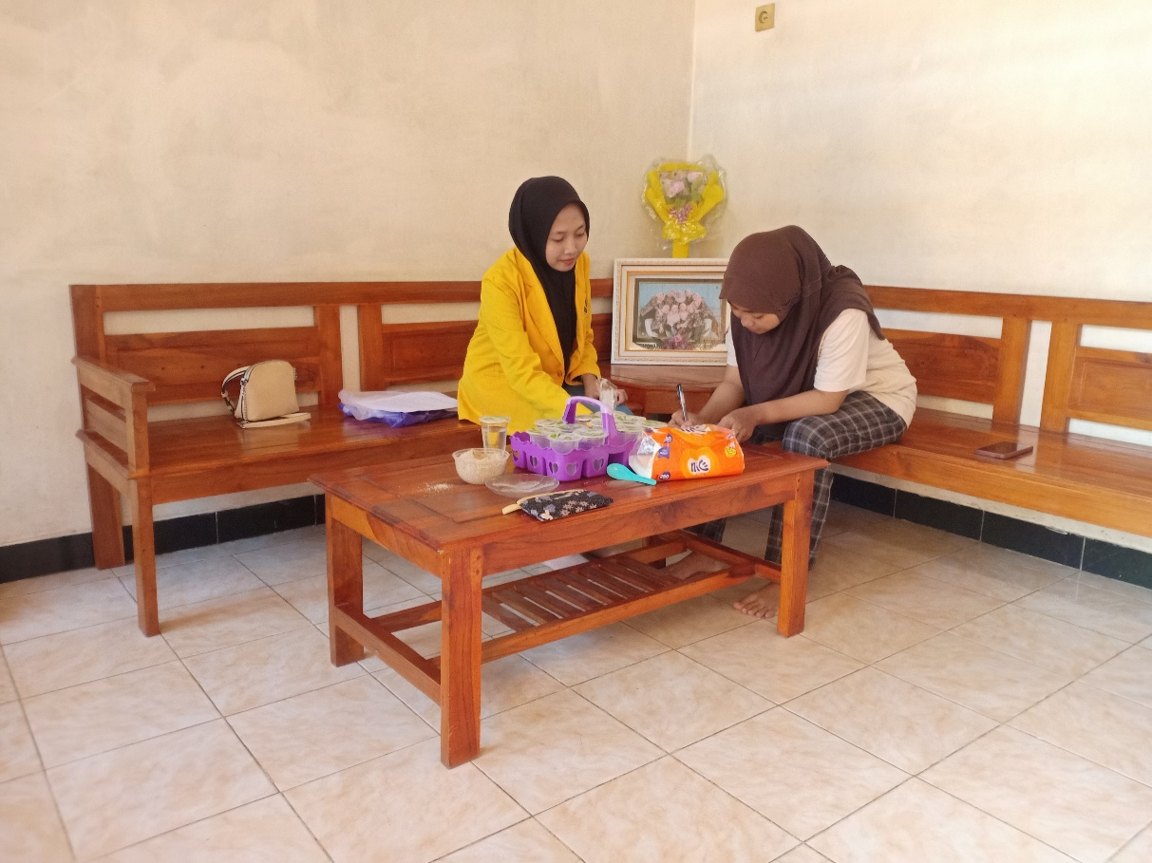

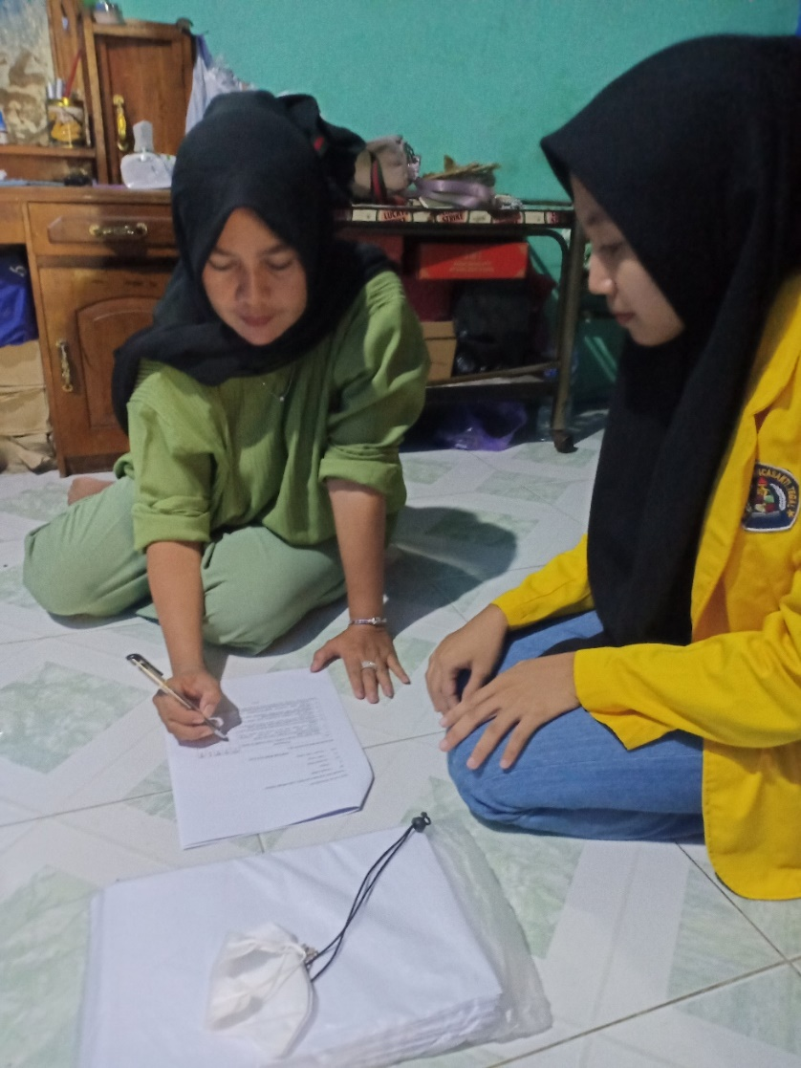

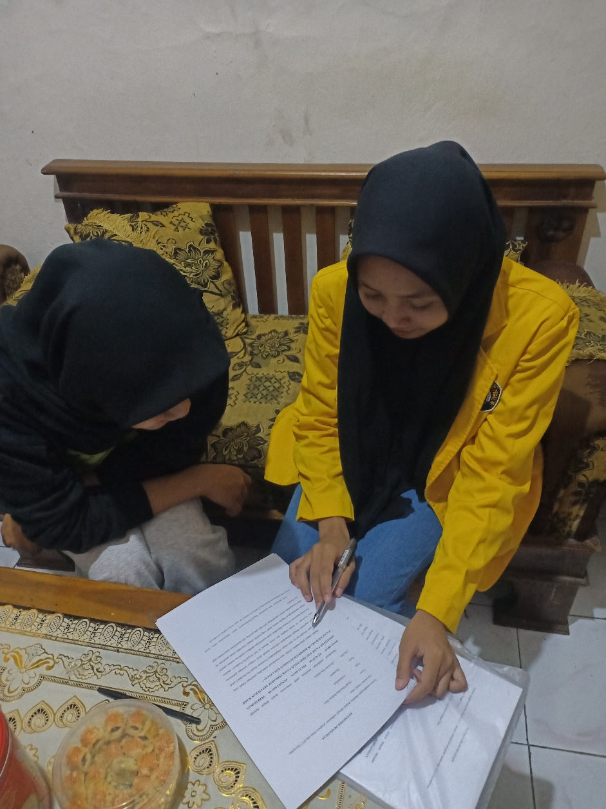

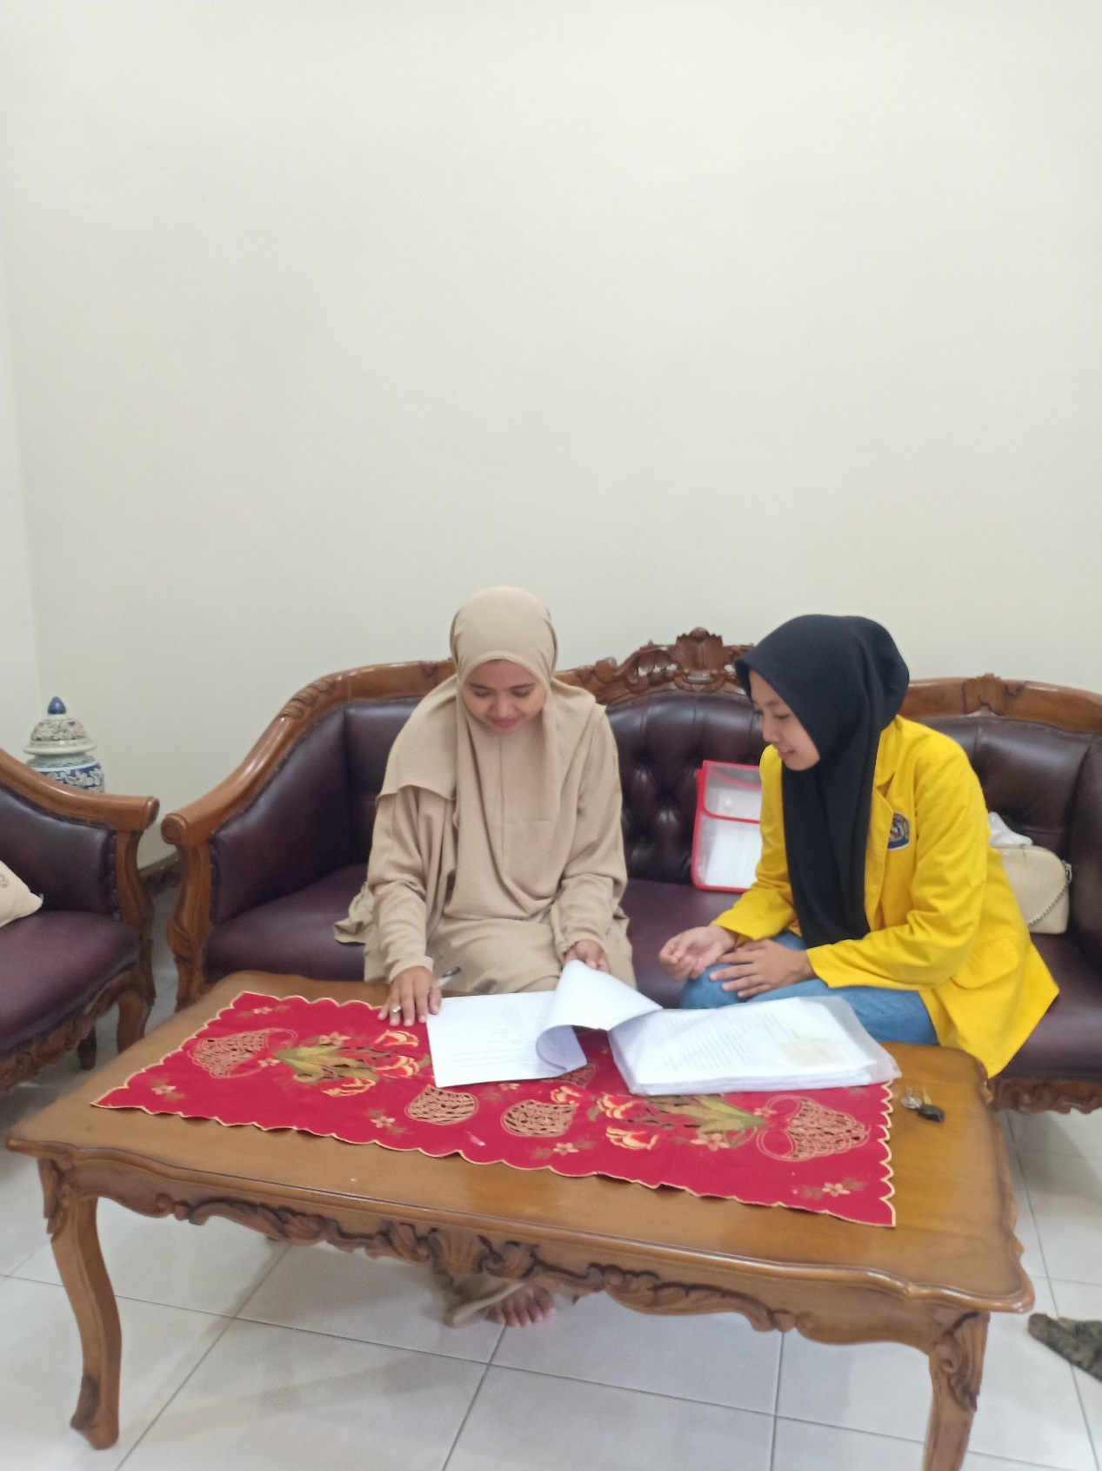

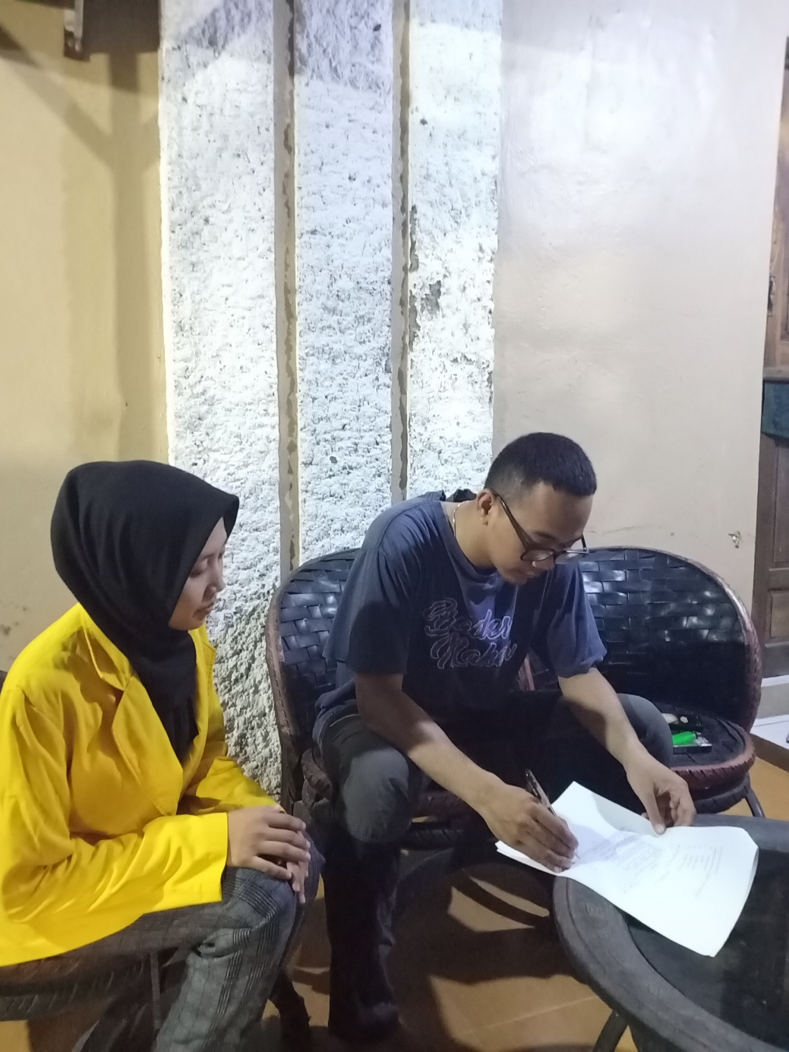

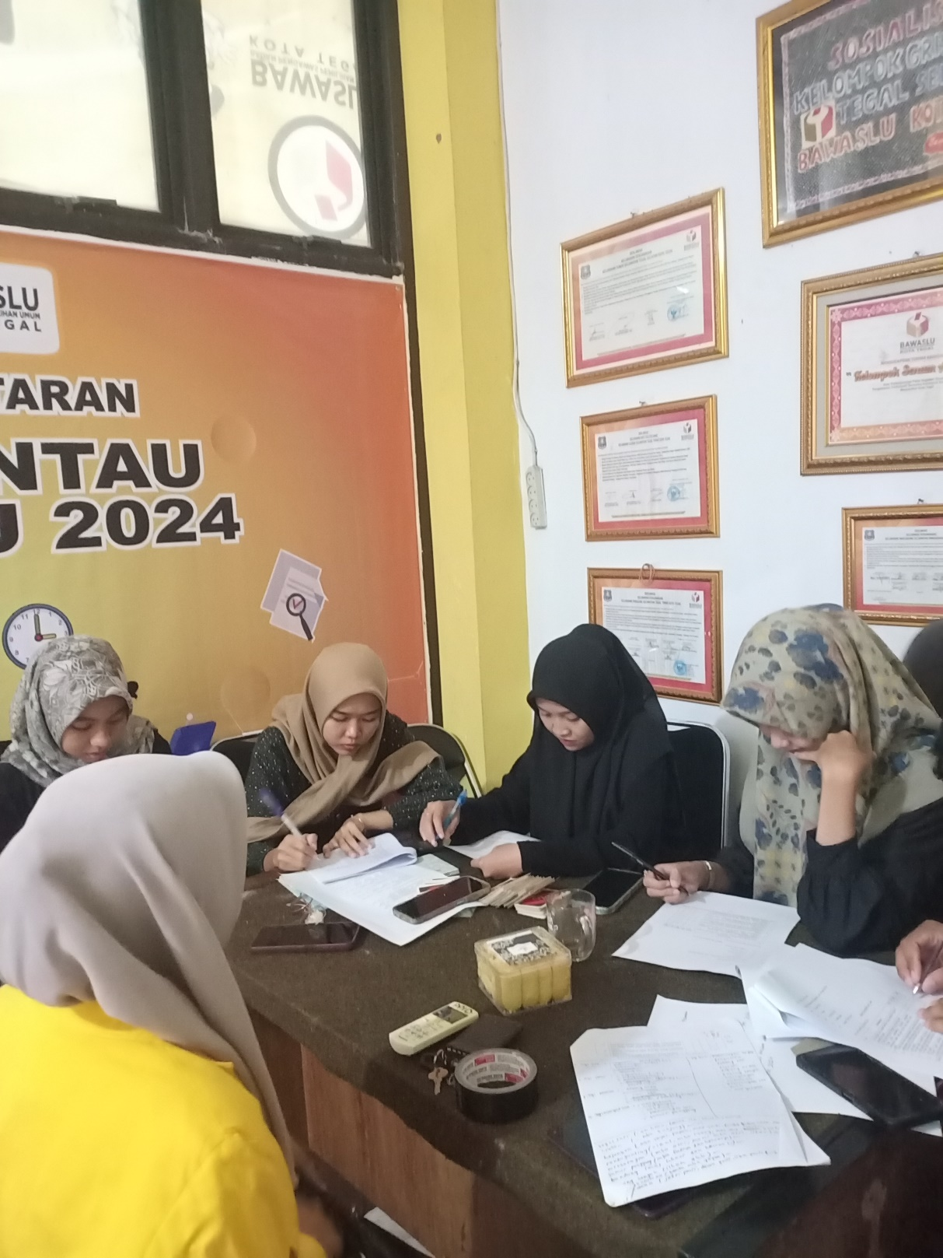

Lampiran 8 Hasil Uji Validitas Kualitas Pelayanan

**HASIL UJI VALIDITAS VARIABEL KUALITAS PELAYANAN (X1)**

|  |  |  |  |  |  |  |  |  |  |  |
| --- | --- | --- | --- | --- | --- | --- | --- | --- | --- | --- |
| **Correlations** | | | | | | | | | | |
|  | | **X1.1** | **X1.2** | **X1.3** | **X1.4** | **X1.5** | **X1.6** | **X1.7** | **X1.8** | **Total** |
| X1.1 | Pearson Correlation | 1 | .046 | .085 | .159 | .083 | .547** | .396* | .337 | .509** |
| Sig. (2-tailed) |  | .810 | .655 | .402 | .662 | .002 | .030 | .068 | .004 |
| N | 30 | 30 | 30 | 30 | 30 | 30 | 30 | 30 | 30 |
| X1.2 | Pearson Correlation | .046 | 1 | .356 | .326 | .308 | .292 | .543** | .257 | .605** |
| Sig. (2-tailed) | .810 |  | .054 | .079 | .098 | .117 | .002 | .170 | .000 |
| N | 30 | 30 | 30 | 30 | 30 | 30 | 30 | 30 | 30 |
| X1.3 | Pearson Correlation | .085 | .356 | 1 | .412* | .471** | .365* | .317 | .319 | .636** |
| Sig. (2-tailed) | .655 | .054 |  | .024 | .009 | .047 | .088 | .085 | .000 |
| N | 30 | 30 | 30 | 30 | 30 | 30 | 30 | 30 | 30 |
| X1.4 | Pearson Correlation | .159 | .326 | .412* | 1 | .125 | .449* | .403* | .814** | .727** |
| Sig. (2-tailed) | .402 | .079 | .024 |  | .510 | .013 | .027 | .000 | .000 |
| N | 30 | 30 | 30 | 30 | 30 | 30 | 30 | 30 | 30 |
| X1.5 | Pearson Correlation | .083 | .308 | .471** | .125 | 1 | .279 | .416* | .066 | .517** |
| Sig. (2-tailed) | .662 | .098 | .009 | .510 |  | .136 | .022 | .729 | .003 |
| N | 30 | 30 | 30 | 30 | 30 | 30 | 30 | 30 | 30 |
| X1.6 | Pearson Correlation | .547** | .292 | .365* | .449* | .279 | 1 | .374* | .490** | .734** |
| Sig. (2-tailed) | .002 | .117 | .047 | .013 | .136 |  | .042 | .006 | .000 |
| N | 30 | 30 | 30 | 30 | 30 | 30 | 30 | 30 | 30 |
| X1.7 | Pearson Correlation | .396* | .543** | .317 | .403* | .416* | .374* | 1 | .323 | .734** |
| Sig. (2-tailed) | .030 | .002 | .088 | .027 | .022 | .042 |  | .082 | .000 |
| N | 30 | 30 | 30 | 30 | 30 | 30 | 30 | 30 | 30 |
| X1.8 | Pearson Correlation | .337 | .257 | .319 | .814** | .066 | .490** | .323 | 1 | .704** |
| Sig. (2-tailed) | .068 | .170 | .085 | .000 | .729 | .006 | .082 |  | .000 |
| N | 30 | 30 | 30 | 30 | 30 | 30 | 30 | 30 | 30 |
| Total | Pearson Correlation | .509** | .605** | .636** | .727** | .517** | .734** | .734** | .704** | 1 |
| Sig. (2-tailed) | .004 | .000 | .000 | .000 | .003 | .000 | .000 | .000 |  |
| N | 30 | 30 | 30 | 30 | 30 | 30 | 30 | 30 | 30 |
| **. Correlation is significant at the 0.01 level (2-tailed). | | | | | | | | | | |
| *. Correlation is significant at the 0.05 level (2-tailed). | | | | | | | | | | |

Lampiran 9 Hasil Uji Validitas pengetahuan perpajakan

**HASIL UJI VALIDITAS PENGETAHUAN PERPAJAKAN (X2)**

|  |  |  |  |  |  |  |  |  |  |  |  |
| --- | --- | --- | --- | --- | --- | --- | --- | --- | --- | --- | --- |
| **Correlations** | | | | | | | | | | | |
|  | | **X2.1** | **X2.2** | **X2.3** | **X2.4** | **X2.5** | **X2.6** | **X2.7** | **X2.8** | **X2.9** | **Total** |
| X2.1 | Pearson Correlation | 1 | .330 | .604** | .461* | .322 | .379* | .294 | .694** | .509** | .787** |
| Sig. (2-tailed) |  | .075 | .000 | .010 | .083 | .039 | .115 | .000 | .004 | .000 |
| N | 30 | 30 | 30 | 30 | 30 | 30 | 30 | 30 | 30 | 30 |
| X2.2 | Pearson Correlation | .330 | 1 | .353 | .529** | .345 | .438* | .394* | .043 | .461* | .656** |
| Sig. (2-tailed) | .075 |  | .056 | .003 | .062 | .015 | .031 | .822 | .010 | .000 |
| N | 30 | 30 | 30 | 30 | 30 | 30 | 30 | 30 | 30 | 30 |
| X2.3 | Pearson Correlation | .604** | .353 | 1 | .434* | .135 | .089 | .323 | .572** | .527** | .702** |
| Sig. (2-tailed) | .000 | .056 |  | .017 | .478 | .639 | .082 | .001 | .003 | .000 |
| N | 30 | 30 | 30 | 30 | 30 | 30 | 30 | 30 | 30 | 30 |
| X2.4 | Pearson Correlation | .461* | .529** | .434* | 1 | .409* | .287 | .437* | .275 | .289 | .715** |
| Sig. (2-tailed) | .010 | .003 | .017 |  | .025 | .125 | .016 | .142 | .121 | .000 |
| N | 30 | 30 | 30 | 30 | 30 | 30 | 30 | 30 | 30 | 30 |
| X2.5 | Pearson Correlation | .322 | .345 | .135 | .409* | 1 | .426* | .266 | .037 | .312 | .548** |
| Sig. (2-tailed) | .083 | .062 | .478 | .025 |  | .019 | .155 | .848 | .093 | .002 |
| N | 30 | 30 | 30 | 30 | 30 | 30 | 30 | 30 | 30 | 30 |
| X2.6 | Pearson Correlation | .379* | .438* | .089 | .287 | .426* | 1 | .167 | .010 | .373* | .521** |
| Sig. (2-tailed) | .039 | .015 | .639 | .125 | .019 |  | .379 | .959 | .043 | .003 |
| N | 30 | 30 | 30 | 30 | 30 | 30 | 30 | 30 | 30 | 30 |
| X2.7 | Pearson Correlation | .294 | .394* | .323 | .437* | .266 | .167 | 1 | .220 | .534** | .620** |
| Sig. (2-tailed) | .115 | .031 | .082 | .016 | .155 | .379 |  | .244 | .002 | .000 |
| N | 30 | 30 | 30 | 30 | 30 | 30 | 30 | 30 | 30 | 30 |
| X2.8 | Pearson Correlation | .694** | .043 | .572** | .275 | .037 | .010 | .220 | 1 | .413* | .569** |
| Sig. (2-tailed) | .000 | .822 | .001 | .142 | .848 | .959 | .244 |  | .023 | .001 |
| N | 30 | 30 | 30 | 30 | 30 | 30 | 30 | 30 | 30 | 30 |
| X2.9 | Pearson Correlation | .509** | .461* | .527** | .289 | .312 | .373* | .534** | .413* | 1 | .741** |
| Sig. (2-tailed) | .004 | .010 | .003 | .121 | .093 | .043 | .002 | .023 |  | .000 |
| N | 30 | 30 | 30 | 30 | 30 | 30 | 30 | 30 | 30 | 30 |
| Total | Pearson Correlation | .787** | .656** | .702** | .715** | .548** | .521** | .620** | .569** | .741** | 1 |
| Sig. (2-tailed) | .000 | .000 | .000 | .000 | .002 | .003 | .000 | .001 | .000 |  |
| N | 30 | 30 | 30 | 30 | 30 | 30 | 30 | 30 | 30 | 30 |
| **. Correlation is significant at the 0.01 level (2-tailed). | | | | | | | | | | | |
| *. Correlation is significant at the 0.05 level (2-tailed). | | | | | | | | | | | |

Lampiran 10 Hasil Uji Validitas Sosialisasi Pajak

**HASIL UJI VALIDITAS VARIABEL SOSIALISASI PAJAK (X3)**

|  |  |  |  |  |  |  |  |  |  |  |
| --- | --- | --- | --- | --- | --- | --- | --- | --- | --- | --- |
| **Correlations** | | | | | | | | | | |
|  | | **X3.1** | **X3.2** | **X3.3** | **X3.4** | **X3.5** | **X3.6** | **X3.7** | **X3.8** | **Total** |
| X3.1 | Pearson Correlation | 1 | .147 | .259 | .180 | .167 | .198 | .326 | .358 | .487** |
| Sig. (2-tailed) |  | .439 | .166 | .340 | .377 | .295 | .079 | .052 | .006 |
| N | 30 | 30 | 30 | 30 | 30 | 30 | 30 | 30 | 30 |
| X3.2 | Pearson Correlation | .147 | 1 | -.041 | .478** | .331 | .466** | .275 | .349 | .558** |
| Sig. (2-tailed) | .439 |  | .831 | .008 | .074 | .009 | .141 | .059 | .001 |
| N | 30 | 30 | 30 | 30 | 30 | 30 | 30 | 30 | 30 |
| X3.3 | Pearson Correlation | .259 | -.041 | 1 | .389* | .414* | .429* | .330 | .445* | .632** |
| Sig. (2-tailed) | .166 | .831 |  | .034 | .023 | .018 | .075 | .014 | .000 |
| N | 30 | 30 | 30 | 30 | 30 | 30 | 30 | 30 | 30 |
| X3.4 | Pearson Correlation | .180 | .478** | .389* | 1 | .254 | .484** | .482** | .445* | .742** |
| Sig. (2-tailed) | .340 | .008 | .034 |  | .176 | .007 | .007 | .014 | .000 |
| N | 30 | 30 | 30 | 30 | 30 | 30 | 30 | 30 | 30 |
| X3.5 | Pearson Correlation | .167 | .331 | .414* | .254 | 1 | .409* | .320 | .299 | .605** |
| Sig. (2-tailed) | .377 | .074 | .023 | .176 |  | .025 | .084 | .108 | .000 |
| N | 30 | 30 | 30 | 30 | 30 | 30 | 30 | 30 | 30 |
| X3.6 | Pearson Correlation | .198 | .466** | .429* | .484** | .409* | 1 | .456* | .509** | .767** |
| Sig. (2-tailed) | .295 | .009 | .018 | .007 | .025 |  | .011 | .004 | .000 |
| N | 30 | 30 | 30 | 30 | 30 | 30 | 30 | 30 | 30 |
| X3.7 | Pearson Correlation | .326 | .275 | .330 | .482** | .320 | .456* | 1 | .212 | .689** |
| Sig. (2-tailed) | .079 | .141 | .075 | .007 | .084 | .011 |  | .260 | .000 |
| N | 30 | 30 | 30 | 30 | 30 | 30 | 30 | 30 | 30 |
| X3.8 | Pearson Correlation | .358 | .349 | .445* | .445* | .299 | .509** | .212 | 1 | .681** |
| Sig. (2-tailed) | .052 | .059 | .014 | .014 | .108 | .004 | .260 |  | .000 |
| N | 30 | 30 | 30 | 30 | 30 | 30 | 30 | 30 | 30 |
| Total | Pearson Correlation | .487** | .558** | .632** | .742** | .605** | .767** | .689** | .681** | 1 |
| Sig. (2-tailed) | .006 | .001 | .000 | .000 | .000 | .000 | .000 | .000 |  |
| N | 30 | 30 | 30 | 30 | 30 | 30 | 30 | 30 | 30 |
| **. Correlation is significant at the 0.01 level (2-tailed). | | | | | | | | | | |
| *. Correlation is significant at the 0.05 level (2-tailed). | | | | | | | | | | |

Lampiran 11 Hasil Uji Validitas Pemutihan Pajak

**HASIL UJI VALIDITAS VARIABEL PEMUTIHAN PAJAK (X4)**

|  |  |  |  |  |  |  |  |  |  |  |
| --- | --- | --- | --- | --- | --- | --- | --- | --- | --- | --- |
| **Correlations** | | | | | | | | | | |
|  | | **X4.1** | **X4.2** | **X4.3** | **X4.4** | **X4.5** | **X4.6** | **X4.7** | **X4.8** | **Total** |
| X4.1 | Pearson Correlation | 1 | -.039 | .189 | .118 | .360 | .098 | .201 | .652** | .535** |
| Sig. (2-tailed) |  | .838 | .318 | .536 | .051 | .606 | .288 | .000 | .002 |
| N | 30 | 30 | 30 | 30 | 30 | 30 | 30 | 30 | 30 |
| X4.2 | Pearson Correlation | -.039 | 1 | .356 | .326 | .308 | .292 | .295 | .084 | .520** |
| Sig. (2-tailed) | .838 |  | .054 | .079 | .098 | .117 | .113 | .660 | .003 |
| N | 30 | 30 | 30 | 30 | 30 | 30 | 30 | 30 | 30 |
| X4.3 | Pearson Correlation | .189 | .356 | 1 | .412* | .471** | .365* | .587** | .257 | .727** |
| Sig. (2-tailed) | .318 | .054 |  | .024 | .009 | .047 | .001 | .171 | .000 |
| N | 30 | 30 | 30 | 30 | 30 | 30 | 30 | 30 | 30 |
| X4.4 | Pearson Correlation | .118 | .326 | .412* | 1 | .125 | .449* | .474** | .145 | .634** |
| Sig. (2-tailed) | .536 | .079 | .024 |  | .510 | .013 | .008 | .445 | .000 |
| N | 30 | 30 | 30 | 30 | 30 | 30 | 30 | 30 | 30 |
| X4.5 | Pearson Correlation | .360 | .308 | .471** | .125 | 1 | .279 | .323 | .540** | .670** |
| Sig. (2-tailed) | .051 | .098 | .009 | .510 |  | .136 | .082 | .002 | .000 |
| N | 30 | 30 | 30 | 30 | 30 | 30 | 30 | 30 | 30 |
| X4.6 | Pearson Correlation | .098 | .292 | .365* | .449* | .279 | 1 | .244 | .081 | .569** |
| Sig. (2-tailed) | .606 | .117 | .047 | .013 | .136 |  | .194 | .672 | .001 |
| N | 30 | 30 | 30 | 30 | 30 | 30 | 30 | 30 | 30 |
| X4.7 | Pearson Correlation | .201 | .295 | .587** | .474** | .323 | .244 | 1 | .236 | .683** |
| Sig. (2-tailed) | .288 | .113 | .001 | .008 | .082 | .194 |  | .209 | .000 |
| N | 30 | 30 | 30 | 30 | 30 | 30 | 30 | 30 | 30 |
| X4.8 | Pearson Correlation | .652** | .084 | .257 | .145 | .540** | .081 | .236 | 1 | .604** |
| Sig. (2-tailed) | .000 | .660 | .171 | .445 | .002 | .672 | .209 |  | .000 |
| N | 30 | 30 | 30 | 30 | 30 | 30 | 30 | 30 | 30 |
| Total | Pearson Correlation | .535** | .520** | .727** | .634** | .670** | .569** | .683** | .604** | 1 |
| Sig. (2-tailed) | .002 | .003 | .000 | .000 | .000 | .001 | .000 | .000 |  |
| N | 30 | 30 | 30 | 30 | 30 | 30 | 30 | 30 | 30 |
| **. Correlation is significant at the 0.01 level (2-tailed). | | | | | | | | | | |
| *. Correlation is significant at the 0.05 level (2-tailed). | | | | | | | | | | |

Lampiran 12 Hasil Uji Validitas Kepatuhan Pajak

**HASIL UJI VALIDITAS VARIABEL KEPATUHAN PAJAK (Y)**

|  |  |  |  |  |  |  |  |  |  |  |
| --- | --- | --- | --- | --- | --- | --- | --- | --- | --- | --- |
| **Correlations** | | | | | | | | | | |
|  | | **Y.1** | **Y.2** | **Y.3** | **Y.4** | **Y.5** | **Y.6** | **Y.7** | **Y.8** | **Total.Y** |
| Y.1 | Pearson Correlation | 1 | .425* | .425* | .533** | .469** | .136 | .068 | .425* | .671** |
| Sig. (2-tailed) |  | .019 | .019 | .002 | .009 | .473 | .723 | .019 | .000 |
| N | 30 | 30 | 30 | 30 | 30 | 30 | 30 | 30 | 30 |
| Y.2 | Pearson Correlation | .425* | 1 | .213 | .285 | .368* | .286 | .056 | 1.000** | .685** |
| Sig. (2-tailed) | .019 |  | .258 | .127 | .045 | .125 | .768 | .000 | .000 |
| N | 30 | 30 | 30 | 30 | 30 | 30 | 30 | 30 | 30 |
| Y.3 | Pearson Correlation | .425* | .213 | 1 | .285 | .450* | .450* | .309 | .213 | .650** |
| Sig. (2-tailed) | .019 | .258 |  | .127 | .013 | .013 | .097 | .258 | .000 |
| N | 30 | 30 | 30 | 30 | 30 | 30 | 30 | 30 | 30 |
| Y.4 | Pearson Correlation | .533** | .285 | .285 | 1 | .171 | .114 | .420* | .285 | .607** |
| Sig. (2-tailed) | .002 | .127 | .127 |  | .367 | .550 | .021 | .127 | .000 |
| N | 30 | 30 | 30 | 30 | 30 | 30 | 30 | 30 | 30 |
| Y.5 | Pearson Correlation | .469** | .368* | .450* | .171 | 1 | .565** | .084 | .368* | .688** |
| Sig. (2-tailed) | .009 | .045 | .013 | .367 |  | .001 | .659 | .045 | .000 |
| N | 30 | 30 | 30 | 30 | 30 | 30 | 30 | 30 | 30 |
| Y.6 | Pearson Correlation | .136 | .286 | .450* | .114 | .565** | 1 | .406* | .286 | .650** |
| Sig. (2-tailed) | .473 | .125 | .013 | .550 | .001 |  | .026 | .125 | .000 |
| N | 30 | 30 | 30 | 30 | 30 | 30 | 30 | 30 | 30 |
| Y.7 | Pearson Correlation | .068 | .056 | .309 | .420* | .084 | .406* | 1 | .056 | .486** |
| Sig. (2-tailed) | .723 | .768 | .097 | .021 | .659 | .026 |  | .768 | .006 |
| N | 30 | 30 | 30 | 30 | 30 | 30 | 30 | 30 | 30 |
| Y.8 | Pearson Correlation | .425* | 1.000** | .213 | .285 | .368* | .286 | .056 | 1 | .685** |
| Sig. (2-tailed) | .019 | .000 | .258 | .127 | .045 | .125 | .768 |  | .000 |
| N | 30 | 30 | 30 | 30 | 30 | 30 | 30 | 30 | 30 |
| Total.Y | Pearson Correlation | .671** | .685** | .650** | .607** | .688** | .650** | .486** | .685** | 1 |
| Sig. (2-tailed) | .000 | .000 | .000 | .000 | .000 | .000 | .006 | .000 |  |
| N | 30 | 30 | 30 | 30 | 30 | 30 | 30 | 30 | 30 |
| *. Correlation is significant at the 0.05 level (2-tailed). | | | | | | | | | | |
| **. Correlation is significant at the 0.01 level (2-tailed). | | | | | | | | | | |

Lampiran 13 Hasil Uji Reabilitas Kepatuhan Pajak

**HASIL UJI REABILITAS VARIABEL KUALITAS PELAYANAN (X1)**

|  |  |
| --- | --- |
| **Reliability Statistics** | |
| **Cronbach's Alpha** | **N of Items** |
| .803 | 8 |

Lampiran 14 Hasil Uji Reabilitas Pengetahuan Perpajakan

**HASIL UJI REABILITAS VARIABEL PENGETAHUAN PERPAJAKAN (X2)**

|  |  |
| --- | --- |
| **Reliability Statistics** | |
| **Cronbach's Alpha** | **N of Items** |
| .829 | 9 |

Lampiran 15 Hasil Uji Reabilitas Sosialisasi Pajak

**HASIL UJI REABILITAS VARIABEL SOSIALISASI PAJAK (X3)**

|  |  |
| --- | --- |
| **Reliability Statistics** | |
| **Cronbach's Alpha** | **N of Items** |
| .802 | 8 |

Lampiran 16 Hasil Uji Reabilitas Pemutihan Pajak

**HASIL UJI REABILITAS VARIABEL PEMUTIHAN PAJAK (X4)**

|  |  |
| --- | --- |
| **Reliability Statistics** | |
| **Cronbach's Alpha** | **N of Items** |
| .764 | 8 |

Lampiran 17 Hasil Uji Reabilitas Kepatuhan Pajak

**HASIL UJI REABILITAS KEPATUHAN PAJAK (Y)**

|  |  |
| --- | --- |
| **Reliability Statistics** | |
| **Cronbach's Alpha** | **N of Items** |
| .790 | 8 |

Lampiran 18 Hasil Uji Statistik Deskriptif

**HASIL UJI STATISTIK DESKRIPTIF**

|  |  |  |  |  |  |
| --- | --- | --- | --- | --- | --- |
| **Descriptive Statistics** | | | | | |
|  | **N** | **Minimum** | **Maximum** | **Mean** | **Std. Deviation** |
| Kepatuhan Pajak | 100 | 25.00 | 37.00 | 33.7500 | 3.05298 |
| Kualitas Pelayanan | 100 | 26.00 | 39.00 | 34.8300 | 3.02199 |
| Pengetahuan Pajak | 100 | 9.00 | 37.00 | 18.3400 | 5.51072 |
| Sosialisasi Pajak | 100 | 28.00 | 37.00 | 34.3200 | 2.24679 |
| Pemutihan Pajak | 100 | 24.00 | 40.00 | 32.6900 | 3.72188 |
| Valid N (listwise) | 100 |  |  |  |  |

Lampiran 19 Hasil Uji Normalitas

**HASIL UJI NORMALITAS**

|  |  |  |
| --- | --- | --- |
| **One-Sample Kolmogorov-Smirnov Test** | | |
|  | | **Unstandardized Residual** |
| N | | 100 |
| Normal Parametersa,b | Mean | .0000000 |
| Std. Deviation | 1.04608810 |
| Most Extreme Differences | Absolute | .066 |
| Positive | .066 |
| Negative | -.049 |
| Test Statistic | | .066 |
| Asymp. Sig. (2-tailed) | | .200c,d |
| a. Test distribution is Normal. | | |
| b. Calculated from data. | | |
| c. Lilliefors Significance Correction. | | |
| d. This is a lower bound of the true significance. | | |
|  | | |

Lampiran 20 Hasil Uji Multikolinieritas

**HASIL UJI MULTIKOLINIERITAS**

|  |  |  |  |  |  |  |  |  |
| --- | --- | --- | --- | --- | --- | --- | --- | --- |
| **Coefficientsa** | | | | | | | | |
| **Model** | | **Unstandardized Coefficients** | | **Standardized Coefficients** | **t** | **Sig.** | **Collinearity Statistics** | |
| **B** | **Std. Error** | **Beta** | **Tolerance** | **VIF** |
| 1 | (Constant) | -11.782 | 2.353 |  | -5.007 | .000 |  |  |
| Kualitas Pelayanan | .414 | .069 | .410 | 6.032 | .000 | .267 | 3.742 |
| Pengetahuan Pajak | .049 | .024 | .089 | 2.059 | .042 | .661 | 1.513 |
| Sosialisasi Pajak | .777 | .092 | .572 | 8.466 | .000 | .271 | 3.695 |
| Pemutihan Pajak | .108 | .036 | .131 | 3.015 | .003 | .654 | 1.530 |
| a. Dependent Variable: Kepatuhan Pajak | | | | | | | | |

Lampiran 21 Hasil Uji Heteroskedastisitas

**HASIL UJI HETEROSKEDASTISITAS**

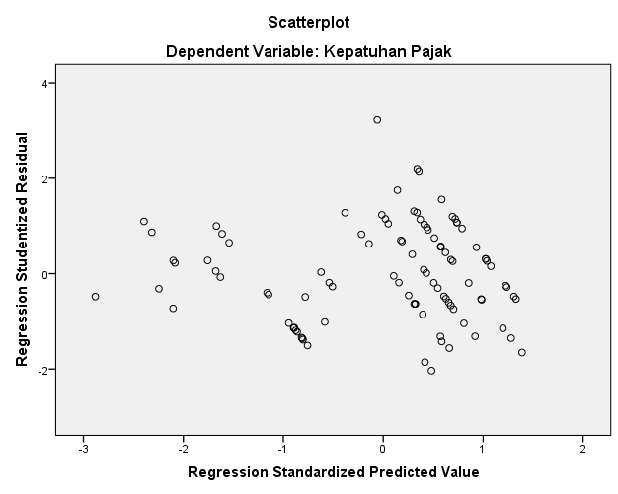

Lampiran 22 Hasil Uji Analisis Regresi Linier Berganda

**HASIL UJI ANALISIS REGRESI LINIER BERGANDA**

|  |  |  |  |  |  |  |  |  |
| --- | --- | --- | --- | --- | --- | --- | --- | --- |
| **Coefficientsa** | | | | | | | | |
| **Model** | | **Unstandardized Coefficients** | | **Standardized Coefficients** | **t** | **Sig.** | **Collinearity Statistics** | |
| **B** | **Std. Error** | **Beta** | **Tolerance** | **VIF** |
| 1 | (Constant) | -11.782 | 2.353 |  | -5.007 | .000 |  |  |
| Kualitas Pelayanan | .414 | .069 | .410 | 6.032 | .000 | .267 | 3.742 |
| Pengetahuan Pajak | .049 | .024 | .089 | 2.059 | .042 | .661 | 1.513 |
| Sosialisasi Pajak | .777 | .092 | .572 | 8.466 | .000 | .271 | 3.695 |
| Pemutihan Pajak | .108 | .036 | .131 | 3.015 | .003 | .654 | 1.530 |
| a. Dependent Variable: Kepatuhan Pajak | | | | | | | | |

Lampiran 23 Hasil Uji T

**HASIL UJI T**

|  |  |  |  |  |  |  |  |  |
| --- | --- | --- | --- | --- | --- | --- | --- | --- |
| **Coefficientsa** | | | | | | | | |
| **Model** | | **Unstandardized Coefficients** | | **Standardized Coefficients** | **t** | **Sig.** | **Collinearity Statistics** | |
| **B** | **Std. Error** | **Beta** | **Tolerance** | **VIF** |
| 1 | (Constant) | -11.782 | 2.353 |  | -5.007 | .000 |  |  |
| Kualitas Pelayanan | .414 | .069 | .410 | 6.032 | .000 | .267 | 3.742 |
| Pengetahuan Pajak | .049 | .024 | .089 | 2.059 | .042 | .661 | 1.513 |
| Sosialisasi Pajak | .777 | .092 | .572 | 8.466 | .000 | .271 | 3.695 |
| Pemutihan Pajak | .108 | .036 | .131 | 3.015 | .003 | .654 | 1.530 |
| a. Dependent Variable: Kepatuhan Pajak | | | | | | | | |

Lampiran 24 Hasil Uji Koefisien Determinasi

**HASIL UJI KOEFISIEN DETERMINASI**

|  |  |  |  |  |
| --- | --- | --- | --- | --- |
| **Model Summaryb** | | | | |
| **Model** | **R** | **R Square** | **Adjusted R Square** | **Std. Error of the Estimate** |
| 1 | .939a | .883 | .878 | 1.06788 |
| a. Predictors: (Constant), Pemutihan Pajak, Sosialisasi Pajak, Pengetahuan Pajak, Kualitas Pelayanan | | | | |
| b. Dependent Variable: Kepatuhan Pajak | | | | |

Lampiran 25 Hasil Uji Simultan (F)

**HASIL UJI SIMULTASN (F)**

|  |  |  |  |  |  |  |
| --- | --- | --- | --- | --- | --- | --- |
| **ANOVAa** | | | | | | |
| **Model** | | **Sum of Squares** | **df** | **Mean Square** | **F** | **Sig.** |
| 1 | Regression | 814.414 | 4 | 203.604 | 178.541 | .000b |
| Residual | 108.336 | 95 | 1.140 |  |  |
| Total | 922.750 | 99 |  |  |  |
| a. Dependent Variable: Kepatuhan Pajak | | | | | | |
| b. Predictors: (Constant), Pemutihan Pajak, Sosialisasi Pajak, Pengetahuan Pajak, Kualitas Pelayanan | | | | | | |

Lampiran 26 Penyebaran Melalui Google Form

**PENYEBARAN MELALUI GOOGLE FORM**

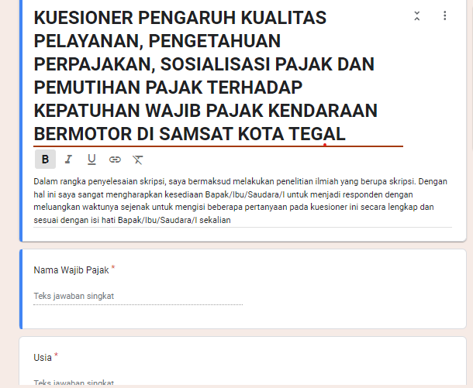

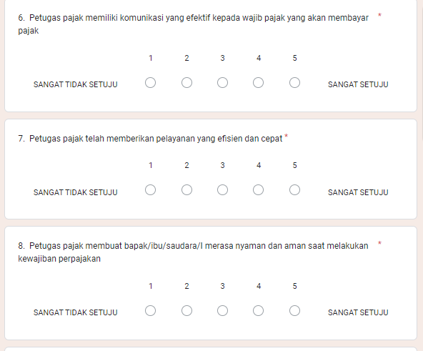

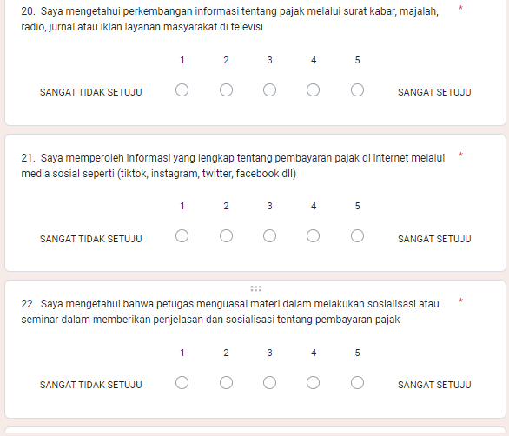

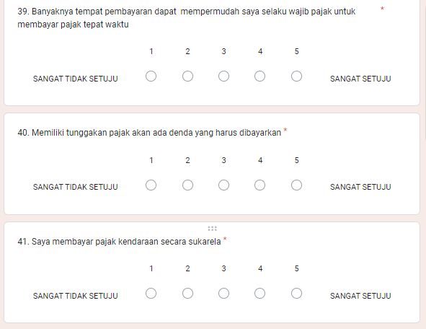

Lampiran 27 Surat Izin Penelitian SAMSAT

**SURAT PERIZINAN PENELITIAN KANTOR SAMSAT KOTA TEGAL**

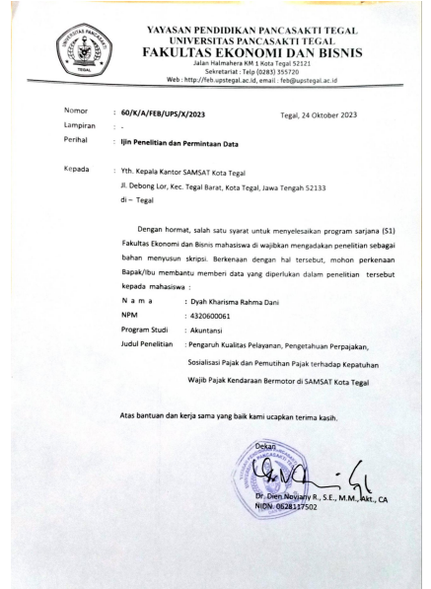

Lampiran 28 Surat Izin Penelitian BAPENDA

**SURAT PERIZINAN PENELITIAN KANTOR BAPENDA**

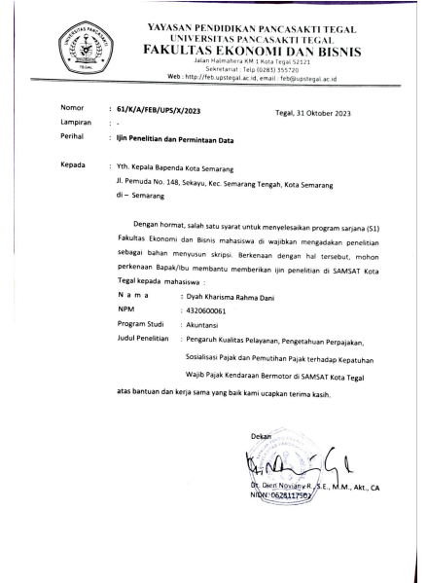

Lampiran 29 Surat Balasan BAPENDA

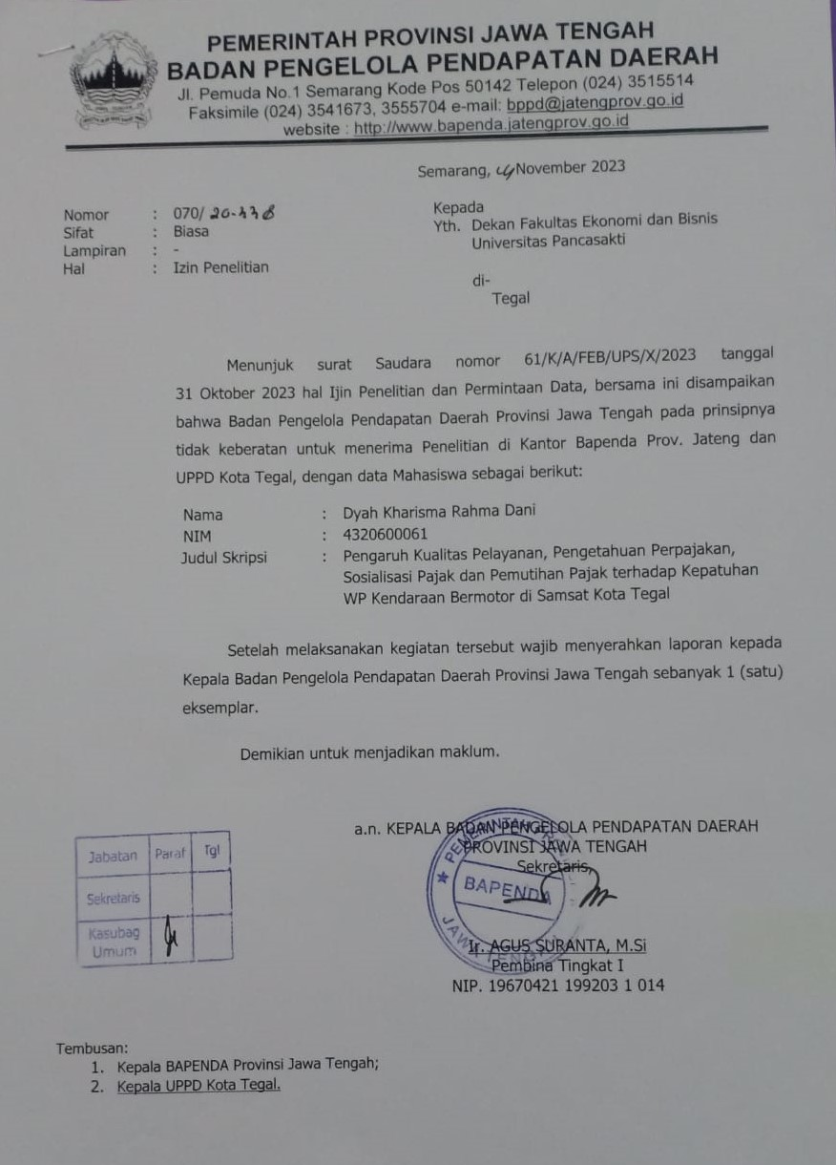**SURAT BALASAN PERIZINAN PENELITIAN BAPENDA**

Lampiran 30 Data Responden

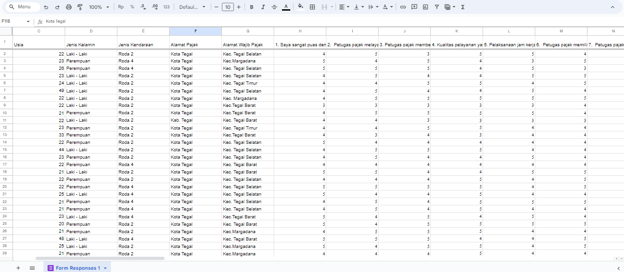

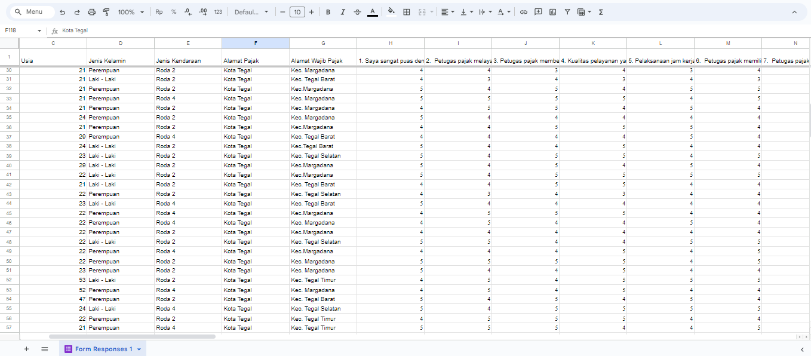

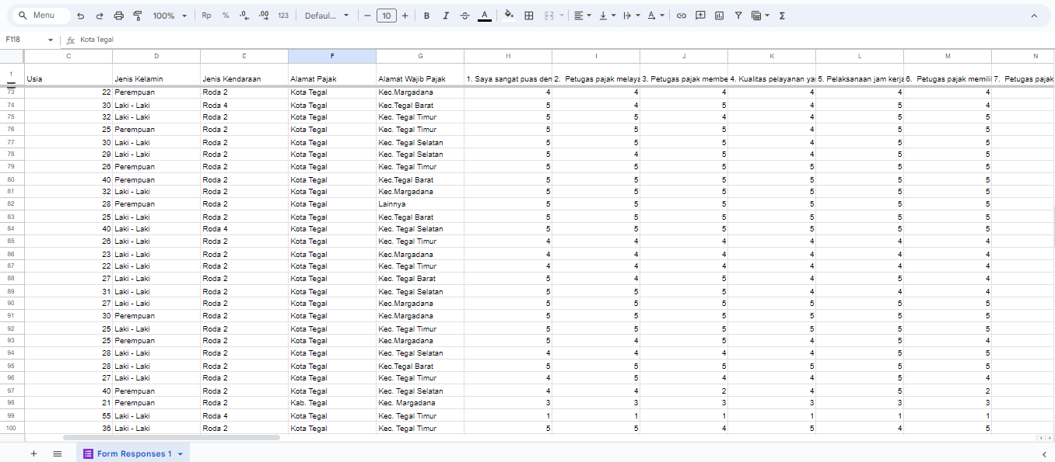

Lampiran 31 Hasil Uji Beda T-Test Independen SPSS

|  |  |  |  |  |  |  |  |  |  |  |
| --- | --- | --- | --- | --- | --- | --- | --- | --- | --- | --- |
| **Independent Samples Test** | | | | | | | | | | |
|  | | **Levene's Test for Equality of Variances** | | **t-test for Equality of Means** | | | | | | |
| **F** | **Sig.** | **t** | **df** | **Sig. (2-tailed)** | **Mean Difference** | **Std. Error Difference** | **95% Confidence Interval of the Difference** | |
| **Lower** | **Upper** |
| Kualitas Pelayanan | Equal variances assumed | 5.157 | .025 | -1.966 | 98 | .052 | -1.22049 | .62066 | -2.45216 | .01119 |
| Equal variances not assumed |  |  | -2.185 | 94.524 | .031 | -1.22049 | .55862 | -2.32956 | -.11141 |
| Pengetahuan Perpajakan | Equal variances assumed | .095 | .758 | -.594 | 98 | .554 | -.68403 | 1.15184 | -2.96982 | 1.60176 |
| Equal variances not assumed |  |  | -.583 | 68.653 | .562 | -.68403 | 1.17397 | -3.02625 | 1.65819 |
| Sosialisasi Pajak | Equal variances assumed | 4.028 | .048 | -2.420 | 98 | .017 | -1.10590 | .45701 | -2.01282 | -.19898 |
| Equal variances not assumed |  |  | -2.633 | 90.981 | .010 | -1.10590 | .42002 | -1.94023 | -.27158 |
| Pemutihan Pajak | Equal variances assumed | .020 | .887 | .661 | 98 | .510 | .51389 | .77761 | -1.02925 | 2.05703 |
| Equal variances not assumed |  |  | .661 | 72.606 | .511 | .51389 | .77785 | -1.03651 | 2.06429 |
| Kepatuhan Wajib Pajak | Equal variances assumed | 7.663 | .007 | -2.227 | 98 | .028 | -1.38889 | .62369 | -2.62658 | -.15120 |
| Equal variances not assumed |  |  | -2.404 | 89.483 | .018 | -1.38889 | .57765 | -2.53657 | -.24120 |