**DAFTAR PUSTAKA**

Ahdiat, Adi. (2023). Emisi Gas Rumah Kaca Global Naik Lagi pada 2022, Rekor Tertinggi Baru. <https://databoks.katadata.co.id/datapublish/2023/09/29/emisi-gas-rumah-kaca-global-naik-lagi-pada-2022-rekor-tertinggi-baru>

Aldama, R. A., Herwiyanti, E., & Srirejeki, K. (2021). Peran Mediasi Reputasi Pada Hubungan Pengungkapan CSR Terhadap Profitabilitas Bank Di Asean Dari Perspektif Green Banking. *Jurnal Bisnis Dan Akuntansi*, *23*(1), 49–64. https://doi.org/10.34208/jba.v23i1.775

Anggraini, D., Aryani, D., & Prasetyo, I. B. (2020). Analisis Implementasi Green Banking Dan Kinerja Keuangan Terhadap Profitabilitas Bank Di Indonesia (2016-2019). *JBMI (Jurnal Bisnis, Manajemen, Dan Informatika)*, *17*(2), 141–161. https://doi.org/10.26487/jbmi.v17i2.11264

Anggraini, F., Puttri, D., Septriani, W., & Zefriyenni. (2021). Peranan Intellectual Capital sebagai Mediasi antara Corporate Social Responsibility dan Kinerja Perusahaan Perbankan. *Jurnal Ekobistek*, *9*(2), 22–31. https://doi.org/10.35134/ekobistek.v9i2.79

Badjuri, A., Jaeni, J., & Kartika, A. (2021). Peran Corporate Social Responsibility Sebagai Pemoderasi Dalam Memprediksi Profitabilitas Dan Ukuran Perusahaan Terhadap Agresivitas Pajak Di Indonesia: Kajian Teori Legitimasi. *Jurnal Bisnis Dan Ekonomi*, *28*(1), 1–19. https://doi.org/10.35315/jbe.v28i1.8534

Bank Indonesia. (2011). *Surat Edaran Bank Indonesia No.13/ 24 /DPNP Tentang Penilaian Tingkat Kesehatan Bank Umum*. 24. http://ridum.umanizales.edu.co:8080/jspui/bitstream/6789/377/4/Mu�oz_Zapata_Adriana_Patricia_Art�culo_2011.pdf

Bhernadha, Y. A. (2016). Pengaruh Corporate Social Responsibility terhadap Kinerja Keuangan Perusahaan (Studi pada Perusahaan Winner of Sustainability Reporting Awards (SRA) 2015 …. *Fakultas Ilmu Administrasi Universitas Brawijaya Malang*, *44*(1). http://repository.ub.ac.id/118402/%0Ahttp://repository.ub.ac.id/118402/1/Yhovita Anggie Bhernadha.pdf

Cui, Y., Geobey, S., Weber, O., & Lin, H. (2018). The impact of green lending on credit risk in China. *Sustainability (Switzerland)*, *10*(6), 1–16. https://doi.org/10.3390/su10062008

Darminto, D. P. (2019). Analisis Laporan Keuangan Konsep dan Aplikasi (Edisi Keempat). Yogyakarta: UPP STIM YKPMN.

Dihni, V. A. (2022). Bank dengan Citra '*Green Banking*' Terkuat, Siapa Juaranya?. https://databoks.katadata.co.id/datapublish/2022/06/07/bank-dengan-citra-green-banking-terkuat-siapa-juaranya

Elok F. (2019). Pengaruh Corporate Social Responsibility Terhadap Kinerja Keuangan Perbankan Dengan Size Dan Leverage Ratio Sebagai Variabel Pemoderasi. *JIAI (Jurnal Ilmiah Akuntansi Indonesia)*, *4*(1), 42–53.

Faisall, A., Samben, R., & Pattisahusiwa, S. (2020). Analisis kinerja keuangan. *ACM International Conference Proceeding Series*, *14*(1), 8–15. https://doi.org/10.1145/3418653.3418670

Ghozali, I. (2016). Aplikasi Analisis Multivariate Dengan Program IBM SPSS 23 (Edisi 8). Semarang: Badan Penerbit Universitas Diponegoro.

Ghozali, I. (2018). Aplikasi Analisis Multivariate Dengan Program IBM SPSS 25 (Edisi 9). Semarang: Badan Penerbit Universitas Diponegoro.

Ghozali, I. (2020). 25 *Grand Theory*: Teori Besar Ilmu Manajemen, Akuntansi, dan Bisnis. Semarang: Yoga Pratama.

Gumanti, T. A. (2009). Teori Sinyal Dalam Manajemen Keuangan. *Manajemen Usahawan Indonesia*, *November*, 4–13.

Handajani, L., Husnan, L. H., & Rifai, A. (2019). Kajian Tentang Inisiasi Praktik Green Banking Pada Bank BUMN di Indonesia. *Jurnal Economia Review of Business and Economics*, *15*(1), 1–16. https://core.ac.uk/download/pdf/201051692.pdf

Hanfan, A., Hapsari, I. M., Setiawan, A. I., & Nupus, H. (2023). Building the Religious Product Advantage to Increase Marketing Performance in Indonesia’s Halal Food Industry Membangun Keunggulan Produk Religiusitas untuk Meningkatkan Kinerja Pemasaran pada Industri Makanan Halal Indonesia Abstrak. *Jurnal Dinamika Manajemen*, *14*(2), 191–204. http://jdm.unnes.ac.id

Hanif, W. N., N., & Iqbal, F. (2020). Green Banking Terhadap Profitabilitas Bank Umum Syariah Di Indonesia. *Jurnal Ilmiah Keuangan Dan Perbankan*, *3*(2), 86–99. https://fe.ummetro.ac.id/ejournal/index.php/JPK/article/viewFile/532/373

Hidayat, F. (2013). *Pengaruh Pengungkapan Corporate Social Responsibility (CSR) terhadap Kinerja Keuangan Perusahaan dan Earning Response Coefecient (ERC) (Studi Pada Perusahaan Pertambangan yang terdaftar dalam Bursa Efek Indonesia (BEI) periode 2012-2013)*. https://jimfeb.ub.ac.id/index.php/jimfeb/article/view/1696

Julialevi, K. O., & Ramadhanti, W. (2021). Pengaruh Pengungkapan Corporate Social Responsibility Terhadap Kinerja Keuangan Perbankan Indonesia (Studi Komparatif Perbankan BUMN dan Swasta). *Jurnal Pendidikan Dan Teknologi Indonesia*, *1*(2), 91–95. https://doi.org/10.52436/1.jpti.19

Kurnianto, E. A., & Prastiwi, A. (2015). Pengaruh Corporate Social Responsibility Terhadap Kinerja Keuangan Perusahaan “(Studi Empiris pada Perusahaan Perbankan yang Terdaftar di Bursa Efek Indonesia Tahun 2005 - 2008). *Fakultas Ekonomi Universitas Diponegoro*, *4*(12), 1–19. https://core.ac.uk/download/pdf/148614396.pdf

Meiyana, A., & Aisyah, M. N. (2019). Pengaruh Kinerja Lingkungan, Biaya Lingkungan, Dan Ukuran Perusahaan Terhadap Kinerja Keuangan Dengan Corporate Social Responsibility Sebagai Variabel Intervening (Studi Empiris Pada Perusahaan Manufaktur yang Terdaftar di Bursa Efek Indonesia Tahun 2014-. *Nominal: Barometer Riset Akuntansi Dan Manajemen*, *8*(1), 1–18.

Mustofa, U. A., Edy, R. N. A. P., Kurniawan, M., & Kholid, M. F. N. (2020). Green Accounting Terhadap CSR pada Bus di Indonesia dengan Kinerja Keuangan Sebagai Variabel Intervening. *Jurnal Ilmiah Ekonomi Islam*, *6*(3), 508. https://doi.org/10.29040/jiei.v6i3.1372

Nofianto, A., Gunistyo, Amirah, & Sumarno. (2018). *Analysis SWOT as a Basis for Strategy Formulation Nissan Car Marketing at PT Wahana Rejeki Mobilindo Tegal*.27–35. https://semnas.upstegal.ac.id/index.php/icag/article/download/31/13

Nurmalia, G. (2021). Green Banking Dan Rasio Kecukupan Modal Mempengaruhi Pertumbuhan Laba Bank Umum Syariah Di Indonesia. *Jurnal Ilmiah Keuangan Dan Perbankan*, *4*(2), 173–187. https://fe.ummetro.ac.id/ejournal/index.php/JPK/article/viewFile/690/422

OJK. (2021). *ROADMAP KEUANGAN BERKELANJUTAN TAHAP II (2021-2025)*. 21. https://www.ojk.go.id/id/berita-dan-kegiatan/publikasi/Pages/Roadmap-Keuangan-Berkelanjutan-Tahap-II-(2021-2025).aspx

Pandia, F. (2012). Manajemen Dana dan Kesehatan Bank. Jakarta: Rineka Cipta.

Purnaningsih, D. (2016). Pengaruh Corporate Social Responsibility Terhadap Kinerja Keuangan Perusahaan Manufaktur yang Terdaftar di Bursa Efek Indonesia periode 2008-2014. *Jurnal Dinamika Akuntansi Dan Bisnis*, *3*(2), 19–32. https://doi.org/10.24815/jdab.v3i2.5384

Rokhlinasari, S. (2013). *Teori –Teori dalam Pengungkapan Informasi Corporate Social Responbility Perbankan*. 1–11.

Shaumya, K., & Arulrajah, A. A. (2017). Measuring Green Banking Practices: Evidence from Sri Lanka. *SSRN Electronic Journal*, 999–1023. https://doi.org/10.2139/ssrn.2909735

Suliyanto. (2011). Ekonometrika Terapan-Teori dan Aplikasi dengan SPSS. Yogyakarta: ANDI OFFSET.

Suliyanto. (2018). Metode Penelitian Bisnis Untuk Skripsi, Tesis, dan Disertasi. Yogyakarta: ANDI OFFSET.

Wrespatiningsih, H. M., & Mahyuni, L. P. (2022). Praktik Green Banking Dalam Memediasi Pengaruh Corporate Social Responsibility Terhadap Kinerja Perusahaan Perbankan. *Jurnal Akuntansi Berkelanjutan Indonesia*, *Vol 5*(1).

Zhou, G., Sun, Y., Luo, S., & Liao, J. (2021). Corporate social responsibility and bank financial performance in China: The moderating role of green credit. *Energy Economics*, *97*, 105190. https://doi.org/10.1016/j.eneco.2021.105190

**LAMPIRAN**

**Lampiran 1**

**Daftar Perusahaan Perbankan yang Terdaftar di Bursa Efek Indonesia Periode Tahun 2019-2023**

|  |  |
| --- | --- |
| **No** | **DAFTAR EMITEN PERBANKAN** |
| 1 | AGRO (PT Bank Raya Indonesia Tbk) |
| 2 | AGRS (PT Bank IBK Indonesia Tbk) |
| 3 | AMAR (PT Bank Amar Indonesia Tbk) |
| 4 | ARTO (PT Bank Jago Tbk) |
| 5 | BABP (PT Bank MNC Internasional Tbk) |
| 6 | BACA (PT Bank Capital Indonesia Tbk) |
| 7 | BANK (PT Bank Aladin Syariah Tbk) |
| 8 | BBCA (PT Bank Central Asia Tbk) |
| 9 | BBHI (PT Allo Bank Indonesia Tbk) |
| 10 | BBKP (PT Bank KB Bukopin Tbk) |
| 11 | BBMD (PT Bank Mestika Dharma Tbk) |
| 12 | BBNI (PT Bank Negara Indonesia (Persero) Tbk) |
| 13 | BBRI (PT Bank Rakyat Indonesia (Persero) Tbk) |
| 14 | BBSI (PT Krom Bank Indonesia Tbk) |
| 15 | BBTN (PT Bank Tabungan Negara (Persero) Tbk) |
| 16 | BBYB (PT Bank Neo Commerce Tbk) |
| 17 | BCIC (PT Bank Jtrust Indonesia Tbk) |
| 18 | BDMN (PT Bank Danamon Indonesia Tbk) |
| 19 | BEKS (PT Bank Pembangunan Daerah Banten Tbk) |
| 20 | BGTG (PT Bank Ganesha Tbk) |
| 21 | BINA (PT Bank Ina Perdana Tbk) |
| 22 | BJBR (PT Bank Pembangunan Daerah Jawa Barat Tbk) |
| 23 | BJTM (PT Bank Pembangunan Daerah Jawa Timur Tbk) |
| 24 | BKSW (PT Bank QNB Indonesia Tbk) |
| 25 | BMAS (PT Bank Maspion Indonesia Tbk) |
| 26 | BMRI (PT Bank Mandiri (Persero) Tbk) |
| 27 | BNBA (PT Bank Bumi Arta Tbk) |
| 28 | BNGA (PT Bank CIMB Niaga Tbk) |
| 29 | BNII (PT Bank Maybank Indonesia Tbk) |
| 30 | BNLI (PT Bank Permata Tbk) |
| 31 | BRIS (PT Bank Syariah Indonesia Tbk) |
| 32 | BSIM (PT Bank Sinarmas Tbk) |
| 33 | BSWD (PT Bank of India Indonesia Tbk) |
| 34 | BTPN (PT Bank BTPN Tbk) |
| 35 | BTPS (PT Bank BTPN Syariah Tbk) |
| 36 | BVIC (PT Bank Victoria International Tbk) |
| 37 | DNAR (PT Bank Oke Indonesia Tbk) |
| 38 | INPC (PT Bank Artha Graha Internasional Tbk) |
| 39 | MASB (PT Bank Multiarta Sentosa Tbk) |
| 40 | MAYA (PT Bank Mayapada Internasional Tbk) |
| 41 | MCOR (PT Bank China Construction Bank Indonesia Tbk) |
| 42 | MEGA (PT Bank Mega Tbk) |
| 43 | NISP (PT Bank OCBC NISP Tbk) |
| 44 | NOBU (PT Bank Nationalnobu Tbk) |
| 45 | PNBN (PT Bank Pan Indonesia Tbk) |
| 46 | PNBS (PT Bank Panin Dubai Syariah Tbk) |
| 47 | SDRA (PT Bank Woori Saudara Indonesia 1906 Tbk) |

**Lampiran 2**

**Rasio Kinerja Keuangan Perusahaan Sub Sektor Perbankan yang Dijadikan Sampel Penelitian**

1. **Return On Assests (ROA)**

ROA = $\frac{\text{Laba Sebelum Pajak}}{\text{Total Aset rata-rata}}$ x 100%

|  |  |  |  |  |  |  |
| --- | --- | --- | --- | --- | --- | --- |
| **No** | **Kode Saham** | **Tahun (%)** | | | | |
| **2019** | **2020** | **2021** | **2022** | **2023** |
| 1 | BBCA | 3.20 | 2.70 | 2.80 | 3.20 | 3.6 |
| 2 | BBMD | 2.72 | 3.17 | 4.31 | 3.97 | 3.26 |
| 3 | BBNI | 2.40 | 0.50 | 1.40 | 2.50 | 2.6 |
| 4 | BBRI | 3.50 | 1.98 | 2.72 | 3.76 | 3.93 |
| 5 | BBTN | 0.13 | 0.69 | 0.81 | 1.02 | 1.07 |
| 6 | BDMN | 3.00 | 1.00 | 1.20 | 2.30 | 2.3 |
| 7 | BJBR | 1.68 | 1.66 | 1.73 | 1.75 | 1.33 |
| 8 | BJTM | 2.73 | 1.95 | 2.05 | 1.95 | 1.87 |
| 9 | BMRI | 3.03 | 1.64 | 2.53 | 3.30 | 4.03 |
| 10 | BNGA | 1.99 | 1.06 | 1.88 | 2.16 | 2.59 |
| 11 | BNII | 1.45 | 1.04 | 1.34 | 1.25 | 1.41 |
| 12 | BNLI | 1.30 | 0.90 | 0.70 | 1.10 | 1.3 |
| 13 | BRIS | 1.44 | 1.38 | 1.61 | 1.98 | 2.35 |
| 14 | BSIM | 0.23 | 0.30 | 0.34 | 0.54 | 0.15 |
| 15 | BTPN | 2.30 | 1.40 | 2.20 | 2.40 | 1.7 |
| 16 | DNAR | -0.27 | 0.35 | 0.38 | 0.22 | 0.35 |
| 17 | INPC | -0.30 | 0.11 | -0.73 | 0.25 | 0.6 |
| 18 | MAYA | 0.78 | 0.12 | 0.07 | 0.04 | 0.04 |
| 19 | MCOR | 0.71 | 0.29 | 0.41 | 0.69 | 1.22 |
| 20 | MEGA | 2.90 | 3.64 | 4.22 | 4.00 | 3.47 |
| 21 | NISP | 2.22 | 1.47 | 1.55 | 1.86 | 2.14 |
| 22 | PNBN | 2.08 | 1.91 | 1.35 | 1.91 | 1.57 |
| 23 | SDRA | 1.88 | 1.84 | 2.00 | 2.33 | 1.72 |
| Rata-rata | | 1.72 | 1.35 | 1.60 | 1.93 | 1.94 |
| Nilai Maksimum | | 3.50 | 3.64 | 4.31 | 4.00 | 4.03 |
| Nilai Minimum | | -0.30 | 0.11 | -0.73 | 0.04 | 0.04 |

1. **Return On Equity (ROE)**

ROE = $\frac{\text{Laba Setelah Pajak}}{\text{Total Modal rata-rata}}$ x 100%

|  |  |  |  |  |  |  |
| --- | --- | --- | --- | --- | --- | --- |
| **No** | **Kode Saham** | **Tahun (%)** | | | | |
| **2019** | **2020** | **2021** | **2022** | **2023** |
| 1 | BBCA | 18 | 16.5 | 18.3 | 21.7 | 23.5 |
| 2 | BBMD | 7.5 | 9.35 | 12.5 | 12.11 | 8.76 |
| 3 | BBNI | 13.4 | 2.6 | 9.4 | 14.9 | 15.2 |
| 4 | BBRI | 19.41 | 11.05 | 16.87 | 20.93 | 22.94 |
| 5 | BBTN | 1 | 10.02 | 13.64 | 16.42 | 13.86 |
| 6 | BDMN | 11.1 | 2.6 | 4.1 | 8.3 | 8.3 |
| 7 | BJBR | 16.51 | 16.95 | 19.01 | 18.63 | 14.55 |
| 8 | BJTM | 18 | 18.77 | 17.26 | 16.24 | 13.96 |
| 9 | BMRI | 15.08 | 9.36 | 16.24 | 22.62 | 27.31 |
| 10 | BNGA | 9.7 | 5.33 | 10.73 | 12.59 | 15.02 |
| 11 | BNII | 7.73 | 5.13 | 6.36 | 5.44 | 6.2 |
| 12 | BNLI | 7.2 | 3.1 | 2.9 | 4.5 | 5.5 |
| 13 | BRIS | 11.28 | 11.18 | 13.71 | 16.84 | 16.88 |
| 14 | BSIM | 0.14 | 2.25 | 2.02 | 3.27 | 1.07 |
| 15 | BTPN | 9.9 | 6.1 | 8.6 | 9.1 | 6.5 |
| 16 | DNAR | -1.17 | 0.39 | 0.7 | 0.41 | 0.35 |
| 17 | INPC | -1.63 | 0.81 | -6.02 | 1.63 | 4.24 |
| 18 | MAYA | 5.92 | 0.58 | 0.35 | 0.22 | 0.18 |
| 19 | MCOR | 4.15 | 1.27 | 1.43 | 2.4 | 4.11 |
| 20 | MEGA | 14.85 | 19.42 | 23.49 | 23.15 | 17.62 |
| 21 | NISP | 11.56 | 7.47 | 8.33 | 10.51 | 12 |
| 22 | PNBN | 8.9 | 7.66 | 4.79 | 6.89 | 5.42 |
| 23 | SDRA | 11.08 | 10.98 | 10.46 | 11.4 | 8.47 |
| Rata-ata | | 9.55 | 7.78 | 9.36 | 11.31 | 10.95 |
| Nilai Maksimum | | 19.41 | 19.42 | 23.49 | 23.15 | 27.31 |
| Nilai Minimum | | -1.63 | 0.39 | -6.02 | 0.22 | 0.18 |

1. **Net Interest Margin (NIM)**

NIM = $\frac{\text{Pendapatan Bunga Bersih}}{\text{Total Aktiva Produktif}}$ x 100%

|  |  |  |  |  |  |  |
| --- | --- | --- | --- | --- | --- | --- |
| **No** | **Kode Saham** | **Tahun (%)** | | | | |
| **2019** | **2020** | **2021** | **2022** | **2023** |
| 1 | BBCA | 6.2 | 5.7 | 5.1 | 5.3 | 5.5 |
| 2 | BBMD | 6.45 | 6.66 | 6.54 | 6.62 | 6.38 |
| 3 | BBNI | 4.9 | 4.5 | 4.7 | 4.8 | 4.6 |
| 4 | BBRI | 6.98 | 6 | 6.89 | 6.8 | 6.84 |
| 5 | BBTN | 3.32 | 3.06 | 3.99 | 4.4 | 3.75 |
| 6 | BDMN | 8.3 | 7.4 | 7.5 | 7.7 | 7.7 |
| 7 | BJBR | 5.75 | 5.39 | 5.84 | 5.86 | 5.18 |
| 8 | BJTM | 6.11 | 5.55 | 5.11 | 5.11 | 5.57 |
| 9 | BMRI | 5.46 | 4.48 | 4.73 | 5.16 | 5.25 |
| 10 | BNGA | 5.31 | 4.88 | 4.86 | 4.69 | 4.4 |
| 11 | BNII | 5.07 | 4.55 | 4.69 | 5.05 | 4.96 |
| 12 | BNLI | 4.4 | 4.6 | 4 | 4.3 | 4.5 |
| 13 | BRIS | 3.97 | 6.04 | 6.04 | 6.31 | 5.82 |
| 14 | BSIM | 7.31 | 6.25 | 5.79 | 5.68 | 6.26 |
| 15 | BTPN | 6.9 | 6.1 | 6.6 | 6.3 | 6.5 |
| 16 | DNAR | 5.47 | 5.25 | 5.09 | 5.68 | 5.87 |
| 17 | INPC | 4.77 | 2.99 | 3.62 | 4.79 | 5.58 |
| 18 | MAYA | 3.61 | 0.47 | 0.69 | 1.92 | 1.8 |
| 19 | MCOR | 3.83 | 2.82 | 3.12 | 3.54 | 4.18 |
| 20 | MEGA | 4.9 | 4.42 | 4.75 | 5.42 | 5.21 |
| 21 | NISP | 3.96 | 3.96 | 3.82 | 4.04 | 4.35 |
| 22 | PNBN | 4.83 | 4.62 | 5.1 | 5.53 | 4.93 |
| 23 | SDRA | 3.4 | 3.82 | 4.16 | 4.41 | 3.51 |
| Rata-rata | | 5.27 | 4.76 | 4.90 | 5.19 | 5.16 |
| Nilai Maksimum | | 8.3 | 7.4 | 7.5 | 7.7 | 7.7 |
| Nilai Minimum | | 3.32 | 0.47 | 0.69 | 1.92 | 1.8 |

**Lampiran 3**

**Rasio Penngungkapan *Corporate Social Responnsibility* (CSR) Perusahaan Sub-Sektor Perbankan Yang Dijadikan Sampel Penelitian**

**CSRi = $\frac{Jumlah pengungkapan CSR }{total pengungkapan indikator CSR} x 100\%$**

|  |  |  |  |  |  |  |  |  |  |  |  |  |
| --- | --- | --- | --- | --- | --- | --- | --- | --- | --- | --- | --- | --- |
| **No** | **Kode Saham** | **Jumlah Pengungkapan** | | | | | **Total** | **Indeks (%)** | | | | |
| **2019** | **2020** | **2021** | **2022** | **2023** | **2019** | **2020** | **2021** | **2022** | **2023** |
| 1 | BBCA | 36 | 39 | 40 | 44 | 41 | 91 | 39.56 | 42.86 | 43.96 | 48.35 | 45.05 |
| 2 | BBMD | 20 | 21 | 21 | 21 | 20 | 91 | 21.98 | 23.08 | 23.08 | 23.08 | 21.98 |
| 3 | BBNI | 32 | 33 | 35 | 42 | 55 | 91 | 35.16 | 36.26 | 38.46 | 46.15 | 60.44 |
| 4 | BBRI | 41 | 39 | 43 | 47 | 39 | 91 | 45.05 | 42.86 | 47.25 | 51.65 | 42.86 |
| 5 | BBTN | 54 | 57 | 58 | 60 | 61 | 91 | 59.34 | 62.64 | 63.74 | 65.93 | 67.03 |
| 6 | BDMN | 25 | 25 | 28 | 45 | 38 | 91 | 27.47 | 27.47 | 30.77 | 49.45 | 41.76 |
| 7 | BJBR | 38 | 42 | 45 | 41 | 35 | 91 | 41.76 | 46.15 | 49.45 | 45.05 | 38.46 |
| 8 | BJTM | 32 | 33 | 36 | 36 | 33 | 91 | 35.16 | 36.26 | 39.56 | 39.56 | 36.26 |
| 9 | BMRI | 50 | 48 | 52 | 55 | 52 | 91 | 54.95 | 52.75 | 57.14 | 60.44 | 57.14 |
| 10 | BNGA | 33 | 33 | 35 | 45 | 51 | 91 | 36.26 | 36.26 | 38.46 | 49.45 | 56.04 |
| 11 | BNII | 33 | 32 | 38 | 36 | 46 | 91 | 36.26 | 35.16 | 41.76 | 39.56 | 50.55 |
| 12 | BNLI | 15 | 12 | 14 | 19 | 16 | 91 | 16.48 | 13.19 | 15.38 | 20.88 | 17.58 |
| 13 | BRIS | 30 | 33 | 38 | 49 | 40 | 91 | 32.97 | 36.26 | 41.76 | 53.85 | 43.96 |
| 14 | BSIM | 6 | 7 | 7 | 11 | 13 | 91 | 6.59 | 7.69 | 7.69 | 12.09 | 14.29 |
| 15 | BTPN | 43 | 42 | 45 | 47 | 49 | 91 | 47.25 | 46.15 | 49.45 | 51.65 | 53.85 |
| 16 | DNAR | 8 | 10 | 10 | 13 | 13 | 91 | 8.79 | 10.99 | 10.99 | 14.29 | 14.29 |
| 17 | INPC | 31 | 27 | 28 | 26 | 36 | 91 | 34.07 | 29.67 | 30.77 | 28.57 | 39.56 |
| 18 | MAYA | 19 | 18 | 19 | 21 | 20 | 91 | 20.88 | 19.78 | 20.88 | 23.08 | 21.98 |
| 19 | MCOR | 5 | 6 | 6 | 7 | 11 | 91 | 5.49 | 6.59 | 6.59 | 7.69 | 12.09 |
| 20 | MEGA | 25 | 17 | 18 | 28 | 30 | 91 | 27.47 | 18.68 | 19.78 | 30.77 | 32.97 |
| 21 | NISP | 34 | 30 | 40 | 33 | 36 | 91 | 37.36 | 32.97 | 43.96 | 36.26 | 39.56 |
| 22 | PNBN | 7 | 6 | 9 | 12 | 12 | 91 | 7.69 | 6.59 | 9.89 | 13.19 | 13.19 |
| 23 | SDRA | 7 | 7 | 9 | 12 | 13 | 91 | 7.69 | 7.69 | 9.89 | 13.19 | 14.29 |
| Rata-rata | | | | | | | | 29.81 | 29.48 | 32.20 | 35.83 | 36.31 |
| Nilai Maksimum | | | | | | | | 59.34 | 62.64 | 63.74 | 65.93 | 67.03 |
| Nilai Minimum | | | | | | | | 5.49 | 6.59 | 6.59 | 7.69 | 12.09 |

**Lampiran 4**

**Rasio Penerapan Praktik *Green Banking* Pada Perusahaan Sub-Sektor Perbankan Yang Dijadikan Sampel Penelitian**

**GB = $\frac{Jumlah pengungkapan }{total pengungkapan indikator green banking} x 100\%$**

|  |  |  |  |  |  |  |  |  |  |  |  |  |
| --- | --- | --- | --- | --- | --- | --- | --- | --- | --- | --- | --- | --- |
| **No** | **Kode Saham** | **Jumlah Pengungkapan** | | | | | **Total** | **Indeks (%)** | | | | |
| **2019** | **2020** | **2021** | **2022** | **2023** | **2019** | **2020** | **2021** | **2022** | **2023** |
| 1 | BBCA | 10 | 11 | 11 | 12 | 12 | 16 | 62.50 | 68.75 | 68.75 | 75.00 | 75.00 |
| 2 | BBMD | 9 | 10 | 11 | 11 | 11 | 16 | 56.25 | 62.50 | 68.75 | 68.75 | 68.75 |
| 3 | BBNI | 11 | 11 | 12 | 13 | 13 | 16 | 68.75 | 68.75 | 75.00 | 81.25 | 81.25 |
| 4 | BBRI | 12 | 12 | 13 | 13 | 13 | 16 | 75.00 | 75.00 | 81.25 | 81.25 | 81.25 |
| 5 | BBTN | 11 | 11 | 12 | 12 | 13 | 16 | 68.75 | 68.75 | 75.00 | 75.00 | 81.25 |
| 6 | BDMN | 10 | 10 | 11 | 12 | 12 | 16 | 62.50 | 62.50 | 68.75 | 75.00 | 75.00 |
| 7 | BJBR | 11 | 11 | 12 | 12 | 12 | 16 | 68.75 | 68.75 | 75.00 | 75.00 | 75.00 |
| 8 | BJTM | 10 | 10 | 10 | 10 | 11 | 16 | 62.50 | 62.50 | 62.50 | 62.50 | 68.75 |
| 9 | BMRI | 11 | 12 | 12 | 13 | 13 | 16 | 68.75 | 75.00 | 75.00 | 81.25 | 81.25 |
| 10 | BNGA | 11 | 11 | 11 | 12 | 12 | 16 | 68.75 | 68.75 | 68.75 | 75.00 | 75.00 |
| 11 | BNII | 10 | 11 | 11 | 11 | 12 | 16 | 62.50 | 68.75 | 68.75 | 68.75 | 75.00 |
| 12 | BNLI | 8 | 8 | 8 | 10 | 10 | 16 | 50.00 | 50.00 | 50.00 | 62.50 | 62.50 |
| 13 | BRIS | 10 | 10 | 10 | 11 | 11 | 16 | 62.50 | 62.50 | 62.50 | 68.75 | 68.75 |
| 14 | BSIM | 5 | 5 | 5 | 6 | 6 | 16 | 31.25 | 31.25 | 31.25 | 37.50 | 37.50 |
| 15 | BTPN | 9 | 10 | 10 | 11 | 11 | 16 | 56.25 | 62.50 | 62.50 | 68.75 | 68.75 |
| 16 | DNAR | 5 | 6 | 6 | 6 | 6 | 16 | 31.25 | 37.50 | 37.50 | 37.50 | 37.50 |
| 17 | INPC | 9 | 9 | 9 | 10 | 10 | 16 | 56.25 | 56.25 | 56.25 | 62.50 | 62.50 |
| 18 | MAYA | 7 | 7 | 7 | 8 | 9 | 16 | 43.75 | 43.75 | 43.75 | 50.00 | 56.25 |
| 19 | MCOR | 4 | 4 | 4 | 5 | 5 | 16 | 25.00 | 25.00 | 25.00 | 31.25 | 31.25 |
| 20 | MEGA | 8 | 8 | 9 | 9 | 9 | 16 | 50.00 | 50.00 | 56.25 | 56.25 | 56.25 |
| 21 | NISP | 9 | 9 | 10 | 11 | 11 | 16 | 56.25 | 56.25 | 62.50 | 68.75 | 68.75 |
| 22 | PNBN | 5 | 5 | 6 | 6 | 7 | 16 | 31.25 | 31.25 | 37.50 | 37.50 | 43.75 |
| 23 | SDRA | 4 | 4 | 5 | 5 | 5 | 16 | 25.00 | 25.00 | 31.25 | 31.25 | 31.25 |
| Rata-rata | | | | | | | | 54.08 | 55.71 | 58.42 | 62.23 | 63.59 |
| Nilai Maksimum | | | | | | | | 75.00 | 75.00 | 81.25 | 81.25 | 81.25 |
| Nilai Minimum | | | | | | | | 25.00 | 25.00 | 25.00 | 31.25 | 31.25 |

**Lampiran 5**

**Statistik deskriptif**

|  |  |  |  |  |  |
| --- | --- | --- | --- | --- | --- |
| **Descriptive Statistics** | | | | | |
|  | N | Minimum | Maximum | Mean | Std. Deviation |
| Corporate Social Responsibility | 115 | 5.49 | 67.03 | 32.7278 | 16.58904 |
| Green Banking | 115 | 25.00 | 81.25 | 58.8043 | 16.34620 |
| Return On Assets | 115 | -.73 | 4.31 | 1.7230 | 1.13757 |
| Return On Equity | 115 | -6.02 | 27.31 | 9.7895 | 6.91964 |
| Net Interest Margin | 115 | .47 | 8.30 | 5.0564 | 1.34117 |
| Valid N (listwise) | 115 |  |  |  |  |

**Lampiran 6**

**Uji Asumsi Klasik**

1. **Uji Normalitas**

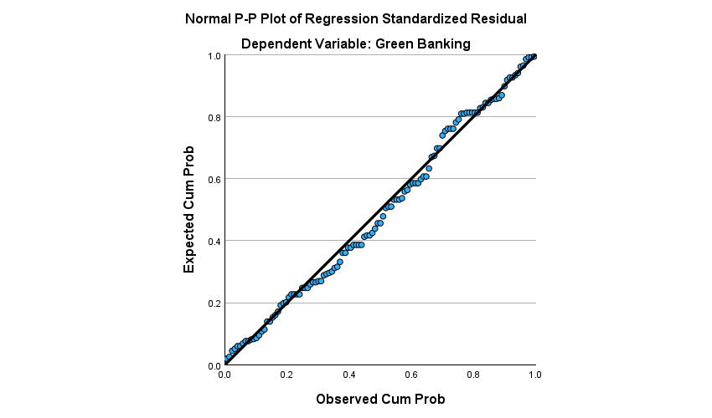

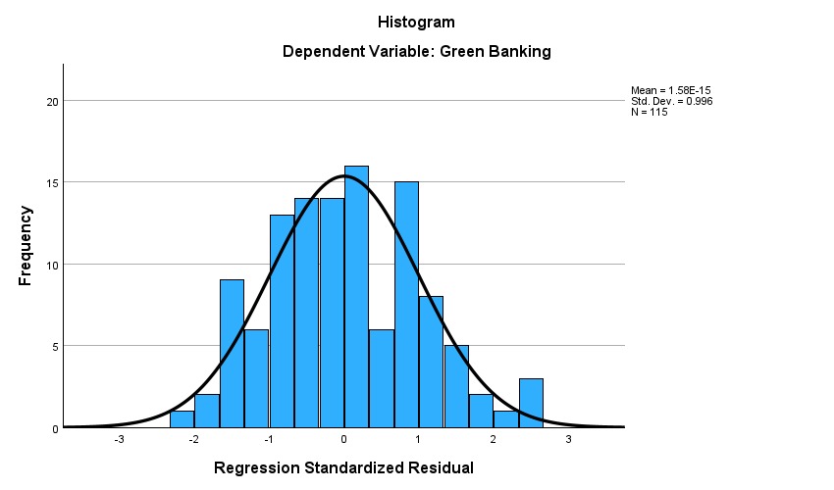

|  |  |  |  |
| --- | --- | --- | --- |
| **One-Sample Kolmogorov-Smirnov Test** | | | |
|  | | | Unstandardized Residual |
| N | | | 115 |
| Normal Parametersa,b | Mean | | .0000000 |
| Std. Deviation | | 7.71437050 |
| Most Extreme Differences | Absolute | | .058 |
| Positive | | .058 |
| Negative | | -.054 |
| Test Statistic | | | .058 |
| Asymp. Sig. (2-tailed)c | | | .200d |
| Monte Carlo Sig. (2-tailed)e | Sig. | | .453 |
| 99% Confidence Interval | Lower Bound | .440 |
| Upper Bound | .465 |

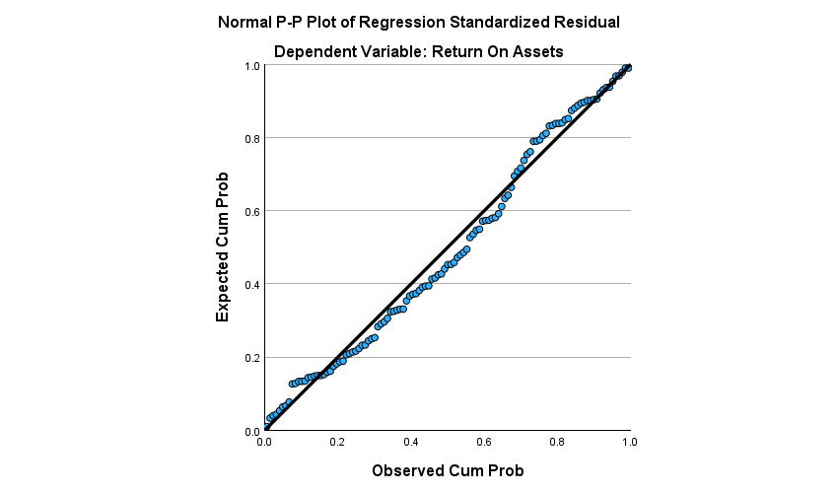

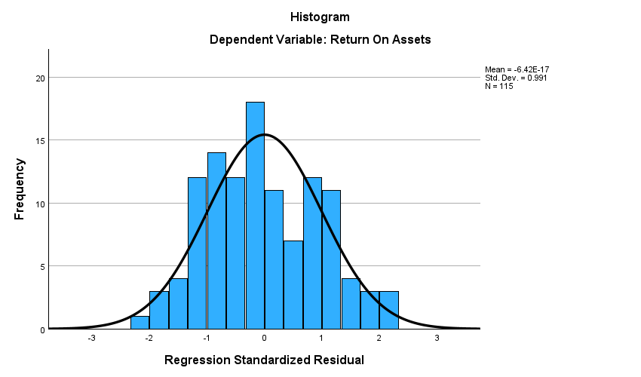

|  |  |  |  |
| --- | --- | --- | --- |
| **One-Sample Kolmogorov-Smirnov Test** | | | |
|  | | | Unstandardized Residual |
| N | | | 115 |
| Normal Parametersa,b | Mean | | .0000000 |
| Std. Deviation | | 1.00695214 |
| Most Extreme Differences | Absolute | | .064 |
| Positive | | .064 |
| Negative | | -.061 |
| Test Statistic | | | .064 |
| Asymp. Sig. (2-tailed)c | | | .200d |
| Monte Carlo Sig. (2-tailed)e | Sig. | | .297 |
| 99% Confidence Interval | Lower Bound | .285 |
| Upper Bound | .309 |

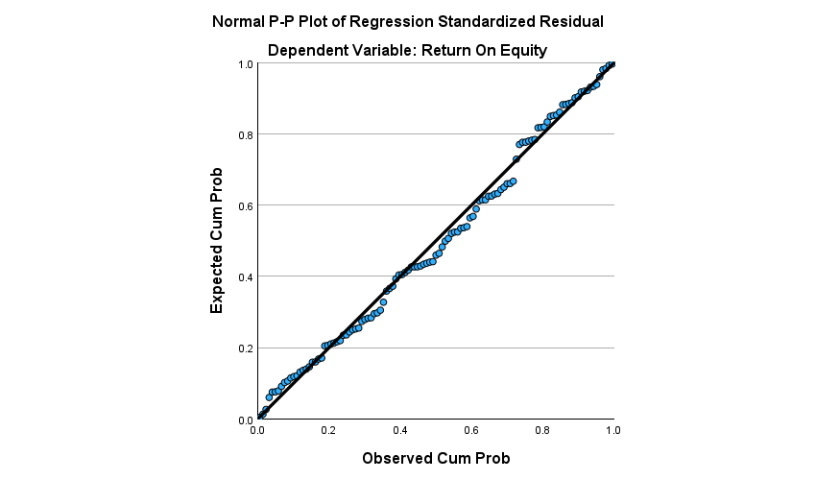

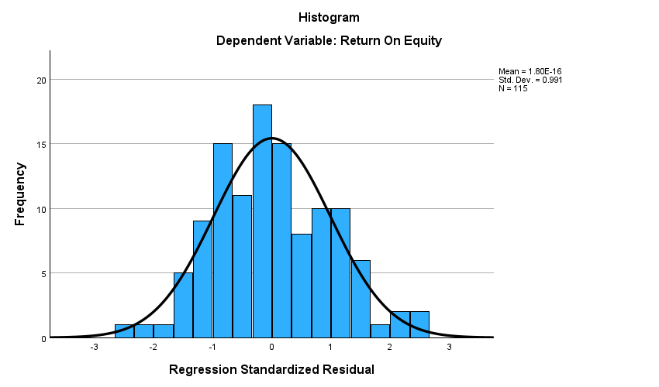

|  |  |  |  |
| --- | --- | --- | --- |
| **One-Sample Kolmogorov-Smirnov Test** | | | |
|  | | | Unstandardized Residual |
| N | | | 115 |
| Normal Parametersa,b | Mean | | .0000000 |
| Std. Deviation | | 5.71896337 |
| Most Extreme Differences | Absolute | | .055 |
| Positive | | .055 |
| Negative | | -.042 |
| Test Statistic | | | .055 |
| Asymp. Sig. (2-tailed)c | | | .200d |
| Monte Carlo Sig. (2-tailed)e | Sig. | | .537 |
| 99% Confidence Interval | Lower Bound | .524 |
| Upper Bound | .550 |

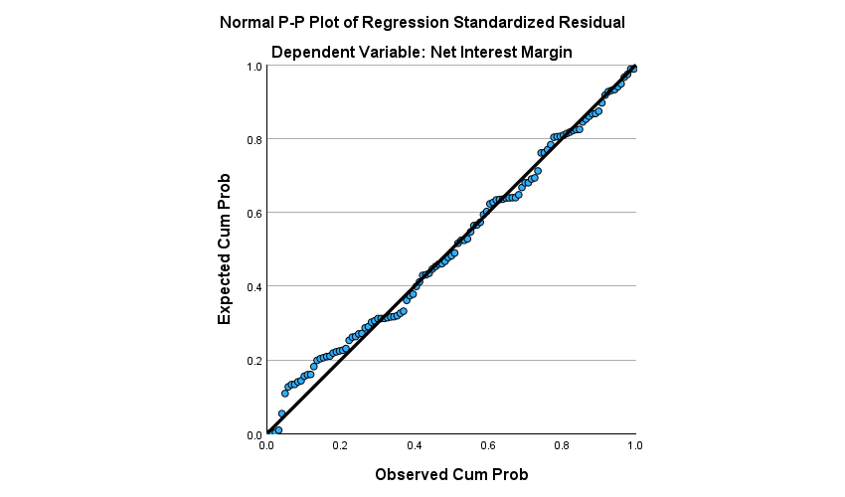

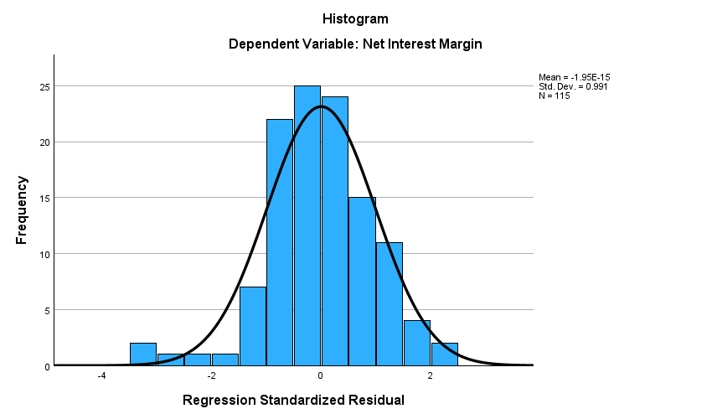

|  |  |  |  |
| --- | --- | --- | --- |
| **One-Sample Kolmogorov-Smirnov Test** | | | |
|  | | | Unstandardized Residual |
| N | | | 115 |
| Normal Parametersa,b | Mean | | .0000000 |
| Std. Deviation | | 1.25137468 |
| Most Extreme Differences | Absolute | | .073 |
| Positive | | .043 |
| Negative | | -.073 |
| Test Statistic | | | .073 |
| Asymp. Sig. (2-tailed)c | | | .192 |
| Monte Carlo Sig. (2-tailed)d | Sig. | | .143 |
| 99% Confidence Interval | Lower Bound | .134 |
| Upper Bound | .152 |

1. **Uji Multikolinearitas**

|  |  |  |  |  |  |  |  |  |
| --- | --- | --- | --- | --- | --- | --- | --- | --- |
| **Coefficientsa** | | | | | | | | |
| Model | | Unstandardized Coefficients | | Standardized Coefficients | t | Sig. | Collinearity Statistics | |
| B | Std. Error | Beta | Tolerance | VIF |
| 1 | (Constant) | 30.373 | 1.604 |  | 18.939 | <,001 |  |  |
| Corporate Social Responsibility | .869 | .044 | .882 | 19.858 | <,001 | 1.000 | 1.000 |
| a. Dependent Variable: Green Banking | | | | | | | | |

|  |  |  |  |  |  |  |  |  |
| --- | --- | --- | --- | --- | --- | --- | --- | --- |
| **Coefficientsa** | | | | | | | | |
| Model | | Unstandardized Coefficients | | Standardized Coefficients | t | Sig. | Collinearity Statistics | |
| B | Std. Error | Beta | Tolerance | VIF |
| 1 | (Constant) | -.505 | .430 |  | -1.175 | .242 |  |  |
| Corporate Social Responsibility | -.021 | .012 | -.307 | -1.732 | .086 | .223 | 4.490 |
| Green Banking | .050 | .012 | .713 | 4.021 | <,001 | .223 | 4.490 |
| a. Dependent Variable: Return On Assets | | | | | | | | |

|  |  |  |  |  |  |  |  |  |  |  |  |  |  |  |  |
| --- | --- | --- | --- | --- | --- | --- | --- | --- | --- | --- | --- | --- | --- | --- | --- |
| **Coefficientsa** | | | | | | | | | | | | | | | |
| Model | | | Unstandardized Coefficients | | | | Standardized Coefficients | | t | Sig. | | Collinearity Statistics | | | |
| B | | Std. Error | | Beta | | Tolerance | | | VIF |
| 1 | (Constant) | | -1.971 | | 2.440 | |  | | -.808 | .421 | |  | | |  |
| Corporate Social Responsibility | | .099 | | .069 | | .238 | | 1.437 | .154 | | .223 | | | 4.490 |
| Green Banking | | .145 | | .070 | | .342 | | 2.067 | .041 | | .223 | | | 4.490 |
| a. Dependent Variable: Return On Equity | | | | | | | | | | | | | | | |
| **Coefficientsa** | | | | | | | | | | | | | | | |
| Model | | | | Unstandardized Coefficients | | | | Standardized Coefficients | t | | Sig. | | Collinearity Statistics | | |
| B | | Std. Error | | Beta | Tolerance | VIF | |
| 1 | | (Constant) | | 2.935 | | .534 | |  | 5.497 | | <,001 | |  |  | |
| Corporate Social Responsibility | | -.033 | | .015 | | -.405 | -2.169 | | .032 | | .223 | 4.490 | |
| Green Banking | | .054 | | .015 | | .662 | 3.544 | | <,001 | | .223 | 4.490 | |
| a. Dependent Variable: Net Interest Margin | | | | | | | | | | | | | | | |

1. **Uji Heteroskedastisitas**

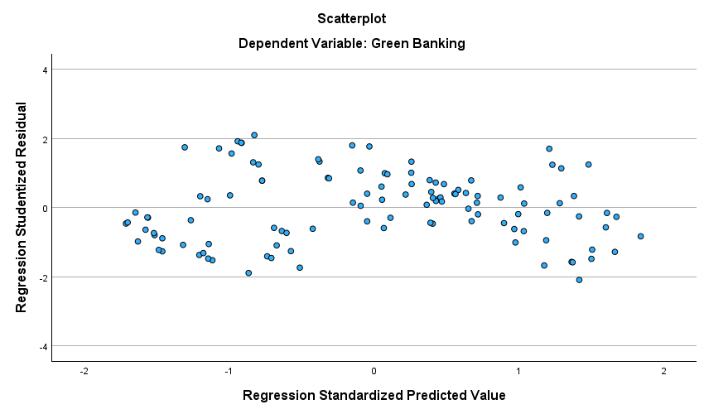

|  |  |  |  |  |  |  |
| --- | --- | --- | --- | --- | --- | --- |
| **Coefficientsa** | | | | | | |
| Model | | Unstandardized Coefficients | | Standardized Coefficients | t | Sig. |
| B | Std. Error | Beta |
| 1 | (Constant) | 7.213 | .914 |  | 7.894 | <,001 |
| Corporate Social Responsibility | -.028 | .025 | -.105 | -1.126 | .263 |
| a. Dependent Variable: Abs_res1 | | | | | | |

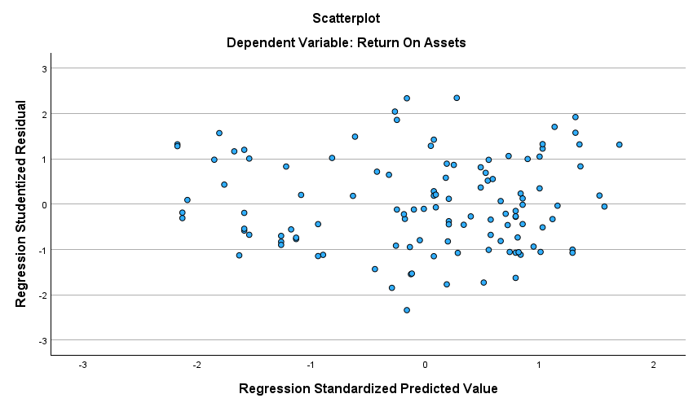

|  |  |  |  |  |  |  |
| --- | --- | --- | --- | --- | --- | --- |
| **Coefficientsa** | | | | | | |
| Model | | Unstandardized Coefficients | | Standardized Coefficients | t | Sig. |
| B | Std. Error | Beta |
| 1 | (Constant) | .724 | .237 |  | 3.056 | .003 |
| Corporate Social Responsibility | -.011 | .007 | -.322 | -1.632 | .105 |
| Green Banking | .008 | .007 | .230 | 1.162 | .248 |
| a. Dependent Variable: Abs_res2 | | | | | | |

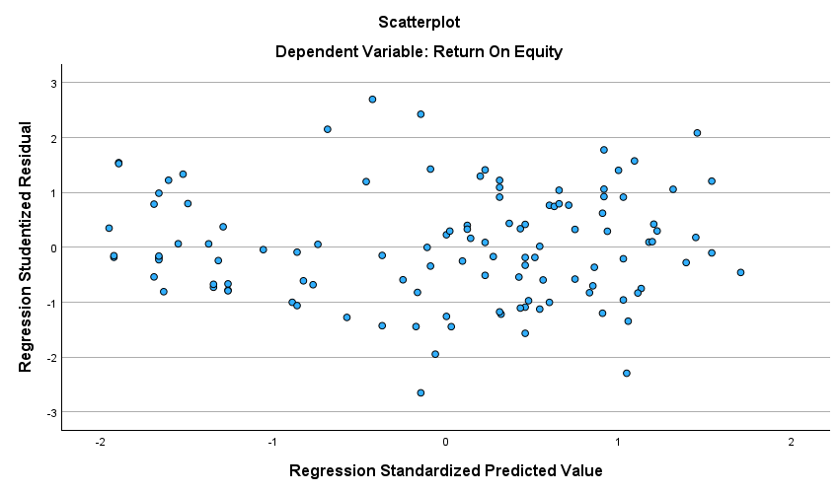

|  |  |  |  |  |  |  |
| --- | --- | --- | --- | --- | --- | --- |
| **Coefficientsa** | | | | | | |
| Model | | Unstandardized Coefficients | | Standardized Coefficients | t | Sig. |
| B | Std. Error | Beta |
| 1 | (Constant) | 4.043 | 1.457 |  | 2.776 | .006 |
| Corporate Social Responsibility | .012 | .041 | .059 | .295 | .768 |
| Green Banking | .002 | .042 | .010 | .049 | .961 |
| a. Dependent Variable: Abs_res3 | | | | | | |

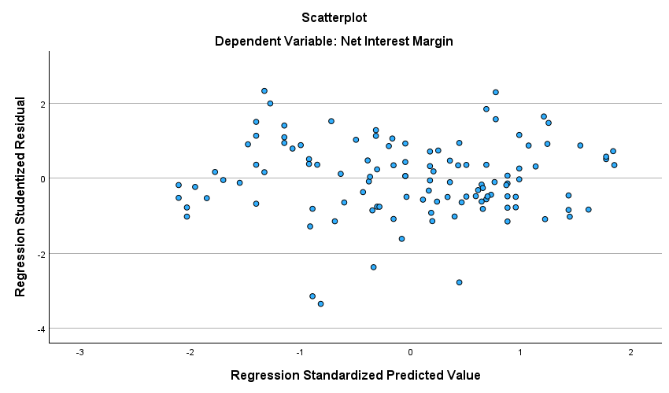

|  |  |  |  |  |  |  |
| --- | --- | --- | --- | --- | --- | --- |
| **Coefficientsa** | | | | | | |
| Model | | Unstandardized Coefficients | | Standardized Coefficients | t | Sig. |
| B | Std. Error | Beta |
| 1 | (Constant) | 1.225 | .337 |  | 3.640 | <,001 |
| Corporate Social Responsibility | .000 | .010 | -.005 | -.024 | .981 |
| Green Banking | -.004 | .010 | -.089 | -.447 | .656 |
| a. Dependent Variable: Abs_res4 | | | | | | |

1. **Uji Autokorelasi**

|  |  |  |  |  |
| --- | --- | --- | --- | --- |
| **Model Summary** | | | | |
| Model | R | R Square | Adjusted R Square | Std. Error of the Estimate |
| 1 | .122a | .015 | -.003 | 7.75668189 |
| a. Predictors: (Constant), Ut_1, Corporate Social Responsibility | | | | |

|  |  |  |  |  |
| --- | --- | --- | --- | --- |
| **Model Summary** | | | | |
| Model | R | R Square | Adjusted R Square | Std. Error of the Estimate |
| 1 | .277a | .077 | .052 | .97601823 |
| a. Predictors: (Constant), Ut_2, Green Banking, Corporate Social Responsibility | | | | |

|  |  |  |  |  |
| --- | --- | --- | --- | --- |
| **Model Summary** | | | | |
| Model | R | R Square | Adjusted R Square | Std. Error of the Estimate |
| 1 | .284a | .080 | .055 | 5.54590445 |
| a. Predictors: (Constant), Ut_3, Green Banking, Corporate Social Responsibility | | | | |

|  |  |  |  |  |
| --- | --- | --- | --- | --- |
| **Model Summary** | | | | |
| Model | R | R Square | Adjusted R Square | Std. Error of the Estimate |
| 1 | .168a | .028 | .002 | 1.25092754 |
| a. Predictors: (Constant), Ut_4, Green Banking, Corporate Social Responsibility | | | | |

**Lampiran 7**

**Hasil Analisis Jalur (*Path Analysis*)**

1. **Analisis Jalur Model Persamaan I**

|  |  |  |  |  |
| --- | --- | --- | --- | --- |
| **Model Summaryb** | | | | |
| Model | R | R Square | Adjusted R Square | Std. Error of the Estimate |
| 1 | .882a | .777 | .775 | 7.74843 |
| a. Predictors: (Constant), Corporate Social Responsibility | | | | |
| b. Dependent Variable: Green Banking | | | | |

|  |  |  |  |  |  |  |
| --- | --- | --- | --- | --- | --- | --- |
| **Coefficientsa** | | | | | | |
| Model | | Unstandardized Coefficients | | Standardized Coefficients | t | Sig. |
| B | Std. Error | Beta |
| 1 | (Constant) | 30.373 | 1.604 |  | 18.939 | <,001 |
| Corporate Social Responsibility | .869 | .044 | .882 | 19.858 | <,001 |
| a. Dependent Variable: Green Banking | | | | | | |

1. **Analisis Jalur Model Persamaan II**

|  |  |  |  |  |
| --- | --- | --- | --- | --- |
| **Model Summaryb** | | | | |
| Model | R | R Square | Adjusted R Square | Std. Error of the Estimate |
| 1 | .465a | .216 | .202 | 1.01590 |
| a. Predictors: (Constant), Green Banking, Corporate Social Responsibility | | | | |
| b. Dependent Variable: Return On Assets | | | | |

|  |  |  |  |  |  |  |
| --- | --- | --- | --- | --- | --- | --- |
| **Coefficientsa** | | | | | | |
| Model | | Unstandardized Coefficients | | Standardized Coefficients | t | Sig. |
| B | Std. Error | Beta |
| 1 | (Constant) | -.505 | .430 |  | -1.175 | .242 |
| Corporate Social Responsibility | -.021 | .012 | -.307 | -1.732 | .086 |
| Green Banking | .050 | .012 | .713 | 4.021 | <,001 |
| a. Dependent Variable: Return On Assets | | | | | | |

|  |  |  |  |  |
| --- | --- | --- | --- | --- |
| **Model Summaryb** | | | | |
| Model | R | R Square | Adjusted R Square | Std. Error of the Estimate |
| 1 | .563a | .317 | .305 | 5.76980 |
| a. Predictors: (Constant), Green Banking, Corporate Social Responsibility | | | | |
| b. Dependent Variable: Return On Equity | | | | |

|  |  |  |  |  |  |  |
| --- | --- | --- | --- | --- | --- | --- |
| **Coefficientsa** | | | | | | |
| Model | | Unstandardized Coefficients | | Standardized Coefficients | t | Sig. |
| B | Std. Error | Beta |
| 1 | (Constant) | -1.971 | 2.440 |  | -.808 | .421 |
| Corporate Social Responsibility | .099 | .069 | .238 | 1.437 | .154 |
| Green Banking | .145 | .070 | .342 | 2.067 | .041 |
| a. Dependent Variable: Return On Equity | | | | | | |

|  |  |  |  |  |
| --- | --- | --- | --- | --- |
| **Model Summaryb** | | | | |
| Model | R | R Square | Adjusted R Square | Std. Error of the Estimate |
| 1 | .360a | .129 | .114 | 1.26250 |
| a. Predictors: (Constant), Green Banking, Corporate Social Responsibility | | | | |
| b. Dependent Variable: Net Interes Margin | | | | |

|  |  |  |  |  |  |  |
| --- | --- | --- | --- | --- | --- | --- |
| **Coefficientsa** | | | | | | |
| Model | | Unstandardized Coefficients | | Standardized Coefficients | t | Sig. |
| B | Std. Error | Beta |
| 1 | (Constant) | 2.935 | .534 |  | 5.497 | <,001 |
| Corporate Social Responsibility | -.033 | .015 | -.405 | -2.169 | .032 |
| Green Banking | .054 | .015 | .662 | 3.544 | <,001 |
| a. Dependent Variable: Net Interes Margin | | | | | | |

**Lampiran 8**

**Hasil Uji Sobel**

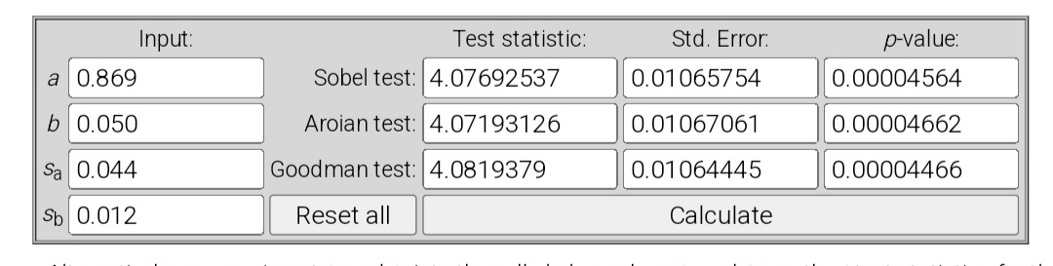

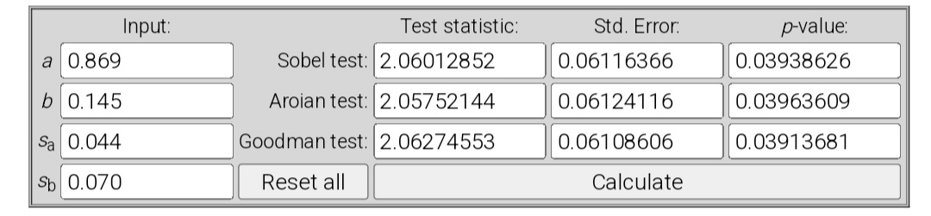

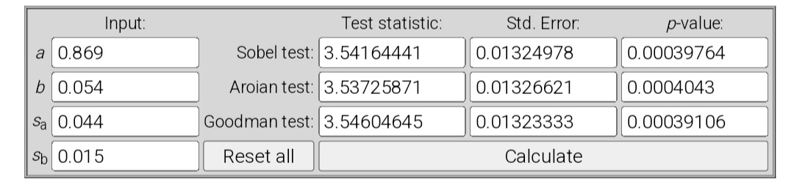

**Lampiran 9**

**Indikator Pengungkapan *Corporate Social Responsibility* (CSR)**

|  |  |  |  |  |  |
| --- | --- | --- | --- | --- | --- |
| **KATEGORI: EKONOMI** | | | | | |
| -Kinerja Ekonomi | | EC1 | | Nilai ekonomi langsung yang dihasilkan dan didistribusikan | |
|  | | EC2 | | Implikasi finansial dan risiko serta peluang lainnya kepada kegiatan organisasi karena perubahan iklim | |
|  | | EC3 | | Cakupan kewajiban organisasi atas program imbalan pasti | |
|  | | EC4 | | Bantuan finansial yang diterima dari pemerintah | |
| -Keberadaan di Pasar | | EC5 | | Rasio upah standar pegawai pemula (entry level) menurut gender dibandingkan dengan upah minimum regional di lokasi- lokasi operasional yang signifikan | |
|  | | EC6 | | Perbandingan manajemen senior yang dipekerjakan dari masyarakat lokal di lokasi operasi yang signifikan | |
| -Dampak Ekonomi Tidak Langsung | | EC7 | | Pembangunan dan dampak dari investasi infrastruktur dan jasa yang diberikan | |
|  | | EC8 | | Dampak ekonomi tidak langsung yang signifikan, termasuk besarnya dampak | |
| -Praktik Pengadaan | | EC9 | | Perbandingan pembelian dari pemasok lokal dilokasi operasional yang signifikan | |
| **KATEGORI: LINGKUNGAN** | | | | | |
| -Bahan | | EN1 | | Bahan yang digunakan berdasarkan berat atau volume | |
|  | | EN2 | | Persentase bahan yang digunakan yang merupakan bahan input daur ulang | |
| -Energi | | EN3 | | Konsumsi energi dalam organisasi | |
|  | | EN4 | | Konsumsi energi di luar organisasi | |
|  | | EN5 | | Intensitas energy | |
|  | | EN6 | | Pengurangan konsumsi energy | |
|  | | EN7 | | Pengurangan kebutuhan energi pada produk dan jasa | |
| -Air | | EN8 | | Total pengambilan air berdasarkan sumber | |
|  | | EN9 | | Sumber air yang secara signifikan dipengaruhi oleh pengambilan air | |
|  | | EN10 | | Persentase dan total volume air yang didaur ulang dan digunakan kembali | |
| -Keanekaragaman Hayati | | EN11 | | Lokasi-lokasi operasional yang dimiliki, disewa, dikelola di dalam, atau yang berdekatan dengan, kawasan lindung dan kawasan dengan nilai keanekaragaman hayati tinggi di luar kawasan lindung | |
|  | | EN12 | | Uraian dampak signifikan kegiatan, produk, dan jasa terhadap keanekaragaman hayati di kawasan lindung dan kawasan dengan nilai keanekaragaman hayati tinggi di luar kawasan lindung | |
|  | | EN13 | | Habitat yang dilindungi dan dipulihkan | |
|  | | EN14 | | Jumlah total spesies dalam iucn red list dan spesies dalam daftar spesies yang dilindungi nasional dengan habitat di tempat yang dipengaruhi operasional, berdasarkan tingkat risiko kepunahan | |
| -Emisi | | EN15 | | Emisi gas rumah kaca (grk) langsung (cakupan 1) | |
|  | | EN16 | | Emisi gas rumah kaca (grk) energi tidak langsung (cakupan 2) | |
|  | | EN17 | | Emisi gas rumah kaca (grk) tidak langsung lainnya (cakupan 3) | |
|  | | EN18 | | Intensitas emisi gas rumah kaca (grk) | |
|  | | EN19 | | Pengurangan emisi gas rumah kaca (grk) | |
|  | | EN20 | | Misi bahan perusak ozon (bpo) | |
|  | | EN21 | | Nox, sox, dan emisi udara signifikan lainnya | |
| -Efluen dan Limbah | | EN22 | | Total air yang dibuang berdasarkan kualitas dan tujuan | |
|  | |  | | Bobot total limbah berdasarkan jenis dan metode pembuangan | |
|  | | EN23 | | Bobot total limbah berdasarkan jenis dan metode pembuangan | |
|  | | EN24 | | Jumlah dan volume total tumpahan signifikan | |
|  | | EN25 | | Bobot limbah yang dianggap berbahaya menurut ketentuan konvensi basel2 lampiran i, ii, iii, dan viii yang diangkut, diimpor, diekspor, atau diolah, dan persentase limbah yang diangkut untuk pengiriman internasional | |
|  | | EN26 | | Identitas, ukuran, status lindung, dan nilai keanekaragaman hayati dari badan air dan habitat terkait yang secara signifikan terkena dampak dari air buangan dan limpasan dari organisasi | |
| -Produk dan Jasa | | EN27 | | Tingkat mitigasi dampak terhadap dampak lingungan produk dan jasa | |
|  | | EN28 | | Persentase produk yang terjual dan kemasannya yang direklamasi menurut kategori | |
| -Kepatuhan | | EN29 | | Nilai moneter denda signifikan dan jumlah total sanksi non- moneter karena ketidakpatuhan terhadap undang-undang dan peraturan lingkungan | |
| -Transportasi | | EN30 | | Dampak lingkungan signifikan dari pengangkutan produk dan barang lain serta bahan untuk operasional organisasi, dan pengangkutan tenaga kerja | |
| -Lain-lain | | EN31 | | Total pengeluaran dan investasi perlindungan lingkungan berdasarkan jenis | |
| -Asesmen Pemasok atas Lingkungan | | EN32 | | Persentase penapisan pemasok baru menggunakan kriteria lingkungan | |
|  | | EN33 | | Dampak lingkungan negatif signifikan aktual dan potensial dalam rantai pasokan dan tindakan yang diambil | |
| -Mekanisme Pengaduan Masalah Lingkungan | | EN34 | | Jumlah pengaduan tentang dampak lingkungan yang diajukan, ditangani, dan diselesaikan melalui mekanisme pengaduan resmi | |
| **KATEGORI: SOSIAL**  SUB-KATEGORI: PRAKTIK KETENAGAKERJAAN DAN KENYAMANAN BEKERJA | | | | | |
| -Kepegawaian | | LA1 | | Jumlah total dan tingkat perekrutan karyawan baru dan turnover karyawan menurut kelompok umur, gender, dan wilayah | |
|  | | LA2 | | Tunjangan yang diberikan bagi karyawan purnawaktu yang tidak diberikan bagi karyawan sementara atau paruh waktu, berdasarkan lokasi operasi yang signifikan | |
|  | | LA3 | | Tingkat kembali bekerja dan tingkat retensi setelah cuti melahirkan, menurut gender | |
| -Hubungan Industrial | | LA4 | | Jangka waktu minimum pemberitahuan mengenai perubahan operasional, termasuk apakah hal tersebut tercantum dalam perjanjian bersama | |
| -Kesehatan dan Keselamatan Kerja | | LA5 | | Persentase total tenaga kerja yang diwakili dalam komite bersama formal manajemen-pekerja yang membantu mengawasi dan memberikan saran program kesehatan dan keselamatan kerja | |
|  | | LA6 | | Jenis dan tingkat cedera, penyakit akibat kerja, hari hilang, dan kemangkiran, serta jumlah total kematian akibat kerja, menurut daerah dan gender | |
|  | | LA7 | | Pekerja yang sering terkena atau berisiko tinggi terkena penyakit yang terkait dengan pekerjaan mereka | |
|  | | LA8 | | Topik kesehatan dan keselamatanmyang tercakup dalam perjanjian formal dengan serikat pekerja | |
| -Pelatihan dan Pendidikan | | LA9 | | Jam pelatihan rata-rata per tahun per karyawan menurut gender, dan menurut kategori karyawan | |
|  | | LA10 | | Program untuk manajemen keterampilan dan pembelajaran  seumur hidup yang mendukung keberlanjutan kerja karyawan dan membantu mereka mengelola purna bakti | |
|  | | LA11 | | Persentase karyawan yang menerima reviu kinerja dan pengembangan karier secara reguler, menurut gender dan kategori karyawan | |
| -Keberagaman dan Kesetaraan Peluang | | LA12 | | Komposisi badan tata kelola dan pembagian karyawan per kategori karyawan menurut gender, kelompok usia, keanggotaan kelompok minoritas, dan indikator keberagaman lainnya | |
| -Kesetaraan Remunerasi Perempuan dan Laki-  laki | | LA13 | | Rasio gaji pokok dan remunerasi bagi perempuan terhadap laki- laki menurut kategori karyawan, berdasarkan lokasi operasional yang signifikan | |
| -Asesmen Pemasok atas Praktik Ketenagakerjaan | | LA14 | | Persentase penapisan pemasok baru menggunakan kriteria praktik ketenagakerjaan | |
|  | | LA15 | | Dampak negatif aktual dan potensial yang signifikan terhadap praktik ketenagakerjaan dalam rantai pasokan dan tindakan yang diambil | |
| -Mekanisme Pengaduan Masalah Ketenagakerjaan | | LA16 | | Jumlah pengaduan tentang praktik ketenagakerjaan yang diajukan, ditangani, dan diselesaikan melalui mekanisme pengaduan resmi | |
| **KATEGORI: SOSIAL**  SUB-KATEGORI: HAK ASASI MANUSIA | | | | | |
| -Investasi | | HR1 | | Jumlah total dan persentase perjanjian dan kontrak investasi yang signifikan yang menyertakan klausul terkait hak asasi manusia atau penapisan berdasarkan hak asasi manusia | |
|  | | HR2 | | Jumlah waktu pelatihan karyawan tentang kebijakan atau prosedur hak asasi manusia terkait dengan aspek hak asasi manusia yang relevan dengan operasi, termasuk persentase karyawan yang dilatih | |
| -Non-diskriminasi | | HR3 | | Jumlah total insiden diskriminasi dan tindakan perbaikan yang diambil | |
| -Kebebasan Berserikat dan Perjanjian Kerja Bersama | | HR4 | | Operasi dan pemasok teridentifikasi yang mungkin melanggar atau berisiko tinggi melanggar hak untuk melaksanakan kebebasan berserikat dan perjanjian kerja bersama, dan tindakan yang diambil untuk mendukung hak-hak tersebut | |
| -Pekerja Anak | | HR5 | | Operasi dan pemasok yang diidentifikasi berisiko tinggi melakukan eksploitasi pekerja anak dan tindakan yang diambil untuk berkontribusi dalam penghapusan pekerja anak yang efektif | |
| -Pekerja Paksa atau Wajib Kerja | | HR6 | | Operasi dan pemasok yang diidentifikasi berisiko tinggi melakukan pekerja paksa atau wajib kerja dan tindakan untuk berkontribusi dalam penghapusan segala bentuk pekerja paksa atau wajib kerja | |
| -Praktik Pengamanan | | HR7 | | Persentase petugas pengamanan yang dilatih dalam kebijakan atau prosedur hak asasi manusia di organisasi yang relevan dengan operasi | |
| -Hak Adat | | HR8 | | Jumlah total insiden pelanggaran yang melibatkan hak-hak masyarakat adat dan tindakan yang diambil | |
| -Asesmen | | HR9 | | Jumlah total dan persentase operasi yang telah melakukan reviu atau asesmen dampak hak asasi manusia | |
| -Asesmen Pemasok atas Hak Asasi Manusia | | HR10 | | Persentase penapisan pemasok baru menggunakan kriteria hak asasi manusia | |
|  | | HR11 | | Dampak negatif aktual dan potensial yang signifikan terhadap hak asasi manusia dalam rantai pasokan dan tindakan yang diambil | |
| -Mekanisme Pengaduan Masalah Hak Asasi Manusia | | HR12 | | Jumlah pengaduan tentang dampak terhadap hak asasi manusia yang diajukan, ditangani, dan diselesaikan melalui mekanisme pengaduan formal | |
| **KATEGORI: SOSIAL** | | | | | |
| **SUB-KATEGORI:MASYARAKAT** | | | | | |
| -Masyarakat Lokal | | SO1 | | Persentase operasi dengan pelibatan masyarakat lokal, asesmen dampak, dan program pengembangan yang diterapkan | |
|  | | SO2 | | Operasi dengan dampak negatif aktual dan potensial yang signifikan terhadap masyarakat lokal | |
| -Anti-korupsi | | SO3 | | Jumlah total dan persentase operasi yang dinilai terhadap risiko terkait dengan korupsi dan risiko signifikan yang teridentifikasi | |
|  | | SO4 | | Komunikasi dan pelatihan mengenai kebijakan dan prosedur anti-korupsi | |
|  | | SO5 | | Insiden korupsi yang terbukti dan tindakan yang diambil | |
| -Kebijakan Publik | | SO6 | | Nilai total kontribusi politik berdasarkan negara dan penerima/penerima manfaat | |
| -Anti Persaingan | | SO7 | | Jumlah total tindakan hukum terkait anti persaingan, anti-trust, serta praktik monopoli dan hasilnya | |
| -Kepatuhan | | SO8 | | Nilai moneter denda yang signifikan dan jumlah total sanksi non-moneter atas ketidakpatuhan terhadap undang-undang dan peraturan | |
| -Asesmen Pemasok Atas Dampak pada Masyarakat | | SO9 | | Persentase penapisan pemasok baru menggunakan kriteria dampak terhadap masyarakat | |
|  | | SO10 | | Dampak negatif aktual dan potensial yang signifikan terhadap masyarakat dalam rantai pasokan dan tindakan yang diambil | |
| -Mekanisme Pengaduan Dampak terhadap Masyarakat | | SO11 | | Jumlah pengaduan tentang dampak terhadap masyarakat yang diajukan, ditangani, dan diselesaikan melalui mekanisme pengaduan resmi | |
| **KATEGORI: SOSIAL**  SUB-KATEGORI: TANGGUNG JAWAB ATAS PRODUK | | | | | |
| -Kesehatan dan Keselamatan Pelanggan | | PR1 | | Persentase kategori produk dan jasa yang signifikan yang  dampaknya terhadap kesehatan dan keselamatan yang dinilai untuk peningkatan | |
|  | | PR2 | | Total jumlah insiden ketidakpatuhan terhadap peraturan dan koda sukarela terkait dampak kesehatan dan keselamatan dari produk dan jasa sepanjang daur hidup, menurut jenis hasil | |
| -Pelabelan Produk dan Jasa | | PR3 | | Jenis informasi produk dan jasa yang diharuskan oleh prosedur organisasi terkait dengan informasi dan pelabelan produk dan jasa, serta persentase kategori produk dan jasa yang signifikan harus mengikuti persyaratan informasi sejenis | |
|  | | PR4 | | Jumlah total insiden ketidakpatuhan terhadap peraturan dan koda sukarela terkait dengan informasi dan pelabelan produk dan jasa, menurut jenis hasil | |
|  | | PR5 | | Hasil survei untuk mengukur kepuasan pelanggan | |
| -Komunikasi  Pemasaran | | PR6 | | Penjualan produk yang dilarang atau disengketakan | |
|  | | PR7 | | Jumlah total insiden ketidakpatuhan terhadap peraturan dan koda sukarela tentang komunikasi pemasaran, termasuk iklan, promosi, dan sponsor, menurut jenis hasil | |
| -Privasi Pelanggan | | PR8 | | Jumlah total keluhan yang terbukti terkait dengan pelanggaran privasi pelanggan dan hilangnya data pelanggan | |
| -Kepatuhan | | PR9 | | Nilai moneter denda yang signifikan atas ketidakpatuhan terhadap undang-undang dan peraturan terkait penyediaan dan penggunaan produk dan jasa | |

**Lampiran 10**

**Indikator Praktik Penerapan *Green Banking***

|  |  |
| --- | --- |
| **No** | **Isu-isu pelaporan** |
| 1 | Pelatihan danpendidikan kesadaran lingkungan |
| 2 | Evaluasi kinerja lingkungan |
| 3 | Sistem penghargaan berbasis lingkungan |
| 4 | Penghematan penggunaan kertas (*paperless*) |
| 5 | Penggunaan peralatan hemat energi |
| 6 | Pengelolaan limbah/daur ulang |
| 7 | Bank ramah lingkungan |
| 8 | *Green loan* |
| 9 | Pembiayaan proyek hijau (*green project*) |
| 10 | Fasilitas *green enterprise* |
| 11 | Evaluasi kredit berbasis lingkungan |
| 12 | Pengelolaan kantor cabang hijau (*green branch*) |
| 13 | Kebijakan berbasis lingkungan (*green policy*) |
| 14 | Kemitraan berbasis lingkungan (*green partnership*) |
| 15 | Perencanaan strategis berbasis lingkungan |
| 16 | *Green procurement* |

**Sumber: (Handajani et al., 2019)**

**Lampiran 11**

**Tabel Nilai Kritis Distribusi Chi-Square**

|  |  |  |  |  |  |  |
| --- | --- | --- | --- | --- | --- | --- |
| df | 0,1 | 0,05 | 0,025 | 0,001 | | 0,005 |
| 1 | 2,705543 | 3,841459 | 5,023886 | 6,634897 | | 7,879439 |
| 2 | 4,605170 | 5,991465 | 7,377759 | 9,210340 | | 10,596635 |
| 3 | 6,251389 | 7,814728 | 9,348404 | 11,344867 | | 12,838156 |
| 4 | 7,779440 | 9,487729 | 11,143287 | 13,276704 | | 14,860259 |
| 5 | 9,236357 | 11,070498 | 12,832502 | 15,086272 | | 16,749602 |
| 6 | 10,644641 | 12,591587 | 14,449375 | 16,811894 | | 18,547584 |
| 7 | 12,017037 | 14,067140 | 16,012764 | 18,475307 | | 20,277740 |
| 8 | 13,361566 | 15,507313 | 17,534546 | 20,090235 | | 21,954955 |
| 9 | 14,683657 | 16,918978 | 19,022768 | 21,665994 | | 23,589351 |
| 10 | 15,987179 | 18,307038 | 20,483177 | 23,209251 | | 25,188180 |
| 11 | 17,275009 | 19,675138 | 21,920049 | 24,724970 | | 26,756849 |
| 12 | 18,549348 | 21,026070 | 23,336664 | 26,216967 | | 28,299519 |
| 13 | 19,811929 | 22,362032 | 24,735605 | 27,688250 | | 29,819471 |
| 14 | 21,064144 | 23,684791 | 26,118948 | 29,141238 | | 31,319350 |
| 15 | 22,307130 | 24,995790 | 27,488393 | 30,577914 | | 32,801321 |
| 16 | 23,541829 | 26,296228 | 28,845351 | 31,999927 | | 34,267187 |
| 17 | 24,769035 | 27,587112 | 30,191009 | 33,408664 | | 35,718466 |
| 18 | 25,989423 | 28,869299 | 31,526378 | 34,805306 | | 37,156451 |
| 19 | 27,203571 | 30,143527 | 32,852327 | 36,190869 | | 38,582257 |
| 20 | 28,411981 | 31,410433 | 34,169607 | 37,566235 | | 39,996846 |
| 21 | 29,615089 | 32,670573 | 35,478876 | 38,932173 | | 41,401065 |
| 22 | 30,813282 | 33,924438 | 36,780712 | 40,289360 | | 42,795655 |
| 23 | 32,006900 | 35,172462 | 38,075627 | 41,638398 | | 44,181275 |
| 24 | 33,196244 | 36,415029 | 39,364077 | 42,979820 | | 45,558512 |
| 25 | 34,381587 | 37,652484 | 40,646469 | 44,314105 | | 46,927890 |
| 26 | 35,563171 | 38,885139 | 41,923170 | 45,641683 | | 48,289882 |
| 27 | 36,741217 | 40,113272 | 43,194511 | 46,962942 | | 49,644915 |
| 28 | 37,915923 | 41,337138 | 44,460792 | 48,278236 | | 50,993376 |
| 29 | 39,087470 | 42,556968 | 45,722286 | 49,587884 | | 52,335618 |
| 30 | 40,256024 | 43,772972 | 46,979242 | 50,892181 | | 53,671962 |
| 31 | 41,421736 | 44,985343 | 48,231890 | 52,191395 | | 55,002704 |
| 32 | 42,584745 | 46,194260 | 49,480438 | 53,485772 | | 56,328115 |
| 33 | 43,745180 | 47,399884 | 50,725080 | 54,775540 | | 57,648445 |
| 34 | 44,903158 | 48,602367 | 51,965995 | 56,060909 | | 58,963926 |
| 35 | 46,058788 | 49,801850 | 53,203349 | 57,342073 | | 60,274771 |
| 36 | 47,212174 | 50,998460 | 54,437294 | 58,619215 | | 61,581179 |
| 37 | 48,363408 | 52,192320 | 55,667973 | 59,892500 | | 62,883335 |
| 38 | 49,512580 | 53,383541 | 56,895521 | 61,162087 | | 64,181412 |
| 39 | 50,659770 | 54,572228 | 58,120060 | 62,428121 | | 65,475571 |
| 40 | 51,805057 | 55,758479 | 59,341707 | 63,690740 | | 66,765962 |
| 41 | 52,948512 | 56,942387 | 60,560572 | 64,950071 | | 68,052726 |
| 42 | 54,090202 | 58,124038 | 61,776756 | 66,206236 | | 69,335997 |
| 43 | 55,230192 | 59,303512 | 62,990356 | 67,459348 | | 70,615900 |
| 44 | 56,368541 | 60,480887 | 64,201461 | 68,709513 | | 71,892550 |
| 45 | 57,505305 | 61,656233 | 65,410159 | 69,956832 | | 73,166061 |
| 46 | 58,640537 | 62,829620 | 66,616529 | 71,201400 | | 74,436535 |
| 47 | 59,774289 | 64,001112 | 67,820647 | 72,443307 | | 75,704073 |
| 48 | 60,906607 | 65,170769 | 69,022586 | 73,682639 | | 76,968768 |
| 49 | 62,037537 | 66,338649 | 70,222414 | 74,919474 | | 78,230708 |
| 50 | 63,167121 | 67,504807 | 71,420195 | 76,153891 | | 79,489978 |
| 51 | 64,295400 | 68,669294 | 72,615992 | 77,385962 | | 80,746659 |
| 52 | 65,422413 | 69,832160 | 73,809863 | 78,615756 | | 82,000826 |
| 53 | 66,548197 | 70,993453 | 75,001864 | 79,843338 | | 83,252551 |
| 54 | 67,672786 | 72,153216 | 76,192048 | 81,068772 | | 84,501905 |
| 55 | 68,796214 | 73,311493 | 77,380466 | 82,292117 | | 85,748952 |
| 56 | 69,918513 | 74,468324 | 78,567165 | 83,513430 | | 86,993755 |
| 57 | 71,039713 | 75,623748 | 79,752192 | 84,732766 | | 88,236375 |
| 58 | 72,159844 | 76,777803 | 80,935592 | 85,950176 | | 89,476870 |
| 59 | 73,278932 | 77,930524 | 82,117406 | 87,165711 | | 90,715293 |
| 60 | 74,397006 | 79,081944 | 83,297675 | 88,379419 | | 91,951698 |
| 61 | 75,514089 | 80,232098 | 84,476437 | 89,591344 | | 93,186135 |
| 62 | 76,630208 | 81,381015 | 85,653731 | 90,801532 | | 94,418653 |
| 63 | 77,745385 | 82,528727 | 86,829591 | 92,010024 | | 95,649297 |
| 64 | 78,859642 | 83,675261 | 88,004051 | 93,216860 | | 96,878113 |
| 65 | 79,973003 | 84,820645 | 89,177145 | 94,422079 | | 98,105144 |
| 66 | 81,085486 | 85,964907 | 90,348904 | 95,625719 | | 99,330430 |
| 67 | 82,197113 | 87,108072 | 91,519359 | 96,827816 | | 100,554011 |
| 68 | 83,307902 | 88,250164 | 92,688539 | 98,028403 | | 101,775925 |
| 69 | 84,417873 | 89,391208 | 93,856471 | 99,227515 | | 102,996209 |
| 70 | 85,527043 | 90,531225 | 95,023184 | 100,425184 | | 104,214899 |
| 71 | 86,635429 | 91,670239 | 96,188704 | 101,621441 | | 105,432028 |
| 72 | 87,743048 | 92,808270 | 97,353055 | 102,816314 | | 106,647630 |
| 73 | 88,849916 | 93,945340 | 98,516262 | 104,009834 | | 107,861736 |
| 74 | 89,956048 | 95,081467 | 99,678349 | 105,202028 | | 109,074377 |
| 75 | 91,061460 | 96,216671 | 100,839338 | 106,392923 | | 110,285583 |
| 76 | 92,166166 | 97,350970 | 101,999252 | 107,582545 | | 111,495383 |
| 77 | 93,270180 | 98,484383 | 103,158112 | 108,770919 | | 112,703803 |
| 78 | 94,373516 | 99,616927 | 104,315938 | 109,958069 | | 113,910872 |
| 79 | 95,476186 | 100,748619 | 105,472750 | 111,144019 | | 115,116615 |
| 80 | 96,578204 | 101,879474 | 106,628568 | 112,328793 | | 116,321057 |
| 81 | 97,679581 | 103,009509 | 107,783410 | | 113,512410 | 117,524222 |
| 82 | 98,780329 | 104,138738 | 108,937294 | | 114,694895 | 118,726134 |
| 83 | 99,880461 | 105,267177 | 110,090238 | | 115,876266 | 119,926817 |
| 84 | 100,979987 | 106,394840 | 111,242259 | | 117,056544 | 121,126292 |
| 85 | 102,078918 | 107,521741 | 112,393374 | | 118,235749 | 122,324581 |
| 86 | 103,177265 | 108,647893 | 113,543598 | | 119,413900 | 123,521704 |
| 87 | 104,275037 | 109,773309 | 114,692947 | | 120,591015 | 124,717683 |
| 88 | 105,372246 | 110,898003 | 115,841436 | | 121,767111 | 125,912536 |
| 89 | 106,468900 | 112,021986 | 116,989080 | | 122,942207 | 127,106284 |
| 90 | 107,565009 | 113,145270 | 118,135893 | | 124,116319 | 128,298944 |
| 91 | 108,660581 | 114,267868 | 119,281889 | | 125,289463 | 129,490534 |
| 92 | 109,755627 | 115,389790 | 120,427081 | | 126,461656 | 130,681073 |
| 93 | 110,850154 | 116,511047 | 121,571483 | | 127,632913 | 131,870578 |
| 94 | 111,944171 | 117,631651 | 122,715107 | | 128,803249 | 133,059065 |
| 95 | 113,037686 | 118,751612 | 123,857967 | | 129,972679 | 134,246550 |
| 96 | 114,130707 | 119,870939 | 125,000073 | | 131,141217 | 135,433049 |
| 97 | 115,223242 | 120,989644 | 126,141437 | | 132,308877 | 136,618578 |
| 98 | 116,315298 | 122,107735 | 127,282072 | | 133,475672 | 137,803151 |
| 99 | 117,406883 | 123,225221 | 128,421989 | | 134,641617 | 138,986783 |
| 100 | 118,498004 | 124,342113 | 129,561197 | | 135,806723 | 140,169489 |
| 101 | 119,588667 | 125,458419 | 130,699709 | | 136,971004 | 141,351283 |
| 102 | 120,678880 | 126,574148 | 131,837533 | | 138,134471 | 142,532177 |
| 103 | 121,768650 | 127,689308 | 132,974681 | | 139,297137 | 143,712185 |
| 104 | 122,857982 | 128,803908 | 134,111163 | | 140,459013 | 144,891320 |
| 105 | 123,946883 | 129,917955 | 135,246987 | | 141,620111 | 146,069595 |
| 106 | 125,035359 | 131,031458 | 136,382163 | | 142,780442 | 147,247022 |
| 107 | 126,123417 | 132,144425 | 137,516701 | | 143,940016 | 148,423613 |
| 108 | 127,211062 | 133,256862 | 138,650610 | | 145,098844 | 149,599379 |
| 109 | 128,298300 | 134,368777 | 139,783897 | | 146,256938 | 150,774332 |
| 110 | 129,385136 | 135,480178 | 140,916573 | | 147,414305 | 151,948483 |
| 111 | 130,471576 | 136,591071 | 142,048644 | | 148,570958 | 153,121843 |
| 112 | 131,557626 | 137,701464 | 143,180120 | | 149,726905 | 154,294423 |
| 113 | 132,643290 | 138,811363 | 144,311008 | | 150,882155 | 155,466234 |
| 114 | 133,728575 | 139,920774 | 145,441316 | | 152,036719 | 156,637285 |
| 115 | 134,813484 | 141,029704 | 146,571052 | | 153,190604 | 157,807586 |
| 116 | 135,898022 | 142,138160 | 147,700223 | | 154,343821 | 158,977148 |
| 117 | 136,982196 | 143,246147 | 148,828836 | | 155,496377 | 160,145979 |
| 118 | 138,066008 | 144,353672 | 149,956899 | | 156,648281 | 161,314089 |
| 119 | 139,149464 | 145,460740 | 151,084419 | | 157,799541 | 162,481488 |
| 120 | 140,232569 | 146,567358 | 152,211403 | | 158,950166 | 163,648184 |

|  |  |
| --- | --- |
| D:\8. SOAL 2x\Soal UAS Gasal 2017-2018\LOGO UPS FE DAN BISNIS 1.jpg | **PERPUSTAKAAN** |
| **FAKULTAS EKONOMI DAN BISNIS**  **UNIVERSITAS PANCASAKTI TEGAL** |
| **Sekertariat. JL. Halmahera Km. 1 Tegal.Telp:355720** |

**Hasil Cek Plagiasi Skripsi**

Nama : Vikri Bagus Maulana

NPM : 4120600203

Program Studi : Manajemen

Konsentrasi : Keuangan

Judul :Analisis Pengaruh Pengungkapan *Corporate Social Responsibility* (CSR) Terhadap Kinerja Keuangan Perusahaan dengan Penerapan Praktik *Green Banking* Sebagai Variabel Mediasi pada Sub-Sektor Perbankan yang Terdaftar di Bursa Efek Indonesia Periode Tahun 2019-2023

Hasil plagiasi : 26 %

Tanggal Plagiasi : 04 Juli 2024

(dengan melampirkan hasil cek plagiasi dari Perpustakaan Fakultas Ekonomi Dan Bisnis Universitas Pancasakti Tegal)

Mengetahui,

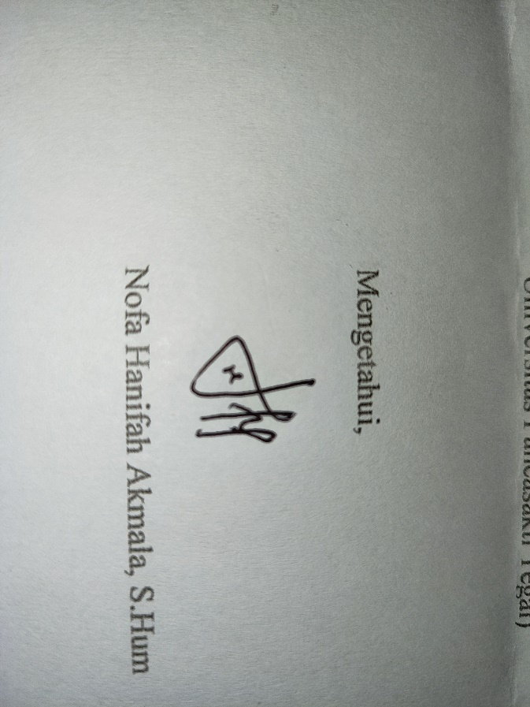

Nofa Hanifah Akmala, S.Hum

**BIODATA PENULIS**

Nama : Vikri Bagus Maulana

Tempat, Tanggal Lahir : Tegal, 17 Agustus 2002

Alamat : Ds. Bongkok RT 02/RW 01 Kec. Kramat

No. Hp : 082325326825

Email : vikribagusmaulana80@gmail.com

Agama : Islam

Nama Orang Tua

Ayah : Karyana

Ibu : Nur Chotimah

Jumlah saudara : 1

Anak Ke : 2

Riwayat Pendidikan : SD N Bongkok 01 (Tahun 2008 - 2014)

SMP N 2 Kramat (Tahun 2014 – 2017)

SMA N 1 Kramat (Tahun 2017 – 2020)

Universitas Pancasakti Tegal (2020 – 2024)

Tegal, Juli 2024



Vikri Bagus Maulana