# DAFTAR PUSTAKA

Adelia, R. (2015). *Pengaruh Peran Auditor Internal, Sistem Pengendalian Intern Pemerintah Dan Penyelesaian Tindak Lanjut Temuan Audit Terhadap Penerapan Tata Kelola Pemerintahan Yang Baik (Good Government Governance) (Studi Empiris Pada Sekretariat Jenderal Dan Inspektorat Jenderal Di Kementerian Republik Indonesia )*. Universitas Islam Negeri Syarif Hidayatullah.

Alfarisi, R., Nadirsyah, & Djalil, M. A. (2020). The Effect Of Implementation Of Government Accounting Standard, Government Internal Control System And Accounting Information System On Good Governance Requirement With The Quality Of Financial Statement As Moderation Of Government Working Unit (Skpa) In The Government Of Aceh, Indonesia. *International Journal Of Business Management And Economic Review*, *04*(06), 294–303. Https://Doi.Org/10.35409/Ijbmer.2021.3341

Amri, Y. (2011). *Pemahaman Aparatur Pemerintah Daerah Terhadap Prinsip-Prinsip Tata Pemerintahan Yang Baik*. Universitas Lampung.

Apaza, C. R. (2009). Measuring Governance And Corruption Through The Worldwide Governance Indicators: Critiques, Responses, And Ongoing Scholarly Discussion. *Ps: Political Science & Politics*, *42*(1), 139–143. Https://Doi.Org/10.1017/S1049096509090106

Ariatin, D. (2021). *Pengaruh Implementasi Sistem Akuntabilitas Kinerja Instansi Pemerintah (Sakip) Terhadap Penerapan Good Governance Pada Badan Pengelola Keuangan Dan Aset Daerah Provinsi Riau*. Universitas Islam Riau.

Atamji, D. W. (2021). *Reformasi Birokrasi*. Kementrian Pendayagunaan Aparatur Negara Dan Reformasi Birokrasi.

Azizah, N. (2018). *Budaya Organisasi Dan Kinerja Pegawai Pada Kantor Pelayanan Pajak (Kpp) Madya Makassar* [Universitas Negeri Makassar]. Http://Eprints.Unm.Ac.Id/11026/1/Jurnal%20iza.Pdf

Azzindani, R., & Irwan. (2020). Pengaruh Implementasi Simda Dan Kinerja Aparatur Pemerintah Daerah Terhadap Kualitas Laporan Keuangan Dimediasi Good Government Governance. *Jurnal Studi Akuntansi Dan Keuangan*, *3*(1), 31–54.

Bakeuda. (2023). *Rencana Kerja (Renja)*. Badan Keuangan Daerah.

Banjarnahor, J., Banjarnahor, J., Purba, W., Laia, Y., Ompusungguh, E. S., Sagala, J. R., Ginting, J. B., & Harmaja, O. J. (2023). *Pengantar Teknologi Informasi*. Unpri Press.

Bemidele, R. (2022). Industrial Sociology, Industrial Relations And Human Resource Management. *Fab Educational Books*, 109–122.

Bpk Ri. (2022). *Hasil Pemeriksaan Atas Laporan Keuangan Pemerintah Kota Tegal*. Badan Pemeriksa Keuangan Perwakilan Provinsi Jawa Tengah.

Bpk Ri. (2023). *Ikhtisar Hasil Pemeriksaan Semester I*. Badan Pemeriksa Keuangan. Www.Bpk.Go.Id

Budi, E., Wira, D., & Infantono, A. (2021). Strategi Penguatan Cyber Security Guna Mewujudkan Keamanan Nasional Di Era Society 5.0. *Prosiding Seminar Nasional Sains Teknologi Dan Inovasi Indonesia (Senastindo)*, *3*, 223–234. Https://Doi.Org/10.54706/Senastindo.V3.2021.141

Dalle, J., Akrim, & Baharuddin. (2020). *Pengantar Teknologi Informasi*. Rajawali Pers.

Dariana, D., & Harrie, A. M. (2020). Pengaruh Penerapan Akuntabilitas Keuangan, Pemanfaatan Teknologi Informasi, Kompetensi Aparatur Pemerintah Dan Ketaatan Peraturan Perundangan Terhadap Kinerja Instansi Pemerintah (Good Governance) Pada Organisasi Perangkat Daerah Kabupaten Bengkalis. *Jas (Jurnal Akuntansi Syariah)*, *4*(1), 124–139. Https://Doi.Org/10.46367/Jas.V4i1.224

Darmawi, E. (2014). Analisis Kinerja Aparatur Pemerintah Dalam Perspektif Good Governance (Studi Deskriptif Mengenai Kinerja Aparatur Kelurahan Ditinjau Dari Dimensi Akuntabilitas, Responsibilitas Dan Responsivitas Di Kelurahan Napal Kecamatan Seluma Kota Kabupaten Seluma). *Jurnal Penelitian Sosial Dan Politik*, *3*(2).

Davis, J. H., Schoorman, D., & Donaldson, L. (1997). Toward A Stewardship Theory Of Management. *Academy Of Management Review*, *22*(1).

Dhiyavani, S. I. (2017). Pengaruh Kinerja Aparatur Pemerintah Daerah, Pengelolaan Keuangan Daerah, Sistem Pengendalian Internal, Dan Implementasi Standar Akuntansi Pemerintah Terhadap Penerapan Good Governance. *Jom Fakultas Ekonomi*, *4*(1).

Dilliana, S. M., & Herdi, H. (2022). *Manajemen Keuangan Daerah*. Eureka Media Aksara.

Diskominfo. (2017). *Pemerintah Kota Tegal*. Pemerintah Kota Tegal. Https://Www.Tegalkota.Go.Id/V2/Index.Php?Option=Com_Content&View=Article&Id=4&Itemid=276&Lang=Id

Edinov, S., Taufik, T., Basri, Y. M., Indrawati, N., & Dp, E. N. (2022). Faktor-Faktor Yang Mempengaruhi Good Governance Dengan Sumber Daya Manusia Sebagai Variabel Moderasi. *Owner*, *6*(4), 3815–3824. Https://Doi.Org/10.33395/Owner.V6i4.1192

Enceng, Liestyodono, & Purwaningdyah. (2008). Meningkatkan Kompetensi Aparatur Pemerintah Daerah Dalam Mewujudkan Good Governance. *Jurnal Kebijakan Dan Manajemen Pns*, *2*(1).

Erayanti, F., Basri, Y. M., & Azlina, N. (2023). *Good Governance Pemerintah Desa: Apakah Dipengaruhi Standar Akuntansi Pemerintah, Gaya Kepemimpinan, Budaya Organisasi?* *6*(2), 12–26.

Ermawati, N. P. D., & Ardana, I. K. (2018). Pengaruh Kepemimpinan Transformasional, Budaya Organisasi, Dan Motivasi Terhadap Komitmen Organisasional Pada Bpr Di Kabupaten Klungkung. *E-Jurnal Manajemen Universitas Udayana*, *7*(11), 6326. Https://Doi.Org/10.24843/Ejmunud.2018.V07.I11.P19

Fanitra, I., & Junaidi, R. (2020). Pengaruh Teknologi Informasi Dan Komitmen Pelayanan Terhadap Good Governance Di Jajaran Pemerintah Kota Banda Aceh. *Jurnal Emt Kita*, *4*(1), 39. Https://Doi.Org/10.35870/Emt.V4i1.138

Garung, C. Y., & Ga, L. L. (2020). Pengaruh Akuntabilitas Dan Transparansi Terhadap Pengelolaan Alokasi Dana Desa (Add) Dalam Pencapaian Good Governance Pada Desa Manulea, Kecamatan Sasitamean, Kabupaten Malaka. *Jurnal Akuntansi : Transparansi Dan Akuntabilitas*, *8*(1), 19–27. Https://Doi.Org/10.35508/Jak.V8i1.2363

Hasana, N. A., & Hamdani, G. (2023). Dampak Penerapan Standar Akuntansi Pemerintahan Dan Kualitas Laporan Finansial Terhadap Akuntabilitas Kinerja Lembaga Pemerintah. *Co-Value Jurnal Ekonomi Koperasi Dan Kewirausahaan*, *14*(7). Https://Doi.Org/10.59188/Covalue.V14i7.3983

Haura, G. A., Junita, A., & Meutia, T. (2019). Pengaruh Sistem Pengendalian Internal Pemerintah (Spip), Pengelolaan Keuangan Daerah, Dan Kinerja Aparatur Pemerintah Daerah Terhadap Good Governance Dengan Komitmen Organisasi Sebagai Variabel Moderasi (Studi Pada Skpk Di Kota Langsa). *Jurnal Penelitian Ekonomi Akuntansi (Jensi)*, *3*(1), 33–52.

Ihsanuddin, Wedhaswary, & Dwi, I. (2018). *Icw: Ada 181 Kasus Korupsi Dana Desa Rugikan Rp40,6 Milliar*. Kompas.Com. Https://Nasional.Kompas.Com/Read/2018/11/21/19000481/Icw-Ada-181-Kasus-Korupsi-Dana-Desa-Rugikan-Negara-Rp-406-Miliar?Page=All

Ikhbaluddin, I. (2020). Strategi Pemerintah Kota Tasikmalaya Dalam Menerapkan Teknologi Informasi Pemerintahan Untuk Meningkatkan Tata Kelola Pemerintahan. *Jurnal Teknologi Dan Komunikasi Pemerintahan*, *2*(2), 41–57. Https://Doi.Org/10.33701/Jtkp.V2i2.2316

Indonesia, P. P. (2003). *Instruksi Presiden (Inpres) Nomor 3 Tahun 2003 Tentang Kebijakan Dan Strategi Nasional Pengembangan E-Government*. Bpk. Https://Peraturan.Bpk.Go.Id/Details/147277/Inpres-No-3-Tahun-2003

Indriasih, D., & Sulistyowati, W. A. (2022). The Role Of Commitment, Competence, Internal Control System, Transparency And Accessibility In Predicting The Accountability Of Village Fund Management. *The Indonesian Accounting Review*, *12*(1), 73–85. Https://Doi.Org/10.14414/Tiar.V12i1.2650

Indriasih, D., Waedi, & Tabrani. (2024). The Influence Of Transformational Leadership, Organizational Culture And Remuneration On Employee Performance Through Work Motivation As Variable Intervening In The Tegal District Transportation Service. *Proceeding Of Management, Law And Pedagogy*, 423–428.

Indriasih, D., Wahyudi, & Jalil, M. (2022). Analisis Faktor–Faktor Yang Mempengaruhi Kinerja Perangkat Desa Melalui Peningkatan Kompetensi Perangkat Desa. *Jurnal Ekonomi Bisnis, Manajemen Dan Akuntansi (Jebma)*, *2*(3), 175–194. Https://Doi.Org/10.47709/Jebma.V2i3.2627

Janedi, A. (2015). Studi Tentang Kinerja Aparatur Pemerintah Di Kantor Badan Perencanaan Pembangunan Daerah Kabupaten Kutai Barat. *E-Jurnal Administrasi Negara*, *3*(3).

Jefri, R. (2018). *The Role Of The Internal Control On The Relationship Between The Organizational Commitment, Organizational Culture, And Competence And Good Governance* [Doctoral Dissertation]. Universitas Hassanudin.

Kair, A. F., Perkasa, D. H., Wahdiniawati, S. A., & Febrian, W. D. (2023). *Pengaruh Kecerdasan Emosional, Kompetensi, Dan Budaya Organisasi Terhadap Kepuasan Kerja Pada Yayasan Pengembangan Potensi Sumber Daya Pertahanan*. *02*(01).

Karim, A., Bangun, B., Kusmanto, Purnama, I., Harahap, S. Z., Irmayani, D., Nasution, M., Munandar, M. H., Rahmadani, & Munthe, I. R. (2020). *Pengantar Teknologi Informasi*. Yayasan Labuhanbatu Berbagi Gemilang.

Kaufmann, D., & Kraay, A. (2023). *Worldwide Governance Indicators*. Www.Govindicators.Org

Kementerian Keuangan Ri. (2022). *Peraturan Menteri Keuangan Ri Tentang Kebijakan Akuntansi Pemerintah Pusat (Pmk Nomor 22 Tahun 2022)*.

Ksap. (2022). *Standar Akuntansi Pemerintahan*.

Kuppelwieser, V. G. (2011). Stewardship Behavior And Creativity. *Management Revue*, *22*(3), 274–295.

Lestariningrum, N., Sarwono, A. E., & Kristianto, D. (2020). Analisis Pengaruh Komitmen Organisasi, Pengelolaan Keuangan Daerah Dan Kinerja Aparatur Terhadap Good Governance. *Jurnal Akuntansi Dan Sistem Teknologi Informasi*, *17*(2).

Liana, L. (2009). Penggunaan Mra Dengan Spss Untuk Menguji Pengaruh Variabel Moderating Terhadap Hubungan Antara Variabel Independen Dan Variabel Dependen. *Jurnal Teknologi Informasi Dinamik*, *14*(2).

Lubis, I., & Safii, M. (2018). *Smart Economy Kota Tangerang Selatan*. Pt Karya Abadi Mitra Indo.

Mailoor, J. H., Sondakh, J. J., & Gamaliel, H. (2017). Pengaruh Sistem Akuntansi Pemerintahan, Budaya Organisasi, Kinerja Aparatur Pemerintah Daerah, Peran Apip, Dan Sistem Pengendalian Intern Pemerintah Terhadap Penerapan Good Governance (Studi Empiris Di Kabupaten Kepulauan Talaud). *Jurnal Riset Akuntansi Dan Auditing “Goodwill,”* *8*(2). Https://Doi.Org/10.35800/Jjs.V8i2.17175

Mardiasmo, D., Barnes, P., & Sakurai, Y. (2008). Implementation Of Good Governance By Regional Governments In Indonesia: The Challenges. *Proceedings Twelfth Annual Conference Of The International Reasearch Society For Public Management*.

Maria, Ahmadi, L. P., Setiawan, A., Tabun, M. A., Syakbani, B., Sudarni, A. A. C., Hariyanti, Nuryati, Suhardaliyah, Sijabat, F. N., Amelia, D., Wati, K. M., Abadi Sukma H K, & Akib, S. (2022). *Perilaku Dan Budaya Organisasi*. Seval Literindo Kreasi.

Maulana, T. (2012). Standar Akuntansi Pemerintahan Dapat Mewujudkan Transparansi Dan Akuntanbilitas Pengelolaan Keuangan Pemerintah Lokal Dalam Era Good Governance. *Jurnal Media Wahana Ekonomika*, *9*(2), 23–43.

Modo, S. M., Saerang, D. P. E., & Poputra, A. T. (2016). Analisis Faktor-Faktor Yang Mempengaruhi Kualitas Informasi Laporan Keuangan Pemerintah Daerah (Studi Empiris Pada Skpd Pemerintah Kabupaten Kepulauan Talaud). *Jurnal Riset Akuntansi Dan Auditing “Goodwill,”* *7*(2). Https://Doi.Org/10.35800/Jjs.V7i2.13550

Moenek, R., & Suwanda, D. (2019). *Good Governance Pengelolaan Keuangan Daerah*. Pt Remaja Rosdakarya.

Mudrikah, F., & Ali, K. (2020). Pengaruh Implementasi Standar Akuntansi Pemerintah Dan Kualitas Laporan Keuangan Terhadap Akuntablitas Kinerja Instansi Pemerintah Dengan Komitmen Organisasi Sebagai Variabel Moderasi. *Jurnal Ilmiahkeuangan Dan Perbankan*, *3*(2).

Nadila, & Septiani, E. (2021). Implementasi Electronic Government Dalam Mewujudkan Good Governance Dan Smart City. *Jurnal Administrasi Nusantara Mahasiswa*, *3*(3).

Nailurrohmah, F. (2021). *Pengaruh Penerapan Standar Akuntansi Pemerintah, Sistem Pengendalian Intern, Dan Kompetensi Sumber Daya Manusia Terhadap Kualitas Laporan Keuangan Desa Di Kecamatan Kabupaten Ponorogo*. Universitas Muhammadiyah Ponorogo.

Nurhikma. (2021). *Pengaruh Pemanfaatan Teknologi Informasi Dan Kompetensi Aparatur Pemerintah Terhadap Akuntabilitas Kinerja Instansi Pemerintah Dengan Standar Akuntansi Pemerintahan Berbasis Akrual Sebagai Variabel Moderating*. Universitas Islam Negeri Alauddin.

Powa, A. A., Kaawoan, J. E., & Pangemanan, F. N. (2021). Pemanfaatan Teknologi Dan Informasi Di Dinas Komunikasi Dan Informatika Statistik Dan Persandian Di Kabupaten Minahasa Tenggara. *Jurnal Governance*, *1*(2).

Putro, P. U. W. (2013). *Pengaruh Pdrb Dan Ukuran Terhadap Pengendalian Intern Pemerintah Daerah Dengan Pad Sebagai Variabel Intervening*. Universitas Negeri Semarang.

Raharjo, E. (2007). Teori Agensi Dan Teori Stewarship Dalam Perspektif Akuntansi. *Fokus Ekonomi*, *2*(1), 37–46.

Rivai, V., & Mulyadi, D. (2012). *Kepemimpinan Dan Perilaku Organisasi* (9 Ed.). Pt Raja Grafindo Persada.

Ruspina, D. O. (2013). *Pengaruh Kinerja Aparatur Pemerintah Daerah, Pengelolaan Keuangan Daerah, Dan Sistem Pengendalian Internal Pemerintah (Spip) Terhadap Penerapan Good Governance* [Jurnal Akuntansi]. Universitas Negeri Padang.

Sari, F. M. (2022). Pengaruh Penerapan Standar Akuntansi Pemerintah, Kualitas Aparatur Pemerintah Daerah, Good Governance Dan Pemanfaatan Teknologi Informasi Terhadap Kualitas Laporan Keuangan Daerah (Studi Empiris Pada Kabupaten Batang). *Jaka (Jurnal Akuntansi, Keuangan, Dan Auditing)*, *3*(1). Https://Doi.Org/10.56696/Jaka.V3i1.6648

Sari, M., Basri, H., & Indriani, M. (2017). Pengaruh Pemanfaatan Teknologi Informasi, Kompetensi Aparatur Dan Komitmen Organisasi Terhadap Kinerja Manajerial Pengelolaan Keuangan Pada Satuan Kerja Perangkat Kabupaten Pemerintah Daerah Kabupaten Aceh Jaya. *Jurnal Megister Akuntansi*, *6*, 67–73.

Sari, R. P., Rice Haryati, & Dica Lady Silvera. (2023). Pengaruh Kinerja Aparatur Pemerintah Daerah Dan Pengelolaan Keuangan Daerah Terhadap Penerapan Good Governance (Studi Kasus Di Kecamatan Koto Xi Tarusan). *Ekasakti Pareso Jurnal Akuntansi*, *1*(2), 183–192. Https://Doi.Org/10.31933/Epja.V1i2.852

Sawlani, D. K., Gautama, I., Furinto, A., & Hamsal, M. (2021). *Competitive Advantage: E-Crm, Project Innovation, Project Organizational Culture, Dynamic Capabilities*. Scopindo Media Pustaka.

Silitonga, P. D. P. (2021). Pemanfaatan Teknologi Informasi Untuk Mendukung Tata Kelola Pemerintahan Desa Pardomuan Ajibata. *Ulead : Jurnal E-Pengabdian*, 1–6. Https://Doi.Org/10.54367/Ulead.V1i1.1304

Situmeang, L. (2021). Analisis Hubungan Kepemimpinan Dan Budaya Organisasi Dengan Motivasi Kerja Dalam Penerapan Good Governance. *Jurnal Manajemen Strategi Dan Aplikasi Bisnis*, *4*(1), 305–314.

Soleh, C., & Suripto. (2021). *Menilai Kinerja Pemerintahan Daerah*. Fokusmedia.

Sudiarianti, N. M., Ulupui, I. G. K. A., & Budiasih. (2015). Pengaruh Kompetensi Sumber Daya Manusia Pada Penerapan Sistem Pengendalian Intern Pemerintah Dan Standar Akuntansi Pemerintah Serta Implikasinya Pada Kualitas Laporan Keuangan Pemerintah Daerah. *Simposium Nasional Akuntansi*.

Sugiyono. (2015). *Metode Penelitian Kuantitatif, Kualitatif, Dan R&D*. Alfabeta.

Sugiyono. (2019). *Metode Penelitian Kuantitatif, Kualitatif, Dan R&D* (2 Ed.). Alfabeta.

Suhardiman, Rachman, M., & Jamiah. (2023). *Birokrasi Dan Public Governance*. Tahta Media Group.

Suharyadi, & Purwanto. (2018). *Statistika Untuk Ekonomi Dan Keuangan Modern* (3 Ed.). Salemba Empat.

Susanti, N. D., & Andayani. (2017). Pengaruh Penerapan Standar Akuntansi Pemerintahan Berbasis Akrual Dan Kompetensi Sumber Daya Manusia Terhadap Kualitas Laporan Keuangan Pemerintah Daerah Kota (Studi Pada Skpd Kota Batu). *Jurnal Ilmiah Mahasiswa Feb*.

Susilo, D. E., Soetjipto, N., Triwulan B, A., Ratnanintyas, D., Riswanto, A., Wasis, & Jaya, F. P. (2019). The Effect Of Employee Commitment, Culture, And Leadership Style On Good Governance Performance Of Jombang District Government (Indonesia). *Revista Espacios*, *40*(27).

Syafina, L., & Harahap, N. (2019). *Metode Penelitian Akuntansi Pendekatan Kuantitatif*. Feb Uin-Su Press.

Syafrion, F. Y. (2015). Pengaruh Sistem Pengendalian Internal, Pengelolaan Keuangan Daerah, Komitmen Organisasi, Dan Budaya Organisasi Terhadap Penerapan Good Governance (Studi Kasus Pada Skpd Kota Solok). *Jom Fakultas Ekonomi*, *2*(2).

Tewal, B., Adolfina, Pandowo, M., & Tawas, H. N. (2017). *Perilaku Organisasi* (1 Ed.). Cv. Patra Media Grafindo.

Tomo. (2019). *Reformasi Birokrasi Menuju Good Governance*. Indocamp.

Tran, Q. H. N. (2021). Organisational Culture, Leadership Behaviour And Job Satisfaction In The Vietnam Context. *International Journal Of Organizational Analysis*, *29*(1), 136–154. Https://Doi.Org/10.1108/Ijoa-10-2019-1919

Wibowo, S. A., & Indeswari, F. M. (2019). The Influence Of Performance Of Local Government, Financial Management, The System Of Internal Control, Implementation Of Government Accounting Standards, Parliamentary Supervision, And Organizational Culture Implementation Of Good Governance (Empirical Study On The Regional Organization Bantul). *Advanced In Economics, Business, And Management Research*, *102*. Https://Doi.Org/10.2991/Icaf-19.2019.28

Widyasanti, Y. S., & Misra, F. (2023). Sistem Pengendalian Intern Pemerintah, Komitmen, Budaya Organisasional Dan Good Government Governance Dengan Kinerja Pemerintah Sebagai Variabel Intervening. *E-Jurnal Akuntansi*, *33*(2), 360. Https://Doi.Org/10.24843/Eja.2023.V33.I02.P06

Wiratno, A., & Pratiwi, U. (2013). Pengaruh Budaya Organisasi, Gaya Kepemimpinan, Komitmen Organisasi Dan Pengendalian Intern Terhadap Penerapan Good Governance Serta Implikasinya Pada Kinerja. *Sustainable Competitive Advantage (Sca)*, *1*(1).

Yuniarti, R., Irwansyah, R., Hasyim, M. A. N., Riswandi, P., Septania, S., & Rochmi, A. (2021). *Kinerja Karyawan (Tinjauan Teori Dan Praktis)*. Widina Bhakti Persada.

Zeyn, E. (2011). Pengaruh Good Governance Dan Standar Akuntansi Pemerintahan Terhadap Akuntabilitas Keuangan Dengan Komitmen Organisasi Sebagai Pemoderasi. *Jurnal Reviu Akuntansi Dan Keuangan*, *1*(1), 21. Https://Doi.Org/10.22219/Jrak.V1i1.497

# LAMPIRAN

Lampiran . Surat Penelitian Skripsi

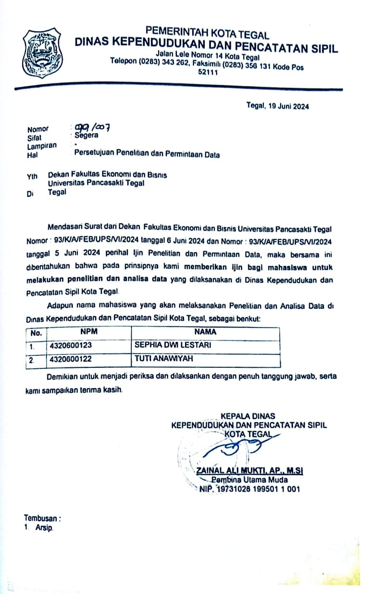

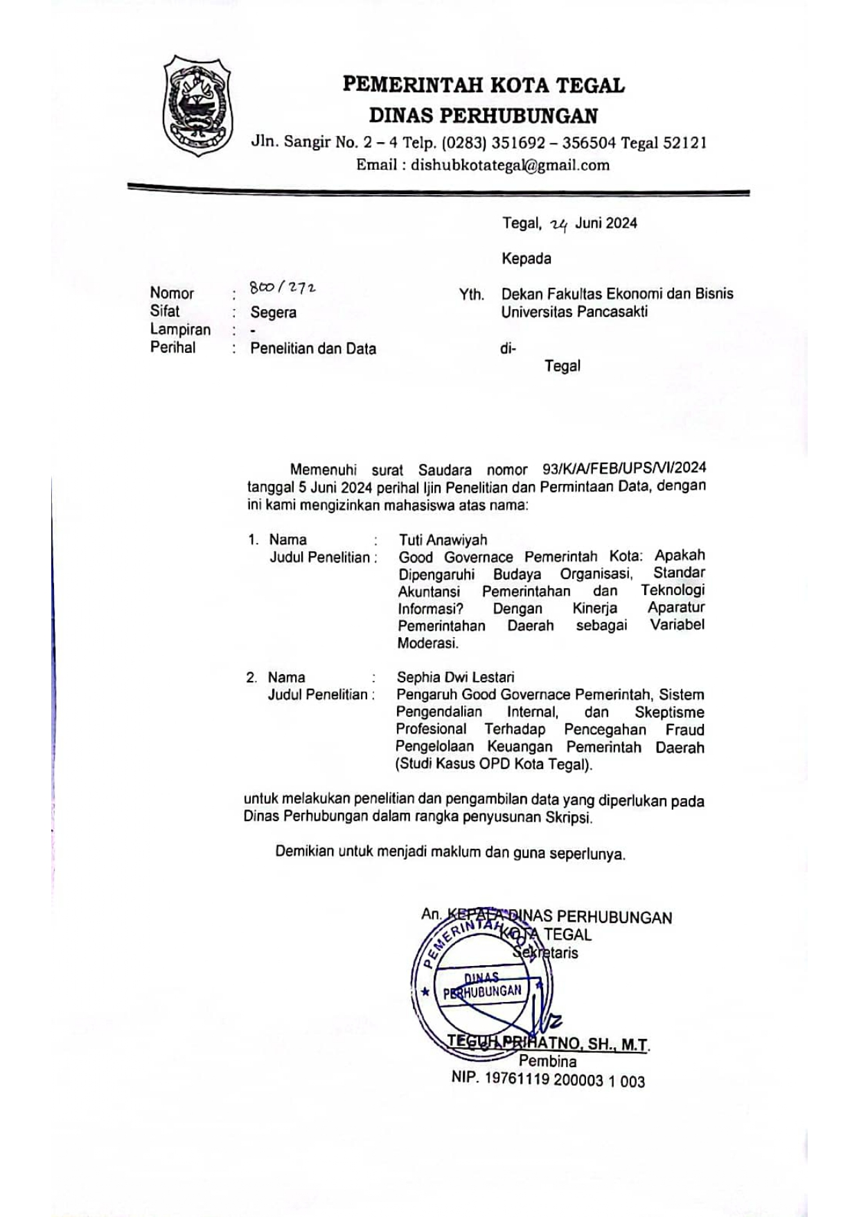

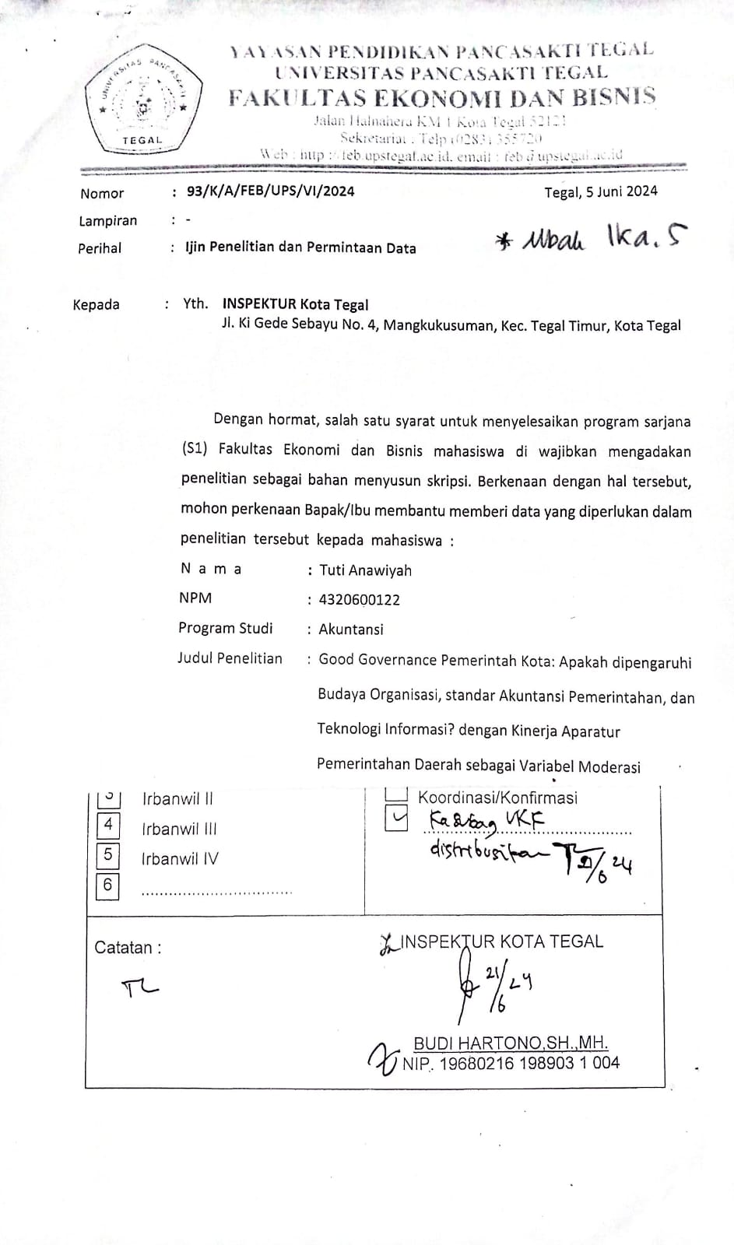

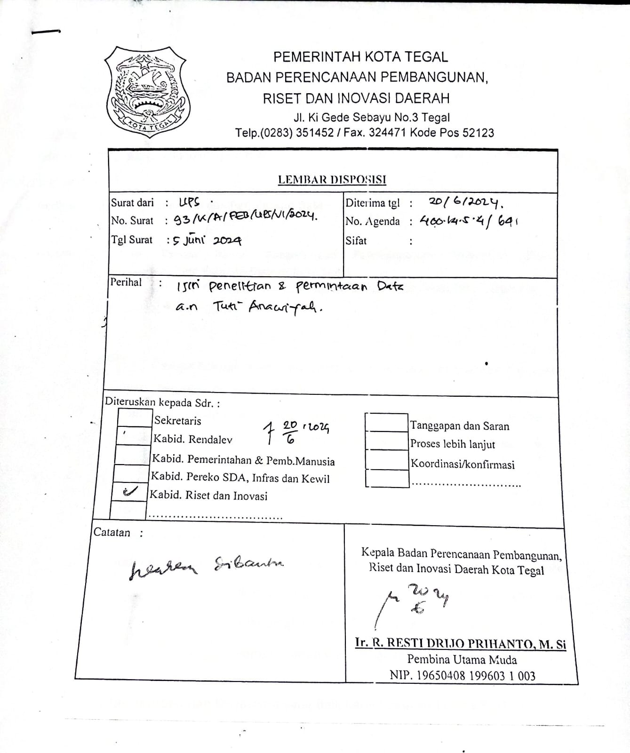

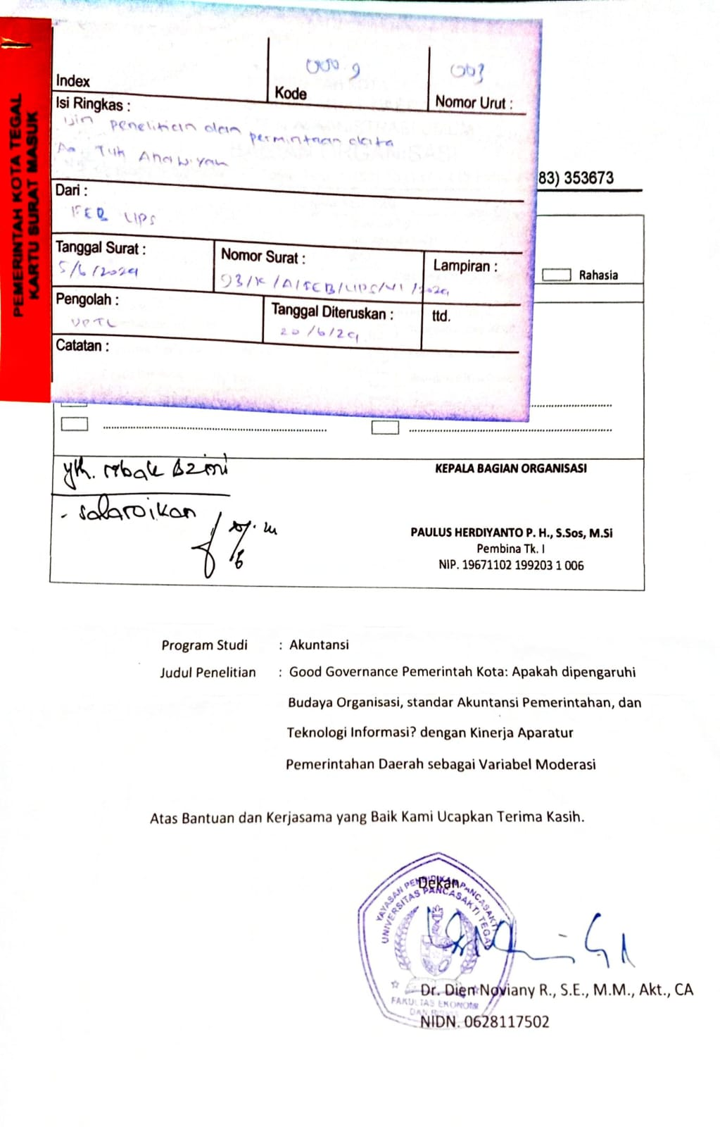

Lampiran . Kuesioner Penelitian

**KUESIONER PENELITIAN**

Perihal: Permohonan Pengisian Kuesioner

Yth. Sdr. Bapak/Ibu

Di Tempat

Dengan Hormat,

Bersama ini, saya atas nama Tuti Anawiyah Jurusan Akuntansi Fakultas Ekonomi dan Bisnis dengan NPM 4320600122 sedang melakukan penelitian dalam rangka penyusunan skripsi dengan judul “***Good Governance* Pemerintah Kota: Apakah Dipengaruhi Budaya Organisasi, Standar Akuntansi Pemerintahan, dan Teknologi Informasi, dengan Kinerja Aparatur Pemerintahan Daerah sebagai Variabel Moderasi (Pada OPD Kota Tegal)**”.

Sehubungan dengan tujuan tersebut, saya membutuhkan bantuan Bapak/Ibu untuk dapat menjadi responden dalam mengisi kuesioner penelitian sebagaimana yang terlampir di bawah ini. Informasi yang Bapak/Ibu/Saudara/Saudari berikan adalah untuk kepentingan akademis semata dan diharapkan dapat bermanfaat bagi peneliti, pemerintah, maupun pengembangan ilmu. Sesuai etika penelitian, saya akan menjaga kerahasiaan jawaban Bapak/Ibu.

Akhir kata saya mengucapkan terima kasih atas bantuan dan kesediaan Bapak/Ibu yang telah meluangkan waktunya dalam pengisian kuesioner.

|  |
| --- |
| Hormat saya, |
|  |
| Tuti Anawiyah |
| NPM. 4320600122 |

**Identitas Responden**

Nama :

Jenis Kelamin : Laki-Laki Perempuan

Usia :

Nama Instansi :

Pendidikan Terakhir : SMA/K Sarjana (S1) Doktor (S3)

Diploma (D3) Magister (S2)

Bidang Keahlian :  Akuntansi Hukum Teknik

Manajemen Lainnya

Jabatan :

Lama Bekerja : 1-5 tahun >10 tahun

6-10 tahun Lainnya

**Petunjuk Pengisian Kuesioner**

Untuk menjawab kuesioner, berilah tanda *check list* ($√$) pada jawaban yang sesuai. Salah satu jawaban yang sesuai pada kolom pilihan jawaban yang tersedia dengan keterangan sebagai berikut**:**

|  |  |  |  |  |  |
| --- | --- | --- | --- | --- | --- |
| **Ket** | **Sangat Setuju** | **Setuju** | **Kurang Setuju** | **Tidak Setuju** | **Sangat Tidak Setuju** |
| **(SS)** | **(S)** | **(KS)** | **(TS)** | **(STS)** |
| **Skor** | **5** | **4** | **3** | **2** | **1** |

**Daftar Pernyataan:**

1. ***Good Governance* (Y)**

|  |  |  |  |  |  |  |
| --- | --- | --- | --- | --- | --- | --- |
| **No** | **Pernyataan** | **Jawaban** | | | | |
| **SS** | **S** | **KS** | **TS** | **STS** |
| **Dimensi: Transparansi** | | | | | | |
| 1 | Instansi tempat saya bekerja menyediakan informasi bagi masyarakat tentang pembuatan, pelaksanaan, dan hasil kebijakan publik. |  |  |  |  |  |
| 2 | Masyarakat dapat mengetahui informasi tentang kegiatan atau program instansi melalui fasilitas iklan layanan masyarakat, *website*, media cetak, dan papan pengumuman. |  |  |  |  |  |
| **Dimensi: Akuntabilitas** | | | | | | |
| 3 | Laporan Keuangan Pemerintah Pusat (LKPP) dan Laporan Akuntabilitas Kinerja Instansi Pemerintah (LAKIP) merupakan bentuk pertanggungjawaban pemerintah terhadap masyarakat yang memuat informasi keuangan dan non-keuangan. |  |  |  |  |  |
| 4 | Instansi tempat saya bekerja memberlakukan *Standar Operating Procedure* (SOP) dalam penyelenggaraan urusan pemerintahan atau pelaksanaan kebijakan. |  |  |  |  |  |
| **Dimensi: Daya Tanggap (*Responsivness*)** | | | | | | |
| 5 | Instansi selalu menanggapi keluhan masyarakat terkait program kegiatan yang dilaksanakan sesuai dengan tupoksi. |  |  |  |  |  |
| 6 | Penyelenggara pemerintah yang memiliki daya tanggap akan menciptakan tata pemerintah yang baik. |  |  |  |  |  |
| **Dimensi: Berkeadilan** | | | | | | |
| 7 | Instansi tempat saya bekerja memberikan pelayanan yang adil. |  |  |  |  |  |
| 8 | Instansi tempat saya bekerja memiliki komitmen dalam memberikan pelayanan kepada masyarakat sesuai tupoksi. |  |  |  |  |  |
| **Dimensi: Aturan Hukum** | | | | | | |
| 9 | Adanya peraturan perundang-undangan yang tegas dan konsisten untuk mendukung pelaksanaan program dan kebijakan. |  |  |  |  |  |
| 10 | Jika terdapat kelalaian yang disengaja atau pelanggaran terhadap peraturan, maka terdapat penindakan hukum secara tegas. |  |  |  |  |  |

Sumber: (Adelia, 2015; Wiratno & Pratiwi, 2013)

1. **Budaya Organisasi ($X_{1})$**

|  |  |  |  |  |  |  |
| --- | --- | --- | --- | --- | --- | --- |
| **No** | **Pernyataan** | **Jawaban** | | | | |
| **SS** | **S** | **KS** | **TS** | **STS** |
| **Dimensi: Inovasi dan Pengambilan Risiko** | | | | | | |
| 1 | Saya diberi kebebasan berinovasi dalam menyelesaikan tugas. |  |  |  |  |  |
| 2 | Saya berani mengambil risiko dalam bertindak. |  |  |  |  |  |
| **Dimensi: Perhatian terhadap Detail** | | | | | | |
| 3 | Saya menerima bimbingan dan komunikasi dari pimpinan agar lebih memperhatikan detail pekerjaan dengan cepat, akurat, dan cermat. |  |  |  |  |  |
| 4 | Saya teliti dalam mengerjakan pekerjaan yang diberikan kepada saya. |  |  |  |  |  |
| **Dimensi: Orientasi pada Individu** | | | | | | |
| 5 | Pegawai di instansi tempat saya bekerja diberi kewenangan untuk membuat keputusan dan diberi tanggung jawab dalam pekerjaannya. |  |  |  |  |  |
| 6 | Instansi mendukung saya untuk aktif mengambil kesempatan. |  |  |  |  |  |
| **Dimensi: Orientasi pada Hasil** | | | | | | |
| 7 | Instansi akan memberikan penghargaan (*reward*) bagi individu atau tim yang mencapai hasil unggul. |  |  |  |  |  |
| 8 | Saya senantiasa bekerja dengan menekankan hasil maksimal. |  |  |  |  |  |
| **Dimensi: Orientasi Bersama** | | | | | | |
| 9 | Tingkat kerjasama dan komunikasi antar anggota tim sudah berjalan dengan baik. |  |  |  |  |  |
| 10 | Di intansi tempat saya bekerja, saling mempedulikan terhadap masalah-masalah pribadi karyawan. |  |  |  |  |  |

Sumber: (Ermawati & Ardana, 2018; Kair dkk., 2023; Wiratno & Pratiwi, 2013)

1. **Standar Akuntansi Pemerintah ($X_{2})$**

|  |  |  |  |  |  |  |
| --- | --- | --- | --- | --- | --- | --- |
| **No** | **Pernyataan** | **Jawaban** | | | | |
| **SS** | **S** | **KS** | **TS** | **STS** |
| **Dimensi: Pengakuan** | | | | | | |
| 1 | Pencatatan aset dan pos lainnya telah didukung dengan bukti sesuai ketentuan. |  |  |  |  |  |
| 2 | Instansi mengakui aset, liabilitas, dan pendapatan, termasuk penilaian yang benar terhadap nilai dan risiko yang terkait. |  |  |  |  |  |
| **Dimensi: Pengukuran** | | | | | | |
| 3 | Bagian pengelolaan keuangan telah memahami penatausahaan keuangan sesuai ketentuan. |  |  |  |  |  |
| 4 | Informasi keuangan memberikan pemahaman yang signifikan terhadap keuangan entitas dan membantu dalam pengambilan keputusan. |  |  |  |  |  |
| **Dimensi: Pengungkapan** | | | | | | |
| 5 | Laporan keuangan instansi mengungkapkan seluruh informasi secara transparan dan jelas. |  |  |  |  |  |
| 6 | Anggaran penerimaan dapat memenuhi seluruh kebutuhan anggaran pengeluaran. |  |  |  |  |  |
| **Dimensi: Pelaporan** | | | | | | |
| 7 | Seluruh pengelolaan keuangan dilaporkan  tepat waktu. |  |  |  |  |  |
| 8 | Menjadikan Peraturan Pemerintah SAP Tahun 2022 sebagai pedoman dalam menyajikan laporan keuangan yang berkualitas. |  |  |  |  |  |

Sumber: (Nailurrohmah, 2021; Susanti & Andayani, 2017)

1. **Teknologi Informasi ($X_{3})$**

|  |  |  |  |  |  |  |
| --- | --- | --- | --- | --- | --- | --- |
| **No** | **Pernyataan** | **Jawaban** | | | | |
| **SS** | **S** | **KS** | **TS** | **STS** |
| **Dimensi: Jaringan Komputer** | | | | | | |
| 1 | Setiap pegawai disediakan komputer dalam melaksanakan tugasnya. |  |  |  |  |  |
| 2 | Proses akuntansi sudah dilakukan secara terkomputerisasi. |  |  |  |  |  |
| **Dimensi: Jaringan Internet** | | | | | | |
| 3 | Kehadiran jaringan internet stabil (WiFi) bisa memudahkan proses evaluasi dan koordinasi antar unit kerja. |  |  |  |  |  |
| 4 | Instansi menyediakan WiFi dengan koneksi yang cepat dan stabil dalam kantor guna mempercepat proses *input* dan *output*. |  |  |  |  |  |
| **Dimensi: Penggunaan Sistem** | | | | | | |
| 5 | Saya membuat laporan keuangan dengan menggunakan *software* atau aplikasi seperti *Microsoft Excel*, MYOB, dan sebagainya. |  |  |  |  |  |
| 6 | Sistem informasi yang digunakan instansi memiliki keamanan yang memadai dan terjaga dari resiko kebocoran data. |  |  |  |  |  |
| 7 | Instansi menyediakan layanan digital secara online. |  |  |  |  |  |
| 8 | Instansi menerapkan teknologi informasi untuk memantau kinerja sistem dengan efektif. |  |  |  |  |  |

Sumber: (Nurhikma, 2021)

1. **Kinerja Aparatur Pemerintah Daerah (Z)**

|  |  |  |  |  |  |  |
| --- | --- | --- | --- | --- | --- | --- |
| **No** | **Pernyataan** | **Jawaban** | | | | |
| **SS** | **S** | **KS** | **TS** | **STS** |
| **Dimensi: Mauskan (*Input*)** | | | | | | |
| 1 | Menurut saya, sikap disiplin harus dimiliki aparat dalam melaksanakan tugas. |  |  |  |  |  |
| 2 | Saya selaku aparatur telah melaksanakan tugas dan bertanggungjawab sesuai dengan bidang. |  |  |  |  |  |
| **Dimensi: Keluaran (*Output*)** | | | | | | |
| 3 | Instansi tempat saya bekerja telah melakukan analisis laporan keuangan setiap program atau kegiatan selesai dilaksanakan. |  |  |  |  |  |
| 4 | Menurut saya, kemampuan dalam melakukan kerja sama dengan aparat lain sangat mendukung keberhasilan dalam menjalankan tugas. |  |  |  |  |  |
| **Dimensi: Hasil (*Outcome*)** | | | | | | |
| 5 | Informasi kinerja *outcome* dapat diandalkan. |  |  |  |  |  |
| 6 | Menurut saya, untuk mencapai hasil maksimal dalam menjalankan tugas diperlukan inisiatif dalam pengambilan keputusan. |  |  |  |  |  |
| **Dimensi: Manfaat (*Benefit*)** | | | | | | |
| 7 | Kebijakan yang dilaksanakan instansi terealisasi sesuai rencana dan berdampak positif bagi masyarakat. |  |  |  |  |  |
| 8 | Program yang dilaksanakan instansi terealisasi sesuai rencana dan berdampak positif bagi masyarakat. |  |  |  |  |  |
| **Dimensi: Damapak (*Impact*)** | | | | | | |
| 9 | Program instansi di tempat kerja saya bekerja telah disesuaikan dengan kebijakan pemerintah guna meningkatkan kinerja instansi. |  |  |  |  |  |

Sumber: (Nurhikma, 2021)

Lampiran . Tabulasi Data

1. **Variabel Budaya Organisasi (X1)**

|  |  |  |  |  |  |  |  |  |  |  |  |
| --- | --- | --- | --- | --- | --- | --- | --- | --- | --- | --- | --- |
| **No** | **X1.1** | **X1.2** | **X1.3** | **X1.4** | **X1.5** | **X1.6** | **X1,7** | **X1,8** | **X1,9** | **X1.10** | **Total X** |
| **1** | 4 | 4 | 5 | 5 | 4 | 4 | 4 | 5 | 5 | 4 | 40 |
| **2** | 4 | 3 | 3 | 5 | 3 | 4 | 4 | 4 | 4 | 3 | 34 |
| **3** | 5 | 5 | 5 | 4 | 5 | 5 | 5 | 4 | 5 | 5 | 43 |
| **4** | 4 | 2 | 4 | 2 | 4 | 3 | 4 | 3 | 3 | 3 | 29 |
| **5** | 5 | 4 | 5 | 4 | 4 | 5 | 4 | 4 | 4 | 4 | 39 |
| **6** | 4 | 4 | 3 | 4 | 4 | 3 | 3 | 5 | 4 | 4 | 34 |
| **7** | 4 | 4 | 4 | 4 | 4 | 4 | 4 | 4 | 4 | 4 | 36 |
| **8** | 4 | 4 | 4 | 4 | 4 | 4 | 4 | 4 | 4 | 4 | 36 |
| **9** | 5 | 5 | 5 | 5 | 5 | 5 | 5 | 5 | 5 | 5 | 45 |
| **10** | 5 | 5 | 5 | 5 | 5 | 5 | 5 | 5 | 5 | 5 | 45 |
| **11** | 5 | 5 | 5 | 4 | 4 | 5 | 4 | 5 | 5 | 4 | 42 |
| **12** | 5 | 5 | 5 | 5 | 5 | 5 | 5 | 5 | 5 | 5 | 45 |
| **13** | 4 | 4 | 4 | 4 | 4 | 4 | 4 | 4 | 4 | 4 | 36 |
| **14** | 4 | 4 | 4 | 4 | 4 | 5 | 4 | 4 | 5 | 4 | 38 |
| **15** | 5 | 5 | 5 | 5 | 5 | 5 | 5 | 5 | 5 | 5 | 45 |
| **16** | 5 | 5 | 5 | 5 | 4 | 5 | 4 | 5 | 5 | 5 | 43 |
| **17** | 4 | 4 | 4 | 5 | 5 | 5 | 4 | 4 | 5 | 5 | 40 |
| **18** | 3 | 2 | 4 | 4 | 4 | 4 | 3 | 4 | 4 | 3 | 32 |
| **19** | 5 | 4 | 5 | 4 | 5 | 5 | 4 | 5 | 5 | 3 | 45 |
| **20** | 4 | 4 | 4 | 5 | 5 | 4 | 4 | 4 | 5 | 3 | 42 |
| **21** | 4 | 4 | 4 | 4 | 4 | 4 | 4 | 4 | 4 | 3 | 39 |
| **22** | 4 | 4 | 4 | 4 | 4 | 4 | 4 | 4 | 4 | 3 | 39 |
| **23** | 4 | 3 | 4 | 4 | 4 | 3 | 5 | 5 | 4 | 3 | 39 |
| **24** | 4 | 3 | 4 | 4 | 4 | 4 | 4 | 4 | 4 | 4 | 39 |
| **25** | 4 | 4 | 4 | 4 | 4 | 4 | 4 | 4 | 4 | 4 | 40 |
| **26** | 4 | 4 | 4 | 4 | 4 | 4 | 4 | 4 | 4 | 4 | 40 |
| **27** | 5 | 4 | 4 | 4 | 4 | 4 | 4 | 4 | 4 | 3 | 40 |
| **28** | 5 | 5 | 4 | 4 | 4 | 4 | 4 | 4 | 4 | 3 | 41 |
| **29** | 5 | 3 | 5 | 5 | 5 | 5 | 5 | 5 | 5 | 5 | 48 |
| **30** | 4 | 3 | 4 | 4 | 4 | 4 | 4 | 4 | 4 | 4 | 39 |
| **31** | 4 | 4 | 4 | 4 | 4 | 4 | 5 | 5 | 4 | 3 | 41 |
| **32** | 4 | 4 | 5 | 4 | 4 | 5 | 4 | 4 | 5 | 5 | 44 |
| **33** | 5 | 4 | 5 | 5 | 5 | 1 | 4 | 3 | 4 | 4 | 40 |
| **34** | 5 | 4 | 5 | 5 | 5 | 1 | 4 | 3 | 4 | 4 | 40 |
| **35** | 4 | 4 | 4 | 4 | 4 | 4 | 4 | 4 | 4 | 4 | 40 |
| **36** | 4 | 4 | 4 | 4 | 4 | 4 | 4 | 4 | 4 | 4 | 40 |
| **37** | 4 | 3 | 4 | 4 | 3 | 4 | 4 | 4 | 4 | 2 | 36 |
| **38** | 4 | 3 | 5 | 3 | 3 | 4 | 3 | 4 | 4 | 4 | 37 |
| **39** | 4 | 4 | 4 | 4 | 4 | 4 | 3 | 4 | 4 | 3 | 38 |
| **40** | 4 | 4 | 4 | 4 | 4 | 4 | 4 | 4 | 4 | 3 | 39 |
| **41** | 4 | 4 | 4 | 4 | 4 | 4 | 4 | 4 | 4 | 4 | 40 |
| **42** | 4 | 3 | 4 | 4 | 4 | 4 | 4 | 4 | 4 | 4 | 39 |
| **43** | 4 | 3 | 4 | 4 | 4 | 5 | 4 | 4 | 4 | 5 | 41 |

|  |  |  |  |  |  |  |  |  |  |  |  |
| --- | --- | --- | --- | --- | --- | --- | --- | --- | --- | --- | --- |
| **No** | **X1.1** | **X1.2** | **X1.3** | **X1.4** | **X1.5** | **X1.6** | **X1,7** | **X1,8** | **X1,9** | **X1.10** | **Total X** |
| **44** | 4 | 4 | 4 | 3 | 4 | 4 | 4 | 4 | 4 | 4 | 39 |
| **45** | 5 | 5 | 5 | 5 | 5 | 5 | 5 | 5 | 5 | 4 | 49 |
| **46** | 4 | 4 | 5 | 4 | 4 | 4 | 4 | 4 | 5 | 4 | 42 |
| **47** | 5 | 4 | 4 | 4 | 4 | 4 | 4 | 5 | 4 | 4 | 42 |
| **48** | 4 | 4 | 4 | 4 | 4 | 4 | 4 | 4 | 4 | 4 | 40 |
| **49** | 4 | 4 | 4 | 4 | 4 | 4 | 4 | 4 | 4 | 4 | 40 |
| **50** | 4 | 4 | 4 | 4 | 4 | 4 | 4 | 4 | 4 | 4 | 40 |
| **51** | 4 | 4 | 4 | 4 | 4 | 4 | 4 | 4 | 5 | 4 | 41 |
| **52** | 4 | 4 | 4 | 4 | 4 | 4 | 2 | 4 | 4 | 3 | 37 |
| **53** | 5 | 5 | 5 | 4 | 5 | 5 | 5 | 4 | 5 | 3 | 46 |
| **54** | 4 | 4 | 4 | 3 | 4 | 4 | 4 | 5 | 4 | 3 | 39 |
| **55** | 4 | 3 | 4 | 4 | 4 | 4 | 3 | 4 | 4 | 4 | 38 |
| **56** | 4 | 2 | 4 | 4 | 4 | 4 | 4 | 4 | 4 | 4 | 38 |
| **57** | 4 | 4 | 5 | 4 | 4 | 4 | 3 | 4 | 4 | 4 | 40 |
| **58** | 4 | 4 | 4 | 4 | 4 | 3 | 3 | 4 | 4 | 3 | 37 |
| **59** | 4 | 4 | 4 | 4 | 4 | 3 | 3 | 4 | 4 | 3 | 37 |
| **60** | 4 | 3 | 4 | 5 | 4 | 4 | 4 | 5 | 4 | 4 | 41 |
| **61** | 5 | 3 | 5 | 4 | 4 | 4 | 3 | 5 | 5 | 1 | 39 |
| **62** | 4 | 4 | 4 | 4 | 4 | 4 | 4 | 4 | 4 | 3 | 39 |
| **63** | 4 | 4 | 4 | 5 | 4 | 5 | 5 | 5 | 5 | 5 | 46 |
| **64** | 4 | 4 | 4 | 4 | 4 | 4 | 4 | 3 | 3 | 3 | 37 |
| **65** | 4 | 4 | 4 | 5 | 4 | 4 | 4 | 4 | 4 | 3 | 40 |
| **66** | 5 | 5 | 5 | 5 | 5 | 5 | 5 | 5 | 5 | 3 | 48 |
| **67** | 4 | 3 | 4 | 4 | 4 | 4 | 3 | 4 | 4 | 3 | 37 |
| **68** | 5 | 5 | 4 | 4 | 5 | 4 | 3 | 5 | 4 | 5 | 44 |
| **69** | 4 | 4 | 5 | 4 | 5 | 5 | 3 | 5 | 5 | 5 | 45 |
| **70** | 2 | 3 | 4 | 4 | 4 | 4 | 4 | 4 | 5 | 4 | 38 |

1. **Variabel Standar Akuntansi Pemerintahan (X2)**

|  |  |  |  |  |  |  |  |  |  |
| --- | --- | --- | --- | --- | --- | --- | --- | --- | --- |
| **No** | **X2.1** | **X2.2** | **X2.3** | **X2.4** | **X2.5** | **X2.6** | **X2.7** | **X2.8** | **Total X2** |
| **1** | 5 | 4 | 4 | 4 | 5 | 4 | 5 | 4 | 35 |
| **2** | 4 | 4 | 4 | 4 | 4 | 2 | 4 | 4 | 30 |
| **3** | 5 | 4 | 5 | 5 | 2 | 2 | 3 | 3 | 29 |
| **4** | 4 | 4 | 4 | 5 | 4 | 4 | 4 | 5 | 34 |
| **5** | 4 | 4 | 4 | 5 | 4 | 4 | 4 | 4 | 33 |
| **6** | 4 | 4 | 4 | 4 | 4 | 4 | 4 | 4 | 32 |
| **7** | 4 | 4 | 4 | 4 | 4 | 4 | 4 | 4 | 32 |
| **8** | 4 | 4 | 4 | 4 | 4 | 4 | 4 | 4 | 32 |
| **9** | 5 | 5 | 5 | 5 | 5 | 5 | 5 | 5 | 40 |
| **10** | 5 | 5 | 5 | 5 | 5 | 5 | 5 | 5 | 40 |
| **11** | 5 | 5 | 5 | 5 | 5 | 4 | 5 | 5 | 39 |
| **12** | 5 | 5 | 5 | 5 | 5 | 5 | 5 | 5 | 40 |
| **13** | 4 | 4 | 4 | 4 | 4 | 4 | 4 | 4 | 32 |
| **14** | 4 | 4 | 4 | 4 | 5 | 5 | 4 | 4 | 34 |
| **15** | 5 | 5 | 5 | 5 | 5 | 5 | 5 | 5 | 40 |
| **16** | 5 | 5 | 5 | 5 | 5 | 5 | 4 | 5 | 39 |

|  |  |  |  |  |  |  |  |  |  |
| --- | --- | --- | --- | --- | --- | --- | --- | --- | --- |
| **No** | **X2.1** | **X2.2** | **X2.3** | **X2.4** | **X2.5** | **X2.6** | **X2.7** | **X2.8** | **Total X2** |
| **17** | 5 | 5 | 5 | 5 | 4 | 5 | 5 | 4 | 38 |
| **18** | 4 | 4 | 4 | 4 | 4 | 3 | 4 | 4 | 31 |
| **19** | 5 | 5 | 5 | 5 | 4 | 5 | 6 | 4 | 39 |
| **20** | 4 | 4 | 4 | 4 | 4 | 3 | 4 | 4 | 31 |
| **21** | 4 | 4 | 4 | 4 | 4 | 4 | 4 | 4 | 32 |
| **22** | 4 | 4 | 4 | 4 | 4 | 4 | 4 | 4 | 32 |
| **23** | 5 | 5 | 5 | 4 | 5 | 4 | 5 | 5 | 38 |
| **24** | 4 | 4 | 4 | 4 | 4 | 4 | 4 | 4 | 32 |
| **25** | 4 | 4 | 4 | 4 | 4 | 4 | 4 | 4 | 32 |
| **26** | 4 | 4 | 4 | 4 | 4 | 4 | 4 | 4 | 32 |
| **27** | 4 | 4 | 4 | 4 | 4 | 4 | 4 | 4 | 32 |
| **28** | 4 | 4 | 4 | 4 | 4 | 4 | 4 | 4 | 32 |
| **29** | 5 | 5 | 5 | 5 | 5 | 5 | 5 | 5 | 40 |
| **30** | 4 | 4 | 4 | 4 | 4 | 4 | 4 | 4 | 32 |
| **31** | 4 | 4 | 4 | 4 | 4 | 4 | 4 | 5 | 33 |
| **32** | 4 | 4 | 4 | 4 | 4 | 4 | 5 | 4 | 33 |
| **33** | 5 | 5 | 5 | 5 | 5 | 5 | 5 | 5 | 40 |
| **34** | 5 | 5 | 5 | 5 | 5 | 5 | 5 | 5 | 40 |
| **35** | 4 | 4 | 4 | 4 | 4 | 4 | 4 | 4 | 32 |
| **36** | 4 | 4 | 4 | 4 | 4 | 4 | 5 | 5 | 34 |
| **37** | 4 | 4 | 4 | 4 | 3 | 4 | 4 | 4 | 31 |
| **38** | 4 | 5 | 4 | 4 | 4 | 3 | 4 | 4 | 32 |
| **39** | 4 | 4 | 4 | 4 | 4 | 3 | 4 | 4 | 31 |
| **40** | 4 | 4 | 4 | 4 | 4 | 2 | 2 | 5 | 29 |
| **41** | 4 | 4 | 4 | 4 | 4 | 4 | 4 | 4 | 32 |
| **42** | 4 | 4 | 4 | 4 | 4 | 4 | 4 | 4 | 32 |
| **43** | 4 | 4 | 4 | 5 | 4 | 4 | 4 | 4 | 33 |
| **44** | 4 | 4 | 4 | 4 | 5 | 4 | 4 | 4 | 33 |
| **45** | 5 | 5 | 5 | 5 | 5 | 3 | 5 | 5 | 38 |
| **46** | 5 | 5 | 5 | 5 | 5 | 3 | 5 | 5 | 38 |
| **47** | 4 | 4 | 4 | 4 | 4 | 4 | 4 | 4 | 32 |
| **48** | 4 | 4 | 4 | 4 | 4 | 3 | 4 | 4 | 31 |
| **49** | 5 | 5 | 5 | 5 | 5 | 5 | 5 | 5 | 40 |
| **50** | 5 | 5 | 5 | 5 | 5 | 5 | 5 | 5 | 40 |
| **51** | 4 | 4 | 4 | 4 | 4 | 4 | 4 | 4 | 32 |
| **52** | 4 | 4 | 4 | 4 | 4 | 4 | 4 | 4 | 32 |
| **53** | 4 | 5 | 4 | 4 | 5 | 4 | 4 | 4 | 34 |
| **54** | 4 | 4 | 5 | 5 | 5 | 5 | 5 | 5 | 38 |
| **55** | 4 | 4 | 3 | 4 | 4 | 3 | 4 | 4 | 30 |
| **56** | 5 | 4 | 5 | 5 | 5 | 3 | 4 | 4 | 35 |
| **57** | 4 | 4 | 4 | 4 | 4 | 3 | 4 | 4 | 31 |
| **58** | 4 | 4 | 4 | 4 | 4 | 3 | 4 | 4 | 31 |
| **59** | 4 | 4 | 4 | 4 | 4 | 3 | 4 | 4 | 31 |
| **60** | 5 | 4 | 5 | 5 | 5 | 5 | 5 | 4 | 38 |
| **61** | 3 | 3 | 3 | 3 | 3 | 3 | 3 | 3 | 24 |
| **62** | 5 | 5 | 5 | 4 | 4 | 4 | 4 | 4 | 35 |
| **63** | 5 | 4 | 5 | 5 | 5 | 5 | 5 | 5 | 39 |

|  |  |  |  |  |  |  |  |  |  |
| --- | --- | --- | --- | --- | --- | --- | --- | --- | --- |
| **No** | **X2.1** | **X2.2** | **X2.3** | **X2.4** | **X2.5** | **X2.6** | **X2.7** | **X2.8** | **Total X2** |
| **64** | 5 | 2 | 4 | 4 | 5 | 5 | 5 | 3 | 33 |
| **65** | 5 | 4 | 5 | 5 | 5 | 5 | 5 | 4 | 38 |
| **66** | 4 | 4 | 3 | 4 | 4 | 3 | 5 | 4 | 31 |
| **67** | 5 | 5 | 5 | 5 | 4 | 3 | 2 | 3 | 32 |
| **68** | 4 | 5 | 5 | 4 | 4 | 4 | 4 | 4 | 34 |
| **69** | 5 | 5 | 5 | 4 | 5 | 4 | 4 | 5 | 37 |
| **70** | 4 | 4 | 5 | 5 | 4 | 3 | 5 | 3 | 33 |

1. **Variabel Teknologi Informasi (X3)**

|  |  |  |  |  |  |  |  |  |  |
| --- | --- | --- | --- | --- | --- | --- | --- | --- | --- |
| **No** | **X3.1** | **X3.2** | **X3.3** | **X3.4** | **X3.5** | **X3.6** | **X3.7** | **X3.8** | **Total X3** |
| **1** | 4 | 5 | 5 | 5 | 5 | 4 | 4 | 4 | 36 |
| **2** | 2 | 4 | 4 | 4 | 4 | 4 | 4 | 4 | 30 |
| **3** | 4 | 5 | 4 | 4 | 1 | 1 | 2 | 2 | 23 |
| **4** | 4 | 4 | 5 | 5 | 2 | 3 | 3 | 3 | 29 |
| **5** | 4 | 5 | 5 | 5 | 5 | 4 | 3 | 4 | 35 |
| **6** | 3 | 4 | 5 | 5 | 5 | 5 | 4 | 4 | 35 |
| **7** | 4 | 4 | 4 | 4 | 4 | 4 | 4 | 4 | 32 |
| **8** | 4 | 4 | 4 | 4 | 4 | 4 | 4 | 4 | 32 |
| **9** | 5 | 5 | 5 | 5 | 5 | 5 | 5 | 5 | 40 |
| **10** | 5 | 5 | 5 | 5 | 5 | 5 | 5 | 5 | 40 |
| **11** | 3 | 5 | 5 | 5 | 5 | 4 | 5 | 5 | 37 |
| **12** | 5 | 5 | 5 | 5 | 5 | 5 | 5 | 5 | 40 |
| **13** | 4 | 4 | 4 | 4 | 4 | 4 | 4 | 4 | 32 |
| **14** | 5 | 4 | 5 | 5 | 4 | 5 | 4 | 5 | 37 |
| **15** | 5 | 5 | 5 | 5 | 5 | 5 | 5 | 5 | 40 |
| **16** | 4 | 4 | 5 | 5 | 5 | 4 | 5 | 5 | 37 |
| **17** | 5 | 4 | 4 | 4 | 4 | 4 | 4 | 4 | 33 |
| **18** | 4 | 4 | 4 | 4 | 4 | 4 | 4 | 4 | 32 |
| **19** | 5 | 5 | 5 | 5 | 5 | 5 | 5 | 5 | 40 |
| **20** | 5 | 4 | 5 | 5 | 4 | 4 | 4 | 4 | 35 |
| **21** | 4 | 4 | 4 | 5 | 4 | 4 | 4 | 4 | 33 |
| **22** | 4 | 4 | 4 | 5 | 4 | 4 | 4 | 4 | 33 |
| **23** | 5 | 5 | 5 | 5 | 4 | 5 | 5 | 5 | 39 |
| **24** | 4 | 4 | 4 | 4 | 4 | 4 | 4 | 4 | 32 |
| **25** | 4 | 4 | 4 | 4 | 4 | 4 | 4 | 4 | 32 |
| **26** | 4 | 4 | 4 | 4 | 4 | 4 | 4 | 4 | 32 |
| **27** | 3 | 4 | 4 | 4 | 4 | 4 | 4 | 4 | 31 |
| **28** | 3 | 5 | 4 | 4 | 4 | 4 | 4 | 4 | 32 |
| **29** | 5 | 5 | 5 | 5 | 5 | 5 | 5 | 5 | 40 |
| **30** | 4 | 4 | 4 | 4 | 4 | 4 | 4 | 4 | 32 |
| **31** | 4 | 4 | 5 | 4 | 4 | 4 | 4 | 4 | 33 |
| **32** | 4 | 5 | 5 | 5 | 4 | 4 | 4 | 4 | 35 |
| **33** | 5 | 5 | 5 | 5 | 5 | 5 | 5 | 5 | 40 |
| **34** | 5 | 5 | 5 | 5 | 5 | 5 | 3 | 4 | 37 |
| **35** | 4 | 4 | 4 | 4 | 4 | 4 | 4 | 4 | 32 |
| **36** | 4 | 4 | 5 | 4 | 4 | 4 | 4 | 4 | 33 |

|  |  |  |  |  |  |  |  |  |  |
| --- | --- | --- | --- | --- | --- | --- | --- | --- | --- |
| **No** | **X3.1** | **X3.2** | **X3.3** | **X3.4** | **X3.5** | **X3.6** | **X3.7** | **X3.8** | **Total X3** |
| **37** | 4 | 4 | 4 | 4 | 4 | 4 | 4 | 4 | 32 |
| **38** | 3 | 2 | 4 | 4 | 4 | 3 | 3 | 3 | 26 |
| **39** | 2 | 4 | 4 | 4 | 4 | 3 | 4 | 4 | 29 |
| **40** | 2 | 4 | 4 | 4 | 4 | 4 | 4 | 4 | 30 |
| **41** | 4 | 4 | 4 | 4 | 4 | 4 | 4 | 4 | 32 |
| **42** | 4 | 4 | 4 | 4 | 4 | 4 | 4 | 4 | 32 |
| **43** | 5 | 5 | 5 | 4 | 4 | 3 | 4 | 4 | 34 |
| **44** | 5 | 4 | 5 | 5 | 4 | 4 | 4 | 4 | 35 |
| **45** | 5 | 5 | 5 | 5 | 5 | 5 | 5 | 5 | 40 |
| **46** | 5 | 5 | 5 | 5 | 5 | 5 | 5 | 5 | 40 |
| **47** | 4 | 4 | 4 | 4 | 4 | 4 | 4 | 4 | 32 |
| **48** | 4 | 4 | 4 | 4 | 4 | 4 | 4 | 4 | 32 |
| **49** | 5 | 5 | 5 | 5 | 5 | 5 | 5 | 5 | 40 |
| **50** | 5 | 5 | 5 | 5 | 5 | 5 | 5 | 5 | 40 |
| **51** | 5 | 5 | 5 | 5 | 4 | 4 | 4 | 4 | 36 |
| **52** | 4 | 4 | 4 | 4 | 4 | 4 | 4 | 4 | 32 |
| **53** | 5 | 5 | 5 | 5 | 5 | 4 | 5 | 5 | 39 |
| **54** | 4 | 4 | 5 | 4 | 4 | 4 | 5 | 5 | 35 |
| **55** | 4 | 4 | 5 | 4 | 5 | 4 | 4 | 3 | 33 |
| **56** | 5 | 5 | 5 | 5 | 5 | 5 | 5 | 5 | 40 |
| **57** | 4 | 4 | 4 | 4 | 4 | 4 | 4 | 4 | 32 |
| **58** | 5 | 4 | 5 | 4 | 4 | 3 | 3 | 4 | 32 |
| **59** | 5 | 4 | 5 | 4 | 4 | 3 | 3 | 4 | 32 |
| **60** | 4 | 4 | 4 | 4 | 4 | 4 | 4 | 4 | 32 |
| **61** | 5 | 5 | 5 | 5 | 5 | 5 | 5 | 5 | 40 |
| **62** | 4 | 4 | 4 | 4 | 4 | 4 | 5 | 4 | 33 |
| **63** | 5 | 3 | 5 | 4 | 5 | 4 | 4 | 4 | 34 |
| **64** | 5 | 5 | 5 | 5 | 4 | 3 | 2 | 3 | 32 |
| **65** | 4 | 4 | 4 | 4 | 4 | 4 | 4 | 4 | 32 |
| **66** | 4 | 4 | 4 | 4 | 4 | 4 | 4 | 4 | 32 |
| **67** | 5 | 5 | 5 | 5 | 5 | 5 | 5 | 5 | 40 |
| **68** | 5 | 4 | 4 | 5 | 5 | 5 | 4 | 5 | 37 |
| **69** | 4 | 4 | 5 | 2 | 4 | 2 | 4 | 2 | 27 |
| **70** | 5 | 4 | 5 | 5 | 5 | 5 | 4 | 5 | 38 |

1. **Variabel *Good Governance* (Y)**

|  |  |  |  |  |  |  |  |  |  |  |  |
| --- | --- | --- | --- | --- | --- | --- | --- | --- | --- | --- | --- |
| **No** | **Y.1** | **Y.2** | **Y.3** | **Y.4** | **Y.5** | **Y.6** | **Y.7** | **Y.8** | **Y.9** | **Y.10** | **Total Y** |
| **1** | 4 | 4 | 4 | 5 | 5 | 4 | 5 | 5 | 5 | 4 | 45 |
| **2** | 4 | 4 | 5 | 5 | 4 | 4 | 4 | 4 | 4 | 4 | 42 |
| **3** | 5 | 5 | 5 | 5 | 5 | 5 | 4 | 4 | 5 | 4 | 47 |
| **4** | 4 | 5 | 4 | 4 | 4 | 4 | 4 | 4 | 5 | 5 | 43 |
| **5** | 4 | 5 | 4 | 4 | 4 | 5 | 5 | 5 | 5 | 5 | 46 |
| **6** | 4 | 5 | 4 | 4 | 5 | 5 | 4 | 4 | 5 | 5 | 45 |
| **7** | 4 | 4 | 4 | 4 | 4 | 4 | 4 | 4 | 4 | 4 | 40 |
| **8** | 4 | 4 | 4 | 4 | 4 | 4 | 4 | 4 | 4 | 4 | 40 |

|  |  |  |  |  |  |  |  |  |  |  |  |
| --- | --- | --- | --- | --- | --- | --- | --- | --- | --- | --- | --- |
| **No** | **Y.1** | **Y.2** | **Y.3** | **Y.4** | **Y.5** | **Y.6** | **Y.7** | **Y.8** | **Y.9** | **Y.10** | **Total Y** |
| **9** | 5 | 5 | 5 | 5 | 5 | 5 | 5 | 5 | 5 | 5 | 50 |
| **10** | 5 | 5 | 5 | 5 | 5 | 5 | 5 | 5 | 5 | 5 | 50 |
| **11** | 5 | 5 | 5 | 5 | 5 | 5 | 5 | 5 | 5 | 5 | 50 |
| **12** | 5 | 5 | 5 | 5 | 5 | 5 | 5 | 5 | 5 | 5 | 50 |
| **13** | 4 | 4 | 4 | 4 | 4 | 5 | 5 | 4 | 4 | 4 | 42 |
| **14** | 4 | 4 | 4 | 4 | 5 | 5 | 4 | 4 | 5 | 4 | 43 |
| **15** | 5 | 5 | 5 | 5 | 5 | 5 | 5 | 5 | 5 | 5 | 50 |
| **16** | 5 | 5 | 5 | 5 | 5 | 5 | 5 | 5 | 5 | 5 | 50 |
| **17** | 5 | 5 | 5 | 4 | 5 | 5 | 4 | 4 | 5 | 5 | 47 |
| **18** | 4 | 4 | 4 | 4 | 4 | 4 | 4 | 4 | 4 | 4 | 40 |
| **19** | 4 | 3 | 5 | 5 | 5 | 5 | 5 | 5 | 5 | 4 | 46 |
| **20** | 5 | 4 | 5 | 5 | 4 | 4 | 4 | 4 | 5 | 5 | 45 |
| **21** | 4 | 4 | 4 | 4 | 4 | 4 | 4 | 4 | 4 | 4 | 40 |
| **22** | 4 | 4 | 4 | 4 | 4 | 4 | 4 | 4 | 4 | 4 | 40 |
| **23** | 4 | 4 | 5 | 5 | 4 | 4 | 4 | 4 | 4 | 4 | 42 |
| **24** | 4 | 4 | 4 | 4 | 3 | 4 | 4 | 5 | 4 | 4 | 40 |
| **25** | 4 | 4 | 4 | 4 | 4 | 4 | 4 | 4 | 4 | 4 | 40 |
| **26** | 4 | 4 | 4 | 4 | 4 | 4 | 4 | 4 | 4 | 4 | 40 |
| **27** | 4 | 4 | 4 | 4 | 4 | 4 | 4 | 4 | 4 | 4 | 40 |
| **28** | 5 | 4 | 4 | 4 | 4 | 4 | 4 | 4 | 4 | 4 | 41 |
| **29** | 5 | 5 | 5 | 5 | 5 | 5 | 5 | 5 | 5 | 5 | 50 |
| **30** | 5 | 5 | 5 | 5 | 5 | 5 | 5 | 5 | 5 | 5 | 50 |
| **31** | 4 | 4 | 4 | 4 | 4 | 5 | 5 | 4 | 4 | 4 | 42 |
| **32** | 5 | 4 | 4 | 4 | 4 | 4 | 4 | 5 | 4 | 4 | 42 |
| **33** | 4 | 4 | 5 | 5 | 5 | 5 | 5 | 5 | 5 | 5 | 48 |
| **34** | 5 | 5 | 5 | 5 | 5 | 5 | 5 | 5 | 5 | 5 | 50 |
| **35** | 4 | 4 | 4 | 4 | 4 | 4 | 4 | 4 | 4 | 4 | 40 |
| **36** | 5 | 4 | 5 | 4 | 5 | 5 | 4 | 4 | 4 | 4 | 44 |
| **37** | 4 | 4 | 3 | 4 | 4 | 4 | 4 | 4 | 4 | 4 | 39 |
| **38** | 2 | 4 | 4 | 5 | 4 | 5 | 4 | 4 | 4 | 4 | 40 |
| **39** | 3 | 4 | 4 | 4 | 3 | 5 | 4 | 5 | 4 | 4 | 40 |
| **40** | 4 | 5 | 5 | 4 | 4 | 5 | 5 | 5 | 5 | 4 | 46 |
| **41** | 4 | 4 | 5 | 5 | 5 | 5 | 5 | 5 | 5 | 5 | 48 |
| **42** | 4 | 4 | 4 | 4 | 4 | 4 | 4 | 4 | 4 | 4 | 40 |
| **43** | 5 | 4 | 4 | 5 | 4 | 5 | 4 | 4 | 4 | 3 | 42 |
| **44** | 4 | 4 | 4 | 4 | 4 | 4 | 4 | 4 | 5 | 5 | 42 |
| **45** | 5 | 5 | 5 | 5 | 5 | 5 | 5 | 5 | 5 | 5 | 50 |
| **46** | 4 | 5 | 5 | 5 | 5 | 5 | 5 | 5 | 5 | 5 | 49 |
| **47** | 4 | 4 | 4 | 4 | 4 | 4 | 4 | 4 | 4 | 4 | 40 |
| **48** | 4 | 4 | 4 | 4 | 4 | 4 | 4 | 4 | 4 | 4 | 40 |
| **49** | 4 | 5 | 4 | 4 | 4 | 4 | 4 | 4 | 4 | 4 | 41 |
| **50** | 5 | 5 | 5 | 5 | 5 | 5 | 5 | 5 | 5 | 5 | 50 |
| **51** | 4 | 4 | 4 | 4 | 4 | 4 | 4 | 5 | 4 | 4 | 41 |
| **52** | 4 | 4 | 4 | 4 | 4 | 4 | 4 | 4 | 4 | 4 | 40 |
| **53** | 5 | 5 | 5 | 5 | 5 | 5 | 5 | 5 | 5 | 5 | 50 |
| **54** | 4 | 4 | 5 | 5 | 5 | 5 | 5 | 5 | 5 | 5 | 48 |
| **55** | 4 | 5 | 4 | 4 | 4 | 4 | 4 | 4 | 4 | 4 | 41 |

|  |  |  |  |  |  |  |  |  |  |  |  |
| --- | --- | --- | --- | --- | --- | --- | --- | --- | --- | --- | --- |
| **No** | **Y.1** | **Y.2** | **Y.3** | **Y.4** | **Y.5** | **Y.6** | **Y.7** | **Y.8** | **Y.9** | **Y.10** | **Total Y** |
| **56** | 4 | 5 | 5 | 4 | 5 | 5 | 5 | 5 | 5 | 5 | 48 |
| **57** | 4 | 4 | 4 | 4 | 4 | 4 | 4 | 4 | 4 | 4 | 40 |
| **58** | 3 | 4 | 4 | 4 | 4 | 4 | 4 | 4 | 3 | 3 | 37 |
| **59** | 3 | 4 | 4 | 4 | 4 | 4 | 4 | 4 | 3 | 3 | 37 |
| **60** | 5 | 4 | 4 | 4 | 4 | 4 | 4 | 4 | 4 | 4 | 41 |
| **61** | 3 | 3 | 5 | 5 | 3 | 4 | 3 | 4 | 4 | 5 | 39 |
| **62** | 5 | 4 | 3 | 4 | 4 | 4 | 4 | 4 | 3 | 4 | 39 |
| **63** | 4 | 5 | 5 | 5 | 4 | 5 | 4 | 5 | 4 | 5 | 46 |
| **64** | 4 | 4 | 4 | 3 | 1 | 4 | 4 | 5 | 3 | 5 | 37 |
| **65** | 4 | 4 | 4 | 4 | 4 | 4 | 4 | 4 | 4 | 4 | 40 |
| **66** | 4 | 5 | 4 | 5 | 4 | 4 | 5 | 5 | 5 | 5 | 46 |
| **67** | 4 | 4 | 4 | 3 | 4 | 4 | 3 | 4 | 3 | 4 | 37 |
| **68** | 4 | 5 | 5 | 5 | 4 | 4 | 4 | 4 | 4 | 5 | 44 |
| **69** | 5 | 5 | 5 | 5 | 3 | 5 | 3 | 4 | 5 | 5 | 45 |
| **70** | 3 | 4 | 4 | 5 | 4 | 3 | 4 | 4 | 3 | 4 | 38 |

1. **Variabel Kinerja Aparatur Pemerintahan Daerah (Z)**

|  |  |  |  |  |  |  |  |  |  |  |
| --- | --- | --- | --- | --- | --- | --- | --- | --- | --- | --- |
| **No** | **Z.1** | **Z.2** | **Z.3** | **Z.4** | **Z.5** | **Z.6** | **Z.7** | **Z.8** | **Z.9** | **Total Z** |
| **1** | 5 | 5 | 4 | 5 | 4 | 4 | 4 | 4 | 4 | 39 |
| **2** | 4 | 5 | 4 | 4 | 4 | 4 | 4 | 4 | 4 | 37 |
| **3** | 3 | 3 | 3 | 3 | 4 | 4 | 4 | 4 | 5 | 33 |
| **4** | 5 | 5 | 5 | 5 | 5 | 5 | 5 | 5 | 5 | 45 |
| **5** | 5 | 5 | 4 | 5 | 4 | 5 | 4 | 4 | 4 | 40 |
| **6** | 4 | 4 | 4 | 4 | 4 | 4 | 4 | 4 | 4 | 36 |
| **7** | 4 | 4 | 4 | 4 | 4 | 4 | 4 | 4 | 4 | 36 |
| **8** | 4 | 4 | 4 | 4 | 4 | 4 | 4 | 4 | 4 | 36 |
| **9** | 5 | 5 | 5 | 5 | 5 | 5 | 5 | 5 | 5 | 45 |
| **10** | 5 | 5 | 5 | 5 | 5 | 5 | 5 | 5 | 5 | 45 |
| **11** | 5 | 5 | 5 | 5 | 5 | 5 | 5 | 5 | 5 | 45 |
| **12** | 5 | 5 | 5 | 5 | 5 | 5 | 5 | 5 | 5 | 45 |
| **13** | 4 | 4 | 4 | 4 | 4 | 4 | 4 | 4 | 4 | 36 |
| **14** | 5 | 5 | 4 | 4 | 4 | 4 | 5 | 5 | 5 | 41 |
| **15** | 5 | 5 | 5 | 5 | 5 | 5 | 5 | 5 | 5 | 45 |
| **16** | 5 | 5 | 5 | 5 | 5 | 5 | 5 | 5 | 5 | 45 |
| **17** | 5 | 5 | 4 | 4 | 5 | 4 | 5 | 5 | 5 | 42 |
| **18** | 4 | 4 | 4 | 4 | 4 | 4 | 4 | 4 | 4 | 36 |
| **19** | 5 | 5 | 5 | 5 | 5 | 5 | 5 | 5 | 5 | 45 |
| **20** | 5 | 5 | 4 | 4 | 4 | 4 | 4 | 4 | 5 | 39 |
| **21** | 5 | 4 | 4 | 4 | 4 | 4 | 4 | 4 | 4 | 37 |
| **22** | 5 | 4 | 4 | 4 | 4 | 4 | 4 | 4 | 4 | 37 |
| **23** | 5 | 5 | 5 | 5 | 4 | 5 | 5 | 5 | 5 | 44 |
| **24** | 4 | 4 | 4 | 4 | 4 | 4 | 4 | 4 | 4 | 36 |
| **25** | 4 | 4 | 4 | 4 | 4 | 4 | 4 | 4 | 4 | 36 |
| **26** | 4 | 4 | 4 | 4 | 4 | 4 | 4 | 4 | 4 | 36 |
| **27** | 5 | 4 | 4 | 4 | 4 | 4 | 4 | 4 | 4 | 37 |
| **28** | 5 | 4 | 4 | 4 | 4 | 4 | 4 | 4 | 4 | 37 |

|  |  |  |  |  |  |  |  |  |  |  |
| --- | --- | --- | --- | --- | --- | --- | --- | --- | --- | --- |
| **No** | **Z.1** | **Z.2** | **Z.3** | **Z.4** | **Z.5** | **Z.6** | **Z.7** | **Z.8** | **Z.9** | **Total Z** |
| **29** | 5 | 5 | 5 | 5 | 5 | 5 | 5 | 5 | 5 | 45 |
| **30** | 4 | 4 | 4 | 4 | 4 | 4 | 4 | 4 | 4 | 36 |
| **31** | 4 | 4 | 4 | 4 | 4 | 4 | 4 | 4 | 4 | 36 |
| **32** | 5 | 5 | 4 | 5 | 4 | 4 | 4 | 5 | 5 | 41 |
| **33** | 5 | 4 | 4 | 4 | 4 | 4 | 4 | 4 | 4 | 37 |
| **34** | 5 | 5 | 5 | 5 | 5 | 5 | 5 | 5 | 5 | 45 |
| **35** | 4 | 4 | 4 | 4 | 4 | 4 | 4 | 4 | 4 | 36 |
| **36** | 5 | 4 | 4 | 4 | 4 | 4 | 4 | 4 | 4 | 37 |
| **37** | 4 | 4 | 4 | 4 | 4 | 4 | 4 | 4 | 4 | 36 |
| **38** | 5 | 4 | 4 | 4 | 3 | 4 | 4 | 4 | 4 | 36 |
| **39** | 4 | 4 | 4 | 4 | 4 | 4 | 4 | 4 | 4 | 36 |
| **40** | 5 | 4 | 3 | 4 | 3 | 3 | 3 | 3 | 3 | 31 |
| **41** | 4 | 4 | 4 | 4 | 4 | 4 | 4 | 4 | 4 | 36 |
| **42** | 4 | 4 | 4 | 4 | 4 | 4 | 4 | 4 | 4 | 36 |
| **43** | 4 | 4 | 4 | 5 | 4 | 4 | 4 | 4 | 3 | 36 |
| **44** | 5 | 4 | 4 | 5 | 4 | 4 | 4 | 5 | 4 | 39 |
| **45** | 4 | 3 | 3 | 4 | 4 | 4 | 4 | 5 | 5 | 36 |
| **46** | 5 | 5 | 5 | 5 | 4 | 4 | 5 | 5 | 5 | 43 |
| **47** | 5 | 5 | 4 | 4 | 4 | 4 | 4 | 4 | 4 | 38 |
| **48** | 4 | 4 | 4 | 4 | 4 | 4 | 4 | 4 | 4 | 36 |
| **49** | 5 | 4 | 3 | 4 | 3 | 3 | 3 | 3 | 4 | 32 |
| **50** | 5 | 4 | 4 | 4 | 4 | 5 | 4 | 2 | 5 | 37 |
| **51** | 5 | 4 | 4 | 4 | 5 | 5 | 4 | 4 | 4 | 39 |
| **52** | 5 | 5 | 4 | 4 | 4 | 4 | 4 | 4 | 4 | 38 |
| **53** | 5 | 4 | 3 | 3 | 3 | 4 | 2 | 4 | 4 | 32 |
| **54** | 5 | 5 | 5 | 4 | 4 | 4 | 4 | 4 | 4 | 39 |
| **55** | 5 | 4 | 4 | 4 | 4 | 4 | 4 | 4 | 4 | 37 |
| **56** | 4 | 3 | 3 | 4 | 4 | 4 | 4 | 4 | 4 | 34 |
| **57** | 4 | 4 | 4 | 4 | 3 | 4 | 4 | 4 | 4 | 35 |
| **58** | 5 | 4 | 3 | 3 | 3 | 4 | 2 | 4 | 4 | 32 |
| **59** | 5 | 4 | 3 | 4 | 3 | 3 | 3 | 3 | 3 | 31 |
| **60** | 4 | 4 | 4 | 4 | 4 | 4 | 4 | 4 | 4 | 36 |
| **61** | 3 | 3 | 3 | 3 | 3 | 3 | 3 | 3 | 3 | 27 |
| **62** | 4 | 4 | 4 | 4 | 4 | 4 | 4 | 4 | 5 | 37 |
| **63** | 5 | 4 | 4 | 5 | 5 | 3 | 4 | 4 | 4 | 38 |
| **64** | 5 | 4 | 4 | 5 | 3 | 5 | 4 | 5 | 4 | 39 |
| **65** | 5 | 4 | 4 | 4 | 4 | 5 | 4 | 2 | 2 | 34 |
| **66** | 5 | 4 | 3 | 3 | 3 | 4 | 2 | 4 | 4 | 32 |
| **67** | 5 | 4 | 4 | 4 | 4 | 5 | 4 | 4 | 4 | 38 |
| **68** | 5 | 4 | 3 | 4 | 3 | 3 | 3 | 3 | 3 | 31 |
| **69** | 5 | 4 | 3 | 4 | 3 | 3 | 3 | 3 | 3 | 31 |
| **70** | 4 | 4 | 3 | 3 | 3 | 4 | 2 | 4 | 4 | 31 |

1. **Tabulasi Data Interaksi Moderasi**

|  |  |  |  |  |  |  |  |  |
| --- | --- | --- | --- | --- | --- | --- | --- | --- |
| **No** | **X1** | **X2** | **X3** | **Y** | **Z** | **X1*Z** | **X2*Z** | **X3*Z** |
| **1** | 40 | 35 | 36 | 45 | 39 | 1560 | 1365 | 1404 |
| **2** | 34 | 30 | 30 | 42 | 37 | 1258 | 1110 | 1110 |
| **3** | 43 | 29 | 23 | 47 | 33 | 1419 | 957 | 759 |
| **4** | 29 | 34 | 29 | 43 | 45 | 1305 | 1530 | 1305 |
| **5** | 39 | 33 | 35 | 46 | 40 | 1560 | 1320 | 1400 |
| **6** | 34 | 32 | 35 | 45 | 36 | 1224 | 1152 | 1260 |
| **7** | 36 | 32 | 32 | 40 | 36 | 1296 | 1152 | 1152 |
| **8** | 36 | 32 | 32 | 40 | 36 | 1296 | 1152 | 1152 |
| **9** | 45 | 40 | 40 | 50 | 45 | 2025 | 1800 | 1800 |
| **10** | 45 | 40 | 40 | 50 | 45 | 2025 | 1800 | 1800 |
| **11** | 42 | 39 | 37 | 50 | 45 | 1890 | 1755 | 1665 |
| **12** | 45 | 40 | 40 | 50 | 45 | 2025 | 1800 | 1800 |
| **13** | 36 | 32 | 32 | 42 | 36 | 1296 | 1152 | 1152 |
| **14** | 38 | 34 | 37 | 43 | 41 | 1558 | 1394 | 1517 |
| **15** | 45 | 40 | 40 | 50 | 45 | 2025 | 1800 | 1800 |
| **16** | 43 | 39 | 37 | 50 | 45 | 1935 | 1755 | 1665 |
| **17** | 40 | 38 | 33 | 47 | 42 | 1680 | 1596 | 1386 |
| **18** | 32 | 31 | 32 | 40 | 36 | 1152 | 1116 | 1152 |
| **19** | 45 | 39 | 40 | 46 | 45 | 2025 | 1755 | 1800 |
| **20** | 42 | 31 | 35 | 45 | 39 | 1638 | 1209 | 1365 |
| **21** | 39 | 32 | 33 | 40 | 37 | 1443 | 1184 | 1221 |
| **22** | 39 | 32 | 33 | 40 | 37 | 1443 | 1184 | 1221 |
| **23** | 39 | 38 | 39 | 42 | 44 | 1716 | 1672 | 1716 |
| **24** | 39 | 32 | 32 | 40 | 36 | 1404 | 1152 | 1152 |
| **25** | 40 | 32 | 32 | 40 | 36 | 1440 | 1152 | 1152 |
| **26** | 40 | 32 | 32 | 40 | 36 | 1440 | 1152 | 1152 |
| **27** | 40 | 32 | 31 | 40 | 37 | 1480 | 1184 | 1147 |
| **28** | 41 | 32 | 32 | 41 | 37 | 1517 | 1184 | 1184 |
| **29** | 48 | 40 | 40 | 50 | 45 | 2160 | 1800 | 1800 |
| **30** | 39 | 32 | 32 | 50 | 36 | 1404 | 1152 | 1152 |
| **31** | 41 | 33 | 33 | 42 | 36 | 1476 | 1188 | 1188 |
| **32** | 44 | 33 | 35 | 42 | 41 | 1804 | 1353 | 1435 |
| **33** | 40 | 40 | 40 | 48 | 37 | 1480 | 1480 | 1480 |
| **34** | 40 | 40 | 37 | 50 | 45 | 1800 | 1800 | 1665 |
| **35** | 40 | 32 | 32 | 40 | 36 | 1440 | 1152 | 1152 |
| **36** | 40 | 34 | 33 | 44 | 37 | 1480 | 1258 | 1221 |
| **37** | 36 | 31 | 32 | 39 | 36 | 1296 | 1116 | 1152 |
| **38** | 37 | 32 | 26 | 40 | 36 | 1332 | 1152 | 936 |
| **39** | 38 | 31 | 29 | 40 | 36 | 1368 | 1116 | 1044 |

|  |  |  |  |  |  |  |  |  |
| --- | --- | --- | --- | --- | --- | --- | --- | --- |
| **No** | **X1** | **X2** | **X3** | **Y** | **Z** | **X1*Z** | **X2*Z** | **X3*Z** |
| **40** | 39 | 29 | 30 | 46 | 31 | 1209 | 899 | 930 |
| **41** | 40 | 32 | 32 | 48 | 36 | 1440 | 1152 | 1152 |
| **42** | 39 | 32 | 32 | 40 | 36 | 1404 | 1152 | 1152 |
| **43** | 41 | 33 | 34 | 42 | 36 | 1476 | 1188 | 1224 |
| **44** | 39 | 33 | 35 | 42 | 39 | 1521 | 1287 | 1365 |
| **45** | 49 | 38 | 40 | 50 | 36 | 1764 | 1368 | 1440 |
| **46** | 42 | 38 | 40 | 49 | 43 | 1806 | 1634 | 1720 |
| **47** | 42 | 32 | 32 | 40 | 38 | 1596 | 1216 | 1216 |
| **48** | 40 | 31 | 32 | 40 | 36 | 1440 | 1116 | 1152 |
| **49** | 40 | 40 | 40 | 41 | 32 | 1280 | 1280 | 1280 |
| **50** | 40 | 40 | 40 | 50 | 37 | 1480 | 1480 | 1480 |
| **51** | 41 | 32 | 36 | 41 | 39 | 1599 | 1248 | 1404 |
| **52** | 37 | 32 | 32 | 40 | 38 | 1406 | 1216 | 1216 |
| **53** | 46 | 34 | 39 | 50 | 32 | 1472 | 1088 | 1248 |
| **54** | 39 | 38 | 35 | 48 | 39 | 1521 | 1482 | 1365 |
| **55** | 38 | 30 | 33 | 41 | 37 | 1406 | 1110 | 1221 |
| **56** | 38 | 35 | 40 | 48 | 34 | 1292 | 1190 | 1360 |
| **57** | 40 | 31 | 32 | 40 | 35 | 1400 | 1085 | 1120 |
| **58** | 37 | 31 | 32 | 37 | 32 | 1184 | 992 | 1024 |
| **59** | 37 | 31 | 32 | 37 | 31 | 1147 | 961 | 992 |
| **60** | 41 | 38 | 32 | 41 | 36 | 1476 | 1368 | 1152 |
| **61** | 39 | 24 | 40 | 39 | 27 | 1053 | 648 | 1080 |
| **62** | 39 | 35 | 33 | 39 | 37 | 1443 | 1295 | 1221 |
| **63** | 46 | 39 | 34 | 46 | 38 | 1748 | 1482 | 1292 |
| **64** | 37 | 33 | 32 | 37 | 39 | 1443 | 1287 | 1248 |
| **65** | 40 | 38 | 32 | 40 | 34 | 1360 | 1292 | 1088 |
| **66** | 48 | 31 | 32 | 46 | 32 | 1536 | 992 | 1024 |
| **67** | 37 | 32 | 40 | 37 | 38 | 1406 | 1216 | 1520 |
| **68** | 44 | 34 | 37 | 44 | 31 | 1364 | 1054 | 1147 |
| **69** | 45 | 37 | 27 | 45 | 31 | 1395 | 1147 | 837 |
| **70** | 38 | 33 | 38 | 38 | 31 | 1178 | 1023 | 1178 |

Lampiran . Deskripsi Tanggapan Responden

1. **Budaya Organisasi (X1)**

|  |  |  |  |  |  |
| --- | --- | --- | --- | --- | --- |
| **X1.1** | | | | | |
|  | | **Frequency** | **Percent** | **Valid Percent** | **Cumulative Percent** |
| Valid | TS | 1 | 1,4 | 1,4 | 1,4 |
| KS | 1 | 1,4 | 1,4 | 2,9 |
| S | 48 | 68,6 | 68,6 | 71,4 |
| SS | 20 | 28,6 | 28,6 | 100,0 |
| Total | 70 | 100,0 | 100,0 |  |
| **X1.2** | | | | | |
|  | | Frequency | Percent | Valid Percent | Cumulative Percent |
| Valid | TS | 3 | 4,3 | 4,3 | 4,3 |
| KS | 14 | 20,0 | 20,0 | 24,3 |
| S | 41 | 58,6 | 58,6 | 82,9 |
| SS | 12 | 17,1 | 17,1 | 100,0 |
| Total | 70 | 100,0 | 100,0 |  |
| **X1.3** | | | | | |
|  | | Frequency | Percent | Valid Percent | Cumulative Percent |
| Valid | KS | 2 | 2,9 | 2,9 | 2,9 |
| S | 46 | 65,7 | 65,7 | 68,6 |
| SS | 22 | 31,4 | 31,4 | 100,0 |
| Total | 70 | 100,0 | 100,0 |  |
| **X1.4** | | | | | |
|  | | Frequency | Percent | Valid Percent | Cumulative Percent |
| Valid | TS | 1 | 1,4 | 1,4 | 1,4 |
| KS | 3 | 4,3 | 4,3 | 5,7 |
| S | 49 | 70,0 | 70,0 | 75,7 |
| SS | 17 | 24,3 | 24,3 | 100,0 |
| Total | 70 | 100,0 | 100,0 |  |
| **X1.5** | | | | | |
|  | | Frequency | Percent | Valid Percent | Cumulative Percent |
| Valid | KS | 3 | 4,3 | 4,3 | 4,3 |
| S | 51 | 72,9 | 72,9 | 77,1 |
| SS | 16 | 22,9 | 22,9 | 100,0 |
| Total | 70 | 100,0 | 100,0 |  |
| **X1.6** | | | | | |
|  | | Frequency | Percent | Valid Percent | Cumulative Percent |
| Valid | STS | 2 | 2,9 | 2,9 | 2,9 |
| KS | 5 | 7,1 | 7,1 | 10,0 |
| S | 44 | 62,9 | 62,9 | 72,9 |
| SS | 19 | 27,1 | 27,1 | 100,0 |
| Total | 70 | 100,0 | 100,0 |  |
| **X1.7** | | | | | |
|  | | Frequency | Percent | Valid Percent | Cumulative Percent |
| Valid | TS | 1 | 1,4 | 1,4 | 1,4 |
| KS | 12 | 17,1 | 17,1 | 18,6 |
| S | 45 | 64,3 | 64,3 | 82,9 |
| SS | 12 | 17,1 | 17,1 | 100,0 |
|  |  |  |  |  |  |
|  |  |  |  |  |  |
|  |  |  |  |  |  |
|  |  |  |  |  |  |
| **X1.8** | | | | | |
|  | | Frequency | Percent | Valid Percent | Cumulative Percent |
| Valid | KS | 4 | 5,7 | 5,7 | 5,7 |
| S | 45 | 64,3 | 64,3 | 70,0 |
| SS | 21 | 30,0 | 30,0 | 100,0 |
| Total | 70 | 100,0 | 100,0 |  |
| **X1.9** | | | | | |
|  | | Frequency | Percent | Valid Percent | Cumulative Percent |
| Valid | KS | 2 | 2,9 | 2,9 | 2,9 |
| S | 45 | 64,3 | 64,3 | 67,1 |
| SS | 23 | 32,9 | 32,9 | 100,0 |
| Total | 70 | 100,0 | 100,0 |  |
| **X1.10** | | | | | |
|  | | Frequency | Percent | Valid Percent | Cumulative Percent |
| Valid | STS | 1 | 1,4 | 1,4 | 1,4 |
| TS | 1 | 1,4 | 1,4 | 2,9 |
| KS | 23 | 32,9 | 32,9 | 35,7 |
| S | 32 | 45,7 | 45,7 | 81,4 |
| SS | 13 | 18,6 | 18,6 | 100,0 |
| Total | 70 | 100,0 | 100,0 |  |

1. **Standar Akuntansi Pemerintahan (X2)**

|  |  |  |  |  |  |
| --- | --- | --- | --- | --- | --- |
| **X2.1** | | | | | |
|  | | Frequency | Percent | Valid Percent | Cumulative Percent |
| Valid | KS | 1 | 1,4 | 1,4 | 1,4 |
| S | 43 | 61,4 | 61,4 | 62,9 |
| SS | 26 | 37,1 | 37,1 | 100,0 |
| Total | 70 | 100,0 | 100,0 |  |
| **X2.2** | | | | | |
|  | | Frequency | Percent | Valid Percent | Cumulative Percent |
| Valid | TS | 1 | 1,4 | 1,4 | 1,4 |
| KS | 1 | 1,4 | 1,4 | 2,9 |
| S | 46 | 65,7 | 65,7 | 68,6 |
| SS | 22 | 31,4 | 31,4 | 100,0 |
| Total | 70 | 100,0 | 100,0 |  |
| **X2.3** | | | | | |
|  | | Frequency | Percent | Valid Percent | Cumulative Percent |
| Valid | KS | 3 | 4,3 | 4,3 | 4,3 |
| S | 40 | 57,1 | 57,1 | 61,4 |
| SS | 27 | 38,6 | 38,6 | 100,0 |
| Total | 70 | 100,0 | 100,0 |  |
| **X2.4** | | | | | |
|  | | Frequency | Percent | Valid Percent | Cumulative Percent |
| Valid | KS | 1 | 1,4 | 1,4 | 1,4 |
| S | 43 | 61,4 | 61,4 | 62,9 |
| SS | 26 | 37,1 | 37,1 | 100,0 |
| Total | 70 | 100,0 | 100,0 |  |

|  |  |  |  |  |  |
| --- | --- | --- | --- | --- | --- |
| **X2.5** | | | | | |
|  | | Frequency | Percent | Valid Percent | Cumulative Percent |
| Valid | TS | 1 | 1,4 | 1,4 | 1,4 |
| KS | 2 | 2,9 | 2,9 | 4,3 |
| S | 41 | 58,6 | 58,6 | 62,9 |
| SS | 26 | 37,1 | 37,1 | 100,0 |
| Total | 70 | 100,0 | 100,0 |  |
| **X2.6** | | | | | |
|  | | Frequency | Percent | Valid Percent | Cumulative Percent |
| Valid | TS | 3 | 4,3 | 4,3 | 4,3 |
| KS | 16 | 22,9 | 22,9 | 27,1 |
| S | 33 | 47,1 | 47,1 | 74,3 |
| SS | 18 | 25,7 | 25,7 | 100,0 |
| Total | 70 | 100,0 | 100,0 |  |
| **X2.7** | | | | | |
|  | | Frequency | Percent | Valid Percent | Cumulative Percent |
| Valid | TS | 2 | 2,9 | 2,9 | 2,9 |
| KS | 2 | 2,9 | 2,9 | 5,7 |
| S | 41 | 58,6 | 58,6 | 64,3 |
| SS | 25 | 35,7 | 35,7 | 100,0 |
| Total | 70 | 100,0 | 100,0 |  |
| **X2.8** | | | | | |
|  | | Frequency | Percent | Valid Percent | Cumulative Percent |
| Valid | KS | 5 | 7,1 | 7,1 | 7,1 |
| S | 44 | 62,9 | 62,9 | 70,0 |
| SS | 21 | 30,0 | 30,0 | 100,0 |
| Total | 70 | 100,0 | 100,0 |  |

1. **Teknologi Informasi (X)**

|  |  |  |  |  |  |  |  |  |  |  |
| --- | --- | --- | --- | --- | --- | --- | --- | --- | --- | --- |
| **X3.1** | | | | | | | | | | |
|  | | Frequency | | Percent | | Valid Percent | | | | Cumulative Percent |
| Valid | TS | 3 | | 4,3 | | 4,3 | | | | 4,3 |
| KS | 5 | | 7,1 | | 7,1 | | | | 11,4 |
| S | 33 | | 47,1 | | 47,1 | | | | 58,6 |
| SS | 29 | | 41,4 | | 41,4 | | | | 100,0 |
| Total | 70 | | 100,0 | | 100,0 | | | |  |
| **X3.2** | | | | | | | | | | |
|  | | Frequency | | Percent | | Valid Percent | | | | Cumulative Percent |
| Valid | TS | 1 | | 1,4 | | 1,4 | | | | 1,4 |
| KS | 1 | | 1,4 | | 1,4 | | | | 2,9 |
| S | 42 | | 60,0 | | 60,0 | | | | 62,9 |
| SS | 26 | | 37,1 | | 37,1 | | | | 100,0 |
| Total | 70 | | 100,0 | | 100,0 | | | |  |
| **X3.3** | | | | | | | | | | |
|  | | Frequency | | Percent | | | Valid Percent | | Cumulative Percent | |
| Valid | S | 31 | | 44,3 | | | 44,3 | | 44,3 | |
| SS | 39 | | 55,7 | | | 55,7 | | 100,0 | |
| Total | 70 | | 100,0 | | | 100,0 | |  | |
|  |  |  | |  | | |  | |  | |
| **X3.4** | | | | | | | | | | |
|  | | Frequency | Percent | | Valid Percent | | | Cumulative Percent | | |
| Valid | TS | 1 | 1,4 | | 1,4 | | | 1,4 | | |
| S | 36 | 51,4 | | 51,4 | | | 52,9 | | |
| SS | 33 | 47,1 | | 47,1 | | | 100,0 | | |
| Total | 70 | 100,0 | | 100,0 | | |  | | |
| **X3.5** | | | | | | | | | | |
|  | | Frequency | Percent | | Valid Percent | | | Cumulative Percent | | |
| Valid | STS | 1 | 1,4 | | 1,4 | | | 1,4 | | |
| TS | 1 | 1,4 | | 1,4 | | | 2,9 | | |
| S | 43 | 61,4 | | 61,4 | | | 64,3 | | |
| SS | 25 | 35,7 | | 35,7 | | | 100,0 | | |
| Total | 70 | 100,0 | | 100,0 | | |  | | |
| **X3.6** | | | | | | | | | | |
|  | | Frequency | Percent | | Valid Percent | | | Cumulative Percent | | |
| Valid | STS | 1 | 1,4 | | 1,4 | | | 1,4 | | |
| TS | 1 | 1,4 | | 1,4 | | | 2,9 | | |
| KS | 7 | 10,0 | | 10,0 | | | 12,9 | | |
| S | 41 | 58,6 | | 58,6 | | | 71,4 | | |
| SS | 20 | 28,6 | | 28,6 | | | 100,0 | | |
| Total | 70 | 100,0 | | 100,0 | | |  | | |
| **X3.7** | | | | | | | | | | |
|  | | Frequency | Percent | | Valid Percent | | | Cumulative Percent | | |
| Valid | TS | 2 | 2,9 | | 2,9 | | | 2,9 | | |
| KS | 6 | 8,6 | | 8,6 | | | 11,4 | | |
| S | 42 | 60,0 | | 60,0 | | | 71,4 | | |
| SS | 20 | 28,6 | | 28,6 | | | 100,0 | | |
| Total | 70 | 100,0 | | 100,0 | | |  | | |
| **X3.8** | | | | | | | | | | |
|  | | Frequency | Percent | | Valid Percent | | | Cumulative Percent | | |
| Valid | TS | 2 | 2,9 | | 2,9 | | | 2,9 | | |
| KS | 4 | 5,7 | | 5,7 | | | 8,6 | | |
| S | 42 | 60,0 | | 60,0 | | | 68,6 | | |
| SS | 22 | 31,4 | | 31,4 | | | 100,0 | | |
| Total | 70 | 100,0 | | 100,0 | | |  | | |

1. **Kinerja Aparatur Pemerintahan Daerah (Z)**

|  |  |  |  |  |  |
| --- | --- | --- | --- | --- | --- |
| **Z.1** | | | | | |
|  | | Frequency | Percent | Valid Percent | Cumulative Percent |
| Valid | KS | 2 | 2,9 | 2,9 | 2,9 |
| S | 24 | 34,3 | 34,3 | 37,1 |
| SS | 44 | 62,9 | 62,9 | 100,0 |
| Total | 70 | 100,0 | 100,0 |  |
| **Z.2** | | | | | |
|  | | Frequency | Percent | Valid Percent | Cumulative Percent |
| Valid | KS | 4 | 5,7 | 5,7 | 5,7 |
| S | 44 | 62,9 | 62,9 | 68,6 |
| SS | 22 | 31,4 | 31,4 | 100,0 |
| Total | 70 | 100,0 | 100,0 |  |
| **Z.3** | | | | | |
|  | | Frequency | Percent | Valid Percent | Cumulative Percent |
| Valid | KS | 13 | 18,6 | 18,6 | 18,6 |
| S | 44 | 62,9 | 62,9 | 81,4 |
| SS | 13 | 18,6 | 18,6 | 100,0 |
| Total | 70 | 100,0 | 100,0 |  |
| **Z.4** | | | | | |
|  | | Frequency | Percent | Valid Percent | Cumulative Percent |
| Valid | KS | 6 | 8,6 | 8,6 | 8,6 |
| S | 45 | 64,3 | 64,3 | 72,9 |
| SS | 19 | 27,1 | 27,1 | 100,0 |
| Total | 70 | 100,0 | 100,0 |  |
| **Z.5** | | | | | |
|  | | Frequency | Percent | Valid Percent | Cumulative Percent |
| Valid | KS | 13 | 18,6 | 18,6 | 18,6 |
| S | 44 | 62,9 | 62,9 | 81,4 |
| SS | 13 | 18,6 | 18,6 | 100,0 |
| Total | 70 | 100,0 | 100,0 |  |
| **Z.6** | | | | | |
|  | | Frequency | Percent | Valid Percent | Cumulative Percent |
| Valid | KS | 7 | 10,0 | 10,0 | 10,0 |
| S | 46 | 65,7 | 65,7 | 75,7 |
| SS | 17 | 24,3 | 24,3 | 100,0 |
| Total | 70 | 100,0 | 100,0 |  |
| **Z.7** | | | | | |
|  | | Frequency | Percent | Valid Percent | Cumulative Percent |
| Valid | TS | 4 | 5,7 | 5,7 | 5,7 |
| KS | 6 | 8,6 | 8,6 | 14,3 |
| S | 46 | 65,7 | 65,7 | 80,0 |
| SS | 14 | 20,0 | 20,0 | 100,0 |
| Total | 70 | 100,0 | 100,0 |  |

|  |  |  |  |  |  |
| --- | --- | --- | --- | --- | --- |
|  | | | | | |
| **Z.8** | | | | | |
|  | | Frequency | Percent | Valid Percent | Cumulative Percent |
| Valid | TS | 2 | 2,9 | 2,9 | 2,9 |
| KS | 6 | 8,6 | 8,6 | 11,4 |
| S | 44 | 62,9 | 62,9 | 74,3 |
| SS | 18 | 25,7 | 25,7 | 100,0 |
| Total | 70 | 100,0 | 100,0 |  |
| **Z.9** | | | | | |
|  | | Frequency | Percent | Valid Percent | Cumulative Percent |
| Valid | TS | 1 | 1,4 | 1,4 | 1,4 |
| KS | 6 | 8,6 | 8,6 | 10,0 |
| S | 43 | 61,4 | 61,4 | 71,4 |
| SS | 20 | 28,6 | 28,6 | 100,0 |
| Total | 70 | 100,0 | 100,0 |  |

1. **Kinerja Aparatur Pemerintahan Daerah (Z)**

|  |  |  |  |  |  |
| --- | --- | --- | --- | --- | --- |
| **Y.1** | | | | | |
|  | | Frequency | Percent | Valid Percent | Cumulative Percent |
| Valid | TS | 1 | 1,4 | 1,4 | 1,4 |
| KS | 5 | 7,1 | 7,1 | 8,6 |
| S | 42 | 60,0 | 60,0 | 68,6 |
| SS | 22 | 31,4 | 31,4 | 100,0 |
| Total | 70 | 100,0 | 100,0 |  |
| **Y.2** | | | | | |
|  | | Frequency | Percent | Valid Percent | Cumulative Percent |
| Valid | KS | 2 | 2,9 | 2,9 | 2,9 |
| S | 42 | 60,0 | 60,0 | 62,9 |
| SS | 26 | 37,1 | 37,1 | 100,0 |
| Total | 70 | 100,0 | 100,0 |  |
| **Y.3** | | | | | |
|  | | Frequency | Percent | Valid Percent | Cumulative Percent |
| Valid | KS | 2 | 2,9 | 2,9 | 2,9 |
| S | 39 | 55,7 | 55,7 | 58,6 |
| SS | 29 | 41,4 | 41,4 | 100,0 |
| Total | 70 | 100,0 | 100,0 |  |
| **Y.4** | | | | | |
|  | | Frequency | Percent | Valid Percent | Cumulative Percent |
| Valid | KS | 2 | 2,9 | 2,9 | 2,9 |
| S | 38 | 54,3 | 54,3 | 57,1 |
| SS | 30 | 42,9 | 42,9 | 100,0 |
| Total | 70 | 100,0 | 100,0 |  |
| **Y.5** | | | | | |
|  | | Frequency | Percent | Valid Percent | Cumulative Percent |
| Valid | STS | 1 | 1,4 | 1,4 | 1,4 |
| KS | 4 | 5,7 | 5,7 | 7,1 |
| S | 41 | 58,6 | 58,6 | 65,7 |
| SS | 24 | 34,3 | 34,3 | 100,0 |
| Total | 70 | 100,0 | 100,0 |  |

|  |  |  |  |  |  |
| --- | --- | --- | --- | --- | --- |
|  | | | | | |
| **Y.6** | | | | | |
|  | | Frequency | Percent | Valid Percent | Cumulative Percent |
| Valid | KS | 1 | 1,4 | 1,4 | 1,4 |
| S | 37 | 52,9 | 52,9 | 54,3 |
| SS | 32 | 45,7 | 45,7 | 100,0 |
| Total | 70 | 100,0 | 100,0 |  |
| **Y.7** | | | | | |
|  | | Frequency | Percent | Valid Percent | Cumulative Percent |
| Valid | KS | 3 | 4,3 | 4,3 | 4,3 |
| S | 43 | 61,4 | 61,4 | 65,7 |
| SS | 24 | 34,3 | 34,3 | 100,0 |
| Total | 70 | 100,0 | 100,0 |  |
| **Y.8** | | | | | |
|  | | Frequency | Percent | Valid Percent | Cumulative Percent |
| Valid | S | 42 | 60,0 | 60,0 | 60,0 |
| SS | 28 | 40,0 | 40,0 | 100,0 |
| Total | 70 | 100,0 | 100,0 |  |
| **Y.9** | | | | | |
|  | | Frequency | Percent | Valid Percent | Cumulative Percent |
| Valid | KS | 6 | 8,6 | 8,6 | 8,6 |
| S | 34 | 48,6 | 48,6 | 57,1 |
| SS | 30 | 42,9 | 42,9 | 100,0 |
| Total | 70 | 100,0 | 100,0 |  |
| **Y.10** | | | | | |
|  | | Frequency | Percent | Valid Percent | Cumulative Percent |
| Valid | KS | 3 | 4,3 | 4,3 | 4,3 |
| S | 38 | 54,3 | 54,3 | 58,6 |
| SS | 29 | 41,4 | 41,4 | 100,0 |
| Total | 70 | 100,0 | 100,0 |  |

Lampiran . Hasil Uji Statistik Deskriptif

|  |  |  |  |  |  |
| --- | --- | --- | --- | --- | --- |
| **Descriptive Statistics** | | | | | |
|  | N | Minimum | Maximum | Mean | Std. Deviation |
| Budaya Organisasi | 70 | 29 | 49 | 40,10 | 3,628 |
| Standar Akuntansi Pemerintahan | 70 | 24 | 40 | 34,09 | 3,607 |
| Teknologi Informasi | 70 | 23 | 40 | 34,33 | 3,892 |
| Good Governance | 70 | 37 | 50 | 43,44 | 4,190 |
| Kinerja Aparatur Pemda | 70 | 27 | 45 | 37,47 | 4,242 |
| Valid N (listwise) | 70 |  |  |  |  |

Lampiran . Hasil Uji Validitas Data

1. Budaya Organisasi (X1)

|  |  |  |  |  |  |  |  |  |  |  |  |  |  |  |  |  |  |  |  |
| --- | --- | --- | --- | --- | --- | --- | --- | --- | --- | --- | --- | --- | --- | --- | --- | --- | --- | --- | --- |
| **Correlations** | | | | | | | | | | | | | | | | | | | |
|  | | X1.1 | X1.2 | | X1.3 | | X1.4 | | X1.5 | | X1.6 | | X1.7 | X1.8 | X1.9 | X1.10 | | Total_X1 | |
| X1.1 | Pearson Correlation | 1 | ,484** | | ,602** | | ,331* | | ,624** | | ,641** | | ,480** | ,320* | ,542** | ,457** | | ,661** | |
| Sig. (2-tailed) |  | ,002 | | ,000 | | ,040 | | ,000 | | ,000 | | ,002 | ,047 | ,000 | ,003 | | ,000 | |
| N | 39 | 39 | | 39 | | 39 | | 39 | | 39 | | 39 | 39 | 39 | 39 | | 39 | |
| X1.2 | Pearson Correlation | ,484** | 1 | | ,438** | | ,478** | | ,441** | | ,523** | | ,463** | ,445** | ,400* | ,295 | | ,624** | |
| Sig. (2-tailed) | ,002 |  | | ,005 | | ,002 | | ,005 | | ,001 | | ,003 | ,005 | ,012 | ,069 | | ,000 | |
| N | 39 | 39 | | 39 | | 39 | | 39 | | 39 | | 39 | 39 | 39 | 39 | | 39 | |
| X1.3 | Pearson Correlation | ,602** | ,438** | | 1 | | ,307 | | ,521** | | ,646** | | ,503** | ,443** | ,583** | ,514** | | ,654** | |
| Sig. (2-tailed) | ,000 | ,005 | |  | | ,057 | | ,001 | | ,000 | | ,001 | ,005 | ,000 | ,001 | | ,000 | |
| N | 39 | 39 | | 39 | | 39 | | 39 | | 39 | | 39 | 39 | 39 | 39 | | 39 | |
| X1.4 | Pearson Correlation | ,331* | ,478** | | ,307 | | 1 | | ,446** | | ,493** | | ,357* | ,518** | ,561** | ,308 | | ,608** | |
| Sig. (2-tailed) | ,040 | ,002 | | ,057 | |  | | ,004 | | ,001 | | ,026 | ,001 | ,000 | ,057 | | ,000 | |
| N | 39 | 39 | | 39 | | 39 | | 39 | | 39 | | 39 | 39 | 39 | 39 | | 39 | |
| X1.5 | Pearson Correlation | ,624** | ,441** | | ,521** | | ,446** | | 1 | | ,665** | | ,622** | ,436** | ,615** | ,428** | | ,751** | |
| Sig. (2-tailed) | ,000 | ,005 | | ,001 | | ,004 | |  | | ,000 | | ,000 | ,006 | ,000 | ,007 | | ,000 | |
| N | 39 | 39 | | 39 | | 39 | | 39 | | 39 | | 39 | 39 | 39 | 39 | | 39 | |
| X1.6 | Pearson Correlation | ,641** | ,523** | ,646** | | ,493** | | ,665** | | 1 | | ,529** | | ,485** | ,746** | | ,621** | | ,778** |
| Sig. (2-tailed) | ,000 | ,001 | ,000 | | ,001 | | ,000 | |  | | ,001 | | ,002 | ,000 | | ,000 | | ,000 |
|  | N | 39 | 39 | 39 | | 39 | | 39 | | 39 | | 39 | | 39 | 39 | | 39 | | 39 |
| X1.7 | Pearson Correlation | ,480** | ,463** | ,503** | | ,357* | | ,622** | | ,529** | | 1 | | ,503** | ,473** | | ,419** | | ,726** |
| Sig. (2-tailed) | ,002 | ,003 | ,001 | | ,026 | | ,000 | | ,001 | |  | | ,001 | ,002 | | ,008 | | ,000 |
| N | 39 | 39 | 39 | | 39 | | 39 | | 39 | | 39 | | 39 | 39 | | 39 | | 39 |

|  |  |  |  |  |  |  |  |  |  |  |  |  |
| --- | --- | --- | --- | --- | --- | --- | --- | --- | --- | --- | --- | --- |
|  | | X1.1 | X1.2 | X1.3 | X1.4 | X1.5 | X1.6 | X1.7 | X1.8 | X1.9 | X1.10 | Total_X1 |
| X1.8 | Pearson Correlation | ,320* | ,445** | ,443** | ,518** | ,436** | ,485** | ,503** | 1 | ,682** | ,486** | ,693** |
| Sig. (2-tailed) | ,047 | ,005 | ,005 | ,001 | ,006 | ,002 | ,001 |  | ,000 | ,002 | ,000 |
| N | 39 | 39 | 39 | 39 | 39 | 39 | 39 | 39 | 39 | 39 | 39 |
| X1.9 | Pearson Correlation | ,542** | ,400* | ,583** | ,561** | ,615** | ,746** | ,473** | ,682** | 1 | ,702** | ,743** |
| Sig. (2-tailed) | ,000 | ,012 | ,000 | ,000 | ,000 | ,000 | ,002 | ,000 |  | ,000 | ,000 |
| N | 39 | 39 | 39 | 39 | 39 | 39 | 39 | 39 | 39 | 39 | 39 |
| X1.10 | Pearson Correlation | ,457** | ,295 | ,514** | ,308 | ,428** | ,621** | ,419** | ,486** | ,702** | 1 | ,519** |
| Sig. (2-tailed) | ,003 | ,069 | ,001 | ,057 | ,007 | ,000 | ,008 | ,002 | ,000 |  | ,001 |
| N | 39 | 39 | 39 | 39 | 39 | 39 | 39 | 39 | 39 | 39 | 39 |
| Total_X1 | Pearson Correlation | ,661** | ,624** | ,654** | ,608** | ,751** | ,778** | ,726** | ,693** | ,743** | ,519** | 1 |
| Sig. (2-tailed) | ,000 | ,000 | ,000 | ,000 | ,000 | ,000 | ,000 | ,000 | ,000 | ,001 |  |
| N | 39 | 39 | 39 | 39 | 39 | 39 | 39 | 39 | 39 | 39 | 39 |
| **. Correlation is significant at the 0.01 level (2-tailed). | | | | | | | | | | | | |
| *. Correlation is significant at the 0.05 level (2-tailed). | | | | | | | | | | | | |

1. Standar Akuntansi Pemerintahan (X2)

|  |  |  |  |  |  |  |  |  |  |  |
| --- | --- | --- | --- | --- | --- | --- | --- | --- | --- | --- |
| **Correlations** | | | | | | | | | | |
|  | | X2.1 | X2.2 | X2.3 | X2.4 | X2.5 | X2.6 | X2.7 | X2.8 | Total_X2 |
| X2.1 | Pearson Correlation | 1 | ,737** | ,846** | ,769** | ,477** | ,480** | ,663** | ,562** | ,816** |
| Sig. (2-tailed) |  | ,000 | ,000 | ,000 | ,002 | ,002 | ,000 | ,000 | ,000 |
| N | 39 | 39 | 39 | 39 | 39 | 39 | 39 | 39 | 39 |
| X2.2 | Pearson Correlation | ,737** | 1 | ,803** | ,627** | ,557** | ,643** | ,616** | ,684** | ,855** |
| Sig. (2-tailed) | ,000 |  | ,000 | ,000 | ,000 | ,000 | ,000 | ,000 | ,000 |
| N | 39 | 39 | 39 | 39 | 39 | 39 | 39 | 39 | 39 |
| X2.3 | Pearson Correlation | ,846** | ,803** | 1 | ,741** | ,377* | ,498** | ,470** | ,531** | ,772** |
| Sig. (2-tailed) | ,000 | ,000 |  | ,000 | ,018 | ,001 | ,003 | ,001 | ,000 |
| N | 39 | 39 | 39 | 39 | 39 | 39 | 39 | 39 | 39 |
| X2.4 | Pearson Correlation | ,769** | ,627** | ,741** | 1 | ,326* | ,480** | ,490** | ,562** | ,730** |
| Sig. (2-tailed) | ,000 | ,000 | ,000 |  | ,043 | ,002 | ,002 | ,000 | ,000 |
| N | 39 | 39 | 39 | 39 | 39 | 39 | 39 | 39 | 39 |
| X2.5 | Pearson Correlation | ,477** | ,557** | ,377* | ,326* | 1 | ,731** | ,717** | ,847** | ,814** |
| Sig. (2-tailed) | ,002 | ,000 | ,018 | ,043 |  | ,000 | ,000 | ,000 | ,000 |
| N | 39 | 39 | 39 | 39 | 39 | 39 | 39 | 39 | 39 |
| X2.6 | Pearson Correlation | ,480** | ,643** | ,498** | ,480** | ,731** | 1 | ,601** | ,684** | ,826** |
| Sig. (2-tailed) | ,002 | ,000 | ,001 | ,002 | ,000 |  | ,000 | ,000 | ,000 |
| N | 39 | 39 | 39 | 39 | 39 | 39 | 39 | 39 | 39 |
| X2.7 | Pearson Correlation | ,663** | ,616** | ,470** | ,490** | ,717** | ,601** | 1 | ,609** | ,808** |
| Sig. (2-tailed) | ,000 | ,000 | ,003 | ,002 | ,000 | ,000 |  | ,000 | ,000 |
| N | 39 | 39 | 39 | 39 | 39 | 39 | 39 | 39 | 39 |

|  |  |  |  |  |  |  |  |  |  |  |
| --- | --- | --- | --- | --- | --- | --- | --- | --- | --- | --- |
|  | | X2.1 | X2.2 | X2.3 | X2.4 | X2.5 | X2.6 | X2.7 | X2.8 | Total_X2 |
| X2.8 | Pearson Correlation | ,562** | ,684** | ,531** | ,562** | ,847** | ,684** | ,609** | 1 | ,856** |
| Sig. (2-tailed) | ,000 | ,000 | ,001 | ,000 | ,000 | ,000 | ,000 |  | ,000 |
| N | 39 | 39 | 39 | 39 | 39 | 39 | 39 | 39 | 39 |
| Total_X2 | Pearson Correlation | ,816** | ,855** | ,772** | ,730** | ,814** | ,826** | ,808** | ,856** | 1 |
| Sig. (2-tailed) | ,000 | ,000 | ,000 | ,000 | ,000 | ,000 | ,000 | ,000 |  |
| N | 39 | 39 | 39 | 39 | 39 | 39 | 39 | 39 | 39 |
| **. Correlation is significant at the 0.01 level (2-tailed). | | | | | | | | | | |
| *. Correlation is significant at the 0.05 level (2-tailed). | | | | | | | | | | |

1. Teknologi Informasi (X3)

|  |  |  |  |  |  |  |  |  |  |  |
| --- | --- | --- | --- | --- | --- | --- | --- | --- | --- | --- |
| **Correlations** | | | | | | | | | | |
|  | | X3.1 | X3.2 | X3.3 | X3.4 | X3.5 | X3.6 | X3.7 | X3.8 | Total_X3 |
| X3.1 | Pearson Correlation | 1 | ,192 | ,544** | ,397* | ,288 | ,376* | ,393* | ,413** | ,630** |
| Sig. (2-tailed) |  | ,241 | ,000 | ,012 | ,076 | ,018 | ,013 | ,009 | ,000 |
| N | 39 | 39 | 39 | 39 | 39 | 39 | 39 | 39 | 39 |
| X3.2 | Pearson Correlation | ,192 | 1 | ,228 | ,078 | ,219 | -,011 | ,205 | ,181 | ,343* |
| Sig. (2-tailed) | ,241 |  | ,163 | ,636 | ,181 | ,948 | ,212 | ,269 | ,033 |
| N | 39 | 39 | 39 | 39 | 39 | 39 | 39 | 39 | 39 |
| X3.3 | Pearson Correlation | ,544** | ,228 | 1 | ,512** | ,461** | ,336* | ,416** | ,343* | ,646** |
| Sig. (2-tailed) | ,000 | ,163 |  | ,001 | ,003 | ,036 | ,009 | ,032 | ,000 |
| N | 39 | 39 | 39 | 39 | 39 | 39 | 39 | 39 | 39 |
| X3.4 | Pearson Correlation | ,397* | ,078 | ,512** | 1 | ,352* | ,628** | ,262 | ,679** | ,687** |
| Sig. (2-tailed) | ,012 | ,636 | ,001 |  | ,028 | ,000 | ,107 | ,000 | ,000 |
| N | 39 | 39 | 39 | 39 | 39 | 39 | 39 | 39 | 39 |
| X3.5 | Pearson Correlation | ,288 | ,219 | ,461** | ,352* | 1 | ,748** | ,744** | ,740** | ,816** |
| Sig. (2-tailed) | ,076 | ,181 | ,003 | ,028 |  | ,000 | ,000 | ,000 | ,000 |
| N | 39 | 39 | 39 | 39 | 39 | 39 | 39 | 39 | 39 |
| X3.6 | Pearson Correlation | ,376* | -,011 | ,336* | ,628** | ,748** | 1 | ,674** | ,905** | ,846** |
| Sig. (2-tailed) | ,018 | ,948 | ,036 | ,000 | ,000 |  | ,000 | ,000 | ,000 |
| N | 39 | 39 | 39 | 39 | 39 | 39 | 39 | 39 | 39 |
| X3.7 | Pearson Correlation | ,393* | ,205 | ,416** | ,262 | ,744** | ,674** | 1 | ,739** | ,788** |
| Sig. (2-tailed) | ,013 | ,212 | ,009 | ,107 | ,000 | ,000 |  | ,000 | ,000 |
| N | 39 | 39 | 39 | 39 | 39 | 39 | 39 | 39 | 39 |
| X3.8 | Pearson Correlation | ,413** | ,181 | ,343* | ,679** | ,740** | ,905** | ,739** | 1 | ,900** |
| Sig. (2-tailed) | ,009 | ,269 | ,032 | ,000 | ,000 | ,000 | ,000 |  | ,000 |
| N | 39 | 39 | 39 | 39 | 39 | 39 | 39 | 39 | 39 |
| Total_X3 | Pearson Correlation | ,630** | ,343* | ,646** | ,687** | ,816** | ,846** | ,788** | ,900** | 1 |
| Sig. (2-tailed) | ,000 | ,033 | ,000 | ,000 | ,000 | ,000 | ,000 | ,000 |  |
| N | 39 | 39 | 39 | 39 | 39 | 39 | 39 | 39 | 39 |
| **. Correlation is significant at the 0.01 level (2-tailed). | | | | | | | | | | |
| *. Correlation is significant at the 0.05 level (2-tailed). | | | | | | | | | | |

1. Kinerja Aparatur Pemerintahan Daerah (Z)

|  |  |  |  |  |  |  |  |  |  |  |  |
| --- | --- | --- | --- | --- | --- | --- | --- | --- | --- | --- | --- |
| **Correlations** | | | | | | | | | | | |
|  | | Z.1 | Z.2 | Z.3 | Z.4 | Z.5 | Z.6 | Z.7 | Z.8 | Z.9 | Total_Z |
| Z.1 | Pearson Correlation | 1 | ,749** | ,641** | ,705** | ,511** | ,550** | ,590** | ,590** | ,434* | ,746** |
| Sig. (2-tailed) |  | ,000 | ,000 | ,000 | ,004 | ,002 | ,001 | ,001 | ,016 | ,000 |
| N | 30 | 30 | 30 | 30 | 30 | 30 | 30 | 30 | 30 | 30 |
| Z.2 | Pearson Correlation | ,749** | 1 | ,732** | ,813** | ,628** | ,676** | ,725** | ,725** | ,594** | ,855** |
| Sig. (2-tailed) | ,000 |  | ,000 | ,000 | ,000 | ,000 | ,000 | ,000 | ,001 | ,000 |
| N | 30 | 30 | 30 | 30 | 30 | 30 | 30 | 30 | 30 | 30 |
| Z.3 | Pearson Correlation | ,641** | ,732** | 1 | ,893** | ,807** | ,881** | ,828** | ,828** | ,610** | ,922** |
| Sig. (2-tailed) | ,000 | ,000 |  | ,000 | ,000 | ,000 | ,000 | ,000 | ,000 | ,000 |
| N | 30 | 30 | 30 | 30 | 30 | 30 | 30 | 30 | 30 | 30 |
| Z.4 | Pearson Correlation | ,705** | ,813** | ,893** | 1 | ,690** | ,881** | ,697** | ,697** | ,473** | ,880** |
| Sig. (2-tailed) | ,000 | ,000 | ,000 |  | ,000 | ,000 | ,000 | ,000 | ,008 | ,000 |
| N | 30 | 30 | 30 | 30 | 30 | 30 | 30 | 30 | 30 | 30 |
| Z.5 | Pearson Correlation | ,511** | ,628** | ,807** | ,690** | 1 | ,783** | ,866** | ,866** | ,756** | ,874** |
| Sig. (2-tailed) | ,004 | ,000 | ,000 | ,000 |  | ,000 | ,000 | ,000 | ,000 | ,000 |
| N | 30 | 30 | 30 | 30 | 30 | 30 | 30 | 30 | 30 | 30 |
| Z.6 | Pearson Correlation | ,550** | ,676** | ,881** | ,881** | ,783** | 1 | ,791** | ,791** | ,675** | ,894** |
| Sig. (2-tailed) | ,002 | ,000 | ,000 | ,000 | ,000 |  | ,000 | ,000 | ,000 | ,000 |
| N | 30 | 30 | 30 | 30 | 30 | 30 | 30 | 30 | 30 | 30 |
| Z.7 | Pearson Correlation | ,590** | ,725** | ,828** | ,697** | ,866** | ,791** | 1 | 1,000** | ,873** | ,935** |
| Sig. (2-tailed) | ,001 | ,000 | ,000 | ,000 | ,000 | ,000 |  | ,000 | ,000 | ,000 |
| N | 30 | 30 | 30 | 30 | 30 | 30 | 30 | 30 | 30 | 30 |
| Z.8 | Pearson Correlation | ,590** | ,725** | ,828** | ,697** | ,866** | ,791** | 1,000** | 1 | ,873** | ,935** |
| Sig. (2-tailed) | ,001 | ,000 | ,000 | ,000 | ,000 | ,000 | ,000 |  | ,000 | ,000 |
| N | 30 | 30 | 30 | 30 | 30 | 30 | 30 | 30 | 30 | 30 |
| Z.9 | Pearson Correlation | ,434* | ,594** | ,610** | ,473** | ,756** | ,675** | ,873** | ,873** | 1 | ,794** |
| Sig. (2-tailed) | ,016 | ,001 | ,000 | ,008 | ,000 | ,000 | ,000 | ,000 |  | ,000 |
| N | 30 | 30 | 30 | 30 | 30 | 30 | 30 | 30 | 30 | 30 |
| Total_Z | Pearson Correlation | ,746** | ,855** | ,922** | ,880** | ,874** | ,894** | ,935** | ,935** | ,794** | 1 |
| Sig. (2-tailed) | ,000 | ,000 | ,000 | ,000 | ,000 | ,000 | ,000 | ,000 | ,000 |  |
| N | 30 | 30 | 30 | 30 | 30 | 30 | 30 | 30 | 30 | 30 |
| **. Correlation is significant at the 0.01 level (2-tailed). | | | | | | | | | | | |
| *. Correlation is significant at the 0.05 level (2-tailed). | | | | | | | | | | | |

1. *Good Governance* (Y)

|  |  |  |  |  |  |  |  |  |  |  |  |  |
| --- | --- | --- | --- | --- | --- | --- | --- | --- | --- | --- | --- | --- |
| **Correlations** | | | | | | | | | | | | |
|  | | Y.1 | Y.2 | Y.3 | Y.4 | Y.5 | Y.6 | Y.7 | Y.8 | Y.9 | Y.10 | Total_Y |
| Y.1 | Pearson Correlation | 1 | ,480** | ,393* | ,557** | ,531** | ,506** | ,520** | ,457** | ,506** | ,604** | ,746** |
| Sig. (2-tailed) |  | ,002 | ,013 | ,000 | ,001 | ,001 | ,001 | ,003 | ,001 | ,000 | ,000 |
| N | 39 | 39 | 39 | 39 | 39 | 39 | 39 | 39 | 39 | 39 | 39 |
| Y.2 | Pearson Correlation | ,480** | 1 | ,392* | ,403* | ,347* | ,490** | ,174 | ,391* | ,490** | ,784** | ,659** |
| Sig. (2-tailed) | ,002 |  | ,014 | ,011 | ,030 | ,002 | ,290 | ,014 | ,002 | ,000 | ,000 |
| N | 39 | 39 | 39 | 39 | 39 | 39 | 39 | 39 | 39 | 39 | 39 |
| Y.3 | Pearson Correlation | ,393* | ,392* | 1 | ,667** | ,355* | ,303 | ,166 | ,199 | ,397* | ,438** | ,572** |
| Sig. (2-tailed) | ,013 | ,014 |  | ,000 | ,027 | ,061 | ,313 | ,224 | ,012 | ,005 | ,000 |
| N | 39 | 39 | 39 | 39 | 39 | 39 | 39 | 39 | 39 | 39 | 39 |
|  | | Y.1 | Y.2 | Y.3 | Y.4 | Y.5 | Y.6 | Y.7 | Y.8 | Y.9 | Y.10 | Total_Y |
| Y.4 | Pearson Correlation | ,557** | ,403* | ,667** | 1 | ,546** | ,414** | ,475** | ,557** | ,574** | ,600** | ,781** |
| Sig. (2-tailed) | ,000 | ,011 | ,000 |  | ,000 | ,009 | ,002 | ,000 | ,000 | ,000 | ,000 |
|  | N | 39 | 39 | 39 | 39 | 39 | 39 | 39 | 39 | 39 | 39 | 39 |
| Y.5 | Pearson Correlation | ,531** | ,347* | ,355* | ,546** | 1 | ,661** | ,705** | ,546** | ,661** | ,445** | ,795** |
| Sig. (2-tailed) | ,001 | ,030 | ,027 | ,000 |  | ,000 | ,000 | ,000 | ,000 | ,005 | ,000 |
| N | 39 | 39 | 39 | 39 | 39 | 39 | 39 | 39 | 39 | 39 | 39 |
| Y.6 | Pearson Correlation | ,506** | ,490** | ,303 | ,414** | ,661** | 1 | ,598** | ,583** | ,659** | ,535** | ,779** |
| Sig. (2-tailed) | ,001 | ,002 | ,061 | ,009 | ,000 |  | ,000 | ,000 | ,000 | ,000 | ,000 |
| N | 39 | 39 | 39 | 39 | 39 | 39 | 39 | 39 | 39 | 39 | 39 |
| Y.7 | Pearson Correlation | ,520** | ,174 | ,166 | ,475** | ,705** | ,598** | 1 | ,702** | ,520** | ,356* | ,716** |
| Sig. (2-tailed) | ,001 | ,290 | ,313 | ,002 | ,000 | ,000 |  | ,000 | ,001 | ,026 | ,000 |
| N | 39 | 39 | 39 | 39 | 39 | 39 | 39 | 39 | 39 | 39 | 39 |
| Y.8 | Pearson Correlation | ,457** | ,391* | ,199 | ,557** | ,546** | ,583** | ,702** | 1 | ,496** | ,516** | ,739** |
| Sig. (2-tailed) | ,003 | ,014 | ,224 | ,000 | ,000 | ,000 | ,000 |  | ,001 | ,001 | ,000 |
| N | 39 | 39 | 39 | 39 | 39 | 39 | 39 | 39 | 39 | 39 | 39 |
| Y.9 | Pearson Correlation | ,506** | ,490** | ,397* | ,574** | ,661** | ,659** | ,520** | ,496** | 1 | ,708** | ,813** |
| Sig. (2-tailed) | ,001 | ,002 | ,012 | ,000 | ,000 | ,000 | ,001 | ,001 |  | ,000 | ,000 |
| N | 39 | 39 | 39 | 39 | 39 | 39 | 39 | 39 | 39 | 39 | 39 |
| Y.10 | Pearson Correlation | ,604** | ,784** | ,438** | ,600** | ,445** | ,535** | ,356* | ,516** | ,708** | 1 | ,801** |
| Sig. (2-tailed) | ,000 | ,000 | ,005 | ,000 | ,005 | ,000 | ,026 | ,001 | ,000 |  | ,000 |
| N | 39 | 39 | 39 | 39 | 39 | 39 | 39 | 39 | 39 | 39 | 39 |
| Total_Y | Pearson Correlation | ,746** | ,659** | ,572** | ,781** | ,795** | ,779** | ,716** | ,739** | ,813** | ,801** | 1 |
| Sig. (2-tailed) | ,000 | ,000 | ,000 | ,000 | ,000 | ,000 | ,000 | ,000 | ,000 | ,000 |  |
| N | 39 | 39 | 39 | 39 | 39 | 39 | 39 | 39 | 39 | 39 | 39 |

Lampiran . Hasil Uji Reliabilitas Data

1. Budaya Organisasi (X1)

|  |  |
| --- | --- |
| **Reliability Statistics** | |
| Cronbach's Alpha | N of Items |
| ,916 | 10 |

1. Standar Akuntansi Pemerintahan (X2)

|  |  |
| --- | --- |
| Reliability Statistics | |
| Cronbach's Alpha | N of Items |
| ,917 | 8 |

1. Teknologi Infromasi (X3)

|  |  |
| --- | --- |
| Reliability Statistics | |
| Cronbach's Alpha | N of Items |
| ,886 | 8 |

1. Kinerja Aparatur Pemerintahan Daerah (Z)

|  |  |
| --- | --- |
| Reliability Statistics | |
| Cronbach's Alpha | N of Items |
| ,959 | 9 |

1. *Good Governance* (Y)

|  |  |
| --- | --- |
| Reliability Statistics | |
| Cronbach's Alpha | N of Items |
| ,931 | 10 |

Lampiran . Hasil Uji Asumsi Klasik

1. Hasil Uji Normalitas Kolmogorov Smirnov

|  |  |  |
| --- | --- | --- |
| **One-Sample Kolmogorov-Smirnov Test** | | |
|  | | Unstandardized Residual |
| N | | 70 |
| Normal Parametersa,b | Mean | ,0000000 |
| Std. Deviation | 2,94338835 |
| Most Extreme Differences | Absolute | ,087 |
| Positive | ,087 |
| Negative | -,052 |
| Test Statistic | | ,087 |
| Asymp. Sig. (2-tailed) | | ,200c,d |
| a. Test distribution is Normal. | | |
| b. Calculated from data. | | |
| c. Lilliefors Significance Correction. | | |
| d. This is a lower bound of the true significance. | | |

1. Hasil Uji Multikolieritas

|  |  |  |  |  |  |  |  |  |
| --- | --- | --- | --- | --- | --- | --- | --- | --- |
| **Coefficientsa** | | | | | | | | |
| Model | | Unstandardized Coefficients | | Standardized Coefficients | t | Sig. | Collinearity Statistics | |
| B | Std. Error | Beta | Tolerance | VIF |
| 1 | (Constant) | 5,308 | 4,915 |  | 1,080 | ,284 |  |  |
| Budaya Organisasi | ,407 | ,117 | ,352 | 3,482 | ,001 | ,743 | 1,347 |

|  |  |  |  |  |  |  |  |  |
| --- | --- | --- | --- | --- | --- | --- | --- | --- |
|  | Standar Akuntansi Pemerintahan | ,355 | ,154 | ,306 | 2,300 | ,025 | ,430 | 2,326 |
| Teknologi Informasi | ,077 | ,115 | ,071 | ,663 | ,509 | ,661 | 1,513 |
| Kinerja Aparatur Pemda | ,189 | ,110 | ,192 | 1,719 | ,090 | ,611 | 1,638 |
| a. Dependent Variable: Good Governance | | | | | | | | |

1. Hasil Uji Heterokedastisitas (Uji Glejser)

|  |  |  |  |  |  |  |
| --- | --- | --- | --- | --- | --- | --- |
| **Coefficientsa** | | | | | | |
| Model | | Unstandardized Coefficients | | Standardized Coefficients | t | Sig. |
| B | Std. Error | Beta |
| 1 | (Constant) | 7,177 | 2,744 |  | 2,616 | ,011 |
| Budaya Organisasi | -,092 | ,065 | -,197 | -1,416 | ,161 |
| Standar Akuntansi Pemerintahan | ,067 | ,086 | ,142 | ,774 | ,441 |
| Teknologi Informasi | ,008 | ,064 | ,019 | ,126 | ,900 |
| Kinerja Aparatur Pemda | -,097 | ,061 | -,243 | -1,581 | ,119 |
| a. Dependent Variable: ABS_RES | | | | | | |

Lampiran . Hasil Uji Analisis Regresi Berganda

1. Uji Regresi Berganda

|  |  |  |  |  |  |  |
| --- | --- | --- | --- | --- | --- | --- |
| **Coefficientsa** | | | | | | |
| Model | | Unstandardized Coefficients | | Standardized Coefficients | t | Sig. |
| B | Std. Error | Beta |
| 1 | (Constant) | 8,445 | 4,631 |  | 1,823 | ,073 |
| Budaya Organisasi | ,372 | ,117 | ,322 | 3,189 | ,002 |
| Standar Akuntansi Pemerintahan | ,499 | ,132 | ,429 | 3,789 | ,000 |
| Teknologi Informasi | ,089 | ,117 | ,083 | ,763 | ,448 |
| a. Dependent Variable: Good Governance | | | | | | |

1. Uji MRA (Moderated Regressin Analysis)

|  |  |  |  |  |  |  |
| --- | --- | --- | --- | --- | --- | --- |
| **Coefficientsa** | | | | | | |
| Model | | Unstandardized Coefficients | | Standardized Coefficients | t | Sig. |
| B | Std. Error | Beta |
| 1 | (Constant) | 22,395 | 41,527 |  | ,539 | ,592 |
| Budaya Organisasi | 2,572 | ,946 | 2,228 | 2,719 | ,008 |
| Standar Akuntansi Pemerintahan | -1,542 | ,784 | -1,328 | -1,967 | ,054 |
| Teknologi Informasi | -,977 | 1,020 | -,908 | -,958 | ,342 |
| Kinerja Aparatur Pemda | -,297 | 1,078 | -,301 | -,276 | ,784 |
| Budaya Organisasi*Kinerja Aparatur Pemda | -,061 | ,026 | -3,507 | -2,362 | ,021 |
| Standar Akuntansi Pemerintahan*Kinerja Aparatur Pemda | ,053 | ,022 | 3,219 | 2,377 | ,021 |
| Teknologi Informasi*Kinerja Aparatur Pemda | ,030 | ,030 | 1,757 | 1,009 | ,317 |
| a. Dependent Variable: Good Governance | | | | | | |

Lampiran . Tanda Bukti Pengambilan Kuesioner

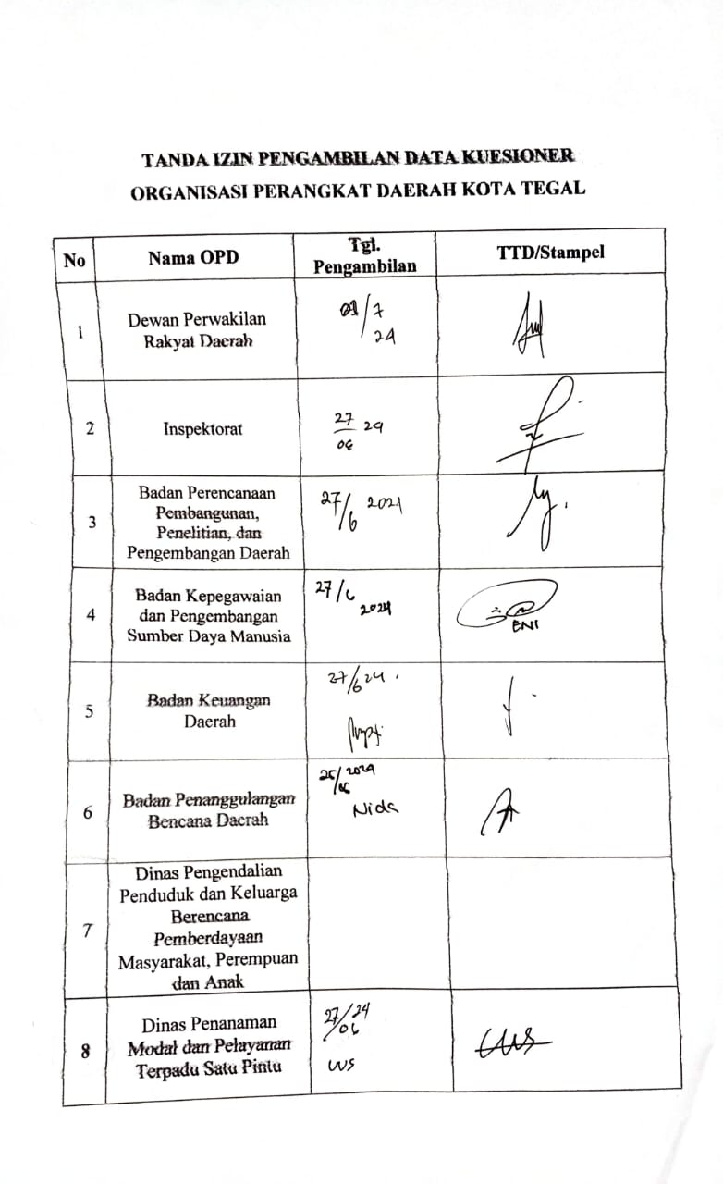

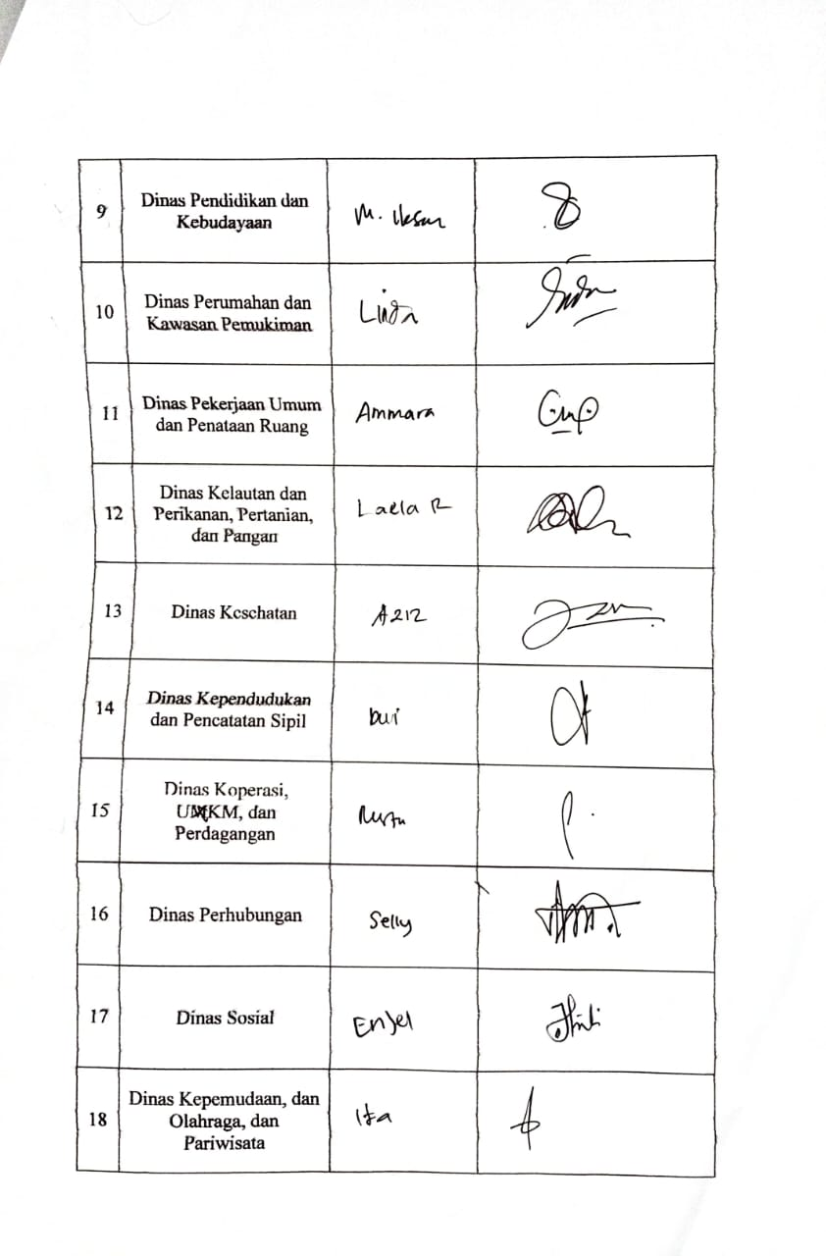

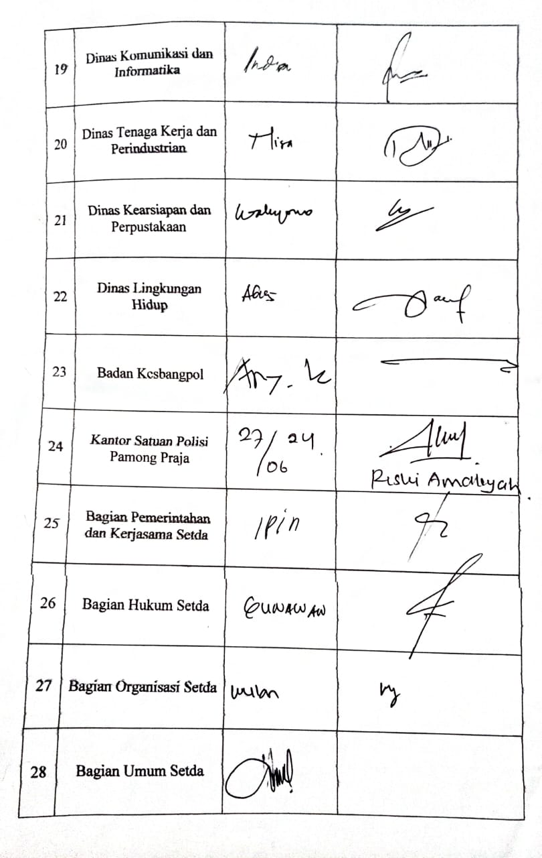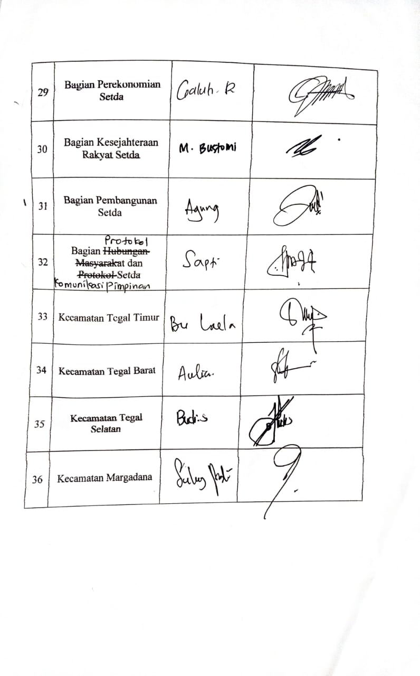

Lampiran . Dokumentasi Pengisian Data Kuesioner

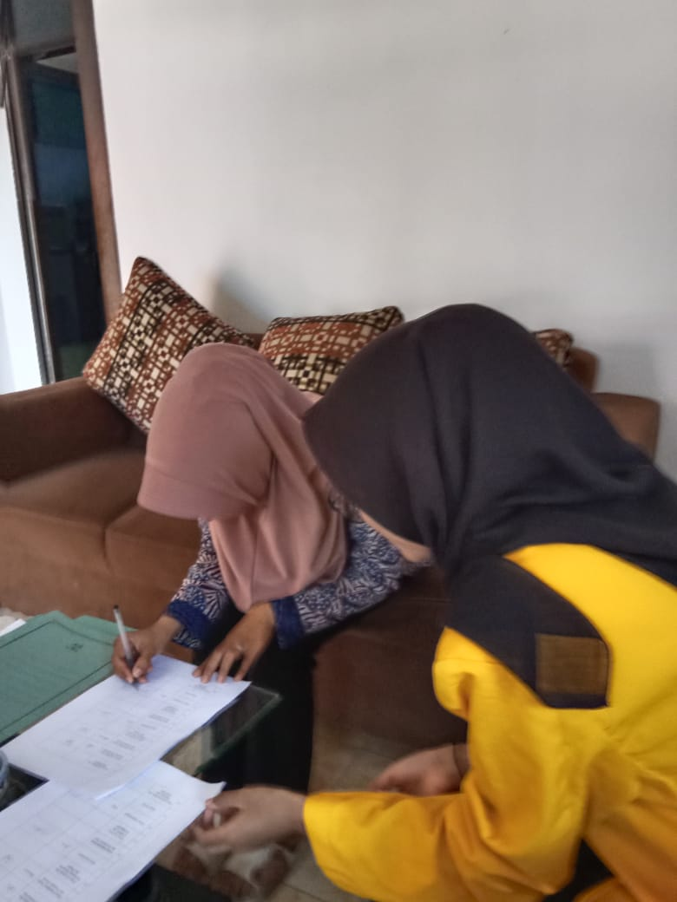

Sumber: Penelitian (2024)

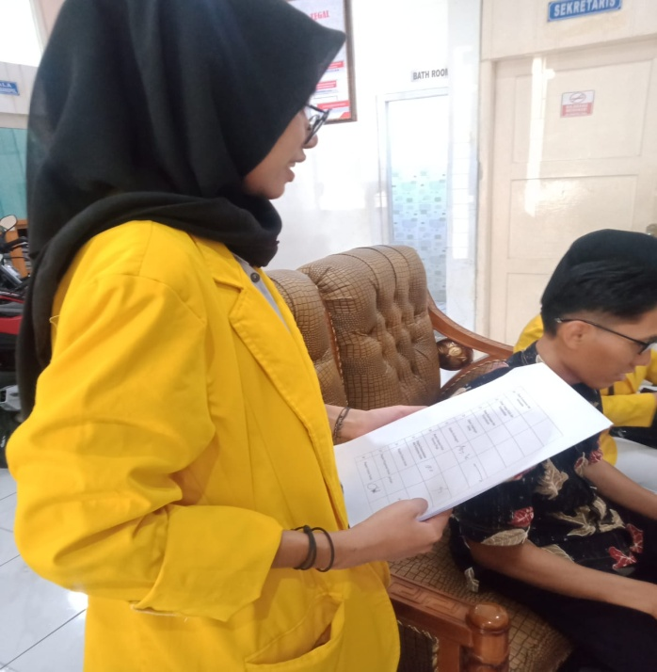

Sumber: Penelitian (2024)

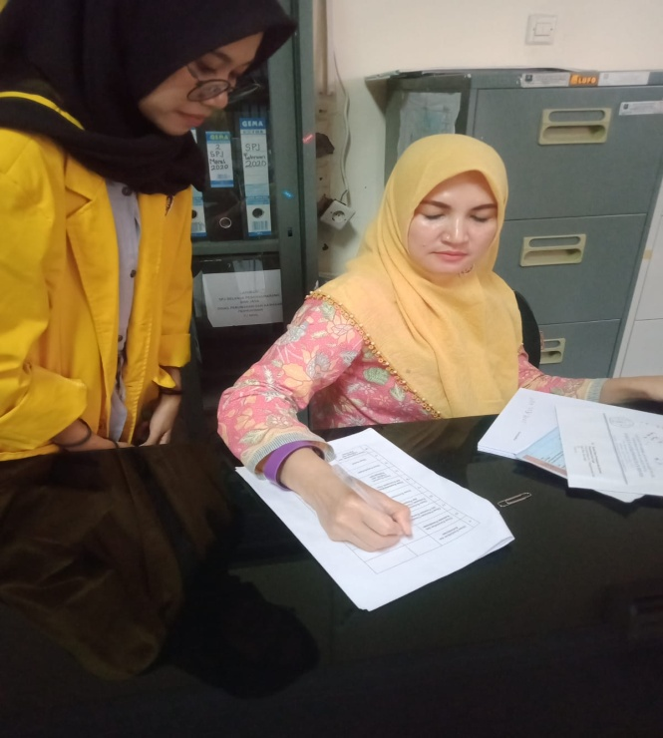

Sumber: Penelitian (2024)

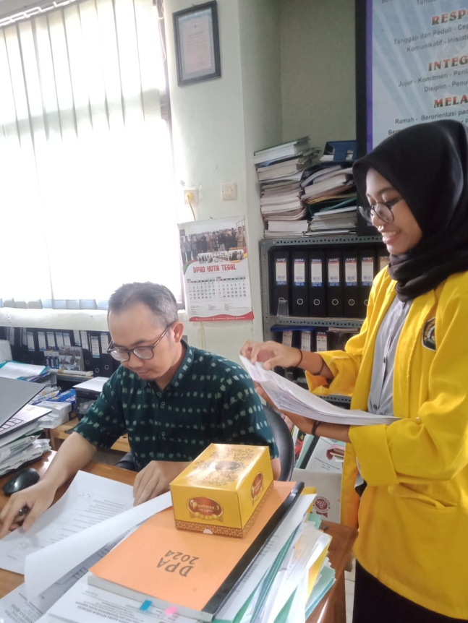

Sumber: Penelitian (2024)