# DAFTAR PUSTAKA

Ajijah, Hilyatul, J., & Selvi, E. (2021). Pengaruh Kompetensi Dan Integritas Terhadap Kinerja Perangkat Desa. *JESS (Journal of Education on Social Science)*, *5*(1), 24. https://doi.org/10.24036/jess.v5i1.314

Ariesta, W., N, H. S., Arafat, Y., & Putri, A. N. (2024). *Kata Kunci: disiplin kerja guru, kepemimpinan kepala sekolah, kinerja guru, Sekolah Menengah Kejuruan .* *10*(January), 179–208.

Aziz, A., Sahra, A., & S, Budi, Fachmi, N. (2019). Pelatihan Komunikasi Interpersonal Untuk Meningkatkan Teamwork Karyawanpada Pt.X. *Al-Qalb : Jurnal Psikologi Islam*, *9*(1), 41–58. https://doi.org/10.15548/alqalb.v9i1.852

Chandra, R. M., Sudjianto, M. K., & Adriana, E. (2023). Faktor-Faktor Komunikasi (Yang Perlu Dimiliki) Generasi Z Dalam Mempersiapkan Karir. *Student Research Journal*, *1*(3), 349–361. http://journal-stiayappimakassar.ac.id/index.php/srj/article/view/345%0Ahttps://journal-stiayappimakassar.ac.id/index.php/srj/article/download/345/351

Darman, S., Natalia, Syahnaz, T., & Saifulloh, I. (2013). Pengaruh Etos Kerja Dan Motivasi Kerja Terhadap Kinerja Karyawan Pada PT. Kirana Permata. *NBER Working Papers*, 89. http://www.nber.org/papers/w16019

Dinda, R., Qomari, N., & Istanti, E. (2021). Pengaruh Komunikasi, Kompensasi dan Disiplin Kerja terhadap Kinerja Karyawan pada PT. The Univenus di Sidoarjo. *Benchmark*, *2*(1), 70–80. https://doi.org/10.46821/benchmark.v2i1.223

Fauzi, A. (2020). *Manajemen Kinerja*. Airlangga University Press. https://www.google.co.id/books/edition/MANAJEMEN_KINERJA/hMjjDwAAQBAJ?hl=id&gbpv=1&dq=pengertian+kinerja&printsec=frontcover

Ghofar, A., & Sukemi. (2024). *Perilaku Organisasi dan Manajemen Kinerja*. https://www.google.co.id/books/edition/Perilaku_Organisasi_dan_Manajemen_Kinerj/zbbxEAAAQBAJ?hl=id&gbpv=1&dq=pengertian+kerjasama+tim&pg=PA27&printsec=frontcover

Heksarini Ariesta. (2021). Konsep Penilaian Kinerja. In *Benchmark* (Vol. 103, Issue 1). http://elibrary.almaata.ac.id/1714/%0Ahttps://osf.io/yejcm/%0Ahttp://elibrary.almaata.ac.id%0Ahttps://bmjopen.bmj.com/lookup/doi/10.1136/bmjopen-2019-030624%0Ahttps://ppjp.ulm.ac.id/journal/index.php/JPKMI/article/view/2758%0Ahttp://stikara.ac.id/jupermik

Ibrahim, F. E., Djuhartono, T., & Sodik, N. (2021). Pengaruh Kerjasama Tim Terhadap Kinerja Karyawan Di Pt Lion Superindo. *Jurnal Arastirma*, *1*(2), 316. https://doi.org/10.32493/arastirma.v1i2.12369

Jasmine, & Pramukty, R. (2023). *Faktor-faktor Yang Mempengaruhi Komitmen Pekerja Dalam Organisasi Budaya, Peraturan Dan Lingkungan Organisasi*. *1*(5).

June, S., & Siagian, M. (2020). Pengaruh Keselamatan Dan Kesehatan Kerja Dan Lingkungan Kerja Terhadap Kinerja Karyawan Pt Lautan Lestari Shipyard. *Jurnal Apresiasi Ekonomi*, *8*(3), 407–420. https://doi.org/10.31846/jae.v8i3.325

Jusmansyah, M. (2020). Analisis Pengaruh Current Ratio, Debt To Equity Ratio, Total Asset Turn Over, Dan Return on Equity Terhadap Harga Saham. *Jurnal Ekonomika Dan Manajemen*, *9*(2), 179–198.

Lesmana, H. (2021). Pengaruh Sistem Informasi Akuntansi dan Pengendalian Internal Terhadap Kualitas Laporan Keuangan Di Kelurahan Pasarbatang. *Jurnal Sistem Informasi Akuntansi (JASIKA)*, *1*(1), 29–37. http://jurnal.bsi.ac.id/index.php/jasika

Letsoin, V. R., & Ratnasari, S. L. (2020). Pengaruh Keterlibatan Karyawan, Loyalitas Kerja Dan Kerjasama Tim Terhadap Kinerja Karyawan. *Jurnal Dimensi*, *9*(1), 17–34. https://doi.org/10.33373/dms.v9i1.2316

Lubis, Miza, Khairum, I., Sembiring, Z., & Wibowo, R. M. (2024). *Pengaruh Kerja Sama Tim , Komunikasi , dan Komitmen terhadap*. *5*(3), 1351–1362.

Marcus, G. V, Dotulong, L. O. H., & Raintung, M. C. (2023). *Pengaruh Komunikasi, Pemberdayaan Pegawai Dan Pendelegasian Wewenang Terhadap Efektivitas Kerja Di Kantor Wilayah Kementerian Agama Provinsi Sulawesi Utara. Jurnal EMBA Vol . 11 No . 3 J*. *11*(3), 1074–1086.

Marlina. (2022). *Buku Ajar Ilmu Komunikasi*. CV. Fenika Muda Sejahtera. https://www.google.co.id/books/edition/BUKU_AJAR_ILMU_KOMUNIKASI/ZGJlEAAAQBAJ?hl=id&gbpv=1&dq=pengertian+komunikasi+2020&pg=PA12&printsec=frontcover

Martin, R., & Janamarta, S. (2023). Pengaruh Komunikasi, Kerjasama Tim, dan Motivasi Kerja terhadap Kinerja Karyawan pada PT. Alba Unggul Metal. *Repository Buddhidarma.Ac.Id*, *2*(15), 100.

Muhtadin, I. (2023). *Kepemimpinan dan Motivasi Kerja Terhadap Kinerja Pegawai* (M. Suardi (ed.)). CV. Azka Puustaka. https://www.google.co.id/books/edition/Kepemimpinan_dan_Motivasi_Kerja_Terhadap/4kfnEAAAQBAJ?hl=id&gbpv=1&dq=pengertian+kinerja+pegawai&pg=PR5&printsec=frontcover

Nafiudin, Andari, Kurnia, D., & Safitri, Tia, A. (2021). Pentingnya Desain Ulang Pekerjaan Dan Deskripsi Pekerjaan Untuk Peningkatan Kinerja Pegawai Pada Masa Pandemi Covid 19. *Sains Manajemen*, *7*(2), 155–167. https://doi.org/10.30656/sm.v7i2.4139

Nova, S., Abdullah, H., Mahrizal, & Yanti, E. M. (2023). Pengaruh Komunikasi dan Etos Kerja Terhadap Efektivitas Kerja. *Jurnal Manajemen STIE Muhammadiyah Palopo*, *9*(1), 96–104.

Olivia, J., & Nurfebiaraning, S. (2019). Pengaruh Video Advertising Tokopedia Versi “ Jadikan Ramadan Kesempatan Terbaik ” Terhadap Respon Afektif. *Jurnal Lontar*, *7*(1), 16–24.

Rahmawati, I., Ferichani, M., & Widadie, F. (2021). *Analisis Pengaruh Marketing Mix (Product, Price, Place, Promotion) Terhadap Keputusan Pembelian Fremilt Thai Tea Di Kota Surakarta*. *9*(4), 149–160.

Ramadhani, Yuda, C. P., & Puspitadewi, Sukmawati, N. W. (2022). Hubungan Budaya Organisasi terhadap Komitmen Organisasional Pada Karyawan Rumah Makan X. *Character : Jurnal Penelitian Psikologi Pada*, *9*(8), 45–56. https://ejournal.unesa.ac.id/index.php/character/article/view/49363/41026

Rohman, S. N., Ambarwati, D., & Saptaria, L. (2023). Pengaruh Beban Kerja dan Lingkungan Kerja Terhadap Kinerja Karyawan PT. Karunia Ultima Kemasan Jatikalen Nganjuk. *Populer: Jurnal Penelitian Mahasiswa*, *2*(4), 22–38.

Sagala, S. (2024). *Komitmen Organisasi*. Umsu Press. https://www.google.co.id/books/edition/KOMITMEN_ORGANISASI_Model_Kausal_Gaya_Ke/pLn4EAAAQBAJ?hl=id&gbpv=1&dq=pengertian+komitmen+kerja&pg=PR5&printsec=frontcover

Simarmata, G. (2022). *Ingin Cepat Kerja*. Andi Offset. https://www.google.co.id/books/edition/Ingin_Cepat_Kerja/kgp0EAAAQBAJ?hl=id&gbpv=1&dq=pengertian+kerjasama+tim&pg=PA49&printsec=frontcover

Tryas, I., Latif, M., & Widdah, M. El. (2022). *Komitmen Organisasi*. Zabags Qu Publish. https://www.google.co.id/books/edition/KOMITMEN_ORGANISASI/dUjHEAAAQBAJ?hl=id&gbpv=1&dq=pengertian+komitmen+kerja+2020&pg=PA64&printsec=frontcover

Widiyana, Olla, E. (2021). *Pengaruh Stres Kerja, Beban Kerja, Konflik Kerja Dan Kompensasi Terhadap Komitmen Kerja Karyawan PT. Intidragon Suryatama Mojokerto. 4.+Eka+Olla,+33-42.pdf*.

Yasir. (2020). *Pengantar Ilmu Komunikasi*. Budi Utama. https://www.google.co.id/books/edition/Pengantar_Ilmu_Komunikasi_Sebuah_Pedekat/_XUCEAAAQBAJ?hl=id&gbpv=1&dq=pengertian+komunikasi&printsec=frontcover

# LAMPIRAN

**Lampiran 1**

**KUESIONER PENELITIAN**

Yang terhormat:

Bapak/Ibu Pegawai

Dinas Tenaga Kerja dan Perindustrian Kota Tegal

Di Tempat

Dengan Hormat

Dalam rangka menyelesaikan penelitian skripsi, kami mahasiswa Fakultas Ekonomi dan Bisnis Universitas Pancasakti Tegal, mohon partisipasinya dari Bapak/Ibu/Sdr untuk mengisi kuesioner yang telah kami sediakan.

Adapun data yang kami minta adalah sesuai dengan kondisi yang dirasakan Bapak/Ibu/Sdr selama ini. Kami akan menjaga kerahasiaannya karena data ini hanya untuk kepentingan penelitian.

Setiap jawaban yang diberikan merupakan bantuan yang tidak ternilai harganya bagi penelitian ini. Kami memberikan jangka waktu selama 1 minggu setelah kuesioner ini kami sebarkan, agar Bapak/Ibu/Sdr dapat segera mengembalikannya kepada kami.

Atas perhatian dan bantuannya, kami mengucapkan banyak terima kasih.

Tegal, Mei 2024

Hormat kami,

Rizqi Septiyani

**KARAKTERISTIK RESPONDEN**

1. Jenis kelamin : a. Laki-laki

b. Perempuan

1. Pendidikan : a. SMA

b. DIII

c. S1

d. S2

1. Umur : a. 21-30 tahun

b. 31-40 tahun

c. 41-50 tahun

d. > 50 tahun

1. Masa Kerja : a. < 1 tahun

b. 1-5 tahun

c. 6-10 tahun

d. > 11 tahun

**PETUNJUK PENGISISAN**

1. Mohon dengan hormat dan kesediaan Bapak/Ibu/Sdr untuk menanggapi seluruh pernyataan yang ada.
2. Beri tanda (X) pada kolom yang tersedia
3. Ada 5 Alternatif jawaban, yaitu:

Sangat Tidak Setuju (STS) : 1

Tidak Setuju (TS) : 2

Netral (N) : 3

Setuju (S) : 4

Sangat Setuju (SS) : 5

**1. Variabel Kinerja (Y)**

|  |  |  |  |  |  |  |
| --- | --- | --- | --- | --- | --- | --- |
| **No** | **Pernyataan** | **Jawaban** | | | | |
| **STS** | **TS** | **N** | **S** | **SS** |
| **Volume Pekerjaan** | |  | | | | |
| 1. | Saya dapat menyelesaikan banyak pekerjaan dalam waktu-waktu tertentu |  |  |  |  |  |
| 2. | Saya hanya dapat menyelesaikan beberapa pekerjaan dalam satu waktu |  |  |  |  |  |
| **Hasil Kerja** | |  | | | | |
| 3. | Hasil kerja saya selalu memuaskan |  |  |  |  |  |
| 4. | Saya kurang puas dengan hasil kerja yang sudah saya kerjakan |  |  |  |  |  |
| **Prosedur Pekerjaan** | |  | | | | |
| 5. | Saya dapat memahami prosedur dalam pekerjaan |  |  |  |  |  |
| 6. | Saya kurang memahami prosedur dalam pekerjaan |  |  |  |  |  |
| **Kemampuan Bertahan** | |  | | | | |
| 7. | Saya mampu bertahan dalam kondisi pekerjaan |  |  |  |  |  |
| 8. | Saya kurang mampu bertahan dalam kondisi pekerjaan |  |  |  |  |  |
| **Mampu Bekerjasama** | |  | | | | |
| 9. | Saya dapat bekerjasama dengan baik dengan pegawai lain |  |  |  |  |  |
| 10. | Saya kurang nyaman untuk bekerjasama dengan pegawai lain |  |  |  |  |  |
| **Tidak Ketergantungan** | |  | | | | |
| 11. | Saya dapat bekerja secara mandiri tanpa bergantung rekan yang lain |  |  |  |  |  |
| 12. | Saya sangat bergantung pada rekan lain dalam beberapa pekerjaan |  |  |  |  |  |

**2. Variabel Kerjasama Tim (X1)**

|  |  |  |  |  |  |  |
| --- | --- | --- | --- | --- | --- | --- |
| **No** | **Pernyataan** | **Jawaban** | | | | |
| **STS** | **TS** | **N** | **S** | **SS** |
| **Hasil Yang Efektif** | |  | | | | |
| 1. | Hasil pekerjaan lebih maksimal dan efektif jika dikerjakan secara tim |  |  |  |  |  |
| 2. | Hasil pekerjaan lebih maksimal dan efektif jika dikerjakan sendiri atau individu |  |  |  |  |  |
| **Kesungguhan Bekerja** | |  | | | | |
| 3. | Saya bersungguh-sungguh dengan apa yang dikatakan dan dilakukan |  |  |  |  |  |
| 4. | Saya dapat bertanggungjawab atas apa yang sudah dikatakan dan dilakukan |  |  |  |  |  |
| **Bertanggungjawab** | |  | | | | |
| 5. | Saya memiliki tingkat solidaritas yang tinggi |  |  |  |  |  |
| 6. | Saya memiliki perasaan positif terhadap kelompok tim |  |  |  |  |  |

**3. Variabel Komunikasi (X2)**

|  |  |  |  |  |  |  |
| --- | --- | --- | --- | --- | --- | --- |
| **No** | **Pernyataan** | **Jawaban** | | | | |
| **STS** | **TS** | **N** | **S** | **SS** |
| **Kemampuan Memprediksi** | |  | | | | |
| 1. | Saya dapat memperkirakan apakah pesan yang disampaikan dapat tersampaikan dengan benar |  |  |  |  |  |
| 2. | Saya dapat memperkirakan apakah pesan yang disampaikan dapat diterima dengan baik oleh penerima |  |  |  |  |  |
| **Pemahaman Keinginan** | |  | | | | |
| 3. | Saya mampu dengan tepat menentukan keinginan atau keperluan pegawai lain |  |  |  |  |  |
| 4. | Saya dapat mengetahui dengan tepat cara berkomunikasi yang benar dengan pegawai lain |  |  |  |  |  |
| **Dapat Dipercaya** | |  | | | | |
| 5. | Saya dapat percaya sepenuhnya kepada pegawai yang lain |  |  |  |  |  |
| 6. | Saya memiliki rasa percaya hanya pada beberapa pegawai tertentu |  |  |  |  |  |
| **Respon Yang Tepat** | |  | | | | |
| 7. | Saya dapat memberikan respon yang tepat terhadap pendapat dari pegawai lain |  |  |  |  |  |
| 8. | Saya dapat memperkirakan bagaimana respon pegawai lain terhadap pendapat yang dia buat |  |  |  |  |  |

**4. Variabel Komitmen Kerja (X3)**

|  |  |  |  |  |  |  |
| --- | --- | --- | --- | --- | --- | --- |
| **No** | **Pernyataan** | **Jawaban** | | | | |
| **STS** | **TS** | **N** | **S** | **SS** |
| **Bersikap Positif** | |  | | | | |
| 1. | Saya dapat bersikap positif dalam segala situasi |  |  |  |  |  |
| 2. | Saya dapat memperkirakan karakter atau sifat dari pegawai lain |  |  |  |  |  |
| 3. | Saya dapat memperkirakan bagaimana keadaan atau suasana dalam tim |  |  |  |  |  |
| **Pengaturan Emosi** | |  | | | | |
| 4. | Saya dapat mengatur emosi dalam segala situasi |  |  |  |  |  |
| 5. | Saya dapat menenangkan pegawai lain jika ada yang sedang emosi |  |  |  |  |  |
| 6. | Saya dapat mengontrol emosi saat berbuat kesalahan |  |  |  |  |  |
| **Perasaan Bangga** | |  | | | | |
| 7. | Saya merasa bangga dapat bekerja ditempat yang sekarang |  |  |  |  |  |
| 8. | Saya merasa bangga atas tugas yang selama ini sudah diselesaikan |  |  |  |  |  |
| 9. | Saya merasa bangga dengan hasil kerja dari tim |  |  |  |  |  |

**Lampiran 2**

**Percakapan Wawancara**

Informan : Metria Marlinda, SH

Pekerjaan : Kepala Sub. Bagian Umum dan Kepegawaian

Tempat : Dinas Tenaga Kerja dan Perindustrian Kota Tegal

Tanggal Wawancara : 22 Februari 2024

Peneliti : Sebelumnya perkenalkan bu, nama saya Rizqi Septiyani dari Universitas Pancasakti Tegal. Maksud kedatangan saya kesini ingin melakukan penelitian di Dinas Tenaga Kerja dan Perindustrian Kota Tegal, yang kaitannya dengan kinerja pegawai bu, bagaimana masalah kinerja pegawainya disini ?

Bu Linda : Judul penelitiannya apa mba ?

Peneliti : Pengaruh Kerjasama tim, komunikasi, dan komitmen kerja terhadapa kinerja pegawai pada Dinas Tenaga Kerja dan Perindustrian Kota Tegal bu.

Bu Linda : Jadi yang ditanyakan itu ?

Peneliti : Variabel kinerja pegawai bu.

Bu Linda :Misalnya ya ada kegiatan yang tidak di SPJ kan (Surat Pertanggungjawaban). SPJ Dinas itu sebuah dokumen yang digunakan untuk menyampaikan pertanggungjawaban atas penggunaan dana atau anggaran dalam suatu kegiatan atau program yang dilakukan oleh suatu instansi atau lembaga pemerintah. Isi dari SPJ Dinas itu mencakup rincian penggunaan dana, termasuk biaya-biaya yang dikeluarkan, serta bukti-bukti atau dokumentasi yang mendukung pengeluaran tersebut. SPJ Dinas bertujuan untuk memastikan transparansi, akuntabilitas, dan kepatuhan terhadap peraturan yang berlaku dalam penggunaan dana atau anggaran tersebut. Nah misalnya ada kegiatan yang tidak di SPJ kan sesuai dengan rencana anggaran kas, maka akan terjadi miskomunikasi, seharusnya pencairan itu bisa dilaksanakan bulan februari tapi belum bisa dicairkan bulan februari itu berartikan ada miskomunikasi buat kami yang menyebabkan keterlambatan administrasi yang menimbulkan resiko mundurnya waktu kegiatan pelaksanaan sehingga target tidak tercapai gitu.

Peneliti : Berarti tidak sesuai targetnya ya bu.

Bu Linda : Iya tidak sesuai target.

Peneliti : Kalo untuk kuantitas kerja, kualitas kerja, pengetahuan, kreativitas, kerjasama, kemandirian, inisiatif dan kehandalan pegawai itu sendiri gimana ya bu apakah ada masalah ?

Bu Linda : Ou kalau untuk kuantitas kerjanya ya mba, mungkin seperti beban kerjanya yang tidak sesuai kemampuan pegawai dan banyaknya beban kerja pegawai yang akhirnya pegawai tersebut jadi kelelahan dan stress, sehingga berdampak negatif pada kinerja mereka, terus untuk kualitas kerjanya juga kurang karena pegawai tersebut tidak memberikan hasil kerja yang memenuhi standar yang ditetapkan, terus untuk pengetahuannya ya mba mungkin kurang karena pegawai itu sendiri merasa bahwa mereka tidak memiliki kemampuan yang cukup untuk menyelesaikan tugas-tugas mereka dengan baik, yang akhirnya pegawai tersebut menjadi frustasi dan kehilangan motivasi sehingga menyebabkan turunnya kinerja pegawai karena pegawai merasa tidak mampu untuk memberikan kontribusi yang signifikan, gitu mba. Nah untuk kurangnya keterampilan pegawai itu sendiri ya mba mereka mungkin merasa tidak aman dan tidak yakin dalam peran mereka karena pegawai itu sendiri merasa tidak memiliki keterampilan yang diperlukan. Kalo untuk kerjasamanya kurang karena beberapa perilaku dari pegawainya yang kurang baik seperti lingkungan yang kurang mendukung untuk bisa menyampaikan pendapat kepada tim tersebut, terus kurangnya kemandirian karena pegawai itu sendiri terlalu bergantung pada pegawai lain, nah hal ini dapat menghambat kemampuan mereka untuk bekerja secara mandiri dan efisien. Terus untuk kurangnya inisiatif karena pegawai itu sendiri tidak berinisiatif untuk mencari solusi atau mengambil tindakan dalam menyelesaikan masalah. Kalo yang terakhir untuk kurangnya kehandalan ya mba pegawai mungkin seringkali tidak dapat dipercaya dalam menyelesaikan tugas mereka dengan baik dan tepat waktu.

Peneliti : Terus dari kerjasama timnya bu masalahnya apa disini ?

Bu Linda : Dari kerjasama tim ya, kemungkinan yang paling besar itu karena beberapa behavior/perilaku dari pegawainya yang kurang baik seperti lingkungannya yang kurang mendukung untuk bisa menyampaikan pendapat kepada tim tersebut, terus kurangnya kepercayaan antar pegawai, kurangnya kekompakan. Nah hal ini dapat menyebabkan ketidakseimbangan dalam lingkungan kerja dan menghambat efisiensi serta efektivitas pelaksanaan tugas mba.

Peneliti : Oh begitu bu, kalo untuk masalah komunikasinya bu disini bagaimana ya?

Bu Linda : Untuk masalah komunikasi ya mba, disini itu komunikasinya juga belum maksimal karena adanya komunikasi yang tidak efektif. Komunikasi yang tidak efektif itu dapat menjadi hambatan besar dalam Dinas Tenaga Kerja dan Perindustrian Kota Tegal, dan dapat menciptakan berbagai masalah seperti kurangnya keterbukaan antara bawahan keatasan atau dari atasan kebawahan, seperti kurangnya persepsi misalnya kita menjelaskan sesuatu tapi tidak tersampaikan dengan baik, terus kurangnya ketepatan seperti kurangnya keahlian atau pengetahuan tentang tugas yang harus mereka lakukan, terus kurangnya kredibilitas dalam komunikasi seperti dari bawahan mungkin tidak diberikan kesempatan untuk mengutarakan pendapatnya atau tidak tersampaikan maksud dan tujuannya kepemimpinan seperti kurangnya mendengarkan usulan dari bawahan tersebut sehingga apa yang disampaikan tidak tersampaikan dengan baik, terus kurangnya pengendalian ya mba seperti tidak memberikan dukungan yang memadai seperti kurangnya menyediakan pelatihan yang diperlukan sehingga kurangnya keterampilan dan pengetahuan yang diperlukan untuk melakukan tugas mereka, dan kurangnya keharmonisan antar pegawai karena dapat mengakibatkan ketidakpastian, ketegangan, dan konflik di tempat kerja yang pada akhirnya dapat mempengaruhi kinerja mereka. seperti itu mba

Peneliti : Kalo yang terakhir, untuk masalah komitmen kerja pegawainya gimana ya bu ?

Bu Linda : Oh iya mba untuk masalah komitmen kerja pegawainya di Disnakerin itu seperti kurangnya memahami emosi positif, seperti seorang pegawai merasa bahwa mereka tidak memiliki kemampuan yang cukup untuk menyelesaikan tugas-tugas mereka dengan baik, pegawai mungkin menjadi frustasi dan kehilangan motivasi, sehingga dapat mengurangi komitmen kerja atau loyalitas karena pegawai merasa tidak mampu untuk memberikan kontribusi yang signifikan, dan kurangnya keterikatan emosional seperti kehilangan motivasi, keengganan untuk bekerjasama dengan rekan kerja. Selain itu mba kurangnya keterikatan emosional juga dapat berdampak negatif pada hubungan antar pegawai dan atasan yang dapat mempengaruhi komunikasi dan kolabirasi ditempat kerja mba.

Peneliti : Udah bu cukup, terimakasih ya terus sementara ini cukup segini saja yang saya tanyakan bu, nanti jika saya membutuhkan informasi yang lainnya saya minta izin ke ibu sekaligus minta maaf karena sudah mengganggu waktunya ibu.

Bu Linda : Engga, sama-sama mba terimakasih juga yah.

**Lampiran 3**

**Surat Balasan Pemberian Ijin Penelitian**

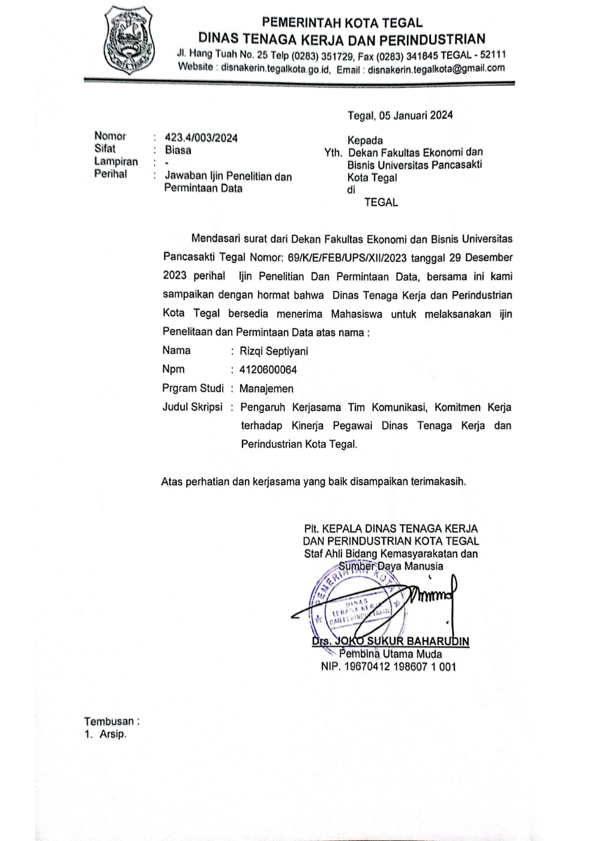

**Lampiran 4**

**Data Penelitian Kinerja**

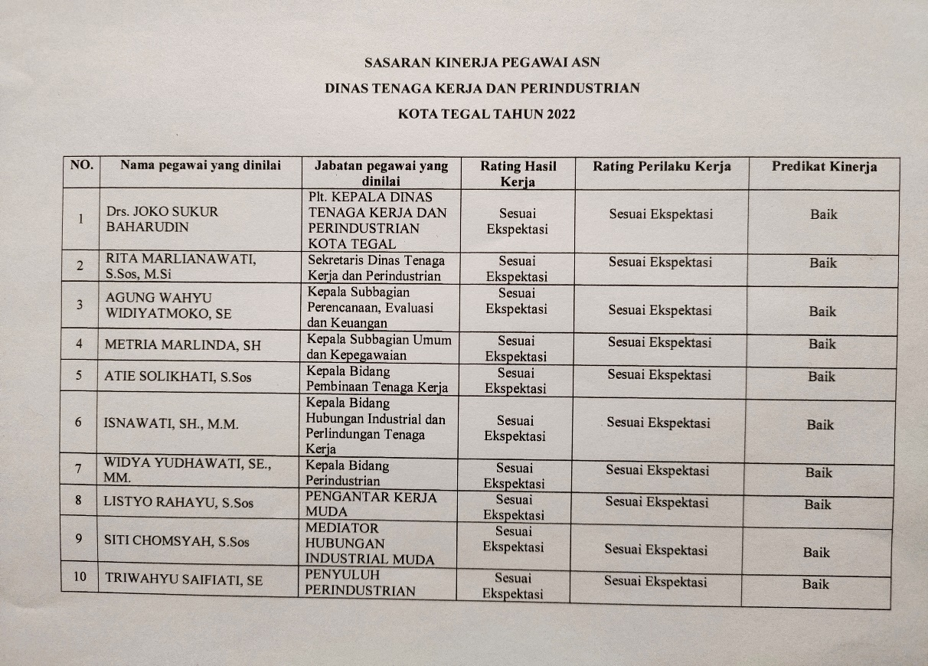

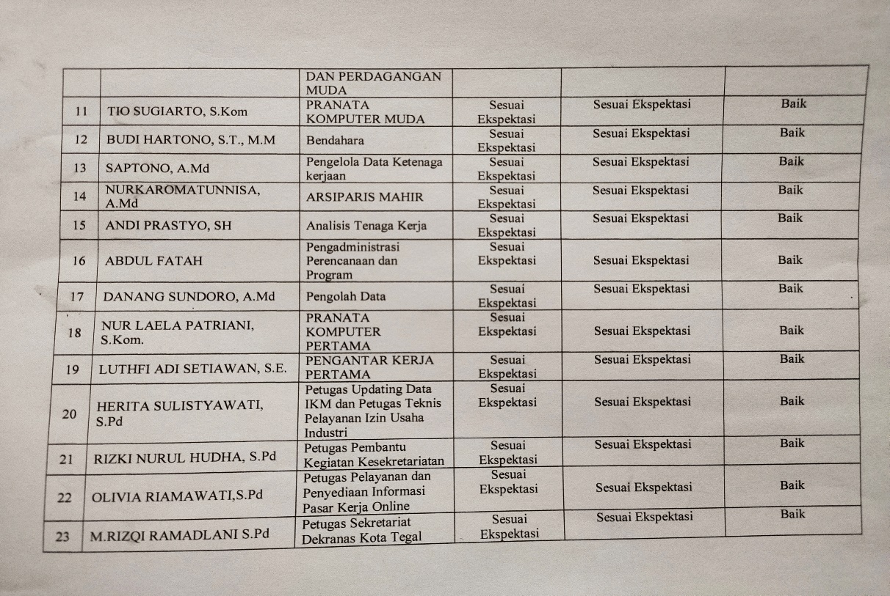

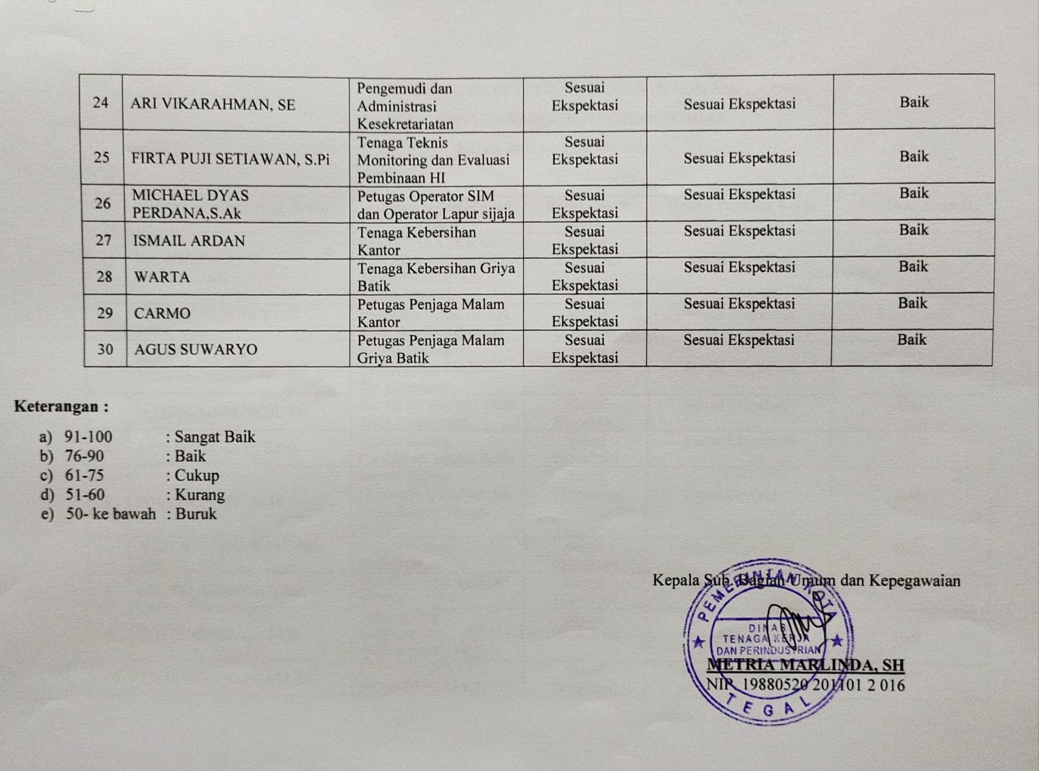

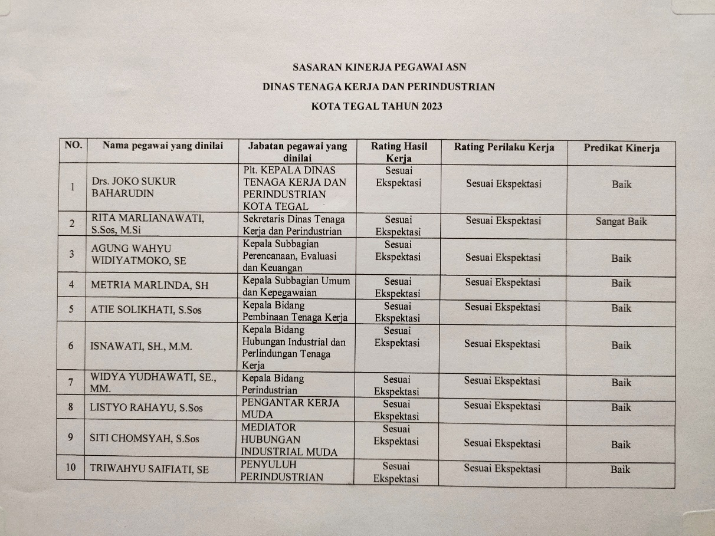

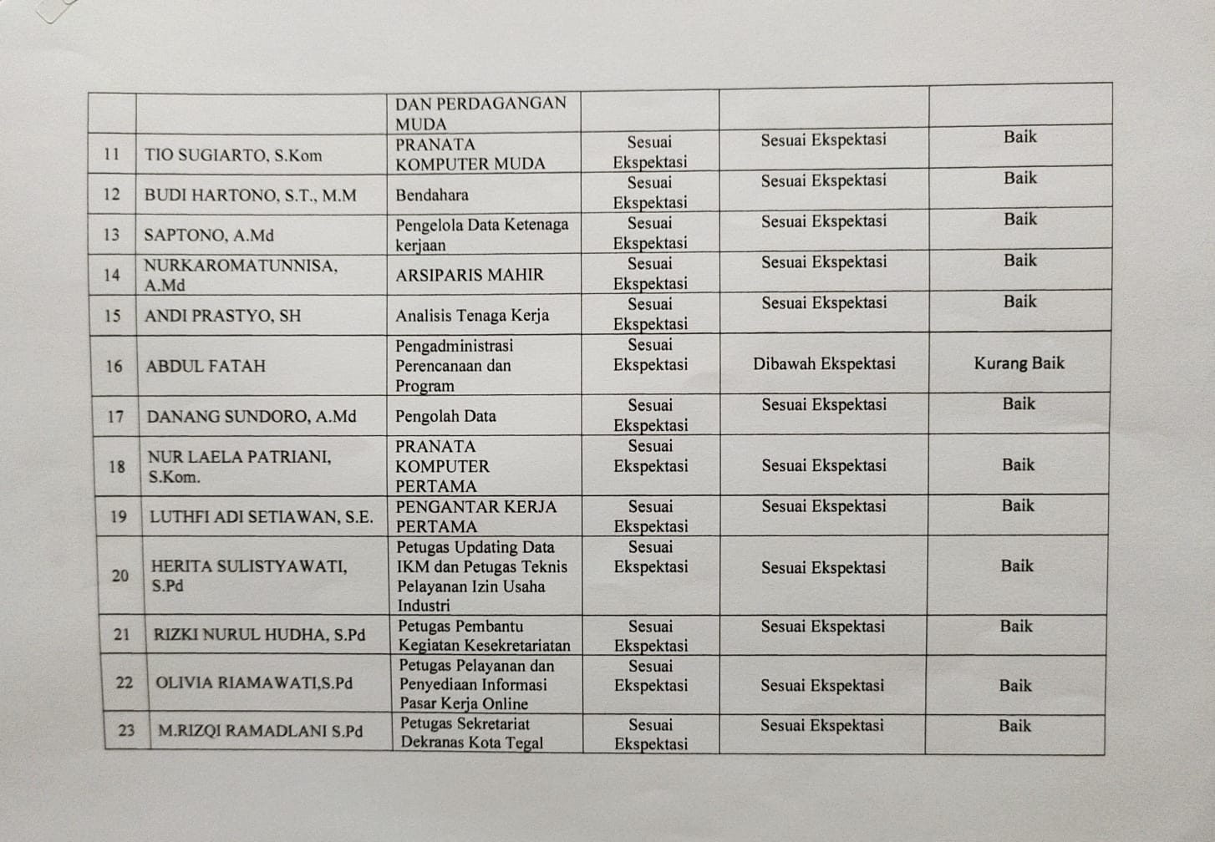

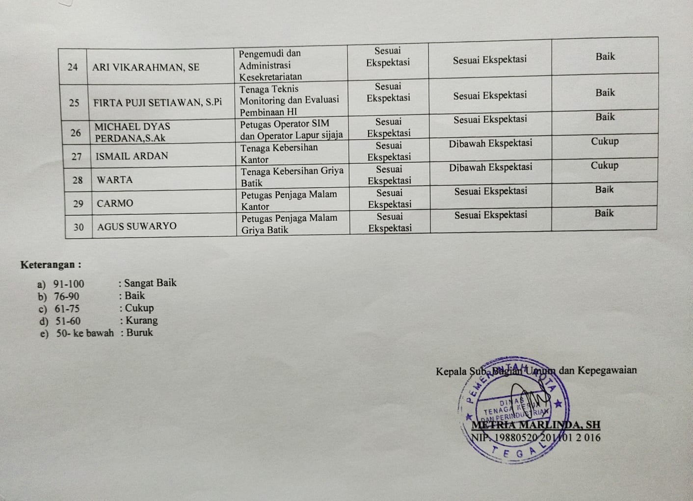

**Data Penelitian Kerjasama Tim**

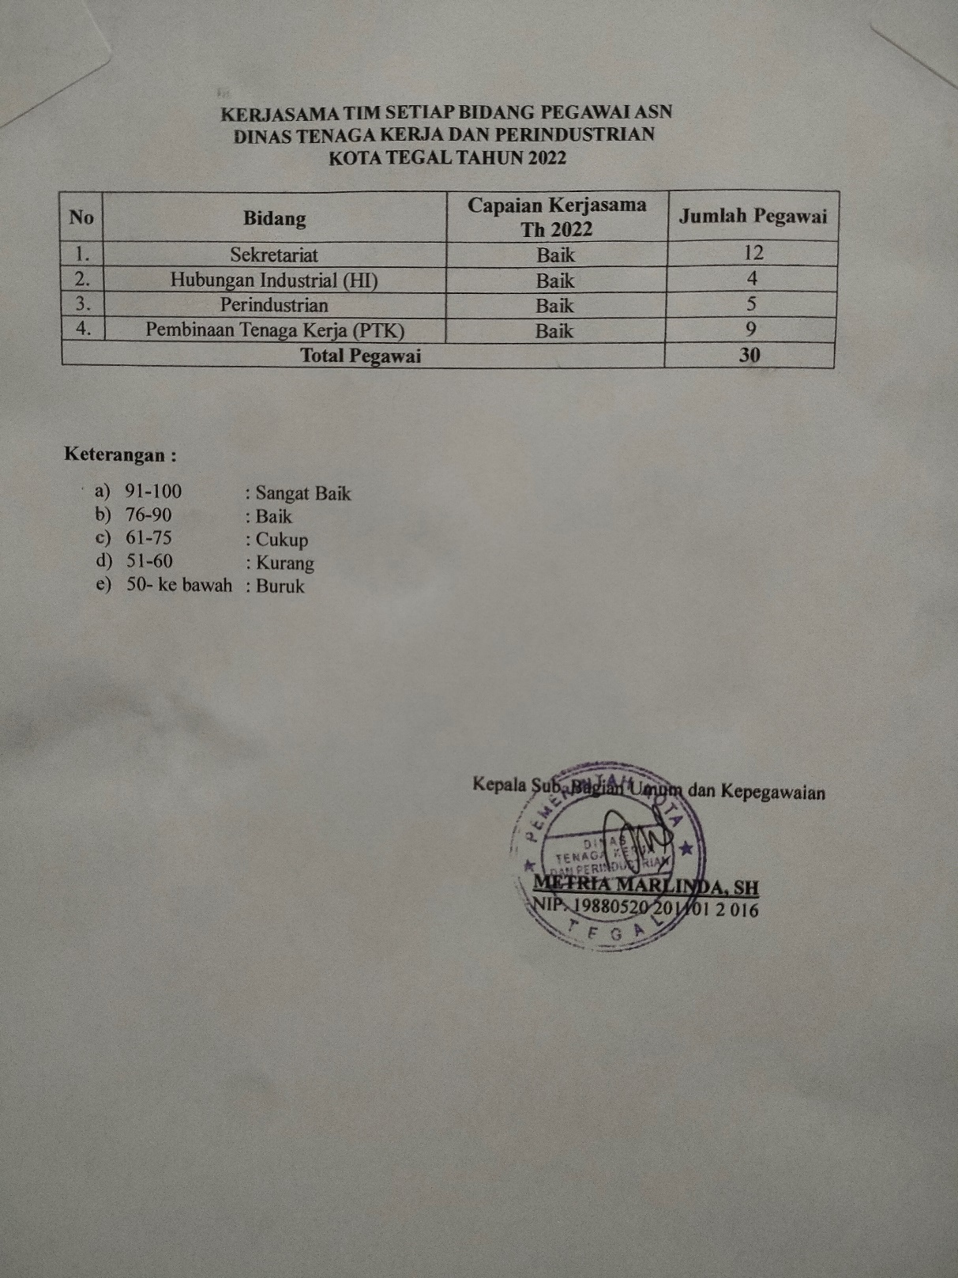

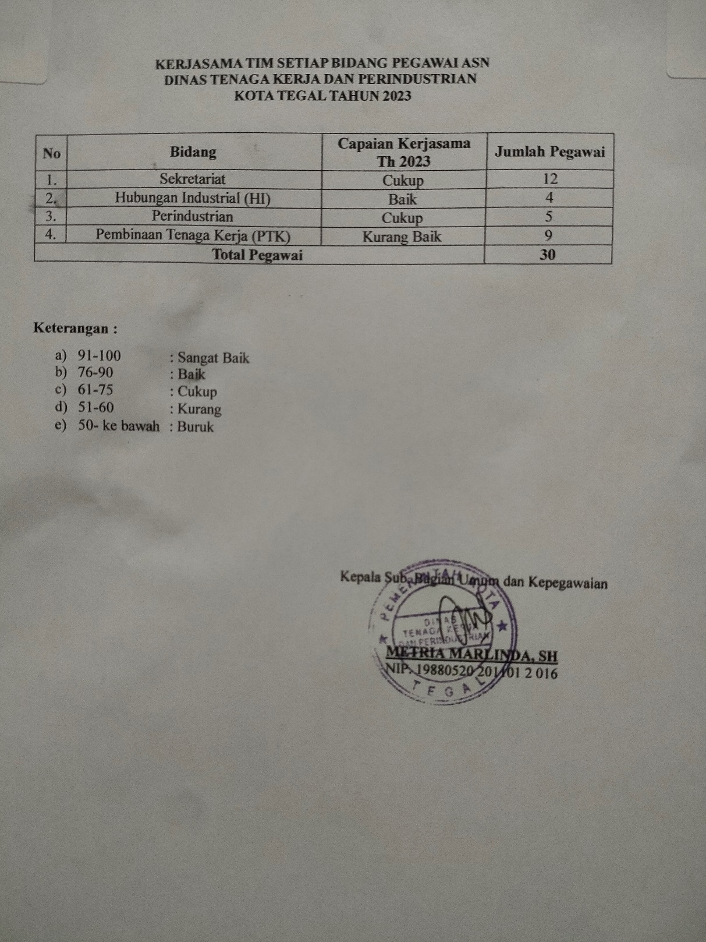

**Lampiran 5**

**Hasil Uji Validitas**

1. **Uji Validitas Variabel Kinerja (Y)**

|  |  |  |  |  |  |  |  |  |  |  |  |  |  |  |
| --- | --- | --- | --- | --- | --- | --- | --- | --- | --- | --- | --- | --- | --- | --- |
| **Correlations** | | | | | | | | | | | | | | |
|  | | Y1.1 | Y1.2 | Y1.3 | Y1.4 | Y1.5 | Y1.6 | Y1.7 | Y1.8 | Y1.9 | Y1.10 | Y1.11 | Y1.12 | TOTAL |
| Y1.1 | Pearson Correlation | 1 | .220 | .453* | .181 | .220 | .453* | .505** | .374* | .453* | .453* | .479** | .301 | .531** |
| Sig. (2-tailed) |  | .242 | .012 | .338 | .242 | .012 | .004 | .042 | .012 | .012 | .007 | .106 | .003 |
| N | 30 | 30 | 30 | 30 | 30 | 30 | 30 | 30 | 30 | 30 | 30 | 30 | 30 |
| Y1.2 | Pearson Correlation | .220 | 1 | .589** | .738** | 1.000** | .589** | .314 | .448* | .589** | .386* | .243 | .396* | .703** |
| Sig. (2-tailed) | .242 |  | .001 | .000 | .000 | .001 | .091 | .013 | .001 | .035 | .195 | .030 | .000 |
| N | 30 | 30 | 30 | 30 | 30 | 30 | 30 | 30 | 30 | 30 | 30 | 30 | 30 |
| Y1.3 | Pearson Correlation | .453* | .589** | 1 | .640** | .589** | 1.000** | .329 | .840** | 1.000** | .615** | .369* | .602** | .923** |
| Sig. (2-tailed) | .012 | .001 |  | .000 | .001 | .000 | .076 | .000 | .000 | .000 | .045 | .000 | .000 |
| N | 30 | 30 | 30 | 30 | 30 | 30 | 30 | 30 | 30 | 30 | 30 | 30 | 30 |
| Y1.4 | Pearson Correlation | .181 | .738** | .640** | 1 | .738** | .640** | .217 | .560** | .640** | .344 | .146 | .290 | .689** |
| Sig. (2-tailed) | .338 | .000 | .000 |  | .000 | .000 | .250 | .001 | .000 | .063 | .442 | .120 | .000 |
| N | 30 | 30 | 30 | 30 | 30 | 30 | 30 | 30 | 30 | 30 | 30 | 30 | 30 |
| Y1.5 | Pearson Correlation | .220 | 1.000** | .589** | .738** | 1 | .589** | .314 | .448* | .589** | .386* | .243 | .396* | .703** |
| Sig. (2-tailed) | .242 | .000 | .001 | .000 |  | .001 | .091 | .013 | .001 | .035 | .195 | .030 | .000 |
| N | 30 | 30 | 30 | 30 | 30 | 30 | 30 | 30 | 30 | 30 | 30 | 30 | 30 |
| Y1.6 | Pearson Correlation | .453* | .589** | 1.000** | .640** | .589** | 1 | .329 | .840** | 1.000** | .615** | .369* | .602** | .923** |
| Sig. (2-tailed) | .012 | .001 | .000 | .000 | .001 |  | .076 | .000 | .000 | .000 | .045 | .000 | .000 |
| N | 30 | 30 | 30 | 30 | 30 | 30 | 30 | 30 | 30 | 30 | 30 | 30 | 30 |
| Y1.7 | Pearson Correlation | .505** | .314 | .329 | .217 | .314 | .329 | 1 | .311 | .329 | .634** | .595** | .444* | .551** |
| Sig. (2-tailed) | .004 | .091 | .076 | .250 | .091 | .076 |  | .094 | .076 | .000 | .001 | .014 | .002 |
| N | 30 | 30 | 30 | 30 | 30 | 30 | 30 | 30 | 30 | 30 | 30 | 30 | 30 |
| Y1.8 | Pearson Correlation | .374* | .448* | .840** | .560** | .448* | .840** | .311 | 1 | .840** | .654** | .454* | .660** | .865** |
| Sig. (2-tailed) | .042 | .013 | .000 | .001 | .013 | .000 | .094 |  | .000 | .000 | .012 | .000 | .000 |
| N | 30 | 30 | 30 | 30 | 30 | 30 | 30 | 30 | 30 | 30 | 30 | 30 | 30 |
| Y1.9 | Pearson Correlation | .453* | .589** | 1.000** | .640** | .589** | 1.000** | .329 | .840** | 1 | .615** | .369* | .602** | .923** |
| Sig. (2-tailed) | .012 | .001 | .000 | .000 | .001 | .000 | .076 | .000 |  | .000 | .045 | .000 | .000 |
| N | 30 | 30 | 30 | 30 | 30 | 30 | 30 | 30 | 30 | 30 | 30 | 30 | 30 |
| Y1.10 | Pearson Correlation | .453* | .386* | .615** | .344 | .386* | .615** | .634** | .654** | .615** | 1 | .585** | .773** | .795** |
| Sig. (2-tailed) | .012 | .035 | .000 | .063 | .035 | .000 | .000 | .000 | .000 |  | .001 | .000 | .000 |
| N | 30 | 30 | 30 | 30 | 30 | 30 | 30 | 30 | 30 | 30 | 30 | 30 | 30 |
| Y1.11 | Pearson Correlation | .479** | .243 | .369* | .146 | .243 | .369* | .595** | .454* | .369* | .585** | 1 | .302 | .546** |
| Sig. (2-tailed) | .007 | .195 | .045 | .442 | .195 | .045 | .001 | .012 | .045 | .001 |  | .105 | .002 |
| N | 30 | 30 | 30 | 30 | 30 | 30 | 30 | 30 | 30 | 30 | 30 | 30 | 30 |
| Y1.12 | Pearson Correlation | .301 | .396* | .602** | .290 | .396* | .602** | .444* | .660** | .602** | .773** | .302 | 1 | .737** |
| Sig. (2-tailed) | .106 | .030 | .000 | .120 | .030 | .000 | .014 | .000 | .000 | .000 | .105 |  | .000 |
| N | 30 | 30 | 30 | 30 | 30 | 30 | 30 | 30 | 30 | 30 | 30 | 30 | 30 |
| TOTAL | Pearson Correlation | .531** | .703** | .923** | .689** | .703** | .923** | .551** | .865** | .923** | .795** | .546** | .737** | 1 |
| Sig. (2-tailed) | .003 | .000 | .000 | .000 | .000 | .000 | .002 | .000 | .000 | .000 | .002 | .000 |  |
| N | 30 | 30 | 30 | 30 | 30 | 30 | 30 | 30 | 30 | 30 | 30 | 30 | 30 |

1. **Uji Validitas Variabel Kerjasama Tim (X1)**

|  |  |  |  |  |  |  |  |  |
| --- | --- | --- | --- | --- | --- | --- | --- | --- |
| **Correlations** | | | | | | | | |
|  | | X1.1 | X1.2 | X1.3 | X1.4 | X1.5 | X1.6 | TTL |
| X1.1 | Pearson Correlation | 1 | .022 | .406* | 1.000** | .785** | .406* | .751** |
| Sig. (2-tailed) |  | .910 | .026 | .000 | .000 | .026 | .000 |
| N | 30 | 30 | 30 | 30 | 30 | 30 | 30 |
| X1.2 | Pearson Correlation | .022 | 1 | .424* | .022 | .256 | .424* | .524** |
| Sig. (2-tailed) | .910 |  | .020 | .910 | .172 | .020 | .003 |
| N | 30 | 30 | 30 | 30 | 30 | 30 | 30 |
| X1.3 | Pearson Correlation | .406* | .424* | 1 | .406* | .576** | 1.000** | .837** |
| Sig. (2-tailed) | .026 | .020 |  | .026 | .001 | .000 | .000 |
| N | 30 | 30 | 30 | 30 | 30 | 30 | 30 |
| X1.4 | Pearson Correlation | 1.000** | .022 | .406* | 1 | .785** | .406* | .751** |
| Sig. (2-tailed) | .000 | .910 | .026 |  | .000 | .026 | .000 |
| N | 30 | 30 | 30 | 30 | 30 | 30 | 30 |
| X1.5 | Pearson Correlation | .785** | .256 | .576** | .785** | 1 | .576** | .868** |
| Sig. (2-tailed) | .000 | .172 | .001 | .000 |  | .001 | .000 |
| N | 30 | 30 | 30 | 30 | 30 | 30 | 30 |
| X1.6 | Pearson Correlation | .406* | .424* | 1.000** | .406* | .576** | 1 | .837** |
| Sig. (2-tailed) | .026 | .020 | .000 | .026 | .001 |  | .000 |
| N | 30 | 30 | 30 | 30 | 30 | 30 | 30 |
| TTL | Pearson Correlation | .751** | .524** | .837** | .751** | .868** | .837** | 1 |
| Sig. (2-tailed) | .000 | .003 | .000 | .000 | .000 | .000 |  |
| N | 30 | 30 | 30 | 30 | 30 | 30 | 30 |

1. **Uji Validitas Variabel Komunikasi (X2)**

|  |  |  |  |  |  |  |  |  |  |  |
| --- | --- | --- | --- | --- | --- | --- | --- | --- | --- | --- |
| **Correlations** | | | | | | | | | | |
|  | | X2.1 | X2.2 | X2.3 | X2.4 | X2.5 | X2.6 | X2.7 | X2.8 | JUMLAH |
| X2.1 | Pearson Correlation | 1 | .164 | .728** | .664** | .234 | .664** | .681** | .164 | .776** |
| Sig. (2-tailed) |  | .386 | .000 | .000 | .213 | .000 | .000 | .386 | .000 |
| N | 30 | 30 | 30 | 30 | 30 | 30 | 30 | 30 | 30 |
| X2.2 | Pearson Correlation | .164 | 1 | .423* | .042 | .437* | .042 | .591** | 1.000** | .636** |
| Sig. (2-tailed) | .386 |  | .020 | .825 | .016 | .825 | .001 | .000 | .000 |
| N | 30 | 30 | 30 | 30 | 30 | 30 | 30 | 30 | 30 |
| X2.3 | Pearson Correlation | .728** | .423* | 1 | .456* | .260 | .456* | .611** | .423* | .779** |
| Sig. (2-tailed) | .000 | .020 |  | .011 | .166 | .011 | .000 | .020 | .000 |
| N | 30 | 30 | 30 | 30 | 30 | 30 | 30 | 30 | 30 |
| X2.4 | Pearson Correlation | .664** | .042 | .456* | 1 | .033 | 1.000** | .520** | .042 | .689** |
| Sig. (2-tailed) | .000 | .825 | .011 |  | .863 | .000 | .003 | .825 | .000 |
| N | 30 | 30 | 30 | 30 | 30 | 30 | 30 | 30 | 30 |
| X2.5 | Pearson Correlation | .234 | .437* | .260 | .033 | 1 | .033 | .408* | .437* | .518** |
| Sig. (2-tailed) | .213 | .016 | .166 | .863 |  | .863 | .025 | .016 | .003 |
| N | 30 | 30 | 30 | 30 | 30 | 30 | 30 | 30 | 30 |
| X2.6 | Pearson Correlation | .664** | .042 | .456* | 1.000** | .033 | 1 | .520** | .042 | .689** |
| Sig. (2-tailed) | .000 | .825 | .011 | .000 | .863 |  | .003 | .825 | .000 |
| N | 30 | 30 | 30 | 30 | 30 | 30 | 30 | 30 | 30 |
| X2.7 | Pearson Correlation | .681** | .591** | .611** | .520** | .408* | .520** | 1 | .591** | .870** |
| Sig. (2-tailed) | .000 | .001 | .000 | .003 | .025 | .003 |  | .001 | .000 |
| N | 30 | 30 | 30 | 30 | 30 | 30 | 30 | 30 | 30 |
| X2.8 | Pearson Correlation | .164 | 1.000** | .423* | .042 | .437* | .042 | .591** | 1 | .636** |
| Sig. (2-tailed) | .386 | .000 | .020 | .825 | .016 | .825 | .001 |  | .000 |
| N | 30 | 30 | 30 | 30 | 30 | 30 | 30 | 30 | 30 |
| JUMLAH | Pearson Correlation | .776** | .636** | .779** | .689** | .518** | .689** | .870** | .636** | 1 |
| Sig. (2-tailed) | .000 | .000 | .000 | .000 | .003 | .000 | .000 | .000 |  |
| N | 30 | 30 | 30 | 30 | 30 | 30 | 30 | 30 | 30 |

1. **Uji Validitas Variabel Komitmen Kerja (X3)**

|  |  |  |  |  |  |  |  |  |  |  |  |
| --- | --- | --- | --- | --- | --- | --- | --- | --- | --- | --- | --- |
| **Correlations** | | | | | | | | | | | |
|  | | X3.1 | X3.2 | X3.3 | X3.4 | X3.5 | X3.6 | X3.7 | X3.8 | X3.9 | JMLH |
| X3.1 | Pearson Correlation | 1 | .657** | .586** | .340 | 1.000** | .745** | .330 | .386* | .657** | .850** |
| Sig. (2-tailed) |  | .000 | .001 | .066 | .000 | .000 | .075 | .035 | .000 | .000 |
| N | 30 | 30 | 30 | 30 | 30 | 30 | 30 | 30 | 30 | 30 |
| X3.2 | Pearson Correlation | .657** | 1 | .700** | .434* | .657** | .419* | .642** | .375* | 1.000** | .818** |
| Sig. (2-tailed) | .000 |  | .000 | .016 | .000 | .021 | .000 | .041 | .000 | .000 |
| N | 30 | 30 | 30 | 30 | 30 | 30 | 30 | 30 | 30 | 30 |
| X3.3 | Pearson Correlation | .586** | .700** | 1 | .498** | .586** | .385* | .698** | .565** | .700** | .791** |
| Sig. (2-tailed) | .001 | .000 |  | .005 | .001 | .036 | .000 | .001 | .000 | .000 |
| N | 30 | 30 | 30 | 30 | 30 | 30 | 30 | 30 | 30 | 30 |
| X3.4 | Pearson Correlation | .340 | .434* | .498** | 1 | .340 | .502** | .536** | .798** | .434* | .674** |
| Sig. (2-tailed) | .066 | .016 | .005 |  | .066 | .005 | .002 | .000 | .016 | .000 |
| N | 30 | 30 | 30 | 30 | 30 | 30 | 30 | 30 | 30 | 30 |
| X3.5 | Pearson Correlation | 1.000** | .657** | .586** | .340 | 1 | .745** | .330 | .386* | .657** | .850** |
| Sig. (2-tailed) | .000 | .000 | .001 | .066 |  | .000 | .075 | .035 | .000 | .000 |
| N | 30 | 30 | 30 | 30 | 30 | 30 | 30 | 30 | 30 | 30 |
| X3.6 | Pearson Correlation | .745** | .419* | .385* | .502** | .745** | 1 | .398* | .656** | .419* | .788** |
| Sig. (2-tailed) | .000 | .021 | .036 | .005 | .000 |  | .029 | .000 | .021 | .000 |
| N | 30 | 30 | 30 | 30 | 30 | 30 | 30 | 30 | 30 | 30 |
| X3.7 | Pearson Correlation | .330 | .642** | .698** | .536** | .330 | .398* | 1 | .518** | .642** | .690** |
| Sig. (2-tailed) | .075 | .000 | .000 | .002 | .075 | .029 |  | .003 | .000 | .000 |
| N | 30 | 30 | 30 | 30 | 30 | 30 | 30 | 30 | 30 | 30 |
| X3.8 | Pearson Correlation | .386* | .375* | .565** | .798** | .386* | .656** | .518** | 1 | .375* | .713** |
| Sig. (2-tailed) | .035 | .041 | .001 | .000 | .035 | .000 | .003 |  | .041 | .000 |
| N | 30 | 30 | 30 | 30 | 30 | 30 | 30 | 30 | 30 | 30 |
| X3.9 | Pearson Correlation | .657** | 1.000** | .700** | .434* | .657** | .419* | .642** | .375* | 1 | .818** |
| Sig. (2-tailed) | .000 | .000 | .000 | .016 | .000 | .021 | .000 | .041 |  | .000 |
| N | 30 | 30 | 30 | 30 | 30 | 30 | 30 | 30 | 30 | 30 |
| JMLH | Pearson Correlation | .850** | .818** | .791** | .674** | .850** | .788** | .690** | .713** | .818** | 1 |
| Sig. (2-tailed) | .000 | .000 | .000 | .000 | .000 | .000 | .000 | .000 | .000 |  |
| N | 30 | 30 | 30 | 30 | 30 | 30 | 30 | 30 | 30 | 30 |

**Lampiran 6**

**Hasil Uji Reliabilitas**

1. **Uji Reliabilitas Variabel Kinerja (Y)**

|  |  |
| --- | --- |
| **Reliability Statistics** | |
| Cronbach's Alpha | N of Items |
| .928 | 12 |

1. **Uji Reliabilitas Variabel Kerjasama Tim (X1)**

|  |  |
| --- | --- |
| **Reliability Statistics** | |
| Cronbach's Alpha | N of Items |
| .840 | 6 |

1. **Uji Reliabilitas Variabel Komunikasi (X2)**

|  |  |
| --- | --- |
| **Reliability Statistics** | |
| Cronbach's Alpha | N of Items |
| .844 | 8 |

1. **Uji Reliabilitas Variabel Komitmen Kerja (X3)**

|  |  |
| --- | --- |
| **Reliability Statistics** | |
| Cronbach's Alpha | N of Items |
| .914 | 9 |

**Lampiran 7**

1. **Data Hasil Kuesioner Variabel Kinerja (Y)**

|  |  |  |  |  |  |  |  |  |  |  |  |  |  |
| --- | --- | --- | --- | --- | --- | --- | --- | --- | --- | --- | --- | --- | --- |
| **Nomor Responde** | **Nomor Pernyataan Pada Kuesioner** | | | | | | | | | | | | **Total Skor** |
| **Y1.1** | **Y1.2** | **Y1.3** | **Y1.4** | **Y1.5** | **Y1.6** | **Y1.7** | **Y1.8** | **Y1.9** | **Y1.10** | **Y1.11** | **Y1.12** |
| 1. | 5 | 5 | 5 | 5 | 5 | 5 | 5 | 4 | 5 | 1 | 4 | 4 | 53 |
| 2. | 5 | 4 | 5 | 5 | 5 | 5 | 4 | 4 | 5 | 1 | 4 | 4 | 51 |
| 3. | 4 | 4 | 5 | 4 | 4 | 5 | 4 | 4 | 5 | 1 | 4 | 4 | 48 |
| 4. | 4 | 4 | 5 | 4 | 5 | 5 | 4 | 4 | 5 | 2 | 4 | 4 | 50 |
| 5. | 5 | 4 | 5 | 5 | 4 | 5 | 4 | 4 | 5 | 1 | 4 | 4 | 50 |
| 6. | 4 | 4 | 5 | 4 | 4 | 5 | 4 | 4 | 5 | 1 | 4 | 4 | 48 |
| 7. | 5 | 4 | 5 | 5 | 4 | 5 | 4 | 4 | 4 | 1 | 4 | 4 | 49 |
| 8. | 5 | 4 | 5 | 5 | 4 | 5 | 4 | 1 | 4 | 2 | 5 | 1 | 45 |
| 9. | 5 | 5 | 5 | 5 | 5 | 5 | 5 | 4 | 5 | 1 | 4 | 4 | 53 |
| 10. | 5 | 5 | 5 | 5 | 5 | 5 | 5 | 4 | 5 | 1 | 4 | 4 | 53 |
| 11. | 4 | 2 | 4 | 4 | 4 | 4 | 2 | 3 | 3 | 2 | 3 | 3 | 38 |
| 12. | 4 | 3 | 4 | 4 | 4 | 4 | 3 | 3 | 3 | 3 | 3 | 3 | 41 |
| 13. | 4 | 3 | 4 | 4 | 4 | 4 | 3 | 3 | 4 | 3 | 3 | 3 | 42 |
| 14. | 4 | 2 | 4 | 4 | 4 | 4 | 2 | 3 | 4 | 2 | 3 | 3 | 39 |
| 15. | 4 | 2 | 4 | 4 | 4 | 4 | 2 | 3 | 4 | 2 | 3 | 3 | 39 |
| 16. | 4 | 2 | 4 | 4 | 4 | 4 | 2 | 4 | 3 | 2 | 4 | 4 | 41 |
| 17. | 4 | 4 | 4 | 4 | 4 | 4 | 4 | 3 | 4 | 2 | 3 | 3 | 43 |
| 18. | 4 | 3 | 3 | 4 | 3 | 3 | 3 | 3 | 4 | 2 | 4 | 3 | 39 |
| 19. | 4 | 2 | 4 | 4 | 3 | 4 | 2 | 2 | 3 | 2 | 3 | 2 | 35 |
| 20. | 4 | 2 | 3 | 4 | 4 | 3 | 2 | 2 | 4 | 2 | 4 | 2 | 36 |
| 21. | 4 | 3 | 4 | 4 | 4 | 4 | 3 | 3 | 3 | 2 | 3 | 3 | 40 |
| 22. | 4 | 3 | 4 | 4 | 4 | 4 | 3 | 3 | 2 | 2 | 3 | 3 | 39 |
| 23. | 4 | 2 | 4 | 4 | 4 | 4 | 2 | 3 | 3 | 2 | 3 | 3 | 38 |
| 24. | 5 | 4 | 4 | 5 | 4 | 4 | 4 | 3 | 3 | 3 | 4 | 3 | 46 |
| 25. | 4 | 4 | 4 | 4 | 4 | 4 | 4 | 3 | 4 | 2 | 3 | 3 | 43 |
| 26. | 4 | 3 | 4 | 4 | 3 | 4 | 3 | 3 | 4 | 2 | 4 | 3 | 41 |
| 27. | 4 | 4 | 4 | 4 | 4 | 4 | 4 | 2 | 3 | 2 | 4 | 2 | 41 |
| 28. | 4 | 3 | 4 | 4 | 4 | 4 | 3 | 2 | 4 | 2 | 4 | 2 | 40 |
| 29. | 5 | 2 | 5 | 5 | 4 | 5 | 2 | 2 | 5 | 2 | 4 | 2 | 43 |
| 30. | 4 | 4 | 3 | 4 | 4 | 3 | 4 | 2 | 4 | 2 | 2 | 2 | 38 |

1. **Data Hasil Kuesioner Variabel Kerjasama Tim (X1)**

|  |  |  |  |  |  |  |  |
| --- | --- | --- | --- | --- | --- | --- | --- |
| **Nomor** | **Nomor Pernyataan Pada Kuesioner** | | | | | | **Total Skor** |
| **Responden** | **X1.1** | **X1.2** | **X1.3** | **X1.4** | **X1.5** | **X1.6** |
| 1. | 4 | 4 | 5 | 5 | 5 | 4 | 27 |
| 2. | 4 | 4 | 5 | 5 | 5 | 4 | 27 |
| 3. | 4 | 4 | 5 | 5 | 5 | 4 | 27 |
| 4. | 4 | 4 | 5 | 5 | 4 | 4 | 26 |
| 5. | 4 | 4 | 4 | 5 | 5 | 5 | 27 |
| 6. | 4 | 4 | 4 | 5 | 5 | 5 | 27 |
| 7. | 4 | 4 | 4 | 5 | 5 | 5 | 27 |
| 8. | 4 | 4 | 4 | 5 | 5 | 5 | 27 |
| 9. | 4 | 4 | 5 | 5 | 5 | 4 | 27 |
| 10. | 4 | 4 | 5 | 5 | 5 | 4 | 27 |
| 11. | 4 | 2 | 4 | 4 | 5 | 5 | 24 |
| 12. | 5 | 2 | 4 | 4 | 5 | 4 | 24 |
| 13. | 4 | 2 | 5 | 5 | 5 | 5 | 26 |
| 14. | 4 | 3 | 4 | 4 | 4 | 4 | 23 |
| 15. | 4 | 4 | 4 | 4 | 5 | 5 | 26 |
| 16. | 4 | 4 | 4 | 4 | 4 | 4 | 24 |
| 17. | 4 | 3 | 4 | 4 | 4 | 4 | 23 |
| 18. | 4 | 3 | 4 | 4 | 4 | 4 | 23 |
| 19. | 4 | 2 | 4 | 4 | 4 | 5 | 23 |
| 20. | 4 | 2 | 4 | 4 | 5 | 5 | 24 |
| 21. | 4 | 2 | 5 | 5 | 5 | 5 | 26 |
| 22. | 3 | 2 | 4 | 4 | 3 | 3 | 19 |
| 23. | 4 | 4 | 4 | 4 | 4 | 4 | 24 |
| 24. | 4 | 2 | 4 | 4 | 4 | 4 | 22 |
| 25. | 4 | 2 | 4 | 4 | 5 | 5 | 24 |
| 26. | 4 | 3 | 5 | 5 | 5 | 5 | 27 |
| 27. | 4 | 2 | 4 | 4 | 4 | 4 | 22 |
| 28. | 4 | 2 | 4 | 5 | 5 | 5 | 25 |
| 29. | 4 | 4 | 5 | 5 | 4 | 5 | 27 |
| 30. | 5 | 2 | 4 | 4 | 4 | 4 | 23 |

1. **Data Hasik Kuesioner Variabel Komunikasi (X2)**

|  |  |  |  |  |  |  |  |  |  |
| --- | --- | --- | --- | --- | --- | --- | --- | --- | --- |
| **Nomor** | **Nomor Pernyataan Pada Kuesioner** | | | | | | | | **Total Skor** |
| **Responden** | **X2.1** | **X2.2** | **X2.3** | **X2.4** | **X2.5** | **X2.6** | **X2.7** | **X2.8** |
| 1. | 4 | 4 | 4 | 4 | 4 | 4 | 4 | 4 | 32 |
| 2. | 4 | 4 | 4 | 4 | 4 | 4 | 4 | 4 | 32 |
| 3. | 4 | 4 | 4 | 4 | 4 | 4 | 4 | 4 | 32 |
| 4. | 5 | 4 | 4 | 4 | 2 | 4 | 4 | 4 | 31 |
| 5. | 5 | 4 | 4 | 5 | 4 | 4 | 4 | 4 | 34 |
| 6. | 5 | 4 | 4 | 5 | 4 | 4 | 4 | 4 | 34 |
| 7. | 5 | 4 | 4 | 5 | 4 | 4 | 4 | 4 | 34 |
| 8. | 5 | 4 | 4 | 5 | 4 | 4 | 4 | 4 | 34 |
| 9. | 4 | 4 | 4 | 4 | 4 | 4 | 4 | 4 | 32 |
| 10. | 4 | 4 | 4 | 4 | 4 | 4 | 4 | 4 | 32 |
| 11. | 4 | 4 | 4 | 4 | 4 | 4 | 4 | 4 | 32 |
| 12. | 4 | 4 | 4 | 4 | 3 | 4 | 4 | 4 | 31 |
| 13. | 4 | 3 | 4 | 4 | 4 | 3 | 3 | 3 | 28 |
| 14. | 4 | 4 | 3 | 3 | 4 | 4 | 4 | 4 | 30 |
| 15. | 4 | 4 | 4 | 4 | 4 | 4 | 4 | 4 | 32 |
| 16. | 4 | 3 | 3 | 3 | 3 | 3 | 4 | 3 | 26 |
| 17. | 4 | 4 | 4 | 4 | 4 | 4 | 4 | 4 | 32 |
| 18. | 4 | 4 | 4 | 4 | 3 | 4 | 4 | 4 | 31 |
| 19. | 4 | 4 | 3 | 3 | 4 | 4 | 4 | 4 | 30 |
| 20. | 4 | 3 | 4 | 4 | 4 | 3 | 3 | 3 | 28 |
| 21. | 4 | 3 | 3 | 4 | 3 | 3 | 3 | 3 | 26 |
| 22. | 3 | 3 | 4 | 4 | 3 | 3 | 4 | 3 | 27 |
| 23. | 4 | 3 | 3 | 3 | 3 | 3 | 3 | 3 | 25 |
| 24. | 4 | 3 | 4 | 4 | 3 | 3 | 3 | 3 | 27 |
| 25. | 4 | 3 | 3 | 3 | 3 | 3 | 3 | 3 | 25 |
| 26. | 4 | 3 | 4 | 4 | 4 | 3 | 3 | 3 | 28 |
| 27. | 4 | 4 | 3 | 3 | 4 | 4 | 4 | 4 | 30 |
| 28. | 4 | 4 | 3 | 4 | 3 | 4 | 4 | 4 | 30 |
| 29. | 4 | 3 | 4 | 4 | 3 | 3 | 3 | 3 | 27 |
| 30. | 4 | 4 | 4 | 4 | 3 | 4 | 4 | 4 | 31 |

1. **Data Hasil Kuesioner Variabel Komitmen Kerja (X3)**

|  |  |  |  |  |  |  |  |  |  |  |
| --- | --- | --- | --- | --- | --- | --- | --- | --- | --- | --- |
| **Nomor** | **Nomor Pernyataan Pada Kuesioner** | | | | | | | | | **Total Skor** |
| **Responden** | **X3.1** | **X3.2** | **X3.3** | **X3.4** | **X3.5** | **X3.6** | **X3.7** | **X3.8** | **X3.9** |
| 1. | 5 | 4 | 5 | 5 | 5 | 4 | 5 | 5 | 5 | 43 |
| 2. | 5 | 4 | 5 | 5 | 5 | 4 | 5 | 5 | 5 | 43 |
| 3. | 5 | 4 | 5 | 5 | 5 | 4 | 5 | 5 | 5 | 43 |
| 4. | 5 | 4 | 5 | 4 | 5 | 4 | 4 | 5 | 5 | 41 |
| 5. | 5 | 4 | 5 | 4 | 5 | 4 | 4 | 5 | 5 | 41 |
| 6. | 5 | 4 | 5 | 4 | 5 | 4 | 4 | 5 | 5 | 41 |
| 7. | 5 | 4 | 5 | 4 | 5 | 4 | 4 | 5 | 5 | 41 |
| 8. | 5 | 4 | 5 | 4 | 5 | 4 | 4 | 5 | 5 | 41 |
| 9. | 5 | 4 | 5 | 5 | 5 | 4 | 5 | 5 | 5 | 43 |
| 10. | 5 | 4 | 4 | 5 | 5 | 4 | 5 | 4 | 5 | 41 |
| 11. | 4 | 4 | 4 | 4 | 4 | 4 | 4 | 4 | 4 | 36 |
| 12. | 4 | 4 | 4 | 4 | 4 | 4 | 4 | 4 | 4 | 36 |
| 13. | 4 | 3 | 4 | 4 | 4 | 3 | 4 | 4 | 4 | 34 |
| 14. | 4 | 4 | 4 | 4 | 4 | 4 | 4 | 4 | 4 | 36 |
| 15. | 4 | 4 | 4 | 4 | 4 | 4 | 4 | 4 | 4 | 36 |
| 16. | 3 | 3 | 4 | 4 | 3 | 3 | 4 | 4 | 3 | 31 |
| 17. | 4 | 4 | 4 | 4 | 4 | 4 | 4 | 4 | 4 | 36 |
| 18. | 4 | 4 | 4 | 4 | 4 | 4 | 4 | 4 | 4 | 36 |
| 19. | 4 | 3 | 5 | 5 | 4 | 3 | 5 | 5 | 4 | 38 |
| 20. | 3 | 3 | 4 | 4 | 3 | 3 | 4 | 4 | 3 | 31 |
| 21. | 4 | 4 | 4 | 4 | 4 | 4 | 4 | 4 | 4 | 36 |
| 22. | 4 | 3 | 4 | 4 | 4 | 3 | 4 | 4 | 4 | 34 |
| 23. | 4 | 4 | 4 | 4 | 4 | 4 | 4 | 4 | 4 | 36 |
| 24. | 4 | 3 | 4 | 4 | 4 | 3 | 4 | 4 | 4 | 34 |
| 25. | 3 | 3 | 4 | 4 | 3 | 3 | 4 | 4 | 3 | 31 |
| 26. | 4 | 4 | 4 | 4 | 4 | 4 | 4 | 4 | 4 | 36 |
| 27. | 4 | 3 | 3 | 3 | 4 | 3 | 3 | 3 | 4 | 30 |
| 28. | 4 | 3 | 4 | 4 | 4 | 3 | 4 | 4 | 4 | 34 |
| 29. | 4 | 4 | 4 | 4 | 4 | 4 | 4 | 4 | 4 | 36 |
| 30. | 4 | 3 | 3 | 3 | 4 | 3 | 3 | 3 | 4 | 30 |

**Lampiran 8**

**Pengolahan Data Interval**

1. **Tabulasi Data Variabel Kinerja (Y)**

|  |  |  |  |  |  |  |  |  |  |  |  |  |  |
| --- | --- | --- | --- | --- | --- | --- | --- | --- | --- | --- | --- | --- | --- |
| **No** | **Succesive Interval** | | | | | | | | | | | | **Total Skor** |
| **Y1.1** | **Y1.2** | **Y1.3** | **Y1.4** | **Y1.5** | **Y1.6** | **Y1.7** | **Y1.8** | **Y1.9** | **Y1.10** | **Y1.11** | **Y1.12** |
| 1. | 2,656 | 3,987 | 3,782 | 2,549 | 4,254 | 1,000 | 3,227 | 1,000 | 4,386 | 1,000 | 3,778 | 4,318 | 35,936 |
| 2. | 2,656 | 2,791 | 3,782 | 2,549 | 4,254 | 1,000 | 3,227 | 1,000 | 4,386 | 1,000 | 3,778 | 4,318 | 34,740 |
| 3. | 1,000 | 2,791 | 3,782 | 1,000 | 2,654 | 1,000 | 3,227 | 1,000 | 4,386 | 1,000 | 3,778 | 4,318 | 29,934 |
| 4. | 1,000 | 2,791 | 3,782 | 2,549 | 4,254 | 1,000 | 3,227 | 1,000 | 4,386 | 2,474 | 3,778 | 4,318 | 34,558 |
| 5. | 2,656 | 2,791 | 3,782 | 1,000 | 2,654 | 1,000 | 3,227 | 1,000 | 4,386 | 1,000 | 3,778 | 4,318 | 31,590 |
| 6. | 1,000 | 2,791 | 3,782 | 1,000 | 2,654 | 1,000 | 3,227 | 1,000 | 4,386 | 1,000 | 3,778 | 4,318 | 29,934 |
| 7. | 2,656 | 2,791 | 3,782 | 1,000 | 2,654 | 1,000 | 3,227 | 1,000 | 3,227 | 1,000 | 3,778 | 4,318 | 30,431 |
| 8. | 2,656 | 2,791 | 3,782 | 1,000 | 2,654 | 1,000 | 3,227 | 1,000 | 3,227 | 2,474 | 5,454 | 1,000 | 30,263 |
| 9. | 2,656 | 3,987 | 3,782 | 2,549 | 4,254 | 1,000 | 3,227 | 1,000 | 4,386 | 1,000 | 3,778 | 4,318 | 35,936 |
| 10. | 2,656 | 3,987 | 3,782 | 2,549 | 4,254 | 1,000 | 3,227 | 1,000 | 4,386 | 1,000 | 3,778 | 4,318 | 35,936 |
| 11. | 1,000 | 1,000 | 2,378 | 2,549 | 2,654 | 1,000 | 3,227 | 1,000 | 2,201 | 2,474 | 2,376 | 3,094 | 24,953 |
| 12. | 1,000 | 1,931 | 2,378 | 2,549 | 2,654 | 1,000 | 3,227 | 1,000 | 2,201 | 3,987 | 2,376 | 3,094 | 27,397 |
| 13. | 1,000 | 1,931 | 2,378 | 2,549 | 2,654 | 1,000 | 3,227 | 1,000 | 3,227 | 3,987 | 2,376 | 3,094 | 28,423 |
| 14. | 1,000 | 1,000 | 2,378 | 2,549 | 2,654 | 1,000 | 3,227 | 1,000 | 3,227 | 2,474 | 2,376 | 3,094 | 25,979 |
| 15. | 1,000 | 1,000 | 2,378 | 2,549 | 2,654 | 1,000 | 3,227 | 1,000 | 3,227 | 2,474 | 2,376 | 3,094 | 25,979 |
| 16. | 1,000 | 1,000 | 2,378 | 2,549 | 2,654 | 1,000 | 1,000 | 1,000 | 2,201 | 2,474 | 3,778 | 4,318 | 25,352 |
| 17. | 1,000 | 2,791 | 2,378 | 2,549 | 2,654 | 2,914 | 3,227 | 1,000 | 3,227 | 2,474 | 2,376 | 3,094 | 29,684 |
| 18. | 1,000 | 1,931 | 1,000 | 2,549 | 1,000 | 2,337 | 3,227 | 2,791 | 3,227 | 2,474 | 3,778 | 3,094 | 28,407 |
| 19. | 1,000 | 1,000 | 2,378 | 2,549 | 1,000 | 1,000 | 3,227 | 1,000 | 2,201 | 2,474 | 2,376 | 2,068 | 22,273 |
| 20. | 1,000 | 1,000 | 1,000 | 2,549 | 2,654 | 1,000 | 3,227 | 1,000 | 3,227 | 2,474 | 3,778 | 2,068 | 24,976 |
| 21. | 1,000 | 1,931 | 2,378 | 2,549 | 2,654 | 1,000 | 3,227 | 1,000 | 2,201 | 2,474 | 2,376 | 3,094 | 25,884 |
| 22. | 1,000 | 1,931 | 2,378 | 2,549 | 2,654 | 2,914 | 3,227 | 1,000 | 1,000 | 2,474 | 2,376 | 3,094 | 26,597 |
| 23. | 1,000 | 1,000 | 2,378 | 3,786 | 2,654 | 1,000 | 3,227 | 3,366 | 2,201 | 2,474 | 2,376 | 3,094 | 28,555 |
| 24. | 2,656 | 2,791 | 2,378 | 2,549 | 2,654 | 1,000 | 3,227 | 1,000 | 2,201 | 3,987 | 3,778 | 3,094 | 31,315 |
| 25. | 1,000 | 2,791 | 2,378 | 1,000 | 2,654 | 2,914 | 3,227 | 1,000 | 3,227 | 2,474 | 2,376 | 3,094 | 28,135 |
| 26. | 1,000 | 1,931 | 2,378 | 2,549 | 1,000 | 1,000 | 3,227 | 1,000 | 3,227 | 2,474 | 3,778 | 3,094 | 26,658 |
| 27. | 1,000 | 2,791 | 2,378 | 4,339 | 2,654 | 2,914 | 3,227 | 1,000 | 2,201 | 2,474 | 3,778 | 2,068 | 30,824 |
| 28. | 1,000 | 1,931 | 2,378 | 4,339 | 2,654 | 1,000 | 3,227 | 1,000 | 3,227 | 2,474 | 3,778 | 2,068 | 29,075 |
| 29. | 2,656 | 1,000 | 3,782 | 2,549 | 2,654 | 1,000 | 5,454 | 1,000 | 4,386 | 2,474 | 3,778 | 2,068 | 32,799 |
| 30. | 1,000 | 2,791 | 1,000 | 2,549 | 2,654 | 1,000 | 3,227 | 1,000 | 3,227 | 2,474 | 1,000 | 2,068 | 23,989 |

1. **Tabulasi Data Variabel Kerjasama Tim (X1)**

|  |  |  |  |  |  |  |  |
| --- | --- | --- | --- | --- | --- | --- | --- |
| **No** | **Succesive Interval** | | | | | | **Total Skor** |
|  | **X1.1** | **X1.2** | **X1.3** | **X1.4** | **X1.5** | **X1.6** |
| 1. | 3,166 | 2,818 | 2,636 | 2,596 | 3,871 | 2,580 | 17,667 |
| 2. | 3,166 | 2,818 | 2,636 | 2,596 | 3,871 | 2,580 | 17,667 |
| 3. | 3,166 | 2,818 | 2,636 | 2,596 | 3,871 | 2,580 | 17,667 |
| 4. | 3,166 | 2,818 | 2,636 | 2,596 | 2,376 | 2,580 | 16,172 |
| 5. | 3,166 | 2,818 | 1,000 | 2,596 | 3,871 | 4,079 | 17,529 |
| 6. | 3,166 | 2,818 | 1,000 | 2,596 | 3,871 | 4,079 | 17,529 |
| 7. | 3,166 | 2,818 | 1,000 | 2,596 | 3,871 | 4,079 | 17,529 |
| 8. | 3,166 | 2,818 | 1,000 | 2,596 | 3,871 | 4,079 | 17,529 |
| 9. | 3,166 | 2,818 | 2,636 | 2,596 | 3,871 | 2,580 | 17,667 |
| 10. | 3,166 | 2,818 | 2,636 | 2,596 | 3,871 | 2,580 | 17,667 |
| 11. | 3,166 | 1,000 | 1,000 | 1,000 | 3,871 | 4,079 | 14,115 |
| 12. | 5,167 | 1,000 | 1,000 | 1,000 | 3,871 | 2,580 | 14,618 |
| 13. | 3,166 | 1,000 | 2,636 | 2,596 | 3,871 | 4,079 | 17,347 |
| 14. | 3,166 | 1,882 | 1,000 | 1,000 | 2,376 | 2,580 | 12,004 |
| 15. | 3,166 | 2,818 | 1,000 | 1,000 | 3,871 | 4,079 | 15,933 |
| 16. | 3,166 | 2,818 | 1,000 | 1,000 | 2,376 | 2,580 | 12,940 |
| 17. | 3,166 | 1,882 | 1,000 | 1,000 | 2,376 | 2,580 | 12,004 |
| 18. | 3,166 | 1,882 | 1,000 | 1,000 | 2,376 | 2,580 | 12,004 |
| 19. | 3,166 | 1,000 | 1,000 | 1,000 | 2,376 | 4,079 | 12,620 |
| 20. | 3,166 | 1,000 | 1,000 | 1,000 | 3,871 | 4,079 | 14,115 |
| 21. | 3,166 | 1,000 | 2,636 | 2,596 | 3,871 | 4,079 | 17,347 |
| 22. | 1,000 | 1,000 | 1,000 | 1,000 | 1,000 | 1,000 | 6,000 |
| 23. | 3,166 | 2,818 | 1,000 | 1,000 | 2,376 | 2,580 | 12,940 |
| 24. | 3,166 | 1,000 | 1,000 | 1,000 | 2,376 | 2,580 | 11,122 |
| 25. | 3,166 | 1,000 | 1,000 | 1,000 | 3,871 | 4,079 | 14,115 |
| 26. | 3,166 | 1,882 | 2,636 | 2,596 | 3,871 | 4,079 | 18,229 |
| 27. | 3,166 | 1,000 | 1,000 | 1,000 | 2,376 | 2,580 | 11,122 |
| 28. | 3,166 | 1,000 | 1,000 | 2,596 | 3,871 | 4,079 | 15,711 |
| 29. | 3,166 | 2,818 | 2,636 | 2,596 | 2,376 | 4,079 | 17,670 |
| 30. | 5,167 | 1,000 | 1,000 | 1,000 | 2,376 | 2,580 | 13,123 |

1. **Tabulasi Data Variabel Komunikasi (X2)**

|  |  |  |  |  |  |  |  |  |  |
| --- | --- | --- | --- | --- | --- | --- | --- | --- | --- |
| **No** | **Succesive Interval** | | | | | | | | **Total Skor** |
|  | **X2.1** | **X2.2** | **X2.3** | **X2.4** | **X2.5** | **X2.6** | **X2.7** | **X2.8** |
| 1. | 3,007 | 3,304 | 2,680 | 2,497 | 3,871 | 1,000 | 2,680 | 2,636 | 21,676 |
| 2. | 3,007 | 3,304 | 2,680 | 2,497 | 3,871 | 1,000 | 2,680 | 2,636 | 21,676 |
| 3. | 3,007 | 3,304 | 2,680 | 2,497 | 3,871 | 1,000 | 2,680 | 2,636 | 21,676 |
| 4. | 4,726 | 3,304 | 2,680 | 2,497 | 1,000 | 3,471 | 2,680 | 2,636 | 22,994 |
| 5. | 4,726 | 3,304 | 2,680 | 4,014 | 3,871 | 1,000 | 2,680 | 2,636 | 24,912 |
| 6. | 4,726 | 3,304 | 2,680 | 4,014 | 3,871 | 1,000 | 2,680 | 2,636 | 24,912 |
| 7. | 4,726 | 3,304 | 2,680 | 4,014 | 3,871 | 1,000 | 2,680 | 2,636 | 24,912 |
| 8. | 4,726 | 3,304 | 2,680 | 4,014 | 3,871 | 1,000 | 2,680 | 2,636 | 24,912 |
| 9. | 3,007 | 3,304 | 2,680 | 2,497 | 3,871 | 1,000 | 2,680 | 2,636 | 21,676 |
| 10. | 3,007 | 3,304 | 2,680 | 2,497 | 3,871 | 1,000 | 2,680 | 2,636 | 21,676 |
| 11. | 3,007 | 3,304 | 2,680 | 2,497 | 3,871 | 3,471 | 2,680 | 2,636 | 24,146 |
| 12. | 3,007 | 3,304 | 2,680 | 2,497 | 2,376 | 2,248 | 2,680 | 2,636 | 21,429 |
| 13. | 3,007 | 3,304 | 2,680 | 2,497 | 3,871 | 3,471 | 1,000 | 1,000 | 20,830 |
| 14. | 3,007 | 3,304 | 1,000 | 1,000 | 3,871 | 3,471 | 2,680 | 2,636 | 20,969 |
| 15. | 3,007 | 3,304 | 2,680 | 2,497 | 3,871 | 3,471 | 2,680 | 2,636 | 24,146 |
| 16. | 3,007 | 3,304 | 1,000 | 1,000 | 2,376 | 2,248 | 2,680 | 1,000 | 16,615 |
| 17. | 3,007 | 3,304 | 2,680 | 2,497 | 3,871 | 3,471 | 2,680 | 2,636 | 24,146 |
| 18. | 3,007 | 3,304 | 2,680 | 2,497 | 2,376 | 2,248 | 2,680 | 2,636 | 21,429 |
| 19. | 3,007 | 3,304 | 1,000 | 1,000 | 3,871 | 2,248 | 2,680 | 2,636 | 19,747 |
| 20. | 3,007 | 3,304 | 2,680 | 2,497 | 3,871 | 2,248 | 1,000 | 1,000 | 19,607 |
| 21. | 3,007 | 3,304 | 1,000 | 2,497 | 2,376 | 2,248 | 1,000 | 1,000 | 16,432 |
| 22. | 1,000 | 1,000 | 2,680 | 2,497 | 2,376 | 2,248 | 2,680 | 1,000 | 15,481 |
| 23. | 3,007 | 3,304 | 1,000 | 1,000 | 2,376 | 2,248 | 1,000 | 1,000 | 14,935 |
| 24. | 3,007 | 3,304 | 2,680 | 2,497 | 2,376 | 2,248 | 1,000 | 1,000 | 18,112 |
| 25. | 3,007 | 3,304 | 1,000 | 1,000 | 2,376 | 2,248 | 1,000 | 1,000 | 14,935 |
| 26. | 3,007 | 3,304 | 2,680 | 2,497 | 3,871 | 2,248 | 1,000 | 1,000 | 19,607 |
| 27. | 3,007 | 3,304 | 1,000 | 1,000 | 3,871 | 3,471 | 2,680 | 2,636 | 20,969 |
| 28. | 3,007 | 3,304 | 1,000 | 2,497 | 2,376 | 2,248 | 2,680 | 2,636 | 19,748 |
| 29. | 3,007 | 3,304 | 2,680 | 2,497 | 2,376 | 2,248 | 1,000 | 1,000 | 18,112 |
| 30. | 3,007 | 3,304 | 2,680 | 2,497 | 2,376 | 2,248 | 2,680 | 2,636 | 21,429 |

1. **Tabulasi Data Variabel Komitmen Kerja (X3)**

|  |  |  |  |  |  |  |  |  |  |  |
| --- | --- | --- | --- | --- | --- | --- | --- | --- | --- | --- |
| **No** | **Succesive Interval** | | | | | | | | | **Total** |
|  | **X3.1** | **X3.2** | **X3.3** | **X3.4** | **X3.5** | **X3.6** | **X3.7** | **X3.8** | **X3.9** | **Skor** |
| 1. | 3,846 | 4,726 | 1,000 | 3,705 | 1,000 | 2,636 | 4,339 | 4,030 | 3,227 | 28,510 |
| 2. | 3,846 | 2,719 | 1,000 | 3,705 | 1,000 | 2,636 | 4,339 | 4,030 | 3,227 | 26,503 |
| 3. | 3,846 | 2,719 | 1,000 | 3,705 | 1,000 | 2,636 | 4,339 | 4,030 | 3,227 | 26,503 |
| 4. | 3,846 | 2,719 | 2,481 | 3,705 | 2,602 | 2,636 | 2,734 | 4,030 | 3,227 | 27,981 |
| 5. | 3,846 | 2,719 | 2,481 | 3,705 | 2,602 | 2,636 | 2,734 | 4,030 | 3,227 | 27,981 |
| 6. | 3,846 | 2,719 | 2,481 | 3,705 | 2,602 | 2,636 | 2,734 | 4,030 | 3,227 | 27,981 |
| 7. | 3,846 | 2,719 | 4,030 | 3,705 | 2,602 | 2,636 | 2,734 | 4,030 | 3,227 | 29,530 |
| 8. | 3,846 | 2,719 | 2,481 | 3,705 | 2,602 | 2,636 | 2,734 | 4,030 | 3,227 | 27,981 |
| 9. | 3,846 | 2,719 | 1,000 | 3,705 | 1,000 | 2,636 | 4,339 | 4,030 | 3,227 | 26,503 |
| 10. | 3,846 | 2,719 | 1,000 | 3,705 | 1,000 | 2,636 | 4,339 | 2,549 | 3,227 | 25,021 |
| 11. | 2,423 | 2,719 | 2,481 | 2,336 | 2,602 | 2,636 | 2,734 | 2,549 | 3,227 | 23,708 |
| 12. | 2,423 | 2,719 | 2,481 | 2,336 | 2,602 | 2,636 | 2,734 | 2,549 | 3,227 | 23,708 |
| 13. | 2,423 | 2,719 | 2,481 | 2,336 | 1,000 | 1,000 | 2,734 | 2,549 | 3,227 | 20,470 |
| 14. | 2,423 | 1,000 | 1,000 | 2,336 | 2,602 | 2,636 | 2,734 | 2,549 | 3,227 | 20,508 |
| 15. | 2,423 | 2,719 | 2,481 | 2,336 | 2,602 | 2,636 | 2,734 | 2,549 | 3,227 | 23,708 |
| 16. | 1,000 | 1,000 | 2,481 | 1,000 | 1,000 | 1,000 | 2,734 | 2,549 | 3,227 | 15,992 |
| 17. | 2,423 | 2,719 | 2,481 | 2,336 | 2,602 | 2,636 | 2,734 | 2,549 | 3,227 | 23,708 |
| 18. | 2,423 | 2,719 | 4,030 | 2,336 | 2,602 | 2,636 | 2,734 | 2,549 | 3,227 | 25,257 |
| 19. | 2,423 | 1,000 | 1,000 | 2,336 | 1,000 | 1,000 | 4,339 | 4,030 | 5,454 | 22,583 |
| 20. | 1,000 | 2,719 | 1,000 | 2,336 | 2,602 | 1,000 | 2,734 | 2,549 | 3,227 | 19,167 |
| 21. | 2,423 | 2,719 | 2,481 | 2,336 | 2,602 | 2,636 | 2,734 | 2,549 | 3,227 | 23,708 |
| 22. | 2,423 | 2,719 | 2,481 | 1,000 | 1,000 | 1,000 | 2,734 | 2,549 | 3,227 | 19,133 |
| 23. | 2,423 | 1,000 | 1,000 | 2,336 | 1,000 | 2,636 | 2,734 | 2,549 | 3,227 | 18,906 |
| 24. | 2,423 | 1,000 | 1,000 | 2,336 | 2,602 | 1,000 | 2,734 | 2,549 | 3,227 | 18,872 |
| 25. | 1,000 | 2,719 | 2,481 | 2,336 | 2,602 | 1,000 | 2,734 | 2,549 | 3,227 | 20,649 |
| 26. | 2,423 | 2,719 | 2,481 | 2,336 | 2,602 | 2,636 | 2,734 | 2,549 | 3,227 | 23,708 |
| 27. | 2,423 | 2,719 | 2,481 | 1,000 | 1,000 | 1,000 | 1,000 | 1,000 | 1,000 | 13,623 |
| 28. | 2,423 | 2,719 | 2,481 | 1,000 | 1,000 | 1,000 | 2,734 | 2,549 | 3,227 | 19,133 |
| 29. | 2,423 | 2,719 | 2,481 | 2,336 | 2,602 | 2,636 | 2,734 | 2,549 | 3,227 | 23,708 |
| 30. | 2,423 | 2,719 | 2,481 | 2,336 | 1,000 | 1,000 | 1,000 | 1,000 | 3,227 | 17,186 |

**Lampiran 9**

**Hasil Uji Asumsi Klasik**

1. 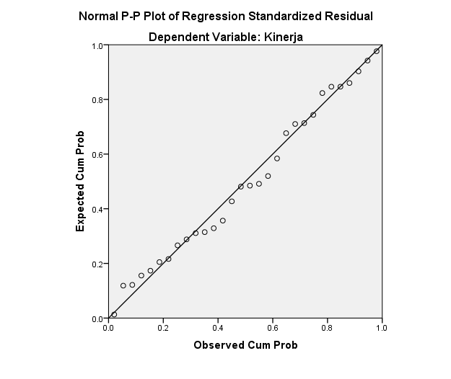**Uji Normalitas**

|  |  |  |
| --- | --- | --- |
| **One-Sample Kolmogorov-Smirnov Test** | | |
|  | | Unstandardized Residual |
| N | | 30 |
| Normal Parametersa,b | Mean | .0000000 |
| Std. Deviation | .07781367 |
| Most Extreme Differences | Absolute | .084 |
| Positive | .084 |
| Negative | -.073 |
| Test Statistic | | .084 |
| Asymp. Sig. (2-tailed) | | .200c,d |
| a. Test distribution is Normal. | | |
| b. Calculated from data. | | |
| c. Lilliefors Significance Correction. | | |
|  | | |
|  | | |

1. **Uji Multikolonieritas**

|  |  |  |  |  |  |  |  |  |
| --- | --- | --- | --- | --- | --- | --- | --- | --- |
| **Coefficientsa** | | | | | | | | |
| Model | | Unstandardized Coefficients | | Standardized Coefficients | T | Sig. | Collinearity Statistics | |
| B | Std. Error | Beta | Tolerance | VIF |
| 1 | (Constant) | 2.721 | .187 |  | 14.538 | .000 |  |  |
| KerjasamaTim | .103 | .040 | .431 | 2.615 | .015 | .576 | 1.735 |
| Komunikasi | .005 | .007 | .122 | .774 | .446 | .635 | 1.576 |
| KomitmenKerja | .011 | .006 | .340 | 1.760 | .090 | .420 | 2.379 |
| a. Dependent Variable: Kinerja | | | | | | | | |

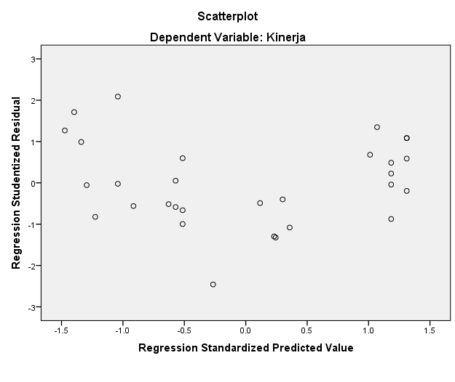**3. Uji Heteroskedastisitas**

**4. Uji Autokorelasi**

|  |  |  |  |  |  |
| --- | --- | --- | --- | --- | --- |
| **Model Summaryb** | | | | | |
| Model | R | R Square | Adjusted R Square | Std. Error of the Estimate | Durbin-Watson |
| 1 | .770a | .593 | .546 | .08218 | 1.831 |
| a. Predictors: (Constant), Kerjasama Tim, Komunikasi, Komitmen Kerja | | | | | |
| b. Dependent Variable: Kinerja | | | | | |

**Lampiran 10**

**Output SPSS**

1. **Hasil Uji Analisis Regresi Linear Berganda**

|  |  |  |  |  |  |  |
| --- | --- | --- | --- | --- | --- | --- |
| **Coefficientsa** | | | | | | |
| Model | | Unstandardized Coefficients | | Standardized Coefficients | t | Sig. |
| B | Std. Error | Beta |
| 1 | (Constant) | 2.721 | .187 |  | 14.538 | .000 |
| KerjasamaTim | .103 | .040 | .431 | 2.615 | .015 |
| Komunikasi | .005 | .007 | .122 | .774 | .446 |
| KomitmenKerja | .011 | .006 | .340 | 1.760 | .090 |
| a. Dependent Variable: Kinerja | | | | | | |

1. **Hasil Uji Koefisien Determinasi ($R^{2}$)**

|  |  |  |  |  |  |  |  |  |  |
| --- | --- | --- | --- | --- | --- | --- | --- | --- | --- |
| **Model Summaryb** | | | | | | | | | |
| Model | R | R Square | Adjusted R Square | Std. Error of the Estimate | Change Statistics | | | | |
| R Square Change | F Change | df1 | df2 | Sig. F Change |
| 1 | .770a | .593 | .546 | .08218 | .593 | 12.632 | 3 | 26 | .000 |
| a. Predictors: (Constant), Komitmen Kerja, Komunikasi, KerjasamaTim | | | | | | | | | |
| b. Dependent Variable: Kinerja | | | | | | | | | |

**Lampiran 11**

**Hasil Uji Hipotesis**

1. **Hasil Uji T (Parsial)**

|  |  |  |  |  |  |  |
| --- | --- | --- | --- | --- | --- | --- |
| **Coefficientsa** | | | | | | |
| Model | | Unstandardized Coefficients | | Standardized Coefficients | t | Sig. |
| B | Std. Error | Beta |
| 1 | (Constant) | 2.721 | .187 |  | 14.538 | .000 |
| Kerjasama Tim | .103 | .040 | .431 | 2.615 | .015 |
| Komunikasi | .005 | .007 | .122 | .774 | .446 |
| Komitmen Kerja | .011 | .006 | .340 | 1.760 | .090 |
| a. Dependent Variable: Kinerja | | | | | | |

1. **Hasil Uji F (Simultan)**

|  |  |  |  |  |  |  |
| --- | --- | --- | --- | --- | --- | --- |
| **ANOVAa** | | | | | | |
| Model | | Sum of Squares | df | Mean Square | F | Sig. |
| 1 | Regression | .256 | 3 | .085 | 12.632 | .000b |
| Residual | .176 | 26 | .007 |  |  |
| Total | .432 | 29 |  |  |  |
| a. Dependent Variable: Kinerja | | | | | | |
| b. Predictors: (Constant), Komitmen Kerja, Komunikasi, Kerjasama Tim | | | | | | |