# **DAFTAR PUSTAKA**

Agustin, M. W., & Mustoffa, A. F. (2023). Analisis Partisipasi Masyarakat dalam Membayar Pajak Bumi dan Bangunan ( Studi Kasus Desa Puhpelem ). *Jurnal Akuntansi*, *7*, 1919–1929.

Amelia, R., Hakim, D. B., & Feryanto. (2023). Strategi Peningkatan Penerimaan Pajak Bumi dan Bangunan di Kabupaten Bangka Barat Strategy to Increase Property Tax Revenue in West Bangka Regency. *Jurnal Ekonomi Dan Kebijakan Pembangunan*, *12*(2), 101–121.

Azizah, D. F., Susetyo, B., & Yunita, E. A. (2022). Pengaruh Profitabilitas , Leverage , dan Chief Financial Officer Expert Power Terhadap Tarif Pajak Efektif. *Jurnal Akuntansi Dan Bisnis Kontemporer*, *3*(1), 1–15.

Badan Pemeriksaan Keuangan (1985). *Undang-Undang Republik Indonesia Nomor12 Tahun 1985 Tentang Pajak Bumi Dan Bangunan*. (1985). Jakarta; Diakses dari https://peraturan.bpk.go.id

Badan Pemeriksaan Keuangan (1994). *Undang-Undang Republik Indonesia Nomor 12 Tahun 1994 Tentang Perubahan Atas Undang-Undang Nomor 12 Tahun 1985 Tentang Pajak Bumi Dan Bangunan*. (1994). Jakarta; Diakses dari https://peraturan.bpk.go.id

Badan Pemeriksaan Keuangan (2009). *Undang-Undang Republik Indonesia Nomor 28 Tahun 2009 Tentang Pajak Daerah Dan Retribusi Daerah*. (2009). Jakarta; Diakses dari https://peraturan.bpk.go.id

Badan Pemeriksaan Keuangan (2022). *Undang-Undang Republik Indonesia Nomor 1 Tahun 2022 Tentang Hubungan Keuangan Antara Pemerintah Pusat Dan Pemerintah Daerah*. (2022). Jakarta; Diakses dari https://peraturan.bpk.go.id

Badan Pemeriksaan Keuangan (2023). *Peraturan Daerah Kabupaten Tegal Nomor 11 Tahun 2023 Tentang Pajak Daerah Dan Retribusi Daerah*. (2023). Slawi; Diakses dari https://peraturan.bpk.go.id

Eprianti, N., & Indarti, S. (2020). Partisipasi Masyarakat Sebagai Solusi Peningkatan Pembayaran Pajak Bumi Dan Bangunan. *Journal of Public Policy and Administration Silampari*, *2*(1), 32–38.

Fauzi, H. M., & Kismadani, F. D. (2019). Pengaruh Motivasi Terhadap Kedisiplinan Masyarakat Dalam Membayar Pajak Bumi dan Bangunan (PBB) di Kelurahan Dawuhan Kecamatan Situbondo Kabupaten Situbondo. *Jurnal Kajian Ilmu Sosial Dan Ilmu Politik*, *15*(1).

Ghozali, I. (2016). *Aplikasi Analisis Multivariete dengan Program IBM SPSS 23*. Semarang; Universitas Diponegoro.

Hamid, H. (2018). *Manajemen pemberdayaan masyarakat*. Makassar; De La Macca

Herlina, V. (2020). Pengaruh Sanksi, Kesadaran Perpajakan Dan Kualitas Pelayanan Terhadap Kepatuhan Wajib Pajak Bumi Dan Bangunan Di Kabupaten Kerinci. *Jurnal Benefita*, *5*(2), 252–263.

Hidayat, I., & Gunawan, S. (2022). Pengaruh Kesadaran Wajib Pajak, Sanksi Perpajakan, Dan Kualitas Pelayanan Perpajakan Terhadap Kepatuhan Wajib Pajak Dalam Membayar Pajak Bumi Dan Bangunan. *Jurnal Manajemen Dan Ilmu Pendidikan*, *4*(1), 110–132.

Hilminawati, E., & Napisah, L. S. (2023). Pengaruh Kesadaran Wajib Pajak Dan Sanksi Perpajakan Terhadap Penerimaan Pajak Bumi Dan Bangunan Di Kabupaten Majalengka (Studi Kasus Pada Badan Pendapatan Daerah Kabupaten Majalengka). *Jurnal Riset Akuntansi Dan Perbankan*, *17*(1), 869–891.

Hutagalung, S. S. (2022). *Buku Ajar Partisipasi Dan Pemberdayaan Di Sektor Publik*. Bandar Lampung; CV. Literasi Nusantara Abadi.

Junita, C., & Segarawasesa, F. S. (2023). Analisis Faktor-Faktor Yang Mempengaruhi Kepatuhan Wajib Pajak dalam Membayar Pajak Bumi Dan Bangunan di Kabupaten Purworejo. *Jurnal Ilmiah Multidisiplin*, *2*(8), 3465–3479.

Kaehe, D., Ruru, J. M., & Rompas, W. Y. (2019). Partisipasi Masyarakat Dalam Perencanaan Pembangunan Di Kampung Pintareng Kecamatan Tabukan Selatan Tenggara. *Jurnal Administrasi Publik*, *5*(80), 14–24.

Kartikasari, I. A., & Estiningrum, S. D. (2022). Faktor Internal dan Eksternal yang Mempengaruhi Kepatuhan Pembayaran Pajak Bumi dan Bangunan. *Jurnal Riset Akuntansi Dan Keuangan*, *10*(1), 83–92.

Kuriawan, M. O., & Aini, D. (2019). Pengaruh pemahaman, kesadaran wajib pajak, dan sanksi pajak terhadap kepatuhan membayar pajak bumi dan bangunan perdesaan dan perkotaan pada badan pengelolaan pajak daerah kota palembang. *Jurnal Akuntansi Dan Bisnis*, *4*, 631–640.

Kurniawan, K. Y., & Winedar, M. (2023). Pengaruh Gender, Latar Belakang Pekerjaan, Dan Tingkat Pendidikan Terhadap Kepatuhan Wajib Pajak Di Wilayah Kabupaten Manggarai. *Soetomo Accounting Review*, *2*(1), 65–84.

Langi, V., Winerungan, R., & Sumual, F. M. (2020). Analisis Partisipasi Wajib Pajak Bumi Dan Bangunan Di Desa Sion Kecamatan Tompasobaru. *Jurnal Akuntansi Manado*, *1*(3), 29–34.

Mardiasmo. (2019). *Perpajakan edisi 2019*. Yogyakarta; Andi.

Marwati, S., Sasanti, E. E., & Nuraibah. (2023). Determinan Kepatuhan Wajib Pajak Dalam Membayar Pajak Bumi Dan Bangunan Perdesaan Dan Perkotaan (PBB-P2) Di Kecamatan Selong. *Jurnal Bisnis Net*, *6*(2), 753–764.

Mompala, D. E., & Asári, H. (2023). Pengaruh Kesadaran Wajib Pajak dan Sanksi Pajak terhadap Kepatuhan Wajib Pajak dalam Membayar Pajak Bumi dan Bangunan di Desa Condongcatur Depok, Sleman. *Jurnal Pendidikan Tambusai*, *7*(3), 28562–28567.

Nugraha, G. A. D. (2019). *Pengaruh Gender, Sanksi Pajak, Pengetahuan Perpajakan, Kesadaran Pajak Terhadap Tingkat Kepatuhan Wajib Pajak Orang Tingkat Kepatuhan Wajib Pajak Orang Pribadi Pekerja Bebas Di Kota Surabaya*. Sekolah Tinggi Ilmu Ekonomi Perbanas Surabaya.

Purba, R. B. (2023). *Teori Akuntansi Sebuah Pemahaman Untuk Mendukung Penelitian Di Bidang Akuntansi*. Medan; CV. Merdeka Kreasi Group.

Rahayu, D., Adila, F. S., & Kefi, B. S. (2023). Pengaruh Sanksi Pajak, Pengetahuan Perpajakan Dan Kesadaran Wajib Pajak Terhadap Kepatuhan Wajib Pajak Bumi Dan Bangunan Di Kecamatan Guntur Kabupaten Demak. *Jurnal Akuntansi, Keuangan Dan Auditing*, *4*(2), 1–14.

Romdhoni, M. T., Kharisma, A. S., Sucipto, H., Dumadi, & Roni. (2023). Pengaruh Kesadaran Wajib Pajak , Sanksi Pajak dan Kualitas Pajak terhadap Kepatuhan Wajib Pajak Bumi dan Bangunan ( Studi Kasus di Kelurahan Pasarbatang, Kecamatan Brebes , Kabupaten Brebes ) The Effect of Taxpayer Awareness, Tax Sanctions and Tax Quali. *Journal of Accounting and Financial Research*, *1*(1), 1–17.

Sasmahera, R. N., Ferdian, T., & Girsang, R. N. (2021). Pengaruh Kesadaran, Pendidikan, Pelayanan Jasa, Pendapatan, Sanksi, dan Sikap Terhadap Partisipasi Masyarakat Dalam Membayar Pajak Bumi dan Bangunan (Studi Kasus Di Kecamatan Rimbo Tengah Kabupaten Bungo). *Jurnal Ilmiah Akuntansi & Bisnis*, *1*(1), 46–60.

Seventeen, W. L., Arnova, I., & Fitriano, Y. (2023). Pengaruh Faktor Demografis (Usia, Jenis Kelamin, dan Penghasilan) Terhadap Kepatuhan Wajib Pajak di Kota Bengkulu. *Jurnal Ilmiah Ekonomi Dan Bisnis*, *11*(2), 1221–1226.

Supriatna, S. (2022). Analisa Kepatuhan Wajib Pajak Bumi Dan Bangunan (PBB) Di Desa Padamukti Tahun 2017-2020. *Jurnal Manajemen Terapan Dan Keuangan (Menkeu)*, *11*(03), 541–553.

Tawai, A., & Yusuf, M. (2017). *Partisipasi Masyarakat Dalam Pembangunan*. Kendari; Literacy Institute.

Waang, A. M. (2023). Analisis Pengaruh Sosialisasi Pajak , Kesadaran Wajib Pajak , dan Sanksi Pajak , Terhadap Kepatuhan Wajib Pajak Dalam Membayar Pajak Bumi dan Bangunan di Kelurahan Kabola Kecamatan Kabola Kabupaten Alor Aneke Marta Waang Program Studi Manajemen Fakultas E. *Jurnal Ilmiah Wahana Pendidikan*, *9*(September), 767–782.

Winarno, M. E. (2013). *Metodologi Penelitian Dalam Pendidikan Jasmani*. Malang; Universitas Negeri Malang (UM Press).

Yuliyanah, P. R., R, D. N., & Fanani, B. (2018). Self Assessment System Terhadap Kepatuhan Wajib. *Jurnal Magister Manajemen*, *3*(1), 11–29.

**LAMPIRAN**

**Lampiran 1**

Data Ketetapan dan Realisasi PBB di Kecamatan Pangkah

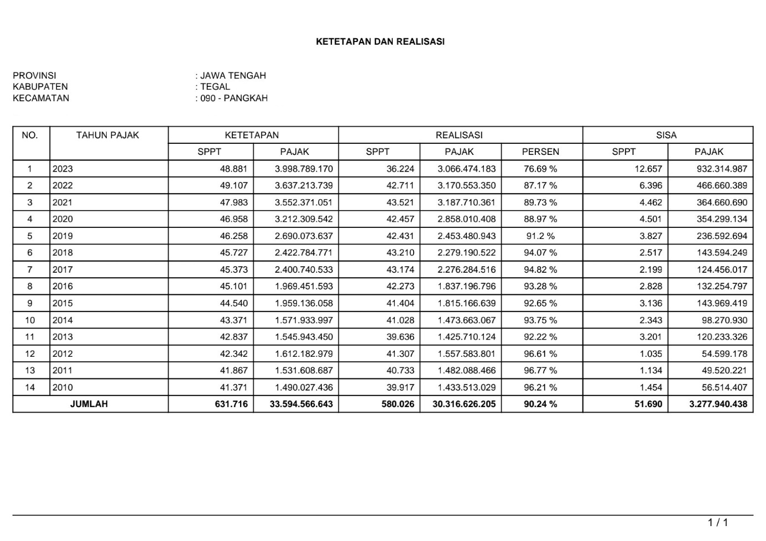

**Lampiran 2**

Kuesioner Penelitian:

Pengaruh Motivasi, Kesadaran Wajib Pajak, Dan Sanksi Pajak Terhadap Partisipasi Pembayaran Pajak Bumi Dan Bangunan (PBB) Di Kecamatan Pangkah Kabupaten Tegal Dengan Variabel Kontrol Gender Dan Usia.

Saya Umi Zulma Nurroifah dengan NPM 4320600035, dari Program Studi Akuntansi Fakultas Ekonomi dan Bisnis Universitas Pancasakti Tegal sedang melaksanakan penelitian tentang “Pengaruh Motivasi, Kesadaran Wajib Pajak, Dan Sanksi Pajak Terhadap Partisipasi Pembayaran Pajak Bumi Dan Bangunan (PBB) Di Kecamatan Pangkah, Kabupaten Tegal Dengan Variabel Kontrol Gender Dan Usia”. Demi tercapainya perolehan data primer ini, penyusun mohon kesediaan dan kesadaran dari Bapak/Ibu untuk mengisi angket/kuesioner atau daftar pernyataan yang telah disediakan berikut sesuai dengan keadaan yang sebenarnya, karena dalam hal ini jawaban anda

1. Dijamin kerahasiaanya,
2. Tidak ada kaitannya dengan karier Bapak/Ibu,
3. Tidak berhubungan dengan Parpol (Partai Politik) manapun,
4. Semata-mata hanya untuk kepentingan ilmu pengetahuan.

Atas kesediaan Bapak/Ibu meluangkan waktu guna mengisi kuesioner ini, penyusun mengucapkan banyak terima kasih.

1. **Petunjuk Pengisian**
2. Kepada Yth. Bapak/Ibu/Saudara/i untuk menjawab seluruh pernyataan dengan jujur dan sesuai dengan keadaaan yang sebenarnya.
3. Berilah tanda ($√$) pada kolom yang tersedia dan pilihlah sesuai hati Nurani Anda.

1. **Identitas Responden**

|  |  |  |
| --- | --- | --- |
| Nama  Desa | :  : |  |
| Jenis kelamin | : 🗆 Laki-laki | 🗆 Perempuan |
| Usia | : 🗆 21 – 39 | 🗆 40 – 59 |
| Pendidikan terakhir | : 🗆 SD dan Sederajat |  |

🗆​ > 60

🗆​ SMP dan Sederajat

🗆​ SMA dan Sederajat

🗆​ D3 – S1

🗆 S2 dan Seterusnya

Pekerjaan : 🗆 Petani 🗆 Buruh 🗆 Lainnya

🗆 PNS 🗆 Karyawan Swasta

**Skala dalam menjawab pertanyaan adalah sebagai berikut:**

Sangat Tidak Setuju (STS) : 1

Tidak Setuju (TS) : 2

Kurang Setuju (KS) : 3

Setuju (S) : 4

Sangat Setuju (SS) : 5

1. **Motivasi, X1**

|  |  |  |  |  |  |  |
| --- | --- | --- | --- | --- | --- | --- |
| **No** | **Pertanyaan** | **Pilihan** | | | | |
| **STS** | **TS** | **KS** | **S** | **SS** |
| 1 | Penerimaan pajak bumi dan bangunan harus digunakan untuk membantu perbaikan fasilitas di daerah masing-masing |  |  |  |  |  |
| 2 | Saya merasa bangga jika membayar pajak bumi dan bangunan dengan tepat waktu |  |  |  |  |  |
| 3 | Menurut saya, perkembangan daerah yang dijalankan dengan baik akan menumbuhkan tingkat kepatuhan dalam pembayaran pajak |  |  |  |  |  |
| 4 | Saya mempunyai keinginan membayar pajak bumi dan bangunan yang hasilnya untuk pembiayaan pembangunan daerah |  |  |  |  |  |
| 5 | Menurut saya, perlu adanya dorongan dan motivasi dari pemerintah terhadap wajiab pajak agar selalu membayar pajaknya |  |  |  |  |  |
| 6 | Saya mau membayar pajak jika penerimaan pajak bumi dan bangunan dapat dimanfaatkan dengan baik |  |  |  |  |  |
| 7 | Saya akan membayar pajak atas kemauan dan keinginan sendiri |  |  |  |  |  |
| 8 | Saya membayar pajak bumi dan bangunan sesuai peraturan perpajakan yang berlaku |  |  |  |  |  |
| 9 | Saya bersedia dalam membayar pajak bumi dan bangunan untuk kesesahteraan bersama |  |  |  |  |  |
| 10 | Adanya dorongan yang tumbuh dalam diri sendiri untuk membayarkan pajaknya |  |  |  |  |  |

Sumber: Fauzi & Kismadani, (2019)

1. **Kesadaran Wajib Pajak, X2**

|  |  |  |  |  |  |  |
| --- | --- | --- | --- | --- | --- | --- |
| **No** | **Pertanyaan** | **Pilihan** | | | | |
| **STS** | **TS** | **KS** | **S** | **SS** |
| 11 | Saya menghitung dan membayar pajak bumi dan bangunan dengan benar |  |  |  |  |  |
| 12 | Menurut saya, perlu mempunyai tingkat kesadaran tinggi terhadap pembayaran pajak |  |  |  |  |  |
| 13 | Saya tidak terpaksa mematuhi kewajiban membayar pajak bumi dan bangunan |  |  |  |  |  |
| 14 | Saya mengerti manfaat pembayaran pajak bumi dan bangunan untuk pembangunan negara dan kesejahterraan warga negara |  |  |  |  |  |
| 15 | Menurut saya, kesadaran wajib pajak terhadap pembayaran pajak bumi dan bangunan merupakan bentuk partisipasi dalam mendukung pembangunan daerah |  |  |  |  |  |
| 16 | Saya tidak merasa terbebani atau dirugikan jika harus membayar pajak |  |  |  |  |  |
| 17 | Saya membayar pajak bumi dan bangunan karena kesadaran diri dengan adanya rasa tanggung jawab sebagai warga negara |  |  |  |  |  |
| 18 | Saya dengan sukarela memenuhi kewajiban membayar pajak bumi dan bangunan |  |  |  |  |  |
| 19 | Saya menyadari sebagai warga negara bertanggung jawab membayar pajak bumi dan bangunan |  |  |  |  |  |
| 20 | Saya dengan senang hati dalam melaksanakan kewajiban membayar pajak bumi dan bnagunan |  |  |  |  |  |

Sumber: Herlina, (2020)

1. **Sanksi Pajak, X3**

|  |  |  |  |  |  |  |
| --- | --- | --- | --- | --- | --- | --- |
| **No** | **Pertanyaan** | **Pilihan** | | | | |
| **STS** | **TS** | **KS** | **S** | **SS** |
| 21 | Menurut saya, Sanksi pajak yang ditetapkan harus sesuai dengan peraturan yang berlaku |  |  |  |  |  |
| 22 | Saya siap dikenai sanksi apabila menunda atau tidak patuh membayar pajak bumi dan bangunan |  |  |  |  |  |
| 23 | Menurut saya, pengenaan sanksi berupa denda, bunga keterlambatan, dan pidana kepada wajib pajak yang melakukan pelanggaran |  |  |  |  |  |
| 24 | Menurut saya, sanksi yang diberikan sesuai dengan besar kecilnya pelanggaran |  |  |  |  |  |
| 25 | Jika saya tidak membayarkan pajak bumi dan bangunan harus diberikan sanksi |  |  |  |  |  |
| 26 | Menurut saya, sanksi yang diberikan kepada pelanggar dapat memberikan efek jera |  |  |  |  |  |
| 27 | Saya setuju jika diadakannya sanksi bagi yang tidak patuh dalam membayar pajak |  |  |  |  |  |
| 28 | Menurut saya, tidak adanya sanksi akan menjadikan wajib pajak tidak patuh dalam membayar pajak bumi dan bangunan |  |  |  |  |  |
| 29 | Jika saya tidak mematuhi kewajiban dalam membayar pajak bumi dan bangunan, maka saya akan menerima sanksi |  |  |  |  |  |
| 30 | Menurut saya, sanksi digunakan agar mendisiplinkan wajib pajak untuk selalu membayarkan pajaknya |  |  |  |  |  |

Sumber: Romdhoni et al., (2023)

1. **Partisipasi, Y**

|  |  |  |  |  |  |  |
| --- | --- | --- | --- | --- | --- | --- |
| **No** | **Pertanyaan** | **Pilihan** | | | | |
| **STS** | **TS** | **KS** | **S** | **SS** |
| 31 | Menurut saya, wajib pajak harus dapat mengetahui semua ketentuan peraturan perundang-undangan perpajakan |  |  |  |  |  |
| 32 | Menurut saya, pemerintah membutuhkan tindakan wajib pajak untuk ikut serta dalam membayar pajaknya dengan tepat waktu |  |  |  |  |  |
| 33 | Saya berusaha untuk tidak mempunyai tunggakan pajak atau menunda dalam membayar pajak bumi dan bangunan |  |  |  |  |  |
| 34 | Saya menghitung jumlah pajak bumi dan bangunan yang terutang dengan benar atau tidak direkayasa |  |  |  |  |  |
| 35 | Apabila saya ikut turut berpartisipasi dalam pembayaran pajak bumi dan bangunan tidak akan dijatuhi denda atau sanksi |  |  |  |  |  |
| 36 | Menurut saya, membayar pajak bumi dan bangunan dengan tidak menunda-nuda perlu mendapatkan suatu apresiasi dari otoritas pajak atau pemerintah |  |  |  |  |  |
| 37 | Saya melaporakan dan membayar pajak bumi dan bangunan sesuai dengan batas waktu yang telah ditentukan |  |  |  |  |  |
| 38 | Saya membayar pajak tepat waktu dan berusaha untuk meminimalisir keterlambatan pembayaran pajak |  |  |  |  |  |
| 39 | Saya antusias dalam melaksanakan kewajiban membayar pajak bumi dan bangunan |  |  |  |  |  |
| 40 | Menurut saya, ketepatan waktu dalam membayar pajak berguna untuk menghindari dari adanya sanksi pajak |  |  |  |  |  |

Sumber: Sasmahera et al., (2021)

**Lampiran 3**

Jawaban kuesioner variabel motivasi (X1)

|  |  |  |  |  |  |  |  |  |  |  |  |
| --- | --- | --- | --- | --- | --- | --- | --- | --- | --- | --- | --- |
| **No. RES** | **MOTIVASI (X1)** | | | | | | | | | | **Mot X1** |
| **X1.1** | **X1.2** | **X1.3** | **X1.4** | **X1.5** | **X1.6** | **X1.7** | **X1.8** | **X1.9** | **X1.10** |
| 1 | 5 | 5 | 5 | 5 | 5 | 5 | 5 | 5 | 5 | 5 | 50 |
| 2 | 5 | 4 | 4 | 4 | 4 | 4 | 4 | 4 | 5 | 4 | 42 |
| 3 | 4 | 4 | 5 | 5 | 4 | 3 | 4 | 3 | 3 | 3 | 38 |
| 4 | 5 | 4 | 3 | 3 | 5 | 4 | 3 | 4 | 5 | 4 | 40 |
| 5 | 5 | 4 | 4 | 4 | 4 | 5 | 5 | 5 | 5 | 5 | 46 |
| 6 | 5 | 4 | 4 | 4 | 4 | 4 | 4 | 4 | 4 | 4 | 41 |
| 7 | 5 | 4 | 4 | 4 | 4 | 4 | 4 | 4 | 4 | 4 | 41 |
| 8 | 5 | 5 | 4 | 4 | 5 | 4 | 4 | 5 | 4 | 4 | 44 |
| 9 | 5 | 4 | 5 | 5 | 4 | 5 | 4 | 4 | 5 | 5 | 46 |
| 10 | 5 | 5 | 3 | 3 | 5 | 3 | 4 | 5 | 3 | 3 | 39 |
| 11 | 4 | 4 | 5 | 5 | 4 | 5 | 4 | 4 | 4 | 5 | 44 |
| 12 | 5 | 4 | 5 | 5 | 4 | 5 | 4 | 4 | 5 | 5 | 46 |
| 13 | 5 | 4 | 5 | 5 | 4 | 5 | 4 | 4 | 5 | 5 | 46 |
| 14 | 4 | 4 | 5 | 5 | 4 | 5 | 4 | 4 | 4 | 5 | 44 |
| 15 | 4 | 4 | 4 | 4 | 4 | 4 | 4 | 4 | 4 | 4 | 40 |
| 16 | 4 | 3 | 4 | 4 | 3 | 4 | 4 | 3 | 4 | 4 | 37 |
| 17 | 4 | 4 | 4 | 4 | 4 | 4 | 4 | 4 | 4 | 4 | 40 |
| 18 | 4 | 4 | 4 | 4 | 4 | 4 | 4 | 4 | 4 | 4 | 40 |
| 19 | 5 | 3 | 5 | 5 | 3 | 5 | 4 | 3 | 4 | 5 | 42 |
| 20 | 4 | 4 | 4 | 4 | 4 | 4 | 4 | 4 | 4 | 4 | 40 |
| 21 | 4 | 5 | 5 | 5 | 5 | 5 | 4 | 5 | 4 | 5 | 47 |
| 22 | 4 | 3 | 5 | 5 | 3 | 5 | 4 | 3 | 4 | 5 | 41 |
| 23 | 4 | 3 | 3 | 3 | 3 | 3 | 4 | 3 | 3 | 3 | 32 |
| 24 | 4 | 4 | 5 | 5 | 4 | 5 | 4 | 4 | 5 | 5 | 45 |
| 25 | 5 | 4 | 4 | 4 | 4 | 4 | 4 | 4 | 5 | 4 | 42 |
| 26 | 5 | 4 | 5 | 5 | 4 | 5 | 4 | 4 | 5 | 5 | 46 |
| 27 | 5 | 4 | 5 | 5 | 4 | 5 | 4 | 4 | 5 | 5 | 46 |
| 28 | 5 | 4 | 4 | 4 | 4 | 4 | 4 | 4 | 5 | 4 | 42 |
| 29 | 5 | 4 | 3 | 3 | 4 | 3 | 4 | 4 | 3 | 3 | 36 |
| 30 | 5 | 4 | 4 | 4 | 4 | 4 | 4 | 4 | 3 | 4 | 40 |
| 31 | 5 | 5 | 4 | 4 | 5 | 4 | 5 | 5 | 4 | 4 | 45 |
| 32 | 5 | 4 | 3 | 3 | 4 | 3 | 4 | 4 | 4 | 3 | 37 |
| 33 | 4 | 4 | 3 | 3 | 4 | 3 | 4 | 4 | 5 | 3 | 37 |
| 34 | 4 | 5 | 5 | 5 | 5 | 5 | 5 | 5 | 5 | 5 | 49 |
| 35 | 4 | 4 | 4 | 4 | 4 | 4 | 4 | 4 | 4 | 4 | 40 |
| 36 | 4 | 4 | 4 | 4 | 4 | 4 | 4 | 4 | 5 | 4 | 41 |
| 37 | 4 | 5 | 5 | 5 | 5 | 5 | 5 | 5 | 4 | 5 | 48 |
| 38 | 4 | 4 | 5 | 5 | 4 | 5 | 4 | 4 | 5 | 5 | 45 |
| 39 | 4 | 4 | 5 | 5 | 4 | 5 | 4 | 4 | 4 | 5 | 44 |
| 40 | 5 | 4 | 5 | 5 | 4 | 5 | 4 | 4 | 5 | 5 | 46 |
| 41 | 4 | 4 | 4 | 4 | 4 | 4 | 4 | 4 | 4 | 4 | 40 |
| 42 | 5 | 5 | 4 | 4 | 5 | 4 | 5 | 5 | 4 | 4 | 45 |
| 43 | 5 | 4 | 5 | 5 | 4 | 5 | 4 | 4 | 4 | 5 | 45 |
| 44 | 5 | 4 | 5 | 5 | 4 | 5 | 4 | 4 | 4 | 5 | 45 |
| 45 | 5 | 5 | 5 | 5 | 5 | 5 | 5 | 5 | 5 | 5 | 50 |
| 46 | 4 | 4 | 4 | 4 | 4 | 4 | 4 | 4 | 5 | 4 | 41 |
| 47 | 5 | 5 | 4 | 4 | 5 | 4 | 5 | 5 | 4 | 4 | 45 |
| 48 | 4 | 5 | 4 | 4 | 5 | 4 | 5 | 5 | 4 | 4 | 44 |
| 49 | 4 | 4 | 5 | 5 | 4 | 5 | 4 | 4 | 5 | 5 | 45 |
| 50 | 5 | 4 | 4 | 4 | 4 | 4 | 4 | 4 | 4 | 4 | 41 |
| 51 | 4 | 4 | 4 | 4 | 4 | 4 | 4 | 4 | 4 | 4 | 40 |
| 52 | 5 | 4 | 5 | 5 | 4 | 5 | 4 | 4 | 4 | 5 | 45 |
| 53 | 4 | 4 | 4 | 4 | 4 | 4 | 4 | 4 | 4 | 4 | 40 |
| 54 | 4 | 3 | 4 | 4 | 3 | 4 | 3 | 3 | 4 | 4 | 36 |
| 55 | 4 | 4 | 4 | 4 | 4 | 4 | 4 | 4 | 5 | 4 | 41 |
| 56 | 4 | 4 | 4 | 4 | 4 | 4 | 4 | 4 | 4 | 4 | 40 |
| 57 | 5 | 4 | 5 | 5 | 4 | 5 | 4 | 4 | 5 | 5 | 46 |
| 58 | 4 | 5 | 4 | 4 | 5 | 4 | 5 | 5 | 4 | 4 | 44 |
| 59 | 5 | 4 | 5 | 5 | 4 | 5 | 4 | 4 | 4 | 5 | 45 |
| 60 | 5 | 4 | 5 | 5 | 4 | 5 | 4 | 4 | 5 | 5 | 46 |
| 61 | 4 | 4 | 5 | 5 | 4 | 5 | 4 | 4 | 4 | 5 | 44 |
| 62 | 5 | 4 | 5 | 5 | 4 | 5 | 4 | 4 | 4 | 5 | 45 |
| 63 | 4 | 4 | 5 | 5 | 4 | 5 | 4 | 4 | 5 | 5 | 45 |
| 64 | 5 | 4 | 5 | 5 | 4 | 5 | 4 | 4 | 5 | 5 | 46 |
| 65 | 4 | 4 | 5 | 5 | 4 | 5 | 4 | 4 | 5 | 5 | 45 |
| 66 | 5 | 4 | 5 | 4 | 4 | 5 | 4 | 4 | 5 | 5 | 45 |
| 67 | 5 | 4 | 5 | 4 | 4 | 5 | 4 | 4 | 4 | 5 | 44 |
| 68 | 4 | 5 | 4 | 4 | 5 | 4 | 5 | 5 | 4 | 4 | 44 |
| 69 | 5 | 4 | 4 | 4 | 4 | 4 | 4 | 4 | 4 | 4 | 41 |
| 70 | 4 | 4 | 4 | 5 | 4 | 4 | 4 | 4 | 4 | 4 | 41 |
| 71 | 4 | 5 | 5 | 4 | 5 | 5 | 5 | 5 | 4 | 5 | 47 |
| 72 | 5 | 5 | 4 | 4 | 5 | 4 | 5 | 5 | 4 | 4 | 45 |
| 73 | 4 | 3 | 4 | 5 | 3 | 4 | 3 | 3 | 4 | 4 | 37 |
| 74 | 4 | 5 | 4 | 5 | 5 | 4 | 5 | 5 | 4 | 4 | 45 |
| 75 | 4 | 4 | 5 | 2 | 4 | 5 | 4 | 4 | 5 | 5 | 42 |
| 76 | 4 | 4 | 4 | 5 | 4 | 4 | 4 | 4 | 4 | 4 | 41 |
| 77 | 4 | 4 | 5 | 4 | 4 | 5 | 4 | 4 | 4 | 5 | 43 |
| 78 | 4 | 5 | 5 | 4 | 5 | 5 | 4 | 5 | 4 | 5 | 46 |
| 79 | 4 | 4 | 5 | 5 | 4 | 5 | 4 | 4 | 4 | 5 | 44 |
| 80 | 4 | 4 | 5 | 5 | 4 | 5 | 4 | 4 | 4 | 5 | 44 |
| 81 | 4 | 5 | 4 | 4 | 5 | 4 | 4 | 5 | 4 | 4 | 43 |
| 82 | 5 | 5 | 5 | 4 | 5 | 5 | 4 | 5 | 4 | 5 | 47 |
| 83 | 4 | 4 | 4 | 4 | 4 | 4 | 4 | 4 | 5 | 4 | 41 |
| 84 | 4 | 5 | 4 | 4 | 5 | 4 | 4 | 5 | 4 | 4 | 43 |
| 85 | 4 | 5 | 4 | 4 | 5 | 4 | 4 | 5 | 4 | 4 | 43 |
| 86 | 4 | 4 | 5 | 4 | 4 | 5 | 4 | 4 | 4 | 5 | 43 |
| 87 | 5 | 3 | 4 | 4 | 3 | 4 | 4 | 3 | 4 | 4 | 38 |
| 88 | 4 | 4 | 5 | 4 | 4 | 5 | 4 | 4 | 4 | 5 | 43 |
| 89 | 5 | 4 | 4 | 4 | 4 | 4 | 4 | 4 | 4 | 4 | 41 |
| 90 | 4 | 5 | 4 | 4 | 5 | 4 | 4 | 5 | 4 | 4 | 43 |
| 91 | 4 | 4 | 4 | 5 | 4 | 4 | 4 | 4 | 4 | 4 | 41 |
| 92 | 4 | 4 | 4 | 4 | 4 | 4 | 4 | 4 | 4 | 4 | 40 |
| 93 | 4 | 5 | 4 | 4 | 5 | 4 | 4 | 5 | 4 | 4 | 43 |
| 94 | 5 | 3 | 4 | 4 | 3 | 4 | 4 | 3 | 4 | 4 | 38 |
| 95 | 4 | 4 | 5 | 4 | 5 | 4 | 4 | 4 | 4 | 4 | 42 |
| 96 | 4 | 4 | 4 | 4 | 5 | 4 | 4 | 4 | 4 | 4 | 41 |
| 97 | 4 | 4 | 5 | 2 | 4 | 5 | 5 | 5 | 5 | 5 | 44 |
| 98 | 5 | 4 | 4 | 4 | 4 | 5 | 4 | 4 | 5 | 5 | 44 |
| 99 | 5 | 4 | 5 | 4 | 4 | 4 | 4 | 4 | 4 | 4 | 42 |
| 100 | 4 | 4 | 5 | 4 | 4 | 4 | 4 | 4 | 4 | 4 | 41 |
| 101 | 4 | 3 | 5 | 4 | 4 | 5 | 4 | 4 | 5 | 4 | 42 |
| 102 | 5 | 4 | 4 | 5 | 2 | 5 | 4 | 5 | 5 | 5 | 44 |
| 103 | 4 | 5 | 4 | 4 | 5 | 4 | 4 | 4 | 4 | 4 | 42 |
| 104 | 5 | 4 | 5 | 4 | 4 | 4 | 4 | 4 | 4 | 4 | 42 |
| 105 | 5 | 4 | 4 | 5 | 5 | 4 | 4 | 4 | 4 | 4 | 43 |
| 106 | 5 | 5 | 5 | 5 | 5 | 5 | 5 | 5 | 5 | 5 | 50 |
| 107 | 5 | 4 | 2 | 4 | 4 | 2 | 2 | 4 | 4 | 4 | 35 |
| 108 | 5 | 4 | 4 | 4 | 5 | 5 | 3 | 4 | 5 | 4 | 43 |
| 109 | 5 | 4 | 4 | 4 | 4 | 4 | 4 | 4 | 4 | 4 | 41 |
| 110 | 4 | 4 | 4 | 4 | 4 | 4 | 4 | 4 | 4 | 4 | 40 |
| 111 | 5 | 5 | 4 | 5 | 5 | 5 | 4 | 5 | 5 | 4 | 47 |
| 112 | 5 | 4 | 5 | 4 | 4 | 4 | 3 | 2 | 3 | 4 | 38 |
| 113 | 4 | 4 | 4 | 4 | 4 | 4 | 4 | 4 | 4 | 4 | 40 |
| 114 | 4 | 4 | 3 | 4 | 4 | 5 | 3 | 4 | 4 | 4 | 39 |
| 115 | 5 | 5 | 5 | 5 | 5 | 5 | 5 | 5 | 5 | 5 | 50 |
| 116 | 4 | 4 | 5 | 4 | 4 | 4 | 5 | 5 | 5 | 4 | 44 |
| 117 | 5 | 4 | 3 | 5 | 4 | 3 | 5 | 4 | 3 | 5 | 41 |
| 118 | 5 | 4 | 4 | 5 | 4 | 5 | 4 | 5 | 5 | 4 | 45 |
| 119 | 5 | 4 | 5 | 5 | 4 | 4 | 4 | 5 | 4 | 4 | 44 |
| 120 | 4 | 4 | 4 | 4 | 4 | 4 | 4 | 4 | 4 | 4 | 40 |
| 121 | 4 | 5 | 5 | 2 | 4 | 4 | 5 | 3 | 5 | 4 | 41 |
| 122 | 4 | 5 | 4 | 5 | 4 | 4 | 5 | 4 | 5 | 4 | 44 |
| 123 | 4 | 4 | 5 | 4 | 4 | 4 | 4 | 4 | 5 | 5 | 43 |
| 124 | 4 | 4 | 4 | 4 | 4 | 4 | 4 | 4 | 4 | 4 | 40 |
| 125 | 4 | 4 | 4 | 4 | 4 | 4 | 4 | 4 | 4 | 4 | 40 |
| 126 | 4 | 5 | 5 | 4 | 5 | 4 | 4 | 5 | 4 | 5 | 45 |
| 127 | 4 | 3 | 5 | 5 | 4 | 2 | 5 | 3 | 4 | 5 | 40 |
| 128 | 5 | 5 | 4 | 4 | 4 | 5 | 5 | 4 | 4 | 5 | 45 |
| 129 | 4 | 4 | 4 | 4 | 5 | 4 | 4 | 4 | 4 | 4 | 41 |
| 130 | 5 | 5 | 4 | 4 | 5 | 4 | 5 | 5 | 4 | 4 | 45 |
| 131 | 4 | 5 | 4 | 4 | 5 | 4 | 5 | 5 | 4 | 4 | 44 |
| 132 | 5 | 4 | 4 | 5 | 4 | 5 | 4 | 4 | 4 | 5 | 44 |
| 133 | 4 | 5 | 5 | 4 | 5 | 4 | 5 | 5 | 5 | 4 | 46 |
| 134 | 4 | 4 | 4 | 4 | 4 | 4 | 4 | 4 | 4 | 4 | 40 |
| 135 | 5 | 4 | 3 | 5 | 4 | 4 | 4 | 3 | 5 | 4 | 41 |
| 136 | 4 | 5 | 4 | 4 | 5 | 4 | 5 | 5 | 4 | 4 | 44 |
| 137 | 5 | 4 | 5 | 4 | 4 | 3 | 5 | 5 | 3 | 5 | 43 |
| 138 | 4 | 4 | 4 | 4 | 5 | 5 | 3 | 5 | 5 | 5 | 44 |
| 139 | 4 | 4 | 4 | 4 | 4 | 4 | 4 | 4 | 4 | 4 | 40 |
| 140 | 4 | 5 | 4 | 5 | 5 | 4 | 5 | 4 | 5 | 4 | 45 |
| 141 | 4 | 4 | 4 | 4 | 4 | 4 | 4 | 4 | 4 | 4 | 40 |
| 142 | 4 | 4 | 4 | 4 | 4 | 4 | 4 | 4 | 4 | 4 | 40 |
| 143 | 4 | 4 | 3 | 5 | 3 | 4 | 5 | 4 | 4 | 4 | 40 |
| 144 | 4 | 4 | 5 | 5 | 4 | 4 | 4 | 4 | 4 | 4 | 42 |
| 145 | 5 | 4 | 5 | 5 | 4 | 5 | 4 | 5 | 4 | 5 | 46 |
| 146 | 4 | 5 | 5 | 4 | 5 | 4 | 4 | 4 | 5 | 4 | 44 |
| 147 | 5 | 4 | 5 | 5 | 4 | 5 | 4 | 5 | 5 | 4 | 46 |
| 148 | 5 | 5 | 5 | 5 | 5 | 4 | 5 | 5 | 5 | 5 | 49 |
| 149 | 3 | 3 | 3 | 3 | 3 | 4 | 3 | 3 | 3 | 3 | 31 |
| 150 | 4 | 4 | 4 | 4 | 4 | 4 | 3 | 4 | 4 | 3 | 38 |
| 151 | 4 | 5 | 4 | 5 | 5 | 5 | 4 | 5 | 4 | 4 | 45 |
| 152 | 4 | 4 | 5 | 4 | 4 | 5 | 5 | 4 | 4 | 5 | 44 |
| 153 | 4 | 5 | 3 | 2 | 5 | 3 | 4 | 5 | 2 | 4 | 37 |
| 154 | 4 | 5 | 5 | 4 | 4 | 5 | 4 | 4 | 5 | 4 | 44 |
| 155 | 4 | 4 | 5 | 4 | 5 | 4 | 5 | 5 | 4 | 4 | 44 |
| 156 | 5 | 4 | 4 | 5 | 4 | 5 | 4 | 4 | 5 | 4 | 44 |
| 157 | 5 | 5 | 4 | 5 | 4 | 5 | 5 | 4 | 5 | 4 | 46 |
| 158 | 4 | 4 | 4 | 5 | 4 | 5 | 4 | 4 | 5 | 5 | 44 |
| 159 | 4 | 4 | 5 | 4 | 5 | 4 | 5 | 4 | 5 | 5 | 45 |
| 160 | 3 | 5 | 5 | 4 | 4 | 5 | 5 | 4 | 4 | 3 | 42 |
| 161 | 5 | 4 | 4 | 5 | 4 | 5 | 5 | 4 | 3 | 5 | 44 |
| 162 | 4 | 5 | 5 | 3 | 5 | 5 | 4 | 4 | 5 | 5 | 45 |
| 163 | 5 | 5 | 4 | 4 | 5 | 5 | 5 | 5 | 5 | 5 | 48 |
| 164 | 5 | 4 | 5 | 5 | 5 | 5 | 5 | 4 | 5 | 4 | 47 |
| 165 | 4 | 5 | 3 | 5 | 3 | 4 | 3 | 5 | 5 | 4 | 41 |
| 166 | 5 | 4 | 5 | 5 | 4 | 5 | 5 | 5 | 4 | 4 | 46 |
| 167 | 5 | 5 | 4 | 4 | 5 | 4 | 4 | 5 | 5 | 5 | 46 |
| 168 | 4 | 5 | 4 | 4 | 3 | 5 | 5 | 5 | 3 | 4 | 42 |
| 169 | 5 | 5 | 4 | 5 | 4 | 5 | 5 | 4 | 5 | 4 | 46 |
| 170 | 4 | 4 | 4 | 4 | 4 | 4 | 4 | 4 | 4 | 4 | 40 |
| 171 | 4 | 4 | 4 | 4 | 4 | 4 | 4 | 4 | 4 | 4 | 40 |
| 172 | 4 | 5 | 3 | 4 | 4 | 3 | 5 | 5 | 5 | 5 | 43 |
| 173 | 5 | 3 | 5 | 4 | 5 | 5 | 3 | 4 | 4 | 3 | 41 |
| 174 | 4 | 3 | 3 | 4 | 4 | 4 | 4 | 4 | 4 | 4 | 38 |
| 175 | 4 | 4 | 4 | 4 | 4 | 4 | 4 | 4 | 4 | 4 | 40 |
| 176 | 4 | 4 | 4 | 4 | 4 | 4 | 4 | 4 | 4 | 4 | 40 |
| 177 | 4 | 4 | 4 | 4 | 4 | 4 | 4 | 4 | 4 | 4 | 40 |
| 178 | 4 | 4 | 4 | 4 | 4 | 4 | 4 | 4 | 4 | 4 | 40 |
| 179 | 4 | 5 | 3 | 4 | 5 | 3 | 5 | 4 | 5 | 3 | 41 |
| 180 | 4 | 4 | 4 | 4 | 4 | 4 | 4 | 4 | 4 | 4 | 40 |
| 181 | 5 | 5 | 4 | 5 | 5 | 4 | 5 | 4 | 5 | 4 | 46 |
| 182 | 5 | 5 | 4 | 5 | 5 | 4 | 5 | 4 | 4 | 5 | 46 |
| 183 | 3 | 5 | 3 | 4 | 4 | 5 | 4 | 5 | 5 | 3 | 41 |
| 184 | 5 | 5 | 4 | 5 | 5 | 4 | 4 | 5 | 4 | 5 | 46 |
| 185 | 5 | 5 | 4 | 3 | 4 | 4 | 5 | 5 | 5 | 5 | 45 |
| 186 | 5 | 5 | 1 | 5 | 4 | 5 | 4 | 4 | 5 | 5 | 43 |
| 187 | 4 | 4 | 4 | 4 | 4 | 4 | 4 | 4 | 4 | 4 | 40 |
| 188 | 4 | 4 | 4 | 4 | 4 | 4 | 4 | 4 | 4 | 4 | 40 |
| 189 | 5 | 5 | 5 | 5 | 5 | 5 | 5 | 5 | 5 | 5 | 50 |
| 190 | 5 | 4 | 5 | 4 | 5 | 5 | 4 | 4 | 4 | 5 | 45 |
| 191 | 4 | 5 | 5 | 4 | 5 | 4 | 4 | 4 | 4 | 4 | 43 |
| 192 | 4 | 4 | 4 | 4 | 4 | 4 | 4 | 4 | 4 | 4 | 40 |
| 193 | 4 | 3 | 5 | 4 | 2 | 5 | 4 | 5 | 3 | 5 | 40 |
| 194 | 4 | 2 | 5 | 3 | 4 | 5 | 3 | 5 | 3 | 4 | 38 |
| 195 | 5 | 5 | 4 | 5 | 5 | 4 | 5 | 4 | 5 | 4 | 46 |
| 196 | 4 | 4 | 5 | 4 | 5 | 4 | 5 | 5 | 4 | 5 | 45 |
| 197 | 5 | 5 | 3 | 4 | 3 | 3 | 5 | 4 | 5 | 5 | 42 |
| 198 | 5 | 5 | 4 | 4 | 5 | 5 | 4 | 4 | 5 | 4 | 45 |
| 199 | 5 | 4 | 4 | 4 | 4 | 4 | 5 | 4 | 5 | 5 | 44 |
| 200 | 4 | 5 | 4 | 4 | 3 | 5 | 5 | 5 | 4 | 5 | 44 |
| 201 | 4 | 4 | 4 | 4 | 4 | 4 | 4 | 4 | 4 | 4 | 40 |
| 202 | 4 | 5 | 5 | 4 | 4 | 3 | 5 | 4 | 5 | 5 | 44 |
| 203 | 5 | 3 | 4 | 5 | 2 | 3 | 5 | 4 | 5 | 5 | 41 |
| 204 | 5 | 4 | 4 | 5 | 4 | 5 | 4 | 5 | 5 | 4 | 45 |
| 205 | 4 | 5 | 5 | 3 | 5 | 4 | 5 | 4 | 4 | 5 | 44 |
| 206 | 3 | 4 | 3 | 4 | 4 | 4 | 4 | 4 | 4 | 5 | 39 |
| 207 | 5 | 4 | 5 | 4 | 4 | 5 | 4 | 5 | 5 | 5 | 46 |
| 208 | 4 | 5 | 3 | 4 | 5 | 4 | 4 | 5 | 4 | 4 | 42 |
| 209 | 4 | 4 | 4 | 4 | 3 | 3 | 4 | 4 | 4 | 5 | 39 |
| 210 | 4 | 5 | 4 | 3 | 4 | 4 | 2 | 4 | 4 | 3 | 37 |
| 211 | 2 | 4 | 5 | 3 | 4 | 4 | 1 | 4 | 5 | 2 | 34 |
| 212 | 5 | 4 | 4 | 4 | 4 | 4 | 3 | 3 | 4 | 5 | 40 |
| 213 | 4 | 5 | 4 | 4 | 4 | 4 | 4 | 4 | 4 | 4 | 41 |
| 214 | 5 | 4 | 4 | 4 | 4 | 5 | 4 | 5 | 5 | 5 | 45 |
| 215 | 4 | 4 | 4 | 4 | 4 | 4 | 5 | 4 | 4 | 5 | 42 |
| 216 | 5 | 5 | 4 | 4 | 4 | 4 | 4 | 4 | 4 | 4 | 42 |
| 217 | 3 | 2 | 4 | 5 | 4 | 2 | 4 | 4 | 5 | 3 | 36 |
| 218 | 5 | 4 | 4 | 4 | 4 | 4 | 4 | 4 | 4 | 3 | 40 |
| 219 | 1 | 3 | 5 | 4 | 3 | 3 | 5 | 4 | 4 | 4 | 36 |
| 220 | 4 | 4 | 4 | 4 | 4 | 4 | 4 | 4 | 4 | 4 | 40 |
| 221 | 4 | 4 | 4 | 4 | 4 | 4 | 4 | 4 | 4 | 4 | 40 |
| 222 | 5 | 4 | 4 | 5 | 3 | 3 | 4 | 4 | 5 | 5 | 42 |
| 223 | 5 | 4 | 5 | 4 | 5 | 4 | 4 | 4 | 5 | 5 | 45 |
| 224 | 4 | 5 | 4 | 4 | 4 | 5 | 4 | 5 | 5 | 4 | 44 |
| 225 | 4 | 5 | 3 | 4 | 2 | 5 | 3 | 5 | 4 | 3 | 38 |
| 226 | 5 | 4 | 4 | 5 | 4 | 4 | 5 | 4 | 5 | 5 | 45 |
| 227 | 5 | 4 | 4 | 5 | 4 | 5 | 4 | 5 | 5 | 4 | 45 |
| 228 | 4 | 3 | 4 | 3 | 5 | 5 | 4 | 5 | 4 | 4 | 41 |
| 229 | 4 | 5 | 3 | 3 | 4 | 5 | 5 | 3 | 5 | 5 | 42 |
| 230 | 3 | 4 | 4 | 4 | 4 | 5 | 5 | 5 | 5 | 5 | 44 |
| 231 | 4 | 4 | 4 | 4 | 4 | 4 | 4 | 4 | 4 | 4 | 40 |
| 232 | 5 | 4 | 4 | 4 | 5 | 5 | 4 | 4 | 4 | 5 | 44 |
| 233 | 5 | 4 | 4 | 4 | 5 | 5 | 3 | 5 | 4 | 5 | 44 |
| 234 | 5 | 4 | 4 | 4 | 4 | 5 | 4 | 4 | 5 | 5 | 44 |
| 235 | 4 | 5 | 3 | 4 | 4 | 5 | 5 | 4 | 3 | 5 | 42 |
| 236 | 5 | 5 | 4 | 5 | 4 | 4 | 4 | 5 | 3 | 4 | 43 |
| 237 | 5 | 4 | 4 | 4 | 4 | 5 | 4 | 4 | 4 | 4 | 42 |
| 238 | 4 | 4 | 5 | 4 | 3 | 5 | 4 | 4 | 5 | 4 | 42 |
| 239 | 4 | 5 | 4 | 3 | 4 | 5 | 4 | 5 | 4 | 4 | 42 |
| 240 | 5 | 5 | 4 | 4 | 5 | 4 | 5 | 5 | 4 | 4 | 45 |
| 241 | 5 | 4 | 4 | 4 | 5 | 4 | 4 | 5 | 4 | 4 | 43 |
| 242 | 4 | 4 | 4 | 4 | 4 | 5 | 5 | 4 | 5 | 5 | 44 |
| 243 | 4 | 4 | 4 | 4 | 4 | 4 | 4 | 4 | 4 | 4 | 40 |
| 244 | 4 | 4 | 5 | 4 | 4 | 4 | 4 | 4 | 4 | 5 | 42 |
| 245 | 4 | 4 | 4 | 4 | 4 | 4 | 4 | 4 | 4 | 4 | 40 |
| 246 | 4 | 4 | 5 | 5 | 4 | 4 | 4 | 5 | 4 | 4 | 43 |
| 247 | 4 | 4 | 4 | 4 | 4 | 4 | 3 | 4 | 4 | 4 | 39 |
| 248 | 4 | 4 | 4 | 5 | 4 | 4 | 4 | 4 | 5 | 4 | 42 |
| 249 | 4 | 4 | 4 | 4 | 4 | 4 | 4 | 4 | 4 | 4 | 40 |
| 250 | 4 | 4 | 4 | 4 | 4 | 4 | 4 | 4 | 4 | 4 | 40 |
| 251 | 5 | 4 | 3 | 4 | 2 | 5 | 3 | 4 | 5 | 3 | 38 |
| 252 | 3 | 5 | 4 | 4 | 4 | 4 | 4 | 4 | 4 | 4 | 40 |
| 253 | 4 | 5 | 3 | 4 | 5 | 5 | 5 | 4 | 4 | 4 | 43 |
| 254 | 4 | 5 | 4 | 4 | 5 | 4 | 4 | 5 | 4 | 5 | 44 |
| 255 | 4 | 5 | 4 | 4 | 4 | 5 | 4 | 4 | 5 | 5 | 44 |
| 256 | 4 | 4 | 5 | 4 | 5 | 5 | 4 | 5 | 4 | 5 | 45 |
| 257 | 5 | 5 | 4 | 5 | 5 | 5 | 4 | 5 | 5 | 4 | 47 |
| 258 | 4 | 5 | 3 | 5 | 5 | 4 | 5 | 3 | 4 | 4 | 42 |
| 259 | 5 | 5 | 5 | 5 | 5 | 5 | 5 | 5 | 5 | 5 | 50 |
| 260 | 5 | 4 | 5 | 5 | 4 | 5 | 3 | 4 | 4 | 4 | 43 |
| 261 | 4 | 5 | 4 | 4 | 5 | 4 | 3 | 4 | 5 | 5 | 43 |
| 262 | 4 | 5 | 5 | 3 | 5 | 5 | 4 | 4 | 5 | 3 | 43 |
| 263 | 5 | 4 | 5 | 4 | 5 | 5 | 4 | 5 | 4 | 4 | 45 |
| 264 | 4 | 5 | 5 | 4 | 5 | 4 | 4 | 5 | 4 | 5 | 45 |
| 265 | 4 | 5 | 3 | 4 | 5 | 3 | 4 | 5 | 3 | 4 | 40 |
| 266 | 4 | 4 | 4 | 4 | 4 | 4 | 4 | 4 | 5 | 5 | 42 |
| 267 | 4 | 4 | 4 | 4 | 4 | 4 | 4 | 4 | 4 | 4 | 40 |
| 268 | 4 | 5 | 4 | 5 | 4 | 5 | 4 | 5 | 4 | 5 | 45 |
| 269 | 4 | 5 | 5 | 4 | 4 | 5 | 4 | 5 | 5 | 4 | 45 |
| 270 | 5 | 4 | 4 | 4 | 5 | 4 | 4 | 4 | 5 | 5 | 44 |
| 271 | 5 | 4 | 5 | 4 | 4 | 5 | 5 | 4 | 4 | 5 | 45 |
| 272 | 4 | 5 | 5 | 5 | 5 | 4 | 4 | 3 | 5 | 4 | 44 |
| 273 | 3 | 2 | 3 | 1 | 4 | 4 | 5 | 3 | 3 | 4 | 32 |
| 274 | 4 | 4 | 4 | 4 | 4 | 4 | 3 | 5 | 5 | 5 | 42 |
| 275 | 5 | 5 | 5 | 5 | 5 | 5 | 5 | 5 | 5 | 5 | 50 |
| 276 | 4 | 4 | 5 | 5 | 4 | 4 | 5 | 4 | 4 | 4 | 43 |
| 277 | 5 | 5 | 5 | 5 | 5 | 5 | 5 | 5 | 5 | 5 | 50 |
| 278 | 4 | 4 | 4 | 4 | 4 | 5 | 5 | 5 | 5 | 4 | 44 |
| 279 | 4 | 5 | 5 | 4 | 4 | 5 | 4 | 4 | 5 | 4 | 44 |
| 280 | 5 | 4 | 5 | 4 | 4 | 5 | 4 | 4 | 4 | 4 | 43 |
| 281 | 5 | 4 | 5 | 3 | 4 | 5 | 4 | 5 | 4 | 5 | 44 |
| 282 | 4 | 5 | 4 | 5 | 5 | 4 | 4 | 5 | 4 | 4 | 44 |
| 283 | 4 | 5 | 3 | 5 | 4 | 2 | 5 | 3 | 4 | 5 | 40 |
| 284 | 5 | 5 | 4 | 5 | 4 | 4 | 5 | 5 | 4 | 5 | 46 |
| 285 | 3 | 4 | 5 | 4 | 5 | 5 | 4 | 4 | 5 | 4 | 43 |
| 286 | 5 | 4 | 4 | 5 | 5 | 4 | 4 | 5 | 5 | 4 | 45 |
| 287 | 4 | 4 | 4 | 5 | 5 | 5 | 4 | 5 | 4 | 5 | 45 |
| 288 | 5 | 5 | 4 | 5 | 4 | 5 | 5 | 4 | 5 | 4 | 46 |
| 289 | 4 | 5 | 4 | 5 | 5 | 4 | 5 | 4 | 4 | 5 | 45 |
| 290 | 4 | 4 | 4 | 3 | 4 | 4 | 3 | 5 | 4 | 4 | 39 |
| 291 | 5 | 5 | 5 | 5 | 5 | 5 | 5 | 5 | 5 | 5 | 50 |
| 292 | 5 | 5 | 5 | 5 | 5 | 4 | 3 | 5 | 4 | 4 | 45 |
| 293 | 5 | 5 | 5 | 5 | 5 | 5 | 4 | 5 | 5 | 5 | 49 |
| 294 | 4 | 5 | 3 | 4 | 2 | 5 | 3 | 4 | 5 | 3 | 38 |
| 295 | 5 | 5 | 4 | 5 | 5 | 4 | 4 | 5 | 4 | 5 | 46 |
| 296 | 5 | 4 | 5 | 3 | 3 | 5 | 4 | 5 | 4 | 4 | 42 |
| 297 | 4 | 4 | 4 | 4 | 4 | 4 | 4 | 4 | 4 | 4 | 40 |
| 298 | 5 | 4 | 4 | 5 | 4 | 4 | 5 | 4 | 4 | 5 | 44 |
| 299 | 4 | 5 | 3 | 5 | 4 | 4 | 5 | 5 | 4 | 4 | 43 |
| 300 | 5 | 4 | 4 | 5 | 5 | 4 | 5 | 4 | 5 | 3 | 44 |
| 301 | 5 | 4 | 4 | 5 | 4 | 5 | 5 | 4 | 4 | 5 | 45 |
| 302 | 4 | 5 | 5 | 4 | 5 | 3 | 5 | 4 | 4 | 5 | 44 |
| 303 | 4 | 5 | 5 | 4 | 5 | 3 | 5 | 4 | 4 | 5 | 44 |
| 304 | 4 | 4 | 2 | 3 | 4 | 5 | 5 | 4 | 5 | 4 | 40 |
| 305 | 5 | 4 | 4 | 5 | 4 | 5 | 4 | 4 | 4 | 5 | 44 |
| 306 | 4 | 5 | 3 | 5 | 2 | 5 | 3 | 5 | 4 | 5 | 41 |
| 307 | 5 | 4 | 5 | 4 | 5 | 4 | 4 | 5 | 4 | 4 | 44 |
| 308 | 4 | 4 | 4 | 4 | 4 | 4 | 4 | 4 | 4 | 4 | 40 |
| 309 | 4 | 4 | 4 | 4 | 4 | 4 | 4 | 4 | 4 | 4 | 40 |
| 310 | 4 | 4 | 4 | 4 | 4 | 4 | 4 | 4 | 4 | 4 | 40 |
| 311 | 4 | 4 | 4 | 4 | 5 | 4 | 4 | 5 | 3 | 4 | 41 |
| 312 | 4 | 4 | 4 | 4 | 4 | 4 | 4 | 4 | 4 | 4 | 40 |
| 313 | 4 | 4 | 4 | 4 | 4 | 4 | 4 | 4 | 4 | 4 | 40 |
| 314 | 4 | 5 | 4 | 4 | 5 | 4 | 5 | 5 | 4 | 4 | 44 |
| 315 | 5 | 4 | 4 | 4 | 5 | 5 | 4 | 4 | 5 | 4 | 44 |
| 316 | 5 | 5 | 3 | 3 | 5 | 4 | 4 | 5 | 4 | 3 | 41 |
| 317 | 4 | 3 | 4 | 4 | 3 | 4 | 4 | 3 | 4 | 4 | 37 |
| 318 | 4 | 4 | 3 | 3 | 4 | 3 | 4 | 4 | 5 | 3 | 37 |
| 319 | 4 | 4 | 4 | 4 | 4 | 4 | 4 | 4 | 4 | 4 | 40 |
| 320 | 4 | 4 | 4 | 4 | 4 | 4 | 4 | 4 | 4 | 4 | 40 |
| 321 | 4 | 4 | 5 | 4 | 5 | 5 | 4 | 5 | 4 | 5 | 45 |
| 322 | 4 | 4 | 5 | 4 | 4 | 5 | 5 | 4 | 5 | 4 | 44 |
| 323 | 4 | 5 | 3 | 5 | 4 | 5 | 3 | 3 | 5 | 3 | 40 |
| 324 | 5 | 5 | 5 | 5 | 5 | 5 | 5 | 5 | 5 | 5 | 50 |
| 325 | 4 | 4 | 4 | 4 | 4 | 4 | 4 | 4 | 4 | 4 | 40 |
| 326 | 4 | 4 | 4 | 4 | 4 | 4 | 4 | 4 | 4 | 4 | 40 |
| 327 | 4 | 5 | 4 | 4 | 4 | 4 | 4 | 4 | 4 | 4 | 41 |
| 328 | 4 | 4 | 4 | 4 | 4 | 4 | 4 | 4 | 4 | 4 | 40 |
| 329 | 4 | 4 | 4 | 4 | 4 | 4 | 4 | 4 | 4 | 4 | 40 |
| 330 | 4 | 5 | 4 | 4 | 5 | 5 | 4 | 4 | 4 | 5 | 44 |
| 331 | 5 | 4 | 5 | 5 | 5 | 4 | 4 | 5 | 4 | 5 | 46 |
| 332 | 4 | 5 | 4 | 4 | 4 | 5 | 4 | 5 | 4 | 4 | 43 |
| 333 | 4 | 5 | 2 | 5 | 3 | 4 | 5 | 3 | 4 | 5 | 40 |
| 334 | 4 | 5 | 5 | 4 | 4 | 4 | 5 | 4 | 4 | 5 | 44 |
| 335 | 5 | 5 | 4 | 5 | 4 | 5 | 4 | 5 | 5 | 4 | 46 |
| 336 | 4 | 4 | 4 | 4 | 4 | 4 | 4 | 4 | 4 | 4 | 40 |
| 337 | 5 | 4 | 5 | 4 | 4 | 5 | 5 | 4 | 4 | 5 | 45 |
| 338 | 5 | 4 | 4 | 5 | 4 | 5 | 4 | 4 | 5 | 4 | 44 |
| 339 | 5 | 5 | 5 | 5 | 5 | 5 | 5 | 5 | 5 | 5 | 50 |
| 340 | 5 | 5 | 5 | 5 | 5 | 5 | 5 | 5 | 5 | 5 | 50 |
| 341 | 4 | 5 | 4 | 4 | 5 | 4 | 4 | 5 | 4 | 5 | 44 |
| 342 | 4 | 5 | 3 | 4 | 5 | 3 | 5 | 4 | 2 | 5 | 40 |
| 343 | 4 | 4 | 5 | 4 | 5 | 5 | 4 | 5 | 4 | 4 | 44 |
| 344 | 4 | 4 | 5 | 4 | 5 | 4 | 4 | 5 | 5 | 4 | 44 |
| 345 | 4 | 5 | 4 | 5 | 5 | 4 | 5 | 4 | 5 | 4 | 45 |
| 346 | 5 | 4 | 4 | 4 | 4 | 5 | 4 | 4 | 5 | 5 | 44 |
| 347 | 3 | 5 | 5 | 4 | 5 | 3 | 4 | 3 | 5 | 5 | 42 |
| 348 | 4 | 4 | 4 | 4 | 4 | 4 | 4 | 4 | 4 | 4 | 40 |
| 349 | 4 | 4 | 4 | 4 | 4 | 4 | 5 | 5 | 5 | 5 | 44 |
| 350 | 4 | 5 | 4 | 4 | 5 | 4 | 5 | 4 | 4 | 5 | 44 |
| 351 | 4 | 4 | 5 | 4 | 4 | 5 | 5 | 4 | 5 | 4 | 44 |
| 352 | 4 | 5 | 3 | 5 | 4 | 3 | 5 | 4 | 3 | 5 | 41 |
| 353 | 5 | 4 | 4 | 5 | 4 | 4 | 5 | 4 | 5 | 5 | 45 |
| 354 | 4 | 5 | 4 | 4 | 5 | 4 | 5 | 5 | 4 | 5 | 45 |
| 355 | 4 | 5 | 4 | 4 | 5 | 4 | 5 | 4 | 5 | 5 | 45 |
| 356 | 4 | 5 | 5 | 4 | 5 | 3 | 5 | 5 | 3 | 4 | 43 |
| 357 | 5 | 4 | 4 | 5 | 4 | 5 | 5 | 4 | 4 | 5 | 45 |
| 358 | 5 | 4 | 5 | 4 | 5 | 5 | 4 | 5 | 4 | 4 | 45 |
| 359 | 5 | 4 | 3 | 4 | 4 | 5 | 4 | 3 | 5 | 4 | 41 |
| 360 | 4 | 4 | 4 | 4 | 4 | 4 | 4 | 4 | 4 | 4 | 40 |
| 361 | 5 | 4 | 4 | 4 | 5 | 4 | 5 | 4 | 4 | 5 | 44 |
| 362 | 5 | 4 | 4 | 5 | 4 | 4 | 5 | 4 | 5 | 4 | 44 |
| 363 | 5 | 5 | 5 | 4 | 5 | 4 | 5 | 4 | 4 | 5 | 46 |
| 364 | 4 | 4 | 5 | 4 | 5 | 4 | 5 | 5 | 4 | 5 | 45 |
| 365 | 4 | 5 | 3 | 5 | 4 | 5 | 2 | 3 | 4 | 3 | 38 |
| 366 | 5 | 4 | 4 | 4 | 5 | 5 | 4 | 4 | 5 | 5 | 45 |
| 367 | 4 | 5 | 4 | 4 | 4 | 5 | 5 | 5 | 5 | 5 | 46 |
| 368 | 4 | 4 | 5 | 4 | 5 | 5 | 4 | 4 | 5 | 4 | 44 |
| 369 | 5 | 5 | 4 | 4 | 4 | 5 | 5 | 5 | 4 | 4 | 45 |
| 370 | 5 | 5 | 4 | 5 | 4 | 4 | 5 | 4 | 5 | 4 | 45 |
| 371 | 4 | 4 | 4 | 4 | 4 | 4 | 4 | 4 | 4 | 4 | 40 |
| 372 | 5 | 4 | 5 | 4 | 4 | 4 | 5 | 5 | 5 | 5 | 46 |
| 373 | 4 | 4 | 4 | 4 | 4 | 4 | 4 | 4 | 4 | 4 | 40 |
| 374 | 4 | 4 | 4 | 4 | 4 | 4 | 4 | 4 | 4 | 4 | 40 |
| 375 | 4 | 5 | 4 | 4 | 5 | 4 | 4 | 4 | 5 | 4 | 43 |
| 376 | 4 | 5 | 3 | 2 | 5 | 3 | 4 | 5 | 3 | 4 | 38 |
| 377 | 4 | 4 | 5 | 5 | 4 | 4 | 5 | 4 | 5 | 4 | 44 |
| 378 | 4 | 5 | 5 | 3 | 5 | 2 | 5 | 4 | 4 | 5 | 42 |
| 379 | 4 | 2 | 4 | 4 | 5 | 3 | 5 | 4 | 5 | 5 | 41 |
| 380 | 4 | 5 | 4 | 5 | 5 | 5 | 3 | 5 | 5 | 5 | 46 |
| 381 | 4 | 4 | 4 | 4 | 4 | 4 | 2 | 4 | 4 | 4 | 38 |
| 382 | 4 | 5 | 5 | 4 | 5 | 4 | 4 | 5 | 3 | 3 | 42 |
| 383 | 5 | 5 | 4 | 5 | 5 | 4 | 4 | 5 | 4 | 5 | 46 |
| 384 | 5 | 5 | 4 | 5 | 5 | 4 | 4 | 5 | 4 | 5 | 46 |
| 385 | 4 | 4 | 5 | 4 | 4 | 5 | 4 | 5 | 5 | 4 | 44 |
| 386 | 4 | 5 | 4 | 4 | 5 | 4 | 5 | 5 | 4 | 4 | 44 |
| 387 | 4 | 5 | 4 | 4 | 5 | 4 | 5 | 5 | 4 | 5 | 45 |
| 388 | 5 | 4 | 5 | 5 | 4 | 5 | 5 | 5 | 4 | 4 | 46 |
| 389 | 5 | 4 | 5 | 4 | 5 | 4 | 5 | 4 | 5 | 5 | 46 |
| 390 | 5 | 4 | 4 | 5 | 4 | 5 | 5 | 4 | 4 | 5 | 45 |
| 391 | 4 | 5 | 5 | 3 | 5 | 5 | 4 | 5 | 3 | 5 | 44 |
| 392 | 5 | 5 | 4 | 4 | 5 | 4 | 5 | 4 | 4 | 5 | 45 |
| 393 | 5 | 3 | 5 | 4 | 5 | 3 | 5 | 4 | 5 | 4 | 43 |
| 394 | 5 | 5 | 5 | 4 | 5 | 5 | 5 | 5 | 5 | 5 | 49 |
| 395 | 5 | 5 | 5 | 5 | 5 | 5 | 5 | 5 | 5 | 5 | 50 |
| 396 | 5 | 4 | 4 | 4 | 4 | 4 | 4 | 4 | 4 | 4 | 41 |

**Lampiran 4**

Jawaban kuesioner variabel kesadaran wajib pajak (X2)

|  |  |  |  |  |  |  |  |  |  |  |  |
| --- | --- | --- | --- | --- | --- | --- | --- | --- | --- | --- | --- |
| **No. RES** | **KESADARAN WAJIB PAJAK (X2)** | | | | | | | | | | **KWP X2** |
| **X2.1** | **X2.2** | **X2.3** | **X2.4** | **X2.5** | **X2.6** | **X2.7** | **X2.8** | **X2.9** | **X2.10** |
| 1 | 5 | 4 | 4 | 5 | 4 | 4 | 4 | 4 | 4 | 4 | 42 |
| 2 | 5 | 5 | 5 | 4 | 4 | 4 | 5 | 5 | 4 | 4 | 45 |
| 3 | 4 | 4 | 4 | 4 | 5 | 5 | 5 | 4 | 4 | 4 | 43 |
| 4 | 4 | 4 | 4 | 4 | 5 | 4 | 4 | 4 | 4 | 4 | 41 |
| 5 | 4 | 5 | 5 | 5 | 4 | 5 | 5 | 5 | 5 | 4 | 47 |
| 6 | 4 | 4 | 4 | 4 | 4 | 4 | 4 | 4 | 4 | 4 | 40 |
| 7 | 4 | 4 | 4 | 4 | 4 | 4 | 4 | 4 | 4 | 4 | 40 |
| 8 | 4 | 4 | 4 | 4 | 4 | 4 | 4 | 4 | 4 | 4 | 40 |
| 9 | 4 | 5 | 5 | 5 | 4 | 5 | 4 | 5 | 5 | 4 | 46 |
| 10 | 4 | 4 | 4 | 5 | 4 | 2 | 4 | 4 | 5 | 5 | 41 |
| 11 | 4 | 4 | 4 | 5 | 4 | 4 | 4 | 4 | 5 | 4 | 42 |
| 12 | 4 | 4 | 4 | 5 | 5 | 4 | 4 | 4 | 5 | 4 | 43 |
| 13 | 4 | 4 | 4 | 4 | 4 | 4 | 4 | 4 | 4 | 4 | 40 |
| 14 | 4 | 4 | 4 | 4 | 4 | 4 | 5 | 4 | 4 | 4 | 41 |
| 15 | 4 | 4 | 4 | 4 | 4 | 3 | 4 | 4 | 4 | 4 | 39 |
| 16 | 5 | 3 | 3 | 4 | 4 | 3 | 4 | 3 | 4 | 4 | 37 |
| 17 | 4 | 4 | 4 | 5 | 4 | 4 | 4 | 4 | 5 | 4 | 42 |
| 18 | 4 | 4 | 4 | 4 | 4 | 3 | 4 | 4 | 4 | 4 | 39 |
| 19 | 5 | 3 | 3 | 4 | 4 | 4 | 4 | 3 | 4 | 4 | 38 |
| 20 | 4 | 4 | 4 | 4 | 5 | 4 | 4 | 4 | 4 | 4 | 41 |
| 21 | 4 | 4 | 4 | 4 | 4 | 3 | 4 | 4 | 4 | 3 | 38 |
| 22 | 4 | 4 | 4 | 4 | 4 | 3 | 4 | 4 | 4 | 4 | 39 |
| 23 | 4 | 4 | 4 | 4 | 4 | 3 | 4 | 4 | 4 | 3 | 38 |
| 24 | 4 | 4 | 4 | 4 | 5 | 4 | 4 | 4 | 4 | 4 | 41 |
| 25 | 4 | 4 | 4 | 4 | 4 | 4 | 4 | 4 | 4 | 4 | 40 |
| 26 | 4 | 4 | 4 | 4 | 4 | 4 | 4 | 4 | 4 | 4 | 40 |
| 27 | 4 | 4 | 4 | 4 | 4 | 4 | 4 | 4 | 4 | 4 | 40 |
| 28 | 4 | 4 | 4 | 5 | 4 | 4 | 4 | 4 | 5 | 4 | 42 |
| 29 | 4 | 4 | 4 | 4 | 4 | 4 | 4 | 4 | 4 | 4 | 40 |
| 30 | 3 | 4 | 4 | 4 | 4 | 4 | 4 | 4 | 4 | 4 | 39 |
| 31 | 4 | 4 | 4 | 4 | 4 | 4 | 4 | 4 | 4 | 4 | 40 |
| 32 | 4 | 4 | 4 | 4 | 4 | 4 | 4 | 4 | 4 | 4 | 40 |
| 33 | 3 | 4 | 4 | 4 | 4 | 4 | 4 | 4 | 4 | 4 | 39 |
| 34 | 4 | 4 | 4 | 4 | 4 | 4 | 5 | 4 | 4 | 4 | 41 |
| 35 | 4 | 4 | 4 | 4 | 4 | 4 | 4 | 4 | 4 | 4 | 40 |
| 36 | 4 | 4 | 4 | 4 | 4 | 4 | 4 | 4 | 4 | 5 | 41 |
| 37 | 4 | 5 | 5 | 4 | 4 | 4 | 5 | 5 | 4 | 4 | 44 |
| 38 | 4 | 4 | 4 | 5 | 4 | 4 | 4 | 4 | 5 | 4 | 42 |
| 39 | 3 | 3 | 3 | 4 | 4 | 3 | 4 | 3 | 4 | 4 | 35 |
| 40 | 4 | 4 | 4 | 5 | 4 | 4 | 4 | 4 | 5 | 4 | 42 |
| 41 | 4 | 4 | 4 | 4 | 4 | 4 | 4 | 4 | 4 | 4 | 40 |
| 42 | 4 | 4 | 4 | 4 | 4 | 4 | 4 | 4 | 4 | 4 | 40 |
| 43 | 4 | 4 | 4 | 5 | 5 | 5 | 4 | 4 | 5 | 4 | 44 |
| 44 | 4 | 4 | 4 | 4 | 4 | 4 | 4 | 4 | 4 | 4 | 40 |
| 45 | 3 | 2 | 2 | 4 | 4 | 4 | 4 | 2 | 4 | 3 | 32 |
| 46 | 5 | 4 | 4 | 5 | 5 | 5 | 4 | 4 | 5 | 4 | 45 |
| 47 | 4 | 4 | 4 | 4 | 4 | 3 | 4 | 4 | 4 | 3 | 38 |
| 48 | 4 | 4 | 4 | 4 | 4 | 4 | 4 | 4 | 4 | 3 | 39 |
| 49 | 4 | 4 | 4 | 4 | 4 | 3 | 3 | 4 | 4 | 4 | 38 |
| 50 | 4 | 4 | 4 | 4 | 5 | 4 | 4 | 4 | 4 | 4 | 41 |
| 51 | 4 | 4 | 4 | 4 | 4 | 3 | 4 | 4 | 4 | 4 | 39 |
| 52 | 4 | 4 | 4 | 4 | 4 | 4 | 4 | 4 | 4 | 4 | 40 |
| 53 | 4 | 4 | 4 | 4 | 4 | 4 | 4 | 4 | 4 | 4 | 40 |
| 54 | 4 | 4 | 4 | 4 | 4 | 4 | 4 | 4 | 4 | 4 | 40 |
| 55 | 4 | 4 | 4 | 4 | 4 | 4 | 4 | 4 | 4 | 4 | 40 |
| 56 | 4 | 4 | 4 | 4 | 4 | 4 | 4 | 4 | 4 | 3 | 39 |
| 57 | 4 | 4 | 4 | 5 | 4 | 4 | 4 | 4 | 5 | 4 | 42 |
| 58 | 4 | 4 | 4 | 4 | 4 | 4 | 4 | 4 | 4 | 4 | 40 |
| 59 | 4 | 4 | 4 | 5 | 4 | 4 | 4 | 4 | 5 | 4 | 42 |
| 60 | 4 | 4 | 4 | 5 | 4 | 4 | 4 | 4 | 5 | 4 | 42 |
| 61 | 4 | 4 | 4 | 4 | 4 | 4 | 4 | 4 | 4 | 4 | 40 |
| 62 | 4 | 4 | 4 | 5 | 4 | 4 | 4 | 4 | 5 | 4 | 42 |
| 63 | 4 | 4 | 4 | 5 | 5 | 4 | 4 | 4 | 5 | 4 | 43 |
| 64 | 4 | 4 | 4 | 5 | 4 | 4 | 4 | 4 | 5 | 4 | 42 |
| 65 | 4 | 4 | 4 | 5 | 5 | 4 | 4 | 4 | 5 | 4 | 43 |
| 66 | 5 | 4 | 4 | 5 | 4 | 4 | 4 | 4 | 5 | 4 | 43 |
| 67 | 4 | 4 | 4 | 5 | 4 | 4 | 4 | 4 | 5 | 4 | 42 |
| 68 | 4 | 4 | 4 | 4 | 5 | 4 | 4 | 4 | 4 | 4 | 41 |
| 69 | 4 | 4 | 4 | 4 | 4 | 3 | 5 | 4 | 4 | 4 | 40 |
| 70 | 4 | 4 | 4 | 4 | 4 | 4 | 4 | 4 | 4 | 4 | 40 |
| 71 | 4 | 4 | 4 | 4 | 4 | 3 | 4 | 4 | 4 | 4 | 39 |
| 72 | 4 | 4 | 4 | 4 | 4 | 4 | 4 | 4 | 4 | 4 | 40 |
| 73 | 4 | 4 | 4 | 4 | 4 | 4 | 4 | 4 | 4 | 3 | 39 |
| 74 | 4 | 4 | 4 | 4 | 4 | 4 | 4 | 4 | 4 | 4 | 40 |
| 75 | 4 | 4 | 4 | 4 | 4 | 4 | 5 | 4 | 4 | 4 | 41 |
| 76 | 4 | 4 | 4 | 4 | 5 | 4 | 4 | 4 | 4 | 4 | 41 |
| 77 | 4 | 4 | 4 | 4 | 4 | 3 | 4 | 4 | 4 | 5 | 40 |
| 78 | 4 | 4 | 4 | 4 | 4 | 4 | 5 | 4 | 4 | 4 | 41 |
| 79 | 4 | 4 | 4 | 5 | 5 | 4 | 4 | 4 | 5 | 4 | 43 |
| 80 | 4 | 4 | 4 | 5 | 5 | 4 | 4 | 4 | 5 | 4 | 43 |
| 81 | 4 | 4 | 4 | 4 | 5 | 4 | 4 | 4 | 4 | 4 | 41 |
| 82 | 4 | 4 | 4 | 4 | 4 | 4 | 4 | 4 | 4 | 4 | 40 |
| 83 | 4 | 4 | 4 | 4 | 4 | 4 | 4 | 4 | 4 | 4 | 40 |
| 84 | 4 | 4 | 4 | 4 | 4 | 4 | 4 | 4 | 4 | 4 | 40 |
| 85 | 4 | 4 | 4 | 4 | 5 | 4 | 4 | 4 | 4 | 4 | 41 |
| 86 | 4 | 4 | 4 | 4 | 5 | 4 | 4 | 4 | 4 | 4 | 41 |
| 87 | 4 | 4 | 4 | 4 | 4 | 4 | 4 | 4 | 4 | 4 | 40 |
| 88 | 4 | 4 | 4 | 4 | 4 | 3 | 4 | 4 | 4 | 4 | 39 |
| 89 | 4 | 4 | 4 | 4 | 4 | 4 | 4 | 4 | 4 | 4 | 40 |
| 90 | 4 | 4 | 4 | 4 | 4 | 4 | 4 | 4 | 4 | 4 | 40 |
| 91 | 4 | 4 | 4 | 4 | 5 | 3 | 4 | 4 | 4 | 4 | 40 |
| 92 | 4 | 5 | 4 | 4 | 5 | 4 | 4 | 4 | 4 | 4 | 42 |
| 93 | 4 | 4 | 4 | 4 | 5 | 4 | 4 | 4 | 4 | 4 | 41 |
| 94 | 4 | 4 | 4 | 4 | 4 | 4 | 4 | 4 | 4 | 4 | 40 |
| 95 | 4 | 4 | 4 | 4 | 5 | 4 | 4 | 4 | 4 | 4 | 41 |
| 96 | 4 | 4 | 4 | 4 | 5 | 4 | 4 | 4 | 4 | 4 | 41 |
| 97 | 4 | 4 | 4 | 4 | 4 | 4 | 5 | 4 | 4 | 4 | 41 |
| 98 | 5 | 4 | 4 | 5 | 4 | 4 | 4 | 4 | 4 | 4 | 42 |
| 99 | 4 | 4 | 4 | 4 | 5 | 4 | 4 | 4 | 4 | 4 | 41 |
| 100 | 4 | 4 | 4 | 4 | 5 | 4 | 4 | 4 | 4 | 4 | 41 |
| 101 | 4 | 4 | 3 | 4 | 4 | 3 | 4 | 4 | 4 | 3 | 37 |
| 102 | 4 | 5 | 5 | 5 | 4 | 5 | 5 | 4 | 5 | 4 | 46 |
| 103 | 4 | 5 | 4 | 4 | 5 | 4 | 4 | 4 | 4 | 4 | 42 |
| 104 | 4 | 5 | 4 | 4 | 4 | 4 | 4 | 4 | 4 | 4 | 41 |
| 105 | 4 | 4 | 4 | 5 | 4 | 4 | 5 | 4 | 4 | 4 | 42 |
| 106 | 5 | 5 | 5 | 5 | 5 | 5 | 5 | 5 | 5 | 5 | 50 |
| 107 | 4 | 4 | 3 | 4 | 4 | 4 | 4 | 4 | 4 | 4 | 39 |
| 108 | 4 | 4 | 4 | 4 | 5 | 3 | 4 | 4 | 4 | 4 | 40 |
| 109 | 4 | 4 | 4 | 4 | 4 | 4 | 4 | 4 | 4 | 4 | 40 |
| 110 | 4 | 4 | 4 | 4 | 4 | 4 | 4 | 4 | 4 | 4 | 40 |
| 111 | 4 | 5 | 4 | 4 | 5 | 3 | 4 | 4 | 4 | 4 | 41 |
| 112 | 3 | 5 | 3 | 4 | 3 | 2 | 4 | 3 | 3 | 3 | 33 |
| 113 | 4 | 4 | 4 | 4 | 4 | 4 | 4 | 4 | 4 | 4 | 40 |
| 114 | 4 | 4 | 4 | 4 | 4 | 4 | 4 | 4 | 4 | 4 | 40 |
| 115 | 5 | 5 | 5 | 5 | 5 | 5 | 5 | 5 | 5 | 5 | 50 |
| 116 | 4 | 4 | 5 | 4 | 4 | 5 | 4 | 4 | 5 | 4 | 43 |
| 117 | 3 | 5 | 4 | 2 | 5 | 3 | 4 | 5 | 3 | 4 | 38 |
| 118 | 4 | 5 | 4 | 4 | 5 | 4 | 5 | 4 | 5 | 5 | 45 |
| 119 | 5 | 5 | 3 | 5 | 4 | 4 | 5 | 5 | 4 | 5 | 45 |
| 120 | 4 | 4 | 4 | 4 | 4 | 4 | 4 | 4 | 4 | 4 | 40 |
| 121 | 4 | 5 | 4 | 5 | 5 | 3 | 5 | 4 | 4 | 5 | 44 |
| 122 | 4 | 5 | 5 | 3 | 5 | 5 | 5 | 5 | 4 | 4 | 45 |
| 123 | 4 | 4 | 4 | 5 | 5 | 5 | 3 | 4 | 4 | 4 | 42 |
| 124 | 4 | 4 | 5 | 4 | 4 | 4 | 4 | 5 | 4 | 4 | 42 |
| 125 | 4 | 4 | 4 | 4 | 4 | 4 | 4 | 4 | 4 | 4 | 40 |
| 126 | 4 | 5 | 4 | 4 | 5 | 4 | 4 | 5 | 4 | 5 | 44 |
| 127 | 4 | 5 | 3 | 4 | 5 | 3 | 4 | 3 | 5 | 4 | 40 |
| 128 | 4 | 5 | 4 | 5 | 5 | 4 | 5 | 5 | 5 | 5 | 47 |
| 129 | 4 | 4 | 4 | 4 | 4 | 3 | 4 | 4 | 4 | 4 | 39 |
| 130 | 4 | 4 | 4 | 4 | 4 | 3 | 4 | 4 | 4 | 3 | 38 |
| 131 | 4 | 4 | 4 | 4 | 4 | 4 | 4 | 4 | 4 | 3 | 39 |
| 132 | 4 | 5 | 5 | 5 | 3 | 2 | 5 | 5 | 5 | 5 | 44 |
| 133 | 4 | 5 | 4 | 5 | 5 | 5 | 4 | 5 | 4 | 5 | 46 |
| 134 | 4 | 4 | 4 | 4 | 4 | 4 | 4 | 4 | 4 | 4 | 40 |
| 135 | 4 | 5 | 3 | 4 | 5 | 4 | 3 | 5 | 4 | 5 | 42 |
| 136 | 5 | 4 | 4 | 5 | 4 | 4 | 5 | 4 | 4 | 5 | 44 |
| 137 | 4 | 4 | 3 | 5 | 4 | 5 | 5 | 4 | 5 | 4 | 43 |
| 138 | 3 | 4 | 5 | 4 | 4 | 4 | 5 | 4 | 4 | 4 | 41 |
| 139 | 4 | 4 | 4 | 4 | 4 | 4 | 4 | 4 | 4 | 4 | 40 |
| 140 | 4 | 5 | 4 | 4 | 4 | 4 | 4 | 4 | 4 | 5 | 42 |
| 141 | 4 | 4 | 4 | 4 | 4 | 4 | 4 | 4 | 4 | 4 | 40 |
| 142 | 4 | 4 | 4 | 4 | 4 | 4 | 4 | 4 | 4 | 4 | 40 |
| 143 | 4 | 4 | 4 | 3 | 3 | 4 | 4 | 4 | 4 | 5 | 39 |
| 144 | 4 | 4 | 4 | 4 | 4 | 4 | 4 | 4 | 4 | 4 | 40 |
| 145 | 5 | 5 | 4 | 5 | 4 | 5 | 4 | 5 | 4 | 4 | 45 |
| 146 | 4 | 5 | 5 | 5 | 4 | 5 | 4 | 4 | 4 | 5 | 45 |
| 147 | 4 | 5 | 5 | 5 | 5 | 3 | 4 | 4 | 4 | 4 | 43 |
| 148 | 4 | 5 | 5 | 5 | 5 | 5 | 5 | 5 | 5 | 5 | 49 |
| 149 | 3 | 3 | 3 | 3 | 3 | 3 | 3 | 3 | 3 | 3 | 30 |
| 150 | 4 | 4 | 4 | 5 | 4 | 4 | 4 | 4 | 4 | 4 | 41 |
| 151 | 4 | 5 | 4 | 5 | 4 | 4 | 3 | 4 | 4 | 5 | 42 |
| 152 | 5 | 4 | 5 | 4 | 4 | 5 | 4 | 4 | 4 | 5 | 44 |
| 153 | 3 | 5 | 3 | 5 | 5 | 2 | 5 | 3 | 4 | 5 | 40 |
| 154 | 4 | 5 | 4 | 5 | 5 | 4 | 4 | 5 | 4 | 4 | 44 |
| 155 | 5 | 4 | 4 | 5 | 4 | 5 | 5 | 4 | 4 | 5 | 45 |
| 156 | 5 | 4 | 4 | 4 | 5 | 4 | 4 | 4 | 5 | 5 | 44 |
| 157 | 5 | 4 | 5 | 4 | 4 | 5 | 5 | 4 | 5 | 4 | 45 |
| 158 | 5 | 3 | 3 | 3 | 3 | 4 | 4 | 3 | 4 | 3 | 35 |
| 159 | 5 | 5 | 4 | 4 | 5 | 4 | 5 | 4 | 5 | 4 | 45 |
| 160 | 5 | 4 | 5 | 4 | 5 | 3 | 3 | 5 | 5 | 4 | 43 |
| 161 | 5 | 4 | 3 | 5 | 5 | 3 | 3 | 4 | 2 | 5 | 39 |
| 162 | 3 | 5 | 3 | 2 | 4 | 3 | 5 | 4 | 4 | 3 | 36 |
| 163 | 4 | 5 | 4 | 5 | 5 | 4 | 5 | 4 | 5 | 4 | 45 |
| 164 | 4 | 4 | 4 | 4 | 5 | 5 | 4 | 4 | 4 | 4 | 42 |
| 165 | 4 | 3 | 5 | 5 | 4 | 5 | 3 | 4 | 4 | 5 | 42 |
| 166 | 5 | 4 | 4 | 5 | 5 | 4 | 5 | 4 | 4 | 5 | 45 |
| 167 | 5 | 5 | 4 | 4 | 5 | 4 | 4 | 5 | 5 | 5 | 46 |
| 168 | 5 | 4 | 4 | 4 | 5 | 5 | 3 | 4 | 5 | 5 | 44 |
| 169 | 5 | 5 | 4 | 5 | 4 | 5 | 4 | 5 | 4 | 5 | 46 |
| 170 | 4 | 4 | 4 | 4 | 4 | 4 | 4 | 5 | 4 | 4 | 41 |
| 171 | 4 | 4 | 4 | 4 | 4 | 4 | 4 | 4 | 4 | 4 | 40 |
| 172 | 4 | 5 | 5 | 4 | 3 | 5 | 4 | 5 | 5 | 3 | 43 |
| 173 | 4 | 4 | 5 | 4 | 5 | 5 | 4 | 5 | 4 | 1 | 41 |
| 174 | 4 | 4 | 4 | 4 | 4 | 4 | 4 | 4 | 4 | 4 | 40 |
| 175 | 4 | 4 | 4 | 4 | 4 | 4 | 4 | 4 | 4 | 4 | 40 |
| 176 | 4 | 4 | 4 | 4 | 4 | 4 | 4 | 4 | 4 | 4 | 40 |
| 177 | 4 | 4 | 4 | 4 | 4 | 4 | 4 | 4 | 4 | 4 | 40 |
| 178 | 4 | 4 | 4 | 4 | 4 | 4 | 4 | 4 | 4 | 4 | 40 |
| 179 | 4 | 5 | 3 | 4 | 5 | 2 | 5 | 3 | 4 | 5 | 40 |
| 180 | 3 | 3 | 3 | 3 | 3 | 3 | 3 | 4 | 4 | 3 | 32 |
| 181 | 4 | 4 | 5 | 4 | 5 | 5 | 4 | 5 | 4 | 5 | 45 |
| 182 | 4 | 5 | 4 | 5 | 4 | 4 | 5 | 5 | 4 | 5 | 45 |
| 183 | 4 | 5 | 5 | 4 | 3 | 5 | 4 | 5 | 4 | 4 | 43 |
| 184 | 5 | 5 | 4 | 4 | 4 | 5 | 5 | 5 | 5 | 5 | 47 |
| 185 | 4 | 4 | 4 | 4 | 4 | 5 | 4 | 4 | 5 | 4 | 42 |
| 186 | 5 | 4 | 5 | 5 | 4 | 5 | 5 | 4 | 5 | 4 | 46 |
| 187 | 3 | 4 | 4 | 4 | 4 | 4 | 4 | 4 | 4 | 4 | 39 |
| 188 | 4 | 4 | 4 | 4 | 4 | 4 | 4 | 4 | 4 | 4 | 40 |
| 189 | 5 | 5 | 5 | 5 | 5 | 5 | 5 | 5 | 5 | 5 | 50 |
| 190 | 5 | 5 | 5 | 5 | 5 | 5 | 5 | 5 | 5 | 5 | 50 |
| 191 | 5 | 4 | 4 | 5 | 4 | 4 | 4 | 5 | 5 | 4 | 44 |
| 192 | 3 | 4 | 4 | 4 | 4 | 4 | 4 | 4 | 4 | 4 | 39 |
| 193 | 4 | 5 | 3 | 5 | 3 | 5 | 3 | 4 | 2 | 5 | 39 |
| 194 | 3 | 5 | 4 | 2 | 5 | 3 | 4 | 5 | 3 | 4 | 38 |
| 195 | 4 | 5 | 4 | 5 | 5 | 5 | 5 | 4 | 4 | 5 | 46 |
| 196 | 4 | 5 | 5 | 4 | 5 | 4 | 5 | 5 | 4 | 5 | 46 |
| 197 | 4 | 5 | 5 | 3 | 4 | 3 | 5 | 5 | 3 | 5 | 42 |
| 198 | 5 | 4 | 4 | 4 | 4 | 5 | 4 | 5 | 5 | 5 | 45 |
| 199 | 5 | 5 | 4 | 4 | 5 | 4 | 5 | 4 | 5 | 5 | 46 |
| 200 | 4 | 3 | 5 | 4 | 5 | 5 | 4 | 3 | 4 | 5 | 42 |
| 201 | 4 | 4 | 4 | 4 | 4 | 4 | 4 | 4 | 4 | 4 | 40 |
| 202 | 4 | 4 | 5 | 4 | 5 | 5 | 5 | 3 | 4 | 5 | 44 |
| 203 | 4 | 5 | 3 | 4 | 5 | 4 | 5 | 3 | 4 | 3 | 40 |
| 204 | 5 | 5 | 4 | 5 | 4 | 5 | 4 | 4 | 5 | 4 | 45 |
| 205 | 5 | 4 | 5 | 3 | 5 | 5 | 5 | 2 | 4 | 4 | 42 |
| 206 | 4 | 4 | 4 | 4 | 4 | 4 | 4 | 4 | 4 | 4 | 40 |
| 207 | 4 | 4 | 5 | 5 | 5 | 5 | 5 | 4 | 4 | 4 | 45 |
| 208 | 3 | 4 | 4 | 3 | 4 | 3 | 4 | 4 | 4 | 4 | 37 |
| 209 | 5 | 3 | 4 | 3 | 3 | 4 | 4 | 4 | 4 | 4 | 38 |
| 210 | 4 | 5 | 4 | 4 | 3 | 4 | 5 | 2 | 3 | 4 | 38 |
| 211 | 3 | 4 | 4 | 2 | 3 | 2 | 4 | 5 | 4 | 5 | 36 |
| 212 | 5 | 4 | 4 | 4 | 4 | 4 | 5 | 5 | 5 | 4 | 44 |
| 213 | 4 | 5 | 4 | 5 | 4 | 4 | 4 | 4 | 4 | 4 | 42 |
| 214 | 4 | 4 | 4 | 4 | 5 | 5 | 5 | 4 | 4 | 4 | 43 |
| 215 | 4 | 4 | 4 | 4 | 4 | 4 | 4 | 4 | 4 | 4 | 40 |
| 216 | 3 | 4 | 3 | 4 | 4 | 3 | 5 | 5 | 4 | 3 | 38 |
| 217 | 2 | 3 | 4 | 5 | 2 | 5 | 3 | 2 | 4 | 4 | 34 |
| 218 | 3 | 4 | 3 | 4 | 4 | 4 | 4 | 3 | 4 | 4 | 37 |
| 219 | 2 | 3 | 4 | 3 | 2 | 4 | 2 | 4 | 5 | 3 | 32 |
| 220 | 4 | 4 | 5 | 4 | 4 | 4 | 4 | 4 | 4 | 4 | 41 |
| 221 | 4 | 4 | 4 | 4 | 4 | 4 | 4 | 3 | 4 | 4 | 39 |
| 222 | 4 | 3 | 3 | 3 | 4 | 4 | 5 | 4 | 3 | 5 | 38 |
| 223 | 5 | 4 | 4 | 5 | 4 | 5 | 4 | 4 | 5 | 5 | 45 |
| 224 | 5 | 4 | 5 | 4 | 4 | 5 | 4 | 4 | 4 | 5 | 44 |
| 225 | 4 | 5 | 4 | 3 | 5 | 4 | 5 | 3 | 5 | 4 | 42 |
| 226 | 4 | 4 | 5 | 4 | 5 | 4 | 4 | 5 | 4 | 4 | 43 |
| 227 | 4 | 4 | 4 | 4 | 5 | 4 | 4 | 4 | 5 | 4 | 42 |
| 228 | 4 | 4 | 4 | 4 | 4 | 4 | 4 | 4 | 4 | 4 | 40 |
| 229 | 5 | 5 | 4 | 3 | 3 | 4 | 5 | 3 | 3 | 5 | 40 |
| 230 | 4 | 4 | 4 | 4 | 4 | 4 | 4 | 4 | 4 | 4 | 40 |
| 231 | 3 | 3 | 4 | 4 | 3 | 4 | 3 | 4 | 3 | 3 | 34 |
| 232 | 5 | 4 | 4 | 5 | 4 | 5 | 5 | 4 | 4 | 5 | 45 |
| 233 | 5 | 4 | 5 | 3 | 3 | 4 | 3 | 4 | 4 | 4 | 39 |
| 234 | 4 | 5 | 5 | 4 | 5 | 4 | 4 | 4 | 5 | 5 | 45 |
| 235 | 3 | 5 | 4 | 4 | 5 | 5 | 3 | 4 | 5 | 4 | 42 |
| 236 | 5 | 5 | 4 | 5 | 4 | 4 | 5 | 5 | 5 | 3 | 45 |
| 237 | 4 | 4 | 4 | 4 | 4 | 4 | 4 | 4 | 4 | 4 | 40 |
| 238 | 4 | 5 | 5 | 5 | 4 | 5 | 5 | 4 | 4 | 4 | 45 |
| 239 | 4 | 4 | 5 | 5 | 5 | 5 | 5 | 4 | 4 | 4 | 45 |
| 240 | 4 | 4 | 4 | 4 | 4 | 3 | 4 | 4 | 4 | 3 | 38 |
| 241 | 4 | 5 | 5 | 5 | 4 | 4 | 4 | 4 | 4 | 5 | 44 |
| 242 | 4 | 4 | 5 | 5 | 4 | 4 | 4 | 5 | 5 | 5 | 45 |
| 243 | 4 | 4 | 4 | 4 | 4 | 4 | 4 | 4 | 4 | 4 | 40 |
| 244 | 4 | 5 | 4 | 4 | 4 | 4 | 4 | 4 | 5 | 4 | 42 |
| 245 | 4 | 4 | 4 | 4 | 4 | 4 | 4 | 4 | 4 | 4 | 40 |
| 246 | 4 | 4 | 4 | 4 | 4 | 4 | 5 | 4 | 4 | 4 | 41 |
| 247 | 4 | 3 | 4 | 4 | 4 | 4 | 3 | 4 | 4 | 4 | 38 |
| 248 | 4 | 4 | 3 | 4 | 4 | 4 | 4 | 5 | 5 | 4 | 41 |
| 249 | 4 | 4 | 4 | 4 | 4 | 4 | 4 | 4 | 4 | 4 | 40 |
| 250 | 4 | 4 | 4 | 4 | 4 | 4 | 4 | 4 | 4 | 4 | 40 |
| 251 | 4 | 3 | 5 | 4 | 2 | 5 | 4 | 3 | 5 | 3 | 38 |
| 252 | 4 | 4 | 4 | 4 | 4 | 4 | 4 | 4 | 4 | 4 | 40 |
| 253 | 5 | 5 | 5 | 4 | 4 | 3 | 4 | 3 | 3 | 3 | 39 |
| 254 | 5 | 5 | 4 | 5 | 4 | 5 | 4 | 4 | 5 | 4 | 45 |
| 255 | 5 | 5 | 4 | 5 | 4 | 4 | 4 | 5 | 4 | 5 | 45 |
| 256 | 4 | 5 | 4 | 4 | 5 | 4 | 5 | 5 | 4 | 5 | 45 |
| 257 | 4 | 5 | 5 | 5 | 5 | 5 | 5 | 5 | 5 | 5 | 49 |
| 258 | 3 | 5 | 5 | 4 | 5 | 3 | 4 | 3 | 5 | 4 | 41 |
| 259 | 5 | 5 | 5 | 5 | 5 | 5 | 5 | 5 | 5 | 5 | 50 |
| 260 | 3 | 4 | 4 | 4 | 4 | 4 | 4 | 4 | 5 | 4 | 40 |
| 261 | 4 | 4 | 4 | 4 | 5 | 4 | 4 | 5 | 5 | 3 | 42 |
| 262 | 4 | 5 | 5 | 3 | 5 | 4 | 3 | 5 | 4 | 4 | 42 |
| 263 | 5 | 4 | 5 | 5 | 4 | 5 | 4 | 5 | 5 | 4 | 46 |
| 264 | 5 | 4 | 5 | 5 | 4 | 5 | 4 | 4 | 5 | 4 | 45 |
| 265 | 5 | 3 | 4 | 5 | 3 | 4 | 5 | 3 | 4 | 2 | 38 |
| 266 | 4 | 5 | 5 | 5 | 4 | 4 | 4 | 5 | 5 | 4 | 45 |
| 267 | 4 | 4 | 4 | 4 | 4 | 4 | 4 | 4 | 4 | 4 | 40 |
| 268 | 4 | 5 | 4 | 5 | 4 | 5 | 4 | 5 | 4 | 5 | 45 |
| 269 | 4 | 5 | 4 | 4 | 5 | 4 | 5 | 5 | 4 | 4 | 44 |
| 270 | 5 | 4 | 4 | 5 | 4 | 5 | 4 | 4 | 4 | 5 | 44 |
| 271 | 5 | 5 | 4 | 4 | 4 | 5 | 5 | 4 | 4 | 5 | 45 |
| 272 | 5 | 5 | 4 | 3 | 4 | 5 | 4 | 5 | 4 | 4 | 43 |
| 273 | 4 | 3 | 4 | 3 | 2 | 5 | 4 | 3 | 3 | 5 | 36 |
| 274 | 4 | 5 | 5 | 4 | 3 | 4 | 4 | 4 | 4 | 5 | 42 |
| 275 | 5 | 5 | 5 | 5 | 5 | 5 | 5 | 5 | 5 | 5 | 50 |
| 276 | 5 | 5 | 5 | 5 | 4 | 4 | 3 | 3 | 4 | 4 | 42 |
| 277 | 5 | 5 | 5 | 5 | 5 | 5 | 5 | 5 | 5 | 5 | 50 |
| 278 | 4 | 5 | 4 | 4 | 4 | 5 | 4 | 5 | 5 | 5 | 45 |
| 279 | 4 | 4 | 5 | 5 | 4 | 5 | 4 | 5 | 5 | 4 | 45 |
| 280 | 4 | 4 | 4 | 4 | 4 | 4 | 4 | 4 | 4 | 4 | 40 |
| 281 | 4 | 5 | 2 | 5 | 4 | 3 | 5 | 4 | 5 | 3 | 40 |
| 282 | 5 | 4 | 4 | 5 | 4 | 4 | 5 | 5 | 4 | 5 | 45 |
| 283 | 4 | 3 | 5 | 4 | 2 | 5 | 3 | 4 | 5 | 3 | 38 |
| 284 | 5 | 4 | 5 | 5 | 4 | 5 | 4 | 5 | 4 | 5 | 46 |
| 285 | 4 | 5 | 4 | 4 | 5 | 5 | 4 | 5 | 4 | 4 | 44 |
| 286 | 4 | 5 | 5 | 4 | 5 | 3 | 5 | 5 | 4 | 5 | 45 |
| 287 | 4 | 5 | 5 | 4 | 4 | 4 | 4 | 4 | 5 | 4 | 43 |
| 288 | 5 | 5 | 4 | 5 | 4 | 4 | 5 | 4 | 5 | 5 | 46 |
| 289 | 4 | 5 | 4 | 5 | 5 | 4 | 4 | 5 | 4 | 5 | 45 |
| 290 | 4 | 4 | 4 | 4 | 4 | 3 | 4 | 4 | 4 | 4 | 39 |
| 291 | 3 | 5 | 5 | 5 | 5 | 5 | 5 | 5 | 5 | 4 | 47 |
| 292 | 4 | 4 | 4 | 5 | 5 | 3 | 4 | 4 | 4 | 4 | 41 |
| 293 | 5 | 5 | 5 | 5 | 5 | 3 | 5 | 5 | 5 | 4 | 47 |
| 294 | 4 | 2 | 5 | 4 | 5 | 3 | 5 | 4 | 3 | 5 | 40 |
| 295 | 4 | 5 | 4 | 5 | 5 | 4 | 4 | 5 | 4 | 4 | 44 |
| 296 | 3 | 5 | 4 | 1 | 5 | 4 | 4 | 5 | 4 | 5 | 40 |
| 297 | 4 | 4 | 4 | 4 | 4 | 4 | 4 | 4 | 4 | 4 | 40 |
| 298 | 5 | 4 | 4 | 5 | 4 | 5 | 4 | 4 | 5 | 4 | 44 |
| 299 | 4 | 5 | 4 | 3 | 4 | 5 | 5 | 4 | 3 | 4 | 41 |
| 300 | 4 | 5 | 5 | 4 | 4 | 4 | 4 | 4 | 5 | 5 | 44 |
| 301 | 5 | 4 | 4 | 5 | 4 | 5 | 5 | 4 | 4 | 5 | 45 |
| 302 | 4 | 5 | 3 | 5 | 4 | 4 | 5 | 3 | 5 | 5 | 43 |
| 303 | 3 | 5 | 5 | 4 | 5 | 2 | 5 | 4 | 4 | 5 | 42 |
| 304 | 3 | 3 | 3 | 3 | 3 | 3 | 2 | 4 | 3 | 4 | 31 |
| 305 | 5 | 5 | 4 | 5 | 5 | 4 | 4 | 5 | 5 | 5 | 47 |
| 306 | 4 | 5 | 3 | 4 | 5 | 4 | 3 | 5 | 4 | 5 | 42 |
| 307 | 5 | 4 | 4 | 5 | 4 | 5 | 5 | 4 | 5 | 4 | 45 |
| 308 | 4 | 4 | 4 | 4 | 4 | 4 | 4 | 4 | 4 | 4 | 40 |
| 309 | 4 | 4 | 4 | 4 | 4 | 4 | 4 | 4 | 4 | 4 | 40 |
| 310 | 5 | 4 | 4 | 4 | 4 | 4 | 4 | 4 | 4 | 4 | 41 |
| 311 | 4 | 4 | 4 | 4 | 5 | 4 | 4 | 4 | 4 | 4 | 41 |
| 312 | 4 | 4 | 4 | 4 | 4 | 4 | 4 | 4 | 4 | 4 | 40 |
| 313 | 4 | 4 | 4 | 4 | 4 | 4 | 4 | 4 | 4 | 4 | 40 |
| 314 | 5 | 4 | 4 | 5 | 5 | 4 | 4 | 5 | 4 | 4 | 44 |
| 315 | 5 | 5 | 4 | 4 | 4 | 5 | 5 | 4 | 4 | 5 | 45 |
| 316 | 4 | 4 | 4 | 5 | 4 | 2 | 4 | 4 | 5 | 5 | 41 |
| 317 | 5 | 3 | 3 | 4 | 4 | 3 | 4 | 3 | 4 | 4 | 37 |
| 318 | 3 | 4 | 4 | 4 | 4 | 4 | 4 | 4 | 4 | 4 | 39 |
| 319 | 4 | 4 | 4 | 4 | 5 | 4 | 4 | 4 | 4 | 4 | 41 |
| 320 | 5 | 5 | 3 | 3 | 3 | 4 | 4 | 4 | 4 | 3 | 38 |
| 321 | 4 | 5 | 5 | 4 | 4 | 5 | 5 | 4 | 5 | 4 | 45 |
| 322 | 5 | 4 | 5 | 4 | 4 | 4 | 5 | 5 | 4 | 4 | 44 |
| 323 | 5 | 4 | 5 | 5 | 3 | 2 | 3 | 4 | 2 | 1 | 34 |
| 324 | 4 | 4 | 4 | 4 | 4 | 4 | 4 | 4 | 4 | 4 | 40 |
| 325 | 4 | 4 | 4 | 4 | 3 | 4 | 4 | 4 | 4 | 4 | 39 |
| 326 | 4 | 4 | 4 | 4 | 4 | 4 | 4 | 3 | 4 | 4 | 39 |
| 327 | 4 | 4 | 4 | 4 | 4 | 4 | 4 | 4 | 4 | 4 | 40 |
| 328 | 4 | 4 | 4 | 4 | 4 | 4 | 4 | 4 | 4 | 4 | 40 |
| 329 | 4 | 4 | 4 | 4 | 4 | 4 | 4 | 4 | 4 | 4 | 40 |
| 330 | 5 | 4 | 4 | 3 | 5 | 5 | 5 | 4 | 5 | 4 | 44 |
| 331 | 5 | 4 | 5 | 5 | 4 | 5 | 4 | 4 | 5 | 4 | 45 |
| 332 | 5 | 4 | 4 | 5 | 5 | 4 | 5 | 5 | 4 | 5 | 46 |
| 333 | 3 | 5 | 4 | 2 | 5 | 3 | 4 | 5 | 3 | 4 | 38 |
| 334 | 5 | 5 | 4 | 4 | 5 | 4 | 5 | 4 | 5 | 5 | 46 |
| 335 | 5 | 4 | 5 | 4 | 5 | 5 | 4 | 5 | 4 | 5 | 46 |
| 336 | 4 | 4 | 4 | 4 | 4 | 4 | 4 | 4 | 4 | 4 | 40 |
| 337 | 5 | 4 | 5 | 4 | 4 | 5 | 5 | 5 | 4 | 5 | 46 |
| 338 | 4 | 4 | 4 | 4 | 5 | 4 | 5 | 4 | 5 | 4 | 43 |
| 339 | 4 | 5 | 4 | 4 | 5 | 4 | 4 | 4 | 5 | 4 | 43 |
| 340 | 4 | 5 | 5 | 5 | 5 | 5 | 5 | 5 | 5 | 5 | 49 |
| 341 | 5 | 4 | 4 | 5 | 4 | 5 | 4 | 4 | 5 | 5 | 45 |
| 342 | 4 | 2 | 5 | 3 | 4 | 5 | 3 | 5 | 4 | 5 | 40 |
| 343 | 5 | 4 | 4 | 5 | 4 | 4 | 5 | 4 | 5 | 5 | 45 |
| 344 | 5 | 5 | 4 | 5 | 4 | 4 | 5 | 4 | 4 | 5 | 45 |
| 345 | 4 | 4 | 5 | 4 | 5 | 4 | 5 | 4 | 5 | 5 | 45 |
| 346 | 5 | 5 | 4 | 4 | 5 | 5 | 5 | 4 | 5 | 5 | 47 |
| 347 | 4 | 3 | 5 | 4 | 4 | 5 | 3 | 5 | 5 | 4 | 42 |
| 348 | 5 | 3 | 4 | 3 | 4 | 4 | 4 | 4 | 4 | 4 | 39 |
| 349 | 5 | 5 | 4 | 4 | 4 | 4 | 4 | 4 | 5 | 4 | 43 |
| 350 | 4 | 5 | 4 | 4 | 4 | 5 | 4 | 4 | 5 | 4 | 43 |
| 351 | 5 | 4 | 5 | 5 | 4 | 5 | 5 | 4 | 5 | 4 | 46 |
| 352 | 4 | 3 | 5 | 4 | 2 | 5 | 3 | 5 | 4 | 3 | 38 |
| 353 | 4 | 5 | 4 | 4 | 5 | 4 | 5 | 4 | 4 | 5 | 44 |
| 354 | 4 | 5 | 5 | 4 | 5 | 4 | 4 | 5 | 4 | 5 | 45 |
| 355 | 5 | 4 | 5 | 4 | 5 | 5 | 4 | 5 | 4 | 5 | 46 |
| 356 | 4 | 5 | 2 | 5 | 4 | 4 | 5 | 5 | 4 | 4 | 42 |
| 357 | 5 | 4 | 4 | 5 | 5 | 4 | 4 | 4 | 5 | 5 | 45 |
| 358 | 4 | 5 | 5 | 4 | 4 | 5 | 4 | 5 | 4 | 4 | 44 |
| 359 | 4 | 4 | 4 | 4 | 4 | 5 | 5 | 4 | 4 | 4 | 42 |
| 360 | 4 | 4 | 4 | 4 | 4 | 4 | 4 | 4 | 4 | 5 | 41 |
| 361 | 5 | 5 | 4 | 5 | 4 | 4 | 5 | 4 | 5 | 5 | 46 |
| 362 | 4 | 5 | 5 | 4 | 5 | 4 | 4 | 5 | 4 | 5 | 45 |
| 363 | 5 | 4 | 5 | 5 | 5 | 4 | 4 | 4 | 5 | 4 | 45 |
| 364 | 4 | 5 | 4 | 4 | 5 | 4 | 5 | 4 | 5 | 5 | 45 |
| 365 | 4 | 5 | 3 | 4 | 4 | 2 | 5 | 4 | 4 | 5 | 40 |
| 366 | 5 | 5 | 4 | 4 | 5 | 5 | 5 | 4 | 5 | 5 | 47 |
| 367 | 4 | 4 | 5 | 4 | 5 | 4 | 4 | 4 | 4 | 4 | 42 |
| 368 | 4 | 5 | 4 | 4 | 5 | 4 | 5 | 5 | 4 | 4 | 44 |
| 369 | 4 | 4 | 5 | 4 | 5 | 5 | 5 | 5 | 5 | 4 | 46 |
| 370 | 4 | 4 | 5 | 4 | 5 | 5 | 4 | 5 | 4 | 5 | 45 |
| 371 | 4 | 4 | 4 | 4 | 4 | 4 | 4 | 4 | 4 | 4 | 40 |
| 372 | 4 | 5 | 4 | 4 | 4 | 4 | 5 | 5 | 5 | 4 | 44 |
| 373 | 4 | 4 | 4 | 4 | 4 | 4 | 4 | 4 | 4 | 4 | 40 |
| 374 | 4 | 4 | 4 | 4 | 4 | 4 | 4 | 4 | 4 | 4 | 40 |
| 375 | 5 | 4 | 5 | 5 | 4 | 5 | 4 | 4 | 4 | 5 | 45 |
| 376 | 4 | 5 | 3 | 4 | 5 | 3 | 4 | 5 | 2 | 4 | 39 |
| 377 | 5 | 5 | 4 | 4 | 5 | 5 | 5 | 4 | 5 | 5 | 47 |
| 378 | 4 | 3 | 5 | 5 | 3 | 5 | 4 | 4 | 5 | 4 | 42 |
| 379 | 4 | 5 | 4 | 4 | 5 | 3 | 5 | 5 | 4 | 5 | 44 |
| 380 | 3 | 5 | 5 | 4 | 4 | 5 | 4 | 5 | 3 | 3 | 41 |
| 381 | 4 | 4 | 4 | 4 | 4 | 4 | 4 | 4 | 4 | 4 | 40 |
| 382 | 4 | 4 | 4 | 4 | 5 | 5 | 4 | 5 | 4 | 4 | 43 |
| 383 | 5 | 4 | 4 | 5 | 4 | 5 | 4 | 4 | 5 | 5 | 45 |
| 384 | 5 | 4 | 4 | 5 | 4 | 5 | 5 | 4 | 5 | 4 | 45 |
| 385 | 5 | 4 | 4 | 5 | 4 | 5 | 5 | 5 | 4 | 5 | 46 |
| 386 | 5 | 4 | 4 | 5 | 4 | 5 | 4 | 4 | 5 | 4 | 44 |
| 387 | 4 | 5 | 4 | 4 | 5 | 4 | 4 | 5 | 4 | 5 | 44 |
| 388 | 4 | 4 | 5 | 4 | 3 | 4 | 4 | 3 | 5 | 4 | 40 |
| 389 | 5 | 4 | 5 | 5 | 4 | 5 | 4 | 5 | 4 | 5 | 46 |
| 390 | 4 | 5 | 4 | 4 | 5 | 4 | 5 | 5 | 4 | 5 | 45 |
| 391 | 4 | 5 | 5 | 3 | 5 | 4 | 5 | 5 | 3 | 4 | 43 |
| 392 | 5 | 4 | 4 | 5 | 4 | 4 | 5 | 4 | 5 | 5 | 45 |
| 393 | 5 | 4 | 5 | 4 | 3 | 5 | 4 | 4 | 5 | 4 | 43 |
| 394 | 5 | 5 | 5 | 5 | 5 | 5 | 5 | 5 | 5 | 5 | 50 |
| 395 | 5 | 5 | 5 | 5 | 5 | 5 | 5 | 5 | 5 | 5 | 50 |
| 396 | 4 | 3 | 3 | 3 | 2 | 3 | 4 | 3 | 3 | 4 | 32 |

**Lampiran 5**

Jawaban kuesioner variabel sanksi pajak (X3)

|  |  |  |  |  |  |  |  |  |  |  |  |
| --- | --- | --- | --- | --- | --- | --- | --- | --- | --- | --- | --- |
| **No. RES** | **SANKSI PAJAK (X3)** | | | | | | | | | | **SP X3** |
| **X3.1** | **X3.2** | **X3.3** | **X3.4** | **X3.5** | **X3.6** | **X3.7** | **X3.8** | **X3.9** | **X3.10** |
| 1 | 4 | 2 | 3 | 4 | 1 | 3 | 2 | 3 | 1 | 3 | 26 |
| 2 | 4 | 3 | 4 | 4 | 3 | 4 | 3 | 4 | 3 | 4 | 36 |
| 3 | 4 | 3 | 3 | 3 | 3 | 3 | 3 | 5 | 3 | 3 | 33 |
| 4 | 5 | 3 | 3 | 3 | 3 | 4 | 3 | 4 | 3 | 3 | 34 |
| 5 | 4 | 2 | 3 | 2 | 2 | 3 | 2 | 3 | 2 | 3 | 26 |
| 6 | 4 | 4 | 4 | 4 | 4 | 4 | 4 | 5 | 4 | 4 | 41 |
| 7 | 4 | 4 | 4 | 4 | 4 | 4 | 4 | 5 | 4 | 4 | 41 |
| 8 | 3 | 2 | 3 | 4 | 3 | 3 | 3 | 3 | 3 | 4 | 31 |
| 9 | 5 | 4 | 5 | 4 | 3 | 4 | 5 | 4 | 4 | 5 | 43 |
| 10 | 5 | 1 | 2 | 2 | 3 | 4 | 3 | 3 | 3 | 5 | 31 |
| 11 | 4 | 2 | 3 | 2 | 2 | 3 | 3 | 3 | 2 | 4 | 28 |
| 12 | 4 | 2 | 2 | 4 | 2 | 4 | 3 | 4 | 2 | 4 | 31 |
| 13 | 4 | 2 | 4 | 4 | 2 | 4 | 4 | 4 | 3 | 4 | 35 |
| 14 | 4 | 2 | 4 | 4 | 3 | 4 | 3 | 4 | 2 | 4 | 34 |
| 15 | 3 | 1 | 2 | 2 | 1 | 3 | 3 | 4 | 1 | 2 | 22 |
| 16 | 4 | 3 | 3 | 3 | 1 | 3 | 2 | 2 | 2 | 3 | 26 |
| 17 | 3 | 1 | 2 | 3 | 1 | 2 | 4 | 4 | 2 | 3 | 25 |
| 18 | 4 | 3 | 3 | 3 | 2 | 3 | 3 | 3 | 2 | 3 | 29 |
| 19 | 1 | 2 | 2 | 2 | 3 | 2 | 3 | 3 | 2 | 3 | 23 |
| 20 | 3 | 2 | 3 | 3 | 2 | 3 | 3 | 3 | 2 | 3 | 27 |
| 21 | 2 | 2 | 2 | 3 | 2 | 3 | 3 | 3 | 2 | 3 | 25 |
| 22 | 2 | 1 | 2 | 2 | 2 | 2 | 2 | 3 | 3 | 3 | 22 |
| 23 | 3 | 2 | 2 | 3 | 3 | 3 | 3 | 3 | 3 | 3 | 28 |
| 24 | 4 | 2 | 3 | 4 | 2 | 3 | 2 | 3 | 2 | 3 | 28 |
| 25 | 4 | 1 | 3 | 4 | 2 | 3 | 2 | 3 | 2 | 3 | 27 |
| 26 | 4 | 2 | 3 | 3 | 2 | 3 | 2 | 3 | 2 | 3 | 27 |
| 27 | 4 | 2 | 3 | 4 | 1 | 3 | 1 | 3 | 2 | 3 | 26 |
| 28 | 4 | 1 | 3 | 4 | 2 | 3 | 1 | 3 | 2 | 3 | 26 |
| 29 | 4 | 4 | 4 | 4 | 4 | 4 | 4 | 4 | 4 | 4 | 40 |
| 30 | 3 | 3 | 3 | 3 | 3 | 3 | 3 | 4 | 3 | 3 | 31 |
| 31 | 4 | 4 | 4 | 4 | 4 | 4 | 3 | 4 | 4 | 4 | 39 |
| 32 | 5 | 4 | 4 | 4 | 4 | 3 | 3 | 3 | 4 | 4 | 38 |
| 33 | 3 | 3 | 3 | 3 | 3 | 2 | 4 | 3 | 4 | 4 | 32 |
| 34 | 3 | 3 | 3 | 4 | 4 | 5 | 3 | 4 | 3 | 3 | 35 |
| 35 | 4 | 3 | 3 | 3 | 3 | 3 | 3 | 4 | 3 | 3 | 32 |
| 36 | 5 | 1 | 1 | 2 | 2 | 3 | 3 | 4 | 4 | 4 | 29 |
| 37 | 3 | 3 | 4 | 3 | 3 | 3 | 4 | 4 | 4 | 4 | 35 |
| 38 | 3 | 3 | 3 | 3 | 3 | 3 | 4 | 4 | 3 | 4 | 33 |
| 39 | 3 | 3 | 2 | 2 | 2 | 3 | 3 | 3 | 3 | 3 | 27 |
| 40 | 4 | 2 | 3 | 4 | 1 | 3 | 2 | 3 | 1 | 3 | 26 |
| 41 | 3 | 3 | 3 | 3 | 1 | 3 | 3 | 3 | 1 | 3 | 26 |
| 42 | 3 | 3 | 3 | 2 | 1 | 3 | 3 | 3 | 3 | 3 | 27 |
| 43 | 4 | 4 | 4 | 4 | 4 | 5 | 4 | 5 | 4 | 4 | 42 |
| 44 | 4 | 4 | 4 | 4 | 4 | 3 | 4 | 3 | 4 | 4 | 38 |
| 45 | 3 | 3 | 2 | 3 | 3 | 3 | 3 | 3 | 4 | 4 | 31 |
| 46 | 4 | 4 | 4 | 4 | 4 | 4 | 5 | 5 | 4 | 4 | 42 |
| 47 | 2 | 1 | 3 | 3 | 1 | 3 | 3 | 3 | 1 | 2 | 22 |
| 48 | 4 | 2 | 3 | 3 | 1 | 3 | 3 | 3 | 2 | 3 | 27 |
| 49 | 2 | 3 | 3 | 3 | 2 | 3 | 3 | 4 | 1 | 3 | 27 |
| 50 | 3 | 2 | 3 | 3 | 3 | 3 | 2 | 3 | 2 | 3 | 27 |
| 51 | 3 | 3 | 3 | 2 | 2 | 2 | 3 | 3 | 1 | 4 | 26 |
| 52 | 3 | 3 | 3 | 2 | 2 | 3 | 3 | 3 | 3 | 3 | 28 |
| 53 | 4 | 3 | 3 | 3 | 3 | 3 | 3 | 3 | 2 | 3 | 30 |
| 54 | 4 | 4 | 4 | 3 | 3 | 3 | 3 | 3 | 3 | 3 | 33 |
| 55 | 3 | 2 | 3 | 3 | 2 | 3 | 3 | 3 | 2 | 3 | 27 |
| 56 | 4 | 3 | 4 | 3 | 1 | 2 | 3 | 3 | 1 | 2 | 26 |
| 57 | 4 | 2 | 3 | 4 | 1 | 3 | 3 | 3 | 2 | 3 | 28 |
| 58 | 1 | 1 | 3 | 3 | 4 | 4 | 4 | 4 | 4 | 3 | 31 |
| 59 | 4 | 1 | 3 | 4 | 1 | 3 | 2 | 3 | 2 | 4 | 27 |
| 60 | 4 | 2 | 3 | 4 | 2 | 3 | 2 | 3 | 2 | 3 | 28 |
| 61 | 3 | 1 | 2 | 2 | 1 | 3 | 3 | 3 | 1 | 3 | 22 |
| 62 | 4 | 1 | 3 | 4 | 1 | 3 | 2 | 3 | 2 | 4 | 27 |
| 63 | 4 | 2 | 2 | 3 | 3 | 3 | 4 | 4 | 2 | 3 | 30 |
| 64 | 4 | 2 | 3 | 4 | 2 | 3 | 2 | 3 | 2 | 3 | 28 |
| 65 | 4 | 2 | 3 | 3 | 2 | 3 | 1 | 3 | 2 | 3 | 26 |
| 66 | 4 | 2 | 3 | 4 | 2 | 3 | 3 | 3 | 2 | 3 | 29 |
| 67 | 4 | 1 | 3 | 4 | 1 | 3 | 2 | 3 | 2 | 4 | 27 |
| 68 | 4 | 3 | 3 | 3 | 3 | 3 | 3 | 3 | 2 | 3 | 30 |
| 69 | 4 | 2 | 3 | 2 | 1 | 3 | 3 | 3 | 1 | 2 | 24 |
| 70 | 4 | 3 | 3 | 2 | 2 | 3 | 3 | 3 | 1 | 3 | 27 |
| 71 | 4 | 3 | 3 | 3 | 2 | 3 | 3 | 2 | 2 | 3 | 28 |
| 72 | 4 | 3 | 3 | 3 | 2 | 3 | 3 | 3 | 1 | 3 | 28 |
| 73 | 3 | 3 | 3 | 3 | 3 | 3 | 3 | 3 | 3 | 3 | 30 |
| 74 | 3 | 3 | 4 | 3 | 3 | 4 | 4 | 4 | 3 | 4 | 35 |
| 75 | 5 | 2 | 5 | 4 | 1 | 1 | 1 | 2 | 1 | 1 | 23 |
| 76 | 3 | 3 | 3 | 4 | 3 | 3 | 3 | 4 | 3 | 3 | 32 |
| 77 | 3 | 3 | 3 | 2 | 3 | 3 | 3 | 3 | 2 | 3 | 28 |
| 78 | 4 | 2 | 3 | 3 | 2 | 3 | 3 | 3 | 2 | 3 | 28 |
| 79 | 4 | 1 | 1 | 3 | 3 | 3 | 2 | 3 | 2 | 3 | 25 |
| 80 | 4 | 1 | 3 | 2 | 3 | 3 | 2 | 3 | 2 | 3 | 26 |
| 81 | 3 | 2 | 3 | 4 | 1 | 3 | 4 | 4 | 1 | 3 | 28 |
| 82 | 3 | 1 | 3 | 3 | 1 | 3 | 3 | 4 | 2 | 3 | 26 |
| 83 | 3 | 2 | 3 | 3 | 2 | 3 | 4 | 4 | 2 | 3 | 29 |
| 84 | 4 | 2 | 4 | 4 | 3 | 3 | 3 | 3 | 2 | 3 | 31 |
| 85 | 2 | 2 | 3 | 3 | 2 | 3 | 3 | 3 | 2 | 3 | 26 |
| 86 | 4 | 2 | 3 | 3 | 2 | 3 | 3 | 3 | 2 | 3 | 28 |
| 87 | 4 | 3 | 3 | 4 | 2 | 3 | 3 | 3 | 4 | 4 | 33 |
| 88 | 4 | 1 | 3 | 3 | 1 | 3 | 3 | 3 | 2 | 3 | 26 |
| 89 | 3 | 1 | 3 | 3 | 1 | 3 | 3 | 4 | 2 | 3 | 26 |
| 90 | 4 | 2 | 3 | 4 | 2 | 3 | 4 | 4 | 2 | 3 | 31 |
| 91 | 4 | 2 | 3 | 4 | 3 | 3 | 3 | 3 | 2 | 3 | 30 |
| 92 | 4 | 3 | 3 | 3 | 2 | 3 | 3 | 3 | 2 | 3 | 29 |
| 93 | 4 | 1 | 3 | 3 | 1 | 3 | 3 | 3 | 1 | 3 | 25 |
| 94 | 4 | 2 | 4 | 4 | 2 | 3 | 4 | 4 | 2 | 3 | 32 |
| 95 | 4 | 2 | 3 | 4 | 2 | 3 | 4 | 4 | 2 | 3 | 31 |
| 96 | 3 | 1 | 3 | 3 | 1 | 3 | 3 | 3 | 1 | 3 | 24 |
| 97 | 5 | 2 | 5 | 4 | 1 | 1 | 1 | 2 | 1 | 1 | 23 |
| 98 | 4 | 2 | 2 | 4 | 3 | 3 | 3 | 3 | 2 | 3 | 29 |
| 99 | 3 | 1 | 3 | 4 | 1 | 3 | 4 | 4 | 1 | 3 | 27 |
| 100 | 3 | 3 | 3 | 4 | 3 | 3 | 4 | 4 | 3 | 3 | 33 |
| 101 | 4 | 2 | 3 | 4 | 3 | 3 | 3 | 4 | 3 | 4 | 33 |
| 102 | 5 | 4 | 5 | 5 | 4 | 4 | 4 | 4 | 5 | 5 | 45 |
| 103 | 4 | 4 | 4 | 4 | 4 | 4 | 4 | 4 | 4 | 5 | 41 |
| 104 | 4 | 4 | 4 | 4 | 4 | 3 | 4 | 4 | 4 | 4 | 39 |
| 105 | 4 | 4 | 4 | 4 | 4 | 4 | 4 | 4 | 4 | 4 | 40 |
| 106 | 4 | 4 | 4 | 4 | 4 | 4 | 4 | 4 | 3 | 3 | 38 |
| 107 | 4 | 4 | 4 | 4 | 4 | 2 | 4 | 4 | 4 | 4 | 38 |
| 108 | 4 | 4 | 4 | 4 | 4 | 4 | 4 | 4 | 4 | 4 | 40 |
| 109 | 4 | 2 | 2 | 4 | 4 | 4 | 4 | 4 | 4 | 4 | 36 |
| 110 | 4 | 4 | 4 | 4 | 4 | 4 | 4 | 2 | 4 | 4 | 38 |
| 111 | 5 | 5 | 5 | 5 | 4 | 3 | 4 | 5 | 5 | 5 | 46 |
| 112 | 3 | 2 | 2 | 3 | 3 | 4 | 3 | 4 | 3 | 3 | 30 |
| 113 | 3 | 3 | 3 | 3 | 3 | 3 | 3 | 3 | 3 | 3 | 30 |
| 114 | 4 | 1 | 1 | 2 | 2 | 2 | 2 | 3 | 2 | 2 | 21 |
| 115 | 5 | 5 | 4 | 5 | 5 | 4 | 4 | 5 | 5 | 5 | 47 |
| 116 | 2 | 1 | 2 | 3 | 2 | 2 | 1 | 3 | 2 | 1 | 19 |
| 117 | 3 | 1 | 2 | 4 | 1 | 2 | 4 | 3 | 1 | 2 | 23 |
| 118 | 3 | 2 | 3 | 1 | 2 | 1 | 1 | 2 | 3 | 2 | 20 |
| 119 | 4 | 2 | 1 | 3 | 2 | 3 | 2 | 2 | 1 | 1 | 21 |
| 120 | 4 | 4 | 3 | 3 | 3 | 3 | 4 | 4 | 3 | 4 | 35 |
| 121 | 3 | 1 | 1 | 3 | 2 | 1 | 2 | 2 | 1 | 2 | 18 |
| 122 | 3 | 3 | 2 | 1 | 3 | 3 | 2 | 2 | 2 | 2 | 23 |
| 123 | 2 | 1 | 1 | 3 | 3 | 3 | 1 | 2 | 3 | 2 | 21 |
| 124 | 4 | 3 | 3 | 3 | 3 | 3 | 3 | 3 | 3 | 3 | 31 |
| 125 | 4 | 3 | 3 | 3 | 3 | 3 | 3 | 3 | 3 | 3 | 31 |
| 126 | 1 | 2 | 2 | 3 | 2 | 1 | 2 | 2 | 3 | 2 | 20 |
| 127 | 3 | 1 | 2 | 3 | 1 | 2 | 3 | 1 | 3 | 4 | 23 |
| 128 | 4 | 4 | 4 | 5 | 4 | 4 | 4 | 4 | 4 | 3 | 40 |
| 129 | 3 | 3 | 3 | 2 | 2 | 2 | 3 | 3 | 1 | 4 | 26 |
| 130 | 2 | 1 | 3 | 3 | 1 | 3 | 3 | 3 | 1 | 2 | 22 |
| 131 | 4 | 2 | 3 | 3 | 1 | 3 | 3 | 3 | 2 | 3 | 27 |
| 132 | 3 | 4 | 4 | 3 | 4 | 3 | 3 | 3 | 4 | 3 | 34 |
| 133 | 4 | 2 | 1 | 2 | 3 | 2 | 1 | 2 | 2 | 1 | 20 |
| 134 | 4 | 4 | 4 | 4 | 4 | 4 | 4 | 4 | 4 | 4 | 40 |
| 135 | 2 | 3 | 1 | 2 | 1 | 3 | 2 | 1 | 3 | 2 | 20 |
| 136 | 2 | 3 | 2 | 1 | 2 | 3 | 2 | 1 | 2 | 3 | 21 |
| 137 | 4 | 1 | 2 | 1 | 2 | 2 | 1 | 3 | 2 | 2 | 20 |
| 138 | 5 | 4 | 4 | 4 | 4 | 4 | 4 | 4 | 4 | 4 | 41 |
| 139 | 4 | 3 | 3 | 3 | 3 | 4 | 3 | 3 | 3 | 4 | 33 |
| 140 | 2 | 2 | 2 | 2 | 2 | 2 | 2 | 2 | 2 | 2 | 20 |
| 141 | 4 | 3 | 3 | 3 | 3 | 3 | 3 | 3 | 3 | 3 | 31 |
| 142 | 3 | 4 | 2 | 2 | 2 | 2 | 3 | 2 | 2 | 3 | 25 |
| 143 | 3 | 3 | 3 | 2 | 3 | 1 | 3 | 1 | 1 | 1 | 21 |
| 144 | 3 | 3 | 3 | 3 | 3 | 3 | 3 | 3 | 3 | 3 | 30 |
| 145 | 2 | 3 | 1 | 3 | 2 | 1 | 1 | 2 | 1 | 3 | 19 |
| 146 | 4 | 4 | 4 | 4 | 4 | 4 | 4 | 4 | 4 | 4 | 40 |
| 147 | 5 | 4 | 5 | 5 | 4 | 4 | 4 | 5 | 4 | 5 | 45 |
| 148 | 4 | 5 | 5 | 4 | 4 | 5 | 5 | 4 | 5 | 5 | 46 |
| 149 | 3 | 3 | 3 | 3 | 3 | 3 | 3 | 3 | 3 | 3 | 30 |
| 150 | 3 | 3 | 3 | 3 | 3 | 3 | 4 | 4 | 3 | 4 | 33 |
| 151 | 3 | 2 | 1 | 3 | 2 | 3 | 2 | 1 | 3 | 2 | 22 |
| 152 | 1 | 2 | 2 | 1 | 1 | 2 | 2 | 3 | 2 | 2 | 18 |
| 153 | 2 | 3 | 1 | 3 | 4 | 1 | 2 | 3 | 1 | 3 | 23 |
| 154 | 4 | 1 | 2 | 3 | 2 | 1 | 2 | 3 | 2 | 1 | 21 |
| 155 | 4 | 1 | 2 | 3 | 2 | 1 | 2 | 3 | 2 | 1 | 21 |
| 156 | 4 | 4 | 4 | 4 | 5 | 4 | 4 | 4 | 5 | 5 | 43 |
| 157 | 2 | 2 | 1 | 3 | 2 | 3 | 1 | 3 | 1 | 2 | 20 |
| 158 | 3 | 3 | 2 | 2 | 3 | 2 | 3 | 3 | 3 | 3 | 27 |
| 159 | 2 | 3 | 2 | 3 | 1 | 2 | 1 | 2 | 3 | 2 | 21 |
| 160 | 2 | 3 | 1 | 2 | 1 | 3 | 2 | 3 | 2 | 2 | 21 |
| 161 | 4 | 2 | 2 | 3 | 1 | 2 | 2 | 3 | 1 | 2 | 22 |
| 162 | 4 | 3 | 1 | 3 | 2 | 2 | 2 | 3 | 5 | 5 | 30 |
| 163 | 2 | 3 | 3 | 3 | 2 | 3 | 3 | 2 | 3 | 2 | 26 |
| 164 | 1 | 2 | 1 | 1 | 2 | 2 | 2 | 2 | 2 | 2 | 17 |
| 165 | 3 | 2 | 2 | 3 | 1 | 3 | 1 | 2 | 2 | 1 | 20 |
| 166 | 3 | 2 | 3 | 3 | 2 | 3 | 2 | 2 | 1 | 2 | 23 |
| 167 | 3 | 3 | 2 | 1 | 2 | 2 | 3 | 3 | 2 | 2 | 23 |
| 168 | 2 | 3 | 2 | 1 | 2 | 1 | 2 | 1 | 2 | 2 | 18 |
| 169 | 2 | 2 | 1 | 3 | 2 | 3 | 1 | 3 | 1 | 2 | 20 |
| 170 | 4 | 3 | 3 | 3 | 3 | 3 | 3 | 3 | 3 | 3 | 31 |
| 171 | 4 | 3 | 3 | 3 | 3 | 3 | 3 | 3 | 3 | 3 | 31 |
| 172 | 1 | 3 | 1 | 2 | 2 | 2 | 2 | 2 | 1 | 2 | 18 |
| 173 | 4 | 3 | 3 | 1 | 1 | 2 | 1 | 2 | 3 | 1 | 21 |
| 174 | 4 | 3 | 3 | 3 | 3 | 3 | 3 | 3 | 3 | 3 | 31 |
| 175 | 4 | 3 | 3 | 3 | 3 | 3 | 3 | 3 | 3 | 3 | 31 |
| 176 | 4 | 3 | 3 | 4 | 3 | 3 | 4 | 4 | 3 | 4 | 35 |
| 177 | 4 | 3 | 3 | 3 | 3 | 3 | 3 | 4 | 3 | 4 | 33 |
| 178 | 4 | 4 | 4 | 4 | 4 | 4 | 4 | 4 | 4 | 4 | 40 |
| 179 | 3 | 1 | 2 | 3 | 1 | 2 | 4 | 1 | 5 | 3 | 25 |
| 180 | 2 | 2 | 2 | 2 | 2 | 2 | 2 | 2 | 2 | 2 | 20 |
| 181 | 1 | 3 | 2 | 1 | 2 | 2 | 3 | 3 | 3 | 2 | 22 |
| 182 | 3 | 2 | 2 | 1 | 3 | 2 | 2 | 1 | 3 | 2 | 21 |
| 183 | 3 | 2 | 3 | 3 | 1 | 2 | 1 | 1 | 2 | 1 | 19 |
| 184 | 5 | 5 | 4 | 4 | 4 | 5 | 4 | 5 | 5 | 4 | 45 |
| 185 | 2 | 2 | 1 | 2 | 2 | 2 | 1 | 2 | 2 | 1 | 17 |
| 186 | 2 | 3 | 2 | 2 | 3 | 2 | 2 | 2 | 3 | 2 | 23 |
| 187 | 4 | 4 | 4 | 4 | 4 | 4 | 4 | 4 | 4 | 4 | 40 |
| 188 | 3 | 3 | 3 | 3 | 3 | 3 | 3 | 3 | 3 | 3 | 30 |
| 189 | 5 | 5 | 5 | 5 | 5 | 5 | 5 | 5 | 5 | 5 | 50 |
| 190 | 5 | 4 | 4 | 5 | 5 | 5 | 5 | 5 | 5 | 5 | 48 |
| 191 | 4 | 4 | 4 | 3 | 4 | 3 | 3 | 4 | 3 | 4 | 36 |
| 192 | 5 | 4 | 4 | 4 | 4 | 4 | 4 | 4 | 4 | 4 | 41 |
| 193 | 3 | 1 | 2 | 3 | 4 | 1 | 3 | 2 | 3 | 1 | 23 |
| 194 | 4 | 1 | 2 | 3 | 1 | 3 | 4 | 1 | 2 | 3 | 24 |
| 195 | 1 | 2 | 1 | 2 | 2 | 1 | 2 | 2 | 2 | 1 | 16 |
| 196 | 1 | 3 | 3 | 2 | 1 | 3 | 1 | 2 | 2 | 1 | 19 |
| 197 | 4 | 2 | 1 | 2 | 1 | 3 | 2 | 2 | 1 | 2 | 20 |
| 198 | 3 | 3 | 2 | 1 | 2 | 2 | 2 | 2 | 1 | 2 | 20 |
| 199 | 3 | 3 | 2 | 2 | 3 | 3 | 3 | 2 | 2 | 3 | 26 |
| 200 | 1 | 3 | 3 | 1 | 1 | 1 | 3 | 2 | 1 | 2 | 18 |
| 201 | 3 | 3 | 3 | 3 | 3 | 3 | 3 | 3 | 3 | 3 | 30 |
| 202 | 2 | 2 | 1 | 3 | 2 | 3 | 2 | 2 | 1 | 2 | 20 |
| 203 | 2 | 1 | 3 | 1 | 4 | 3 | 1 | 2 | 3 | 1 | 21 |
| 204 | 3 | 2 | 2 | 3 | 2 | 3 | 3 | 1 | 2 | 1 | 22 |
| 205 | 2 | 1 | 2 | 3 | 1 | 2 | 1 | 1 | 3 | 2 | 18 |
| 206 | 3 | 3 | 3 | 3 | 3 | 2 | 3 | 3 | 2 | 2 | 27 |
| 207 | 5 | 4 | 4 | 5 | 4 | 4 | 5 | 5 | 4 | 4 | 44 |
| 208 | 5 | 5 | 4 | 5 | 4 | 4 | 4 | 5 | 4 | 5 | 45 |
| 209 | 2 | 3 | 3 | 3 | 3 | 3 | 2 | 3 | 3 | 2 | 27 |
| 210 | 4 | 4 | 2 | 4 | 4 | 4 | 4 | 1 | 4 | 4 | 35 |
| 211 | 3 | 4 | 4 | 4 | 2 | 3 | 5 | 2 | 4 | 4 | 35 |
| 212 | 2 | 3 | 3 | 3 | 3 | 3 | 2 | 3 | 3 | 2 | 27 |
| 213 | 3 | 2 | 2 | 3 | 4 | 3 | 3 | 3 | 3 | 3 | 29 |
| 214 | 3 | 2 | 3 | 3 | 3 | 3 | 3 | 3 | 2 | 2 | 27 |
| 215 | 3 | 2 | 2 | 3 | 3 | 3 | 3 | 3 | 3 | 3 | 28 |
| 216 | 4 | 3 | 3 | 4 | 3 | 4 | 3 | 4 | 3 | 4 | 35 |
| 217 | 4 | 2 | 3 | 4 | 4 | 3 | 2 | 2 | 4 | 5 | 33 |
| 218 | 4 | 4 | 4 | 4 | 4 | 4 | 4 | 3 | 4 | 4 | 39 |
| 219 | 4 | 4 | 3 | 3 | 4 | 1 | 4 | 4 | 4 | 5 | 36 |
| 220 | 4 | 4 | 4 | 4 | 4 | 4 | 4 | 4 | 4 | 4 | 40 |
| 221 | 3 | 3 | 3 | 2 | 3 | 3 | 3 | 3 | 3 | 3 | 29 |
| 222 | 1 | 2 | 3 | 2 | 1 | 2 | 2 | 2 | 2 | 1 | 18 |
| 223 | 4 | 3 | 2 | 2 | 1 | 3 | 2 | 1 | 2 | 2 | 22 |
| 224 | 4 | 2 | 2 | 2 | 3 | 2 | 1 | 2 | 2 | 1 | 21 |
| 225 | 3 | 3 | 1 | 2 | 3 | 1 | 2 | 4 | 1 | 2 | 22 |
| 226 | 3 | 2 | 2 | 1 | 2 | 3 | 2 | 1 | 2 | 1 | 19 |
| 227 | 4 | 4 | 4 | 5 | 4 | 4 | 4 | 4 | 4 | 4 | 41 |
| 228 | 2 | 2 | 1 | 2 | 2 | 2 | 3 | 3 | 2 | 1 | 20 |
| 229 | 2 | 3 | 3 | 2 | 2 | 3 | 1 | 2 | 2 | 1 | 21 |
| 230 | 3 | 3 | 3 | 2 | 3 | 2 | 3 | 2 | 3 | 2 | 26 |
| 231 | 1 | 1 | 1 | 2 | 2 | 1 | 2 | 3 | 3 | 3 | 19 |
| 232 | 4 | 3 | 2 | 2 | 3 | 3 | 2 | 3 | 3 | 2 | 27 |
| 233 | 1 | 1 | 3 | 2 | 2 | 2 | 3 | 2 | 3 | 3 | 22 |
| 234 | 5 | 4 | 4 | 5 | 4 | 5 | 4 | 4 | 5 | 5 | 45 |
| 235 | 1 | 2 | 2 | 2 | 2 | 3 | 2 | 1 | 2 | 2 | 19 |
| 236 | 2 | 2 | 1 | 3 | 2 | 2 | 3 | 2 | 1 | 2 | 20 |
| 237 | 4 | 4 | 4 | 4 | 4 | 3 | 4 | 3 | 3 | 4 | 37 |
| 238 | 3 | 3 | 2 | 3 | 3 | 2 | 2 | 3 | 3 | 3 | 27 |
| 239 | 3 | 2 | 3 | 3 | 3 | 3 | 2 | 2 | 3 | 2 | 26 |
| 240 | 2 | 1 | 3 | 3 | 1 | 3 | 3 | 3 | 1 | 2 | 22 |
| 241 | 3 | 2 | 3 | 3 | 2 | 3 | 3 | 2 | 3 | 3 | 27 |
| 242 | 4 | 4 | 4 | 5 | 5 | 4 | 5 | 4 | 4 | 4 | 43 |
| 243 | 3 | 3 | 3 | 2 | 2 | 3 | 3 | 3 | 3 | 3 | 28 |
| 244 | 3 | 3 | 2 | 3 | 3 | 3 | 3 | 2 | 2 | 3 | 27 |
| 245 | 4 | 3 | 3 | 3 | 3 | 3 | 3 | 3 | 3 | 3 | 31 |
| 246 | 2 | 3 | 2 | 3 | 3 | 3 | 3 | 3 | 2 | 5 | 29 |
| 247 | 3 | 3 | 3 | 3 | 3 | 3 | 3 | 2 | 2 | 3 | 28 |
| 248 | 3 | 3 | 3 | 3 | 2 | 3 | 3 | 3 | 2 | 3 | 28 |
| 249 | 3 | 3 | 3 | 3 | 3 | 3 | 3 | 3 | 3 | 3 | 30 |
| 250 | 3 | 3 | 3 | 3 | 3 | 3 | 4 | 4 | 4 | 4 | 34 |
| 251 | 3 | 2 | 3 | 1 | 2 | 3 | 1 | 4 | 3 | 1 | 23 |
| 252 | 5 | 4 | 4 | 4 | 4 | 4 | 4 | 4 | 4 | 4 | 41 |
| 253 | 5 | 5 | 5 | 5 | 5 | 3 | 5 | 5 | 5 | 5 | 48 |
| 254 | 2 | 2 | 1 | 3 | 3 | 3 | 2 | 3 | 2 | 2 | 23 |
| 255 | 1 | 2 | 3 | 2 | 1 | 2 | 2 | 2 | 2 | 2 | 19 |
| 256 | 3 | 2 | 1 | 2 | 2 | 2 | 1 | 2 | 3 | 1 | 19 |
| 257 | 2 | 2 | 2 | 2 | 2 | 1 | 1 | 3 | 1 | 4 | 20 |
| 258 | 3 | 1 | 2 | 1 | 1 | 2 | 1 | 2 | 2 | 2 | 17 |
| 259 | 3 | 3 | 2 | 2 | 2 | 2 | 3 | 3 | 3 | 2 | 25 |
| 260 | 5 | 4 | 4 | 5 | 4 | 4 | 4 | 4 | 4 | 5 | 43 |
| 261 | 1 | 2 | 2 | 2 | 1 | 1 | 2 | 2 | 2 | 2 | 17 |
| 262 | 1 | 2 | 1 | 1 | 3 | 2 | 2 | 1 | 2 | 1 | 16 |
| 263 | 1 | 1 | 2 | 1 | 3 | 2 | 2 | 1 | 2 | 3 | 18 |
| 264 | 1 | 2 | 2 | 1 | 3 | 1 | 2 | 2 | 3 | 2 | 19 |
| 265 | 3 | 1 | 4 | 3 | 1 | 2 | 4 | 1 | 2 | 3 | 24 |
| 266 | 3 | 3 | 2 | 3 | 3 | 2 | 3 | 3 | 3 | 3 | 28 |
| 267 | 4 | 3 | 3 | 3 | 3 | 3 | 3 | 3 | 3 | 3 | 31 |
| 268 | 1 | 2 | 3 | 2 | 1 | 2 | 3 | 2 | 1 | 2 | 19 |
| 269 | 3 | 2 | 1 | 1 | 2 | 3 | 2 | 1 | 2 | 3 | 20 |
| 270 | 4 | 4 | 5 | 5 | 4 | 5 | 4 | 4 | 4 | 5 | 44 |
| 271 | 5 | 4 | 4 | 4 | 4 | 5 | 4 | 5 | 4 | 5 | 44 |
| 272 | 2 | 1 | 1 | 2 | 3 | 2 | 1 | 2 | 1 | 2 | 17 |
| 273 | 1 | 1 | 2 | 1 | 3 | 1 | 3 | 2 | 3 | 1 | 18 |
| 274 | 4 | 4 | 4 | 4 | 4 | 5 | 4 | 4 | 4 | 5 | 42 |
| 275 | 5 | 5 | 5 | 5 | 5 | 5 | 5 | 5 | 5 | 5 | 50 |
| 276 | 3 | 2 | 3 | 3 | 4 | 3 | 2 | 4 | 3 | 3 | 30 |
| 277 | 5 | 3 | 3 | 4 | 3 | 2 | 5 | 4 | 3 | 4 | 36 |
| 278 | 3 | 3 | 3 | 3 | 4 | 4 | 4 | 5 | 5 | 5 | 39 |
| 279 | 2 | 2 | 1 | 2 | 3 | 1 | 2 | 2 | 1 | 2 | 18 |
| 280 | 4 | 4 | 4 | 4 | 4 | 4 | 4 | 4 | 4 | 4 | 40 |
| 281 | 2 | 3 | 1 | 2 | 1 | 3 | 2 | 1 | 2 | 1 | 18 |
| 282 | 3 | 2 | 1 | 2 | 3 | 2 | 1 | 2 | 3 | 2 | 21 |
| 283 | 2 | 3 | 1 | 4 | 1 | 3 | 2 | 3 | 1 | 2 | 22 |
| 284 | 2 | 2 | 1 | 3 | 2 | 1 | 1 | 2 | 1 | 2 | 17 |
| 285 | 2 | 1 | 2 | 3 | 2 | 1 | 2 | 3 | 2 | 1 | 19 |
| 286 | 2 | 1 | 2 | 2 | 3 | 2 | 2 | 1 | 2 | 1 | 18 |
| 287 | 3 | 3 | 3 | 2 | 2 | 3 | 3 | 3 | 2 | 3 | 27 |
| 288 | 2 | 2 | 1 | 2 | 1 | 3 | 2 | 1 | 2 | 3 | 19 |
| 289 | 1 | 2 | 3 | 3 | 3 | 1 | 2 | 3 | 2 | 3 | 23 |
| 290 | 5 | 3 | 3 | 3 | 3 | 4 | 3 | 3 | 3 | 3 | 33 |
| 291 | 4 | 4 | 4 | 4 | 4 | 4 | 4 | 4 | 5 | 5 | 42 |
| 292 | 5 | 4 | 4 | 5 | 4 | 5 | 5 | 5 | 5 | 4 | 46 |
| 293 | 5 | 4 | 5 | 4 | 4 | 5 | 4 | 4 | 4 | 5 | 44 |
| 294 | 3 | 1 | 4 | 3 | 2 | 3 | 1 | 3 | 2 | 1 | 23 |
| 295 | 2 | 2 | 1 | 2 | 3 | 1 | 2 | 2 | 1 | 2 | 18 |
| 296 | 1 | 3 | 1 | 1 | 3 | 2 | 2 | 3 | 1 | 2 | 19 |
| 297 | 4 | 4 | 4 | 4 | 4 | 4 | 4 | 4 | 4 | 4 | 40 |
| 298 | 3 | 2 | 3 | 3 | 2 | 3 | 3 | 2 | 3 | 3 | 27 |
| 299 | 1 | 2 | 2 | 1 | 3 | 2 | 2 | 2 | 1 | 2 | 18 |
| 300 | 2 | 2 | 3 | 2 | 1 | 2 | 2 | 2 | 2 | 3 | 21 |
| 301 | 1 | 2 | 3 | 2 | 1 | 2 | 3 | 2 | 1 | 2 | 19 |
| 302 | 3 | 1 | 2 | 1 | 1 | 3 | 2 | 2 | 3 | 3 | 21 |
| 303 | 2 | 1 | 3 | 1 | 2 | 2 | 1 | 3 | 2 | 2 | 19 |
| 304 | 3 | 3 | 3 | 3 | 3 | 3 | 3 | 4 | 4 | 4 | 33 |
| 305 | 2 | 1 | 2 | 3 | 2 | 2 | 3 | 2 | 2 | 1 | 20 |
| 306 | 1 | 3 | 4 | 1 | 2 | 4 | 3 | 2 | 3 | 1 | 24 |
| 307 | 5 | 4 | 4 | 5 | 5 | 4 | 4 | 4 | 5 | 4 | 44 |
| 308 | 4 | 3 | 3 | 3 | 3 | 3 | 3 | 3 | 3 | 3 | 31 |
| 309 | 4 | 3 | 3 | 3 | 3 | 3 | 3 | 3 | 3 | 3 | 31 |
| 310 | 4 | 3 | 3 | 3 | 3 | 3 | 3 | 3 | 3 | 3 | 31 |
| 311 | 3 | 2 | 3 | 3 | 3 | 3 | 2 | 2 | 3 | 3 | 27 |
| 312 | 3 | 3 | 3 | 2 | 3 | 2 | 3 | 3 | 3 | 3 | 28 |
| 313 | 2 | 2 | 3 | 2 | 3 | 2 | 3 | 3 | 3 | 3 | 26 |
| 314 | 3 | 2 | 1 | 2 | 3 | 3 | 2 | 1 | 2 | 3 | 22 |
| 315 | 5 | 4 | 4 | 5 | 5 | 4 | 4 | 4 | 5 | 4 | 44 |
| 316 | 5 | 1 | 2 | 2 | 3 | 4 | 3 | 3 | 3 | 5 | 31 |
| 317 | 4 | 3 | 3 | 3 | 1 | 3 | 3 | 4 | 1 | 2 | 27 |
| 318 | 3 | 3 | 3 | 3 | 3 | 2 | 4 | 3 | 4 | 4 | 32 |
| 319 | 3 | 3 | 4 | 4 | 3 | 3 | 3 | 3 | 4 | 4 | 34 |
| 320 | 3 | 3 | 3 | 3 | 3 | 3 | 3 | 3 | 4 | 4 | 32 |
| 321 | 1 | 1 | 2 | 3 | 2 | 2 | 3 | 1 | 2 | 2 | 19 |
| 322 | 3 | 2 | 1 | 2 | 1 | 1 | 2 | 1 | 1 | 3 | 17 |
| 323 | 4 | 1 | 2 | 3 | 1 | 3 | 1 | 2 | 3 | 1 | 21 |
| 324 | 3 | 2 | 2 | 3 | 3 | 3 | 2 | 2 | 2 | 3 | 25 |
| 325 | 4 | 3 | 3 | 3 | 3 | 3 | 3 | 3 | 3 | 3 | 31 |
| 326 | 3 | 3 | 3 | 3 | 3 | 3 | 3 | 3 | 3 | 3 | 30 |
| 327 | 2 | 3 | 2 | 2 | 3 | 3 | 3 | 3 | 2 | 2 | 25 |
| 328 | 3 | 3 | 3 | 3 | 3 | 3 | 3 | 3 | 3 | 3 | 30 |
| 329 | 4 | 3 | 4 | 4 | 4 | 2 | 4 | 4 | 4 | 4 | 37 |
| 330 | 2 | 2 | 1 | 2 | 3 | 2 | 1 | 2 | 2 | 1 | 18 |
| 331 | 1 | 3 | 2 | 2 | 1 | 2 | 3 | 3 | 2 | 2 | 21 |
| 332 | 1 | 2 | 2 | 1 | 3 | 3 | 2 | 2 | 3 | 1 | 20 |
| 333 | 3 | 1 | 4 | 2 | 3 | 3 | 3 | 2 | 4 | 1 | 26 |
| 334 | 2 | 2 | 1 | 3 | 2 | 2 | 1 | 3 | 2 | 1 | 19 |
| 335 | 1 | 3 | 2 | 1 | 1 | 2 | 1 | 3 | 2 | 1 | 17 |
| 336 | 3 | 3 | 3 | 3 | 3 | 3 | 3 | 3 | 3 | 3 | 30 |
| 337 | 1 | 2 | 2 | 2 | 2 | 2 | 2 | 2 | 1 | 2 | 18 |
| 338 | 5 | 4 | 4 | 5 | 5 | 5 | 4 | 5 | 5 | 4 | 46 |
| 339 | 5 | 5 | 4 | 4 | 5 | 5 | 5 | 5 | 5 | 5 | 48 |
| 340 | 5 | 5 | 5 | 5 | 4 | 4 | 4 | 4 | 4 | 4 | 44 |
| 341 | 1 | 2 | 2 | 1 | 3 | 2 | 3 | 1 | 2 | 2 | 19 |
| 342 | 4 | 1 | 2 | 3 | 1 | 3 | 1 | 2 | 4 | 1 | 22 |
| 343 | 2 | 3 | 2 | 1 | 2 | 3 | 2 | 1 | 2 | 3 | 21 |
| 344 | 2 | 2 | 1 | 2 | 3 | 2 | 2 | 1 | 2 | 2 | 19 |
| 345 | 1 | 3 | 2 | 3 | 1 | 3 | 2 | 1 | 1 | 3 | 20 |
| 346 | 5 | 4 | 4 | 5 | 4 | 5 | 4 | 4 | 5 | 5 | 45 |
| 347 | 2 | 1 | 2 | 2 | 1 | 3 | 3 | 2 | 3 | 1 | 20 |
| 348 | 2 | 2 | 2 | 3 | 2 | 3 | 4 | 3 | 3 | 4 | 28 |
| 349 | 3 | 3 | 3 | 2 | 2 | 3 | 2 | 3 | 3 | 3 | 27 |
| 350 | 1 | 2 | 2 | 1 | 3 | 1 | 2 | 3 | 2 | 2 | 19 |
| 351 | 1 | 3 | 2 | 2 | 1 | 2 | 2 | 3 | 2 | 3 | 21 |
| 352 | 4 | 1 | 3 | 2 | 4 | 1 | 2 | 3 | 1 | 2 | 23 |
| 353 | 2 | 3 | 2 | 1 | 2 | 3 | 2 | 1 | 2 | 3 | 21 |
| 354 | 3 | 2 | 3 | 2 | 1 | 2 | 3 | 2 | 1 | 2 | 21 |
| 355 | 3 | 2 | 1 | 3 | 3 | 2 | 1 | 2 | 1 | 1 | 19 |
| 356 | 2 | 1 | 2 | 1 | 1 | 3 | 2 | 3 | 3 | 3 | 21 |
| 357 | 4 | 5 | 4 | 5 | 4 | 4 | 4 | 4 | 5 | 5 | 44 |
| 358 | 2 | 1 | 2 | 2 | 1 | 2 | 1 | 2 | 1 | 4 | 18 |
| 359 | 1 | 2 | 2 | 3 | 3 | 2 | 1 | 1 | 3 | 2 | 20 |
| 360 | 4 | 4 | 4 | 4 | 4 | 4 | 4 | 4 | 4 | 4 | 40 |
| 361 | 1 | 2 | 2 | 2 | 3 | 1 | 2 | 2 | 1 | 2 | 18 |
| 362 | 3 | 2 | 2 | 1 | 2 | 3 | 2 | 1 | 2 | 3 | 21 |
| 363 | 2 | 2 | 3 | 1 | 1 | 2 | 2 | 2 | 1 | 2 | 18 |
| 364 | 1 | 3 | 2 | 1 | 3 | 3 | 2 | 1 | 2 | 2 | 20 |
| 365 | 2 | 1 | 2 | 2 | 1 | 3 | 2 | 2 | 3 | 1 | 19 |
| 366 | 2 | 3 | 2 | 2 | 2 | 2 | 3 | 2 | 2 | 3 | 23 |
| 367 | 3 | 3 | 2 | 4 | 4 | 4 | 5 | 5 | 5 | 4 | 39 |
| 368 | 2 | 3 | 2 | 1 | 2 | 3 | 2 | 1 | 2 | 3 | 21 |
| 369 | 2 | 1 | 2 | 2 | 2 | 1 | 3 | 3 | 2 | 2 | 20 |
| 370 | 3 | 2 | 1 | 2 | 1 | 1 | 2 | 1 | 3 | 2 | 18 |
| 371 | 3 | 3 | 3 | 3 | 4 | 3 | 3 | 3 | 4 | 4 | 33 |
| 372 | 4 | 3 | 3 | 4 | 3 | 2 | 4 | 3 | 3 | 4 | 33 |
| 373 | 4 | 4 | 4 | 4 | 4 | 4 | 4 | 4 | 4 | 4 | 40 |
| 374 | 3 | 2 | 3 | 3 | 2 | 3 | 3 | 3 | 3 | 3 | 28 |
| 375 | 2 | 2 | 1 | 3 | 2 | 1 | 1 | 2 | 2 | 2 | 18 |
| 376 | 3 | 1 | 2 | 3 | 1 | 2 | 3 | 4 | 1 | 2 | 22 |
| 377 | 2 | 2 | 3 | 2 | 1 | 2 | 2 | 3 | 2 | 1 | 20 |
| 378 | 1 | 1 | 3 | 2 | 3 | 1 | 2 | 2 | 1 | 2 | 18 |
| 379 | 2 | 1 | 2 | 1 | 1 | 2 | 2 | 3 | 1 | 2 | 17 |
| 380 | 1 | 2 | 1 | 2 | 2 | 2 | 2 | 2 | 3 | 2 | 19 |
| 381 | 4 | 4 | 4 | 4 | 4 | 4 | 4 | 4 | 4 | 4 | 40 |
| 382 | 2 | 2 | 2 | 2 | 2 | 3 | 3 | 2 | 2 | 2 | 22 |
| 383 | 5 | 4 | 5 | 5 | 4 | 4 | 4 | 5 | 5 | 5 | 46 |
| 384 | 3 | 4 | 2 | 2 | 3 | 3 | 2 | 1 | 2 | 2 | 24 |
| 385 | 1 | 3 | 2 | 2 | 1 | 2 | 3 | 2 | 2 | 1 | 19 |
| 386 | 2 | 1 | 2 | 3 | 2 | 1 | 2 | 3 | 2 | 1 | 19 |
| 387 | 2 | 1 | 2 | 3 | 2 | 1 | 2 | 3 | 2 | 1 | 19 |
| 388 | 2 | 2 | 3 | 2 | 1 | 2 | 3 | 2 | 1 | 2 | 20 |
| 389 | 2 | 2 | 1 | 3 | 2 | 3 | 2 | 1 | 3 | 2 | 21 |
| 390 | 1 | 2 | 3 | 2 | 1 | 2 | 3 | 2 | 1 | 2 | 19 |
| 391 | 2 | 1 | 2 | 1 | 1 | 3 | 2 | 3 | 3 | 1 | 19 |
| 392 | 5 | 4 | 4 | 5 | 4 | 5 | 4 | 4 | 5 | 5 | 45 |
| 393 | 2 | 1 | 2 | 1 | 2 | 3 | 2 | 1 | 3 | 2 | 19 |
| 394 | 5 | 5 | 5 | 5 | 5 | 5 | 5 | 5 | 5 | 5 | 50 |
| 395 | 5 | 5 | 5 | 5 | 5 | 5 | 5 | 4 | 4 | 4 | 47 |
| 396 | 5 | 4 | 5 | 5 | 4 | 4 | 5 | 5 | 5 | 5 | 47 |

**Lampiran 6**

Jawaban kuesioner variabel partisipasi pembayaran pajak bumi dan bangunan (Y)

|  |  |  |  |  |  |  |  |  |  |  |  |
| --- | --- | --- | --- | --- | --- | --- | --- | --- | --- | --- | --- |
| **No. RES** | **PARTISIPASI PEMBAYARAN PAJAK BUMI DAN BANGUNAN (Y)** | | | | | | | | | | **PP PBB (Y)** |
| **Y.1** | **Y.2** | **Y.3** | **Y.4** | **Y.5** | **Y.6** | **Y.7** | **Y.8** | **Y.9** | **Y.10** |
| 1 | 4 | 4 | 4 | 4 | 4 | 4 | 4 | 4 | 4 | 4 | 40 |
| 2 | 4 | 4 | 5 | 4 | 4 | 4 | 5 | 5 | 4 | 5 | 44 |
| 3 | 5 | 4 | 4 | 4 | 4 | 4 | 4 | 4 | 4 | 4 | 41 |
| 4 | 3 | 3 | 2 | 3 | 3 | 3 | 4 | 2 | 3 | 4 | 30 |
| 5 | 4 | 4 | 4 | 4 | 4 | 4 | 4 | 4 | 4 | 4 | 40 |
| 6 | 4 | 5 | 4 | 5 | 5 | 5 | 4 | 4 | 4 | 4 | 44 |
| 7 | 4 | 5 | 4 | 5 | 5 | 5 | 4 | 4 | 4 | 4 | 44 |
| 8 | 4 | 4 | 4 | 4 | 4 | 5 | 4 | 4 | 4 | 4 | 41 |
| 9 | 4 | 5 | 4 | 5 | 5 | 4 | 4 | 4 | 4 | 4 | 43 |
| 10 | 4 | 4 | 3 | 4 | 4 | 4 | 3 | 3 | 4 | 3 | 36 |
| 11 | 4 | 4 | 4 | 4 | 4 | 4 | 4 | 4 | 4 | 4 | 40 |
| 12 | 4 | 4 | 4 | 4 | 4 | 4 | 4 | 4 | 5 | 4 | 41 |
| 13 | 4 | 4 | 4 | 4 | 4 | 4 | 4 | 4 | 4 | 4 | 40 |
| 14 | 4 | 4 | 4 | 4 | 4 | 4 | 4 | 4 | 4 | 5 | 41 |
| 15 | 3 | 4 | 4 | 4 | 4 | 4 | 4 | 4 | 5 | 5 | 41 |
| 16 | 4 | 4 | 4 | 4 | 4 | 4 | 4 | 4 | 4 | 5 | 41 |
| 17 | 4 | 4 | 5 | 4 | 4 | 5 | 5 | 5 | 4 | 4 | 44 |
| 18 | 4 | 4 | 4 | 4 | 4 | 5 | 4 | 4 | 4 | 4 | 41 |
| 19 | 3 | 3 | 4 | 3 | 3 | 5 | 4 | 4 | 4 | 5 | 38 |
| 20 | 3 | 3 | 2 | 3 | 3 | 3 | 4 | 2 | 3 | 4 | 30 |
| 21 | 4 | 4 | 4 | 4 | 4 | 4 | 5 | 4 | 4 | 4 | 41 |
| 22 | 4 | 4 | 4 | 4 | 4 | 4 | 4 | 4 | 4 | 5 | 41 |
| 23 | 4 | 3 | 4 | 3 | 3 | 5 | 4 | 4 | 5 | 5 | 40 |
| 24 | 4 | 4 | 4 | 4 | 4 | 4 | 4 | 4 | 4 | 4 | 40 |
| 25 | 4 | 4 | 4 | 4 | 4 | 4 | 4 | 4 | 4 | 4 | 40 |
| 26 | 4 | 4 | 4 | 4 | 4 | 4 | 4 | 4 | 4 | 4 | 40 |
| 27 | 4 | 4 | 4 | 4 | 4 | 4 | 4 | 4 | 4 | 4 | 40 |
| 28 | 4 | 4 | 4 | 4 | 4 | 4 | 4 | 4 | 4 | 4 | 40 |
| 29 | 5 | 4 | 4 | 4 | 4 | 5 | 4 | 4 | 4 | 4 | 42 |
| 30 | 3 | 3 | 2 | 3 | 3 | 3 | 4 | 2 | 3 | 4 | 30 |
| 31 | 4 | 4 | 4 | 4 | 4 | 5 | 4 | 4 | 4 | 4 | 41 |
| 32 | 4 | 5 | 4 | 5 | 5 | 5 | 4 | 4 | 4 | 4 | 44 |
| 33 | 4 | 4 | 4 | 4 | 4 | 5 | 4 | 4 | 4 | 4 | 41 |
| 34 | 4 | 4 | 4 | 4 | 4 | 3 | 3 | 4 | 4 | 5 | 39 |
| 35 | 3 | 4 | 4 | 4 | 4 | 3 | 3 | 4 | 4 | 4 | 37 |
| 36 | 4 | 4 | 4 | 4 | 4 | 4 | 3 | 4 | 4 | 5 | 40 |
| 37 | 5 | 5 | 4 | 5 | 5 | 4 | 4 | 4 | 5 | 5 | 46 |
| 38 | 4 | 4 | 5 | 4 | 4 | 4 | 4 | 5 | 5 | 5 | 44 |
| 39 | 3 | 4 | 4 | 4 | 4 | 5 | 4 | 4 | 5 | 5 | 42 |
| 40 | 4 | 4 | 4 | 4 | 4 | 4 | 4 | 4 | 4 | 4 | 40 |
| 41 | 3 | 3 | 2 | 3 | 3 | 3 | 4 | 2 | 3 | 4 | 30 |
| 42 | 2 | 5 | 4 | 5 | 5 | 5 | 4 | 4 | 4 | 4 | 42 |
| 43 | 4 | 4 | 4 | 4 | 4 | 5 | 4 | 4 | 4 | 4 | 41 |
| 44 | 4 | 4 | 4 | 4 | 4 | 5 | 4 | 4 | 5 | 4 | 42 |
| 45 | 4 | 5 | 4 | 5 | 5 | 4 | 4 | 4 | 4 | 4 | 43 |
| 46 | 4 | 4 | 4 | 4 | 4 | 4 | 4 | 4 | 5 | 5 | 42 |
| 47 | 3 | 3 | 2 | 3 | 3 | 3 | 4 | 2 | 3 | 4 | 30 |
| 48 | 3 | 4 | 4 | 4 | 4 | 4 | 4 | 4 | 4 | 4 | 39 |
| 49 | 3 | 3 | 2 | 3 | 3 | 3 | 4 | 2 | 3 | 4 | 30 |
| 50 | 3 | 3 | 4 | 3 | 3 | 4 | 4 | 4 | 4 | 4 | 36 |
| 51 | 4 | 4 | 4 | 4 | 4 | 5 | 4 | 4 | 4 | 4 | 41 |
| 52 | 4 | 4 | 4 | 4 | 4 | 5 | 4 | 4 | 4 | 4 | 41 |
| 53 | 3 | 3 | 4 | 3 | 3 | 5 | 4 | 4 | 4 | 5 | 38 |
| 54 | 3 | 4 | 4 | 4 | 4 | 5 | 4 | 4 | 4 | 5 | 41 |
| 55 | 3 | 3 | 4 | 3 | 3 | 4 | 4 | 4 | 4 | 4 | 36 |
| 56 | 4 | 4 | 4 | 4 | 4 | 4 | 4 | 4 | 4 | 4 | 40 |
| 57 | 5 | 4 | 4 | 4 | 4 | 4 | 4 | 4 | 4 | 4 | 41 |
| 58 | 4 | 4 | 4 | 4 | 4 | 5 | 4 | 4 | 4 | 4 | 41 |
| 59 | 4 | 4 | 4 | 4 | 4 | 4 | 4 | 4 | 4 | 4 | 40 |
| 60 | 4 | 4 | 4 | 4 | 4 | 4 | 4 | 4 | 4 | 4 | 40 |
| 61 | 4 | 4 | 4 | 4 | 4 | 5 | 4 | 4 | 4 | 4 | 41 |
| 62 | 4 | 4 | 4 | 4 | 4 | 5 | 4 | 4 | 4 | 4 | 41 |
| 63 | 4 | 4 | 4 | 4 | 4 | 4 | 4 | 4 | 4 | 4 | 40 |
| 64 | 4 | 4 | 4 | 4 | 4 | 4 | 4 | 4 | 4 | 4 | 40 |
| 65 | 4 | 4 | 4 | 4 | 4 | 4 | 4 | 4 | 4 | 4 | 40 |
| 66 | 4 | 4 | 4 | 4 | 4 | 4 | 5 | 4 | 4 | 4 | 41 |
| 67 | 4 | 4 | 4 | 4 | 4 | 4 | 4 | 4 | 4 | 4 | 40 |
| 68 | 4 | 4 | 4 | 4 | 4 | 4 | 4 | 4 | 4 | 4 | 40 |
| 69 | 3 | 3 | 4 | 3 | 3 | 5 | 4 | 4 | 4 | 4 | 37 |
| 70 | 4 | 4 | 4 | 4 | 4 | 5 | 4 | 4 | 4 | 4 | 41 |
| 71 | 4 | 4 | 4 | 4 | 4 | 5 | 4 | 4 | 4 | 4 | 41 |
| 72 | 4 | 4 | 4 | 4 | 4 | 4 | 4 | 4 | 4 | 5 | 41 |
| 73 | 4 | 4 | 4 | 4 | 4 | 4 | 5 | 4 | 5 | 4 | 42 |
| 74 | 3 | 3 | 4 | 3 | 3 | 5 | 4 | 4 | 4 | 4 | 37 |
| 75 | 3 | 3 | 4 | 3 | 3 | 5 | 4 | 4 | 4 | 4 | 37 |
| 76 | 4 | 4 | 4 | 4 | 4 | 4 | 4 | 4 | 4 | 4 | 40 |
| 77 | 3 | 4 | 4 | 4 | 4 | 5 | 4 | 4 | 4 | 4 | 40 |
| 78 | 4 | 4 | 4 | 4 | 4 | 4 | 4 | 4 | 4 | 5 | 41 |
| 79 | 4 | 4 | 4 | 4 | 4 | 5 | 4 | 4 | 4 | 5 | 42 |
| 80 | 4 | 4 | 4 | 4 | 4 | 4 | 4 | 4 | 4 | 4 | 40 |
| 81 | 4 | 5 | 4 | 5 | 5 | 4 | 4 | 4 | 4 | 4 | 43 |
| 82 | 4 | 5 | 4 | 5 | 5 | 4 | 4 | 4 | 4 | 5 | 44 |
| 83 | 4 | 5 | 4 | 5 | 5 | 4 | 4 | 4 | 4 | 4 | 43 |
| 84 | 4 | 4 | 4 | 4 | 4 | 5 | 4 | 4 | 4 | 4 | 41 |
| 85 | 3 | 4 | 4 | 4 | 4 | 5 | 4 | 4 | 4 | 4 | 40 |
| 86 | 3 | 4 | 4 | 4 | 4 | 5 | 4 | 4 | 4 | 4 | 40 |
| 87 | 3 | 4 | 4 | 4 | 4 | 4 | 4 | 4 | 4 | 5 | 40 |
| 88 | 4 | 4 | 4 | 4 | 4 | 5 | 4 | 4 | 4 | 4 | 41 |
| 89 | 4 | 4 | 4 | 4 | 4 | 4 | 4 | 4 | 4 | 5 | 41 |
| 90 | 4 | 4 | 4 | 4 | 4 | 4 | 4 | 4 | 4 | 4 | 40 |
| 91 | 3 | 4 | 4 | 4 | 5 | 5 | 4 | 4 | 4 | 4 | 41 |
| 92 | 4 | 4 | 4 | 4 | 5 | 4 | 4 | 4 | 4 | 4 | 41 |
| 93 | 4 | 4 | 4 | 4 | 5 | 5 | 4 | 4 | 4 | 4 | 42 |
| 94 | 4 | 4 | 4 | 4 | 5 | 4 | 4 | 4 | 4 | 4 | 41 |
| 95 | 4 | 4 | 4 | 4 | 4 | 4 | 4 | 4 | 4 | 4 | 40 |
| 96 | 4 | 4 | 4 | 4 | 4 | 4 | 4 | 4 | 4 | 5 | 41 |
| 97 | 3 | 3 | 4 | 4 | 5 | 5 | 4 | 4 | 4 | 4 | 40 |
| 98 | 4 | 4 | 4 | 4 | 4 | 4 | 5 | 4 | 4 | 5 | 42 |
| 99 | 4 | 4 | 4 | 4 | 5 | 4 | 4 | 4 | 4 | 4 | 41 |
| 100 | 4 | 4 | 4 | 4 | 4 | 4 | 4 | 4 | 4 | 4 | 40 |
| 101 | 5 | 4 | 4 | 4 | 5 | 4 | 3 | 4 | 3 | 4 | 40 |
| 102 | 4 | 5 | 5 | 5 | 4 | 4 | 3 | 5 | 5 | 4 | 44 |
| 103 | 4 | 4 | 4 | 4 | 5 | 4 | 4 | 4 | 4 | 4 | 41 |
| 104 | 3 | 4 | 4 | 4 | 4 | 4 | 3 | 3 | 4 | 4 | 37 |
| 105 | 4 | 4 | 4 | 4 | 4 | 5 | 4 | 4 | 4 | 4 | 41 |
| 106 | 3 | 4 | 4 | 4 | 4 | 4 | 4 | 4 | 4 | 4 | 39 |
| 107 | 3 | 4 | 4 | 4 | 4 | 2 | 4 | 4 | 4 | 4 | 37 |
| 108 | 4 | 4 | 5 | 4 | 3 | 4 | 4 | 4 | 4 | 4 | 40 |
| 109 | 4 | 4 | 4 | 4 | 4 | 4 | 4 | 4 | 4 | 4 | 40 |
| 110 | 4 | 4 | 4 | 4 | 2 | 2 | 4 | 4 | 4 | 4 | 36 |
| 111 | 5 | 5 | 5 | 5 | 4 | 4 | 5 | 5 | 5 | 5 | 48 |
| 112 | 2 | 4 | 5 | 3 | 4 | 5 | 3 | 4 | 3 | 5 | 38 |
| 113 | 3 | 5 | 4 | 4 | 3 | 5 | 4 | 4 | 4 | 3 | 39 |
| 114 | 3 | 3 | 3 | 3 | 3 | 4 | 4 | 4 | 4 | 3 | 34 |
| 115 | 5 | 5 | 5 | 5 | 5 | 5 | 5 | 5 | 5 | 5 | 50 |
| 116 | 4 | 5 | 4 | 4 | 5 | 4 | 5 | 5 | 4 | 5 | 45 |
| 117 | 4 | 3 | 5 | 4 | 2 | 5 | 3 | 4 | 5 | 3 | 38 |
| 118 | 5 | 4 | 5 | 4 | 5 | 5 | 4 | 5 | 4 | 5 | 46 |
| 119 | 5 | 5 | 4 | 5 | 4 | 4 | 5 | 5 | 4 | 5 | 46 |
| 120 | 4 | 4 | 4 | 4 | 4 | 4 | 4 | 4 | 4 | 4 | 40 |
| 121 | 4 | 5 | 5 | 4 | 3 | 5 | 4 | 4 | 5 | 5 | 44 |
| 122 | 5 | 4 | 5 | 5 | 3 | 4 | 5 | 5 | 4 | 4 | 44 |
| 123 | 5 | 5 | 4 | 5 | 4 | 3 | 5 | 4 | 4 | 4 | 43 |
| 124 | 4 | 4 | 4 | 4 | 4 | 4 | 4 | 4 | 4 | 4 | 40 |
| 125 | 4 | 4 | 4 | 4 | 4 | 4 | 4 | 4 | 4 | 4 | 40 |
| 126 | 4 | 5 | 5 | 4 | 4 | 5 | 5 | 4 | 4 | 5 | 45 |
| 127 | 4 | 3 | 5 | 4 | 3 | 5 | 2 | 5 | 3 | 4 | 38 |
| 128 | 4 | 4 | 4 | 4 | 4 | 4 | 4 | 4 | 5 | 5 | 42 |
| 129 | 4 | 4 | 4 | 4 | 4 | 5 | 4 | 4 | 4 | 4 | 41 |
| 130 | 3 | 3 | 2 | 3 | 3 | 3 | 4 | 2 | 3 | 4 | 30 |
| 131 | 3 | 4 | 4 | 4 | 4 | 4 | 4 | 4 | 4 | 4 | 39 |
| 132 | 4 | 4 | 4 | 4 | 4 | 4 | 4 | 4 | 4 | 4 | 40 |
| 133 | 5 | 5 | 4 | 5 | 5 | 4 | 4 | 5 | 4 | 5 | 46 |
| 134 | 4 | 4 | 4 | 4 | 4 | 4 | 4 | 4 | 4 | 4 | 40 |
| 135 | 4 | 5 | 3 | 4 | 5 | 4 | 3 | 5 | 4 | 5 | 42 |
| 136 | 4 | 5 | 4 | 4 | 5 | 4 | 5 | 4 | 5 | 4 | 44 |
| 137 | 4 | 5 | 5 | 3 | 5 | 2 | 4 | 5 | 5 | 4 | 42 |
| 138 | 4 | 4 | 4 | 4 | 4 | 5 | 4 | 3 | 4 | 4 | 40 |
| 139 | 4 | 4 | 4 | 4 | 4 | 4 | 4 | 4 | 4 | 4 | 40 |
| 140 | 4 | 3 | 4 | 4 | 3 | 4 | 4 | 4 | 4 | 2 | 36 |
| 141 | 4 | 4 | 4 | 4 | 4 | 4 | 4 | 4 | 4 | 4 | 40 |
| 142 | 4 | 4 | 4 | 4 | 3 | 4 | 4 | 4 | 4 | 4 | 39 |
| 143 | 3 | 3 | 4 | 3 | 3 | 2 | 3 | 4 | 4 | 4 | 33 |
| 144 | 4 | 4 | 4 | 4 | 5 | 5 | 4 | 4 | 4 | 4 | 42 |
| 145 | 4 | 5 | 4 | 4 | 5 | 5 | 4 | 5 | 4 | 5 | 45 |
| 146 | 4 | 4 | 4 | 4 | 4 | 4 | 4 | 4 | 4 | 4 | 40 |
| 147 | 5 | 5 | 4 | 5 | 5 | 5 | 5 | 5 | 4 | 5 | 48 |
| 148 | 4 | 5 | 5 | 4 | 5 | 4 | 5 | 5 | 5 | 5 | 47 |
| 149 | 3 | 3 | 3 | 3 | 3 | 4 | 3 | 3 | 3 | 3 | 31 |
| 150 | 4 | 4 | 4 | 4 | 4 | 4 | 4 | 4 | 4 | 4 | 40 |
| 151 | 5 | 4 | 5 | 4 | 5 | 3 | 4 | 5 | 5 | 4 | 44 |
| 152 | 4 | 4 | 5 | 4 | 4 | 4 | 5 | 4 | 4 | 5 | 43 |
| 153 | 5 | 3 | 4 | 5 | 2 | 4 | 5 | 3 | 5 | 4 | 40 |
| 154 | 4 | 5 | 5 | 4 | 4 | 5 | 4 | 5 | 4 | 4 | 44 |
| 155 | 5 | 4 | 4 | 5 | 4 | 5 | 5 | 4 | 5 | 4 | 45 |
| 156 | 5 | 4 | 4 | 5 | 5 | 4 | 4 | 4 | 5 | 5 | 45 |
| 157 | 5 | 5 | 4 | 5 | 4 | 5 | 5 | 4 | 5 | 4 | 46 |
| 158 | 4 | 4 | 4 | 4 | 5 | 5 | 5 | 5 | 5 | 5 | 46 |
| 159 | 4 | 5 | 5 | 4 | 3 | 5 | 4 | 3 | 4 | 5 | 42 |
| 160 | 4 | 5 | 5 | 3 | 5 | 4 | 4 | 5 | 3 | 5 | 43 |
| 161 | 5 | 3 | 5 | 4 | 3 | 3 | 3 | 5 | 2 | 2 | 35 |
| 162 | 4 | 4 | 4 | 4 | 3 | 5 | 4 | 4 | 3 | 4 | 39 |
| 163 | 5 | 5 | 4 | 4 | 4 | 4 | 4 | 5 | 4 | 4 | 43 |
| 164 | 4 | 5 | 5 | 4 | 4 | 5 | 5 | 5 | 4 | 5 | 46 |
| 165 | 3 | 5 | 4 | 4 | 5 | 3 | 5 | 5 | 4 | 5 | 43 |
| 166 | 5 | 4 | 4 | 5 | 4 | 4 | 5 | 4 | 4 | 5 | 44 |
| 167 | 5 | 5 | 4 | 4 | 5 | 5 | 4 | 4 | 5 | 4 | 45 |
| 168 | 5 | 4 | 5 | 5 | 4 | 4 | 5 | 4 | 3 | 4 | 43 |
| 169 | 5 | 5 | 4 | 5 | 5 | 4 | 5 | 4 | 5 | 4 | 46 |
| 170 | 4 | 4 | 4 | 4 | 4 | 4 | 4 | 4 | 4 | 5 | 41 |
| 171 | 4 | 4 | 4 | 4 | 4 | 4 | 4 | 4 | 4 | 5 | 41 |
| 172 | 4 | 3 | 5 | 4 | 5 | 3 | 4 | 4 | 5 | 4 | 41 |
| 173 | 3 | 5 | 3 | 5 | 2 | 4 | 5 | 4 | 5 | 5 | 41 |
| 174 | 4 | 4 | 4 | 4 | 4 | 4 | 4 | 4 | 4 | 4 | 40 |
| 175 | 4 | 4 | 4 | 4 | 4 | 4 | 4 | 4 | 4 | 4 | 40 |
| 176 | 4 | 4 | 4 | 4 | 4 | 4 | 4 | 4 | 4 | 4 | 40 |
| 177 | 4 | 4 | 4 | 4 | 4 | 4 | 4 | 4 | 4 | 4 | 40 |
| 178 | 4 | 3 | 4 | 4 | 4 | 4 | 4 | 4 | 4 | 4 | 39 |
| 179 | 4 | 3 | 5 | 4 | 3 | 5 | 4 | 3 | 5 | 2 | 38 |
| 180 | 4 | 4 | 4 | 4 | 4 | 4 | 4 | 4 | 4 | 4 | 40 |
| 181 | 4 | 5 | 4 | 4 | 5 | 4 | 5 | 4 | 5 | 5 | 45 |
| 182 | 4 | 4 | 5 | 4 | 4 | 4 | 4 | 5 | 5 | 4 | 43 |
| 183 | 4 | 5 | 5 | 3 | 5 | 4 | 4 | 2 | 5 | 5 | 42 |
| 184 | 5 | 5 | 4 | 4 | 5 | 5 | 4 | 5 | 4 | 5 | 46 |
| 185 | 5 | 4 | 4 | 4 | 5 | 5 | 4 | 5 | 4 | 5 | 45 |
| 186 | 4 | 3 | 5 | 5 | 4 | 4 | 5 | 4 | 5 | 4 | 43 |
| 187 | 4 | 4 | 4 | 4 | 4 | 4 | 4 | 4 | 4 | 4 | 40 |
| 188 | 3 | 5 | 4 | 4 | 3 | 5 | 4 | 4 | 4 | 3 | 39 |
| 189 | 5 | 5 | 5 | 5 | 5 | 5 | 5 | 5 | 5 | 5 | 50 |
| 190 | 5 | 4 | 4 | 5 | 4 | 5 | 4 | 5 | 4 | 4 | 44 |
| 191 | 4 | 4 | 4 | 4 | 4 | 4 | 4 | 5 | 4 | 5 | 42 |
| 192 | 4 | 4 | 4 | 4 | 4 | 4 | 4 | 4 | 4 | 4 | 40 |
| 193 | 4 | 5 | 3 | 5 | 4 | 2 | 5 | 4 | 3 | 5 | 40 |
| 194 | 4 | 3 | 5 | 4 | 3 | 5 | 4 | 3 | 5 | 4 | 40 |
| 195 | 4 | 4 | 4 | 4 | 5 | 4 | 5 | 5 | 4 | 4 | 43 |
| 196 | 5 | 4 | 5 | 5 | 4 | 5 | 4 | 4 | 5 | 4 | 45 |
| 197 | 4 | 5 | 5 | 3 | 4 | 3 | 5 | 5 | 4 | 5 | 43 |
| 198 | 5 | 4 | 4 | 5 | 4 | 5 | 4 | 5 | 5 | 4 | 45 |
| 199 | 5 | 4 | 4 | 5 | 5 | 4 | 4 | 5 | 5 | 4 | 45 |
| 200 | 5 | 5 | 4 | 5 | 5 | 4 | 5 | 5 | 5 | 4 | 47 |
| 201 | 3 | 5 | 4 | 4 | 3 | 5 | 4 | 4 | 4 | 4 | 40 |
| 202 | 5 | 4 | 4 | 5 | 5 | 4 | 5 | 4 | 5 | 5 | 46 |
| 203 | 4 | 5 | 3 | 5 | 4 | 5 | 3 | 4 | 5 | 4 | 42 |
| 204 | 5 | 5 | 4 | 4 | 5 | 4 | 5 | 4 | 4 | 5 | 45 |
| 205 | 4 | 5 | 3 | 5 | 4 | 4 | 5 | 4 | 5 | 5 | 44 |
| 206 | 4 | 4 | 4 | 4 | 4 | 4 | 4 | 4 | 4 | 4 | 40 |
| 207 | 4 | 4 | 4 | 4 | 4 | 4 | 4 | 4 | 4 | 4 | 40 |
| 208 | 5 | 4 | 5 | 5 | 5 | 4 | 4 | 5 | 4 | 5 | 46 |
| 209 | 4 | 3 | 4 | 4 | 4 | 4 | 4 | 5 | 4 | 5 | 41 |
| 210 | 2 | 3 | 4 | 3 | 4 | 3 | 4 | 5 | 4 | 4 | 36 |
| 211 | 1 | 2 | 3 | 3 | 2 | 3 | 2 | 2 | 4 | 2 | 24 |
| 212 | 4 | 4 | 4 | 5 | 5 | 4 | 5 | 4 | 4 | 4 | 43 |
| 213 | 4 | 5 | 4 | 4 | 3 | 3 | 4 | 4 | 4 | 5 | 40 |
| 214 | 4 | 4 | 4 | 4 | 5 | 5 | 4 | 4 | 4 | 4 | 42 |
| 215 | 4 | 4 | 4 | 4 | 4 | 4 | 5 | 4 | 4 | 4 | 41 |
| 216 | 4 | 3 | 4 | 3 | 2 | 4 | 4 | 4 | 3 | 4 | 35 |
| 217 | 5 | 4 | 5 | 4 | 2 | 1 | 4 | 2 | 4 | 3 | 34 |
| 218 | 4 | 4 | 4 | 4 | 3 | 4 | 3 | 4 | 2 | 4 | 36 |
| 219 | 4 | 3 | 2 | 4 | 3 | 4 | 1 | 4 | 5 | 3 | 33 |
| 220 | 4 | 4 | 4 | 4 | 4 | 4 | 4 | 4 | 4 | 4 | 40 |
| 221 | 3 | 3 | 4 | 3 | 4 | 4 | 4 | 4 | 4 | 4 | 37 |
| 222 | 4 | 5 | 4 | 4 | 4 | 5 | 4 | 5 | 3 | 4 | 42 |
| 223 | 5 | 4 | 4 | 5 | 5 | 4 | 5 | 4 | 4 | 5 | 45 |
| 224 | 4 | 4 | 5 | 4 | 4 | 5 | 4 | 4 | 5 | 4 | 43 |
| 225 | 4 | 3 | 5 | 4 | 5 | 3 | 5 | 3 | 5 | 4 | 41 |
| 226 | 5 | 4 | 4 | 5 | 5 | 4 | 4 | 5 | 4 | 4 | 44 |
| 227 | 4 | 4 | 4 | 3 | 4 | 4 | 4 | 4 | 4 | 4 | 39 |
| 228 | 4 | 4 | 4 | 4 | 4 | 4 | 3 | 5 | 4 | 5 | 41 |
| 229 | 3 | 2 | 1 | 2 | 4 | 5 | 3 | 5 | 3 | 5 | 33 |
| 230 | 4 | 4 | 4 | 4 | 4 | 4 | 4 | 4 | 4 | 4 | 40 |
| 231 | 3 | 3 | 3 | 3 | 4 | 4 | 4 | 4 | 4 | 4 | 36 |
| 232 | 5 | 5 | 4 | 4 | 4 | 5 | 5 | 5 | 5 | 5 | 47 |
| 233 | 2 | 5 | 3 | 5 | 4 | 3 | 5 | 5 | 4 | 4 | 40 |
| 234 | 5 | 4 | 5 | 4 | 4 | 5 | 5 | 4 | 4 | 5 | 45 |
| 235 | 5 | 3 | 4 | 4 | 4 | 4 | 4 | 4 | 5 | 4 | 41 |
| 236 | 4 | 4 | 5 | 4 | 4 | 5 | 5 | 4 | 4 | 5 | 44 |
| 237 | 4 | 4 | 4 | 4 | 4 | 3 | 4 | 4 | 3 | 4 | 38 |
| 238 | 4 | 5 | 5 | 5 | 4 | 4 | 5 | 5 | 5 | 5 | 47 |
| 239 | 4 | 4 | 5 | 4 | 5 | 5 | 4 | 4 | 5 | 5 | 45 |
| 240 | 3 | 3 | 2 | 3 | 3 | 3 | 4 | 2 | 3 | 4 | 30 |
| 241 | 4 | 4 | 5 | 4 | 4 | 5 | 5 | 4 | 5 | 5 | 45 |
| 242 | 3 | 4 | 5 | 3 | 4 | 5 | 4 | 4 | 4 | 4 | 40 |
| 243 | 4 | 4 | 5 | 4 | 4 | 4 | 4 | 4 | 4 | 4 | 41 |
| 244 | 4 | 3 | 3 | 4 | 4 | 5 | 4 | 4 | 5 | 4 | 40 |
| 245 | 4 | 5 | 4 | 4 | 4 | 4 | 4 | 4 | 4 | 4 | 41 |
| 246 | 4 | 5 | 4 | 5 | 4 | 4 | 5 | 4 | 4 | 4 | 43 |
| 247 | 4 | 5 | 4 | 4 | 4 | 4 | 4 | 4 | 4 | 4 | 41 |
| 248 | 4 | 4 | 4 | 4 | 4 | 5 | 5 | 5 | 4 | 5 | 44 |
| 249 | 4 | 4 | 4 | 4 | 4 | 4 | 4 | 3 | 4 | 5 | 40 |
| 250 | 4 | 4 | 4 | 4 | 4 | 4 | 4 | 4 | 4 | 4 | 40 |
| 251 | 3 | 2 | 5 | 3 | 4 | 5 | 3 | 2 | 5 | 3 | 35 |
| 252 | 4 | 4 | 4 | 4 | 4 | 4 | 4 | 4 | 4 | 4 | 40 |
| 253 | 4 | 5 | 5 | 4 | 5 | 5 | 5 | 5 | 5 | 5 | 48 |
| 254 | 4 | 4 | 5 | 4 | 4 | 5 | 4 | 4 | 4 | 4 | 42 |
| 255 | 5 | 4 | 5 | 5 | 5 | 4 | 4 | 5 | 5 | 4 | 46 |
| 256 | 4 | 4 | 5 | 4 | 5 | 4 | 5 | 5 | 4 | 5 | 45 |
| 257 | 5 | 5 | 5 | 5 | 5 | 5 | 5 | 5 | 5 | 5 | 50 |
| 258 | 4 | 5 | 4 | 4 | 5 | 3 | 3 | 5 | 4 | 4 | 41 |
| 259 | 4 | 4 | 4 | 4 | 3 | 3 | 4 | 3 | 3 | 4 | 36 |
| 260 | 4 | 4 | 4 | 3 | 4 | 4 | 4 | 5 | 4 | 5 | 41 |
| 261 | 5 | 4 | 5 | 3 | 4 | 3 | 4 | 5 | 4 | 3 | 40 |
| 262 | 4 | 5 | 3 | 3 | 5 | 4 | 4 | 5 | 4 | 5 | 42 |
| 263 | 4 | 4 | 5 | 4 | 5 | 5 | 4 | 5 | 4 | 5 | 45 |
| 264 | 5 | 4 | 4 | 5 | 4 | 4 | 5 | 4 | 4 | 4 | 43 |
| 265 | 4 | 2 | 5 | 4 | 3 | 5 | 4 | 3 | 5 | 4 | 39 |
| 266 | 4 | 3 | 4 | 4 | 4 | 4 | 4 | 4 | 4 | 4 | 39 |
| 267 | 5 | 4 | 4 | 4 | 4 | 4 | 4 | 4 | 4 | 4 | 41 |
| 268 | 4 | 5 | 4 | 5 | 4 | 5 | 4 | 5 | 4 | 5 | 45 |
| 269 | 4 | 5 | 5 | 4 | 4 | 5 | 4 | 4 | 5 | 4 | 44 |
| 270 | 5 | 4 | 4 | 5 | 4 | 4 | 4 | 5 | 4 | 5 | 44 |
| 271 | 5 | 4 | 4 | 4 | 4 | 4 | 4 | 5 | 5 | 5 | 44 |
| 272 | 5 | 4 | 5 | 3 | 3 | 3 | 4 | 5 | 5 | 5 | 42 |
| 273 | 3 | 5 | 3 | 3 | 4 | 4 | 5 | 5 | 3 | 5 | 40 |
| 274 | 4 | 4 | 4 | 4 | 4 | 4 | 5 | 3 | 3 | 4 | 39 |
| 275 | 5 | 5 | 5 | 5 | 5 | 5 | 5 | 5 | 5 | 5 | 50 |
| 276 | 3 | 3 | 4 | 4 | 4 | 5 | 5 | 4 | 4 | 4 | 40 |
| 277 | 4 | 5 | 5 | 5 | 4 | 4 | 4 | 3 | 3 | 4 | 41 |
| 278 | 3 | 3 | 4 | 4 | 3 | 3 | 5 | 5 | 5 | 4 | 39 |
| 279 | 5 | 4 | 5 | 5 | 4 | 4 | 5 | 4 | 5 | 5 | 46 |
| 280 | 4 | 4 | 4 | 4 | 4 | 4 | 4 | 4 | 4 | 4 | 40 |
| 281 | 4 | 5 | 3 | 5 | 4 | 5 | 3 | 5 | 4 | 5 | 43 |
| 282 | 4 | 5 | 5 | 4 | 4 | 5 | 4 | 4 | 5 | 4 | 44 |
| 283 | 3 | 5 | 4 | 3 | 5 | 4 | 2 | 5 | 3 | 4 | 38 |
| 284 | 5 | 4 | 5 | 5 | 5 | 4 | 5 | 4 | 5 | 5 | 47 |
| 285 | 4 | 5 | 5 | 4 | 5 | 4 | 4 | 5 | 4 | 5 | 45 |
| 286 | 4 | 5 | 5 | 4 | 5 | 3 | 5 | 4 | 4 | 5 | 44 |
| 287 | 5 | 4 | 5 | 4 | 5 | 5 | 4 | 4 | 4 | 5 | 45 |
| 288 | 5 | 5 | 4 | 5 | 4 | 5 | 4 | 5 | 5 | 4 | 46 |
| 289 | 5 | 4 | 4 | 5 | 4 | 5 | 5 | 4 | 5 | 4 | 45 |
| 290 | 4 | 4 | 4 | 4 | 4 | 4 | 4 | 4 | 4 | 4 | 40 |
| 291 | 5 | 5 | 5 | 5 | 5 | 5 | 5 | 5 | 5 | 5 | 50 |
| 292 | 3 | 5 | 5 | 5 | 5 | 4 | 5 | 5 | 3 | 5 | 45 |
| 293 | 3 | 5 | 4 | 4 | 4 | 5 | 5 | 5 | 5 | 4 | 44 |
| 294 | 4 | 5 | 3 | 2 | 5 | 3 | 5 | 5 | 3 | 4 | 39 |
| 295 | 4 | 5 | 4 | 4 | 5 | 4 | 4 | 5 | 4 | 5 | 44 |
| 296 | 5 | 4 | 4 | 5 | 3 | 5 | 5 | 4 | 5 | 3 | 43 |
| 297 | 4 | 4 | 4 | 4 | 4 | 4 | 4 | 4 | 4 | 4 | 40 |
| 298 | 5 | 4 | 4 | 5 | 5 | 5 | 4 | 4 | 5 | 5 | 46 |
| 299 | 4 | 5 | 5 | 5 | 4 | 4 | 4 | 4 | 5 | 4 | 44 |
| 300 | 4 | 5 | 5 | 5 | 3 | 3 | 4 | 5 | 4 | 5 | 43 |
| 301 | 5 | 4 | 4 | 5 | 5 | 4 | 4 | 5 | 4 | 5 | 45 |
| 302 | 4 | 5 | 4 | 5 | 5 | 4 | 5 | 3 | 5 | 5 | 45 |
| 303 | 4 | 5 | 4 | 3 | 4 | 4 | 5 | 5 | 4 | 5 | 43 |
| 304 | 3 | 2 | 3 | 4 | 4 | 3 | 4 | 4 | 4 | 5 | 36 |
| 305 | 5 | 4 | 5 | 5 | 4 | 5 | 4 | 4 | 5 | 4 | 45 |
| 306 | 4 | 5 | 3 | 5 | 3 | 2 | 5 | 4 | 3 | 5 | 39 |
| 307 | 5 | 4 | 4 | 5 | 4 | 5 | 5 | 4 | 4 | 5 | 45 |
| 308 | 5 | 4 | 4 | 4 | 4 | 4 | 4 | 4 | 4 | 4 | 41 |
| 309 | 5 | 4 | 4 | 4 | 4 | 4 | 4 | 4 | 4 | 4 | 41 |
| 310 | 5 | 4 | 4 | 4 | 4 | 4 | 4 | 4 | 4 | 4 | 41 |
| 311 | 4 | 4 | 4 | 4 | 4 | 4 | 4 | 4 | 4 | 4 | 40 |
| 312 | 4 | 4 | 4 | 4 | 4 | 4 | 4 | 4 | 4 | 4 | 40 |
| 313 | 4 | 4 | 4 | 4 | 4 | 4 | 4 | 3 | 4 | 4 | 39 |
| 314 | 4 | 5 | 5 | 4 | 5 | 4 | 4 | 5 | 4 | 4 | 44 |
| 315 | 5 | 5 | 4 | 4 | 4 | 4 | 4 | 5 | 4 | 4 | 43 |
| 316 | 4 | 5 | 4 | 5 | 5 | 4 | 4 | 4 | 4 | 3 | 42 |
| 317 | 4 | 4 | 4 | 4 | 4 | 4 | 4 | 4 | 4 | 5 | 41 |
| 318 | 4 | 4 | 4 | 4 | 4 | 5 | 4 | 4 | 4 | 4 | 41 |
| 319 | 4 | 5 | 4 | 4 | 4 | 4 | 4 | 5 | 4 | 4 | 42 |
| 320 | 3 | 4 | 4 | 4 | 4 | 4 | 5 | 5 | 3 | 3 | 39 |
| 321 | 4 | 4 | 5 | 5 | 4 | 5 | 4 | 4 | 5 | 4 | 44 |
| 322 | 4 | 5 | 4 | 3 | 5 | 5 | 4 | 4 | 5 | 5 | 44 |
| 323 | 3 | 3 | 2 | 4 | 5 | 5 | 4 | 3 | 4 | 5 | 38 |
| 324 | 4 | 4 | 5 | 4 | 4 | 4 | 3 | 3 | 3 | 3 | 37 |
| 325 | 4 | 4 | 4 | 4 | 4 | 4 | 4 | 4 | 4 | 4 | 40 |
| 326 | 3 | 5 | 4 | 4 | 2 | 5 | 4 | 4 | 4 | 3 | 38 |
| 327 | 3 | 5 | 4 | 5 | 2 | 2 | 4 | 4 | 4 | 3 | 36 |
| 328 | 3 | 5 | 4 | 5 | 3 | 5 | 4 | 4 | 4 | 2 | 39 |
| 329 | 4 | 4 | 4 | 4 | 4 | 4 | 4 | 4 | 4 | 4 | 40 |
| 330 | 4 | 5 | 4 | 4 | 4 | 5 | 5 | 4 | 5 | 4 | 44 |
| 331 | 5 | 4 | 5 | 4 | 4 | 5 | 4 | 4 | 5 | 4 | 44 |
| 332 | 5 | 4 | 5 | 5 | 4 | 4 | 5 | 4 | 5 | 5 | 46 |
| 333 | 4 | 5 | 3 | 4 | 5 | 2 | 3 | 5 | 4 | 3 | 38 |
| 334 | 4 | 5 | 4 | 4 | 5 | 4 | 5 | 5 | 4 | 4 | 44 |
| 335 | 5 | 5 | 4 | 5 | 4 | 5 | 5 | 4 | 5 | 4 | 46 |
| 336 | 3 | 5 | 4 | 5 | 3 | 4 | 4 | 4 | 4 | 3 | 39 |
| 337 | 4 | 4 | 4 | 5 | 4 | 3 | 4 | 3 | 5 | 5 | 41 |
| 338 | 5 | 5 | 5 | 4 | 4 | 4 | 4 | 4 | 4 | 5 | 44 |
| 339 | 3 | 4 | 5 | 3 | 4 | 5 | 5 | 5 | 5 | 5 | 44 |
| 340 | 5 | 5 | 5 | 4 | 2 | 5 | 4 | 5 | 5 | 3 | 43 |
| 341 | 4 | 5 | 5 | 4 | 4 | 5 | 4 | 5 | 4 | 4 | 44 |
| 342 | 4 | 5 | 3 | 2 | 5 | 4 | 3 | 5 | 4 | 3 | 38 |
| 343 | 4 | 5 | 5 | 4 | 4 | 5 | 4 | 5 | 5 | 4 | 45 |
| 344 | 4 | 4 | 5 | 4 | 5 | 4 | 5 | 4 | 4 | 5 | 44 |
| 345 | 5 | 4 | 5 | 4 | 5 | 5 | 4 | 5 | 4 | 5 | 46 |
| 346 | 5 | 5 | 4 | 4 | 5 | 4 | 4 | 4 | 5 | 5 | 45 |
| 347 | 4 | 5 | 3 | 5 | 5 | 4 | 5 | 3 | 5 | 5 | 44 |
| 348 | 4 | 4 | 4 | 4 | 3 | 3 | 4 | 4 | 4 | 4 | 38 |
| 349 | 5 | 4 | 5 | 5 | 5 | 4 | 5 | 5 | 5 | 5 | 48 |
| 350 | 4 | 5 | 4 | 4 | 5 | 4 | 5 | 5 | 4 | 5 | 45 |
| 351 | 4 | 5 | 4 | 4 | 4 | 5 | 4 | 4 | 5 | 4 | 43 |
| 352 | 4 | 3 | 2 | 5 | 3 | 4 | 5 | 4 | 3 | 5 | 38 |
| 353 | 4 | 5 | 4 | 4 | 5 | 4 | 5 | 5 | 4 | 4 | 44 |
| 354 | 4 | 5 | 4 | 5 | 5 | 4 | 5 | 4 | 4 | 5 | 45 |
| 355 | 4 | 5 | 5 | 4 | 5 | 4 | 4 | 5 | 4 | 4 | 44 |
| 356 | 4 | 5 | 4 | 5 | 3 | 5 | 4 | 5 | 5 | 3 | 43 |
| 357 | 4 | 4 | 5 | 4 | 4 | 5 | 4 | 4 | 4 | 5 | 43 |
| 358 | 5 | 4 | 4 | 5 | 4 | 4 | 5 | 4 | 5 | 4 | 44 |
| 359 | 4 | 4 | 5 | 4 | 3 | 5 | 5 | 4 | 4 | 5 | 43 |
| 360 | 4 | 4 | 4 | 4 | 4 | 5 | 4 | 4 | 4 | 4 | 41 |
| 361 | 4 | 5 | 4 | 4 | 5 | 5 | 4 | 5 | 4 | 5 | 45 |
| 362 | 4 | 5 | 5 | 4 | 5 | 4 | 4 | 5 | 4 | 5 | 45 |
| 363 | 4 | 4 | 5 | 4 | 5 | 3 | 4 | 4 | 3 | 5 | 41 |
| 364 | 5 | 4 | 5 | 5 | 4 | 5 | 4 | 5 | 4 | 5 | 46 |
| 365 | 4 | 5 | 4 | 5 | 5 | 3 | 5 | 4 | 5 | 5 | 45 |
| 366 | 5 | 5 | 4 | 4 | 5 | 4 | 5 | 4 | 4 | 5 | 45 |
| 367 | 4 | 5 | 5 | 5 | 5 | 5 | 5 | 5 | 5 | 5 | 49 |
| 368 | 4 | 5 | 4 | 5 | 5 | 4 | 5 | 4 | 4 | 5 | 45 |
| 369 | 4 | 5 | 4 | 4 | 5 | 4 | 5 | 5 | 5 | 5 | 46 |
| 370 | 5 | 5 | 4 | 5 | 4 | 5 | 4 | 5 | 5 | 4 | 46 |
| 371 | 4 | 4 | 4 | 4 | 4 | 4 | 4 | 4 | 4 | 4 | 40 |
| 372 | 3 | 4 | 4 | 5 | 5 | 4 | 4 | 5 | 4 | 5 | 43 |
| 373 | 4 | 4 | 4 | 4 | 4 | 5 | 4 | 4 | 4 | 4 | 41 |
| 374 | 3 | 5 | 4 | 4 | 3 | 5 | 4 | 4 | 4 | 4 | 40 |
| 375 | 4 | 5 | 4 | 4 | 5 | 4 | 5 | 5 | 4 | 5 | 45 |
| 376 | 4 | 5 | 3 | 5 | 4 | 2 | 5 | 3 | 4 | 5 | 40 |
| 377 | 4 | 4 | 5 | 4 | 5 | 5 | 4 | 5 | 4 | 4 | 44 |
| 378 | 3 | 5 | 4 | 4 | 5 | 3 | 5 | 4 | 4 | 5 | 42 |
| 379 | 4 | 5 | 5 | 3 | 5 | 4 | 5 | 3 | 5 | 5 | 44 |
| 380 | 5 | 3 | 5 | 5 | 4 | 5 | 5 | 4 | 5 | 4 | 45 |
| 381 | 4 | 4 | 4 | 4 | 4 | 4 | 4 | 4 | 4 | 4 | 40 |
| 382 | 5 | 4 | 5 | 4 | 3 | 4 | 4 | 5 | 5 | 5 | 44 |
| 383 | 5 | 4 | 4 | 5 | 4 | 4 | 5 | 4 | 4 | 5 | 44 |
| 384 | 5 | 4 | 4 | 5 | 4 | 4 | 5 | 4 | 4 | 5 | 44 |
| 385 | 4 | 4 | 5 | 5 | 4 | 5 | 4 | 4 | 4 | 5 | 44 |
| 386 | 4 | 5 | 5 | 4 | 4 | 5 | 4 | 5 | 4 | 4 | 44 |
| 387 | 4 | 5 | 5 | 4 | 4 | 5 | 4 | 4 | 5 | 4 | 44 |
| 388 | 4 | 4 | 5 | 4 | 5 | 5 | 5 | 4 | 5 | 4 | 45 |
| 389 | 5 | 5 | 4 | 5 | 4 | 5 | 4 | 4 | 5 | 4 | 45 |
| 390 | 4 | 5 | 4 | 5 | 4 | 4 | 5 | 5 | 4 | 4 | 44 |
| 391 | 4 | 5 | 5 | 4 | 3 | 5 | 4 | 5 | 5 | 4 | 44 |
| 392 | 5 | 4 | 4 | 5 | 5 | 4 | 4 | 4 | 5 | 4 | 44 |
| 393 | 5 | 3 | 5 | 4 | 5 | 3 | 4 | 5 | 4 | 5 | 43 |
| 394 | 5 | 5 | 5 | 5 | 5 | 5 | 5 | 5 | 5 | 5 | 50 |
| 395 | 5 | 5 | 4 | 5 | 5 | 5 | 5 | 5 | 4 | 5 | 48 |
| 396 | 3 | 3 | 3 | 3 | 3 | 4 | 4 | 4 | 3 | 3 | 33 |

**Lampiran 7**

Hasil deskripsi data responden

1. Berdasarkan alamat Desa

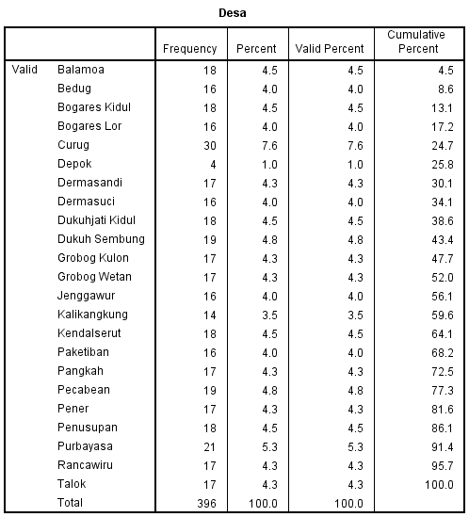

1. Berdasarkan jenis kelamin atau gender

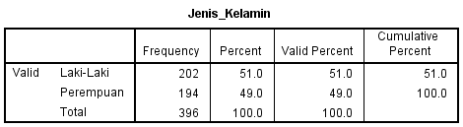

1. Berdasarkan usia

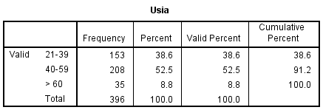

1. Berdasarkan pendidikan terakhir

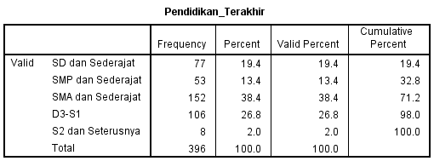

1. Berdasarkan pekerjaan

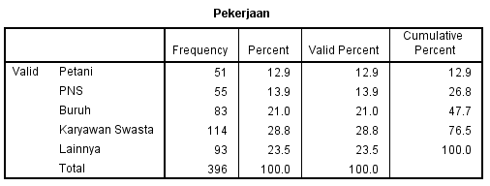

**Lampiran 8**

Hasil uji validitas

1. Uji validitas variabel motivasi

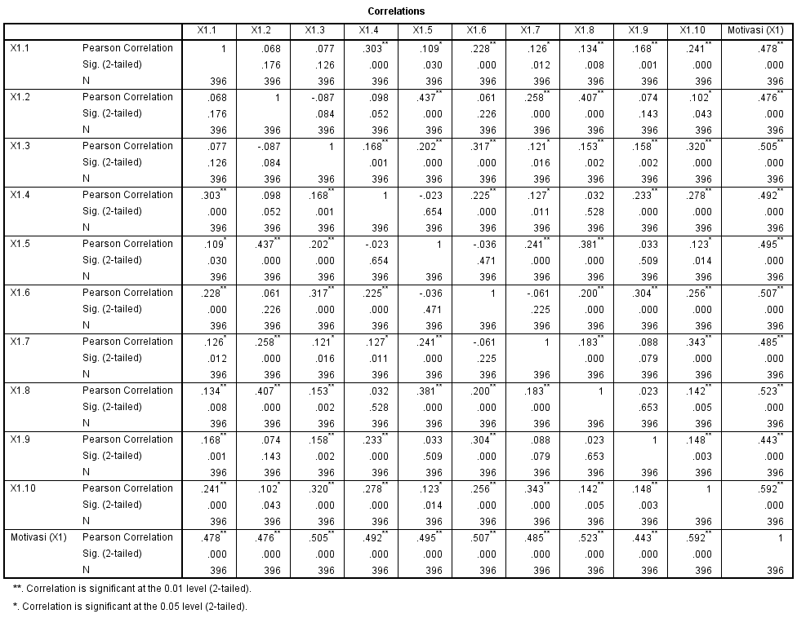

1. Uji validitas variabel kesadaran wajib pajak

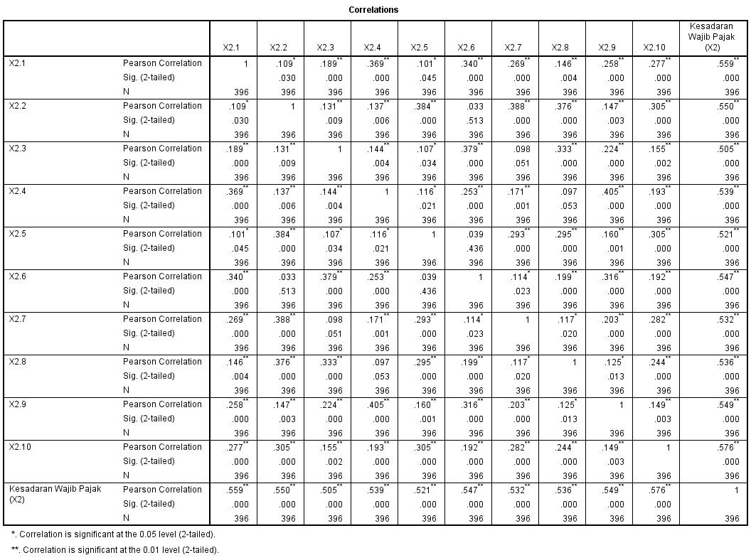

1. Uji validitas sanksi pajak

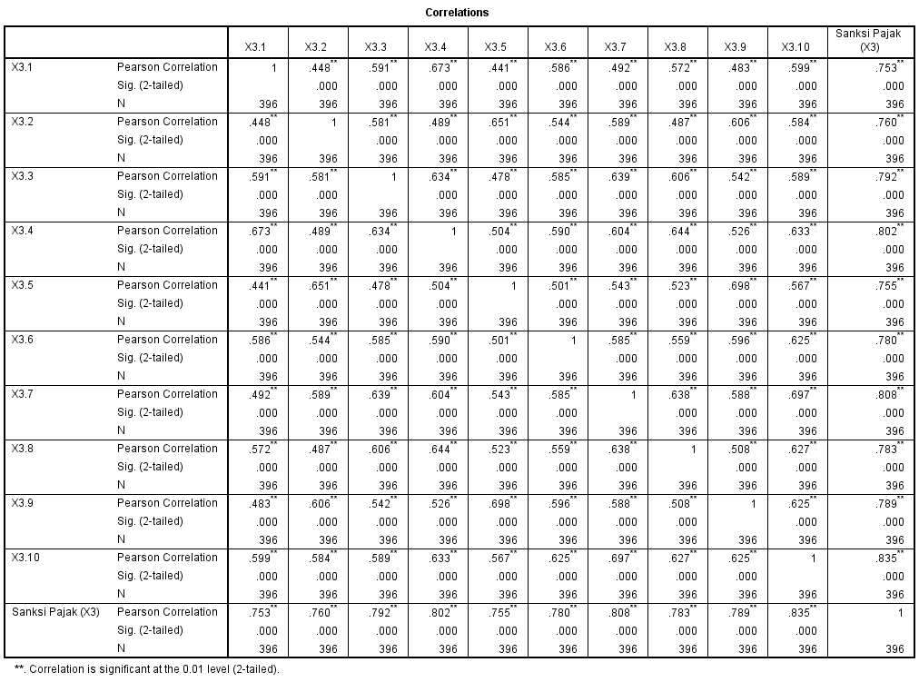

1. Uji validitas variabel partisipasi pembayaran pajak bumi dan bangunan (PBB)

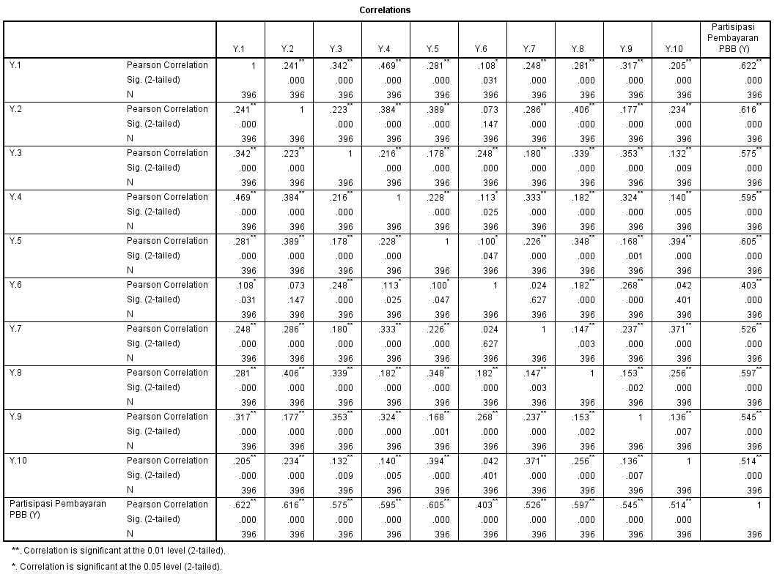

**Lampiran 9**

Hasil Uji Reliabilitas

|  |  |  |
| --- | --- | --- |
| **Reliability Statistics** | | |
| Cronbach's Alpha | Cronbach's Alpha Based on Standardized Items | N of Items |
| .715 | .763 | 10 |

1. 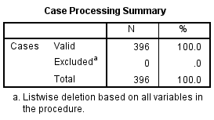Uji reliabilitas variabel motivasi
2. Uji reliabilitas variabel kesadaran wajib pajak

|  |  |  |
| --- | --- | --- |
| **Reliability Statistics** | | |
| Cronbach's Alpha | Cronbach's Alpha Based on Standardized Items | N of Items |
| .731 | .732 | 10 |

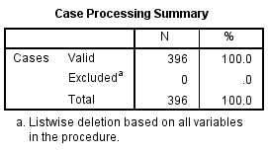

1. Uji reliabilitas variabel sanksi pajak

|  |  |  |
| --- | --- | --- |
| **Reliability Statistics** | | |
| Cronbach's Alpha | Cronbach's Alpha Based on Standardized Items | N of Items |
| .931 | .931 | 10 |

1. Uji reliabilitas variabel partisipasi pembayaran PBB

|  |  |  |
| --- | --- | --- |
| **Reliability Statistics** | | |
| Cronbach's Alpha | Cronbach's Alpha Based on Standardized Items | N of Items |
| .754 | .757 | 10 |

**Lampiran 10**

Hasil Uji Metode Analisis Data

1. 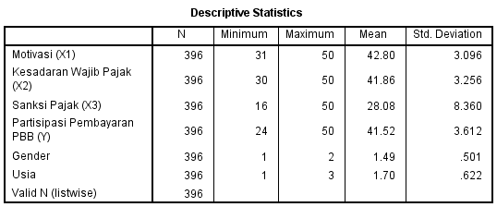Statistik Deskriptif
2. Uji Asumsi Klasik
3. Uji Normalitas

Sebelum di Transformasi Data

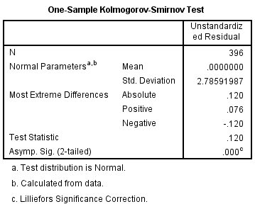

Setelah di Tranformasi Data

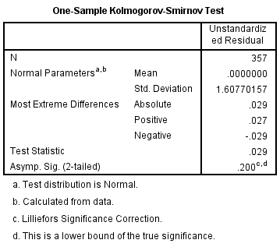

1. Uji Multikolonieritas

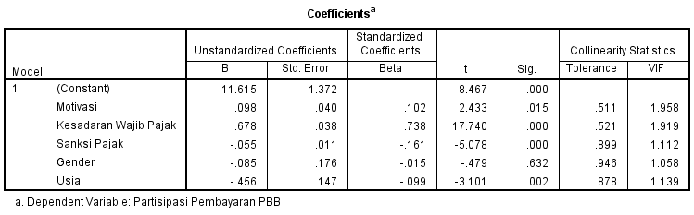

1. Uji Heteroskedastisitas

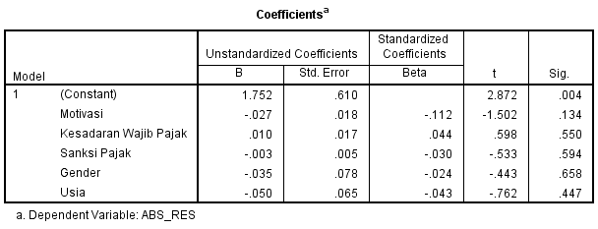

Analisis Regresi Lienar Berganda

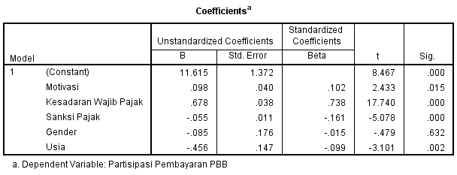

1. Uji Hipotesis
2. 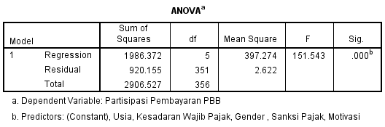Uji Kelayakan Model (uji f)
3. 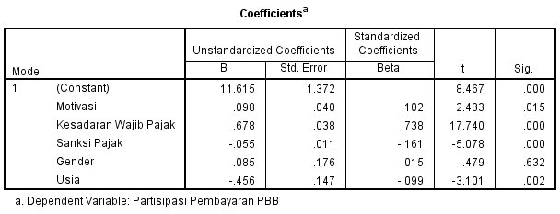Uji Persial (uji t)
4. 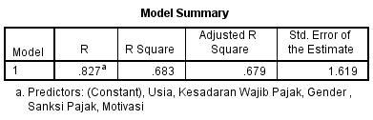Uji Koefisien Determinasi (R2)

**Lampiran 11**

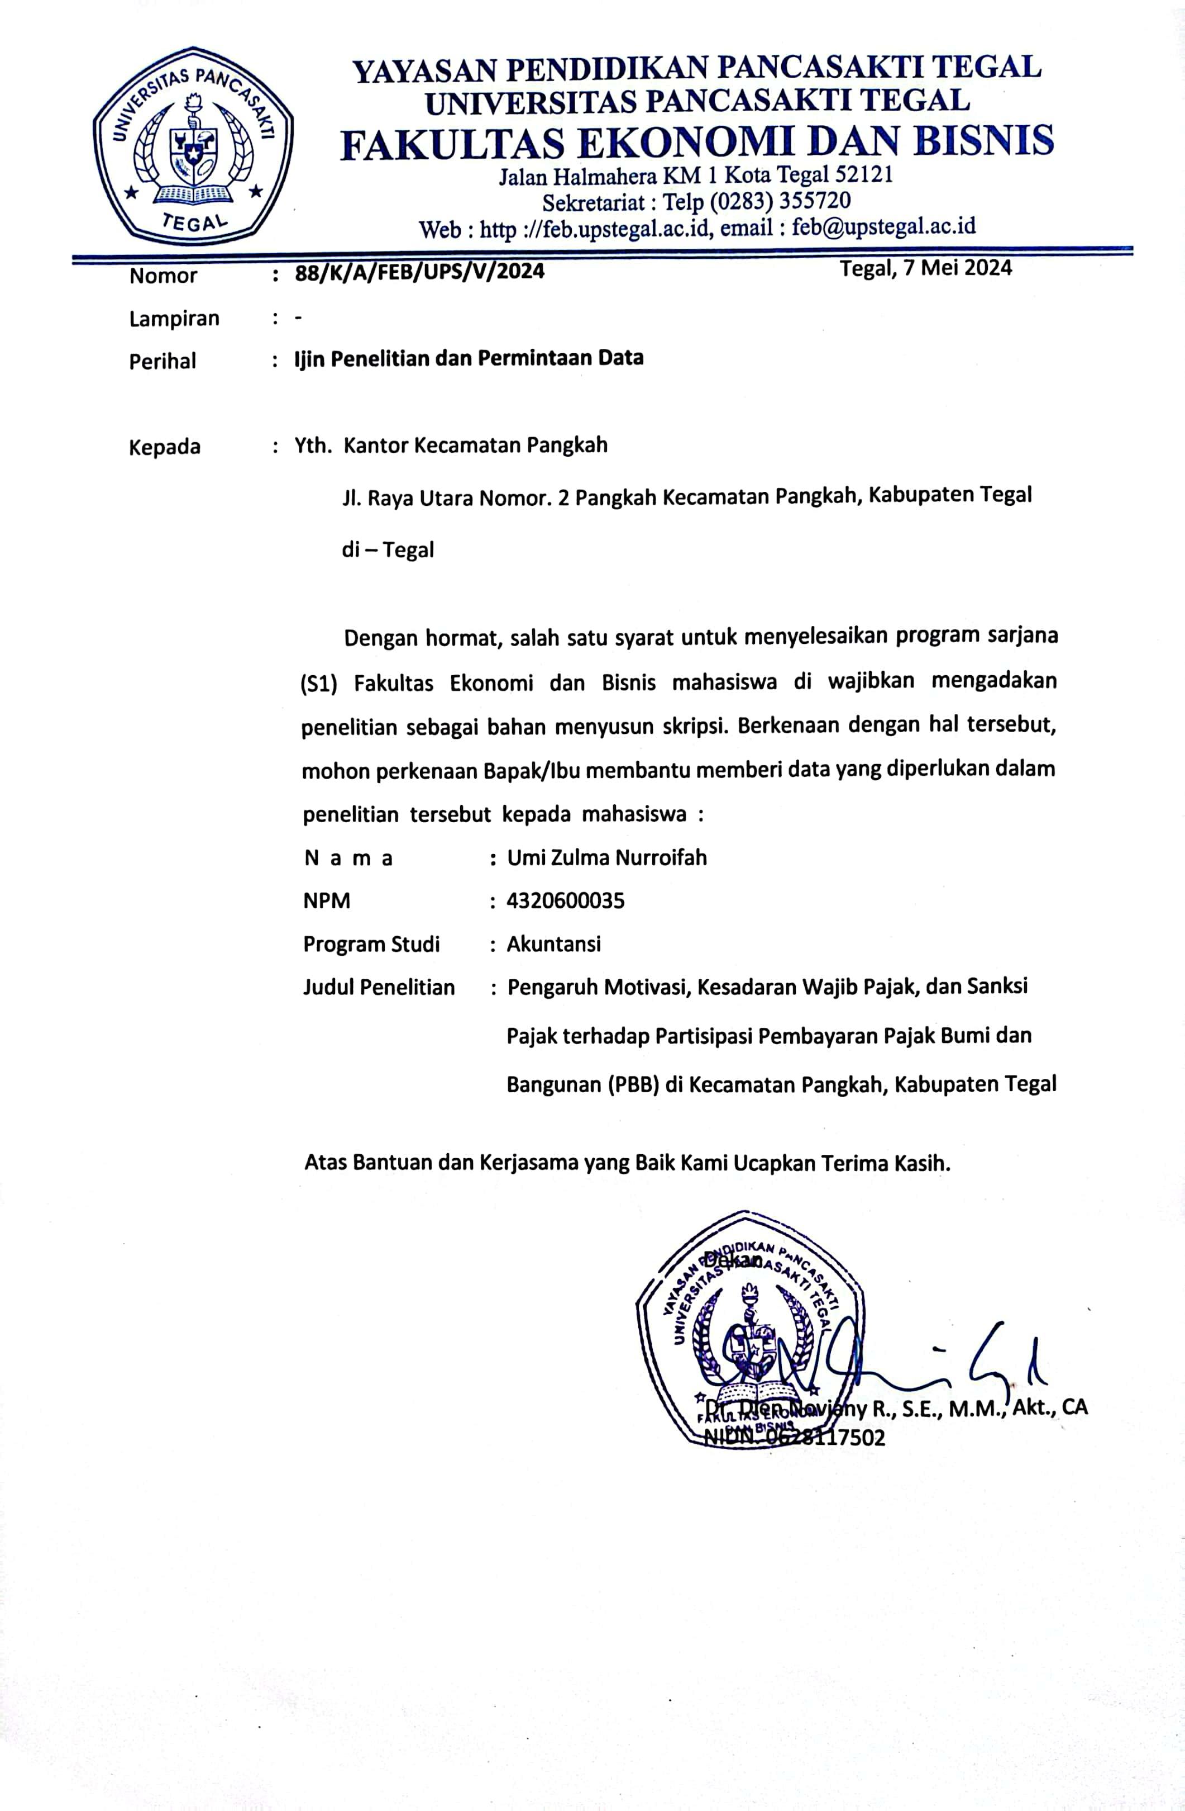Surat Izin Penelitian

**Lampiran 12**

Surat Pengantar Izin Penelitian untuk ke setiap Desa yang ada di Kecamatan Pangkah

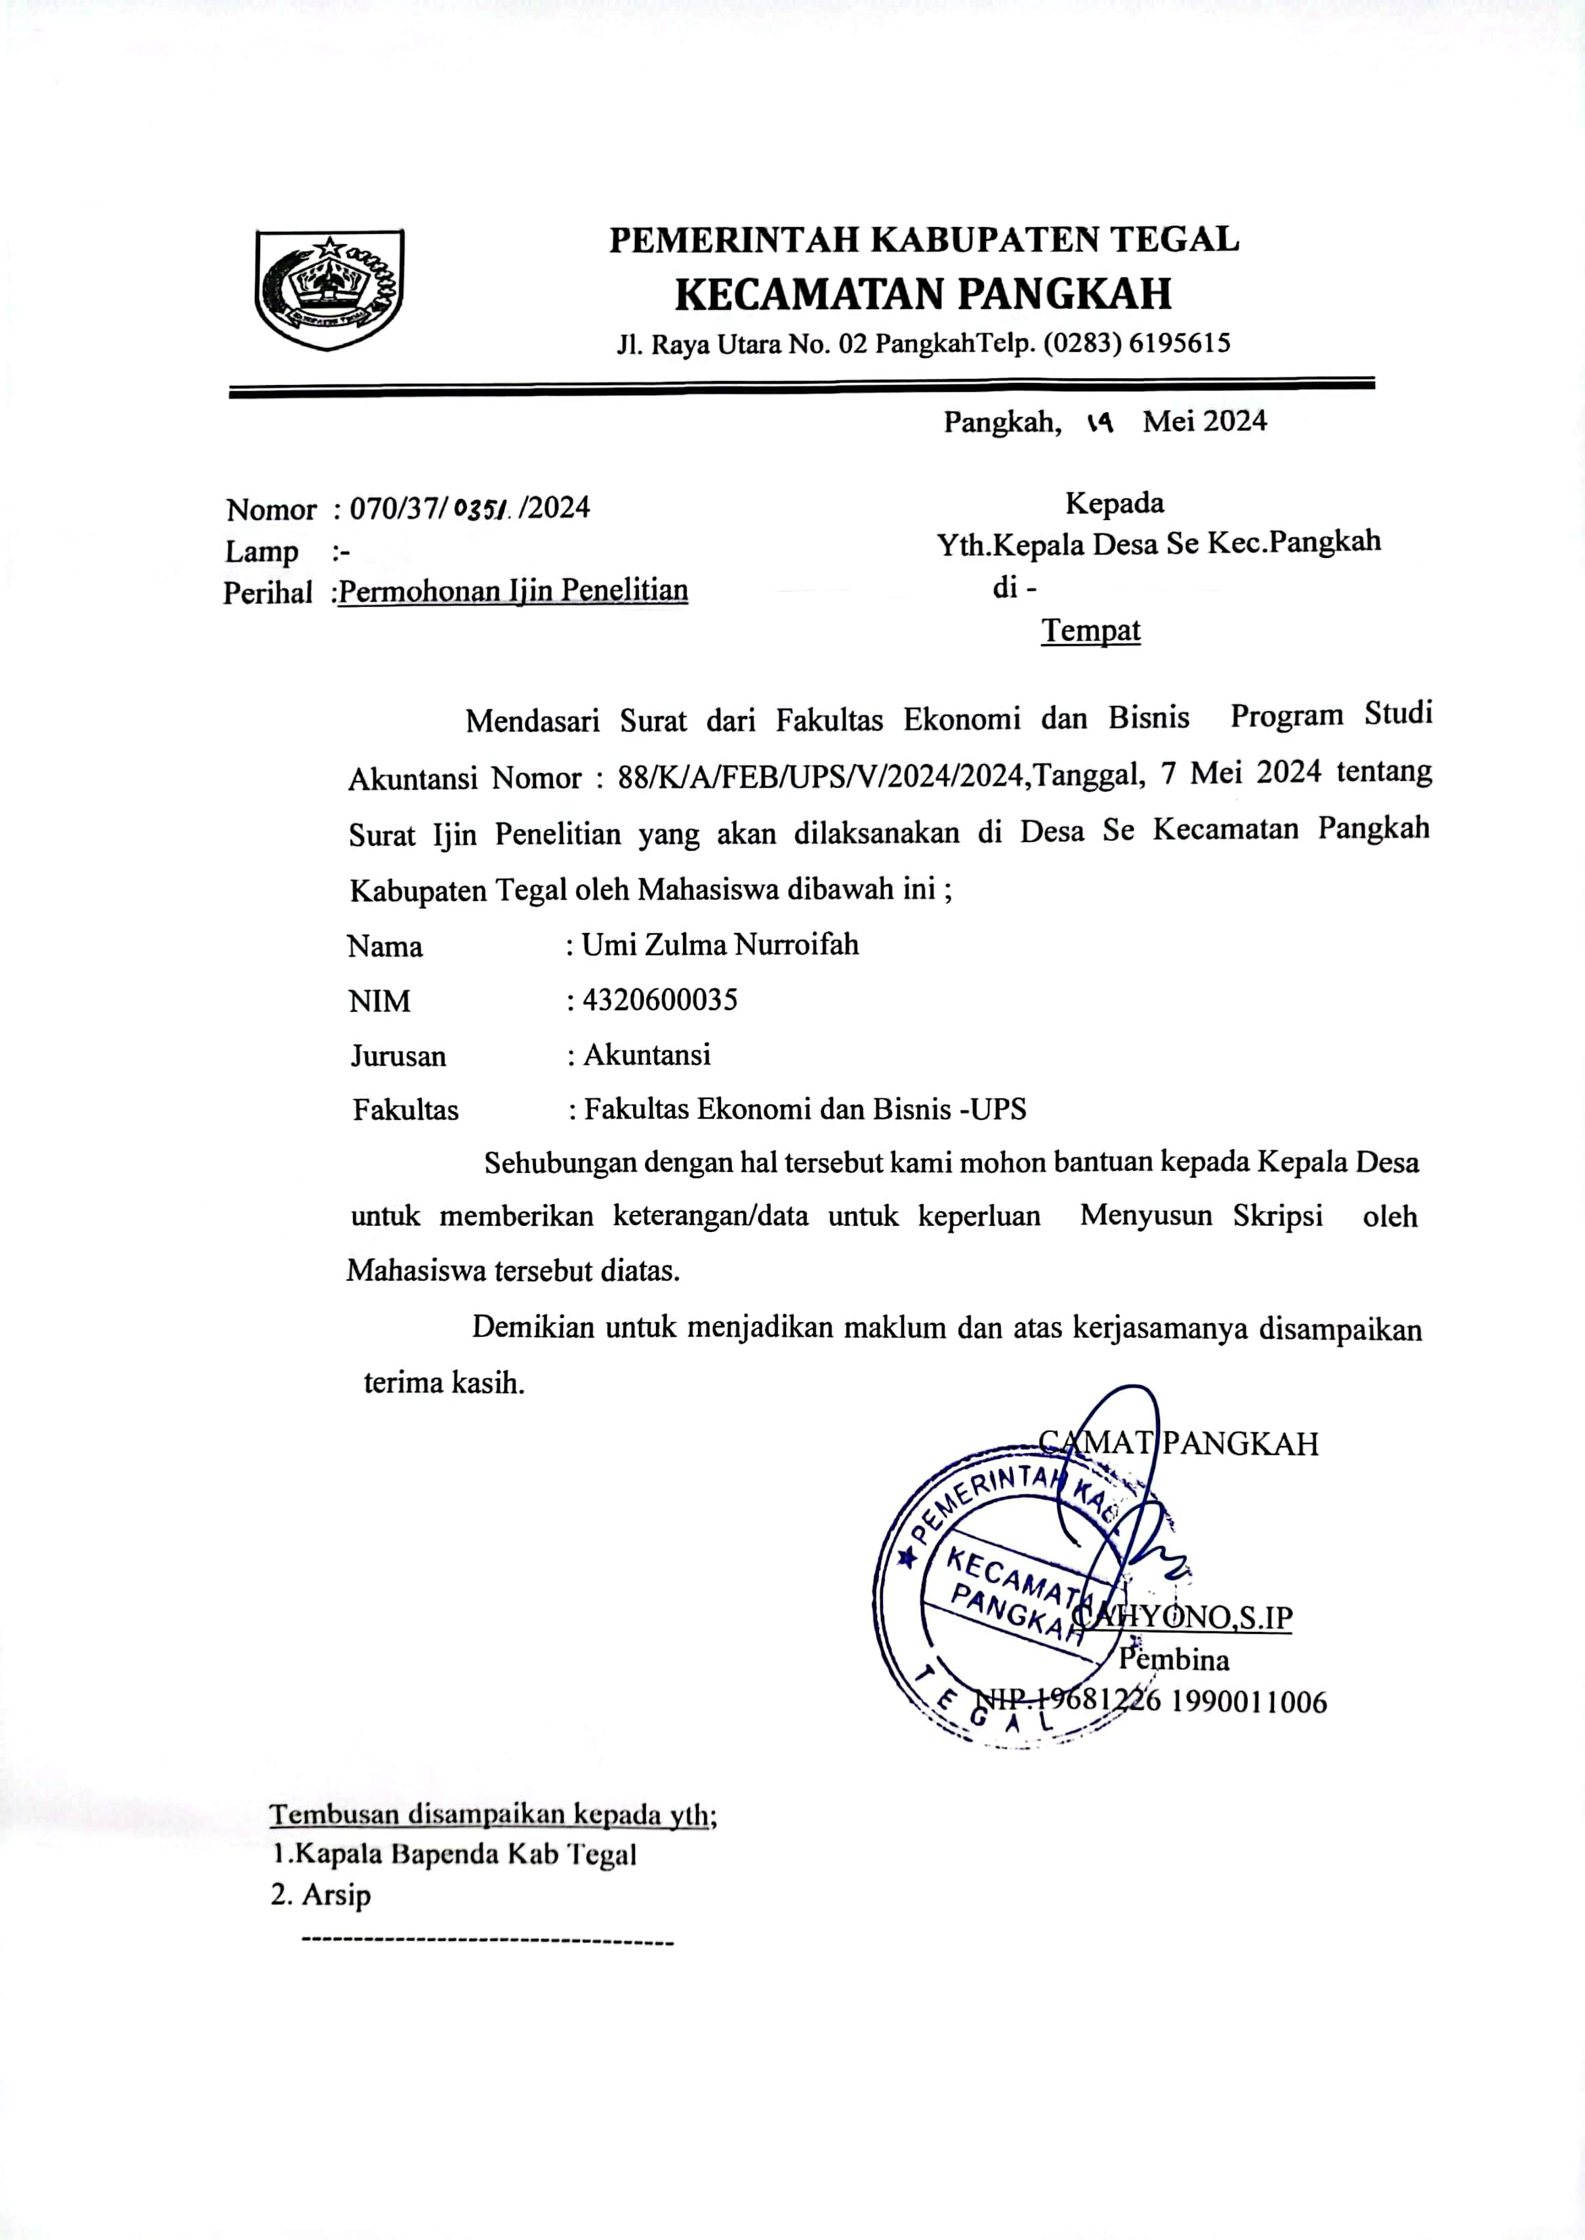

**Lampiran 13**

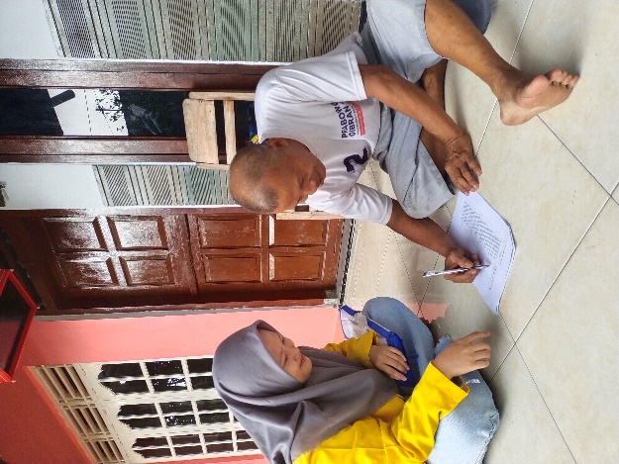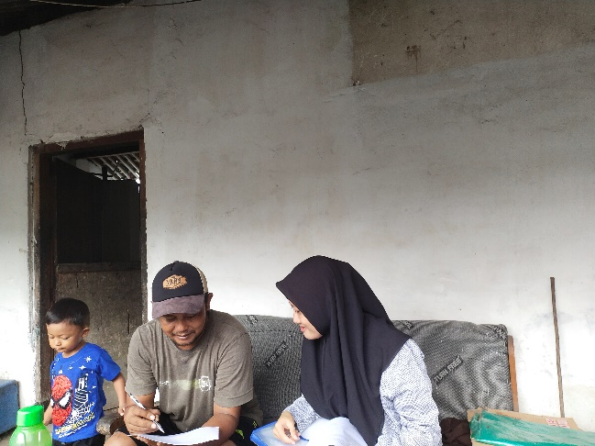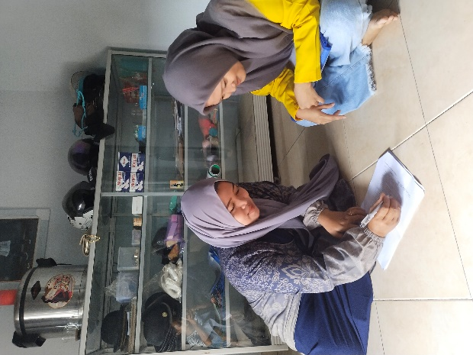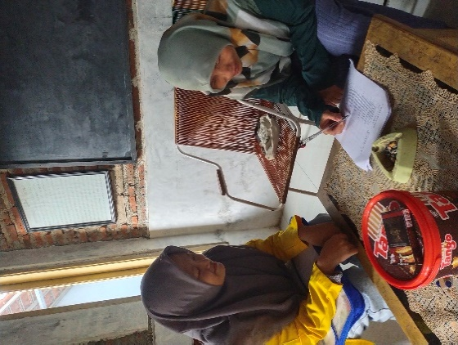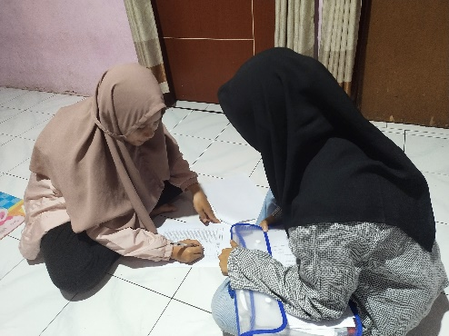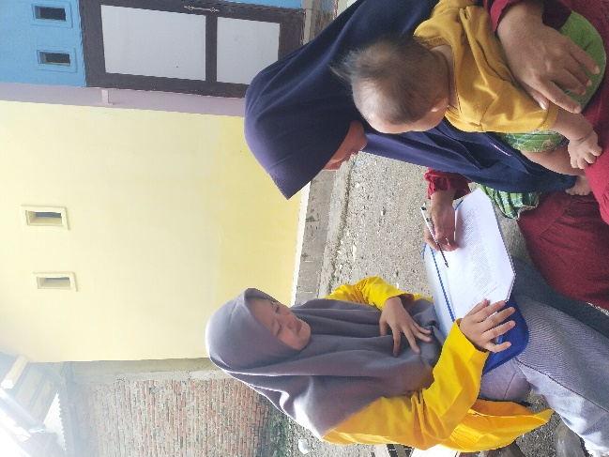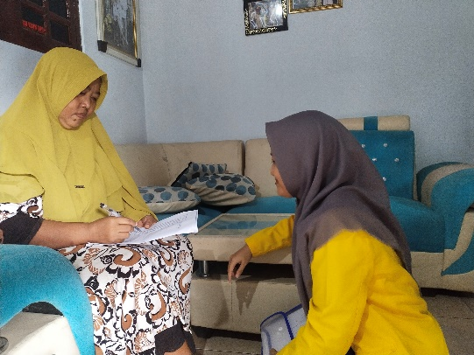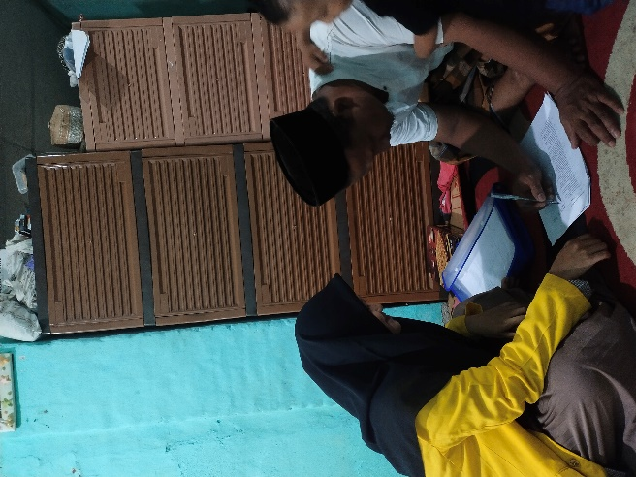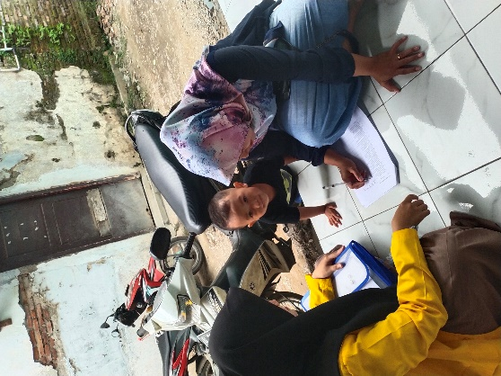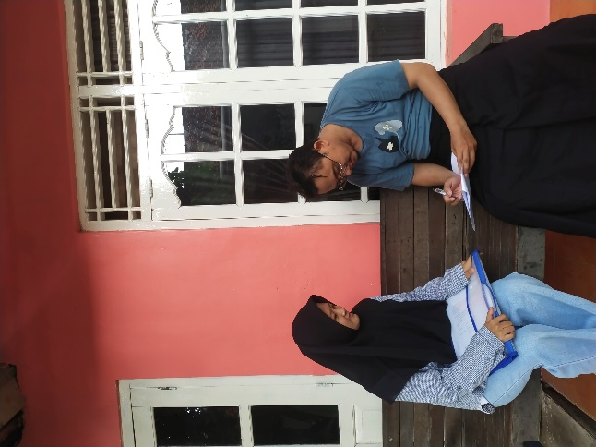Dokumentasi Pembagian Kuesioner

