**DAFTAR PUSTAKA**

Afrilia, K., Zunaida, D., & Chanafi, A. (2023). Pengaruh Inflasi , Ukuran Dan Umur Terhadap Kinerja Reksadana Saham Di Indonesia ( Studi pada Kasus Reksadana Saham yang Terdaftar di Bursa Efek Indonesia ). *JIAGABI*, *15*(1), 1–11. https://jim.unisma.ac.id/index.php/jiagabi/article/view/23188

Aji, L., & Akbar, T. (2022). Pengaruh IHSG, Inflasi Dan Kurs Terhadap Nilai Aktiva Bersih Reksa Dana Saham Periode 2015-2019. *Jurnal Riset*

*Perbankan, Manajemen, Dan Akuntansi*, *6*(2), 84–92.https://doi.org/10.56174/jrpma.v6i2.87

Akasumbawa, M. D. D., & Qoyum, A. (2023). Dampak Variabel Makroekonomi Terhadap Nilai Aktiva Bersih (Nab) Reksadana Syariah Menggunakan Metode Regresi Data Panel. *Rekan :Riset Ekonomi,Akuntansi Dan* *Perpajakan*, *4*(2), 127–142. https://doi.org/10.30812/rekan.v4i2.3213

Alim, F. A., Mai, M. U., & Setiawan. (2021). Analisis Pengaruh Faktor Internal dan Faktor Ekternal terhadap Kinerja Reksa Dana Syariah Saham. *Journal of*

*Applied Islamic Economics and Finance*, *1*(2), 435–445.https://doi.org/10.35313/jaief.v1i2.2476

Apriyanto, M., Setyowati, D. H., & Mayasari, I. (2022). Pengaruh BI Rate, Inflasi, dan Kurs Terhadap Nilai Aktiva Bersih Reksadana Syariah Campuran. *Journal of Applied Islamic Economics and Finance*, *2*(3), 559–568.https://doi.org/10.35313/jaief.v2i3.3034

Asriati, A., & Sumiati, S. (2021). Investasi Online Reksadana: Aspek Hukum dan Perlindungan Bagi Investor selaku Konsumen. *Pleno Jure Jurnal Ilmu Hukum*

*LL-DIKTI Wilayah IX Sulawesi*, *10*(1), 38–53.https://doi.org/10.37541/plenojure.v10i1.561

Chairani, S. (2020). Pengaruh Nilai Tukar Rupiah (Kurs), Jakarta Islamic Index (JII), Usia Reksadana dan Volume Perdagangan Reksadana Terhadap Nilai Aktiva Bersih (Nab) Reksadana Campuran Syariah. *Tirtayasa Ekonomika*, *15*(1), 31–43. https://doi.org/10.35448/jte.v15i1.6325

Dewi, I. A., & Hidayati, A. N. (2023). Economics and Digital Business Review Pengaruh Fund Size, Fund Age, Dan Turn Over Ratio Terhadap Kinerja Reksa Dana Syariah Indonesia Tahun 2016-2021. *Ecomics Adn Digital Business*

*Review*, *4*(2), 235–247.https://ojs.stieamkop.ac.id/index.php/ecotal/article/view/830

Dwi, A. (2023). Pengertian Investasi dan Jenis-jenisnya. *Fakultas Ekonomi Bisnis* *UMSU*. https://feb.umsu.ac.id/pengertian-investasi-dan-jenis-jenisnya/

Effendi, N. I., Nelvia, R., Wati, Y., Sufyati, Putri, D. E., Fathur, A., Wulandari, I., Seto, A. A., Kurniawan, M. Z., Puspitasari, D., Sesario, R., Arumingtyas, F.,

114

115

Santoso, A., & Putra, I. G. C. (2022). *Manajemen Keuangan*. PT Global Eksekutif Teknologi.

Ghofur, A. (2017). *Pengantar Ekonomi Syariah* (1st ed.). Depok: Rajawali Pers.

Ghozali, I. (2018). *Aplikasi Analisis Multivariate Dengan Program SPSS* (9th ed.).

Semarang: Universitas Diponegoro.

Ghozali, I. (2020). *25 Grand Theory*. Semarang: Yoga Pratama.

Hamid, A. K. A., & Cahyadi, I. F. (2019). Analisis Kinerja Reksadana Saham Syariah Di Pasar Modal Indonesia Menggunakan Metode Sharpe, Treynor, Dan Jensen Periode 2017-2018. *MALIA: Journal of Islamic Banking and* *Finance*, *3*(2), 95–124. https://doi.org/10.21043/malia.v3i2.8408

Helmi, M., & Jumali. (2021). Analisis Umur Reksadana, Expense Ratio Dan Kinerja Reksadana Saham. *JEMBATAN (Jurnal Ekonomi, Manajemen, Bisnis,*

*Auditing, Dan Akuntansi)*, *6*(1), 1–12.https://scholar.google.com/scholar?hl=id&as_sdt=0%2C5&q=analisis+umur +Reksadana%2C+expense+ratio+dan+kinerja+Reksadana+saham+di+perusa haan+mandiri&btnG=#d=gs_qabs&t=1709464187546&u=%23p%3DL93d3 c0wWhoJ

Hermuningsih, S. (2019). *Pasar Modal Indonesia* (2nd ed.). Yogyakarta: UPP STIM YKPN.

Ichamahari. (2023). Syariah Yang Terdaftar Pada Aplikasi Bareksa Periode 2020-

2022 Syariah Yang Terdaftar Pada Aplikasi Bareksa. *Eprints.Iain-Surakarta*,

1–127.

https://scholar.google.com/scholar?hl=id&as_sdt=0%2C5&q=ichamaharani

&btnG=#d=gs_qabs&t=1709113504534&u=%23p%3DbN3I16cTutYJ

Ilyas, M., & Shofawati, A. (2019). Pengaruh Inflasi, Nilai Tukar Rupiah, Bi Rate Terhadap Nilai Aktiva Bersih Reksa Dana Terproteksi Syariah Periode 2014-2018 Di Indonesia. *Jurnal Ekonomi Syariah Teori Dan Terapan*, *6*(9), 1830– 1839. https://doi.org/10.20473/vol6iss20199pp1830-1839

Iman, N. (2008). *Panduan Singkat dan Praktis Memulai Investasi Reksadana*.

Jakarta: PT Elex Media Komputindo.

Oktavinela, L., Habriyanto, H., & Putriana, M. (2023). Pengaruh Inflasi, Nilai Tukar Rupiah, dan Tingkat Suku Bunga Terhadap Nilai Aktiva Bersih Reksa Dana Campuran Syariah Tahun 2019-2021. *ECo-Buss*, *6*(1), 345–356. https://doi.org/10.32877/eb.v6i1.817

Prasetyo, D., & Widiyanto. (2019). Pengaruh Inflasi, Nilai Tukar Rupiah, Suku Bunga Bank Indonesia, dan Harga Emas Terhadap Nilai Aktiva Bersih Reksadana Syariah. *Konferensi Ilmiah Mahasiswa Unissula (Kimu) 2*, 133– 153. http://jurnal.unissula.ac.id/index.php/kimue/article/view/8720/3999

116

Priyandini, S., & Wirman. (2021). Pengaruh Nilai Tukar (Kurs) dan Inflasi Terhadap Nilai Aktiva Bersih Reksa Dana Syariah di Indonesia Tahun 2015-2019. *JIMEA: Jurnal Ilmiah MEA (Manajemen, Ekonomi, & Akuntansi)*, *5*(1), 852–868. https://journal.stiemb.ac.id/index.php/mea/article/view/493

Putri Mulya Aliefiani Ganis, Maharani Putri Srirahayu, & Nisrina Ghina. (2022). Putri dkk (2022). In *Jurnal Ekonomi Manajemen Sistem Informasi*. https://dinastirev.org/JEMSI/article/view/819/515

Putri, N. M. W., Iskandar, & Safarida, N. (2022). Pengaruh Inflasi, BI Rate dan IHSG terhadap Nilai Aktiva Bersih Reksadana Syariah di Indonesia Periode

2015-2020. *Concept and Communication*, *4*(1), 57–76. https://doi.org/10.15797/concom.2019..23.009

Rizal, David, Shabri, H., & Nengsih, I. (2021). Pengaruh Inflasi, BI Rate, Nilai Tukar, dan Jumlah Reksadana Terhadap Nilai Aktiva Bersih (NAB) Reksadana Syariah dan Konvensional di Indonesia. *Al-Mashrafiyah: Jurnal* *Ekonomi, Keuangan, Dan Perbankan Syariah*, *5*(2), 15–27.https://doi.org/10.24252/al-mashrafiyah.v5i2.22783

Salim, J. (2010). *10 Investasi Paling Gampang & Paling Aman*. Jakarta Selatan:

Transmedia Pustaka.

Sari, Y. N. I. (2020). Tinjauan Hukum Islam Terhadap Investasi Reksa Dana Syariah. *Jurnal Masharif Al-Syariah: Jurnal Ekonomi Dan Perbankan* *Syariah*, *5*(2), 94–105. http://journal.um-surabaya.ac.id/index.php/Maqasid

Sugiyono. (2013). *Metode Penelitian Kuantitatif Kualitatif Dan R&D*. Bandung:

Alfabeta.

Sulistia, R., Djuwarsa, T., & Purbayati, R. (2023). Pengaruh Faktor Eksternal dan Internal terhadap Nilai Aktiva Bersih Reksadana Syariah Saham Sebelum dan Selama Covid-19 (2018-2021). *Journal of Applied Islamic Economics and* *Finance*, *3*(3), 612–624. https://doi.org/10.35313/jaief.v3i3.5495

Suliyanto. (2018). *Metode Penelitian Bisnis untuk Skripsi, Tesis, dan Disertasi* (1st ed.). Yogyakarta: Andi Offset.

117

**LAMPIRAN**

118

**LAMPIRAN 1**

Data Populasi Penelitian

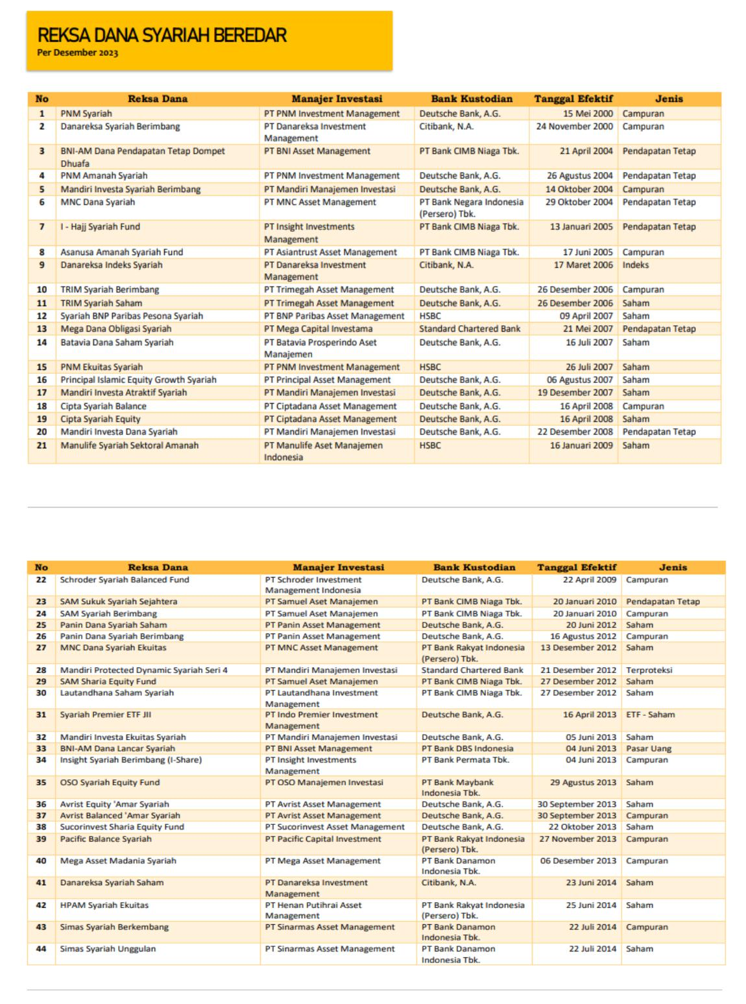

119

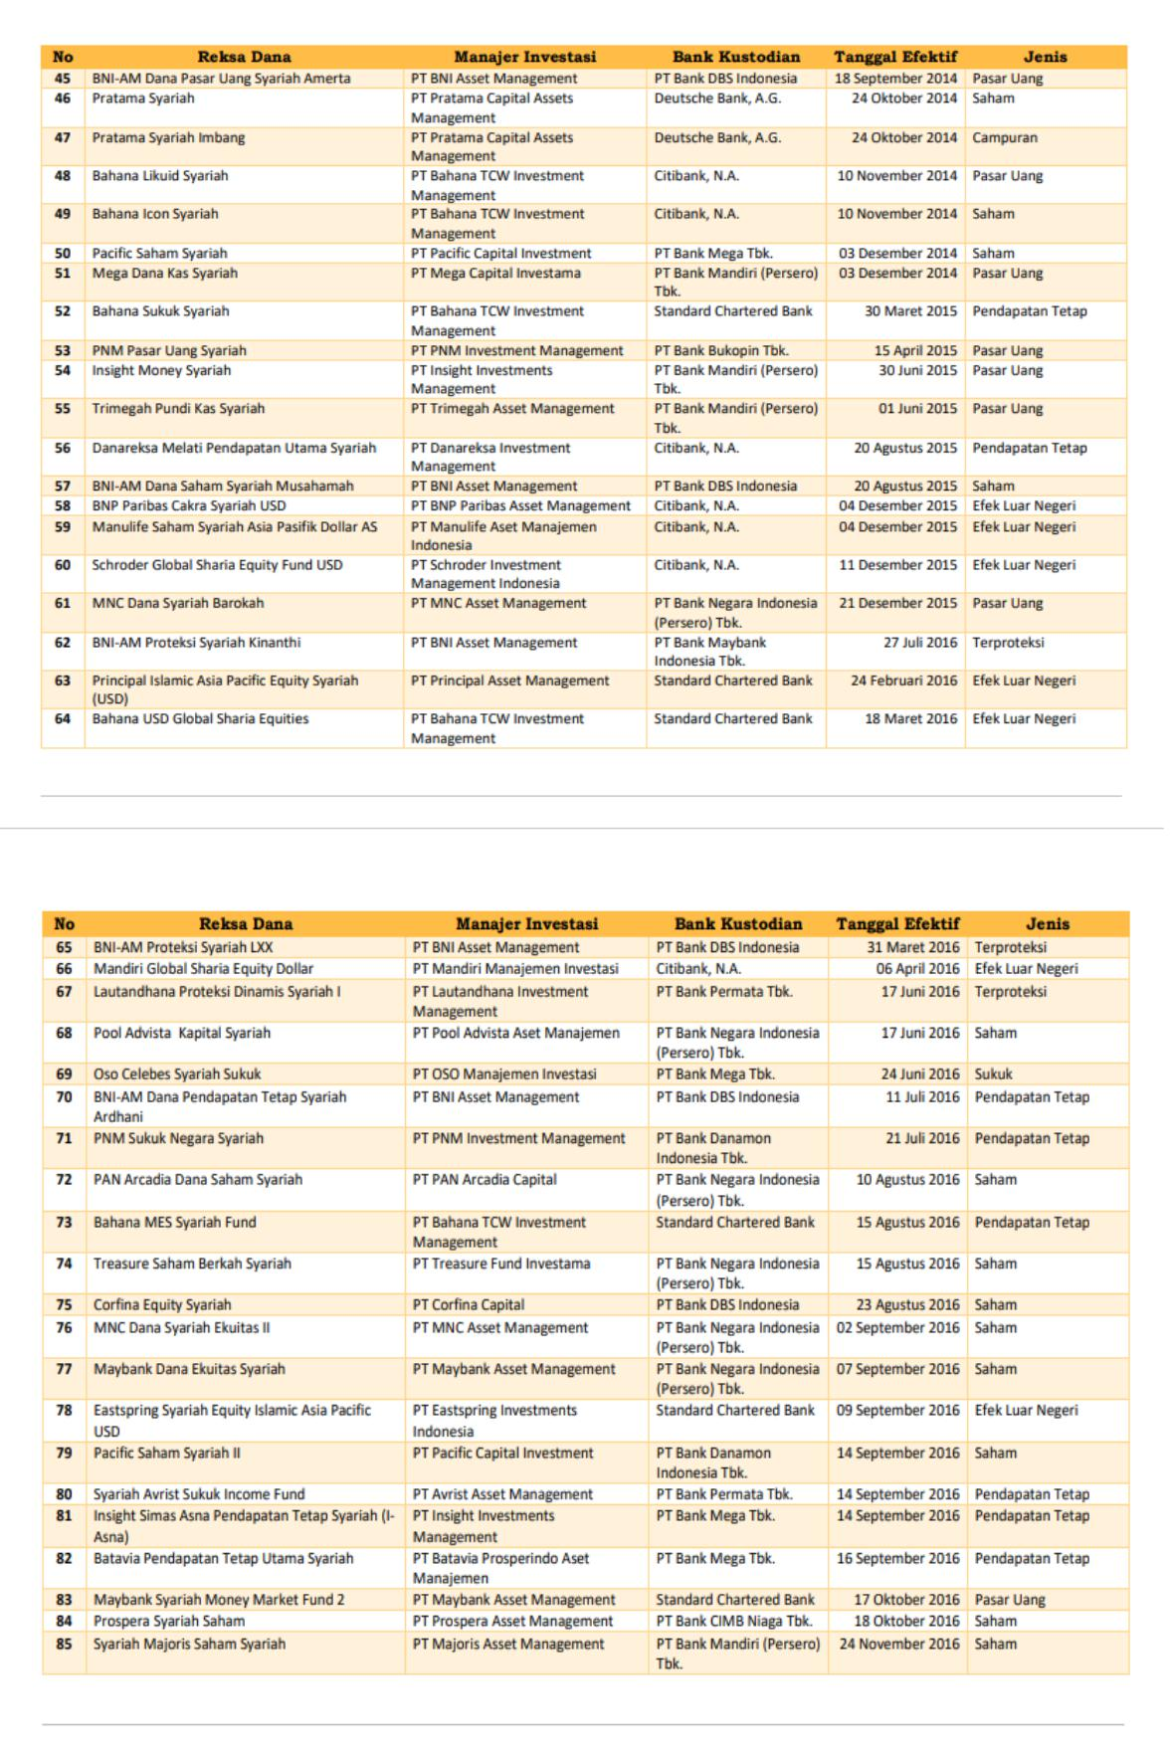

120

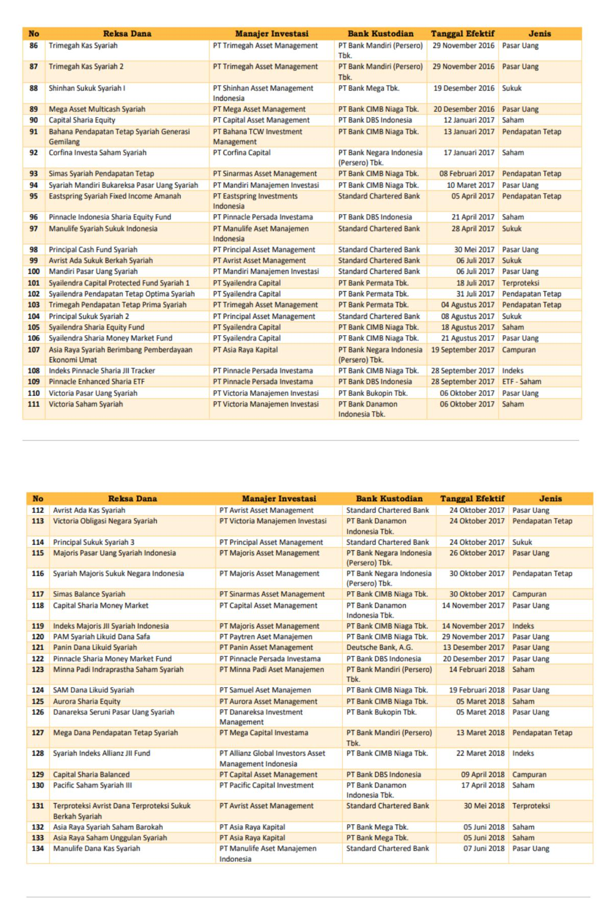

121

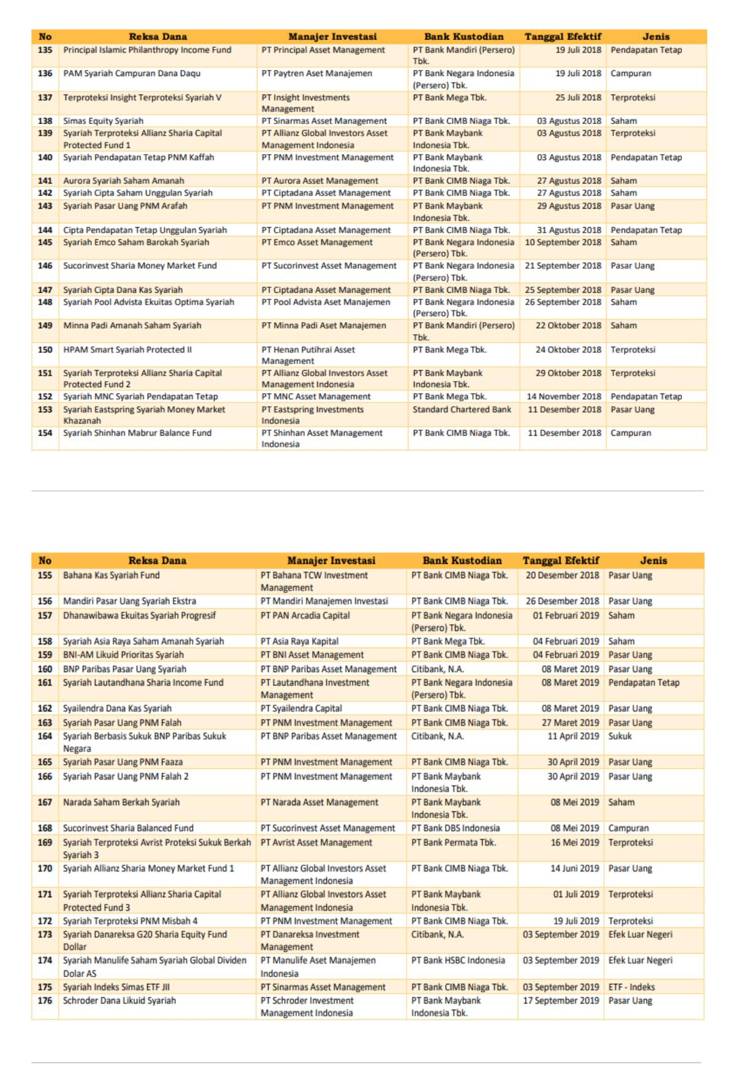

122

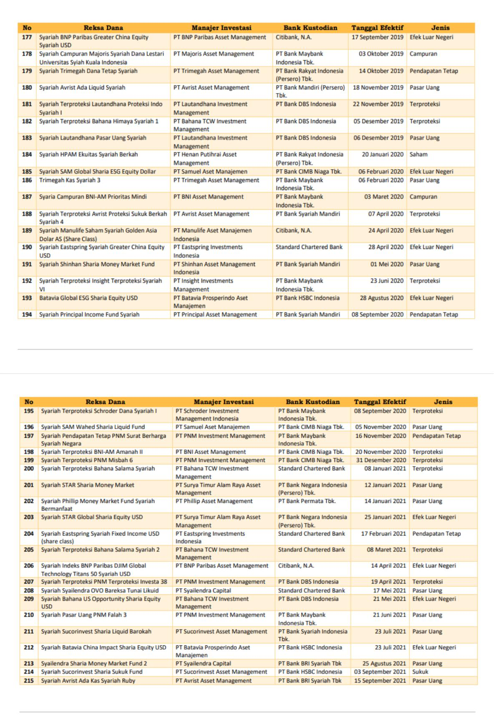

123

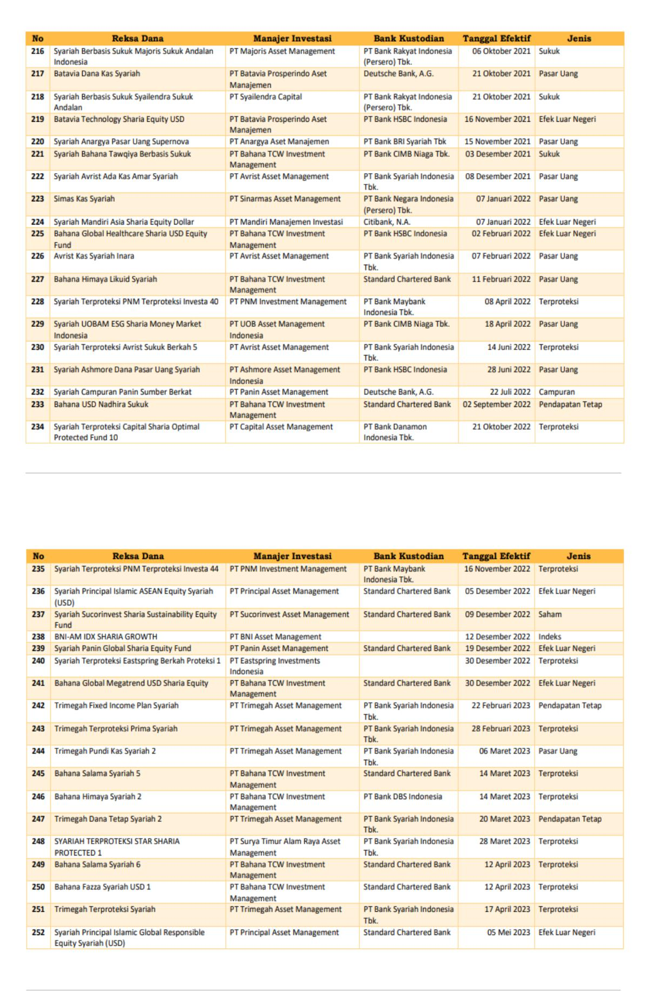

124

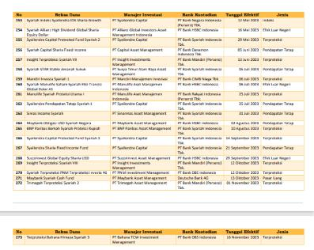

125

|  |  |
| --- | --- |
|  | **LAMPIRAN 2** |
|  | Sampel Penelitian |
|  |  |
| No | Produk Reksa dana Saham Syariah |
| 1 | TRIM Syariah Saham |
| 2 | Syariah BNP Paribas Pesona Syariah |
| 3 | Batavia Dana Saham Syariah |
| 4 | PNM Ekuitas Syariah |
| 5 | Principal Islamic Equity Growth Syariah |
| 6 | Mandiri Investa Atraktif Syariah |
| 7 | Cipta Syariah Equity |
| 8 | Manulife Syariah Sektoral Amanah |
| 9 | Panin Dana Syariah Saham |
| 10 | SAM Sharia Equity Fund |
| 11 | Lautandhana Saham Syariah |
| 12 | Syariah Premier ETF JII |
| 13 | Mandiri Investa Ekuitas Syariah |
| 14 | Avrist Equity 'Amar Syariah |
| 15 | Sucorinvest Sharia Equity Fund |
| 16 | HPAM Syariah Ekuitas |
| 17 | Simas Syariah Unggulan |
| 18 | Pratama Syariah |
| 19 | Pacific Saham Syariah |
| 20 | Pool Advista Kapital Syariah |
| 21 | PAN Arcadia Dana Saham Syariah |
| 22 | Treasure Saham Berkah Syariah |
| 23 | Corfina Equity Syariah |
| 24 | MNC Dana Syariah Ekuitas II |
| 25 | Maybank Dana Ekuitas Syariah |
| 26 | Pacific Saham Syariah II |
| 27 | Prospera Syariah Saham |
| 28 | Syariah Majoris Saham Syariah |
| 29 | Capital Sharia Equity |
| 30 | Corfina Investa Saham Syariah |
| 31 | Aurora Sharia Equity |
| 32 | Pacific Saham Syariah III |
| 33 | Asia Raya Syariah Saham Barokah |
| 34 | Asia Raya Saham Unggulan Syariah |
| 35 | Simas Equity Syariah |
| 36 | Aurora Syariah Saham Amanah |
| 37 | Syariah Cipta Saham Unggulan Syariah |
| 38 | Syariah Emco Saham Barokah Syariah |
| 39 | Syariah Pool Advista Ekuitas Optima Syariah |

126

1. Minna Padi Amanah Saham Syariah
2. Syariah Asia Raya Saham Amanah Syariah
3. Narada Saham Berkah Syariah

127

**LAMPIRAN 3**

Data Hasil Penelitian Produk Reksa Dana Syariah Yang Terdaftar Di OJK periode

2019-2023

|  |  |  |  |  |  |  |
| --- | --- | --- | --- | --- | --- | --- |
| No | Produk Reksadana | Nilai Aktiva Bersih | Usia | Ukuran | Nilai | Bi |
|  |  |  |  | Reksadana | Tukar | Rate |
|  |  |  |  |  | Rupiah |  |
| 1 | TRIM Syariah Saham (2019) | 80103780604,22 | 4753 | 25,11 | 13901,01 | 0,05 |
| 2 | Syariah BNP Paribas Pesona | 770931422407,00 | 4649 | 27,37 | 13901,01 | 0,05 |
|  | Syariah (2019) |  |  |  |  |  |
| 3 | Batavia Dana Saham Syariah | 206428538730,58 | 4551 | 26,05 | 13901,01 | 0,05 |
|  | (2019) |  |  |  |  |  |
| 4 | PNM Ekuitas Syariah (2019) | 17114085283,27 | 4541 | 23,56 | 13901,01 | 0,05 |
| 5 | Principal Islamic Equity | 137577013054,18 | 4530 | 25,65 | 13901,01 | 0,05 |
|  | Growth Syariah (2019) |  |  |  |  |  |
| 6 | Mandiri Investa Atraktif | 80623518899,82 | 4395 | 25,11 | 13901,01 | 0,05 |
|  | Syariah (2019) |  |  |  |  |  |
| 7 | Cipta Syariah Equity (2019) | 31833357914,99 | 4276 | 24,18 | 13901,01 | 0,05 |
| 8 | Manulife Syariah Sektoral | 299373829369,00 | 4001 | 26,42 | 13901,01 | 0,05 |
|  | Amanah (2019) |  |  |  |  |  |
| 9 | Panin Dana Syariah Saham | 46124664179,61 | 2750 | 24,55 | 13901,01 | 0,05 |
|  | (2019) |  |  |  |  |  |
| 10 | SAM Sharia Equity Fund | 55097974124,21 | 2560 | 24,73 | 13901,01 | 0,05 |
|  | (2019) |  |  |  |  |  |
| 11 | Lautandhana Saham Syariah | 11077189841,97 | 2560 | 23,13 | 13901,01 | 0,05 |
|  | (2019) |  |  |  |  |  |
| 12 | Syariah Premier ETF JII (2019) | 15512075163,50 | 2450 | 23,46 | 13901,01 | 0,05 |
| 13 | Mandiri Investa Ekuitas | 22382447335,48 | 2400 | 23,83 | 13901,01 | 0,05 |
|  | Syariah (2019) |  |  |  |  |  |
| 14 | Avrist Equity 'Amar Syariah | 11583485798,71 | 2283 | 23,17 | 13901,01 | 0,05 |
|  | (2019) |  |  |  |  |  |
| 15 | Sucorinvest Sharia Equity | 196812442684,00 | 2261 | 26,01 | 13901,01 | 0,05 |
|  | Fund (2019) |  |  |  |  |  |
| 16 | HPAM Syariah Ekuitas (2019) | 305755838472,28 | 2015 | 26,45 | 13901,01 | 0,05 |
| 17 | Simas Syariah Unggulan | 97212669423,14 | 1988 | 25,30 | 13901,01 | 0,05 |
|  | (2019) |  |  |  |  |  |
| 18 | Pratama Syariah (2019) | 22267281509,50 | 1894 | 23,83 | 13901,01 | 0,05 |
| 19 | Pacific Saham Syariah (2019) | 78033115874,33 | 1854 | 25,08 | 13901,01 | 0,05 |
| 20 | Pool Advista Kapital Syariah | 209165658093,76 | 1292 | 26,07 | 13901,01 | 0,05 |
|  | (2019) |  |  |  |  |  |
| 21 | PAN Arcadia Dana Saham | 158670084225,30 | 1238 | 25,79 | 13901,01 | 0,05 |
|  | Syariah (2019) |  |  |  |  |  |
| 22 | Treasure Saham Berkah | 118968510213,87 | 1233 | 25,50 | 13901,01 | 0,05 |
|  | Syariah (2019) |  |  |  |  |  |
| 23 | Corfina Equity Syariah (2019) | 77057941205,00 | 1225 | 25,07 | 13901,01 | 0,05 |
| 24 | MNC Dana Syariah Ekuitas II | 160794888974,30 | 1215 | 25,80 | 13901,01 | 0,05 |
|  | (2019) |  |  |  |  |  |

128

|  |  |  |  |  |  |  |
| --- | --- | --- | --- | --- | --- | --- |
| 25 | Maybank Dana Ekuitas | 203019656981,80 | 1210 | 26,04 | 13901,01 | 0,05 |
|  | Syariah (2019) |  |  |  |  |  |
| 26 | Pacific Saham Syariah II | 132494916007,11 | 1203 | 25,61 | 13901,01 | 0,05 |
|  | (2019) |  |  |  |  |  |
| 27 | Prospera Syariah Saham | 288004932934,62 | 1169 | 26,39 | 13901,01 | 0,05 |
|  | (2019) |  |  |  |  |  |
| 28 | Syariah Majoris Saham | 10324500986,55 | 1132 | 23,06 | 13901,01 | 0,05 |
|  | Syariah (2019) |  |  |  |  |  |
| 29 | Capital Sharia Equity (2019) | 165691073923,16 | 1083 | 25,83 | 13901,01 | 0,05 |
| 30 | Corfina Investa Saham | 225333758250,39 | 1078 | 26,14 | 13901,01 | 0,05 |
|  | Syariah (2019) |  |  |  |  |  |
| 31 | Aurora Sharia Equity (2019) | 230547301664,88 | 666 | 26,16 | 13901,01 | 0,05 |
| 32 | Pacific Saham Syariah III | 75333196207,07 | 623 | 25,05 | 13901,01 | 0,05 |
|  | (2019) |  |  |  |  |  |
| 33 | Asia Raya Syariah Saham | 89439197652,03 | 574 | 25,22 | 13901,01 | 0,05 |
|  | Barokah (2019) |  |  |  |  |  |
| 34 | Asia Raya Saham Unggulan | 59199500931,44 | 574 | 24,80 | 13901,01 | 0,05 |
|  | Syariah (2019) |  |  |  |  |  |
| 35 | Simas Equity Syariah (2019) | 10775330333,78 | 515 | 23,10 | 13901,01 | 0,05 |
| 36 | Aurora Syariah Saham | 17168172392,69 | 491 | 23,57 | 13901,01 | 0,05 |
|  | Amanah (2019) |  |  |  |  |  |
| 37 | Syariah Cipta Saham | 7746798999,68 | 491 | 22,77 | 13901,01 | 0,05 |
|  | Unggulan Syariah (2019) |  |  |  |  |  |
| 38 | Syariah Emco Saham Barokah | 94958993237,39 | 477 | 25,28 | 13901,01 | 0,05 |
|  | Syariah (2019) |  |  |  |  |  |
| 39 | Syariah Pool Advista Ekuitas | 178511486590,73 | 461 | 25,91 | 13901,01 | 0,05 |
|  | Optima Syariah (2019) |  |  |  |  |  |
| 40 | Minna Padi Amanah Saham | 261920325415,85 | 435 | 26,29 | 13901,01 | 0,05 |
|  | Syariah (2019) |  |  |  |  |  |
| 41 | Syariah Asia Raya Saham | 78123388885,85 | 330 | 25,08 | 13901,01 | 0,05 |
|  | Amanah Syariah (2019) |  |  |  |  |  |
| 42 | Narada Saham Berkah Syariah | 91015669869,56 | 237 | 25,23 | 13901,01 | 0,05 |
|  | (2019) |  |  |  |  |  |
| 43 | TRIM Syariah Saham (2020) | 127387816733,32 | 5119 | 25,57 | 14105,01 | 0,04 |
| 44 | Syariah BNP Paribas Pesona | 853743243418,00 | 5015 | 27,47 | 14105,01 | 0,04 |
|  | Syariah (2020) |  |  |  |  |  |
| 45 | Batavia Dana Saham Syariah | 157344932484,49 | 4917 | 25,78 | 14105,01 | 0,04 |
|  | (2020) |  |  |  |  |  |
| 46 | PNM Ekuitas Syariah (2020) | 15573676223,58 | 4907 | 23,47 | 14105,01 | 0,04 |
| 47 | Principal Islamic Equity | 118625399992,50 | 4896 | 25,50 | 14105,01 | 0,04 |
|  | Growth Syariah (2020) |  |  |  |  |  |
| 48 | Mandiri Investa Atraktif | 67517712467,26 | 4761 | 24,94 | 14105,01 | 0,04 |
|  | Syariah (2020) |  |  |  |  |  |
| 49 | Cipta Syariah Equity (2020) | 28578197339,49 | 4642 | 24,08 | 14105,01 | 0,04 |
| 50 | Manulife Syariah Sektoral | 278189888843,00 | 4367 | 26,35 | 14105,01 | 0,04 |
|  | Amanah (2020) |  |  |  |  |  |
| 51 | Panin Dana Syariah | 64146571423,14 | 3116 | 24,88 | 14105,01 | 0,04 |
|  | Saham(2020) |  |  |  |  |  |

129

|  |  |  |  |  |  |  |
| --- | --- | --- | --- | --- | --- | --- |
| 52 | SAM Sharia Equity Fund | 50423344849,16 | 2926 | 24,64 | 14105,01 | 0,04 |
|  | (2020) |  |  |  |  |  |
| 53 | Lautandhana Saham | 10046931324,60 | 2926 | 23,03 | 14105,01 | 0,04 |
|  | Syariah(2020) |  |  |  |  |  |
| 54 | Syariah Premier ETF JII (2020) | 16763291196,04 | 2816 | 23,54 | 14105,01 | 0,04 |
| 55 | Mandiri Investa Ekuitas | 16843137764,03 | 2766 | 23,55 | 14105,01 | 0,04 |
|  | Syariah (2020) |  |  |  |  |  |
| 56 | Avrist Equity 'Amar | 11464815053,20 | 2649 | 23,16 | 14105,01 | 0,04 |
|  | Syariah(2020) |  |  |  |  |  |
| 57 | Sucorinvest Sharia Equity | 430696466728,00 | 2627 | 26,79 | 14105,01 | 0,04 |
|  | Fund (2020) |  |  |  |  |  |
| 58 | HPAM Syariah Ekuitas (2020) | 280701066539,26 | 2381 | 26,36 | 14105,01 | 0,04 |
| 59 | Simas Syariah Unggulan | 67648014302,19 | 2354 | 24,94 | 14105,01 | 0,04 |
|  | (2020) |  |  |  |  |  |
| 60 | Pratama Syariah (2020) | 14080988872,89 | 2260 | 23,37 | 14105,01 | 0,04 |
| 61 | Pacific Saham Syariah (2020) | 55997809398,47 | 2220 | 24,75 | 14105,01 | 0,04 |
| 62 | Pool Advista Kapital Syariah | 305397435106,14 | 1658 | 26,44 | 14105,01 | 0,04 |
|  | (2020) |  |  |  |  |  |
| 63 | PAN Arcadia Dana Saham | 184224249930,56 | 1604 | 25,94 | 14105,01 | 0,04 |
|  | Syariah (2020) |  |  |  |  |  |
| 64 | Treasure Saham Berkah | 139714672078,75 | 1599 | 25,66 | 14105,01 | 0,04 |
|  | Syariah (2020) |  |  |  |  |  |
| 65 | Corfina Equity Syariah (2020) | 89512218041,32 | 1591 | 25,22 | 14105,01 | 0,04 |
| 66 | MNC Dana Syariah Ekuitas II | 178597399925,92 | 1581 | 25,91 | 14105,01 | 0,04 |
|  | (2020) |  |  |  |  |  |
| 67 | Maybank Dana Ekuitas | 183257250233,34 | 1576 | 25,93 | 14105,01 | 0,04 |
|  | Syariah (2020) |  |  |  |  |  |
| 68 | Pacific Saham Syariah II | 83622190356,66 | 1569 | 25,15 | 14105,01 | 0,04 |
|  | (2020) |  |  |  |  |  |
| 69 | Prospera Syariah Saham | 339971184642,58 | 1535 | 26,55 | 14105,01 | 0,04 |
|  | (2020) |  |  |  |  |  |
| 70 | Syariah Majoris Saham | 7842947017,94 | 1498 | 22,78 | 14105,01 | 0,04 |
|  | Syariah (2020) |  |  |  |  |  |
| 71 | Capital Sharia Equity (2020) | 100713581754,29 | 1449 | 25,34 | 14105,01 | 0,04 |
| 72 | Corfina Investa Saham | 213343010536,57 | 1444 | 26,09 | 14105,01 | 0,04 |
|  | Syariah (2020) |  |  |  |  |  |
| 73 | Aurora Sharia Equity (2020) | 261697685916,76 | 1032 | 26,29 | 14105,01 | 0,04 |
| 74 | Pacific Saham Syariah III | 42511953271,86 | 989 | 24,47 | 14105,01 | 0,04 |
|  | (2020) |  |  |  |  |  |
| 75 | Asia Raya Syariah Saham | 89439197652,03 | 940 | 25,22 | 14105,01 | 0,04 |
|  | Barokah (2020) |  |  |  |  |  |
| 76 | Asia Raya Saham Unggulan | 59199500931,44 | 940 | 24,80 | 14105,01 | 0,04 |
|  | Syariah (2020) |  |  |  |  |  |
| 77 | Simas Equity Syariah (2020) | 13227446749,41 | 881 | 23,31 | 14105,01 | 0,04 |
| 78 | Aurora Syariah Saham | 6321874741,78 | 857 | 22,57 | 14105,01 | 0,04 |
|  | Amanah (2020) |  |  |  |  |  |
| 79 | Syariah Cipta Saham | 9621066667,45 | 857 | 22,99 | 14105,01 | 0,04 |
|  | Unggulan Syariah (2020) |  |  |  |  |  |

130

|  |  |  |  |  |  |  |
| --- | --- | --- | --- | --- | --- | --- |
| 80 | Syariah Emco Saham Barokah | 36875073378,40 | 843 | 24,33 | 14105,01 | 0,04 |
|  | Syariah (2020) |  |  |  |  |  |
| 81 | Syariah Pool Advista Ekuitas | 229847933943,70 | 827 | 26,16 | 14105,01 | 0,04 |
|  | Optima Syariah (2020) |  |  |  |  |  |
| 82 | Minna Padi Amanah Saham | 5022,06 | 801 | 8,52 | 14105,01 | 0,04 |
|  | Syariah (2020) |  |  |  |  |  |
| 83 | Syariah Asia Raya Saham | 78123388885,85 | 696 | 25,08 | 14105,01 | 0,04 |
|  | Amanah Syariah (2020) |  |  |  |  |  |
| 84 | Narada Saham Berkah Syariah | 40118845267,10 | 603 | 24,42 | 14105,01 | 0,04 |
|  | (2020) |  |  |  |  |  |
| 85 | TRIM Syariah Saham (2021) | 154092002375,74 | 5484 | 25,76 | 14269,01 | 0,04 |
| 86 | Syariah BNP Paribas Pesona | 765770993262,00 | 5380 | 27,36 | 14269,01 | 0,04 |
|  | Syariah (2021) |  |  |  |  |  |
| 87 | Batavia Dana Saham Syariah | 123716833633,42 | 5282 | 25,54 | 14269,01 | 0,04 |
|  | (2021) |  |  |  |  |  |
| 88 | PNM Ekuitas Syariah (2021) | 13222910671,93 | 5272 | 23,31 | 14269,01 | 0,04 |
| 89 | Principal Islamic Equity | 107452330123,11 | 5261 | 25,40 | 14269,01 | 0,04 |
|  | Growth Syariah (2021) |  |  |  |  |  |
| 90 | Mandiri Investa Atraktif | 52540190886,37 | 5126 | 24,68 | 14269,01 | 0,04 |
|  | Syariah (2021) |  |  |  |  |  |
| 91 | Cipta Syariah Equity (2021) | 21542038934,85 | 5007 | 23,79 | 14269,01 | 0,04 |
| 92 | Manulife Syariah Sektoral | 234322732682,00 | 4732 | 26,18 | 14269,01 | 0,04 |
|  | Amanah (2021) |  |  |  |  |  |
| 93 | Panin Dana Syariah | 230466583083,46 | 3481 | 26,16 | 14269,01 | 0,04 |
|  | Saham(2021) |  |  |  |  |  |
| 94 | SAM Sharia Equity Fund | 44083605247,84 | 3291 | 24,51 | 14269,01 | 0,04 |
|  | (2021) |  |  |  |  |  |
| 95 | Lautandhana Saham | 10132972921,24 | 3291 | 23,04 | 14269,01 | 0,04 |
|  | Syariah(2021) |  |  |  |  |  |
| 96 | Syariah Premier ETF JII (2021) | 17877440127,78 | 3181 | 23,61 | 14269,01 | 0,04 |
| 97 | Mandiri Investa Ekuitas | 13599811377,71 | 3131 | 23,33 | 14269,01 | 0,04 |
|  | Syariah (2021) |  |  |  |  |  |
| 98 | Avrist Equity 'Amar | 9851765124,02 | 3014 | 23,01 | 14269,01 | 0,04 |
|  | Syariah(2021) |  |  |  |  |  |
| 99 | Sucorinvest Sharia Equity | 686302658757,00 | 2992 | 27,25 | 14269,01 | 0,04 |
|  | Fund (2021) |  |  |  |  |  |
| 100 | HPAM Syariah Ekuitas (2021) | 275718831038,60 | 2746 | 26,34 | 14269,01 | 0,04 |
| 101 | Simas Syariah Unggulan | 57218018152,48 | 2719 | 24,77 | 14269,01 | 0,04 |
|  | (2021) |  |  |  |  |  |
| 102 | Pratama Syariah (2021) | 11979077953,45 | 2625 | 23,21 | 14269,01 | 0,04 |
| 103 | Pacific Saham Syariah (2021) | 96770520652,19 | 2585 | 25,30 | 14269,01 | 0,04 |
| 104 | Pool Advista Kapital Syariah | 270906328102,02 | 2023 | 26,33 | 14269,01 | 0,04 |
|  | (2021) |  |  |  |  |  |
| 105 | PAN Arcadia Dana Saham | 162335709890,44 | 1969 | 25,81 | 14269,01 | 0,04 |
|  | Syariah (2021) |  |  |  |  |  |
| 106 | Treasure Saham Berkah | 102733217743,92 | 1964 | 25,36 | 14269,01 | 0,04 |
|  | Syariah (2021) |  |  |  |  |  |
| 107 | Corfina Equity Syariah (2021) | 82739691261,78 | 1956 | 25,14 | 14269,01 | 0,04 |

131

|  |  |  |  |  |  |  |
| --- | --- | --- | --- | --- | --- | --- |
| 108 | MNC Dana Syariah Ekuitas II | 135113711079,35 | 1946 | 25,63 | 14269,01 | 0,04 |
|  | (2021) |  |  |  |  |  |
| 109 | Maybank Dana Ekuitas | 182889058496,11 | 1941 | 25,93 | 14269,01 | 0,04 |
|  | Syariah (2021) |  |  |  |  |  |
| 110 | Pacific Saham Syariah II | 74957442977,54 | 1934 | 25,04 | 14269,01 | 0,04 |
|  | (2021) |  |  |  |  |  |
| 111 | Prospera Syariah Saham | 237743509432,25 | 1900 | 26,19 | 14269,01 | 0,04 |
|  | (2021) |  |  |  |  |  |
| 112 | Syariah Majoris Saham | 6628879241,07 | 1863 | 22,61 | 14269,01 | 0,04 |
|  | Syariah (2021) |  |  |  |  |  |
| 113 | Capital Sharia Equity (2021) | 120145729171,79 | 1814 | 25,51 | 14269,01 | 0,04 |
| 114 | Corfina Investa Saham | 186915971018,61 | 1809 | 25,95 | 14269,01 | 0,04 |
|  | Syariah (2021) |  |  |  |  |  |
| 115 | Aurora Sharia Equity (2021) | 219847008904,12 | 1397 | 26,12 | 14269,01 | 0,04 |
| 116 | Pacific Saham Syariah III | 37799720753,38 | 1354 | 24,36 | 14269,01 | 0,04 |
|  | (2021) |  |  |  |  |  |
| 117 | Asia Raya Syariah Saham | 89439197652,03 | 1305 | 25,22 | 14269,01 | 0,04 |
|  | Barokah (2021) |  |  |  |  |  |
| 118 | Asia Raya Saham Unggulan | 59199500931,44 | 1305 | 24,80 | 14269,01 | 0,04 |
|  | Syariah (2021) |  |  |  |  |  |
| 119 | Simas Equity Syariah (2021) | 10748130074,51 | 1246 | 23,10 | 14269,01 | 0,04 |
| 120 | Aurora Syariah Saham | 5698868028,27 | 1222 | 22,46 | 14269,01 | 0,04 |
|  | Amanah (2021) |  |  |  |  |  |
| 121 | Syariah Cipta Saham | 21320745046,18 | 1222 | 23,78 | 14269,01 | 0,04 |
|  | Unggulan Syariah (2021) |  |  |  |  |  |
| 122 | Syariah Emco Saham Barokah | 36067696638,08 | 1208 | 24,31 | 14269,01 | 0,04 |
|  | Syariah (2021) |  |  |  |  |  |
| 123 | Syariah Pool Advista Ekuitas | 161553505441,50 | 1192 | 25,81 | 14269,01 | 0,04 |
|  | Optima Syariah (2021) |  |  |  |  |  |
| 124 | Minna Padi Amanah Saham | 161553505441,50 | 1166 | 25,81 | 14269,01 | 0,04 |
|  | Syariah (2021) |  |  |  |  |  |
| 125 | Syariah Asia Raya Saham | 78123388885,85 | 1061 | 25,08 | 14269,01 | 0,04 |
|  | Amanah Syariah (2021) |  |  |  |  |  |
| 126 | Narada Saham Berkah Syariah | 22826173305,48 | 968 | 23,85 | 14269,01 | 0,04 |
|  | (2021) |  |  |  |  |  |
| 127 | TRIM Syariah Saham (2022) | 121364969092,91 | 5849 | 25,52 | 15731,00 | 0,06 |
| 128 | Syariah BNP Paribas Pesona | 672462280243,00 | 5745 | 27,23 | 15731,00 | 0,06 |
|  | Syariah (2022) |  |  |  |  |  |
| 129 | Batavia Dana Saham Syariah | 132903952014,58 | 5647 | 25,61 | 15731,00 | 0,06 |
|  | (2022) |  |  |  |  |  |
| 130 | PNM Ekuitas Syariah (2022) | 7950964567,80 | 5637 | 22,80 | 15731,00 | 0,06 |
| 131 | Principal Islamic Equity | 110961032486,82 | 5626 | 25,43 | 15731,00 | 0,06 |
|  | Growth Syariah (2022) |  |  |  |  |  |
| 132 | Mandiri Investa Atraktif | 50779771319,34 | 5491 | 24,65 | 15731,00 | 0,06 |
|  | Syariah (2022) |  |  |  |  |  |
| 133 | Cipta Syariah Equity (2022) | 24281167666,77 | 5372 | 23,91 | 15731,00 | 0,06 |
| 134 | Manulife Syariah Sektoral | 253114116480,00 | 5097 | 26,26 | 15731,00 | 0,06 |
|  | Amanah (2022) |  |  |  |  |  |

132

|  |  |  |  |  |  |  |
| --- | --- | --- | --- | --- | --- | --- |
| 135 | Panin Dana Syariah | 214818533205,48 | 3846 | 26,09 | 15731,00 | 0,06 |
|  | Saham(2022) |  |  |  |  |  |
| 136 | SAM Sharia Equity Fund | 27679679725,98 | 3656 | 24,04 | 15731,00 | 0,06 |
|  | (2022) |  |  |  |  |  |
| 137 | Lautandhana Saham | 6198933747,73 | 3656 | 22,55 | 15731,00 | 0,06 |
|  | Syariah(2022) |  |  |  |  |  |
| 138 | Syariah Premier ETF JII (2022) | 11982679655,25 | 3546 | 23,21 | 15731,00 | 0,06 |
| 139 | Mandiri Investa Ekuitas | 9355334592,39 | 3496 | 22,96 | 15731,00 | 0,06 |
|  | Syariah (2022) |  |  |  |  |  |
| 140 | Avrist Equity 'Amar | 2768844814,01 | 3379 | 21,74 | 15731,00 | 0,06 |
|  | Syariah(2022) |  |  |  |  |  |
| 141 | Sucorinvest Sharia Equity | 631203337220,00 | 3357 | 27,17 | 15731,00 | 0,06 |
|  | Fund (2022) |  |  |  |  |  |
| 142 | HPAM Syariah Ekuitas (2022) | 293789422903,61 | 3111 | 26,41 | 15731,00 | 0,06 |
| 143 | Simas Syariah Unggulan | 47893209545,79 | 3084 | 24,59 | 15731,00 | 0,06 |
|  | (2022) |  |  |  |  |  |
| 144 | Pratama Syariah (2022) | 12066251539,32 | 2990 | 23,21 | 15731,00 | 0,06 |
| 145 | Pacific Saham Syariah (2022) | 88964951758,99 | 2950 | 25,21 | 15731,00 | 0,06 |
| 146 | Pool Advista Kapital Syariah | 260751109764,34 | 2388 | 26,29 | 15731,00 | 0,06 |
|  | (2022) |  |  |  |  |  |
| 147 | PAN Arcadia Dana Saham | 149120287086,60 | 2334 | 25,73 | 15731,00 | 0,06 |
|  | Syariah (2022) |  |  |  |  |  |
| 148 | Treasure Saham Berkah | 86917971912,64 | 2329 | 25,19 | 15731,00 | 0,06 |
|  | Syariah (2022) |  |  |  |  |  |
| 149 | Corfina Equity Syariah (2022) | 81456588136,59 | 2321 | 25,12 | 15731,00 | 0,06 |
| 150 | MNC Dana Syariah Ekuitas II | 110863911996,47 | 2311 | 25,43 | 15731,00 | 0,06 |
|  | (2022) |  |  |  |  |  |
| 151 | Maybank Dana Ekuitas | 197812376507,71 | 2306 | 26,01 | 15731,00 | 0,06 |
|  | Syariah (2022) |  |  |  |  |  |
| 152 | Pacific Saham Syariah II | 65216803175,77 | 2299 | 24,90 | 15731,00 | 0,06 |
|  | (2022) |  |  |  |  |  |
| 153 | Prospera Syariah Saham | 231965731540,97 | 2265 | 26,17 | 15731,00 | 0,06 |
|  | (2022) |  |  |  |  |  |
| 154 | Syariah Majoris Saham | 4563586277,03 | 2228 | 22,24 | 15731,00 | 0,06 |
|  | Syariah (2022) |  |  |  |  |  |
| 155 | Capital Sharia Equity (2022) | 103359621897,89 | 2179 | 25,36 | 15731,00 | 0,06 |
| 156 | Corfina Investa Saham | 178334825784,70 | 2174 | 25,91 | 15731,00 | 0,06 |
|  | Syariah (2022) |  |  |  |  |  |
| 157 | Aurora Sharia Equity (2022) | 204364480435,09 | 1762 | 26,04 | 15731,00 | 0,06 |
| 158 | Pacific Saham Syariah III | 99149696811,39 | 1719 | 25,32 | 15731,00 | 0,06 |
|  | (2022) |  |  |  |  |  |
| 159 | Asia Raya Syariah Saham | 89439197652,03 | 1670 | 25,22 | 15731,00 | 0,06 |
|  | Barokah (2022) |  |  |  |  |  |
| 160 | Asia Raya Saham Unggulan | 59199500931,44 | 1670 | 24,80 | 15731,00 | 0,06 |
|  | Syariah (2022) |  |  |  |  |  |
| 161 | Simas Equity Syariah (2022) | 11026020552,56 | 1611 | 23,12 | 15731,00 | 0,06 |
| 162 | Aurora Syariah Saham | 5220538216,80 | 1587 | 22,38 | 15731,00 | 0,06 |
|  | Amanah (2022) |  |  |  |  |  |

133

|  |  |  |  |  |  |  |
| --- | --- | --- | --- | --- | --- | --- |
| 163 | Syariah Cipta Saham | 21277083463,67 | 1587 | 23,78 | 15731,00 | 0,06 |
|  | Unggulan Syariah (2022) |  |  |  |  |  |
| 164 | Syariah Emco Saham Barokah | 35932207007,01 | 1573 | 24,30 | 15731,00 | 0,06 |
|  | Syariah (2022) |  |  |  |  |  |
| 165 | Syariah Pool Advista Ekuitas | 130107738696,50 | 1557 | 25,59 | 15731,00 | 0,06 |
|  | Optima Syariah (2022) |  |  |  |  |  |
| 166 | Minna Padi Amanah Saham | 5022,06 | 1531 | 8,52 | 15731,00 | 0,06 |
|  | Syariah (2022) |  |  |  |  |  |
| 167 | Syariah Asia Raya Saham | 78123388885,85 | 1426 | 25,08 | 15731,00 | 0,06 |
|  | Amanah Syariah (2022) |  |  |  |  |  |
| 168 | Narada Saham Berkah Syariah | 17670052629,63 | 1333 | 23,60 | 15731,00 | 0,06 |
|  | (2022) |  |  |  |  |  |
| 169 | TRIM Syariah Saham (2023) | 125234551514,33 | 6214 | 25,55 | 15416,00 | 0,06 |
| 170 | Syariah BNP Paribas Pesona | 585188382496,00 | 6110 | 27,10 | 15416,00 | 0,06 |
|  | Syariah (2023) |  |  |  |  |  |
| 171 | Batavia Dana Saham Syariah | 84778213003,14 | 6012 | 25,16 | 15416,00 | 0,06 |
|  | (2023) |  |  |  |  |  |
| 172 | PNM Ekuitas Syariah (2023) | 10273388038,00 | 6002 | 23,05 | 15416,00 | 0,06 |
| 173 | Principal Islamic Equity | 100775727653,98 | 5991 | 25,34 | 15416,00 | 0,06 |
|  | Growth Syariah (2023) |  |  |  |  |  |
| 174 | Mandiri Investa Atraktif | 55772116854,92 | 5856 | 24,74 | 15416,00 | 0,06 |
|  | Syariah (2023) |  |  |  |  |  |
| 175 | Cipta Syariah Equity (2023) | 21035386282,02 | 5737 | 23,77 | 15416,00 | 0,06 |
| 176 | Manulife Syariah Sektoral | 208324724901,00 | 5462 | 26,06 | 15416,00 | 0,06 |
|  | Amanah (2023) |  |  |  |  |  |
| 177 | Panin Dana Syariah | 163220826812,93 | 4211 | 25,82 | 15416,00 | 0,06 |
|  | Saham(2023) |  |  |  |  |  |
| 178 | SAM Sharia Equity Fund | 16246300813,69 | 4021 | 23,51 | 15416,00 | 0,06 |
|  | (2023) |  |  |  |  |  |
| 179 | Lautandhana Saham | 5293970910,22 | 4021 | 22,39 | 15416,00 | 0,06 |
|  | Syariah(2023) |  |  |  |  |  |
| 180 | Syariah Premier ETF JII (2023) | 11236063733,53 | 3911 | 23,14 | 15416,00 | 0,06 |
| 181 | Mandiri Investa Ekuitas | 3034451944,48 | 3861 | 21,83 | 15416,00 | 0,06 |
|  | Syariah (2023) |  |  |  |  |  |
| 182 | Avrist Equity 'Amar | 2763522782,47 | 3744 | 21,74 | 15416,00 | 0,06 |
|  | Syariah(2023) |  |  |  |  |  |
| 183 | Sucorinvest Sharia Equity | 487475048473,00 | 3722 | 26,91 | 15416,00 | 0,06 |
|  | Fund (2023) |  |  |  |  |  |
| 184 | HPAM Syariah Ekuitas (2023) | 385793523471,77 | 3476 | 26,68 | 15416,00 | 0,06 |
| 185 | Simas Syariah Unggulan | 39983992919,65 | 3449 | 24,41 | 15416,00 | 0,06 |
|  | (2023) |  |  |  |  |  |
| 186 | Pratama Syariah (2023) | 10739384614,70 | 3355 | 23,10 | 15416,00 | 0,06 |
| 187 | Pacific Saham Syariah (2023) | 70897236942,77 | 3315 | 24,98 | 15416,00 | 0,06 |
| 188 | Pool Advista Kapital Syariah | 252157329836,05 | 2753 | 26,25 | 15416,00 | 0,06 |
|  | (2023) |  |  |  |  |  |
| 189 | PAN Arcadia Dana Saham | 143001599892,50 | 2699 | 25,69 | 15416,00 | 0,06 |
|  | Syariah (2023) |  |  |  |  |  |

134

|  |  |  |  |  |  |  |
| --- | --- | --- | --- | --- | --- | --- |
| 190 | Treasure Saham Berkah | 85848000317,76 | 2694 | 25,18 | 15416,00 | 0,06 |
|  | Syariah (2023) |  |  |  |  |  |
| 191 | Corfina Equity Syariah (2023) | 76804653340,00 | 2686 | 25,06 | 15416,00 | 0,06 |
| 192 | MNC Dana Syariah Ekuitas II | 102293637978,04 | 2676 | 25,35 | 15416,00 | 0,06 |
|  | (2023) |  |  |  |  |  |
| 193 | Maybank Dana Ekuitas | 205923090137,91 | 2671 | 26,05 | 15416,00 | 0,06 |
|  | Syariah (2023) |  |  |  |  |  |
| 194 | Pacific Saham Syariah II | 51370861150,21 | 2664 | 24,66 | 15416,00 | 0,06 |
|  | (2023) |  |  |  |  |  |
| 195 | Prospera Syariah Saham | 218106305234,53 | 2630 | 26,11 | 15416,00 | 0,06 |
|  | (2023) |  |  |  |  |  |
| 196 | Syariah Majoris Saham | 12845469318,94 | 2593 | 23,28 | 15416,00 | 0,06 |
|  | Syariah (2023) |  |  |  |  |  |
| 197 | Capital Sharia Equity (2023) | 67638767181,00 | 2544 | 24,94 | 15416,00 | 0,06 |
| 198 | Corfina Investa Saham | 168303468869,98 | 2539 | 25,85 | 15416,00 | 0,06 |
|  | Syariah (2023) |  |  |  |  |  |
| 199 | Aurora Sharia Equity (2023) | 187885604769,25 | 2127 | 25,96 | 15416,00 | 0,06 |
| 200 | Pacific Saham Syariah III | 65839632109,76 | 2084 | 24,91 | 15416,00 | 0,06 |
|  | (2023) |  |  |  |  |  |
| 201 | Asia Raya Syariah Saham | 187885604769,25 | 2035 | 25,96 | 15416,00 | 0,06 |
|  | Barokah (2023) |  |  |  |  |  |
| 202 | Asia Raya Saham Unggulan | 59199500931,44 | 2035 | 24,80 | 15416,00 | 0,06 |
|  | Syariah (2023) |  |  |  |  |  |
| 203 | Simas Equity Syariah (2023) | 10696298861,51 | 1976 | 23,09 | 15416,00 | 0,06 |
| 204 | Aurora Syariah Saham | 5097213102,64 | 1952 | 22,35 | 15416,00 | 0,06 |
|  | Amanah (2023) |  |  |  |  |  |
| 205 | Syariah Cipta Saham | 22127433026,85 | 1952 | 23,82 | 15416,00 | 0,06 |
|  | Unggulan Syariah (2023) |  |  |  |  |  |
| 206 | Syariah Emco Saham Barokah | 32224459601,60 | 1938 | 24,20 | 15416,00 | 0,06 |
|  | Syariah (2023) |  |  |  |  |  |
| 207 | Syariah Pool Advista Ekuitas | 116364266645,57 | 1922 | 25,48 | 15416,00 | 0,06 |
|  | Optima Syariah (2023) |  |  |  |  |  |
| 208 | Minna Padi Amanah Saham | 5022,06 | 1896 | 8,52 | 15416,00 | 0,06 |
|  | Syariah (2023) |  |  |  |  |  |
| 209 | Syariah Asia Raya Saham | 78123388885,85 | 1791 | 25,08 | 15416,00 | 0,06 |
|  | Amanah Syariah (2023) |  |  |  |  |  |
| 210 | Narada Saham Berkah Syariah | 6810038172,16 | 1698 | 22,64 | 15416,00 | 0,06 |
|  | (2023) |  |  |  |  |  |

135

**LAMPIRAN 4**

Hasil Analisis SPSS

1. Hasil Uji Statistik Deskriptif

**Descriptive Statistics**

|  |  |  |  |  |  |  |
| --- | --- | --- | --- | --- | --- | --- |
|  | N |  | Minimum | Maximum | Mean | Std. Deviation |
| NAB |  | 210 | 5022.06 | 4011884526710.00 | 141151441523.3260 | 304535531035.98040 |
| Age |  | 210 | 237.00 | 6214.00 | 2554.3381 | 1541.53963 |
| Size |  | 210 | 8.52 | 27.47 | 24.5655 | 2.57999 |
| Kurs |  | 210 | 13901.01 | 15731.00 | 14684.4060 | 743.73675 |
| BI Rate |  | 210 | .04 | .06 | .0500 | .00897 |
| Valid N (listwise) |  | 210 |  |  |  |  |

2. Hasil Uji Normalitas

**One-Sample Kolmogorov-Smirnov Test**

|  |  |  |
| --- | --- | --- |
|  |  | Unstandardized |
|  |  | Residual |
| N |  | 197 |
| Normal Parametersa,b | Mean | .0000000 |
|  | Std. Deviation | .27199214 |
| Most Extreme Differences | Absolute | .054 |
|  | Positive | .054 |
|  | Negative | -.053 |
| Test Statistic |  | .054 |
| Asymp. Sig. (2-tailed) |  | .200c,d |
| a. Test distribution is Normal. |  |  |
| b. Calculated from data. |  |  |
| c. Lilliefors Significance Correction. | |  |
| d. This is a lower bound of the true significance. | |  |

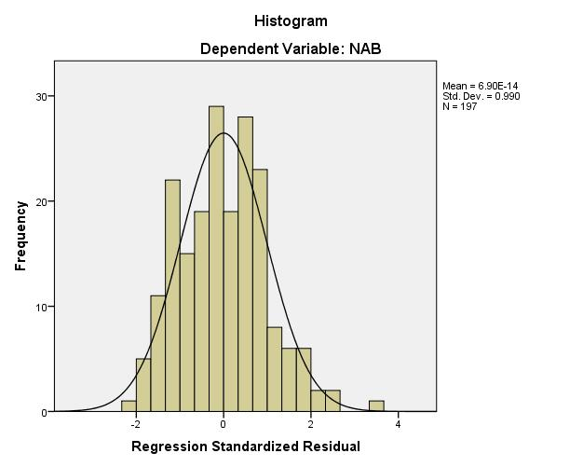

136

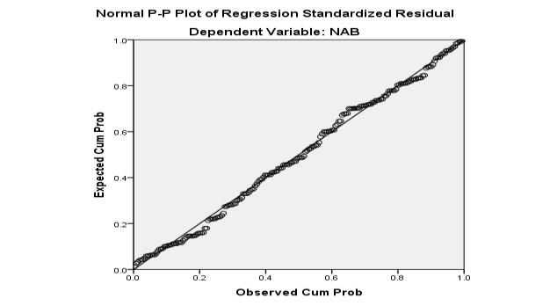

3. Hasil Uji Multicolienaritas

**Coefficientsa**

|  |  |  |  |  |  |  |  |  |
| --- | --- | --- | --- | --- | --- | --- | --- | --- |
|  |  | Unstandardized | | Standardized |  |  |  |  |
|  |  | Coefficients | | Coefficients |  |  | Collinearity Statistics | |
| Model |  | B | Std. Error | Beta | t | Sig. | Tolerance | VIF |
| 1 | (Constant) | 13.553 | 4.250 |  | 3.189 | .002 |  |  |
|  | Age | .946 | .284 | .200 | 3.333 | .001 | .863 | 1.159 |
|  | Size | 35.294 | 3.121 | 1.053 | 11.308 | .000 | .358 | 2.792 |
|  | Kurs | -29.876 | 4.202 | -.953 | -7.110 | .000 | .173 | 5.789 |
|  | BI rate | 1.133 | 2.631 | .044 | .431 | .667 | .297 | 3.371 |

a. Dependent Variable: NAB

4. Hasil Uji Autokorelasi

**Model Summaryb**

|  |  |  |  |  |  |
| --- | --- | --- | --- | --- | --- |
|  |  |  | Adjusted R | Std. Error of the |  |
| Model | R | R Square | Square | Estimate | Durbin-Watson |
| 1 | .635a | .404 | .391 | .27481 | 1.932 |

a. Predictors: (Constant), BI rate, Age, Size, Kurs

b. Dependent Variable: NAB

137

5. Hasil Uji Heterokedatisitas

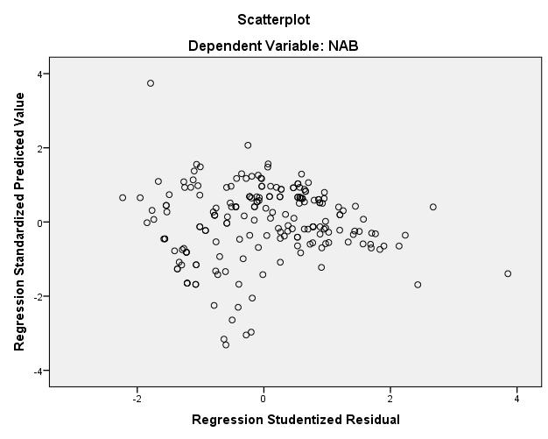

6. Hasil Uji Heterokedatisitas (Uji *White)*

**Model Summary**

|  |  |  |  |  |
| --- | --- | --- | --- | --- |
|  |  |  |  | Std. Error of the |
| Model | R | R Square | Adjusted R Square | Estimate |
| 1 | .312a | .097 | .069 | .09737 |

* 1. Predictors: (Constant), Age, Size, Kurs, BI rate, X1_kuadrat, X2_kuadrat, X3_kuadrat,

X4_kuadrat, X1X2, X1X3, X1X4, X2X3,X2X4,X3X4

1. Hasil Uji Regresi Linear Berganda

**Coefficientsa**

|  |  |  |  |  |  |  |  |  |
| --- | --- | --- | --- | --- | --- | --- | --- | --- |
|  |  | Unstandardized | | Standardized |  |  |  |  |
|  |  | Coefficients | | Coefficients |  |  | Collinearity Statistics | |
| Model |  | B | Std. Error | Beta | t | Sig. | Tolerance | VIF |
| 1 | (Constant) | 13.553 | 4.250 |  | 3.189 | .002 |  |  |
|  | Age | .946 | .284 | .200 | 3.333 | .001 | .863 | 1.159 |
|  | Size | 35.294 | 3.121 | 1.053 | 11.308 | .000 | .358 | 2.792 |
|  | Kurs | -29.876 | 4.202 | -.953 | -7.110 | .000 | .173 | 5.789 |
|  | BI rate | 1.133 | 2.631 | .044 | .431 | .667 | .297 | 3.371 |

a. Dependent Variable: NAB

138

|  |  |  |  |  |  |  |  |  |
| --- | --- | --- | --- | --- | --- | --- | --- | --- |
|  | 8. Hasil Uji Parsial | |  |  |  |  |  |  |
|  |  |  | **Coefficientsa** | |  |  |  |  |
|  |  | Unstandardized | | Standardized |  |  |  |  |
|  |  | Coefficients | | Coefficients |  |  | Collinearity Statistics | |
| Model |  | B | Std. Error | Beta | t | Sig. | Tolerance | VIF |
| 1 | (Constant) | 13.553 | 4.250 |  | 3.189 | .002 |  |  |
|  | Age | .946 | .284 | .200 | 3.333 | .001 | .863 | 1.159 |
|  | Size | 35.294 | 3.121 | 1.053 | 11.308 | .000 | .358 | 2.792 |
|  | Kurs | -29.876 | 4.202 | -.953 | -7.110 | .000 | .173 | 5.789 |
|  | BI rate | 1.133 | 2.631 | .044 | .431 | .667 | .297 | 3.371 |
| a. Dependent Variable: NAB | | |  |  |  |  |  |  |

|  |  |  |  |  |  |  |  |  |  |  |  |  |  |  |  |  |
| --- | --- | --- | --- | --- | --- | --- | --- | --- | --- | --- | --- | --- | --- | --- | --- | --- |
| 9. | | Hasil Uji Simultan | | | |  |  |  |  |  |  |  |  |  |  |  |
|  |  |  |  |  |  |  |  | **ANOVAa** | |  |  |  |  |  |  |  |
| Model | |  |  |  | Sum of Squares | | | df | |  | Mean Square | |  | F |  | Sig. |
| 1 |  | Regression | | |  | 9.817 | | 4 | |  | 2.454 | |  | 32.498 |  | .000b |
|  |  | Residual | | |  | 14.500 | | 192 | |  | .076 | |  |  |  |  |
|  |  | Total | | |  | 24.317 | | 196 | |  |  |  |  |  |  |  |
| a. Dependent Variable: NAB | | | | | |  |  |  |  |  |  |  |  |  |  |  |
| b. Predictors: (Constant), BI rate, Age, Size, Kurs | | | | | | | | | |  |  |  |  |  |  |  |
|  | 10. Hasil Uji Koefisiensi Determinasi | | | | | | | | |  |  |  |  |  |  |  |
|  |  |  |  |  |  |  | **Model Summaryb** | | |  |  |  |  |  |  |  |
|  |  |  |  |  |  |  | Adjusted R | |  | Std. Error of the | |  |  |  |  |  |
|  | Model |  | R |  | R Square |  | Square | |  |  | Estimate |  | Durbin-Watson | | |  |
|  | 1 |  | .635a |  | .404 |  |  | .391 |  | .27481 | |  | 1.932 | | |  |

a. Predictors: (Constant), BI rate, Age, Size, Kurs

b. Dependent Variable: NAB