**DAFTAR PUSTAKA**

Maulana Idris, T. T. P. (2019). PENGEMBANGAN PRODUK POWER CHARGER PORTABLE DENGAN MENGGUNAKAN METODE QUALITY FUNCTION DEPLOYMENT (QFD). *Jurnal Teknik Industri ITN Malang*.

Molly , A., Jurusan Pendidikan Tata Boga Fakultas Teknik, R., Negeri Jakarta, U., Jl Rawamangun Muka Raya, K. A., Pulo Gadung, K., Timur, J., Jakarta, D., & korespondensi, P. (2022). *Differences Grind Size Effect To Quality Of Brewed Arabica Batumirah with Vietnam Drip Technique* (Vol. 10, Issue 2).

Elky, A., Putra, D., Damayanti, T. N., & Haryanti, T. (2022). *PERANCANGAN MESIN GRINDER KOPI BERBASIS INTERNET OF THINGS Design Grinder Coffe Machine based on Internet of Things*.

Nina Tania,. .L. (2023). KAJIAN LITERATUR QUALITY FUNCTION DEPLOYMENT DALAM PERAN MANAJEMEN INDUSTRI LITERATURE REVIEW OF QUALITY FUNCTION DEPLOYMENT IN ROLE MANAGEMENT INDUSTRY. *Journal of Information Technology and Computer Science (INTECOMS)*, *6*(2).

Lestariningsih, S. (2019). PENGGUNAAN METODE QUALITY FUNCTION DEPLOYMENT (QFD) DALAM REDESAIN KOMPOR BATIK ELEKTRIK “KOMBATRIK.” In *JRI: Jurnal Rekayasa Industri* (Vol. 1, Issue 1).

Nurkhoirudin, A., Dzaky Arafi, M., & Murnawan, H. (2023). Redesain Mesin Grinder Kopi Untuk Meningkatkan Kapasitas Produksi Dan Efisiensi Kerja Pada CV. Oyitok Company. *Nusantara Journal of Multidisciplinary Science*, *1*(5). https://jurnal.intekom.id/index.php/njms

Fatihah., & Prihatiningsih, M. I. (2019). ANALISA KEPUASAN PELANGGAN TERHADAP HASIL PENGEMBANGAN PRODUK LAMPU RUMAH DENGAN METODE QUALITY FUNCTION DEPLOYMENT (QFD). *Jurnal Rekayasa Sistem Industri*, *8*(1), 55–62. https://doi.org/10.26593/jrsi.v8i1.3187.55-62

Yaumita, F., & Priyono, P. (2022). Pengembangan Dan Perancangan Alat Pemotong Daun Tembakau Menggunakan Metode Quality Function Deployment (QFD). *Jurnal Teknologi Dan Manajemen Industri Terapan (JTMIT)*, *1*(3), 137–144.

Rusnoto ., Siswiyanti, ., R., Luthfianto, S., & Nurjanah, N. (2019). The Application of Quality Function Deployment (QFD) Towards The Design of Batik Coloring Machines to Increase The Value of Fading and Stains on Fabrics. *Jurnal Ilmiah Teknik Industri*, *18*(1), 95–102. https://doi.org/10.23917/jiti.v18i1.7165

Tofik Hidayat, M. C. C. U. (2020). Optimasi Produksi Letak Fasilitas Produksi Tunggak Jati Melalui Rancangan Tata. *Jurnal Manajemen & Teknik Industri*, *XX*. <https://doi.org/10.350587/Matrik>

**LAMPIRAN**

**Lampiran 1. 1 Kuesioner Kebutuhan Responden**

Angket penelitian 1

Identitas Responden Nama :

Umur :

Petunjuk Pengisisan

Kuesioner awal jawablah pertanyaan dibawah ini yang menyangkut harapan anda dalam menentukan kebutuhan yang diperlukan untuk redesain hand grinder kopi manual.

* 1. Apakah hand grinder yang digunakan saat menggiling biji kopi aman?

Jawab :

* 1. Sangat aman
  2. Aman
  3. Cukup aman
  4. Kurang aman
  5. Tidak

1. Apakah hand grinder yang digunakan saat ini sudah nyaman saat penggilingan biji kopi?

Jawab :

* 1. Sangat nyaman
  2. Nyaman
  3. Cukup nyaman
  4. Kurang nyaman
  5. Tidak

1. Tidak hand grinder yang digunakan mudah digunakan?

Jawab :

* 1. Sangat mudah
  2. mudah
  3. Cukup mudah
  4. Kurang mudah
  5. Tidak

1. Apakah hand grinder yang digunakan sudah cukup kuat?

Jawab :

* 1. Sangat kuat
  2. Kuat
  3. Cukup kuat
  4. Kurang kuat
  5. Tidak

1. Seberapa penting harga terjangkau?
   1. Sangat terjangkau
   2. Terjangkau
   3. Cukup terjangkau
   4. Kurang terjangkau
   5. Tidak

**Lampiran 1. 2 Kuesioner Kepentingan Responden**

Angket Penelitian

Kuesioner ini bertujuan untuk mengetahui tingkat kepentingan konsumen dalam menggunakan hand grinder kopi, responden dimohon untuk memberikan penilain terhadap alat penggiling biji kopi tersebut. Berilah tanda (✓) pada setiap pertanyaan yang sesuai dengan tingkat kepentingan menurut anda.

Nama :

Usia :

Jenis Kelamin :

TP (Tidak Penting) : Nilai 1 Tidak Berpengaruh

KP (Kurang Penting) : Nilai 2 Pengaruh Tidak Terlalu Kuat

P (Penting) : Nilai 3 Pengaruh Kuat

CP (Cukup Penting) : Nilai 4 Pengaruh Cukup Kuat

SP (Sangat Penting) : Nilai 5 Pengaruh Sangat Kuat

|  |  |  |  |  |  |  |
| --- | --- | --- | --- | --- | --- | --- |
| No | Pertanyaan | Skala | | | | |
| TP | KP | P | CP | SP |
| 1. | Keamanan |  |  |  |  |  |
| 2. | Kenyamanan |  |  |  |  |  |
| 3. | Kemudahan Penggunaan |  |  |  |  |  |
| 4. | Kekuatan |  |  |  |  |  |
| 5. | Harga |  |  |  |  |  |

**Lampiran 1. 3 Kuesioner Penilaian Tingkat Kepuasan**

Angket Penelitian

Kuesioner Kuesioner ini bertujuan untuk mengetahui tingkat kepuasan konsumen dalam menggunakan hand grinder kopi manual, responden dimohon untuk memberikan penilain terhadap hand grinder kopi manual tersebut. Berilah tanda (✓) pada setiap pertanyaan yang sesuai dengan tingkat kepentingan menurut anda.

Nama :

Usia :

Jenis Kelamin :

TP (Tidak Puas) : Nilai 1 Tidak Berpengaruh Sama Sekali

KP (Kurang Puas) : Nilai 2 Pengaruh Tidak Terlalu Kuat

P (Puas) : Nilai 3 Pengaruh Kuat

CP (Cukup Puas) : Nilai 4 Pengaruh Cukup Kuat

SP (Sangat Puas) : Nilai 5 Pengaruh Sangat Kuat

|  |  |  |  |  |  |  |
| --- | --- | --- | --- | --- | --- | --- |
| No | Pertanyaan | Skala | | | | |
| TP | KP | P | CP | SP |
| 1. | Keamanan |  |  |  |  |  |
| 2. | Kenyamanan |  |  |  |  |  |
| 3. | Kemudahan Penggunaan |  |  |  |  |  |
| 4. | Kekuatan |  |  |  |  |  |
| 5. | Harga |  |  |  |  |  |

**Lampiran 1. 4 ekapan Data Kepentingan Responden**

|  |  |  |  |  |  |  |
| --- | --- | --- | --- | --- | --- | --- |
| Responden | Tingkat Kepentingan | | | | | Jumlah |
| 1 | 2 | 3 | 4 | 5 |
| 1 | 4 | 4 | 5 | 3 | 3 | 19 |
| 2 | 4 | 4 | 4 | 4 | 4 | 20 |
| 3 | 4 | 3 | 4 | 4 | 4 | 19 |
| 4 | 4 | 4 | 3 | 3 | 2 | 16 |
| 5 | 4 | 4 | 4 | 4 | 1 | 17 |
| 6 | 4 | 5 | 4 | 4 | 2 | 19 |
| 7 | 4 | 5 | 4 | 5 | 2 | 20 |
| 8 | 4 | 4 | 4 | 4 | 2 | 18 |
| 9 | 4 | 3 | 5 | 4 | 4 | 20 |
| 10 | 5 | 3 | 5 | 5 | 4 | 22 |
| 11 | 4 | 5 | 4 | 4 | 2 | 19 |
| 12 | 4 | 4 | 4 | 5 | 3 | 20 |
| 13 | 4 | 4 | 3 | 3 | 4 | 18 |
| 14 | 5 | 4 | 4 | 4 | 4 | 21 |
| 15 | 5 | 5 | 3 | 4 | 2 | 19 |

**Lampiran 1. 5 Rekap Data Kepuasan Kepuasan hand grinder manualHand grinder kopi manual**

|  |  |  |  |  |  |  |
| --- | --- | --- | --- | --- | --- | --- |
| Responden | Tingkat Kepuasan | | | | | Total |
| 1 | 2 | 3 | 4 | 5 |
| 1 | 4 | 4 | 4 | 4 | 2 | 18 |
| 2 | 3 | 3 | 3 | 3 | 3 | 15 |
| 3 | 3 | 3 | 2 | 3 | 4 | 15 |
| 4 | 4 | 4 | 3 | 4 | 1 | 16 |
| 5 | 3 | 3 | 4 | 3 | 3 | 16 |
| 6 | 3 | 3 | 4 | 4 | 2 | 16 |
| 7 | 4 | 4 | 5 | 4 | 2 | 19 |
| 8 | 3 | 4 | 2 | 3 | 3 | 15 |
| 9 | 4 | 5 | 4 | 4 | 4 | 21 |
| 10 | 4 | 4 | 3 | 4 | 4 | 19 |
| 11 | 3 | 3 | 3 | 3 | 2 | 14 |
| 12 | 3 | 3 | 3 | 3 | 3 | 15 |
| 13 | 4 | 3 | 3 | 3 | 1 | 14 |
| 14 | 3 | 3 | 4 | 4 | 3 | 17 |
| 15 | 4 | 3 | 3 | 3 | 2 | 15 |

**Lampiran 1. 6 Uji Validitas Kepentingan**

**Correlations**

|  |  |  |  |  |  |  |  |
| --- | --- | --- | --- | --- | --- | --- | --- |
| item1 | | | item2 | item3 | item4 | item5 | total |
| item1 | Pearson Correlation | 1 | .821** | .222 | .284 | .377 | .750** |
| Sig. (2-tailed) |  | .000 | .426 | .305 | .166 | .001 |
| N | 15 | 15 | 15 | 15 | 15 | 15 |
| item2 | Pearson Correlation | .821** | 1 | .128 | .383 | .216 | .685** |
| Sig. (2-tailed) | .000 |  | .648 | .159 | .439 | .004 |
| N | 15 | 15 | 15 | 15 | 15 | 15 |
| item3 | Pearson Correlation | .222 | .128 | 1 | .297 | .436 | .571* |
| Sig. (2-tailed) | .426 | .648 |  | .282 | .104 | .02 |
| N | 15 | 15 | 15 | 15 | 15 | 15 |
| item4 | Pearson Correlation | .284 | .383 | .297 | 1 | .293 | .636* |
| Sig. (2-tailed) | .305 | .159 | .282 |  | .289 | .03 |
| N | 15 | 15 | 15 | 15 | 15 | 15 |
| item5 | Pearson Correlation | .377 | .216 | .436 | .293 | 1 | .771** |
| Sig. (2-tailed) | .166 | .439 | .104 | .289 |  | .001 |
| N | 15 | 15 | 15 | 15 | 15 | 15 |
| Total | Pearson Correlation | .750** | .685** | .571* | .636* | .771** | 1 |
| Sig. (2-tailed) | .001 | .004 | .002 | .003 | .001 |  |
| N | 15 | 15 | 15 | 15 | 15 | 15 |

**. Correlation is significant at the 0.01 level (2-tailed).

*. Correlation is significant at the 0.05 level (2-tailed).

**Lampiran 1. 7 Uji Validitas Kepuasan hand grinder manual**

**Correlations**

|  |  |  |  |  |  |  |  |
| --- | --- | --- | --- | --- | --- | --- | --- |
| item1 | | | item2 | item3 | item4 | item5 | total |
| item1 | Pearson Correlation | 1 | .852** | .404 | .545* | .621* | .834** |
| Sig. (2-tailed) |  | .000 | .136 | .036 | .013 | .000 |
| N | 15 | 15 | 15 | 15 | 15 | 15 |
| item2 | Pearson Correlation | .852** | 1 | .492 | .703** | .415 | .788** |
| Sig. (2-tailed) | .000 |  | .062 | .003 | .124 | .000 |
| N | 15 | 15 | 15 | 15 | 15 | 15 |
| item3 | Pearson Correlation | .404 | .492 | 1 | .548* | .274 | .705** |
| Sig. (2-tailed) | .136 | .062 |  | .034 | .323 | .003 |
| N | 15 | 15 | 15 | 15 | 15 | 15 |
| item4 | Pearson Correlation | .545* | .703** | .548* | 1 | .228 | .665** |
| Sig. (2-tailed) | .036 | .003 | .034 |  | .414 | .007 |
| N | 15 | 15 | 15 | 15 | 15 | 15 |
| item5 | Pearson Correlation | .621* | .415 | .274 | .228 | 1 | .791** |
| Sig. (2-tailed) | .013 | .124 | .323 | .414 |  | .000 |
| N | 15 | 15 | 15 | 15 | 15 | 15 |
| Total | Pearson Correlation | .834** | .788** | .705** | .665** | .791** | 1 |
| Sig. (2-tailed) | .000 | .000 | .003 | .004 | .000 |  |
| N | 15 | 15 | 15 | 15 | 15 | 15 |

**. Correlation is significant at the 0.01 level (2-tailed).

*. Correlation is significant at the 0.05 level (2-tailed).

**Lampiran 1. 8 Uji Realibility Kepentingan**

**Case Processing Summary**

N %

|  |  |  |  |
| --- | --- | --- | --- |
| Cases | Valid | 15 | 100.0 |
| Excludeda | 0 | .0 |
| Total | 15 | 100.0 |

a. Listwise deletion based on all variables in the procedure.

|  |  |
| --- | --- |
| **Reliability Statistics** | |
| Cronbach's  Alpha | N of Items |
| .716 | 5 |

**Lampiran 1. 9 Uji Realibility Kepuasan hand grinder manual**

**Hand grinder**

**Case Processing Summary**

N %

|  |  |  |  |
| --- | --- | --- | --- |
| Cases | Valid | 15 | 100.0 |
| Excludeda | 0 | .0 |
| Total | 15 | 100.0 |

a. Listwise deletion based on all variables in the procedure.

|  |  |
| --- | --- |
| **Reliability Statistics** | |
| Cronbach's  Alphaa | N of Items |
| .711 | 5 |

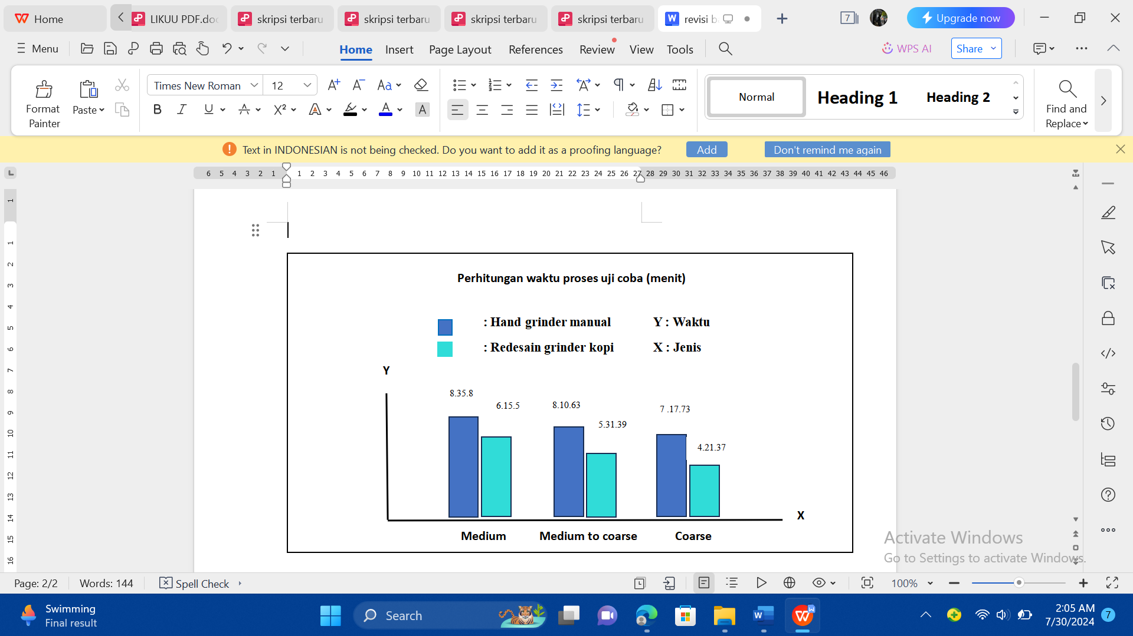

**Lampiran 1. 10 dokumentasi produk sebelum diredesain**

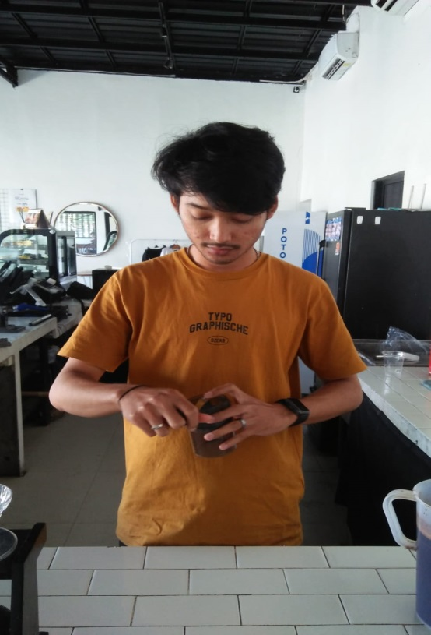

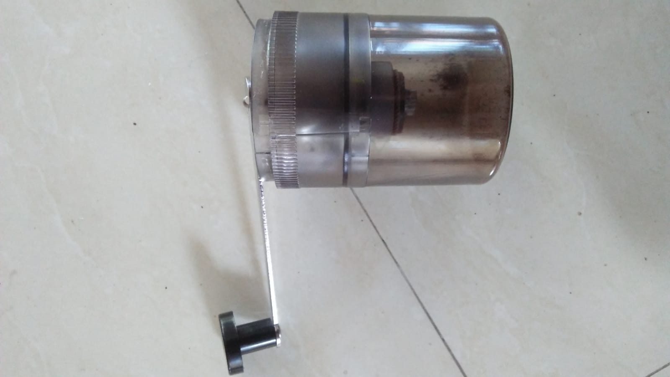

**Lampiran 1. 11 desain dan foto mesin grinder kopi**

1. Desain

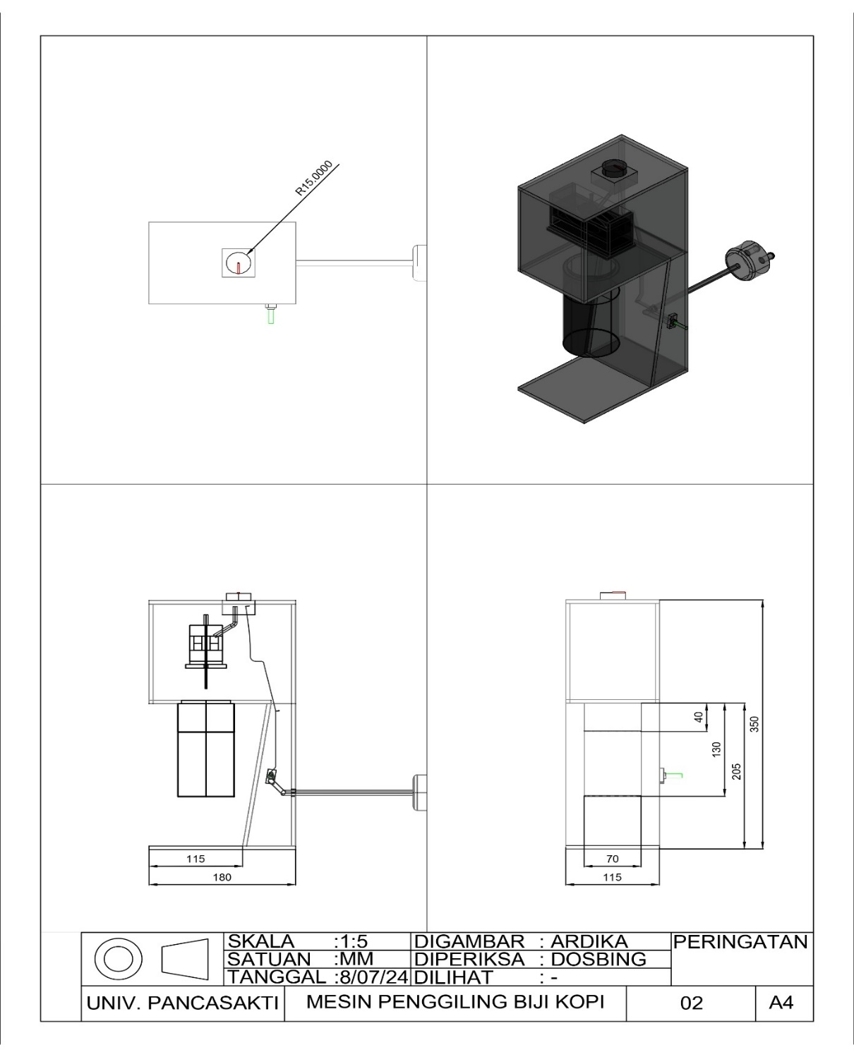

1. Foto

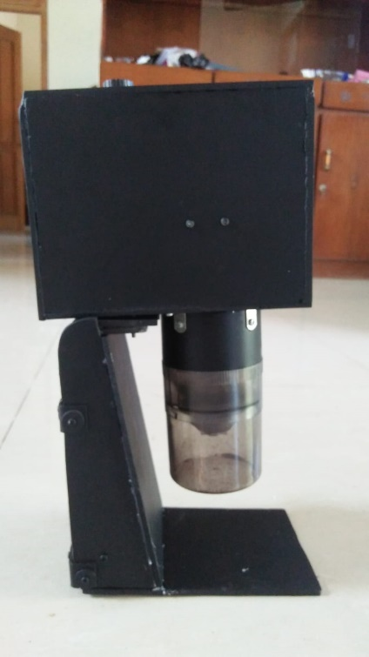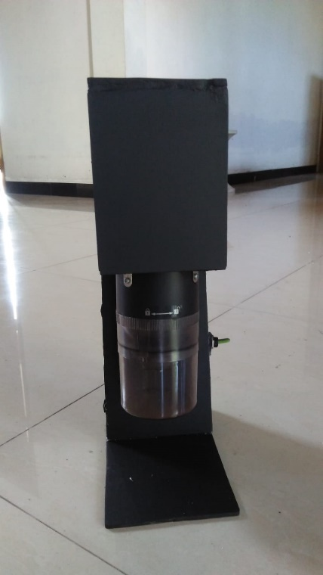

**Lampiran 1. 12 dokumentasi video**

https://youtu.be/6g1GYSkQ-pl

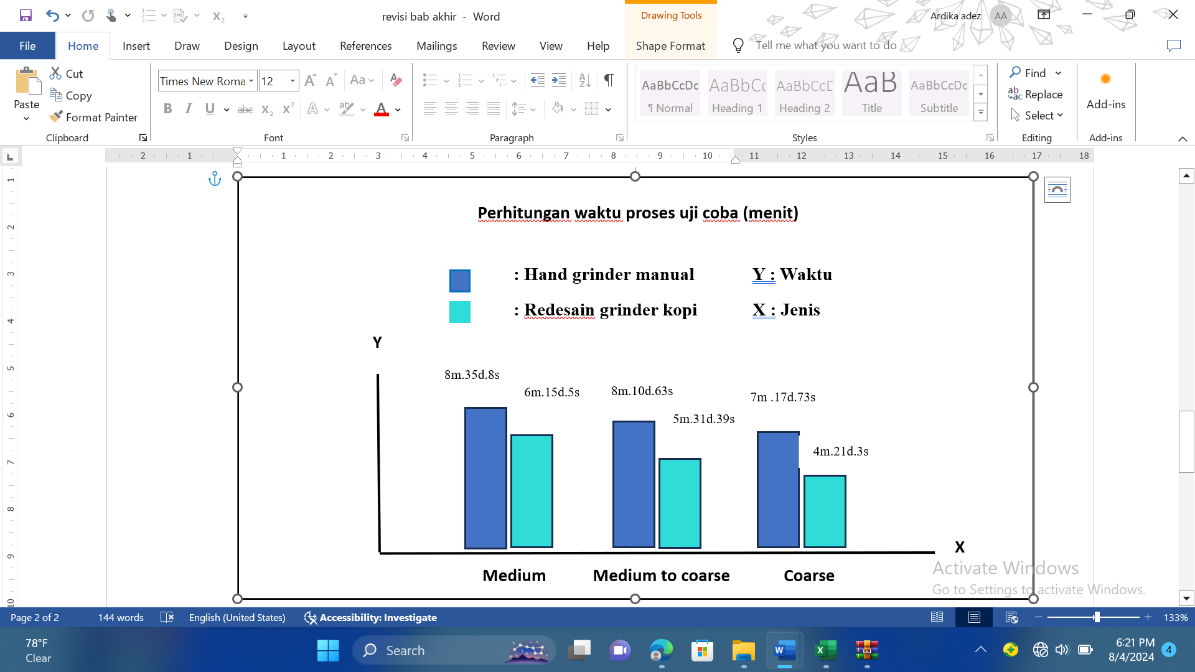**Lampiran 1. 13 diagram perhitungan perbandingan waktu proses uji coba**