# **DAFTAR PUSTAKA**

Anonim, 1986, *Standar Perencanaan Irigasi Bagian Perencanaan Jaringan Irigasi*, KP-01, Departemen Pekerjaan Umum, Direktorat Jendral Pengairan, CV. Galang Persada, Bandung.

### [A Purwanto](https://scholar.google.com/citations?user=RzwKRQcAAAAJ&hl=id&oi=sra), E Sriyono, [S Sardi](https://scholar.google.com/citations?user=QzUPb-EAAAAJ&hl=id&oi=sra) - ReTII, 2017. [*Analisis Ketersediaan Air Embung Tambakboyo Sleman DIY*](https://journal.itny.ac.id/index.php/ReTII/article/view/722) . Journal.itny.

Anwar Anwar. 2020. *Analisis Ketersediaan Air Embung sebagai Sumber untuk Memenuhi Kebutuhan Air Irigasi Pekon Podosari Kabupaten Pringsewu*. Universitas Bumi Ruwa Jurai.

Bardan, Mochammad. 2014. Irigasi. Yogyakarta: Graha Ilmu. Cholil, munawar dan Indhitalaras jiasukma

Harto, Sri. B.R., 1993, *Analisis Hidrologi*, PT. Gramedia Pustaka Utama, Jakarta.

Ikrar Hanggara dan Harvi Irvani. 2019. *Analisa Kelayakan Teknis dan Ekonomi Embung Putukrejo Kabupaten Malang*. Teknik Sipil Universitas Tribhuwana Tunggadewi Malang

<https://katadata.co.id/berita/lifestyle/621e0bd7a3cf8/35-motto-hidup-sukses-dari-para-tokoh-terkenal>

<https://tanjungharja.tegal.website/>

<https://tegalkab.bps.go.id/subject/151/iklim.html>

Jayadi, R., 2000, *Optimasi Potensial Air Embung Kali Ujung Dalam Memenuhi Kebutuhan Irigasi Daerah Irigasi Embung Kali Ujung*. Tugas Akhir, JurusanTeknik Sipil Fakultas Teknik Universitas Mataram.

Legono dkk., 1998, *Modelisasi Pengelolaan Sumber Daya Air Secara Terpadu Untuk Mendukung Pemanfaatan Yang Optimum*, UGM, Yogyakarta.

Mustari, 2008, *Optimasi Pemanfaatan Sumber Daya Air Embung Bangka*, Tugas Akhir Jurusan Teknik Sipil Fakultas Teknik Universitas Mataram, Mataram.

*SNI 19-6728.1-2002, Penyusunan Neraca Sumber Daya*

Sudirja, 2008, *Optimasi Pemanfaatan Sumber Daya Air Untuk Irigasi, Peternakan dan Air Baku Pada Daerah Aliran Sungai (DAS) Reak*, Tugas Akhir JurusanTeknik Sipil Fakultas Teknik Universitas Mataram, Mataram.

Soemarto,C.D., 1987, *Hidrologi Teknik,* Usaha Nasional, Surabaya.

Sosrodarsono, S,. Takeda, K,. 1987, *Hidrologi Untuk Pengairan*, Pradnya Paramitha, Jakarta.

Teguh Haris Santoso, Isradias Mirajhusnita, M Yusuf. 2023. *Penanganan Banjir Di Lingkungan Universitas Pancasakti Tegal Dengan Menggunakan Sistem Drainase U-Ditch Dan Box Culvert.* Universitas Pancasakti Tegal (UPS). Tegal.

Tisnawati, 2010, *Optimasi Pemanfaatan Sumber Daya Air Embung Batu Tulis di*

*Kecamatan Jonggat Kabupaten Lombok Tengah,* Tugas Akhir Jurusan Teknik Sipil Fakultas Teknik Universitas Mataram,Mataram

Puspitaningrum, Intan, Ussy Andawayanti, and Evi Nur Cahya, 2015, *“Studi Kelayakan Pembangunan Embung Penggung Guna Memenuhi Kebutuhan Air Bersih di Kecamatan Nawangan Kabupaten Pacitan”*

# [W Bunganaen](https://scholar.google.com/citations?user=kUci30cAAAAJ&hl=id&oi=sra). 2013. *[Analisis Kinerja Embung Oelomin](http://sipil.ejournal.web.id/index.php/jts/article/view/277)*. Jurnal teknik sipil.

# Y Dethan, [W Bunganaen](https://scholar.google.com/citations?user=kUci30cAAAAJ&hl=id&oi=sra), [Ya Messah](https://scholar.google.com/citations?user=34d-jZUAAAAJ&hl=id&oi=sra). 2015. *Evaluasi Kinerja Embung Oeltua.* Jurnal teknik sipil.

Zulkifli, 2012, *Analisis Pendapatan dan Nilai Tambah Pada Agroindustri Kripik Ubi di Kecamatan Tanah luas Kabupaten Aceh Utara.*

**LAMPIRAN**

|  |  |  |  |  |  |  |  |  |  |  |
| --- | --- | --- | --- | --- | --- | --- | --- | --- | --- | --- |
| **Bulan** | **Curah Hujan (mm)** | | | | | | | | | |
| **2013** | **2014** | **2015** | **2016** | **2017** | **2018** | **2019** | **2020** | **2021** | **2022** |
| **Januari** | 545,0 | 221,0 | 501,0 | 198,0 | 530,0 | 211,0 | 332,0 | 563,0 | 447,0 | 316,0 |
| **Februari** | 93,0 | 567,0 | 473,0 | 463,0 | 386,0 | 685,0 | 414,0 | 422,0 | 412,0 | 611,0 |
| **Maret** | 252,0 | 382,0 | 416,0 | 155,0 | 341,0 | 365,0 | 391,0 | 584,0 | 300,0 | 15,0 |
| **April** | 192,0 | 244,0 | 366,0 | 370,0 | 204,0 | 236,0 | 211,0 | 225,0 | 235,0 | 229,0 |
| **Mei** | 71,0 | 181,0 | 112,0 | 137,0 | 119,0 | 71,0 | 8,0 | 226,0 | 217,0 | 214,0 |
| **Juni** | 181,0 | 109,0 | 30,0 | 118,0 | 67,0 | 54,0 | 11,0 | 107,0 | 112,0 | 227,0 |
| **Juli** | 197,0 | 98,0 | 0,0 | 108,0 | 19,0 | 0,0 | 5,0 | 24,0 | 30,0 | 150,0 |
| **Agustus** | 38,0 | 2,0 | 0,0 | 24,0 | 5,0 | 0,0 | 0,0 | 49,0 | 45,0 | 39,0 |
| **September** | 42,0 | 0,0 | 0,0 | 248,0 | 77,0 | 4,0 | 2,0 | 53,0 | 68,0 | 133,0 |
| **Oktober** | 73,0 | 7,0 | 0,0 | 235,0 | 87,0 | 9,0 | 1,0 | 163,0 | 196,0 | 294,0 |
| **November** | 125,0 | 169,0 | 127,0 | 180,0 | 224,0 | 97,0 | 107,0 | 152,0 | 176,0 | 343,0 |
| **Desember** | 351,0 | 280,0 | 415,0 | 409,0 | 269,0 | 184,0 | 258,0 | 131,0 | 220,0 | 214,0 |
| **Maks** | **545,0** | **567,0** | **501,0** | **463,0** | **530,0** | **685,0** | **414,0** | **584,0** | **447,0** | **611,0** |

**Lampiran 1.** Data Curah Hujan

Sumber: Badan Meteorologi dan Geofisika Balai Wilayah II Stasiun Meteorologi Klas III Tegal

**Lampiran 2.** Data Klimatologi

|  |  |  |  |  |  |  |  |  |  |  |
| --- | --- | --- | --- | --- | --- | --- | --- | --- | --- | --- |
| **Bulan** | **Suhu Kecepatan Angin (knot)** | | | | | **Arah Angin Maksimal (derajat)** | | | | |
| **2018** | **2019** | **2020** | **2021** | **2022** | **2018** | **2019** | **2020** | **2021** | **2022** |
| **Januari** | 4,0 | 3,0 | 3,8 | 3,7 | 4,0 | 350,0 | 288,0 | 335,0 | 335,0 | 335,0 |
| **Februari** | 4,0 | 3,0 | 3,5 | 4,0 | 3,0 | 350,0 | 240,0 | 335,0 | 335,0 | 155,0 |
| **Maret** | 3,0 | 4,0 | 2,5 | 2,8 | 3,0 | 340,0 | 233,0 | 20,0 | 20,0 | 20,0 |
| **April** | 3,0 | 3,0 | 3,3 | 3,0 | 3,0 | 350,0 | 182,0 | 20,0 | 200,0 | 245,0 |
| **Mei** | 4,0 | 4,0 | 2,8 | 3,1 | 3,0 | 340,0 | 211,0 | 65,0 | 200,0 | 110,0 |
| **Juni** | 4,0 | 5,0 | 3,2 | 2,9 | 2,0 | 200,0 | 204,0 | 200,0 | 200,0 | 200,0 |
| **Juli** | 5,0 | 5,0 | 3,8 | 3,2 | 3,0 | 210,0 | 193,0 | 200,0 | 200,0 | 200,0 |
| **Agustus** | 5,0 | 5,0 | 4,4 | 4,0 | 4,0 | 210,0 | 192,0 | 200,0 | 200,0 | 200,0 |
| **September** | 5,0 | 5,0 | 4,6 | 3,9 | 3,0 | 350,0 | 200,0 | 200,0 | 200,0 | 200,0 |
| **Oktober** | 5,0 | 5,0 | 4,1 | 3,9 | 4,0 | 350,0 | 205,0 | 200,0 | 200,0 | 200,0 |
| **November** | 4,0 | 5,0 | 3,9 | 3,1 | 3,0 | 350,0 | 220,0 | 200,0 | 200,0 | 245,0 |
| **Desember** | 4,0 | 3,0 | 4,2 | 3,7 | 3,0 | 290,0 | 243,0 | 335,0 | 245,0 | 295,0 |
| **Rata-Rata** | **4,2** | **4,2** | **3,7** | **3,4** | **3,2** | **307,5** | **217,6** | **192,5** | **211,3** | **200,4** |

Sumber: Badan Meteorologi dan Geofisika Balai Wilayah II Stasiun Meteorologi Klas III Tegal

|  |  |  |  |  |  |  |  |  |  |  |
| --- | --- | --- | --- | --- | --- | --- | --- | --- | --- | --- |
| **Bulan** | **Penyinaran Matahari (%)** | | | | | **Temperatur (◦C)** | | | | |
| **2018** | **2019** | **2020** | **2021** | **2022** | **2018** | **2019** | **2020** | **2021** | **2022** |
| **Januari** | 52,0 | 47,0 | 55,0 | 30,0 | 62,0 | 27,2 | 27,7 | 28,1 | 27,1 | 27,7 |
| **Februari** | 51,0 | 67,0 | 58,0 | 38,0 | 45,0 | 26,7 | 27,8 | 27,6 | 27,0 | 27,2 |
| **Maret** | 54,0 | 56,0 | 61,0 | 67,0 | 70,0 | 27,5 | 27,7 | 27,9 | 27,7 | 27,3 |
| **April** | 58,0 | 53,0 | 72,0 | 82,0 | 78,0 | 28,9 | 28,6 | 28,4 | 28,4 | 28,3 |
| **Mei** | 42,0 | 65,0 | 76,0 | 80,0 | 75,0 | 33,9 | 28,7 | 28,7 | 28,9 | 28,4 |
| **Juni** | 57,0 | 47,0 | 85,0 | 77,0 | 67,0 | 28,5 | 27,5 | 28,1 | 28,1 | 27,7 |
| **Juli** | 66,0 | 43,0 | 90,0 | 94,0 | 87,0 | 27,6 | 27,0 | 27,8 | 28,2 | 28,1 |
| **Agustus** | 70,0 | 91,0 | 91,0 | 95,0 | 86,0 | 27,6 | 26,9 | 28,4 | 28,0 | 28,3 |
| **September** | 84,0 | 84,0 | 89,0 | 81,0 | 89,0 | 25,5 | 27,4 | 29,0 | 28,5 | 27,9 |
| **Oktober** | 66,0 | 69,0 | 71,0 | 86,0 | 64,0 | 26,7 | 28,7 | 28,7 | 28,0 | 28,0 |
| **November** | 55,0 | 75,0 | 72,0 | 51,0 | 54,0 | 26,6 | 29,0 | 27,5 | 28,0 | 27,7 |
| **Desember** | 49,0 | 56,0 | 54,0 | 59,0 | 50,0 | 28,0 | 28,6 | 28,2 | 28,0 | 27,8 |
| **Rata-Rata** | **58,7** | **62,8** | **72,8** | **70,0** | **68,9** | **27,9** | **28,0** | **28,2** | **28,0** | **27,9** |

Sumber: Badan Meteorologi dan Geofisika Balai Wilayah II Stasiun Meteorologi Klas III Tegal

|  |  |  |  |  |  |  |  |  |  |  |
| --- | --- | --- | --- | --- | --- | --- | --- | --- | --- | --- |
| **Bulan** | **Kelembaban Udara (%)** | | | | | **Tekanan Udara (%)** | | | | |
| **2018** | **2019** | **2020** | **2021** | **2022** | **2018** | **2019** | **2020** | **2021** | **2022** |
| **Januari** | 80,0 | 82,0 | 82,0 | 84,0 | 82,0 | 1009,2 | 1010,1 | 1010,4 | 1008,4 | 1009,4 |
| **Februari** | 86,0 | 81,0 | 83,0 | 86,0 | 84,0 | 1010,1 | 1011,5 | 1011,1 | 1009,2 | 1008,6 |
| **Maret** | 80,0 | 81,0 | 83,0 | 82,0 | 83,0 | 1010,0 | 1010,5 | 1010,5 | 1009,0 | 1008,2 |
| **April** | 79,0 | 79,0 | 81,0 | 79,0 | 79,0 | 1010,2 | 1009,7 | 1010,8 | 1009,8 | 1008,7 |
| **Mei** | 76,0 | 75,0 | 79,0 | 77,0 | 79,0 | 1010,1 | 1010,5 | 1010,2 | 1009,0 | 1008,8 |
| **Juni** | 76,0 | 73,0 | 77,0 | 80,0 | 79,0 | 1010,8 | 1010,9 | 1010,9 | 1010,5 | 1009,3 |
| **Juli** | 71,0 | 72,0 | 75,0 | 75,0 | 76,0 | 1011,3 | 1011,8 | 1010,3 | 1010,1 | 1009,1 |
| **Agustus** | 68,0 | 70,0 | 73,0 | 75,0 | 74,0 | 1010,8 | 1012,0 | 1011,0 | 1010,7 | 1009,6 |
| **September** | 69,0 | 70,0 | 71,0 | 76,0 | 76,0 | 1010,9 | 1012,4 | 1011,2 | 1010,1 | 1010,2 |
| **Oktober** | 69,0 | 69,0 | 75,0 | 75,0 | 79,0 | 1009,8 | 1010,6 | 1009,9 | 1009,6 | 1009,6 |
| **November** | 74,0 | 71,0 | 76,0 | 81,0 | 80,0 | 1007,8 | 1010,1 | 1009,2 | 1008,3 | 1008,1 |
| **Desember** | 76,0 | 78,0 | 81,0 | 80,0 | 81,0 | 1008,9 | 1009,9 | 1010,4 | 1009,4 | 1009,0 |
| **Rata-rata** | **75,3** | **75,1** | **78,0** | **79,2** | **79,3** | **1010,0** | **1010,8** | **1010,5** | **1009,5** | **1009,1** |

Sumber: Badan Meteorologi dan Geofisika Balai Wilayah II Stasiun Meteorologi Klas III Tegal

**Lampiran 3.** Tabel *adjusment* faktor (c) bulanan

|  |  |  |  |  |  |  |  |  |  |  |  |  |
| --- | --- | --- | --- | --- | --- | --- | --- | --- | --- | --- | --- | --- |
| Bulan | Jan | Feb | Mar | Apr | Mei | Jun | Jul | Ags | Sep | Okt | Nov | Des |
| C | **1,1** | 1,1 | 1,0 | 0,9 | 0,9 | 0,9 | 0,9 | 1,0 | 1,1 | 1,1 | 1,1 | 1,1 |

Sumber : Suroso, A. (2011) Irigasi dan Bangunan

**Lampiran 4.** Tabel Tekanan uap jenuh (ea) menurut temperatur udara rata-rata

|  |  |  |  |  |  |  |  |  |  |  |  |
| --- | --- | --- | --- | --- | --- | --- | --- | --- | --- | --- | --- |
| Temperatur  (°C) | 0 | 1 | 2 | 3 | 4 | 5 | 6 | 7 | 8 | 9 | 10 |
| ea (mbar) | 6,1 | 6,6 | 7,1 | 7,6 | 8,1 | 8,7 | 9,8 | 10 | 10,7 | 11,5 | 12,3 |
| Temperatur  (°C) | 11 | 12 | 13 | 14 | 15 | 16 | 17 | 18 | 19 | 20 | 21 |
| ea (mbar) | 13,1 | 14 | 15 | 16,1 | 17 | 18,2 | 19,4 | 20,6 | 22 | 23,4 | 24,9 |
| Temperatur  (°C) | 22 | 23 | 24 | 25 | 26 | **27** | 28 | 29 | 30 | 31 | 32 |
| ea (mbar) | 26,4 | 28,1 | 29,8 | 31,7 | 33,6 | **35,7** | 37,8 | 40,1 | 42,4 | 44,9 | 47,6 |
| Temperatur  (°C) | 33 | 34 | 35 | 36 | 37 | 38 | 39 |  | | | |
| ea (mbar) | 60,3 | 53,2 | 56,2 | 59,4 | 62,8 | 66,3 | 69,9 |

Sumber : Kebutuhan Air Tanaman, Departemen Pertanian, 1977

|  |  |  |  |  |  |  |  |  |  |  |  |
| --- | --- | --- | --- | --- | --- | --- | --- | --- | --- | --- | --- |
| T  (°C) | 0 | 2 | 4 | 6 | 8 | 10 | 12 | 14 | 16 | 18 | 20 |
| F(T) | 11 | 11,4 | 11,7 | 12 | 12,4 | 12,7 | 13,1 | 13,5 | 13,8 | 14,2 | 14,6 |
| T (°C) | 22 | 24 | **26** | 28 | 30 | 32 | 34 | 36 |  | | |
| F(T) | 15 | 15,4 | **15,9** | 16,3 | 16,7 | 17,2 | 17,7 | 18,1 |

**Lampiran 5.** Tabel Pengaruh Temperatur Udara f(T) pada radiasi gelombang

Sumber : Hadisusanto dalam Oktawirawan (2015)

**Lampiran 6.** Tabel *Extra Terrestial Radiation* (Ra)

|  |  |  |  |  |  |  |  |  |  |  |  |  |
| --- | --- | --- | --- | --- | --- | --- | --- | --- | --- | --- | --- | --- |
| Lintang Utara $°$ | Jan | Feb | Mar | Apr | Mei | Jun | Jul | Agu | Sep | Okt | Nov | Des |
| 0 | 15 | 15,5 | 15,7 | 15,3 | 14,4 | 13,9 | 14,1 | 14,8 | 15,3 | 15,4 | 15,1 | 14,8 |
| 2 | 14,7 | 15,3 | 15,6 | 15,3 | 14,6 | 14,2 | 14,3 | 14,9 | 15,3 | 15,3 | 14,8 | 14,1 |
| 4 | 14,3 | 15 | 15,5 | 15,5 | 14,9 | 14,4 | 14,6 | 15,1 | 15,3 | 15,1 | 14,5 | 14,1 |
| **6** | **13,9** | 14,8 | 15,4 | 15,4 | 15,1 | 14,7 | 14,9 | 15,2 | 15,3 | 15 | 14,2 | 13,7 |
| 8 | 13,6 | 14,5 | 15,3 | 15,6 | 15,3 | 15 | 15,1 | 15,4 | 15,3 | 14,8 | 13,9 | 13,3 |
| 10 | 13,2 | 14,2 | 15,3 | 15,7 | 15,5 | 15,3 | 15,3 | 15,5 | 15,3 | 14,7 | 13,6 | 12,9 |
| 12 | 12,8 | 13,9 | 15,2 | 15,7 | 15,7 | 15,5 | 15,5 | 15,6 | 15,2 | 14,4 | 13,3 | 12,5 |
| 14 | 12,4 | 13,6 | 14,9 | 15,7 | 15,8 | 15,7 | 15,7 | 25,7 | 15,1 | 14,1 | 12,8 | 12 |
| 16 | 12,0 | 13,3 | 14,7 | 15,6 | 16 | 15,9 | 15,9 | 15,7 | 15 | 13,9 | 12,4 | 11,6 |
| 18 | 11,6 | 13,0 | 14,6 | 15,6 | 16,1 | 16,1 | 16,1 | 15,8 | 14,9 | 13,6 | 12 | 11,1 |
| 20 | 11,2 | 12,7 | 14,4 | 15,6 | 16,3 | 16,4 | 16,3 | 15,9 | 14,8 | 13,3 | 11,6 | 10,7 |
| 22 | 10,7 | 12,3 | 14,2 | 15,5 | 16,3 | 16,4 | 16,4 | 15,8 | 14,6 | 13 | 11,1 | 10,2 |
| 24 | 10,2 | 11,9 | 13,9 | 15,4 | 16,4 | 16,5 | 16,5 | 15,8 | 14,5 | 12,6 | 10,7 | 9,7 |
| 26 | 9,8 | 11,5 | 1,37 | 15,3 | 16,4 | 16,7 | 16,6 | 15,7 | 14,3 | 12,3 | 10,3 | 9,3 |
| 28 | 9,3 | 11,1 | 13,4 | 15,3 | 16,5 | 16,8 | 16,7 | 15,7 | 14,1 | 12 | 9,9 | 8,8 |
| 30 | 8,8 | 10,7 | 13,1 | 15,2 | 16,5 | 17 | 16,8 | 15,7 | 13,9 | 11,6 | 9,5 | 8,3 |

Sumber : Hadisusanto dalam Oktawirawan (2015)

**Lampiran 7.** Tabel Nilai Faktor Penimbang (W) Untuk Efek Radiasi

|  |  |  |  |  |  |  |  |  |  |  |
| --- | --- | --- | --- | --- | --- | --- | --- | --- | --- | --- |
| Temperatur (T)°C | 2 | 4 | 6 | 8 | 10 | 12 | 14 | 16 | 18 | 20 |
| Keringgian (z) m  0  500  1000  2000 | 0,43  0,44  0,46  0,49 | 0,46  0,48 | 0,49  0,51  0,52  0,55 | 0,52  0,54  0,55  0,58 | 0,55  0,57  0,58  0,61 | 0,58  0,6  0,61  0,64 | 0,61  0,62  0,64  0,66 | 0,64  0,65  0,66  0,69 | 0,66  0,67  0,69  0,71 | 0,69  0,7  0,71  0,73 |
| Temperatur (T)°C | 22 | 24 | 26 | 28 | 30 | 32 | 34 | 36 | 38 | 40 |
| Ketinggian (z) m  0  500  1000  2000 | 0,71  0,72  0,73  0,75 | 0,73  0,74 | 0,75  0,76  0,77  0,79 | 0,77  0,78  0,79  0,81 | 0,78  0,79  0,8  0,82 | 0,8  0,81  0,82  0,84 | 0,82  0,82  0,83  0,85 | 0,83  0,84  0,85  0,86 | 0,84  0,85  0,86  0,87 | 0,85  0,86  0,87  0,88 |

Sumber : Hadisusanto dalam Oktawirawan (2015)

**Lampiran 8.** Data Ketersediaan Air Embung Margapadang

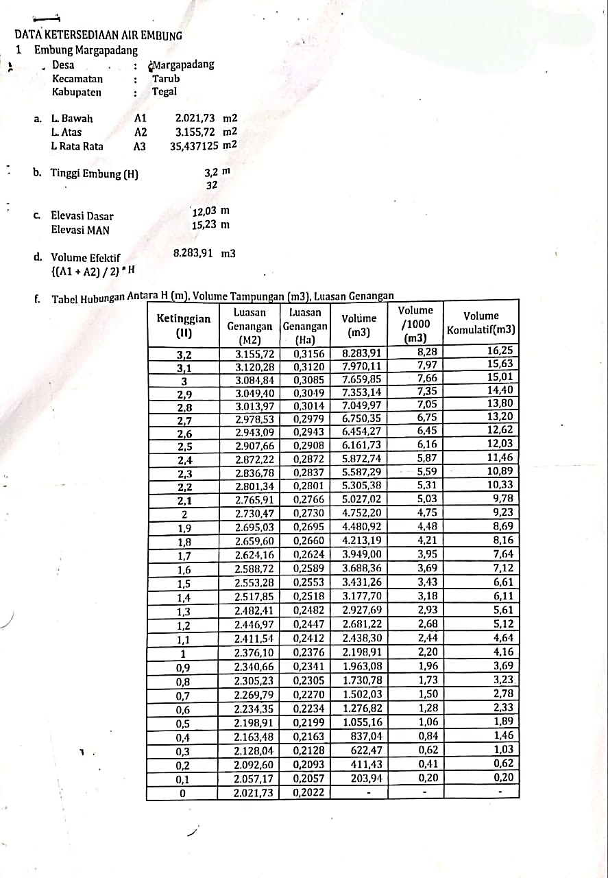

Sumber : PSDA Pemali Comal

**Lampiran 9.** Surat Izin Penelitian

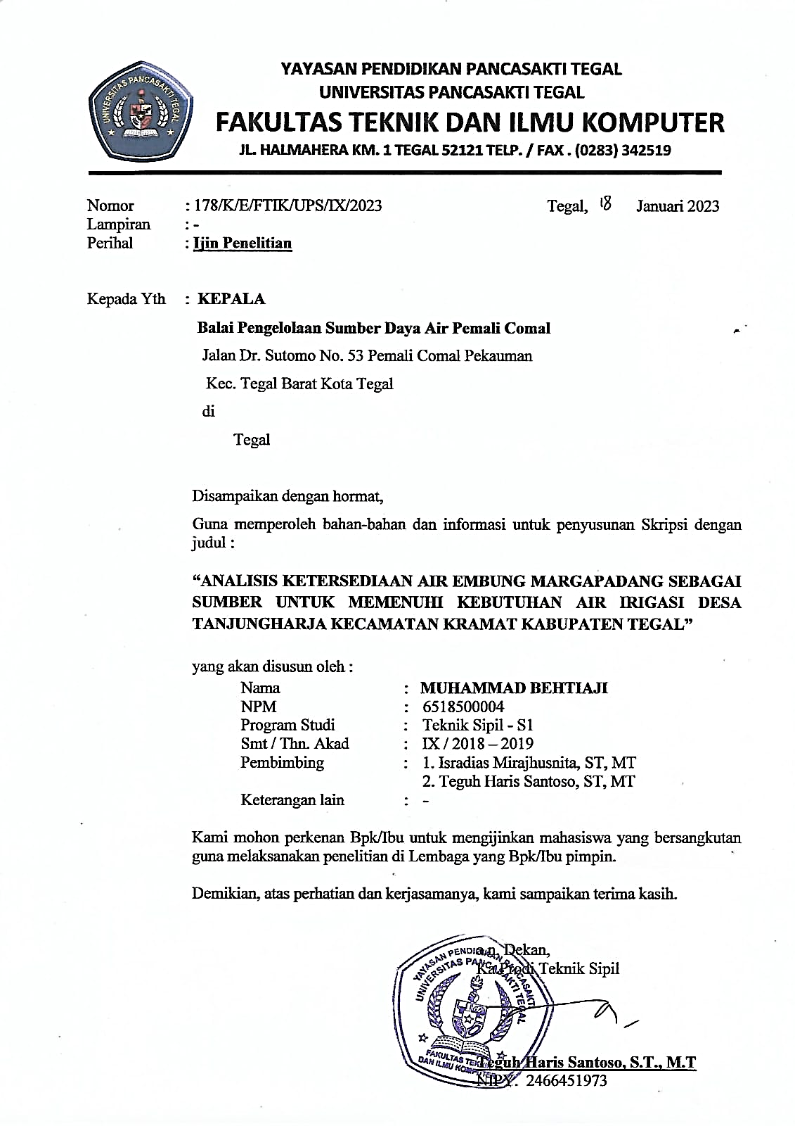

**Lampiran 10.** Foto Penelitian

|  |  |
| --- | --- |
| Gambar | Keterangan |
|  | Embung Margapadang |
|  | Tampak Samping Embung Margapadang |
|  | Tampak Samping Embung Margapadang |
|  | Pengaturan Air |
|  | Tampak Depan Embung Margapadang |

**Lampiran 11.** Peta DAS

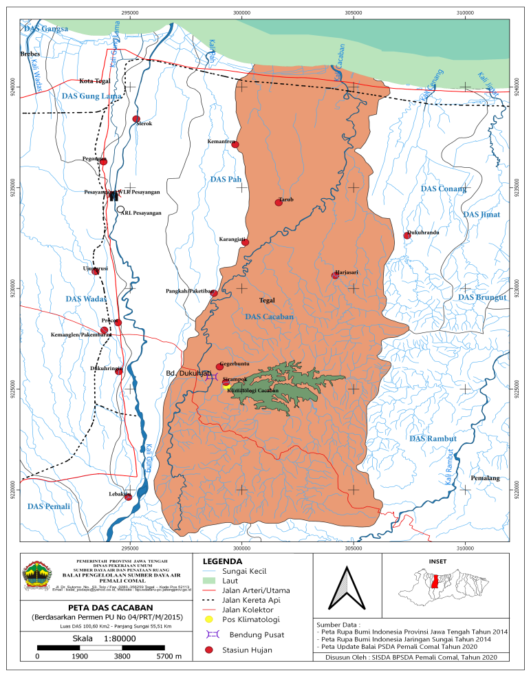

**Lampiran 12..** Peta Topografi

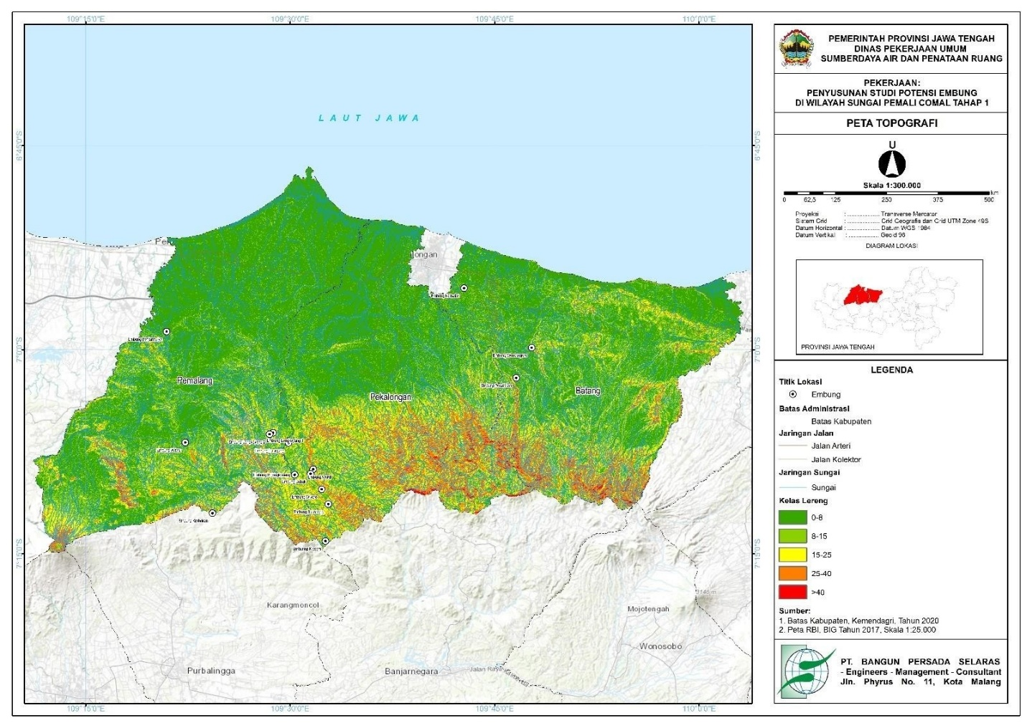

**Lampiran 13.** Curah Hujan Rerata



**Lampiran 14.** Luas Area Daerah

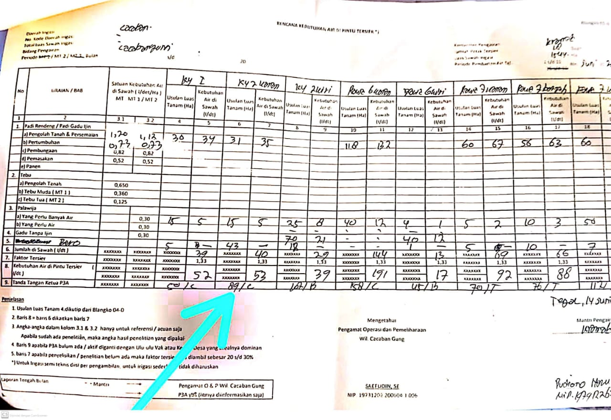

**Lampiran 15.** Skema Jaringan Irigasi

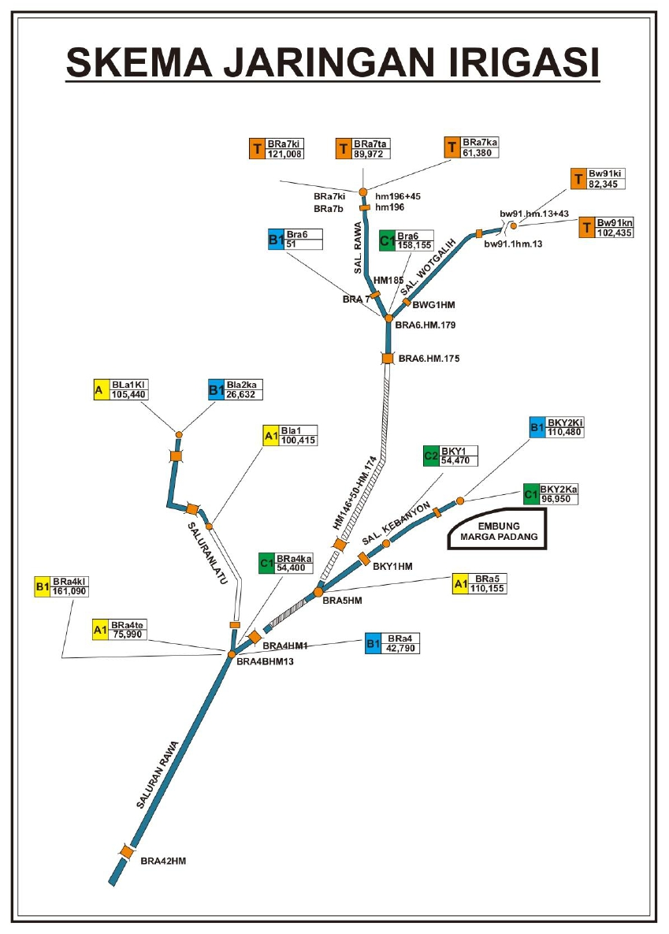

**Lampiran 15.** Jaringan Irigasi

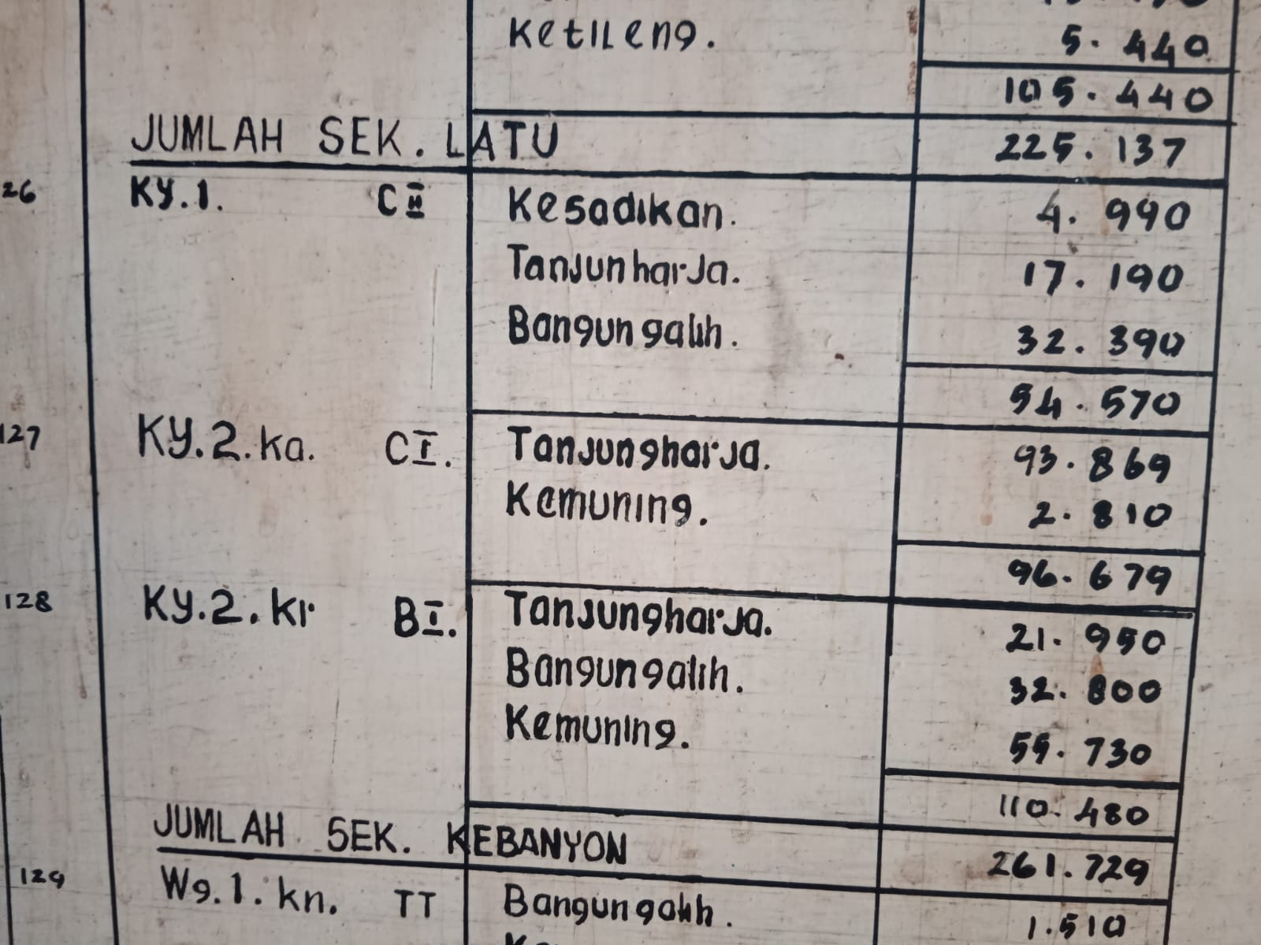

**Lampiran 15.** Layout Embung Margapadang

