# **DAFTAR PUSTAKA**

Annisa, M. (2021). *Pengaruh Lingkungan Kerja Terhadap Produktivitas Kerja Karyawan Pada Bagian Produksi PT. P&P Bangkinang Desa Simalinyang Kabupaten Kampar.* Pekanbaru: Universitas Islam Riau.

Arikunto, S. (2006). *Prosedur Penelitian Suatu Pendekatan Praktik.* Jakarta: Rineka Cipta.

Bangun, W. (2012). *Manajemen Sumber Daya Manusia.* Jakarta: Penerbit Erlangga.

Darma, B., & Wulansari, K. Y. (2022). Pengaruh Fasilitas dan Lingkungan KerjaTerhadap Kepuasan KerjaPegawaipada Kantor Camat Kecamatan Bajubang. *Citra Ekonomi*, 24-31.

Dewi, L. K. (2022). *Pengaruh Tata Ruang Kantor Dan Fasilitas Kerja Terhadap Kepuasan Kerja Pegawai Bank Syariah Indonesia Kcp Pemalang.* Tegal: Universitas Pancasakti Tegal.

Eksan, F., & Dharmawan, D. (2020). Pengaruh Kompetensi Dan Motivasi Terhadap Produktivitas Kerja Karyawan PT. Astra Internasional Daihatsu, Tbk Cibubur. *Jurnal Ekonomi dan Industri*, 8-20.

Ghozali, I. (2018). *Aplikasi Analisis Multivariate Dengan Program IBM SPSS 25.* Semarang: Badan Penerbit Universitas Diponegoro.

Hasibuan, M. S. (2014). *Manajemen Sumber Daya Manusia.* Bandung : CV. Pustaka Setia.

Kumalasari, I. (2019, Oktober 17). Produktivitas : Cara Menghitung Produktivitas. Retrieved from https://www.jtanzilco.com/blog/detail/1467/slug/produktivitas-cara-menghitung-produktivitas-2-3

Kurnia, E., Daulay, R., & Nugraha, F. (2019). Dampak Faktor Motivasi dan Fasilitas Kerja Terhadap Produktivitas Kerja Karyawan Pada Badan Usaha Milik Negara di Kota Medan. *Proseding Seminar Nasional Kewirausahaan, 1 (1)*, 365-372. doi:https://doi.org/10.30596/snk.v1i1.3638

Marwansyah. (2016). *Manajemen Sumber Daya Manusia. Edisi ke dua.* Bandung: CV. Alphabeta.

Mathis, R. L., & Jackson, J. H. (2002). *Manajemen Sumber Daya Manusia.* Jakarta: Salemba Empat.

Moenir. (2008). *Manajemen Pelayanan Publik di Indonesia.* Jakarta: Bumi Aksara.

Mulyasa, E. (2003). *Kurikulum Berbasis Kompetensi: Konsep, Karakteristik, dan Implementasi.* Bandung: PT. Remaja Rosdakarya.

Pasaribu, J., & Anshori, M. I. (2021). Penerapan Work From Home Terhadap Produktivitas Kerja (Studi Karyawan PT. Berlian Jasa Terminal Indonesia). *Jurnal Inovasi Bisnis dan Manajemen Indonesia, IV*(03), 409-423.

Pratiwi, A., & Permatasari, R. I. (2022). Pengaruh Disiplin Kerja Dan Fasilitas Kerja Terhadap Produktivitas Kerja Buruh Divisi Produksi PT. Multi Elektrik Sejahtrindo, Citeureup Kabupaten Bogor. *Jurnal Inovatif Mahasiswa Manajemen*, 14-26.

Rosida, & Sulistiyani, A. T. (2009). *Manajemen Sumber Daya Manusia Konsep, Teori dan Pengembangan Dalam Konteks Organisasi Publik.* Yogyakarta: Graha Ilmu.

Ruky, A. S. (2006). *Sistem Manajemen Kinerja.* Jakarta: PT. Gramedia.

Sari, F. N., Eva Sari, A. D., & Murdiayanto, E. (2022). Pengaruh Pengalaman kerja, fasilitas, Komunikasi, Kepuasan Kerja Terhadap Produktivitas Kerja Karyawan Bagian Produksi CV. Aneka Sukses. *Digital Bisnis: Jurnal Publikasi Ilmu Manajemen dan E-Commerce*, 149-162.

Sedamaryanti. (2011). *Tata Kerja dan Produktivitas Kerja.* Bandung: CV. Mandar Maju.

Simamora, H. (2015). *Manajemen Sumber Daya Manusia.* Yogyakarta: STIEY.

Sinungan, M. (2011). *Produktivitas Apa dan Bagaimana.* Jakarta: Bumi Aksara.

Sugiyono. (2016). *Metode Penelitian Manajemen.* Bandung: Alfabeta.

Sugiyono. (2017). *Metode Penelitian Kuantitatif, Kualitatif, dan R&D Pendidikan.* Bandung: CV. Alfabeta.

Sugiyono. (2018). *Metode Penelitian Pendidikan Pendekatan Kuantitatif, kualitatif, dan R&D.* Bandung: Alfabeta.

Sujarweni, V. (2019). *Metodologi Penelitian Bisnis dan Ekonomi.* Yogyakarta: Pustaka Baru Press.

Sukrispiyanto. (2019). *Manajemen Sumber Daya Manusia.* Sidoarjo: indomedia Pustaka.

Sulistiani, Heriyanto, Y., & Sobari, I. S. (2023). Pengaruh Kompetensi Karyawan dan Fasilitas Kerja Terhadap Produktivitas Kerja Karyawan Di Kantor Pusat PT. Tri Banyan Tirta. *Jurnal Adminitrasi Bisnis*, 224-235.

Suliyanto. (2018). *Metode Penelitian Bisnis.* Yogyakarta: Andi Offset.

Sutrisno, E. (2016). *Manajemen Sumber Daya Manusia.* Kencana Prenada.

Tagala, M. (2018). *Psikologi Industri dan Organisasi.* RajaGrafindo Persada.

Umar, H. (2001). *Riset Sumber Daya Manusia Dalam Organisasi.* Jakarta: Gramedia Pustaka.

Utami, S. D. (2019). *Pengaruh Fasilitas Kerja Dan Karakteristik Individu Terhadap Kinerja Karyawan PT. Ira Widya Utama Medan.* Medan: Universitas Medan Area.

Yusup, F. (2018). Uji Validitas Dan Reliabilitas Instrumen Penelitian Kuantitatif. *Jurnal Tarbiyah: Jurnal Ilmiah Kependidikan, 7 (1)*, 17-23.

# **LAMPIRAN**

**Lampiran Kuesioner**



**FAKULTAS EKONOMI DAN BISNIS**

**UNIVERSITAS PANCASAKTI TEGAL**

**Kusioner Penelitian**

**PENGARUH KOMPETENSI KARYAWAN DAN FASILITAS KERJA TERHADAP PRODUKTIVITAS KARYAWAN PT. TUNAS MUDA TEGAL**

**Hal : Permohonan menjadi Responden**

**Kepada Yth.**

**Bapak/Ibu karyawan PT. Tunas Muda Tegal**

**Assalamualaikum Wr.Wb.**

Dengan hormat disampaikan, bahwa dalam rangka menyelesaikan tugas penelitian pada Program Studi Manajemen, Fakultas Ekonomi dan Bisnis Universitas Pancasakti Tegal, dengan ini saya:

Nama : Fahar Amaris Daffa

NPM : 4120600265

Memohon bantuan dan kesediaan Bapak/Ibu karyawan PT. Tunas Muda Tegal untuk menjadi responden dan berkenan memberikan jawaban yang paling sesuai dengan persepsi Bapak/Ibu atas pernyataan yang sudah saya siapkan. Jawaban Bapak/Ibu terhadap kuesioner ini tidak akan dipublikasikan dan dijamin kerahasiaanya, karena data ini hanya digunakan untuk kepentingan akademis.

Demikian disampaikan atas bantuan dan kerja samanya saya ucapkan terima kasih. Wassalamu’alakum Wr.Wb.

Tegal,

Hormat Saya

Fahar Amaris Daffa

**PETUNJUK PENGISIAN**

1. Sebelum Bapak/Ibu/Saudara mengisi angket, bacalah baik-baik setiap item seluruh jawabannya.

2. Pilihlah salah satu alternatif jawaban yang paling sesuai menurut Bapak/Ibu/Saudara dengan memberi tanda checklist (✓) pada kolom yang tersedia.

3. Alternatif jawaban disediakan dalam kriteria sebagai berikut :

SS : Sangat Setuju

S : Setuju

N : Netral

TS : Tidak Setuju

STS : Sangat Tidak Setuju

4. Untuk setiap butir pernyataan hanya diperbolehkan memilih salah satu alternatif jawaban saja.

5. Semua pernyataan yang ada mohon dijawab dengan sebenar-benarnya.

6. Mohon agar kuesioner ini diisi pada waktu yang telah ditetapkan dan kerahasiaan jawabannya dapat terjamin.

7. Terima kasih atas partisipasi Bapak/Ibu/Saudara.

**IDENTITAS RESPONDEN**

Isilah identitas diri Bapak/Ibu dengan benar:

1. Nama Responden :
2. Umur : ⃝ 20 Tahun Sampai 30 Tahun ⃝ 40 Sampai 50 Tahun

⃝ 30 Sampai 40 Tahun ⃝ Di Atas 50 Tahun

1. Jenis Kelamin : ⃝ Laki-Laki ⃝ Perempuan
2. Masa Kerja : ⃝ 0 – 5 Tahun ⃝ 10 - 15 Tahun

⃝ 6 - 10 Tahun ⃝ Di atas 15 Tahun

KUESIONER PRODUKTIVITAS KARYAWAN (Y)

|  |  |  |  |  |  |  |
| --- | --- | --- | --- | --- | --- | --- |
| No. | Pernyataan | STS | TS | N | S | SS |
|  | **Ketepatan Waktu** |  |  |  |  |  |
| 1 | Saya bekerja sesuai dengan waktu kerja yang telah ditetapkan perusahaan |  |  |  |  |  |
| 2 | Saya mampu menyelesaikan tugas tepat waktu |  |  |  |  |  |
|  | **Disiplin Kerja** |  |  |  |  |  |
| 3 | Saya memulai pekerjaan tepat waktu |  |  |  |  |  |
| 4 | Saya selalu memakai APD saat melakukan pekerjaan |  |  |  |  |  |
|  | **Kuantitas Pekerjaan** |  |  |  |  |  |
| 5 | Saya selalu berusaha meningkatkan hasil produktivitas kerja |  |  |  |  |  |
| 6 | Saya selalu mencapai target produksi yang telah ditentukan |  |  |  |  |  |
| 7 | Jumlah kayu yang saya hasilkan tidak sesuai dengan target perusahaan |  |  |  |  |  |
|  | **Kualitas Pekerjaan** |  |  |  |  |  |
| 8 | Saya selalu memperhatikan kualitas output yang dihasilkan |  |  |  |  |  |
| 9 | Hasil kerja saya sesuai dengan ketentuan perusahaan |  |  |  |  |  |

KUESIONER KOMPETENSI KARYAWAN (X1)

|  |  |  |  |  |  |  |
| --- | --- | --- | --- | --- | --- | --- |
| No. | Pernyataan | STS | TS | N | S | SS |
|  | **Pengetahuan** |  |  |  |  |  |
| 1 | Saya memiliki pengetahuan dasar tentang pekerjaan yang saya jalani |  |  |  |  |  |
| 2 | Saya selalu bertanya apabila ada hal yang belum saya ketahui |  |  |  |  |  |
|  | **Pemahaman** |  |  |  |  |  |
| 3 | Saya memahami kondisi lingkungan kerja baik fisik atau non fisik |  |  |  |  |  |
| 4 | Saya memahami tugas dan tanggung jawab pekerjaan yang diberikan |  |  |  |  |  |
|  | **Nilai** |  |  |  |  |  |
| 5 | Saya dapat memecahkan masalah yang ada dalam pekerjaan |  |  |  |  |  |
| 6 | Saya dapat menyelesaikan masalah dan memberikan solusi atas masalah tersebut |  |  |  |  |  |
|  | **Sikap** |  |  |  |  |  |
| 7 | Saya memiliki minat tinggi terhadap pekerjaan yang dilakukan saat ini |  |  |  |  |  |
| 8 | Saya mendukung penyelesaian pekerjaan yang membutuhkan kerja sama tim |  |  |  |  |  |
| 9 | Saya memiliki ketekunan dan disiplin waktu dalam bekerja |  |  |  |  |  |

KUESIONER FASILITAS KERJA (X2)

|  |  |  |  |  |  |  |
| --- | --- | --- | --- | --- | --- | --- |
| No. | Pernyataan | STS | TS | N | S | SS |
|  | **Sesuai dengan kebutuhan** |  |  |  |  |  |
| 1 | Fasilitas kerja dapat meringankan pekerjaan saya |  |  |  |  |  |
| 2 | Saya mendapatkan fasilitas pendukung sesuai dengan kebutuhan pekerjaan |  |  |  |  |  |
|  | **Peralatan dan perlengkapan lengkap** |  |  |  |  |  |
| 3 | Saya mendapatkan fasilitas jaminan asuransi kesehatan |  |  |  |  |  |
| 4 | Saya mendapat fasilitas berupa APD yang memadai |  |  |  |  |  |
| 5 | Mesin pemotong kayu berfungsi dengan baik |  |  |  |  |  |
|  | **Mempercepat proses** |  |  |  |  |  |
| 6 | Fasilitas kerja yang disediakan dapat meningkatkan produktivitas saya |  |  |  |  |  |
| 7 | Fasilitas kerja menghambat pekerjaan saya |  |  |  |  |  |
|  | **Mudah digunakan** |  |  |  |  |  |
| 8 | Fasilitas kerja tidak dapat digunakan dengan haik |  |  |  |  |  |
| 9 | Mesin pemotong kayu mudah dioperasikan |  |  |  |  |  |

**Lampiran 1 Jawaban kuesioner variabel Produktivitas Karyawan (Y)**

|  |  |  |  |  |  |  |  |  |  |  |
| --- | --- | --- | --- | --- | --- | --- | --- | --- | --- | --- |
| Responden | Y.1 | Y.2 | Y.3 | Y.4 | Y.5 | Y.6 | Y.7 | Y.8 | Y.9 | Total Y |
| 1 | 3 | 4 | 3 | 3 | 3 | 2 | 3 | 5 | 5 | 31 |
| 2 | 4 | 2 | 3 | 3 | 4 | 4 | 5 | 3 | 3 | 31 |
| 3 | 4 | 3 | 4 | 4 | 4 | 3 | 4 | 5 | 5 | 36 |
| 4 | 3 | 4 | 3 | 3 | 3 | 3 | 3 | 4 | 3 | 29 |
| 5 | 2 | 3 | 4 | 4 | 3 | 3 | 3 | 3 | 3 | 28 |
| 6 | 3 | 3 | 4 | 3 | 4 | 5 | 5 | 3 | 3 | 33 |
| 7 | 4 | 5 | 4 | 3 | 4 | 4 | 4 | 5 | 5 | 38 |
| 8 | 4 | 5 | 4 | 3 | 5 | 4 | 4 | 5 | 4 | 38 |
| 9 | 4 | 4 | 5 | 5 | 4 | 5 | 4 | 4 | 4 | 39 |
| 10 | 4 | 3 | 4 | 4 | 5 | 4 | 4 | 4 | 4 | 36 |
| 11 | 4 | 4 | 5 | 3 | 3 | 4 | 5 | 3 | 5 | 36 |
| 12 | 4 | 4 | 3 | 4 | 5 | 5 | 5 | 4 | 4 | 38 |
| 13 | 4 | 5 | 4 | 5 | 3 | 4 | 4 | 5 | 4 | 38 |
| 14 | 3 | 4 | 4 | 4 | 3 | 5 | 5 | 4 | 4 | 36 |
| 15 | 5 | 3 | 3 | 3 | 3 | 3 | 3 | 3 | 4 | 30 |
| 16 | 3 | 4 | 3 | 3 | 3 | 3 | 3 | 3 | 3 | 28 |
| 17 | 3 | 2 | 4 | 3 | 3 | 3 | 3 | 3 | 3 | 27 |
| 18 | 4 | 3 | 4 | 2 | 3 | 4 | 4 | 3 | 3 | 30 |
| 19 | 3 | 4 | 4 | 4 | 3 | 4 | 4 | 3 | 4 | 33 |
| 20 | 3 | 4 | 3 | 4 | 3 | 3 | 4 | 3 | 3 | 30 |
| 21 | 3 | 4 | 3 | 3 | 3 | 2 | 4 | 3 | 3 | 28 |
| 22 | 3 | 5 | 4 | 2 | 5 | 4 | 5 | 3 | 3 | 34 |
| 23 | 4 | 5 | 4 | 5 | 5 | 4 | 4 | 4 | 4 | 39 |
| 24 | 4 | 4 | 5 | 4 | 4 | 4 | 4 | 5 | 4 | 38 |
| 25 | 5 | 4 | 5 | 4 | 4 | 5 | 4 | 5 | 3 | 39 |
| 26 | 4 | 4 | 4 | 4 | 3 | 3 | 4 | 3 | 4 | 33 |
| 27 | 4 | 4 | 4 | 4 | 4 | 4 | 3 | 4 | 4 | 35 |
| 28 | 5 | 3 | 4 | 3 | 5 | 5 | 5 | 3 | 4 | 37 |
| 29 | 3 | 4 | 3 | 3 | 4 | 3 | 3 | 4 | 3 | 30 |
| 30 | 4 | 4 | 4 | 4 | 4 | 3 | 3 | 4 | 4 | 34 |
| 31 | 3 | 2 | 5 | 4 | 3 | 5 | 3 | 3 | 4 | 32 |
| 32 | 2 | 5 | 3 | 2 | 2 | 4 | 2 | 4 | 3 | 27 |

**Lampiran 2 Jawaban kuesioner variabel Kompetensi Karyawan (X1)**

|  |  |  |  |  |  |  |  |  |  |  |
| --- | --- | --- | --- | --- | --- | --- | --- | --- | --- | --- |
| Responden | X1.1 | X1.2 | X1.3 | X1.4 | X1.5 | X1.6 | X1.7 | X1.8 | X1.9 | Total X1 |
| 1 | 2 | 5 | 3 | 4 | 5 | 4 | 3 | 2 | 5 | 33 |
| 2 | 4 | 3 | 4 | 3 | 3 | 2 | 3 | 4 | 4 | 30 |
| 3 | 3 | 5 | 3 | 4 | 5 | 3 | 4 | 3 | 3 | 33 |
| 4 | 3 | 4 | 3 | 5 | 3 | 4 | 3 | 3 | 5 | 33 |
| 5 | 3 | 3 | 3 | 4 | 3 | 3 | 4 | 3 | 4 | 30 |
| 6 | 5 | 3 | 3 | 4 | 3 | 3 | 3 | 5 | 5 | 34 |
| 7 | 4 | 5 | 4 | 3 | 5 | 5 | 3 | 4 | 5 | 38 |
| 8 | 4 | 5 | 3 | 4 | 4 | 5 | 3 | 4 | 4 | 36 |
| 9 | 5 | 4 | 4 | 5 | 4 | 4 | 5 | 5 | 5 | 41 |
| 10 | 4 | 4 | 5 | 4 | 4 | 3 | 4 | 4 | 5 | 37 |
| 11 | 4 | 3 | 4 | 4 | 5 | 4 | 3 | 4 | 5 | 36 |
| 12 | 5 | 4 | 4 | 3 | 4 | 4 | 4 | 5 | 4 | 37 |
| 13 | 4 | 5 | 5 | 4 | 4 | 5 | 5 | 4 | 4 | 40 |
| 14 | 5 | 4 | 4 | 5 | 4 | 4 | 4 | 5 | 5 | 40 |
| 15 | 3 | 3 | 3 | 4 | 4 | 3 | 3 | 3 | 3 | 29 |
| 16 | 3 | 3 | 3 | 4 | 3 | 4 | 3 | 3 | 5 | 31 |
| 17 | 3 | 3 | 4 | 3 | 3 | 2 | 3 | 3 | 3 | 27 |
| 18 | 4 | 3 | 3 | 2 | 3 | 3 | 2 | 4 | 3 | 27 |
| 19 | 4 | 3 | 4 | 4 | 4 | 4 | 4 | 4 | 4 | 35 |
| 20 | 3 | 3 | 3 | 4 | 3 | 4 | 4 | 3 | 4 | 31 |
| 21 | 2 | 3 | 5 | 3 | 3 | 4 | 3 | 2 | 5 | 30 |
| 22 | 4 | 3 | 3 | 4 | 3 | 5 | 2 | 4 | 3 | 31 |
| 23 | 4 | 4 | 4 | 3 | 4 | 5 | 5 | 4 | 4 | 37 |
| 24 | 4 | 5 | 5 | 4 | 4 | 4 | 4 | 4 | 3 | 37 |
| 25 | 5 | 5 | 4 | 4 | 3 | 4 | 4 | 5 | 4 | 38 |
| 26 | 3 | 3 | 4 | 4 | 4 | 4 | 4 | 3 | 4 | 33 |
| 27 | 4 | 4 | 4 | 4 | 4 | 4 | 4 | 4 | 4 | 36 |
| 28 | 5 | 3 | 4 | 3 | 4 | 3 | 3 | 5 | 4 | 34 |
| 29 | 3 | 4 | 3 | 5 | 3 | 4 | 3 | 3 | 5 | 33 |
| 30 | 3 | 4 | 4 | 4 | 4 | 4 | 4 | 3 | 4 | 34 |
| 31 | 3 | 2 | 2 | 4 | 4 | 5 | 2 | 3 | 3 | 28 |
| 32 | 2 | 3 | 3 | 3 | 3 | 4 | 3 | 4 | 4 | 29 |

**Lampiran 3 Jawaban Kuesioner Variabel Fasilitas Kerja (X2)**

|  |  |  |  |  |  |  |  |  |  |  |
| --- | --- | --- | --- | --- | --- | --- | --- | --- | --- | --- |
| Responden | X2.1 | X2.2 | X2.3 | X2.4 | X2.5 | X2.6 | X2.7 | X2.8 | X2.9 | Total X2 |
| 1 | 5 | 3 | 5 | 3 | 4 | 3 | 5 | 5 | 5 | 38 |
| 2 | 3 | 3 | 4 | 4 | 5 | 3 | 3 | 3 | 5 | 33 |
| 3 | 3 | 4 | 3 | 4 | 5 | 3 | 5 | 5 | 5 | 37 |
| 4 | 4 | 3 | 3 | 3 | 4 | 3 | 3 | 3 | 3 | 29 |
| 5 | 3 | 4 | 3 | 2 | 3 | 5 | 3 | 3 | 4 | 30 |
| 6 | 3 | 3 | 4 | 3 | 4 | 3 | 3 | 3 | 5 | 31 |
| 7 | 5 | 3 | 4 | 4 | 4 | 4 | 5 | 5 | 4 | 38 |
| 8 | 5 | 3 | 4 | 4 | 4 | 3 | 4 | 4 | 5 | 36 |
| 9 | 4 | 5 | 3 | 4 | 5 | 5 | 4 | 4 | 5 | 39 |
| 10 | 4 | 4 | 5 | 4 | 3 | 5 | 4 | 4 | 5 | 38 |
| 11 | 4 | 3 | 4 | 4 | 5 | 5 | 5 | 5 | 5 | 40 |
| 12 | 4 | 4 | 5 | 4 | 5 | 4 | 4 | 4 | 5 | 39 |
| 13 | 4 | 5 | 5 | 4 | 5 | 5 | 4 | 4 | 4 | 40 |
| 14 | 5 | 4 | 4 | 3 | 4 | 4 | 4 | 4 | 4 | 36 |
| 15 | 3 | 3 | 3 | 5 | 3 | 4 | 4 | 4 | 4 | 33 |
| 16 | 4 | 3 | 3 | 3 | 4 | 3 | 3 | 3 | 5 | 31 |
| 17 | 3 | 3 | 3 | 3 | 5 | 4 | 3 | 3 | 4 | 31 |
| 18 | 3 | 2 | 3 | 4 | 3 | 3 | 3 | 3 | 4 | 28 |
| 19 | 3 | 4 | 3 | 3 | 4 | 3 | 4 | 4 | 5 | 33 |
| 20 | 3 | 4 | 3 | 3 | 3 | 3 | 3 | 3 | 4 | 29 |
| 21 | 3 | 3 | 3 | 3 | 3 | 3 | 3 | 3 | 4 | 28 |
| 22 | 4 | 2 | 3 | 3 | 3 | 2 | 3 | 3 | 4 | 27 |
| 23 | 4 | 5 | 5 | 4 | 4 | 5 | 4 | 4 | 4 | 39 |
| 24 | 5 | 4 | 5 | 4 | 5 | 5 | 4 | 4 | 5 | 41 |
| 25 | 4 | 4 | 5 | 5 | 4 | 5 | 3 | 3 | 4 | 37 |
| 26 | 4 | 4 | 4 | 4 | 5 | 4 | 4 | 4 | 4 | 37 |
| 27 | 5 | 4 | 4 | 4 | 4 | 4 | 4 | 4 | 4 | 37 |
| 28 | 3 | 3 | 3 | 5 | 3 | 5 | 4 | 4 | 4 | 34 |
| 29 | 3 | 3 | 5 | 3 | 3 | 4 | 3 | 3 | 4 | 31 |
| 30 | 4 | 4 | 4 | 4 | 4 | 4 | 4 | 4 | 4 | 36 |
| 31 | 2 | 3 | 2 | 3 | 4 | 3 | 4 | 3 | 3 | 27 |
| 32 | 3 | 1 | 3 | 4 | 3 | 3 | 3 | 4 | 4 | 28 |

**Lampiran 4 Transformasi Data Responden Variabel Produktivitas Karyawan (Y)**

|  |
| --- |
| **Succesive Interval** |

|  |  |  |  |  |  |  |  |  |
| --- | --- | --- | --- | --- | --- | --- | --- | --- |
| Y.1 | Y.2 | Y.3 | Y.4 | Y.5 | Y.6 | Y.7 | Y.8 | Y.9 |
| 2,406 | 2,955 | 1,000 | 2,421 | 1,000 | 2,481 | 1,000 | 3,147 | 2,383 |
| 3,693 | 1,000 | 1,000 | 1,000 | 2,213 | 1,000 | 3,420 | 1,000 | 2,383 |
| 3,693 | 1,932 | 2,396 | 1,000 | 2,213 | 1,000 | 2,237 | 3,147 | 1,000 |
| 2,406 | 2,955 | 1,000 | 2,421 | 1,000 | 3,969 | 1,000 | 2,167 | 1,000 |
| 1,000 | 1,932 | 2,396 | 1,000 | 1,000 | 2,481 | 1,000 | 1,000 | 3,780 |
| 2,406 | 1,932 | 2,396 | 2,421 | 2,213 | 2,481 | 3,420 | 1,000 | 2,383 |
| 3,693 | 4,221 | 2,396 | 3,846 | 2,213 | 2,481 | 2,237 | 3,147 | 2,383 |
| 3,693 | 4,221 | 2,396 | 2,421 | 3,233 | 2,481 | 2,237 | 3,147 | 3,780 |
| 3,693 | 2,955 | 3,780 | 2,421 | 2,213 | 1,000 | 2,237 | 2,167 | 3,780 |
| 3,693 | 1,932 | 2,396 | 2,421 | 3,233 | 2,481 | 2,237 | 2,167 | 1,000 |
| 3,693 | 2,955 | 3,780 | 2,421 | 1,000 | 2,481 | 3,420 | 1,000 | 3,780 |
| 3,693 | 2,955 | 1,000 | 2,421 | 3,233 | 2,481 | 3,420 | 2,167 | 2,383 |
| 3,693 | 4,221 | 2,396 | 2,421 | 1,000 | 2,481 | 2,237 | 3,147 | 3,780 |
| 2,406 | 2,955 | 2,396 | 2,421 | 1,000 | 2,481 | 3,420 | 2,167 | 3,780 |
| 5,038 | 1,932 | 1,000 | 2,421 | 1,000 | 2,481 | 1,000 | 1,000 | 3,780 |
| 2,406 | 2,955 | 1,000 | 2,421 | 1,000 | 2,481 | 1,000 | 1,000 | 2,383 |
| 2,406 | 1,000 | 2,396 | 1,000 | 1,000 | 2,481 | 1,000 | 1,000 | 2,383 |
| 3,693 | 1,932 | 2,396 | 2,421 | 1,000 | 2,481 | 2,237 | 1,000 | 2,383 |
| 2,406 | 2,955 | 2,396 | 3,846 | 1,000 | 2,481 | 2,237 | 1,000 | 3,780 |
| 2,406 | 2,955 | 1,000 | 3,846 | 1,000 | 3,969 | 2,237 | 1,000 | 2,383 |
| 2,406 | 2,955 | 1,000 | 2,421 | 1,000 | 3,969 | 2,237 | 1,000 | 2,383 |
| 2,406 | 4,221 | 2,396 | 1,000 | 3,233 | 1,000 | 3,420 | 1,000 | 3,780 |
| 3,693 | 4,221 | 2,396 | 2,421 | 3,233 | 3,969 | 2,237 | 2,167 | 2,383 |
| 3,693 | 2,955 | 3,780 | 2,421 | 2,213 | 1,000 | 2,237 | 3,147 | 1,000 |
| 5,038 | 2,955 | 3,780 | 2,421 | 2,213 | 2,481 | 2,237 | 3,147 | 2,383 |
| 3,693 | 2,955 | 2,396 | 2,421 | 1,000 | 2,481 | 2,237 | 1,000 | 2,383 |
| 3,693 | 2,955 | 2,396 | 1,000 | 2,213 | 2,481 | 1,000 | 2,167 | 2,383 |
| 5,038 | 1,932 | 2,396 | 1,000 | 3,233 | 1,000 | 3,420 | 1,000 | 2,383 |
| 2,406 | 2,955 | 1,000 | 3,846 | 2,213 | 3,969 | 1,000 | 2,167 | 3,780 |
| 3,693 | 2,955 | 2,396 | 1,000 | 2,213 | 2,481 | 1,000 | 2,167 | 2,383 |
| 2,406 | 1,000 | 1,000 | 2,421 | 1,000 | 2,481 | 1,000 | 1,000 | 2,383 |
| 3,693 | 4,221 | 2,396 | 1,000 | 1,000 | 2,481 | 1,000 | 1,000 | 2,383 |

**Lampiran 5 Transformasi Data Kuesioner Variabel Kompetensi Karyawan (X1)**

**Succesive Interval**

|  |  |  |  |  |  |  |  |  |
| --- | --- | --- | --- | --- | --- | --- | --- | --- |
| X1.1 | X1.2 | X1.3 | X1.4 | X1.5 | X1.6 | X1.7 | X1.8 | X1.9 |
| 1,000 | 2,689 | 1,000 | 3,384 | 3,547 | 2,133 | 2,259 | 2,468 | 3,447 |
| 3,301 | 1,000 | 2,331 | 2,121 | 1,000 | 3,211 | 2,259 | 2,468 | 2,184 |
| 2,245 | 2,689 | 1,000 | 3,384 | 3,547 | 1,000 | 3,400 | 2,468 | 1,000 |
| 2,245 | 2,689 | 1,000 | 4,785 | 1,000 | 2,133 | 2,259 | 2,468 | 3,447 |
| 2,245 | 2,689 | 1,000 | 3,384 | 1,000 | 2,133 | 3,400 | 1,000 | 2,184 |
| 4,403 | 2,689 | 1,000 | 3,384 | 1,000 | 2,133 | 2,259 | 2,468 | 3,447 |
| 3,301 | 4,318 | 2,331 | 2,121 | 3,547 | 2,133 | 2,259 | 2,468 | 3,447 |
| 3,301 | 2,689 | 1,000 | 3,384 | 2,331 | 3,211 | 2,259 | 3,918 | 2,184 |
| 4,403 | 2,689 | 2,331 | 4,785 | 2,331 | 1,000 | 4,571 | 2,468 | 3,447 |
| 3,301 | 2,689 | 3,547 | 3,384 | 2,331 | 2,133 | 3,400 | 1,000 | 3,447 |
| 3,301 | 4,318 | 2,331 | 3,384 | 3,547 | 2,133 | 2,259 | 2,468 | 3,447 |
| 4,403 | 2,689 | 2,331 | 2,121 | 2,331 | 1,000 | 3,400 | 2,468 | 2,184 |
| 3,301 | 2,689 | 3,547 | 3,384 | 2,331 | 2,133 | 4,571 | 3,918 | 2,184 |
| 4,403 | 2,689 | 2,331 | 4,785 | 2,331 | 1,000 | 3,400 | 2,468 | 3,447 |
| 2,245 | 2,689 | 1,000 | 3,384 | 2,331 | 3,211 | 2,259 | 2,468 | 1,000 |
| 2,245 | 2,689 | 1,000 | 3,384 | 1,000 | 3,211 | 2,259 | 3,918 | 3,447 |
| 2,245 | 2,689 | 2,331 | 2,121 | 1,000 | 3,211 | 2,259 | 2,468 | 1,000 |
| 3,301 | 4,318 | 1,000 | 1,000 | 1,000 | 2,133 | 1,000 | 1,000 | 1,000 |
| 3,301 | 4,318 | 2,331 | 3,384 | 2,331 | 3,211 | 3,400 | 3,918 | 2,184 |
| 2,245 | 2,689 | 1,000 | 3,384 | 1,000 | 3,211 | 3,400 | 3,918 | 2,184 |
| 1,000 | 1,000 | 3,547 | 2,121 | 1,000 | 3,211 | 2,259 | 2,468 | 3,447 |
| 3,301 | 4,318 | 1,000 | 3,384 | 1,000 | 1,000 | 1,000 | 3,918 | 1,000 |
| 3,301 | 2,689 | 2,331 | 2,121 | 2,331 | 1,000 | 4,571 | 3,918 | 2,184 |
| 3,301 | 2,689 | 3,547 | 3,384 | 2,331 | 1,000 | 3,400 | 2,468 | 1,000 |
| 4,403 | 2,689 | 2,331 | 3,384 | 1,000 | 1,000 | 3,400 | 2,468 | 2,184 |
| 2,245 | 2,689 | 2,331 | 3,384 | 2,331 | 1,000 | 3,400 | 2,468 | 2,184 |
| 3,301 | 2,689 | 2,331 | 3,384 | 2,331 | 1,000 | 3,400 | 2,468 | 2,184 |
| 4,403 | 1,000 | 2,331 | 2,121 | 2,331 | 1,000 | 2,259 | 3,918 | 2,184 |
| 2,245 | 2,689 | 1,000 | 4,785 | 1,000 | 2,133 | 2,259 | 2,468 | 3,447 |
| 2,245 | 2,689 | 2,331 | 3,384 | 2,331 | 1,000 | 3,400 | 2,468 | 2,184 |
| 2,245 | 2,689 | 1,000 | 4,785 | 1,000 | 2,133 | 1,000 | 1,000 | 2,184 |
| 2,245 | 2,689 | 1,000 | 3,384 | 1,000 | 3,211 | 2,259 | 2,468 | 3,447 |

**Lampiran 6 Trasnformasi Data Kuesioner Variabel Fasilitas Kerja (X2)**

**Succesive Interval**

|  |  |  |  |  |  |  |  |  |
| --- | --- | --- | --- | --- | --- | --- | --- | --- |
| X2.1 | X2.2 | X2.3 | X2.4 | X2.5 | X2.6 | X2.7 | X2.8 | X2.9 |
| 4,688 | 1,700 | 3,120 | 1,000 | 2,152 | 2,406 | 3,104 | 2,555 | 4,207 |
| 2,456 | 3,111 | 2,133 | 1,000 | 3,270 | 2,406 | 4,082 | 2,555 | 4,207 |
| 2,456 | 3,111 | 1,000 | 2,436 | 3,270 | 2,406 | 3,104 | 2,555 | 4,207 |
| 3,585 | 1,700 | 1,000 | 2,436 | 2,152 | 2,406 | 3,104 | 4,317 | 1,569 |
| 2,456 | 3,111 | 1,000 | 2,436 | 1,000 | 4,452 | 3,104 | 2,555 | 2,754 |
| 2,456 | 3,111 | 2,133 | 1,000 | 2,152 | 2,406 | 3,104 | 2,555 | 4,207 |
| 4,688 | 3,111 | 2,133 | 1,000 | 2,152 | 3,414 | 1,000 | 4,317 | 2,754 |
| 4,688 | 3,111 | 2,133 | 2,436 | 2,152 | 2,406 | 1,000 | 4,317 | 4,207 |
| 3,585 | 3,111 | 1,000 | 2,436 | 3,270 | 4,452 | 2,045 | 4,317 | 4,207 |
| 3,585 | 4,688 | 3,120 | 2,436 | 1,000 | 4,452 | 2,045 | 4,317 | 4,207 |
| 3,585 | 4,688 | 2,133 | 2,436 | 3,270 | 4,452 | 2,045 | 3,550 | 4,207 |
| 3,585 | 3,111 | 3,120 | 2,436 | 3,270 | 3,414 | 2,045 | 2,555 | 4,207 |
| 3,585 | 3,111 | 3,120 | 2,436 | 3,270 | 4,452 | 2,045 | 2,555 | 2,754 |
| 4,688 | 3,111 | 2,133 | 3,871 | 2,152 | 3,414 | 2,045 | 3,550 | 2,754 |
| 2,456 | 3,111 | 1,000 | 2,436 | 1,000 | 3,414 | 2,608 | 4,317 | 2,754 |
| 3,585 | 4,688 | 1,000 | 1,000 | 2,152 | 2,406 | 4,082 | 2,555 | 4,207 |
| 2,456 | 3,111 | 1,000 | 2,436 | 3,270 | 3,414 | 3,104 | 2,555 | 2,754 |
| 2,456 | 3,111 | 1,000 | 2,436 | 1,000 | 2,406 | 4,082 | 2,555 | 2,754 |
| 2,456 | 3,111 | 1,000 | 3,871 | 2,152 | 2,406 | 3,104 | 2,555 | 4,207 |
| 2,456 | 3,111 | 1,000 | 2,436 | 1,000 | 2,406 | 3,104 | 2,555 | 2,754 |
| 2,456 | 3,111 | 1,000 | 2,436 | 1,000 | 2,406 | 4,082 | 2,555 | 2,754 |
| 3,585 | 4,688 | 1,000 | 2,436 | 1,000 | 1,000 | 4,082 | 2,555 | 2,754 |
| 3,585 | 3,111 | 3,120 | 3,871 | 2,152 | 4,452 | 1,000 | 3,550 | 2,754 |
| 4,688 | 3,111 | 3,120 | 2,436 | 3,270 | 4,452 | 1,000 | 4,317 | 4,207 |
| 3,585 | 4,688 | 3,120 | 3,871 | 2,152 | 4,452 | 2,045 | 2,555 | 2,754 |
| 3,585 | 3,111 | 2,133 | 3,871 | 3,270 | 3,414 | 2,045 | 3,550 | 2,754 |
| 4,688 | 4,688 | 2,133 | 1,000 | 2,152 | 3,414 | 2,045 | 1,000 | 2,754 |
| 2,456 | 3,111 | 1,000 | 2,436 | 1,000 | 4,452 | 2,608 | 2,555 | 2,754 |
| 2,456 | 3,111 | 3,120 | 3,871 | 1,000 | 3,414 | 4,082 | 2,555 | 2,754 |
| 3,585 | 3,111 | 2,133 | 2,436 | 2,152 | 3,414 | 2,045 | 1,000 | 2,754 |
| 2,456 | 3,111 | 1,000 | 2,436 | 1,000 | 2,406 | 3,104 | 2,555 | 1,000 |
| 1,000 | 1,000 | 1,000 | 2,436 | 1,000 | 3,414 | 2,608 | 2,555 | 4,207 |

**Lampiran 7 Hasil Uji Validitas Variabel Produktivitas Karyawan (Y)**

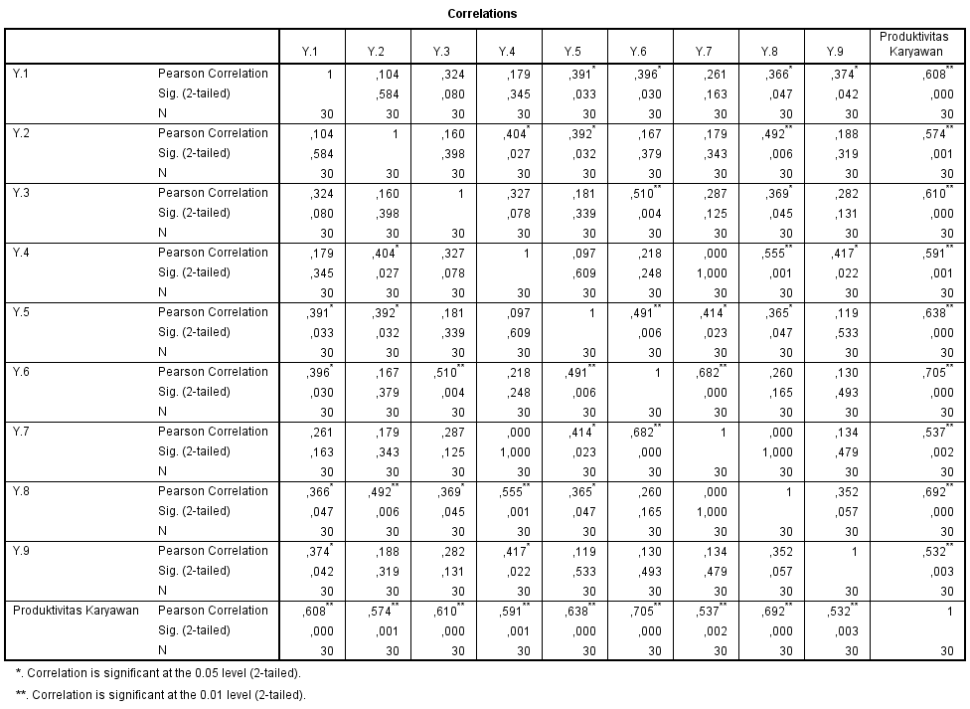

**Lampiran 8 Hasil Uji Validitas Variabel Kompetensi Karyawan (X1)**

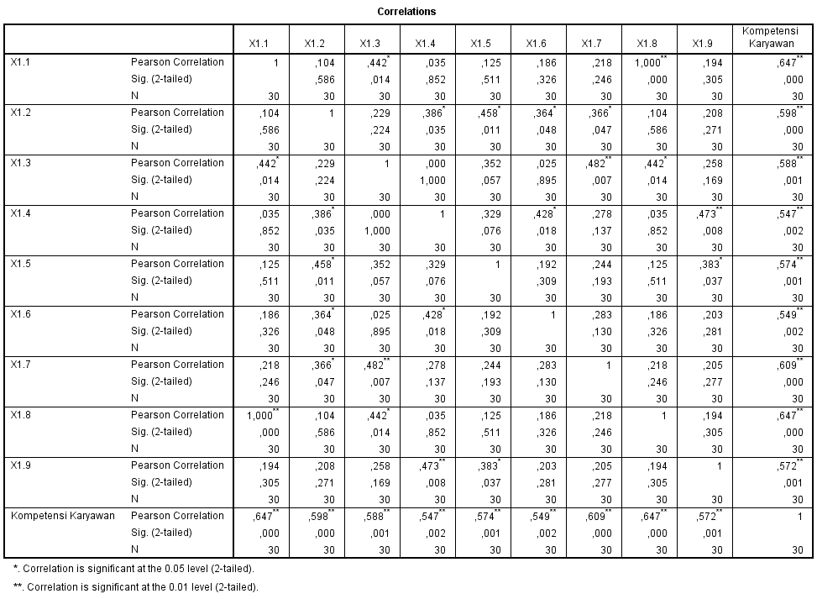

**Lampiran 9 Hasil Uji Validitas Variabel Fasilitas Kerja (X2)**

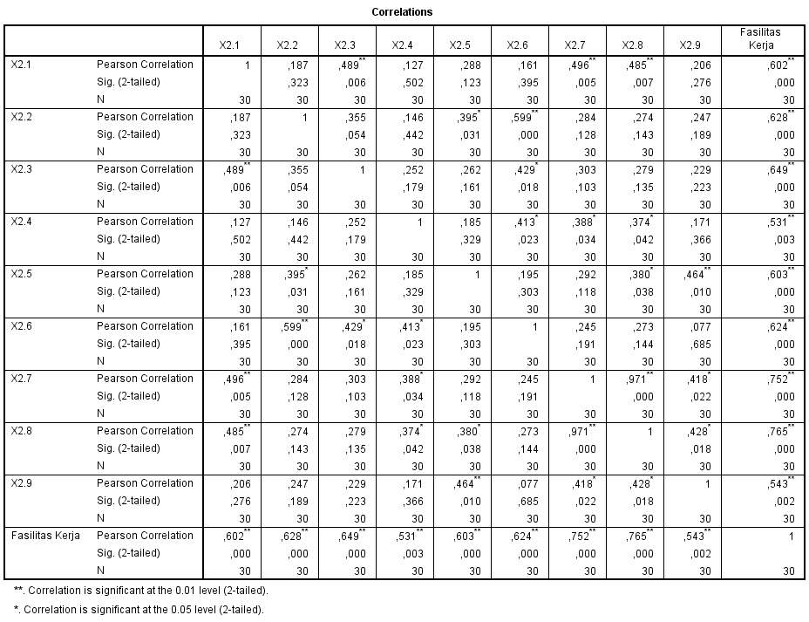

**Lampiran 10 Hasil Uji Realibilitas Variabel Produktivitas Karyawan (Y)**

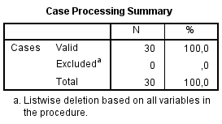

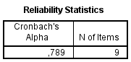

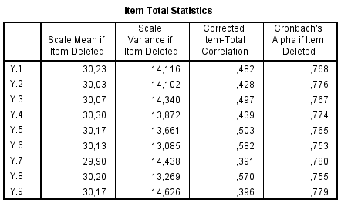

**Lampiran 11 Hasil Uji Realibilitas Variabel Kompetensi Karyawan**



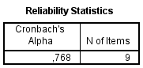

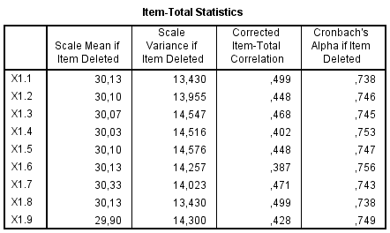

**Lampiran 12 Hasil Uji Realibilitas Variabel Fasilitas Kerja (X2)**



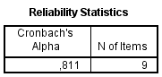

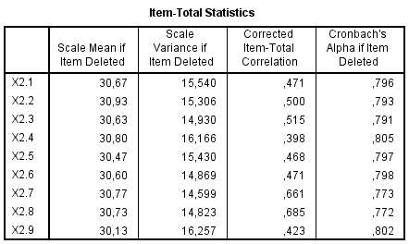

**Lampiran 13 Grafik Uji Normalitas**

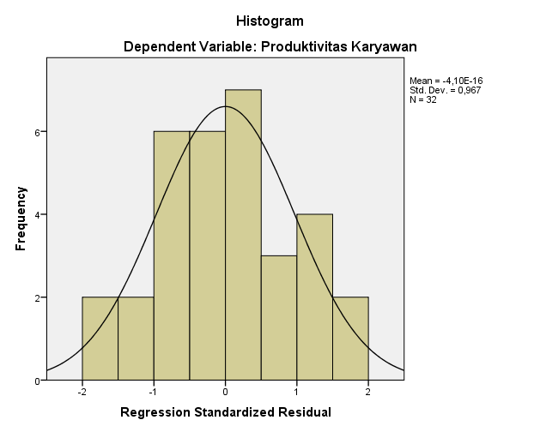

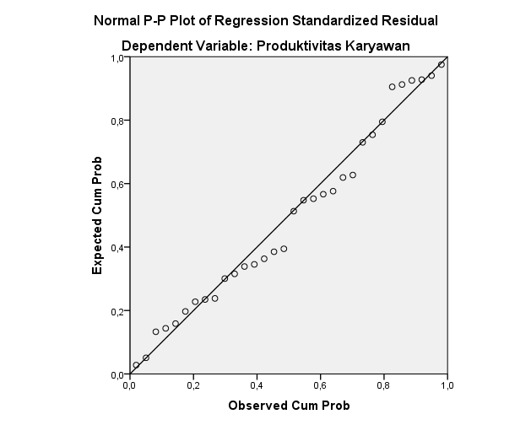

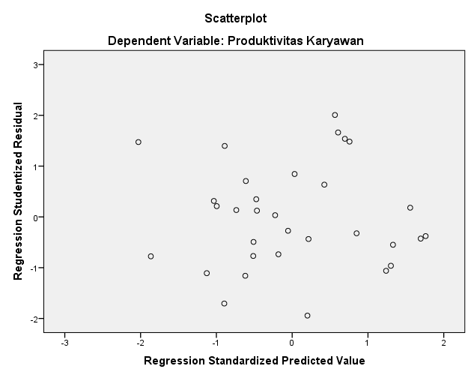

**Lampiran 14 Hasil Uji Normalitas Kolmogorov-Smirnov**

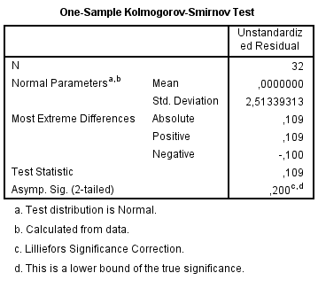

**Lampiran 15 Hasil Uji Multikolinearitas**

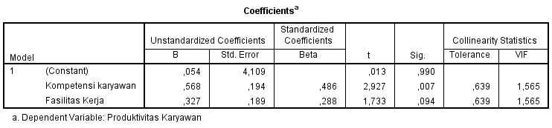

**Lampiran 16 Hasil Uji Signifikansi Parsial (Uji t)**

|  |  |  |  |  |  |  |  |
| --- | --- | --- | --- | --- | --- | --- | --- |
| **Coefficientsa** | | | | | | | |
| Model | | Unstandardized Coefficients | | Standardized Coefficients | t | Sig. |
| B | Std. Error | Beta |
| 1 | (Constant) | ,054 | 4,109 |  | ,013 | ,990 |
| Kompetensi karyawan | ,568 | ,194 | ,486 | 2,927 | ,007 |
| Fasilitas Kerja | ,327 | ,189 | ,288 | 1,733 | ,094 |
| a. Dependent Variable: Produktivitas Karyawan | | | | | | | |

**Lampiran 17 Hasil Uji Signifikansi Simultan (Uji F)**

