# DAFTAR PUSTAKA

Almanda, S., Suzan, L., & Pratama, F. (2021). Pengaruh Profitabilitas, Leverage, Umur Perusahaan Dan Komisaris Independen Terhadap Pengungkapan Intellectual Capital. *Jurnal Ilmiah MEA (Manajemen, Ekonomi, Dan Akuntansi)*, *5*(3), 1140–1153. http://journal.stiemb.ac.id/index.php/mea/article/view/1563

Andriana, N., Mariana, C., & Andari, D. (2023). *Capital Disclosure*. *5*(2), 398–409.

https://jurnal.usi.id/index.php/mea/article/view/766.

Anggraini, F., Puttri, D., Septriani, W., & Zefriyenni. (2021). Peranan Intellectual Capital sebagai Mediasi antara Corporate Social Responsibility dan Kinerja Perusahaan Perbankan. *Jurnal Ekobistek*, *9*(2), 22–31. https://doi.org/10.35134/ekobistek.v9i2.79

Ariedina, A., & Susanto, L. (2023). Pengaruh Good Corporate Governance Dan Profitabilitas Terhadap Pengungkapan Modal Intelektual. *Jurnal Paradigma Akuntansi, 5(3), 1149-1159.*, *V*(3), 1149–1159.

https://scholar.google.com/scholar?hl=id&as_sdt=0%2C5%q=Ariedina%C+2C+26%+282023%29btnG

Barokah, L., & Fachrurrozie. (2019). Accounting Analysis Journal Profitability Mediates the Effect of Managerial Ownership, Company Size, and Leverage on the Disclosure of Intellectual Capital ARTICLE INFO ABSTRACT. *Accounting Analysis Journal*, *8*(1), 1–8. https://doi.org/10.15294/aaj.v8i1.27860

Bukh, P., Nielsen, C., Gormsen, P., & Mouritsen, J. (2019). Disclosure of information on intellectual capital in Danish IPO prospectuses. *Accounting, Auditing & Accountability Journal*, *18*(6), 713–732. https://doi.org/10.1108/09513570510627685

Cahyati, A. D. (2017). Intellectual Capital Pengukura, Pengelolaan, dan Pelaporan. *Cahyati, Ari Dewi. “Intellectual Capital: Pengukuran, Pengelolaan Dan Pelaporan.” JRAK: Jurnal Riset Akuntansi Dan Komputerisasi Akuntansi 3.1 (2012): 45-56.*, *3*(1), 45–56. https://media.neliti.com/media/publications/4475-ID-intellectual-capital-pengukuran-pengelolaan-dan-pelaporan.pdf

Delvia, Y., & Alexander, N. (2019). the Effect of Size, Firm Age, Growth, Audit Reputation, Ownership and Financial Ratio on Intellectual Capital Disclosure. *Jurnal Bisnis Dan Akuntansi*, *20*(1), 69–76. https://doi.org/10.34208/jba.v20i1.410

Ghozali, I. (2018). *Aplikasi Anallisis Multivariate*.

Hesniati, H. (2021). Effect of Corporate Governance on Intellectual Capital Disclosure. *International Journal of Economics, Business and Accounting Research (IJEBAR)*, *5*(1), 34–41.

https://doi.org/10.29040/ijebar.v5i1.1584

Himawan, F. A., & Widiastuti, A. (2021). Pengaruh Ukuran Perusahaan, Profitabilitas, Leverage dan Lenght of Listing Terhadap Pengungkapan Intellectual Capital. *Jurnal Eksplorasi Akuntansi*, *3*(1), 112–136.

https://scholar.google.com/scholar?hl=id&as_sdt=0%2C5&q=Himawan%2C+F+A.%2C+%26+Widiastuti%282021%29&btnG=

Icih, & Hati, P. utami P. (2021). The Effect Of Company Size, Company Age, Ownership Concentration, Leverage, Audit Committee, And Company Performance, On Intellectual Capital Disclosure (Empirical Study on Financial Companies Listed on the Indonesia Stock Exchange Year 2017 to 2019). *Journal of Accounting for Sustainable Society (JASS)*, *3*(1), 19–44.

https://ojs.stiesa.ac.id/index.php/jasss/article/view/829

Khayati, A., Sari, R. D. P., & Giovanni, A. (2022). Nilai Tambah Modal Manusia dan Keberlangsungan Bisnis Perusahaan Sektor Consumer Non-Cyclicals. *Borobudur Management Review*, *2*(2), 169–189. https://doi.org/10.31603/bmar.v2i2.7377

Kusmayadi, D., Rudiana, D., & Badruzaman, J. (2015). *Good Corporate Governance*.

Latusura, B., & Muid, D. (2021). Analisis Pengaruh Tata Kelola Perusahaan Terhadap Pengungkapan Modal Intelektual (Studi Empiris Pada Perusahaan Perbankan yang Terdaftar di Bursa Efek Indonesia Tahun 2017-2019). *Diponegoro Journal of Accounting*, *10*(4), 1–15.

http://ejournal-s1.undip.ac.id/index.php/accounting

Laurencia,B., & Muid , D. (2021). Analisis Pengaruh Tata Kelola Perusahaan Terhadap Pengungkapan Modal Intelektual dan Dampaknya terhadap Nilai perusahaan pada perusahaan yag melakukan IPO di BEI 2016-2018. Jurnal Ilmu komputer dan bisnis 11(1),23442355

https://doi.org/10.47927/jikb.v11i1.197

Mulyana, A., & Daito, A. (2021). Pengaruh Umur Perusahaan, Profitabilitas, Dan Ukuran Perusahaan Terhadap Intellectual Capital Disclosure Dan Dampaknya Terhadap Cost of Debt. *Jurnal Akuntansi Bisnis Pelita Bangsa*, *6*(02), 68–87.

https://doi.org/10.37366/akubis.v6i02.269

Naimah, Z., & Mukti, N. A. (2019). The influence of audit committee’s and company’s characteristic on intellectual capital disclosure. *Asian Journal of Accounting Research*, *4*(2), 170–180.

https://doi.org/10.1108/AJAR-05-2019-0036

Noor, H. . Z. Z. (2021). *INTELLECTUAL CAPITAL*.

Nurdin, N. N., Hady, H., & Nalurita, F. (2019). Pengaruh Ukuran Perusahaan, Profitabilitas Dan Leverage Terhadap Pengungkapan Intellectual Capital. *Prosiding Seminar Nasional Pakar*, 1–7. https://doi.org/10.25105/pakar.v0i0.4301

Nurziah, F., & Darmawati, D. (2014). Analisis pengaruh corporate governance, kepemilikan manajerial, dan kepemilikan institusional terhadap intellectual capital disclosure. *Jurnal Keuangan Dan Perbankan*, *16*(2), 172–192. http://journal.perbanas.id/index.php/jkp/article/view/194/18

Paradila, V. R. I., Wijaya, A. L., & Widiasmara, A. (2019). Pengaruh Pertumbuhan Penjualan, Size Perusahaan, dan Leverage terhadap Nilai Perusahaan dengan Profitabilitas sebagai Variabel Intervening (Studi Kasus Perusahaan Manufaktur sektor Konsumsi Yang Terdaftar di Bursa Efek Indonesia tahun 2015 - 2017). *Seminar Inovasi Manajemen, Bisnis Dan Akuntansi I*, 617–635.

Rahma, M., Wijaya, M., & Priyatama, T. (2021). Analisis Pengungkapan Modal Intelektual. *Jurnal Ilmiah Universitas Batanghari Jambi*, *21*(3), 1232. https://doi.org/10.33087/jiubj.v21i3.1663

Rahman, M. M., Sobhan, R., & Islam, M. S. (2019). Intellectual Capital Disclosure and Its Determinants: Empirical Evidence from Listed Pharmaceutical and Chemical Industry of Bangladesh. *Journal of Business Economics and Environmental Studies*, *9*(2), 35–46. https://doi.org/10.13106/jbees.2019.vol9.no2.35

Rosiana, A., & Mahardhika, A. S. (2021). Pengaruh Good Corporate Governance dan Intellectual Capital Terhadap Kinerja Keuangan pada Perusahaan Perbankan. In *Jurnal SIKAP (Sistem Informasi, Keuangan, Auditing Dan Perpajakan)* (Vol. 5, Issue 1, p. 76). https://doi.org/10.32897/jsikap.v5i1.332

Saendy, G. A., & Anisykurlillah, I. (2020). Accounting Analysis Journal. *Accounting Analysis Journal*, *1*(1), 264–272.

https://doi.org/10.30997/jakd.v6i2.4578

Saragih, A. E., & Sihombing, U. T. (2021). Pengaruh Intellectual Capital, Good Corporate Governance, Dan Ukuran Perusahaan Terhadap Kinerja Keuangan Perusahaan Perbankan Yang Terdaftar Di Bursa Efek Indonesia. *Jurnal Riset Akuntansi & Keuangan*, *7*(1), 1–17. https://doi.org/10.54367/jrak.v7i1.1133

Sariningsih, W., & Saputro, F. E. (2021). Firm Size, Profitabilitas, Leverage, Jenis Perusahaan Audit, Jenis Industri, Penelitian Dan Pengembangan Sebagai Determinan Pengungkapan Modal Intelektual (Icd). *Jurnal Akunida*, *6*(2), 26. https://doi.org/10.30997/jakd.v6i2.3564

Senthilkumar, D. C., & Packiaraji, C. D. S. (2019). Fundamentals Of Financial Management. In *Fundamentals Of Financial Management*. https://doi.org/10.59646/ffm/152

Sinaga, A. L., & Sudarno. (2018). Pengaruh Tata Kelola Perusahaan Terhadap Pengungkapan Modal Intelektual. *Diponegoro Journal of Accounting*, *7*(4), 1–13. http://ejournal-s1.undip.ac.id/index.php/accounting

Sofiatin, D. A. (2020). Pengaruh Profitabilitas, Leverage, Likuiditas, Ukuran Perusahaan Dan Kebijakan Dividen Terhadap Nilai Perusahaan. *Jurnal Ilmiah Akuntansi Dan Manajemen*, *16*(2), 57–66. https://doi.org/10.31599/jiam.v16i2.395

Sudana, I. M. (2015). *Manajemen Keuangan Perusahaan*. Erlangga.

Sugiyono. (2013). *Metode Penelitian Kuantitatif Kualitatif dan R&D*.

Susilowati, S., & Oktarina, D. (2021). Pengaruh Kinerja Keuangan, Ukuran Perusahaan, Leverage, Dan Ukuran Komite Audit Terhadap Pengungkapan Modal Intelektual. *Ecopreneur.12*, *4*(1), 19. https://doi.org/10.51804/econ12.v4i1.918

Suyono, N. A. (2019). Analisis Pengaruh Ownership Structure, Ukuran Perusahaan dan Jenis Industri Terhadap Pengungkapan Modal Intelektual. *Journal of Economic, Management, Accounting and Technology*, *2*(2), 156–168. https://doi.org/10.32500/jematech.v2i2.729

Syarifudin, S., Nuriah, S., & Ahmad Yusuf, A. (2023). Pengaruh Ukuran Perusahaan, Leverage, Profitabilitas Dan Umur Perusahaan Terhadap Pengungkapan Modal Intelektual. *Jurnal Manajemen Dan Bisnis Jayakarta*, *5*(1), 65–78.

Tatang, C., Agoes, S., & Wirianita, H. (2022). Faktor-Faktor Yang Memengaruhi Intellectual Capital Disclosure Pada Perusahaan Manufaktur. *Jurnal Ekonomi*, *27*(03), 283–301. https://doi.org/10.24912/je.v27i03.877

Utami, R. S., & Agustin, H. (2020). Pengaruh Ukuran Perusahaan, Profitabilitas, dan Reputasi Kantor Akuntan Publik Terhadap Intellectual Capital Disclosure (Studi Empiris pada Perusahaan High-IC Intensive yang Terdaftar pada Bursa Efek Indonesia Tahun 2016-2018). *Jurnal Eksplorasi Akuntansi*, *2*(3), 3197–3215.

Utami, Y., Permananingrum, A., & Hapsari, I. M. (2022). Independensi Intelectual Capital pada Value creation asset dan modal. *Owner*, *6*(1), 759–768. https://doi.org/10.33395/owner.v6i1.665

Wahyuni, M. A., & Rasmini, N. K. (2016). Pengaruh Mekanismme Corporate Governance Pada Pengungkapan Modal Intelektual (Studi Empiris Pada Perusahaan Manufaktur Yang Terdaftar di Bursa Efek Indonesia). *Jurnal Buletin Studi Ekonomi*, *21*(1), 48–58.

https://scholar.google.com/scholar?hl=id&as_sdt=0%2C5&q=pengaruh+mekanisme+corporate+govrenance+pada+pengungkapan+modal+intelektual+studi+empiris+&btnG=

Wardoyo, D. U., Rahmadani, R., & Hanggoro, P. T. (2021). Good Corporate Governance Dalam Perspektif Teori Keagenan. *EKOMA : Jurnal Ekonomi, Manajemen, Akuntansi*, *1*(1), 39–43.

https://doi.org/10.56799/ekoma.v1i1.25

Widiatmoko, J., & Indarti, M. G. K. (2019). Karateristik Perusahaan, Tipe Auditor dan Konsentrasi Kepemilikan Saham terhadap Pengungkapan Modal Intelektual. *Jurnal Bisnis Dan Ekonomi*, *25*(2), 35–46.

https://journal.unnes.ac.id/nju/jda/article/view/20481

Zulkarnaen, E. I. dan, & Mahmud, A. (2019). Pengaruh Good Corporate Governance Terhadap Luas Pengungkapan Intellectual Capital. *Jurnal Dinamika Akuntansi*, *5*(2004), 79–85.

https://journal.unnes.ac.id/nju/jda/article/view/2565

Undang-Undang, N. 20 T. 2008. (2008).

PER/MBU. (2011). *Peraturan Menteri Negara Badan Usaha Milik Negara No. 117/M-MBU/2002. Tentang Penetapan Tata Kelola Perusahaan yang Baik pada Badan Usaha Milik Negara*. http://www.bphn.go.id/data/documents/11pmbumn001.pdf

PSAK, 19. (2019). *PSAK 19 Ruang Lingkup*. *Rev 2009*, 1–2.

**LAMPIRAN**

**LAMPIRAN 1 : Hasil Perhitungan *Good Corporate Governance* (GCG) Tahun 2019-2023**

$$Ukuran Dewan Komisaris =\frac{Jumlah Dewan Komisaris Independen }{Total Jumlah Dewan Komisaris}$$

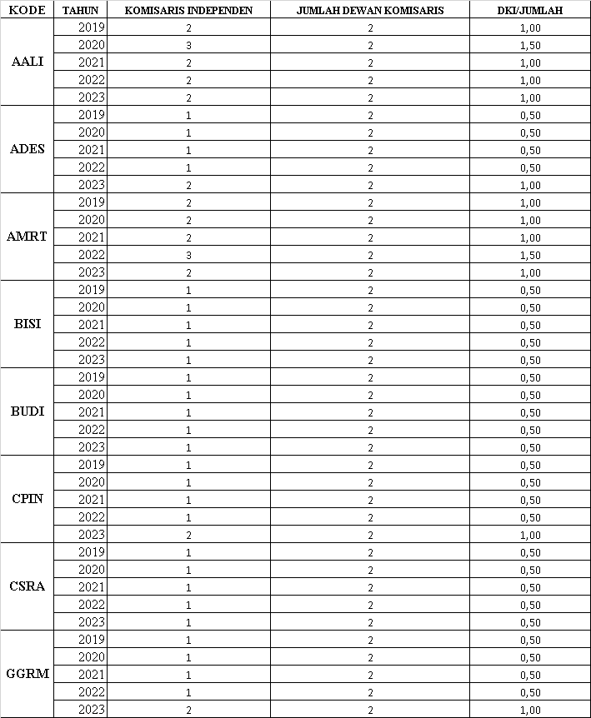

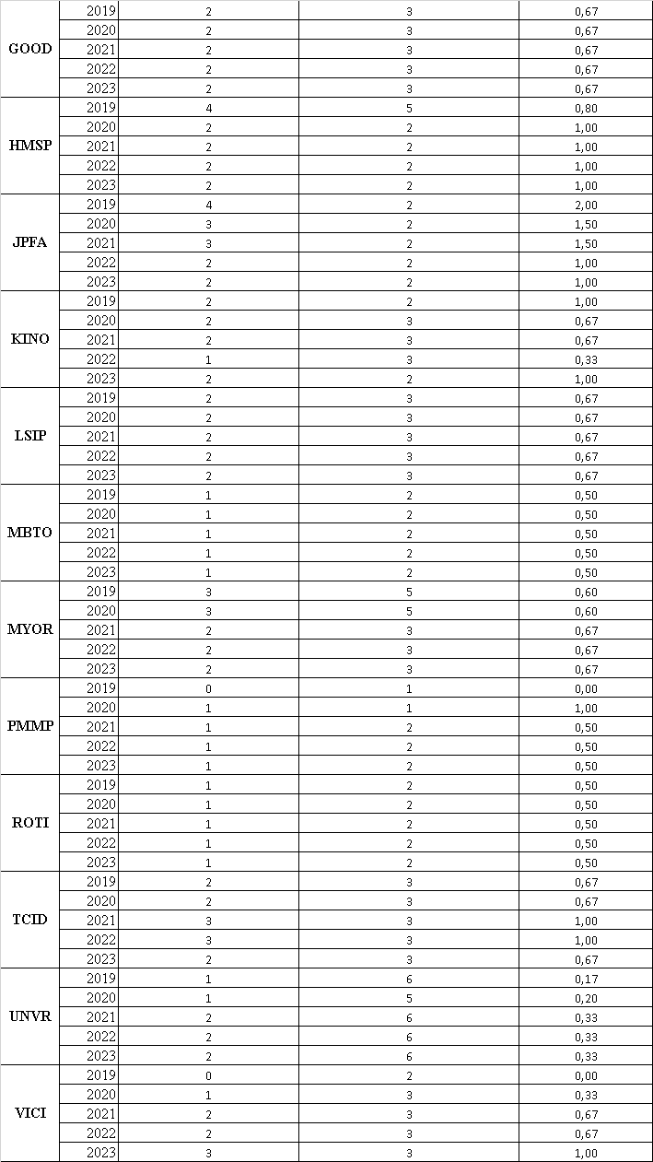

**LAMPIRAN 2 : Hasil Perhitungan *Leverage* Tahun 2019-2023**

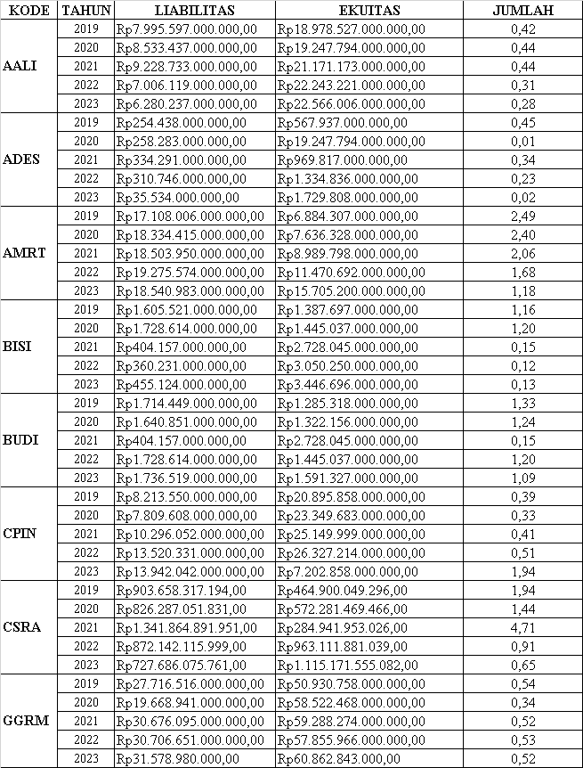**DER $=\frac{Total liabilitas}{Total Ekuitas}$**

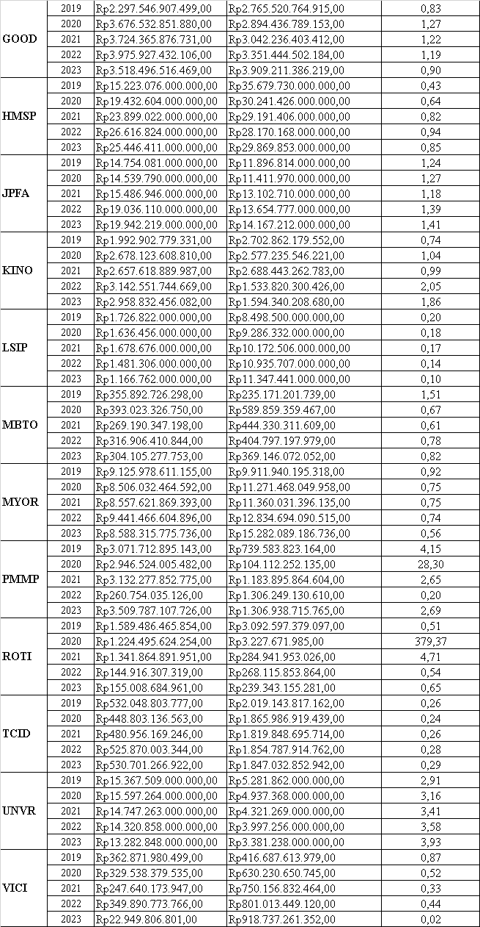

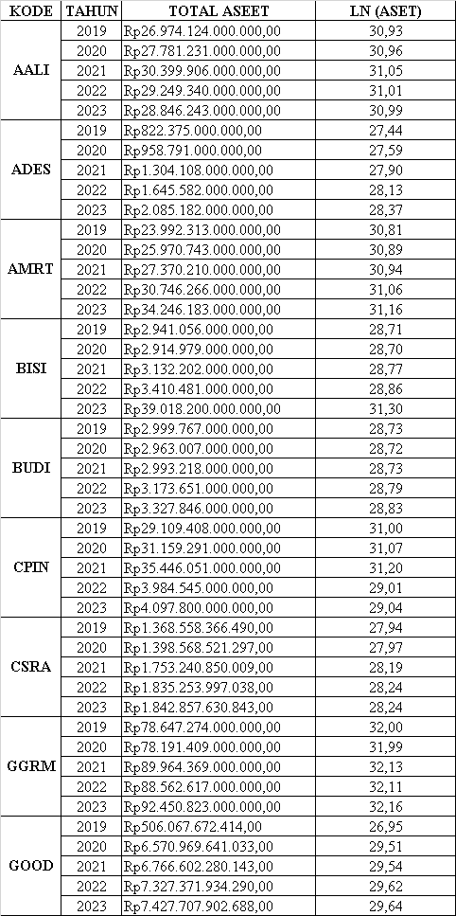**LAMPIRAN 3 : Hasil Perhitungan *Firm Size* Tahun 2019-2023**

$$Size =Ln (Total Aset)$$

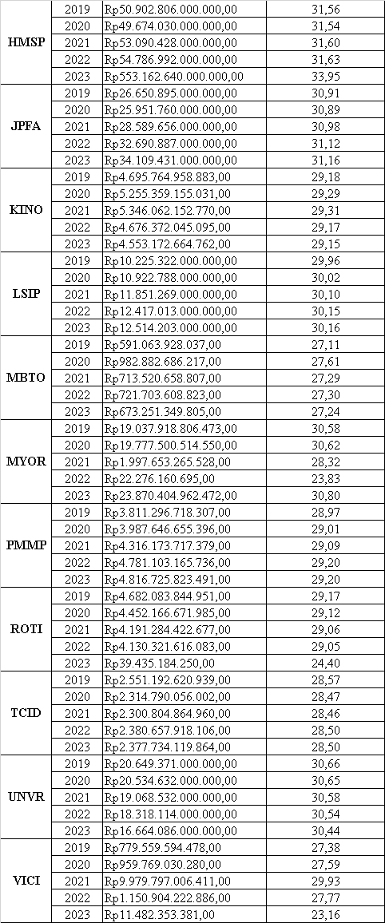

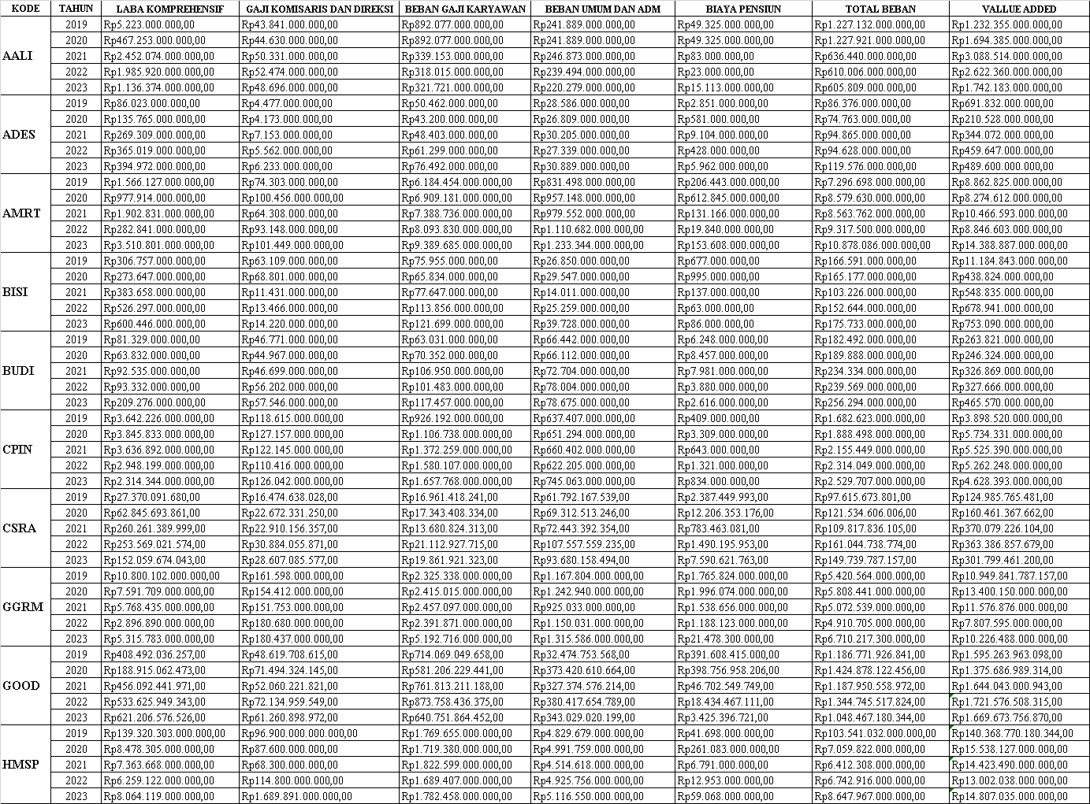**nLAMPIRAN 4 : Hasil Perhitungan *Value Added* Tahun 2019-2023**

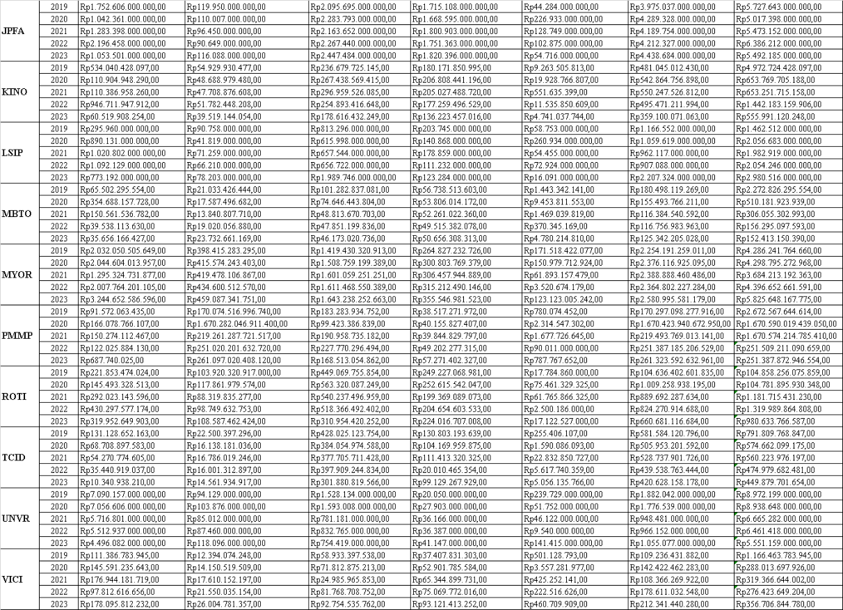

**LAMPIRAN 5 : Hasil Perhitungan VACA Tahun 2019-2023**

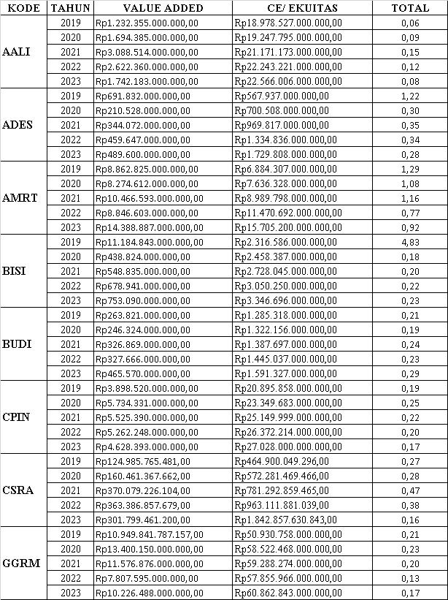 **VACA $=\frac{VA}{CE}$**

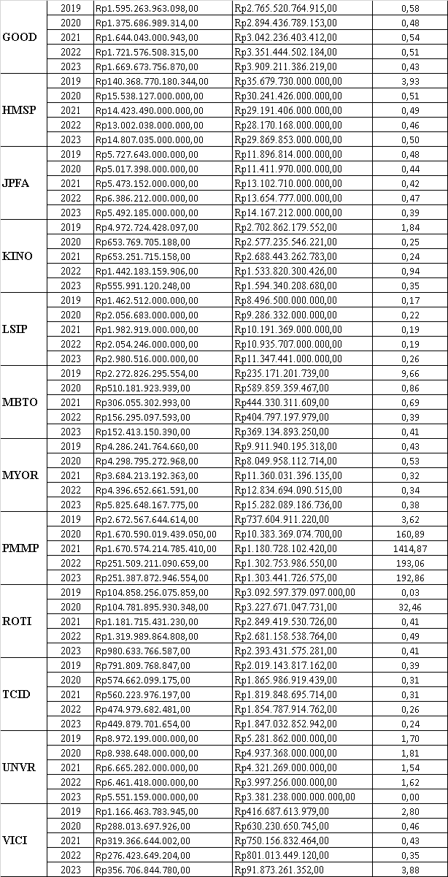

**LAMPIRAN 6 : Hasil Perhitungan VAHU Tahun 2019-2023**

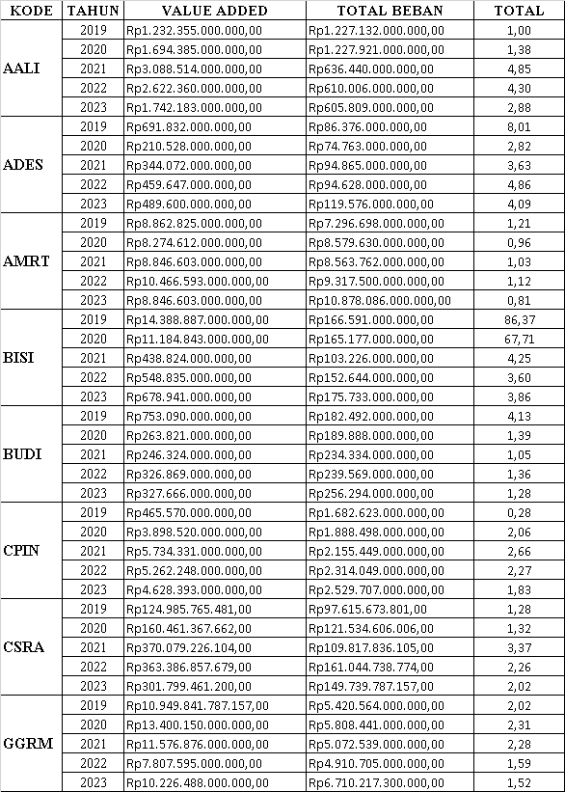**VAHU $=\frac{VA}{HC}$**

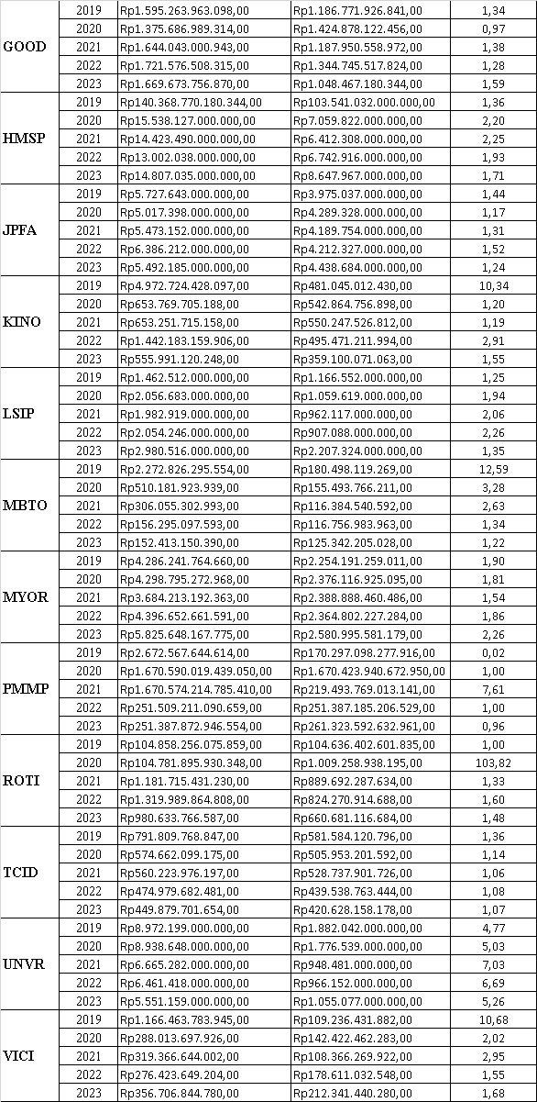

**LAMPIRAN 7 : Hasil Perhitungan STVA Tahun 2019-2023**

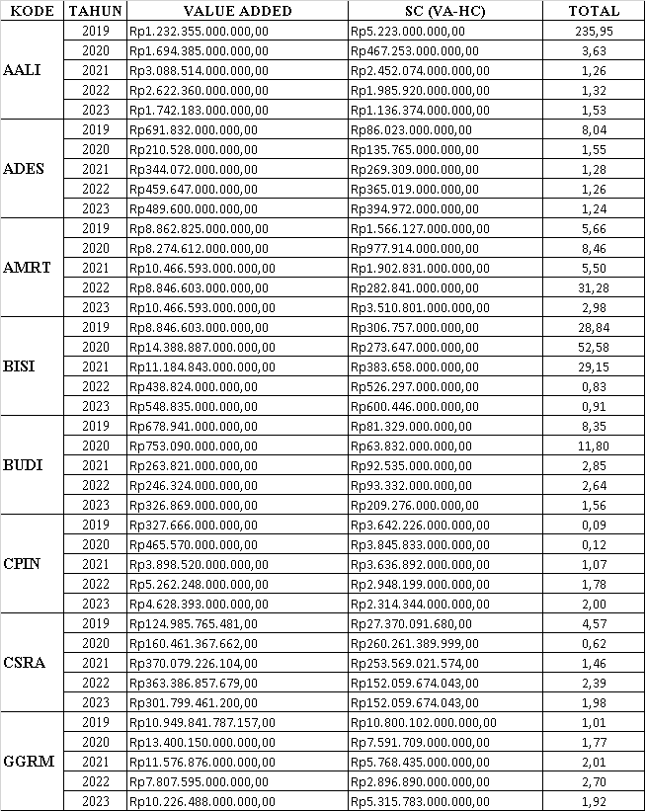**STVA $=\frac{SC}{VA}$**

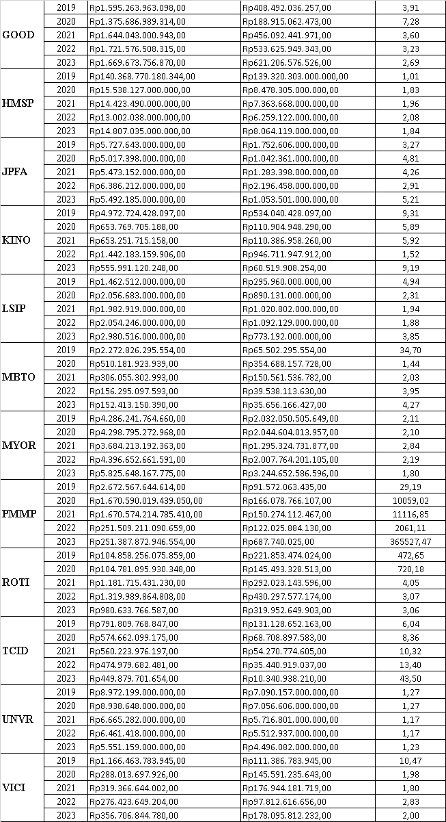

**LAMPIRAN 8 : Hasil Perhitungan $VAIC ™$ Tahun 2019-2023**

$$VAIC ™ =VACA+VAHU+STVA$$

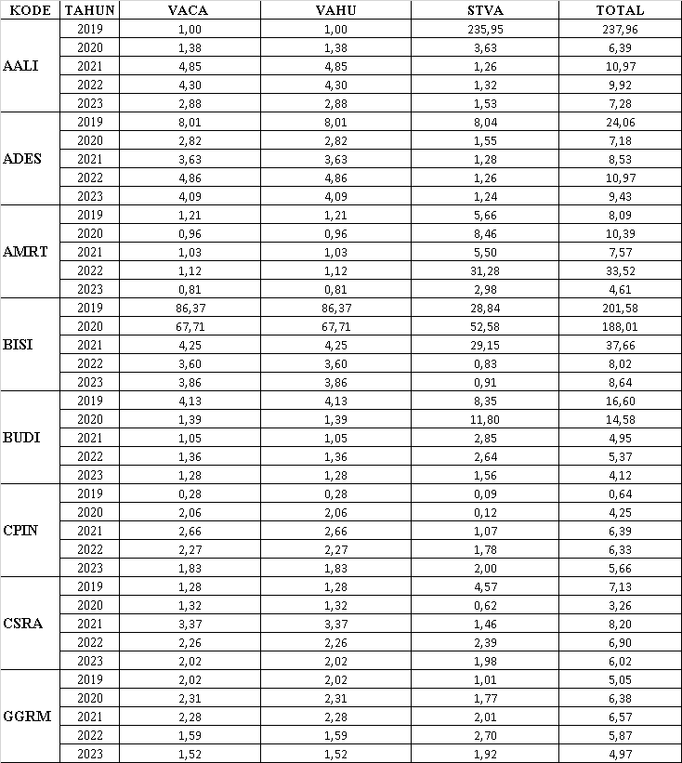

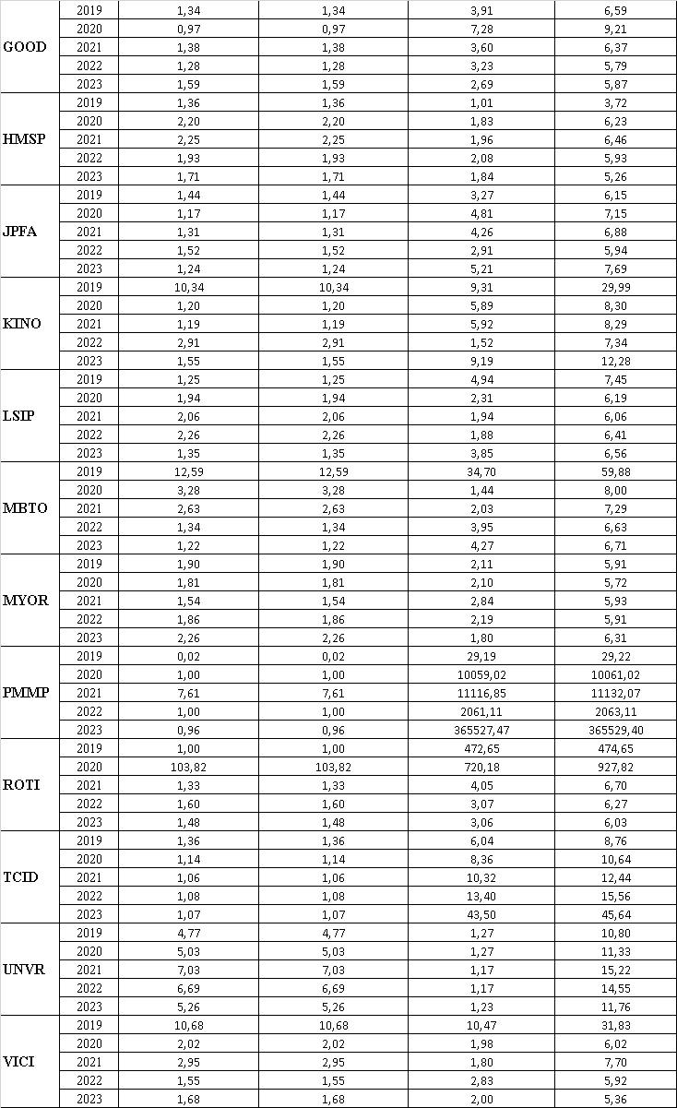

**LAMPIRAN 9 : Hasil Perhitungan Semua Variabel**

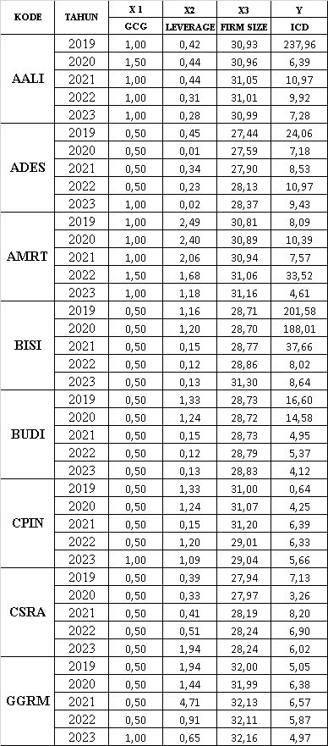

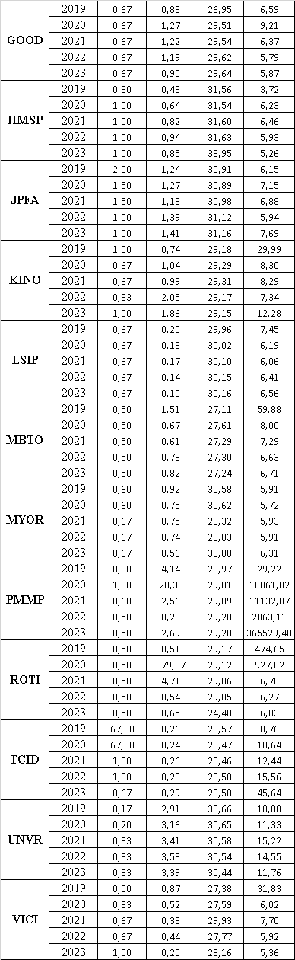

**LAMPIRAN 10 : Hasil Uji Normalitas**

|  |  |  |
| --- | --- | --- |
| **One-Sample Kolmogorov-Smirnov Test** | | |
|  | | Unstandardized Residual |
| N | | 100 |
| Normal Parametersa,b | Mean | ,0000000 |
| Std. Deviation | ,43234477 |
| Most Extreme Differences | Absolute | ,045 |
| Positive | ,045 |
| Negative | -,039 |
| Test Statistic | | ,045 |
| Asymp. Sig. (2-tailed) | | ,200c,d |
| a. Test distribution is Normal. | | |
| b. Calculated from data. | | |
| c. Lilliefors Significance Correction. | | |
| d. This is a lower bound of the true significance. | | |

**LAMPIRAN 11 : Hasil Uji Multikolonieritas**

|  |  |  |  |
| --- | --- | --- | --- |
| **Coefficientsa** | | | |
| Model | | Collinearity Statistics | |
| Tolerance | VIF |
| 1 | GCG | ,954 | 1,048 |
| Leverage | ,974 | 1,027 |
| Firm Size | ,916 | 1,092 |
| Intellectual Capital | ,892 | 1,121 |
| a. Dependent Variable: Intellectual Capital | | | |

**LAMPIRAN 12 : Hasil Uji Heterokedaktisitas**

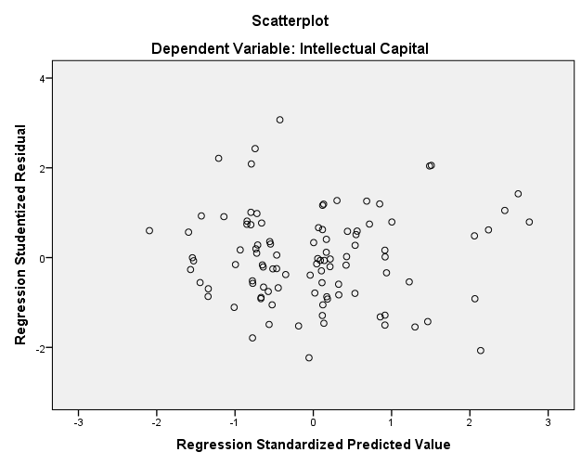

**LAMPIRAN 13 : Hasil Uji Autokorelasi**

|  |  |  |  |  |  |
| --- | --- | --- | --- | --- | --- |
| **Model Summaryb** | | | | | |
| Model | R | R Square | Adjusted R Square | Std. Error of the Estimate | Durbin-Watson |
| 1 | ,662a | ,438 | ,414 | ,37555 | 1,810 |
| a. Predictors: (Constant), Intellectual Capital, Leverage, GCG, Firm Size | | | | | |
| b. Dependent Variable: Intellectual Capital  Sumber: Data Output SPSS 22 2024 | | | | | |

**LAMPIRAN 14 : Hasil Uji regresi Linier Berganda**

|  |  |  |  |  |  |  |  |
| --- | --- | --- | --- | --- | --- | --- | --- |
| **Coefficientsa** | | | | | | | |
| Model | | Unstandardized Coefficients | | Standardized Coefficients | t | Sig. |
| B | Std. Error | Beta |
| 1 | (Constant) | 3,147 | ,795 |  | 3,958 | ,000 |
| GCG | -,441 | ,108 | -,374 | -4,073 | ,000 |
| Leverage | ,007 | ,034 | ,019 | ,203 | ,840 |
| Firm Size | -,720 | ,247 | -,267 | -2,920 | ,004 |
| a. Dependent Variable: Intellectual Capital | | | | | | | |

**LAMPIRAN 15: Hasil Uji Parsial (Uji t)**

|  |  |  |  |  |  |  |  |
| --- | --- | --- | --- | --- | --- | --- | --- |
| **Coefficientsa** | | | | | | | |
| Model | | Unstandardized Coefficients | | Standardized Coefficients | t | Sig. |
| B | Std. Error | Beta |
| 1 | (Constant) | 3,147 | ,795 |  | 3,958 | ,000 |
| GCG | -,441 | ,108 | -,374 | -4,073 | ,000 |
| Leverage | ,007 | ,034 | ,019 | ,203 | ,840 |
| Firm Size | -,720 | ,247 | -,267 | -2,920 | ,004 |
| a. Dependent Variable: Intellectual Capital  Sumber : Data Output SPSS 22 2024 | | | | | | | |

**LAMPIRAN 16 : Hasil Uji Simultan (Uji F)**

|  |  |  |  |  |  |  |
| --- | --- | --- | --- | --- | --- | --- |
| **ANOVAa** | | | | | | |
| Model | | Sum of Squares | df | Mean Square | F | Sig. |
| 1 | Regression | 10,448 | 4 | 2,612 | 18,519 | ,000b |
| Residual | 13,398 | 95 | ,141 |  |  |
| Total | 23,846 | 99 |  |  |  |
| a. Dependent Variable: Intellectual Capital | | | | | | |
| b. Predictors: (Constant), Intellectual Capital, Leverage, GCG, Firm Size | | | | | | |

**LAMPIRAN 17 : Hasil Uji Koefisien Determinasi (R²)**

|  |  |  |  |  |  |
| --- | --- | --- | --- | --- | --- |
| **Model Summaryb** | | | | | |
| Model | R | R Square | Adjusted R Square | Std. Error of the Estimate |
| 1 | ,662a | ,438 | ,414 | ,37555 |
| a. Predictors: (Constant), Intellectual Capital, Leverage, GCG, Firm Size | | | | | |
| b. Dependent Variable: Intellectual Capital | | | | | |
|  | | | | | |
|  | | | | | |

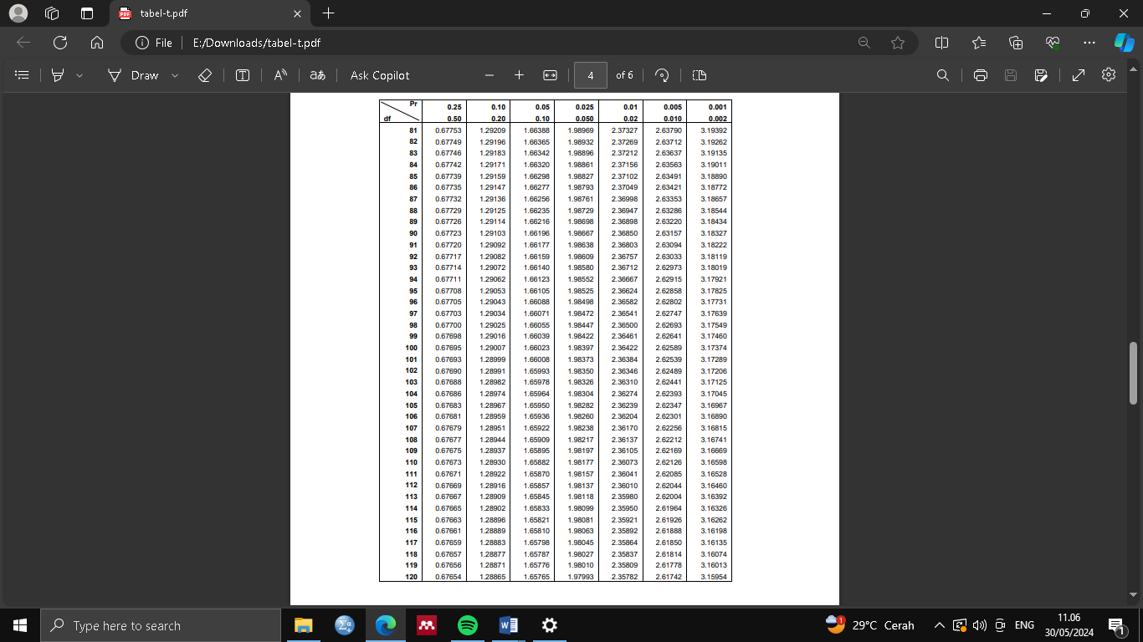**LAMPIRAN 18 : Tabel Uji t**

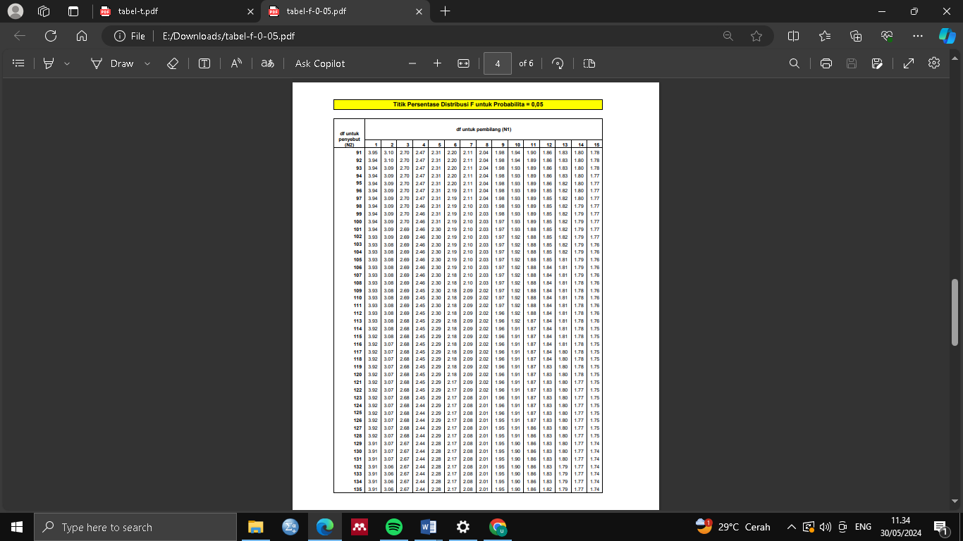**LAMPIRAN 19 : Tabel Uji F**

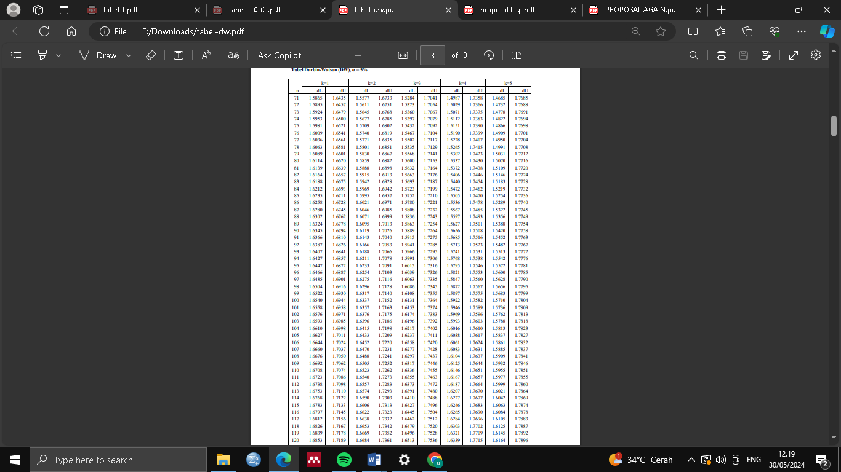**LAMPIRAN 20 : Tabel Durbin Watson**