# DALFTALR PUSTALKA

Amabarita, & Himsar. (2011). *Materi Kuliah Metode Perhitungan Dinamika Fluida.* Medan: Depertemen Teknik Mesin USU.

Ambariita, H. (2011). *Perpindahan Panas Konveksi dan Pengantar Alat Penukar Kalor.* Medan: Depertemen Teknik Mesin USU.

Ambarita, H. (2011). *Buku Kuliah Perpindahan Panas Konduksi (penyelesaian analitik dan numerik).* Medan: Depertemen Teknik Mesin USU.

Ambarita, H. (2018). Kajian Numerik Penguapan Pada Evaporator Desalinasi Air Laut Sistem Vakum Alami. Dalam *Talenta Conference Series : Energy and Enginering (EE), 1 (1)* (hal. 095-700). https://doi.org/10.32734/ee/vlil.117.

Ambekar Aniket Shrikant, R. Sivakumar, N. Anantharaman, & M. Vivekenandan. (2016). *Applied Thermal Engineering.* ScienceDirect.

Caesar Wiratama. (2021). *Teori Dan Best Practices Computational Fluid Dynamiycs (CFD).* aeroengineering service.

Cengel, Y.A. (2003). *Heat Transfer A Practical Approach* (2nd ed.). Singapore: Mc Graw-Hill, Book Company. Halaman 26.

Cengel, Y.A. (2006). *Heat And Mass Transfer : A Practica Approach.*

Chokkalingam, G, S. C. (2020). *CFD analysis of solar still with PCM. Material Today : Proceeding.* https://doi.org/10.1016/j.matpr.2020.05.638.

El-Sebaey, M. S, Ellman, A, Hegazy, A, & Ghonim, T. (2020). Experimental analysis and CFD modeling for conventional basin-type solar still. Energies,. https;//doi.org/10.3390/en13215734.

F. Kreith, & Burmeister,G. (1991). *Energy Management And Conservation.* United States: u.s depertement of energy.

García-Chávez, R. J.,, Chávez-Ramírez, A. U.,, Villafan-Vidales, H. I.,, Velazquez-Fernandez, J. B.,, & Hernandez-Rosasel, I. P. (2020). Thermal Dtudy of a solar distiller using computational fluid dynamic (CFD). Revista Mexicana de Ingeniera Quimica, 19(2). https://doi.org/10.24275.rmiq/IE671.

Ghanavel, C, Saravanan, R, & Chandrasekaran, M. (2020). CFD analysis of solar still with PCM. Dalam *Materials Today : Proceeding, 37 (Part 2)* (hal. 694-700). https://doi.org/10.1016/j.matpr.2020.05.638.

H Ambarita, A D Ronowikarto, R E T Siregar, & E Y Setyawan. (2019). CFD Analysis of Evaporation-Condensation Phenomenon In an Evaporation Chamber of Natutral Vacuum Solar Desalination. IOP Publishing.

Haryanto.B, M. (2012). *Buku Ajar Perpindahan Panas.*

Holman, J. P. (2010). Heat Transfer. *Tenth Edition (McGraw-Hill Series in Mecabical Engginering*.

Holman, J.P. (2000). *Perpindahan Kalor.* Penerbit Erlangga.

Incropera, F.P, & David P. De Witt. (1985). *Fundamentals Of Heat and Mass Transfer* (2nd ed.). New York: John Wiley & Sons Inc.

izzati, I. A. (2021). *Material Perubahan Fasa Berbasis Ethylene Propylene Diene Monomer (EPDM) Untuk Penyimpanan Energi Panas.* Jurnal Sains Dan Teknologi Reaksi, 18(01). http://doi.org/10.30811/jstr.v18i01.2251.

Kurniawan, A. B. (2022). Analisa Perpindahan Panas Desalinasi Single Slope Still Dengan Metode Komputasi. *Skripsi Teknik Mesin, Fakultas Teknik dan Ilmu Komputer, Universitas Pancasakti Tegal*.

Mittal, G. (2021). An unsteady CFD modelling of a single slope solar still. Today : Proceedings. https://doi.org/10.1016/j.matpr.2021.02.090.

Naryanto, R. F. (2021). Simulasi Numerik Pada Downdraft Gasifier Biomassa Dengan Computational Fluid Dynamic. *Teknovasi*, 8. 2.

P. Siagian, R.A.M. Nopitupulu, and H. Ambarita, L. Siagian, E.Y. Setyawan, & F.H Nopitupulu. (2018). *Analysis of Temperatur and Velocity Distribution in Solar Drying Box Coffe Beans.* IOP Publishing.

Panchal, H. R. (2021). Use of Computational Fluid Dynamic for solar desalination system. Dalam *a review. Internsional Jurnal of Ambient Energy,* (hal. 1-29). https://doi.org/10.1080/01430750.2021.1965019.

Sahabuddin, Baharuddin Hamzah, & Ihsan. (2014). Pengaliran Udara Untuk Kenyamanan Thermal Ruang Kelas Dengan Metode Simulasi Computational Fluid Dynamics. Dalam U. M. Makasar (Penyunt.). Jurnal Sinetika Vol.14 No.2.

Santosa, I. (2015). Analisa Filmwise dan Dropwise Hibrid basin Solar Still. Dalam *Prosiding Seminar Nasional Pangan, Dan Lingkungann,1* (hal. 163-170).

Saputra, E. T. (2021). *Pengaruh Massa PCM (Phase Change Material) Terhadap Produkvitas dan Efisiensi Alat Destilasi Tenaga Surya Menggunakan PCM Jenis Lauric Acid Sebagai Penyimpanan Panas.* Eksergi,17(3), 201. https://doi.org/10.32497/eksergi.v17i03.2877.

Sayma, & AbdulNaser. (2009). *Computational Fluid Dynamics.*

Shoehabi, S, Kargarsharifabad, H, Rahbar, N, Ahmadi, G, & Safaei, M, R. (2022). Performance evaluation of a solar still using hybrid nanofluid glass cooling-CFD simulation and environmental analysis. Dalam *Sustainable Energy Technologies and Assessments* (hal. 49). http://doi.org/10.1016/j.seta.2021.101728.

Sugeng Abdullah. (2005). *Pemanfaatan Diistilator Tenanga Surya (Solar Energy) Untuk Memprodusi Air Tawar Dari Air Laut.* Yogyakarta: Universitas Gajah Mada.

Wiratama, C. (2021). *Teori Dan Best Practices Computational Fluid Dynamic (CFD).* aeroengineering services.

# 

# LAMPIRAN

Lampiran 1. Tabel Pengambilan Data 3x24 Jam

|  |  |  |
| --- | --- | --- |
| Data Pengukuran Temperatur Distilasi Hari Ke 1 | | |
| Jam / WIB | T1 Air(oC) | T2 Uap(oC) |
| 10.00 | 28 | 35 |
| 11.00 | 31 | 93 |
| 12.00 | 43 | 94 |
| 13.00 | 43 | 103 |
| 14.00 | 47 | 106 |
| 15.00 | 49 | 106 |
| 16.00 | 54 | 104 |
| 17.00 | 58 | 113 |
| 18.00 | 60 | 113 |
| 19.00 | 62 | 114 |
| 20.00 | 65 | 115 |
| 21.00 | 65 | 115 |
| 22.00 | 67 | 116 |
| 23.00 | 69 | 116 |
| 24.00 | 70 | 117 |
| 01.00 | 71 | 116 |
| 02.00 | 73 | 116 |
| 03.00 | 74 | 116 |
| 04.00 | 80 | 116 |
| 05.00 | 87 | 116 |
| 06.00 | 86 | 115 |
| 07.00 | 85 | 115 |
| 08.00 | 86 | 115 |
| 09.00 | 87 | 115 |
| 10.00 | 88 | 114 |

|  |  |  |
| --- | --- | --- |
| Data Pengukuran Temperatur Distilasi Hari Ke 2 | | |
| Jam / WIB | T1 Air(oC) | T2 Uap(oC) |
| 10.00 | 88 | 115 |
| 11.00 | 89 | 115 |
| 12.00 | 86 | 114 |
| 13.00 | 90 | 115 |
| 14.00 | 90 | 115 |
| 15.00 | 86 | 114 |
| 16.00 | 85 | 115 |
| 17.00 | 86 | 116 |
| 18.00 | 86 | 118 |
| 19.00 | 89 | 117 |
| 20.00 | 93 | 117 |
| 21.00 | 92 | 117 |
| 22.00 | 91 | 116 |
| 23.00 | 93 | 118 |
| 24.00 | 94 | 118 |
| 01.00 | 90 | 118 |
| 02.00 | 88 | 117 |
| 03.00 | 89 | 118 |
| 04.00 | 88 | 118 |
| 05.00 | 87 | 119 |
| 06.00 | 87 | 118 |
| 07.00 | 90 | 119 |
| 08.00 | 89 | 119 |
| 09.00 | 87 | 117 |
| 10.00 | 84 | 117 |

|  |  |  |
| --- | --- | --- |
| Data Pengukuran Temperatur Distilasi Hari Ke 3 | | |
| Jam / WIB | T1 Air(oC) | T2 Uap(oC) |
| 10.00 | 84 | 117 |
| 11.00 | 84 | 117 |
| 12.00 | 83 | 117 |
| 13.00 | 83 | 117 |
| 14.00 | 83 | 117 |
| 15.00 | 83 | 117 |
| 16.00 | 84 | 118 |
| 17.00 | 85 | 117 |
| 18.00 | 85 | 117 |
| 19.00 | 85 | 117 |
| 20.00 | 87 | 118 |
| 21.00 | 89 | 119 |
| 22.00 | 89 | 120 |
| 23.00 | 89 | 120 |
| 24.00 | 87 | 121 |
| 01.00 | 88 | 120 |
| 02.00 | 89 | 120 |
| 03.00 | 88 | 119 |
| 04.00 | 82 | 120 |
| 05.00 | 81 | 120 |
| 06.00 | 82 | 120 |
| 07.00 | 80 | 121 |
| 08.00 | 80 | 121 |
| 09.00 | 80 | 122 |
| 10.00 | 81 | 122 |

Lampiran 2. Gambar Pengujian Eksperimen

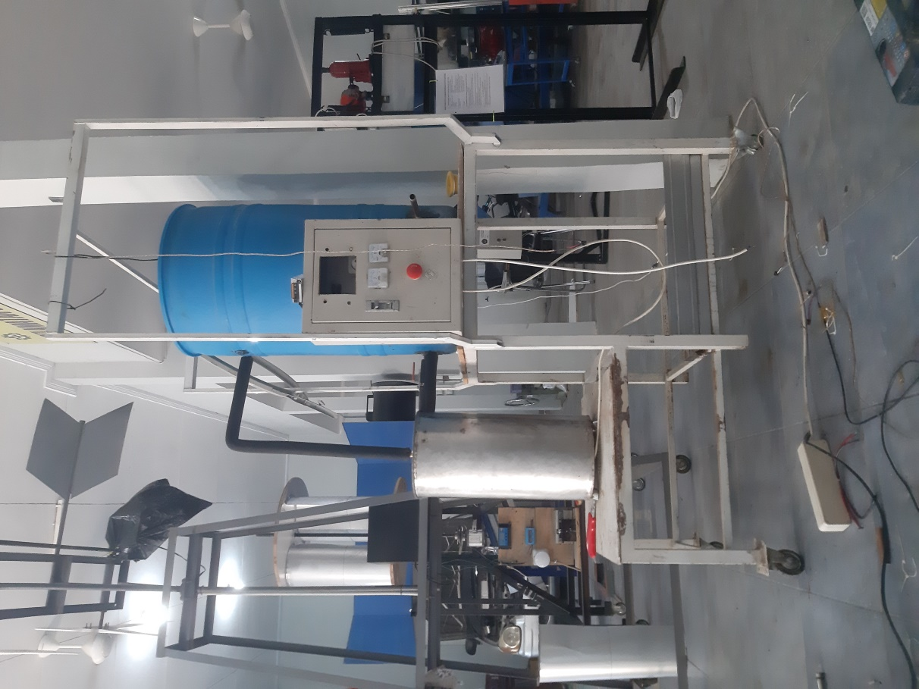 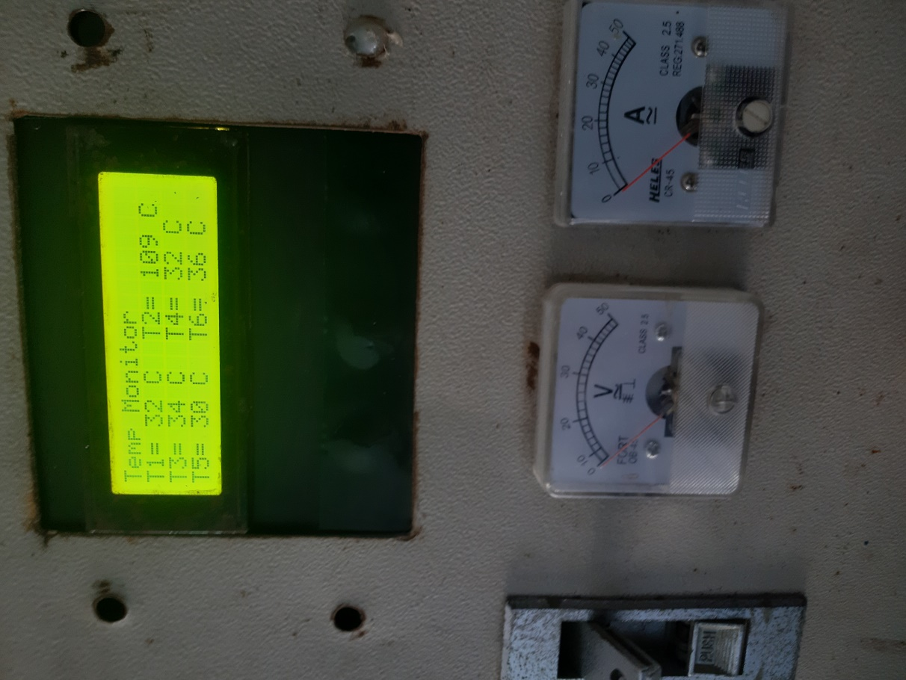

Lampiran 3. Pengujian Simulasi

