**DAFTAR PUSTAKA**

Abraham, I., & Supriyati, Y. (2022). *Desain Kuasi Eksperimen Dalam Pendidikan: Literatur Review*. Jurnal Ilmiah Mandala Education, 8(3), 2476–2482. https://doi.org/10.58258/jime.v8i3.3800

Alexandro, R., Misnawati, & Wahidin. (2021). *Profesi Keguruan (Menjadi Guru yang Profesional)*. Bogor : Guepedia.

Amelia, D. (2021). *Upaya Peningkatan Kosakata Bahasa Inggris Melalui Storytelling Slide and Sound*. Journal of Social Sciences and Technology for Community Service (JSSTCS), *2*(1), 22. https://doi.org/10.33365/jsstcs.v2i1.948

Anggraini, N. (2021). *Peranan Orang Tua Dalam Perkembangan Bahasa Anak Usia Dini*. Metafora: Jurnal Pembelajaran Bahasa Dan Sastra, *7*(1), 43. https://doi.org/10.30595/mtf.v7i1.9741

Ansori, S. B., & Sugiarti, N. (2022). *Peningkatan Penguasaan Kosakata Anak Usia Dini Dengan Metode Bernyanyi*. Jurnal Al Mahsuni: Jurnal Studi Islam …, 10(01). http://ojs.kopertais14.or.id/index.php/almahsuni/article/view/82

Antia, S., Arfe, B., Argyropoulos, V., & Bergmann, E. (2021). *The Oxford Handbook of Deaf Studies in Literacy*. Oxford : Oxford University Press.

Aryani, R., Susanti, A., Fatchurrohmah, L. M., & Yuliana, N. (2023). *Bunga Rampai Manajemen PAUD : Sebuah Pengembangan Manajemen dari Para Pendidik Anak Usia Dini*. Sukabumi : CV Jejak.

B, H., & Mohamad, N. (2022). *Belajar Dengan Pendekatan PAILKEM : Pembelajaran Aktif, Inovatif, Lingkungan, Kreatif, Efektif, Menarik*. Jakarta : PT Bumi Aksara.

Deluma, R. Y. (2023). *Strategi Pembalajaran Anak Usia Dini*. Nganjuk : CV Dewa Publishing.

Ebi, S. (2023). *Golden Age Parenting : Memaksimalkan Potensi Anak di Usia Emas*. Yogyakarta : Anak Hebat Indonesia.

Eliyyil Akbar, M. P. I. (2020). *Metode Belajar Anak Usia Dini*. Prenada Media. https://books.google.co.id/books?id=MYP1DwAAQBAJ

Fatimah, F. N., Larasati, S. A., Aulia, P., & Lubis, H. Z. (2024). *Penerapan dan Dampak Bernyanyi di Kelas pada Anak Usia Dini di TK IT Nurul Ilmi.* Jurnal Pendidikan Tambusai, 8(1), 180–186. https://scholar.google.com/citations?view_op=view_citation&hl=en&user=w4NpRyIAAAAJ&pagesize=100&citation_for_view=w4NpRyIAAAAJ:QIV2ME_5wuYC

Fauziddin, M., Daulay, M. I., & Lestari, L. (2023). *Penerapan Gerak Dan Lagu “Naik-Naik Ke Puncak Gunung” untuk Meningkatkan Kemampuan Motorik Kasar Anak Usia 5-6 Tahun.* Refleksi: Jurnal Penelitian Tindakan, 1(1), 35–47. https://doi.org/10.37985/refleksi.v1i1.154

Fauziddin, M., & Fikriya, M. (2020). *Mengenal Kosakata Bahasa Arab melalui Permainan Kartu Huruf Hijaiyah yang Dilengkapi Kosakata*. Journal on Early Childhood Education Research (JOECHER), 1(2), 90–99. https://doi.org/10.37985/joecher.v1i2.13

Fitri, A. S. S., Rijal, S., & Burhanuddin, B. (2022). *Aplikasi Quizlet Dalam Meningkatkan Kosakata Bahasa Jerman*. Phonologie : Journal of Language and Literature, 2(2). https://doi.org/10.26858/phonologie.v2i2.35303

Fitri, Y. M., & Nurhafizah, N. (2021). *Pengaruh Metode Gerak dan Lagu Terhadap Perkembangan Sosial dan Emosional Anak di Kota Padang.* Jurnal Basicedu, 5(2), 636–642. https://doi.org/10.31004/basicedu.v5i2.779

Guntur, M., Rahayu, E. P., Ilise, R. N., & Setyawati, N. S. (2023). *Perkembangan Bahasa Pada Anak Usia Dini*. Yogyakarta : Selat Media Partners.

Hafiz, M., & Anisa, Y. (2022). *Improving Early Childhood Counting Ability Through Modification Of Illustrated Counting Books*. Sensei: International Journal Of Education and Linguistics, 2(1). http://sijel-journal.sensei-journal.com/index.php/jbo/article/view/74/77

Handayani, N., Kariasih, A., Rosarini, F., & Yulaeha, S. (2022). *Pengembangan Model Pembelajaran Untuk Meningkatkan Hasil belajar Siswa*. Magelang : Pustaka Rumah Cinta.

Harahap, S. A., Dimyati, D., & Purwanta, E. (2021). *Problematika Pembelajaran Daring dan Luring Anak Usia Dini bagi Guru dan Orang tua di Masa Pandemi Covid 19.* Jurnal Obsesi : Jurnal Pendidikan Anak Usia Dini, 5(2), 1825–1836. https://doi.org/10.31004/obsesi.v5i2.1013

Hartono, H. (2020). *Metode dan Teknik Kreatif Mengajar Bahasa Inggris untuk Anak-anak Usia Dini*. Semarang : Universitas Katolik Soegijapranata.

Hasanah, Z., & Himami, A. S. (2021). *Model Pembelajaran Kooperatif Dalam Menumbuhkan Keaktifan Belajar Siswa*. Irsyaduna: Jurnal Studi Kemahasiswaaan, 1(1), 1–13. https://doi.org/10.54437/irsyaduna.v1i1.236

Hasna, S., Pertiwi, A. D., & Nurfatimah, S. A. (2022). *Menerapkan Metode Pembelajaran Berorientasi Student Centered Menuju Masa Transisi Kurikulum Merdeka.* Jurnal Pendidikan Tambusai, 6(2), 8839–8848.

Hayati, M., & Yesmneca, W. (2023). *Meningkatkan Motivasi Belajar Anak Tipe Kinestetik Melalui Kegiatan Gerak dan Lagu di RA Arafah Kabupaten Solok*. *7*, 12527–12532.

Hestiana, M., & Anita, A. (2022). *The Role of Movie Subtitles To Improve Students’ Vocabulary.* Journal of English Language Teaching and Learning, 3(1), 46–53. https://doi.org/10.33365/jeltl.v3i1.1715

Husna, L., & Ma’ruf, A. (2019). *Implementasi Metode Gerak Dan Lagu Untuk Meningkatkan Kosakata Bahasa Arab Dan Inggris (di Taman Kanak-kanak PesantrenAnak Sholeh Al-Ihlas Capang)*. *Mafhum*, *4*(1), 43–60.

Iskandar, B. (2021). *Bermain Sambil Belajar: Konsepsi Guru dalam Mengelola Permainan Anak Usia Dini di PAUD*. Jurnal Ilmiah Profesi Pendidikan, 6(3), 461–466. https://doi.org/10.29303/jipp.v6i3.242

Jaya, I. M. L. M. (2021). *Metode Penelitian Kuantitatif dan Kualitatif*. Jakarta : Penerbit Quadrant.

Kaban, R. H., Anzelina, D., Sinaga, R., & Silaban, P. J. (2020). *Pengaruh Model Pembelajaran PAKEM terhadap Hasil Belajar Siswa di Sekolah Dasar*. Jurnal Basicedu, 5(1), 102–109. https://doi.org/10.31004/basicedu.v5i1.574

Krisnanto, H. (2022). *Pengaruh Model Pembelajaran Flipped Classroom terhadap Pelajaran Bahasa Inggris pada Siswa Kelas IX di SMP Negeri 1 Pangkah*. Tegal : Universitas Pancasakti Tegal.

Kurniawan, A., Maulana, A., Syafruddin, M. A., & Yenni. (2023). *Strategi Pembelajaran*. Padang : PT Global Eksekutif Teknologi.

Kurniawan, A., Nanang, Arifannisa, & Noflidaputri, R. (2022). *Metode Pembelajaran di Era Digital 4.0*. Padang : PT Global Eksekutif Teknologi.

Kurniawan, A., Ningrum, A. R., Hasanah, U., & Dewi, R. N. (2023). *Pendidikan Anak Usia Dini*. Padang : PT Global Eksekutif Teknologi.

Marlisa, L. (2018). *Tuntutan Calistung Pada Anak Usia Dini.* Golden Age: Jurnal Ilmiah Tumbuh Kembang Anak Usia Dini, 1(3), 25–38. https://doi.org/10.14421/jga.2016.13-03

Mukhtazar. (2020). *Prosedur Penelitian Pendidikan*. Yogyakarta : Absolute Media.

Nafilah, I. (2022). *Meningkatkan Motivasi Belajar Siswa Pada Pelajaran Ips Menggunakan Strategi Lagu Anak-Anak*. SOCIAL : Jurnal Inovasi Pendidikan IPS, 1(3), 205–218. https://doi.org/10.51878/social.v1i3.954

Nurul Iman. (2021). *Sing a Song: Strategi Pengembangan Bahasa Pada Anak Usia Dini (Aud).* JOURNAL SCIENTIFIC OF MANDALIKA (JSM) e-ISSN 2745-5955 | p-ISSN 2809-0543, 2(3), 116–125. https://doi.org/10.36312/10.36312/vol2iss3pp116-125

Nuryati, & Talango, S. R. (2022). *Alat Permainan Edukatif Berbasis Multiple Intellegence*. Cilegon : PT Runzune Sapta Konsultan.

Padang, D., & Herawati, J. P. (2023). *Pengembangan Percaya Diri Anak Melalui Metode Bernyanyi Dengan Menggunakan Gerakan.* Pediaqu: Jurnal Pendidikan Sosial Dan Humaniora, 2(3), 11590–11598. https://publisherqu.com/index.php/pediaqu/article/view/376

Parapat, A. (2020). *Strategi Pembelajaran Anak Usia Dini*. Tasikmalaya : Edu Publisher.

Peranginangin, A., Barus, H., & Rafeli Gulo, R. (2020). *Perbedaan Hasil Belajar Siswa Yang Di Ajar Dengan Model Pembelajaran Elaborasi Dengan Model Pembelajaran Konvensional*. Jurnal Penelitian Fisikawan, 3, 43–50. http://jurnal.darmaagung.ac.id/index.php/jurnalpenelitianfisikawan/article/view/452/436

Pertiwi, A. B., Rahmawati, A., & Hafidah, R. (2021). *Metode Pembelajaran Kosakata Bahasa Inggris Pada Anak Usia Dini*. Kumara Cendekia, 9(2), 95. https://doi.org/10.20961/kc.v9i2.49037

Puling, I. (2024). *Sarung Tenun Alor Berbasis Etnomatika terhadap Kemampuan Mengenal Geometri dan Penjumlahan pada Anak Usia Dini*. *5*(1), 649–661. https://doi.org/10.37985/murhum.v5i1.633

Purwanti, R. (2020). *Pembelajaran Bahasa Inggris Untuk Anak Usia Dini Melalui Metode Gerak dan Lagu.* Jurnal Ilmiah Potensia, 5(2), 91–105. https://doi.org/10.33369/jip.5.2.

Purwanti, R., & Suhaimi, S. (2020). *Model GELPITAS (gerak & lagu, picture & picture, talking stick) untuk meningkatkan perkembangan bahasa Inggris anak taman kanak-kanak*. JPPM (Jurnal Pendidikan Dan Pemberdayaan Masyarakat), 7(2), 124–134. https://doi.org/10.21831/jppm.v7i2.30204

Rahayu, P. (2019). *Pengaruh Era Digital Terhadap Perkembangan Bahasa Anak.* Al-Fathin: Jurnal Bahasa Dan Sastra Arab, 2(1), 47. https://doi.org/10.32332/al-fathin.v2i2.1423

Rahayu, W. W. (2021). *Bahasa Inggris untuk Anak Usia Dini*. Garut : Mobidu Publisher.

Rantika, P., Pudjiati, D., & Megawati. (2019). *Meningkatkan Penguasaan Kosakata Siswa melalui Game Spelling Bee*. Prosiding Seminar Nasional Pendidikan STKIP Kusuma Negara, 2004, 1–6. http://jurnal.stkipkusumanegara.ac.id/index.php/semnara2019/article/view/329

Rapisa, D. R. (2019). *Program Latihan Koordinasi Sensomotorik Bagi Anak Usia Dini dan Anak Berkebutuhan Khusus.* Yogyakarta : Deepublish.

Ratminingsih, N. M., Artini, L. P., Santosa, M. H., & Adnyani, L. D. S. (2021). *Pembelajaran Bahasa Inggris untuk Anak Abad 21*. Depok : PT Raja Grafindo Persada.

Riawati, E., Imron Rosadi, K., & Mahluddin. (2022). *Penerapan Pembelajaran Science Technology Engineering and Mathematics (STEM) dalam Meningkatkan Keaktifan Belajar Anak Usia Dini*. Journal of Educational Research, 1(2), 273–298. https://doi.org/10.56436/jer.v1i2.141

Roisah. (2022). *Penerapan Model Pembelajaran Kooperatif Tipe Think Talk Write (TTW) dalam Meningkatkan Kemampuan Berpikir Kritis Pada Mata Pelajaran IPS Siswa Kelas VII di SMP Negeri 4 Adiwerna Kabupaten Tegal*. Tegal : Universitas Pancasakti Tegal.

Rostini, S., Mugara, R., & Naqiqoh, H. (2020). *Meningkatan Kosakata Bahasa Inggris Melalui Permainan Pesan Berantai dengan Media Gambar pada Kelompok B di RA Al-Islamiyah*. CERIA (Cerdas Energik Responsif Inovatif Adaptif, 3(4), 282–289.

Safira, Bahrun, & Fauzia, S. N. (2021). *Analisis Penerapan Metode Tanya Jawab Dalam Perkembangan Bahasa Anak.* Jurnal Ilmiah Mahasiswa Pendidikan Guru Anak Usia Dini, 6(1), 11–20.

Shalehah, N. A. (2023). *Konsep Kurikulum Merdeka Pada Satuan Pendidikan Anak Usia Dini.* Jurnal Ilmiah Cahaya PAUD, 5(1), 70–81. https://ejournal.unkhair.ac.id/index.php/cahayapd/article/download/6043/3875

Siregar, R. L. (2021). *Memahami Tentang Model, Strategi, Metode,Pendekatan, Teknik, Dan Taktik*. Jurnal Pendidikan Islam, 10(1), 63–75.

Suryana, D. (2021). *Pendidikan Anak Usia Dini. Teori dan Praktik Pembelajaran.* Jakarta : Penerbit Kencana.

Syarani, R. N. (2019). *Efektivitas Model Pembelajaran Kooperatif Tipe Teams Games Tournaments dalam Peningkatan Kemampuan Kanji (Studi Eksperimen Murni terhadap Mahasiswa Semester 4 STBA JIA BEKASI.* Chi’e: Journal of Japanese Learning and Teaching, 7(2), 82–90. https://doi.org/10.15294/chie.v7i2.34094

Thomas, S., Girsang, M., Lumbantobing, P. A., & Panggabean, R. D. (2023). *Vocabulary Building : Meningkatkan Kemampuan Berbicara dan Kosa*. Tour Abdimas Journal, 2(2), 23–28. https://tourjurnal.akupuntour.com/index.php/tourabdimasjournal/article/view/74

Via Cahya Bulan, D., Sofia Fitriasari, N., & Deni Widjayatri, R. (2023). *Implementasi ECC dalam Mengembangkan Kosakata Bahasa Inggris Calon Pendidik Anak Usia Dini*. Murhum : Jurnal Pendidikan Anak Usia Dini, 4(1), 378–391. https://doi.org/10.37985/murhum.v4i1.224

Wahyuni, F., & Azizah, S. M. (2020). *Bermain dan Belajar pada Anak Usia Dini.* Al-Adabiya: Jurnal Kebudayaan Dan Keagamaan, 15(01), 161–179. https://doi.org/10.37680/adabiya.v15i01.257

Wang, A., & Pellicer-Sánchez, A. (2022). *Incidental Vocabulary Learning From Bilingual Subtitled Viewing: An Eye-Tracking Study.* Language Learning, 72(3), 765–805. https://doi.org/10.1111/lang.12495

Warmadewi, A. A. I. M., Susanthi, I. G. A. A. D., & Suarjaya, A. A. G. (2019). *Introducing The English Language to Early Childhood*. Proceeding of The 2nd Warmadewa Research and Development Seminar (p. 201). EAI Research Meets Innovation.

Watini, S. (2019). *Implementasi Model Pembelajaran Sentra pada TK Labschool STAI Bani Saleh Bekasi*. Jurnal Obsesi : Jurnal Pendidikan Anak Usia Dini, 4(1), 112. https://doi.org/10.31004/obsesi.v4i1.190

Wilson, A., & Sutrisno, S. (2022). *Efektifitas Aplikasi Cake Terhadap Kemampuan Penguasaan Kosakata Bahasa Inggris Siswa*. Research and Development Journal of Education, 8(1), 263. https://doi.org/10.30998/rdje.v8i1.12093

Witono, R. (2023). *Keefektifan Model Pembelajaran Problem Base Leraning Berbantuan Media Foto Autentik dalam Meningkatkan Motivasi dan Hasil Belajar Mapel IPS Siswa di SMP Negeri 1 Adiwerna.* Tegal : Universitas Pancasakti Tegal.

Wulandari, A., Imania, H., Nur Fitriah, A., Permata Sari, Y., & Dwi Fitriani, L. (2022). *Islamic Early Childhood Education Upaya Guru dalam Mengembangkan Bahasa Melalui Metode Bernyanyi pada Anak Usia Dini di TK Sahabat Qur’an*. Islamic Early Childhood Education, 7(1), 84–93.

Wulandari, T. S., Lestari, K. E., & Karawang, U. S. (2024). *Pengaruh Kemampuan Representasi Matematis Terhadap Kemampuan Pembuktian Matematis Siswa*. Jurnal Ilmiah Matematika Realistik (JI-MR), 5(1), 190–197.

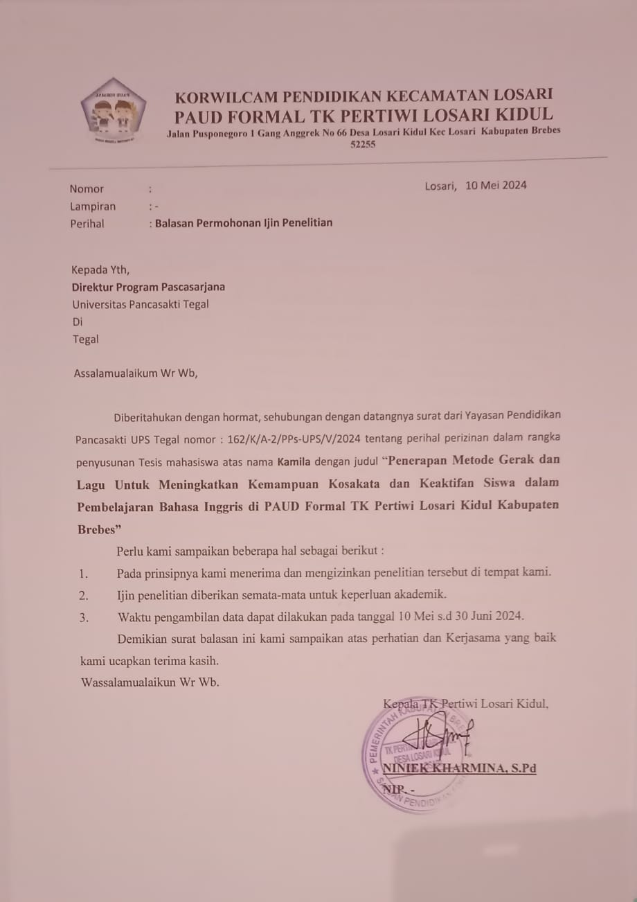

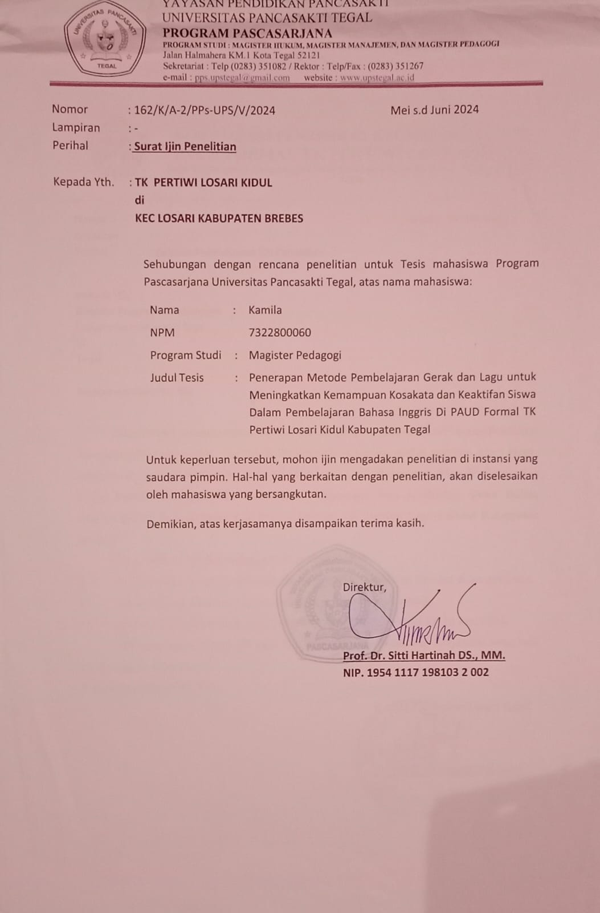

|  |  |  |  |  |  |  |  |  |  |
| --- | --- | --- | --- | --- | --- | --- | --- | --- | --- |
| **REKAP HASIL JAWABAN RESPONDEN** | | | | | | | | | |
| **OBSERVASI GERAK DAN LAGU** | | | | | | | | | |
|  | | | | | | | | |  |
| **No** | **Nama Responden** | **Indikator** | | | | | **Jumlah** | **Skor Maksimal** | **Persentase** |
| **1** | **2** | **3** | **4** | **5** |
| 1 | ABID NAILUL FALAH | 4 | 4 | 4 | 4 | 4 | 20 | 25 | 80 |
| 2 | ABIZARD ARSENO | 4 | 3 | 4 | 3 | 3 | 17 | 25 | 68 |
| 3 | ADARA RISQIA FAYZA | 4 | 4 | 4 | 4 | 4 | 20 | 25 | 80 |
| 4 | ADI MAULANA | 4 | 4 | 4 | 4 | 4 | 20 | 25 | 80 |
| 5 | ADIBA AILA VHARISYA | 4 | 3 | 4 | 3 | 1 | 15 | 25 | 60 |
| 6 | AFIZA SHEZA LETICIA | 4 | 4 | 4 | 4 | 4 | 20 | 25 | 80 |
| 7 | AGINDA DWI KHANAYA | 3 | 3 | 3 | 3 | 4 | 16 | 25 | 64 |
| 8 | AIRA ALMIRA DAMAYANTI | 4 | 4 | 4 | 4 | 4 | 20 | 25 | 80 |
| 9 | AKHMAD NUR SODIK | 4 | 4 | 4 | 4 | 4 | 20 | 25 | 80 |
| 10 | AKHTAR MUAZZAM AL GHIFARI | 4 | 4 | 4 | 4 | 4 | 20 | 25 | 80 |
| 11 | AKIFA CAHAYA NAILA | 4 | 4 | 3 | 4 | 4 | 19 | 25 | 76 |
| 12 | ALBY LUTHFY FACHRY | 4 | 4 | 4 | 4 | 4 | 20 | 25 | 80 |
| 13 | ALESHA ZAHRA | 4 | 4 | 4 | 4 | 4 | 20 | 25 | 80 |
| 14 | ALIF ALVIAN ALFARIZQI | 4 | 4 | 4 | 3 | 3 | 18 | 25 | 72 |
| 15 | ANIQ CAHYA DEWI | 4 | 4 | 4 | 3 | 4 | 19 | 25 | 76 |
| 16 | ANNASYA KEYLA | 4 | 4 | 4 | 3 | 3 | 18 | 25 | 72 |
| 17 | ANNISA SHEZA RAZITHA | 4 | 4 | 4 | 3 | 4 | 19 | 25 | 76 |
| 18 | AQIL PRANAJA | 4 | 4 | 4 | 4 | 3 | 19 | 25 | 76 |
| 19 | AQILLA FARIZA MUFIA | 4 | 4 | 4 | 3 | 4 | 19 | 25 | 76 |
| 20 | ARDAVAN MALIK IBRAHIM | 4 | 4 | 4 | 3 | 4 | 19 | 25 | 76 |
| 21 | ARKAN FAYZA | 4 | 4 | 4 | 3 | 4 | 19 | 25 | 76 |
| 22 | ARLIN KANESHA PUTRI | 4 | 4 | 4 | 4 | 4 | 20 | 25 | 80 |
| 23 | ARSENIO AKBAR | 4 | 4 | 4 | 3 | 4 | 19 | 25 | 76 |
| 24 | ARSY ASHADIYA OKTARIANI | 4 | 4 | 4 | 4 | 4 | 20 | 25 | 80 |
| 25 | ARSYILA NALADHIVA | 4 | 4 | 4 | 3 | 4 | 19 | 25 | 76 |
| 26 | ARWAN AL FARIZI | 4 | 4 | 4 | 4 | 3 | 19 | 25 | 76 |
| 27 | ASIFA FELISIA SARI | 4 | 4 | 4 | 4 | 4 | 20 | 25 | 80 |
| 28 | ASSYFA PUTRI JASMINE | 4 | 4 | 4 | 4 | 3 | 19 | 25 | 76 |
| 29 | ASYIFA AURA EFFENDI | 4 | 4 | 4 | 4 | 4 | 20 | 25 | 80 |
| 30 | ASYTAR AS SAYYID | 4 | 3 | 4 | 4 | 4 | 19 | 25 | 76 |
| 31 | ATTAHYA EGA SYAPUTRA | 4 | 4 | 4 | 3 | 4 | 19 | 25 | 76 |
| 32 | AULIA IZZATUNNISA | 3 | 3 | 3 | 4 | 3 | 16 | 25 | 64 |
| 33 | AZKIA FYRA ANTOLIN | 4 | 3 | 4 | 2 | 4 | 17 | 25 | 68 |
| 34 | AZRIL FAUZAN RASHYA | 4 | 3 | 4 | 3 | 4 | 18 | 25 | 72 |
| 35 | BANGKIT HARTAWAN | 2 | 3 | 4 | 2 | 3 | 14 | 25 | 56 |
| 36 | CELLO VIANO PRAMESTI | 4 | 3 | 4 | 4 | 4 | 19 | 25 | 76 |
| 37 | DEDE | 3 | 4 | 4 | 4 | 4 | 19 | 25 | 76 |
| 38 | DELLA FAUZIYAH | 4 | 3 | 3 | 1 | 1 | 12 | 25 | 48 |
| 39 | DHAIFAH KEYSHA SALSABILA | 4 | 4 | 3 | 3 | 3 | 17 | 25 | 68 |
| 40 | DIEGO WIRAWAN | 4 | 3 | 4 | 3 | 3 | 17 | 25 | 68 |
| 41 | DIMAS ADITYA HAIDAR | 2 | 1 | 3 | 3 | 4 | 13 | 25 | 52 |
| 42 | DWI AZKHA RANANDIKA | 3 | 4 | 4 | 3 | 4 | 18 | 25 | 72 |
| 43 | DZAR AL GHIFARI | 4 | 4 | 3 | 4 | 2 | 17 | 25 | 68 |
| 44 | EL VANO GHUMARA DHEANDRA | 4 | 4 | 4 | 4 | 4 | 20 | 25 | 80 |
| 45 | EVANO ATHARIZ FEBBRA | 3 | 4 | 4 | 4 | 4 | 19 | 25 | 76 |
| 46 | FADIL RISKI ARROFIQ | 3 | 4 | 3 | 4 | 2 | 16 | 25 | 64 |
| 47 | FAIZAH PRATIWI | 4 | 2 | 3 | 3 | 3 | 15 | 25 | 60 |
| 48 | FAIZAN NIZAR AL FATIH | 4 | 3 | 3 | 4 | 3 | 17 | 25 | 68 |
| 49 | FARID RHAMADHANI | 3 | 2 | 3 | 1 | 2 | 11 | 25 | 44 |
| 50 | FELICIA NABILA SYIFA | 4 | 4 | 4 | 4 | 4 | 20 | 25 | 80 |
| 51 | GHEYSAR DZAKWAN AL BARRAQ | 3 | 4 | 4 | 4 | 4 | 19 | 25 | 76 |
| 52 | GHUMAISHA ARSYILA | 4 | 4 | 4 | 4 | 4 | 20 | 25 | 80 |
| 53 | HAFSAH ZUKHRUF MUSLIMAH | 4 | 4 | 3 | 4 | 2 | 17 | 25 | 68 |
| 54 | HASBI AL GHIFARI | 4 | 2 | 3 | 3 | 3 | 15 | 25 | 60 |
| Jumlah | | 204 | 195 | 203 | 186 | 189 |  |  |  |

|  |  |  |  |  |  |  |  |  |  |
| --- | --- | --- | --- | --- | --- | --- | --- | --- | --- |
| **REKAP HASIL JAWABAN RESPONDEN** | | | | | | | | | |
| **KEMAMPUAN KOSAKATA** | | | | | | | | | |
|  | | | | | | | | |  |
| **No** | **Nama Responden** | **Indikator** | | | | | **Jumlah** | **Skor Maksimal** | **Persentase** |
| **1** | **2** | **3** | **4** | **5** |
| 1 | ABID NAILUL FALAH | 4 | 4 | 4 | 4 | 4 | 20 | 25 | 80 |
| 2 | ABIZARD ARSENO | 4 | 4 | 4 | 3 | 4 | 19 | 25 | 76 |
| 3 | ADARA RISQIA FAYZA | 4 | 4 | 4 | 4 | 3 | 19 | 25 | 76 |
| 4 | ADI MAULANA | 4 | 4 | 4 | 4 | 4 | 20 | 25 | 80 |
| 5 | ADIBA AILA VHARISYA | 4 | 4 | 4 | 4 | 3 | 19 | 25 | 76 |
| 6 | AFIZA SHEZA LETICIA | 4 | 4 | 4 | 4 | 4 | 20 | 25 | 80 |
| 7 | AGINDA DWI KHANAYA | 4 | 3 | 4 | 4 | 4 | 19 | 25 | 76 |
| 8 | AIRA ALMIRA DAMAYANTI | 4 | 4 | 4 | 3 | 4 | 19 | 25 | 76 |
| 9 | AKHMAD NUR SODIK | 3 | 3 | 3 | 4 | 3 | 16 | 25 | 64 |
| 10 | AKHTAR MUAZZAM AL GHIFARI | 4 | 3 | 4 | 2 | 4 | 17 | 25 | 68 |
| 11 | AKIFA CAHAYA NAILA | 4 | 4 | 3 | 4 | 4 | 19 | 25 | 76 |
| 12 | ALBY LUTHFY FACHRY | 4 | 4 | 4 | 4 | 4 | 20 | 25 | 80 |
| 13 | ALESHA ZAHRA | 4 | 4 | 4 | 4 | 4 | 20 | 25 | 80 |
| 14 | ALIF ALVIAN ALFARIZQI | 4 | 4 | 4 | 3 | 3 | 18 | 25 | 72 |
| 15 | ANIQ CAHYA DEWI | 4 | 4 | 4 | 3 | 4 | 19 | 25 | 76 |
| 16 | ANNASYA KEYLA | 4 | 4 | 4 | 3 | 3 | 18 | 25 | 72 |
| 17 | ANNISA SHEZA RAZITHA | 4 | 4 | 4 | 3 | 4 | 19 | 25 | 76 |
| 18 | AQIL PRANAJA | 4 | 4 | 4 | 4 | 3 | 19 | 25 | 76 |
| 19 | AQILLA FARIZA MUFIA | 4 | 4 | 4 | 3 | 4 | 19 | 25 | 76 |
| 20 | ARDAVAN MALIK IBRAHIM | 4 | 4 | 4 | 4 | 3 | 19 | 25 | 76 |
| 21 | ARKAN FAYZA | 4 | 4 | 4 | 3 | 4 | 19 | 25 | 76 |
| 22 | ARLIN KANESHA PUTRI | 4 | 4 | 4 | 3 | 4 | 19 | 25 | 76 |
| 23 | ARSENIO AKBAR | 4 | 4 | 4 | 3 | 4 | 19 | 25 | 76 |
| 24 | ARSY ASHADIYA OKTARIANI | 4 | 4 | 4 | 4 | 4 | 20 | 25 | 80 |
| 25 | ARSYILA NALADHIVA | 4 | 4 | 4 | 3 | 4 | 19 | 25 | 76 |
| 26 | ARWAN AL FARIZI | 4 | 4 | 4 | 4 | 3 | 19 | 25 | 76 |
| 27 | ASIFA FELISIA SARI | 4 | 4 | 4 | 4 | 4 | 20 | 25 | 80 |
| 28 | ASSYFA PUTRI JASMINE | 4 | 4 | 4 | 4 | 3 | 19 | 25 | 76 |
| 29 | ASYIFA AURA EFFENDI | 4 | 4 | 4 | 4 | 4 | 20 | 25 | 80 |
| 30 | ASYTAR AS SAYYID | 4 | 3 | 4 | 4 | 4 | 19 | 25 | 76 |
| 31 | ATTAHYA EGA SYAPUTRA | 4 | 4 | 4 | 3 | 4 | 19 | 25 | 76 |
| 32 | AULIA IZZATUNNISA | 3 | 3 | 3 | 4 | 3 | 16 | 25 | 64 |
| 33 | AZKIA FYRA ANTOLIN | 4 | 3 | 4 | 2 | 4 | 17 | 25 | 68 |
| 34 | AZRIL FAUZAN RASHYA | 4 | 3 | 4 | 3 | 4 | 18 | 25 | 72 |
| 35 | BANGKIT HARTAWAN | 2 | 3 | 4 | 2 | 3 | 14 | 25 | 56 |
| 36 | CELLO VIANO PRAMESTI | 4 | 3 | 4 | 4 | 4 | 19 | 25 | 76 |
| 37 | DEDE | 3 | 4 | 4 | 4 | 4 | 19 | 25 | 76 |
| 38 | DELLA FAUZIYAH | 4 | 3 | 3 | 1 | 1 | 12 | 25 | 48 |
| 39 | DHAIFAH KEYSHA SALSABILA | 4 | 4 | 3 | 3 | 3 | 17 | 25 | 68 |
| 40 | DIEGO WIRAWAN | 4 | 3 | 4 | 3 | 3 | 17 | 25 | 68 |
| 41 | DIMAS ADITYA HAIDAR | 2 | 1 | 3 | 3 | 4 | 13 | 25 | 52 |
| 42 | DWI AZKHA RANANDIKA | 4 | 4 | 4 | 4 | 4 | 20 | 25 | 80 |
| 43 | DZAR AL GHIFARI | 4 | 4 | 4 | 4 | 4 | 20 | 25 | 80 |
| 44 | EL VANO GHUMARA DHEANDRA | 4 | 3 | 4 | 3 | 1 | 15 | 25 | 60 |
| 45 | EVANO ATHARIZ FEBBRA | 4 | 4 | 4 | 4 | 4 | 20 | 25 | 80 |
| 46 | FADIL RISKI ARROFIQ | 3 | 3 | 3 | 3 | 4 | 16 | 25 | 64 |
| 47 | FAIZAH PRATIWI | 4 | 4 | 4 | 4 | 4 | 20 | 25 | 80 |
| 48 | FAIZAN NIZAR AL FATIH | 4 | 4 | 4 | 4 | 4 | 20 | 25 | 80 |
| 49 | FARID RHAMADHANI | 4 | 4 | 4 | 4 | 4 | 20 | 25 | 80 |
| 50 | FELICIA NABILA SYIFA | 4 | 4 | 3 | 4 | 4 | 19 | 25 | 76 |
| 51 | GHEYSAR DZAKWAN AL BARRAQ | 4 | 4 | 4 | 4 | 4 | 20 | 25 | 80 |
| 52 | GHUMAISHA ARSYILA | 4 | 4 | 4 | 4 | 4 | 20 | 25 | 80 |
| 53 | HAFSAH ZUKHRUF MUSLIMAH | 4 | 4 | 4 | 3 | 3 | 18 | 25 | 72 |
| 54 | HASBI AL GHIFARI | 4 | 2 | 3 | 3 | 3 | 15 | 25 | 60 |
| Jumlah | | 208 | 198 | 207 | 187 | 195 |  |  |  |

|  |  |  |  |  |  |  |  |  |  |
| --- | --- | --- | --- | --- | --- | --- | --- | --- | --- |
| **REKAP HASIL JAWABAN RESPONDEN** | | | | | | | | | |
| **KEAKTIFAN SISWA (FISIK DAN NON FISIK)** | | | | | | | | | |
|  | | | | | | | | |  |
| **No** | **Nama Responden** | **Indikator** | | | | | **Jumlah** | **Skor Maksimal** | **Persentase** |
| **1** | **2** | **3** | **4** | **5** |
| 1 | ABID NAILUL FALAH | 4 | 4 | 3 | 4 | 4 | 19 | 25 | 76 |
| 2 | ABIZARD ARSENO | 4 | 4 | 4 | 4 | 4 | 20 | 25 | 80 |
| 3 | ADARA RISQIA FAYZA | 4 | 4 | 4 | 4 | 4 | 20 | 25 | 80 |
| 4 | ADI MAULANA | 4 | 4 | 4 | 4 | 4 | 20 | 25 | 80 |
| 5 | ADIBA AILA VHARISYA | 4 | 4 | 4 | 4 | 4 | 20 | 25 | 80 |
| 6 | AFIZA SHEZA LETICIA | 4 | 4 | 4 | 4 | 4 | 20 | 25 | 80 |
| 7 | AGINDA DWI KHANAYA | 4 | 4 | 3 | 4 | 4 | 19 | 25 | 76 |
| 8 | AIRA ALMIRA DAMAYANTI | 4 | 4 | 4 | 4 | 4 | 20 | 25 | 80 |
| 9 | AKHMAD NUR SODIK | 4 | 4 | 4 | 4 | 4 | 20 | 25 | 80 |
| 10 | AKHTAR MUAZZAM AL GHIFARI | 4 | 4 | 4 | 3 | 4 | 19 | 25 | 76 |
| 11 | AKIFA CAHAYA NAILA | 4 | 4 | 4 | 3 | 4 | 19 | 25 | 76 |
| 12 | ALBY LUTHFY FACHRY | 4 | 4 | 4 | 3 | 4 | 19 | 25 | 76 |
| 13 | ALESHA ZAHRA | 4 | 4 | 4 | 4 | 4 | 20 | 25 | 80 |
| 14 | ALIF ALVIAN ALFARIZQI | 4 | 4 | 4 | 3 | 4 | 19 | 25 | 76 |
| 15 | ANIQ CAHYA DEWI | 4 | 4 | 4 | 4 | 3 | 19 | 25 | 76 |
| 16 | ANNASYA KEYLA | 4 | 4 | 4 | 4 | 4 | 20 | 25 | 80 |
| 17 | ANNISA SHEZA RAZITHA | 4 | 4 | 4 | 4 | 3 | 19 | 25 | 76 |
| 18 | AQIL PRANAJA | 4 | 4 | 4 | 4 | 4 | 20 | 25 | 80 |
| 19 | AQILLA FARIZA MUFIA | 4 | 3 | 4 | 4 | 4 | 19 | 25 | 76 |
| 20 | ARDAVAN MALIK IBRAHIM | 4 | 4 | 4 | 3 | 4 | 19 | 25 | 76 |
| 21 | ARKAN FAYZA | 3 | 3 | 3 | 4 | 3 | 16 | 25 | 64 |
| 22 | ARLIN KANESHA PUTRI | 4 | 4 | 4 | 3 | 4 | 19 | 25 | 76 |
| 23 | ARSENIO AKBAR | 4 | 4 | 4 | 3 | 4 | 19 | 25 | 76 |
| 24 | ARSY ASHADIYA OKTARIANI | 4 | 4 | 4 | 4 | 4 | 20 | 25 | 80 |
| 25 | ARSYILA NALADHIVA | 4 | 4 | 4 | 3 | 4 | 19 | 25 | 76 |
| 26 | ARWAN AL FARIZI | 4 | 4 | 4 | 4 | 3 | 19 | 25 | 76 |
| 27 | ASIFA FELISIA SARI | 4 | 4 | 4 | 4 | 4 | 20 | 25 | 80 |
| 28 | ASSYFA PUTRI JASMINE | 4 | 4 | 4 | 4 | 3 | 19 | 25 | 76 |
| 29 | ASYIFA AURA EFFENDI | 4 | 4 | 4 | 4 | 4 | 20 | 25 | 80 |
| 30 | ASYTAR AS SAYYID | 4 | 3 | 4 | 4 | 4 | 19 | 25 | 76 |
| 31 | ATTAHYA EGA SYAPUTRA | 4 | 4 | 4 | 3 | 4 | 19 | 25 | 76 |
| 32 | AULIA IZZATUNNISA | 3 | 3 | 3 | 4 | 3 | 16 | 25 | 64 |
| 33 | AZKIA FYRA ANTOLIN | 4 | 3 | 4 | 2 | 4 | 17 | 25 | 68 |
| 34 | AZRIL FAUZAN RASHYA | 4 | 3 | 4 | 3 | 4 | 18 | 25 | 72 |
| 35 | BANGKIT HARTAWAN | 2 | 3 | 4 | 2 | 3 | 14 | 25 | 56 |
| 36 | CELLO VIANO PRAMESTI | 4 | 3 | 4 | 4 | 4 | 19 | 25 | 76 |
| 37 | DEDE | 3 | 4 | 4 | 4 | 4 | 19 | 25 | 76 |
| 38 | DELLA FAUZIYAH | 4 | 3 | 3 | 1 | 1 | 12 | 25 | 48 |
| 39 | DHAIFAH KEYSHA SALSABILA | 4 | 4 | 3 | 3 | 3 | 17 | 25 | 68 |
| 40 | DIEGO WIRAWAN | 4 | 3 | 4 | 3 | 3 | 17 | 25 | 68 |
| 41 | DIMAS ADITYA HAIDAR | 2 | 1 | 3 | 3 | 4 | 13 | 25 | 52 |
| 42 | DWI AZKHA RANANDIKA | 4 | 4 | 4 | 4 | 4 | 20 | 25 | 80 |
| 43 | DZAR AL GHIFARI | 4 | 4 | 4 | 4 | 4 | 20 | 25 | 80 |
| 44 | EL VANO GHUMARA DHEANDRA | 4 | 3 | 4 | 3 | 1 | 15 | 25 | 60 |
| 45 | EVANO ATHARIZ FEBBRA | 4 | 4 | 4 | 4 | 4 | 20 | 25 | 80 |
| 46 | FADIL RISKI ARROFIQ | 3 | 3 | 3 | 3 | 4 | 16 | 25 | 64 |
| 47 | FAIZAH PRATIWI | 4 | 4 | 4 | 4 | 4 | 20 | 25 | 80 |
| 48 | FAIZAN NIZAR AL FATIH | 4 | 4 | 4 | 4 | 4 | 20 | 25 | 80 |
| 49 | FARID RHAMADHANI | 4 | 4 | 4 | 4 | 4 | 20 | 25 | 80 |
| 50 | FELICIA NABILA SYIFA | 4 | 4 | 3 | 4 | 4 | 19 | 25 | 76 |
| 51 | GHEYSAR DZAKWAN AL BARRAQ | 4 | 4 | 4 | 4 | 4 | 20 | 25 | 80 |
| 52 | GHUMAISHA ARSYILA | 4 | 4 | 4 | 4 | 4 | 20 | 25 | 80 |
| 53 | HAFSAH ZUKHRUF MUSLIMAH | 4 | 4 | 4 | 3 | 4 | 19 | 25 | 76 |
| 54 | HASBI AL GHIFARI | 3 | 3 | 3 | 4 | 3 | 16 | 25 | 64 |
| Jumlah | | 207 | 200 | 206 | 193 | 200 |  |  |  |

|  |  |  |  |  |  |  |
| --- | --- | --- | --- | --- | --- | --- |
| **REKAP HASIL UJI ANOVA** | | | | | | |
| **OBSERVASI GERAK DAN LAGU TERHADAP KEMAMPUAN KOSAKATA** | | | | | | |
|  | | | | | | |
| **No** | **Nama Responden** | | | **Jumlah Skor Postest** | | |
|  |
| 1 | ABID NAILUL FALAH | | | 20 | | |  |
| 2 | ABIZARD ARSENO | | | 17 | | |  |
| 3 | ADARA RISQIA FAYZA | | | 20 | | |  |
| 4 | ADI MAULANA | | | 20 | | |  |
| 5 | ADIBA AILA VHARISYA | | | 15 | | |  |
| 6 | AFIZA SHEZA LETICIA | | | 20 | | |  |
| 7 | AGINDA DWI KHANAYA | | | 16 | | |  |
| 8 | AIRA ALMIRA DAMAYANTI | | | 20 | | |  |
| 9 | AKHMAD NUR SODIK | | | 20 | | |  |
| 10 | AKHTAR MUAZZAM AL GHIFARI | | | 20 | | |  |
| 11 | AKIFA CAHAYA NAILA | | | 19 | | |  |
| 12 | ALBY LUTHFY FACHRY | | | 20 | | |  |
| 13 | ALESHA ZAHRA | | | 20 | | |  |
| 14 | ALIF ALVIAN ALFARIZQI | | | 18 | | |  |
| 15 | ANIQ CAHYA DEWI | | | 19 | | |  |
| 16 | ANNASYA KEYLA | | | 18 | | |  |
| 17 | ANNISA SHEZA RAZITHA | | | 19 | | |  |
| 18 | AQIL PRANAJA | | | 19 | | |  |
| 19 | AQILLA FARIZA MUFIA | | | 19 | | |  |
| 20 | ARDAVAN MALIK IBRAHIM | | | 19 | | |  |
| 21 | ARKAN FAYZA | | | 19 | | |  |
| 22 | ARLIN KANESHA PUTRI | | | 20 | | |  |
| 23 | ARSENIO AKBAR | | | 19 | | |  |
| 24 | ARSY ASHADIYA OKTARIANI | | | 20 | | |  |
| 25 | ARSYILA NALADHIVA | | | 19 | | |  |
| 26 | ARWAN AL FARIZI | | | 19 | | |  |
| 27 | ASIFA FELISIA SARI | | | 20 | | |  |
| 28 | ASSYFA PUTRI JASMINE | | | 19 | | |  |
| 29 | ASYIFA AURA EFFENDI | | | 20 | | |  |
| 30 | ASYTAR AS SAYYID | | | 19 | | |  |
| 31 | ATTAHYA EGA SYAPUTRA | | | 19 | | |  |
| 32 | AULIA IZZATUNNISA | | | 16 | | |  |
| 33 | AZKIA FYRA ANTOLIN | | | 17 | | |  |
| 34 | AZRIL FAUZAN RASHYA | | | 18 | | |  |
| 35 | BANGKIT HARTAWAN | | | 14 | | |  |
| 36 | CELLO VIANO PRAMESTI | | | 19 | | |  |
| 37 | DEDE | | | 19 | | |  |
| 38 | DELLA FAUZIYAH | | | 12 | | |  |
| 39 | DHAIFAH KEYSHA SALSABILA | | | 17 | | |  |
| 40 | DIEGO WIRAWAN | | | 17 | | |  |
| 41 | DIMAS ADITYA HAIDAR | | | 13 | | |  |
| 42 | DWI AZKHA RANANDIKA | | | 18 | | |  |
| 43 | DZAR AL GHIFARI | | | 17 | | |  |
| 44 | EL VANO GHUMARA DHEANDRA | | | 20 | | |  |
| 45 | EVANO ATHARIZ FEBBRA | | | 19 | | |  |
| 46 | FADIL RISKI ARROFIQ | | | 16 | | |  |
| 47 | FAIZAH PRATIWI | | | 15 | | |  |
| 48 | FAIZAN NIZAR AL FATIH | | | 17 | | |  |
| 49 | FARID RHAMADHANI | | | 11 | | |  |
| 50 | FELICIA NABILA SYIFA | | | 20 | | |  |
| 51 | GHEYSAR DZAKWAN AL BARRAQ | | | 19 | | |  |
| 52 | GHUMAISHA ARSYILA | | | 20 | | |  |
| 53 | HAFSAH ZUKHRUF MUSLIMAH | | | 17 | | |  |
| 54 | HASBI AL GHIFARI | | | 15 | | |  |
| Jumlah | | | | 977 | | |  |
|  |  | | |  | | |  |
|  | SAMPEL KASUS (EKSPERIMEN) | | |  | | |  |
|  | SAMPEL KONTROL | | |  | | |  |
| **DATA INPUT SPSS** | | | | |
| **OBSERVASI GERAK DAN LAGU TERHADAP KEKMPUAN KOSAKATA** | | | | |
|  | |  |  | |
| **Nama Responden (Koding)** | | **Jumlah Skor Postest** | **Jumlah Skor (Coding)** | |
|  |
| 1 | | 20 | 4 | |  |
| 1 | | 17 | 4 | |  |
| 1 | | 20 | 4 | |  |
| 1 | | 20 | 4 | |  |
| 1 | | 15 | 3 | |  |
| 1 | | 20 | 4 | |  |
| 1 | | 16 | 4 | |  |
| 1 | | 20 | 4 | |  |
| 1 | | 20 | 4 | |  |
| 1 | | 20 | 4 | |  |
| 1 | | 19 | 4 | |  |
| 1 | | 20 | 4 | |  |
| 1 | | 20 | 4 | |  |
| 1 | | 18 | 4 | |  |
| 1 | | 19 | 4 | |  |
| 1 | | 18 | 4 | |  |
| 1 | | 19 | 4 | |  |
| 1 | | 19 | 4 | |  |
| 1 | | 19 | 4 | |  |
| 1 | | 19 | 4 | |  |
| 1 | | 19 | 4 | |  |
| 1 | | 20 | 4 | |  |
| 1 | | 19 | 4 | |  |
| 1 | | 20 | 4 | |  |
| 1 | | 19 | 4 | |  |
| 1 | | 19 | 4 | |  |
| 1 | | 20 | 4 | |  |
| 2 | | 19 | 4 | |  |
| 2 | | 20 | 4 | |  |
| 2 | | 19 | 4 | |  |
| 2 | | 19 | 4 | |  |
| 2 | | 16 | 4 | |  |
| 2 | | 17 | 4 | |  |
| 2 | | 18 | 4 | |  |
| 2 | | 14 | 3 | |  |
| 2 | | 19 | 3 | |  |
| 2 | | 19 | 3 | |  |
| 2 | | 12 | 3 | |  |
| 2 | | 17 | 4 | |  |
| 2 | | 17 | 4 | |  |
| 2 | | 13 | 3 | |  |
| 2 | | 18 | 4 | |  |
| 2 | | 17 | 4 | |  |
| 2 | | 20 | 4 | |  |
| 2 | | 19 | 4 | |  |
| 2 | | 16 | 4 | |  |
| 2 | | 15 | 3 | |  |
| 2 | | 17 | 4 | |  |
| 2 | | 11 | 3 | |  |
| 2 | | 20 | 4 | |  |
| 2 | | 19 | 4 | |  |
| 2 | | 20 | 4 | |  |
| 2 | | 17 | 4 | |  |
| 2 | | 15 | 4 | |  |
|  | |  |  | |  |
| **KATEGORI KOSAKATA** | |  |  | |  |
| **Jumlah Nilai** | | **Kategori** | **Koding Kategori** | |  |
| 1 - 5 | | Sangat Kurang | 1 | |  |
| 6 - 10 | | Kurang | 2 | |  |
| 11 - 15 | | Cukup | 3 | |  |
| 16 - 20 | | Baik | 4 | |  |
| 21 - 25 | | Sangat Baik | 5 | |  |

|  |  |  |  |  |  |  |
| --- | --- | --- | --- | --- | --- | --- |
| **REKAP HASIL UJI ANOVA** | | | | | | |
| **OBSERVASI GERAK DAN LAGU TERHADAP KEAKTIFAN SISWA** | | | | | | |
|  | | | | | | |
| **No** | **Nama Responden** | | | **Jumlah Skor Postest** | | |
|  |
| 1 | ABID NAILUL FALAH | | | 19 | | |  |
| 2 | ABIZARD ARSENO | | | 20 | | |  |
| 3 | ADARA RISQIA FAYZA | | | 20 | | |  |
| 4 | ADI MAULANA | | | 20 | | |  |
| 5 | ADIBA AILA VHARISYA | | | 20 | | |  |
| 6 | AFIZA SHEZA LETICIA | | | 20 | | |  |
| 7 | AGINDA DWI KHANAYA | | | 19 | | |  |
| 8 | AIRA ALMIRA DAMAYANTI | | | 20 | | |  |
| 9 | AKHMAD NUR SODIK | | | 20 | | |  |
| 10 | AKHTAR MUAZZAM AL GHIFARI | | | 19 | | |  |
| 11 | AKIFA CAHAYA NAILA | | | 19 | | |  |
| 12 | ALBY LUTHFY FACHRY | | | 19 | | |  |
| 13 | ALESHA ZAHRA | | | 20 | | |  |
| 14 | ALIF ALVIAN ALFARIZQI | | | 19 | | |  |
| 15 | ANIQ CAHYA DEWI | | | 19 | | |  |
| 16 | ANNASYA KEYLA | | | 20 | | |  |
| 17 | ANNISA SHEZA RAZITHA | | | 19 | | |  |
| 18 | AQIL PRANAJA | | | 20 | | |  |
| 19 | AQILLA FARIZA MUFIA | | | 19 | | |  |
| 20 | ARDAVAN MALIK IBRAHIM | | | 19 | | |  |
| 21 | ARKAN FAYZA | | | 16 | | |  |
| 22 | ARLIN KANESHA PUTRI | | | 19 | | |  |
| 23 | ARSENIO AKBAR | | | 19 | | |  |
| 24 | ARSY ASHADIYA OKTARIANI | | | 20 | | |  |
| 25 | ARSYILA NALADHIVA | | | 19 | | |  |
| 26 | ARWAN AL FARIZI | | | 19 | | |  |
| 27 | ASIFA FELISIA SARI | | | 20 | | |  |
| 28 | ASSYFA PUTRI JASMINE | | | 19 | | |  |
| 29 | ASYIFA AURA EFFENDI | | | 20 | | |  |
| 30 | ASYTAR AS SAYYID | | | 19 | | |  |
| 31 | ATTAHYA EGA SYAPUTRA | | | 19 | | |  |
| 32 | AULIA IZZATUNNISA | | | 16 | | |  |
| 33 | AZKIA FYRA ANTOLIN | | | 17 | | |  |
| 34 | AZRIL FAUZAN RASHYA | | | 18 | | |  |
| 35 | BANGKIT HARTAWAN | | | 14 | | |  |
| 36 | CELLO VIANO PRAMESTI | | | 19 | | |  |
| 37 | DEDE | | | 19 | | |  |
| 38 | DELLA FAUZIYAH | | | 12 | | |  |
| 39 | DHAIFAH KEYSHA SALSABILA | | | 17 | | |  |
| 40 | DIEGO WIRAWAN | | | 17 | | |  |
| 41 | DIMAS ADITYA HAIDAR | | | 13 | | |  |
| 42 | DWI AZKHA RANANDIKA | | | 20 | | |  |
| 43 | DZAR AL GHIFARI | | | 20 | | |  |
| 44 | EL VANO GHUMARA DHEANDRA | | | 15 | | |  |
| 45 | EVANO ATHARIZ FEBBRA | | | 20 | | |  |
| 46 | FADIL RISKI ARROFIQ | | | 16 | | |  |
| 47 | FAIZAH PRATIWI | | | 20 | | |  |
| 48 | FAIZAN NIZAR AL FATIH | | | 20 | | |  |
| 49 | FARID RHAMADHANI | | | 20 | | |  |
| 50 | FELICIA NABILA SYIFA | | | 19 | | |  |
| 51 | GHEYSAR DZAKWAN AL BARRAQ | | | 20 | | |  |
| 52 | GHUMAISHA ARSYILA | | | 20 | | |  |
| 53 | HAFSAH ZUKHRUF MUSLIMAH | | | 19 | | |  |
| 54 | HASBI AL GHIFARI | | | 16 | | |  |
| Jumlah | | | | 1006 | | |  |
|  |  | | |  | | |  |
|  | SAMPEL KASUS (EKSPERIMEN) | | |  | | |  |
|  | SAMPEL KONTROL | | |  | | |  |
| **DATA INPUT SPSS** | | | | |
| **OBSERVASI GERAK DAN LAGU TERHADAP KEAKTIFAN SISWA** | | | | |
|  | |  |  | |
| **Nama Responden (Koding)** | | **Jumlah Skor Postest** | **Jumlah Skor (Coding)** | |
|  |
| 1 | | 19 | 4 | |  |
| 1 | | 20 | 4 | |  |
| 1 | | 20 | 4 | |  |
| 1 | | 20 | 4 | |  |
| 1 | | 20 | 4 | |  |
| 1 | | 20 | 4 | |  |
| 1 | | 19 | 4 | |  |
| 1 | | 20 | 4 | |  |
| 1 | | 20 | 4 | |  |
| 1 | | 19 | 4 | |  |
| 1 | | 19 | 4 | |  |
| 1 | | 19 | 4 | |  |
| 1 | | 20 | 4 | |  |
| 1 | | 19 | 4 | |  |
| 1 | | 19 | 4 | |  |
| 1 | | 20 | 4 | |  |
| 1 | | 19 | 4 | |  |
| 1 | | 20 | 4 | |  |
| 1 | | 19 | 4 | |  |
| 1 | | 19 | 4 | |  |
| 1 | | 16 | 4 | |  |
| 1 | | 19 | 4 | |  |
| 1 | | 19 | 4 | |  |
| 1 | | 20 | 4 | |  |
| 1 | | 19 | 4 | |  |
| 1 | | 19 | 4 | |  |
| 1 | | 20 | 4 | |  |
| 2 | | 19 | 4 | |  |
| 2 | | 20 | 4 | |  |
| 2 | | 19 | 4 | |  |
| 2 | | 19 | 4 | |  |
| 2 | | 16 | 4 | |  |
| 2 | | 17 | 4 | |  |
| 2 | | 18 | 4 | |  |
| 2 | | 14 | 3 | |  |
| 2 | | 19 | 4 | |  |
| 2 | | 19 | 4 | |  |
| 2 | | 12 | 3 | |  |
| 2 | | 17 | 4 | |  |
| 2 | | 17 | 4 | |  |
| 2 | | 13 | 3 | |  |
| 2 | | 20 | 4 | |  |
| 2 | | 20 | 4 | |  |
| 2 | | 15 | 3 | |  |
| 2 | | 20 | 4 | |  |
| 2 | | 16 | 4 | |  |
| 2 | | 20 | 4 | |  |
| 2 | | 20 | 4 | |  |
| 2 | | 20 | 4 | |  |
| 2 | | 19 | 4 | |  |
| 2 | | 20 | 4 | |  |
| 2 | | 20 | 4 | |  |
| 2 | | 19 | 4 | |  |
| 2 | | 16 | 4 | |  |
|  | |  |  | |  |
| **KATEGORI KEAKTIFAN SISWA** | | |  | |  |
| **Jumlah Nilai** | | **Kategori** | **Koding Kategori** | |  |
| 1 - 5 | | Sangat Kurang | 1 | |  |
| 6 - 10 | | Kurang | 2 | |  |
| 11 - 15 | | Cukup | 3 | |  |
| 16 - 20 | | Baik | 4 | |  |
| 21 - 25 | | Sangat Baik | 5 | |  |

**OUTPUT HASIL OBSERVASI GERAK DAN LAGU**

|  |  |  |  |  |  |  |  |
| --- | --- | --- | --- | --- | --- | --- | --- |
| **Correlations** | | | | | | | |
|  | | Menggerakan Kedua Tangan | Melakukan Gerakan Kaki | Melakukan Gerakan Kaki dan Bertepuk Tangan | Melakukan Gerakan Tangan Kesamping dan Keatas | Melakukan Gerakan Memutar Badan | Skor Total Indikator |
| Menggerakan Kedua Tangan | Pearson Correlation | 1 | .403** | .271* | .219 | .047 | .502** |
| Sig. (2-tailed) |  | .003 | .047 | .111 | .734 | .000 |
| N | 54 | 54 | 54 | 54 | 54 | 54 |
| Melakukan Gerakan Kaki | Pearson Correlation | .403** | 1 | .507** | .494** | .295* | .782** |
| Sig. (2-tailed) | .003 |  | .000 | .000 | .031 | .000 |
| N | 54 | 54 | 54 | 54 | 54 | 54 |
| Melakukan Gerakan Kaki dan Bertepuk Tangan | Pearson Correlation | .271* | .507** | 1 | .222 | .522** | .685** |
| Sig. (2-tailed) | .047 | .000 |  | .107 | .000 | .000 |
| N | 54 | 54 | 54 | 54 | 54 | 54 |
| Melakukan Gerakan Tangan Kesamping dan Keatas | Pearson Correlation | .219 | .494** | .222 | 1 | .383** | .729** |
| Sig. (2-tailed) | .111 | .000 | .107 |  | .004 | .000 |
| N | 54 | 54 | 54 | 54 | 54 | 54 |
| Melakukan Gerakan Memutar Badan | Pearson Correlation | .047 | .295* | .522** | .383** | 1 | .701** |
| Sig. (2-tailed) | .734 | .031 | .000 | .004 |  | .000 |
| N | 54 | 54 | 54 | 54 | 54 | 54 |
| Skor Total Indikator | Pearson Correlation | .502** | .782** | .685** | .729** | .701** | 1 |
| Sig. (2-tailed) | .000 | .000 | .000 | .000 | .000 |  |
| N | 54 | 54 | 54 | 54 | 54 | 54 |
| **. Correlation is significant at the 0.01 level (2-tailed). | | | | | | | |
| *. Correlation is significant at the 0.05 level (2-tailed). | | | | | | | |

**OUTPUT HASIL KEMAMPUAN KOSAKATA**

|  |  |  |  |  |  |  |  |
| --- | --- | --- | --- | --- | --- | --- | --- |
| **Correlations** | | | | | | | |
|  | | Melingkari Gambar Binatang Sesuai Kosakata | Melingkari Gambar Buah Buahan Sesuai dengan Kosakata | Melingkari Gambar Kendaraan Sesuai dengan Kosakata | Mewarnai Bentuk Lingkaran Sesuai dengan Perintah Kosakata Warna | Memahami Arti Kosakata yang dimaksud | Skor Total Indikator |
| Melingkari Gambar Binatang Sesuai Kosakata | Pearson Correlation | 1 | .567** | .407** | .163 | .054 | .587** |
| Sig. (2-tailed) |  | .000 | .002 | .239 | .697 | .000 |
| N | 54 | 54 | 54 | 54 | 54 | 54 |
| Melingkari Gambar Buah Buahan Sesuai dengan Kosakata | Pearson Correlation | .567** | 1 | .490** | .370** | .224 | .779** |
| Sig. (2-tailed) | .000 |  | .000 | .006 | .103 | .000 |
| N | 54 | 54 | 54 | 54 | 54 | 54 |
| Melingkari Gambar Kendaraan Sesuai dengan Kosakata | Pearson Correlation | .407** | .490** | 1 | .157 | .256 | .609** |
| Sig. (2-tailed) | .002 | .000 |  | .257 | .061 | .000 |
| N | 54 | 54 | 54 | 54 | 54 | 54 |
| Mewarnai Bentuk Lingkaran Sesuai dengan Perintah Kosakata Warna | Pearson Correlation | .163 | .370** | .157 | 1 | .347* | .686** |
| Sig. (2-tailed) | .239 | .006 | .257 |  | .010 | .000 |
| N | 54 | 54 | 54 | 54 | 54 | 54 |
| Memahami Arti Kosakata yang dimaksud | Pearson Correlation | .054 | .224 | .256 | .347* | 1 | .630** |
| Sig. (2-tailed) | .697 | .103 | .061 | .010 |  | .000 |
| N | 54 | 54 | 54 | 54 | 54 | 54 |
| Skor Total Indikator | Pearson Correlation | .587** | .779** | .609** | .686** | .630** | 1 |
| Sig. (2-tailed) | .000 | .000 | .000 | .000 | .000 |  |
| N | 54 | 54 | 54 | 54 | 54 | 54 |
| **. Correlation is significant at the 0.01 level (2-tailed). | | | | | | | |
| *. Correlation is significant at the 0.05 level (2-tailed). | | | | | | | |

**OUTPUT HASIL KEAKTIFAN SISWA**

|  |  |  |  |  |  |  |  |
| --- | --- | --- | --- | --- | --- | --- | --- |
| **Correlations** | | | | | | | |
|  | | Turut Serta Dalam Mengerjakan Tugas Sampai Selesai | Terlibat Dalam Proses Pemecahan Masalah | Bertanya / Diskusi Bersama Teman | Mempu Mempresentasikan Hasil Kerjanya | Terlihat Antusias Selama Pembelajaran | Skor Total Indikator |
| Turut Serta Dalam Mengerjakan Tugas Sampai Selesai | Pearson Correlation | 1 | .662** | .448** | .194 | .143 | .658** |
| Sig. (2-tailed) |  | .000 | .001 | .160 | .303 | .000 |
| N | 54 | 54 | 54 | 54 | 54 | 54 |
| Terlibat Dalam Proses Pemecahan Masalah | Pearson Correlation | .662** | 1 | .425** | .359** | .312* | .790** |
| Sig. (2-tailed) | .000 |  | .001 | .008 | .021 | .000 |
| N | 54 | 54 | 54 | 54 | 54 | 54 |
| Bertanya / Diskusi Bersama Teman | Pearson Correlation | .448** | .425** | 1 | .127 | .293* | .594** |
| Sig. (2-tailed) | .001 | .001 |  | .362 | .031 | .000 |
| N | 54 | 54 | 54 | 54 | 54 | 54 |
| Mempu Mempresentasikan Hasil Kerjanya | Pearson Correlation | .194 | .359** | .127 | 1 | .395** | .672** |
| Sig. (2-tailed) | .160 | .008 | .362 |  | .003 | .000 |
| N | 54 | 54 | 54 | 54 | 54 | 54 |
| Terlihat Antusias Selama Pembelajaran | Pearson Correlation | .143 | .312* | .293* | .395** | 1 | .681** |
| Sig. (2-tailed) | .303 | .021 | .031 | .003 |  | .000 |
| N | 54 | 54 | 54 | 54 | 54 | 54 |
| Skor Total Indikator | Pearson Correlation | .658** | .790** | .594** | .672** | .681** | 1 |
| Sig. (2-tailed) | .000 | .000 | .000 | .000 | .000 |  |
| N | 54 | 54 | 54 | 54 | 54 | 54 |
| **. Correlation is significant at the 0.01 level (2-tailed). | | | | | | | |
| *. Correlation is significant at the 0.05 level (2-tailed). | | | | | | | |

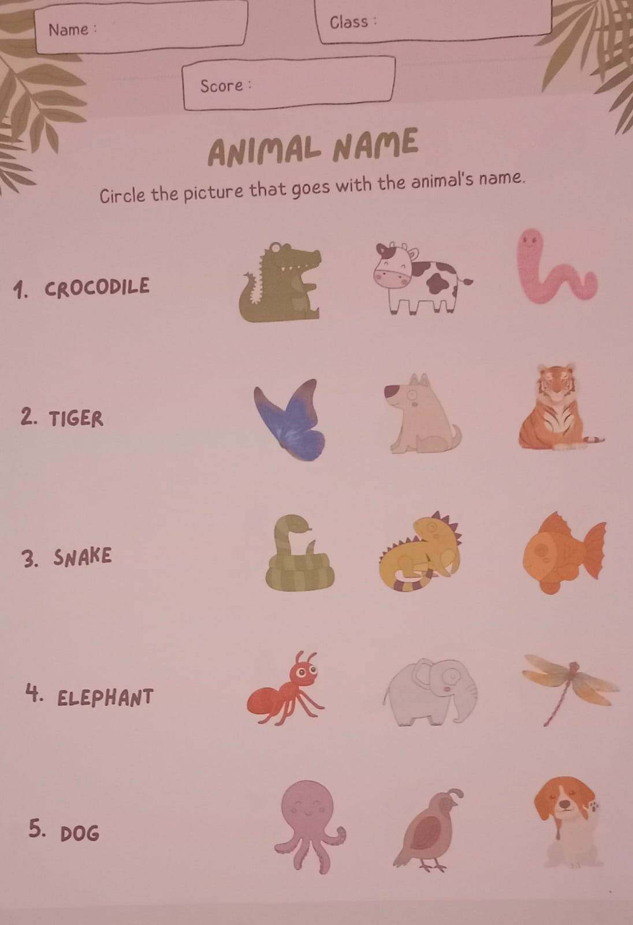**INSTRUMEN LEMBAR TEST**

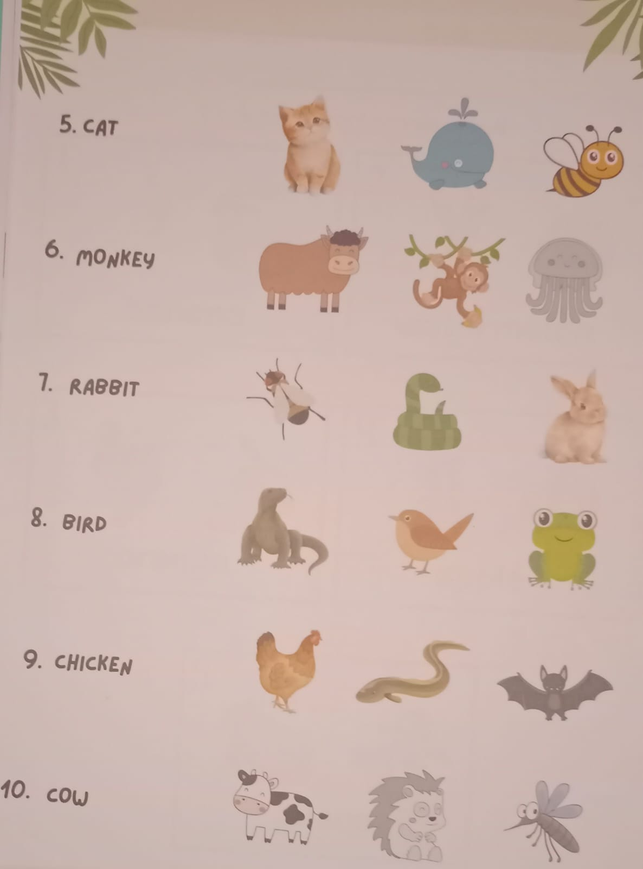

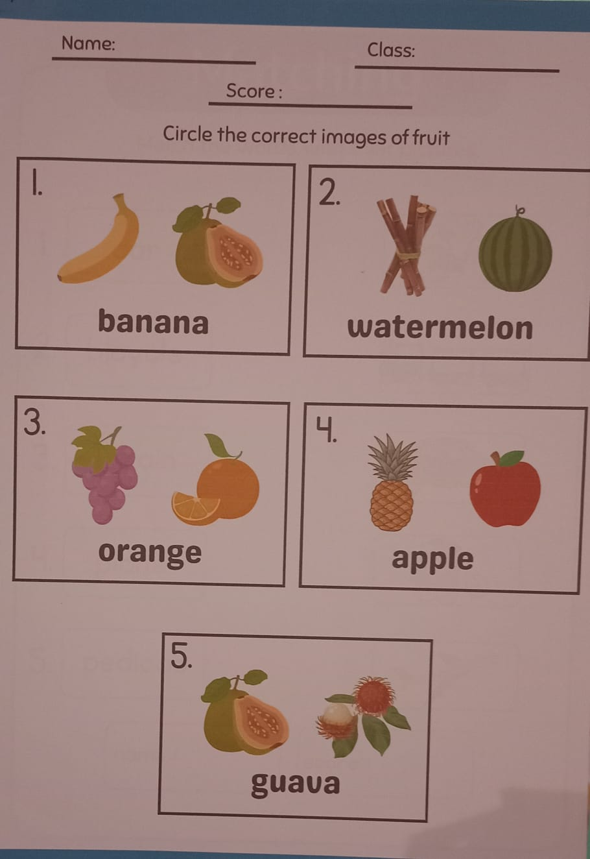

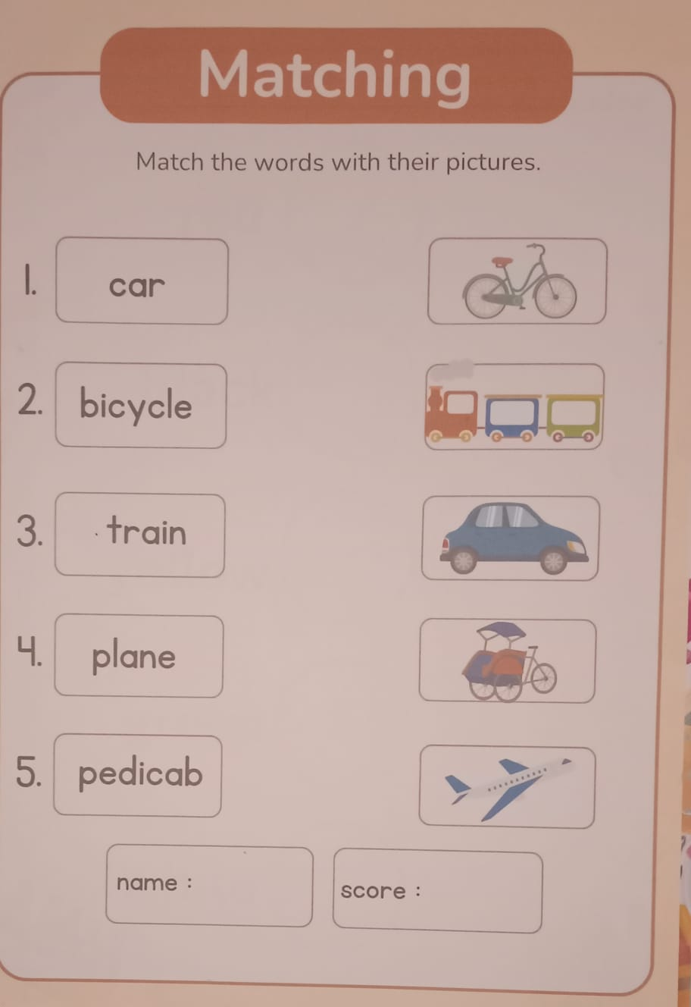

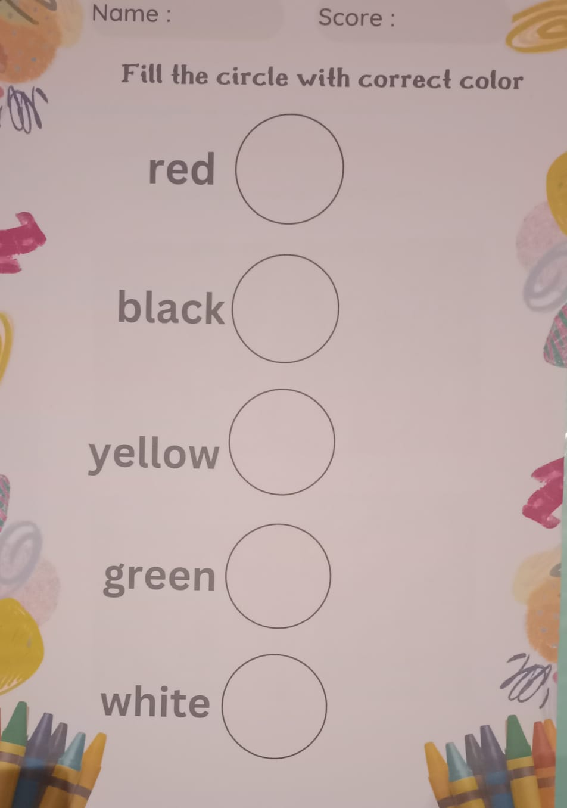

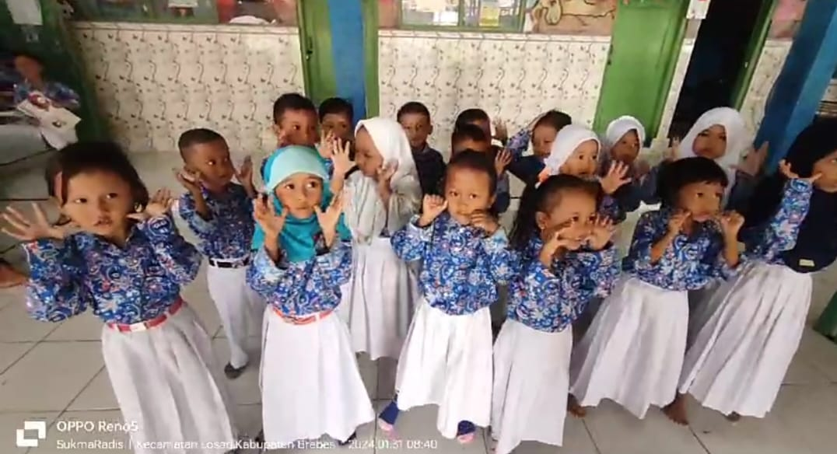**FOTO KEGIATAN**

