# DAFTAR PUSTAKA

Ardyanti, A. A. . P., Purnama, N., & Nyajentari, N. L. (2017). Sistem Pendukung Keputusan Siswa Berprestasi SMA Dwijendra Denpasar dengan Metode ANP & Topsis. *Inform : Jurnal Ilmiah Bidang Teknologi Informasi Dan Komunikasi*, *2*(2). https://doi.org/10.25139/inform.v2i2.313

Arta, I. P. S., Satriawan, D. G., Bagiana, I. K., Loppies, Y., Shavab, F. A., Mala, C. M. F., Sayuti, A. M., Safitri, D. A., Berlianty, T., Julike, W., Wicaksono, G., Marietza, F., Kartawinata, B. R., & Utami, F. (2021). *Manajemen Risiko*. Widina Bhakti Persada Bandung.

Arvianto, A., Sari, D. P., & Olivia, G. (2014). Pemilihan Strategi Pemasaran Pada Pt. Nyonya Meneer Dengan Menggunakan Pendekatan Metode Analytical Network Process (Anp) Dan Technique for Order Preference By Similarity To an Ideal Solution (Topsis). *J@Ti Undip : Jurnal Teknik Industri*, *9*(1), 35–44. https://doi.org/10.12777/jati.9.1.35-44

Balili, S., & Yuamita, F. (2022). Analisis Pengendalian Risiko Kecelakaan Kerja Bagian Mekanik Pada Proyek PLTU Ampana (2x3 MW) Menggunakan Metode Job Safety Analysis (JSA). *Jurnal Teknologi Dan Manajemen Industri Terapan*, *1*(2), 61–69. https://doi.org/10.55826/tmit.v1iii.14

Darmawan, R., Ummi, N., & Umyati, A. (2017). Metode Hazard Identification And Risk Assessment ( Hira ) Di Area Batching Plant Pt Xyz. *Jurnal Teknik Industri*, *5*(3), 308–313.

Darmawi. (2016). *Manajemen Risiko*. Bumi Aksara.

Gustriansyah, R. (2016). Sistem Pendukung Keputusan Pemilihan Dosen Berprestasi Dengan Metode Anp Dan Topsis. *Seminar Nasional Teknologi Informasi Dan Komunikasi*, *2016*(Sentika), 8.

Hakim, A. (2023). *PEMILIHAN VENDOR DENGAN TEKNIK MULTI CRITERIA DECISION MAKING*. CV Pena Persada. https://books.google.co.id/books?id=MF68EAAAQBAJ

Indonesia, S. sign. (2015). *Setiap 15 Detik, 1 Pekerja di Dunia Meninggal Akibat Kecelakaan Kerja.* Safety Sign. https://www.safetysign.co.id/news/Setiap-15-Detik-1-Pekerja-di-Dunia-Meninggal-Akibat-Kecelakaan-Kerja

Irzal, M. K. (2016). *Dasar-Dasar Kesehatan dan Keselamatan Kerja: Edisi 1*. Kencana. https://books.google.co.id/books?id=D-VNDwAAQBAJ

Kemenperin. (2022). *Industri Logam Tumbuh Melesat pada Triwulan II-2022*. Kemenperin.Go.Id. https://kemenperin.go.id/artikel/23469/Industri-Logam-Tumbuh-Melesat-pada-Triwulan-II-2022

Martin Butar-Butar, R., Martin Butar Butar, R., & Utomo, P. (2022). Bulletin of Data Science Sistem Pendukung Keputusan Seleksi Penerimaan Karyawan Baru dengan Menerapkan Kombinasi Metode ANP-TOPSIS. *Media Online*, *2*(1), 2022–2030. https://ejurnal.seminar-id.com/index.php/bulletinds

Mutmainah, I., & Yunita, Y. (2021). Penerapan Metode Topsis Dalam Pemilihan Jasa Ekspedisi. *Jurnal Sisfokom (Sistem Informasi Dan Komputer)*, *10*(1), 86–92. https://doi.org/10.32736/sisfokom.v10i1.1028

Pohan, F. (2017). Integrasi Model Pendukung Keputusan Evaluasi Pemilihan Vendor Dengan Fuzzy Analytical Network Process Dan Topsis Studi Kasus Pt Samudera Indonesia Ship Management. *Jurnal Teknik*, *6*(2). https://doi.org/10.31000/jt.v6i2.455

Pujotomo, D., Puspitasari, N. B., & Rizkiyani, D. (2017). Integrasi Metode Anp Dan Topsis Dalam Evaluasi Kinerja Supplier Dan Penentuan Prioritas Supplier Bahan Baku Utama Cetak Koran Pada Pt Masscom Graphy Semarang. *J@ti Undip : Jurnal Teknik Industri*, *11*(3), 151. https://doi.org/10.14710/jati.11.3.151-160

Runtuwarow, N. Y., Kawatu, P. A. T., & Maddusa, S. S. (2020). Hubungan Kepatuhan Penggunaan Alat Pelindung Diri Dengan Kejadian Kecelakaan Kerja. *Indonesian Journal of Public Health and Community Medicine*, *1*(2), 21–26.

Rusydiana, A. ., & Devi, A. (2013). *Analytic Network Process Pengantar Teori dan Aplikasi, Cetakan Pertama*. SMART Publishing.

Saaty, T. L. (1999). *Fundamental of The Analytic Network Process*. ISAHP, Kobe.

Saaty, T. L. (2004). Fundamental of the analytic network process dependence and feedback in decision-making with a single network. In *RWS Publications*.

Saaty, T. L. (2005). *Theory and Applications of the Analytic Network Process*. RWS Publications.

Saaty, T. L. (2008). Decision Making With Analytical Hierarchy Process. *International Journal*, *Vol. 1*, *No*.

Saaty, T. L. (2013). *The Analytic Network Process, In: Gass S.1., Fu M.C. (eds) Encylopedia of Operations Research and Management Science*. Springer.

Saaty, T. L., & Vargas, L. G. (2006). *Decision Making with The Analytic Network Process, Economic, Political, Social and Technological Applications with Benefits, Opportunities, Cost, And Risk*. University of Pittsburgh.

Sampe, F., Fauzan, M., Asri, M., Tarmizi, R., Irawan, J. L., Chakim, M. H. R., Tampubolon, R. I., Martha, D., & Burhan, R. R. (2023). *Manajemen Risiko*. Sada Kurnia Pustaka. https://books.google.co.id/books?id=xnfXEAAAQBAJ

Sugiono, M. C. (2023). Pemilihan Vendor Dengan Mengintegrasikan Metode ANP-TOPSIS dan Goal Programming. *Jurnal Media Teknik Dan Sistem Industri*, *7*(1), 18. https://doi.org/10.35194/jmtsi.v7i1.2346

Sultan, M. (2019). *KECELAKAAN KERJA; Mengapa Masih Terjadi di Tempat Kerja ?* uwais inspirasi indonesia. https://books.google.co.id/books?id=ohLpDwAAQBAJ

Sumiyatun, S., & Wardoyo, R. (2016). Kombinasi Metode Anp Dan Topsis Dalam Menentukan Prioritas Media Promosi Perguruan Tinggi (Studi Kasus: Stmik Akakom Yogyakarta). *JIKO (Jurnal Informatika Dan Komputer)*, *1*(2), 21–27. https://doi.org/10.26798/jiko.2016.v1i2.34

Susanty, A., & Adiati, W. (2014). Pemilihan Strategi Pemasaran Di Kampoeng Kopi Banaran Menggunakan Pendekatan Metode Analytical Network Process (Anp) Dan Technique for Order Preference By Similarity To an Ideal Solution (Topsis). *J@Ti Undip : Jurnal Teknik Industri*, *9*(3), 163–172. https://doi.org/10.12777/jati.9.3.163-172

Syaharani, M. (2023). *Jumlah Kecelakaan Kerja Indonesia dalam 8 Tahun Terakhir*. Goodstats. https://data.goodstats.id/statistic/jumlah-kecelakaan-kerja-indonesia-dalam-8-tahun-terakhir-sjo5X

Tanjung, H., & Devi, A. (2013). *Metodologi Penelitian Ekonomi Islam*. Gramatika Publishing.

Triyono, R. M. A. (2019). *Manajemen resiko*. Deepublish. https://books.google.co.id/books?id=khyeDwAAQBAJ

Yanti, N., & Rahmadani, U. (2014). Penyeleksian Calon Mahasiswa Dengan Fuzzy Multi Attribute Decision Making Menggunakan TOPSIS. *Konferensi Nasional Sistem Informasi (Hlm. 304–310)*.

# LAMPIRAN

Lampiran 1. Dokumentasi Penelitian

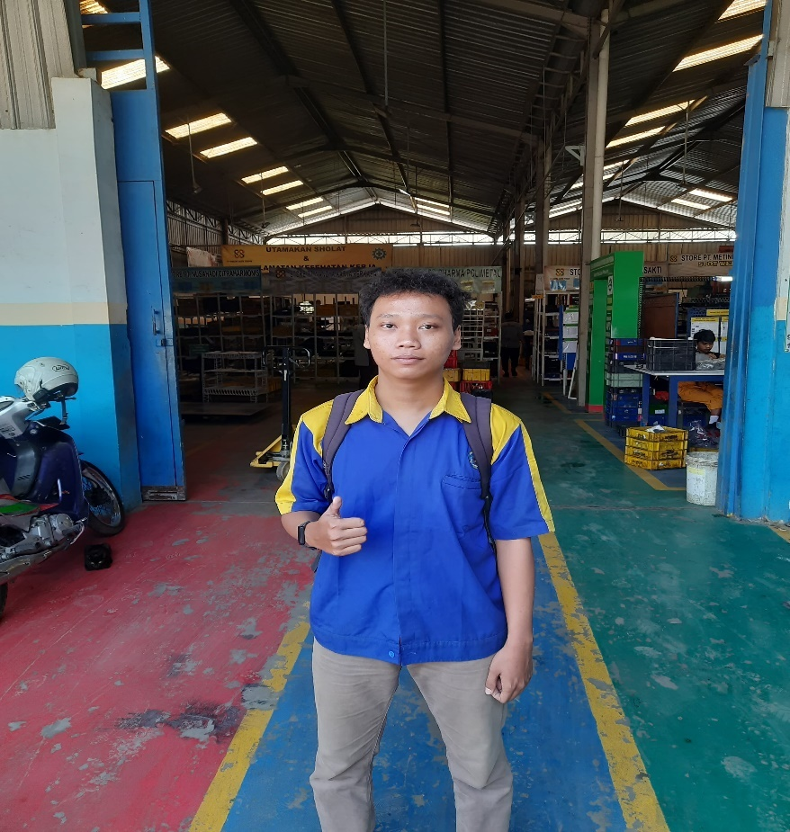

Dokumentasi 1 Perusahaan

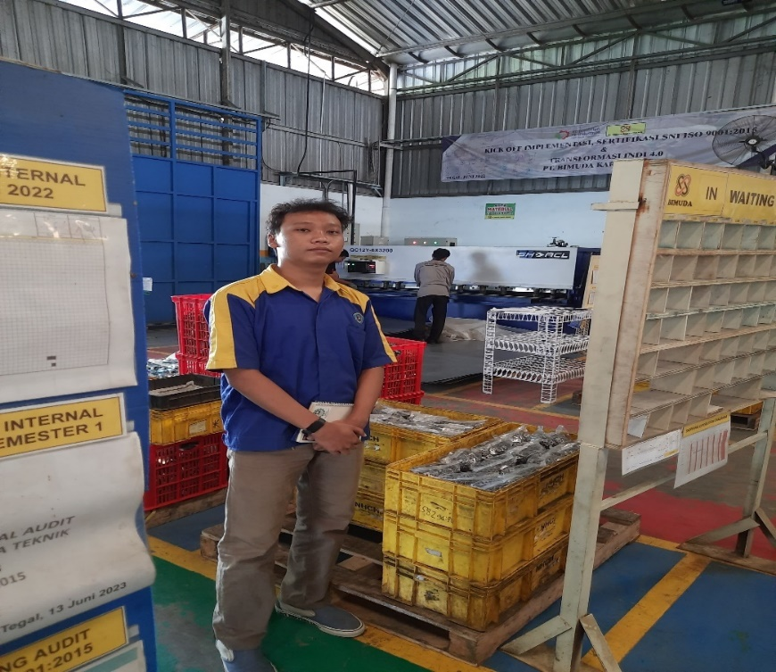

Dokumentasi 2 Produk

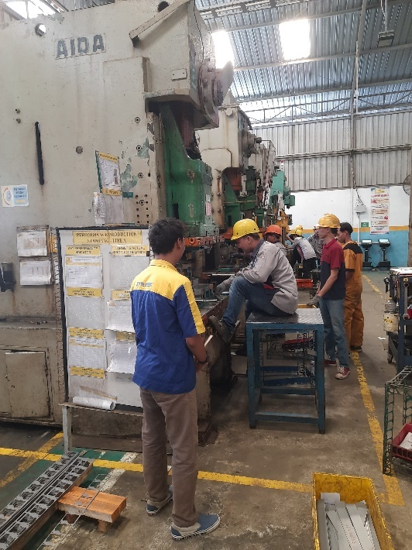 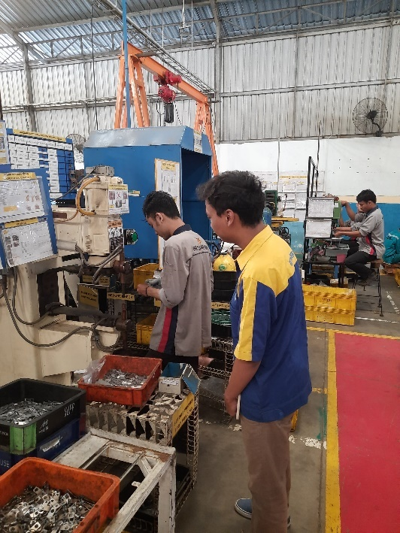

Dokumentasi 3 Observasi Dokumentasi 4 Observasi

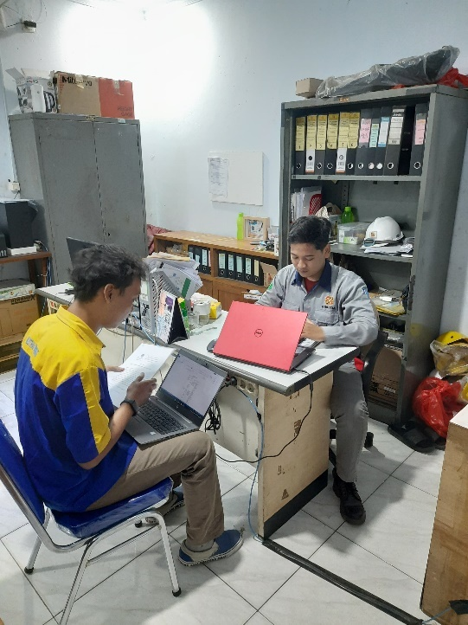 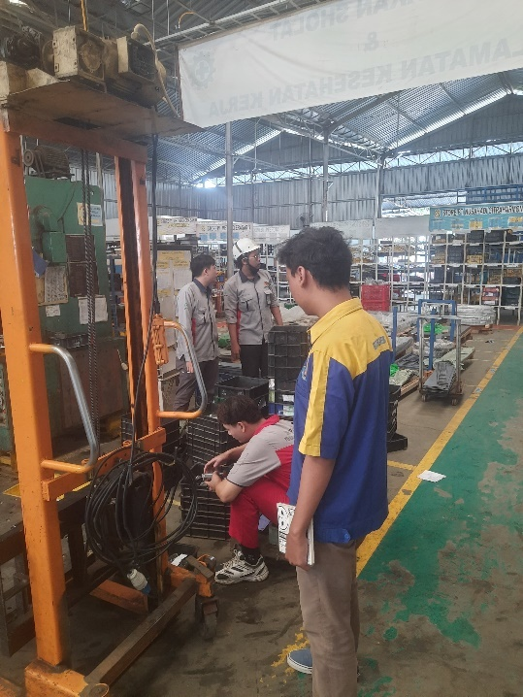

Dokumentasi 5 Wawancara Dokumentasi 6 Observasi

Lampiran 2 Tabel Supermatrix

*Unweighted Supermatrix*

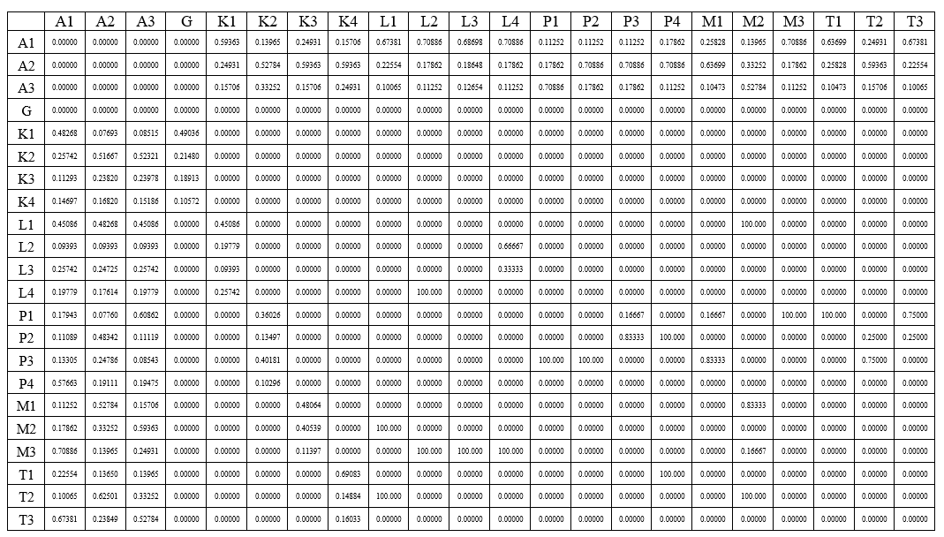

*Weighted Supermatrix*

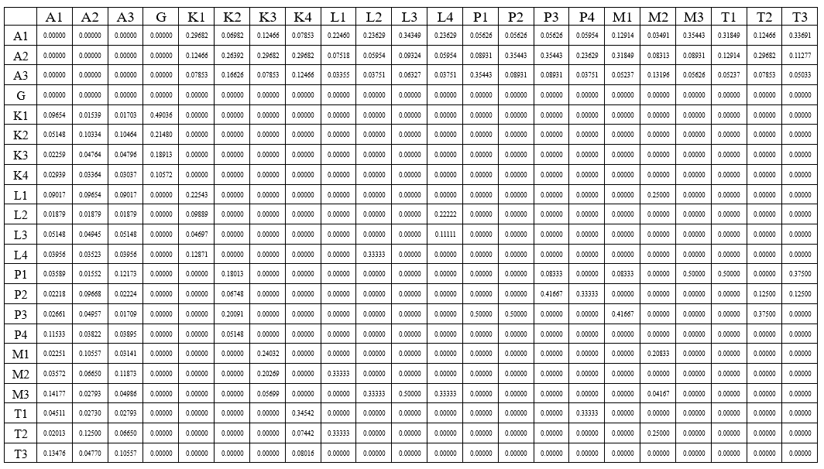

*Limitting Supermatrix*

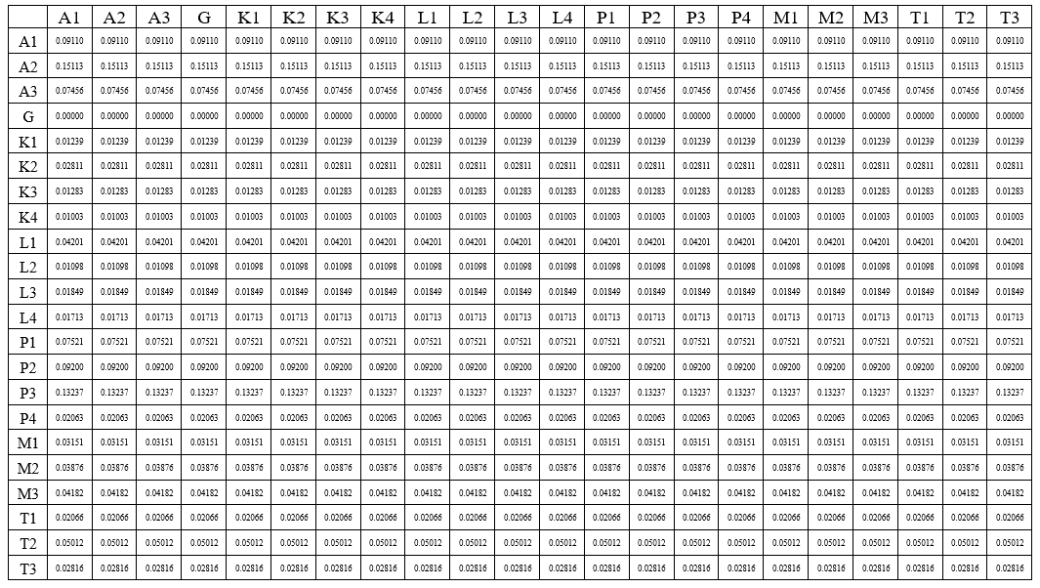

Lampiran 3 Kuesioner

|  |  |
| --- | --- |
| https://api-frontend.kemdikbud.go.id/v2/detail_pt_logo/QkZERjFGNjgtODIwMC00NTM2LThGRTUtQTczNURDNzkzNTQy**Prodi Teknik Industri**  **FTIK UNIVERSITAS**  **PANCASAKTI TEGAL** | **KUESIONER *ANALYTICAL NETWORK PROCESS* STRATEGI MITIGASI RISIKO KECELAKAAN KERJA** |

**KUESIONER 1**

**PENENTUAN HUBUNGAN ANTAR RISIKO DALAM MITIGASI RISIKO KECELAKAAN KERJA**

**Assalamualaikum Wr. Wb**

Perkenalkan saya Dwinanda Haristiawan, mahasiswa jurusan Teknik Industri, Fakultas Teknik dan Ilmu Komputer, Universitas Pancasakti Tegal. Dengan kuesioner ini meminta kesediaan Bapak/Ibu untuk berpartisipasi dalam mengisi kuesioner ini. Penelitian ini digunakan untuk menyusun tugas akhir dengan judul “**Integrasi *Analitical Network Process* (ANP)-TOPSIS Dalam Mitigasi Risiko Kecelakaan Kerja di PT. XYZ**”. Pada kuesioner ini, responden dimohon untuk menentukan sub-kriteria dengan tujuan untuk mengetahui hubungan antar risiko kecelakaan kerja yang di inginkan dalam mitigasi risiko kecelakaan kerja. Pada kuesioner 1, cara pengisiannya dengan memberi “x” pada kolom yang tersedia. Atas waktu dan kesediaannya saya ucapkan terima kasih.

**Nama Responden :**

**Jabatan :**

Lampiran 4 Rekapitulasi Kuesioner

**Kuesioner perbandingan berpasangan antar kriteria untuk penilaian risiko kecelakaan kerja**

|  |  |  |  |  |  |  |  |  |  |  |  |  |  |  |  |  |  |  |  |  |
| --- | --- | --- | --- | --- | --- | --- | --- | --- | --- | --- | --- | --- | --- | --- | --- | --- | --- | --- | --- | --- |
|  | 9 | 8 | 7 | 6 | 5 | 4 | 3 | 2 | 1 | 2 | 3 | 4 | 5 | 6 | 7 | 8 | 9 |  | GM | RU |
| Lingkungan |  |  |  |  |  |  | 3 |  |  |  |  |  |  |  |  |  |  | Manusia | 3 | 3 |
| Lingkungan |  |  |  |  |  |  | 3 |  |  |  |  |  |  |  |  |  |  | Mesin | 3 | 3 |
| Lingkungan |  |  |  |  |  |  | 3 |  |  |  |  |  |  |  |  |  |  | Peralatan | 3 | 3 |
| Manusia |  |  |  |  |  |  |  |  | 1 |  |  |  |  |  |  |  |  | Mesin | 1 | 1 |
| Manusia |  |  |  |  |  |  | 3 |  |  |  |  |  |  |  |  |  |  | Peralatan | 3 | 3 |
| Mesin |  |  |  |  |  |  | 3 |  | 1 |  |  |  |  |  |  |  |  | Peralatan | 1,7321 | 2 |

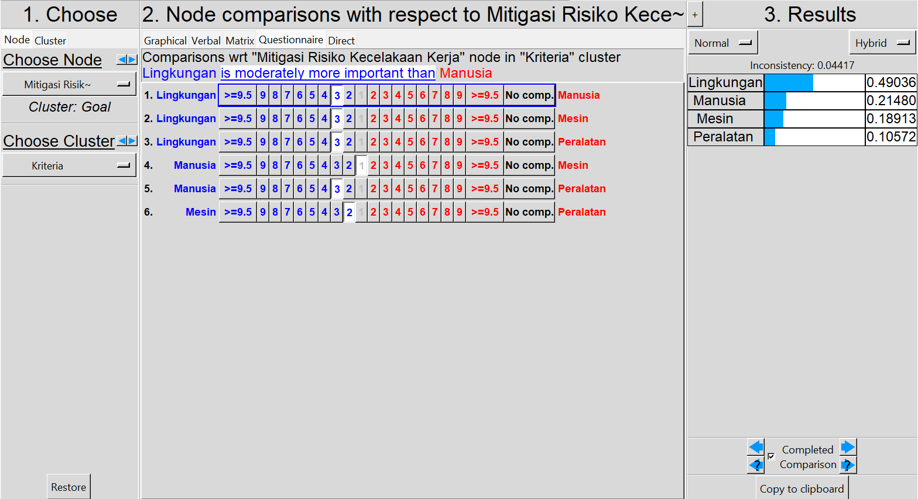

**Kuesioner perbandingan berpasangan antar kriteria**

**Lingkungan**

|  |  |  |  |  |  |  |  |  |  |  |  |  |  |  |  |  |  |  |  |  |
| --- | --- | --- | --- | --- | --- | --- | --- | --- | --- | --- | --- | --- | --- | --- | --- | --- | --- | --- | --- | --- |
|  | 9 | 8 | 7 | 6 | 5 | 4 | 3 | 2 | 1 | 2 | 3 | 4 | 5 | 6 | 7 | 8 | 9 |  | GM | RU |
| L1 |  |  |  |  |  |  | 3 |  | 1 |  |  |  |  |  |  |  |  | L2 | 1,732 | 2 |
| L1 |  |  |  |  |  |  | 3 |  |  |  |  |  |  |  |  |  |  | L3 | 3 | 3 |
| L1 |  |  |  |  |  |  | 3 |  |  |  |  |  |  |  |  |  |  | L4 | 3 | 3 |
| L2 |  |  |  |  |  |  | 3 |  |  |  |  |  |  |  |  |  |  | L3 | 3 | 3 |
| L2 |  |  |  |  |  |  |  |  | 1 |  | 3 |  |  |  |  |  |  | L4 | 1,732 | 2 |
| L3 |  |  |  |  |  |  |  |  |  |  | 3 |  |  |  |  |  |  | L4 | 3 | 3 |

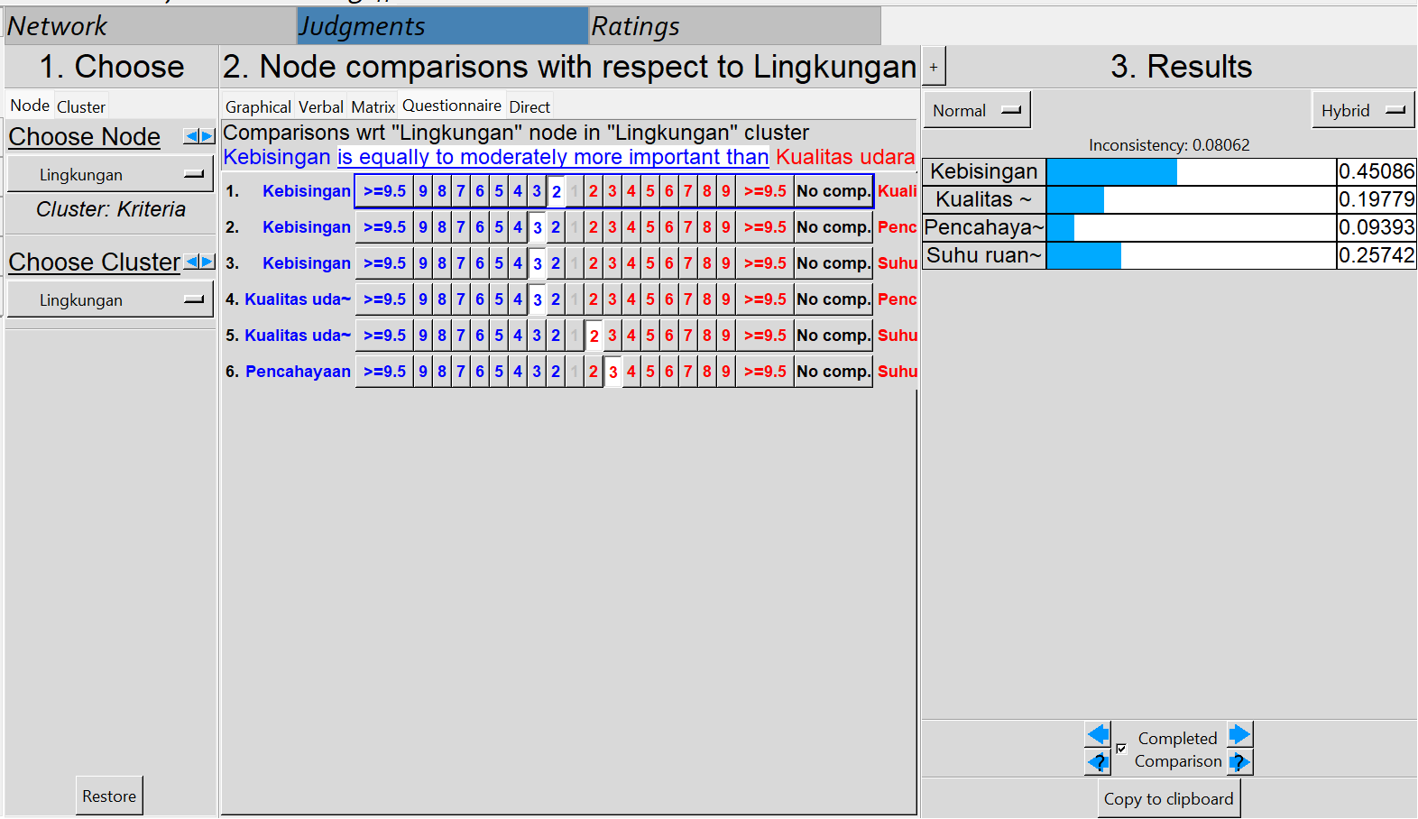

**Manusia**

|  |  |  |  |  |  |  |  |  |  |  |  |  |  |  |  |  |  |  |  |  |
| --- | --- | --- | --- | --- | --- | --- | --- | --- | --- | --- | --- | --- | --- | --- | --- | --- | --- | --- | --- | --- |
|  | 9 | 8 | 7 | 6 | 5 | 4 | 3 | 2 | 1 | 2 | 3 | 4 | 5 | 6 | 7 | 8 | 9 |  | GM | RU |
| P1 |  |  |  |  | 5 |  | 3 |  |  |  |  |  |  |  |  |  |  | P2 | 3,873 | 4 |
| P1 |  |  |  |  |  |  |  |  | 1 |  |  |  |  |  |  |  |  | P3 | 1 | 1 |
| P1 |  |  |  |  |  |  | 3 |  | 1 |  |  |  |  |  |  |  |  | P4 | 1,732 | 2 |
| P2 |  |  |  |  |  |  |  |  |  |  | 3 |  |  |  |  |  |  | P3 | 3 | 3 |
| P2 |  |  |  |  |  |  | 3 |  | 1 |  |  |  |  |  |  |  |  | P4 | 1,732 | 2 |
| P3 |  |  |  |  | 5 |  |  |  |  |  |  |  |  |  |  |  |  | P4 | 5 | 5 |

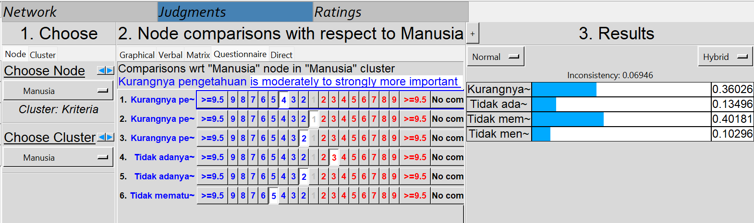

**Mesin**

|  |  |  |  |  |  |  |  |  |  |  |  |  |  |  |  |  |  |  |  |  |
| --- | --- | --- | --- | --- | --- | --- | --- | --- | --- | --- | --- | --- | --- | --- | --- | --- | --- | --- | --- | --- |
|  | 9 | 8 | 7 | 6 | 5 | 4 | 3 | 2 | 1 | 2 | 3 | 4 | 5 | 6 | 7 | 8 | 9 |  | GM | RU |
| M1 |  |  |  |  |  |  |  |  | 1 |  |  |  |  |  |  |  |  | M2 | 1 | 1 |
| M1 |  |  |  |  | 5 |  |  |  |  |  |  |  |  |  |  |  |  | M3 | 5 | 5 |
| M2 |  |  |  |  |  |  | 3 |  |  |  |  |  |  |  |  |  |  | M3 | 3 | 3 |

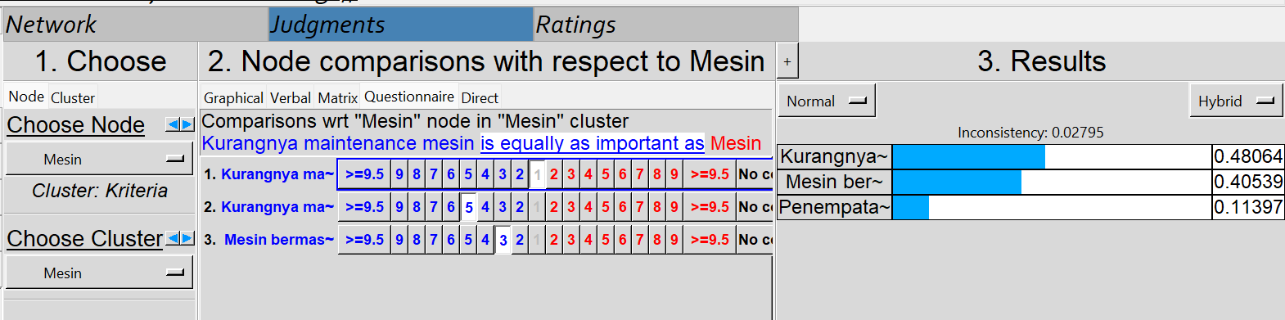

**Peralatan**

|  |  |  |  |  |  |  |  |  |  |  |  |  |  |  |  |  |  |  |  |  |
| --- | --- | --- | --- | --- | --- | --- | --- | --- | --- | --- | --- | --- | --- | --- | --- | --- | --- | --- | --- | --- |
|  | 9 | 8 | 7 | 6 | 5 | 4 | 3 | 2 | 1 | 2 | 3 | 4 | 5 | 6 | 7 | 8 | 9 |  | GM | RU |
| T1 |  |  |  |  | 5 |  |  |  |  |  |  |  |  |  |  |  |  | T2 | 5 | 5 |
| T1 |  |  |  |  | 5 |  | 3 |  |  |  |  |  |  |  |  |  |  | T3 | 3,873 | 4 |
| T2 |  |  |  |  |  |  |  |  | 1 |  |  |  |  |  |  |  |  | T3 | 1 | 1 |

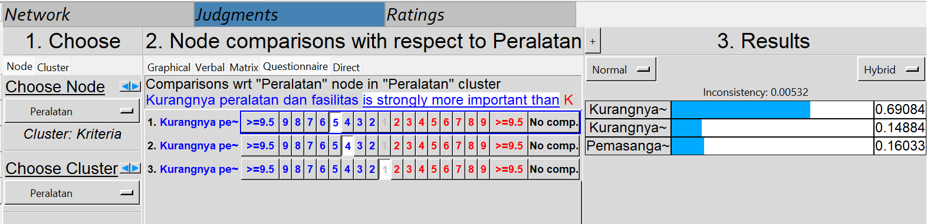

**Kuesioner perbandingan berpasangan alternatif dengan antar kriteria**

**Memperbaiki standar penerapan K3**

|  |  |  |  |  |  |  |  |  |  |  |  |  |  |  |  |  |  |  |  |  |
| --- | --- | --- | --- | --- | --- | --- | --- | --- | --- | --- | --- | --- | --- | --- | --- | --- | --- | --- | --- | --- |
|  | 9 | 8 | 7 | 6 | 5 | 4 | 3 | 2 | 1 | 2 | 3 | 4 | 5 | 6 | 7 | 8 | 9 |  | GM | RU |
| Lingkungan |  |  |  |  |  |  | 3 |  |  |  |  |  |  |  |  |  |  | Manusia | 3 | 3 |
| Lingkungan |  |  |  |  |  |  | 3 |  |  |  |  |  |  |  |  |  |  | Mesin | 3 | 3 |
| Lingkungan |  |  |  |  |  |  | 3 |  |  |  |  |  |  |  |  |  |  | Peralatan | 3 | 3 |
| Manusia |  |  |  |  |  |  | 3 |  | 1 |  |  |  |  |  |  |  |  | Mesin | 1,7321 | 2 |
| Manusia |  |  |  |  |  |  | 3 |  |  |  |  |  |  |  |  |  |  | Peralatan | 3 | 3 |
| Mesin |  |  |  |  |  |  |  |  | 1 |  | 3 |  |  |  |  |  |  | Peralatan | 1,7321 | 2 |

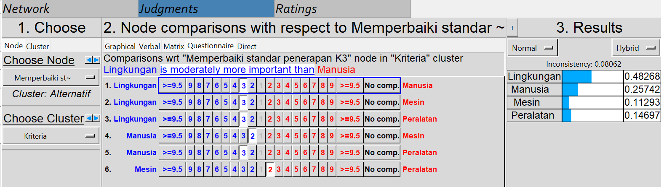

**Perbaikan pada SOP dan kontroling**

|  |  |  |  |  |  |  |  |  |  |  |  |  |  |  |  |  |  |  |  |  |
| --- | --- | --- | --- | --- | --- | --- | --- | --- | --- | --- | --- | --- | --- | --- | --- | --- | --- | --- | --- | --- |
|  | 9 | 8 | 7 | 6 | 5 | 4 | 3 | 2 | 1 | 2 | 3 | 4 | 5 | 6 | 7 | 8 | 9 |  | GM | RU |
| Lingkungan |  |  |  |  |  |  |  |  |  |  |  |  | 5 |  |  |  |  | Manusia | 5 | 5 |
| Lingkungan |  |  |  |  |  |  |  |  |  |  | 3 |  |  |  |  |  |  | Mesin | 3 | 3 |
| Lingkungan |  |  |  |  |  |  |  |  |  |  | 3 |  |  |  |  |  |  | Peralatan | 3 | 3 |
| Manusia |  |  |  |  |  |  | 3 |  |  |  |  |  |  |  |  |  |  | Mesin | 3 | 3 |
| Manusia |  |  |  |  |  |  | 3 |  |  |  |  |  |  |  |  |  |  | Peralatan | 3 | 3 |
| Mesin |  |  |  |  |  |  |  |  | 1 |  | 3 |  |  |  |  |  |  | Peralatan | 1,7321 | 2 |

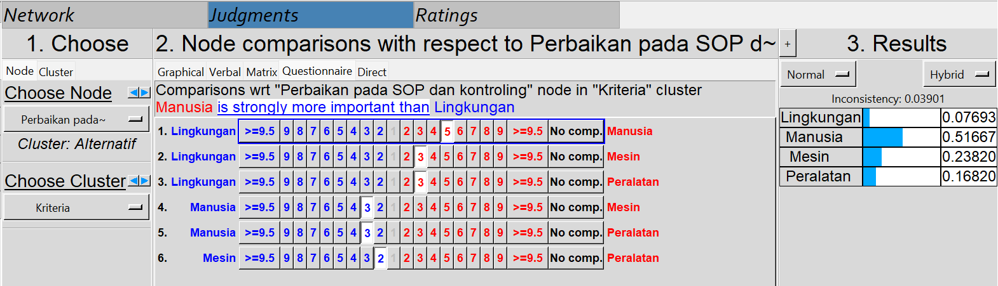

**Training pekerja**

|  |  |  |  |  |  |  |  |  |  |  |  |  |  |  |  |  |  |  |  |  |
| --- | --- | --- | --- | --- | --- | --- | --- | --- | --- | --- | --- | --- | --- | --- | --- | --- | --- | --- | --- | --- |
|  | 9 | 8 | 7 | 6 | 5 | 4 | 3 | 2 | 1 | 2 | 3 | 4 | 5 | 6 | 7 | 8 | 9 |  | GM | RU |
| Lingkungan |  |  |  |  |  |  |  |  |  |  |  |  | 5 |  |  |  |  | Manusia | 5 | 5 |
| Lingkungan |  |  |  |  |  |  |  |  |  |  | 3 |  |  |  |  |  |  | Mesin | 3 | 3 |
| Lingkungan |  |  |  |  |  |  |  |  | 1 |  | 3 |  |  |  |  |  |  | Peralatan | 1,7321 | 2 |
| Manusia |  |  |  |  |  |  | 3 |  |  |  |  |  |  |  |  |  |  | Mesin | 3 | 3 |
| Manusia |  |  |  |  |  |  | 3 |  |  |  |  |  |  |  |  |  |  | Peralatan | 3 | 3 |
| Mesin |  |  |  |  |  |  | 3 |  | 1 |  |  |  |  |  |  |  |  | Peralatan | 1,7321 | 2 |

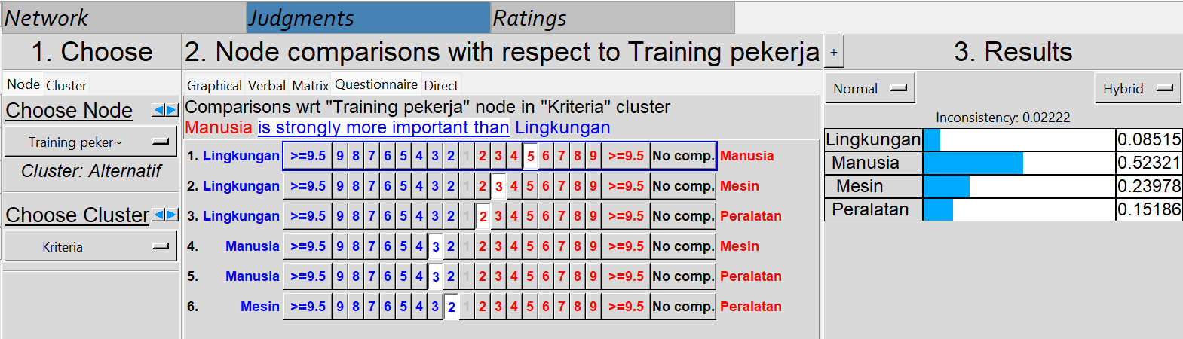

**Kuesioner perbandingan berpasangan kriteria dengan antar alternatif**

**Lingkungan**

|  |  |  |  |  |  |  |  |  |  |  |  |  |  |  |  |  |  |  |  |  |
| --- | --- | --- | --- | --- | --- | --- | --- | --- | --- | --- | --- | --- | --- | --- | --- | --- | --- | --- | --- | --- |
|  | 9 | 8 | 7 | 6 | 5 | 4 | 3 | 2 | 1 | 2 | 3 | 4 | 5 | 6 | 7 | 8 | 9 |  | GM | RU |
| A1 |  |  |  |  |  |  | 3 |  |  |  |  |  |  |  |  |  |  | A2 | 3 | 3 |
| A1 |  |  |  |  |  |  | 3 |  |  |  |  |  |  |  |  |  |  | A3 | 3 | 3 |
| A2 |  |  |  |  |  |  | 3 |  | 1 |  |  |  |  |  |  |  |  | A3 | 1,7321 | 2 |

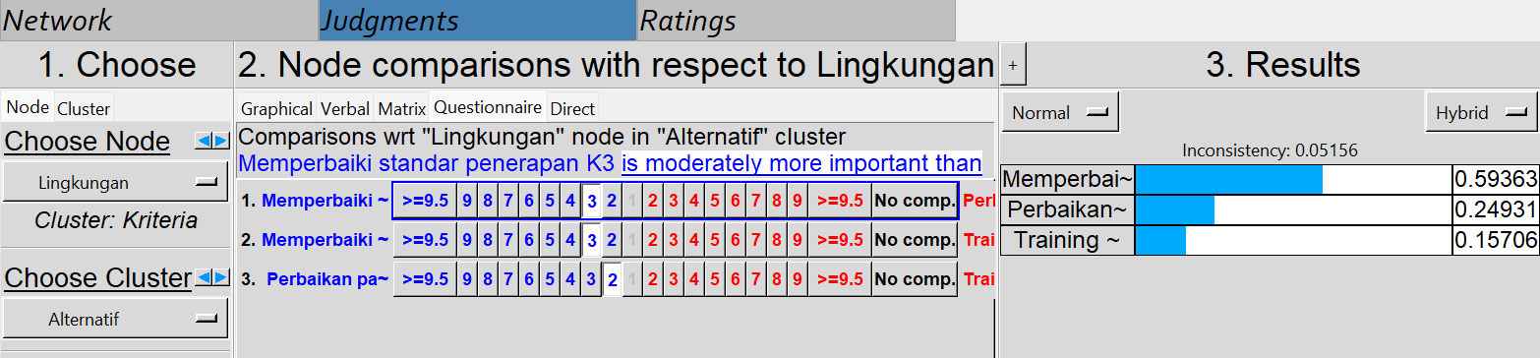

**Manusia**

|  |  |  |  |  |  |  |  |  |  |  |  |  |  |  |  |  |  |  |  |  |
| --- | --- | --- | --- | --- | --- | --- | --- | --- | --- | --- | --- | --- | --- | --- | --- | --- | --- | --- | --- | --- |
|  | 9 | 8 | 7 | 6 | 5 | 4 | 3 | 2 | 1 | 2 | 3 | 4 | 5 | 6 | 7 | 8 | 9 |  | GM | RU |
| A1 |  |  |  |  |  |  |  |  |  |  | 3 |  |  |  |  |  |  | A2 | 3 | 3 |
| A1 |  |  |  |  |  |  |  |  |  |  | 3 |  |  |  |  |  |  | A3 | 3 | 3 |
| A2 |  |  |  |  |  |  |  |  | 1 |  | 3 |  |  |  |  |  |  | A3 | 1,7321 | 2 |

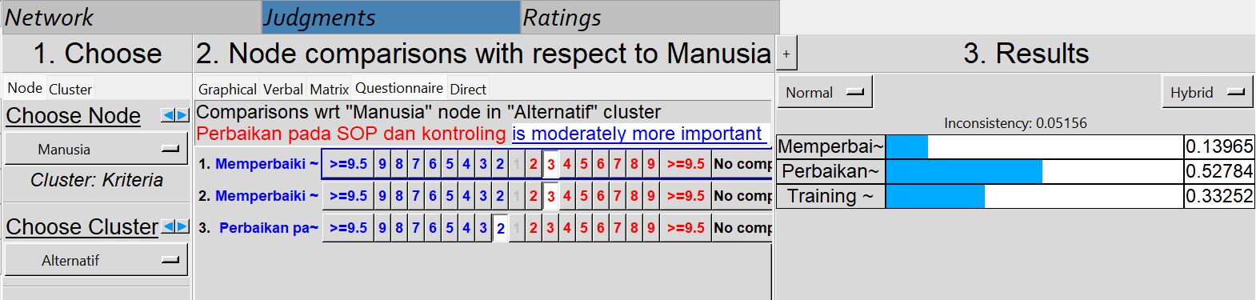

**Mesin**

|  |  |  |  |  |  |  |  |  |  |  |  |  |  |  |  |  |  |  |  |  |
| --- | --- | --- | --- | --- | --- | --- | --- | --- | --- | --- | --- | --- | --- | --- | --- | --- | --- | --- | --- | --- |
|  | 9 | 8 | 7 | 6 | 5 | 4 | 3 | 2 | 1 | 2 | 3 | 4 | 5 | 6 | 7 | 8 | 9 |  | GM | RU |
| A1 |  |  |  |  |  |  |  |  |  |  | 3 |  |  |  |  |  |  | A2 | 3 | 3 |
| A1 |  |  |  |  |  |  | 3 |  | 1 |  |  |  |  |  |  |  |  | A3 | 1,7321 | 2 |
| A2 |  |  |  |  |  |  | 3 |  |  |  |  |  |  |  |  |  |  | A3 | 3 | 3 |

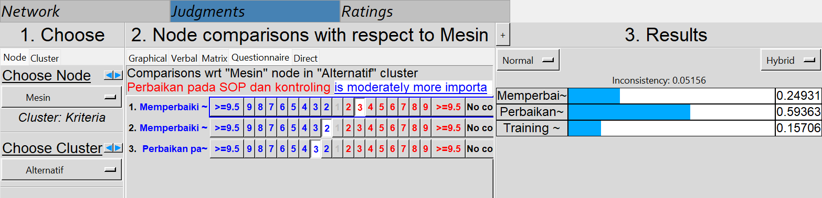

**Peralatan**

|  |  |  |  |  |  |  |  |  |  |  |  |  |  |  |  |  |  |  |  |  |
| --- | --- | --- | --- | --- | --- | --- | --- | --- | --- | --- | --- | --- | --- | --- | --- | --- | --- | --- | --- | --- |
|  | 9 | 8 | 7 | 6 | 5 | 4 | 3 | 2 | 1 | 2 | 3 | 4 | 5 | 6 | 7 | 8 | 9 |  | GM | RU |
| A1 |  |  |  |  |  |  |  |  |  |  | 3 |  |  |  |  |  |  | A2 | 3 | 3 |
| A1 |  |  |  |  |  |  |  |  | 1 |  | 3 |  |  |  |  |  |  | A3 | 1,7321 | 2 |
| A2 |  |  |  |  |  |  | 3 |  |  |  |  |  |  |  |  |  |  | A3 | 3 | 3 |

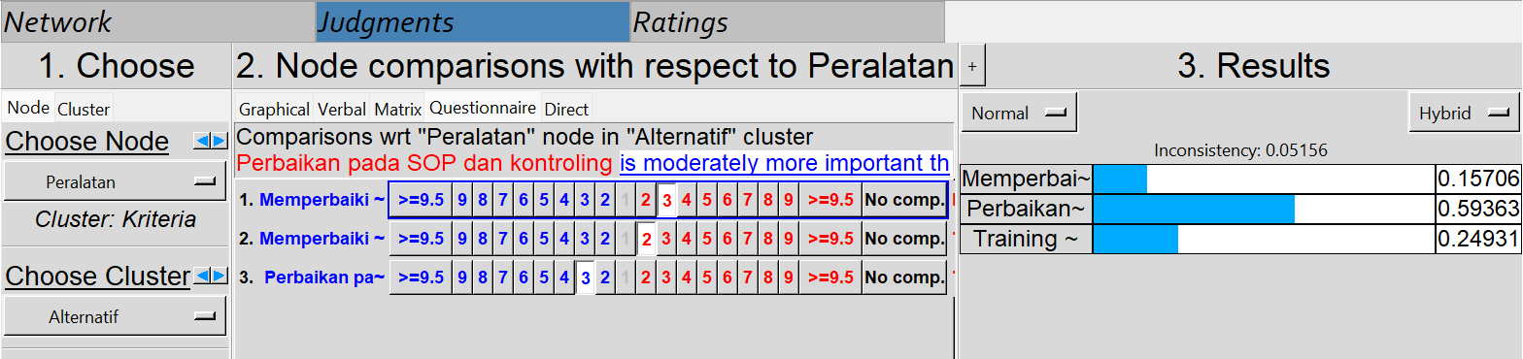

**Kuesioner perbandingan berpasangan antar hubungan sub-kriteria**

**Suhu ruangan**

|  |  |  |  |  |  |  |  |  |  |  |  |  |  |  |  |  |  |  |  |  |
| --- | --- | --- | --- | --- | --- | --- | --- | --- | --- | --- | --- | --- | --- | --- | --- | --- | --- | --- | --- | --- |
|  | 9 | 8 | 7 | 6 | 5 | 4 | 3 | 2 | 1 | 2 | 3 | 4 | 5 | 6 | 7 | 8 | 9 |  | GM | RU |
| L2 |  |  |  |  |  |  | 3 |  | 1 |  |  |  |  |  |  |  |  | L3 | 1,7321 | 2 |

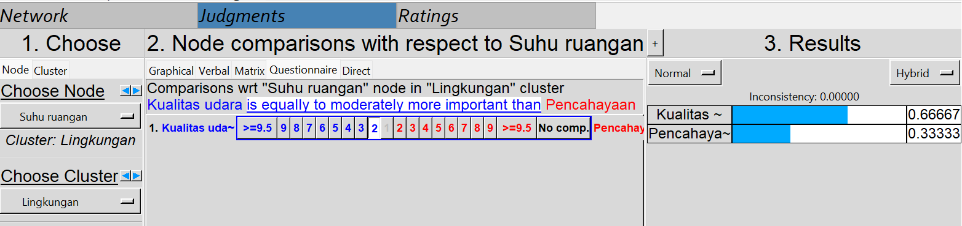

**Tidak mematuhi prosedur kerja**

|  |  |  |  |  |  |  |  |  |  |  |  |  |  |  |  |  |  |  |  |  |
| --- | --- | --- | --- | --- | --- | --- | --- | --- | --- | --- | --- | --- | --- | --- | --- | --- | --- | --- | --- | --- |
|  | 9 | 8 | 7 | 6 | 5 | 4 | 3 | 2 | 1 | 2 | 3 | 4 | 5 | 6 | 7 | 8 | 9 |  | GM | RU |
| P1 |  |  |  |  |  |  |  |  |  |  |  |  | 5 |  |  |  |  | P2 | 5 | 5 |

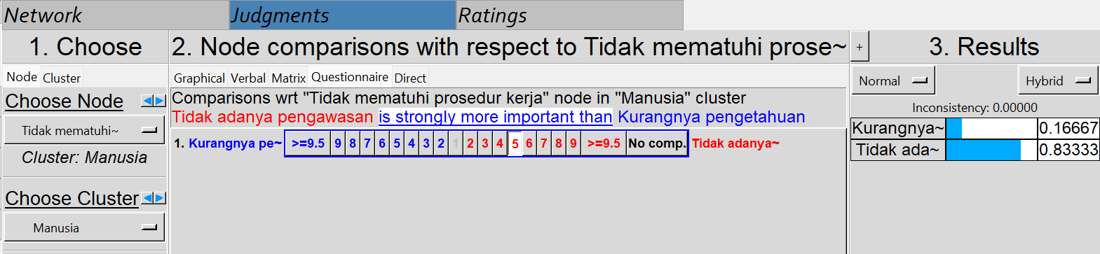

**Kurangnya maintenance mesin**

|  |  |  |  |  |  |  |  |  |  |  |  |  |  |  |  |  |  |  |  |  |
| --- | --- | --- | --- | --- | --- | --- | --- | --- | --- | --- | --- | --- | --- | --- | --- | --- | --- | --- | --- | --- |
|  | 9 | 8 | 7 | 6 | 5 | 4 | 3 | 2 | 1 | 2 | 3 | 4 | 5 | 6 | 7 | 8 | 9 |  | GM | RU |
| P1 |  |  |  |  |  |  |  |  |  |  | 5 |  |  |  |  |  |  | P3 | 5 | 5 |

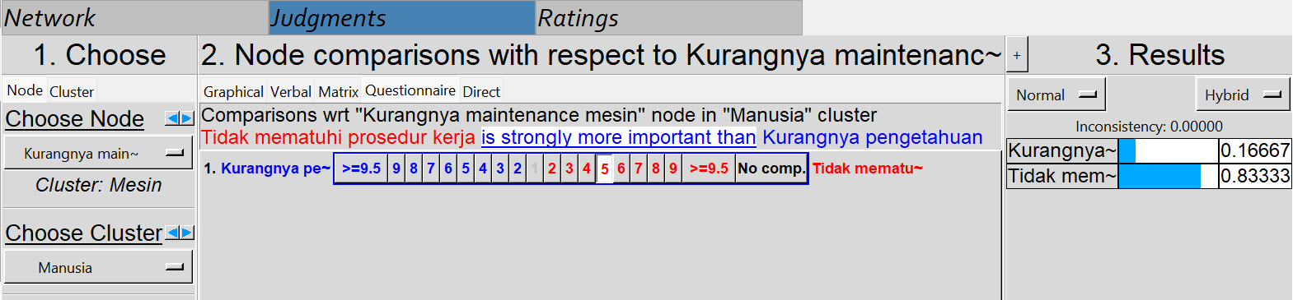

**Mesin bermasalah**

|  |  |  |  |  |  |  |  |  |  |  |  |  |  |  |  |  |  |  |  |  |
| --- | --- | --- | --- | --- | --- | --- | --- | --- | --- | --- | --- | --- | --- | --- | --- | --- | --- | --- | --- | --- |
|  | 9 | 8 | 7 | 6 | 5 | 4 | 3 | 2 | 1 | 2 | 3 | 4 | 5 | 6 | 7 | 8 | 9 |  | GM | RU |
| M1 |  |  |  |  | 5 |  |  |  |  |  |  |  |  |  |  |  |  | M3 | 5 | 5 |

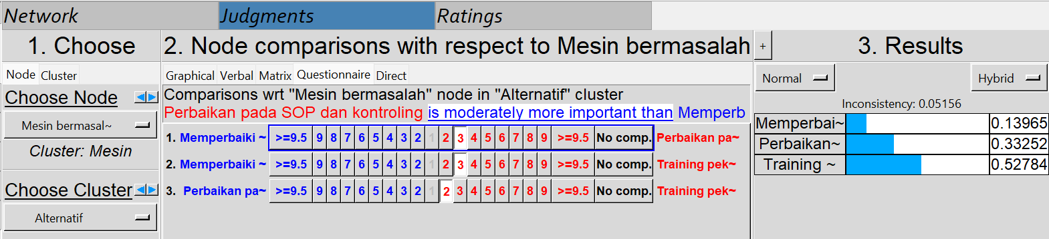

**Kurangnya perawatan peralatan**

|  |  |  |  |  |  |  |  |  |  |  |  |  |  |  |  |  |  |  |  |  |
| --- | --- | --- | --- | --- | --- | --- | --- | --- | --- | --- | --- | --- | --- | --- | --- | --- | --- | --- | --- | --- |
|  | 9 | 8 | 7 | 6 | 5 | 4 | 3 | 2 | 1 | 2 | 3 | 4 | 5 | 6 | 7 | 8 | 9 |  | GM | RU |
| P1 |  |  |  |  |  |  |  |  |  |  | 3 |  |  |  |  |  |  | P3 | 3 | 3 |

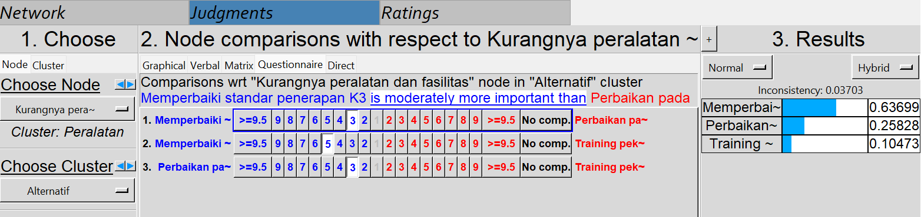

**Pemasangan instalasi listrik tidak benar**

|  |  |  |  |  |  |  |  |  |  |  |  |  |  |  |  |  |  |  |  |  |
| --- | --- | --- | --- | --- | --- | --- | --- | --- | --- | --- | --- | --- | --- | --- | --- | --- | --- | --- | --- | --- |
|  | 9 | 8 | 7 | 6 | 5 | 4 | 3 | 2 | 1 | 2 | 3 | 4 | 5 | 6 | 7 | 8 | 9 |  | GM | RU |
| P1 |  |  |  |  |  |  | 3 |  |  |  |  |  |  |  |  |  |  | P2 | 3 | 3 |

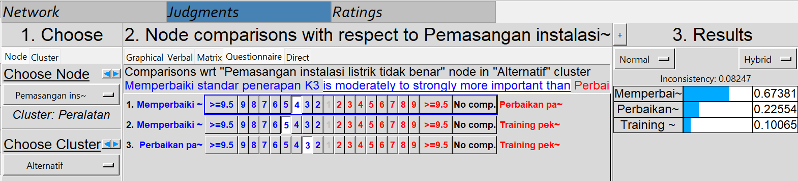

**Kesioner perbandingan berpasangan antar sub-kriteria dengan alternatif**

**Kebisingan**

|  |  |  |  |  |  |  |  |  |  |  |  |  |  |  |  |  |  |  |  |  |
| --- | --- | --- | --- | --- | --- | --- | --- | --- | --- | --- | --- | --- | --- | --- | --- | --- | --- | --- | --- | --- |
|  | 9 | 8 | 7 | 6 | 5 | 4 | 3 | 2 | 1 | 2 | 3 | 4 | 5 | 6 | 7 | 8 | 9 |  | GM | RU |
| A1 |  |  |  |  | 5 |  | 3 |  |  |  |  |  |  |  |  |  |  | A2 | 3,873 | 4 |
| A1 |  |  |  |  | 5 |  |  |  |  |  |  |  |  |  |  |  |  | A3 | 5 | 5 |
| A2 |  |  |  |  |  |  | 3 |  |  |  |  |  |  |  |  |  |  | A3 | 3 | 3 |

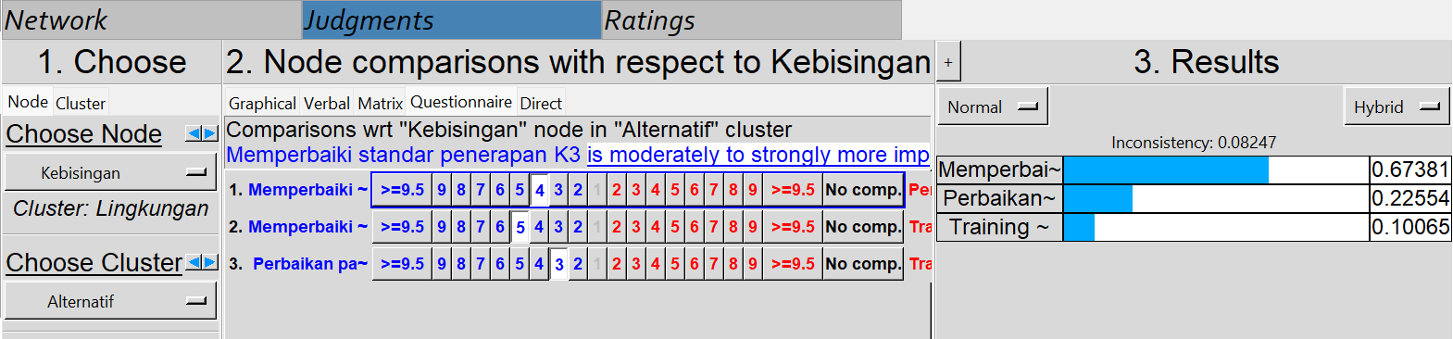

**Kualitas Udara**

|  |  |  |  |  |  |  |  |  |  |  |  |  |  |  |  |  |  |  |  |  |
| --- | --- | --- | --- | --- | --- | --- | --- | --- | --- | --- | --- | --- | --- | --- | --- | --- | --- | --- | --- | --- |
|  | 9 | 8 | 7 | 6 | 5 | 4 | 3 | 2 | 1 | 2 | 3 | 4 | 5 | 6 | 7 | 8 | 9 |  | GM | RU |
| A1 |  |  |  |  | 5 |  |  |  |  |  |  |  |  |  |  |  |  | A2 | 5 | 5 |
| A1 |  |  |  |  | 5 |  |  |  |  |  |  |  |  |  |  |  |  | A3 | 5 | 5 |
| A2 |  |  |  |  |  |  | 3 |  | 1 |  |  |  |  |  |  |  |  | A3 | 1,732 | 2 |

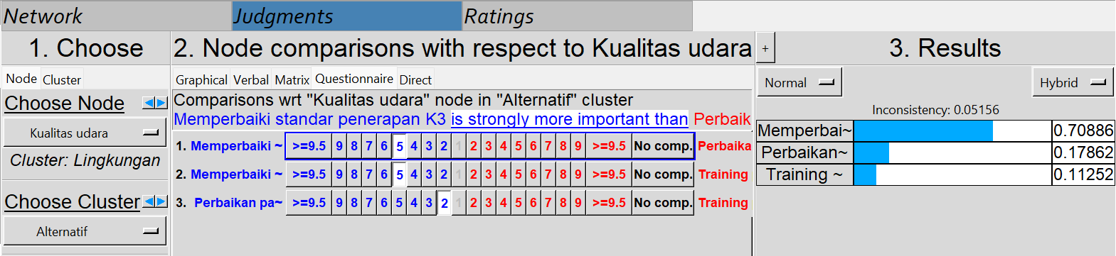

**Pencahayaan**

|  |  |  |  |  |  |  |  |  |  |  |  |  |  |  |  |  |  |  |  |  |
| --- | --- | --- | --- | --- | --- | --- | --- | --- | --- | --- | --- | --- | --- | --- | --- | --- | --- | --- | --- | --- |
|  | 9 | 8 | 7 | 6 | 5 | 4 | 3 | 2 | 1 | 2 | 3 | 4 | 5 | 6 | 7 | 8 | 9 |  | GM | RU |
| A1 |  |  |  |  | 5 |  |  |  |  |  |  |  |  |  |  |  |  | A2 | 5 | 5 |
| A1 |  |  |  |  | 5 |  | 3 |  |  |  |  |  |  |  |  |  |  | A3 | 3,873 | 4 |
| A2 |  |  |  |  |  |  | 3 |  | 1 |  |  |  |  |  |  |  |  | A3 | 1,732 | 2 |

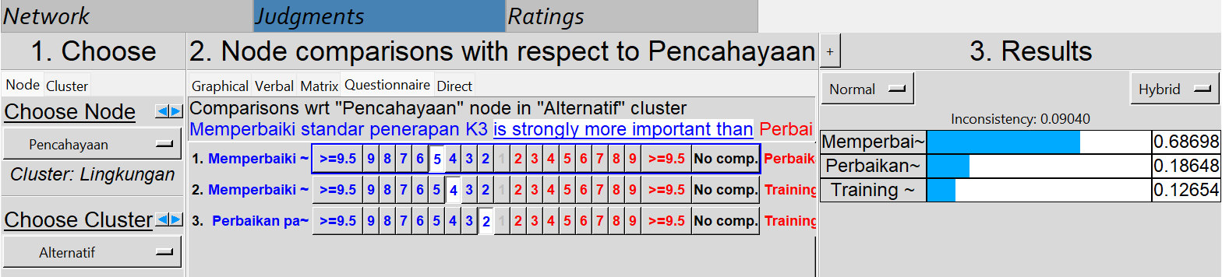

**Suhu Ruangan**

|  |  |  |  |  |  |  |  |  |  |  |  |  |  |  |  |  |  |  |  |  |
| --- | --- | --- | --- | --- | --- | --- | --- | --- | --- | --- | --- | --- | --- | --- | --- | --- | --- | --- | --- | --- |
|  | 9 | 8 | 7 | 6 | 5 | 4 | 3 | 2 | 1 | 2 | 3 | 4 | 5 | 6 | 7 | 8 | 9 |  | GM | RU |
| A1 |  |  |  |  | 5 |  |  |  |  |  |  |  |  |  |  |  |  | A2 | 5 | 4 |
| A1 |  |  |  |  | 5 |  |  |  |  |  |  |  |  |  |  |  |  | A3 | 5 | 4 |
| A2 |  |  |  |  |  |  | 3 |  | 1 |  |  |  |  |  |  |  |  | A3 | 1,732 | 2 |

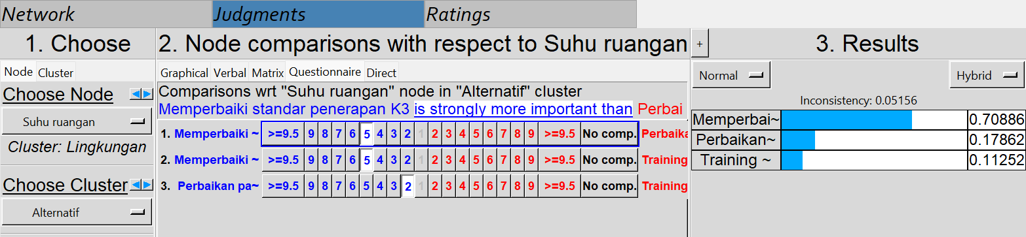

**Kurangnya Pengetahuan**

|  |  |  |  |  |  |  |  |  |  |  |  |  |  |  |  |  |  |  |  |  |
| --- | --- | --- | --- | --- | --- | --- | --- | --- | --- | --- | --- | --- | --- | --- | --- | --- | --- | --- | --- | --- |
|  | 9 | 8 | 7 | 6 | 5 | 4 | 3 | 2 | 1 | 2 | 3 | 4 | 5 | 6 | 7 | 8 | 9 |  | GM | RU |
| A1 |  |  |  |  |  |  |  |  | 1 |  | 3 |  |  |  |  |  |  | A2 | 1,732 | 2 |
| A1 |  |  |  |  |  |  |  |  |  |  |  |  | 5 |  |  |  |  | A3 | 5 | 5 |
| A2 |  |  |  |  |  |  |  |  |  |  |  |  | 5 |  |  |  |  | A3 | 5 | 5 |

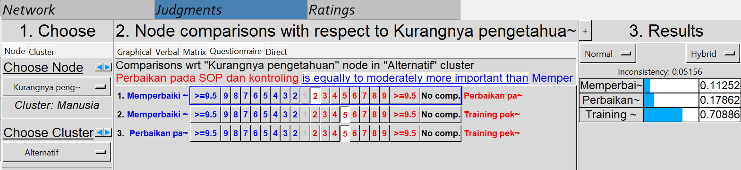

**Tidak Adanya Pengawasan**

|  |  |  |  |  |  |  |  |  |  |  |  |  |  |  |  |  |  |  |  |  |
| --- | --- | --- | --- | --- | --- | --- | --- | --- | --- | --- | --- | --- | --- | --- | --- | --- | --- | --- | --- | --- |
|  | 9 | 8 | 7 | 6 | 5 | 4 | 3 | 2 | 1 | 2 | 3 | 4 | 5 | 6 | 7 | 8 | 9 |  | GM | RU |
| A1 |  |  |  |  |  |  |  |  |  |  |  |  | 5 |  |  |  |  | A2 | 5 | 5 |
| A1 |  |  |  |  |  |  |  |  | 1 |  | 3 |  |  |  |  |  |  | A3 | 1,732 | 2 |
| A2 |  |  |  |  | 5 |  |  |  |  |  |  |  |  |  |  |  |  | A3 | 5 | 5 |

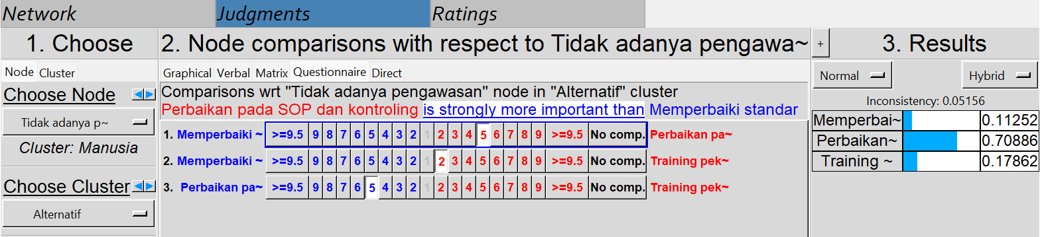

**Tidak Mematuhi Prosedur Kerja**

|  |  |  |  |  |  |  |  |  |  |  |  |  |  |  |  |  |  |  |  |  |
| --- | --- | --- | --- | --- | --- | --- | --- | --- | --- | --- | --- | --- | --- | --- | --- | --- | --- | --- | --- | --- |
|  | 9 | 8 | 7 | 6 | 5 | 4 | 3 | 2 | 1 | 2 | 3 | 4 | 5 | 6 | 7 | 8 | 9 |  | GM | RU |
| A1 |  |  |  |  |  |  |  |  |  |  |  |  | 5 |  |  |  |  | A2 | 5 | 5 |
| A1 |  |  |  |  |  |  |  |  | 1 |  | 3 |  |  |  |  |  |  | A3 | 1,732 | 2 |
| A2 |  |  |  |  | 5 |  |  |  |  |  |  |  |  |  |  |  |  | A3 | 5 | 5 |

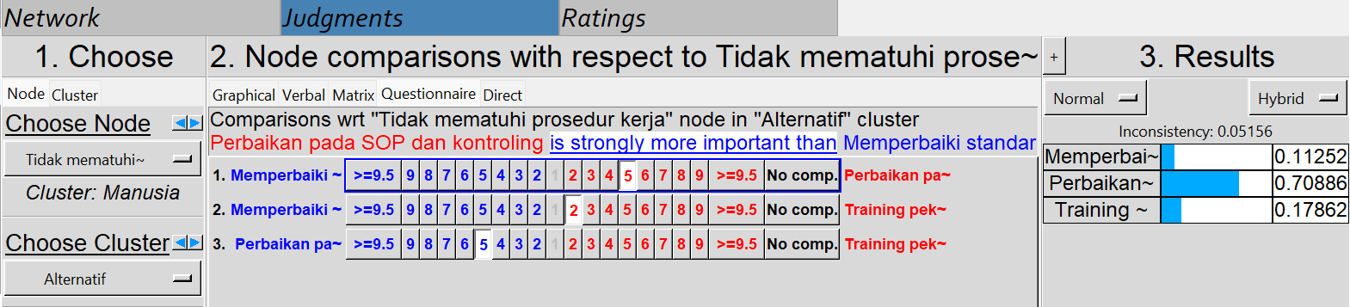

**Tidak Menggunakan APD**

|  |  |  |  |  |  |  |  |  |  |  |  |  |  |  |  |  |  |  |  |  |
| --- | --- | --- | --- | --- | --- | --- | --- | --- | --- | --- | --- | --- | --- | --- | --- | --- | --- | --- | --- | --- |
|  | 9 | 8 | 7 | 6 | 5 | 4 | 3 | 2 | 1 | 2 | 3 | 4 | 5 | 6 | 7 | 8 | 9 |  | GM | RU |
| A1 |  |  |  |  |  |  |  |  |  |  |  |  | 5 |  |  |  |  | A2 | 5 | 5 |
| A1 |  |  |  |  |  |  | 3 |  | 1 |  |  |  |  |  |  |  |  | A3 | 1,732 | 2 |
| A2 |  |  |  |  | 5 |  |  |  |  |  |  |  |  |  |  |  |  | A3 | 5 | 5 |

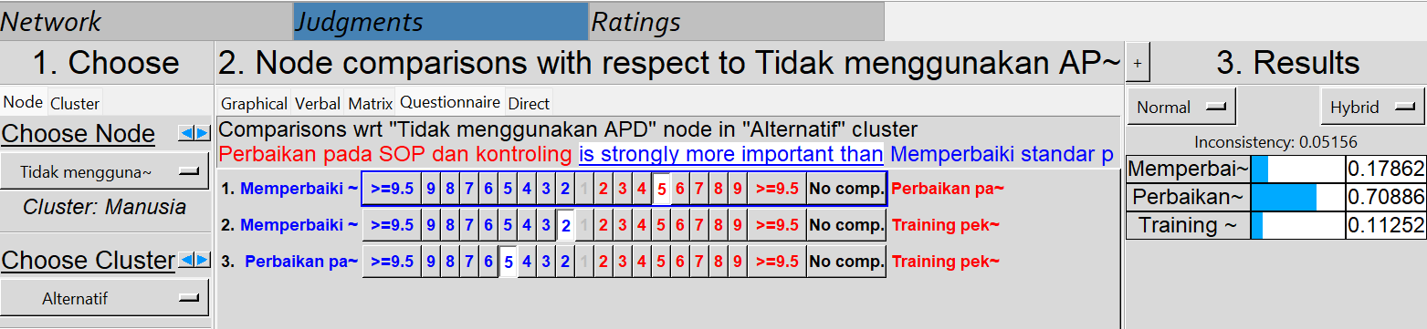

**Kurangnya Maintenance Mesin**

|  |  |  |  |  |  |  |  |  |  |  |  |  |  |  |  |  |  |  |  |  |
| --- | --- | --- | --- | --- | --- | --- | --- | --- | --- | --- | --- | --- | --- | --- | --- | --- | --- | --- | --- | --- |
|  | 9 | 8 | 7 | 6 | 5 | 4 | 3 | 2 | 1 | 2 | 3 | 4 | 5 | 6 | 7 | 8 | 9 |  | GM | RU |
| A1 |  |  |  |  |  |  |  |  |  |  | 3 |  |  |  |  |  |  | A2 | 3 | 3 |
| A1 |  |  |  |  |  |  | 3 |  |  |  |  |  |  |  |  |  |  | A3 | 3 | 3 |
| A2 |  |  |  |  | 5 |  |  |  |  |  |  |  |  |  |  |  |  | A3 | 5 | 5 |

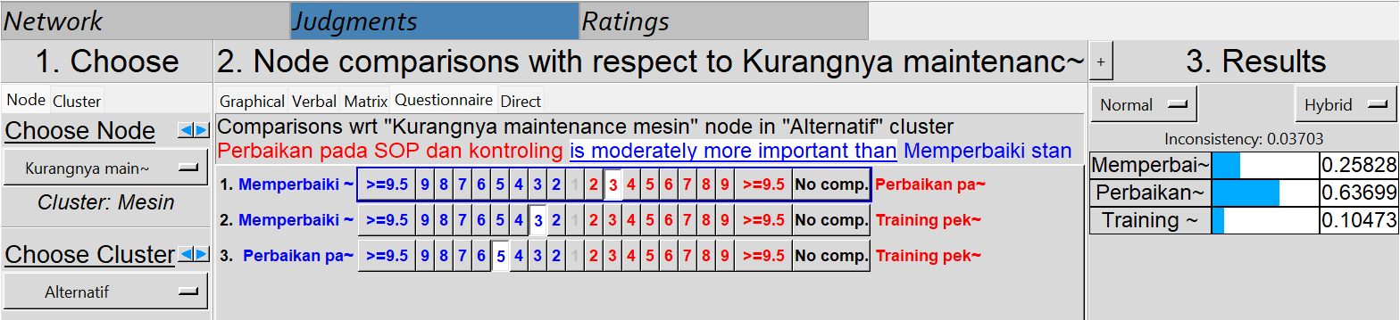

**Mesin Bermasalah**

|  |  |  |  |  |  |  |  |  |  |  |  |  |  |  |  |  |  |  |  |  |
| --- | --- | --- | --- | --- | --- | --- | --- | --- | --- | --- | --- | --- | --- | --- | --- | --- | --- | --- | --- | --- |
|  | 9 | 8 | 7 | 6 | 5 | 4 | 3 | 2 | 1 | 2 | 3 | 4 | 5 | 6 | 7 | 8 | 9 |  | GM | RU |
| A1 |  |  |  |  |  |  |  |  |  |  | 3 |  |  |  |  |  |  | A2 | 3 | 3 |
| A1 |  |  |  |  |  |  |  |  |  |  | 3 |  |  |  |  |  |  | A3 | 3 | 3 |
| A2 |  |  |  |  |  |  |  |  | 1 |  | 3 |  |  |  |  |  |  | A3 | 1,732 | 2 |

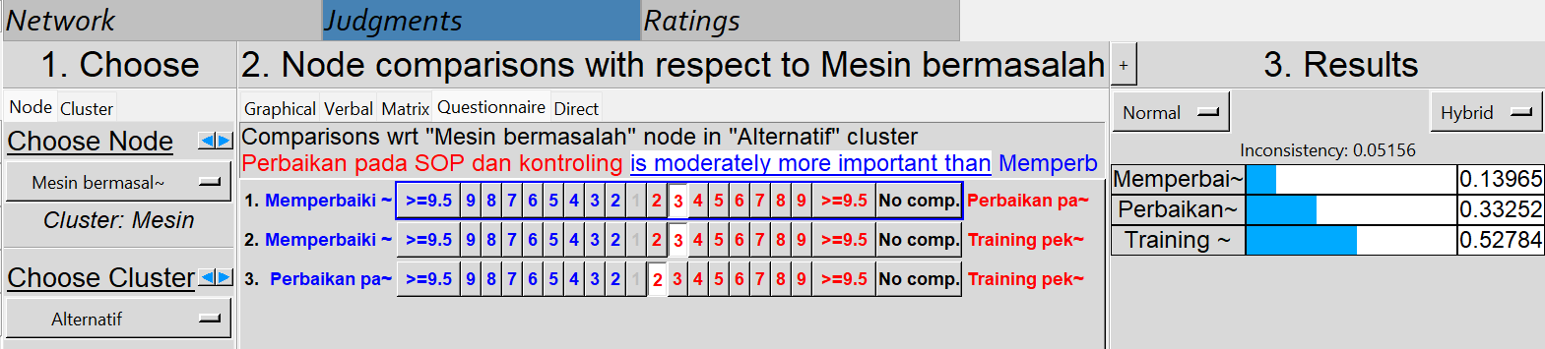

**Penempatan Mesin**

|  |  |  |  |  |  |  |  |  |  |  |  |  |  |  |  |  |  |  |  |  |
| --- | --- | --- | --- | --- | --- | --- | --- | --- | --- | --- | --- | --- | --- | --- | --- | --- | --- | --- | --- | --- |
|  | 9 | 8 | 7 | 6 | 5 | 4 | 3 | 2 | 1 | 2 | 3 | 4 | 5 | 6 | 7 | 8 | 9 |  | GM | RU |
| A1 |  |  |  |  | 5 |  |  |  |  |  |  |  |  |  |  |  |  | A2 | 5 | 5 |
| A1 |  |  |  |  | 5 |  |  |  |  |  |  |  |  |  |  |  |  | A3 | 5 | 5 |
| A2 |  |  |  |  |  |  | 3 |  | 1 |  |  |  |  |  |  |  |  | A3 | 1,732 | 2 |

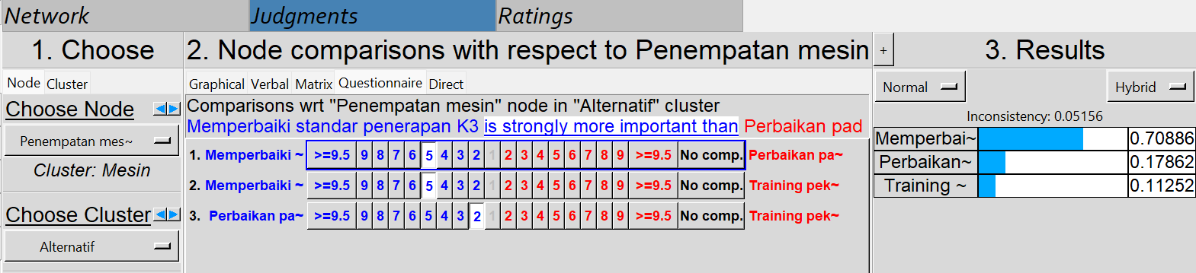

**Kurangnya Peralatan Dan Fasilitas**

|  |  |  |  |  |  |  |  |  |  |  |  |  |  |  |  |  |  |  |  |  |
| --- | --- | --- | --- | --- | --- | --- | --- | --- | --- | --- | --- | --- | --- | --- | --- | --- | --- | --- | --- | --- |
|  | 9 | 8 | 7 | 6 | 5 | 4 | 3 | 2 | 1 | 2 | 3 | 4 | 5 | 6 | 7 | 8 | 9 |  | GM | RU |
| A1 |  |  |  |  |  |  | 3 |  |  |  |  |  |  |  |  |  |  | A2 | 3 | 3 |
| A1 |  |  |  |  | 5 |  |  |  |  |  |  |  |  |  |  |  |  | A3 | 5 | 5 |
| A2 |  |  |  |  |  |  | 3 |  |  |  |  |  |  |  |  |  |  | A3 | 3 | 3 |

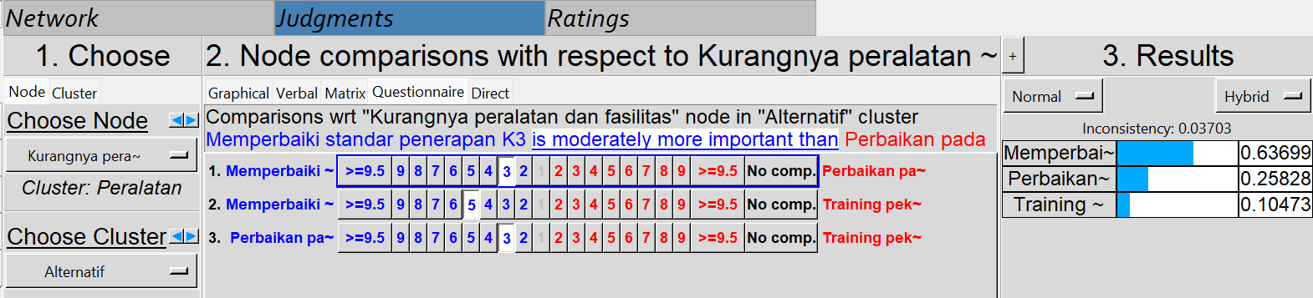

**Kurangnya Perawatan Peralatan**

|  |  |  |  |  |  |  |  |  |  |  |  |  |  |  |  |  |  |  |  |  |
| --- | --- | --- | --- | --- | --- | --- | --- | --- | --- | --- | --- | --- | --- | --- | --- | --- | --- | --- | --- | --- |
|  | 9 | 8 | 7 | 6 | 5 | 4 | 3 | 2 | 1 | 2 | 3 | 4 | 5 | 6 | 7 | 8 | 9 |  | GM | RU |
| A1 |  |  |  |  |  |  |  |  |  |  | 3 |  |  |  |  |  |  | A2 | 3 | 3 |
| A1 |  |  |  |  |  |  | 3 |  | 1 |  |  |  |  |  |  |  |  | A3 | 1,732 | 2 |
| A2 |  |  |  |  |  |  | 3 |  |  |  |  |  |  |  |  |  |  | A3 | 3 | 3 |

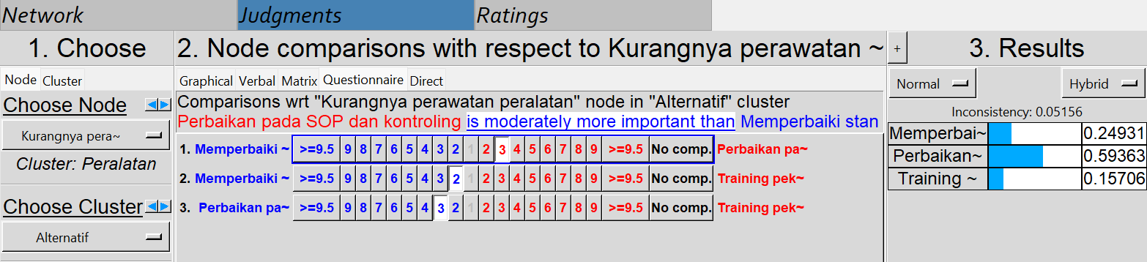

**Pemasangan Instalasi Listrik Tidak Benar**

|  |  |  |  |  |  |  |  |  |  |  |  |  |  |  |  |  |  |  |  |  |
| --- | --- | --- | --- | --- | --- | --- | --- | --- | --- | --- | --- | --- | --- | --- | --- | --- | --- | --- | --- | --- |
|  | 9 | 8 | 7 | 6 | 5 | 4 | 3 | 2 | 1 | 2 | 3 | 4 | 5 | 6 | 7 | 8 | 9 |  | GM | RU |
| A1 |  |  |  |  | 5 |  | 3 |  |  |  |  |  |  |  |  |  |  | A2 | 3,873 | 4 |
| A1 |  |  |  |  | 5 |  |  |  |  |  |  |  |  |  |  |  |  | A3 | 5 | 5 |
| A2 |  |  |  |  |  |  | 3 |  |  |  |  |  |  |  |  |  |  | A3 | 3 | 3 |

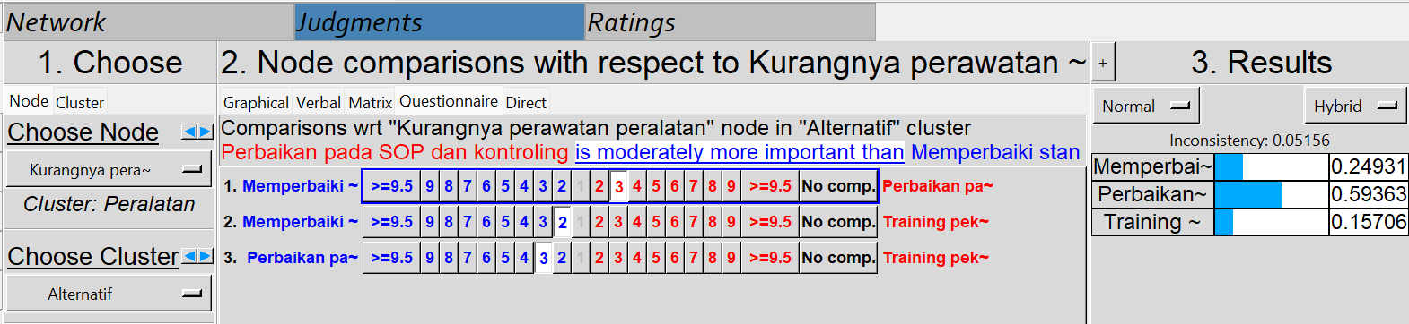

**Kuesioner perbandingan berpasangan antar alternatif dengan sub-kriteria**

**Memperbaiki standar penerapan K3**

|  |  |  |  |  |  |  |  |  |  |  |  |  |  |  |  |  |  |  |  |  |
| --- | --- | --- | --- | --- | --- | --- | --- | --- | --- | --- | --- | --- | --- | --- | --- | --- | --- | --- | --- | --- |
|  | 9 | 8 | 7 | 6 | 5 | 4 | 3 | 2 | 1 | 2 | 3 | 4 | 5 | 6 | 7 | 8 | 9 |  | GM | RU |
| L1 |  |  |  |  |  |  | 3 |  |  |  |  |  |  |  |  |  |  | L2 | 3 | 3 |
| L1 |  |  |  |  |  |  | 3 |  |  |  |  |  |  |  |  |  |  | L3 | 3 | 3 |
| L1 |  |  |  |  |  |  | 3 |  | 1 |  |  |  |  |  |  |  |  | L4 | 1,73 | 2 |
| L2 |  |  |  |  |  |  |  |  |  |  | 3 |  |  |  |  |  |  | L3 | 3 | 3 |
| L2 |  |  |  |  |  |  |  |  |  |  | 3 |  |  |  |  |  |  | L4 | 3 | 3 |
| L3 |  |  |  |  |  |  | 3 |  | 1 |  |  |  |  |  |  |  |  | L4 | 1,73 | 2 |

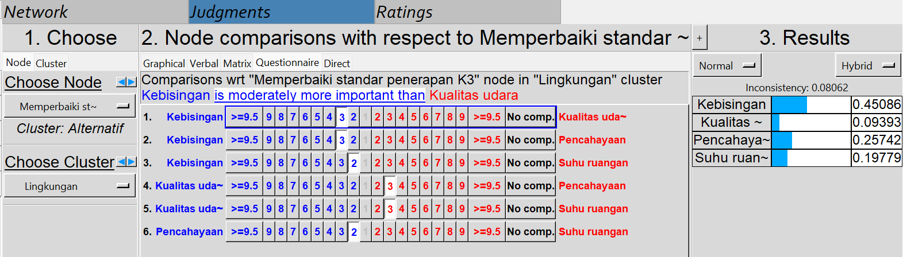

|  |  |  |  |  |  |  |  |  |  |  |  |  |  |  |  |  |  |  |  |  |
| --- | --- | --- | --- | --- | --- | --- | --- | --- | --- | --- | --- | --- | --- | --- | --- | --- | --- | --- | --- | --- |
|  | 9 | 8 | 7 | 6 | 5 | 4 | 3 | 2 | 1 | 2 | 3 | 4 | 5 | 6 | 7 | 8 | 9 |  | GM | RU |
| P1 |  |  |  |  |  |  | 3 |  | 1 |  |  |  |  |  |  |  |  | P2 | 1,73 | 2 |
| P2 |  |  |  |  |  |  |  |  | 1 |  |  |  |  |  |  |  |  | P3 | 1 | 1 |
| P3 |  |  |  |  |  |  |  |  |  |  | 3 |  |  |  |  |  |  | P4 | 3 | 3 |
| P2 |  |  |  |  |  |  |  |  | 1 |  |  |  |  |  |  |  |  | P3 | 1 | 1 |
| P2 |  |  |  |  |  |  |  |  |  |  |  |  | 5 |  |  |  |  | P4 | 5 | 5 |
| P3 |  |  |  |  |  |  |  |  |  |  |  |  | 5 |  |  |  |  | P4 | 5 | 5 |

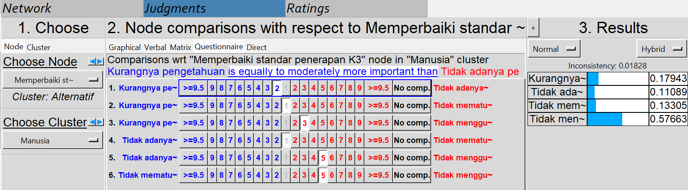

|  |  |  |  |  |  |  |  |  |  |  |  |  |  |  |  |  |  |  |  |  |
| --- | --- | --- | --- | --- | --- | --- | --- | --- | --- | --- | --- | --- | --- | --- | --- | --- | --- | --- | --- | --- |
|  | 9 | 8 | 7 | 6 | 5 | 4 | 3 | 2 | 1 | 2 | 3 | 4 | 5 | 6 | 7 | 8 | 9 |  | GM | RU |
| M1 |  |  |  |  |  |  |  |  | 1 |  | 3 |  |  |  |  |  |  | M2 | 1,73 | 2 |
| M1 |  |  |  |  |  |  |  |  |  |  |  |  | 5 |  |  |  |  | M3 | 5 | 5 |
| M2 |  |  |  |  |  |  |  |  |  |  |  |  | 5 |  |  |  |  | M3 | 5 | 5 |

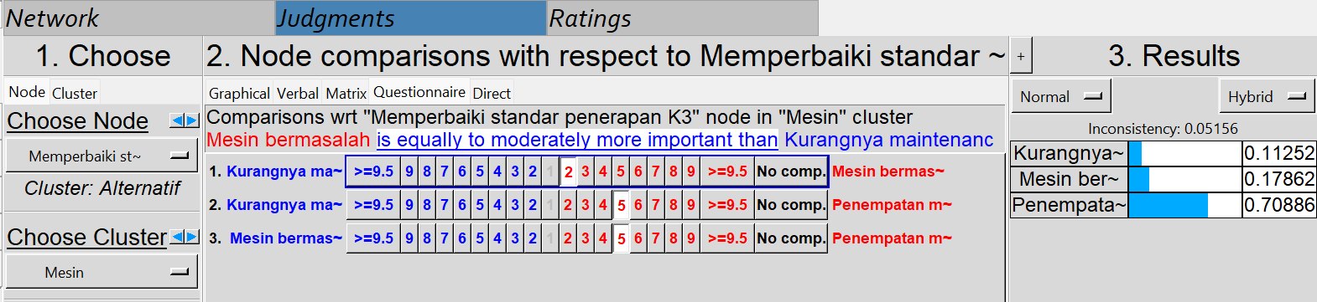

|  |  |  |  |  |  |  |  |  |  |  |  |  |  |  |  |  |  |  |  |  |
| --- | --- | --- | --- | --- | --- | --- | --- | --- | --- | --- | --- | --- | --- | --- | --- | --- | --- | --- | --- | --- |
|  | 9 | 8 | 7 | 6 | 5 | 4 | 3 | 2 | 1 | 2 | 3 | 4 | 5 | 6 | 7 | 8 | 9 |  | GM | RU |
| T1 |  |  |  |  |  |  | 3 |  |  |  |  |  |  |  |  |  |  | T2 | 3 | 3 |
| T1 |  |  |  |  |  |  |  |  |  |  | 3 |  | 5 |  |  |  |  | T3 | 3,87 | 4 |
| T2 |  |  |  |  |  |  |  |  |  |  |  |  | 5 |  |  |  |  | T3 | 5 | 5 |

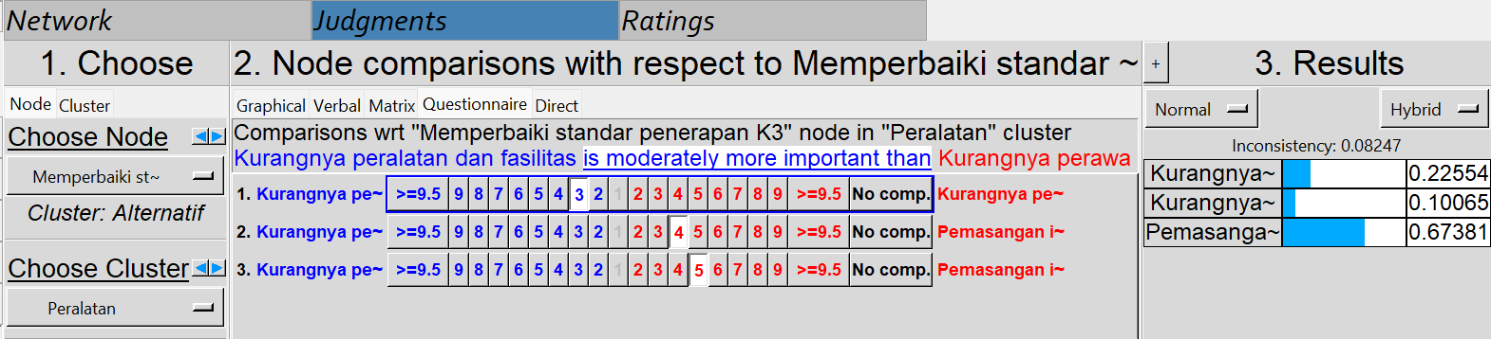

**Perbaikan terhadap SOP dan kontroling**

|  |  |  |  |  |  |  |  |  |  |  |  |  |  |  |  |  |  |  |  |  |
| --- | --- | --- | --- | --- | --- | --- | --- | --- | --- | --- | --- | --- | --- | --- | --- | --- | --- | --- | --- | --- |
|  | 9 | 8 | 7 | 6 | 5 | 4 | 3 | 2 | 1 | 2 | 3 | 4 | 5 | 6 | 7 | 8 | 9 |  | GM | RU |
| L1 |  |  |  |  |  |  | 3 |  |  |  |  |  |  |  |  |  |  | L2 | 3 | 3 |
| L1 |  |  |  |  |  |  | 3 |  |  |  |  |  |  |  |  |  |  | L3 | 3 | 3 |
| L1 |  |  |  |  |  |  | 3 |  |  |  |  |  |  |  |  |  |  | L4 | 3 | 3 |
| L2 |  |  |  |  |  |  |  |  |  |  | 3 |  |  |  |  |  |  | L3 | 3 | 3 |
| L2 |  |  |  |  |  |  |  |  |  |  | 3 |  |  |  |  |  |  | L4 | 3 | 3 |
| L3 |  |  |  |  |  |  | 3 |  | 1 |  |  |  |  |  |  |  |  | L4 | 1,732 | 2 |

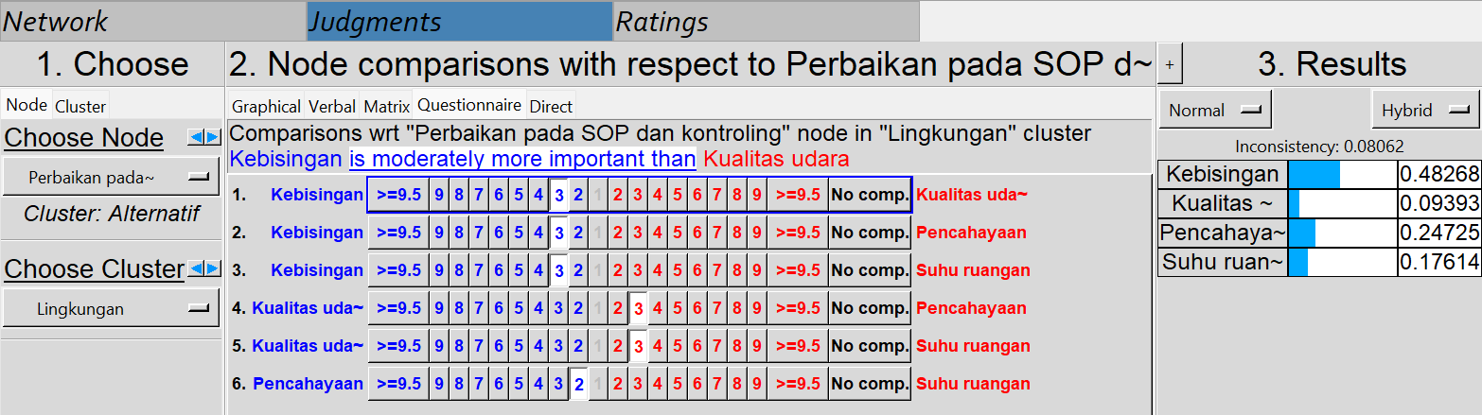

|  |  |  |  |  |  |  |  |  |  |  |  |  |  |  |  |  |  |  |  |  |
| --- | --- | --- | --- | --- | --- | --- | --- | --- | --- | --- | --- | --- | --- | --- | --- | --- | --- | --- | --- | --- |
|  | 9 | 8 | 7 | 6 | 5 | 4 | 3 | 2 | 1 | 2 | 3 | 4 | 5 | 6 | 7 | 8 | 9 |  | GM | RU |
| P1 |  |  |  |  |  |  |  |  |  |  |  |  | 5 |  |  |  |  | P2 | 5 | 5 |
| P1 |  |  |  |  |  |  |  |  |  |  | 3 |  |  |  |  |  |  | P3 | 3 | 3 |
| P1 |  |  |  |  |  |  |  |  |  |  | 3 |  |  |  |  |  |  | P4 | 3 | 3 |
| P2 |  |  |  |  |  |  | 3 |  |  |  |  |  |  |  |  |  |  | P3 | 3 | 3 |
| P2 |  |  |  |  |  |  | 3 |  | 1 |  |  |  |  |  |  |  |  | P4 | 1,732 | 2 |
| P3 |  |  |  |  |  |  | 3 |  | 1 |  |  |  |  |  |  |  |  | P4 | 1,732 | 2 |

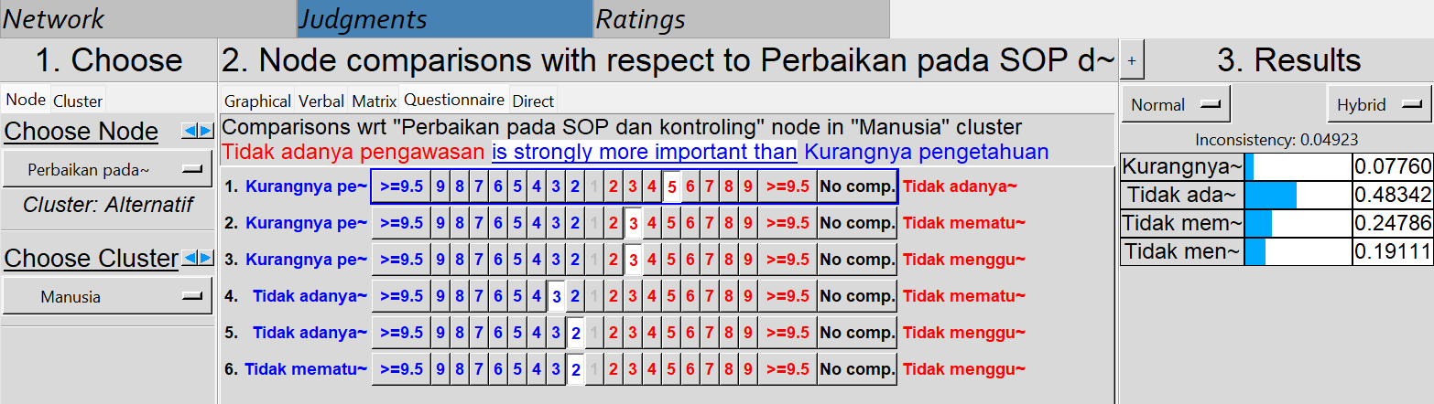

|  |  |  |  |  |  |  |  |  |  |  |  |  |  |  |  |  |  |  |  |  |
| --- | --- | --- | --- | --- | --- | --- | --- | --- | --- | --- | --- | --- | --- | --- | --- | --- | --- | --- | --- | --- |
|  | 9 | 8 | 7 | 6 | 5 | 4 | 3 | 2 | 1 | 2 | 3 | 4 | 5 | 6 | 7 | 8 | 9 |  | GM | RU |
| M1 |  |  |  |  |  |  | 3 |  | 1 |  |  |  |  |  |  |  |  | M2 | 1,732 | 2 |
| M1 |  |  |  |  |  |  | 3 |  |  |  |  |  |  |  |  |  |  | M3 | 3 | 3 |
| M2 |  |  |  |  |  |  | 3 |  |  |  |  |  |  |  |  |  |  | M3 | 3 | 3 |

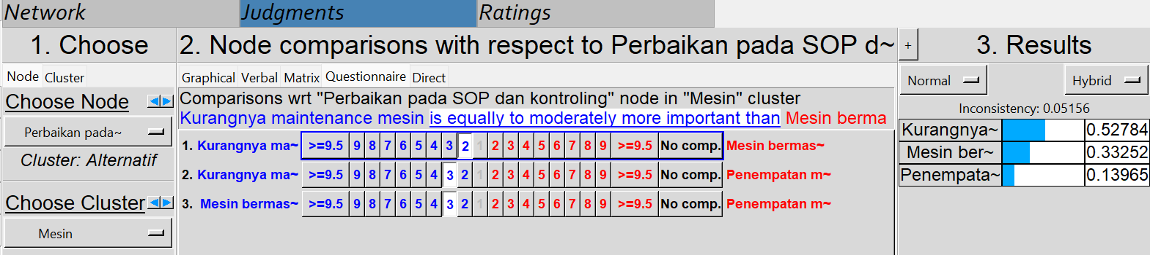

|  |  |  |  |  |  |  |  |  |  |  |  |  |  |  |  |  |  |  |  |  |
| --- | --- | --- | --- | --- | --- | --- | --- | --- | --- | --- | --- | --- | --- | --- | --- | --- | --- | --- | --- | --- |
|  | 9 | 8 | 7 | 6 | 5 | 4 | 3 | 2 | 1 | 2 | 3 | 4 | 5 | 6 | 7 | 8 | 9 |  | GM | RU |
| T1 |  |  |  |  |  |  |  |  |  |  | 3 |  | 5 |  |  |  |  | T2 | 3,873 | 4 |
| T1 |  |  |  |  |  |  |  |  | 1 |  | 3 |  |  |  |  |  |  | T3 | 1,732 | 2 |
| T2 |  |  |  |  |  |  | 3 |  |  |  |  |  |  |  |  |  |  | T3 | 3 | 3 |

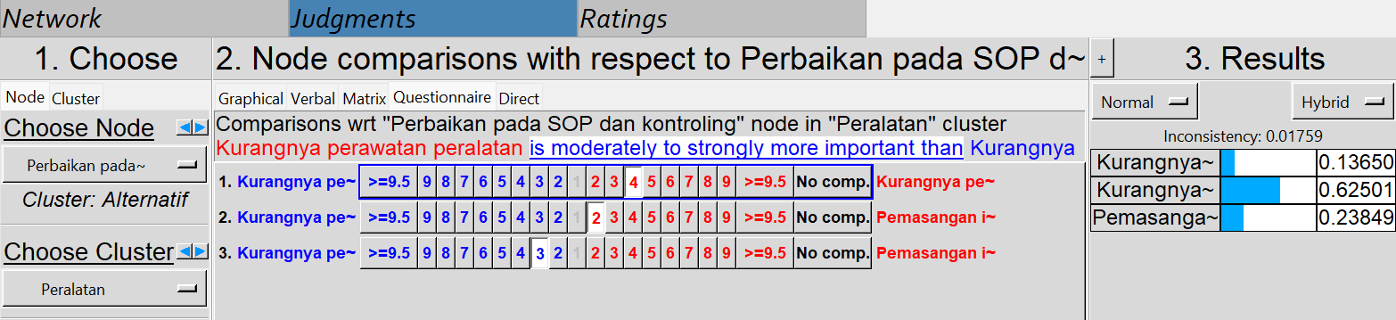

**Training pekerja**

|  |  |  |  |  |  |  |  |  |  |  |  |  |  |  |  |  |  |  |  |  |
| --- | --- | --- | --- | --- | --- | --- | --- | --- | --- | --- | --- | --- | --- | --- | --- | --- | --- | --- | --- | --- |
|  | 9 | 8 | 7 | 6 | 5 | 4 | 3 | 2 | 1 | 2 | 3 | 4 | 5 | 6 | 7 | 8 | 9 |  | GM | RU |
| L1 |  |  |  |  |  |  | 3 |  |  |  |  |  |  |  |  |  |  | L2 | 3 | 3 |
| L1 |  |  |  |  |  |  | 3 |  |  |  |  |  |  |  |  |  |  | L3 | 3 | 3 |
| L1 |  |  |  |  |  |  | 3 |  | 1 |  |  |  |  |  |  |  |  | L4 | 1,732 | 2 |
| L2 |  |  |  |  |  |  |  |  |  |  | 3 |  |  |  |  |  |  | L3 | 3 | 3 |
| L2 |  |  |  |  |  |  |  |  |  |  | 3 |  |  |  |  |  |  | L4 | 3 | 3 |
| L3 |  |  |  |  |  |  | 3 |  | 1 |  |  |  |  |  |  |  |  | L4 | 1,732 | 2 |

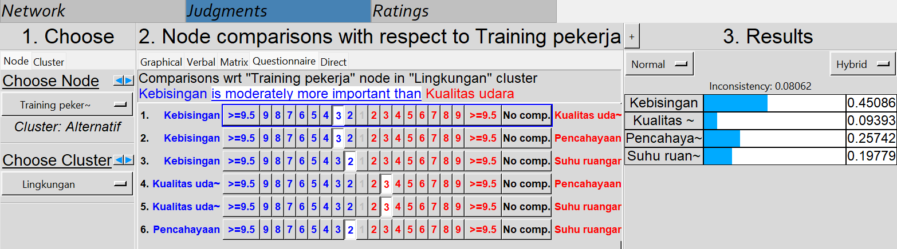

|  |  |  |  |  |  |  |  |  |  |  |  |  |  |  |  |  |  |  |  |  |
| --- | --- | --- | --- | --- | --- | --- | --- | --- | --- | --- | --- | --- | --- | --- | --- | --- | --- | --- | --- | --- |
|  | 9 | 8 | 7 | 6 | 5 | 4 | 3 | 2 | 1 | 2 | 3 | 4 | 5 | 6 | 7 | 8 | 9 |  | GM | RU |
| P1 |  |  |  |  | 5 |  |  |  |  |  |  |  |  |  |  |  |  | P2 | 5 | 5 |
| P1 |  |  |  |  | 5 |  |  |  |  |  |  |  |  |  |  |  |  | P3 | 5 | 5 |
| P1 |  |  |  |  | 5 |  |  |  |  |  |  |  |  |  |  |  |  | P4 | 5 | 5 |
| P2 |  |  |  |  |  |  | 3 |  | 1 |  |  |  |  |  |  |  |  | P3 | 1,732 | 2 |
| P2 |  |  |  |  |  |  |  |  |  |  | 3 |  |  |  |  |  |  | P4 | 3 | 3 |
| P3 |  |  |  |  |  |  |  |  | 1 |  | 3 |  |  |  |  |  |  | P4 | 1,732 | 2 |

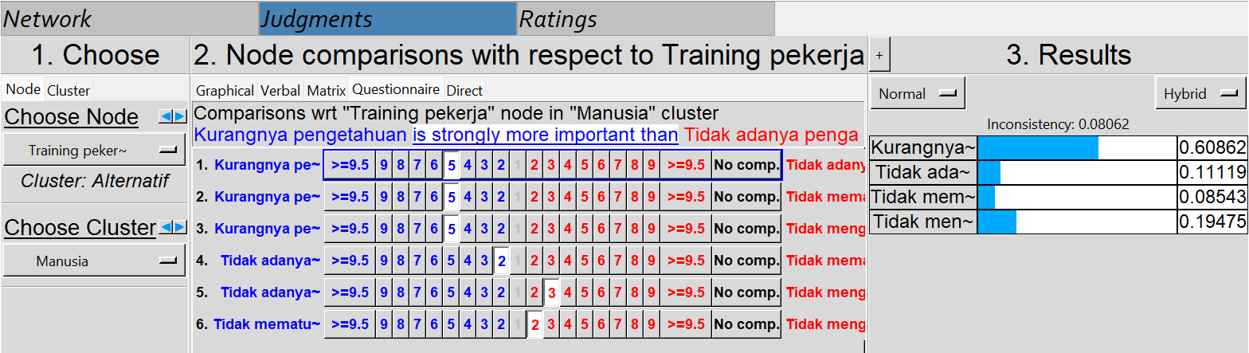

|  |  |  |  |  |  |  |  |  |  |  |  |  |  |  |  |  |  |  |  |  |
| --- | --- | --- | --- | --- | --- | --- | --- | --- | --- | --- | --- | --- | --- | --- | --- | --- | --- | --- | --- | --- |
|  | 9 | 8 | 7 | 6 | 5 | 4 | 3 | 2 | 1 | 2 | 3 | 4 | 5 | 6 | 7 | 8 | 9 |  | GM | RU |
| M1 |  |  |  |  |  |  |  |  |  |  | 3 |  |  |  |  |  |  | M2 | 3 | 3 |
| M1 |  |  |  |  |  |  |  |  | 1 |  | 3 |  |  |  |  |  |  | M3 | 1,732 | 2 |
| M2 |  |  |  |  |  |  | 3 |  |  |  |  |  |  |  |  |  |  | M3 | 3 | 3 |

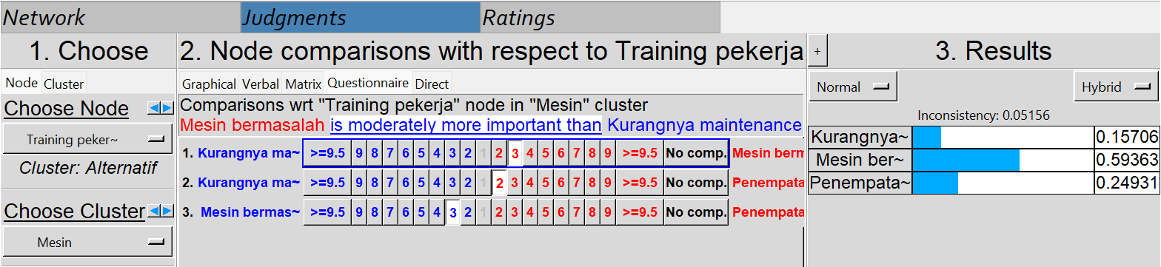

|  |  |  |  |  |  |  |  |  |  |  |  |  |  |  |  |  |  |  |  |  |
| --- | --- | --- | --- | --- | --- | --- | --- | --- | --- | --- | --- | --- | --- | --- | --- | --- | --- | --- | --- | --- |
|  | 9 | 8 | 7 | 6 | 5 | 4 | 3 | 2 | 1 | 2 | 3 | 4 | 5 | 6 | 7 | 8 | 9 |  | GM | RU |
| T1 |  |  |  |  |  |  |  |  |  |  | 3 |  |  |  |  |  |  | T2 | 3 | 3 |
| T1 |  |  |  |  |  |  |  |  |  |  | 3 |  |  |  |  |  |  | T3 | 3 | 3 |
| T2 |  |  |  |  |  |  |  |  | 1 |  | 3 |  |  |  |  |  |  | T3 | 1,732 | 2 |

