# DAFTAR PUSTAKA

Agus Iqbal Manu. (1995). *Dasar-Dasar Perencanaan Jembatan Beton Bertulang* (A. S. Muntohar (ed.); 1st ed.). PT. Mediatama Sapta Karya. https://pu.go.id/pustaka/biblio/dasar-dasar-perencanaan-jembatan-beton-bertulang/34D87

Anoto, G. A., Nurhidayatullah, E. F., Studi, P., Sipil, T., Yogyakarta, U. T., Memanjang, G., Atas, S., Vertikal, B., & Baja, J. R. (2019). *Pengaruh kemiringan sudut terhadap respons struktur jembatan rangka baja type camelback truss*. 59–61.

Ashari, W., Pathoni, H., & Nuklirullah, M. (2021). Perencanaan Bangunan Atas Duplikasi Jembatan Rangka Baja Tipe Warren Desa Muara Kumpeh Kecamatan Kumpeh Ulu Kabupaten Muaro Jambi. *Universitas Jambi*. https://repository.unja.ac.id/19265/%0Ahttps://repository.unja.ac.id/19265/1/PERENCANAAN BANGUNAN ATAS DUPLIKASI JEMBATAN RANGKA BAJA TIPE WARREN DESA MUARA KUMPEH KECAMATAN KUMPEH ULU KABUPATEN MUARO JAMBI.pdf

Caley, D. H., & Trimurtiningrum, R. (2023). Studi Perencanaan Struktur Atas Jembatan Semanding Tuban Dengan Menggunakan Struktur Rangka Baja. *Jurnal Teknik Sipil*, *4*(1), 492–506.

Kusnan, I. (2016). *TIM EJOURNAL Ketua Penyunting: Penyunting: Mitra bestari*. 1–10.

Maharani, I. G. A. E., Sutriono, B., & Rizkiardi, A. (2021). Perencanaan Struktur Atas Jembatan Rangka Baja Sungai Ihi Kabupaten Barito Selatan. *Skripsi. Surabaya: Universitas 17 Agustus 1945*, 1–15.

Rancangan Standar Nasional Indonesia. (2005). Perencanaan Struktur Baja untuk Jembatan (RSNI T-03-2005). *Badan Standarisasi Nasional*, *9*.

Sipil, J. T., Teknik, F., Widya, U., & Klaten, D. (2018). *Jurusan teknik sipil fakultas teknik universitas widya dharma klaten 2018*.

Siswanto. (1993). *Metode Konstruksi Jembatan Rangka Baja* (1st ed.). UI-Press.

SNI 1725 : 2016. (2017). Pembebanan Untuk Jembatan. *The Loading Standards on Bridges According to SNI 1725 2016*, *9*, 8.

Standar Pembebanan Pada Jembatan Menurut SNI 1725 2016. (2017). Standar Pembebanan Pada Jembatan Menurut SNI 1725 2016. *The Loading Standards on Bridges According to SNI 1725 2016*, *9*, 8. https://repository.unikom.ac.id/54571/1/vii-10-y.djoko-setiyarto-standar-pembebanan-pada-jembatan.pdf

Supriyadi, B., & Muntohar, A. S. (2007). Jembatan (Edisi Pertama). *Jembatan*, 1–244.

Syamsudin, A., Darma, E., & Azis, A. (2015). Perencanaan Struktur Bangunan Atas Jembatan Rangka Baja A-60 M Di Kabupaten Supiori Provinsi Papua. *Bentang*, *3*(2), 262554.

Tanah, D. (2010). *Program Studi Teknik Sipil S-1 Program Studi Teknik Sipil S-1*. *2*(April), 1–6.

Turnitin, C. (2022). *Perancangan Struktur Atas Jembatan Busur Baja TipeTied Arch BridgeBentang 60 M by Check Turnitin*.

Wijaya, I. K. D., Indra, S., &, & Erfan, M. (2020). Alternatif Desain Struktur Bangunan Atas Jembatan Rangka Baja Type Steel Arch dengan Rangka Warren pada Jembatan Tukad Bangkung di Kab. Badung-Bali. *Jurnal Sondir*, *1*(1), 45–53. https://ejournal.itn.ac.id/index.php/sondir/article/view/2543

**LAMPIRAN**

1. Model geometry



1. Material properties

| Table 7: Material Properties 02 - Basic Mechanical Properties | | | | | | |
| --- | --- | --- | --- | --- | --- | --- |
| Material | UnitWeight | UnitMass | E1 | G12 | U12 | A1 |
|  | KN/m3 | KN-s2/m4 | KN/m2 | KN/m2 |  | 1/C |
| BJ 37 | 7.6973E+01 | 7.8490E+00 | 200000000. | 76923076.92 | 0.3 | 1.1700E-05 |
| BJ 55 | 7.6973E+01 | 7.8490E+00 | 200000000. | 76923076.92 | 0.3 | 1.1700E-05 |
| F'C350MPa | 3.1200E+01 | 3.1815E+00 | 27805574.98 | 11585656.24 | 0.2 | 9.9000E-06 |

| Table 8: Material Properties 03a - Steel Data | | | |
| --- | --- | --- | --- |
| Material | Fy | Fu | FinalSlope |
|  | KN/m2 | KN/m2 |  |
| BJ 37 | 240000. | 370000. | -0.1 |

| Table 9: Material Properties 03b - Concrete Data | | | |
| --- | --- | --- | --- |
| Material | Fc | eFc | FinalSlope |
|  | KN/m2 | KN/m2 |  |
| F'C350MPa | 35000. | 27579.03 | -0.1 |
|  |  |  |  |
|  |  |  |  |

| Table 10: Frame Section Properties 01 - General, Part 1 of 4 | | | | | | | | |
| --- | --- | --- | --- | --- | --- | --- | --- | --- |
| SectionName | Material | Shape | t3 | t2 | tf | tw | t2b | tfb |
|  |  |  | m | m | m | m | m | m |
| A 250.250.35 | BJ 55 | Angle | 0.25 | 0.25 | 0.035 | 0.035 |  |  |
| BA 400.300.10.16 | BJ 55 | I/Wide Flange | 0.4 | 0.3 | 0.016 | 0.01 | 0.3 | 0.016 |
| BD 400.400.45.70 | BJ 55 | I/Wide Flange | 0.4 | 0.4 | 0.07 | 0.045 | 0.4 | 0.07 |
| GM 700.300.15.28 | BJ 55 | I/Wide Flange | 0.7 | 0.3 | 0.028 | 0.015 | 0.3 | 0.028 |
| GP 400.400.45.70 | BJ 37 | I/Wide Flange | 0.4 | 0.4 | 0.07 | 0.045 | 0.4 | 0.07 |
| GPT 400.400.18.28 | BJ 37 | I/Wide Flange | 0.4 | 0.4 | 0.028 | 0.018 | 0.4 | 0.028 |

| Table 13: Load Pattern Definitions | | | |
| --- | --- | --- | --- |
| LoadPat | DesignType | SelfWtMult | AutoLoad |
|  |  |  |  |
| DEAD | Dead | 1. |  |
| LIVE | Live | 0. |  |
| EQX | Quake | 0. | USER LOADS |
| EQY | Quake | 0. | USER LOADS |
| WIND | Wind | 0. | None |

Structure results



| Table 21: Base Reactions | | | | | | |
| --- | --- | --- | --- | --- | --- | --- |
| OutputCase | GlobalFX | GlobalFY | GlobalFZ | GlobalMX | GlobalMY | GlobalMZ |
|  | KN | KN | KN | KN-m | KN-m | KN-m |
| DEAD | 3429.515 | -2.522E-12 | 7454.894 | 26092.1291 | -223646.821 | -12003.3041 |
| LIVE | 1973.552 | -1.617E-12 | 4173.24 | 14606.34 | -125197.2 | -6889.7214 |
| EQX | -35.194 | 0. | 0. | 0. | 0. | 123.1777 |
| EQY | 0. | -35.194 | 0. | 0. | 0. | 0. |
| WIND | -2.075E-03 | -44.534 | 2.130E-11 | 2029.2 | -6.656E-10 | -937.5861 |

| Table 27: Material List 2 - By Section Property | | | | |
| --- | --- | --- | --- | --- |
| Section | ObjectType | NumPieces | TotalLength | TotalWeight |
|  |  |  | m | KN |
| A 250.250.35 | Frame | 16 | 148.80305 | 186.411 |
| BA 400.300.10.16 | Frame | 9 | 63. | 64.399 |
| BD 400.400.45.70 | Frame | 54 | 447.7568 | 2333.289 |
| GPT 400.400.18.28 | Frame | 50 | 300. | 660.242 |
| GM 700.300.15.28 | Frame | 11 | 77. | 156.826 |
| GP 400.400.45.70 | Frame | 20 | 120. | 625.328 |
| SLAB JALAN | Area |  |  | 2246.4 |
| SLAB TROTOAR | Area |  |  | 468. |

Structure results

This section provides structure results, including items such as structural periods and base reactions.



Figure 2: Deformed shape

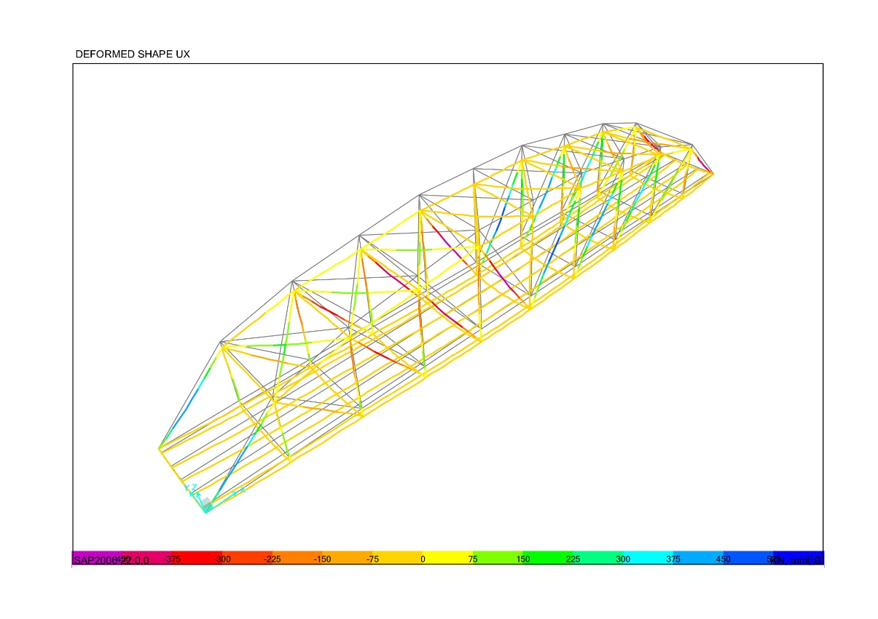

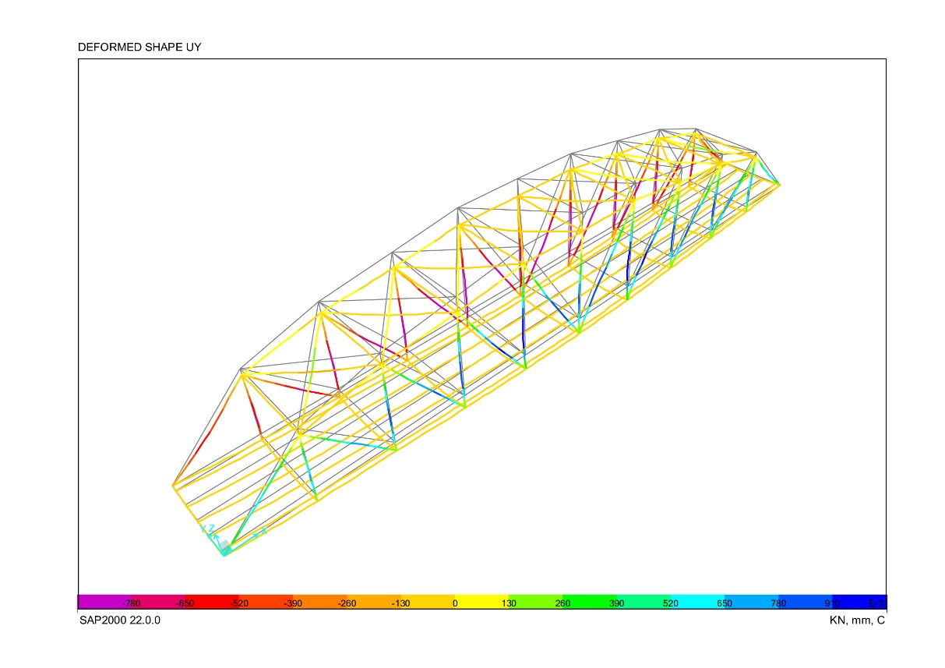



BANGUNAN ATAS JEMBATAN

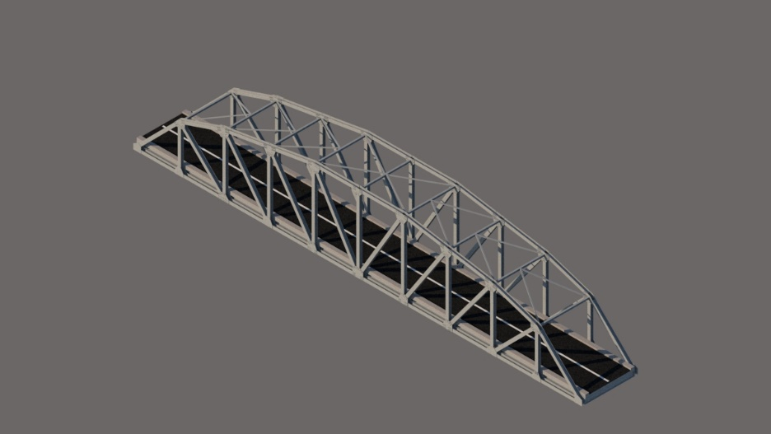

Gambar 3D Jembatan Camelback Truss

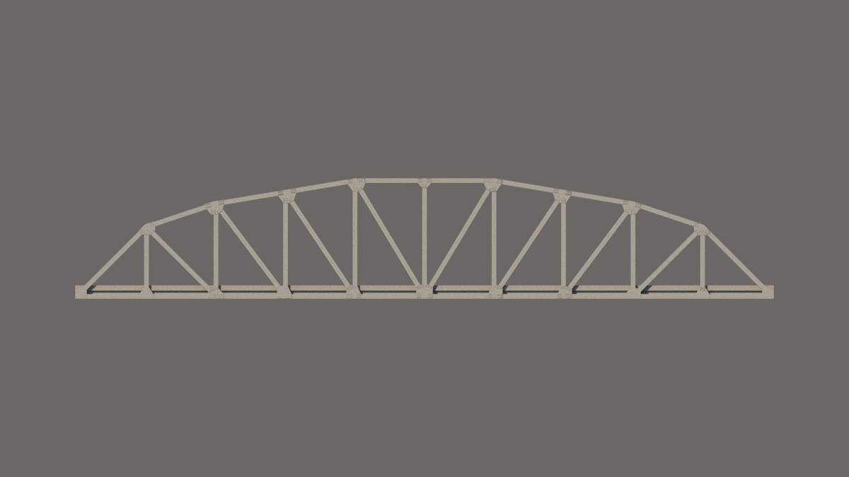

**Tampak Samping Jembatan**

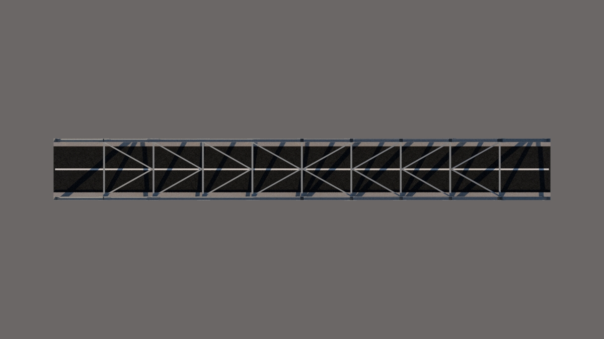

**Tampak Atas Jembatan**

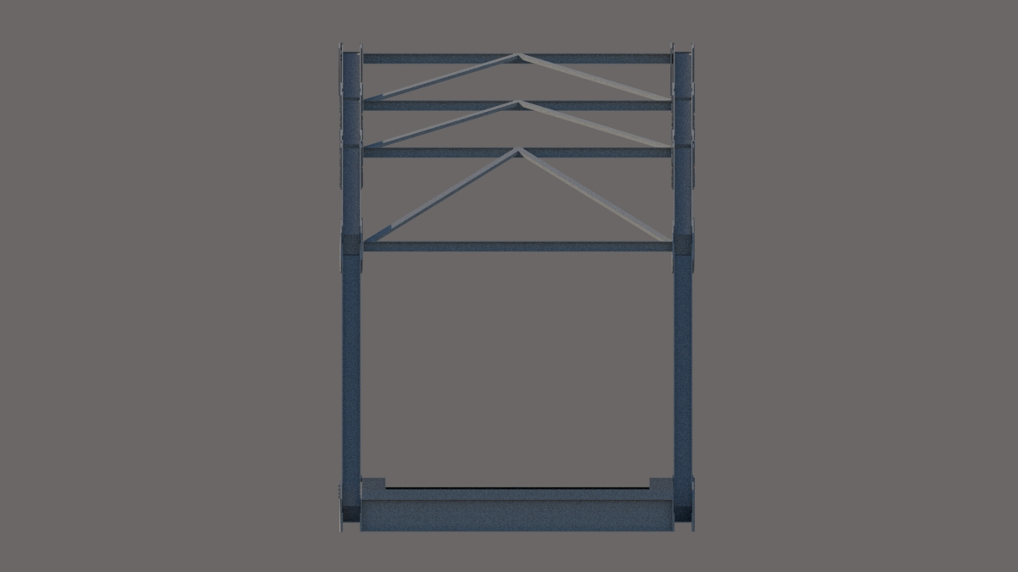

**Tampak Depan Jembatan**

