# DAFTAR PUSTAKA

Adriantasari, S. R., Winarno, B., & Utomo, P. H. (2023). *Klasifikasi Mitra Badan Pusat Statistik Kota Decision Tree Formation for Partner Classification of Salatiga City Statistical Center Using C4 . 5 Algorithm*. *15*, 12–20.

Anwar, C., & Nurhidayat, A. E. (2020). *Perancangan Just In Time Di Proses Produksi Dalam Pengendalian Persediaan Bahan Baku Komponen Otomotif Pada PT Chuhatsu Indonesia*. *2*(2), 51–58.

Apriyanti, R. I., Laksono, F. A., & Dharmawan, R. (2021). *Penerapan Metode Just In Time Untuk Efisiensi Pengendalian Persediaan Bahan Baku Pada Home Industry Winonamodest Cakung Jakarta Timur*. *2*(2).

Diana, F. T. & A. (2001). *Total Quality Management* (revisi). C.V ANDI OFFSET.

Dipa Nusantara, P., Zuli, F., Kurniawan, T. A., Sitorus, H., Kusumawati, K., & Nauli, S. B. (2023). Universitas Satya Negara Indonesia 3,4,5,6Teknik Informatika. *Universitas Satya Negara Indonesia Jln. Arteri Pondok Indah*, *15*(1), 12240. http://dx.doi.org/10.22441/fifo.2023.v15i1.002

I Made Weda Adnyanaa, I. M. S. (2022). *ANALISIS OPTIMASI PERSEDIAAN BAHAN BAKU DENGAN MENGGUNAKAN METODE JUST IN TIME PADA UD . KARIA JAYA*. *2*(3), 292–299.

Istiqomah, P. S., Nandita, W. V., & Sayekti, N. P. (2023). *Pengaruh Implementasi Konsep Just-in-Time terhadap Efisiensi Operasional dan Pengendalian Biaya di Perusahaan Manufaktur ( Studi Kasus PT Waskita Karya Tbk )*. *1*(6), 221–230.

Jannah, B. P. dan L. miftahul. (2016). Metodologi Penelitian Kuantitatif. In *PT Rajagrafindo Persada* (Vol. 3, Issue 2). https://www.infodesign.org.br/infodesign/article/view/355%0Ahttp://www.abergo.org.br/revista/index.php/ae/article/view/731%0Ahttp://www.abergo.org.br/revista/index.php/ae/article/view/269%0Ahttp://www.abergo.org.br/revista/index.php/ae/article/view/106

Maarif, M. S. (n.d.). *Manajemen Operasi*. Grasindo. https://books.google.co.id/books?id=MzZ4T0MjvcAC

Magfirah B, O. S., & Fitri, Y. (2019). Analisis Efisiensi Biaya Produksi Dengan Penggunaan Biaya Standar Dalam Meningkatkan Rasio Net Profit Margin (Studi Empiris Pada Umkm Dendeng Sapi Di Banda Aceh). *Jurnal Ilmiah Mahasiswa Ekonomi Akuntansi*, *4*(2), 334–343. https://doi.org/10.24815/jimeka.v4i2.12262

Maharani, L. S. dan C. (2015). *Analisis pengaruh penerapan*. *XX*(03), 371–386.

Melina Agustina, D. (2016). Analisis Perbandingan Algoritma ID3 Dan C4.5 Untuk Klasifikasi Penerima Hibah Pemasangan Air Minum Pada PDAM Kabupaten Kendal Comparative Analysis Of ID3 And C4.5 Algorithm For Classification Of Grant Recipients Of Drinking Water Installation At PDAM Kend. *Journal of Applied Intelligent System*, *1*(3), 234–244.

Much Aziz Muslim, Budi Prasetiyo, Eva Laily Harum m, Anisa Juli H, Siti Hardiyanti R, A. N. (2019). Data Minng Algoritma C4.5. In *Вестник Росздравнадзора: Vol.* (Issue).

Pristianingrum, N. (2017). *Peningkatan Efisiensi Dan Produktivitas Perusahaan Manufaktur Dengan Sistem Just In Time*. *1*(1), 41–53.

Qurniawati, R. S. (2013). Efisiensi Perbankan Di Indonesia Dan Pengaruhnya Terhadap Return Saham Dengan Pendekatan Data Envelopment Analysis (Dea). *BENEFIT Jurnal Manajemen Dan Bisnis*, *17*(1), 27–40.

Richter, L. E., Carlos, A., & Beber, D. M. (2022). *METODOLOGI PENELITIAN KUANTITATIF*.

Rohyana, C., & Wulandari, C. (2023). Analisis Efisiensi Biaya Operasional Menggunakan Pendekatan Forecasting (Studi Kasus Pt Pos Indonesia Kantor Cabang Garut). *Land Journal*, *4*(2), 134–153. https://doi.org/10.47491/landjournal.v4i1.3045

Rosela, Y. (2019). *IMPLEMENTASI KLASIFIKASI DECISION TREE MENGANALISA STATUS PENJUALAN BARANG MENGGUNAKAN C4 . 5 ( Studi Kasus : Pt . Matahari Department Store Medan Mall )*. *7*, 404–411.

Rosnani Ginting. (2007). *SISTEM PRODUKSI*. Graha Ilmu.

Rusdiana, D. H. A. (2014). *Penerbit CV Pustaka Setia Bandung*. http://digilib.uinsgd.ac.id/8788/1/Buku Manajemen Operasi.pdf

Saputra, N., Muhardi, & Sofiah, P. (2014). Analisis Implementasi Just in Time (Jit) Terhadap Peningkatan Produktivitas Perusahaan Pada Pt. Ras Jaya. *Prosiding Manajemen*, *2*(2), 169–177.

Sari, R. M. (2015). *Prediksi Data Anggaran Pendapatan Belanja Daerah Menggunakan*.

Susanti, S. I. (2021). *Implementasi Just In Time System Dalam Meningkatkan Efisiensi Biaya Persediaan Bahan Baku ( Studi Kasus Pada Perusahaan Much Dessert – Bandung ) Just In Time System Implementation In Increasing Efficiency Of Raw Material Inventory Costs ( Case Study At Mu*. *01*(03), 621–636.

Wahyudi, I. (2023). *Penerapan Just In Time Dalam Meningkatkan Efektivitas Dan Efisiensi Produksi ( Suatu Studi Pada PT Albasi Priangan Lestari Kota Banjar )*.

Wicaksana, I. W. S. (n.d.). *Belajar data mining dengan rapidminer*.

Zahirah, S. H., & Arista, A. (2019). Pengendalian Persediaan Dengan Menggunakan Metode Economy Order Quantity pada Distributor Makanan. *Computer and Science Industrial Engineering (COMASIE)*, *11*(01), 32–41. https://ejournal.itn.ac.id/index.php/valtech/article/view/209

# LAMPIRAN

1. Langkah - langkah penggunaan software *rappidminer*

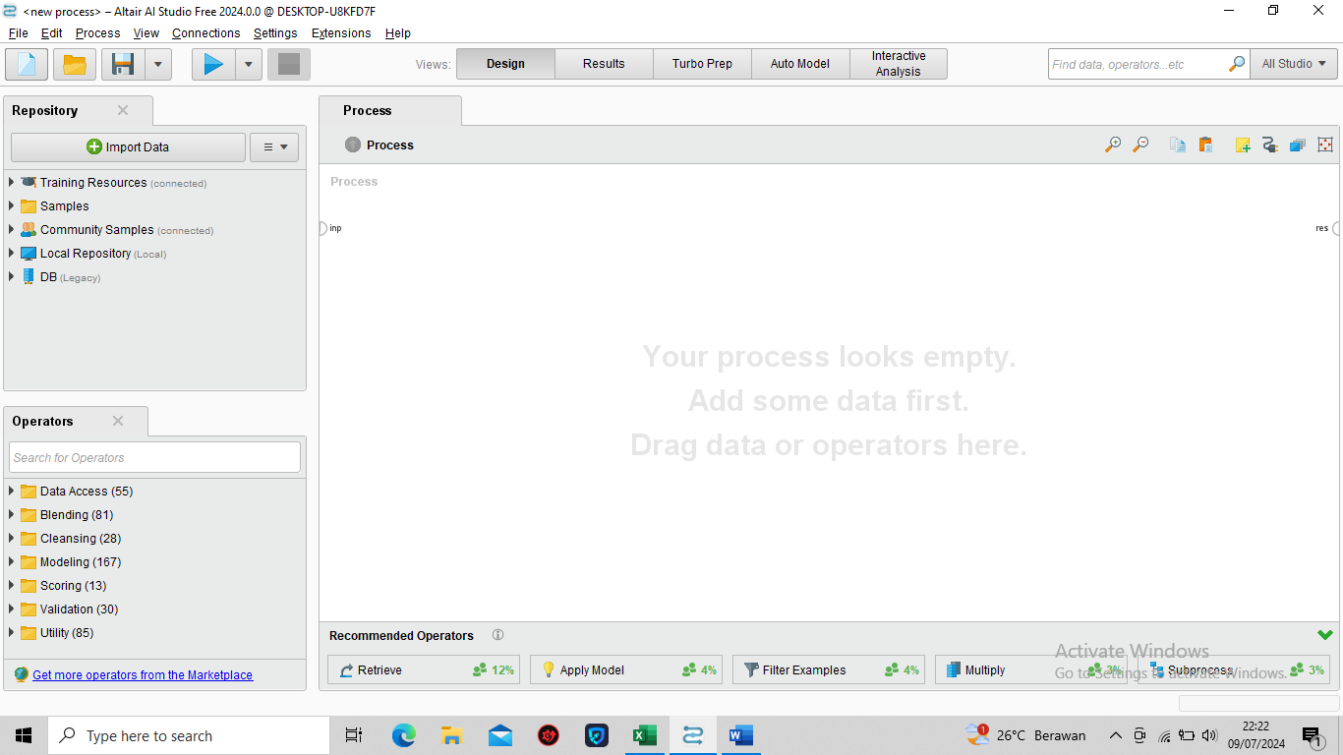

**Lampiran 1** Tampilan Awal Software Rappid Miner

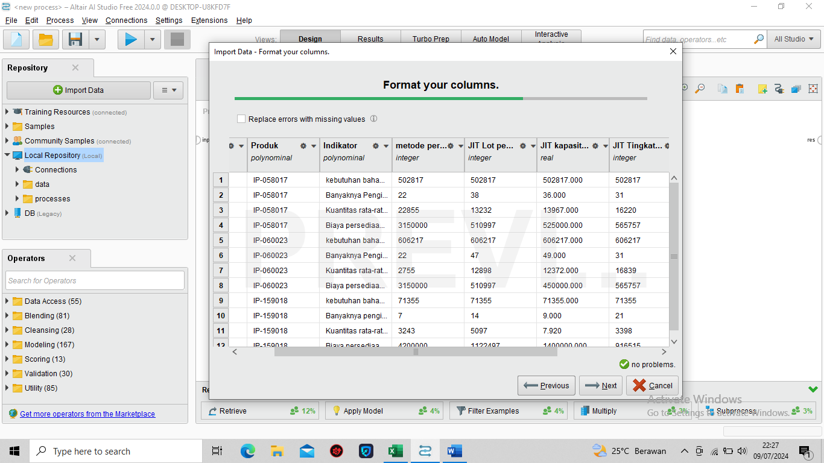

**Lampiran 2** Input data hasil penelitian

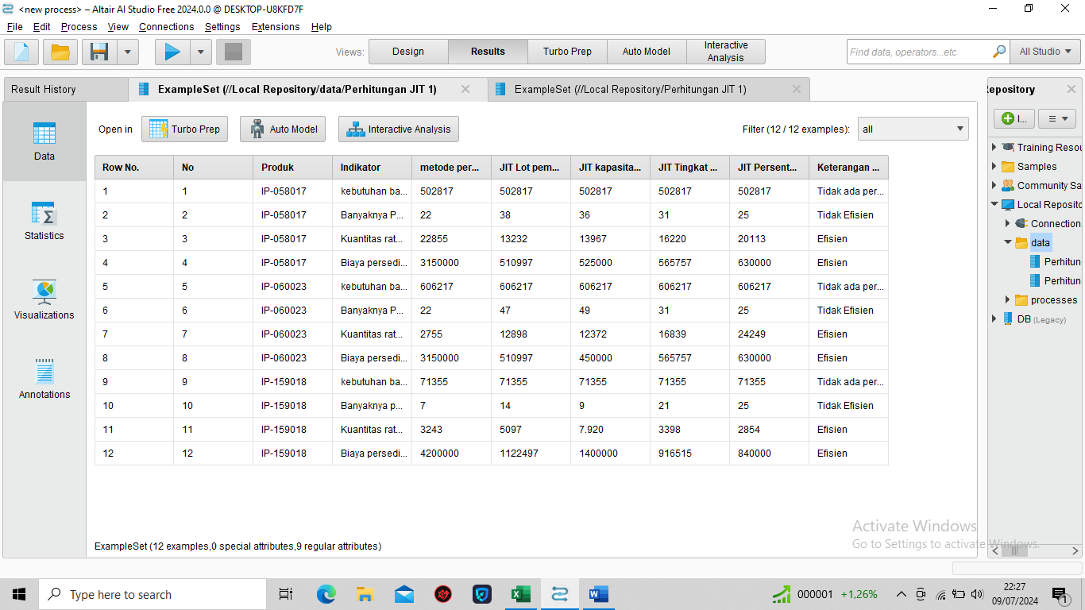

**Lampiran 3** Data yang akan diolah

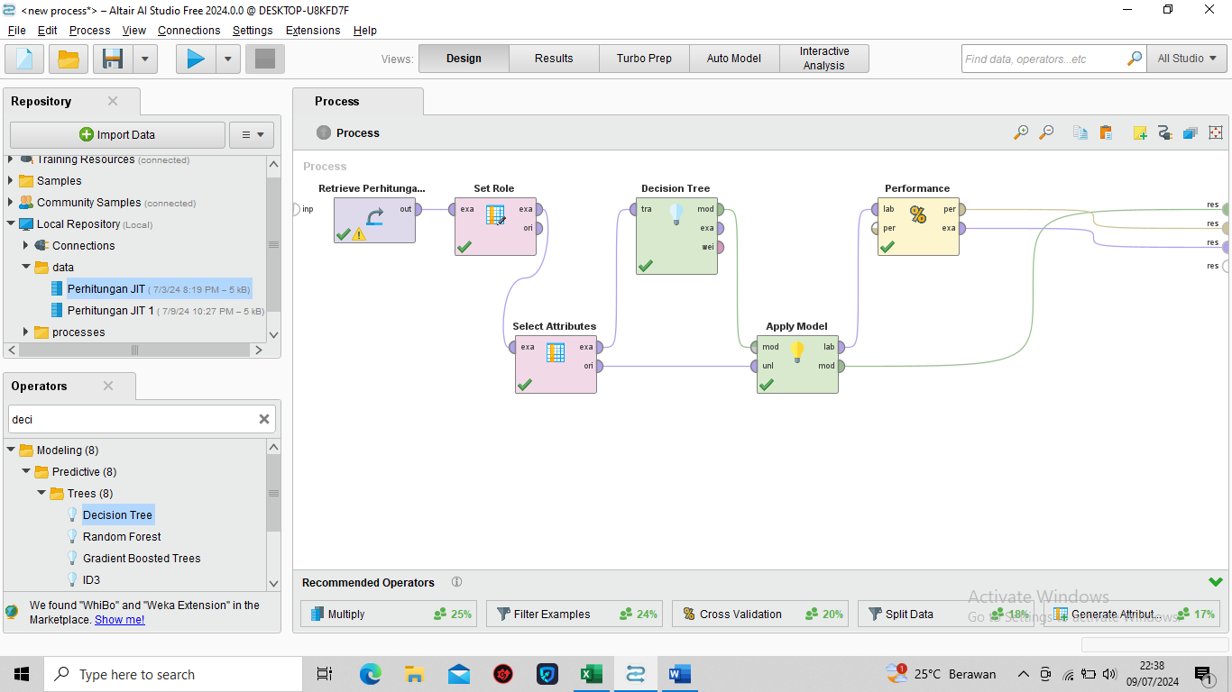

**Lampiran 4** Tools Decision Tree

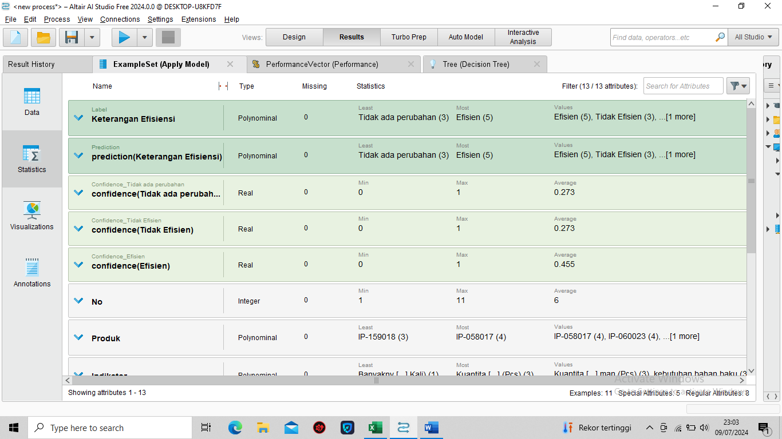

**Lampiran 5** Hasil Pengolahan Data

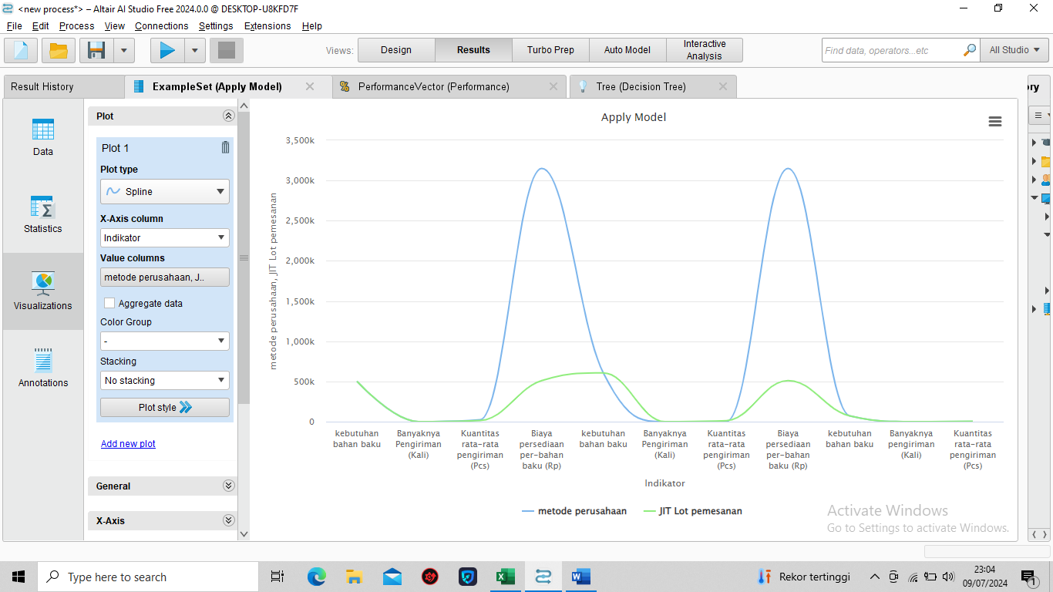

**Lampiran 6** Grafik Perbandingan

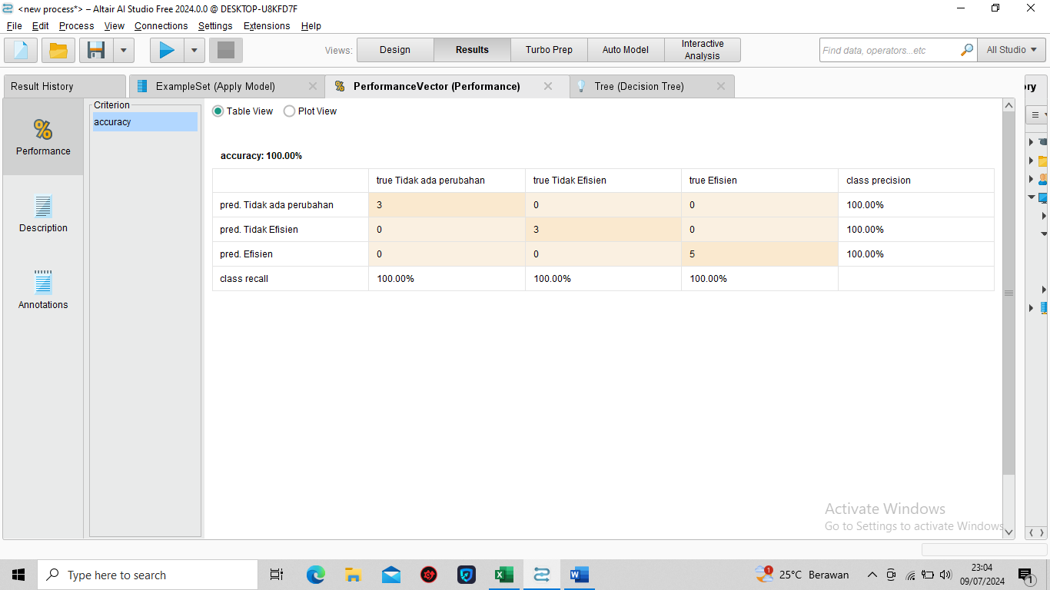

**Lampiran 7** Nilai Accuracy Performance

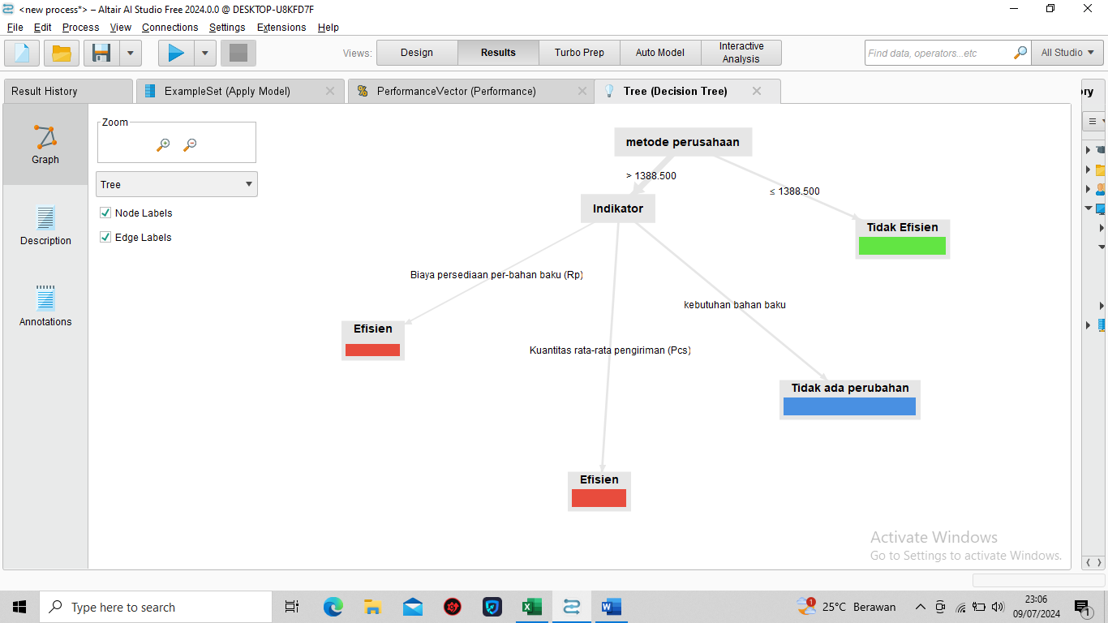

**Lampiran 8** Decision Tree berdasarkan Efisiensi

1. Dokumentasi Penelitian

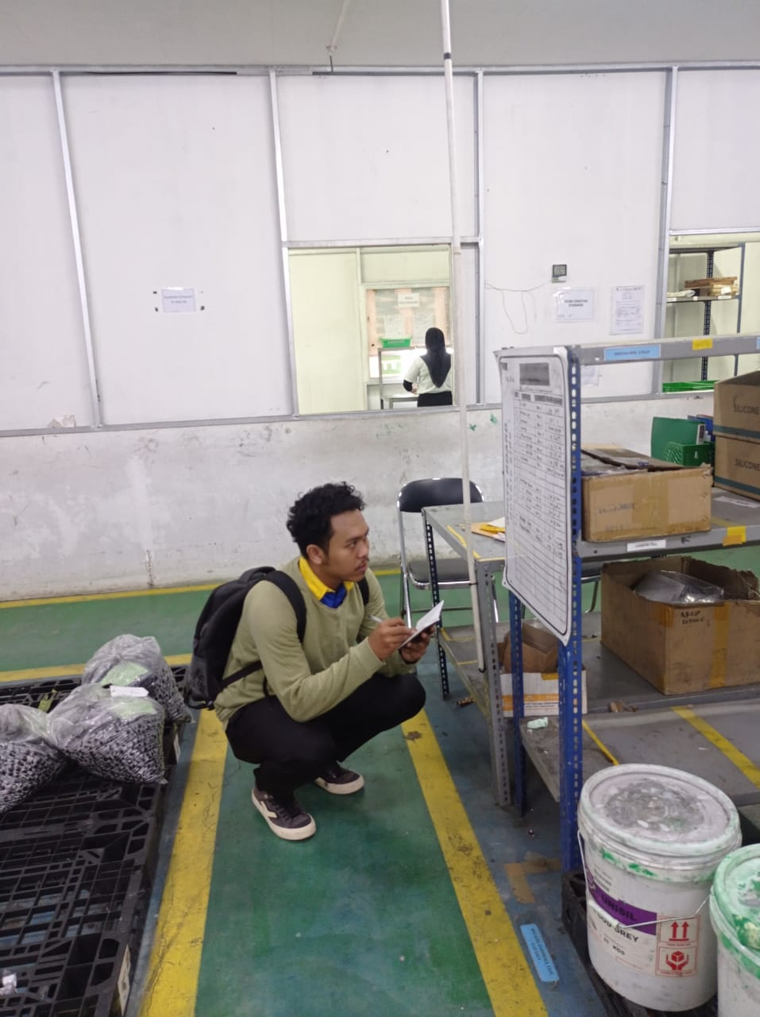

**Lampiran 9** Pengambilan Data Perusahaan

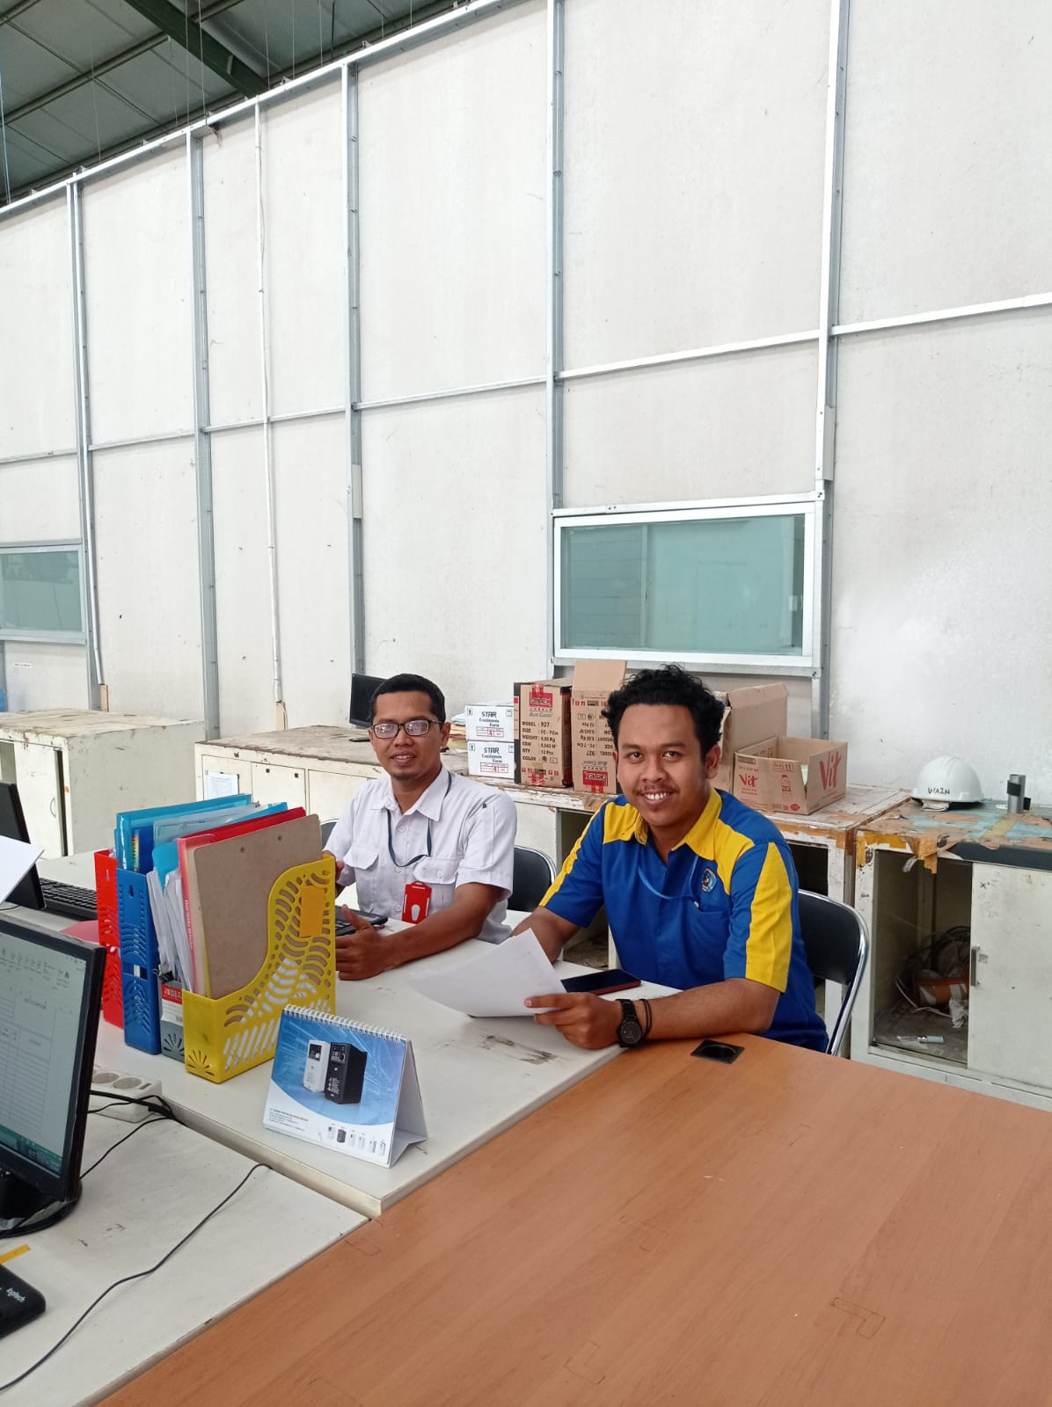

**Lampiran 10** Wawancara Pada Departemen Inventory

1. *Data Perusahaan*
2. Data Persediaan Awal Bulan Januari – Desember 2023

|  |  |  |  |  |  |  |  |  |
| --- | --- | --- | --- | --- | --- | --- | --- | --- |
|  | **PERIODE** | **PRODUK** | | | | | | |
| **No** | **IP-058017 (Lot)** | **IP-060023 (Lot)** | **IP-090015 (Lot)** | **IP-106007 (Lot)** | **IP-122024 (Lot)** | **IP-159018 (Lot)** | **IP-169001 (Lot)** |
| **1** | **Januari** | 30 | 45 | 0 | 1 | 5 | 20 | 3 |
| **2** | **Februari** | 36 | 16 | 9 | 5 | 3 | 7 | 0 |
| **3** | **Maret** | 26 | 14 | 7 | 0 | 6 | 18 | 0 |
| **4** | **April** | 23 | 12 | 5 | 0 | 3 | 9 | 0 |
| **5** | **Mei** | 33 | 21 | 8 | 6 | 4 | 26 | 1 |
| **6** | **Juni** | 15 | 8 | 13 | 3 | 0 | 20 | 0 |
| **7** | **Juli** | 15 | 23 | 9 | 5 | 0 | 17 | 1 |
| **8** | **Agustus** | 23 | 15 | 9 | 1 | 0 | 21 | 3 |
| **9** | **September** | 38 | 12 | 8 | 2 | 8 | 24 | 1 |
| **10** | **Oktober** | 24 | 9 | 0 | 3 | 0 | 17 | 0 |
| **11** | **November** | 9 | 16 | 0 | 0 | 4 | 8 | 0 |
| **12** | **Desember** | 17 | 31 | 2 | 0 | 0 | 13 | 0 |

1. Data *Finish Good* dan Kebutuhan Produksi

|  |  |  |  |  |  |  |  |
| --- | --- | --- | --- | --- | --- | --- | --- |
|  | **Periode** | ***Finish Good*** | | | **Kebutuhan Bahan Baku** | | |
| **No** | **IP-058017 (Pcs)** | **IP-060023 (Pcs)** | **IP -159018 (Pcs)** | **IP - 058017 (Pcs)** | **IP - 060023 (Pcs)** | **IP - 159018 (Pcs)** |
| **1** | **Januari** | 102.539 | 175.841 | 17.879 | 106.811 | 183.168 | 18.624 |
| **2** | **Februari** | 6.653 | 1.521 | 7.860 | 6.930 | 1.584 | 7.682 |
| **3** | **Maret** | 63.645 | 55.204 | 5.394 | 66.297 | 57.504 | 5.619 |
| **4** | **April** | 76.998 | 16.174 | 1.961 | 80.206 | 16.848 | 2.043 |
| **5** | **Mei** | 90.559 | 29.215 | 3.851 | 94.332 | 30.432 | 4.011 |
| **6** | **Juni** | 0 | 26.817 | 1.503 | 0 | 27.934 | 1.566 |
| **7** | **Juli** | 8.940 | 29.445 | 4.563 | 9.312 | 30.672 | 4.753 |
| **8** | **Agustus** | 26.832 | 32.899 | 4.302 | 27.950 | 34.270 | 4.481 |
| **9** | **September** | 26.784 | 32.899 | 4.304 | 27.900 | 34.270 | 4.483 |
| **10** | **Oktober** | 26.868 | 32.899 | 5.851 | 27.987 | 34.270 | 6.095 |
| **11** | **November** | 32.264 | 65.388 | 6.459 | 33.608 | 68.112 | 6.728 |
| **12** | **Desember** | 20.625 | 83.667 | 4.573 | 21.484 | 87.153 | 4.728 |
| **Total** | | 482.704 | 581.968 | 68.501 | 502.817 | 606.217 | 71.355 |

1. Biaya Persediaan

|  |  |  |  |
| --- | --- | --- | --- |
| **No** | **Biaya pemesanan** | Biaya (Rp) | |
| 1 | Biaya Wifi, Telepon, materai | | 2.000.000 |
| 2 | Biaya administrasi | | 1.500.000 |
| 3 | Biaya pengiriman dan transportasi | | 2.500.000 |
|  | **Total Biaya Pemesanan** | | **6.000.000** |
| **No** | **Biaya Penyimpanan** | | |
| 1 | Biaya pemeliharaan bahan baku | | 26.000.000 |
| 2 | Biaya resiko kerugian | | 5.300.000 |
| 3 | Biaya listrik gudang | | 4.700.000 |
|  | **Total Biaya Penyimpanan** | | **36.000.000** |
| **Total biaya persediaan** | | | **42.000.000** |

1. Data Produk
2. IP-058017 (PT. Isuzu Astra Motor Indonesia)

|  |  |  |  |  |  |  |  |  |  |  |
| --- | --- | --- | --- | --- | --- | --- | --- | --- | --- | --- |
| **PERIODE** | **Persediaan Awal** | | **Pembelian** | | **Kebutuhan Bahan Baku** | | **Persediaan Akhir** | | **Jumlah Pembelian (Rupiah)** | **Frekuensi (Kali)** |
| **Lot** | **Pcs** | **Lot** | **Pcs** | **pcs** | **Lot** | **Lot** | **Pcs** |
| **Januari** | 30 | 21.000 | 159 | 111300 | 153 | 106.811 | 36 | 25.200 | 5.565.000 | 4 |
| **Februari** | 36 | 25.200 | - | - | 10 | 6.930 | 26 | 18.200 | - | - |
| **Maret** | 26 | 18.200 | 92 | 64400 | 95 | 66.297 | 23 | 16.100 | 3.220.000 | 3 |
| **April** | 23 | 16.100 | 125 | 87500 | 115 | 80.206 | 33 | 23.100 | 4.375.000 | 4 |
| **Mei** | 33 | 23.100 | 117 | 81900 | 135 | 94.332 | 15 | 10.500 | 4.095.000 | 3 |
| **Juni** | 15 | 10.500 | - | - | - | - | 15 | 10.500 | *-* | - |
| **Juli** | 15 | 10.500 | 21 | 14700 | 13 | 9.312 | 23 | 16.100 | 735.000 | 1 |
| **Agustus** | 23 | 16.100 | 55 | 38500 | 40 | 27.950 | 38 | 26.600 | 1.925.000 | 2 |
| **September** | 38 | 26.600 | 26 | 18200 | 40 | 27.900 | 24 | 16.800 | 910.000 | 1 |
| **Oktober** | 24 | 16.800 | 25 | 17500 | 40 | 27.987 | 9 | 6.300 | 875.000 | 1 |
| **November** | 9 | 6.300 | 56 | 39200 | 48 | 33.608 | 17 | 11.900 | 1.960.000 | 2 |
| **Desember** | 17 | 11.900 | 20 | 14000 | 31 | 21.484 | 6 | 4.200 | 700.000 | 1 |
| **Jumlah** | **289** | **202.300** | **696** | **487.200** | **718** | **502.817** | **265** | **185.500** | **24.360.000** | **22** |

1. IP-060023 (PT. Nichias Metalwork Indonesia)

|  |  |  |  |  |  |  |  |  |  |  |
| --- | --- | --- | --- | --- | --- | --- | --- | --- | --- | --- |
| **Bulan** | **Persediaan awal** | | **Pembelian** | | **Kebutuhan produksi** | | **Persediaan akhir** | | **Jumlah Pembelian (Rupiah)** | **Frekuensi (Kali)** |
| **Lot** | **Pcs** | **Lot** | **Pcs** | **Lot** | **Pcs** | **Lot** | **Pcs** |
| **Januari** | **45** | 36.000 | 200 | 160.000 | 229 | 183.168 | 16 | 12.832 | 7.600.000 | 6 |
| **Februari** | **16** | 12.800 | 0 | 0 | 2 | 1.584 | 14 | 11.216 | - | 0 |
| **Maret** | **14** | 11.200 | 70 | 56.000 | 72 | 57.504 | 12 | 9.696 | 2.660.000 | 2 |
| **April** | **12** | 9.600 | 30 | 24.000 | 21 | 16.848 | 21 | 16.752 | 1.140.000 | 1 |
| **Mei** | **21** | 16.800 | 25 | 20.000 | 38 | 30.432 | 8 | 6.368 | 950.000 | 1 |
| **Juni** | **8** | 6.400 | 50 | 40.000 | 35 | 27.934 | 23 | 18.466 | 1.900.000 | 1 |
| **Juli** | **23** | 18.400 | 30 | 24.000 | 38 | 30.672 | 15 | 11.728 | 1.140.000 | 1 |
| **Agustus** | **15** | 12.000 | 40 | 32.000 | 43 | 34.270 | 12 | 9.730 | 1.520.000 | 1 |
| **September** | **12** | 9.600 | 40 | 32.000 | 43 | 34.270 | 9 | 7.330 | 1.520.000 | 2 |
| **Oktober** | **9** | 7.200 | 50 | 40.000 | 43 | 34.270 | 16 | 12.930 | 1.900.000 | 1 |
| **November** | **16** | 12.800 | 100 | 80.000 | 85 | 68.112 | 31 | 24.688 | 3.800.000 | 3 |
| **Desember** | **31** | 24.800 | 100 | 80.000 | 109 | 87.153 | 22 | 17.647 | 3.800.000 | 3 |
| **Jumlah** | **222** | **177.600** | **735** | **588.000** | **758** | **606.217** | **199** | **159.383** | **27.930.000** | **22** |

1. IP-159018 (PT. Chemco Astra Indonesia)

|  |  |  |  |  |  |  |  |  |  |  |
| --- | --- | --- | --- | --- | --- | --- | --- | --- | --- | --- |
| **Bulan** | **Persediaan awal** | | **Pembelian** | | **Kebutuhan Bahan Baku** | | **Persediaan akhir** | | **Jumlah Pembelian (Rupiah)** | **Frekuensi** |
| **Lot** | **Pcs** | **Lot** | **Pcs** | **Lot** | **Pcs** | **Lot** | **Pcs** |
| **Januari** | 20 | 13.000 | 18 | 11.700 | 29 | 18.624 | 9 | 6.076 | 900.000 | 1 |
| **Februari** | 9 | 5.850 | 21 | 13.650 | 12 | 8.188 | 18 | 11.818 | 1.050.000 | 1 |
| **Maret** | 18 | 11.700 | 0 | 0 | 9 | 5.619 | 9 | 6.081 | - | 0 |
| **April** | 9 | 5.850 | 20 | 13.000 | 3 | 2.043 | 26 | 16.807 | 1.000.000 | 1 |
| **Mei** | 26 | 16.900 | 0 | 0 | 6 | 4.011 | 20 | 12.889 | - | 0 |
| **Juni** | 20 | 13.000 | 0 | 0 | 3 | 1.566 | 17 | 11.110 | - | 0 |
| **Juli** | 17 | 11.050 | 11 | 7.150 | 7 | 4.753 | 21 | 13.447 | 550.000 | 1 |
| **Agustus** | 21 | 13.650 | 10 | 6.500 | 7 | 4.481 | 24 | 15.669 | 500.000 | 1 |
| **September** | 24 | 15.600 | 0 | 0 | 7 | 4.483 | 17 | 11.117 | - | 0 |
| **Oktober** | 17 | 11.050 | 0 | 0 | 9 | 6.095 | 8 | 4.955 | - | 0 |
| **November** | 8 | 5.200 | 15 | 9.750 | 10 | 6.728 | 13 | 8.222 | 750.000 | 1 |
| **Desember** | 13 | 8.450 | 10 | 6.500 | 8 | 5.073 | 15 | 9.877 | 500.000 | 1 |
| **Jumlah** | **202** | **131.300** | **105** | **68.250** | **110** | **71.355** | **197** | **128.068** | **Rp 5.250.000** | **7** |

1. Data Kapasitas Bahan Baku dan Rata-rata Persediaan dalam satu tahun terakhir

|  |  |  |  |  |  |
| --- | --- | --- | --- | --- | --- |
| **No** | **Produk** | **Kapasitas Bahan Baku** | | **Rata-rata Persediaan** | |
| **Lot** | **Pcs** | **Lot** | **Pcs** |
| 1 | IP-058017 | 120 | 84.000 | 65 | 45.500 |
| 2 | IP-060023 | 108 | 86.400 | 78 | 54.400 |
| 3 | IP-159018 | 36 | 23.400 | 12 | 7.800 |