# DAFTAR PUSTAKA

Abdillah. 2014. “Program Linear.” *Paper Knowledge . Toward a Media History of Documents* 5(2): 40–51.

Aji, Gagas Gayuh, and Amak Mohamad Yaqoub. 2016. “Identifikasi Penyebab Bullwhip Effect Pada Distribusi PT Alfian Jaya Di Bali.” *Journal of Theoretical and Applied Management (Jurnal Manajemen Teori dan Terapan)* 8(2 SE-Articles). doi:10.20473/jmtt.v8i2.2729.

Amimah, Faizatul, and Putu Wati. 2023. “Optimalisasi Persediaan Pakan Udang Menggunakan Linear Programming Guna Meminimalkan Biaya Persediaan Pada Pt. Universal Agri Bisnisindo Banyuwangi.” *i tabaos* 3(3 SE-Articles). doi:10.30598/i-tabaos.2023.3.3.134-142.

Ardyan, E, Y Boari, A Akhmad, L Yuliyani, H Hildawati, A Suarni, D Anurogo, et al. 2023. *Metode Penelitian Kualitatif Dan Kuantitatif : Pendekatan Metode Kualitatif Dan Kuantitatif Di Berbagai Bidang*. PT. Sonpedia Publishing Indonesia.

Arif, M. 2018. *Supply Chain Management*. Deepublish.

Astuti, S M. 2022. *Operations Research Edisi 2*. Media Nusa Creative (MNC Publishing).

Azhari, Dhawam Yuangga, Emmalia Adriantantri, and Sujianto3. 2020. “Optimasi Perencanaan Produksi Menggunakan Linier Progamming Dan Perencanaan Bahan Baku Di CV. Widi Kauza, Malang.” *Jurnal Valtech (Jurnal Mahasiswa Teknik Industri)* 3(2): 200–204.

Blongkod, Rostianti, Ventje Ilat, Lidia M Mawikere, Fakultas Ekonomi, Dan Bisnis, Jurusan Akuntansi, Sam Ratulangi, and Jl Kampus Bahu. 2023. “Analisis Pengendalian Persediaan Bahan Baku Dengan Konsep Economic Order Quantity (Eoq) Pada Cv Bregas Likupang Timur Minahasa Utara.” *Going Concern : Jurnal Riset Akuntansi* 18(1): 24–34. https://ejournal.unsrat.ac.id/v3/index.php/gc/article/download/47022/42044/108208.

Cindy Permata Dewi, Cornelia. 2022. “Penerapan Pencatatan Akuntansi Persediaan Barang Dagang Berdasarkan PSAK No.14 Pada Toko Online Shop Cutiestore.Co.” *Sinomika Journal: Publikasi Ilmiah Bidang Ekonomi dan Akuntansi* 1(2): 145–52. doi:10.54443/sinomika.v1i2.167.

Dewi, Fenny Rubbayanti, and Annisa Kesy Garside. 2016. “Pengurangan Bullwhip Effect Dengan Metode Vendor Managed Inventory.” *Jurnal Optimasi Sistem Industri* 14(2 SE-Articles): 292–98. doi:10.25077/josi.v14.n2.p292-298.2015.

Eunike, A, N W Setyanto, R Yuniarti, I Hamdala, R P Lukodono, and A A Fanani. 2021. *Perencanaan Produksi Dan Pengendalian Persediaan: Edisi Revisi*. Universitas Brawijaya Press.

Fradinata, E. 2022. *Pesanan Pembelian Dalam Rantai Pasok*. Syiah Kuala University Press.

Gofur, Abdul. 2009. “Aplikasi Program Linier Menggunakan Lindo Pada Optimalisasi Biaya Bahan Baku Pembuatan Rokok PT. Djarum Kudus.” *Tesis*: 1–132.

Habib, Mamun. 2011. “Supply Chain Management (SCM): Theory and Evolution.” In ed. Mamun Habib. Rijeka: IntechOpen, Ch. 1. doi:10.5772/24573.

Hanifa, Dina Silmi. 2022. “Optimasi Keuntungan Produksi Olahan Salak Pondoh Di Desa Wisata Pulesari Dengan Metode Integer Linear Programming.” *Journal of Mathematics* 11(1): 69–79.

Hapsari, VY. 2013. “Bab Ii Economic Order Quantity.” : 12–39.

Hendrayanti, S, W Fauziyanti, and E P Estuti. 2022. *Konsep Dasar Manajemen Keuangan*. Penerbit NEM.

Herjanto, E. *Manajemen Operasi (Edisi 3)*. Grasindo.

Hidayah, Amalia Amanda, Erwin Harahap, and Farid H. Badruzzaman. 2022. “Optimasi Keuntungan Bisnis Bakery Menggunakan Program Linear Metode Simpleks.” *Jurnal Matematika* 21(1): 77–83.

Hollmann, Roberto, Luiz Scavarda, and Antonio Marcio Thomé. 2015. “Collaborative Planning, Forecasting and Replenishment: A Literature Review.” *International Journal of Productivity and Performance Management* 64: 971–93. doi:10.1108/IJPPM-03-2014-0039.

Huwaida, H. 2020. *Program Linier*. Deepublish.

Indah, Dewi Rosa, and Purnita Sari. 2019. “Penerapan Model Linear Programming Untuk Mengoptimalkan Jumlah Produksi Dalam Memperoleh Keuntungan Maksimal (Studi Kasus Pada Usaha Angga Perabot).” *J M I Jurnal Manajemen Inovasi* 10(2): 98–115. http://www.jurnal.unsyiah.ac.id/JInoMan.

Ir. Sarbini, M T. 2023. *Buku Ajar Supply Chain Management Untuk Industri Menengah Kecil*. Media Nusa Creative (MNC Publishing).

Komala, A L, D Suprayitno, L O Sabaruddin, N Nurdiansyah, H A Pongoh, M Rifni, S Kurniawan, et al. 2024. *Buku Ajar Supply Chain Management*. PT. Sonpedia Publishing Indonesia.

Maarif, M S. *Manajemen Operasi*. Grasindo.

*Manajemen Biaya 1 (Ed. 3)*. Penerbit Salemba.

Martono, R V. 2019. *Dasar-Dasar Manajemen Rantai Pasok*. Bumi Aksara.

Martono, R V. 2020. *Supply Chain 4.0: Berbasis Blockchain Dan Platform*. Gramedia Pustaka Utama.

Mukhsin, M. 2022. *Membangun Kualitas Hubungan Rantai Pasokan*. https://eprints.untirta.ac.id/22181/1/10. Buku Digital - Membangun Kualitas Hubungan Rantai Pasok.pdf.

Pianda, D. 2018. *Optimasi Perencanaan Produksi Pada Kombinasi Produk Dengan Metode Linear Programming*. CV Jejak (Jejak Publisher).

Purnomo, Hery, and Lilia Pasca Riani. 2018. “Optimasi Pengendalian Persediaan.” *Hery Purnomo*: 122.

Rachmatika, R. 2022. *Implementasi Teknik Riset Operasional Dengan Metode Linear Programming*. Pascal Books.

Rosmasari, Adisti, and Wandhansari Sekar Jatiningrum. 2021. “Optimasi Produksi Untuk Meminimasi Total Biaya Pada Usaha Mikro Kecil Menengah.” *Jurnal Rekayasa Sistem Industri* 10(1): 15–26. doi:10.26593/jrsi.v10i1.4491.15-26.

Santoso, M, and Tedjo Sukmono. 2023. *Analysis of Optimization of Raw Material Inventory Control Using the Linear Programming Method: Analisis Optimalisasi Pengendalian Persediaan Bahan Baku Menggunakan Metode Linear Programming*. doi:10.21070/ups.3360.

Saxena, R S. 2009. *Inventory Management: Controlling in a Fluctuating Demand Environment*. Global India Publications Pvt. Limited.

Setiajatnika, Eka, and Muhamad Ardi Nupi Hasyim. 2019. “Strategi Bersaing Dalam Meningkatkan Kinerja Perusahaan Pada Bisnis Jasa Perhotelan.” *Coopetition : Jurnal Ilmiah Manajemen* 10(1): 23–28. doi:10.32670/coopetition.v10i1.27.

Setiyani, Tita Talitha, Saufik Luthfianto. 2023. “Optimasi Pembelian Bahan Baku Menggunakan Software Lingo.” : 27–36.

Siagian, Y M. *Aplikasi Supply Chain Management ...* Grasindo.

Stadtler, H, and C Kilger. 2007. *Supply Chain Management and Advanced Planning: Concepts, Models, Software, and Case Studies*. Springer Berlin

Syamil, A, R D M Danial, S Saori, E Waty, M A Fahmi, V Hartati, R P Ishak, et al. 2023. *Buku Ajar Manajemen Rantai Pasok*. PT. Sonpedia Publishing Indonesia.

Syamil, Ahmad, R. Deni Muhammad Danial, Sopyan Saori, Ervina Waty, Muhammad Ainul Fahmi, Verani Hartati, and Riani Prihatini Ishak. 2023. 1 International Journal of Refrigeration *Buku Ajar Manajemen Rantai Pasok*.

Williams, M. 2000. “Making Consignment- and Vendor-Managed Inventory Work for You.” *Hospital materiel management quarterly* 21: 59–63.

# LAMPIRAN

Lampiran 1. 1 Input Perangkat Lunak Lingo

!FUNGSI TUJUAN;

MIN=5700*X1_1+5700*X1_2+5700*X1_3+5700*X1_4+5700*X1_5+5700*X1_6+5700*X1_7+5700*X1_8+5700*X1_9+5700*X1_10+5700*X1_11+5700*X1_12+3300*X2_1+3300*X2_2+3300*X2_3+3300*X2_4+3300*X2_5+3300*X2_6+3300*X2_7+3300*X2_8+3300*X2_9+3300*X2_10+3300*X2_11+3300*X2_12+3400*X3_1+3400*X3_2+3400*X3_3+3400*X3_4+3400*X3_5+3400*X3_6+3400*X3_7+3400*X3_8+3400*X3_9+3400*X3_10+3400*X3_11+3400*X3_12+3000*X4_1+3000*X4_2+3000*X4_3+3000*X4_4+3000*X4_5+3000*X4_6+3000*X4_7+3000*X4_8+3000*X4_9+3000*X4_10+3000*X4_11+3000*X4_12+14000*X5_1+14000*X5_2+14000*X5_3+14000*X5_4+14000*X5_5+14000*X5_6+14000*X5_7+14000*X5_8+14000*X5_9+14000*X5_10+14000*X5_11+14000*X5_12+10000*X6_1+10000*X6_2+10000*X6_3+10000*X6_4+10000*X6_5+10000*X6_6+10000*X6_7+10000*X6_8+10000*X6_9+10000*X6_10+10000*X6_11+10000*X6_12+3500*X7_1+3500*X7_2+3500*X7_3+3500*X7_4+3500*X7_5+3500*X7_6+3500*X7_7+3500*X7_8+3500*X7_9+3500*X7_10+3500*X7_11+3500*X7_12;

!FUNGSI BATASAN;

X1_1-12 <= 50000;

X2_1-12 <= 25000;

X3_1-12 <= 1000;

X4_1-12 <= 1500;

X5_1-12 <= 5000;

X6_1-12 <= 4000;

X7_1-12 <= 40000;

X1_1 >= 24600;

X1_2 >= 30000;

X1_3 >= 25800;

X1_4 >= 26000;

X1_5 >= 28000;

X1_6 >= 31000;

X1_7 >= 29500;

X1_8 >= 33000;

X1_9 >= 25300;

X1_10 >= 25000;

X1_11 >= 24100;

X1_12 >= 25000;

X2_1 >= 6600;

X2_2 >= 7100;

X2_3 >= 6700;

X2_4 >= 7100;

X2_5 >= 8000;

X2_6 >= 10200;

X2_7 >= 9500;

X2_8 >= 11300;

X2_9 >= 7200;

X2_10 >= 7000;

X2_11 >= 6500;

X2_12 >= 7000;

X3_1 >= 60;

X3_2 >= 105;

X3_3 >= 75;

X3_4 >= 65;

X3_5 >= 70;

X3_6 >= 100;

X3_7 >= 95;

X3_8 >= 110;

X3_9 >= 70;

X3_10 >= 65;

X3_11 >= 60;

X3_12 >= 65;

X4_1 >= 180;

X4_2 >= 250;

X4_3 >= 200;

X4_4 >= 220;

X4_5 >= 240;

X4_6 >= 290;

X4_7 >= 245;

X4_8 >= 300;

X4_9 >= 180;

X4_10 >= 185;

X4_11 >= 175;

X4_12 >= 185;

X5_1 >= 750;

X5_2 >= 875;

X5_3 >= 880;

X5_4 >= 900;

X5_5 >= 950;

X5_6 >= 1000;

X5_7 >= 850;

X5_8 >= 1100;

X5_9 >= 800;

X5_10 >= 760;

X5_11 >= 700;

X5_12 >= 760;

X6_1 >= 600;

X6_2 >= 800;

X6_3 >= 650;

X6_4 >= 700;

X6_5 >= 750;

X6_6 >= 900;

X6_7 >= 780;

X6_8 >= 950;

X6_9 >= 600;

X6_10 >= 630;

X6_11 >= 600;

X6_12 >= 630;

X7_1 >= 15000;

X7_2 >= 17800;

X7_3 >= 15500;

X7_4 >= 16000;

X7_5 >= 18000;

X7_6 >= 20000;

X7_7 >= 17500;

X7_8 >= 20000;

X7_9 >= 15000;

X7_10 >= 15200;

X7_11 >= 15000;

X7_12 >= 15200;

!BATASAN NON NEGATIF;

X1<=0;

X2<=0;

X3<=0;

X4<=0;

X5<=0;

X6<=0;

X7<=0;

Lampiran 1. 2 Output Perangkat Lunak *Lingo*

Global optimal solution found.

Objective value: 0.3118766E+10

Infeasibilities: 0.000000

Total solver iterations: 0

Elapsed runtime seconds: 0.08

Model Class: LP

Total variables: 91

Nonlinear variables: 0

Integer variables: 0

Total constraints: 99

Nonlinear constraints: 0

Total nonzeros: 182

Nonlinear nonzeros: 0

Variable Value Reduced Cost

X1_1 24600.00 0.000000

X1_2 30000.00 0.000000

X1_3 25800.00 0.000000

X1_4 26000.00 0.000000

X1_5 28000.00 0.000000

X1_6 31000.00 0.000000

X1_7 29500.00 0.000000

X1_8 33000.00 0.000000

X1_9 25300.00 0.000000

X1_10 25000.00 0.000000

X1_11 24100.00 0.000000

X1_12 25000.00 0.000000

X2_1 6600.000 0.000000

X2_2 7100.000 0.000000

X2_3 6700.000 0.000000

X2_4 7100.000 0.000000

X2_5 8000.000 0.000000

X2_6 10200.00 0.000000

X2_7 9500.000 0.000000

X2_8 11300.00 0.000000

X2_9 7200.000 0.000000

X2_10 7000.000 0.000000

X2_11 6500.000 0.000000

X2_12 7000.000 0.000000

X3_1 60.00000 0.000000

X3_2 105.0000 0.000000

X3_3 75.00000 0.000000

X3_4 65.00000 0.000000

X3_5 70.00000 0.000000

X3_6 100.0000 0.000000

X3_7 95.00000 0.000000

X3_8 110.0000 0.000000

X3_9 70.00000 0.000000

X3_10 65.00000 0.000000

X3_11 60.00000 0.000000

X3_12 65.00000 0.000000

X4_1 180.0000 0.000000

X4_2 250.0000 0.000000

X4_3 200.0000 0.000000

X4_4 220.0000 0.000000

X4_5 240.0000 0.000000

X4_6 290.0000 0.000000

X4_7 245.0000 0.000000

X4_8 300.0000 0.000000

X4_9 180.0000 0.000000

X4_10 185.0000 0.000000

X4_11 175.0000 0.000000

X4_12 185.0000 0.000000

X5_1 750.0000 0.000000

X5_2 875.0000 0.000000

X5_3 880.0000 0.000000

X5_4 900.0000 0.000000

X5_5 950.0000 0.000000

X5_6 1000.000 0.000000

X5_7 850.0000 0.000000

X5_8 1100.000 0.000000

X5_9 800.0000 0.000000

X5_10 760.0000 0.000000

X5_11 700.0000 0.000000

X5_12 760.0000 0.000000

X6_1 600.0000 0.000000

X6_2 800.0000 0.000000

X6_3 650.0000 0.000000

X6_4 700.0000 0.000000

X6_5 750.0000 0.000000

X6_6 900.0000 0.000000

X6_7 780.0000 0.000000

X6_8 950.0000 0.000000

X6_9 600.0000 0.000000

X6_10 630.0000 0.000000

X6_11 600.0000 0.000000

X6_12 630.0000 0.000000

X7_1 15000.00 0.000000

X7_2 17800.00 0.000000

X7_3 15500.00 0.000000

X7_4 16000.00 0.000000

X7_5 18000.00 0.000000

X7_6 20000.00 0.000000

X7_7 17500.00 0.000000

X7_8 20000.00 0.000000

X7_9 15000.00 0.000000

X7_10 15200.00 0.000000

X7_11 15000.00 0.000000

X7_12 15200.00 0.000000

X1 0.000000 0.000000

X2 0.000000 0.000000

X3 0.000000 0.000000

X4 0.000000 0.000000

X5 0.000000 0.000000

X6 0.000000 0.000000

X7 0.000000 0.000000

Row Slack or Surplus Dual Price

1 0.3118766E+10 -1.000000

2 25412.00 0.000000

3 18412.00 0.000000

4 952.0000 0.000000

5 1332.000 0.000000

6 4262.000 0.000000

7 3412.000 0.000000

8 25012.00 0.000000

9 0.000000 -5700.000

10 0.000000 -5700.000

11 0.000000 -5700.000

12 0.000000 -5700.000

13 0.000000 -5700.000

14 0.000000 -5700.000

15 0.000000 -5700.000

16 0.000000 -5700.000

17 0.000000 -5700.000

18 0.000000 -5700.000

19 0.000000 -5700.000

20 0.000000 -5700.000

21 0.000000 -3300.000

22 0.000000 -3300.000

23 0.000000 -3300.000

24 0.000000 -3300.000

25 0.000000 -3300.000

26 0.000000 -3300.000

27 0.000000 -3300.000

28 0.000000 -3300.000

29 0.000000 -3300.000

30 0.000000 -3300.000

31 0.000000 -3300.000

32 0.000000 -3300.000

33 0.000000 -3400.000

34 0.000000 -3400.000

35 0.000000 -3400.000

36 0.000000 -3400.000

37 0.000000 -3400.000

38 0.000000 -3400.000

39 0.000000 -3400.000

40 0.000000 -3400.000

41 0.000000 -3400.000

42 0.000000 -3400.000

43 0.000000 -3400.000

44 0.000000 -3400.000

45 0.000000 -3000.000

46 0.000000 -3000.000

47 0.000000 -3000.000

48 0.000000 -3000.000

49 0.000000 -3000.000

50 0.000000 -3000.000

51 0.000000 -3000.000

52 0.000000 -3000.000

53 0.000000 -3000.000

54 0.000000 -3000.000

55 0.000000 -3000.000

56 0.000000 -3000.000

57 0.000000 -14000.00

58 0.000000 -14000.00

59 0.000000 -14000.00

60 0.000000 -14000.00

61 0.000000 -14000.00

62 0.000000 -14000.00

63 0.000000 -14000.00

64 0.000000 -14000.00

65 0.000000 -14000.00

66 0.000000 -14000.00

67 0.000000 -14000.00

68 0.000000 -14000.00

69 0.000000 -10000.00

70 0.000000 -10000.00

71 0.000000 -10000.00

72 0.000000 -10000.00

73 0.000000 -10000.00

74 0.000000 -10000.00

75 0.000000 -10000.00

76 0.000000 -10000.00

77 0.000000 -10000.00

78 0.000000 -10000.00

79 0.000000 -10000.00

80 0.000000 -10000.00

81 0.000000 -3500.000

82 0.000000 -3500.000

83 0.000000 -3500.000

84 0.000000 -3500.000

85 0.000000 -3500.000

86 0.000000 -3500.000

87 0.000000 -3500.000

88 0.000000 -3500.000

89 0.000000 -3500.000

90 0.000000 -3500.000

91 0.000000 -3500.000

92 0.000000 -3500.000

93 0.000000 0.000000

94 0.000000 0.000000

95 0.000000 0.000000

96 0.000000 0.000000

97 0.000000 0.000000

98 0.000000 0.000000

99 0.000000 0.000000

Lampiran 1. 3 Gambar Penelitian

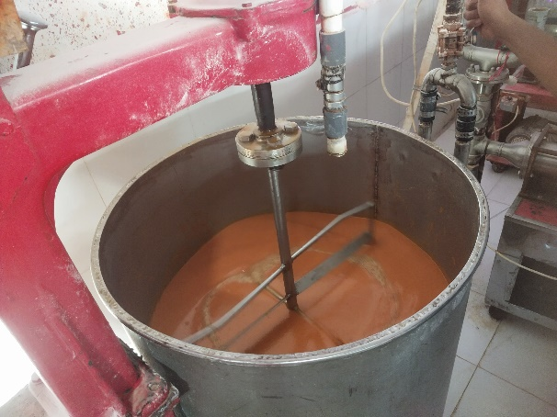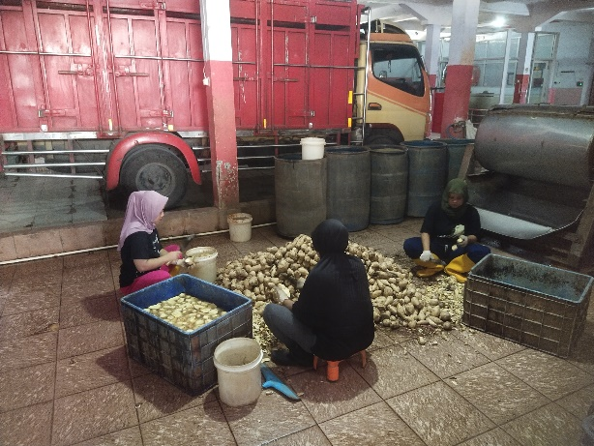

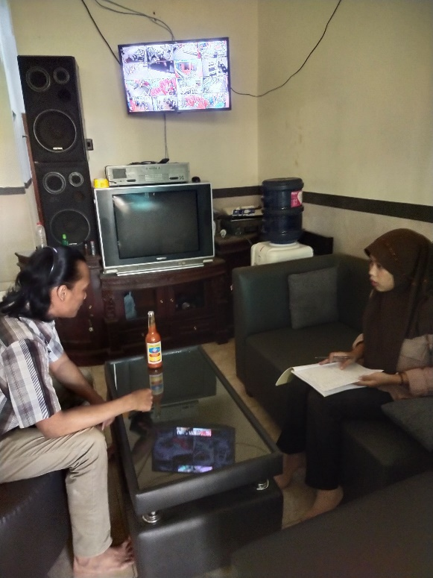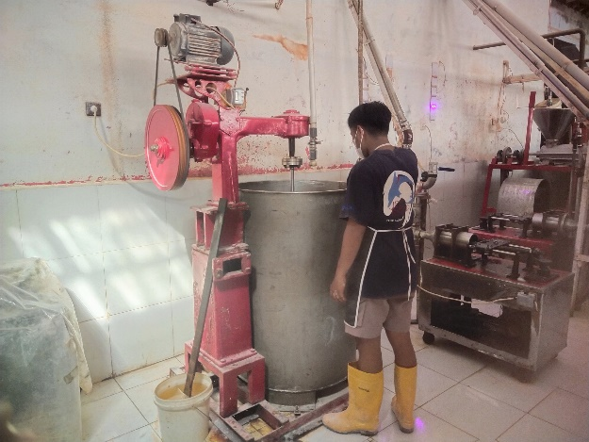

Lampiran 1. 4 Surat Keterangan Selesai Penelitian

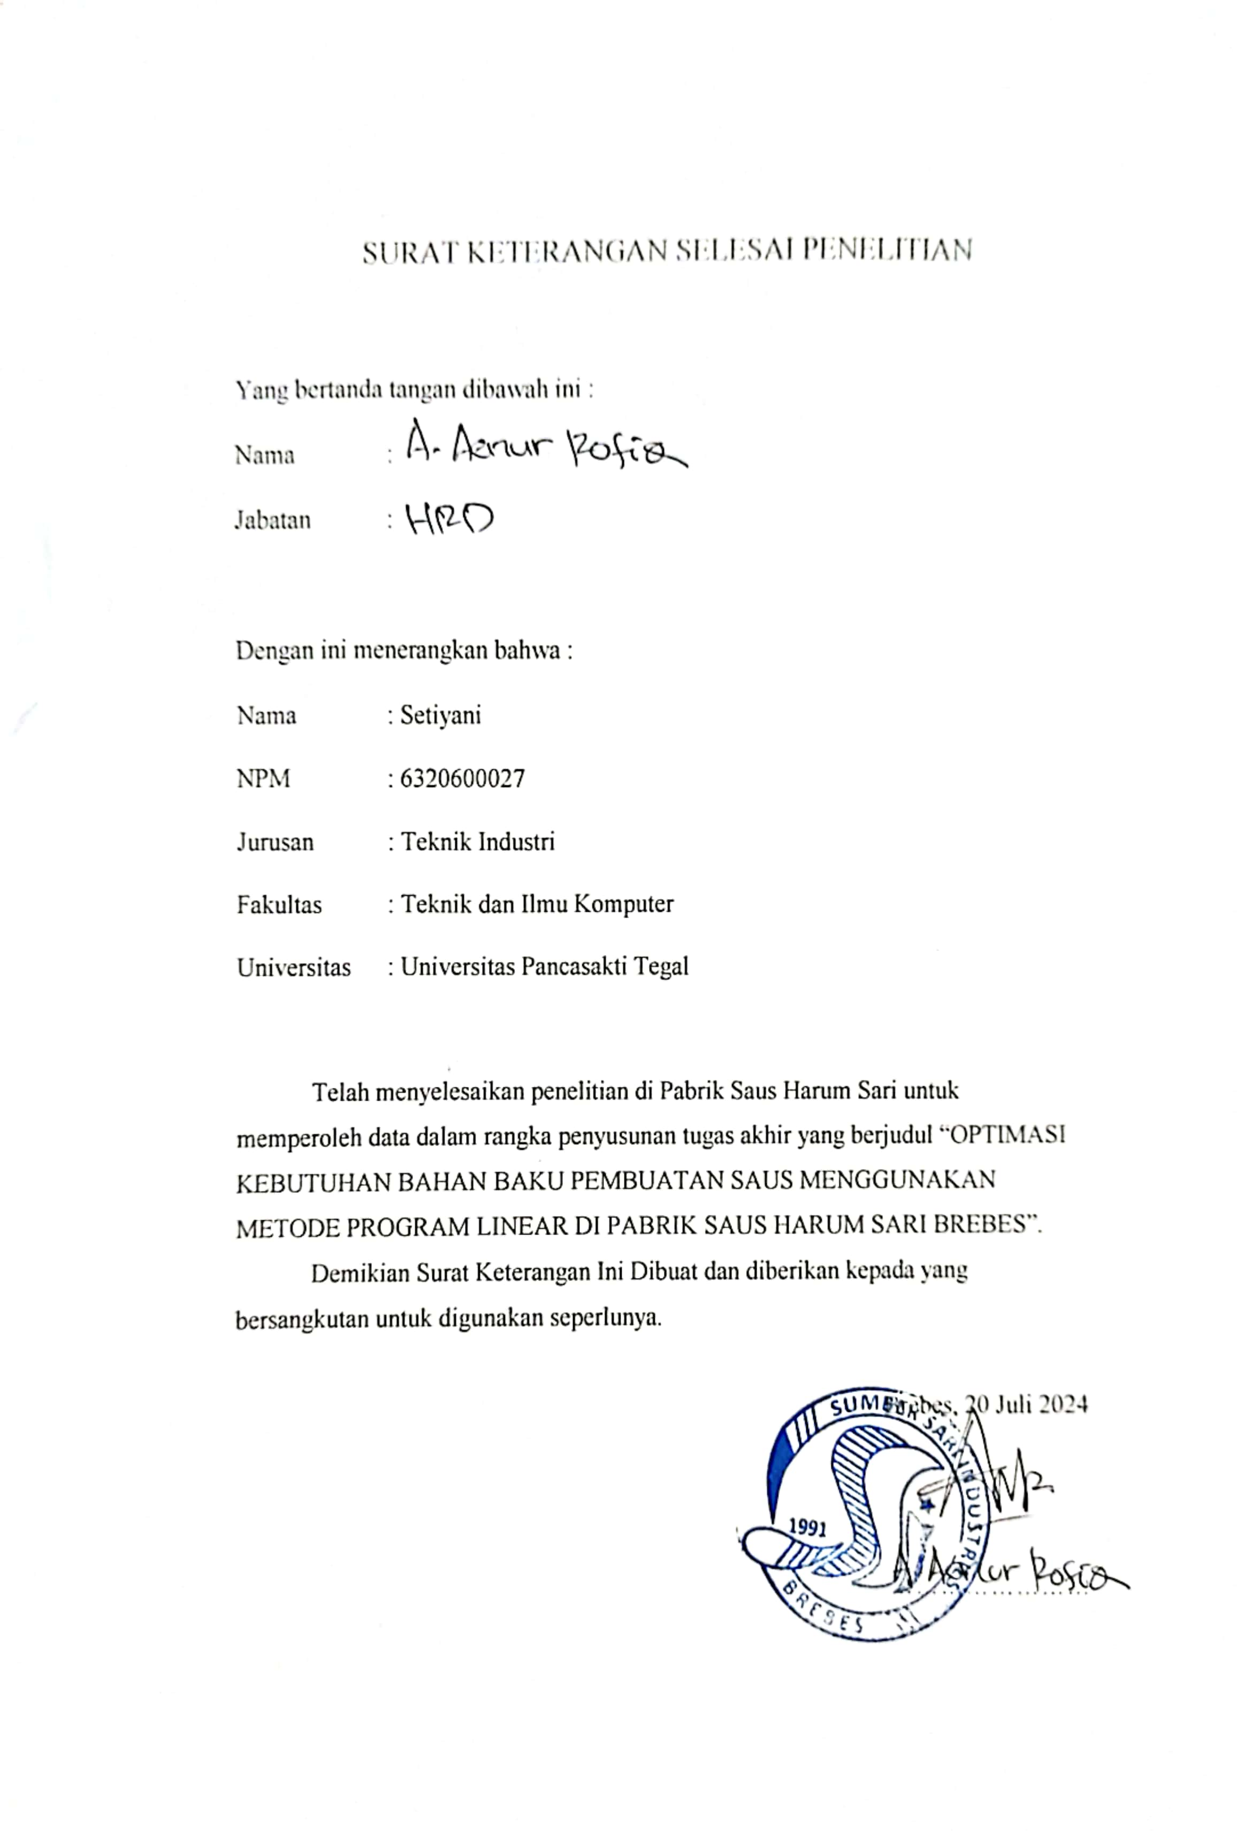

Lampiran 1. 5 Lembar Bimbingan

