**Daftar Pustaka**

Anggraeni, D. A., & Rahardja, E. (2018). Pengaruh Gaya Kepemimpinan Feminin, Motivasi Kerja dan Komitmen Organisasional terhadap Kinerja Karyawan PT Leo Agung Raya, Semarang. Diponegoro Journal of Management, 7(4), 1–14.

Apriyanti, Harahap, J. M., & Hasibuan, M. I. (2021). Pengaruh Pemberian Reward Dan Tunjangan Terhadap Kinerja Karyawan Pada PT. Binanga Mandala Labuhanbatu Selatan Sumatera Utara. *Jurnal Ilmu Manajemen*, *03*, 01–10.

Budiasa, I. K. (2021). *BEBAN KERJA DAN KINERJA SUMBER DAYA MANUSIA* (M. Dr. Ni Kadek Suryani, SE, SIKom (ed.)). CV. Pena Persada.

Ellyzar, N. (2017). Pengaruh Mutasi Kerja, Beban Kerja Dan Konflik Interpersonal Terhadap Setres Kerja Serta Dampaknya Pada Kinerja Karyawan BPKP Perwakilan Provinsi Aceh. *Jurnal Magister Manajemen Fakultas Ekonomi & Bisnis Unsyiah*, *1*.

Ir. Syifian Siregar, M. M. (2017). *Metode Penelitian KUANTITATIF DILENGKAPI DENGA PERBANDINGAN PERHITUNGAN MANUAL & SPSS*. KENCANA (Devisi dari PRENADAMEDIA Group).

Nurhasanah, N., Jufrizen, J., & Tupti, Z. (2022). Pengaruh Etika Kerja, Budaya Organisasi Dan Beban Kerja Terhadap Kinerja Karyawan Dengan Kepuasan Kerja Sebagai Variabel Intervening. *Jesya (Jurnal Ekonomi & Ekonomi Syariah)*, *5*(1), 245–261. https://doi.org/10.36778/jesya.v5i1.618

Prof. Dr. Sugiyono. (2019). *METODE PENELITIAN KUANTITATIF KUALITATIF dan R&D* (M. Dr. Ir. Sutopo.S.Pd (ed.)). www.cvalfabeta.com

Prof.H.Imam Ghozali, M.Com, Ph.D. CA, A. (2018). *APLIKASI ANALISIS MULTIVARIATE Dengan Program IBM SPSS 25* (9th ed.).

Qomariah, N. (2020). *MANAJEMEN SUMBER DAYA MANUSIA*. CV. Pustaka Abadi.

Salman Farisi, Irnawati, J., & Fahmi, M. (2020). *Pengaruh Motivasi dan Disiplin Kerja Terhadap Kinerja Karyawan*. *4*(1), 15–33.

Sari, erni Y., & Utama, I. (2022). PENGARUH TUNJANGAN KINERJA DAN JAMINAN SOSIAL TERHADAP KINERJA PEGAWAI PADA DINAS SUMBERDAYA AIR,CIPTA KARYA TATA RUANG PTROVINSI SUMATRA UTARA. *Jurnal Manajemen Dan Bisnis*, *2*(3). https://doi.org/10.36490/jmdb.v1i2.366

Surhamiyati, Iskandar, Y., & Maralis, R. (2021). Dampak Pemberian Tunjangan terhadap Kinerja Karyawan pada PT. Mitra Agung Swadaya PKS Kelayang Kabupaten Indragiri Hulu. *Jurnal Manajemen Dan Sains*, *6*(April), 256–260. https://doi.org/10.33087/jmas.v6i1.251

Zulmaidarleni, R. Sarianti, dan Y. Fitria. 2019. Pengaruh Beban Kerja dan Lingkungan Kerja Fisik terhadap Stres Kerja pada Pegawai Kantor Kecamatan Padang Timur. Jurnal Eco Gen, 2 Nomor 1 (Maret),

LAMPIRAN

**KUESIONER PENGARUH MOTIVASI KERJA, BEBAN KERJA, TUNJANGAN KINERJA TERHADAP KINERJA KARYAWAN**

**KARAKTERISTIK RESPONDEN**

1. Jenis kelamin :
2. Perempuan
3. Laki-laki
4. Usia
5. 17-30 Tahun
6. 30-40 Tahun
7. > 40 Tahun
8. Pendidikan
9. S1
10. SMA/SMK
11. SMP
12. SD/Sederajat

**Keterangan**

STS : Sangat Tidak Setuju

TS : Tidak Setuju

N : Netral

S : Setuju

SS : Sangat Setuju

### PETUNJUK PENGISIAN

1. Isilah identitas secara lengkap
2. Bacalah pertanyaan dengan teliti sebelum menjawab.
3. Berilah jawaban sesuai dengan kondisi yang bapak/Ibu/Saudara rasakan agar diperoleh daya yang benar, akurat dan objektif.
4. Isilah pernyataan dibawah ini dengan memberi tanda (√) pada kolom yang telah tersedia :

STS (Skor 1) : Sangat tidak setuju

TS (Skor 2) : Tidak setuju

N (Skor 3) : Netral

S (Skor 4) : Setuju

SS (Skor 5) : Sangat setuju

**DAFTAR PERNYATAAN KOESIONER**

1. **Variabel Kinerja (Y)**

|  |  |  |  |  |  |  |
| --- | --- | --- | --- | --- | --- | --- |
| **No.** | **Pernyataan** | **Tanggapan** | | | |  |
| **STS** | **TS** | **N** | **S** | **SS** |
|  | **Pelaksanaan Tugas** |  | | | |  |
| **1** | Saya dapat menyelesaikan pekerjaan sesuai dengan yang ditetapkan oleh perusahaan |  |  |  |  |  |
| **2** | Saya selalu menyelesaikan tugas sesuai dengan setandar kerja perusahaan |  |  |  |  |  |
| **Kualitas dan Kuantitas Kerja** | | | | | | |
| **3** | Saya memiliki pengalaman kerja yang tidak perlu diragukan lagi dalam melaksanakan tugas |  |  |  |  |  |
| **4** | Saya memiliki keahlian dalam bekerja |  |  |  |  |  |
|  | **Komunikasi antar karyawan** |  | | | |  |
| **5** | Dalam bekerja saya selalu berkomunikasi dengan karyawan lain |  |  |  |  |  |
| **6** | Dalam berkomunikasi, saya selalu meningkatkan hubungan interpersonal |  |  |  |  |  |
| **Tugas tambahan** | | | | | | |
| **7** | Saya melakukan pekerjaan tambahan yang diberikan oleh perusahaan |  |  |  |  |  |
| **8** | Saya selalu bertanggung jawab atas pekerjaan yang telah diberikan oleh atasan |  |  |  |  |  |
| **Kesadaran untuk bekerja sama** | | | | | | |
| **9** | Saya dapat membina kerjasama yang baik dengan rekan kerja yang lain |  |  |  |  |  |
| **10** | Saya melukan tugas yang diberikan perusahaan bersama karyawan yang lainya |  |  |  |  |  |
| **11** | Dalam bekerja, saya membantu pekerjaan karyawan yang lain |  |  |  |  |  |

1. **Motivasi Kerja (X1)**

|  |  |  |  |  |  |  |
| --- | --- | --- | --- | --- | --- | --- |
| **No.** | **Pernyataan** | **Tanggapan** | | | |  |
| **STS** | **TS** | **N** | **S** | **SS** |
|  | **Promosi** |  | | | |  |
| 1 | Saya melaksankan pekerjaan dengan penuh rasa tanggung jawab untuk menambatkan imbalan yang wajar |  |  |  |  |  |
| 2 | Saya suka melaksanakan pekerjaan yang menantang untuk mengembangkan keterampilan |  |  |  |  |  |
| **Kenaikan gaji** | | | | | | |
| 3 | Karyawan yang sudah lama bekerja mendapatkan kenaikan gaji |  |  |  |  |  |
| 4 | Saya bekerja keras untuk mendapatkan kenaikan gaji |  |  |  |  |  |
|  | **Promosi kenaikan jabatan** |  | | | |  |
| 4 | Karyawan yang sudah lama bekerja mendapatkan kenaikan jabatan |  |  |  |  |  |
| 5 | Saya bekerja dengan baik untuk diberikan promosi kenaikan jabatan |  |  |  |  |  |
| **Kehadiran pemimpin** | | | | | | |
| 6 | Pemimpin diharapkan selalu berangkat dijam kerja |  |  |  |  |  |
| 7 | Kehadiran manajer dalam bekerja, dapat memberikan dorongan atau motivasi |  |  |  |  |  |
| 8 | Manajer memberikan contoh untuk tidak datang terlambat |  |  |  |  |  |

1. **Beban Kerja (X2)**

|  |  |  |  |  |  |  |
| --- | --- | --- | --- | --- | --- | --- |
| **No.** | **Pernyataan** | **Tanggapan** | | | |  |
| **STS** | **TS** | **N** | **S** | **SS** |
|  | **Pandangan mengenai tugas** |  | | | |  |
| 1 | Saya merasa mampu menyelesaikan pekerjaan sesuai dengan target yang harus dicapai |  |  |  |  |  |
| 2 | Saya bertanggung jawab dan menyelesaikan tugas dengan tepat waktu |  |  |  |  |  |
|  | **Mengambil keputusan dengan cepat** |  | | | |  |
| 3 | Saya dituntut untuk dapat setiap saat mengambil keputusan dengan cepat |  |  |  |  |  |
| 4 | Saya dituntut untuk dapat setiap saat mengambil keputusan dengan cepat tepat |  |  |  |  |  |
| **Waktu yang digunakan menyelesaikan tugas** | | | | | | |
| 5 | Dalam melaksanakan pekerjaan,saya melaksanakan tugas tepat waktu |  |  |  |  |  |
| 6 | Saya dituntut melaksnakan tugas dengan tepat waktu |  |  |  |  |  |

1. **Tunjangan Kinerja (X3)**

|  |  |  |  |  |  |  |
| --- | --- | --- | --- | --- | --- | --- |
| **No.** | **Pernyataan** | **Tanggapan** | | | |  |
| **STS** | **TS** | **N** | **S** | **SS** |
|  | **Waktu pemberian tunjangan** |  | | | |  |
| 1 | Perusahaan memberikan tunjangan tepat waktu |  |  |  |  |  |
| 2 | Pemberian tunjangan kepada setiap bagian yang ada |  |  |  |  |  |
| 3 | Ketepatan pemberian tunjangan hari raya pada karyawan |  |  |  |  |  |
|  | **Persaingan pemberian tunjangan** |  | | | |  |
| 3 | Adanya persaingan untuk mendapatkan reward (bonus) |  |  |  |  |  |
| 4 | Saya menerima tunjangan berdasarkan prestasi kerja dan tanggung jawab saya terhadap pekerjaan |  |  |  |  |  |
| **Pemberian tunjangan** | | | | | | |
| 5 | Saya merasa perusahaan sudah memberikan tunjangan sesuai dengan setandar yang berlaku |  |  |  |  |  |
| 6 | Pemberian tunjangan yang sesuai dengan kemampuan perusahaan |  |  |  |  |  |

**Lampiran 1**

**Deskripsi Hasil Tanggapan Responden (Y)**

|  |  |  |  |  |  |  |  |  |  |  |  |  |
| --- | --- | --- | --- | --- | --- | --- | --- | --- | --- | --- | --- | --- |
| RESPONDEN | **Y.1** | **Y.2** | **Y.3** | **Y.4** | **Y.5** | **Y.6** | **Y.7** | **Y.8** | **Y.9** | **Y.10** | **Y.11** | **Total (Y)** |
| 1 | 5 | 5 | 4 | 4 | 3 | 5 | 5 | 5 | 5 | 5 | 5 | 51 |
| 2 | 4 | 3 | 4 | 4 | 3 | 3 | 5 | 3 | 4 | 3 | 5 | 41 |
| 3 | 4 | 3 | 3 | 4 | 3 | 4 | 3 | 4 | 4 | 3 | 4 | 39 |
| 4 | 5 | 5 | 5 | 5 | 5 | 5 | 5 | 5 | 5 | 5 | 5 | 55 |
| 5 | 5 | 4 | 2 | 4 | 5 | 4 | 5 | 1 | 5 | 5 | 5 | 45 |
| 6 | 4 | 4 | 4 | 4 | 4 | 4 | 4 | 4 | 5 | 4 | 4 | 45 |
| 7 | 4 | 4 | 5 | 4 | 4 | 3 | 5 | 5 | 5 | 4 | 5 | 48 |
| 8 | 5 | 4 | 5 | 5 | 5 | 4 | 4 | 4 | 5 | 5 | 3 | 49 |
| 9 | 4 | 4 | 4 | 4 | 4 | 4 | 4 | 4 | 4 | 4 | 4 | 44 |
| 10 | 4 | 4 | 4 | 4 | 4 | 3 | 4 | 4 | 4 | 4 | 4 | 43 |
| 11 | 4 | 4 | 3 | 3 | 3 | 3 | 4 | 4 | 4 | 3 | 3 | 38 |
| 12 | 4 | 4 | 4 | 3 | 3 | 2 | 4 | 3 | 4 | 3 | 4 | 38 |
| 13 | 4 | 4 | 4 | 4 | 4 | 4 | 4 | 4 | 4 | 4 | 4 | 44 |
| 14 | 2 | 4 | 3 | 4 | 2 | 3 | 4 | 3 | 4 | 3 | 4 | 36 |
| 15 | 5 | 4 | 4 | 5 | 5 | 3 | 5 | 5 | 5 | 5 | 5 | 51 |
| 16 | 5 | 4 | 4 | 4 | 3 | 3 | 5 | 4 | 4 | 5 | 5 | 46 |
| 17 | 5 | 4 | 4 | 4 | 3 | 3 | 4 | 4 | 4 | 5 | 5 | 45 |
| 18 | 5 | 4 | 4 | 4 | 4 | 4 | 4 | 4 | 4 | 5 | 5 | 47 |
| 19 | 3 | 5 | 5 | 5 | 5 | 4 | 4 | 4 | 4 | 4 | 5 | 48 |
| 20 | 3 | 5 | 5 | 5 | 5 | 4 | 4 | 4 | 4 | 5 | 5 | 49 |
| 21 | 4 | 5 | 5 | 5 | 5 | 4 | 4 | 4 | 4 | 4 | 4 | 48 |
| 22 | 5 | 5 | 5 | 5 | 4 | 4 | 4 | 4 | 4 | 4 | 4 | 48 |
| 23 | 4 | 5 | 2 | 5 | 4 | 4 | 4 | 5 | 4 | 4 | 4 | 45 |
| 24 | 4 | 5 | 2 | 5 | 4 | 4 | 5 | 5 | 5 | 4 | 4 | 47 |
| 25 | 5 | 5 | 2 | 5 | 4 | 4 | 5 | 5 | 5 | 4 | 4 | 48 |
| 26 | 5 | 5 | 3 | 5 | 4 | 4 | 5 | 5 | 5 | 4 | 4 | 49 |
| 27 | 5 | 3 | 4 | 4 | 4 | 4 | 5 | 5 | 5 | 4 | 4 | 47 |
| 28 | 5 | 3 | 4 | 4 | 4 | 4 | 5 | 5 | 5 | 4 | 5 | 48 |
| 29 | 4 | 3 | 5 | 4 | 5 | 4 | 4 | 5 | 5 | 4 | 5 | 48 |
| 30 | 4 | 3 | 5 | 4 | 5 | 4 | 4 | 5 | 5 | 4 | 5 | 48 |
| 31 | 5 | 4 | 5 | 3 | 5 | 4 | 4 | 5 | 5 | 4 | 5 | 49 |
| 32 | 4 | 4 | 5 | 4 | 5 | 4 | 4 | 5 | 5 | 4 | 4 | 48 |
| 33 | 4 | 5 | 4 | 4 | 5 | 4 | 4 | 5 | 5 | 4 | 4 | 48 |
| 34 | 3 | 5 | 4 | 4 | 4 | 4 | 4 | 5 | 5 | 4 | 4 | 46 |
| 35 | 3 | 4 | 4 | 4 | 4 | 5 | 5 | 4 | 5 | 3 | 4 | 45 |
| 36 | 4 | 4 | 5 | 4 | 5 | 5 | 4 | 4 | 4 | 3 | 5 | 47 |
| 37 | 5 | 5 | 5 | 5 | 5 | 5 | 5 | 4 | 4 | 3 | 5 | 51 |
| 38 | 5 | 5 | 5 | 5 | 5 | 5 | 5 | 4 | 4 | 4 | 5 | 52 |
| 39 | 5 | 5 | 2 | 5 | 5 | 5 | 5 | 4 | 4 | 4 | 5 | 49 |
| 40 | 5 | 5 | 4 | 4 | 5 | 5 | 5 | 4 | 5 | 5 | 5 | 52 |
| 41 | 4 | 5 | 5 | 5 | 4 | 4 | 5 | 5 | 5 | 5 | 5 | 52 |
| 42 | 4 | 5 | 5 | 5 | 4 | 4 | 5 | 5 | 5 | 4 | 4 | 50 |
| 43 | 5 | 5 | 5 | 5 | 4 | 4 | 5 | 4 | 5 | 5 | 4 | 51 |
| 44 | 5 | 5 | 5 | 4 | 4 | 4 | 5 | 4 | 5 | 5 | 4 | 50 |
| 45 | 5 | 5 | 5 | 5 | 5 | 4 | 4 | 4 | 5 | 5 | 5 | 52 |
| 46 | 3 | 4 | 5 | 4 | 5 | 4 | 4 | 4 | 5 | 5 | 5 | 48 |
| 47 | 3 | 4 | 4 | 5 | 5 | 5 | 4 | 5 | 5 | 5 | 5 | 50 |
| 48 | 4 | 4 | 4 | 5 | 5 | 4 | 4 | 5 | 5 | 4 | 5 | 49 |
| 49 | 4 | 4 | 4 | 5 | 4 | 4 | 4 | 5 | 5 | 5 | 5 | 49 |
| 50 | 5 | 5 | 5 | 5 | 4 | 4 | 4 | 5 | 5 | 4 | 5 | 51 |
| 51 | 4 | 4 | 4 | 3 | 4 | 3 | 4 | 3 | 4 | 5 | 1 | 39 |
| 52 | 3 | 4 | 3 | 3 | 4 | 4 | 3 | 3 | 4 | 4 | 4 | 39 |
| 53 | 4 | 4 | 3 | 3 | 3 | 3 | 4 | 4 | 4 | 4 | 5 | 41 |
| 54 | 4 | 4 | 4 | 3 | 3 | 3 | 4 | 4 | 4 | 3 | 4 | 40 |
| 55 | 3 | 5 | 2 | 3 | 3 | 4 | 4 | 5 | 4 | 4 | 4 | 41 |
| 56 | 4 | 4 | 3 | 3 | 4 | 2 | 4 | 3 | 4 | 5 | 1 | 37 |
| 57 | 4 | 4 | 3 | 4 | 4 | 2 | 4 | 2 | 3 | 5 | 5 | 40 |
| 58 | 4 | 4 | 3 | 4 | 4 | 3 | 2 | 2 | 4 | 4 | 4 | 38 |
| 59 | 4 | 4 | 3 | 3 | 3 | 4 | 4 | 3 | 4 | 4 | 5 | 41 |
| 60 | 4 | 4 | 3 | 4 | 4 | 4 | 2 | 4 | 4 | 4 | 5 | 42 |
| 61 | 4 | 4 | 3 | 3 | 3 | 4 | 4 | 5 | 4 | 5 | 5 | 44 |
| 62 | 4 | 4 | 2 | 4 | 5 | 4 | 5 | 5 | 5 | 4 | 5 | 47 |
| 63 | 4 | 4 | 2 | 4 | 5 | 4 | 5 | 5 | 5 | 4 | 5 | 47 |
| 64 | 4 | 4 | 2 | 4 | 5 | 4 | 5 | 5 | 5 | 4 | 5 | 47 |
| 65 | 4 | 4 | 3 | 3 | 3 | 2 | 3 | 4 | 4 | 4 | 4 | 38 |
| 66 | 4 | 4 | 4 | 4 | 3 | 3 | 4 | 4 | 4 | 4 | 5 | 43 |
| 67 | 4 | 4 | 4 | 3 | 5 | 3 | 4 | 4 | 5 | 5 | 5 | 46 |
| 68 | 4 | 4 | 5 | 4 | 4 | 4 | 3 | 4 | 4 | 4 | 5 | 45 |
| 69 | 4 | 4 | 3 | 3 | 4 | 3 | 3 | 4 | 3 | 4 | 5 | 40 |
| 70 | 4 | 4 | 4 | 4 | 4 | 4 | 4 | 4 | 4 | 4 | 4 | 44 |
| 71 | 4 | 4 | 4 | 4 | 4 | 4 | 4 | 4 | 4 | 4 | 4 | 44 |
| 72 | 4 | 4 | 4 | 4 | 4 | 4 | 4 | 4 | 4 | 4 | 4 | 44 |
| 73 | 4 | 4 | 4 | 4 | 4 | 4 | 5 | 4 | 4 | 5 | 4 | 46 |
| 74 | 4 | 4 | 4 | 4 | 3 | 4 | 5 | 4 | 4 | 5 | 4 | 45 |
| 75 | 5 | 5 | 3 | 3 | 3 | 3 | 5 | 4 | 4 | 5 | 5 | 45 |
| 76 | 5 | 5 | 3 | 3 | 3 | 3 | 5 | 4 | 4 | 5 | 5 | 45 |
| 77 | 5 | 5 | 3 | 4 | 3 | 3 | 5 | 4 | 4 | 4 | 5 | 45 |
| 78 | 3 | 5 | 3 | 4 | 3 | 3 | 5 | 3 | 4 | 4 | 5 | 42 |
| 79 | 3 | 5 | 4 | 4 | 4 | 3 | 5 | 3 | 5 | 4 | 5 | 45 |
| 80 | 4 | 4 | 4 | 4 | 4 | 4 | 4 | 3 | 5 | 4 | 5 | 45 |

Deskripsi Hasil Tanggapan Responden (X1)

|  |  |  |  |  |  |  |  |  |  |
| --- | --- | --- | --- | --- | --- | --- | --- | --- | --- |
| RESPONDEN | X1.1 | X1.2 | X1.3 | X1.4 | X1.5 | X1.6 | X1.7 | X1.8 | Total (X1) |
| 1 | 5 | 5 | 5 | 5 | 3 | 5 | 5 | 3 | 36 |
| 2 | 3 | 4 | 3 | 4 | 3 | 3 | 3 | 3 | 26 |
| 3 | 4 | 3 | 3 | 4 | 3 | 4 | 3 | 3 | 27 |
| 4 | 3 | 4 | 1 | 4 | 1 | 4 | 4 | 2 | 23 |
| 5 | 1 | 5 | 4 | 5 | 2 | 5 | 5 | 5 | 32 |
| 6 | 5 | 3 | 4 | 4 | 1 | 4 | 4 | 2 | 27 |
| 7 | 3 | 5 | 3 | 3 | 3 | 5 | 4 | 3 | 29 |
| 8 | 4 | 5 | 4 | 4 | 3 | 3 | 5 | 5 | 33 |
| 9 | 4 | 4 | 4 | 4 | 4 | 4 | 4 | 4 | 32 |
| 10 | 3 | 4 | 4 | 4 | 3 | 3 | 4 | 4 | 29 |
| 11 | 3 | 3 | 5 | 4 | 2 | 4 | 4 | 4 | 29 |
| 12 | 3 | 4 | 4 | 3 | 5 | 3 | 3 | 3 | 28 |
| 13 | 5 | 4 | 3 | 4 | 4 | 4 | 5 | 4 | 33 |
| 14 | 4 | 2 | 4 | 2 | 1 | 5 | 5 | 4 | 27 |
| 15 | 1 | 4 | 4 | 5 | 5 | 5 | 5 | 4 | 33 |
| 16 | 3 | 4 | 4 | 5 | 3 | 4 | 5 | 4 | 32 |
| 17 | 3 | 4 | 4 | 5 | 3 | 4 | 5 | 4 | 32 |
| 18 | 3 | 4 | 4 | 5 | 3 | 4 | 5 | 4 | 32 |
| 19 | 3 | 4 | 4 | 5 | 3 | 4 | 5 | 4 | 32 |
| 20 | 4 | 3 | 4 | 5 | 3 | 4 | 5 | 4 | 32 |
| 21 | 5 | 3 | 4 | 4 | 4 | 5 | 5 | 4 | 34 |
| 22 | 5 | 3 | 4 | 4 | 4 | 5 | 5 | 4 | 34 |
| 23 | 4 | 3 | 4 | 4 | 4 | 5 | 5 | 4 | 33 |
| 24 | 4 | 4 | 4 | 4 | 4 | 5 | 5 | 5 | 35 |
| 25 | 4 | 4 | 4 | 4 | 4 | 5 | 4 | 5 | 34 |
| 26 | 4 | 4 | 4 | 4 | 4 | 5 | 4 | 5 | 34 |
| 27 | 5 | 4 | 4 | 5 | 3 | 5 | 4 | 5 | 35 |
| 28 | 5 | 4 | 4 | 5 | 3 | 5 | 4 | 5 | 35 |
| 29 | 5 | 4 | 4 | 5 | 3 | 5 | 4 | 5 | 35 |
| 30 | 5 | 4 | 4 | 5 | 4 | 5 | 4 | 5 | 36 |
| 31 | 5 | 4 | 4 | 5 | 3 | 4 | 4 | 5 | 34 |
| 32 | 5 | 4 | 5 | 5 | 4 | 4 | 4 | 4 | 35 |
| 33 | 4 | 4 | 4 | 5 | 4 | 4 | 4 | 4 | 33 |
| 34 | 4 | 5 | 4 | 4 | 4 | 4 | 4 | 4 | 33 |
| 35 | 4 | 5 | 4 | 4 | 4 | 4 | 5 | 4 | 34 |
| 36 | 4 | 5 | 4 | 4 | 4 | 4 | 5 | 4 | 34 |
| 37 | 4 | 5 | 5 | 4 | 3 | 4 | 5 | 5 | 35 |
| 38 | 4 | 5 | 5 | 4 | 3 | 4 | 5 | 3 | 33 |
| 39 | 4 | 5 | 5 | 4 | 3 | 4 | 5 | 3 | 33 |
| 40 | 4 | 5 | 4 | 4 | 3 | 4 | 4 | 4 | 32 |
| 41 | 5 | 5 | 4 | 4 | 3 | 4 | 4 | 4 | 33 |
| 42 | 5 | 5 | 4 | 4 | 1 | 5 | 4 | 4 | 32 |
| 43 | 5 | 5 | 4 | 5 | 1 | 5 | 5 | 4 | 34 |
| 44 | 4 | 5 | 4 | 5 | 1 | 4 | 5 | 4 | 32 |
| 45 | 4 | 5 | 4 | 5 | 2 | 4 | 5 | 4 | 33 |
| 46 | 4 | 5 | 4 | 5 | 3 | 4 | 5 | 5 | 35 |
| 47 | 4 | 5 | 4 | 5 | 3 | 4 | 5 | 5 | 35 |
| 48 | 4 | 5 | 4 | 5 | 3 | 4 | 5 | 5 | 35 |
| 49 | 4 | 5 | 4 | 5 | 4 | 5 | 4 | 4 | 35 |
| 50 | 4 | 5 | 4 | 5 | 4 | 4 | 4 | 5 | 35 |
| 51 | 1 | 4 | 4 | 4 | 4 | 4 | 4 | 4 | 29 |
| 52 | 4 | 3 | 3 | 4 | 4 | 4 | 4 | 4 | 30 |
| 53 | 4 | 3 | 3 | 3 | 3 | 3 | 3 | 4 | 26 |
| 54 | 4 | 2 | 4 | 4 | 2 | 4 | 3 | 3 | 26 |
| 55 | 4 | 4 | 4 | 2 | 3 | 4 | 4 | 4 | 29 |
| 56 | 4 | 3 | 4 | 4 | 1 | 3 | 4 | 4 | 27 |
| 57 | 3 | 4 | 5 | 4 | 4 | 3 | 5 | 3 | 31 |
| 58 | 4 | 2 | 4 | 4 | 4 | 4 | 4 | 4 | 30 |
| 59 | 3 | 3 | 3 | 3 | 3 | 3 | 3 | 4 | 25 |
| 60 | 4 | 4 | 3 | 4 | 4 | 4 | 3 | 4 | 30 |
| 61 | 4 | 2 | 4 | 4 | 4 | 4 | 4 | 5 | 31 |
| 62 | 2 | 4 | 4 | 2 | 3 | 3 | 4 | 4 | 26 |
| 63 | 2 | 4 | 4 | 2 | 3 | 4 | 4 | 5 | 28 |
| 64 | 2 | 4 |  | 4 | 4 | 2 | 3 | 4 | 23 |
| 65 | 3 | 5 | 5 | 2 | 3 | 4 | 3 | 4 | 29 |
| 66 | 4 | 4 | 3 | 3 | 3 | 3 | 4 | 4 | 28 |
| 67 | 4 | 4 | 5 | 5 | 2 | 5 | 4 | 5 | 34 |
| 68 | 2 | 4 | 4 | 5 | 4 | 5 | 5 | 5 | 34 |
| 69 | 4 | 4 | 3 | 3 | 3 | 3 | 4 | 3 | 27 |
| 70 | 4 | 4 | 4 | 4 | 4 | 4 | 4 | 4 | 32 |
| 71 | 4 | 4 | 4 | 4 | 4 | 4 | 4 | 4 | 32 |
| 72 | 4 | 4 | 4 | 4 | 4 | 4 | 4 | 4 | 32 |
| 73 | 4 | 4 | 4 | 4 | 4 | 4 | 4 | 4 | 32 |
| 74 | 4 | 4 | 4 | 4 | 4 | 4 | 5 | 3 | 32 |
| 75 | 4 | 4 | 4 | 4 | 4 | 4 | 5 | 4 | 33 |
| 76 | 4 | 5 | 4 | 4 | 4 | 4 | 3 | 4 | 32 |
| 77 | 4 | 5 | 4 | 4 | 4 | 4 | 3 | 4 | 32 |
| 78 | 5 | 5 | 4 | 4 | 4 | 4 | 3 | 4 | 33 |
| 79 | 5 | 4 | 3 | 5 | 4 | 4 | 3 | 4 | 32 |
| 80 | 5 | 4 | 3 | 5 | 5 | 4 | 4 | 4 | 34 |

**Deskripsi Hasil Tanggapan Responden (X2)**

|  |  |  |  |  |  |  |  |
| --- | --- | --- | --- | --- | --- | --- | --- |
| RESPONDEN | X2.1 | X2.2 | X2.3 | X2.4 | X2.5 | X2.6 | Total (X2) |
| 1 | 5 | 5 | 4 | 5 | 4 | 3 | 26 |
| 2 | 5 | 4 | 4 | 5 | 4 | 4 | 26 |
| 3 | 5 | 4 | 4 | 5 | 5 | 4 | 27 |
| 4 | 5 | 4 | 4 | 5 | 5 | 4 | 27 |
| 5 | 5 | 4 | 4 | 5 | 5 | 4 | 27 |
| 6 | 5 | 4 | 4 | 5 | 5 | 4 | 27 |
| 7 | 5 | 4 | 5 | 5 | 4 | 3 | 26 |
| 8 | 5 | 4 | 5 | 5 | 4 | 3 | 26 |
| 9 | 5 | 4 | 5 | 5 | 4 | 4 | 27 |
| 10 | 5 | 4 | 4 | 5 | 5 | 4 | 27 |
| 11 | 5 | 4 | 4 | 5 | 5 | 4 | 27 |
| 12 | 5 | 5 | 4 | 5 | 5 | 4 | 28 |
| 13 | 5 | 5 | 4 | 5 | 5 | 4 | 28 |
| 14 | 5 | 5 | 5 | 5 | 4 | 4 | 28 |
| 15 | 4 | 5 | 5 | 5 | 4 | 4 | 27 |
| 16 | 4 | 5 | 4 | 5 | 4 | 4 | 26 |
| 17 | 4 | 5 | 4 | 4 | 4 | 4 | 25 |
| 18 | 4 | 5 | 4 | 4 | 4 | 4 | 25 |
| 19 | 5 | 5 | 4 | 4 | 4 | 4 | 26 |
| 20 | 5 | 5 | 4 | 5 | 4 | 4 | 27 |
| 21 | 5 | 5 | 4 | 5 | 4 | 4 | 27 |
| 22 | 5 | 5 | 4 | 5 | 4 | 4 | 27 |
| 23 | 5 | 5 | 4 | 5 | 4 | 4 | 27 |
| 24 | 4 | 5 | 4 | 5 | 4 | 4 | 26 |
| 25 | 4 | 5 | 4 | 5 | 4 | 4 | 26 |
| 26 | 5 | 5 | 4 | 5 | 4 | 4 | 27 |
| 27 | 5 | 5 | 4 | 5 | 4 | 4 | 27 |
| 28 | 5 | 4 | 4 | 5 | 3 | 5 | 26 |
| 29 | 5 | 4 | 4 | 5 | 3 | 5 | 26 |
| 30 | 5 | 4 | 4 | 5 | 4 | 5 | 27 |
| 31 | 5 | 4 | 4 | 5 | 3 | 4 | 25 |
| 32 | 5 | 4 | 5 | 5 | 4 | 4 | 27 |
| 33 | 4 | 4 | 4 | 5 | 4 | 4 | 25 |
| 34 | 4 | 5 | 4 | 4 | 4 | 4 | 25 |
| 35 | 4 | 5 | 4 | 4 | 4 | 4 | 25 |
| 36 | 4 | 5 | 4 | 4 | 4 | 4 | 25 |
| 37 | 4 | 5 | 5 | 4 | 3 | 4 | 25 |
| 38 | 4 | 5 | 5 | 4 | 3 | 4 | 25 |
| 39 | 4 | 5 | 5 | 4 | 3 | 4 | 25 |
| 40 | 4 | 5 | 4 | 4 | 3 | 4 | 24 |
| 41 | 5 | 5 | 4 | 4 | 3 | 4 | 25 |
| 42 | 5 | 5 | 4 | 4 | 1 | 5 | 24 |
| 43 | 5 | 5 | 4 | 5 | 1 | 5 | 25 |
| 44 | 4 | 5 | 4 | 5 | 1 | 4 | 23 |
| 45 | 4 | 5 | 4 | 5 | 2 | 4 | 24 |
| 46 | 4 | 5 | 4 | 5 | 3 | 4 | 25 |
| 47 | 4 | 5 | 4 | 5 | 3 | 4 | 25 |
| 48 | 4 | 5 | 4 | 5 | 3 | 4 | 25 |
| 49 | 4 | 5 | 4 | 5 | 4 | 5 | 27 |
| 50 | 4 | 5 | 4 | 5 | 4 | 4 | 26 |
| 51 | 1 | 4 | 4 | 4 | 4 | 4 | 21 |
| 52 | 4 | 3 | 3 | 4 | 4 | 4 | 22 |
| 53 | 4 | 3 | 3 | 3 | 3 | 3 | 19 |
| 54 | 4 | 2 | 4 | 4 | 2 | 4 | 20 |
| 55 | 4 | 4 | 4 | 2 | 3 | 4 | 21 |
| 56 | 4 | 3 | 4 | 4 | 1 | 3 | 19 |
| 57 | 3 | 4 | 5 | 4 | 4 | 3 | 23 |
| 58 | 4 | 2 | 4 | 4 | 4 | 4 | 22 |
| 59 | 3 | 3 | 3 | 3 | 3 | 3 | 18 |
| 60 | 4 | 4 | 3 | 4 | 4 | 4 | 23 |
| 61 | 4 | 2 | 4 | 4 | 4 | 4 | 22 |
| 62 | 2 | 4 | 4 | 2 | 3 | 3 | 18 |
| 63 | 2 | 4 | 4 | 2 | 3 | 4 | 19 |
| 64 | 2 | 4 |  | 4 | 4 | 2 | 16 |
| 65 | 3 | 5 | 5 | 2 | 3 | 4 | 22 |
| 66 | 4 | 4 | 3 | 3 | 3 | 3 | 20 |
| 67 | 4 | 4 | 5 | 5 | 2 | 5 | 25 |
| 68 | 2 | 4 | 4 | 5 | 4 | 5 | 24 |
| 69 | 4 | 4 | 3 | 3 | 3 | 3 | 20 |
| 70 | 4 | 4 | 4 | 4 | 4 | 4 | 24 |
| 71 | 4 | 4 | 4 | 4 | 4 | 4 | 24 |
| 72 | 4 | 4 | 4 | 4 | 4 | 4 | 24 |
| 73 | 4 | 4 | 4 | 4 | 4 | 4 | 24 |
| 74 | 4 | 4 | 4 | 4 | 4 | 4 | 24 |
| 75 | 4 | 4 | 4 | 4 | 4 | 4 | 24 |
| 76 | 4 | 5 | 4 | 4 | 4 | 4 | 25 |
| 77 | 4 | 5 | 4 | 4 | 4 | 4 | 25 |
| 78 | 5 | 5 | 4 | 4 | 4 | 4 | 26 |
| 79 | 5 | 4 | 3 | 5 | 4 | 4 | 25 |
| 80 | 5 | 4 | 3 | 5 | 5 | 4 | 26 |

Deskripsi Hasil Tanggapan Responden (X3)

|  |  |  |  |  |  |  |
| --- | --- | --- | --- | --- | --- | --- |
| RESPONDEN | X3.1 | X3.2 | X3.3 | X3.4 | X3.5 | Total (X3) |
| 1 | 5 | 5 | 5 | 5 | 5 | 25 |
| 2 | 2 | 2 | 4 | 3 | 3 | 14 |
| 3 | 3 | 3 | 3 | 3 | 3 | 15 |
| 4 | 3 | 2 | 2 | 2 | 2 | 11 |
| 5 | 5 | 5 | 5 | 5 | 5 | 25 |
| 6 | 5 | 4 | 3 | 3 | 4 | 19 |
| 7 | 5 | 4 | 4 | 3 | 3 | 19 |
| 8 | 5 | 5 | 3 | 3 | 4 | 20 |
| 9 | 4 | 4 | 4 | 4 | 4 | 20 |
| 10 | 3 | 4 | 4 | 4 | 3 | 18 |
| 11 | 3 | 4 | 4 | 3 | 3 | 17 |
| 12 | 4 | 3 | 5 | 4 | 3 | 19 |
| 13 | 4 | 4 | 4 | 4 | 3 | 19 |
| 14 | 2 | 4 | 3 | 2 | 4 | 15 |
| 15 | 4 | 4 | 5 | 4 | 4 | 21 |
| 16 | 4 | 4 | 4 | 4 | 4 | 20 |
| 17 | 4 | 4 | 4 | 4 | 4 | 20 |
| 18 | 4 | 4 | 4 | 4 | 4 | 20 |
| 19 | 4 | 4 | 4 | 4 | 4 | 20 |
| 20 | 4 | 4 | 4 | 4 | 4 | 20 |
| 21 | 4 | 4 | 4 | 4 | 4 | 20 |
| 22 | 4 | 4 | 4 | 3 | 4 | 19 |
| 23 | 4 | 4 | 4 | 3 | 4 | 19 |
| 24 | 5 | 4 | 5 | 3 | 5 | 22 |
| 25 | 5 | 4 | 5 | 3 | 5 | 22 |
| 26 | 5 | 4 | 5 | 3 | 5 | 22 |
| 27 | 4 | 4 | 5 | 4 | 5 | 22 |
| 28 | 4 | 4 | 5 | 4 | 5 | 22 |
| 29 | 4 | 4 | 4 | 4 | 4 | 20 |
| 30 | 4 | 5 | 4 | 4 | 4 | 21 |
| 31 | 4 | 5 | 4 | 4 | 4 | 21 |
| 32 | 3 | 5 | 4 | 4 | 4 | 20 |
| 33 | 3 | 4 | 4 | 3 | 4 | 18 |
| 34 | 3 | 4 | 4 | 3 | 4 | 18 |
| 35 | 3 | 4 | 5 | 3 | 4 | 19 |
| 36 | 4 | 4 | 5 | 3 | 4 | 20 |
| 37 | 4 | 5 | 5 | 4 | 4 | 22 |
| 38 | 4 | 5 | 5 | 4 | 4 | 22 |
| 39 | 3 | 5 | 4 | 4 | 4 | 20 |
| 40 | 3 | 4 | 5 | 3 | 4 | 19 |
| 41 | 3 | 4 | 5 | 3 | 4 | 19 |
| 42 | 4 | 5 | 5 | 3 | 4 | 21 |
| 43 | 4 | 4 | 5 | 4 | 4 | 21 |
| 44 | 4 | 4 | 5 | 4 | 4 | 21 |
| 45 | 5 | 4 | 5 | 4 | 4 | 22 |
| 46 | 5 | 4 | 4 | 3 | 4 | 20 |
| 47 | 5 | 4 | 4 | 3 | 4 | 20 |
| 48 | 5 | 4 | 4 | 3 | 4 | 20 |
| 49 | 5 | 4 | 4 | 3 | 4 | 20 |
| 50 | 5 | 4 | 4 | 4 | 4 | 21 |
| 51 | 4 | 4 | 4 | 4 | 4 | 20 |
| 52 | 4 | 4 | 4 | 4 | 4 | 20 |
| 53 | 4 | 4 | 4 | 4 | 4 | 20 |
| 54 | 4 | 4 | 4 | 4 | 4 | 20 |
| 55 | 4 | 4 | 4 | 4 | 4 | 20 |
| 56 | 4 | 4 | 4 | 4 | 4 | 20 |
| 57 | 4 | 4 | 4 | 4 | 4 | 20 |
| 58 | 4 | 3 | 4 | 4 | 4 | 19 |
| 59 | 4 | 3 | 4 | 3 | 4 | 18 |
| 60 | 4 | 3 | 4 | 3 | 4 | 18 |
| 61 | 4 | 4 | 4 | 3 | 4 | 19 |
| 62 | 4 | 4 | 5 | 3 | 4 | 20 |
| 63 | 4 | 4 | 5 | 4 | 3 | 20 |
| 64 | 4 | 4 | 5 | 4 | 3 | 20 |
| 65 | 4 | 4 | 5 | 3 | 4 | 20 |
| 66 | 5 | 4 | 4 | 3 | 4 | 20 |
| 67 | 5 | 3 | 4 | 4 | 4 | 20 |
| 68 | 5 | 3 | 4 | 4 | 4 | 20 |
| 69 | 5 | 4 | 5 | 4 | 4 | 22 |
| 70 | 5 | 4 | 4 | 4 | 4 | 21 |
| 71 | 4 | 4 | 4 | 4 | 5 | 21 |
| 72 | 4 | 4 | 4 | 4 | 5 | 21 |
| 73 | 4 | 4 | 4 | 4 | 5 | 21 |
| 74 | 4 | 4 | 4 | 4 | 5 | 21 |
| 75 | 4 | 4 | 5 | 3 | 5 | 21 |
| 76 | 4 | 4 | 5 | 3 | 4 | 20 |
| 77 | 4 | 4 | 5 | 4 | 4 | 21 |
| 78 | 5 | 4 | 4 | 4 | 4 | 21 |
| 79 | 5 | 3 | 4 | 4 | 4 | 20 |
| 80 | 5 | 4 | 4 | 4 | 4 | 21 |

**Lampiran 2**

**Transformasi dataordinal menjadi data skala likert menggunakan *Methode***

***Succesive Interval* (MSI)**

Variabel kinerja karyawan (Y)

|  |  |  |  |  |  |  |  |  |  |  |
| --- | --- | --- | --- | --- | --- | --- | --- | --- | --- | --- |
| **Succesive Interval** | | | | | | | | | | |
| **5** | **5** | **4** | **4** | **3** | **5** | **5** | **5** | **5** | **5** | **5** |
| 4,867 | 4,056 | 2,778 | 2,381 | 2,332 | 4,959 | 4,479 | 4,803 | 4,120 | 3,942 | 4,141 |
| 3,422 | 1,000 | 2,778 | 2,381 | 2,332 | 2,072 | 4,479 | 2,260 | 2,618 | 1,000 | 4,141 |
| 3,422 | 1,000 | 1,870 | 2,381 | 2,332 | 3,404 | 1,704 | 3,428 | 2,618 | 1,000 | 2,666 |
| 4,867 | 4,056 | 3,985 | 3,768 | 4,936 | 4,959 | 4,479 | 4,803 | 4,120 | 3,942 | 4,141 |
| 4,867 | 2,566 | 1,000 | 2,381 | 4,936 | 3,404 | 4,479 | 1,000 | 4,120 | 3,942 | 4,141 |
| 3,422 | 2,566 | 2,778 | 2,381 | 3,596 | 3,404 | 3,014 | 3,428 | 4,120 | 2,487 | 2,666 |
| 3,422 | 2,566 | 3,985 | 2,381 | 3,596 | 2,072 | 4,479 | 4,803 | 4,120 | 2,487 | 4,141 |
| 4,867 | 2,566 | 3,985 | 3,768 | 4,936 | 3,404 | 3,014 | 3,428 | 4,120 | 3,942 | 1,533 |
| 3,422 | 2,566 | 2,778 | 2,381 | 3,596 | 3,404 | 3,014 | 3,428 | 2,618 | 2,487 | 2,666 |
| 3,422 | 2,566 | 2,778 | 2,381 | 3,596 | 2,072 | 3,014 | 3,428 | 2,618 | 2,487 | 2,666 |
| 3,422 | 2,566 | 1,870 | 1,000 | 2,332 | 2,072 | 3,014 | 3,428 | 2,618 | 1,000 | 1,533 |
| 3,422 | 2,566 | 2,778 | 1,000 | 2,332 | 1,000 | 3,014 | 2,260 | 2,618 | 1,000 | 2,666 |
| 3,422 | 2,566 | 2,778 | 2,381 | 3,596 | 3,404 | 3,014 | 3,428 | 2,618 | 2,487 | 2,666 |
| 1,000 | 2,566 | 1,870 | 2,381 | 1,000 | 2,072 | 3,014 | 2,260 | 2,618 | 1,000 | 2,666 |
| 4,867 | 2,566 | 2,778 | 3,768 | 4,936 | 2,072 | 4,479 | 4,803 | 4,120 | 3,942 | 4,141 |
| 4,867 | 2,566 | 2,778 | 2,381 | 2,332 | 2,072 | 4,479 | 3,428 | 2,618 | 3,942 | 4,141 |
| 4,867 | 2,566 | 2,778 | 2,381 | 2,332 | 2,072 | 3,014 | 3,428 | 2,618 | 3,942 | 4,141 |
| 4,867 | 2,566 | 2,778 | 2,381 | 3,596 | 3,404 | 3,014 | 3,428 | 2,618 | 3,942 | 4,141 |
| 2,051 | 4,056 | 3,985 | 3,768 | 4,936 | 3,404 | 3,014 | 3,428 | 2,618 | 2,487 | 4,141 |
| 2,051 | 4,056 | 3,985 | 3,768 | 4,936 | 3,404 | 3,014 | 3,428 | 2,618 | 3,942 | 4,141 |
| 3,422 | 4,056 | 3,985 | 3,768 | 4,936 | 3,404 | 3,014 | 3,428 | 2,618 | 2,487 | 2,666 |
| 4,867 | 4,056 | 3,985 | 3,768 | 3,596 | 3,404 | 3,014 | 3,428 | 2,618 | 2,487 | 2,666 |
| 3,422 | 4,056 | 1,000 | 3,768 | 3,596 | 3,404 | 3,014 | 4,803 | 2,618 | 2,487 | 2,666 |
| 3,422 | 4,056 | 1,000 | 3,768 | 3,596 | 3,404 | 4,479 | 4,803 | 4,120 | 2,487 | 2,666 |
| 4,867 | 4,056 | 1,000 | 3,768 | 3,596 | 3,404 | 4,479 | 4,803 | 4,120 | 2,487 | 2,666 |
| 4,867 | 4,056 | 1,870 | 3,768 | 3,596 | 3,404 | 4,479 | 4,803 | 4,120 | 2,487 | 2,666 |
| 4,867 | 1,000 | 2,778 | 2,381 | 3,596 | 3,404 | 4,479 | 4,803 | 4,120 | 2,487 | 2,666 |
| 4,867 | 1,000 | 2,778 | 2,381 | 3,596 | 3,404 | 4,479 | 4,803 | 4,120 | 2,487 | 4,141 |
| 3,422 | 1,000 | 3,985 | 2,381 | 4,936 | 3,404 | 3,014 | 4,803 | 4,120 | 2,487 | 4,141 |
| 3,422 | 1,000 | 3,985 | 2,381 | 4,936 | 3,404 | 3,014 | 4,803 | 4,120 | 2,487 | 4,141 |
| 4,867 | 2,566 | 3,985 | 1,000 | 4,936 | 3,404 | 3,014 | 4,803 | 4,120 | 2,487 | 4,141 |
| 3,422 | 2,566 | 3,985 | 2,381 | 4,936 | 3,404 | 3,014 | 4,803 | 4,120 | 2,487 | 2,666 |
| 3,422 | 4,056 | 2,778 | 2,381 | 4,936 | 3,404 | 3,014 | 4,803 | 4,120 | 2,487 | 2,666 |
| 2,051 | 4,056 | 2,778 | 2,381 | 3,596 | 3,404 | 3,014 | 4,803 | 4,120 | 2,487 | 2,666 |
| 2,051 | 2,566 | 2,778 | 2,381 | 3,596 | 4,959 | 4,479 | 3,428 | 4,120 | 1,000 | 2,666 |
| 3,422 | 2,566 | 3,985 | 2,381 | 4,936 | 4,959 | 3,014 | 3,428 | 2,618 | 1,000 | 4,141 |
| 4,867 | 4,056 | 3,985 | 3,768 | 4,936 | 4,959 | 4,479 | 3,428 | 2,618 | 1,000 | 4,141 |
| 4,867 | 4,056 | 3,985 | 3,768 | 4,936 | 4,959 | 4,479 | 3,428 | 2,618 | 2,487 | 4,141 |
| 4,867 | 4,056 | 1,000 | 3,768 | 4,936 | 4,959 | 4,479 | 3,428 | 2,618 | 2,487 | 4,141 |
| 4,867 | 4,056 | 2,778 | 2,381 | 4,936 | 4,959 | 4,479 | 3,428 | 4,120 | 3,942 | 4,141 |
| 3,422 | 4,056 | 3,985 | 3,768 | 3,596 | 3,404 | 4,479 | 4,803 | 4,120 | 3,942 | 4,141 |
| 3,422 | 4,056 | 3,985 | 3,768 | 3,596 | 3,404 | 4,479 | 4,803 | 4,120 | 2,487 | 2,666 |
| 4,867 | 4,056 | 3,985 | 3,768 | 3,596 | 3,404 | 4,479 | 3,428 | 4,120 | 3,942 | 2,666 |
| 4,867 | 4,056 | 3,985 | 2,381 | 3,596 | 3,404 | 4,479 | 3,428 | 4,120 | 3,942 | 2,666 |
| 4,867 | 4,056 | 3,985 | 3,768 | 4,936 | 3,404 | 3,014 | 3,428 | 4,120 | 3,942 | 4,141 |
| 2,051 | 2,566 | 3,985 | 2,381 | 4,936 | 3,404 | 3,014 | 3,428 | 4,120 | 3,942 | 4,141 |
| 2,051 | 2,566 | 2,778 | 3,768 | 4,936 | 4,959 | 3,014 | 4,803 | 4,120 | 3,942 | 4,141 |
| 3,422 | 2,566 | 2,778 | 3,768 | 4,936 | 3,404 | 3,014 | 4,803 | 4,120 | 2,487 | 4,141 |
| 3,422 | 2,566 | 2,778 | 3,768 | 3,596 | 3,404 | 3,014 | 4,803 | 4,120 | 3,942 | 4,141 |
| 4,867 | 4,056 | 3,985 | 3,768 | 3,596 | 3,404 | 3,014 | 4,803 | 4,120 | 2,487 | 4,141 |
| 3,422 | 2,566 | 2,778 | 1,000 | 3,596 | 2,072 | 3,014 | 2,260 | 2,618 | 3,942 | 1,000 |
| 2,051 | 2,566 | 1,870 | 1,000 | 3,596 | 3,404 | 1,704 | 2,260 | 2,618 | 2,487 | 2,666 |
| 3,422 | 2,566 | 1,870 | 1,000 | 2,332 | 2,072 | 3,014 | 3,428 | 2,618 | 2,487 | 4,141 |
| 3,422 | 2,566 | 2,778 | 1,000 | 2,332 | 2,072 | 3,014 | 3,428 | 2,618 | 1,000 | 2,666 |
| 2,051 | 4,056 | 1,000 | 1,000 | 2,332 | 3,404 | 3,014 | 4,803 | 2,618 | 2,487 | 2,666 |
| 3,422 | 2,566 | 1,870 | 1,000 | 3,596 | 1,000 | 3,014 | 2,260 | 2,618 | 3,942 | 1,000 |
| 3,422 | 2,566 | 1,870 | 2,381 | 3,596 | 1,000 | 3,014 | 1,596 | 1,000 | 3,942 | 4,141 |
| 3,422 | 2,566 | 1,870 | 2,381 | 3,596 | 2,072 | 1,000 | 1,596 | 2,618 | 2,487 | 2,666 |
| 3,422 | 2,566 | 1,870 | 1,000 | 2,332 | 3,404 | 3,014 | 2,260 | 2,618 | 2,487 | 4,141 |
| 3,422 | 2,566 | 1,870 | 2,381 | 3,596 | 3,404 | 1,000 | 3,428 | 2,618 | 2,487 | 4,141 |
| 3,422 | 2,566 | 1,870 | 1,000 | 2,332 | 3,404 | 3,014 | 4,803 | 2,618 | 3,942 | 4,141 |
| 3,422 | 2,566 | 1,000 | 2,381 | 4,936 | 3,404 | 4,479 | 4,803 | 4,120 | 2,487 | 4,141 |
| 3,422 | 2,566 | 1,000 | 2,381 | 4,936 | 3,404 | 4,479 | 4,803 | 4,120 | 2,487 | 4,141 |
| 3,422 | 2,566 | 1,000 | 2,381 | 4,936 | 3,404 | 4,479 | 4,803 | 4,120 | 2,487 | 4,141 |
| 3,422 | 2,566 | 1,870 | 1,000 | 2,332 | 1,000 | 1,704 | 3,428 | 2,618 | 2,487 | 2,666 |
| 3,422 | 2,566 | 2,778 | 2,381 | 2,332 | 2,072 | 3,014 | 3,428 | 2,618 | 2,487 | 4,141 |
| 3,422 | 2,566 | 2,778 | 1,000 | 4,936 | 2,072 | 3,014 | 3,428 | 4,120 | 3,942 | 4,141 |
| 3,422 | 2,566 | 3,985 | 2,381 | 3,596 | 3,404 | 1,704 | 3,428 | 2,618 | 2,487 | 4,141 |
| 3,422 | 2,566 | 1,870 | 1,000 | 3,596 | 2,072 | 1,704 | 3,428 | 1,000 | 2,487 | 4,141 |
| 3,422 | 2,566 | 2,778 | 2,381 | 3,596 | 3,404 | 3,014 | 3,428 | 2,618 | 2,487 | 2,666 |
| 3,422 | 2,566 | 2,778 | 2,381 | 3,596 | 3,404 | 3,014 | 3,428 | 2,618 | 2,487 | 2,666 |
| 3,422 | 2,566 | 2,778 | 2,381 | 3,596 | 3,404 | 3,014 | 3,428 | 2,618 | 2,487 | 2,666 |
| 3,422 | 2,566 | 2,778 | 2,381 | 3,596 | 3,404 | 4,479 | 3,428 | 2,618 | 3,942 | 2,666 |
| 3,422 | 2,566 | 2,778 | 2,381 | 2,332 | 3,404 | 4,479 | 3,428 | 2,618 | 3,942 | 2,666 |
| 4,867 | 4,056 | 1,870 | 1,000 | 2,332 | 2,072 | 4,479 | 3,428 | 2,618 | 3,942 | 4,141 |
| 4,867 | 4,056 | 1,870 | 1,000 | 2,332 | 2,072 | 4,479 | 3,428 | 2,618 | 3,942 | 4,141 |
| 4,867 | 4,056 | 1,870 | 2,381 | 2,332 | 2,072 | 4,479 | 3,428 | 2,618 | 2,487 | 4,141 |
| 2,051 | 4,056 | 1,870 | 2,381 | 2,332 | 2,072 | 4,479 | 2,260 | 2,618 | 2,487 | 4,141 |
| 2,051 | 4,056 | 2,778 | 2,381 | 3,596 | 2,072 | 4,479 | 2,260 | 4,120 | 2,487 | 4,141 |
| 3,422 | 2,566 | 2,778 | 2,381 | 3,596 | 3,404 | 3,014 | 2,260 | 4,120 | 2,487 | 4,141 |

**Lampiran 3**

**Transformasi dataordinal menjadi data skala likert menggunakan *Methode***

***Succesive Interval* (MSI)**

Variabel Motivasi Kerja (X1)

|  |  |  |  |  |  |  |  |
| --- | --- | --- | --- | --- | --- | --- | --- |
| **Succesive Interval** | | | | | | | |
| **5** | **5** | **5** | **5** | **3** | **5** | **5** | **3** |
| 4,696 | 4,402 | 5,461 | 4,201 | 2,296 | 4,985 | 3,749 | 2,029 |
| 2,147 | 3,000 | 2,223 | 2,779 | 2,296 | 2,089 | 1,000 | 2,029 |
| 3,282 | 1,818 | 2,223 | 2,779 | 2,296 | 3,506 | 1,000 | 2,029 |
| 2,147 | 3,000 | 1,000 | 2,779 | 1,000 | 3,506 | 2,366 | 1,000 |
| 1,000 | 4,402 | 3,771 | 4,201 | 1,603 | 4,985 | 3,749 | 4,849 |
| 4,696 | 1,818 | 3,771 | 2,779 | 1,000 | 3,506 | 2,366 | 1,000 |
| 2,147 | 4,402 | 2,223 | 1,648 | 2,296 | 4,985 | 2,366 | 2,029 |
| 3,282 | 4,402 | 3,771 | 2,779 | 2,296 | 2,089 | 3,749 | 4,849 |
| 3,282 | 3,000 | 3,771 | 2,779 | 3,455 | 3,506 | 2,366 | 3,378 |
| 2,147 | 3,000 | 3,771 | 2,779 | 2,296 | 2,089 | 2,366 | 3,378 |
| 2,147 | 1,818 | 5,461 | 2,779 | 1,603 | 3,506 | 2,366 | 3,378 |
| 2,147 | 3,000 | 3,771 | 1,648 | 4,903 | 2,089 | 1,000 | 2,029 |
| 4,696 | 3,000 | 2,223 | 2,779 | 3,455 | 3,506 | 3,749 | 3,378 |
| 3,282 | 1,000 | 3,771 | 1,000 | 1,000 | 4,985 | 3,749 | 3,378 |
| 1,000 | 3,000 | 3,771 | 4,201 | 4,903 | 4,985 | 3,749 | 3,378 |
| 2,147 | 3,000 | 3,771 | 4,201 | 2,296 | 3,506 | 3,749 | 3,378 |
| 2,147 | 3,000 | 3,771 | 4,201 | 2,296 | 3,506 | 3,749 | 3,378 |
| 2,147 | 3,000 | 3,771 | 4,201 | 2,296 | 3,506 | 3,749 | 3,378 |
| 2,147 | 3,000 | 3,771 | 4,201 | 2,296 | 3,506 | 3,749 | 3,378 |
| 3,282 | 1,818 | 3,771 | 4,201 | 2,296 | 3,506 | 3,749 | 3,378 |
| 4,696 | 1,818 | 3,771 | 2,779 | 3,455 | 4,985 | 3,749 | 3,378 |
| 4,696 | 1,818 | 3,771 | 2,779 | 3,455 | 4,985 | 3,749 | 3,378 |
| 3,282 | 1,818 | 3,771 | 2,779 | 3,455 | 4,985 | 3,749 | 3,378 |
| 3,282 | 3,000 | 3,771 | 2,779 | 3,455 | 4,985 | 3,749 | 4,849 |
| 3,282 | 3,000 | 3,771 | 2,779 | 3,455 | 4,985 | 2,366 | 4,849 |
| 3,282 | 3,000 | 3,771 | 2,779 | 3,455 | 4,985 | 2,366 | 4,849 |
| 4,696 | 3,000 | 3,771 | 4,201 | 2,296 | 4,985 | 2,366 | 4,849 |
| 4,696 | 3,000 | 3,771 | 4,201 | 2,296 | 4,985 | 2,366 | 4,849 |
| 4,696 | 3,000 | 3,771 | 4,201 | 2,296 | 4,985 | 2,366 | 4,849 |
| 4,696 | 3,000 | 3,771 | 4,201 | 3,455 | 4,985 | 2,366 | 4,849 |
| 4,696 | 3,000 | 3,771 | 4,201 | 2,296 | 3,506 | 2,366 | 4,849 |
| 4,696 | 3,000 | 5,461 | 4,201 | 3,455 | 3,506 | 2,366 | 3,378 |
| 3,282 | 3,000 | 3,771 | 4,201 | 3,455 | 3,506 | 2,366 | 3,378 |
| 3,282 | 4,402 | 3,771 | 2,779 | 3,455 | 3,506 | 2,366 | 3,378 |
| 3,282 | 4,402 | 3,771 | 2,779 | 3,455 | 3,506 | 3,749 | 3,378 |
| 3,282 | 4,402 | 3,771 | 2,779 | 3,455 | 3,506 | 3,749 | 3,378 |
| 3,282 | 4,402 | 5,461 | 2,779 | 2,296 | 3,506 | 3,749 | 4,849 |
| 3,282 | 4,402 | 5,461 | 2,779 | 2,296 | 3,506 | 3,749 | 2,029 |
| 3,282 | 4,402 | 5,461 | 2,779 | 2,296 | 3,506 | 3,749 | 2,029 |
| 3,282 | 4,402 | 3,771 | 2,779 | 2,296 | 3,506 | 2,366 | 3,378 |
| 4,696 | 4,402 | 3,771 | 2,779 | 2,296 | 3,506 | 2,366 | 3,378 |
| 4,696 | 4,402 | 3,771 | 2,779 | 1,000 | 4,985 | 2,366 | 3,378 |
| 4,696 | 4,402 | 3,771 | 4,201 | 1,000 | 4,985 | 3,749 | 3,378 |
| 3,282 | 4,402 | 3,771 | 4,201 | 1,000 | 3,506 | 3,749 | 3,378 |
| 3,282 | 4,402 | 3,771 | 4,201 | 1,603 | 3,506 | 3,749 | 3,378 |
| 3,282 | 4,402 | 3,771 | 4,201 | 2,296 | 3,506 | 3,749 | 4,849 |
| 3,282 | 4,402 | 3,771 | 4,201 | 2,296 | 3,506 | 3,749 | 4,849 |
| 3,282 | 4,402 | 3,771 | 4,201 | 2,296 | 3,506 | 3,749 | 4,849 |
| 3,282 | 4,402 | 3,771 | 4,201 | 3,455 | 4,985 | 2,366 | 3,378 |
| 3,282 | 4,402 | 3,771 | 4,201 | 3,455 | 3,506 | 2,366 | 4,849 |
| 1,000 | 3,000 | 3,771 | 2,779 | 3,455 | 3,506 | 2,366 | 3,378 |
| 3,282 | 1,818 | 2,223 | 2,779 | 3,455 | 3,506 | 2,366 | 3,378 |
| 3,282 | 1,818 | 2,223 | 1,648 | 2,296 | 2,089 | 1,000 | 3,378 |
| 3,282 | 1,000 | 3,771 | 2,779 | 1,603 | 3,506 | 1,000 | 2,029 |
| 3,282 | 3,000 | 3,771 | 1,000 | 2,296 | 3,506 | 2,366 | 3,378 |
| 3,282 | 1,818 | 3,771 | 2,779 | 1,000 | 2,089 | 2,366 | 3,378 |
| 2,147 | 3,000 | 5,461 | 2,779 | 3,455 | 2,089 | 3,749 | 2,029 |
| 3,282 | 1,000 | 3,771 | 2,779 | 3,455 | 3,506 | 2,366 | 3,378 |
| 2,147 | 1,818 | 2,223 | 1,648 | 2,296 | 2,089 | 1,000 | 3,378 |
| 3,282 | 3,000 | 2,223 | 2,779 | 3,455 | 3,506 | 1,000 | 3,378 |
| 3,282 | 1,000 | 3,771 | 2,779 | 3,455 | 3,506 | 2,366 | 4,849 |
| 1,612 | 3,000 | 3,771 | 1,000 | 2,296 | 2,089 | 2,366 | 3,378 |
| 1,612 | 3,000 | 3,771 | 1,000 | 2,296 | 3,506 | 2,366 | 4,849 |
| 1,612 | 3,000 | 0,000 | 2,779 | 3,455 | 1,000 | 1,000 | 3,378 |
| 2,147 | 4,402 | 5,461 | 1,000 | 2,296 | 3,506 | 1,000 | 3,378 |
| 3,282 | 3,000 | 2,223 | 1,648 | 2,296 | 2,089 | 2,366 | 3,378 |
| 3,282 | 3,000 | 5,461 | 4,201 | 1,603 | 4,985 | 2,366 | 4,849 |
| 1,612 | 3,000 | 3,771 | 4,201 | 3,455 | 4,985 | 3,749 | 4,849 |
| 3,282 | 3,000 | 2,223 | 1,648 | 2,296 | 2,089 | 2,366 | 2,029 |
| 3,282 | 3,000 | 3,771 | 2,779 | 3,455 | 3,506 | 2,366 | 3,378 |
| 3,282 | 3,000 | 3,771 | 2,779 | 3,455 | 3,506 | 2,366 | 3,378 |
| 3,282 | 3,000 | 3,771 | 2,779 | 3,455 | 3,506 | 2,366 | 3,378 |
| 3,282 | 3,000 | 3,771 | 2,779 | 3,455 | 3,506 | 2,366 | 3,378 |
| 3,282 | 3,000 | 3,771 | 2,779 | 3,455 | 3,506 | 3,749 | 2,029 |
| 3,282 | 3,000 | 3,771 | 2,779 | 3,455 | 3,506 | 3,749 | 3,378 |
| 3,282 | 4,402 | 3,771 | 2,779 | 3,455 | 3,506 | 1,000 | 3,378 |
| 3,282 | 4,402 | 3,771 | 2,779 | 3,455 | 3,506 | 1,000 | 3,378 |
| 4,696 | 4,402 | 3,771 | 2,779 | 3,455 | 3,506 | 1,000 | 3,378 |
| 4,696 | 3,000 | 2,223 | 4,201 | 3,455 | 3,506 | 1,000 | 3,378 |
| 4,696 | 3,000 | 2,223 | 4,201 | 4,903 | 3,506 | 2,366 | 3,378 |

**Lampiran 4**

**Transformasi dataordinal menjadi data skala likert menggunakan *Methode***

***Succesive Interval* (MSI)**

Variabel Beban Kerja (X2)

|  |  |  |  |  |  |
| --- | --- | --- | --- | --- | --- |
| **Succesive Interval** | | | | | |
| **5** | **5** | **5** | **5** | **3** | **5** |
| 4,696 | 4,402 | 5,461 | 4,201 | 2,296 | 4,985 |
| 2,147 | 3,000 | 2,223 | 2,779 | 2,296 | 2,089 |
| 3,282 | 1,818 | 2,223 | 2,779 | 2,296 | 3,506 |
| 2,147 | 3,000 | 1,000 | 2,779 | 1,000 | 3,506 |
| 1,000 | 4,402 | 3,771 | 4,201 | 1,603 | 4,985 |
| 4,696 | 1,818 | 3,771 | 2,779 | 1,000 | 3,506 |
| 2,147 | 4,402 | 2,223 | 1,648 | 2,296 | 4,985 |
| 3,282 | 4,402 | 3,771 | 2,779 | 2,296 | 2,089 |
| 3,282 | 3,000 | 3,771 | 2,779 | 3,455 | 3,506 |
| 2,147 | 3,000 | 3,771 | 2,779 | 2,296 | 2,089 |
| 2,147 | 1,818 | 5,461 | 2,779 | 1,603 | 3,506 |
| 2,147 | 3,000 | 3,771 | 1,648 | 4,903 | 2,089 |
| 4,696 | 3,000 | 2,223 | 2,779 | 3,455 | 3,506 |
| 3,282 | 1,000 | 3,771 | 1,000 | 1,000 | 4,985 |
| 1,000 | 3,000 | 3,771 | 4,201 | 4,903 | 4,985 |
| 2,147 | 3,000 | 3,771 | 4,201 | 2,296 | 3,506 |
| 2,147 | 3,000 | 3,771 | 4,201 | 2,296 | 3,506 |
| 2,147 | 3,000 | 3,771 | 4,201 | 2,296 | 3,506 |
| 2,147 | 3,000 | 3,771 | 4,201 | 2,296 | 3,506 |
| 3,282 | 1,818 | 3,771 | 4,201 | 2,296 | 3,506 |
| 4,696 | 1,818 | 3,771 | 2,779 | 3,455 | 4,985 |
| 4,696 | 1,818 | 3,771 | 2,779 | 3,455 | 4,985 |
| 3,282 | 1,818 | 3,771 | 2,779 | 3,455 | 4,985 |
| 3,282 | 3,000 | 3,771 | 2,779 | 3,455 | 4,985 |
| 3,282 | 3,000 | 3,771 | 2,779 | 3,455 | 4,985 |
| 3,282 | 3,000 | 3,771 | 2,779 | 3,455 | 4,985 |
| 4,696 | 3,000 | 3,771 | 4,201 | 2,296 | 4,985 |
| 4,696 | 3,000 | 3,771 | 4,201 | 2,296 | 4,985 |
| 4,696 | 3,000 | 3,771 | 4,201 | 2,296 | 4,985 |
| 4,696 | 3,000 | 3,771 | 4,201 | 3,455 | 4,985 |
| 4,696 | 3,000 | 3,771 | 4,201 | 2,296 | 3,506 |
| 4,696 | 3,000 | 5,461 | 4,201 | 3,455 | 3,506 |
| 3,282 | 3,000 | 3,771 | 4,201 | 3,455 | 3,506 |
| 3,282 | 4,402 | 3,771 | 2,779 | 3,455 | 3,506 |
| 3,282 | 4,402 | 3,771 | 2,779 | 3,455 | 3,506 |
| 3,282 | 4,402 | 3,771 | 2,779 | 3,455 | 3,506 |
| 3,282 | 4,402 | 5,461 | 2,779 | 2,296 | 3,506 |
| 3,282 | 4,402 | 5,461 | 2,779 | 2,296 | 3,506 |
| 3,282 | 4,402 | 5,461 | 2,779 | 2,296 | 3,506 |
| 3,282 | 4,402 | 3,771 | 2,779 | 2,296 | 3,506 |
| 4,696 | 4,402 | 3,771 | 2,779 | 2,296 | 3,506 |
| 4,696 | 4,402 | 3,771 | 2,779 | 1,000 | 4,985 |
| 4,696 | 4,402 | 3,771 | 4,201 | 1,000 | 4,985 |
| 3,282 | 4,402 | 3,771 | 4,201 | 1,000 | 3,506 |
| 3,282 | 4,402 | 3,771 | 4,201 | 1,603 | 3,506 |
| 3,282 | 4,402 | 3,771 | 4,201 | 2,296 | 3,506 |
| 3,282 | 4,402 | 3,771 | 4,201 | 2,296 | 3,506 |
| 3,282 | 4,402 | 3,771 | 4,201 | 2,296 | 3,506 |
| 3,282 | 4,402 | 3,771 | 4,201 | 3,455 | 4,985 |
| 3,282 | 4,402 | 3,771 | 4,201 | 3,455 | 3,506 |
| 1,000 | 3,000 | 3,771 | 2,779 | 3,455 | 3,506 |
| 3,282 | 1,818 | 2,223 | 2,779 | 3,455 | 3,506 |
| 3,282 | 1,818 | 2,223 | 1,648 | 2,296 | 2,089 |
| 3,282 | 1,000 | 3,771 | 2,779 | 1,603 | 3,506 |
| 3,282 | 3,000 | 3,771 | 1,000 | 2,296 | 3,506 |
| 3,282 | 1,818 | 3,771 | 2,779 | 1,000 | 2,089 |
| 2,147 | 3,000 | 5,461 | 2,779 | 3,455 | 2,089 |
| 3,282 | 1,000 | 3,771 | 2,779 | 3,455 | 3,506 |
| 2,147 | 1,818 | 2,223 | 1,648 | 2,296 | 2,089 |
| 3,282 | 3,000 | 2,223 | 2,779 | 3,455 | 3,506 |
| 3,282 | 1,000 | 3,771 | 2,779 | 3,455 | 3,506 |
| 1,612 | 3,000 | 3,771 | 1,000 | 2,296 | 2,089 |
| 1,612 | 3,000 | 3,771 | 1,000 | 2,296 | 3,506 |
| 1,612 | 3,000 | 0,000 | 2,779 | 3,455 | 1,000 |
| 2,147 | 4,402 | 5,461 | 1,000 | 2,296 | 3,506 |
| 3,282 | 3,000 | 2,223 | 1,648 | 2,296 | 2,089 |
| 3,282 | 3,000 | 5,461 | 4,201 | 1,603 | 4,985 |
| 1,612 | 3,000 | 3,771 | 4,201 | 3,455 | 4,985 |
| 3,282 | 3,000 | 2,223 | 1,648 | 2,296 | 2,089 |
| 3,282 | 3,000 | 3,771 | 2,779 | 3,455 | 3,506 |
| 3,282 | 3,000 | 3,771 | 2,779 | 3,455 | 3,506 |
| 3,282 | 3,000 | 3,771 | 2,779 | 3,455 | 3,506 |
| 3,282 | 3,000 | 3,771 | 2,779 | 3,455 | 3,506 |
| 3,282 | 3,000 | 3,771 | 2,779 | 3,455 | 3,506 |
| 3,282 | 3,000 | 3,771 | 2,779 | 3,455 | 3,506 |
| 3,282 | 4,402 | 3,771 | 2,779 | 3,455 | 3,506 |
| 3,282 | 4,402 | 3,771 | 2,779 | 3,455 | 3,506 |
| 4,696 | 4,402 | 3,771 | 2,779 | 3,455 | 3,506 |
| 4,696 | 3,000 | 2,223 | 4,201 | 3,455 | 3,506 |
| 4,696 | 3,000 | 2,223 | 4,201 | 4,903 | 3,506 |

**Lampiran 5**

**Transformasi dataordinal menjadi data skala likert menggunakan *Methode***

***Succesive Interval* (MSI)**

Variabel Tunjangan Kinerja (X3)

|  |  |  |  |  |
| --- | --- | --- | --- | --- |
| **Succesive Interval** | | | | |
| **5** | **5** | **5** | **5** | **5** |
| 4,716 | 5,176 | 4,846 | 5,842 | 5,332 |
| 1,000 | 1,000 | 3,303 | 2,390 | 2,011 |
| 1,938 | 1,832 | 1,753 | 2,390 | 2,011 |
| 1,938 | 1,000 | 1,000 | 1,000 | 1,000 |
| 4,716 | 5,176 | 4,846 | 5,842 | 5,332 |
| 4,716 | 3,421 | 1,753 | 2,390 | 3,634 |
| 4,716 | 3,421 | 3,303 | 2,390 | 2,011 |
| 4,716 | 5,176 | 1,753 | 2,390 | 3,634 |
| 3,263 | 3,421 | 3,303 | 3,889 | 3,634 |
| 1,938 | 3,421 | 3,303 | 3,889 | 2,011 |
| 1,938 | 3,421 | 3,303 | 2,390 | 2,011 |
| 3,263 | 1,832 | 4,846 | 3,889 | 2,011 |
| 3,263 | 3,421 | 3,303 | 3,889 | 2,011 |
| 1,000 | 3,421 | 1,753 | 1,000 | 3,634 |
| 3,263 | 3,421 | 4,846 | 3,889 | 3,634 |
| 3,263 | 3,421 | 3,303 | 3,889 | 3,634 |
| 3,263 | 3,421 | 3,303 | 3,889 | 3,634 |
| 3,263 | 3,421 | 3,303 | 3,889 | 3,634 |
| 3,263 | 3,421 | 3,303 | 3,889 | 3,634 |
| 3,263 | 3,421 | 3,303 | 3,889 | 3,634 |
| 3,263 | 3,421 | 3,303 | 3,889 | 3,634 |
| 3,263 | 3,421 | 3,303 | 2,390 | 3,634 |
| 3,263 | 3,421 | 3,303 | 2,390 | 3,634 |
| 4,716 | 3,421 | 4,846 | 2,390 | 5,332 |
| 4,716 | 3,421 | 4,846 | 2,390 | 5,332 |
| 4,716 | 3,421 | 4,846 | 2,390 | 5,332 |
| 3,263 | 3,421 | 4,846 | 3,889 | 5,332 |
| 3,263 | 3,421 | 4,846 | 3,889 | 5,332 |
| 3,263 | 3,421 | 3,303 | 3,889 | 3,634 |
| 3,263 | 5,176 | 3,303 | 3,889 | 3,634 |
| 3,263 | 5,176 | 3,303 | 3,889 | 3,634 |
| 1,938 | 5,176 | 3,303 | 3,889 | 3,634 |
| 1,938 | 3,421 | 3,303 | 2,390 | 3,634 |
| 1,938 | 3,421 | 3,303 | 2,390 | 3,634 |
| 1,938 | 3,421 | 4,846 | 2,390 | 3,634 |
| 3,263 | 3,421 | 4,846 | 2,390 | 3,634 |
| 3,263 | 5,176 | 4,846 | 3,889 | 3,634 |
| 3,263 | 5,176 | 4,846 | 3,889 | 3,634 |
| 1,938 | 5,176 | 3,303 | 3,889 | 3,634 |
| 1,938 | 3,421 | 4,846 | 2,390 | 3,634 |
| 1,938 | 3,421 | 4,846 | 2,390 | 3,634 |
| 3,263 | 5,176 | 4,846 | 2,390 | 3,634 |
| 3,263 | 3,421 | 4,846 | 3,889 | 3,634 |
| 3,263 | 3,421 | 4,846 | 3,889 | 3,634 |
| 4,716 | 3,421 | 4,846 | 3,889 | 3,634 |
| 4,716 | 3,421 | 3,303 | 2,390 | 3,634 |
| 4,716 | 3,421 | 3,303 | 2,390 | 3,634 |
| 4,716 | 3,421 | 3,303 | 2,30 | 3,634 |
| 4,716 | 3,421 | 3,303 | 2,90 | 3,634 |
| 4,716 | 3,421 | 3,303 | 3889 | 3,634 |
| 3,263 | 3,421 | 3,303 | 3,889 | 3,634 |
| 3,263 | 3,421 | 3,303 | 3,889 | 3,634 |
| 3,263 | 3,421 | 3,303 | 3,889 | 3,634 |
| 3,263 | 3,421 | 3,303 | 3,889 | 3,634 |
| 3,263 | 3,421 | 3,303 | 3,889 | 3,634 |
| 3,263 | 3,421 | 3,303 | 3,889 | 3,634 |
| 3,263 | 3,421 | 3,303 | 3,889 | 3,634 |
| 3,263 | 1,832 | 3,303 | 3,889 | 3,634 |
| 3,263 | 1,832 | 3,303 | 2,390 | 3,634 |
| 3,263 | 1,832 | 3,303 | 2,390 | 3,634 |
| 3,263 | 3,421 | 3,303 | 2,390 | 3,634 |
| 3,263 | 3,421 | 4,846 | 2,390 | 3,634 |
| 3,263 | 3,421 | 4,846 | 3,889 | 2,011 |
| 3,263 | 3,421 | 4,846 | 3,889 | 2,011 |
| 3,263 | 3,421 | 4,846 | 2,390 | 3,634 |
| 4,716 | 3,421 | 3,303 | 2,390 | 3,634 |
| 4,716 | 1,832 | 3,303 | 3,889 | 3,634 |
| 4,716 | 1,832 | 3,303 | 3,889 | 3,634 |
| 4,716 | 3,421 | 4,846 | 3,889 | 3,634 |
| 4,716 | 3,421 | 3,303 | 3,889 | 3,634 |
| 3,263 | 3,421 | 3,303 | 3,889 | 5,332 |
| 3,263 | 3,421 | 3,303 | 3,889 | 5,332 |
| 3,263 | 3,421 | 3,303 | 3,889 | 5,332 |
| 3,263 | 3,421 | 3,303 | 3,889 | 5,332 |
| 3,263 | 3,421 | 4,846 | 2,390 | 5,332 |
| 3,263 | 3,421 | 4,846 | 2,390 | 3,634 |
| 3,263 | 3,421 | 4,846 | 3,889 | 3,634 |
| 4,716 | 3,421 | 3,303 | 3,889 | 3,634 |
| 4,716 | 1,832 | 3,303 | 3,889 | 3,634 |
| 4,716 | 3,421 | 3,303 | 3,889 | 3,634 |

**Lampiran 5**

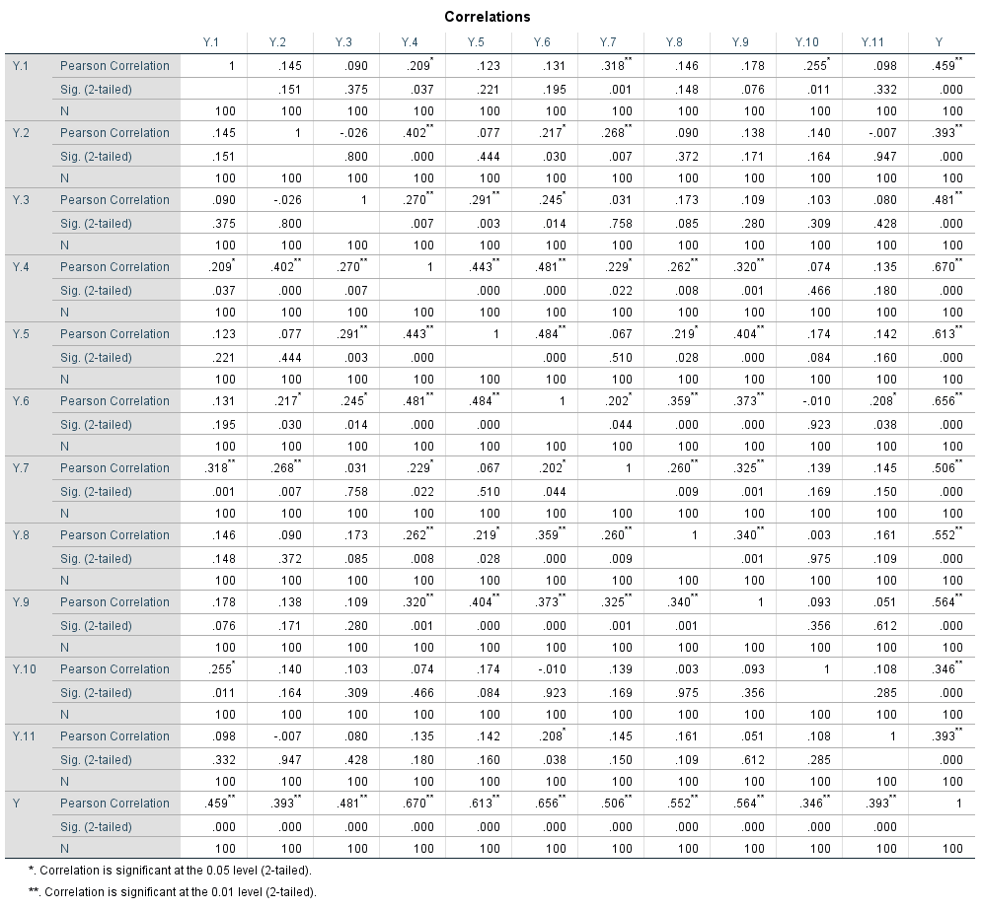**Uji Validitas Y**

**Uji Validitas X1**



**Uji Validitas X2**

**Uji Validitas X3**

Uji Reliabilitas Y

**Reliability Statistics**

|  |  |
| --- | --- |
| Cronbach's |  |
| Alpha | N of Items |
| .606 | 11 |

Uji Reliabilitas X1

**Reliability Statistics**

|  |  |
| --- | --- |
| Cronbach's |  |
| Alpha | N of Items |
| .712 | 8 |

Uji Reliabilitas X2

**Reliability Statistics**

|  |  |
| --- | --- |
| Cronbach's |  |
| Alpha | N of Items |
| .607 | 6 |

Uji Reliabilitas X3

**Reliability Statistics**

|  |  |
| --- | --- |
| Cronbach's |  |
| Alpha | N of Items |
| .604 | 5 |

**Lampiran 6**

**Uji Asumsi Klasik**

1. **Uji Normalitas**

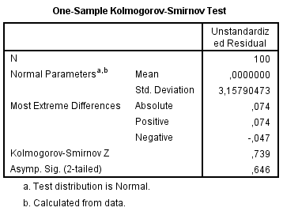

1. **Uji Multikolonieritas**

|  |  |  |  |
| --- | --- | --- | --- |
| Model |  | Collinearity Statistics | |
| Tolerance | VIF |
| 1 | (Constant)  Motivasi Kerja  Beban Kerja |  |  |
| .679 | 1.472 |
| .720 | 1.388 |
| Tunjangan Kinerja | .588 |  |

1. Dependent Variable: Kinerja Karyawan
2. **Uji Heteroskedastisitas**

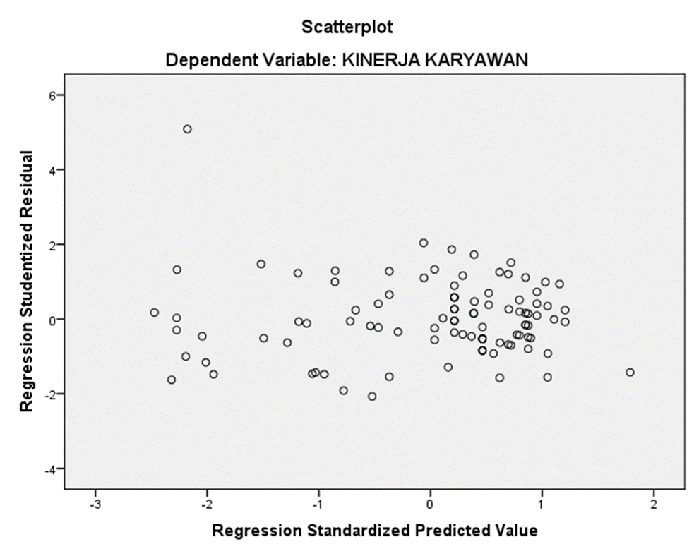

1. **Uji autokolerasi**

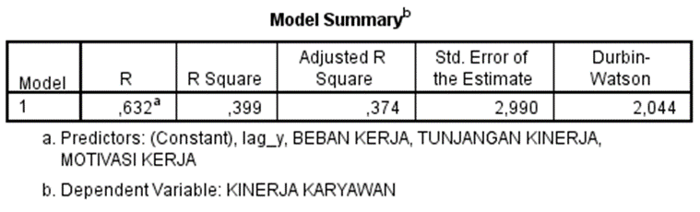

**Lampiran 7**

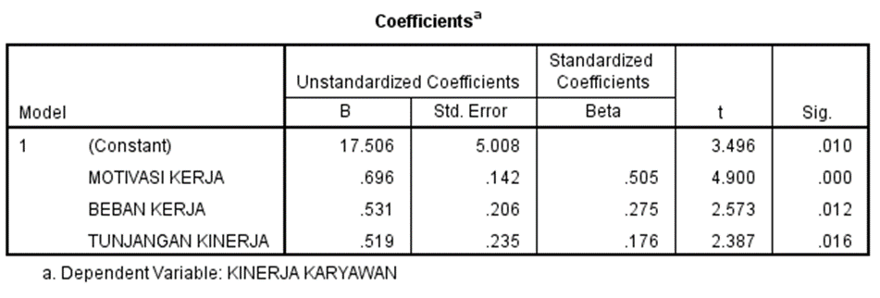**Analisi Regresi Linier Berganda**

**Lampiran 8**

**Uji Hipotesis**

1. Uji t (Parsial)
2. Uji F (Simultan)

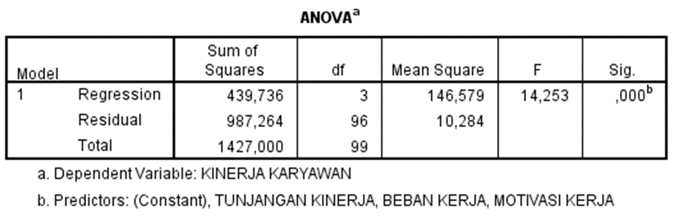

3. Uji Koefisien Determinasi (R2)

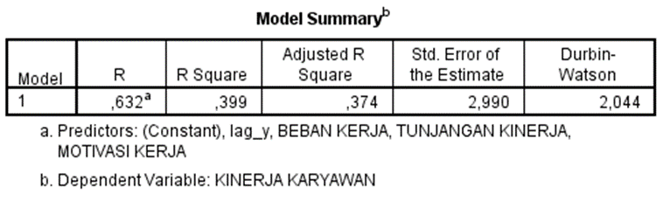

**Lampiran 9**

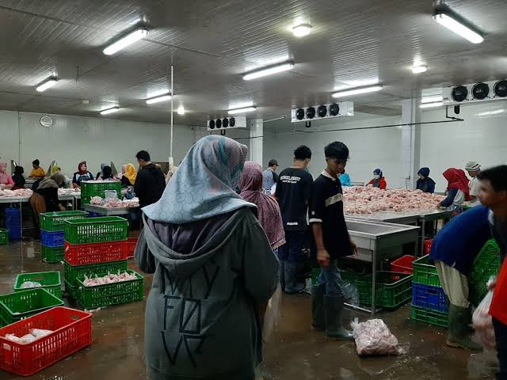**Gambar 3 Area Bersih**

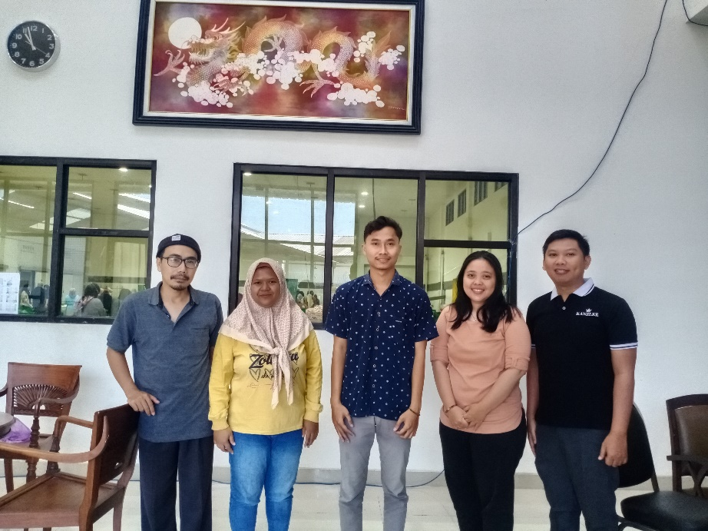**Gambar 4 Foto Bersama Manajer Dan Karyawan Pt Sahabat Pangan Sejahtera Tegal**

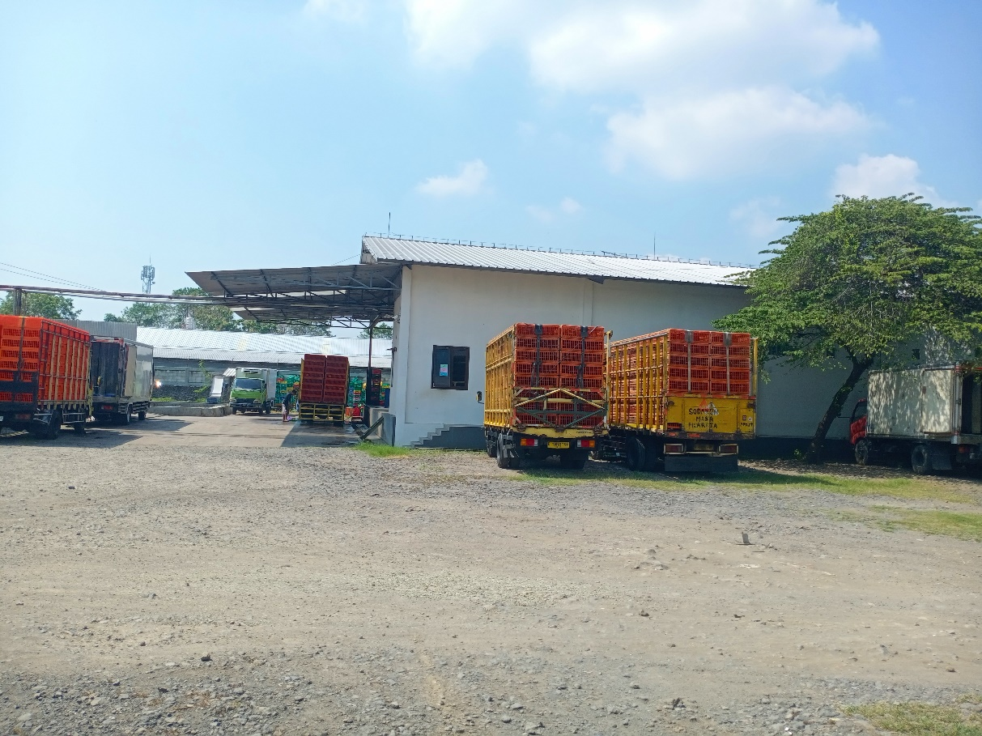**Gambar 5 Area Parkir Truk Pengangkut Ayam**

**Gambar 6 Area Kotor**

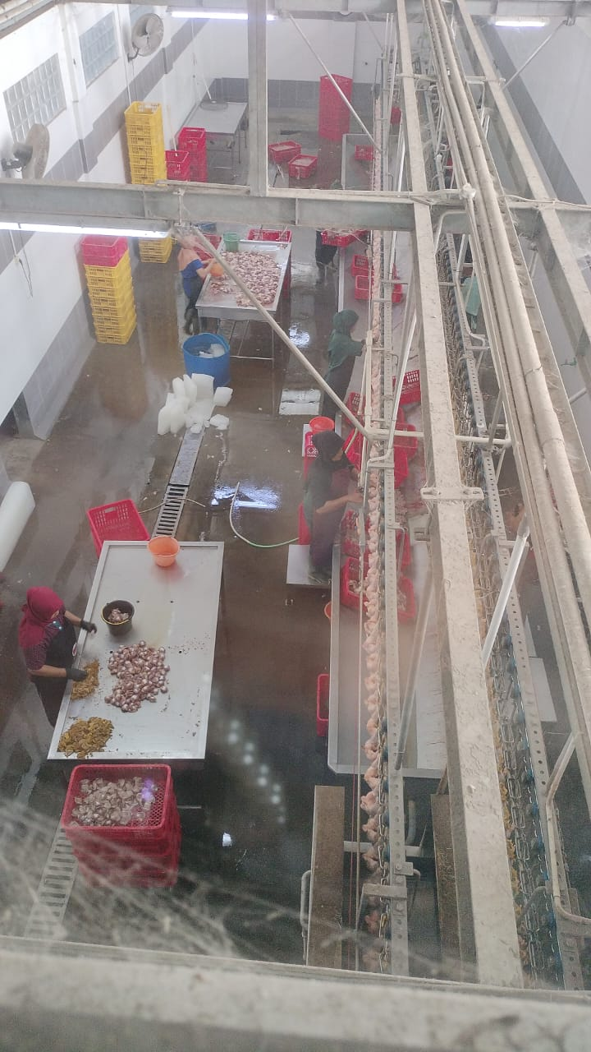

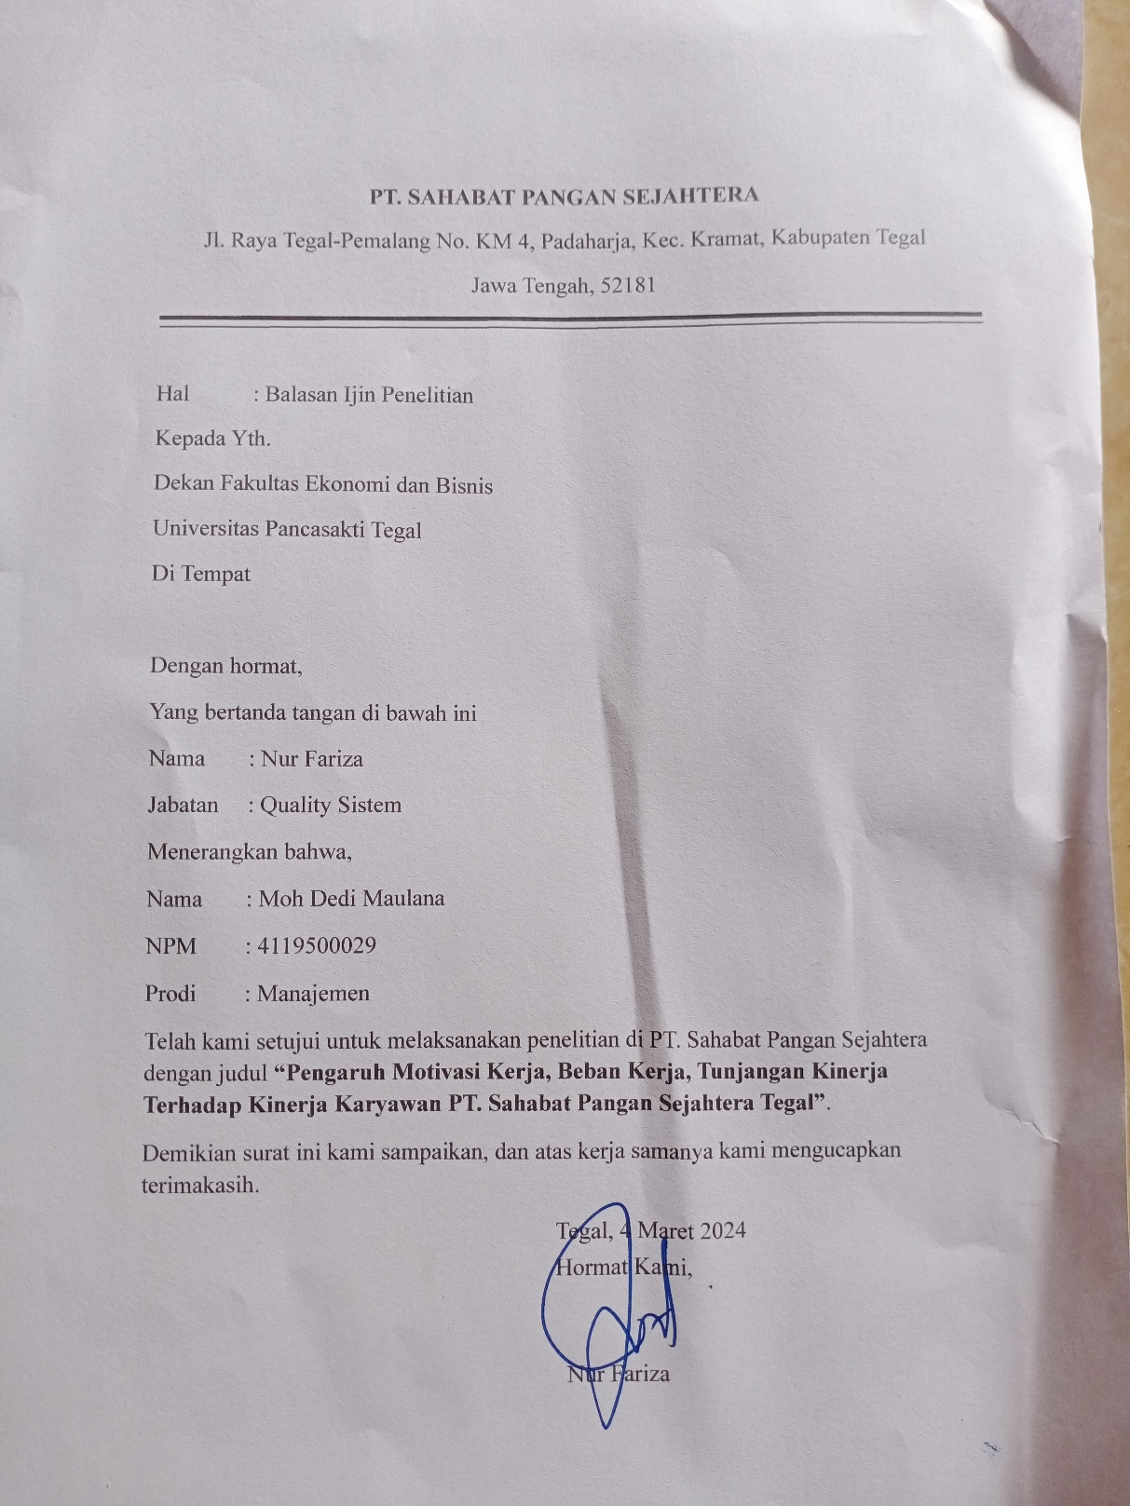**Gambar 7 Surat Balasan PT Sahabat Pangan Sejahtera Tegal**

**Gambar 8 izin penelitian dan Permintaan Data**

