# **DAFTAR PUSTAKA**

Abdullah, R., Mahmuda, D., Malik, E., Pratiwi, E. T., Rais, M., Dja’Wa, A., Abdullah, L. O. D., Hardin, Lampe, M., & Tjilen, A. P. (2019). The influence of environmental performance, environmental costs, and firm size on financial performance with corporate social responsibility as intervening variables (empirical study on manufacturing companies listed on the Indonesia stock exchange 2014-2. *IOP Conference Series: Earth and Environmental Science*, *343*(1). https://doi.org/10.1088/1755-1315/343/1/012136

Al-Mawali, H. (2021). Environmental cost accounting and financial performance: The mediating role of environmental performance. *Accounting*, *7*(3), 535–544. https://doi.org/10.5267/j.ac.2021.1.005

Amani, A., Nurleli, & Lestari, R. (2020). Pengaruh kinerja lingkungan dan biaya lingkungan terhadap kinerja keuangan perusahaan bumn tahun 2015-2018. *Prosiding Akuntansi*, *6*(1), 266–269.

Astuti, I. N., Mediyanti, S., Eliana, E., & Ridha, A. (2023). Menuju Sustainability: Apakah Lingkungan, Sosial dan Tata Kelola berdampak pada Kinerja Keuangan? *Jurnal Akademi Akuntansi*, *5*(4), 579–594. https://doi.org/10.22219/jaa.v5i4.23017

Astutie, Y. P., Chariri, A., & Mutmainah, S. (2019). Private Disclosure and Corporate Value Creation. *The Indonesian Journal of Accounting Research*, *22*(02). https://doi.org/10.33312/ijar.439

Aulia, R., & Hadinata, S. (2019). Pengaruh Environmental Performance, Environmental Disclosure, Dan Iso 14001 Terhadap Financial Performance. *JURNAL AKUNTANSI, EKONOMI Dan MANAJEMEN BISNIS*, *7*(2), 136–147. https://doi.org/10.30871/jaemb.v7i2.1439

Ayyash, A. H. A., Saadon, M. S. I., Nordin, N., & Othman, M. R. (2023). The Impact of Implementing ISO 26000 on Firms’ Performance: The Mediating Role of Corporate Governance. *International Journal of Professional Business Review*, *8*(10), e01042. https://doi.org/10.26668/businessreview/2023.v8i10.1042

Azizah, A. N. (2020). Pengaruh Akuntansi Lingkungan Terhadap Financial Performance Yang Dimoderasi Oleh Dewan Komisaris. In *Corporate Governance (Bingley)* (Vol. 10, Issue 1).

Cahyani, R. S. A., & Mayangsari, S. (2022). Pengaruh Environmental Performance, Corporate Governance, Dan Corporate Social Responsibility Terhadap Kinerja Keuangan. *Jurnal Ekonomi Trisakti*, *2*(2), 475–486. https://doi.org/10.25105/jet.v2i2.14321

Chakroun, S., Salhi, B., Ben Amar, A., & Jarboui, A. (2020). The impact of ISO 26000 social responsibility standard adoption on firm financial performance: Evidence from France. *Management Research Review*, *43*(5), 545–571. https://doi.org/10.1108/MRR-02-2019-0054

Christina, O., & Robiyanto. (2018). the Effect of Financial Performance and Firm Size on Stock Prices of Manufacturing Company in 2013-2016. *Prosiding SENDI_U*, *2007*, 559–565.

Deegan, C. (2002). Introduction: The legitimising effect of social and environmental disclosures – a theoretical foundation. *Accounting, Auditing & Accountability Journal*, *15*(3), 282–311. https://doi.org/10.1108/09513570210435852

Dewan Energi Nasional. (2023). *OUTLOOK ENERGI INDONESIA 2023*.

Dhara Kartika, & Musmini, L. S. (2022). Pengaruh Literasi Keuangan, Kompetensi Sumber Daya Manusia Dan Minat Menggunakan E-commerce Terhadap Kinerja Keuangan UMKM Pada Masa Pandemi …. *JIMAT (Jurnal Ilmiah Mahasiswa Akuntansi)*, 1–11. https://ejournal.undiksha.ac.id/index.php/S1ak/article/view/35273%0Ahttps://ejournal.undiksha.ac.id/index.php/S1ak/article/download/35273/21390

Dianty, A., & Nurrahim, G. (2022). Pengaruh Penerapan Green Accounting dan Kinerja Lingkungan terhadap Kinerja Keuangan. *Economics Professional in Action (E-PROFIT)*, *4*(2), 126–135. https://doi.org/10.37278/eprofit.v4i2.529

Dika Putra, G. M. P., & Wirawati, N. G. P. (2020). Pengaruh Good Corporate Governance pada Nilai Perusahaan dengan Kinerja Keuangan sebagai Variabel Mediasi. *E-Jurnal Akuntansi*, *30*(2), 388. https://doi.org/10.24843/eja.2020.v30.i02.p09

Dowling, J., & Pfeffer, J. (1975). Pacific Sociological Association Organizational Legitimacy: Social Values and Organizational Behavior. *Source: The Pacific Sociological Review*, *18*(1), 122–136.

Emilia Nur Hidayah, & Saiful Anwar. (2023). Pengaruh Media Exposure, Profitabilitas, ISO 14001 dan Slack Resources Terhadap Pengungkapan CSR Dimoderasi Kepemilikan Institusional. *EKOMA : Jurnal Ekonomi, Manajemen, Akuntansi*, *2*(2), 338–353. https://doi.org/10.56799/ekoma.v2i2.1478

Ermaya, H. N. L., & Mashuri, A. A. S. (2020). The Influence of Environmental Performance, Environmental Cost and ISO 14001 on Financial Performance in Non-Financial Companies Listed on the Indonesia Stock Exchange. *Neraca : Jurnal Akuntansi Terapan*, *1*(2), 74–83. https://doi.org/10.31334/neraca.v1i2.857

Evita, M., & Syafruddin, S. (2019). Pengaruh Biaya Lingkungan, Kinerja Lingkungan, Dan Iso 14001 Terhadap Kinerja Keuangan Perusahaan Pertambangan Studi Kasus Pada Bursa Efek Indonesia Tahun 2014-2017. *Measurement : Jurnal Akuntansi*, *13*(1), 27. https://doi.org/10.33373/mja.v13i1.1829

Exchange, I. S., & Division, D. S. (2023a). *IDX Yearly Statistics 2023*.

Exchange, I. S., & Division, D. S. (2023b). *IDX Yearly Statistics Portofolio 2022*.

Fahmi, Nur, Elyanti Rosmanidar, F. S. T. (2023). *Pengaruh Biaya Lingkungan Dan Kinerja Lingkungan Terhadap Roa Pada Perusahaan Energi Yang Terdaftar Di Efek Syariah ( Des ) Tahun*. *16*(2), 415–425. https://doi.org/10.51903/e-bisnis.v16i2

Febriansyah, E., & Fahreza, R. (2020). Pengaruh Pengungkapan Akuntansi Lingkungan dan Mekanisme Good Corporate Governance Terhadap Kinerja Keuangan (Studi Empiris pada Perusahaan yang Terdaftar di Bursa Efek Indonesia). *Jurnal Pasar Modal Dan Bisnis*, *2*(2), 129–154. https://doi.org/10.37194/jpmb.v2i2.44

Gray, R., Kouhy, R., & Lavers, S. (1995). The learning style of people with autism: An autobiography. In K. A. Quill (Ed.),Teaching children with autism: Strategies to enhance communication and socialization. *Delmar Publishers*, *8*(2), 277–279.

Gunawan, B., & Yuanita, R. (2018). Pengaruh Pengungkapan Corporate Social Responsibility Terhadap Kinerja Keuangan Yang Dimoderasi Oleh Struktur Kepemilikan. *Riset Akuntansi Dan Keuangan Indonesia*, *3*(1), 58–70. https://doi.org/10.23917/reaksi.v3i1.5608

Handoko, J., & Santoso, V. (2023). Pengaruh Akuntansi Hijau dan Kinerja Lingkungan terhadap Kinerja Keuangan dengan Tanggung Jawab Sosial sebagai Pemediasi. *Nominal Barometer Riset Akuntansi Dan Manajemen*, *12*(1), 84–101. https://doi.org/10.21831/nominal.v12i1.56571

Handoyo, F., Akram, A., & Nurabiah, N. (2022). PENGARUH KINERJA LINGKUNGAN DAN PENGUNGKAPAN LINGKUNGAN TERHADAP PROFITABILITAS PERUSAHAAN (Studi Pada Perusahaan Pertambangan Yang Terdaftar Di BEI Tahun 2017-2021). *Jurnal Riset Akuntansi Aksioma*, *21*(2), 107–117. https://doi.org/10.29303/aksioma.v21i2.169

Hapsoro, D., & Ambarwati, A. (2020). Relationship Analysis of Eco-Control, Company Age, Company Size, Carbon Emission Disclosure, and Economic Consequences. *The Indonesian Journal of Accounting Research*, *23*(02), 41–52. https://doi.org/10.33312/ijar.487

Harningsih, Henri, A. &, & Angelina. (2019). Pengaruh Kinerja Keuangan Terhadap Nilai Perusahaan DCSR Dan Kebijakan Dividen Sebagai Variabel Moderasiengan Pengungkapan. *Ranah Research Journal of Multidisciplinary Research and Development*, *1*(2), 199–209.

Peraturan Pemerintah Indonesia No.22 Tahun 2021, (2021).

Hotimah, H. (2020). Analisis Penerapan Etika Bisnis Dan Nilai Perusahaan Pt Axa Mandiri Financial Services. *Jurnal Ekonomi Manajemen Sistem Informasi*, *1*(6), 570–580. https://doi.org/10.31933/jemsi.v1i6.219

Imam Ghozali. (2018). *Aplikasi Analisis Multivariate Dengan Program IBM SPSS 25* (p. 67).

Indra Suyoto Kurniawan, Ledy Setiawati, Iskandar, Herawati, Anita Muhtadina, A. S. (2023). Pengaruh Kinerja Lingkungan terhadap Kinerja Keuangan dengan Corporate Social Responsibility Sebagai Variabel Intervening. *Jurnal Ilmu Dan Riset Akuntansi*, *5*(4), 1–15. https://doi.org/10.20885/ncaf.vol5.art11

Indra Suyoto Kurniawan, Ledy Setiawati, I., & Herawati, Anita Muhtadina, A. S. (2023). Pengaruh kinerja lingkungan terhadap kinerja keuangan dengan corporate social reponsibility sebagai variabel intervening. *Proceeding of National Conference on Accounting & Finance*, 90–97. https://doi.org/https://doi.org/10.20885/ncaf.vol5.art11

Ismail, A. A. (2021). *THE INFLUENCE OF ENVIRONMENTAL PERFORMANCE AND ENVIRONMENTAL COSTS ON FINANCIAL PERFORMANCE*. *5*(3), 395–408.

ISO. (2014). GRI G4 guidelines and ISO 26000:2010 - How to use the GRI G4 guidelines and ISO 26000 in conjunction. *Iso*, 44. http://www.iso.org/iso/iso-gri-26000_2014-01-28.pdf

Ivan, R., Baniady, A., & Pronosokodewo, G. (2020). *Apakah Kinerja Lingkungan dan Biaya Lingkungan Berpengaruh Terhadap Pengungkapan Informasi Lingkungan ? Does Environmental Performance and Environmental Cost Affect on Environmental Information Disclosure ?* *16*(2), 157–165.

Jari, T. (2021). *Jejak Kejahatan Indominco di Kaltim*. Jatam.Org. https://www.jatam.org/jejak-kejahatan-indominco-di-kaltim/

Kementerian Lingkungan Hidup dan Kehutanan. (2021). Peraturan Mentri Lingkungan Hidup dan Kehutanan Republik Indonesia No. 1 tahun 2021. *Kementrian LHK RI*, 249.

Ks, N., Rahayu, R., & Kartika, R. (2022). *Pengaruh Corporate Governance dan Diversifikasi terhadap Kinerja Keuangan Perusahaan yang Menerapkan Enterprise Resource Planning ( ERP )*. *6*(1), 78–86. https://doi.org/10.33087/ekonomis.v6i1.458

Kurnia Uthami, I. G. A. A. D., & Wirasedana, I. W. P. (2018). Pengaruh Kinerja Lingkungan dan Komponen Good Corporate Governance pada Nilai Perusahaan yang Terdaftar di BEI. In *E-Jurnal Akuntansi* (Vol. 24). https://doi.org/10.24843/eja.2018.v24.i03.p04

Mamduh M. Hanafi, A. H. (2018). *Analisis laporan keuangan* (5th ed.). UPP STIM YKPN.

Manrique, S., & Martí-Ballester, C. P. (2017). Analyzing the effect of corporate environmental performance on corporate financial performance in developed and developing countries. *Sustainability (Switzerland)*, *9*(11). https://doi.org/10.3390/su9111957

Mauliddina, S. (2018). Pengaruh Environmental Performance, ISO 14001 dan Environmental Cost Terhadap Kinerja Keuangan Perusahaan Manufaktur. In *UIN Syarif Hidayatullah*.

Meiyana, Aida, M. N. A. (2019). *UKURAN PERUSAHAAN TERHADAP KINERJA KEUANGAN DENGAN CORPORATE SOCIAL RESPONSIBILITY SEBAGAI VARIABEL INTERVENING ( Studi Empiris Pada Perusahaan Manufaktur yang Terdaftar di Bursa Efek Indonesia Tahun 2014-2016 )*. *VIII*(1).

Meiyana, A., & Anggita, N. (2018). *Pengaruh Kinerja Lingkungan,Biaya Lingkungan, dan Ukuran Perusahaan terhadap Kinerja Keuangan dengan Corporate Social Responbility Sebagai Variabel Intervening*.

Miladiasari, M., Agriyanto, R., Farida, D., Prasetyoningrum, A., & Muhlis, M. (2021). *The Effect of Environmental Performance and Environmental Cost on Financial Performance with Good Corporate Governance as the Moderating Variable*. *32*. https://doi.org/10.4108/eai.14-10-2020.2303857

Mira Afriani, Yadi Nurhayadi, U. S. A. A. (2021). Pengaruh Kinerja Lingkungan, Ukuran Perusahaan, Corporate Social Responsibility Terhadap Kinerja Keuangan Perusahaan Pada Perusahaan Manufaktur. *JAD : Jurnal Riset Akuntansi & Keuangan Dewantara*, *3*(2), 101–109. https://doi.org/10.26533/jad.v3i2.666

Munir, A., Khan, F. U., Usman, M., & Khuram, S. (2019). Relationship between corporate governance, corporate sustainability and financial performance. *Pakistan Journal of Commerce and Social Science*, *13*(4), 915–933.

Nababan, L. M. (2019). Pengaruh Firm Size dan Leverage Ratio Terhadap Kinerja Keuangan pada Perusahaan Pertambangan. *Jurnal Wira Ekonomi Mikroskil*, *9*(1), 13–20. https://doi.org/10.55601/jwem.v9i1.588

Nababan, L. M., & Hasyir, D. A. (2019). PENGARUH ENVIRONMENTAL COST DAN ENVIRONMENTAL PERFORMANCE TERHADAP FINANCIAL PERFORMANCE (Studi Kasus pada Perusahaan Sektor Pertambangan Peserta PROPER Periode 2012 – 2016). *E-Jurnal Ekonomi Dan Bisnis Universitas Udayana*, *3*, 259. https://doi.org/10.24843/eeb.2019.v08.i03.p03

Nano, S., Ponirah, A., & Falah, N. (2021). Pengaruh Firm Size Dan Financial Leverage Terhadap Financial Performance Pada Pt. Japfa Comfeed Indonesia. *Finansha: Journal of Sharia Financial Management*, *1*(2), 44–53. https://doi.org/10.15575/fsfm.v1i2.10565

Niresh, J. A., & Silva, W. H. E. (2018). The Nexus between Corporate Social Responsibility Disclosure and Financial Performance: Evidence from the Listed Banks, Finance and Insurance Companies in Sri Lanka. *Accounting and Finance Research*, *7*(2), 65. https://doi.org/10.5430/afr.v7n2p65

Pambudi, J. E. (2022). *Pengaruh Environmental Performance, Environmental Cost, Dan Corporate Social Responbility Terhadap Financial Performance pada Perusahaan Tambang Yang Terdaftar di Bursa Efek Indonesia Tahun 2017-2021*. *4*(2), 6.

Pham, D. C., Do, T. N. A., Doan, T. N., Nguyen, T. X. H., & Pham, T. K. Y. (2021). The impact of sustainability practices on financial performance: empirical evidence from Sweden. *Cogent Business and Management*, *8*(1). https://doi.org/10.1080/23311975.2021.1912526

Pramitha, Ida Ayu Yuni, I. P. S. (2021). *Pengungkapan Corporate Social Responsibility, Kinerja Lingkungan dan Nilai Perusahaan*. 615–634.

Prena, G. Das. (2021). Pengaruh Penerapan Green Accounting, Dan Kinerja Lingkungan Terhadap Kinerja Keuangan Pada Perusahaan Manufaktur Di Bursa Efek Indonesia. *Jurnal Akun Nabelo: Jurnal Akuntansi Netral, Akuntabel, Objektif*, *3*(2), 495–507.

Rachman, F., Nurleli, N., & Rosdiana, Y. (2019). Analisis Penerapan Sistem Manajemen Lingkungan Terhadap Kinerja Lingkungan pada Rumah Sakit di Kota Bandung. *Kajian Akuntansi*, *21*(2), 36–44. https://doi.org/10.29313/ka.v21i2.4498

Radhali, & Wahyu Ramadhani. (2021). Pencemaran Lingkungan Akibat Pembuangan Limbah Yang Dilakukan Oleh Pt. Medco Di Kabupaten Aceh Timur Menurut Undang-Undang Nomor 32 Tahun 2009 Tentang Perlindungan Dan Pengelolaan Lingkungan Hidup. *Jurnal Hukum Samudra Keadilan*, *16*(1), 86–97. https://doi.org/10.33059/jhsk.v16i1.3198

Rahmandani, N., & Sukmana, R. (2023). Analisis Keberlanjutan Lingkungan Melalui Capaian Pertumbuhan Ekonomi Dan Konsumsi Energi Terbarukan Di Indonesia. *Relasi: Jurnal Ekonomi*, *19*(2), 327–344.

Rahmi, E. (2011). Standarisasi Lingkungan (ISO 26000) sebagai Harmonisasi Tanggung Jawab Sosial Perusahaan dan Instrumen Hukum di Indonesia. *Jurnal Ilmu Hukum*, *ISO26000*, 1–14.

Rifani, N., Buana, U. M., Liaoktaviana, C., Buana, U. M., Tumiur, R., Carolin, M., & Buana, U. M. (2022). *Pengukuran dan penyusunan laporan biaya lingkungan*. *May*.

Ruhana, A., & Hidayah, N. (2020). *The Effect of Liquidity, Firm Size, and Corporate Governance Toward Sustainability Report Disclosures (Survey on: Indonesia Sustainability Report Award Participant)*. *120*(Icmeb 2019), 279–284. https://doi.org/10.2991/aebmr.k.200205.048

Sakiyah, D. E., Agus Salim, M., & Agus Priyono, A. (2020). Pengaruh Pengungkapan Sustainability Report Terhadap Kinerja Keuangan Pada Perusahaan Perbankan Yang Terdaftardi BEI 2016-2018. *Jurnal Riset Manajemen*, *9*(10), 68–85.

Saputra, M. F. M. (2020). PENGARUH KINERJA LINGKUNGAN DAN BIAYA LINGKUNGAN TERHADAP KINERJA KEUANGAN DENGAN PENGUNGKAPAN LINGKUNGAN SEBAGAI VARIABEL INTERVENING (Studi Empiris Pada Perusahaan Pertambangan Yang Terdaftar di BEI Tahun 2014-2018. *Jurnal Riset Akuntansi Tirtayasa*, *5*(2), 123–138. https://doi.org/10.48181/jratirtayasa.v5i2.8956

Sawitri, A. P., & Setiawan, N. (2019). Analisis Pengaruh Pengungkapan Sustainability Report, Kinerja Keuangan, Kinerja Lingkungan Terhadap Nilai Perusahaan. *Journal of Business & Banking*, *7*(2), 1–8. https://doi.org/10.14414/jbb.v7i2.1397

Shi, Y., Li, X., & Asal, M. (2023). Impact of sustainability on financial distress in the air transport industry: the moderating effect of Asia–Pacific. *Financial Innovation*, *9*(1). https://doi.org/10.1186/s40854-023-00506-1

Siregar, I. F., Rasyad, R., & Zaharman. (2019). Pengaruh Implikasi Biaya lingkungan dan Kinerja Lingkungan Terhadap Kinerja Keuangan Perusahaan Pertambangan Umum Kategori PROPER. *Jurnal Ekonomi Dan Bisnis Dharma Andalas*, *21*(2), 198–209.

Soewarno, N., Tjahjadi, B., & Hanifah Firdausi, R. (2018). The Impacts of Carbon Emission Disclosure, Environmental Performance, and Social Performance on Financial Performance (Empirical Studies in Proper Participating Companies Listed in Indonesia Stocks Exchange, Year 2013–2016). *KnE Social Sciences*, *3*(10), 957–971. https://doi.org/10.18502/kss.v3i10.3439

Suhendra, A., Faisal, Y., & Soleha. (2022). *Volume 01 Issue 01 (2022) https://ejurnal.stietribhakti.ac.id/index.php/JAATB*. *01*(01), 30–46.

Supadi, Y. M., & Sudana, I. P. (2018). Pengaruh Kinerja Lingkungan dan Corporate Social Responsibility pada Perusahaan Sektor Pertambangan. *E-Jurnal Ekonomi Dan Bisnis Universitas Udayana*, *4*, 1165. https://doi.org/10.24843/eeb.2018.v07.i04.p09

Susetyo, B. (2020). Pengaruh Pengungkapan Corporatesocial Responsibility dan Kinerja Lingkungan Terhadap Upaya Pencapaian Sustainable Development Goals (SDGS) 2030 di Perusahaan Pertambangan. *Jurnal Akuntansi Dan Bisnis Kontemporer*, *1*(1), 39–50. http://jabko.upstegal.ac.id/index.php/JABKO

Suwandi, & Akyuwen, R. (2019). Gap Analysis Implementasi Iso 26000 Pada Perusahaan Publik. *Modus*, *31*(2), 172–183.

Suyanto. (2022). Kinerja Keuangan Usaha Mikro Kecil Dan Menengah (Umkm): Inklusi Keuangan Sebagai Mediasi. *Jurnal Akuntansi Dewantara*, *6*(1), 1–20.

Tambunan, A. L., Aristi, M. D., & Azmi, Z. (2023). *Pengaruh Biaya Lingkungan dan Corporate Social Responsibility Terhadap Kinerja Keuangan*. *1*(01), 1–9.

Tambunan, J. T. A. dan B. P. (2018). Pengaruh ukuran perusahaan, leverage dan struktur modal terhadap kinerja keuangan perusahaan (studi pada perusahaan manufaktur sektor aneka industri tahun 2012-2016). *Diponegoro Journal of Social and Politic*, *7*, 1–10. http://ejournal-s1.undip.ac.id/index.php/

*The epa’s environmental justice strategy*. (1995).

*The impact of ISO 2600O social responsibiliy standard adoption on firm financial pefformance: Evidence from France*. (2019).

Tochukwu, G. O. (2018). Environmental Costs Accounting and Reporting on firm financial performance: A survey of Nigerian quoted oil companies Environmental Costs Accounting and Reporting on Firm Financial Performance: A Survey of Quoted Nigerian Oil Companies. *Article in International Journal of Finance & Accounting Studies*, *7*(1), 1–6. https://doi.org/10.5923/j.ijfa.20180701.01

Ulum, I. (2015). Intellectual capital disclosure: Suatu analisis dengan four way numerical coding system. *Jurnal Akuntansi & Auditing Indonesia*, *19*(1), 39–50. https://doi.org/10.20885/jaai.vol19.iss1.art4

Wasik, Z., & Rusli, M. (2022). Analisis Penerapan ISO 26000 Koperasi Simpan Pinjam Lamongan dan Mojokerto. *Jurnal Manajerial*, *9*(03), 298. https://doi.org/10.30587/jurnalmanajerial.v9i03.4352

Wijaya, A. (2022). Dampak lingkungan dan kesehatan pada masa transisi energi. *Buletin Pertamina Energy Institute*, *8*(November), 70–76.

Yesica, Y., Sitorus, T., & Purwanto, E. (2020). Pengaruh Tata Kelola Perusahaan yang Baik dan Tanggung Jawab Sosial Perusahaan terhadap Kinerja Keuangan. *Journal of Business & Applied Management*, *13*(2), 191. https://doi.org/10.30813/jbam.v13i2.2356

Zainab, A., & Burhany, D. I. (2020). Biaya Lingkungan, Kinerja Lingkungan, dan Kinerja Keuangan pada Perusahaan Manufaktur. *Industrial Research Workshop and National Seminar*, 26–27.

# 

# **LAMPIRAN**

Daftar sampel perusahaan sektor energi Tahun 2018-2023

|  |  |  |
| --- | --- | --- |
| **NO** | **KODE** | **NAMA PERUSAHAAN** |
| 1 | ADRO | Adaro Energy Indonesia Tbk |
| 2 | PGAS | Perusahaan Gas Negara Tbk |
| 3 | PTBA | Bukit Asam Tbk |
| 4 | ITMG | Indo Tambangraya Megah Tbk |
| 5 | HRUM | Harum Energy Tbk |
| 6 | ELSA | Elnusa Tbk |
| 7 | BUMI | Bumi Resources Tbk |
| 8 | INDY | Indika Energy Tbk |
| 9 | AKRA | AKR Corporindo Tbk |
| 10 | BSSR | Baramulti Suksessarana Tbk |
| 11 | TOBA | TBS Energi Utama Tbk |
| 12 | ABMM | ABM Investama Tbk |
| 13 | SMMT | Golden Eagle Energy Tbk |
| 14 | GEMS | Golden Eagle Mines Tbk |
| 15 | KKGI | Resource Alam Indonesia Tbk |
| 16 | DSSA | Dian Swastatika Sentosa Tbk |
| 17 | MEDC | Medco Energi Internasional Tbk |

Lampiran 1. 1 Sampel Perusahaan Sektor energi

Lampiran 1. 2 Tabulasi data ROA





Lampiran 1. 3 Perusahaan dengan kategori PROPER

Lampiran 1. 4 Environmental Cost





Lampiran 1. 5

**Lampiran 1. 6 Firm Size**





Lampiran 1. 7 Hasil Olah Data



Lampiran 1. 8 Uji normalitas

|  |  |  |
| --- | --- | --- |
| **One-Sample Kolmogorov-Smirnov Test** | | |
|  | | Unstandardized Residual |
| N | | 102 |
| Normal Parametersa,b | Mean | .0000000 |
| Std. Deviation | .12079494 |
| Most Extreme Differences | Absolute | .112 |
| Positive | .112 |
| Negative | -.061 |
| Test Statistic | | .112 |
| Asymp. Sig. (2-tailed) | | .003c |
| a. Test distribution is Normal. | | |
| b. Calculated from data. | | |
| |  |  |  | | --- | --- | --- | | **One-Sample Kolmogorov-Smirnov Test** | | | |  | | Unstandardized Residual | | N | | 93 | | Normal Parametersa,b | Mean | .0000000 | | Std. Deviation | .31711783 | | Most Extreme Differences | Absolute | .091 | | Positive | .044 | | Negative | -.091 | | Test Statistic | | .091 | | Asymp. Sig. (2-tailed) | | .053c | | a. Test distribution is Normal. | | | | b. Calculated from data. | | | | c. Lilliefors Significance Correction. | | |   c. Lilliefors Significance Correction. | | |

Lampiran 1. 9 Normal P-plot

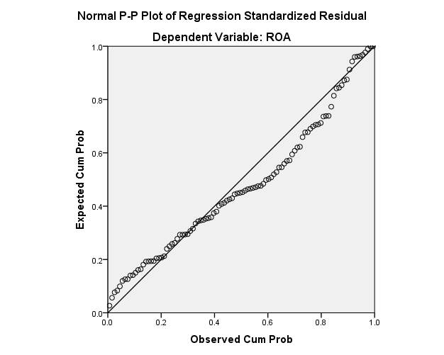

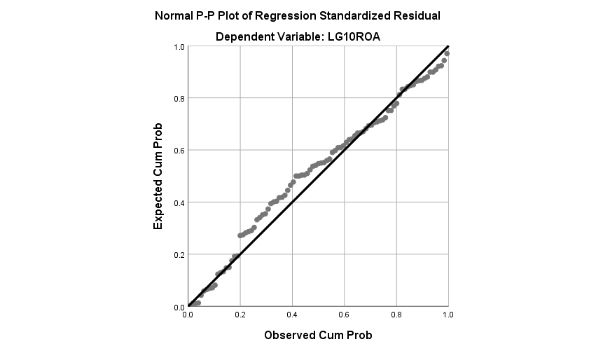

Lampiran 1. 10 Coefficients

|  |  |  |  |  |  |  |  |  |
| --- | --- | --- | --- | --- | --- | --- | --- | --- |
| **Coefficientsa** | | | | | | | | |
| Model | | Unstandardized Coefficients | | Standardized Coefficients | t | Sig. | Collinearity Statistics | |
| B | Std. Error | Beta | Tolerance | VIF |
| 1 | (Constant) | .932 | .381 |  | 2.446 | .016 |  |  |
| EP | -.007 | .017 | -.048 | -.423 | .673 | .666 | 1.502 |
| EC | -.178 | .081 | -.215 | -2.181 | .032 | .894 | 1.119 |
| CSR2 | .024 | .104 | .037 | .230 | .819 | .328 | 3.046 |
| CSR3 | -.419 | .146 | -.442 | -2.862 | .005 | .363 | 2.752 |
| CSR5 | .194 | .131 | .326 | 1.482 | .142 | .179 | 5.595 |
| CSR6 | .035 | .077 | .054 | .450 | .654 | .611 | 1.637 |
| CSR7 | .174 | .081 | .214 | 2.156 | .034 | .883 | 1.133 |
| SIZE | -.025 | .012 | -.247 | -2.050 | .043 | .597 | 1.674 |
| a. Dependent Variable: ROA | | | | | | | | |

|  |  |  |  |  |  |  |  |  |
| --- | --- | --- | --- | --- | --- | --- | --- | --- |
| **Coefficientsa** | | | | | | | | |
| Model | | Unstandardized Coefficients | | Standardized Coefficients | t | Sig. | Collinearity Statistics | |
| B | Std. Error | Beta | Tolerance | VIF |
| 1 | (Constant) | 1.227 | 1.068 |  | 1.149 | .254 |  |  |
| EP | -.012 | .050 | -.018 | -.236 | .814 | .616 | 1.623 |
| LG10EC | -.793 | .066 | -.830 | -12.073 | .000 | .776 | 1.289 |
| LNCSR1 | 116.960 | 351.824 | .021 | .332 | .740 | .921 | 1.085 |
| CSR2 | .894 | .290 | .317 | 3.087 | .003 | .348 | 2.870 |
| CSR3 | -2.397 | .424 | -.581 | -5.651 | .000 | .347 | 2.882 |
| LNCSR4 | -118.637 | 348.552 | -.021 | -.340 | .734 | .939 | 1.065 |
| CSR5 | .409 | .372 | .153 | 1.101 | .274 | .189 | 5.278 |
| CSR6 | .233 | .221 | .082 | 1.054 | .295 | .612 | 1.635 |
| CSR7 | .813 | .226 | .234 | 3.601 | .001 | .866 | 1.155 |
| SIZE | -.108 | .034 | -.247 | -3.167 | .002 | .602 | 1.660 |
| a. Dependent Variable: LG10ROA | | | | | | | | |

Lampiran 1. 11 Uji Runs Test

|  |  |
| --- | --- |
| **Runs Test** | |
|  | Unstandardized Residual |
| Test Valuea | -.01543 |
| Cases < Test Value | 51 |
| Cases >= Test Value | 51 |
| Total Cases | 102 |
| Number of Runs | 28 |
| Z | -4.776 |
| Asymp. Sig. (2-tailed) | .000 |
| a. Median | |

Dibawah ini tabel Runs test yang ditransformasikan ke LG10ROA,LG10EC,LNCSR1,LNCSR4

|  |  |
| --- | --- |
| **Runs Test** | |
|  | Unstandardized Residual |
| Test Valuea | .04018 |
| Cases < Test Value | 46 |
| Cases >= Test Value | 47 |
| Total Cases | 93 |
| Number of Runs | 41 |
| Z | -1.354 |
| Asymp. Sig. (2-tailed) | .176 |
| a. Median | |

Lampiran 1. 12 Scatterplot

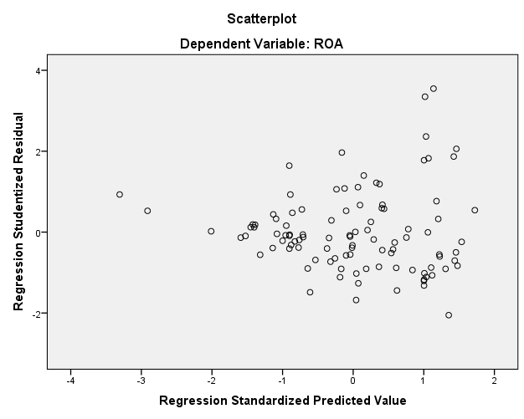

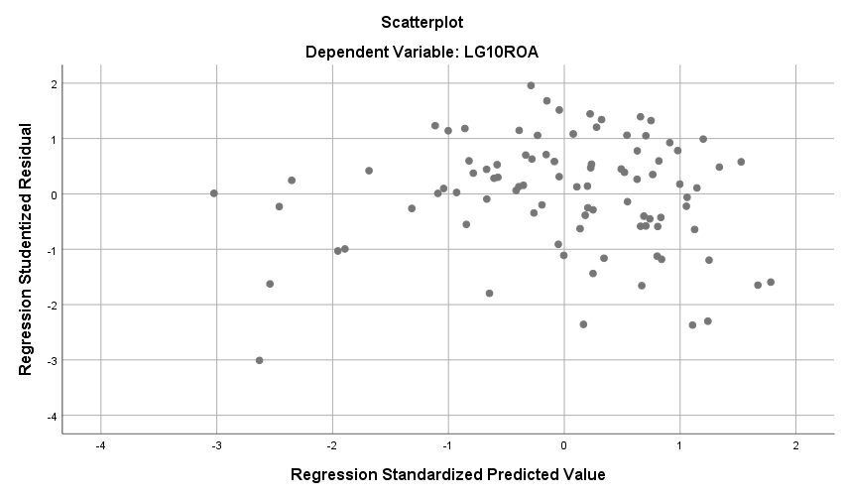

|  |  |  |  |  |  |  |
| --- | --- | --- | --- | --- | --- | --- |
| **Coefficientsa** | | | | | | |
| Model | | Unstandardized Coefficients | | Standardized Coefficients | t | Sig. |
| B | Std. Error | Beta |
| 1 | (Constant) | .932 | .381 |  | 2.446 | .016 |
| EP | -.007 | .017 | -.048 | -.423 | .673 |
| EC | -.178 | .081 | -.215 | -2.181 | .032 |
| CSR2 | .024 | .104 | .037 | .230 | .819 |
| CSR3 | -.419 | .146 | -.442 | -2.862 | .005 |
| CSR5 | .194 | .131 | .326 | 1.482 | .142 |
| CSR6 | .035 | .077 | .054 | .450 | .654 |
| CSR7 | .174 | .081 | .214 | 2.156 | .034 |
| SIZE | -.025 | .012 | -.247 | -2.050 | .043 |
| a. Dependent Variable: ROA | | | | | | |

Lampiran 1. 13 Uji T

|  |  |  |  |  |  |  |  |  |  |  |  |
| --- | --- | --- | --- | --- | --- | --- | --- | --- | --- | --- | --- |
| **Coefficientsa** | | | | | | | | | | | |
| Model | | Unstandardized Coefficients | | | | Standardized Coefficients | | t | | Sig. | |
| B | | Std. Error | | Beta | |
| 1 | (Constant) | | 1.227 | | 1.068 | |  | | 1.149 | | .254 | |
| EP | | -.012 | | .050 | | -.018 | | -.236 | | .814 | |
| LG10EC | | -.793 | | .066 | | -.830 | | -12.073 | | .000 | |
| LNCSR1 | | 116.960 | | 351.824 | | .021 | | .332 | | .740 | |
| CSR2 | | .894 | | .290 | | .317 | | 3.087 | | .003 | |
| CSR3 | | -2.397 | | .424 | | -.581 | | -5.651 | | .000 | |
| LNCSR4 | | -118.637 | | 348.552 | | -.021 | | -.340 | | .734 | |
| CSR5 | | .409 | | .372 | | .153 | | 1.101 | | .274 | |
| CSR6 | | .233 | | .221 | | .082 | | 1.054 | | .295 | |
| CSR7 | | .813 | | .226 | | .234 | | 3.601 | | .001 | |
| SIZE | | -.108 | | .034 | | -.247 | | -3.167 | | .002 | |
| a. Dependent Variable: LG10ROA | | | | | | | | | | | |

Lampiran 1. 14 Model Summary

|  |  |  |  |  |
| --- | --- | --- | --- | --- |
| **Model Summaryb** | | | | |
| Model | R | R Square | Adjusted R Square | Std. Error of the Estimate |
| 1 | .441a | .195 | .125 | .125883 |
| a. Predictors: (Constant), SIZE, CSR6, EC, CSR7, CSR3, EP, CSR2, CSR5 | | | | |
| b. Dependent Variable: ROA | | | | |

|  |  |  |  |  |  |
| --- | --- | --- | --- | --- | --- |
| **Model Summaryb** | | | | | |
| Model | R | R Square | Adjusted R Square | Std. Error of the Estimate | Durbin-Watson |
| 1 | .836a | .699 | .663 | .33590 | 2.007 |
| a. Predictors: (Constant), SIZE, LG10EC, LNCSR1, CSR3, LNCSR4, CSR7, CSR6, EP, CSR2, CSR5 | | | | | |
| b. Dependent Variable: LG10ROA | | | | | |

|  |  |  |  |  |  |  |  |  |  |  |  |  |  |  |  |  |  |  |  |  |  |  |  |  |  |  |  |  |  |  |  |  |  |  |  |  |  |  |  |  |  |  |  |  |  |  |  |  |  |  |  |  |  |
| --- | --- | --- | --- | --- | --- | --- | --- | --- | --- | --- | --- | --- | --- | --- | --- | --- | --- | --- | --- | --- | --- | --- | --- | --- | --- | --- | --- | --- | --- | --- | --- | --- | --- | --- | --- | --- | --- | --- | --- | --- | --- | --- | --- | --- | --- | --- | --- | --- | --- | --- | --- | --- | --- |
| |  |  |  |  |  |  |  | | --- | --- | --- | --- | --- | --- | --- | | **ANOVAa** | | | | | | | | Model | | Sum of Squares | df | Mean Square | F | Sig. | | 1 | Regression | .356 | 8 | .044 | 2.807 | .008b | | Residual | 1.474 | 93 | .016 |  |  | | Total | 1.830 | 101 |  |  |  | | a. Dependent Variable: ROA | | | | | | | | b. Predictors: (Constant), SIZE, CSR6, EC, CSR7, CSR3, EP, CSR2, CSR5 | | | | | | |   **ANOVAa** | | | | | | |
| Model | | Sum of Squares | df | Mean Square | F | Sig. |
| 1 | Regression | 21.517 | 10 | 2.152 | 19.070 | .000b |
| Residual | 9.252 | 82 | .113 |  |  |
| Total | 30.769 | 92 |  |  |  |
| a. Dependent Variable: LG10ROA | | | | | | |
| b. Predictors: (Constant), SIZE, LG10EC, LNCSR1, CSR3, LNCSR4, CSR7, CSR6, EP, CSR2, CSR5 | | | | | | |